From Hidden Technology to Exhibition Showpiece:

The Journey of 2LO, the BBC’s First Radio Transmitter,
1922-2012

By Alison Hess

Royal Holloway, University of London

PhD thesis

Declaration of Authorship
I ……………………. (Alison Hess) hereby declare that this thesis and the work presented in it is entirely my own. Where I have consulted the work of others, this is always clearly stated.
Signed: _____________________
Date: 1st October 2012
Acknowledgements
I would like to thank my supervisors David Gilbert, Klaus Dodds, John Liffen and Tim Boon for their advice and enthusiasm throughout this research. As well as my friends and colleagues at the Science Museum and Royal Holloway for making this such a varied and interesting three years.
I would also like to thank my friends and family more generally for continuing to listen, and support me, through the highs and lows of this research.
Finally I would like to thank and acknowledge the many people who I have spoken to and been advised by in the course of this research. Without them I would never have got to know this remarkable object.

Abstract
On the 14th of November 1922, those with radios in the south of England tuned into the first broadcast of the newly formed British Broadcasting Company (BBC). Hidden away from public view in Marconi House, on The Strand in London, was the technology that converted the sound waves of the studio into radio waves, amplifying them so that they could reach across the ether into thousands of homes across the country. This technology was the 2LO transmitter, and this thesis traces its journey from this remote place to the national platform of the Science Museum nearly ninety years later.
Engaging with a range of theories relating to object theory and material culture, this thesis initially considers 2LO as a representative of the BBC: rarely seen apart from by a privileged few yet facilitating a connection which eventually stretched across the UK. It then follows 2LO’s removal from London to Brookman’s Park in Hertfordshire and its transformation into a display piece that played a key role in the corporate image making of the BBC. It also explores the personal affection that this object inspired in many of those who worked with it, often saving it from near disaster until it came safely to the Science Museum in 2002. This thesis then goes on to look more closely at the physical object, tracing the marks of time on the materials that make up 2LO. Through this exercise, 2LO is literally rather than socially deconstructed, with issues of authenticity and the aesthetics of age being discussed. Through the use of ethnography and interview this thesis goes on to look at the role of 2LO within the Science Museum, and the conscious way in which cultural institutions shape narratives for the public. Across a range of institutional spaces 2LO’s image has been shaped into that of an ‘icon of broadcasting history’, and at present is destined for a multi-million pound gallery based on the history of communications. In closely following the life of a unique object, this thesis seeks to unpick our complex relationship with the ‘things’ in our world, and the multiple narratives that can be weaved around even one piece of material heritage.

Contents
Introduction and Methodology 6
Chapter One: The Working Life of the 2LO Transmitter 34
Chapter Two: An Uncertain path- 2LO as Relic, Junk and Display Piece from 1929 to 2002 85
Chapter Three: The 2LO Artefact- Mapping an Object’s Experience onto its Materials 138
Chapter Four: 2LO in the Spaces of the Science Museum- Artefact, Icon and Exhibition Showpiece, from 2002 to 2012 165
Conclusion 224
Appendix A 234
Bibliography 250

Introduction and Methodology
2LO, 2LO...2LO was at the top of everyone’s list. Some included crystal sets and one volunteer spoke passionately about the inclusion of a particular Burndept valve receiver, but everyone said the exhibition just wouldn’t be complete without 2LO. Halfway round the table Charlotte, who was writing down suggestions on a flip chart wrote 2LO in the middle with a big marker pen and circled it. It was agreed 2LO had to go in.

On the 23rd of May 2011 a group from the British Vintage Wireless Society (BVWS) visited Blythe House, the Science Museum’s storage facilities in Kensington Olympia. With them were John Liffen, the Curator of Communications; Charlotte Connelly, Assistant Curator of Computing and Communications; Deanne Naula the Participant Co-ordinator for Public Engagement in the Treasury Galleries; and me. The BVWS group was made up of ten men, ranging in age from their mid forties to their early seventies, who all shared a passionate enthusiasm for old wireless technology. Their personal collections ranged from radios and televisions from every era, to valves and other components, to pieces of transmission equipment.
The aim of the visit was primarily to show these individuals just how rich the Science Museum’s collections were and allow them to indulge their passion for this technology. However there was also another agenda: to consult this group on what they considered to be the important objects to include in a new communications gallery. Following a number of hours wandering the labyrinthine halls of Blythe House, admiring some of the thousands of objects that lined the shelves, we went for a much needed cup of tea. While they relaxed, Deanne went round the table and asked each member which objects they felt were important to the story of communications, and particularly the history of radio. The response I recorded in my Field Diary is quoted above: every member agreed that you could not have a communications gallery without the 2LO transmitter.
This event occurred only a few months before my Collaborative Doctoral Award between the Geography Department at Royal Holloway and the Science Museum came to an end. Nevertheless, this anecdote raises many of the key questions around which this thesis revolves and acts as an excellent introduction to the ‘star’ of this research: the 2LO transmitter. In September 2008 I applied to work on the research topic: ‘The 2L0 Transmitter: Technology, Material Culture and Metropolitan Modernity in Inter-War London.’ This title suggested a straightforward history of inter-war radio or an account of London and technological modernity in the 1920s.
However this title did not hint at how evocative and significant this object continued to be in the years that followed this revolution in broadcasting. 2LO is the BBC’s first radio transmitter and, as its journey was uncovered, further examples of those expressing similar opinions to the members of the BVWS emerged. This was not just a reflection of its status as a museum object, which it gained remarkably late in its life. 2LO has a long history, and as such had developed a mythology of its own. During this same BVWS visit, one member recounted the story of how BBC engineers had tried to hook the transmitter up to the power supply at Brookman’s Park transmitting station during the 1950s in an effort to ‘get it working again.’ This was not the first time I had heard this story.
What rapidly became apparent was that this was not just an investigation of radio or the BBC or London; this was the biography of an object, whose length of life had crossed the boundaries between time, space and meaning. Questioning what this object was, and is. What it represents. What it has meant to so many people over its near ninety year life span. This is an evocative story of a conventionally unromantic object. This is the journey of 2LO.

- Understanding Objects
In considering the life of the 2LO transmitter this thesis brings a fresh perspective to the complex relationships we form with our material world. That we form meaningful relationships with objects has long been recognised. That certain objects hold a particular attraction; form part of social relationships and appear to communicate meaning to people, is also generally acknowledged. In communicating meaning, objects can take on human characteristics, subscribing to the literary term ‘pathetic fallacy’ coined by John Ruskin in the nineteenth century. Even if the term itself has since been questioned, it nevertheless draws attention to the fact that flowers smile, computers can be our enemies and toys our friends. In personifying the objects in our world we are able to further our interaction with them; making sense of the powerful emotions they often inspire including anger, fear, hope and terror.
This thesis is interested in the role that objects themselves play in the establishment and maintenance of these relationships. It questions the role of emotions and social preconceptions and ponders the innate qualities which they are able to communicate to those who interact with them. Through the varied journey of 2LO, and its constantly shifting identity and material form, this thesis will address these questions while being attentive to what qualities help to make an object.
In beginning to address the conceptual definition of the 2LO transmitter it is worth considering how it might be described. It is a large, heavy, and complex piece of technology. It is a collection of components made of glass, ceramic, wood and metal. It is the BBC’s first radio transmitter. The Marconi Company built it. It converted sound waves into radio waves. It is a relic of broadcasting history. It has been called iconic. It has been called rubbish. It is unique and priceless. The object 2LO has been and is all of these things: a degree of heterogeneity, which is problematic when trying to unravel its meaning(s). Its ontology is further complicated by the fact that each of these definitions were/are not only true in different social and physical spaces, but also in different times.
For proponents of Actor-Network Theory (ANT), however, this does not present an insurmountable challenge. ANT removes the hierarchy from any social relationship, placing human and non-human actors on an equal footing. In so doing, an object’s meaning is derived from its interconnectedness with other social actors: allowing it to both receive and communicate meaning. According to Johannesson and Barenholdt, human geographers have turned to ANT as a way to ‘bypass what seemed to be insolvable dualism [i.e. between the human and non-human] in geographical research practices.’ In this sense ANT allowed geographers to overcome what felt like an out-dated vision of the world which divided it into the social or cultural, and the natural.
In applying ANT to the 2LO transmitter, John Law’s Aircraft Stories is particularly relevant. In his close examination of the TSR2 warplane, the object’s physical and social/cultural attributes hold equal significance, assembling an account of a technology that is at once multiple yet cohesive. In creating a coherent object, Law considers representations of that object as part of the whole. As such he pays particular attention to a catalogue developed for selling these aircraft to foreign militaries. The images and descriptions of the aircraft contained in this publication, though multiple, nevertheless show how this object is conceptually manufactured as a collective whole. We are encouraged to understand that (despite the fact that these are pages of representations) it is one aircraft, and not many, that possesses these attributes. In this sense, Law’s methodology is highly relevant when defining the object 2LO, particularly during its working life. If the object itself is mostly invisible, as was the case between 1922 and 1929, then its identity must be inferred from the collective perspectives provided by additional material, such as newspaper articles, cartoons, and the programmes it transmitted.
However, Law’s methodology falls short in terms of being directly transferable to the 2LO transmitter. While he argues convincingly that by decentring an object we are able to appreciate that every single object is multiple, Law nevertheless relies on an example made up of multiple objects. The TSR2 is not a single object per se, rather it is a single type of object, and therefore a collection of (admittedly similar) multiple objects. 2LO, by contrast, is singular in a more literal sense: it is one of kind, quite literally unique.
The application of ANT nonetheless offers other advantages to the study of technology objects and particularly those that have existed for a significant period of time. With its stress on actors and the networks that link them, actors are able to form connections that transcend temporal as well as spatial distances. Links can be made between an object experiencing an event and that same object a hundred years later. A simple example of this is the link between 2LO’s identity as ‘the BBC’s first transmitter’ and its position as a ‘star’ object in the Science Museum in 2012. While the connection might appear obvious, it allows for a more innovative approach to the social hubs in this relationship. As ANT does not prioritise any of its actors, meaning does not necessarily only flow forward in time. Our relationship with the past is therefore also a two-way exchange, so that we are at once receiving and constructing meaning. This approach allows us to see the different incarnations of 2LO as individual entities linking across time and space to form a cohesive definition of the object. Applying this theoretical model to the various narratives recounted in this thesis allows for this series of critically-informed vignettes, describing essentially radically different objects, to be a comprehensive exploration of the one and only 2LO.
While ANT provides a useful model through which to approach objects it does also present some challenges. The equality with which all the network hubs, both human and non-human, are viewed can result in the object being studied becoming lost amongst the increasingly complex connections. By accepting a purely ANT approach the powerful affect that things can have on us is not being addressed (as described at the beginning of this introduction.) In a departure from ANT, yet nevertheless acknowledging shared intellectual roots Jane Bennett, in her book Vibrant Matter, attempts to pin down this affective force. Having acknowledged it, she goes on to show through a series of examples how this blurs the lines between human and non-human; demonstrating how this can transform our approach to political issues. The force being sought can be compared to Thoreu’s notion of ‘The Wild,’ and has been the subject of a number of other philosophical texts. In doing this Bennett also makes reference to the theory of affect which also reoccurs throughout this thesis. In his 2010 article ‘Emotions and Affect in Recent Human Geography’ Steve Pile attempts to define an approach to affect:
1 Affect refers to the production of a capacity of a body, a capacity that is defined by its radical openness to other bodies.
2 Affect is not simply personal or inter-personal (along the lines of emotional geography’s conception of emotion); it is transpersonal, drawing in many bodies. Affect, then, is both within and between bodies.
3 Affect is non- or pre-cognitive, -reflexive, -conscious and -human. This means two things:
3a Affect is temporally prior to the representational translation of an affect into a knowable emotion.
3b Affect is spatially located below cognition and consciousness and beyond reflectivity and humanness.
4 Affect is defined in opposition to: cognition, reflexivity, consciousness and humanness.
5 Affect connects bodies, and makes them proximate, by flowing between them.
6 Affect has potential.
7 Affect’s radical openness necessarily implicates bodies in ethical relations.
8 Representations of affect can only ever fail to represent affect itself – that is, it is necessary to be suspicious of, and if possible to avoid, representations of emotions.
9 All that said, affects can be manipulated.
While this is an attempt at a simple description of affect, it is not without its controversy, as later responses to this paper in Transactions show. Such was the conviction, variety, and contradiction in many of these responses Pile felt compelled to write a response of his own in 2011, addressing the many attacks on his attempt to standardise an ‘affective approach.’ These debates aside, one of the defining aspects of affect is spatial: the question of where it originates, and where it lies between the spaces of conscious and unconscious thought. At what point does affect translate into feeling and latterly emotion? Pile describes it as being ‘both within and between bodies,’ occurring in the space before cognitive thought. In this sense we are never actually able to engage directly with affect, but are only able to hypothesise about it based on its physical manifestation i.e. emotion.
Why then is affect so significant to this study of 2LO? This introduction has already referred to the emotional relationships that are formed with material objects. Chapters two and four illustrate that 2LO is no different. Viewers of this object have been inspired by feelings of nostalgia, affection, and connectedness with the past. Affect points to the pre-cognitive force that connects aesthetics with emotional response. A connection that becomes all the more important when considering ways in which it can be manipulated in the artificial spaces of the Science Museum. There are, as has already been indicated, challenges inherent in the application of affect. The blur between emotional and affective geographies is one of these, but more significantly, where this force is located and indeed whether it might be described in such terms. Bennett seeks to address this in her book The Enchantment of Modern Life by focussing particularly on day-to-day objects and considering the enchanting power they have on individuals that interact with them. To return to her most recent book, Vibrant Matter, she re-emphasises this point, stating that:
…the figure of enchantment points in two directions: the first toward the humans who feel enchanted, and whose agentic capacities may be thereby strengthened, and the second toward the agency of the things that produce (helpful, harmful) effects in human and other bodies.
In this paragraph there are hints at a Latourian idea of object and network agency, however, there are also allusions towards the power of affect in the question of how this exchange is taking place. In the light of this, Bennett goes on to clarify her position: ‘I equate affect with materiality, rather than posit a separate force that can enter and animate a physical body.’ This returns to the debate of where to locate affect: while Pile sees it as being located either between or within a body Bennett sees the affective-ness of an object as integral to its make-up. In doing this though, Bennett effectively removes the space in-between actors establishing for us a much more direct relationship with the material world. The objects in Bennett’s account, ranging from stem cells to fish oils, electricity, metal, and trash, are therefore rendered more powerful and distinct; drawing us into their meaning rather than projecting it out to us. While this may appear a small distinction, it is also a significant one, with the former creating less of a barrier between the human and the material world. In the case of 2LO, descriptions provided by engineers who have worked with it as an ‘old friend’ and ‘a child of a divorced family,’ became all the more meaningful without the implied distance of affect.
In equating affect with materiality, Bennett is also drawing attention to an aspect of object studies that is surprisingly little engaged with, namely the materials from which they are made of. While John Law deconstructs the idea of the TRS2 he devotes relatively little space to the composition of the airplanes. This has been recently taken up in the work of Tim Ingold who seeks to concentrate on the substances from which our material world is made. In doing this he brings a different perspective, in particular, to object mobility. In Ingold’s vision, substances are part of a continuous flow, translating from one form to another. This undermines the idea that objects are self-contained and further erodes the distinction made between the human and the material world. Bennett applies this to the relationship between the human body and the food that we consume and digest: at what point do these cease to be separate? She, in turn, transforms this into a political engagement with the crisis of obesity being faced by the United States.
For 2LO, while the physical distinction between human and non-human in the material sense is not of great importance, the focus on materials is. The 2LO artefact has never been static. Even in its heyday in the 1920s the transmitter was undergoing constant changes and upgrades. In the years that followed its removal from Marconi House the object was subject to damage, repair, and gradual decay. Within the museum environment in which it has existed since 2002 this process, though slowed, is ongoing. With 2LO being viewed as so significant, it is important to consider whether the object in the Science Museum stores is in fact an authentic representation of broadcasting history. And, if not, what impact this has on its ability to communicate meaning to those that interact with it? This need to focus on the materials resulted in a unique methodological approach which is described briefly in the next section and forms the basis of chapter three. This chapter, in the context of the more conventional, sociologically-based chapters, might appear anomalous. But it seeks to counterbalance the, at times, abstract model of 2LO produced through the various theoretical approaches discussed in this introduction.
A focus on materials drew attention to the physical components that exist at even more minute levels: atoms, protons, electrons etc. While not an aspect that this thesis has the space or the equipment to really engage with, it is still a useful reminder that there are other forces at work beyond human ones. In focussing on materials, and the transformations they undergo, the boundaries between individual objects once again became blurred. If the world is simply a flow of materials then it becomes impossible to distinguish singular entities within this. Faced with this problem it becomes all the more apparent that any divisions between ‘things’ result from our arbitrary epistemological systems. Things are what they are because of the labels that are attached to them and the value that label represents. An object’s physical value therefore results from an on-going dialectic between its conceptual and material attributes. It is these exchanges that are at the heart of this thesis.
- Objects and Relationships
This introduction so far has outlined the various approaches that can be taken towards the objects that populate our world, but what of the types of relationships that we form with them? In many ways the answers to this are as various as the objects themselves. Things can be our friends; they can be ways of tracing our personal history; they can be co-workers; and they can be awe-inspiring icons. In the course of its long history, 2LO touches upon all of these roles. A key theme of this thesis is to highlight these transformations by following its move from one social interaction to another.
The relationship formed between 2LO and the chief actors in its life has a powerful effect on the way it has been defined. More significantly this definition had dramatic consequences for the direction its journey ultimately took. Hence, in the early 1990s, tensions between BBC engineers who defined it as a ‘relic’ and BBC management who saw it as something to be ‘tipped in a skip’ resulted in uncertainty for the transmitter. When the research for this thesis began in 2008 2LO had already received the label ‘icon of broadcasting history’ as part of the case for acquisition by the Science Museum. Between 2010 and 2012, with the developments surrounding the proposed Making Modern Communications gallery, this iconic status continued to be solidified. Identifying 2LO as an icon raised it in the hierarchy of objects in the radio communications collection; marking it out for special attention including this PhD. Throughout this thesis, 2LO’s iconic status is frequently returned to as a means of questioning its nature and the ‘work’ that this label performs.
In contrast to the writings of Turkle and Bennett studies of icons focus on single objects (rather than types of objects) which have transcended a personal identity and become a national or even international phenomenon. An example of this can be found in Robert Callahan’s study of the Liberty Bell which looks at the definition of the word ‘icon’ and pieces together the justification for this object to own this term. Throughout the article there is a presumption (even though Callahan looks back to when the bell existed in relative obscurity having been crafted to summon lawmakers to legislative sessions) of this objects iconic status. There is a presumption that the Liberty Bell was predetermined to be an icon.
This approach cannot be taken with 2LO. As chapter four will show, assessed by the same criteria that Callahan analyses the Liberty Bell, 2LO would struggle to be categorised as an icon per se. While 2LO is recognised as being historically important it does not demonstrate a sufficient degree of cultural saturation to be deemed iconic. However if the object presented in chapter one is considered its iconic status could be more successfully argued for. It is this stage in its life that has played a chief role in its redefinition by the Science Museum. Consequently, while being defined by this institution, 2LO could also be considered to be undergoing a process of conscious ‘re-iconification.’
Despite the difference in status between 2LO and the Liberty Bell there is much in Callahan’s method which provides precedent for the approach taken in this thesis. In his article he follows the Bell from its origins, through its different modes of display, to the dispersal of its image by the media. In this thesis 2LO follows a similar route, though unlike the example of the Liberty Bell, an iconic object does not necessarily appear at the end of it. Callahan was not the first scholar to adopt this methodological approach to objects. In the eighteenth century narrative objects became a firm literary device, with an object literally speaking or narrating the story of their lives. Thus there were the Adventures of a Hackney Coach, 1781; The Adventures of a Pin, Supposed to be Related by Himself, Herself, or Itself, 1790; and The Genuine and Most Surprizing Adventures of a Very Unfortunate Goose-Quill, 1734 to name but a few. While the subjects (objects?) of these adventures differ they nevertheless seek, through their alternative gaze, to explore key social issues.
While at no point in the course of this thesis does 2LO actually ‘talk’ by following its journey, both temporal and spatial, conclusions can be drawn about the social situations in which it has been involved. An academic precedent, Ian Cook’s 2004 paper ‘Follow the Thing,’ mapped the various actors that appeared in the journey of the commercially grown papaya. This included not only the individual growers and consumers, but also the qualities of the plant, such as its physical and economic environment, as well as the syntax and images through which it was marketed. Though Cook allows each of these actors to speak for themselves, drawing few formal conclusions, nevertheless the inequality of the industry and the extent to which the image of the fruit has been manufactured is conveyed to the reader.
As with Law’s work, the example of 2LO’s journey does not directly translate to that of Cook’s papaya, it being one significant object rather than a collection of types of object. However the way in which Cook’s papaya ‘collected’ actors on its journey is pertinent to this account of the BBC’s first transmitter. In following the journey of this particular object this thesis aims to closely interrogate the different meanings that are attributed to our material world and consider how this multiplicity can be reconciled with 2LO’s claims of singularity and uniqueness. The next part of this introduction will present in more detail the journey that 2LO has taken, and the methodological techniques employed to enable the transmitter to ‘speak’.

3. Following the Thing: Methodological Approach to 2LO’s Journey
This project began as a history of technology in inter-war London with a specific focus on radio. The journey of 2LO also starts, gaining much of the meaning that was to prove so significant in its later life, in this period. The 2LO transmitter came into being in January 1922 when it was commissioned, designed, and built, by the Marconi Company. Following this it was installed in the roof of their London headquarters: Marconi House. In these early days it was used purely as an instrument to demonstrate the wonders of ‘wireless’; with individuals or groups requesting programmes to be broadcast to specific events.
In the wider political world, however, it became increasingly clear that the regulations on radio were in need of review. From as early as 1919 the British Government were under significant pressure from wireless enthusiasts, and radio manufacturers, to relax the regulations on broadcasting, and allow radio to be used for entertainment, as well as formal communication. In a global context the perceived ascendancy of the United States, whose progress with radio broadcasting far outstripped that of the UK, marked for some the beginning of the end for the British Empire. This led to the formation of the British Broadcasting Committee by the Postmaster General. This Committee, made up of British radio manufacturers, organised a series of meetings during the summer of 1922 to decide on a future form for British radio broadcasting. The background and details of the debates have been thoroughly explored in Asa Briggs’ essential book on BBC history The History of Broadcasting in the United Kingdom. For an understanding of the development of broadcasting in Britain from its pre-BBC history to 1955 Brigg’s series of books provide detailed background and contextualisation.
These debates took place when the potential of radio as a mass media was first being explored and pioneered in places such as France, the Netherlands, and importantly the United States. The model for the latter is particularly significant given Britain’s claims to be a global leader and the close relationship the Post Office had once enjoyed with Guilielmo Marconi the controversially titled ‘father of radio.’ With its free market, capitalist approach to broadcasting and the chaos this brought to the airwaves for many in Britain, however, the United States represented a radio system they had no wish to recreate. Nevertheless broadcasting could not be ignored altogether, and it was generally acknowledged that some kind of system would have to be adopted.
Amateur radio enthusiasts, who built their own crystal sets and listened into shipping channels, played a significant role in bringing radio to Britain as well as the on-going journey of 2LO. This enthusiasm, and much of the humour that characterised this period, is found in Tim Wander’s book 2MT Writtle: The Birth of British Broadcasting, recounting a more personal narrative of individual engineers than Briggs’ epic institutional survey. While the British Broadcasting Committee discussed the future of radio in Britain 2LO was undergoing a substantial rebuild under the supervision of a brilliant, yet historically neglected engineer, Captain Henry James Round. By the autumn of 1922, when the Committee had decided on a system suitable for British society, it was 2LO that was deemed technologically sophisticated enough to act as the London transmitter of the new system. On the 14th of November 1922 it was this piece of transmitting equipment that enabled parts of Britain to hear Arthur Burrows speak the first words of the British Broadcasting Company (BBC).
The BBC studios and offices were installed in Savoy Hill on the Strand while 2LO remained in Marconi House just up the road. Brian Hennessey’s books The Emergence of Broadcasting in Britain and Savoy Hill: the Early Years of British Broadcasting both provide detailed descriptions of the working environment of Savoy Hill, between 1922 and 1925, when 2LO was used to broadcast. Further, these books provide a rare insight into the technological progress that the BBC was achieving in this period. Most studies of early broadcasting history such as Briggs and, for example, Andrew Crissell’s An Introductory History of British Broadcasting tend to focus on programme content, or the BBC’s upper management structures and their relationship with the wider political world.
These are of course important subjects to consider, but with a specific focus on 2LO, much of the research for this thesis was to be located in archival sources. The sources which help to construct the story of 2LO’s working life, and which formed chapter one, are predominantly unpublished documents, newspapers, and specialist magazines. The BBC written archives at Caversham, where the BBC stores all its printed material and resources relevant to the organisation’s history, was the most obvious place to begin tracing 2LO’s journey. This first visit, however, was not very successful as, despite working carefully with the BBC archivists, there were remarkably few records from the early history of the organisation. It is a matter of speculation whether and why these records had been destroyed. Those that survived had already been described and analysed by previous academics of the BBC on numerous occasions. For instance the transcriptions of the British Broadcasting Committee meetings could be read through in their entirety but, key to 2LO’s history as these were, Briggs had already investigated them in much greater detail than would ever be useful for this thesis.
However, this first visit to the BBC written archives did have some success. The 2LO transmitter of this thesis had been replaced by another 2LO which was placed in the roof of Selfridges on Oxford Street in 1925. While this was not unknown the files at the BBC written archives highlighted what a major intervention this was in this object’s story. Commemorative press statements had been written by the Marconi Company speaking of the important role played by the original 2LO in the development of broadcasting. This raised questions about how the public really related to this technology and what became of the original transmitter when it was decommissioned. These statements also included the first allusions to 2LO’s changeable state. One document described it as ‘made up from scrap material by Marconi engineers.’ The suggestion that the transmitter was assembled from ‘scrap’ worked contrary to the perceived image of 2LO as a cutting edge technology. Was 2LO’s prestige a result of its technological or its social attributes? How much of its identity derived from the development of a later BBC inspired mythology?
The 2LO transmitter was made by the Marconi Company and, to build on the information uncovered in the BBC written archives, a visit to the Marconi Collection held at the Bodleian Library in Oxford was necessary. The Marconi Collection contained numerous files relating to this era of broadcasting with the most relevant concentrating on 2LO in the early part of 1922. These files provided details on some of 2LO’s earliest and most historic broadcasts: not least among these was that by the Prince of Wales to the Boy Scouts of Great Britain. These files also introduced Arthur Burrows; one of the key characters in 2LO’s history. Originally the Publicity Officer at Marconi House Burrows went on to be Head of Programmes at the BBC. Burrows’ correspondence as a representative of the Marconi Company provides an insight into the discussions being made within a British radio station before the BBC. Burrows’ later biography of the period, written in 1924, also provides a lucid, and possibly the only, description of 2LO at work. In the absence of material from this period in the BBC Written Archives, accounts by individuals, such as Burrows and his deputy Cecil Lewis, helped to better understand the social and institutional environment which 2LO was networked into.
In the time 2LO spent in Marconi House, it was by design, more than just an isolated piece of technology: it facilitated communication and public engagement with thousands of people across Britain during the early 1920s. Understanding the way that members of the public related to these voices that appeared in their homes, is a significant part of the definition of 2LO as a technological object. In attempting to do this the British Library Newspaper Archives and the Institution for Electrical Engineers Library provided significant resources. Both of these provided access to a range of different publications which provided both an amateur radio enthusiast’s, and an inexpert view, of this technology in what was a crucial turning point in its development. Among these, two publications stood out as being particularly significant: Wireless World and Radio Review and The Radio Times.
Wireless World was a Marconi Company publication first published in 1913 and later re-launched as the Wireless World and Radio Review. Unlike many enthusiast magazines it covered all of the 1920s and beyond. Not only did this carefully map the technological history of radio but it also fed into the rich visual history that surrounds 2LO. This visual archive was crucial in charting the many physical changes that 2LO went through during its working life. Comparing these photographs with contemporary accounts showed how the transmitter was assembled and played an important part in discussions over the authenticity of different versions of the object.
The Radio Times provides a very different perspective having been written to appeal to those completely new to radio. It also, in a period with a limited internal paper trail, and even smaller collection of recorded programmes, provided a key insight into the policies and programme content of the BBC. It was also in the Radio Times that the importance that the BBC attributed to its historic milestones became evident, such as celebrating the birthday of its first broadcast with a special on-air show. Events such as these were central to 2LO’s future meaning, as well as its continued physical survival, beyond its usefulness as a radio transmitter.
In reconciling the images of transmitters, and other radio equipment, in Wireless World with the cartoons and descriptions of disembodied voices in the Radio Times, it was clear that radio’s uniquely dualist quality played a role in contemporary understanding of 2LO. Academic work taking a philosophical approach towards communications technology helped in comprehending the experience of early radio audiences. Among these John Peters book, Speaking into the Air, contextualised these issues with a wider history of communications and within other technologies such as the phonograph, and the telephone. From this reading, as well as sources relating to 2LO, emerged the close relationship that many perceived between radio and spiritualist practices of communicating with the dead.
Jeffrey Sconce’s book Haunted Media explores this connection and provided a key reading of the early amateur experience of ‘listening in’. Sconce demonstrates that, while there were those who believed technology could be developed to contact the dead, these reactions were actually indicative of the increasing anxiety and isolation experienced by those new users of communications technology. One criticism of this literature is that they focus exclusively on the American listening experience. Those writing on British radio are more concerned with the practicalities of the BBC. Concentrating on the listening experience also highlighted the changes that took place during the 1920s/30s. In this period radio became increasingly domestic, moving from the shed to the front room, and developed as a family technology.
In examining the materials uncovered in archives and libraries it was clear that 2LO existed in a number of different versions. It existed as a transmitter in Marconi House, but also as radio programmes and significantly, as an interchangeable term with the BBC. It was this multiplicity of forms, discussed in relation to Law’s work in the section above, that solidified the aims of this thesis. If something was at once material, sound, image and concept was this still only one object being investigated?
With the focus wholly on defining 2LO as an object it became necessary to trace its journey beyond decommission. While 2LO was replaced with a newer transmitter in 1925 it continued to be used in experimental work. It was only in 1929 that both the 2LOs were finally shut down and what happened to the Marconi House version of the transmitter in the immediate aftermath remained a mystery. The rediscovery of 2LO in a shed at Bookman’s Park transmitting station in the 1950s, and its loving restoration by BBC engineers, was a part of the transmitter’s mythology long before this project began. Science Museum files relating 2LO’s history, and collected as part of the acquisition process in 2002, made reference to this significant moment in its life. In particular, an article from Prospero, a magazine for retired BBC personnel, gave a personal account of the moment when the transmitter was rediscovered in 1953. However there still remained a considerable period, 1929-1953, unaccounted for in the transmitter’s life.
In asking these questions, chapter two engages with 2LO in a different way to that of chapter one: seeing it as an object on both a geographic and temporal journey as described in the first part of this introduction. Methodologically it marked a shift towards a more biographical approach, with precedent across a range of academic disciplines. Igor Koptykof, for instance, saw a biographical study of things as a vehicle for exploring ideas about commodity. He describes his method through a series of questions:
In doing the biography of a thing, one would ask questions similar to those one asks about people: What sociologically, are the biographical possibilities inherent in its ‘status’ and in the period and culture, and how are these possibilities realized? Where does the thing come from and who made it? What has been its career so far, and what do people consider to be an ideal career for such things? What are recognized ‘ages’ or periods in the thing’s ‘life’, and what are the cultural markers for them? How does the thing’s use change with its age, and what happens when it reached the end of its usefulness?

Some of these questions are discussed in chapter one particularly in relation to the transmitter’s origin. Chapter two focuses on the final question: ‘what happens when it reached the end of its usefulness?’ However, 2LO’s life beyond 1929 suggests a slight (if important) adjustment, asking instead: does an object reach the end of its usefulness or does its use merely change? Koptykof wrote this in 1988, and since then there have been a number of other works examining (generally social issues) through the method of object biography. These include, for instance, Janet Hoskins Biographical Objects.
In more recent work object biography is used to explore institutional relations between the art world, and graffiti, through the journey of a piece of rock placed on the British Museum by well-known artist Banksy in 2005 in an article by Luke Dickens. Jude Hill uses a collection of amulets and charms from the Wellcome Museum collections to question museum definitions of objects as ‘scientific.’ Again, Ian Cook’s 2004 paper ‘Follow the Thing,’ discussed in more detail earlier in the introduction should be referenced here. All these works use objects as a vehicle to engage with wider social, historical and geographical issues. Similarly, 2LO’s journey remains at the heart of the methodological approach to this object. Charting 2LO’s biography facilitates an assessment of the way different individuals and organisations have interpreted it. This, in turn, allows us to reflect on the impact these different social and political factors have had on the shifting identity of the object. This is a study of 2LO in order to define 2LO but it will also reflect more generally on the way object meanings are generated and our relationship with the material world.
A number of different sources, uncovered through a variety of methodologies, were utilised in order to piece together 2LO’s later past. With new questions being asked, a number of archives were returned to, including the BBC written archive, British Library and the IEE Library. It was in Caversham that the crucial note in the BBC Board’s Meeting Minutes, recording the decision made by the Chief Engineer to preserve 2LO so that ‘future generations’ could benefit from it, was found. Visits such as these confirmed, even after 1929, that the meaning of 2LO remained closely bound up with that of the BBC. The BBC Written Archive provided unique materials on events that shaped the Corporation’s history and identity. In his book, Creating the Corporate Soul , Roland Marchand employs a similar method to demonstrate how American corporations employ their institutional history when creating a clear public image.
One of the key questions chapter two addresses is how 2LO fitted into this process of corporate image making. One way was through its exhibition at two Radio Shows held at the Olympia Exhibition Halls during the 1930s. Finding first hand material from these shows for a long time seemed a fruitless task. Most of the information gleaned about 2LO in this period was found in accounts in Wireless World and other specialist publications. However, through a personal contact of one of my supervisors at the Science Museum, the existence of an archive in the basement of the present Earl’s Court exhibition centre was revealed. This little known resource kept in a damp, dark room that was obviously the home to a family of mice, proved a rich resource for the study of trade exhibition history. It also contained images of the shows 2LO took part in. This incident is notable for two reasons. First it highlights a significant and generally untapped resource. Secondly it is illustrative of the valuable discoveries that were made through easy access to the expertise at the Science Museum.
This incident also shows the importance that personal connections and meetings play in the production of knowledge. Sometimes this resulted from formal interviews but often it was the casual and unexpected conversations which yielded the best results. These conversations demonstrated what a clear and important role 2LO played in many people’s lives. For instance, while reading through a stack of copies of Wireless World in the IEE Library, I was approached by another visitor who described himself as having ‘amateuritis’ and had read the magazines as a young boy. He had ‘of course’ heard of 2LO and was delighted to hear about the research into it.
The best example of this came about through an arranged visit to Brookman’s Park. The visit consisted of a tour around the site where 2LO spent so much of its life after it was removed from Marconi House. The visit was made up of myself, John Liffen (the curator of communications), Rod Viveash, and Charlie Sutton, both of whom had worked to restore 2LO at different stages in its life. The visit, as well as collecting the rich, personal experience of these two men, also provided an opportunity to see a real, if modern, transmitting station in action. In this remote place, in the presence of this machinery, it was easy to imagine what it would have been like to see 2LO in the 1920s. The extent of the technological progress made over the last eighty years was also particularly striking.
Meeting Rod Viveash and Charlie Sutton; the visitor to the IEE; and later the BVWS, described in the first paragraph of this thesis, provided firsthand experience of technology-centred enthusiasm. A peculiar kind of enthusiasm which is explored in Hilary Geoghegan’s PhD thesis, ‘The Culture of Enthusiasm: Technology, Collecting and Museums.’ This describes a predominantly male obsession with technological objects. Most often this manifests itself in the accumulation and restoration of, these objects. In a visit to the British Vintage Wireless and Television Museum the extremes that these obsessions can reach became clear. In my field diary I described the visit:
Gerald didn’t come with us on the tour, he is quite elderly now. However one of his friends took us round. Every room, every hall way was packed with radios and television sets, with little labelling or explanation. They spanned the whole history of wireless, a vast homage to this technology....In the garden it continued- sheds filled with wires and valves. Workshops for repairing sets, vast collections of components. It was amazing and exhausting.

The museum was actually a house in Dulwich, London in which the owner, Gerald Wells, was born in 1929. When he was unable to continue working as an electrical contractor he began collecting and, as the walls of radio sets demonstrate, he has not stopped. While enthusiasts such as these can appear strange or even comical they can also be seen as uniquely tuned to the beauty of these non-traditional objects. As is the case with 2LO, the intervention of enthusiasts such as these has so often been responsible for the survival of many historically significant objects.
To return to Bookman’s Park, our visit to the site produced a further, though largely unexpected, source of material on 2LO’s past. Stephen Cole, the site senior engineer and our tour guide produced from the top of a cupboard a box, labelled ‘2LO,’ of papers containing correspondence and newspaper clippings. In addition to these were two guest books, kept since the station was opened, and dutifully recording all visitors to the site. As 2LO had remained at Bookman’s Park since 1929 it also therefore recorded the old transmitter’s audience. At the time of writing these papers were not known about by the BBC written archives and therefore do not appear on any database.
This experience leads one to wonder what other resources are hidden away, neglected and forgotten, in the BBC’s many older transmitting sites. In the course of the Corporation’s history, as chapter two explores, it has maintained an ambiguous relationship with its material culture: at times praising it and in other instances destroying it. In preserving these papers at Brookmans Park the engineers have ensured that these important records of history have survived to benefit future scholars. However their safety remains short term, and reliant on the good will of the engineer-in-charge, a situation rendered more uncertain by the privatisation of the BBC’s broadcasting system. Even should they remain relatively secure, the extent to which the well intentioned gatekeepers have to be negotiated, adds additional concern for their continued survival.
While these conversations with former employees, and examinations of the BBC’s written histories, provided key insights into 2LO’s identity it remained unclear what the BBC’s feelings towards its material culture were. An interview with Robyn Reynolds, former Head of BBC Heritage, addressed this to a degree, as can be seen in chapter two. However, uncovering the BBC’s current heritage policy was more of a challenge. Contacts within the organisation were slow to respond or did not at all. To an outsider, the present corporation remains nearly impenetrable: layers of bureaucracy meant even an email address was difficult to find. However it was the Science Museum who again facilitated access, arranging an introduction to the present head of BBC heritage, Robert Seatter. This interview provided a key perspective on the relationship the BBC has with its heritage, as well as a different interpretation of 2LO’s turbulent past.
2LO featured in two British Radio shows during the 1930s. However, as chapter two goes on to investigate, this was only a small part of a long history of visibility and invisibility. During its time at Brookman’s Park 2LO experienced periods of ruination as well as being the centre of displays and even appearing in television programmes. In exploring this cycle of decay, ruin and rejuvenation, the aesthetic properties of 2LO and old technologies in general, have been considered. Drawing on work such as that of Tim Edensor and David Lowenthal, it is questioned whether 2LO was visually affective or if its impact results from an awareness of its identity. To return to the opening paragraph of this thesis: why did the BVWS participants feel so strongly about 2LO’s place in a history of broadcasting? Considering the aesthetics of the transmitter marked another turning point in the methodological approach to 2LO. In order to engage with the impact of the look, feel and smell of the transmitter, the archives were abandoned in favour of the storeroom.
Working to identify 2LO’s components initially stemmed from my personal enthusiasm for the object as well as a desire to understand ‘how it worked.’ Even at this stage, when there was no hint that 2LO would be included in any future exhibitions, being in the museum encouraged the consideration of the object through audience engagement. In other words, what was it important for an audience to know? When viewed from this perspective an understanding of the transmitter’s technical processes became as significant as its geography and history.
Coming to this project with a limited understanding of the engineering processes involved in transmitting and receiving a radio wave at first proved a problem. In an attempt to overcome this, a meeting was arranged with Martin Ellen, a former BBC engineer, who had played a key part in 2LO’s acquisition by the Science Museum. During the course of a long visit to Blythe House, he explained the basic science behind broadcasting, mapping the different processes onto the transmitter before us. Helpful as this was it raised more questions than it answered. Not just questions about the function of components but whether they were authentic. The scratches, the empty spaces on the frame and the detached components came under increasing scrutiny. This was no longer just a case of ‘how does it work?’ but also of ‘what is it made of?’
As a technology object these are particularly pertinent questions. 2LO was designed and created for a purpose. Every version of the transmitter after 1929 was a move beyond this purpose and changes incurred during this period rendered it, arguably, less and less authentic. However little of the existing literature satisfactorily addresses these concerns. Object biographies rarely dwell, beyond a cursory few lines, on what the object is actually made of, who made it, and how its physical form is affected over time. In asking these questions a broad reaching, outward looking, biography was turned into an inward looking study of the composition of a technology. As Hahn and Soentgen say in their essay on substances:
If we look as the substance out of which a thing is made, we reduce the distance from which we observe it, if possible from arms length to a few hand widths, and we look obliquely at the surface.

Rod Viveash came to the project through the suggestion of Martin Ellen, as someone possessing a lifelong enthusiasm for 2LO as well as the technical skill gained through his years as a BBC engineer, to analyse the transmitter’s components. By the time of Viveash’s first visit a number of photographs and circuit diagrams had already been collected through various archive visits. These allowed us to make a comparison between the transmitter of the present and its various incarnations in the past. Viveash visited Blythe House on five different occasions between the end of 2009 and the end of 2010. With each visit taking up much of a day, we identified and dated the different components of 2LO as accurately as possible.
In the course of these visits, we noted any damaged or missing items, and mapped these onto the events that marked 2LO’s long life. As my Fieldwork diary shows, we discussed the future of 2LO and the decisions that would need to be made about its conservation and restoration. A notable theme to emerge was Viveash’s desire to intervene in 2LO’s inevitable disintegration. Given his way he would, for example, replace missing components so as to complete the circuit: a logical decision, which nevertheless, worked in opposition to contemporary conservation practice. These practical conversations about 2LO’s physical form led to more general discussions about where to locate an object’s message and meaning.
At the end of these sessions we had produced a comprehensive picture of the 2LO transmitter. Viveash wrote much of this up into a detailed technical description of the transmitter which explained in full how it works. This description is included as Appendix A since (much like museum visitors) readers of this thesis should have access to an accurate account of 2LO’s original function as it was this that first marked it out as noteworthy. It is also highly appropriate that this description be in the language of those who originally designed the transmitter and who, as chapter two shows, have invested the most in it. Chapter three is written with reference to Viveash’s technical description, with the discussions on conservation, restoration, and object authenticity being read alongside the photographs and circuit diagram in Appendix A.
It was with difficulty that this stage of the research was located within the wider academic canon as this remains a much neglected area of material studies in a field, which over the last twenty years, has tended to prioritise objects rather than substances. Tim Ingold, encourages a refocus on the materials in materiality and a consideration of the literal, rather than the metaphorical, way in which objects are constructed. His work provided a theoretical, if not a methodological, reference for this work. An interview with the museum conservation team enabled me to gain a more practical perspective on these issues. They explained to me the many decisions and discussions that have to be had around each individual object and how there are surprisingly few guidelines for them to adhere to. This conversation was also contextualised with the most recent copies of the museum’s conservation policy and reveals the complex negotiations that occur between the museum’s various departments before an intervention can be made. While this conversation provided an insight into specific negotiations around 2LO it also highlighted a gap in the literature. While curators and designers have formed the subject of a number of studies there are significantly fewer that intellectualise the crucial decision making processes that occur within conservation departments.
It was during these sessions in Blythe House that I became aware of the personal relationship I was forming with this conventionally unattractive lump of wood and metal. Viveash’s enthusiasm was infectious. He looked forward to each one of these sessions, and on his return, had spent the interim time puzzling over 2LO’s latest mystery. A process involving such concentration, and attention to minute detail, left me increasingly fascinated by each new revelation. While the research for chapter one and two did focus on 2LO they also necessarily engaged with the wider social and political environment. The research for chapter three, as dictated by the methodology, maintained a narrower focus. Through this intimate relationship 2LO gained almost human characteristics: a life, an identity, a gender. Was this Jane Bennett’s ‘thing power’ at work or was this a natural consequence of the obsessive nature of a PhD?
About half –way through my time with Viveash rumours had begun to circulate about a new communications gallery. My reaction to this was similar to that of the BVWS at the beginning of the introduction: how could 2LO not be included? This was a signal to take a step back. There are thousands of objects stored in Blythe House and a large percentage of them could find just as enthusiastic an advocate. However, their national or historic importance, does not automatically justify their inclusion in the Science Museum’s galleries. 2LO’s significance was largely unquestioned but it would still have to play an interesting and informative part in the narrative of the proposed gallery.
The initial plans for the new gallery were fortuitously announced when I was most anxious about the narrow focus of the work in Blythe House. This desire to look out demonstrates one of the difficulties in adhering too closely to Ingold’s approach. Eventually research needs to relate to a wider narrative, and as approaches such as we took in Blythe House are still relatively unique, how this is accomplished remains a challenge for this methodological approach.
Being a collaborative doctoral award holder with the Science Museum has been overall a very positive, if at times, perplexing experience. In the first couple of years the question of positionality within the museum was never much of an issue. From early on in the award I had a security tag, a desk in an office, and freedom to work in the museum like any other member of staff. Most of the initial research, as described here, lay outside of the museum with interviews and archive visits. Nevertheless 2LO’s journey eventually led to the Science Museum, and if this was to be a faithful biography of this object, its relationship with the museum would have to be examined with a critical gaze.
The announcement of a funding bid for a new Making Modern Communications (MMC) gallery in May 2010 provided a welcome focus for this stage of the research. The proposal for the new gallery had been in development for a number of years. In 2008, when this thesis was proposed, it was with the view that it would provide useful research for the larger project. MMC passed the first stage of its Heritage Lottery bid in the spring of 2010 and for the museum this meant just eighteen months to assemble a comprehensive gallery proposal including detailed content and budget. This thesis follows the development of the proposal, from the formation of a Content Development Team in June 2010 to the acceptance of a design proposal by an external company in March 2011. For three months during this period I joined the Content Development Team leading the development of a zone called ‘the Broadcast.’ However, before MMC was proposed, 2LO had participated in the life of the museum in other ways since its acquisition in 2002.
As in the other chapters the aim of chapter four is to interrogate the idea of object meaning through the specific example of 2LO. While the work in Blythe House had led to a critical engagement with 2LO as an isolated object chapter four expands this to a wider engagement with the radio communications collection and the environment of the stores in which they are kept. The radio communications collection not only provides an authoritative account of the history of communication in Britain but also reveals the institutional history of the museum. Using the museum’s collections database, Mimsy XG, the number of object acquisitions within each year, and then each decade, could be charted. Comparing this to events in the museum’s history, provided by John Liffen, Curator of Communications and resources in the museum’s archives the narratives of the collection were drawn out. This exercise enabled 2LO to be contextualised with the collection and mirrored the work of Jude Hill on a collection of amulets.
Through the time in the stores, as a result of the work done for chapter three, it was clear that this was a highly atmospheric space. Steve Pile’s discussion of theoretical engagements with affect provided a helpful model through which to consider emotional response to the stores. Similarly, the literature on ‘big things,’ which examines the responses to the environment within large buildings, provided additional theoretical context for this engagement with Blythe House. As chapter four shows, Blythe House has on a number of occasions proved itself to be an emotive building. As with 2LO, considering affect draws attention to the qualities of the building: allowing us to connect these with the emotional responses they illicit. Appreciating the link between environment and emotion facilitates a better understanding of the responses 2LO receives in the stores. It also, as other environments are considered, draws attention to the role that the conscious construction of spaces can play on an audience’s relationship with an object.
The opportunity to explore a more constructed environment came in the autumn of 2010 when it was decided that a new Smith Centre exhibition was to include the 2LO transmitter. Seeing 2LO in this environment compared with the previous, unmediated space of the storerooms, made clear the different narratives this object could be used to represent. As this gallery come together, it offered the chance to reflect on the ways that 2LO had been displayed in the past, and the messages it had been used to convey. In studying this exhibition I spoke to those involved, including the curator in charge; visited it at different stages of development and attended the opening event. These processes revealed how closely 2LO was bound up with the social and professional networks of the museum.
An object’s visibility within a museum is not simply due to how important or interesting it is but is dictated by political trends occurring both internally and externally to the institution. In the case of 2LO its significance had to be recognised, not just by the curator charged with its care, but also by various other layers of authority. Only having negotiated these different gate keepers would money be invested and the object appear on the museum floor. In the case of the Smith centre exhibition 2LO justified the expenditure, as it not only proved a popular object, but encouraged external sponsorship and investment in the Science Museum.
Following 2LO’s path through the professional networks of the museum drew attention to my own position within the institution. For nearly two years I worked at my desk and shared casual conversations with members of staff. Interesting comments were noted, but this was a project on the historical geography of a radio transmitter, not ethnography. As MMC continued to evolve I became aware of being immersed in the friendship, gossip, intrigues and other emotions that formed the social network of this organisation. In Laboratory Life Latour and Woolgar point out the importance that social networks play in scientific discoveries within the laboratory: a similar process has to be adopted in order to understand museum work. This approach is key to the methodology employed by a previous ethnographer at the Science Museum, Sharon MacDonald. She points out that her own position and that of others within the gallery development team directly impacted on the final version of the museum’s new food gallery.
One inescapable impression formed during those two years was that the history of science and the collections were undervalued. Much of this feeling stemmed from the influence of a particular director, in charge when 2LO was acquired, and whose hostility to the collections had left a lasting sense of uncertainty and unease. That the collections were unfashionable with museum management directly impacted on 2LO and explains why it has not been on display since it joined the museum nearly ten years ago. How to write about something that was an open secret remained a matter of some anxiety throughout this stage of the project.
Addressing these anxieties presented a challenge. Many of the documents on collecting policy and the Science Museum’s public face, particularly its website, speak enthusiastically about their collections. At the heart of this contradiction, was confusion over what the Science Museum’s mission should be. A new edited collection charting the Science Museum’s history and marking their centenary provided some welcome perspective. This book, entitled Science for Nation, surveyed the history of the museum from its roots in the Great Exhibition of 1851; to finding a home on Exhibition Road; taking the name Science Museum, and beyond. What emerged from this volume was that the debate over whether contemporary or historical science should be the subject of display had been with the museum from its foundation. Chapter four links the interpretation of this mission with the visibility of objects such as 2LO.
The final part of chapter four stems from what is the most directly ethnographic portion of this thesis: as part of the Making Modern Communications (MMC) content team. Joining the team in June 2010 again emphasizes the benefits of the CDA. The content team found it was short of people to do the initial research and as my work was closely bound up with MMC I happily filled the gap. Directly involved from June to September 2010, I attended all content meetings, cross department meetings and visits by the team to relevant off-site locations, such as the former home of the BBC, Savoy Hill House. It also provided firsthand experience of the amount of information to be uncovered and selected even early on in process of exhibition development.
‘The Broadcast’ covered the period from the beginning of the twentieth century to the present day, encompassing all radio, television and point to point radio communication. Engaging with a wider timescale and themes also had the added benefit of placing 2LO within a wider communications history. It also encouraged a more critical evaluation of an object whose significance was now almost unquestioned. Radio, as one of our oldest mass communication technologies, presented a challenge in terms of engaging the public. Looking at 2LO in this light, the question had to be asked: was this the right object to do this?
The role of an ethnographer is fraught with anxiety. Some of the documents referenced in chapter four resulted directly from work I completed while with MMC. For instance a storyline based around the Titanic stemmed from an image I uncovered and put forward. In critically analysing the decision to include this story, I am also analysing myself. In order to address this potential bias a division has been maintained between the role of MMC content producer and that of critical ethnographer.
The anxiety over when to leave the project was almost as difficult to negotiate as my position within it. My departure from the MMC Content team was agreed for September 2010 when both the formality, and the workload, would increase: a Head of Content and Project Manager were both officially appointed. The decision to leave resulted from time pressures on entering the third year of a Ph.D. Despite this, close links were maintained with the content team: attending occasional meetings and being forwarded any relevant documents.
The formal collection of data ended in March 2011, when a Design Brief for the gallery was accepted, marking a natural conclusion to the first part of the proposal process. This was not done easily however, the gallery proposal continued to develop, with the content team working more closely with the designers, object lists being selected, and narratives being finalised. The one exception to this decision is the visit described at the beginning of this introduction. At the time of writing, the success of the bid had just been announced.
It is strange to be introducing 2LO: this transmitter has been a large part of my life and my own identity for the last three years. Usually within a couple of sentences of introducing myself, I end up introducing 2LO. Studying 2LO’s journey has brought about a closer understanding of our relationship with the entire material world with which we co-exist. Why are we so attracted to some objects? Why do we attribute so much more value (monetary, emotional, and social) to some objects than to others? Why are some objects considered rubbish and others icons? 2LO, in its lifetime, has been both and it is because of its changing state and status that it has offered such a rich example to engage with our material culture, and particularly our material heritage. 2LO is an object, a thing, inanimate, a lump of assorted materials, nevertheless in describing its journey it has also provided an opportunity to reflect on relationships with the past, and what is important to preserve for the future.

Chapter One: The Working Life of the 2LO Transmitter

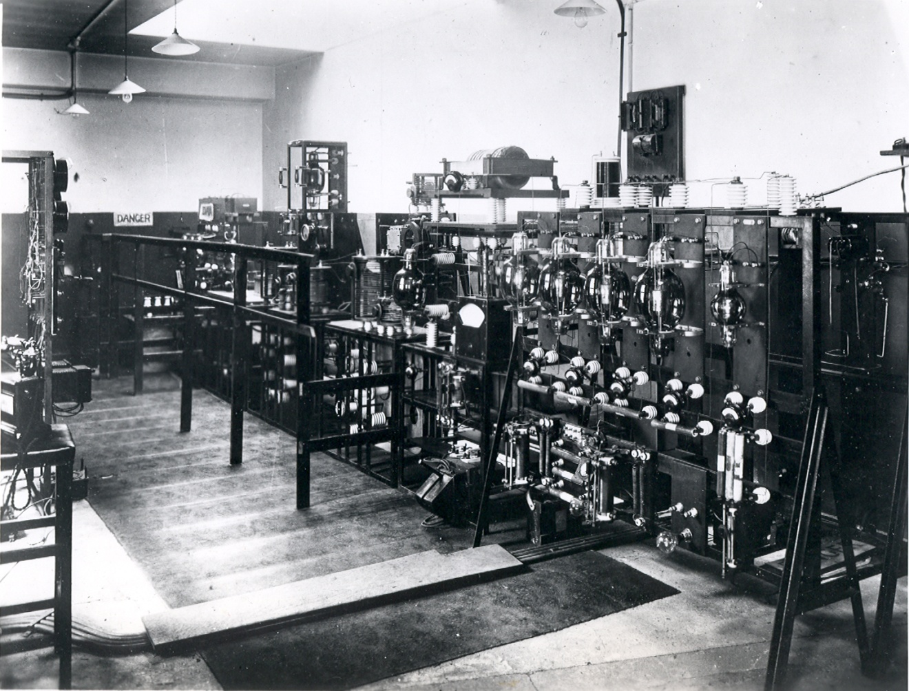
Figure 1: Picture of ‘2LO in Marconi House’ taken between 1923 and 1929, Science Museum archives.

Somehow, the man who uses the word ‘uncanny’ when talking about a transmitting station is right. It is from such a station as this, with its monotonous hum, its weird lights, and its highly scientific and unromantic atmosphere, that the sweet notes of the nightingale were caught up out of a Surrey garden in the middle of May and projected across stormy seas and wind swept mountains to a Swedish home, as well as thousands of homes in the crowded cities of this country. Through the medium of ten thousand such founts of energy in the early summer the voice of His Majesty and of the heir to the throne gave pleasure for the first time to millions of hearers. Who knows what is yet to follow?

The above quotation forms part of a rare passage that describes in detail the experience of seeing the 2LO transmitter during one of its broadcasts. Standing before this large piece of machinery in what, as the picture above shows, would have been a dimly lit, somewhat cramped room, Burrows turns to words such as ‘uncanny’ and ‘weird’. The room would have been warm, heated by the apparatus as it hummed with electricity, and in the darkness, the ‘weird lights’ or valves would have lit the space with a dim, eerie glow. Despite this somewhat ghostly description of the transmitter room, the transmitter itself is still viewed with an ‘unromantic atmosphere’ and does not escape from the modernist imagery of being an instrument of science. In the presence of this hulking, functional, heap of materiality Burrows nevertheless lets his mind drift to the purpose of the transmitter, sending out music and voices to distant and romantic locations.
Burrow’s description comes directly out of London in the 1920s, when modernism was at its height, and the arts and sciences blended to form a gleaming vision of the future. In this period some of the first silent movies were seen, with few capturing the imagery and anxieties of the time better than Metropolis, a dystopian epic which envisions a society dominated by technology. Looking at the photograph of 2LO in Marconi House, Figure 1, there are striking similarities between the actual and imagined technologies. The 1920s saw science leave the elite establishments of the nineteenth century and be transformed into utilitarian, everyday technology. Yet this was not a straight forward transition: these technologies were at times mistrusted, and more often misunderstood.
Therefore, at the heart of Burrows’ description of the transmitting station, lies a fascination bordering on disbelief with the dualist nature of radio technology. How is it that something can be at once static and immovable, while at the same time touching the lives of countless individuals? Looking at 2LO’s relatively brief working life between 1922 and 1929, this chapter seeks to consider this working object as a heterogeneous assemblage of material and immaterial elements and how these came together to form a single coherent radio personality.
The qualities of 2LO’s various manifestations during its working life present the greatest challenge in this chapter as well as differentiate it from all those that follow. Between 1922 and 1925 2LO was not a historical artefact and for most of this period was rarely seen by the majority of people who experienced it. As a technology 2LO therefore presents a particular theoretical challenge, or as Ron Eglash states, ‘the artefacts that transform matter and energy hold a special place as troubling objects of social inquiry.’ As the introduction has already explored, John Law’s Airplane Stories sees technology objects as both physically and socially constructed. Of most relevance to 2LO’s working life is that all the different qualities of the aeroplane are perceived as being equally important to an object’s overall identity. Through this approach to a technological object we are able to at once separate and unite its function with its material presence.
2LO has been physically altered on many occasions throughout its relatively short career and this chapter considers ways to reconcile this with a homogenous identity. It is an object which only a privileged few ever saw, but which existed for a wider public, through the radio programmes it was designed to transmit. It is this disparity between the two experiences of 2LO that Arthur Burrow’s tries to capture in the quotation at the beginning of this chapter. In adopting Law’s methodology, and Burrows’ identification of the qualities that make up ‘2LO’, this chapter will investigate the way in which radio (and to some degree all communications technology) can be understood by theoretically pulling it apart and reassembling it. In order to examine these qualities this chapter has been divided into three different sections:
- The first examines 2LO as a physical object, 2LO the radio transmitter, a technology formed of materials and interacted with on a fully sensory level. This section will consider who saw and worked with 2LO, and how its form changed during its working life until 1929.
- The second section will consider 2LO as a radio station, focusing on the development of its public personality and how this became closely entangled with that of the BBC. It will also consider how widely this personality permeated into public consciousness. And who, in fact, was listening to it.
- The final section attempts to tie together the themes of the first two sections by considering some of the philosophical implications of radio, highlighted by Peters in his book, Speaking into the Air.
How did listeners reconcile the two different aspects (the physical and the ethereal) apparitions of 2LO? Did its popular identity change with its physical state? And when the call signal, 2LO, was finally taken off the air how was this complex identity reconciled with the artefact that remained. While 2LO, the object and the icon, are at the centre of this chapter it will also provide new perspectives on well studied areas such as the BBC, inter-war Britain and the impact of the technological wonder of the time: wireless telephony or, as it is better known today, radio.

- 2LO: The Physical Object
It [2LO] was installed at a time when the art of broadcasting was in its infancy and, realising that rapid strides would be made as a result of the research work which was being carried out in the laboratories as well as the experience gained in the working of the station, the Marconi Company wisely decided to install apparatus which could be quickly modified and corrected as experience should dictate. Gradually the station was brought to a very high degree of efficiency and perfection in its performance although its outward appearance, as would be expected, suffered in proportion to the magnitude of the changes made.

The aforementioned comes from a press statement released when the 2LO of Marconi House was retired from active service in 1925. From this, it is clear that 2LO was never designed to be a static object; it was constantly shifting and evolving to keep pace with the rapidly changing field of wireless. It was not a one off piece of miracle technology perfectly suited to the job it was designed to do. It was adaptable; easily adjustable in the face of new experience and new requirements; and subject to the introduction of increasingly sophisticated technological design. However, as a press statement by the Marconi Company it was intended to provide some positive publicity for the company. In this case, adding intention to the work of the engineers when the actual circumstances were much more haphazard. This statement, which in its entirety acts as a celebration and historicisation of the transmitter, is unrepresentative of the company’s feelings. For what the 2LO transmitter is most notable for, particularly in its early years, is its absence.

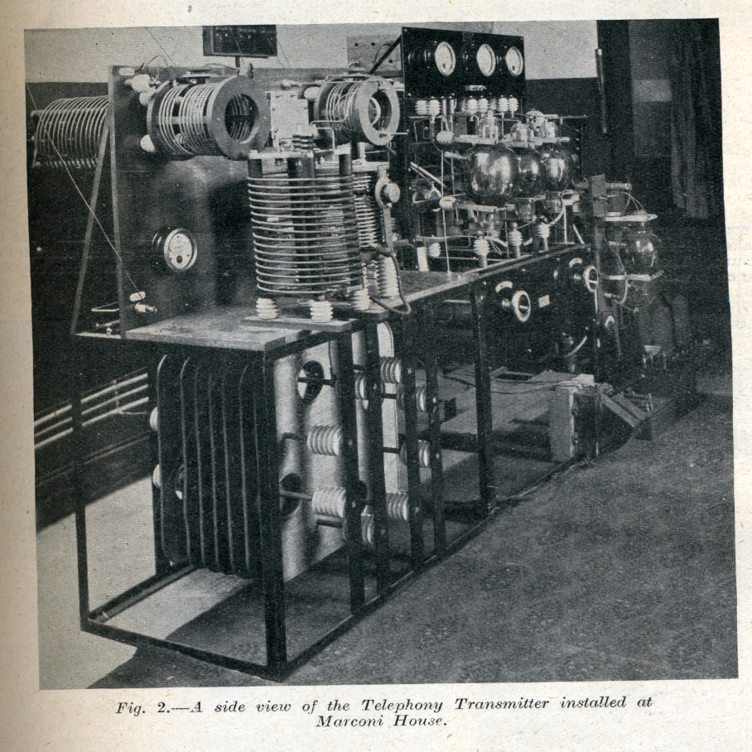
Figure 2: Image from ‘Some notes on Telephony Transmissions’ 27/05/1922, Wireless World and Radio Review.

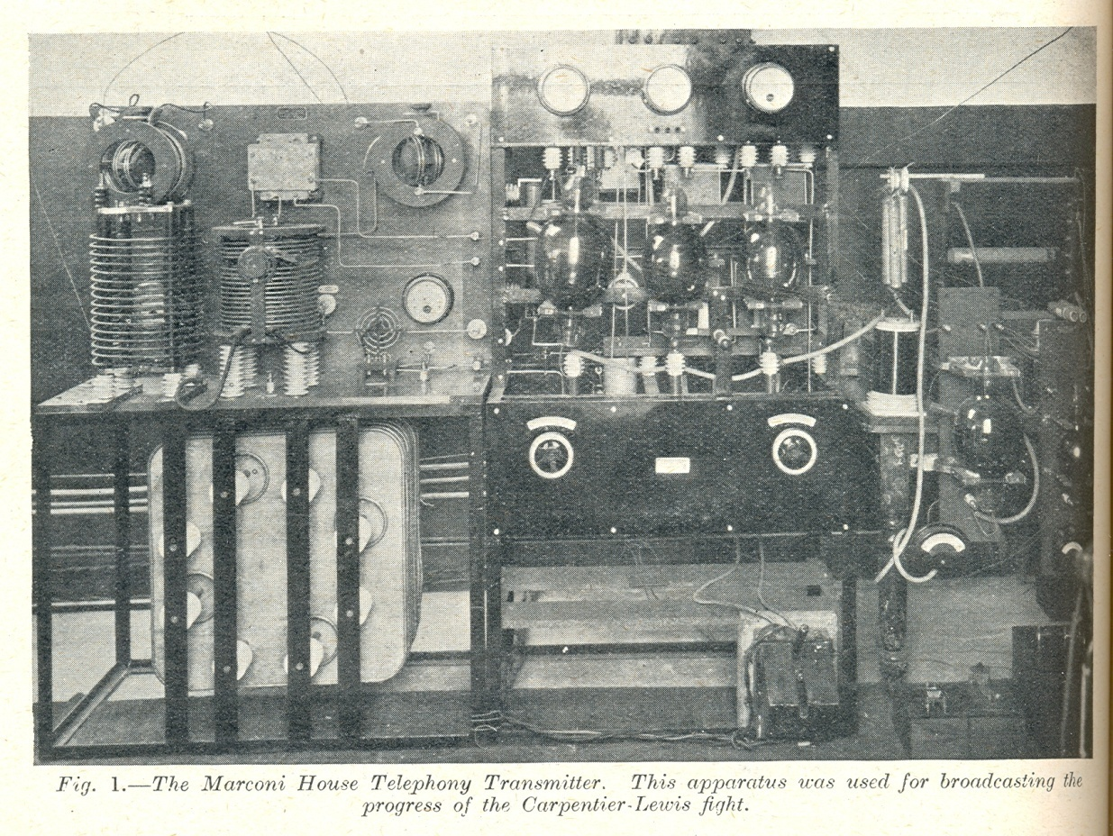
Figure 3: Image from ‘Some notes on Telephony Transmissions,’ 27/05/1922, Wireless World and Radio Review.
A large piece of broadcasting apparatus called the 2LO transmitter was first installed in Marconi House in January 1922. A few months later in May the transmitter was photographed at Marconi House and appeared in an article for Wireless World. The article that accompanies this photograph is full of enthusiasm for the potential of broadcasting, referring in particular to the recent broadcast of the Carpentier-Lewis fight arranged in partnership with the Daily Mail, and was the first live sporting event ever broadcast. The first panel is made up of aerial tuning inductances, fixed condensers and an aerial ammeter. The second panel is made up of an oscillating valve, a control, and a sub-control valve. While finally the third panel holds a transformer and eliminating valves. A description of the same model contextualised, in terms of technical development, appears a couple of years later in Dowsett’s Wireless Telephony and Broadcasting of which more will be said later.
Compared with the later press photograph taken of 2LO in Marconi House after 1923, (and like the object held in the Science Museum today) there are many similarities. In the later model the transmitter has been made more powerful mainly by increasing the number of valves at different stages along the overall circuit. The individual components appear to be more complex in the later photograph and altogether show a much more advanced technology. Though these are obviously two very different transmitters, all the components featured in this earlier picture can be traced onto the apparatus and circuit diagram of the later one, showing a continuous, evolving relationship between the two models.
Eglash states that there is a consensus among the traditional school of social analysts of technology which states that:
...technological change brings social change and social influence is primarily a ‘bias’ or ‘contamination’ of what would otherwise be governed by universal technical concerns.

In the case of 2LO, however, more significant is the impact that social changes had on its physical manifestation. The alterations to the transmitter’s form did not happen independently of its surroundings, and the social and political circumstances it was immersed in, can be mapped onto the physical frame. Later, in chapter three, this will be applied to the history of the object, but for now this section will consider the circumstances that brought about such rapid changes to this working technology.
It was not a single event which had such a transformative effect but rather a succession of gradual changes. First it became apparent that the public had an appetite for broadcasting evidenced by the hundreds of letters received at Marconi House. In view of this, the Post Office began to consider an official approach to broadcasting, and the Marconi Company the future possibilities for its station. Hennessey believes that, before the transmitter pictured in Figures 2 and 3, an even earlier 2LO was used by the Marconi Company. The reason being that before the Post Office took a firm interest in broadcasting the signal strength was limited to only 1.5 kilowatts. A fact evidenced by Arthur Burrows, who later recalls installing 2LO, describing it as ‘a 100-watt set contained in a small teak cabinet, and installed in the cinema theatre on the top floor of Marconi House, London.’ Figures 2 and 3 corroborate Hennessey’s claim as it is difficult to imagine this apparatus fitting in ‘a small teak cabinet.’
The real transformation of 2LO from amateur device to cutting edge technology, however, occurred over the summer of 1922. These were significant times for broadcasting in Britain; the Post Office now under pressure from both amateur radio enthusiasts and radio manufacturers had to accept that broadcasting was not a short term phenomenon. On the 23rd May 1922 a committee made up of representatives from the six biggest companies in wireless communication was set up to discuss the future of broadcasting. These companies were the Marconi Wireless and Telegraph Company, Metropolitan-Vickers, the Radio Communication Company, British Thomson-Houston, General Electric and Western Electric. These debates went on for months. The dialogue, alliances, and major setbacks have been well documented, most notably, in Asa Briggs’ comprehensive The History of Broadcasting in the United Kingdom.
Of all the debates there is one in particular that is relevant to the transformation of 2LO: the much disputed issue of who would build the London station. The Marconi Company, from the beginning, felt that it had the best claim but this was opposed for months by the other representatives of the larger manufacturers. The committee reached such an impasse that for a time it was proposed that there should be two British broadcasting companies: one headed by Marconi’s and the other by a collaboration of three other companies. This suggestion caused only further delays to proceedings and it was with a despairing tone that the chairman said ‘the main source of the difficulty is the construction of the stations. I believe if that were settled the rest would follow.’ Had this model gone ahead British broadcasting would have taken a completely different shape and 2LO may not have had the significance it does today. These problems were eventually overcome and it was decided that Marconi’s existing London station, 2LO, should be used to launch the infant British Broadcasting Company. In order to do this a newer, more powerful radio transmitter was required.
With the decision to transform 2LO into the BBC’s London station, one of Marconi’s top engineers, Henry James Round, was asked to produce an up to date version of the transmitter. Captain H. J. Round was born in Kingswinsford, Staffordshire in 1881 and joined the Marconi Company at the age of twenty-one. He spent his early career in the United States where he worked at the American Marconi Company’s training school for wireless operators in Babylon, Long Island. During his time in America he worked on numerous projects, including the first arc radio phones, which he showed to Marconi himself on his return to the UK and to whom he then became a personal assistant. During the First World War he joined Military Intelligence, where he was given the job of ‘building a network of valve direction-finding stations to cover the entire Western Front.’ These were built just prior to the war with a second set designed during it enabling the British to detect a seven mile change of direction by the German fleet during the battle of Jutland. Round received the Military Cross for his efforts. After the war Round returned to his work for the Marconi Company where he continued to make several significant contributions to wireless science.
While the early pictures of 2LO depict a fairly basic transmitter in what is obviously a temporary space (the pattern of the carpet in the theatre where it was installed is still visible) in Figures 2 and 3 the transmitter that was redesigned and built over the summer of 1922 marks a definite step forward in technology. Attributing 2LO’s refit to Round is not without its controversy. There is, for instance, no record of his work in the Marconi archives. In his account of pre-BBC history, Tim Wander describes 2LO ‘getting an immediate facelift’ by Captain H. J. Round, but again it remains unclear as to how he came to this conclusion. The most direct evidence of Round’s involvement with 2LO is a document from the BBC which states that he ‘designed the 2LO transmitter and studio and was responsible for many important experiments and improvements in those early days.’ This document was written as a retrospective account of the early days of the BBC and therefore remains problematic, with no indication of when it was written. There is a risk, therefore, that this account is based on the same hearsay that every other historian has relied on. Despite the lack of evidence it is clear that only Round or someone equally qualified would have been entrusted with the important task of building the BBC’s first radio transmitter.

Figure 4: Enlarged section of 2LO at Brookman’s Park, 1935.
How the November 1922 radio transmitter would have looked is also shrouded in mystery. The photograph in Figure 1 is referred to as being an image of 2LO in 1922 at the time of the BBC’s launch. However a closer study of the image proves that this was not the case. On the left hand side of the image, standing on a bench, is a telephone on which the words ‘Savoy Hill’ can be made out on the label. The telephone appears again in a later image of 2LO in Brookman’s Park in 1935, on which the label can be read more clearly. The Savoy Hill studio did not open until the 1st of May 1923 with the programmes, up until this date, all being produced in Marconi House. This immediately dates this photograph from the spring of 1923 at the earliest as before this the engineers in charge of the transmitter would have had no need to contact Savoy Hill as the BBC had yet to take up residence.
The incorrect date of the photograph raises the question: if the image was not taken in 1922, when was it taken? The obvious use for this publicity shot would have been to appear alongside articles referring to the transmitter, but this was not the case. The earliest record of the image in print recovered appears in a Wireless World article from the 17th of September 1930. This article, entitled ‘A Contrast in Transmitters,’ describes 2LO’s exhibition at the Radio Show in 1930 and the image used to contrast the old transmitter with an image of the latest model at Brookman’s Park. This indicates that the image was not taken until just before its removal from Marconi House in 1929. That the protective bars in front of the transmitter have been removed from approximately half way along also suggests that this could have been taken during a transition period. Until a dated copy appears, the photograph remains ambiguous, with the absence of any photographs of 2LO from May 1922 until September 1930 revelatory of the public visibility of this technology.
The presumptions made about the visibility of 2LO were as unfounded as those made about the date of the photograph in Figure 1. The impression given, particularly by press statements in the Marconi collection which described 2LO as being ‘a place of pilgrimage,’ was that the transmitter was regularly viewed by members of the public. Articles, such as that found in Amateur Wireless describing a visit to 2LO by a representative of that magazine, substantiated this opinion. However, as the number of journals which described visiting 2LO the station but made no mention of seeing the actual transmitter accumulated, it became apparent that 2LO was not the technological spectacle it was originally thought to be.
An article by R. H. White entitled the ‘The London Station of the British Broadcasting Company,’ again from Wireless World confirmed this and raised suspicions about how the Marconi Company actually viewed its pioneering transmitter. The article, written by Marconi House’s former Chief Engineer, provides a detailed technical description of what it claims to be ‘the type of transmitting apparatus employed at the London Broadcasting Station.’ However it is soon apparent that the technical description given does not match the Science Museum’s version of the transmitter. For instance the apparatus in White’s article is described as having four panels while modern 2LO has five panels. More tellingly, a picture of a transmitter described as being used in the London Station is included with the article: not only is this definitely not the same object as the genuine 2LO but actually appears to be a much later specimen of a transmitter.
In H. M. Dowsett’s comprehensive technical account of broadcasting the same image found in White’s account, pictured in Figure 5, is used to illustrate the ‘latest type of Broadcast Transmitter,’ which, given that this volume was published in 1923, would have made it contemporaneous with 2LO. In a later volume of the same series, the original picture of 2LO from May 1922 (Figure 2) is included and described as being ‘later replaced by the one illustrated in Vol. I’, but once again the famous photograph in Figure 1 is notably absent.

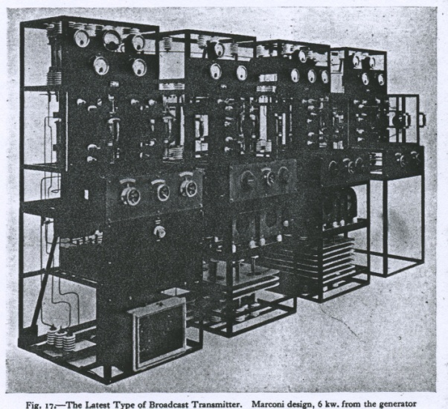
Figure 5: Images from, H.M Dowsett's, Wireless Telephony and Broadcasting, 1923

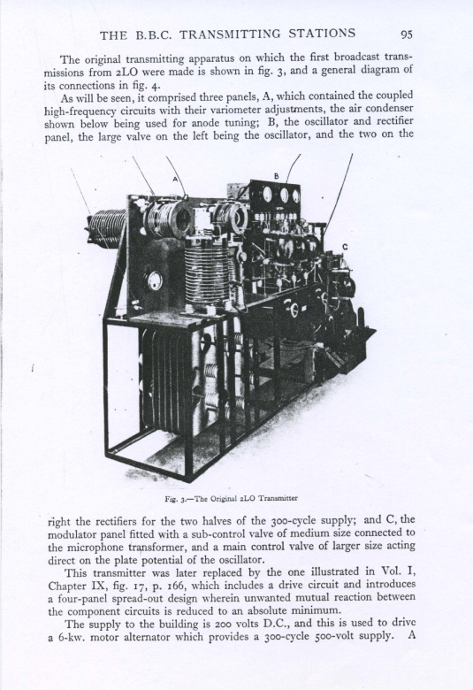
Figure 6: Images from, H.M Dowsett's, Wireless Telephony and Broadcasting, 1923

Why the transmitter was kept so firmly out of the public eye has never been quite clear but it is likely that the actual 2LO was an embarrassment to the Marconi Company. Contemporary accounts of the early years of the BBC describe an organisation where, as Cecil Lewis the Deputy Director of Programmes says, ‘Pandemonium reigned!’ One of the most unpredictable elements of broadcasting was always the technology. For instance Arthur Burrows recalls how an engineer who, despite reading scripts and scores for the programmes in an effort to prevent damage to the equipment, was caught off guard by an unexpected gunshot during a performance of Robert E. Lee. This released so much energy that it overwhelmed the choke-coil at the station and caused it to burst into flames.
Burrows’ story was not an isolated incident: the engineers at Marconi House were constantly altering and rebuilding the transmitting equipment in response to these frequent emergencies. Neither was this an entirely negative process: advances were being made in transmitting technology all the time and these were constantly being applied and tested at the BBC. For this reason 2LO did not have the sleek orderliness of design that the transmitter pictured in Dowsett and Wireless World (Figure 5) possesses. The Marconi Company’s press statement describes it best: ‘gradually the station was brought to a very high degree of efficiency and perfection in its performance although its outward appearance, as would be expected, suffered in proportion to the magnitude of the changes made.’ While in 1930, when the station was shut down, this innovation was something to be celebrated; in 1922 in the competitive radio manufacturing industry, it would not have been a good advertisement for Marconi’s Wireless Electric Company.
So who did see the working 2LO transmitter, and what impression did it have on them? It is likely that only BBC staff would have been able to visit the transmitter. In the early days when the difference between roles was more fluid and the organisation less formal BBC staff would have been able to access the transmitter with relative ease. Despite this there is little mention in contemporary accounts of the appearance of the transmitter, focussing instead on the making of programmes. Even P. P. Eckersley’s account of the early years, as the BBC’s first Chief Engineer, dwells more on his development of a national broadcasting system than on the transmitter in London. However, given Eckersley’s character and engineering background, it is likely that he was too busy imagining the possibilities for the future to commemorate the past.
It would have taken a non-expert, someone not so focussed on the details of the machine, to fully appreciate the magical qualities of the apparatus before them. This is what Arthur Burrows, the BBC’s first Director of Programmes provides in his book The Story of Broadcasting. He describes the transmitter as follows:
There is something uncanny about a broadcasting transmitting station when it is in operation. Firstly the big valves emit a light which differs from that to which one is usually accustomed. This light is not exactly phosphorescent in character although it reminds one of the light of a glow-worm on a gigantic scale. There is also a steady hum from the transformers used to lift the electrical voltage as it arrives from the power station to that required for broadcasting purposes
But the glow of the lamps, which are in many cases as big as Rugby footballs, and the hum of the transformers are not the only influences which make the visitor conscious of the unusual. He feels that despite the absence of an outward and visible sign of great activity, he is present at the fountain head of a mystical power. This is confirmed by the many weird effects which can be demonstrated by the engineers if they have the leisure for the purpose.

For Burrows, seeing a transmitter such as this played on the senses and with the imagination, the hum and glow of the components was an essential part of the experience of the machine. This account was written a mere two years after the launch of the BBC but even so, radio was already being accepted as a mainstream domestic device. Despite this increasing ordinariness Burrows attributes supernatural powers to this hidden device behind the programmes. The final line where he refers to ‘the fountain head of a mystical power’ is particularly illuminating. In this he alludes to the form that 2LO takes, beyond the immovable, physical transmitter in Marconi House. 2LO is the focal point from which springs a mysterious power which touches countless lives around the country. Even for someone such as Arthur Burrows, who works daily in the presence of such forces, this aspect, the concept that makes everything he does possible, remained a mystery.
The final, and most decisive change that 2LO underwent during its working life occurred on the 17th of March 1925 when the original transmitter was replaced with a new higher powered transmitter installed in the roof of Selfridges on Oxford Street, London. To the average listener nothing changed: programmes were still produced in the Savoy Hill studios and the station was still referred to as 2LO. On the engineering side, though, everything was different. The decision to build a new 2LO was made early on as the Marconi House transmitter was only ever an experimental model. As a document in the BBC archives observes ‘Its [2LO] use by the BBC was only intended to be temporary, until they had built one of their own.’ A point confirmed by Harold Bishop, one of the original Savoy Hill team: ‘We decided in 1923 that we wanted something rather bigger and better than the transmitter…this mash up transmitter in Marconi House.’
At the same time the Air Ministry at Kingsway had begun to object to the existing location of the transmitter at Marconi House. Public broadcasting had been seen as frivolous by the authorities, and conflict with the more important military communications services: ‘broadcasting was a prostitution of the noble art of radio.’ Given the rapid expansion of the BBC and their close proximity to the air ministry a new station more capable of meeting the BBC’s demands was needed. The only problem was the location, as a transmitter this powerful had very specific requirements. These are set out in a BBC document:
The new transmitter was required to be within 1 ½ miles of the Savoy Hill studio, for Post Office line reasons, and over a mile from the Air Ministry at Kingsway and the Admiralty at Whitehall. It must be on the roof of a high building that was strong enough to stand the strain of two 100 feet aerial masts, and should be on fairly high ground.

A site on Wardour Street was considered for a time but, when the firm that owned the building insisted that fire sprinklers be installed throughout the building, the cost rendered the site unworkable. The roof of Selfridges on Oxford Street was finally decided on as a suitable location, though this had its own challenges. During a discussion in the House of Commons, the Postmaster General was asked:
....whether the removal has been designed to advertise the firm owning the store in question; what is the value of the presence of the transmitting station; and whether the sum so paid will be wholly transferred to the revenue of the Broadcasting Company.

In response the Postmaster General was keen to reassure the Commons that Selfridges had been chosen for its technical merits and not for generating advertising revenue. The contract also stressed that Selfridges could not use the presence of the transmitter for any kind promotion. How effective this restriction was is debateable, as the twin masts of the new transmitter towered over the building and were easily visible from Oxford Street, one of the busiest shopping streets in Britain.
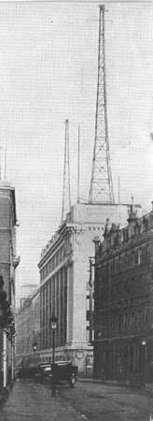
Figure 7: The new 2LO, view from the back of Selfridges. ‘A Farewell Glimpse of the Present London Station.’
The announcement that there was to be a new 2LO transmitter was received with excitement by the enthusiasts’ magazines from February 1925 when testing of the new station was due to begin. The most notable aspect of the new station, as far as these writers were concerned, was that its power would be three kilowatts: twice as much as the old 2LO. This would mean that BBC programmes would be accessible to more people than ever before, though there was concern that other stations would be more difficult to receive. These complaints, however, were in the minority and with the news being generally well received by listeners. A survey conducted by Wireless World indicated a particularly high level of enthusiasm from those living on coastal regions, as the new station would overcome the problem of jamming from ships’ radios. Characteristically these magazines also explore in great detail the technical qualities of the station: the height of the aerial; the design of the high tension electricity supply; and that the transmitter was connected to earth through the skeletal structure of the building. Also, unlike the Marconi House 2LO, pictures of the Selfridges version often appeared in magazines.

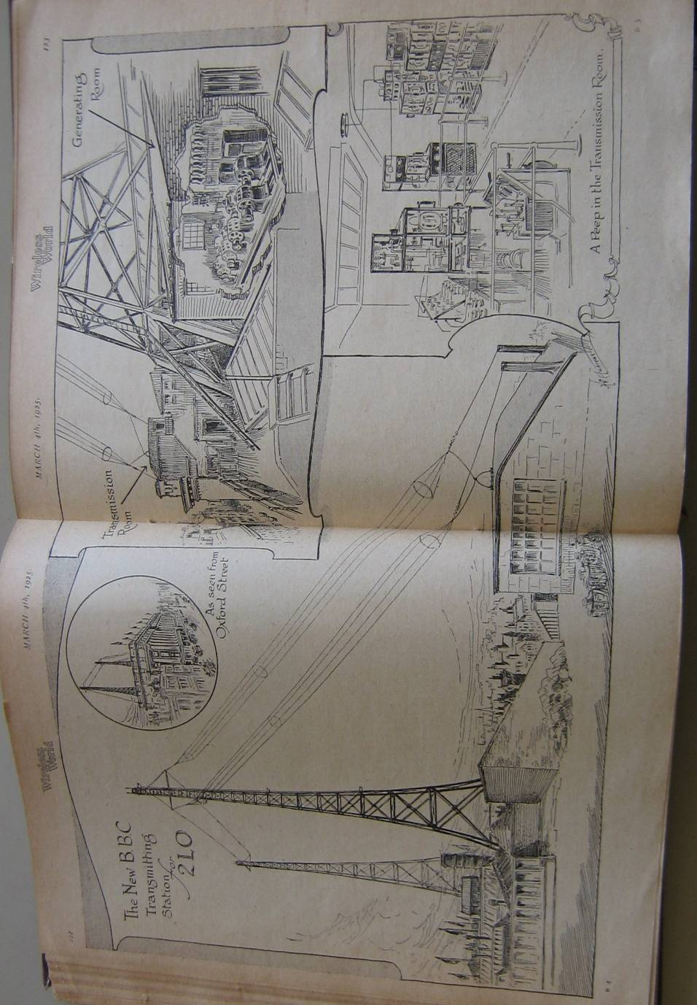
Figure 8 Drawing of the planned, new 2LO Station, Wireless World and Radio Review, 04/03/1925.

The opening of the new 2LO station marked the beginning of the end for the old transmitter. While it did remain in Marconi House for another four years it no longer broadcast directly to the public. Instead it was used for experiments that furthered the BBC’s knowledge of radio and particularly the implications of simultaneous broadcasting. However, as the next section will show, the cultural associations of the name 2LO were transferred to the new station. This also marked the beginning of a process by which the Marconi transmitter’s meaning was condensed into the object, and a sense of identity associated with the past, rather than the future of broadcasting, began to assert itself. The next section will explore 2LO’s other form: the programmes that it transmitted; who was listening to them and what their reaction was. This will explore public personality that 2LO possessed during the 1920s. In doing this it will further consider how to constitute an identity for an object that has suffered so many physical changes. Do the changes described in this chapter, really impact on the overall meaning of 2LO or is its presence in the popular imagination more responsible for generating its lasting identity.

2. 2LO and its On-air Personality
As section one has demonstrated, 2LO underwent a series of transformations throughout its working life. However the general public would have been largely unaware of this, as it was a hidden technology. Despite this, as will be seen, the name ‘2LO’ was well known and strongly associated with the experience of broadcasting and the personality of the BBC. This section will consider 2LO as a radio station, by investigating who was listening and what they were listening to.
Unfortunately it is nearly impossible to fully recreate what listening to a transmission from 2LO would have sounded like as the absence of a sound archive from this period means there are few recordings in existence. There is one recording of a broadcast of 2LO made at the end of its working life in 1924. This was a live broadcast of the opening of the British Empire Exhibition by King George IV with accompanying trumpets and audience applause. The recording can be confirmed as a genuine live broadcast as there is no record in the King’s diary that he travelled to any studios in connection with the speech. Besides this the cheering of the crowd and the reverberation of his voice all confirms that the speech was made outside and to a live audience.
The recording itself is not good quality, with the voice of the King often crackly and indistinguishable, against a general background hiss. The British Library catalogue entry attributes the recording to EMI, and if this is assumed to be the case, than it would have been recorded from a radio receiver and not directly hooked up to microphones. However, despite its authenticity and how much it sounds like 2LO, this will never truly capture the experience of listening. Radio in those early days had an excitement and immediacy which can never truly be recorded much as the experience of live music can never truly be captured. As Theodore Gracyck says on the subject of music and recordings, ‘my position is that however a recording of a traditional work comes about, no matter how the sounds are manipulated or generated in the production stage, the sounds heard during normal playback offer either a reproduction or representation of its performance.’
However, Gracyck talks about the experience as being connected with the space and the visual experience of the performance, while radio remains an aural one based on the mediating technology. 2LO listeners would have experienced its broadcasts in the comfort of their own homes and this was the most revolutionary aspect of the technology. Arthur Burrows, in the opening quote of this chapter, talks of how ‘the sweet notes of the nightingale were caught up out of a Surrey garden in the middle of May and projected across stormy seas and wind swept mountains to a Swedish home.’ The distance between the source of the broadcasts and the radio in the living room (or as was the case in the early days, the shed or the attic) proved a great challenge, as well as a source of excitement, for audiences. During its short life the kind of audiences that 2LO attracted changed dramatically and for each of them the ‘listening in’ (as it was termed at the time) experience meant radically different things. Based on the photographs and letters received by enthusiasts’ magazines, these early listeners were mainly white, male and middle to upper class, with the means to afford the paraphernalia necessary for early broadcasting. However, with the introduction of the BBC, the programmes began to be aimed at a more general audience. Radio receivers became less a science experiment and more a piece of furniture. The shift in the kinds of audiences mirrored the rapid expansion of the BBC and a change in the public identity of 2LO.
For the early wireless listener, both telegraphic and telephonic, the experience of listening was isolated, yet thrilling. Though fiction, one of the best descriptions of the experience of early a wireless enthusiast is to be found in Tom McCarthy’s recent novel C. In this, the novel’s protagonist, Serge, tunes in nightly to the airwaves in the years before the First World War, listening in to boats, lighthouses, press bulletins and other amateur signals. In this passage, on removing himself from the airwaves, he is struck by the material presence of the sound and the interconnectedness of the environment:
...He slips the headphone off, opens the silence cabin’s door to let some air in and hears a goods train passing half a mile away. The pulsing of its carriage-joins above the steel rails carries to him cleanly. He looks down at his desk: the half worn pencil, the light’s edge across the paper sheet, the tuning box, the tapper. These things-here, solid, tangible- are somehow made more present by the tinny sound still spilling from the headphones lying beside them. The sound’s present too, material: Serge sees it ripple snaking through the sky, pleats in its fabric, join pulsing as they make their way down corridors of air and moisture, rock and metal, oak, pine and bamboo...

The escapist nature of this hobby is evident in this example and is close to the real experience: headphones on, ear strained for any sound from the ether, operators could easily feel they had left day-to-day life far behind. The anonymity that the radio provided was empowering to these individuals. It allowed them the space within which to interact, as well as a common, highly technical language with which to communicate.
The intimate one-to-one relationship that developed with this technology, and the network into which it fed, can be compared with those formed by individuals today who become involved in online computer games or ‘chat rooms.’ Research being conducted into these modern ‘virtual’ spaces is perhaps limiting itself by concentrating on the computer age when much of the phenomena they are recording has already been experienced by these early wireless pioneers. In an article investigating ‘ham’ radio enthusiasts from the mid- twentieth century America, Kristen Haring describes many of the same experiences, in a collection of people who fit a similar gender, socio-economic and ethnic profile. Haring uses the example of the radio ham to investigate male identity during this period, and how it relates to the home.
The enthusiasts of the 1920s were, like their 1950s counterparts: almost without exception young men, and usually of the middle or upper classes as this allowed them the financial freedom to afford the equipment that allowed them to indulge in their hobby. Most of these men had discovered wireless through their experiences in the First World War, when its importance to the war effort as a communication tool between individuals, ships and later on aeroplanes, came to the fore. P. P. Eckersley describes in his autobiography that it was only by chance that he was placed in a wireless communications unit but that it was there that he really discovered his love for the science. His experience can be considered typical of many wireless enthusiasts. In a later interview another BBC employee, Rex Haworth, describes his first experience of radio:
Like so many who wanted to work in radio I was a wireless operator at sea. Early in 1923 the ship was coming home after a six month voyage when we ran into a fog off Ashent. As I was writing the bearings on a clean bit of paper to send to the bridge, I accidently brushed against the tuning knob of the receiver and was astounded to hear music… so after radio watch, four of us sat there with single ear pieces, dismantled head phones glued to our ears. And I’m rather fond of music myself and I thought if we can transmit operas like that and it can all be very much improved and I thought some kind of loud speaker would become freely available well... then I began to feel rather more convinced about the BBC as a viable concern in the future.

Though Howarth’s story occurred some years after Eckersley’s it shows the same enthusiasm for the possibilities of radio and its captivating qualities. With the end of the war these young men brought their passion home with them, some, like Eckersley found employment with one of the leading radio manufacturers, while others settled into their everyday lives, and contented themselves with building radio receivers and transmitters in their living rooms. These were Britain’s first radio audience, listening in to any communication flying around on the airwaves: naval, press, or simply chatting to other enthusiasts. Most exciting were the occasional experimental broadcasts which manufacturers such as Marconi’s Wireless Electric Company were allowed to transmit. It is generally acknowledged that amateur wireless groups, such as the Radio Society of Great Britain, played a key part in convincing the authorities to establish the BBC. However, with the emergence of 2LO, the amateur was to find that his place in British broadcasting was to become increasingly marginalised.
Most hobbies at this time had a publication to accompany it. They informed hobbyists about wider developments of their particular passion, and created a sense of community. The wireless enthusiast community had dozens: Experimental Wireless 1923-1931, Institute of Wireless Technology Journal 1926-1929, Modern Wireless 1923-1925, Yearbook of Wireless Telegraphy and Telephony 1913-1925, and Radio Review 1919-1922 to name but a few. However Wireless World remains one of the most important, partly because it was founded by the Marconi Company, but also because it remained one of the few journals still running after the Second World War. The tagline for Wireless World described the magazine as ‘An illustrated monthly magazine for all those interested in Wireless Telegraphy and Telephony.’
Wireless World articles were heavy on technical detail and often included circuit diagrams to illustrate its points. However it did attempt to portray the human side of the industry: it had a keen awareness of radio’s near past and often included the real life stories of those working with wireless in a professional capacity. Wireless World also took care to reflect the war time roots that many of its readers could identify with by including, for example, a number of stories on wireless in aircraft in the 1919 issue. These articles and more particularly the letters sent to the magazine reflect a particular type of interest being expressed by their readers. For these readers, radio’s fascination lay in the construction of the receiver/transmitter: developing new circuits and trying new components in order to get better and better signals. They loved the thrill of: hearing another operator playing music or speaking; discovering how far away they were; and the quality of their transmissions. When 2LO began broadcasting these periodicals were also full of helpful tips from these individuals to the station manager. For example, on one occasion, the following suggestion was made by the Hon. Secretary of the Wireless and Experimental Association:
(1)Would it be possible, when 2LO is closing down for one minute or more to switch off the carrier wave (2) Would the Company consider the broadcasting of a suggestion to the licensed amateurs that they should refrain from transmitting during the ‘close-down’ half hour? (3) Could the call-sign of the station always be used before and after each item? (4) Would necessary Sunday testing be kept down to a minimum?

One of the best ways to understand these early radio listeners is through the case of Britain’s first regular broadcasting service, 2MT. Like 2LO it was established as an experimental station by the Marconi Company. It broadcast for half an hour on Tuesday evenings from a hut in the English countryside near a village called Writtle. The station was a relaxed affair, and was headed up by the talented and charismatic P.P. Eckersley who later told lively accounts of these early days. The most thorough account of the Writtle station, told in a style sympathetic to the time, is Tim Wander’s book, 2MT Writtle: The Birth of British Broadcasting.
The broadcasts were always very low budget. At most the company paid for a performer to travel up from London but usually the show relied on the imagination and ingenuity of the Writtle engineers. The whole programme was performed under the station’s call signal 2MT, or as it was more affectionately referred to through the phonetic alphabet as, ‘Two Emma Tock.’ The 2MT broadcasts were a favourite among the audience of amateur enthusiasts as the stacks of postcards they received each week paid testament. Listeners enjoyed when Eckersley made up nursery rhymes based around the technical challenges of broadcasting:
Four and twenty B valves standing on a shelf,
Ash couldn’t find one so I had to go myself.
When the circuit opened the phones began to sing,
Don’t you think I was right to smash the beastly thing?

In this rhyme the name ‘Ash’ refers to Noel Ashbridge, who is noteworthy not only for his later involvement with the BBC, but also the pivotal role he played in 2LO’s journey. The Writtle engineers’ sense of humour is largely to be credited for the station’s popularity as it was speaking directly to the personal experience of the audience. The engineers in Writtle were all young men, and reflected the majority of their audience. The technology created the same problems for them as for their listeners and their solutions just as creative. Also, like their listeners, these young engineers shared a firm belief in the great potential of wireless though, as would be proved some years later, nationalising broadcasting meant that for many an essential part of the experience was lost.
In contrast 2LO presented a more staid, professional listening experience. In its early days the station only provided programmes through individual request in exchange for a fee. In a letter from July 1922, Arthur Burrows states, ‘may I make it clear at the outset that broadcasting in the correct sense of the term has not yet commenced and that such transmissions as are taking place from London at the moment are to definite addresses under special license from the Postmaster General.’ However each broadcast was well publicised in newspapers such as the Daily Mail so that those within range could listen-in to the broadcasts. During this early period, however, its signal never reached much further than the Home Counties.

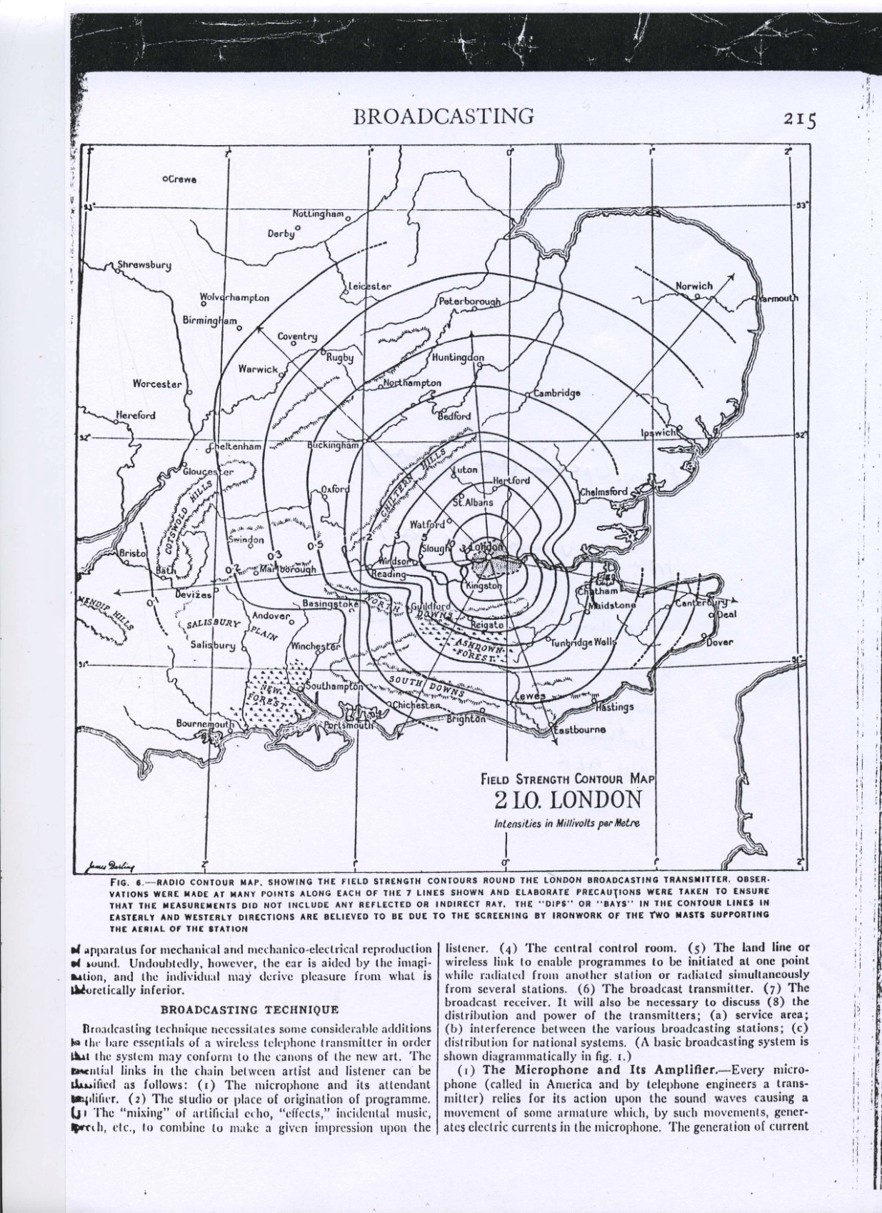
Figure 9 Map from Rod Viveash personal collection, the source is unreferenced beyond being an encyclopaedia entry, however when compared with other sources this can be seen as an accurate representation of the 2LO’s range.

While few of the broadcasts would have interested the enthusiasts, being mostly gramophone music and the occasional live set, there were some notable exceptions. Chief among these was the Carpentier-Lewis fight already mentioned. Another was a speech by the Prince of Wales on October 7th 1922 to the Boy Scouts of Great Britain arguably the biggest celebrity appearance on British radio at the time. Though in terms of 2LO’s listenership, the best example is the broadcast of the ‘Round Britain Air Race,’ coverage of which was transmitted over three days. It is not the content of the broadcast that makes this coverage so significant but rather who was listening. Arthur Burrows received a letter from one enthusiastic female listener, ‘Dear Sir- You will be pleased to hear how much I have enjoyed your news of the air race. I have enjoyed equally the three-minute intervals, which have given me time to reach the kitchen and baste the joint for dinner.’ This letter shows that 2LO was beginning to reach an audience outside the traditional wireless community and that radio had the potential appeal to a more general British audience. This example is prescient of the domestic, family companion that radio was soon to be, and a contrast to the lone listener, earphones on, pioneering the airwaves.
The life of the early wireless user has been romanticised but the hobby was actually an isolating one. Haring describes, not only the passion of 1950s radio hams and the on-air communities they developed, but also the feelings of alienation from even their own families that came from spending time alone with the ether. Jeffrey Sconce attributes these feelings more specifically to the qualities of the technology:

Wireless thus presented a paradox: alone at their crystal sets and radios, listeners felt an electronic kinship with an invisible, scattered audience, and yet they were also acutely aware of the incredible distances involved in this form of communication that ultimately reaffirmed the individual listener’s anonymity and isolation.

However, the days when ‘wireless contact was of more interest than wireless content’ were short lived. The talks conducted by the British Broadcasting Committee were mirrored by a noticeable shift in the stories featured in Wireless World. These were catering for new radio users: endless advice was given on everything from how to build your own crystal set, to how to get the best reception. With a decision finally reached by the British Broadcasting Committee, and a newly revamped 2LO in Marconi House, radio went mainstream and with this the listenership changed dramatically.
In a Marconi Press statement marking the opening of the Selfridges transmitter, 2LO is referred to as being ‘the mother of the British Broadcasting Company.’ While some of this is clearly hyperbole on the part of the Marconi Company it nevertheless represents the genuinely close relationship that existed between the names BBC and 2LO. For new listeners the qualities of one quickly became associated with the other, and the language and experience often became interchangeable:
I was seven years old when I sat on the running board of my uncle’s Wolseley, in its garage, and heard from 2LO, through a single earpiece, voices, music, and the footsteps of Uncle Rex (the Director of Programmes) coming down a passage. My mother and aunt were more impressed than I was, for when I had heard my grandmother on the telephone, I had been able to reply to her. I did not understand that thousands of other people could hear these things at the same time. It was 1922 or perhaps 1923.

In this passage, Uncle Rex (the term uncles and aunts when referring to BBC presenters came from the Children’s Hour programmes) is heard from 2LO. Having a technology with such an immediate identity, in the form of its call-sign, meant that 2LO easily became associated with the character of the programmes it was transmitting, particularly to a public becoming less interested in the practicalities of wireless. This reminiscence again demonstrates the transition from solo, male listener to a more diverse audience. The relationship between the BBC and its new listeners presented new challenges and further facilitated the development of 2LO’s identity.
During the 2LO years of the BBC one of the clearest indicators of the British public’s enthusiasm for wireless was the annual Radio Shows that were held at increasingly large venues throughout the 1920s and into the 1930s. These shows were an opportunity for radio manufacturers to show off technology and a chance to engage the interest of the general public directly. Often these shows would offer visitors the opportunity to buy components from manufacturers in order to finish off their home built set for bargain prices. From 1923 the BBC also had a stall at this event and used it as a PR opportunity. The BBC’s stalls were mainly made up of: the latest broadcasting equipment; behind the scenes tours of transmitting stations; and, as the decade progressed, models inside and out of the new Broadcasting House. However 1923 was not 2LO’s first Radio Show. It had been used to broadcast to the show the previous year much to the delight and wonder of those who attended. The sheer number of people who attended the 1922 show surprised everyone, with visitors queuing to get through the doors as can be seen in Figure 9. Many of those waiting patiently outside had no previous experience of radio as one account shows:
Luckily the band struck up a lively tune and we found pleasurable distraction in successfully persuading the Innocent that he was listening to 2LO. But when he saw the blue coats of the operators in the balcony he swung to the opposite pole of incredulity; so that, when at three o’clock the real concert began we could not convince him that the gentleman who ‘featured’ Pagliacci was not concealed in the depths of the loudspeaker.

Figure 10 ‘Jammed- An Impression of the Exhibition by H. R. Taunton,’ Wireless World and Radio Review Vol. IX, 21/10/1922, 92.
This event occurred in October 1922 when the details of the new broadcasting company were already well known, and so those new to broadcasting, such as Taunton’s ‘Innocent,’ associate the almost unbelievable reality of radio with both the name 2LO and the idea of the BBC.
Before the development of mass advertising these shows were the public face of the BBC and offered a physical point of contact with that most ephemeral of public services. However, the trade fair was not the only way in which BBC technology was brought to the public’s attention. Despite an initially rocky relationship with the print media, who had expressed fears that the immediacy of radio news would render their medium redundant, the BBC’s latest achievements were reported with increasing regularity in most of the national newspapers.
Rather than concentrating on celebrity personalities as is common today, newspapers reported enthusiastically about the technological achievements of the BBC. This ranged from opera broadcasts direct from Covent Garden, to transmitting the voices of animals at the zoo to recording the English countryside. These were the ‘events’ or as Asa Briggs describes them, ‘gimmicks,’ that people were most interested in. While easy to dismiss the importance of these ‘gimmicks’ when assessing the cultural impact of the BBC, for many years these were a mainstay of early programming. They made a simple statement about what both the BBC, and radio in general, could achieve with the latest technology.
The BBC offered increased accessibility and legitimacy to a medium that, as has been described, had been the preserve of technically able enthusiasts. Hundreds of letters were received everyday at Savoy Hill. The topics of these letters included anything from requests for technical advice on reception, to queries about licences, and even love letters for the announcers. These letters were all dutifully answered by BBC staff, either personally, over the airwaves, or in the BBC’s publication The Radio Times. Eckersley was well known for engaging directly with listeners on the more technical issues, through enthusiasts’ magazines or speaking at radio clubs. Some members of the public even called directly into the office. Burrows describes how one gentleman ‘of position’ walked in one day and asked if he could pay them to send a message to Mars in ‘the orthodox Martian language.’ The BBC was unfortunately unable to oblige as the man in question required that the wave-length be raised to 35,000 metres.
The novelty and experimental nature of the technology, as well as the close relationship they maintained with the public, helped to establish an early identity for the BBC. As part of this, the company was historicised remarkably early on. Employees were looking wistfully back when the company had only just begun to move forward. Books by leading figures such as Arthur Burrows and C. A. Lewis were released in 1924, barely two years after broadcasting had first begun. Incorporated into this rapidly developing nostalgia, was the presence of the 2LO transmitter which embodied all that was loved about the early days of broadcasting: the innovation, the excitement and the fun.
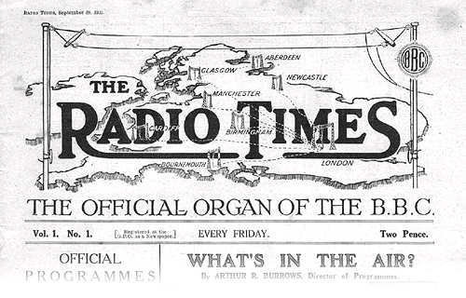
Figure 11 Mast head of Radio Times.
The significant physical changes that 2LO underwent when it became part of the BBC have already been described but as a radio station its public identity also changed dramatically. It was no longer just a London transmitter, it was the British Broadcasting Company’s London transmitter, and the only one that provided programmes (though by relay through 5XX at Daventry) that were received by most of the country. Figure 11 shows the front cover of the first Radio Times but appeared on all subsequent issues in the first years of publication. The map shows London as the largest transmitter feeding all the other stations across the country. This depiction of 2LO is reminiscent of Arthur Burrows’ description of the physical transmitter as ‘the fountain head of a mystical power’ from which radio waves flow out across Britain. In the months that followed the historic first broadcast on the 14th of November 1922 the name 2LO became synonymous with the activities of the BBC and (between 1922 and 1924) the two names would have been interchangeable. Examples of this can be found throughout copies of the Radio Times, as well as many of the technical journals, in which 2LO is casually referred to in a number of different kinds of articles. One such reference occurs in a story entitled ‘A Message to the Pope’ in which:
On this occasion we [The BBC] also hope to broadcast a special message from 2LO to the His Holiness the Pope. His Holiness is the possessor of a wireless set on which he regularly listens to British programmes.

In this example 2LO appears as the seat from which the BBC operates. It evokes an image of a physical centre in which the words of the BBC could be grounded. Again 2LO subscribes to the image of the ‘fountain,’ an immovable point from which sound and music flows to different parts of the world. From this powerful centre Arthur Burrows, the first announcer at the BBC, came to be known as the ‘voice of 2LO.’ This casual interchangeableness of terms even extended to the individual programme listings in which, even as late as 1929, the London station was being referred to as 2LO. The identity of the radio station had become so strong that it even developed a form of ownership. It was ‘2LO’s studio’ and ‘2LO’s Aerial’ and, when it was moved to Selfridges, the station had a ‘new home.’ In amongst these examples there is a curious intermingling of types of identity: is 2LO a place? A thing? A persona? A network? In Law’s work, an aeroplane can be an image, a diagram or a text and 2LO emerges as a similarly heterogeneous object.
The sheer newness of radio meant that the BBC’s identity closely related to the technology that produced the programmes rather than any on-air personalities or signature style. Though, as the article referring to the Pope’s broadcast shows, this did not detract from the high profile that the BBC was developing on the international stage. Operas from Covent Garden; plays from the West End; and speakers from the Royal Society: the programmes of 2LO were taken directly from the cultural life of London. When anyone tuned into the BBC national service they were tuning into the culture of the capital city. However this was not the BBC’s intention, as the opening of the regional stations, and the following statement shows:
Some people, however, have an erroneous idea that the object of the tests in which radiation occurs simultaneously from all broadcasting stations, is to have one central station from which a programme may be carried out, the remaining broadcasting stations radiating that same programme. This scheme would, of course, destroy local colour as a singer in London would hardly be as much appreciated in Lancashire as a Lancashire singer would be. Items however such as the opera from Covent Garden Theatre, and notable singers who sing from time to time from one of the broadcasting stations would be highly appreciated no matter where they might be.

The key phrase in this paragraph is that ‘notable singers’ from one of the stations ‘would be highly appreciated no matter where they might be’. However given the migration of talent to London, and BBC being based there, most of these nationally relevant programmes tended to originate in the capital. London of the 1920s was a booming city, both in terms of population and entertainment, unknowingly poised on the brink of economic and eventually global catastrophe in the form of the Wall Street Crash, and Second World War respectively. It is known as a wild and exciting decade. Fresh out of the horrors of the First World War it was determined to face forward and enthusiastically embrace everything new and progressive. The term modernism was born in this period to describe not only an artistic approach, but a general philosophy, reflecting a fascination with the new technology that was becoming a part of people’s everyday lives. Not all of these changes brought positive results, as Jeffrey Sconce observes ‘in a great paradox of modernity the very cities that led to larger public communities held the potential for increasing alienation.’ For Sconce the introduction of technologies like radio increased feelings of temporality and social isolation which, in turn, fed into the artistic frenzy that was modern London.
It is to be supposed that the BBC would reflect this burst of creativity in its programming, however, this was not the case. Briggs attributes this to a number of reasons. Firstly they faced a general resistance on the part of the agents and managers who acted as gate keepers to the stars. For similarly political reasons live broadcasts from theatres and music halls were equally difficult to arrange. Briggs attributes these problems with access to a lack of vision and an unwillingness to work with an organisation that was not owned by the entertainment industry.
The second reason for the BBC’s often conservative content and style was due to the influence of the overpowering personality of its first Director General, John Reith. His vision for the BBC as a public service shaped the new company: giving it a mandate to educate, inform and entertain. While entertainment floundered for many years, education was much more successfully produced. However, the result, with few of the speakers ever having practised presentation for radio, was very dull. These talks were widely derided in the press particularly as the decade progressed. In between these two strands of Reith’s BBC approach to programming was Children’s Hour, one of the BBC’s earliest and most widely listened to regular programmes. The Uncles and Aunts of these early days contributed much to the image of the BBC and the programme was regarded with great affection. Like many in this exciting modern world, the BBC was trying to find its place in society. Inevitably therefore some of these experiments were successful and some were not. Under Reith 2LO was beginning to find ways of bringing the life of the big city, and indeed the wider world, to the listener but in a voice that was appropriate for the home.
With broadcasting more popular every year 2LO had been adopted into the everyday language of thousands of people. It became a favourite with cartoonists wanting to explore the more light hearted side of radio. Unsurprisingly the Radio Times referred particularly frequently to the transmitter but 2LO also appears in non-BBC publications. The two examples included here are from the Daily Express and from the Radio Times illustrating its use in both the independent media and in the BBC’s ‘in-house’ publication.
The cartoon from the Daily Express (Figure 12) refers to the Locarno Treaties, signed in 1925, in which several European countries sought to secure post-war European territories. Briefly, this cartoon is suggesting that the French prime minster Aristide Briand is using the British foreign secretary as a puppet to speak to the British people. He is using the anonymity of radio and the well known format of Children’s Hour to facilitate his deceit. In the corner the name 2LO is used in a play on words to represent the Locarno Treaties which the pair were involved in negotiating the year before. More importantly, the cartoon demonstrates that 2LO had meaning beyond that of the Radio Times, and the institution of the BBC, even as early as 1926. The comic device relies on the reader not only having some knowledge of the Locarno treaties but also of the name and tone of 2LO broadcasts. In this case the illustrator is suggesting that the authoritative tone that was so integral to the BBC could in fact be used for deception.
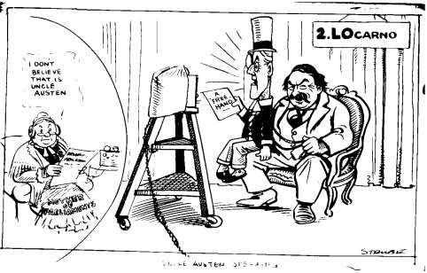
Figure 12 Sidney, ‘George’ Stube, ‘Uncle Austen Speaking,’ The Daily Express, 06/05/1926.
The second cartoon (Figure 13) illustrates a much simpler idea. The negative responses that the BBC lectures received have already been discussed and this cartoon shows two young women comparing their father’s tirade to the tone of these programmes. The punch line in this case is the well known line heard at the end of each BBC broadcast; ‘2LO now closing down!’ However it is the listeners that are notable in these cartoons. In one, an elderly lady is depicted sitting in her living room, and in the other, it is two young women who are expressing such a casually, authoritative knowledge of radio. Only a year before this ‘2LO’ would have been the preserve of a select group of young, white, technically-minded men: it was now being appropriated by women, old and young.
The transition of the radio into the domestic space of the home has been well documented. The extent to which it became an increasingly feminine technology has also been explored in work such as Richard Butsch’s analysis of American listeners in the 1920s. More contemporaneously, a BBC survey conducted by Winnifred Gill and Hilda Jennings explored the effect of broadcasting on British home life. A survey that Shaun Moores uses to investigate the shift that occurred in family dynamics and the home, in predominantly working class families, following the popularisation of radio in the UK. However this thesis focuses on the identity of 2LO, and these examples show that radio, and therefore the Savoy Hill programmes, had become embedded in the more general public consciousness.
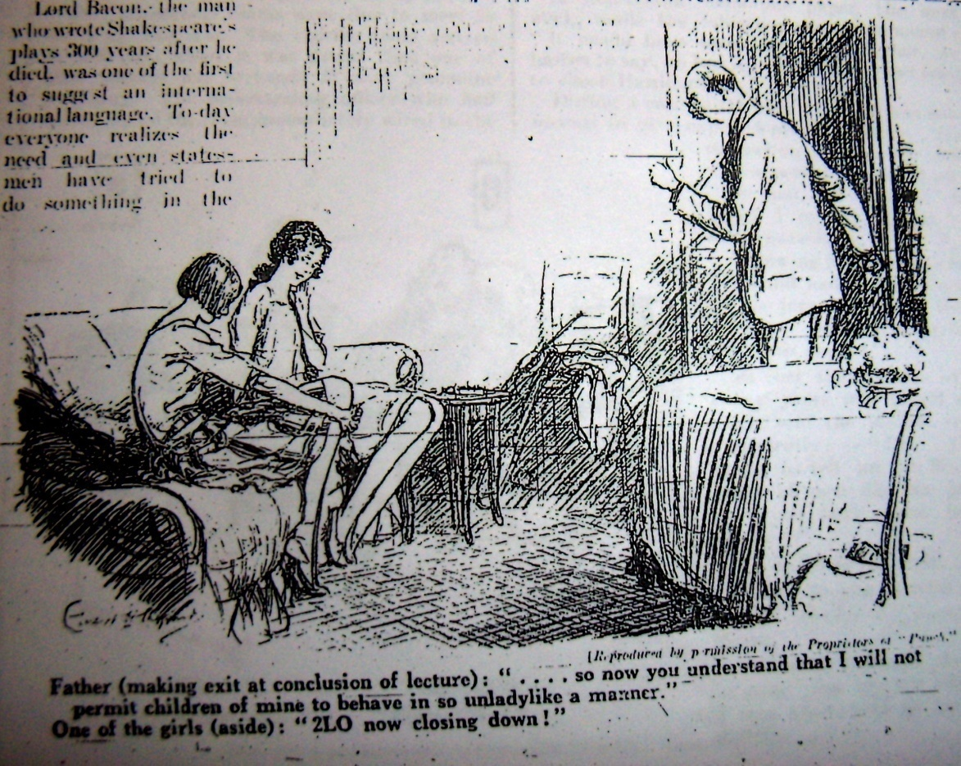
Figure 13 ‘2LO Now Closing Down,’ Radio Times, 16/08/1923, 253.
While both Figure 12 and Figure 13 use the name 2LO to make different points they both rely on their readers having a shared knowledge of the listening experience of radio. Without this background understanding the humour would be lost on the reader. The Evening Standard cartoon is the most significant when considered from this point of view. It can be assumed that the readers of the Radio Times have bought that publication because they already own a radio, and therefore have the experiences essential to understanding radio humour, in the same way that the Writtle engineers were entertained by Eckersley’s nursery rhymes. However, the Evening Standard is expecting the same awareness from its readers. This could only be possible if radio had reached a level of popularity beyond its original audience of enthusiasts. Critical to this study, however, is that ‘2LO’ was being used as the key representation of, not only the BBC, but also the personality of broadcasting in 1920s Britain. The 2LO transmitter was more than just a piece of equipment hidden away from the world. It was a key element of the public persona of the BBC and acted as a physical centre for the ethereal phenomenon that was radio.

3. Reconciling the Machine with the Voices in the Air
2LO’s qualities present it as a contradiction. It is an object, solid and material in the traditional sense, yet almost totally hidden from the world. However, it is also a complex, intangible apparition of sound which touches the lives of thousands of people. These are separate incarnations of one thing, which together have been called 2LO. This section seeks to reconcile these two radically different 2LOs and consider how, theoretically, they can be assembled to produce a coherent whole.
This is not just retrospectively applying modern anxieties about the definition of the material. Connecting disembodied sound to its source was also a topic of concern in the 1920s. This is also not necessarily an exercise in positing the material against the immaterial: the latter had a much more definable identity than the former in this period. As Anderson and Wylie say:
The question of materiality therefore far exceeds any invocation of ground or physicality. In our encounters with the material we should take care, as a matter of principle, not to assume that materiality has properties of shape consistency and obduracy that are assumed to define the state of a solid or the element of earth.

They urge us not to limit the material to a solid form but to engage with a whole range of substances through what is described as a ‘material imagination.’ This allows the purely aural form of 2LO to be considered in the same material light as the bulky collection of metals and glass that wake up the transmitter. This is an approach that runs contrary to many contemporary engagements with sound reproducing technology and particularly radio, which tend to draw firm lines between material and immaterial qualities. It was this distinction which so closely entangled radio with ghosts, haunting and telepathy. In the case of 2LO, any theory is further complicated by the event in 1929 when the transmitter was removed from Marconi House and its on-air presence effectively disappeared forever.
In a description of the telephone Wurtzler describes the paradoxical nature of all sound reproduction and distribution technology:
This quality of the telephone (and like it later acoustic devices) to be both simultaneously material yet immaterial, physically present as an artefact yet producing that which was physically absent, utilitarian yet wondrous, resided at the heart of both their appeal and some of the anxieties that acoustic technology provoked.

Each new technological advancement covered greater and greater distances, while at the same time, the human body became increasingly inconsequential. Peters talks of ‘Phantasms of the Living,’ replicas of us created by these technologies, with the ability to conquer time and space in a way that our fragile bodies cannot. The introduction of sound technologies, including the phonograph, telephone, and telegraph as well as the radio, meant that people were able to replicate, and physically detach themselves from, communication in a way that had never been possible before. Given these unnerving properties it is hardly surprising that the emergence of other forms of communication, such as psychic or telepathic, converged with the introduction of these technologies. In some cases, it is difficult to distinguish whether the technology inspired the spiritualists or the spiritualists built the technology.
Luckhurst describes such a sharp increase in interest in telepathy and spiritualism during the late nineteenth and early twentieth century that the scientific community began to take a serious interest in it. Many of the great pioneers in science had some spiritualist roots. Among the most famous examples of these was Oliver Lodge, ‘one of the most preeminent physicists in the Western world.’ He had achieved fame though his experiments with radio, and in 1897 patented a method of ‘syntonized telegraphy’ allowing the frequency of receiver and transmitter to be tuned. Lodge however believed that radio held the key to more than just earthly communication and it was only a matter of tuning into the right frequency. For Oliver Lodge, ‘ether was the medium which united every aspect of his research, from syntonic Leyden jars and telepathy to long wave detection, Hertzian signalling without wires, and the ectoplasmic protrusions of mediums.’ Though much of the ‘evidence’ accrued had been refuted by the 1920s the idea that science could be applied to communicate with those who had died was an enduring one. It is therefore in this context that the radio listening experience should be assessed.
Despite spiritualism having been undermined by scientific realism, there remained a definite unease around many of the qualities of radio. For some this encapsulated by the term uncanny. The word ‘uncanny’ is explored in Robert Spadoni’s investigation into early sound film, which describes how audiences found the figures on the screen more ghostly when given the added dimension of sound. Spadoni takes Freud’s essay on the ‘Uncanny’ as a way of considering the responses of these audiences and concentrating particularly on the sensation that animate or inanimate objects inspire when they appear to be working contrary to their nature. The uncanny is particularly prevalent when things appear to be either uncharacteristically dead or alive. There is much in Freud’s essay that is useful when considering early cinematic technology and can also be applied to the radio listening experience. Later in the essay Freud more concretely aligns the sensations of the uncanny with anything that can be associated with ghosts and the dead, and there are few things more ghostly than a disembodied voice.
Though never actually referring directly to Freud’s essay John Durham Peters touches upon similar issues when considering early wireless communication. He agrees with a further element of Freud’s definition: that an essential part of this ghostly quality was often based on the creation of doubles or in the case of sound, recordings that remain copies forever, even after the original has died. In both Peters and Spadoni’s work it is the overwhelming experience of disembodied sound that inspires the feeling of the uncanny. For Covert, however, radio is seen as possessing a quality of sound that was more disturbing than any previous sound reproduction technology:
Radio presented a new reality… the immediate experience of the remote person or event, an experience in company with millions of others, yet strangely separate. Here were ambiguities: the sense that one was participating, yet alone: in command, yet swept blindly along on a wave of sound.

2LO at the BBC, though responsible for transmitting such cheerily, bland programmes as Children’s Hour and John Reith’s educational speeches, was nevertheless not free from these kinds of associations. This chapter is headed with a quote from Arthur Burrows which contains one of the few descriptions of 2LO as a working machine. Notably the first sentence of that passage starts with the words ‘Somehow, the man who uses the word ‘uncanny’ when talking about a transmitting station is right.’ Again that word ‘uncanny’ and an emphasis on the unbelievable sense of multitudinous distances and individuals scattered about the world. 2LO also starred in its own ghost story. A. J. Alan was a well known personality on the radio throughout the 1920s, known for his mysterious, comic stories and his impeccable sense of timing. Like most who worked at the BBC, Alan also had considerable technical knowledge of radio. In a collection of these radio stories entitled Good Evening Everyone, one entitled ‘The voice’, has the narrator travelling to the house of a friend named Nugent, to investigate why 2LO’s broadcasts are continually interrupted by a mysterious singer. After a series of comic incidents the truth is revealed:
After dinner we listened to the London programme until half-past nine, and then we tuned out 2LO and waited for the real show of the evening to begin.
That sounds rather disparaging to 2LO, but it isn’t meant to be.
It was half an hour before anything happened and then she began, as clear as a bell. She went through the usual procedure-scales first; but when she began exercises I thought old Fratellini would have a fit. He gripped hold of the arms of the chair and stared at the loud speaker as though it were a ghost; He said, ‘That’s an old pupil of mine. I know her voice. Where is she?’ and all the rest of it. We said: ‘That’s just what we want to know,’ and calmed him down as best we could.
Then came a most extraordinary incident. If you remember, the singer always ended up with an aria from some opera. Well, she was half-way through when Mrs Nugent said: ‘Look at Elsie’ and we looked and it gave me quite a turn. She was sitting up in her chair going through all the movements of singing a song at the piano, only, of course, there was no piano. Her head was thrown slightly back and she was singing with the ease of a prima donna. But no sound actually came from her. Both the voice and the accompaniment were coming from the loud speaker on the other side of the room.

The mysterious singer is eventually revealed as the dead mother of Nugent’s adoptive daughter, communicating with her child from beyond the grave and encouraging her, through the medium of radio, to follow in her footsteps to become an opera singer. This ghost story follows the form of many others which connected spiritualist properties to the radio set. One of the best know of these is Kipling’s Wireless which is described as ‘paradigmatic of the haunted wireless stories to follow.’ ‘The voice’ has the same basic device as all these stories: once the dial is turned there was no telling who or what might be tuned into. However Burrows description does differ from traditional ghostly wireless stories such as Alan’s. Firstly it is not fiction, but more significantly it is written from the perspective of someone looking out from the centre rather than listening in. Burrows is the voice from the ether, the spirit in the home.
Thomas Burke, a novelist, in describing his experience of the London broadcasting station, who sums up best, the effect that combining the two contradictory qualities of 2LO can have:
I could not conceive these voices as the voices of mortals, or those strains of an earthy orchestra. They came to me as the music of the spheres, floating from nothing, through nothing: singers and musicians having their being somewhere east of the sun and west of the moon. There was something of Ariel about it. ‘Hertzian waves’ said my informant, but he might as well as have said ‘Spectres of the Brochen’. The more he explained, the more incomprehensible the thing became. The more I learned about it, the more I shivered and wondered.
And then, one day, I learned too much about it and the magic was materialised and shattered. The British Broadcasting Company invited me to visit Savoy Hill and see ‘2LO’ at work.
As Burke describes it, an essential part of the enjoyment of listening to the radio was the belief that these sounds came from some magical source, a belief that is shattered by the realities of the transmitting station. The unnerving effect of disembodied sound had long been acknowledged by those who produced it and ‘…telephone managers, phonograph marketers, and radio spokespeople, among others sought to reassure their customers by reconnecting the mechanically reproduced representations to the originating body.’ The description of a visit by a Scientific American reporter to a telephone exchange in 1887 highlights a similar experience. Having met the staff, and viewed the technology, the author says that the experience is ‘not so ghostly after all.’ Wurtzler summarises this as follows, ‘the demystification of technology (and technology providers) offered by behind-the-scenes accounts such as this, sought to contain the potential anxieties provoked by the disembodied voice.’ In visiting 2LO’s studio Burke’s is experiencing a similar exorcism by establishing a definite location for the BBC’s programmes: he is even turning the old spiritualist association on its head by titling the piece ‘A Séance in the London Studio.’
Burke’s account is not the only article that sought to connect the programmes being broadcast with the physical centre of radio. Numerous items appeared in both the Radio Times and World-Radio describing what went on behind the scenes at a radio station. The announcers and programme directors were soon familiar faces, appearing frequently in print, and even starring in a series of cigarette cards produced by the Sunripe Cigarette Company. Though actual images of the 2LO transmitter were tellingly absent at this time, it nevertheless featured in attempts to centre the allusive medium of radio. A picture from the Illustrated London News shows clearly connects the sound travelling from the singer, to the amplifier, to the transmitter and finally up, and out of the aerial. These latter stages are all clearly labelled in bold type, 2LO. The rest of the article explains each stage, and demonstrates in simple scientific terms, how the signal then reaches the home.
Figure 14 ‘How 2LO’s band items are broadcast,’ Popular Wireless, 6/10/1923, 703.

A better example can be found in a copy of Popular Wireless (Figure 14) which illustrates in the same style how music performances are produced. It juxtaposes the orchestra at the bottom of the image with an inset on one side of the transmitter and finally tops it off with a romantic picture of the London skyline with words ‘the music of the grenadiers dispersed in Hertzian waves’ floating in the clouds. Of the illustrated 2LO transmitters, it is the Popular Wireless image that is also the closest to reality, while the Illustrated London News shows a machine that is much closer in appearance to the version that the Marconi Company wanted to promote.
Another Popular Wireless illustration (Figure 16) the King being broadcast from the British Empire Exhibition is the subject of the only extant recording of a broadcast from 2LO. Unlike the previous article this was an outside broadcast conducted some distance from Savoy Hill and Marconi House. Nevertheless, it includes a diagram at the top of the page explaining how they are all linked up and how the speech is projected into the wider world. In this case the transmitting equipment (though not 2LO) has been put at the forefront of the image, appearing even larger than the stage on which the King and Queen are sitting.

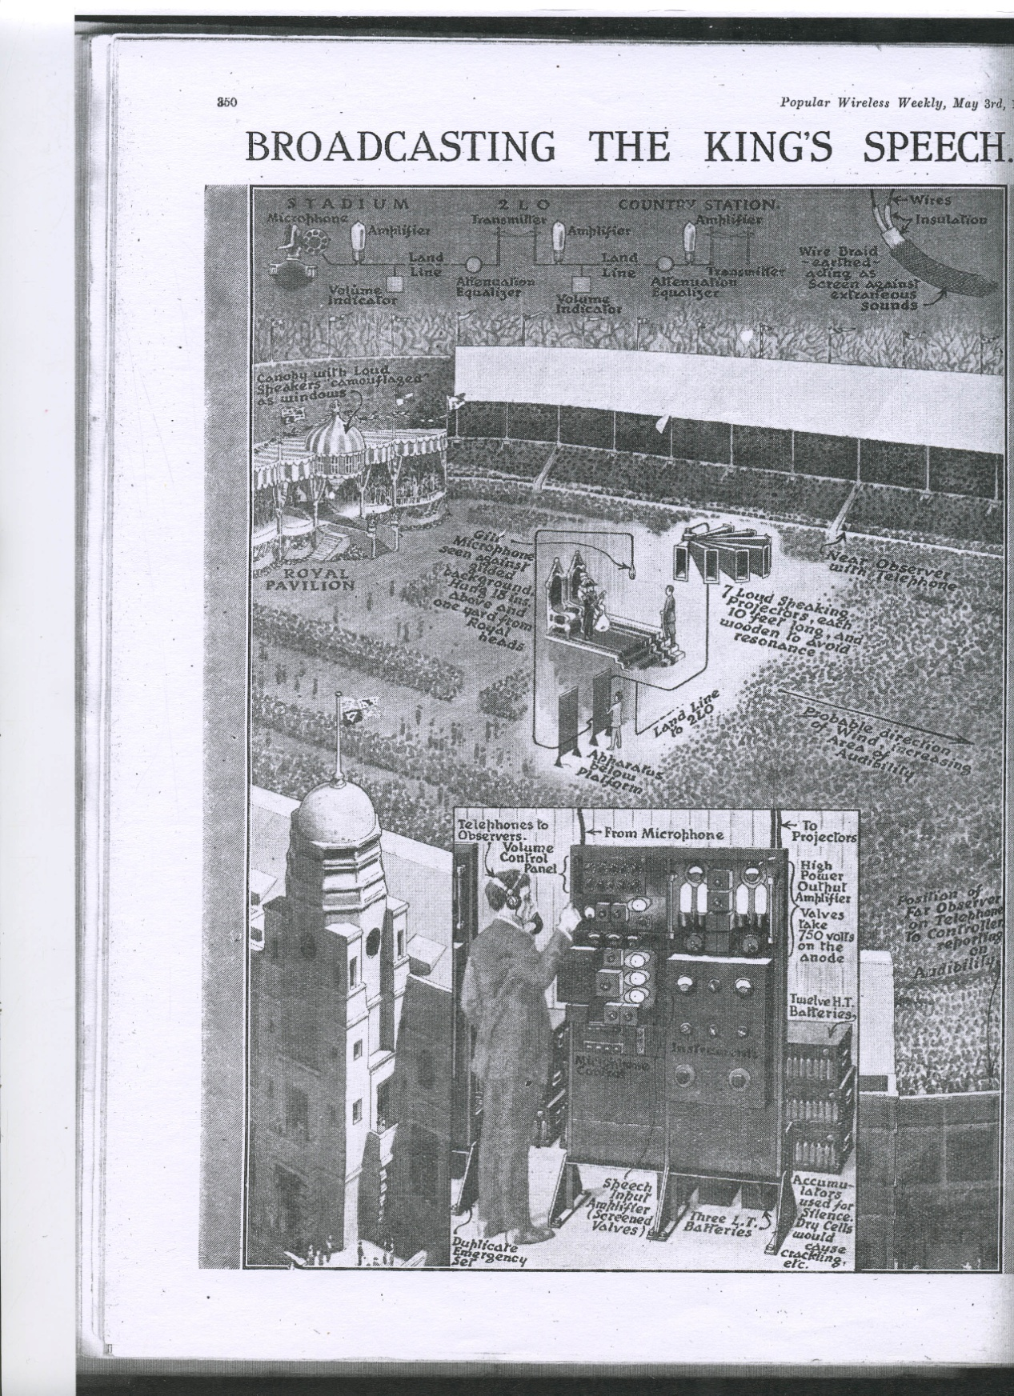
Figure 15 ‘Broadcasting the King’s Speech,’ Popular Wireless, 03/05/1924, 350.

It is difficult to establish whether the BBC was following any definite policy in so explicitly connecting its programmes to its centre, documentary records from the Savoy Hill era have either disappeared or been destroyed. Nevertheless the secondary evidence suggests that they did invest time in creating a geographical centre for themselves. This took solid form with the opening of Broadcasting House in 1932. By this stage radio was an accepted technology of the home; nevertheless the BBC still felt it necessary to co-operate in the production of a feature length, documentary film about the world behind the broadcast entitled BBC: The Voice of Britain.
The film cost a staggering £7000 (a large sum at the time) to produce, and presents a fragmented, impressionistic portrait of the BBC, which was not well received by many contemporary critics. While the film provides an unparalleled insight into the early history of the BBC and interwar entertainment, it is the way it presents the centre’s relationship with its audience that is significant here. The film makes frequent reference to unseen listeners, for example during a segment on Henry Hall, the Music Director, the narrator refers to how ‘countless people he can’t see dances to the rhythms he is preparing with his boys.’ One of the most effective scenes for conveying the connection that exists between performer, audience and equipment, is a sequence showing a performance of Beethoven’s 5th Symphony by the BBC Symphony Orchestra. During the piece, the shot changes from the orchestra in front of a microphone, to an aerial view over the city and then to various listeners at home. The music, playing throughout, ties the visuals firmly together. In this film the BBC creates for itself a physical centre that reflects the language that surrounded 2LO nearly ten years previously. However, this is not simply about creating a sense of place, performances such as this film are also about the self-historicisation of the BBC, a topic that will interrogated to a greater extent in chapter two.
While the listeners may have been able to negotiate their anxieties about receiving broadcasts performers equally found, both their disconnectedness from the audience, and the position of power that access to the microphone gave them deeply unsettling. An example of this is found in the BBC: The Voice of Britain where girls performing tap dancing for the radio are shown to be dressed in full costumes, despite the fact that no one can see them, in order to ‘get the atmosphere,’ though equally this could have been for the benefit of the cameras. Thomas Burke too expresses similar concerns about his own broadcast as he describes approaching the microphone:
In the middle of the room is a small pedestal. On the pedestal, in a bed of wadding, rests a small cylinder. That cylinder is ‘2LO’, and when connection is made, every whisper in that room, every cough, every sneeze, is heard in all parts of England. A terrifying thought! Sitting there I was conscious of the existence behind the cylinder of the impalpable audience; an audience of thousands, sitting in kitchens, in drawing rooms, in bedrooms, in slum cottages, and in elegant villas; and all en rapport with that room.

While the audience can potentially learn to link the aural with the material, and thus overcome any anxiety, the performer is left with a terrifying sense of his own small presence in amongst this sea of humanity. Sconce notes this same anxiety amongst earlier radio enthusiasts and describes the feeling of being ‘a small boat tossed about on the waves of this etheric ocean.’ For Burke connecting 2LO the intangible radio station with the technology of production has led to the twin evils of disillusionment and diminishment of self. At the end of this 2LO remains a list of contradictions: omnipresent yet contained, material yet intangible, ageless yet changing, soulless technology and fireside friend.

Conclusion
As this chapter has demonstrated 2LO, in the years between 1922 and 1929, was far from a simple object. Physically it was in a state of constant flux; continuously altered to respond to scientific progress and social change. Yet little, if any, of these major upheavals were seen by more than a privileged few: remaining hidden from public view as the shameful secret of the Marconi Company. Despite this the name ‘2LO’ became a household word, and was endowed with the BBC’s contemporary radio personality. This on-air personality was also undergoing rapid changes to its style and content. After only three years in Marconi House, 2LO ceased to be the main broadcast transmitter for the BBC, being replaced by a higher-powered version, sequestered in the roof of Selfridges on Oxford Street. It is doubtful whether anyone beyond the enthusiasts’ groups was even aware of the dramatic transformations taking place as the programmes remained largely unaffected.
This thesis questions the idea of how objects are defined. Traditionally an object is something that can be seen, felt and interacted with. Undoubtedly, there was a version of 2LO that possessed all these qualities, but it was not this 2LO that has made it such a meaningful object today. It is this contradiction that makes Law’s examination of aeroplanes so relevant to this chapter. As the introduction demonstrates, Law sees the images, plans and descriptions (as well as sound in this case) as being integral to the overall definition of the object. By de-centring the material version of 2LO, the transmitter, it becomes conceptually more flexible and better able to fit into later reimagining’s of it.
The period described in chapter one marks a crucial stage in 2LO’s journey. It was in the years 1922-1925 that 2LO was the BBC’s first transmitter and all its later meaning, including its eventual claim to be an ‘icon of broadcasting history,’ unravels from this temporal and spatial point. The fact that the materials from which the object is made participated in the 2LO ‘event’, described in this chapter, is crucial to the next stage of its journey. In 1929, with its removal to Brookmans Park, all of 2LO’s meaning (derived from its uniquely, ethereal relationship with the public) was condensed into a relatively small collection of components. While it is possible to see the results of this process as a re-centring of the material object, 2LO is seen through Law’s work with no temporal limits, the inter-war version of the transmitter continues to play equal parts in its later meaning. In chapter two, as 2LO’s transformation from technology to artefact is followed, and it continues to be historicised by various organisations and individuals, the link between the past and even further past versions of the object take on an even greater significance.

Chapter Two: An Uncertain path- 2LO as Relic, Junk and Display Piece from 1929 to 2002

C.E. said that on the abandonment of the transmitter he would prefer not to break it up and sell it at scrap value, but would rather keep it for its sentimental or historical value to technicians of the future, in view of the differences in design between that and later installations. It was left to him to retain the set if he desired and either store it or set it up where he might consider desirable.

This quotation is taken from the Control Board Meeting’s Minutes on the 22nd of October 1929. The C.E. in the first line is the Chief Engineer, Noel Ashbridge and the ‘Ash’ mentioned in Eckersley’s nursery rhymes from the Writtle days. The transmitter is 2LO. By suggesting this course of action, Ashbridge is revealing much about the value and meaning of the 2LO transmitter. Primarily, it is historic interest that he is preserving it for, however there are also more subtle concerns here. Ashbridge talks of its ‘sentimental’ value, suggesting that he has an emotional as well as an intellectual interest in the object. Ashbridge is demonstrating his own enthusiasm for the object as well as acknowledging a more general enthusiasm for old technologies of this type.
It is suggested that it could be displayed: ‘set it up where he might consider desirable.’ Finally this statement is also revelatory of the wider identity of the BBC and marks a point when the Corporation, a company no longer, paused to consider its own history, and how this would be presented to future generations. Through these themes, represented by Ashbridge’s statement, this chapter will consider the different relationships (and gazes) that defined the 2LO transmitter in the years following its decommission when it no longer performed the function for which it was designed.
When 2LO was removed from Marconi House in 1929, its future for a time was uncertain. It was only through the enthusiasm of the Chief Engineer that it was preserved. This proved to be a recurring theme throughout its long life: many times it was broken, restored, and almost thrown out. It was only through the timely intervention of a number of enthusiastic individuals that 2LO was able to find a home at the Science Museum in 2002. This chapter draws on the idea that material objects have their own lives and stories. In her book Biographical Objects Janet Hoskins, an ethnographer working with the Kodi people in Indonesia, says that ‘what I discovered, quite to my surprise, was that I could not collect the histories of objects and the life histories of persons separately.’ Hoskins discovered that the lives of the people, and the lives of the objects, were so closely intertwined that they were impossible to separate, forcing her to adjust her methodology to allow for this.
Hoskins’ book examines relationships with the everyday material objects that share our world. Others in this field include works such as Jane Bennett The Enchantment of Modern Life and Arjun Appadurai’s collected work The Social Life of Things. However, while these examples offer ways of understanding our personal relationships with objects, 2LO does not entirely fit into this literature as the majority of these works focus on the domestic, the everyday experience and personal possessions. As this chapter demonstrates, while many people have formed strong emotional attachments to 2LO through the years, it is not a domestic object and much as some might dream of possessing it, 2LO has never been owned by a single person.
Being owned by first the institution of the BBC and then the Science Museum (as well as some unexpected others in between) further complicates the way the object is viewed. In consequence one of the themes being explored is whether 2LO can better be understood through a network of relationships as in Actor Network Theory. This allows the link between the object’s corporate identity, and personal identity, to be acknowledged and deconstructed. The spaces in which this network occurs can be accidental, and not always perceived, but can also be deliberately constructed such as when 2LO has been displayed at trade fairs or other exhibitions.

Table 1 Showing the Dates of 2LO’s Locations and Appearances
Date | Location/ Appearance
1922-1929 | Installed in Marconi House, London
1930 | Brookman’s Park, location unknown
September 1930 | Radio Show, Empire Hall, Olympia, London
September 1930 | Brookman’s Park, Studio
September 1937 | Radio Show, Olympia, London
Post-1937 (date has not been confirmed) | Brookman’s Park, Shed near mast D
1953 | Brookman’s Park, Pavilion
1953/4 | Brookman’s Park, Returned to Studio
1960 | Displayed in Marconi House foyer
Mid-1960s | Brookman’s Park Machine Room (1929)
1970 | Displayed at Mullard House, Torrington Place for the Mullard Golden Jubilee
1972 | Brookman’s Park, Transmitter Hall (1929)
1972 | BBC documentary ‘Cough and you’ll deafen thousands’
1978 | Brookman’s Park, Brick Building near Mast B
1982 | Brookman’s Park, Machine Room (1929)
1990 | Appeared in television programme, The Secret Life of the Radio
1992 | Moved to Daventry transmitting station
1992 | Displayed in Broadcasting House, Radio Show Exhibition
November, 2002 | Given to Science Museum as part of the BBC 80th birthday celebrations, in Birmingham
November, 2002 | Smaller handover ceremony in G44 Blythe House, Science Museum
11th May 2004 | Displayed in BBC White City
24 November 2004 | New Location BBC White City
1st September 2005 | Returned to Blythe House, this time F30C
2010 | Appeared in, Seven Ages of Britain: Age of Ambition, BBC Television Production
2011 | Modulator Unit on display in Smith centre, Science Museum

As this chapter spans quite a range of history and a number of different locations a summary of them has been include in table 1. Given the timescale covered, and the complexity of the issues raised this chapter has been divided into the following three sections. The first section will consider 2LO in light of its institutional identities: firstly as a product and part of the BBC; secondly through the acquisition process by the Science Museum, who in the mission statement of its umbrella organisation the NMSI declares that ‘Our collections are world class...we have the key ingredients to be the best science and industry museum in the world.’ Both these corporations have strong public images and this first section seeks to understand how this image reflects on 2LO, and conversely, how possessing 2LO impacts of the institution’s public image. This section will also consider literatures surrounding corporate identities and how the past can be used as a means of self-definition, such as in Roland Marchand’s Creating the Corporate Soul.
The second section carries on from this and considers the way that this identity has been constructed in public exhibition and the narratives 2LO has been used to convey to the public. This section will also consider the technological aesthetic, and sensual attributes that 2LO possesses and which have made it a popular display piece, and occasional television star. It will consider this in the light of some of the public displays which 2LO has been involved in.
The final section considers 2LO through the personal relationships that have been formed with the transmitter, and the important part that it has played in lives of individuals who have encountered it, taking into account literatures surrounding cultures of enthusiasm. It is in this section that the literature surrounding object biographies is the most relevant. When corporate interest waned, it was only through the dedication of this small number of people that 2LO survived the seventy three, intervening years between the words of Noel Ashbridge and its public hand over to the Science Museum.

- Expressing Corporate Identity through Material Culture
Chapter one described how the 2LO station and transmitter became part of the identity network of the BBC in the 1920s. However with the end of its working life this relationship with the corporation became uncertain: in the first instance being recognised as a valuable artefact before, only a short time later, being discarded. 2LO’s significance was only acknowledged by the BBC again at the point when it was handed over to the Science Museum but behind the scenes, this handover, was the result of a tense negotiation over authority between two distinct owners.
The early days of the BBC, as chapter one showed, were characterised by their informality, innovation, and the relatively small number of people employed there. However, from the outset, John Reith recognised that this situation was unsustainable and with the establishment of the Crawford committee (whose job was to assess the BBC licence arrangements) John Reith submitted a 21 page document of suggestions for change. These pages included the key suggestion that the British Broadcasting Company should be dissolved and replaced by a new Corporation. The committee agreed and as Hennessey says:
It rejected the United States’ system of free and uncontrolled transmission and reception, deciding that Broadcasting must remain a monopoly controlled by a single authority- a public corporation set up to act as a trustee for the national interest in broadcasting and invested with full authority.

Following the dramatic events of the 1926 General Strike, in which the BBC proved its worth as an independent media organisation, the government was also convinced of the need for a change in its status. On the 1st January 1927, the British Broadcasting Corporation was constituted under Royal Charter, with Reith as Director General. This marked a new stage in the life of the BBC, and as Hennessey says above, it now had full ‘authority’ for the ‘national interest in broadcasting.’ What this section aims to explore is how the corporate identity of the BBC came to be articulated and how 2LO fitted, or at times failed to fit, into this developing corporate image.
A corporation under British law is defined as being ‘a succession of persons or body of persons authorized by law to act as one person and having rights and liabilities distinct from the individuals forming the corporation.’ Having the status of a person, it also takes on an identity as such, having a public image, private thoughts and a personal history. Corporations can be formed in many ways; the BBC was formed through a Royal Charter which lends it an additional status, as this is usually reserved for universities and professional institutions.
That corporations require a public image is not a modern phenomenon. In late nineteenth-century America a number of high profile mergers led to the idea of big business being questioned by both the public and the corporations themselves. The feeling that a corporation wanted, to be not only, viewed as legitimate, but loved by the public was a common one. On entering the first half of the twentieth century, developing this image became increasingly part of main stream practice. In his book, Creating the Corporate Soul, Roland Marchand describes how a form of public story telling became increasingly dominant in the process of corporate image making:

This fable of the efficient and the benevolent giant, ever attentive to the welfare of the tiniest entity, was simply one of a myriad stories that pervaded corporate publicity during the first half of twentieth century. Other fables recounted the corporations’ discovery of its grand mission amid humble surroundings, of its founders tiny shop or described the salutary working milieu within which it had nurtured the skill and loyalty of its workers.

While the corporations that Marchand describes are, on the whole, American and purely money making institutions, there is much in this quote that can be applied to the BBC. The idea of a ‘benevolent giant’ fits well with the BBC’s sense of providing a service which benefitted the public as is articulated by their mission statement ‘To enrich people's lives with programmes and services that inform, educate and entertain.’ That the service being provided benefits the public, therefore justifying the money they receive from the government and from licence holders, is still with the corporation today and at every level of the BBC, is seen as central to its public image. The corporation’s mission statement dates back to John Reith’s time as Managing Director and links with another important point in Marchand’s quote. The ‘founders tiny shop’ or the history of the corporation accumulates, legitimises and strengthens the corporation’s claim to a fixed identity. It is this dimension of Marchand’s work which is particularly applicable to the 2LO transmitter.
The BBC showed an awareness of its own history from early on. In November 1923 they celebrated their first birthday with a special programme. This included speeches by both Guglielmo Marconi and John Reith who reflected on the history of wireless and the huge contribution that the BBC had made. Separate from the broadcasts, BBC staff members were also adding their own accounts to the collective history of the institution. In one account Arthur Burrows recounts a famous voyage across the Atlantic where the press were able to maintain a connection with England for most of the journey by wireless. These examples demonstrate that a connection was being formed between the longer history of radio, the achievements of the Marconi Company, and those of the BBC. In these early days, the sense that the young company was part of longer, successful technological tradition was being developed.
Throughout the Company years the BBC continued to mark, sometimes only in a minor way, each subsequent birthday often with the latest technological achievement.
Following its incorporation in 1927, this image was developed further, and the BBC began to recognise that it had a meaningful history of its own. With this the BBC began the final transition from corporation to national institution, a status, that Marchand claims, is the final ambition of every major corporation. It was only a couple of years later, and through the story of 2LO, that a physical articulation of this new self-aware corporation appeared.
In 1929, with the launch of the new high powered transmitting station at Brookman’s Park imminent, a decision had to be made as to what to do with the existing transmitting equipment including the original 2LO at Marconi House. Given the BBC’s propensity for disposing of its broadcasting equipment the outlook for 2LO was bleak, and if it had been any earlier it is unlikely that it would have survived. However, with the BBC’s new self-awareness, and its growing recognition of its own history, when Noel Ashbridge, the Chief Engineer, proposed that 2LO be kept for future generations he was met with a positive response. 2LO had become a historical artefact carrying with it the history and achievements of the BBC.
As David Nye observes the problem with studying any corporation is that ‘the historian confronts an institution bent on controlling the past.’ This is certainly a problem with the BBC who is well known for having destroyed documents, equipment and even early recordings; though it is unlikely there was anything sinister behind this. Today, as an organisation, they are notoriously difficult to infiltrate for an outsider. The BBC’s most publicly accessible account of their own history, the website, presents a polished, progressive story of the corporation, rendered highly accessible in both design and content.
It is this self conscious attention to its own history that makes studying the BBC such a challenge. The number of perspectives needed to adequately explore a corporation (in Nye’s case General Electric) explains why there is so little literature on such a massive and culturally important form of institution. Nye uses this to justify a methodology that focuses primarily on the images employed by General Electric, to construct its history and identity, rather than tackling the whole complexity of the corporation. In a similar way, by focussing on the narratives that the BBC is constructing about itself, and the imagery and the material objects used to do this, the ideological development of the corporation as a whole will be revealed.
With 2LO safely preserved (in the short term at least) and its existence protected by the Royal Charter, the BBC continued to develop its institutional identity. In 1932 two key events occurred that significantly progressed the development of this identity. Firstly the BBC marked its tenth birthday with a week of special programmes and a dedicated issue of the Radio Times. Secondly it moved to the purpose built Broadcasting House on Portland Place. The timing of these two events is not a coincidence and the move to Broadcasting House, in particular, marks a important stage in the BBC’s history. Not everyone was happy about the move and some claimed that once the BBC left Savoy Hill the organisation became impersonal and bureaucratic. Asa Briggs says, that these strong emotions, ‘indicates the powerful hold buildings have on the imagination.’
Broadcasting House was built to reflect the importance, grandeur and mysticism of the service that the BBC provided. Jutting out on the corner of a street, resembling a ship, the building is toweringly modern. It was in every sense the home of the BBC as well as the implied home of British broadcasting. In recognition of this historic moment, the BBC released two commemorative photo books which provide an intimate picture of both the architecture and the technical side of broadcasting. This image of modernity is reflected in the art work on the cover of the tenth anniversary issue of the Radio Times (Figure 16) which boldly states that in ten years of broadcasting the number of licences rose from 18,000 to 5,000,000.
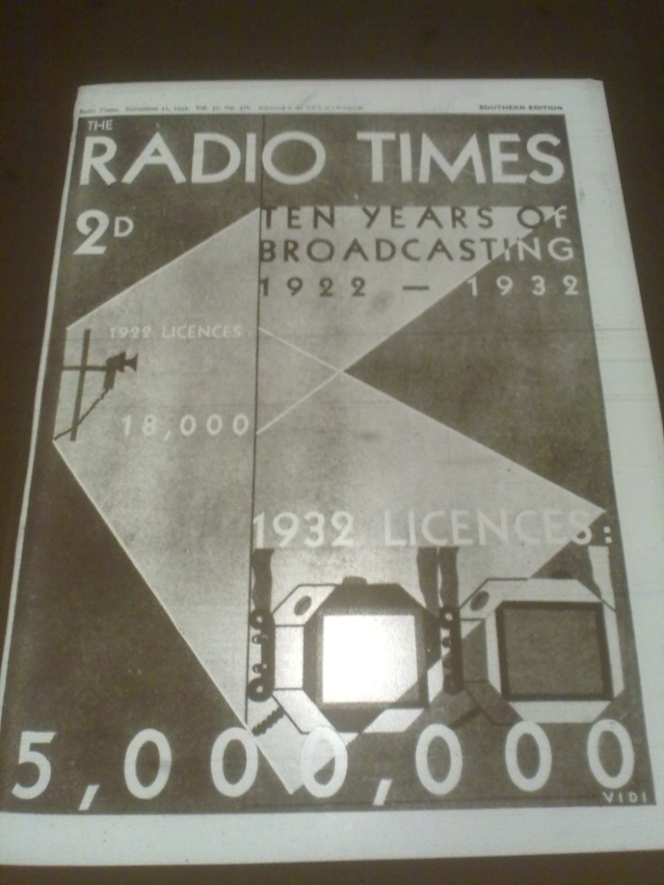
Figure 16 ‘Celebrating Ten Years of Broadcasting,’ Radio Times 11/11/1932, Front Cover.

In the manufacturing corporations that Marchand investigates many of the visual representations of their identity demonstrate a physical link between the humble origins of the past and their later impressive status. This is achieved by juxtaposing the image of a cottage or the founder with their modern factory. This model is adapted in the 10th anniversary issue of the Radio Times. The scheduling highlights special programmes being broadcast as part of the birthday celebrations, including a ‘Tour of Broadcasting House’ and various musical programmes for ‘Birthday Week.’ Notably, a programme called ‘Communications 1922-1932 A story of Ten years Progress’ is also included, recounting the traditional story of the development of radio. However rather than starting with Marconi, as was the accepted narrative, it begins with the formation of the BBC. This indicates two things: firstly that the technological progress made in these ten years had been sufficient to justify its own narrative, and secondly that the BBC felt it had a monopoly on this history.
The intervention of the Second World War had a dramatic effect on the BBC as it did on all of British society. While its role in providing information to the nation ensured it a lasting place in the affections of the British people, the extreme circumstances of the time meant that the BBC was forced to concentrate its efforts on the present, at the price of neglecting its past. This had dramatic consequences for 2LO as well as significantly reducing the conscientious image building that the BBC had been pursuing before the war. Evidence of this can be seen in the treatment of the BBC birthdays, which were celebrated every year throughout the 1920s and 30s, but after 1939 were hardly acknowledged.
As the BBC entered the second half of the twentieth century it also faced fresh challenges from commercial organisations who wanted the right to broadcast content of a more radical nature than the old-fashioned corporation was willing to. This period is notable, for the increased listenership of Radio Luxemburg, described by David Hendy as ‘for the young a relative oasis in a BBC-dominated market which persisted in making few concessions to the popular music revolution.’ The comforting image of the institution of the BBC was increasingly being portrayed as dated, and maintaining a tyrannical monopoly on broadcasting. However in 1972 the BBC decided to reassert itself with a decision to celebrate its 50th birthday through a variety of special publications, magazine articles and programmes. Once again the history of the BBC was put at the forefront of the Corporation’s identity.
Products of this celebration included Edward Pawley’s history of BBC engineering released specially to commemorate the progress made over the last 50 years. A television documentary entitled Cough and you’ll Deafen Thousands in which (as will be discussed later) 2LO made a guest appearance, celebrated the history of BBC engineering from 1922-1952 through the recollections of engineers. A special exhibition was put on at the Institute of Electrical Engineers, which occupied the same building, Savoy Hill, where the BBC had first been housed. These celebrations helped to re-establish the trend for celebrating BBC anniversaries with special events occurring in 1982, 1992 and 2002 subsequently.
The current Head of BBC Heritage, Robert Seatter, sees the BBC’s relationship with its past as ‘very schizophrenic.’ He attributes this to two fundamental anxieties within the organisation: fear of self-promotion and a question of what the BBC should represent. The first refers to the BBC’s aim to provide a public service, as proposed through Reith’s early vision for the company. As its funding derives from the licence fee, as well as government support, the BBC has remained, particularly in recent years, sensitive to suggestions of self promotion or bias. This has meant that any effort to commemorate the institution’s past has required walking the fine line between interesting programming, and self-indulgence. Seatter, therefore, sees the BBC anniversaries (the first radio broadcast, the first television broadcast and the first episode of the Archers, to give a few examples) as a chance to allow audiences to reflect on the institution’s past and revive the material collections that it holds.
The second anxiety stems from a divide within the BBC. Some see the tradition of the BBC as an integral part of its identity, to be celebrated, while the others distance themselves from this obsession with the past. This latter group want to promote the BBC as an innovative, modern media company. In his role as Head of Heritage (with an office adjacent to the Director General’s office) Seatter has to balance these two demands, and reflect that often ‘objects say dead and heritage means sepia film to parts of the BBC.’ Balancing the demands of these various stakeholders within the BBC continues to be one of the greatest challenges that the Heritage department faces.
In recent years heritage has been used to facilitate audience engagement with BBC’s past through personal recollections. Members of the public have, for instance, chosen their favourite Eastenders (the corporation’s long running soap opera) cliff-hanger for the 25th anniversary of the programme. Events such as this contrast with previous eras when the words ‘BBC and heritage used to just mean bits of kit.’ However, as 2LO’s journey demonstrates, for many, these ‘bits of kit’ continued to embody the true meaning of the BBC. The public service, the innovation, even the ideals of Reith have become condensed in the BBC heritage objects; the majority of which are on loan to the National Media Museum in Bradford. These objects are tangible reminders of the humble roots from which the British Broadcasting Corporation emerged.
This brief analysis of the BBC’s corporate identity shows that the 2LO transmitter was being maintained in a constantly shifting political environment. It also contextualises the uncertainty that continued to characterise the transmitter’s post-war experience and discussed in detail in the third section of this chapter. This uncertainty came to an end in 2002 when, following a dramatic clash of corporate identities, 2LO was rescued from a state of balanced ambiguity, and handed over to the Science Museum.
In 1997 the BBC transmission service was privatised. Its operations were taken over by Crown Castle International (who purchased the home transmissions services for £244m) and Merlin Communications (who purchased BBC world transmission services for £30m). The idea to privatise the transmission services had been mooted since the late 1980s and by the mid nineties the transmitters were up for sale. From early on the suggestion of privatisation was met with sadness, and in some cases feelings of betrayal, by many of the BBC staff. In a document leaked to the media, Leigh Jackson, the then Head of Communications states that while some elements of the privatisation may be reasonable, the ‘symbolic significance of the transmitter network for all staff might prompt wider protest action.’
Jackson’s reaction shows the sense of pride and ownership felt by many in the BBC, especially among the engineers, towards the transmitters. Part of this was due to the inevitable loss of colleagues and friends, through the restructure. Some felt they were losing a second family. The reaction was also, as Jackson says, about the ‘symbolic’ loss of what had originally been the foundation on which the BBC was built. Technological innovation had, throughout its history, been at the heart of the BBC, and now the corporation, in the eyes of many within the organisation, was betraying its ‘humble origins.’ A move that undermined the foundations of a ‘good’ corporation according to the definition set out by Marchand.
In the midst of these radical changes one victory could be claimed by the engineers. Originally the deal agreed with Crown Castle included all the domestic transmitters. In the final stages of negotiation, and to the BBC’s horror they realised that 2LO would also be included in this deal. An initiative set up by a group of senior BBC engineers, wrote to Crown Castle requesting that 2LO be returned as they felt that the transmitter was part of ‘their heritage too.’ Following prolonged negotiations which delayed the final transfer of the transmissions system to Crown Castle, it was decided that 2LO would be jointly owned. Contracts were drawn up so that it would remain legally balanced between the two organisations. As Martin Ellen, one of those engineers who had fought so hard for the transmitter, describes it:
In fact, the future of 2LO was not resolved until the day that the privatisation was finalised in 1997. A senior person in the Texan organisation that formed the new company suggested that there should be joint custody, like a child in a divorce! This was agreed. I thought that this was a good idea under the circumstances, because the two organisations could ‘keep an eye’ on each other and make sure that 2LO was preserved.

One of the positive results of this embarrassing situation was that the BBC realised that it needed to take active ownership of its material heritage. Only a short time later the BBC Heritage Department was established. However this was never going to be a permanent solution, for 2LO. Ellen further recounts, ‘the policy of the new private company, that was due to take over all the other transmitters from BBC Transmission, was unknown. It could be motivated entirely by profit, have no interest in its heritage and discard 2LO.’ The problem was where to store such a large and bulky object. While papers and photographs could be cared for in-house at the BBC written archives and the BBC Photographic Library respectively, for its historical objects the only solution was to involve another public institution whose mission adhered to BBC’s aims.
Ellen had felt for a long time that the safest place for 2LO was the Science Museum, ‘because it would then be preserved professionally and eventually made available for the public to appreciate as a piece of national heritage.’ Before the problem with Crown Castle had occurred Ellen remembers offering 2LO to the Science Museum in 1995 when, he admits, he had little authority to do so. However, surprisingly given the museum’s later enthusiasm, the offer was rejected. He later discovered that this was due to ‘staff issues and reorganisations within the Science Museum.’ When the agreement with Crown Castle was reached, Ellen tried again unsuccessfully to give 2LO to the Science Museum.
John Liffen, the current Curator of Communications theorises that this may have been due to a series of staff changes. He also cites a dispute that occurred between the Science Museum and the Marconi Company in the 1990s over the long term stewardship of some of the Marconi collection. This disagreement dragged on for a number of years and it is likely that amidst this larger issue, and high staff turnover, 2LO simply slipped by. This episode highlights the link between internal politics, and who is directing the institutional gaze, to the perceived value of an object. Even when the museum did eventually acquire the transmitter the balances of power within the institution continued to underpin the object’s meaning.
In 2002, the BBC again (though with greater formality) offered the 2LO transmitter to the Science Museum. This time the right gate keeper was formed and the offer was met with enthusiasm by members of the curatorial team. Liffen, an Associate Curator at the time, describes the first meeting to discuss the handover:
My first memory of involvement in it was to go of all places to the Crypt tea room at St Martin-in-the-Field’s church, where John Griffiths, Keith Parker [Assistant Curator] and I went and met Robyn Reynolds round a tea table there and had a chat. Maybe because it was convenient to meet at a central point, and we just talked it over. And I think at that point John Griffiths was minded to take it…

As this statement shows, from the very beginning John Griffiths, at the time Senior Curator of Media Technologies had decided to acquire the transmitter. His enthusiasm is clear in a letter sent to Crown Castle in the early part of 2002: ‘As we discussed I am very very keen to acquire the object- it resonated history!’ However 2LO’s entry into the museum occurred at a time of tremendous upheaval with the arrival of Dr Lindsay Sharp as a new director of the Science Museum. Sharp was a strong personality intent on making his mark on the museum. One of his methods is described by Tim Boon, now Head of Research and Public History:
Lindsay Sharp was the kind of director who liked to challenge established practice. Everything was fair game, especially if he detected what he saw as conventional thinking. So, he announced that there would be a ‘moratorium on collecting’ whilst it was reconsidered whether and what should be collected.

This moratorium officially suspended the acquisition of all new objects, though some covert collecting continued to occur, during this period. Also, as part of this reassessment of museum practice, most of the curatorial staff found they were under review or at ‘risk’ for a number of months while it was determined who was allowed to stay. The lasting effect of this policy on both staff and collections will be explored in greater detail in chapter four, but for this stage in 2LO’s journey, it is to be understood that the transmitter’s acquisition occurred in a time of great stress for the curators, and managerial hostility to the principle of collecting. Surprisingly, 2LO’s negotiation of this process was relatively straightforward, as Boon explains:
Suffice to say, an exception to limits can always be made for unique and significant objects. This was easy for an object that was presented as the BBC’s original transmitter. Any experienced curator is well acquainted with rhetorical exaggerations and obfuscations that can be used to inflate the significance of an object.

The acquisition files are testament to the enthusiasm that Griffiths felt for this object, underlined by pragmatism brought about by the changing political climate within the museum. The proposal for acquiring the object not only outlines the value inherent in the object (stating that ‘there is no doubt this is an ‘icon’) but also how this value would be reflected onto the Science Museum in a section entitled ‘opportunities’:
If this proposal became a reality then I believe the opportunities to hit our strategic values are great and exciting, if we wish to target some resources and time at it.
- There is potential for very good and extensive media coverage.
- There is great potential for on-line activities, the object resonated stories, with NOF potential and also linking to the BBC On-line site.
- We could consider setting up an actor role
- And perhaps a publication
- And even a short lecture
- We might want to explore some oral history
- And even some commercial activities in conjunction with the BBC
- A small surrogate display (with live link up of the event on 14 Nov?) can be held at NMSFT
- We might want to consider activity in On Air
- And possibly much more.....

As this extract shows, the 2LO that Griffiths was fighting so hard for had the potential to both gain positive media attention for the Science Museum and feed into permanent displays and an online presence. In this proposal there is open acknowledgment of the different roles this object could play as both an icon, and an object that ‘resonated stories’ with the potential for generating oral histories. Despite Griffiths’ obvious enthusiasm little of this came to pass and, in an environment undergoing drastic changes, his time at the Science Museum came to an end shortly after.
The final handover ceremony was an excellent performance in corporate image making: playing a part in the larger ceremonies surrounding the BBC’s eightieth birthday, some of the most elaborate in the institution’s history. The ceremonial handover took place at the Birmingham Symphony Hall in front of a large audience and included performances by the BBC Symphony Orchestra. However, for the Science Museum team on site, this was not the celebratory moment it should have been. Instead it resulted in embarrassment and the clearest indication yet of the direction the new management was taking the museum in:
And so there was a real heavy tension coupled with the fact that Lindsay Sharp appeared to lose interest in the acquisition and at some point a few weeks before the formal handover ceremony at Birmingham Robyn Reynolds, who’d striven mightily to work the BBC, he had not privileged access to the Director General, but his position was such, they could talk to each other quite informally, and he’d got the DG to do the handover but Lindsay Sharp drew back from going to Birmingham, being Birmingham’s representative... I remember Robyn saying to John Griffiths we’ve fielded our top man, where’s your top man?

Despite this behind the scenes tension, the public language of the BBC heralds this as a historic moment, and it is here that the transmitter is first publically referred to as being an ‘icon of broadcasting history.’ In view of this the words of Gavyn Davies, the then Chairman of the BBC, speaking on behalf of the institution whose identity had become engrained in the object are to be viewed as particularly significant:
Future generations should be able to share what is a fascinating piece of early 20th century technology. We also want them to understand its significance in the development of our broadcasting system, which is held up as a model for the world. So I can't think of a more appropriate home for 2LO.

These words unconsciously mirror the sentiments expressed by Noel Ashbridge in 1929 when the question of 2LO’s future was also at the centre of the BBC’s attention. Both drew both Ashbridge and Davies attention to the duty the BBC has to both its past and its future. That figures such as these have to make such emotive statements demonstrates the continually ambiguous nature of the relationship that the corporation has with its heritage. Given this relationship it is no surprise that 2LO was at its safest when the BBC acknowledged and embraced its own history.
However for the Science Museum curators involved in the acquisition it also represented a victory in the face of hostile changes to their own institution:
.... so we felt we were acquiring this historic object almost in defiance of Science Museum management rather than at their whole hearted wish...it was almost as if John Griffiths and I were doing this because we knew in the long run this was the right thing for the Science Museum to do, regardless of who was up at the top management at the time, they would pass by but we were doing it for the greater good of the Science Museum we had that vision.

In this move 2LO once again was a key actor in an institution’s identity network. Its acquisition by the Science Museum represented defiance and a material articulation of what the vision of the museum should be. The role of these curators as personal saviours of this transmitter is a motif that, as this chapter goes on to show, has been a theme of 2LO’s journey. As far as its relationship with the BBC is concerned, it is not without irony that the moment at which 2LO’s value was most publically declared, was also the point at which it left the corporation’s care. Having entered the storerooms of the museum it was well guarded by both enthusiastic carers and a complex bureaucracy. If ever there was an argument for the national funding of museums then it can be found in the safety of objects such as 2LO. For in the hands of corporations, history too, becomes a commodity: profitable, alterable and disposable.

- A History of Displaying History: The Exhibition of 2LO
As the previous section has shown the 2002 Science Museum handover acted as a public performance of the complex corporate history of the BBC. This section will focus more specifically on 2LO and consider the narratives it has been used illustrate through its various displays, and television appearances. These displays cannot always be understood in the sense of traditional museum exhibitions. As a BBC artefact 2LO was used, in trade fairs and press events, as part of the ongoing process of historicisation and positive image making for the corporation. However, the BBC was not the only claimant to the history that 2LO represents. This section will also consider the transmitter as representative of: the Marconi Company, 2LO’s original designers; a history of progress in communications history; and the grand narrative of British society.
In describing the effect that vintage records have on their listeners Lowenthal makes a generalisation that can be applied to all technological objects:
Because ‘worn’ sounds powerfully evoke a sought after sense of the past, studios preserve scratches in old recordings and the Retrospect Collectors Society distributes records with ‘characteristic’ surface effects retained in the interests of authenticity.

People generally feel closer to the past when the object they are presented with demonstrates the qualities of having aged or at least what these are imagined to be. In the example of records it is the crackles and hisses when played that is both an evocative and legitimising part of the experience.
In relating its history as a display piece the aesthetic qualities of the transmitter have to be considered. These qualities interact with the environment in which 2LO is situated as well as the audience’s gaze, to construct meaningful narratives. The 2LO in the Science Museum storerooms (as chapter three will explore) is very different from the one that occupied Marconi House in the 1920s. To look at the transmitter with modern eyes, it speaks through its dishevelled appearance and dated components, of a different era. Lowenthal describes how a fascination with age and decay dates back to the nineteenth century reflecting a cultural obsession with human mortality and death. Applying this to 2LO another reason for its preservation, and popularity as a display piece, begins to emerge.
2LO is large and imposing, appearing impossibly complex to the untrained eye. On closer inspection, the marks of time become apparent: the speech choke, its cover peeling away, and wiring spilling out; a rheostat, its metal bottom having detached from the fragile, glass tubing, and the wooden frame, scratched and stained by the years. As chapter three will show, each of these marks represents a story of its own but, in terms of how 2LO has been displayed, the overall impression it leaves the viewer with is of age, experience and a bygone era.

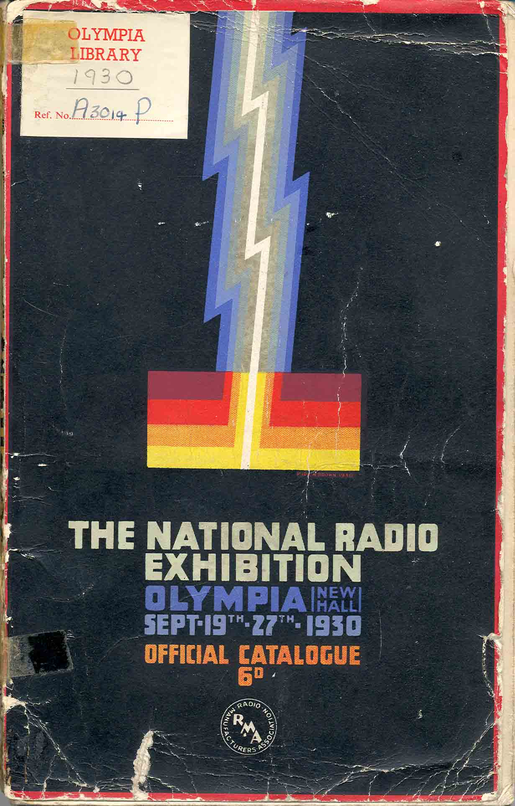
Figure 17: Front cover of The National Radio Exhibition, Olympia September 19th-27th 1930, Earls Court and Olympia Library, London.

2LO was first displayed at The National Radio Exhibition, the radio industry’s annual show, in September 1930, only a few months after it was removed from Marconi House. The industrial trade show was a tradition that dated back to the mid-1850s in the United States with the World’s Fairs and in the UK, on the largest scale, with the Great Exhibition in 1851. Generally, it is these large fairs that have been the subject of study as they provide a uniquely visual platform to engage with representations of national identity within an international context. For instance, in his article ‘Utopia, Nostalgia and World War at the 1939-40 New York World’s Fair,’ Marco Duranti explores how the war in Europe articulated itself on the stage of the fair. He focuses on the Czech and Polish stalls which, in the course of the Fair, ceased to be independent countries following their occupation by Nazi Germany. They became highly politicised spaces for exiled citizens to both mourn, and glorify, their lost nations.
However, these large scale events make up only a small proportion of the exhibitions that occurred between the 1850s and the 1950s, when the popularity of the shows began to decline. Before radio and television (with the exception of newspaper adverts) these exhibitions offered the only means by which companies could speak directly to their intended public. This relationship accounts for the proliferation of these shows, and why in the US, the style of the exhibitions evolved across the time period: corporations were just as concerned with communicating their image as selling their products. In the UK, while some of these exhibitions went on tour around the country, the biggest and most comprehensive show cases of the nation’s different industries were held in the purpose built venues of Earls Court and Olympia in West London.
The All-British Wireless Show had been running since the autumn of 1922 and was first held in the smaller venue of the Horticultural Hall, in Westminster London. As the enthusiasts’ magazines report, this proved to be wholly inadequate for the number of people who attended, and the unanticipated level of enthusiasm the public felt for the new technology. However by 1930, the ‘Radio Show’ as it was fondly referred to, had become a regular feature of the industry’s calendar as is illustrated by this article, from Wireless World celebrating the history of the Radio Show:
Every Industry of national importance, from baking to shipbuilding, holds an annual exhibition. After every exhibition the cynics and pessimists get to work with pencil and paper and ‘prove’ that exhibitions do not pay. ‘Next year we will spend the money in newspaper advertising,’ they say; but next year finds them there just the same. The fact is, that exhibitions have a ‘goodwill’ value- call it what you like- that cannot be estimated with pencil and paper. The opportunities for personal contact between producer and consumer serve to stimulate interest and renew enthusiasm, while the necessity of formulating a programme for the coming season forces the manufacturer to marshal the results of his research activity during the past twelve months and to present these results in concrete form.

This short extract illustrates relationship between corporation and public that Marchand has found in America. Corporations also express a desire to create ‘goodwill’ among their public and to interact with them on a personal level. The important place that the Radio Show has gained in the rhythm of the industry’s year is also clear, giving manufacturers a point in time when they can deliver the results of a year’s research and development. Notably this article is called ‘Radio Shows in Retrospect’ and is not looking eagerly to the future of radio as they did in earlier years but rather, as the BBC did at roughly the same time, is reflecting on the progress the industry had made, and the part they played in this history.
This tone runs throughout the 1930 exhibition catalogue. In ‘A Message from The Rt. Hon. Sir William Bull, Bt., F.S.A.’ the President of the Radio Manufacturers Association, is much more reflective than in previous years saying that:
I have had special occasion to watch the development of ‘Wireless’- the greatest of modern wonders- and I am proud at what my countrymen have accomplished in the short space of eight years...

Later on in the passage he points out that ‘radio is no longer a novelty’ and that it had taken its place ‘as an essential in the home.’ Bull is making the radio industry aware that it no longer represents the exciting new technology particularly as Baird’s first experimental television broadcast in the UK occurred the year before in September 1929. From this point on the industry would have to consider new ways to attract the public to its shows, and more importantly, its products. Bull’s words were prophetic as the 1930 show marked a high point in the showmanship of the British radio industry. During the years that followed attendance and interest in the Radio Shows went into slow decline.
In this context it is unsurprising that this was the year the BBC first chose to display the 2LO transmitter. The transmitter was guaranteed to attract interest as can be seen from its inclusion in a later Radio Show in 1937. By the time of this show the industry was undeniably in decline and felt it necessary to include a ‘Radio Museum’ feature to the event. The show did not leave a positive impression: ‘There is no dearth of interesting exhibits, but the pity is that they are not displayed in a more orderly and spacious way...’ and was designed more as a last minute gimmick to encourage attendance to the show, than for any merit of its own. The BBC’s motives for entering the shows are unclear as there is no mention of them in the BBC Written Archive.
In the 1930 Radio Show, 2LO was included in the BBC’s stand in the Empire Hall of Olympia exhibition halls. Its message that can be summed up in one sentence from the Exhibition catalogues: ‘It was the original 2LO, and the progress made in transmitter design is astonishing when this set is compared with the modern high-power transmitters at Brookman’s Park.’ 2LO was presented as a visual contrast with the most cutting-edge broadcasting equipment, which reflected the Radio Show’s theme of introspection and nostalgia. Visiting journalists to the stand also picked up on this theme: one remarking that while the stand ‘lacks the flamboyance of some of the others’ nevertheless it is ‘interesting alike to the technical visitor and student of wireless history.’
The impression of 2LO is that while it ‘still might wear an air of importance,’ in comparison with the Brookman’s Park equipment the ‘the older apparatus appears strangely frail and experimental’. The picture in Figure 18 shows how the aesthetics of the new and old, transmitters related to each other and the strength of the message being conveyed by this display. The new transmitters, in the bottom half of the image, appear all the more modern when juxtaposed with the rickety assemblage reproduced above it.
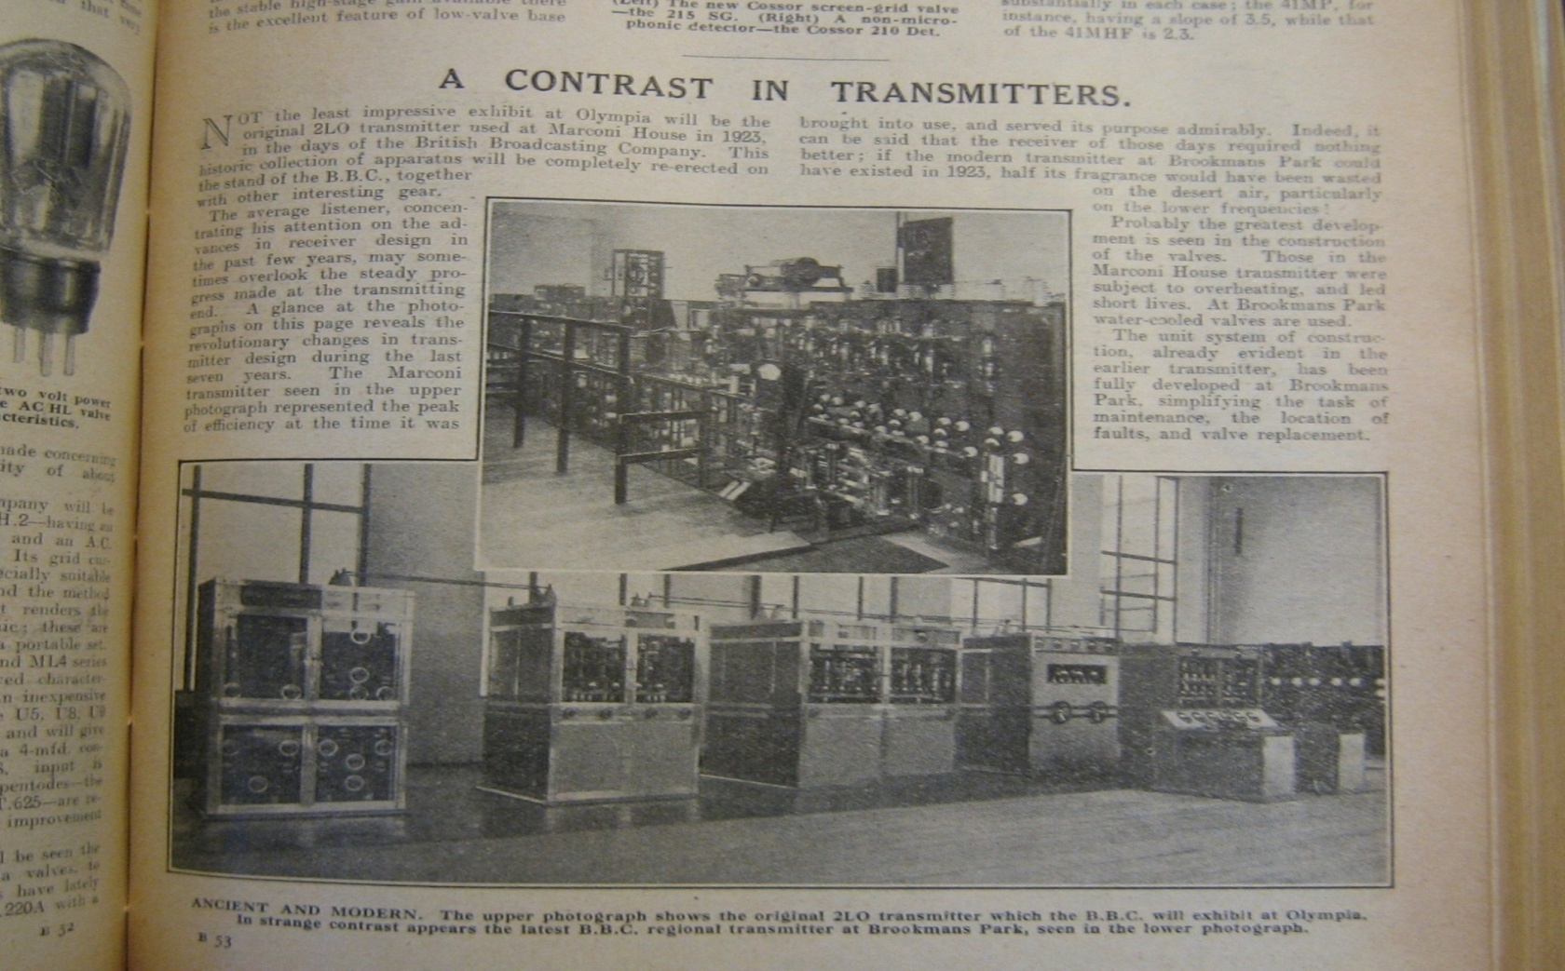
Figure 18 ‘A Contrast in Transmitters,’ Wireless World and Radio Review, 17/09/1930, 209.
However, the exhibition did not just highlight the attributes of the new transmitter. It also alluded to the early days of broadcasting a subject which increasingly prompted feelings of nostalgia:
Those who listened in 1922 and 1923 can probably be classed as veterans among the B. C. L.’s, and it will be the veterans, I think who will fix their sentimental gaze on the actual transmitter used at Marconi House in the days when technical breakdowns were accepted as almost every day occurrences, and when a cough in the control room set the valves ‘ponging’ like a dropped toast rack.

To those that could remember, 2LO acted as a channel, connecting people with those fondly recalled, pioneering days of radio. In looking ‘frail and experimental’ 2LO was more genuinely of that past and provided a stronger connection to it much as Lowenthal’s records did. An aesthetic generated through age and experience, as well as its symbolic significance, meant that 2LO was used in a variety of different exhibitions in the years that followed. This was not a one way process: those who viewed it, as the article above suggests, brought their own memories and ‘sentimental gaze’ to bear on the transmitter. It is the interaction between these viewers, and the viewed, which generates the overall exhibition experience.
The passage from Wireless World, Figure 18 refers to a specific type of gaze based on memories and experiences which would only last as long as the people carrying them did. When these people had gone, the type of display that featured in the 1930 Radio Show would no longer have the impact that it once did. In considering the history and geography of 2LO’s display, it is not only the change in space that is being analysed, but also the different types of gaze that fell upon it and the meaning generated from an interaction of the two.
Given the extent to which it was contrasted with the Brookman’s Park equipment it is logical that it ended up sharing a building with it. This is where Noel Ashbridge intended for it to remain, and on its return from Olympia, the transmitter was set up in the Brookman’s Park Studio as shown in Figure 19. On the back of the photograph, in faded blue ink is typed ‘February 1935, The London (2LO) transmitter from Marconi House erected and photographed at Brookman’s Park. Oscillator and Modulator Panels and Programme input board. The speech choke and modulation meter can be seen above the panels.’

Figure 19 Photograph of 2LO transmitter erected in Brookman’s Park in February 1935, Found on BP site amongst unfiled papers.
For the most part this represents a complete version of the transmitter as it was removed from Marconi House. In the photograph is even visible the telephone that would have connected the transmitter team at Marconi House to the studios at Savoy Hill and which has since disappeared. The new site of 2LO was reported briefly in Wireless World:
Contrasts at Brookman’s Park
The lucky folk who manage to obtain permits to visit the Brookman’s Park station can now compare the appearance, though not the performance, of the new transmitters with that of the original 2LO at Marconi House. The original gear has been re-erected in the main building.

The intended impact of this new display of 2LO was, much the same as it had been at the Radio Show: to be illustrative of the technological progress that the BBC had made in the years since 1922. Because of its close proximity to the new transmitter this message was even stronger than it had been at the Radio Show. Harold Bishop, Assistant Chief Engineer of the BBC remarked on this in an article for World-Radio, following a visit to the site in 1935, saying it ‘was most instructive to have it with the equipment that has been in Brookman’s Park since 1929.’ Bishop also points out that, while there is a marked contrast between the two transmitters, the development of radio technology has not stood still, with the more recent Brookman’s Park transmitters, already earning the title ‘old gentlemen’.
This places 2LO in a more complicated narrative: it was no longer just viewed in the context of new compared with old, but was seen as one step in a constantly evolving process of development. Evolutionary presentations of scientific progress are intrinsically fraught with danger, not least because each step will appear predetermined. Lubar warns academics engaging in the study of objects such as 2LO to be wary of straying into technological determinism as they are particularly prone to ‘the tyranny of the artefact.’ This tyranny Lubar attributes to the sheer size of technology objects and the power they represent. Their very physical presence dominates the narrative they are representing, something which ‘is all too often emphasised in museum exhibits.’ With a history as short as radio (several stages had occurred within living memory) it is understandable that each new breakthrough was seen as merely the herald of the next one. In this vein there is a humorous article which looks to the future of wireless technology in 2030 saying:

Perhaps it is best to begin with the carrying case. Whether this is made with synthetic leather, wood, or some new metal alloy, one can be quite sure that it will be almost entirely without weight, whilst at the same time it will possess considerable strength. Upon opening the lid we will find that all there is to be seen is a small switch panel, and a plain white screen, which will occupy the same position as does the ebonite panel in the 1930 portable. Needless to say, this is the television screen, and it will probably be somewhat similar in appearance to the focusing screen or an ordinary stand camera.

Vincer-Minter describes an object that is very like a laptop with functions similar to Skype. Writing in a world full of these kinds of devices it is easy to appreciate how a feeling of inevitability can begin to associate itself with technological development. Both by looking back historically, and looking forward as a social commentator as this article does, the steps towards portable, visual and verbal, remote communication can easily be traced. However, just because this is possible, does not mean these stages were preordained. Examples such as this illustrate how seamlessly 2LO fitted into a grand narrative of broadcast history. The real success of this narrative relied on the audience engaging with it, and to return to the earlier quote from Wireless World, the ‘lucky folk’ who managed to view 2LO are just as important to the message it was managing to communicate.
Brookman’s Park was no ordinary transmitting site. It was the first purpose-built twin transmitter station in the world which meant it was capable of broadcasting two radio programmes simultaneously. Part of Eckersley’s Regional scheme, it was the first of a number of transmitters that were built away from city centres, allowing them to broadcast at a higher power. The Brookman’s Park site is therefore set high on a hill in Hertfordshire, surrounded by fields, and a good walk from the nearby village. The building that houses the transmitters is, in comparison with the grounds it is set in, quite small. While there have been major structural changes, externally it appears today much as it did in 1929, with the most impressive structures on the site being the vast aerials towering over the surrounding landscape. The outside of the building is made up of pale gray, Portland stone, and the entrance way has an imposing art deco style, reminiscent of Broadcasting House on Portland Place.
On visiting the site, the Engineer-in-Charge explained that this was the most attractive of all the BBC’s transmitter buildings. The reason for this attention to the design of the building was that it was intended to perform a function greater than merely housing the transmitting equipment. It was also a symbol of the technological prowess of the BBC. As Eckersley describes it this was a deliberate decision made by the BBC:
…it was certainly unconventional and I expect that is why some thought it ugly. My concentration on the aesthetic issues in an engineering scheme was a source of tolerant mirth among BBC technicians. One of the engineers called it 'art nonsense'. I felt when the station was built that the main transmitter hall at any rate justified my childish preoccupation with appearance as well as performance.

Further (reminiscent of Burrows’ musings on witnessing 2LO at work in 1923) Eckersley writes in his autobiography nearly forty years later:
A high powered-station is such a lovely thing. The process is silent, there is no gas or smell or fussy reciprocation, no sound except a powerful humming. One is conscious of power contained and controlled. I felt that the building should be fitting to purpose.

On visiting Brookman’s Park in November 2009, two official guest books were uncovered. In these were recorded the names of all the people who have visited the site since 1929 that provide a key insight into why both Brookman’s Park was so carefully designed, and why the 2LO transmitter was displayed there. In the time following its opening in 1929, until the outbreak of the Second World War in 1939, when the book goes dramatically blank, a large number of people are recorded as having visited the site. These visitors came from all over the world and included representatives from: Amalgamated Wireless, Sydney; the Broadcasting Corporation of Japan; Union Internationale Radiodiffusion-Brussels, and Am. Tel & Tel. Co. New York, as well as many more.
There is no significant work on the international role of Brookman’s Park, so without further research the reasons these individuals had for visiting the site remain unclear. However, given the companies they represent, it is likely that they came to view this as cutting edge technology. Such high profile visitors account for Brookman’s Park being designed with such an impressive aesthetic. These visitors also provide a context for the display of 2LO. From the moment the visitors crossed the threshold, with the BBC symbol emblazoned on the marble entrance way, the intention was to impress them with the achievements of the BBC. In this case, rather than targeting their listeners as at the Radio Shows, this was for the benefit of their overseas equivalents and competitors.

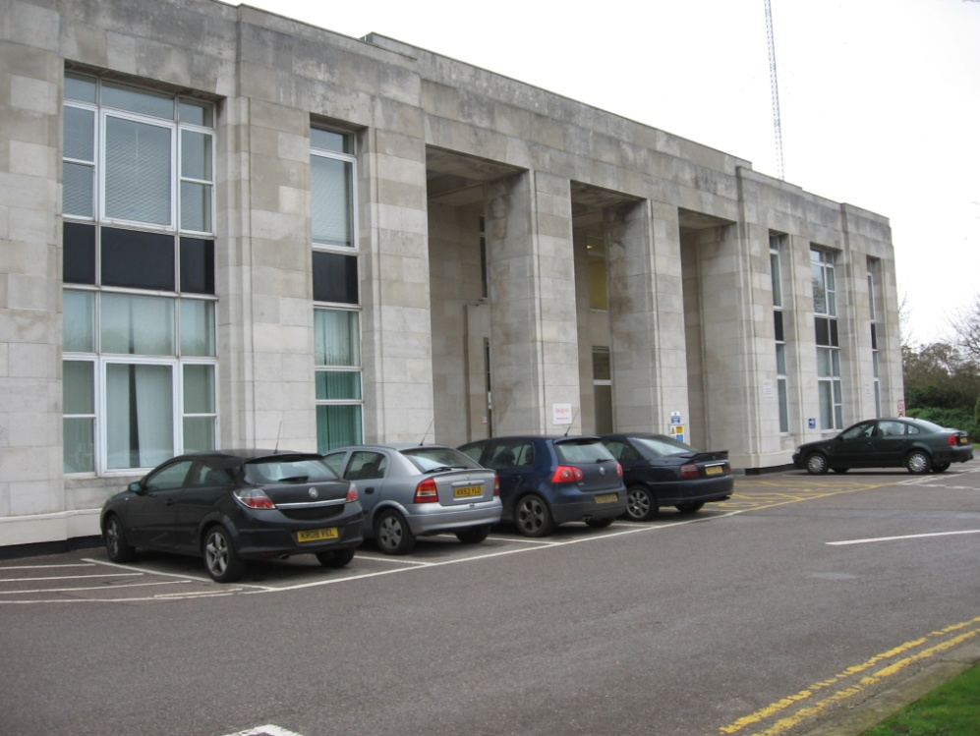
Figure 20 External view of Brookmans Park Taken 18/11/2009.

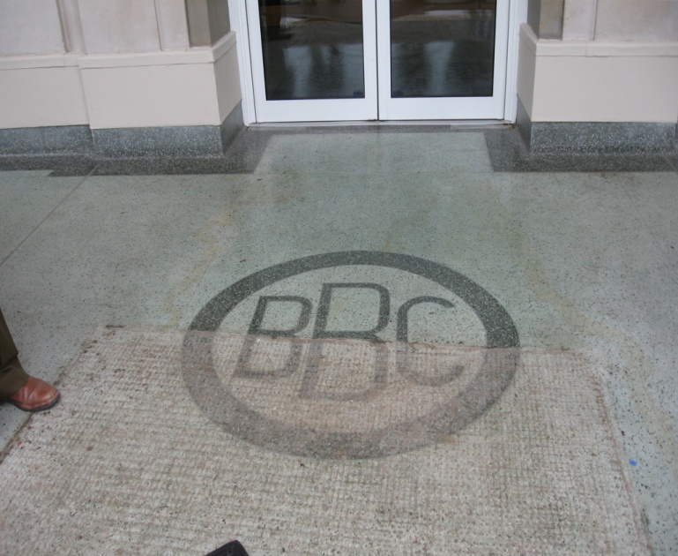
Figure 21 BBC logo on the doorstep on Brookman's Park Taken 18/11/2009.
2LO was to remain in Brookman’s Park, in various locations around the site, for the next sixty years. As section three of this chapter will show, it did not remain on display all of this time, but was moved to sheds and out buildings so that even the engineers working on the site forgot it was there. However from around 1953/1954 2LO was once again located in the main building. From this point it drifted around various rooms on the site, as alterations to the existing broadcasting equipment dictated, see Figures 22 and 23.

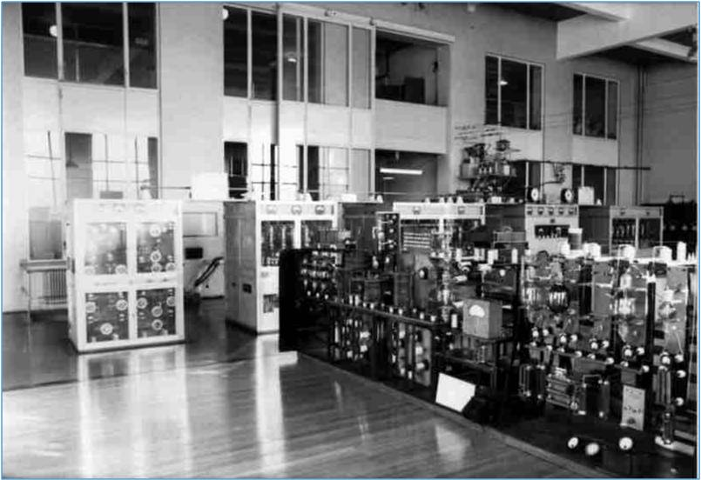
Figure 22 2LO in 1970, photograph found at Brookmans Park site.

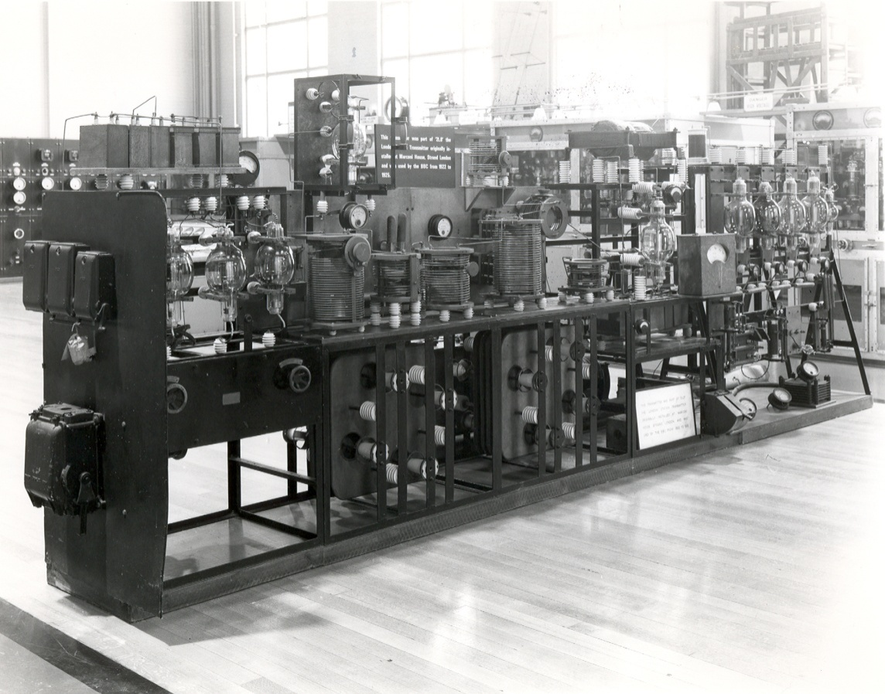
Figure 23 2LO in Brookmans Park 1978, photograph found at Brookmans Park site.

With a dramatic reduction in visitors to the site after the war it is debateable whether this later display of 2LO can be defined as an exhibition. Certainly some non-BBC personnel did visit the site but these tended to be only on special open days. For instance one ex-Brookman’s Park employee described how Cub Scout groups were sometimes allowed to visit though these were eventually stopped because things kept getting ‘smashed up!’ A particularly remarkable exception also occurred in 1964 when, as one local paper records, 3,000 people took the opportunity to visit the station. One of the highlights of the visit, for the more elderly visitors at least was, ‘In contrast with all the modern equipment’ a chance to see the 2LO transmitter. However, as the paper goes on to describe, there were distinct differences between the experience of the older and younger viewers:
How primitive and elementary it looked. But there was something noble about those gloriously bulbous valves, the considerable amount of the woodwork and the exposed innards of the thing. Perhaps after all the fun has gone out of radio.

In this description 2LO is described, for the first time, as separate from its BBC, and even its Marconi identities. The journalist is appreciating 2LO as an object in its own right, old and ‘primitive’ it may be, but for the writer this adds to the attractive qualities of the transmitter. The final sentence of the article alludes to the nostalgia for the early days of radio that cling to the object. The use of the word ‘fun,’ refers back to the amateur enthusiasts of chapter one. The engineers in Writtle certainly had ‘fun’, but in the face of expansion and the practicalities of providing a public service this easy-going approach had disappeared. Significantly this comes from someone who did not have firsthand experience of those days. In this experience of 2LO on display the active dialogue between object and audience is apparent and with the overall meaning is constructed from the resulting network between human visitor and nonhuman object.
Despite the fact that the spaces 2LO has inhabited in the years following its removal from Marconi House (Brookman’s Park, Daventry Transmitting Site, and finally Blythe House, the Science Museum store rooms) enjoyed few visitors it nevertheless came into contact with a number of audiences. This was due, not only to its visits to external exhibitions, but also its occasional appearances on television. In each of these appearances and exhibitions 2LO was used to illustrate a different kind of narrative and present a different message. This presents an opportunity to consider the power relationship between an object and the space in which it is displayed, as in all these examples the object remains the same, while the surroundings change.
Displaying an object draws attention to its physical properties; facilitating a communion between the audience and the materials. More broadly displays call into question what the real affective power of an object is. Does the presence of objects, such as 2LO, improve the communication of ideas to an audience or is the success of an exhibition mainly dependent on context? The question of an object’s ‘thing power,’ as Bennett describes it, is central to this thesis. Considering 2LO’s individual displays therefore provides significant insight into the power of the object.
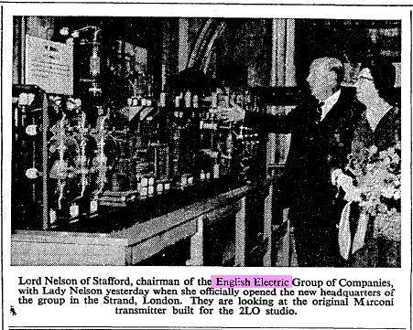
Figure 24 ‘Lord and Lady Nelson with 2LO,’ The Times, 26/10/1960, 18.
The exhibitions 2LO has appeared in demonstrate a revivification of many of the strands of ownership described in chapter one, as well as the introduction of new stakeholders, in the history it represents. In an exhibition at English Electric House, formerly Marconi House, 2LO’s original designers and owners, the Marconi Company, re-emerge. They had become a subsidiary of the English Electric Company in 1946. In 1960 Marconi House was reopened as English Electric House in a ceremony attended by Lord and Lady Nelson of Stafford, who are pictured pointing at the 2LO transmitter on display as part of the festivities of the day (Figure 24).
While nothing about this ceremony appears in the Marconi collection, letters found in Brookman’s Park record an active correspondence leading up to the removal and transportation of the transmitter. In one note, it is even remarked that ‘it is hoped it will be retained permanently’ at English Electric House. The rest of the correspondence refers mainly to the practicalities of transporting 2LO, and keeping track of the components on loan to English Electric. Despite there being only a brief description of the exhibit itself, this is a significant event, and offers example of another major corporation using the aesthetic qualities of the 2LO transmitter to enhance its image. In this case 2LO is being called on to represent a much earlier stage in its identity: when it was the Marconi owned and developed transmitter before the ownership of the BBC.
This is also an example of how material heritage can be used to strengthen a corporate identity in a time crisis. Having just become a subsidiary the Marconi Company must have been questioning its own identity. In an effort to address this anxiety, and reassert its identity, it resurrects this icon from its past, as a celebration of a long history of innovation. The approach resembles the actions of the Heinz Company in 1904, when they physically moved by barge, the original brick house where Henry J. Heinz had first bottled preserves, from Sharpsburg, Pennsylvania to the site of the modern plant in Pittsburgh. The visual juxtaposition between the founding home and the new factory, allowed visitors to construct a historical and moral narrative of the company. In English Electric House the effect was similar, with 2LO taking the place of Heinz’s brick building, it represented the progress the company had made as well as the humble origins where it all began. This reinforced the identity of the Marconi Company when it was most needed.

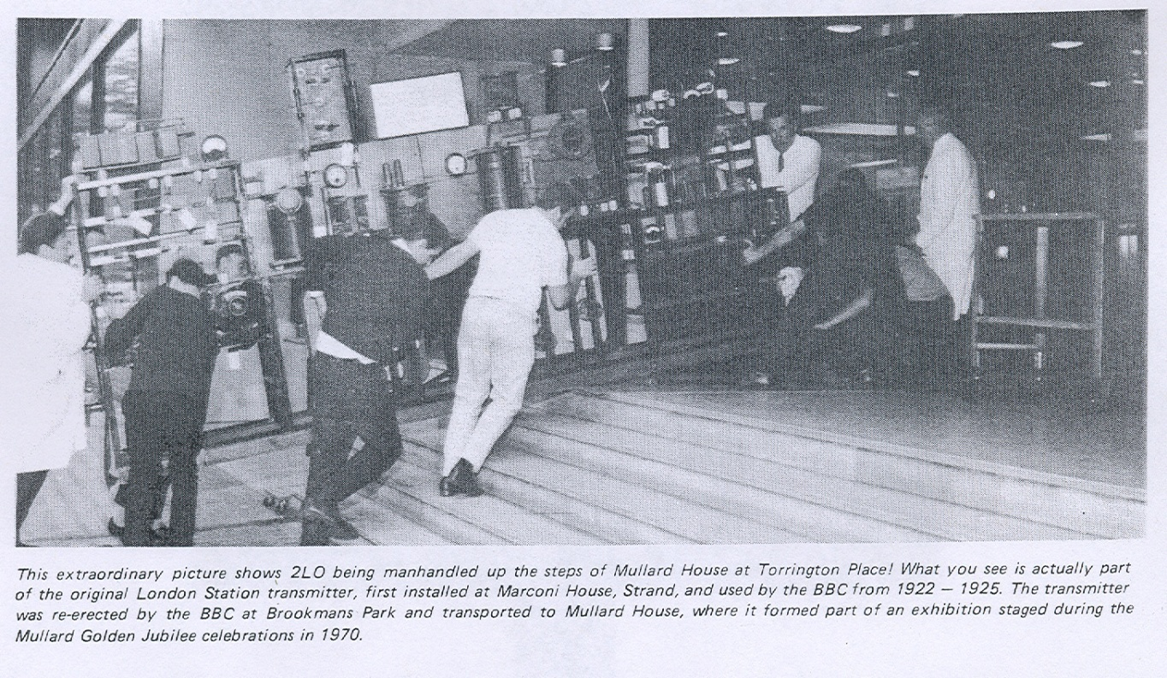
Figure 25 ‘Mullard Golden Jubilee Celebrations,’ Sounds Vintage, Vol. 1: 6 (Nov-Dec 1979) 156.
More recent illustrative uses of 2LO have seen it used to represent universal ideas closer to the original vision Noel Ashbridge had for it in 1929 as having ‘historical value to technicians of the future.’ However, 2LO appeals to a far wider audience then simply ‘technicians.’ The Science Museum’s John Griffiths, describing its later function best when he referred to it as an ‘icon of broadcasting history.’ In displays whose agenda is educational rather than propagandist the aesthetic properties of 2LO as both an aged artefact and as a substantially sized one, are significant. The image in Figure 25, of a group of men hauling 2LO up the steps of Mullard House at Torrington Place, for the Mullard Golden Jubilee Celebrations in 1970, illustrates the size and weight of the object. At this precarious angle it also looks worryingly frail and vulnerable.
One example of the way 2LO has been used to represent a wider narrative was in an exhibition called the ‘Radio Show’ held in 1992 at Broadcasting House and run by the BBC. This exhibition was designed to celebrate the 70th anniversary of BBC radio. 2LO was located in the foyer of Broadcasting House and was one of the first objects the visitor would see on entering. Across the foyer from the 2LO transmitter stood the latest in Marconi technology, a ‘Marconi Marine ‘Satpax’ transportable earth station type TP0’ used by Simon Bates and John Ruffle during a 1989 BBC Radio One round the world trip. This piece of technology was the latest in transportable broadcasting equipment. It allowed the BBC crew to transmit programmes from a different country every day for sixty-seven days and raised money for Oxfam.
These two objects, in one visual set piece, told the entire history of broadcasting: from the clunky, large, low power days of 2LO, to the high power, miniaturised technologies (made possible, in part, by the supplanting of the valve by the transistor) represented by the Marconi Marine. The rest of the exhibition provided a detailed explanation of the progress that had been made by the BBC in the preceding seventy years. Unfortunately there are no photographs of the exhibition which limits the extent to which it can be engaged with. However, 2LO’s inclusion in the ‘Radio Show’ mirrors that of its role in Brookman’s Park: being illustrative of the progress that radio technology had made by visually juxtaposing it with the new. In this case though, the aim is not to impress overseas visitors or competitors, but to indulge the British public’s enthusiasm for history and the BBC.
It is not just through physical exhibitions that the public has engaged with 2LO. It has also appeared in three television programmes. In these programmes many of the familiar themes have been resurrected: the BBC, the history of radio and technology. As all these programmes were aired in general viewing time slots, on either Channel 4 or the BBC they take an inclusive approach to the subjects being present. The audience is involved in a narrative without any requiring specialist or background knowledge. 2LO therefore becomes an illustrative tool, with techniques employed to enhance its aesthetics rather than its function. This style of presentation further emphasises its qualities as an artefact to be viewed, over a technology to be interacted with.
The earliest of these documentaries is the 1972 Mullard production, Cough and you’ll deafen thousands, which was released alongside the BBC’s fiftieth anniversary celebration. This documentary recounts the history of the BBC through the memories of the engineers who worked for the corporation over the years. For 2LO behind the scenes, this was also a moment when fresh efforts were made to revive it; subjecting it to another bout of restoration. These efforts also brought into its life one of its most enthusiastic supporters, Rod Viveash, who, as the next section discusses, continued to be a prominent figure in 2LO’s journey.
Cough and you’ll deafen thousands adheres to a conventional documentary style: depicting a series of interviewees, interspersed with simple graphics, and usually static images of technology. The interviews themselves are disappointingly formal, with each interviewee telling a different part of the history, in a style that suggests a pre-rehearsed script. While there are some references to personal experience, these are rare, and are overridden by the greater impetus of the narrative: to tell the heroic tale of the BBC. Despite this there remain moments when the human side of broadcasting is represented. In one light-hearted incident three ex-BBC engineers re-enact a radio play originally broadcast from 2MT Writtle, substituting a spoon for the microphone.
2LO appears about a third of the way through, with B.N. McLarty, the former Head of Design and Installation offering some thoughts on the transmitter. The filming of the transmitter takes place in Brookman’s Park, 2LO’s home at the time. In the background the modern transmitters are just visible and again offer the visual juxtaposition of old and new. Walking along the transmitter McLarty describes 2LO as being ‘preserved as a museum piece’ and briefly outlines how 2LO would have worked to two observers at his side. One of these observers was Rod Viveash, of 2LO’s restoration, while the other was George Morley, another Brookman’s Park engineer. Just previous to filming this sequence, Viveash describes how, ‘McLarty admitted he knew nothing about 2LO as his involvement came later. George and I had to explain its workings to him so that he could tell it back to us on film!’
This documentary has many similarities with Asa Briggs’ construction of a grand narrative of the BBC. Hardly a coincidence as this book was published only ten years earlier, and was still seen as the definitive history of the BBC, tracing the relentless progress of technological innovation, with 2LO representing a key turning point in the story. This documentary also presents an overtly glamorised version of the BBC’s past. The latter half of the programme dwells heavily on the important role the BBC played in the Second World War, and the heroism of individual engineers. Given Robert Seatter’s imaginative, if slightly under-handed way of slipping BBC heritage into programming today, it is unlikely that this story would be presented in the same way for the 90th anniversary in 2012.
2LO’s second appearance on television was in an episode of a Channel 4 series called The Secret Life of Machines, specifically titled ‘The Secret Life of Radio,’ and presented by Tim Hunkin and Rex Garrod. In this documentary 2LO appears in a short segment in which Tim Hunkin explains the differences between old and new types of broadcasting technology. This section of the programme is again filmed in front of 2LO on site at Brookman’s Park. The presenter is then able to walk in one continuous shot, from the old transmitter to the new ones. Even from these few minutes of footage it can be seen that 2LO has been moved since its appearance in 1972. This programme focuses on the technical side of broadcasting, interspersing the formal, presenter moments, with humorous animations.
In ‘The Secret Life of the Radio’ 2LO represents the key moment when broadcasting went from an experimental to a national service, placing the transmitter in strangely prominent position. The narrative history of the organisation pivots on this one artefact, with events being divided between before the BBC, before 2LO, and after. In this documentary the Brookman’s Park transmitter is more visible than in Cough and you’ll Deafen Thousands. For the first time the considerable changes that have taken place on the site since the original installation in 1929 become apparent: underlining the distinct differences between old and new. In a final twist to the sequence, the presenter turns a dial on the new transmitter, and music from a Radio Three programme becomes audible. With 2LO’s valves glowing eerily (a small current had been run through them specially for filming) in the dimly lit room and music pouring out of the new transmitter, the mystery and atmosphere of early radio listening is briefly conveyed to the audience.
2LO’s most recent television appearance occurred in 2010, when it was featured in a BBC television series hosted by David Dimbleby called the Seven Ages of Britain in an episode entitled ‘Age of Ambition.’ This programme had a more ambitious aim than any of the previous documentaries, seeking to present the history of Britain through historic artworks, objects and people. The ‘Age of Ambition’ is the last episode in the series and ‘looks at how the 20th century saw ordinary Britons upturning ancient power structures and class hierarchies.’ 2LO forms a segment which describes the democratisation of Britain through the provision of mass media in the form of radio. Standing by 2LO in Blythe House, Dimbleby briefly explains the processes behind the technical side of these broadcasts, and traces the route that sound would have followed from the studio, through the transmitter, and out to the wider country. It is a romanticised version of the story of radio and suitable for the format that this programme’s history is being delivered in. Present at the filming my field diary records how selective television is with the history it presents:
Met DD, quick shake of the hand and then there were more important things to do. Was generally ignored until suddenly someone wanted to know what they had said in the first BBC broadcast. Felt a bit stupid, I had no idea what they said exactly. Quick script re-write and then I had to run through a simple explanation of how it worked, with JL there as well thankfully! Interestingly they decided after talking about 2LO to walk across to the radios on the shelf opposite and pick up one with a radiating sun beam carved on the front. DD will say this symbolises radio reaching out to all of the nation. Was this object really designed to represent this? Could be?

As well as presenting 2LO with a particular narrative slant the environment of the stores is used to present 2LO in a certain way. As part of the 2LO sequence, Dimbleby is filmed walking through a darkened version of Blythe House, as if he is discovering a hidden treasure. On the day of the filming the lights were mostly turned off and 2LO was lit so that it appeared to glowing in the dark. The narrative of this documentary depends on Dimbleby discovering 2LO: guiding the audience to something that is lost, and through this action, emphasising its age and value. The negotiation between the atmosphere of the space, and the emotion that the sequence is trying to prompt in the audience draws attention to the inherent multiplicity of the object. As Anderson and Wylie point out the affect of an object is dependent of the relational qualities it receives from its surroundings. Thus 2LO in this context has to be viewed as a cohering message: it is both evocative object and atmospheric space. The final impression the audience is left with is of a remote and hidden power. An appropriate impression as, in the course of this sequence, 2LO comes to represent, not just the BBC and the development of radio, but the democratisation of British society.
While the BBC had a vested interest in promoting 2LO, it is not just their interpretations that have led to its debateable iconic status. 2LO’s present identity results from an accumulation of exhibitions and constructed narratives that have occurred in the years since its removal from Marconi House. This process began with the trade exhibitions of the 1930s who presented the BBC as both historical and progressive. This was continued with its move to Brookman’s Park, speaking to visitors from around the world, of the BBC’s (and Britain’s) proud technological heritage. As the years have gone on, and the audiences have changed, 2LO has moved away from this original narrow interpretation. The transmitter has come to represent an increasingly diverse number of histories.
As technology continues to change, 2LO will look increasingly alien to its audience, and its role as a display piece will continue to evolve. As chapter four will explore 2LO’s acquisition by the Science Museum, as a place that preserves scientific objects for the benefit of the nation, has intervened significantly in the meaning attached to this object. Even the establishment and funding of this thesis will serve to complicate and elevate its position in broadcasting heritage. However, the formal presentation of 2LO is not the only method by which its identity can be explored. The individuals who have interacted with it have also played a crucial role in both the physical and ontological shaping of this object. In the journey of 2LO these individuals have played a particularly significant role, preserving 2LO in the face of neglect and disinterest from those organisations who later heralded it an icon.

3. The Enthusiasts and 2LO
In 1929 Noel Ashbridge saved 2LO from being ‘scrapped,’ however, his motivation for doing so was not simply derived from his responsibilities as the Chief Engineer of the BBC. Ashbridge had been with the BBC since it was first established and had been a member of the original 2MT team in Chelmsford. He worked in Savoy Hill, when 2LO was still the latest in broadcasting technology, and remembered how each day brought a new pioneering break through. In 2LO he recognised an important artefact, and one which he felt personally enthused by: the transmitter was one of the few items of broadcasting equipment to survive from this period. This section considers how 2LO survived, even when the institutional interests of the BBC were elsewhere, while at the same time questioning the mythology that surrounds the transmitter, which places individuals in opposition to institutions.
The subject of enthusiasm is, as Hilary Geoghegan has shown in her PhD thesis, a diverse, and at times, deeply personal area of study: the roots of which are often lie in an individual’s personal history. Studies into enthusiasm have ranged from collectors of radio sets to train spotters, and consider enthusiasm in a professional sense such as curators, as well as hobbyists and private collectors. In this section, the role of enthusiasts will be considered in reference to the work of well known object theorist Jane Bennett. In a 2010 conference Bennett described her work with extreme hoarders: individuals who fill their houses with such an array of possessions that the space eventually becomes uninhabitable.
Hoarders have been studied numerous times from a psychological point of view, focussing on the motivations behind their condition. Bennett proposes a different approach: considering what qualities of the objects call out to these people. She describes people who hoard as having a particular sensitivity to what these objects communicate, drawing on a Latourian idea that objects can speak. This approach also addresses the complex issues surrounding the location of affect, emphasised in Pile’s work, and discussed in the introduction to this thesis. It is undeniable that individuals who hoard are drawn to objects, but does the attraction lie in the object, or with the viewer, or in the invisible spaces in between? The same question can be asked of the relationship between those who enthuse and that which is enthused about. By considering enthusiasts as people who are specially tuned into the attributes of particular objects, this section explores why these men (and they were all men) felt particularly driven to rebuild, protect, and preserve the 2LO transmitter.
On the 20th of August 1935 the following memo was sent to the Senior Engineer-in-charge of Transmitters from the Engineer-in-charge at Brookman’s Park:
Subject: Marconi House Transmitter
The remains of the above transmitter are, as you know, at present in the Studio at the L.R.S [London Regional Station].

I would submit that, in its present state this collection of transmitter is no longer an object of interest to persons visiting the Station.

A large number of component parts have been removed from the units at various times, and the remainder resemble a jumble of obsolete junk.

The exhibit is not a credit to the Corporation, and therefore I would suggest that it be removed to some place where obsolete transmitters are stored.

The response of senior management to this alarming letter was to demand to know how the transmitter had fallen into such a state, and whether it could be restored to its original condition. In the meantime another letter was received from Brookman’s Park, this time stating that, ‘During my absence on holiday a memo was sent to you suggesting that the above should be removed from our Studio’ and that apart from some slight damage it ‘is maintained in a clean condition, and from an antique point of view it still has value.’ This letter shows the surprise the actual Engineer-in-Charge felt on discovering that an attempt had been made to discard the 2LO transmitter in his absence.
Why this first letter was written is unclear, but suggests that not all the engineers at Brookman’s Park recognised 2LO as an invaluable artefact. In an interview for the BBC website on the Heritage Collection, Rory O’Connell BBC Heritage representative for the collections stored at the National Media Museum, states:
The BBC has always been completely dependent on the latest technology and because of that we have a lot in the collection, mainly because engineers, in particular, with a view to history, would often set things aside at the end of its life rather than throw it away.

O’Connell’s statement reflects a general perception of the engineers as being the great preservers of the corporation’s history. The attempt to dispose of 2LO in 1935 disrupts this unified image of the engineers as guardians of BBC heritage.
BBC management’s continued interest in transmitter during the 1930s was further underlined by its inclusion of 2LO in a radio museum at the All-British Wireless Show only a couple of years later. However what happened to 2LO after 1937 remains one of the great mysteries of the transmitter’s life. One hypothesis is that, with the advent of the Second World War, space became a priority and this large, bulky object simply took up too much space. It is also possible that those responsible for this move, like the unknown writer of 1935, no longer recognised its value, or had more pressing concerns. Whatever the motivation, it is clear following an undetermined hiatus, on the 7th of January 1947 2LO was removed from an out building called the ‘pavilion’ to the main building on the site.
According to correspondence found on the site, a programme of reassembly was attempted. A letter sent to the Engineer-in-Charge at Brookman’s Park, refers to a sketch assembled by an unidentified person called ‘Abbott,’ as well as photographs, which had been sent over by the Superintendent Engineer, allowing the engineers to ‘construct a complete circuit of the diagram.’ These letters also describe how an involved cleaning process was also under way. More significantly these recently rediscovered letters contradict another part of 2LO’s long-established mythology. In 1998 Ray Milligan wrote of the rediscovery of 2LO as having occurred in 1954 when a senior engineer from Head Office on a routine visit:
...managed to evade his escort and entered the back room where he saw piles of largely broken antique bits and pieces... On being told it was, or rather had been, 2LO he decided that it must be rebuilt.

Milligan goes on to describe how he was spotted by N. Wilkins, the Engineer-in-Charge, and, along with Charlie Sutton, was given the job of rebuilding 2LO. More recently, a conversation with Sutton has confirmed Milligan’s version of these events, though he was less certain of the date, placing the event in either 1953 or 1954. If Milligan and Sutton’s recollections are accurate, then it is unclear what became of the original 1947 attempt to restore 2LO: whether interest or financial support simply fell away in favour of other priorities. As with all post-event recollections, it is possible that the dates became confused in the memories of the two men, however, additional evidence confirms their version of events. In his Prospero article, Milligan refers to the Engineer-in-Charge as being ‘Wilkins’ while the 1947 letters attributes an S. Goodyear to that role. Sutton also talked of Wilkins during an interview, and of how the Engineer-in-Charge was ‘particularly fond of 2LO.’ Further support for the stories of Sutton and Milligan are found in an exchange of letters between the Engineer-in-Charge and the Superintendent Engineer sent from July 1954 to the end of 1955 discussing the rebuild of 2LO.
Milligan’s account of restoring 2LO goes into greater detail than any of the letters sent contemporarily by the senior engineers. He recalls the difficulties the engineers faced in trying to identify the individual components, particularly as 2LO, upon discovery, had become jumbled up with other period wireless pieces. Milligan’s account also reflects on the dramatic impact that this project had on the members of staff at Brookman’s park:
The whole project had hooked us both, together with various other members of staff who gave us their time and energy on days off. I remember Christie, Thurgood, Perry and others of 43 years ago. It was only then that we learned that £1000 had been set aside for this job; we had spent only £15!

The engineers’ enthusiasm for the project is evident in Mulligan’s account. Since the near disaster in 1935, as well as its experience during the Second World War which left it ‘a heap of junk,’ 2LO’s future has never been certain. It has been the interventions of enthusiasts, such as Milligan and Sutton, who have ensured its survival during these moments of crisis. During the 1954 restoration, both the senior BBC personnel who advocated the restoration, and those who so willingly carried it out, were engineers. During an interview with the former Head of BBC Heritage, Robyn Reynolds, the accidental donation of the transmitter to Crown Castle was discussed. When the ‘accident’ was realised it was senior engineers that fought to get 2LO back, and Reynolds’ speculates that this was because they felt it ‘was their heritage too.’ This is a similar opinion to that expressed by O’Connell when discussing the source of the BBC’s collection.
Reynold’s speculates that because the engineers had built the machines they felt they were better positioned to appreciate its value and therefore legitimately claim ownership of it. Arguably it is only through their agency that the true value of objects such as 2LO can be appreciated. Further, it was their moral duty to preserve what they perceived to be of important historical value. Precedence for this behaviour can be found in the work of Gell and Kuchler, who describe the process of making intricate wooden carvings called ‘malanggan’ in New Ireland as part of funerals. The process of carving produces ‘a kind of body that accumulates, like a charged battery, the potential energy of the deceased.’ As with the malanggan, while constructing machines, engineers are imparting to these objects their memories and emotions, weaving them into their personal history, and establishing a powerful, lasting connection between them.
In the 1954 restoration of 2LO, there is evidence that this process was at work. Milligan, in a letter to the editor of Prospero registers his apparent dismay that 2LO is ‘back under the sheets again in Daventry!’ going on to say:
Does no-one see its value? Can you imagine the Ford Motor Company dumping the first Model T or Rolls Royce a Phantom I? It should be in the Science Museum to be cared for and for all to see at the same time as becoming increasingly priceless as have the earliest motor cars.

Milligan’s 2LO, while being protected in its own right, should also perform the additional role of informing the public about what he perceived to be the forgotten history of the BBC engineers; without whom programme makers ‘might as well have shouted out of the window!’ Milligan was not alone in these opinions. Among many of the engineers met in the course of this research, there was a feeling that large amounts of historically important work was being neglected, and needed to be brought to the public’s attention. However these opinions are also indicative of the balancing act described by Robert Seatter of BBC Heritage and for whom the institution’s heritage remains ‘bits of kit.’ As Bennett’s work on hoarders identifies individuals who are specially attuned to the value of certain objects, then engineers can be seen as being particularly sensitive to the qualities of the technology they have helped craft and care for.
These feelings re-emerge when discussing 2LO with those involved in its preservation in more recent times. One BBC engineer described how when he worked in Brookman’s Park during the 1980s his senior manager suggested he should put 2LO ‘in the skip’, and that he replied: ‘if it goes into the skip I will go with it!’ Having recalled his shock at this suggestion he explains why he feels the preservation of 2LO is so important:
…this transmitter we fondly refer to as 2LO is historically of tremendous importance. Of all the pieces of equipment the BBC might have saved, and they have a terrible record of throwing away just about anything, this would be the one item that should have pride of place. It was the original means of the beginning of an era which was to effect the lives of the whole of our society.

In this account, 2LO again represents a major transformation in society, and N.S. goes on to express hope, much as Milligan does, that it will someday be displayed for the benefit of the public. That the public is being denied an opportunity is clear from both these accounts. Previously this chapter introduced the aesthetics of old technologies, and how 2LO’s appearance facilitates a connection between the audience and the early days of broadcasting. A phenomenon exemplified by the article ‘Nostalgic moment for the Cat’s whisker character’ which makes the connection between the look of the old transmitter and the era it represents. One particular sentence: ‘the Cat’s whisker Character’s heart must have leapt for joy when he saw... the 2LO transmitter.’ encapsulates the power the transmitter possesses.
As the ‘Cat’s-whisker’ article indicates the source of the enthusiasm for 2LO stems from more than just an awareness of its history. There is a connection between the enthusiasm that these individuals feel for the transmitter; its physical appearance; and their ability to interact with the object. In Milligan’s story, and from conversations with Sutton, it was the process of restoration that captured the engineers’ enthusiasm in 1954. This initially aimed to rebuild 2LO so as to enable it to recreate the broadcasts it made in the 1920s. For enthusiasts such as these the enjoyment came from touching the transmitter, repairing it, healing it even. In 2011, years after this event but reflecting the same feelings, one member of the British Vintage Wireless Society expressed exasperation with the conservation procedures at the Science Museum, saying he would rather ‘get in and fix things’.
Evidence of the 1953 interventions in the object are visible on the science museum’s 2LO: a large metal panel and power connectors attached to one side of the transmitter being the most obvious sign. In actual fact, it is unlikely that power was ever put through the transmitter, as too many original parts would need to have been replaced. More recently, for documentaries such as the Secret Life of the Radio and Cough and You’ll Deafen Thousands, the valves of the transmitter were lit up with a small current giving the impression that it was working. The desire to ‘get in and fix’ 2LO shows an awareness of the duality of the radio experience, and to reconnect the inert transmitter with its original function, allowing it to appear in most historically recognisable form: broadcast sound. However, the work done to restore 2LO over the years has not always been motivated by a desire to connect with a wider historical geography of broadcasting. In some cases affection was developed simply for 2LO as an object.
Rod Viveash helped repair 2LO for its appearance in Cough and you’ll Deafen Thousands in 1972 marking the 50th anniversary of the BBC. He has also, in the course of this thesis, been heavily involved in collection of data for chapter three. Over the many years Viveash has known 2LO, he has developed a strong personal relationship with the transmitter, leading him, at times, to attribute anthropomorphic qualities to it. This kind of relationship draws on a different approach to object theory then those discussed so far: where objects can possess, as Janet Hoskins says ‘a gender, name, history and ritual function.’ Examples have tended to be domestic objects accumulating a personality, and historical identity through their day-to-day interaction with their human owners.
In the case of Viveash his relationship with 2LO followed a similarly autobiographical pattern. 2LO was present at Brookman’s Park during Viveash’s entire career there, and when he transferred to Daventry transmitting site, 2LO followed him only a few years later. As he remarked in an email, ‘I have said goodbye to 2LO three times and three times it's come back into my life perhaps it's my destiny.’ This email is an example of someone giving full agency to an object. 2LO, without any involvement on the part of the subject, reappears in his life. Viveash’s imaging of this object is best summed up in a sketch he sent to me not long after our visit to Brookman’s Park, see Figure 26. In this image 2LO’s path, as he knows it, is traced across a map of the site in red ink. Depicting himself as a stickman in the centre of the drawing, the transmitter slides around the site of its own volition, with no human names mentioned except his own, and that, only in a few words (Figure 26).
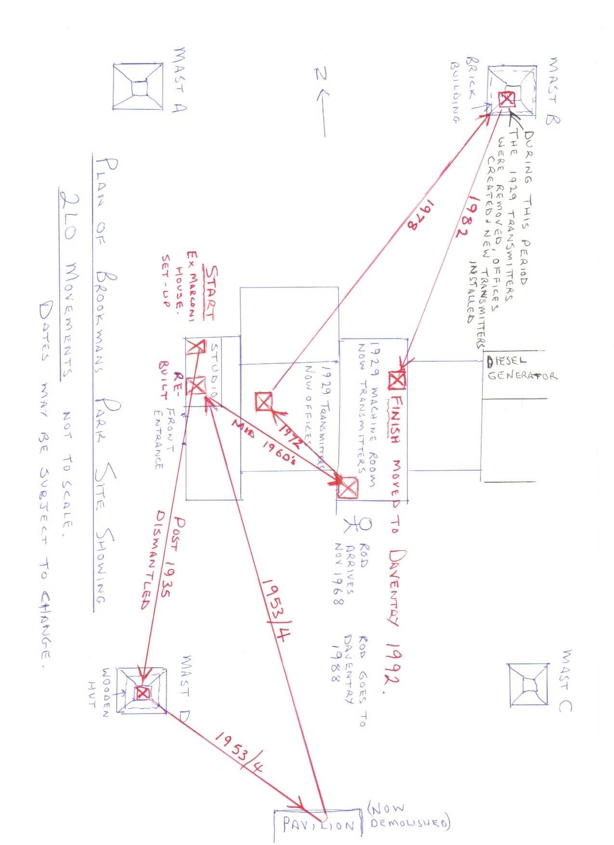
Figure 26 Diagram drawn by R.V. 20/11/2009.

In an article written for the British Vintage Wireless Society Magazine Viveash reflects on his history with the transmitter. The tone of article is, at times, more appropriate for a romantic novel than a history of technology as can be seen from a recollection of his first meeting with 2LO:
In the early 1950s 2LO’s remains were rediscovered and restored by Ray Milligan and Charlie Sutton, helped by many others, all of whom were members of Brookman’s Park staff at the time. I arrived at Brookman’s Park in the Autumn of 1968 as a shift engineer. I’ll never forget the moment when the dust covers were removed and restored 2LO stood in all its glory. It was love at first sight!

The rest of the article describes Viveash’s work with the transmitter: restoring it for television; rescuing it during a purge on old components at Brookman’s Park; assisting in its move to Birmingham as part of the Science Museum handover in 2002; and generally caring for it during his breaks at work. Through these day to day interactions, a relationship similar to that described by Hoskins emerges: a sympathy between object and person. 2LO even gains a gender through these interactions: ‘I thought that I had seen the last of 2LO, until a few years later the old girl followed me and arrived at Daventry’.
The process by which we anthropomorphise or imbue ‘the imagined or real behaviour of nonhuman agents with humanlike characteristics, motivations, intentions and emotions’ has been studied numerous times. Academic studies have considered both the motivations of subjects, and the properties of objects, that stimulate such responses. For instance, people are more likely to anthropomorphise objects with human features, such as eyes and hands. Through the time that Viveash routinely spent with the transmitter 2LO became elevated above ordinary nonhuman entities. Referring to, and behaving towards, the transmitter in a human way allowed him to explain the social forces, and accidents of decision, that kept bringing him back into contact with his beloved object.
This intimate relationship between human and object exemplifies the final way in which 2LO, and ‘things’ in general, develop meaning: through the value of companionship and personal history. In another email Viveash remembers seeing 2LO at the Birmingham ceremony in 2002 saying ‘that was the last I saw of a ‘friend’ I had gotten to know so well.’ 2LO, through this gaze, has shed much of its historical significance and weaved itself through agency, or serendipity, into the life of this engineer. In a final twist, these same forces brought this engineer back together with his treasured transmitter once again; working with it to provide the contents for chapter three.
Conclusion
In tracing 2LO’s journey from its decommission in 1929 to its acquisition by the Science Museum in 2002, chapter two demonstrated, not just how meaningful an object can be, but also how diverse and subjective this meaning is. The power and sense of connection that has been felt with this object is reflected in the expressions of possession and representation. This was manifest in corporations at the highest level, in the form of the BBC, Crown Castle and the Science Museum, through to select groups, such as the engineering community of the BBC, down to the individuals who have worked to repair and preserve it.
Each change in ownership marks a point of reflection for those involved: a reassessment of its value. As this chapter has shown, this has not always been a positive experience. As many accounts as there are from those who saved the transmitter, thereby reasserting its significance, equally there are those who perceived it as valueless. In this dialectic between those who see an historic artefact, and those who see a bulky, heap of junk, can be seen the roots of a controversy that continues to surround our technological, material, heritage.
The strength of feeling on either side of this debate is evident in the examples of both the BBC and the Science Museum. In both cases the rejection and subsequent preservation of 2LO has represented an articulation of wider principles and in the latter action, a defiance of authority. In the BBC, 2LO was preserved in the face of uninterested management as well as the wider context of transmitter privatisation, and an organisation felt to be looking forward rather than back. Similarly in the Science Museum, after originally rejecting the transmitter, it was acquired by a group of curators in defiance of hostile management who opposed all the principles for which they stood. In both these examples, this was not simply a case of preserving ‘the BBC’s first radio transmitter’ it became an articulation of a wider political struggle.
For many pieces of technology the end of their function also meant the end of their existence though this did not necessarily mean the end of the journey. Artist Hito Steyerl, in her film entitled In Free Fall (2010) uses the setting of an aeroplane junkyard in California to explore the current economic climate by focusing on the aeroplanes involved in a number of crash scenes filmed for Hollywood movies. In her narratives it is not just the commodity of the aeroplanes, but that of the materials they are made of, which are significant; drawing on the exploration of capitalism provided by Sergei Tretiakov's 1929 The Biography of the Object.
In Steyerl’s work the object is part of a larger transition of material, brought together by a series of coincidental narratives, continuing to have life even beyond the ‘crash’ which acts as the pivotal moment in the films. This work contrasts with the biographical account of 2LO: whereas Steyerl is chiefly concerned with the separation and dissemination of materials, 2LO’s journey has been dictated by individual efforts to keep these materials together. Only by keeping 2LO together, is the aesthetic connection with the past maintained. This is exemplified by the various stages of restoration and repair that it has undergone in the years since its removal from Marconi House. As an exhibition piece, the meaning of 2LO has been firmly grounded in its ability to connect the audience to the past, and in particular to those early days of radio. The aesthetics of 2LO have been integral to achieving this effect: from the period components, to broken, scarred frame, these allow the viewer to commune with an earlier time, and an earlier 2LO.
The stage of 2LO’s journey explored in chapter two serves to further demonstrate the complexity of the objects interacted with in the course of day-to-day lives. While 2LO continues to fit into an ANT model, deriving its meaning from the actors it is networked with, the material presence of the object continues to reassert itself. The aesthetics of its decay, its size, ‘thing power’ as Bennett would say, has continued to play on the imaginations of those who have interacted with it. But is ‘thing power’ real, or is it merely the projection of our emotions onto an unreceptive surface? Chapter three seeks to address this by removing 2LO (as far as possible) from the networks of meaning described in chapters one and two: re-centering the object and empowering its materials to speak.

Chapter Three: The 2LO Artefact- Mapping an Object’s Experience onto its Materials

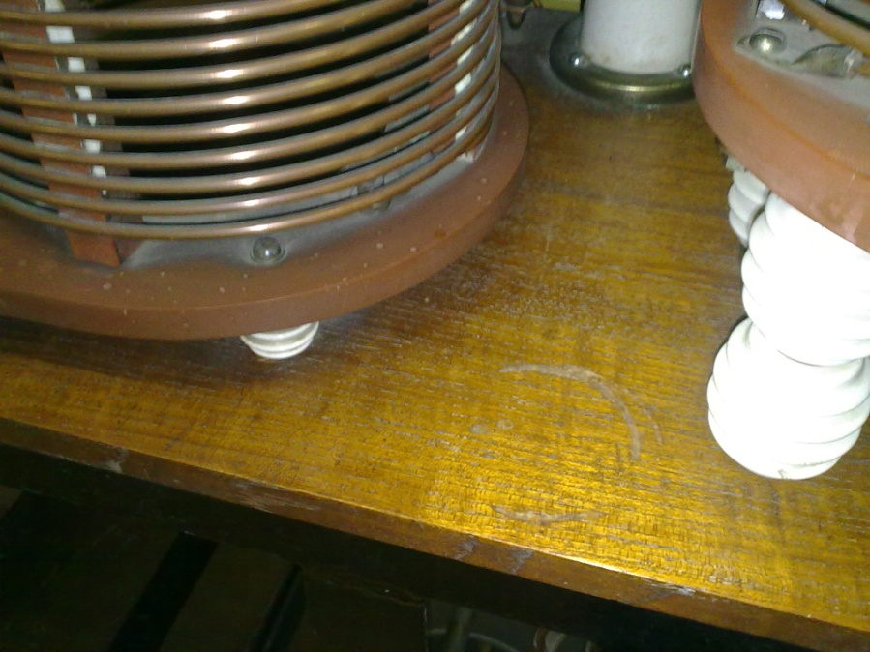
Figure 27 Coffee stain on 2LO, photograph taken 01/10/2009
A light-hearted remark about a coffee cup stain provides the inspiration for this chapter. Working with Rod Viveash, the former BBC Engineer introduced in chapter two, a process embarked on aimed at uncovering further evidence of 2LO’s working life as well as exploring its ‘composition’ and ‘employment’ history. Viveash, as has already been explored, was a former Brookman’s Park employee who worked to restore 2LO in the 1970s, and since then has enjoyed a close relationship with the transmitter. His version of the technical description is included under a separate appendix, along with photographs, and circuit diagram.
To return to the coffee stain, often when working with 2LO, either Viveash or I, would draw attention to a damaged area on a wooden board in the centre of the Master Oscillator panel. On one occasion, when joined by John Liffen, the curator of communications, it was joked, ‘that must be where Viveash put his coffee cup back in 1972! ‘While this story is clearly illustrative of the long relationship that Viveash has had with 2LO, and the personal attachment he feels for it, it also can be used to exemplify a distinct theoretical process. Viveash’s autobiographical connection with this stained piece of wood questions whether an object experiential history can ever really be abstracted from its physical qualities but should instead be traced onto the materials from which it is constructed. In a deliberate reversal of the methods adopted by Law, this chapter cuts the strands of meaning, established in the previous two chapters, and re-centres the object.
This re-centring of 2LO’s physical form is provided precedent by an article by Tim Ingold in which he calls on those who study the material world to change focus from the metaphor of materiality, to the materials themselves. Through this, the artificial divisions formed between mind and materials, human and non-human entities, are avoided. Instead:
...the forms of things, far from having been imposed from without upon an inert substrate, arise and are borne along- as indeed we are to-within this current of materials.

Hahn and Soentgen adopt a similar argument to Ingold when discussing ‘substances,’ noting that the neglect of these ‘basic’ materials can be linked to more general divisions that exist between the sciences and the humanities.
…modernist thought uses the agency of the individual as an indicator of whether or not specific objects have significance, meaningfulness is no longer an attribute of a thing or a substance as such, but rather becomes a consequence of the abilities of the acting individual.

However for Hahn and Soentgen the individual’s power of agency is problematic and overwhelms the defining qualities of the object. It is the ‘attribute of a thing or a substance’ that they and Ingold are so keen to re-emphasise. While it is difficult to divorce an object’s meaning from the external gaze resting upon it (and all the emotion and preconceptions attached to it) some argue that this goes too far. By concentrating unwaveringly on the gaze the material object becomes so abstracted that it eventually disappears. Hahn and Soentgen refer to the work of Bill Brown who explains this through a simple analogy. Brown sees objects as windows: in searching for their meaning we tend to look through them without noticing the glass from which they are made.
For Ingold, prioritising materials also empowers an object, in a way reminiscent of Bennet’s ‘lively matter’:
As the underbelly of things, materials may lie low but are never entirely subdued. Despite the best efforts of curators and conservationists, no object lasts forever. Materials always and inevitably win out over materiality in the long run.

Agency is therefore no longer externalised, or even a matter of exchange, but is concealed within the basic qualities of an object. 2LO is therefore situated in a process of continuous change, crafted from materials such as wood, glass, copper and steel, it stands at one point within the shift and flow of a world constructed of and dominated by materials. This suggestion is not as radical as it first seems. The shifts in 2LO’s history and geography, has seen its physical integrity constantly undermined. However Ingold distinguishes between moments when, for instance, the transmitter was altered by human and non-human forces. The changes he discusses are brought about by forces that are external to, or even oppositional to, human intention. Though why stop at materials, when matter can be subdivided into smaller and smaller elements? Objects can be seen as ordered electrons and protons moving to the rules or whims of the universe.
Practically, however, this emphasis on materials has to be reconciled with a coffee stain on a wooden board. Ingold’s approach offers an opportunity to engage with the minutiae of ‘2LO the artefact’ and consider: the components that construct it; the materials from which these are made; and how they have altered with the passage of time. By questioning the origin of these materials, an unquestionable quality of 2LO is able to be questioned: that this is truly an authentic piece of broadcasting history. Only with this authenticity ascertained can the viewer truly commune with the past the object claims to represent. In doing this, warnings from academics such Cosgrove must be considered: authenticating objects is based on a preconceived idea of ‘the real,’ a notoriously frustrating concept to locate.
‘The real’ represents an artefact’s truly authentic state, and often be an idealised or imagined version. This is a state that is particularly problematic for technological objects seen for example, in the case of Stephenson’s Rocket, described in an article by Peter Mann:
Within the first four years of Rocket’s short eleven-year working life several major physical rearrangements were made, and it was twice repaired after accidents. No original drawings survive which show the details of its construction at the time of the Rainhill Trials. Because of this there has always been intense speculation about the design of the firebox, with everybody dredging every last inference from the limited available evidence.
Of all the objects in the Science Museum, one might imagine that this incomplete holy relic might have been left untouched to survive as archaeological evidence. Far from it, before it came to the museum it was restored by Stephensons (the original builders) to an erroneous configuration which it could never have had in its life. Some of the anachronistic features were removed by 1900. Others were changed in 1929.

As this excerpt shows attempts to return an artefact to an authentic, original state are often frustrated by the constantly revised qualities of technology and the lack of a static ‘real’ moment in its history. The experiences of the Rocket act as a poignant reminder of 2LO’s unfixed state. Despite these challenges, this chapter adopts an archaeological approach, and with reference to the information presented in the previous two chapters, engages with the narratives embedded in the collections of materials that are referred to as ‘2LO.’
Of those few who do advocate the case for materials few actually suggest a methodology to achieve this. Not having studied engineering, let alone specialised in broadcasting, the input of a specialist was necessary to get the most out of this object. Viveash, with his expertise in transmitter technology gained through years of experience as a BBC engineer, and his enduring enthusiasm for ‘all things 2LO,’ was invaluable to this process. Over the months that followed an initial meeting on the 1st of October 2009, we mapped, photographed, measured and counted every component of the artefact 2LO. Following these meetings, Viveash completed a technical description of the transmitter included in Appendix A, accompanied by photographs and a pre-existing circuit diagram: with each component allotted a different number. When referring to individual components in the course of this chapter, this number system will be used for ease of identification and cross referencing.
One of the most challenging aspects, particularly when presented with such a large and inelegant object, is what questions should be asked of it. As well as addressing the deeper issues surrounding authenticity, materials, and material history, this stage of the research was to be of use to the conservationists at the museum and anyone else with an interest in the technical history of broadcasting; particularly as rumours surrounding 2LO’s forthcoming exhibition were rapidly gaining credibility. In the course of this research therefore, informal interviews were conducted with members of the Conservation team at the Science Museum. This gave an insight into the kinds of problems they encountered and what information would be useful to the future care of this object.
In the course of these informal conversations it became apparent that a number of grey areas existed in conservation practice. Decisions made about individual objects were often based more on the discretion of the individuals involved than established protocols. Lowenthal says that because:
…material objects are continuously transformed, every stage in preservation forces choices among these many valid but irreconcilable criteria. No preservation decision is logically right, let alone permanently appropriate.

This is the reality of conservation for both practitioners and theorists. New preservation methods are constantly being developed accounting, in part, for the lack of any substantial conservation policy documents at the Science Museum.
The work with 2LO was, at times, a haphazard process with each new revelation leading to new strands of enquiry. To provide some structure to the time in Blythe House the process addressed the following four questions:
- To identify all the components that make up the 2LO artefact at present and consider their role in the original circuit, as illustrated by the 1971 circuit diagram.
- To see how the present transmitter compares with the only image of 2LO in situ at Marconi House, taken between 1923 and 1929, see Figure 1.
- To locate the interventions made by previous restorers on the 2LO transmitter.
- To identify components which require the attention of present day conservation. In particular, consider whether a number of loose copper wires could/ should be attached to the transmitter in a way that adhere to the structure in the 1971 circuit diagram.
With research questions defined, over a series of five visits to 2LO in Blythe House, each lasting upwards of six hours, evidence of 2LO’s eventful journey was drawn from its materials. A selection of photographs, taken at various stages of its life, and collected since this project began, were used as comparisons with the present specimen. The most significant of these was the photograph taken of 2LO in Marconi House (Figure 1) as it remains the most accurate record of its appearance during its working life. Early on in the assessment images that appeared in Wireless World of 2LO in 1922 in its pre-BBC days (Figures 2 and 3) also provided significant evidence.
However, this photographic evidence was also problematic. For instance the photograph in Figure 1 shows one end of 2LO disappearing into the shadows and despite magnifying, and digitally lightening the image, a large section of the transmitter remained unclear. Further problems were encountered with the version of 2LO’s circuit diagram used. While the 1971 circuit diagram was the earliest one discovered it remains only a reproduction of a 1969 diagram which it has proved impossible to trace. This 1969 diagram had in turn been copied from an original drawing done in 1929.
Other than the 1971 circuit diagram, two others have also been uncovered, however one of these, labelled 1922-1929 was actually a much later, illustrative reproduction of the 1971 diagram. The other, found in Brookman’s Park, also proved to be contemporaneous with the 1971 circuit diagram. The existence of an earlier diagram is alluded to in a note on the 1971 version saying, ‘this drawing is a re-drawn version of M.W.T. [Marconi Wireless Telegraph] Drawing No. TP9966N, Dated 29-10-1969? Obtained from M.W.T. December 1971’ and would have been drawn by Viveash or one of his colleagues when 2LO was being repaired in preparation for the BBC’s 50th Birthday. The 1969 date has no connection with any significant events in 2LO’s life and it is likely that it was originally copied from the 1953 version produced when 2LO was first rebuilt.
One further impediment to the work on 2LO was the process of gaining access to the object. While accessing 2LO as a Science Museum Collaborative Doctoral Award Holder was never in question, the procedure by which members of the public were allowed to visit objects changed in the early part of 2010. This resulted in several months delay before Viveash was allowed, even accompanied, into the stores. Much of the administrative delay was the result of the previously identified risk of asbestos: an ongoing problem for all museums. While the asbestos in 2LO had been immobilised, and was therefore safe to interact with, it had not been assessed with a view to exposing a member of the public to it. The question of access will be engaged with further in chapter four, but, appropriately for this chapter, even this delay provides an example of the power materials can have in dictating real life events. With health and safety assessed (if not guaranteed) the process of mapping history onto materials could go ahead.

- Assessing 2LO’s Damaged Components
As a working technology, and a display piece, 2LO presents a theoretical challenge not adequately addressed by any one literature, and its transition to ruined artefact does nothing to simplify this. As a technological artefact 2LO sits awkwardly between, on the one hand, work on the aesthetics of ruin and decay such as is explored in Edensor’s Industrial ruins: spaces, aesthetics and materiality. On the other, museum studies literature, concentrating on damage in terms restoration, conservation and authenticity, as in the work of Lowenthal, and Reisinger. This section focuses on the components of 2LO that have been broken, damaged, or are slowly disintegrating. Rusted components, sometimes hanging from a single wire; deep scratches in the varnished wood; ancient plastic wrappers slowly unravelling, often have the most immediate visual impact. As such, these alterations to 2LO’s physical state are being considered in terms of an aesthetic, peculiar to old, or ruined, technological artefacts.
Given its age, 2LO remains in remarkably good condition: the result of the care it has received from individual enthusiasts over the years and latterly specialists at the Science Museum. Nevertheless, it is old and looks it. Originally unplanned for levels of mobility resulted in 2LO sustaining damage to both its frame and its components. In some cases this damage has been caused by human accident or intervention, while in others, such as the appearance of rust, this is the result of the materials undergoing a natural change in state as referred to by Ingold. Traditionally damage and decay has been discussed in reference to architectural ruins. The correlation between their physical disintegration and the human condition has been remarked on by academic and fiction writers alike.
A lover finds his mistress asleep on a mossy bank; he wishes to catch a glimpse of her fair face without waking her. He steals softly over the grass, careful to make no sound; he pauses—fancying she has stirred: he withdraws: not for worlds would he be seen. All is still: he again advances: he bends above her; a light veil rests on her features: he lifts it, bends lower; now his eyes anticipate the vision of beauty—warm, and blooming, and lovely, in rest. How hurried was their first glance! But how they fix! How he starts! How he suddenly and vehemently clasps in both arms the form he dared not, a moment since, touch with his finger! How he calls aloud a name, and drops his burden, and gazes on it wildly! He thus grasps and cries, and gazes, because he no longer fears to waken by any sound he can utter—by any movement he can make. He thought his love slept sweetly: he finds she is stone dead. I looked with timorous joy towards a stately house: I saw a blackened ruin.
However a ruin is more than just a metaphor for mortality: having reached a point of ruination it can in turn become timeless, allowing the viewer to experience a length of time beyond human experience, as Trigg reflects:
Having fallen from (active) time, a ruin becomes disjoined from time. The untimeliness is evident in how past, present and future conspire to converge in the ruin. Having outlived its functional existence, the ruin’s persistence in time disproves outright extinction, so compels an unexpected return.

Trigg sees the ruin as having transcended temporal limitations. It no longer represents the past nor does it exist wholly in the present. It is enduring. Cut loose from mortal ties, it exists simultaneously in multiple times, allowing the viewer a brief glimpse of immortality. These words are echoed by Lowenthal:
Prior wear and tear provides comfort as proof that a building or artefact was not created for our use alone or to exert control of us. Its marks of longevity show that we are temporary tenants and caring stewards… in time we leave our own mark, alike enriching and aging any objects.

Reconciling theories of aesthetics, time, space and immortality with an old radio transmitter can feel slightly incongruous. However in considering even the most damaged and unobtrusive parts of 2LO it became apparent that the signs of decay have a significant effect on the meaning of the whole. Chapter two has already explored how visibly aged objects legitimise displays, allowing audiences to be more authentically attached to the past it represents. The desire to replace or reconstruct 2LO’s damaged components is difficult to suppress: a topic that was returned to on numerous occasions throughout the work in Blythe House. However attempts to repair 2LO would significantly alter its form, and therefore its meaning, in turn undermining its ability to communicate with audiences.
Table 2- List of 2LO’s Damaged Components
Table Listing the damaged components of 2LO
Component Number (RV System) | Component Type | Location | Damage Description
55 | Valve type MT7B | Modulator | Lower connection Broken
57 | Valve type MT7B | Modulator | Lower Connection Broken
70 | Holder for Valve type MT4 | Modulator | Missing peg and spring. Cracked ceramic (?) holder
67 | Potentiometer (rheostat) | Modulator | Bottom connection loose and coming away from baseboard
43 | coil marked ‘1/2 Kw type’ | Modulator | Terminal has broken off but in Science Museum Possession.
30 | Speech Choke | Modulated Amplifier | Loose lamination, loose wires. Cover deteriorating.
35 | Tubular capacitor | Modulated Amplifier | Bottom of component loose and at times coming apart.
45 | Large Wooden Voltmeter | Modulated Amplifier | Not attached to main frame.
15 | Valve, type MT2 | Master Oscillator | Upper connections missing, upper support insulator damaged. Insulator connecting 15 and 12 damaged.
13 & 16 | Tubular Capacitors | Master Oscillator | Bottoms loose and coming apart
23 | Coil | Master Oscillator | Ceramic Knob broken off
22 | Reaction Coil | Master Oscillator | Left, Bottom insulator damaged
10 | Capacitors | Rectifier Unit | One supporting insulator damaged and detached.

As Table 2 shows, most of the damage that 2LO has suffered is superficial, having been relatively well cared for over the years. Much of the damage it has sustained was therefore due to the natural result of materials undergoing a gradual process of disintegration. For example, the laminate coating of the speech choke (30) has gradually begun peeling away from the core of tightly wound wires. This damage has occurred since it was placed in the Science Museum store and despite it being in an atmospherically stable environment. The damage to the speech choke was the result of the deterioration of the glue that holds the protective wrapping of the component together. While 2LO was on display in the Smith Centre, the Speech Choke (due to size and weight) was removed from the Modulated Amplifier Unit. During this time it was decided that the laminate wrapping would be glued back into place. This intervention was justified as the repairs would return 2LO to the state it was in when it was brought to the Science Museum. Similarly, damage that had occurred to the tubular capacitors (13,16 and 30), in which the inside of the component has fallen out of its glass casing would be treated in this way.
These repairs would need to be addressed before 2LO in its entirety could be put on display as they would be worsened by further movement. Intervention of this kind complies with Science Museum conservation codes of practice, which in turn adheres to international policy. While this treatment is arguably necessary the museum is facilitating an artificial intrusion into the natural laws of decay. An object in this situation is maintained in a state of suspended animation from the moment it enters the store rooms.
A delicate compromise therefore has to be reached between, preventing an object’s further deterioration, and repairing it to the point where it appears new or compromises too many of the original materials. As Cosgrove says, this is a natural if slightly arbitrary intervention in the life of an object, and rather than become overly anxious, it should simply be acknowledged as such. Despite the lengthy conversations going on behind the scenes at museums, little of it actually permeates into public awareness. Objects in a gallery are already in a heavily constructed, artificial environment, and by not acknowledging the processes that brought them there museums risk abstracting them beyond meaningful engagement with an audience.
Conversations with both the curatorial, and conservation departments, revealed that the degree to which the aging process should be intervened in are often the subject of ongoing conversations. Technological objects are particularly problematic. Most were built to perform a function and an argument could therefore be made for returning it to an original working condition. In many science and technology museum artefacts are in fact regularly displayed in working condition. Mann explains that, rather than showing a disregard or disinterest in the historical evidence these artefacts represent, it demonstrates a reinterpretation of the ethical code museums adhere to:
...whilst paying lip-service to the dominant museum ethic, the Science Museum is in fact acting out a more appropriate, though unexpressed, ethic for technical museums. That more appropriate ethic is that the primary objective of a technical museum is the exploitation of the artefact for the public benefit rather than the simple preservation of material evidence. This change in the primary objective of the technical museum is in turn based on the fundamental change in the assumption of artefacts as material evidence to one of objects as also including functional evidence. What the museum is doing is to accept the destruction of one form of evidence so that another ‘more important’ form of evidence can be revealed by the sectioning and operation of artefacts.

While Mann attempts to explain museums’ practice of running working artefacts he is under no illusion that this is done at the price of destroying potentially significant historical evidence. As this passage shows, technological objects are able to represent the past in more diverse ways than objects preserved purely for their aesthetic qualities. Despite the good intentions behind restoring objects to working order this will always remain a short-sighted approach, as a Group Report from the mid-nineties illustrates:

Scientists, limited by present-day technologies and present-day theory and practice, may be incapable of extracting all the information that an artefact contains. It is therefore desirable to take every precaution to preserve valued artefacts in such a way that future researchers may be able to extract that information. Our ability to do so continually expands. We must take over as our working principle: do the least possible harm to the artifact given present knowledge.

This group’s conclusions mirror those of Trigg, and place the object within a much longer timescale, with ramifications for past, present and future. An object can act as a conduit between an audience, and various other past and future times. However, in the museum, the practice of conservation obliterates the manifestations of the present: repairing the damage incurred within it, and returning the object to a reimaging of the past. Paradoxically, without intervention in the present, the material stories of the past would be lost to researchers in the future. The Science Museum’s official approach to objects reflects this delicate balancing act, with conservation’s web page stating that, ‘generally… the Museum now has a policy of preservation and conservation, rather than restoration, so that the historical integrity of objects is maintained.’
Clavir, in an article discussing the social history of conservation, explains that the aim of conservation is the preservation of material cultural heritage, ‘within an ethical frame work which ensures that the intrinsic nature of the object is not altered.’ Internationally, this intention is summarized with the word ‘integrity’, which Clavir acknowledges, is a term that has never been adequately defined. Instead various sub-categories are used: physical integrity, aesthetic integrity, historic integrity, and conceptual integrity. As the work of Mann and his example of the Rocket show industrial objects remain a challenge to this attempt at classification. To maintain an object’s integrity it is presumed that this preserves in an ideal state for its historical and conceptual integrity to be appreciated. Though in a life of constant change, when exactly 2LO existed in this ideal state, is a matter of debate. Should, for example, the aim be to restore 2LO to its original January 1922 form, or its later November design, when it had been substantially altered for the purposes of the BBC? Again these issues manifest themselves as points of individual contention within the context of the material artefact.
The components which have sustained the most damage are the insulators; these are white, tubular, glazed-ceramic connectors, visible in all the pictures in Appendix A. The majority of these are at least chipped and with a couple have broken away altogether. Replacements for these insulators are easy to find, with Viveash having already located spares in his former place of work, Brookman’s Park. Is the ‘historical integrity,’ mentioned in the Science Museum’s conservation policy better maintained by keeping 2LO as it is, broken insulators included, or should the insulators be replaced: more accurately reflecting the circuit diagram on Appendix A? This is a decision about whether to prioritise 2LO’s conceptual or physical integrity. In putting this problem to the conservation team they were reluctant to commit one way or the other, turning the question back on me, as a perceived source of expertise.
However, the problem of the insulators can, to an extent, be circumvented through an awareness of 2LO’s later history. Many of these particular components date from Brookman’s Park. Given the insulators’ evidential tendency to break many would not have survived into the 1950s. Replacing these insulators with ones that are, not only contemporaneous with the rest of the transmitter, but have been sourced from Brookman’s Park, adheres to both the conceptual integrity of 2LO as being ‘of the 1920s,’ as well as its physical integrity as it was re-imagined in the 1950s. However as this section shows, not all the damaged components can be treated in this way. Physical evidence of 2LO’s age in the form of damage and decay is as important to the messages it can convey to audiences as maintaining a historically faithful representation of its circuitry.
- Authenticating 2LO
The authenticity of 2LO’s components and whether they should remain part of the object, particularly in the case of public display, remains a series of difficult negotiations. Again this is the result of the extensive rebuilds 2LO has undergone at different stages in its life. The idea that heritage can be considered more or less authentic has been the subject of a number of recent studies of material history. Tourism is a focal point for many of these studies: assessing attempts to provide visitors with an authentic experience of a time or place. They question tourists’ experience of history through either museums or historical recreations, such as in Halewood and Hannam’s investigation into Viking heritage tourism. It is the museological idea of authenticity which is most relevance to 2LO. This provides a further opportunity to engage with idea of historical integrity, introduced through Clavir’s work in the previous section.
In an article for ‘Museum Management and Curatorship,’ Prentice presents an unromantic view of the significance of authenticity to museums:
As consumer resources, rather than agents for conservation, museums proffer as authentic an experience as possible of their chosen subject, utilizing objects as media, supplemented by curatorial interpretation designed to inform, delight and provoke. The very acts of removal to museums, abstraction and interpretation of course temper the authenticity which can be offered… Equally this context may no longer exist, or may be otherwise inaccessible. As such, museums may be seen as an early form of commodiﬁcation: creating access and understanding via relics of the past or of items of wonder, and by so doing, conferring value on these relics and items as rare and worthy of attention, conservation and celebration.

For Prentice authentic objects legitimise the institutions in which they are housed, and improve their overall market value. However this also raises an essential point about museum work. Artefacts within museums have been taken out of context and therefore have unavoidably reduced their claim to authenticity. Despite this, seeking to achieve physical and historical integrity should not be abandoned. Much as a connection with the past is facilitated by the visual qualities of an aged object, this object also has to correspond with an imagined version of how it should appear in order to create a ‘real’ experience.
This investigation of 2LO has focused on what the inauthentic pieces communicate about the transmitter’s history and whether they enhance a conceptual understanding of the whole. Out of the transmitter’s long history of physical change a moment when originality, and therefore authenticity could be dated from had to be decided on. The only photograph of the transmitter taken during its working life, reproduced in Figure 1, represents a moment in time that crystallised the object’s historical integrity.
Given the turbulence of 2LO’s life, before this investigation was launched, it was expected that not all the components would be authentic. For example, early accounts confirmed that all the fragile glass valves had already broken by the time 2LO was rediscovered in 1953. The valves were replaced during the same period restoration with spares available at Brookman’s Park. Not all the replaced components had a simple explanation as was the case for a large meter (45) on the Modulated Amplifier. On comparison with Figure 1 the meter in the 1920s is different in appearance from one in the same place at the time of this investigation. This suggests that it was replaced during one of the transmitter’s restorations. There is also the possibility that this meter was replaced during 2LO’s working life, but after the photograph in Figure 1 was taken. However, there is no mention of this component in documentation or later accounts, leaving the matter of its authenticity in question.
This section therefore focuses on two sections of the transmitter whose histories are known: a black panel (8) on the front of the Rectifier Unit, and a large metal plate with connectors, on the end of the transmitter closest to the Rectifier Unit. The function, documentation, and materials provide key clues to the authenticity of both these examples. However, they also demonstrate that authenticity is not always clear cut, and exemplifies the grey areas that make conservation such a difficult practice to define. In each case the issue of defining Cosgrove’s ‘real’ and Clavir’s ‘conceptual integrity’ are key to whether these sections are to be considered as enhancing or detracting from 2LO’s overall meaning.
Facing the transmitter, on the far left hand side, is a black painted, metal panel on the front of the rectifier unit supporting two wheels, one of which turns the choke (9) connected to it. This had originally been part of a group of components, including the now lost rectifier filament transformer, responsible for lighting the filaments of the valves. However the significance of this panel becomes apparent when compared with the Marconi House photograph (Figure 1), where, despite the blurriness of the image, the panel does not exist. If this is then compared with the even earlier photographs from Wireless World (Figure 28) taken before the BBC owned the transmitter, this panel is present. In this photograph the panel sits in the same position as the present day object: beneath the three valves of the rectifier unit. It would also have performed a similar function to the one described in Viveash’s technical description in Appendix A.

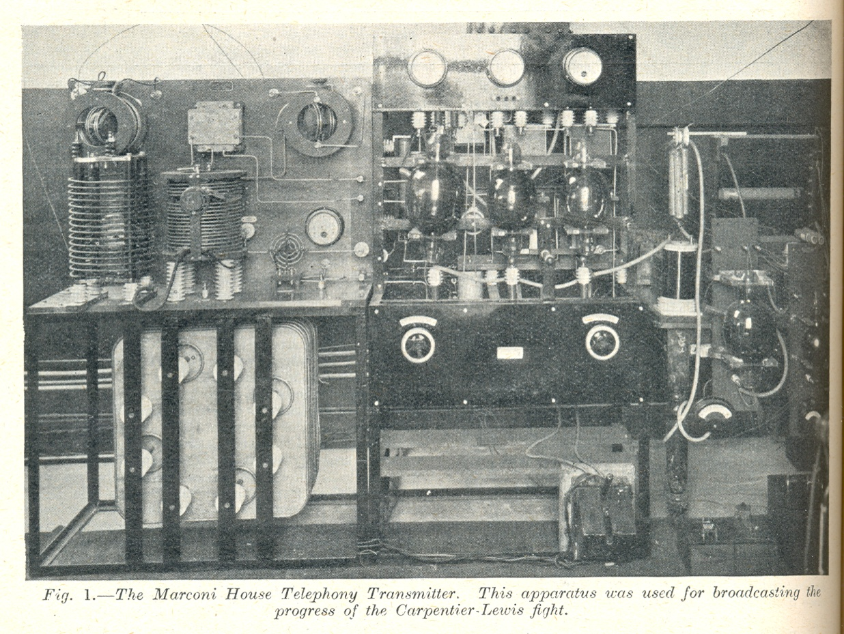
Figure 28 ‘Some notes on Telephony Transmissions’ 27/05/1922, Wireless World and Radio Review Vol. X, 256-258 (see Chapter 1, Figures 2 and 3). Highlighted in the red circle is panel that was incorporated into the Science Museum’s 2LO.
There is no clear explanation for the disappearance, and reappearance, of this panel between the three different versions of 2LO. The most likely explanation is that when Marconi House was stripped of all its transmitting equipment in 1929, some of the pre-BBC 2LO was still present, little time having passed between 1922 and 1929. When all the components were then transferred to Brookmans Park, where 2LO was to be reassembled in 1929, the pre-BBC, and the post-BBC transmitters were mixed up together. While this theory fits the physical evidence, it is also possible that the panel was incorporated into the frame during its initial set up at Brookman’s Park in 1929, or the rebuild in 1953.
That this mistake was made on the later occasion is more likely as those working on 2LO in 1953 were further removed from when the technology was in use. It is unlikely that these later engineers had seen the transmitter in Marconi House, and oral testimonies claim they were wholly dependent on an old circuit diagram, and educated guesses. It is also apparent from the correspondence between senior Brookman’s Park engineers that the only photograph they referred to was Figure 1 in which the rectifier unit is impossible to study in any great detail.
This panel provides direct physical evidence, when contextualised with photographs, of the differences and similarities between the 2LO designed by Marconi engineers in the early part of 1922, and the version improved by Round later that year. Significantly it evidences the existence of a lineage between the two 2LOs, proving that Round’s intervention did take place, despite there being no mention of it in official documentation. The existence of the Science Museum’s 2LO hybrid further proves that it was re-built on at least one occasion and that those who performed this work were unfamiliar with how the transmitter should appear. The existence of the black, metal panel is physical evidence of the interventions made by the Brookman’s Park engineers both in 1929 and 1953. Finally, identifying this piece has revealed that a part of a transmitter, previously thought destroyed, actually still exists.
The second inauthentic piece provides a particularly dramatic example of the effect that human intervention can have on an artefact. It also demonstrates the impact that different cultures of conservation practice can have. Again, facing the rectifier unit and the black panel discussed above, a move to the left hand end will reveal another, larger metal panel bolted onto the main frame. Contained within this panel are four large connectors with flip up lids, see Figure 29.
Figure 29 Image taken on the 16 January 1978 in Brookman’s Park, and later found on site. The end panel can clearly be seen.

According to both Viveash, and Sutton (see chapter two), this panel was fitted to the transmitter during the 1953 restoration so that it could be attached to an electricity supply. Some controversy surrounds whether or not electricity ever actually passed through 2LO during its time in Brookman’s Park. In an article for Ariel, former BBC employee George Saunders recalls speaking with a John Gilman, who claimed to have helped recover 2LO from the shed in 1953. According to Saunders, Gilman was involved in the reassembly, and eventual retuning of 2LO. He goes on to describe what happened next:
It was then retuned, and one night actually worked in a BP aerial after closedown. I understand that power was ‘borrowed’ from various supplies in the building- probably in complete defiance of the Safety Regulations! It worked perfectly, and was successfully tone-modulated.

This is an exciting and humorous story, subscribing to a trope of adventurous early BBC engineers, established since the 1920s. However it is unlikely that it ever actually happened. The Science Museum’s version of 2LO demonstrates, through the existence of this panel, that the engineers did originally plan to attempt a broadcast from the transmitter. In a later Prospero article Ray Milligan, who worked on 2LO in 1953, also describes ‘arranging power supplies from Brookman’s Park’s reserve sources and some kind of safety barrier.’ Milligan was transferred to another site before the work was complete but he does not believe current was ever passed through 2LO. This opinion is substantiated by an interview with Charlie Sutton, who did stay on to see 2LO completed. The fragile state of the components provides further evidence for Sutton and Milligan’s claim. The transmitter had not broadcast since 1929 and had been largely uncared for between 1937 and 1953. As Viveash’s technical description states:
The 500 volts supply from the generator was fed to transformer (2) via the transmitter on/off switch (1) in front of the Modulated Amplifier unit. The transformer stepped up the 500 volts to 22,500 Volts across a centre earthed winding the ends of which connect to the anodes of 2 pairs of rectifier valves type MR6 (3,4,5,6).

In order to function 2LO required 500 volts of electricity but, despite the fragility of the components, there is no evidence on 2LO to suggest that current of this strength had been passed through it. As well as this research shows that 2LO’s circuit is not complete and would not have functioned.
Both these panels raise questions about the historical integrity of the 2LO transmitter. Neither are authentic parts of the BBC’s first broadcast transmitter. Therefore should they be included as part of an authentic representation of 2LO? Both these pieces provide physical evidence of the interventions that have occurred during 2LO’s long life. They provide physical evidence of the events that 2LO has endured. Clavir’s list includes the idea of ‘conceptual integrity:’ a much more fluid concept than ‘historical integrity’. As chapters one and two have shown, the concept of 2LO, the qualities that define it, have evolved, so that it is not just a representation of the BBC first radio transmitter but also the whole pioneering era.
In replacing these parts and trying to revive 2LO’s function an attempt had been made to recapture and reconnect with this nostalgic, bygone era. While these parts remain inauthentic to a historical representation of 2LO they do present an authentic experiential performance of the transmitter. Ingold envisions the world as a ‘current of materials.’ Objects such as 2LO are therefore in a state of constant change, driven by both human, and non-human forces. In this state, there is no single moment in history when an object can be considered a ‘real’ version. Instead, it can be seen as a series of moments along a scale of meaning: blurring the lines between what is authentic and inauthentic.
In viewing 2LO as existing on an unfixed scale of meaning it is appropriate that the transmitter’s physical manifestation should reflect this disparate identity. Closely studying the materials of the object provides a unique opportunity for a deeper understanding of the history and geography it has participated in. Lowenthal claims that, ‘every relic displayed in a museum is a fake in that it has been wrenched out of its original context.’ Retrospectively imposing preconceived ideas about authenticity upon an object does not necessarily result in a truer version of reality. Instead this forces the materials into an imagined version of its identity. Within the museum context, undermining the integrity of an object that has already been ‘wrenched out of its original context,’ serves only to further undermine the qualities that gave it value and meaning in the first place.
- Missing Pieces and what Holds Things Together
While the version of 2LO studied as part of this research no longer represents a complete circuit, it is not far off. Despite the loss or breakage of some of the original parts, replacements are well thought out, and, as the previous section explored, are difficult to categorise as authentic or inauthentic. However, a couple of components, identified on the early photographs, have disappeared and no attempt has been made to replace them. This final section examines three case studies, each of which provide illuminating stories, or frustrating problems for the display of 2LO. These are a large transformer that appears at the far end of the Figure 1 photograph; a telephone that once connected the station to the Savoy Hill studios; and a series of packing cases labelled 2LO.
For years 2LO’s transformer was not even noticed to be missing. It was only following the careful study of the photograph in Figure 1 that a dark oblong was noticed to be standing at the far end of the transmitter (see close up in Figure 30). This large piece of equipment did not correspond with any of the components attached to, or sitting separately from 2LO’s frame. On consulting John Liffen, curator of communications, present at the removal of 2LO from the Daventry broadcasting station in 2002, he recalled seeing this mystery object during the removal. Enquiries were made with the present Daventry engineering team, and the transformer was quickly located, having languished in the station unnoticed, or at least unquestioned for nearly eight years. Despite the ease with which it was found, at the time of writing, the Science Museum had been unable to arrange for the transformer to be reunited with the rest of 2LO. The delay was largely the result of bureaucracy but also exemplifies how even objects with little perceived value can become embroiled in discussions over organisational entitlement and ownership.
Following the privatisation of BBC broadcasting, Daventry was eventually bought by Arqiva, a corporation which describes itself rather obliquely as ‘Leaders in broadcast transmission, media services, communications infrastructure and network solutions for a digital world.’ Since the Daventry engineers no longer work for the BBC, there is no sense of who had authority over this object, and they were therefore unwilling to release it into the Science Museum’s care. Legally the transformer, as part of the 2LO transmitter, is considered to have been gifted to the museum with the rest of the apparatus. However, being on Arqiva property, the onus remains with the Science Museum to prove they own the transformer rather than with Arqiva to prove they do not.
In a surprising repetition of history this leaves it balanced, much as the rest of 2LO was during the 1990s, between two ownership claims. However it is unlikely that Arqiva actually want to keep the transformer. On its own it has little real attraction, with its value only really the result of Science Museum’s interest in it. The real cause of the delay is not the perceived power of the object but an unclear path of bureaucratic responsibility. It remains a question of ownership rather than an assertion of it. Negotiations at various levels within both the Science Museum and the Arqiva organisation do favour the reunion of 2LO with its transformer. The experience of the transformer exemplifies how the movement of materials (or not in this case) is not always subject to human control. One moment of forgetfulness by the human actors, in this case the curators, brought on by stress or time pressures caused a fragmentation in the physical form of 2LO and division in ownership and identity.
The transformer can just be seen in the centre of the circle
Figure 30 Section from 2LO in Marconi House 1923-1929 photograph (see figure 1).
The second component, unlike the transformer, has never been recovered. This is a telephone which connected Marconi House to Savoy Hill and appears in a number of photographs of 2LO. The photographs reproduced in Figure 31 do not make this clear, but after editing the image in a photo editing program the words ‘Savoy Hill’ can be seen on the label of the uppermost photograph. The top image is reproduced from a photograph taken in 1935, while the bottom image is a magnified portion of Figure 1, showing the telephone was present in Marconi House. As chapter one showed, it was the label on the telephone that dated the well known photograph in Figure 1 from after 1923, rather than 1922 as had been previously claimed (1923 being the year that the BBC moved to Savoy Hill and would have required a phone line between the studios, and transmitter, at Marconi House.)
The telephone had remained with the rest of the transmitter during its reassembly in 1953 but on studying later photographs taken in the 1970s, it is notably absent. What became of the telephone remains a mystery. However in the course of this research it has frequently been noted that bits of technology have a habit of going missing. In chapter two Robyn Reynolds described how engineers felt they could claim ownership of the things they had constructed. Rarely were these actions the result of any malicious intent. Given the uncertain future that the BBC’s material heritage had, exemplified by 2LO’s journey, pieces such as this telephone were often acquired to ensure its preservation. However in preserving an object in this way, rather than in a museum, the object becomes a personal souvenir rather than a publically beneficent heritage.

Figure 31 Two images of 2LO's missing telephone to Savoy Hill.

1 | Triode Valve, Unknown make
2 | Rectifier Valve, Type MR4, Post- 2LO Selfridges
3 | Triode Valve, DEM2
4 | Marconi condenser, Type No 60, Metal casing
5 | High Voltage Change-over switch
6 | Broken Insulator
7 | Ammeter RF, Marconi, 2LO spare
8 | Voltmeter, Marconi, Brookman’s Park (BP) era
9 | Ammeter RF, Marconi, 2LO spare
10 | 2LO interconnecting wires
11 | 2LO interconnecting wires
12 | 2LO interconnecting wires
13 | Valve holder
14 | Valve holder
15 | Later insulator
16 | Valve, ex-BP. MW transmitter 1939 STC valve. Type 427a
17 | Valve, STC, Water-cooled, 3Q/260E, BP
18 | Rubber sealing washers for 17
19 | Rubber sealing washers for 17
20 | 2LO filament connecting wires, modern
21 | 2LO filament connecting wires, modern
22 | 2LO filament connecting wires, modern
23 | 2LO filament connecting wires, modern
24 | 2LO filament connecting wires, modern
25 | 2LO filament connecting wires, modern
26 | Cat 6 Water-cooled valve, GEC, BP, 1929
27 | Cat 6 Water jacket.
28 | Water-cooled Valve, 4081a, STC, 1939
29 | 4081a Valve water-jacket
30 | Cat 6 Water-cooled valve, GEC, BP, 1929
31 | 4278A Valve, STC, BP, 1939
32 | Valve, MR6, Marconi, 2LO spare (crated)
33 | Valve, DET3, Marconi, BP, 1929 (crated)
34 | Valve, MR6, Marconi, 2LO spare (crated)
35 | Valve, MT9L, GEC, BP, 1929, 2LO spare (crated)
36 | Valve, MT9L, GEC, BP, 1929, 2LO spare (crated)
37 | Valve, MR6, Marconi, 2LO spare (crated)
38 | Valve, MR6, Marconi, 2LO spare (crated)
39 | Rheostat, 2LO spare based on comparison with rheostat on 2LO currently.
Table 3 listing items unpacked from ‘2LO’ crate
This final example is not one object, but a list of components found in packing cases that accompanied the 2LO transmitter from Daventry to Blythe House, see Table 3. While these cases had been in Blythe House for as long as 2LO had been, they were not opened until the 12th August 2010, when Rod Viveash, curator John Liffen and I decided it would be useful to this investigation. The newspapers that surrounded the objects dated the packing of the crates to around October 1992 coinciding with 2LO’s move from Brookman’s Park to Daventry transmitting station. In Table 3, highlighted in red, are the components that are either contemporaneous with 2LO’s working life or have been identified as being spares on comparison with the original. These components make up less than half of those found in the cases, with many, such as the valve holders and interconnecting wires, being nearly impossible to date.
As with the transmitter, these boxes of components provide a material account of 2LO’s life. For instance Viveash speculated that a broken insulator (number 6 in Table 3) was one that he replaced during one of the transmitter’s many moves. Similarly, these crates contain valves from the period immediately following the Selfridges 2LO, and a number of items from Brookman’s Park, referencing other important moments in 2LO’s history. Not only has the transmitter been scarred by its journey but it has collected baggage along the way. These crates and boxes, labelled with the name 2LO in chalk or marker pen, have in coming to the museum, become a permanent part of this object. Objects as heterogeneous and changeable as 2LO, therefore, have the ability to increase as well as decrease the materials from which they are formed. The presence of the packing cases, as much as the absence of the transformer and telephone question the physical limitations of objects and how lines of definition are drawn.

Having reached Blythe House in this capacity it is unlikely that the components in the packing cases will ever leave the collection. They are now identified as ‘heritage’ despite this only being based on their physical proximity to genuinely valuable artefact. As an appropriate ending to this section, the value of these components gives credence to a comment by Cosgrove:
It is the act of conservation itself that makes an object part of cultural heritage, not the cultural heritage that demands conservation.

Conclusion
This thesis is about the journey of an assembled group of materials. In 1922 there was a crucial creation moment, not just of the idea of the BBC or 2LO, but the transmitter itself. Since that moment, conceptually 2LO has existed, but its structure has been as variable as its meaning. Nevertheless the examples discussed throughout this chapter present a surprisingly cohesive object. For instance with the transformer, despite being forgotten in a distant location for a number of years, the desire remains to reunite it with the whole. The packing cases contain components that stem from completely different origins and yet have now fallen permanently within 2LO’s orbit. What is it that holds these materials together? A return to the question that dominates this thesis: how are objects defined?
In partial answer to this Ingold has urged for an engagement with the materials from which objects are made. While there is no denying that the method has provided valuable insights into the way 2LO is defined there is a sense of incompleteness to the conclusions drawn. Beyond the flow of Ingold’s material ocean, there is a force that connects a displaced transformer with the rest of its transmitter, and underpins the connectedness of the two objects. The introduction to this chapter questioned why, if Ingold is correct, are smaller and smaller pieces of our material world not examined. Any Chemistry textbook shows that beyond the composite materials there are the 118 elements that make up everything in our universe and, within these, even tinier elementary particles.
Latour describes human and non-human actors, all equal, all connected, but nevertheless distinct. In focussing on the elementary parts of our world divisions become blurred and unclear. An occurrence that Bennett explores through the example of digested food, to question at what point the boundaries break down. However, in proving the apparent futility of socially constructing objects it also reveals their merit. Without these collectively imposed boundaries, however fluid, things becomes meaningless. This is to temper rather than reject Ingold’s plea for materials. Inscribed on them (or through them) are traces of age and the physical evidence of the events that an object has endured. The museum, and in particular, conservationists have to consider how important these traces are to the meaning of the object. Only through these careful conversations can lines be drawn, however artificial, between authentic and inauthentic heritage.
In chapters one and two, the object being explored is definitively heterogeneous, with each of its parts playing an equal role in the production of its meaning. Chapter three however, sought to deliberately oppose this wanton fragmentation. As the conclusion to chapter two pointed out, for all the people, the organisations, the spaces, that have defined the 2LO transmitter, the ‘thing’ itself continued to play an important part in the way it was received by audiences. As an object it has a physical presence, experienced through the collective operation of the five senses, confirming that it is real. In a approach deliberately calculated to oppose the methods of Law and other ANT proponents chapter three has sought to re-centre the object.
This chapter has abstracted this object from the interpretations that have played such a large part in this thesis so far, isolating it even from the environment of the stores, where much of this research took place. Rather than the wide view, following the social strands that form a web of meaning, the gaze has remained fixed on the minute details, the components, and the materials. This chapter has demonstrated how significant these details are to the overall narrative of this transmitter and the benefits as well as the pitfalls that come from adopting this type of gaze. In chapter four a wider perspective is again adopted. Following 2LO on its journey through the Science Museum.
.

Chapter Four: 2LO in the Spaces of the Science Museum- Artefact, Icon and Exhibition Showpiece, from 2002 to 2012

The 2LO radio transmitter was there at the birth of the BBC in 1922 - it is truly an icon of broadcasting history. Fortunately it has survived and the Science Museum is proud to acquire such an important piece of our nation's heritage for the national collections .It will be restored by Science Museum experts with a view to put it on display for future generations to marvel at.

Our objects have fantastic stories to tell. But not all of our objects speak for themselves. Our role as a Museum is to help find ways to engage our audiences with them

Other than this I have little else to contribute apart from the obvious point that this transmitter we fondly refer to as 2LO is historically of tremendous importance. Of all the pieces of equipment the BBC might have saved, and they have a terrible record of throwing away just about anything, this would be the one item that should have pride of place. It was the original means of the beginning of an era which was to affect the lives of the whole of our society. I wish you well with your project, and I look forward to the day when 2LO goes on permanent display.

As chapter two showed, 2LO was acquired by the Science Museum in 2002, where it can be safeguarded for future generations to enjoy and learn from. However, since its arrival there have been few opportunities for 2LO to perform either of these functions having spent much of its time hidden in the depths of the museum stores at Blythe House. Access to the stores is by appointment, and is dependent on negotiating the various gatekeepers maintained by the bureaucratic processes of the museum. It is only through the unique and, at times, complicated position as a Collaborative Doctoral Award Holder that easy, and unmediated, access to both 2LO and the storerooms has been possible.
In 2010 a brighter future began to emerge for 2LO as plans were put in place to once again bring the transmitter into the public realm. This chapter considers the ways in which 2LO has been used and presented within the institutional framework of the Science Museum, both in Blythe House, and a recent temporary exhibition in the Smith Centre. It also considers the future plans being laid out for it, in the development of a new Making Modern Communications (MMC) Gallery, which in 2010, moved into stage two of a Heritage Lottery Funding bid, the results of which were announced (just as this thesis was being submitted) in the spring of 2012. By tracing 2LO’s path through these past, present and future spaces, this chapter will also assess the status of objects within the Science Museum; an institution whose often conflicted sense of mission has had a profound effect on the transmitter’s ever shifting identity and public visibility.
One of the themes to run through this thesis is 2LO’s presentation within a variety of environments and the responses of different people, both collectively and individually, to it. As the introduction to this thesis discussed, the emotional response generated through these encounters has led to a consideration of the location and power of affect, discussed by geographers such as Ben Anderson and Nigel Thrift. Traditionally affect sits between an object’s qualities and the emotions it inspires. This affective space facilitates an engagement with the power of an object within different environments. However by connecting affect too overtly with its environment a challenge to the value of an object within a gallery arises.
2LO is presented to its audience with varying levels of interpretation: from Blythe House where there is a small plaque and subtle collections management; to the envisioned MMC, a heavily designed and constructed environment, involving layers of internal and external expertise. These acts of mediation offer one example of constructed affect, and question how active a part 2LO actually plays in these displays. Should it be considered a dead and passive object or should it be seen as innately powerful and active? Jane Bennett describes this inherent power through ‘Thoreau’s notion of the Wild’: ‘…his idea that there is an existence peculiar to a thing that is irreducible to the thing’s imbrication with human subjectivity.’ These debates have become increasingly significant within museums, particularly in the field of Audience Research, which aims to define the magic formula to attract, educate and entertain visitors. My Field Diary records one conversation with an audience researcher:
During the break I had a quick chat with MH about the role of Audience Research. Asked her about the difficulty of making ‘boring’ objects interesting for visitors. Was this just a case of simplifying things? She explained that it was more complicated than that- it was about identifying the level of knowledge at which visitors were at, and the level we wanted them to attain. What were the key messages we wanted to convey to them to achieve this step? She said ‘most people require our [Science Museum] intervention in order to have a meaningful and memorable experience with our objects.’

As new technologies, such as interactive computer screens, become more sophisticated exhibition designers are able to place objects within increasingly ornate layers of mediation, facilitating wider audience engagement. These approaches have also been criticised, with the rise of the ubiquitous term ‘dumbing down,’ inspiring strong opinions on either side of the argument. If the emotional effect of objects could be artificially reproduced, then is the presence of objects in exhibitions an unnecessary, and costly, extravagance? As chapter three explored, questions of authenticity and authority have followed 2LO throughout its life, and it is unlikely that this debate will ever be settled. To further complicate the issue 2LO has entered an institution which has yet to come to a coherent decision on the value of its own collections.
Within the Science Museum 2LO’s main function is that of a display piece. In this position its interaction with its environment is more important than ever before. Therefore this analysis has been structured around both the museum spaces it has occupied and those it will occupy in the future. This chapter moves from the secluded halls of Blythe House, to the corporate advertising platform of the current Smith Centre exhibition, and finally into the future, imagined space of the MMC Gallery. This chapter draws on ethnographic observations of the development of both galleries and visits to Blythe House. In the course of these observations, both the role of ethnography when studying museum processes, and the, at times, conflicted position of a Collaborative Doctoral Award Holder are reflected upon.
In adopting this methodology it is impossible to ignore the work of a previous ethnographer at the Science Museum, Sharon MacDonald, whose observations of the development of a food gallery in the late eighties opened ‘a fascinating window onto into the rarely seen institutional workings of museums.’ Referring back to the research into 2LO’s journey described in the previous chapters, chapter four considers how its different narratives and meanings have become interwoven with the themes of the Science Museum’s public and private spaces.
- The Dialectics of the Science Museum
In June 2010 the Science Museum was undergoing a period of introspection and reflection as the year 2009-2010 marked the museum’s centenary. Amongst the more public celebrations a new history of the Science Museum was published. This collection of essays reflected on different periods in the institution’s history. The divisions that exist within the museum soon became apparent on spending a significant period of time within the institution, and as the centenary book shows, were not a modern phenomenon. Though at the time of writing, rifts had re-emerged, in the face of the austere future faced by all heritage organisations and the 10% cuts the Science Museum in particular had decided to make.
In October 2010 the British government cut funding to national museums by 15% yet maintained the policy of free entry. Museums such as the Science Museum were therefore forced to look for other sources of funding, such as the Heritage Lottery Fund, Research councils, corporate and private donors. Attracting external funding is often dependent on a clearly articulated mission and a firm brand. Part of this brand has to include evidence of the institution’s role within the culture sector. Using the example of the British Museum, Caldwell demonstrates how its collections policy, and the strength of its scholarly research, both contribute positively to its brand, and through this, its ability to attract visitors/ investors.
However the Science Museum remains divided over what the mission of a museum of science and industry should be. In the centenary book, Science for the Nation this debate is frequently returned to, and generally coincided with the appointment of each successive director. In a chapter exploring the book’s most recent period Tim Boon sums up the substance and longevity of these debates:
If it is possible to discern in the Museum’s own history a dialectic between the history of science and technology on the one hand and science communication on the other, then it is also necessary to note that the two sides of the argument have taken different forms since 1857.

As Boon shows, controversy rests on whether a science museum should be representing the history of science and technology, or the most up to date debates and discoveries. While Robert Budd dates the beginning of this controversy to the period immediately following the1851 Great Exhibition (specifically in relation to audience) most of the authors refer to the 1911 Bell report as a defining moment in the museum’s sense of purpose. It was this report, written by the Departmental Committee on the Science Museum and Geological Museum, which first articulates a clear mission. Crucially, while generally this report repeats the Science Museum’s educational role, it also states that ‘the Museum ought also to be a worthy and suitable house for the preservation of appliances which hold honoured places in the progress of Science or in the history of invention.’ In the years that followed, each subsequent director has positioned themselves in reference to this statement, either in support or opposition to it.
For instance, the ‘interwar Science Museum presented the history of science as the cornerstone of the history of civilisation, as a history of mankind’s largely interrupted progress’ while in the 1960s, responding to media criticism, the museum swung strongly towards contemporary science and ‘blockbuster exhibitions.’ In the late nineties and 2000s there has been a firm move back towards contemporary science, following the Public Understanding of Science movement, which aimed to increase the basic understanding of scientific principles. However the history of science approach has never completely disappeared. To quote Boon again, two of the most recent permanent exhibitions demonstrate the opposing schools of thought that continue to co-exist within the museum:
These twin gallery openings expressed the dialectic at the heart of the Museum’s enterprise in the concentrated form: whereas the Wellcome Wing is highly interactive and fast paced space ‘Making the Modern World’ was deliberately slow and contemplative; the Wellcome Wing was contemporary and Making the Modern World was historical...

However, the conflict experienced in the course of this CDA cannot be entirely explained by historical precedent. Among the curatorial team was disillusionment about upper levels of museum management; the internal politics dictating the contents of the museum floor; and a general feeling that their skills were undervalued or unappreciated. The advertisement of permanent posts for the MMC Content Team captures many of these feelings:
The roles for the Content Team have been circulated by email. Disappointment was the general feeling to greet this initially- the salaries were much lower than expected. Much lower than those advertised for Climate Change which for some seems to show where the museum’s priorities are.

This centres particularly on the collections and a feeling that the museum is no longer interested in objects or funding research into them. There is some justification for this, curators’ time is often dedicated to content writing for short exhibitions, with little surplus time to manage and research the collections or to produce publications. It has been remarked, on more than one occasion, that ‘if you look at other museums they have sabbaticals if they want to write a book or a paper, imagine that, there’s no time here.’ These feelings are not restricted to the curatorial team: during a conversation with members of the conservation team it was with some sadness that they recalled the size and vibrancy of the workshop as compared to its much reduced state.
Chapter two described how 2LO’s entry into the Science Museum coincided with a period of turbulence and uncertainty for the curatorial team brought on by the arrival of new director Dr Lindsay Sharp. It further showed how one of his policies introduced an object moratorium: a suspension on the collecting of objects while new rules were drawn up. Tim Boon, Head of Collections at the time describes the effect that this had:
Curators were outraged (which may have been part of his intention) and they initially determined to pay no attention. But, slowly, curators began to devote less and less time to collecting, which had been a core activity, netting in an average year something like 1,000 objects. By the time Sharp’s contract was not renewed, collecting had dropped to a very low ebb and it continues at this low ebb, despite attempts to stimulate it.

This moratorium, as well as the large numbers of redundancies that followed, had a lasting impact on collecting policy within the museum. In 2005 Sharp’s departure from the museum was as controversial as any other period in his directorship:
There may be ructions in the boardroom - Lindsay Sharp, director of the National Museum of Science and Industry for the last five years, has unexpectedly announced his departure, after complaints about Disneyfication, dumbing down and management style - but the show must go on...

The perceived attack on collections, and emphasis put on ‘Disney-style’ attractions, had a long term effect on morale, and as a tangential consequence, has significantly reduced public access to the museum’s collections. Further to this, it has affected the brand of the museum, with a perception that the museum is a destination for children rather than a serious research institution. In the years following Sharp’s departure, the focus on modern science and showmanship, was continued by his successor Chris Rapley. On his appointment he made his intentions for the Museum’s direction clear in an interview for Time Out magazine:
Rapley’s remit is a simple one, he says: to make London’s Science Museum the most advanced in the world. ‘I can only do that by addressing the most important scientific issues of the day,’ he adds. ‘Climate change and energy policy are clearly our most pressing concerns, of course, though there are many others – stem cell science, genetics, and modern agriculture, for example – that we need to get involved with.’

During Rapley’s time, however, there were efforts to stimulate research around the collections, not least the establishment of a number of AHRC Collaborative Doctoral Awards such as this one. The arrival of a new director in 2010, more about whom will be said later, brought fresh hope that the link between research, collections, and exhibition will be fully re-established. Though the museum’s ability to create long term goals is also dependent on its sources of funding which is by nature piecemeal and short term. However this has been drawn to the attention of the Research Councils and it is remains to be seen whether the funding structure will respond to these necessities.
Latour has shown that when engaging with the sociology of scientific production both the ‘social’ and the ‘technical’ aspects of the process should be engaged with. A museum is no different with the technical aspects equivalent to the objects and other materials that make up the exhibition space. 2LO, like every other Science Museum object, is networked into the political environment of the museum and thus subject to the predominant political culture. As the next section shows, being part of this kind of network can have a dramatic effect on the definition of the object, as well as the access to, and influence of, it.
- The Role of Objects in Museums
The German word ‘museal’ [museumlike] has unpleasant overtones. It describes objects to which the observer no longer has a vital relationship and which are in the process of dying. They owe their own preservation more to historical respect than to the needs of the present. Museum and mausoleum are connected by more than phonetic association. Museums are like the family sepulchres of works of art. They testify to the neutralization of culture. Art treasures are hoarded in them and their market value leaves no room for the pleasure of looking at them.

This paragraph from Adorno’s ‘Valery Proust Museum’ has been referenced in a number of critical engagements with the work of museums. For instance, Beth Lord, in her article, ‘Foucault’s Museum: Difference, Representation and Genealogy’ uses Adorno’s comparison of museums with mausoleums, to illustrate how twentieth century philosophers rebelled against the hallowed status of the museum. Tony Bennett in his book Pasts Beyond Memory sees Adorno’s quote as illustrative of the close relationship between the museum and death. In Bennett’s work this is a literal relationship as he explores natural history collections made up of objects that were once dead creatures. Generally it is the comparison between ‘museum and mausoleum’ that facilitates a discussion about the cultural role of museums, questioning whether the abstract environments they create has a terminal effect on an objects meaning.
On entering a museum an object has moved beyond its intended purpose and entered into what, Benjamin describes as, its ‘Afterlife’:
Afterlife refers to the patient process of disintegration and ruination in which the object emerges from earlier contexts, shorn of some of its original features but with new accretions upon it. Afterlife is the period in which the pure but deceptive surfaces of the object are eroded, in which hidden meanings are unfolded and truth is ultimately disclosed. It is the time in which the object is subject to transformations and interventions which re-cognize its significance and ’actualize’ its potential: translation, transcription, imitation, criticism, appropriation, (re)construction, reproduction, remembrance, redemption.

Benjamin sees this post-functional existence as peeling away layers of physical and contextual identity, leaving a truer version of an artefact. In this sense, objects in museums reach a truer meaning than at any point since their creation. This process is not limited to its entry into a museum. As chapters two and three have shown, 2LO was undergoing a process of ‘disintegration and ruination’ many years before it entered the museum. Despite the positive light in which Benjamin casts the word ‘afterlife,’ there is still the suggestion that museum objects experience a terminal moment, and a departure from life. Taking Benjamin’s ‘Afterlife’ and Adorno’s idea that an artefact is ‘in the process of dying’ this chapter will question how the definition of an object changes on its entry into a cultural institution. Is the museum’s function simply that of a mausoleum or does it maintain a more active relationship with the objects it houses?
As the previous section showed, objects have not automatically enjoyed a high status within the Science Museum despite the significant historical value of its collections. The appearance of an object on the museum floor is therefore dependent on present interpretations of the institution’s mission. The debate over the role of objects in science institutions is not restricted to the Science Museum, as can be seen from the establishment of national organisations such as the Committee on the Public Understanding of Science (COPUS) in 1985. This organisation established working parties to investigate those institutions involved in perpetuating the public’s understanding of science and technology. Adorno refers to objects in museums as something ‘the observer no longer has a vital relationship with.’ The legitimacy of this claim remains fundamental to whether objects have a place in science museums. By following 2LO through the different spaces of the Science Museum, this chapter will consider what effect the entry into its ‘afterlife’ has had on its meaning, and its relationship with an institution that remains unconvinced about the importance of its objects.
- Blythe House, the Science Museum Stores
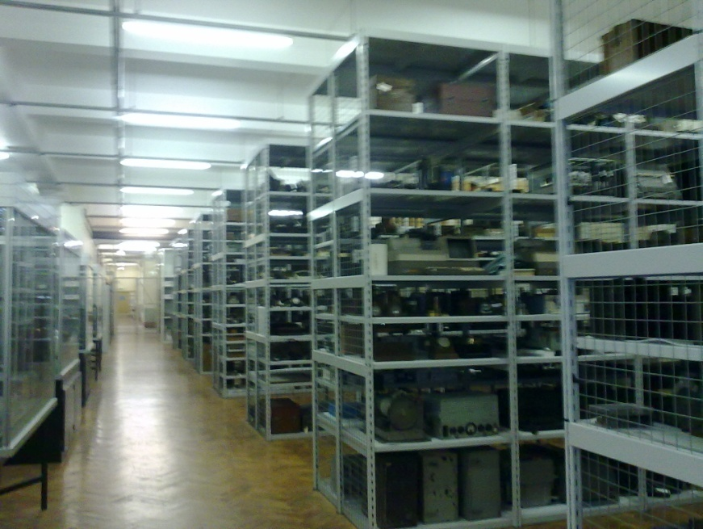
Figure 32 Photograph taken from inside storeroom F30C, Blythe House, 12/04/2010.
While chapter three is contained almost exclusively within the Science Museum stores at no point does it look up from the substances of the transmitter and engage with the environment in which it has been placed. The exterior of Blythe House gives little clue of the treasures that lie within: formerly providing office space for the Post Office Savings Bank, it is a vast building sitting unobtrusively behind the even larger structure of the Olympia exhibition halls. Visitors enter through a nondescript gate, and, having negotiated security, are ushered into a labyrinthine space, with rooms that are little more than cupboards to expansive halls. Within this network of rooms, are a plethora of objects representing every aspect of science, technology and medicine from the last 200 years. Housed within this building are more than just the Science Museum collections, but also the greater part of the V&A and British Museum collections.
Collections are significant not only because of the wealth of information they contain but because they define the institution that cares for them. In the case of science institutions, collections have a particularly strong definitive quality:
...the differences between science centres and science museums are rooted firmly in the single distinction between the two types of institution which deserves to be fundamental: science centres do not hold collections of scientific artefacts (instruments, tools, equipment etc) for the benefit of posterity, and science museums do.

An obvious starting point for this research was to visit the transmitter in its present home. A field diary entry records my first visit:
Each room seemed to open into another and then another, with objects representing the weird and wonderful as well as the utterly mundane, coming to light at the turn of every corner. In one room we found a collection charting the history of the razor, in another an airborne camera from the 1960s, designed for monitoring the battlefield, which could easily have been a prop in the War of the Worlds. The effect of this odd collection of objects within these silent halls was often unnerving. I said to John at one point, that if I lose him they would never find me again- I think I was only half joking! At one point we visited the sound recording collection, kept in a string of increasingly small rooms, no windows, silent, cool and what felt like a million miles from anywhere.

These impressions are not unique, following a guided tour of the collections, a group of teenagers were asked to describe the building, and came up with words such as ‘James Bond-ish, atmospheric, creepy.’ Hilary Geoghegan made similar observations on a tour of Blythe House in 2006 describing it as ‘enchanting, engaging, and awe-inspiring, but also mysterious, evocative and unruly.’ Emotional experiences of buildings, such as these, have frequently been engaged with by geographers. In a paper investigating a Milton Keynes’ shopping centre as a consciously assembled environment, Rose et al dwell on the emotions experienced by shoppers, as a means of engaging with constructed affect of the building. The atmosphere of Blythe House stimulates feeling of being inducted into a secret world, a private club, a privileged and guarded space. In David Dimbleby’s ‘discovery’ of 2LO in the stores, it is the setting that informs the audience of the objects’ value, giving them an impression of entering into a secluded treasure house.
These impressions are not unfounded; members of the public were only allowed into Blythe House by pre-arranged appointment, following security clearance. This is in distinct contrast with the free and accessible environment of the main museum at South Kensington where members of the public are encouraged to walk in off the street. Researchers have been able to access the collections without supervision, but this follows a carefully established relationship between the individual, and the curatorial staff. Most of the objects in the stores remain on open storage, and so could easily be touched, broken, or even stolen, clear justification for this level of security. However, is the air of exclusivity and privileged access that permeates the objects in the stores, really appropriate for a publically owned, national collection? A problem that museums in general have yet to solve: though with increased investment in the digitisation of collections web access may offer a way forward.

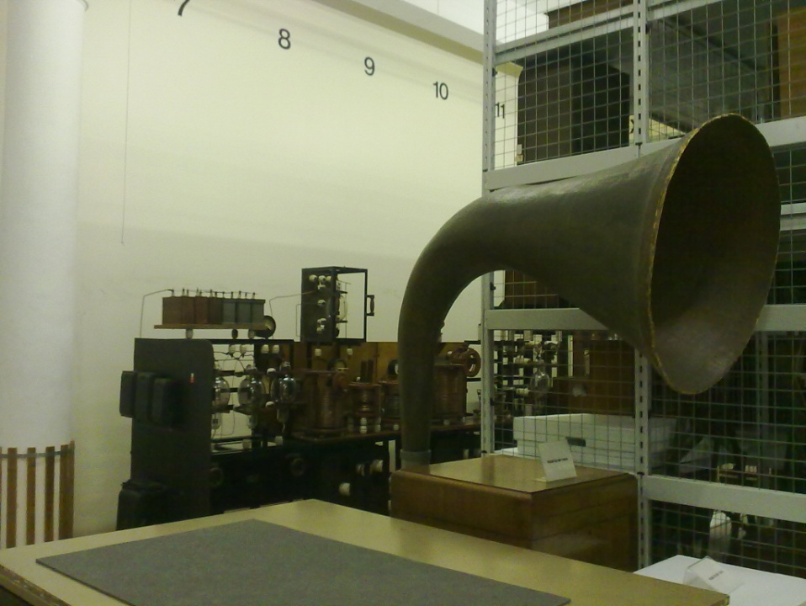
Figure 33 Photograph of gramophone with 2LO in the background, Blythe House, 12/04/2010.
Focussing on the particular location of 2LO and the telecommunications collection with which it is housed, the relationship between the object, and its immediate environment, can be considered. In this three-way network (object, environment and viewer) meaning is both given and received. Unravelling the meaning of 2LO is therefore reliant on an engagement with the other parts of this network. Alongside the building it is the collections that contribute the most to the environment of the stores. Field diary of first visit, 28th July 2008:

We came to the end of our tour- 2LO and the telecoms collection. 2LO is kept in a storeroom on the first floor of BH, on entering the building the room is reached by walking along a corridor and up some winding steps, passing through a locked gate. The name of this particular store was F30C- a quite large space it is lined with shelves that reach from floor to ceiling, and which provide a comprehensive account of the history of communications technology in Britain. John told me that in 2LO’s storeroom alone there are over 1800 objects! As we walked along the central aisle, switching the massive overhead lights on, these objects, invaluable in their own right, seemed almost to act as a visual introduction to the transmitter I had come to see.

This strong sense of narrative amongst the objects is not a coincidence, as Roger Silverman says:
An object is nothing unless it is part of a collection. A collection is nothing unless it can successfully lay claim to a logic of classification which removes it from the arbitrary or the occasional. In its work of collection the museum provides both a model for, and a echo of, the work of consumption in which we all engage, extracting from a world of commercial values, objects which gain their meaning by their inclusion in our own symbolic universe.

Silverman argues that museum objects develop meaning through a collective biographical process, as is further explored in the work of Igor Koptyoff. Silverman describes these meaning-generating biographies as reliant on an interweaving with the multiple other object-biographies within the museum collection and which collectively generate a coherent narrative. Therefore, 2LO can be understood not only as an object insulated in its own unique identity, but also as an object networked into a collective of other objects, each with their own story and meaning. One way in which 2LO justifies the care it receives from the museum is through its place within one of these networked collections. By interacting with these other objects, 2LO produces meaningful narratives, which in turn benefit and facilitate museum displays.

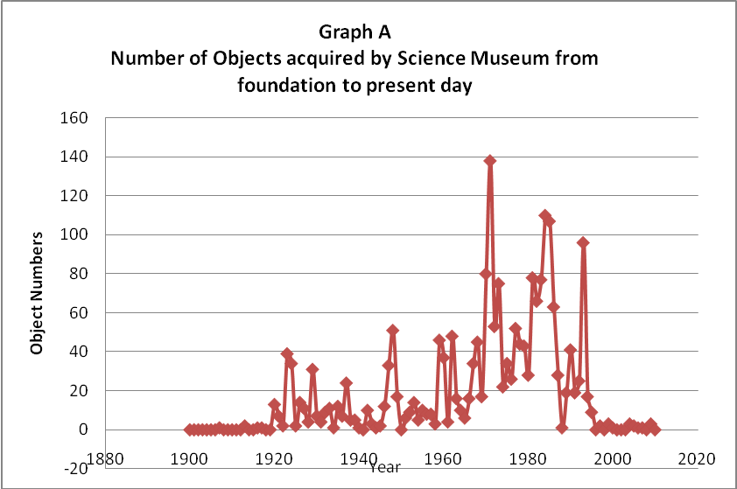
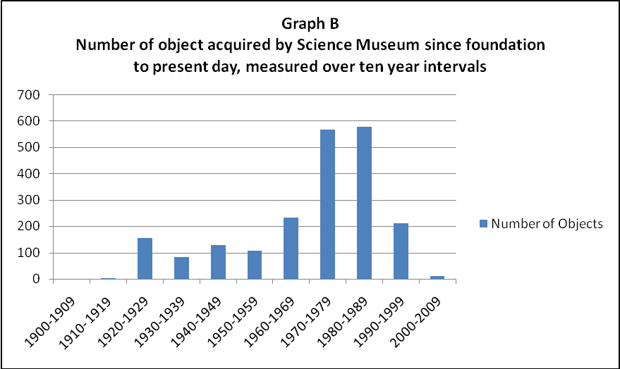
The radio communication collection, a sub category of the telecommunications collection, (to which 2LO belongs) presents the researcher with particular challenges. It is made up of a plethora of objects, including household radio receivers, transmitting equipment of every size, and military communicators. Like much of the Science Museum’s collection, objects were either acquired at a revolutionary moment; when there was a surplus of particular technology or if they have retrospectively gained historical significance. Objects have been both purposely sought out by curators and donated into the museum’s care by families or organisations. That a collection should be selective and self-limiting is a concept that was only adopted by the museum relatively late in its history. Though as early as the end of the nineteenth century the Museum was being ‘encouraged to weed its collections to ensure obsolete artefacts did not accumulate.’
Using Mimsy, the Museum’s object database and noting acquisition dates of all the objects within the radio communication collection, key moments within the collection were revealed. This does not date when the objects were created but when they were brought into the museum. This brief study therefore reveals museum acquisition patterns rather than how representative the collection is of the history of radio communications. Graph A shows the numbers of objects collected in each year while graph B shows the number of objects collected at ten yearly intervals. Of the two, graph B is the most useful, as the number of objects collected in some years makes graph A difficult to interpret.
Unsurprisingly, the number of acquisitions rises dramatically in the 1920s, when radio had peaked in popularity. Similarly, as the interest and developments in radio began to plateau, so acquisitions dropped in the 1930s. Before the 1920s, radio broadcasting hardly existed in Britain, and it is indicative of this change that the first significant increase in collecting occurred in 1923, the year after the establishment of the BBC and 2LO began broadcasting. Another factor was the appointment by the Science Museum in 1922 of Roderick Denman to the position of ‘Assistant for the Electrical Communication collections’ who concentrated on telecommunications. Previous to this, radio was part of the Machinery and Inventions Division who, as their name suggests, had a much wider remit. While there are artefacts in the collection which date from before this period, they have been acquired later, again reflecting contemporary enthusiasm for the subject.
The next big peak in the graphs appears in the latter half of the 1940s following the Second World War. At this time, the museum acquired a large amount of communications equipment used in the war, and again the number of acquisitions drops away into the 1950s. There is an inexplicable jump in acquisitions during the 1970s and 1980s. This is explained by the opening of a series of radio and television galleries: 1971 Telecom gallery, 1980 Television special exhibit and 1983 STC centenary exhibit. The biggest peak, occurring in the 1980s, is explained by the documentation department catching up with the high number of acquisitions made in previous years. This highlights one of the flaws in a survey that relies on acquisition dates, and if a more comprehensive review of a collection were to be done, many other factors would have to be taken into account. The leap in the 1980s is almost as dramatic as the drop in the 2000s: a striking illustration of the impact that Director Lindsay Sharpe’s ‘Collecting Moratorium’ had on acquisition. As graph A shows, in recent years acquisition has not returned to previous levels. Interpreting this collection is an on-going process and defined by different criteria for each new exhibition. 2LO’s relationship with the collective radio communications narrative will be explored further through the specific narratives of the MMC gallery. In this context the power of these objects becomes apparent, and it is their stories that ultimately dictate the grand narratives of artefact led galleries such as this one.
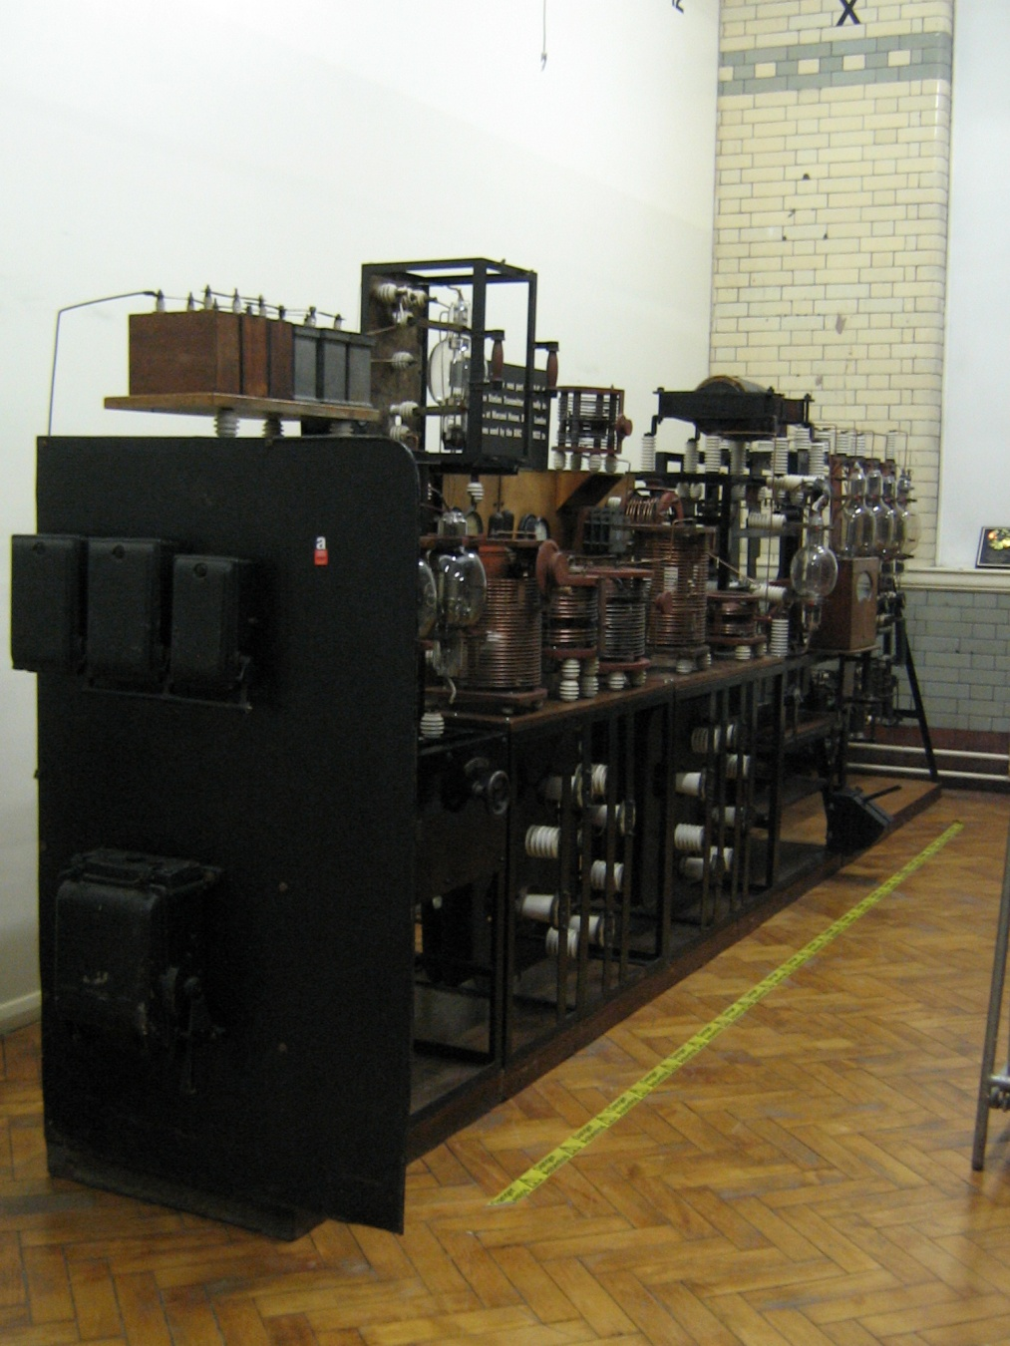
Figure 34 Photograph of 2LO in Blythe House, 30/04/ 2009.
In Blythe House, 2LO is located at the far end of F30C and appears almost unexpectedly around a corner, slotted into a narrow space between a shelf of radio receivers and the wall. As John Liffen, the curator of these collections describes, its position in this space and within the radio communications collection in general, was the result of careful planning, and some luck:

I was now starting working under Doug Millard a very enlightened senior curator, who allowed me the time to do a massive reorganisation of the stored collection at Blythe House. I was well on half way through that when the time came to retrieve 2LO from the new white city. And I talked it over with Barry Marshall [head of logistics and object handling at Blythe House] because at that time the store position in room G44 at Blythe House which we’d used when it first came back and we’d had the presentation, was no longer available to us. We didn’t want to take it to Wroughton, because we felt it was too delicate and fragile and also likely to be of interest of people in store. But it’s a big object for Blythe House but we took our measuring stick and Barry said you could get it in at the far end of F30C....we took a tape measure to the far wall, and it fitted! It fitted beautifully! And that was our project, and that helped me plan the way I organised the reshelving of the collection because I then decided if 2LO could go up against that back wall (which would be perfect) we weren’t planning to put new rack there, which was ideal. And that the racking opposite, I would make that my broadcast receivers rack, so that was to make something that was a real feature in the store. So the planning of the shelving worked round to accommodate 2LO in that position. We went to White City, put it on the van , brought it back, set it up in its new position and this time we put the voice choke into position on top of the modulator panel, to make it more complete. There it is to this day...

As the interview with Liffen demonstrates, the impression that the object on the shelves ‘seemed almost to act as a visual introduction to the transmitter,’ was the result of a careful system of planning based around the position of the 2LO transmitter. In this description the importance of 2LO’s physical shape is again apparent: its size and delicacy dictating both its geographical location within Britain and its position within the stores. It is also clear from the enthusiasm of the curator; the organising of the stores around it; and its being of ‘interest to people in the stores’ that even though not on public display, 2LO continued to be a prized object within the Science Museum. The careful thought that has evidently gone into the layout of this store contrasts with the ‘unruly’ space that Geoghegan described during her visit. However, this remained a system dependent on expert knowledge and insider information: to the untrained eye the logic imposed on the stores is not readily apparent.
That 2LO was in a uniquely, exclusive environment was underlined by the conditions it was kept in when this research began:
First view of 2LO was a little tricky, as it is currently behind a curtain of plastic sheeting. The reason for this is that asbestos has been identified in the valve holders so work is being done on it to stabilise it. There are stickers all over the transmitter saying ‘Danger Asbestos’ which makes you feel as if your approaching a bomb rather than an 80+ year old radio artefact. Got some pictures, see digi cam, but these had to be taken from on top of a ladder looking down over the plastic sheet so not sure how useful they’ll be. Amazing to finally see it though, even if it is in hiding.

Seeing 2LO behind plastic sheeting, and brightly marked with warning stickers, echoed its time in Marconi House, when again marked with ‘Danger’ signs, it was capable of a lethal shock of several thousand vaults. More generally, it provided a strong visual reminder of the environment of the store rooms as an unmediated, guarded space. In this condition, a piece such as this, could not be viewed by the public on the museum floor. It was only the peculiar conditions of the store, and my status within it, that allowed for such free interaction with the object.
That history was repeating itself gave the impression that 2LO was at home in the storerooms. During its working life it was, by design, a secretive, hidden piece of technology; its physical form kept well away from the public eye. As chapter one showed, access to the transmitter was generally restricted to a few BBC employees. Accounts such as those by Arthur Burrows demonstrate the same sense of mystery, and privileged access, in the presence of a technology that communicated with thousands of homes across the country. This experience is recreated within the museum stores, where it is also necessary to successfully negotiate a way through bureaucratic channels, in order to enter a similarly dim, enclosed and remote space.
This environment also contributed positively to the success of the official handover ceremony held for the transmitter on the 14th of November 2002, marking the date of its first broadcast, and following the main 80th birthday celebrations of the BBC in Birmingham. The theme decided on for the event, as a video taken on the night shows, was a recreation of an original 1920s BBC broadcast. To enhance the authenticity of this experience the museum hired an actor to play the part of a BBC presenter and host for the evening, even setting him up with a contemporary microphone which, though not of Marconi manufacture, was distinctive enough to place the audience in the correct era. The evening featured talks from historians and engineers on discussing the history of 2LO and its technology.
Rose et al refer to the relationship between material environments and emotion as ‘building events.’ Both Rose’s example of the shopping centre, and 2LO’s evening at Blythe House, demonstrate the extent to which the experience has been constructed. Steve Pile describes how, in reference to the city, ‘Thrift passionately argues that affect is being actively engineered, such that it is becoming increasingly akin to the networks of pipes and cables that are already part of the technological unconscious of the city.’ The ability to control the affect of the environment can be used to deliberately encourage a particular emotional engagement with a place or situation. Significantly this can render the experience of that environment more memorable. In terms of the Blythe House evening event the environment of the storerooms had been altered to make 2LO more engaging. While the position of objects in the storeroom had been guided by a subtle, pervading narrative, as described by Liffen, the interpretation in this event had been designed to be deliberately overt.
Analysing the affect of a place is problematic not least because of the subjectivity that it relies on. The positive comparison between 2LO in Blythe House, and the atmosphere of Marconi House, are the result of the personal experiences of someone who has researched, and developed a personal relationship with, this object. No two experiences are the same. Silverstone describes objects as simultaneously occupying two spaces within the museum: a present, physical, structured space, and a distant, imagined space where the object has or once had significance. It is the museum’s role to facilitate the visitors’ experience of the object in both these spaces, by confronting them with the immediacy of the materiality in front of them, and by locating it within the other distant reality. The presenter in his dinner jacket placed the audience in the 1920s, the historical lectures located 2LO in a specific time, dragging those who listened along with the speaker. Objects have previously been imagined as time capsules or even time machines, but what can be surmised from the unmediated space of the storerooms is that the ‘time machine’ requires guidance in order to take anyone else with it, and it is at this point that the museum’s intervention is most needed.
2LO’s entry into the Blythe House store rooms has so far ironically (it having joined an institution dedicated to the promotion of science and technology to the public) yet to be seen as a step forward. Whereas under its previous ownerships, it had been (albeit infrequently) an exhibition piece, in the stores it remained an isolated, publically invisible technology. More significantly, it was removed from the community of enthusiasts who so long protected it. For instance in the case of Viveash, whereas before he had only to draw on personal connections to gain access to the transmitter, in Blythe House he is required to negotiate formal bureaucracy, with occasionally frustrating consequences.
This has remained a source of disappointment for a number of people encountered throughout the course of this research. The question of when it is going to be on display has been frequently brought up. In a letter to the editor of Prospero one ex-BBC staff member, during an enquiry about the eventual fate of 2LO, says:
Some acute BBC member once described BBC transmitting stations as ‘the monastic fortresses of the BBC’...Time this wonderful story was told. Think of all the wonderful programmes and news broadcasts which have become part of history. Without transmitters and their engineers these programmes would have just about reached the street downstairs from the studios- might as well have shouted out the window!

This recalls feelings of ownership and entitlement that many enthusiasts, but particularly those who have been, or still are, employed by the BBC express towards 2LO. The environment of the stores has been primarily designed for the preservation of objects of 2LO. In this capacity it does not, nor does it attempt to, recreate an experience of 1920s transmitter technology for the ‘average’ visitor to engage with. 2LO was handed over to the Science Museum so that it could be protected and preserved for the benefit of the nation. However, one of the chief ways in which 2LO could benefit the nation is for it to be freely and regularly accessed. This touches on one of the major dilemmas inherent in any nationally owned collections.
Objects in national collections are not singularly owned. There is no, one individual who decides the best way to interact with it. It is the institution collectively that gives an object the ability to speak a language that can be understood by as many different people as possible. While this makes the argument in favour of mediation it also exposes the problem with which faces all large museum: the inability to ever have all of their collections on show, due to the sheer size of them, and further limiting factors of cost and space. Though, as the remainder of this chapter will show, 2LO could finally be one of the exceptional few to make it onto the museum floor.

- The 2LO Transmitter as Science Museum Showpiece
Politics, in other words, lies not just in policy statements and intention (though these are important) but also in apparently non-political and even ‘minor’ details, such as the architecture of the buildings, the classification and juxtaposition of artefacts in an exhibition, the use of the glass case or interactive and the presence or lack of voice-over on a film

Intention and political forces are contained within every detail of a museum display both consciously and unconsciously. This Foucauldian approach to museum display considers not only domestic politics but also the articulation of national and universal cultural influences. As MacDonald’s edited collection demonstrates, unpicking the political intentions behind display is often a complicated task, which is further frustrated by the different definitions for a science museum’s mission. Should a science museum be about: educating future scientists; teaching the general public about the fundamentals of science; the history of its achievements; or elevating the profile of national industries?
However in some displays, as the Smith Centre Exhibition entitled What if the Gyros Fail? exemplifies the intention can be relatively easy to interpret. Nevertheless while the gallery was overtly political in nature, it still presented its materials in an imaginative and complex way. The result was a delicate juxtaposition between the strength of the initial message and the techniques employed to soften the political motivations behind it. The objects in the gallery, meanwhile, had to negotiate this duel purpose.
In November 2010, the curatorial communications team was contacted by the curator developing a Smith Centre special exhibition, saying that he wanted to feature the 2LO transmitter alongside a selection of other notable objects. The Smith Centre exhibitions have a very specific target audience; these being, affluent individuals, or companies, who are encouraged to give financial support to the institution. In considering the exhibition of 2LO in this context, one of the themes of chapter two is revisited, as once again the object embodied the values and messages of an organisation. As with the BBC, the Science Museum claims to provide a service that is of universal benefit to the public and a key part of the nation’s heritage. Despite this, finding sufficient funding remains a constant challenge, and like many institutions, the Science Museum has had to develop ways in which to market itself to investors.
What if the Gyros Fail? (an exhibition lasting twelve months) offered an opportunity to explore the image that the Science Museum promotes to these potential investors. This exhibition was particularly timely as the development of the Heritage Lottery Funding (HLF) bid for the MMC Gallery required the museum to match the applied-for funding with donations from independent sponsors. For this reason, in the latter part of 2010, it was even mooted that the Smith Centre exhibition should be communications themed. However for various reasons (not least that the team needed for this, were preoccupied with writing the HLF bid) this scheme never went any further.
Given the income to be generated by this exhibition it was therefore designed with the intention of highlighting the best aspects of the Science Museum. In doing this, a strong emphasis was placed on the status of the heritage the investor would be buying into, raising their profile through association with it. A quote from the Science Museum website openly states the kinds of individuals who would be appropriate supporters:
...but more than that, they share our passion to make sense of the science which shapes our lives and to inspire the scientists and technologists of tomorrow, enabling us to communicate how science and technology have shaped the modern world and the options that science and technology offer for different futures.

In this quote is collected all the possible missions that the Science Museum aspires to represent: past, present, and future scientists; education; and industry. The sponsor becomes a partner in this mission, building on their own, pre-existing idea of legacy and corporate image. It is an exchange; the Science Museum receives financial support, and the partner benefits from the reflected glory of having invested in the good of the nation. As a two way process this can sometimes have negative consequences, as can be seen in the example of an ‘oil slick protest’ carried out in July 2010, by a group call ‘Culture beyond Oil’, against BP’s sponsorship of the British Museum. However, with museum funding unlikely to be increased, this remains a complex negotiation of financial and moral obligations.

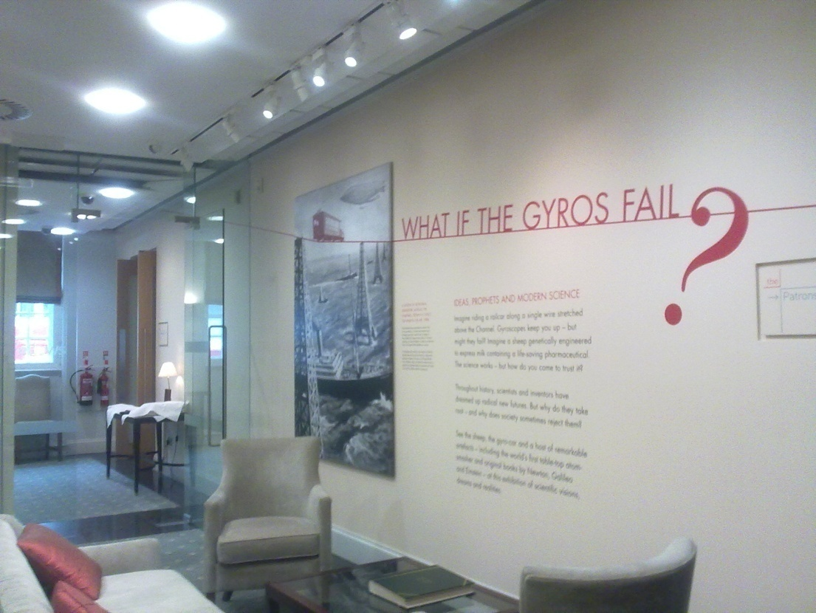
Figure 35 Photograph of the entrance to ‘What if the Gyros Fail?’ 13/04/2011.
The Smith Centre is a series of rooms attached to the outside of the museum and next to the Post Office sorting office with its own separate, glass fronted entrance. The centre is not open to the general admission and can only be entered upon pre-arranged appointment. The physical separation from the main building enhances its air of exclusivity and professionalism, so different from the rest of the museum. On entering, a visitor is greeted by a receptionist behind a desk, and guided into the attractively decorated and highly finished rooms beyond. The rooms themselves are split in two, the Gallery and the Patron’s Room, the former being set out as a boardroom with long table and chairs, while the latter, larger room has the feel of a library. Shortly after its opening a field diary entry describes the Gallery:
Smith Centre Impressions:
Corduroy, tartan chairs. Bookshelves with attractive volumes. The exhibit cases have a presence in the room but do not encroach on the type of space being presented. The room 2LO is in is like a well to do library, with comfortable armchairs and a fire place. Elaborate reliefs on the ceiling, of snakes and dragons holding torches. Very quiet. 2LO in a glass case so can be viewed on all sides adds to the sense that it is being integrated into the room’s surroundings. Cream walls, light turquoise carpet, flower pattern. Luxurious. Gallery is much more formal, board room table and chairs. Still the display cases do not infringe too much. Innocuous, yet highly politicised space.

The Centre gives the impression of restrained luxury; while at the same time, non-descript and characterless meeting rooms. The exhibition was there, but not there, not allowed to dominate the room, but rather enhanced its air of privilege, its exclusivity. In this setting 2LO, in its purpose-built glass case, was set up like a trophy to be admired but not necessarily engaged with.
It was in glass cabinets such as these that the Science Museum has displayed some of its treasures as part of a regular series of themed, short exhibitions. Past exhibitions have included: ‘25 years of collecting at the National Media Museum’, ‘People and Climate’ ‘Ingenious Unbound: Telling our Collections Stories’ and ‘Modelling the Body and Mapping the Mind’ to name but a few. Each of these exhibitions was designed to last between six and twelve months, and provided simple, striking messages to those who attended events in the Smith Centre. As such, the individual cabinets were fairly bare, apart from the objects, and the explanatory panels were short even in museum terms.
Few, if any, of the museum’s usual visual techniques (illustrations, models, computer graphics, sound recordings etc) were employed here unless they remained discreet. These exhibitions do not allow for the usual considerations surrounding audience and accessibility. In What if the Gyros Fail? there was only one top level message: that the museum is important, influential and worth investing in. However, the aim was rather to impress and seduce the investor, than beg for investment, using objects such as 2LO to endorse this message.
The question of whether 2LO can be considered an iconic object has been touched upon a number of times throughout this thesis, though it was never referred to in those terms before its acquisition by the Science Museum in 2002. In favour of its iconic status, is the continued inter-changeability between the terms 2LO and BBC, even after it was decommissioned in1929. Non-specialist examples of this can be found in the House of Commons Hansard debates where the early character of the BBC is often illustrated by casual use of this term. However, balanced against this, is a more academic engagement with the term ‘icon’ by scholars such as Panofsky who study the social conditions through which images obtain their conventional meaning. In his paper considering the process of iconisation or ‘singularisation’(as he terms it) of the Liberty Bell, an undisputed icon in the United States, Callahan refers to there being four different stages:
The four media of presenting and representing I hold to be to the keys to understanding the singularization of the Bell are: the changing manners of its exhibition; its various train journeys; the popularization of mythic tales of its early days; and its representation in advertising and tourism.

It is striking that 2LO has already progressed through the first two of these media (with the ‘train journey’ representing its physical change of location and interaction with the public) and to some extent the third of these, as there are myths surrounding its working life and its restoration. Though how popularised these myths is debateable. However, it is questionable as to whether it fulfils the fourth and final criteria: while 2LO did have a presence in the popular imagination during its working life this was no longer the case by the time it entered the Smith Centre. 2LO can therefore be most accurately defined as a former icon, which the museum was attempting to resurrect through activities such as the Smith Centre exhibition. In doing this it has undertaken a process of reinvention. The object has become part of the branding of the museum, and through this was beginning to fulfil the criteria that an icon be involved in advertising. In the case of 2LO’s Smith Centre display, it was difficult to tell which had come first: had 2LO been included in the exhibition because it is iconic or had its inclusion initiated the process of iconification?
On entering the Smith Centre, the visitor was presented with the exhibition title, ‘What if the Gyros Fail?’ on the wall just adjacent to the reception area (Figure 35) with a summary of the exhibition:
Ideas, Prophets and Modern Science:
Imagine riding a rail car along a single wire stretched above the Channel. Gyroscopes keep you up-but might they fail? Imagine a sheep genetically engineered to express milk containing a life-saving pharmaceutical. The science works-but how do you come to trust it? Throughout history, scientists and inventors have dreamed up radical new futures. But why do they take root-and why does society sometimes reject them? See the sheep, the gyro-car and a host of remarkable artefacts- including the world’s first table-top atom-smasher and original books by Newton and Einstein- at this exhibition of scientific visions, dreams and realities.

The curator in charge of the exhibition goes further in describing his ideas behind the exhibition:
In What If The Gyros Fail? I was interested in the prophecies, predictions and dreams of scientists, engineers, inventors and commentators- and what happened when they collided with the complex realities of the modern world.

In What if the Gyros Fail? the curator constructed a narrative of how reality and imagination collide in science by concentrating on revolutionary events and inventions. However, embedded in this simple message, was a more subtle one: that science has accomplished extraordinary things, which are represented by ‘remarkable artefacts,’ and are cared for by the Science Museum. Included in the exhibition were: Tracy a genetically modified sheep (case 1); the first specimen of synthetic ammonia, 1909 (case 2); Francis Aston’s Mass Spectograph, 1919 (case 3); Ernest Lawrence’s Cyclotron, 1931 (case 3); the magnet used with the first Cavity Magnetron 1940 (case 4); Louis Brennan’s Gyroscopic Monorail 1906 case 5); a selection of rare, historic books (case 6); the Hildebrand and Wolfmuller Motorcycle 1894 (case 7); a painting entitled ‘Analytical Chemistry Laboratory’ by E. Wallcousins, 1957; and of course the 2LO transmitter (case 8).
It was Louis Brennan’s Gyroscopic Monorail that inspired the title of the gallery: offering ‘a dream of cheap and reliable rail infrastructure,’ passengers still feared that the gyroscope would fail. Between these misgivings, and a block by railway investors, this potentially revolutionary transport system was never more than a dream. However this was not a gallery about failure, as many of the other objects testified to, but rather a consideration of the infinite possibilities that science and technology offer. The layout of the gallery can be seen in Figure 36 below.
Patron’s Room
The Gallery
Reception
Introduction
kitchen
Case 2
Case 3
Case 4
Case 5
Case 6
Case 7
Case 8 2LO
Case 1
Painting
Layout of Smith Centre Exhibition
Entrance
Figure 36 Diagram based on visit to exhibition 13/04/2011.
To those unfamiliar with the modern history of technology, these objects did not instantly present themselves as ‘remarkable artefacts’: the objects in cases 2 and 3 were particularly good examples of, in the words of an audience researcher, ‘objects that do not speak for themselves.’ To facilitate an appreciation of their significance, the objects were presented with eye-catching headlines, and impressive, contextualising photographs. These explained to audiences that these objects, for example, helped harness ‘the awesome power of atoms;’ created the first specimen of ammonia which took the world ‘From fertilisers to the Western Front;’ and was the ‘World’s First Motorcycle.’ Most impressive were the contents of Case 6 (see Figure 37) described as follows:
This showcase contains some of the most important science books ever written. Drawn from the Science Museum Library’s collection of rare books, the display includes works by Newton, Galileo and Einstein as well as pioneering publications in science, medicine and engineering.

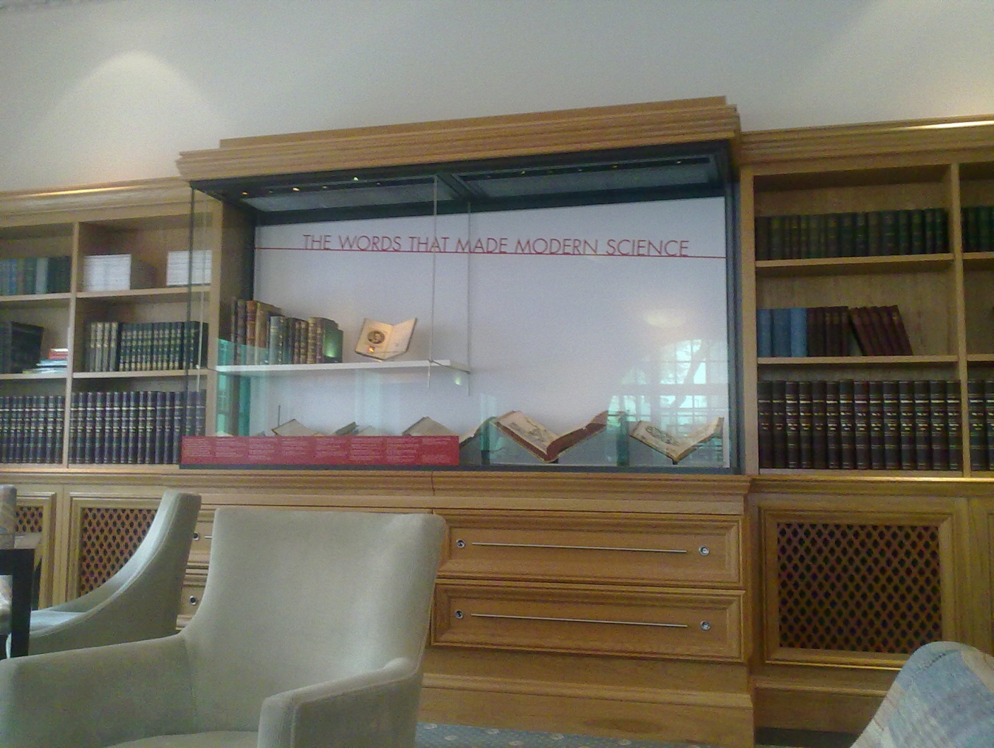
Figure 37 Photograph of ‘The Words that made Modern Science’ 13/04/2011.
This was one of the cases the curator in charge of this exhibition was most excited about, as it showed off the library’s impressive collections. The books in this showcase were indisputably iconic with names, such as ‘Darwin’ and ‘Einstein,’ holding international significance and their texts having run into hundreds of reprints in multiple languages. Speaking directly to popular narratives of the history of science items such as these elevated the museum to a position of international significance. This was clearly articulated in the caption, which in two lines juxtaposes the words ‘some of the most important science books ever written’ with the ‘Science Museum Library.’ This clearly reflected the value of these objects onto the museum as a whole.
With the message firmly established by the interaction of text and objects there were other devices employed by the museum to emphasise the connection between future exhibitions and investment. A field diary entry records one of these:
As I wandered around the room taking pictures, making notes, I noticed piles of leaflets and brochures. These are booklets describing the future plans for the MMC gallery, including colourful illustrations. Set on side tables and on mini easels, they catch the visitors eye- maybe while you’re sitting thinking what a lovely exhibition this is, you’ll read this leaflet and think ‘I have a spare million, I’ll invest in this!’

The presence of these leaflets (see Figure 39) allowed the visitor (and potential investor) to make the connection between the present and future space. This approach was not new to this gallery space, and not even the most obvious example, for instance ‘Ingenious Unbound: Telling our Collections’ Stories’ described itself as: ‘This Ingenious Unbound exhibition opens up the Science Museum’s treasure house to bring you five examples of shows we want to develop under the Ingenious banner’ In these brochures was an overt link to 2LO: on page five of the MMC promotional literature was a picture of the 2LO transmitter within the imagined, future space of the gallery. This picture enabled the visitor to visualise the potential of the object seen within the current exhibition, as well as create a meaningful link with its past.
In What if the Gyros Fail? only 2LO’s Modulator panel was on show (see Figure 38) with the main bulk of the transmitter remaining in its original location in Blythe House. The decision to include only this element of the transmitter was due to limitations on space and the cost of moving/ housing the whole transmitter. The cost of making a case for the whole transmitter was recently priced at upwards of £20,000, with no way of displaying it without due to the delicacy of the instruments, and the presence (even though stabilised) of asbestos. The unit, while it did not have the same impact as the complete transmitter, nevertheless fairly represented the whole with its metal frame, ornate wooden ammeter and glass valves. The unit had been set on a low plinth, and encased in a specially built glass case, so that it could be examined from every angle.

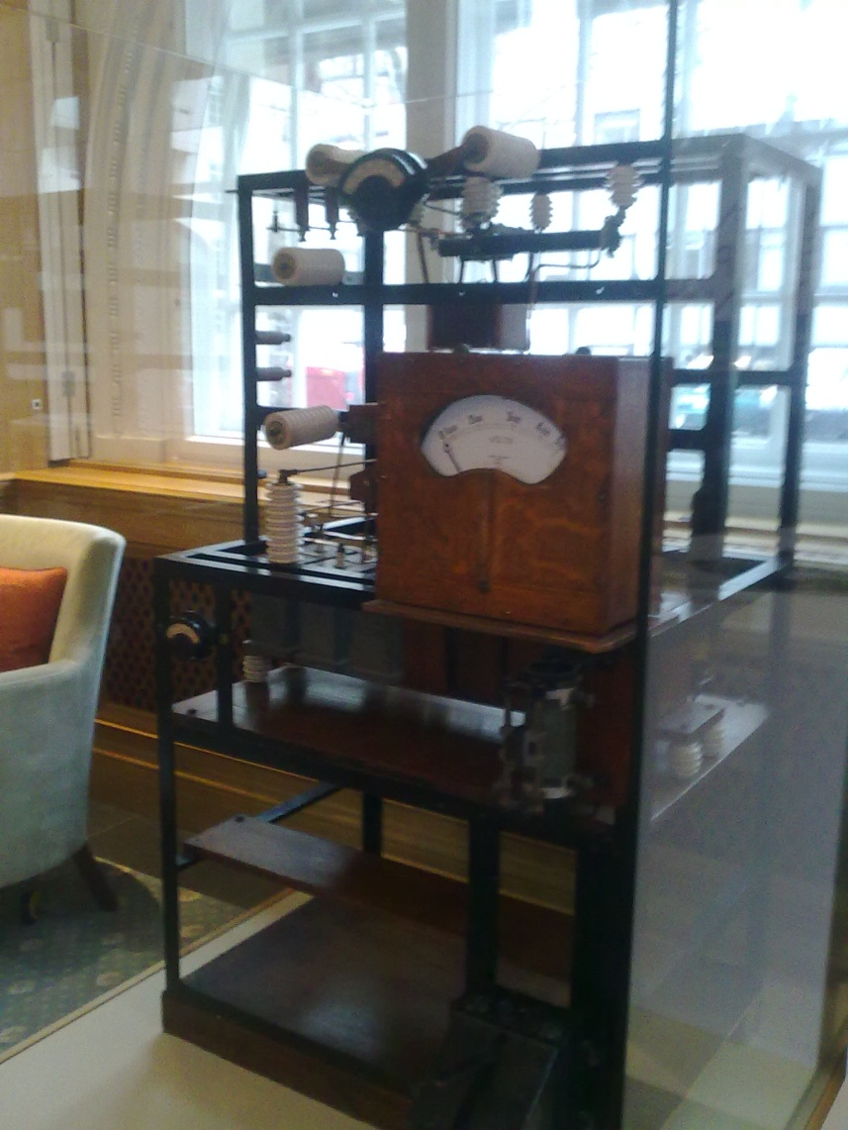
Figure 38 Photograph of modulator unit on display, 13/04/2011

The assembled items including case, transmitter, information signs, and images, were all set at the far end of the Patron’s Room, with its back against a tall window, so that 2LO was bathed in natural sunlight. During the installation in the Smith Centre it was remarked by one member of the conservation team:
... it looks really impressive in here [Smith Centre]. When I saw it in Blythe House a few weeks ago, for the initial assessment I wasn’t so sure how it would work. Being in the case makes a real difference- I can imagine it appearing in MMC now.

The final effect was of a beautiful, scientific instrument sitting in the context of a library and drawing attention through its size and design. As in previous exhibitions, its age and eccentric appearance only added to its impact, though this time behind a protective glass case it appeared to have a more genuine claim to being a ‘relic of 1922’, a term attributed to it in 1930. 2LO had not been left simply as a beautiful object, the over-arching message of the gallery required it to be contextualised within a grander narrative, therefore on a colourful sign accompanying it appeared the words:
Part of 2LO, The BBC’s First Radio Transmitter, 1922
The BBC was founded in 1922 as a consortium of wireless equipment manufacturers. Its Managing Director, John Reith, instilled in the company an ethos of ‘public service’ that underpinned its conversion to a non-commercial corporation in 1927. Reith’s vision for the BBC was strongly influenced by his belief in the power of education and knowledge shaping a democratic society. He often considered ‘the incalculable harm which might have been done had different principles guided the conduct of the service in the early days’. Today, pure Reithian principles have been tempered by the radical reshaping of British society since the 1920s and the proliferation of mass media.

In this instance, it was being used to introduce both the character of the BBC, and its first Managing Director John Reith. Through 2LO the audience was called on to consider the impact that this institution had on British society and, as the sign outlined, the influence it had on the British mass media. This was the intended message of David Rooney, the curator in charge of the exhibition, who described his vision for 2LO as follows:
With the 2LO transmitter I wanted to highlight the dream of public service broadcasting, with a strong moral ethos leading to Reith's 'mighty instrument to instruct and fashion public opinion; to banish ignorance and misery; to contribute richly and in many ways to the sum total of human wellbeing'. Yet Reith himself was aware of just how different it might have been had he not gained the post of managing director at the start. Reith's vision was influenced by his belief in education and knowledge to shape a democratic society. How have his principles been tempered by the radical reshaping of British -- and world -- society since 1922? Has his dream been universally applied across the globe? What do today's mass media offer towards the 'sum total of human wellbeing'?

In this exhibition 2LO re-enacted the same role that it has played on numerous occasions before: that of BBC artefact, acting as a conduit to the early days of broadcasting. However, it was also being used to represent a more complex, and revisionist approach to BBC history. Not only was it, once again, emblematic of the Reithian ideal of broadcasting, but also whether he was successful, and the realities of modern broadcasting. 2LO was being used as a physical link between the hopes of the past, and a reflective approach to the present, adding an additional layer of complexity to its already multifaceted personality. In this presentation are hints at how 2LO’s meaning could be conveyed to modern audiences. While there are none now who can remember the ‘cat’s whisker’ days, most people have experienced the BBC, and can use the experiences of the past to reflect on the future of media in this country.
In the introduction to his edited book, The Invention of Tradition, Eric Hobsbawm states:
Yet all historians, whatever else their objectives, are engaged in this process inventing tradition] inasmuch as they contribute, consciously or not, to the creation, dismantling and restructuring of images of the past which belong not only to the world of specialist investigation but to the public sphere of man as a political being.

Museum practitioners, much like historians, play a significant, if sometimes unacknowledged role, in designing a country’s collective past. The repetition of existing narratives in reference to 2LO not only adds to the iconification process but creates a historical tradition around it. The example of 2LO further demonstrates how historio-geographic tradition does not always adhere to the ‘facts’ such as they are. In chapter one 2LO was an object hidden from the public but by putting it on display, the museum is creating a version of visibility more reminiscent of the exhibition object that it became in chapter two, through an unacknowledged transformative process.
Furthermore, when displayed in What if the Gyros Fail? with these other society-altering objects, 2LO was used to reflect its perceived iconic status back onto the Science Museum. This marked a shift in 2LO’s status: fifteen years ago the museum could not be convinced to take 2LO in, and for the last eight years it was, while not forgotten by its curators, not part of the museum’s public image-making. Its inclusion in the Smith Centre transformed it into one of the material heralds of the treasures that the museum holds, representing thousands of other artefacts, which remain hidden from public view. Why 2LO underwent such a dramatic change in fortunes lies in the activity which surrounded the funding bid for the new MMC Gallery.

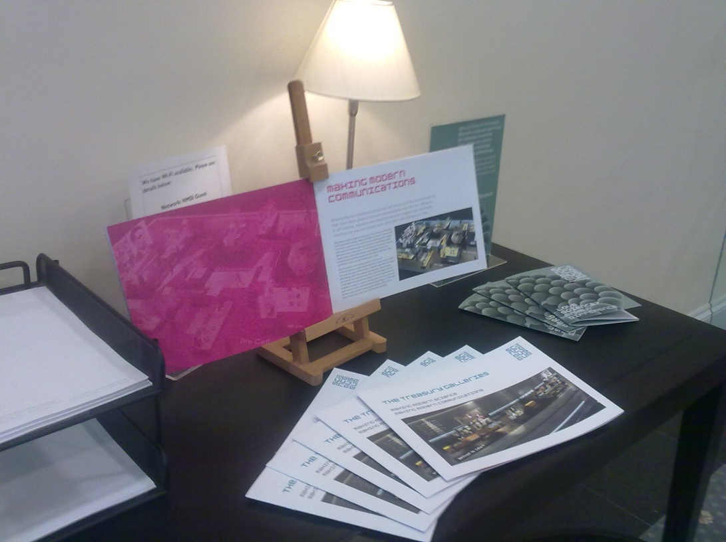
Figure 39 Photograph of table displaying Making Modern Communications promotional material in Smith Centre 13/04/2011.

- 2LO in the ‘Making Modern Communications’ Gallery?
2LO’s time in Blythe House, and the later display of its Modulator unit as part of the Smith Centre exhibition, can both be understood as preludes to the plans for a major gallery underway at the museum between 2010 and 2011. These plans centred on a bid for Heritage Lottery funding for the Making Modern Communications Gallery (MMC). Having worked regularly in the museum since 2008, the emergence of these plans in June 2010 required a much more ethnographic engagement with the museum than at any other stage. As part of this a limit was imposed on the time ‘in the field,’ lasting between June 2010, when I joined the MMC Content Team, and March 2011 when the team chose a design brief that best suited their ideas, provided by external company Universal Design Studio. Since March 2011, there continued to be a number of changes to the Treasury gallery proposal, including a couple of quite dramatic ones. However, time, funding pressures, and a risk of losing sight of 2LO, meant that the actual analysis is limited to this time period. However, the end of this chapter will reflect on some of these changes and what they may mean for any future interpretations of 2LO.
This has been one of the most difficult sections to write: leading to questions over the position of a Collaborative Doctoral Award Holder (CDA) within the partner organisation. Chief among these concerns was how to present an impartial analysis of the MMC gallery while at the same time contributing to its content. Facing these twin responsibilities of, museum content developer, and geographic ethnographer required a constantly reflexive approach.
The Science Museum has previously come under ethnographic scrutiny in Sharon MacDonald’s influential and, at times, controversial book, Behind the Scenes at the Science Museum. This study raises many of the same issues as this research has over twenty years later. However, while MacDonald is comfortable labelling herself as an ‘ethnographer’ and even voices concern over staff’s ‘initial suspicion over what I might be doing there’ as an outsider, a CDA student faces a different challenge. A challenge summarised by my Science Museum security pass in Figure 40: well-worn, marking me as officially part of the curatorial team, the red visitor ribbon nevertheless confusingly labels me as an outsider.

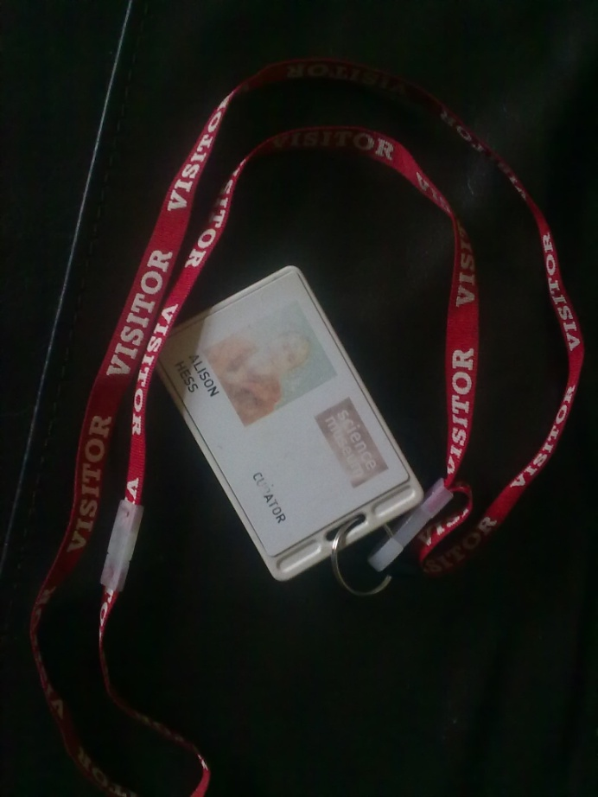
Figure 40 Photograph of my Science Museum security pass 11/08/2011.
As a CDA student, the first two and a half years, and particularly in the months between June 2010 and May 2011, involved a careful balancing act between the roles of member of staff and external observer. Occasionally this even involved hearing and participating in casual conversations and noting them in a research diary after. As was explored in the methods section of this thesis, the ethical considerations of this stage of the research were a cause of frequent anxiety. A direct ethnography of the museum had not been included in the original research proposal, and the methods adopted had to be reflexive. The temptation was always to get further involved with the discussions around presenting a history of communications.
However the focus of this chapter, like the thesis, is on the 2LO transmitter and the way that the stories of this particular object were selected and presented to the public by a national institution. Reference to the transmitter’s iconic status in the original BBC handover in 2002, and the image created for it in the Smith Centre exhibition as a representative of a golden vision of broadcasting, all fed into the discussions for this, one of the largest and most high profile exhibitions the Science Museum had attempted in years.
Telling the Story of communication- constructing a narrative
One of the greatest challenges to constructing a coherent narrative for MMC was the size of the subject matter: the history and contemporary philosophy of communications. It is possible (seen in the work of Russell Burns or Marshall Poe for example) to tell a story from the Stone Age with the development of language, through the written word to the means by which both of these have been transmitted across/down the ages. This was summarised in first meeting of the MMC content team when it was pointed out that it was possible to tell the traditional story of ‘the Rosetta stone to the present day.’
However this was not the story that the Science Museum wished to tell. Traditionally the museum has focussed on the history of modern science (with a few exceptions, such as the Measuring Time gallery) and, as the close analysis of the radio communications collections has shown, objects tend to date from post-1800. Beyond the practical considerations, the content team felt that the last two hundred years reflected ‘a communications revolution that has transformed people’s lives.’ Focussing on this revolution gave the museum a chance to develop a gallery that addressed a significant technological phenomenon with a unique selling point.
Based on these initial criteria it was decided to start the timeline of the gallery in 1830 with the invention and application of the electric telegraph. However, as another meeting of the content team showed, this decision was not without controversy:
Discussion moved on to the time limits of the gallery- starting in 1830. Big controversy is the inclusion of the printing press, which as the gallery is now would not be included. Argument for is that it would have a good narrative, make use of a large, un-displayed, existing collection and the history of the printed word it not currently represented anywhere else in the museum. Arguments against it were strong though- it would make the timescale too large and unmanageable, doesn’t belong to the modern revolution. Also it is not a first-hand user technology which is one of the big things we’re emphasising. Debate showed there isn’t much room for negotiating timeline at this stage.

Retrospectively imposing a narrative on a series of events has inherent difficulties, and there will always be opposing opinions as to where a defined timeline should start. By the time of this incident, the HLF bid had advanced to a point where details could not be changed, and the hierarchy of the team meant that some individuals had more influence than others.
Presenting the consumer experience of technology, and the ‘human story’ behind the development of technology, was key to the original vision of MMC and represented a wider shift in the intellectual approach of the museum. In recent years the museum had tended to concentrate on explaining the scientific principles behind the technological objects on display: emphasising the science rather than history. When people did feature there was an emphasis on ‘big names.’ However with new input from audience research, and an increased interest in family history research, perpetuated by television programmes such as the BBC’s Who do you think you are? it had become apparent that a successful exhibition needed people in its narrative. This was raised in a discussion on the project’s challenges during the first MMC content meeting:
TPB- Challenges: audiences think they know the subject, they are not novel, too everyday; Bringing objects to life; high expectations. Audience studies were excited by the prospect of large objects and involving art installations. Immersive, see ‘Babel’ Tate Modern. Rugby Tuning Coil, vast, different.

TB- From Audience Studies- Laying of trans- Atlantic cable, very popular. Engaging with human experiences. More interactive, more involving. HLF wants to target ‘uninterested groups’

Audiences were interested in ‘engaging with human experiences.’ The content team therefore had to think creatively about the sources they used to construct these narratives. These could include personal testimonies, oral histories, or co-curation projects, all sources which the museum had not traditionally engaged in. MMC also aimed to address other noticeable absences within the history of communications: for example, the contributions made by female or non-Western scientists and engineers.
The above field diary entry also mentions intended audiences so called ‘uninterested groups’. This included independent adults, families with children 11+, DCMS priority groups as well as, more traditionally, school children at levels KS3 and KS4. Even this latter group represented children at the end of secondary school, marking a move away from the Science Museum’s usual audiences of families with primary school age children. As Scott Anthony’s chapter in Science for the Nation explores, the Science Museum had worked at being more ‘child-friendly’ since the 1960s, when pressure from the British media was pushing the Museum in the direction of North American Science Centres. These institutions tended to target families, through fun simplified, interactive galleries. While the museum never went this far, the effect of this policy can still be seen in the existence of Launchpad, the Imax Cinema and temporary exhibitions such as Wallace and Gromit: A World of Cracking Ideas. ‘Uninterested groups’ were not only defined by age. The HLF also required that MMC be designed to encourage the involvement of those who did not usually visit museums. These demands influenced the approach of the gallery from the beginning, and determined an emphasis on people, rather than technologies. This was also an example of the museum reacting to wider political factors, in this case, a trend in arts and heritage institutions having to demonstrate impact.
The Content team was required to work within the structure that had passed stage one of the HLF bidding process which gave some aspects of the gallery a degree of permanence. The structure is outlined below:
The Message: An interactive gallery allowing visitors to send messages using different kinds of communications technologies.

The Network: the main contents of the gallery, made up of the following seven zones-
The Cable, concentrating on telegraph.
The Exchange, the story of the telephone.
The Wave, electronic sound and music
The Broadcast, radio communication, and, radio and television broadcasting. This would also be the section into which 2LO would be incorporated.
The Cloud, computers and graphical interface.
The Constellation, satellites and GPS etc
The Cell, mobile phones.

The Wall: An interactive wall, allowing visitors to access further information, contribute themselves and see other peoples contributions. This would feed into the online presence of the gallery through the museum’s web page.

This structure was first presented to the content team in June 2010 and provided a focus for discussion and debate. Even with the structure fairly decided on some details changed dramatically over the months that followed. The separation of electronic music into a category of its own was one of the first challenges and was discussed in a number of content meetings. A field diary entry shows that this also bled into some private conversation as well:
In the office, just had another conversation about electronic music. Obviously there is great enthusiasm about it from some in the museum, but not entirely sure it fits in with the other zones. Problem is, as___ said, that it is a type of data not a communications technology in its own right. So if one of the zones were film or the written word, it would be alright. However it was one of the big selling points of the original proposal, feeds into other projects, so all a bit tricky!

Following a detailed research paper produced by Charlotte Connelly, an Assistant Curator on the project, the argument against the inclusion of electronic music in the final proposal was conclusive. Instead it was decided to incorporate the information from the Wave into one or more of the other networks. The museum owns an extraordinary collection of electronic music objects, and by incorporating them into other zones, this allowed these to be displayed while maintaining a clear structure for the gallery as a whole. This conversation also shows the influence that individual enthusiasm had on the project, and how personalities and politics had as much influence on the shaped of the galleries, as the content.
The form ‘The Wall’ should appear in was also the subject of much debate. Should it be an actual wall, appearing as a piece of interactive art work in the centre or at the beginning of the exhibition, or should it be taken less literally, and appear as themed points throughout the whole of the exhibition? The design brief, proposed in March 2011, advocated a series of large screens as can be seen in Figure 41:
The Wall is a large scale platform for expressing the core narratives of the gallery. The visitor’s role is that of audience member and curator. The narrative plays out in a rotational format across a series of sequential cells or frames which deal with themes of temporal and spatial distortion. The technology behind The Wall is relatively simple: A series of transparent projection screens that work well in bright or subdued light. The simplicity of The Wall format brings longevity and durability as it is the projected content that evolves and updates over time.

Though as late as September 2011 this was still a matter of discussion.

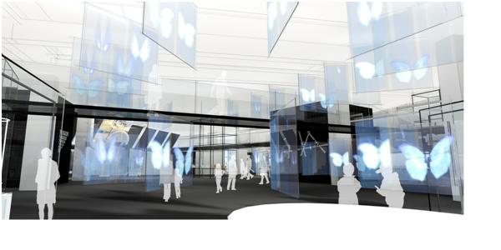
Figure 41 Image of ‘The Wall’ from Design Brief, Universal Design Studios, copyright 2011, 65.
How, physically, the networks would work together, also proved a challenging aspect of the new gallery. Many of the stories within each individual zone occurred simultaneously despite appearing to be categorised differently. With the close interweaving of time and purpose, charting the development story of many of the technology objects was difficult to separate across different zones. For instance, there was an obvious narrative connection between mobile phones and satellites, yet these appeared in the Cell and the Constellation respectively. The problem of one object being categorised in several different ways was raised in one content team discussion:
The matrix is considering the themes that run through the zones in an attempt to see how they interlink. This will aid with physical interlinking, through the wall (?) Re-emphasising the idea that the user dominates. Wider than technology based. Transforming events that also tick boxes in terms of what people expect to see in terms of developmental moments. Reflecting the linear development of technology.

One way to approach the gallery as a whole was to trace the themes that run through the different zones. Once these had been established the way these would be represented physically was discussed. This was more problematic, as the layout determined the audience’s movements, as well as their basic understanding of the information being presented. The gallery had never been proposed as a linear story of technology, but as the above discussion shows, this still had to be implicitly understood. These challenges were further frustrated by the fact that, not only did MMC have to present itself as a coherent whole, but had to work with its twin Treasury gallery, Making Modern Science.
Throughout these discussions, the space in which the new gallery was destined to fit, the current shipping gallery had to be considered, see Figure 42. During a walk round with the curators a field diary entry describes the space as follows:
The walk around we did was in the current shipping gallery. A large space, much longer than it is wide. A few metres from each side are a row of concrete pillars that run the length of the gallery and act as support but also as a strong physical barrier to the flexibility of the space.

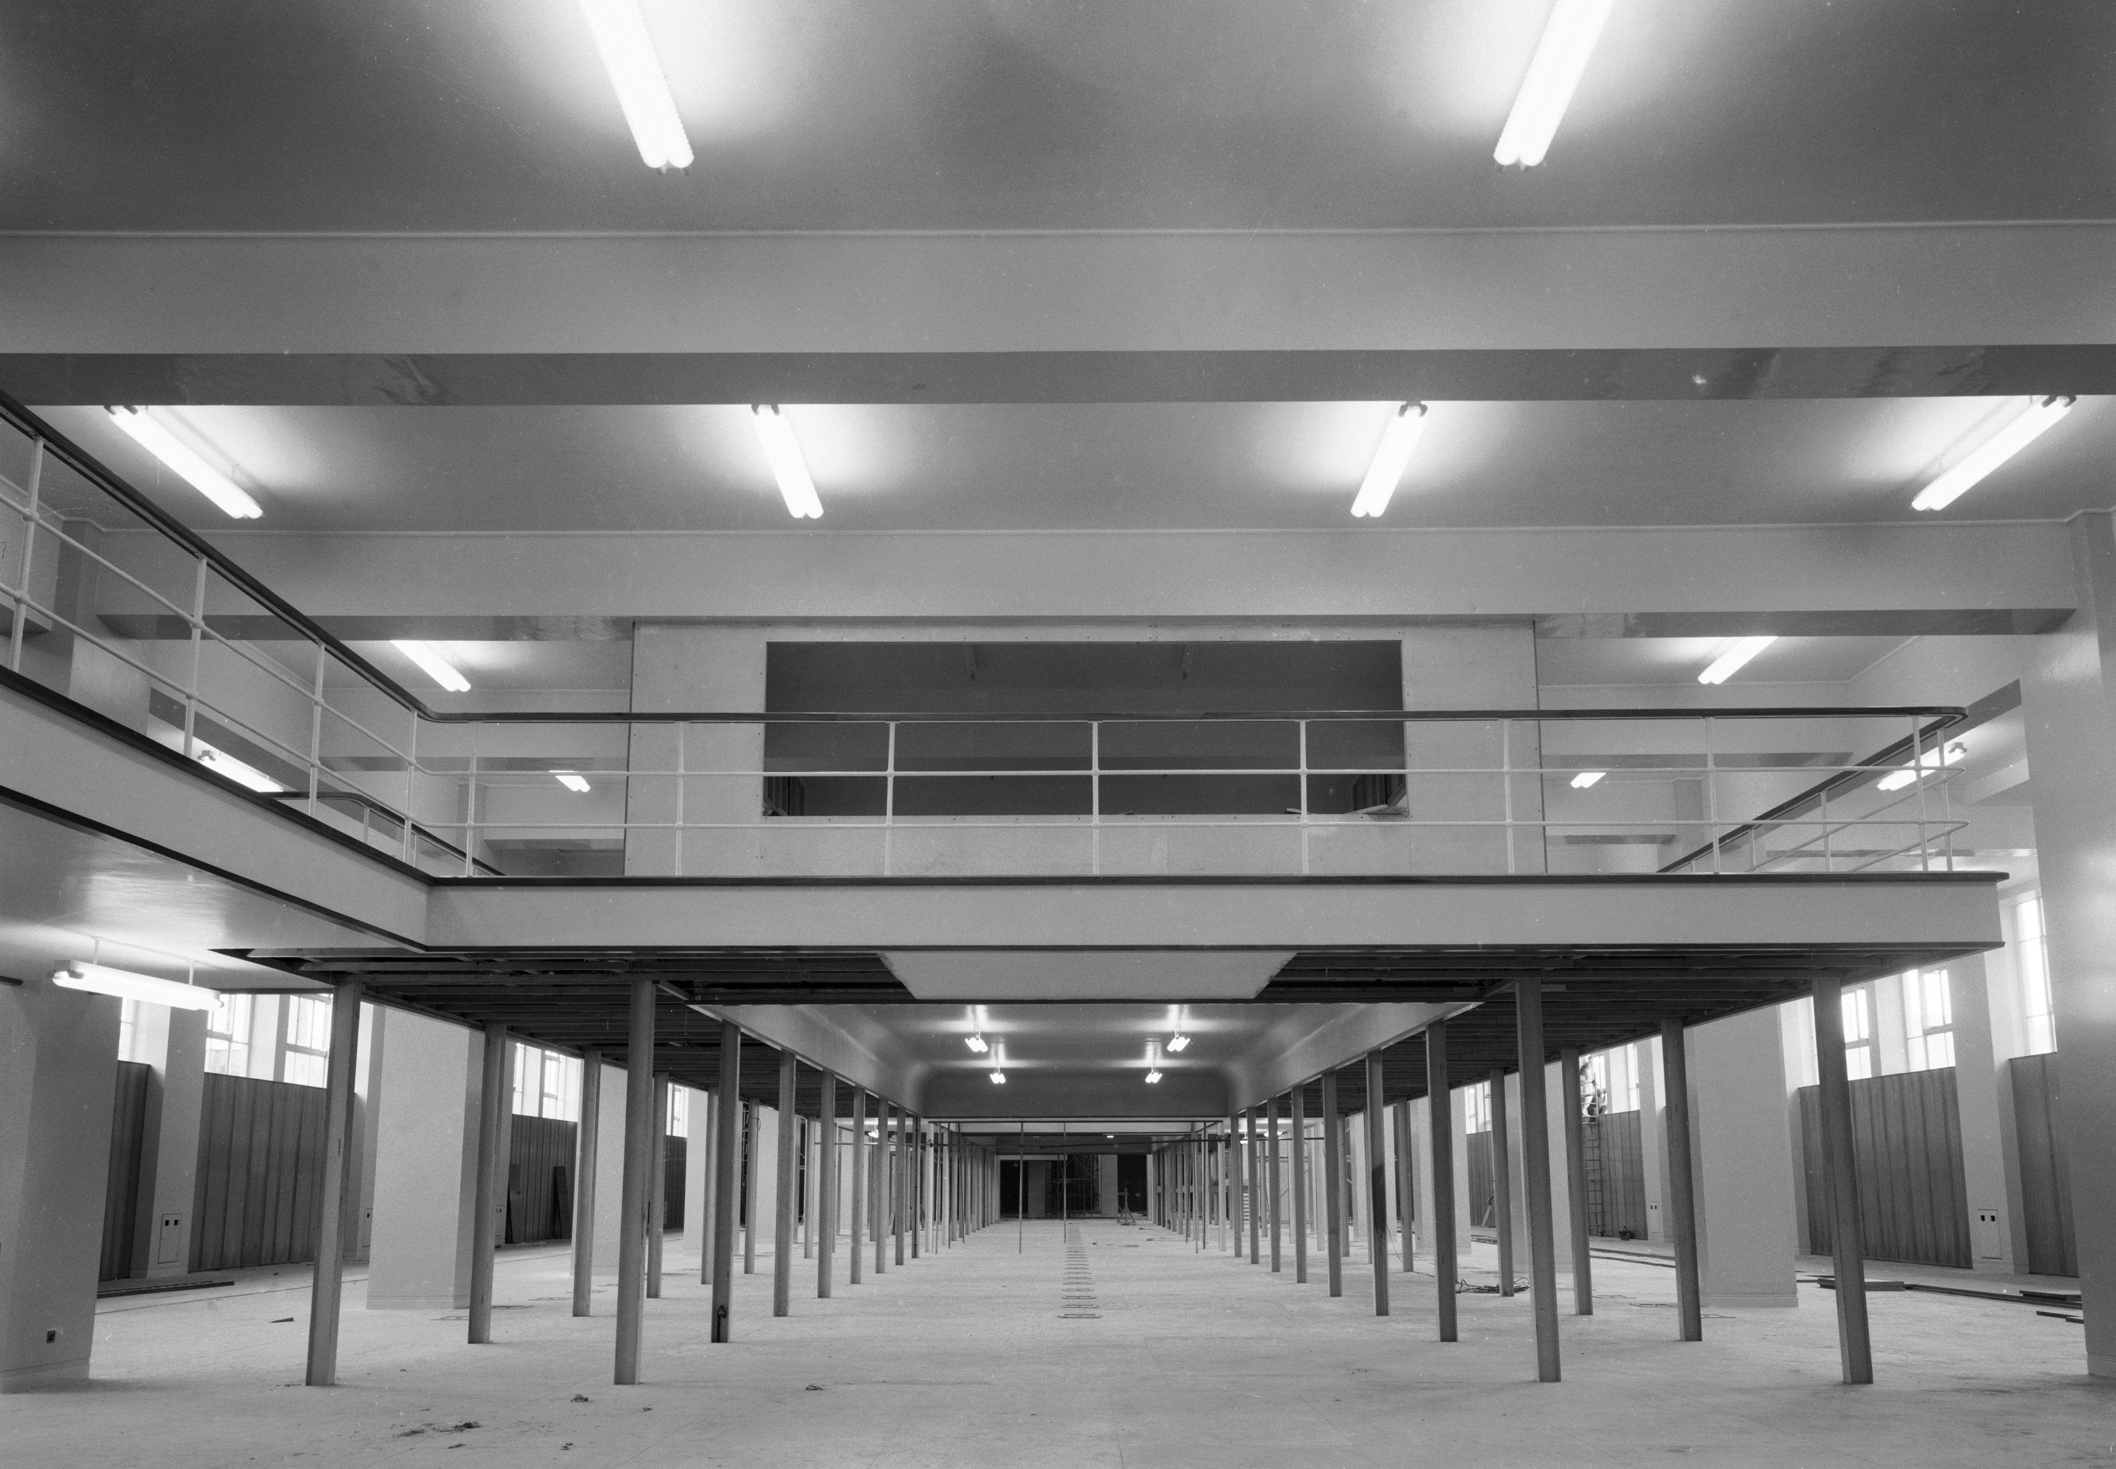
Figure 42 Shipping gallery unfilled, July 1961, Science Museum Archive. The mezzanine structure may be removed entirely as part of the new gallery design.
The inflexibility of the space continued to prove problematic to the shape of the future exhibition, and, even the inclusion of some objects. One particular challenge was that the ‘back of the gallery is lower than the rest, a more enclosed space separate from the main area, how to avoid the problem of dead space?’
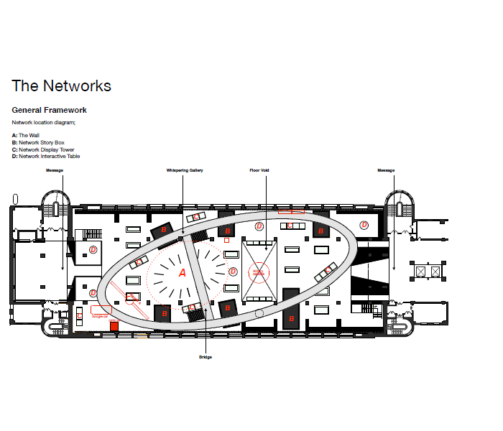
Figure 43 The Image shows the proposed plan for the gallery within the allocated space, red circles indicate the placement of the different zones taken from, MMC, Universal Design Studio brief March 2011, 32.
In contrast to written work an exhibition must be coherent in both a spatial and narrative sense. Considering the path that visitors take through the gallery, creating smaller spaces within the whole that all work together to convey an overall message to the visitors (see Figure 43) is vital to the effective communication of the gallery’s message. Many of these challenges were considered in the chosen design brief for the gallery, with ‘a vertical connection between the Treasury Galleries’ and by inserting a high-level walk-way or whispering gallery into the space.The height of the existing space was not as imposing as in, for example, the Making the Modern World gallery and with the danger that this would result in the space appearing overly cluttered. These discussions demonstrate the complex negotiations that occurred around the narrative, space and ideology, into which the 2LO transmitter had to network into.

The Broadcast
The Broadcast, a subsection of the Network, that included radio and television technology, and was also the section to which I contributed most directly. Much of this section is based on this content development work, as well as subsequent interviews with the successor to the Broadcast, Charlotte Connelly, Assistant Curator. My involvement in the project as a content developer ended in September 2010, but following this, a close relationship with the team was maintained. In the months that followed the gallery continued to be refined, and updated, and this section must be viewed as a ‘moment in time’ as the Head of Content said, rather than the end product.
Selecting narratives and objects for the Broadcast section of the gallery, often involved delicate negotiations between, being historically representative; creating an interesting story; and the objects contained in the collection. However sometimes the balance shifted, with stories being shaped to accommodate the artefact, as Connelly describes:
...we had hoped to use War of the Worlds, looking at broadcasting in the states and then maybe compare with the BBC but it became apparent that if we used that we couldn’t really work 2LO the object in and its one of our key objects in the museum, it’s something that we want to shout and bang a drum about, so why pick a story that doesn’t conform to that object?

As with the Electronic music zone, there remained a great deal of personal enthusiasm for 2LO within the museum. The Content team therefore began with the idea that 2LO would be included and constructed narratives that justified this. This section seeks to explore the reasons for and against 2LO’s inclusion in the Broadcast and what this reveals about the internal politics of museum making.
An initial challenge in structuring the Broadcast, as with all the zones, was whether it should be chronologically or thematically driven. In a gallery driven by user experience, rather than scientific discoveries, a series of themes offered the most flexible solution and allowed curators to link the networks together, while still highlighting chief historical developments. Based on Audience Research feedback on the new galleries at the Museum of London, the MMC zones were designed so that visitors could access layers of information. By organising content around themes, these layers made room for the more trivial, yet entertaining stories that visitors so often enjoyed. However, in the Broadcast, the thematic approach also caused some problems when considering the types of technology to be included as an early field diary entry shows:
The Broadcast has to include three different types of technology- point-to-point radio communication; radio broadcasting; and television. Problematic as while the first is the obvious chronological forerunner to the other two, thematically there is not much in common. The first is practical communication, whereas the other two are talking about media with all that’s involved.

In a document developed by Connelly, this problem was also highlighted which accounts for the fate of the Titanic transforming event, discussed below.
A way of simplifying the individual zones both for the intended audience, and the funding bid, was to highlight three key turning points or ‘transformative events’ that act as both exciting hooks, and concise summaries of the gallery themes. Not only did these work in the narrative sense, but they offered an opportunity for the museum to use less traditional presentation methods, such as new media, immersive environments and art installations. For instance during the early content discussions, attention was paid to the newly opened Museum of London modern galleries, and particularly the Pleasure Garden area. This area offered a smaller, immersive environment so that the audience was plunged into the sights and sounds of a Georgian pleasure garden, surrounded by objects of the era.This kind of conscious manipulation of these micro-environments refers back to Pile’s discussion of the way that the power of affect can be used as a form of political control seen in the Blythe House section of this chapter. Highlighting a positive aspect of successfully appealing to emotion, Mike Crang and Divya Tolia-Kelley argue, ‘that the production and circulation of feeling and sentiment, rather than civic knowledge, are crucial in excluding and including different people.’ In other words, creating an environment that influences the audiences emotionally, can ultimately lead to a more engaging and meaningful experience.

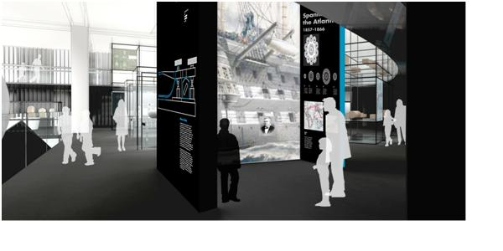
Figure 44 Image shows the proposed shape of these micro environments, Inside ‘The Cable,’ from MMC, Universal Design Studio brief March 2011 61.
It was this kind of multi-sensory experience that the Science Museum was aiming to achieve in MMC, and, given the shape of the existing space, these smaller environments, within the whole, would have a greater impact on the visitor than allowing them to wander the length of the space. This aim manifested in the form of spaces called ‘story boxes’ which performed the following function within the gallery:
...a mechanism for identifying a ‘hero’ object within a network collection and conveying the human story associated with it by providing an integrated area for film, supporting text and images. The dimension of the story boxes will allow for human scale imagery and film to enhance the visitor-object relationship.

This describes a space similar to that of the Pleasure Gardens, but with a much stronger narrative function, as it introduces the ‘hero’ object and, through this, immerses the visitor in the themes of the individual zone. The boxes acted as the introductory experience for each zone. In the design brief there was also mention of ‘hero’ objects, and for 2LO this marked another development in its definition, having been a: relic, icon, star and now hero. While the term did add much needed structure to the gallery, the idea of 2LO being a hero object also developed it as a particular brand, continuing the process established in What if the Gyros Fail? Elsa Vivant says ‘[m]useum branding is one of the major corporate management strategies emerging. The aim of branding is to add symbolic value to a functional value by creating a narrative discourse on a product.’
In the case of the hero objects, including 2LO, added layers of symbolism were used to enhance the meaning and visual impact of the proposed gallery, in the eyes of potential investors, and the public. The ‘visual’ in these cases was particularly important, as can be seen from early MMC Gallery promotional material pictured in Figure 44. The image of 2LO on a plinth surrounded by members of the public shows the powerful impact these ‘hero’ objects were intended to have.

Figure 45 2LO in the MMC gallery, image from MMC promotional catalogue, Science Museum 2010.
As with all zones in the Network there was debate over which transforming events should be used to represent the Broadcast. As with the overarching theme of the gallery, these events had not only to represent technological turning points, but a specific point when this technology entered general consciousness. The Broadcast’s three events were:
- 2LO the spirit of British Broadcast
- The broadcast of the Queen’s Coronation in 1953.
- The broadcast of the first series of Big Brother.
- The Titanic story (for a long time in the Broadcast has now moved to the Cable and acts as a link between the two)
Each of these represented a moment when the technology (point-to-point radio communication, and global/national radio and television events) became a universal consumer experience. These events were the result of months of conversation and debate. Despite this, they cannot be considered as totally representative, as an excerpt from an interview with Connelly shows:
CC: ...So there’s 2LO, the coronation of 1953...

AH: That was a story included quite early on...?

CC: And everyone we speak to about television mentions the coronation at some point, so it’s just an obvious selection and then we had a team meeting about Big Brother after ... we were trying to find something that talked about contemporary television, digital...

AH: Yeah there seems like there’s a gap....

CC: We do, there’s a gap between ‘53 and 2000 but there’s the Gulf War in the 90s and satellite in the 60s so actually there’s quite a bit there really... but not a lot of radio.

AH: Oh no [laughing]

CC: We’re trying to work it in with the Big Brother stuff and I’ve got at least one radio in the object list for the coronation to demonstrate that not everyone had a television and from the oral histories...from the mass observation had essays people had written where they were really upset that hadn’t been able to watch it but that they had still listened to it on the radio. It will be around...but it’s a bit like all the radio is at the start and oh we’ve progressed and no one listens to the radio anymore which clearly isn’t true...

Only a month before the project was submitted there were still concerns to be negotiated before the opening of the gallery in four year’s time. The problem with chronological gaps could be solved, as Connelly says, with more explicit interlinking between the different zones. For instance the quite substantial gap in the broadcast, between 1953 and 2000, was to be addressed by other zones referring to the internet and satellite. Nevertheless, as the last few lines of this interview show, the challenge was not to slip into an evolutionary narrative, with each successive achievement replacing the previous one. Though, if this model were not used, the gallery would run the risk of being too diverse and confusing for visitors to follow.
Like electronic music, the Titanic story had a particularly uncertain time. Included in the first proposal in August 2010, it was removed during the autumn, and replaced with the story of the famous 1938 War of the World’s broadcast. Later in January 2011 it was reinstated but only a few months later moved to the Cable, a zone dedicated to the telegraph, where it was felt to be more thematically appropriate. The interview with Connelly shows how the Big Brother story was included as a later storyline for the Broadcast, addressing an over-emphasis on the developments of the early twentieth century. The Big Brother story also raised the issue of whether the content in the gallery would continue to reach audiences ten to fifteen years in the future. That event was relevant at the time the gallery was developed did not mean it would have the same resonance years in the future. This highlights a more general challenge as many of the stories were not to be generated until after the HLF bid has been successful.
As the example of 2LO shows, the gallery narratives were not always chosen for their merits, they also had to demonstrate a strong engagement with the Science Museum’s collections. In each zone, the hero object (as mentioned above) was an object that curators felt it was imperative to put on show: because it was interesting aesthetically; had unique historic significance; or had not been seen by the public for a long period of time. In some cases the star or ‘hero’ object fulfilled all these criteria, giving it added impetus for the need for a strong case to justify its inclusion in the gallery: such was the case with 2LO. This was also the case with the Rugby tuning coil intended for the Broadcast section of the gallery.
The Rugby tuning coil shared many attributes with 2LO: it was unique and aesthetically challenging to engage with; it was historically important, used since the 1920s for communicating news and time signals from Greenwich to the rest of the world. It was also a very large, impressive object. Though its sheer size was also one of its most problematic attributes: with a footprint of 5m by 7m, and an approximate height of 10m, it would tower over every other object (excepting the satellites) proposed for the gallery. On a walk round the proposed gallery space:
Problems of the location of Rugby Tuning Coil. Gallery ceiling is too low down- but could fit in where spiral staircases in current gallery are. It would then be the opening sight of the gallery- large but see through, so could work. In this position would have to be seen as a key object transcending its zone. Health and Safety!! It would block the entrance of the gallery.

The Tuning coil would stand a full two metres taller than the height of the shipping gallery, so if it were to be displayed, a large part of either the object or the ceiling had to be removed. Nevertheless, its size was one of its most compelling qualities, and it was described as having a ‘monumental, almost sculptural appearance.’ These problems were not overcome easily:
NB. Sounded like controversy is still dogging RTC- decisions made without consultation. Not the whole thing is going to be included. Fears that this might undermine the impact it has on gallery.

However, even the doubts expressed by senior members of the team were allayed, during a visit to see the object at the outlying stores near Wroughton, when the full visual impact of the tuning coil could be fully appreciated. The Rugby Tuning Coil was included in the final proposal, with the only barriers to its inclusion being financial or the physical limits of the intended space. These would not be simple points to overcome, as has been noted, ‘the Rugby Tuning Coil will need massive planning and expenditure and at least one member of staff to co-ordinate the whole thing.’

2LO in the Broadcast
One of the key requirements of the Heritage Lottery Fund was that the MMC gallery be ‘rich in objects,’ a point that was welcomed by the curatorial team. In observing this aspect of the gallery development there was again an articulation of the wider tensions within the Science Museum. Time spent in the museum was marked by the suspicion, and uncertainty felt by the curatorial team towards the institution. Despite, as Peter Morris says in Science for the Nation, ‘the Bell Committee in its report of 1911 set a new course for the new Museum, calling for the ‘preservation of appliances which hold honoured place in the progress of science’ the collections have not always been in favour. Since the 1990s the feeling that objects have been deliberately neglected had increased and impacted on the kinds of exhibitions to make it to the museum floor. In many cases, with the exception of Making the Modern World, exhibitions have prioritised interactive new media over objects.
From the wider debates coming out of the Public Understanding of Science movement, as well as the institutional history of the museum, this was not as clear cut as right and wrong. Education has always been at the heart of the institution, and as such, galleries less dependent on the collections such as Atmosphere: the Climate Change Gallery and Who Am I? in presenting issues around modern science, equally fulfil the mission of the museum. In the early twentieth century, the museum sought to display the latest in modern technology, and as a result, began to collect objects to illustrate this. At times acting as a collective trade fair for the industries of Britain, the museum sought to increase awareness of science and technology, while harking back to its origins in the 1851 exhibition. It was these acquisitions that formed the basis for the museum’s historic collections.
With the predominant culture of the museum being science education, rather than science history, there was some concern over the reception MMC would receive from the upper management of the museum:
Today divisions between science centre people and history of science people remain. These tensions will be accentuated in MMC as ___ is of the former whereas HLF has asked for a gallery that engages heavily with the historic collections. ___as of last week has supplanted ___ as the head of MMC, as she is much more senior. But this holds questions as to what slant the gallery will take? Will objects such as 2LO find their way in?

However the dramatic curtailing of curatorial influence that some were expecting did not occur. In part this may have been due to the arrival of a new Director, Ian Blatchford, in 2010, who heralded yet another change in direction for the museum. In particular Blatchford re-emphasised the importance of objects to the museum, saying at the opening of the Watts Workshop exhibition, ‘after a decade of ambivalence the Science Museum is falling in love with its collections again.’ With a Director favouring the collections, and a funding body demanding an object rich gallery, the political environment favoured the inclusion of 2LO the MMC galleries.
In 2011, 2LO expanded on the role that had been established for it in the Smith Centre:
CC: 2LO has been shown at most events we have done, whether as part of a presentation. We have some fund raising lunches and breakfasts in the Smith Centre which has the modulation unit on display currently, which meant we actually had a bit we could show people alongside its picture...obviously we can’t carry that around with us, so I did an event yesterday at the BT tower where we took a crystal receiver so we talked about 2LO through that, so you might have listened to 2LO through this receiver umm and I think the reason 2LO is a key object, there are many, is that it is big, its bound to get a lot of attention just through size... As I said its relatively newly acquired so its not something we’ve trotted out before. I think by mentioning the BBC that gathers a lot enthusiasm for it so we can ride on the back of their reputation a little bit. And its a fantastic object to look at, it doesn’t meet anyone’s expectations, if I said to you what does a radio transmitter look like? Well you’d know! But an awful lot of people wouldn’t and I’d guess they’d imagine the aerial... but actually its quite a surprising object and it looks quite kind of hand made so it allows us to talk about the uses of tinkering and the back room boys, it also British industries such as valve manufacture... There’s all sorts we can get in there, Marconi and the BBC icon, so it stands for an awful lot of what the gallery is about...

AH : So has it been very well received?

CC: Yeah very well, a lot of surprise. And the sort of stories we have been telling round it haven’t really been about the origins of the BBC... they’ve been about what must it have felt like the very first time you heard a voice in your home, how unusual must that have been at least crystal sets weren’t very expensive, they were pretty much anyone who lives nearby could use them. So we’ve been really focussing on the user which again a surprising... and they’ve taken that message home quite a bit and often recycled it back to us particularly... so that’s struck a cord....

The final section of this chapter considers 2LO’s role within the Broadcast section of Making Modern Communications. One of the greatest challenges to the inclusion of 2LO in MMC has been the focus the gallery has had on the user-experience of technology. 2LO was not a domestic, user technology: people benefited from its function rather than operated it personally. It was a largely hidden technology, with only a few, privileged BBC employees ever seeing it. 2LO therefore is a poor example of a user-experienced technology which made its inclusion in MMC initially problematic. However, as the interview with Connelly shows, the Science Museum overcame these limitations by talking about 2LO through other objects, such as the ‘crystal set.’ This allowed the user to be brought back into the narrative, encouraging people to put themselves in the place of early radio users and through this, engage with the wider issues of technological change. This approach was well received by audiences who enjoyed how this allowed them to place themselves within the historical period.
As well as facilitating the inclusion of the user experience, this approach allowed for the development of a narrative about the BBC, and broadcasters in general. During 2LO’s working life radio transitioned quickly from an experience of wonder and magic, to just another technology of the home, an idea central to the Transforming Events documents for the Broadcast. These documents overtly link 2LO and the BBC, and the role the latter played in moving radio-listening out of the realm of the enthusiast, and into mainstream public consciousness. 2LO set the scene for the radio broadcast section of the exhibition, and was intended to develop a thematic narrative exploring British and international broadcasting.
This document contains a repetition of many of the same themes that have occurred throughout the course of 2LO’s history, though in MMC, the added dimension of an emphasis on user experience provided a novel twist to the transmitter’s meaning. In the Transforming Events Document there is a description of how 2LO should be presented:

The 2LO transmitter itself lends itself to a dramatic display where the glowing and humming of the valves is evoked. As an object it was never designed to be seen and spent its working life hidden in an attic, and its transmissions seemed almost magical to the first listeners. Many of the accounts from the time describe the sound and feel of being near the transmitter. This is echoed in recollections of both the Writtle transmitter and especially the Daventry transmitter which stood isolated on top of a hill away from Daventry town.

This description captures the atmosphere of 2LO in its working life: mysterious, and above (both literally and figuratively) the day-to-day goings at the BBC. The connection with the BBC was at once a useful selling point, as can be seen from the marketing presentation described above, while at the same time problematic for the narrative of the gallery. MMC aspired to tell an international story of communications and too strong a focus on the BBC would dilute this message. This problem was further complicated by the emphasis MMC put on its own collections:
Have spent the day working though Mimsy’s Radio Communication Collection. Stopping at 1000, 27 items currently in object spreadsheet. Bearing in mind this is only first pass. With the idea that this is an international story we are telling have been looking at the collection- it is predominantly British. Occasional Japanese and German exceptions, but on the whole not very representative.

2LO was destined for one of the immersive spaces within the gallery, displayed alongside a selection of receivers, selected through the co-curation project that opened this thesis. The design placed the receivers in a series of arcs, mirroring radio waves, opposite the transmitter. This allowed visitors to make the direct connection between the transmission source, and the users, again re-emphasising the main theme of the gallery. There was one potential problem with this immersive environment, involving a decision between the two roles 2LO has played since 1929. Should it be used as an illustration of technical and scientific principles, or should it be used for its aesthetic properties, as a historical showpiece?
As can be seen from Connelley’s comments above, the visual impact of 2LO was a large part of its appeal: its size, the fact that ‘it’s a fantastic object to look at’ and that ‘it doesn’t meet anyone’s expectations.’ The surprise felt by audiences that ‘this is where radio comes from’ in 2LO has also played an significant role in 2LO’s success as an exhibition piece. In any interpretation of 2LO, the audience is being asked to look behind the scenes, demystifying the technical processes behind broadcasting. The surprise experienced by attendees to the museum’s marketing events was reminiscent of the experience of Thomas Burke at his Séance in a London Studio in 1924. Part of the attraction of 2LO is its ability to provide a ‘big reveal.’
However, this was not the only way of presenting 2LO. In conversations with Viveash, during the identification project in Blythe House, he expressed a desire that the transmitter be used to educate people on the scientific principles behind radio broadcasting. Viveash’s emphasis on the technical aspects of the transmitter speaks to Noel Ashbrdge’s’s original vision for 2LO from 1929 when he saw it as having ‘historical value to technicians of the future.’ The similarity between the two is unsurprising as both men spent their much of their working life in service of the BBC’s transmission systems.
In many ways 2LO could perform this function well: it has large, easily distinguishable parts, and as chapter three has shown, it remains largely intact. A computer interactive could allow interested visitors to search through layers of information linking the components on the actual transmitter with descriptions of their function, and in turn, with a replica of one of the circuit diagrams. However this would prove difficult in some conditions, such as low lighting or limited space. It highlights one of the key negotiations made by the Science Museum: whether to prioritise the transmitter’s historical and scientific substance, or to atmospherically enhance the spectacle of the transmitter. Only through close co-operation across all the museum departments can a satisfactory compromise be reached that allows for maximum public engagement with every aspect of 2LO.

- A Future at the Science Museum?
On Tuesday 27th March 2012, shortly before this thesis was submitted, it was revealed that the Science Museum’s HLF bid had been successful. The museum was to receive 6 million pounds to produce the proposed Making Modern Communications Gallery. In the months between the end of this research, and the announcement, the development of the gallery had continued apace. These included the consultations with the British Vintage Wireless Society whose comments opened this thesis. These sessions were some of the first tentative steps the museum has taken towards co-curation and helped select some of the objects which will accompany 2LO in the Broadcast section. These objects, each with a fascinating history of its own, complement the story of 2LO and will present an engaging collective narrative to audiences of the future. The designers, whose initial illustrations have featured in this chapter, have worked to shape the environment into which 2LO will be placed. Some of these designs have been described in the final chapter and the careful negotiations between the style of the gallery, and the messages of 2LO, continued to play a central part.
For the overall development of the Treasury Galleries the most dramatic change was the loss of the Making Modern Science (MMS) gallery, MMC’s twin gallery. One reason given for the gallery cancellation was that the Director felt the history of modern science should appear throughout the museum rather than being cordoned off in one specific area. The loss of MMS again shows the increasing importance of object visibility to the higher political agenda of the museum. To contain the whole history of modern science within one gallery would abstract the principles of science from the technology based on it. There is also little doubt that the cancellation of the gallery was also the result of economic pressure: even with the HLF grant money the museum would be committing itself to a huge outlay. How exactly the pure history of science will be introduced into the galleries is yet to be seen but will require a much more coherent plan for the whole museum than exists at the time of writing. This exhibition brings to the fore the problem of how to display such a complex technological object. Particularly the difficulty of presenting a multiplicity of identities for an object that, as chapter one has shown, was essentially invisible during its working life.
According to Beth Lord, Foucault sees museums as part of a specific category of political institutions, able to control history and therefore society:
Like hospitals, prisons, and schools, museums are instances of state power as it is embodied in the built environment; like encyclopaedias and libraries, museums are monuments of the eighteenth-century drive to categorize, classify, and order the world into a totality universal in scope and universally intelligible. The museum can be – and has been– characterized as an Enlightenment institution whose power to collect and display objects is a function of capitalism and imperialism, and whose power to form individuals is exercised through the careful and ordered deployment of knowledge within an institutionally controlled and publicly monitored space.

However, in 2012 does the museum really represent an approach that could be considered ‘total history’ or, as co-curation projects and the introduction of ‘the user’ show, has a post-modern approach taken hold, resulting in there only ever being multiple histories? And if the latter, then how can objects be used to presenting these multiple histories while still maintaining the coherent, publically accessible narrative that audiences expect?
Conclusion
Central to this thesis is the question of: ‘what is an object?’ However given the number of types of objects 2LO has been throughout its journey, at the end of chapter four a more appropriate revision of this question is: ‘what is this object now?’ In following 2LO through the spaces of the Science Museum, it has become apparent that Adorno’s claim that an object always suffers a terminal moment is inadequate. Neither is it entirely satisfactory to understand museum objects as having entered an ‘afterlife’ as Benjamin claims. From the moment the BBC handed it over, 2LO has been networked into the policies, decisions, networks and personalities of the various individuals that make up the Science Museum. As the internal politics of the museum, and the extended time that 2LO has spent in the stores (separated from most of those who asserted its significance in chapter two) demonstrate, its fate was evidently still defined by the micro-society in which it had become entangled. Forgotten by the general public certainly but not by the curators and conservators who have worked to maintain, and subsequently promote it.
In 2007, 2LO started to reassert itself. This began with the decision to put it at the centre of an extended piece of research, the results of which you are reading now. In this chapter more than any other, the role of being 2LO’s ‘personal’ historical geographer has been the subject of much self-reflection. A few years later, in 2010, it was announced that 2LO would be included in the Making Modern Communications gallery Heritage Lottery Funding (HLF) bid, and following on from this, in 2011 part of the transmitter was put on display in the museum. 2LO’s ascendency has been such, that it was being used as a showpiece for the museum, marketing the Science Museum to potential sponsors through the Smith Centre exhibition, and other corporate events. It even appears in the original artwork for the new MMC galleries as one of its ‘hero’ objects.
The 2012 version of this object not only embodied the narratives of the BBC and radio’s pioneering days, but also saw it being rapidly transformed by the Science Museum into a British icon. The extent to which it has achieved this will be further discussed in the conclusion of this thesis. What this chapter has demonstrated is that, even in the supposedly ‘dead’ environs of the museum, objects remain innately powerful. Their existence defines the institution within which they reside and constructs lasting public narratives. In this period, the Science Museum has not only constructed 2LO as an icon, but also redefined itself, reasserting its position as guardians of our nation’s scientific and technological heritage. To once again make use of Bennett’s term: this version of 2LO is an example of ‘thing power’ on a massive scale.

Conclusion

Objects and their Meanings

1. Defining an Object
This thesis has sought to explore the relationships people form with objects, and how we define them, through a comprehensive account of the journey of one object. The example of 2LO is a complex one, crossing the boundaries between functional technology, personal object, and heritage icon. However, it is the movement between these different roles that has made it such a fruitful object to engage with. This conclusion will highlight the significant themes that have emerged from the journey of 2LO and the key contributions it has made to an understanding of our relationship with the material world.
In recent years research into objects has tended to fall into one of two categories. The first takes a genre of objects and uses them to map a social or cultural phenomenon. This can be seen, for example, in Janet Hoskin’s Biographical Objects which explores, through a group of individuals from Eastern Indonesia, the way that we narrate our lives through the objects that populate our world. Sherry Turkle takes a similar approach, using everyday objects as a means to engage scientists, humanists, artists, and designers in conversations about their lives and memories. This first category also focuses on everyday objects: when Jane Bennett talks about the ‘vitality of things’ it is the commonplace objects of day-to-day life. For example in ‘The Force of Things’ she dwells on her experience with ‘trash.’
The second approach is to look at a single object at a certain point in its life; David Nye does this through a series of case studies in his book the American Technological Sublime. Through the examples of the Empire State Building, the Boulder Dam and the Brooklyn Bridge, he explores the construction of an American sense of self and its relationship to large-scale technological developments. In Nye’s work there is a greater focus on objects (including buildings in this definition) that could be called either icons or iconic. The study of icons, with particular reference to the work of Callahan, has been discussed in the introduction to this thesis, and returned to numerous times throughout the thesis.
The analysis of 2LO has moved between these two categories: considering it both in terms of its claim to iconicity and from a more personal, biographical point of view. The approach is biographical both in terms of the methodology used to engage with it and the part it plays in other biographical understandings of self. In so doing, this thesis has sought to engage with the plethora of theories that seek to define objects and explore how they communicate meaning to us. In the course of this thesis 2LO has been seen from the point of view of Bennett’s ‘lively matter’ with the place of affect being considered both within and between objects and audience. It has also been tested against Law’s theory of assembled and multiple objects. Ingold has made a plea to look beyond materiality and at the materials themselves: hoping to discover greater meaning in their unbounded, shifting universe. 2LO has therefore also been tested against concerns around authenticity and what ‘holds things together.’
These, at times, contradictory approaches have highlighted the potential complexity of all ‘objects’ and how encompassing and fluid this term really is. That is if the decision is made to ‘look’ at them in the first place. The significance of this decision and what draws our ‘gaze’ is one of the key findings of this thesis. Sometimes it has resulted from an awareness of an object’s history; an attraction to its aesthetic qualities or even a management decision based on corporate self-image. As soon as the decision to engage with an object is made, concerns around affect, agency, ANT, ‘lively matter’ and the movement of materials begin to emerge. This thesis has also explored what happens when a conversation goes ‘wrong’: an object is labelled ‘junk,’ disposed of or neglected to the point of ruination. This process is not always the result of an active, negative exchange: the majority of objects can be seen as passive, eliciting disinterest. These objects are merely part of the pattern of our everyday lives, and their eventual departure is hardly noted, much as Bennett’s ‘trash’ would have been until she turned her scholarly gaze upon it. This thesis has shown how an object can stray between interesting and uninteresting and under multiple gazes can be both at once.
Stressing the importance of the gaze would seem to be removing agency from the object at the end of this thesis. However the example of 2LO has shown that objects cannot be so simply categorised, and by shifting the focus from object to the decision, the impetus behind individual choice is left open for exploration: what is it that inspires a greater engagement with some objects over others? As a result of seeing 2LO through so many different eyes, it becomes, at once, a shifting, chameleon object. In this state, 2LO calls into question the straightforward narrative structure so familiar in institutions such as the Science Museum. Acknowledging that objects can be viewed in different ways and exploring their reasons for being in the institution rather than assuming their status can help personalise them, empowering the visitor to make decisions about their own heritage.
Finally this thesis has demonstrated the benefits of taking a multi-theoretical approach to material culture with an object as the main point of inquiry. All the approaches, as the remainder of this conclusion will explore, have revealed different aspects of 2LO’s significance, history and meaning. Law’s dissection on an aircraft has been referenced throughout this thesis and remains the most appropriate model for the journey of 2LO, with its materials, agency and identity bound up into single yet heterogeneous ‘thing.’ Returning to Law at the end of this section does not mean that the other theories engaged with have been discounted, but rather that they can be seen as one aspect of a whole. An approach that mirrors the physical reality of this technological object: constructed and reconstructed, a whole formed of changeable, component parts.

2. The Journey of the 2LO Transmitter
In chapter one, 2LO is a machine, a working object; it had also been labelled as a nationally defined icon of British broadcasting. As this chapter demonstrates, the word 2LO during the period 1922-1929 became synonymous with that of the BBC and, by association, radio listening. Even so, it is problematic to automatically equate the iconification of the word ‘2LO’ with the object, ‘the 2LO transmitter.’ Chapter one has shown that the transmitter remained a hidden technology, undergoing dramatic physical changes, even being entirely replaced, without altering the public’s relationship with the name 2LO. For this reason, even at the peak of its popularity, 2LO fails to adhere to the defining qualities of an icon: being visually recognisable and reproduced.
However by applying an ANT approach to this situation, as seen in the work of Law, 2LO is able to maintain its iconic status. In order to reconcile 2LO’s later definition as the ‘relic’ of early radio described in chapter two with the icon of chapter one, the radio sound that was transmitted and the transmitter itself, are reassembled to form one cohesively defined object. Transmitter and transmitted become part of a whole, and to form a relationship with one quality, in this case the radio programmes received in people’s homes, was to form a relationship with a concept of the whole. The 2LO of the 1920s presents an object as a collection of qualities, and a relationship formed with one of these qualities, translates to all of the others
The continuation of 2LO’s journey in chapter two underlines this claim. Throughout the period 1929 to 2002, 2LO suffered a series of crises, as its perceived value fluctuated within different social arenas. In the moments when 2LO was allowed to decay, or an attempt was made to dispose of it, can be seen a breakdown, or a change, in the qualities that generate its meaning. The example of the mystery writer who tried to throw 2LO away in 1935, shows a disconnection between the present and the past versions of this object. This BBC employee no longer saw this object as drawing meaning from its past experience: 2LO had metamorphosed from icon to junk through the introduction of a different gaze and the social preconceptions connected to it. The significance of the gaze in valuing an object can be seen when this example of 2LO is compared with the later example of the 1950s engineers who worked to restore it. In their case, when presented with the same materials as that of the earlier BBC employee, the engineers intuitively re-established the connection between the physical components, and the materials’ experiential qualities. This was the BBC’s first transmitter, and it should, therefore, be restored and preserved.
In both these examples, not only is the object gaze important, but also the temporal distance at which 2LO is from its creation point. In 1935, it is still only thirteen years away from when it first began broadcasting. In this condition, the transmitter was more an out-of-date technology than a genuine historical artefact. That 2LO was labelled a ‘relic’ at the Radio Show in 1929 pays testament to the speed with which the technology was developing. By 1953, over thirty years had passed since that famous first broadcast, the object had started to gain history; it had begun to develop a mythology. This process is a cumulative one: the longer an object exists, the more people interact with it, the more narratives it becomes a part of. Its identity continues to become more complex, and constructions of meaning become reconstructions and reinterpretations. As chapter two shows, this process was not only initiated by individuals but also by organisations, as they have sought to incorporate 2LO into their institutional narrative. At the end of chapters one and two, 2LO has demonstrated that objects are a multiple collection of qualities. These qualities are both physical and conceptual. They are also changeable, subjective and sometimes disconnected. As time progresses there becomes more than one version of an object, sitting as equals in different places in history.
These changes of state manifest themselves most strongly in the language that has surrounded 2LO. Since its acquisition by the Science Museum, the idea of it being an icon has been, to an extent, legitimised through the attention it has received from that institution. However 2LO’s label has always been subject to the gaze of its owners. While always maintaining the aura of being a ‘relic of broadcasting history’ it has been claimed by the BBC, the Marconi Company, Crown Castle, the Science Museum and countless other individuals. The ownership expressed, particularly by institutions, are examples of a unique style of dialogue. Law weaves the ‘story’ of English Electric into portrait of the T.S.R.2 and demonstrates how simply a grand narrative can be undermined by a postmodern sense of multiple exchanges. Similarly an institution may attempt to impose its narratives and interpretation onto 2LO; the object’s core identity as the ‘BBC’s first radio transmitter,’ and the influence of its previous owners, also acts upon the institution.
In the example of the BBC, in one of the longest and most involved relationships with 2LO, this exchange is evident. During the 1920s the BBC referred to the transmitter and station as 2LO in many of their publications, linking their name with the name of their London station. As can be seen from the BBC’s celebration of ‘2LO’s first birthday,’ in chapter two, the transmitter was integral to the corporate image they were beginning to construct. In the years that followed this event 2LO had an inconsistent relationship with the BBC. According to the BBC’s Head of Heritage in 2011, much can be attributed to the internal divisions of the BBC over its mission: should the corporation’s image be its cutting edge technology, or should it be ‘aunty’- a historic, national institution. Despite internal controversy, whenever the BBC has wanted to remind the public of its long history, and the decisive role it played in early British broadcasting, 2LO is generally used to complete the picture. A circular narrative affect is therefore generated, with 2LO taking its meaning from the BBC, and the BBC reaffirming its identity through the existence of 2LO, and so on.
Chapter four explores how a similar relationship developed between 2LO and the Science Museum, with both institution and object taking status from their involvement with the other, locking them into a self-fulfilling legacy. The beginning of this process was rooted in its original acquisition described in chapter two and achieved in spite of a hostile political environment. Exploring the acquisition process meant drawing on established rhetoric about broadcasting and the BBC. The Smith Centre exhibition, which ran from 2011-2012, provides the most obvious example of the exchanges at work between the museum and the transmitter.
As the Smith Centre exhibition was designed to encourage donations to the museum it had a vested interest in promoting the uniqueness and significance of its objects: 2LO was no exception. In this example a similar pattern to that of the relationship with the BBC emerged. The narrative is inherent within the object, and its physical authenticity is not disputed, but it is the significance of this authenticity which is defined by the museum. So in this exchange, both institution and object have their value enhanced: the museum in the eyes of the public and potential investors; and 2LO in terms of the likelihood of its future preservation.
In discussing natural history objects Susan Pearce defines museum objects thus:
This brings us to a point of crucial significance. What distinguishes the ‘discrete lumps’ from the rest- what makes a ‘movable piece’ in our sense of the term-is the cultural value it is given, and not primarily the technology which has been used to give it form or content, although this is an important mode of value creation. The crucial idea is that of selection, and it is the act of selection which turns a part of the natural world into an object and a museum piece.

Though Pearce goes on to explore the example of a piece of moon rock the main argument she puts forward can also be applied to 2LO within the Science Museum. There were many transmitters around during 2LO’s time; it is only its initial role within the BBC which makes this particular transmitter unique. This is not an innate quality of the materials of the actual transmitter. It is only through the interpretive work of institutions such as the Science Museum that this uniqueness has been pointed out, and this object’s status universally accepted. However, the museum can also be seen as working contrary to the multiplicity which, for much of its life, was so significant to the definition of 2LO. In the world of the museum, there is rarely room for more than one narrative. In the future presentation of 2LO there remains a large stretch of unaccounted for time between 1922 and 2002. While this is unlikely to have any impact on an audience’s experience, it nevertheless leaves the object with a feeling of disconnect, even if it is born from positive intentions. Even if objects are to be argued to be multiple, it is not always easy, or desirable, to present them as such.
The work undertaken in Blythe House, and described in chapter three, explores the central importance that authenticity has to 2LO’s meaning as the transmitter that launched the BBC. However in tracing this history, and establishing this authenticity, this object’s defining qualities were cemented within its physical frame. In chapter three, Lowenthal is quoted on the importance of authenticity to objects, and how they act as a conduit between present and the past. The authenticity of an object’s origins and experience can never truly be recreated even with an accurate reproduction. So in tracing the damaged components, the erroneous additions of the1950s and even the coffee stains on the wood, it was evident that the meaning and narrative of 2LO had become distilled within them.
Even the interference of the Science Museum, the repairs and the asbestos stickers, are only another part of its journey which again becomes physically ingrained in the object. Should 2LO, for some reason, leave the Science Museum, the physical marks of its time there will remain etched into its frame until it is finally allowed to disintegrate completely. The constructed meanings and interpretations placed on an object are of course significant, but without the original object itself, these are just stories hanging in the air. However, it is through the personal relationships formed with individual objects that both the physical properties and wider narratives can be most powerfully engaged with.
In tracing the journey of 2LO conversations have been integral to the methodology of this thesis. Some of these have been structured interviews, some casual conversations with research participants, while still others were during random meetings in libraries. Most significant to this investigation, were the enthusiasts who, at different times, have worked to preserve this transmitter. Though chapter two has demonstrated that the decision to restore 2LO was taken from within the higher management levels of the BBC, it was the engineers of Brookman’s Park who dedicated their time to the project, and a large part of the ‘mythology’ of 2LO is the result their activities. Over time, the narrative has altered, so that it was the engineers who discovered it, driving the restoration project in the face of management disinterest. In amongst these accounts, is also the recurring story of the Brookman’s Park engineers attaching 2LO to the power supply, in order to allow it to broadcast one more time. It is unclear whether this actually happened, but the prevalence of this narrative demonstrates the emotional power that this object continues to have on certain sections of the BBC community.
Chapter one charts radio’s rapid change from a pioneering technology to a domestic one which led BBC employees to write nostalgically about the birth of British broadcasting only two or three years after the event. This has formed the backdrop to 2LO’s early narrative. By working with the 2LO transmitter these engineers found they were brought closer to a simpler, more exciting time, when engineers had greater freedom of experimentation. Following the privatisation of BBC transmission, among older BBC engineers, this yearning for an earlier era has been strengthened. Though never directly articulated, 2LO also represented a time when the engineering section of the BBC felt respected and being radio pioneers won them recognition, both within the Company, and the nation at large. Even for those who had never been BBC engineers, but nevertheless held an enthusiasm for radio, 2LO represented this perceived golden age of wireless. For these reasons the British Vintage Wireless Society felt the Making Modern Communications Gallery had to include 2LO.
What made 2LO so significant to this group, however, was not just that it represented a turning point in British broadcasting, but that it facilitated reflection on their own personal histories. For older, former BBC engineers such Rod Viveash and Charlie Sutton, 2LO conjured up memories of their working lives and the friends they made. In a conversation with Charlie Sutton at the Brookman’s Park site, we moved easily from the previous location of 2LO, to the Christmas parties (including the site cooks!) they had in the past, to looking at pictures of some of these events still on the site. Rod Viveash, in his BVWS article, describes 2LO following him from Brookman’s Park to Daventry and the pleasure he experienced in seeing it there. However when speaking of it, he relates his interactions with it to other experiences, and thus traces the narrative of his life as interwoven with that of 2LO.
Of all the people spoken to, Viveash demonstrated the most genuine affection for this object. It was also an experience that this writer can empathise with; as this object has, over the last three years, come to play a dominant part in my life. In the future, if ever I come into contact with this object again, I will remember these three years, and for example, on recalling my first visit to Blythe House, will also remember where I was living, who my friends were, and what ambitions I had for the future. As with Viveash, 2LO has gained specific effective qualities: it is no longer just an authentic link to the early history of the BBC, but also a material link to an important period in my life.
The journey of 2LO demonstrates the different ways in which objects can generate meaning, whether it is somehow integral to the materials of which they are made, or a process of layered relational meaning. In exploring the ontology of a specific object, this thesis has also shown that there exist multiple meanings or multiple versions of the same thing. In each encounter with this object a connection is formed with these other versions of itself scattered throughout time and space. This connection is not always consciously formed. An eye might register a scratch or crack on the wooden frame, and unaware the viewer is linked with a previous incarnation of this thing.
As has already been discussed the gaze of the audience is integral to the meaning of the object, and can often differentiate between a thing being classified as rubbish or priceless artefact. 2LO has shown how it is possible to be both, sometimes simultaneously. Answering the question, ‘what is an object?’ was never going to be straightforward, and in as much as 2LO is an object of multiple qualities, it also provides a multiplicity of answers. In 2LO’s case, an object is innovative; it is personal; it is public; it is valuable; it is valueless; it is an icon; it is relic; it is a treasure. It is also large, heavy, fragile, complex, and redundant. An object such as 2LO, therefore, is a collection of qualities whose meaning is crystallised through the emotional, and intellectual, responses it inspires.
Of 2LO’s journey the most remarkable aspect has been the crises it has suffered and survived. In 1929 when it was removed from Marconi House; in 1953 when it was rediscovered as a pile of scrap; and in 2002 when it teetered in a balance between an ill-equipped BBC and an uninterested, private company. In each instance an individual has stepped in and reasserted their belief in its value. This belief has stemmed both from a personal relationship formed with the object, and a recognition that, for a number of years, for thousands more people, it was a key piece of the complex definition of the BBC. The task that faces the Science Museum is to take the most powerful quality attributed to the object, that of personal narrative, and translate it into an experience that is able to speak to a wider public. While there is a danger that for those individual 2LO enthusiasts the interpretation or the setting might never be quite what they imagined, the question that has been asked repeatedly throughout this project is ‘when will 2LO be on display?’
In finally being able to answer this question it can only be hoped that the excitement and magic of the early days of radio can be communicated to audiences, and that this unconventionally beautiful, and unique object, can continue to be safeguarded for generations to come. I hope, in a modest way, this thesis stands as a critical yet generous assessment of this remarkable object – 2LO.

Appendix A:

Accompanying Notes for Chapter Three

Marconi House 2LO Transmitter Technical Description
by Roderick Viveash
Numbers in brackets refer to component numbers on circuit diagram and on the photos where they still exist.
Power Supplies
Although not part of the transmitter itself they are essential to make it work. A large rechargeable battery or accumulator (93) was located in a room next to the transmitter room on the top floor of Marconi House. This 40 volt battery gave the power to heat the filaments of the main transmitter valves, (not the rectifier valves). The 45 Ampere current from the battery caused the thin wire filaments in the centre of the valves to glow white hot and emit electrons which allowed them to function (see later in the transmitter circuit diagrams). Some sort of mains operated charger would have been used to recharge the battery during transmitter closedown periods.
In the basement of Marconi House, a large 10 horse power electric motor, running from the area mains electricity supply, was coupled to a generator producing 500 Volts alternating current- AC. At that time (1922) the mains electricity supply was 200 volts direct current- DC from the Electric Supply Co- they also had a feed from the London theatre supply, this gave them a reserve should one supply fail they could keep the transmission going on the other one. The generator was also duplicated for the same reason.
Cables from the generators transferred the power to 2LO transmitter room 8 floors above.

2LO Transmitter
Rectifier Unit
The 500 volts supply from the generator was fed to transformer (2) via the transmitter on/off switch (1) in front of the Modulated Amplifier unit. The transformer stepped up the 500 volts to 22,500 Volts across a centre earthed winding the ends of which connect to the anodes of 2 pairs of rectifier valves type MR6 (3,4,5,6).
The 2 electrode valves (diodes) have the characteristic of only conducting electricity in one direction and convert the alternating current from the transformer to direct current- DC suitable for operating the valves in the rest of the transmitter. Today only 3 on the 4 rectifier valves remain, the 4th being part of a unit that has not survived .
The DC from the rectifiers being rectified AC has a large ripple component on it which is smoothed out to a constant unvarying voltage by the combination of capacitors (10) and chokes (9). The capacitors act as electrical storage devices and charge up to the peak of the ripple and the chokes, consisting of large numbers of turns of wire on an iron core, have a high resistance to the ripple but let the DC through unimpeded. The resultant 10,000 Volts of pure DC in indicated on the Voltmeter (11). Further smoothing is provided by capacitors (29) mounted in the Modulated Amplifier Unit.
The rectifier filament transformer (7) has not survived but choke (8) in the right hand control of the two hand wheels on the panel below the rectifier valves. These components lit the filament wires at the centre of the valves to white heat. When the tubular anode surrounding the filament is charged to a positive potential, the negatively charged electrons being emitted from the filament are attracted to the anode and the valve conducts electricity. When the anode is negatively charged the electrons are repelled and the valve does not conduct. Hence the valves only let through the positive half of the AC cycle and are so arranged to produce a series of positive going pulses, the DC with the ripple component mentioned above.
The Master Oscillator
Moving to the right from the Rectifier, the next unit with the valve on top forms the Master Oscillator, or Drive as we would call it today.
The valve, type MT2, (15) is a Triode or three electrode valve as are the remainder of the valves in the transmitter. The 10,000 volts DC from the rectifier unit passes through the ammeter (12) and high frequency choke (14) to the anode of the valve- the metal cylinder visible inside the glass envelope of the valve. Negatively charged electrons emitted from the white hot filament at the centre of the valve are attracted towards the high positive voltage on the anode causing current to flow. Between the filament and the anode is a fine spiral of wire called a grid. This controls the flow of current between the filament and the anode, the more negative the grid is with respect to the filament less current flows to the anode, the grid repels the electrons emitted from the filament. The more positive the grid is with respect to the filament the more current flows to the anode more electrons are attracted through the grid.
The grid in connected to a winding in the reaction coil (22) the other winding feeds back to the anode via tubular capacitor (16). The two windings in (22) are so arranged to cause the valve to ‘oscillate’. A small voltage variation on the grid of the valve causes a larger voltage variation on the anode. This anode voltage ‘swing’ feeds back to the grid via the two coils in the reaction coil (22) causing more grid voltage variation, this in turn causes a greater anode voltage swing. The whole thing goes round in a circle building to a very large anode swing or oscillation. This ‘swing’ is an alternating voltage swinging from zero to a high positive potential, back through zero to an equally high negative voltage and back to zero again. High frequency choke (14) has a low resistance to the DC anode voltage but a high resistance to the high frequency anode voltage swings preventing these from reaching the 10,000 volt H.T.
The number of times this cycle repeats itself per second is known as the frequency of the oscillation. This frequency is controlled by the combination of the anode winding in reaction coil (22) and the large air spaced capacitor (24) under the deck of the unit. The wavelength 2LO operated on is produced by the master oscillator, 369 Meters or 813,000 anode swings per second known now as 813,000 Hertz-Hz or 813 Kilohertz-KHz.
The wavelength of 369 Meters refers to the distance between the crests of the radio wave as it travels away from the transmitting aerial at a velocity of 300,000,000 meters per second. From the mathematical formula:-
Frequency =Velocity
Wavelength
We arrive at the frequency of 813 KHz.
The Modulated Amplifier
This unit with the type MT2 valve (36) has the large iron cored choke on top. The coils on the deck of the unit between the master oscillator and the modulated amplifier (now referred to as the mod amp) consist of two windings one fixed and the other adjustable. Turning the adjustable winding alters the electromagnetic coupling between the windings. The high frequency 813 KHz signal from the mast oscillator is fed to the fixed winding of the coil (23) the output from the adjustable winding will vary depending on its setting, the device was known as a variometer. The signal then passes through variometer (28), the small winding on ‘anti-reaction’ coil (27), through capacitor and resistor (37) to the grid of the valve. Capacitor (39) tunes the windings on (28) and (27) to 813 KHz to provide a large grid signal to the valve. The purpose of the resistor capacitor combination (37) is to provide grid bias to the valve. Current flowing into the grid develops a negative voltage across (37) onto the grid with respect to the filament and this enables the valve to operate more efficiently. Components (17) in the master oscillator grid circuit perform the same task.
As explained in the master oscillator circuit, small voltage variations on the grid of the valve produce large variations on the anode, the valve amplifies the signal. The mod amp valve similarly has a large anode voltage swing produced by the grid voltage. The 10,000 volts high tension (HT) voltage from the rectifier is fed to the anode via speech choke (30) high frequency choke (34) and ammeter (33). The current drawn by the anode and the voltage swing produces power which is fed through tubular capacitor (35), which blocks the DC and allows the high frequency 813 KHz through anti reaction coil (27), through variometers (26) (25) (21) to the transmitting aerial on the roof of Marconi House above the transmitter.
The large air-spaced capacitor (38) under the deck tuned the anode winding of antireaction coil (27) and hence the anode circuit to 813 KHz.
The purpose of anti reaction coil (27) is to feed a small amount of power from the anode back to the grid of the valve, not enough to make it oscillate but to neutralize the effect of small stray capacitance between the valve electrodes. This capacitance reduces the efficiency of the valves as a high frequency amplifier.
As its name implies the modulated amplifier produces the studio programme information superimposed on the 813 KHz output, how this is achieved is explained in the modulator description.
The Modulator
In the studio next to the transmitter room in Marconi House, the sounds of the voices and the music converted into electrical impulses by the microphones in front of the performers. These electrical signals consist of a complex mixture of frequencies in the range of approximately 30 to 10,000 Hz called audio frequencies.
On the extreme right hand side of 2LO on the rear panel of the modulator frame is a box with terminal on top (91). His device is a transformer to which was connected the cabled carrying the audio signals from the studio. This line transformer passes the signal to the grid of the type MT4 sub-modulator valve (70) the small valve, last on the right. Missing battery (89) applies a negative ‘ grid bias’ voltage to the grid of the valve through resistors (87, 88). This voltage reduces the current flowing from the high voltage 10,000 volt supply through resistors (72) and ammeter (69) to the anode of the valve. Without any grid bias the valve would take a large current and destroy itself very quickly! The anode voltage varies in sympathy with the grid amplifying the small voltage from the studio microphones.
The output from the anode of the sub-modulator valve feeds the grids of the 4 large modulator valves type MT7B (54,55,56,57) through capacitor (68) on the back panel, this blocks the high voltage to the 4 modulator valves. As in the case of the sub-modulator this bias sets the anode currents to their optimum values.
Working together the modulator valves amplify the output of the sub-mod producing a large voltage and current swing at their anodes, faithfully following the varying signals from the microphones, but at many thousands of times the power.
The 10,000 volt HT supply from the rectifier is fed to the modulator valve anodes via the ‘speech choke’ (30), mounted on the top of the modulated amplifier unit. The speech choke consists of many thousands of turns of thin insulated wire on the central bobbin surrounding a heavy core of iron strips. This device acts exactly like the smoothing chokes in the rectifier unit having a low resistance to the HT supply but a very high resistance to the audio frequencies produced by the modulator valves.
From the circuit diagram it can be seen that the speech choke not only feeds the HT to the modulator valves but also to the modulated amplifier. Let us assume an instrument in the studio is producing a note of 1KHz in frequency. The 10,000 volt HT at the modulator anodes will be swinging say from 5,000 volts to 15,000 at 1KHz (1,000 times per second). Because the modulated amplifier HT also comes via the speech choke it will also vary at the same amplitude and frequency. Consequently the amplitude of the 813 KHz radio frequency signal coming out of the modulated amplifier will vary at the rate of 1 KHz, and the amount of variation will depend on the loudness of the sound from the instrument in the studio. The system is known as the amplitude modulation (AM) and is still used today for the medium wave and the long wave transmissions. In a radio receiver tuned to 2LO the amplitude modulated signal is passed through a ‘detector’, a rectifying device, that extracts the audio signal from the 813 KHz carrier wave feeding it to headphones or loudspeaker, which reproduce the studio sounds.
Measurement of modulation Depth
Just above a small wooden panel below the modulator valves is mounted a receiver valve type LS2 (80). This is connected into the grid circuit of the modulator via a very sensitive ammeter (74)- a ‘galvanometer’ which no longer survives.
The valve derived its HT anode supply from now missing 180 Volt batter (77) and resistor (78, 79) which do still exist. The valve is wired as a diode with its grid connected to its anode and in a circuit known as a ‘peak voltmeter’.
The galvanometer registers the instantaneous peak voltage applied to the modulator grids by the sub-modulator valve and hence the loudness of the studio signals.
It is important to monitor the volume from the studio, as, if it is allowed to become too great the transmitter will ‘over modulate’ and the sound signals become very distorted. There would have been a potentiometer to adjust the level (volume) of the signals from the studio to prevent over modulation. Of course conversely if the signals are too small and the modulation depth too low the volume from the listeners receivers would be too quiet.
Voltmeter (45) is connected to the 10, 000 colts HT supply via resistor (44). This meter is housed in the large wooden box at the front of the mod amp. As is calibrated up to 5,000 volts I assume, as it is connected after the speech choke, that is registers the average value of the audio variations of the modulator anodes again an indication of modulation depth.
Components not mentioned in text
These are mostly the resistor, some variable (potentiometer), some fixed in value, that reduce the 40 volts from the filament battery (93) to the correct voltage for the individual valves.
The master oscillator valve has potentiometer (19) (missing) and resistors (20) the filament volts being measured by voltmeter (18). Similarly the modulated amplifier uses fixed resistor (41), potentiometer (42) and voltmeter (40) to set its filament volts. The modulators, fed in pairs through potentiometers (65) and (67), fixed resistors (64) and (66) and voltmeters (62) and (63). Finally the sub modulator potentiometer (85), the purpose of the low frequency choke (86) in its filament supply is not known but perhaps they had a problem with audio frequencies feeding back from the modulators causing ‘howling’. The small peak voltmeter valve (80) has a 6 volt battery (84) for its filament supply which like all the other batteries is missing, This can be recharged by throwing changeover switch (82) which connects it to the DC mains supply via lamp (83) which acts as a voltage dropper (reducer).
Tubular (13) and (32) in the anode circuits of the oscillator and the modulated amplifier valves are to decouple or remove to earth any residual high frequencies that have got passed the HF ‘type Q’ chokes.
The coil marked ‘1/2 Kw type’ (43) feeding the modulator valve anodes is to block any remaining high frequency (813 KHz) signals from the anodes where they would upset the function of the valves.
Ammeters (47,49, 51 and 53) with resistors (46, 48, 50 and 52) in the modulator anode circuits, allow the individual anode currents to be set accurately by adjusting the grid bias batteries (58, 59, 60 and 61).

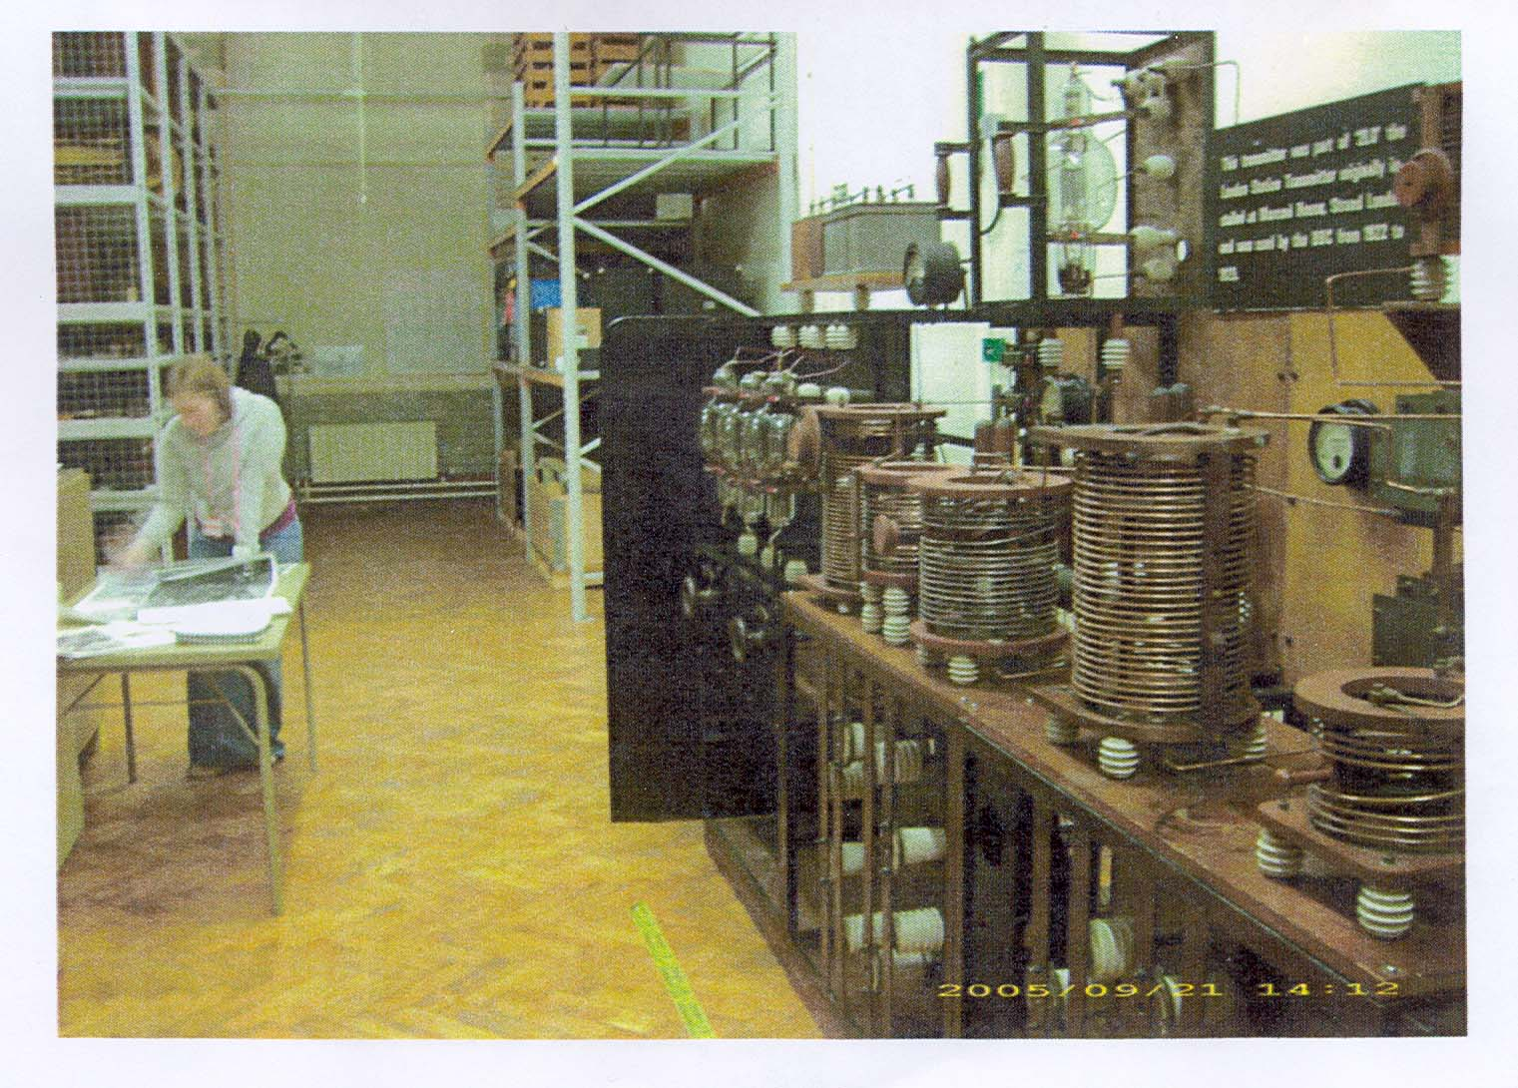
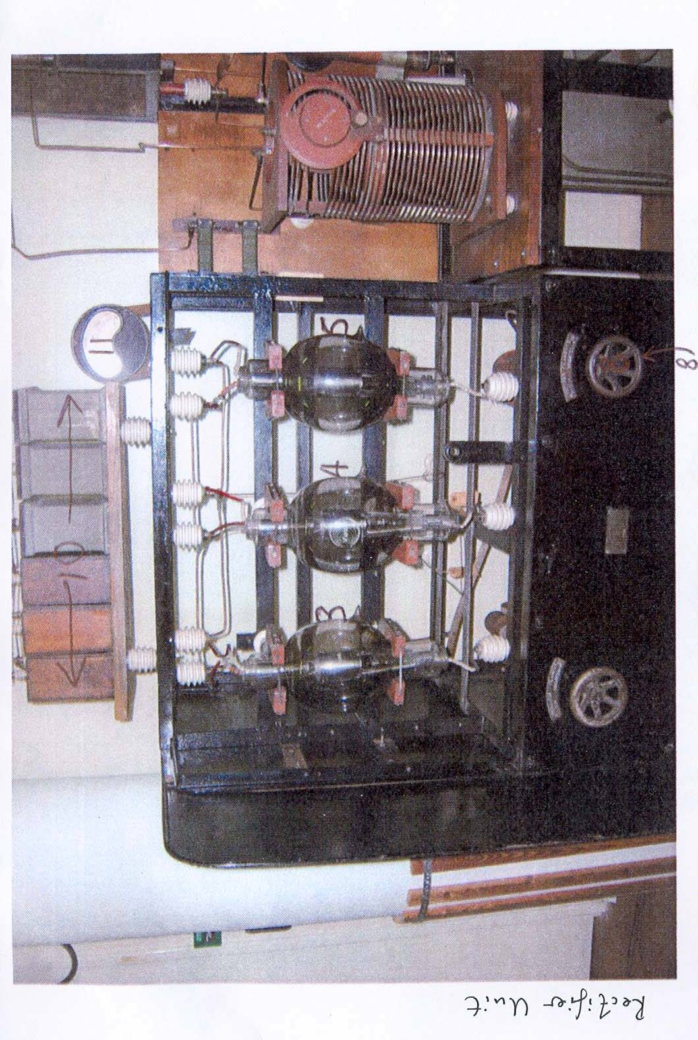

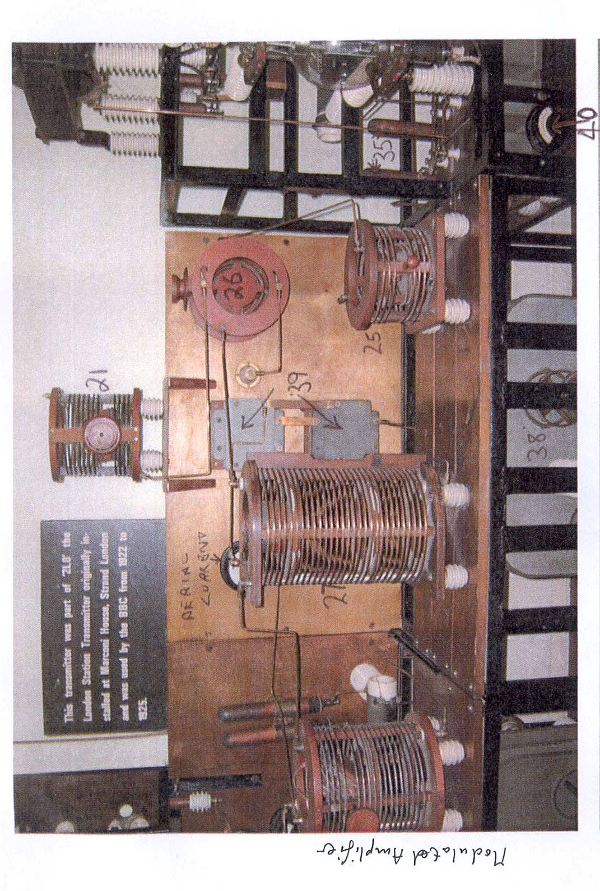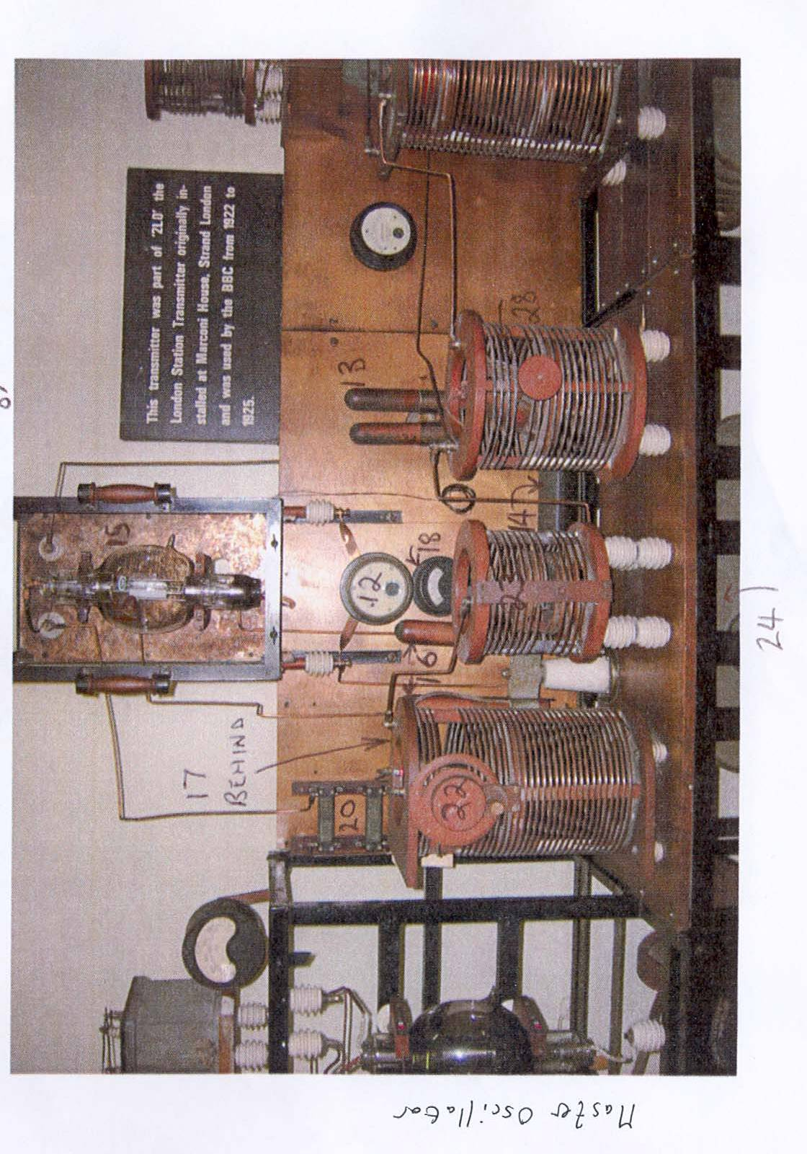
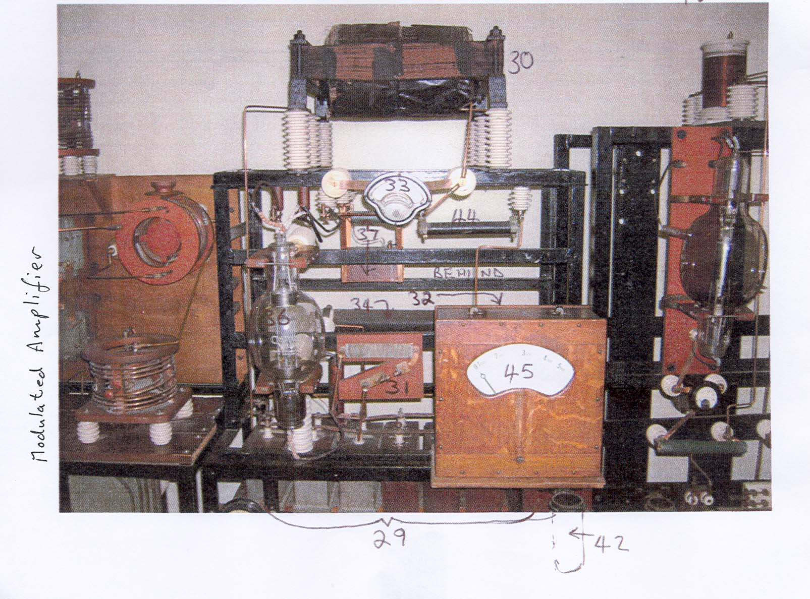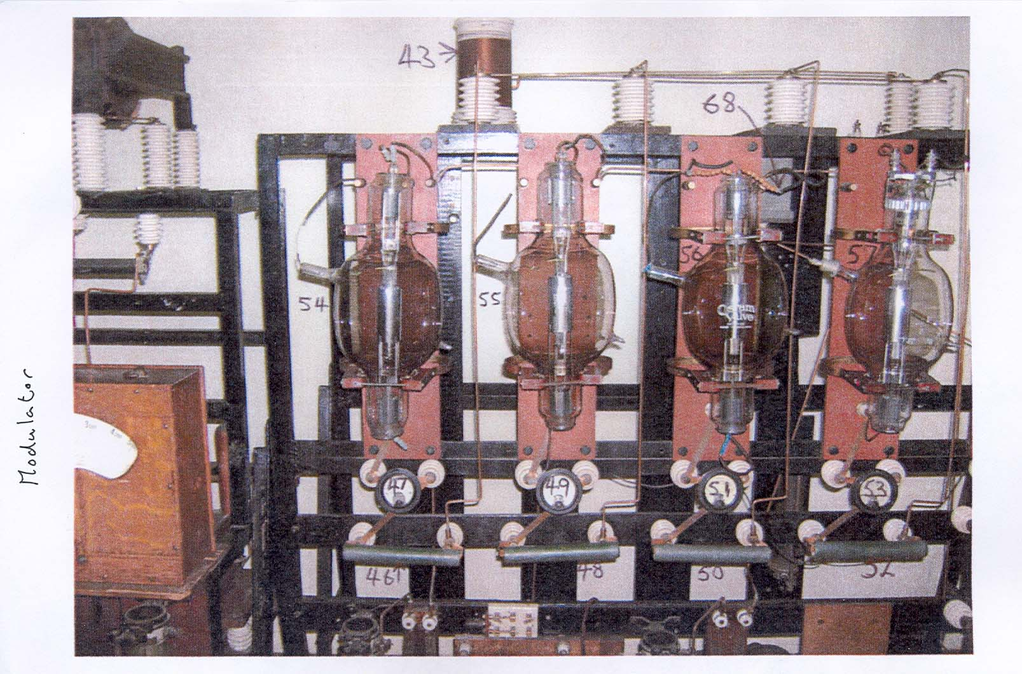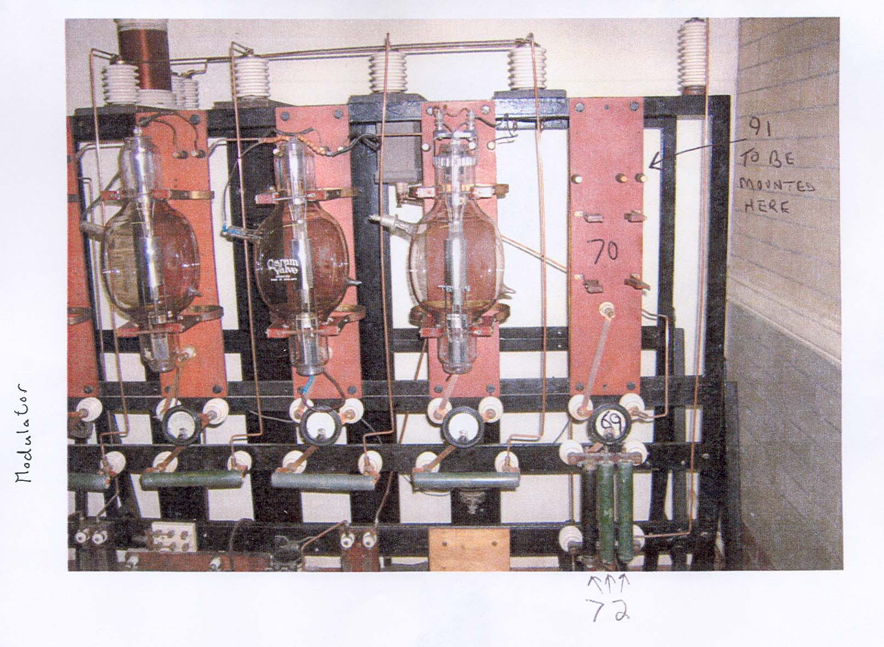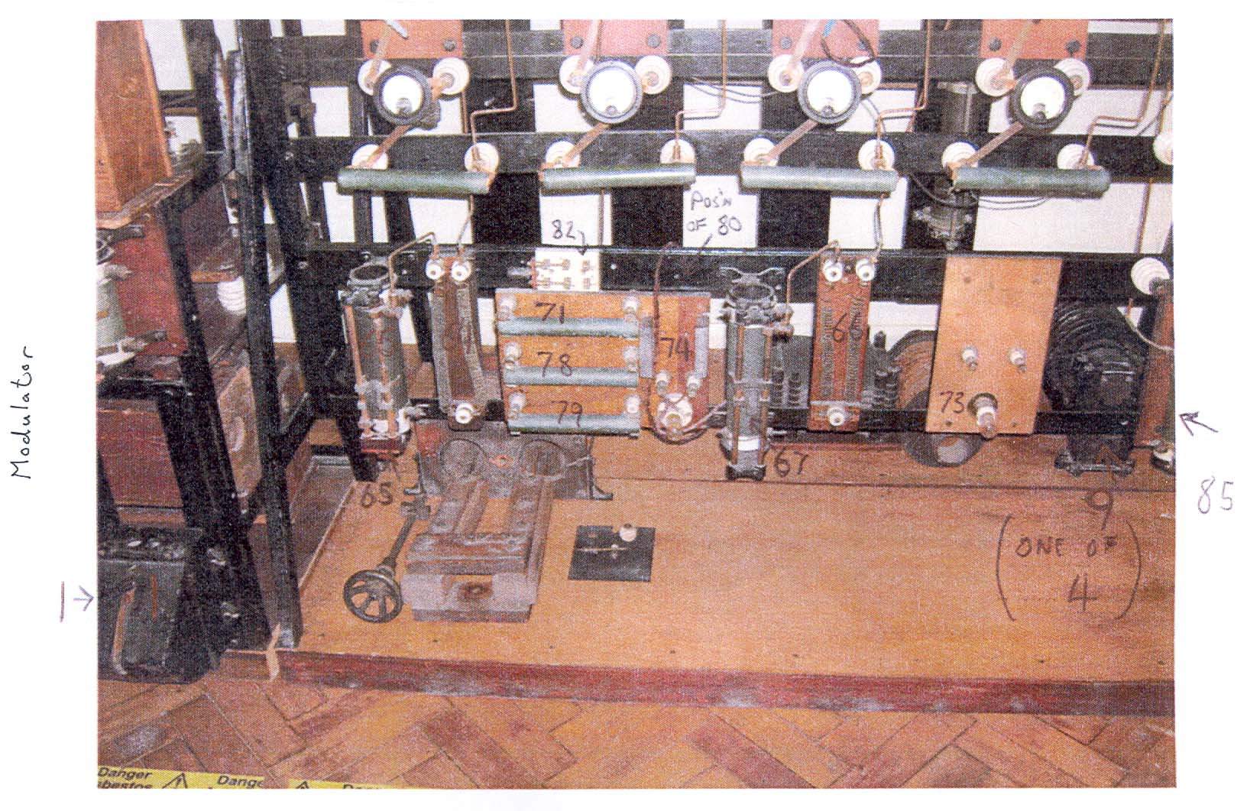

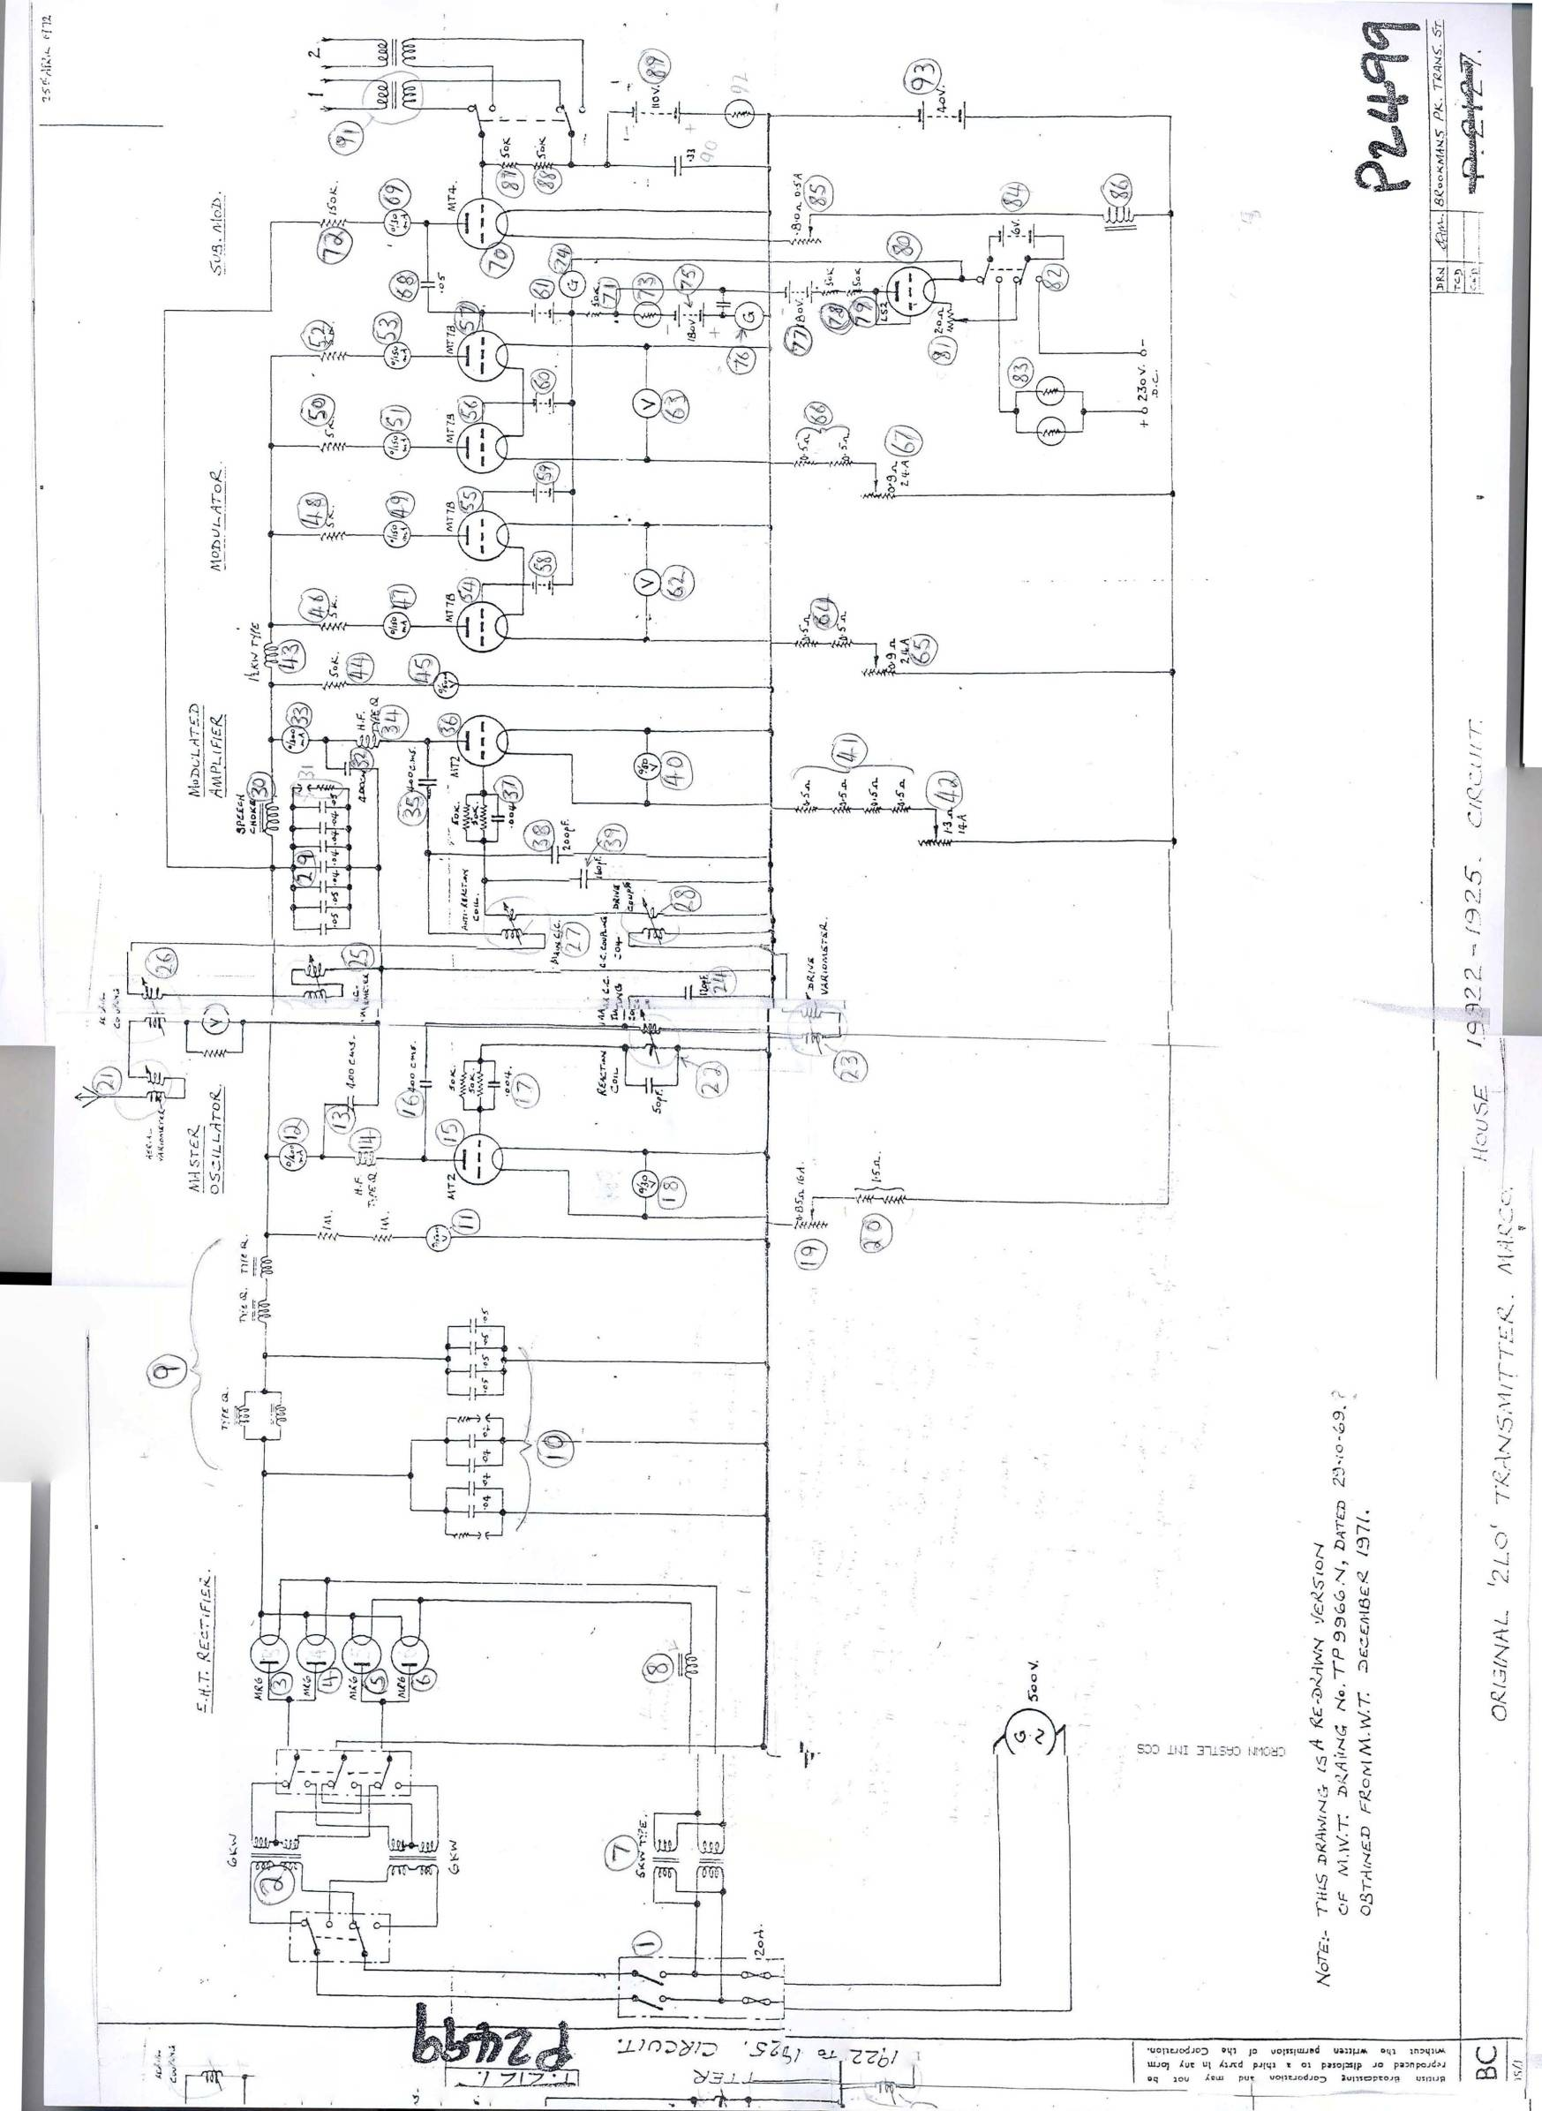

Bibliography
Printed Resources- books and articles
Adorno, Theodor (translated by Weber) ‘Valery and Proust Museum,’ Prisms (MIT Press, Cambridge, 1981).

Alan, A.J. Good Evening Everyone (Hutchinson, London, 1928).

Anderson, Ben, Wylie J, ‘On Geography and Materiality,’ Environment and Planning A 41:2, (2009) 318-335.

Appadurai, Arjun, The Social Life of Things: Commodities in Cultural Perspective (Cambridge University Press, Cambridge, 1997).

Auerbach, Jeffrey A. The Great Exhibition Soul of 1851: A Nation on Display (Yale University Press, 1999).

Balmer, John, ‘Dimensions and Associations of Corporate Identity: Insights from the British Monarchy, the BBC and from Identity Consultancy,’ Working Paper Bradford University School of Management (April, 2004).

Barr, Jean, ‘Dumbing Down Intellectual Culture: Frank Furedi, Lifelong Learning and Museums: A Viewpoint,’ Museum and Society, Vol. 3:2 (2005) 98-114

Bennett, Jane, ‘The Force of Things: Steps Towards an Ecology of Matter,’ Political Theory, Vol. 32:3 (June, 2004) 347-372

Bennett, Jane, The Enchantment of Modern Life: Attachments, Crossings and Ethics (Princeton University Press, Princeton, 2001).

Bennett, Jane, Vibrant Matter: A Political Ecology of Things (Duke University Press, Durham, 2010).

Bennett, Tony, Pasts Beyond Memory: Evolution, Museums, Colonialism (Routledge, London, 2004).

Bondi, L. and Davidson J. ‘Lost in Translation: A Response to Steve Pile,’ Transactions of the Institute of British Geographers, Vol. 36 (2011) 595–8.
Briggs, Asa, The History of Broadcasting in the United Kingdom, Vol. I: The Birth of Broadcasting (Oxford University Press, Oxford, 1995).
Briggs, Asa, The History of Broadcasting in the United Kingdom: Vol. II The Golden Age of Wireless (London: Oxford University Press, 1965).
Bronte, Charlotte, Jane Eyre: An Autobiography (Everyman, London, 1991).

Brown, B. (ed.) Things (University of Chicago, Chicago, 2004).

Burrows, Arthur, The Story of Broadcasting (Cassell &Co. London, 1924).
Butsch, Richard, ‘Crystal Sets and Scarf-pin Radios: Gender, Technology and the Construction of American Radio Listening in the 1920s,’ Media, Culture & Society (Oct. 1998) 557-572.

Caldwell, N.G. ‘The Emergence of Museum’s Brands,’ International Journal of Arts Management, Vol. 2:3 (2000) 28-34.

Callahan, ‘The Liberty Bell: From Commodity to Sacred Object,’ Journal of Material Culture, Vol. 4:1 (1999) 57-78.

Colman, Andrew, A Dictionary of Psychology (Oxford University Press, Oxford Reference Online, 2009).

Covert, Catherine, ‘We May Hear Too Much: American Sensibility and the Response to Radio 1919-1924,’ Catherine Covert and John Stevens (eds.) Mass Media Between the Wars (Syracuse University Press: 1984).

Caras, Lilian, A History of Brookman’s Park Transmitting Station (2002). http://www.brookmans.com/history/transmitting/transmittingstation.shtml

Clavir, Miriam, ‘The Social and Historic Construction of Professional Values in Conservation,’ Studies in Conservation, Vol. 43:1, (1998) 1-8.

Cook, Ian, ‘Follow the Thing,’ Antipode, Vol. 36:4 (2004) 642-664.

Cosgrove, ‘Should We Take it All So Seriously? Culture, Conservation and Meaning in the Contemporary World,’ W.E. Krumbein (ed.) Durability and Change: The Science, Responsibility, and Cost of Sustaining Cultural Heritage (John Wiley, Chichester, 1994).

Crang, Mike, Divya P Tolia-Kelly, ‘Nation, Race, and Affect: Senses and Sensibilities at National Heritage Sites,’ Environment and Planning A, Vol. 42 (2010) 2315 – 2331.

Dickens, Luke, ‘Placing Post-graffiti: The Journey of the Peckham Rock,’ Cultural Geographies, Vol. 15: 4 (Oct. 2008) 471-496.

Dowsett, H. M. Wireless Telephony and Broadcasting, Vol. 2 (The Gresham Publishing Co Ltd. 1924).

Douglas, Susan, Listening in: Radio and the American Imagination (University of Minnesota Press, London, 2004).

Durant, John, Museums and the Public Understanding of Science (Science Museum with COPUS, London, 1992).

Duranti, Marco, ‘Utopia, Nostalgia and World War at the 1939-40 New York World's Fair,’ Journal of Contemporary History, Vol. 41:4 (Oct.2006) 663-683.

Eckersley, Peter Pendleton, The Power Behind the Microphone (Cape, London, 1941).

Edensor, Tim, Industrial Ruins: Spaces, Aesthetics and Materiality (Berg, Oxford, 2005).

Eglash, Ron, ‘Technology as Material Culture,’ Christopher Tilley (ed.) The Handbook of Material Culture (Sage, London, 2006) 329-341.

Epley, Wytz, & Cacioppo, ‘On Seeing Human: A Three-factor Theory of Anthropomorphism,’ Psychological Review, Vol. 114:4 (2007) 864-886.

Freud, Sigmund, The Uncanny (Penguin Book, London, 2003).

Geoghegan, Hilary, ‘The Culture of Enthusiasm: Technology, Collecting and Museums’ (Unpublished PhD Thesis, Royal Holloway, University of London, 2008).

Geoghegan, Hilary, ‘The Great Un-displayed: Stories from the Science Museum’s Store,’ AAG conference paper, March 2006.
Gell, Alfred, Art and Agency: A New Anthropological Theory (Oxford University Press, Oxford, 1998).
Gilloch, G. Walter Benjamin: Critical Constellations (Polity, Cambridge, 2001).
Gracyk, Theodore, ‘Listening to Music: Performances and Recordings,’ The Journal of Aesthetics and Art Criticism, Vol. 55:2 (1997) 139-150.
Glanfield, John, Earls Court and Olympia: from Buffalo Bill to the ‘The Brits,’ (Sutton Pub. Stroud, 2003).
Hahn, H.P. and Soentgen, J. ‘Acknowledging Substances: Looking at the Hidden Side of the Material World,’ Philosophy and Technology, Vol. 24:1 (July 2010) 19-33.

Halewood, C. K. Hannam, ‘Viking Heritage Tourism: Authenticity and Commodification,’ Annals of Tourism Research, Vol. 28: 3 (2001) 565-580

Haring , Kristen, ‘The ‘Freer Men’ of Ham Radio: How a Technical Hobby Provided Social and Spatial Distance,’ Technology and Culture, Vol. 44: 4 (Oct., 2003)734-761.

Hennessey, Brian, The Emergence of Broadcasting in Britain (Southerleigh, Lympstone, 2005).

Hennessey, Brian, Savoy Hill: the Early Years of British Broadcasting (Ian Henry, Romford, 1996).

Herbert, R. A. ‘Growing up with Wireless,’ Norman Shacklady, Martin Ellen, On Air: A History of BBC Transmission, (Wavechange Books, London, 2002).

Hugil, Peter, Global Communications since 1844: Geopolitics and Technology (John Hopkins University Press, Baltimore, 1999).

Hoskins, Janet, Biographical Objects: How Things Tell the Stories of Peoples’ Lives (Routledge, London, 1998).

Hoskins, Janet, ‘Agency, Biography and Objects,’ Christopher Tilley, The Handbook of Material Culture (London: SAGE, 2006) 74-85.

Jóhannesson, G.T. J.O. Bærenholdt ‘Actor-Network Theory/Network Geographies,’
Kitchen, Rob, Nigel Thrift (eds.) International Encyclopaedia of Human Geography (Elsevier, Boston, 2009) 15-19.

Hill, Jude, ‘The Story of the Amulet: Locating the Enchantment of Collections,’ Journal of Material Culture, Vol. 12: 1 (2007) 65-87.

Hobsbawm, Eric, The Invention of Tradition (Cambridge University Press, Cambridge, 1983).

Ingold, ‘Materials Against Materiality,’ Archaeological Dialogues, Vol. 14 (2007) 1-16.

Jennings, H. and W. Gill, Broadcasting in Everyday Life: a Survey of the Social Effects of the Coming of Broadcasting (BBC: London, 1939).

Kibbie, Ann, ‘Object Narratives,’ The Oxford Encyclopaedia of British Literature, David Scott Kastan (ed.) (Oxford University Press, Oxford online, 2005).

Kipling, Rudyard, ‘Wireless,’ Traffics and Discoveries (London: Macmillan, 1973).

Knutson, Karen and Kevin Crowley, ‘Book Review: Behind the Scenes at the Science museum,’ Science Education, Vol. 88: 2 (March 2004) 297-300.

Kopytoff, Igor, ‘The Cultural Biography of Things,’ Arjun Appadurai, The Social Life of Things: Commodities in Cultural Perspective (Cambridge University Press, Cambridge, 1997).

Kuchler, Susan, Malanggan: Art, Memory and Sacrifice (Berg, Oxford, 2002).

Latour, Woolgar, Laboratory Life: the Construction of Scientific Facts (Princeton University Press, Princeton, 1979).

Lewis, C.A. Broadcasting from Within, (London, George Newnes, 1924).

Law, John, Aircraft Stories: Decentring the Object in Technoscience (Duke University Press, Durham 2002).

Law, John and John Hassard (ed.) Actor Network Theory and After (Blackwell Publisher, Oxford, 1999).

Law, Jonathon (ed.) A Dictionary of Business and Management (Oxford University Press, Oxford Reference Online, 2009).

Lord, Beth, ‘Foucault’s Museum: Difference, Representation and Genealogy,’ Museum and Society Vol. 4:1 (March, 2006).

Lowenthal, David, ‘The Value of Age and Decay,’ W. E. Krunbein, P. Brimblecombe, D.E. Cosgrove and S. Stainforth, Durability and Change, The Science, Responsibility, and Cost of Sustaining Cultural Heritage (Wiley, London, 1994).

Lowenthal, David, The Past is a Foreign Country, (Cambridge University Press, Cambridge, 1985).

Lowenthal, David, ‘Material Preservation and its Alternatives,’ Perspecta, Vol. 25 (1989) 66-77.

Luckhurst, Roger, The Invention of Telepathy (Oxford University Press, Oxford, 2002).

Lubar, Steven, ‘Learning from Technological Things,’ David Kingery (ed.) Learning from Things: Method and Theory of Material Cultural Studies (Smithsonian Institution Press, 1996).

Lumley, The Museum Time Machine: Putting Cultures on Display (Routledge, London, 1990).

Mann, Peter, ‘Working Exhibits and the Destruction of Evidence in the Science Museum,’ The International Journal of Museum Management and Curatorship, Vol. 8 (1989) 369-387.

MacDonald, Sharon, Behind the Scenes at the Science Museum (Berg, Oxford, 2002).

MacDonald, Sharon, Politics of Display (Routledge, London, 1998).

Marchand, Roland, Creating the Corporate Soul: the Rise of Public Relations and Corporate Imagery in American Big Business (University of California Press, Berkeley, 1998).

Mazda, Xerxes, ‘The Changing Role of History in the Policy and Collections of the Science Museum 1857-1973,’ Science Museum Papers in the History of Technology No 3 (1996).

McCarthy, Tom, C, (Vintage, London, 2011).

Morris, Peter, Science for the Nation: Perspectives on the History of the Science Museum (NMSI, 2010).

Moore, Shaun, ‘The Box on the Dresser: Memories of Early Radio and Everyday Life,’ Media, Culture, and Society Vol. 10: 23 (1988) 23-40.

Murdoch, Jonathan ‘The Spaces of Actor-Network Theory,’ Geoforum, Vol. 29:4 (Nov. 1998) 357-374.

Nye, David, Image Worlds: Corporate Identities at General Electric 1890-1930 (MIT Press, London, 1985).

Nye, David, The American Technological Sublime (MIT, Cambridge, 1994).

Panofsky, Erwin, Meaning in the Visual Arts (University of Chicago Press, Chicago, 1982).

Pawley, Edward, BBC Engineering, 1922-1972 (British Broadcasting Corporation, London, 1972).

Pearce, Susan, Interpreting Objects and Collections (Routledge, Andover, 2001).

Peters, John Durham, Speaking into the Air: A History of the Idea of Communication (University of Chicago Press, London, 2000).

Pile, Steve, ‘Emotions and Affect in Recent Human Geography,’ Transactions of the Institute of British Geographers Vol. 35:1 1 (2010) 5-20.

Poe, Marshall, A History of Communications: Media and Society from the Evolution of Speech to the Internet (Cambridge University Press, 2010).

Prentice, Richard, ‘Experiential Cultural Tourism: Museums & the Marketing of the New Romanticism of Evoked Authenticity,’ Museum Management and Curatorship, Vol. 19:1 (2007) 5-26.

Rose, Gillian, Monica Degen and Begum Bas, ‘More on ‘big things’: Building Events and Feelings,’ Transaction of the Institute of British Geographers, Vol. 35: 3 (July 2010) 334–349.

Reisinger, Carol, ‘Reconceptualising Object Authenticity,’ Annals of Tourism Research, Vol. 33:1 (Jan. 2006) 65-86.

Sconce, Jeffrey, Haunted Media: Electronic Presence from Telegraphy to Television, (Duke University Press, Durham, 2000).

Schwartz, Chandler, ‘Use does not Wear Ragged the Fabric of Friendship: Thinking of Objects as Alive makes People Less Willing to Replace Them,’ Journal of Consumer Psychology, Vol. 20 (2010) 138-145.

Shackledy, Norman and Martin Ellen (eds.), On Air: A History of BBC Transmission, (Wavechange Books, London, 2003).

Silverstone, R. ‘Science on Display: the Representations of Controversy in Science,’ Museums and the Public Understanding of Science, an International Journal of Research in the Public Dimensions of Science and Technology, Vol. 1: 1 (Jan. 1992) 69-87.

Spadoni, Robert, ‘The Uncanny Body of Early Sound Film,’ The Velvet Light Trap Vol. 51 (2003) 4-16.

Turkle, Sherry, ‘Cyberspace and Identity,’ Contemporary Sociology, Vol. 28:6 (Nov. 1999) 643-648.

Turkle, Sherry, Evocative Objects: Things We Think With (MIT Press, London, 2007).

Trigg, Dylan, Aesthetics of Decay: Nothingness, Nostalgia and the Absence of Reason, (Peter Lang, Oxford, 2006).

Vivant, Elsa, ‘Who Brands Whom? The Role of Local Authorities in the Branding of Art Museums,’ Town Planning Review, Vol. 82:1 (Jan 2011) 99-115.

Wander, Tim, 2MT Writtle: The Birth of British Broadcasting (Capella, Stowmarket, 1988).

Weightman, Gavin, Signor Marconi’s Magic Box (Harper Collins, London, 2004).

White, Jerry, London in the Twentieth Century: A City and its People (Viking, London, 2001).

Wright, J. E. ‘The BBC: Engineering Landmarks over 50 Years,’ Electronics and Power (Oct. 1972) 344-348.

Wurtzler, Steve, Electric Sounds:Technological Change and the Rise of Corporate Mass Media (Columbia University Press, New York, 2007).

Published Serials

The Radio Times

Wireless World and Radio Review

World-Radio

The Engineer

Popular Wireless

Experimental Wireless

Institute of Wireless Technology Journal

Modern Wireless

Yearbook of Wireless Telegraphy and Telephony

Radio Review

BBC Handbooks 1929- 1939

The Times

The Daily Mail

The Daily Express

Prospero

Aerial

The Guardian

Time Out

The Listener

Illustrated London News

BVWS Bulletin

Archives

BBC Written archives, Caversham

BBC Photograph Collection, White City.

The Marconi Collection, Bodleian, Oxford University

Science Museum Archives

Earl’s Court and Olympia Archive

Brookman’s Park Private Collection

Institute for Engineering and Technology (IET) Archive and Library.

British Film Institute National Archive

British Cartoon Archive, University of Kent

British Library Newspaper Archive, Colindale

Other Sources

In Freefall, directed by HitoSteyerl, (Chisenhale Gallery, Picture This, Bristol and Collective, Edinburgh, 2010)

The Secret Life of the Radio, The Secret Life of Machines, (Channel 4, 1994).

The Age of Ambition, The Seven Ages of Britain, (BBC, 2010)

Cough and You’ll Deafen Thousands (Mullard, 1972).

Field Diary, 23/05/2011.
AHRC proposal http://www.gg.rhul.ac.uk/postgrads/AHRC-SM.html accessed 12/08/2011
Field Diary, 23/05/2011.
Colman, Andrew, A Dictionary of Psychology (Oxford University Press, Oxford Reference Online, 2009).
Johannesson, G.T. Baernholdt, J.O. ‘Actor Network Theory/ Network Geographies,’ Kitchin, Rob, Nigel Thrift (eds.) International Encyclopaedia of Human Geography, (Elsevier, Boston, 2009) 17.
Bennett, Jane, Vibrant Matter: A Political Ecology of Things, Kindle edition, (Duke University Press, 2009).
Pile, Steve, ‘Emotions and Affect in Recent Human Geography,’ Transactions of the Institute of British Geographers, Vol. 35:11 (2010) 12.
Bondi, L, Davidson J,’ Lost in Translation: a Response to Steve Pile,’ Transactions of the Institute of British Geographers, Vol. 36 (2011) 595–8
Pile, Steve, ‘For a Geographical Understanding of Affect and Emotions,’ Transactions of the Institute of British Geographers (2011) 603-606.
Bennett, Jane, Vibrant Matter (2009) Kindle edition.
Callahan, Robey, ‘The Liberty Bell: From Commodity to Sacred Object,’ Journal of Material Culture Vol. 4:1 (1999) 57-78.
Kibbie, Ann Louise, ‘Object Narratives,’ David Scott (ed.) The Oxford Encyclopaedia of British Literature (Oxford University Press, Kastan, 2005). Accessed online at http://www.oxfordreference.com/views/ENTRY.html?subview=Main&entry=t198.e0347 31/08/2012
Cook, Ian, ‘Follow the Thing: Papaya,’ Antipode Vol. 36:4 (2004) 642-664.
Hennessey, Brian, The Emergence of Broadcasting in Britain, (Southerleigh, Lympstone, 2005).
Briggs, Asa, The History of Broadcasting in the United Kingdom, Vol. I: The Birth of Broadcasting (Oxford University Press, Oxford, 1995) 97.
Hugil, Peter, Global Communications since 1844: Geopolitics and Technology (John Hopkins University Press, Baltimore, 1999).
Briggs, The History of Broadcasting in the United Kingdom, Vol. I (1995).
Weightman, Gavin, Signor Marconi’s Magic Box (Harper Collins, London, 2004).
Wander, Tim, 2MT Writtle: The Birth of British Broadcasting (Capella, Stowmarket, 1988).
Hennessey, The Emergence of Broadcasting in Britain (2005).
Hennessey, Brian, Savoy Hill: the Early Years of British Broadcasting (Ian Henry, Romford, 1996).
Crisell, Andrew, An Introductory History of British Broadcasting (Routledge, London, 2002).
Briggs, The History of Broadcasting in the United Kingdom, Vol. I (1995) 97.
‘Information on 2LO,’ Internal Document, File R53/312, BBC Written Archives, Caversham.
Burrows, Arthur, The Story of Broadcasting (Cassell & Co. London, 1924).
Lewis, C. A. Broadcasting from Within (George Newnes, London, 1924).
Wireless World and Radio Review, 1919-1939.
Radio Times, 1923-1930.
Burrows, Arthur, ‘BBC’s First Birthday,’ Radio Times, 09/11/1923, 228.
Peters, John Durham, Speaking into the Air: A History of the Idea of Communication (University of Chicago Press, London, 2000).
Sconce, Jeffrey, Haunted Media: Electronic Presence from Telegraphy to Television (Duke University Press, Durham, 2000).
‘Piecing Together Radio’s Past,’ Prospero, 04/1998, BBC Written Archive, Caversham.
Kopytoff, Igor, ‘The Cultural Biography of Things,’ Arjun Appadurai, The Social Life of Things: Commodities in Cultural Perspective (Cambridge University Press, Cambridge) 66.
Hoskins, Janet, Biographical Objects: How Things Tell the Stories of Peoples’ Lives (Routledge, London, 1998).
Dickens, Luke, ‘Placing Post-graffiti: the Journey of the Peckham Rock,’ Cultural Geographies, Vol. 15: 4 (2008) 471-496.
Hill, Jude, The Story of the Amulet: Locating the Enchantment of Collections,’ Journal of Material Culture, Vol. 12: 1 (2007) 65-87.
Cook, ‘Follow the Thing’ (2004) 642-664.
Sir Noel Ashbridge, Control Board’s Meeting Minutes, 11/10/1929, BBC Written Archives, Caversham.
Marchand, Roland, Creating the Corporate Soul: the Rise of Public Relations and Corporate Imagery in American Big Business (University of California Press, Berkeley, 1998).
Field Diary, 08/12/2009.
Field Diary, 18/11/2009.
Geoghegan, Hilary, ‘The Culture of Enthusiasm: Technology, Collecting and Museums’ (Unpublished PhD Thesis, Royal Holloway, University of London, 2008).
Field Diary, 20/06/2009. Images of the museum can be viewed here http://bvwm.org.uk/tour/ accessed 01/03/2012.
Interview with RR 06/05/2010.
Edensor, Tim, Industrial Ruins: Spaces, Aesthetics and Materiality (Berg, Oxford, 2005). Lowenthal, D, ‘The Value of Age and Decay,’ W. E. Krunbein, P. Brimblecombe, D.E. Cosgrove and S. Stainforth, Durability and Change, The Science, Responsibility, and Cost of Sustaining Cultural Heritage (John Wiley, Chichester, 1994). Lowenthal, D. The Past is a Foreign Country (Cambridge University Press, Cambridge, 1985).
Interview with ME 05/03/2009.
Ingold, Tim, ‘Materials Against Materiality,’ Archaeological Dialogues, Vol. 14 (2007) 1-16.
Hahn, H.P. Soentgen, J. ‘Acknowledging Substances: Looking at the Hidden Side of the Material World,’ Philosophy and Technology Vol. 24:1 (2010) 21.
Hahn, Soentgen, ‘Acknowledging Substances’ (2010) 19.
Ingold, ‘Materials Against Materiality,’ (2007).
Field Diary 03/02/2011.
Bennett, Jane, ‘The Force of Things: Steps towards an Ecology of Matter,’ Political Theory, Vol. 32:3 (2004) 348.
Hill, Jude, ‘The Story of the Amulet,’ (2007) 65.
Pile, Steve, ‘Emotions and Affect in Recent Human Geography’ Transactions of the Institute of British Geographers Vol. 35:1 1, (2010) 12.
Rose, Gillian, Monica Degen and Begum Bas, ‘More on ‘big things’: Building Events and Feelings’ Transaction of the Institute of British Geographers, Vol. 35: 3 (2010) 334–349.
Latour, Bruno, Woolgar, Steve, Laboratory Life: the Construction of Scientific Facts (Princeton University Press, Princeton, 1979).
MacDonald, Sharon, Behind the Scenes at the Science Museum (Berg, Oxford, 2002) 12.
Morris, Peter (ed.) Science for the Nation: Perspectives on the History of the Science Museum (Pelgrave Macmillan, Basingstoke, 2010).
Burrows, The Story of Broadcasting (1924) 111.
Metropolis, Directed by Fritz Lang, Universum Film A.G. (1927).
Ross, Cathy, Twenties London: City in the Jazz Age (Philip Wilson, London, 2003).
Eglash, Ron, ‘Technology as Material Culture,’ Christopher Tilley (ed.) The Handbook of Material Culture (Sage, London, 2006) 329.
Peters, Speaking into the Air (2000).
‘The New 2LO- Britain’s Latest Broadcasting Station’ Marconi Press Release 18/03/1925, MS Marconi 312, Marconi collection, Bodleian Library, Oxford University.
Letter to A. R. Burrows from the W. H. White Chief Engineer, 24/01/1922 Marconi Collection, Bodleian Library, Oxford University, MS Marconi 312. Though the exact date is difficult to specify, the license, also in the Marconi Collection, is mentioned in a letter as arriving on the 17th of January, so we can presume the station was active from around then.
‘Some notes on Telephony Transmissions’ 27/05/1922, Wireless World and Radio Review Vol. X, 1922, 256-258.
Hennessey, The Emergence of Broadcasting in Britain (2005) 106.
Dowsett, H. M. (Dowsett, 1924) (Briggs, 1995) Wireless Telephony and Broadcasting, Vol. 2 (The Gresham Publishing Co Ltd, 1924) 95.
See Figure 1.
Eglash, ‘Technology as Material Culture’ (2006) 330.
Many of these are discussed in files 312 and 313, Marconi Collection, Bodleian Library, Oxford University.
Hennessey, The Emergence of Broadcasting in Britain (2005) 106.
Burrows, The Story of Broadcasting (1924) 59.
Briggs, The History of Broadcasting in the United Kingdom, Vol. I (1995).
Minutes of the British Broadcasting Committee, 16/05/1922, BBC Written Archives, Caversham.
Minutes of the British Broadcasting Committee, 01/06/1922, BBC Written Archives, Caversham.
F. Gill, BBC- Broadcasting Committee Minutes 07/06/ 1922, CO1/1/1, BBC Written Archives, Caversham.
‘Captain H. J. Round: An Electronics Pioneer: Obituary’ The Times, 19/08/1966, 12.
‘Captain H. J. Round: An Electronics Pioneer: Obituary’ The Times, 19/08/1966, 12.
Wander, 2MT Writtle (1988) 91.
Typescript ‘2LO the London Station’, File C58 Compilations BBC Early History, BBC Written Archives Caversham, 4.
‘A Contrast in Transmitters,’ Wireless World and Radio Review, 17/09/1930, 209.
‘2LO Closing Down’ 18/03/1925, MS Marconi 312, Marconi Collection, Bodleian Library, Oxford.
‘‘A. W’s ‘Special Representative Visits 2LO’ Amateur Wireless, 23/12/1922, 678.
White, R. H. ‘The London Station of the British Broadcasting Company’ Wireless World and Radio Review 03/12/1922, 389-39.
White, R. H. ‘The London Station of the British Broadcasting Company’ Wireless World and Radio Review 03/12/1922, 391.
Dowsett, H. M. Wireless Telephony and Broadcasting, Vol. 1 (The Gresham Publishing Co Ltd, 1923) 166.
Dowsett, H. M. Wireless Telephony and Broadcasting, Vol. 2 (The Gresham Publishing Co Ltd, 1924.) 95.
Lewis, Broadcasting from Within (1924) 27.
Burrows, The Story of Broadcasting (1924) 106.
‘The New 2LO’ 18/03/1925, MS Marconi 312, Marconi Collection, Bodleian Library, Oxford.
Lewis, Broadcasting from Within (1924).
Eckersley, P.P. The Power Behind the Microphone (Cape, London, 1941).
Burrows, The Story of Broadcasting (1924) 109.
‘2LO Transmitter,’ R53/312, BBC Written Archives, Caversham.
‘2LO Finds a New Home,’ Wireless World and Radio Review, 04/03/1925, 121.
‘2LO Transmitter,’ R53/312, BBC Written Archives, Caversham.
Harold Bishop, interview in Cough and You’ll Deafen Thousands (Mullard, 1972).
Minutes of the Broadcasting Board, 14/05/1924, BBC Written Archives, Caversham.
R.T.B Wynn, Director of Engineering 1952-1965, Cough and You’ll Deafen Thousands (Mullard, 1972).
‘2LO Transmitter,’ R53/312, BBC Written Archives, Caversham.
Minutes of the Broadcasting Board, 12/09/1923, BBC Written Archives, Caversham.
Broadcasting Board, ‘Site of London Broadcasting Station,’ 29/04/1929, BBC Written Archives, Caversham.
‘A Farewell Glimpse of the Present London Station,’ BBC Handbook, 1929, 31.
‘The New 2LO,’ Wireless World and Radio Review, 11/02/1925.
‘The New Broadcasting Station- Will is Supersede 2LO?’ Wireless World and Radio Review, 27/08/1924, 629-630.
See for example Popular Wireless, 18/08/1925, 906.
Correspondence surrounding the simultaneous broadcasts, 18/03/1925, BBC Written Archives, Caversham.
‘Opening of the British Empire Exhibition, Wembley,’ 23/04/1924, Ref. 21525, BBC Sound Archive, British Library Sound Archive, London.
http://www.studygroup.org.uk/Articles/Content/The%20British%20Empire%20Exhib%201.html Courtesy of Paul Wilson, Curator of Radio, British Library.
BBC Sound Archive, Ref. 21/5/25, British Library.
Gracyk, Theodore ‘Listening to Music: Performances and Recordings,’ The Journal of Aesthetics and Art Criticism, Vol. 55: 2, Perspectives on the Arts and Technology (1997) 142.
Burrows, The Story of Broadcasting (1924) 111.
McCarthy, Tom, C (Vintage, London: 2011) 66.
Turkle, Sherry, ‘Cyberspace and Identity’ in Contemporary Sociology, Vol. 28: 6 (1999) 643-648. This is just one example of Sherry Turkle’s wide ranging work into the impact of computer technology and virtual spaces. This introduction to a symposium, in particular acts as a good introduction to ideas that are relevant to early wireless, including personal identity in a virtual environment and how that can differ from our perception of our ‘real’ self.
Haring, Kristen, ‘The ‘Freer Men’ of Ham Radio: How a Technical Hobby Provided Social and Spatial Distance,’ Technology and Culture, Vol. 44: 4 (2003), 735.
Eckersley, The Power Behind the Microphone (1941) 33-34.
Rex Haworth, interview in Cough and You’ll Deafen Thousands (Mullard, 1972).
Including the famous Dame Nellie Melba broadcast of 1920. ‘Broadcasting Reminisces: A Brief Review of Ten Years Progress by Captain H. J. Round,’ World-Radio 18/11/1932, 1147-1150.
Asa Briggs details this in his third chapter ‘Amateurs and Professionals,’ The Birth of British Broadcasting. Vol. 1. Reference is also made for example in Andrew Crisell, An Introductory History of British Broadcasting (Routledge: London, 1997) 13.
Asa Briggs discusses this in detail in an article entitled ‘New Light on the BBC’s Beginning,’ The Listener, 02/11/1972, 572-3.
All examples currently in the IET Library. One notable exception to the rule of issue run is Wireless World and Radio Review which still continues as Electronics World today.
Wireless World and Radio Review, Vol. VII April 1919-March 1920.
For example Dr W. H. Eccles, ‘The Work of a Wireless Engineer,’ Wireless World and Radio Review 04/06/1925, 649.
‘Notes and News,’ Wireless World and Radio Review, 23/06/1923, 388.
Wander, 2MT Writtle: The Birth of British Broadcasting (1988) 67.
Wander, 2MT Writtle: The Birth of British Broadcasting (1988) 76.
Covert, Catherine, ‘‘We may hear too much’: American Sensibility and the Response to Radio 1919-1924’ Catherine Covert and John Stevens (eds.) Mass Media Between the Wars (Syracuse University Press: 1984) 205.
Letter from Arthur Burrows to Harold Davies, 13/07/1922, Marconi Collection, Bodleian Library, Oxford University.
The original press statements as compiled by Arthur Burrows appear in MS Marconi 312, Marconi Collection, Bodleian Library, Oxford University.
Hennessey, The Emergence of Broadcasting in Britain (2005) 104.
Arthur Burrows, Press Statement, 09/10/2011, MS Marconi 312, Marconi Collection, Bodleian Library, Oxford University. See also separate file marked ‘King’s speech’ containing souvenir book and reports of reception.
Press Statement, ‘Round Britain Air Race-Progress to be Broadcast by Wireless Telephony,’ 06/09/1922, MS Marconi 312, Marconi Collection, Bodleian Library, Oxford University.
Burrows, The Story of Broadcasting (1924) 61.
Haring, ‘The ‘Freer Men’ of Ham Radio’ (2003) 741.
Sconce, Haunted Media, (2000) 62.
Sconce, Haunted Media, (2000) 65.
While in Wireless World these articles still retained some degree of technical knowledge to understand, those younger publications, and particularly World-Radio, the BBC’s technical journal, and Popular Wireless were aimed at a more basic level..
‘2LO Closing Down,’ 18/03/1925, MS Marconi 312, Marconi Collection, Bodleian Library, Oxford.
Herbert, R.A. ‘Growing up with Wireless’ in Norman Shacklady and Martin Ellen, On Air: A History of BBC Transmission (Wavechange Books, London, 2002) 97.
‘Radio Shows in Retrospect,’ Wireless World and Radio Review, 24/09/1930, 301-304.
‘The First British Wireless Exhibition,’ Wireless World and Radio Review, Vol. IX, 14/10/1922, 39-40.
‘Jammed- An Impression of the Exhibition,’ H. R. Taunton, Wireless World and Radio Review, Vol. IX, 21/10/1922, 92.
‘Jammed- An Impression of the Exhibition,’ H. R. Taunton, Wireless World and Radio Review, Vol. IX, 21/10/1922, 92.
The BBC at the trade fair is discussed in detail in Chapter 2. See in particular, Marchand, Creating the Corporate Soul (1998) Ch 7.
See Arthur Burrows’ pre-BBC correspondence, Marconi Collection, The Bodleian, Oxford University. In particular correspondence between Burrows and H.C. Robbins between the 10th-17th May 1922 MSS Marconi 311.
Burrows, The Story of Broadcasting (1924) 72
‘Radio Notes by W. H. S.’ Illustrated London News, 27/01/1923, 146.
‘Broadcasting from the Zoo. A New Form of Concert’ The Times, 06/10/1924, 17.
See cartoon W.K. Haselden, ‘Why not Broadcast the Spring’ Daily Mirror, 22/03/1924.
Briggs, The History of Broadcasting in the United Kingdom Vol. 1 (1995) 4.
‘Love Letters to Announcers,’ Radio Times, 11/04/1924, 88.
Hennessey, The Emergence of Broadcasting in Britain (2005) 104
Radio Times, Issue 1, 28/09/1923, Front Cover, British Library, London.
Burrows, The Story of Broadcasting (1924) 109.
Radio Times Vol. 3, 25/04/1924, 175.
‘A Chat with the Voice at 2LO,’ Wireless World and Radio Review, 03/02/1923, 589.
Radio Times, Vol. 24, 16/08/1929.
‘A Special Visit to 2LO’s New Home by Ariel,’ Popular Wireless and Wireless Review, 07/03/1925 81.
Law, Aircraft Stories (2002).
‘2LO Testing by C. C. J. Frost of the BBC,’ Wireless World and Radio Review, 30/06/1923, 402-403.
White, Jerry, London in the Twentieth Century: a City and its People (Viking, London, 2001).
Sconce, Haunted Media (2000) 64.
Briggs, The History of Broadcasting in United Kingdom, Vol. 1 (1995) 251.
Briggs, The Birth of British Broadcasting, Vol. 1 (1995) 256.
Sidney ‘George’ Stube, ‘Uncle Austen Speaking,’ The Daily Express, 06/03/1926.
‘2LO Now Closing Down,’ Radio Times, 16/11/1923, 253.
Butsch, Richard, ‘Crystal Sets and Scarf-pin Radios: Gender, Technology and the Construction of American Radio Listening in the 1920s,’ Media, Culture & Society, (1998) 557-572.
Jennings, H. W. Gill, Broadcasting in Everyday Life: a Survey of the Social Effects of the Coming of Broadcasting (BBC, London, 1939).
Moore, Shaun, ‘The Box on the Dresser: Memories of Early Radio and Everyday Life,’ Media, Culture, and Society Vol. 10: 23 (1988) 23-40.
Anderson B, J. Wylie, ‘On Geography and Materiality,’ Environment and Planning A, Vol. 41:2 (2009) 319.
Sconce, Haunted Media (2000).
Wurtzler, Steve, Electric sounds : technological change and the rise of corporate mass media (Columbia University Press, New York 2007) 71.
Peters, Speaking into the Air (2000) 141.
Luckhurst, Roger, The Invention of Telepathy (Oxford University Press, Oxford, 2002) 69.
Douglas, Susan, Listening in: Radio and the American Imagination (University of Minnesota Press, London, 2004) 42.
Luckhurst, The Invention of Telepathy (2002) 90.
Spadoni, Robert, ‘The Uncanny Body of Early Sound Film,’ The Velvet Light Trap Vol. 51 (2003) 12.
Freud, Sigmund, The Uncanny (Penguin Books: London, 2003) 123.
Peters, Speaking in the Air (2000) 141-142.
Covert, Mass Media Between the Wars (1984) 206.
Burrows, The Story of Broadcasting (1924) 111.
Alan, A.J. ‘The Voice,’ Good Evening Everyone (London: Hutchinson, 1928)159.
Kipling, Rudyard, ‘Wireless,’ Traffics and Discoveries (London: Macmillan, 1973).
Sconce, Haunted Media (2000) 69.
‘A Séance at the London Studio by Thomas Burke author of Limehouse Lights,’ Radio Times, 23/05/ 1924, 371.
Peters, Speaking in the Air (2000) 143.
Wurtzler, Electric Sounds (2007) 71.
Wurtzler, Electric Sounds (2007) 72.
Wireless Telephony Broadcasting Series, Sunripe Cigarettes, 1920-1929, MoL_2002.125/22. Museum of London,
‘How the Miracle of Broadcasting is Performed,’ London Illustrated News, 10/11/1923.
‘How 2LO’s Band Items are Broadcast,’ Popular Wireless, 06/10/1923, 3.
‘Broadcasting the King’s Speech,’ Popular Wireless, 03/05/1924, 350.
BBC- The Voice of Britain, GPO Film Unit, London, 1935, British Film Institute Archive.
Cranston, Ros, BFI Film description, http://www.screenonline.org.uk/film/id/580998/
‘A Séance at the London Studio by Thomas Burke author of Limehouse Lights’ Radio Times, 23/05/1924, 371.
Sconce, Haunted Media (2000) 63.
Sir Noel Ashbridge, Control Board’s Meeting Minutes, 11/10/1929, BBC Written Archives, Caversham.
See Table1.
Hoskins, Biographical Objects (1998) 2.
Bennett, Jane, The Enchantment of Modern Life: Attachments, Crossings and Ethics, (Princeton University Press, Princeton, 2001). Appadurai, The Social Life of Things (1997).
Law, John and John Hassard (ed.), Actor Network Theory and After (Blackwell Publisher, Oxford, 1999).
These dates are from a range of sources including newspapers and oral testimony. It is also important to note, to avoid confusion, that the Brookman’s Park locations are based on the 1929 room names, as the building lay out has changed on a number of different occasions.
NMSI Corporate Plan 2009, 4. http://www.nmsi.ac.uk/nmsipages/documents/Corporate_plan/NMSI_Corporate_Plan_2009_-_Final_Version.pdf
Marchand, Creating the Corporate Soul (1998).
Hennessey, The Emergence of Broadcasting in Britain (2005) 376.
Hennessey, The Emergence of Broadcasting in Britain (2005) 377.
Hennessey, The Emergence of Broadcasting in Britain (2005) 378.
Law, Jonathon (ed.) A Dictionary of Business and Management, (Oxford University Press, Oxford Reference Online, 2009). <http://www.oxfordreference.com/views/ENTRY.html?subview=Main&entry=t18.e1556>
Balmer, John, ‘Dimensions and Associations of Corporate Identity: Insights from the British Monarchy, the BBC and from Identity Consultancy,’ Working Paper, Bradford University School of Management (2004) 9.
Marchand, Creating the Corporate Soul (1998) 4.
Marchand, Creating the Corporate Soul (1998) 1.
BBC mission statement, http://www.bbc.co.uk/aboutthebbc/purpose/
Balmer, ‘Dimensions and Associations of Corporate Identity’ (2004) 10
Amateur Wireless, 24/11/1923, 588.
Amateur Wireless, 24/11/1923, 585-6; 588.
Arthur Burrows, Radio Times, 09/11/1923, 228.
Marchand, Creating the Corporate Soul (1998) 4.
Sir Noel Ashbridge, Control Board’s Meeting Minutes, 11/10/1929, BBC Written Archives, Caversham.
Nye, David, Image Worlds: Corporate Identities at General Electric 1890-1930 (MIT Press, London, 1985) 3.
BBC website: history of the BBC http://www.bbc.co.uk/historyofthebbc/index.shtml accessed 30/04/2012
‘Ten Years of Broadcasting 1922-32,’ Radio Times, 11/11/1932.
Briggs, Asa, The History of Broadcasting in the United Kingdom: Vol. II The Golden Age of Wireless (Oxford University Press, London, 1965) 458.
Broadcasting House (BBC, London, 1932).
A Technical Description of Broadcasting House (BBC, London, 1932) (Much of the content of both these BBC publications can be accessed on a personal website: http://www.btinternet.com/~roger.beckwith/bh/bh32/bh32_i.htm
‘Celebrating Ten Years of Broadcasting,’ Radio Times 11/11/1932, 152-153.
Briggs, The History of Broadcasting in the United Kingdom: Vol. II (1965).
Hendy, David, A Concise History of British Radio, (Kelly Publications, Tiverton, 2002) 107.
Pawley, Edward, BBC Engineering, 1922-1972 (London: British Broadcasting Corporation, 1972).
Wright, J. E. ‘The BBC- engineering landmarks over 50 years,’ Electronics and Power, (1972) 344-348.
The Listener, 11/08/1982 ‘60th Anniversary Edition’, 11/08/1992, ‘Seventy Years of BBC History has been packed into BH92: The Radio Show opens later this month’ 11.
Interview Robert Seatter, Head of BBC Heritage, 19/10/2011
Interview Robert Seatter, Head of BBC Heritage, 19/10/2011.
http://www.bbc.co.uk/eastenders/twentyfive/ accessed 27/10/2011.
Interview Robert Seatter, Head of BBC Heritage, 19/10/2011.
Shackledy, Ellen(eds.), On Air (2003) i-ii.
Shackledy, Ellen (eds.), On Air, (2003) 214.
‘BBC Privatisation Begins,’ The Independent 15/10/1995. http://www.independent.co.uk/news/bbc-privatisation-begins-1577645.html accessed 29/04/2012.
Shackledy Ellen (eds.) On Air (2003) 216.
Interview with ME 05/03/2009.
Interview with RR 06/05/2010.
Interview with ME 05/03/2009.
Email Correspondence with ME 16/01/2012.
Interview with RR 05/03/2010.
Email Correspondence with ME 16/01/2012.
Email Correspondence with JL 24/01/2012.
John Griffiths, Senior Curator of Media Technologies to Andy Maw Crown Castle 18/02/2002, Email, Science Museum Archives, T/2009-146.
Interview, TB, 05/10/2011.
Interview, TB, 05/10/2011.
Griffiths, John, 2LO Calling- the Birth of the BBC, An opportunity to acquire the original BBC transmitter and celebrate the 80th anniversary of the first transmission on 14 November 1922, 05/04/2002 in T/2009-146, Science Museum Archive.
Interview JL, 28/09/2011.
Interview JL, 28/09/2011.
Dr John Griffiths, Science Museum, BBC Press Statement 03/11/2002. http://www.bbc.co.uk/pressoffice/pressreleases/stories/2002/11_november/03/2lo.shtml
Science Museum Press Release, 07/11/2002. http://www.sciencemuseum.org.uk/about_us/press_and_media/press_releases/2002/11/155.aspx accessed on 14/03/2012.
Interview JL, 28/09/2011.
Lowenthal, ‘The Value of Age and Decay’ (1994) 44.
Lowenthal, ‘The Value of Age and Decay’ (1994) 45.
Interview and identification session with RV at Blythe House 30/09/2010.
Brochure of The National Radio Exhibition, Olympia, September 19th-27th 1930, Earls Court and Olympia Library, London.
Marchand, Creating the Corporate Soul, (1998) 249 and Auerbach, Jeffrey A. The Great Exhibition Soul (1999).
of 1851: A Nation on Display (Yale University Press, 1999).
Marco Duranti, ‘Utopia, Nostalgia and World War at the 1939-40 New York World's Fair,’ Journal of Contemporary History, Vol. 41:4 (2006), 663-683.
Marchand, Creating the Corporate Soul (1998); Auerbach, The Great Exhibition Soul (1999) 249.
Glanfield, John, Earls Court and Olympia: from Buffalo Bill to the ‘The Brits,’ (Stroud: Sutton Pub. 2003).
‘The First British Wireless Exhibition,’ Wireless World and Radio Review Vol. IX, 14/10/1922, 39-40.
‘Radio Shows in Retrospect- Milestones of Technical Development in Broadcast Receiver Design,’ Wireless World and Radio Review, 24/09/1930, 301.
‘A Message from the RT. Hon. Sir William Bull, Bt., F.S.A,’ The National Radio Exhibition, Olympia September 19th-27th 1930, from the Earls Court and Olympia Library, London, 19.
‘Olympia Sideshows,’ World-Radio, 03/09/1937.
‘The Original London Station Transmitter,’ The National Radio Exhibition, Olympia September 19th-27th 1930, 178, Earls Court and Olympia Library, London.
‘British Broadcasting Corporation,’ Wireless World and Radio Review, 24/09/1930, 364.
‘A Contrast in Transmitters,’ Wireless World and Radio Review, 17/09/1930, 209.
‘A Relic of 1922- Broadcast Brevities,’ Wireless World and Radio Review, 12/08/1930, 203.
Lowenthal, ‘The Value of Age and Decay’ (1994).
This photograph was not unknown, it can also be found in Pawley, BBC Engineering 1922-1972 (1972).
‘Contrasts at Brookman’s Park in Broadcast Brevities,’ Wireless World and Radio Review, 14/10/1931, 455.
Bishop, Harold, ‘Thirteen Years of Technical Progress,’ World-Radio, 15/09/1935, 15.
Lubar, Steven, ‘Learning from Technological Things,’ David Kingery (ed.) Learning from Things: Method and Theory of Material Cultural Studies (1996) 32.
Lubar, ‘Learning from Technological Things’ (1996) 33.
Vincer-Minter, N.P. ‘The Portable of 2030’ Wireless World and Radio Review, 11/06/1930, 620.
‘Contrasts at Brookman’s Park in Broadcast Brevities,’ Wireless World and Radio Review, 14/10/1931, 455.
Caras, Lilian, A History of Brookman’s Park Transmitting Station (2002). http://www.brookmans.com/history/transmitting/transmittingstation.shtml
Eckersly, The Power behind the Microphone (1941).
Interview with SC during visit to BP 18/11/2009.
Caras, Lilian, ‘A History of Brookmans Park Transmitting Station,’ Brookmans Park Newsletter, January 2002.
See chapter one.
Eckersley, The Power behind the Microphone (1941).
These visitor books are still on the BP site and can viewed on contacting the Engineer in Charge.
See Figures 20 and 21.
Based on the account of CS who is elderly and unsure of the exact date.
Field Diary, 25/11/2010.
‘Nostalgic Moment for the Cat’s Whisker Character,’ Barnet Press Series, 28/08/1964, 118.
‘Nostalgic Moment for the Cat’s Whisker Character,’ Barnet Press Series, 28/08/1964, 118.
Law, Hassard (eds.) Actor Network Theory and After (1999). Jane Bennett also has an interesting and not strictly ANT take on the agency of nonhuman things during political events, in her book Vibrant Matter: A Political Ecology of Things (Durham, 2010)
‘Note following Phone Call from Mr Varley, EEC by J.S.L, Brookman’s Park,’ from papers found at Brookman’s Park site, 25/07/1960.
Marchand, Creating the Corporate Soul (1998) 31-32.
Sir Noel Ashbridge, Control Board’s Meeting Minutes, 11/10/1929, BBC Written Archives, Caversham.
‘Mullard Golden Jubilee Celebrations,’ Sounds Vintage, Vol. 6 (1979) 156.
Radio Show Exhibition Program August 22nd-October 1992, BBC Written Archives, Caversham.
This object is also currently in the Science Museum stores, acquired in 1993. Object number 1993-129.
Viveash, Roderick, ‘The 2LO Story,’ BVWS Bulletin, Vol. 3: 3 (2006) 13.
The Secret Life of the Radio, The Secret Life of Machines, 1991, television programme, Channel 4, distributed by Channel 4 and the Discovery Channel, UK.
The Age of Ambition, The Seven Ages of Britain, 2010, television programmes, BBC, distributed by BBC, UK
The Seven Ages of Britain website http://www.bbc.co.uk/programmes/b00rqsfm accessed 06/11/2010
Field Diary, 15/02/2009.
Anderson, Wylie, ‘On Geography and Materiality’ (2009) 320.
Geoghegan, ‘Cultures of Enthusiasm’ (2008).
Carter, Ian, British Railway Enthusiasm, (Manchester, Manchester University Press, 2008).
Bennett, Jane, ‘The Political Life of Things’ conference at the Imperial War Museum 03/12/2010.
See for instance Frost, R & Gross, R. ‘The Hoarding of Possessions,’ Behaviour Research and Therapy, 31:4, (1993) 367-381. And Steketee, Gail & Frost, R. ‘Compulsive Hoarding: Current Status of Research,’ Clinical Psychology Review, 23:7 (2003) 905-927.
Pile, ‘Emotions and Affect in Recent Human Geography’ (2010) 12.
Letter from E in C LRS to S.E. (Transmitters) 20/08/ 1935, File R54/88/2, BBC Written Archives, Caversham.
Letter from S.E. (Transmitters) To E in C LRS 23/08/1935, File R54/88/2, BBC Written Archives, Caversham.
Letter from E in C LRS to S.E. (Transmitters), 28/08/1935, File R54/88/2, BBC Written Archives, Caversham.
Rory O’Connell, Curator in charge of BBC Heritage Collection, National Media Museum, http://www.bbc.co.uk/archive/heritage.shtml?chapter=3 accessed 21/03/2012.
Letter from J. B. Webb, Superintendent (Transmitter) to S. Goodyear, Engineer in Charge BP, 07/01/1947, papers found on BP site.
Letter from J. B. Webb, Superintendent (Transmitter) to S. Goodyear, Engineer in Charge BP, 17/01/1947, papers found on BP site.
Letter from J. B. Webb, Superintendent (Transmitter) to S. Goodyear, Engineer in Charge BP,12/11/1947, papers found on BP site.
Letter from S. Goodyear, Engineer in Charge BP to J. B. Webb, Superintendent (Transmitter), 20/01/1947, papers found on BP site.
‘Piecing Together Radio’s Past,’ Prospero, April 1998, BBC Written Archive, Caversham.
CS Interview during visit to BP, 18/11/2009.
Letters found on BP site, 19/07/1954, 20/07/1954, 18/10/ 1955, 20/10/1955, 25/10/1955.
Piecing Together Radio’s Past,’ Prospero, April 1998, BBC Written Archive, Caversham.
Piecing Together Radio’s Past,’ Prospero, April 1998, BBC Written Archive, Caversham.
Interview with R.R. 06/05/2010.
Kuchler, Susan, Malanggan: Art, Memory and Sacrifice (Berg, Oxford, 2002).
Gell, Alfred, Art and Agency: a New Anthropological Theory (Oxford: Oxford University Press, 1998) 225.
Letter from Ray Milligan to Mike Brown, Editor of Prospero, 3rd February 1998, T/2009-146, Science Museum Archives, London.
Email from NS 07/03/2010.
Email from NS 07/03/2010.
‘Nostalgic Moment for the Cat’s Whisker Character,’ Barnet Press Series, 28/08/1964, 118.
‘Piecing Together Radio’s Past’ Prospero, April 1998, BBC Written Archive, London.
Field Diary 28/07/2011.
The Secret Life of the Radio, The Secret Life of Machines, 1991, television programme, Channel 4, distributed by Channel 4 and the Discovery Channel, UK.
Hoskins, Janet, ‘Agency, Biography and Objects,’ Tilley, Christopher, The Handbook of Material Culture (London, SAGE, 2006) 74.
Hoskins, Biographical Objects, (1998).
Email from RV 24/11/ 2009.
Viveash, ‘The 2LO Story’ (2006), 12.
Epley, Wytz, & Cacioppo, ‘On Seeing Human: A Three-factor Theory of Anthropomorphism’ Psychological Review, Vol. 11:4, (Oct, 2007) 865.
Chandler, Schwartz, ‘Use does not Wear Ragged the Fabric of Friendship: Thinking of Objects as Alive Makes People Less Willing to Replace Them,’ Journal of Consumer Psychology, 20 (2010), 139.
Email from RV, 10/09/2009.
In Freefall, 2010, film, directed by Hito Steyerl, commissioned by Chisenhale Gallery, Picture This, Bristol and Collective, Edinburgh.
Field Diary, 01/10/2009.
Law, Aircraft Stories (2002).
Ingold, ‘Material Against Materiality’ (2007) 7.
Hahn, Soentgen, ‘Acknowledging Substances’ (2010) 23.
Brown, B, ‘Thing theory,’ B. Brown (ed.) Things (University of Chicago, Chicago, 2004), 1-16.
Ingold, ‘Material Against Materiality’ (2007) 10.
Cosgrove, D.E. ‘Should we take it all so seriously? Culture, Conservation and Meaning in the Contemporary World,’ Durability and Change : the Science, Responsibility, and Cost of Sustaining Cultural Heritage, W.E. Krumbein (ed.) (John Wiley, Chichester, 1994) 263.
Mann, Peter ‘The Restoration of Vehicles for use in Research, Exhibition and Demonstration,’ Restoration: is it Acceptable? Andrew Oddy (ed.) British Museum Occasional Paper (1994) 132.
Field Diary, 03/02/2011.
Lowenthal, David, ‘Material Preservation and its Alternatives,’ Perspecta, Vol. 25 (1989) 67.
This is also contained in Appendix A.
Picture of ‘2LO in Marconi House’ taken between 1923 and 1929, Science Museum Archives. See Figure 1.
R. H. White ‘Some notes on Telephony Transmissions’ 27/05/1922, Wireless World and Radio Review Vol. X, 1922, 256-258.
Circuit Diagram, 1971, 2LO file, Science Museum Archives, London, See appendix A.
Circuit Diagram, 1925-1929, MSS Marconi 312, Marconi Collection, Bodleian Library, Oxford University.
Circuit Diagram unfiled, Brookman’s Park
Conversations with RV and CS 18/11/2009.
Edensor, Industrial Ruins (2005).
Lowenthal, ‘Material Preservation and its Alternatives’, 1989; Lowenthal, The Past is a Foreign Country (1995). Reisinger, Yvette, Steiner, Carol, ‘Reconceptualising Object Authenticity,’ Annals of Tourism Research, Vol. 33:1 (2006) 65-86.
Lowenthal, The Value of Age and Decay (1994) 39.
Bronte, Charlotte, Jane Eyre: An Autobiography, (Everyman, London, 1991) 246-247.
Trigg, Dylan, ‘Aesthetics of Decay: Nothingness, Nostalgia and the Absence of Reason’ (Peter Lang, Oxford, 2006), 131.
Lowenthal, The Value of Age and Decay (1994) 48.
Field Diary, 04/01/2011.
http://www.sciencemuseum.org.uk/about_us/about_the_museum/collections/conservation.aspx
Cosgrove, ‘Should we take it all so seriously?’ (1994) 265.
Mann, Peter, ‘Working Exhibits and the Destruction of Evidence in the Science Museum,’ The International Journal of Museum Management and Curatorship, Vol. 8 (1989) 383.
Group Report, ‘What is Durability in Artefacts and what Inherent Factors Determine it?’(1994)
Conservation Policy Documents. http://www.sciencemuseum.org.uk/about_us/about_the_museum/collections/conservation.aspx
Clavir, M. ‘The Social and Historic Construction of Professional Values in Conservation,’ Studies in Conservation, Vol 43:1 (1998) 1.
Halewood, C. Hannam, K. ‘Viking heritage tourism: Authenticity and Commodification,’ Annals of Tourism Research, Vol. 28:3 (2001) 565-580.
Prentice, R. ‘Experiential Cultural Tourism: Museums & the Marketing of the New Romanticism of Evoked Authenticity,’ Museum Management and Curatorship, Vol. 19:1 (2001) 6.
Field Diary 18/11/2009.
‘Some notes on Telephony Transmissions,’ 27/05/1922 Wireless World and Radio Review Vol. X, 1922, 256-258 (see Chapter 1 for full discussion).
Letter from J. B. Webb, Superintendent (Transmitter) to S. Goodyear, Engineer in Charge BP, 12/11/1947, papers found on BP site.
Field Diary, 18/11/2009.
‘Garden shed Transmitter had Famous Name-2LO,’ Ariel, 12/08/1981, 2, BBC Written Archive, Caversham.
See Chapter 1 and 2.
‘Piecing Together Radio’s Past’ Prospero, April 1998, BBC Written Archive, Caversham.
Visit to BP, 18/11/2009.
See Appendix A.
Lowenthal, ‘Forging the Past’ (1990) 17.
See Chapter Two
Arqiva mission statement http://www.arqiva.com/corporate/
Conversations with RV and CS
Interview with RR 06/05/2010.
Field Diary, 12/08/2010.
Cosgrove, ‘Should we Take it All So Seriously?’ (1994) 265.
John Griffiths, Senior Curator of Media Technologies at the Science Museum, http://www.bbc.co.uk/pressoffice/pressreleases/stories/2002/11_november/03/2lo.shtml
Conversation with MH Audience Research, Science Museum, 28/07/2011.
Email correspondence with Norman Shacklady, ex-BBC engineer and co-author of On-Air: A History of BBC Transmission.(2006).
Pile, ‘For a Geographical Understanding of Affect and Emotions’ (2011).
Adorno, Theodor (trans. By Weber) ‘Valery and Proust Museum,’ Prisms (MIT Press, Cambridge, 1981).
Bennett, ‘The Force of Things’ (2004) 348.
Field Diary, 22/08/2011.
See Barr, Jean, ‘Dumbing Down Intellectual Culture: Frank Furedi, Lifelong Learning and Museums-a Viewpoint,’ Museum and Society (2005) Vol. 3:2, 98-114 for an interesting discussion of this topic.
MacDonald, Behind the Scenes at the Science Museum (2002). Karen Knutson and Kevin Crowley , ‘Book Review: Behind the scenes at the science museum’ Science Education Vol. 88:2 (2004) 300.
Various events took place at the Museum during the Summer of 2010, and a centenary book was published Morris, Peter, Science for the Nation: Perspectives on the History of the Science Museum (NMSI, 2010).
‘Arts Council Budget cut by 30%’ 20/10/2010 http://www.bbc.co.uk/news/entertainment-arts-11582070 accessed 28/03/2012.
See Vivant, Elsa, ‘Who Brands Whom? The Role of Local Authorities in the Branching of Art Museums’ Town Planning Review Vol. 82:1, (2011) 101. Caldwell, NG, ‘The Emergence of Museum’s Brands,’ International Journal of Arts Management, Vol. 2:3 (2000) 28-34.
Boon, Tim, ‘Parallax Error? A Participant’s Account of the Science Museum 1980-2000,’ Morris, Science for the Nation: Perspectives on the History of the Science Museum (NMSI, 2010) 111.
Budd, Robert, ‘Infected by the Bacillus of Science,’ Morris, Science for the Nation (2010) 36.
Mazda, Xerxes, ‘The changing role of history in the policy and collections of the Science Museum 1857-1973,’ Science Museum Papers in the History of Technology, 3.
Scheinfeldt, Tom, ‘The First Years: The Science Museum as War and Peace,’ Morris, Science for the Nation (2010) 51.
Anthony, Scott, ‘Ambition and Anxiety: The Science Museum 1950-1983,’ Morris, Science for the Nation, (2010) 99.
Boon, ‘Parallax Error? A Participant’s Account of the Science Museum 1980-2000’ Morris, Science for the Nation, (2010) 126.
Field Diary, 22/09/2010.
Field Diary, 23/02/2009.
Field Diary 03/02/2011.
Interview TB 06/10/2011.
Radford, Tim, ‘Stand by for the Exploding Spitfire,’ Guardian, 28/07/2005, http://www.guardian.co.uk/science/2005/jul/28/8 accessed 30/04/2012.
McKie, Robin, ‘The Science Museum,’ Time Out, 18/09/2007, http://www.timeout.com/london/museums-attractions/features/3506/The_Science_Museum.html accessed 30/04/2012.
‘AHRC Collaborative Doctoral Awards Session,’ RGS-IBG Annual Conference, London, September 2011.
Latour, Woolgar, Laboratory Life (1979).
Adorno, ‘Valery and Proust Museum’ (1981).
Lord, Beth, ‘Foucault’s Museum: Difference, Representation and Genealogy,’ Museum and Society, Vol. 4:1 (2006) 175.
Bennett, Tony, Pasts Beyond Memory: Evolution, Museums, Colonialism, (Routledge, London, 2004).
Gilloch, G. Walter Benjamin: Critical Constellations (Polity, Cambridge, 2001) 4.
Durant, John, Museums and the Public Understanding of Science (Science Museum with COPUS, London, 1992) 7.
Adorno, Valery and Proust Museum (1981) 175.
Liffen, John, ‘Behind the Scenes,’ Morris, Science for the Nation (2010) 290.
Science Museum website http://www.sciencemuseum.org.uk/
Durant, Public Understanding of Science (1992) 8.
Field Diary, 28/07/2008
Oramics-Blythe House Observations, ARAA, 2011, Science Museum.
Geoghegan, Hilary, ‘The Great Un-displayed: stories from the Science Museum’s store’ AAG conference paper, (2006).
Rose, Degen & Bas, ‘More on ‘big things’: Building Events and Feelings’ (2010).
See chapter two.
Brown, Rose, ‘From Blindness to Blindness: Museums, Heterogeneity and the Subject,’ Law, Hassard, After Actor-Network Theory, (Oxford, Blackwell, 2005).
Field Diary, 28/07/2008.
Field Diary, 28/07/2008.
Silverstone, ‘Science on Display: the Representations of Controversy in Science,’ Museums and the Public Understanding of Science, an International Journal of Research in the Public Dimensions of Science and Technology Vol. 1: 1 (1992) 36.
Mazda, Xerxes, ‘‘The changing role of history in the policy and collections of the Science Museum 1857-1973,’ Science Museum Papers in the History of Technology Vol. 3, 12.
See scatter diagram and bar chart based on data collected from Mimsy the collections database, and based on the acquisition dates of all objects in the radio communications collection.
Email from JL, Curator of Communications, 08/11/2011.
Conversation with JL, 19/05/2011.
Conversation with JL, 19/05/2011.
Interview JL, 28/09/2011.
Field Diary 28/07/2008.
Burrows, The Story of Broadcasting, (1924).
See chapter two.
DVD filmed and supplied by the Science Museum, 14/11/2002.
Rose, Degen & Bas, ‘More on ‘big things’: Building Events and Feelings’ (2010) 335.
Pile, ‘Emotions and Affect in Recent Human Geography’ (2010) 12.
Silverstone, Museums and the Public Understanding of Science (1992) 40.
Lumley, R. The Museum Time Machine: Putting cultures on display (Routledge, London, 1990).
This has come up in numerous conversations with RV and ME.
Letter to Mike Brown, Editor of Prospero from Ray Milligan, 03/02/1998, Science Museum Archives
A challenging task, as I found from a conversation with an Audience Researcher. Conversation with MH Audience Research, Science Museum, 28/07/2011.
MacDonald, Politics of Display, (1998) 3.
MacDonald, Politics of Display (1998) 2.
Morris, Science for the Nation, (2010).
For example of this debate outside the museum see COPUS movement of the 1990s Durant, John, Museums and the Public Understanding of Science, (1992).
Details of the different types of general sponsorship the museum can be found here http://www.sciencemuseum.org.uk/about_us/support_us.aspx accessed 08/08/11.
Field Diary, 12/07/2010.
http://www.sciencemuseum.org.uk/about_us/support_us/corporate_sponsorship.aspx accessed 08/08/11
http://www.bbc.co.uk/news/10620821 accessed 09/11/2011.
Field Diary 13/04/2011.
Smith Centre Catalogues, Science Museum Archive, London.
For future research an interesting study could be conducted into the methods heritage organisations employ in encouraging investors.
See chapter two.
One example can be found in Solicitor-General (Sir Nicholas Lyell) House of Commons Hansard Debates for 22/02/1991, Parliamentary Records Office, London.
Panofsky, Erwin, Meaning in the Visual Arts (University of Chicago Press, Chicago, 1982).
Callahan, ‘The Liberty Bell’ (1999) 75.
Introductory Panel of ‘What if the Gyros Fail?’ Smith Centre, Science Museum, 2011.
Email from DR curator in charge of Smith Centre exhibition, 15/04/2011.
Email from DR curator in charge of Smith Centre exhibition, 15/04/2011.
Panel describing Case 6 in What of the Gyros Fail? Science Museum, 13/04/2011.
Field Diary 04/ 11/ 2010.
Field Diary 13/04/2011.
‘Ingenious Unbound’ collections booklet, Science Museum Archives, (2009) cat.2355, 1.
Field Diary, 24/01/2011.
Field Diary, 18/10/2011. A link between the materiality of the object discussed in chapter three and the grand designs of museum work discussed here.
Field Diary, 24/01/2011.
‘A Relic of 1922- Broadcast Brevities,’ Wireless World and Radio Review, 12/081930, 203.
Caption from display of 2LO, Smith Centre, Science Museum, 2011.
Email from DR curator in charge of Smith Centre exhibition, 15/04/2011.
Hobsbawm, Eric, ‘Introduction,’ The Invention of Tradition (Cambridge University Press, University, 1983) 13.
Conversation with ME 05/03/2009.
MacDonald, Behind the Scenes at the Science Museum, (2002) 12.
http://www.bbc.co.uk/pressoffice/pressreleases/stories/2002/11_november/03/2lo.shtml accessed 16/05/2011.
Burns, Russell, Communications: an International History of the Formative Years (Stevenage: IEE, 2004).
Poe, Marshall, A History of Communications: Media and Society from the Evolution of Speech to the Internet (Cambridge University Press, 2010).
MMC content team meeting, 24/06/2010.
MMC content team meeting, 24/06/2010.
MMC content meeting 05/07/2010.
Conversation with TB, 12/05/2011.
CARAT (Audience Research) presentation 19/07/2010. Who Do You Think You Are? BBC Production, 2007-2011.
MMC content team meeting, 24/06/2010.
The shift in interest is further evidenced by a ‘Co-Curation and the Public History of Science & Technology: International Workshop’ 22/10/2010- 24/10/2010 organised by the Science Museum.
Anthony, Scott, ‘Ambition and Anxiety: The Science Museum 1950-1983,’ Morris, Science for the Nation, (2010) 97.
Wallace and Gromit: A World of Cracking Ideas, Science Museum Exhibition, 28/03/2009- 01/11/ 2009.
Field Diary,24/06/2010.
Layout from Field Diary, 24/06/2010 and original HLF proposal documents.
Field Diary, 22/08/2010.
‘Electronic Music Research Document’, Internal Document, Science Museum, 01/2011.
Field Diary, 14/10/2010.
Field Diary, 14/10/2010.
Design Brief, Universal Design Studios, copyright 2011.
Field Diary, 18/10/2010.
Since this research was conducted the Making Modern Science Gallery has been cancelled with the director wanting a more holistic approach, with references to the development of pure science permeating throughout the museum. Private Conversation, CC and JL 14/07/2011. See conclusion.
Field Diary, 18/10/2010.
Field Diary, 18/10/2010.
MMC, Universal Design Studio brief March 2011.
Field Diary, 28/ 09/2011.
Interview with CC, 28/09/2011.
CARAT Meeting, 19/07/2010.
Field Diary, 06/07/2010.
Reflected in the ‘Broadcast message document’, August 2010.
Field Diary 05/07/2010.
Field Diary, 19/07/2010.
Galleries of Modern London, Museum of London, 2010.
Crang, Mike, Divya P Tolia-Kelly, ‘Nation, Race, and Affect: Senses and Sensibilities at National Heritage Sites,’ Environment and Planning A Vol. 42, (2010) 2315.
See Figure 44 for example of immersive spaces within the gallery.
MMC, Universal Design Studio brief March 2011.
Vivant, Elsa ‘Who Brands Whom? The Role of Local Authorities in the Branding of Art Museums,’ Town Planning Review Vol. 82:1 (2011) 101.
2LO in the MMC gallery, image from MMC promotional catalogue, Science Museum 2010.
Interview with CC, 28/09/2011.
Email CC 05/05/2011.
Field Diary 18/10/2010.
‘Disposal of Tuning-Coil Assembly at Rugby Radio Station by John Liffen,’ Science Museum 11/08/2004.
‘Disposal of Tuning-Coil Assembly at Rugby Radio Station by John Liffen,’ Science Museum 11/08/2004.
Field Diary, 14/10/2010.
‘Disposal of Tuning-Coil Assembly at Rugby Radio Station by John Liffen,’ Science Museum 11/08/2004.
Field Diary, 18/10/2010
Field Diary, 28/02/2011
Field Diary, 14/07/2010.
Morris, Peter, ‘Introductions,’ Morris, Science for the Nation (2010) 2.
Dana Centre is a separate building which regularly runs events questioning the key philosophical issued in contemporary science. http://www.danacentre.org.uk/ accessed 10/08/2011.
Morris, ‘Introductions’ Morris, Science for the Nation (2010) 2.
Field Diary, 26/07/2010.
Ian Blatchford, Director of the Science Museum, speech made at the opening of the new Watt’s Workshop exhibition 07/04/2011.
Charlotte Connelly, Assistant Curator, ‘2LO and the Spirit of British Broadcasting,’ Transforming Event Document, Science Museum 16/03/2011.
Charlotte Connelly, Assistant Curator, ‘2LO and the Spirit of British Broadcasting,’ Transforming Event Document 16/03/2011.
Field Diary, 06/06/2010.
Field Diary, 23/05/2011.
‘A Séance at the London Studio by Thomas Burke author of Limehouse Lights,’ Radio Times, 23/05/1924 371.
Field Diary, 25/11/2010.
Sir Noel Ashbridge, Control Board’s Meeting Minutes, 11/10/1929, BBC Written Archives, Caversham.
Field Diary, 22/08/2011.
Email correspondence with TB Project Content Leader, 11/08/2011
Field Diary, 14/07/2011.
Lord, ‘Foucault's museum’ (2006) 2.
Lord, ‘Foucault's museum’ (2006).
These included specially invited breakfast sessions at the Science Museum’s Dana Centre featuring the curatorial team.
Hoskins, Biographical Objects (1998).
Turkle, Sherry, Evocative Objects: Things We Think With (MIT Press, London, 2007).
Bennett, ‘The Force of Things’ (2004) 347-372.
Nye, David, The American Technological Sublime (MIT, Cambridge, 1994).
Callahan, ‘The Liberty Bell’ (1999).
Bennett , ‘The Force of Things’ (2004) 347-372
Law, Aircraft Stories (2002).
Ingold, ‘Materials against Materiality,’ 2007.
Law, Aircraft Stories (2002).
Law, Aircraft Stories (2002).
Law, Aircraft Stories (2002) 65-88.
See Chapter Two for details.
Pearce, Susan, Interpreting objects and Collections (Routledge, Andover, 2001) 10.
Lowenthal, ‘The Value of Age and Decay’ (1994) 44.
Field Diary 18/11/2009.

