Exploring the Roles of Compassion and PTSD on Global Distress after Sexual Trauma

Runa Dawood
14th March 2022

Research submitted in partial fulfilment of the requirements for the degree of Doctor in Clinical Psychology (DClinPsy), Royal Holloway, University of London.

Acknowledgments

I would like to thank my supervisors Dr Jane Vosper, Dr Chris Irons and Dr Stuart Gibson for their knowledge, wisdom, and support with this project, as well as Dr Gary Brown for his insight and guidance. I would also like to thank the Experts by Experience who offered their wisdom and advice in supporting the development of this study. I would also like to acknowledge those from TransPlus, the university Library, and peers who offered their consultation and peer-reviews on this research. I am very grateful to the participants that took part in this study for their time and expertise on this research, for without their participation this research could not have taken place. Finally, I would like to thank my friends and family for all their support, patience, and encouragement throughout this journey.

Contents

Acknowledgements | 2
Contents | 3
List of figures | 5
List of tables | 6
Lay summary | 7
Background | 7
Aims of the research | 8
Design and method | 8
Results | 9
Public involvement | 9
Distribution | 10
Chapter 1: How do people with a history of sexual abuse experience psychological interventions for sexual trauma? A qualitative systematic literature review | 11
Abstract | 11
Introduction | 12
Method | 18
Results | 46
Discussion | 73
Chapter 2: Exploring the Roles of Compassion and PTSD on Global Distress after Sexual Trauma | 81
Abstract | 81
Introduction | 82
Method | 90
Results | 102
Discussion | 121
Chapter 3: Integration, Impact and Dissemination | 130
Introduction | 130
Integration | 132
Impact | 138
Dissemination | 140
References | 142

Appendices for the Systematic Review
Appendix A: Systematic Review Protocol | 160
Appendix B: Prospero registration | 164
Appendix C: Sample of meta-synthesis codes for primary data | 168
Appendix D: Sample of peer reviewer feedback | 170
Appendix E: Example of Mind-Mapping themes for meta-synthesis | 172
Appendices for the Empirical Study
Appendix F: Table of frequencies for mental health support received | 173
Appendix G: Table of frequencies for therapy received and known diagnoses | 174
Appendix H: Descriptive statistics for CFT, PTSD and global distress | 177
Appendix I: CFT and Sexual Trauma resource website | 179
Appendix J: Participant information sheet | 180
Appendix K: Consent form | 183
Appendix L: Question on sexual trauma | 192
Appendix M: De-brief sheet | 193
Appendix N: Study advert | 195
Appendix O: Advertising poster (for social media) | 196
Appendix P: Ethics approval | 197
Appendix Q: The Compassionate Engagement and Action Scales | 198
Appendix R: The Fears of Compassion Scales | 202
Appendix S: The Forms of Self-Criticising/ Self-Attacking Scale | 205
Appendix T: The External and Internal Shame Scale (EISS) | 207
Appendix U: The PTSD Checklist for DSM-5 (PCL-5) | 208
Appendix V: The Clinical Outcomes in Routine Evaluation- Outcome Measure (CORE-OM) | 210
Appendix W: Histogram for global distress | 212
Appendix X: Normal Probability-Probability Plot for global distress | 213
Appendix Y: Scatterplot for global distress | 214
Appendix Z: Variances for each variable (questionnaire item) taken from AMOS output. | 215
Appendix AA: Squared multiple correlations for each predictor variable (questionnaire item) taken from AMOS output. | 224
Appendix BB: Full document for CFT resource | 229

List of Figures
Figure 1: PRISMA Flow Diagram | 23
Figure 2: Regression weights and covariances for exploratory model | 120
Figure 3: Regression weights and covariances for exploratory model after removing self-compassion and compassion from others | 121

List of Tables
Table 1: Data extraction table of final papers and study characteristics | 25
Table 2: Quality appraisal table of final papers in order of reliability, using CASP Qualitative Checklist (2022) criteria | 36
Table 3: Table of main study findings in themes | 48
Table 4: Themes and Sub-themes developed from Meta-Study and Meta-Ethnography | 53
Table 5: Participant characteristics for age, country and ethnicity | 104
Table 6: Participant characteristics for gender identity, sexual orientation and relationship status | 106
Table 7: Age when abuse occurred | 108
Table 8: Means and standard deviations for all variables in current study sample and in non-clinical samples | 109
Table 9: Correlations for all variables | 110
Table 10: Multiple regressions of CFT related variables on PTSD and global distress | 112
Table 11: Results from hierarchical regression analysis | 114
Table 12: Covariances and correlations of latent variables | 117

Lay Summary

Background
Sexual trauma is a widescale issue often with serious repercussions on the individual. People seeking help after sexual trauma may gain support from different medical and/or psychological services. It is therefore important that services are able to support people with the most appropriate techniques and therapies. To do so it is important to understand the experiences of those who have received psychological therapies, to support their recovery after sexual trauma.

In psychological services trauma is most often understood in terms of Post-Traumatic Stress Disorder (PTSD) and treated with psychological techniques such as Cognitive-Behavioural Therapy (CBT). Whilst these therapies have been found to be effective, there are some people who benefit less from these treatments. There may also be differences in how trauma is experienced for those who have specifically suffered a sexual trauma, as it can also have an impact on trust and relationships, as well as other factors.

There is some evidence for aspects of Compassion-Focused Therapy (CFT) as playing an important role in the recovery from sexual trauma. CFT is a type of therapy created to develop “compassion for the self and others to increase well-being and aid recovery” (Gilbert, 2010). The research shows that important aspects include how we develop self-compassion, how we accept compassion from others, how we may have a fear of compassion, a sense of shame, and also a sense of self-criticism. The following two studies attempted to firstly understand the experiences of those who have had therapy for sexual trauma, and second to explore whether these aspects of CFT play an important role in distress after sexual trauma.

Aims of the research
These studies had a number of aims that were hoped to be achieved through looking at previous research on this topic, and also through completing a new piece of research.
These main aims were:
- To review previous research studies investigating the experiences of sexual abuse survivors after therapy, to understand what is helpful or unhelpful in sexual trauma therapy.
- To carry out a new investigation into the role of CFT for those who have experienced sexual trauma.

This new investigation was conducted by surveying people with experiences of sexual trauma and asking them about different aspects related to compassion and trauma. We aimed to find out how important CFT was in relation to PTSD and feeling distressed. The aspects of CFT that we chose to look at were self-compassion, compassion from others, fear of compassion, shame, and self-criticism. We also aimed to explore the relationships between these different aspects to find out which ones were most important.

Design and method
In the first study, the previous scientific literature was reviewed by looking at 1,360 articles related to sexual abuse. Many of these papers were then removed to find a smaller number of papers related to the experiences of survivors in therapy. This final sample of papers included 12 papers providing information on client opinions and perspectives of therapy. The results from these studies were examined together to create a new set of results. To run the second study the authors ran a survey online, advertised through charities and social media. 155 adults, aged 18 and above, and located anywhere in the world, took part in this study. They were asked to complete several questionnaires related to compassion, PTSD and distress.

Results
In the first study, the review of the scientific literature found four main themes relating to:
- Helpful therapy relies on giving clients choice and freedom.
- The impact of sexual abuse is complex, and therapist need to understand this complexity to help people engage in therapy.
- Feeling cared for and able to connect with a therapist is important in recovery.
- Therapy can create positive emotional and lifestyle changes and can provide new skills and learning.

In the second study, the researchers found that CFT does play a small but significant role in the impact on mental health after trauma. It was found that fear of compassion, shame and self-criticism were the most important aspects of CFT. PTSD also played a large role. The implications of this study are that PTSD-based therapy alone may be helpful and sufficient in therapy for sexual trauma. However, CFT may also play a role in supporting therapy and could be used alongside a PTSD framework. Further research would be helpful to explore the specific roles of each of these factors in therapy.

Public involvement
Experts by experiences offered their guidance on this study by looking over the survey and all the documents that were to be shown to participants. They were asked about the use of language and advertising methods. Members of the public and those who took part in the study were invited to give feedback on the study either by email or at the end of the survey.

Distribution
The results of this study will be written up for scientific publication and reported at conferences focusing on PTSD and CFT, as well as other relevant psychology conferences.

Systematic Review

Chapter 1:
How do people with a history of sexual abuse experience psychological interventions for sexual trauma? A qualitative systematic literature review.
Runa Dawood, Dr Jane Vosper, Dr Stuart Gibson, Dr Chris Irons

Abstract

Sexual abuse is a widescale issue and can lead to many physical and psychological difficulties. Survivors of sexual abuse who develop sexual trauma may seek support from psychological services and receive various types of therapeutic treatment including talking therapies. Whilst there are various forms of talking therapy, it is important to determine what key features of the therapeutic process are helpful or less helpful to recovery. It is therefore important to understand the unique experiences of those in sexual trauma treatments to determine what aspects of intervention are helpful. Qualitative descriptions provide an in-depth idiographic understanding of the various helpful and unhelpful aspects of treatments occurring for sexual abuse survivors that may not be captured through quantitative means. This study investigated the qualitative experiences of sexual abuse survivors in talking therapy treatments with respect to helpful and hindering aspects of therapy. Searches were conducted on databases PubMed, Web of Science, PsycInfo, Psycarticles and PsycExtra, and through searching reference lists. Papers were included where they provided sufficient qualitative primary data of client experiences of therapy, did not involve specialist clinical populations, and were written in English. Papers were included irrespective of whether study participants had experienced sexual abuse in childhood, adulthood, or both. Studies were appraised using the Critical Appraisal Skills Programme (CASP) qualitative checklist (2022). A meta-study (Paterson, Thorne, Canam, & Jillings, 2001) and ethnographic (Noblit & Hare, 1988) analysis is used to determine themes of cultural relevance to this specific population. Four themes emerged regarding 1. helpful and hindering experiences, 2. experiences of barriers and facilitators in treatment, 3. the quality of the therapeutic relationship, and 4. the benefits and detriments of treatment. These themes are considered in relation to understanding supportive factors in therapy and in determining areas of further research investigation.

Introduction

Sexual abuse impacts a large proportion of the UK with the most recent Crime Survey for England and Wales data estimating 20% of women and 4% of men as having experienced some type of sexual assault since the age of 16 in 2017 (Office for National Statistics (ONS), 2021b), 7.5% of adults aged 18 to 74 years having experienced sexual abuse before the age of 16 (ONS, 2021a), and an estimated 3.1% of women and 0.8% of men aged 16 to 59 having experienced sexual assault in the last year in 2017 (ONS, 2021b). It is estimated that, around 5 in 6 victims (83%) did not report their experiences to the police (ONS, 2021b), highlighting the complexity of this issue. The medical and psychological consequences of sexual abuse can be numerous (Petrak & Hedge, 2002) and devastating to an individual’s wellbeing and social systems (Herman, 1997). Sexual Trauma can be understood as the resultant impact from sexual abuse which can be defined as: An “unwanted sexual activity, with perpetrators using force, making threats or taking advantage of victims not able to give consent” (American Psychological Association (APA), 2022). Sexual abuse may be distinct from other traumatic events in that it involves an intrusion on the body, on an individual’s sexuality or sexual development, and also on an individual’s relational capacity with others (Petrak, 2002).

Studies investigating sexual trauma interventions include a numerous and varied range of modalities. This includes particular interventions that hold an evidence base for trauma such as Cognitive-Behaviour Therapy (CBT) and Trauma-Focused CBT (Dorrepaal et al., 2012; Glowacki & Glowacki, 2021; Petrak & Hedge, 2002), EMDR (Lindsay, 1995), Narrative Therapy (Miller, Cardona, & Hardin, 2007; Nguyen & Bellehumeur, 2013; Sahin & McVicker, 2009), Psychodynamic (Gould, 2019) and Psychoanalytic therapy (Fortgang, 1992), as well as relatively recent interventions such as mindfulness (Edwards, 2016), Dialectical Behaviour Therapy (DBT) (Decker & Naugle, 2008) and Compassion Focused Therapy (CFT) (Lee, 2012; Luna, 2016). Other less evidenced and lesser-known therapies have also been used such as somatic therapy (Williams, 2021), and other non-talking therapies have also featured for sexual trauma intervention, such as body work therapy (Asselstine, 2000), expressive therapy (Horton, 2021), breath work and yoga (Bluntzer, 2017; Rhodes, 2015; Stevens & McLeod, 2019), and art therapy (Volker, 1999). Specialist services have been set up to work with the complexity of these presentations by offering a range of idiopathically tailored interventions; for example, NHS services such as the Tavistock and Portman Trauma Historical Child Sexual Abuse Service (2021) and The Haven Network (2021), and also third sector services such as Life Centre (2021), One in Four (2021), Rape Crisis (2021), and The Survivor’s Trust (2021). Psychological therapies for sexual abuse survivors are therefore facilitated through holding an understanding of the complex and distinct features of sexual trauma presentations (Petrak, 2002).

Determining the best practice for survivors of sexual trauma may be limited through the use of quantitative research alone (Dayan, 2021) as this may serve a reductionist role in underplaying the themes from idiographic narratives and relying heavily on diagnostic and Post-Traumatic Stress Disorder (PTSD) frameworks. Over reliance on quantitative methodology to ascertain answers to health research has been criticised as “preconceived, rigidly structured and highly quantified techniques that pigeonhole the empirical social world into the operational definitions that the researcher has constructed” (Filstead, 1970). A qualitative descriptive approach supports the researcher to “understand the meaning of events and interactions to people in particular situations” (Bogdan & Biklen, 1982), and allows an understanding of effective clinical approaches for individuals with complex trauma responses (Spinazzola, Blaustein, & Van der Kolk, 2005). Therefore, to understand psychological interventions for survivors of sexual trauma, it is important to understand the unique and specific experiences of being in treatment for individuals with this presentation. It is important to learn from the narratives of these experiences, to shed light on shared factors across therapies that are deemed helpful for this specific client population, and to give a voice to those who use these treatments.

Previous and current reviews
A current review investigates the range of interventions available for adult victims of sexual assault or sexual harassment (Rollison et al., 2021). Whilst this review is helpful in understanding the effect of psychological treatment for sexual abuse, it excludes qualitative studies. This review quantitively compares various psychological interventions for sexual trauma including interventions aimed to reduce PTSD, anxiety, depression and/or increasing psychosocial adjustment. They investigate studies covering a number of evidence-based talking therapeutic modalities. This review focuses specifically on military and workplace sexual abuse which is a specific sub-population of those who have experienced sexual abuse. The results may therefore be less applicable to a general population of sexual abuse survivors. This review excludes studies specific to participants who have experienced sexual abuse in childhood. Additionally, the nature of a quantitative review means that it does not provide qualitative descriptions of the experiences of psychological interventions to gain an idiographic understanding. Further research providing qualitative descriptions and focusing on sexual abuse survivors who experienced the abuse at any age, is therefore needed.

Further, a qualitative thematic review by Parry and Simpson examine how adult survivors of child sexual abuse experienced nonspecific and trauma-focused talking therapies (2016). They examined twenty-three qualitative studies and used a thematic synthesis, finding the following themes: “The therapeutic process as a means for forming connections, which discusses therapeutic relationships; developing a sense of self through the therapeutic processes, which identifies stages of develop- mental recovery; therapeutic lights and black holes in the shadows of child sexual abuse, which reflects on how a history of child sexual abuse influenced experiences of therapy; and healing or harrowing: connecting with others and first-time experiences, which explores what was helpful, hindering, and new throughout the therapeutic journey.” (Parry & Simpson, 2016). These themes are fitting with literature on the critical nature of the therapeutic process for survivors of sexual abuse (Herman, 1997), as Van der Kolk describes: “finding words where words were absent before and, as a result, being able to share your deepest pain and deepest feelings with another human being” (2014). These results also reinforce the need for connection with others in recovery inherent in the sexual trauma literature (Scott & Stubley, 2022; Wampold, 2015). Whilst this review is helpful in providing an insight into the experience of talking therapy for survivors of sexual abuse, it does not investigate cases where sexual abuse has occurred in adulthood, and it is difficult to determine whether these themes are unique to experiences of childhood abuse. A further review is therefore needed to explore narratives from those who have experienced abuse across the lifespan.

Current review
This study aims to explore the treatment experiences of those who have suffered sexual trauma in either childhood, adulthood, or both. Examining the narratives of those who have experienced sexual trauma across the lifespan is important for a number of reasons: Whilst experiencing trauma during child development may contrast significantly against a similar experience in adulthood, differentiating traumatic histories creates a number of complex theoretical dilemmas; first a number of individuals recover childhood trauma memories only in adulthood (Roth & Friedman, 1998), and so a report of adult abuse may not be based on full awareness of traumatic experiences. Second, some people reporting adult sexual abuse may also have a history of child sexual abuse, and it is important to acknowledge these experiences of “cumulative trauma” (Follette, Polusny, Bechtle, & Naugle, 1994); Follette et al. found that multiple victimisation experiences were not only frequent but also that the number of experiences were significantly related to the level of trauma symptoms (1994). Third, there are many survivors of trauma who do not realise that their experiences fit the description of sexual abuse/assault, until exposed to intervention or the appropriate information, as demonstrated in “unacknowledged rape” (Wilson & Miller, 2016), and it is important to recognise such individuals in research. Furthermore, mental health outcomes have been shown to differ across groups depending on whether their experiences of sexual abuse occurred in childhood or adulthood (Kjose, 2019). Therefore, whether trauma has been experienced in childhood or adulthood may lead to different themes, and to only explore one age point may emphasise themes related to that age point, rather than generalise to give an awareness of the overall experience of recovering from sexual trauma in therapy. Broadening the scope of this review to explore child as well as adult sexual trauma, allows the authors to capture a range of narratives, indicative of a generalised sexual trauma presentation. Additionally, amalgamating research on trauma from across these age points allows us to gather age-specific themes that may also be significant to all trauma survivors. We also extend these previous reviews by synthesising our data using interpretative rather than inductive methods. This allows us to take into consideration the role of the researcher and utilise clinical understandings in making sense of how participants express their narratives of the experience of psychological therapies for sexual abuse.

Aims
This systematic literature review explored qualitative experiences of being in psychological treatment for survivors of sexual trauma who have experienced abuse across the lifespan. Our aim was to understand survivors’ experiences in talking therapy to determine what was helpful and less helpful in treatments, exploring the common shared factors across various talking therapies. Doing so qualitatively allowed us to determine the lived experiences of these services and gather unique themes that may not be measured in quantitative research. We analysed participant narratives using a Meta-Study (Paterson et al., 2001) and Meta-Ethnography (Noblit & Hare, 1988) framework. This enabled us to understand the cultural context of survivors of sexual abuse whilst integrating the researchers’ observations and clinical understanding into the analysis. Doing so may help services direct treatment, as well as support researchers in the development of future exploratory and intervention studies in support of survivors of sexual abuse.

Rationale
The purpose of this study is to gain an in-depth understanding of the overlapping experiences of psychological treatment in the form of talking therapy for sexual abuse survivors across various previous studies. This included narratives from individuals who had experienced sexual abuse in childhood, adulthood, or both.

Objectives
- To aggregate and cluster themes that are relevant to experiences of various talking therapies.
- To pay particular attention to factors that indicate helpful and unhelpful aspects of treatment for this participant population.
- To convey participants hopes for treatment as well as barriers to engaging with treatment.
- To convey divergent, as well as convergent, themes within this data.

Method

The PRISMA updated guidelines for reporting systematic reviews were adhered to for this report (Page et al., 2021). The systematic review topic was granted approval by the Royal Holloway university Clinical Psychology department on the 19th November 2021. A study protocol was created (Appendix A), and was registered on Prospero (2022) on the 7th of December 2021 (ID: CRD42021293533, Appendix B). Databases and other sources of information were searched on the 16th of December 2021.

Eligibility criteria
Studies were included that investigated the qualitative experiences of adult survivors of childhood or adulthood sexual abuse in talking therapies. This study only investigated narratives of victims of sexual abuse, rather than the narratives of perpetrators of sexual abuse or other related parties such as parents or carers. Studies were included if they answered the research question relating to how participants experienced therapy focused on trauma for sexual abuse; for example, what was helpful or less helpful for them in therapy. Studies that did not address this question, such as studies regarding participant experiences of the abuse, were excluded. This search included studies of participants who had experienced any kind of talking therapy. However, only studies of individual therapy experiences were included; participant experiences of group work or couples work were excluded. This was decided on the basis that themes emerging from group or couples work may not generalise to individual work as the settings and therapy format are very different. This search therefore, included only qualitative or mixed-method studies; quantitative studies, review papers, theoretical papers and books were excluded. The studies included needed to have sufficient primary data of participant quotations available for review and synthesis. Therefore studies, in particular case studies where the participants’ narratives were paraphrased by the author, rather than transcribed, were excluded. The included studies could have been analysed from any qualitative epistemological framework through any qualitative data collection process such as interview or focus groups. Papers were also excluded where a specific and unique population group were investigated. This included military samples as military sexual abuse involves a unique systemic environment that may not generalise to non-military experiences. Other areas included specific mental health patient populations such as learning disabilities where trauma work may require adaptation, addictions where the goal of drug and alcohol reduction is often prioritised over or coincides with trauma work, and forensic settings which also require specialist services, and in the context of this study, often involved narratives from those who were perpetrators as well as victims of sexual abuse. We chose to only include papers written in or translated into English due to the capacity of the research team.

Information sources
The following databases were used to search for articles: PubMed was used as a database with a broad range of articles on life sciences and biomedical topics. Web of Science was used as it contains a large number of citations for various disciplines by accessing multiple databases. PsycInfo was used as a database with a large range of papers on scholarly literature in the behavioural sciences and mental health. PsycArticles was used as it has a large number of full-text articles published by the American Psychological Association and other relevant fields. PsycExtra was also used as it contains articles and other literature that do not fall within the peer-review system (grey literature). These articles are aimed at both a lay and professional audience. In addition to the use of databases, the reference sections of key reviews in this area were also searched. Websites were also examined for further relevant primary data.

Search Strategy
Search terms were divided into three concepts and were as follows:

Concept one; search terms related to sexual abuse:
(“sexual abuse” OR “sexual assault” OR “sexual trauma*” OR “child abuse” OR “child sexual abuse” OR rape OR molestation OR “sexual offence*” OR “unlawful sexual” OR “sex crime” OR “forcible intercourse” OR “date rape” OR incest)

Concept two; search terms related to talking therapies:
(CBT OR “Cognitive Behav*” OR “Psychological intervention*” OR psychotherapy* OR mindfulness OR “Dialectical behav*” OR “compassion focused therap*” OR “compassionate mind training” OR “commitment therap*” OR “narrative exposure therap*” OR EMDR OR “Eye Movement Desens*” OR “schema therap*” OR “psychodynamic” OR “psychotherapy” OR “psychoanalysis” OR “narrative therap*” OR counseling OR counselling OR “talking therap*”)

Concept three; search terms related to qualitative data collection:
(qualitative OR discourse OR narrative OR interview* OR ethnograph* OR phenomenolog* OR thematic OR “grounded theory” OR “framework analysis” OR “content analysis”)

For all three concepts only titles and abstracts were searched. Boolean operators and truncations were used as shown above. These search criteria were kept broad in order to capture all the relevant articles. No further restrictions or filters were applied to this search strategy. Support was sought from the Royal Holloway university psychology discipline Librarian regarding the accuracy and appropriacy of these search terms.

Study Selection
The results from these searches were combined which yielded 1335 articles identified via databases and 25 identified via other sources (Figure 1). These were exported to EndNoteTM for desktop where duplicates were initially removed automatically through EndNoteTM, yielding 1024 articles. Further duplicates were removed manually yielding 935 articles. Papers were then excluded on the basis of title and abstract and a further 886 articles were excluded. Of these, 847 were excluded as they did not describe the qualitative evaluation of a psychological intervention in participants who had experienced sexual abuse. 14 articles were excluded as there were not in English. 15 articles were excluded as they examined specialist population areas. 10 articles were excluded as they involved group, rather than individual interventions. This yielded 49 studies which were examined for eligibility as full texts. Of these, 37 studies were excluded. Of these excluded articles, 12 studies did not address the research question; for example, studies which provided a qualitative analysis of a recorded session, with no direct questioning regarding the experience of therapy. Another example is of studies which provided interviews of participants’ therapy experiences, but only with regards to very specific aspects of a particular intervention. 10 studies did not contain sufficient primary data. 7 studies did not focus on participant experiences of talking therapy, but instead focused on other body or art-based therapeutic interventions. 5 studies did not clearly focus on the experiences of survivors of sexual abuse; examples of these were studies which did not provide any primary data from the client perspective, but instead provided transcripts taken from sessions. Similarly interpretative psychoanalytic case reports were another example of this. 3 studies were not accessible as full text documents as they were not available via the Royal Holloway university database, the Senate House database, or via inter-library loan. There was also no option to self-purchase these items online. This left 12 studies which were then included in the data extraction, quality assessment and meta-synthesis.

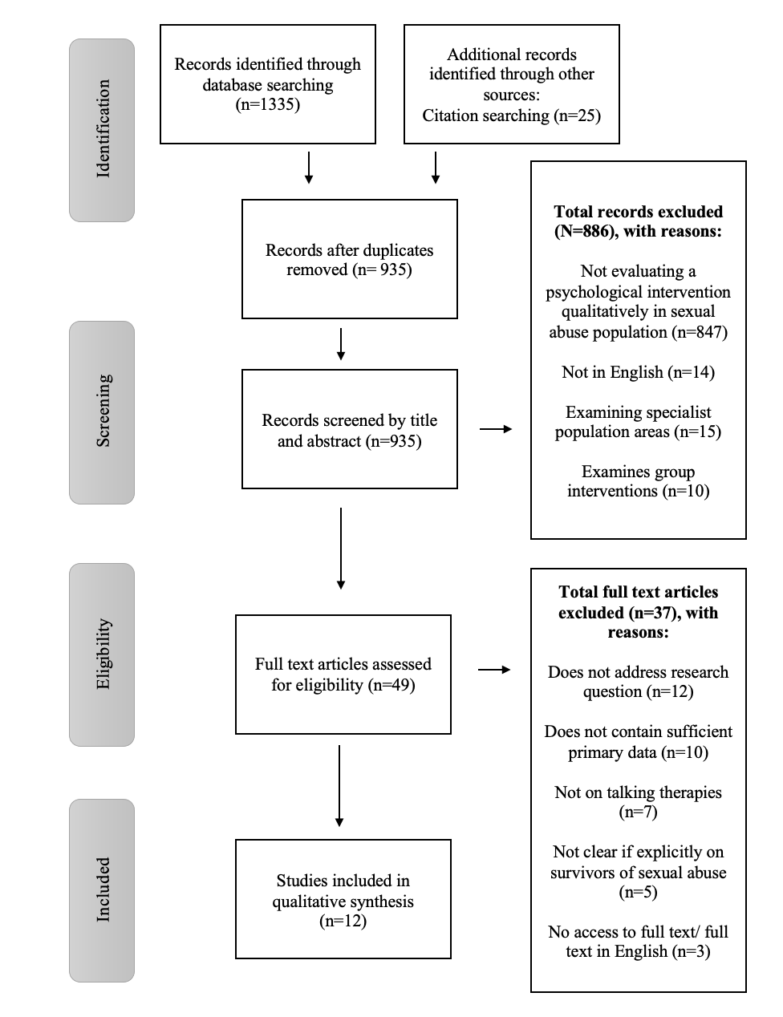

Figure 1: PRISMA Flow Diagram

Data Collection Process
Full text articles were received through the online Royal Holloway university library services or through searching on Google.com. Where there were not available, inter-library loans were sought.

Data Extraction
Data was extracted for the 12 remaining articles. This was conducted by the lead author. Information was extracted and recorded in a Microsoft® Word table. The following descriptors of data to extract were modelled on relevant systematic review guides (Cherry, Smith, Perkins, & Boland, 2017; Fleeman & Dundar, 2017). Where mixed-methods studies were present, only the data referring to the qualitative section were extracted. Table 1 provides a summary of the extracted data.

Table 1: Data extraction table of final papers and study characteristics

Paper Number, Author, Year,  & Focus (CSA, Adult abuse or both) | Title | Study design | Study setting | Intervention(s) used | Study outcomes | Qualitative analysis | Sampling | Data collection | Participants; N and inclusion | Study sponsorship
1  (Chouliara et al., 2011)  CSA | Talking therapy services for adult survivors of childhood sexual abuse (CSA) in Scotland: Perspectives of service users and professionals | Qualitative; phenomenological | Scotland, UK | The range of therapeutic approaches; CBT, PCT, art therapy, CAT, CFT, DBT, interface intervention model and solution-focused therapy. | Perspectives of adult survivors of CSA and of professionals working therapeutically in this field about talking therapy services, especially regarding helpful and hindering experiences and perceived satisfaction of needs.  Recommendations for good practice with adult CSA survivors. | Interpretative Phenomenological Analysis | Purposive sampling  NHS | Qualitative interview | N=13  Adults, CSA survivors, accessing mental health services. | Unsure
2  (Garcia, 2004)  Both | Experiences of young Mexican American women in psychotherapy  (Doctoral thesis) | Qualitative; thematic | USA,  California | Non-specified therapy | Understanding of what is actually working for young Mexican American women in psychotherapy. | Thematic analysis | Purposive sampling | Qualitative interview | N=7  Mexican American females, adults, participated in psychotherapy between ages 18-25 in last 2 years with minimum of 5 sessions. | Not stated
3  (Edmond, Sloan, & McCarty, 2004)  CSA | Sexual Abuse Survivors' Perceptions of the Effectiveness of EMDR and Eclectic Therapy | Qualitative; Ethnographic  (with parent study- RCT) | USA  Texas | Eclectic therapy and EMDR | Client perceptions of the effectiveness of treatment. | Framework analysis | Convenience sampling  Newspaper ads and flyers | Qualitative interview | N=40  CSA survivors, received either EMDR or eclectic therapy, adult female, no previous exposure to EMDR, no concurrent therapy, and no contraindications for use of EMDR. | Not stated
4  (Chandler, 2010)  CSA | Resilience in healing from childhood sexual abuse  (Doctoral thesis) | Mixed-methods  Qualitative, thematic | USA | Integrative therapies | Understanding female CSA survivors’ unique experiences of personal healing using integrative therapies. | Thematic content analysis | Snowball/ Referral sampling  Online networking groups. | Qualitative interview | N=10  Age 30-55, history of CSA by age 11, CSA symptoms in adulthood, history of treatment with both traditional psychotherapy or psychotropic medication and integrative healing therapies. | Not stated
5  (Holland, Cipriano, & Huit, 2021)  Adult abuse | LGBTQ and straight sexual assault survivors’ interactions with counselling in a campus counselling centre and women’s centre | Qualitative; thematic | USA,  Nebraska | Campus counselling services | Sexual assault victims’ actual and anticipated interactions with counselling services in a counselling centre and women’s centre on a college campus, including the kind of treatment that victims expected and/or experienced from these supports.  How survivors’ gender identity and sexuality played a role in their interactions with these counselling spaces. | Thematic analysis | Quota sampling | Qualitative interview | N=40  Undergraduate students, 17 years or older, had unwanted sexual experience at university. | Unsure
6  (McGregor, Thomas, & Read, 2006)  CSA | Therapy for child sexual abuse: Women talk about helpful and unhelpful therapy experiences. | Qualitative; grounded theory | New Zealand | Non-specified therapy for CSA | Therapy experiences of women with histories of CSA. | Grounded theory | Quota sampling | Qualitative interview | N=20  Adult, women, history of CSA, had at least 5 sessions of therapy over the age of 20, are not currently in therapy. | Not stated
7  (Koehn, 2007)  CSA | Women's Perceptions of Power and Control in Sexual Abuse Counselling | Qualitative; thematic | Canada | Counselling | Counselling behaviours that female sexual abuse survivors have perceived to be helpful or hindering and that relate to clients’ perceptions of power and control. | Thematic analysis; critical incident technique | Convenience sampling | Qualitative interview | N=50  Adult, females, CSA history, had attended one or more individual counselling sessions in adulthood. | Yes
8  (Koehn, 1995)  CSA | Sexual abuse survivors' perceptions of helpful and hindering counsellor behaviours  (Doctoral thesis) | Qualitative; thematic | Canada | Counselling | Female sexual  abuse survivors' perceptions of helpful and hindering counsellor behaviours. | Thematic analysis; critical incident technique | Convenience sampling  University | Qualitative interview | N=50  Women, CSA history, 19 years or older, had attended one or more individual sessions with a counsellor in adulthood. | Yes
9  (Harper, Stalker, Palmer, & Gadbois, 2008)  CSA | Adults traumatized by child abuse: What survivors need from community-based mental health professionals. | Qualitative; ethnographic? | Canada,  Ontario | Specialized trauma treatment program. (Inpatient) | Experiences of program participants in the first six months following discharge. | Grounded theory | Purposive sampling | Qualitative interview | N=30  Adults, history of CSA, completed the six-week inpatient treatment program. | Not stated
10  (Shannon, 1996)  CSA | The therapy experiences of women survivors of childhood sexual abuse  (Doctoral thesis) | Qualitative; feminist narrative | USA,  Michigan | Psychotherapy | Women survivors of childhood sexual abuse efforts toward recovery and views of the psychotherapy relationship. | Narrative; feminist | Convenience sampling | Qualitative interview | N=12  Adult, women, CSA history, currently in therapy. | Not stated
11  (Weingarten, 2020)  Both | Examining healing trajectories for survivors of rape and sexual assault  (Doctoral thesis) | Mixed-methods  Qualitative, feminist | USA, Hawaii | Non-specified therapy | Survivors’ experiences with various forms of treatment.  To determine what types of services are utilised by survivors of sexual violence through an online survey and to identify patterns of therapy use that are potentially related to positive outcomes. | Narrative; feminist | Convenience sampling | Qualitative interview | N=20  Adult, women, experience of sexual abuse. | Not stated
12  (O’Brien, Henderson, & Bateman, 2007)  CSA | Finding a place for healing: Women survivors of childhood sexual abuse and their experience of accessing services | Qualitative, thematic | Australia | Counselling | Develop an understanding of the women’s experiences of accessing services. | Thematic analysis | Convenience sampling | Qualitative interview and focus groups | N=14  Women, adults, history of CSA, used not-for-profit services. | Not stated

Quality Appraisal
The qualitative quality assessment tool, Critical Appraisal Skills Programme (CASP) Qualitative Checklist (2022) was used to critically appraise the remaining twelve articles (Table 2). This tool was chosen because it was designed based upon medical literature and piloted with health care practitioners. Prompt questions within the CASP were used to determine whether each paper met the criteria for each item. The quality appraisal was conducted by the lead author. A peer reviewed the initial decisions to improve rigour and address biases. Disagreements were resolved through discussion and negotiation. Papers were then ordered according to quality assessment from most reliable and valid to least (1-12) according to the quality assessment.

Table 2: Quality appraisal table of final papers in order of reliability, using CASP Qualitative Checklist (2022) criteria

Paper number  & Author | Paper name | Section A:  Are the results valid? |  | Is it worth continuing? |  |  |  | Section B:  What are the results? |  |  | Section C: Will the results help locally?
 |  | Was there a clear statement of the aims of the research? | Is a qualitative methodology appropriate? | Was the research design appropriate to address the aims of the research? | Was the recruitment strategy appropriate to  the aims of the research? | Was the data collected in a way that addressed the  research issue? | Has the relationship between researcher and  participants been adequately considered? | Have ethical issues been taken into consideration? | Was the data analysis sufficiently rigorous? | Is there a clear statement of findings? | How valuable is the research?
1  (Chouliara et al., 2011) | Talking therapy services for adult survivors of childhood sexual abuse (CSA) in Scotland: Perspectives of service users and professionals | Yes  Aimed to convey perspectives and provide recommendations | Yes | Yes | Yes | Yes | Yes  Considered bias | Yes  Selection biases considered  Limitations in generalisability | Yes  Reflective journal  Triangulation | Yes | /  Informing training, supervision, and therapy.
2  (Garcia, 2004) | Experiences of young Mexican American women in psychotherapy | Yes  Understanding what works in therapy | Yes | Yes | Yes | Yes | Yes  Therapist position considered | Yes  Selection biases considered | Yes  Reflective journal  Data saturation | Yes | /  Create a better understanding of the participant group.
3  (Edmond, Sloan, & McCarty, 2004) | Sexual Abuse Survivors' Perceptions of the Effectiveness of EMDR and Eclectic Therapy | Yes  Collect data on effectiveness of EMDR and gather perspectives | Yes | Yes | Yes | Yes | Yes  Researcher position considered | Yes  Recruitment bias considered  Researcher bias considered | Yes  Triangulation | Yes | /  Provides insights into the processes of therapeutic change.
4  (Chandler, 2010) | Resilience in healing from childhood sexual abuse | Yes  Understand experiences and challenges in therapy | Yes | Yes | Can’t tell  Unclear whether snowball or convenience sampling used | Yes | Yes  Researcher contribution and therapist position considered | Yes  Confidentiality considered  Sensitivity of study considered | Yes  Audit trail | Yes | /  To inform protocols, modalities, and further education.
5  (Holland, Cipriano, & Huit, 2021) | LGBTQ and straight sexual assault survivors’ interactions with counseling in a campus counseling center and women’s center | Yes  Examining experiences in counselling services | Yes | Yes | Yes | Yes | Can’t tell  Awareness of researcher demographic but potential bias not accounted for. | Yes  Recruitment bias considered | Yes  Created codebook  Triangulation | Yes | /  Provides guidance for therapists regarding trauma survivors from gender and sexual minority groups.
6  (McGregor, Thomas, & Read, 2006) | Therapy for child sexual abuse: Women talk about helpful and unhelpful therapy experiences. | No  No details of the aims | Yes | Yes | Yes | Yes | Yes  Researcher contribution considered | Yes  Researcher bias considered in results | Yes  Pilot study  Triangulation  Consistency checks | Yes | /  Highlights the need for training and provides insights for therapists in working with participant group.
7  (Koehn, 2007) | Women's Perceptions of Power and Control in Sexual Abuse Counseling | No  No details of the aims | Yes | Can’t tell  Unsure of epistemology of design | Yes | Yes | Yes  Consideration to standardising interview | Yes  Researcher bias considered in results | Yes  Triangulation  Agreement checks | Yes | /  Implications for therapy, research, and training.
8  (Koehn, 1995) | Sexual abuse survivors' perceptions of helpful and hindering counsellor behaviours | Yes | Yes | Can’t tell  A unique technique was used- may not be the most appropriate | Yes | Yes | Yes  Researcher role in interview considered | Yes  Researcher bias considered in results | Yes  Saturation achieved  Triangulation | Can’t tell  Findings discussed clearly but no discussion of the credibility of findings | /  Provides therapists with understanding of helpful and unhelpful therapist behaviours for this participant group.
9  (Harper, Stalker, Palmer, & Gadbois, 2008) | Adults traumatized by child abuse: What survivors need from community-based mental health professionals. | No  Not clearly stated | Yes | Yes | Can’t tell  Can’t tell rationale for selecting participants | Yes | Yes  Researcher bias in interviewing considered  Researcher role considered | Yes  Sensitivity of study considered | Yes  Triangulation  Reflective journal | Yes | /  Provides insight into treatment experiences of participant group and what they found helping in accessing services.
10  (Shannon, 1996) | The therapy experiences of women survivors of childhood sexual abuse | Yes  View of psychotherapy | Yes | Yes | Yes | Yes | Yes  Role of researcher considered | Yes  Researcher subjectivity considered | No  Description of analysis type but not their process. | Can’t tell  Findings discussed clearly but no discussion of the credibility of findings | /  Highlights need and direction for future guidelines.
11  Weingarten, 2020) | Examining healing trajectories for survivors of rape and sexual assault | No  Not clear what therapy intervention participants have experienced | Yes | Yes | Yes | Yes | No  Not discussed | Yes  Recruitment bias considered | Yes  Triangulation  Credibility and transferability checks | Yes | /  Provides insight into treatment experiences and the various options of treatment accessed by participant group.
12  (O’Brien, Henderson, & Bateman, 2007) | Finding a place for healing: Women survivors of childhood sexual abuse and their experience of accessing services | Yes  Understand experiences of accessing services | Yes | Yes | Yes | Can’t tell  Two methods used which may create bias in interpreting results | No  Not discussed | Yes  Recruitment bias considered | Can’t tell  No detailed description | Can’t tell  Findings discussed clearly but no discussion of the credibility of findings | /  A description of what is helpful for participant group in recovery.

Note: The CASP checklist uses the criteria: ‘Yes’, ‘No’, or ‘Can’t tell’.
Data Synthesis
A Meta-Synthesis was conducted on the final included studies utilising a Meta-Study framework (Paterson et al., 2001) with a Meta-Ethnographic perspective for the analysis phase (Noblit & Hare, 1988), as advised by Paterson et al. (2001). Meta-study was chosen as an overall framework for the analysis as the approach lends itself to health research, allowing for an interpretive (rather than inductive) understanding of themes that occur for specific health populations. This was chosen over a thematic-synthesis approach as the interpretative stance allows acknowledgment of researcher contributions to the interpretation, both from the authors of the primary studies and from the authors of this meta-synthesis. Meta-study is based on the epistemological perspectives of utilising the hermeneutic and dialectic, where the hermeneutic is concerned with the accuracy of the participants’ accounts of their constructs being depicted through the research, and the dialectic is concerned with how the researcher hears and interprets these constructions (Paterson et al., 2001). Hermeneutic philosophy also holds an awareness of these participant responses as part of a larger whole. This is encapsulated in the notion that “to understand any given part, you look to the whole; to understand the whole, you look to the parts.” (Smith, Larkin, & Flowers, 2009). This is important to this piece of research as we examine responses from survivors of sexual trauma and try to understand this in the context of such participants on a wider scale.

Paterson et al. (2001) describe the need to conduct the analysis in the final part of the synthesis from a specific epistemological framework and recommend ethnography for observing and interpreting perspectives in healthcare. Ethnography enables the synthesis of qualitative findings across studies to create new holistic interpretations and allows the systemic study of specific cultures and groups (Noblit & Hare, 1988). It is concerned with the participant’s understanding of social and cultural behaviours. This is important to this research question as we are exploring the responses of a heterogeneous group in the sense of a shared experience through sexual abuse, but not a group of individuals with a shared diagnosis and hence the study of sexual abuse survivors as a social group is fitting. Meta-Summary and Meta-Aggregation were excluded as methodology types due to insufficient data available to reach saturation for the specific research question (Finfgeld-Connett, 2018). Theory generated Meta-Synthesis was also excluded due to the insufficient data on this research question to generate a new theory (Finfgeld-Connett, 2018).

In conducting the synthesis, the final included 12 papers were ordered according to the results from the quality assessment. Papers were given extra weighting where there were fewer recording inadequacies according to the CASP Qualitative Checklist (2022). Primary data was collected from each of the final included papers and inserted into a Microsoft® Word table. The papers were ordered according to their position in the quality assessment. Participant quotes were extracted from the primary data and coded (Appendix C). Codes were then placed onto Mind Mapping® software Mind View and clustered into themes (Appendix E). Themes were then categorised and labelled utilising the Meta-Study and Meta-Ethnographic epistemology. Themes were created holding in mind the weighting of the papers from which each code was derived. Some papers included a disproportionately large quantity of primary data (such as doctoral thesis papers). To not sway the weighting of the entire selection of papers, a sub-sample of quotations were selected from these papers. During the selecting of quotes from the papers, quotes that were not relevant to the research question were excluded.

Certainty Assessment
The above stages were conducted by the lead author. The initial search criteria were also reviewed by a peer. A sub-sample (20%) of the papers included in the quality assessment were reviewed by a second peer-reviewer who checked the assessment criteria against the full text papers. The meta-synthesis was conducted by the lead researcher. A sub-sample (20%) of the initial codes for synthesis were then checked by the same second peer-reviewer (Appendix D). Codes were adapted according to feedback and concepts derived by the peer-reviewer were integrated into the analysis. Disagreements were resolved through mutual consideration of the decisions and through discussion in supervision.

Results

Study Characteristics
This review examined 12 studies published between 1996 and 2021. A summary of the main findings from each study is shown in Table 3. Six of these studies were located in the USA, three in Canada, one in the UK, one in Australia and one in New Zealand. The total number of participants included in these studies ranged from sample sizes of 7 to 50 (with a mean of 26). These participants were recruited through different qualitative sampling methods: Six through convenience sampling, three through purposive sampling, two through quota sampling and one through referral sampling. The participants were recruited based on their experiences of sexual abuse. It was recorded that nine of the papers examined experiences of childhood sexual abuse, one paper examined experiences of sexual abuse in adulthood, and two papers examined experiences of both childhood and adulthood sexual abuse. All the papers were analysed using different qualitative methods: Six studies used thematic analysis, two studies used narrative analysis, two studies used grounded theory analysis, one study used interpretative phenomenological analysis, and one study used framework analysis. All studies used individual qualitative semi-structured interviews to collect the data, and one of these studies used focus groups in addition to individual qualitative semi-structured interviews.

Table 3: Table of main study findings in themes

Paper Number, Author & Year | Main Study Findings in Themes
1  (Chouliara et al., 2011) | - Benefits of therapeutic process: trusting therapeutic relationship, feeling safe to disclose, breaking isolation, enhancing self-esteem and self-worth, contextualising the abuse, and moving toward recovery.  - Challenges of therapeutic process: trauma-focused work, supportive contact, continuity and consistency of services, accessibility during acute episodes, hearing and managing disclosures, child protection issues, and availability and accessibility of services.
2  (Garcia, 2004) | - Significance of sexual abuse history and family conflicts.  - Importance of explicitly addressing the role of culture in presenting problems (e.g., gender roles, acculturative stress).  - Likelihood of negative initial feelings about therapy and the therapist.  - Importance of personalism in the therapeutic relationship.
3  (Edmond et al., 2004) | - Importance and effect of the client- therapist relationship.  - The depth of change reportedly caused by the different therapies.
4  (Chandler, 2010) | - A variety of integrative healing techniques.  - Endorsement of mindfulness practice and somatic therapies as being the most helpful among integrative therapies in eliminating unconscious triggered responses that resulted from abuse.  - Resiliency regained despite early childhood trauma.
5  (Holland et al., 2021) | - Anticipating positive treatment.  - Anticipating negative treatment.  - Experienced positive treatment.  - Experienced negative treatment.
6  (McGregor et al., 2006) | - Therapists need special skills to be aware of the dynamics and effects of CSA and of abuse-focused therapy and to deal with abuse-related material.  - Therapists need to develop an equal and open therapy relationship that includes ongoing consultation with clients about their experiences of therapy.
7  (Koehn, 2007) | - Flexibility with agenda.  - Willingness to offer choices.  - Response to criticism.  - Response to client as an equal or with honour.  - Sexual interest.  - Approach to client’s suggestions.  - Expectations regarding forgiveness.  - Consultation with alter identities.
8  (Koehn, 1995) | - Therapist validation.  - Approach to power and control.  - Application of therapeutic methods.  - Involvement in nurturing behaviour.
9  (Harper et al., 2008) | - Difficulties managing intense feelings.  - Therapists who were patient, understanding, and respectful of survivors’ needs for a sense of control in working toward their own solutions were most helpful.  - The need for accessible trauma-based treatment from clinicians.
10  (Shannon, 1996) | - “Good enough” therapies: establishing trust in dynamic and productive therapies.  - Survivors who need to idealise and therapists who need to be idealised.  - Survivors who are afraid to commit to therapy.
11  (Weingarten, 2020) | - Types of therapy used.  - Timing of therapy use.  - Impacts associated with therapy use.  - Barriers to treatment.
12  (O’Brien et al., 2007) | - Lack of availability particularly in terms of longer-term counselling.  - Lack of consistency in terms of models and standard.  - What was helpful and what was not.

Risk of Bias in Studies
The quality of these studies was assessed using the CASP Qualitative Checklist (CASP, 2022). The quality rating for each of these studies is shown in Table 2. The assessment showed that papers 1-3 (Chouliara et al., 2011; Edmond et al., 2004; Garcia, 2004) met all of the criteria on the CASP qualitative checklist. Papers 4-6 (Chandler, 2010; Holland et al., 2021; McGregor et al., 2006) met all but one criterion on the checklist. Papers 7-11 (Harper et al., 2008; Koehn, 1995, 2007; Shannon, 1996; Weingarten, 2020) met all but two criteria on the checklist and paper 12 (O’Brien et al., 2007) did not meet four items on the checklist. The papers were ordered according to this assessment.

Four studies did not provide accurate information regarding the study research aims (studies 6, 7, 9, and 11 (Harper et al., 2008; Koehn, 2007; McGregor et al., 2006; Weingarten, 2020)). Two studies did not fully explain their research design in order to determine whether it was appropriate to their research question (studies 7 and 8 (Koehn, 1995, 2007)). Two of the studies were unclear with regards to the appropriacy of their sampling methods (studies 4 and 9 (Chandler, 2010)). One study collected data in a way that may have biased the results of the research question through using different recruitment strategies (study 12 (O’Brien et al., 2007)). Three papers did not provide an accurate account of the impact of the relationship between the researcher and the participants to account for bias (studies 5, 11, and 12 (Holland et al., 2021; O’Brien et al., 2007; Weingarten, 2020)). Two studies did not provide evidence of a sufficiently rigorous data analysis (studies 10 and 12 (O’Brien et al., 2007; Shannon, 1996)). Three studies did not provide a clear statement of their findings (studies 8, 10, and 12 (Koehn, 1995; O’Brien et al., 2007; Shannon, 1996)). However, all studies appropriately utilised a qualitative method and all studies took into consideration ethical concerns.

Results of Syntheses
Four themes and twelve sub-themes were identified, outlined in Table 4.

Table 4: Themes and sub-themes developed from Meta-Study and Meta-Ethnography

Theme | Theme title | Sub-Themes
1 | Helpful therapy for sexual abuse survivors relies on therapeutic processes that provide choice, autonomy, and the freedom to choose when to speak and what to speak on. | - Therapist qualities of helping
 |  | - Choice and autonomy
 |  | - Therapy process contradictions
2 | Engagement with treatment relies on considerations of the complexity and emotional challenges of recovery from sexual abuse. | - Complexity of sexual abuse
 |  | - Trust in therapist and therapy to engage
 |  | - Structural and practical barriers
3 | Feeling cared for and connected with the therapist is important in sexual abuse recovery. | - Feeling contained and cared for by therapist
 |  | - Connecting with and relating to therapist
 |  | - Negligence and bad practice are detrimental
4 | Therapy can create positive holistic emotional and lifestyle changes and provide new skills and learning. | - Lifestyle and emotional benefits
 |  | - Psycho-educational and learning benefits
 |  | - Negatives after treatment

Theme 1: Helpful therapy for sexual abuse survivors relies on therapeutic processes that provide choice, autonomy, and the freedom to choose when to speak and what to speak on. Therapists are helpful when they listen, validate and are non-judgemental, holding the client in mind and enabling empowerment.
This theme explores the helpful and unhelpful aspects of therapy experienced by survivors of sexual abuse. Participants largely describe experiences of being given the freedom to choose the direction of the therapy as well as being encouraged to choose for themselves when to talk about their trauma experiences. Rogerian therapeutic qualities (Rogers, 1957) are outlined as well as additional characteristics of taking part in therapy that empowers rather than disempowers clients. All the papers contributed to this theme. This theme had three sub-themes.

Sub-theme 1: Therapists who listen, validate and are non-judgemental. They need expertise to provide safety and containment.
This sub-theme refers to the experience of being treated appropriately and respectfully by the therapist. Papers 1, 2, 3, 6, 8, 10, 11, and 12 contributed to this theme. Participants discuss a non-judgemental and validating environment, for example: “For me, just literally having somebody who wants to sit and listen to me for an hour and values my time (tearful) and my sharing enough to be grateful that I’m doing it, is very supportive, very healing.” Participant 19, paper 3, (Edmond et al., 2004, p. 265). Participants discussed the converse, in being treated with judgement or feeling not understood:
“I was really annoyed with her interpretation. I didn’t go back to her. It was very controlling telling me what my experience meant without me having any input into it. I thought she was arrogant, condescending, misguided, and she wasn’t listening to me at all really.” Participant 7, paper 6, (McGregor et al., 2006, p. 54).

Another participant spoke of feeling invalidated and needing to prove their difficulties to their therapist: “What did I have to do to make my psychiatrist see that underneath the apparent coping I was a mess?” Paper 12, (O’Brien et al., 2007, p. 5). A number of participants spoke about the need for the therapist to have expertise, rather than to be inexperienced, and praised skilled therapists:
“She is good because if one angle wouldn’t work she’d try a different angle. And, not just with the finger movement, the hand movement, the terminology, the words she would use to help me weave into what ever was going on.” Participant 1, paper 3 (Edmond et al., 2004, p. 266).

Expertise in adapting therapy to the individual was described:
“She (therapist) was really good because we just started right at the beginning of my first abusive experience . . . and we went right through everything and every negative and positive significant event in my life. We worked through the whole lot . . . she had a wonderful holistic approach and we integrated all of that stuff.” Participant 17, paper 6, (McGregor et al., 2006, p. 47).

Therapists were also required to be approachable and use accessible language:
“She was a good listener, sincere—that was very important. She was real—authentic, she wouldn’t just spit psychology jargon at me; she was actually invested. I think just the fact that she was tailored to us, that she took the time, like if she were making clothes, she took our measurements. She tailored her program, her personality, her style to us... what would benefit us the most.” Participant C, paper 2, (Garcia, 2004, p. 145).

Safety through boundaries was also an important feature:
“I remember her talking about boundaries which is really important to me. Her boundaries are like really tight you know? She doesn't sway from them very often and some of them not at all ever. And I remember her talking about that and how I needed a safe place just to be you know?” Participant “Tonya” (pseudonym), paper 10, (Shannon, 1996, p. 172).

Participants also spoke about the need for flexibility and additional support where needed: “Umm I mean, the place it is really easy to get to, it is really accessible, it has been very flexible in terms of when we meet.” Participant 40, paper 1, (Chouliara et al., 2011, p. 142). “He gave me his home phone number if I were getting suicidal and he would make more sessions than two if I had to.” Participant “Sasha” (pseudonym), paper 10, (Shannon, 1996, p. 140). Ethnographically, this sub-theme highlights a culture of requiring supportive attention and flexibility in trauma work.

Sub-theme 2: Clients are provided with choice and autonomy and given the freedom to control the session.
This sub-theme explored the distinctions between being given choice or not as a client. Papers 5, 6, 7 and 10 contributed to this theme. Providing choice enabled participants to engage in the therapy freely:
“[My counsellor] walked me through the resources and then shared like, ‘You don’t have to do this or this. You can choose.’...She was very adamant about making sure that I was just aware of my options and then if I didn’t want to do any of them that it was ok.” Participant “Jane” (pseudonym), paper 5, (Holland et al., 2021, p. 348).

Meanwhile participants described an intuitive dislike for rules and a lack of choice:
“The other one that I saw was very young and professional looking, not motherly anyway and very business like and I was uncomfortable with that. I was trying to see if I was comfortable and she had these rules that she wanted to tell me.” Participant “Mary” (pseudonym), paper 10, (Shannon, 1996, p. 151)

Furthermore, participants described not being aware of the choices available to them and conveyed their disempowerment through needing to compromise their personal preferences to access treatment:
“She was the only one I saw in person and I remember being in there and she was like asking me all sorts of questions and I was sort of like a rag doll. I couldn't even hardly breath. I was like okay, okay, okay, just take me, you know? and back then, I didn't have any idea about choice and I didn't have any idea that I should interview her and see what her qualifications were and all that stuff. I was like okay, here's help and this is going to be good...I was desperate.” Participant “Tonya” (pseudonym), paper 10, (Shannon, 1996, p. 170).

Ethnographically, this theme speaks to the notion of reclaiming power in the therapy through being given choices.

Sub-theme 3: The therapy process as contradictory; to be free, open and empowered to speak but also being limited by talk therapy alone. To talk or not is an individual preference.
This sub-theme explored a divide in participants’ opinions on the need to talk openly or the need to withhold, explaining that talk therapy is not helpful relative to other embodied therapies. Papers 1, 2, 3, 4, 6, 7, 10, and 11 contributed to this theme. Participants spoke about the value in being able to articulate trauma narratives:
“I don’t think I would have told anybody in my whole life . . . I don’t even think then I could say the word “rape,” but I think I was like “I had something really bad that happened to me and I want to talk to you about it,” so yeah, that was kind of like my journey to being able to first verbalize it.” Participant 11, paper 11, (Weingarten, 2020, p. 78).

Participants also spoke about establishing a sense of empowerment through their right to not disclose:
“He asked permission. When I agreed to it, I really sensed he had asked my permission to do it, and I have said ok. . . . It made me feel that I was in control. It made me feel I was doing this because I want to. . . . People should have to ask your permission before they march into the centre of your soul. You have some privacy, some boundaries. Just because someone asks a question doesn’t mean they deserve an answer. It’s my soul. And I don’t have to talk about it if I don’t want to. And I never realized it until then.” Paper 7, (Koehn, 2007, p. 48).

Meanwhile some participants voiced that talking therapy wasn’t helpful: “I have not found traditional therapy to be that helpful.” Paper 4, (Chandler, 2010, p. 92), or limited in its utility: “I’ve just been reminded of some tools I can use […]. I kind of feel like all the problems are still there. All the issues are still present and not resolved.” Participant 25, paper 3, (Edmond et al., 2004, p. 267). Meanwhile other participants spoke about using specific modalities and that finding ways to process the trauma was helpful (Chouliara et al., 2011; Edmond et al., 2004; Weingarten, 2020). This sub-theme speaks to a cultural split within the client group regarding the right to speak but also the right to reserve disclosures of trauma.

Theme 2: Engagement with treatment relies on considerations of the complexity and emotional challenges of recovery from sexual abuse. Trust in the therapist and therapy are vital. Structural and practical barriers need to be overcome.
This theme explores barriers to engaging with the therapy and aspects which facilitate a person’s engagement. This regards engagement in the early processes of therapy, but also on-going engagement. Participants convey the complexity of recovering from sexual abuse, and that specialist treatments that take into consideration this complexity are required. They describe the need to trust the therapeutic process and how difficulties in establishing this trust can stand in the way of engagement. They also discuss some of the barriers that make it difficult to access therapy. All papers contributed to this theme. This theme had 3 sub-themes.

Sub-theme 1: Recovery from sexual abuse is complex and emotionally challenging. It requires time and space to explore.
This sub-theme explored how emotionally challenging and difficult it was for participants to engage in therapy for sexual abuse. Papers 1, 2, 3, 4, 5, 7, 9, 10, 11, and 12 contributed to this sub-theme. The complexity of sexual abuse is conveyed through the notion that there is a lot of material to cover in therapy and that this takes a long time to work through (Chouliara et al., 2011). Participants describe the unrealistic expectations from others to resolve trauma quickly: “Other people expect you to be fixed, and I found that a problem because I didn’t feel fixed.” Paper 9, (Harper et al., 2008, p. 367). Participants explain that it takes time to be able to talk in sessions (Garcia, 2004; Shannon, 1996; Weingarten, 2020) and therapy is described as emotionally difficult and exposing:
“I would say most aspects are pretty challenging. […] I think that is because when you are in psychotherapy you often have to reveal things about yourself that you don’t . . . you are very exposed and that is very difficult.” Participant 34, paper 1, (Chouliara et al., 2011, p. 140).

Participants explain that it takes a while to be ready to access therapy (Weingarten, 2020) and one participant spoke about needing to feel very bad before seeking help:
“I guess when it started it was denial, and then I started therapy a few months after I graduated from college because the last semester of senior year, I was just really depressed, I could barely get to class or my extracurriculars, I had been like so involved on campus trying to just push through everything and it finally just like all came crumbling down.” Participant 2, paper 11, (Weingarten, 2020, p. 75).

The role of therapy itself was spoken about as being complex and self-determined:
“I always thought that going to a counselor would be similar to going to a medical doctor. “These are my symptoms. What do you prescribe?” But the process is different. It comes from me. And I think that was my first experience in realizing I was going to heal myself. That he wasn’t going to do it. That he had no magic answers. It was like I was in charge of the session.” Paper 7, (Koehn, 2007, p. 49).

They explain that time and space is needed to explore the complexity of sexual abuse (Chouliara et al., 2011; Holland et al., 2021; O’Brien et al., 2007; Weingarten, 2020). Ethnographically, this theme speaks to the need for additional provisions required that are unique to survivors.

Sub-theme 2: Engagement with therapy for sexual abuse relied on trust in the therapist and therapy, and in the therapist's expertise and flexibility.
This theme explored some of the difficulties that participants had in trusting therapists or the therapy process and needing a therapist with good expertise and experience that is specific to working with survivors of sexual abuse. Papers 2, 4, 5, 6, 7, 8, 9, 10, and 11 contributed to this theme. A number of participants spoke about the length of time it took to develop trust in their therapist such as: “I don't believe people. The only thing that helped me was seeing how he was over time, really. You know, that I could trust him....” Participant “Madeline” (pseudonym), paper 10, (Shannon, 1996, p. 163), and another expressed concerns regarding the therapist’s genuineness: “I was nervous and skeptical about the sincerity of my therapist, about whether or not she really cared or was just getting paid.” Participant C, paper 2, (Garcia, 2004, p. 137). Meanwhile others articulated their distrust towards the therapy process itself: “I thought it wasn’t going to work and I thought she wasn’t going to be able to change anything.” Participant D, paper 2, (Garcia, 2004, p. 137), and described apprehension that softened during the course of sessions:
“Before the session I felt like why am I going to have to be telling people this? Why am I going to have to tell that lady this? And during the session I couldn’t say anything, I just couldn’t tell her anything, I couldn’t speak about anything. And afterwards I was like I’m not going to come back, I don’t feel comfortable, and my mother’s like just give it a try. After like the third session maybe that’s when I started talking to her more, I started telling her things about myself.” Participant G, paper 2, (Garcia, 2004, p. 138).

Meanwhile other participants spoke of being ill-informed about what to expect in therapy 2, 5, 6, 11 (Garcia, 2004; Holland et al., 2021; McGregor et al., 2006; Weingarten, 2020) and unaware of the various types of therapy, for example: “I think if I was looking for something else like I don’t even know like where I would look.” Participant 17, paper 11, (Weingarten, 2020, p. 86). The therapist’s expertise were important and normalising for some. One participant spoke about their therapist having a helpful intuition about the abuse: “I didn't even have to say anything to him and he knew.” Paper 8, (Koehn, 1995). Another participant spoke about the normalisation of sexual arousal during abuse and valued their therapist’s insights:
“I felt awkward and almost embarrassed. I was almost hesitant to tell her, "Well I might have enjoyed it. I must have liked it if I enjoyed it." She just basically discussed with me that for a lot of survivors, that is normal. Just knowing that that happened for a lot of survivors. I felt like a freak, and she let me know that I wasn't the only one that this had happened to. That this is quite ordinary for survivors to feel this way. I wasn't really aware of that.” Paper 8, (Koehn, 1995, p. 56).

This sub-theme spoke to an ethnographic culture of clients requiring trust and appreciation of the therapist’s skills to participate with trauma work.

Sub-theme 3: There are structural and practical barriers to accessing treatment for sexual abuse survivors.
The sub-theme highlights the practical and resource-based barriers to engaging with therapy. Papers 1, 5, 10, 11, and 12 contributed to this sub-theme. Participants described issues such as location of services being a barrier (Chouliara et al., 2011), long waiting lists (O’Brien et al., 2007), length of treatment (Chouliara et al., 2011) and one participant spoke of safeguarding processes making it difficult to open up about historic abuse (Chouliara et al., 2011). Several participants spoke about the impact of re-telling trauma narratives due to therapist changes: “This will be my third therapist in two years and so sometimes it’s hard just telling your story all over again and everything.” Participant 9, paper 11, (Weingarten, 2020, p. 85). Ethnographically, this highlights a felt sense of needing to overcome obstacles in order to recover from trauma.

Theme 3: Feeling cared for and connected with the therapist is important in sexual abuse recovery. Negligence from the therapist can have a detrimental and lasting effect on survivors.
This theme focused on the quality and features within the therapeutic relationship for survivors of sexual abuse. It focused on helpful aspects of this relationship, as well as the detrimental and even abusive aspects described. It covered a sense of being cared for by the therapist but also a sense of connection with the therapist, as well as issues pertaining to negligence. All papers except papers 4 and 9 contributed to this theme. This theme had 3 sub-themes.

Sub-theme 1: To feel cared for by the therapist who is attentive and appropriately responsive. To not feel burdened by the therapist's needs but instead to be thought of and held in mind.
In this sub-theme, participants describe the specific qualities of a good therapeutic relationship, whilst also describing areas where they felt less contained by their therapist. Papers 1, 2, 5 ,6, 8, 10, and 11 contributed to this sub-theme. Participants describe a helpful therapeutic relationship as one where the therapist is caring, attentive, friendly, and appropriately reacting to their story. They express the helpfulness of a friendly therapist (Garcia, 2004) that is caring and understanding (Holland et al., 2021) and that can allow them space to talk without over-reacting (Chouliara et al., 2011). One participant comments on having their needs anticipated:
“The great thing about her (therapist) is that she anticipated how I might feel and so she might say, “I’m going to make an appointment for you in three days” and I would just feel like I just wanted to cry and because she knew. She obviously looked at me and, seeing how the session had gone, . . . knew that I couldn’t last a week . . . so it’s like . . . her knowing and understanding what might happen–because it’s a very horrible thing to be desperate . . . she catered for (my needs).” Participant 5, paper 6, (McGregor et al., 2006, p. 48).

Others spoke of being thought of by their therapists outside the session. One participant recalled being touched by being given a box to place written reflections into (Weingarten, 2020) and another recalled being given additional reading and resources as helpful (Garcia, 2004). Meanwhile other participants spoke of being concerned for their therapists, through being too much like friends (Garcia, 2004), being fearful of allowing their therapist to see their anger in case they could not handle it (Koehn, 1995), or being concerned about upsetting their therapist:
“I didn't really know what to do. I wanted to be with a therapist who was a human being and who I knew I could experience that way and maybe I didn't want that much. I felt like it was going to affect me. I'd be afraid of upsetting her. I worried about whether I could depend on her. You know, that this is a constant trusting relationship where that person, you can count on them not to let you down...I wanted to be able to count on her being there all the time and nobody's like that.” Participant “Beth” (pseudonym), paper 10, (Shannon, 1996, p. 202).

Ethnographically this sub-theme describes a culture created between therapist and client of nurturance and care.

Sub-theme 2: To be able to relate to and connect with the therapist rather than distrustful or ambivalent towards them.
This sub-theme explores the distinction between being able to or not being able to connect with the therapist. Papers 2, 3, 6, 7, 10, and 11 contributed to this sub-theme. Participants spoke of being with a therapist that suited them (Garcia, 2004) and that they felt that they had a bond with (Edmond et al., 2004). One spoke of being able to relate to their therapist (Garcia, 2004) and another of the need to get close to their therapist in order to open up (Garcia, 2004). This was also echoed in another participant’s discussion of shared experiences:
“So it was like a shared experience. . . . It was very equalizing. . . . No barriers like “I am the counselor. You are the client.” Just “I am a person, and you’re a person, and we’re doing this work together.”” Paper 7, (Koehn, 2007, p. 51).

Other participants struggled to articulate what made it difficult to connect with their therapists, but some describe a felt sense of not feeling okay with the therapist: “One thing was immediately realizing that there was something not OK about her.” Participant 6, paper 6, (McGregor et al., 2006, p. 50). Meanwhile others discuss ambivalence towards trusting their therapist: “In some ways we could relate to each other and other ways we didn’t because sometimes he’s a little bit different than I was and sometimes we don’t connect”. Participant F, paper 2, (Garcia, 2004, p. 135). This sub-theme builds on the ethnographic concept of a culture between client and therapist; to be able to connect with and familiarise with the therapist facilitates a working relationship.

Sub-theme 3: Negligence and bad practice can occur through blaming, not believing or undermining the client and their narrative. There can also be direct misconduct through abuses of power.
This theme explored some of the difficult and even negligent or abusive interactions that participants had with therapists. Papers 2, 6, 7, 8, 10, 11, and 12 contributed to this theme. Participants describe feeling unable to talk about the sexual abuse because the therapist did not seem to understand child sexual abuse (McGregor et al., 2006), or would change the topic from sexual abuse (McGregor et al., 2006). One described being unable to talk about the abuse: “It’s [the abuse] been thirty years and I still can’t talk about it!” Participant 6, paper 6, (McGregor et al., 2006, p. 50). Other participants spoke about having their trauma stories undermined by therapists. Some spoke about receiving blame for the therapy not working (O’Brien et al., 2007), and one participant spoke of being blamed for the abuse occurring: “She got mad at me because she thought that I had been too drunk and had brought it on myself essentially. So that was obviously very negative and it sort of tainted my whole perception of that relationship.” Participant 6, paper 11, (Weingarten, 2020, p. 80). Others spoke of the detrimental impact of their stories not being believed: (Edmond et al., 2004; O’Brien et al., 2007; Shannon, 1996). The language that therapists used also served to undermine their belief in trauma narratives:
“He would say, "Well, when you would make love with your father. .." My head went blank. I began feeling first the intense smothering, the nauseousness, my head whirling, and all the racing thoughts of my mom saying, "This never happened" […] He minimized it. I felt he mocked me. I did feel more devaluated.” Paper 8, (Koehn, 1995, p. 58).

Meanwhile other participants spoke of malpractice through bullying (Koehn, 1995; McGregor et al., 2006), abuses of power (Koehn, 2007; McGregor et al., 2006) and even sexual misconduct towards the client (Koehn, 2007). Ethnographically this sub-theme highlights the need to be attentive in not re-enacting dynamics of abuse within the therapeutic relationship, and the re-traumatising nature of such dynamics.

Theme 4: Therapy can create positive holistic emotional and lifestyle changes and provide new skills and learning. Ending therapy inappropriately can create enduring harm.
This theme explores the impact of finishing treatment for sexual trauma, the benefits that people experienced from the treatment and also the negative impact that some people experienced. The theme looks at the changes people made after treatment, the tools that they acquired and the negative repercussions where these occurred. Papers 1, 2, 3, 4, 6, 8, 9, 11, and 12 contributed to this theme. This theme had 3 sub-themes.

Sub-theme 1: Therapy healed relationship with self, others and the past. It had holistic lifestyle and emotional benefits.
This sub-theme explored the holistic emotional and lifestyle changes that some individuals made during and after treatment. Papers 1, 2, 3, 4, 6, 9, 11, and 12 contributed to this sub-theme. Participants spoke of therapy as removing a fog (Edmond et al., 2004), alleviating stress (Garcia, 2004), and leaving them with happiness and joy (Edmond et al., 2004), as well as optimism (Chandler, 2010). Other’s spoke of their emotional experience in terms of achieving gains by working through the pain:
“I had a lot of anger inside of me because I all of a sudden realized that I had to deal with these feelings. I could not suppress them; I couldn’t hide them with antidepressants any more, like I had for over 20 years.” Paper 9, (Harper et al., 2008, p. 366).

The positive outcomes of therapy included having hope (Chandler, 2010), engaging in self-care (Chouliara et al., 2011), and having a life that feels more integrated (Chandler, 2010), as well as with meaning and purpose: “My life is entirely meaningful and I am purpose driven.” Paper 4, (Chandler, 2010, p. 100). Participants described resolving relationships with others and also with themselves, for example: “I’ve been functioning better in my personal relationships and at work.” Participant 34, paper 3, (Edmond et al., 2004, p. 266), and:
“Accepting things as they are umm permission, give permission to myself or the capacity to give myself permission to myself that it is ok to be me, meaning think and feel the way I do and the ability to cope with what happened and... and cope with the past and move on so that’s what that say.” Participant 34, paper 1, (Chouliara et al., 2011, p. 138).

They spoke about finding their own sense of healing through helping others (Chandler, 2010) and also through forgiveness for themselves and others (Chandler, 2010). They also described their relationship with trauma as having changed; most described the trauma as still being there but with less impact on their lives:
“It doesn’t cause me pain for any of it [which is] just totally amazing. I almost feel like, not that it didn’t happen, I mean I know it happened but I feel very relieved because I don’t have to carry around the pain of it, and I don’t have to carry around the weight of it.” Participant 31, paper 3, (Edmond et al., 2004, p. 267).

Meanwhile another participant described an emotional numbness:
“I just almost have no feelings about it. It’s not like I have happy feelings now, I just have no feelings about it. I’m not even angry about it. I don’t know why, and I don’t care why. It’s not my worry.” Participant 22, paper 3, (Edmond et al., 2004, p. 267)

Ethnographically, this sub-theme highlights the generalised effects of therapy, and an alleviation of psychological fusion with the intensity of trauma related distress.

Sub-theme 2: Therapy provided tools and new insights to help create new links in understanding trauma and alleviate self-blame.
This theme explored the various tools and learnings acquired through treatment. Papers 1, 3, 4, 6, and 8 contributed to this sub-theme. Tools that participants acquired from therapy included developing coping skills (Chandler, 2010), confidence (Chouliara et al., 2011), boundaries (Edmond et al., 2004) and compassion for themselves (Edmond et al., 2004). One participant remarked “I have gratitude that I discovered ways to heal myself.” Paper 4, (Chandler, 2010, p. 98). One participant spoke about making new links and understanding the impact of trauma after therapy:
“Before therapy (I had) all of these bad beliefs . . . about myself (and) I never ever made any connection that the horrific abuse that I’d lived through could have attributed to my drug abuse; my alcohol abuse; my promiscuity; my inability to have non abusive relationships with people . . . I never made any connection that (the effects were) connected (to the CSA)–Therapy set me free from that . . . therapy has saved my life.” Participant 17, paper 6, (McGregor et al., 2006, p. 49).

Other participants spoke about learning to alleviate self-blame through therapy: “I have managed to come to some self-forgiveness, but even that is relatively new for me.” Paper 4, (Chandler, 2010, p. 99). Ethnographically, this highlights the need for participants to take away something ostensibly tangible from the therapeutic process in the form of skills or tools.

Sub-theme 3: Ending therapy prematurely can have dangerous repercussions and a negative emotional impact. Some therapists create enduring psychological harm.
This theme explores some of the risks associated with ending treatment, as well as the potential for therapists to cause harm. Papers 1, 4, 8, 9, and 12 contributed to this theme. Participants spoke about their lack of therapeutic progress on ending therapy. One participant describes: “It is a constant battle.” Paper 4, (Chandler, 2010, p. 98). Others explain that they still self-harm (Chandler, 2010) and haven’t used what they have learnt (Harper et al., 2008). Others discuss the negative emotional impact of therapy:
“[The therapy] dealt a lot with getting in touch with your feelings and emotions . . . . I was just starting to touch them when the program ended and then all of a sudden I’m sitting home by myself and I’ve got these emotions [which] would just wash over me and I really wasn’t sure what to do with them . . . because, all my life, emotions were a bad thing. And they were quelled and they were squashed and then all of a sudden, here they are and what do I do?” Paper 9, (Harper et al., 2008, p. 366).

Other participants spoke about a lasting negative emotional impact from harmful and inaccessible comments in the therapy:
“And she said that people like me used a lot of "denial." I didn't know what that meant....I felt stupid because I couldn't relate to what she was saying....! just listened to her. I would just go on with what's she's doing. And I would pretend that I knew what she was talking about....I didn't feel too good about myself. I felt like I wasn't very smart.” Paper 8, (Koehn, 1995, p. 61).

This sub-theme reinforces an ethnographic culture of survivors requiring upmost sensitivity and compassion. Standard treatment procedures, such as endings, appear to require additional tentative attention.

Researcher influence
It is important to acknowledge that the primary analysis of this data has been conducted by a trainee clinical psychologist with experience of working in specialist trauma services. Clinical experience may therefore have influenced the interpretation of these findings, particularly in relation to a professional stance taken on therapeutic boundaries and negligence. It may have also impacted the professional awareness of a working therapeutic relationship. These researcher influence aspects relate primarily to theme three regarding therapy relationship and safety. These biases may be most apparent through any subjective choices of language to describe negative experiences for the clients.

Discussion

This study provides insight into the experiences of therapy for those who have suffered sexual abuse across the lifespan. The findings provide insight into what is helpful or hindering, what actions serve as barriers or facilitators, what makes a good therapeutic relationship and what facilitates helpful transitions into recovery. The qualitative findings allow clinicians an increased awareness of service user experiences and serve to enhance clinical practice. Observing these findings through an ethnographic lens enables a perspective on the specific cultural distinctions for those with shared experiences of sexual trauma. The overall strengths of these studies include their commitment to conveying in-depth participant narratives, which is particularly the case for papers 2, 4, 8, 10 and 11. Other strengths include the application of qualitative rigour through triangulation, reflective journals and audits trails in all papers, but 10 and 12. Some of the main limitations include a lack of acknowledgement of the researcher’s role and influence as in papers 5, 11 and 12, and a lack of clarity in conveying the findings and their implications as in papers 8, 10 and 12.

The themes found in this analysis cover a broad range of positive and negative experiences for participants who have taken part in talking therapy for sexual abuse. The descriptions of helpful and hindering therapy outlined within the first theme may reflect ‘common factors’ across different client populations (Wampold, 2015); for example, to not be judged and to be listened to and validated. These also echo traditional Rogerian principles of ‘necessary and sufficient’ therapeutic practice (Rogers, 1957). However, there are aspects of the first theme which may be specific to the experience of recovering from sexual abuse; the frequency of sub-themes relating to choice, autonomy and empowerment are additionally necessary for a client population that has experienced abuse which violates these aspects (Herman, 1997). In working with individuals with experiences of sexual abuse, choice is therefore crucial and treatment decisions should be respected (Webster, 2002). Ensuring elements of choice and freedom should be ascertained through various stages of the therapeutic process such as the therapy itself, but also the referral and discharge process, as outlined in the recovery model (Anthony, 1993).

The barriers and facilitators to engaging with treatment identified in the second theme of these results highlights aspects of therapeutic safety that may be further enhanced in this client population. For example, participants describe the need for the complexity of sexual trauma to be understood, and doing so builds therapeutic safeness through warmth support and validation as described by Lee (2012). This is reinforced by Liotti, who explains that building therapeutic safeness requires the therapist to help clients to move from feelings of threat to feeling safe to explore (2007). This theme reveals several practical and resource-based barriers that make it difficult for sexual abuse survivors to engage in treatment; time and space to tell their story in a sensitively held environment and with an on-going therapist appear to be helpful to this. The need for flexibility in services to support engagement is acknowledged in the national guidance for PTSD (NICE, 2018). These issues may be more pertinent to this client population due to their trauma histories and potential experiences of distrust or betrayal from professionals and in systems more broadly. These results are reinforced by a review revealing key barriers to treatment for survivors of sexual abuse to include the practical availability of services and resources, time constraints and expenses amongst other barriers (Kanto, Knefel, & Lueger-Schuster, 2017).

In theme three the therapeutic relationship is explored in relation to aspects that build a working relationship and those which create an unhelpful or even abusive relationship. Participants describe not only conventional needs in the relationships such as trust, non-judgementalism, openness and space to discuss their difficulties, as mirrored through the person-centred notion of unconditional positive regard (Rogers, 1957), but they also discuss needing to be able to connect with and relate to the therapist on a personal level. This may be more pertinent to survivors of sexual abuse as it impacts interpersonal capacities for trust. This concept is reflected in specialist services that describe survivors as needing this familiarity in therapeutic spaces in order to engage (Scott & Stubley, 2022). It may therefore be more important to survivors of sexual abuse to be able to know more about their therapist in order to make an appropriate assessment of the therapist’s awareness and understanding of their difficulties. This extends observations found in a previous systematic review that clients ‘develop a sense of themselves through the therapeutic relationship’ (Parry & Simpson, 2016), and it is possible to assume that the interpersonal dynamics between the therapist and client are of great importance for survivors. A number of participants described issues of power and control which may be an incredibly important aspect of therapy for individuals who have, through their trauma histories, suffered assaults related to power and control (Herman, 1997). These narratives highlight the importance for clinical governance to monitor ethical practices when working with survivors of sexual trauma.

Positive and negative impacts after treatment are explored in theme four in relation to the benefits that participants experienced from therapy, the skills and learnings developed from engaging in therapy, and also the potential harm caused by therapy. Fundamental to this client population is the impact of developing a new relationship with the trauma history. Participants describe their situation of still having the trauma in their life, but it not having such a strong hold on them. This is again a sentiment in line with the recovery model (Anthony, 1993) and within the trauma literature (Garland, 1998), as well as the cognitive-behavioural (Kennerley, 2009; Zayfert & Becker, 2007) and third-wave literature (Hayes, Strosahl, & Wilson, 2012). In terms of tools acquired, participants discussed the notion of alleviating self-blame which stands in contrast with some of the negative therapist comments described, where they were assigned blame. The ability to appreciate their victimisation appears to be key in understanding their trauma narratives. Discussions around ending suggest that therapists need to be mindful of the impact of ending prematurely or on negative terms, as reiterated through the notion of a “good enough ending” (Holmes, 1997), as it appears in such instances that therapy can do more harm than good for survivors of sexual abuse.

Limitations
There are several potential limitations to this study. The first is the role of the researcher; whilst utilising the researchers’ lens is integral to the process of Meta-Study and Meta-Ethnography, it is important to consider the impact of researcher experiences. The lead researcher has some experience of working within trauma-focused therapy services and this may have swayed interpretations of therapeutic practice as described by the participants. This was particularly pertinent with regards to the labelling of negligence and malpractice. Experience of trauma-informed services highlights the seriousness of some of these reports of negligence, which can have a detrimental effect on the client (Curran et al., 2019). Another bias may arise in the perception of a working therapeutic relationship; as a clinician, the lead researcher may have interpreted these narratives with a different understanding from the participants giving their accounts. For example, participant perspectives of being treated with an EMDR model may rely on a different working relationship from that of an integrative practitioner.

Another limitation may be in the inclusion of paper 9 which explored experiences after in-patient treatment. Excluding this paper during the process was considered as in-patient settings provide distinct experiences, and a number of the quotes in the paper were specific to the experience of leaving an in-patient facility, focusing less on the experience of therapy. In-patient treatment may also stand in contrast to outpatient work in its scope and delivery (Thornicroft & Tansella, 2004). However, after careful consideration and discussion with a peer-reviewer, it was decided to retain this paper as it yielded several quotes relevant to the research question. Less relevant quotes were excluded, as they were in the other papers. However, it is important to consider the role of these quotes as a potential to bias some of the results, particularly in relation to the negative effects of ending therapy. A third limitation lies in the discrepancies in the quality of the final sample of papers as highlighted in the CASP assessment, making it difficult to weight the significance of specific quotes. Similarly, discrepant lengths of the final 12 papers (which included research articles and theses papers) made it difficult to compare the papers in terms of their relative quality, as well as determine the relevant contributions of each. A fourth limitation may relate to the use of Meta-Ethnography; this was chosen as an appropriate method due to the research question and nature of the data collected. However, it is important to hold in mind that Meta-Ethnography is designed for the study of educational settings (Noblit & Hare, 1988) and so the idea of understanding social and cultural themes may be slightly difficult to ascertain in the exploration of individual experiences in therapy. A final limitation is that due to the nature of synthesis, this review prioritised convergent as opposed to divergent themes in the data. Future research may wish to explore discrepancies in participant narratives in greater depth.

Clinical Implications
This study poses several clinical implications. It does not provide information regarding the effectiveness of specific interventions for sexual trauma. However, it does provide information for the clinician regarding positive and negative experiences of therapy, how therapists can adjust their practice or service settings to facilitate therapeutic engagement, how to better build a working therapeutic relationship and how to manage an effective and sensitive transition into recovery. Due to the nature of qualitative research and the sample size of this review, it is important to note that the findings do not provide generalisable results that may inform service-level decisions. However, they do provide an idiographic insight into the lived experience of service users which may otherwise be overlooked through research.

Future Research
Future research may look to investigate each of these themes identified here more broadly; for example, future qualitative research investigating the role of the therapeutic relationship for survivors of sexual abuse may provide insights into the unique and essential aspects of a working relationship specific to this client population. Furthermore, participants of this study gave divided opinions on the utility of talking therapies and some praised non-psychologically informed therapies as more effective than talking therapies. Future quantitative reviews may look to compare the effectiveness of specific talking therapies for this group against other integrative and holistic therapies. Another area of potential research would be to conduct an exploratory quantitative study examining the specific differences in experiences of therapy for those who suffered sexual abuse in childhood versus those who suffered sexual abuse in adulthood, as this may provide further important insights into the individual needs of those with different trauma experiences.

Empirical Project

Chapter 2:
Exploring the Roles of Compassion and PTSD on Global Distress after Sexual Trauma
Runa Dawood, Dr Jane Vosper, Dr Chris Irons, Dr Stuart Gibson

Abstract

Recovery from sexual trauma is understood to be complex and multi-faceted. Current psychological treatment protocols for trauma largely involve using a cognitive model of Post-Traumatic Stress Disorder (PTSD). However, sexual trauma may include specific complexities and the distress experienced after sexual abuse may involve variables not exclusive to a PTSD model. This study explored the relationship between Compassion Focused Therapy (CFT) related variables, PTSD and Global Distress in survivors of sexual abuse. Questionnaires were administered online investigating these variables using a cross-sectional design. Participants included adults who had experienced sexual abuse or any unwanted sexual experience at any point in their lives. 155 participants completed questionnaires pertaining to CFT; specifically self-compassion, receiving compassion from others, having a fear of compassion from others, having a fear of compassion for the self, shame and self-criticism. Participants were also asked to complete a questionnaire measuring global distress as the outcome of sexual abuse and a questionnaire measuring PTSD symptoms as a comparison to the CFT related variables. Results found that the exploratory model including CFT related variables explained significantly more of the variance (66.7% in total) in global distress than PTSD symptomology alone (F(8,145)=2.65, R²=0.69, p=0.01). This data supports the development of treatments including CFT alongside the standard cognitive model of PTSD based treatments for survivors of sexual abuse. Future research may explore experimental designs utilising CFT in this population, as well as further investigations of the roles of these specific variables.

Introduction

Sexual abuse prevalence and problems
Sexual abuse both in adulthood and childhood is a widescale issue with multiple serious implications for individuals and society. Sexual abuse can be defined as any “unwanted sexual activity, with perpetrators using force, making threats or taking advantage of victims not able to give consent” (American Psychological Association (APA), 2020). The most recent Crime Survey for England and Wales data inform us that an estimated 20% of women and 4% of men have experienced some type of sexual assault since the age of 16 in 2017 (Office for National Statistics (ONS), 2021b). In 2019, 7.5% of adults aged 18 to 74 years reported they had experienced sexual abuse before the age of 16, including from both adult and child perpetrators (ONS, 2021a), and an estimated 3.1% of women and 0.8% of men aged 16 to 59 have experienced sexual assault in the last year in 2017 (ONS, 2021b). This data also shows that in 2019, around 5 in 6 victims (83%) did not report their experiences to the police (ONS, 2021b), highlighting the difficulties associated with these experiences. The medical and psychological consequences of sexual abuse can include physical injury, sexually transmitted diseases, risk of pregnancy, gynaecological trauma, medically explained and unexplained somatic symptoms, chronic illness, emotional disturbance, sexual dysfunction, suicide, and substance abuse (Koss and Harvey, 1991; Golding, 1994. Cited in: Petrak, 2002). Sexual trauma can therefore be present in numerous individuals seeking support across various mental and physical health service settings.

Conceptualising trauma
Trauma is conventionally understood in terms of post-traumatic stress disorder (PTSD), which is defined by exposure to actual or threatened death, injury or violence, accompanied by fear-based intrusions, avoidance and alterations in cognitions and mood (American Psychiatric Association, 2013). In psychological intervention this conceptualisation of PTSD lends itself to being treated with cognitive and behavioural therapies as it allows an intervention that can directly target PTSD symptomatology. Standard PTSD protocols are based on cognitive processes (Brewin, Dalgleish, & Joseph, 1996), and focused on managing fear responses and memory processing (Zayfert & Becker, 2007). Treatment recommendations are therefore in line with cognitive and behavioural models (through Cognitive Processing Therapy, Cognitive Therapy for PTSD and Prolonged Exposure Therapy), and also Narrative Exposure Therapy (NET) (NICE, 2018).

Treatment for sexual trauma
Whilst the use of existing PTSD protocols has been found to be effective for some populations diagnosed with PTSD after sexual violence (Smallwood, 2020), a substantial number of individuals treated for PTSD drop out of, or do not respond to PTSD treatment (Taylor, Abramowitz, & McKay, 2012), 64% of which have some experience of childhood physical or sexual abuse (Zayfert et al., 2005). Furthermore Rothbaum et al. found that 47% of sexual abuse survivors continued to experience PTSD symptomatology after treatment (1992). Failure in treatment success is an important problem, where for some their symptoms may even worsen over time (Lambert, 2010). Saraiya and Lopez-Castro suggest that despite progress in the treatment of PTSD, many individuals remain symptomatic following therapies, and that it is important to examine affective disturbances that involve emotions beyond that of fear or threat (2016). Sexual trauma may be experienced differently to other life-threatening events as it involves an intrusion on the body and often impacts individuals both in terms of fear, and their interpersonal and intimate relationships (Herman, 1997). For instance, related problems include difficulties in social functioning and also in the availability of social support after abuse (Frank, Turner, and Stewart, 1980; Calhoun, Atkeson, and Ellis, 1981; Baker, Skolnik, Davis, and Brickman, 1991, cited in: Petrak, 2002), as well as “negative internal representations about safety, power, trust, esteem, and intimacy” (McCann, Sakheim, and Abrahamson, 1988, cited in: Petrak, 2002, p. 34). These difficulties may explain the occurrence of specialist NHS and third-sector services such as the Haven Network (2021), Life Centre (2021), One in Four (2021), The Tavistock and Portman Trauma Historical Child Sexual Abuse Service (2021), The Survivor’s Trust (2021). Sexual trauma involves heightened levels of despair, hopelessness and shame (Petrak, 2002), and where sexual trauma has occurred in a context where it could have been prevented by others (such as caregivers or organisational systems), Herman describes how distrust of others can also become a repercussion to this trauma response (1997). In therapy, difficulties with trust can have an additional and nuanced impact on therapy as the inherent power imbalance within a therapeutic relationship can be re-triggering (Scott & Stubley, 2022). It is therefore vital that when survivors of sexual trauma are offered treatment, that this treatment considers the distinct repercussions of sexual trauma, instead of focusing on trauma as a single event as often conceptualised in PTSD theory and clinical research. The cognitive models of PTSD alone may therefore not sufficiently explain the psychological and relational impact of sexual traumas.

Compassion Focused Therapy as a model for sexual trauma
There is a theoretical argument for exploring the relationships amongst a number of variables important in Compassion Focused Therapy (CFT) in sexual trauma, as the CFT model was developed to treat high levels of shame and self-criticism and support the regulation of the threat-based system following trauma (McLean, Steindl, & Bambling, 2017). CFT typically includes variables such as compassion, shame, self-criticism, and fear of compassion in formulation and treatment (Gilbert, 2010). CFT is a meta-theoretical model that encompasses evolutionary, attachment, interpersonal, self-concept and social-concept perspectives as well as the cognitive and behavioural aspects that are attended to closely within a Cognitive-Behavioural Therapy (CBT) framework (Gilbert, 1998, 2010, 2017). This integrative approach provides a potential framework for the interpersonal and shame-based difficulties exhibited in survivors of sexual trauma (McLean et al., 2017). Lee, Scragg and Turner argue the need to address emotional responses in PTSD other than fear, with a particular emphasis on shame and guilt (2001) which can be particularly disabling as they affect “the experience of the self and social behaviour”, as well as help-seeking behaviour (Andrews, 1995, 1998; Gilbert, 1997, cited in: Lee et al., 2001, p. 451), and may therefore contribute to later psychopathology. There is an emerging understanding of trauma as linked to shame, self-criticism, self-compassion, and fear of compassion which is explored in this current study.

Shame
Saraiya et al.’s scoping review of 47 studies investigating PTSD showed an association between shame and PTSD, and also provided evidence to support the utility of shame reduction as a treatment target (2016). There is an argument for examining shame in relation to trauma, in combination with fear-based responses as it often has “equally debilitating effects, including being related to inadequacy, self-criticism, and secondary emotions, such as anger” (Irons & Lad, 2017). Furthermore, Adshead describes persistent shame, as well as fear reactions, as key to understanding PTSD, but that these different types of reactions may require different treatments (2000). Shame and guilt are also associated with PTSD symptom severity and treatment outcomes and have been associated with increased suicide risk among individuals with PTSD (Cunningham, 2020). This study, however, is specific to US veterans and military members and further research is needed to determine these associations within a general population of sexual abuse survivors. Additionally, Bhuptani & Messman-Moore inform us that shame and self-blame are common following sexual assault (2019) and further research is required to understand the specific role that these factors play. Furthermore, Au et al. (2017) describe a CFT intervention that effectively reduced shame and self-blame, and increased compassion in adults with PTSD. Shame may therefore be an important variable in the exploration of factors related to sexual trauma.

Self-criticism
Another important variable is self-criticism. In clinical settings self-criticism is a construct that is often co-occurring with shame (Gilbert, 2009; Lee, 2012). In relation to sexual trauma, it has been found to mediate the relationship between experiences of sexual violence and mental health outcomes in women (McAllister, 2019). This study however was limited as it did not include the experiences of gender minority individuals, 80.6% of whom report sexual abuse before the age of 18 (Sterzing, Edleson, Fisher, & Gartner, 2017). It would therefore be helpful to explore self-criticism across gender identities. It has also been found to mediate the relationship between sexual abuse and non-suicidal self-injury (Glassman, Weierich, Hooley, Deliberto, & Nock, 2007). Self-criticism is therefore an important variable to explore as one that often co-exists with shame.

Self-compassion
Self-compassion has also been found to be negatively associated with trauma related stress and PTSD (McLean, Fiorillo, & Follette, 2018), and negatively associated with traumatic shameful memories in children with experiences of trauma (Minimol & Lucila, 2019). Mindful self-compassion appears to be helpful for those who have experienced intimate partner abuse (including sexual abuse) (Tesh, Learman, & Pulliam, 2015), and self-compassion has been found to increase well-being after an imagined sexual assault in women (Allen, Cazeau, Grace, & Banos, 2020). However, this latter study described an imagined abuse and participants therefore “likely did not experience negative thoughts and emotions at the same intensity as women who actually experience sexual assault” (Allen et al., 2020). Further research on the link between self-compassion and outcomes in those who have had these experiences is therefore needed. Compassion, whether it is received from the self or from others may therefore be an important aspect relating to sexual trauma. It is also important to consider the role of compassion depending on the age at which abuse occurred for a person; the role of self-compassion differs across those who experienced sexual trauma in childhood or adulthood (Kjose, 2019); the author found that self-kindness and mindful awareness were significant predictors of psychological wellbeing for those with a history of sexual abuse in childhood and in adulthood, but that feeling isolated from others only significantly (inversely) predicted the psychological wellbeing for individuals with adult experiences of sexual abuse. These distinctions regarding age of abuse are therefore also important considerations.

Fear of compassion
There is also a positive association between the fear of self-compassion and PTSD in those who have experienced childhood sexual abuse (Miron, Seligowski, Boykin, & Orcutt, 2016). However only 48 participants (12.73% of this study sample) reported experiences of childhood sexual abuse. Additionally, data of sexual abuse experiences in adulthood was not collected. Further research including larger samples of individuals who have experienced sexual trauma across the lifespan, may provide more generalisable insights into the role of fear of compassion. Fear of compassion has also been found to mediate the relationship between childhood maltreatment and PTSD in female survivors of childhood maltreatment (Boykin et al., 2018). Feeling fearful of, or blocked to, compassion may therefore also be an important consideration in the factors that play a role in mental health outcomes after sexual trauma.

The CFT model as exploratory
These studies, therefore, provide evidence for the CFT model as one that may be important in understanding distress experienced by survivors of sexual trauma. Existing studies suggest that variables important in CFT such as self-compassion, compassion from others, fear of compassion from others, fear of compassion for the self, shame and self-criticism are important in the distress associated with sexual trauma. However, no research has explicitly investigated how the variables relate to one another and whether they contribute to survivors’ distress above and beyond standard measures of PTSD symptoms. Whilst sexual trauma treatment often requires idiographic and integrative approaches tailored to the individual based on clinical judgement (Petrak & Hedge, 2002), understanding the mechanisms common in sexual trauma would help determine how to develop and tailor treatment more effectively. It would therefore be helpful to explore how these important CFT processes link to the distress experienced after sexual trauma.

Research aims and hypotheses
This study proposed to look at the relationship between CFT variables, PTSD and global distress in survivors of sexual trauma. The authors aimed to explore whether the CFT model was a useful adjunct to the cognitive model of PTSD for survivors of sexual trauma by exploring the relationship between CFT related variables and the diagnostic criteria for PTSD on global distress in those who self-reported experiences of sexual abuse across childhood and/or adulthood. CFT related variables that are prevalent in the literature in relation to sexual trauma were included: compassion (from the self and received from others), fear of compassion (from others and for the self), shame (experienced as directed from the self/internal and from others/external) and self-criticism. Global distress was used as a mental health outcome, as this is frequently used within service settings where victims of trauma are seen (such as Community Mental Health Teams (Leach et al., 2005) and specialist Trauma services (Tavistock & Portman NHS Foundation Trust, 2021)). As the diagnostic criteria for PTSD and global distress are highly related concepts, the authors planned to examine the degree to which CFT related variables predicted global distress, as well as the degree to which they predicted PTSD, to gain an understanding of which CFT related variables contributed to distress and PTSD outcomes most. Finally, this study also explored the relationship between all these variables to determine the magnitude of these hypothesised connections and understand the structure of the relationships among them. The authors hypothesised that 1. the CFT variables would be related to global distress and PTSD, and 2. the CFT variables, alongside PTSD, would be more predictive of global distress after sexual trauma than PTSD alone. However, it is expected that the contribution from CFT variables to the variance in global distress would be small.

Method

Research Design
The study used a cross sectional design, surveying participants at a single time point. Questionnaires related to CFT (self-compassion, compassion from others, fear of compassion from others, fear of compassion for the self, shame and self-criticism), PTSD and global distress were administered online via Qualtrics XM® between the dates 15.11.2021 and 14.02.2022.

Participants
Participants were 155 adults aged 18 and above who identified as any gender or sexual orientation. Recruitment specifically sought individuals who had experienced sexual trauma at any point in their life. Participants were located anywhere globally due to online recruitment. However, they were made aware that this study was taking place in the UK. The sample were predominantly aged 18-50 (83.2%), lived in the UK (62.6%), and of white ethnicities (86.1%) (Table 5). The plurality (49.7%) of the sample also identified as heterosexual, with a high proportion (20.5%) identifying as bisexual (Table 6). In terms of gender, 80.9% of the sample identified as female (Table 6). Most of the sample were either single (37.6%), engaged/ married/ civil partnered (33.8%), or in a relationship (20.4%) (Table 6). 95% of the sample had received mental health support and 84.5% had received some form of psychological therapy (Appendix G). Appendix G highlights the duration and type of therapies received as well as diagnoses given.

Power analysis
Power calculations gave a recommended minimum sample size of 119 participants to detect an effect based on a full response rate, and 400 participants taking into consideration incomplete data sets and withdrawn data. For the hierarchical regression analysis, N=153 at a medium effect size (G*Power (Faul, Erdfelder, Buchner, & Lang, 2009): Effect size f²=0.15, α=0.05, power=0.95, with 6 tested predictor variables, and 7 total predictor variables). For the structural equation modelling (SEM) analysis, N=119 to detect an effect, N=256 for model structure (which was recommended) at a medium effect size (A-priori Sample Size Calculator for Structural Equation Models (Soper, 2021): Effect size Cohen’s d =0.3, α=0.05, power=0.80, with 3 latent variable; CFT, PTSD, global distress, and 8 observed variables; self-compassion, compassion from others, fear of compassion from others, fear of compassion for the self, shame, self-criticism, global distress and PTSD).

Recruitment
Participants were recruited online by voluntary response (convenience) sampling. An advert was disseminated through appropriate charities related to sexual trauma and related difficulties. In addition to this, social media accounts on various popular platforms (Facebook, Twitter and Instagram) were set up in line with the study and a poster was circulated via these accounts, including hashtags related to sexual trauma. The advert and poster directed participants to the website where the Qualtrics XM® survey was situated. The offer of a £100 voucher prize draw was included in return for completing the study. Irrespective of whether participants chose to commence the study, they were offered a free and uniquely designed CFT and Sexual Trauma resource (Appendix I & BB) co-developed with a leading author in the field of CFT that was also checked by two Experts by Experience.

Procedure
Prior to starting the questionnaires, participants were asked to download the participant information sheet (Appendix J), and electronically sign the consent form (Appendix K). The survey then generated a participant ID number, and the participant would then automatically access the following study survey including the questionnaires. This was to protect the anonymity of the participants, so that consent forms and survey data were kept separately and only linked by a participant ID number. Participants were advised to keep a copy of their participant ID number, which they could use in the instance of needing to contact the researcher for withdrawal of data. They were prompted with this number at the start and end of the survey. Prior to starting the survey, participants were reminded that this study is aimed at those who have experienced sexual trauma. Participants were asked if they were able to read English to a sufficient level to complete the questionnaires and were also screened out if they were under the age of 18. Where eligibility was not met, participants were deferred to a page exiting the survey, advising them of risk information for those under the age of 18. They were also able to look at the CFT resource.

Eligible Participants were directed to a single question defining sexual trauma and asking whether their sexual trauma had occurred in childhood, adulthood, or both (Appendix L). They were then reminded that no further details about their trauma were required. They were then directed to take part in the main survey questionnaires focusing on CFT, PTSD and distress. This main survey took approximately 20-30 minutes to complete. After completing the questionnaires, they were then asked to provide optional information relating to demographics to check for heterogeneity of the sample, and mental health history to collect information related to potential confounders. These questions included: age, ethnicity, country of residence, gender identity, sexual orientation, relationship status, previous mental health treatment (pharmaceutical or psychological), previous or current psychological mental health treatment, specification of which previous psychological therapy if any, total duration of psychological therapy, and psychiatric diagnosis. Participants were then offered the opportunity to relay any feedback on the survey to the researchers if they wished, with information reminding them that researchers could not act on any risk or medical/ psychological information. Participants were then directed to the end of the survey and were asked if they would like to be included in the prize draw at the end of the study. Before exiting the survey, they were reminded of this question in case they had missed it. On completing the survey, participants were directed to a page thanking them for their time, providing advice and links on how to find out more about CFT, a link to the free CFT resource and also information related to risk and sexual trauma services. They were given a de-brief sheet (Appendix M) to download which also included this information.

Materials
Participant facing documents included advertisements, information sheet, de-brief sheet and the CFT resource. The study advert (Appendix N) and advertising poster (Appendix O) were used in recruitment where the advert was circulated via email through various charities, with the poster attached. The poster was used on social media alongside a short blurb tailored to the forum. Both advert and poster contained information regarding the study purpose, eligibility, joining details, contact details as well as incentive information. As per Expert by Experience feedback, the terms “sexual trauma”, “sexual abuse” and “unwanted sexual experiences” were used interchangeably to refer to the same concept. The advice given was that different people may relate to different terms or not always perceive their experiences as “abuse” or “trauma”. The study set-up aimed to sensitively highlight all these descriptions as valid and important to the research.

Ethical considerations
Considerations were taken with regards to the sensitivity of the topic. Expert by Experience feedback on the Qualtrics XM® survey and all participant facing documentation was sought. To make the study easier to access the Qualtrics XM® link was re-directed to a secure and easy to remember web domain. Anonymity of survey responses was attained through Qualtrics XM®. This was achieved through creating two surveys: a first survey for the participant information sheet and consent form, and a second survey for the screening question (regarding participant age), the study questionnaires, the prize draw entry form, and the de-briefing information. Anonymity was maintained by connecting these two surveys with the participant ID number. Participants were made aware of the length of the survey and were offered information on how to seek support if needed. At the end of the study participants had a space to leave feedback to the researchers on the study process if participants wished to. Participants were given the contact details for the primary researcher as well as the university contact details and names of all supervisors. They were made aware of withdrawal procedures and the right to opt out at any point during the study by disengaging with it. Participants were able to withdraw their data up to a week after completing the study. They were also made aware that incomplete data would be saved, but that they would be able to contact the researcher to withdraw this if they preferred. This study was piloted by the researchers on 10.10.2021, an Expert by Experience on 15.10.2021 and a second Expert by Experience on 08.11.2021. This was carried out by completing the Qualtrics XM® surveys. Ethical approval was granted from the Royal Holloway, University of London Ethics department on 11.11.2021 (ethics ID: 2743, Appendix P). Amendments were requested through the ethics department depending on feedback from participants. For example, several participants requested not to leave their real name and so ethical approval was granted for the use of pseudonyms on the consent form. Final amendments were granted on 26.11.2021. For accessibility, E-reader friendly versions of all the documents and descriptions of the study graphics were made available on Qualtrics XM® and E-reader text was added to all social media posts.
Regarding the collection of sensitive demographic and mental health information, questions for gender identity, sexual orientation, relationship status and diagnosis allowed participants to respond via free text, yielding multiple response answers. This decision was made in collaboration with service user guidance and in consultation with a staff member at TransPlus UK (2022). This allowed space for participants to give their own descriptions on these items. Regarding diagnosis, we acknowledged participants’ dismissal of diagnosis; where a participant had received a diagnosis but explained that they did not agree with it or felt that they had been misdiagnosed we honoured and reflected their perspective in the data. For example, where PTSD or C-PTSD had been diagnosed as a personality disorder to their disagreement.

Materials
Questionnaires administered via Qualtrics XM® included the following scales and sub-scales: self-compassion (for the self and receiving from others), fear of compassion (from others and for the self), shame (internal and external), self-criticism, PTSD symptoms and global distress. For all of the questionnaires the Cronbach alpha’s ranged between α=.72 and α=.94, showing appropriate internal reliability across the measures used. Additionally, the items in the PTSD and global distress measures were checked for overlap and found to be significantly highly positively correlated (r=.80, p<.01). The implications of this were considered during the analysis.

Compassion
The Compassionate Engagement and Action Scales (Gilbert et al., 2017) are a set of three measures of compassion competencies derived from an evolutionary, motivational approach totalling 39 items. These three scales assess 1. Self-compassion (where the definition from the CFT literature is used to define self-compassion as “a sensitivity to the suffering of self and others, with a deep commitment to try to relieve it” (The Dalai Lama, cited in: Gilbert, 2010, p. 3), 2. Compassion we experience for others, and 3. Compassion experienced from others. Each scale has two sub-scales pertaining to how motivated people are to deal with their distress (engagement) and how people cope with this distress (action). For the purposes of this study only scales 1 and 3 were used (with a total of 26 items) as scale 2 felt less appropriate for this participant population. Both scales showed good internal consistency; self-compassion (α=.77 and α=.72 for two-factors of sensitivity and engagement, α=.90 for action), and compassion from others (α=.89 for engagement, α=.91 for action) sub-scales. In a non-clinical sample, the self-compassion and compassion from others scales and sub-scales were highly significantly positively correlated, except the self-compassion subscale for sensitivity (r=.67, p=.405 self-compassion sensitivity, r=.74, p<.001 self-compassion engagement, r=.89, p<.001 self-compassion action, r=.90, p<.001 compassion from others engagement, r=.94, p<.001 compassion from others action) indicating good test-retest reliability. Both scales showed significant positive correlations when compared to similar scales, indicating acceptable construct validity (e.g. r=.34, p<.001 for compassion from others, and r=.60, p<.001 for self-compassion, when compared against the Self-Compassion Scale (Neff, 2003)). In the present study there was a high level of agreement between items on each of the scales (self-compassion α=.73 and compassion from others α=.83), a medium level of agreement on the self-compassion sub-scales (engagement α=.57 and action α=.58), and a high level of agreement on the compassion from others sub-scales (engagement α=.68 and action α=.83). This indicates sufficient inter-rater reliability on both scales. Items for scales 1 and 3 are shown in Appendix Q.

Fear of compassion
The Fears of Compassion Scale (Gilbert, McEwan, Matos, & Rivis, 2011a) are a set of three measures to assess fear of compassion across three domains; 1. for others, 2. from others and 3. for the self, totalling 38 items. For the purposes of this study scales 2 (fear of compassion from others) and 3 (fear of compassion for the self) were used (with a total of 28 items), as scale 1 seemed less appropriate for this participant population. Both scales showed good internal consistency; responding to the expression of compassion from others (α=.87) and expressing kindness and compassion towards yourself (α=.85). In non-clinical samples of students and therapists both fear of compassion scales were significantly positively correlated (r=.67, p<.01 for students, and r=.51, p<.01 for therapists) indicating good test-retest reliability. Both scales showed significant positive correlations when compared to similar scales, indicating acceptable construct validity (e.g. r=.69, p<.01 for fear of compassion for self, and r=.45, p<.01 for fear of compassion from others, when compared against the Forms of Self-Criticism/ Self-Reassuring Scale, inadequate self sub-scale (Gilbert, Clark, Hempel, Miles, & Irons, 2004)). In the present study there was a high level of agreement between items on each of these scales (fear of compassion from others α=.93 and fear of compassion for self α=.95), as well as on both scales collectively (α=.96). This indicates good inter-rater reliability on both scales. Items for scales 2 and 3 are shown in Appendix R.

Self-criticism
The Forms of Self-Criticising/ Self-Attacking Scale (Baião, Gilbert, McEwan, & Carvalho, 2015) is a 22 item scale that measures self-criticism and self-reassurance with three sub-scales for reassured self, inadequate self, and hated self. This scale showed good internal consistency for all sub-scales; the reassured-self (α=.85), the inadequate-self (α=.90), and the hated-self (α=.85), sub-scales. In a non-clinical sample reassured-self was significantly negatively correlated with inadequate-self (r=-.60, p<.001) and significantly negatively correlated with hated-self (r=-.68, p<.001). Inadequate-self was significantly positively correlated with hated-self (r=-.78, p<.001), indicating good test-retest reliability. All three sub-scales showed good construct validity; r=.95 for inadequate-self, r=.91 for hated-self, and r=.91 for reassured-self. In the present study there was a medium level of agreement between items on this scale (α=.62), indicating sufficient inter-rater reliability. Items for scales 1 and 3 are shown in Appendix S.

Shame
The External and Internal Shame Scale (EISS)- short form (Ferreira, Moura-Ramos, Matos, & Galhardo, 2020) is an 8 item scale that measures two dimensions of shame: “External shame is focused on the experience of the self as seen in a judgemental way by others, whereas internal shame is conceptualized as self-focused negative evaluations and feelings about the self.” (Ferreira et al., 2020, p. 1). These items cover four domains of shame; 1. Inferiority/ inadequacy, 2. Sense of isolation/ exclusion, 3. Uselessness/ emptiness, and 4. Criticism/ judgement, with 2 items per domain. This scale showed good internal consistency on both sub-scales; external shame (α=.80), and internal shame (α=.82). The EISS total scale also showed good internal consistency (α=.89). In a non-clinical sample external shame and internal shame were highly significantly positively correlated with shame (r=.99, p<.001 external shame, r=.92, p<.001 internal shame) indicating good test-retest reliability. Both sub-scales showed highly significant positive correlations when compared to a similar scale, indicating good construct validity (r=.80, p<.001 for external shame, and r=.75, p<.001 for internal shame, when compared against the Other as Shamer Scale-2 (Matos, Pinto-Gouveia, Gilbert, Duarte, & Figueiredo, 2015)). In the present study there was a high level of agreement between items on this scale (α=.88), indicating good inter-rater reliability. Items for scales 1 and 3 are shown in Appendix T.

Post-traumatic stress
The Posttraumatic Stress Disorder Checklist (PTSD) Checklist for DSM-5 (PCL-5) (Blevins, Weathers, Davis, Witte, & Domino, 2015) is a DSM-5 corresponding measure of PTSD symptoms, containing 20 items. It has items relating to symptoms associated with memories, dreams, flashbacks, cued distress, cued physical reactions, avoiding internal reminders, avoiding external reminders, amnesia, loss of interest, detachment or estrangement, numbing, sleep, irritability, concentration, hypervigilance, and startle. These are important symptoms related to treatment using a cognitive model of PTSD, as they refer to the cognitive, affective, and behavioural aspects consequences of PTSD. This scale shows strong internal consistency (α=.94). In a non-clinical sample, the PCL-5 has a predicted positive correlation of r=.80 suggesting good test-retest reliability. The PCL-5 showed good test-retest reliability (r=.82), and convergent (rs=.74 to .85) and discriminant (rs=.31 to .60) validity. In the present study there was a high level of agreement between items on this scale (α=.95), indicating good inter-rater reliability. Items for scales 1 and 3 are shown in Appendix U.

Global distress
The Clinical Outcomes in Routine Evaluation- Outcome Measure (CORE-OM) (Evans et al., 2002); is a measure of global distress created to assess efficacy and effectiveness across multiple disciplines offering psychological therapies. It has four domains relating to subjective well-being, problems/symptoms, life functioning, and risk/harm, and has a total of 34 items. The scale showed strong internal consistency for all the domains; for subjective well-being α=.77, problems/symptoms α=.90, life functioning α=.86, and risk/harm α=.79, with an overall Cronbach alpha of α=.94 for the whole scale. Test-retest reliability is shown in the non-clinical sample correlations between domains; well-being was positively correlated with problems (r=.80, p<.05), functioning (r=.75, p<.05), and risk (r=.39, p=.26). Problems were positively correlated with functioning (r=.68, p<.05), and risk (r=.48, p=.26). Functioning was positively correlated with risk (r=.48, p=.26). All domains showed positive correlations when compared to related scales, indicating acceptable construct validity (e.g. r=.77 for well-being, r=.78 for problems, r=.78 for functioning, and r=.59 for risk, when compared against the Beck Depression Inventory (Beck, Ward, Mendelson, Mock, & Erbaugh, 1961)). In the present study there was a high level of agreement between items on this scale (α=.86), indicating good inter-rater reliability. Items for scales 1 and 3 are shown in Appendix V. Information pertaining to risk and signposting further support was provided at the end of the CORE-OM due to the nature of these questions. The total score for the CORE-OM was used in analysis rather than a created CORE-OM score (which is calculated using the total score divided by the number of items answered). This is because there was no missing data on the scale responses as the survey was set up to prompt for questionnaire completion. However, CORE-OM scores are also reported for reference.

Analysis
IMB® SPSS® (IBM, 2020) and AMOS™ (Arbuckle, 2014) were used to analyse the results. Hierarchical regression analysis was conducted to determine whether the CFT related variables could explain significantly more of the variance in global distress than the PTSD measure alone. A multiple linear regression analysis was also conducted to determine whether CFT related variables predicted outcomes on the diagnostic criteria for PTSD and global distress, to explore the contributing role of each of the CFT related variables. Exploratory path analysis was then conducted; structural equation modelling (SEM) was used to determine the interrelationships between variables and clusters. Demographic data and psychiatric information were used to provide descriptive statistics relevant to establishing heterogeneity of the sample and to look for simple trends indicating possible further exploration in future research. The differences for global distress across therapy experience and age at which abuse occurred were also examined.

Results

The following results include information regarding participant age of sexual abuse experience, demographics, psychiatric information, and the independent and dependent variables. Tests of normality, skewness and kurtosis were conducted. Parametric assumptions were met and so tests include Pearson’s correlations, multiple regression, hierarchical multiple regression of the independent and dependent variables. Model structures were then explored using structural equation modelling. Differences for the dependent variable across groups for previous duration of therapy and age at which abuse occurred were also examined. Participant characteristics are shown in Table 5 and Table 6. Frequencies for the age at which abuse occurred are shown in Table 7. Nearly half of the sample had experienced sexual abuse both in childhood and adulthood.

Table 5: Participant characteristics for age, country and ethnicity

Age group |  |  |  | Country |  |  |  | Ethnicities
 | Frequency | Percent |  |  | Frequency | Percent |  |  | Responses | Percent
N=155 |  |  |  | N=155 |  |  |  | N=155
18-29 | 48 | 31% |  | UK- unspecified | 36 | 23.2%
30-39 | 49 | 31.6% |  | England | 51 | 32.9% |  | English/ Welsh/ Scottish/ Northern Irish/ British | 105 | 58.70%
40-49 | 32 | 20.6% |  | Wales | 2 | 1.3% |  | Irish | 11 | 6.10%
50-59 | 19 | 12.3% |  | Scotland | 6 | 3.9% |  | Gypsy/ Traveller/ Irish Traveller | 1 | 0.60%
60-69 | 6 | 3.9% |  | Northern Ireland | 2 | 1.3% |  | Any other White background | 37 | 20.70%
No answer | 1 | 0.6% |  | Ireland | 2 | 1.3% |  | White and Black Caribbean | 2 | 1.10%
 |  |  |  | Switzerland | 2 | 1.3% |  | White and Asian | 2 | 1.10%
 |  |  |  | Nigeria | 1 | 0.6% |  | Any other Mixed Multiple ethnic background | 6 | 3.40%
 |  |  |  | Arabia | 1 | 0.6% |  | Indian | 2 | 1.10%
 |  |  |  | USA | 34 | 21.9% |  | Chinese | 3 | 1.70%
 |  |  |  | Canada | 13 | 8.4% |  | Any other Asian background | 3 | 1.70%
 |  |  |  | Uruguay | 1 | 0.6% |  | African | 2 | 1.10%
 |  |  |  | Singapore | 1 | 0.6% |  | Arab | 1 | 0.60%
 |  |  |  | Australia | 1 | 0.6% |  | Any other ethnic group | 3 | 1.70%
 |  |  |  | New Zealand | 1 | 0.6% |  | Prefer not to say | 1 | 0.60%
 |  |  |  | NA | 1 | 0.6% |  | Total | 179 | 100.00%

Table 6: Participant characteristics for gender identity, sexual orientation and relationship status

Gender Identity |  |  |  | Sexual Orientation |  |  |  | Relationship Status
 | Responses | Percent |  |  | Responses | Percent |  |  | Responses | Percent
N=155 |  |  |  | N=155 |  |  |  | N=155
Female/ Woman | 127 | 80.90% |  | Straight/ Heterosexual |  | 49.70% |  | Single |  | 37.60%
Male/ Man | 10 | 6.40% |  | Lesbian | 13 | 8.10% |  | Relationship/ Cohabiting | 32 | 20.40%
Nonbinary | 9 | 5.70% |  | Gay | 1 | 0.60% |  | Engaged/ Married/ Civil Partnership | 53 | 33.80%
Trans Male | 2 | 1.30% |  | Bisexual | 33 | 20.50% |  | Open Relationship/ Polyamorous | 3 | 1.90%
Agender | 2 | 1.30% |  | Queer | 8 | 5.00% |  | Divorced/ Separated | 7 | 4.50%
Gender Fluid | 4 | 2.50% |  | Asexual | 7 | 4.30% |  | Complicated | 2 | 1.30%
Gender Queer | 1 | 0.60% |  | Pansexual | 10 | 6.20% |  | No answer | 1 | 0.60%
Female Questioning | 1 | 0.60% |  | Demisexual | 2 | 1.20% |  | Total | 157 | 100.00%
Male Questioning | 0 | 0.00% |  | Graya-sexual | 1 | 0.60%
Female with male alters | 1 | 0.60% |  | No Sexual Orientation | 1 | 0.60%
Male with female alters | 0 | 0.00% |  | Unsure/ Questioning/ maybe other | 3 | 1.90%
No answer | 0 | 0.00% |  | No Answer | 2 | 1.20%
Total | 157 | 100.00% |  | Total | 161 | 100.00%

Table 7: Age when abuse occurred

Age when abuse occurred | Frequency | Percentage
Child | 35 | 22.60%
Adult | 44 | 28.40%
Both | 76 | 49.00%

Descriptive statistics
Descriptive statistics for the CFT related variables, diagnostic criteria for PTSD and global distress are given in Table 8. Composite variables were created for each of the predictor variables of interest (self-compassion, compassion from others, fear of compassion from others, fear of compassion for the self, shame and self-criticism), the predictor variable being controlled for (PTSD) and the dependent variable (global distress) by taking the mean of all items for each scale (as the data was normally distributed and there was no missing data). Self-compassion, compassion from others, shame and self-criticism were examined both as overarching variables and with their respective sub-scales (Appendix H). Descriptive statistics for the current study are compared against non-clinical samples in Table 8. Descriptive statistics for all scales and predictor subscales is given in Appendix H.

Table 8: Means and standard deviations for all variables in current study sample and in non-clinical samples

 | Current study |  | Non-clinical samples*
Variable | Mean | SD | Mean | SD
Self-Compassion | 36.44 | 8.19 | 60.46 | 14.50
Compassion from others | 34.22 | 9.10 | 57.35 | 16.67
Fear of Compassion from others | 40.12 | 12.46 | 12.30 | 7.61
Fear of Compassion for self | 41.01 | 15.82 | 12.14 | 8.45
Shame | 27.11 | 6.47 | 9.28 | 5.20
Self-Criticism | 69.50 | 9.24 | 13.85 | 5.94
PTSD | 58.96 | 19.59 | 15.42 | 14.72
Global Distress | 96.63 | 17.66 | 18.30 | 7.10

*Non-clinical samples taken from the original papers on scales (Baião et al., 2015; Blevins et al., 2015; Evans et al., 2002; Ferreira et al., 2020; Gilbert et al., 2017; Gilbert, McEwan, Matos, & Rivis, 2011b)

As anticipated, the means for self-compassion and compassion from others are higher in the non-clinical samples than the current study sample. The means for fear of compassion from others, fear of compassion for the self, shame, self-criticism, PTSD and global distress are higher in the current study sample than in non-clinical samples. Normality, skewness and kurtosis were also examined for the residuals of the dependent variable, global distress. The sample data was found to be normally distributed (Kolmogorov-Smirnov=0.06, df=155, p=0.20). No skewness was found as the statistic was not greater than 1 or less than -1, nor was it greater than double the size of the standard error (skewness=0.17, SE=0.20). However, the distribution was slightly mesokurtic (kurtosis=-0.85, SE=0.39).

Correlations
Pearson’s correlations are shown in Table 9. PTSD and self-criticism are significantly highly positively correlated with global distress (r(153)=0.80, p<0.01 and r(153)=0.61, p<0.01, respectively), fear of compassion for the self and shame showed a significant moderately positive correlation with global distress (r(153)=0.56, p<0.01, and r(153)=0.53, p<0.01, respectively), and self-compassion showed a significant small negative correlation with global distress (r(153)=-0.25, p<0.01). It’s important to note that as PTSD is highly correlated with global distress and it is therefore important to consider the distinction between these two constructs and whether they are measuring similar aspects of psychopathology.

Table 9: Correlations for all variables

 | Self  Comp | Other  Comp | Fear  Comp others | Fear  Comp self | Shame | SelfCrit | PTSD | Global  Distress
Self  Comp | 1.00
Other  Comp | .452** | 1.00
Fear  Comp others | -.394** | -.399** | 1.00
Fear  Comp self | -.413** | -.209** | .689** | 1.00
Shame | -.508** | -.409** | .660** | .664** | 1.00
SelfCrit | -.221** | -.140 | .521** | .605** | .607** | 1.00
PTSD | -.390** | -.298** | .580** | .612** | .647** | .571** | 1.00
Global Distress | -.253** | -.166* | .494** | .560** | .533** | .611** | .801** | 1.00
Note. Correlation is significant at corresponding level: ***p<.001, **p<.01, *p<.05

Multiple regressions on PTSD and global distress
The results showed that PTSD and global distress were highly positively correlated (r(153)=.80, p<.01). It is possible that this strong correlation may mask the proportion of variance in global distress contributed by any of the CFT related variables as a large proportion of it would have been explained by PTSD. It was therefore decided to first examine the data using simple linear regressions of 1. CFT related variables on PTSD and 2. CFT related variables on global distress (Table 10). This allowed us to determine which CFT variables contributed a significant proportion of variance to both PTSD and global distress. A standard multiple regression was therefore performed with PTSD as the dependent variable and self-compassion, compassion from others, fear of compassion from others, fear of compassion for the self, shame and self-criticism as the independent variables. These six variables accounted for a significant amount of variance in PTSD (R²=.52, adjusted R²=.50; F(6,148)=26.30, p<.001). The partial regression coefficients showed that only fear of compassion for the self, shame and self-criticism had a significant unique positive relationship to PTSD: (fear of compassion for the self: B=.18, β=.19, t(148)=2.07, p<.05, shame: B=.31, β=.26, t(148)=2.72, p<.01, and self-criticism B=.50, β=.22, t(148)=2.75, p<.01). A second standard multiple regression was then performed with global distress as the dependent variable and self-compassion, compassion from others, fear of compassion from others, fear of compassion for self, shame and self-criticism as the independent variables. These six variables accounted for a significant amount of variance in global distress (R²=.45, adjusted R²=.42; F(6,148)=19.78, p<.001). The partial regression coefficients showed that only self-criticism had a significant unique positive relationship with global distress (B=.46, β=.38, t(148)=4.48, p<.001).

Table 10: Multiple regressions of CFT related variables on PTSD and global distress

Model | Predictors | B | SE B | Beta | p | ∆ F | Adjusted R² | ∆ R²
CFT predicting PTSD |  |  |  |  | <.001 | 26.30 | .496*** | .516
 | SelfComp | -.056 | .061 | -.065 | .362
 | OtherComp | -.032 | .050 | -.044 | .523
 | FearComp others | .127 | .090 | .124 | .162
 | FearComp self | .177 | .085 | .190 | .040
 | Shame | .310 | .114 | .256 | .007
 | SelfCrit | .503 | .182 | .216 | .007
CFT predicting global distress |  |  |  |  | <.001 | 19.78 | .423*** | .445
 | SelfComp | .001 | .035 | .002 | .981
 | OtherComp | .005 | .029 | .014 | .850
 | FearComp others | .050 | .051 | .092 | .335
 | FearComp self | .093 | .048 | .190 | .056
 | Shame | .081 | .065 | .126 | .214
 | SelfCrit | .464 | .104 | .375 | <.001

Note. Regression is significant at corresponding level: ***p<.001, **p<.01, *p<.05

Hierarchical multiple regression analysis
Prior to the hierarchical multiple regression, no transformation of the data was required. Both models in the hierarchical multiple regression were statistically significant showing consensus with the hypothesis that CFT related variables may play a role in addition to PTSD in predicting distress after sexual trauma (Table 11). Model 1 showed that PTSD had a significant effect on distress (R²=.64, adjusted R²=.64, F(1,153)=273.16, p<.001). Model 2 showed that compassion variables contributed an additional 4.4% to the total variance (R²=0.69, adjusted R²=0.67, F(6,147)=3.40, p<.01). Therefore, when the number of predictors in the model are taken into account, the exploratory model of PTSD in addition to CFT related variables contributed to 68.5% (adjusted R square) of the variance in global distress in survivors of sexual abuse. The partial regression coefficients showed that only PTSD and self-criticism had a significant unique positive relationship to global distress (PTSD: B=.37, β=.70, t(147)=10.57, p<.001, and self-criticism B=.28, β=.23, t(147)=3.44, p<.01). These results, in combination with the hierarchical regression, provide some evidence that fear of compassion for the self and self-criticism may significantly contribute to the variance in global distress.

Table 11: Results from hierarchical regression analysis

Step | Predictors | B | SE B | Beta | p | ∆ F | Adjusted R² | ∆ R²
1 |  |  |  |  | <.001 | 273.16 | .639*** | .641
 | PTSD | .425 | .026 | .801 | <.001
2 |  |  |  |  | .004 | 3.40 | .670** | .685
 | PTSD | .373 | .035 | .704 | <.001
 | SelfComp | .022 | .026 | .048 | .411
 | OtherComp | .017 | .022 | .045 | .422
 | FearComp others | .002 | .039 | .056 | .954
 | FearComp self | .028 | .037 | .056 | .459
 | Shame | -.035 | .050 | -.055 | .485
 | SelfCrit | .276 | .080 | .223 | .001
Note. Regression is significant at corresponding level: ***p<.001, **p<.01, *p<.05

Model 1 and 2 are also statistically significant in the ANOVA (F(1,153)=273.16, p<.001 and F(6,147)=45.61, p<.001 respectively), suggesting the means of these models are different. The standard residual is between -3 to 3 (-2.29 minimum and 2.55 maximum) suggesting that there is a strong difference between the observed and expected values in the regression.

Goodness of fit
Charts confirms the normal distribution as indicated on the histogram (Appendix W). The normal probability-probability plot (Appendix X) shows all of the points to be close to the line, indicating a normal distribution. The scatter plot (Appendix Y) shows all of the points on the x and y axis to be between -3 and 3, again indicating a normal distribution. The Cooks distance is not above 1 (.00 minimum and .08 maximum) suggesting an absence of outliers. This highlights the difference between the predicted values and the regression with and without individual observation for each individual.

Multicollinearity
With regards to the concern of multicollinearity, the collinearity statistics show that the tolerance is greater than .10 on all the variables (model 1 PTSD statistic=1.0), suggesting that multicollinearity isn’t a problem. The variance inflation factor (VIF) is less than 10 for all variables (model 1 PTSD statistic=1.0), again suggesting that the predictor variables aren’t better explained by other variables and that there is no multicollinearity. Furthermore, collinearity diagnostics show that the eigen values for all variables were greater than zero, indicating that the total amount of variance can be explained by each variable or principle component.

Differences on duration of therapy and age when abuse occurred
Further analyses were conducted to examine the data in relation to duration of therapy experienced and the age at which abuse occurred. Multiple linear regressions showed that age at which abuse occurred did not significantly predict outcomes on global distress (R²=.03, adjusted R²=.01, F(2,152)=, p=.128), and the duration of therapy experienced also did not significantly predict outcomes on global distress (R²=.08, adjusted R²=.02, F(10,144)=1.25, p=.264). Dummy variables for the two categoric variables were created and ANOVAs were conducted and showed that the means of the age at which abuse occurred and the duration of therapy experienced did not significantly differ across groups (F(2,152)=2.09, p=.128, and F(10,144)=1.25, p=.264 respectively).

Structural Equation Modelling

Estimates
The model exploring the diagnostic criteria for PTSD in combination with CFT related variables as independent (exogenous) variables, on global distress as the dependent (endogenous) variable, was examined using structural equation modelling. In exploring the estimates, we examined the covariances between latent variables (see Table 12). The critical ratio showed that there were significant covariance of correlation between all sets of latent variables at the p<.001 level, except for compassion from others to fear of compassion for self, which was significant at the p<.01 level (see Table 12). All variances were significant at the p<0.001 level, except fear of compassion from others and one error term relating to global distress, which were both significant at the p<.01 level (Appendix Z). The squared multiple correlations for each of the observed variables showed that a number of the predictors contributed to the measurement of their corresponding variables (see Appendix AA).

Table 12: Covariances and correlations of latent variables

Variables | Estimate (covariate) | S.E | C.R | p-value | Estimate  (correlation)
SelfComp ⇔ OtherComp | 1.71 | .40 | 4.31 | *** | .42
SelfComp ⇔ Shame | -.86 | .17 | -5.17 | *** | -.72
SelfComp ⇔ SelfCrit | -1.16 | .20 | -5.87 | *** | -.74
SelfComp ⇔ PTSD | -1.00 | .21 | -4.72 | *** | -.49
OtherComp ⇔ Shame | -.66 | .15 | -4.37 | *** | -.49
OtherComp ⇔ SelfCrit | -.64 | .17 | -3.80 | *** | -.36
OtherComp ⇔ PTSD | -.79 | .21 | -3.71 | *** | -.34
Shame ⇔ SelfCrit | .47 | .09 | 5.56 | *** | .90
Shame ⇔ PTSD | .47 | .09 | 5.14 | *** | .70
SelfCrit ⇔ PTSD | .58 | .10 | 5.57 | *** | .65
FearOther ⇔ FearSelf | .38 | .08 | 4.52 | *** | .71
SelfComp ⇔ FearOther | -.51 | .12 | -4.09 | *** | -.52
Shame ⇔ FearOther | .23 | .05 | 4.24 | *** | .70
PTSD ⇔ FearOther | .34 | .08 | 4.39 | *** | .60
SelfCrit ⇔ FearOther | .27 | .06 | 4.42 | *** | .63
OtherComp ⇔ FearOther | -.52 | .13 | -3.40 | *** | -.47
SelfComp ⇔ FearSelf | -1.10 | .22 | -4.99 | *** | -.57
Shame ⇔ FearSelf | .48 | .09 | 5.08 | *** | .74
PTSD ⇔ FearSelf | .70 | .13 | 5.36 | *** | .63
SelfCrit ⇔ FearSelf | .63 | .11 | 5.68 | *** | .74
OtherComp ⇔ FearSelf | -.56 | .20 | -2.85 | .004 | -.26
Note: *** denotes significance at the p<.001 level

Model Fit
The model fit for the exploratory model of self-compassion, compassion from others, fear of compassion from others, fear of compassion for the self, shame, self-criticism and PTSD (as exogenous variables) regressed onto global distress, (as the endogenous variable) was examined (Figure 2). The maximum likelihood parameter estimate was used to estimate model parameters, and goodness-of-fit of all the confirmatory factor analysis models was examined. This showed only a marginal model fit: RMSEA ≤ 0.089 (90% CI ≤ 0.090), SRMR ≤ 0.20, CFI ≥ 0.52, and TLI ≥ 0.51. Additionally, the chi-square/df ratio was ≤ 3. This was compared against the same model structure but with self-compassion and compassion from others removed as these showed only small significant negative correlations with global distress (r=-0.25 and r=-0.17 respectively) (Figure 3). This also showed only a marginal model fit: RMSEA ≤ 0.085 (90% CI ≤ 0.087), SRMR ≤ 0.14, CFI ≥ 0.59, and TLI ≥ 0.58. The chi-square/df ratio was ≤ 3. Both models were compared against a PTSD only on global distress model. This however, showed a poor model fit: RMSEA ≤ 0.10 (90% CI ≤ 0.10), SRMR ≤ 0.12, CFI ≥ 0.68, and TLI ≥ 0.67. The chi-square/df ratio was ≤ 3.
The AIC statistics were also examined for model comparisons with this adjusted exploratory model (removing self-compassion and compassion from others) against our comparator model of PTSD as a predictor alone. This gave the scores 13412.08 and 3726.5 respectively, indicating the PTSD model as a relatively better model fit. In the adjusted exploratory model (of fear of compassion from others, fear of compassion for the self, shame, self-criticism and PTSD regressed onto global distress) results for the CFT and TFI were low suggesting that there is unexplained variance. Modification indices were then examined to determine what is missing from the model. Doing this involved summing together the error terms where the modification indices were above 10, by altering the threshold for model indices to 10 and covarying the associated error terms. This showed an acceptable model fit,: RMSEA ≤ 0.07 (90% CI ≤ 0.071), SRMR ≤ 0.125, CFI ≥ 0.747, and TLI ≥ 0.729. The chi-square/df ratio was ≤ 3.

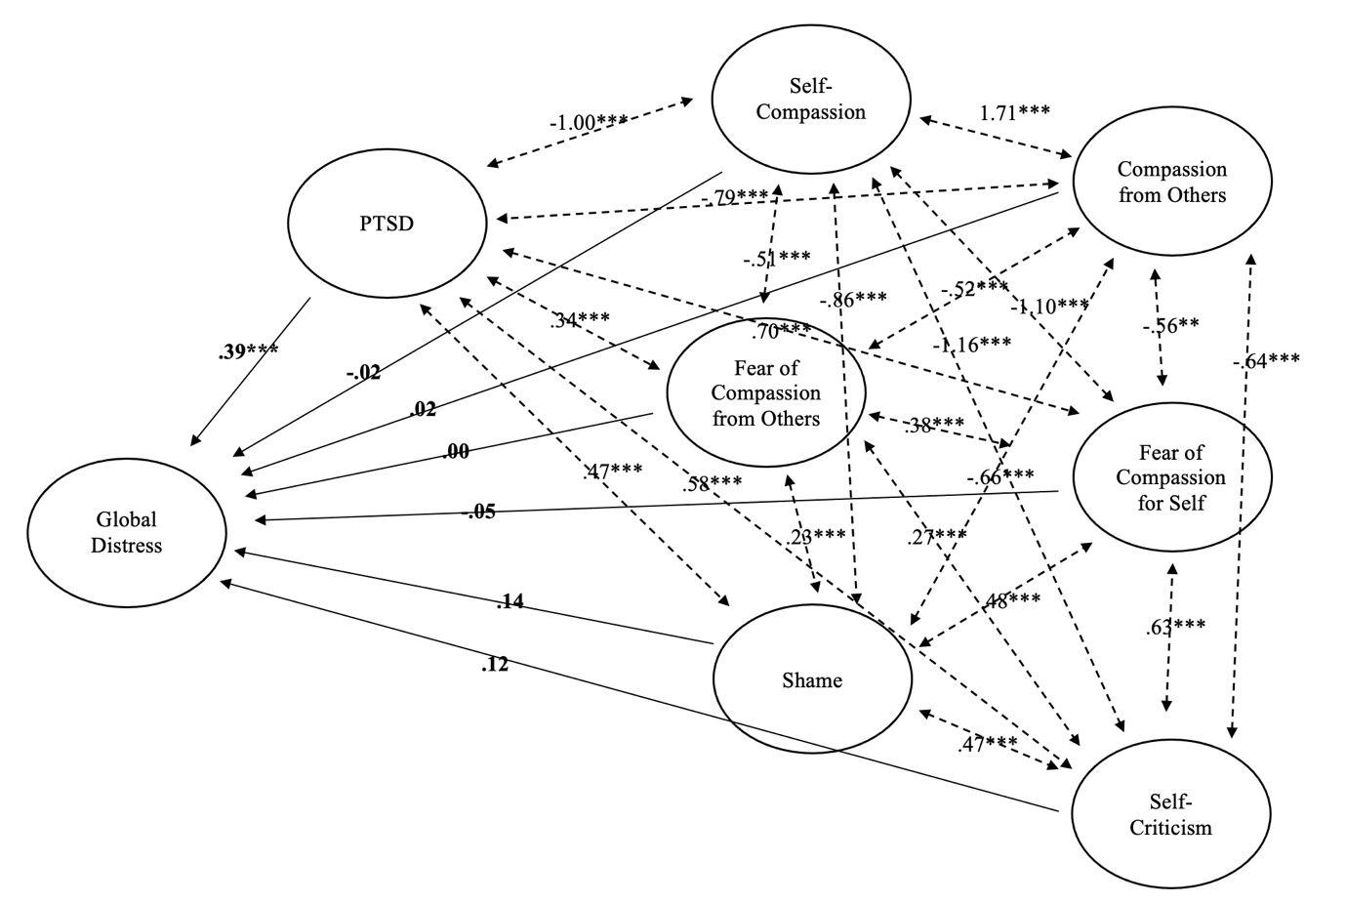
Figure 2: Regression weights and covariances for exploratory model

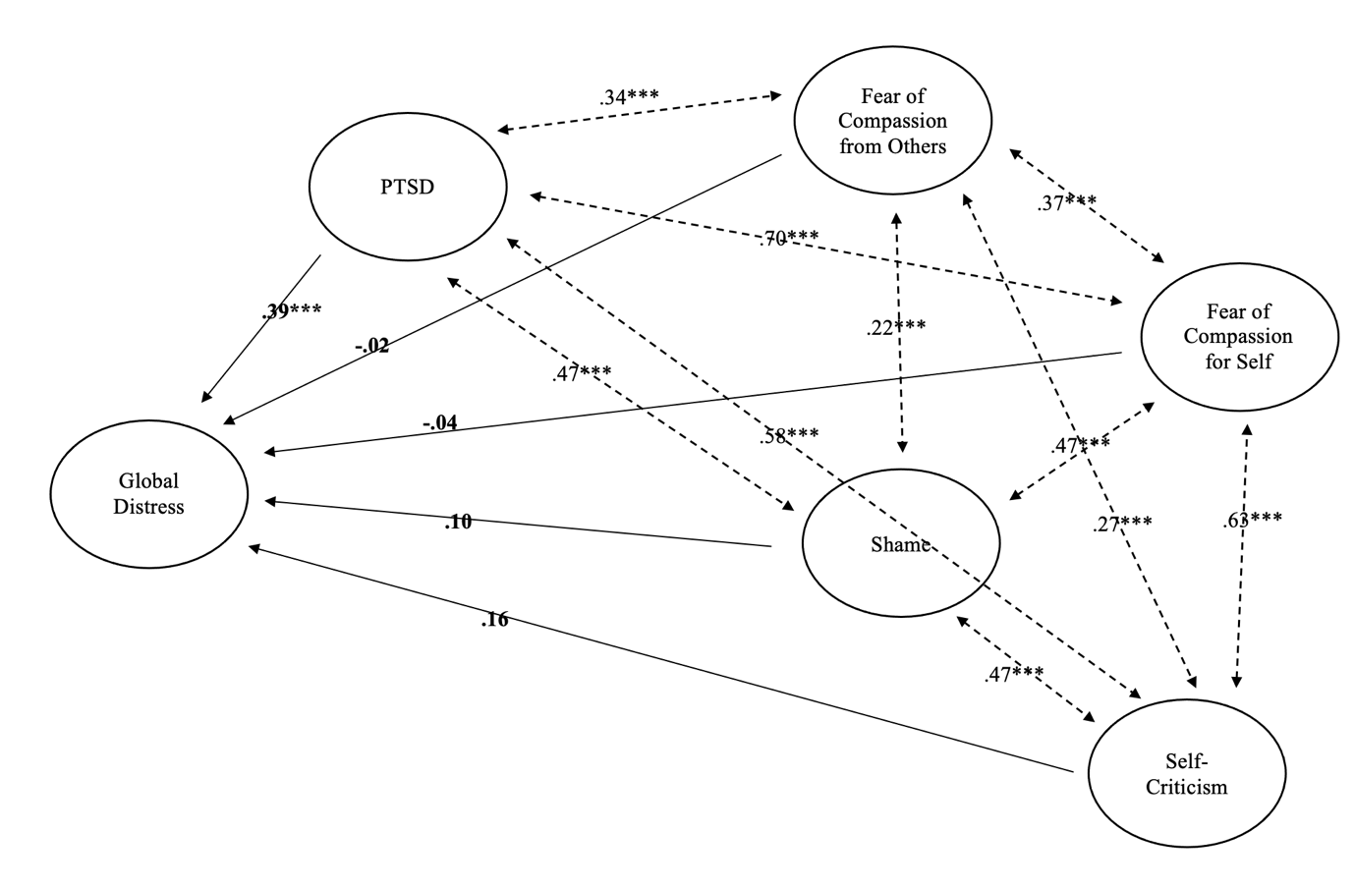

Figure 3: Regression weights and covariances for exploratory model after removing self-compassion and compassion from others, and adjusting for unknown variance in model indices

Discussion

In summary, this study explored the role of compassion and how it relates to trauma associated distress experienced by survivors of sexual abuse. The aim was to look at the relevant contributions of a variety of CFT related variables to self-reported sexual trauma-associated distress and examine the relationships between all the variables. An aim was to decipher whether CFT could be a viable adjunct to sexual trauma therapy based on the cognitive model of PTSD. These results show that there is some evidence for the role of the CFT model, alongside the cognitive PTSD model, in the experiences of sexual trauma-related distress. The CFT related variables alone contributed a small but significant amount of the variance in distress. However, when the contributions of each variable were examined, we find that not all the CFT related variables may play an equal role in distress. For example, self-compassion and compassion from others only show small significant negative correlations with global distress. Additionally, when all the variables are examined for their unique contributions to the hierarchical regression model, only self-criticism significantly predicts global distress. Furthermore, when the model’s structure was examined, it appeared to show a poor model fit, indicating that whilst the CFT related variables explained some of the variance in distress, this exploratory model including all variables did not provide a theoretical model. It is important to consider however, that this model build is exploratory rather than confirmatory and further investigation may be required to find theoretically meaningful paths. Despite the aggregation of a model to explain distress in sexual trauma survivors, these results may yet provide insights into which aspects of the CFT model are important to a therapeutic context.

Sample factors
Examining the sample, these results highlighted that many of the participants had experienced sexual abuse both in childhood and adulthood. Looking at this mixed sample of individuals who experienced sexual abuse across the lifespan, allowed us to capture data that is shared across these groups. This supports the notion that sexual abuse prevalence is complex, as reinforced by national statistics (ONS, 2020, 2021b), and that these nuances should be considered in therapeutic settings. Despite these complexities, results from our sample showed no significant differences in distress across groups categorised by age of abuse occurrence, which contrasts with previous findings that point to differences in self-compassion across such age groups (Kjose, 2019). This particular phenomenon however, would require further specific research, as our results may be skewed by the high proportion of the sample having experienced abuse in both childhood and adulthood (49%).

It was also noted that many participants had experienced some form of psychological support for up to four years or more. Although comparisons against non-clinical samples did show reduced compassion and elevated fear of compassion, shame, and self-criticism in this study sample, it is possible that prior experience of therapy may have impacted the results. For example, substantial experience in therapy may foster the capacity to accept compassion from others or somewhat alleviate the fear of compassion due to the exposure to validation and compassionate care from a therapist, (as Common Factors Theory informs us that all therapy will rely on a supportive therapeutic relationship (Wampold, 2015)). Therefore, with larger samples who had not experienced therapy, we may expect the fear of compassion (from others and for the self) scales to be more highly correlated with global distress. Previous experiences of therapy may also promote self-compassion as has been shown by Minimol and Lucila (2019) and Tesh et al. (2015), which may have played a role in the small correlations in the compassion (from others and from self) scales. It may also be the case that shame and self-criticism require more long-standing treatment than other CFT related variables, as these are often more entrenched and interpersonally reinforced difficulties (Gilbert, 2010), with shame being comprised of “a range of feelings like anger, anxiety, humiliation, embarrassment and disgust” (Lee, 2012). This may provide some explanation for the higher correlations found in shame and self-criticism with global distress in this sample. It was also noted that the majority of the sample had been given one or more psychiatric diagnoses with the majority of these being depressive, post-traumatic stress, and anxiety-based disorders. This was to be expected given the traumatic impact of sexual abuse. However, an important consideration lies in whether people had received treatment corresponding to these diagnoses. The main therapies reported were counselling and CBT, which may be indicative of the sample mainly accessing UK service provisions. However, it may also indicate that for a large proportion of this sample, cognitive and behavioural models had been used to specifically target depression, anxiety and PTSD. Targeted prior treatment for these diagnoses therefore may have impacted these results.

Variable regressions and relationships
This analysis showed that the exploratory model (CFT related variables plus the diagnostic criteria for PTSD as predictors of global distress) did make a significant contribution to predicting distress after sexual abuse, compared to a model of the diagnostic criteria for PTSD alone. However, it is important to consider the possibility of type one errors in relation to potential confounding variables not accounted for, such as demand characteristics and participant expectancy effects; participants may have anticipated the role of CFT from the study advertisements, or may have experienced evaluation apprehension, as they were asked to complete numerous questionnaires. Further investigation of this data may also wish to examine the potential role of the CFT related variables as mediators or moderators in these relationships, suggesting a slightly different role for CFT in the mechanism of therapeutic change after sexual trauma. Furthermore, whilst the exploratory model was significant, the amount of variance in sexual abuse related distress contributed by CFT related variables alone was relatively small (<5%), indicating that whilst the CFT model may be important to consider in the treatment of distress after sexual abuse, it provides a complementary addition, rather than a substitution, to the PTSD model. This reinforces that the cognitive model of PTSD for sexual trauma associated distress is clinically useful and appropriate.

These results highlight the importance of understanding the discreet nature amongst various CFT related constructs. Compassion (from the self and from others) had small significant inverse relationships with global distress in this study, which reflects evidence for the scale as correlated highly with other aspects of compassion, but not with variables related to psychopathology (Gilbert et al., 2017). Contradictory to this, previous findings from other studies highlighted the significant negative associations between self-compassion and psychopathology (McLean et al., 2018; Minimol & Lucila, 2019). Therefore, self-compassion may be quite distinct from receiving compassion from others. It may be important to query the construct of compassion from others as it captures people’s perceptions of responding to compassion from others, whilst actual compassion from others may be better recorded through observational rather than self-report means.

The CFT related variables with stronger relationships to distress were self-criticism, fear of compassion (from others and for the self), and shame. Previous findings showed that self-criticism and fear of compassion played important roles as mediators between sexual abuse and various mental health outcomes (Boykin et al., 2018; Glassman et al., 2007; McAllister, 2019), which is supported by the results of this current study. These results also reinforce the previous evidence for the positive association between fear of compassion and PTSD (Miron et al., 2016). The importance of self-criticism is also shown in the results of this study as it significantly predicted global distress and PTSD in the multiple regression models, and also significantly predicted global distress in the hierarchical model. Conceptually, we can deduce that self-criticism provides a significant contribution to the variance in global distress in our exploratory model, irrespective of the high correlation between PTSD and global distress. Whilst shame also showed a strong relationship with global distress in the correlations matrix, it only predicted the outcome of PTSD and not global distress. This stands in contrast to previous findings that suggest that shame as key to understanding PTSD (Adshead, 2000; Cunningham, Davis, Wilson, & Resick, 2018; Saraiya & Lopez-Castro, 2016). However, these results should be viewed in the context of the measures used; the 8-item EISS-short form was used with the aim to not increase participant distress as the study was completed online and without direct clinician support. Using the full version of the scale may have captured shame in more depth. It is also important that these results are viewed in light of the high correlation between the diagnostic criteria for PTSD and global distress, making it challenging to determine the unique contributions of CFT related variables once they are in a regression model alongside PTSD.

Exploratory model structure
SEM was used to further explore the results of the regression analyses; whilst the regression analyses provided useful information of the relative contributions of each predictor variable in the model, SEM enabled a further exploration of how these variables that were important to the CFT model, fit together in a model related to distress after sexual trauma. Examining the structure of the exploratory model revealed that all exogenous (or “independent”) latent variables significantly covaried with one another. However, only PTSD significantly regressed onto the endogenous (or “dependent”) variable, global distress. Furthermore, although the exploratory model fit was marginally better after removing compassion (from the self and from others), the model fit remained to be only marginal for the exploratory model. It is important to consider that the sample size (N=155) is relatively low to determine accurate structural equation modelling (as power calculations required N=256 to determine the model structure). Once unexplained variance was accounted for, this model provided an acceptable fit. Despite the challenges of power, the model does provide us with important information on the relative contributions of each observed variable (the questionnaire items), and also provides an exploratory basis for further investigations into model structure.

Conceptual considerations
When contemplating these results, it is also important to consider challenges with construct validity; various aspects of CFT may be difficult to operationalise and measure unlike the cognitive processes outlined in other evidence-based theories, such as the cognitive model of PTSD. The CFT model as defined by Gilbert (2010) is underpinned by evolutionary, motivational, and affective processes that may be harder to objectively define and measure and thus determine their impact through research. Further, CFT is not a specific theory, but rather a therapeutic approach, which may make it difficult to determine a model structure. Another important conceptual consideration is the emerging use of a complex-PTSD diagnosis (World Health Organization, 2019), which takes into consideration types of relational and nuanced trauma that are often present in sexual trauma. The emerging scientific understandings of trauma, therefore, may play a role in how we treat and understand experiences of sexual trauma.

Limitations
An important limitation of this study was the lack of heterogeneity in the demographic representation of the sample. The sample was predominantly white, female, UK-based and heterosexual, suggesting that the results may not reflect the established diversity of patient demographics. Future research may want to consider alternative purposive or quota-based sampling methods. Clinical researchers may also want to investigate the barriers to engagement in sexual trauma research, which would be appropriate to the various diversity initiatives and guidelines within the British Psychological Society (BPS, 2020). It is important to consider some other potential confounders that may have impacted generalisability of this sample. Recruitment through social media suggests that participants do not feel distressed in approaching a study advertisement acknowledging sexual trauma, which may not be the case for everyone. It is also important to consider that generalisability may be difficult to determine, as the parameters of what constitutes this “population” are difficult to define. Sexual trauma is not a diagnosis in itself, and therefore, the study sample is identified and defined by the experience of abuse, rather than a specific psychological presentation. The difficulties of determining a generalisable population may also be a limitation, as no two individuals who have experiences abuse may be alike in psychological presentations exclusive to PTSD symptomatology. Another limitation is that the sample may be too small for structural equation modelling. This poses a difficult compromise regarding the recruitment period duration of this sensitive study topic, whilst holding in mind the need to ‘maximise research benefit whilst minimising harm’ as outlined in the BPS research guidelines (BPS, 2014).

It is also important to consider any conceptual limitations in relation to the variables examined in this study. It was noted that the measures for PTSD and global distress were highly positively correlated within this sample. This highlights the potential challenges of distinguishing these two concepts to determine distress after sexual trauma, and consequently may have minimised the role of the CFT related variables within a regression model. Future researchers may wish to explore various outcome variables in sexual trauma and their relationship with one another. Other conceptual limitations regarding operationalising and measuring compassion have also been discussed, and future research may wish to continue in its consideration of these challenges when devising scales. There is also another consideration regarding the assumption that measuring compassion related variables will accurately translate to the CFT model. Therefore, future experimental research into this therapy and its underlying constructs is important.

Future implications
Clinically, the results from this study highlight the role of CFT as a useful adjunct to the PTSD cognitive model of therapy for those who are recovering from sexual abuse. However, whilst CFT may be a useful adjunct, these results highlight that the cognitive model of PTSD alone may be sufficient, as reinforced by prior research. Despite this, the CFT model may support aspects of recovery that are based in affect and internalised processes such as shame and self-criticism, which may be harder to access through cognitive conceptualisations of trauma. The variables that showed the strongest relationships to distress were self-criticism, fear of compassion (from others and for the self) and shame. However, it is important to note that shame and self-criticism are not exclusive to CFT, and clinicians may wish to consider incorporating these aspects into their work more broadly, irrespective of the modality used. Clinicians may also wish to consider monitoring some of these relevant variables in the work that they do, as without direct observation, these important aspects may be overlooked. Regarding research, future investigations may wish to examine experimental designs utilising CFT for survivors of sexual trauma. Compassion concepts may be useful when considering therapeutic intervention trials. Future research may also wish to investigate the role of self-criticism specifically, by utilising qualitative investigations to determine the quality and nature of these self-critical experiences. Such research may support further intervention studies helping to alleviate high levels of self-criticism.

Chapter 3:
Integration, Impact and Dissemination

Introduction

This chapter covers the integration of the systematic review and empirical project as a combined learning activity. It covers the strengths and limitations of this work, as well as the implications for research, service, or policy development. Means of research dissemination are also outlined.

Interest in topic area
I have had a longstanding interest of working with trauma across different settings. Prior to doctoral training I had worked in multiple setting that involved “complex presentations” where I would often learn about the patient’s experiences of trauma. During training I was privileged to work with a number of individuals with very complex difficulties including dissociative disorders, depersonalisation and derealisation, attachment and relational traumas. In the third year I specialised in the Tavistock Trauma Unit (2021), which enhanced my understanding of trauma presentations and their connections with experiences of various types of abuse. Within this service I was fortunate to specialise within the Historical Child Sexual Abuse (HCSA) pathway alongside my general trauma caseload, which showed me that recovering from sexual abuse had its own unique and distinct set of complications, such as challenges in trusting the safety of a therapeutic relationship and ingrained difficulties in self-perception and shame. As a clinician with a longstanding interest in Compassion Focused Therapy (CFT), I felt that these difficulties super-imposed onto the multi-theoretical, attachment, evolutionary and social mentality-based framework within the CFT model. I was very interested to explore experiences of sexual trauma therapy and determine whether there is any evidence for aspects of the CFT model in sexual trauma therapy.

Summary of thesis
This thesis investigated key experiences and aspects relevant to sexual trauma therapy. This was accomplished through two pieces of research: 1. A qualitative systematic review exploring experiences in talking therapies for survivors of sexual abuse, and 2. A quantitative exploration of the role of aspects of CFT in mental health outcomes for survivors of sexual abuse. The literature review found four themes and twelve sub-themes related to 1. Helpful and unhelpful aspects of therapy, 2. Barriers and facilitators to and in therapy, 3. The quality of the therapeutic relationship, and 4. The potential beneficial and detrimental impacts of treatment. The empirical study found that there was some evidence for the potential use of CFT as an adjunct to PTSD-based therapy for survivors of sexual abuse but could not confidently determine a model for how these aspects of the CFT model fit with one another. The implications of these studies together highlight the complexity of sexual trauma recovery. The review conveys that there appears to be qualitative aspects of recovery unique to sexual trauma therapy that are important for clinicians to hold in mind, and the empirical study highlights that several factors related to the Compassion model may be at play in sexual trauma therapy. Furthermore, this thesis highlights the complexity and challenges of measuring all aspects that may be relevant to sexual trauma therapy through singularly quantitative or qualitative means, and that future research may wish to seek clarity on these issues through mixed-methods research.

Integration

The empirical study and systematic review both examined experiences of sexual abuse across the lifespan. This was unique to the systematic review, as a similar previous review only investigated participants with experiences of childhood sexual abuse (Parry & Simpson, 2016). Keeping this focus broad within the empirical study allowed it to be more inclusive in sampling, whilst conveying an acknowledgement of the complexities in recognising and reporting more nuanced experiences of sexual abuse. This also acknowledged the complexity of “cumulative trauma” (Follette, Polusny, Bechtle, & Naugle, 1994), which was reinforced in the empirical study which showed 49% of participants to have experienced trauma in both childhood and adulthood. Whilst this inclusivity poses a strength in the thesis, it can also be viewed as a limitation in the lack of determining age-specific factors related to when abuse occurred for participants. Practically it also posed some challenges to the systematic review as there were few qualitative studies that focused on experiences of adult sexual abuse. Despite this, it was deemed important by the research team and in consultation with Experts by Experience to broaden this inclusion criteria across both studies as there may be key themes and/or findings that are critical to sexual abuse trauma, that are not identified through the specific investigations of childhood trauma experiences. Similarly, where previous studies had focused specifically on female or male participants, this thesis did not focus on any particular gender or sexual orientation. This decision was made to acknowledge the complexities of gender and sexual identities, in line with psychological guidance to promote inclusivity in practice and research (BPS, 2014, 2020; Richards et al., 2019). Furthermore, keeping the studies inclusive in this sense, allowed the research to focus on shared themes with the potential to translate across therapeutic settings.

The results from each study complimented one another. For example, the systematic review highlighted helpful and unhelpful therapeutic factors that were non-specific to any one modality. This supported the learnings from the empirical study that sexual trauma mental health outcomes may be comprised of a complex mix of various psychological aspects, rather than confined to one psychological model. This is fitting with the range of eclectic and idiopathic approaches signposted in the trauma literature (Garland, 1998; Herman, 1997; Lee, 2012; Petrak & Hedge, 2002; Porges, 2011; Stubley & Young, 2022; Van der Kolk, 2014; Zayfert & Becker, 2007). The systematic review emphasised the critical importance of sensitivity, flexibility, and therapist warmth, understanding and compassion to sexual trauma work. These results highlighted the usefulness of exploring compassion qualities within therapy for this patient group, as conducted in the empirical study, and together these studies signpost the need for further research into aspects of the CFT model. The empirical study however, highlighted that CFT constructs are not easy to measure and may be more easily accessed in qualitative work. Another consideration is that whilst standard diagnostic PTSD protocols do not specifically target aspects of the CFT model such as compassion, shame, or fear of compassion, therapists using PTSD frameworks may work on these constructs inadvertently, which is reinforced through the results of the systematic review. Another consideration is that this thesis posed both challenges and benefits of using a mix-methods approach; whilst differing theoretical and epistemological frameworks were used for the systematic review and the empirical project, doing so enabled a balanced and rich understanding of the complexities for this topic.

Recruitment challenges
For the empirical project, recruitment was conducted online. There were several practical challenges to this. Social media sites: Twitter (2022), Facebook (2022) and Instagram (2022) were used. Emails were also sent to 26 relevant charities, of which 7 agreed to send the study advert to their mailing lists. Several charities were unable to disseminate the advert due to their service structure, lack of mailing list, or workload capacities. Gaining internet traffic to the study advert on social media was challenging and required time to circulate the advert sensitively. Consideration was taken with regards to hashtags used and blurbs framing the advert, with appropriate use of ‘content/trigger’ warnings. Utilising Facebook as a platform to disseminate the advert required careful consideration in deciding which groups to approach; the advert was disseminated on groups related to compassion, psychology, trauma, and sexual trauma. Due to the sensitivity of the study, the blurb was tailored to suit the groups and feedback was applied from group facilitators on this. A complaint regarding the use of language in advertising was received from a member of the public. This individual was offered details for the ethics committee along with details of the procedure for raising a concern and/or complaint about research. Recruitment was temporarily paused whilst advice and consultation were sought from supervision and the university ethics department regarding how to act on these concerns and on implementation of this individual’s feedback. Positive feedback was also received from participants and other members of the public during the recruitment process, including enthusiasm for the research topic and appreciation of the study survey. Another consideration in recruitment was to professionally manage the dual role of being a clinician and researcher; this was held in mind in conversations with participants and potential participants, and appropriate signposting for support was pivotal.

Dilemmas and methodological choices
Regarding the systematic review, there were several methodological dilemmas and challenges. During the quality assessment there were challenges in applying the CASP Quality Assessment Checklist (2022) in a standardised way to all the papers; five papers were doctoral theses and it was therefore difficult to create a fair comparison about the reporting style of these papers against much shorter research publications. Doing so involved taking word limits into account when comparing the depth and richness of each analysis.
Utilising Meta-Study (Paterson, Thorne, Canam, & Jillings, 2001) and Meta-Ethnography (Noblit & Hare, 1988) also posed challenges. Whilst according to Paterson et al. there is no single way to conduct these methods (2001), ethnography is most familiarly used within education settings, and it was nevertheless challenging to apply epistemology concerned with social and cultural constructs, to health care research. Integrating philosophy from Meta-Ethnography during the analysis, therefore required the need to apply an awareness of social patterns of clinical populations and hold in mind the epistemological underpinnings, whilst examining and theming the participant quotes.

There were also several challenges during the analysis phase of the systematic review. Creating a coherent narrative of all the participant responses in a way that respectfully and accurately conveyed their voices, was difficult given that the interview transcripts were not available, and it was not possible to determine non-verbal and interpersonal interactions with the participants. For similar reasons it was difficult to select the quotes that would appear to be the most meaningful points that participants would have liked to convey. Another important aspect of the analysis was trying to ensure that the themes did not blend into one another. This was particularly pertinent to themes concerning the therapeutic relationship. However, this challenge perhaps spoke to the importance of the therapeutic relationship as an overarching theme in qualitative investigations of therapy. Participant discussion of this relayed that their interactions with therapists were vital to their experiences of therapy, perhaps even above and beyond the method of therapy. This is fitting with literature that centres the importance of the therapeutic relationship (Gilbert & Leahy, 2007). During analysis it was also important to hold in mind researcher influence; theming the material in relation to therapeutic negligence and abuse towards patients was influenced by holding a dual role as researcher and clinician, and was guided by ethical principles within the clinical psychology profession (BPS, 2021). Similarly, the perception of a helpful therapeutic relationship was undoubtably influenced by what constitutes a good therapeutic relationship as a trainee clinical psychologist and so the analysis was influenced by a clinical and professional, as well as research understanding, of these themes. A final dilemma during analysis of the systematic review involved the integration of feedback from the peer-reviewers; their method of coding was in line with Thematic Analysis (Braun & Clarke, 2022) and differed from Ethnographic coding, and so slightly different positions were taken with regards to using the researcher’s perspective. These discrepancies were resolved through in-depth discussion and a consensus was reached regarding the use of detail and interpretation in the analysis.

Regarding the empirical project there were a number of items that needed sensitive consideration during the planning. Expert by Experience feedback was gained from two individuals on the set up of the study, and also on the demographics and recruitment strategy. Advice was also given around the use of language in advertising and in the CFT resource. Discussions were had regarding the use of sensitive terminology in describing individuals who had experienced sexual trauma. The interchangeability of terms “survivor” and “victim” as well as terms such as “unwanted sexual experiences” and “sexual trauma” was discussed. It was advised that it would be most appropriate to not settle on a single terminology for each of these areas, as the most appropriate choice of language differs from person to person. The use of psychological terminology was discussed, and it was deemed most appropriate to keep the language accessible to as many people as possible by simplifying it and avoiding psychological jargon. This was later a concern after receiving the complaint, as one of the main causes of concern was surrounding the use of language as too simplistic. How to reach a compromise in the use of language was discussed in supervision and with the ethics team.

In setting up the study careful consideration was given to how to collect demographic information. Government guidelines (GOV.UK, 2022) were sought regarding ethnicity status, and consultation with TransPlus (2022) was sought for how to collect information pertaining to gender, sexual orientation, and relationship status. A dilemma involved whether to categorise this data collection to facilitate data analysis or provide free text options to participants. After discussion with a member from TransPlus it was agreed that free text boxes would be best to allow individuals to self-identify and promote inclusivity in the research. Coding and analysing this data required multiple response sets to reflect areas where people had selected more than one gender identity, sexual orientation, or relationship status, and then generating the frequencies from these. Participants were also able to select more than one ethnic group and add additional responses, which was valued in the participant feedback. The duration of the recruitment period was also considered as an ethical dilemma; it was important to meet the minimum sample size required. However, this was considered in light of the sensitivity of the study and need to attend to study queries from the general public, and so recruitment was paused during analysis of the data. Another area to contemplate in recruitment is that the study may have been difficult for men to engage with. Feedback from members of the public was given surrounding the challenges of stigma towards male survivors of sexual abuse and it was important to consider this in light of a female researcher led study. These issues were perhaps reflected in the data as the final sample showed that very few individuals who identified as male took part. This issue requires careful consideration for future research in this area.

Impact

The potential impact of this research is considered with regards to the psychological and related mental health professions.

Beneficiaries
The main beneficiaries of this thesis are specialist trauma and sexual trauma services. These services most frequently exist in the third and voluntary sectors, but also exist within the National Health Service (NHS). The systematic review provides a rationale for utilising a more idiographic approach to working with sexual trauma (e.g; Lifecentre, 2021; OneInFour, 2021; RapeCrisis, 2021), as opposed to purely protocol-based working; flexibility and tailoring treatment to the participants was depicted as pivotal. It is often the case that charity services use a person-centred approach according to their client-base needs, and this study provides a theoretical argument for the provision of such services. Other beneficiaries include specialist NHS services who are continually looking to expand their understanding of the evidence for trauma (e.g; HavenNetwork, 2021; Tavistock&Portman, 2021). Also, as CFT is developing in its usage within the NHS, the empirical project may provide some rationale for its piloting within services. Other beneficiaries include the clinical psychology profession and researchers; these studies may expand the awareness of the unique needs of trauma survivors, as well as help signpost areas for further research. The empirical study might guide further research into intervention studies of CFT, whilst the systematic review might support further qualitative research to understand shared and unique experiences for survivors who have experienced sexual trauma at different times across the lifespan.

Benefits
Some of the benefits of the systematic review are that it provides first person descriptions of experiences in therapy and aggregates these across various samples. This provides clinicians with an accessible format to the overarching themes from numerous narratives which can be applied clinically. Meanwhile the empirical study provides benefits as it highlights the key aspects of the CFT model that clinicians may wish to focus on in their therapy. Findings from these two studies will also be of use to the general public: Regarding the empirical study an awareness of the difficulties with various aspects of the CFT model can feel incredibly normalising and may facilitate accessing therapy. Similarly, the systematic review may also be of benefit to the general public in that it normalises difficult and helpful experiences in therapy, supporting potential patients in understanding what to expect or look for in therapy. Furthermore, the results of the systematic review may support the field of Meta-Study and Meta-Ethnography as a means of expanding this academic literature further in health research.

Maximising benefits
The results from this work could be maximised through dissemination within the CFT therapist community so that CFT therapists working with sexual trauma can be made aware of the specific aspects of the CFT model to consider in their work. Potential barriers to applying CFT clinically lie in the cost of training staff members and of specialist supervision, and so disseminating these findings through the CFT therapist community may provide access to peer learnings on working with key areas of the model. Furthermore, the results of the systematic review could be provided to NHS specialist and third sector services. This could be conducted via individual consultation with services. However, a potential barrier to this involves the provision of practitioner time, and so this information could also be disseminated to services through summarised versions of the research.

Evidencing benefits
The benefits of these studies could be evidenced through further follow up research. For example, the themes highlighted from the systematic review could be examined in more detail in future qualitative exploratory research, and the findings discovered in the empirical project could be tested through future intervention studies. The study results and their benefits could also be tested through implementation and/or piloting in services, followed by patient and clinician feedback.

Dissemination

On completing this study, I have plans to disseminate these findings through a number of avenues. My aim is to publish both the systematic review and empirical project with the BPS Journal; Psychology and Psychotherapy, theory, research and practice, as this journal has a wide audience of clinicians who will be able to consider the results clinically. It also has a relatively high impact factor of 3.915 and publishing through this journal would help develop the quality of these manuscripts through the revisions process. I also aim to disseminate both the systematic review and empirical project at various conferences; the DCP conference, the CFT conference and the BABCP conference. A trauma specific conference would also be a useful forum to disseminate these results particularly where there are a number of non-clinicians present as this would provide useful discussion to develop future research. I also plan to disseminate the results via social media to make them more accessible for a wider audience; I plan to disseminate a plain English version of the results via the platforms and groups that the study was advertised. I also hope to give a plain English summary to various third sector services, particularly the services that were approached for recruitment, as well as specialist NHS services. Where services would find it helpful, I would like to attend meetings to disseminate these results. A particular service that may find this useful is the Tavistock Trauma Unit that I completed my third-year placement within. I will also share my results within the CFT forums where different clinicians can discuss future research and clinical implications. In the process of completing this work I gathered a network of CFT therapists and CFT interested clinicians specialising in sexual trauma. I hope to share my results with them so that we can collectively look to future research in this area.

References

Adshead, G. (2000). Psychological therapies for post-traumatic stress disorder. The British Journal of Psychiatry, 177, 144–148. doi:10.1192/bjp.177.2.144
Allen, A. B., Cazeau, S., Grace, J., & Banos, A. S. (2020). Self-Compassionate Responses to an Imagined Sexual Assault. Violence Against Women. doi:10.1177/1077801220905631
Anthony, W. A. (1993). Recovery from mental illness: The guiding vision of the mental health service system in the 1990s. Psychosocial Rehabilitation Journal, 16(4), 11-23. doi:10.1037/h0095655
APA. (2013). American Psychiatric Association: Diagnostic and Statistical Manual of Mental Disorders (DSM-5®) (5th ed.). Washington: American Psychiatric Association.
APA. (2020). Sexual abuse. Retrieved from https://www.apa.org/topics/sexual-abuse/
APA. (2022). Sexual abuse. Retrieved from https://www.apa.org/topics/sexual-assault-harassment
Arbuckle, J. L. (2014). Amos, (Version 23.0) [Computer Program]. Chicago: IBM SPSS.
Asselstine, M. E. (2000). Body experiences of women survivors of child sexual abuse: Implications for therapeutic intervention. (60). ProQuest Information & Learning, Retrieved from https://search.ebscohost.com/login.aspx?direct=true&db=psyh&AN=2000-95006-054&site=ehost-live Available from EBSCOhost APA PsycInfo database.
Au, T. M., Sauer-Zavala, S., King, M., W.,, Petrocchi, N., Barlow, D. H., & Litz, B. T. (2017). Compassion-Based Therapy for Trauma-Related Shame and Posttraumatic Stress: Initial Evaluation Using a Multiple Baseline Design. Behav Ther, 48(2), 207-221. doi:10.1016/j.beth.2016.11.012
Baião, R., Gilbert, P., McEwan, K., & Carvalho, S. (2015). Forms of Self-Criticising/Attacking & Self-Reassuring Scale: Psychometric properties and normative study. Psychology and Psychotherapy: Theory, Research and Practice, 88, 438–452. doi:10.1111/papt.12049
Beck, A. T., Ward, C. H., Mendelson, M., Mock, J., & Erbaugh, J. (1961). An inventory for measuring depression. Archives of General Psychiatry., 4, 561-571.
Bhuptani, P. H., & Messman-Moore, T. L. (2019). Blame and Shame in Sexual Assault. In O'Donohue W. & S. P. (Eds.), Handbook of Sexual Assault and Sexual Assault Prevention (pp. 309-322). Cham: Springer.
Blevins, C. A., Weathers, F. W., Davis, M. T., Witte, T. K., & Domino, J. L. (2015). The Posttraumatic Stress Disorder Checklist for DSM-5 (PCL-5): Development and Initial Psychometric Evaluation. Journal of Traumatic Stress, 28, 489–498. doi:10.1002/jts.22059
Bluntzer, L. H. (2017). Befriending the survivor: a qualitative analysis of yoga as an adjunctive therapy for female survivors of sexual abuse. (78). ProQuest Information & Learning, Retrieved from https://search.ebscohost.com/login.aspx?direct=true&db=psyh&AN=2017-01062-073&site=ehost-live Available from EBSCOhost APA PsycInfo database.
Bogdan, R., & Biklen, S. (1982). Qualitative research for education: An introduction to theory and methods. Boston, MA: Allyn & Bacon.
Boykin, D. M., Himmerich, S. J., Pinciotti, C. M., Miller, L. M., Miron, L. R., & Orcutt, H. K. (2018). Barriers to Self-Compassion for Female Survivors of Childhood Maltreatment: The Roles of Fear of Self-Compassion and Psychological Inflexibility. Child Abuse & Neglect, 76(February), 216-224. doi:10.1016/j.chiabu.2017.11.003
BPS. (2014). Code of Human Research Ethics. (978-1-85433-762-7). Leicester: The British Psychological Society Retrieved from https://www.bps.org.uk/sites/bps.org.uk/files/Policy/Policy%20-%20Files/BPS%20Code%20of%20Human%20Research%20Ethics.pdf
BPS. (2020). Declaration on equality, diversity and inclusion. Retrieved from Leicester: https://www.bps.org.uk/sites/www.bps.org.uk/files/EDI/Declaration%20on%20equality%2C%20diversity%20and%20inclusion.pdf [Online. Accessed 25.02.2022]
BPS. (2021). Code of Ethics and Conduct. Retrieved from Leicester: https://www.bps.org.uk/sites/www.bps.org.uk/files/Policy/Policy%20-%20Files/BPS%20Code%20of%20Ethics%20and%20Conduct.pdf [Online: Accessed 12.03.2022]
Braun, V., & Clarke, V. (2022). Thematic Analysis: a practical guide. London: Sage.
Brewin, C. R., Dalgleish, T., & Joseph, S. (1996). A dual representation theory of posttraumatic stress disorder. Psychol Rev, 103(4), 670-686. doi:10.1037/0033-295x.103.4.670
CASP. (2022). Critical Appraisal Skills Programme. CASP Qualitative Checklist. Retrieved from https://casp-uk.net [Online: Accessed 24.01.2022]
Chandler, P. (2010). Resilience in Healing from Childhood Sexual Abuse. (Doctor of Philosophy (Ph.D.) in Psychology). Saybrook University, ProQuest LLC. (3418925)
Cherry, M. G., Smith, H., Perkins, E., & Boland, A. (2017). Reviewing Qualitative Evidence. In A. Boland, M. G. Cherry, & R. Dickson (Eds.), Doing a Systematic Review (2nd ed., pp. 193-222). London: Sage.
Chouliara, Z., Karatzias, T., Scott-Brien, G., Macdonald, A., MacArthur, J., & Frazer, N. (2011). Talking Therapy Services for Adult Survivors of Childhood Sexual Abuse (CSA) in Scotland: Perspectives of Service Users and Professionals. Journal of Child Sexual Abuse, 20(2), 128-156. Retrieved from 10.1080/10538712.2011.554340
Cunningham, K. C. (2020). Shame and Guilt in PTSD. In M. T. Tull & N. A. Kimbrel (Eds.), Emotion in Posttraumatic Stress Disorder: Etiology, Assessment, Neurobiology, and Treatment (pp. 145-171). London: Academic Press: Elsevier.
Cunningham, K. C., Davis, J. L., Wilson, S. M., & Resick, P. A. (2018). A relative weights comparison of trauma-related shame and guilt as predictors of DSM-5 post- traumatic stress disorder symptom severity among US veterans and military members. British Journal of Clinical Psychology, 57(2), 163-176. doi:10.1111/bjc.12163
Curran, J., Parry, G. D., Hardy, G. E., Darling, J., Mason, A. M., & Chambers, E. (2019). How Does Therapy Harm? A Model of Adverse Process Using Task Analysis in the Meta-Synthesis of Service Users' Experience. Front Psychol, 10. doi:10.3389/fpsyg.2019.00347
Dayan, S. T. (2021). The benefits of life stories to trauma research: Child disaster studies through ecological-developmental lenses. Children & Society, 00, 1-15. doi:10.1111/chso.12514
Decker, S. E., & Naugle, A. E. (2008). DBT for sexual abuse survivors: Current status and future directions. The Journal of Behavior Analysis of Offender and Victim Treatment and Prevention., 1(4), 52-68.
Dorrepaal, E., Thomaes, K., Smit, J. H., van Balkom, A. J., Veltman, D. J., Hoogendoorn, A. W., & Draijer, N. (2012). Stabilizing group treatment for complex posttraumatic stress disorder related to child abuse based on psychoeducation and cognitive behavioural therapy: a multisite randomized controlled trial. Psychother Psychosom, 81(4), 217-225. doi:10.1159/000335044
Edmond, T., Sloan, L., & McCarty, D. (2004). Sexual Abuse Survivors’ Perceptions of the Effectiveness of EMDR and Eclectic Therapy. Research on Social Work Practice, 14(4), 259-272. doi:10.1177/1049731504265830
Edwards, N. (2016). Experiences of clinicians using mindfulness-based therapy with adult survivors of childhood sexual abuse: A qualitative analysis. (77). ProQuest Information & Learning, Retrieved from https://search.ebscohost.com/login.aspx?direct=true&db=psyh&AN=2016-37854-216&site=ehost-live Available from EBSCOhost APA PsycInfo database.
Evans, C., Connell, J., Barkham, M., Margison, F., McGrath, G., Mellor-Clark, J., & Audin, K. (2002). Towards a standardised brief outcome measure: Psychometric properties and utility of the CORE–OM. British Journal of Psychiatry, 180(1), 51-60. doi:10.1192/bjp.180.1.51
Facebook. (2022). Facebook Website. Retrieved from https://twitter.com [Online. Accessed 13.03.2022]
Faul, F., Erdfelder, E., Buchner, A., & Lang, A. G. (2009). Statistical power analyses using G*Power 3.1: Tests for correlation and regression analyses. Behav Res Methods, 41, 1149-1160. doi:10.3758/BRM.41.4.1149
Ferreira, C., Moura-Ramos, M., Matos, M., & Galhardo, A. (2020). A new measure to assess external and internal shame: development, factor structure and psychometric properties of the External
and Internal Shame Scale. Current Psychology. doi:10.1007/s12144-020-00709-0
Filstead, W. J. (1970). Qualitative methodology: Firsthand involvement with the social world. Chicago: Markham Publishing.
Finfgeld-Connett, D. (2018). A Guide to Qualitative Meta-Synthesis. New York: Routledge.
Fleeman, N., & Dundar, Y. (2017). Data Extraction: Where Do I Begin? In A. Boland, M. G. Cherry, & R. Dickson (Eds.), Doing a Systematic Review (2nd ed., pp. 93-106). London: Sage.
Follette, V. M., Polusny, M. A., Bechtle, A. E., & Naugle, A. E. (1994). Cumulative trauma: The impact of child sexual abuse, adult sexual assault, and spouse abuse. Journal of Traumatic Stress, 9(1), 25-35. doi:10.1002/jts.2490090104
Fortgang, S. (1992). An investigation into practice: Adult incest victims and psychoanalytic psychotherapy. Smith College Studies in Social Work, 62(3), 265-281. doi:10.1080/00377319209516713
Garcia, M. A. (2004). Experiences of Young Mexican American Women in Psychotherapy. (Doctor of Psychology). Pepperdine University, ProQuest Information and Learning Company. (3150342)
Garland, C. (1998). Thinking About Trauma. In C. Garland (Ed.), Understanding Trauma; A Psychoanalytical Approach (pp. 9-31). Oxon: Routledge.
Gilbert, P. (1998). Evolutionary psychopathology: Why isn't the mind designed better than it is? British Journal of Medical Psychology, 71(4), 353-373. doi:10.1111/j.2044-8341.1998.tb00998.x.
Gilbert, P. (2009). The Compassionate Mind. London: Constable and Robinson Ltd.
Gilbert, P. (2010). Compassion Focused Therapy: Distinctive Features. Hove and New York: Routledge.
Gilbert, P. (2017). A Brief Outline of the Evolutionary Approach for Compassion Focused Therapy. EC Psychology and Psychiatry, 3(6), 218-227.
Gilbert, P., Catarino, F., Duarte, C., Matos, M., Kolts, R., Stubbs, J., . . . Basran, J. (2017). The Development of Compassionate Engagement and Action Scales for Self and Others. Journal of Compassionate Health Care, 4(4), 1-24. doi:10.1186/s40639-017-0033-3
Gilbert, P., Clark, M., Hempel, S., Miles, J. N. V., & Irons, C. (2004). Criticising and reassuring oneself: An exploration of forms, styles and reasons in female students. British Journal of Clinical Psychology, 43, 31-50.
Gilbert, P., & Leahy, R. L. (Eds.). (2007). The Therapeutic Relationship in Cognitive Behavioural Psychotherapies. East Sussex: Routledge.
Gilbert, P., McEwan, K., Matos, M., & Rivis, A. (2011a). Fears of Compassion: Development of Three Self-Report Measures. Psychology and Psychotherapy: Theory, Research and Practice, 84(3), 239-255. doi:10.1348/147608310X526511
Gilbert, P., McEwan, K., Matos, M., & Rivis, A. (2011b). Fears of Compassion: Development of Three Self-Report Measures. Psychology and Psychotherapy: Theory, Research and Practice, 84, 239–255. doi:10.1348/147608310X526511
Glassman, L. H., Weierich, M. R., Hooley, J. M., Deliberto, T. L., & Nock, M. K. (2007). Child maltreatment, non-suicidal self-injury, and the mediating role of self-criticism. Behav Res Ther, 45(10), 2483-2490. doi:10.1016/j.brat.2007.04.002
Glowacki, C. R., & Glowacki, Z. R. (2021). Utilizing cognitive processing therapy to treat sexual trauma with a Pakistani-American: A case report. Clinical Case Studies, 20(6), 435-451. doi:10.1177/15346501211011255
Gould, R. (2019). Working psychodynamically and psychosocially with women who have been raped. Psychodynamic Practice: Individuals, Groups and Organisations, 25(3), 208-222. doi:10.1080/14753634.2019.1639541
GOV.UK. (2022). Ethnicity Facts and Figures. Retrieved from https://www.ethnicity-facts-figures.service.gov.uk/style-guide/ethnic-groups [Online: Accessed 13.03.2022]
Harper, K., Stalker, C. A., Palmer, S., & Gadbois, S. (2008). Adults traumatized by child abuse: What survivors need from community-based mental health professionals. Journal of Mental Health, 17(4), 361-374. doi:10.1080/09638230701498366
HavenNetwork. (2021). The Havens. Retrieved from http://www.havennetwork.org.uk [Accessed 03.03.2021]
Hayes, S. C., Strosahl, K. D., & Wilson, K. G. (2012). Acceptance and Commitment Therapy: The Process and Practice of Mindful Change (2nd ed.). New York: Guilford Publications.
Herman, J. (1997). Trauma and Recovery: The Aftermath of Violence- From Domestic Abuse to Political Terror. New York: Basic Books.
Holland, K. J., Cipriano, A. E., & Huit, T. Z. (2021). LGBTQ and Straight Sexual Assault Survivors’ Interactions with Counseling in a Campus Counseling Center and Women’s Center. Women & Therapy, 44(3-4), 337-357. doi:10.1080/02703149.2021.1961439
Holmes, J. (1997). "Too early, too late": Endings in Psychotherapy- an Attachment Perspective. British Journal of Psychotherapy, 14(2), 159–171. doi:10.1111/j.1752-0118.1997.tb00367.x
Horton, M. G. (2021). 'Will you scream with me?'; The experience of expressive therapy for one adult survivor of childhood sexual abuse and their counselor: A single-case study giving voice to complex trauma. (82). ProQuest Information & Learning, Retrieved from https://search.ebscohost.com/login.aspx?direct=true&db=psyh&AN=2021-65616-155&site=ehost-live Available from EBSCOhost APA PsycInfo database.
IBM. (2020). IBM SPSS Statistics for Windows, (Version 27.0) [Computer Program]. Armonk, NY: IBM Corporation.
Instagram. (2022). Instagram Website. Retrieved from www.instagram.com [Online. Accessed 13.03.2022]
Irons, C., & Lad, S. (2017). Using Compassion Focused Therapy to Work with Shame and Self-Criticism in Complex Trauma. Australian Clinical Psychologist, 3(1), 47-54.
Kanto, V., Knefel, M., & Lueger-Schuster, B. (2017). Perceived barriers and facilitators of mental health service utilization in adult trauma survivors: A systematic review. Clinical psychology review, 52, 52-68. doi:10.1016/j.cpr.2016.12.001
Kennerley, H. (2009). Overcoming Childhood Trauma: A Self-Help Guide Using Cognitive Behavioral Techniques. London: Constable & Robinson.
Kjose, A. (2019). Post-Assault Recovery in Undergraduate College Students: The Role of Mindfulness and Self-Compassion. (Doctor of Philosophy). University of Oklahoma,
Koehn, C. (1995). Sexual Abuse Survivors’ Perceptions of Helpful and Hindering Counsellor Behaviour. (Doctor of Philosophy). University of Victoria, University of Victoria.
Koehn, C. (2007). Women's Perceptions of Power and Control in Sexual Abuse Counseling. Journal of Child Sexual Abuse, 16(1), 37-60. doi:10.1300/ J070v16n01_03
Lambert, M. J. (2010). Prevention of Treatment Failure: The Use of Measuring, Monitoring, and Feedback in Clinical Practice: American Psychological Association.
Leach, C., Lucock, M., Barkham, M., Noble, R., Clarke, L., & Iveson, S. (2005). Assessing risk and emotional disturbance using the CORE–OM and HoNOS outcome measures at the interface between primary and secondary mental healthcare. Psychiatric Bulletin, 29(11), 419-422. doi:10.1192/pb.29.11.419
Lee, D. A. (2012). The Compassionate Mind Approach to Recovering from Trauma Using Compassion Focused Therapy. London: Constable and Robinson Ltd.
Lee, D. A., Scragg, P., & Turner, S. (2001). The role of shame and guilt in traumatic events: A clinical model of shame-based and guilt-based PTSD. British Journal of Medical Psychology, 74, 451–466.
Lifecentre. (2021). Lifecentre [online]. Retrieved from https://lifecentre.uk.com [Accessed 08.03.2021]
Lindsay, J. K. (1995). Eye movement desensitization and reprocessing (emdr) in the treatment of rape survivors. (56). ProQuest Information & Learning, Retrieved from https://search.ebscohost.com/login.aspx?direct=true&db=psyh&AN=1995-95015-170&site=ehost-live Available from EBSCOhost APA PsycInfo database.
Liotti, G. (2007). Internal working models of attachment in the therapeutic relationship Giovanni Liotti. In P. Gilbert & R. L. Leahy (Eds.), The Therapeutic Relationship in the Cognitive Behavioral Psychotherapies. (pp. 143-161). East Sussex: Taylor and Francis.
Luna, E. C. (2016). Loving-kindness and compassion: Group psychotherapy for survivors of campus sexual assault. (77). ProQuest Information & Learning, Retrieved from https://search.ebscohost.com/login.aspx?direct=true&db=psyh&AN=2016-31155-278&site=ehost-live Available from EBSCOhost APA PsycInfo database.
Matos, M., Pinto-Gouveia, J., Gilbert, P., Duarte, C., & Figueiredo, C. (2015). The other as Shamer scale - 2: Development and validation of a short version of a measure of external shame. Personality and Individual Differences, 74(6–11). doi:10.1016/j.paid.2014.09.037.
McAllister, P. (2019). Sexual violence and mental health: an analysis of the mediating role of self-compassion using a feminist lens. (Master of Science). Kansas State University,
McGregor, K., Thomas, D. R., & Read, J. (2006). Therapy for Child Sexual Abuse: Women Talk About Helpful and Unhelpful Therapy Experiences. Journal of Child Sexual Abuse, 15(4), 35-59. doi:10.1300/J070v15n04_03
McLean, L., Fiorillo, D., & Follette, V. M. (2018). Self-Compassion and Psychological Flexibility in a Treatment-Seeking Sample of Women Survivors of Interpersonal Violence. Violence Vict, 33(3). doi:10.1891/0886-6708.v33.i3.472
McLean, L., Steindl, S. R., & Bambling, M. (2017). Compassion-focused Therapy as an Intervention for Adult Survivors of Sexual Abuse (Publication no. 10.1080/10538712.2017.1390718).
Miller, B. J., Cardona, J. R. P., & Hardin, M. (2007). The use of narrative therapy and internal family systems with survivors of childhood sexual abuse: Examining issues related to loss and oppression. Journal of Feminist Family Therapy: An International Forum, 18(4), 1-27. doi:10.1300/J086v18n04_01
Minimol, J., & Lucila, B. O. (2019). Self-compassion as a predictor of traumatic shameful memories among selected Indian sexually abused female children. Indian Journal of Positive Psychology, 10(3), 140-145.
Miron, L. R., Seligowski, A. V., Boykin, D., & Orcutt, H. K. (2016). The Potential Indirect Effect of Childhood Abuse on Posttrauma Pathology Through Self- Compassion and Fear of Self-Compassion. Mindfulness, 7(3), 596–605. doi:10.1007/s1267-016-0493-0
Neff, K. D. (2003). Self-compassion: An alternative conceptualization of a healthy attitude toward oneself Self Identity, 2, 85–102.
Nguyen, T.-T., & Bellehumeur, C. (2013). Grieving the loss linked to childhood sexual abuse survivor: A narrative therapy in search of forgiveness. Counselling and Spirituality / Counseling et spiritualité, 32(1), 37-58. Retrieved from https://search.ebscohost.com/login.aspx?direct=true&db=psyh&AN=2014-02857-003&site=ehost-live
tufmm2000@yahoo.com
NICE. (2018). Post-Traumatic Stress Disorder (NG116). In: National Institute for Health and Care Excellence.
Noblit, G. W., & Hare, R. D. (1988). Meta-Ethnography: Synthesizing Qualitative Studies. London: Sage.
O’Brien, L., Henderson, C., & Bateman, J. (2007). Finding a place for healing: Women survivors of childhood sexual abuse and their experience of accessing services. Australian e-Journal for the Advancement of Mental Health, 6(2), 91-100. doi:10.5172/ jamh.6.2.91
OneInFour. (2021). One In Four [online]. Retrieved from https://oneinfour.org.uk [Accessed 08.03.2021]
ONS. (2020). Office for National Statistics: Sexual offences in England and Wales: year ending March 2017. Retrieved from https://www.ons.gov.uk/peoplepopulationandcommunity/crimeandjustice/articles/sexualoffencesinenglandandwales/yearendingmarch2017
ONS. (2021a). Office for National Statistics; Child sexual abuse in England and Wales: year ending March 2019. Retrieved from https://www.ons.gov.uk/peoplepopulationandcommunity/crimeandjustice/articles/childsexualabuseinenglandandwales/yearendingmarch2019 [Online. Accessed 20.11.2021]
ONS. (2021b). Office for National Statistics; Sexual offences in England and Wales: year ending March 2017. Retrieved from https://www.ons.gov.uk/peoplepopulationandcommunity/crimeandjustice/articles/sexualoffencesinenglandandwales/yearendingmarch2017 [Online. Accessed 20.11.2021]
Page, M. J., McKenzie, J. E., Bossuyt, P. M., Boutron, I., Hoffmann, T. C., Mulrow, C. D., . . . Moher, D. (2021). The PRISMA 2020 statement: an updated guideline for reporting systematic reviews. Br Med J (Clin Res Ed), 372(71). doi:10.1136/bmj.n71
Parry, S., & Simpson, J. (2016). How Do Adult Survivors of Childhood Sexual Abuse Experience Formally Delivered Talking Therapy? A Systematic Review. Journal of Child Sexual Abuse, 25(7), 793-812. doi:10.1080/10538712.2016.1208704
Paterson, B. L., Thorne, S. E., Canam, C., & Jillings, C. (2001). Meta-Study of Qualitative Health Research: A practical guide to meta-analysis and meta-synthesis. London: Sage.
Petrak, J. (2002). The Psychological Impact of Sexual Trauma. In J. Petrak & B. Hedge (Eds.), The Trauma of Sexual Assault: Treatment, Prevention and Practice. West Sussex: John Wiley & Sons.
Petrak, J., & Hedge, B. (2002). The Trauma of Sexual Assault: Treatment, Prevention and Practice. West Sussex: John Wiley & Sons.
Porges, S. W. (2011). The Polyvagal Theory: Neurophysiological Foundations of Emotions, Attachment, Communication, and Self-regulation (Norton Series on Interpersonal Neurobiology). New York: W. W. Norton.
PROSPERO. (2022). PROSPERO: International prospective register of systematic reviews. Retrieved from https://www.crd.york.ac.uk/prospero/#searchadvanced [Online. Accessed 12.03.2022]
RapeCrisis. (2021). Rape Crisis. Retrieved from https://rapecrisis.org.uk [Accessed 06.04.2021]
Rhodes, A. (2015). Yoga for traumatic stress: A three paper dissertation. (75). ProQuest Information & Learning, Retrieved from https://search.ebscohost.com/login.aspx?direct=true&db=psyh&AN=2015-99090-159&site=ehost-live Available from EBSCOhost APA PsycInfo database.
Richards, C., Gibson, S., Jamieson, R., Lenihan, P., Rimes, K., & Semlyen, J. (2019). Guidelines for psychologists working with gender, sexuality and relationship diversity: For adults and young people (aged 18 and over). Retrieved from Online: https://www.bps.org.uk/sites/www.bps.org.uk/files/Policy/Policy%20-%20Files/Guidelines%20for%20psychologists%20working%20with%20gender%2C%20sexuality%20and%20relationship%20diversity.pdf [Online: Accessed 13.03.2022]
Rogers, C. R. (1957). The necessary and sufficient conditions of therapeutic personality change. J Consult Psychol, 21(2), 95-103. Retrieved from http://www.ncbi.nlm.nih.gov/pubmed/13416422
Rollison, J., Gore, K., Farris, C., Hero, J., Weilant, S., Feistel, K., . . . Akinniranye, O. (2021). Psychological interventions for adult victims of sexual assault or sexual harassment. Retrieved from https://www.crd.york.ac.uk/prospero/display_record.php?RecordID=240276 [Accessed: 15.01.2022]
Roth, S., & Friedman, M. J. (1998). Childhood Trauma Remembered: A Report on the Current Scientific Knowledge Base and its Applications. Journal of Child Sexual Abuse, 7(1), 83-109. doi:10.1300/J070v07n01_07
Rothbaum, B. O., Foa, E. B., Riggs, D. S., Murdock, T., & Walsh, W. (1992). A Prospective Examination of Post-Traumatic Stress Disorder in Rape Victims. Journal of Traumatic Stress, 5(3), 455-475.
Sahin, Z. S., & McVicker, M. (2009). The Use of Optimism in Narrative Therapy with Sexual Abuse Survivors. Journal of European Psychology Students, 1(1), 1-6. doi:10.1037/e537222013-007
Saraiya, T., & Lopez-Castro, T. (2016). Ashamed and Afraid: A Scoping Review of the Role of Shame in Post-Traumatic Stress Disorder (PTSD). Journal of Clinical Medicine, 5(94). doi:10.3390/jcm5110094
Scott, S., & Stubley, J. (2022). Designing and working in a service for women with historical child sexual abuse. In J. Stubley & L. Young (Eds.), Complex Trauma: The Tavistock Model (pp. 122-129). Oxon: Routledge.
Shannon, P. J. (1996). The Therapy Experiences of Women Survivors of Childhood Sexual Abuse. (Doctor of Philosophy, Psychology). University of Michigan, UMI Company. (9712082)
Smallwood, J. (2020). Increasing Access to Cervical Screening Following Sexual Assault: The My Body Back App. (Doctor in Clinical Psychology). Royal Holloway University of London, Retrieved from https://pure.royalholloway.ac.uk/admin/files/38967072/2020SmallwoodJDClinPsy.pdf
Smith, J. A., Larkin, M. H., & Flowers, P. (2009). Interpretative phenomenological analysis : theory, method and research. Los Angeles ; London: SAGE.
Soper, D. (2021). A-priori Sample Size Calculator for Structural Equation Models. Retrieved from https://www.danielsoper.com/statcalc/calculator.aspx?id=89 [Online. Accessed 20.04.2021]
Spinazzola, J., Blaustein, M., & Van der Kolk, B. (2005). Posttraumatic stress disorder treatment outcome research: The study of unrepresentative samples. Journal of Traumatic Stress, 18, 425–436.
Sterzing, P. R., Edleson, J., Fisher, A., & Gartner, R. E. (2017). Final summary overview: Polyvictimization prevalence rates for sexual and gender minority adolescents: Breaking down the silos of victimization research. Retrieved from Online: https://www.ojp.gov/pdffiles1/nij/grants/251353.pdf [Online: Accessedd 08.03.2022]
Stevens, K., & McLeod, J. (2019). Yoga as an adjunct to trauma-focused counselling for survivors of sexual violence: A qualitative study. British Journal of Guidance & Counselling, 47(6), 682-697. doi:10.1080/03069885.2018.1472368
Stubley, J., & Young, L. (Eds.). (2022). Complex Trauma: The Tavistock Model. Oxon: Routledge.
Tavistock&Portman. (2021). Trauma service. Retrieved from https://tavistockandportman.nhs.uk/care-and-treatment/our-clinical-services/trauma-service/ [Accessed 03.03.2021]
Taylor, S., Abramowitz, J. S., & McKay, D. (2012). Non-adherence and non-response in the treatment of anxiety disorders. Journal of Anxiety Disorders, 26, 583–589. doi:10.1016/j.janxdis.2012.02.010
Tesh, M., Learman, J. A., & Pulliam, R. M. (2015). Mindful Self-Compassion Strategies for Survivors of Intimate Partner Abuse. Mindfulness, 6, 192–201. doi:10.1007/s12671-013-0244-4
TheSurvivorsTrust. (2021). The Survivors Trust [online]. Retrieved from https://www.thesurvivorstrust.org/our-work [Accessed 08.03.2021]
Thornicroft, G., & Tansella, M. (2004). Components of a modern mental health service: a pragmatic balance of community
and hospital care. Overview of systematic evidence. British Journal of Psychiatry, 185, 283-290.
TransPlus. (2022). TransPlus. Retrieved from https://www.wearetransplus.co.uk [Online. Accessed 12.01.2022]
Twitter. (2022). Twitter Website. Retrieved from www.twitter.com [Online. Accessed 13.03.2022]
Van der Kolk, B. (2014). The Body Keeps the Score: Mind, Brain and Body in the Transformation of Trauma. New York: Penguin Books.
Volker, C. A. (1999). Treatment of sexual assault survivors utilizing cognitive therapy and art therapy (self-esteem, posttraumatic stress disorder, victimization). (60). ProQuest Information & Learning, Retrieved from https://search.ebscohost.com/login.aspx?direct=true&db=psyh&AN=1999-95022-382&site=ehost-live Available from EBSCOhost APA PsycInfo database.
Wampold, B. E. (2015). How important are the common factors in psychotherapy? An update. World psychiatry: Official journal of the World Psychiatric Association (WPA), 14(3), 270–277. doi:10.1002/wps.20238
Webster, L. (2002). Treatment for the Psychosexual Impact of Sexual Assault. In J. Petrak & B. Hedge (Eds.), The Trauma of Sexual Assault: Treatment, Prevention and Practice. West Sussex: John Wiley & Sons.
Weingarten, C. A. (2020). Examining Healing Trajectories for Survivors of Rape and Sexual Assault. (Doctor of Philosophy). University of Hawai’i, ProQuest LLC. (28000167)
WHO. (2019). World Health Organization. ICD-11: International classification of diseases (11th revision). Retrieved from https://icd.who.int/ [Online]
Williams, A. (2021). The integration of spirituality and a body-based coping strategy for survivors of sexual assault. (82). ProQuest Information & Learning, Retrieved from https://search.ebscohost.com/login.aspx?direct=true&db=psyh&AN=2020-79976-108&site=ehost-live Available from EBSCOhost APA PsycInfo database.
Wilson, L. C., & Miller, K. E. (2016). Meta-Analysis of the Prevalence of Unacknowledged Rape. Trauma, Violence, & Abuse, 17, 149-159. doi:10.1177/1524838015576391
Zayfert, C., & Becker, C. B. (2007). Cognitive Behavioural Therapy for PTSD: A Case Formulation Approach. New York: Guilford.
Zayfert, C., DeViva, J. C., Becker, C. B., Pike, J. L., Gillock, K. L., & Hayes, S. A. (2005). Exposure Utilization and Completion of Cognitive Behavioral Therapy for PTSD in a “Real World” Clinical Practice. Journal of Traumatic Stress, 18(6), 637–645. doi:10.1002/jts.20072

Appendices

Appendix A: Systematic Review Protocol

Systematic Review Protocol

Title: How do people with a history of sexual abuse experience psychological interventions for sexual trauma? A qualitative systematic review.

Date: 07/12/2021
Authors: Runa Dawood, Jane Vosper.
University: Royal Holloway,
Contact: runa.dawood.2018@live.rhul.ac.uk

Aims and Objectives:
Qualitative outcomes; experiences and understanding/ narrative descriptions and themes. To determine:
- How people experience psychological interventions for sexual trauma
Whether current interventions are helpful or not
- What is helpful about current interventions
What is not helpful about current interventions
What people would like or hope for in psychological interventions for sexual trauma What were the barriers and facilitators to utilising the psychological intervention.
- The main primary outcome is to determine qualitatively How do people experience current psychological interventions delivered for sexual trauma. Which interventions were delivered and received more positively over others.

Background:
- Those who experience abuse often have resulting trauma.
- Trauma is understood in terms of PTSD (DSM) but also in terms of C-PTSD (ICD). Also it is understood in with more multifaceted implications, e.g. trauma-informed care, recovery model.
- Survivors of sexual trauma may have distinct difficulties from PTSD due to the relational, interpersonal and social implications of their trauma.
- When survivors of sexual about receive treatment it will be in line with the PTSD diagnosis and evidence base.
- It is important to understand their experiences of these interventions so as to better tailor research to explore treatment options that may be helpful for them.

Review Strategy:
- Qualitative papers exploring experiences of intervention for sexual trauma.
- This review will use standard review methodology to appraise evidence of experiences of interventions for sexual trauma survivors.
- Literature will be searched, screened and will undergo validity assessment using qualitative quality assessment tool CASP.
- Data bases: PubMed, Web of Science, PsycInfo, PsycArticles, PsycExtra
- Search terms: 3 concepts; abuse survivors, intervention, qualitative

Methods:
Specific review questions
- The search will focus on the main question of:
  - How do people experience current psychological interventions delivered for sexual trauma. Which interventions were delivered and received more positively over others?
- Additional questions of:
  - How people experience psychological interventions for sexual trauma
  - Whether current interventions are helpful or not
  - What is helpful about current interventions
  - What is not helpful about current interventions
  - What people would like or hope for in psychological interventions for sexual trauma
  - What were the barriers and facilitators to utilising the psychological intervention.

Evidence synthesis:
- Further meta-synthesis of literature will be conducted using meta-study and meta-ethnographic perspective in the analysis.

PICOS- Population, Intervention, Comparators, Outcomes, Study Designs

P- Sexual trauma survivors
I- Talking therapy
C- N/A
O- What was experience
S- Qualitative

Study selection process: Title and abstracts, agreed with peer, screened, whole paper reviewed
Inclusion/ exclusion criteria: Adult of child sexual abuse survivors, experience in therapy, primary data sufficient, written in English.
Validity assessment: CASP
Data extraction: Word

Evidence synthesis:
- Meta-study and Meta-Ethnography

Appendix B: Prospero registration

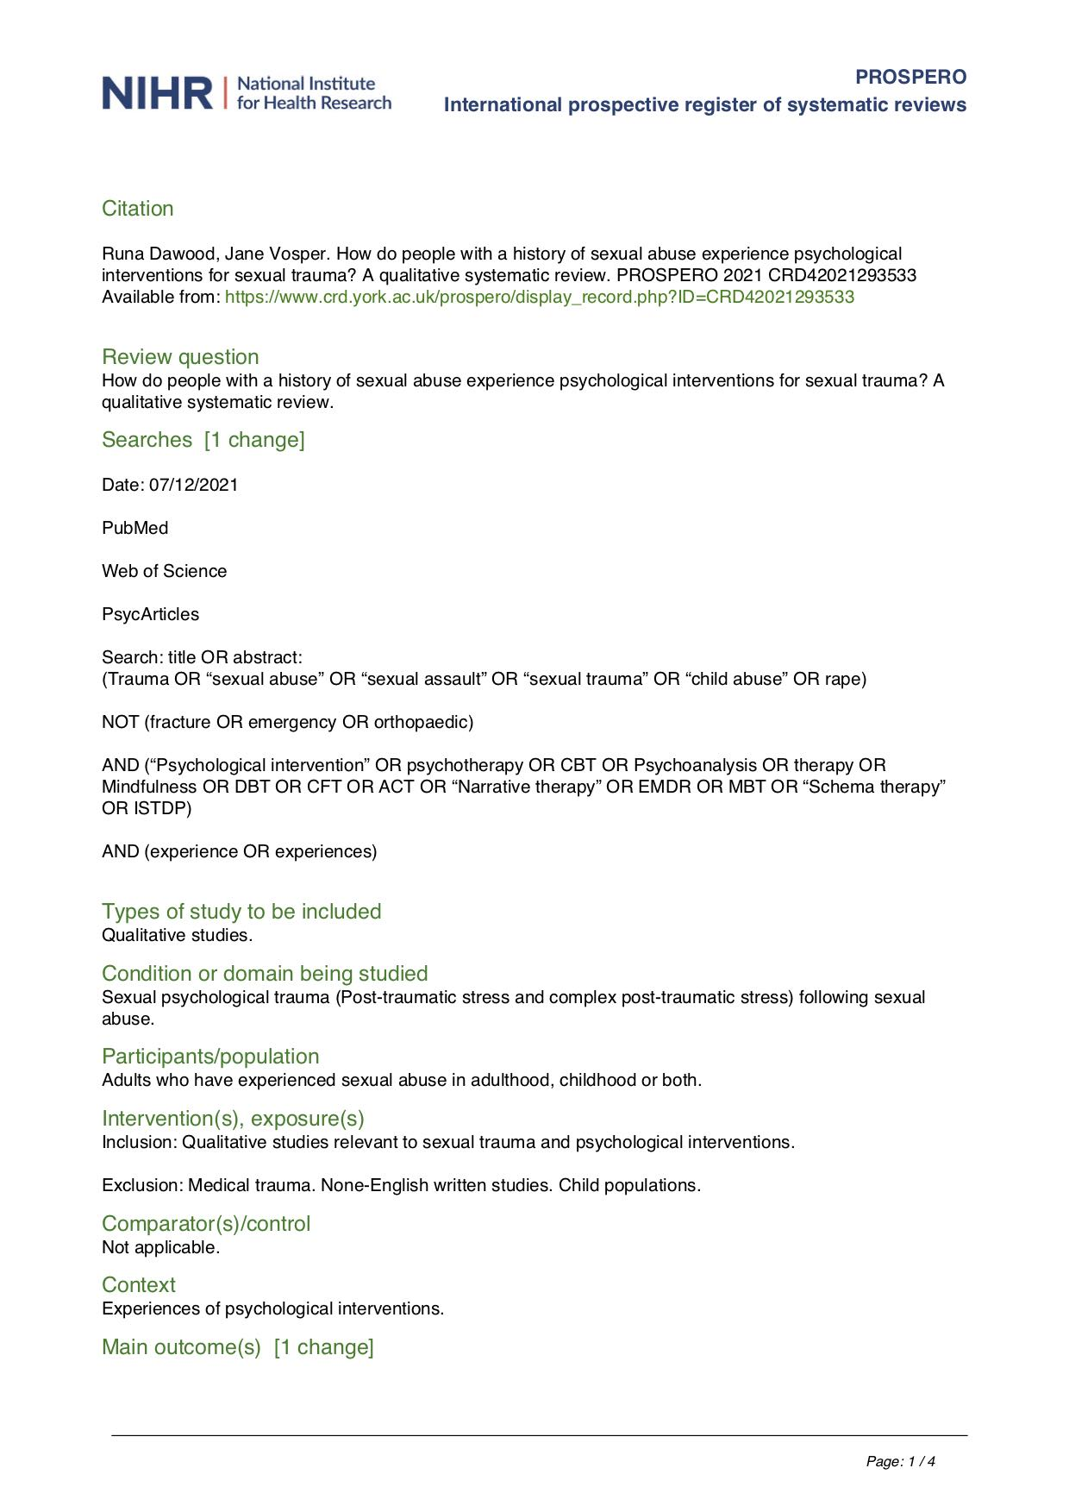
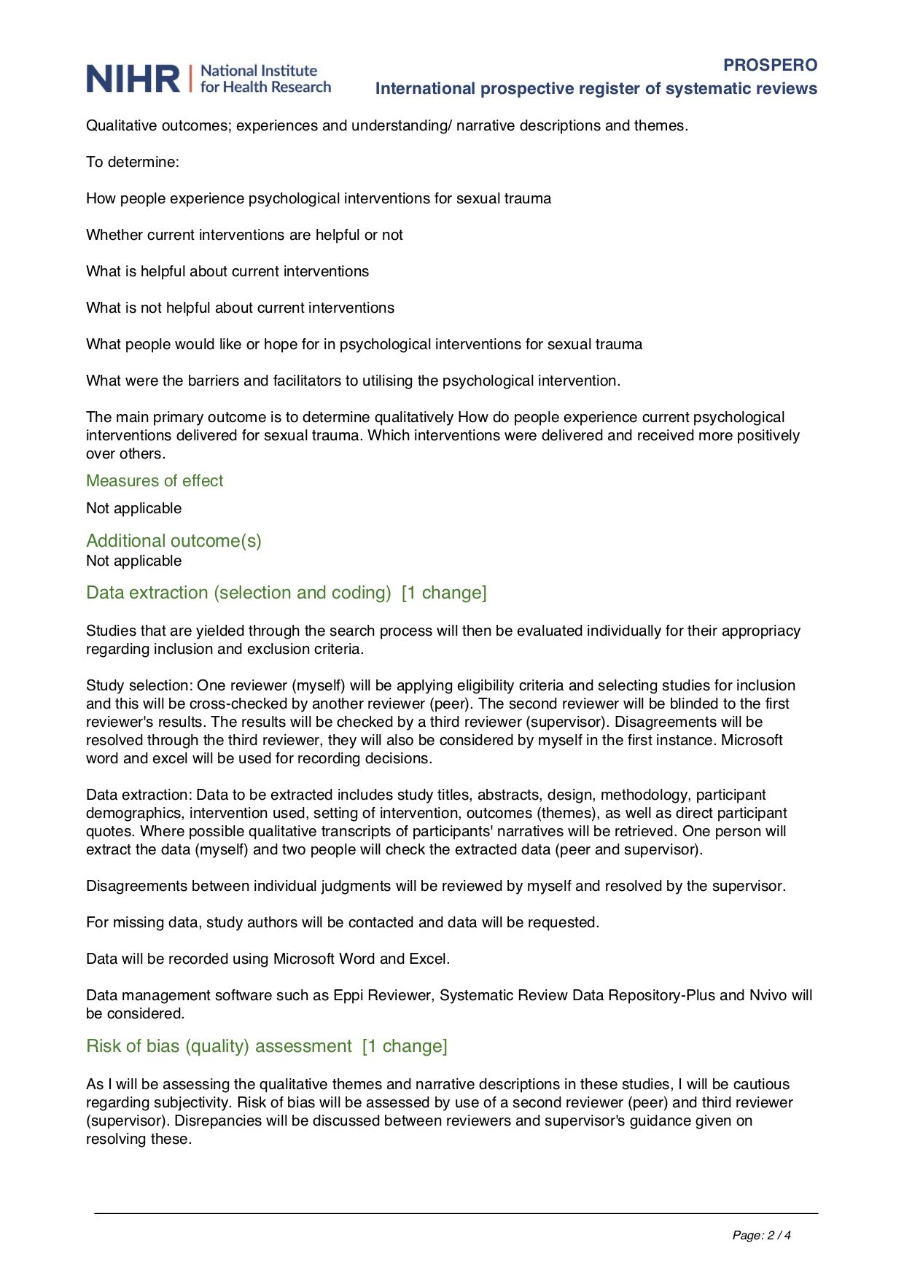
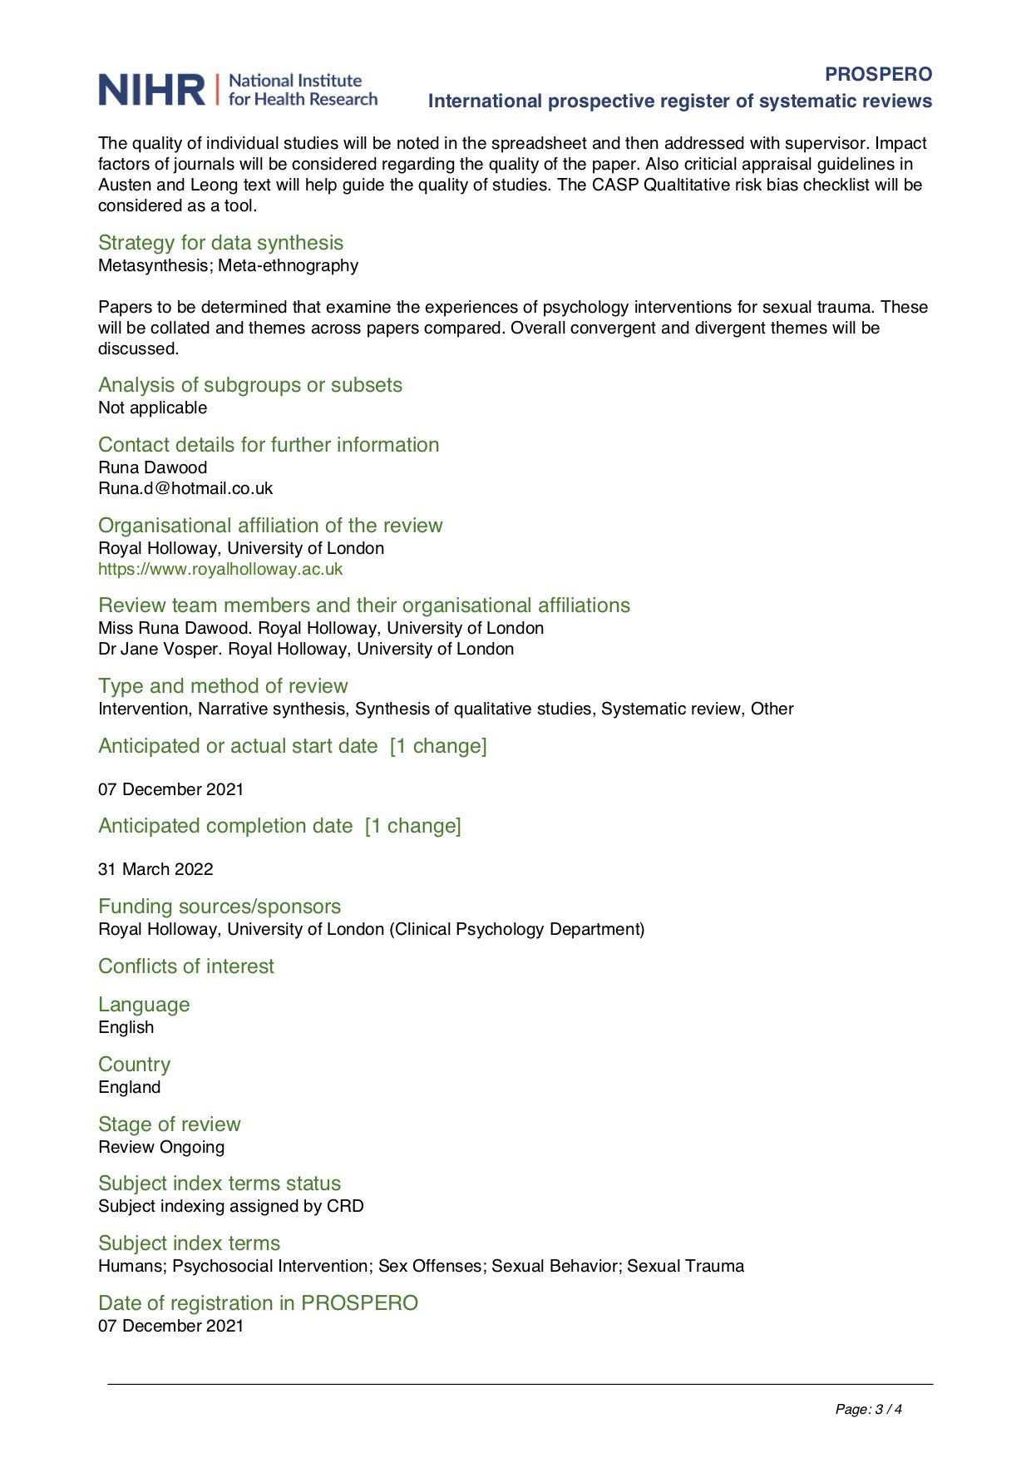
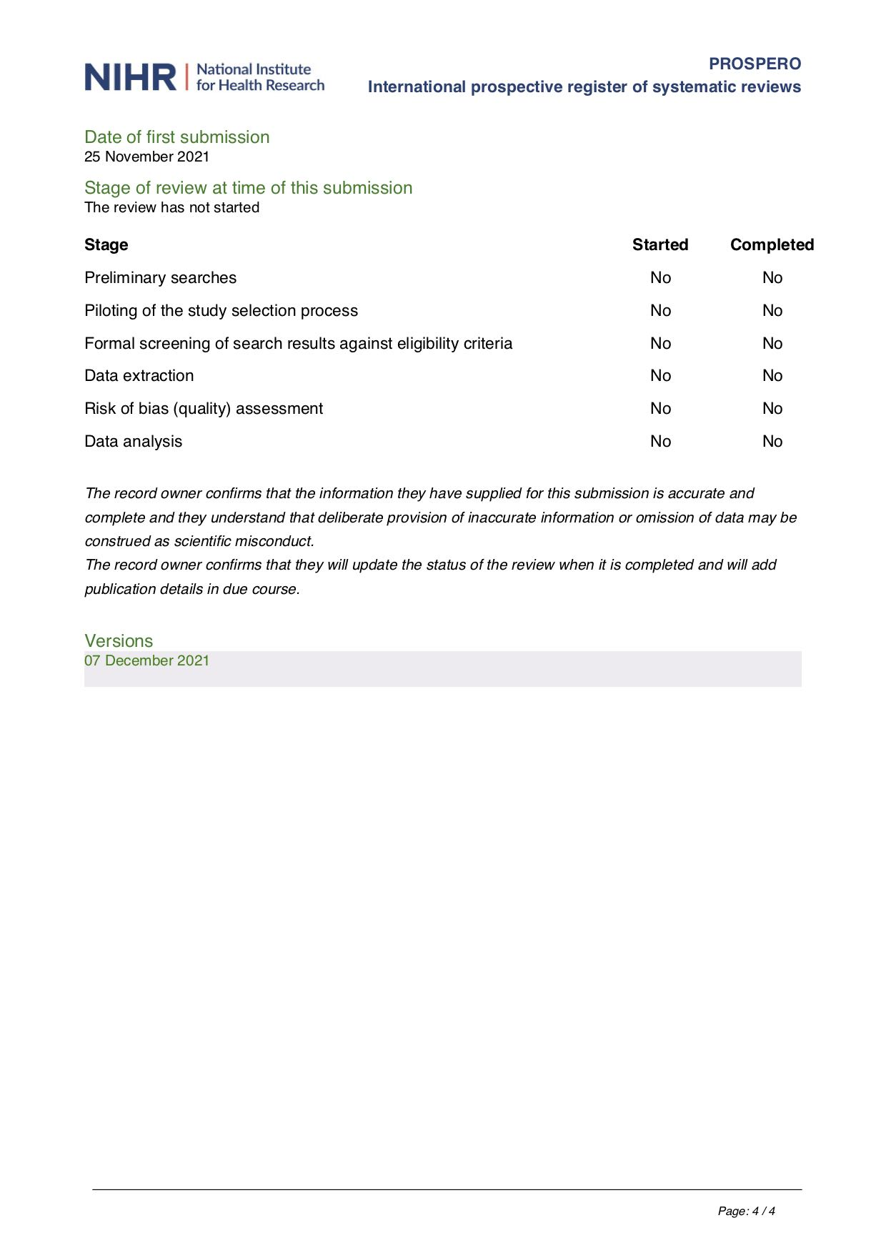

Appendix C: Sample of meta-synthesis codes for primary data

# | Quotes | Codes
1 | Psychotherapy has saved my life is how I would have to put it . . . it has taken the counsellor a long long long time to separate these things out, unpack them and deal with them individually which I have now done and I’ve got nothing but the highest regard for them and ok it has not been easy on me but it has not been easy on them either a few of them have been in tears I assure you soo emm . . . I think, yes, psychotherapy has helped me a great great deal. (Survivor 21) | Therapy as a live saver  Sexual trauma means there is a lot of material to go through  Therapy takes a long time for SA  A lot of respect for therapists  Therapy is challenging for the SU and for the Therapist
2 | She is just very very experienced and very . . . I don’t know I feel like she is honest, genuine that she is very caring, she is kind, she is warm, she gives me space, she doesn’t push things, she doesn’t judge me, she doesn’t get angry, she doesn’t get frustrated she is just like wow but also really like down to earth and grounded. (Survivor 40) | Good qualities of a Therapist are:  honesty, genuine  Caring  Non-judgmental, non-pushy/ intrusive  Calm, relatable
3 | She really listened but as well as listening she heard me and for me there is a huge difference between listening and hearing and for me she did, you knew it was ok to say what you felt, she would take it in. (Survivor 21) | A lot of respect for therapists are:  A good listener
4 | Well [talking therapy] helps me get through the weeks, it makes me feel that I am not alone, that there is help there when I need it. That is really about it. (Survivor 38) | Therapy helps get by in life  To have help available
6 | I can go into the shower and not feel dirty or afraid or whatever, I have learnt to change my clothes, you know different styles before I was just t-shirt and a pair of jogging bottoms, I didn’t care what I looked like but now I am beginning to think I well I do need to look after myself, I do need to look nice just for me not for anybody else. (Survivor 23) | Started engaging in self-care after therapy.  Looking after themselves for themselves, not for approval from others.
7 | I can look in the mirror, I couldn’t look in the mirror before, I couldn’t look myself in the eyes . . . because my eyes were empty and cold and grey and unhappy, I suppose, and now I can, I still might not like what I see in the mirror but I can. (Survivor 21) | Developing confidence after therapy.  Didn’t like self image before therapy.
10 | My experiences in the past but also about . . . about the impact of that on like everyday life so not just a sense of if I talk about this then everything will be alright . . . because it is all in the past because so much of that is related to how I behave and how I feel in the present. (Survivor 40) | Re-relating to my past
11 | Well I have found myself . . . that is the biggest gain from psychotherapy and while nothing erases the abuse or the grief over it . . . if you can imagine if you have a scar and you get an infection in it and the pain and all the puss that comes out of it, there is now the scar has healed over, it is still there but it is not painful and its not its not going to flare up or very seldom, occasionally it might; so that’s the biggest gain: that the scars have been emmmmm . . . I don’t know what they have been . . . they have been something, aren’t words useless sometimes!! Emmm . . . no, I can’t think of the word, the scar is now benign . . . they are not active or reactive anymore they are just there, but they don’t hurt so that’s the biggest gain. (Survivor 21) | The past is still there but doesn’t hurt anymore.  Healing trauma is like a healing scar.

Appendix D: Sample of peer-reviewer feedback

# | Quotes | Codes | REVIEWER COMMENTS
1 | I felt overpowered. . . . Like, I’ve got to do what this parental person says, and he’s the professional. . . . This was very autocratic, authoritarian. I felt like my power was taken away almost force- fully. I felt really pressured, like, “You just have to do what I want, lady!” And I felt very obliged to agree with him. . . . It was abusive.  His ego needed me to be little and him to be big. Me to be down and him to be up. . . . There was a sense that he needed power, at someone’s expense. | Therapist wanted power over me. He was autocratic and authoritarian. | I felt really pressured  I felt I had to do what he wanted/obliged to agree with therapist  Sense of power imbalance  Therapist held the power/Client lacked power
3 | We went back to talk about the flashback. He first asked if it was ok to talk about it. He didn’t just assume that that’s what we were going to talk about. He asked permission. When I agreed to it, I really sensed he had asked my permission to do it, and I have said ok. . . . It made me feel that I was in control. It made me feel I was doing this because I want to. . . . People should have to ask your permission before they march into the centre of your soul. You have some privacy, some boundaries. Just because someone asks a question doesn’t mean they deserve an answer. It’s my soul. And I don’t have to talk about it if I don’t want to. And I never realized it until then. | Therapist asked my permission before talking about the flashback and this made me feel in control.  Therapist made me realise that people should always ask for permission to talk about someone’s trauma. | I was doing this [therapy] because I wanted to  Some experiences are private  Sharing experiences should be person’s choice  Disclosing experiences should not feel forced
5 | I said that I really didn’t appreciate her views on, that her views on men and interjecting them into our session weren’t helping me. . . . she had a lot of room for me being mad. She wasn’t scared of me being mad. . . . I learned a lot of self trust in that. Because I was challenging what the counselor was saying. I didn’t have to assume that she was the all-knowing one and the one with all the answers. . . . I sort of felt that I did have to agree with everybody, because they were the experts and they knew what they were do- ing. With her, she allowed me to challenge that ideal. . . . I had my battle boots on and I was ready to go toe-to-toe with her and she defused that by giving me more room. Rather than charging back at me, she gave me more room to express myself. | Therapist and I did not share the same opinions but she gave me room to express myself and my opinions/ thoughts. | Therapists are the experts/know what they are doing  Opportunity to challenge that ideal  Power balance between therapist and client sought  Had the freedom to express self

Appendix E: Example of Mind-Mapping themes for meta-synthesis

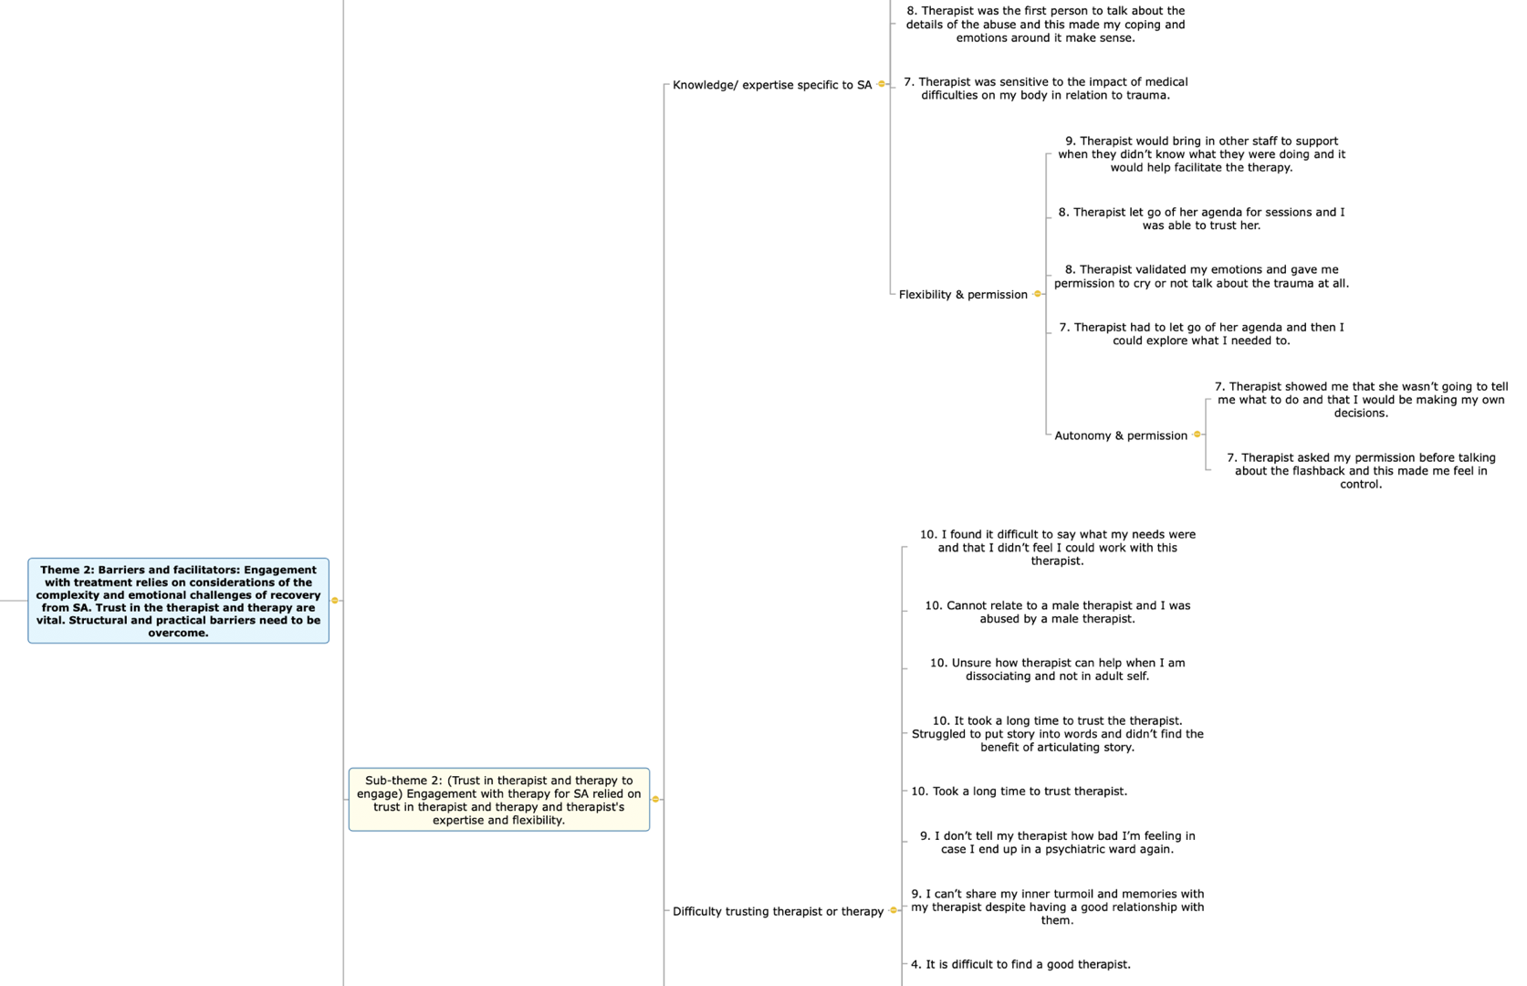

Appendix F: Table of frequencies for mental health support received

Whether or not participants had received previous mental health support |  |  |  | Whether previous mental health treatment was medical or psychological |  |  |  | Whether or not participants had received/ were receiving psychological therapy
 | Frequency | Percent |  |  | Frequency | Percent |  |  | Frequency | Percent
N=155 |  |  |  | N=155 |  |  |  | N=155
Yes | 148 | 95.5% |  | Medication | 8 | 5.2% |  | Yes | 131 | 84.5%
No | 5 | 3.2% |  | Psychological therapy | 34 | 21.9% |  | No | 21 | 13.5%
Unsure | 2 | 1.3% |  | Both Medication and Psychological therapy | 1 | 0.6% |  | Unsure | 3 | 1.9%
Total | 155 | 100% |  | Prefer not to say | 109 | 70.3% |  | Total | 155 | 100%
 |  |  |  | No answer | 3 | 1.9%
 |  |  |  | Total | 155 | 100%

Table G: Table of frequencies for therapy received and known diagnoses

Total duration of previous/ current therapy |  |  |  | Type of therapy received |  |  |  | Known historic or current diagnoses
 | Frequency | Percent |  |  | Responses | Percent |  |  | Responses | Percent
N=115 |  |  |  | N=155 |  |  |  | N=155
6 weeks or less | 12 | 7.7 |  | Medication | 87 | 16.60% |  | Depression/ MDD/ Dysthymia | 76 | 24.10%
6 weeks to 3 months | 16 | 10.3 |  | Counselling | 94 | 17.90% |  | Anxiety/ GAD | 54 | 17.10%
3 months to 6 months | 10 | 6.5 |  | CBT | 71 | 13.50% |  | Panic | 6 | 1.90%
6 months to 1 year | 18 | 11.6 |  | CFT | 19 | 3.60% |  | Social Anxiety | 8 | 2.50%
1-2 years | 27 | 17.4 |  | ACT | 11 | 2.10% |  | OCD | 7 | 2.20%
2-3 years | 15 | 9.7 |  | DBT | 16 | 3.10% |  | PTSD/ CPTSD | 66 | 20.90%
3-4 years | 10 | 6.5 |  | Mindfulness | 40 | 7.60% |  | Dissociation/ Dissociative disorder | 5 | 1.60%
4 years or more | 36 | 23.2 |  | CAT | 9 | 1.70% |  | Depersonalisation/ Derealisation | 1 | 0.30%
Prefer not to say | 2 | 1.3 |  | TF_CBT | 15 | 2.90% |  | Dissociative Identity Disorder | 9 | 2.80%
Not applicable- I haven't received any psychological therapy | 8 | 5.2 |  | EMDR | 38 | 7.30% |  | Adjustment Disorder | 2 | 0.60%
No answer | 1 | 0.6 |  | Schema | 7 | 1.30% |  | Seasonal Affective Disorder | 1 | 0.30%
Total | 155 | 100 |  | MBT | 3 | 0.60% |  | Bipolar | 6 | 1.90%
 |  |  |  | ISTDP | 1 | 0.20% |  | Borderline Personality Disorder | 10 | 3.20%
 |  |  |  | Integrative | 21 | 4.00% |  | Emotionally Unstable Personality Disorder | 5 | 1.60%
 |  |  |  | Psychodynamic | 31 | 5.90% |  | Paranoid Personality Disorder | 1 | 0.30%
 |  |  |  | Systemic Family | 14 | 2.70% |  | Eating Disorder/ Anorexia/ Bulimia | 9 | 2.80%
 |  |  |  | Other | 23 | 4.40% |  | Psychosis | 1 | 0.30%
 |  |  |  | Unsure | 13 | 2.50% |  | Functional neurological symptom disorder/ FNP | 1 | 0.30%
 |  |  |  | Prefer not to say | 1 | 0.20% |  | ADHD | 6 | 1.90%
 |  |  |  | Not applicable/ No therapy | 9 | 1.70% |  | Autism Spectrum Condition/ ASD | 3 | 0.90%
 |  |  |  | No answer | 1 | 0.20% |  | Learning Disability | 1 | 0.30%
 |  |  |  | Total | 524 | 100.00% |  | No diagnosis | 15 | 4.70%
 |  |  |  |  |  |  |  | Prefer not to say | 4 | 1.30%
 |  |  |  |  |  |  |  | NA/ Unsure | 5 | 1.60%
 |  |  |  |  |  |  |  | No answer | 14 | 4.40%
 |  |  |  |  |  |  |  | Total | 316 | 100.00%

Appendix H: Descriptive statistics for CFT related variables, PTSD and global distress
Note: Global distress indicates the total score on the CORE-OM, however calculate CORE score is provided here for reference.

 | N | Range | Minimum | Maximum | Mean |  | Std. Deviation | Variance | Skewness |  | Kurtosis
 |  |  |  |  | Statistic | Std. Error |  |  | Statistic | Std. Error | Statistic | Std. Error
SelfComp engagement | 155 | 67 | 8 | 75 | 46.36 | 0.762 | 9.49 | 90.063 | -0.406 | 0.195 | 1.804 | 0.387
SelfComp action | 155 | 41 | 5 | 46 | 26.52 | 0.553 | 6.88 | 47.329 | -0.005 | 0.195 | 0.455 | 0.387
OtherComp engagement | 155 | 59 | 8 | 67 | 40.48 | 0.839 | 10.447 | 109.147 | -0.08 | 0.195 | 0.144 | 0.387
OtherComp action | 155 | 35 | 12 | 47 | 27.95 | 0.623 | 7.751 | 60.075 | 0.048 | 0.195 | -0.556 | 0.387
FearComp from others | 155 | 52 | 13 | 65 | 40.12 | 1.001 | 12.459 | 155.225 | -0.203 | 0.195 | -0.768 | 0.387
FearComp for self | 155 | 60 | 15 | 75 | 41.01 | 1.271 | 15.823 | 250.376 | 0.098 | 0.195 | -1.059 | 0.387
Shame external | 155 | 14 | 6 | 20 | 13.17 | 0.262 | 3.260 | 10.625 | 0.216 | 0.195 | -0.446 | 0.387
Shame internal | 155 | 15 | 5 | 20 | 13.94 | 0.299 | 3.718 | 13.827 | -0.372 | 0.195 | -0.534 | 0.387
SelfCrit reassured self | 155 | 32 | 8 | 40 | 21.55 | 0.569 | 7.081 | 50.145 | 0.422 | 0.195 | -0.258 | 0.387
SelfCrit inadequate self | 155 | 36 | 9 | 45 | 33.22 | 0.685 | 8.529 | 72.744 | -0.741 | 0.195 | -0.047 | 0.387
SelfCrit hated self | 155 | 20 | 5 | 25 | 14.73 | 0.478 | 5.957 | 35.485 | 0.132 | 0.195 | -1.133 | 0.387
GlobalD | 155 | 72 | 65 | 137 | 96.63 | 1.419 | 17.663 | 311.974 | 0.168 | 0.195 | -0.845 | 0.387
CORE Score | 155 | 2.12 | 1.91 | 4.03 | 2.8421 | 0.04173 | 0.51949 | 0.27 | 0.168 | 0.195 | -0.845 | 0.387
PTSD | 155 | 79 | 20 | 99 | 58.96 | 1.573 | 19.588 | 383.7 | -0.023 | 0.195 | -0.779 | 0.387

Appendix I: CFT and Sexual Trauma resource website, co-developed with Dr C. Irons
(Resource website is accessible on: www.compassionstudy.com/resource)
(Images and image licences for use were purchased from bigstockphoto.com, domain hosted through Amazon Web Services)

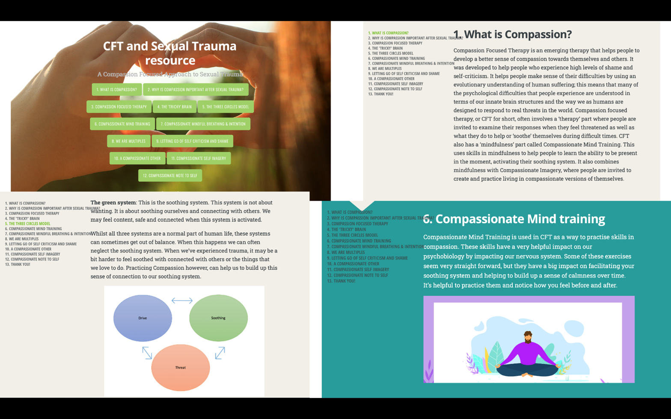

Appendix J: Participant information sheet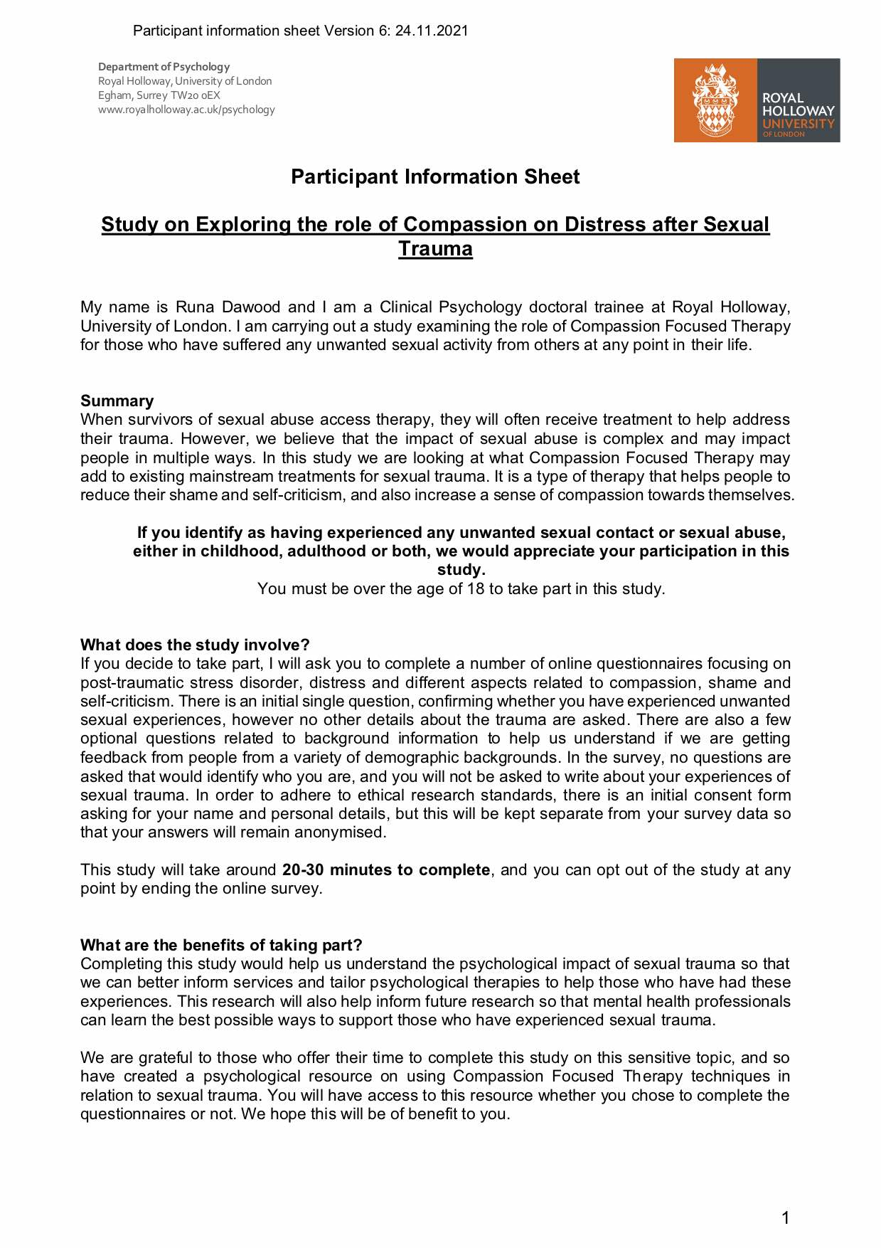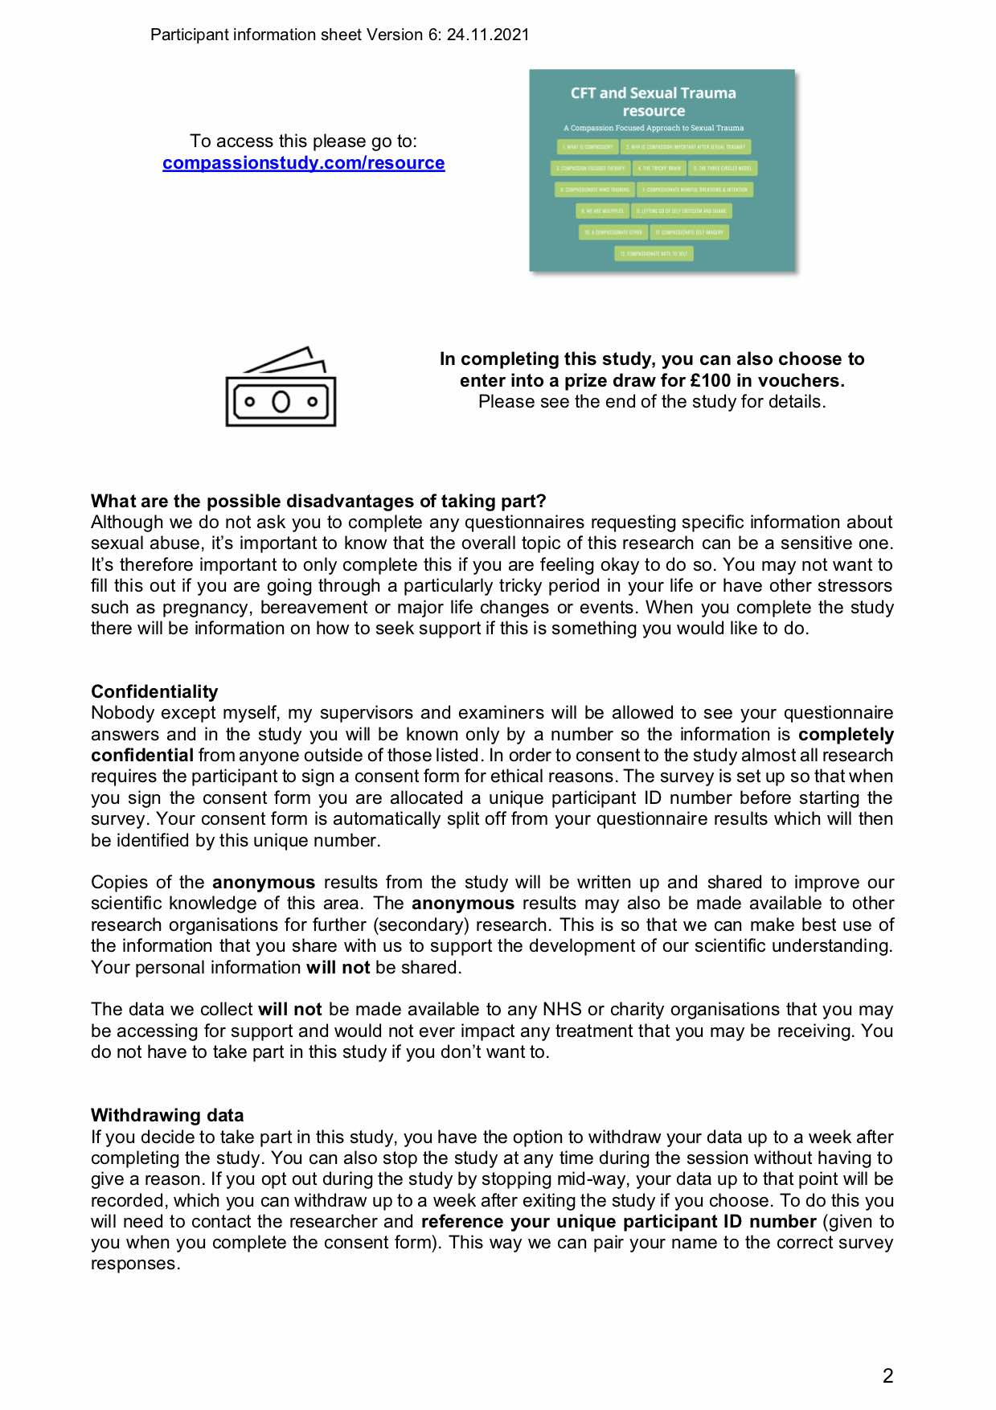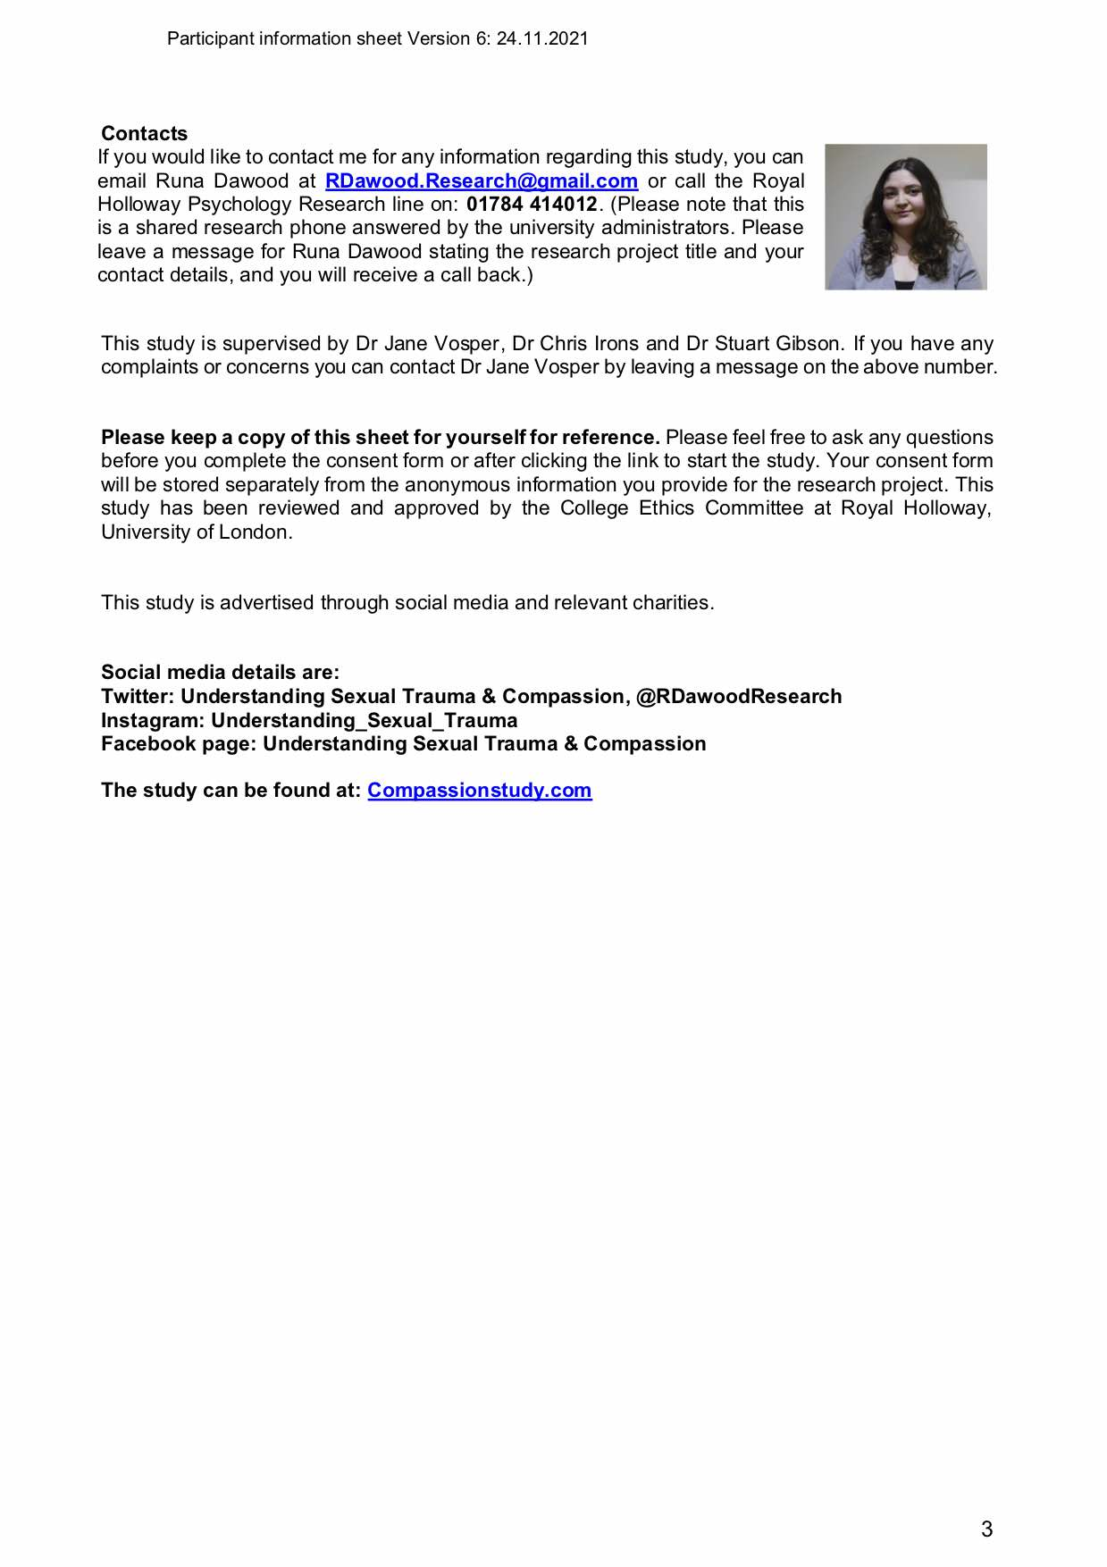
Appendix K: Consent form (from Qualtrics)

Consent: Understanding sexual trauma

Welcome
Welcome to this study on Compassion and Unwanted Sexual Experiences.
We are exploring various aspects of compassion, distress and post-traumatic stress for people who have experienced some kind of sexual abuse and/or trauma. This includes any unwanted sexual experience. Completing this study will help us understand more about the impact of unwanted sexual experiences, sexual trauma or abuse.
Whilst we are hoping to find out more to help those who have experienced sexual trauma, we will not be asking you to describe the trauma or give any written details. This study involves a set of questionnaires that should take roughly 20-30 minutes to complete.
This study is for anyone aged over 18 who has had any experience of unwanted sexual experiences, sexual abuse or sexual trauma.
In taking part in this study you will be offered a unique Compassion Focused Therapy for sexual trauma resource made alongside Dr Chris Irons, a lead author in the field of Compassion therapy. You do not need to complete the study to access this. A link is provided in the participant information sheet and also at end of the study.
On completing this study you will also be given the choice to enter into a £100 voucher prize draw.
If you have any questions please do not hesitate to contact Runa Dawood at RDawood.Research@gmail.com or on: 01784 414012.
(Please note: This is the Royal Holloway Universities Psychology Research line so if you would like to get in contact please leave a message for me, leaving your name and number, and stating that it is regarding the "Compassion and unwanted sexual experiences" study and I will get back to you.)
E-reader friendly advertisement poster of this study is available here: Study advertising poster

Consent Consent Form
Title of Research Project: Exploring the role of compassion on distress after sexual trauma
Name of Researcher: Runa Dawood, Royal Holloway, University of London
This consent form will be stored separately from the anonymous information that you provide. Your data will only be identified by your Participant Identification Number. In psychological research we require informed consent in order to adhere to our ethical guidelines and allow the participant to withdraw their information if required.
Please note you have to be over 18 years old and be able to read English to a sufficient level to complete the questionnaires to take part in this study.
If you believe that completing the questionnaires will be difficult due to language, please do not continue with the survey. You will still have access to the Compassion Focused Therapy resource when you download the participant information sheet.

PIS Please download this Participant Information Sheet
Please take a look at the participant information sheet before you start and keep a copy for your reference; it has all the study information on it.
Participant Information Sheet

Q27 Consent Form
Please confirm that you agree to the following before starting the study:

Consent 1 Q1:
- I confirm that I have read the information sheet for the above study, and I have had the opportunity to consider the information and ask questions by calling the contact number on the information sheet. Where I have asked questions, have had these answered satisfactorily. (1)

Consent 2 Q2:
- I understand that my participation is voluntary and that I am free to withdraw at any time during the study, without giving any reason. (1)

Consent 3 Q3:
- I understand that the anonymous data collected from me may be used to support other research in the future, and may be shared anonymously with other appropriate research groups. (1)

Consent 4 Q4:
- I understand that all data will be kept confidential, and that no personal identifying information will be disclosed in any reports on the project, or to any other party. (1)

Consent 5 Q5:
- I agree to take part in the above study. (1)

Q2 Name of participant taking the survey:
This is required under research ethics guidelines; it allows you the option to get in touch or withdraw your responses at a later point if you wish. Your survey answers however will be kept completely anonymous from your name and consent form which are all stored securely in line with the university approved research ethics guidelines.
Some people may prefer to use a pseudonym (fake name) but please note that it is important that you use a name that you can remember in case you would like to contact us about your survey responses at a later point.

Q16 First name
________________________________________________________________

Q17 Last name
________________________________________________________________

Q18 Please enter you Email address${Q18/ChoiceTextEntryValue}
________________________________________________________________

Q26 Please confirm your Email address
(this is important for entering into the £100 prize draw)
________________________________________________________________

Q3 Date:
________________________________________________________________

Q9 Signature:

Q6 Name of person taking consent (researcher):
Runa Dawood

Q7 Date:
________________________________________________________________

Q8 Signature of researcher:
[PRE-SIGNED]

Q10 Please confirm capture verification:

Q19
Your personal information above will be stored separately from your answers to the survey to keep your answers anonymous.
On the next page you will be given a participant ID number. Please write this down.
If you want to withdraw your data or have any questions about it, please contact the researcher citing your personal number.
The next page will prompt you to start to the survey.
Please allow it a bit of time on the next page as it will take approximately 60 seconds to set up your anonymous survey.
Please note, if you have any difficulty opening this through facebook, instagram or twitter, please try a web browser like Chrome, Safari or Internet Explorer/ Edge Browser. The link is www.compassionstudy.com

Appendix L: Question on sexual trauma

Question:
Do you have any experience of sexual trauma? Sexual trauma can be described as: “unwanted sexual activity, with perpetrators using force, making threats or taking advantage of victims not able to give consent”. For example, being exposed to sex organs when unwanted, being threatened to have sex with someone when unwanted, having your sex organs touched by another person when unwanted, being made to touch someone else’s sex organs when you did not want to, being forced to have sex when you did not want to, or any other unwanted sexual experiences.

If so, did this occur as:
A child __
An adult __
Both __

Appendix M: De-brief sheet 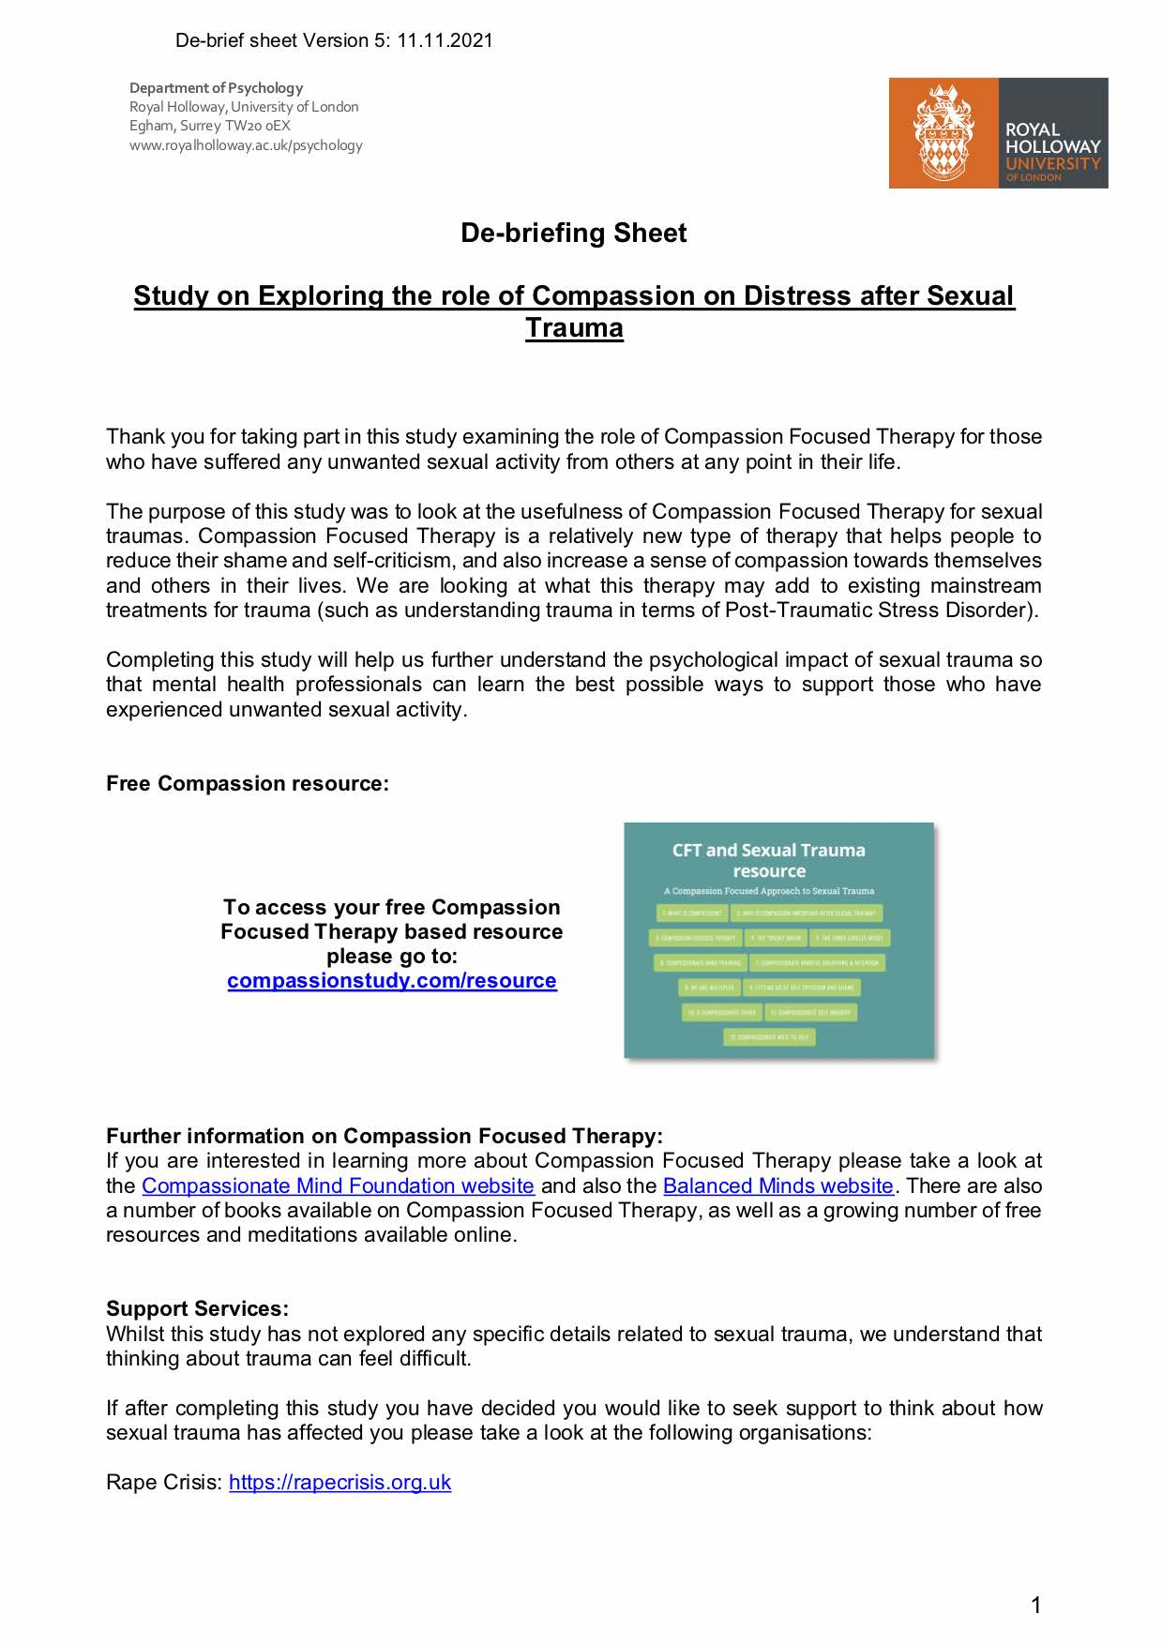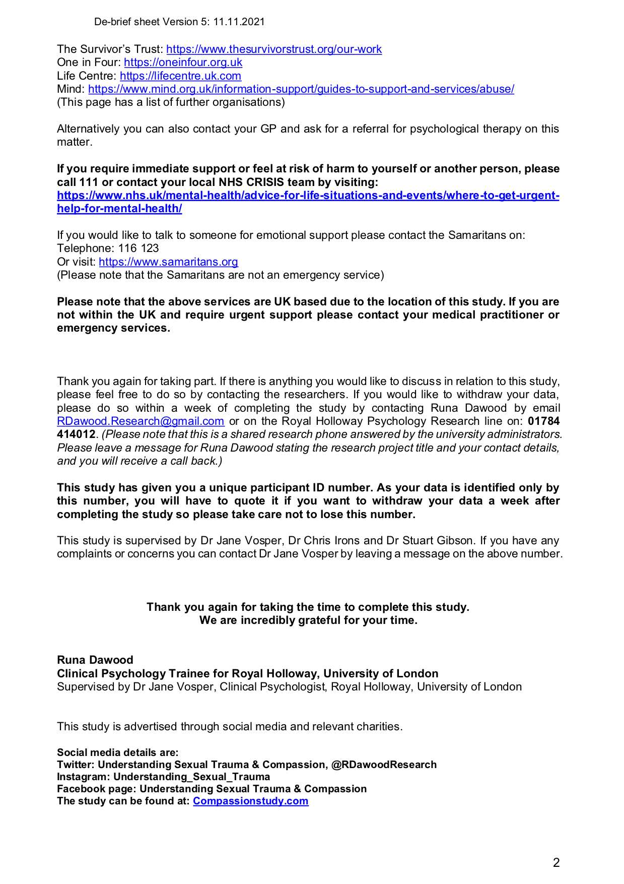
Appendix N: Study advert
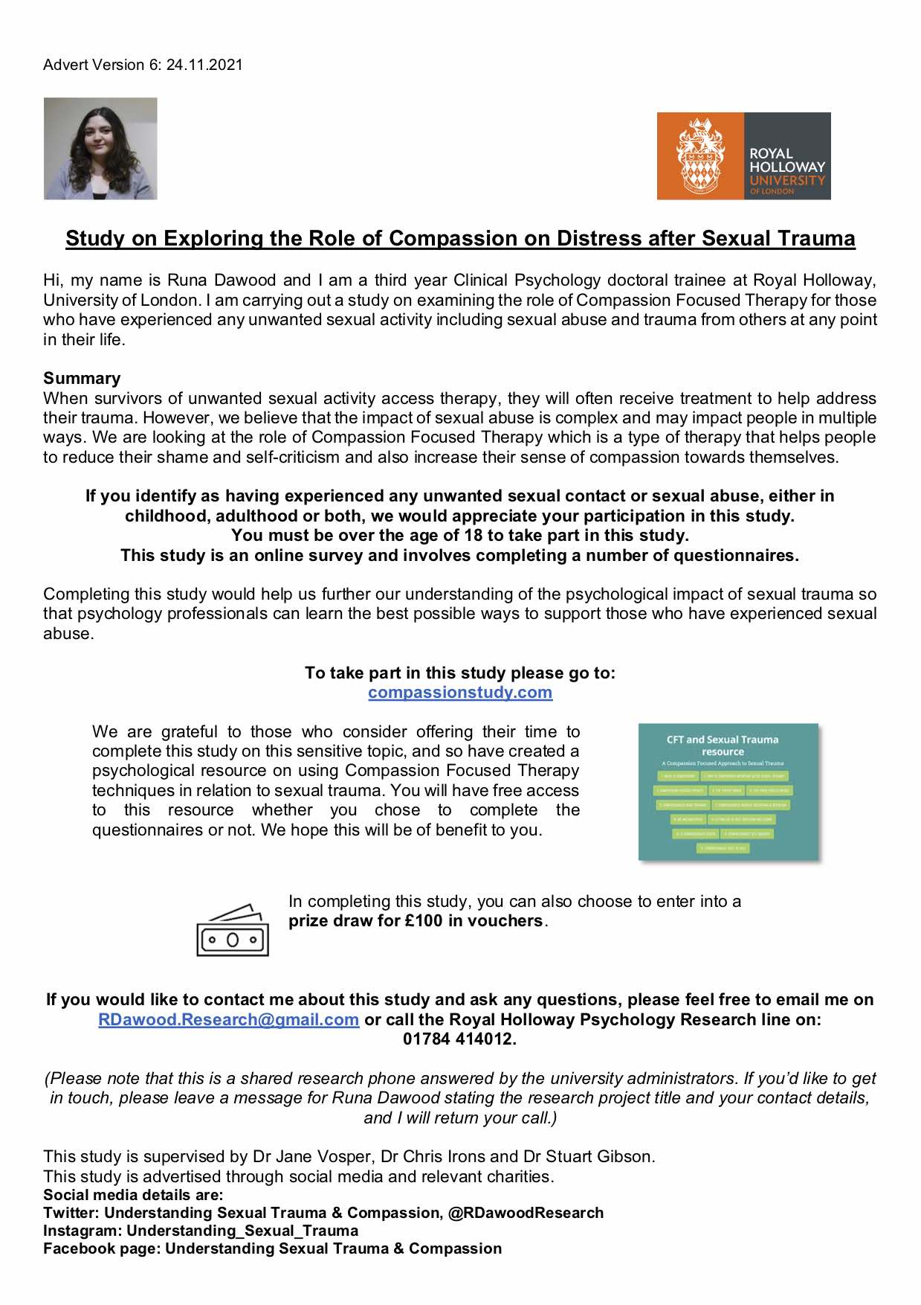
Appendix O: Advertising poster (for social media)
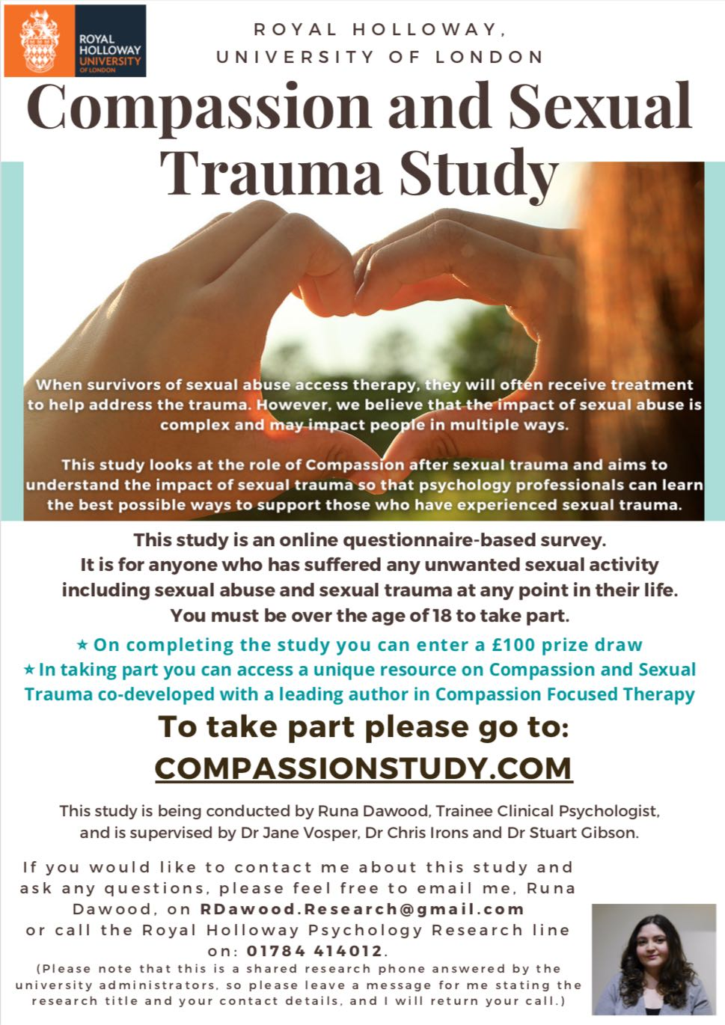
Appendix P: Ethics approval

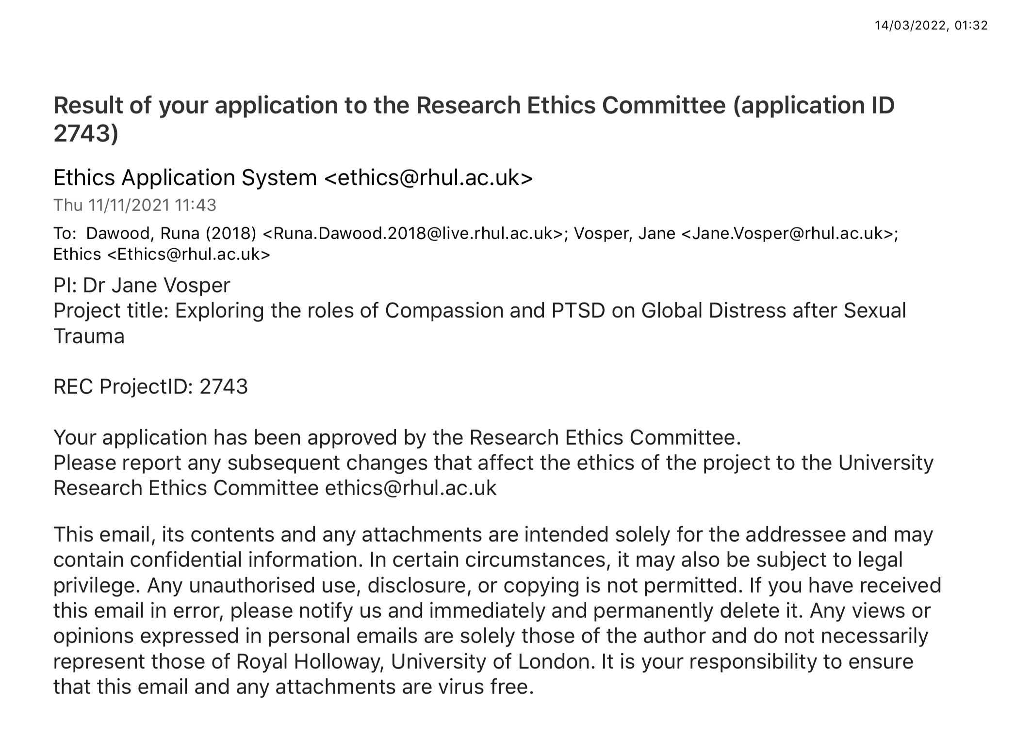
Appendix Q: The Compassionate Engagement and Action Scales; Self-Compassion and Compassion from others. (Gilbert et al., 2017)

Self-compassion

When things go wrong for us and we become distressed by setbacks, failures, disappointments or losses, we may cope with these in different ways. We are interested in the degree to which people can be compassionate with themselves. We define compassion as “a sensitivity to suffering in self and others with a commitment to try to alleviate and prevent it.” This means there are two aspects to compassion. The first is the ability to be motivated to engage with things/feelings that are difficult as opposed to trying to avoid or supress them. The second aspect of compassion is the ability to focus on what is helpful to us. Just like a doctor with his/her patient. The first is to be motivated and able to pay attention to the pain and (learn how to) make sense of it. The second is to be able to take the action that will be helpful. Below is a series of questions that ask you about these two aspects of compassion. Therefore read each statement carefully and think about how it applies to you if you become distressed. Please rate the items using the following rating scale:

Never Always
1 2 3 4 5 6 7 8 9 10

Section 1 – These are questions that ask you about how motivated you are, and able to engage with distress when you experience it. So:
When I’m distressed or upset by things...
1. I am motivated to engage and work with my distress when it arises.
2. I notice, and am sensitive to my distressed feelings when they arise in me.
(r)3. I avoid thinking about my distress and try to distract myself and put it out of my mind.
4. I am emotionally moved by my distressed feelings or situations.
5. I tolerate the various feelings that are part of my distress.
6. I reflect on and make sense of my feelings of distress.
(r)7. I do not tolerate being distressed.
8. I am accepting, non-critical and non-judgemental of my feelings of distress.

Section 2 – These questions relate to how you actively cope in compassionate ways with emotions, thoughts and situations that distress you. So:
When I’m distressed or upset by things...
1. I direct my attention to what is likely to be helpful to me.
2. I think about and come up with helpful ways to cope with my distress.
(r)3. I don’t know how to help myself.
4. I take the actions and do the things that will be helpful to me.
5. I create inner feelings of support, helpfulness and encouragement.

Compassion from others
When things go wrong for us and we become distressed by setbacks, failures, disappointments or losses, others may cope with our distress in different ways. We are interested in the degree to which you feel that important people in your life can be compassionate to your distress. We define compassion as “a sensitivity to suffering in self and others with a commitment to try to alleviate and prevent it.” This means there are two aspects to compassion. The first is the ability to be motivated to engage with things/feelings that are difficult as opposed to trying to avoid or supress them. The second aspect of compassion is the ability to focus on what is helpful to us or others. Just like a doctor with his/her patient. The first is to be motivated and able to pay attention to the pain and (learn how to) make sense of it. The second is to be able to take the action that will be helpful. Below is a series of questions that ask you about these two aspects of compassion. Therefore read each statement carefully and think about how it applies to the important people in your life when you become distressed. Please rate the items using the following rating scale:
Never Always
1 2 3 4 5 6 7 8 9 10
Section 1 – These are questions that ask you about how motivated you think others are, and how much they engage with your distress when you experience it. So:
When I’m distressed or upset by things...
1. Other people are actively motivated to engage and work with my distress when it arises.
2. Others notice and are sensitive to my distressed feelings when they arise in me.
(r)3. Others avoid thinking about my distress, try to distract themselves and put it out of their mind.
4. Others are emotionally moved by my distressed feelings.
5. Others tolerate my various feelings that are part of my distress.
6. Others reflect on and make sense of my feelings of distress.
(r)7. Others do not tolerate my distress.
8. Others are accepting, non-critical and non-judgemental of my feelings of distress.

Section 2 – These questions relate to how others actively cope in compassionate ways with emotions and situations that distress you. So:
When I’m distressed or upset by things...
1. Others direct their attention to what is likely to be helpful to me.
2. Others think about and come up with helpful ways for me to cope with my distress.
(r)3. Others don’t know how to help me when I am distressed
4. Others take the actions and do the things that will be helpful to me.
5. Others treat me with feelings of support, helpfulness and encouragement.

Appendix R: The Fears of Compassion Scales (from others and for the self) (Gilbert, McEwan, Matos, & Rivis, 2011)

Different people have different views of compassion and kindness. While some people believe that it is important to show compassion and kindness in all situations and contexts, others believe we should be more cautious and can worry about showing it too much to ourselves and to others. We are interested in your thoughts and beliefs in regard to kindness and compassion in three areas of your life:
- Expressing compassion for others
- Responding to compassion from others
- Expressing kindness and compassion towards yourself
Below are a series of statements that we would like you to think carefully about and then circle the number that best describes how each statement fits you.

SCALE

Please use this scale to rate the extent that you agree with each statement:

Don’t agree at all Somewhat agree Completely agree

0 1 2 3 4

Scale 2: Responding to the expression of compassion from others

1. Wanting others to be kind to oneself is a weakness
2. I fear that when I need people to be kind and understanding they won’t be
3. I’m fearful of becoming dependent on the care from others because they might not always be available or willing to give it
4. I often wonder whether displays of warmth and kindness from others are genuine
5. Feelings of kindness from others are somehow frightening
6. When people are kind and compassionate towards me I feel anxious or embarrassed
7. If people are friendly and kind I worry they will find out something bad about me that will change their mind
8. I worry that people are only kind and compassionate if they want something from me
9. When people are kind and compassionate towards me I feel empty and sad
10. If people are kind I feel they are getting too close
11. Even though other people are kind to me, I have rarely felt warmth from my relationships with others
12. I try to keep my distance from others even if I know they are kind
13. If I think someone is being kind and caring towards me, I ‘put up a barrier’

Scale 3: Expressing kindness and compassion towards yourself

1. I feel that I don’t deserve to be kind and forgiving to myself
2. If I really think about being kind and gentle with myself it makes me sad
3. Getting on in life is about being tough rather than compassionate
4. I would rather not know what being ‘kind and compassionate to myself’ feels like
5. When I try and feel kind and warm to myself I just feel kind of empty
6. I fear that if I start to feel compassion and warmth for myself, I will feel overcome with a sense of loss/grief
7. I fear that if I become kinder and less self-critical to myself then my standards will drop
8. I fear that if I am more self compassionate I will become a weak person
9. I have never felt compassion for myself, so I would not know where to begin to develop these feelings
10. I worry that if I start to develop compassion for myself I will become dependent on it
11. I fear that if I become too compassionate to myself I will lose my self-criticism and my flaws will show
12. I fear that if I develop compassion for myself, I will become someone I do not want to be
13. I fear that if I become too compassionate to myself others will reject me
14. I find it easier to be critical towards myself rather than compassionate
15. I fear that if I am too compassionate towards myself, bad things will happen

Appendix S: The Forms of Self-Criticising/ Self-Attacking Scale (Baião, Gilbert, McEwan, & Carvalho, 2015)

(Sub-scales: Reassured self, Inadequate self, Hated self)

When things go wrong in our lives or don’t work out as we hoped, and we feel we could have done better, we sometimes have negative and self-critical thoughts and feelings. These may take the form of feeling worthless, useless or inferior etc. However, people can also try to be supportive of them selves. Below are a series of thoughts and feelings that people sometimes have. Read each statement carefully and circle the number that best describes how much each statement is true for you.

Please use the scale below.

Not at all A little bit Moderately Quite a bit Extremely
like me like me like me like me like me
0 1 2 3 4

When things go wrong for me:

- I am easily disappointed with myself. (IS)
- There is a part of me that puts me down. (IS)
- (r) I am able to remind myself of positive things about myself. (RS)
- I find it difficult to control my anger and frustration at myself. (IS)
- (r) I find it easy to forgive myself. (RS)
- There is a part of me that feels I am not good enough. (IS)
- I feel beaten down by my own self-critical thoughts. (IS)
- (r) I still like being me. (RS)
- I have become so angry with myself that I want to hurt or injure myself. (HS)
- I have a sense of disgust with myself. (HS)
- (r) I can still feel lovable and acceptable. (RS)
- I stop caring about myself. (HS)
- (r) I find it easy to like myself. (RS)
- I remember and dwell on my failings. (IS)
- I call myself names. (HS)
- (r) I am gentle and supportive with myself. (RS)
- I can’t accept failures and setbacks without feeling inadequate. (IS)
- I think I deserve my self-criticism. (IS)
- (r) I am able to care and look after myself. (RS)
- There is a part of me that wants to get rid of the bits I don’t like. (IS)
- (r) I encourage myself for the future. (RS)
- I do not like being me. (HS)

Appendix T: The External and Internal Shame Scale (EISS) (Ferreira, Moura-Ramos, Matos, & Galhardo, 2020)

Below are a series of statements about feelings people may have, but that might be experienced by each person in a different way. Please carefully read each statement and circle the number that best indicates how often you feel what is described in each item.

Please use the following rating scale:

0= Never 1= Rarely 2= Sometimes 3= Often 4= Always

In relation to several aspects of my life:

I feel that:
1. People around me see me as not being up to their standards (ES)
2. I am isolated (IS)
3. Other people don’t understand me (ES)
4. I am different and inferior to others (IS)
5. Others are judgmental and critical of me (ES)
6. Other people see me as uninteresting (ES)
7. I am unworthy as a person (IS)
8. I am judgmental and critical of myself (IS)

Appendix U: The PTSD Checklist for DSM-5 (PCL-5) (Blevins, Weathers, Davis, Witte, & Domino, 2015)

PTSD: PTSD Checklist for DSM-5 (PCL-5) (Blevins, Weathers, Davis, Witte, & Domino, 2015)

In the past month, how much were you bothered by:
0= Not at all 1= A little bit 2= Moderately 3= Quite a bit 4= Extremely

1. Repeated, disturbing, and unwanted memories of the stressful experience?
2. Repeated, disturbing dreams of the stressful experience?
3. Suddenly feeling or acting as if the stressful experience were actually happening again (as if you were actually back there reliving it)?
4. Feeling very upset when something reminded you of the stressful experience?
5. Having strong physical reactions when something reminded you of the stressful experience (for example, heart pounding, trouble breathing, sweating)?
6. Avoiding memories, thoughts, or feelings related to the stressful experience?
7. Avoiding external reminders of the stressful experience (for example, people, places, conversations, activities, objects, or situations)?
8. Trouble remembering important parts of the stressful experience?
9. Having strong negative beliefs about yourself, other people, or the world (for example, having thoughts such as: I am bad, there is something seriously wrong with me,
no one can be trusted, the world is completely dangerous)?
10. Blaming yourself or someone else for the stressful experience or what happened after it?
11. Having strong negative feelings such as fear, horror, anger, guilt, or shame?
12. Loss of interest in activities that you used to enjoy?
13. Feeling distant or cut off from other people?
14. Trouble experiencing positive feelings (for example, being unable to feel happiness or have loving feelings for people close to you)?
15. Irritable behavior, angry outbursts, or acting aggressively?
16. Taking too many risks or doing things that could cause you harm?
17. Being “superalert” or watchful or on guard?
18. Feeling jumpy or easily startled?
19. Having difficulty concentrating?
20. Trouble falling or staying asleep?

Appendix V: The Clinical Outcomes in Routine Evaluation- Outcome Measure (CORE-OM) (Evans et al., 2002)

IMPORTANT - PLEASE READ THIS FIRST
This form has 34 statements about how you have been OVER THE LAST WEEK. Please read each statement and think how often you felt that way last week. Then tick the box which is closest to this.

Over the last week ...

0= Not at all 1= Only occasionally 2= Sometimes 3= Often 4= Most or all of the time

- I have felt terribly alone and isolated
- I have felt tense, anxious or nervous
- I have felt I have someone to turn to for support when needed
- I have felt O.K. about myself
- I have felt totally lacking in energy and enthusiasm
- I have been physically violent to others
- I have felt able to cope when things go wrong
- I have been troubled by aches, pains or other physical problems
- I have thought of hurting myself
- Talking to people has felt too much for me
- Tension and anxiety have prevented me doing important things
- I have been happy with the things I have done
- I have been disturbed by unwanted thoughts and feelings
- I have felt like crying
- I have felt panic or terror
- I made plans to end my life
- I have felt overwhelmed by my problems
- I have had difficulty getting to sleep or staying asleep
- I have felt warmth or affection for someone
- My problems have been impossible to put to one side
- I have been able to do most things I needed to
- I have threatened or intimidated another person
- I have felt despairing or hopeless
- I have thought it would be better if I were dead
- I have felt criticised by other people
- I have thought I have no friends
- I have felt unhappy
- Unwanted images or memories have been distressing me
- I have been irritable when with other people
- I have thought I am to blame for my problems and difficulties
- I have felt optimistic about my future
- I have achieved the things I wanted to
- I have felt humiliated or shamed by other people
- I have hurt myself physically or taken dangerous risks with my health

Appendix W: Histogram for global distress

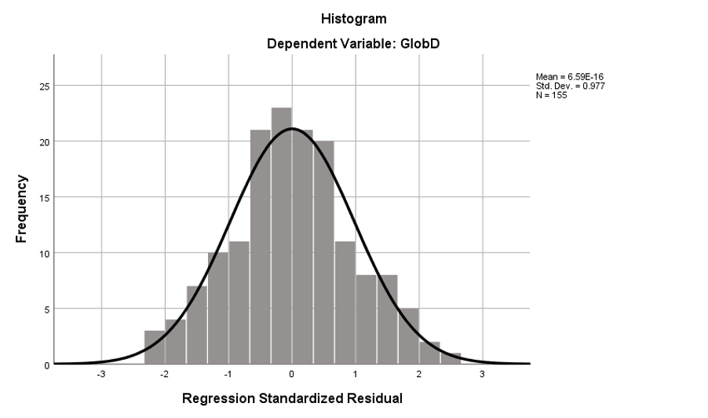

Appendix X: Normal Probability-Probability Plot for global distress

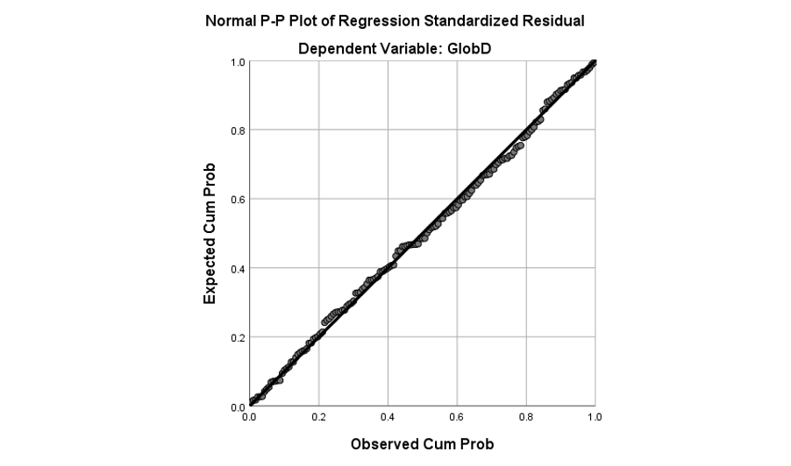

Appendix Y: Scatterplot for global distress

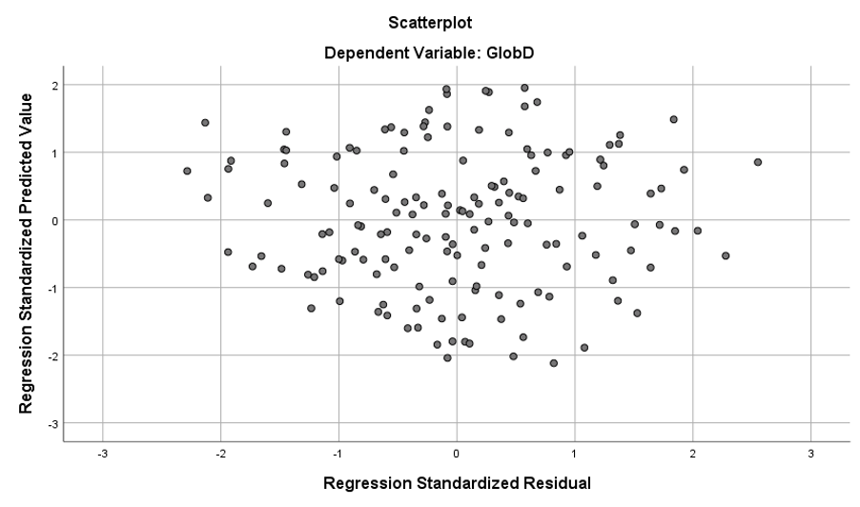

Appendix Z: Variances for each variable (questionnaire item) taken from AMOS output.

Variances: (Group number 1 - Default model)
 |  |  | Estimate | S.E. | C.R. | P | Label
SelfComp |  |  | 3.568 | .642 | 5.560 | ***
OtherComp |  |  | 4.592 | .694 | 6.619 | ***
Shame |  |  | .396 | .099 | 3.986 | ***
SelfCrit |  |  | .693 | .127 | 5.475 | ***
PTSD |  |  | 1.157 | .202 | 5.731 | ***
Fearother |  |  | .266 | .085 | 3.148 | .002
Fearself |  |  | 1.050 | .211 | 4.979 | ***
e139 |  |  | .060 | .019 | 3.127 | .002
e1 |  |  | 2.451 | .312 | 7.858 | ***
e2 |  |  | 4.363 | .505 | 8.638 | ***
e3 |  |  | 5.319 | .609 | 8.734 | ***
e4 |  |  | 4.755 | .545 | 8.720 | ***
e5 |  |  | 3.600 | .421 | 8.554 | ***
e6 |  |  | 3.043 | .374 | 8.128 | ***
e7 |  |  | 4.864 | .561 | 8.672 | ***
e8 |  |  | 2.742 | .342 | 8.018 | ***
e9 |  |  | 1.657 | .213 | 7.775 | ***
e10 |  |  | 1.918 | .239 | 8.025 | ***
e11 |  |  | 5.133 | .589 | 8.715 | ***
e12 |  |  | 2.629 | .314 | 8.381 | ***
e13 |  |  | 1.424 | .178 | 8.000 | ***
e14 |  |  | 2.116 | .256 | 8.261 | ***
e15 |  |  | 3.618 | .420 | 8.608 | ***
e16 |  |  | 2.074 | .252 | 8.218 | ***
e32 |  |  | .707 | .084 | 8.417 | ***
e33 |  |  | .667 | .079 | 8.387 | ***
e34 |  |  | .492 | .059 | 8.352 | ***
e35 |  |  | .597 | .076 | 7.804 | ***
e36 |  |  | .570 | .069 | 8.248 | ***
e37 |  |  | .762 | .091 | 8.348 | ***
e38 |  |  | .600 | .081 | 7.401 | ***
e39 |  |  | .475 | .059 | 8.072 | ***
e40 |  |  | .524 | .063 | 8.364 | ***
e41 |  |  | .421 | .052 | 8.139 | ***
e42 |  |  | .702 | .082 | 8.549 | ***
e43 |  |  | .910 | .106 | 8.573 | ***
e44 |  |  | .708 | .083 | 8.506 | ***
e45 |  |  | .463 | .056 | 8.277 | ***
e46 |  |  | .566 | .069 | 8.156 | ***
e47 |  |  | .752 | .089 | 8.433 | ***
e48 |  |  | 1.614 | .187 | 8.618 | ***
e49 |  |  | 1.031 | .123 | 8.399 | ***
e50 |  |  | .506 | .062 | 8.173 | ***
e51 |  |  | .887 | .105 | 8.434 | ***
e52 |  |  | .484 | .058 | 8.276 | ***
e53 |  |  | .746 | .088 | 8.500 | ***
e54 |  |  | 1.268 | .148 | 8.576 | ***
e55 |  |  | .561 | .067 | 8.383 | ***
e56 |  |  | 1.035 | .121 | 8.550 | ***
e57 |  |  | .771 | .093 | 8.333 | ***
e58 |  |  | 1.032 | .119 | 8.699 | ***
e59 |  |  | 1.084 | .125 | 8.644 | ***
e60 |  |  | 1.022 | .118 | 8.669 | ***
e61 |  |  | .754 | .091 | 8.280 | ***
e62 |  |  | .746 | .090 | 8.243 | ***
e63 |  |  | 1.071 | .126 | 8.502 | ***
e64 |  |  | 1.027 | .122 | 8.437 | ***
e65 |  |  | .519 | .064 | 8.126 | ***
e66 |  |  | .661 | .080 | 8.236 | ***
e67 |  |  | .778 | .093 | 8.351 | ***
e68 |  |  | .958 | .115 | 8.357 | ***
e69 |  |  | 1.593 | .183 | 8.692 | ***
e70 |  |  | .999 | .119 | 8.392 | ***
e71 |  |  | 1.009 | .121 | 8.374 | ***
e72 |  |  | .672 | .083 | 8.134 | ***
e73 |  |  | .867 | .104 | 8.334 | ***
e74 |  |  | .766 | .092 | 8.313 | ***
e75 |  |  | 1.076 | .126 | 8.547 | ***
e76 |  |  | 1.181 | .136 | 8.679 | ***
e77 |  |  | .996 | .116 | 8.622 | ***
e78 |  |  | .832 | .101 | 8.269 | ***
e79 |  |  | .755 | .092 | 8.246 | ***
e80 |  |  | 1.000 | .117 | 8.518 | ***
e81 |  |  | 1.326 | .155 | 8.574 | ***
e82 |  |  | 1.041 | .120 | 8.693 | ***
e83 |  |  | 1.285 | .148 | 8.679 | ***
e84 |  |  | .749 | .087 | 8.593 | ***
e85 |  |  | .674 | .079 | 8.555 | ***
e86 |  |  | .869 | .102 | 8.503 | ***
e87 |  |  | .875 | .101 | 8.686 | ***
e88 |  |  | .839 | .099 | 8.494 | ***
e89 |  |  | .413 | .051 | 8.177 | ***
e90 |  |  | 1.196 | .139 | 8.600 | ***
e91 |  |  | 1.095 | .126 | 8.685 | ***
e92 |  |  | .932 | .110 | 8.446 | ***
e93 |  |  | .448 | .057 | 7.929 | ***
e94 |  |  | .536 | .061 | 8.771 | ***
e95 |  |  | .828 | .096 | 8.634 | ***
e96 |  |  | .654 | .078 | 8.411 | ***
e97 |  |  | 1.127 | .129 | 8.734 | ***
e98 |  |  | 1.389 | .160 | 8.663 | ***
e99 |  |  | .573 | .070 | 8.248 | ***
e100 |  |  | .808 | .093 | 8.664 | ***
e101 |  |  | .765 | .091 | 8.435 | ***
e102 |  |  | .779 | .092 | 8.511 | ***
e103 |  |  | .804 | .095 | 8.444 | ***
e104 |  |  | .676 | .079 | 8.575 | ***
e105 |  |  | .830 | .098 | 8.505 | ***
e106 |  |  | .673 | .079 | 8.529 | ***
e107 |  |  | 1.046 | .122 | 8.545 | ***
e108 |  |  | 1.675 | .192 | 8.727 | ***
e109 |  |  | .596 | .070 | 8.539 | ***
e110 |  |  | .294 | .033 | 8.775 | ***
e111 |  |  | .902 | .104 | 8.649 | ***
e112 |  |  | .553 | .065 | 8.501 | ***
e113 |  |  | 1.259 | .144 | 8.718 | ***
e114 |  |  | .513 | .060 | 8.500 | ***
e115 |  |  | .762 | .090 | 8.451 | ***
e116 |  |  | 1.872 | .234 | 7.994 | ***
e117 |  |  | 1.198 | .175 | 6.855 | ***
e118 |  |  | 4.331 | .509 | 8.513 | ***
e119 |  |  | 1.512 | .197 | 7.661 | ***
e120 |  |  | 2.137 | .277 | 7.717 | ***
e121 |  |  | .975 | .135 | 7.227 | ***
e122 |  |  | 1.354 | .178 | 7.599 | ***
e123 |  |  | 4.212 | .484 | 8.694 | ***
e124 |  |  | 1.569 | .196 | 8.024 | ***
e125 |  |  | 1.549 | .196 | 7.893 | ***
e140 |  |  | .847 | .098 | 8.604 | ***
e141 |  |  | .893 | .105 | 8.488 | ***
e142 |  |  | 1.020 | .121 | 8.445 | ***
e143 |  |  | .839 | .102 | 8.207 | ***
e144 |  |  | .575 | .076 | 7.558 | ***
e145 |  |  | .717 | .088 | 8.108 | ***
e146 |  |  | 1.089 | .132 | 8.244 | ***
e147 |  |  | .808 | .101 | 8.031 | ***
e148 |  |  | .840 | .102 | 8.196 | ***
e149 |  |  | .708 | .090 | 7.868 | ***
e150 |  |  | .888 | .107 | 8.270 | ***
e151 |  |  | .818 | .101 | 8.109 | ***
e152 |  |  | .655 | .082 | 7.960 | ***
e153 |  |  | 1.049 | .126 | 8.339 | ***
e154 |  |  | 1.000 | .118 | 8.449 | ***
e155 |  |  | 1.093 | .129 | 8.459 | ***
e156 |  |  | .684 | .082 | 8.332 | ***
e157 |  |  | .630 | .079 | 8.017 | ***
e158 |  |  | .946 | .115 | 8.228 | ***
e159 |  |  | 1.006 | .122 | 8.227 | ***
e160 |  |  | .898 | .110 | 8.196 | ***
e161 |  |  | 1.075 | .129 | 8.355 | ***
e162 |  |  | .866 | .106 | 8.196 | ***
e163 |  |  | .958 | .117 | 8.203 | ***
e164 |  |  | .869 | .106 | 8.174 | ***
e165 |  |  | .884 | .108 | 8.171 | ***
e166 |  |  | .833 | .099 | 8.448 | ***
e167 |  |  | .674 | .086 | 7.874 | ***

Appendix AA: Squared multiple correlations for each predictor variable (questionnaire item) taken from AMOS output.

Squared Multiple Correlations: (Group number 1 - Default model)

 |  |  | Estimate
GlobD |  |  | .830
FCS3.15 |  |  | .674
FCS3.14 |  |  | .429
FCS3.13 |  |  | .581
FCS3.12 |  |  | .580
FCS3.11 |  |  | .568
FCS3.10 |  |  | .571
FCS3.9 |  |  | .491
FCS3.8 |  |  | .571
FCS3.7 |  |  | .557
FCS3.6 |  |  | .557
FCS3.5 |  |  | .635
FCS3.4 |  |  | .504
FCS3.3 |  |  | .421
FCS3.2 |  |  | .429
FCS3.1 |  |  | .500
FCS2.13 |  |  | .599
FCS2.12 |  |  | .550
FCS2.11 |  |  | .481
FCS2.10 |  |  | .624
FCS2.9 |  |  | .515
FCS2.8 |  |  | .577
FCS2.7 |  |  | .494
FCS2.6 |  |  | .550
FCS2.5 |  |  | .690
FCS2.4 |  |  | .511
FCS2.3 |  |  | .377
FCS2.2 |  |  | .346
FCS2.1 |  |  | .239
OCS2.5 |  |  | .710
OCS2.4 |  |  | .676
OCS2.3 |  |  | .184
OCS2.2 |  |  | .765
OCS2.1 |  |  | .811
SCS2.5 |  |  | .626
SCS2.4 |  |  | .638
SCS2.3 |  |  | .295
SCS2.2 |  |  | .752
SCS2.1 |  |  | .554
GLOBD.1 |  |  | .571
GLOBD.2 |  |  | .530
GLOBD.3 |  |  | .190
GLOBD.4 |  |  | .529
GLOBD.5 |  |  | .341
GLOBD.6 |  |  | .001
GLOBD.7 |  |  | .491
GLOBD.8 |  |  | .165
GLOBD.9 |  |  | .485
GLOBD.10 |  |  | .502
GLOBD.11 |  |  | .525
GLOBD.12 |  |  | .451
GLOBD.13 |  |  | .576
GLOBD.14 |  |  | .520
GLOBD.15 |  |  | .582
GLOBD.16 |  |  | .312
GLOBD.17 |  |  | .683
GLOBD.18 |  |  | .315
GLOBD.19 |  |  | .145
GLOBD.20 |  |  | .598
GLOBD.21 |  |  | .367
GLOBD.22 |  |  | .015
GLOBD.23 |  |  | .776
GLOBD.24 |  |  | .574
GLOBD.25 |  |  | .270
GLOBD.26 |  |  | .418
GLOBD.27 |  |  | .710
GLOBD.28 |  |  | .536
GLOBD.29 |  |  | .267
GLOBD.30 |  |  | .527
GLOBD.31 |  |  | .474
GLOBD.32 |  |  | .427
GLOBD.33 |  |  | .282
GLOBD.34 |  |  | .252
PTSD.20 |  |  | .370
PTSD.19 |  |  | .428
PTSD.18 |  |  | .607
PTSD.17 |  |  | .596
PTSD.16 |  |  | .309
PTSD.15 |  |  | .220
PTSD.14 |  |  | .399
PTSD.13 |  |  | .574
PTSD.12 |  |  | .563
PTSD.11 |  |  | .651
PTSD.10 |  |  | .539
PTSD.9 |  |  | .528
PTSD.8 |  |  | .195
PTSD.7 |  |  | .549
PTSD.6 |  |  | .553
PTSD.5 |  |  | .611
PTSD.4 |  |  | .654
PTSD.3 |  |  | .496
PTSD.2 |  |  | .443
PTSD.1 |  |  | .608
SCRIT.22 |  |  | .615
SCRIT.21 |  |  | .255
SCRIT.20 |  |  | .296
SCRIT.19 |  |  | .196
SCRIT.18 |  |  | .588
SCRIT.17 |  |  | .420
SCRIT.16 |  |  | .558
SCRIT.15 |  |  | .391
SCRIT.14 |  |  | .469
SCRIT.13 |  |  | .616
SCRIT.12 |  |  | .523
SCRIT.11 |  |  | .659
SCRIT.10 |  |  | .548
SCRIT.9 |  |  | .336
SCRIT.8 |  |  | .524
SCRIT.7 |  |  | .666
SCRIT.6 |  |  | .616
SCRIT.5 |  |  | .465
SCRIT.4 |  |  | .394
SCRIT.3 |  |  | .422
SCRIT.2 |  |  | .672
SCRIT.1 |  |  | .570
Shame.8 |  |  | .521
Shame.7 |  |  | .674
Shame.6 |  |  | .400
Shame.5 |  |  | .450
Shame.4 |  |  | .598
Shame.3 |  |  | .398
Shame.2 |  |  | .378
Shame.1 |  |  | .359
OCS1.8 |  |  | .608
OCS1.7 |  |  | .317
OCS1.6 |  |  | .588
OCS1.5 |  |  | .683
OCS1.4 |  |  | .523
OCS1.3 |  |  | .143
OCS1.2 |  |  | .675
OCS1.1 |  |  | .735
SCS1.8 |  |  | .546
SCS1.7 |  |  | .142
SCS1.6 |  |  | .507
SCS1.5 |  |  | .261
SCS1.4 |  |  | .081
SCS1.3 |  |  | .061
SCS1.2 |  |  | .179
SCS1.1 |  |  | .593

Appendix BB: Full document for CFT resource, co-developed with Dr C. Irons
(Images and image licences for use were purchased from bigstockphoto.com)