Disruption of cognitive performance by sound: Differentiating two forms of auditory distraction
* Robert W. Hughes¹, Francois Vachon², Mark Hurlstone¹, John E. Marsh¹, William J. Macken¹, & Dylan M. Jones¹
¹ School of Psychology, Cardiff University, Cardiff, UK, CF10 3AT, *corresponding author: HughesRW@cardiff.ac.uk
² École de psychologie, Université Laval, Québec, Québec, Canada, G1V 0A6.
INTRODUCTION
Attentional selectivity—the capacity to focus on task-relevant events and ignore effectively task-irrelevant events—is a core feature of all efficient information processing. In order to be maximally efficient, attention must be flexible so that it can be responsive to unexpected and potentially significant events outside the focus of attention. Flexibility is achieved by having a degree of processing of events that are at any one time outside the attentional focus. This is only achieved at some cost, however, both from the need to monitor events but also because such events have the potential to wrest attention away from task-relevant processing even when they are not in fact of interest or importance. Attentional control—which is essentially about mapping of events in the world onto one of a range of possible actions—cannot be completely efficient. Indeed, in the auditory modality there is evidence that all auditory information is processed in an obligatory fashion, making behaviour particularly liable to distraction by sound.
A range of findings reviewed here suggest that this obligatory processing of sound can lead to two distinct forms of auditory distraction. The first—competition-for-action—occurs when the results of obligatory sound processing are similar to those of the focal task. The second—interruption-of-action—takes place when an unexpected sound draws attention away from the focal activity. In this paper, we focus on reviewing four lines of recent evidence that suggest that the two forms of distraction are distinct, namely: i) that the two forms act additively; as well as differences in the expression of each according to ii) the type of focal task; iii) the attentional load involved in stimulus-encoding; and iv) whether the focal information is being taken in or whether it is being acted-upon. We first provide an overview of each form of distraction.

Competition-for-action
A great deal of the laboratory research on auditory distraction over the last 30 years or so has focused on the particular vulnerability of how we remember sequences. This is a basic and ubiquitous mental function that underpins language and thought. The typical paradigm involves presenting a list of usually visually-presented items (e.g., digits, words, or letters), slowly, one-by-one on a screen and requiring that they be remembered in the order in which they were presented. Sometimes, sound is presented that is irrelevant to the task and which the person is told to ignore. Despite its irrelevance, the sound disrupts serial recall appreciably compared to a quiet control condition (up to 30-50% disruption for sound such as narrative speech; e.g., Colle and Welsh, 1976; Salamé & Baddeley, 1982; Jones, Madden, & Miles, 1990; for further discussion of the psychometric characteristics of the effect, see Ellermeier & Zimmer, 1997).
Many of the key empirical characteristics of the disruption of serial recall by irrelevant sound are well established and have been reviewed in greater detail elsewhere (e.g., Hughes & Jones, 2001). In brief, the meaning of the sound plays little or no role in the disruption of serial recall nor does its intensity (at least within the range 48 to 72 dBA). Although speech was typically used in early studies (e.g., Colle & Welsh, 1976), the effect is not specific to speech (Jones & Macken, 1993). Rather, the chief characteristic underpinning the disruption is the presence of acoustic variation or ‘changing state’ (e.g., in timbre or pitch) within the sound. Thus, not only do changing-state speech tokens impair performance (e.g., “c, j, t, u, f, q…” compared to “c, c, c, c, c…”), changing-state tones (e.g., tones changing in frequency compared to the same tone repeated; Divin, Coyle, & James, 2001; Jones & Macken, 1993) and changing band-pass noise bursts produce the impairment also. We have argued that the disruption is best explained by a conflict of two similar processes involving the maintenance of the order of events, or ‘competition-for-action’: Obligatory perception of changes in a changing-state sequence yields information about order (which would be impoverished or absent with a repeated item) which compete for, and hence compromise, the deliberate serial motor (vocal-articulatory) planning involved in supporting the reproduction of the order of the to-be-remembered items (e.g., Hughes, Tremblay, & Jones, 2005; Jones & Macken, 1993).

INTERRUPTION-OF-ACTION
There is a distinct tradition of work on auditory distraction embedded originally within psychophysiological studies of the orienting response (OR; Sokolov, 1963). The OR refers to the panoply of responses to a novel stimulus: physiological (e.g., increased skin conductance, heart-rate deceleration), motor (e.g., head and eye movements), and—most importantly in the present context—psychological (an involuntary shift of attentional focus). Importantly, the OR is assumed to habituate with repeated presentation of the initially-novel stimulus, as a memory for, or ‘neuronal model’ of the physical features of the repetitive stimulus is gradually established (e.g., Sokolov, 1963). Attentional orienting to auditory stimuli has been demonstrated mainly using the oddball (or ‘deviant’) paradigm in which, following a repeated sound (e.g., tone ‘A’: AAAA…), an unexpected deviant sound is presented (e.g., a tone of a different frequency, B, i.e., AAAAB). The deviant produces disruption of an ongoing cognitive task, again even if that task is presented visually (e.g., Escera et al., 1998): ongoing action is interrupted momentarily to allow further evaluation of the novel, and hence potentially important, change within the auditory scene.
Whether this interruption-of-action mechanism can also explain the changing-state effect in serial recall (what we will term the ‘unitary account’)—making the competition-for-action account redundant—is moot. Rather than being due to a competition between two streams of order cues as we have argued, the changing state effect may just be a succession of ORs (e.g., Chein & Fiez, 2010; Cowan, 1995; Elliott, 2002): When each stimulus differs from its predecessor (“c, j, t, u, f, q…”), the lack of a neuronal model of each stimulus means that each stimulus captures attention thereby causing a constant interruption of the focal serial recall task. In contrast, with a steady-state sound (“c, c, c, c, …”), each successive stimulus would be increasingly less likely to capture attention due to the development of a neuronal model of the stimulus (i.e., the capture mechanism habituates), leaving serial recall relatively unscathed. However, we now review a number of recently-emerging lines of evidence showing that this unitary model is not adequate, suggesting that there are therefore two distinct types of auditory distraction.

COMPETITION-FOR VS. INTERRUPTION-OF-ACTION
Recent work has used serial recall as a focal task to explore both types of auditory distraction effect, one involving sequences of stimuli, the other, the impact of single stimuli deviating from some background context. This work has yielded numerous lines of evidence which, when combined, indicate a double dissociation between the effects of deviant compared to changing-state sounds.
i) Additive effects of changing-state and deviant sounds
The view that changing-state stimuli (e.g., “c, j, t, u, k, q…”) disrupt serial recall because each stimulus captures attention (like a succession of deviants) predicts that introducing an additional deviant event into that sequence should have relatively little disruptive impact compared to when that same deviant event occurs within a steady-state, and hence habituated-to, sequence (“k, k, k, k, k…”). For example, a single deviation in the voice conveying an irrelevant steady-state sequence of speech tokens should be very likely to capture attention (“k, k, k, k, k k, k…”; where the ‘k’s are presented in a male voice, and the ‘k’ in a female voice). However, if that same item already captures attention because it is different in identity from its predecessors (“c, j, t, u, k, q…”)—the key assumption of the unitary account—then the fact that it differs also in voice should have relatively little impact.
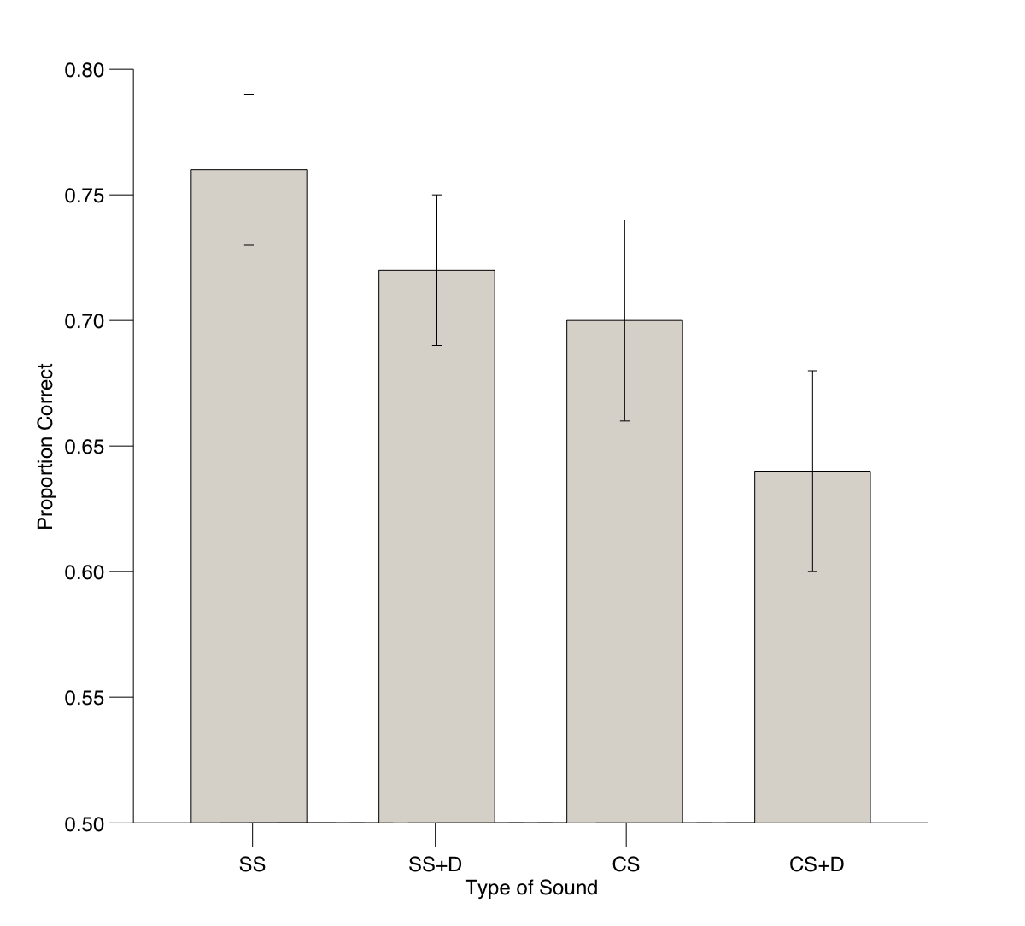

Figure 1: Proportion of items correctly recalled in a serial recall task in irrelevant sound conditions of steady-state (SS), steady-state plus a voice deviant (SS+D), changing-state (CS), and changing-state plus a voice deviant (CS+D). Adapted from Hughes, Vachon, & Jones (2007).
However, the data indicate otherwise: As shown in Figure 1, the effect of a voice deviant is of the same magnitude whether it occurs in the context of a steady-state or changing-state sequence. In other words, the two effects are additive (Hughes et al., 2005, 2007) which suggests that changing-state stimuli are not already capturing attention from the focal task.
ii) Focal processing modulates the changing-state effect but not the deviation effect
A defining principle of the competition-for-action account of the changing-state effect is that the effect should only be found when the focal task involves serial rehearsal, more specifically, when both the focal task and the sound share a common process, that of encoding order. Without a serial ordering component within the focal task, there would be no competition from the order cues derived from the changing-state sound and hence no disruption. This can be established by comparing two tasks identical in their perceptual characteristics, but where one task requires the maintenance of order. One variant of this approach involves presenting all but one of a well-known set of items (e.g., eight of the nine digits in the set 1-9) in a random order and the participant is required to report the missing digit (e.g., Buschke, 1963). This task involves remembering all the items so that that the missing items can be identified; however, the order of the items is immaterial to the task (Buschke, 1963). The second variant uses the same lists, but this time one item from the list is re-presented (a ‘probe’) and the person is asked to report the item that followed it in the list. This task does indeed necessitate the retention of item order, just like serial recall. As predicted by the competition-for-action view, only the probe task is disrupted by changing-state irrelevant sound (Beaman & Jones, 1997).

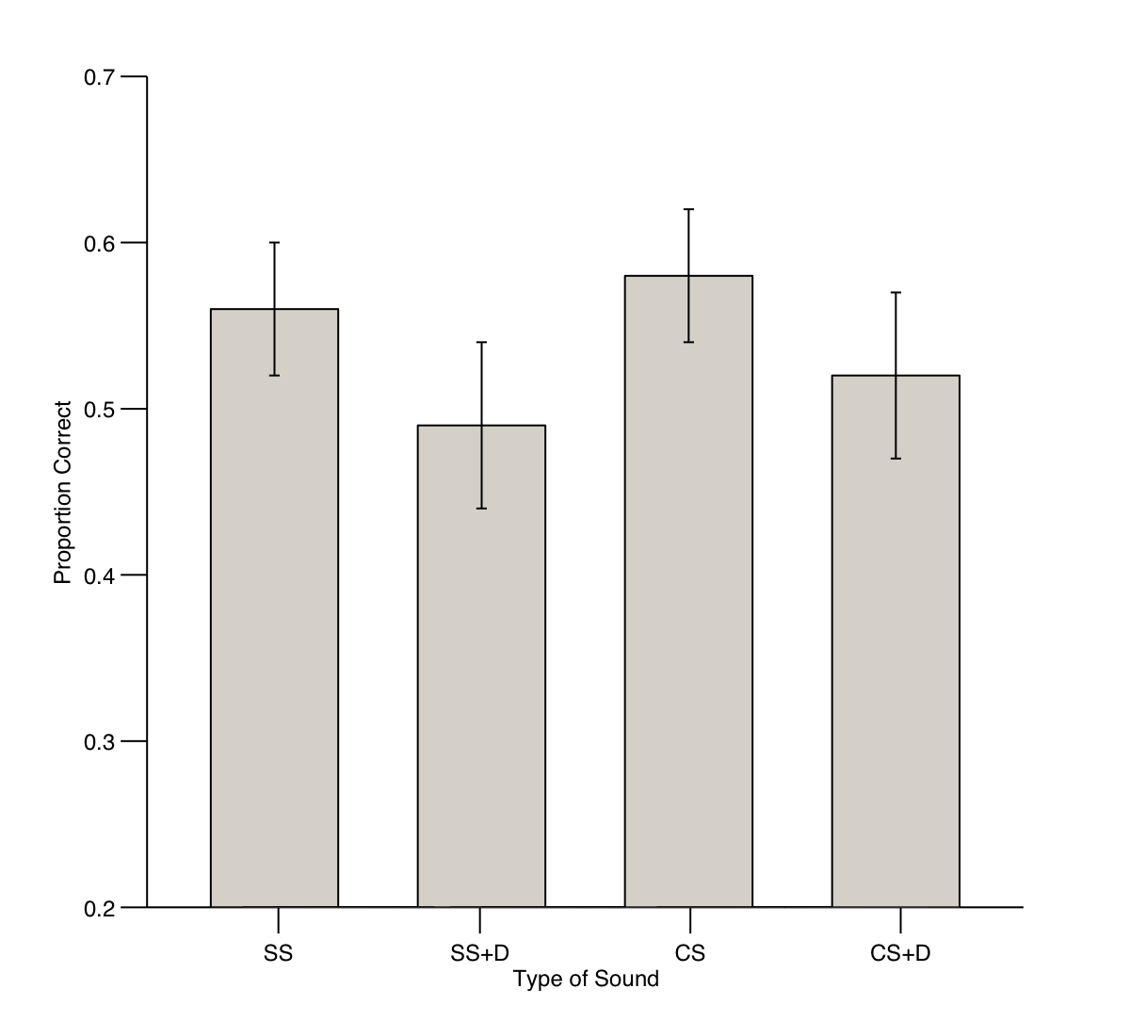

Figure 2: Proportion of items correctly recalled in a missing-item task in irrelevant sound conditions of steady-state (SS), steady-state plus a voice deviant (SS+D), changing-state (CS), and changing-state plus a voice deviant (CS+D). Adapted from Hughes, Vachon, & Jones (2007).
Does the deviation effect depend on order retention? Figure 2 shows the results of a study in which we examined the impact of a deviant embedded in steady and changing-state sequences on missing-item performance (Hughes et al., 2007). As expected, there was no changing state effect on this task (e.g., Beaman & Jones, 1997), but a clear deviation effect was evident (again regardless of the auditory background on which it took place). Indeed, deviation effects have been found in a range of other non-order based tasks including speeded classification of visually-presented digits (e.g., Escera et al., 1998). This would seem to make functional sense: The interruption of ongoing action due to a potentially important change in the auditory scene should not depend on the particular task a person is undertaking.

iii) Attentional load involved in stimulus-encoding modulates the deviation effect but not the changing-state effect
If the deviation effect, but not the changing-state effect, is due to attention being captured away from the prevailing task, then making the focal task more attentionally-demanding should modulate the former effect more than the latter. One way of making the task more attentionally-demanding is to degrade the to-be-remembered items by embedding them in static visual noise (see Figure 3). A pilot study used a task in which a series of stimuli was presented one by one on a screen and each stimulus could be either a digit or a letter. Participants were simply required to press one of two buttons to indicate its category membership (digit or letter). Static noise slowed the person’s speed of making the decision thereby validating the load manipulation. When the degraded digits were then used as to-be-remembered items in a serial recall task (high attentional load), the impact of a voice deviation was abolished. In contrast, the disruption caused by changing- compared to steady-state stimuli was not affected by increased load (Hughes et al., 2011). It seems, therefore, that attentional capture by a deviant stimulus is diminished when encoding conditions are difficult. There is little reason to suppose, however, that high load precluded serial rehearsal, thus the key precondition for the changing-state effect remained.
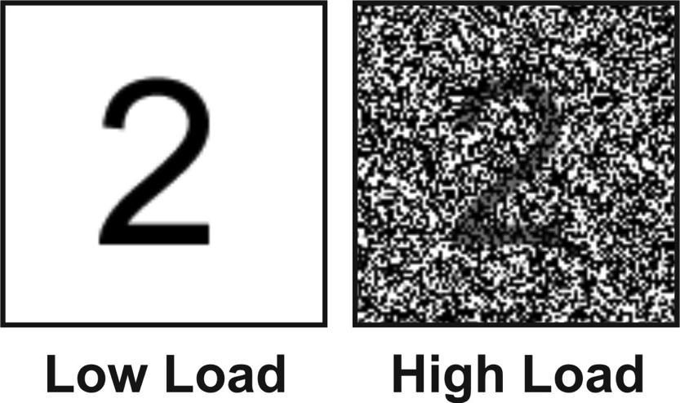

Figure 3: Illustration of the encoding load manipulation. Visually degraded stimuli (right panel) were set to a transparency of 50% and embedded in static visual noise.

iv) Deviation and changing-state effects have a different cognitive locus.

There is other work showing that deviation and changing state effects are quite distinct and separte phenomena. Experiments in which the timing of the presentation of the irrelevant sound in relation to the task differs suggest as much. Two conditions are typically contrasted, one in which the presentation of the sound is restricted to the time during which the to-be-remembered items are being presented or to a retention stage located between the last item and a cue (some 10s later) to recall the list. Miles, Jones, and Madden (1991) showed that changing-state irrelevant sound has a similar disruptive effect at both stages of the task. The most plausible explanation is that changing-state stimuli interfere with serial rehearsal (the factor common to both stages of the task), not stimulus encoding (a factor characteristic only of the presentation stage). When a temporal deviant (one item delayed in time relative to the others) was embedded in an irrelevant sequence confined to the presentation stage, it exerted its usual disruptive effect. However, as shown in Figure 4, no such effect was evident when the sound coincided only with the retention stage (Hughes et al., 2005). This is entirely in line with the idea that deviants act through encoding and changing state acts through rehearsal.
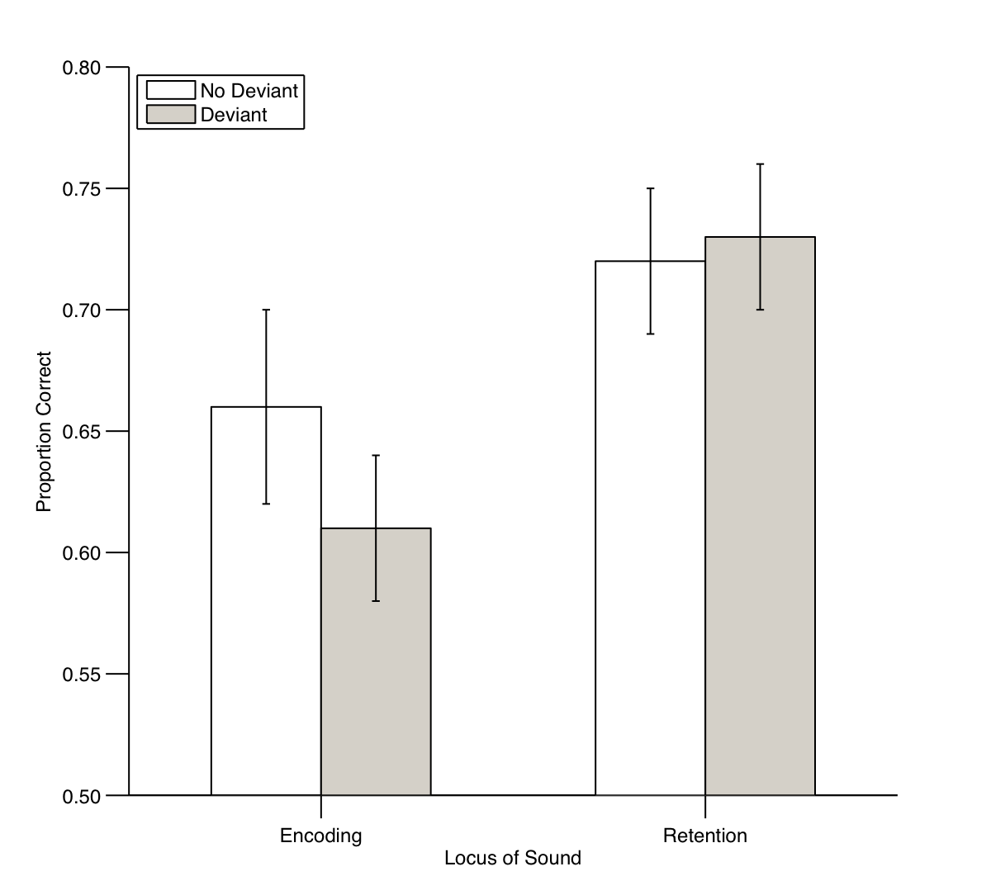

Figure 4: Proportion of items correctly recalled in a serial recall task according to whether an irrelevant sound sequence was presented during encoding only or during retention only and whether or not it contained a (temporal) deviant. Adapted from Experiments 1 and 2 of Hughes, Vachon, & Jones (2005).
CONCLUSIONS AND PRACTICAL IMPLICATIONS

Like all the research using methods of the sort we have just described, the key message is that not very loud sound can have an appreciable impact on cognitive performance. Just how these laboratory results translate into effects in everyday life is by no means certain, but we do know from our own work that sounds of modest intensity can be distracting. So, it might be that such effects also impair efficiency in real-world safety-critical tasks or highly skilled work. This by-now substantial body of laboratory evidence is yet to be acted on by those whose primary interest is in abatement however. For this constituency of noise researchers, noise level seems to be the main pre-occupation in spite of this evidence. The particular studies we have reviewed here have further refined our understanding of distraction. Evidence is accumulating that there are two types: one from unexpected sounds that seems to be due to a violation of a pattern already built up. The registration of stimuli seems to be particularly vulnerable to this effect. We know too that this type of distraction can be resisted by the person who hears it, such as by giving a warning that it is going to appear as well as by increasing effort on the prevailing cognitive activity (Hughes et al., 2011). This suggests that requiring the listener to increase their concentration will have beneficial effects. The other type of distraction occurs when changing sounds are heard in sequence. This is far more enduring and robust—it does not habituate and increased concentration does not help—and it seems more related to what is happening within the cognitive system when we are planning actions related to language such as speaking, reading and remembering. Again, it is worth emphasising that this effect is not related to the intensity of the sounds [the sounds are typically about 60 dB(A)]. Knowing there are two types of response to low-intensity sound extends our knowledge of how distraction works. One of the challenges of the future is to see how these effects can be traced beyond the laboratory, to the classroom, the home and the office to explore in what ways our everyday experiences are shaped by auditory distraction.

References
Buschke H. (1963). Relative retention in immediate memory determined by the missing scan method. Nature 200: 1129-1130.
Beaman, C.P., & Jones, D.M. (1997). The role of serial order in the irrelevant speech effect: Tests of the changing-state hypothesis. J Exp Psychol: LMC 23: 459-471.
Colle HA, Welsh A (1976). Acoustic making in primary memory. J Verb Learn Verb Behav 15: 17-32.
Cowan N (1995). Attention and memory: An integrated framework. Oxford, England: Oxford University Press.
Chein JM, Fiez JA (2010). Evaluating models of working memory through the effects of concurrent irrelevant information. J Exp Psychol: Gen 139: 117–137.
Divin W, Coyle K, James, DTT (2001). The effects of irrelevant speech and articulatory suppression on the serial recall of silently presented lipread lists. Brit J Psychol 92: 593-616.
Ellermeier W, Zimmer K (1997). Individual differences in susceptibility to the "irrelevant speech effect". J Acoust Soc Am 102:
2191-2199.
Elliott EM (2002). The irrelevant speech effect and children: Theoretical implications of developmental change. Mem Cognit 30:478-87.
Escera C, Alho K, Winkler I, et al (1998). Neuronal mechanisms of involuntary attention to acoustic novelty and change. J Cognitive Neurosci 10: 590–604.
Hughes RW, Jones DM (2001). The intrusiveness of sound: Laboratory findings and their implications for noise abatement. Noise Health 4: 55–74.
Hughes RW, Vachon F, Jones DM (2005). Auditory attentional capture during serial recall: Violations at encoding of an algorithm-based neural model? J Exp Psychol: LMC 31: 736-749.
Hughes RW, Vachon F, Jones DM (2007). Disruption of short-term memory by changing and deviant sounds: Support for a
duplex-mechanism account of auditory distraction. J Exp Psychol: LMC 33: 1050-1061.
Hughes RW, Hurlstone M, Marsh JE et al. (2011). Cognitive control of auditory attention: Evidence for resistible and ineluctable forms of distraction by sound. Manuscript submitted for publication.
Jones DM, Macken WJ. (1993). Irrelevant tones produce an irrelevant speech effect: Implications for phonological coding in working memory. J Exp Psychol: LMC 19: 369-381.
Jones DM, Miles C, Page J (1990). Disruption of proofreading by irrelevant speech: Effects of attention, arousal or memory?
Appl Cog Psychol 4: 89-108.
Miles, C., Jones, D. M., & Madden, C. A. (1991). Locus of the irrelevant speech effect in short-term memory. J Exp Psychol: LMC 17: 578-584.
Salamé P, Baddeley A. (1982). Disruption of short-term memory by unattended speech: Implications for the structure of working memory. J Verb Learn Verb Behav 21:150-164.
Sokolov EN (1963). Perception and the conditioned reflex. London: Pergamon Press.

