Accounting for the ‘transcendent self’: spirituality, narcissism, testimony, and gift

Giulia Achilli,
School of Business and Management, Royal Holloway University of London, Egham,

Cristiano Busco,
Roehampton Business School, Roehampton University, London, SW15 5PJ, UK, and
Luiss Business School, Luiss University, Rome, Italy

Elena Giovannoni,
School of Business and Management, Royal Holloway University of London, Egham, Surrey TW20 OEX, UK, and Department of Business and Law, University of Siena, Italy

Abstract

Purpose: We explore the process of construction of the ‘accountable self’, particularly as this process engages with the spirituality of the self. We examine the ‘space of accountability’ within which the accountable self constructs itself as such, and we investigate how different accounts of the self are drawn upon in the making of this space, both defining and transcending it.

Design/methodology/approach: We rely upon archival material concerning accounting and accountability practices about the project for building the altar of St. Ignatius in the Church of Gesù, Rome, Italy (1691 – 1706). We examine calculative and narrative accounts about the project from the perspective of the superintendent, who was the sole person accountable for the building works.

Findings: Whereas calculative accounts enabled the self to account for actions within the specific space of accountability of the project, narrative accounts opened up this space, providing for a testimony of actions and a gift of accountability towards future indefinite others. This process was prompted by the spirituality of the self and the narcissistic gratification of fulfilling this spirituality.

Originality: We add to the literature on the accountable self and to theological perspectives into accountability. We suggest exploring how different accounts of the self engage with each other through testimony, gift, narcissism and spirituality in the construction of the accountable self, providing for a ‘transcendent’ space of accountability. We also add to studies on narrative accounts by showing that they are drawn upon alongside calculative accounts in the construction of the transcendent, accountable, self.

Keywords: accountable self; transcendent self; space of accountability, testimony; gift; narcissism; spirituality

Paper type: Research paper

- Introduction

Accounting studies have for long explored the role of accounting in the making of accountability as part of a nexus of social relationships between multiple actors (Roberts and Scapens, 1985; Munro and Mouritsen, 1996; Killian, 2015; Dillard and Villari, 2019). As well as recognizing the importance of the ‘social space’ in which accountability relationships take place (see, e.g., Carmona and Ezzamel, 2007), a number of scholars have taken on the perspective of ‘the self’ in the making of this space (see, e.g., Roberts 1991; 1996; 2009; Boland and Schultze, 1996; and more recently Masiero, 2020). From this perspective, accountability relationships are grounded in a process of self-recognition of the accountable self, through which the self separates itself from ‘others’ and constructs itself as the ‘I’ that is accountable for action (Willmott, 1996).

In examining the process of construction of the ‘accountable self’, studies on accountability have discussed the tensions between calculative forms of accountability, centred on narcissism and self-interest (see e.g., Roberts 1991), versus more sentient, socializing, and non-calculative forms of accountability, grounded on love and care for the others (see e.g., McKernan and MacLullich, 2004). These studies have emphasised the risk of regarding the calculative and the sentient self as if they were in opposition (Roberts, 2021), with the calculative self undermining the sentient self. We aim to add to this debate by delving into the process of construction of the accountable self, within which calculative and non-calculative forms of accountability may engage with each other in complex, and still overlooked ways. In exploring this process, we argue, it is necessary to consider the space of accountability in which the accountable self constructs itself as such.

In this regard, a number of studies have highlighted the importance of ideology (Sinclair, 1995), as well as spirituality (McPhail and Cordery 2019), and the socio-historical and economic context of the self (Masiero, 2020) in relation to accountability. McPhail and Cordery (2019) emphasise that current perspectives on accounting and accountability, also when related to spirituality, tend to overlook the theological and transcendent forces that span beyond the more immediate and ‘material’ space of accountability, therefore ignoring the relationships between “eternity and immediacy” (p. 2337). They conceive of spirituality as being related to an inner search of meaning shaped by transcendental elements (McPhail and Cordery, 2019). In their view, current perspectives end up linking accountability to the time-space context in which accountability relations develop, reinstating their immanent, rather than transcendent, dimension. Although taking place within a specific time-space frame, we argue that the production of the self as an accountable self is likely to span beyond this frame, particularly as this production engages with the spiritual dimension of the individual.

We highlight this idea by referring to the concept of ‘transcendent self’, by which we refer to the process of construction of the self that both depends on, and spans beyond, the specific context within which it originally develops. We research the process of construction of the accountable self as a transcendent self, and we investigate whether this construction can provide for transcendent forms (and spaces) of accountability. We explore this argument in the context of the project of construction of the altar of St. Ignatius in the Church of Gesu’ in Rome, Italy, between 1695 and 1699.

The altar of St. Ignatius is worldwide recognized as an icon of the Jesuit Order as well as one of the greatest examples of Baroque artistic style (Gargano, 1996; Dal Mas, 1996). In spite of the number of actors involved in the project of construction of the altar, the responsibility for the project was given to one sole person, Carlo Mauro Bonacina, a member of the Jesuit Order who acted as “sovrintendente” (Bonacina, ARSI, Rom. 140, f. 10 v) - hereafter translated with “superintendent”. In this role, Bonacina was expected to act as work supervisor, manager and accountant for the project (Bonacina, ARSI, Rom. 140, f. 28 v; De Feo, 1996; Gargano, 1996). The engagement with non-contemplative activities, as well as the centrality of the individual in accounting for these activities, were typical precepts of the Jesuit Order which fused accountability with the ‘individualism of the self’ (Quattrone, 2004; 2015; Wittkower and Jaffe, 1972).

The fusion between accountability and the individualism of the self in this setting, also related to the precepts of the Jesuit Order and the religious dimension of the altar, makes the building of the altar of St. Ignatius particularly interesting for exploring the space of accountability in relation to the accountable self, at its encounter with the spirituality of the self. By examining calculative and narrative accounts about the project from the perspective of the accountable self, our analysis reveals that, while calculative accounts defined a specific, finite, time-space of accountability for the project, narrative accounts enabled the self to account towards future, indefinite, ‘others’ beyond the time-space of the project, thereby providing for a transcendent space of accountability.

This paper offers a number of contributions. Firstly, we contribute to the literature on accountability by adding new insights into the process of construction of the accountable self (Boland and Schultze, 1996; Willmott, 1996; Roberts, 2009; McKernan, 2012; Joannides, 2012; Masiero, 2020). We show that this process can transcend the specific time-space in which it originally develops, following the attempt of the self to provide a testimony of actions and a gift for future generations. We extend the work of McKernan (2012), by showing that the gift of accountability and testimony can be driven by both the spirituality of the self, as well as the narcissistic return of the self in fulfilling such spirituality. Therefore, accountability is not only produced to legitimize the self in the immediate space in which actions take place, but it also transcends this space. Here, we show the role of calculative and narrative accounts in the making of the time-space of accountability as a transcendent space. Whereas calculative accounts define this space by providing the accountable self with a calculative means to legitimize its actions, narrative accounts open up this space by enabling the accountable self to account for its actions towards future indefinite others through testimony, gift, spirituality and narcissism.

Secondly, we answer the call for more studies on theological perspectives on accounting and accountability (McPhail and Cordery, 2019; Cordery, 2015). We show that the spirituality of the self may prompt the construction of the accountable self as a transcendent self and provide for transcendent forms of accountability. Our findings highlight the need for a shift in the theoretical efforts for understanding the making of accountability: from a focus on immediate societal relationships, and their calculative accounts, taking place in a specific, finite, time-space frame, to the diverse (calculative and non-calculative) accounts produced by the self to account towards indefinite future others, while fulfilling its spirituality. In doing so, we also contribute to the literature on accounting narratives (Eshraghi and Taffler, 2015; Beattie and Davison, 2015; Lai et al., 2018). We demonstrate that it is through narrative accounts that the individual can provide for a personal story of itself, both a calculative and a sentient spiritual self, as part of the process of construction of the accountable self.

The paper is structured as follows. Section 2 reviews prior research on the nature of accountability, with specific reference to the studies on the ‘accountable self’ and theological perspectives into accountability. Then in Section 3 we introduce our research methods, which draw on the project for building the altar of St. Ignatius in the Church of Gesù in Rome, Italy. We present the social space of the project in Section 4. In Section 5 we explain calculative accounts for the project. Narrative accounts about the project are analysed in Section 6. In Section 7 we discuss the process of construction of the accountable self within and beyond the time-space frame of the project. Section 8 outlines the contributions of our study.

- Accountability and the accountable self

A number of studies have highlighted the role of accounting practices in the ‘production of the self’ (Willmott, 1996; McKernan, 2012; Roberts, 1991; 2009; Masiero, 2020). These studies have emphasised that giving an account “is one activity in which we come to be as selves” (Schweiker, 1993, p. 234), and as morally responsible subjects (Messner, 2009). The production of the self implies a process of self-recognition that is essential within accountability relationships: accountability is regarded possible insofar as “human beings are endowed with a capacity to identify themselves as centres of consciousness that can engage in (seemingly) self-determined activity” (Willmott, 1996, p. 34).

Different forms of accountability have different effects on the production of the self. Accounting has been for long associated with calculative forms of accountability, in which the self is accountable for calculative instrumental actions based on accounting information (see Roberts, 1991; Messner, 2009). Calculative accountability may produce a ‘narcissistic sense’ of the self, when the self comes to view others mainly as an instrument for achieving self-interest (Roberts, 1991; 2021), thereby threatening the morality of the relationship with others. This form of accountability is closely related to the contingent time-space in which the actions of the accountable self take place, and within which the self attempts to realize its self-interest. Here, the act of ‘giving of an account’ for actions - that is accountability - may discharge individuals from any intimate self-reflection on their moral reasons for action – that is responsibility (McKernan, 2012).

According to McKernan and MacLullich (2004), the tension between accountability and responsibility can be resolved through socializing mechanisms grounded on solidarity and justice (see also Kosmala and McKernan, 2011). Contemporary issues such as global poverty, refugee crises, or natural disasters have led to a rising interest in socializing forms of accountability (Frey-Heger and Barret, 2021), within which the self conceives of itself as part of a much broader space of accountability centred on care and love for ‘others’ (Kosmala and McKernan, 2011), spanning beyond instrumental self-interest and narcissism. Because of the sentient nature of humans, the self is “unavoidably vulnerable” and hence responsible for the vulnerability of the other (Roberts, 2021, p. 9). Socializing forms of accountability emphasise the co-presence of the self with others in a broader but well-defined space of accountability, conceived as a “local, situated and lived reality” (Frey-Heger and Barret, 2021, p. 3): seeing and recognising the other render individuals “more sensitive for other’s needs and for problems that go beyond one’s own egoistic concerns” (Frey-Heger and Barret, 2021, p. 3). However, not only visibility, but also invisibility matters in producing organising effects (Quattrone et al., 2021). Indeed, the other is not always visible and recognizable in the space of accountability.

Drawing on the work of Derrida (1991; 1996), McKernan (2012) discusses two types of accountability towards an indefinite, invisible, other: accountability as testimony and accountability as gift. Accountability as testimony assumes a relationship of promise and trust between the accountable self and ‘others’. The self promises to tell others the truth, as the self sees it, and to be faithful to this promise (Derrida, 1996). This promise implies an act of faith from the others, who have to trust the accounts given by the self without the need of proof. Hence, accountability becomes “a matter of faith not knowledge” (McKernan, 2012, p. 272). Since it gives an account of truth ‘as the self sees it’, testimony is personal. While calculative accounts allow little scope for the “creative constitution of identities” (McKernan and MacLullich, 2004, p. 342), and can abolish the need for testimony (McKernan, 2012; Kamuf, 2007), the self can narrate its personal story through narrative accounts, in the contexts of its relations with others and through time (Masiero, 2020; Eshraghi and Taffler, 2015). However, narrative accounts tend to be “consistently undervalued and often suppressed” (Boland and Schultze, 1996, p. 62; Lai et al., 2018), with “narrative and subjective elements being subsumed by quantification, that threatens to put counting in the place of thought” (McKernan, 2012, p. 261). Still narrative accounts are not exempt from the narcissistic needs of the self (Beattie, 2014), as the self may attempt to manipulate impressions while narrating its ‘version’ of the story (Evans and Pierpont, 2015; Collins et al., 2015).

As well as testimony, accountability can be conceived as a gift - “the gift of accountability” (McKernan, 2012, p. 273). For there to be a gift, “there must be no reciprocity, return, exchange, countergift, or debt” (Derrida, 1991, p. 12). The paradox is that while there is no gift without the intention ‘to give’, such “intentionality threatens to instantly annul the gift by pulling it into the circle of exchange” (McKernan, 2012, p. 275), and into “a movement of narcissistic reappropriation” (McKernan, 2012, p. 276) which takes the form of a debt of gratitude. The narcissistic gratification arises when the donor and donee recognize the gift as such and constitute themselves as subjects in the circle of exchange (McKernan, 2012). However, not all types of narcissism threaten the concept of gift: “there are narcissisms that are more or less comprehensive, generous, open, extended” (Derrida, 1986, p. 199). If the narcissistic subject wants the good of the other, then narcissism can enable the gift. According to McKernan, (2012) the gift moves us “towards a certain surrender to the other, surrender to the impossible” and “in that surrender we might recognize ‘love itself’” (McKernan, 2012, p. 276).

The concepts of accountability as gift and testimony explained above suggest ways for exploring the ‘space of accountability’ beyond the specific, immediate context in which the actions of the accountable self take place, and within which the self pursues its calculative instrumental interest. According to McKernan (2012), through gift and testimony, the accountable self longs towards an ‘infinite alterity’, fully transcendent from the self: a “mysterium tremendum” (Derrida, 1992, p. 91) that “is to come” (McKernan, 2012, p. 264), without the comfort of knowing its shape or character. This idea emphasises an intimate, often religiously inspired, moral responsibility towards the other (Parker, 2014).

As recently argued by McPhail and Cordery (2019), current perspectives into accounting and accountability tend to overlook the ‘divine other’ that drives action and transcends the situated space of accounting (see, also, McPhail et al., 2004). In their view, although researching religious contexts, prior studies have privileged a secular perspective on accounting and accountability, overlooking how they engage with broader, transcendent, aspects. These aspects lie at the heart of the spirituality of individuals, also connecting to their human condition and subjective sphere (McPhail and Cordery, 2019; see also Gallhofer and Haslam, 2011). Therefore, McPhail and Cordery (2019) call for more theological approaches into accounting and accountability, embracing “the disruptive, transcendental elements at the core of religious spirituality” (McPhail et al., 2004, p. 321). We argue that these approaches are helpful to explain accountability, and the process of construction of the accountable self, beyond the immediate, calculative, time-space context in which the accountability relationships take place.

In this regard, the concepts of testimony and gift, if associated with the spirituality of the self, are capable of bringing a theological perspective into the study of the accountable self, by opening up the space of accountability beyond the finite space in which the calculative actions of the self initially take place. Whereas this finite space is certainly relevant to understand the self-interest that moves certain forms of accountability, linking testimony and gift to spirituality may help addressing the divide between the need to account for actions within a specific space, with a narcissistic return for the self, and the responsibility of the self towards ‘others’. Next, we explore this argument in the religious context of the project for the altar of St. Ignatius in the Church of Gesù, in Rome, Italy (1695-1699). We will investigate the self-construction of the accountable self, how it happens in practice, and ultimately engages with a broader (transcendent) space of accountability.

- Research Method

  - Research background: the Society of Jesus and the project for the altar

The Society of Jesus was founded by Ignatius Loyola (1491–1556) in 1539 and received the formal approval of Pope Paul III on 27th September 1540, taking the Italian name of Compagnia di Gesù (Society of Jesus). The Society was organised through a hierarchical structure regulated by the General Constitutions of the Society (see the English translation by Ganss, 1970). The General of the Society was the head of the Order, and was assisted by a General Procurator, who was in charge of the economic affairs of the Order, and by several Provincial Procurators who took care of the administrative and accounting issues of each Province in which the Society was organised. The Congregatio Procuratorum (“Congregation of Procurators”) had to take place every three years in Rome to discuss and monitor the economic affairs of the Jesuit Order (ARSI, Rom. 140, f. 28 v).

The altar of St. Ignatius was meant to honour the founder of the Society of Jesus and to preserve St. Ignatius’ ashes. Differently from other medieval religious Orders mainly devoted to contemplation and isolation, the Jesuits “were animated by an activism previously unknown in the Catholic Church” (Quattrone 2004, p. 654), which required them to engage in numerous non-contemplative activities, such as missionary, educational, and economic enterprises, as well as theatre, dance and artistic projects (Wittkower and Jaffe, 1972).

As emphasised by Quattrone (2015), the Jesuits were driven by a “quasi-religious belief in moral and administrative improvement” (p. 415). This belief was based on practices of spiritual self-accountability and administrative accounting and recordkeeping, aimed “at continuously generating questions about God, about the self, and about the right course of action to be taken in various circumstances” (Quattrone, 2015, pp. 434, 435). In the construction of the altar and the management of the project, one sole person was held accountable: Carlo Mauro Bonacina, a member of the Jesuit Order.

Bonacina was born in the city of Milan, Italy, on 15th January 1640 and joined the Order at the age of 21, on 15th December 1661 (ARSI, Med. 55, f. 43 r). Since then, he was a very active member of the Society of Jesus. Bonacina was able to earn the trust of the highest offices of the Order in his province, Milan, where he was entrusted with the roles of director of novices and personal assistant of the Procurator of the Milan Province (ARSI, Med. 55, f. 43 r). In 1691, the General of the Society, Tirso Gonzales, asked Bonacina to move to Rome to become his personal assistant (ARSI, Rom. 78 c, f. 117 r; 126 r). In the same year, the General appointed Bonacina as superintendent for the project of construction of the altar, which was the most prestigious role Bonacina covered during his life. Initially, he was reluctant to accept this role: “this is a burden for other shoulders, not for mine” (Bonacina, ARSI, Rom. 140, f. 7v). Also, the decision of the General of the Society to entrust Bonacina with this responsibility stimulated numerous rumours and dissatisfaction among members of the Order:

Poor us [the Jesuits]. How [miserable] we are reduced! […] Father Bonacina was often told: “you should build huts and not chapels” (Bonacina, ARSI, Rom. 140, f. 10 r).

Numerous architects came to Rome aspiring to be elected as superintendent for the construction of the altar. These architects “were moved by two major stimuli of the human soul, that are honour and interest, hoping to gain notoriety through such a famous project and make profit from such an expensive work” (Bonacina, ARSI, Rom. 140, f. 11 v). In spite of the rumours on the choice of offering Bonacina the role of superintendent for the project, the General of the Society confirmed this choice and Bonacina decided to take over. In Bonacina’s view, “the higher the fury of the storm, the higher the pride of facing it in the deep sea!” (ARSI, Rom. 140, f. 10 r). More than 500 workmen were involved in the construction of the altar, under the supervision of Bonacina (Dal Mas, 1996; Gargano, 1996; De Feo, 1996). As the construction of the altar started, rumours and critiques did not cease:

I [Bonacina] struggle to find, in my memory, another major project that has been more doubtful for aversion of opinions, more tempestuous for the exceptions of externals, and more agitated for the discord of the internals (Bonacina, ARSI, Rom. 140, f. 11v).

The multiple groups of interests in the project (aristocratic families, members of the Order and of the Roman Church, architects) created complex pressures for Bonacina to account for the use of resources and for the outcome of the project. In spite of the tensions that informed the social space of the project, the altar was completed in a few years, and this was possible mainly for the leading role of Bonacina (Dal Mas, 1996; Gargano, 1996). The altar of St. Ignatius now constitutes one of the most elaborated and splendidly extravagant Baroque architectures of the Seventeenth century (Dal Mas, 1996; Gargano, 1996; De Feo, 1996).

  - Research design, data sources and analysis

Numerous scholars have emphasised the importance of historical analysis for capturing and understanding the current nature of accounting and accountability practices (e.g., Miller, Hopper and Laughling, 1991; Miller and Napier, 1993; Carnegie and Napier, 2012). As well as exploring calculative accounts, studies in accounting history have also encouraged scholars to rediscover the narrative dimension of accounting (Cordery, 2015; Parker, 1999), including the analysis of personal histories, as a way to critically unpack accounting and accountability practices from the perspective of the individual (McPhail and Cordery, 2019; Cordery 2015).

Narrative accounts are particularly relevant to research and understand the construction of the accountable self (Boland and Schultze, 1996; Masiero, 2020), as the possibilities for a dialogue with accountees rely on the narrative capacity of the accountors, namely their “ability to narrate their experience and that of others in making sense of the world” (Boland and Schulze, 1996, p. 64; see also Lai et al., 2018). Moreover, narrativity “is central to any understanding of human action and behaviour, it is located at the heart of selfhood, and is central to identity and ethics” (McKernan and MacLullich, 2004, p. 338). Still, accountability “has from its very inception been dominated by calculation and quantitative practices” (McKernan and McPhail, 2012, p. 178; Gibbon, 2012; Lai et al., 2018; Dillard and Vinnari, 2019).

In this paper we examine the calculative and narrative accounts of the self within an historical setting: the project for building the altar of St. Ignatius (see figure 1). For the entire duration of the project Bonacina kept accurate calculative accounts about it (ARSI, Chiesa del Gesù, 2056, 2057, 2058; ARSI, Rom. 141, Vol. 2). Also, during the project Bonacina wrote a detailed memoriale (memoir) (Bonacina, ARSI, Rom. 140, ff. 3 r – 41 v) finalized seven years after the completion of the altar and six years after the calculative accounts were presented to the Congregatio Procuratorum. Our historical perspective draws on a period of 16 years, from 1691, when Bonacina was invited to lead the project for the building of the altar, to 1706, when Bonacina completed his memoriale containing the narrative accounts related to the project. Bonacina died in Rome one year after the completion of his memoriale, on 4th March 1707 at the age of 67 (ARSI, Rom. 97, f. 186).

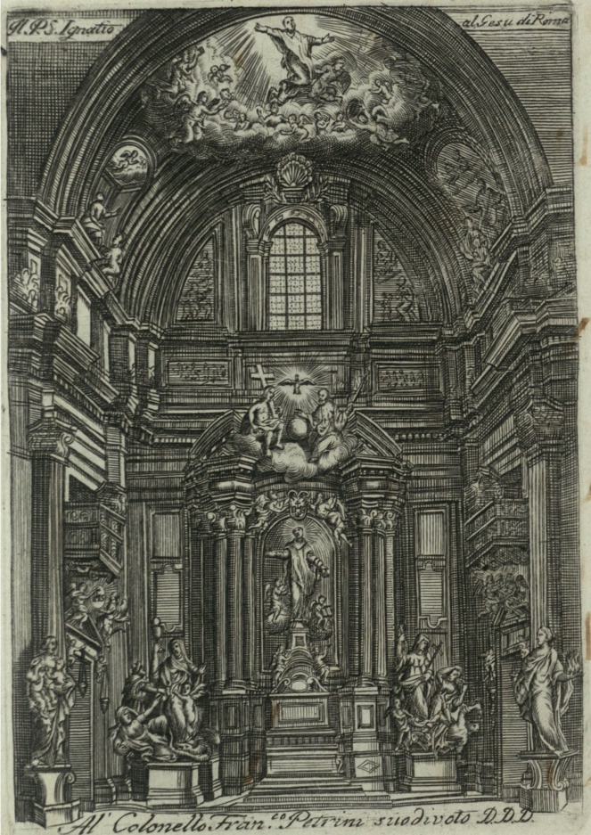

Figure 1. The altar of St.Ignatius in the Church of Gesù in Rome, Italy
(ARSI, Rom. 140, f. 2 v) © Archivum Romanum Societatis Iesu

Prior historical studies have examined the project of the altar of St. Ignatius in the Church of Gesù in Rome (Dal Mas, 1996; Gargano, 1996; De Feo, 1996). This church was built in 1568 and has been regarded as the most important church of the Society of Jesus (Schwager and Schlimme, 2002). Also, various studies have reconstructed the historical background of the Jesuit Order, its accounting and accountability system, its rationality and logics (Quattrone, 2004; 2009; 2015; Bento da Silva and Quattrone, 2021). We use these studies as our secondary sources to reconstruct the social and political background of the works for the altar. Our secondary sources allowed us to identify the main actors involved in the project and the accountability relationships of the self in the time-space of the project. All secondary sources emphasise the sole role of Bonacina in the management of the project (Dal Mas, 1996; Gargano, 1996; De Feo, 1996).

Our primary sources come from the Archivum Romanum Societatis Iesu (the Roman Archive of the Society of Jesus, or ARSI). ARSI constitutes the main archive of the Jesuit Order in Rome, Italy, and it holds all primary documents related to Bonacina and the project of constructions of the altar. A growing number of scholars have recognised the importance of archival sources for accounting and management research (see Carnegie and Napier, 2012; Decker, 2013). Cordery (2015) has emphasised that archives provide rich sources for accounting researchers “to explore the nature, role, uses and impacts of accounting in historical (organizational) contexts” (p. 443). For the purpose of this research, we consulted all ARSI sources related to the project of construction of the altar, as well as the documents of the examining commission appointed for the project (ARSI, Rom. 140) and all the accounting records of the building site (ARSI, Chiesa del Gesù, 2056; 2057; 2058; ARSI, Rom. 141, Vol. 2). A detailed description of these sources is provided in Appendix 1.

As our research focuses on the accountable self, we also analysed all archival material pertaining to, and written by, the superintendent Bonacina. We examined Bonacina’s memoriale contained into the book titled: Ristretto dell’avvenuto nella fabrica della Cappella del Nostro Santo Padre Ignatio nella Chiesa della Casa professa della Compagnia di Gesu’ di Roma con l’aggiunta d’un istruzzione per chi volesse fare un’opera simile (“Synopsis of the building works related to the construction of the altar for our patriarch Saint Ignatius Loyola in the Church of Gesù with instructions for building a similar architecture”, ARSI, Rom.140, ff. 3 r - 41 r). Through these narrative accounts Bonacina explained his point of view, his “truth” about his own accountability for the project. This type of accounts (of the self about the self) provides for a form of ‘autobiography’: “one’s biographical story about the self” (Gendron and Spira, 2010, p. 278; see also Eshraghi and Taffler, 2015). More in general, narrative accounts are crucial to understand the construction of the accountable self (Boland and Schultze, 1996), its experience and sense of the world (Eshraghi and Taffler, 2015).

Further, alongside the Ristretto, we analysed the accounting books related to project: Libro Giornale, Libro Mastro, Libro degli Operai - Journal, General Ledger, and Workmen Book (ARSI, Chiesa del Gesù 2056; 2057; 2058; ARSI, Rom. 141, Vol. 2). We also analysed all the Catalogi (“Catalogues”) for the years of service of Bonacina in the Jesuit Order, from 1661 to 1707 (ARSI, Med. 54; Med. 55; Med. 56; Med. 57; Med. 58; Med. 59; Rom. 78 c; Rom. 97). The Catalogi were detailed reports sent every year (Catalogi Breves) or every three years (Catalogi Triennales) to Rome by each Province. These reports provided information on the members of the Order who lived in each Province, their role and activities. We relied upon these sources to reconstruct the life and career of Bonacina. Finally, we analysed the letters the General of the Society sent to the General Procurator, concerning the financial resources needed for the completion of the project (ARSI, Fondo Gesuitico 494, ff. 203 r - 204 v).

Thanks to our primary and secondary sources, we were able to trace the social space of accountability of the self, as well as the narrative accounts and calculative accounts through which Bonacina constructed himself as ‘accountable’. By relying upon the literature reviewed in Section 2, we built a plot (Czarniawska, 1998) linking the narrative and calculative accounts of the self to different forms of accountability (calculative, testimony and gift), as well as to the spirituality and narcissism of the self. In doing so, we could unpack the processes of construction of the self within and beyond the specific time-space of the project, which we analyse next.

- The altar of St. Ignatius Loyola: the social space of the project

As I [Bonacina] arrived in Rome on 22nd November of the same year [1691] […], inspired by God, I shared with our Father [the General of the Society] my surprise to see how poor was the chapel of the Holy Father [Ignatius Loyola], in the mother church of the Order [the Church of Gesù], under the eyes of so many Generals, […] in the heart of Rome, head of the Christian World, […]; yet, in other parts of the world, to the sole name of St. Ignatius, precious chapels and very sumptuous churches had been already built. These simple words served just as a stimulus. The mine was ready: this spark was enough to give it fire and make the mine fly (Bonacina, ARSI, Rom. 140, 7 v).

The idea of the project for the construction of the altar started in mid-Seventeenth century, when the highest offices of the Jesuit Order decided to employ a great amount of donations initially devoted to the foundation of a College in Biscaglia, Spain, and a huge donation from the King of Poland to the construction of the altar (De Feo, 1996). However, the difficulties in collecting these donations, as well as the diatribe concerning the final location of St. Ignatius’ ashes delayed the project for years. In July 1687 Tirso Gonzales was elected General of the Jesuit Order and in this capacity, he decided to finally initiate the construction of the altar of St. Ignatius inside the Church of Gesù. At that time, parts of the Church of Gesù were under the patronage of different Italian aristocratic families (Dal Mas, 1996; Gargano, 1996; De Feo, 1996). According to an initial plan, the altar had to be built in a part of the church under the patronage of the Duke of Parma, who however refused to grant permission (Bonacina, ARSI, Rom. 140, f. 8 r; Gargano, 1996). Therefore, the Jesuits had to give up their original plan and start a new negotiation for a different chapel with another family, the noble Savelli family, who finally conceded its patronage for the ‘Ancient Chapel’ (Dal Mas, 1996). As mentioned by Bonacina in his memoriale:

Father Pier Franceso Orta [General Procurator], […] handled the negotiation with such dexterity that […] he was able to obtain the benevolence of the Prince [Savelli] in exchange of two conditions: that the new chapel hosted both the Savelli’s family coat of arms as well as a marble inscription to commemorate the donation (Bonacina, ARSI, Rom. 140, ff. 8 r, 8 v).

Alongside the negotiation for the patronage, the Jesuits started to search for the best possible design for the altar. The General of the Society wanted the Jesuit architect Andrea Pozzo to design it, thus complying with the so-called ‘Jesuit-way’ (Wittkower and Jaffe, 1972; Gargano, 1996), according to which all the works had to be fully controlled by the Jesuits in all aspects. However, influential Italian aristocratic families pushed other architects to develop project proposals, wishing to exert some degree of control over the project, thereby initiating a sort of competition between different architects (Bonacina, ARSI, Rom. 140, f. 9 v). An examining commission was appointed to select the best project and, starting from 20th February 1695, architects began to exhibit their ideas and designs (Dal Mas, 1996). Among all projects, Pozzo’s design was the most ambitious, innovative and original (Gargano, 1996). Although the Order supported Pozzo’s project, the more conservative members of the commission (e.g., the aristocratic families) had different opinions and supported other architects (Dal Mas, 1996).

The Jesuit Order wanted a painted image of St. Ignatius, thus complying with the Jesuit ideals of humility and the didactic intent of teaching the precepts of the saint through a painting. Differently, the aristocratic members of the commission wanted a statue of St. Ignatius, to make the altar more magnificent and richer (Gargano, 1996). As reported by Bonacina in his memoriale, the statue had to be preferred over the picture because it was more magnificent and sublime; moreover, it could better attract and impress financial benefactors, due to the solidity of marble and its perceived ‘eternity’. Finally, the statue could be perceived as a more ‘innovative’ ornament inside the church. At the same time, according to Bonacina, the painting could stimulate more devotion than the statue; it was more appropriate for the ornamentation and symmetry with the other parts of the church and for its structure (Bonacina, ARSI, Rom. 140, f. 13 v). Furthermore, the choice of the material for the statue was problematic:

A silver statue will make the Chapel richer, but it will not stimulate devotion; a marble statue will increase astonishment, but not reverence; a bronze statue will be particularly subject to wear and tear; and none of them will provide a faithful depiction of the Saint (Bonacina, ARSI, Rom. 140, f. 13 v).

Aiming to mediate among the different interests, Pozzo designed a machination, which was later called “Baroque Machine” (Macchina Barocca). As part of Pozzo’s Macchina Barocca, a painting with the portrait of the saint had to hide the statue. Then, the painting had to be lifted by the machine to reveal the statue of the saint hidden behind the painting. The idea was to create wonder and surprise in the spectators, to engage them in a transcendent experience of prayer and belief for the saint (Dal Mas, 1996; Gargano, 1996; De Feo, 1996).

The majority of the judging commission involved in the examination of the project designs was favourable to elect Pozzo’s design as the winner. As testified by Bonacina, “cardinals, bishops, prelates, princes, knights, architects, painters, priests, religious, seculars came [to see the project]. There was a perpetual coming and going of people, like a tidal wave” (Bonacina, ARSI, Rom. 140, f. 12 v). At the end of September 1695, the commission finalised the decision about selecting Pozzo’s design.

The building site for the altar officially opened in 1695. Aristocratic families, members of the Roman Church and even some members of the Jesuit Order were not satisfied with the choice of having Pozzo and Bonacina respectively as the architect and the superintendent of the project, “openly disapproving, that a work of such effort, of such expectation, of such expenditure should be held by one Pozzo, and by one Bonacina, that is to say by two humble and foreigner brothers” (Bonacina ARSI, Rom. 140, ff. 9 v, 10 r; see also Gargano, 1996). On 25th July 1695, to make such rumours cease, the General of the Society named the General Procurator, Pier Francesco Orta, as the official superintendent of the project, while leaving the actual supervision to Bonacina (Bonacina, ARSI, Rom. 140, f. 12 v). However, the escamotage was soon discovered by some members of the Order and critiques restarted. Therefore, the General, exhausted by these critiques, issued an edict directed to all the members of the Jesuit Order:

Our Father [the General] forbids anyone to interfere, either directly or indirectly with it [the project], for any reason, […] and exhort to not criticize, nor blame any of the actions that will be done, […], and most importantly in front of outsiders [people outside the Jesuit Order] (Bonacina, ARSI, Rom. 140, f. 13 r).

In addition to the rumours against Pozzo and Bonacina, many critiques were directed towards the construction site, which was perceived as too chaotic:

There were rumours, as it usually happens in Rome, about the project. The whole community surrounding the Church of Gesù could see no rhyme or reason. People thought works would result in fraud, garbage, a mess; that the workmen were exploited; that the whole project was just the portrait of a Babel Tower (Bonacina, ARSI, Rom. 140, f. 17 r).

Such critiques led to attempts for stopping or slowing down the works of the project. For example, the Duke of Parma, who had previously refused to concede the patronage of his part of the church, sustained the argument that potential damages might have been caused to the church because of the construction works related to the altar. During the Spring of 1696, without any notice, the Duke of Parma sent experts and architects to check the situation and to eventually block the construction. According to an Avviso dated 16th April 1696, the architect Carlo Fontana, sent by the Duke of Parma, stopped the works “to protect the walls of the chapel which had been damaged by the construction works, while the Jesuits claimed this was a lie made up by the architect as a revenge because Pozzo’s project was preferred over Fontana’s one” (Archivio Vaticano, Fondo Borghese, Serie II, 446, quoted in Rossi, 1943, p. 117). The experts verified the conditions of the site and could not do anything but give their approval to the works. These inspections to the building site were repeated six times during 1696 (Bonacina, ARSI, Rom. 140, f. 16 r).

The rumours about the ‘Babel Tower’ (as quoted above) also spread into the Roman Church. The Cardinal Ferdinando D’Adda, who knew Bonacina well, asked him for explanations about the rumours. Bonacina invited the Cardinal to visit the construction site and verify with his eyes. When the Cardinal arrived at the building site, he did not see anything that did not deserve his wonder and praises (Bonacina, ARSI, Rom. 140, f. 17 v). Later on, in 1696, other inspections took place into the building site both from aristocratic families as well as from members of the Church, often without any advance notice and with the only aim of finding an excuse to stop the project. The Pope himself visited the site twice between 1696 and 1697. Nothing wrong was found and the works kept on moving relentlessly. As recalled by Bonacina,

Opponents took every single opportunity to discredit the project, either verbally or in writing: but this just contributed to the project’s greater praise, as all the rumours worked as a stimulus to make the world come to see the chapel even from far away, and this was enough to demonstrate the malice and the envy [of the rumours and critiques] (Bonacina, ARSI, Rom. 140, f. 18 v – emphasis added).

As shown above, the project for the construction of the altar of St. Ignatius was a site of contestation, malice and envy between different groups of interests and actors: the aristocratic families, the Jesuits, the architects, and the Roman Church. The contestations described by Bonacina in his memoriale are also mentioned by Pozzo (1698-1700), by the news bulletins of the time (see, e.g., the “Avviso” above) and confirmed by secondary sources which refer to “nasty rumours” about the project and against the superintendent (Gargano, 1996, p. 156; De Feo, 1996; Dal Mas, 1996). Within this site of contestation, accounting and accountability practices played a crucial role, both in facilitating the building works for the altar, as well as in the construction of the accountable self.

- Accounting practices and calculative accountability for the altar

The building of the altar of St. Ignatius was certainly an ambitious project. The complex design involving a sculpture and a painting, as well as the machination for lifting up the painting to reveal the sculpture and leave believers in astonishment, the precious materials used as well as the huge workforce employed in the building site, all made the project unique and the altar “the greatest architecture of the Italian late Seventeenth century Baroque art” (De Feo, 1996, p. 126).

The artistic grandeur of the project was accompanied by the incredible efficiency and pace with which the works were conducted. As the architect Pozzo recalled, “it is very rare to find elsewhere such a unique work [the altar] for the variety of details, the richness of metals and exceptional choice of stones, begun and completed in the space of four years, also thanks to the mastery of the artisans who competed to work for this project and let their names live in the memory of posterity” (Pozzo, 1700, Perspectiva Pictorum et Architectorum, vol. II, LX)

While Pozzo’s role was crucial in the design of the altar, Bonacina was the sole accountable person for the building works and the use of financial and non-financial resources: “Bonacina was a masterful superintendent of such a splendid construction while Pozzo only interfered as an advisor for the solution of architectural problems” (De Feo, 1996 p. 133; Gargano, 1996; this is confirmed by primary sources: ARSI, Chiesa del Gesù, 2056, ff. 1,3,5,6,7; 2057, ff. 6,7,19).

As for all artistic projects funded by the Jesuit Order, Bonacina had to report accurate accounts about the building works to the first meeting of the Congregatio Procuratorum taking place after the completion of the works. Therefore, Bonacina kept a very detailed accounting system. Accounting books were used to record every single transaction along the entire duration of the project (Gargano, 1996; De Feo, 1996). Bonacina also explained his method of bookkeeping in his narrative accounts:

Transactions are recorded using double-entry bookkeeping, in a Cash book and a Journal together, and a General Ledger. […] In addition, we used a separate book, named ‘Workmen’, containing all the transactions and agreements with the workforce (Bonacina, ARSI, Rom. 140, ff. 29 r, 29 v).

Bonacina took detailed accounts of daily cash inflows and outflows, debts, expenses of any sort, and notes about everything happening within the building site. All these accounts were recorded into the Journal that was used also as a Cash Book (an example is provided in figure 2). Each transaction was then posted into the Ledger (an example is provided in figure 3). In order to verify the accuracy of his bookkeeping, Bonacina checked the available amount of cash and compared it to what was written on bookkeeping notes at least once a month (Bonacina, ARSI, Rom. 140, f. 39 v). Keeping a detailed accounting system was deemed necessary by Bonacina, also because in case of “[Bonacina’s] absence or death, it would have been easy to understand what the Ledger contained” (Bonacina, ARSI, Rom. 140, f. 37 v).

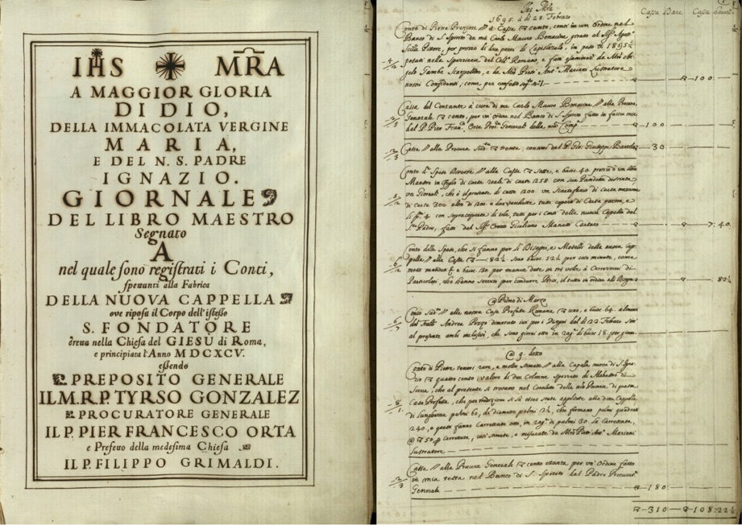

Figure 2. The Journal. Example of debit (dare) and credit (havere) entries for the cash account (Cassa) (ARSI, Chiesa del Gesù, 2056, Front page, f. 1 r)
© Archivum Romanum Societatis Iesu

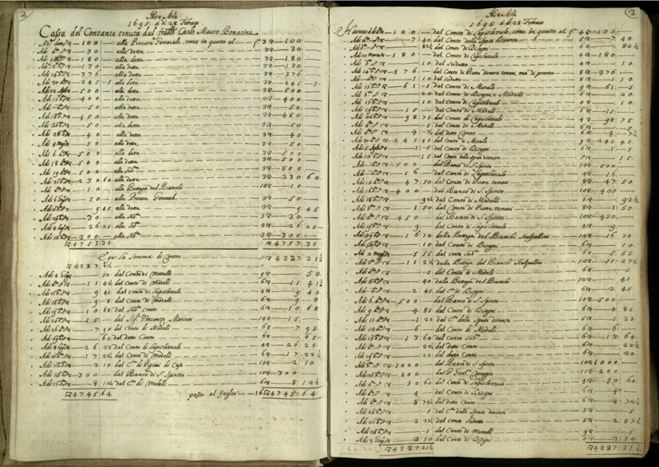

Figure 3. A page from the General Ledger (ARSI, Chiesa del Gesù, 2057, ff. 2 r, 2 v)
© Archivum Romanum Societatis Iesu

Together with the Journal and the Ledger, another book titled ‘Workmen’ was filled in with information about salaries and payments. The workmen had to keep their own notes (an example is provided in figure 4) and present them to Bonacina as soon as the due works were completed.

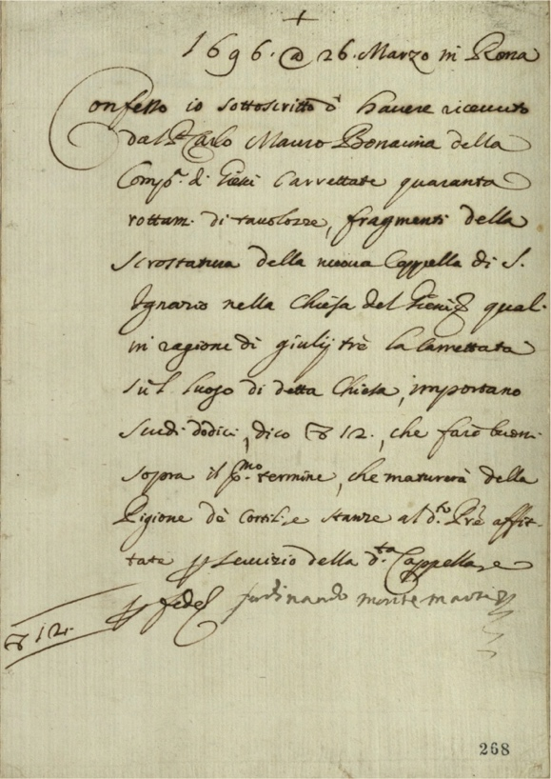

Figure 4. A Receipt from a workman (ARSI, Rom. 140, f. 268 r)
© Archivum Romanum Societatis Iesu

Bonacina had to report his accounts to the Congregatio Procuratorum only after the completion of the works. In his memoriale he wrote that “the accounts related to the project were not viewed by anyone before the Congregatio Procuratorum, which took place here [in Rome] in 1700” (Bonacina, ARSI, Rom. 140, f. 28 v). However, there is evidence that the General of the Order viewed the accounts before that time and that the accounts were used to justify the request for further financial support in the project of construction. This is demonstrated by a letter written by the General of the Society on 14th May 1699 to the General Procurator (ARSI, Fondo Gesuitico 494, f. 203 r):

For the completion of the works of the chapel, it is necessary to pay many workers and other things, such as ornaments and precious stones [...] there is no money destined for these works, as can be seen from the accounts of brother Bonacina, superintendent of the project. Since we currently do not have the cash offers from the Provinces of the Indies, and other places, we order the Procurator Orta to find the sum of 4,000 scudi in every practicable way. According to our estimates, this sum will be sufficient for the aforementioned completion of the altar.

In a further document dated 3rd August 1699, the General of the Order asked the General Procurator to find additional 2,500 scudi and give this amount to Bonacina (ARSI, Fondo Gesuitico 494, ff. 204 r, 204 v):

According to the calculations of expenses presented by Bonacina, superintendent of the project, additional 2,452 scudi are needed to complete the works that are not yet finished. I therefore decided to collect this missing sum and round it up to 2,500 scudi so that all the work can be quickly completed. I order the Procurator to collect and pay the sum of 2,5000 scudi in the hands of brother Carlo Mauro Bonacina according to the need. [...] I promise to repay such sums to the Procurator and his successors pro tempore with the alms and the sums that we will have at free disposal.

The final comprehensive financial statement related to the total expenses of the project (Nota dè capi delle spese fatte per la fabbrica della nuova cappella di n.ro S.P. Ignazio, cominciando dal dì 28 Febbraio 1695 sino alli 8 marzo 1700 - Total expenses for the building of the altar of St. Ignatius, from 28th February 1695 to 8th March 1700) was finally presented to the Congregatio Procuratorum in 1700. The accounts showed total cost for the altar of 118,923.21½ Roman scudi (see figure 5), which was far below the amount of 400,000 Roman scudi that rumours attributed to the project.

According to a universal voice the total expense for the construction of the altar was more than 400,000 roman scudi. Those who had some experience in similar projects made it worth 200,000 roman scudi. The truth is that the final expense on 8th March 1700, as seen in the following note [see figure 5], already presented to the aforementioned Congregation [the Congregatio Procuratorum], reaches the sum of 118,923.21½ Roman scudi (Bonacina, ARSI, Rom. 140, f. 29 r).
List of expenses
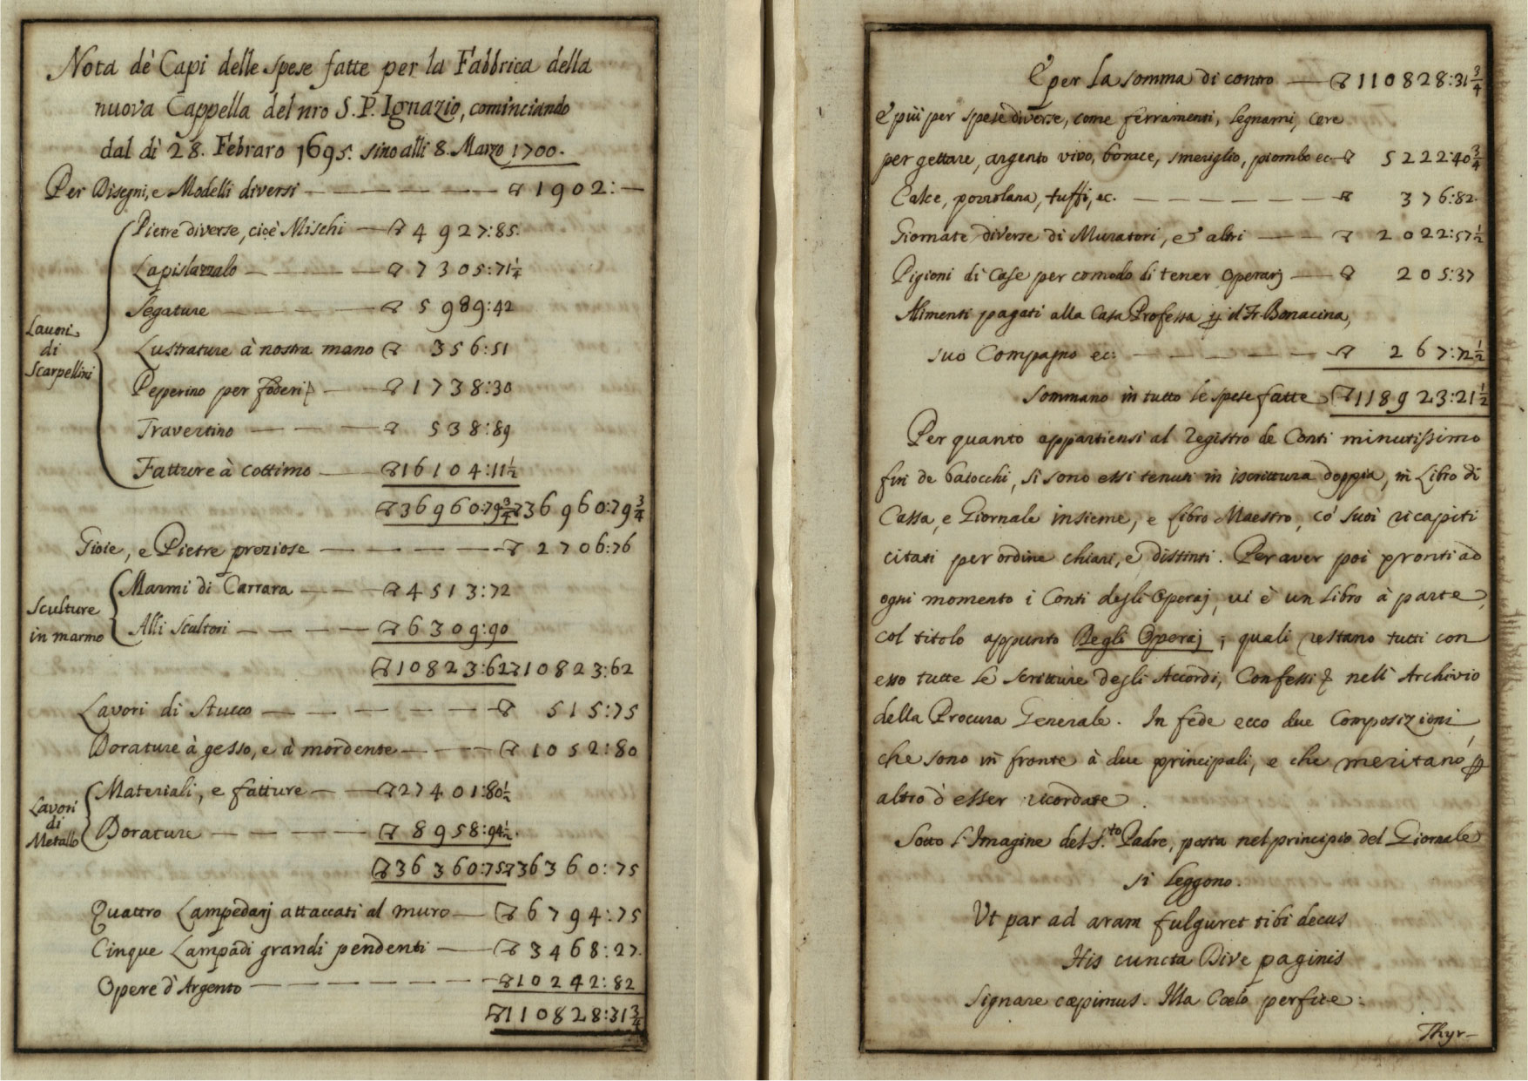
Total cost of the project: 118,923.21½ Roman scudi

List of expenses

Figure 5. The total cost of the altar of St. Ignatius in the Church of Gesù
(Bonacina, ARSI, Rom. 140, ff. 29 r, 30 v) © Archivum Romanum Societatis Iesu

The accounting books kept by Bonacina provided very detailed calculative accounts defining a specific, finite, time-space of accountability for the project: these accounts fulfilled Bonacina’s calculative accountability towards the Order and the aristocratic families who had an interest in the project, by enabling Bonacina to give (calculative) reason for action. The accounting books could be drawn upon to demonstrate Bonacina’s efficient and effective use of resources for the entire duration of the project against the rumours, interferences and critiques moved towards him. Indeed, on the basis of these accounts, Bonacina obtained further 6,500 Roman scudi from the Order for the ornaments of the altar (ARSI, Fondo Gesuitico 494, ff. 203 r, 204 r, 204 v). However, calculative accountability did not discharge Bonacina from providing a self-reflection about his actions, including his bookkeeping, and about the precepts and reasons inspiring those actions. As we will see next, this self-reflection was aided by narrative, non-calculative, accounts and spanned beyond the time-space frame of the project.

- Narrative accounts about accounting and organizing

As well as keeping detailed calculative accounts about the project, Bonacina wrote a memoriale in which he provided his story about the project: a personal view about his actions and decisions for the building works, the accounting system and the management of the project. In his memoriale, Bonacina compared his building site to a clock which “cannot mark or strike the time right, if every wheel does not perform its role well” (Bonacina, ARSI, Rom. 140, f. 40 v). Also, Bonacina praised the efficiency of the works and the absence of incidents:

The reader [of this memoriale] may rightly be surprised of not having heard of any disorder or tragedy happened: that seems unthinkable in such a machine that carries and transports so many delicate marbles in their place, so many statues, columns, with so many workmen on scaffoldings […] We often see accidents happening in minor projects […]; it is very surprising to notice that in this project [the construction of the altar] no man and no marble was ever hurt (Bonacina, ARSI, Rom. 140, f. 25 v).

Bonacina provided a personal account of the jubilation of the hearts following the opening of the chapel, and the astonishment of the believers and visitors, admiring the ‘miracle’ of the painting lifted up to reveal the statue of the saint:

And the day of the solemn opening of the chapel arrived. Here the reader must forget about all the images of the past, that this discovery [the altar] is almost a splendid sun, which rises to dissipate and clouds, and mists, which enlivens the herbs, languid, and dull flowers, which rejoices and earth, and heaven, bringing not less light to the eyes, than jubilation to the hearts (Bonacina, ARSI, Rom. 140, ff. 23 r, 23 v).

A secular who was perhaps the fiercest enemy of this project, in the midst of that great world of people, ran towards Father Bonacina and hugged him, extinguishing with this generous act the fire of his past fervour (Bonacina, ARSI, Rom. 140, f. 24 r).

Bonacina also offered his view of the calculative accounts he kept for the project (Bonacina, ARSI, Rom. 140, ff. 29 r, 29 v – quoted above), and he suggested ways for keeping accurate accounts, as “it is of utmost importance to know how to record accounting transactions” (Bonacina, ARSI, Rom. 140, f. 37 v). For example, Bonacina explained that:

It is necessary to calculate the costs, not roughly, but exactly and carefully, by considering not only the materials and invoices, but also the dangers of the conduct, consumption of the tools, gifts and tips, and then add a 15 percent, with regard to unplanned expenses, and additions for improvements (Bonacina, ARSI, Rom. 140, f. 34 r).

In the Ristretto, Bonacina explained his view about the key features of an ‘ideal superintendent’: “being a good leader, like a practical helmsman of a ship, or a brave general of an army” (Bonacina, ARSI, Rom. 140, f. 34 r). The ideal superintendent described by Bonacina reflected the broader Jesuit ideals of order, activism, self-discipline, self-control and ‘holistic individualism’ (Quattrone, 2004, p. 660), as well as benevolence, humility, patience and charity. Bonacina detailed the qualities of the ideal superintendent into 32 key points. For example:

[The superintendent has to] select trusted experts and sometimes let them secretly visit the works […] Besides listening to the opinions of the experts, [the superintendent needs to be aware] that it is good to listen to everyone, even idiotic people. […] How often the words of a simple person open the intellect of a wise man? Humility! (Bonacina, ARSI, Rom. 140, f. 38 v).

The superintendent has to be aware that […] without order, rule, and subordination, the project will not progress well, and this depends on the superintendent, who must monitor, and be careful, so that everyone does his job (Bonacina, ARSI, Rom. 140, f. 40 v).

Following the Jesuits’ precept of activism, the ideal superintendent had to give prominence to practical knowledge and non-contemplative activities:

[The superintendent has to] [b]e an expert, and not have any other task that occupies him, so that he can be constantly focused [on the project]; [he has to] be of good and known fame. He has not to be in need of money, otherwise his poverty would lead him to vile acts. He has to have had other experiences and needs to be used to directing. He has not to be of short understanding, but prudent and sharp; [he has to have] a bilious nature, but also know how to be moderated, otherwise he will be cheated, and considered as intractable; if he is too impassive, he will never complete the project (Bonacina, ARSI, Rom. 140, ff. 34 v, 35 r).

In so doing, Bonacina also offered his view on the accounting skills expected from the ideal superintendent:

He [the superintendent] must be a skilled accountant, and able to bargain with the chief workmen […] While setting the prices, he has to keep a middle way, without being either too generous or too greedy; and [he] must ensure not to divide activities which can be performed by one workman or under one chief (Bonacina, ARSI, Rom. 140, ff. 35 r, 35 v).

Overall, the narrative accounts of Bonacina provided for a ‘personal voice’: Bonacina accounted for his actions and decisions by narrating his truth about the project in its management, calculative and artistic dimensions, as Bonacina saw them. Also, Bonacina provided an ‘ideal image’ of himself as ideal accountant and ideal superintendent, presenting this image as his legacy for future generations. This is reflected in the title of the memoriale which mentions Bonacina’s aim to leave “instructions for building a similar architecture” (Bonacina, ARSI, Rom. 140, f. 3 r) in future projects. Bonacina wished to provide a comprehensive guide: a “method that may be observed by anyone who wants to conduct a similar work” (Bonacina, ARSI, Rom. 140, f. 34 r). The memoriale was completed by Bonacina in 1706, seven years after the end of the project, six years after the presentation of the calculative accounts to the Congregatio Procuratorum, and one year before Bonacina died. Therefore, the memoriale was not meant to give reasons for action in the specific time-space of the building site. Through the aid of the memoriale, Bonacina offered his accounts to an indefinite future ‘other’.

This indefinite other was sometimes referred to as the Pope [“I am here to humbly plead that Your Holiness may save a few glances on this little ‘Ristretto’ that I am offering, and this will be worth more than any other honour to me” (Bonacina, ARSI, Rom. 140, f. 5r)] - even if there is no evidence that the Pope was actually meant to read the memoriale or ever read it. Other times, Bonacina’s narratives are addressed to a generic ‘reader’ potentially interested in conducting similar works [“The reader may rightly be surprised of not having heard of any disorder or tragedy happened” (Bonacina, ARSI, Rom. 140, f. 25 v); “Here the reader must forget about all the images of the past” (Bonacina, ARSI, Rom. 140, f. 23 r); “I kindly ask the reader for permission to offer a small, but perhaps non intrusive digression” (Bonacina, ARSI, Rom. 140, f. 28 r)].

While addressing his narratives to indefinite ‘others’, Bonacina offered them a personal reflection of himself. In some of the accounts Bonacina detached from himself, taking the point of view of others. He described himself as if he were someone else:

Father Bonacina was a curious figure, of middle stature, half crooked. He resembled a screw, with a little dress, and a little hat. You could hardly see him around, and he spoke little; it happened that when he was first seen [in Rome], and it was clear that he had been called by our Father [the General of the Society], ours [the Jesuits] began to say: “good heavens, look if this is the individual to be called from far away [Bonacina moved from Milan to Rome to take over the administration of the project for the altar] to be the companion of a General” (Bonacina, ARSI, Rom. 140, f. 10 r).

Through these narratives, Bonacina did not attempt to avoid criticism but exposed himself to the rumours and critiques moved by other actors interested in the project. Here, calculative accounts were drawn upon by Bonacina to defend himself from the rumours (Bonacina, ARSI, Rom. 140, f. 29 r). Also, by taking the point of view of others in his narration, Bonacina praised the ideal image of himself. For example, he described his own work as crucial for the success of the project:

The continuous vigilance and diligence of Father Bonacina contributed to the completion and alacrity of the work more than anything else. Although some people, moved by charity, urged him [Bonacina] not to haste, he replied with many thanks: but the success of the work was the responsibility of the superintendent, who had to govern everything, be informed of everything, and supervise and understand everything. To this aim he had to be available at all hours: also because, with the aim of ending the chapel for the holy year, the commitment was such, that forced him [Bonacina] to sacrifice a part of his sleep even more than necessary (Bonacina, ARSI, Rom. 140, f. 28 r).

Bonacina also accounted for his own work from the perspectives of others, such as Cardinal D’Adda (Bonacina, ARSI, Rom. 140, f. 17 v), and through the celebration of the additional works, such as the construction of the Gonzaga chapel between 1697 and 1699) that he was invited to manage, following the success of the altar in the Church of Gesù. While describing the ideal superintendent, Bonacina both defended and gratified himself, exalting his ideal image as a ‘good and indulgent father’ (Bonacina, ARSI, Rom. 140, f. 39 r), following the Jesuits’ precepts. These narratives, however, were not intended for his actual opponents in the time-space of the project, but for indefinite future readers.

Bonacina relied on narrative accounts to offer a personal story of himself as an accountable self: an ideal accountant, an ideal superintendent and a hero of the Jesuit precepts. Calculative accounts and narrative accounts were profoundly intertwined in the construction of the accountable self: whereas the calculative accounts were necessary to ‘define’ the space of accountability of the self, the narrative accounts enabled the self to open up this space and transcend it, placing calculative accountability in a broader context and constructing the self as a ‘transcendent’ self. This process can be further illuminated through the concepts of testimony, gift, narcissism and spirituality, all implicated in the construction of the accountable self.

- The transcendent self and the space of accountability

Testimony and gift
As argued by McKernan (2012), testimony is a personal voice which opens up a relationship with ‘the other’ that calculative forms of accountability do not. Testimony relies upon those narratives through which the self can narrate its story, as the self sees it (McKernan and MacLullich, 2004). However, evidence can abolish the need for testimony (McKernan, 2012), as calculative accounts may lead “to displace the responsibility of decision and judgment from the ‘subjective’ place of thought to the balance sheet of summary numbers that ‘speak for themselves’” (Kamuf, 2007, p. 252). The detailed accounting books kept by Bonacina certainly provided him with a means of ‘evidence’ towards the Jesuit Order and aristocratic families: a means of calculative accountability about the efficiency and effectiveness of the management of the project. Still, this (calculative) means of evidence did not abolish the need for testimony. Through the aid of narrative accounts Bonacina could both reveal his own voice, as testimony, and relate it to the evidence provided by the calculative accounts, thereby defending himself against the criticisms he received for the project (Bonacina, ARSI, Rom. 140, f. 29 r - as quoted above). Rather than defending himself in the specific time-space frame of the project, through testimony Bonacina narrated his calculative accountability to future generations (indeed, the memoriale was completed seven years after the end of the project).

This consideration aids to prior studies that have contrasted ‘testimony’ with forms of ‘evidence’ (McKernan, 2012; Kamuf, 2007), by showing how testimony and evidence can come together in a ‘transcendent’ space of accountability, spanning beyond the specific frame of actions of the accountable self. Judgment was not left only to calculative accounts, ‘speaking for themselves’ through evidence. Nor judgment was left only to the narrative accounts providing for a ‘subjective place of thought’ through testimony. Narrative accounts placed calculative accounts in the broader context of the sentient spiritual dimension of the self: the context provided by the precepts for the ideal accountants and the ideal superintendent, in line with the Jesuits’ precepts, as well as by the ‘jubilation of the hearts’ at the opening of the chapel, the celebration of the saint, the lifting of the spirit, the beauty of the altar and the revelation of the statue hidden behind the painting, all narrated in Bonacina’s memoriale alongside his view on the calculative accounts. Through testimony, narrative accounts both complemented and reinforced calculative accountability by relating it to the personal view of the self, enabling the self to offer a personal account of his own accountability.

At the same time, calculative accounts were part of, and reinforced, the gift of accountability, as Bonacina donated his commitment towards good accounting practices, his detailed bookkeeping, his skills as superintendent, and his fulfilment of the Jesuits’ precepts, as a legacy to future generations. This consideration adds to prior work that has discussed the tensions between calculative accountability and responsibility of the self (McKernan, 2012; Messner, 2009; Roberts, 1991; 2009): we show that these tensions can be addressed through narrative accounts of the self about the self, insofar as these accounts reveal both the sentient spiritual self (longing for a beautiful artwork that could lift the spirits, as well as for an ideal superintendent fulfilling the Jesuits’ precepts) and the calculative self (committed to the efficient use of resources and accurate bookkeeping). It follows that calculative accounts become part of the gift of accountability when such accounts are related to the subjective, sentient, sphere of the self, including its spirituality. Here, whereas the narrative accounts render the self ‘vulnerable’, opening it to judgement and criticism (for example, Bonacina revealed the rumours and critiques against himself in his narratives – see Bonacina, ARSI, Rom. 140, f. 10 r, quoted above), the calculative accounts reinforce the gift of accountability, linking it to forms of evidence. This evidence, however, was not provided only towards a visible ‘other’ inside the time-space frame of the project. As well as being provided through calculative accounts to a specific audience, calculative accountability was also narrated (through testimony) and donated (as a gift) to indefinite future others.

Prior studies have emphasised the importance of ‘visibility relations’ between the accountable self and the ‘other’ within a “local, situated and lived reality “(Frey-Heger and Barret, 2021, p. 3; Messner 2009). The narrative accounts addressed the calculative accounts to an indefinite future ‘reader’ (that could potentially read the accounts after Bonacina’s death – Bonacina, ARSI, Rom. 140, f. 37 v. quoted above) and to future, invisible, generations potentially interested in conducting similar works (Bonacina, ARSI, Rom. 140, f. 34 r, quoted above). This invisibility prevented the ‘other’ to become co-present with the accountable self within the space of accountability, thereby reinforcing the construction of the self through its narcissistic gratification. Whereas prior studies have shown that visibility relations emphasise the sentient dimension of accountability (Frey-Heger and Barret, 2021; Roberts, 1991; 2009; Shearer, 2002), we show that ‘invisibility relations’ between the self and the other can broaden the time-space frame of accountability and, at the same time, exalt the ‘self’ in this frame.

Narcissism and spirituality
In his memoriale Bonacina reflected on his own description of himself. He constructed this description from the point of view of others: Bonacina referred to himself as if he were not him. By both reflecting himself in the narrative accounts and detaching from himself, Bonacina praised himself as an ‘ideal’ superintendent, vigilant and diligent (e.g., Bonacina, ARSI, Rom. 140, f. 28 r, as quoted above). This provided a narcissistic reflection of the self: Bonacina alienated himself from his ‘specular image’, rendering it an ideal image. This imaginary self also provided an account of the spirituality of the self: through the narrative accounts, Bonacina linked the ideal superintendent to the Jesuits’ precepts of benevolence, humility as well as patience and charity, discipline, order, and rule. By celebrating an imaginary self through his narrative accounts, Bonacina exalted himself as a hero of the Jesuits’ precepts, while also providing an account - towards the Order and future indefinite others - of his own way to live and fulfil his spirituality.

Here, we aid to the concept of narcissism explained by Roberts (1991; 2009; 2021) by showing that narcissism is not always associated with calculative accounts, threatening the morality of the accountability relations. Rather, narcissism can derive from the gratification of fulfilling such accountability. This gratification was not a self-interested return derived from the gift of accountability – which would have paradoxically erased the gift itself. Rather, narcissism was provided by Bonacina’s self-admiration for fulfilling the Jesuit precepts through an ideal image of superintendent, thereby making the gift of accountability possible. According to McKernan (2012), drawing on Derrida’s work, the gift of accountability can be undermined by narcissism as the gift is only possible if related to a “subjectless generosity toward the other, a generosity without origin or propriety” (p. 274). We extend this consideration by showing that the spirituality of the self may lead to ‘generous’ forms of narcissism where the self is willing to donate an ideal image of himself - his ideal self - to others. The ideal self incorporates both an ideal calculative self, committed to the efficient and effective use of resources through calculative accounts, as well as an ideal spiritual self, hero of the Jesuit precepts. It also follows that the self can construct itself within and beyond a finite time-space of accountability, as a transcendent, accountable self, through the interplay between testimony, gift, narcissism and spirituality.

McPhail and Cordery (2019) emphasise that a theological perspective into accounting “may be instructive”, as it enables “viewing spirituality as part of our human condition” (p. 2346). We reinforce this consideration by showing that through the narrative accounts (of the self and about the self), calculative accountability can be related to the spirituality of the self, showing how the self fulfils this spirituality. In so doing, it is possible to overcome the risk pointed by Roberts (2021) about viewing the calculative self in opposition with the sentient, human, self. Here, we suggest that narrative accounts can be drawn upon to link the calculative self to the spirituality the self aims to fulfil. It follows that the sentient spiritual self needs the calculative self, and the opposite, as the space of accountability is both defined and transcended through calculative and narrative accounts.

- Conclusions

By drawing on the unique setting of the project for the altar of St. Ignatius in Rome, Italy (1695 - 1699), this paper extends prior studies on accountability that have focussed on the construction of the accountable self (Boland and Schultze, 1996; Willmott, 1996; Roberts, 2009; Joannides, 2012; Masiero, 2020). We demonstrate that narrative accounts and calculative accounts engage in the construction of the accountable self, and of its space of accountability, as they both define and transcend this space, thereby constructing the self as a transcendent self. We show that this engagement can be read through testimony, gift, narcissism and spirituality. Through testimony and gift, narrative accounts place calculative accounts into a broader space of accountability, addressing those accounts towards an indefinite, invisible, future other. Such invisibility reinforces the narcissistic gratification of the self, which however does not oppose the gift itself as the self donates its ideal image (both as a calculative and a sentient self) to indefinite others, in the attempt to fulfil its spirituality. In so doing, we extend prior work on testimony and gift (McKernan, 2012) by showing their engagement with calculative accountability through narrative and calculative accounts.

Our findings also answer the call for more studies on theological perspectives on accounting and accountability (McPhail and Cordery, 2019; Cordery, 2015; McPhail et al., 2004) and on the sentient self (Roberts, 2021). We show that spirituality is not a mere background for calculative accounting and accountability practices, but rather it enhances the possibility for transcendent forms of accountability, while revealing the human, sentient, dimension of the self. Here, we show the importance of understanding how calculative and narrative accounts engage and are drawn upon together in the making of the accountable self, emphasising the need for a shift from a focus on the social relationships taking place in a definite, finite, time-space context, to the understanding of a ‘transcendent space’, embracing the spirituality of the self while leaving the self, with its narcissism, at centre stage in the space of accountability. In so doing, we also add to prior studies on accounting narratives (e.g., Beattie and Davison, 2015; Eshraghi and Taffler, 2015; Lai et al., 2018) by showing how narrative accounts of the self and about the self, both a calculative and a sentient self, can be drawn upon to broaden the space of accountability, linking calculative accounts to the subjective and spiritual sphere of the individual.

In this paper we examined the narrative and calculative accounts about the project of construction of an altar. Further research can be undertaken to uncover how theological perspectives can be drawn upon to reveal the sentient dimension of accountability relations also outside religious settings. Future research could also examine further (non-calculative) accounts of the self, such as images, portraits, but also other artworks, in engaging with the subjective, spiritual and emotional sphere pertaining to the self, eventually providing for non-calculative forms of accountability. Here, our study suggests the need for exploring multiple accounts of the self, understanding how these accounts engage with each other in both defining and transcending the space of accountability.

Appendix 1 – Primary sources

Primary sources written by Carlo Mauro Bonacina

Narrative accounts

Archival records | Description of the source | Period covered and date of preparation | Location, codes and pages
Ristretto dell’avvenuto nella fabrica della Cappella del Nostro Santo Padre Ignatio nella Chiesa della Casa professa della Compagnia di Gesv’ di Roma con l’aggiunta d’un istruzzione per chi volesse fare un’opera simile (“Synopsis of the building works related to the construction of the altar for our patriarch Saint Ignatius Loyola in the Church of Gesù with instructions for building a similar architecture”) | The memoriale (memoir) contains all the narrative accounts related to the project and its accountings. | The memoriale is dated 1706, and covers the period from 1691 (when Bonacina arrived in Rome) to 1700 (when the final comprehensive financial statement related to the total expenses of the project was presented to the Congregatio Procuratorum) | ARSI, Archivum Romanum Societatis Iesu, Rom. 140, ff. 3 r – 41 v.

Calculative accounts

Archival records | Description of the source | Period covered and date of preparation | Location, codes and pages
Libro Giornale (“The Journal”) | The accounting books of the building works for the altar of St. Ignatius. | 1695 - 1699 | ARSI, Chiesa del Gesù, 2056.
Libro Mastro (“The General Ledger”) |  | 1695 - 1699 | ARSI, Chiesa del Gesù, 2057.
Libro Operai (“The Workmen book”) |  | 1695 - 1699 | ARSI, Chiesa del Gesù, 2058. ARSI, Rom. 141, Vol. 2.

Other primary sources

Archival records | Description of the source | Period covered and date of preparation | Location, codes and pages
Catalogus Triennales (“Triennal Catalogue of the Milan Province”) | The Catalogi were reports sent every year (Catalogi Breves) and every three years (Catalogi Triennales) to Rome by each Province in order to inform the superiors of the local situation. These reports provided information on the number and identity of the Jesuits that lived in each Province. | 1665 - 1690 | ARSI, Med. 54, 55, 56, 57, 58, 59.
Catalogus Breves Domus Professa Roma (“Catalogue of the Roman Domus Professa”) |  | 1549 - 1730 | ARSI, Rom. 78 c.
Catalogus Breves (“Annual Catalogue of the Roman Province”) |  | 1705 - 1710 | ARSI, Rom. 97.
Diligenze fatte per l’elezzione del disegno per la nuova cappella del N.S.P. Ignazio dà farsi in questa chiesa del Gesù di Roma (“Diligences on the election of the design for the new chapel of our patriarch Saint Ignatius to be built in in this Church of the Gesù in Rome”) | The records of the examining commission appointed for the project. | 1695 | ARSI, Rom. 140, ff. 46 r – 66 r.
Epistolae Generalis (“Letters of the General”) | Letters from the General of the Order, Tirso Gonzales, to the General Procurator, Pier Francesco Orta, concerning the financial resources needed for the completion of the project. | 14th May, 1699 | ARSI, Fondo Gesuitico 494, ff. 203 r, 203 v.
 |  | 3rd August, 1699 | ARSI, Fondo Gesuitico 494, ff. 204 r, 204 v.

References

Beattie, V., (2014), “Accounting narratives and the narrative turn in accounting research: issues, theory, methodology, methods and a research framework”, The British Accounting Review, Vol. 46 No. 2, pp. 111–134.

Beattie, V. and Davison, J. (2015), “Accounting narratives: storytelling, philosophising and quantification”, Accounting and Business Research, Vol. 45 No. 6/7, pp. 655-660.

Bento da Silva, J., Quattrone, P. (2021), “Mystery-driven Institutionalism: The Jesuit Spiritual Exercises as a Book of Practices Leading Nowhere” in Lounsbury, M., Anderson, D.A. and Spee, P. (Ed.) On Practice and Institution: New Empirical Directions. Research in the Sociology of Organizations, Vol. 71, pp. 145-164.

Boland R. J. and Schultze U. (1996), “Narrating accountability: Cognition and the production of the account- able self”. In: Munro, R. and Mouritsen, J. (eds) Accountability: Power, Ethos and the Technologies of Managing. London: International Thomson Business Press, pp. 62–81.

Carmona, S. and Ezzamel, M. (2007), “Accounting and accountability in ancient civilizations: Mesopotamia and ancient Egypt”, Accounting, Auditing & Accountability Journal, Vol. 20 No. 2, pp. 177-209.

Carnegie, G., D., Napier, C. J. (2012), “Accounting’s past, present and future: the unifying power of history”, Accounting, Auditing & Accountability Journal, Vol. 25 No. 2, pp. 328-369.

Collins, D., Dewing, I. and Russell, P., (2015), “Between maxwell and micawber: plotting the failure of the equitable life”, Accounting and Business Research, Vol. 45 No. 6/7, pp. 715–737.

Cordery, C.J. (2015), “Accounting history and religion: a review of studies and a research agenda”, Accounting History, Vol. 20 No. 4, pp. 430-463.

Czarniawska, B. (1998). A Narrative Approach to Organization Studies. SAGE University Paper, SAGE, Thousand Oaks, CA, London and New Delhi.

Dal Mas, R. M. (1996). “L’altare di sant’Ignazio nel Gesù di Roma: cronache del progetto”. In De Feo, V. and Martinelli, V. (eds.), Andrea Pozzo, pp. 144-155. Milano. Electa.

De Feo, V. (1996). “Le cappelle e gli altari”. In De Feo, V. and Martinelli, V. (eds.), Andrea Pozzo, pp. 114-143. Milano. Electa.

Decker, S. (2013), The silence of the archives: Business history, postcolonialism and archival ethnography. Management & Organizational History, 8, 155–173.

Derrida J. (1986), Le bon plaisir de Jacques Derrida – an interview with Didier Cahen, for France-Culture, Broadcast on March 22, 1986. Published as: Entretien avec Jacques Derrida. Diagraphe 1987;42(December). Translated by Kamuf P. There is no one Narcissism. In: Weber E, editor. Points . . . interviews 1974–1994. Stanford: Stanford University Press; 1995, pp. 196–215.

Derrida J. (1991). Donner le temps: 1. La fausse monnaie. Paris: Editions Galilée. Translated by Kamuf P. Given time: 1. Counterfeit money. Chicago: University of Chicago Press; 1992.

Derrida J. (1992), Donner la mort. In: L’éthique du don, Jacques Derrida, et la pensée du don. Paris: Métailié-Transition; 1992. Translated by Wells D. The gift of death. Chicago: University of Chicago Press; 1995.

Derrida J. (1996), Foi et savoir: les deux sources de la religion aux limites dela simple raison. In: La Religion: Séminaire de Capri sous la direction de Jacques Derrida et Gianni Vattimo. Paris: Éditions du Seuil; pp. 9–86. Translated by Weber S. Faith and knowledge: two sources of ‘religion’ at the limits of reason alone. In: Anidjar G, editor. Acts of religion. New York: Routledge; 2002. p. 42–101.

Dillard, J. and Vinnari, E. (2019), “Critical dialogical accountability: From accounting-based accountability to accountability-based accounting”, Critical Perspectives on Accounting, Vol. 62, pp. 16–38.

Eshraghi, A. and Taffler, R., (2015), “Heroes and victims: fund manager sensemaking, self-legitimation and Storytelling”, Accounting and Business Research, Vol. 45, No. 6/7, pp. 691–714.

Evans, L. and Pierpoint, J., (2015), “Framing the magdalen: sentimental narratives and impression management in charity annual reporting”, Accounting and Business Research, Vol. 45, No. 6/7, pp. 661–690.

Frey-Heger, C. and Barret, M. (2021), “Possibilities and limits of social accountability: The consequences of visibility as recognition and exposure in refugee crises”, Accounting, Organizations and Society, Vol. 89, 101197.

Gallhofer, S. and Haslam, J. (2011), “Emancipation, the spiritual and accounting”, Critical Perspectives on Accounting, Vol. 22 No. 5, pp. 500-509.

Ganss, G. E. S. J. (1970). Ignatius of Loyola. The Constitutions of the Society of Jesus (G. E. S. J. Ganss (Transl. & Ed.). St. Louis: The Institute of Jesuit Sources).

Gargano, M. (1996). “L’altare di sant’Ignazio nel Gesù di Roma: committenza e cantiere”. In De Feo, V. and Martinelli, V. (eds.), Andrea Pozzo, pp. 156-167. Milano. Electa.

Gendron, Y. and Spira, L.F., (2010), “Identity narratives under threat: a study of former members of Arthur Andersen”, Accounting Organizations and Society, Vol. 35, pp. 275–300.

Gibbon J., (2012), “Understandings of accountability: an autoethnographic account using metaphor”, Critical Perspectives on Accounting, Vol. 23, No. 3, pp. 201-212.

Joannides, V. (2012), “Accounterability and the problematics of accountability”, Critical Perspectives on Accounting, Vol. 23 No. 3, pp. 244–257.

Kamuf, P. (2007), “Accounterability”. Textual Practice, Vol. 21 No. 2, pp. 251–66.

Killian, S. (2015), “‘For lack of accountability’: The logic of the price in Ireland’s Magdalen laundries”, Accounting, Organizations and Society, Vol. 43, pp. 17 –32.

Kosmala, K. and McKernan J. F. (2011), “From care of the self to care for the other: Neglected aspects of Foucault’s late work”, Accounting, Auditing & Accountability Journal, Vol. 24 No. 3, pp. 377–402.

Lai, A., Stacchezzini, R. and Melloni, G. (2018), “Integrated reporting and narrative accountability: the role of preparers”, Accounting, Auditing & Accountability Journal, Vol. 31 No. 5, pp. 1381-1405.

Masiero, E. (2020), “Accountability by the accountable self: The case of Leone Wollemborg”, Accounting History, Vol. 25 No. 1, pp. 109–133.

McKernan J. F. (2012), “Accountability as aporia, testimony, and gift”, Critical Perspectives on Accounting, Vol. 23 No. 3, pp. 258–278.

McKernan J. F. and MacLullich K. K. (2004), “Accounting, love and justice”, Accounting, Auditing & Accountability Journal, Vol. 17 No. 3, pp. 327–360.

McKernan J. F. and McPhail K. (2012), “Accountability and Accounterability”, Critical Perspectives on Accounting, Vol. 23, pp. 177-182.

McPhail K. and Cordery C. (2019), “Theological perspectives on accounting: worldviews don’t change overnight”, Accounting, Auditing & Accountability Journal, Vol. 32 No. 8, pp. 2330-2352.

McPhail, K., Gorringe, T. and Gray, R. (2004), “Accounting and theology, an introduction: initiating a dialogue between immediacy and eternity”, Accounting, Auditing &Accountability Journal, Vol. 17 No. 3, pp. 320-326.

Merleau-Ponty, M. (1962), The Phenomenology of Perception, Routledge and Kegan Paul.

Messner, M. (2009), “The limits of accountability”, Accounting Organizations and Society, Vol. 34 No. 8, pp. 918–38.

Miller, P., and Napier, C. (1993), “Genealogies of calculations”. Accounting, Organizations and Society, Vol. 18, Nos. 7/8, pp. 631–647.

Miller, P., Hopper, T. and Laughlin, R. (1991), “The new accounting history: an introduction”, Accounting, Organizations and Society, Vol. 16 Nos. 5/6, pp. 395-403.

Munro, R., and Mouritsen J. (1996). Accountability: Power, Ethos and the Technologies of Managing. London: International Boston Business Press.

Parker, L. D. (1999), “Historiography for the new millennium: Adventures in accounting and management”, Accounting History, Vol. 4 No. 2, pp. 11–42.

Parker, L. D. (2014), “Corporate social accountability through action: Contemporary insights from British industrial pioneers”, Accounting, Organizations and Society, Vol. 39 No.8, pp. 632–659.

Pozzo, A. (1700). Perspectiva Pictorum et Architectorum, vol. II, Roma.

Quattrone, P. (2004), “Accounting for God. Accounting and accountability practices in the society of Jesus (Italy, 16th– 17th centuries)”, Accounting, Organizations and Society, Vol. 29 No. 7, pp. 647–683.

Quattrone, P. (2009), “Books to be practiced: Memory, the power of the visual, and the success of accounting.” Accounting, Organizations and Society, Vol. 34 No. 1, pp. 85–118.

Quattrone, P. (2015), “Governing Social Orders, Unfolding Rationality, and Jesuit Accounting Practices: A Procedural Approach to Institutional Logics”, Administrative Science Quarterly, Vol. 60 No. 3, pp. 411-445.

Quattrone P., Ronzani, M., Jancsary, D., and Hoellerer, M. A., (2021), “Beyond the visible, the material, and the performative: Shifting perspectives on the visual in Organization Studies”, Organization Studies.

Roberts, J. (1991), “The possibilities of accountability”, Accounting, Organizations and Society, Vol. 16 No. 4, pp. 355-368.

Roberts, J. (1996), “From discipline to dialogue: Individualizing and socializing forms of accountability”. In: Munro R. and Mouritsen J. (eds) Accountability: Power, Ethos and the Technologies of Managing. London: International Boston Business Press, pp. 40–61.

Roberts, J. (2009), “No one is perfect: the limits of transparency and an ethic for ‘intelligent’ accountability”, Accounting Organizations and Society, Vol. 34, pp. 957–70.

Roberts. J. (2021), “The boundary of the ‘economic’: Financial accounting, corporate ‘imaginaries’ and human sentience”, Critical Perspectives on Accounting, Vol. 76, 102203.

Roberts, J. and Scapens, R. (1985), “Accounting systems and systems of accountability–Understanding accounting practices in their organizational contexts”, Accounting, Organizations and Society, Vol. 10 No. 4, pp. 443–456.

Rossi, E. (1943), Roma Ignorata, in “Roma”, XXI.

Schwager, K. and Schlimme, H. (2002), “La chiesa del Gesù di Roma”, in R. J. Tuttle, B. Adorni, C. L. Frommel, C. Thoenes (eds.), Jacopo Barozzi da Vignola, p. 272-99. Milano. Electa.

Schweiker, W. (1993), “Accounting for ourselves: accounting practice and the discourse of ethics”. Accounting Organizations and Society; Vol. 18 Nos. 2/3, pp. 231–52.

Shearer, T. (2002), “Ethics and accountability: from the for-itself to the for-the-other”. Accounting, Organisations and Society, Vol. 27 No. 6, pp. 541–73.

Sinclair, A. (1995), “The chameleon of accountability: Forms and discourses”, Accounting, Organizations and Society, Vol. 20 No. 2–3, pp. 219–237.

Willmott H. (1996), “Thinking accountability: Accounting for the disciplined production of self”. In: Munro R. and Mouritsen J. (eds) Accountability: Power, Ethos and the Technologies of Managing. London: International Boston Business Press, pp. 23–39.

Wittkower, R., and Jaffe, I. B. (1972), Baroque art: the Jesuit contribution. New York: Fordham University Press.

In this paper all quotes from the Archivum Romanum Societatis Iesu (the Roman Archive of the Society of Jesus, or ARSI) are the authors’ translation from ancient Italian.
The Avvisi were handwritten and usually anonymous news bulletins prepared by private individuals. Roman Avvisi were collected and published by Ermete Rossi in the 1930s and 1940s in the periodical Roma, under the rubric “Roma Ignorata”. The quote from the Avviso cited in the paper is the authors’ translation from ancient Italian.
The quote from Pozzo’s Perspectiva Pictorum et Architectorum is the authors’ translation from ancient Italian.
“I certify to have received from Father Carlo Mauro Bonacina of the Society of Jesus, 40 cartloads of palette, […] for a value of 12 Roman scudi, which I will use to reduce the rent of the rooms taken for the works in the Chapel, In witness, [workman’s signature]”
The Roman scudo was the currency of the Papal States until 1866.

