Strategic Transformation in Japan’s SMEs, 1990-2008: Flexible Specialization, Industrial Restructuring, and Technological Change

In creating an ‘economic miracle’, the post-war Japanese business system became the admired model of policy makers and business leaders worldwide. Explanations of rapid success veered between the developmental state, bank-led finance, cooperative inter-firm relations, employment practices, a unique culture, or any combination of these elements. Analysis identified a triangle of key actors - government, banks and big business – yet initially overlooked the integral contribution of SMEs. While later interpretations of the ‘miracle’ period partially corrected this imbalance, our knowledge of these firms remains limited, and, in comparison to Japan’s corporations, markedly so. With the perspectives of national bureaucrats and big business executives dictating our understanding of Japanese business history, our article focuses on the goals and actions of small enterprise leaders and their employees. The bursting of the ‘bubble economy’, in 1989-90, turned Japan from challenger of the Western economies into the subject of international criticism. SMEs acutely felt the consequences of failing growth rates and industrial restructuring, and could no longer rely on long-term relationships and supply chains dominated by big companies. This sudden turnabout in economic fortunes, during Japan’s so-called ‘lost’ decades, offers a well-defined opportunity to investigate major debates about SMEs, their management, and, specifically, their capacity to effect purposeful business strategies and transform their businesses. Crisis forced a reconfiguration of internal resources and competitive capabilities, and, to avoid closure, innovation in products and production methods. But rapid change in economic circumstances and industrial structure was just one major strategic issue confronting Japanese SMEs in the 1990s: equally concerning were pressing decisions about installing computerized machinery, which, seemingly, had the potential to replace existing production methods rooted in older, non-computerized tools and handcraft skills. Rival firms re-equipped with transformative technologies would, it was assumed, pose an existential threat to unrestructured businesses. Furthermore, the operational flexibility and efficiencies associated with numerical control and automation offered an available and increasingly persuasive strategic solution to reduced demand, falling prices, and over-dependency on supply-chains. For Japanese SMEs, the conversion from conventional subcontractor into flexible specialist meant acquiring the resources and capabilities to meet varied orders, customize products, and obtain new customers.
Using in-depth cases, government reports, and national data, we present a needed account of Japan’s SMEs in the slow growth era of the 1990s and 2000s. We analyze and compare changes in production, technology and skills in two firms, Industrial Manufacturing Center Ltd (IMC) and Precion Co. Inc., which both fabricated sheet metals for machinery and other products. Responding to the economic crisis, these enterprises acquired computerized equipment and pursued flexible specialisation. Yet they achieved different outcomes. As a result, our research explores the other strategic and operational factors that governed the conversion from subcontractor. The gaps in our historical knowledge of Japan’s SMEs, their organizational characteristics, and innovation processes is especially regrettable for an important and unprecedented period of transformation. One interpretation perceives a ‘paradigm shift’. We investigate the development of systems and capabilities within the two case firms, and detail what any ‘paradigm shift’ meant in practice. After evaluating the influence of economic, structural and technological trends on the decisions of owner-managers, the study focuses on changes in organizational processes and operations.
The article assesses two research questions. Firstly, in responding to waning relational subcontracting and transformative technologies, how effectively did Japanese SMEs between 1990 and 2008 revise their internal resources, products and production capabilities to become flexible specialists? Falling demand, re-ordered supply chains, and growing use of computerized machinery forced Japan’s SMEs to address core strategic issues of market positioning, technological sophistication, and product development. Our cases reveal the direct influence of factors external to the firm, namely economic and technological change, and important decisions by owner-managers. They show, additionally, the role of reformulated internal operational routines, involving owner-managers and engineers, in achieving sustainable strategic transformation. Firms discovered that becoming a distinctive flexible specialist, defined as turning newly-installed technological resources into performance-enhancing capabilities, was more difficult than anticipated. One reason was exaggerated expectations about the ability of the latest production tools to fulfil all production and customer needs. Moreover, because computerization and automation were widely available, they could not by themselves be a source of competitive differentiation and long-term advantage. The case studies concentrate, therefore, on the complex processes of organizational change that followed the introduction of new machinery. Rather than just the adoption of leading technologies, it was their unique combination with existing experience, skills and machinery that created distinctive capabilities and competitive differentiation. Secondly, to what extent can the strategic successes and failures of Japanese SMEs between 1990 and 2008 supply general insights? To elucidate this issue, we draw on major ideas in business strategy and the goals of SMEs.
Before detailing the IMC and Precion cases, the article considers in turn the two key external factors, namely economic restructuring and technological advances, that shaped the fortunes of SMEs after 1990. We begin, therefore, with an historical survey of relational subcontracting and production pyramids, and assess their particular importance to Japanese manufacturing. The article discusses how the bursting of the bubble economy and the reaction of large companies threatened a well-established system, and how economic restructuring forced SMEs in the 1990s into strategic realignment. An analysis of major developments in production technology follows, including the ways in which flexible specialization appeared an apposite response to a contemporary crisis. The next section describes the core aims of SME strategy, and their relation to economic restructuring and technological change during 1990-2008. Based on the production and product problems confronting Japanese SMEs, the section explains the choice of case firms and their analysis. After our accounts of IMC and Precion, the article concludes by addressing the research questions.

Japanese SME Networks and Economic Restructuring

Small-scale workshops contributed to industrial development before and during the First World War, and expanded in scope during the 1920s and 1930s. The 1937-45 Pacific War left a lasting legacy: as well as greatly expanding industry, it forged the political and economic structures that would oversee post-war growth. The conflict influenced the Japanese model of industrial planning, state-firm relationships, bank finance, business networks, professionalized corporate management, and inclusive employment relations. Furthermore, it embedded SMEs into production pyramids with major companies at their apex. War’s insatiable demand for munitions and resources forced large firms to switch from in-house production in favor of subcontracting. Small enterprises were, by 1945, tied to government-controlled businesses, and these relationships enabled advances in their engineering techniques, skills, and quality of output. After the Korean War of 1950-53, the Ministry of International Trade and Industry (MITI) formulated plans that prioritized national resources, and selected industries for development. During the ‘miracle’ growth period, Japan absorbed leading foreign technologies and product standards, but it ensured indigenous control of production and promoted local innovation. Industrial plans focused in turn on steel, automobiles, and electronics, while allowing scope for corporate initiative. To facilitate the rapid growth in production, large manufacturers increasingly utilized subcontracting networks. GDP grew by 8.8 per cent per annum between 1950-60, doubling the size of the economy, and by 10.2 per cent between 1960-73, which drove a shift towards high value services and greater capital-intensity. Some 1.1m workers moved from agriculture and the primary sector into industry between 1950 and 1955, when manufacturing employees numbered 6.9m, subsequently growing to 13.5m by 1970. Although global crises in the 1970s curbed the ‘miracle’ growth rates, the 4.2 per cent per annum achieved in the 1980s compared favourably with major rivals.

[Table 1]

While legally and financially independent, Japanese SMEs could be functionally and strategically reliant on main customers. Studies of the post-war automobile industry demonstrate how the integration of keiretsu networks supported the development of highly competitive production methods. They show, too, that large company programmes to enhance supplier competence significantly constrained SME governance and investment decisions. Established in 1948, as part of MITI, the SME Agency recognized the duality of the industrial system. In 1951, wages in enterprises with 4-19 on their payroll equalled 50 per cent of those available in large firms; businesses with 20-59 employees offered some 56-68 per cent. The employees of small enterprises could not anticipate job security, and expected few non-wage benefits. Major manufacturers relied, nonetheless, on the cost efficiencies, quality components, skills, and specialized machinery to be found within vertical supply chains. They offered SMEs secure orders, and technological, managerial, and production assistance; in return, they used SMEs as buffers against demand and price falls. Banks preferred to finance SMEs with long-term contracts and stable orders from large companies. Being distrustful of outside shareholders, and valuing managerial control, SME owners needed access to bank financing. Although the lean production system associated with large Japanese manufacturers lacked the returns to scale and automation levels associated with the US, it contained compensating advantages in low inventory, fewer product defects, and a just-in-time system entrenched in relational subcontracting. Stable relationships limited the leaking of proprietary and insider information. Subcontractor motives were complex and conflicted. They relied on their connections with large companies, but vulnerability and fear of terminated orders motivate production and investment decisions. Suppliers experienced a paradoxical cycle of deeper vertical integration and greater insecurity. Many did not possess or proved unable to develop distinctive products, skills, technologies, innovation capabilities, or marketing expertise. The loss of a major contract badly damaged a firm’s reputation with customers and banks. The story from the bottom of the production pyramid was frequently one of technology expropriation and squeezed prices. As a result, independent SME associations sought to improve the status and operational freedom of its members.

[Table 2]

Employment in a recognized corporation bestowed social status, higher pay, regular promotion, and steady employment. SMEs implied economic backwardness, low productivity, old technologies, and cheap labour. In 1963, the Basic Small Business Law defined SMEs as having less than 300 employees, reiterated their role within supply chains, and urged improvements in management, skills, and machinery. Some 24.2 per cent of Japanese SMEs, in 1966, stated that they had only a single customer; 18.6 per cent had several main customers; some 10.6 per cent engaged in a mix of subcontracting and independent sales; and, therefore, a total of 53.4 per cent declared involvement in some form of subcontracting. Government policy slowly acknowledged the limits of scale economies and the benefits of industrial diversity. It accordingly encouraged horizontal links and cooperative associations in specialized production and handcrafts, such as those in textiles, houseware and food. In 1982, enterprises with less than 100 employees accounted for approximately two-thirds of private sector personnel, and those employing between 4-299 employees were responsible for 51.9 per cent of manufacturing value-added. By 1991, average wage levels in firms with 30-99 and 100-299 employees were respectively 73.6 and 81.2 per cent of those sized 1,000-4,999. Smaller firms remained more inclined to use ‘non-permanent’ labour.
The latter half of the 1980s witnessed financial deregulation, easy credit, and an asset bubble. The fall in property and share prices that followed 1989-90 cast doubts on Japan’s corporate governance, and challenged the viability of its economic model. An era of deflation, low growth, and industrial restructuring began, involving a banking crisis during 1997-98, with the recession seeing partial recovery by 2000-01 (Table 1). The unravelling of an industrial system exposed the strategic weaknesses of SMEs tied to production pyramids. The loss of stable orders and revenues undermined the foundations of relational subcontracting. Contemporary commentators perceived the hollowing-out of SMEs after 1990 as hastening longer-term challenges for SMEs: they noted the growing sophistication of demand, market segmentation, internationalization, the relocation of production overseas, and technological progress. All these developments, it was argued, required subcontractors to operate more independently. One factor, it was contended, would favour SMEs: new flexible production machinery could greatly enhance their competitive advantage.
More immediately, Japanese SMEs faced an historically unprecedented crisis. A Bank of Japan survey recorded far-reaching price cuts to the components and services supplied by subcontractors between 1991 and 2002. Banks refused loans to endangered or underperforming small firms. The SME Agency recorded how most subcontractors, having invested in operations attuned to the needs of major customers, encountered the crisis with limited managerial know-how, market knowledge, marketing expertise, brand recognition, or financial resources. In 1993, Small and Medium Manufacturers (SMMs) accounted for 71.8 per cent of all Japanese employees and 56.7 per cent of manufacturing value added, against, respectively, the 28.2 and 43.3 per cent for companies employing 300 or more. National shares of employee numbers and value added between small and large firms continued largely unchanged through to 2006 and beyond. The figures indicate the importance of SMMs to total employment, but, in parallel, the continued higher productivity and stronger value chain position of large firms (Table 2). The Small and Medium Enterprise Basic Law of 1999 marked a reversal in official policy: it recognized small firms as sources of economic growth, and emphasized the revitalization of industrial districts, start-ups, innovation, technological upgrading, diversification, better employment, or, in summary, overcoming the duality of firms. By the end of the 1990s, general opinion about SMEs and subcontracting had significantly shifted. Table 3 demonstrates large swings in the operating profits of SMEs and SMMs, and the uncertainty of their environment, particularly during 1996 and 2005 (Table 1).

[Table 3]

Flexible Specialization in Japan

Piore and Sabel, famously, devised the term ‘flexible specialization’. They denied the link between industrial efficiency and mass production, which relied on single-purpose machines, unskilled labour, and the production of standardized goods. Instead, Piore and Sabel pointed to other historically significant forms of production organization. Scranton’s account of US manufacturing, from the late 19th century to the 1920s, similarly re-evaluates mass production. Speciality producers pioneered technological and organizational transformations distinct from routinized assembly, bureaucratic management, and oligopolistic competition. Alongside mass standardised flow production, often labelled Fordism, was bulk production, connected to staple goods and simple technologies. It lowered prices by systemizing output, but did not standardize products. Batch production was potentially large-scale and capital-intensive, but it responded to unpredictable, ‘lumpy’ or varied customer orders. Machinery and engineering projects required different production systems to mass manufactured automobiles or branded packaged goods. Custom production, usually small scale, crafted a single product to meet a specific customer order. Both batch and custom manufacturing needed flexibility and specialization, and complex specifications and differentiated products could assume priority over price competition. Unlike mass producers, with routinized inflexible systems, other firms relied on adjustable, general purpose machinery and skilled workers. Firms could combine a mix of approaches. Although the 1920s saw the rise of mass manufacturing and large enterprises, in the US and Europe, production systems and product markets continued to vary. Flexibility and specialization expanded alongside standardization and mass production. In Japan, post-war large-scale manufacturing achieved competitiveness through higher levels of flexibility than in the US or Western Europe, as evidenced by lean production, multi-skilling, just-in-time, and responsive subcontracting networks. Traditional craft skills, operational flexibility, investments in machinery, cost cutting, and product development within SMEs all contributed to Japan’s post-war success. When writing in the 1980s, Piore and Sabel perceived flexible specialization as defining ‘post-Fordist’ societies. Cooperative networks and specialist subcontracting (distinct from production networks dominated by large firms) would be another characteristic. Piore and Sabel argued that computerized machines and data reduced the advantages of scale, and supported cost-effective batch production. In contrast to large companies, flexible specialists could switch nimbly between customers during periods of economic turbulence. Critics doubted the demise of mass markets and producers, and questioned the ability of resource-limited SMEs to innovate or implement significant changes in product and production strategies. Piore and Sabel held an optimistic vision of differentiated, innovation-led, high-skilled production; they underestimated, arguably, technology’s potential for work intensification and de-skilling. CNC (or Computerized Numerical Control) machines had originated in the US, and, by the 1970s, integrated CAD/CAM (Computer Aided Design/Computer Aided Manufacture) had become commercially available. Over the next decade, Japan emerged as the biggest manufacturer and user of CNC machine-tools, with their rapidly-improving functionality and falling prices. Their technological sophistication and utility improved accuracy, and programming facilitated set-up times, operational agility, and specialized production runs. Automation replaced labour and established skills. Yet it was the post-bubble crisis, the cancellation of major orders, or the threat of closure that led to substantial numbers of Japanese SMEs extensively installing already-available CNC machinery. As a result, contemporary observers viewed Japanese small businesses as transforming themselves into ‘flexible specialists’, with CNC machines creating gains in production methods, batch processes, costs, and product quality. With notable exaggeration, they interpreted flexible specialization as turning subcontractors into the collaborating equals of large companies.
There is danger in simply assuming that Japan’s SMEs were by the 1990s devoid of innovative capabilities or the capacity to change. Many had more than one customer, and would regularly compete for new orders. Investments in plant and machinery secured or retained major clients. Retirement among older craftsmen and the disinclination of younger employees towards traditional skills necessitated the installation of CNC machines. Yet the subcontracting system and dependency on large orders inevitably curtailed production flexibility, and limited strategic options. Technological change appeared as both competitive opportunity and threat during a time of economic uncertainty and supply chain restructuring.
Historical evidence about the impact of new technology on the activities and performance of firms is limited and little understood. As our case studies reveal, SMEs could mistakenly believe that CNC machinery automatically brought the capacity to thrive in the post-bubble economy. In reality, some 53 per cent of surveyed Japanese SMEs, in 2000, reported that established handcraft skills retained their importance and could not be mechanised; 43.8 per cent that technology could not fulfil diverse customer requirements; and 31.0 per cent that traditional techniques allowed flexible responses to design changes. Throughout the 1990s and 2000s, craft techniques and older machinery continued to offer specific operational advantages that CNC tools could not substitute. Since rivals could imitate the example of early users, the new technology was, by itself, a strategically-insufficient solution.

Analyzing SME Strategies: the Japanese Case

In general, four key factors influence and determine SME strategies: external equity, market positioning, new products, and technological sophistication. With traditions of personal control or family inheritance being markedly strong in Japanese SMEs, they commonly relied on long-term bank support. Owners characteristically sought to remain ‘lord of the castle’, and avoided outside shareholders. During the 1990s, over 70 per cent of firms employing less than 300 people continued to declare no interest in external equity, and, after internal revenues, banks remained their main means of finance. With cuts in production capacity and employee numbers, borrowing inevitably fell over the decade. IMC and Precion reported good relations with their banks, and finance was no strategic barrier to their investing in new production equipment and computerized machines. Market positioning enables SMEs to exploit established products more successfully, or to maximize product developments. When large manufacturers in Japan transferred production overseas and moved away from conventional contracting, matters of market positioning, greater independence, and enhanced product development constituted urgent strategic considerations for SMEs. Subcontracting had previously resolved or confirmed market position within supply chains. They exercised, it follows, limited choices over product development, production methods, and technological upgrading. The 1990s pointed to re-appraisal: some 70 per cent of SMEs claimed to have pursued product differentiation. Regarding technological sophistication, Japanese firms had to evaluate their mix of manual skills, human abilities, and machinery, and decide on their willingness or capacity to invest in leading-edge equipment. CNC machines, in principle, bestowed the production flexibility needed to compete for customers, and enabled specialization in high value products and services. Flexible specialization appeared an available alternative to a production architecture and product range designed for supply chains.
Through case-studies, we address the ability of Japan’s SMEs to transform their market position, production, and products through new equipment and technology. As we shall see, aspirations to convert from subcontractor to flexible specialist led to the installation of CNC machinery. To achieve intended strategic outcomes, SMEs had to integrate their new equipment into their existing production systems, and create new or augmented combinations of assets. The resource-based view (RBV) interprets business strategy as firms utilizing heterogeneous internal resources - such as finance, equipment, technology, knowledge, skills, and production and product development systems - to create a sustainable competitive advantage over rivals. Resources contribute to competitive advantage when they are valuable, rare, imperfectly mobile between firms, and non-substitutable. As exampled by Japanese SMEs converting into flexible specialists after 1990, both distinct individual resources and systemic resources that optimize different assets within a firm have relevance. It is the exploitation and not the existence of resources that underpins durable performance. The firm’s capabilities determine the capacity of combined resources to perform a task or activity. Complex internal organizational patterns, built through learning routines and repetition, grow along an incremental development path. A ‘systemic resource’ derives value and uniqueness from being a vital part of a system. By retaining a variety of production options, technologies, and skills, Japanese SMEs maximized operational flexibility, customer responsiveness, and product diversity. Our case-studies identify both individual skills and resources and their systemic linkages, and map out production systems and internal competence transformation over time.
The RBV provides a useful framework for understanding how firms build sustainable and specialized competitive capabilities from their ‘feedstock’ of internal resources. On the other hand, it says little about how firms adapt specialised resources and capabilities in changed circumstances. The RBV does not explain how firms maintain competitive advantage over time, or, as illustrated so clearly in post-bubble Japan, respond to periods of turbulence. The Dynamic Capabilities approach attempts to describe how firms build new competencies or reconfigure existing ones in an altered external environment. In the case of the RBV, internally-generated differentiating capabilities enable firms to compete more effectively or to acquire a lead in the external marketplace; for Dynamic Capabilities, the external environment shapes the formation of differentiating capabilities within firms, and, to survive long-term, changes in external conditions necessitate the reconfiguration of internal capabilities. Critics have commented on the RBV’s inability to distinguish clearly between resources and capabilities, leaving its analytical approach vulnerable to accusations of tautology. Similarly, empirically demonstrating the existence and workings of Dynamic Capabilities presents well-acknowledged problems. Our historical review of Japanese SMEs, therefore, explores how firms responded in different ways to transformed economic and technological circumstances, and, as they sought conversion into flexible specialists, it pinpoints stages in internal reconfigurations of resources and capabilities. The cases support the Dynamic Capabilities school that stresses the significant role of owner-managers in sensing changing conditions and seizing new opportunities. They show, too, that existing SMEs had the capability to transform their competitive fortunes during a period rapid economic and technological change. Our analysis highlights, therefore, the impact of external factors on the internal evolving systems of firms. But it acknowledges how sustainable differentiated resources and long-term flexibility stemmed directly from the internal interactions of owner-managers, engineers and key personnel, and from the inculcation of new or improved systems and routines in product development and production.
Commentators question whether SMEs, lacking scale and resources, can pursue deliberative business strategies, and, therefore, whether they can react effectively to a shifting external environment by fundamentally revising operations or market-position. One response is that researchers have paid comparatively little attention to SMEs, and that more evidence and cases are needed. This article, consequently, details the strategic aims and operational transformation of Japanese SMEs between 1990 and 2008. It describes how reactions to contextual factors rested ultimately on internal processes for acquiring, absorbing and utilizing knowledge. The owner-manager’s personal networks and willingness to assimilate external information were critical catalysts, while internal experimentation and systemization determined the absorptive capacity of firms. The challenges for resource-constrained small firms were, nonetheless, considerable. The advantages of CNC machines were well-known but non-specific, and abandoning valuable resources and capabilities for the advanced technology equipment amounted to a strategic risk. A more evolutionary process allowed opportunities for combining or linking new and old techniques, with the resulting systemic resources and capabilities facilitating hard-to-imitate differentiation in products and production. Traditional skills and older machinery reflected a firm’s experiences and proven competencies. During this period, they continued to embody important production options. Experimentation within a firm, combining older and new techniques, offered chances to build or reconfigure resources more likely to be valuable, rare, imperfectly mobile, and non-substitutable. Integrating technological improvements into existing assets allowed the achievement of strategic aims rather than just operational efficiency. We are concerned with internal processes, including the decisions, contributions, and daily interactions of entrepreneurs, managers, and engineers. Our cases show how one firm, committing wholly to computerized production methods, failed to convert into a flexible specialist. The other firm integrated, systemized, or improved combinations of traditional skills, technology-related skills, older machinery, and new equipment, and achieved the goal of flexible specialist.

[Table 4]

Our research investigates what strategic transformation through flexible specialization meant for SMEs as a process and as outcome. For research purposes, SMEs have the advantage of being at a scale small enough to identify and track the evolution of varied resources and capabilities. Through case studies, we are able to show the interplay of external forces and internal firm processes, and the resulting contribution of internal resources and capabilities to operations and performance. In his insightful survey, Whittaker reveals how Japan’s small firms differed in character from the corporations one-sidedly depicted as the ‘Japanese enterprise model’. He notes how industrial restructuring, the overseas relocation of production, insecure demand, and falling prices signalled in the 1990s severe challenges for SMEs. Whittaker discusses the emerging threat, but, at the time of writing, he cannot describe the fate of small firms during the low growth era that followed. Possible outcomes included the polar opposites of ‘hollowing-out’ and a ‘paradigm shift’. Our research looks in detail at the capacity of Japanese SMEs to undertake a strategic transformation during rapidly-changing circumstances. The cases demonstrate, moreover, the valuable contribution that historical methods and longitudinal case-studies can make in demonstrating the internal processes of firms reacting to a changing landscape.
Both IMC and Precion originated in the 1960s, the high era of supply chain subcontracting (Table 4), and, by 1990, they were located among Japan’s top 5 prefectures for machinery and components manufacture. IMC fell into the category of SMEs with 4-19 employees, which, during 1993, accounted for some 10.4 per cent of Japan’s total employees and 6.8 per cent of value added. Precion could be found among the 20-99 employee category, which, nationally, held 30.8 per cent of employees and 23.9 per cent of value added (Tables 2 and 4). We explore the organizational challenges of the 1990s and 2000s, the strategic reasoning of owner-managers, and the opinions and contributions of engineers. The research used semi-structured interviews, as well as written information and business documents. All interviews were conducted and recorded in Japanese, and later transcribed into English. Surveys and reports, from government and other organizations, allowed the evolving strategies and internal organization of firms to be set within national trends. Owner-managers and engineers completed questionnaires, in which they recorded their roles, skills, years of training, and involvement in and understanding of different processes and production stages. We used the questionnaires to record and construct the individual skills and production tasks of each firm in every year, charting changes in competencies, product development, and production systems. The categorization of engineering skills and expertise follows the approach of Japan’s SME Agency, whose definitions relate directly to the engineers’ ability to work innovatively, independently, or under direction (Table 5). In this way, the research could trace developments over a decade in the level, composition and range of skills; degrees of multiskilling; uses of machinery, and technological change; and integration between production stages. The analysis focuses on the major reconfigurations carried out at each firm specifically as a response to the loss of major contracts and the decline in traditional subcontracting. The cases explore how knowledge exchange and modified combinations of equipment, skills, and experience influenced product development or production.

[Table 5]

Strategic Dependency versus New Technology: IMC

Archetypal Subcontractor: 1967-1995
Hideaki Namiki founded Industrial Manufacturing Center Ltd or IMC, during 1967, in Koga City, Ibaraki Prefecture, northeast of Tokyo. There were four main process stages in shearing and shaping metal sheets for the manufacture of machinery and related goods: product design, blanking (punching holes, or cutting shapes), bending, and welding. As an archetypal subcontractor focused on one customer’s needs, IMC in its early decades needed the efficiency of mass-production machines. Nevertheless, the equipment required manual dexterity and experience, and craft-based skills dominated more complex processes. The combination of methods secured operational flexibility. Relying heavily on three separate groups of craft engineers, who controlled production, clashes over manufacturing plans and access to machinery were commonplace.

[Figure 1]

First Reconfiguration: 1995-1997
In 1995, Shunichiro Namiki, the founder’s son, succeeded as managing director, and embarked on supplementing IMC’s price-sensitive manufacturing with niche markets and product quality. Using his experience as a product designer for a large machine firm, Namiki introduced CAD/CAM to transform IMC’s production system, and, specifically, to fulfil the potential of an under-utilized CNC turret-punch press. The firm acquired the ability to receive customer data electronically, and the central database it created allowed changes to product or component designs. Potentially, CAD/CAM could transform production planning, and automate the cutting and pressing of sheet metal. This new facility, potentially, challenged the operational control and status of the engineers. While it was possible to download CAD/CAM data to the CNC turret-punch press, the number of applications had been limited. In the event, CAD/CAM remained a stand-alone function separate from the other unaltered production processes, and the firm remained, noticeably, a conventional subcontractor in its operational methods, priorities, and narrow sales base. Excepting those involved in CAD/CAM design, most IMC engineers continued with their recognised craft methods and mechanical equipment, and, revealingly, those engaged in the long-established blanking and bending stages held the highest levels of skills and experience (Figure 1).

Second Reconfiguration: 1998
When, during 1998, Japan’s economic difficulties worsened, and its main customer went bankrupt, IMC overnight lost half its sales revenue. Operating profits reached a low of -9.2 per cent, against the national SMM average of 1.7, reversing respective returns of 5.8 and 2.6 per cent the year previously. Confronted with a crisis, Namiki followed his belief in transformative technologies. He set out wholly to cease reliance on conventional machinery and craftsmanship, and to convert IMC into a fully ‘modern’ factory. More sophisticated manufacturing methods would, it was argued, bring greater customer responsiveness and product differentiation. To secure orders and long production runs, Namiki believed that computerized flexible manufacturing had become critical to the large-scale batch efficiency he aspired to implement. Reflecting on recent experience with CAD/CAM, he judged that ‘the most important thing should be to organise these important elements systematically’, transforming processes and deepening links between production stages. In this task, he argued, the managing director would be the prime mover, and the chief reason for success or failure.
IMC began its extensive change programme by investing in additional CNC machinery (namely a LCV3012B laser cutter) to ‘upgrade’ into a more complete computer-based production system. Installing the equipment in parallel to the existing CNC turret press initiated a step-change. Laser cutting gave IMC greater opportunities to exploit transferred customer data and to cut complex shapes automatically, reducing set-up times, increasing operational speed, and improving quality. The laser cutter and turret press tendered distinctive production capabilities: the cutter suited large standarized batches; the press was better for small-batches of differentiated products. Although the press was less flexible than the laser for cutting complicated shapes or fabricating acute angles, it was cheaper to operate and more efficient in making repeated holes of similar patterns. Having received customers’ product data, engineers decided on the appropriate production process, and selected, as required, the laser cutter, turret-punch press, or the older press-brake machine. They then assembled and welded individual manufactured components into saleable products. The change programme, however, had important limits: IMC chose not to invest in expensive CNC bending machines, leaving the process as comparatively time-consuming and craft-based, and all the blanking machines, old and new, required manual and craft skills. As a method of metal-sheet shearing, the laser cutter reduced the number of manual interventions and skills. Comparing 1997 with 2001, IMC increased flexibility and product range at the blanking stage, but, the operations of other more established processes being left unchanged, the deepening or further integrating of production techniques was minimal (Figures 1 and 2). Engineers on the laser cutter involved themselves little in other processes, and had few opportunities and little motivation to exchange knowledge and experience. As laser cutting came to dominate blanking at IMC, its lack of integration and a general failing in systemic planning had consequences. By contrast, skill combinations between the less used computerized punch press and conventional blanking, bending and welding remained minimal, reflecting an entrenched production architecture (Figure 2). Just as CAD/CAM and laser cutter engineers kept mainly to themselves, their older colleagues found computer-based systems difficult to operate.

[Figure 2]

The separateness of laser cutting from much of the production system hindered the building of capabilities in manufacturing flexibility and batch-production. Within a few years, the laser cutter lost its competitive advantage. Little integrated into a distinctive production system, rival firms easily copied its functionality. The problem was especially difficult for IMC, whose shearing, set press and bending skills were similarly commonplace. The costly automated welding facilities were poorly suited to small batch production and multiple lines, and, in reverting back to manual welding, the firm undertook training in skills very recently relinquished. While the CAD/CAM engineers could computerize customer data for production, IMC did not develop the capability for customizing products. Connections between CAD/CAM, design skills, and machining processes were highly restricted, despite such linkages remaining a major strategic objective (Table 7). High competence levels in CAD/CAM rested with the same two expert engineers throughout 1996 to 2005. Since employees involved in CAD/CAM but without highly-rated skills almost doubled from 2002 onwards, the average expertise level at the firm became diluted. Blanking skills and expertise with the CNC machines (the LCV-3012B and the BPEGA357) did not improve, and fell from 2001; bending and welding techniques followed the same pattern. The number of expert engineers engaged in CAD/CAM design, blanking, bending or welding did not increase, and interactions between design and production showed a long-term decline (Table 7). Knowledge diffusion and differentiation in products or production within the firm could not, as a result, fulfil Namiki’s expressed strategic objectives.

Third Reconfiguration in 2002
By 2002, IMC had not upgraded from conventional subcontractor to flexible specialist. CAD/CAM and laser blanking aside, individual engineers continued to control the production of particular product lines, and inhibited the emergence of new routines and techniques. They also saw themselves as being de-skilled. Namiki had been reluctant to challenge the practices of his father and the subordinates he had appointed. Small Japanese manufacturers regarded the emergence of distinct computerized and conventional ‘language’ groups as problematic, and workplace tensions could disrupt production. In deciding every production plan, including choice of materials, machines, and cutting tools, CAD/CAM programmers had gained oversight but not control of operations. In their role, they were unable to increase skill linkages, or generate production and product innovations.

All decisions are made in the office, not in the factory. The managing director and the CAD/CAM programmers discuss issues among themselves, and what we do is to manufacture goods under their decisions and supervision…This created conflict with the older engineers, often relegated to less skilful downstream activities...

From 2002, Namiki abandoned conventional cutting machinery, and pursued differentiation through greater use of new technologies. Instead of evaluating each machine and process, or their contribution to overall effectiveness, IMC looked to new technology to overcome its strategic impasse.

It was a common trend that small manufacturers replaced an old set of cutting machines, called mechanical cutters, with a new set, such as laser cutters and punch presses, around the turn of the century. At that time, the new machines were very expensive, because they had just gone on the market. Therefore, if a firm had a laser cutter, it could highly differentiate its production from competitors.

It was questionable if, in the long term, the available new production technologies by themselves could achieve the goals of flexibility or specialization, and, in the short term, competence might be lost before being replaced. Figure 3 shows the resulting production architecture. The skills associated with shearing and set press processes disappeared, and skill linkages and the capacity to differentiate fell markedly. By ceasing to use the older equipment, Namiki inevitably reduced the variety of production facilities, in the hope that new technology would generate net advantages. He thought it necessary to replace skills he now regarded as redundant. As a result, Namiki had to tackle matters of personnel, observing that:

We had plenty of machines. We could manufacture any line made from sheet metals. The problem was the low rate of operation… I forced our craftsmen not to use those old machines. I abandoned and sold them to change the engineers’ attitudes. In general, the division of labour will increase productivity, but craftsmen with older skills tend to be firmly fixed to stand-alone production with old machines.

[Figure 3]

Organizational change became an issue of transforming attitudes and personnel associated with handcraft skills. Given Namiki’s belief that IMC had too many old machines, total assets per employee decreased from approximately ¥16 million to ¥9 million, far below industry average, between 2003-05. Interestingly, while Japan’s SMMs on average improved their operating profits during this period, those of IMC were falling. The advantages of new technology had seemingly justified full computerization and automation, but IMC’s history from 2002 illustrates its waning advantage. The relinquishing of old technologies and skills depleted IMC’s specialization overall, and, in fact, led to linkages with both traditional and new skills being abandoned (Figure 3). The policy constituted a competence destroying event. When, by 2005, the laser cutting machine had become commonplace in the industry, the rareness and inimitability of the firm’s resources reduced further. The IMC case reveals the critical role of the owner-manager, and, for SMEs, the gains and pitfalls of advanced technologies. Namiki hoped that computerized and centralized product design would itself facilitate innovative product development, integrate design with the most modern production machinery, and generate manufacturing efficiencies. He aspired for IMC to be a product innovator, as well as a flexible specialist and efficient batch producer. Yet the firm did not enhance product differentiation or customization, and, while new technologies at first did bring greater flexibility, the loss of specialised skills eventually had the greater counter-effect. With skill levels and overall connectivity between production stages falling, Namiki failed to integrate or embed routines and understanding between different expert engineers, and to generate product or production specialisms. While Namiki’s strategic intent from 2002 onwards was evident, IMC proved unable to realize his objectives.

[Figure 4]

Flexible Specialization and Systemic Resources: Precion

Subcontractor Capabilities: 1961-2000
Etsuro Suzuki established his private firm, during 1961, as a provider of metal-cutting services, and he re-founded it, formally, as Suzuki Seiki Machinery Ltd ten years later. Tsuneyoshi Suzuki succeeded his father as managing director, during 1991, just as Japan’s economy was slowing. In the following year, wanting to meet the needs of existing customers more effectively, and to expand his business, Suzuki built a new factory in Kanuma City, Tochigi prefecture, north-east of Tokyo, creating Suzuki Precion Co. Inc. The plant used several types of cutting machines to fabricate sheet metal, and manufactured for numerous firms and industries. But it operated principally as a subcontractor to three customers, with one hard disk device (HDD) producer accounting for over 70 per cent of sales. In 1996, Precion extended its capital to ￥20m, mainly to fund investment in new machinery. While the sharp economic downturn of 1997 hit the profits of Japan’s SMMs, Precion recovered quickly between 1998 and 2000. Thanks to the growing demand for HDDs, sales revenues reached ￥1bn. Although Precion sought greater differentiation in production capabilities, its growing dependence on a single customer locked the firm in as a conventional subcontractor.

First Reconfiguration in 2000
From 2000, Tsuneyoshi Suzuki aimed to be a flexible specialist and to distinguish his production processes.

Since around 1995, a variety of new machines with multiple cutting functions had begun to go on the market... As we had sought uncertainly for the potential to expand our business, we decided to install the new CNC machines and specialise in the small-batch production of multiple products… [we] developed a bundle of skills and technology to manufacture highly intricate product shapes.

Despite buying new CNC machines, Precion wanted to augment rather than replace existing craft skills. Computer engineers, who could learn their skills in two years, became increasingly available, and could not offer sustainable differentiation. In contrast to IMC, the production manager of Precion’s CNC precision lathe department defended the combined instilling and preserving of techniques:

The young engineers lack knowledge on cutting techniques, cutting tools, and the quality of materials. There is an implicit knowledge that engineers can learn only from experience. For example, when an experienced engineer looks at a production plan, he can immediately decide on the manufacturing machine, cutting tools, materials, and programming details.

Precion introduced CAD/CAM as the central operating system for CNC machinery and as the basis of its design skill. But, downstream, the firm relied on the experience of older engineers who implemented defining subtle adjustments in product development and production.
CAD/CAM and computerized machines extended the firm’s range of production processes, and they brought about a reconfigured web of interlocking varied specializations and skills. Two new CNC precision lathes (the Takamatsu X-10 and the T-Wave) supported the manufacture of HDDs, and an automatic loader improved set-up times, accuracy, and quality. The T-Wave could process products within an accuracy of 0.1 microns, while the less accurate X-10 assisted mass production. A CNC machining center (the A55) became the main cutting equipment for Precion, and the combination of CAD/CAM with the A55 made it ‘possible to carve complicated shapes out of solid workpieces, so speeding production’. This ‘carving-out’ technique added production functionality, increased the skills pool, and established a machining center department equal in importance to its lathe counterpart. Production developed a multi-functional approach. The firm invested in ‘Swiss-type’ automatic lathes (the SV-12 and the SR-20R) to introduce greater flexibility and high-speed in the machining of sophisticated products, notably medical devices. Four production stages evolved, beginning with design, and moving on to three different cutting pathways. Located in the two lathe departments or the machining department, experienced engineers with CAD/CAM skills undertook product design, and used their acquired knowledge to integrate design with production. While the clear separation of production tasks according to machine types positively influenced efficiency, the integration between processes established flexibility and differentiation (Figure 5).
Comparisons of Figures 4 and 5 illustrate Precion’s transformation, from 2000, and the increasing complexity of its production web. New CAD/CAM skills connected to CNC machinery supported a strategy of design and improvement at each process stage. The firm continued to deepen capabilities in computerized design, until, by 2005, there were 11 engineers with expert, practical or basic CAD/CAM skills. The number of engineers using the CNC precision lathes rose from 6 in 2000 to 14 by 2005, with expert skills specifically increasing from 3 to 7; the two basic skills employed for cutting on the CNC multiple-function machining centers increased to three at expert or practical level, between 2001 and 2005. Importantly, the connectivity between CAD/CAM design and production processes strengthened overall from 2000 onwards. Precion simultaneously integrated the two ‘language’ groups engaged on the machining centers and the lathes. It linked conventional machining skills with those on the CNC tools, and interconnected precision lathe techniques with those for automatic lathes. While CNC machines had their own intrinsic advantages, Precion ensured that technological opportunities brought deeper connections with all processes. The firm, once a conventional subcontractor, succeeded in transforming itself into a flexible specialist with a wide range of hard-to-imitate production techniques. Precion’s operations manager summed up the outcome:

Our knowledge of production technology tends to be much greater than our customers. In other words, they know where to go, but do not know how to get there. So, we can navigate them by telling them about a variety of methods… Finally, we could join in with the product development processes of our customers from the very beginning.

[Figure 5]

Second Reconfiguration in 2001-05
Precion lost its main customer to bankruptcy in 2001. Suzuki pondered closing the business, but decided instead to speed up the production and technological changes already being implemented.

Our overall strategic change had to start with new technological development, leading to the creation of our own unique technology, and finally differentiating our technological strengths from others, by developing original production techniques and methods.

Precion implemented a phased series of changes, between 2001 and 2005, ultimately increasing its capital to ￥30m. The company renovated its factory, and introduced fine-cutting technology and a high-speed machining center.

Precion’s total assets per employee gradually increased, and matched the average of SMMs by 2003. Figure 6 shows the culmination of changes in production architecture by 2005. The addition of further CNC machines in 2001, when combined with CAD/CAM and other CNC equipment, boosted the integration of computer and longer established skills. Two 5-axis machines, one installed in 2001, and another in 2005, increased the capability to shape complicated geometries. But, as a production manager at Precion pointed out, the core production philosophy remained:

Although machining centers [are] functionally enhanced, and able to carve intricately shaped products through technological developments, the skills to design products and plan production process are still human tasks. Expert engineers can picture production processes in their heads soon after receiving the production plans, immediately choose suitable machines and cutting tools, and programme the efficient tool-paths.

The production manager argued that the more technology progressed, the more important it became to match individual engineering expertise with highly sophisticated machines. Specialised skills and knowledge, for carving intricate shapes in small batches with CNC machining centers, bolstered the differentiation strategy. Suzuki regarded overall skill development as a major contributor to the firm’s improved performance between 2001 and 2005, when the operating profit margin grew from 0.1% to 8.8%. He commented on the benefits of engineers with differing skills interacting:

I could see the capability of some engineers had been growing. I also recruited some young workers and conducted on-the-job training for them. Over the last five or six years, these young engineers became competent, and the co-operation between younger engineers and the elder workers seems to enhance their skill development process.

When installed in 2004, CNC automatic lathes boosted skills-technology combinations. Compared to precision lathes, they brought both manufacturing speed and functional flexibility to pattern cutting, and their efficient use depended on the experience and planning of engineers. By recognising the strengths of conventional machines, Precion gained operational flexibility, the cross-fertilization of techniques, and the creation of unique competencies through the integration of technology and craft skills.

[Figure 6]

On-the-job rather than formalized training was prevalent within Japanese SMEs, and key skills were commonly experiential and firm specific. Yamazaki, in 2002, and Yamamoto, in 2004, argue that on-the-job training demonstrated the firm-specific nature of skills, and the continued relationship between traditional hand-craft techniques and product development. During 2004, some 27.6 per cent of firms claimed that they had maintained skills or redeployed older workers. Only 11.4 per cent allocated specific human resources or procedures to training. Because SMEs could not attract young workers willing or able to learn conventional skills, the loss of older employees put valuable competencies and production processes at risk. With younger engineers preferring technology-related tasks, systemic interactions between different skills became operationally necessary for SMEs to sustain or improve competitive advantage. Precion used the installation of new equipment as opportunities to increase skills specialisation and skills integration. Moreover, while IMC merely transferred submitted data to CNC machines, Precion could through interactions between engineers improve the designs provided by customers. Co-operation between ‘old’ and ‘new’ staff and knowledge exchange between departments contributed to production flexibility and product differentiation.

Discussion: Systemizing Resources and Strategic Differentiation

The research, firstly, evaluates the extent Japanese SMEs could strategically transform their internal resources and capabilities between 1990 and 2008, and successfully convert into flexible specialists. Our account reassesses the economic events that shaped the post-bubble fortunes of SMEs, and reveals the influence of changes in technology and production machinery on their strategies. It moves the story of small firms into the critical decade after 1997, filling a gap in our understanding of Japan’s economy. Both case firms aimed to become flexible specialists in response to uncertain market conditions, the decline in relational contracts, the loss of large customers, and falling profitability. Our objective was to identify the critical resources and capabilities of SMEs empirically and in real historical time, setting these businesses and the calculations they made within an evolving and uncertain context. While quoting government reports and national trends, we argue that underlying explanations require insights into firms. Our case-studies necessarily concentrated on specific aspects – management decision-making, key personnel, skills, technology, product development processes, production systems – and their contribution to the goal of greater strategic independence. The research clearly uncovers the links between external trends in the economy and in technology, managerial decision-making, and the reorganization of internal processes. The SME Agency reported that, given their long involvement in production pyramids, small firms were in general short of the financial resources, market knowledge, and managerial know-how to cope with the crisis. IMC and Precion proved able to finance new equipment purchases, and they had similar and accurate perceptions of market and technological trends. It was differences in ‘managerial know-how’, shown in decisions over production systems and product development, that had distinct varied consequences for the two firms. The installation of new computerized equipment by itself ensured neither sustained competitiveness nor successful conversion into flexible specialist. It was, more precisely, the combination of CNC machines with existing assets that brought production flexibility and product differentiation.

[Table 6]

Despite losing major customers, IMC and Precion navigated the ‘lost decades’ better than the ‘average’ Japanese SME. Available figures indicate a ‘hollowing out’ of the Japanese SME sector: the number of establishments, some 411,000 in 1992, fell to nearly 355,000 by 1997, and then to 255,000 by 2006; employee numbers, likewise, took a downward trajectory, from 8.0m to 7.2m between 1992-97, reaching 5.8m in 2006. In 1993, large manufacturers were over 1.9 times more productive measured by valued added per employee than their SMM counterparts; by 2006, despite small business closures, the figure was nearly 2.4. Such trends revealed the strategic realities of the dual structure economy. Large manufacturers continued to benefit from brand recognition, patents, and scale. They gained, importantly, from the falling supply chain costs that, in turn, hurt SME sales, profitability, and capacity to upgrade. IMC and Precion’s performance, as measured by labor productivity, and operating profit margins, was higher than the average SME in the difficult decade after 1996. IMC’s labor productivity was above Precion’s in 1998, but, tellingly, the position was reversed from 1999 onwards (Tables 6 & 7). The SME Agency reported, in 2003, that seven out of ten SMEs had adopted a strategy of differentiating products or services, as exampled through the IMC and Precion cases, and as might be anticipated from the weakening of relational contracting. Differentiators generally secured higher operating profit margins than pursuers of cost-superiority. The recessionary years of 1998-99 were noticeably damaging for IMC’s profitability. Following investments in computerized machinery, the firm made gains in 2002-03, but subsequently profits fell to a point below those of 1996. Precion’s contrasting long-term upwards progress is notable (Table 7). In reacting to declining demand and orders, SMEs had the choice of reducing their workforces, enhancing technology, improving skills, or combining these approaches. Our research attempts to evaluate the major external and internal factors that shaped their decisions and achievements.

[Table 7]

IMC and Precion attempted to avoid the fate of ‘hollowing-out’ through programmes of upgrading. While IMC did not escape the role of dependent sub-contractor, Precion achieved levels of flexibility and specialization. IMC’s strategy ultimately relied on replacing its craft-based skills and older machinery with new technology. In reducing the variedness of its production system, it shrank its functional scope and capabilities. The firm reflected a common contemporary view: that new technology offered a fast remedy to the problem of a suddenly-transformed business environment. Yet, at the time, automation could not replicate the finer tolerances of craft workers, and did not offer the most effective or efficient operational solution for every process or product. IMC’s differentiation and competitive capabilities stalled and declined. Precion combined new technology with craft-based skills and older machinery, and, evaluating experientially the advantages and disadvantages of each, built mixed modes of operation. It found ways to utilize, inter-connect and enhance new technology and established skills and processes. From the viewpoint of flexibility and specialisation, new technology could augment but not fully replace older techniques and methods. Precion encouraged traditional craftsmen to learn CAD/CAM and CNC skills, or to cooperate and interact with engineers familiar with newer techniques. Maintaining an evolutionary capability through the interactions of different personnel, skills and equipment underpinned distinctiveness in production and products.
At Precion, Suzuki was actively interested in recruiting and training. He recognised the ability of expert engineers independently to organize production, evaluate product and production needs, and choose between older and newer techniques or some combination. These processes gave Precion the capability to adapt and incrementally innovate products in collaboration with customers. The comparison between IMC and Precion is enlightening: they inherited similar operational traditions and production architecture, but their varying approaches, after 1997, had divergent consequences. Both firms proved that they had the capacity, strategically, to transform: in a period of turbulence, they were able to introduce new resources and change their operational architecture. But only Precion, in creating sustainable competitive-enhancing capabilities, converted from a mainly contracted supplier into a flexible specialist. Unlike IMC, Precion appreciated the need to retain diverse individual skills and equipment, and, over time and through experimentation, the contribution they could make to enhancing systemic resources and capabilities. Due to the size, limited resources and vulnerability of SMEs, an iterative approach that mixed and matched high-tech resources with older craft and machine resources proved effective in Japan during 1990-2008. The approach retained operational complexity, flexibility, and specialization, and developed opportunities for internally-generated, differentiated, and hard-to-imitate capabilities. It had the potential to create mind-sets and operational routines based on adaptability, and, as circumstances changed, it increased the chances of avoiding future obsolescence. With ‘mix and match’, differentiation came through the interactions, knowledge exchange, and routines continuously undertaken between owners and engineers, between highly-skilled engineers, and between those with craft and new skills. Influencing decisions over operational requirements, and regarding subsequent production and product development reconfigurations, they made strategic differentiation and market-repositioning possible.
The analysis reveals that Japanese SMEs could avoid the dangers of hollowing-out after 1990, and that we need to consider carefully the relationship between broader contemporary trends, managerial decision-making, internal processes, and sustainable competence enhancement during strategic transformation. We can ask, as a second research aim, if the achievements and failures of Japanese SMEs in this period can offer more general insights, or were a product of their time. Our cases highlight how owner-managers were pivotal figures in determining responses to external factors, and, crucially, in initiating internal reorganization. It was they who acquired information about market opportunities, production methods, and product ideas, and they were cognisant of rapid changes in the economy, market structure, and technology. In contrast to IMC, the manager at Precion more astutely considered the enduring advantages of existing resources within their firms, the limits of the new technologies, and the importance of systemic differentiating capabilities. Strategies succeed by retaining a focus on enduring capability development, particularly when under pressure to meet immediate market needs. Prior experience shaped the attitudes and decision-making of owner-managers. IMC’s Namiki succeeded his father after working as a product designer at a larger manufacturer; Precion’s Suzuki stayed with the business during his formative years. Through his extended familiarity with his firm, Suzuki favoured the retention of existing production processes and working relations. Frustrated with his engineers and their practices, Namiki followed many in the sector by placing his trust heavily on computerized machinery. The separation of design and manufacturing negatively affected IMC’s innovative capability. Its owner did not build on his firm’s firm-specific tacit knowledge, and ultimately reduced its specialized, inimitable resources.
Both owner-managers shared similar entrepreneurial capabilities in the identification of strategic opportunities: what distinguished the firms were differences in reconfiguring internal resources. As suggested in the Resource Based View, the IMC and Precion cases suggest that it is not the firm’s resources but their organization and systemization that induces long-term competitive differentiation. The impact of computerized production technologies by themselves on performance or survivability underlines that point, and raises interesting questions about the nature of flexible specialization within SMEs historically and generally. The case studies indicate that SMEs could restructure their combinations of resources and capabilities, and could do so during a period of rapid change. They underline Dynamic Capabilities ideas that stress the role of managers and their ability to sense external opportunities, and implement strategic renewal. The importance of interactions between owner-managers and key personnel in enhancing products and production systems is additionally apparent. The organizational processes by which ﬁrms synthesize knowledge and equipment created distinctive applications of new and established resources at Precion. Shared understanding and trust relationships within the firm rather than individual efforts were determinant. Other Dynamic Capabilities viewpoints stress the importance of firms building, integrating and reconﬁguring competencies as the basis of value-creating strategies. Dynamic Capabilities, it has been argued, share signiﬁcant levels of commonalities, substitutability, or best practice across ﬁrms. Competitive advantage, it follows, lies more precisely in the resource conﬁgurations created by Dynamic Capabilities, not in the Dynamic Capabilities themselves. It is resources that can be valuable, rare, inimitable, and non-substitutable. IMC and Precion provide insights into the origins, characteristics and significance of these resource configurations. Eisenhardt and Martin distinguish between ‘learning-by-doing’, as in Precion’s iterative change process, and ‘learning-before-doing’, as exemplified by IMC’s fuller embrace of new technology. Learning and improvising from concrete experience deepens understanding of existing resources and personnel, with frequent, small variations helping managers to reinforce capabilities and ensure sustainability.

Conclusion: Trends in Technology and Skills

Our study adds to our understanding of Japanese business and the wider economy during a critical period of change. Japanese SMEs demonstrated that they possessed and reshaped strategic resources and capabilities in the era of low growth and technological change after 1990, and converted into flexible specialists. The period reveals the potential but also the contemporary limits of computerized machines. The analysis points to the influence of factors external to the firm, the contribution of owner-managers, and the determinant role of internal processes in integrating and systemizing resources and capabilities in the creation of sustainable differentiated competitive advantages. These factors enabled SMEs to adjust their market position away from the pyramid of subcontractors dominated by the strategic needs of large firms and towards greater independence.
Yet the lessons to be drawn from this period could too easily suggest that craft skills specifically would remain an enduring core competence for SMMs. Later evidence shows that the evolution of CAD/CAM, CNC machinery, and digitalization would surpass the speed and accuracy once held in handcrafts in production and product development. While the need to assess fully the continuing value of existing resources and skills remained, the balance between integrating or more fully adopting new technologies shifted, as, therefore, did the character of strategic differentiation. The owner-managers active in the 1990s and 2000s handed over control of their firms to a third generation more aware of the hastening speed and advantages of advancing technologies. Young engineers trained only in computerized design and production replaced older colleagues. Firms could no longer depend on the interactions of owner-managers and declining numbers of craft engineers. New business leaders had to interact instead with CAD/CAM-trained personnel, if they were to connect externally acquired knowledge with the internal dynamics of product development and differentiation. In any case, for reasons of cost, accuracy, and efficiency, customers would force SMMs to use transferred computerized data, and their suppliers had to re-configure their developmental and production architecture accordingly. Nonetheless, studies of Japanese SMEs indicate, after the 2008 bank crisis, a continued emphasis on both skills and technology in underpinning production knowledge, product diversity, and competitiveness. As in the earlier period, changing market and technological contexts required continuing adjustments in systems and strategies that prioritized long-term competitive differentiation over short-term market and technological responses. Within firms, the nature of expertise and internal interactions changed considerably from earlier decades. But, as before, it was the combined maintenance and enhancement of firm-specific expertise and internal interactions that could contribute directly to sustainable competitive distinctiveness.

Bibliography
Books
Abe, Etsuo and Robert Fitzgerald, eds. The Origins of Japanese Industrial Power: Strategy, Institutions and the Development of Organisational Capabilities. London: Frank Cass, 1995.
Analoui, Farhad and Azhdar Karami. Strategic Management in Small and Medium Enterprises. London: Thomson, 2003.
Chandler, Alfred D. The Visible Hand: the managerial revolution in American business. Cambridge, MA: Harvard UP, 1977.
Scale and Scope: the dynamics of industrial capitalism. Cambridge, MA: Harvard UP, 1990.
Francks, Penelope. Japanese Economic Development: Theory and Practice. London: Routledge, 1992.
Fruin, W. Mark. Japanese Enterprise System: Competitive Strategies and Cooperative Structure. Oxford: OUP, 1992.
Gordon, Andrew. The Evolution of Labor Relations in Japan: Heavy Industry, 1853–1955. Cambridge, Mass.: Harvard UP, 1981.
The Wages of Affluence: Labor and Management in Postwar Japan. Cambridge, Mass.: Harvard UP, 2001.
Johnson, Chalmers. MITI and the Japanese Miracle. Stanford, CA: Stanford UP, 1982.
Kameda, T. (in Japanese) SME Studies in Japan. Tokyo: Yamakawa. 2003.
Kaplinsky, Raphael. Computer Aided Design in a Dynamic World: Electronics, Comparative Advantage and Development. London: Francis Pinter, 1982.
Kiyonari, Tadao. (in Japanese) The Age When New Ventures and SMEs Have an Advantage. Toyo Keizai Inc. 1996.
Kiyonari, Tadao. (in Japanese) Renaissance for SMEs. Yuhikaku Publishing. 1993.
Lockwood, William W. The Economic Development of Japan: Growth and Structural Change, 1868-1938. Princeton, N.J.: Princeton UP, 1954.
Maeda, Juro and Ishizaki, Tadashi, eds. (in Japanese) Current Status of Japanese SMEs and Management for the Next Era. Chuo University Press: chs.1,2. 1990.
Miyazaki. K. Building Competences in the Firm: Lessons from Japanese and European Optoelectronics. New York: St. Martin’s Press. 1995.
Morris, J. and R. Imrie. Transforming Buyer-supplier Relations Japanese-style Industrial Practices in a Western Context. London: Macmillan, 1992.
Nakamura, Takafusa. The Postwar Japanese Economy: its Development and Structure, 1937-1994. Tokyo: Tokyo University Press, 1995.
Nishiguchi, Toshihiro. Strategic Industrial Sourcing: the Japanese Advantage. Oxford: OUP (1994).
Odaka, Konosuke and Minoru Sawai, eds. Small Firms, Large Concerns: The Development of Small Business in Comparative Perspective. Oxford: OUP, 1999.
Ohkawa, Kazushi and Miyoshei Shinohara, eds. Patterns of Japanese Economic Development: an Analytical Economic History. Chicago: University of Chicago Press, 1974.
Penrose, E. (1995) The Theory of the Growth of the Firm. Oxford: Oxford University Press, 1959.
Piore, Michael J., and Charles Sabel. The Second Divide: Possibilities for Prosperity. New York: Basic Books, 1984.
Rosovsky, Henry, ed. Industrialization in Two Systems. New York: Wiley, 1974.
Scranton, Philip. Endless Novelty: Speciality Production and American Industrialization, 1865-1925. Princeton: Princeton UP, 1997.
Proprietary Capitalism: The Textile Manufacture at Philadelphia, 1800-1885. New York: Cambridge University Press, 1983.
Storey, David J. Understanding the Small Business Sector. London: Routledge, 1994.
Suzuki, Yoshitaka. Japanese Management Structures, 1920-1980. London: PalgraveMacMillan, 1991.
Wada, Kazuo. The Evolution of the Toyota Production System. Singapore: Springer, 2020.
Whipp, Richard and Peter Clark. Innovation and the Auto Industry: product, process and work organization. London: Continuum International, 1985.
Whittaker, D. Hugh. Managing Innovation: a Study of British and Japanese Factories. Cambridge: CUP, 1990.
Small Firms in the Japanese Economy. New York: Cambridge University Press, 1997.
Yamamoto, T. (in Japanese) The Study of the System to Pass Down Advanced Skills. Tokyo: Hakuto, 2004.

Articles and Chapters
Abe, Etsuo and Robert Fitzgerald. “Japanese Economic Success: Timing, Culture and Organisational Capability”. Business History, 37, 2 (1995): 1-31.
Arndt, Felix, Lamar Pierce, and David J. Teece. “The Behavioral and Evolutionary Roots of Dynamic Capabilities”. Industrial and Corporate Change, 27, 2 (2018): 413-424.
Asanuma, Banri. (in Japanese) “Manufacturer-Supplier Relationships in Japan and the Concept of Relation-Specific Skill”. Keizai-Ronsou, 145, 1-2 (1990). Kyoto University Economic Society.
Barney, J.B. “Firm Resources and Sustained Competitive Advantage”. Journal of Management, 17 (1991): 99-120.
Bartezzaghi, Emilio. “The evolution of production models: is a new paradigm emerging?”. International Journal of Operations and Production Management, 19, no.2 (1999): 229-250.
Bernard, Mitchell. "Post-Fordism and Global Restructuring". In Political Economy and the Changing Global Order, edited by Richard Stubbs and Geoffrey Underhill. Ontario: Oxford University, 2000.
Bingham, C.B. & Eisenhardt, K.M. "Rational Heuristics: The 'simple rules' that Strategists Learn from Process Experience." Strategic Management Journal, 32 (2011): 1437-1464.
Calogirou, Yiannis, Ioanna Kastelli and Aggelos Tsakanikas. “Internal capabilities and external knowledge sources: complements or substitutes for innovative performance?” Technovation, 24, 1 (2004): 29-39.
Cohen, Wesley and Daniel Levinthal. “Absorptive capacity: a new perspective on learning and innovation”. Administrative Science Quarterly, 35, 1 (1990): 128-152.
Collis, David J. and Cynthia A. Montgomery. “Creating corporate advantage”. Harvard Business Review, May-June (1988): 71-83.
Corner, Patricia D. and Shuyuan Wu. “Dynamic capability emergence in the venture creation process”. International Small Business Journal, 30, 2 (2011): 138–160.
Daneels, Erwin. “Trying to become a different type of company: dynamic capability at Smith Corona”. Strategic Management Journal, 32, 1: 1-31.
Debroux, Phillipe. “A New Entrepreneurial Drive in Large and Small Manufacturing Firms in Japan”. Asia Pacific Business Review, 6 (1999): 59-73.
Doi, Noriyuki and Marc Cowling. “The structure of transactions in the Japanese small business sector”. Small Business Economics, vol.12, 1, 1999: 85-95.
Edwards, Clive T. and Rod Samimi. “Japanese Interfirm Networks: exploring the seminal sources of their success”. Journal of Management Studies, 34, no.4 (1997): 489-510.
Eisenhardt, Kathleen M. and Jeffrey A. Martin. “Dynamic capabilities: what are they?”. Strategic Management Journal, 21, 10-11 (2000): 1105-1121.
Evans, David F. “Japanese SMEs and independence: a different view”. Journal of Small Business Management, 37, 4 (1999): 67-72.
Fuji, Hidemichi, Kazuma Edamura, Koichi Sumikura, Yoko Furusawa, Naomi Fukuzawa, and Shunsuke Managi. “How enterprise strategies are related to innovation and productivity change: an empirical study of Japanese manufacturing firms”. Economics of Innovation and New Technology, 24, 3 (2015): 248-60.
Fujimoto, T. (1994). “Reinterpreting the resource-capability view of the firm: a case of the development-production systems of the Japanese auto makers”. In The Dynamic Firm: the Role of Technology. Strategy, Organizations and Regions, edited by Alfred D. Chandler, Peter Hogstrom and Orjan Solvell. Oxford: OUP, 1998.
Helfat C.E., S. Finkelstein, W. Mitchell, M.A. Peteraf, H. Singh and D.J. Teece. Dynamic Capabilities: Understanding Strategic Change in organizations. Singapore: Blackwell, 2007.
Huang, Kuo-Feng, Romano Dyerson, Lei-Yu Wu, G. Harindranath. “From temporary competitive advantage to sustainable competitive advantage”. British Journal of Management, 26, no.4 (2015): 617-636.
Hung, Shih-Chang and Richard Whittington. “Strategies and institutions: a pluralistic account of strategies in the Taiwanese computer industry”. Organization Studies, 18, no.4 (1997): 551-575.
Ibata-Arens, Kathryn and Hiromichi Obayashi. “Escaping the Japanese Pyramid: the Association of Small and Medium Sized Enterprise Entrepreneurs (SME Doyukai), 1947-1999”. Enterprise & Society, 7, no.1 (2006): 128-163.
Ikeda, M. “Globalization’s impact upon the subcontracting system”. In H. Hasegawa and G.D. Hook (ed). Japanese Business Management: Restructuring for Low Growth and Globalization. London: Routledge, 1998: 109-27.
Isobe, Takehiko, Shige Makino & David B. Montgomery. “Technological capabilities and firm performance: the case of small manufacturing firms in Japan”. Asia Pacific Journal of Management, 25 (2008): 413–428.
Itakura, F. (in Japanese) “Analysis of Environments Surrounding Creative Innovation in Small- to Medium-Sized Enterprises”. The Bulletin of Jissen Women’s University Junior College, 41 (2020): 33-42.
Itoh, Motoshige and Shijiro Urata. “Small and Medium-size Enterprise Support Policies in Japan”. Policy Research Working Paper. Washington, D.C.: World Bank, 1994.
Kimura, Fukunari. "Subcontracting and the performance of small and medium firms in Japan." In Small Firm Dynamism in East Asia, edited by F.Iqbal and S.Urata. Boston, MA: Springer, 2002.
Kodera, M. (in Japanese) “A Study of Securing the Human Resources of SMEs – A View of Diverse and Sustainable Growth”. Quarterly Report on Small and Medium-sized Enterprises, 2, (2017). Osaka University of Economics.
Levinthal, Daniel A. and James G. March. “The Myopia of Learning”. Strategic Management Journal, vol.14 (1993): 95-112.
McKelvie, Alexander and Per Davidsson. “From resource base to dynamic capabilities: an investigation of new firms”. British Journal of Management, 20, 1 (2009): 63-80.
Miller, D. and J. Shamsie. “The resource-based view of the firm in two environments: the Hollywood film studios from 1956 to 1965’. Academy of Management Journal, 39 (1996): 519-543.
Miyawaki, T., T. Fukami and K. Iwata. (in Japanese) “Strategic Management of Clustering SMEs in Japan”. Kansai Venture Academic Journal, 7 (2015): 41-45.
Morris, John and Rob Imrie. “A Review of Recent Changes in Buyer-Supplier Relations”. Omega, 20, 5–6 (1992): 641-652.
Mosey, Simon, Jeremy Clare and David Woodcock. “Innovation decision making in British manufacturing SMEs”. Integrated Manufacturing Systems, 13, 3 (2002): 176-184.
Nagano, H. (in Japanese) “Manufacturing positioning strategy for Japanese SMEs”. Quarterly Report on Small and Medium-sized Enterprises, 2, (2019): 17-37. Osaka University of Economics.
Newbert, S.L. “New firm formulation: a dynamic capability perspective”. Journal of Small Business Management, 43 (2005): 55-77.
Nguyen, ThuyUyen H. “Information technology adoption in SMEs: an integrated framework”. International Journal of Entrepreneurial Behavior & Research, 15, no.2 (2009):162-186.
Odd, Jarl Borch and Einar Lier Madsen. “Dynamic capabilities facilitating innovative strategies in SMEs”. International Journal of Technoentrepreneurship, 1, no.1 (2007): 109-125.
Oke, Adegoke, Gerard Burke and Andrew Myers. “Innovation types and performance in growing UK SMEs”. International Journal of Operations and Production Management, 27, no.7 (2007): 735-753.
Ota, Masaharu, Yohsuke Hazama, and Danny Samson. “Japanese innovation processes”. International Journal of Operations and Production Management, 33, no.3 (2015): 275-95.
Patchell, J. (1993). From production systems to learning systems: lessons from Japan. Environment and Planning A, 25(6), 797-815.
Patrick, Hugh and Thomas Rohlen. “Small-Scale Family Enterprises’. In The Political Economy of Japan, vol. 1: the domestic transformation, edited by Kozo Tamamura and Yasukichi Yasuba. Stanford, CA: Stanford UP, 1987.
Peteraf, Margaret, Giada Di Stefano and Gianmario. “The elephant in the room of dynamic capabilities: bringing two diverging conversations together”. Strategic Management Journal, 34, 12 (2013): 1389-1410.
Phillimore, A.J. “Flexible specialisation, work organisation and skills: approaching the ‘second industrial divide”. New Technology, Work and Management, 4, 2 (1989): 79-91.
Priem, R.H. and J.E. Butler. “Is the Resource-based ‘View’ a useful perspective for strategic management research?’. Academy of Management Review, 26 (2001): 22-40.
Sabel, Charles and Jonathan Zeitlin. “Historical Alternatives to Mass Production: Politics, Markets and Technology in Nineteenth-Century Industrialization”. Past and Present, 108 (1985): 133-176.
Sako, Mari. “Supplier Development at Honda, Nissan and Toyota: Comparative Case Studies of Organizational Competence Enhancement”. Industrial and Corporate Change, 13, 2: 281-308.
Teece, David J. “Explicating dynamic capabilities: the nature and microfoundations of (sustainable) enterprise performance”. Strategic Management Journal, 28, 13 (2007): 1319-1350.
“Profiting from technological innovation: implications for integration, collaboration, licensing and public policy”. Research Policy, 15, 6 (1986): 285-305.
Teece, David J. et al. “Dynamic capabilities and strategic management’. Strategic Management Journal, 18 (1997): 509-533.
Teece, David J. and Gary Pisano. “The dynamic capabilities of firms: an introduction”. Industrial and Corporate Change, 3, 3 (1994): 537–556.
Teramoro, Y. “Changes in interorganizational networks of Japanese corporate groups: from Parentomg to Partnering’. In Business Networks in Asia, edited by F. Richter. Westport: Quorum Books, 1999.
Uchikawa, Shuji. “Small and Medium Enterprises in Japan: Surviving the Long-Term Recession”. Tokyo: Asian Development Bank Institute, 2009.
Urata, S. and H. Kawai. “Technological Progress by Small and Medium Enterprises in Japan”. Small Business Economics, 18 (2002): 53-67.
Wada, Kazuo. “The Development of Tiered Inter-Firm Relationships of Toyota Motor Corporation”. Japanese Yearbook on Business History, 8 (1991): 23-47.
Watanabe, S. “A changing image of Japanese small entrepreneurs”. In Japanese Management in the Low Growth Era: Between External Shocks and Internal Evolution, edited by D. Dirks. Berlin: Springer, 1999.
Wernerfelt, B. “A Resource-Based View of the Firm’. Strategic Management Journal, 5 (1984): 171-180.
Winter, Sidney G. “Understanding Dynamic Capabilities”. Strategic Management Journal, 24 (2003): 991-995.
Woldesenbet, Kassa, Monder Ram and Trevor Jones. “Supplying large firms: the role of entrepreneurial and dynamic capabilities in small businesses”. International Small Business Journal, 30, 5 (2011): 493–512.
Yamawaki, Hideki. “The evolution and structure of industrial clusters in Japan”. Small Business Economics, 18, 1-3 (2002): 121-40.
Yasuda Lee M. and C.L. Mulford, “Reasons Why Japanese Small Business Form Cooperatives”. Journal of Small Business Management, 28 (1990): 62-71.
Zahra, Shaker and Gerard George. “Absorptive capacity: a review, reconceptualization, and extension”. The Academy of Management Review, 27, 2 (2002): 185-203.
Zahra, Shaker, Harry Sapienza and Per Davidsson. “Entrepreneurship and dynamic capabilities: a review, model and research agenda”. Journal of Management Studies, 43, 4 (2006): 917-55.
Zollo, M. & Winter, Sidney G. "Deliberate Learning and the Evolution of Dynamic Capabilities." Organization Science, 13 (2002): 339-351.
Zonooz, Behrooz Hadi, Vahid Farzam, Mohammad Satarifar and Lotfali Bakhshi. “The relationship between knowledge transfer and competitiveness in “SMEs” with emphasis on absorptive capacity and combinative capabilities”. International Business and Management, 2, 1 (2011).

Official Publications
Ministry of Finance. (in Japanese) Financial Statements of Corporations by Industry. Tokyo: Gyosei, 2006.
SME Agency. (in Japanese) White Paper on Small Medium Enterprises in Japan. Tokyo: Gyosei, 1976, 2002, 2003, 2006, 2007.

Table 1: GDP in Current and Real Terms, 1989-2008

Year GDP GDP GDP Growth
Current (100=1989) Per Annum %
Ytrn Ytrn Real Terms Real Terms
1989 421.5 421.5
1990 453.6 442.1 4.9
1991 482.8 457.2 3.4
1992 495.1 461.1 0.9
1993 495.3 458.7 - 0.5
1994 501.5 463.3 1.0
1995 512.4 476.0 2.7
1996 525.8 490.7 3.1
1997 534.1 496.0 1.1
1998 527.9 490.4 - 1.1
1999 519.6 489.1 - 0.3
2000 526.7 502.8 2.8
2001 523.0 504.8 0.4
2002 516.0 505.4 0.1
2003 515.4 513.1 1.5
2004 521.0 524.2 2.2
2005 524.1 533.1 1.7
2006 526.9 540.7 1.4
2007 531.7 549.7 1.7
2008 520.7 543.7 - 1.1

Source: Recalculated from World Bank, Japan, GDP data, GDP constant (2010) data.
Table 2: Japanese Manufacturers by Size of Establishment,
Employees, and Value Added

1990
Manufacturers Employees (000s) % Number of Firms
4-9 employees 1,455,000 13.0 244,004
10-19 1,193,000 10.7 86,533
20-99 3,450,000 30.9 89,213
100-299 1,995,000 17.9 12,407
All SMMs 8,093,000 72.4 432,157
Firms 300/+ employees 3,079,000 27.6 3,840
Total 11,173,000 100.0 435,997

1993
All Firms Percentage Employed Percentage Value Added
SMMs (10-19 employees) 10.4 6.8
SMMs (20-99 employees) 30.8 23.9
All SMMs (10-299 employees) 71.8 56.7
Firms 300/+ employees 28.2 43.3
Total 100.0 100.0

1997
Manufacturers Employees (000s) % Gross V.A. (Ybn) %
4-9 employees 1,115 11.6 7,071 5.9
10-19 1,007 10.1 7,482 6.2
20-99 3,107 31.3 28,215 23.5
100-299 1,881 18.9 23,977 20.0
SMMs 4-299 7,150 72.0 66,745 55.7
Firms 300/+ employees 2,787 28.0 53,128 44.3
Total 9,937 119,873

2006
Manufacturers Employees (000s) % Gross V.A. (Ybn) %
4-9 employees 731 8.9 4,305 4.0
10-19 824 10.0 6,169 5.7
20-99 2,480 30.1 23,247 21.6
100-299 1,743 21.2 23,842 22.2
SMMs 4-299 5,777 70.2 57,562 53.5
Firms 300/+ employees 2,448 29.8 50,036 46.5
Total 8,225 100,598

Sources: SME Agency (1993, 1997, 2006), White Paper on Small Medium Enterprises in Japan (Tokyo); MITI (1995), Census of Manufacturers (Tokyo).
Table 3: Average Operating Profits, Current and Constant Terms, and Real Growth Per Annum, Japanese SMEs and SMMs, 1996-2005

Average SME Average SME Real Average SMM Average SMM Real
Profits Profits Growth Profits Profits Growth
Current Terms 1989=100 p.a. Current Terms 1989=100 p.a.
1996 23,786 27,687 32,833 38,218
1997 18,908 22,255 - 19.6 29,063 34,207 -10.5
1998 14,947 17,398 - 21.8 21,002 24,446 -28.5
1999 15,103 17,535 0.8 21,224 24,641 0.8
2000 18,907 22,556 28.6 29,124 34,745 41.0
2001 15,282 18,308 -18.8 21,265 25,476 - 26.7
2002 13,904 16,671 - 8.9 18,290 21,930 - 13.9
2003 15,695 19,101 14.6 22,921 27,895 27.2
2004 16,887 21,007 10.0 27,656 34,404 23.3
2005 20,100 25,427 21.0 29,364 37,146 7.8

Source: Ministry of Finance (2006), Financial Statements Statistics of Corporations by Industry (Tokyo).
Table 4: Japanese Manufacturing SMEs: Precion, CIC and IMC
 | Precion | CIC | IMC
Founded | 1961 | 1963 | 1967
Founder | Etsuro Suzuku | Isamu Hayashi | Hideaki Namiki
Location | Kanuma City, Tochigi Prefecture | Hiki District, Saitama Prefecture | Koga City,  Ibaraki Prefecture
Products | Sheet metal products & fabricator | Plastic automotive accessories | Sheet metal products & fabricator
Manager-  Owner (2006) | Tsuneyoshi Suzuki,  founder’s son | Kazaharu Mishimagi, founder’s son-in-law | Shunichiro Namiki, founder’s son
Employees (April 2006) | 45 | 90 | 17

Table 5: Definitions of Skill Levels in Japanese SMEs, 2006

Skill Level | Definition | Acquisition Years
Basic Skill | Ability to contribute to production plans under the supervision of senior colleagues | Up to 3 years
Practical Skill | Ability to work independently in achieving production plans | Over 3 to 6 years
Expert Skill | Participation in product or process innovation and flexible responses to customer requirements | Over 6 to 9 years

Source: SME Agency (2006), White Paper on Small Medium Enterprises in Japan (Tokyo): 189.
Table 6: Labor Productivity: Japanese SMM Average, IMC, Precion and CIC
Current and Constant (1989=100) Figures, 1996-2006

Current Terms Constant Terms
Year SMMs IMC Precion CIC SMMs IMC Precion CIC
1996 6,140 8,117 6,592 12,805 5,730 7,575 6,152 11,950
1997 6,078 8,472 8,148 15,530 5,644 7,868 7,567 14,422
1998 5,928 5,521 6,079 8,019 5,507 5,129 5,647 7,449
1999 5,447 4,963 6,502 8,399 5,127 4,672 6,120 7,906
2000 5,588 6,707 9,410 9,664 5,334 6,403 8,983 9,225
2001 5,349 6,996 7,297 8,335 5,163 6,753 7,043 8,045
2002 5,147 5,418 7,748 9,288 5,041 5,307 7,589 9,097
2003 4,976 6,155 8,935 8,403 4,954 6,128 8,895 8,366
2004 5,355 5,642 9,869 10,581 5,388 5,677 9,930 10,646
2005 5,175 5,848 8,984 8,940 5,264 5,948 9,138 9,094
2006 5,335 6,319 7,956 9,899 5,475 6,485 8,164 10,158

Sources: Recalculated from SME Agency (2006), White Paper on Small Medium Enterprises in Japan, 15; Ministry of Finance (2006), Financial Statements: Statistics of Corporations by Industry; IMC (1996-2005), Financial Statements; Precion (1996-2005), Financial Statements; Hayashi Chemical (1996-2005), Financial Statements. Notes: Labor productivity is value added divided by number of employees. Value added is the sum of operating profit, personnel costs, depreciation, interest expenses, discount charges, and rent from property.

Table 7: Operating Profit Margins: Japanese SMM Average, IMC, Precion and CIC,
percentage of sales, 1996-2006

Year SMMs IMC Precion CIC
1996 2.6 6.6 2.8 24.1
1997 2.6 5.8 4.6 28.7
1998 1.7 -9.2 2.3 10.4
1999 1.8 -3.9 5.3 15.7
2000 2.6 3.9 7.0 21.6
2001 2.2 5.2 0.1 8.6
2002 1.8 11.2 3.3 20.9
2003 2.3 11.7 7.2 14.8
2004 3.0 4.4 8.6 20.5
2005 3.0 1.9 8.8 14.5
2006 2.4 4.3 5.0 18.0

Sources: Recalculated from Ministry of Finance (2006), Financial Statements Statistics of Corporations by Industry; IMC (1996-2006), Financial Statements (1996-2005); Precion Ltd (1996-2005), Financial Statements; CIC Ltd (1996-2005), Financial Statements.

Figure 1: IMC’s Production and Skills Architecture, 1997

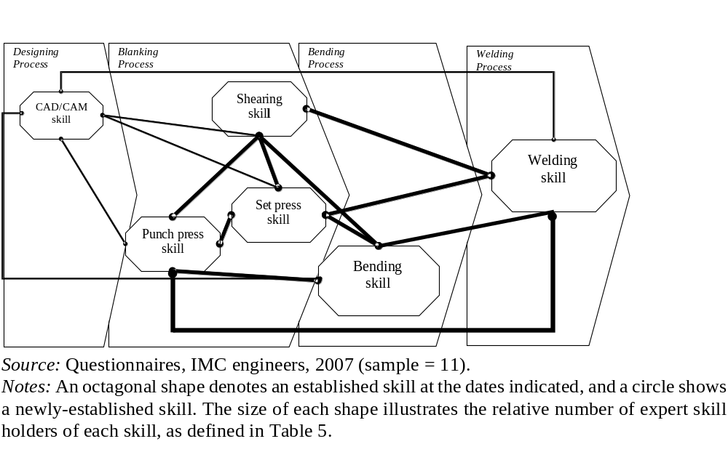

Figure 2: IMC’s Production and Skills Architecture, 1998-2001

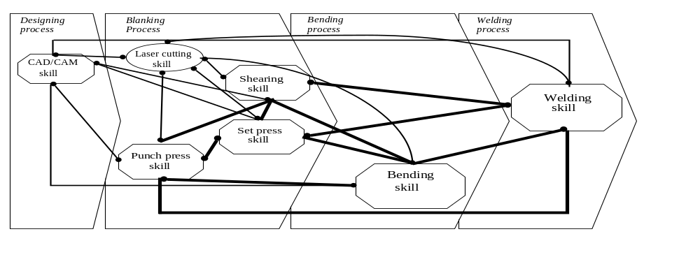
Figure 3: IMC’s Production and Skills Architecture, 2002-2005

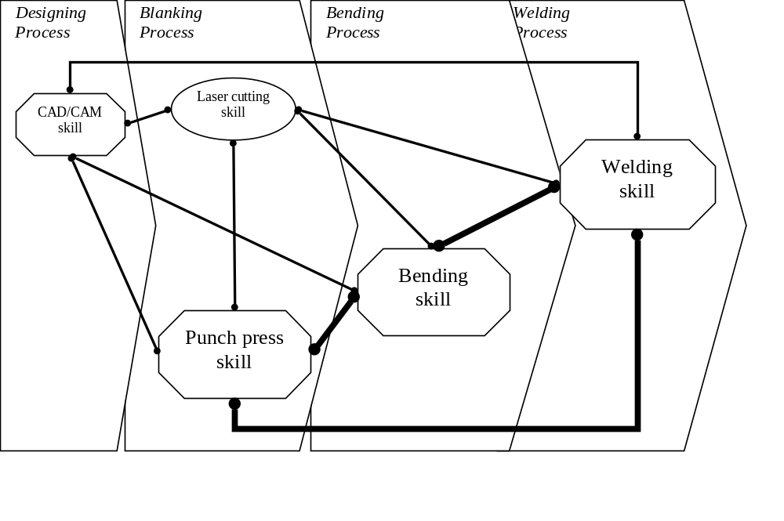
Figure 4: Precion’s Production and Skills Architecture, 1996-1999

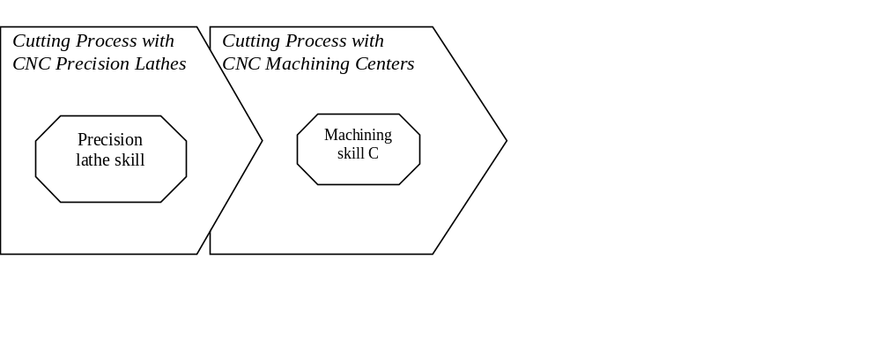Source: Questionnaires, Precion engineers, 2007 (sample = 21). Notes: refer to Figure 1.

Figure 5: Precion’s Production and Skills Architecture, 2000
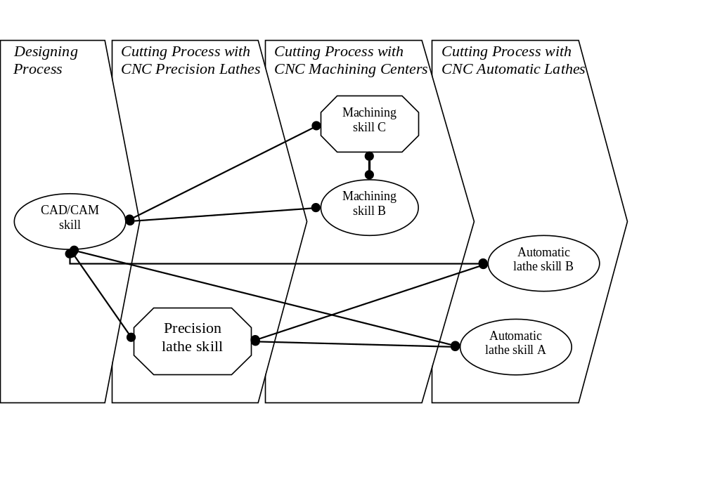

Figure 6: Precion’s Production and Skills Architecture, 2005

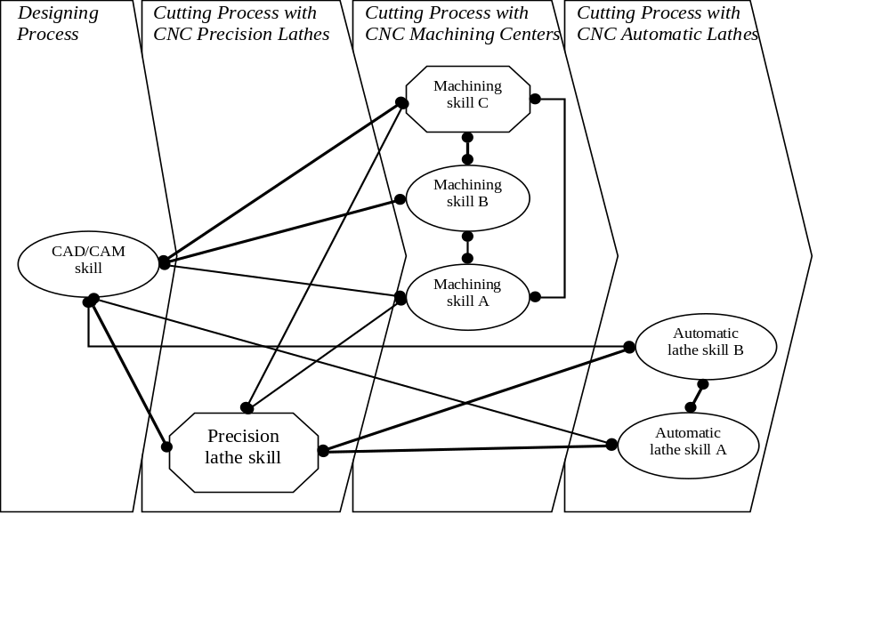

Ota et al., “Japanese innovation processes”; Debroux, “New Entrepreneurial Drive”; Ibata-Arens and Obayashi, “Escaping the Japanese Pyramid”; Morris and Imrie, Transforming Buyer Supplier Relations; Nishiguchi, Strategic Industrial Sourcing; Whittaker, Small Firms.?
Storey, Understanding the Small Business Sector.
Nakamura, Postwar Japanese Economy; Odaka and Sawai, Small Firms, Large Concerns; Abe and Fitzgerald, “Japanese Economic Success”.
Johnson, MITI; Lockwood, Economic Development; Francks, Japanese Economic Development; Abe and Fitzgerald, Rise of Japanese Industrial Power; Rosovsky, Two Systems; Ohkawa and Shinohara, Patterns of Japanese Economic Development; Suzuki, Japanese Management Structures; Fruin, Japanese Enterprise System; Gordon, Evolution of Japanese Labour; Gordon, Evolution of Labor Relations; Ibata-Arens and Obayashi. “Escaping the Japanese Pyramid”.
Nakamura, Postwar Japanese Economy; Abe and Fitzgerald, Origins of Japanese Industrial Power; Lockwood, Economic Development of Japan; Patrick and Rohlen, “Small-Scale Family Enterprises’.
Whittaker, Small Firms; Uchikawa, “Small and Medium Enterprises”; Asanuma, “Manufacturer-Supplier Relationships”.
Wada, “Development of Tiered Inter-Firm Relationships”; Sako, “Supplier Development”; Wada, Evolution of Toyota Production System.
Nakamura, Postwar Japanese Economy: 235.
Doi and Cowling, “Structure of Transactions”; Evans, “Japanese SMEs”; Whittaker, Small Firms.
Teramoro, “Changes in Interorganizational Networks”; Kimura, “Subcontracting”; Edwards and Samimi, “Japanese Interfirm Networks”.
Debroux, “New Entrepreneurial Drive”; Whittaker, Small Firms; Watanabe, Changing Image; Ikeda, “Globalization’s Impact”.
Yasuda and Mulford, “Reasons Why Japanese Small Business Form Cooperatives”; Ibata-Arens and Obayashi, “Escaping the Japanese Pyramid”.
Odaka and Sawai, Small Firms, Large Concerns.
https://www.chusho.meti.go.jp/sme_english/outline/08/01.html.
Nakamura, Postwar Japanese Economy: 168-82.
Whittaker, Managing Innovation.
Itoh and Urata, “Small and Medium-Size Enterprises”.
Patrick and Rohlen, “Small Scale Family Enterprises”: 332-2,338; Whittaker, Small Firms: 3.
Whittaker, Small Firms: 147.
Debroux, “New Entrepreneurial Drive”; Whittaker, Small Firms; Watanabe, Changing Image; Ikeda, “Globalization’s Impact”.
Maeda and Ishizaki “Current Status”; Kiyonari, “Renaissance for SMEs”; Kiyonari, “Age when New Venture and SMEs”; Kameda, SME Studies in Japan.
. SME Agency, White Paper, 2002.
SME Agency, White Paper, 2007; Uchikawa, “Small and Medium Enterprises”.
Kimura, "Subcontracting”.
Piore and Sabel, "The Second Divide".
Scranton, Speciality Production, and Proprietary Capitalism. See also Chandler, Visible Hand, and Scale and Scope.
Fruin, Japanese Enterprise System; Odaka and Sawai, Small Firms, Large Concerns.
Piore and Sabel, The Second Divide; Bernard, "Post-Fordism"; Sabel and Zeitlin, “Historical Alternatives”; Phillimore, “Flexible Specialization”; Kaplinsky, Computer Aided Design; Debroux, “New Entrepreneurial Drive”.
Urata, S. and H. Kawai. ‘Technological Progress by Small and Medium Enterprises in Japan’. Small Business Economics, 18 (2002): 53-67.
Morris and Imrie, Transforming Buyer Supplier Relations; Nishiguchi, Strategic Industrial Sourcing; Debroux, “New Entrepreneurial Drive”.
Whittaker, Small Firms: 134-5,159-61.
Whittaker, Small Firms: 3.
SME Agency, White Paper, 2006.
Storey, Understanding the Small Business Sector.
SME Agency, White Paper, 2002: 3,155-56; White Paper, 2006: 16.
Interview, Shunichiro Namiki, Managing Director, IMC, 18 Dec 2006, 11 July 2007; Interview, Tsuneyoshi Suzuki, Managing Director, Precion, 22 July 2006.
Storey, Understanding the Small Business Sector; Analoui and Karami, Strategic Management.
Nagano, “Manufacturing Positioning Strategy”.
SME Agency, White Paper, 2003: 76.
Wernerfelt, “Resource Based View”; Newbert, New Firm Formulation; Penrose, Theory of the Growth of the Firm.
Barney, “Firm Resources”; Teece, “Explicating Dynamic Capabilities”; Miller and Shamsie, “Resource Based View of the Firm”.
Winter, “Understanding Dynamic Capabilities”; Helfat et al., “Understanding Dynamic Capabilities”.
Miller and Shamsie, “Resource Based View of the Firm”.
Collis and Montgomery, “Creating Corporate Advantage”; Levinthal & March, “Myopia of Learning”.
Miller and Shamsie, “Resource Based View of the Firm”; Eisenhardt and Martin, “Dynamic Capabilities”; Zahra et al., Entrepreneurship and Dynamic Capabilities.
Teece et al., “Dynamic Capabilities and Strategic Management”; Peteraf et al., “Elephant in the room of dynamic capabilities”; Winter, Understanding Dynamic Capabilities; Helfat et al., “Understanding Dynamic Capabilities”.
Teece, "Dynamic Capabilities and Strategic Management"; Teece, "Explicating Dynamic Capabilities"; Teece, "Dynamic Capabilities: Routines Versus Entrepreneurial Action".
Zollo and Winter, “Deliberate Learning”; Winter, Understanding Dynamic Capabilities; Bingham and Eisenhardt, “Rational Heuristics”; Eisenhardt and Martin, “Dynamic Capabilities”; Arndt et al., “Behavioral and Evolutionary Roots”.
McKelvie and Davidsson, “From Resource-Base to Dynamic Capabilities”; Woldesesnbet, “Supplying Large Firms”.
Corner and Wu, “Dynamic capability emergence”.
Teece and Pisano, “Dynamic Capabilities of Firms”; Zahra and George, “Absorptive Capacity”
Caloghirou, “Internal Capabilities”; Borch and Madsen, “Dynamic Capabilties”; Zonooz et al., “Relationship between Knowledge Transfer”; Cohen and Levinthal, “Absorptive Capacity”.
Storey, Understanding the Small Business Sector; Analoui and Karami, Strategic Management.
See Miyazaki, Building Competences.
Barney, “Firm Resources”; Teece, “Explicating Dynamic Capabilities”; Miller and Shamsie, “Resource Based View of the Firm”.
Isobe, Makino and Montgomery, “Technological Capabilities and Firm Performance”.
Whittaker, Small Firms.
Debroux, “New Entrepreneurial Drive”.
Daneels, “Trying to Become”.
Whittaker, Small Firms: 50.
SME Agency, White Paper 2002.
IMC, Financial Statement, 1996; Interview, Production Manager 1, IMC, 11 July 2007.
Interview, Namiki, 10 Aug 2006.
IMC, Financial Statement, 1997; Interview, Namiki, 27 July, 10 Aug 2006.
Ministry of Finance, Financial Statements 2006; IMC, Financial Statements, 1996-2005.
Interview, Namiki, 18 Dec 2006, 11 July 2007.
Interview, Namiki, 27 July 2006.
Interview, Namiki, 10 Aug 2006.
Interview, Production Manager 1, IMC, 11 July 2007.
Questionnaires, Managers and Engineers, IMC, 1996-2006; Interview, Production Manager 2, 11 July 2007.
Interview, Sales Manager, Amada Co. Ltd, 5 June 2007.
Interview, Production Manager 2, IMC, 11 July 2007; Production Manager 1, IMC, 11 July 2007; Interview, Namiki, 18 Dec 2006.
Questionnaires, Managers and Engineers, IMC, 1996-2006; Interview, Production Manager 1, 11 July 2007.
Interview, Namiki, 27 July 2006, 10 Aug 2006.
Interview, Production Manager 2, IMC, 11 July 2007.
Questionnaires, Managers and Engineers, IMC, 1996-2006.
Interview, Namiki, 10 Aug 2006.
Interview, Production Manager 2, IMC, 11 July 2007.
Interview, Production Manager 1, IMC, 11 July 2007.
Interview, Sales Manager, Amada Co. Ltd, 5 June 2007.
Interview, Namiki, 27 July 2006, 10 Aug 2006.
Interview, Namiki, 27 July 2006, 10 Aug 2006.
Ministry of Finance, Financial Statements 2006; IMC, Financial Statements, 1996-2005.
Precion, “History”, n.d.; Financial Statement, 1997.
Interview, Suzuki, 3 August 2006.
Precion, “History”, n.d.; Interview, Suzuki, 22 Dec 2006.
Interview, Suzuki, 3 Aug 2006.
Interview, Production Manager 2, Precion, 3 Aug 2006.
Precion, “History”, n.d.; Interview, Production Manager 2, Precion, 3 Aug 2006; Questionnaires, Managers and Engineers, Precion, 1996-2006.
Interview, Production Manager 3, Precion, 3 Aug 2006.
Precion, “Profile”, 2005.
Interview, Production Manager 3, Precion, 3 Aug 2006.
Questionnaires, Managers and Engineers, Precion, 1996-2006; Interview, Production Manager 1, Precion, 3 Aug 2006.
Precion, “Company Profile”; Interview, Operations Manager, Precion, 8 April 2006.
The split in skills was 5 expert, 3 practical and 3 at basic level in 2005.
Questionnaires, Managers and Engineers, Precion, 1996-2006.
Interview, Operations Manager, Precion, 24 July 2007.
Interview, Suzuki, 3 Aug 2006.
Precion, “History”, n.d.; Questionnaires, Managers and Engineers, Precion, 1996-2006.
Ministry of Finance, Financial Statements Statistics 2006; Suzuki Precion, Financial Statements, 1996-2005.
Interview, Production Manager 3, Precion, 3 Aug 2006.
Precion, Financial Statement, 2006.
Interview, Suzuki, 3 Aug 2006.
Questionnaires, Managers and Engineers, Precion, 1996-2006; Interview, Production Manager 1, 3 Aug 2006.
Yamamoto, Study of the System; Yamawaki, “Evaluation of Structure”.
SME Agency, White Paper 2006: 126,192.
SME Agency, White Paper 2002.
SME Agency, White Paper, 2008: 343-4.
SME Agency, White Paper 1993, White Paper 2006.
SME Agency, White Paper 2003.
Patchell, “From production systems”.
Morris and Imrie, Transforming Buyer-supplier Relations; Nishiguchi, Strategic Industrial Sourcing; Debroux, “New Entrepreneurial Drive”.
Fujimoto, “Reinterpreting the resource-capability view”; Bartezzaghi, “The evolution of production models”.
Oke, Burke and Myers, “Innovation types”.
Collis and Montgomery, “Creating Corporate Advantage”; Levinthal & March, “Myopia of Learning”.
Storey, Understanding the Small Business Sector.
Teece, “Profiting from technological innovation”.
Huang, Dyerson, Wu and Harindranath, “From temporary competitive advantage”.
Nguyen, “Information technology adoption”.
Whipp and Clark. “Innovation”; Hung and Whittington, “Strategies and Institutions”.
Eisenhardt and Martin, “Dynamic Capabilities”; Woldesenbet et al., “Supplying large firms”; Arndt et al., “Behavioral and Evolutionary Roots”.
Teece, “Explicating dynamic capabilities”; Arndt et al., “Behavioral and Evolutionary Roots”.
Zonooz et al., “Relationship between Knowledge Transfer”.
Eisenhardt and Martin, “Dynamic Capabilities”.
Forthcoming paper on CIC, product development and technology.
Miyawaki et al., “Strategic Management”; Itakura, “Analysis of Environments”; Kodera, “Study of Securing Human Resources”.

