Royal Holloway University of London
Department of Geography
PhD Thesis

Imagined Airport
A practice-led project exploring airport spaces through methods of collage.

Clare Booker

Declaration of Authorship

I, Clare Booker, hereby declare that this thesis and the work presented in it is entirely my own. Where I have consulted the work of others, this is always clearly stated.

Signed: 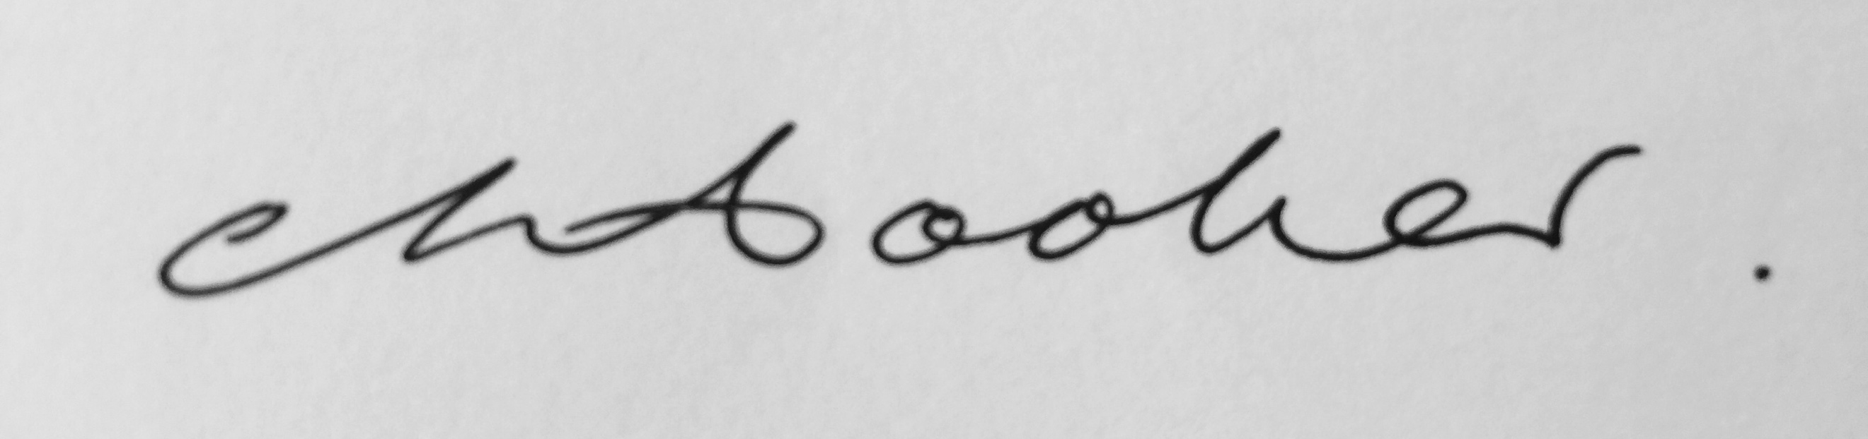
Date: 3/5/2021

Abstract

Imagined Airport is a practice-led thesis exploring airport spaces through methods of collage. I focus in particular on the fragmentation and multiplicity of airport sites and spatial experience. As a cultural, social, philosophical and psychological space, the airport has been the subject of a range of different interpretations and visual representations, prompting many contemporary debates around surveillance, security, mobility, simultaneity and globalization. This thesis investigates these interpretations and representations through a series of visualisations and re-imaginings of the airport space, employing methods of collage as a conceptual and aesthetic approach.

The thesis is shaped by three art projects which each investigate three key themes within the body of practice: Airport Spatial Perspectives, Airport Movement and Airport People. The first project Street View Diaries is a series of short films, which represent my ‘journey’ through the digital airport, as I assemble and record observations whilst navigating around the multiple airport spatial zones via Google Earth and Street View. The second project, Apron Space presents a series of short films, drawings and paintings, based on and located in the apron area of the airport, with a focus on the relationship between human and non-human mobility at the airport. The third project, Model Fiction presents a three-dimensional collage of real and virtual space, in the form of a virtual airport model. A concluding project, Cubist Datascape, provides a conclusion as practice in the form of a book and a series of experimental image and film, which assemble and mix imagery from each theme and project. Together these projects aim to offer a different way of exploring and understanding the airport, through juxtaposing and layering multiple fragments to generate a series of alternative, imaginative responses to the space.

The art practice submissions can be viewed at https://imaginedairport.com/. This written document offers a critical commentary, reflection and evaluation of these projects, discussing how the practice has evolved and the ideas which have emerged through the process of making the work.

Acknowledgements

Firstly, I would like to say a huge thankyou to my supervisors, Professor Peter Adey and Professor Harriet Hawkins. Their support over the course of the PhD has been invaluable. Their fantastic commitment and knowledge has enabled me to realize a project, which at times seemed too much of a challenge. To have such insightful, informed and creative responses to my practice gave me the confidence and drive to keep going and bring the project together. I have thoroughly enjoyed our long discussions and many meetings, where exciting ideas have been explored and developed.

I must also say a big thankyou to Professor Tim Cresswell for giving me the opportunity to study for a PhD at Royal Holloway and for providing support and guidance at the start of the project. Not only did his early advice stay with me throughout the project, but his own academic writing has continued to provide important research, which my thesis has continually drawn upon.

I would like to say a huge thankyou to my friends and family, who have been there to listen to me talking about my many ideas and uncertainties about the project. They have encouraged me to stick with it and work through difficult times, along with continually offering friendship, love and support along the way.

Finally, the biggest thankyou goes to my wonderful Mum and Dad. I’ve done it!

Table of Contents
Declaration of Authorship 2
Abstract 3
Acknowledgements 4
Table of Figures 7
Chapter 1: INTRODUCTION 9
Aims/ Objectives/ Rationale 9
Background 12
Research Questions 14
The Three Projects 15
Street View Diaries. 15
https://imaginedairport.com/street-view-diaries/ 15
Apron Space. 15
https://imaginedairport.com/apron-traffic/ 15
Model Fiction. 16
https://imaginedairport.com/model/ 16
Literature / Art Review 17
Introduction 17
Airport Spatial Zones 17
Airport Movement 22
Airport People 26
Conclusion 30
Chapter 2: COLLAGE AS METHOD 31
Introduction 31
Collage: Background / History 32
Airport as Collage 36
Collage as a Method for Art and Mobilities Research 44
Conclusion 45
Chapter 3: STREET VIEW DIARIES 47
Introduction 47
Virtual Wanderings – written observations and gathering video footage. 49
Spatial Zones 52
Movement 55
People 59
Conclusion 65
Chapter 4: APRON SPACE 67
Introduction 67
Film: Apron Traffic 69
Film: Gate 16 72
Film: Heathrow Purple 75
Film: FAO 77
Film: Jetway 79
Conclusion 83
Chapter 5: MODEL FICTION 84
Introduction 84
Building the Model. Assemblage of Spatial Zones 88
Animating the Model – Movement 92
Film: Multi Story 93
Film: Choose Your Space 97
Add Life – The People in the model 101
Conclusion 104
Chapter 6: CONCLUSION 106
Introduction 106
Research Questions 107
Research Question 1. 107
Research Question 2. 109
Research Question 3. 114
Contribution to Art and Mobilities Research Field 117
Conclusion as Practice 119
Bibliography: 123

Table of Figures

Figure 1 Clare Booker. Series of images taken from the three projects, 2019 9
Figure 2 Edward Ruscha. Lockhead Air Terminal, 1967 19
Figure 3 Carol Rhodes. Airport, 1995. Oil on Board 19
Figure 4 Andreas Gursky. Schipol,1994 21
Figure 5 Peter Fischli and David Weiss. 800 Views of Airports, 2012 21
Figure 6 Peter Fischli and David Weiss. 800 Views of Airports, 2012 21
Figure 7 Julian Opie. Airport, 2017 21
Figure 8 Wolfgang Tilmans. Concrete Grid, 1997 21
Figure 9 Andreas Gursky. Frankfurt, 2007 24
Figure 10 Mark Wallinger. Threshold to the Kingdom, 2000 28
Figure 11 Duane Hanson. Traveller, 1988. Tourists, 1988 29
Figure 12 Martha Rosler. In the Place of the Public, 1996 29
Figure 13 Clare Booker. Stills from Street View Diaries, 2016 46
Figure 14 Charles and Ray Eames. Powers of Ten, 1977 51
Figure 15 Clare Booker. Stills and Extracts from SV Diaries, 2016 53
Figure 16 Clare Booker. Stills and Extracts from SV Diaries, 2016 54
Figure 17 Clare Booker. Extracts from SV Diaries Voiceover, 2016 57
Figure 18 Clement Valla. Postcards from Google Earth, 2010 58
Figure 19 David Hockney. Pearblossom Highway, 1986 58
Figure 20 Clare Booker. Stills from Street View Diaries, 2016 58
Figure 21 Paul Auster. Page from City of Glass Graphic Novel, 2004 59
Figure 22 Sophie Calle. Suite Venitienne, 1980 59
Figure 23 Clare Booker. Voice over text from Street View Diary films, with stills, 2016 60
Figure 24 Enxuto and Love. Anonymous Paintings series, 2013 60
Figure 25 Paolo Cirio. Street Ghosts, 2012-2017 61
Figure 26 Michael Wolf. Paris Street View, 2010 61
Figure 27 Clare Booker. Airport SV People, 2018. Digital Image 62
Figure 28 Clare Booker. Airport SV People, 2018. Digital Image 62
Figure 29 Fernand Leger. Men in the City / The City, 1919. Oil on Canvas 62
Figure 30 Clare Booker. Extracts from SV Diaries Voiceover, 2016 63
Figure 31 Clare Booker. Voice over extract and film still: Gatwick, 2016 64
Figure 32 Clare Booker. Stills from Apron Space films, 2017-2018 66
Figure 33 Clare Booker. Exert from voiceover to Apron Traffic, listing headers from an airport website, 2017 70
Figure 34 Dziga Vertov. Man with a Movie Camera, 1929. 71
Figure 35 Chris Marker. La Jetee, 1962. 71
Figure 36 James Nares. Street, 2001 71
Figure 37 Mark Wallinger. Threshold to the Kingdom, 2000 71
Figure 38 Clare Booker. Stills from Gate16, 2017 71
Figure 39 Pieter Brueghel the Elder. The Tower of Babel, 1563-1565 73
Figure 40 Tatlin. Monument to the Third International, 1919 73
Figure 41 Bernd and Hilla Becher. Water Towers, 1972-2009 74
Figure 42 Robert Delaunay. Eiffel Tower Series, 1910 74
Figure 43 Clare Booker. Stills from Heathrow Purple, 2017 75
Figure 44 Gerhard Richter. 17 Febr 92, 1992 76
Figure 45 Ellsworth Kelly. Postcard Collage, 1979 76
Figure 46 Ellsworth Kelly. Red Blue, 1964 76
Figure 47 Clare Booker. Still from Heathrow Purple, 2017 76
Figure 48 Clare Booker. Stills from FAO, 2017 78
Figure 49 Victor Pasmore. Points of Contact. No.3, 1965 78
Figure 50 Clare Booker. Still from FAO, 2017 78
Figure 51 Eadweard Muybridge. Jumping over boy's back (leap-frog). Plate 169, 1887 79
Figure 52 Etienne-Jules Marey. Analyse Cinematique de la Marche, published May 19, 1884. 79
Figure 53 Clare Booker. Stills from Jetway, 2017 79
Figure 54 Thomson & Craighead. Short films about flying, 2002 80
Figure 55 Jill Magid. Evidence Locker, 2004 80
Figure 56 Emily Jacir. Europa, Nothing Will Happen, 2003 80
Figure 57 Mike Figgis. Timecode, 2000 82
Figure 58 Charles and Ray Eames. Glimpses of the USA, 1959 82
Figure 59 Clare Booker. Stills from Model Fiction, 2017 83
Figure 60 Superstudio Monumento Continuo, 1969 84
Figure 61 Archigram. Garden Exhibition, 1975 84
Figure 62 Langlands and Bell. Apple, Sunny Vale, 2017. 86
Figure 63 Toby Paterson. Theatre of Illusion, 2003. 86
Figure 64 Olivo Barbieri. Collosio, 2004 87
Figure 65 Thomas Demand. Zeichensaal / Drafting Room, 1996 87
Figure 66 Rem Koolhaas. Delirious New York, 1978 88
Figure 67 Sim City Video Game, Screen Shots, 1989 / 2018 88
Figure 68 Clare Booker. Stills from Mode Fiction, 2017 89
Figure 69 Giorgio de Chirico. Piazza d’Italia con piedistallo vuoto, 1955 90
Figure 70 Sassetta. Saint Francis renounces his Earthly Father, 1437-44 90
Figure 71 Piero Della Francesca. Flagellation of Christ, 1445-1450 90
Figure 72 Clare Booker. Stills from Model Fiction, 2018 90
Figure 73 Clare Booker. Photographs of Terminal 2, Manchester Airport, 2017 91
Figure 74 Herbert Bayer. Design for Trade Fair Stand of a Toothpaste Producer, 1924 93
Figure 75 Herbert Bayer. Design for a newspaper stand, 1924. 93
Figure 76 Aleksandr Rodchenko. Illustration for the magazine 'Young Guard', 1924, Photomontage 93
Figure 77 Patrick Caulfield. After lunch, 1975. 93
Figure 78 Richard Hamilton. Interior II, 1964. 94
Figure 79 Clare Booker. Stills from Multi Story, 2017 94
Figure 80 Clare Booker. Stills from Choose Your Space, 2017 94
Figure 81 Pieter de Hooch. Musical Party in a Courtyard, 1677. 95
Figure 82 Pieter de Hooch. The Courtyard of a House in Delft, 1658. 95
Figure 83 Clare Booker. Stills from Choose Your Space, 2017. 97
Figure 84 Julian Opie. Imagine you are Walking, 1998. 98
Figure 85 Lawrence Lek. Berlin Mirror (2042 Retrospective), 2016. 98
Figure 86 Clare Booker. Observational 'diary' text, describing own experience of watching the film Choose Your Space. 100
Figure 87 Clare Booker. Add life series. Paint / Digital Collage, 2018. 101
Figure 88 Clare Booker. Retail Perspective Acrylic and Collage on Board. 90x80cm, 2013 102
Figure 89 Clare Booker. Pier Root and Duty Free. Acrylic and Collage on Board. 90x80cm, 2013 102
Figure 90 Airport Terminal webcams: Dusseldorf, 2017 103
Figure 91 Webcam: Cologne Bonn, 2017 103
Figure 92 Lewis Klahr. Video Still, False Ageing, 2008 104
Figure 93 Lewis Klahr. Still, 66 Episode 6, Saturn's Diary #3, 2013 104
Figure 94 Clare Booker. Add Life series. Paint / Digital Collage, 2018 104

Chapter 1: INTRODUCTION

Aims/ Objectives/ Rationale

Imagined Airport is a practice-led exploration and response to the space and place of the airport, through a series of art projects. The three projects, Street View Diaries, Apron Space and Model Fiction employ methods of collage across the multi-media practices of painting, video, photography, model-making, drawing, and experimental writing, as a way of examining and re-imagining the space. The three projects can be viewed via the Imagined Airport website, https://imaginedairport.com/, which is a platform / interface to view the films, paintings, drawings, and texts. I have also produced a concluding project Cubist Datascape, and a book, Imagined Airport, which is a collection and collage of the images and text I have made and assembled throughout the process. The practice, which examiners will experience through the website and book is accompanied by this written text, which offers a critical commentary, reflection and evaluation of these projects, discussing how the practice has evolved and the ideas which have emerged through the process of making the work. Website links have been inserted into the text to direct the viewer to particular works. I would suggest that the examiners initially view the three projects in the same order as the written chapters. The practice can also be experienced in a more open fragmented way, where the viewer/reader can move between the projects freely, allowing connections to made between the three projects.
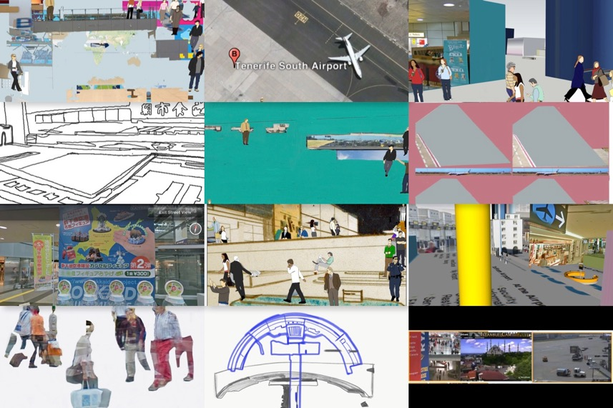
Figure 1 Clare Booker. Series of images taken from the three projects, 2019

The cultural, social, philosophical and psychological space of the airport has been the subject of a range of different interpretations and visual representations. Sociologists and geographers have written widely about the space and many artists have explored and represented the airport visually. The site of the airport has been used to examine broader themes in depth, such as surveillance, security, mobility, identity, duration, simultaneity and globalization. The airport has been described as many things, for example, as a non-place, an anonymous, detached space (Auge 1992), a dystopian space (Ballard 1997), a city (Kasarda 2008; Gottdiener 2001; Pearman 2004), a space of control and surveillance (Adey 2004; Cresswell 2006), a machine (Fuller and Harley 2004), a virtual space (Pascoe 2001), an assemblage (Salter 2008), amongst others. Artists have responded to and represented the airport from different perspectives, often from a static gaze, or depicting one particular part of the airport (Rhodes 1995; Ruscha 1967; Opie 2017; Fishli & Weiss 2012; Gursky 1994; Rosler 1998; Wallinger 2000, amongst others). Imagined Airport responds to and builds on these existing investigations and interpretations of the airport, whilst aiming to challenge and dispute the idea that any singular description, concept or spatial perspective can be used as a way of describing the space. I am seeking to explore and experiment with creating a new visual response, which layers and juxtaposes many of these descriptions, concepts and spatial perspectives simultaneously.

Imagined Airport will experiment with visual strategies through which to explore the airport not from a particular spatial zone or perspective but rather, as an evolving space of juxtaposed, overlapping and constantly changing views. I feel that existing art about airports lack this sense of collision and coexistence of multiple spaces, movements, and people within one surface / work of art. By employing methods of collage, Imagined Airport is attempting to produce work which addresses this gap, by generating a more visually fragmented, multiple and disorientating experience, akin both to the accounts emerging from within airport literatures and my own experience of these spaces.
This practice-led thesis is positioned within a diverse range of research areas, working across the multi-disciplinary areas of art, human geography, architecture, mobilities, and digital geographies, with a particular focus on the space and place of airports. It is difficult to position the project within one particular area of research as it aims to contribute to all these areas in some way. However, as the project has developed, the three themes which have emerged and shaped the project (spatial zones, movement and people), seem to come under the umbrella term of ‘mobilities’. The term and concept, mobilities, explores the movements of people and objects and how these movements interrelate and impact on everyday life and society, locally and globally. The research area of mobilities and the ‘mobilities turn’ has been shaped by a key group of researchers who have explored the concept extensively, both independently and collaboratively (Urry 2003, 2006, 2007, 2012, 2016; Sheller 2004, 2006, 2014, 2016; Cresswell 2004, 2006, 2011, 2012; Adey 2004, 2006, 2007, 2008, 2009, 2010; Bissell 2007, 2009, 2011, 2010, 2018; Merriman 2010, 2014 amongst many others). The ‘mobilities turn’ emerged in response to how issues of movement, globally and locally, were becoming central to many people’s lives (Urry 2012). The mobility turn has been described as post-disciplinary, beyond the individual separate disciplines and concerned with the multiple ways in which economic, social and political life is performed and organized through time and across many complex spaces (Urry 2012). As a way of analyzing and exploring these processes there has been the emergence of new methodologies that are more eclectic, experimental, creative, and linked to arts, design, and public policy (Sheller 2017). The field has become vast and expanded into many other disciplines, notably the visual arts. Through a body of experimental art practice Imagined Airport aims to contribute to this field. Aside from the area of mobilities, Imagined Airport also aims to contribute to the wider areas of creative methods and digital geographies, as throughout the project I gather, assemble and make work, using experimental visual methods, which often employ digital technologies as a viewing platform and tool to generate the practice. I discuss these methods more specifically within the three practice chapters.
The three themes of airport spatial zones, movement and people have emerged through the process of assembling visual research from the airport and developing the practice. Although these three themes continuously inter-connect, I found myself concentrating on each theme independently at times. For periods of the project, I would find myself concentrating on the architecture and interior design of the space, looking at how the space was divided up into different spatial zones and how these continuously interconnect. At other times, airport movement was the focus, where I was generating ways in which to explore and visualize this movement, whether this was the movement of people or objects in the space and then how these human and non-human movements interconnect. At other times, observing the people in the airport became my preoccupation, whether these were people I observed in the physical space, or images of airport people, travelers or workers, which I found and appropriated from airport advertisements, websites, webcams and Google Street View photography. As a way of working my way through airport literatures and other areas of literature and art, I made the decision to use these three key themes which were established through the practice, as a way of structuring the thesis. In the Literature/Art review I investigate how these themes have been explored in academic literatures and art. The three themes are also used to structure and connect the three practice chapters, with each practice project /chapter exploring the themes of airport spatial zones, airport movement and airport people in different ways. In Street View Diaries and Model Fiction these themes are explored as separate sections within the chapter, whereas in Apron Space the three themes are explored in a non- linear way and are discussed through the individual art works I have produced.

Imagined Airport is a deliberately fragmented project. Each project uses the method of collage to generate a mix of realities, a mix of real and virtual, a mix of physical and digital surface and a mix of perspectives as a way of exploring the space. I continuously gather and assemble visual research from multiple perspectives in the pursuit of assembling these fragments into new visual forms, whether this be an image or film. I assemble and collage text, video, sound and surfaces from different, disparate locations, from footage I have taken myself whilst being in an actual physical airport, and also from footage taken from the digital spaces, directly from the screen, via digital technologies and digital viewing environments, such as websites, webcams and Google Street View. In each project parallels between the physical and digital airport are being explored through experimental practice. Chapter 2, Collage as Method, provides a rationale for why and how the methodological framework of collage is being used as a way of exploring and understanding the airport space and the experience of being in an airport.

Background

- Years before this project, I had experience of being a worker at the airport. Although I do not use any visual material from this period of time, it laid the ground for my interest in the space and provided me with ideas which I have now begun to develop. It was 1998 when I began a job at Manchester Airport, waiting on tables in the Executive Lounges within the three terminals. The working shifts varied. Sometimes I would start at 5am, whilst other shifts began at 2pm. At the time I lived close by to the airport, a short car journey, which, for the early shift, was relatively traffic free and uninterrupted. I parked my car in the staff carpark, which was a few miles distance from the terminal, and waited for a bus with other airport workers. Those mornings were cold and dark, hazily lit by the distant lights of the runway. Workers from all areas of the airport seemed to be on the staff bus. I sat alone by the window, overhearing fragments of conversation amongst workers. I would often hear airline crew discussing where they were flying to that day. I remember a particular conversation referring to the day’s itinerary of ‘Double Paris’, a phrase and description which presumably referred to the same journey twice in one day. The phrase has always stuck in my mind, thinking that at some point I would use this for a title of work.

At this time, like most airports, Manchester Airport was much more open, in terms of areas to access. As an airport worker I had the freedom to enter any zone, landside or airside. I could also take photographs relatively freely. Even as a visitor you could enter the terminal and walk straight through the main concourse, to the large windows looking out onto the apron area. This area has now changed completely. As a visitor you have very little access to the spaces of the airport, and only have permission to enter these spaces once you have checked in. During my time working at the airport I wasn’t sure what I was looking for in the airport in terms of my art practice, but I just knew I was fascinated by the environment, the amazing feeling of space, juxtaposed against the vast visual activity in the form of signage, advertising, people, planes and other vehicles contained within one environment. I was intrigued by the changing light and atmosphere of the space, which I observed at different times of the airport day. As I began the early shift, I witnessed some fantastic sunrises across the apron area, whilst preparing the breakfast for the first visitors to the lounge that day. When on the late shift the light and atmosphere changed completely. Looking back, the space at the end of the airport day now makes me think of the photographic series of Martha Rosler, In the Place of the Public (1990), which I discuss in the Literature / Art review, where the airport was dark and relatively deserted. There was a calmness about the space at night which I liked, relative to the busyness and chaos of the day.

- During this period of working at the airport I produced a series of paintings, which would lead to a more extensive body of work a few years later. I began an MA in Creative Technology, where the focus shifted to taking video footage of the space and using this to inform the painting process. Looking at the airport space through a video camera changed and influenced how I saw and experienced the airport, and how I would construct paintings. The composition, colour and light of the video screen began to dictate the aesthetics and the structure of the painting. The airport was now contained within the parameters of a screen. These early experiments with viewing the airport via visualizing technologies would lay the foundations for this PhD project, ten years later.

Today, I continue to be an artist fascinated by the airport, looking for ways to visually respond to what I see and what I feel about the space. I am defining this project as both ‘an observation of reality’ (Collier & Collier 1986) and as ‘constructed narratives’ or ‘fictions’ (Clifford 1986), generating a body of art practice, which explores the airport as a collage of reality and fiction. I am digitally assembling multiple viewpoints, wandering and observing, as Baudelaire describes in The Painter of Modern Life (1863: 13), ‘the ebb and flow, the bustle, the fleeting and the infinite’. I spend endless time ‘walking’ around to find an interesting ‘snapshot’, searching for the ‘image’ which tells me something new. I am reacting to what is there, what is interesting at that particular time, within the different locations of the airport, using ethnographic strategies which are shaped by the subject’s situations (Josephides 1997). More directly, I am recording what am I seeing, what is happening in-front of and around me. Exploring the airport in this way, by recording a personal experience of being there, is a method also employed by Alain de Botton (2009) and Christopher Schaberg (2012, 2015, 2018), who both present a series of creative observational texts, which offer insights into their own airport experiences. As a way of doing this Schaberg (2012) draws on his own experience of working in the airport. He focuses on the airport as a place in its own right, not as an extension of somewhere else, or a space in-between locations. He makes observations about the different zones in the airport, from the screening zone, the waiting areas and the baggage claim areas and through his own experience of being there and through observations of others, he sees how stories of those who occupy these spaces shape the environment and give it its identity. He talks about ‘interpretive threads that unravel in these sites’ (2012,1), an idea which I explore and experiment within the Street View Diaries project, where I ‘follow’ people in the airport, generating an imagined narrative to accompany the images on screen. De Botton (2009) also explores the airport from his own perspective, recording what he is observing whilst taking up a privileged position as writer in residence at Heathrow, which allows him to gather research from both landside and airside. Imagined Airport is also an exploration of the airport from a personal point of view and perspective, but in contrast with Schaberg and De Botton, I am visually investigating these observations and experiences, through art practice, rather than through writing.

Research Questions

The research questions I am asking throughout the thesis:

- How can collage be used as a method to explore and understand the airport space?

- What do these collage methods reveal about the spatial zones, movement and people encountered and experienced whilst in the airport?

- How are digital technologies and digital viewing environments creating new ways of seeing and experiencing the airport and how do these digital experiences help me draw parallels with the experience of being in the physical airport space?

The Three Projects

Street View Diaries.

https://imaginedairport.com/street-view-diaries/

The first project you will encounter is Street View Diaries. Street View Diaries is a series of short films which visualize my ‘journey’ through the digital airport. The films are an assemblage of my own observations as I navigate around multiple airport spatial zones via Google Street View. I explore 16 different airports, the first to be available to view on Google Street View. As I occupy each space, I gather and assemble observations and imagery, collaging and fusing them together to generate a narrative to accompany the filmic journey, as a way of representing the experience of spatial disorientation within the airport. Street View Diaries attempts to address the struggle to stabilize the airport and to visualize the ongoing spatial collisions and fusions, which I talk about throughout the thesis. The aim is also to explore how navigating through this digital interface can offer new ways of seeing and experiencing the airport, and how these digital experiences help me examine consistencies but also inconsistencies with the experience of being in the physical airport space (research question 3).

- In the chapter Street View Diaries, I analyze how the interface of Google Street View is itself a collage, a collage of photographs stitched together to represent ‘one space’. Collage is embedded within the technology of Google Street View. The collage is already there. Through the assembling and editing of the Street View collage I generate a series of expanded collages. I have also produced a series of paintings, drawings and digital stills in response to the films. In the Street View Diaries chapter, I refer to and discuss the photo collages of David Hockney (1986), the collage texts of Walter Benjamin’s Arcades Project (1927-1949) and Italo Calvino’s Invisible Cities (1974) in relation to my practice. I also investigate how academic researcher’s and artists are exploring the digital space of Google Street View through their practice.

Apron Space.

https://imaginedairport.com/apron-traffic/

- The second project Apron Space presents a series of short films, drawings and paintings, based on and located in the apron area of the airport. The apron space is the area at the airport where airplanes are located, waiting to be boarded, unloaded or re-fueled. I combine my own video footage of the space with found footage appropriated from airport webcams. The project addresses themes of time and simultaneity attempting to visualize the experience of displacement and being located in-between two time zones and locations. Flight timetables are used as a device to direct the shape and form of the visual outcomes. In this project there is a focus on the relationship between human and non-human movement at the airport, where I visualize the movement of passengers, workers and the mobile architecture and vehicles which occupy the Apron Space simultaneously. Methods of collage are used to juxtapose and layer different spaces and different visual languages. Here I experiment with collaging drawing, painting and film onto one surface, often using the device of split screens and grids. In relation to these experiments, I refer to the filmmakers Vertov (1929), Marker (1962), Figgis (2000) and Charles & Ray Eames (1959), amongst others, regarding their use of collaging footage and employing the devices of multiple screens and grids. I collage sound from disparate locations, mixing the ambient sound of the actual space, with the sound of a voiceover reading information from an airport website.

Model Fiction.

https://imaginedairport.com/model/

The third project Model Fiction presents a three-dimensional collage of real and imagined space, in the form of a virtual airport model. Multiple visual representations of the airport, both found and made, are combined and juxtaposed as a way of generating a ‘new’ imagined airport architecture. A mix of viewpoints, perspectives and visualities are used to generate and form a new fictional environment which aims to reflect the fragmentary nature of the airport space. I have produced two short films which move through this fictional airport in different ways. Still and moving image are layered and juxtaposed as a way of reflecting upon moments of interruption, redirection, moving and waiting at the airport. Alongside the films I have produced a series of digital images and paintings from the model. In the written chapter I talk about collage and architecture, in relation to the practice, in particular the 1960’s architectural practices of Archigram, Superstudio and architect Rem Koolhaas (b. 1944). Model Fiction employs the method of collage to generate layer upon layer of information and space, experimenting with still and moving image, shifting scales and perspectives, and layering and juxtaposing found and made imagery.

Literature / Art Review

Introduction

The process of assembling the three art practice projects has led to many areas of research, gathering and assembling research from a diverse range of sources and disciplines. I draw influences from art, architecture, geography, sociology, film, literature and new media, as a way of exploring the space and place of the airport. Throughout the thesis I explore how different descriptions and responses to the airport have helped shape my understanding and experience of the airport environment, and how they have influenced my own art practice. The art and academic literature and research have often given me openings for my project. I have taken aspects from many of these responses as a starting point for a piece of work, whether this be a still or moving image. The project considers how other writers and artists have explored the airport through their practice, prompting ideas on how my own art practice can respond to and expand on this existing work.
By way of a structure, I have organized the review thematically, giving a brief review of literatures and art which explore the three themes which shape the thesis: airport spatial zones, airport movement and airport people. Within each practice chapter I expand on these themes in relation to my practice and the related art and literature.

Airport Spatial Zones

Many writers, (Cresswell 2006; Kitchen & Dodge 2011; Adey 2007; Salter 2008; Fuller/Harley 2005; Nikolaeva 2012; Bok 2015) talk about the different spatial zones (check-in, departure lounges, shops, arrivals, customs, apron area, hotels, carparks) of the airport and their functions, their differences and divisions. These differences and divisions are usually due to safety and security constraints and designed in a way to influence and control how people move through these spaces. Often, these spatial zones at the airport are used as a way of organising the sitemap of many airport websites, offering them as headers at the top of their pages for people to find information and navigate through their airports digitally. These headers and labels divide and separate the zones. But as many airport literatures acknowledge (Cresswell 2006, Kitchen & Dodge 2011, Adey 2007, Salter 2008, Fuller/Harley 2004), these zones interconnect and impact on each other, whether this is physically or psychologically. These zones continuously overlap and merge, making the separation of zones, inside/outside/in-between problematic.

Kitchen & Dodge (2011) explore this interconnectedness of airport zones through diagrams, showing flows of movement from arriving at the airport to boarding the aircraft. Salter (2008) talks about the airport and its multiplicity, and how the concept of the ‘assemblage’, from Deleuze and Guatarri (1987) is particularly useful in analyzing the incomplete, fragmented, and dispersed nature of airport politics (Salter 2008). Building on this idea of assemblage, Fuller and Harley (2004), describe the airport as an environment and space, which connects the topics of global interconnections, effects of technology, information, architecture, people, machines and mobility. Fuller and Harley (2004) use visual methods to examine and represent these ideas, through their use of imaginative juxtapositions of photography and text, where these multiple spaces and viewpoints are successfully visualized. Shots from inside / outside / empty / crowded, landscape / signage, collide to form a visual montage of the environment. They examine the different separate levels and sections of the airport and explore how the architecture of the outside has a direct relation to architecture and activity of the inside. More recently, Nikolaeva (2012), investigates the design of airports and the complexities of its different spatial zones. She looks at the way airports are designed as multifunctional, acknowledging the challenges of incorporating multifunctional spaces within one environment. She argues that airport design is not ruled by any specific interest, for example, commercial or operational, exclusively, but has a complexity and diversity of visions in operation at any one time. This idea could suggest a layering of these visualities, commercial and functional, which could be explored through my practice.

Graham (2008) looks at the processes behind running a successful airport and the demands and complexities of managing these spaces from a strategic and commercial perspective, looking at the changing demands due to an increase of passenger numbers and in air traffic. Bok (2015) also acknowledges this constant necessity to plan for ever growing rates of air traffic, stating that ‘airports are never truly finished’ (Bok 2015: 2731). I aim to reflect upon this idea in the project Model Fiction, constructing a model airport which is ever evolving. In her study of Changi Airport, Bok (2015) talks about the requirements of the airport to retain a sustained appeal to multiple audiences and the importance of spatial interconnectedness between airport zones. She explores how the different spatial zones of the airport have been designed to ensure strong connectivity, designing and linking spaces such as the airport hotel, departure gates and interterminal transfers in a way to generate smooth connections and transitions between spaces, especially for the business passenger. She goes on to talk about Changi’s role as a popular transit hub and its importance to the rising trend of transit tourism, a term which suggests people are seeing the airport as a tourist destination in itself. She says, ‘This need to satisfy various travel-unrelated demands of increasingly discerning passengers has been translated into a focus on re-inventing airport spaces’ (Jarach 2001). This idea echoes the discussion by Wattanacharoensil, Schuckert, & Graham (2016), who look at how airports are now expanding their role, offering other types of experiences within the airport. They explore how airports are no longer just a utility for transportation but are now a place where various and different experiences can be offered. They seem to position the airport as an extension of tourism, where the space is contributing to a destination.

Since Auge (1995) defined the airport as a ‘non-place’, many have seen these spaces change dramatically over the last 20 years and now dispute this idea, seeing the space, not as placeless but as meaningful and embodied (Urry, Elliott, Radford, & Pitt, 2016; Colomer, 2018; Adey 2004, 2007 amongst others). Urry, Elliott, Radford, & Pitt (2016: 13) argue that airports are distinct spaces with particular kinds of atmosphere, of emotions, affects and passionate intensities. Colomer (2018) also argues against the airport as being a placeless space, but sees them as meaningful spaces and locations, which are experienced as extremely significant to many people who use them, and which generate memories and affections and where identity is confirmed rather than lost. I aim to explore these ideas through visual experimentation, using the method of collage as a way of visualising the embodied, contrasting, fragmented, multiple spatial experiences and emotions in which the airport environment generates.

Artists have represented the airports different spatial zones, and from different perspectives, often from a static gaze, or depicting one particular part of the airport. The outside space of the airport has been represented from above (Rhodes 1995; Ruscha 1967) and from ground level (Opie 2017; Fishli & Weiss 2012 and Gursky 1994), whilst artists Rosler (1998), Wallinger (2000), Gursky (1994) and Opie (2017) have represented the airport from inside the terminal.

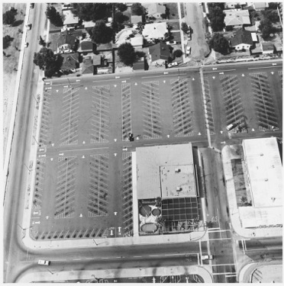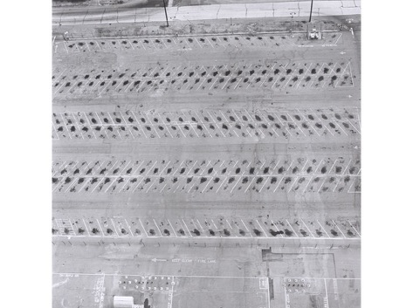
Figure 2 Edward Ruscha. Lockhead Air Terminal, 1967
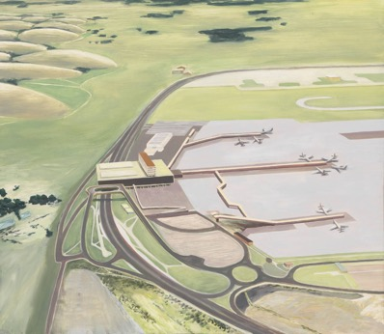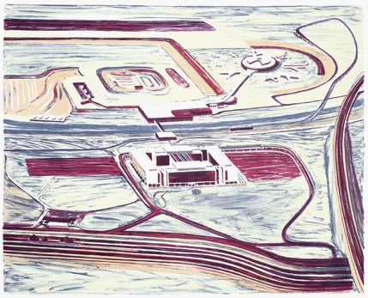
Figure 3 Carol Rhodes. Airport, 1995. Oil on Board

In 1967 the artist Edward Ruscha produced a series of black and white photographs titled, Lockhead Air Terminal. The photographs depict an aerial image of the airport landscape below. Here, the camera has zoomed in, presenting the landscape as a geometric design. Painter Carol Rhodes (1959-2018) has produced a series of paintings depicting the airport from an aerial perspective. I came across the painting Airport (1995) by Carol Rhodes at the Tate Britain, in the Framing the View exhibition (2013). The use of cool colour and muted tones generates a distant, quiet view of the airport landscape below. There is no sign of people in the space. It is empty and un-inhabited and I can only presume the activity is within the building just left to the centre of the painting. What makes this painting particularly interesting to me is the small scale, despite the vastness of the landscape. It has an intensity whilst being uncluttered, free of detail, and noise, a contrast to how many airports are often experienced (Gottdeiner 2001). In Rhodes’ paintings the terminal, the apron and runway, and the surrounding road network are all evident. The only space we cannot see is inside the terminal.
The work of Wolfgang Tillmans (b.1968) offers a different perspective on airport spatial zones by adopting and presenting the viewpoint of looking up, away from the terminal. The series of photographic images are of an airplane landing and taking off. The artist has used different viewpoints to take the images, shown through the varying scales and angles of the airplanes. The security fence around the airport is evident in some of the photographs, which puts the image in an interesting context, reminding the viewer of prohibited airport space, and the boundaries around the airport landscape in which security imposes restrictions of access (Pascoe 2001; Adey 2004; Hall 2015). Through my own practice I also aim to visually experiment with prohibited spaces at the airport, as a way of expanding discussions around spatial zones and control of movement.

Other artists have represented the spatial zone of the apron through their practice. The artist Andreas Gursky (b.1955), and the collaborative pairing of Peter Fischli and David Weiss (b.1952,1946) have each used large format photography as a way of emphasizing the vastness and emptiness of the apron space. Gursky’s Schipol (1994) represents the empty apron framed by a window, with no other visual interruptions. In comparison, Fischli and Weiss’s photographic series 800 Views of Airports (2012) do not empty the space completely, but include the airport traffic, fuel engines and baggage trucks. The artist Julian Opie (b.1958) uses a flat, cartoonlike aesthetic, of bold colour and simplified forms in his painting Airport (2017). The feeling generated here, is that of being inside a computer game, removed from reality. Despite the strong aesthetic appeal of each of these artists responses to the space, each of these works seem to be a static and almost lifeless vision of the airport. I seek to challenge this ‘static’ representation of the apron and visualize the movement and activity which shapes the space.
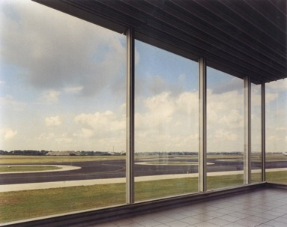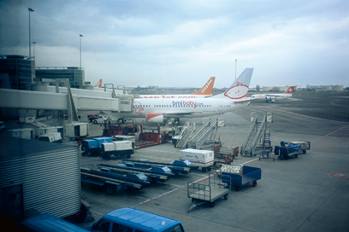
Figure 4 Andreas Gursky. Schipol,1994
Figure 5 Peter Fischli and David Weiss. 800 Views of Airports, 2012
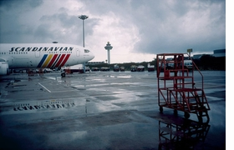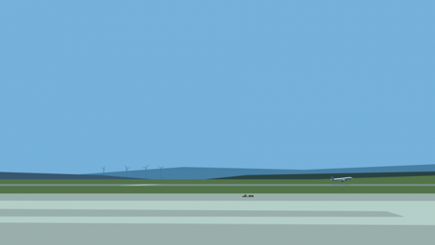
Figure 6 Peter Fischli and David Weiss. 800 Views of Airports, 2012
Figure 7 Julian Opie. Airport, 2017
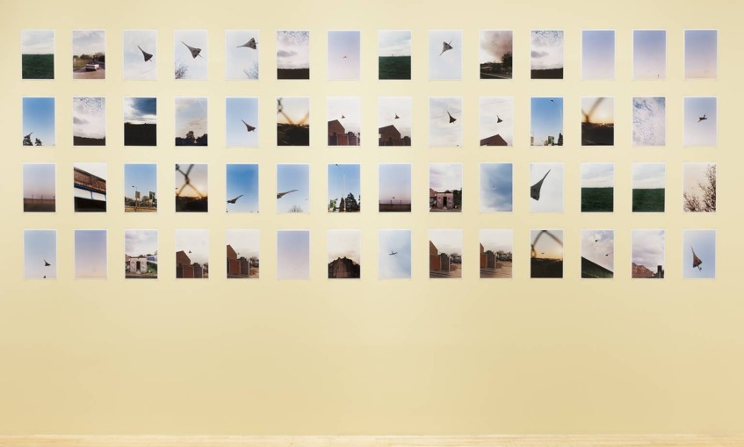
Figure 8 Wolfgang Tilmans. Concrete Grid, 1997

More recently, artists working in the area of art and mobilities have also challenged these static representations, by exploring the apron space, through multi-media practices. Panoramic Climates (Barry 2016) is a series of photographs generated by people from different areas of the world, who have uploaded their images of mobile experiences to create a moving panoramic projection. Tower (Kerr 2017) explores the apron space from the airport control tower, again generating a panoramic format, assembling an imagined ‘whole’ 360 degree view of the space. Both artists are providing a space which accumulates multiple experiences of the airport from multiple perspectives, a concept which I also aim to experiment with through methods of collage.

Airport Movement

Within these different spatial zones at the airport there are people and things moving, which give shape to the space. As Salter (2008) observes, airports are often examined and described in literatures as spaces of flow (Adey 2004; Fuller and Harley 2004; Salter 2008; Pearman 2004), whilst at the same time these writers acknowledge this ‘flow’ is often interrupted due to security procedures, commercial spaces redirecting our movement, changes in flight times and gate locations, amongst other factors. The topic of airport movement, and the kinds of logics (such as commercial or operational) that shape and direct this movement has been a topic explored by Adey (2004, 2010); Salter (2008); Cresswell (2006); Fuller and Harley (2004); Ballard (1997); Nikolaeva (2012); Rosler (1986); Wallinger (2000). What seems consistent in these perspectives is that movement at the airport is often attempted to be controlled through a variety of different means and sometimes for competing purposes.

In the aftermath of 9/11, as international terrorism increased, surveillance and control in airports greatly intensified. Surveillance and control are key topics often discussed in airport literature, where writers have used the airport to examine questions of affect, mobility and personal identity within a highly controlled and regulated environment (Salter, 2008; Adey, 2004,2010; Cresswell, 2006; Urry, Elliott, Radford, & Pitt, 2016). Cresswell writes: ‘Airports are places where the motion of human bodies is finely managed. They are machines for mobility. There are few sites on earth where the individual motions of human bodies are so consistently monitored and micromanaged’ (Cresswell, 2006: 237). Ballard (1997), also talks about this control, saying that while all individuals are free to meet all their needs, they are nevertheless rigidly constrained in what they are able or encouraged to do. As Adey (2008;148) observes, ‘the idea of airports is to change people’s movement, to make them move where the authorities want them to go’. And yet, despite these regimes of control, we should not assume that they are successful or go without contestation.

When considering these ideas about control, it is important to think about what factors are contributing to this control of movement. Many writers (Creswell 2006; Rosler 1996; Kitchen & Dodge 2011; Fuller & Harley 2004; Salter 2008), suggest technology plays a big part here, in the form of information, signage, and surveillance systems. Cresswell (2006) asks us to consider the interconnected roles of information technology, signs and architecture, and their impact on the body. Similarly, Rosler (1998) discusses how the airport, like the modern corporate space, cleanly embodies Foucault’s (1967) observations on the ways that information is used to organize and control people, and where identity is removed, which generates an impersonal and disembodied virtual space in which to occupy and move through.

Many have written about the security zones at the airport and how these areas of control, halt and interrupt movement. When exploring the impact of security zones on passengers at the airport, Hall (2017) interestingly refers to these spaces as performative, suggesting that the security practices in the airport generate a kind of embodied performance from the passenger. The passenger, she says, becomes transparent, in readiness for the security procedures (Hall, 2017: 184-186). The x-ray machines then go on to further enforce this transparency. Imagined Airport aims to explore and expand on these ideas of transparency at the airport through various visual experimentations and responses.

Terms such as ‘networks’ and ‘nodes’ are often used to describe airports (Kitchen & Dodge 2011; Fuller & Harley 2004), terms which are often associated with technology and the digital. In the airport we are immersed in technology. As Pascoe (2001;33) observes, “As soon as one drives into an airport car park, one finds oneself integrated into an unparalleled conglomeration of communication and control systems which refuses any dissent’. He goes on to discuss how each zone has its own technologies which affect movement through the space and that the airport is as much an intersection of processes as a building. The idea that the airport is a site where information and data direct and control movement are echoed by Kitchen & Dodge (2011), who suggest movement in the airport is often shaped by the systems and technology of the space. There are constant interruptions of visual information in the form of signage and advertising. As Fuller and Harley (2004) observe, all airport spaces are overlaid with signs, which affect experience, and direct movement. The work Frankfurt (2007) by artist Gursky provides us with a visual impression of this idea. Here, the figures in the departure hall occupy the bottom third of the space, whilst the rest of the image is dominated by the arrivals and departures boards. The data visually dominates, emphasizing the dominant power of information which looms over the people below.

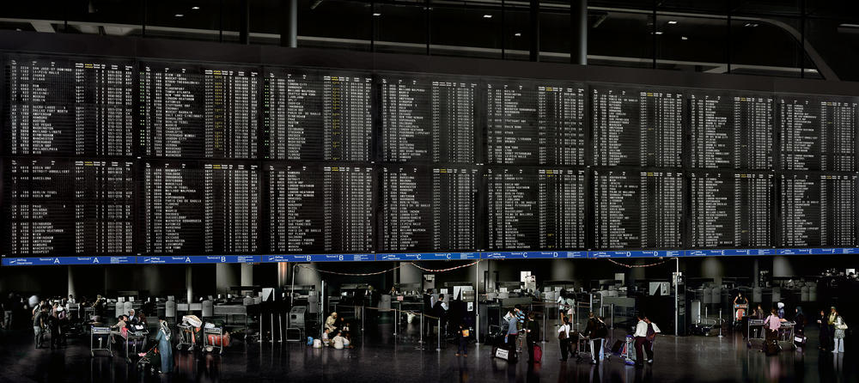
Figure 9 Andreas Gursky. Frankfurt, 2007

The airport is often seen and described as a space of constant movement and flux. As Salter (2008) suggests, airports become politically interesting when they are also understood as sites of de-stabilization, ambiguity and constant movement. However, many writers (Adey 2004, 2010; Bissell 2010; Fuller & Harley 2004) have brought to attention the moments of stillness at the airport, which have as much significance as movement when considering airport spatial experience. There are slow and fast areas of the airport. When movement is being discussed in relation to the airport, ideas of fast and slow movement are interesting to consider, especially in relation to what causes this variation in speed. Commercialization at the airport has become an increasing mode of containment since 9/11 as a result of the intensified security controls and the length of time we have to now spend there as a consequence. Passengers are now seen as a captive market for retailing. The airport locates passengers within zones, tells them when to move according to specifically tied schedules, and how much time they want them to dwell in certain areas. (Adey 2004, 2010). Bissell (2007, 2010, 2011) expands these ideas on activity and inactivity, immobility and stillness, arguing that such spaces of speed and flow are countered by spaces of waiting. Bissell (2007) interrogates the experience of waiting during the process of journeying, with a particular focus on the body and its relationship to inactivity and activity. He talks about the potential and significance of waiting as an event in itself, as opposed to waiting being something still or passive. Bissell and Fuller (2011) look at the importance and complexity of stillness, exploring the relationship between mobility and immobility. They consider how, with stillness and immobility comes a range of different emotions to when we move.

At the airport, moments of stillness and immobility may come at different times and evoke different emotions and tensions. As Harley (2008) observes, waiting and stillness are active forms of bodily engagement, where, at the airport many travellers are loaded with a variety of contradictory associations and affects. These moments of waiting and stillness may arrive through waiting at a gate, through listening to an important announcement, through moments of thought and anticipation in relation to the journey. These moments may come with conflicting feelings of unease, tension, excitement or joy. Whilst being in an airport, I believe we often experience a range of emotions and moments of mobility and immobility simultaneously. Often whilst walking through the terminal I would pause, to listen to an announcement or to check I have something in my bag or to look up to a screen for my flight time. I may sit waiting with my child, laughing at something they said, whilst at the same time feeling uneasy about a delayed flight. I aim to visually experiment with these juxtapositions of emotion, mobility and immobility throughout Imagined Airport, using still and moving image alongside each other and at times still images layered upon moving images and vice versa, as a way of exploring how, even if still and moving can be seen as different forms of movement and mobility, being still and moving at the airport are often bound together, without separation. In Chapter 2, Collage as Method, I talk in more depth about these ideas of activity and inactivity, immobility and stillness, and how I employ methods of collage to layer, edit speed and insert intervals as a way of visually experimenting with these ideas.

Airport People
Literature and art about airport people and the subject of personal identity in the airport have been explored in different ways, whether this is looking at the anonymous people in spaces of transit (Auge 2009; Castells 2006; Cirio 2012, 2017; Calle 1980,1996), the airport workers (Cresswell 2006; Sharma 2014), the waiting passengers (Bissell 2007; Fuller 2007), the transparent passengers (Hall 2015) or the anxious passengers (Salter 2008; Pascoe 2001; Adey 2007). Different terms and words have been used to describe the people in the airport. Passengers have been described as a ‘package on legs’ (Brett 1962), a ‘legible record’ (Cresswell 2006), ‘sterile’ (Voight 1996), ‘liquid’ (Sharma 2014) and an ‘imaginative figure that can be trialled and tested’ (Adey 2008: 443). Schaberg (2011: 1) suggests ‘airports are sites where identity is confirmed or questioned’. These observations about the people at the airport are each different, which, in itself, emphasizes that the airport provides a montage of people, a collage of multiple identities, with multiple reasons for being there, who interact and interconnect within the same space, but experience the space in different ways. What comes through and is consistent in the airport literatures is the emphasis on ‘difference’, between those who occupy and move through the space. As Cresswell (2006: 222) observes, ‘clearly not all passengers in terminals are mobile in quite the same way. People move through them in new and sometimes unpredictable ways’. Cresswell highlights the differences in how people move through and occupy the space in different ways, which reflects the differentiation of society (Cresswell 2006). Adey (2007) also makes the argument that the airport sorts passengers into different modalities, calling it a ‘difference machine’. Similarly, Merriman (2004: 152) observes:

‘different people dwell in, move through and inhabit these spaces of travel and exchange in different ways, as thoughts, materials, spaces, atmospheres and flesh are enfolded into unique, hybrid, mobile, and both individualized and normalized, assemblages such as the business executive, car-driver or shopper’

These ideas also critique some of the existing work about airport experience, suggesting it comes from a mono-perspective of a relatively privileged academic perspective drawn from a few different academic’s own lofty perspective on airport experience (Merriman 2004). Expanding on this idea, not only is the airport experienced in multiple ways by different people, but there is also a multiplicity of experience within the individual, depending on when and where they inhabit and encounter the airport space. For example, I experience the airport very differently as a researcher, to when I am travelling through the airport with my family. I experience the airport differently through the mediated technologies of Google Street View, websites and webcams, to when I am in the physical airport. I experience particular spatial zones differently – for example, the apron space and the arrivals hall provide me with hopeful, optimistic feelings, in contrast with the more anxious, claustrophobic feelings experienced in the security check points and the departure lounge. It is these multiple experiences of different people, and multiple experiences of the individual (myself), which I aim to explore further, through art practice.

Pascoe (2004:7) describes the airport “as a space which, more effectively than any other framed by the last century, reflects and shapes the narratives of those who process through it”. There are many different narratives in action here, where different people are at the airport for different reasons but are occupying the same space at the same time. This joint occupation of the space generates a series of unexpected connections and relations between people. This idea of the montage of people within the airport, with differing positions, roles and purposes is interestingly discussed by Sharma (2014), who talks about how these different individuals experience very different temporalities, from the ‘liquid man’ (frequent business traveller), to the workers, which is an observation echoed by Auge (1999: 110): “An airport does not have the same status in the eyes of the passenger who hastily crosses through it and an employee who works there everyday”. In the recent publication Transit Life (2018), geographer David Bissell presents a fascinating account of how people encounter spaces of transit differently. Through engaging with many commuters and their different experiences Bissell explores the routines, movements, tensions, relationships and encounters, which commuting brings about in different ways. In response to these ideas I am also fascinated by how different people are experiencing and occupying space at the same time but in different ways. However, unlike the fieldwork of Bissell, I am not asking the people in the airport about their experience. I am observing, as an artist, the people I see and hear, considering how to visually explore this montage of people with multiple experiences / identities / temporalities within one space. There is something alluring about watching the people in the airport and observing what they are doing. I discuss the different approaches to experimenting with this idea within the three practice chapters.

When talking about the people in the airport there is of course the issue of how people feel differently and experience the space in different ways. Within the airport there are heightened feelings of anticipation, excitement, whilst at the same time alienation and disappointment. Pascoe (2004) argues that the multiple systems in the airport add to traveller’s edginess. Adey (2008) also reflects on this unease and anxiety, seeing the space as providing a kaleidoscope of emotions, and asks the question of how and why these feelings are experienced and what factors are causing them, whether these are political, architectural or both. Urry, Elliott, Radford, & Pitt (2016) argue that the airport has a highly managed atmosphere, which affects passenger’s emotions. One of my challenges is to try and convey this kaleidoscope of emotion through the images and films and make connections between spaces and people which may suggest these differing emotions and what factors influence them. I talk directly about my own experience, but I am only speculating and observing the possible emotions felt by others, through using photography, video and audio recordings of people around me and looking at found footage and uploads on Google Street View, which indicate people’s experiences of the airport.

In the video Threshold to the Kingdom (2000), the artist Mark Wallinger (b.1959) makes us confront these differences between people at the airport as we watch individuals and groups of varying appearances arriving at the airport. The viewpoint is from a fixed position, focusing on a doorway, waiting for the passengers to come through the arrivals gate. Automatic doors open and close, as passengers and airport workers emerge from the doorway and walk towards the foreground of the space. The video is presented in slow motion. The film was shot in one take, without the permission of the airport, which gives the film a particular aesthetic, a sense of being in a familiar moment, of waiting to see a familiar face come through the doors. The accompanying music and decision to use slow motion generate an almost dreamlike effect, generating a feeling of detachment from the reality of the space. It feels there is a building up to something, a sense of waiting, which is why people are often in that particular space of the airport. There is both a tension and a calmness. The title of Wallinger’s work, and the doorway itself, seem to symbolize and allude to entering into a new place, and perhaps a new life. The doors opening and closing seem to represent the opening and closing of possibilities. There is a sense of both hope and anxiety whilst watching the video, which reminds me of Adey’s emotional Kaleidoscope description (Adey 2008). I particularly experienced these mixed feelings of tensions and calmness, a simultaneity of emotion, of hope and anxiety, whilst researching on site, whether in the digital or physical space. It is how I visualise these feelings which is the challenge.

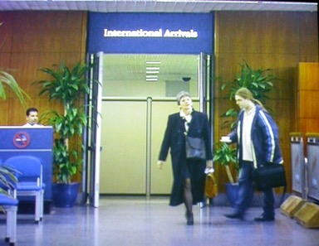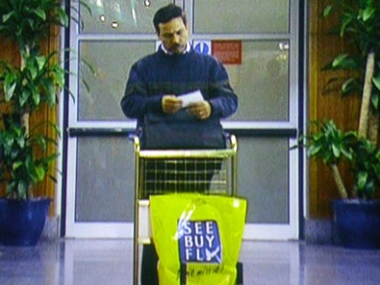
Figure 10 Mark Wallinger. Threshold to the Kingdom, 2000

Artist Duane Hanson deals with the subject of people in the airport directly, through his hyper-real life size sculptures of figures waiting in the space. In Traveler (1988), a life size figure of a tourist is slumped asleep amongst luggage, waiting for a flight. The figures in Tourists appear to be looking up, maybe towards an information screen, looking for their departure time. Artist Martha Rosler (b.1943) confronts the relationship between airport people and airport space in a less direct way than Hanson in the text and photographic series In the Place of the Public (1998). The subject of the body and identity are addressed through the emptiness and banality of the interior photographic compositions. Her images of the airport at night show the space as an empty architectural void, challenging the viewer to re-imagine this space as one which removes traces of identity and human presence. Despite the lack of figures in the images she creates, there always seems a strong human presence. The ‘body’ is not always visible but somehow leaves a trace, leaving the emptiness of the environment to be observed.
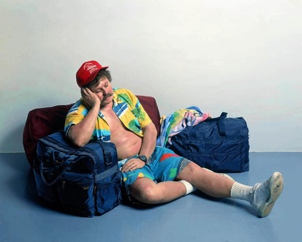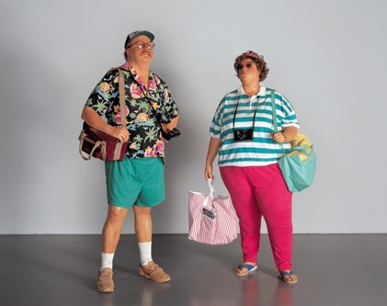
Figure 11 Duane Hanson. Traveler, 1988. Tourists, 1988
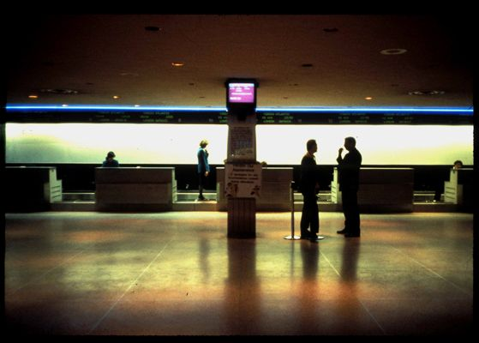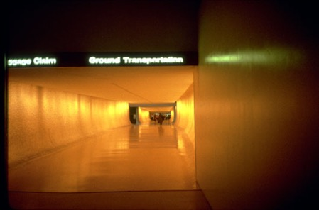
Figure 12 Martha Rosler. In the Place of the Public, 1996

The subject of the passenger has been explored in relation to the area of mobilities, where questions have been asked about what distinguishes the passenger from other mobile people and how is the passenger represented, practiced and performed (Adey, Bissell, McCormack, Merriman, 2012). I aim to continue this investigation on how the passenger is represented, by exploring the airport passenger visually, experimenting with ways in which the passenger relates to the other mobile people and objects in the airport space in which they occupy.

Conclusion
In this review I have presented different perspectives and visual representations of the airport, with particular focus on three themes: airport spatial zones, movement and people.
The art works and literatures I have discussed here have been a real influence on my practice and have provided a platform for expanding on the many ideas and discussions around these three airport themes. My practice aims to add to and expand on these discussions and artistic responses through a series of sustained visual, experimental investigations.

In response to expanding the theme of airport spatial zones, I am seeking to somehow visually explore the multiple zones simultaneously, rather than represent one particular spatial zone in isolation or from one singular perspective. I am looking to generate a surface which combines spatial zones from outside and inside, landside and airside, whether this is on a painting, digital image or film. I discuss these methods further in the following methods section. In response to the theme of airport movement there seems many ways in which ideas around the interconnection between information, control and movement can be responded to through art practice. My three projects will each experiment with these ideas in different ways, aiming to add and expand on the existing ideas discussed in this review. As a way of visually responding to the theme of airport people, I aim to explore methods of collage, which enable me to experiment with visualising the differences and multiplicities in action at the same time.

Chapter 2: COLLAGE AS METHOD

"Seeing more than one thing at once, either simultaneously, side by side, or layered on top of each other. It’s the way the brain works. You think of one thing and see another"
Joan Jonas (I am Curious about Life, Tate Shots, 2018)

Contents:
Introduction
Collage: Background / History
Airport as Collage
Collage as a Method for Art & Mobilities Research
Conclusion

Introduction

The purpose of this chapter is to provide a rationale for why and how the methodological framework of collage is being used as a way of exploring and understanding the airport space and the experience of being in an airport. Collage is a vast topic and has been employed in many different ways through a range of diverse art practices and research. As such, this chapter provides only a partial account of collage as method and focuses more specifically on the different collage methods I am using to explore the airport and in particular, the spatial zones, movement and people encountered and experienced whilst in the space.
Each project in Imagined Airport uses the method of collage in different ways, as a way of layering and juxtaposing spaces, visual information, people and movement in the pursuit of presenting an alternative view and understanding of the airport space and to enable a way to visualize the network of spaces and activities of the airport that impact on each other. I am using collage as a representational system, to show different viewpoints at the same time, within the same space. The project aims to experiment with visual strategies through which to explore the airport not from a particular spatial zone or perspective but rather, as an evolving space of juxtaposed, overlapping and constantly changing views. I feel that existing art about airports, which I explore in the previous chapter and within the following practice chapters, lack this sense of collision and coexistence of multiple spaces, movements, and people within one surface / work of art. By employing methods of collage, Imagined Airport is attempting to produce work which addresses this gap, by generating a more visually fragmented, multiple and disorientating experience, akin both to the accounts emerging from within airport literatures and my own experience of these spaces.

In the first section of the chapter Collage: Background / History, I introduce the discipline of collage, providing discussion and analysis on how artists, filmmakers, writers and architects have employed collage as an art practice. I refer to specific examples here, providing a short overview of historical and contemporary practices. I discuss how many of these practices have influenced my own practice.

In the second section, Airport as Collage, I discuss how I see the airport as a collage and suggest ways in which the method of collage can tell us about the space and spatial experience of the airport. I look at collage in relationship to key theoretical concepts which have been applied to the airport, such as heterotopia (Foucault 1967), the rhizome (Deleuze & Guatarri 1987) and media surface (Dorian 2013), proposing how and why I believe these theoretical concepts of space are connected and related to the airport and the method of collage. In this section, I discuss how I am using collage to explore the airport as a heterotopic space, rhizome and media surface, underpinning my explanation of collage through specific examples of my own research and practice. I discuss how, by employing collage methods, I am seeking a way to investigate the airport in new ways and provide an alternative understanding of the space. I discuss how I am collaging spatial zones, movement and people in the three projects, as a way of exploring airport space and spatial experiences.

In the third section, Collage as a Method for Art & Mobilities Research, I explore how collage can be used as a method of research in the field of arts and mobilities. I suggest ways in which this method can contribute to the area in new ways. I use specific examples of my own practice here, and how the methods I have used show the potential to be transferable for myself and others in researching alternative sites and spaces. In addition, I consider how using collage as a research method is at times difficult and problematic, in terms of enabling a way of working which can be articulated and explained through written form.

Collage: Background / History

The term collage comes from the French verb coller, which means ‘to glue’ or to ‘stick’. It is commonly known as a process of physically cutting and gluing together fragments of images, papers and other physical materials to make a new image on a single surface. In this thesis, both in the practice and written analysis, I am interpreting collage more broadly, incorporating different forms of collage which employ both physical and digital methods. Collages can now be generated and constructed by ‘gluing’ digitally as well as physically, utilizing technologies which enable the cutting and pasting of digital image, film, video and sound, from either found or made sources. I provide examples of artists employing digital collage methods in the following practice chapters. Whatever the chosen medium, collage enables an assemblage of diverse and often unrelated elements or fragments, which can be layered and juxtaposed onto a single surface as a way of generating new, often unexpected forms.

Within the definitions of art history, the origins of collage are attributed to the early twentieth century art movement of Cubism, and specifically the artists Picasso (1881–1973) and Braque (1882-1963). Cubism provided a radical shift in representation and thinking about space, where visual devices of simultaneity, transparency, overlapping planes and juxtaposing spaces provided a revolutionary break with the European tradition of creating the illusion of real space from a fixed viewpoint. It was an attempt to unify disparate images (both formally and conceptually) in order to promote connections between contradictory aspects of our experiences in the world (Shields 2014: 92). The cubists set out to show all aspects of an object at once (Nash 1974). It was as if the painter had moved freely around his subject, gathering information from various angles and viewpoints (Golding 1959). Cubist space was not only optical but phenomenological, which, as Rowe and Slutsky (1963) observed, involved a new spatial order, a simultaneous perception of different locations, which displaces the static viewer. But the different angles of view are not presented in any sequence, they are juxtaposed (Colomina 1997). The non-perspectival spatial compositions of cubism generated a new perception of space in terms of time, or ‘space- time’ marked by planarity, transparency and multiple viewpoints (Gideon 1941).

Both the analytical and synthetic cubism of Picasso and Braque experimented with combining multiple viewpoints through the method of deconstructing and reassembling. Analytical cubism represented an object as a fragmented form made up of various viewpoints, whereas synthetic cubism introduced the methods of collage, applying fragments of found material on to the surface of the canvas, which tended to flatten the space, removing the allusion of three-dimensional space, through juxtaposing shapes and textures made with found paper and newsprint. The practice of collage represented a deliberate rejection of the traditional and stable materials of which painting had been made since the renaissance. Collage allowed a more perfect abandonment of illusionism in favour of ‘residual’ illusionism - used to bring these glued objects into relation to each other (Shields 2014).

Methods of collage played a crucial role in the subsequent art movements of Futurism, Dadaism, Surrealism and Pop art. After the mid-19th century, it was common practice for artists to integrate and collage photographs into their work, a method, which the dadaist’s named “photomontage”. Collage is often discussed in relation to its associated praxes, montage, photomontage and assemblage. I use these terms myself at times in the thesis but felt the term collage is the more central to the project as a whole.

The dadaists’ used photomontage as a political tool of critique and went on to greatly influence collage artists such as Kurt Schwitters (1887–1948) and Hannah Hoch (1889-1978), as well as many filmmakers. Cinematic Montage, a method of juxtaposition and layering of shots and sequences in film, is often discussed in relation to the theory and practice of the filmmakers Sergei Eisenstein (1898-1948) and Dziga Vertov (1895-1954). I draw influence from these filmmakers, with particular attention to the pauses and intervals I use in each project. I discuss these methods further in the practice chapters. Cinematic montage is today expanding into new areas. The rise of the internet is now providing many artists opportunities to appropriate and manipulate found images and footage in exciting ways, using digital fragments to generate imagined environments which often critique how we inhabit and use digital space and technologies (Bruce Nauman, b.1941; Ryan Trecartin, b.1981; Tacita Dean, b.1965; Phillippe Parreno, b.1964; Lev Manovich, b.1960; Michael Wolf b.1954; Paolo Cirio b.1979; Jon Rafman, b.1981). These artists, amongst an expanding field of artists, experiment with the fragmentation of found images taken from internet sources, which are then transformed into new spatial and formal configurations. In response to these ideas, I am also seeking to transform and re-position found digital fragments, imposing a restructuring through collaging multiple sources of imagery. This method of assembling and collaging multiple imagery is being used to reinforce the ideas around multiple experiences encountered in the airport (Merriman 2004; Cresswell 2006).

This language of collage and montage - the superimposition, juxtaposition and interruption of many elements to form one space was also adopted by writers. Examples here are Walter Benjamin’s Arcades Project (1927-1940) and Italo Calvino’s Invisible Cities (1974), which both adopt imaginative methods of critique, representation and description through fragments and juxtaposition. Benjamin’s Arcades Project, an unfinished project at the time of his death in 1940, is an assemblage of notes, observations sketches and proposals in response to life in the Parisian Arcades. Fragments of personal notes, descriptions and reflections are combined with text cited from critics and historians. These literary fragments are grouped by topic into 28 different bundles (or folders – Konvoluts), generating an ‘image’ of modern life in which Benjamin was experiencing in front of and around him. Through these textual and visual fragments, it seemed apparent that Benjamin was trying to develop a mode of critical discourse that reduced theorizing and authorial interpretation to a minimum in favour of a series of "images" (Buck-Morss 1991). Similarly, Italo Calvino’s Invisible Cities (1974) is a collection of fragmented thoughts and observations which come together as a single work. His descriptions of 55 different cities are imagined spaces, constructed not of steel and concrete but of ideas, with each city representing a thought experiment (Weiner 2013). These imaginative assemblages of observation seem an exciting and appropriate method in which to compile my own response to the airport, as this fragmented method conveys a sense of discontinuity and dislocation, feelings and experiences often associated with the airport space. Each project and written chapter in Imagined Airport adopts similar collage methods, providing ethnographic vignettes of written observations whilst being there, talking about my own experience and senses experienced whilst in the space, whilst combining these personal notes with found text, appropriated from found image and footage. This text is converted to ‘speech’ as a non-linear sound narrative to accompany the images in the films. I discuss this method further, within the three practice chapters. The majority of the work in Imagined Airport is presented as film and video, which has been made by collaging image, sound and text. The work has often been constructed with physical cut and paste collage as their starting point / background or final layer. I also regularly combine still and moving image onto one surface as a way of reflecting airport space and experience. Both the methods of montage and collage are often in operation at one time, taking place simultaneously.

As well as a method in visual art, film and literature, collage and montage became a method adopted by architects who saw the method as presenting many exciting ways in which to generate ideas and to present architectural concepts. Examples here, which I discuss further in the practice chapters, are the 1960’s architectural practices of Archigram and Superstudio. Both groups, through alternative methods of layering and fragmenting space presented ambiguous collages as concepts for architecture. The visual concepts, in the form of two and three-dimensional collages offered a plurity of readings and possibilities, presenting a critique of the normative modes of architectural representation (Shields 2014). Both these practices have been a big influence on my own practice, especially in the project Model Fiction, where I am generating my own imagined architecture by using collage as a method of architectural design and construction.

Many of these historical and contemporary experimental methods of collage, which I have introduced in this section have greatly influenced my practice. I provide further suggestions of how in the three practice chapters, referring to specific works. There are many more collage practices which I could draw upon as the field is extensive and ever expanding. However, the focus of this thesis is to be on how and why I am using collage in my own art practice as a way of offering a new study of airports.

Airport as Collage
The experience of being in an airport to me, mirrors the experience of both constructing and viewing a visual collage, where the space is continuously changing, demanding constant re-orientation, where spatial zones, movement and people overlap and interrelate. It is an environment where the activity within it forms the shape of the space, which refers to the spatial ideas of French urban sociologist Henri Lefebvre (1974), who saw space as not a thing or container but a set of relations and forms, whether these are living beings, things, objects, works, signs and symbols, which continuously interrelate. He views space as neither static nor pre-ordained, but a continuous production of spatial relations, which encompass multiplicity and coexistence (Lefebvre 1974: 101).

Airport space and experience, like a collage, may be fragmentary, which is a view at odds with how many airports attempt to represent themselves as ordered, whole, seamless spaces. My experience of the airport, whether being in the actual space or inhabiting the airport through digital media, provides a visual feast of architecture, graphics, figures, colour, light, form, movement, all within one contained environment, a surface and space of assembled imagery and sound, where there is no place to settle. Like the fragments of a collage, I get moved around, re-positioned, overlapped, fixed and unfixed. At times I have very little space to move, whereas at other times I seem to occupy a vast open space. The light is flat and illuminated at the same time. Photographic images from advertising screens and billboards come in and out of focus, flickering towards the edge of the surface. As Gordon (2004) observes, the airport is a space which overwhelms the senses, a site rife with affects, moods, and signs to be interpreted. Fuller (2008) makes similar observations about the space, referring to the airport as an ‘image matrix’, where the visual dominates and where we witness our own multiple visualizations as we pass through the stages of transit. Reflecting upon these ideas, the method of collage seems the perfect medium for addressing the airport as a space saturated in images. By employing the method of collage, it enables me to bring together these multiple fragmented images we experience as we pass through the space, in the form of signage, advertising, billboards and the images we see through the windows of the terminals. Collage is also a way of controlling this visual overload in some way, by imposing a control through reduction and repositioning.

The collision of spaces and perspectives I present through collage aims to reflect my own experience of the space. The method of collage is also being used in relation to the theoretical concepts of space which have been applied to the airport, – heterotopia (Foucault 1967), a rhizome (Deleuze and Guattari 1987) and a media surface (Dorrian 2013). The particular theoretical concepts of the heterotopia, rhizome and media surface have helped illuminate and guide my thinking and experience of the airport and how I have approached it. Each of these concepts imply a network of spaces, contradictory spaces, multiplicities of form, binary oppositions, fragmentation - all of which I would say are key characteristics of both an airport and a collage. Imagined Airport is very much a response to these ideas about multiplicity and coexistence, where each project explores and experiments with the concepts visually. I borrow from these concepts and use them as a way to explore the space of the airport through my art practice. In the following section I outline what these concepts are and how they relate to my chosen method of collage.

Heterotopia
The concept of heterotopia originates with Michel Foucault (1926–1984), who uses it to describe spaces which are ‘other’ and ‘in-between’. In his lecture Of Other Spaces (1967), Foucault proposes that heterotopias are locations that are ‘‘in relation with all other sites, but in such a way to suspect, neutralize, or invert the set of relations that they happen to designate, mirror, or reflect … spaces which are linked with all the others, which however contradict all the(se) sites . . .’’ (1986:24). He defines heterotopia in opposition to utopia. He argues that while utopias are unrealized representations of a perfected society, heterotopias exist within all societies as realms differentiated from everyday life. Although Foucault does not examine the airport as heterotopic (his focus in on ceremonial, sacred, and institutional spaces such as chapels, cemeteries, prisons, workhouses, convents, military academies amongst others), his attention on the contradictory elements in these spaces could certainly be applied to the airport and to the method of collage. Salter (2007) explores this idea, using Foucault’s concept of the heterotopia to highlight how the airport is a space of contradictory and intersecting forces. The airport, he says, while emancipatory and open for some, represents a locus of anxiety and interrogation for many others (Salter 2007; 49).

Heterotopic spaces are designated for special activities – creating their own sense of time and operating according to their own standards (Foucault 1967). The heterotopic spaces Foucault refers to are often heavily surveilled and can only be entered with certain permissions. There are similarities with the airport here. At the airport, ‘not only are we questioned before boarding, our identities checked, our clothes frisked, our belongings searched, and our bodies scanned, but we are constantly watched as well, through Closed Circuit Television (CCTV)’ (Wagenaar and Boersma 2012:66).

Foucault’s description of heterotopias being ‘‘capable of juxtaposing in a single real place several places, several sites that are in themselves incompatible’’ (1986:25) could be in itself a description of both an airport and a visual collage. In my practice I apply this theory when visually experimenting with the collision and overlapping of spatial zones which regularly occur whilst looking at and experiencing the airport. In each project a heterotopic collaging takes place, mixing, layering and juxtaposing spatial zones. For example, in Street View Diaries I visually highlight, through the editing process, the spatial transitions between airport zones, whether moving from inside to outside, or from one interior space to another within the terminal. In Apron Space, each of the short films experiment with layering and juxtaposing more than two spatial zones simultaneously. I do this through collaging video footage with inserts and layers of colour, line or sound. These methods can also be used to visually represent heterotopic ideas of control and interruption, by applying collaged shapes and surfaces as a way of blocking, covering and obscuring elements of spaces. In Model Fiction the space has been constructed by assembling multiple spatial zones within one imagined environment. The challenge of the work across the three projects is to arrange a series of disparate spatial zones, viewpoints and figures and assemble them so they can occupy one imagined architectural space.

In each project in Imagined Airport, as a way of reinforcing these heterotopic ideas about ‘real’ and ‘other’ spaces existing simultaneously, I collage the visualities of transparent surfaces, such as screens and windows, whether this is through still images or video footage. Many of the short films I make are from observing and recording the airport from behind a screen or window. The collaging process enables me to juxtapose several spaces at the same time, generating an experience of being located and active in one airport space whilst other spaces and activity is all round me. A method, which again references a cubist layering of spatial planes. The method of collage in Imagined Airport uses the visual surface (this could be a physical or digital picture plane) as the ‘single real place’ which brings together and juxtaposes multiple viewpoints from multiple spatial zones, which usually function as separate spaces from each other. By bringing them together onto one picture plane I am attempting to find ways to make them more compatible with each other, as a way of showing that although they are separate spaces to some extent, they exist and inter-relate within the same airport environment.
Foucault talks about how heterotopias isolate deviant individuals, or those going through rites of passage, through the arrangement of space, technologies, and authorities (Foucault 1967). Although he isn’t referring to the airport here, such an observation could be applied to the airport. Although the idea of ‘deviant individuals’ is not necessarily relevant to the airport, the concept of isolating individuals who are being directed and controlled could be applied. Many geographers (Merriman 2004; Cresswell 2006; Adey 2007, 2008) have analyzed the different people in the airport, how they behave and move differently and the reasons for this. Wagenaar and Boersma (2012) talk about how no one acts ‘normally’ at the airport, where no one is ‘at home’ and therefore ‘normal behaviour’ does not exist. In my practice I employ collage as a device to visually experiment with these ideas, isolating figures from their surroundings, unhooking them from their original context as a way of addressing ideas about dislocation. People, whilst in these spaces, become the moveable elements of the airport collage, that are positioned and repositioned, across the ‘whole’ space and surface, due to security procedures and way finding systems. They are unfixed elements in an unfixed space. The cut and paste collage method provides a way in which to visualize this idea.

Analysing the airport as a heterotopia has led me to consider how closely the method of collage relates to this particular spatial theory. The contradictory and controlling elements of spaces Foucault describes can be represented through the visual devices and processes of collage. By physically or digitally cutting, pasting, slicing, layering, juxtaposing fragments from disparate sources, ‘other’ and ‘in-between’ spaces can be alluded to and imagined. A collage always represents more than one space simultaneously. There are continuous contradictory elements in play at any one time, through the juxtaposition of contrasting imagery from different sources.

Rhizome
Within the thesis I compare both the airport and the method of collage to the theoretical concept of the Rhizome, a concept developed by Deleuze & Guattari (1987), which suggests ideas on how different spaces can interact to form a multiplicity. The word rhizome is derived from a Greek word rhizōma, meaning “to take root.” The term originates in botany, describing a horizontal plant stem capable of producing the shoot and root systems of a new plant. Deleuze and Guattari use the term and concept of the rhizome as a way of analysing the book, describing any work of literature in general, as an assemblage, opposing and resisting the organizational structure of the root-tree system. The tree plainly represents a hierarchy and also refers to binary systems, and according to Deleuze and Guattari does not offer an adequate explanation of multiplicity. Deleuze and Guattari propose instead the rhizome book – which morphs, redirects, and moves in multiple directions at once (Clarke and Parsons 2013).

According to Deleuze and Guattari, a rhizomatic process acknowledges that there are multiple roots of knowledge and understanding, and one does not preclude the other. Unlike the tree, whose branches have all grown from a single trunk, the rhizome has no unique source from which the development of branches occurs. This growth can happen from different points, in different directions. The rhizome is non-hierarchical and has no centre, branching out into various directions without limit. It can be entered from many different points, all of which connect to each other, with no exact centre, or beginning and end point. Salter (2008) sees the rhizome as “particularly useful in analysing the incomplete, fragmented and dispersed nature of airport politics” (Salter 2008: xiii). He argues that using the work of Deleuze and Guattari (1987) to analyse the airport opens theoretical space for empirical analysis of the expansion of surveillance practices and controls over mobilities in the site of the airport. Power is seen as expanding horizontally over the topology of political life, rather than simply an imposition of power from above. In relation to the airport as a rhizome, Haggerty and Ericson (2000) argue that the ‘security assemblage’ which operates by abstracting human bodies from their territorial settings and separating them into a series of discrete flows generates a ‘rhizomatic’ levelling of the hierarchy of surveillance. They argue that “there is no hierarchical security system, with groups which were previously exempt from routine surveillance now increasingly being monitored’’ (Haggerty and Ericson 2000:606).

Imagined Airport is building on these ideas of the airport as a Rhizome, exploring the concept through the method of collage. The analogy of collage to rhizome is clear when analysing integral characteristics of the rhizome and descriptions and words associated with the rhizome – multiplicity, fragmentation, juxtaposition, words and traits which I also use throughout the thesis to describe the airport and the spatial experience encountered there. Both the rhizome and the collage allow for the coming together of multiple and fragmented parts. In the case of Imagined Airport, by applying concepts of the rhizome through collage, various multiple parts of the airport are brought together on one visual surface, with no sense of spatial hierarchy. Each spatial zone, advertisement, figure, occupies the space in an equal way. This is especially explored in Street View Diaries and Model Fiction, where you can enter the airport space at any point, in any location, and navigate around the space in multiple ways.

Media Surface
Another spatial concept which I apply to the airport and explore through the method of collage is the concept of ‘media surface’. This concept originates with Dorrian (2013), who explores how the ‘image’ of the landscape is changing as a result of the impact of technology and the many media filters applied to the surface through mapping software such as Google Earth. He argues that the terrestrial surface is becoming manipulated as a media surface, where a ‘mash up’ takes place, a fusing, layering and juxtapositioning of visualities – signs, symbols, photography, diagrams, which are in action at the same time. In this way the media surface has similarities with both the heterotopic space and rhizome, through its spatial multiplicity and fragmentation. Like the heterotopic and rhizomic space, there is no hierarchy here. Each element occupies the space and surface with equal importance. November and Latour (2010) also write about this multiplicity of visualities which are encountered whilst inhabiting this digital space, observing the abrupt movement from cartography to photography, from 2D to 3D. In relation to Google Earth, they echo Dorrian’s idea of the media surface, where advertising pop ups and street views taken by strangers begin to transform the scene you are looking at (November, Latour 2010).

Much of the research for the thesis has been conducted and experienced whilst inhabiting the media surface of the digital airport. By digital airport I refer to the airport via Google Earth and Google Street View, websites, webcams and virtual models. Throughout Imagined Airport I continuously observe and visually experiment with the airport’s media surface. I do this by utilising the surface of the screen, whether this is a mobile device, video camera, or the screen of a computer, using the filter of different software platforms. In each project I assemble and reconstruct elements and fragments from the digital airports as a way generating a series of media surfaces through collage. The airport environment, in my experience, is a space in which we constantly interact with multiple media interfaces, where architecture, information and media are interconnected. As we move through the airport, the signage, screens, electronic billboards, public announcements shape our movement and sensory experience of the space. I aim to translate this dynamic between spatial form and information through collaging the surfaces of paint, film, drawing, photography, generating my own visual interpretations of a media surface.

From the start of the project, it became increasingly apparent that the digital viewing environments of airport websites, webcams and Google Earth/ Street View presented a source of many different possibilities as a research method and a subject in itself, as well as an object for considerable creative inspiration. Through these media surfaces, I can gain much more (virtual) access to the different spatial zones of the airport, landside and airside, which allows me a way in which to experience and represent the space in a more transparent way.

Research Practices and Processes in Imagined Airport

One of the main challenges of researching the airport has often been obtaining access to the site and location of the airport. The highly controlled, monitored, commercialized and privatized spaces of airport sites pose particular problems for researchers, in terms of obtaining access (Lassen 2020). Lassen (2020) explores the methodological challenges of researching the airport, investigating and highlighting the challenges and problems airport researchers face. This challenge has been intensified since 9/11 due to a massive increase in security control and the introduction of prohibited areas to access. Lassen asks the question of which methods can be used to overcome these problems and challenges of access and permission to collect data. In order to continue researching the airport, the challenge of these restrictions has to be accepted and worked around in creative ways. Throughout the thesis I talk about how I employ various methods to overcome these challenges.

Lassen (2020) proposes two methods of researching the airport: the ‘trust approach’ (play by the rules) and the ‘guerrilla approach’ (work around the rules). I would say I have taken both approaches, combining visual data I collected from site visits in which I gained permission to the space, and also from site visits, where I have gathered research as a ‘participant observer’ (Lassan 2020), researching the space whilst moving through as a passenger. The first stage of the collaging process in Imagined Airport is to collect and assemble visual material from both these approaches, using photography, video, drawing and note-making from both the physical and digital sites. The physical airports I have gathered research from have been sites which are most personal to me, the airports which I have found myself in due to travel, and proximity to where I live, in the North of England. Occasionally I went to Manchester and Leeds Bradford airport for the sole purpose of taking photographs and video without the distraction of being there as a traveller. However, most of the site visits were short and unstructured, where I gathered research on the move, whilst travelling. As a participant observer I would take short videos and photographs with a mobile phone or hand held video camera, from different zones of the airport, either whilst I was moving, or during moments of waiting, which often involved looking at the spectacle of the airport through the window. Early in the project I gained permission to film in the space, agreeing to stay in particular zones. In the introduction I talk about the time I had working at the airport, which allowed me to see and experience the airport ‘behind the scenes’, getting to know other people who worked there and also to occupy airside spaces I would not usually encounter as a traveller. Although this experience was prior to this research, the memories of that time have also impacted on this study.

My collage approach for Imagined Airport allows me to gather and analyse a wide range of diverse information and image fragments related to the airport topics over a long period of time. Within the three projects I regularly collage together my own images and observations, with found material. Looking at and appropriating found images has played a huge part in the research process and has always been a main characteristic of the collage method. Many of the ‘found’ images I have used as starting points for the practice have been from digital sources (Google Earth, Webcams, websites, as well as from image-based publications (Pearman 2004; Gordon 2004; Fuller and Harley 2004; Van Uffelen 2012; Eiselin 2015), where the glossy, photographic images of the airport have prompted many thoughts on what the images tell us about the space. Do they convey airport experience, or do they generate a more distant, detached view? (Rose 2013). Many of these visual representations of airports which I have appropriated are often from an aerial perspective, detaching and distancing the viewer from what is happening inside the terminal. I expand on this discussion in the chapter Model Fiction.

After the gathering of materials, I then use the method of collage for the editing, manipulation and transformation of this material, producing outcomes in the form of final images, models or films, which form the three projects. I wasn’t always sure what to do with the fragments as the collecting of them was often instinctive. Much of the collage method relies on intuition, and what ‘feels’ right. It is not a method to find a particular answer, but to generate more questions. As Barry (2020: 323) observes, ‘creative arts practice might act as a prompt, a trigger or a lure for other modes of interaction to think and feel movement as it manifests and feeds back into the research inquiry.’

The method of collage is reliant on collecting things – found and made images, textures, sounds, video clips, and assembling them into a new form which attempts to make these elements compatible with each other, able to occupy the same space. Many creative choices followed in terms of how I would assemble, juxtapose, layer and ultimately synthesize the visual materials to form a final image or film. Davis and Butler-Kisber (1999) say that this collage process makes our results ‘strange’, perhaps showing us associations that we had not expected. The creator seeks the fragments and glues them together to express a feeling or sense of an experience or phenomenon rather than a particular idea (Butler-Kisber 2017). Shields (2014) talks about how fragmentation and synthesis imbue meaning as a result of context, as the relationships between the elements become more important than the objects themselves. This new ‘meaning’ which Shields alludes to is suggesting that when disparate elements are brought together a greater truth about how space is experienced as fragmentary is presented. Collage enables the coming together of these disparate elements and to be re-assembled into a new whole, where they can occupy the same space, and reflect on the fragmentary nature of spatial experience.

- The three projects have themselves been a form of collage, as working on these projects have often overlapped and moved around in the order of ‘doing’. At times I would work on each project simultaneously, as working on one would provide ideas for another. One did not start when another ended. For example, on the completion of a ‘final’ image or film, a new idea has emerged, which has sent me back to the site to begin gathering new material. Although the projects often overlapped, they evolved in a particular order, beginning with Street View Diaries, followed by Apron Space and Model Fiction, which provides me with the structure of the chapters for this written document.

Throughout the project I collage together the physical surface of drawing and painting with the digital surface of photographic imagery, film and video. I draw on influences from art and architecture here, in particular Gerhard Richter (b.1932), Richard Hamilton (1922-2011), Herbert Bayer (1900-1985), Patrick Caulfield (1936-2005) and again, the 1960’s architectural practices of Archigram and Superstudio. I also use digital model making software to collage and assemble imagined spaces. I work across the different methods and media, knowing instinctively when a particular method is appropriate. I work fast, and slow. I repeat, delete, paint over, cut out, project, overlay. I am still. I am moving across the surface. I stop, I start, I re-work. The collaging of the digital and the physical is ever present, combining the activity of the drawn and painted mark with the more distant digital film and print. Each surface / process / method offers a different pace and rhythm, and a different spatial experience.

Collage as a Method for Art and Mobilities Research

As well as providing new methods to research the particular space of the airport, the collage methods in Imagined Airport provide and propose an alternative new framework in which to conduct art and mobilities research. Creative methods within this field are rapidly expanding. (Barry 2013, 2015, 2016, 2018, 2019; Fuller, Harley 2004; Kerr 2013, 2014, 2017; Steindorf 2017; Southern 2012, 2013, 2017, 2018, 2019; Tan 2015, 2016, 2018, 2019; Thulin 2018; Witzgall 2013, amongst others). Barry (2020) talks about the growing enthusiasm in mobilities research for creative methods, which provide alternative modes of knowledge, maintaining that creative arts practice, as a method for mobilities research is an emergent process in which experience, sensation and the embodied doing of research comes to the fore (Barry 2020). Many of these artist / researchers work across disciplines; Geography, Art, Sociology, Architecture, Film, employing diverse experimental methods to engage and contribute to the exploration of mobility research. A range of methods and modes of representation are employed, from diagramming (Barry 2019,2020), performance (Tan 2019), sound (Thulin 2018), locative media (Southern 2015) and photography (Fuller & Harley 2004; Steindorf 2017). Much of this creative practice is carried out and produced as a result of collaborations, often with the reliance on the participation of others to realize the work. These participatory projects often engage the involvement of wider communities, employing digital platforms as a way of inviting participants to become integral to the work. The emergence of these new diverse approaches offer an exciting experimental, creative approach to the field of art and mobilities. As yet, however, it seems that the method of collage as a way of exploring and representing the mobile world has been relatively under used. Imagined Airport aims to address and fill this gap and provide a body of work which shows how collage can be so important as a method of research in this field.

Away from the particular field of Art and Mobilities however, there is evidence that collage as a method of fragmentation and reconstruction is being used and explored, particularly as a pedagogical approach and as a theoretical framework in which to organize and generate ideas (Brockelman 2001; Butler-Kisber 2017; Gray 1996; Mullen 1999; Vaughan 2005). With the increasing activity of interdisciplinary research looking towards the arts for alternative experimental approaches, scholars from various disciplines have begun to explore and recognize the potential of collage as a method of research. Collage seems to invoke an interdisciplinarity, in its juxtapositions representing “the intersection of multiple discourses” (Brockelman 2001: 2). This experimental, visual, simultaneous and non-hierarchical approach to research has many exciting possibilities and has been taken up by cultural geographers to discuss arts-based approaches and visual methods in research (Hawkins 2014; Rose 2016; Butler-Kisber 2017; Clarke and Parsons 2013; Holbrook and Porchier 2014; Freeman 2020; Yuen 2016). A much earlier example of collage being used as a theoretical framework to research space rather than visually represent it is the concept of a 'collage city', theorised by architectural critics Colin Rowe and Fred Koetter in 1979, where in rejection and opposition to any utopian vision of total planning and total design, they propose a 'collage city' that can accommodate a whole range of utopias in miniature. They suggested that through the superimposition of a cities many elements, the representational technique of collage enabled a truer immersive space to be formed. Collage was being used here to explore how the complexities and layering of space offer different ways of understanding space and place. In response, this project presents and explores a ‘collage airport’ through a body of art practice.

Conclusion

Collage can be used as information / image gathering and as a method of selection, inquiry, reflection, analysis, synthesis and elicitation (Gray 1996; Butler-Kisber 2017), as well as an art form. In this project I am using collage for all of these stages of research and making, employing the method as both a material and informational strategy to answer the problem of how the mixed airport spatial environment and experience can be visually represented. Imagined Airport employs collage as a conceptual approach for reflection, analysis and ultimately as a visual device to make art about the airport. The collage processes and methods I am using are both for the purpose of producing a visual outcome, and also as a way of analysis of the space. Kathleen Vaughan (2005) is a visual artist who also undertook a practice led PhD, choosing collage as a method of research. Through using examples of her own practice Vaughan suggests how she is integrating practice and theory to propose characteristics of a collage method. By doing practice-led inquiry through an intuitive, collage-like process Vaughan argues that piecing together fragments from multiple sources creates resonances and connections that form the basis of discussion and learning (Vaughan 2005). In response, I believe that collage offers a new approach to researching the airport, and the wider field of arts and mobilities.

In this chapter I have provided an overview of collage as an art practice and research method, using examples of other artists and writers and discussing how my own methods in Imagined Airport have been influenced by these practices. I have begun to make connections between specific characteristics of collage (fragmentation, multiplicity, transparency, juxtaposition) with key theoretical spatial concepts, focusing on the concepts of heterotopia (Foucault 1967), rhizome (Deleuze and Guatarri 1987) and media surface (Dorrian 2013). I have provided descriptions of particular collage methods I have used, across the three projects, which relate to the understanding of airports, and which continue the debate and exploration of airport spatial zones, movement, people and how they interrelate within the space. I have discussed why and how I think collage is an appropriate, important and exciting way of exploring and describing the airport space. The method of collage provides a new way to analyse and evaluate airport space and experience. I continue these discussions about collage in the three chapters which follow, in direct reference to my own art practice.

Chapter 3: STREET VIEW DIARIES

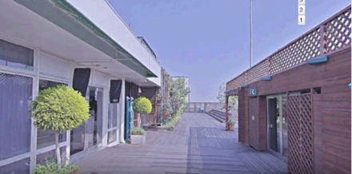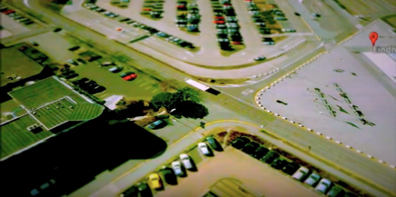
Figure 13 Clare Booker. Stills from Street View Diaries, 2016

Practice: https://imaginedairport.com/street-view-diaries/
16 Films. Series of Paintings, Drawings, Digital Stills and images.

Contents:
Introduction
Virtual Wanderings – written observations and gathering video footage.
Spatial Zones
Movement
People
Conclusion

Introduction

Street View Diaries is a project driven by my fascination with Google Street View’s representations of the inside and outside of airport terminals. In response to this digital space, I present a series of short films, based around my virtual wanderings around sixteen airports launched by Google Street View in 2014, where permission was granted to not only survey the landscape of these airports, but to also access and enter the terminal buildings. The films present a non-linear journey around the spaces, where alternative situations and stories unfold in front of and around the viewer, presenting snapshots of human life outside and inside the airport terminal. They aim to explore how the experience of viewing and navigating the airport via Google Street View can augment our real experience of these spaces and ask the question of how this virtual experience may help me re-imagine, disrupt, and change my understanding of the airport.

In this chapter I talk about how and why I made the films, discussing the methods used in the construction and editing of the films. This chapter will present a description of how I am using this technology as a method of research, and as a method to generate new art forms, through digital image and film. The 16 films and series of digital images, paintings and drawings, can be viewed at imaginedairport.com, and also in the book Imagined Airport.

Making the films provides a platform to explore and experiment with the three themes of the project: airport spatial zones, movement and people, which I discuss in Chapter 1. The chapter is therefore organized thematically, as three sections. The first section of the chapter looks at how I am experimenting with the interconnection between the spatial zones of the airport, discussing the spaces outside and inside the airport and the transitions and interruptions, which occur between each space. The second section presents ideas on airport movement, discussing how, through this interface, I experience and visualize airport space in motion and how moving through this digital space relates to moving through an actual airport. Finally, in the third section I talk about how I experiment with representing the people in the Street View airport and discuss how I use and analyse the aesthetics and behaviours of the interface as a way of exploring how the space is occupied by different ‘unseen’ users.

Many writers and artists are investigating and exploring the interface of Google Street View in different ways. Various literatures present an analysis and discussion around Street View’s potential for seeing, experiencing and representing spaces and places differently (Graham 2012; Hewitt 2012; Farman 2010; November 2010; Di Palma 2009, et al). Often discussed are the multiple viewpoints available to view and navigate through (Di Palma 2009), whilst others (Di Palma 2009; Dorrian 2007) explore Google Street View as a platform for interactivity, where people are able to add to and reshape the landscape through applying layers of visual and textual information. Google Street View is being used as a tool for artists to make work, where they are transforming, manipulating and collaging images to generate a new space, between fiction and reality. Some artists are using Google Street View photography as a documentary source, capturing people and unexpected happenings on the street (Cirio 2012; Vala 2010; Wolf 2013; Henner 2015). Howarth and McLaren (2010:10) recognize Google Street View as ‘the most prolific street photographer today”. Artists such as Wolf (2013) and Cirio (2012) zoom in to extract details from the Street View screen and collage them into a new space. capturing fragments of reality with all social context removed (Rafman 2012). Other artists (Valla 2010; Rafman 2012) focus on visualizing and critiquing the irregularities and glitches of the software, using these visualities as a metaphor for wider discussions around fragmentation of experience. Hoelz and Marie (2014) argue that the Google Street View image is an ‘operative image’, a term used by Harun Farocki (2004), who describes an operative image as an image that no longer represents an object but is part of an operation. These many ideas and responses to Google Street View provide me with starting points for experimentation through my own practice. Concepts and methods of multiple viewpoints, interactivity, documentary, fragmentation and blurring all play a big part in the making of the films.

I have used methods of collage to construct the films, assembling and juxtaposing spaces to create a fictional journey through the space. I collage the series of layers offered by the software, (photos, text, 3D buildings, spatial viewpoints) to reinforce the concept of multiplicity, both spatially and experientially. Cubist methods are in play here at all times - Google Street View’s navigation controls offer multiple viewpoints in which I can view and experience space. Street View’s version of the airport provides me with the space in both vertical and horizontal format. The screen enables me to frame the space and choose a composition and view to capture and transform in some way. The horizontal format offers the illusion of a wider expanse of space, a more panoramic view. The vertical portrait format creates a different spatial experience and puts emphasis on a tilted, disorientating perspective. Google Street View software deconstructs and fragments the space, reminding the viewer that the place we are looking at is constructed and pieced together through a vast series of stitched photographs. These fragments at times become disconnected, creating an ‘inaccurate’ distorted, or new image of a place (Valla 2010), with considerable creative possibilities. The Street View airport is a collage within itself.

Virtual Wanderings – written observations and gathering video footage.

The starting point for each film is a written ‘diary’ of my virtual wanderings around the 16 individual locations, via the navigation controls and tools of Google Earth and Street View. In order to access the Street View airport, I start by typing an airport location into the search box on Google Earth. My starting point is always from an aerial perspective. I assess the airport from above and choose a random location in which to land. I have to then descend to ground level to gain access into the terminal. At which part of the airport I land and enter is very much by chance.

Phenomenological and auto-ethnographic methods are used as a way of documenting my random journey, personal observations and experiences as I move through the different zones and encounter different viewpoints of these digital airport spaces. Through this mediated interface I have permission to zoom in and pan across the airport, outside and inside, choosing a desired location in which to observe and capture, as I would if I was in a physical space accompanied by a notebook and hand held camera. I am looking for a space of interest, an image, composition, shape, object, person, in which I want to focus in on. The diaries / texts are visually descriptive, describing what I am looking at, rather than what I may be imagining. I talk about the movement, the light, the colours, the signage and advertising. The texts are short, and mix observation with factual information which is presented on screen. These literary vignettes of observation and imagination are influenced by Walter Benjamins Arcades Project (1927-1940) and Italo Calvino’s Invisible Cities (1974), work I discussed in the introduction, which are both making social and aesthetic observations through assemblages of descriptions and reflections, which are grouped by topics or locations.
To read the diaries / texts please go to https://streetviewdiaries.com/ and click ‘continue reading’ which appears under each film title. These same texts are used for the text to speech voiceovers which accompany the moving image.

The process of negotiating Google’s digital airport for moments of interest becomes quite addictive, and as Rafman (2012) describes, you enter a ‘trance-like state.’ This feeling draws parallel with being in the physical airport, where the experience at times seems disembodied. These virtual wanderings are compelling. As Jordan (2016) argues, Street View offers a unique opportunity for re-inventing flânerie, an act of inhabiting and observing places from a detached singular perspective. I can wander, endlessly, observing what is in-front and around me. Whilst I walk there seems endless routes in which to take. Each ‘journey’ is very obviously or subtly different, with no possibility of repeating the same experience. An extract from Paul Auster’s City of Glass (1985), describes this act of walking and seeing through the character of Quinn, which resonates with how I have begun to feel whilst observing the airport space and gathering research;

- “By giving himself up to the movement of the streets, by reducing himself to a seeing eye, he was able to escape the obligation to think, and this, more than anything else, brought him a measure of peace, a salutary emptiness within. The world was outside of him, around him, before him, and the speed with which it kept changing made it impossible for him to dwell on any one thing for very long. Motion was of the essence, the act of putting one foot in-front of the other and allowing himself to follow the drift of his own body. By wandering aimlessly, all places became equal and it no longer mattered where he was” (Auster, City of Glass, 1985;4)

As I ‘walk’ through the various digital airport terminals and write down my observations, I observe that although there are many similarities in their appearance, they feel quite different as I move through them. This goes back to my discussion in the literature review about differences, where Cresswell (2006) and Merriman (2004), acknowledge the risk of generalising the airport experience and not acknowledging the differences between experiences. These different experiences, it seems, apply to being in the digital airport as well as the physical airport. I attempt to address these differences in the Street View Diaries films, where I try and find the moments where something unique to that space may happen, or appear in front of me, as a way of giving some sort of independent identity to that particular airport.

After producing the written observations / diaries, I revisit the sites in hope of finding the original path I took so I can record a video of the ‘same’ journey in an attempt to match the image with the text. The video recordings of my journey, on first playback are fast and fragmented. I slow these down as a way of getting closer to the original experience of when I produced the written diaries, and as a way of allowing things to unfold in-front of me which I may have missed the first time. I begin editing, in an attempt to collage and assemble the moments I refer to in the texts.

For the films sound, I use text to speech technology, where the computer voice, male and female, speaks the descriptive texts I have written. The voiceover doesn’t always match the visuals directly. Some match more accurately than others. At times the voiceover is describing a different space to the one you are seeing on screen. This disjuncture between sound and image is a device used to layer two spaces simultaneously, onto one surface, a method I use throughout the three projects of the thesis. This idea refers to the airport as heterotopic (Foucault 1967), where I often seem in-between spaces. The artificial voice of the computer- generated speech echoes the pre-recorded speech of airport announcements. It also aims to match the artificial world of Google Street View, mirroring the unexpected glitches, pauses, and abrupt re-direction, which the interface imposes upon me as I navigate through this digital airport. At certain moments in the films the voiceovers generate another layer of errors and glitches by inaccurately interpreting my text. I take influence here from a film by Charles and Ray Eames, Powers of Ten (1977), which is often talked about in association with Google Earth (Di Palma 2009) due to its descent down to earth. Powers of Ten uses a similar voiceover technique, where the voice is dispassionate and robot like, describing the journey in full rapid detail, which at times is interrupted with unexpected information.

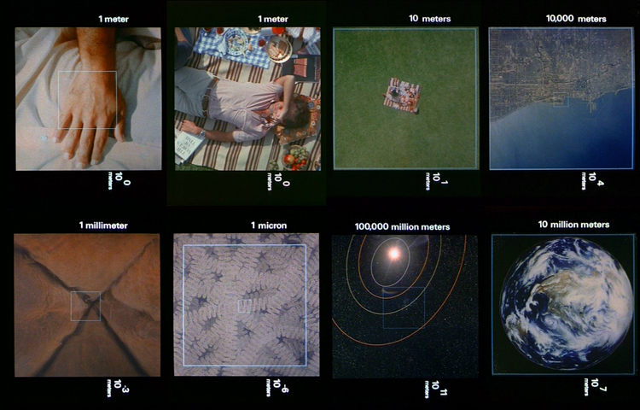
Figure 14 Charles and Ray Eames. Powers of Ten, 1977

Spatial Zones

As I drag the orange Street View figure on to the top of the terminal, I often find myself ‘landing’ in similar zones of the airport, no matter which global location I am in. The random arrival point is often the shopping area, and at times I cannot seem to get out of the shopping zone. It appears that even occupying the digital airport directs me to the commercial area of shops and restaurants. Adey (2007) describes this area as a ‘holding zone’, a space in which, as passengers we are channelled into after passing security and encouraged to spend time in the shops and restaurants as we wait for our flights. Once I do leave the shopping zone in this digital space, it seems I can move and access many different spatial zones (check-in, departure lounges, arrivals, customs, apron area, hotels, carparks) with relative ease. However, as in the physical airport, the chance of resting in one place, or observing a particular part of the airport is limited. There are many moments in the 16 Street View Diary films when one spatial zone becomes another, at seemingly unexpected times. I am never fixed to one location but instead encounter a fleeting experience, a moving photograph of one space, which quickly becomes another space, creating a layering of spatial views in quick succession. Street View provides a more transparent space where I can walk through zones and experience the inside and outside almost simultaneously, as with any slight movement of the navigation controls I can be in a completely different zone, whether this be at ground level, street view, or back on top of the airport. I can move from the carpark to the departure gate to the outdoor viewing area with a few clicks of the mouse. These moments where one space becomes another echoes the spatial experience of being in the physical airport, where the fusion of spatial zones seem to continuously merge and overlap.

In the films I attempt to visualize this idea through experimenting with the transitions and interruptions which occur between these spaces. Through editing and slowing down the initial video recording I try and make this transition between spatial zones visible. I attempt to capture the moment that one spatial zone of the airport meets another, where I am accelerated backwards or forwards into another space or freely move through a wall, a window, a door. The reason I wanted to focus on exploring this layering of spatial views and zones goes back to my rationale for using cubist methods, which I talk about in the methods section of the thesis. I believe that visualizing these spatial transitions is important for helping understand how the airport is experienced as a collision of multiple viewpoints and spaces which continuously interrelate and overlap. No sooner have we arrived in departures, but we are back in arrivals. The technology of Google Street View enables me to experiment with these cubist methods of spatial shifts, allowing me to layer multiple viewpoints in quick succession. These fast, spatial shifts are also expanding on the idea of the disorienting experience often felt in the actual airport. It is also easy to become disorientated in this digital airport as I am able to move through zones as easily as moving around them. There appears no division between the spatial zones of the airport.

Below are extracts from the diaries and films to highlight this experience. The name of the airport and the time in the film is included in the text, to enable the viewing of these specific moments.

//In Alicante I move towards to the lifts but as I get closer I arrive in a different area of the terminal, where rows of orange tape divide the floor. Checked in online? Speedy Boarding Plus! The check-in desks are empty. I realize I am back to where I started, but as I move around to the left the long line of people waiting at gate 53 and 54 have gone.
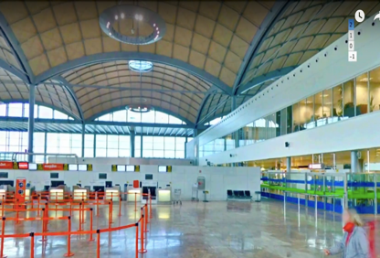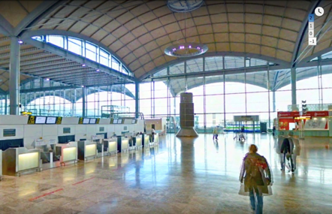
1:14
// In Barcelona-El Prat Airport a white wall appears in front of me but quickly turns into another part of the terminal, where the wall is now glass, allowing light to illuminate the polished floor.
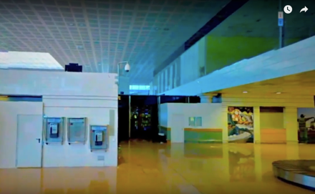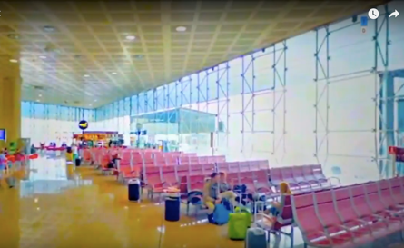
1:36 1:44
//I place the orange man onto the roof of Kagoshima Airport to see what happens, but as the outside turns into the inside the space has the look of a video game interior. I am inside a model, built by ‘hong’. I leave the model and return to Google Earth, where I exit ground level. I am back on top of the terminal roof. Exit Street view. We arrive back outside looking down on the terminal. I zoom out to find a new street view area to access. I land back inside, close by to an information desk with a baggage and way out sign overhead.
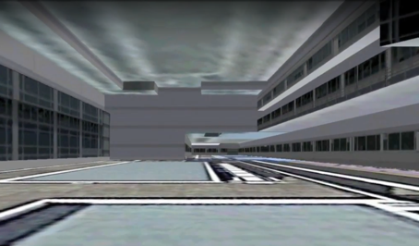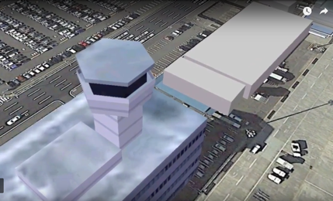
0:17 0:57
Figure 15 Clare Booker. Stills and Extracts from SV Diaries, 2016

//New Chitose Airport, Japan. Before I get chance to scan the flight information the camera shifts and I arrive in a shop selling handbags and wallets.
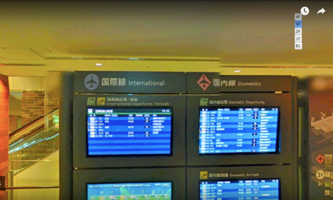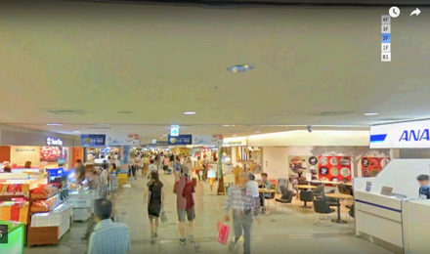
1:53 1:57
// Palma de Mallorca. I decide to move backwards but do not get very far. I move to the left and suddenly I am outside the terminal looking at a 3D virtual model of an airport tower.
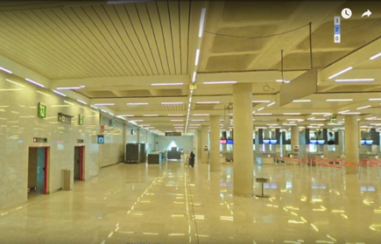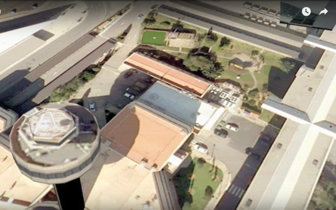
1:31 1:39
// Madrid. June 28, 2014. I approach the exit, quickening my movement towards the glass doors. As I creep forwards the camera jumps to another space, unrecognizable from where I was. It is unclear as to whether I have just turned around or whether this is a completely different part of the terminal.
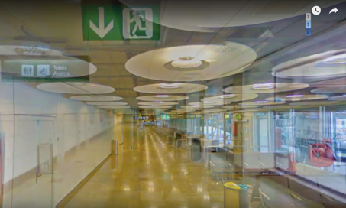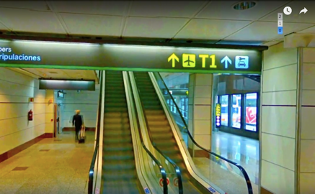
0:28 0:35
//Aeropuerto de Malaga
I cannot move any further so I go back to the Ferrari store, which after 1 click becomes an empty bookstore with a wooden floor. //
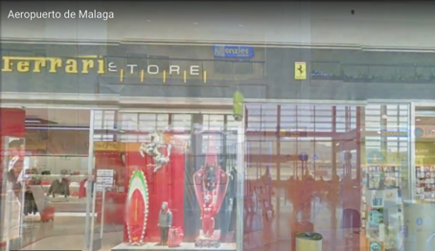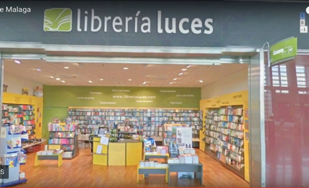
1:26 1:30
Figure 16 Clare Booker. Stills and Extracts from SV Diaries, 2016

Movement

The Street View Diary films aim to present a visual exploration of the airports control over movement, a topic explored by Adey (2010); Cresswell (2006); Fuller and Harley (2004); Urry, Elliott, Radford, & Pitt (2016); Hall (2015), as discussed in the literature review in Chapter 1.
I aim to do this by presenting the moments of visual fragmentation, disruption and redirection of movement I experience whilst navigating around the airport via Google Street View. As I film my virtual wanderings, I am viewing the space as a series of still images, and also as a space in motion. The technology allows me to travel through the airport, experiencing simulated and photographic representations of the space whilst on the move.

When I arrive inside the terminal, the viewpoint is fixed, and I cannot alter it. I have to view the space from a point of view dictated by the technology, which is just above eyelevel, a slightly elevated point of view. This ‘control’ in itself in interesting in relation to the controlled movements and viewpoints we are restricted to whilst in the actual physical airport. The directions and restrictions of movement enforced upon airport inhabitants are accompanied by our own anxieties of deviating from a particular path, in case of missing any important information, or moving too far away from the place we ought to be. My journey through a physical airport is often interrupted by unexpected happenings, movement, and activity around me. Through the disembodied flight and spatial experience of Google Street View these pressures and interruptions are somewhat lessened. It is an interface through which I can relax, observe and fantasize about possible journeys and locations without the pressure of getting to a particular place or zone in which my journey demands. To some extent it offers what Urry (2007) has called an imaginative or virtual mobility. The film theorist Ann Friedberg (1993, 2006) also offers many insightful observations on the subject of the mobilized and virtual gaze, suggesting that viewing space via a mediated surface, transports viewers to an imaginary elsewhere (Friedberg 1993, 2006). I believe it is this very space, between the technology and the physical space, which generates a new imagined airport, that exists beyond, behind or in-front of the frame of the screen.

The navigation controls of Google Street View allow me to move through the airport in ways I cannot in the ‘real’ space. Navigating through the airport via this interface allows me time to discover and capture ‘hidden’ parts of the airport in which I would never usually encounter in an actual airport, due to being regularly guided, and controlled through the space. However, despite the apparent ‘freedom’ of movement offered to me in the digital airport, there is a constant visual reminder that the software itself imposes restrictions. Jordan (2016), when talking about the potential Google Street View offers for artists, talks about Street Views ‘unquestioned access to everything on the street’ (Jordan 2016: 202). This is not the case in the Street View airport, where many areas are impossible to gain access to. A yellow line directs me along straight paths. I can turn back, or change direction, but as the yellow line disappears, I know a particular area is prohibited, indicating restrictions to accessing certain areas of the space. In contrast to the directive yellow line, a blue line encloses the space from above, showing me which areas are available as street view. Much of the imagery has been blurred, suggesting concerns of privacy, and also state secrecy.

In the digital airport it is still difficult to fully control my movements. I am shifted between foreground and background, with the continuous sense of disorientation, feelings which are familiar when experiencing and inhabiting the ‘real’ space. The extracts below highlight parts of the films where I describe and visualize this disruption and control of movement;

Tokyo International
I move to the right following the sign but get pushed back to face a shop selling sweets, where a man in a black bowler hat stands behind the counter. I double click on his hat to get closer, but I enter a new space. Still in the Market Place I attempt to get back to Star Sweets, but have lost my way. I try to get close to the gate, to see the destination but I am pushed backwards.
Eindhoven
I carry on walking but reach a wall I cannot seem to get past. Staff only. I turn right and move towards the light again. I turn back and attempt to move quickly. The space breaks up into flashes of broken images.
Sendai
As I try to cross I am pushed back into a different space, looking down onto a turquoise walkway. I try and catch him up but I cannot reach the end. All I can seem to do is move backwards or sideways.
New Chitose Airport, Japan.
I stop outside a green shop named Daiso. ‘All goods 100 yen shop’. I try to zoom in and view the products but again I am abruptly redirected.
There is no access beyond this point.
Kagoshima
As I attempt to move closer to the entrance I am pushed to the side, the image breaking up as I move. I can only pan across the surface of the terminal. There is no way in. I follow the sign for the gates. M33 to M39. I get pushed backwards with nowhere to go.
Figure 17 Clare Booker. Extracts from SV Diaries Voiceover, 2016

The interior of the Street View airport is revealed through a sequence of photographs which have been apparently stitched together to create the illusion of a ‘real’ three-dimensional space. However, as I pass by, the photographs become fragmented and detached from each other. As I pan across the ground level or street view, there is a gradual breaking up of the photographic surface, stretching and interrupting the expected image, reminding me of the digital world in which I am inhabiting, and that it is a space made up of two-dimensional images. The images separate themselves from their adjoining image and temporarily appear as though they are floating in space, not attached to any kind of formal structure, searching for a place to settle. I cannot settle in either the physical or digital airport. In both there feels a sense of lack of direction, and lack of control when making decisions on where to move. Both the physical and digital airport present a fragmented experience, where ‘the excessive flow of imagery gives rise to an experience of a discontinuous and displaced world’ (Pallasmaa 2011: 15). The light and colour changes as I move, presumably depending on the stitching of the photography and what time of day and year it was taken. These fractures and changes of light in the images take on real significance in my attempt to visualize the fractured and disorientating spatial experience of being in and moving through an ‘actual’ physical airport.

Artist Clement Valla (2010) uses this detachment of one image from another in his fascinating photographic series Postcards from Google Earth (2010) (Fig.18). This concept and aesthetic also reminds me of David Hockney’s (b.1937) photo collages, the ‘joiners’ (1986), which, although produced much before the arrival of Google Earth technology, use the same process, using a patchwork of photographs from a multitude of viewpoints to make one composite image. The spatial and formal fragmentation that occurs here certainly seems a method influenced by the Cubists. As Woods (1995: 123) observes, ‘Hockney seeks to select, to discriminate, to describe as a painter does, to add layers of time to the photographic moments, through the creation of his joiners.’ In response to these ideas, I am also seeking to ‘add layers’ to what is already there - to add another collage layer to the collage which already exists. This process of layering is used to generate the layers and multiple experiences encountered in the airport (Merriman 2004; Cresswell 2006).

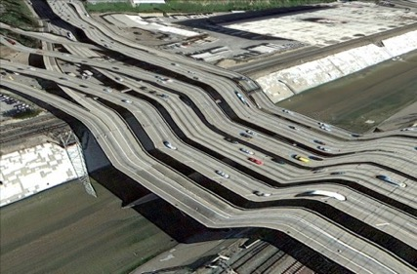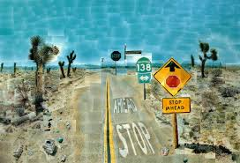
Figure 18 Clement Valla. Postcards from Google Earth, 2010
Figure 19 David Hockney. Pearblossom Highway, 1986
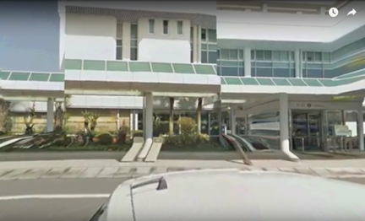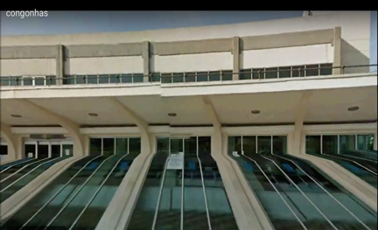
Kagoshima. 1:17 Congonhas. 0:57
Figure 20 Clare Booker. Stills from Street View Diaries, 2016

People

The voiceover to the Street View Diary films talks about the people in the space, speculating on who these people are and what they are doing. In this section I explore further the figures in the Google Street View airport and expand on the conversation around identity and differences which I discuss in the literature review in Chapter 1.

Through my initial virtual wanderings and written diaries, I observed and described the people I saw in-front of and around me in the digital airport. In order to make the films I had to retrace my steps, looking for the people who featured in these original texts. Retracing my steps was at times difficult, due to the shifting nature of the Google camera. I know all these people are still there, but if I take a slightly different route, or enter the terminal at a different location it would be difficult to find them. This process in itself became a fascinating way to explore the space, and this process became integral to how the films would be edited, and eventually turn out. I began looking at other examples of how artists and writers used the concept and method of following and tracing another person’s steps and seeking and imagining the identity of others. Two examples of how following has been imaginatively represented can be seen in the literature of Paul Auster (City of Glass,1985), (which I refer to at the beginning of this chapter), and the art practice of Sophie Calle (1980,1996). Paul Auster, assuming the false identity of a private detective follows the father of the character Peter Stillman across the city, where it eventually emerges that a pattern has been created by the figure’s movements. In the work Suite Venitienne (1980), Calle documents her activity of following people around the cities of Paris and Venice through a series of photographic grids, allowing the viewer to imagine the sequence of time and action. In both works there is a sense of building up to something, waiting, finding clues, which were feelings I had whilst seeking out the people I had described in the Street View diaries. Who were they and why had I picked them out to describe or follow? Looking for people started to make me ask the questions: why are they there? Where are they going?

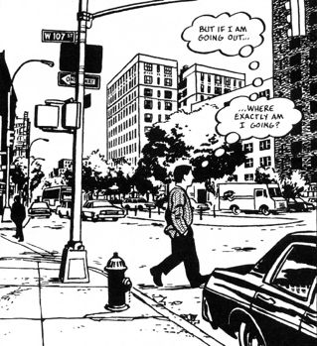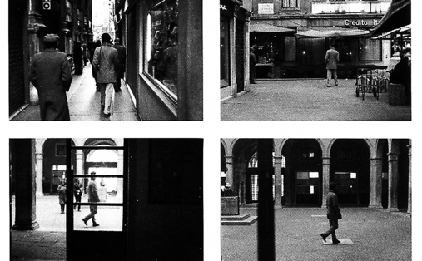
Figure 21 Paul Auster. Page from City of Glass Graphic Novel, 2004
Figure 22 Sophie Calle. Suite Venitienne, 1980

The people I walk past and observe in the digital airport are anonymous. They have been photographed by the Google camera at an unknown time of day, and assume no particular identity, becoming weightless and ghostlike in appearance, with their faces and bodies blurred and pixelated by the technology. In the Street View Diary films, there are many occurrences whilst moving through the digital airport, when blurred figures come and go and re-appear as I move. People are there, then not. Figures come in and out of the frame as I move forward. They reappear as I move around to the right or left. At times they completely disappear. One step back and the people have gone. I try and move again and the people have disappeared, double-click and they are back again. They become flashes of animated figures, coming in and out of the space. The following text selects moments in the films where this is happening;

Barcelona. A man in a green uniform cleans the already polished floor whilst sat on a red and blue vehicle with various attachments. I move forward and the man in the green uniform has gone, replaced by the ghostly figure of a man in a high-vis jacket. I turn approximately 90 degrees to the left and the man in the green uniform re-appears, this time he seems to be chatting to a man in a black jacket with a red collar, who stands static with authority.

Congonhas. At Congonhas airport it is dark outside. I cannot see anybody. I turn and three men stand with their back to me. Two have the same uniform, white shirts and black trousers. The other stands in all black, his boots high above his ankles.
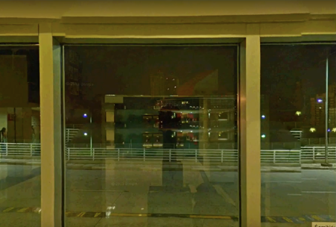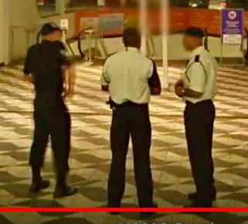
Congonhas 1:00 Congonhas 1:08

Figure 23 Clare Booker. Voice over text from Street View Diary films, with stills, 2016

Artists Joao Enxuto and Erica Love’s Anonymous Paintings series (2013) (Fig.24), directly deals with this idea of anonymity, using the blurring of people’s identity as the main focus of work. The artists’ re-imagine the censoring blur as an abstract mark in the pursuit of paralleling the anonymous people who get blurred out on Google Street View. These blurry compositions become works in themselves, extracted from the original space and reproduced and transformed into another medium. Another artist, Paolo Cirio (2012-2017), extracts figures from Google Street View, prints them as life-size, and physically replaces them back into the location in which they were originally captured by the Google camera. (Fig 25). As does the artist Michael Wolf (2009) who zooms in to Google Street View images of Paris and selects and crops screenshots of people in the streets. (Fig 26).

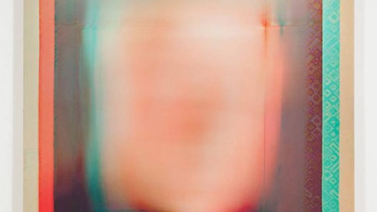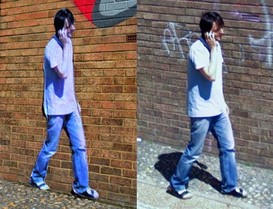
Figure 24 Enxuto and Love. Anonymous Paintings series, 2013
Figure 25 Paolo Cirio. Street Ghosts, 2012-2017
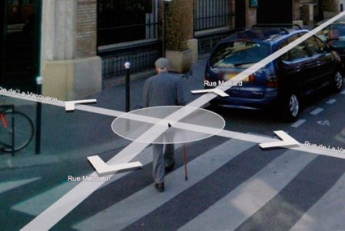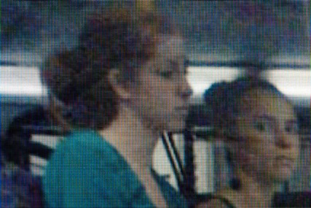
Figure 26 Michael Wolf. Paris Street View, 2010

I explore these ideas of anonymity, blurring and re-location of figures through the people in the films, emphasising how the technology leaves a visual trace of any ‘body’ that moves. The figures in the Street View Diary films often form a cluster and pattern of activity, where their bodies have been visually repeated and layered, transparently overlapping each other, which creates the illusion of moving figures. A visual trace like shadow suggests the position in which that person / people may have just moved from. I start to visually explore this idea (Fig 27 & 28), where I have isolated the figures in the space, by drawing around the figures and removing background space. By separating out, visually, airport people from their space and time, I am aiming to highlight and bring to attention the people in the space and question how they relate to their surroundings. This method allows me to look and think about these figures for longer, allowing more space and time for reflecting on the people in the space and how they move.

What also struck me about these figures when I isolated them, was that the background space was visible within the shape of the figure, due to the fast-moving camera. The figure and the environment it occupies become almost inseparable. One does not exist without the other. In some ways the travellers become transparent (Hall 2015), although areas of the Street View figures remain opaque. The work of the artist Fernand Leger (1881-1955) comes to mind here, especially the paintings, Men in the City and The City (1919). In these paintings the human figure becomes as de-individualized and mechanized as the environment it occupies. This idea and method of representation resonates with how I see and aim to represent the people in the airport – de-individualized and mechanized through being in the controlled environment of the airport. Leger also captured a sense of movement and rhythmic energy creating single images that capture simultaneous sensations, which refers back to the cubist ideas I talk about in the methods section, and throughout the thesis.

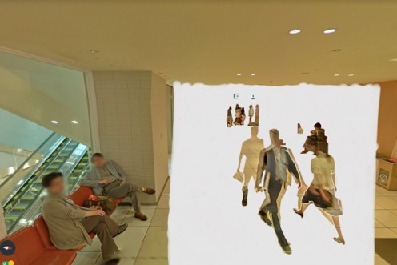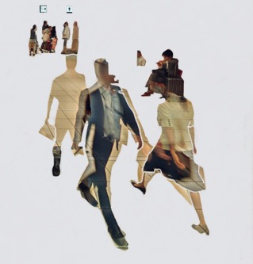
Figure 27 Clare Booker. Airport SV People, 2018. Digital Image
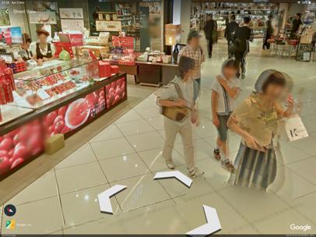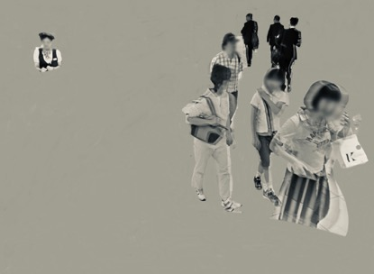
Figure 28 Clare Booker. Airport SV People, 2018. Digital Image
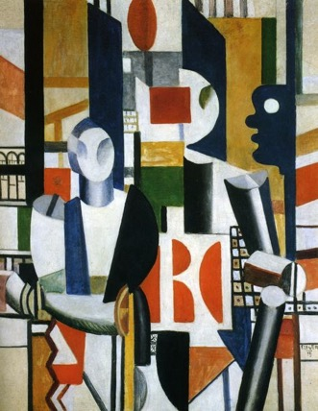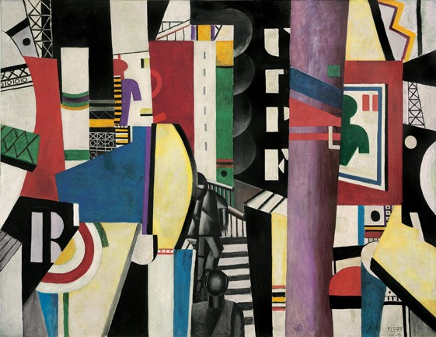
Figure 29 Fernand Leger. Men in the City / The City, 1919. Oil on Canvas

Whilst filming my virtual journey I often found myself in front of a boarding gate where people appeared to be waiting to commence the next step of their journey. I haven't yet encountered a space where people appear to be walking through the gate. People here always seem static. They just wait. The experience of waiting as a passenger is a mix of moments of activity and inactivity, immobility and stillness (Bissell, Fuller, 2011). The voiceover in the Street View Diaries talks about my observations on the activity and inactivity of waiting;

I come across an area where people appear to be waiting in line to check in or board their flights. A group of people stand around a large suitcase. Another group appear, this time 5 men in a circle, stand, with no luggage. Behind them, to the right, in the distance I see a figure sat by a pillar looking towards the group. I move around to the left, where a long line of people are waiting at gate 53 and 54. They look out towards the huge wall of glass windows as they wait. A man sits nearest he can to the window, legs crossed with a bag beside him, looking down at a book on his lap. There are two figures in the foreground on red leather seats, one appears to be sleeping. A man in a blue hooded sweatshirt holds his phone in-front of him. People look at their mobile devices for something to do. There seems very little conversation. At Sendai airport I arrive at a viewing area, where people sit and stand, looking out across the apron area at the airplanes below.
Figure 30 Clare Booker. Extracts from SV Diaries Voiceover, 2016

In the next two chapters I continue experimenting with these ideas of activity and inactivity, immobility and stillness, and how I employ methods of editing speed and inserting intervals as a way of visualizing these ideas, both in still and moving image.

The airport is not only a collage of spaces, but a collage of space and information. As I navigate through the Street View airport the space is littered with pop up signage and layers of textual information. Google Earth’s content overlays (KLM files) and ‘mash up’ options enable users to add content in the form of photographs, sightseeing recommendations and 3D virtual models of buildings, which are inserted into the airport location in which they belong, with the intention of replicating the ‘real’. These overlays give us a digital representation and insight into people’s differentiated experience of the airport (Merriman 2004; Creswell 2006; Sharma 2014). We are viewing the landscape not only from our own perspective but have insights into other people's points of view and experience. These content overlays offer an insight into how people use the space and collaborate in its production. Farman (2010: 869) describes Google Earth as a platform which engages users as embodied interactors rather than disembodied voyeurs. He argues that the software and its structure is enabling users to recontextualize and subvert ‘master representations’ of visual media. By uploading images and models and placing them in the relevant location, there becomes a sense of wanting to belong to this landscape, to contribute to its evolution and claim some sort of territory and ownership, leaving a personal marker or trace, which is very evident. I was there. I am here.

This multi layered landscape of signs, symbols, images and landscape mirror that of a physical airport, in which spaces of the airport are overlaid with signs (Fuller & Harley 2004). This ‘mash up’ – the hybridization of text, diagram and photography is being transferred to the terrestrial surface. The terrestrial surface is becoming manipulated as a media surface (Dorrian 2007). November and Latour (2010) also write about this multiplicity of visualities which are encountered whilst inhabiting this digital space, observing the abrupt movement from cartography to photography, from 2D to 3D. They echo Dorrian’s idea of the media surface, where advertising pop ups and street views taken by strangers begin to transform the scene you are looking at (November, Latour 2010).

Below is a exert from one of the Street View Diary films, Gatwick, where I incorporate visual and textual information inputted from a different user.

- // Gatwick. As I move over and above the control tower the colour of this structure changes, indicating more information is available. I click the tower and have immediate access to an uploaded photograph and 3dmodel. The photograph was uploaded to the location on August 30, 2008. 25404 views. No comments, favourites or likes. 93 total views in the last 30 days..

- 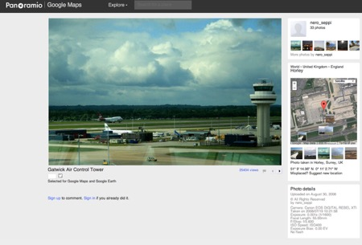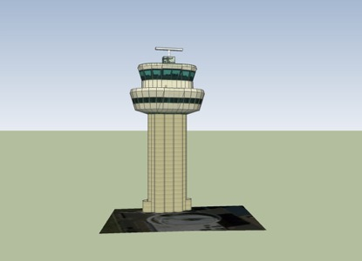
Figure 31 Clare Booker. Voice over extract and film still: Gatwick, 2016

In this section I looked at the people in the Street View Diaries and asked questioned of their identity, their purpose for being there, their appearance, and how the Street View software fragments and distorts this appearance. I have looked at the people I can see and the people who are present within the interface, the unseen users who integrate their identity through digital insertions upon the space. The subject of the people in the Google Street View airport has opened up many areas of research and enquiry. The more I study and represent these figures, the more possibilities I find for expanding the research. I continue the discussion and visual experimentation around airport people in the following chapter Apron Space. In the final chapter Model Fiction, the Street View people will return.

Conclusion

This chapter has presented different ways in which I have used the representations of Google Earth and Street View to explore and represent the airport space. The software has enabled me to make visual connections between spaces, movement and the people that shape the environment. The sixteen short films have provided a series of ‘walkthroughs’ and journeys around the airport, moving through the airport from different perspectives and viewpoints. Through the different films I have explored the topics of walking and following as a research method, and how the digital landscape is providing new opportunities to become a virtual flaneur(se), which enables a new way of looking at and representing the space. Methods of pausing and highlighting spatial transitions, from outside to inside, from one spatial zone to another, have been used and discussed, in relation to how they can reflect spatial experience in the actual physical airport. I have talked about and visually experimented with the subject of airport movement, and how this technology can be used to explore airport movement through art practice. I have looked at the people in the space, and how their visual representations can prompt discussions on anonymity, identity and movement.

In the introduction I asked the question of how digital technologies and digital viewing environments are creating new ways of seeing and experiencing the airport and how these digital experiences are helping me draw parallels with the experience of being in the physical airport space (Research question 3). The Street View Diaries project aims to provide an experimental approach to this question, by providing a space in which to engage with the conflict and transition between virtual and physical experience. The Google Street View airport offers a more transparent site than the physical space, to gather and assemble visual research, which may help shape further understanding of the airport environment and spatial experience. As an artist I see the technology not only offers a way in which to explore the site but also opens up so many new possibilities for re-imagining and representing the airport in different ways. It provides a space in which to construct fictional documentaries, making fictional connections between people and place. This project has much potential for further development, especially as the number of airports you can now access via Street View has radically increased. For now, though, I will leave the digital airport, and return to the physical space.

Chapter 4: APRON SPACE

Practice: https://imaginedairport.com/apron-traffic/
Short Films / Animation. Stills. Paintings. Drawings.

Contents:
Introduction
Films:
Apron Traffic
Gate 16
Heathrow Purple
FAO
Jetway

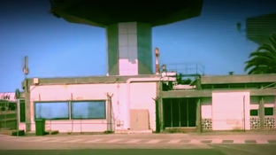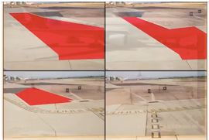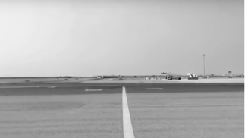
Figure 32 Clare Booker. Stills from Apron Space films, 2017-2018

Introduction

For this chapter I return to the physical airport, having left the digital airport from the previous chapter. Here, I am located specifically in one area of the space, the apron space. The project Apron Space presents a series of five experimental films, which respond to the space of the airport apron, and continue to experiment with and explore the themes of airport spatial zones, movement and people. The short films are based on my personal observations, viewing the apron space from the taxiing aircraft, an airport bus journey to and from the terminal, looking out of the window from inside the terminal and viewing the space via an airport webcam. The footage used for assembling the films has been recorded over different periods of time. The films are deconstructing and re-imagining my experience of viewing the space. Each film uses methods of collage in different forms, as a way in which to visually explore and experiment with the aesthetic, symbolic and psychological aspects of the apron space.

The apron, the space located on the airside of the airport, has always fascinated me. Whether I am viewing the apron space from behind the window of the terminal, the airport bus, the aircraft, or viewing from the mediated filter of the computer screen, the shape and form of the apron landscape, with its vast expanses of space and rhythmic movements of aircrafts, people and objects has been a space I have always wanted to capture and visually explore in some way. When Fuller and Harley (2004) talk about how movements of the body impact on the space and how the space impacts on the body, it makes me think of how different spaces in the airport impact on the body in different ways (Gottdeiner 2001). Compared to the often anxious, claustrophobic and noisy space of the airport terminal, the vast viewing expanse of the apron has a sense of quietness, calm, and order, and is a space which, as Schwarzer (2004) observes, stimulates our expectations of the journey. Thakara (1997) compares the airport to an artificial space, which shields us from phenomena like climate, and particularly daylight. In response to Thakara’s view, I believe the apron space is a particular spatial zone in the airport where we are momentarily introduced to these phenomena of climate and daylight, as well as changes in sound and smell, which impact on our bodies. When we leave the inside of the terminal and enter the outside apron space it always acts as somewhat of a shock when we sense the air on our bodies, whether warm or cool and experience the volume increase of the airport traffic all around.

I see the apron as a space detached from anywhere. As travellers, whilst located in the apron area we occupy a liminal in-between space, located in both departures and arrivals. We are either on the way to somewhere, or on the way back, in a space of detachment in between locations, which could be described as heterotopic (Foucault,1967). I believe that although this concept should not be applied to the airport space as a whole, the apron space, to me, could certainly be described as this. The apron is a space in time, which sits in-between the airport and your destination, both psychologically and geographically. I began to make a series of short films to explore this idea, experimenting with different ways in which I could visually investigate the apron as a heterotopic spatial zone. The films aim to capture this experience of being in between locations. I use the visual device of collage to present a mix of locations, representing the space we have left and the space we are going, of here and elsewhere, simultaneously.

In terms of spatial zones, I am concentrating on one area, the apron, but continuously making connections between this zone and other spatial zones at the airport. Unlike the Street View Diaries project, these zones are not visible in the films, but are sensed and imagined, through methods such as inserting sound from a different location in the airport. The device of pausing footage is used as a way of generating a space for the imagination to be momentarily transported to another place. The five short films each experiment with airport movement in different ways, with a particular focus on the relationship between human and non-human movement and how these impact on and affect each other. Each of these films represent airport people in different ways. Often, I refer to the people around me in the space, whether this is on an airport bus, aircraft, or within the terminal. You cannot always see these people in the films, but I refer to their presence, to their conversation and movements. In most of the films I explore the interaction between different people in the apron space, observing and representing the workers and passengers and how their movements interact and interrelate.

The apron space of the airport provides a multiplicity of human and non-human mobility, where people and machines interact continuously. The architectural forms of the portable objects such as stairways and luggage trolleys puncture the space, both as static and moveable forms which move around at different speeds. Due to their architectural like forms it is often surprising when they move from position. The activity and movement of these temporal architectures (the moving stairways, trolleys, containers) within the apron space have direct impact on the activity and movement of people within the airport. The movement of people and objects/machines at the airport connect and overlap, with each movement impacting on each other.

Within each film the themes of spatial zones, movement and people emerge, often simultaneously. There are many crossovers between themes, where they overlap and interrelate. This chapter therefore, is using a less linear approach to the themes, but is employing a more collage-like approach to the writing about them. For this chapter I have written a separate text for each film, which provides an individual response to the moments of filming and moments of making work. I present a personal account of my observations, methods and influences whilst on site and whilst making the films. Within each film text there is a collaging and mixing of discussion around methods, concepts, themes, and influences.

Film: Apron Traffic

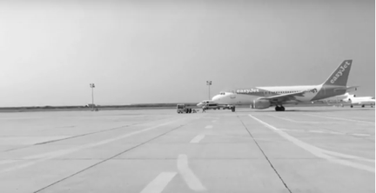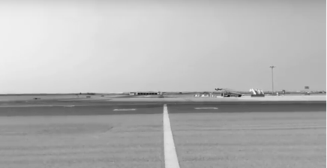
Clare Booker. Stills from Apron Traffic. 2017

Apron Traffic is a film in response to an airport bus journey from the terminal to the aircraft. It is a hot July day at Faro Airport, where I am travelling home after a family holiday. I climb on board the airport bus and find a seat by the window towards the back. It is hot outside, and the sky is a deep clear blue with the interior of the bus a cool and dark contrast. The bus begins to fill rapidly, with people moving around awkwardly to find a small space in which to stand, before we eventually begin to move away from the terminal. As I look out of the bus window the vast open landscape opens out in front of the camera. The apron markings split and divide the surface, creating a rhythm of movement, a dancing of lines and coloured shapes as we pass workers and various functional objects, such as luggage containers and boarding bridges. I can hear the overlapping conversations of the people around me, with only singular words becoming clear amongst the overall collective sound of human voices and apron traffic outside. I place the camera phone onto the window and attempt to keep the camera steady as the bus moves across the Apron, picking up speed, and swaying the passengers gently into each other. I take a continuous shot, holding tight to the camera, whilst at the same time attempting to keep my body still.

Apron Traffic is filmed as one continuous shot, panning across the landscape from right to left. The original journey has been reduced in speed and colour, with the insertion of intervals within the footage. The intervals and moments of pause provide a break in motion and a break from the ambient sound. The pause creates a fracture, and transports the viewer to a different space, where the audio becomes a text to speech voiceover. The voiceover is making reference to being elsewhere, through the reading of textual information taken from an airport website, which either references air travel and the airport in some way or refers to a different travel destination. (Fig 33). What is happening on screen is intercut with the more mechanical language of airport website textual information. This idea refers back to Dorians ‘media’ surface, where space becomes layered with information (Dorian 2007). It is this idea I wanted to expand upon in Apron Traffic, along with exploring the apron space as a heterotopia (Foucault 1967), a space where we are being placed in-between locations.
Pause// Connect to the cosmopolitan city of Hong Kong.
//Report a map error//Fast track through security
Abu Dhabi offers much more than just perfect sandy beaches.
Pause// Flights can be subject to alteration
//You should check with your travel agent or airline before
finalizing your arrangements
Figure 33 Clare Booker. Exert from voiceover to Apron Traffic, listing headers from an airport website, 2017

Intervals, spaces and pauses between frames, are a subject and a method, which have been written about and explored visually by many artists and filmmakers. Particular films which have strongly influenced my thinking and methods due to this break in motion and ‘pause’ of the still image, have been Man with a Movie Camera (Vertov 1929), and Chris Marker’s La Jetee (1962). Each use a method of juxtaposing black and white still and moving imagery, presenting a narrative through the use of collaging and montaging disparate moments in time. In the first issue of the journal Kino-Fot in 1922, filmmaker Dziga Vertov argued for the importance and significance of intervals, seeing the filmic transitions from one movement to another having the potential to form the subject matter of the film itself. He wanted to render the filmmaking process visible, suggesting that the moments and space between the activity take on as much, if not more significance, than the action itself. In relation to this idea, I think about the discussions on waiting passengers (Bissell, 2007, 2010, 2012) and the liminal spaces in-between zones at the airport such as the apron space, the waiting areas, and the walkways which connect the spatial zones. These waiting times / intervals and the places of relative inactivity are consistently juxtaposed with times and areas of faster movement and activity. The insertion of pauses, shifting of perspectives and references to different spaces within my practice aim to expand on these ideas of intervals and in-between, liminal spaces.

Gordon (2004) talks about how, at the airport, dream and function are intertwined. I would say this could certainly apply to the apron space. Passengers movements once in the apron space have usually slowed and calmed down and become more linear, following one direction to the aircraft or terminal. Once in the apron area it seems the space allows a more conducive environment to relax and dream of where we are going. For the film Apron Traffic, I attempt to generate this almost dream-like and detached feeling through reducing the speed of the video footage, a method influenced by many contemporary filmmakers who use slow motion and single takes from a fixed position. Particular examples, which have influenced my work have been James Nares’ Street (2001) and Mark Wallinger’s Threshold to the Kingdom (2000), which I talk about in the literature /art review. These videos and films linger on the slow motion of the moving figure in the public places of the city and airport, creating a sense of detachment from the space they are in.

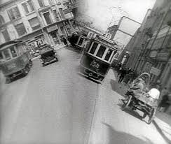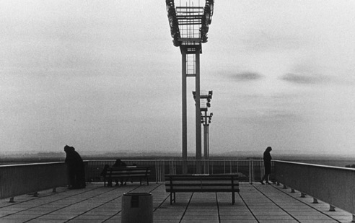
Figure 34 Dziga Vertov. Man with a Movie Camera, 1929.
Figure 35 Chris Marker. La Jetee, 1962.
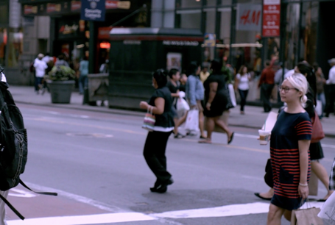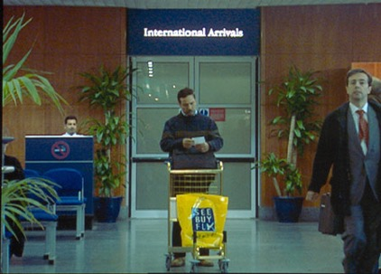
Figure 36 James Nares. Street, 2001
Figure 37 Mark Wallinger. Threshold to the Kingdom, 2000

Film: Gate 16

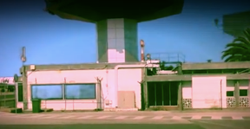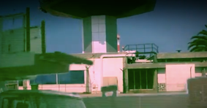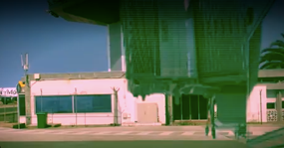
Figure 38 Clare Booker. Stills from Gate16, 2017

Gate 16 is a short experimental collage film, juxtaposing the static structure of the control tower, with the transient movement of the airport traffic. The footage, taken whilst travelling on an airport bus, (the same journey as in the previous film Apron Traffic), both to and from the terminal at different times, is used to represent the journey, and the experience of viewing the apron space. This time the airport tower is the focal point, using it as a static form and structure in which to act as a juxtaposition to the ongoing activity of the vehicles and people in motion all around it. The film experiments with multi layering and multiple exposures as a way of generating the disorientating experience of being in this heterotopic space, in- between departures and arrivals. The film attempts to represent the multiple spaces I am experiencing simultaneously, looking out at the tower, at the apron space, from inside the interior of a moving bus. Multiple viewpoints and perspectives of the same apron space have been multi layered and collaged to form a montage of space and time.

As I record the footage, light flickers and dances across the apron surface, and flashes onto the glass of the bus window. It is difficult to focus. Vehicles move in unexpected directions, until eventually the bus slows down and arrives at its destination. The experience is disorientating and lasts only a short time. I think of the short experimental films of Stan Brackage (1933-2003), in particular Mothlight (1963), where the intense flickering of light, multiple exposures and multi-layering of broken images and forms creates an anxiety and disruption to the viewing and experience of space. Juxtaposed against the activity of the moving apron vehicles and the transient light stands the control tower. It is a constant presence. Its’ balanced solid sculptural form seems to hold the space together, acting as a structure, which is central to the activity around it, directing and monitoring the movement of aircraft and the interconnected apron traffic. We look at it, and it looks at us. Whilst travelling to the airport, or located within the airport space, the airport tower often acts as a marker in the landscape, signifying your proximity to or within the airport. The tower represents and functions as a structure of surveillance and control, whilst at the same time an anchor point in which to orientate us. As a way of emphasizing this idea, I have positioned the tower as a central form throughout the film Gate 16. Light, vehicles, and figures move around and through the tower, as the inside of the bus, and the outside space become inseparable. Whilst looking at the tower, I imagine the spaces which exist all around, whether this is the physical building of the terminal, or the imagined places I may be on the way to or on the way back from. This displacement between what I am looking at and what I sense and imagine brings to mind Merleau Ponty’s idea that space does not exist in front of us, but all around us. In Eye and Mind, (1964: 178) he argues, “I do not see [space] according to its exterior envelope; I live in it from the inside; I am immersed in it. After all, the world is all around me, not in front of me”.

Artists have often responded to and used the subject and image of architectural towers as a way of representing ideas on power and modernity. Examples of this are The Tower of Babel (1563-1565), by Pieter Brueghel the Elder, and Vladimir Tatlin’s relief sculpture ‘Monument to the Third International (1919), which employ visual methods of painting, collage and assemblage to create images and constructs of social order. Examples of work, which particularly resonate with my research and practice, are Bernd Becher and Hilla Becher’s photographic series Water Towers (1972-2009) and the Eiffel Tower paintings of Robert Delaunay (1910). The Bechers’ black and white photographic images achieve a sense of purity of form through their reduced aesthetic. Through reduction of colour and background, a transformation has taken place, where the structures have become removed from their location and now merely occupy the surface of the photographic paper. The tower has become isolated. There appears no evidence of the surrounding space or landscape in which the towers were located. To me, this reduction, although fascinating in terms of their aesthetic form, does not convey the experience of actually viewing a tower. The tower and its landscape are intrinsically linked, functionally and aesthetically.

Decisions on the editing were driven by ways in which I could reconstruct the experience of disorientation and fragmentation of space, whilst at the same time retain the static consistency of the towers structure, making it the central focal point throughout the film. The architectural form and surface of the tower becomes distorted, disrupted and fractured by the flickering of light as I travel past. The image of the tower is constantly broken up. I can never view it as an isolated form (as the Becher’s towers are presented), which refers back to my rationale for adopting cubist methods as a way of visualizing this fragmented experience. In order to get closer to representing this spatial fragmentation I revisit Robert Delaunay’s Eiffel Tower series of paintings, which present the Eiffel tower and surrounding buildings from different viewpoints and perspectives. The form of the tower and the surface of painting are shattered, with the tower recognisable but constantly shifting in perspective. The tower is represented from the viewpoint of a window, which attempts to visualise the simultaneity of the inside and outside space.

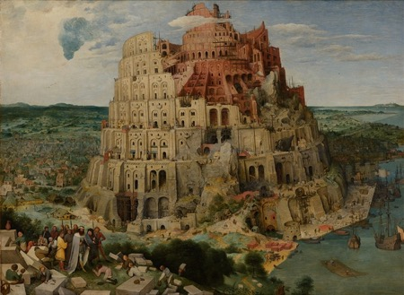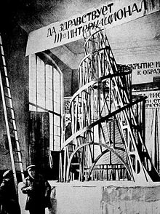
Figure 39 Pieter Brueghel the Elder. The Tower of Babel, 1563-1565
Figure 40 Tatlin. Monument to the Third International, 1919
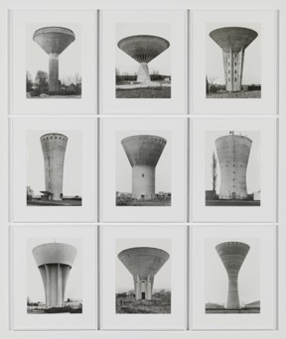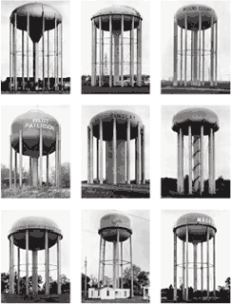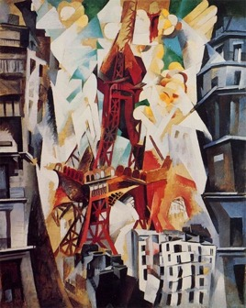
Figure 41 Bernd and Hilla Becher. Water Towers, 1972-2009
Figure 42 Robert Delaunay. Eiffel Tower Series, 1910

Film: Heathrow Purple

Although the film Heathrow Purple experiments with each of the three themes, airport spatial zones, movement, and people, the emphasis here is based on movement, exploring the shape and movement of the apron landscape, whilst I am in motion. The starting point for the film is a series of photographs taken whilst looking out of an aircraft window, whilst slowly taxiing around the airport apron, towards the runway. As I look out of the window, I now feel a sense of detachment from the airport terminal, even though it is just a small distance away. The frenetic activity and movement experienced in the terminal has subsided. Before the airplane begins to move, I look out at the final preparations being made by the workers below. Small vehicles move around the airplane, until it begins to slowly move away from the gate. Once in motion the tarmac begins to become clearer, more open, and less cluttered by the activity of the terminal. Dividing the space is a series of painted lines, rectangles, and other unusual geometric shapes, linear patterns and numbers. As the airplane approaches the runway, grassy areas interrupt the flatness and graphic language of the apron surface.

As I hold my camera to the window, I employ the assistance of the I-phone app Quad-Camera, which takes four consecutive images in quick succession. The time between images was set at one second. The resulting grid of multiple images begin to define, shape and contain the apron landscape, generating a series of shifting shapes as the aircraft moves around the space. I stop filming at the point of take-off, a moment which brings a mixed experience of anticipation, unease and relief (Schwarzer, 2004). With Heathrow Purple I wanted to stop taking the photographs just before the moment of take-off, as a way of generating and emphasizing the slow build up to the sudden speed of the aircraft. The focus is on the movement of the flat landscape, from a ground level perspective, at a slow consistent speed. The resulting images represent a narrative of movement and time.

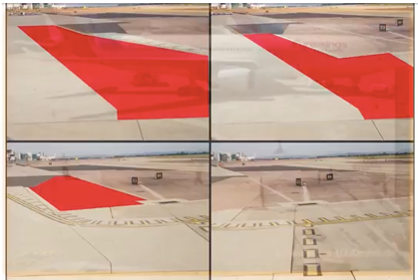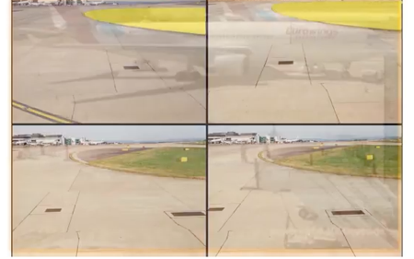
Figure 43 Clare Booker. Stills from Heathrow Purple, 2017

By employing the grid as method in Heathrow Purple, I am able to capture much more of the space at that particular moment than I would with a single shot, reinforcing the notion of airport as collage, made up of a multiplicity of spaces, experiences and emotions. The camera is capturing the moments between the times of looking, representing the ‘unseen’ moments, and the sense of the in-between, which I talk about throughout this chapter. The sequence of images as grid presents the apron as a new visual form, a sequence of shapes, which change and evolve as I travel past.

When reviewing the images after the event, I began considering how the grids of photographs could be further transformed, as a way of emphasizing and representing the apron landscape in motion, and its changing shape and form as I travel past. A method I have used to do this has been to add another ‘layer’ to the original images, by ‘painting’ over areas of the photograph, a method used by artists Gerhard Richter, Richard Hamilton, and the filmmaker Peter Greenway (b.1942), as a device to represent multiple spaces and experiences within one surface. I have selected areas of the landscape to extract and fill with areas of flat colour, simplifying the form of the space, as a way of representing the movement in a clearer form. I look at how colour can begin to define the physical space, a concern of many artists, notably the colour field painters, Kenneth Noland, (1924-2010), Ellsworth Kelly (1923-2015) and Barnett Newman (1905-1970). As well as spatial concerns I am also using colour to explore the psychology of the space. The areas of flat colour in Heathrow Purple are also used as a visual device to ‘block’, to stop and interrupt movement, as a way of a reminder of airport restrictions and control.
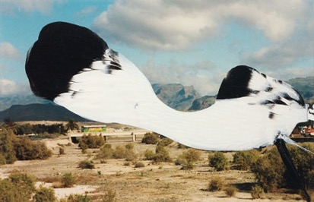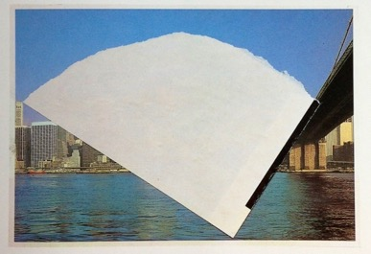
Figure 44 Gerhard Richter. 17 Febr 92, 1992 Figure 45 Ellsworth Kelly. Postcard Collage, 1979
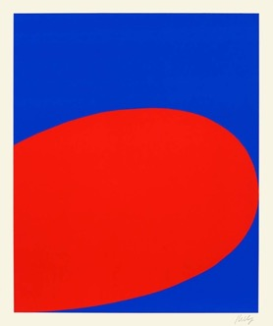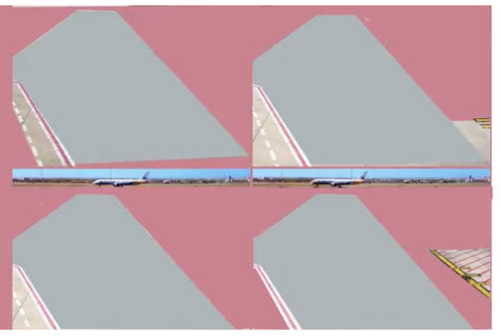
Figure 46 Ellsworth Kelly. Red Blue, 1964
Figure 47 Clare Booker. Still from Heathrow Purple, 2017

Film: FAO

FAO is a short collage animation representing a montage of motion, human and non-human, within the apron area. It presents the apron space from the more static viewpoint of looking out of the window from within the terminal. The relationship between human and non-human movement is being explored through layering video and drawing, where I ‘trace’ movement across the video footage, across the space of the screen.

I decided to start filming in this particular location as I had arrived early at the gate to board my flight. I took a seat by the window whilst I waited for the announcement to board. The window looked out directly onto a road by the apron, where the apron traffic seemed to come and go. The view from the window was interrupted by a scattering of black graphic symbols stuck to the glass from the outside, the back of pictograms, of sunshine, flowers, and historical buildings, no doubt aimed at the tourists about to arrive. This juxtaposition of graphic symbols against the actual space created a layer of distance between myself and the view out of the window.

I began to film the movements through the window, using my mobile device. The ambient noise of the bustling activity around me inside the terminal seemed a strange contrast to the silent, serene scene, which I was filming through the window. The sound from the outside could not be heard. Yellow vehicles of different shapes and sizes moved across the screen / window, with a certain rhythm and purpose, coming into view from different directions and angles. The movement seems relatively consistent, with some periods of less activity. Airport workers, communicating with each other over something, moved around the vehicles and machinery, as slow- moving aircrafts came into view in the distance. Other aircrafts appeared, moving slowly as smaller vehicles sped past.

The filming had to be cut short, as my flight was boarding. Whist later reviewing the footage, patterns and rhythms emerged. I discovered this through the process of digitally tracing over the movement on screen, drawing over any object, person or vehicle that moved, with a fluid red line, as a way of generating and mapping the human and non-human activity and motion within the surface of the screen. Often the traced drawings would overlap, suggesting where vehicles and people had occupied the same space. An interconnectedness between human and non-human movement became apparent through the interconnectedness of the traced lines. Repetitions occur. Certain paths seem to be repeatedly taken, creating a linear pattern at times. Particular areas of the apron seemed to be occupied more than others. The drawn marks are beginning to establish factual information on how and where movement takes place within this space.

At each interval of footage, between frames, I have removed the scene from behind the drawing. What is left are the traced lines, a drawing representing the motion on screen. Each drawing is very different in how it fills the surface, and how much movement appears to have happened.
Artists have regularly adopted a range of visual methods to trace and capture movement. (Duchamp 1912; Balla 1913; Boccioni 1913; Auerbach 1968; Hirst 2002 amongst many others). Famously, Eadweard Muybridge (1830-1904) and Etienne-Jules Marey (1830-1904), both visually represented motion, through the layering and overlapping of the human form. Through new photographic techniques, using faster shutter speeds, Muybridge used sequences of photographs to capture movements of a horse, and later the human figure. In contrast, Marey uses graphic methods to represent movement, through cardiograms and diagrams, plotting movement of the human body. Cresswell (2006: 83) talks about the representational strategies of Muybridge and Marey, which were used to capture movement, seeing these methods as attempting to capture the fleeting and invisible, whilst at the same time making important connections and tensions between different forms of motion, abstract and embodied. He is interested in how these practices were trying to make mobility legible in order to rationalise it for the purpose of making the body more efficient for capitalist forms of industrialised production. Cresswell talks about how these images generate a kind of narrative, a story of movement, which is being made visible. This idea is key, when discussing the work in Apron Space. The main drive here, is to make ideas about airport movement visible. I am not focusing on the movement of one thing / person, but I am attempting to capture the movement of many things / people, simultaneously. To do this, I am using the method of collaging actual video / photographic footage, with the graphic language of drawing lines and blocking areas and shapes with colour, as a way of building on Creswell’s (2006) ideas about differences in mobility. One thing / person moves differently to another, simultaneously, within the frame of the screen. I am attempting to make this more apparent, making it visible, enabling the viewer to see this happening in front of them.

In relation to the methods I am using in FAO I am particularly drawn to the more recent artist Victor Pasmore’s (1908-1998) series of drawings and prints Points of Contact (1964-1967), which show a preoccupation with capturing the layering of movement through the use of line on paper. Such methods enable the mapping and tracing of movement across a surface and can be used as a way of condensing time and space, generating sequences of movement and time through ‘one’ line /image. The processes of deconstruction and reconstruction of movement which I am using in FAO and other work in Imagined Airport, through both painting and drawing, provide new ways of representing airport movement. These methods and final works also enable the ‘slowing down’ of looking and recording, which present an alternative analytical method of researching airport movement.
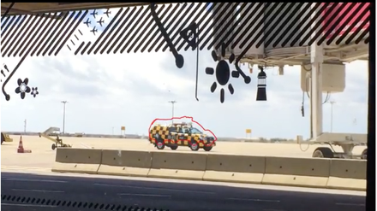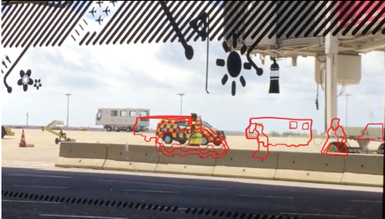
Figure 48 Clare Booker. Stills from FAO, 2017
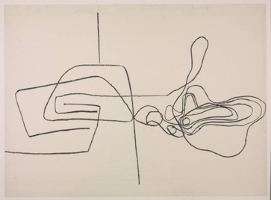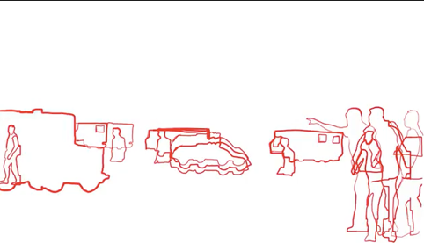
Figure 49 Victor Pasmore. Points of Contact. No.3, 1965
Figure 50 Clare Booker. Still from FAO, 2017
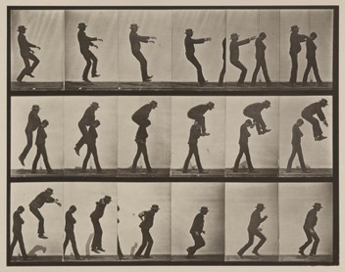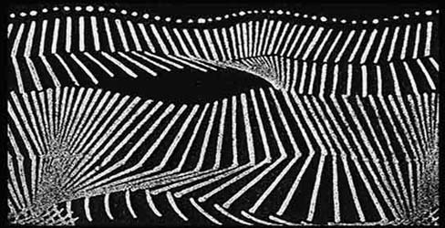
Figure 51 Eadweard Muybridge. Jumping over boy's back (leap-frog). Plate 169, 1887
Figure 52 Etienne-Jules Marey. Analyse Cinematique de la Marche, published May 19, 1884.

Film: Jetway

Figure 53 Clare Booker. Stills from Jetway, 2017

Jetway represents a different perspective to the apron space, removed from the direct experience of being in the space. This film is looking at the apron space from the perspective of the airport webcam. The decision to use airport webcams was driven by a voyeuristic intrigue at being able to watch the airport for long periods of time. By using the live webcams, the technology is providing me virtual access to the apron space. I can watch for as long as I like, undisturbed from any distractions or requirements to move, which come with actually being there. It is a clear view of the space, a view which is getting much harder to experience at the actual airport, due to increased security. The viewing areas for passengers have become more and more restricted, with the window space often difficult to access. However, although the webcam provides this ‘free’ access, it is itself restricted in what it presents. The webcam puts a frame around the scene, distancing and reducing the wider space from the viewer. The vast open space has been condensed into a rectangular window of activity.

Many artists have explored webcam technology in recent years, both as a subject to be critiqued, and as a method of generating footage, which documents the actions and movements of others or the self. Artists such as Jill Magid (b.1973) and Emily Jacir (b.1972) use the technology to insert themselves into the frame of surveillance. Others have used it as a way of looking in, a voyeuristic preoccupation of many artists in the past. The artists Thomson & Craighead (b.1969) work collaboratively to make art about such networked places. Short Films about Flying (2002) is a networked installation, resulting in series of low-tech films, displayed as a grid of moving images, which are generated in real time from live webcam feeds from Boston airport, a mix of appropriated found footage. Connections are made between the images and footage as they begin to occupy the same time and space. Jetway is adopting some of these methods as a way of researching the airport in new ways.

- 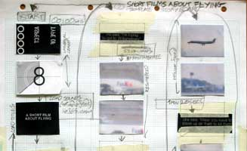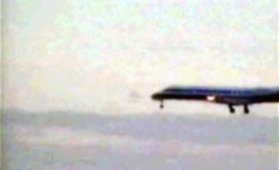
- Figure 54 Thomson & Craighead. Short films about flying, 2002
- 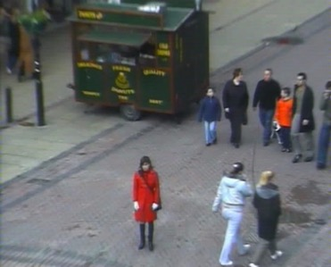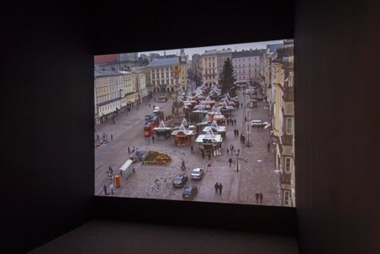
Figure 55 Jill Magid. Evidence Locker, 2004
Figure 56 Emily Jacir. Europa, Nothing Will Happen, 2003

Jetway is a split screen film, which presents a montage of non-human and human activity within the apron space. Airplanes, trucks, trailers, buses and vans move in and out of the frame, whilst at the same time passengers and workers appear at different intervals, occupying the space for different reasons. The webcam footage has been taken from outside the terminal of Cologne Bonn airport, but this could be a scene from any airport from anywhere in the world. I recorded the live footage, one morning, between the times of 11am and 11.30 am. During that time, 8 separate flights arrived to and departed from the airport. The footage has been divided across two screens, showing what was happening outside the terminal during that time. Whenever one of the 8 flights arrived or departed during that time, I have inserted the flight details as scrolling text across the bottom of the screen, using the arrivals and departures live feed from the airport website. The flight arrivals and departures live feed informs and dictates the structure and pacing of the film. Connections have been made between random flight numbers and destinations. These eight locations have been linked together, through the system of flight timetables, occupying the same space in time. The montage of information, space and movement in Jetway aims to explore and visualize in some way how information dictates the airports shape and form (Kitchen & Dodge 2011). These timetables continuously reshape and direct both the ‘static’ and the ‘portable’ architecture inside and outside the terminal, enabling the flow of movement of objects and people. Time and temporalities are mixed, with a series of
non-linear paths of movement in action at the same time simultaneously.
This process is essentially a collaging of elements and layers, which through their shared space in time have a connection to each other in some way. Through the assembling of footage, an imagined narrative unfolds through the succession of frames. The sound is a text to speech commentary on what I am observing as I watch the action unfold within the webcam frame. The film attempts to capture a sequence of motion, whether it is the successive movements of people or the apron traffic entering and departing the screen. I intercut this activity in front of me with indications of elsewhere, interrupting the flow of movement with descriptions of the location, which corresponds to the flight that has arrived or departed, locations in which these people or vehicles may be connected to. This method of intercutting with a ‘different’ space was discussed in relation to the film Apron Traffic, earlier in the chapter. I discussed the idea of being in-between spaces, as heterotopic (Foucault 1967). Another way to describe the sense of being in two locations, physically and psychologically is to be telepresent, a term often used in the writing of Viriio (1997), which is used to describe being virtually present in another location. Viewing the live feed of flights is in a sense being telepresent, being here and elsewhere, in two places at once simultaneously.

Again, as in the previous work discussed, ideas of fragmentation and disorientation are being explored, using fragmented modes of representation. The use of the split screen divides the time and space, and aims to disorientate the viewer, both through the movement, text and sound. It is difficult to focus on any one of these aspects, whether it be reading the text, or listening to the sound. As experienced when in the actual airport, you can focus on certain details, but it is difficult to become aware of the ‘whole’ space. By placing live webcams alongside each other we can see simultaneous movement in different locations. There is a pattern created on screen, which connects the multiplicities of human and non-human movement in the space.

The single image, as single frame, has been challenged by many filmmakers who use a variety of methods to present simultaneous views through layering, superimposition and collage. The films of Mike Figgis and Charles and Ray Eames have been a particular influence, regarding the use of split screens. Timecode (Figgis 2000), presents four frames of simultaneous action. This film, as I have tried with Jetway, creates a fracture of activity which is difficult to watch initially due to the split of action. However, soon a pattern of movement and narrative emerges, which enables the viewing of the ‘whole’ film. Another exciting example of multiple screens is the film Glimpses of the USA (Eames 1959), which uses seven screens which simultaneously represent different aspects of American life and society, through sequencing still and moving image of everyday life. Multiple screens as a mode of representation shatter the fixity of single point perspective, challenging the fixed viewpoint (Friedberg 2006).
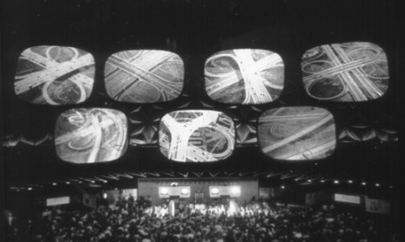
Figure 57 Mike Figgis. Timecode, 2000
Figure 58 Charles and Ray Eames. Glimpses of the USA, 1959

Conclusion

The project Apron Space has employed methods of collage as a way of exploring the themes of airport spatial zones, movement and people, with particular focus on the apron space zone of the airport. I have collaged methods of drawing, painting and video and used the visual devices of layering, grids and split screens to explore the apron as a fragmented, in-between, heterotopic space. The apron is a multi-layered space which exists as a physical place in itself, but it is the ‘other’ places it is connected to (the terminal, the global destinations of the aircrafts), which gives the apron space its meaning, shape and form.

Each film is about the experience of being there, with exception to Jetway, which observes the apron through the mediation of the computer screen. I mainly experience viewing the space whilst moving, whether this is looking out of the window of a moving vehicle or walking past a window which overlooks the apron. However, there are times when I have viewed the space from a still, static viewpoint. By using the visual methods of layering, sequencing and grids I am aiming to visually explore these experiences, presenting both a static and moving gaze simultaneously.

What has emerged through the making of the films has been the continuous interconnection and
layering of human and non-human movement, both spatially and operationally. The movement of people in the space has integral connections to the non-human movement and activity. Although this has been explored in literature (Kitchen & Dodge 2011; Fuller & Harley 2005), the aim of these experimental collage films is to offer a new visual way of expanding on these ideas of interconnectivity of spaces, movement and people at the airport.

Chapter 5: MODEL FICTION

(This airport does not exist in real life...)
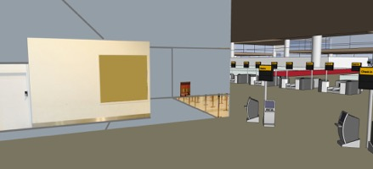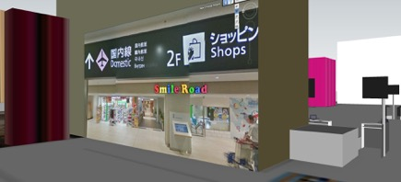
Figure 59 Clare Booker. Stills from Model Fiction, 2017
Practice: https://imaginedairport.com/model/
Short Films / Animation. Model Stills. Paintings. Drawings.

Contents:
Introduction
Building the Model (Spatial Zones)
The Architecture and interior space.
Animating the Model (Movement)
Films:
Multi Story
Choose your space
Add Life (People)
Conclusion

Introduction

Model Fiction presents a three-dimensional collage, a conceptual model, which has been assembled and constructed through the collaging of fragments of text, image, video and sound, both found and made. Visual and audio material from the two previous projects are brought into this space, alongside new material. Through this assemblage a transformation of the material has taken place, where a new fictional environment has been constructed, as a way of reflecting on the fragmentary nature of airport experience. The purpose of the model is to not only act as a ‘site’ in which to locate and re-position visual research, but also to imagine and construct a space and environment as if it could possibly exist, where fiction and reality collide.

Constructing an environment through collaging multiple perspectives and found and made material, provides a method, which enables the possibility of presenting a more transparent airport, where spaces and people overlap and interrelate (Hall 2015; Fuller 2008). This transparency and layering is important in terms of my rationale for using cubist methods of collage, which is discussed in the introduction.
The model aims to provide a new form of visual representation of airport zones and how they interconnect, overlap and remain independent. It provides a set, a collection of zones in which to explore the different areas of the airport environment and what happens within them. Through the films I explore moving through the airport in different ways, reflecting on existing literatures around airport movement. At a later stage of the project Model Fiction, I begin to ‘add life’, inserting people into the space as a way of engaging with ideas on how different people use and occupy the space differently (Creswell 2006; Merriman 2004; Sharma 2014).

I am using the ‘model’ as a conceptual tool, as the model here only exists as a virtual model, and not as a material model in which you can walk around physically. It does not function as a projection of an actual building, but rather as a set of ideas and experiences, which are embedded within the imagined architecture, an ambiguous poetic space, which takes great influence from the architectural practices of the 1960’s and 70’s avante-garde group of architects Archigram and Superstudio, whose methods present ambiguous, imagined architectures which have a plurity of readings and possibilities. Both groups presented a critique of the normative modes of architectural representation, through alternative methods of layering and fragmenting space, where the methods of collage become the vehicle through which to interrogate indeterminacy (Shields 2014). Their work is often speculative and unrealized physically, remaining as a series of visual concepts on paper, or model form.

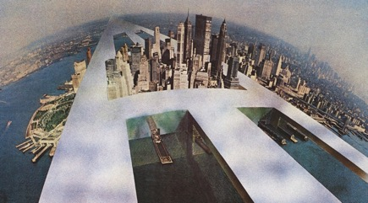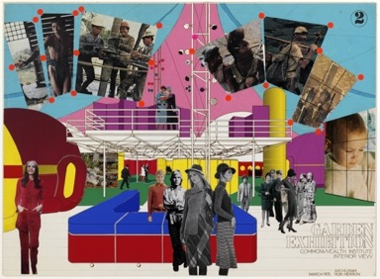

Figure 60 Superstudio Monumento Continuo, 1969
Figure 61 Archigram. Garden Exhibition, 1975

I am attempting to explore the airport as ‘an infinitely intermeshed series of happenings’, a description used by Peter Cook of Archigram in reference to the city (Cook 1969). Archigram and Superstudio enforce the concept of architecture as a ‘non-solution’ (Domus 479,1969), and as an ‘event space’, a term later used by the Dutch architect Rem Koolhaas (b.1944), whom I talk about later in the chapter. The concept of an ‘event space’ resonates with my thinking on the space of the airport, where activity and space are constantly interconnected. The architectural theorists, Virilio and Tschumi’s (1996) definition of architecture as space, movement and event also comes to mind here, as described by Armitage (2015: 90). He says;
“In contrast to conventional accounts of architecture, which tend to concentrate on stability, it is Tschumi and Virilios consideration of the relation between the three levels of space, movement and event that makes their approach so productive. The dynamic relation between the levels, as opposed to inertia, is what both Tschumi and Virilio feel best characterizes their architectural achievements” (Armitage, 2015:90).

I explore this idea in Model Fiction and the previous two projects, where I continually experiment with how the network of airport spaces, movement and people continuously inter-connect and impact on each other. One cannot exist without the other.

The project Model Fiction starts in one place but soon re-starts in another. The model can be ‘read’ in many ways, aiming to prompt new ideas about the airport on each visit / viewing. This struggle (or refusal) to stabilize the airport and find a start, middle or end point refers back to Gilles Deleuze (1925-1995) and Felix Guattari’s (1930-1932) concept of the rhizome (Deleuze, Guattari 1987), which challenges linear, hierarchical representation, and presents alternative ways of seeing how space is multiple and interrelated, a map like surface where any point can be connected to another.

Models suggest possibilities. They allude to real spaces but remain detached. The model is often viewed as a replica, but the aim here is not to replicate a particular space but to create an imagined space, which gives me a platform in which to experiment and re-imagine the multiple airport spaces simultaneously. Many artists have used and constructed models, both physical and digital, within different contexts. Many of these have been a big influence on my own practice, especially those who have used collage and assemblage as methods of construction. Artists have used models, both directly and indirectly, through a range of media, experimenting through video, painting, sculpture and drawing. The space between fiction and reality often plays an important role, where artists are experimenting with illusion, through manipulation and filtering of original images. The model is often being used as a fanciful ‘proposition’, both a dystopian and utopian construct and representation of an actual or fictional ‘place’. The work of collaborative duo Ben Langlands (b.1955) and Nikki Bell (b.1959) explores the relationship between people and architecture, with recent work focusing on the architectures of huge corporations such as Facebook and Apple, and the global networks that connect them. By using methods of model making and photography, these headquarter buildings are transformed into white relief models, often representing the building from an appropriated Google Earth aerial perspective, a method I use in this project Model Fiction, and throughout the project Street View Diaries.

This method and viewpoint create the illusion of the buildings becoming detached from their surroundings, presenting an ambiguous sense of scale. The painter Toby Paterson (b.1974) also removes buildings from their original context, reassembling and juxtaposing fragments of modernist architectural details against more abstract areas, to create large and small painterly renderings of dislocated forms. Another example of this sense of detachment between architecture and its surroundings can be seen through the short films of artist Olivo Barbieri (b.1954), where the ‘actual’ building appears as a model, a method and particular aesthetic which seems to be frequently used in current T.V advertising, transforming the photographic image in a way that creates the illusion of the miniature / the model, a ‘second reality’ (Baudrillard 1981). The work of German artist Thomas Demand (b.1964) is another example of using the model in art. Here, he disguises the model, making the viewer question what it is we are looking at, and whether this object or place is ‘real’. Demand makes paper models of buildings, some real and some imagined and then photographs them. It is the photography that is exhibited, whilst the model is destroyed. With each of these works discussed there is very little or no human presence. The model produced for Model Fiction began in this way, remaining relatively empty, until the last stage of the project Add Life, where figures began entering the space.

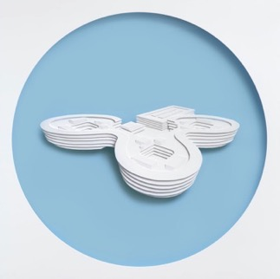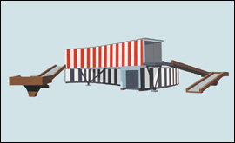
Figure 62 Langlands and Bell. Apple, Sunny Vale, 2017.
Figure 63 Toby Paterson. Theatre of Illusion, 2003.
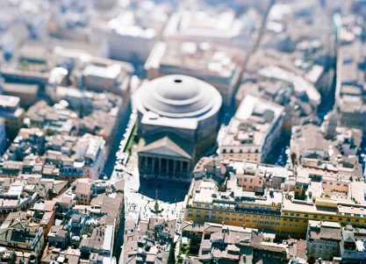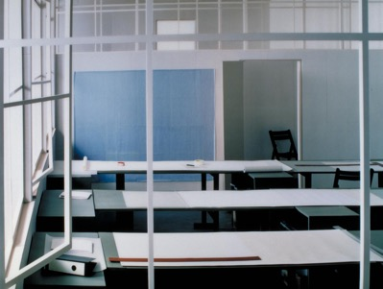
Figure 64 Olivo Barbieri. Collosio, 2004
Figure 65 Thomas Demand. Zeichensaal / Drafting Room, 1996

Model Fiction is presented as a series of visual concepts, in the form of short collage films, animations and still images, which present a ‘journey’ around this fictional environment. The films, which animate and move through the model aim to ask the questions of what I am looking at and what am I imagining, prompting questions about the overlaying of actual and virtual spatial experience.

The first section of the chapter will discuss the building of the model, exploring the assemblage of multiple spatial zones and how they interconnect. The second section will be discussing the different collage films which animate the model, as a way of continuing the discussion around airport movement. The final section discusses how the model becomes populated, exploring the significance of and difference between the people in the space. Within each section I draw on architecture, art and geography as sources of inspiration, and to support and challenge my thinking and modes of representation.

Building the Model. Assemblage of Spatial Zones

The construction of the top floor of the model draws on the methods of the architect Rem Koolhaas (b.1944), where, in the project Delirious New York (1978), he employs the formal strategy and the language of the grid, creating a space of blocks for human activity, which each represent separate ‘cities’ but also through their juxtaposition occupy the same space. This collaging of locations reminds me of the computer game Sim City, originally designed in 1989 but has had many subsequent versions. The method also brings to mind Calvino’s Invisible Cities (1974), which I refer to in the introduction and in the Street View Diaries chapter.

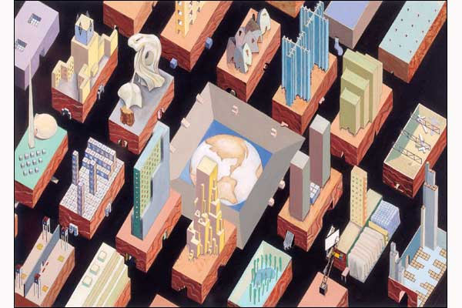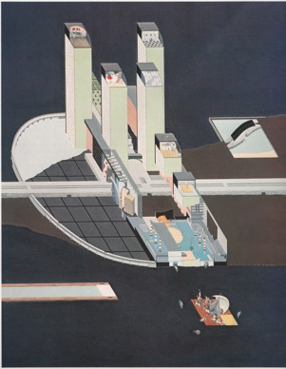
Figure 66 Rem Koolhaas. Delirious New York, 1978
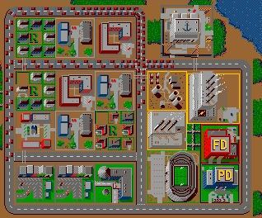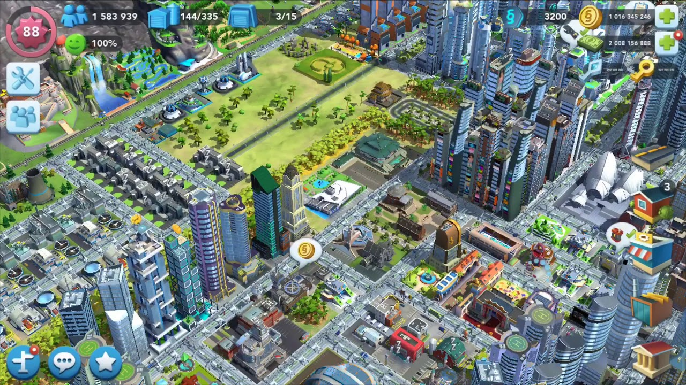

Figure 67 Sim City Video Game, Screen Shots, 1989 / 2018

In response to Delirious New York, SimCity and Invisible Cities, I decided to adopt the method of using spatial blocks in Model Fiction as a way of beginning the construction of the imagined airport model. I felt that this would be an exciting and appropriate way to organize the space and impose a kind of structure and system to the process of making the model, as a way of reflecting on how the actual airport space imposes a structure and system to organize passengers (Kitchen & Dodge 2011). As a way of deciding the design and content of each ‘block’ I revisited the airport websites I had used for the sound in the Apron Space films. I looked again at how the airport website could be used as an organisational device to instruct the shape and content of the virtual model. I had spent a lot of time looking at airport websites for research and begun to see these digital spaces as architectural forms in themselves. Each page could be a block, a room, in which activity takes place. I began placing the image of the website pages, as a ‘ground’ and floor plan, extruding the flat shapes of the website graphics to form the 3D architectural forms, which provide the building blocks for the new space. By simplifying and reconstructing the website interface in this way, it is enabling me to re-imagine the mass of information provided by the website, which, as in the physical airport, the space is overlaid with signs (Fuller & Harley 2004), becoming a media surface (Dorrian 2007). The extruded forms aim to reduce the textual information to a more abstract language of colour and shape and connect the multiple layers of information into a clearer form.

The airport has been described as an anonymous, detached space (Auge 1995), and by reducing the model’s architecture to abstract blocks I am attempting to visualize this, whilst at the same time disputing it through the alternative methods I use in constructing the floor below. As a contrast to the spacious, open and ordered layout of the top floor, the ground floor is assembled with a denser collision of visual imagery as I seek to balance order and indeterminacy to get closer to the idea of the airport as a collage. By placing representational images onto the facades of some of the forms, I am superimposing visual interventions into the architecture, as a way of generating a dialogue between the architectural geometry and the more fluid, organic human inhabitation, activity and movement.

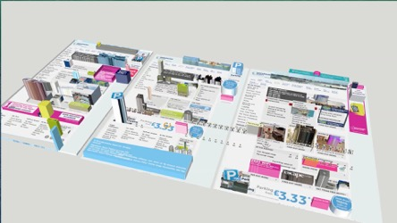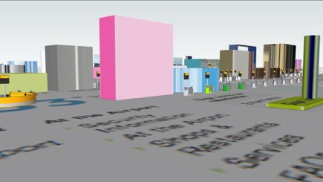
Figure 68 Clare Booker. Stills from Mode Fiction, 2017

Whilst constructing the model in this way I am reminded of the metaphysical spaces of Giorgio de Chirico (1888-1978), which are relatively empty of people. They appear as stage sets, awaiting the performance. What also comes to mind are the early renaissance paintings of Paolo Ucello (1397-1475), Piero della Francesca (1416-1492), and Sasetta (active by 1427; died 1450), which I often visit in London’s National Gallery. The flat architectural columns and facades often appear detached from the people within and around them. Interestingly, the columns also act as a device to separate scenes and divide narratives, a method I have experimented with in Model Fiction.

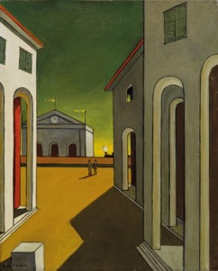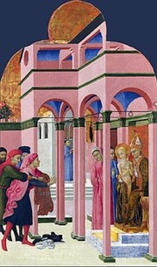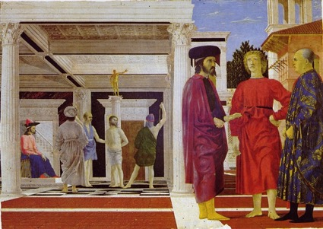
Figure 69 Giorgio de Chirico. Piazza d’Italia con piedistallo vuoto, 1955
Figure 70 Sassetta. Saint Francis renounces his Earthly Father, 1437-44
Figure 71 Piero Della Francesca. Flagellation of Christ, 1445-1450
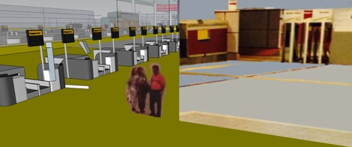
Figure 72 Clare Booker. Stills from Model Fiction, 2018

The initial ideas for the structure and content of the ground floor of the model came from a visit to Manchester Airport’s Terminal 2, one Tuesday afternoon, where to my surprise the terminal was relatively empty. There were very few people, enabling me to see the interior as one space, one visual form. I thought about the few workers who were there and how they must experience this empty space often, unlike the passengers who are rushed through and have very little time for contemplation.

For me, the experience of being in this empty terminal was like being inside a model or architectural visualization, where the architectural design of the space was not disturbed or fragmented by other activity. It was calm and quiet, a vast open space where my own body and movement felt very exposed. The experience reminded me of what captured my fascination with airports in the first place, many years ago. It was the sense of space, the architectural forms, the light, the scale, the juxtaposition of representational imagery against vast empty space, aesthetic and spatial preoccupations which have always driven my art practice. I realized that over the years my visits to Manchester airport had become a very different experience. This open space had been very much closed down, broken up, and fragmented, due to increased security and the overall busyness of the terminal, which has changed the interior’s appearance and atmosphere over the years I have been going. As a visitor to the airport for travel purposes, the ceilings seem lower, the light dimmer, the noise louder and multi layered, the colours duller, than they did on this Tuesday afternoon visit in my role as artist researcher. Maybe, on reflection, by building the model, I wanted to get back to the idealized and romanticized vision of the airport, which I had as a child. A utopian model, presenting a more optimistic, hopeful space, than the one I encounter now as a traveller. Although, interestingly, the trend of many new airports is to increase the volumes of space and light as a way of enhancing passenger experience.

I spent time there photographing the space, using my mobile device to frame details and to construct wide panoramas of the interior. From the photography taken on the site visit I began to reconstruct the images and to stitch them together to form the interior of the model, in an attempt to re -construct the physical space and transform it from the photography back to a three- dimensional space. (The process of stitching together mimicking the Google Street View methods as discussed in the Street View Diaries chapter.) I began combining appropriated elements from found airport models and images, with my own imagery, generated through painting, drawing and photography. This combination of visual sources, made and found, aims to create a multi-layered ‘landscape’ of history and personal experience, presenting the spaces of the airport from different perspectives, my own and others.

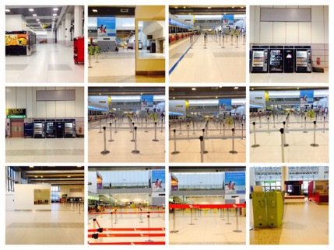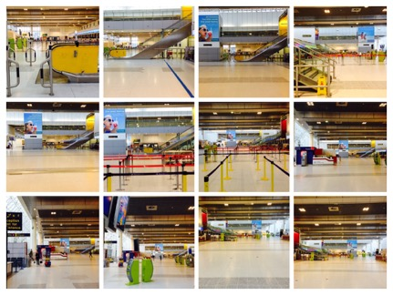

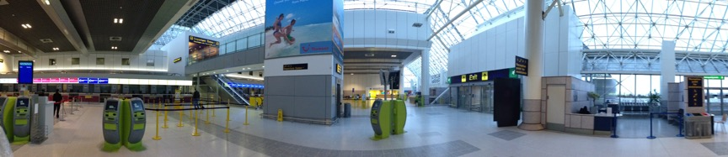
Figure 73 Clare Booker. Photographs of Terminal 2, Manchester Airport, 2017

Animating the Model – Movement

Whilst constructing the model I was considering how the model would be viewed, and how the viewer would experience the space. I decide to begin filming the model, generating a series of films which would move through and around the space in different ways. In the two films, Multi Story and Choose Your Space, I move through the space differently, continuing to explore ideas on fixity and motion, waiting and moving at the airport (Adey 2007; Bissell 2007, 2009, 2011; Fuller 2011), combining still and moving image which I experiment with in the previous chapters / projects. As the camera navigates around the model through the films, the aim is to prompt new ideas in relation to the space of the airport, with each film and ‘frame’ providing a different spatial experience. With the use of multiple screens, windows and images, the space is presented from different perspectives simultaneously, a cubist method, which combines multiple viewpoints from ground level, and from an elevated point of view. This layering and juxtaposing of spaces and information aims to expand on the theme of interconnected spatial zones, movement and people, which are explored in the previous projects.

Film: Multi Story

The film Multi Story is presented as a sequence of frames, each 10 seconds in duration. As a way of compiling the series of frames, I navigate through and around the model, looking for a frame to select, which seems to work compositionally, aesthetically and spatially, in terms of having enough activity and interest, visually and conceptually. I begin putting these frames into a sequence, which has no particular linear narrative, but attempts to cover the ground of the whole space. This decision to ‘present’ the space to the viewer as a ‘framed’ representation, a framed ‘window’ is comparable to the picture plane of a painting (Friedberg 2006), rather than an ‘unframed’ immersive space where the viewer could decide their next move, or which direction to take. I am enforcing my own restrictions and control, as a way of reflecting on the restrictions and control often enforced upon us in the actual physical airport, which is often referred to in airport literatures (Adey 2004, 2010; Cresswell 2006; Salter 2008; Urry, Elliott, Radford, & Pitt 2016).

Framed images organize and structure perception and cognition in a very different way (Friedberg 2006). With still images, in contrast to film you can only imagine what is around the corner and beyond the immediate perspective. I see each separate frame as a painting, using large areas of flat colour around the areas of representational imagery, an aesthetic very much influenced by the architects Archigram and Superstudio, along with artists such as Patrick Caulfield (1936-2005) and Richard Hamilton (1922-2011), who juxtapose these different visualities to create a spatial tension between areas within one picture plane. The visual methods of combining flat areas of colour with photographic areas of representation, draws from the previous work of the Russian Constructivists and the Bauhaus. The insertion of photographic elements provides the presence and ‘noise’ of human activity, set against the architecture in which it is placed within, a method which I have adopted throughout the project Model Fiction, to describe the relationship between the people and space in the airport.

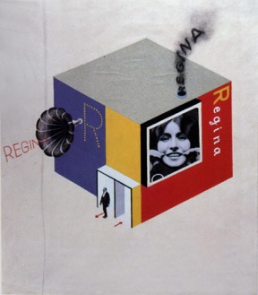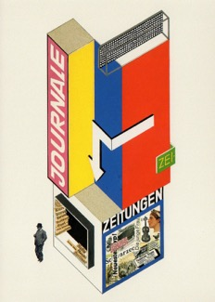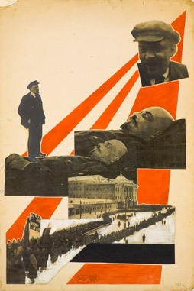
Figure 74 Herbert Bayer. Design for Trade Fair Stand of a Toothpaste Producer, 1924
Figure 75 Herbert Bayer. Design for a newspaper stand, 1924.
Figure 76 Aleksandr Rodchenko. Illustration for the magazine 'Young Guard', 1924, Photomontage

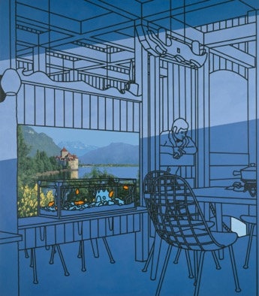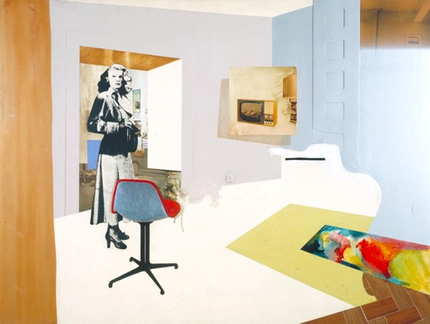
Figure 77 Patrick Caulfield. After lunch, 1975.
Figure 78 Richard Hamilton. Interior II, 1964.

Within each still frame a moving image has been inserted into an area of the composition, a clip of video footage taken from either found or made footage. These sections of video within the still image, are at times not so apparent. They often appear in the corner of the image, or towards the edge, as if the ‘real’ space is on the edge of the central viewing space. Still and moving image are placed alongside each other creating a confusion and collision of visual information, whilst at the same time attempting to present a coherent homogenized space. Through this collaging of still and moving image the spaces of inside and outside the airport can often be viewed simultaneously. At times there is a feeling of being inside the model, whereas at others there is a greater distance, a detachment from the space. There is a collision of spaces and perspectives at all times, even though the airport is one ‘place’. Disparate locations sit alongside each other as if they belong to the same space. This collision of spaces and perspectives aims to reinforce the concept of the airport as collage, a fragmented, disorientating space, an assemblage (Deleuze and Guatari 1987) of global interconnections, information, architecture, people, machines and mobility (Fuller and Harley 2005; Salter 2007; Dodge and Kitchen 2011).

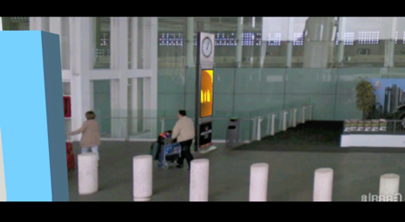
Figure 79 Clare Booker. Stills from Multi Story, 2017
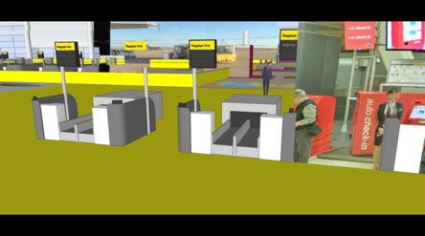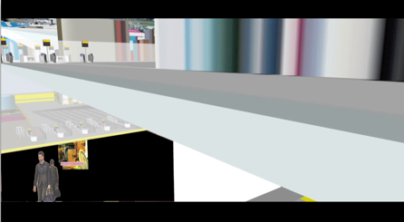
Figure 80 Clare Booker. Stills from Choose Your Space, 2017

The inserted video becomes a space within a space, a window within a window, a screen within a screen. Screens and windows appear everywhere in airports, and shape mobility and experience (Fuller 2007; Friedberg 2006; Adey 2007; Hall 2015). At each stage of the airport experience we have to look up to a screen, or through a window. Through the layering and juxtaposing of multiple images Multi Story attempts to convey this experience of multiple ‘screens’ which are experienced within the space of the actual airport. This method is again driven by the cubist preoccupation with layering multiple spatial viewpoints and spatial planes within one surface. I am seeking to combine and synthesize the disparate and contrasting viewpoints offered by the screen and window as a way of generating a new imagined space, in which you could possibly enter and inhabit.

When exploring the subject of the screen and window at the airport, the paintings of Pieter de Hooch (1629-1684) come to mind, work which I regularly re-visit in London’s National Gallery. The paintings have always fascinated me, with their use of composition, and their implication of another space beyond the one you enter. The surface is divided into rectangular sections, whether this be a picture on a wall, a doorway, a sign, a floor surface or area of landscape. The doorways and light offer the contrasts and boundaries between these different spaces. Each ‘space’ is like a separate painting, but they all come together seamlessly as if they have always occupied the same space. The figures in the spaces offer different kind of intimacies (together or alone, individual thoughtfulness). I explore these ideas of figures in space at the end of the chapter, through the Add Life series of images.

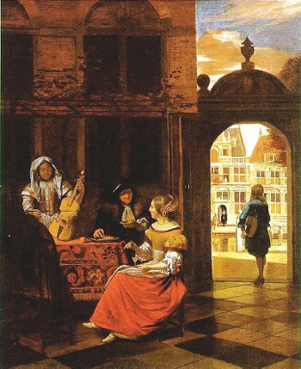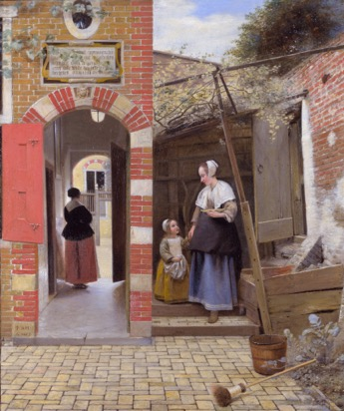
Figure 81 Pieter de Hooch. Musical Party in a Courtyard, 1677.
Figure 82 Pieter de Hooch. The Courtyard of a House in Delft, 1658.

The sound for the film Multi Story uses the method of a text to speech voiceover, a method used previously in Street View Diaries and Apron Space. Words from the pages of an airport website are read, which refer mainly to the commercial space of the airport, the products on sale, and the destinations in which to travel. The sound, although referring to the airport space, is not directly referring to the space it accompanies on screen. As in the previous projects, this disconnected narrative aims to add another layer of spatial complexity, and the feeling of being ‘elsewhere’. In other words, you are located in one space, but are aware of another, whether this be another space in the airport, or an unseen space, one in which I am imagining, or travelling to or from.

Film: Choose Your Space

For the film Choose Your Space I take a different approach to presenting the model. Here, I wanted to generate the feeling that the viewer was also moving, unlike in Multi Story, where the viewer is still, and watching the movement in the space. Therefore, whilst constructing and editing the film Choose your Space, I made the decision to present the space as a slow ‘walkthrough’, where the viewer moves at a consistent pace, moving as a ‘1st person’ would through a video game, but different to a video game, the viewer has no control over their movements. The decision to present the space in this way was to enable reflection upon the controlled spaces of the airport, and how decisions on which direction to move are taken away from us. Whilst in the airport we do not have a freedom of movement. We can choose to some extent which direction to take, but our movements are mainly controlled.

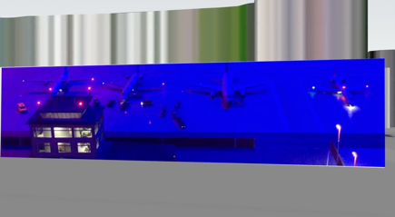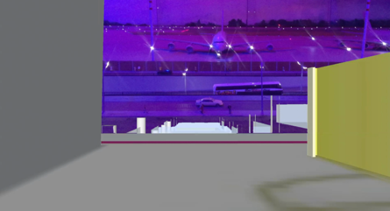
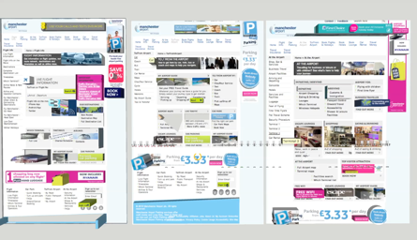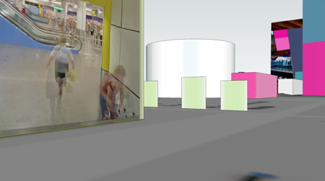

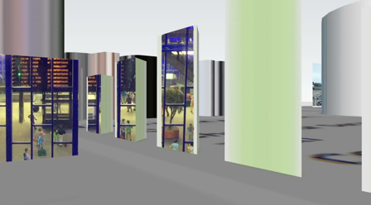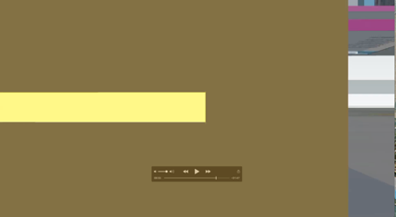
Figure 83 Clare Booker. Stills from Choose Your Space, 2017.

Choose Your Space is neither a video game, or an architectural walkthrough, but occupies an imaginative space between reality and fiction, virtual and actual. Other artists who have worked with the ‘walkthrough’ in this way include Julian Opie (b.1958) and Lawrence Lek (b.1982), who in different ways transport the viewer through a fictional space. Julian Opie’s Imagine You Are Walking is a series of prints, paintings and film, which depict a cool, almost monochromatic empty space devoid of human life or any features that suggest a particular place. Simple geometric blocks are used generating a computer game aesthetic, enticing the viewer to imagine entering the space and navigating around it. The work of video artist Lawrence Lek also represents an imagined world, but in this case the viewer can enter the space, rather than solely imagine being there. Lek’s work Berlin Mirror (2042 Retrospective), (2016) is complex, in the use of technical methods, content, and the context in which it is placed, occupying the space and disciplines of art, history, video games and documentary. The video format leads the viewer on a guided tour of a fictional exhibition at the KW Institute (Kunste Werke) in Berlin. It is presented in two ways, - as a space presented as a video, and as an interactive space in which the viewer can choose which direction to take, as in a video game. What I love about this work is the sense of motion of moving through a space, but reaching a surface, often an interior wall, where my movement is paused and interrupted, and I am presented with a piece of historical or fictional information, through both written text and voiceover.

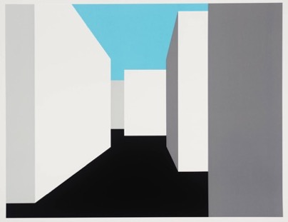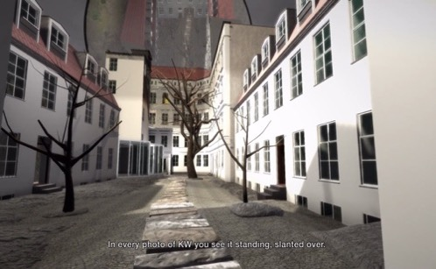
Figure 84 Julian Opie. Imagine you are Walking, 1998.
Figure 85 Lawrence Lek. Berlin Mirror (2042 Retrospective), 2016.

In Choose Your Space I also insert moments of pause, as I do in the project Apron Space, which interrupt the flow of the walkthrough, which aim to reflect the interruption of flow in the physical airport. As in Multi Story, these moments of pause present a still frame in which to contemplate the space before it changes. Within this frame a moving image has been inserted, a clip of video footage taken from a ‘found’ airport model.

The found model is that of a physical model airport, which is situated at the top of a shopping centre in Berlin, advertised as a major visitor attraction. Both the inserted video and the ambient sound in the film are taken from video recordings I made whilst visiting the model. During my visit it was just myself and 2 other people, a child and guardian observing the visitor attraction. It is their voices, alongside the simulated airport sounds of the model which can be heard throughout the film. I have always found something fascinating about models, as they appear as a way into an environment which allows open access to the space. There is a childlike fascination, a hopefulness. The small scale allows the eye to pan the landscape in its entirety, seeing how each zone interconnects. In contrast, the virtual model I have constructed cannot be experienced as one 'whole' space that can be viewed all at once. This airport model represents a space which is being constantly rearranged, juxtaposed, added to and taken away, due to the fluid unstable nature of the airport environment (Fuller & Harley 2004). Due to the nature of the space and the demands of security, the whole space becomes impossible to grasp, both the real and the model airport. Spatial experience becomes fragmented and broken down into separate moments and stages.

In Choose Your Space there are layers of collage in action here – a collage of models, a collage of sound, a collage of found and made material. The fusion of these elements aims to mirror the experience of disorientation and confusion as to where we are located whilst in the airport. Neither here, nor there. As part of the practice, I have included a description of my own experience and observations whilst watching the film Choose Your Space, which is using a similar method to the descriptive diaries of virtual wanderings in Street View Diaries. This method enables me to assemble and prompt thoughts and ideas around the three themes, spatial zones, movement and people, in a less direct and more poetic way. It also reinforces the idea that the experience of viewing and inhabiting this space is different to different users, and different to the individual each time the space is encountered, just as in the ‘real’ airport.

I begin from an aerial point of view, looking down at what appears to be an airport website, where 3 pages sit alongside each other. As I descend, the graphic shapes of the website pages emerge from the surface and extrude, becoming architectural structures within a graphic city.
// I am now on ground level moving towards and through a blue rectangle of space. The apparent sound of a child and ambient airport noise accompanies my movement.

I move slowly to the right, where a blurred figure appears in front of the more abstract forms. As I get closer to the surface of one of these shapes, an image appears of a departures board, with figures below. The figures are static, whereas a red light flashes continuously.
//I continue to move to the left, at the same pace.
In front of me is a night scene of an airport, where airplanes wait in the apron area. The sound of an aircraft engine breaks the quietness of the surrounding space. I continue to move slowly, encountering flickers of other spaces coming into view. My pace quickens. People of different scales occupy the same space. I am inside a model. I am both inside and outside simultaneously.

An airport bus moves out of view, whilst a plane takes off in the distance. I keep moving slowly and I am faced with a white tiled wall. Suddenly I am shifted into a completely different space, where a horizontal band of red interrupts the interior. A lone figure, a man, can be seen in the distance. I move towards him as the airport tower appears on my right, followed by the emergency exit. I face the glass doors, where I look outside towards the grey sky on one side, and the deep purple night sky on the other side. I move around to the right and hear the sound of a plane landing. I quicken my movements towards a group of figures, again static. One is black and white, whilst the others are in colour. A public announcement is made, followed by the sound of sirens as I pass the man from earlier and move closer towards a red door. I am abruptly redirected into a different space, where a cerulean blue sky and ochre sandy beach appears in front of me. I move forward and descend downwards, through to the level below. I become lost in an abstract landscape of colour and shape, which is moving all around me to the rhythm of the airport sounds.

Figure 86 Clare Booker. Observational 'diary' text, describing own experience of watching the film Choose Your Space.

Add Life – The People in the model

The Add Life series of work can be viewed by scrolling below the films at https://imaginedairport.com/model/

The final stage of the model’s construction was to ‘add life’, a term used by architectural visualisers, which refers to the stage where people are added to the interior and exterior of the spaces. As Hackelsberger (2004: 26) writes, “airports without people are like an empty stage”. Up until this point in the project, the model has remained a relatively empty space. I now wanted to activate the space, drawing on the idea that space only exists as a direct result of human activity and social movement (Lefebvre 1974). Add Life presents a series of alternative architectural visualisations, in the form of collaged images, which layer and juxtapose a montage of airport spaces and people. There is a mix and collision of viewpoints and visualities, combining photographs, models and painted surfaces within one picture plane.

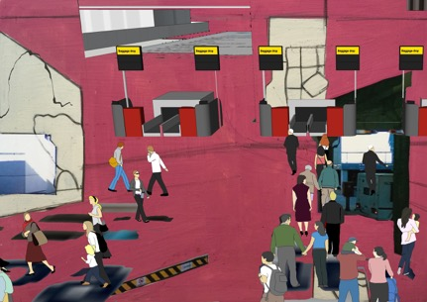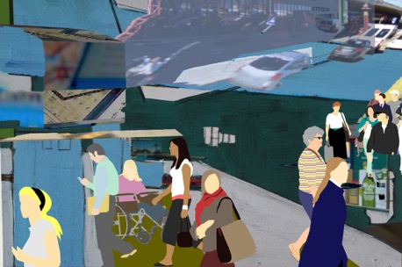
Figure 87 Clare Booker. Add life series. Paint / Digital Collage, 2018.

In contrast to an architectural visualisation, Add Life has a different rationale. An architectural visualization has many purposes. It is often designed to project a future construction, to present, as Bridle describes, ‘a kind of digital futurism, a pixelated vision of what is to come’ (Bridle 2013: 966). It aims to ‘sell’ a space to clients and retailers, to create a ‘replica’ of what will be seen and experienced. In contrast, Add Life presents a more ambiguous space, an alternative architectural visualisation, which doesn’t need to function as a projection of an actual building, but rather as an imagined space, mixing perspectives and visualities, which prevent the viewer from being able to make sense of where they are located.

In the earlier stages of the PhD research, before the project Model Fiction began, I produced two paintings in response to architectural visualizations of airport terminals. By transforming the original images through various mediated stages- photograph, enlargement, photocopy, painting, the image becomes pixelated and blurred, and the figures gradually become further integrated into the ground of the space. Through the painterly transformation of these images I aimed to reinstate the intensity and heat of the actual experience of being in an airport. The painted surface allows the space to be transformed into a richer, more embodied image, with atmosphere and feeling. The painterly renderings aim to retain a subjectivity, different to the often dry, cool photorealist digital visualisations, which aim to go beyond a ‘suggestion’, and aim to get closer to how the space will actually look with a more ‘accurate’ representation. Despite the increased sophistication in digital rendering, I challenge just how ‘real’ these images of the spaces actually are. The closer they supposedly get to reality, the further away they become (Rose 2013). Representing these spaces through digital rendering is in fact, an unachievable hyper-reality (Bridle 2013), whereas the colour and texture of the painted surface can be more successful in achieving the intangible sense of tension, atmosphere and ‘feeling’ of being in an actual space, and in this case, an actual airport.

For the composition of the paintings I decided to zoom in, to crop the image as a way of focusing on the pattern of figures below. In the original images the pattern of the figures in relation to the architecture intrigued me. The figures are evenly spaced out, creating a uniformity across the surface, neatly placed within the perspective of the interior. The figures are repeated, copied, cut and pasted into different areas of the space, a technique to populate the image, but also a method, which, although not the intention, could also suggest a narrative of movement. The people seem detached and disembodied from the environment, a feeling and experience common to being in an airport space.

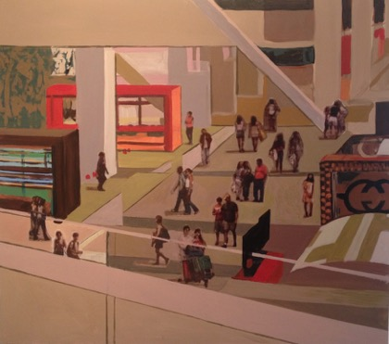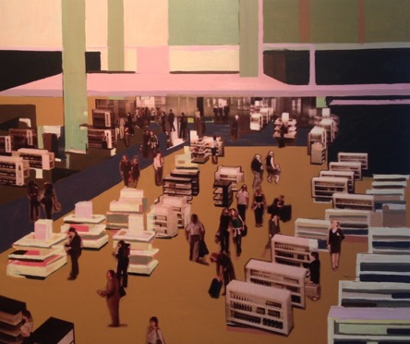
Figure 88 Clare Booker. Retail Perspective Acrylic and Collage on Board. 90x80cm, 2013
Figure 89 Clare Booker. Pier Root and Duty Free. Acrylic and Collage on Board. 90x80cm, 2013

The viewpoint is from an elevated perspective, creating a distance between the viewer and the space. This viewpoint began to remind me of the airport terminal webcams you can access, which show the continuous flow of movement of people, albeit often interrupted and presented as a kind of stop frame animation on screen. In the webcam footage, the patterns are less uniform than appear in the architectural visualisation, with different groupings, clusters of movement and more dynamic activity. Again, this brings into question the accuracy of the architectural visualization, in particular, whether movement can be accurately suggested and represented through a still image.

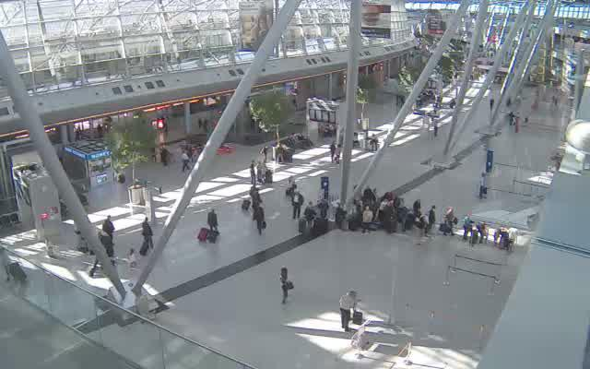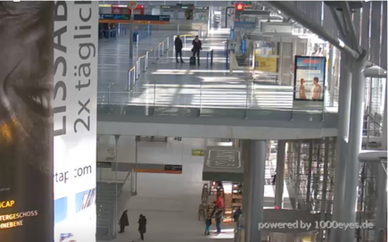

Figure 90 Airport Terminal webcams: Dusseldorf, 2017
Figure 91 Webcam: Cologne Bonn, 2017

In the series Add Life the people in the images are a mix of figures from both appropriated sources and own video footage and photography, which have been placed alongside each other and positioned within the same space. The figures can be seen alone, and in groups, which refers back to the De Hooch paintings, and to the figures / people discussed and represented in the previous two projects. The aim here is to explore multiple visualities and multiple identities. There is a contrast between the anonymity and the particularity of specific people and spaces. The figures are collaged into the space as two-dimensional cut outs. The people range from the blurry figures of Google Earth, model people from Google Sketchup, the ‘cutout’ people from architectural visualizations, figures from own photographs and video, through to the ‘wallpaper people,’ who are figures cut out from advertising screens and images found in and around the airport. Their contrasting visualities, from the photographic to the flat graphic figure aim to represent a space of fiction and reality, and the collision and parallels between the two. The same figures are often repeated and pasted into the different zones of the space, at different scales, suggesting a narrative of movement and how passengers occupy the different zones of the airport at different times. The method of the cut-out figure is being used conceptually, to suggest the sense of detachment between people and place, experienced in the airport. By cutting and pasting figures into disparate spaces and transforming and varying the scale, I am attempting to decontextualize the individual, unhooking it from space and time. The figures are now moveable, re-located, by myself, to a different space, which aims to reflect on how the mobile bodies of the airport are regulated, controlled and directed (Adey 2007; Cresswell 2006; Fuller/Harley 2004 et al).
The cut-out figure seems ever present in the architectural practices of Archigram and Superstudio, and in the work of Richard Hamilton (1922-2011), whom I discussed earlier in the chapter. Aside from these influences the films of Lewis Klahr (b.1956) have had a particular influence on my practice, regarding the dialogue between figure and space. Klahr is an experimental filmmaker, using stop motion and collage as a method to juxtapose and combine cut-out figures in various spaces, using found materials from a range of appropriated sources. This aesthetic particularly fits with how I am attempting to visualize the experience of the transient, unfixed, collage airport.

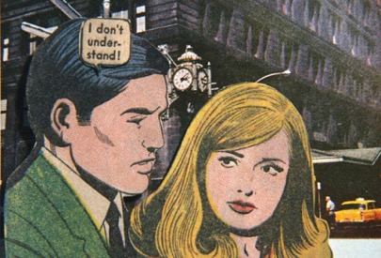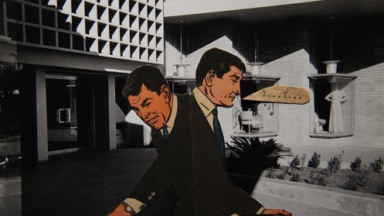
Figure 92 Lewis Klahr. Video Still, False Ageing, 2008
Figure 93 Lewis Klahr. Still, 66 Episode 6, Saturn's Diary #3, 2013
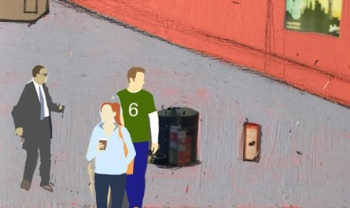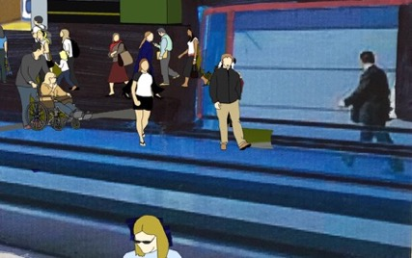
Figure 94 Clare Booker. Add Life series. Paint / Digital Collage, 2018

Conclusion

Model Fiction presents a surface of ideas in relation to the disorientating spatial experience of being in an airport. The method of using an imagined, virtual model, a three dimensional collage, has enabled me to experiment with multiple ideas and visualities within one space, treating it as an environment in which I can experiment freely, add and delete, move and reposition as a way of exploring the three themes of spatial zones, movement and people. The project experiments with juxtaposing the different spatial zones of the airport, often combining the outside and inside of the terminal as a way of investigating their relationship to each other. The model has enabled me to experiment with airport movement and the different people in the space, which aim to add to conversations about how people occupy and move in the space, and what factors contribute to this. Model Fiction began its construction in 2014. During this time the building and its interior has evolved through the duration of the project. Construction is still underway. It is never meant to be fixed but has the potential for continuous modification, interpretation, and reactivation. In the ‘real’ airport the increased demand of security and passenger numbers has led to many terminals being majorly altered. Expansions and renovations mean that airports are never finished. They are in a constant state of flux, re-shaping themselves, and adapting to new technologies (Gordon 2004; Nikolaeva 2012; Graham 2008; Bok 2015). The airport, both real and imagined remains suspended in possibilities.

Chapter 6: CONCLUSION

Contents:
Introduction
Research Questions
Contribution to Art and Mobilities Research Field
Conclusion as Practice

Introduction

This project brings the disciplines of geography, art, architecture and digital media together in creative ways, offering an original contribution to the areas of art, airport research, art and mobilities, digital geographies and visual creative methods. By employing the method of collage, Imagined Airport offers a different way of exploring and understanding the airport, through juxtaposing and layering multiple fragments to generate a series of alternative, imaginative and creative responses to the space. The project offers a new set of starting points, in which to continue experimenting with how to explore the airport.

Short conclusions have been written at the end of each project / chapter. For this final conclusion I explore how the individual projects connect and relate to each other. Here, I aim to draw parallels between the projects and how particular themes connect them together. In this conclusion I reflect on how the method of collage has been used to explore and understand the airport space, and what these methods have revealed about the spatial zones, movement and people encountered and experienced whilst in the airport (question 1&2). I discuss how the thesis has used digital technologies and digital viewing environments to create new ways of seeing and experiencing the airport and explore how these digital experiences have helped me draw parallels with the experience of being in the physical airport space (question 3). I go on to discuss how the thesis makes an original contribution to the area of art, geography and mobilities and suggest how the research and methods I have used can be now taken into new areas and directions. I end the chapter by discussing a final body of work, which provides a conclusion as practice by collaging imagery together from each project.

Research Questions

In this section I am going to respond to how I think the thesis has addressed and explored the research questions I ask in the introduction.

Research Question 1.

How can collage be used as a method to explore and understand the airport space?

The method of collage has been used in many different ways throughout the thesis and has enabled me to produce a significant body of work which responds to the space of the airport. This written commentary on the practice has presented my rationale for how and why I am using particular collage methods to explore the airport. By using the method of collage for research and production of art practice, I have provided a very different response to the space of the airport than has been produced before, which offers the viewer different ways of looking at and experiencing the space.

The method of collage has enabled new imaginary environments and spaces to be generated from gathered and assembled research, both made and found. I have assembled research material from a diverse range of sources, combining made imagery (drawings, photographs, models, paintings), with found imagery (historical and contemporary images and footage of the airport, found in publications, films, websites). These combinations and juxtapositions of made and found material offer new perspectives, aesthetically and theoretically. I have used collage in many ways, from physical cut and paste, to digital collage, text collage, collage film and collage animation. I have moved from the real to the virtual and back again. I have continuously experimented with collaging and juxtaposing multiple perspectives and visualities as a way of reflecting on how the airport is a heterotopic, rhizomic space of multiplicity and fragmentation.

Imagined Airport collages visual material as generative art practice, whilst at the same time collages ideas and concepts from geography, art, architecture and new media to produce new connections between multiple disciplines, juxtaposing and layering visual and theoretical responses to the airport. Collage allows for ‘re-seeing, re-locating, and connecting anew’ (Mullen 1999: 292). These methods of collage used for both analysis and production can now be transferable, having real potential for being used to research new sites, away from the airport. Throughout Imagined Airport I have used the method of collage as an approach to theorising and visualising airport space, aesthetically and experientially. Using this method presents many exciting future possibilities for investigating different sites and spaces of mobility.

Imagined Airport starts in one place but soon re-starts in another. The projects can be ‘read’ in many ways, aiming to prompt new ideas about the airport on each visit / viewing. This struggle (or refusal) to stabilize the airport and find a start, middle or end point refers back to Deleuze and Guattari’s concept of the rhizome (1987), which challenges linear, hierarchical representation, and presents alternative ways of seeing how space is multiple and interrelated, a map like surface where any point can be connected to another. Researching and producing art practice in this rhizomic non-linear and intuitive way can help to conceptualize dimensions of understanding that were previously unconscious (Butler-Kisber 2017). Like a rhizome, a collage provokes us towards seeing interconnections rather than separations.

Barry (2020) talks about the emergent encounters in the research process that creative arts practice embraces. She argues that these emergent practices draw attention to moments when we become aware of the multiplicity of movements in everyday life. Collage is an emergent, embodied process, which often makes it difficult to explain how the work was constructed and how it arrived at its final point. I have explained to a certain extent my thinking behind the making of work in the three project chapters but there are inevitable gaps in this explanation. Whilst making a collage, still or moving, there is often an uncertainty around how to arrange a composition of fragments, as there seems endless possibilities of arrangements. Often, the final decision of where the fragments are located in the ‘whole’ composition are made based on what ‘feels’ right. The work often unfolds instinctively. Whilst making a collage, we do not seek complete or final works or concrete answers to our questions, but instead temporary sites that beg for re-construction and re-vision (Butler-Kisber 2012). The collages become relational situations and contemplative transitory spaces, fabricated to provoke responses both in ourselves and others (Irwin & Springgay 2008). They are never intended to be fixed, or to conclude but to prompt more questions and thoughts.

In their paper Collage as Analysis, Holbrook and Pourchier (2014) discuss the difficulties of articulating the way collages are made or how they emerge, often not knowing why certain fragments have been selected or put together, not always being able to ‘capture’ in words what happens when they make collages.
‘I will never capture exactly what happens when I do collage. These strange couplings—chaos and order, folding and unfolding—cannot be captured, and when we give into the loss we experience when we try, we notice that the loss pushes us into other questions and different inquiries. There is a rolling pleasure—both anxious and calm—in working in chaos and order.’ Holbrook and Pourchier (2014; 758)
Through my practice I have been questioning whether the airport can in fact be described as one thing or another or whether it can be more than one thing at the same time, depending on which spatial zone is being discussed or from which and who’s perspective. Here, I have been building on the ideas of Salter (2008), who talks about the airport as an assemblage, a site of multiplicity and fragmentation and the work of Fuller & Harley (2005) who visualize this multiplicity and fragmentation through photographic juxtapositions. Both these approaches to the airport dispute any singular description or fixed perspective. The airport, like the method of collage is a fluid process of change and re-positioning. In response, through methods of collage, I have attempted to visualize how many concepts, descriptions and perspectives can be applied to the airport at different times, or simultaneously. To describe the airport as one thing is problematic. Therefore, the collage experiments of the three projects have aimed to convey the space as more than one thing in different zones and at different times.

Within each project I have collaged methods of drawing, painting and video and used the visual devices of layering, grids and split screens to explore the airport as a fragmented, in-between space, made up of a multiplicity of experiences. There are opposing factors which shape the space, and which cause opposing and conflicting spatial experience. There is a tension between speed and security (Shaberg 2011), between anxiety and excitement (Adey 2008), a mix of operational factors which affect emotional response. The method of collage used throughout the project has provided a new suggestion of how these opposing and conflicting aspects of airport experience can operate within the same space, on the same surface.

The collages in Imagined Airport are not just spatial, but temporal. Different spaces, from different airports, at different times are layered and juxtaposed to generate and reflect upon a mixed, multiple and fragmented experience. The collages I produce throughout the project are not pictures of a space, but represent a process, space and viewpoint which, although static and still at times, are often changing and shifting, just like the airport itself. In relation to this idea, I refer to the observations of Pascoe (2004: 14), who believes that ‘airports should be seen as organic entities, a virtual space created from the flow of digital fragments, bits and bytes, through systems, and around networks.’ This different way of framing airport research, through the concept of collage, has been effective in realising these ideas about the airport, visually, and helped open up new perspectives on the space.

Research Question 2.

- What do these collage methods reveal about the spatial zones, movement and people encountered and experienced whilst in the airport?

Imagined Airport has added to and expanded on existing ideas and discussions around the airport themes of spatial zones, movement and people in the space. Within each project I have used the method of collage to explore and visualize the interconnection of spatial zones, movement and people in a number of ways, using an experimental approach to exploring these three themes. In this section I discuss what these methods of collage have revealed about each theme.

- Spatial Zones
- What do collage methods reveal about spatial zones encountered and experienced whilst in the airport?

- Each project in Imagined Airport looks at ways to explore and expand upon the ideas of Adey (2007), Bok (2015), Cresswell (2006), Fuller/Harley (2005), Hall (2017), Kitchen & Dodge (2011), Nikolaeva (2012), Salter (2008), Sharma (2014), amongst others, who have investigated airport spatial zones and their interconnection in different ways. The three projects have aimed to expand on these ideas in a visual way. The Street View Diaries explore the transitions between spatial zones, presenting the airport zones from various perspectives, whilst emphasizing the moments where one zone merges or unexpectedly jumps into another. In Apron Space I focus on the outside of the airport, whilst emphasizing the experience of being in-between spatial zones, psychologically and physically. In Model Fiction I visually experiment with collaging multiple zones of the airport, inside and outside, layered and juxtaposed. In regard to spatial perspectives my ‘findings’ have reinforced the view that spatially the airport is a site of intrinsically linked zones which cannot be separated. This reinforces my decision to use the concepts and visual strategies of collage as method, where this fragmented mode of representation allows these ideas to be visualized.

The projects draw on the spatial concepts of Heterotopia (Foucault 1967) and the Rhizome (Deleuze & Guattari 1987) by visualizing the airport as a site, which exists as a physical place in itself, whilst ‘other’ places it is connected to (the global destinations of the departures/ arrival boards), gives the airport its meaning, shape and form. The method of collage enables me to visually explore these concepts through visualizing multiple airport zones simultaneously, rather than representing one particular spatial zone in isolation or from one singular perspective. The mixing up of spatial zones and presenting them in a non-linear way aims to mirror the disorientating spatial experience of being in an airport. Many of the processes you have to go through in an airport are linear, in terms of order of activities and direction of movement. However, the experience can often be disrupted and fragmented due to unexpected delays or re-directions. Collage forces us to think and work in a non-linear way. Unexpected resonances and connections can stimulate discussion and learning (Butler-Kisber and Poldma 2010). In each project I adopt a rhizomic method of entering the space at different points, which branch off in different directions. The films each begin in different areas of the airport, at different stages of the journey or visit. I produce a series of collaged surfaces, whether this is through painting, digital image or film, which combines and juxtaposes spatial zones from outside and inside, landside and airside, from multiple airport locations, as a way of investigating their relationship to each other. This method presents a new way of seeing the airport and a new method to research and make art about the space.

Movement
- What do collage methods reveal about movement encountered and experienced whilst in the airport?

- Responding to existing art and literatures which explore airport movement, Imagined Airport employs methods of collage as a way of making airport movement and its differences, visible. Collaging photographic and video material with the application of drawing and painting have enabled the mapping, tracing and sequencing of movement across a surface, generating new visual representations of movement at the airport, both human and non-human. The deconstruction and reconstruction of airport movement through these visual methods has enabled a ‘slowing down’ of the process of looking and recording which presents a way of developing a closer scrutiny of how people move through space.

Through the different films I have explored moving through the airport in different ways. In both Street View Diaries and Model Fiction I provide a series of virtual ‘walk-throughs’ and journeys around the airport. ‘Walking’ as a mobile method in geography and sociology has been extensively explored (Buscher, et al 2020; Myers 2011; Peters 2018; Steindorf 2017; Pink 2008, amongst many others.) When I refer to walking in this thesis it is usually a virtual walk in which I am referring to, although my own physical walking through the space as a researcher / passenger has also contributed. The ‘virtual’ walk presents a different kind of experience to the physical walk. By walking through the airport, via virtual walkthroughs, the experience is a more detached imagined one. Through these walkthroughs, which have been collaged together from different perspectives and viewpoints, I am presenting and critiquing the different ways we move through the airport, fast, slow, free flowing or interrupted. The method of collage has enabled a multiple of movements to be seen and experienced in quick succession. In contrast to the virtual walkthroughs of Street View Diaries and Model Fiction, the short films in Apron Space are assembled from footage taken from my own moving position, whether this is walking past the terminal window or looking through a window of an airport bus or aircraft whilst travelling. In each project I have employed methods of pausing footage as a way of highlighting spatial transitions, from outside to inside, from one spatial zone to another. This device has been used to reflect the fast shifting and disorientating experience of being in the actual physical airport.

At the airport there are specific constellations of movement and non-movement (Lassan 2020). There are moments of moving through the terminal contrasted by moments of waiting and stillness (Bissell 2010). Through the art practice in Imagined Airport, I have explored these two forms of mobility, regularly collaging moving and still images alongside or layered upon each other. By using the visual methods of layering, sequencing and grids I am visually exploring these experiences, presenting both a static and moving gaze simultaneously. Collaging moments of movement and stillness has enabled the visualization of ideas around the interconnection between information, control and movement in different ways. By employing methods of layering, editing speed and inserting intervals, I have continuously experimented with fast and slow moments at the airport, as a way of reflecting ideas of motion and fixity, of activity and inactivity, of immobility and mobility. It is often the intervals, overlaps and the blank areas that provoke the most interesting critical reflections. I experiment with a range of artistic devices and strategies that aim to show the controlled and interrupted movement at the airport, considering how to visualize the filtering and shaping structures (Adey 2004) which affect movement in the space. I experiment with collaging spatial boundaries and prohibited spaces, attempting to visually explore the relationship between control and movement at the airport. I address control and movement in each project, but particularly in the project Street View Diaries, where I use the blue line of Street View which suggests the areas I am allowed or not allowed to access. The films glitches and redirections also aim to emphasize and visualize these ideas about controlled spaces and their impact on how people move through and around the airport.

What has emerged through the making of the films has been the visible interconnection and layering of human and non-human movement, both spatially and operationally. There are different types of movement in play (of people, objects, capital, information), as well as their intersections and dynamics across multiple systems and scales (Hannam et al 2006:1). The movement of people in the airport has integral connections to non-human movement and activity. As well as observing the movement of people at the airport there is also the observing and following the movement of objects, in order to make visible the connections between them. I employ methods to follow objects, to ‘follow the thing’ (Büscher, et al 2014), through collaging human movement with object movement (cases, flickering signage, moving walkways, trucks, jetways). This relationship between human and non-human movement at the airport has been explored in the wider academic literature (Kitchen & Dodge 2011; Fuller & Harley 2005). What this thesis does differently is use the process and form of collage to make these ideas and observations visible.

- As Ritchhart and Perkins (2008: 58) note,
“fostering thinking requires making thinking visible: Thinking happens mostly in our heads, invisible to others and even to ourselves. Effective thinkers make their thinking visible, meaning they externalize their thoughts through speaking, writing, drawing, or some other method”

There is often a temptation to hold down and dissect the phenomena of movement and mobilities in order to study and write about them (Büscher, Urry and Witchger (2011). However, as Buscher et al acknowledge, this holding down and dissecting can have the tendency to destroy the phenomena of movement. Visualizing movement at the airport without destroying it’s phenomena has been a challenge. As a way of facing this challenge, using the method of collaging drawings, paintings, photographs, models and film/video has provided me with a way of observing and visualizing the vast numbers of mobile air travelers at the airport, along with tracing non-human movement within the space. The visual processes and devices used in making the work for Imagined Airport have been just as important as the final works, in contributing to studies of movement and mobilities.

People
- What do collage methods reveal about people encountered and experienced whilst in the airport?

- When considering the theme of airport people, I have experimented with the ideas discussed in the literature / art review which explore multiple identities and the differentiated traveler in the airport (Cresswell 2006; Merriman 2004; Sharma 2014; Hall 2017). As a way of exploring the differentiated and interconnected movement and mobilities of the workers and passengers, I have employed the method of collage to literally cut and paste visual representations of airport people onto one surface, whether this be a painted or filmic surface. Collaging images and video clips of airport workers alongside other people in the airport has provided a way of observing and visually representing how the two groups may move differently in the space. Examples of this can be seen in each project, but especially in the virtual model and paintings presented in Model Fiction.

Writers such as Cresswell (2006) and Merriman (2004) talk about how different people move differently in spaces they jointly occupy, depending on their identity and their purpose for being there. Collaging images and footage of different people moving at the airport has provided a method in which to experiment with these differences. I use a range of diverse visual methods as a way of highlighting these differences and putting an emphasis on the people in the space. I experiment with the visualities of the appearance of airport people, using painterly, graphic and photographic forms of representation. I collage found and made images of different people within the same space. I cut out, draw around, frame, isolate and repeat figures, aiming to ultimately collage them together on to one surface to reflect their shared occupancy of the space. The figures are repeated, copied, cut and pasted into different areas of the space, a technique to populate the image, but also a method, which suggests a narrative of movement. This visual technique of detaching and re-attaching the people in the space is also being used to intensify the sense of detachment and disembodiment, a common experience and feeling whilst being in an airport space (Adey 2007; Cresswell 2006; Fuller/Harley 2004; Rosler 1998 et al).

Research Question 3.

How are digital technologies and digital viewing environments creating new ways of seeing and experiencing the airport and how do these digital experiences help me draw parallels with the experience of being in the physical airport space?

Digital technologies are changing how we can interact and view the world we live in. Landscape and architecture are being increasingly viewed, experienced and represented via mediated technologies and digital viewing environments. These technological changes are enabling a wide range of experiments in visual methods, where researchers are increasingly utilising new digital technologies (camera-phones, mapping software, video recording and editing) as research techniques. Digital audio-visual technologies and mobile media have played a large role in the surveying of mobilities, offering new ways to track and trace movement across various spatial and temporal experiences. Artists are using Global Positioning System (GPS) and locative media to uncover ‘new relationships to location’ that involve situated, embodied and relational awareness (Southern 2015:181). Technological aesthetics are being pushed to explore alternative spatial configurations of mobilities infrastructures (Barry 2020). Digital methods are often working alongside the physical, where methods such as drawing and diagramming are being used as an experimental approach to analyse mobilities (Barry 2016, 2017, 2018; Jir.n & Iturra 2014). Various scholars have investigated and explored these digital technologies and interfaces in relation to spatial experience (Graham 2012; Hewitt 2012; Farman 2010; November 2010; Di Palma 2009 et al), which I have spoken about in previous chapters.
Each practice chapter in the thesis responds to and builds upon these ideas and responses around technology, through a series of data driven projects, utilizing airport timetables, website information and mapping software to drive and shape visual outcomes. More specifically, this thesis presents ways in which digital technologies can be used to generate visual collages, which provide a new way of seeing and experiencing the airport. The project is based in material developed from a range of contemporary digital technologies; Google Street View; Webcams, Websites, Mobile Phone Footage and Virtual Models. The projects in Imagined Airport employ these digital technologies for the production of practice, whilst simultaneously critiquing the technologies. The thesis explores how the experience of viewing and navigating the airport via these technologies can augment our real experience of these spaces and asks the question of how this virtual experience may help us re-imagine, disrupt, and change our understanding of the airport.

By employing technologies such as Google Street View and live webcams I have been able to access many different airport sites. The identity of these different sites however, has not always been apparent, as the collaging of assembled footage has often hidden any clear visual indicators as to which airport I am in. As Schaberg (2011: 6) notes, ‘sometimes airports are identifiably “regional,” and other times one might feel as though one could be anywhere- airports can feel utterly generic (pleasingly or uncomfortably so).” I have developed this idea of the ‘generic’ airport in the Street View Diaries project, where I navigate around and collage a number of different airport sites, making connections and observing differences between them. The Street View Diaries project engages with the conflict and transition between virtual and physical experience of the airport more directly than in the other two projects. By collaging clips together of the Google Street View airports, it provides a space in which to construct an imaginary space, made up of digital fragments taken from different and multiple airports.

The technologies and digital viewing environments I have used in Imagined Airport have provided a way in which to explore the site of the airport differently than I would be able to in the real physical space. I can explore the three themes of airport space, movement and people in a slower more controlled way than I would be able to do in the physical space. Occupying the digital airport allows me more time to observe and wander, than I would have at the actual airport. I can gain access into places, zones I would not otherwise be given permission. Through combining, juxtaposing and layering video clips from my journeys around the different street view airports, I can make fictional documentaries, making fictional connections between people and place. The digital spaces of Street View present so many new possibilities for re-imagining and representing other spaces, away from the airport. The collaging of Street View imagery I have used has much potential for further development, especially as the number of locations you can now access is continually growing.

- The virtual model, a three-dimensional collage, in the project Model Fiction has enabled me to experiment with multiple ideas and visualities within one space, treating it as an environment in which I can experiment freely, add and delete, move and reposition as a way of exploring the three themes of spatial zones, movement and people. The model has enabled me to experiment with airport movement and the different people in the space, which aim to add to conversations about how people occupy and move in the airport, and what factors contribute to this. The method of assembling a virtual model has provided a site, which I can continuously modify and reactivate in reaction to how ideas and research on my subject have evolved and developed. In the ‘real’ airport the increased demand of security and passenger numbers has led to many terminals being majorly altered. Expansions and renovations mean that airports are never finished. The architect of Schiphol Airport, Jan Bentham, describes his vision for the airport as a place that is never finished and is always being built (quoted from Cresswell 2006:232). The virtual model mirrors these visions. Airports are in a constant state of flux, re-shaping themselves, and adapting to new technologies (Gordon 2004; Nikolaeva 2012; Graham 2008; Bok 2015). Building virtual models from assembled research is a method which has real potential for future projects. It provides a way in which multiple modes of data collated through the research process can come together in one visual form.

- As I have navigated through the airport via digital technologies, I have attempted to make the transitions and parallels between the physical and digital airport visually apparent through different methods within the practice. Accessing the airport via these technologies has allowed me to enter and view different airports and spaces within them simultaneously. I have been able to move between zones and view and capture them in quick succession. This has enabled me to make closer links between the zones and see how they are all interconnected as a whole space. I have manipulated and transformed the digital images I was able to access and gather, re-assembling them to create new airport spatial perspectives and experiences. These different technologies provide new modes of representation and a particular aesthetic of fragmentation. Digital Viewing Environments offer different kinds of temporalities of inhabitation to the airport.
This thesis provides a space in which we can reflect on the experience of using digital technologies to explore space and place and design new research methods, which can contribute to producing geographical knowledges. Experimenting with these digital interfaces and platforms offers such an intriguing way in which to analyse and explore many airport sites and spaces and seems one of the best ways of trying to apprehend and investigate a phenomenal experience.

In recent conferences and exhibitions, the project has contributed to dialogues around digital geographies. In 2016 I participated in the annual RGS conference, delivering a paper and screening work, as part of the session Digital methods as influences on research design in geography, led by the Digital Geographies Research Group. The paper, entitled Digital viewing environments as visual methods of research and practice, aimed to present ways in which mediated technologies and digital viewing environments can be used as methods in which to generate process driven outcomes in response to the particular site of the airport. I continued this discussion around digital technologies for the 2019 RGS conference, again, as part of the Digital Geographies Research Group, for the session Geographies of interactive digital narratives, which explored the conceptual and methodological opportunities and challenges that interactive digital narratives present to geographers. Here, I discussed the project Model Fiction and its potential for using digital three-dimensional collages and models for future geographical research, not only to explore the airport, but to explore different sites and public spaces. These are examples of the project’s contributions to both the areas of visual creative methods and digital geographies, which I hope to continue contributing to with new work in response to different sites of public space.

Contribution to Art and Mobilities Research Field

Imagined Airport responds to and builds on ideas around airport spatial zones, movement and people, offering a new visual contribution to the field of mobilities research. Before the project started, I had little prior knowledge about the research field of mobilities, so becoming newly immersed in this area presented me with an exciting opportunity, in terms of expanding my practice and becoming a part of something different, new and unexpected. I started this project as an artist, fascinated and driven by the space of the airport and how I could make art about it. I looked at existing art about airports (in which I discuss in the literature/art review) and felt that I could continue and expand on this practice, hopefully offering a different visual exploration of the space. At this early stage I positioned my work within this field - the field of art about airports. As the project began to develop I was introduced to the area of mobility research and subsequently the field of art and mobilities. I realised my art practice could begin to be positioned within a wider academic context and find a new place to occupy and contribute to.

The area of art and mobilities seems to be rapidly developing, with many artists such as Southern (2012, 2013, 2017, 2018, 2019); Barry (2013, 2015, 2016, 2018, 2019); Tan (2015, 2016, 2018, 2019); Kerr (2013, 2014, 2017), amongst others, employing diverse experimental approaches and practices as a way of offering new and creative methods and contributions to mobility research. These artists often employ an interdisciplinary approach, using methods of installation, drawing, video and interactive media to explore site-specific, multi-sensory interactions that are experienced whilst on the move and whilst in transit. Audience participation and collaborative methods become key in shaping the research and practice. Through these methods, the artwork extends from its original singular form, adding layers of participation and interaction as new people engage and contribute to it, and in doing so, reshape the configuration of mobilities (Barry 2020). This field is greatly expanding with many networks of interdisciplinary mobilities research emerging and recent conferences and exhibitions taking place to explore how art can engage with mobilities in different ways. Imagined Airport aims to engage with this existing research and add and contribute to this emerging field.

An example of this was in 2018, when I took part in the Art & Mobilities Network Inaugural Symposium at Cemore (Centre for Mobilities Research) at Lancaster University. The aim of the symposium was to bring together artists and researchers to share their work as a way of focusing on what contribution art can make to mobilities research and vice versa. The sharing of creative practice prompted lively discussions around the different processes, methods and subjects being explored and how this exciting diverse area of research could be expanded, with the potential for further collaborations, activities and symposiums. Later in 2018 I also participated in the Joint Mobilities Symposium, Mobilities, Stories, Movement and Art at the University of Waikato, New Zealand, screening a series of films from the Imagined Airport project. The work received a really positive response and has opened up many discussions around my work, along with giving me the opportunity to become an active member of the network of mobilities researchers, which has led to discussions about future collaborative projects.

Whilst visual artistic methods are being increasingly adopted and employed in art and mobilities research, the role of collage has been relatively overlooked. Collage as a conceptual device and mode of representation has perhaps not been utilized enough as an active research method. This thesis shows how important the method of collage can be in contributing to geographical enquiries, particularly in the area of art and mobilities. Exploring and participating in the field with methods of collage presents many exciting possibilities. The non-linear, sensory, embodied and ambiguous language of collage can generate multiple meanings, responses and interpretations. Collage fragments “work against one another so hard, the mind is sparked into new ways of knowing” (Steinberg 1972:14). Novel juxtapositions and/or connections, and gaps or spaces, can reveal both the intended and the unintended. The collage process reduces “conscious control over what is being presented which contributes to greater levels of expression, and in turn greater areas for examination and subsequent clarification” (Williams 2000: 275).

There now seems to be a growing momentum for creative, emergent and experiential methods in the field of geography and art and mobilities research, which provide a way of dealing with the fleeting and the multiple more directly. There are claims that art and creative practice can often be used as an intervention to prompt new knowledge making (Witzgall et al 2013; Barry 2020; Candy & Edmonds 2018). I believe that collage methods have the potential for adding a new experimental and alternative approach to the field of mobilities. Imagined Airport shows many examples of how collage methods can make new innovative contributions to how space and place are researched and visually represented.

Colour
Whilst producing the various collages of the project, whether this has been a still or moving image, other formal qualities have been considered in the making of the work. I have discussed fragmentation, juxtaposition and layering but the use of colour has also been integral, in terms of how it impacts and contributes to the themes of space, movement and people in the space. Like collage, the role of colour has been underexamined in geographical enquiry (Barry, Bhattacharya, Endensor 2019). Whilst generating the work for the three practice projects I have asked myself how and why I am using colour in a particular way. Each project provides different ways in which I experiment with how colour can be used as a way of analysing and visually representing the airport.

- Often the photography and visual representations of airports through architectural visualizations are represented as a collection of cool tones, with an emphasis on monochromatic silvers, whites, greys and browns. In response to these images, I wanted to transform the colour into brighter, richer, bolder tones as a way of reflecting upon the sense of tension, excitement, frustration, speed and slowness often encountered in the space. In Model Fiction I have aimed to reinstate the intensity and heat of the actual experience of being in an airport, through painterly experiments of heightening tones and inserting large flat areas of colour against the cooler moments of photographic detail. In Street View Diaries I also heighten and exaggerate colour, by digitally manipulating the original cool colours of the Google Street View footage. Another visual strategy has been to use large areas and shapes of colour to imply how movement is interrupted or blocked (Street View Diaries, Heathrow Purple, Choose Your Space). I also use lines of colour for different purposes - to divide space and to show how people and objects have moved across the surface (Street View Diaries, FAO). At times I have reduced colour, or removed it completely, a decision taken for the purpose of generating a distance and detachment or to emphasis the anonymity of which airport we are in (Apron Traffic). Through the voiceovers of the Street View Diaries, many references are given to colour when describing a particular airport space and the people and objects within it. I use descriptions of how the colour and light change as I move, which implies a shifting of time and space. In all of the work, colour is used to unify the collage surface, pulling areas together to generate a certain rhythm and cohesion. Like collage, colour as method has great potential for contributing to ways in which spaces of mobility can be explored and researched.

Conclusion as Practice

As part of the conclusion I wanted to make a ‘final conclusion’ in practice form, which would reflect upon and assemble material from the three projects together. Dealing with spatial zones, movement and people has provided a thematic structure to the thesis. However, as the projects have evolved, it has become increasingly apparent that these themes are interconnected at all times. My main preoccupation throughout Imagined Airport has been to somehow visualise the interconnectedness of space, movement and people in the airport, and how each impact on the other. It is a space of multiplicity. I refer back to the spatial ideas of Lefebvre (1974), Foucault (1967), and Deleuze & Guatarri (1987) here, of which I have been keen to retain throughout the project. In order to make visible the concept of space as a set of relations and forms that continuously interrelate, I felt that a further fusion had to take place, a further layer, where the visualities and theoretical findings of the three themes and three projects became flattened and condensed, with no separation. This began to happen in the Add Life series at the end of the Model Fiction chapter, where spaces began to become a collection of ambiguous interlocking shapes, textures and fragmented imagery, taken from each of the projects. Following the Add Life series, I felt the work could be pushed even further in the pursuit of presenting an ‘all over space’, a Jackson Pollock like surface, which has no focal point, no centre of interest, a mix of realities, a mix of real and virtual, a mix of physical and digital surface and a mix of perspectives.
The resulting final series of work, Cubist Datascape and the book Imagined Airport, provide a conclusion as practice, assembling imagery from each theme and project into a series of collages assembled from the collages from the three projects. By making this work, visual connections can begin to be made between the projects. Cubist Datascape aims to reflect on the information and image overload experienced whilst in the airport, and experienced during this whole research process, where thousands of images and files have been generated along the way. I began reconstructing these thousands of fragments into new forms, as a way of making new cubist images which amalgamate multiple viewpoints and perspectives from the project as a whole. The final project Cubist Datascape can be viewed via the Imagined Airport website, https://imaginedairport.com/airport-collage/. The book Imagined Airport can be viewed at: https://imaginedairport.com/imagined-airport-book/. The PDF needs be viewed as a two page view in Adobe Acrobat. There is also a physical version of the book.

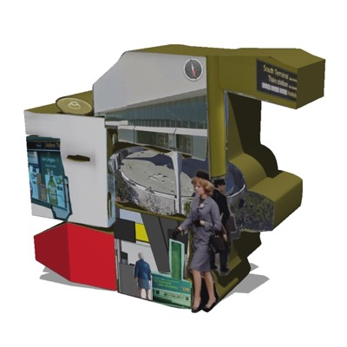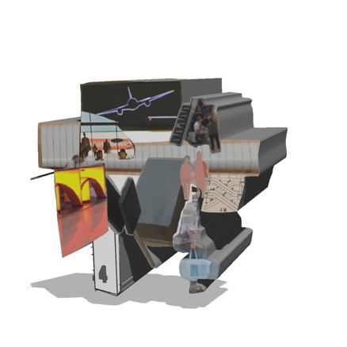
Figure 95 Clare Booker. Airport Fragments (from Cubist Datascape project), 2019

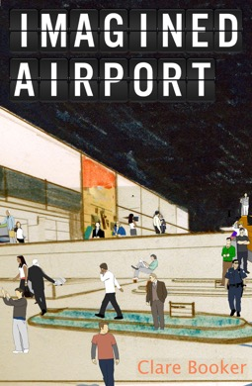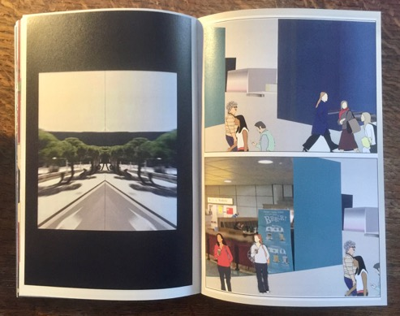

Figure 96 Clare Booker. Book: Imagined Airport, 2020

Each project /chapter of Imagined Airport is packed with ideas that could be expanded upon greatly. At times I may move too quickly away from ideas, into another one. I know this is happening, but my eagerness to visually explore a new idea is too strong to resist. Opportunities in the process of working are encountered that were not envisioned when work began, but that speak so eloquently about the promise of emerging possibilities that new options are pursued (Eisner 2002). Each time I revisited and edited a chapter I felt the need to reactivate it in some way, as I saw new meaning and new possibilities for further work. As Gray & Pyrie (1995) observe, practice-led research seems to work heuristically, back and forth between creation and analysis. Whilst writing I would often break off to work something out visually. I must do another drawing, cut a shape out, make another film or painting to try and make sense of an idea, or expand upon it with a new interpretation. The collage process goes through many movements, placements, re-placements before the images are actually ‘glued’ (whether physically or digitally) into place, providing alternate ways for interpreting both conscious and unconscious ideas. As a result, ideas get left behind, and sometimes never returned to. But that is the nature of this research and the collage methods I have adopted. This sense of restlessness often mirrors the experience of being in the airport. I cannot settle. There is very little time to stop and think. I keep moving, until I get to my destination, but will I ever reach it? It is not a fixed response, but it is ever changing and open to new ideas in response to the work I have produced.

Although the work in each of the three projects represents ideas to some extent, the work also generates ideas within itself, through the intuitive process of making. The spontaneous and intuitive method of collage draws out more complex notions about experience, disrupting and challenging safer, more traditional textual routes, leading to learning that is both personal and significant (Butler-Kisber et al 2007). Whilst in the process of working on the practice it has been difficult at times to break off and write about my thoughts and observations, as so much of the thinking around ideas has taken place during the making of the work. Many times throughout the project there seemed a clarity in an image or film I was making but when I came to write about it, clarity and rational understanding became hard to find. As a result, many ideas, thoughts, observations and experiences are embedded within the visual language of the work, rather than drawn out from the practice and articulated through written form. Writing about the practice in the chapters felt conflicted at times, in terms of deciding how descriptive I should be about the practice, whether this was through discussion around how the work was made, or what the work ‘meant’. How much did I explain, or leave open to the viewer’s interpretation?

The project has become an endless collaging process of re-imagining, deconstructing and re-assembling, a process which inevitably results in ambiguity, whilst at the same time hoping to provide many exciting ideas for further development and research. Imagined Airport has no end point. It provides a series of pauses in the search for another idea. Candy and Edmonds (2018: 64) describe creative arts research as ‘characterized not only by a focus on creating something new but also by the way that the making process itself leads to a transformation in the ideas’. The result is often a fluid and process led engagement with the subject, in which the final product or outcome of the research may be unknown or unexpected. Using collage as an art and research method has been just as much about the process as the art object. Employing creative visual methods often puts emphasis on the process of research, of the gathering and generating of material. This process encourages the embracing of unexpected encounters and overlaps that develop through practice (Barry 2020). The collage process takes this idea literally, with a continuous overlapping, materially and conceptually.

- Throughout this research journey I have moved through topics with a restlessness and unease about where I am going and why. Questions have been asked about my rationale, my aims, my argument. I have a new idea almost daily, a new breakthrough and clarity, but as soon as it arrives it leaves. I eventually realized that this search for an idea IS the project. And the search is continuous. There are no answers, no arrival points. I am in constant transit, stuck between departures and arrivals. It is this space which I am obsessively attempting to visualize. And the possibilities seem endless. The search and visual experimentation could go on forever, but I need to press pause at some point. This moment of pause arrives here.

Bibliography:

Adey, P. (2004). Surveillance at the Airport: surveilling mobility/mobilising surveillance. Environment and Planning A, Vol 36, pp 1365-1380.

Adey, P. (2004). Secured and Sorted Mobilities: examples from the airport. Surveillance and Society, Vol 1 (4), pp 500-519.

Adey, P. (2006). Airports and air-mindedness: spacing, timing and using Liverpool Airport 1929-39. Social and Cultural Geography, Vol 7, pp 343-363.

Adey, P. (2007). May I have your attention: airport geographies of spectatorship, position, and (im)mobility. Environment and Planning D: Society and Space, Vol 25 pp 515-536.

Adey, P. (2008). Airport’s, mobility and the calculative architecture of affective control. Geoforum 39 438–451.

Adey, P. (2009). Mobility (Key Ideas in Geography). Routledge.

Adey, P. (2010). Aerial Life. Wiley-Blackwell.

Adorno, T. (1991). The Culture Industry. Routledge.

Antliff, M. Leighton, P. (2001). Cubism and Culture. Thames & Hudson.

Armitage, J. (2015). Virilio for Architects. Routledge.

Augé, M. (1995). Non-places: introduction to an anthropology of supermodernity.
Verso. London.

Auster, P. (1985). The New York Trilogy. Faber & Faber.

Auster, P. (2004). City of Glass: The Graphic Novel. Picador.

Bachelard, G. (1958). The Poetics of Space. Beacon Press.

Baldacci, C. Bertozzi, M. (2018). Montages. Assembling as a Form and Symptom in Contemporary Arts. Mimesis International.

Ballard, J. G. (1997). Airports. The Observer 14/09/1997.

Barber, S. (2001). Projected Cities; Cinema and Urban Space. Reaktion Books.

Barker, J.L. (2014). Tilt-Shift Flânerie: Miniature View, Globalscape
Animation, Vol.9(2), pp.177-195.

Barry, K (2020). Creative Arts Practices in Mobilities. Handbook of Research Methods and Applications for Mobilities. Edward Elgar Publishing

Baudelaire, C. (1972). The Painter of Modern Life. Penguin Books.

Baudrillard, J. (1988). The Ecstasy of Communication. New York: Semiotext(e).

Baudrillard, J. (1981. 1994). Simulcra and Simulation. Michigan.

Benjamin, W. (1999). The Arcades Project (Translated by H. Eiland & K. McLaughlin). Cambridge (Mass) : Harvard.

Berger, J. (1972). Ways of seeing. Penguin. London.

Berger, J. (2013). Understanding a Photograph. Penguin.

Berry, D.M. (2001). The Philosophy of Software. Code and Mediation in the Digital Age. Palgrave Macmillan.

Bissell, D. (2007). Animating Suspension: Waiting for Mobilities. Mobilities 2(2): 277–
98.

Bissell, D. (2009). Travelling vulnerabilities: mobile timespaces of quiescence. Cultural Geographies: 427–445.

Bissell, D. and Fuller, G. (2009). The Revenge of the Still. M/C Journal 12(1).

Bissell, D. (2010). Passenger mobilities: affective atmospheres and the sociality of public transport. Environment and Planning D: Society and Space, volume 28, pages 270 – 289.

Bissell, D. Fuller, G. (2011). Stillness in a Mobile World. Routledge.

Bissell, D, Fuller. (2011). Stillness unbound. In: Bissell, D, Fuller, G (eds) Stillness in a Mobile World. Abingdon: Routledge, 1–17.

Bissell, D, Adey, P, Laurier, E (2011). Introduction to the special issue on geographies of the passenger. Journal of Transport Geography 19: 1007–1009.

Bissell, D; Adey, P; McCormack, D; Merriman, P. (2012). Profiling the passenger: mobilities, identities, embodiments. Cultural geographies, vol. 19, 2: pp. 169-193.

Bissell, D. (2018). Transit Life. How Commuting is transforming our cities. MIT Press.

Blau, E. Troy, N.J. (1997). Architecture and Cubism. Canadian Centre for Architecture.

Bode, S. Millar, J. (1997). Airport. The Photographers Gallery.

Bok, R. (2015). Airports on the move? The policy mobilities of Singapore Changi Airport at home and abroad. Urban Studies, 52(14), 2724-2740.

Brereton, R; Roberts, C. (2011). Cut & Paste: 21st Century Collage. Laurence King Publishing.

Bridle, J. (2013). Balloons and Render Ghosts. Domus. 966.

Brockelman T. P. (2001). The frame and the mirror: On collage and the postmodern. Evanston, IL: Northwestern University Press.

Buck Morss, S. (1991). The Dialectics of Seeing: Walter Benjamin and the Arcades Project. MIT Press; New Ed Edition

Budd, L. (2011). On being aeromobile: Airline passengers and the affective experience of flight. Journal of Transport Geography 19: 1010–1016.

Burgin, V. (1996). In Different Spaces: Place and Memory in Visual Culture. University of California Press.

Büscher, M., Urry, J. and Witchger, K. (2011) Mobile Methods. Abingdon: Routledge.

Butler-Kisber, L. (2010). Collage Inquiry. In Qualitative Inquiry: Thematic, Narrative and Arts-Informed Perspectives (p. 102). 55 City Road: SAGE Publications.

Calvino, I. (1974/1979). Invisible Cities. Picador.

Castells, E. (2000). The rise of the network society. Wiley-Blackwell. Oxford.

Chambers, E. Orchard, K. (2013). Schwitters in Britain. Tate Publishing.

Clifford, J. (1986). Writing Culture: The Poetics and Politics of Ethnography. University of California Press.

Coates, N. (2003). Guide to Ecstacity. Laurence King Publishing.

Collier, J; Collier, M. (1986). Visual Anthropology: Photography as a Research Method. UNM Press.

Colomer, L. (2018). Feeling like at home in airports: Experiences, memories and affects of placeness among Third Culture Kids. Applied Mobilities, 1-16.

Company, D. (2007). The Cinematic. Documents of Contemporary Art. Whitechapel, London / The MIT Press.

Corner, J. (1999). Recovering Landscape. Princeton Architectural Press.

Cosgrove, D. (1985). Prospect, Perspective and the Evolution of the Landscape Idea
Transactions of the Institute of British Geographers, Vol.10(1), pp.45-62.

Cosgrove, D; Daniels, S. (1988). The iconography of landscape: essays on the symbolic representation, design and use of past environments. Cambridge University Press.

Cresswell, T. (2004). Place: a short introduction. Wiley-Blackwell. Oxford.

Cresswell, T. (2006). On the move: mobility in the modern world. Routledge. London.

Cresswell, T. (2012). Mobilities II: Still. Progress in Human Geography, Vol.36(5), pp.645-653.

Crompton, D. (1999). Concerning Archigram. Archigram Archives; New edition.

Debord, G. (1967). Society of the Spectacle. (K. Knabb. Trans) London : Rebel Press.

De Botton, A. (2006). The Architecture of Happiness. Hamish Hamilton.

De Botton, A. (2009). A Week at the Airport. Profile Books.

DeKoven, M. (1981). Gertrude Stein and Modern Painting: Beyond Literary Cubism. Contemporary Literature, 22(1), 81-95.

Deleuze, G. (1981). Francis Bacon. Continuum books.

Dillon, G. L. (2004). Montage/Critique: Another Way of Writing Social History. Postmodern Culture 14.2.

Di Palma, V. (2009). Zoom: Google Earth and Global Intimacy. Intimate Metropolis: Urban Subjects in the Modern City, edited by London: Routledge. 239-270.

Doherty, C. (2009). Situation: Documents of Contemporary Art. Whitechapel Gallery / MIT Press.

Dorrian, M. (2013). Seeing From Above: The Aerial View in Visual Culture. I.B.Tauris.

Droste, M. (2002). Bauhaus. Taschen.

Ehrenberg, R. (2011). Science from on high: Google Earth gives researchers new access. Science News. Vol.180(7), p.26(2).

Eisner, E. (2002). The Arts and the Creation of Mind. New Haven, CT: Yale University Press.

Elkins, James. (1996). The Poetics of Perspective. Cornell University Press.

Elkin, L. (2016). Flaneuse: Women Walk the City. Chatto & Windus. London.

Eiselin, S: Frommberg, L: Gutzmer, A. (2016). The Art of the Airport: The Worlds Most Beautiful Terminals. Francis Lincoln.

Farman, J. (2010). Mapping the digital empire: Google earth and the process of postmodern cartography. New media and society. 869-888.

Faulconbridge, J & Hui, A. (2016). Traces of a Mobile Field: Ten Years of Mobilities Research, Mobilities, 11:1, 1-14,

Feireiss, L. (2014). Imagine Architecture: Artistic Visions of the Urban Realm
Die Gestalten Verlag.

Finch, M. (1998). New Technology, New Painting. CVA Magazine Issue 17.

Foster, Hal. (1996). The Return of the Real: Art and Theory at the End of the Century. MIT Press.

Foucault, M (1986). Of Other Spaces. Diacritics, Vol 16 (1) pp 22-27.

Freeman, C. (2020). Multiple methods beyond triangulation: Collage as a methodological framework in geography. Geografiska Annaler. Series B, Human Geography, 1-13.

Friedberg, A. (1993). Window shopping: cinema and the postmodern. University of California Press.

Friedberg, A. (2006). The Virtual Window: From Alberti to Microsoft. MIT Press.

Frølund, M. (2016). Becoming capital: A journey through the political economic space of copenhagen airport. ACME, 15(1), 230-252.

Fuller, G. (2003). Life in Transit: between. airport and camp. Borderlands Vol 2, No 1, 'Windows'. 'The Arrow - Directional. Semiotics: Wayfinding in. Vol 1, 2003.

Fuller, G & Harley, R. (2004). Aviopolis: A Book About Airports. London : Black Dog Publishing.

Garret, B. L. (2010). Videographic geographies: Using digital video for geographic research. Progress in Human Geography. 35(4):521.

Gartside, S. (2003). Model Forms; Sculpture / Architecture in 50’s 60’s Britain. Henry Moore Institute, Essays on Sculpture – 37.

Gay, C., Landrieve, S. & Kovalevsky, A. (2019). Mobile/Immobile: Artists and researchers explore our ways of life. Paris: lienart editions

Giedion, S. (1941). Space, time & architecture. The growth of a new tradition. 5th edition. Harvard University Press (2008).

Goffman, E (1991). Asylums: Essays on the Social Situation of Mental Patients and other Inmates. Harmondsworth: Penguin.

Goldsmith, K. (2015). Capital. Verso.

Gordon, A. (2008). Naked Airport: A Cultural History of the World’s Most Revolutionary Structure. University of Chicago Press.

Gottdiener, M. (1985). The Social Production of Urban Space (2nd Edition). Austin : Univ. Of Texas Press.

Gottdiener, M. (2001). Life in the Air: Surviving the New Culture of Air Travel. Oxford: Rowman & Littlefield Inc.

Graham, A., & ScienceDirect. (2008). Managing airports an international perspective. Oxford ; Burlington, MA: Butterworth-Heinemann.

Graham,S. (1998). The end of geography or the explosion of place? Conceptualising space, place and information technology. Progress in Human Geography, 22 (2): 165- 185.

Graham, S; Hewitt, L. (2013). Getting off the ground: On the politics of urban verticality
Progress in Human Geography. Vol.37(1), pp.72-92.

Gray, C., & Pyrie, I. (1995). “Artistic” research procedure: Research at the edge of chaos? Design Interfaces Conference 1995.

Gray, C. (1996). Inquiry through practice: Developing appropriate research techniques.
Retrieved January 25, 2004, from
http://www2.rgu.ac.uk/criad/cgpapers/ngnm/ngnm.html

Green, J. (1983). Paris. Champ Vallon.

Grosz, E. (2001). Architecture from the Outside. MIT Press.

Hackelsberger, C. (2004). Munich International Airport Two. Basel: Birkhauser. 26.

Haggerty, K, & Ericson R. (2000). The Surveillant Assemblage. British Journal of
Sociology 51:605–622.

Hall, R. (2015). The Transparent Traveler: The Performance and Culture of Airport Security. Duke University Press Books.

Hannam, K; Sheller, M; Urry,J (2006). Editorial: Mobilities, Immobilities and Moorings,Mobilities, 1:1, 1-22.

Hawkins, H. (2013). Geography and art. An expanding field: Site, the body and practice. Progress in Human Geography, February, Vol.37(1), pp.52-71.

Hawkins, H. (2014). Montage/Collage: Art-Making, Place-Making. You Are Here: Journal of Creative Geographies 17: 53–60.

Hayward, P. (1990). Culture, Technology and Creativity in the Late Twentieth Century. London. John Libbey.

Healey, P. (2008). The Model and its Architecture. 010 Publishers.

Higgins, H. (2009). The Grid Book. MIT Press.

Hoelzl, I; Marie, R. (2014). Google Street View: navigating the operative image
Routledge. Visual Studies, Vol.29(3), p.261-271.

Holbrook, T, & Pourchier, N. (2014). Collage as Analysis. Qualitative Inquiry, 20(6), 754-763.

Horlock, M. (2004). Julian Opie. Tate Publishing; 01 edition.

Horst, H. A. Miller, D. (2012). Digital Anthropology. Bloomsbury.

Ingold, T. (1993). The temporality of the landscape. Taylor & Francis Group
World Archaeology, 01 October, Vol.25(2), p.152-174.

Jacobs, J. (2013). Listen with Your Eyes; Towards a Filmic Geography
Geography Compass, Vol.7(10), pp.714-728.

Jensen, J. (2010). Augmentation of Space: Four Dimensions of Spatial Experiences of Google Earth. Space and Culture, February, Vol.13(1), pp.121-133.

Johnstone, S. (2008). The Everyday: Documents of Contemporary Art. Whitechapel / MIT Press.

Jonas, J. (2018). I am Curious about Life. Tate Shots,
https://www.tate.org.uk/art/artists/joan-jonas-7726/joan-jonas-i-am-curious-about-life

Jordan, S; Lindner, C. (2017). Cities Interrupted. Visual Culture and Urban Space. Bloomsbury Academic; HPOD edition.

Kasarda, J. (2012). Aerotropolis. The Way We'll Live Next. Penguin.

Kern, Stephen. (1983). The Culture of Time and Space. Harvard University Press.

Kesselring, S. (2006). Pioneering Mobilities: New Patterns of Movement and Motility in a Mobile World. Environment and Planning A, 38(2), 269-279.
Kitchin, R. and Dodge, M. (2011). Code/Space. MIT press. Cambridge.

Koolhaas, R. Mau, B. (1995). S,M,L,XL. The Monacelli Press.

Koolhaas, R. (2000). Mutations, Project on the City. Actar. Arc en reve centre d’architecture.

Lassen, C. (2020). Airport as Mobile Method. Handbook of Research Methods and Applications for Mobilities. Edward Elgar Publishing.

Law, J and Urry, J (2004). Enacting the Social. Economy and Society 33(3):
390–410.

Lawder, S D. (1975). The Cubist Cinema. New York University Press.

Lefebvre, H. (1974, 1991). The Production of Space. Wiley-Blackwell. Oxford.

Lloyd, J. (2003). Dwelltime: airport technology, travel and consumption. Space and Culture, Vol 6, No 2, pp 93-109.

Luz, A. (2006). Places In-Between: The Transit(ional) Locations of Nomadic Narratives. Place and Location Studies in Environmental Aesthetics and Semiotics 143-165.

Margolin, V. (1997). The Struggle for Utopia: Rodchenko, Lissitzky, Moholy-Nagy, 1917-1946. University of Chicago Press.

Masereel, F. (2006). The City: A Vision in Woodcuts. Dover Publications.

Massey, D. (1994). A Global Sense of Place. In: Massey, D. (ed.) Space, place and
gender. Polity press. London.

Massey, D. (2005). For Space. Sage. London.

McCandless, D. (2009). Information is Beautiful. Collins.

McLuhan, M. (1967). The Medium is the Massage: An inventory of Effects. New York: Bantam Books, 1967.

McQuire, S. (1998). Visions of Modernity: Representation, Memory, Time and Space in the Age of the Camera. London: Sage.

Melia, P. Woods, A. (1998). Peter Greenaway, Artworks 63-98. Manchester University Press.

Merriman, P. (2010). Architecture/dance: Choreographing and inhabiting spaces with Anna and Lawrence Halprin. Cultural Geographies 17: 427–450.

Merriman, P. (2014). Rethinking mobile methods. Mobilities, 9 (2): 167-187.

Millar, J. Schwarz, M. (1998). Speed-Visions of an Accelerated Age. The Photographers Gallery.

Morris, M. (2006). Architecture and the Miniature: Models. Wiley Academy.

Muir, L. (2012). Control space? cinematic representations of surveillance space between discipline and control. Surveillance and Society, Vol.9(3), pp.263-279.

Mullen C. A. (1999). Carousel: A metaphor for spinning inquiry in prison and education. In Diamond C. T. P., & Mullen C. A. (Eds.), The postmodern educator: Arts-based inquiries in teacher development (pp. 281–309). New York: Peter Lang.

Nash, J. M. (1974). Cubism, Futurism and Constructivism. Thames & Hudson.

Nikolaeva, A. (2012). Designing Public Space for Mobility: Contestation, Negotiation and Experiment at Amsterdam Airport Schiphol. Tijdschrift Voor Economische En Sociale Geografie, 103(5), 542-554.

Noble, R. (2009). Utopias. Documents of Contemporary Art. Whitechapel Gallery.

November, V; Camacho-Hübner; E. Latour, B. (2010). Entering a risky territory: space in the age of digital navigation. Environment and Planning D: Society and Space, 28: 581-599.

Pallasmaa, J. (2011). The Embodied Image. John Wiley & Sons Ltd.

Pearman, H. (2004). Airports. A century of Architecture. London: Laurence King.

Pascoe, D. (2001). Airspaces. Reaktion Books.

Pink, S. (2001). Visual Ethnography: Images, Media and Representation in Research. London : Sage.

Pink, S. (2008). Walking with Video. Published online 240-252

Poynor, R. (2011). "Cut" and "paste": Collage will endure in the digital age if we define it beyond the physical process of cutting and gluing images. Print (New York), 65(3), 34.

Rees, A.L. (1999). The History of Experimental Film and Video. Palgrave Macmillan. BFI.

Robertson, R. (2011). Eisenstein on the Audio Visual: The Montage of Music, Image and Sound in Cinema. I.B Tauris.
.
Robins, K. (1996). Into the Image: Culture and Politics in the field of vision. Routledge.

Rohdie, S. (2006). Montage. Manchester University Press.

Rose, G. (2001). Visual Methodologies. London : Sage.
Rosler, M. (1994). In the Place of the Public. Observations of a Frequent Flyer. Assemblage. No 35 pp 44-79.

Rowe, C. Koetter, F. (1978). Collage City. MIT Press.

Rush, M. (1999). New Media in Late 20th Century Art. London. Thames &Hudson Ltd.

Sadler, S. (2005). Archigram: Architecture without Architecture. The MIT Press.

Salter, M. B. (2007). Governmentalities of an Airport: Heterotopia and Confession. International Political Sociology, 1(1), 49-66.

Salter, M. B. (2008). Politics at the Airport. Minneapolis, MN : University of Minnesota Press.

Schaberg, C. (2011). The Textual Life of Airports: Reading the Culture of Flight. Bloomsbury Academic.

Schaberg, C. (2015). The End of Airports. Bloomsbury Academic; 1 edition.

Schaberg, C. (2016). Airplane Reading. Zero Books.

Schaberg, C. (2017). Airportness: The nature of Flight. Bloomsbury Academic.

Schwabsky, B. (2002). New Perspectives in Painting. Phaidon Press.

Schwarzer, M. (2004). Zoomscape. Architecture in Motion and Media. Princeton Architecture Press.

Sharma, S. (2014). In the Meantime: Temporality and Cultural Politics. Duke University Press.

Sheller, M. and Urry, J. (2006). The new mobilities paradigm. Environment and Planning A, 38: 207-226.

Sheller, M. (2014). The new mobilities paradigm for a live sociology. Current Sociology, 62(6), 789-811.

Sheller, M., & Urry, J. (2016). Mobilizing the new mobilities paradigm. Applied Mobilities, 1(1), 10-25.

Shields, J.A.E. (2013). Collage and Architecture. Routledge.

Simmons, N. (2013). The Art of Thinking: Using Collage to Stimulate Scholarly Work. The Canadian Journal for the Scholarship of Teaching and Learning. 4(1), 1-14.

Southern, J. (2012). Comobility: How Proximity and Distance Travel Together in Locative Media. Canadian Journal of Communication, 37(1), 75-91.

Stallabrass, J. (2011). Negative Dialectics in the Google Era: A Conversation with Trevor Paglen. October. pp.3-14.

Stangos, N. (1981). Concepts of Modern Art. Thames & Hudson.

Steinberg, L. (1972). The Flat Bed Picture Plane. Oxford University Press.

Thakara, J. (1997). Lost in Space – A Travellers Tale. The Photographers Gallery.

Thrift, N. May, J. (2001). Timespace: Geographies of Temporality. Critical Geographies.

Tuan, Y. (1974). Topophilia: a study of environmental perception, attitudes, and values. Columbia University Press. Columbia.

Tuan, Y. (1977). Space and place: the perspective of experience. University of
Minnesota Press. Minnesota.

Urry, J. (2002). The Tourist Gaze. Sage. London.

Urry, J. (2007). Mobilities. Polity.

Urry, J., Elliott, A., Radford, D., & Pitt, N. (2016). Globalisations utopia? On airport atmospherics. Emotion, Space and Society, 19, 13-20.

Van Uffelen, C. (2012). Airport Architecture. Braun Publishing.

Vaughan, K. (2004). Pieced Together: Collage as an Artist's Method for Interdisciplinary Research. International Journal of Qualitative Methods. Vol.4(1), pp.27-52.

Virilio, P. (1986). Speed and Politics. New York: Semiotext(e).

Virilio, P. (1997). Open Sky. Verso.

Wagenaar, F.P, & Boersma, F.K. (2012). Zooming in on ‘Heterotopia’: CCTV-operator Practices at Schiphol Airport. Information Polity, 17(1), 7-20.

Ward, R. K. (2004). Terminal 5. JFK Airport, New York City. Lukas & Sternberg, New York.

Wattanacharoensil, W, Schuckert, M., & Graham, A. (2016). An Airport Experience Framework from a Tourism Perspective. Transport Reviews, 36(3), 318-340.

Weiner, E. (2013). Urban Oases: Getting Lost in 'Invisible Cities':
https://www.npr.org/2013/01/21/161712231/urban-oases-getting-lost-in-invisible-cities?t=1573664207154

Witzgall, S., Vogl, G., and Kesselring, S. (Eds.) (2013). New Mobilities Regimes in Art and Social Sciences. Aldershot: Ashgate.

Yuen, F. (2016). Collage. Journal of Leisure Research, 48(4), 338-346.

