Prevalence and consequences of malnutrition and malnourishment in older individuals admitted to hospital with a hip fracture

Thang S Han,¹ Keefai Yeong², Radcliffe Lisk², David Fluck³, Christopher H Fry⁴

¹Institute of Cardiovascular Research, Royal Holloway, University of London, Egham, Surrey TW20 0EX, UK
²Department of Orthogeriatrics, Ashford and St Peter’s NHS Foundation Trust, Guildford Road, Chertsey, Surrey KT16 0PZ, UK
³Department of Cardiology, Ashford and St Peter’s NHS Foundation Trust, Guildford Road, Chertsey, Surrey KT16 0PZ, UK
⁴School of Physiology, Pharmacology and Neuroscience, University of Bristol, Bristol BS8 1TD, UK

Running title: Nutritional status and hip fracture outcomes
Word count: 2872 words; 2 Tables; 4 Figures
Keywords: discharge planning; geriatrics; healthcare; length of stay in hospital; mortality; nutritional status

Corresponding author: Dr Thang S Han
Institute of Cardiovascular Research, Royal Holloway, University of London
Egham, Surrey, TW20 0EX, UK. Tel: 01784443807
Email: thang.han@rhul.ac.uk
ABSTRACT
BACKGROUND/OBJECTIVES: Major causes of hip fractures are osteoporosis and falls, both of which are determined by nutrition. Information on the nutritional status of patients admitted to hospital with a hip fracture is lacking. In this study, we assessed determinants and adverse outcomes associated with malnutrition and malnourishment.
METHODS: Nutritional status, assessed using the Malnutrition Universal Screening Tool protocol, was compared to age and residency prior to admission, and outcomes during hospital stay and at discharge.
RESULTS: A total of 1239 patients admitted with a hip fracture (349 men, 890 women), aged 60-100yr. Compared with well-nourished individuals, the prevalences of malnutrition risk or malnourishment were higher in older age groups and those from residential or nursing care. Those with risk of malnutrition or malnourishment stayed in hospital longer by 3.0 days (95% confidence interval (CI), 1.5-4.5 days; p<0.001) and 3.1 days (95%CI, 0.7-5.5 days; p=0.011), respectively. Compared with the well-nourished group, malnourished individuals had increased: i) risk for failure to mobilise within 1-day of surgery (rates=17.9 versus 27.0%; odds ratio (OR)=1.6 (95%CI, 1.0-2.7), p=0.045); ii) pressure ulcers (rates=1.0% versus 5.0%; OR= 5.5 (95%CI, 1.8-17.1), p=0.006; iii) in-patient mortality (rates=4.5% versus 10.1%; OR=2.3 (95%CI, 1.1-4.8) p=0.033 and iv) discharge to residential/nursing care: rates=4.3% versus 11.1%; OR=2.8 (95%CI, 1.2-6.6), p=0.022.
CONCLUSIONS: Inadequate nutrition is common in patients admitted to hospital with a hip fracture, which in turn predisposes them to a number of complications. More research on nutritional support should be directed to this group to prevent or minimise hip fractures.
INTRODUCTION
The prevalence of hip fracture is common in high income countries, rising steeply with age [1, 2]. Hip fractures are associated with disability which imposes heavy personal and social costs [1-3]. Osteoporosis and frequent falls are interrelated predisposing factors of bone fractures [4]. Osteoporosis may arise from physical inactivity [5], drugs such as steroids and a decline in the levels of sex hormones [6], falls on the other hand, are primarily caused by frailty [7], poor vision and postural stability [8], cognitive decline [9], impaired mobility, urinary incontinence and a number of drugs [10]. Common conditions such as urinary [11] and lower respiratory tract infections often co-exist with frequent falls [12]. All of these risk factors are closely and reciprocally related to the nutritional status of the individual; poor nutrition leads to physical and mental impairment, predisposing an individual to osteoporosis and falls, and conversely these described conditions can often lead to inadequate nutritional intake. Despite medical and healthcare advances, and the understanding of the role of nutrition in the aetiology of chronic diseases, malnutrition and malnourishment remain highly prevalent in modern societies [13].

The nutritional status of an individual is undoubtedly an important indicator of their health status during the period leading to a hip fracture, and a prognostic marker for recovery potential. Previous studies on nutritional status in patients admitted with a hip fracture focussed primarily on mortality [14], while its association with other complications is surprisingly scarce and mostly based on small samples [15, 16]. In this study of older patients admitted with a hip fracture, we sought to measure the prevalence of risk of malnutrition and malnourishment in relation to age and the type of their residency before admission, and to evaluate the complications of malnutrition and malnourishment including mobility 1-day after surgery (an indicator of rapid functional recovery), pressure ulcers, length of stay (LOS) and deaths in hospital, as well as discharge destination.

METHODS
Study design, participants and setting
We conducted a cross-sectional study of older individuals aged ≥60 years admitted with hip fractures as the principal diagnosis between 01/01/2016 and 06/06/2019 to a National Health Service hospital. This study does not require NHS Research Ethics Committee approval since it involves secondary analysis of anonymised data.

Measurement
Data were prospectively collected by a Trauma Coordinator for patients admitted with a hip fracture through our participation in the National Hip Fracture Database (NHFD) Audit Programme [17-20]. Information on clinical characteristics and care quality from the time of admission to discharge was documented including: age; sex; residency prior to admission; nutritional status on admission; mobility within 1-day after hip surgery; abbreviated mental test score (AMTS); pressure ulcers; LOS and mortality in hospital; new treatment with an antiresorptive agent and discharge destination. All data were updated regularly into a database managed by the lead orthogeriatrician who examined and corrected any error and ensured completeness of data collection as required by the NHFD Audit Programme. All patients with information on the variables described above were included in the present study. Patients whose primary diagnosis was other than hip fracture, or younger than 60 years were excluded.

Categorisation of variables
Nutritional status, assessed by the Malnutrition Universal Screening Tool (MUST) protocol, was stratified into overall scores of 0, 1, and ≥2 to indicate low, medium and high risk, respectively [21]. Mobilisation within 1-day after surgery was defined as those who were able to start rehabilitation no later than the day after surgery [22], pressure ulcers as the presence a new pressure ulcer (of grade 2 or above) acquired during the admission [20], and change in discharge destination as those who came from their own home before hospital admission but were transferred to places where increased care was provided, including residential care, nursing care, or rehabilitation units.

Nutritional support
All patients received nutritional assessment using MUST protocol and Fortisip® Compact (Nutritcia, The Netherlands) was prescribed for patients with medium (score = 1) or high risk (score ≥2) of malnutrition. For patients with medium risk, Fortisip® Compact was continued until reassessment on day 4, while patients with high risk were referred to dietitians for further assessment. The appropriate level of nutritional support depended on the level of deficiency, but in general, patients would be provided with Fortisip® Compact Protein (Nutritcia) if they were deemed to be protein deficient. Other supplements include Forticreme® Complete (Nutritcia), FortiJuice® (Nutritcia), Meritene® (Nestlé Health Science, UK) and Scandishakes® (Nutritcia) but these were generally determined by patient requirement and preference. Patients who were not able to tolerate or at risk of oral intake, enteral or parental nutrition would be considered if appropriate.

Rehabilitation programmes
Physiotherapy during hospital stay consisted of exercising in bed to improve the circulation, strengthen muscles around the hip and regain hip movement. This was done at least four times a day, progressing to daily walking exercises with crutches or sticks and then walking up and down stairs.

Statistical analysis
The minimum sample size was calculated based on the formula for cross-sectional studies: n = [Z² × P (1 - P)]/d², where Z is the level of confidence (we chose Z = 1.96 for 95% CI), P is the expected prevalence (P for risk of malnutrition/malnourishment = 30% based on study by Lisk et al [18]), and d is precision (selected at 0.04, approximately 15% of P which is within the recommended precision of 10-20%) [23]. Thus, n = [1.96² × 0.3 × (1- 0.3)]/0.04² = 504. Group data are expressed as mean values ± standard deviation (SD). Differences in age and LOS between nutritional groups were tested by ANOVA with post-hoc analyses using a least-significant difference test where necessary. Differences between categorical variables were assessed by chi-squared tests. Logistic regression was performed to assess the association of different nutritional status with outcome measures, unadjusted and adjusted for age and sex. Analyses were performed using IBM SPSS Statistics, v23.0 (IBM Corp., Armonk, NY).

RESULTS
From a total of 1239 patients admitted with a hip fracture (349 men and 890 women), 1011 (81.6%) patients came from their own home, 144 (11.6%) from residential care and 84 (6.8%) from nursing care. The mean age was 83.8 ±8.6 years and LOS was 13.5 ±11.5 days, and median AMTS was 9 (interquartile range = 6-10). During admission, 20.0% of all patients failed to mobilise within 1-day of hip surgery, 1.5% developed a new pressure ulcer, and 5.2% died in hospital, i.e. 1174 (94.8%) survived to discharge (Table 1). Almost all received specialist falls (99.4%) and physiotherapy (96.5%) assessment while in hospital. There were only 3.3% of patients on an oral or injectable antiresorptive agent before admission. After the assessment in hospital 3.5% did not require treatment, whilst 67.3% were newly prescribed with an oral and 17.0% with an injectable antiresorptive agent: 8.9% of patients were waiting for results of dual X-ray absorptiometry assessment for a decision on antiresorptive treatment to be made. Of the survivors, 943 were originally from their own home, among whom 528 (56.0%) returned home; whilst 31 (3.3%) were transferred to residential care, 21 (2.2%) to nursing care, 333 (35.3%) to rehabilitation and 30 (3.2%) to other destinations (Figure 1). Subsequently, all 1239 patients were analysed, except for the study on discharge destination where only those who originally came from their own home and survived to the point of discharge were selected (n=943).

Association of age and residency prior to admission with nutritional status
Patients were aged between 60 and 100 years. Overall, 67.8% were well-nourished, 24.1% at risk of malnutrition and 8.1% malnourished on admission (Table 1). The risk of malnutrition and malnourishment increased with age (χ² = 43.1, p <0.001) and with residential and nursing care (χ² = 60.5, p <0.001). Within the 60-70yr, 70-79yr, 80-89yr and 90-103yr age bands, the prevalences of risk of malnutrition were 6.7, 26.5, 24.0 and 28.5% and the corresponding values of malnourishment were 5.8, 3.6, 7.7 and 13.2% (Figure 2A). Among those who came from their own home, residential care or nursing care prior to admission, the prevalences of the risk of malnutrition were 20.3, 41.7 and 40.5%, and malnourishment were 7.1, 10.4 and 15.5%, respectively (Figure 2B).

Association of nutritional status and outcomes in hospital
Within each of the three nutritional status categories (well-nourished, risk of malnutrition and malnourishment), there was a significant rise in the proportions of failure to mobilise within 1-day of hip surgery: 17.9, 23.7 and 28.6% (χ² = 8.1, p = 0.018), pressure ulcers: 1.0, 1.7 and 5.0% (χ² = 10.4, p = 0.006), and also of mortality: 4.5, 6.2 and 10.1% (χ² = 6.0, p = 0.049), respectively (Figure 3).

The LOS was also significantly different between nutritional status (F = 11.1, p <0.001). Compared with the LOS for the well-nourished group (mean 12.5 days ±10.1), the LOS was longer for the risk of malnutrition group (mean 15.5 days ±14.0) and the malnourished group (mean 15.6 days ±13.4), equating to a longer LOS in hospital by 3.0 days (95% CI: 1.5-4.5 days, p <0.001) and 3.1 days (95% CI = 0.7-5.5 days, p = 0.003), respectively (Figure 4). There were no significant differences in LOS between risk of malnutrition and malnourishment groups.

Table 2 shows that compared with those considered to be well-nourished on admission, the age- and sex-adjusted risk in those with malnourishment for failure to mobilise within 1-day of surgery was: OR=1.64 (95%CI = 1.01-2.65, p = 0.045); for pressure ulcers was: OR = 4.88 (95%CI = 1.53-15.60, p = 0.007); and for inpatient mortality was: OR = 2.26 (95%CI = 1.07-4.80, p = 0.033).

Association of nutritional status and discharge destination
Among the 943 patients admitted from their own home who survived to discharge, there were 4.3, 8.0 and 11.1% in the well-nourished, risk of malnutrition and malnourished groups, respectively, who were discharged to residential/nursing care (χ² = 7.9, p = 0.019). Compared with the well-nourished group, the risk for a discharge to residential/nursing care was increased by 1.93-fold (95%CI = 1.01-3.65, p = 0.045) for those with risk of malnutrition, and by 2.76-fold (95%CI = 1.16-6.57, p = 0.022) for those with malnourishment.

DISCUSSION
In this study of older adults admitted with a hip fracture, risk of malnutrition and malnourishment were more prevalent with increasing age and in those from residential/nursing care. More of those identified with risk of malnutrition and malnourishment failed to mobilise within 1-day after surgery, pressure ulcers, longer LOS and mortality in hospital. Those who survived to the point of discharge from hospital were more likely to be transferred in a residency of high level of care.

Nutritional status mirrors the underlying health and well-being of an individual. The present study highlights the common and persisting occurrence of inadequate nutrition and its complications in older adults and those living in a care home, which helps raise greater awareness to healthcare professionals in order to prevent or minimise the risk of fractures. A recent review of 12 studies on nutritional status, assessed by Mini-Nutritional Assessment (MNA) and MNA short form (MNA-SF), showed that among patients admitted to hospital with a hip fracture showed the average prevalence of risk of malnutrition was 35.3% and malnourishment was 18.7% [14], which are higher than our figures of 24% and 8% respectively. However, the review included studies, from high income countries, dating back more than a decade ago. The prevalence of inadequate nutrition in individuals with a hip fracture living in an institution is less well documented. Using MNA to assess nutritional status, reports on non-hip fracture studies showed that among German home-care receivers with functional impairments, 57% of these individuals were at risk of malnutrition and 12% were malnourished, [24]. Among Swedish older patients admitted to hospital, the corresponding figures were 55.1% and 9.4% [25], which are similar to figures reported from a multinational study of 1586 older adults from nursing home of 53.4% and 13.8%, both studies also used MNA [26]. In comparison, the prevalence of risk of malnutrition (40.5% from residential and 41.7% from nursing care) observed in our study was lower, but the prevalence of malnourishment was not too dissimilar (10.4% from residential and 15.5% from nursing care). The observations of the association of risk of malnutrition or malnourishment with older age in our study are similar to those reported in other studies [27].

Although the association between nutritional status in patients admitted with hip fracture and mortality has been established [14], less is known about its relationship with other clinical outcomes. The findings of this study showing an association of risk of malnutrition or malnourishment with a number of complications are in line with those of patients admitted to hospital for general conditions other than hip fractures [25, 28]. Overall, there were only 1.5% of our patients who developed a pressure ulcer, which is relatively low compared with a recently reported figure of 5.2% among patients admitted with a hip fracture in the US [29], and 12% in Europeans studied more than a decade ago [30]. Our study showed the important role of nutrition and risk of pressure ulcers and is supported by evidence from a smaller study of older adults with dementia living in nursing homes showing an association of inadequate nutrition with increased risk of developing pressure ulcers [31]. Findings from our study are also consistent with previous observations of the association of risk of malnutrition and malnourishment in non-hip fracture admissions with longer LOS and discharge to high level of care in a study by Neuman et al [28], and risk of all-cause mortality in a five year follow-up study by Söderström et al [25].

Observations from our study suggest the need to gain further insights into ways that improve nutrition of older adults living in the community, particularly those from institutionalised residency, in order to lower the risk of fractures and their complications. For those who were admitted to hospital with a hip fracture and with evidence of malnutrition or malnourishment, early nutrition support is vital for adequate supply of energy and nutrients to prevent rapid loss of muscular and skeletal mass and strength arising from extreme physical inactivity. Interventional studies have been conducted to address malnutrition or malnourishment and showed mixed results [32], with some success reported in reducing LOS in hospital [33], functional recovery [34] and reducing [35] or delaying onset and progression of pressure ulcers [36], while some studies found little or no benefit [37, 38], probably due to non-compliance [37, 39] but may also be confounded by a number of other co-existing factors such as co-morbidities, medications and infections.

The relatively high prevalence of risk of malnutrition or malnourishment in the community and hospital, together with their adverse consequences observed in our study, lend support for routine nutritional assessment of older patients admitted to hospital. Oral nutritional supplement in adults admitted to hospital has been shown to reduce the hospital LOS by 2.3 days, and 30-day readmission by 2.3% [40], while enteral nutrition support for critically ill patients has been shown to reduce mortality by 56% [41]. A delay in a dysphagia screen (thus delay in nutrition support) for patients admitted with an acute stroke was shown to associate with a LOS on hyperacute stroke units, increased risk of urinary tract infection and pneumonia within seven days of admission and greater in-patient mortality [42]. More research on the effect of early nutrition support for at-risk patients (e.g. those developed a new life-changing condition such as cognitive impairment) may be helpful to see if early intervention would prevent or reduce adverse clinical outcomes.

Limitations and strengths
The present study has certain limitations due to the nature of its study design. Although risk of malnutrition or malnourishment were identified on admission and routinely treated in our centre, we did not have information on their nutritional status afterwards. However, all those with evidence of risk of malnutrition or malnourishment were referred to dietitians. Previous studies have shown that patients with malnourishment on admission and without nutritional support lost 5.4% of body weight, whilst those referred for nutritional support gained 7.9% on discharge [43]. While only 3% of patients in our study was on an antiresorptive treatment, 84% received a new antiresorptive agent while in hospital and a further 9% were being considered after discharge. The strengths of the study include its relatively large sample with precise and detailed data collected according to the national guidelines [13-15]. We used the MUST protocol because it was selected by the Royal College of Physicians for the NHFD Audit Programme for its well-validated and widely applied in clinical practice for assessing nutritional status [21], and has been shown to be comparable with other nutritional assessment tools [44]. There exist a number of other methods for assessing nutritional status, including the Mini Nutritional Assessment instrument (MNA-SF) which is an effective tool for screening the nutritional status of geriatrics across settings. However, MUST and Nutrition Risk Screening (NRS-2002) proposed by the European Society for Clinical Nutrition and Metabolism (ESPEN) for the hospital setting are applicable to all hospital patients, irrespective of age [21].

In conclusion, inadequate nutrition is common in patients admitted to hospital with a hip fracture from residential/nursing, which in turn predisposes patients to a number of complications. More research on nutritional support should be directed in this group to prevent or minimise hip fractures.
Acknowledgements We are grateful to all patients who participated in this NHFD Audit Programme and hospital staff who provided clinical care and support to patients throughout their hospital stay.

Author contributions TSH reviewed the topic related literature and conceived the original idea. KY and RL performed the study coordination and data collection. TSH wrote the first draft, analysed, interpreted the data and revised the manuscript. CHF and DF edited the manuscript. All authors checked, interpreted the results and approved the final version.

Compliance with ethical standards The authors declare that they have no conﬂict of interest.
REFERENCES
- Veronese N, Maggi S. Epidemiology and social costs of hip fracture. Injury. 2018; 49: 1458-1460.
- Rapp K, Büchele G, Dreinhöfer K, Bücking B, Becker C, Benzinger P. Epidemiology of hip fractures. Z Gerontol Geriatr. 2019; 52: 10-16.
- Hagen G, Magnussen J, Tell G, Omsland T. Estimating the future burden of hip fractures in Norway. A NOREPOS study. Bone. 2020; 131: 115156. https: //doi.org/10.1016/j.bone.2019.115156
- Greenspan SL, Myers ER, Kiel DP, Parker RA, Hayes WC, Resnick NM. Fall direction, bone mineral density, and function: risk factors for hip fracture in frail nursing home elderly. Am J Med. 1998; 104: 539-545.
- Gregg EW, Pereira MA, Caspersen CJ. Physical activity, falls, and fractures among older adults: a review of the epidemiologic evidence. J Am Geriatr Soc. 2000; 48: 883-893.
- Cannarella R, Barbagallo F, Condorelli RA, Aversa A, La Vignera S, Calogero AE. Osteoporosis from an endocrine perspective: the role of hormonal changes in the elderly. J Clin Med. 2019; 8: 1564. Doi: 10.3390/jcm8101564
- Ensrud KE, Ewing SK, Cawthon PM, Fink HA, Taylor BC, Cauley JA, Dam TT, Marshall LM, Orwoll ES, Cummings SR, Osteoporotic Fractures in Men Research Group. A comparison of frailty indexes for the prediction of falls, disability, fractures, and mortality in older men. J Am Geriatr Soc. 2009; 57: 492-498.
- Lord SR, Ward JA, Williams P, Anstey KJ. An epidemiological study of falls in older community‐dwelling women: the Randwick falls and fractures study. Aust J Public Health. 1993; 17: 240-245.
- Buchner DM, Larson EB. Falls and fractures in patients with Alzheimer-type dementia. JAMA. 1987; 257: 1492-1495.
- Tromp AM, Smit JH, Deeg DJ, Bouter LM, Lips PT. Predictors for falls and fractures in the Longitudinal Aging Study Amsterdam. J Bone Miner Res. 1998; 13: 1932-1939.
- Rhoads J, Clayman A, Nelson S. The relationship of urinary tract infections and falls in a nursing home. Director. 2007; 15: 22-26.
- Pigłowska M, Kostka J, Kostka T. Association between respiratory tract infections and incidence of falls in nursing home residents. Pol Arch Med Wewn. 2013; 123: 371-377.
- Verlaan S, Ligthart-Melis GC, Wijers SL, Cederholm T, Maier AB, de van der Schueren MA. High prevalence of physical frailty among community-dwelling malnourished older adults–a systematic review and meta-analysis. J Am Med Dir Assoc. 2017; 18: 374-382.
- Malafarina V, Reginster JY, Cabrerizo S, Bruyère O, Kanis JA, Martinez JA, Zulet M. Nutritional status and nutritional treatment are related to outcomes and mortality in older adults with hip fracture. Nutrients. 2018; 10: 555.
- Koren-Hakim T, Weiss A, Hershkovitz A, Otzrateni I, Grosman B, Frishman S, Salai M, Beloosesky Y. The relationship between nutritional status of hip fracture operated elderly patients and their functioning, comorbidity and outcome. Clin Nutr. 2012; 31: 917-921.
- Goisser S, Schrader E, Singler K, Bertsch T, Gefeller O, Biber R, Bail HJ, Sieber CC, Volkert D. Malnutrition according to mini nutritional assessment is associated with severe functional impairment in geriatric patients before and up to 6 months after hip fracture. J Am Med Dir Assoc. 2015; 16: 661-667.
- Lisk R, Uddin M, Parbhoo A, Yeong K, Fluck D, Sharma P, Lean ME, Han TS. Predictive model of length of stay in hospital among older patients. Aging Clin Exp Res. 2019; 31: 993-999.
- Lisk R, Yeong K, Enwere P, Jenkinson J, Robin J, Irvin-Sellers M, Fluck D, Osmani A, Sharmin R, Sharma P, Fry CH, Han TS. Associations of 4AT with mobility, length of stay and mortality in hospital and discharge destination among patients admitted with hip fractures. Age Ageing; 2020; 49: 411-417.
- Royal College of Physicians. National Hip Fracture Database annual report 2017. RCP, London (2017) http: //www.nhfd.co.uk/. Accessed 1 February 2019.
- National Hip Fracture Database National report 2013. Prepared on behalf of the Clinical Effectiveness and Evaluation Unit at the Royal College of Physicians. https: //www.nhfd.co.uk/20/hipfractureR.nsf/0/CA920122A244F2ED802579C900553993/$file/NHFD%20Report%202013.pdf
- Kondrup JE, Allison SP, Elia M, Vellas B, Plauth M. ESPEN guidelines for nutrition screening 2002. Clin Nutr. 2003; 22: 415-421.
- NICE quality standard QS16 (updated in 2016)
- Pourhoseingholi MA, Vahedi M, Rahimzadeh M. Sample size calculation in medical studies. Gastroenterol Hepatol Bed Bench. 2013;6:14-17.
- Kiesswetter E, Pohlhausen S, Uhlig K, Diekmann R, Lesser S, Heseker H, Stehle P, Sieber CC, Volkert D. Malnutrition is related to functional impairment in older adults receiving home care. J Nutr Health Aging. 2013; 17: 345-350.
- Söderström L, Rosenblad A, Adolfsson ET, Bergkvist L. Malnutrition is associated with increased mortality in older adults regardless of the cause of death. Br J Nutr. 2017; 117: 532-540.
- Kaiser MJ, Bauer JM, Rämsch C, Uter W, Guigoz Y, Cederholm T, Thomas DR, Anthony PS, Charlton KE, Maggio M, Tsai AC. Frequency of malnutrition in older adults: a multinational perspective using the mini nutritional assessment. J Am Geriatr Soc. 2010; 58: 1734-1738.
- Chavarro-Carvajal D, Reyes-Ortiz C, Samper-Ternent R, Arciniegas AJ, Gutierrez CC. Nutritional assessment and factors associated to malnutrition in older adults: a cross-sectional study in Bogotá, Colombia. J Aging Health. 2015; 27: 304-319.
- Neumann SA, Miller MD, Daniels L, Crotty M. Nutritional status and clinical outcomes of older patients in rehabilitation. J Hum Nutr Diet. 2005; 18: 129-136.
- Galivanche AR, Kebaish KJ, Adrados M, Ottesen TD, Varthi AG, Rubin LE, Grauer JN. Postoperative Pressure Ulcers After Geriatric Hip Fracture Surgery Are Predicted by Defined Preoperative Comorbidities and Postoperative Complications. JAAOS-Journal of the American Academy of Orthopaedic Surgeons. 2020; 28: 342-351.
- Lindholm C, Sterner E, Romanelli M, Pina E, Torra y Bou J, Hietanen H, Iivanainen A, Gunningberg L, Hommel A, Klang B, Dealey C. Hip fracture and pressure ulcers–the Pan‐European Pressure Ulcer Study–intrinsic and extrinsic risk factors. International wound journal. 2008; 5: 315-328.
- Jones A, Pope J, Anguah KO, Erickson D. Mini Nutritional Assessment Score as a potential predictor of pressure ulcers in elderly nursing home patients with dementia. Topics in Clinical Nutrition. 2020; 35: 42-49.
- Hedström M, Ljungqvist O, Cederholm T. Metabolism and catabolism in hip fracture patients nutritional and anabolic intervention—a review. Acta Orthopaedica. 2006; 77: 741-747.
- Bell JJ, Bauer JD, Capra S, Pulle RC. Multidisciplinary, multi-modal nutritional care in acute hip fracture inpatients–results of a pragmatic intervention. Clin Nutr. 2014; 33: 1101-1107.
- Li HJ, Cheng HS, Liang J, Wu CC, Shyu YI. Functional recovery of older people with hip fracture: does malnutrition make a difference?. J Adv Nurs. 2013; 69: 1691-1703.
- Gunnarsson AK, Lönn K, Gunningberg L. Does nutritional intervention for patients with hip fractures reduce postoperative complications and improve rehabilitation?. Journal of Clinical Nursing. 2009; 18: 1325-1333.
- Houwing RH, Rozendaal M, Wouters-Wesseling W, Beulens JW, Buskens E, Haalboom JR. A randomised, double-blind assessment of the effect of nutritional supplementation on the prevention of pressure ulcers in hip-fracture patients. Clin Nutr. 2003; 22: 401-405.
- Espaulella J, Guyer H, Diaz-Escriu F, Mellado-Navas JA, Castells MO, Pladevall MA. Nutritional supplementation of elderly hip fracture patients. A randomized, double-blind, placebo-controlled trial. Age Ageing. 2000; 29: 425-431.
- Bruce D, Laurance I, McGuiness M, Ridley M, Goldswain P. Nutritional supplements after hip fracture: poor compliance limits effectiveness. Clin Nutr. 2003; 22: 497-500.
- Lawson RM, Doshi MK, Ingoe LE, Colligan JM, Barton JR, Cobden I. Compliance of orthopaedic patients with postoperative oral nutritional supplementation. Clin Nutr. 2000; 19: 171-175.
- Philipson TJ, Snider JT, Lakdawalla DN, Stryckman B, Goldman DP. Impact of oral nutritional supplementation on hospital outcomes. Am J Manag Care. 2013; 19: 121-128.
- Barr J, Hecht M, Flavin KE, Khorana A, Gould MK. Outcomes in critically ill patients before and after the implementation of an evidence-based nutritional management protocol. Chest. 2004; 125; 1446-1457.
- Han TS, Lean ME, Fluck D, Affley B, Gulli G, Patel T, Barrett C, Kakar P, Sharma S, Sharma P. Impact of delay in early swallow screening on pneumonia, length of stay in hospital, disability and mortality in acute stroke patients. Eur J Clin Nutr. 2018; 72:1548-1554.
- McWhirter JP, Pennington CR. Incidence and recognition of malnutrition in hospital. BMJ. 1994; 308: 945-948.
- Koren-Hakim T, Weiss A, Hershkovitz A, Otzrateni I, Anbar R, Nevo RF, Schlesinger A, Frishman S, Salai M, Beloosesky Y. Comparing the adequacy of the MNA-SF, NRS-2002 and MUST nutritional tools in assessing malnutrition in hip fracture operated elderly patients. Clin Nutr. 2016; 35: 1053-1058.
LEGENDS
Figure 1. Flow chart showing the distribution of patients before, during and after hospitalisation.

Figure 2. Prevalence of patients at risk of malnutrition (open bars) or malnourishment (solid bars) on admission to hospital with a hip fracture according to age (A) and residency prior to admission (B).

Figure 3. Proportions of patients with pressure ulcers, failure to mobilise within 1-day after hip surgery, and mortality according to nutritional status: white bars indicate well-nourished, grey bars indicate risk of malnutrition, and black bars indicate malnourishment.

Figure 4. Length of stay in hospital among individuals with different nutritional status.

Table 1. Characteristics of 1239 of older adults aged 60-100 years admitted with hip fractures.
 | Mean ±SD
Age (years) | 83.8 ±8.6
Length of stay in hospital (days) | 13.5 ±11.5
 | Median (IQR)
Abbreviated mental test score | 9 (6-10)
 | Proportion (%)
Sex distribution (women: men) | 71.8: 28.2
Residence before admission
Own home: residential care: nursing care | 81.6: 11.6: 6.8
Mobility within 1-day after hip surgery
Able to mobilise: failure to mobilise | 88.0: 22.0
Pressure ulcers acquired in hospital | 1.5
Death in hospital | 5.2
Nutritional status on admission
Well nourished: risk of malnutrition: malnourished | 67.8: 24.1: 8.1
Specialist falls assessment | 99.4
Physiotherapist assessment | 96.5
SD, standard deviation; IQR, interquartile range.

Table 2. Rates and risk of failure to mobilise within 1-day after hip surgery, pressure ulcers and death in hospital, and discharge to residential/nursing care.
 | Well-nourished  (n=840)* | Risk of malnutrition (n = 299) |  |  | Malnourishment (n = 100)
Model 1: Unadjusted | OR | OR | 95% CI | p | OR | 95% CI | p
Failure to mobilise within 1-day of surgery | 1 | 1.43 | 1.04-1.97 | 0.028 | 1.70 | 1.06-2.74 | 0.028
Pressure ulcers in hospital | 1 | 1.77 | 0.57-5.45 | 0.321 | 5.47 | 1.76-17.07 | 0.003
Death in hospital | 1 | 1.40 | 0.79-2.51 | 0.251 | 2.39 | 1.15-4.98 | 0.019
Discharge to residential/nursing care | 1 | 1.93 | 1.01-3.65 | 0.045 | 2.76 | 1.16-6.57 | 0.022
Model 2: Age and sex adjusted
Failure to mobilise within 1-day of surgery | 1 | 1.42 | 1.03-1.96 | 0.033 | 1.64 | 1.01-2.65 | 0.045
Pressure ulcers in hospital | 1 | 1.70 | 0.55-5.26 | 0.360 | 4.88 | 1.53-15.60 | 0.007
Death in hospital | 1 | 1.43 | 0.80-2.58 | 0.230 | 2.26 | 1.07-4.80 | 0.033
Discharge to residential/nursing care | 1 | 1.66 | 0.87-3.20 | 0.128 | 2.10 | 0.87-5.06 | 0.099
*Reference group; For analysis of discharge to residential/nursing care, only those admitted from own home were selected (n = 943): Well-nourished = 693, risk of malnutrition = 187, malnourished = 63.

Figure 1.
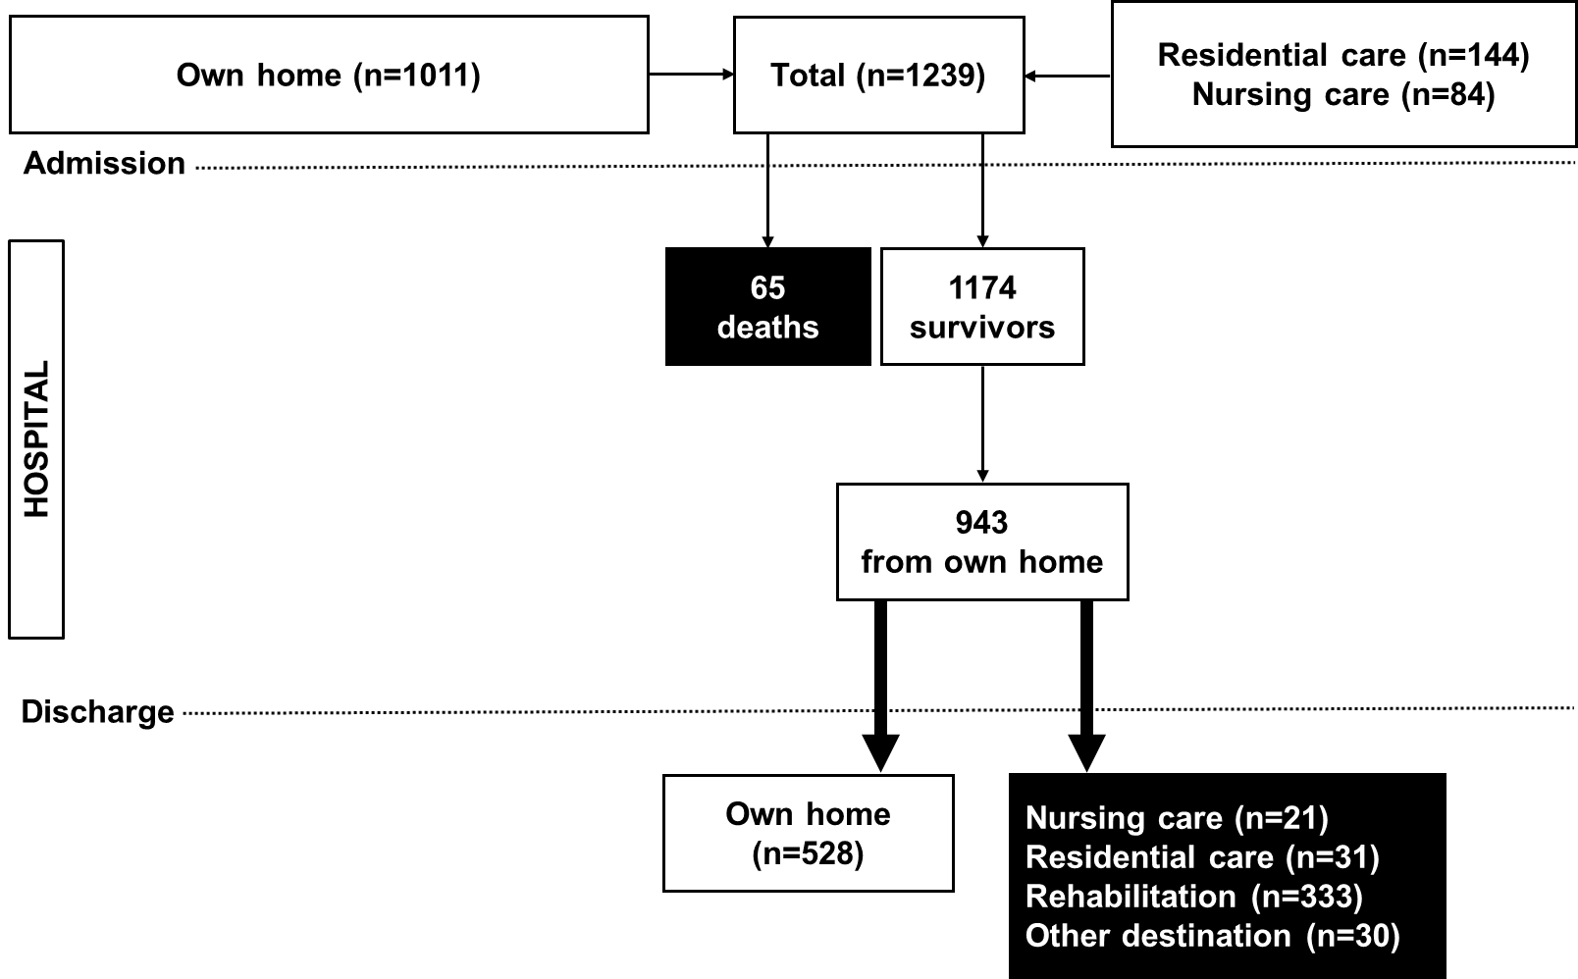

Figure 2.
(A)
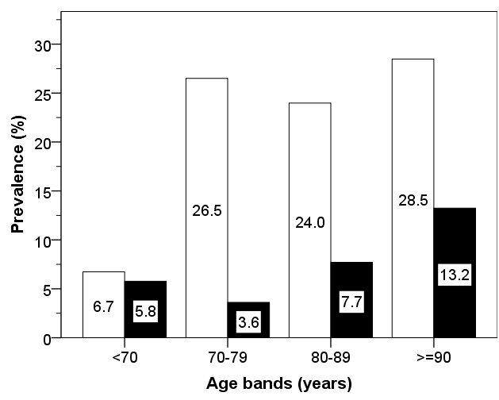
(B)
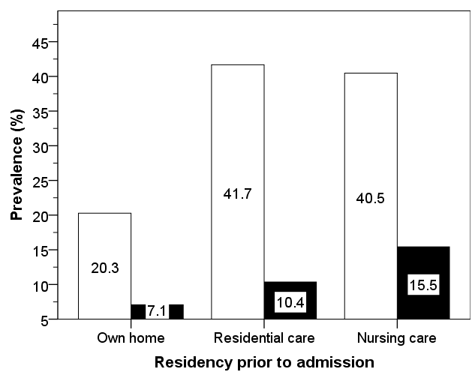

Figure 3.
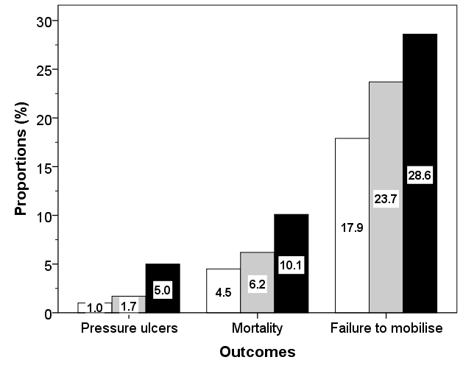

Figure 4.

