A Portfolio of Compositions Exploring the Use of Modular Synthesis in Electronic Music

Chelsea Anna Bruno

Department of Music

Submitted for partial fulfillment of the requirements

for the degree of
Doctor of Philosophy

Royal Holloway, University of London

2020

Table of Contents

Acknowledgements 3

Abstract 4
List of Figures 5
Portfolio USB Drive contents 6

Introduction 7

CHAPTER 1: Artistic Context: The Modular Synthesizer Revolution 8

1.1 The Synthesizer Community 9

1.2 My Approach to Research Composition 11

1.3 My Background 14

CHAPTER 2: Methodology 16

2.1 Ableton Live 18

2.2 Elektron RYTM 18

2.3 Eurorack Modular Synthesizer 19

CHAPTER 3: Composition Analysis 23

3.1 SuperBooth18 Performance 23

3.2 Live Patching Demonstrations 25
3.3 Studio Works 28
Conclusion 49
Bibliography 50

Appendices 52

Acknowledgements

Thank you to my supervisor Brian Lock, the Director of Graduate Studies Julie Brown and Julian Johnson, and to my examiners Dr Christopher Haworth and Sally Rodgers.

I would like to thank Craig Clifford, Jeremy Fosker, Paul Soulsby, Matthew Allum, Dan Wahlbeck, Steven Grimley-Taylor, and Tom Whitwell for sponsoring and being a part of the CV FREQS events.

Thank you to Cathy Wilkinson for inviting me to perform for the ePhil Electronic Music Series in Hamburg.

A big thank you to Finlay Shakespeare, Jan Willem Hagenbeek, Thomas Margolf, Vladimir Pantelic, Václav Peloušek, André Gonçalves, Bernhard Rasinger, Arjan Schuijt, Martin Klang, HRTL, Eric Baldwin, Igor Sabara and all the other artists and manufacturers who came to perform and show their modules at CV FREQS.

Thank you Will Montgomery for leading me to Iklectik, and to Eduard Solaz of Iklectik for hosting the first of many CV FREQS London Modular Synthesis meet events. Thank you also to House of Vans London for hosting CV FREQS events.

Thank you Laura Plana Gracia (eXperimental electronics) and Roberto Villela (Musica Dispersa) for bringing me into the London noise scene.

Thank you Frances Morgan and Elektronmusikstudio EMS Stockholm for my two-week residency to play the Buchla and Serge synthesizers.

Special thanks to 4MS Company, STG Soundlabs, Steady State Fate, ALM Busy Circuits, Pittsburgh Modular, Malekko Heavy Industry, Steady State Fate, birdkids, Bastl Instruments, Industrial Music Electronics, Grp Synthesizer, and Strymon Engineering.

Thanks to Andreas Schneider, Timm Stobbe and all of the crew at SchneidersLaden for having me perform at SuperBooth, making SuperBooth a great success every year.

Thank you to my parents, Paul and Diana Bruno, my collaborators Bernhard Living, Alan Clinton, Alexandra Clouston and Edmund Davie, and to all my friends and family for the endless support and encouragement.

Abstract

This commentary will address my approach to composition, which focuses on the exploration of modular synthesis in electronic music. My main instrument, the Eurorack modular synthesizer, can be utilized in many ways. One of my methods involves recording long sessions with my modular synthesizer to see what unpredictable sounds I can find. I select parts to sample from recordings to use in compositions. Alternatively, a recording of the synthesizer can be a composition on its own. In this commentary, I will be discussing my approach to composing with the complex processes of synthesis; the sounds I create with my Eurorack synthesizer are the focal point of my compositions in the portfolio.
My research focuses on how it is possible to make compositional decisions based on the collective memory of industrialization, noise, and silence. Considering these elements, I focus on the differences I find between improvising in the live performance setting vs. composing in the studio. My work involves the combination of freeform improvisation with structured composition. This integration becomes evident in my compositions when I blend several musical aesthetics using electronic means.
In my compositional practice, I use the modular synthesizer as a sound design tool, creating unique sounds with it that focus on frequencies, textures and timbres. My approach involves integrating synthesized sounds, recorded live during active patching into various styles of composition; dub-techno, ambient, and electronica. The Eurorack modular synthesizer has allowed live, improvised forms to serve as the foundation for my compositions.

List of Figures

Figure 1.0: Susurrus Album Cover 15
Figure 1.1: My Eurorack Synthesizer, July 2019 20
Figure 1.2: ALM Sid Guts Deluxe Eurorack Module 22
Figure 1.3: Harvestman Polivoks VCO Eurorack Module 23
Figure 2.0: Sugar I’ve Consumed Arrangement View 29
Figure 2.1: Phantom Trails Arrangement View 31
Figure 2.2: Paradoxa Shift Arrangement View 33
Figure 2.3: Mind Birds Arrangement View 35
Figure 2.4: Luigi Russolo and Ugo Piatti with the Intonarumori 36
Figure 2.5: Bubbles Clip View 38
Figure 2.6: Bubbles Sequence Clip Detail #1 39
Figure 2.7: Bubbles Sequence Clip Detail #2 39
Figure 2.8: Clip Transposition 40
Figure 2.9: Kick/Snare Detail 40
Figure 3.0: Rob Papen’s Blue VSTi Plugin 41
Figure 3.1: MIDI Detail 42
Figure 3.2: EQ Filter – Center Kill 42
Figure 3.3: Bubbles Arrangement View 43
Figure 3.4: Detuned Arrangement View 44
Figure 3.5: Buchla Sample Detail 46
Figure 3.6: Gradience Arrangement View 47

Portfolio USB Drive Contents

01- SuperBooth18 Live Performance (36:00, 3 May 2018)

Live Patching Demonstrations

02- Paul Soulsby (2:31, 19 Oct 2018, 22 Oct 2018, 11 Nov 2018)
03- Václav Peloušek at CV FREQS (8:07, 7 Dec 2019)
04- Matthew Allum at CV FREQS (16:01, 7 Dec 2019)
05- Eden Grey (20 Jan 2020)

Invisible City (2015)

06-Sugar I’ve Consumed (5:42)
07-Phantom Trails (5:04)

What was Tundra (2016)

08-Mind Birds (5:20)
09-Paradoxa Shift (3:40)

Zen Speed (2016)

10-Next Saturn (6:16)
11-Intonarumori (10:00)
12-Into the Depths (4:10)

Susurrus (2017)

13-Bubbles (3:04)
14-Detuned (3:56)

Gradience (2018)

15-Gradience (7:01)
16-Trippel Fabrik (5:01)

Introduction
My research addresses the utilization of the Eurorack modular synthesizer as my main instrument and compositional tool for sound design. This commentary and supporting portfolio of compositions demonstrates my practices and techniques using my custom synthesizer. It aims to answer the following research question: How does the Eurorack modular synthesizer allow new methods of composing through free improvisation?
My compositional style has developed as a result of my research in synthesis, which has focused on comparing the sounds created by synthesizers: analogue, digital and hybrids of both, widely influenced by modern electronic music genres including experimental, industrial, ambient, techno and trip-hop. Noise, sound art and the multifarious electronic dance music genres have been researched extensively, but the effects the modular synthesizer is having on the evolution of these is new territory to explore. Use of the modular synthesizer is continuing to drive change in electronic music genres, thanks to each technical innovation that occurs and each musical movement it is part of. It has challenged barriers of distinct and standalone genres, blurring boundaries and engendering genre overlaps. This is where my unique contribution to this field of knowledge comes into force, as my own music is a product of the creative and technical experimentation made possible by the modular synthesizer.

CHAPTER 1
Artistic Context: The Modular Revolution
The artist statement of Vince Clarke sums up my feelings about working with the modular synthesizer:

What I love about using synthesizers is their unpredictability. Most older analogue synths, and now newer Eurorack modular systems, do not have the capacity to store sounds. This means that it is nearly impossible to create the exact same sound twice, and this is where the fun begins.

The overarching DIY aesthetic in customizing a modular synthesizer allows for fresh, unique creativity. Engineers design modules to enable themselves, as well as sound designers and music composers, to embark on a journey in search of a new sound. Similarly, I have always found the DIY approach of building the synthesizer myself to be an exciting experience. For example, soldering a module for my system is a really intriguing process, where I can see how all of the electronic components are connected inside. When adding a new module, I am eager to try out new patching methods and to hear audible differences from my system.
I conducted several interviews with module designers to find out more about their perspectives and how they might align with each other. As I researched Eurorack manufacturing companies, I noticed there was a particular sense of humour presented in different ways. When I asked engineer Dan Wahlbeck of Stockholm-based module design company DPW Design about his thoughts on the sense of humour in the expanding modular synthesis community, this was his reply:

There are quite a few companies who do fun things that no normal product management department would approve. As an example, the NerdSeq module by XOR Electronics. They were joking about how cool it would be to have a tracker in Eurorack, so they built one. That would probably not have passed a normal ROI calculation by the product management. The fun thing is that there are a lot of people out there who appreciate when someone does things like that and buys them.

A tracker is a software technology that originated circa 1987, and it becomes amusing in this instance where there is an overlap of old and new technology. It is fun when companies do unexpected things to challenge the norm, and many of them do. Another one of the ‘fun things’ that companies do is produce and give away stickers at the modular synth events, which has given rise to the sticker culture associated with the modular revolution. Sticker culture nods back to the punk and metal scenes, some designed with similar fonts. Many artists’ custom modular synthesizer cases are now decorated with the stickers of different companies. Sticker culture has grown to become a part of the modular synthesis scene as there are always new manufacturers presenting their ideas in new formats. Steven Grimley-Taylor, of Brighton-based Thonk, designed a sticker that says ‘This Synth Kills Fascists’ and numerous other stickers that use activist iconography. I asked him where he got the idea for this particular sticker, which was embraced by the modular synth community. He told me the design is borrowed from American folk musician Woodie Guthrie who customized his guitar with the slogan ‘This Machine Kills Fascists’ back in 1941. This is not only a nod to an American political music icon, but it enacts associations between the guitar and the modular synthesizer as tools for social commentary. In short, the synthesizer is capable of both humour and social commentary.

1.1 The Synthesizer Community
The importance of the synthesizer community in nurturing new developments and discourses between musicians and engineers is evident by the number of conventions and trade show events that take place each year. At these events, musicians and engineers can convene to discuss the ever-evolving arena of analogue and digital sound synthesis, and test out the new products that are being developed.
SchneidersLaden is a shop based in Berlin for synthesizers and Eurorack modules in particular. The founder of the shop, Andreas Schneider, also established SuperBooth, the largest trade show for synthesizers and particularly Eurorack module manufacturers worldwide. This three-day event, which began in 2016, allows a large amount of the world’s synthesizer developers, large and small, to be surveyed. There is no buying or selling of synthesizers during SuperBooth; it is primarily an investigatory experience. One can find out about new product releases from companies, old and new, and share in-progress work with other artists.
As well as attending the SuperBooth trade show every year since it began, I actively promote the modular synthesizer by regularly giving lectures and demonstrations with my customized system at shows and universities. I am also the founder of CV FREQS, a modular synthesis meet-up and concert event, where I invite special guest artists to perform and modular synth manufacturers to show their products. Similar to SuperBooth, CV FREQS events allow for a hands-on experience with custom modular synthesizers, creating an exciting platform for sharing. I encourage everyone to play my modular synthesizer, which I also give demonstrations with at every CV FREQS event.
I asked London-based module designer Tom Whitwell, of Music Thing Modular, what he finds most exciting about the modular synthesizer community:

It's a lot of people doing something they love, learning from each other. There are experiments in the way business can work, and I like the way that being experimental is celebrated at the core - it's not like the guitar pedal world where there really are 10,000 different kinds of boost and a few really interesting clever things around the fringes.

Rapidly increasing in popularity over the past decade, custom synthesis presents a similar mindset and language among the musicians and engineers who employ it. Crossing boundaries in the fields of computer programming, sound engineering, mathematics, and physics, the music that results from custom modular synthesizers spans all types of interdisciplinary sonic art forms.
Author and professor of media and innovation, Douglas Kahn, quotes early contemporary composer Carlos Chavez:

The composers of the present need large fields of experimentation in which to develop new instrumental aptitudes. It is very natural that, for the moment, no hints of new productions are at hand, since the artists are far from the instruments, while the only ones who know them are the engineers.

I have been networking with engineers since I was introduced to the Eurorack format of modular synthesis in 2013 at the NAMM convention in Anaheim, California, as I wanted to build my own synthesizer and discover more about the tools that are available to compose with. Talking to module designers and finding out about their creative and technical approach is an important experience of the events. For example, I spoke with Vladimir Pantelic of vpme.de at Superbooth18, and he told me about how he began his journey into module design. In the interview with Mr Pantelic, he states that he would not describe his background as being musical, but that he ‘would always end up on the technical side of “artistic” things.’ In contrast, London-based synthesizer engineer Paul Soulsby of Soulsby Synthesizers has a strong musical background which shines through in his approach to designing synthesizers and Eurorack modules. Although my background is musical, I have become increasingly interested in the technical side of Eurorack which is reflected in the music I perform and compose.
1.2 My Approach to Research Composition
My own practice with the modular synthesizer is an investigation into the noises that are the result of patching experimentation. The recording process can be a strenuous activity as much as it can be meditative because of the drastic changes in the sounds that can result from a single connection. Observing the fluctuations of textures in the sounds, my experimentation with patching during recording sessions leads to the most interesting results: complex evolution of sounds that cannot be easily reproduced. The changing of variable options demonstrates my interactivity with the synthesizer on the patched components, which are audible in the live performance or recording. The hypnotic sensation of composing this music has led me to call the longer sessions ‘sonic meditations,’ a term I have borrowed from conceptual American composer Pauline Oliveros, who has been an influential figure in my research. Sonic meditation is focused concentration, when I am only thinking about the sound produced; how it sounds in the surrounding environment; and how it can be changed in the patch.
As my synthesis research has evolved, performing music live has resulted in a completely different outcome to my studio works. The studio works are polished and fit into the styles of several electronic dance music genres. For the studio works, I often use the Elektron RYTM drum machine, which I have never used in a live performance. I create drum tracks that are inspired by the dub, ambient and trip-hop genres, usually with a fairly slow tempo. I do not find it exciting to perform studio works live (essentially playing them back) except for hearing them at a higher volume and in a larger space, amplified on a good PA system. However, my live performances are very hands-on for me, changing the speed of the tempo at unexpected times using the improvisation method. Performing my sonic meditations live leads to an exciting listening experience that demonstrates the fusion of rhythm and noise.
The work I produce largely depends on the mood I am trying to create for myself and the listeners. My studio works are emotional, colourful, and haunting; it is the aim of my compositions to capture a sense of nostalgia or to disorient the listener. I believe the subtle feeling of disorientation is assisted by the strange tunings that can be achieved with the oscillators and other less obvious functions of the synthesizer. My compositions often capture reminiscences of electronic music from the 1990s, a period of increased experimentalism with synth and drum machine sounds.
The precision of tuning with the modular synthesizer is one difficult aspect that I use to achieve my signature sound. One problem I am faced with in playing the modular synthesizer live is that the tuning of the oscillator and sequencer modules sometimes cannot be accurate enough for the desired tone. However, I sometimes choose to embrace this problem and allow the detuning to become a focal point. Other times I will sample the recording of the synthesizer and change the pitch in Ableton for my studio works. The tuning of several oscillator modules often leads to discordant melodies in the frequency modulation.
During my time as a PhD student, I have self-released several albums. I selected tracks from each album for my portfolio to demonstrate my development as a composer. I am using minimal melodies and focusing on the textures of the synthesized sounds used to create them. As previously stated, I focus on the direction of imperfect tunings in my work, for example, in Bubbles and Detuned.
Melodies can potentially trigger the memory depending on repetition or the catchiness of a tune, but I do not intend for my music to linger uncomfortably in my own memory or those of the listeners. Detuning, modulation and the use of noise can possibly spare listeners from ‘earworms’ since it is nearly impossible for the human voice to imitate a heavily modulated melody or synthesized noise. The use of modulation in the melodies of my tracks allows them to embody a surreal quality. It abstracts the melodies so that it is not easy to pinpoint an exact note; modulation does not make the composition less memorable but makes it less likely to cause an earworm. I mean to communicate in my compositions that music listening as an activity is still very much a revelatory experience. Particularly for myself as the composer, I view the act of playing the modular synthesizer as a revelatory experience.
The majority of the compositions in my portfolio are devoid of vocals or comprehensive lyrics. Unintelligible recitation, where only few words (if any) can be understood, does not act in the same way as representational lyrics do. Instrumental composition provides a real experience of my worldview narrative, where I am sonically and metaphorically giving the voice to the synthesizer itself. This approach may allow my work to be more relatable to a wider audience and to fit within the scope of multiple genres.
I am composing with an aim to make sonically palatable sounds that are in themselves often perceived as simple or monotonous. For example, sirens of emergency vehicles create the sensation of alertness and are naturally unnerving to hear. Sometimes, a slight change in the tuning can create the sensation of the Doppler effect, as an emergency vehicle passing by. The sound of helicopter blades beating the air is a good example of a pulse waveform. In addition to haunted, ghost-like singing of waveforms, I can also create spaceship or UFO sounds. These styles have often been attributed to the BBC Radiophonic Workshop, and particularly the works of Daphne Oram and Delia Derbyshire.
I produce studio music compositions mainly for home listening, without the intention to perform them live. This allows them to fit in the category of film music: it is a musical narrative without telling a story, rarely inclusive of lyrics or singing. These productions are intended to excite or stimulate the imagination without guided direction, only by the sound journey provided within their soundscape-like qualities. The rhythm creates a sort of armature that metaphorically supports the noises and sounds which I carefully select and edit.

1.3 My Background
My artist alias, Eden Grey, is the name for my artistic identity that has been evolving since I began creating art and composing electronic music. With a background in visual art, I painted and sculpted with different media to express my reflections of nature and mind states. I would sometimes listen to my favourite songs repeatedly to allow my mind to explore and attempt to create the visual space of the music. My earliest electronic music influences were Aphex Twin, Autechre, Boards of Canada and Massive Attack.
Synthesizing sound is like mixing colours on the palette and then applying them to composition arrangements creates the sound art work. I interpret emotions with sound, and they become a part of my compositions. I practise a sort of informal meditation with my synthesizer, with concentrated Deep Listening and patching experimentation to allow my compositions to tread new territory in tunings and sonic substance.
When I listen back to my compositions, sometimes they sound obscure to me. I employ obscure and indeterminate tunings, and I wonder how listeners perceive them. My album, Susurrus, makes me feel at ease and relaxed, but at the time of composing I was pregnant and nervous about giving birth.

Figure 1.0
Susurrus album cover, designed by Peter Piper.

I believe my compositions create a surreal listening experience, as they can potentially alter my moods. To me, the music embodies a panicked sense of calm or a peaceful anxiety. These conflicting moods demonstrate the audible effect on the composition through the juxtaposition of percussive noise and soft melodies. Working with the synthesizer as a meditative practice of controlled chaos yields my signature sound. When something special catches my ear in a sonic meditation, I will record it.

CHAPTER 2

Methodology: My Technical Setup and Working Practices
Throughout this chapter, the use of the word ‘patch’ is synonymous with temporary electronic connections plugged into the modular synthesizer. There is a limitless expanse of patching experimentation I employ with my modular system that leads to fresh, new synthesized sounds. The polyrhythmic textures created in different patches are often interesting source materials that can lead the direction of a composition.
When I take a structured approach (as opposed to freely improvising), different results are produced. I put so much time into the sound design and the smallest details of studio compositions to create them overall. Likewise, I spend a lot of time practising sonic meditations and freely improvised experimental patching on the modular synthesizer in the studio before I take it into the live performance setting. R. Murray Schafer refers to these two methods of composing as absolute and programmatic.
I realize the importance of being able to recreate a composition in a live performance, which is something I have steered away from while doing this practise-based research in London. I enjoy playing the modular synthesizer at home or in the studio to such an extent, I thought it would be exciting to bring that energy to the live performance setting. This is how I became typified as a noise artist on the London music scene during my PhD research period, from 2015-2018. As the sounds of the modular synthesizer are sometimes harsh and unpredictable, it creates a very exciting and noisy atmosphere. My live performances cannot be recreated or performed by anyone else.
Haworth discusses noise in his essay on Iannis Xenakis in Resonances. He states that ‘noise works against all forms of control, especially the control of the creative act itself’. He goes on to say that ‘the performer employs improvisation as a tool with which to bring about surprise at what she herself produces, thus forcing her to be present, listening and responding here and now’. In other words, the performer is capturing the essence of a moment. This statement is widely representative of my methodological approach.
My method of patching has developed according to the modules in my system and this arrangement determines what I play in a live performance. As my system has expanded, my live performance with it has become a prominent part of my artistic identity. My live performance cannot be replicated, though the overall style becomes evident with my method of patching. The precision afforded by knobs and sliders--their position and sensitivity which determine the tunings, timings and other factors--is impossible to recreate exactly. I need at least ten input channels on my mixer modules to produce the varying array of rich, modulating sounds for the live performance.
Sometimes I create drum arrangements to provide the main structure for my compositions, and other times I create a composition’s structure with the use of synthesized noise itself. The original definition of noise must be reconsidered, as the word was once interchangeable with unwanted sounds. I often employ noise as a formal sonic event in my music.
Paul Hegarty writes of American modernist composer Charles Ives:

As well as the dissonant elements in the music, Ives disturbs the genres of music, something essential in all ‘noise music’, where expectations are supposed, however temporarily, to be upset.

This indicates how a new appreciation has developed around the concept of noise and dissonance. Working with synthesizers allows me to focus on these elements.
Early developments in music technology have paved the way for the current boom in the field of modular synthesis research. Emmerson states: ‘The idea that ‘systems other than the composer’ might generate aspects of the music came to the foreground of avant-garde ideas after 1945.’ To set up a complex patch on the synthesizer so that it will play itself is a phenomenon given further possibilities with the developments of new components. The electric current running through the synthesizer can fluctuate and alter the stability of the potentiometer settings, which produces unpredictable occurrences in the sounds. I spend a lot of time listening closely while slowly turning the knobs to find the ‘sweet spots,’ the unique sounds with unexpected characteristics. For example, some dust in a pot could create a crackling sound. I often experiment to find by cross-modulating two oscillators and adjust the knobs to create a special modulation sound, which resembles a haunted voice-like quality. I focus on the harmonic tones and rhythms created by frequency modulation as a method to find new sounds to compose with in live recordings and post-production.

2.1 Ableton Live
Ableton Live is the DAW I compose with. It has two views, the clip view and arrangement view. The clip view is where I do the majority of recording and sampling; here, I collect recorded sounds on multiple audio channels. As I develop a composition, I move the clips over to the arrangement view. The complete arrangement is how the composition takes form from beginning to end. The clip view is like all the pieces of the puzzle, which forms the picture in the arrangement view. The audio files can be edited and mastered in both views.
Ableton has no limits on the amount of audio channels you can use, so I sometimes will separate a sound splice to its own channel and apply an effect to create a single instance in the piece. This is useful to create transitions and dynamic accents, as well as the introductions and endings of my compositions.

2.2 Elektron RYTM
After the first year of my PhD I realized I needed more versatility in the area of composing drums and percussive elements to create more interesting works. I had the Moog Sub Phatty monophonic keyboard synthesizer, and the Eurorack, but did not have a drum machine. I had been sampling and writing the drum tracks in the Ableton Live Suite and observed that the drums in my compositions needed more emphasis.
I introduced the Elektron Analog RYTM to my studio setup in the summer of 2015. I made the decision to keep the entity of the drum machine separate from the modular and to use it only for studio compositions, with the intent to make tracks for home listening, or something that a DJ might want to put in a mix. I heard the Elektron machines in action before, and I knew Elektron were creating really exceptional, professional equipment. The Analog RYTM users’ manual introductory note highlights how the machine combines the ‘fearless hands-on strumming of nature’s vibrating strings with the cool analytical framework of digital computation’, adding that ‘at last the great divide will be bridged’ between analog and digital.
As the quote suggests, the RYTM is more hands-on than composing drum patterns using software and therefore facilitates the creation of different types of rhythms. The interactivity I had embraced fully with my Eurorack system is what made me realize I can compose with improvisation, and that I enjoy the manual activity of composing.

2.3 Eurorack Modular Synthesizer
Throughout my PhD, I have been expanding the main instrument with which I compose, my custom Eurorack modular synthesizer. I first began building it in the summer of 2013, and throughout my PhD research it has greatly evolved with the addition of new modules with different functions. The Eurorack modular synthesizer is a complex, customized instrument that creates and processes sounds through a variety of connections.
The size of Eurorack modules is referred to as 3U, where the U is an abbreviation for rack units. Eurorack modules are a more compact format than 5U, which is the industry standard size of earlier synthesizer modules manufactured by Moog and others. My synthesizer as shown in Figure 1.1 is in two separate cases. It has three mixer modules which I have positioned on the right side with a total of 14 audio inputs. This means that the synthesizer is polyphonic and can potentially send out 14 different sounds at once.
When I begin a patch, I focus on the design of one sound. I run an oscillator waveform through a filter first, to control the cutoff and resonance frequencies of the input. After the filter comes the CV controls, which are on both the filter and oscillator modules. I connect the CV inputs on the oscillator and filter modules to an output of a gate or trigger signal to create variations in the sounds. CV inputs can also affect the timing and variation of pitches, controlled with a pitch knob on the oscillator modules. I discuss this in more detail in Section 3.2, in my ‘Eden Grey Patching Demonstration’ video.
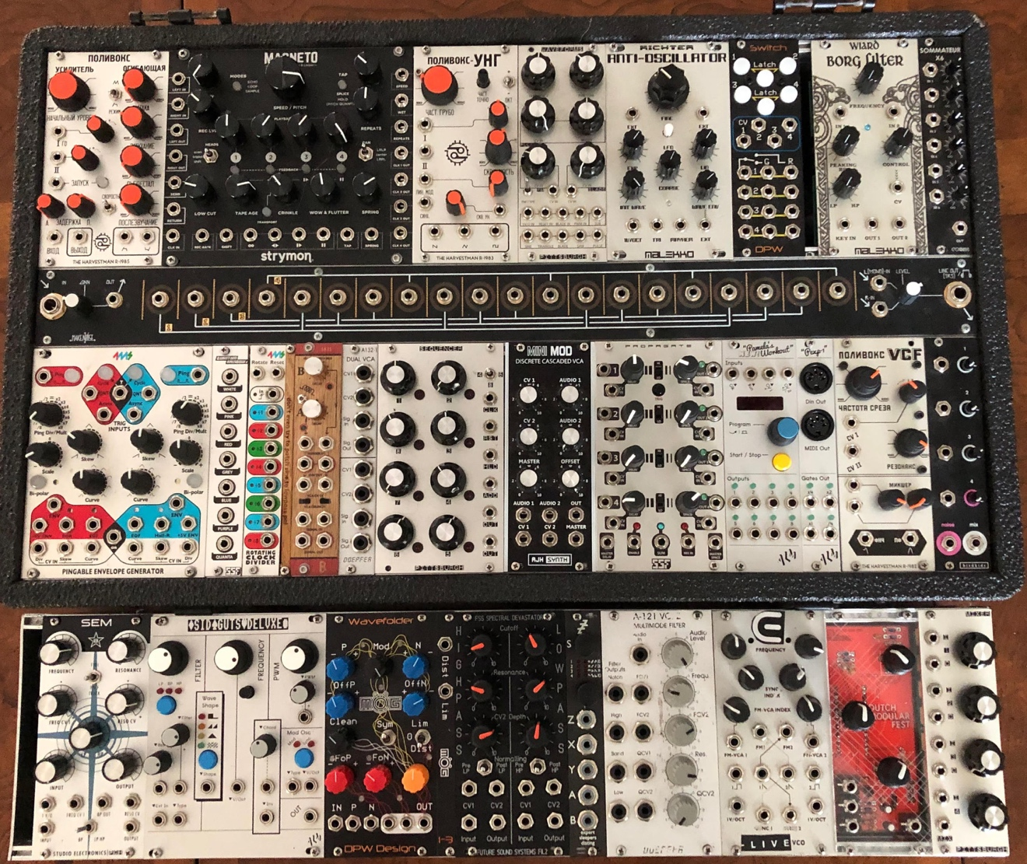

Figure 1.1
My Eurorack Synthesizer, July 2019

I have found that module designers are often musicians themselves who create their own components in order to create the music they desire. When I asked Matthew Allum, owner of London-based Eurorack module manufacturer ALM Busy Circuits, if he played music before he started designing synthesizer modules, this was his response:

I got into electronic music in my late teens (early 1990s - mainly techno) and began building a very small home studio so I could make my own music. After university, however, my interest wavered due to less free time, due to a full-time job, etc. Later in life I got back into synths and realized in the meantime, I had built the basic knowledge and confidence to build my own synths!

Adding components to my modular synthesizer allows new pathways to be explored and figured out via experimentation. Sound design and analysis capabilities that are possible with the synthesizer often lead to unexpected results.
The customizability of the Eurorack synthesizer gives it more of an artistic interpretation, depending on how unique the musician who is building it wants to make it. The musician it will know how to work it the most efficiently to suit his purposes. Each component with its set of variants needs to be understood to connect them together and make something comprehensible.
Richard Scott, in his essay ‘Back to the Future: On Misunderstanding Modular Synthesizers’, states that ‘a modular synthesizer is a sound design tool containing near infinite settings, routes and possibilities; you can do almost anything with it, but it doesn’t give you anything on a plate’. To me, its complexity and cryptic nature are attractive qualities to create distinctive electronic music compositions. The sound quality is very good, often being a hybrid of analogue and digital components. I noticed that when I would integrate sounds created with my Eurorack, the sound quality of my compositions would have a deeper dimension than if composed using only digital means. The challenging experience of patching a modular synthesizer is all-encompassing and requires complete focus. This is another reason why I refer to playing the modular synthesizer as a form of sonic meditation.
Adding one module to my synthesizer can allow a whole new range of sounds. For example, when I added the ALM Busy Circuits Sid Guts Deluxe module in 2016, I was then able to create three-voice chords by plugging in one patch cable into the audio output labelled ‘OUT’ on the bottom right corner to the input of the mixer (which I demonstrate in my live patching video). This digital oscillator module allows the tuning of the chord to be adjusted with the frequency knob. It has a built-in filter control that can be changed from ‘lowpass’, ‘bandpass’ or ‘highpass’ with the blue button directly under it. The pulse-width modulation (PWM) has a dedicated knob, and the ‘Wave Shape’ can be changed with a button.
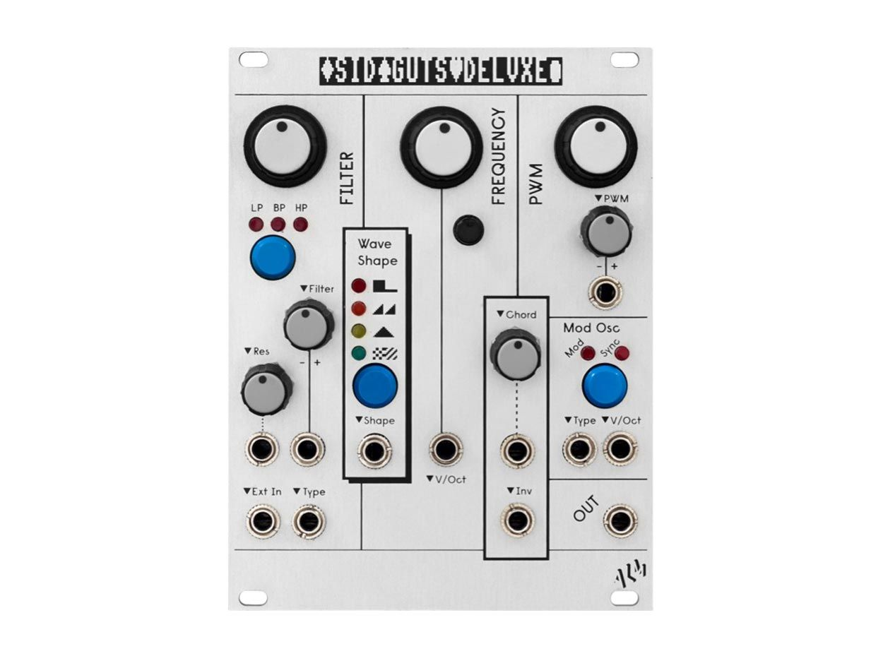
Figure 1.2
ALM Sid Guts Deluxe Eurorack Module

The Polivoks VCG (voltage-controlled generator) analogue oscillator module, engineered by Scott Jaeger, The Harvestman from Seattle, Washington USA (now Industrial Music Electronics), was a very important addition to my Eurorack. I purchased this module from SchneidersLaden in the summer of 2015, as I had previous experience testing out Harvestman modules but had never owned any. I was also attracted to the Russian lettering of its design, which referenced original Soviet integrated circuits. I use it in nearly every patch I create, and it is my favourite module because of its distinct waveform sounds and CV input controls.
An interesting quirk about my Polivoks VCG module is that the octave switch, which spans three octaves, is not perfectly in tune. In the highest octave, there is a slight half-step difference. It is my only module that has an octave switch, and I really enjoy using that feature.

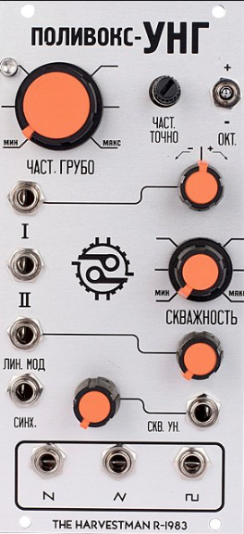

Figure 1.3
Polivoks VCG Mk II Eurorack Module

CHAPTER 3
Composition Analysis
In my portfolio, I have included: 1) several video demonstrations of live patching on my custom modular system by others and myself; 2) my live performance at SuperBooth18; and 3) a collection of studio works I composed during my PhD research.

3.1 SuperBooth18 Performance
My live performance at SuperBooth18 consists of improvisational patching that focuses on the possibilities of sounds created with my custom Eurorack. Performing live with my modular synthesizer in this setting feels like a form of alchemizing with sound.
This performance embodies a significant combination of rhythm, noise and drone. It starts off with a very slow clock and has a progression of sounds that are introduced, which are patched before I begin the performance, and the volume of each sound is brought up as the sound intensifies. Navigating through the patched components can be challenging as it was during this performance, with many of the patch cords overlapping. I use a chaotic approach to demonstrate just how fascinating the sounds can be.
At 7:13, a change in pitch is audible, and I achieved this by adjusting the coarse frequency control knob, labelled ЧАСТ. ГРУБО on the Harvestman PVCG.
At 11:40, there is a distinct change of tempo which I controlled by adjusting the Half-R output on my 4MS Dual Pingable Envelope Generator module. This is usually the main source of clocking I employ for my modular system. At 12:18, I began to hear some interesting tones taking shape. It is very dissonant and dark, and I wanted to embrace that as it is an important part of my aesthetic. At 14:30, there is a notable change where I am adjusting the frequency as I let interesting tonal parts occur for some time and then change them to keep the performance an exciting experience for myself and the audience.
The modular synthesizer has a way of deciphering extreme subtleties in frequency. At 16:56, a very high-pitched frequency is introduced because of a specific filter module I have patched in, the Harvestman R-1982 Polivoks Voltage Controlled Filter. After 18:00, I noticed a sound begin to take shape, the spaceship-like sound I use semi-frequently, which creates a memorable moment. It hits the peak elevation of the fluttering filter moment from 18:21 until 18:30. I could have explored this sound further, but after observing several recordings of my live performances, I noticed that I tend to change things on the synthesizer quickly. This finding can inform my practice further if I will take more time to explore the sounds achieved in peak moments of my performance.
At 21:30, I slowly begin to bring in another oscillator which is patched in to be a fast-paced 8-step sequence which increases the amount of tonal information. Then, at 22:40, there is a major shift that instantly draws the attention to the frequency modulation, which is achieved by cross-oscillating. This is done by patching the CV input on one oscillator module to a waveform output on a different oscillator module. A frequency modulation sound occurs when I connect a waveform output on my Pittsburgh Waveforms module to one of the CV inputs on the Harvestman PVCG. The frequency modulation between these two modules sounds very rich and even sometimes has a vocal-like quality when turning the pitch knob.
After 23:00, there is a build-up of excitement for what is going to happen. At 23:32, I drastically change the pitch again, and at the end of minute 23:00 the ‘ungodly noise’ starts. The oscillator frequency modulated to this extent creates the audible illusion of a scream. At 29:20, a clear 4/4 kick beat begins and carries on until almost the end of the set.
3.2 Live Patching Demonstrations
Observing others play my modular system gives me new ideas for patching, which has been one of my main motives for organizing CV FREQS events. I traveled to the Dutch Modular Fest and Synthfest UK in Sheffield with Paul Soulsby in 2018. Afterwards I let him borrow my system for a month so he could experiment with it. I also invited several special guest modular synth manufacturers to attend the CV FREQS event I organized at House of Vans in London on December 7, 2019. Among them were Václav Peloušek, head engineer of Bastl Instruments and Matthew Allum, head engineer of ALM / Busy Circuits. I asked them to patch my modular system at CV FREQS to note the differences between their interpretations and mine. Being familiar with the functions of the modules in my system, they produced interesting musical patches on my synthesizer without having played it before.

Paul Soulsby of Soulsby Synthesizers
Mr Soulsby’s demonstration is a compilation of three short videos of different patches he recorded while playing my system in his studio. Having spent more time with my modular system, Mr Soulsby created some very complicated patches on my synthesizer that reflect his musical style and sound like they could be finished tracks. In all three of these demonstrations, he creates rhythms with the ALM Pamela’s New Workout sequencer, and he uses the Steady State Fate Quantum Rainbow Noise Source module for the hi-hats and snare sounds. He uses the Pittsburgh Sequencer to create 8-step melodies.
In the second video, he demonstrates the Strymon Magneto creating the low, drone-like bass note and he is filtering the sequenced melody with the Harvestman Polivoks Voltage-Controlled Filter. In the third patch, he focuses on changing the modulation sound created by the E-Live VCO.

Václav Peloušek of Bastl Instruments
Mr Peloušek sets up a complex patch right from the beginning, stating that he is setting up a voice. He starts by taking an output from the Pamela’s New Workout to the input of the 4-channel CV bus, which is the long 1u module in the middle of the MakeNoise Shared System case. The orange lights on the CV bus that he plugs in indicate that the timing of the Pamela’s New Workout will control the timing of his whole patch. He uses both sides of the Bastl SKIS VCA to send the two sounds at different times, and he deploys the Malekko Anti-Oscillator for the cascading melodic fifth sound. He also runs it through the Strymon Magneto module to create the reverb effect and is filtering this sound with the Malekko Borg filter module. For the repeating bass note heard on every fourth count which becomes audible around 3:26, he is using a waveform output of the Pittsburgh Waveforms oscillator module sent through the Grp Synthesizer State Variable Filter.
He plugs in one output from the CV bus to the input of the 4MS Shuffling Clock Multiplier (SCM) module to control its timing. Then he takes the ×7 output on the SCM to the trigger input of one side of the Bastl SKIS dual VCA. He patches the signal input of the Bastl SKIS VCA to the Mayhem waveform output on the Malekko Anti-Oscillator. Then, he takes the signal output on the SKIS VCA to the input on the Malekko Borg filter module. At 1:09, he uses the red cable to plug the output of the Borg to the second channel of the CV Bus, which allows him to patch the Borg output to three other inputs. He then plugs the output of the Strymon Magneto module into the mixer. It is interesting that he had been creating his patch for 1 minute and 24 seconds before he plugged it into the mixer to hear the sound he was creating. He immediately adjusts the volume and tunes it to his preference.
Mr Peloušek sets up his patch differently than I do, starting from the clocking source. I always start my patches from the mixer inputs. Here it is evident how we do things differently in our approach and methods of patching. I always find it amazing how when playing the modular, a session sometimes seems to conclude itself, as it does in this example.

Matthew Allum of ALM / Busy Circuits
Mr Allum begins by tuning the Sid Guts Deluxe module to a low bass note and modulating it through the PWM input with the +5V output on the 4MS Pingable Envelope Generator. Then he adjusts the rhythm of one trigger output on the Pamela’s New Workout module. He uses the Malekko Borg Filter module with the resonance and peak turned up, to create the high-pitched rhythmic tweeting sound, patched through the Strymon Magneto module to add a slight reverb. He connects the 1v/oct input on the Sid Guts Deluxe module to the Pittsburgh 8-step sequencer to create the melody with the bass note. At 4:50 he begins to tune the 8-step sequencer to his desired bass melody. He controls the timing of the Pittsburgh Sequencer with the trigger output on the PEXP-1, the Pamela’s New Workout Expander module. This is a very useful module I added in the summer of 2019 which can be used to sync the timing of my Elektron RYTM to my modular synthesizer via a MIDI output on the PEXP.
He adds a 4/4 kick drum sound using a waveform output on the Pittsburgh Waveforms oscillator and one channel the Doepfer dual VCA. On the other channel of the Doepfer VCA, he patches the Malekko Anti-Oscillator to add a new melodic rhythmic element. The excitement of the live patching process is captured by Mr Allum in this video. I really like this party-style patching which differs from my methods.

Eden Grey Patching Demonstration
In my patching demonstration video, I explain how I’ve patched several modules in my system. The first sound I demonstrate is a kick drum sound, made with the sine wave output on the Pittsburgh Waveforms oscillator. I show how the timing is controlled by sending the ÷2 output from the 4MS Rotating Clock Divider (RCD) to the Trigger input on the Bastl SKIS VCA. I show how the decay is turned all the way up on the SKIS VCA to give the kick drum sound its warmth. My use of the VCA is also what I employed in my live performance at SuperBooth18 and all my live performances to create rhythms and my desired distribution and timing of sounds. I then demonstrate how the 4MS PEG is controlling the timing of the RCD by sending the Half-R output on the PEG to the input of the RCD. I show how the same Half-R output is also patched to the clock input of the Pamela’s New Workout clocked modulation source using a signal multiplier cable.
Then, I show how the second sound I’ve patched is the Harvestman PVCG oscillator being filtered by the Grp State Variable Filter. I have the mixer input patched to the 6db BP output of the filter, and the filter input to the square wave output on the PVCG. I show how the resonance being turned up creates a difference in the melody.
I patched the third sound by taking the input of the mixer straight to the square wave output on the E-Live VCO. The 1v/oct input on the VCO is patched to output 8 Pamela’s New Workout, and the input labelled FM-VCA 2 is patched into the Triangle output on the Malekko Anti-Oscillator.
I slow down the timing on the PEG to show how it controls the timing of all three sounds and how the sounds can be further altered with the change of the timing. When I speed up the timing, I continue to demonstrate how I would play the patch and find sound material that I find musically interesting. By using only one mixer, all four of the sounds that are patched will be coming through one channel on my audio interface and be recorded as a mix. At 5:37, I take the input of the mixer to the Strymon Magneto 4 Head dTape Echo & Looper module to show how it can output a feedback signal with no input. Then, I take the audio output from the ALM Sid Guts Deluxe module and send it through the Magneto to show how the Magneto can affect the sound.
My demonstration shows how creating synthesis patches can start sonically simple but become quickly complicated, by isolating sounds on the mixer and then adding more. This contrasts with Mr Peloušek’s patch, which is complicated from the outset and continues to develop. It also contrasts with Mr Allum’s patch in that he creates and builds up a techno style music with his patch, whereas the style of the music created by Mr Peloušek is more similar to the music I create with my system.

3.3 Studio Works
In this section, I will discuss several of the studio research compositions I have produced for the portfolio utilizing different aspects of modular synthesis. The track title is followed by the album name in parentheses. Here, I employ what Landy refers to as a structural analysis by providing several graphics of the arrangement view of my compositions in Ableton Live. In addition to showing the amount of audio channels I use, these structural analyses show details of the sounds I use to compose with.
Invisible City is the title of an album that includes several of my portfolio compositions. I had the idea for this title when I was on a long bus ride. I was seeing much more of the city of London while listening to my compositions on headphones than I had on the underground trains. The same experience occurred when I was in Berlin and decided to walk the journey instead of taking underground transport so that I could see some of the city. I took a picture on this walk of a stone sculpture and used it as the cover art to further emphasize the concept of the album. I realized that the rush of public transport makes parts of the city invisible to us, and that my lone presence in the rush of the city sometimes made me feel invisible.

SUGAR I’VE CONSUMED (Invisible City)
Sugar I’ve Consumed was one of the first works I composed while undertaking my research at Royal Holloway. It features a recording of a friend saying, ‘because of the amount of sugar I’ve consumed’, and my own speaking voice being tonally and texturally glitched as a central focus. I randomly recorded the sample of my friend’s voice, and I did not tell him to say that specifically; it was by chance that the line became the basis for the entire piece. Figure 2.0 shows the arrangement view of this composition and that all the sounds I used are on ten audio channels.

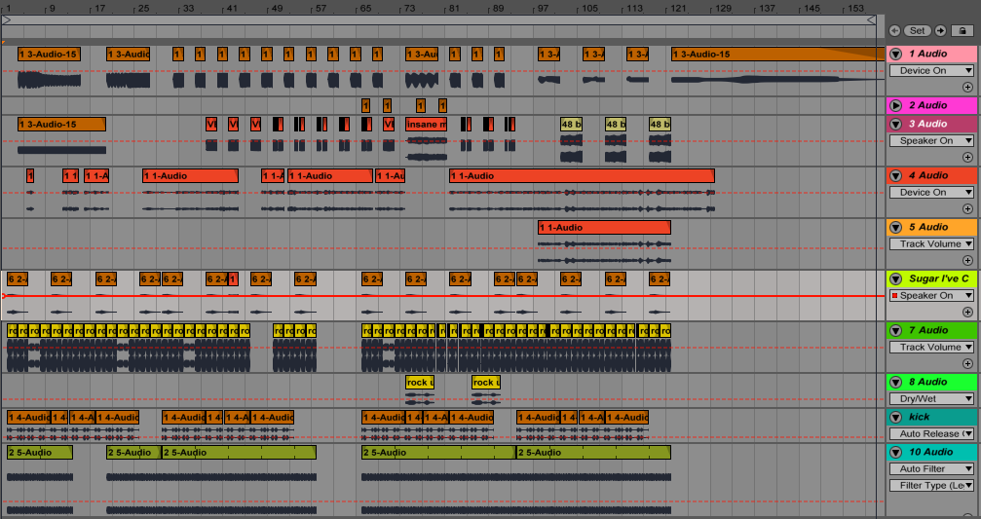

Figure 2.0

Sugar I’ve Consumed Arrangement View

I used a small clip of a drum from Aphex Twin’s unreleased recording, Rock Up, and looped it (shown in Figure 2.0 on the 7th audio channel) as the basis for the composition. Aphex Twin temporarily released a large section of his back catalogue as a free download. Therefore, Rock Up is listed on Discogs as a release from AFX Jnr and was only available to download for a short time. What I did in the latter part of the track worked out well to create a mysterious dimension. It was here that I dropped the pitch of a lo-fi vocal recording of James’ son, another sample I created from Rock Up. Dropping the pitch by nine semitones made the young boy’s voice sound like the voice of James himself. The expansive music catalogue of Aphex Twin, and what Haworth refers to as ‘Aphex Twin’s disavowal of genre’ has been a profound influence on my work, inspiring a great sense of creative freedom while composing with technology.
In this track, I use a long recording of my own voice reading an excerpt from R. Murray Schafer’s The Soundscape (from page 7). My voice is processed with delay effects so that hardly any of the words can be recognized, and it creates a mysterious context for the song. The delay effect allows tones of the voice to be accentuated in some parts and for the recitation to become rhythmic. Also, time-stretching is an important element applied to the voice in this piece. Time-stretching changes the original sound by applying the warp markers in Ableton Live and allows me to create glitch effects on the vocals. This composition highlights the full sound that the modular synthesizer can potentially create by using four inputs on the mixer module to achieve four different oscillator voices (I only had one 4-channel mixer module in my Eurorack system when I composed it in 2015).
I set out to capture an altogether disorienting and obscure sound with all methods of mixing, tunings, delay and sampling. I conclude that the nonchalance of style in this composition through the use of unconventional source material was intentional and an inherent focus.

PHANTOM TRAILS (Invisible City)
The starting point of this composition was a four-note melody recreation of church bells I heard while visiting Ljubljana, Slovenia to give a presentation on my synthesizer at Music Tech Fest Central Europe. Phantom Trails is loop-based in its use of drums, which I created on the RYTM. The drums are repetitive because I wanted to emphasize the synthesized sounds. Here I am using Pauline Oliveros’ Deep Listening practice of sound memory, recreating the song of the church bells by playing the four-note melody on my Moog synthesizer after I returned to London, as I had no recording device with me to record them while I was there. In this composition, I focus on the alternation of the two types of synthesizers, the Moog and my modular system. By alternating these two, I have created a tonal dialogue: the Moog is present throughout while the modular synthesizer supplies variable parametric sound textures. There are corresponding melodic lines with the Moog at the beginning and conclusion of the piece.
The space between the notes is an important element. According to David Toop, the analysis of sounds and their relation to silence is a major factor. He states that ‘sounds are woven with memory. For this reason, they may need to be undone as memories become an anchor, dragging in the mud of personal history and accumulated nostalgia’. I captured my memory of the bells in Ljubljana while composing this piece.
Figure 2.1 shows a close-up detailed screenshot of the arrangement view of Phantom Trails. This composition was made across 14 audio channels. The figure demonstrates how the Moog synthesizer was used on three channels and the modular synthesizer was used on the bottom six channels (audio channels eight to 14). All of the percussion tracks are contained in channels one to five. The channel labelled Moog 1 is the sound of the church bells in Ljubljana being played on the Moog Sub Phatty.

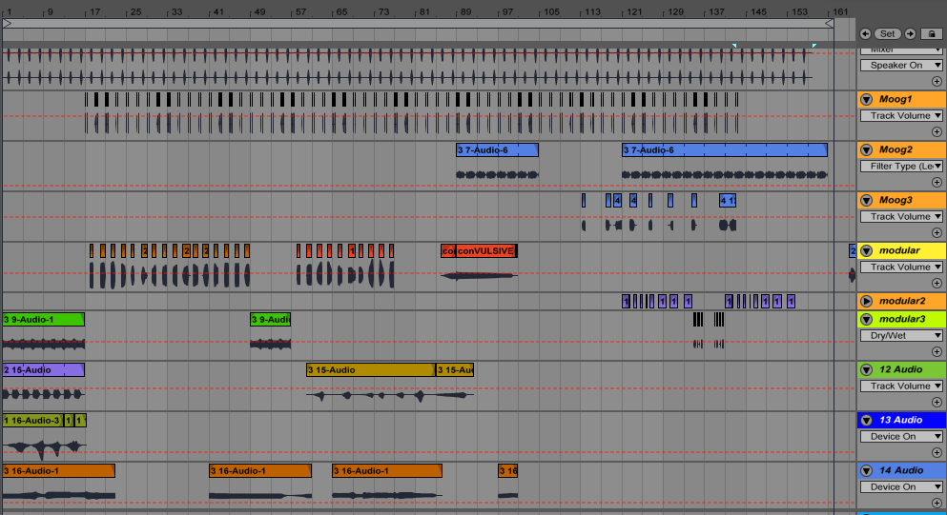

Figure 2.1

Phantom Trails Arrangement View
PARADOXA SHIFT (What Was Tundra)
In this track, I present my method of composing with broken-up sounds to create elements that are both rhythmic and melodic. The sounds of the synthesizer are strange and cascading, and I added a simple bass line with the Moog to make a perceptible melody. In the beginning of the song, the bass line is actually a recording I took of a cellist. I used my own voice, reciting a few lines from Nietzsche’s Beyond Good and Evil, text that was recommended to me by my collaborator Alexandra Clouston. I stretched my voice with the warp markers in Ableton to create the glitch effect. This process helps to disguise the words and make them more difficult to detect. It is a distinct compositional decision in many of my works to keep the words unrecognizable so that they do not become a dominant quality of the composition. I use only these words:
Oh life's midday! Oh festival!
Oh garden of summer!
I wait restless…
Later in the piece, when my voice can again be detected, it is the word ‘restless’ reversed with a delay effect. In an attempt to give a lead voice to the synthesizer, I created the main broken melodic line that changes frequency. It is this sound that really gives the whole groove to the piece, which is intended to be a celebration of the changing of seasons. Paradoxa Shift is also a play on words, taken from the term ‘paradigm shift’, which means a fundamental change in the accepted way of doing or thinking.
The main ‘noise’ was created with the modular synthesizer, and then used to create obscured melodies by setting the timing right. If the synthesizer is recorded in close time then this is easy to change; the exact tempo can be replicated using the warp markers in Ableton. There is tonal information in these sequences, for example the rhythmic pulse lead that glides over a half-step. The sounds in this piece are not random noise, and they would be difficult to recreate.
Audio channels one to nine all contain samples I created with the modular synthesizer and the minimal vocal samples. I did not label them because they are all recordings created from a collage of samples. Notice in Figure 2.2 that I overlapped some of the samples in many instances onto different channels. I do this so that the effects applied on those channels can be dispersed to the sounds differently and unexpectedly. It also changes the volume of the sound; if I overlap the sound on two channels, it is with the intention to increase the volume and add the desired effect. The important thing to consider here is the original sound not being drowned out completely by the sound processed with the effects.

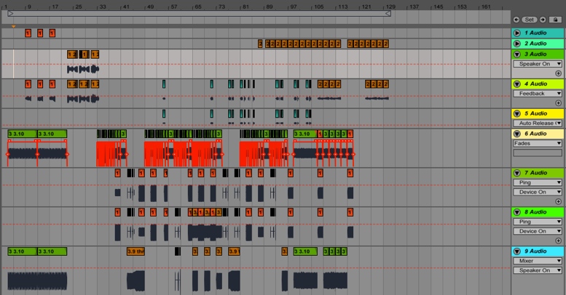

Figure 2.2

Paradoxa Shift Arrangement View

MIND BIRDS (What Was Tundra)
The tunings of synthesized music are so minutely precise that they invariably differ on each occassion. Mind Birds is another piece that, like Intonarumori (discussed below), was difficult to complete because of its cascading modulation solos. They are both pieces that are challenging to listen to because they feature heavily modulated leads.
The introduction sound provides a chord-like texture and foundation, made by tuning the two oscillators on the Moog to sound harmonious. The simple eight-step sequencer module made by Pittsburgh provides the main melody and rhythmic source of this piece. Each step has its own tuning, while the tuning of all the steps as a group is controlled by the main oscillator patched into the sequencer. The rhythm of the sequencer does not change, but the speed of the trigger changes to give the progression a rapid fluttering effect. Many of the synthesized sounds in this piece create an illusion of birdsong, which is why I called the piece Mind Birds.
The broken drone is employed in the second half of the piece, during which the mood of the song undergoes a dramatic shift. The chord progression drops off suddenly, being replaced by one note that extends to 16 counts. That note then shifts down a third and carries out until the end of the piece, becoming slower in tempo with the cutoff filter being gradually turned down.
This piece does not feature drums, yet it has rhythm. It is not exclusively ambient or noisy, but instead presents a variety of tonal information, including harmonic progressions played with the keyboard on the Moog and dissonances created in the subtle tunings of the oscillators. In terms of pinning down a genre, it is experimental electronic, focusing on the textures and comparison of synthesized sounds. This strangely melodic song was entirely created with my two hardware synthesizers, the Moog and the Eurorack.
With six recordings arranged in five channels in Ableton, the song is clearly divided into two sections. The duplicate recording in channels 1 and 2 has reverb and panning effects applied. It is layered to create a fuller sound. Channels 3, 4 and 5 all have the ping delay effect applied.
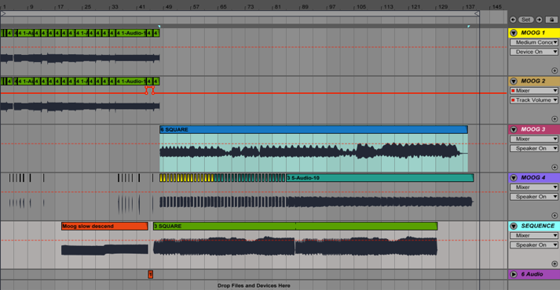

Figure 2.3

Mind Birds Arrangement View

NEXT SATURN (Zen Speed)
Next Saturn creates an illusion of the synthesizer breathing, taking on a life. It is a slow rhythmic drone that fades in and out, with changes in the higher pitched frequencies. These changes are all recordings of adjustments on the potentiometer settings. The mechanical sounds produced by the synthesizer make it texturally interesting throughout. The breaks of silence between the sounds are important in this piece to emphasize the differences between the sounds and the changes that are being made on the synthesizer. This piece fits more in the school of sound art and noise than in any rhythmic genre, although the synthesizer creates its own rhythm, creating the illusion of breathing.

INTONARUMORI (Zen Speed)
This piece is an interpretation of what Italian Futurist painter Luigi Russolo’s Intonarumori machines may have sounded like, inspired by his manifesto, The Art of Noises. It is what I imagined when I saw this picture of him and Ugo Piatti with the obscure Intonarumori. My interpretation sounds much different than the recordings of the original Intonarumori but perhaps has a haunted quality in common.

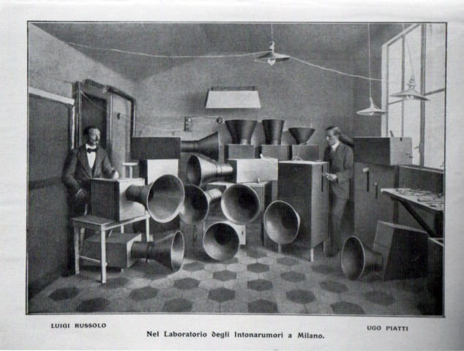

Figure 2.4
Luigi Russolo and Ugo Piatti with the Intonarumori.

A recorded improvisation on the modular synthesizer is the highlight of this composition as it changes drastically throughout the piece. The bass line and siren lead were created with the Moog Sub Phatty subtractive analogue synthesizer. I recorded the slow movement of the pitch wheel on the Moog to create the slow siren sound. The automated kick, snare drum and hi-hats provide the rhythmic gestalt, the nuance element that ties together the composition.
The crunchy sound that I am using as the snare drum in this piece is a sample of noise created with the Steady State Fate Quantum Rainbow noise module. I added some reverb directly to this channel to create the desired effect. It was a challenge to finish this composition because the collection of sounds was a lot to process.

INTO THE DEPTHS (Zen Speed)
Into the Depths is a triptych intended to guide the listener through three sections, its style giving a nod back to 1980s synth-pop. It features a vocal track I recorded of Alexandra Clouston as a textural focus.
In the first section of the piece, the vocal track is saturated in reverb to contrast the airy sound of human vocals with the clean, bright sound of digital synthesis. The first part leads into the middle section, which uses a two-note drone as a bass line. It is the recording of a pure sine wave oscillator with applied filtering effects and is transposed to the appropriate key every four measures. This section also highlights a specific treatment to the vocals, where they are spliced, reversed, and pitch-shifted. I used the warp markers in Ableton here to create the glitch effect on the vocal track. The listener goes further ‘into the depths’ when the composition reaches the one note oscillator drone at the end.

BUBBLES (Susurrus)
This composition fits well into the genre of ambient, using a simple patch of a slow eight-step melodic sequence to create the basis of the song. It is a composition recorded on nine audio channels with a structure that is easy to understand, following a simple melody. I have included several figures to explain this composition.

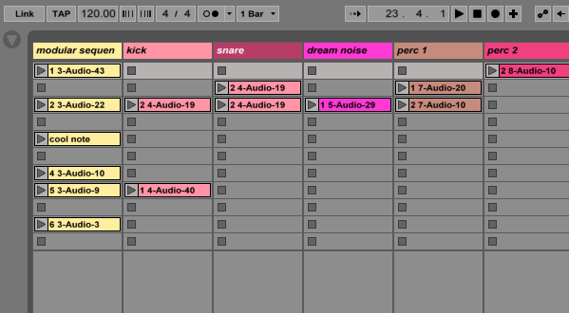

Figure 2.5

Bubbles Clip View

Figure 3.0 is a screenshot of the clip view in Ableton Live. This is where the recordings are collected and edited after they are made. In this composition, I started with the recording of the modular synthesizer on channel one as the basis for the composition. Note how many recordings there are in the modular sequence channel; I did not use all of them, but just one small segment of one recording (2-3 Audio-22).
This method can be described as a microanalysis sampling of the synthesizer. Figure 2.6 shows how long the initial sample I created to use is and that I chose to use only the first 14-bar clip of one modular sequence recording. I set the warp markers to adjust the timing of the clip.
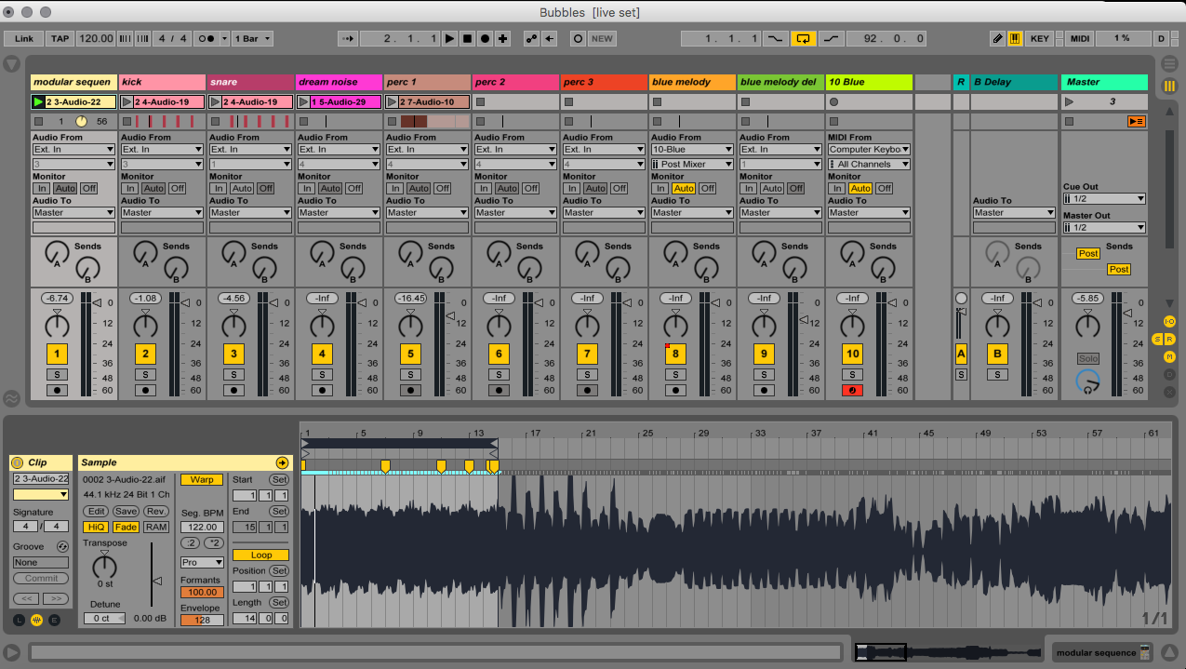

Figure 2.6

Bubbles Sequence Clip Detail #1

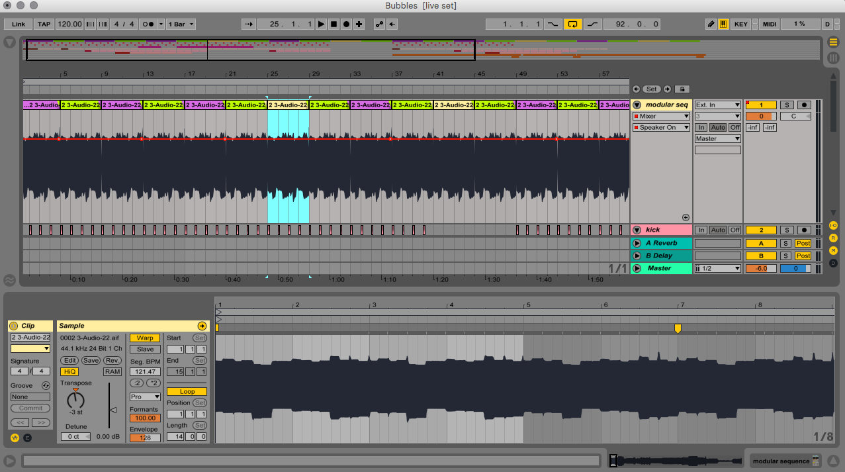

Figure 2.7

Bubbles Sequence Clip Detail #2
Even though I created the clip to be 14 bars, I only ended up using a four-bar clip and transposing it to create the desired melody. The clip highlighted in Figure 2.7 is the second note in the eight-step sequence melody and was transposed down a fifth. I shifted the clip pitch down by seven semitones for the initial sample to shift down a fifth. Figure 2.8 shows a close-up on this transposition setting.

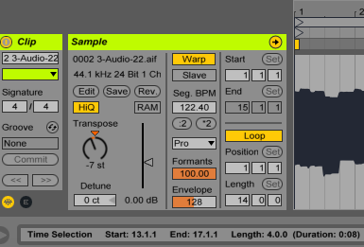

Figure 2.8

Clip Transposition

I did the same for the third note in the melody but shifted the clip pitch down by three semitones to create the minor third.
I recorded the kick and snare audio samples in from the RYTM in time with the melody, then I separated them to their own channels to add desired effects and to mix them properly. Figure 2.9 has the snare drum sample highlighted.

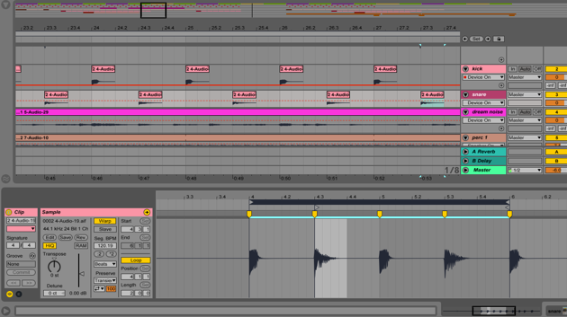

Figure 2.9 Kick/Snare Detail

A new sound is brought in for the second half of the composition. It is a sound from Rob Papen’s Blue plugin, shown in Figure 3.0, which is the only VSTi I plugin I used on any of the research compositions I present here. I like its digital sound quality and how it sometimes has structured rhythms within the presets, which can all be adjusted. Figure 3.1 shows how I muted all oscillators except for the ‘Triangle 2’ sound on OSC A to create the desired sound.

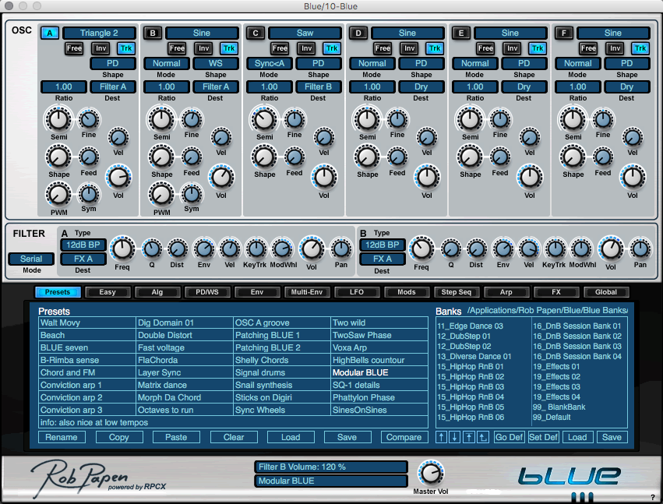

Figure 3.0

Rob Papen’s Blue VSTi Plugin

Figure 3.1 demonstrates my use of MIDI, and the notes for this melody on six keys. I play them in with the computer QWERTY keyboard and then use the mouse to adjust the timings of the notes. After the MIDI clip is ready, I record the melody to its own audio channel for mixing and effects. The only effect I used on this recording was an EQ Filter in Ableton, as shown in Figure 3.2.

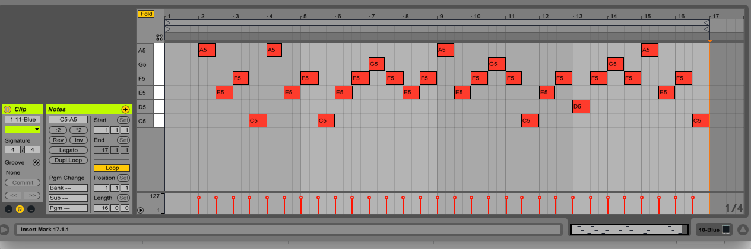

Figure 3.1
MIDI Detail

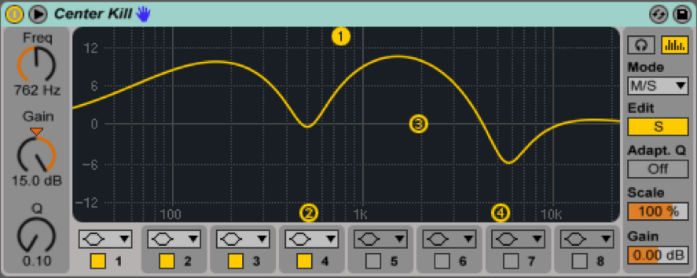

Figure 3.2
EQ Filter – Center Kill

As previously indicated, the arrangement view is where I organize all the clips into a structure from start to finish and finalize compositions. In my studio approach, the composition always begins in the clip view and ends in the arrangement view. Figure 3.3 shows the final arrangement of the composition.

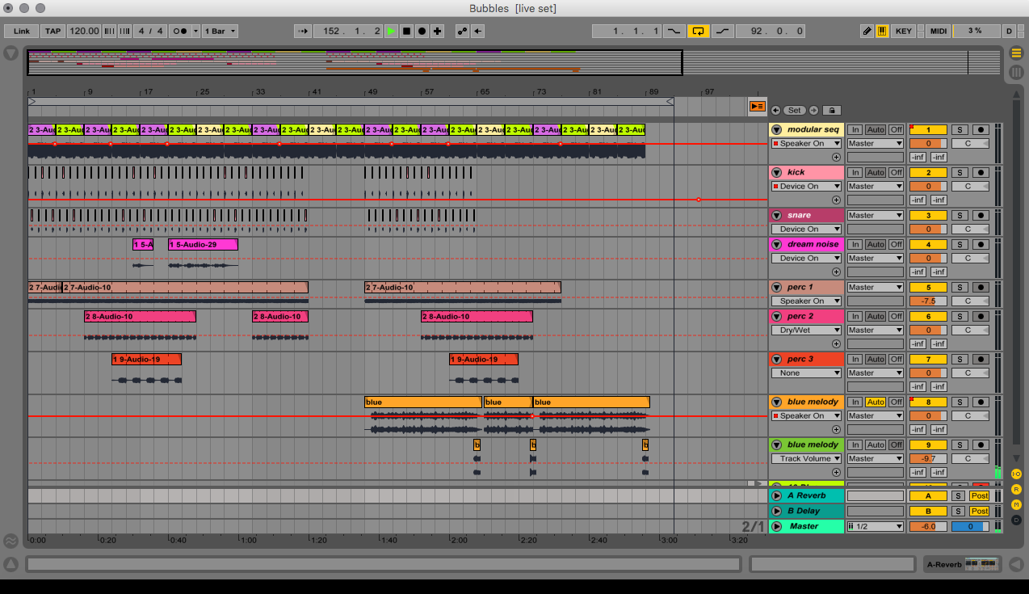

Figure 3.3

Bubbles Arrangement View

DETUNED (Susurrus)
At the Elektronmusikstudion (EMS) in Stockholm, I had a two-week artist residency in November 2016 to make recordings of the Buchla and Serge synthesizers for new compositions. I found these vintage synthesizers vastly different from my Eurorack. They are larger in size and use banana jack cables that make it somewhat easier to multiply the functions of the pathway when the cables are stacked. Playing these synthesizers was a highly intensive process because I had no previous hands-on experience with them. In my residency, I would experiment with the various inputs and outputs on the oscillator modules to find interesting sounds. While recording my improvisation on the patch, I kept the delay effect switched on in Ableton. The synthesized sounds without the delay effect switched on can be too harsh. Having the effect turned on in the software softens the sound and allows me to start composing using the improvisational recording method.
Rhythm is an inherent feature of the step sequencer that separates the tunings of each note by step. By utilizing the five-step sequencer in the Buchla and the sixteen-step sequencer in the Serge, I was able to achieve rhythmic sequences that combined melodies and noise. To leave these sequences running at one speed and then work with the patch was most effective method, as the speed provides a sort of musical trancing that allows further concentration and listening involvement. There is a hypnotic concentration involved in the act of playing a patch, and then once the speed is changed, the concentration breaks; I experienced this several times after I changed the speed, and how it affected my experience of playing the synthesizer. I found that tuning the oscillators on the Buchla is much like tuning a radio, using the ear to look for the ‘sweet spots’ - the frequencies that complement each other harmonically. The only song that I use the Buchla recordings for in my portfolio is Detuned, a rhythmic synthesis composition I arranged in 12 channels. The channel with the Buchla recording is highlighted in Figure 3.4.

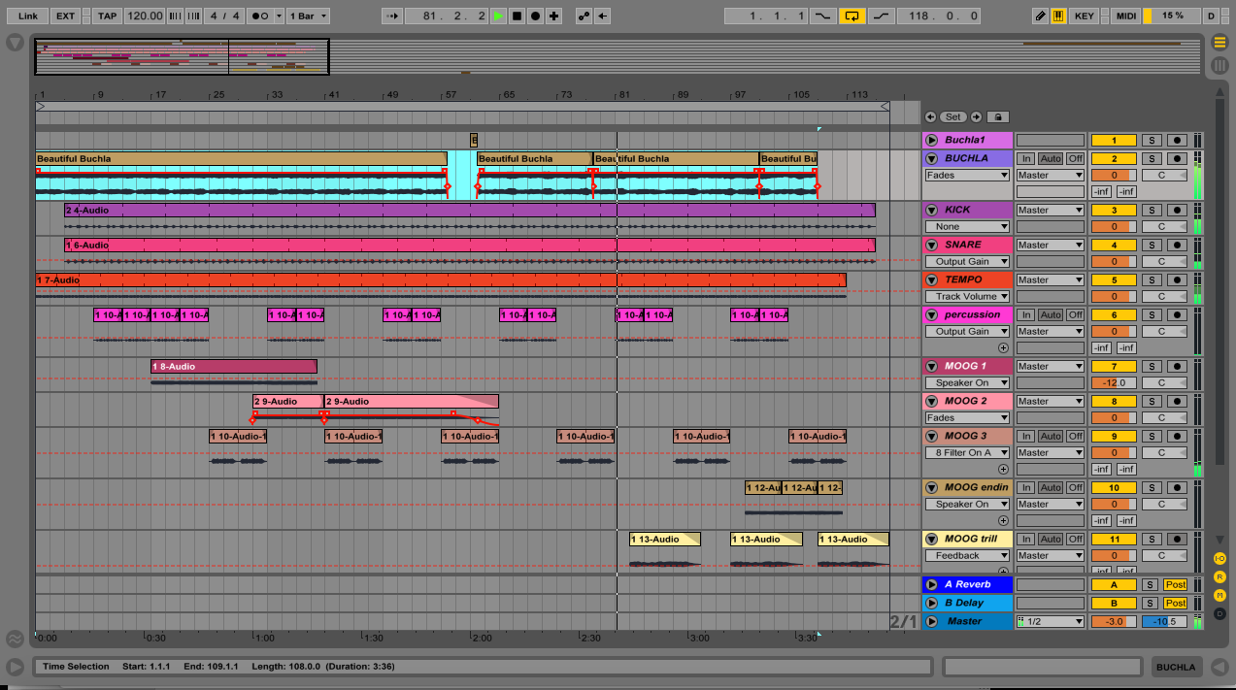

Figure 3.4

Detuned Arrangement View

I recorded the five-step sequence melodic line of Detuned on the Buchla the day after I went to concert by English electronic music duo, Autechre, in Stockholm. This five-step melody excited me in the moment because it sounded very similar to a high point of the concert the night before. The concert was extremely loud, reaching the point of discomfort. One of the greatest things about seeing Autechre perform live is that they always perform in the dark, with no lights or visuals. This allows the audience to experience the sound for itself in a truly unique way that is not easily compromised by any other factor of the environment. It seems to be a collective understanding that watching Autechre perform live in concert is a discipline in itself. It is clear that the duo’s music is meant to be observed, and much of it is not intended for dancing.
A few months after my residency, when I was back in London with my Moog and my RYTM, I created the arrangement and added other parts, notably the lead parts, which I overdubbed to drift in and out and create the ending. The detuning of this composition makes it difficult to decipher what key it is in; not in major or minor, but both. The song makes me feel very relaxed as a complete composition. However, when I first found that five-step sequence on the Buchla, I was really excited because I knew I had come across something special that would make a great composition when I was finally able to finish it.
The even rhythmic distribution of notes via sequencer modules creates a precise stylistic and mathematical sound that is characteristic of early vintage synthesizers and that are sometimes reminiscent of science fiction films. Because the tunings are unpredictable, the randomized characteristic of the potentiometer settings can lead to an interesting interpretation of melodies. Figure 3.5 shows a close-up detail of the Buchla recording and how I have used the warp markers in Ableton to have the five-step sequence in time with the rhythm, which is 120 BPM, in 4/4 time.
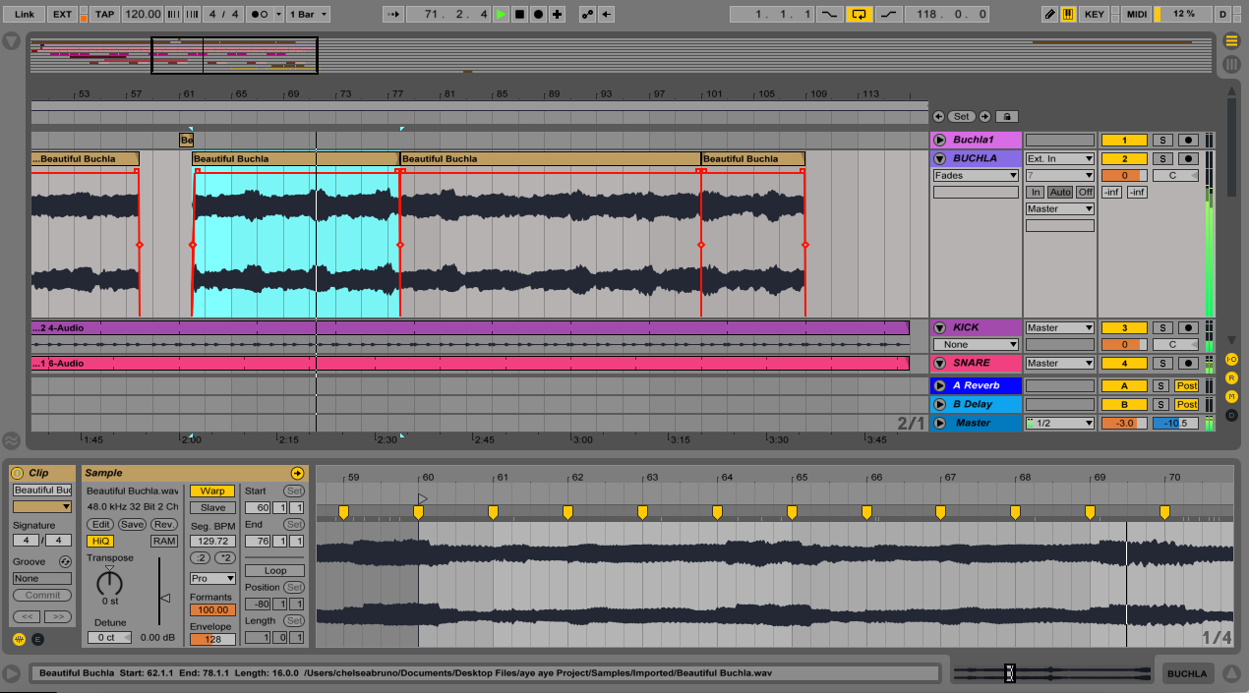

Figure 3.5

Buchla Sample Detail

GRADIENCE (Gradience)
This composition took quite a long time for me to complete; it took nearly two years for me to decide it was finished. I recorded the 16-step lead melody with the Arturia BeatStep, a 16-step hardware sequencer, which I patched into an oscillator module on my Eurorack to create the lead melody. After adding the drum sounds, the bass, and completing the arrangement at the beginning of 2018, I decided it was finished. When I had initially created the recording of the lead melody, I did not know if I wanted to add drums.
The arrangement view of Gradience is shown in Figure 3.7 (on the following page). This composition consists of the lead synthesized melody on channels 1-3, the kick on channel 4, snare on channel 5, bass on channels 6 and 7 and the hat on channel 8. With so few elements, this track can be considered a minimal ambient. The first channel contains small splices of the lead melody to create dynamic accents. The second and third channels create the lead melody and are almost the same, except that channel 2 has a reverb effect, and I cut the sample at the end to create subtle harmonies in the lead. Channel 3 has an ‘Auto Filter Slide Away’ effect applied to the lead melody.

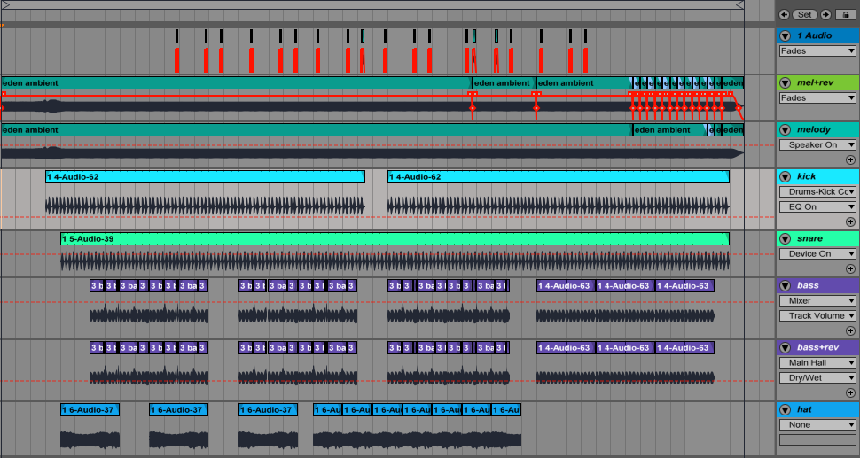

Figure 3.6

Gradience Arrangement View

TRIPPEL FABRIK (Gradience)
This composition highlights the use of rhythm made with the Elektron Analog RYTM drum computer. The workflow of the RYTM and the modular synthesizer are very different, and they contrast well in this piece.
I first created the drum beat and recorded each rhythmic sound to separate audio channels. Channels 4-11 are recordings of the RYTM and are all individually labeled. Then I played the oscillator drone adjusting the filter and modulation to the rhythm of the beat. I switched the drone up by one octave while recording it with the octave switch on the Harvestman PVCG oscillator module. I also adjusted the cutoff and resonance knobs on the filter module to create the audible harmonics. After the rhythmic, harmonic oscillator drone was recorded, I adjusted the warp markers to make its rhythm precisely in time with the drumbeat, though I recorded it in time with the drums so it only needed slight adjusting to be absolutely precise. Since the oscillator drone is in time with the drums, they fuse together to create a fluid composition.
This piece can be considered rhythmic ambient, as it does not have many changes but creates a colourful mood by accentuating the colours in the harmonic resonance created with the Malekko Borg filter module. I also played in a simple melody on the Moog Sub Phatty that is used only three times throughout the composition to add a slight accent to the melody.
Trippel Fabrik is named for the reference of the word trippel, in reference to the Belgian style beer, and the German word fabrik, meaning ‘factory.’ It does not fit into the genres of techno or electro because it has a different rhythm. Even though it is in 4/4 time, it does not have the characteristics of being a classic techno track, with more variations in its percussive content. It is also at a slower pace than typical club music, with a speed of 113 BPM.
Because of the tactile activity of playing the touch-sensitive pads on the RYTM, I was allowed to program these drums differently than if I had programmed them in Ableton using MIDI notes drawn in with the mouse. The style of this composition was inspired by the experimental techno style of the German duo, Modeselektor.

Conclusion
My contribution to the modular revolution by organizing the CV FREQS events has been an important part in developing my own work. Changes are evident in the style of the compositions presented chronologically in the portfolio, due to this practice-based research and the expansion of my modular system. I did not foresee that one of my main compositions submitted for the portfolio would be an improvised live performance from SuperBooth18, but I believe it to be a strong example of a sonic meditation recorded live in front of an audience. Also, the live patching demonstration videos show the expansive capabilities of my unique instrument. I am confident in the development of my compositional style, and that it is an important contribution to the catalogue of electronic music.
I view the Eurorack modular synthesizer as not only a complex instrument and a versatile sound design tool, but as a customized interactive art piece that is suitable for installations, as it can perpetually play itself after I have patched it, but as the performer, I become the interactive subject and the projection for the soundscape. Because of my musical background and experience, I have an aptitude for playing it. I am looking forward to seeing the modular synth community continue to flourish, as I will continue to observe how my Eurorack system will evolve and my music along with it.

Bibliography
AFX Jnr, ‘Rock Up’ <www.discogs.com/AFX-Jnr-Rock-Up/release/6620592>
Allum, Matthew, interviewed by Chelsea Bruno, 9 October 2018.
Analog RYTM Reference Manual, Elektron Music Machines MAV AB, Sweden, 2014.

Collins, Nick and d’Escrivan, Julio, eds. The Cambridge Companion to Electronic Music. 2nd ed. (Cambridge: Cambridge University Press, 2017).

Emmerson, Simon, Living Electronic Music, (Hampshire and Burlington: Ashgate, 2007).

Goddard, Michael, Halligan, Benjamin and Spelman, Nicola, eds., ‘Noise as Music: Is There a Historical Continuum? From Historical Roots to Industrial Music’, Resonances: Noise and Contemporary Music, (London: Bloomsbury Academic, 2013).

Haworth, Christopher, ‘All the Musics Which Computers Make Possible’: Questions of Genre at the Prix Ars Electronica’, Organised Sound 21, no. 1 (2016): 15–29.

Hegarty, Paul, Noise / Music: A History, (London: Continuum, 2007).

Kahn, Douglas, Noise Water Meat: A History of Sound in the Arts, (Cambridge, MA.: MIT Press, 1999).

Landy, Leigh, Understanding the Art of Sound Organization, (London: MIT Press, 2007).

LTM Recordings, ‘Avant-Garde Art \ Music Futurista: The Art of Noises’ [LTMCD 2401] <www.ltmrecordings.com/musica_futurista_the_art_of_noises_ltmcd2401>

New Oxford American Dictionary, Version 2.2.1 (171.1) Apple, Inc., 2014.

Nietzsche, Friedrich, <http://sqapo.com/nietzsche.htm>.

Pantelic, Vladimir, interviewed by Chelsea Bruno, 13 July 2018.

Roholt, Tiger C., Groove: A Phenomenology of Rhythmic Nuance, (London: Bloomsbury Academic, 2014).

Schafer, R. Murray, The Soundscape: Our Sonic Environment and The Tuning of the World, (Rochester: Destiny Books, 1994).

Scott, Richard, ‘Back to the Future: On Misunderstanding Modular Synthesizers.’ no. 17.4 eContact!, Spring 2016, <econtact.ca/17_4/scott_misunderstanding>.

Soulsby, Paul, interviewed by Chelsea Bruno, 19 October 2018.

Toop, David, Haunted Weather: Music, Silence, and Memory, (London: Serpent’s Tail, 2005).

Wahlbeck, Dan, interviewed by Chelsea Bruno, 18 July 2018.

Whitwell, Tom, interviewed by Chelsea Bruno, 22 June 2018.

Further Listening
Apocalypse Gamma Mine
https://gammamine.bandcamp.com/track/apocalypse
Entropy from Modularism 1 – Music from Somewhere on the Spectrum
https://lawauder.bandcamp.com/album/modularism-1-music-from-somewhere-on-the-spectrum
SuperBooth17 Performance (excerpt)
https://www.mixcloud.com/CashmereRadio/cashmere-radio-x-superbooth-2017-eden-grey/
Perihelion EP Musica Dispersa
https://musicadispersarecords.bandcamp.com/album/perihelion-e-p
Vacant State
https://edengrey.bandcamp.com/album/vacant-state
AVA 2 from Tone Science Module No. 3 Cosines and Tangents
https://din7d.bandcamp.com/album/tone-science-module-no-3-cosines-and-tangents

Further Reading
Bruno, Chelsea A. “An Artist’s Approach to the Modular Synthesizer in Experimental Music Composition and Performance” CEC eContact! Issue 17.4 Analog and Modular Synthesis Resurgence and Evolution. Published 1 February 2016.

Appendices

Appendix 1

Lyrics from Into the Depths by Alexandra Clouston:
Heart is beating like a drum
Water soaked right through to bone
Down into the depths you go
To the murky dark below
Isis Diana
Astarte Diana

Appendix 2

Interview with Dan Wahlbeck, DPW Design

Did you play music before you started designing synthesizer modules? If yes, what kind of music/style/genre and what instrument(s)?

- Yes, I started playing guitar when I was 16. Back then I started with blues-rock as everyone else but also with the wonderful liberating punk. I have tried to in some way keep parts of the punk approach in some of the things I do.
I was part of a very normal rock band during the early 80s for a while. It wasn't really my thing. So I got myself a 4 track cassette tape recorder, a drum machine and a synth and started to do less main stream musical experiments. I have been collecting instruments and sound sources ever since, more or less everything I could get my hands on.
When I started to do those early 4 track recordings I was in a phase when I listened a lot to bands like The Residents, Snakefinger and Devo. But also blues, progressive rock and British synth music and punk. Most of my life I have listened to everything that is good, regardless of genre.

Do you make music at home using your synthesizer modules? Do you make recordings to share?

-Yes I do. The main reason for designing things are my own needs. The fact that there are others who actually like my modules feels very nice.
I put out a bit of music via Soundcloud. I see that more as experiments, not really produced but a fun way to share. I have been collaborating with David Elfström Lilja in his ambient project Numb a few years ago. David and I are about to start a new Numb collaboration involving modular.
I am also involved in the progressive metal band Soen. Soens 4th album is being recorded right now.
I have recently started a collaboration with a hip-hop producer to make beats and sounds to his material.
On top of that I have started to work on my first solo album.
As all these projects progress, I will probably come up with new ideas of things I just have to design to get them the way I want them.

Do you have a music or engineering degree or background?

- I have a BsC in electronic Engineering. No musical education apart from the guitar I studied when I was 16 to 18 at school. Basically, I am self-taught musically.

Are your modules using digital or analogue components, or both, and why?

- So far, I have only done analogue modules because I like it. The functions I have built so far are easier to implement in pure analogue, it is also easy to design imperfections in them to give them a sound and some kind of character.
I have some ideas for digitally controlled analog for the future. Where the audio signal chain is pure analog but controlled digitally. I can build very interesting functions that way.

When did you begin module design? What was the motive for beginning i.e how or why did you start designing modules?

- It actually started with the need for a good distortion/overdrive for bass for the band Soen. It wasn't possible to buy anything that sounded the way Martin Lopez and I wanted, so I had to design one. That is the multiband dist that was my first product under the DPW Design name
I discovered that it worked really good on synths and started also selling it via the synth shop, Jam, in Stockholm. Then there were quite a few that told me that I should do a Eurorack version of it. I started to look at the Eurorack format, bought a few modules and got hooked. But I didn't start by just porting my multiband dist to the format. I built a few other modules first, as it is no fun doing the same function two times in a row and I had some other ideas that I wanted to try first.

Do you find there is a sense of humour in the expanding modular synthesis community? If yes, what do you find humorous in particular?

- Yes, there are quite a few companies who do fun things that no normal product management department would approve. As an example, the NerdSeq by XOR Electronics. They were joking about how cool it would be to have a tracker in Eurorack, so they built one. That would probably not have passed a normal ROI calculation by the product management. The fun thing is that there are a lot of people out there who appreciate when someone does things like that and buys them.

What do you find the most exciting about the modular synthesis community?

- It is like a loosely connected family more than a competitive market. People help each other. It is still a very niche market even though it has grown most companies who produce modules are very small. A lot of them are just one person doing modules in the evenings and weekends.
Since there is a lot of small companies that doesn't have to adapt to what they think will sell a lot, if they don't want to. There will be quite a few specialized strange modules coming out. That kind that you need a few mixed in among the more normal modules for inspiration and the possibility of doing sounds that no pre-wired synth can ever do.
I also find that the fact that it is very DIY friendly very nice.

Appendix 3

Interview with Tom Whitwell, Music Thing Modular

Did you play music before you started designing synthesizer modules? If yes, what kind of music/style/genre and what instrument(s)

I've tinkered about with music pretty much all my life - guitar, music software as it developed - I remember seeing Rebirth when it first appeared (in 1996) and being amazed. I've always liked a pretty wide range of music - Talking Heads & Iggy Pop & Prince when I was growing up, dance music during the 90s & 00s, now just anything - African music, 70s minimalism, singer songwriters, 80s electronic academic music, instant access to all recorded music ever is such a joy.

Do you make music at home using your synthesizer modules? Do you make recordings to share?

I occasionally record & things - https://tomwhitwell.bandcamp.com/ - but I think my skills lie elsewhere.

Do you have a music or engineering degree or background?

Not at all - I did a degree in Politics, worked in magazines from 1996-2004, then in newspapers, I've been an innovation consultant since 2014.
The electronics and coding is entirely self-taught from web sources - reading schematics from people like Ken Stone, Grant Richter, old Buchla schematics, Douglas Self's book, adafruit tutorials, sparkfun tutorials.

Are your modules using digital or analogue components, or both, and why?

Mixture -
mikrophonie, spring, EQs are completely analogue.
Radio Music is completely digital.
Turing machine works using digital signals and gates, but doesn't have any code or a microprocessor - so it's somewhere in between.
I much prefer working with analog designs, but if I have an idea that requires some computer power, I'll try to work out a simple way to do it.

When did you begin module design? What was the motive for beginning i.e how or why did you start designing modules?

[Here's a block of text I just wrote for Kim Bjorn's new book]

My background was in publishing - editing magazines like Mixmag and The Face.
In 2004 I started writing Music Thing as a blog, - the principle was to celebrate the love of gear - weird and interesting gear - for the sake of it, rather than the 'if I spend $3000 on this guitar I will have good 'tone' stuff'.
By 2010 I was experimenting with Arduino and building simple DIY stompboxes. In 2011 I went to a London Modular event, bought a Doepfer case and started making DIY modules — a simple sequencer, a touch-pad keyboard, a spring reverb and a CV-controlled radio. Even in 2010 there was a huge amount of information online; the forums electro-music and Muffwiggler had huge and active communities. Ken Stone, Mark Verbos and Grant Richter shared designs and ideas on their websites and Don Buchla's hand-drawn schematics were incredibly inspiring.
In March 2012 I designed my first PCB - a socket-to-breadboard adaptor that I still use all the time. June 2012 I published the Turing Machine as an open source project - a couple of days later, Steven Grimley Taylor started selling kits, which became Thonk.

Why did you start creating your own modules?

I enjoyed the process of designing and DIY-ing modules, but only wanted to share those designs that I felt were original that might be useful to people. I really like the cross-disciplinary aspect of designing a module - creating the electronics, designing the interface, really trying to understand how the user will interact with those two things, building a narrative to explain why the module should exist, working to make it easy to build and at a sensible price.

Do you find there is a sense of humour in the expanding modular synthesis community? If yes, what do you find humorous in particular?

I'm not sure what you mean, but I've always been wary of taking what we do too seriously - I can really deeply enjoy a piece of experimental music - a Russell Haswell set, or a 20-minute long Carl Stone piece, while at the same time thinking how mad and extreme it is - either in sound, or in repetition, or in concept. I enjoy music that has a chutzpah, that shows great confidence or willingness to do something extraordinary - and often that is also funny - or at least joyful - in a way that is different from someone making something purely academic, which can only be appreciated on some theoretical level.

Something like 'I am sitting in a room' by Alvin Lucier is at the same time remarkable to listen too, personally moving (it is - as I understand it - partly about his self-consciousness about his stutter), and a kind of conceptual joke, a prank that can be explained in once sentence. There is something joyful about work like this, that feels - to me - like a celebration, an exploration.

What do you find the most exciting about the modular synthesis community?

It's a lot of people doing something they love, learning from each other. There are experiments in the way business can work, I like the way that being experimental is celebrated at the core- it's not like the guitar pedal world where there really are 10000 different kinds of boost and a few really interesting clever things around the fringes.

Appendix 4

Interview with Vladimir Pantelic, vpme.de
Did you play music before you started designing synthesizer modules? If yes,
what kind of music/style/genre and what instrument(s)?
Before starting on Eurorack, I was playing electric bass, badly. I started a band with a few friends somewhere around the end of high school and we got up to a dozen or so songs, mostly covers, played only one or two gigs but had tons of fun. Ever since then I noodled on the bass from time to time.
When I started playing bass, I immediately also started working on the bass guitars and amps that I had, tweaking, repairing, improving. and also collecting. The same thing happened before with photography where I quickly went from taking pictures to collecting and repairing cameras and lenses. So, in a way, I always end up on the technical side of ‘artistic’ things.
Do you make music at home using your synthesizer modules? Do you make recordings to share?
I never made any electronic music before I started with Eurorack, but since I had a rack of a certain size I did create a few patches or tracks, often when playing around with a new module ‘under design’ but also just because making music with Euro is ‘easy’ in the sense that somebody like me with no previous musical training can do it. and of course there is that ’it's 9pm, let's try one more thing, and suddenly it's 1am’ :)
I have a few tracks up at https://soundcloud.com/vladimir-pantelic
Do you have a music or engineering degree or background?
I have zero musical background, since after the singing and clapping in primary school I totally tuned out of music in school.
I have do have a master in Electrical Engineering, though little of that had practical application when designing modules.
Are your modules using digital or analogue components, or both, and why?
Mostly digital, though I did a headphone amplifier and a precision adder in all analog. ;)
All my other modules have a microcontroller and lots of software inside to make them work. I am not an analog ‘god’ and I feel more comfortable around digital circuits and microcontrollers.
When did you begin module design? What was the motive for beginning i.e how or
why did you start designing modules?
It was a coincidence of three things. First, I came across a semimodular synth from way back and started to play around with it. At the same time I wanted to do something with microcontrollers again and then it turned out a friend of mine that I was talking to about technical topics for years was also designing modules and making software for a few Eurorack manufacturers. He pointed to Eurorack and answered a ton of my questions in the beginning.
So I decided to make a MIDI2CV interface as my first module, thinking I would use that with that old synth. I even bought a cheap MIDI keyboard off of Ebay that I touched a few times then set it aside since I'm not a player after all.
That first module never got finished, but anyway I was hooked and started making more modules using microcontrollers, like a sequencer, a VCO, an 8x8 matrix mixer. At the same time I bought a few analog modules second hand in order to have a test rig for my stuff. Eventually I had the idea for Euclidean Circles and that pushed me from the pure DIY to being a Eurorack manufacturer.
Do you find there is a sense of humour in the expanding modular synthesis community? If yes, what do you find humorous in particular?
Well, there are people that find my postings in various modular related groups humorous, so there must be some humour at least. I try to have a bit of a distanced look at things, so you will not find me getting into a discussion which filter has the ‘fattest sound’ or which VCO square wave sounds the best, I find it amusing that a lot of the modular ‘users’ understand their own predicament being basically ‘junkies’ for new gear. And me being a ‘dealer’ selling to them :)
What do you find the most exciting about the modular synthesis community?
I found the community very welcoming, be it the DIY crowd, modular musicians or other manufacturers.
One thing that is nice is that so many of the makers are musicians and vice versa with all the implications that this brings. On one side there are certainly modules that could ‘technically’ be better but then I often admire the sounds that other module makers are able to create with their stuff.
Another thing is the inherent trust that people have, when I started with selling modules total strangers offered to send me money straightaway although I had no track record in this field at all. That surely helped to bootstrap my little commercial Eurorack operation.
Other manufacturers proved to be very helpful and answered my questions and I could spend all of SuperBooth just chatting to fellow module makers.
So I guess the most exciting thing about the modular community is a real sense of community.

Appendix 5

Interview with Matthew Allum, ALM Busy Circuits
Did you play music before you started designing synthesizer modules? If yes, what kind of music/style/genre and what instrument(s)?

I got into electronic music in my late teens (early 90s - mainly techno) and began building a very small home studio so I could make my own music. After university however my interest wavered due to less free time due to full time job, etc. Later in life I got back into synths and realized in the meantime I had built the basic knowledge and confidence to build my own synths!

Do you make music at home using your synthesizer modules? Do you make recordings to share?

Yes, I make music at home but am never really satisfied enough with anything to really share!

Do you have a music or engineering degree or background?

I have a degree in Physics.

Are your modules using digital or analogue components, or both, and why?

I use either and have no preference. Using whatever may fit the task or is most challenging, fun or inventive.

When did you begin module design? What was the motive for beginning i.e how or why did you start designing modules?

I began about 6-7 years ago. I had a Doepfer system and I wanted a module to sync that with some other gear. Coming from a more software-based background I wanted to build something physical and liked the challenge of building and selling my own module (original Pamela)

Do you find there is a sense of humour in the expanding modular synthesis community? If yes, what do you find humorous in particular?

Well I like to be a little humorous with my modules (some of the naming, visual design) but in general I think the community is sometimes a little too serious.

What do you find the most exciting about the modular synthesis community?

I like the broad range of interesting, creative, technical people that I have met and made good friends with all from different places and backgrounds. I like it when people enjoy using my modules or make sounds with it I never expected or understand!

Appendix 6

Interview with Paul Soulsby, Soulsby Synthesizers
Did you play music before you started designing synthesizer modules? If yes, what kind of music/style/genre and what instrument(s)?

Yes. Violin and Viola from about age 6 to 20 and piano from 8 onwards. I played all the standard classical pieces while learning (preferring baroque and romantic periods) and then developed a love for 70s prog rock and 80s synth pop during my teens, which lead to buying and playing synths and eventually joining a synth pop band.

Do you make music at home using your synthesizer modules? Do you make recordings to share?

Yes, but sadly it’s now only really to promote the modules, not as a proper artist. I’m hoping that’ll change with the new products though.

Do you have a music or engineering degree or background?

Yes, BEng Music Technology, from York Uni

Are your modules using digital or analogue components, or both, and why?

Sound source and control is all digital, but of course analogue components are essential for interfacing with Eurorack format (eg filter off PWM freq of microcontroller, buffer CV inputs etc).

When did you begin module design? What was the motive for beginning i.e how or why did you start designing modules?

2016 - I started with a MIDI desktop module and had numerous requests for Eurorack CV connectivity, so naturally did some research. I actually barely knew about it before this!

Do you find there is a sense of humour in the expanding modular synthesis community? If yes, what do you find humorous in particular?

I had to leave nearly all online groups as I found I was spending too much time reading comments (and then getting wound up if I disagreed with them!). I’m still a member of Synth Memes on Facebook. I find the really obscure gags funny, although there’s a lot of tedious ones too (misogynistic / pro Behringer / anti Behringer etc etc).

What do you find the most exciting about the modular synthesis community?

Definitely the open nature of it. Lots of Open Source and Open Hardware projects and even closed source companies are always very keen to chat and help. Having chatted to synth engineers from the 70s/80s, it was much more secretive back then apparently.

Vince Clarke began his professional career in new wave synth pop band, Depeche Mode, in 1980, and went on to form synth pop outfits Yazoo and The Assembly, as well as current synth pop duo Erasure, which he formed in 1985 with Andy Bell.
Vince Clarke, ‘Artists’ statements III’, The Cambridge Companion to Electronic Music, eds. Nick Collins and Julio d’Escrivan (Cambridge: Cambridge University Press, 2017), 295.
Dan Wahlbeck, interviewed by Chelsea Bruno, 18 July 2018.
Tom Whitwell, interviewed by Chelsea Bruno, 22 June 2018.
Douglas Kahn, Noise Water Meat: A History of Sound in the Arts (Cambridge, Mass.: MIT Press, 1999), 135.
Vladimir Pantelic, interviewed by Chelsea Bruno, 13 July 2018.
Paul Soulsby, interviewed by Chelsea Bruno, 19 October 2018.
R. Murray Schafer, The Soundscape: Our Sonic Environment and The Tuning of the World (Rochester, Vermont: Destiny Books, 1994), 103.
Christopher Haworth, ‘Xenakian Sound Synthesis’, Resonances: Noise and Contemporary Music, eds. Goddard, Halligan and Spelman, (Oxford: Bloomsbury, 2013), 195.
Paul Hegarty, Noise/Music: A History, (London: Continuum, 2007) 15.
Simon Emmerson, Living Electronic Music, (Hampshire and Burlington: Ashgate, 2007), 37.
Elektron RYTM Users’ Manual.
Matthew Allum, interviewed by Chelsea Bruno, 9 October 2018.
Richard Scott, ‘Back to the Future: On Misunderstanding Modular Synthesizers.’ no. 17.4, eContact!, Spring, 2016, <econtact.ca/17_4/scott_misunderstanding.html>
Leigh Landy, Understanding the Art of Sound Organization, (London: MIT Press, 2007) 206.
AFX Jnr, ‘Rock Up’ <www.discogs.com/AFX-Jnr-Rock-Up/release/6620592>
Haworth, Christopher. ‘All the Musics Which Computers Make Possible’: Questions of Genre at the Prix Ars Electronica.’ Organised Sound 21, no. 1 (2016): 15–29. doi:10.1017/S1355771815000345.
David Toop, Haunted Weather; Music, Silence and Memory (London: Serpent’s Tail, 2005), 42.
Friedrich Nietzsche, Beyond Good and Evil <http://sqapo.com/nietzsche.htm>
Notice that these chords made with the Moog oscillators are similar to the chords made with the Buchla in Detuned. This is because they are both made using frequency modulation with two oscillators tuned differently.
LTM Recordings, ‘Avant-Garde Art \ Musica Futurista: The Art of Noises’, <www.ltmrecordings.com/musica_futurista_the_art_of_noises_ltmcd2401>
Tiger C. Roholt, Groove: A Phenomenology of Rhythmic Nuance (London: Bloomsbury Academic, 2014), 134.
It is my intention for some of my compositions to be selected by DJs for mixes as well as to be listened to on their own. This is why it is important for some of my studio works to be released on vinyl.

