Practice Exchange Paper

Final Year Research Project as a Tool for Maximizing Students’ Employability Prospects
Danijela Serbic & Victoria Bourne
Abstract
Embedding employability in higher education is a key Teaching Excellence Framework requirement, and psychology departments across the UK recognise that this is indeed important for students’ employability prospects. The Final Year Research Project is the most important independent piece of work that psychology undergraduate students undertake, contributing considerably to the overall degree classification. Therefore, it can provide a fertile ground for embedding employability and allows for innovation in teaching and supervision of projects. Yet, based on our extensive Final Year Research Project supervision and coordination experience, this opportunity tends to be overlooked by psychology departments, project coordinators and supervisors; often resulting in Projects being given insufficient attention in students’ job and further study applications and interviews. In this practice exchange paper, we first detail how employability is built into Years One and Two of our undergraduate degree, before outlining how it is integrated in Year Three within Final Year Research Projects. We then describe and discuss several initiatives that we developed and implemented to embed employability in Final Year Research Projects. We developed the 3Rs approach to helping students Recognise and Reflect on their skill development, and Relate them to the next step in their career.

Final Year Research Project (referred to as the Project hereafter) is a compulsory component of any British Psychological Society accredited undergraduate psychology degree, where final year (Year Three) students are required to conduct a substantial piece of original empirical research and report on it. Some institutions may use the term ‘Dissertation’ instead of ‘Project’; in the Department of Psychology at Royal Holloway, University of London we use the term ‘Project’. It is worth 45 credits and runs across Term One and Two. In order to reflect the collaborative nature of ‘real world’ research projects and enable more effective recruitment of participants, students are expected to work in groups of four to five members and each group is supervised by an academic member of staff. A project group develops and works on the same broad research design, but individual students can explore different variables within the same research project. Individual students are expected to work on literature review, data analysis and writing up their entire project independently, and they are required to submit a 7000 words report at end of this process. Inherently, the Project is perceived as a purely research based endeavor, where students are expected to demonstrate excellent research knowledge and skills and an in-depth understanding of a specific research area. The Project is seen as a ‘pièce de résistance’ of undergraduate research training. But surely, being such an important component of an undergraduate degree, it must serve a much greater and long-lasting purpose, such as impacting students’ next step in life. Projects enable students to develop and utilize a number of employability (or transferable) skills; however, they often fail to recognise these skills, their value and how they can use them to maximize their employability and further study prospects. For students to be able to recognise, reflect on and relate these skills, structured and employability focused training and supervision of Projects is required. In this paper, we describe our 3Rs (Recognise, Reflect, Relate) approach to embedding employability in Projects, which we developed and implemented in the Department of Psychology at Royal Holloway, in the academic year 2018/19. Specifically, we implemented these within the three core components of our Projects: a) employability focused lectures, which took place throughout Term One, b) Project monitoring self-reflective logs, which were available to students to complete throughout Term One and Two, and c) employability focused student presentation, which took place at the beginning of Term Two.

Employability should not just be extracurricular, voluntary or the responsibility of university career services; it should be embedded in university curriculum (Yorke, 2006). There are clear expectations from the Teaching Excellence Framework to embed employability across the curriculum. In order for students to make the most of employability opportunities in their final year, it is important for them to have a solid foundation of knowledge about what employability is, and why it is vital for their prospects following graduation. Consequently, embedding employability should start from the very beginning of the degree, with the Project being the accumulation of employability knowledge and skills, following on from two-year long training. Hence, we start by briefly describing how we embed employability in Year One and Year Two of our undergraduate degree.

Employability in Year One
In their first year of study, students are introduced to careers in psychology and employability through the academic skills component of the Research Methods module, co-taught between academics in the department and the psychology representative from the central career’s service. In the first session, students are introduced to the various resources that are available to them to support their career development and employability, highlighting the support from within the Department, from University services and from the British Psychological Society. Students are also introduced to some of the key career routes taken by psychology graduate (including non-psychology careers) and the key employability skills that are sought in graduates. In the second session, there is a wide ranging discussion about the importance of gaining experience to support career development, including paid work experience, voluntary work, and work placements. For each of these, there are well established schemes, both at Departmental and University levels, to help students gain the relevant experience to be competitive after graduation. It is important to establish the importance of gaining experience early in their degree to allow them to make more informed career decisions once they reach the end of their degree. The final session focuses on how to present information, primarily through oral presentations, but also informal approaches, such as through blogs. Lots of hints and tips are given about how to be confident and project a good impression of yourself, a key skill for gaining either work experience during a degree, or for gaining employment after graduation.

Employability in Year Two
In their second year, employability is fully embedded within their Research Methods and Statistics module. Many of the key skills that employers seek in graduates are gained through the research projects that student undertake. However, students can find it difficult to link the academic work that we ask them to do with the employability skills that we outlined in Year One. Therefore, the key aim of employability within Year Two is to ensure that students are explicitly aware of the skills that they are gaining, from both an educational and an employability perspective, providing a strong foundation of insight for their final year research project.
The core employability content is delivered through a two-hour lab class, taught in groups of around 25-30 students. This class is split into three key sections. First, we outline some of the key employability skills sought by employers (see Figure 1), and students brainstorm the way in which they can develop these skills when doing a research project (examples of which are included in Figure 1). Second, they are introduced to the way in which their assessed research projects are conducted through group work. All of their research projects in Year Two are conducted in small groups, to prepare them adequately for their Final Year Research Projects. In second year, students work in small groups to conduct a piece of research whereby they are given a partially designed study, and they need to complete the design and conduct the piece of research as a team. For example, in the factorial ANOVA lab report, students are given an experimental design where one independent variable and the dependent variable are specified, and the group then needs to develop a second independent variable. During the employability lab class, students complete a series of tasks to help them understand their strengths and weaknesses as a researcher, the stages of teamwork when developing a project, and the role that they best take when working as a team (e.g., creating ideas, planning and organization, leadership). With this understanding of the way that they will work best in a research team, students can hopefully be more effective in the way that they work and develop an understanding of their own strengths and weaknesses, allowing them to reflect on these when applying for placements or employment. Finally, they complete two group exercises where they have to design experimental studies: first, in groups of people who have similar strengths, weaknesses and approaches to group work, second, with different team members who have complementary skills. The class finishes with a discussion around how they found working with people who were very similar or different to them, and how they may need to adapt their own approaches when working in a team to ensure that the necessary outcomes are achieved.
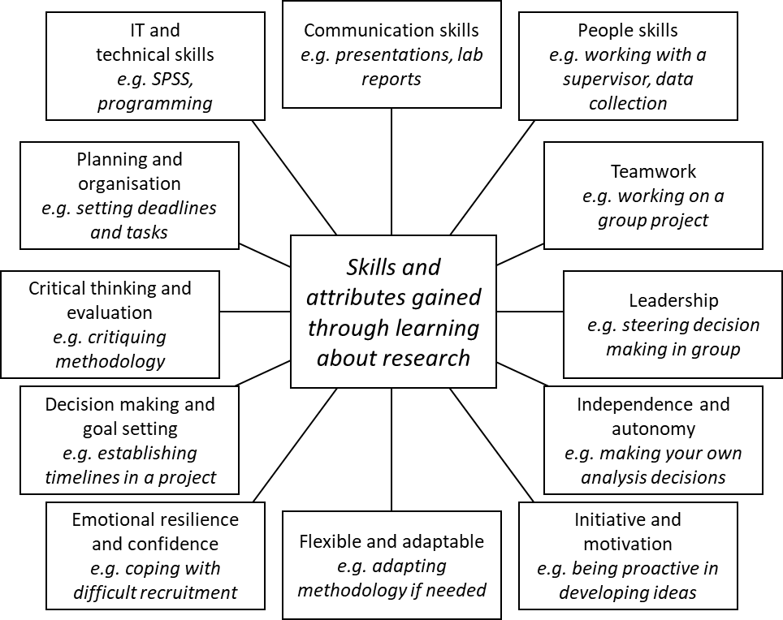
Figure 1: A summary of the key skills and attributes that students acquire when learning how to become a researcher, and the ways in which they may develop these skills (in italics).

With this ground work and understanding in place, the various elements covered are referred back to throughout the year, particularly when working on their second year group research projects. To embed employability within these projects, the group starts by discussing each member’s strengths, weaknesses and approach to team work, and together they develop a “Group Contract” to clearly define the key roles and deadlines for the project. Students are also given an “Employability Profile” to complete for each research project, allowing them to keep track of examples of when they have demonstrated each of the key employability skills, which they can then use in job applications and interviews.
The remainder of this paper describes employability focused strategies and initiatives that we developed and implemented in Year Three, within our Final Year Research Project module.

Recognise: Employability focused lectures
We introduced three compulsory employability focused lectures on our Projects module, which were scheduled in Term One, whilst students were developing their projects. An overarching goal of these lectures was to help students recognise the knowledge and skills they have gained and to discuss their application beyond their undergraduate degree. The first lecture was developed and delivered by a member of staff, who had also been an undergraduate student in the department. The purpose of this lecture was to guide the students in how they can get most out of their Projects by learning from those who have done it. Students often think about employability in a very generic way, but we wanted them think more specifically about their Projects. Therefore, this lecture included a lot of practical advice for students on how to manage Projects effectively, as well as on how to use them to advance their career prospects. It was scheduled relatively early in Term One in order to provide initial guidance and encouragement from somebody who, not so long ago, was in the same position. The lecture was also envisaged as a support for Project supervision in that it addressed several practical generic skills, such as managing your time, your group members and your Project supervisor. An aim was to assist Project supervisors by providing uniform training across the entire cohort and managing student expectations when it comes to working with a supervisor.
The second lecture was developed and delivered by a colleague from the university career’s service, also a psychology graduate. This lecture focused on helping students recognise specific skills developed and used in Projects, but this time more from an employer’s perspective, by discussing and providing examples on how Projects can be used in job and further study applications and interviews. An important message of this lecture was to demonstrate to students that the skills required to conduct research can be used in a variety of jobs, both within and outside the discipline of psychology.
The final lecture focused on guiding students to prepare and deliver a presentation on their Projects in a form of a mock job interview, which we describe later in the paper.

Reflect: Progress self-reflection logs
Employability is “evidenced in the application of a mix of personal qualities and beliefs, understandings, skilful practices and the ability to reflect productively on experience” (Yorke, 2006, p. 13). Being able to monitor, reflect on and evaluate your own progress is an important employability skill (Rivera-Pelayo, Zacharias, Muller, & Braun, 2012; Yorke 2006). Therefore, our next initiative focused on building students’ self-reflective and self-evaluative skills through the entire Project. We designed an optional activity where students were encouraged to complete self-reflective logs on Moodle (our virtual learning environment) after each Project milestone (e.g. proposal, ethics, data collection, presentation, etc.). These are example questions: ‘Have you completed data collection?’ [Include here] your comments/self-reflection on how you found this process and your learning’. This enabled them to reflect on their progress and learning, consider what they could have done differently and how they might use these skills in the future. They were instructed on how to use these logs in their first Project lecture. These logs were designed for students’ personal use, so that they can track their own progress and self-reflect. They could then discuss their progress with their supervisor in one of their progress monitoring meetings. Students can potentially use their completed self-reflective logs later, in their job and further study applications.

Relate: Employability focused student presentations
We used employability focused lectures to help students recognise the knowledge and skills they learned, developed and used while doing their Project. Self-reflective logs were used to encourage students to reflect on these skills. The next step was to help them articulate and relate these skills to their career plans. In the past, our Project students were required to present their Project to their group and their supervisor. This involved presenting on their Project background, hypotheses, methodology and expected results. This year, we decided to use presentations to enable students to practise their presentation and interviewing skills. This is a formative assessment and each student was required to present for ten minutes in front of their Project group and their supervisor. They were instructed to imagine that they were being interviewed for their dream job/further study position, in front of an interview panel. Firstly, they were asked to provide a brief summary of their Project progress so far. After this, they were expected to answer two to three interview questions, which they selected from a pool of twenty interview questions ahead of their presentations, allowing them to prepare their answers. They were also required to relate their answers specifically to the skills they developed and used in their Projects. The twenty questions were developed in collaboration with our career’s service and they covered a range of skills, for example: ‘Tell me about a time you had to work as part of a team’; ‘Tell me about a time you had to manage or co-manage a large project’; ‘Describe a time you had to use analytical skills’; ‘What do you know about Open Science and good research practices’?
We also embedded employability in the presentation feedback, through peer feedback. Being able to provide constructive feedback is a key employability skill (Dochy, Segers, & Sluijsmans, 1999), often overlooked and overshadowed by focusing primarily on students receiving feedback. We developed a brief peer feedback form, which each student in the audience (typically five to eight students) was asked to use to provide feedback to their fellow students. Students were instructed to provide helpful, meaningful and constructive feedback. Another goal of peer feedback was to provide support to supervisors by actively involving students in the feedback process and creating a shared learning environment (Coffield, Moseley, Hall, & Eccelstone, 2005).

Conclusions and next step
The three initiatives we described in this paper, in combination, focused on helping students recognise, reflect and relate the knowledge and skills they gained and utilized in their Final Year Research Project. To evaluate the success of these initiatives, feedback was gathered via college student feedback forms, progress self-reflective logs and personal communication with students and staff. So far, we have received positive initial feedback on all the initiatives described in this paper, from both students and staff. We are yet to receive completed student feedback forms and fully analyse them. We will also continue to monitor our post-graduation employment statistics and get in touch with our alumni.
As we continue developing our employability focused approach to Projects, our next step is to work closely with Project supervisors and explore how employability could be embedded in their one-to-one supervision of students. We know that many supervisors already do this, for example by engaging students in their existing, often externally funded projects, enabling students to present at conferences, etc. Our aim is to develop a systematic approach where all students would benefit from such activities. This would require developing and providing appropriate guidance and training for supervisors to help them implement this.
We are happy to share our resources with the readers and look forward to their feedback on our existing and future employability initiatives within our Final Year Research Projects module.

References
Coffield, F., Moseley, D., Hall, E., & Eccelstone, K. (2005). Learning styles and pedagogy in post-16 learning: A systematic and critical review. [Online] London: Learning Skills Research Centre.

Dochy, F., Segers, M., & Sluijsmans, D. (1999) The use of self-, peer and co-assessment in higher education: A review. Studies in Higher Education, 24(3), 331-350.

Rivera-Pelayo, V., Zacharias, V., Muller, L., & Braun, S. (2012). Applying Quantified Self Approach to Support Reflective Learning. Proceedings of the 2nd International Conference on Learning and Knowledge (pp. 111-114), Vancouver, Canada.

Yorke, M. (2006). Employability in higher education: what it is – what it is not. Learning and employability series I. Higher Education Academy.

