Heparan sulfate proteoglycans regulate BMP signalling during neural crest induction

James Pegge¹, Arnold Junior Tatsinkam^{2, 3}, Christopher C. Rider², Esther Bell¹

¹Centre for Developmental Neurobiology, King’s College London, Guy’s Campus, London SE1 1UL, UK

²Centre for Biomedical Sciences, Royal Holloway University of London, Egham Hill, Egham, Surrey TW20 0EX, UK

³Present address: Merck, Route de Fenil 25, 1809, Corsier-sur-Vevey, Switzerland

Abstract

Bone morphogenetic protein (BMP) signalling is key to many developmental processes, including early regionalisation of the ectoderm. The neural crest is induced here by a combination of BMP and Wnt signals from nearby tissues with many secreted factors contributing to its initial specification at the neural plate border. Gremlin 1 (Grem1) is a secreted BMP antagonist expressed in the neural crest in Xenopus laevis but its function here is unknown. As well as binding BMPs, Grem1 has been shown to interact with heparan sulfate proteoglycans (HSPGs), a family of cell surface macromolecules that regulate a diverse array of signalling molecules by affecting their availability and mode of action. This study describes the impact of HSPGs on the function of Grem1 in neural crest induction. It shows for the first time that Grem1 is required for neural crest development in a two-step process comprising an early HSPG-independent, followed by a late HSPG-dependent phase.

Introduction

The neural crest is a crucial progenitor cell population arising at the border of the neural plate during vertebrate embryogenesis. Neural crest cells migrate throughout the body and differentiate into diverse derivatives, including melanocytes, craniofacial skeleton, and much of the peripheral nervous system (Simoes-Costa and Bronner, 2015). The neural crest is specified by a combination of signals including BMPs (Barth et al., 1999; Marchant et al., 1998; Nguyen et al., 1998; Tribulo et al., 2003), Wnts (Bang et al., 1999; Chang and Hemmati-Brivanlou, 1998; Garcia-Castro et al., 2002; LaBonne and Bronner-Fraser, 1998; Saint-Jeannet et al., 1997), and FGFs (Monsoro-Burq et al., 2003; Nichane et al., 2008) from the non-neural ectoderm and underlying mesoderm. These signals are integrated at the neural plate border by a set of key transcription factors. For instance, Msx1 responds to both active Wnt signalling and levels of BMP signalling intermediate to those in the neural plate and non-neural ectoderm to promote Pax3 and Zic1 (Monsoro-Burq et al., 2005; Tribulo et al., 2003). Pax3 also responds directly to Wnt signalling (Monsoro-Burq et al., 2005). The combined activity of Pax3 and Zic1 activates specifier genes like foxd3 to initiate neural crest cell migration and their later differentiation into a wide array of derivatives (de Croze et al., 2011; Milet et al., 2013; Monsoro-Burq et al., 2005; Sato et al., 2005).

Gremlin 1 (Grem1) is a member of the Dan family of BMP antagonists, secreted proteins that directly bind BMPs to obstruct signal transduction (Brazil et al., 2015). Originally identified in Xenopus, it was found to be expressed in neural crest cells, although its role in their development remains unknown (Hsu et al., 1998). Like many signalling molecules (Rider and Mulloy, 2017), Grem1 can also bind to heparan sulfate proteoglycans (HSPGs), cell surface macromolecules that may regulate its distribution and biological activity (Tatsinkam et al., 2015; Tatsinkam et al., 2017). HSPGs have been shown to mediate Grem1 Vegfr2 agonism, independently from its role in BMP signalling (Chiodelli et al., 2011). The present study details a novel requirement for Grem1 in neural crest induction in Xenopus that depends on its ability to bind HSPGs.

Results and discussion

Endogenous Grem1 expression

To determine the function of Grem1 in neural crest development, we first investigated its endogenous expression. Transcriptomic studies, including microarray (Yanai et al., 2011) and RNA-Seq (Session et al., 2016) approaches have detected early grem1 expression in Xenopus around the time of gastrulation, when neural crest induction occurs. This was verified here using qPCR, which showed the same profile of early expression, followed by a slight fall then a gradual rise (Fig. S1). The source of early expression remains unclear. Single-cell RNA-Seq on Xenopus laevis ectoderm does not show specific grem1 expression at early stages, suggesting it may be expressed by deeper tissue layers such as mesoderm (Plouhinec et al., 2017). Similarly, a whole-embryo single-cell dataset fails to reveal tissue specificity, although this may be due to insensitivity to lower expression levels (Briggs et al., 2018).

Later in development, however, tissue-specific expression is detectable by in situ hybridisation (Hsu et al., 1998). At tailbud stages expression is seen in the cranial neural crest (Fig. 1A), within the periocular mesenchyme (Fig. 1B) and dorsal pharyngeal region (Fig. 1C). The function of neural-crest-derived Grem1 is unclear but in chickens it has been linked with the maintenance of forebrain development (Creuzet, 2009), and craniofacial myogenesis (Tzahor et al., 2003). Due to the early onset of grem1 expression (Session et al., 2016; Yanai et al., 2011), preceding neural fold stages, and its later expression in migratory neural crest cells, we investigated its requirement in initial neural crest specification.

Grem1 is required for neural crest development

To examine the role of Grem1 in neural crest specification we first analysed the expression of twist1, a cranial neural crest marker (Fig. 1D). Unilateral overexpression by injection of Xenopus grem1 RNA caused an expansion in twist1 expression (Fig. 1E), indicating an increase in neural crest cells. Knockdown was achieved with the use of an antisense, translation-blocking morpholino. While injection of a standard control morpholino had no effect on twist1 (Fig. 1F), injection of the grem1 morpholino caused a severe reduction (Fig. 1G), indicating disrupted neural crest formation.

To test the functional conservation of Grem1 with its mammalian counterpart, the effect of the mouse orthologue was also analysed. Injection of murine grem1 RNA also caused a substantial expansion in twist1 expression (Fig. 1H), indicating that the proteins are conserved with respect to neural crest specification. Murine grem1, which escapes inactivation by the Xenopus-specific morpholino due to mismatches in the sequence flanking the start codon, was subsequently used for rescue experiments. Compared to embryos injected with a control morpholino (Fig. 1I), bilateral knockdown caused a reduction in neural crest on both sides (Fig. 1J). Subsequent unilateral supplementation with murine grem1 successfully rescued the neural crest on the injected side (Fig. 1K). Minimal lateral shift suggested that the neural plate was not dramatically expanded, as might be expected of a generic BMP antagonist, but that Grem1 specifically affects the neural crest. The ability to rescue the morphant phenotype also demonstrated specificity of the morpholino, eliminating the possibility of off-target effects.

To ensure that this was a general effect on the neural crest, several additional markers were examined. The neural crest specifier sox10 (Fig. 1L) was also reduced after knockdown (Fig. 1M), confirming that Grem1 is required, and was correspondingly expanded by overexpression (Fig. 1N). Another general neural crest marker, foxd3 (Fig. 1O), was similarly reduced after knockdown (Fig. 1P), and was also expanded by overexpression (Fig. 1Q). This validated the importance of Grem1 for neural crest specification.

Grem1 is required for neural plate border formation

Neural crest induction is part of the more general process of ectoderm regionalisation. The effect of Grem1 knockdown and overexpression on the neural crest prompted an analysis of its effects on other genes involved in ectoderm patterning. The neural plate expresses sox2 (Fig. 2A), and, unlike twist1, sox10, and foxd3, was maintained after knockdown (Fig. 2B). Although sox2 was expanded by overexpression (Fig. 2C), the expansion was less pronounced than those of the neural crest markers. Grem1 is therefore sufficient but not required for neural induction.

In addition to this general marker, some more specific genes were examined to assess any changes along the anteroposterior axis. Expression of otx2 in the forebrain and midbrain (Fig. 2D) was moderately reduced in the most rostral part after Grem1 knockdown (Fig, 2E), but overexpression had no clear effect (Fig. 2F). Expression of emx1 in the anterior forebrain (Fig. 2G) was lost after knockdown (Fig. 2H), but also unaffected by overexpression (Fig. 2I). These results suggested that Grem1 is also required for the specification of the anterior neural plate. The effect on both the neural crest at the lateral border and the anterior forebrain at the rostral border may reflect a general requirement for neural plate border specification. The ability of exogenous Grem1 to affect sox2 (Fig. 2C) but not otx2 (Fig. 2F) or emx1 (Fig. 2I) indicates that the expanded neural plate possesses altered positional identity.

To determine the position of Grem1 in the neural crest induction cascade, several upstream markers of the neural plate border were examined. Expression of msx1 in the neural plate border (Fig. 2J) was reduced after knockdown (Fig. 2K) and expanded after overexpression (Fig. 2L). Expression of pax3 in the anterior neural plate border (Fig. 2M) was unaffected by loss of Grem1 (Fig. 2N) but also expanded by overexpression (Fig. 2O). Likewise, zic1, which is additionally expressed in the anterior neural fold (Fig. 2P), was unaffected by knockdown (Fig. 2Q) but expanded by exogenous Grem1 (Fig. 2R). The expansion of all these markers after overexpression demonstrates that Grem1 is sufficient to expand the neural plate border. The effect of knockdown on msx1 (Fig. 2K), foxd3 (Fig. 1P) sox10 (Fig. 1M), and twist1 (Fig. 1G,J), indicates a fundamental requirement in the neural crest induction programme at this region.

Grem1 is not required for mesoderm specification

The mesoderm marker tbxt (also known as brachyury or xbra, Fig. 2S) was also examined to determine whether the effect of Grem1 on the neural crest and neural plate border was due to defects in mesoderm specification impairing signalling to the ectoderm. No clear change was seen after either Grem1 knockdown (Fig. 2T) or overexpression (Fig. 2U). This implies that Grem1 is not required for mesoderm specification.

The activity of Grem1 in vivo is dependent on HSPG binding

Grem1, like many secreted signalling proteins, is able to bind cell surface HSPGs, which can modulate its biological activity (Chiodelli et al., 2011; Tatsinkam et al., 2015; Tatsinkam et al., 2017). Two mutant Grem1 (Mgr) proteins with impaired HS binding have been well-characterised. Their expression levels in cell culture and their affinity to BMP4 were comparable to wild-type Grem1 (Tatsinkam et al., 2015; Tatsinkam et al., 2017). These were used here to investigate the impact of HSPGs on the activity of Grem1 in vivo. The mutants contain non-conservative substitution mutations in key arginine and lysine residues, within the functionally important cysteine knot domain, (Fig. 3A) that mediate HS binding.

Xenopus laevis has proven to be an invaluable model organism for linking molecular function to biological relevance. Indeed, Grem1 was originally identified and defined as a BMP antagonist by an axis induction screen in Xenopus (Hsu et al., 1998). This approach was used again here to compare the mutants with the wild-type protein. Embryos were injected with RNA into a ventral blastomere at the four-cell stage and assessed at tailbud stages for the presence of a secondary axis. Coinjected gfp was used as a lineage tracer and alone had no effect (Fig. 3B,B′). Wild-type Grem1, as expected, was able to induce a secondary axis (Fig. 3C,C′), a readout for BMP antagonism. However, neither Mgr5 (Fig. 3D,D′) nor Mgr6 (Fig. 3E,E′) could induce a secondary axis at any of the tested doses (Fig. 3F). Independently from its affinity to BMPs, therefore, the ability of Grem1 to efficiently inhibit BMP signalling relies on unimpaired HS binding. HSPGs may facilitate its activity directly at the cell surface or alter its distribution and availability in the extracellular space. Experiments in cell culture have shown a modest reduction in BMP inhibition by Mgr5 and Mgr6 compared with wild-type Grem1 (Tatsinkam et al., 2017). The present findings indicate that HSPGs are essential for this aspect of Grem1 activity in vivo.

The effect of Grem1 on neural crest induction is dependent on HSPG binding

The requirement for Grem1 to bind HSPGs to induce neural plate border was also investigated. As in the earlier experiments (Fig. 2J-R), embryos were analysed at stage 14 for msx1 (Fig. 4A), pax3 (Fig. 4D), and zic1 (Fig. 4G) expression. Unexpectedly, in contrast to their loss of function in the axis induction assay (Fig. 3), both constructs retained the ability to expand the expression of msx1 (Fig. 4B-C), pax3 (Fig. 4E-F), and zic1 (Fig. 4H-I). Effective HSPG binding, therefore, is not required for the initial inductive capacity of Grem1 at the neural plate border.

The effect of the mutants on the neural crest itself was then tested. As before (Fig. 1D-K), embryos were analysed at the neurula stage for twist1 expression (Fig. 4J). Again, unilateral Grem1 overexpression caused an expansion on the injected side (Fig. 4K). However, neither Mgr5 (Fig. 4L) nor Mgr6 (Fig. 4M) could do the same. Similar results were found for sox10 (Fig. S2A-C). However, foxd3 was affected by Mrg5 and Mgr6 in a minority of cases (Fig. S2D-F). This may represent a more upstream position in the neural plate border and neural crest induction cascade. These findings were supported by attempts to rescue neural crest induction (Fig. 4N-R). As in the previous rescue experiment (Fig. 1I-K), bilateral morpholino knockdown caused a severe reduction in expression (Fig. 4O), but subsequent unilateral injection of Grem1 was sufficient to restore it again (Fig. 4P). Again, neither Mgr5 (Fig. 4Q) nor Mgr6 (Fig. 4R) could do the same. This demonstrated that functional HSPG binding is essential for the capacity of Grem1 to induce neural crest, for which it is endogenously required.

The effect of the mutants on the neural plate border was confirmed by a similar rescue experiment (Fig. S2G-K). Bilateral knockdown obliterated msx1 expression (Fig. S2H), which was partially rescued by Grem1, as expected (Fig. S2I). Interestingly, both Mgr5 (Fig. S2J) and Mgr6 (Fig. S2K) were also able to rescue msx1. This confirmed that HSPG binding is not required for the upstream activity of Grem1 at the neural plate border.

Conclusion

The experiments presented in this study demonstrate a novel role for Grem1 in neural crest induction. Furthermore, they show that this function is regulated by HSPGs. Grem1 acts independently of HSPGs to first induce neural plate border genes such as msx1. It then enters a second, HSPG-dependent phase to allow the expression of neural crest specifiers (Fig. 4S). The results of this study highlight the importance of interactions between HSPGs and components of key signalling pathways during embryonic development.

Whether HSPGs simply stabilise Grem1 protein sufficiently to maintain its inductive activity, or whether they also modulate its interactions with other molecules remains to be seen. For example, HSPGs have been shown to mediate Vegfr2 agonism by Grem1, indicating that they can impact its effects on pathways other than BMP signalling (Chiodelli et al., 2011). Furthermore, VEGF signalling has previously been linked to neural crest migration so it is reasonable to suggest that HSPG-dependent VEGF signalling may be involved in other aspects of neural crest development, such as induction (McLennan et al., 2015). Our data suggest that the effect of Grem1 on BMP signalling and potentially VEGF and other pathways is dependent on the presence and perhaps the composition of surrounding HSPG molecules. This study represents the first evidence of a role for Grem1 in neural crest specification and reveals a novel role for HSPGs during this process.

Acknowledgements

The authors would like to thank Anthony Graham, Clemens Kiecker, and Karen Liu for their helpful advice throughout this work, and A.G. and K.L. for their insightful comments on the manuscript. Thanks also to Ali Brivanlou, Richard Harland, Anne-Hélène Monsoro-Burq, and Christof Niehrs for sharing plasmids.

Funding sources

This project was supported by an MRC PhD studentship to J.P.

Materials and methods

In vitro transcription and morpholino preparation

Plasmids were linearised by restriction digest and RNA for embryo microinjection transcribed using the mMessage mMachine Kit (Invitrogen). Riboprobes for in situ hybridisation were transcribed using the DIG RNA Labelling Kit (Roche). Morpholinos (Gene Tools) were prepared by dissolving in autoclaved, double deionised H₂O to the required concentration for microinjection. Sequence for grem1 translation-blocking morpholino 1: TGT CCT ACT TGA CAG AGC AAA TAC G. Sequence for morpholino 2: CTG GCT CAC AGC AGA TCA AGA CTA G.

Microinjection

Micropipettes were prepared from glass capillary tubes using a Sutter P-97 needle puller and embryos injected using a Harvard Apparatus PLI-100 microinjector. Injection volume was calibrated by adjusting pulse duration and measuring the size of the droplet in mineral oil over a 0.05 mm graticule. Embryos were immersed in a 3.5% w/v solution of Ficoll (Sigma) in 0.5x Marc’s Modified Ringer’s solution (MMR) for injection to prevent leakage and remained in this solution for at least 4 hours post-injection to allow puncture closure before transfer into 0.1x MMR. For overexpression and knockdown experiments, injection into the animal pole of one hemisphere at the two-cell stage was used to target the ectoderm unilaterally, leaving the contralateral side unaffected, providing an internal control.

Fixation and screening

Embryos were fixed in MEMFA for 10 minutes then washed into PBS for screening and, if necessary, X-gal staining. They were then screened by epifluorescence microscopy. Embryos were selected based on the presence of fluorescent lineage tracer, indicating successful injection uptake, then sorted by location of fluorescence on either the right- or left-hand side, indicating unilateral targeting. Embryos also injected with lacZ were assessed for the presence of β-galactosidase by incubation at 37C with X-gal solution until suitable staining was observed. All embryos were fully fixed for a further 50 minutes in MEMFA to total 1-hour overall fixation. They were then dehydrated by washing twice in methanol and stored at -20C.

In situ hybridisation

Embryos were gradually rehydrated by a decreasing methanol series. They were then bleached for 2 hours in 4% v/v H₂O₂, 5% v/v formamide in 0.5x saline sodium citrate buffer (SSC). This was followed by six washes in PBS. Embryos were equilibrated in hybridisation buffer at 60C for 1 hour then were hybridised overnight with 1 µg/ml riboprobe.

Excess riboprobe was washed out with fresh hybridisation buffer. Embryos were then washed once in 2x SSC, twice in 0.2x SSC, and once in maleic acid buffer (MAB), prior to blocking in 2% w/v blocking reagent (Roche) in MAB for 1 hour. Embryos were then incubated with anti-DIG antibody conjugated to alkaline phosphatase (Roche) in blocking solution at 4C overnight.

Excess antibody was removed by a series of five MAB washes of 1 hour at room temperature, followed by an additional overnight wash. Embryos were equilibrated in NTMT and colour reaction performed in the dark in NBT/BCIP (Roche) diluted 1:200 in NTMT until suitable staining was observed.

Sectioning

Whole-mount stained embryos for sectioning were fixed in 4% v/v paraformaldehyde at 4C overnight then washed thoroughly in PBS. They were then equilibrated in molten 20% w/v gelatine at 50C. Embryos were embedded in gelatine and the blocks trimmed before fixation in 4% v/v paraformaldehyde for a further 3-5 days then washed in PBS. Blocks were sectioned on a Leica VT1000 S vibratome to a thickness of 50 µm and mounted on slides in 90% v/v glycerol under a coverslip.

qPCR

Total RNA was extracted from whole embryos with 500 μl TRIzol (Invitrogen) and resuspended in autoclaved, double deionised H₂O. Random hexamer primers were annealed at 65 °C for 4 minutes then left on ice before cDNA was reverse transcribed with SuperScript II (Invitrogen) at 42 °C for 30 minutes. qPCR was performed using a SensiMix SYBR Hi-ROX Kit (Bioline) and the following primers: grem1f TGG GCA ATG CAA CTC CTT CT, grem1r GTG GGA GGT TGT AGC TCT GG, odc1f TGC TTT GCT GGT TCT AGT TAC TG, odc1r GTA CCC ATC GAG GCC ACA AA. Amplification was run on a Lightcycler 480 (Roche) in 96-well plates with the following parameters: initial denature 10 minutes 95 °C, 40 amplification cycles, denature 15 seconds 95 °C, anneal 30 seconds 60 °C, elongate 30 seconds 72 °C, final melt curve to check primer specificity. Expression of grem1 was normalized to odc1 and given relative to that at NF stage 36.

Figure 1. Endogenous grem1 expression pattern, and effects of knockdown and overexpression on the neural crest. (A-C) Stage 36 grem1 expression pattern. (A) Whole-mount stained embryo showing strong expression in the kidney primordia (k), posterior roofplate (rp) and tailbud (tb), and neural crest (nc). (B-C) Transverse sections from embryo like the one shown, with approximate anteroposterior locations marked by dashed lines in A. (B) In the most anterior region, grem1 is expressed in neural crest cells ventral to the developing eye fields (e). (C) In the pharyngeal region, expression is seen in neural crest cells flanking the neural tube (nt) and invading the tissue around the pharyngeal pouches (pp). (D-E) Effect of grem1 overexpression on the neural crest. (D) Cranial neural crest (nc) around stage 18 is marked by the expression of twist1, flanking the anterior neural plate. (E) Overexpression by injection of Xenopus grem1 RNA causes a substantial expansion (arrowhead) of the neural crest (n = 12/19). (F-G) Effect of grem1 knockdown. (F) At stage 21 twist1 marks the neural crest as it begins to surround the eye fields (e) and to migrate in two more posterior streams. It is unaffected by unilateral injection of a standard control morpholino (n = 30/30). (G) Knockdown of grem1 by injection of a translation-blocking morpholino severely impairs neural crest formation (asterisk, n = 80/93). (H) Injection of murine grem1 RNA is also able to expand the domain of twist1 expression (arrowhead), indicating functional conservation between the mouse and Xenopus orthologues (n = 59/74). (I-K) Rescue of neural crest formation with murine grem1. (J) Bilateral grem1 knockdown depletes the neural crest from both sides (asterisks). (K) Unilateral rescue using murine grem1 RNA, mismatched with the morpholino, which only targets the Xenopus orthologue, is able to restore neural crest development (arrowhead, n = 14/20). (L-Q) Effect of gain and loss of grem1 on other neural crest markers. (L) Control neural crest expresses sox10 (n = 25/25). (M) Unilateral grem1 knockdown abolishes expression on the injected side (asterisk, n = 19/24). (N) Unilateral overexpression expands the domain of sox10 (arrowhead, n = 21/30). (O) Control neural crest also expresses foxd3. (P) Knockdown similarly abolishes expression (asterisk, n = 24/24). (Q) Likewise, the domain is expanded by overexpression (arrowhead, n = 12/15). Embryo in A is shown in side view with anterior towards the left, sections in B-C are transverse with dorsal towards the top, and embryos in D-Q are shown in frontal view.

Figure 2. Grem1 affects regionalisation of the ectoderm and is required for neural plate border formation. (A, D, G, J, M, P, S) Control embryos, (B, E, H, K, N, Q, T) unilateral Grem1 knockdown, (C, F, I, L, O, R, U) unilateral overexpression. (A-I) Stage 17 embryos assayed for neural plate markers, (J-R) stage 14 embryos assayed for neural plate border markers, and (S-U) stage 11 embryos assayed for mesoderm markers. (A-C) The neural plate (np) expresses sox2, which appears to be unaffected by control morpholino (n = 25/25) or loss of Grem1 (n = 26/26) but is expanded (arrowhead) by overexpression (n = 20/33). (D-F) Prospective midbrain and forebrain (fb) regions express otx2, which is unaffected by control morpholino (n = 24/24), while the most anterior part is reduced by knockdown (n = 5/25). It is unaffected by Grem1 overexpression (n = 16/16). (G-I) The future telencephalon (t) expresses emx1, which is unaffected by control morpholino (n = 17/17), requires Grem1 (asterisk, n = 17/25), but is unaffected by overexpression (n = 18/18). (J-L) The neural plate border (npb) is marked by msx1, which is unaffected by control morpholino (n = 19/19), lost (asterisk) after Grem1 knockdown (n = 30/45), and expanded (arrowhead) by overexpression (n = 21/26). (M-O) It is also marked by pax3, which is unaffected by control morpholino (n = 19/19), does not require Grem1 expression (n = 21/23), but can be similarly expanded (arrowhead) by overexpression (n = 20/24). (P-R) Likewise, zic1, which is expressed additionally in the anterior neural fold, is unaffected by control morpholino (n = 18/18) or knockdown (n = 25/25) but expanded (arrowhead) by exogenous Grem1 (n = 21/23). (S-U) The mesoderm (m) expresses tbxt (S), which is unaffected by either Grem1 knockdown (n = 8/8) or overexpression (n = 8/8). Embryos in A-R are shown in frontal view with dorsal-posterior towards the top. Embryos in S-U are shown in vegetal view.

Figure 3. The activity of Grem1 in vivo is dependent on HSPG binding. (A) Sequence alignment of the cysteine knot domains of the wild-type mouse protein and two mutant Grem1 (Mgr) constructs with impaired HS binding. Residues of the characteristic eight-membered cysteine knot are highlighted in yellow, with key basic residues mediating HS affinity in green, and non-conservative substitutions of these residues in red. (B-F) Axis induction assay by ventral misexpression of the indicated genes, traced by coinjected gfp (B-E), and assessed morphologically (B′-E′) for formation of a conjoined secondary axis. (B) Injection of gfp alone has no effect. (C) 150 pg grem1, as expected, is able to induce a secondary axis (arrowhead). (D) This ability is abolished in mgr5. (E) The same goes for mgr6. (F) Graph summarising results of axis induction assay across a range of doses: 200 pg gfp (n = 0/92), 50 pg grem1 (n = 73/78), 150 pg grem1 (n = 31/32), 300 pg grem1 (n = 7/7), 500 pg grem1 (n = 3/3), 50 pg mgr4 (n = 0 /41), 150 pg mgr5 (n = 0/55), 300 pg mgr5 (n = 0/24), 500 pg mgr5 (n = 0/18), 50 pg mgr6 (n = 0/39), 150 pg mgr6 (n = 2/49), 300 pg mgr6 (n = 0/27), 500 pg mgr6 (n = 0/31). All embryos are oriented with anterior towards the left.

Figure 4. The effect of Grem1 on neural crest induction is dependent on HSPG binding. (A-I) Stage 14 embryos assayed for neural plate border markers. (A, D, G) Control embryos, (B, E, H) unilateral mgr5 expression, (C, F, I) unilateral mgr6 expression. (A-C) msx1 expression at the neural plate border is unexpectedly expanded and upregulated by both mgr5 (n = 6/8) and mgr6 (n = 7/9). (D-F) pax3 is similarly affected by mgr5 (n = 7/9) and mgr6 (n = 5/9). (G-I) The same goes for zic1, with mgr5 (n = 7/7) and mgr6 (n 7/7). (J-R) Stage 18 embryos assayed for twist1 expression. (J) The cranial neural crest (nc) is marked by twist1. (K) As expected, unilateral overexpression of grem1 RNA, expands the neural crest on the injected side (arrowhead). (L-M) The same dose of mgr5 (L, n = 26/26) or mgr6 (M, n = 29/29) is unable to elicit an expansion. (N-R) Neural crest induction rescue experiment. (O) Bilateral Grem1 knockdown severely impairs neural crest formation (asterisks). (P) As before, unilateral supplementation with 100 pg wild-type mouse grem1 restores neural crest development (arrowhead). (Q-R) Accordingly, the same dose of mgr5 (Q, n = 17/17) or mgr6 (R, n = 15/16) is unable to rescue the neural crest. (S) Schematic summarising a working model for the function of Grem1 in neural crest induction. (i) BMP (blue) antagonism from the organiser initially induces neural identity in the ectoderm. (ii) Wnt (pink) from the underlying mesoderm and non-neural ectoderm, and Grem1 (yellow), perhaps also from the underlying mesoderm, signals to the future neural plate border, independently of HSPGs. (iii) HSPGs in the neural plate border stabilise and/or modulate the activity of Grem1 protein in this tissue. (iv) This enables the eventual induction of the neural crest. Embryos are shown in frontal view with dorsal-posterior towards the top.
Figure S1. Temporal expression profile of Grem1. qPCR of whole embryos shows an early peak of expression before gastrulation, a slight decrease, then a gradual increase into tailbud stages. NF stage, Nieuwkoop and Faber stage.
Figure S2. Dependence of Grem1 HSPG binding on neural crest and neural plate border specification. (A-F) stage 17 embryos assayed for neural crest markers. (A-C) sox10 expression in the neural crest (nc) is unaffected by Mgr5 (n = 8/8) and Mgr6 (n = 9/9). (D-F) foxd3 is variably expanded (arrowheads) by Mgr5 (n = 4/20) and Mgr6 (n = 5/20). (G-K) stage 15 embryos assayed for neural plate border (npb) marker msx1. (H) Bilateral Grem1 knockdown severely reduces expression (asterisks). (I) Unilateral injection of wild-type mouse grem1 partially restores (arrowhead) expression levels (n = 5/7). (J-K) This ability is retained by Mgr5 (n = 2/3) and Mgr6 (n = 7/7). Embryos are shown in frontal view with dorsal-posterior towards the top.

Figure 1

Figure 2

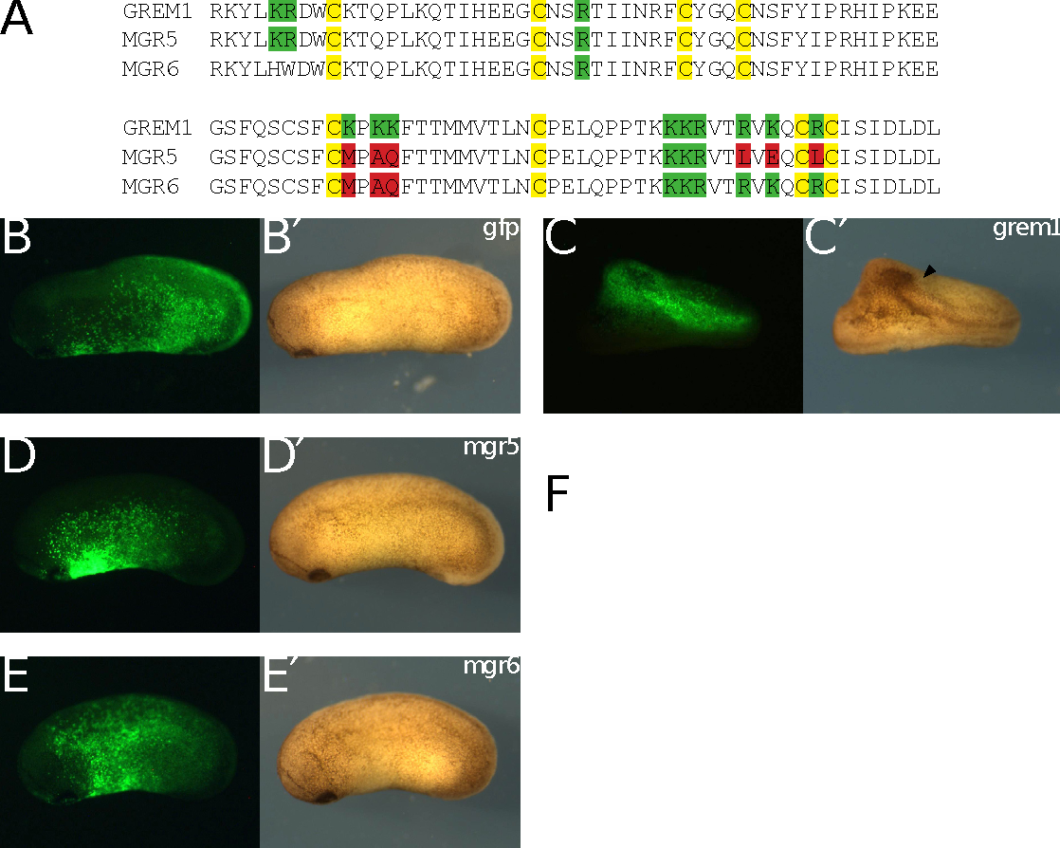

Figure 3

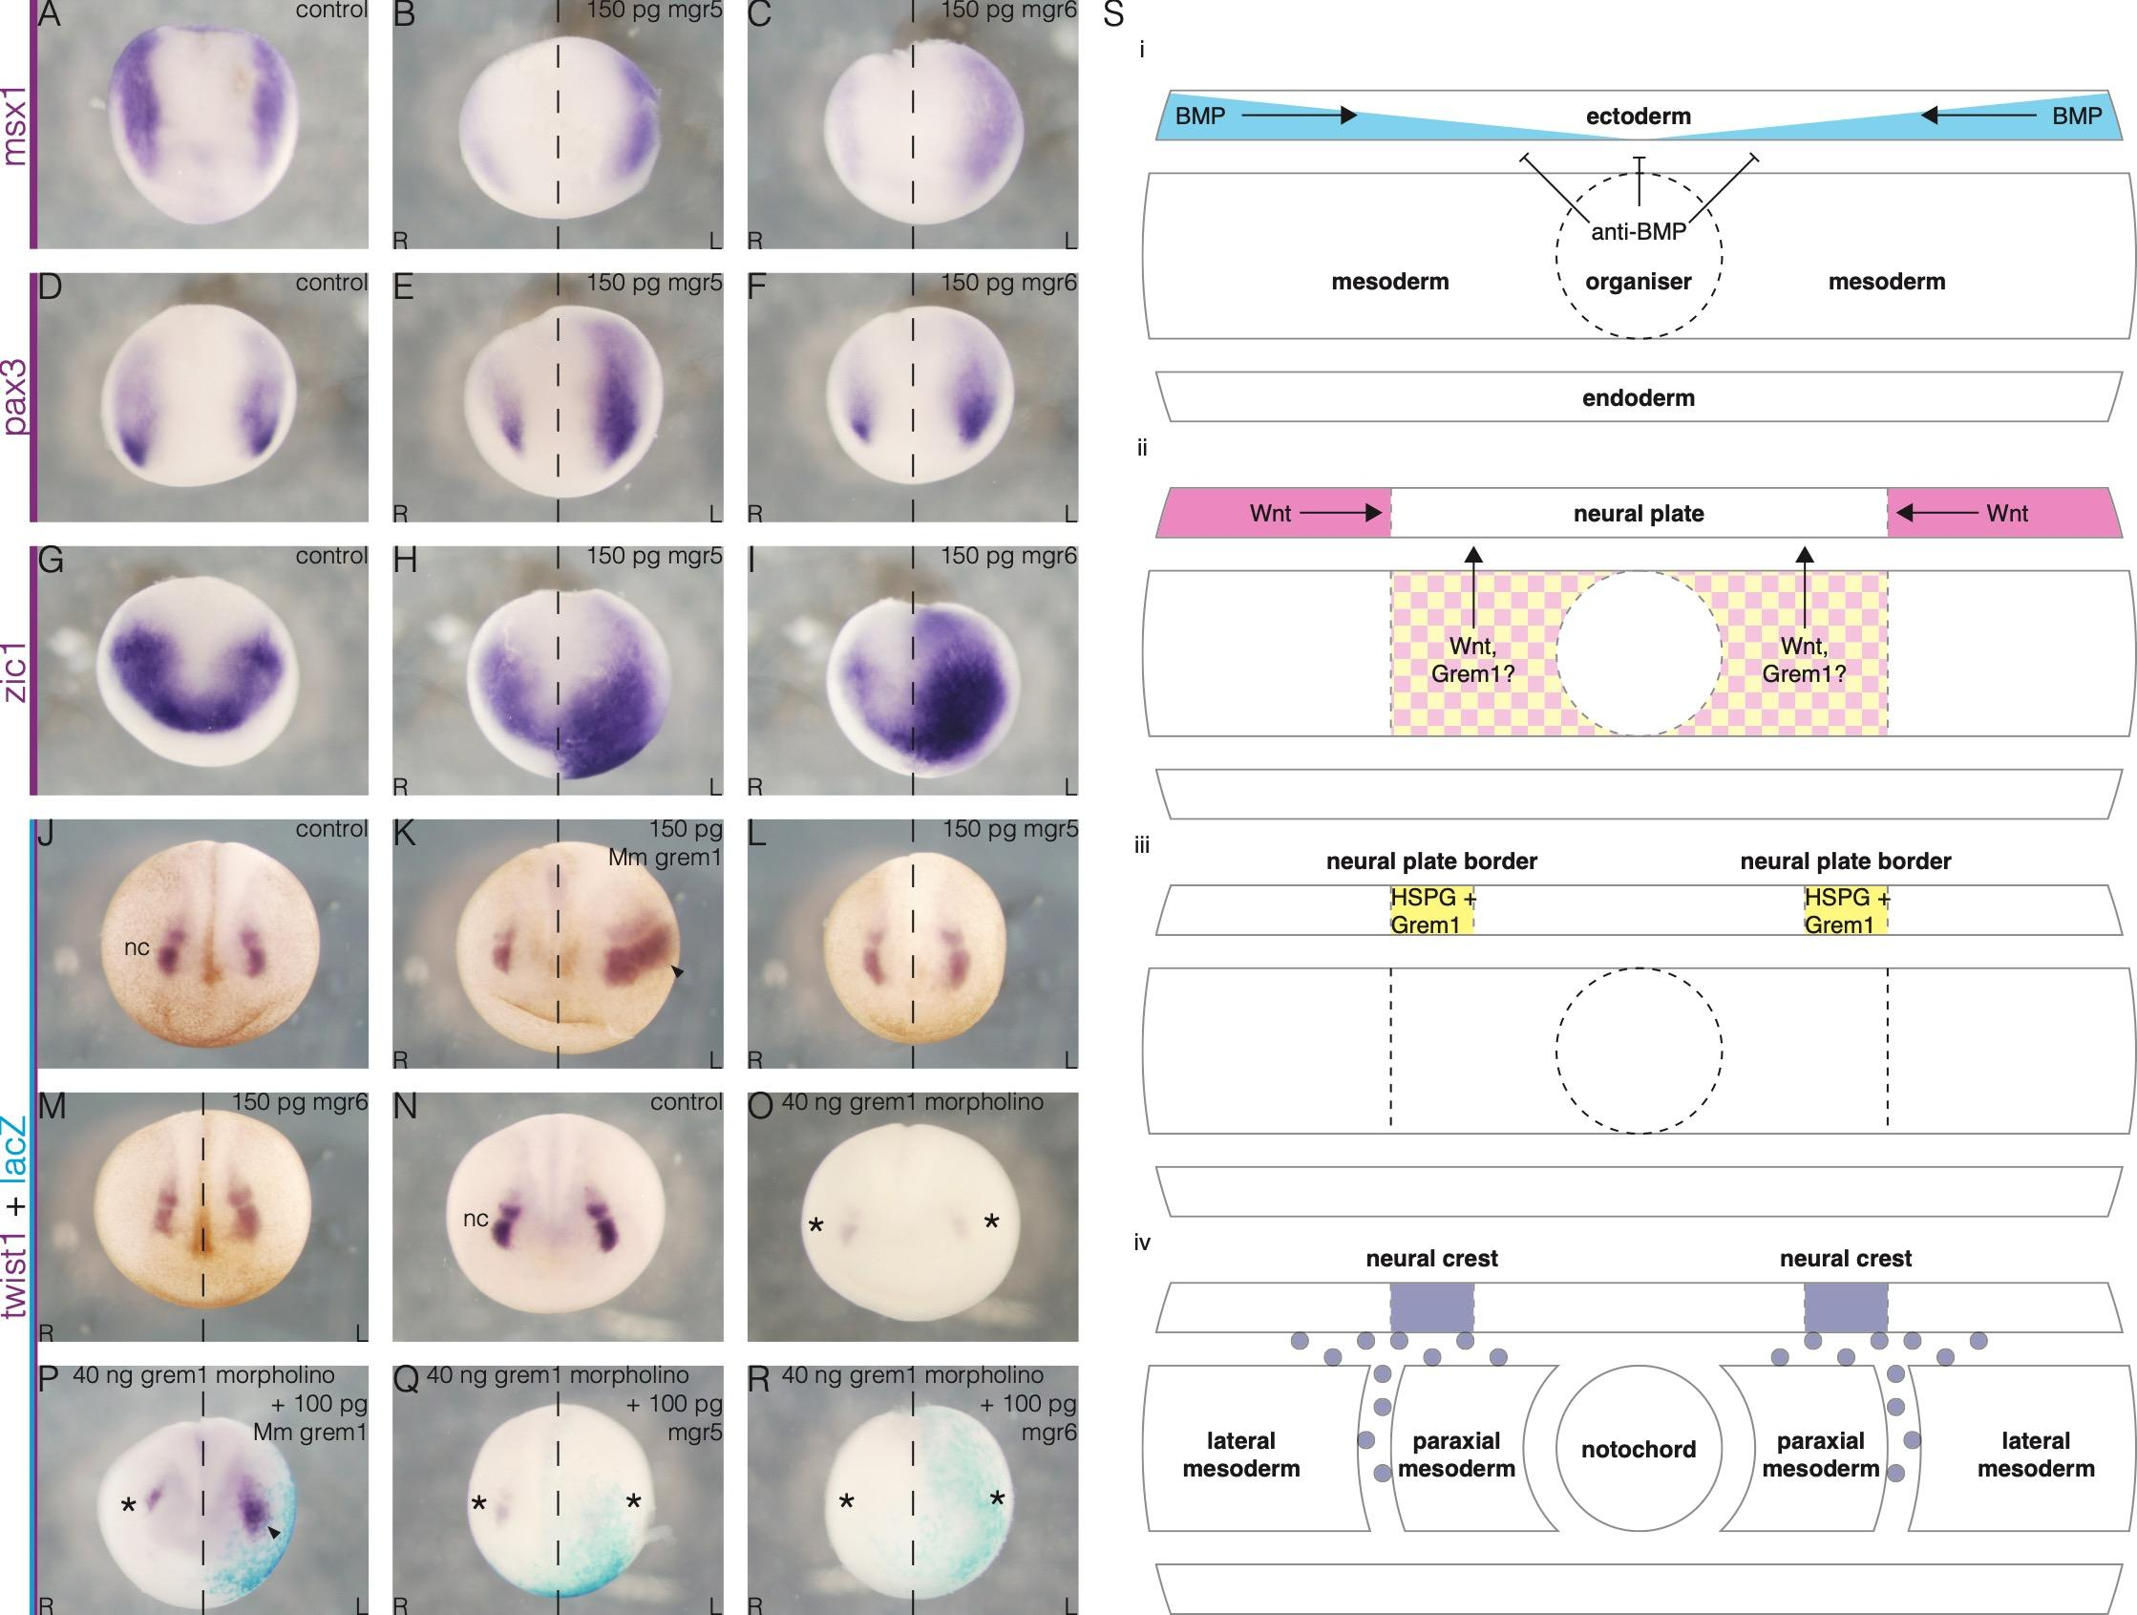

Figure 4

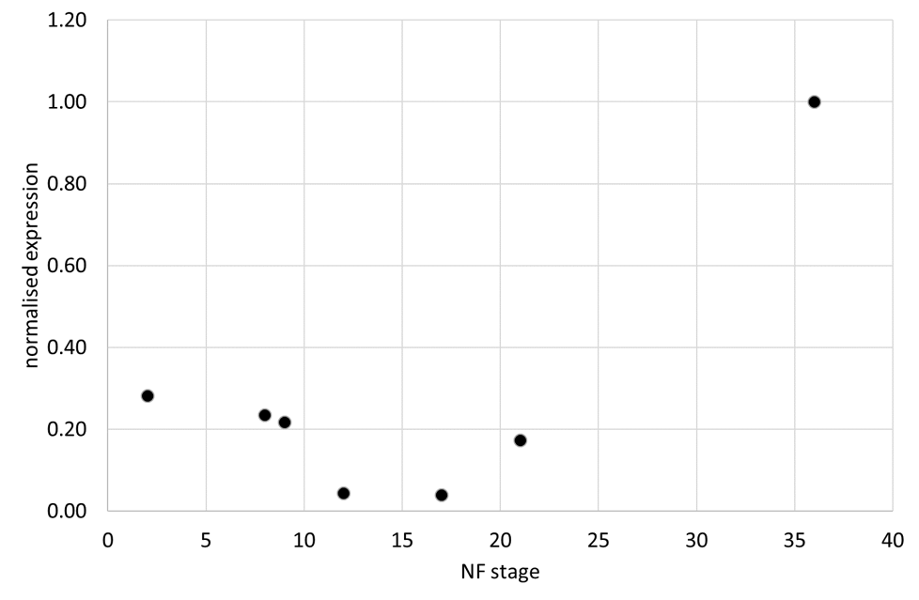

Figure S1

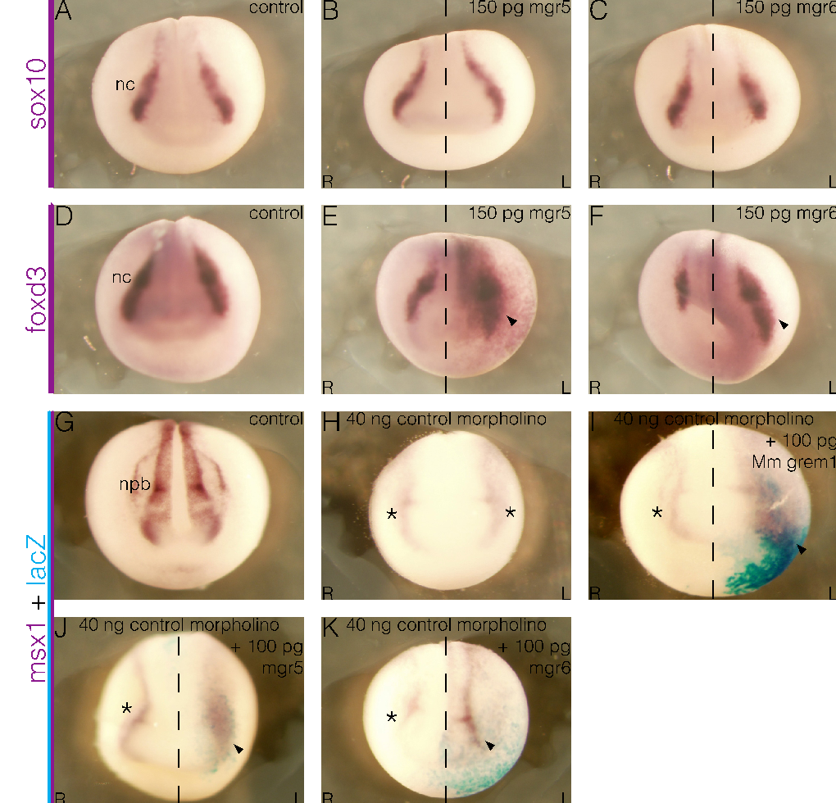

Figure S2

References

Bang, A.G., Papalopulu, N., Goulding, M.D., Kintner, C., 1999. Expression of Pax-3 in the lateral neural plate is dependent on a Wnt-mediated signal from posterior nonaxial mesoderm. Developmental biology 212, 366-380.
Barth, K.A., Kishimoto, Y., Rohr, K.B., Seydler, C., Schulte-Merker, S., Wilson, S.W., 1999. Bmp activity establishes a gradient of positional information throughout the entire neural plate. Development (Cambridge, England) 126, 4977-4987.
Brazil, D.P., Church, R.H., Surae, S., Godson, C., Martin, F., 2015. BMP signalling: agony and antagony in the family. Trends Cell Biol 25, 249-264.
Briggs, J.A., Weinreb, C., Wagner, D.E., Megason, S., Peshkin, L., Kirschner, M.W., Klein, A.M., 2018. The dynamics of gene expression in vertebrate embryogenesis at single-cell resolution. Science 360.
Chang, C., Hemmati-Brivanlou, A., 1998. Neural crest induction by Xwnt7B in Xenopus. Developmental biology 194, 129-134.
Chiodelli, P., Mitola, S., Ravelli, C., Oreste, P., Rusnati, M., Presta, M., 2011. Heparan sulfate proteoglycans mediate the angiogenic activity of the vascular endothelial growth factor receptor-2 agonist gremlin. Arteriosclerosis, thrombosis, and vascular biology 31, e116-127.
Creuzet, S.E., 2009. Regulation of pre-otic brain development by the cephalic neural crest. Proceedings of the National Academy of Sciences of the United States of America 106, 15774-15779.
de Croze, N., Maczkowiak, F., Monsoro-Burq, A.H., 2011. Reiterative AP2a activity controls sequential steps in the neural crest gene regulatory network. Proceedings of the National Academy of Sciences of the United States of America 108, 155-160.
Garcia-Castro, M.I., Marcelle, C., Bronner-Fraser, M., 2002. Ectodermal Wnt function as a neural crest inducer. Science (New York, N.Y.) 297, 848-851.
Hsu, D.R., Economides, A.N., Wang, X., Eimon, P.M., Harland, R.M., 1998. The Xenopus dorsalizing factor Gremlin identifies a novel family of secreted proteins that antagonize BMP activities. Mol Cell 1, 673-683.
LaBonne, C., Bronner-Fraser, M., 1998. Neural crest induction in Xenopus: evidence for a two-signal model. Development (Cambridge, England) 125, 2403-2414.
Marchant, L., Linker, C., Ruiz, P., Guerrero, N., Mayor, R., 1998. The inductive properties of mesoderm suggest that the neural crest cells are specified by a BMP gradient. Developmental biology 198, 319-329.
McLennan, R., Schumacher, L.J., Morrison, J.A., Teddy, J.M., Ridenour, D.A., Box, A.C., Semerad, C.L., Li, H., McDowell, W., Kay, D., Maini, P.K., Baker, R.E., Kulesa, P.M., 2015. VEGF signals induce trailblazer cell identity that drives neural crest migration. Developmental biology 407, 12-25.
Milet, C., Maczkowiak, F., Roche, D.D., Monsoro-Burq, A.H., 2013. Pax3 and Zic1 drive induction and differentiation of multipotent, migratory, and functional neural crest in Xenopus embryos. Proc Natl Acad Sci U S A 110, 5528-5533.
Monsoro-Burq, A.H., Fletcher, R.B., Harland, R.M., 2003. Neural crest induction by paraxial mesoderm in Xenopus embryos requires FGF signals. Development (Cambridge, England) 130, 3111-3124.
Monsoro-Burq, A.H., Wang, E., Harland, R., 2005. Msx1 and Pax3 cooperate to mediate FGF8 and WNT signals during Xenopus neural crest induction. Developmental cell 8, 167-178.
Nguyen, V.H., Schmid, B., Trout, J., Connors, S.A., Ekker, M., Mullins, M.C., 1998. Ventral and lateral regions of the zebrafish gastrula, including the neural crest progenitors, are established by a bmp2b/swirl pathway of genes. Developmental biology 199, 93-110.
Nichane, M., de Croze, N., Ren, X., Souopgui, J., Monsoro-Burq, A.H., Bellefroid, E.J., 2008. Hairy2-Id3 interactions play an essential role in Xenopus neural crest progenitor specification. Developmental biology 322, 355-367.
Plouhinec, J.L., Medina-Ruiz, S., Borday, C., Bernard, E., Vert, J.P., Eisen, M.B., Harland, R.M., Monsoro-Burq, A.H., 2017. A molecular atlas of the developing ectoderm defines neural, neural crest, placode, and nonneural progenitor identity in vertebrates. PLoS Biol 15, e2004045.
Rider, C.C., Mulloy, B., 2017. Heparin, Heparan Sulphate and the TGF-beta Cytokine Superfamily. Molecules (Basel, Switzerland) 22.
Saint-Jeannet, J.P., He, X., Varmus, H.E., Dawid, I.B., 1997. Regulation of dorsal fate in the neuraxis by Wnt-1 and Wnt-3a. Proceedings of the National Academy of Sciences of the United States of America 94, 13713-13718.
Sato, T., Sasai, N., Sasai, Y., 2005. Neural crest determination by co-activation of Pax3 and Zic1 genes in Xenopus ectoderm. Development (Cambridge, England) 132, 2355-2363.
Session, A.M., Uno, Y., Kwon, T., Chapman, J.A., Toyoda, A., Takahashi, S., Fukui, A., Hikosaka, A., Suzuki, A., Kondo, M., van Heeringen, S.J., Quigley, I., Heinz, S., Ogino, H., Ochi, H., Hellsten, U., Lyons, J.B., Simakov, O., Putnam, N., Stites, J., Kuroki, Y., Tanaka, T., Michiue, T., Watanabe, M., Bogdanovic, O., Lister, R., Georgiou, G., Paranjpe, S.S., van Kruijsbergen, I., Shu, S., Carlson, J., Kinoshita, T., Ohta, Y., Mawaribuchi, S., Jenkins, J., Grimwood, J., Schmutz, J., Mitros, T., Mozaffari, S.V., Suzuki, Y., Haramoto, Y., Yamamoto, T.S., Takagi, C., Heald, R., Miller, K., Haudenschild, C., Kitzman, J., Nakayama, T., Izutsu, Y., Robert, J., Fortriede, J., Burns, K., Lotay, V., Karimi, K., Yasuoka, Y., Dichmann, D.S., Flajnik, M.F., Houston, D.W., Shendure, J., DuPasquier, L., Vize, P.D., Zorn, A.M., Ito, M., Marcotte, E.M., Wallingford, J.B., Ito, Y., Asashima, M., Ueno, N., Matsuda, Y., Veenstra, G.J., Fujiyama, A., Harland, R.M., Taira, M., Rokhsar, D.S., 2016. Genome evolution in the allotetraploid frog Xenopus laevis. Nature 538, 336-343.
Simoes-Costa, M., Bronner, M.E., 2015. Establishing neural crest identity: a gene regulatory recipe. Development (Cambridge, England) 142, 242-257.
Tatsinkam, A.J., Mulloy, B., Rider, C.C., 2015. Mapping the heparin-binding site of the BMP antagonist gremlin by site-directed mutagenesis based on predictive modelling. The Biochemical journal 470, 53-64.
Tatsinkam, A.J., Rune, N., Smith, J., Norman, J.T., Mulloy, B., Rider, C.C., 2017. The binding of the bone morphogenetic protein antagonist gremlin to kidney heparan sulfate: Such binding is not essential for BMP antagonism. The international journal of biochemistry & cell biology 83, 39-46.
Tribulo, C., Aybar, M.J., Nguyen, V.H., Mullins, M.C., Mayor, R., 2003. Regulation of Msx genes by a Bmp gradient is essential for neural crest specification. Development (Cambridge, England) 130, 6441-6452.
Tzahor, E., Kempf, H., Mootoosamy, R.C., Poon, A.C., Abzhanov, A., Tabin, C.J., Dietrich, S., Lassar, A.B., 2003. Antagonists of Wnt and BMP signaling promote the formation of vertebrate head muscle. Genes Dev 17, 3087-3099.
Yanai, I., Peshkin, L., Jorgensen, P., Kirschner, M.W., 2011. Mapping gene expression in two Xenopus species: evolutionary constraints and developmental flexibility. Developmental cell 20, 483-496.

