XXX et al. 2019. Multiple traits and multifarious environments: integrated divergence of morphology and life history. – Oikos 000: 000–000.

Supplementary material Appendix 1:

Identity of Sampled Populations

We studied seven blue holes with the predatory fish Gobiomorus dormitor present, and seven blue holes in the absence of this predatory fish on Andros Island, The Bahamas (Fig. A1). The studied blue holes have an average surface diameter of 104 m and average depth of 43 m.
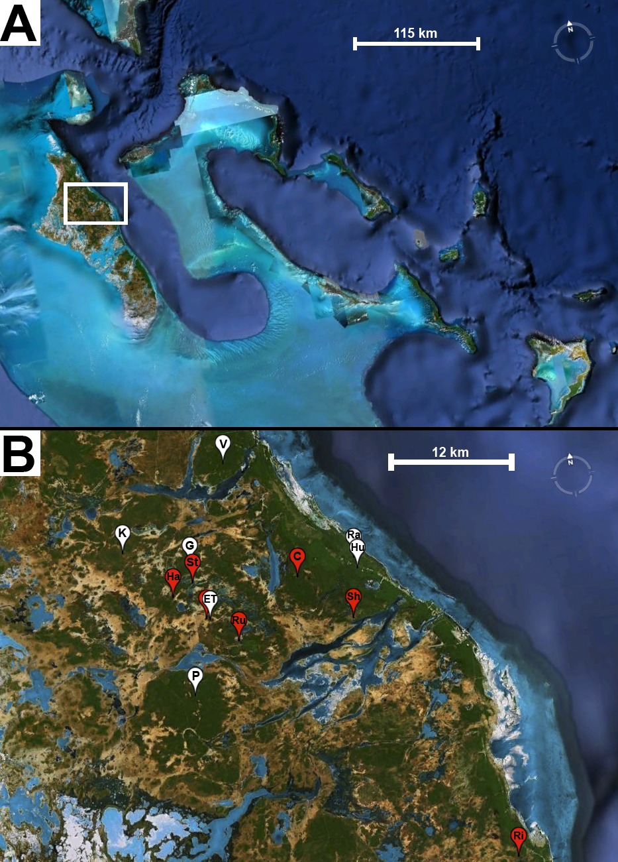

Figure A1. (A) Overview of the general study area in the Bahamas. (B) Magnification of the study area on northern Andros Island with locations of all sampled blue holes. Low-predation sites in white: East Twin (ET), Gollum’s (G), Hubcap (Hu), Ken’s (K), Pigskin (P), Rainbow (Ra), Voy’s (V). High-predation sites in red: Cousteau’s (C), Hard Mile (Ha), Rivean’s (Ri), Runway (Ru), Shawn’s (Sh), Stalactite (St), West Twin (hidden behind white ET). Maps were created with Google Earth.

Supplementary material Appendix 2:

Landmarks for Morphometric Analyses

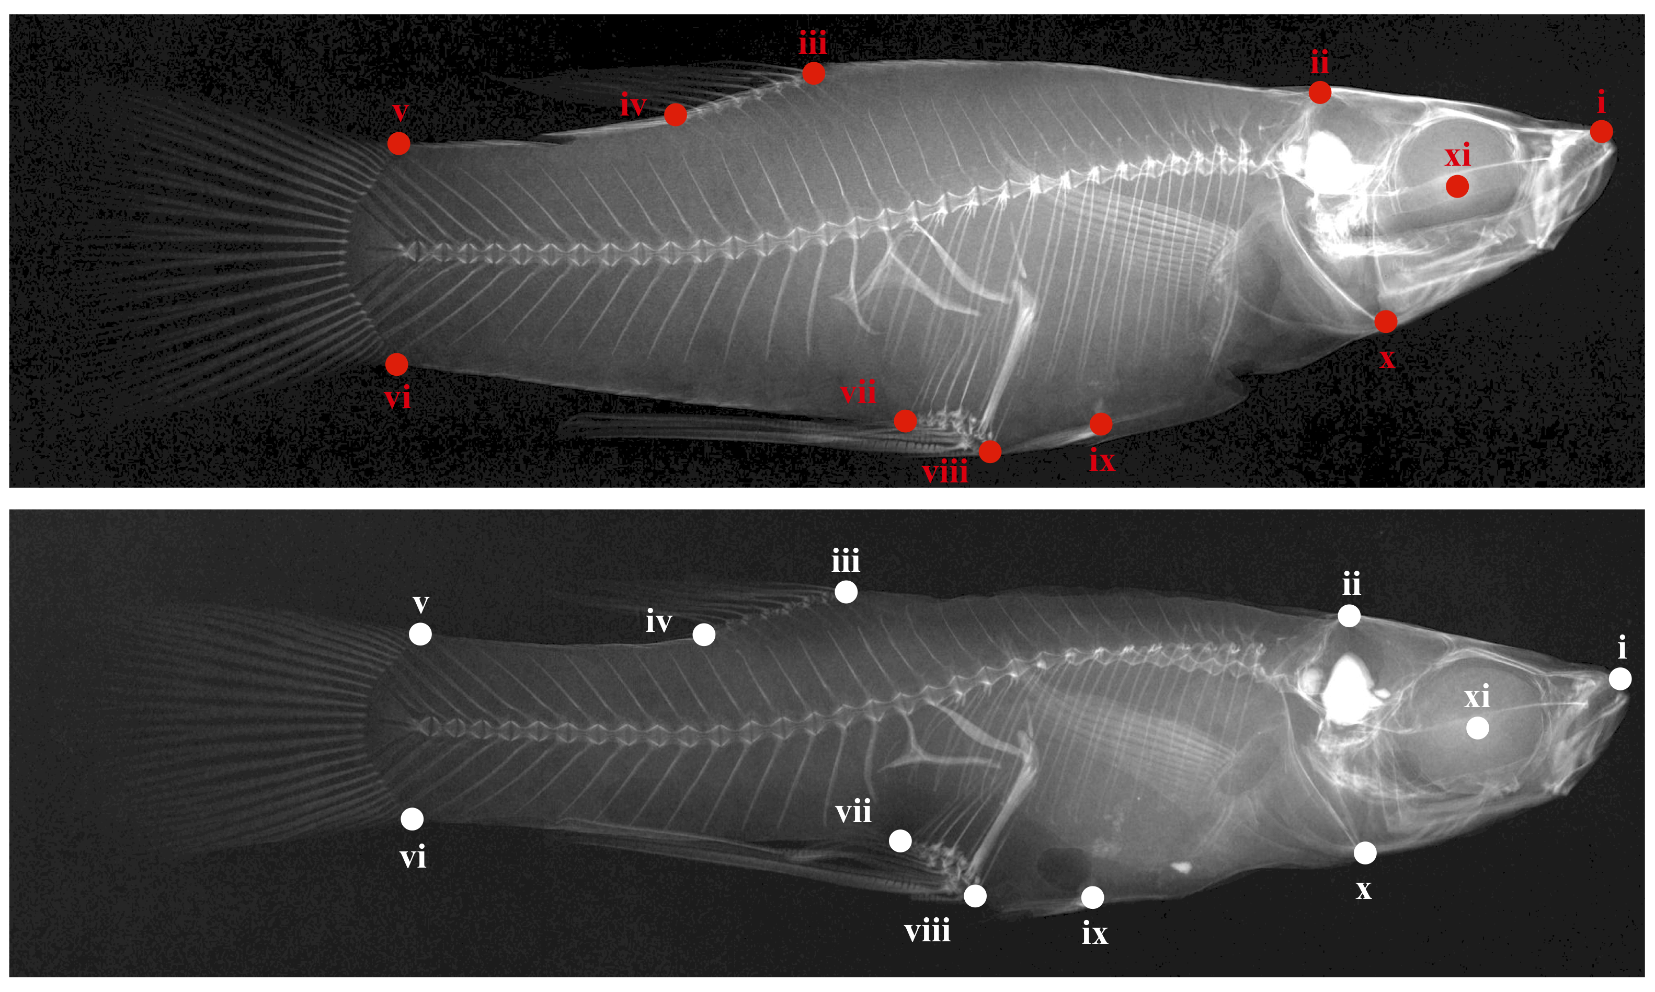
Figure A2. Landmarks used for morphometric analysis. Top (red): male G. hubbsi from a high-predation blue hole; bottom (white): male from a low-predation blue hole.

Supplementary material Appendix 3:

Life-history Traits and Canonical Loadings

Table A1. Descriptive statistics (means ± SD) for life-history traits of female Gambusia hubbsi from seven high-predation and seven low-predation blue holes collected on Andros Island, Bahamas. Female GSI: reproductive allocation. Cohen’s d is the standardized effect size for the predator regime term.
Predation regime | Population | N | Mean SL [mm] | Female Fat  Content^{b} [%] | Female Lean Weightª [mg] | Fecundityª [# offspring] | Female GSI^{b} [%] | Estimated Embryo Dry Weight at Birth^{c} [mg] | Embryo Fat Content^{b} [%]
Low predation | East Twin | 10 | 30.20±4.12 | 0.90±2.21 | 98.99±12.95 | 3.12±1.79 | 10.35±2.85 | 3.74 | 2.93±3.79
 | Gollum | 10 | 29.87±3.56 | 0.86±2.21 | 104.67±12.91 | 3.29±1.78 | 13.69±2.85 | 4.09 | 11.00±3.79
 | Hubcap | 10 | 25.27±1.49 | 2.89±2.21 | 115.22±13.57 | 4.88±1.88 | 12.68±2.85 | 4.05 | 7.25±3.79
 | Ken’s | 10 | 30.25±3.33 | 4.68±2.21 | 101.72±12.95 | 3.44±1.79 | 15.22±2.85 | 4.69 | 12.10±3.79
 | Pigskin | 10 | 29.85±4.86 | 4.46±2.21 | 124.73±12.91 | 4.08±1.78 | 13.64±2.85 | 4.50 | 14.37±3.79
 | Rainbow | 10 | 27.45±2.08 | 2.26±1.80 | 98.58±13.01 | 4.17±1.79 | 15.49±2.85 | 4.97 | 7.92±3.79
 | Voy’s | 9 | 28.38±3.89 | 2.81±1.80 | 106.74±12.90 | 5.50±1.78 | 14.88±3.00 | 3.55 | 6.16±3.90
 | Total/Avg | 69 | 28.76±3.77 | 2.38±2.49 | 107.24±12.92 | 4.04±2.27 | 13.66±3.32 | 4.23 | 8.79±4.98
High predation | Cousteau’s | 9 | 35.29±2.82 | 4.21±2.10 | 123.68±14.49 | 9.32±1.98 | 15.32±3.00 | 2.66 | 7.89±3.90
 | Hard Mile | 9 | 28.06±3.89 | 2.48±2.10 | 115.90±12.93 | 3.93±1.79 | 10.17±3.00 | 3.43 | 3.11±3.90
 | Rivean’s | 5 | 29.84±3.44 | 1.45±2.01 | 122.26±12.90 | 7.08±1.78 | 12.29±2.91 | 1.62 | 3.44±3.80
 | Runway | 7 | 25.04±2.07 | 1.82±2.11 | 128.04±13.42 | 10.03±1.86 | 11.69±2.91 | 1.29 | 1.40±3.97
 | Shawn’s | 10 | 28.69±4.97 | 2.92±2.21 | 124.23±12.89 | 9.50±1.78 | 11.07±2.85 | 1.71 | 2.84±3.79
 | Stalactite | 10 | 30.36±1.92 | 1.83±1.90 | 109.86±12.96 | 6.42±1.79 | 15.12±2.85 | 2.93 | 2.91±3.79
 | West Twin | 10 | 27.95±2.17 | 0.96±2.21 | 115.35±12.94 | 7.56±1.78 | 13.22±2.85 | 2.07 | 2.23±3.79
 | Total/Avg | 60 | 29.41±4.22 | 2.07±3.10 | 119.90±13.28 | 7.67±2.26 | 12.81±3.10 | 2.24 | 3.50±4.65
Cohen’s d |  |  | 0.16 | 0.11 | 0.97 | 1.60 | 0.26 | - | 1.10
ª estimated marginal means from a MANCOVA with ‘SL’ as a covariate. ^{b} estimated marginal means from a MANCOVA with ‘stage of development’ as a covariate. ^{c} estimated using the intercept and slope from a regression of log-transformed embryo dry weight against stage of development.
Table A2. Descriptive statistics (means ± SD) for life-history traits of male Gambusia hubbsi from seven high-predation and seven low-predation blue holes collected on Andros Island, Bahamas. GSI: gonadosomatic index. Cohen’s d is the standardized effect size for the predator regime term.
Predation regime | Population | N | Mean SL [mm] | Male Fat  Contentª [%] | Male Lean Weightª [mg] | GSIª [%]
Low predation | East Twin | 10 | 22.72±2.32 | 2.05±2.85 | 42.89±4.65 | 0.96±0.32
 | Gollum’s | 10 | 24.50±2.19 | 3.55±2.85 | 41.99±4.74 | 1.13±0.32
 | Hubcap | 10 | 21.51±2.49 | 2.21±2.85 | 47.18±4.71 | 1.42±0.32
 | Ken’s | 10 | 24.62±2.34 | 0.49±2.85 | 38.17±4.74 | 1.11±0.32
 | Pigskin | 10 | 22.08±3.43 | 1.88±2.85 | 49.87±4.68 | 1.09±0.32
 | Rainbow | 10 | 23.37±2.21 | 3.23±2.85 | 41.83±4.65 | 1.57±0.32
 | Voy’s | 10 | 20.68±2.29 | 1.69±2.85 | 49.26±4.81 | 1.00±0.32
 | Total/Avg | 70 | 22.78±2.76 | 2.17±1.26 | 44.46±4.66 | 1.18±0.32
High predation | Cousteau’s | 10 | 24.70±1.94 | 5.19±2.85 | 50.62±4.78 | 1.84±0.32
 | Hard Mile | 10 | 22.18±1.45 | 3.56±2.85 | 44.09±4.68 | 1.35±0.32
 | Rivean’s | 10 | 23.97±2.85 | 3.39±2.85 | 49.32±4.71 | 1.22±0.32
 | Runway | 10 | 22.65±2.19 | 0.56±2.85 | 50.77±4.65 | 1.50±0.32
 | Shawn’s | 10 | 20.50±2.91 | 2.76±2.85 | 53.50±4.84 | 1.44±0.32
 | Stalactite | 10 | 22.80±2.30 | 6.26±2.85 | 51.24±4.65 | 1.76±0.32
 | West Twin | 10 | 23.61±1.75 | 2.54±2.85 | 49.89±4.68 | 1.42±0.32
 | Total/Avg | 70 | 22.92±2.51 | 3.46±1.26 | 49.92±4.66 | 1.50±0.32
Cohen’s d |  |  | 0.05 | 1.02 | 1.17 | 1.00
ª estimated marginal means from a MANCOVA with ‘SL’ as a covariate.

Supplementary material Appendix 4

2B-PLS Vectors

Table A3. Summary of the first 2B-PLS vector derived for the LH traits for each sex-PR combination (vectors explaining greatest covariance between LH and MR). Latent variable loadings presented are correlations (correlations ≥ |0.5| are in bold text). LP = low predation, HP = high predation. Significance of correlations between each pair of LH and MR vectors tested using 10,000 randomizations (all P < 0.0001). Relationships between LH and MR vectors were consistent within each population in all cases (interaction term from ANCOVAs: all P > 0.53).
 | Females |  |  | Males
Life-history trait | LP Vector 1 | HP Vector 1 |  | LP Vector 1 | HP Vector 1
Log SL | 0.46 | 0.25 |  | 0.70 | 0.75
Residual log lean weight | 0.74 | 0.69 |  | 0.60 | 0.74
Residual arcsine square-root fat content | 0.52 | -0.49 |  | 0.43 | 0.21
Residual square-root fecundity | 0.41 | 0.69 |  | - | -
Residual log embryo lean weight | -0.02 | -0.39 |  | - | -
Residual arcsine square-root embryo fat content | 0.63 | -0.42 |  | - | -
Residual arcsine square-root reproductive allocation | 0.31 | 0.28 |  | - | -
Residual arcsine square-root gonadosomatic index | - | - |  | 0.10 | 0.42
Percent of total covariation | 79.89 | 62.55 |  | 65.58 | 74.83
Correlation with body morphology | 0.68 | 0.72 |  | 0.69 | 0.69
Intercorrelation | 0.67 |  |  | 0.95

Figure A3. Thin-plate spline transformation grids depicting observed body shape variation along each 2B-PLS vector for MR derived for females (A: low-predation, B: high predation) and males (C: low predation, D: high predation) and description of LH loadings on these axes.

Supplementary material Appendix 5:

Model Averaging
Methods
We employed model averaging to evaluate the relative importance of environmental factors on life-history variation (a similar approach for morphology was not taken because isolating meaningful individual traits from the shape matrix is difficult, i.e., from a geometric morphometric perspective, shape is inherently multivariate). To do so we first constructed global linear models for each of the life-history traits described above. The global model for each trait included the mean life-history trait value for each blue hole as a response variable and predation regime, sex ratio, G. hubbsi density, proportion of G. hubbsi juveniles, relative chlorophyll a density, and log-transformed zooplankton density of each population. All variables were standardized to a standard deviation of 1. We included all pairwise interactions with predation and the other environmental parameters.
We performed model selection on each global model using the R package MuMIn (Bárton 2011). Specifically, we employed the function ‘dredge’ to fit all possible permutations of each global model, while respecting marginality (i.e., interactions were not included in a model without the corresponding main effects). We ranked the model pool for each global model using Akaike Information Criteria corrected for small sample size (AICc). Because in all cases there was no one best model we chose a subset of the most informative models with ∆ AICc ≤ 4 from the model pool (Burnham and Anderson 2002).
We next carried out model averaging with each model subset using the function ‘model.avg’ to assess the predictive power of explanatory variables (i.e., relative importance values; hereafter RIV) from a set of models using information criteria (i.e., AICc, sensu Burnham and Anderson 2002; reviewed in Grueber et al. 2011).

Results
Model averaging helped uncover some specific environmental factors important in explaining life-history variation, beyond what was found with PLS-SEM. Overall, predation clearly had the largest relative importance values for explaining variation in the majority of male and female life-history traits (Fig. A3), with the exceptions of male and female SL, female fat content, and female GSI (Tables A4-A14). For male and female SL, as well as for female GSI (i.e., reproductive allocation), no environmental variable had great explanatory power. For female fat content, on the other hand, sex ratio had the highest relative importance value (RIV = 0.79). For embryo fat content, predation (RIV = 0.63) and density (RIV = 0.46) were of almost equal importance, while zooplankton (RIV = 0.58) was a strong predictor for embryo lean weight. For males, additional environmental factors only played an important role for variation in GSI; in this case, predation was the strongest predictor (RIV = 0.85), while sex ratio (RIV = 0.58) and proportional density of juveniles (RIV = 0.53) had important effects as well.

References
Bartoń, K. 2011. MuMIn: Multi-model inference. R package version 1.6.5. < http://CRAN.R-project.org/package=MuMIn >
Burnham, K. P. and Anderson, D. R. 2002. Model selection and multimodel inference: a practical information-theoretic approach. – Springer.
Grueber, C. E. et al. 2011. Multimodel inference in ecology and evolution: challenges and solutions. – J. Evol. Biol. 24: 699–711.

Table A4. Model rankings (delta AIC_{C} < 4) for female SL. PR: predation regime.
Model Parameters | Delta AICc | Model Weight
Intercept | 0 | .24
Zooplankton | .04 | .24
Sex Ratio | 2.49 | .07
Proportional Juvenile Density | 2.83 | .06
Proportional Juvenile Density, Zooplankton | 2.86 | .06
Zooplankton, Sex Ratio | 2.88 | .06
Chlorophyll a | 2.9 | .06
Density, Zooplankton | 3.07 | .05
PR | 3.15 | .05
Density | 3.16 | .05
Chlorophyll a, Zooplankton | 3.79 | .04
PR, Zooplankton | 3.81 | .04

Table A5. Model rankings (delta AIC_{C} < 4) for female lean weight. PR: predation regime.
Model Parameters | Delta AICc | Model Weight
PR | 0 | .53
PR, Chlorophyll a | 2.9 | .2
PR, Density | 3.15 | .11
PR, Sex Ratio | 3.73 | .08
PR, Zooplankton | 3.74 | .08
PR, Proportional Juvenile Density | 3.9 | .08

Table A6. Model rankings (delta AIC_{C} < 4) for female fat content. PR: predation regime.
Model Parameters | Delta AICc | Model Weight
Sex Ratio | 0 | .41
Density, Sex Ratio | 2.56 | .11
PR, Sex Ratio | 2.61 | .11
Intercept | 2.61 | .11
Chlorophyll a | 2.8 | .1
Proportional Juvenile Density, Sex Ratio | 3.42 | .07
Chlorophyll a, Sex Ratio | 3.56 | .07

Table A7. Model rankings (delta AIC_{C} < 4) for female fecundity. PR: predation regime.
Model Parameters | Delta AICc | Model Weight
PR | 0 | .31
PR, Zooplankton | .28 | .27
PR, Sex Ratio | 1.69 | .13
PR, Zooplankton, Sex Ratio | 2.45 | .09
PR, Proportional Juvenile Density | 3.43 | .06
PR, Chlorophyll a | 3.85 | .05
Density | 3.87 | .05
PR, Density, Zooplankton | 3.94 | .04

Table A8. Model rankings (delta AIC_{C} < 4) for embryo lean weight. PR: predation regime.
Model Parameters | Delta AICc | Model Weight
PR, Zooplankton | 0 | .29
PR, Zooplankton, PR x Zooplanton | .88 | .18
PR | .97 | .18
Density | 1.62 | .13
PR, Proportional Juvenile Density | 2.63 | .08
PR, Proportional Juvenile Density, Zooplankton | 2.98 | .06
PR, Zooplankton, Sex Ratio | 3.68 | .05
PR, Sex Ratio | 3.91 | .04

Table A9. Model rankings (delta AIC_{C} < 4) for embryo fat content. PR: predation regime.
Model Parameters | Delta AICc | Model Weight
PR | 0 | .35
Density | .56 | .27
Density, Sex Ratio | 2.05 | .13
PR, Sex Ratio | 2.84 | .09
PR, Density | 3.41 | .06
PR, Zooplankton | 3.63 | .06
PR, Proportional Juvenile Density | 3.99 | .05

Table A10. Model rankings (delta AIC_{C} < 4) for female GSI (i.e., reproductive allocation). PR: predation regime.
Model Parameters | Delta AICc | Model Weight
Intercept | 0 | .28
Proportional Juvenile Density | .94 | .18
Density | 1.84 | .11
Chlorophyll a | 2.17 | .1
PR | 2.53 | .08
Zooplankton | 3.12 | .06
Proportional Juvenile Density, Chlorophyll a | 3.28 | .05
Sex Ratio | 3.28 | .05
Proportional Juvenile Density, Sex Ratio | 3.58 | .05
Chlorophyll a, Density | 3.82 | .04

Table A11. Model rankings (delta AIC_{C} < 4) for male SL. PR: predation regime.
Model Parameters | Delta AICc | Model Weight
Intercept | 0 | .32
Zooplankton | .31 | .27
Chlorophyll a | 2.56 | .09
Chlorophyll a, Zooplankton | 3.02 | .07
Sex Ratio | 3.08 | .07
Proportional Juvenile Density | 3.19 | .06
Density | 3.23 | .06
PR | 3.3 | .06

Table A12. Model rankings (delta AIC_{C} < 4) for male lean weight. PR: predation regime.
Model Parameters | Delta AICc | Model Weight
PR | 0 | .49
PR, Zooplankton | 2.35 | .15
PR, Proportional Juvenile Density | 3.33 | .09
PR, Sex Ratio | 3.33 | .09
PR, Chlorophyll a | 3.37 | .09
PR, Density | 3.62 | .08

Table A13. Model rankings (delta AIC_{C} < 4) for male fat content. PR: predation regime.
Model Parameters | Delta AICc | Model Weight
Proportional Juvenile Density, Density | 0 | .18
PR | .08 | .17
Intercept | .09 | .17
Density | .44 | .14
PR, Proportional Juvenile Density | .91 | .11
PR, Chlorophyll a, PR x Chlorophyll a | 2.65 | .05
Sex Ratio | 3.21 | .04
Chlorophyll a | 3.28 | .03
Zooplankton | 3.39 | .03
Proportional Juvenile Density | 3.39 | .03
PR, Sex Ratio | 3.74 | .03
Density, Sex Ratio | 3.79 | .03

Table A14. Model rankings (delta AIC_{C} < 4) for male GSI. PR: predation regime.
Model Parameters | Delta AICc | Model Weight
PR, Proportional Juvenile Density, Sex Ratio | 0 | .36
PR, Chlorophyll a | 1.89 | .14
PR | 2.15 | .12
PR, Proportional Juvenile Density, Zooplankton,  Sex Ratio | 2.47 | .1
Density | 2.89 | .08
PR, Chlorophyll a, Zooplankton, PS x Zooplankton | 3.09 | .08
Proportional Juvenile Density, Density, Sex Ratio | 3.28 | .07
PR, Sex Ratio | 3.94 | .05

