Determination of carotenoids in sweet potato (Ipomoea batatas L., Lam) tubers: implications for accurate provitamin A determination in staple sturdy tuber crops
Margit Drapal and Paul D. Fraser*
School of Biological Sciences, Royal Holloway University of London, Egham, TW200EX, United Kingdom

*Corresponding author: Paul D. Fraser, P.Fraser@rhul.ac.uk, Tel: +44 (0)1784 443894, Fax: +44 (0)1784 414224

Abbreviations: CGIAR, Consultative group on International Agriculture Research; GRAS, generally recognised as safe; LMICs, low medium income countries; TCC, total carotenoid content; TpAC, total provitamin A content; VAD, Vitamin A deficiency;

Abstract
Vitamin A deficiency (VAD) is a global health problem, which despite significant financial investments and initiatives has not been eradicated. Biofortification of staple crops with β-carotene (provitamin A) in Low Medium Income Countries (LMICs) is the approach advocated and adopted by the WHO and HarvestPlus programme. The accurate determination of β-carotene is key to the assessment of outputs from these activities. In the present study, HPLC-PDA analysis displayed superior resolving power, separating and identifying 23 carotenoids in the orange sweet potato (Ipomoea batatas) variety used, including only eight carotenoids with provitamin A properties. Additionally, the results evidently displayed that the use of lyophilised material facilitated the extraction of twice the amount of pigments compared to fresh material, which impacts the precise calculation of the provitamin A content. These results highlight that yellow to orange starchy edible crops produce a wide array of carotenoids in addition to β-carotene. Biosynthetically it is clear from the intermediates and products accumulating that the β-branch of the carotenoid pathway persists in sweet potato tuber material. Collectively, the data also have implications with respect to the determination and biosynthesis of provitamin A among staple crops for developing countries.

Key words:
Ipomoea batatas; Convolvulaceae; sweet potato; carotenoids; provitamin A; β-carotene; HarvestPlus

Introduction
Vitamin A deficiency (VAD) remains a global health problem (WHO, www.who.int). It is the leading cause of preventable blindness in young children (Manusevich Wiseman et al., 2017), can compromise immune function and exacerbates childhood diseases. If left untreated, VAD has fatal consequences (Sommer et al., 2012; Wassef et al., 2014). The effects of VAD are most prevalent in children and pregnant women in low-income populations of Africa and South East Asia (WHO, www.who.int). Supplementation and fortification programmes have diminished VAD, but coverage, recurrent costs and compliance are factors that have prevented eradication of VAD using this approach (Stein et al., 2006).
Vitamin A is represented by retinol, retinal and retinoic acid. These retinoids are all bioactive and toxic at non-physiological dosages and can cause teratogenic effects. Hence, retinoids exist in the human body at low levels with a high turnover rate (Teelmann, 1989). The precursors of retinoid formation are carotenoid pigments, such as β-carotene, which is often termed provitamin A. Carotenoids cannot be synthesised de novo and must be acquired from dietary sources. β-Carotene and other carotenoids are Generally Recognised as Safe (GRAS) with a long history of safe use as natural food constituents or additives. β-Carotene is the optimal provitamin A carotenoid as it contains two β-ionone rings (Fig. 1), which facilitate the formation of the maximum number of retinal molecules by the action of the β-carotene 15, 15' monooxygenase (BCO-1) enzyme in the body (von Lintig et al., 2000). Other carotenoids in foodstuffs can have a combination of β- and ε-ionone end groups as well as decoration of the ionone rings with hydroxyl or keto groups. In these cases, it is only the non-substituted β-ionone ring that can deliver retinoids. Thus, food crops high in β-carotene are the optimal sources of provitamin A (Rodriguez-Amaya et al., 2004).
In contrast to the difficulties associated with supplementation, the provision of provitamin A in a sustainable manner through agriculture and local trade products, offers an attractive alternative. This is predominantly due to the ease of logistical multiplication compared to supplementation programmes. Such a philosophy has underpinned the work of HarvestPlus (HarvestPlus, www.harvestplus.org).
Storage roots of sweet potato Ipomoea batatas (L.) Lam. (Convolvulaceae) are an important source for a variety of nutrients (Woolfe, 1992). Of particular interest are orange sweet potatoes due to their high β-carotene (provitamin A) content. Intervention studies have showed that regular intake of orange sweet potatoes can increase vitamin A levels and improve general health (Low et al., 2017; van Jaarsveld et al., 2005).
The analysis of carotenoids is notoriously error prone, due to their sensitivity to light, oxygen and heat. All of these factors cause carotenoids to isomerise, undergoing modifications or degrade, which has a significant impact on carotenoid quantification and furthermore the calculation of provitamin A content (Schiedt et al., 1995). Another aspect that has to be taken into consideration during carotenoid measurements is the similarity between UV/Vis spectral properties of carotenoids. In particular, isomers and epoxides can vary by a slight shift in their UV/Vis spectra or NIRS which cannot be distinguished with simplistic methods such as a spectrophotometer. The tissue matrix can also affect accurate determination of carotenoids. This is particularly pertinent in edible starchy crop tissues consumed as staples in Low Medium Income Countries (LMICs).
Global initiatives, such the HarvestPlus programme, are coordinated through the Consultative group on International Agriculture Research (CGIAR) programme has invested intensively in the development of biofortified provitamin A staple crops such as cassava, sweet potato, yam and plantains. In this article we have used sweet potato as an exemplar high caloric staple crop and evaluated how parameters such as lyophilisation and analytical platform can affect the accuracy of carotenoid determinations in these crops. The findings are discussed with respect to provitamin A determinations in these biofortified crops.

Results and discussion

Carotenoid composition of sweet potato storage roots
The main objectives for the present comparative analysis of fresh and lyophilised tissue were (i) composition of carotenoids present and (ii) accuracy of the measurements. Hence, technical replicates of pooled samples (three tubers per variety) were analysed to exclude the variation present in biological replicates. Compounds detected by liquid chromatography (LC) systems were identified by their unique UV/Vis spectrum, mass spectrum and by comparison to analytical standards (Fig. 2, Supplementary Table S1). All carotenoid amounts were calculated per fresh weight (FW), which included the conversion of lyophilised samples by the dry matter content of the individual varieties (InternationalPotatoCentre, 2016).
HPLC showed the most accurate results of the three analytical platforms due to complete separation of carotenoids in the extracts (Fig. 2b) and quantification by individual standard curves. This enabled the identification of all carotenoids present in sweet potato storage root tissue analysed as well as the absolute quantification of these 23 carotenoids (Fig. 1, Supplementary Table S2). UPLC analysis differed in column stationary phase and had a shorter run time compared to the HPLC. Based on these conditions, several carotenoids coeluted (e.g. luteochrome and β-cryptoxanthin epoxides) (Gupta et al., 2015) and lead to the quantification of ten carotenoids (Fig. 2a, Supplementary Table S2). No separation between carotenoids was possible with the spectrophotometer. This technique measures the absorbance of a fixed wavelength for the whole extract and most carotenoids exhibit absorption of similar wavelengths (e.g. Fig. 2c) (Mercadante et al., 2004). Additionally, detection of phytoene and phytofluene are only possible on a spectrophotometer with a UV lamp, measuring wavelengths below 350nm. Measurements by spectrophotometer were taken for all carotenoids with available absorption coefficients for petroleum ether and ethanol (Rodriguez-Amaya et al., 2004). The results indicated the presence of α-carotene, zeaxanthin and neoxanthin in the sweet potato roots tested, based on wavelength data recorded at 450nm. None of these three compounds were identified by LC platforms and highlight the disadvantage of analysis without separation. Potential solutions to avert misidentification are preparation techniques such as open column chromatography (OCC) and thin layer chromatography (TLC) (Rodriguez-Amaya et al., 2004). In either case a comparison with an analytical standard is advisable, based on the present results. These findings also advocate the development of routine proceeds for carotenoid standards and the annotation of defined extracts at a community level.
The accuracy of the performed measurements depended on the tissue extracted and the platform used (Table 1). Fresh tissue extraction showed an approximate four-times higher standard deviation (S.D.) for the HPLC and UPLC analyses compared to lyophilised tissue. This is a well-known complication in fresh plant tissue due to the water content influencing the extraction quality (Mitchell, 1949). Hence, acetone, a water-soluble organic solvent, is commonly adopted for a better penetration into hydrophilic tissue, such as starchy sweet potato roots (Rodriguez-Amaya et al., 2004). Nevertheless, the irregular water content of the samples influences the solvent ratio in the extraction and leads to unpredictable carotenoid recoveries. This phenomenon especially effects tissues with low carotenoid content such as white and yellow sweet potato roots resulting in higher S.D. (e.g. Alam et al., 2016). Additionally, the commonly adapted extraction of fresh tissue entailed the laborious effort of several extraction steps per one sample – with a large amount of solvents (~80 ml) and a partition with water in a separating funnel. These steps bear the danger of degradation, if not performed under light and heat reduced conditions (Butnariu, 2016). The use of large solvent volumes also precludes the use of solvents such as chloroform because it forms a hypophase requiring penetration through debris to remove the solution.
The spectrophotometric measurements of fresh tissue displayed similar S.D. to the chromatographic platforms and varied greatly by the solvent used for suspension. Samples suspended in ethanol varied by 18% whereas samples in petroleum ether varied by 34%. The S.D. was higher in yellow and orange roots and could be connected to the multiple dilutions of the highly concentrated extracts to achieve a recommended absorbance value between 0.2 and 0.8 (Rodriguez-Amaya et al., 2004).
Overall, the extraction of lyophilised material comprised 40-times less solvent, 600-times less water and achieved an almost complete carotenoid extraction in the first extraction cycle. Additionally, the extraction of lyophilised tissue resulted in the detection of twice the amount of carotenoids with a low S.D. The short extraction time and low solvent use of the applied protocol enable the analysis of more replicates, which will lead to a more accurate and therefore precise quantification. Studies comparing different sweet potato varieties (e.g. (Kammona et al., 2014; Teow et al., 2007) rely on the extraction of lyophilised tissue to exclude the variable error of fresh tissue extractions (Schiedt et al., 1995).

Quantitation of provitamin A content
Some carotenoids can be converted into vitamin A (retinol) molecules. The β-carotene equivalents of various carotenoids depends on their structural components and can be calculated to provide their individual provitamin A activity (Mercadante et al., 2004; Sander et al., 2000). For example, all-trans-β-carotene has the highest provitamin A activity (100%), whereas cis-β-carotene has a lower activity (62%) due to a geometrical isomerism of one double bond (Fig. 1). Determination by HPLC-DAD provides the correct information for identification of carotenoids (and their geometric isomers) and therefore the accurate quantification of total provitamin A content (TpAC, Table 2, Supplementary Table S2) (Bauernfeind, 1972; Price et al., 2018). In comparison, the TCC and TpAC from spectrophotometric measurements are calculated based on the absorption coefficient of β-carotene or an average from several carotenoids (Biehler et al., 2010; Wellburn, 1994). This approach presumes that the major or only carotenoid in the sample is β-carotene, specifically all-trans-β-carotene with 100% provitamin A activity, and would result in an inaccurate calculation of the TpAC value.
The HPLC analysis highlighted the loss of a small amount of β-carotene in fresh white and yellow samples (0.4 and 0.7 µg/g fr. wt, respectively), which barely affected the TpAC (Table 2). Carotenoids, as antioxidants, are prone to react to light, heat, oxygen and enzymatic reactions if the tissue is not stored and prepared properly (Schiedt et al., 1995). Therefore, a minor loss of carotenoids is to be expected during the extraction process (Davey et al., 2009; Rodriguez-Amaya et al., 2008).
The sensitivity of HPLC analysis is of particular advantage in tissues with low carotenoid content such as white and yellow sweet potato roots. These two sweet potato phenotypes present traditional varieties in some countries and are a consumer preference due to their higher starch content compared to orange varieties (Tanumihardjo et al., 2017). The accurate quantification of TpAC can establish the amount consumed in white/yellow sweet potatoes and how much TpAC is required from additional vegetables to achieve RDA of vitamin A in the diet (Drapal et al., 2019; Low et al., 2017; Tumwegamire et al., 2011).

Conclusion
The use of freeze-dried sample tissue, facilitates the use of more amenable scalability and suitable organic extraction solvents for the accurate high-throughput analysis of individual carotenoid components in edible tissue of starchy crops. Such accurate robust procedures need to be implemented alongside more rapid procedures to ensure accurate detection of provitamin A content in breeding populations of staple crops advocated in developing regions. The availability of relevant facilities/equipment in germplasm centres would benefit the interaction with farmers and field stations. Additionally, the collaboration between these parties might lead to a more accurate protocol for carotenoid measurement outside high-end laboratory facilities.

Experimental

Extraction of carotenoids from fresh (HarvestPlus protocol) and freeze-dried storage roots
Varieties of sweet potato Ipomoea batatas (L.) Lam. (Convolvulaceae) included in this study were Xushu 18 (CIP 440025), Tanzania (CIP 440166) and Jewel (CIP 440031), further referred to by their storage root pigmentation phenotype white, yellow and orange, respectively. For each variety, three tubers from one plant were peeled, combined, blended and processed in triplicate (Rodriguez-Amaya et al., 2004). Acetone (20 ml) was added to the blended sweet potatoes (3.5 g/ replicate) for 3 min in a light protected beaker. The acetone was separated by vacuum filtration through a Buchner funnel lined with filter paper (Grade 1, Whatman) into a light protected side-arm flask. This step was repeated for a complete removal of colour from the tissue. The pooled acetone extracts were transferred into a separating funnel maintained in a dark environment. Petroleum ether (40-60°C; 20 ml) and distilled water (150 ml) were added and left to rest for 10min. The bottom phase containing water and acetone was removed and discarded. Another aliquot of distilled water (150 ml) was added to the separating funnel and discarded after 10min. The remaining petroleum ether phase containing carotenoids was dried under nitrogen gas and the resulting residue stored at -20°C until analysis.
Using identical biological tissue samples to the material used in the fresh extraction, sweet potato tubers were peeled, cut into 1x5cm cubes, frozen in liquid nitrogen and lyophilised to complete dryness (as judged by stable weight). As described for the fresh extraction, tissue from three storage roots were combined during the grinding process and analysed in triplicate. An aliquot of the dried sweet potato powder (30 mg) was extracted on ice with methanol, chloroform and water instead of TRIS HCl buffer (pH 7.3) as previously described (Fraser et al., 2000). Care was taken to reduce exposure of the samples to light during the extraction. The whole chloroform extract containing carotenoids was dried down and stored at -20°C until analysis.

Chromatographic analysis
The carotenoid extracts from fresh and dried root material were diluted in ethyl acetate immediately before HPLC analysis (Alliance, Waters, UK) with a C30 column (Fraser et al., 2000). The same extracts were analysed by LC-QTof (maXis, Bruker, UK) with the same HPLC conditions (Perez-Fons et al., 2011). Acetonitrile was added to an aliquot of the dilution for HPLC analysis (1:6, v/v) and analysed by UPLC (Acquity, Waters, UK) with a C18 column (Nogueira et al., 2013). The chromatograms were analysed with the respective manufactures software (Empower, Waters and DataAnalysis, Bruker) and carotenoids identified by their retention time, UV/Vis spectrum, mass spectrum and comparison to analytical standards prepared by Price et al. (2018) or purchased from Sigma-Aldrich (UK) (Supplementary Table S1).

Calculation of amounts per g fresh weight
The amounts of individual carotenoids were calculated per fresh weight for fresh tissue (g fr. wt) and per dry weight for freeze-dried tissue (g dry wt). The amounts for freeze-dried tissue were then converted to g fr. wt by means of dry matter content as published on the CIP gene bank (CIP): 27% (white), 30% (yellow) and 26% (orange). Total carotenoid content (TCC) for spectrophotometric measurements were calculated with the equations published by Wellburn (1994) and Biehler et al. (2010). Total provitamin A content (TpAC) was calculated based on provitamin A activity of individual carotenoids (Bauernfeind, 1972; Price et al., 2018).

Declaration of interest
Declarations of interest: none.

Acknowledgement
We would like to thank Chris Gerrish for excellent technical support.

Funding
This work was supported through the CGIAR Research Program on Roots, Tubers and Bananas (RTB) and the European Union Framework Program DISCO (from DISCOvery to products: a next-generation pipeline for the sustainable generation of high-value plant products; Project 613513).

References
Alam, M. K., Rana, Z. H., Islam, S. N., 2016. Comparison of the Proximate Composition, Total Carotenoids and Total Polyphenol Content of Nine Orange-Fleshed Sweet Potato Varieties Grown in Bangladesh. Foods 5, 64.
Bauernfeind, J. C., 1972. Carotenoid vitamin A precursors and analogs in foods and feeds. J Agric Food Chem 20, 456-473.
Biehler, E., Mayer, F., Hoffmann, L., Krause, E., Bohn, T., 2010. Comparison of 3 spectrophotometric methods for carotenoid determination in frequently consumed fruits and vegetables. J Food Sci 75, C55-61.
Butnariu, M., 2016. Methods of Analysis (Extraction, Separation, Identification and Quantification) of Carotenoids from Natural Products. J Ecosys Ecograph 6.
CIP, http://genebank.cipotato.org/gringlobal/search.aspx, 14/12/2018.
Davey, M. W., Mellidou, I., Keulemans, W., 2009. Considerations to prevent the breakdown and loss of fruit carotenoids during extraction and analysis in Musa. Journal of Chromatography A 1216, 5759-5762.
Drapal, M., Rossel, G., Heider, B., Fraser, P. D., 2019. Metabolic diversity in sweet potato (Ipomoea batatas, Lam.) leaves and storage roots. Hortic Res 6, 2.
Fraser, P. D., Pinto, M. E., Holloway, D. E., Bramley, P. M., 2000. Technical advance: application of high-performance liquid chromatography with photodiode array detection to the metabolic profiling of plant isoprenoids. Plant J 24, 551-558.
Gupta, P., Sreelakshmi, Y., Sharma, R., 2015. A rapid and sensitive method for determination of carotenoids in plant tissues by high performance liquid chromatography. Plant methods 11, 5-5.
HarvestPlus, https://www.harvestplus.org/, 28/01/2019.
InternationalPotatoCentre, http://germplasmdb.cip.cgiar.org/index.jsp, October 2018.
Kammona, S., Othman, R., Jaswir, I., Jamal, P., 2014. Characterisation of carotenoid content in diverse local sweet potato (ipomoea batatas) flesh tubers.
Low, J. W., Mwanga, R. O. M., Andrade, M., Carey, E., Ball, A.-M., 2017. Tackling vitamin A deficiency with biofortified sweetpotato in sub-Saharan Africa. Global Food Security 14, 23-30.
Manusevich Wiseman, E., Bar-El Dadon, S., Reifen, R., 2017. The vicious cycle of vitamin a deficiency: A review Critical Reviews in Food Science and Nutrition 57, 3703-3714.
Mercadante, A. Z., Egeland, E. S., 2004. Carotenoids Handbook. Birkenhӓuser Verlag, Basel - Boston - Berlin.
Mitchell, H. L., 1949. Determination of Carotene in Sweet Potatoes. Plant Physiology 24, 323-326.
Nogueira, M., Mora, L., Enfissi, E. M., Bramley, P. M., Fraser, P. D., 2013. Subchromoplast sequestration of carotenoids affects regulatory mechanisms in tomato lines expressing different carotenoid gene combinations. Plant Cell 25, 4560-4579.
Perez-Fons, L., Steiger, S., Khaneja, R., Bramley, P. M., Cutting, S. M., Sandmann, G., Fraser, P. D., 2011. Identification and the developmental formation of carotenoid pigments in the yellow/orange Bacillus spore-formers. Biochim Biophys Acta 1811, 177-185.
Price, E. J., Bhattacharjee, R., Lopez-Montes, A., Fraser, P. D., 2018. Carotenoid profiling of yams: Clarity, comparisons and diversity. Food Chem 259, 130-138.
Rodriguez-Amaya, D. B., Kimura, M., 2004. HarvestPlus Handbook for Carotenoid Analysis. International Food Policy Research Institute (IFPRI) and International Center for Tropical Agriculture (CIAT), Washington, DC and Cali, Columbia.
Rodriguez-Amaya, D. B., Kimura, M., Godoy, H. T., Amaya-Farfan, J., 2008. Updated Brazilian database on food carotenoids: Factors affecting carotenoid composition. J Food Compos Anal 21, 445-463.
Sander, L. C., Sharpless, K. E., Pursch, M., 2000. C30 stationary phases for the analysis of food by liquid chromatography. Journal of chromatography. A 880, 189-202.
Schiedt, K., Liaaen-Jensen, S., 1995. Isolation and Analysis. In: Britton, G., Liaaen-Jensen, S., Pfander, H. (Eds.), Isolation and Analysis, vol. 1A. Birkhäuser Verlag, Basel, Switzerland.
Sommer, A., Vyas, K. S., 2012. A global clinical view on vitamin A and carotenoids. Am J Clin Nutr 96, 1204s-1206s.
Stein, A. J., Sachdev, H. P., Qaim, M., 2006. Potential impact and cost-effectiveness of Golden Rice. Nat Biotechnol 24, 1200-1201.
Tanumihardjo, S. A., Ball, A. M., Kaliwile, C., Pixley, K. V., 2017. The research and implementation continuum of biofortified sweet potato and maize in Africa. Ann N Y Acad Sci 1390, 88-103.
Teelmann, K., 1989. Retinoids: Toxicity and teratogenicity to date. Pharmacology & Therapeutics 40, 29-43.
Teow, C. C., Truong, V.-D., McFeeters, R. F., Thompson, R. L., Pecota, K. V., Yencho, G. C., 2007. Antioxidant activities, phenolic and β-carotene contents of sweet potato genotypes with varying flesh colours. Food Chemistry 103, 829-838.
Tumwegamire, S., Kapinga, R., Rubaihayo, P. R., LaBonte, D. R., Grüneberg, W. J., Burgos, G., Felde, T. z., Carpio, R., Pawelzik, E., Mwanga, R. O. M., 2011. Evaluation of Dry Matter, Protein, Starch, Sucrose, β-carotene, Iron, Zinc, Calcium, and Magnesium in East African Sweetpotato [Ipomoea batatas (L.) Lam] Germplasm. HortScience 46, 348-357.
van Jaarsveld, P. J., Faber, M., Tanumihardjo, S. A., Nestel, P., Lombard, C. J., Benadé, A. J. S., 2005. β-Carotene–rich orange-fleshed sweet potato improves the vitamin A status of primary school children assessed with the modified-relative-dose-response test. The American Journal of Clinical Nutrition 81, 1080-1087.
von Lintig, J., Vogt, K., 2000. Filling the Gap in Vitamin A Research: MOLECULAR IDENTIFICATION OF AN ENZYME CLEAVING β-CAROTENE TO RETINAL. Journal of Biological Chemistry 275, 11915-11920.
Wassef, L., Wirawan, R., Quadro, L., Hoffman, D. J., Breslin, P. A. S., Chikindas, M., 2014. β-Carotene–Producing Bacteria Residing in the Intestine Provide Vitamin A to Mouse Tissues In Vivo. The Journal of Nutrition 144, 608-613.
Wellburn, A. R., 1994. The Spectral Determination of Chlorophylls a and b, as well as Total Carotenoids, Using Various Solvents with Spectrophotometers of Different Resolution. Journal of Plant Physiology 144, 307-313.
WHO, https://www.who.int/nutrition/topics/vad/en/, 28/01/2019.
Woolfe, J. A., 1992. Sweet Potato: an untapped food resource. University Press, Cambridge, UK.

Figures and tables
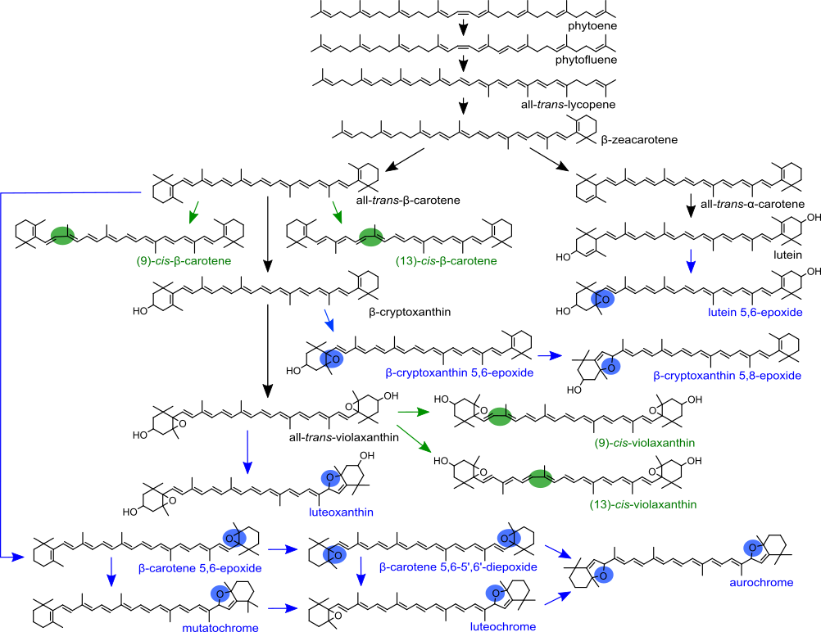
Figure 1 Carotenoid biosynthetic pathway based on the carotenoids detected in sweet potato roots by HPLC-DAD and LC/MS. Cis-isomers are labelled in green and epoxides labelled in blue. The green and blue dots indicate the location of the cis-bond and epoxide-group, respectively.

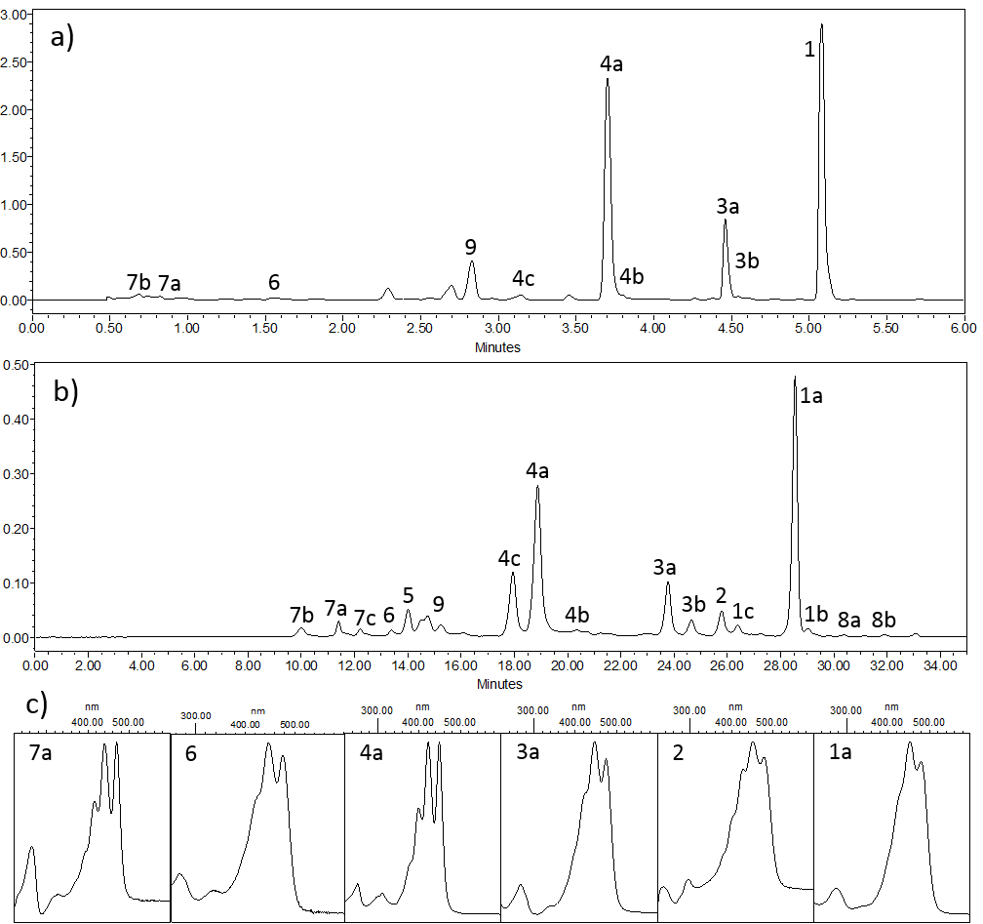
Figure 2 Example chromatograms of carotenoids present in orange sweet potato root tissue. Extracts were analysed by UPLC (a) and HPLC (b). Both chromatograms are displayed at 450nm and the y-axis shows the absorbance units measured. Identified carotenoids included β-carotene isomers (1), β-cryptoxanthin (2), β-carotene mono-epoxides (3) and di-epoxides (4), lutein epoxide (5), lutein (6), violaxanthin isomers (7), β-zeaxanthin isomers (8) and unknown epoxides (9). Characteristic UV/Vis spectra (c) were used for identification. The axes of the spectra display the absorbance (y-axis) of the wavelengths 200-600 nm (x-axis).

Table 1 Main carotenoids detected in storage roots of different pigmentation phenotypes. Amount of carotenoids are displayed as µg/g fr.wt. For spectrophotometric measurements, the resuspension solvent is listed in brackets.
*Combined amount of β-cryptoxanthin and β-cryptoxanthin epoxides.
Platform | Tissue (solvent) | Root flesh colour | phytoene/ phytofluene | β-zeacarotene | all-trans-β-carotene | cis-β-carotene | β-carotene epoxides | β-cryptoxanthin | violaxanthin | lutein | lutein epoxide
HPLC | fresh | white |  |  | 0.44 ± 0.02 |  | 0.75 ± 0.28 |  | 1.1 ± 0.5 | 0.05 ± 0.01
 |  | yellow |  | 0.73 ± 0.27 | 0.66 ± 0.10 |  | 1.6 ± 0.5 | 1.3 ± 0.5 | 0.53 ± 0.08 | 0.06 ± 0.02
 |  | orange | 0.14 ± 0.01 | 1.0 ± 0.1 | 10.7 ± 2.6 | 1.2 ± 0.1 | 9.2 ± 2.4 | 0.66 ± 0.05 | 0.88 ± 0.41 | 0.1 ± 0.02 | 0.57 ± 0.03
 | lyophilised | white |  |  |  |  |  |  | 4.5 ± 0.5 | 0.11 ± 0.01
 |  | yellow |  |  |  |  | 10.6 ± 0.5 |  |  | 0.11 ± 0.01 | 0.37 ± 0.04
 |  | orange | 0.27 ± 0.02 | 2.5 ± 0.03 | 21 ± 1.9 | 4.4 ± 0.4 | 18.9 ± 1.4 | 2.0 ± 0.1 | 6.8 ± 0.7 | 0.22 ± 0.02 | 0.70 ± 0.05
UPLC | fresh | white | 0.15 ± 0.13 |  | 0.33 ± 0.13 |  | 1.0 ± 0.7 |  | 1.6 ± 0.6 | 0.34 ± 0.19
 |  | yellow | 0.95 ± 0.43 |  | 3.3 ± 2.2 |  | 7.5 ± 1.8 |  | 3.3 ± 2.7 | 0.61 ± 0.60
 |  | orange | 1.2 ± 0.9 |  | 18.3 ± 1.6 |  | 6.9 ± 1.8 | 0.11 ± 0.03 | 1.5 ± 0.6 | 0.20 ± 0.07
 | lyophilised | white |  |  | 0.18 ± 0.03 |  |  |  | 1.7 ± 0.3 | 0.27 ± 0.02
 |  | yellow | 0.45 ± 0.05 |  | 0.30 ± 0.04 |  | 5.2 ± 2.3
 |  | orange | 4.2 ± 0.2 |  | 33.8 ± 1.1 |  | 12.9 ± 0.4 |  |  | 0.31 ± 0.00
Spectro- photometer | fresh (ethanol) | white |  |  | 0.14 ± 0.02 |  |  |  | 0.12 ± 0.00 | 0.14 ± 0.02
 |  | yellow |  |  | 2.2 ± 0.1 |  |  |  | 1.9 ± 0.0 | 2.2 ± 0.0
 |  | orange |  |  | 5.9 ± 2.6 |  |  |  | 5.3 ± 2.4 | 5.8 ± 2.6
 | fresh (petroleum ether) | white |  |  | 0.17 ± 0.04 |  |  | 0.2 ± 0.06
 |  | yellow |  |  | 1.5 ± 1.5 |  |  | 1.6 ± 1.6
 |  | orange |  |  | 1.0 ± 0.42 |  |  | 1.2 ± 0.5

Table 2 Total carotenoid content (TCC) and total provitamin A content (TpAC) detected in sweet potato roots by HPLC-DAD. Amounts are displayed as µg/g fr. wt. The root colour refers to the visual pigmentation of the varieties.
Root colour | white |  |  | yellow |  |  | orange
Tissue type | fresh | lyophilised |  | fresh | lyophilised |  | fresh | lyophilised
β-carotene | 0.4 | 0 |  | 0.7 | 0 |  | 10.7 | 21.0
TCC | 2.4 | 4.6 |  | 4.8 | 8.7 |  | 24.6 | 57.2
TpAC | 0.6 | 0 |  | 1.7 | 2.1 |  | 13.8 | 29.2

