Dike-induced stresses and displacements in layered volcanic zones

Mohsen Bazargan and Agust Gudmundsson
Department of Earth Sciences, Queen’s Building, Royal Holloway University of London, Egham TW20 0EX, UK (rock.fractures@googlemail.com)

Abstract
During a volcanic unrest period with dike injection, one of the main scientific tasks is to assess the geometry and the propagation path of the dike and, in particular, the likelihood of the dike reaching the surface to erupt. Currently, the dike path and geometry (including depth and opening/aperture) are both partly determined from geodetic surface data using mostly dislocation models that assume the volcanic zone/volcano to be an elastic half space of uniform mechanical properties. By contrast, field observations of volcanic zones/volcanoes (active and extinct) show that they are composed of numerous layers whose mechanical properties (primarily Young’s modulus) vary widely and whose contacts commonly arrest dikes. Here we provide field observations and numerical models on the effects of a typical variation in Young’s modulus in an active volcanic zone on the internal and surface stresses and displacements induced by a dike whose tip is arrested at 0.5 km depth below the surface of the volcanic zone. Above the layer or unit hosting the dike are four layers of equal thickness. We vary the Young’s modulus or stiffness of the fourth layer (the one adjacent to the layer or unit hosting the dike) from 10 GPa to 0.01 GPa, while all the other layers/units maintain their Young’s moduli in the model runs. The results show that as the fourth layer becomes more compliant or soft (0.1-0.01 GPa) dike-induced stresses and displacements (lateral and vertical) above the layer, including those at the surface, become suppressed but the stresses and displacements of the layer/unit hosting the dike increase and their peaks do not coincide in location or magnitude with those of the other layers. Thus, the dike-induced internal deformation of the volcanic zone increases as the fourth layer becomes softer. Also, the tensile-and-shear stress peaks at the surface occur at locations widely different from those of maximum surface uplift. More specifically, for a comparatively stiff fourth layer (1-10 GPa), the surface tensile and shear stresses peak at lateral distances of 0.5-0.7 km from the projection of the dike to the surface. (Essentially no tensile/shear stresses reach the surface when the fourth layer is as soft as 0.1-0.01 GPa, so that there are no stress peaks). By contrast the maximum surface displacements (uplift) peak at lateral distances of 2.8-3.3 km from the dike projection to the surface. If tension fractures or faults – in particular the boundary faults of a graben – are induced by the dike, they should form at the tensile/shear stress peaks and not, as is commonly suggested, at the location of the surface displacement peaks. Our results thus suggest that any dike-induced graben is likely to be of a width about twice the depth to the tip/top of the arrested dike. The results demonstrate that elastic half-space models overestimate the dike-induced surface stresses, and thus the depth to the tip/top of the

Fig. 1. Internal structure of a central volcano (composite volcano, stratovolcano, basaltic edifice) and the associated part of the volcanic zone/system to which it belongs. A shallow magma chamber supplies magma to the inclined (cone) sheets and most of the local radial dikes associated with the volcano itself. The magma chamber, in turn, is supplied with magma by a much larger deep-seated magma reservoir, which also supplies magma to many of the regional dikes. Thus eruptions within the composite/central volcano are mainly supplied with magma from thin inclined sheets and radial dikes injected from the shallow chamber, whereas the eruptions outside the central volcano are primarily supplied with magma through much thicker regional dikes. Most dikes and inclined sheets do not reach the surface to erupt but stop on their propagation paths, become arrested (Figs. 2-5), at contacts between mechanically dissimilar layers, some deflecting into sills at the contacts. Arrested dikes may induce deformation, particularly fractures, at the surface.

associated dike. In particular, the models presented here indicate that, for typical dikes little or no dike-induced surface deformation would be expected until the dike tip propagates to depths below the surface of less than a kilometre.

Keywords: volcano deformation, volcano stresses, crustal displacements, volcano unrest, geodetic data, numerical modelling

- Introduction

Almost all eruptions, whether in volcanic zones/fields or central volcanoes (composite volcanoes/stratovolcanoes, collapse calderas, basaltic edifices), are supplied with magma through dikes or inclined sheets (cone sheets). The dikes/sheets, in turn, derive their magmas from a particular source, normally a shallow magma chamber or a deep-seated reservoir (Fig. 1). Thus most eruptions occur when a magma-filled fracture is able to propagate from its source chamber/reservoir to the surface. In central volcanoes the source is usually a shallow magma chamber with a roof at a depth of less than 5-6 km below the surrounding surface. The shallow chamber, in turn, is supplied by magma from a deeper reservoir or reservoirs (Fig. 1; Gudmundsson, 2017). In volcanic zones and volcanic fields outside central volcanoes, however, dikes commonly propagate directly from deep-seated reservoirs (Fig. 1).

Fig. 2. Dike arrested at 5 metres below the surface of the active Holocene volcanic zone of the Reykjanes Peninsula in Southwest Iceland. (a) View northwest, the dike became arrested at the contact between a soft tuff and the stiff basaltic lava flow. (b) Close-up of the contact and the dike tip as well as the entire thickness of the 800-year-old basaltic lava flow, showing that the dike became arrested, most likely around 800 years ago (soon after the eruption of the lava flow), just below the surface of the volcanic zone. No normal faults or grabens occur ahead of the arrested tip. In the lowermost exposed part the dike is about 35 cm thick but it gradually thins to a few centimetres at its arrested tip (cf. Gudmundsson, 2017).

In volcanic rift zones the minimum compressive (maximum tensile) principal stress σ₃ is normally horizontal and parallel with the local spreading vector or rifting vector. Since magma-filled fractures generally form perpendicular to the σ₃, and thus follow the direction of the maximum principal compressive stress σ₁, most magma paths in rift zones tend to be vertical dikes (e.g., Pinel and Jaupart, 2004, 2005; Acocella and Neri, 2009; Kervyn et al., 2009). Inside central volcanoes, particularly close to magma chambers, however, the trajectories of σ₁ are commonly inclined because of local stress concentration around the shallow chamber – resulting in modification of the regional stress field – so that inclined (cone) sheets are common in the volcanoes (Fig. 1; Gautneb and Gudmundsson, 1992; Siler and Karson, 2009; Tibaldi et al., 2008, 2011, 2013). In this paper we focus on induced stresses and displacements by vertical dikes; inclined sheets will be treated in a separate publication.
Many recent studies show that most dikes do not reach the surface to erupt but rather become arrested or stall at various depths in the crust (Figs. 2-5; Gudmundsson et al., 1999; Gudmundsson and Brenner, 2001; Gudmundsson, 2002, 2003; Moran et al., 2011; Rivalta et al., 2015; Townsend et al., 2017). The conditions for dike arrest have been studied in the field (Figs. 2-5; Gudmundsson and Brenner, 2001; Gudmundsson, 2002, 2003; Gudmundsson and Philipp, 2006) and through analytical models (Gudmundsson, 2011a, b). In recent years, there have also been many analogue (Kvanagh et al., 2006) and numerical (Gudmundsson and Philipp, 2006; Barnett and Gudmundsson, 2014; Rivalta et al., 2015; Townsend et al., 2017) studies of the conditions for dike arrest.
Understanding the conditions for dike arrest is of very great importance for assessing volcanic hazards during unrest periods; in particular, for forecasting likely dike paths following magma-chamber rupture and, thereby, the likelihood of a dike-fed eruption.
Fig. 3. Vertically arrested basaltic dike (highlighted) in the caldera wall of Santorini (Greece). The dike tip is rounded, partly because it is arrested in (hosted by) a comparatively compliant (soft) pyroclastic unit. More specifically, the tip arrest occurs at the contact between mechanically dissimilar layers, partly because their different grain size, within the pyroclastic unit. The maximum dike thickness is about 2 m.
Despite extensive instrumentation for volcano monitoring, we still cannot make reliable forecasts of dike-propagation paths. This is because there is a lack of well-founded theoretical tools for forecasting likely path of an injected dike during unrest period in a volcano. More specifically, we cannot provide reliable forecasts whether a dike injected during an unrest period is likely to reach the surface and erupt or, alternatively, become arrested at some depth in the volcano. Direct field studies of arrested, solidified or ‘frozen’ dikes (Figs. 2-4) as well as geodetic and seismic studies of dike arrest during unrest periods provide the data with which any reliable theories of dike propagation and dike-fed eruptions must fit.
One aim of this paper is to demonstrate how the internal stresses and displacements/deformation in a volcano/volcanic zone induced by a dike change as a function of changes in the mechanical properties (primarily Young’s modulus) of the layers located between the tip of the dike and the surface. We present brief field data on arrested dike tips (Figs. 2-4), but the focus is on the results of numerical models on dike-induced stresses and displacements inside and at the surface of volcanoes/rift zones composed of layers with widely varying mechanical properties. We use the new results to propose likely – and in our view reliable – scenarios for expected internal and surface stresses and displacements/deformation during dike emplacement in central volcanoes and volcanic rift zones.
A second aim is to explain and discuss the implications these new results have for the interpretation of volcano deformation and, in general, for understanding volcanic unrest periods with dike injections. We explain how the results suggest that any dike-induced graben is likely to be of a width about twice the depth to the tip/top of the arrested dike or less. We discuss how this result differs from the common assumption that the width of a dike-induced graben is equal to the much greater distance between the associated surface-displacement peaks (Pollard et al., 1983; Rubin and Pollard, 1988). We also explain how the present results indicate that standard elastic half-space models tend to overestimate the dike-induced surface stresses, and thus the depth to the tip and the dimensions (and therefore the volume), particularly the thickness, of the associated dike. As regards hazards, we emphasise that the present models, in combination with other recent models (Al Shehri and Gudmundsson, 2018) indicate that little or no dike-induced surface deformation would normally be expected unless the dike tip propagates to depths below the surface of much less than a kilometre. This

Fig. 4. Vertically arrested somewhat curved thin basaltic dike in the caldera wall of Santorini (Greece). At the bottom of the outcrop, at sea level, the dike thickness is is about 0.4 m but gradually decreases upwards. The dike dissects lava flows and pyroclastic layers and ends vertically at the contact between a stiff lava flow and a comparatively soft scoria layer.

implies that when significant dike-induced deformation is seen at the surface, the dike is would be expected to be very close to the surface, indicating a rather high likelihood of its reaching the surface to erupt.

2.Volcanotectonic data

  - Arrested dikes – geophysical data

Many episodes of volcanic unrest with dike injection and arrest have been reported in recent decades. While some of the unrest episodes have eventually resulted in dike-fed eruptions, others have not. A well-documented episode of the former type was the unrest in the volcano Eyjafjallajökull in South Iceland. From 1993 to 2010 there were 4-5 dike injections from reservoir at great depth (perhaps as deep as 25 km; Tarasewicz et al., 2012). All these dikes became arrested at various crustal depths, some being deflected into sills. Then in March 2010 a new dike injection finally reached the surface and erupted (Sigmundsson et al., 2010). Many dikes and sills are exposed in the volcano, suggesting that episodes of this kind are common (Gudmundsson, 2017).

Fig. 5. Vertically arrested basaltic dike in Tenerife (Canary Islands). The dike is hosted by comparatively compliant or soft pyroclastic rock and becomes arrested where its tips comes into contact with much stiffer (higher Young’s modulus) inclined basaltic sheet. The maximum thickness of the dike is about 0.8 m.

Some episodes of dike injection and propagation to shallow depths, however, eventually did not result in eruptions. These include the dike propagation at the depth of several kilometres in the volcanic complex of Teide-Pico Viejo in Tenerife, Canary Islands, in 2004 (Carracedo and Troll, 2006; Garcia et al., 2006; Gottsmann et al., 2006). No surface deformation was detected and the interpretation is debated.
A better documented recent dike injection and arrest occurred in Harrat Lunayyir in western Saudi Arabia in 2009 (Baer and Hamiel, 2010; Pallister et al., 2010; Xu et al., 2016). The surface deformation associated with the episode was primarily in a zone 3-7 km wide composed of normal faults and tension fractures. Since there are no significant normal faults at the east margin of the zone – only tension fractures – the deformation does not constitute a real graben. Part of the surface fracturing, however, is likely to be induced by the dike. In order to do so, the shallowest tip of the dike may have had to be within 500 m of the surface (Al Shehri and Gudmundsson, 2018).
One of the difficulties in obtaining reliable information on injected dikes and assessing the hazards associated with episodes such as in Teide-Pico Viejo in 2004 and in Harrat Lunayyir in 2009 is that most current surface-deformation interpretations rely on standard dislocation models. These models normally assume the volcano/volcanic zone and the hosting crustal segment to be an elastic half space of uniform mechanical properties. As we show below, such models tend to overpredict the likely surface stresses and deformation, for a given dike-tip depth, associated with dikes typically injected into central volcanoes/volcanic zones. In particular, the models in the present paper indicate that, for

Fig. 6. Setup of the numerical models. (a) Schematic illustration of the modelled dike. The dike is vertical with a tip or top arrested at 0.5 km below the free surface of the volcanic zone/volcano within which the dike is emplaced. In all the models and figures the x-axis is the horizontal axis and the y-axis the vertical axis. The model itself is 20 km × 20 km in size. Each of the four layers above the dike tip (layers 1-4) is 100 m thick, whereas layer 5, the unit hosting the dike, extends to the lower tip of the dike (arbitrarily the dike dip dimension or height is set at 10 km). The indicated dike thickness is not to scale (it is far too thick in comparison with the thickness of the crustal layers). The actual dike thickness depends on the overpressure used, the dike dimensions, and the Young’s modulus of the host rock (there is greater dike thickness for given overpressure and dimensions in more compliant layers or units). In the model the entire dike is located in the comparatively stiff unit/layer 5 (with a Young’s modulus of 40 GPa). Simple fracture-mechanics models (Gudmundsson, 2011b; Becerril et al., 2013) indicate model-dike thickness of about 2.3 m for an overpressure of 5 MPa and a thickness of 6.9 m for an overpressure of 15 MP. This range is similar to common thicknesses of dikes as observed in the field (Rickwood, 1990; Delaney and Pollard, 1981; Gudmundsson, 2002; Geshi et al., 2010; Becerril et al., 2013). In most models, the Young’s moduli are as follows: layer 1 modulus of 3 GPa, layer 2 modulus of 20 GPa, layer 3 modulus of 30 GPa, and layer or unit 5 modulus of 40 GPa. The modulus of layer 4 is varied between models, from 0.01 GPa (very soft) to 10 GPa (moderately stiff). All the layers, 1-5, have a Poisson’s ratio of 0.25. We also tested some models with a very stiff surface layer 1, namely with a modulus of 20 GPa. In most models the magmatic overpressure of the dike (the only loading) is 5 MPa, but we also tested all the models with an overpressure of 15 MPa, and show two of them here. (b) Setup of the Comsol model with the 10 km tall dike in the central upper part (black vertical line) of the model (whose dimensions are 20 km × 20 km, as indicated above). The minimum element quality is 0.4534 m, the number of boundary triangular elements is 1100, and the total number of elements in the model is 12,981.

typical dikes, little or no surface deformation would be expected unless the dike tip propagated to depths below the surface of much less than a kilometre.
One way to put constraints on the likely stresses and associated deformation, including fracture formation at the surface, induced by a dike is explore the geometry of and the deformation around the tips of arrested dikes. We shall therefore now describe briefly some typical arrested dike tips as seen in the field.

  - Arrested dikes – geological data

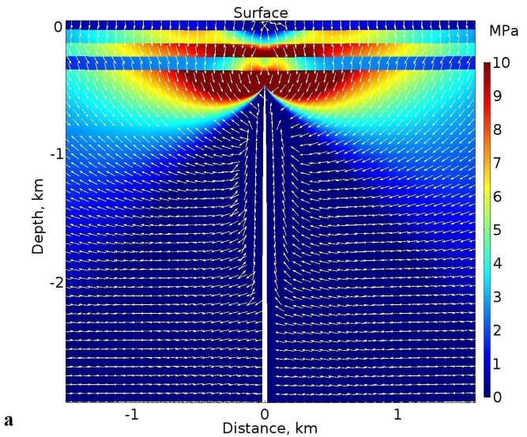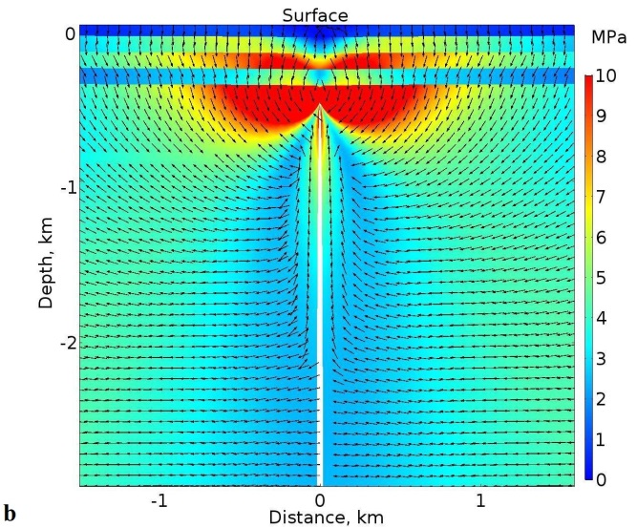

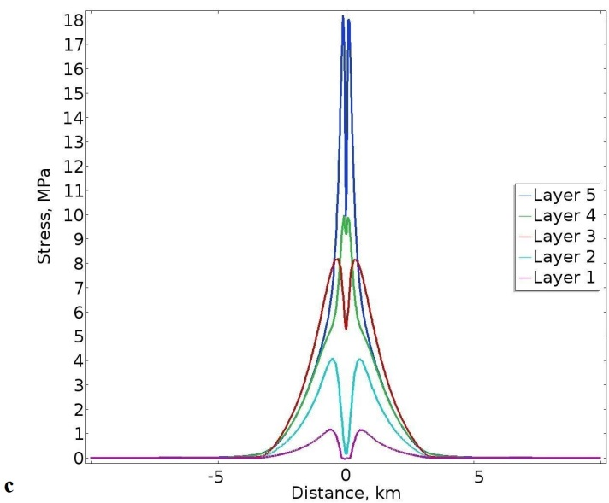
Fig. 7. Numerical model results with the following Young’s moduli: 3 GPa (layer 1), 20 GPa (layer 2), 30 GPa (layer 3), 10 GPa (layer 4), and 40 GPa (layer 5). Overpressure of dike: 5 MPa. (a) Contours of the maximum tensile principal stress σ₃ in mega-pascals (red highest stress, blue lowest), with white arrows (ticks) indicating the direction or trajectories of the maximum principal compressive stress σ₁. (b) Contours of the von Mises shear stress in mega-pascals. (c) Plots of the variation in the magnitude of the maximum tensile principal stress σ₃ (in mega-pascals) at the contacts between the layers. Layer 5 denotes the contact between layer 5 and 4. Layer 4 denotes the contact between layer 4 and 3. Layer 3 denotes the contact between layer 3 and 2. Layer 2 denotes the contact between layer 3 and 2. Layer 1 denotes the contact between layer 1 and the atmosphere, that is, is the free surface of the volcanic zone/volcano.

Arrested dikes are commonly observed during detailed field studies in well-exposed parts of active and inactive (eroded) volcanoes and volcanic zones. Studies in the past decades include those of Gudmundsson et al. (1999), Gudmundsson and Brenner (2001), Gudmundsson (2002, 2003, 2011a,b), Geshi et al. (2010, 2012), Moran et al. (2011), and Browning et al. (2015). By contrast, feeder-dikes are much more rarely observed, although careful observations often allow such dikes to be identified in the field (Gudmundsson et al., 2008; Geshi et al., 2010, 2012; Galindo and Gudmundsson, 2012; Becerril et al., 2013; Geshi and Neri, 2014). Here the focus is on non-feeders since the surface stresses and deformation induced by dikes that fail to reach the surface are the main topic of the paper. Given the number of arrested dikes described in the papers cited above, we here present only a rather brief description of those indicated above (Figs. 2-5).
First, however, we provide a short overview of the main mechanical conditions for dike arrest, mostly at contacts between mechanically dissimilar layers as in Figs. 2-5. There are three main mechanical conditions that encourage dike arrest, namely: Cook-Gordon delamination, stress barrier, and elastic mismatch. These are discussed in detail elsewhere
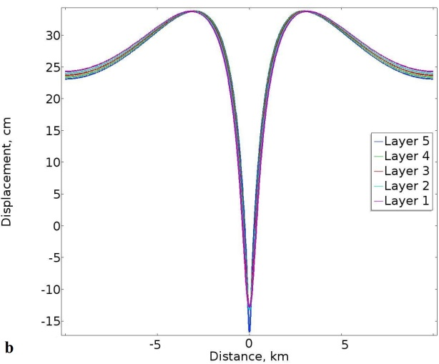
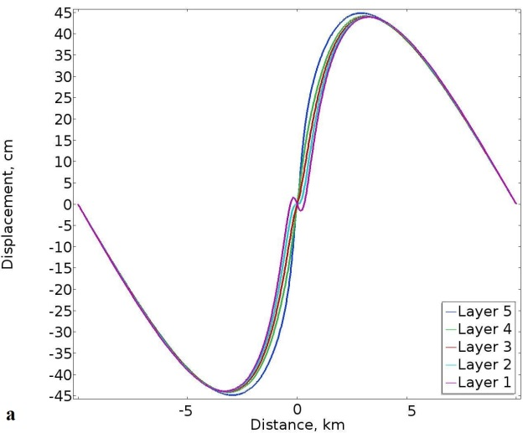

Fig. 8. Lateral and vertical displacement of the contacts between layers (denoted as layers 1-5) in the model in Fig. 7. (a) Here the lateral displacements at all the contacts, including the surface (layer 1), are similar and reach a maximum of 44 cm at a horizontal distance of about 3 km from the dike (the dike projection to the surface is located at 0 km). Displacements to the right of the dike are regarded arbitrarily as positive whereas those to the left of the dike as negative. (b) All the vertical displacements at the contacts are here also similar. The maximum uplift or vertical displacement of the contacts is about 34 cm and occurs at a horizontal distance of about 3 km on either side of the dike. Right above the tip of the dike there is a general subsidence of 12 cm for all the contacts except for the contact between layers 5 and 5 (denoted as layer 5), where the subsidence reaches 16 cm.

(Gudmundsson, 2011a,b; Al Shehri and Gudmundsson, 2018), but a brief summary may be helpful here.
In the Cook-Gordon delamination mechanism the contact that arrests the dike opens up, that is, becomes delaminated. For this to happen the tensile strength of the contact (and, by implication, the shear strength also, because these strengths are related) must be low. For a propagating dike, the highest tensile stress is perpendicular to the dike and generates the dike-fracture. But there is also a high dike-parallel tensile stress which, for a low-tensile-strength, may open up the contact when the dike tip approaches the contact. When the dike tip eventually reaches the open contact, the tip may become deflected along the contact to form sill or, alternatively, become arrested.
Stress barrier is a layer or unit where the local stress field is unfavourable for a particular type of fracture propagation, here vertical dike propagation. Normally, a dike propagates along a path whose direction is parallel with σ₁ and σ₂ and perpendicular to the minimum compressive (maximum tensile) principal stress, σ₃. A stress barrier to dike propagation is thus a layer/unit where σ₁ and σ₂ are horizontal and σ₃ thus vertical. On meeting such a layer, the dike must either deflect into a sill or become arrested. In volcanic rift zones, stress barriers commonly form either when the overpressure of an earlier dike injections have resulted in a 90° flip of the principal stresses. Slip on the boundary faults of a graben may also generate stress barriers to dyke propagation (Gudmundsson, 2011a; Al Shehri and Gudmundsson, 2018).
In an elastic-mismatch mechanism deflection and arrest of a dike are primarily controlled by the contrast – the mismatch – in elastic properties (primarily Young’s modulus) of the layers or units on either side of a contact, in relation to the elastic properties of the
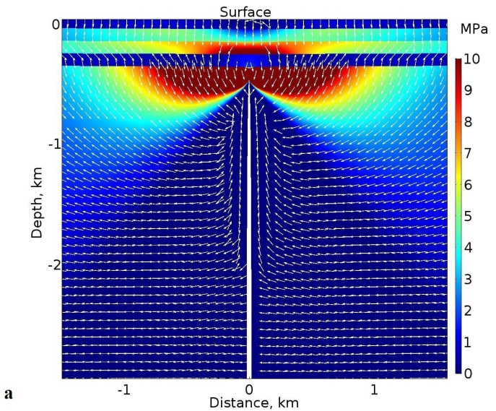
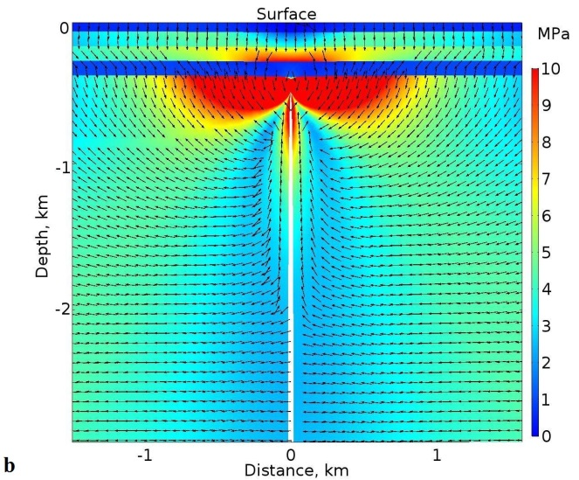

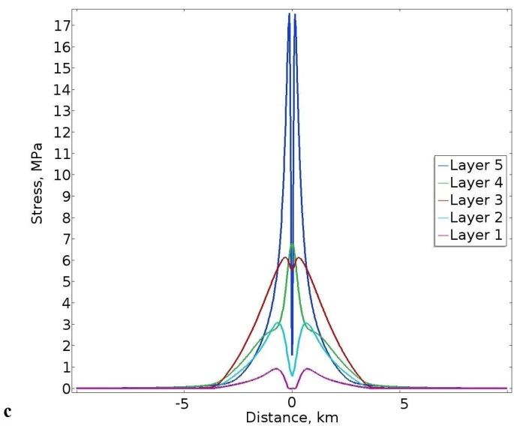
Fig. 9. The same model as in Fig. 7 except that layer 4 has here a Young’s modulus of 1 GPa. (a) Contours of the maximum tensile principal stress σ₃ (red highest stress, blue lowest), with white arrows (ticks) indicating the direction or trajectories of the maximum principal compressive stress σ₁. (b) Contours of the von Mises shear stress. (c) Plots of the variation in the magnitude of the maximum tensile principal stress σ₃ at the contacts between the layers. Layer 5 denotes the contact between layer 5 and 4. Layer 4 denotes the contact between layer 4 and 3. Layer 3 denotes the contact between layer 3 and 2. Layer 2 denotes the contact between layer 3 and 2. Layer 1 denotes the contact between layer 1 and the atmosphere, that is, is the surface of the volcanic zone/volcano.

contact itself (He and Hutchinson, 1989; Hutchinson, 1996; cf. Gudmundsson 2011a,b; Al Shehri and Gudmundsson, 2018). More specifically, when a dike (or any extension fracture) meets a contact between layers, its arrest or deflection is encouraged when the Young’s modulus of the layer hosting the fracture (E₂) and below the contact is lower than that of the layer above the contact (E₁). The probability of dike arrest at a contact varies positively with increasing elastic mismatch or difference between E₁ and E₂, that is, with increasing Dundurs parameter (Gudmundsson, 2011a,b). In particular, arrest of a dike or its deflection into a sill is more likely when the layer above the contact (E₁ has a higher Young’s modulus than the layer below the contact (E₂).
Let us now consider some typical arrested dikes as seen in the field (Figs. 2-5). The first one is remarkable in the sense that the dike became arrested at only 5 m below the surface of the rift zone of the Reykjanes Peninsula in Southwest Iceland (Fig. 2). The arrested dike, well-exposed in a sea cliff, and a nearby (25 m to the west) feeder-dike, both basaltic and about 800 year-old, are described in great detail by Gudmundsson (2017), so that only a brief description of the arrested dike is given here. The top or tip of the non-feeder becomes
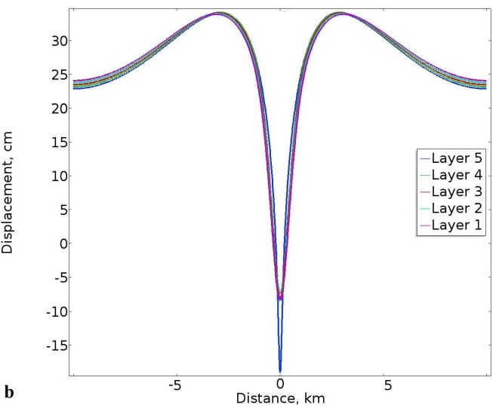
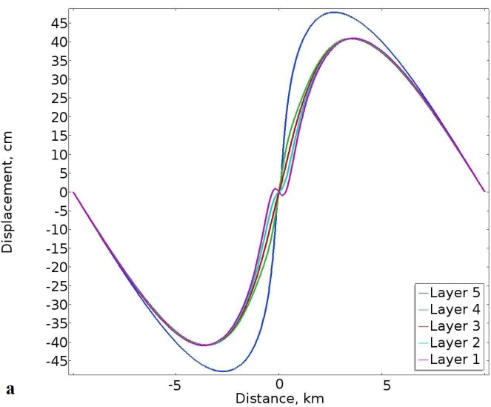
Fig. 10. Lateral and vertical displacement of the contacts between layers (denoted as layers 1-5) in the model in Fig. 9. (a) The lateral displacements at all the contacts, including the surface (layer 1), are similar except for layer 5 (contact 5/4) and reach a maximum of 40 cm at a horizontal distance of about 4 km from the dike (the dike is located at 0 km). By contrast, the lateral displacement of layer 5 (contact 5/4) reaches a maximum of about 47 cm at a distance of about 2.7 km from the dike. Displacements to the right of the dike are regarded arbitrarily as positive whereas those to the left of the dike as negative. (b) All the vertical displacements at the contacts are here also similar, except for layer 5 (contact 5/4). The maximum uplift or vertical displacement of the contacts is about 34 cm and occurs at a horizontal distance of about 3 km on either side of the dike. Right above the tip of the dike there is a general subsidence of 7 cm for all the contacts except for contact 5/4 (layer 5) where the subsidence reaches 14 cm.

arrested on meeting a contact between a stiff basaltic lava flow above and a compliant tuff layer below. The arrest therefore occurs where there is an abrupt increase in Young’s modulus or stiffness from the layer below to the layer above the contact – a condition that, through the elastic-mismatch mechanism described above, encourages dike arrest. However, this dike is arrested at a very shallow depth, so that it is likely that the Cook-Gordon delamination discussed above may also have contributed to the arrest.
The overall strike of the dike is N25°E, but the individual segments vary in strike; for example, the top, arrested segment strikes N46°E. The dike is of basalt and with numerous phenocrysts of plagioclase as well as vesicles. The lowermost visible exposure of the dike is about 0.35 m thick, and from there it gradually thins to a few centimetres where it ends vertically at the contact with the lava flow. The lava flow was formed in the Reykjanes Fires, during the period from 1210 to 1240 CE. It follows that the lava flow had considerable time to solidify and become stiff before the non-feeder met it, even if the non-feeder most likely was injected sometime during the same period.
One of the main themes in this paper is the relation between surface deformation and dike-induced stresses and fractures. None of the arrested dikes discussed in this paper (Figs. 2-4) has induced any observed grabens or normal faults ahead of the dike tip. This is particularly remarkable for the present dike, since it is arrested only 5 m below the surface of the rift zone, yet is unable to generate surface tension fractures or normal faults. The same applies to the nearby feeder-dike – no surface faults or tension fractures (apart from the

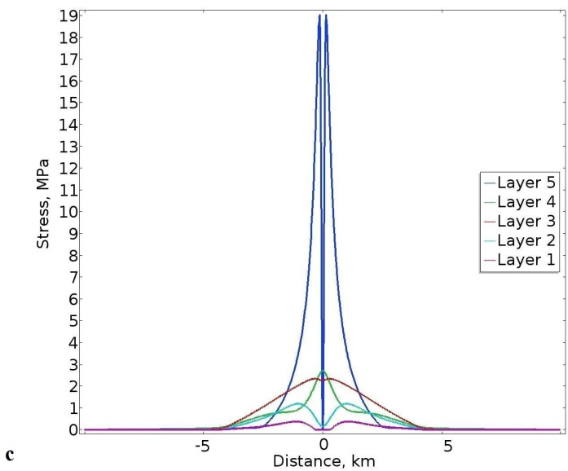
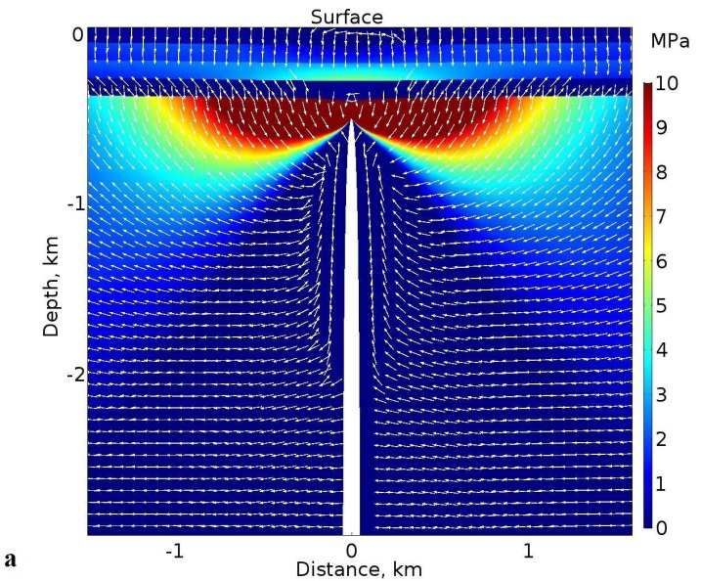
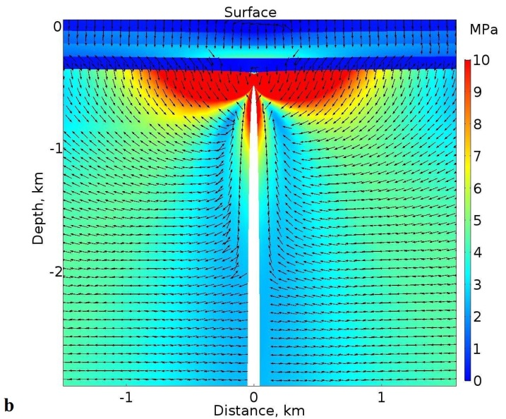
Fig. 11. The same model as in Fig. 7 except that layer 4 has here a Young’s modulus of 0.1 GPa. (a) Contours of the maximum tensile principal stress σ₃ (red highest stress, blue lowest), with white arrows (ticks) indicating the direction or trajectories of the maximum principal compressive stress σ₁. (b) Contours of the von Mises shear stress. (c) Plots of the variation in the magnitude of the maximum tensile principal stress σ₃ at the contacts between the layers. Layer 5 denotes the contact between layer 5 and 4. Layer 4 denotes the contact between layer 4 and 3. Layer 3 denotes the contact between layer 3 and 2. Layer 2 denotes the contact between layer 3 and 2. Layer 1 denotes the contact between layer 1 and the atmosphere, that is, is the surface of the volcanic zone/volcano.

extension fracture which the dike itself occupies) were associated with its emplacement (Gudmundsson, 2017). While this may sound surprising, it is in fact a common observation. Most volcanic fissures worldwide are not associated with grabens that are likely to have been induced by the feeder-dikes of the fissures.
The two next arrested dikes are particularly well exposed in the caldera walls of Santorini, Greece (Figs. 3, 4). The first dike (highlighted) is vertical, with a maximum thickness of about 2 m, and arrested within a layered pyroclastic rock (Fig. 3). The tip is rounded and arrested at the contact between mechanically dissimilar layers – the dissimilarly being partly due to their different grain size - in the pyroclastic host rock unit. The tip is rounded because the layers that constitute the pyroclastic unit were comparatively soft or compliant at the time of dike emplacement. Thus, at the tip the host rock deforms in a quasi-ductile manner rather than in an entirely brittle manner. Very soft (compliant) pyroclastics and sediments normally have close to zero tensile strength, so that it is essentially impossible to propagate an extension fracture through such materials. They can, however, fail in shear,
generating shear fractures or faults, while most dikes are extension fractures. All these factors contribute to dike arrest, many of which have rounded tips in compliant pyroclastic and sedimentary layers within stratovolcanoes and volcanic zones (Fig. 3) thereby making the volcanoes fracture resilient to dike propagation (Gudmundsson, 2009, 2011a,b). Here either a stress barrier or an elastic mismatch, or both, are the most likely reasons for dike arrest.
The next dike, also basaltic and in Santorini, is arrested at a contact between compliant pyroclastic/scoria layer (below the contact) and stiff lava flow (Fig. 4). This is a very common type of arrest (Figs. 2, 4, 5; Gudmundsson, 2002, 2003), and can, again, be attributed either to elastic mismatch or a stress barrier, except at very shallow depths (Fig. 2) where the Cook-Gordon delamination or debonding may dominate as an arrest mechanism (Gudmundsson, 2011a, b; Marti et al., 2016, 2017; Al Shehri and Gudmundsson, 2018). Here the bottom of the dike, at sea level, has a thickness of about 0.4 m thick but the dike becomes gradually thinner upwards (Fig. 4).
The final example presented here of an arrested basaltic dike is from Tenerife, one of the Canary Islands (Fig. 5). This vertically arrested dike is hosted by comparatively compliant pyroclastic rock and becomes arrested at its contact with much stiffer inclined basaltic sheet. The maximum thickness of the dike is about 0.8 m. The dike tip is blunt, as is common for dike tips arrested at contacts where the layer above the contact is stiff, such as a stiff lava flow or, as here, a sheet intrusion (Fig. 5). A very likely mechanism of dike arrest here is elastic mismatch.
These and other field examples show that dike arrest is particularly common at contacts between mechanically dissimilar layers. Perhaps the most favoured contacts for vertical dike arrest are those where the stiff layer (e.g., a lava flow or a sheet intrusion) is above the contact and the soft or compliant layer (e.g., pyroclastic, soil, or sedimentary) below the contact. This is in accordance with the three main mechanisms of dike arrest, namely the Cook-Gordon delamination/debonding, the stress barrier, and the elastic mismatch (Gudmundsson, 2011a, b; Marti et al., 2016, 2017).
None of the arrested dikes described here (Figs. 2-5) induced fractures ahead of the dike tip. By implication, presumably none of these dikes generated fractures at the surface. This follows because the dike-induced stresses are normally largest at the dike tip. So if the dike is unable to induce fractures at or close to its tip, then the dike is unlikely to induce fractures at the surface far above the tip (cf. Gudmundsson, 2003; Geshi et al., 2010; Philipp et al., 2013). This applies particularly when there are soft (compliant) layers between the dike tip and the surface (Section 3; Al Shehri and Gudmundsson, 2018). Clearly, therefore, dike-induced fractures at the surface require special conditions which were presumably not satisfied by any of the dikes seen here. One of the aims of the present paper is to explore these conditions.
All these arrested dikes are rather thin, ranging in thickness from about 0.3 m to 2 m (Figs. 2-5). While many dikes are of thicknesses similar to these (e.g. Rickwood, 1990; Gudmundsson, 2002; Galindo and Gudmundsson, 2012; Becerril et al., 2013; Rivalta et al., 2015), it should be noted that non-feeder dikes tend to become thinner on approaching their tips/tops (Gudmundsson et al., 1999). This thinning is most noticeable in the uppermost few tens of metres below the arrested tip (Geshi et al., 2010, 2012). In fact, such a thinning is seen in the exposed parts of the dikes in Figs. 2-4. It follows that all the arrested dikes in Figs. 2-5 could be thicker at depths below the present exposures.
The dikes seen in Figs. 2-5, and in the field in general, are segments. The entire three-dimensional structures of dikes are, for obvious reasons, never seen exposed in the field. Many dikes, however, have been traced for tens of kilometres in essentially lateral sections, some for hundreds of kilometres, and others in vertical sections for tens to hundreds of metres (e.g., Delaney and Pollard, 1981; Rickwood, 1990; Ernst et al., 2001; Geshi et al., 2010, 2012; Kavanagh and Sparks, 2011), so that the general field geometries of dikes are well known. It is, for example, well established that dikes are normally segmented and propagate as segmented fractures – a conclusion also supported by observations of the development of dike-fed volcanic fissures (e.g. Gudmundsson, 2017) and seismic and geodetic studies of dike propagation (Gudmundsson et al., 2014; Sigmundsson et al., 2015).
In view of the segmentation, a question is sometimes raised to the effect that while individual dike segments may be seen arrested (Figs. 2-5), it does not follow that the entire dike became arrested. More specifically, the observations of arrested dike segments, such as those in Figs. 2-5, does not preclude the possibility that other segments of the dike reached the surface to erupt - were feeders. That interpretation is correct in the sense that all the observations of arrested dikes as seen in the field refer to dike segments. But the same applies to all measurements of dikes in the field – and to those of other types of fractures (and most structures) as measured in specific outcrops. Namely, the measurements – say of an attitude (strike and dip) or opening/thickness - always refer to a given segment or part of the structure. The results of such measurements are statistical in nature, and the same applies to observed vertical ends of dikes. More specifically, most vertical ends of dike segments, as observed in numerous outcrops worldwide, are arrested rather than connected to eruptive materials (such as crater cones, lava flows, and pyroclastic flows). It then follows that most dike segments and - since individual dikes are simply collections of dike segments - most vertical ends or tips of entire dikes also become arrested.

- Numerical modelling - framework
In the following numerical models, the finite-element-method (FEM) software Comsol Multiphysics (www.comsol.com) is used to analyse the local stresses and displacements induced by dikes in a mechanically layered crustal segment hosting a volcano/volcanic zone. Like other FEM software, Comsol divides or discretises the problem to be solved into an equivalent system of small units or ‘elements’ and solves simultaneous algebraic equations. The resulting numerical approximations for each element are then combined into solutions for the entire body. The solutions are approximate solutions for the differential equations that describe the problem. At the corners of the elements (and sometimes also along their outer lines), are the nodes that connect the elements. In calculations, loads (stresses, displacements, or, as here, magmatic overpressures) are applied to these nodes and the resulting displacements at each node calculated. From these displacements, the nodal stresses and the element stresses, strains, and displacements are derived using linear equations (cf. Deb, 2006; Liu and Quek, 2014).

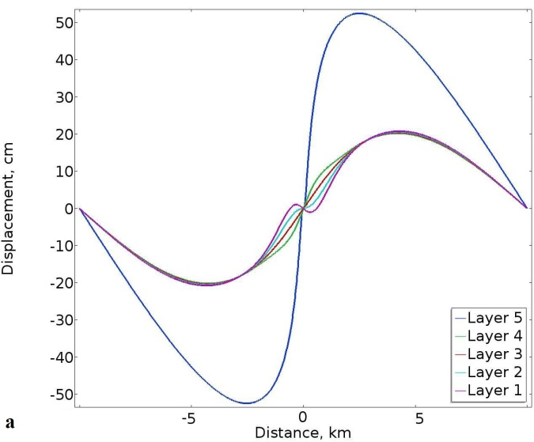
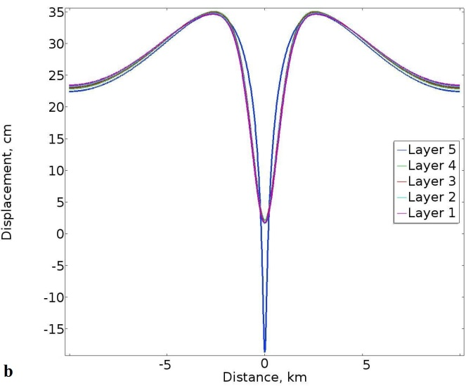
Fig. 12. Lateral and vertical displacement of the contacts between layers (denoted as layers 1-5) in the model in Fig. 11. Here the lateral and vertical displacements of the layers/contacts are increasingly different close to the dike. (a) The maximum lateral displacements are still similar for layers/contacts 1-4, about 20 cm at a distance of about 4.3 km from the dike. The maximum lateral displacement of layer 5 (contact 5/4), however, reaches a maximum of about 52 cm at about 3 km from the dike. Displacements to the right of the dike are regarded arbitrarily as positive whereas those to the left of the dike as negative. (b) The maximum upward displacements of all the layers roughly coincide and reach about 34 cm at a distance of about 2.8 km from the dike. Here, however, layers/contacts 1-4 do not show any absolute subsidence above the dike tip, while layer 5 (contact 4/5) shows an absolute maximum vertical subsidence of about 18 cm.

The results are specific solutions to a particular set of conditions and, as indicated, provide solutions only for the specified points in the body. In the models presented here the layered crustal segment hosting the dike is divided or discretised using triangular elements (Fig. 6b). All the models are fastened in the corners, so as to avoid rigid-body rotation and translation. The dimensions of the computational domain are 20 km × 20 km. This is large enough so that the main displacements and stresses induced by the dike are unaffected by the boundary conditions of the models being fastened in the corners. More specifically, the main dike-induced stresses and displacement are within a few kilometres of the dike tip, and are negligible at distances of 10 km to either side of the tip (where the model is fastened).
The crustal segment hosting the dike, including all the layers of which it is composed, is assumed to behave as elastic. This assumption rests experimental physics results which show that solid rocks at crustal conditions and low strain normally behave as elastic (Gudmundsson, 2011b). But also on in-situ or field measurements of crustal deformation around fault zones prior to earthquake ruptures and at volcanoes during inflation and deflation periods, all of which suggest elastic behaviour to a first approximation (Scholz, 1990; Dzurisin, 2006; Segall, 2010). No failure criteria is used for the dikes, because in all the models the dikes are already emplaced with a tip at 500 m depth below the surface and propagate no further – that is, the tip becomes arrested at this depth. When estimating whether the dike-induced stresses and displacements would be large enough to cause tension fractures and/or faults, the normal criteria for the formation of these fractures (based on tensile strength and shear strength) are used as a basis (Gudmundsson, 2011b).
In all the models the only loading is internal magmatic overpressure (driving or net magmatic pressure) defined as (Gudmundsson, 2011b):

(1)

Here p_{o} is the overpressure, ρ_{r} the average host-rock density, ρ_{m} the average magma density, g the acceleration due to gravity, h the dip dimension of the dike, and σ_{d} the differential stress (the difference between the maximum and the minimum principal stress) - at the time of emplacement - in the host rock where the dike is studied. The dip dimension of a dike (and any rock fracture) is its dimension in the direction of dip, that is, the height (in seismology the width) of the dike. Similarly, strike dimension is the dike dimension in the direction of strike, that is, its outcrop length (Gudmundsson, 2011b).
The second term on the right-hand side of Eq. (1) is the buoyancy term. For almost all volcanoes and volcanic zones, the average density of the uppermost 1-3 km of the crust is 2500-2600 kg m⁻³. By contrast, basaltic magma at depth may have density between 2650 and 2800 kg m⁻³ (e.g., Gudmundsson, 2011b). Consequently, in the uppermost part of the crust, buoyancy for basaltic magmas is commonly potentially negative. During ascent of magma, there is normally gas expansion which reduces the magma density. Gas expansion and density reduction is common in acid magmas to depths of many kilometres (Gonnermann and Manga, 2013). By contrast, much of the gas exsolution in basaltic magmas takes place at very shallow depths. Studies in Hawaii, for example, suggest that gas exsolution in basaltic magmas occurs primarily in the uppermost few hundred metres of the feeder-dike/conduit (Greenland et al., 1985, 1988). Field studies of basaltic dikes, sills, and inclined sheets in deeply eroded lava piles and central volcanoes show only small and rather infrequent gas-formed vesicles at depths exceeding several hundred below the original surface of the volcanic zone/central volcano, while large and small vesicles are common very close to the surface (Fig. 2), particularly in feeder-dikes (Galindo and Gudmundsson, 2012; Gudmundsson, 2017).
Density decrease of basaltic magma due to gas exsolution is thus unlikely to affect the potential negative buoyancy term in Eq. (1), except close to the surface. For basaltic dikes injected from shallow magma chambers the only driving pressure in Eq. (1) is therefore commonly the excess pressure p_{e} in the chamber at the time of its rupture. That pressure is roughly equal to the tensile strength of the walls or, normally, the roof of the magma chamber. The tensile strength of most rocks is between 0.5 and 9 MPa, the common values being 2-5 MPa. We use 5 MPa magmatic overpressure in most of the models. However, some basaltic dikes are injected directly from deep-seated reservoirs at 15-25 km depth, or deeper (Fig. 1), in which case the overall crustal density is higher than that of typical basaltic magma and the buoyancy term is positive. To take this into account, we also ran models where the dike overpressure is 15 MPa. Generally, the results are similar for the 5 MPa and the 15 MPa dike overpressure, except that the magnitudes of the dike-induced stresses and displacements are, of course, larger for the models with 15 MPa overpressure. This is as expected, since we use linear elastic material for the crustal layers, so that the stresses and deformation/displacements are proportional to the overpressure, for a given dike geometry
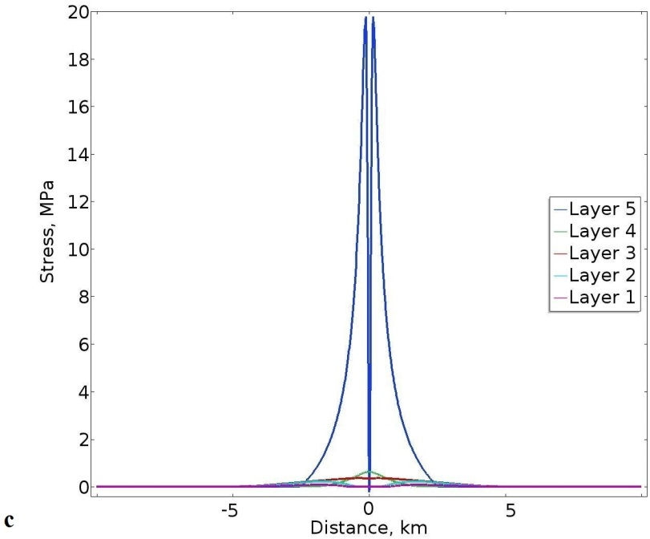
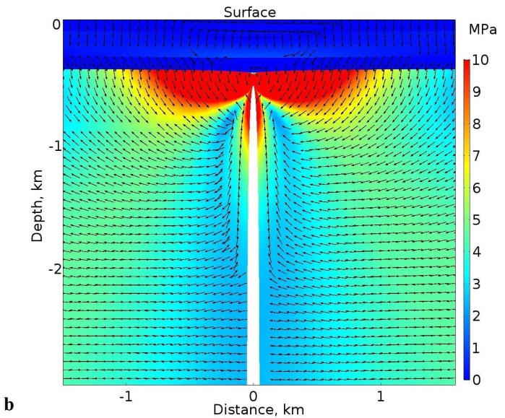
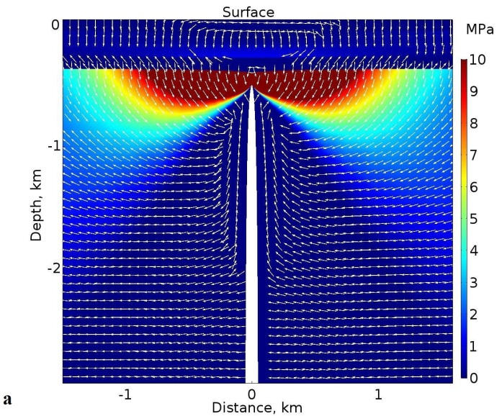

Fig. 13. The same model as in Fig. 7 except that layer 4 has here a Young’s modulus of 0.01 GPa. (a) Contours of the maximum tensile principal stress σ₃ (red highest stress, blue lowest), with white arrows (ticks) indicating the direction or trajectories of the maximum principal compressive stress σ₁. (b) Contours of the von Mises shear stress. (c) Plots of the variation in the magnitude of the maximum tensile principal stress σ₃ at the contacts between the layers. Layer 5 denotes the contact between layer 5 and 4. Layer 4 denotes the contact between layer 4 and 3. Layer 3 denotes the contact between layer 3 and 2. Layer 2 denotes the contact between layer 3 and 2. Layer 1 denotes the contact between layer 1 and the atmosphere, that is, is the surface of the volcanic zone/volcano.

and rock properties. Nevertheless, we show a few of the 15 MPa-overpressure models just to emphasise how the geometry and magnitudes of the stresses and displacement change proportionally with the overpressure.
In all the models the dike is vertical and with an upper tip at 500 m below the free surface of the volcano/volcanic zone (Fig. 6). The dike dip dimension is taken as 10 km, but is to a degree arbitrary. The indicated dike thickness in Fig. 6 is not to scale (it is far too thick in comparison with the thickness of the crustal layers). The actual dike thickness depends on the overpressure used, the dike dimensions, and the Young’s modulus of the host rock (there is greater dike thickness for given overpressure and dimensions in more compliant layers or units). The entire dike is located in the comparatively stiff unit/layer 5 (with a Young’s modulus of 40 GPa), in which case fracture-mechanics models (Gudmundsson, 2011b; Becerril et al., 2013) indicate model-dike thickness of about 2.3 m for an overpressure of 5 MPa (similar to that of the dike in Fig. 3) and 6.9 m for an overpressure of 15 MPa. These values cover a range similar to common thicknesses of dikes worldwide (Rickwood, 1990; Delaney and Pollard, 1981; Gudmundsson, 2002; Geshi et al., 2010; Becerril et al., 2013). For the present purpose the surface is taken as flat, so that it is more appropriate for a volcanic zone or a caldera will little topography than for a volcanic edifice that stands high above its surroundings. In all the models, there is one unit or layer hosting the dike, and then 4 layers of different mechanical properties above the dike tip. Each of these 4 layers has a thickness of 100 m, but their mechanical properties vary between model runs.
The main point of the layering used in the models is to study the effects of variation in Young’s modulus or stiffness on the dike-induced stresses and displacements. For this purpose we vary the stiffnesses of the layers but not the thicknesses between model runs. By contrast, the thickness of the layers, here taken as 100 m, is somewhat arbitrary. Sedimentary layers with thicknesses of tens of metres or more are common in volcanic zones – such as late glacial sediments which underlie many Holocene lava flows in the volcanic zones of Iceland. Similarly, hyaloclastite (basaltic breccia) layers and units formed during the last glacial period reach thicknesses of hundreds of metres and are commonly compliant (Gudmundsson, 2017). Comparatively thick compliant sedimentary and hyaloclastite layers, as well as pyroclastic layers (Figs. 2 and 3), are common in volcanic zones and central volcanoes, thereby reflecting the thicknesses used in the models. More generally, however, the 100-m-thick layers may be regarded as ‘seismic layers’, that is, groups of layers with similar seismic/mechanical properties, in which case the thicknesses of the layers in the models would be interpreted as mechanical/seismic rather than lithological.
In most of the numerical models the overpressure of the dike is 5 MPa and layering is as follows (Fig. 6). The surface layer has a Young’s of 3 GPa, the second layer from the top a Young’s modulus of 20 GPa, the third layer from the top a Young’s modulus of 30 GPa, the fourth layer from the top a variable Young’s modulus, and the fifth layer from the top, that is, the unit hosting the dike, a Young’s modulus of 40 GPa. These are all reasonable values for typical volcanic zones (e.g., Gudmundsson, 2011b). In particular, many Holocene lava flows have static Young’s moduli of the order of several mega-pascals and young pyroclastic layer may be still lower. Older lava flows, such as layers 2 and 3 here, may have static Young’s moduli of 20-30 MPa, while some would be lower. The stiffness of 40 GPa is similar to the estimated average static Young’s modulus of the uppermost 10 km of the volcanic rift zones in Iceland (Gudmundsson, 2003, 2011b).
We also tested some models with stiffer surface layers, namely 10 GPa and 20 GPa, some of the results being indicated below. The main change between model runs, however, is the stiffness of the fourth layer from the top. We vary the stiffness of layer 4 between model runs so as to explore the effects on dike-induced stresses and displacements. The Young’s moduli used for layer 4 vary from 10 GPa, which is reasonably stiff, to 0.01 GPa, which is very compliant. However, it is likely that most or all active volcanic zones and central volcanoes contain layers as soft as 0.1-0.01 GPa. This follows because such zones normally contain many layers of unconsolidated pyroclastics, including tuff layers, and many contain unconsolidated soils and sediments. In addition, clays are common in some of the volcanoes, particularly in association with geothermal fields. As examples, the normal range
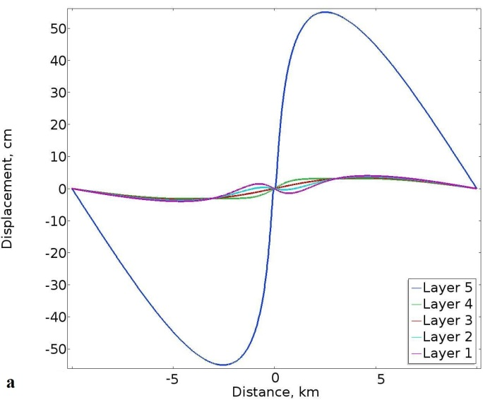
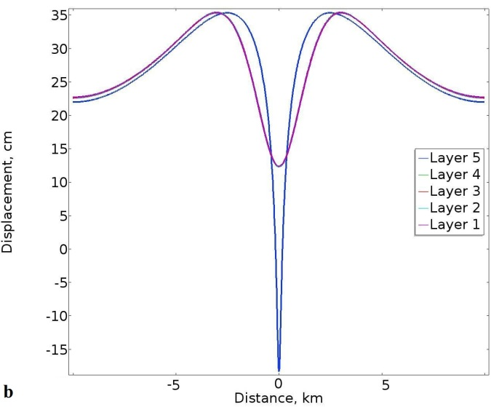
Fig. 14. Lateral and vertical displacement of the contacts between layers (denoted as layers 1-5) in the model in Fig. 13. (a) The lateral displacements of layers/contacts 1-4 are somewhat dissimilar close to the dike, but reach a maximum of about 4 cm at a distance of about 5 km from the dike. The maximum lateral displacement of layer 5 (contact 5/4), however, reaches a maximum of about 54 cm at a distance of about 2.8 km from the dike. (b) The vertical upward displacement of layers/contacts 1-4 roughly coincide and reach about 35 cm at a distance of about 3.3 km from the dike, showing a clear trough or two-peak displacement above the dike tip, but with the minimum displacement still at about 13 cm above the un-deformed surface (so no absolute subsidence). By contrast, layer 5 (contact 5/4) shows a maximum upward displacement of about 35 cm at a distance of about 2.6 km from the dike and an absolute subsidence right about the dike tip of about 17 cm.

of Young’s moduli (measured in the laboratory) of unconsolidated sand is 0.01-0.1 GPa, that of clay is 0.003-0.5 GPa, and that of tuff 0.05-5 GPa (Gudmundsson, 2011b). The models discussed are presented in the order of gradually decreasing stiffness of layer 4.

- Numerical modelling - results

  - Layer 4 with a stiffness of 10 GPa

In the first model layer 4 has a stiffness of 10 GPa, or similar to the in-situ stiffness of a lava flow, a welded pyroclastic layer, or a sedimentary rock. The results as regards stress (Fig. 7) show that layer 4, being of lower stiffness than the adjacent layers (40 GPa below and 30 GPa above), tends to suppress the tensile the minimum principal compressive or maximum tensile stress, σ₃ (Fig. 7a) as well as the von Mises shear stress (Fig. 7b). Yet considerable stresses pass through layer 4 up into layers 3 and 2. This is confirmed in the stress-magnitude curves plotted at the contacts between the layers (Fig. 7c). All the stress curves show the typical double-peak variation in σ₃, but the distance between the peaks is much smaller in layers 4 and 5 than in the other 3 layers. This is partly because these layers are closer to the surface, and partly because of the variation in the mechanical properties of the layers.
The white (Fig. 7a) and black (Fig. 7b) ticks show the direction of the trajectories of the maximum principal compressive stress, σ₁. Below about 2 km, that is, far from the free surface of the Earth, the ticks are horizontal and perpendicular to the dike. They continue to be perpendicular to the dike down to its bottom (not shown here). This is as expected since the magmatic overpressure in the dike (here 5 MPa) induces horizontal compressive stress in the surrounding host rock. Close to the surface, however, there is rotation of σ₁ close to the dike, but further away from the dike the ticks are still horizontal and perpendicular to the dike. This rotation is presumably related to the free-surface effects, that is, the fact that the uppermost part of the dike is close to the free surface of the Earth.
The associated displacements are given for lateral and vertical directions (Fig. 8). For the present model, the lateral displacements at the surface (layer or contact 1) and all the contacts (layers 2-5) are similar and reach a maximum of about 44 cm (Fig. 8a) at a lateral distance of around 3 km from the dike (the dike is located at 0 km). The vertical displacements induced by the dike are also generally similar (Fig. 8b). The model predicts absolute subsidence or downward vertical displacement of the layers just above the dike tip, of a maximum of about 16 cm for layer 5 (the lowermost contact), but about 12 cm for the other layers. Similarly, there is a double-peak rise or upward vertical displacement on either side of the dike, reaching a maximum uplift of about 34 cm. The maximum upward vertical displacement occurs in two peaks at about 3 km to either side of the dike projection to the surface.
Comparison of Figs. 7c and 8b shows that while the peak of the surface tensile stress (layer or contact 1) is at about 0.5 km measured horizontally from the projection of the dike to the surface (Fig. 8b), the peak of the upward vertical displacement is at 3 km from the projection of the dike to the surface. Although not shown here, our results show that the surface peak of the von Mises shear stress also coincides roughly with the peak of the tensile stress at the surface. The lateral distance from the projection of the dike tip to the surface to the peak on either side is roughly equal to the depth to the tip or top of the dike. This suggests that the maximum width of a dike-induced graben is roughly double the vertical distance to its bottom or the top (upper tip) of the dike. For this relation to hold in general, the boundary faults of the graben must have shallow dips between 40° and 50°. Such shallow dips on graben faults do occur, particularly in sedimentary basins, but are not common on grabens in volcanoes and volcanic zones, where normal-fault dips are mostly 60-80°, and some vertical close to the surface (e.g., Gudmundsson, 2005, 2017). In the latter case, the width of the induced graben would be less than twice the vertical distance to the top of the dike. Another exception to this relationship between the depth to the dike top and the lateral distance between the induced stress peaks at the surface is when there is an open contact between layers, usually at shallow depths, in which case the stress peaks occur above the lateral ends of the open contact (Gudmundsson, 2003). Thus, in the absence of open contacts that deflect the stress peaks laterally or vertical or steeply dipping normal faults, the above relationship holds (sometimes referred to as the ‘graben rule’), as is confirmed by many numerical models (e.g., Al Sheri and Gudmundsson, 2018).
In the present model, and in the subsequent models, because the dike tip is arrested at 0.5 km depth, the lateral distance to the stress peaks on either side of the dike is about 0.5 km. Thus, the lateral distance between the peaks is about 1 km. As discussed further below, if any tension fractures and/or normal faults would be induced by an arrested dike, they would tend to form at the location of the tensile and shear stress peaks at the surface and not at the location of the maximum vertical upward displacement of the surface.

  - Layer 4 with a stiffness of 1 GPa

Certain aspects of the stress field remain very similar when the stiffness of layer 4 is reduced from 10 to 1 GPa (Figs 7 and 9). For example, the direction of the trajectories of the maximum principal compressive stress, σ₁, are very similar, as they are in all the models. There are, however, clear differences. The first is that layer 4 with a stiffness of 1 GPa has much lower tensile and shear stresses than when its stiffness is 10 GPa. The zones of high stresses, tensile and shear, are also much more extensive in layer 3 when layer 4 has a stiffness of 10 GPa than when its stiffness is 1 GPa. This means that higher stresses ‘pass through’ the 10 GPa layer than through the 1 GPa layer to the shallower layers (Figs. 7a,b and 9a,b). By contrast, the area (volume in 3D) of high stress (red) in layer or unit 5 just under layer 4 is larger in Fig. 9a,b than in Fig. 7a,b, indicating that as less high stress passes through layer 4, more stress above the dike tip becomes concentrated at its contact with the stiff layer or unit 5.
As in the previous model (Fig. 8), the lateral and vertical displacements at the surface (layer or contact 1) and at the other layers/contacts are generally similar, except for layer 5, that is, the layer or unit hosting the dike (Fig. 10). The lateral displacements for most of the layers (layers 1-4) reach a maximum of about 40 cm at about 4 km from the dike (Fig. 10a). By contrast, the lateral displacement of layer 5 reaches a maximum of about 47 cm at a distance of about 2.7 km from the dike. We are here beginning to see the effect of softening of layer 4 in that the displacements below and above that layer are gradually more out of phase.
This difference between the displacement of layer 5 and the other layers is also seen in the vertical displacement (Fig. 10b). While the maximum upward displacements of all the layers roughly coincide and reach about 34 cm at a distance of about 3 km from the dike, the maximum downward displacements show differences between layer 5 and the other layers. In particular, while layers or contacts 1-4 show a maximum subsidence of about 7 cm below the surface in the centre above the dike tip, layer or unit 5 shows a displacement of as much as 14 cm at the same location.

4.3 Layer 4 with a stiffness of 0.1 GPa

At this low stiffness of layer 4, little stress passes through the layer. As a consequence the stresses above layer 4, such as in layer 3, are very low (Fig. 11). At the same time the tensile and shear stress concentration in layer 5 increase (Fig. 11a,b). These results are confirmed by the stress-magnitude curves (Fig. 11c). These show that while the tensile stress in layer 5 peaks at about 19 MPa, hardly any stresses (fraction of a mega-pascal) reach the surface (layer or contact 1) and only about 1 MPa reach the contact between the surface layer and layer below (contact or layer 2).
Here the lateral and vertical displacements of the layers/contacts are increasingly different close to the dike – that is, close to zero (Fig. 12). The maximum lateral displacement however, is still similar for layers/contacts 1-4, as regards the magnitude, about 20 cm, and
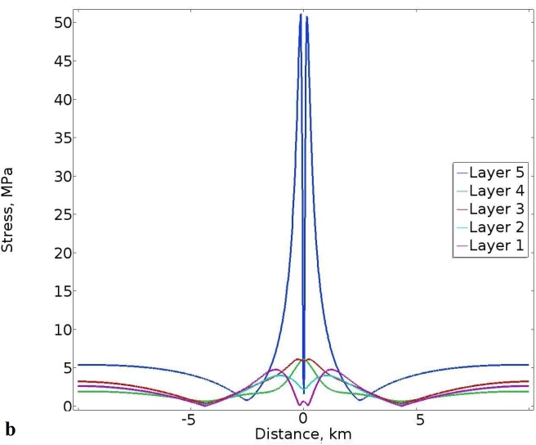
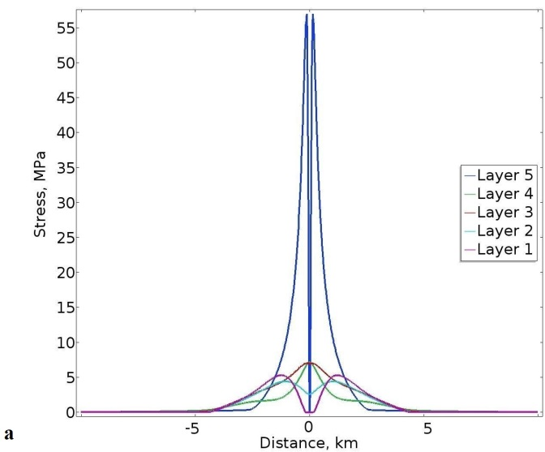

Fig. 15. The same basic model as in Fig. 7. The differences are (1) layer 4 has Young’s modulus of 0.1 GPa, the surface layer 1 has a Young’s modulus of 20 GPa, and the magmatic overpressure in the dike is 15 MPa. (a) Plots of the variation in the magnitude of the maximum tensile principal stress σ₃ at the contacts between the layers. (b) Plots of the variation in the magnitude of the von Mises shear stress (τ) at the contacts between the layers. Layer 5 denotes the contact between layer 5 and 4. Layer 4 denotes the contact between layer 4 and 3. Layer 3 denotes the contact between layer 3 and 2. Layer 2 denotes the contact between layer 3 and 2. Layer 1 denotes the contact between layer 1 and the atmosphere, that is, is the surface of the volcanic zone/volcano.

location - at about 4.3 km from the dike (Fig. 12a). By contrast, the maximum lateral displacement of layer 5, that is, the layer or unit hosting the dike, reaches a maximum of about 52 cm at 3 km from the dike.
While the maximum upward displacements of all the layers roughly coincide and reach about 34 cm at a distance of about 2.8 km from the dike, the maximum downward displacements show an increasing difference between layer 5 and the other layers. Here layers 1-4 do not show any absolute subsidence above the dike tip, in contract to that in previous models. There is still a clear trough or two-peak displacement, but the surface (layer 1, and contacts 2-4) is still at about 2 cm above the un-deformed surface. Layer 5, however, shows an absolute vertical subsidence of as much as 18 cm right above the dike tip (Fig. 12b).

  - Layer 4 with a stiffness of 0.01 GPa

Such a low-stiffness layer 4 effectively blocks or suppresses all the stress above layer 5. little stress passes through the layer. As a consequence, there are hardly any tensile or shear stresses in layers 1-4 while stresses in layer 5 above and around the dike tip up to the contact with layer 4 increase (Fig. 13a,b). These results are seen more clearly by the stress-magnitude curves (Fig. 13c). These show that while the tensile stress in layer 5 peaks at about close to 20 MPa, the surface stresses in layers/contacts 1 and 2 above the dike are essentially zero, and a fraction of a mega-pascal for layers/contacts 3 and 4.
Here the maximum lateral displacements of layers/contacts 1-4 are somewhat dissimilar close to the dike, but reach a maximum of only about 4 cm at a distance of about 5 km from the dike (Fig. 14a). The maximum lateral displacement of layer 5, that is, the layer or unit hosting the dike, however, reaches a maximum of about 54 cm at a distance of about 2.8 km from the dike.
With the exception of layer/contact 5, the maximum upward displacements of all the layers/contacts roughly coincide and reach about 35 cm at a distance of about 3.3 km from the dike (Fig. 14b). Layers/contacts 1-4 show a clear trough or two-peak displacement above the dike tip, but the surface (layer/contact 1) and layers/contacts 2-4 is still at about 13 cm above the un-deformed surface. By contrast, layer/contact 5 shows a maximum upward displacement of about 35 cm, but the location is different from that of the other layers/contacts, namely at a distance of about 2.6 km from the dike.
This model and the previous one (with layer 4 of stiffness 0.1 GPa) show that further softening of layer 4 makes the variation in internal stresses and displacements induced by the dike more complex than in the models where layer 4 had a stiffness more similar to that of the adjacent layers. In particular, the results show that the differences in magnitudes and locations of the horizontal and vertical displacements increase as layer 4 becomes softer.

- Discussion

Because of their role in assessing volcanic hazards and estimating geometries of dikes (including their volumes) injected from magma chambers/reservoirs during unrest periods, surface deformation studies in volcanoes/volcanic zones are of increasing importance in volcanology. In particular, geodetic studies together with seismic studies are of fundamental importance for assessing dike volumes, and thus the volume of magma supposed to flow out of the chamber/reservoir during the associated unrest period. In addition, deformation studies help determine the dike path and assess the likelihood of dike-fed eruptions.
There have been many numerical models on local stresses and surface deformation during inflation of magma chambers hosted by layered rocks. These include, for example, Gudmundsson (2002), Gudmundsson and Philipp (2006), Manconi et al. (2007), and Masterlark (2007). These provide information on local stresses and deformation inside volcanoes that can be of great use in making crude forecasts as to the likely paths of injected dikes, but do not address the stresses and displacements/deformation induced by the dikes themselves (or mode I cracks, extension fractures, in general), which is the main theme of the present paper.
Following earlier general analytical studies of the deformation and stresses at the surface of an elastic half-space above an elliptical crack (Isida, 1955; Tsuchida and Nakahara, 1970) there have been many numerical fracture studies focusing on dikes in an elastic half-space. These include studies by Pollard et al. (1983), Davis (1983), Rubin and Pollard (1988), and Cayol and Cornet (1998). A very different approach is to model dikes as elastic dislocations. The models are applied to invert surface geodetic data to infer the opening or thickness, strike, dip, and depth of dikes, inclined sheets, and sills. The application of the dislocation theory volcano deformation is reviewed in detail by Okada (1985, 1992) and also by Dzurisin (2006) and Segall (2010).
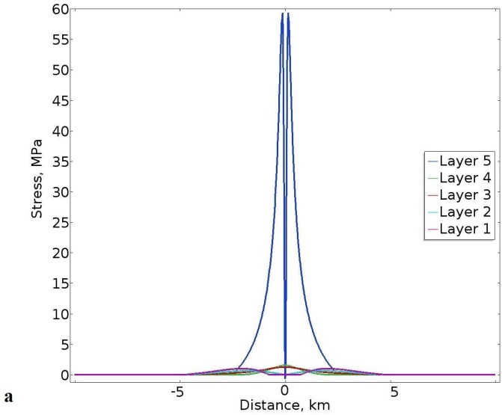
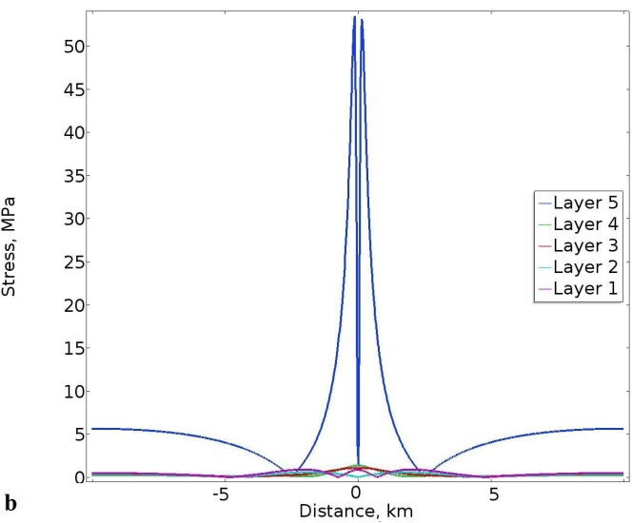

Fig. 16. The same model as in Fig. 15, except that layer 4 has here a Young’s modulus of 0.01 GPa. (a) Plots of the variation in the magnitude of the maximum tensile principal stress σ₃ at the contacts between the layers. (b) Plots of the variation in the magnitude of the von Mises shear stress (τ) at the contacts between the layers. Layer 5 denotes the contact between layer 5 and 4. Layer 4 denotes the contact between layer 4 and 3. Layer 3 denotes the contact between layer 3 and 2. Layer 2 denotes the contact between layer 3 and 2. Layer 1 denotes the contact between layer 1 and the atmosphere, that is, is the surface of the volcanic zone/volcano.

All these numerical and dislocation models assume the volcanic zone/volcano hosting the dike to act as a homogeneous, isotropic, elastic half-space. This means that the models do not consider the effects of mechanical layering or contacts between layers on the dike-induced stresses and deformation. Surface deformation in layered elastic host rocks, however, has been considered by Bonafede and Rivalta (1999a,b). Dislocation and numerical models of dike-induced deformation are reviewed by Rivalta et al. (2015) and by Townsend et al. (2017).
With a few exceptions, all these models focus on the surface displacement induced by the dike. Only a few studies have combined field observations of arrested dikes/hydrofractures in layered rocks with numerical models of the local stresses induced by the dike in the adjacent layers as well as at the surface. These studies include Gudmundsson and Brenner (2001), Gudmundsson (2003), Gudmundsson and Loetveit (2005), and Philipp et al. (2013). In contrast to the present study, none of these studies focuses on the changes in the dike-induced stresses and displacements/deformation inside the volcano/volcanic zone as a function of the variation in the elastic properties of the mechanical layering.
Since almost all the early models assume the rocks hosting the dike to be homogeneous and isotropic, and thus do not consider any layering, the most appropriate comparison as regards the present models is with the first models, namely where layer 4 has a stiffness of 10 GPa and thus rather similar to the stiffnesses of the adjacent layers. The present results are in good general agreement with the surface displacements obtained in the earlier elastic half-space models, such as summarised by Dzurisin (2006) and Segall (2010). In particular, for this model (layer 4 with stiffness of 10 GPa) the surface displacements and stresses show similarities to those obtained by Pollard et al. (1983) and Rubin and Pollard (1988).
The surface upward and downward displacements are of importance for understanding better the location, geometry, and propagation paths of associated dikes. For understanding and forecasting dike-induced surface fracturing, however, the surface stresses are of main concern. This follows because tension fractures and faults form at the surface – or elsewhere – only if the local stresses reach certain magnitudes. These magnitudes are well known. For tension fractures, the local absolute tensile stress must normally reach at least 2-5 MPa, which is the most common tensile strength of rocks (Gudmundsson, 2011b). Similarly, for faults – here in particular dip-slip faults – the shear strength is normally about double the tensile strength, so commonly 4-8 MPa, which is, indeed, similar to common stress drops in earthquakes (Kanamori and Anderson, 1975; Scholz, 1990).
The present models (Figs. 7-14) show clearly that the location of the maximum surface uplift or vertical displacement does not coincide with the location of the maximum surface stress concentration. The maximum shear and tensile stress at the surface (as well as in the subsurface) roughly coincide and occur at locations widely different from those of maximum surface uplift. In particular, the lateral distance between the two peaks of the surface tensile (and shear) stresses is much less than that between the two peaks of the surface uplift. Thus, while the surface stresses peak at lateral distances of 0.5-0.7 km from the projection of the dike to the surface, the surface uplifts peak at 2.8-3.3 km from the project of the dike. The models clearly show that the maximum surface uplifts, the uplift peaks, do not show high tensile or shear stresses. This is understandable because the strain associated with uplift of a fraction of a metre over distances of kilometres to tens of kilometres is of the order of 10⁻⁴ to 10⁻⁵ and thus too small to result in high stress for the given Young’s modulus of the surface layer of 3 GPa.
The maximum tensile and shear stress occurs at a lateral distance from the projection of the dike which is similar to the depth to the tip of the dike. The present results thus support other recent results on dike-induced stresses (Al Shehri and Gudmundsson, 2018) that any tension fractures or normal faults induced by arrested dikes would tend to form within a zone of a width similar to that of the depth to the tip of the dike. In particular, any dike-induced graben would be likely to be of a width similar to, or perhaps somewhat less than, the depth to the tip of the arrested dike. Our results thus do not lend any support to the common practice of interpreting the boundary faults of grabens as coinciding with the maximum uplift, the upward displacement peaks, at the surface above an arrested dike.
The only exceptions to the above relationship between the depth of the arrested dike tip (the dike top) and the location of the stress peaks at the surface occur when (1) the graben faults are steeply (sometimes vertically) dipping or (2) the contact arresting the dike also opens up through Cook-Gordon delamination or debonding (Gudmundsson, 2011a,b). Contact delamination may happen at very shallow crustal depths, and has been modelled for arrested dikes (Gudmundsson, 2003, 2011b). The main result of the modelling is that for delamination the stresses at the surface normally peak above the lateral ends of the opened-up contact. It follows that the double-stress peak does not have any correlation with the depth to arrested tip of the dike (Gudmundsson, 2003). In the models in the present paper, however, the contacts are mechanically too strong to open up.
In all the models presented here the magmatic overpressure or driving pressure p_{o} is 5 MPa and the surface layer has a Young’s modulus or stiffness of 3 GPa. We ran all the models also for the much higher magmatic overpressure of 15 MPa. The results are geometrically similar, while the absolute stresses induced by the dike are, as expected, higher. To test the maximum possible effects, we used the overpressure of 15 MPa combined with a surface layer with the very high stiffness of 20 GPa. This high stiffness in unrealistic but the models are intended to explore the greatest effects very stiff surface layers could have on the results (cf. Geyer and Gottsmann, 2010). We ran the models for the two cases of greatest importance, namely layer 4 with a stiffness of 0.1 GPa and stiffness of 0.01 GPa. The main aim was to see how great much the surface stresses would increase for high overpressure and very high surface stiffness in a volcanic zone/volcano with one or more soft layers (layer 4).
For layer 4 with stiffness of 0.1 the results show that the surface tensile and shear stresses reach about 5 MPa (Fig. 15). Thus tension-fracture and normal-fault formation (including graben formation) would be possible under these conditions. For this very great surface stiffness, the lateral distance between the stress peaks is about 2.2 km, rather than about 1.4 km so that the graben, if formed, would be somewhat wider than in the models with 3 GPa surface-layer stiffness. The results mean that for a dike with an arrested tip at 0.5 km below a very stiff surface of 20 GPa and with the high overpressure of 15 MPa, normal faulting and tension fracturing is just possible.
For layer 4 with stiffness of 0.01 GPa, an overpressure of 15 MPa, and a surface stiffness of 20 GPa, the results show that the surface tensile and shear stresses reach only a fraction of a mega-pascal (Fig. 16). Thus, even an unusually high surface-layer stiffness and overpressure for an arrested dike with a tip at the shallow depth of 0.5 km, the stresses at the surface are still far too small to generate either tension fractures or normal faults. The results thus underline the great effects of soft layers in reducing dike-inducing stresses and in suppressing surface stresses and fracture formation even for very high driving pressures and unusually stiff surface layers.
As regards the likelihood of dike-fed eruption, the models indicate that for 5 MPa overpressure little or no dike-induced surface deformation would be expected unless the dike tip propagates to depths below the surface of less than a kilometre, and commonly to depths of only several hundred metres. The model results thus suggest that when significant dike-induced deformation is seen at the surface, the dike is normally very close to the surface – within several hundred metres of the surface - indicating a rather high likelihood of the dike reaching the surface to erupt.
Elastic half-space models commonly overestimate the potential dike-induced surface stresses and, consequently, the depth of the tip of the associated dike below the surface. It also follows that half-space models commonly underestimate the dimensions – particularly the thickness – and therefore the volumes of the dike inducing a particular surface deformation during a volcanotectonic episode (e.g., Al Shehri and Gudmundsson, 2018). When the dike volumes are underestimated, then the flow of magma out of the source chamber during the episode is also underestimated. For an eruption, the combined intrusive and extrusive (erupted) volume of magma injected from the chamber is then also underestimated. Since this combined volume is one of the factors used to estimate the volume of the source magma chamber that volume, and hence the likely dimensions of the chamber, will also be in error.
In summary, the results of all the models (Figs. 7-16) demonstrate the importance of the effects of mechanical layering in volcanic zones and volcanoes on dike-induced displacements and stresses. In particular, the results show that compliant layers make dike-induced surface fracturing unlikely until the dike is at a very shallow depth, or with a very high overpressure, or both. This is in agreement with the field observations of arrested dike tips, showing that many dikes arrested at shallow depths did not generate tension fractures or normal faults above their tips (Figs. 2-5). More specifically, the results suggest that the common use of homogeneous, elastic half-space dislocation models to infer dike geometries and dimensions thorough the inversion of surface-deformation data is likely to lead to highly unreliable results. Furthermore, the present models indicate that the common practice of associating the calculated the maximum theoretical surface displacements with graben formation is not justified.

- Conclusions

The main conclusions of this paper may be summarised as follows:
- Field observations show that although some dikes just thin out, or taper away in vertical sections, most dikes become arrested at contacts between mechanically dissimilar rock layers. The main mechanical property that varies across the contact is the stiffness or Young’s modulus. The ideal condition for a dike (or any other mode I, extension, fracture) to become arrested at such a contact is when the layer above the contact is much stiffer than the layer below the contact (the one hosting the dike). However, for many arrested dikes the layer above may be more compliant than the one hosting the dike. This is because there are three processes that may contribute to dike arrest at any particular contact: Cook-Gordon delamination, stress barrier, and elastic mismatch.
- Field observations also show that many arrested dike tips do not generate any significant large-scale fracturing ahead of the dike tip. Even dikes that become arrested only several metres below the free surface of a rift zone may, for specific mechanical layering, be unable to generate fractures at the surface. There are, however, many well-documented cases of tension-fracture and normal-fault generation associated with dike emplacement during unrest periods.
- The new numerical results presented here use 5 layers with different mechanical properties, that is, different Young’s moduli. In most models, the surface layer, layer 1, has a stiffness of 3 GPa, layer 2 a stiffness of 20 GPa, layer 3 a stiffnes of 30 GPa, and layer or unit 5 a stiffness of 40 GPa. Layer or unit 5 is the one hosting the dike whose tip is arrested at 0.5 km below the surface. Between model runs, the stiffness of layer 4 is varied, from 10 GPa, and thus rather stiff, to 1 GPa, 0.1 GPa, and 0.01 GPa. The last stiffness, 0.01 GPa, is very compliant but layers of similar stiffness are likely to occur in most active volcanoes and volcanic zones.
- As for dike-induced stresses, the numerical results show very great effect of layering, in particular of the gradually more compliant layer 4. When its stiffness becomes as low as 0.1-0.01 GPa, layer 4 transports hardly any stresses to the shallower layers. The result is very low stress at shallower depth, including the surface. Generally, the location of the maximum tensile and shear stresses roughly coincide so that, when significant stresses are transported to the surface, the most likely initiation of tension fracture and shear fractures should occur in roughly the same areas at the surface.
- When the stiffness of layer 4 is gradually decreased from 10 GPa to 0.01 GPa, the internal deformation of the volcano/volcanic zone increases. This is reflected in the displacement fields. Thus, the horizontal displacement of all layers/contacts is generally similar while the stiffness of layer 4 is 10 GPa, but as the layer becomes softer, the difference in displacements between the layers/contacts increases and reaches a maximum when the stiffness of layer 4 is 0.01 GPa. At that stiffness the horizontal displacement of layer/contact 5 is totally different, in terms of magnitude and location of the peaks, from that of the other layers/contacts. And similarly for the vertical displacement.
- The maximum tensile and shear stresses, that is, the stress peaks vary throughout the interior of the volcano/volcanic zone. They are highest in layer/contact 5, hosting the dike, and decrease towards the surface. As the stiffness of layer 4 decreases, so do the tensile and shear stresses inside and above that layer, including the surface. At the surface the tensile and shear stresses peak mostly at a lateral distances of 0.5-0.7 km from the projection of the dike to the surface. This implies that any dike-induced graben would be likely to be of a width about twice the depth to the tip of the arrested dike. Thus, in most of the present models, a graben, if formed at all, would tend to be between 1 km and 1.4 km wide at the surface.
- The maximum surface uplift or vertical displacement peaks at lateral distances of 2.8-3.3 km from the projection of the dike to the surface and have low stresses. We conclude that tension fractures and faults – in particular the boundary faults of grabens – are most likely to form, if at all, in the location of the tensile/shear stress peaks and not, as is commonly suggested, at the location of the surface uplift peaks. Our results thus do not lend any support to the common practice of interpreting the boundary faults of grabens as coinciding with the maximum uplift, the upward displacement peaks, at the surface above an arrested dike.
- The results suggest that failure to take typical and reasonable mechanical layering in volcanoes and volcanic zones into account, such as in using homogeneous, elastic half-space dislocation models, when inferring dike geometries and dimensions through the inversion of surface-deformation data is likely to lead to highly unreliable results. In particular, such models tend to overestimate the dike-induced surface stresses, and thus the depth to the tip of the associated dike. It also follows that half-space models commonly underestimate the dimensions – particularly the thickness – and therefore the volumes of the dike inducing the surface deformation. When the dike volumes are underestimated, then the flow of magma out of the source chamber during the volcanotectonic episode is also underestimated.
- As regards the likelihood of dike-fed eruption, the present models indicate that, normally, little or no dike-induced surface deformation would be expected unless the dike tip propagates to depths below the surface of less than a kilometre. This implies that when significant dike-induced deformation is seen at the surface, the dike is normally very close to the surface – within several hundred metres of the surface - indicating a rather high likelihood of the dike reaching the surface to erupt.

Acknowledgements
We thank Weld on Sweden for financial support. We also thank Adelina Geyer and Alessandro Tibaldi for very helpful review comments.

References

Acocella, V., Neri, M., 2009. Dike propagation in volcanic edifices: Overview and possible developments. Tectonophysics, 471, 67-77, doi: 10.1016/j.tecto.2008.10.002.
Al Shehri, A., Gudmundsson, A., 2018. Modelling of surface stresses and fracturing during dyke emplacement: Application to the 2009 episode at Harrat Lunayyir, Saudi Arabia. J. Volcanol. Geotherm. Res., 356, 278-303.
Baer, G., Hamiel, Y., 2010. Form and growth of an embryonic continental rift: InSAR observations and modelling of the 2009 western Arabia rifting episode. Geophysics. J. Int. 182, 155-167.
Barnett, Z.A., Gudmundsson, A., 2014. Numerical modelling of dykes deflected into sills to form a magma chamber. J. Volcanol. Geotherm. Res., 281, 1-11.
Becerril, L., Galindo, I., Gudmundsson, A., Morales, J.M., 2013. Depth of origin of magma in eruptions. Scientific Reports 3, 2762. doi: 10.1038/srep02762
Bonafede, M., Rivalta, E., 1999a. The tensile dislocation problem in a layered elastic medium. Geophys. J. Int., 136, 341-356.
Bonafede, M., Rivalta, E., 1999b. On tensile cracks close to and across the interface between two welded elastic half-spaces. Geophys. J. Int., 138, 410-434.
Browning, J., Drymoni, K., Gudmundsson, A., 2015. Forecasting magma-chamber rupture at Santorini volcano, Greece. Scientific Reports, 5, doi: 10.1038/srep15785.
Carracedo, J.C., Troll, V.R., 2006. Seismicity and gas emissions on Tenerife: a real cause for alarm? Geology Today, 22, 138-141.
Cayol, V., Cornet, F.H., 1998. Three-dimensional modelling of the 1983-1984 eruption of Piton de la Fournaise volcano, Reunion Island. J. Geophys. Res., 103, 18,025-18,037.
Davis, P.M., 1983. Surface deformation associated with a dipping hydrofracture. J. Geophys. Res., 88, 5826-5834.
Deb, D., 2006. Finite Element Method: Concepts and Applications in Geomechanics. Prentice-Hall, New Jersey.
Delaney, P.T., Pollard, D.D., 1981. Deformation of host rock and flow of magma during growth of minette dike and breccia-bearing intrusions near Ship Rock, New Mexico. U.S. Geol. Surv. Prof. Pap. 1202, 1-69.
Dzurisin, D., 2006. Volcano Deformation. Springer Verlag, New York.
Ernst, R.E., Grosfils, E.B., Mege, D., 2001. Giant dike swarms: Earth, Venus, and Mars. Annu. Rev. Earth Planet. Sci., 29, 489-534.
Galindo, I., Gudmundsson, A., 2012 Basaltic feeder-dykes in rift zones: geometry, emplacement, and effusion rates. Natural Hazards and Earth System Sciences, 12, 3683–3700.
Garcia, A. Ortiz, R., Marrero, J.M., Sanchez, N., Tarraga, M., Vila, J., Correig, Macia, R., Sleeman, R., 2006. Monitoring the reawakening of Canary Islands’ Teide Volcano. Eos, 87, 61-72.
Gautneb, H., Gudmundsson, A., 1992. Effect of local and regional stress fields on sheet emplacement in West Iceland. Journal of Volcanology and Geothermal Research, 51, 339-356.
Geshi, N., Kusumoto, S., Gudmundsson, A., 2010. Geometric difference between non-feeder and feeder dikes. Geology, 38, 195–198.
Geshi, N., Kusumoto, S., Gudmundsson, A., 2012. Effects of mechanical layering of host rocks on dike growth and arrest. J. Volcanol. Geotherm. Res., 223-224, 74-82.
Geshi, N., Neri, M., 2014. Dynamic feeder dyke systems in basaltic volcanoes: the exceptional example of the 1809 Etna eruption (Italy). Frontiers in Earth Science, 2, doi: 10.3389/feart.2014.00013.
Geyer, A., Gottsmann, J., 2010. The influence of mechanical stiffness on caldera deformation and implications for the 1971-1984 Rabaul uplift (Papua New Guinea). Tectonophysics, 483, 399-412, doi: 10.1016/j.tecto.2009.10.029.
Gonnermann, H.M., Manga, M., 2013. Dynamics of magma ascent in the volcanic conduit. In: Fagents, S.A., Gregg, T.K.P., Lopes, R.M.C. (eds), Modeling Volcanic Processes. Cambridge University Press, Cambridge, pp. 55-84.
Gottsmann, J., Wooller, L., Marti, J., Fernandez, J., Camacho, A.G., Gonzalez, P.J., Garcia, A., Rymer, H., 2006. New evidence for the reawakening of Teide volcano. Geophys. Res. Lett., 33, L20311, doi:10.1029/2006GL027523.
Greenland, L.P., Rose, W.I., Stokes, J.B., 1985. An estimate of gas emissions and magmatic gas content from Kilauea volcano. Geochim. Cosmochim. Acta, 49, 125-129.
Greenland, L. P., Okamura, A. T., Stokes, J. B., 1988. Constraints on the mechanics of the eruption. In: Wolfe, E. W (ed), The Puu Oo Eurption of Kilauea Volcano, Hawaii: Episodes Through 20, January 3, 1983 Through June 8, 1984, US Geol. Survey Professional Paper, 1463, 155–164.
Gudmundsson, A., 2002. Emplacement and arrest of sheets and dykes in central volcanoes. J. Volcanol. Geotherm. Res., 116, 279-298.
Gudmundsson, A., 2003. Surface stresses associated with arrested dykes in rift zones: Bull. Volcanol., 65, 606-619.
Gudmundsson, A., 2005. Effects of mechanical layering on the development of normal faults and dykes in Iceland. Geodinamica Acta, 18, 11-30.
Gudmundsson, A., 2009. Toughness and failure of volcanic edifices. Tectonophysics, 471, 27-35.
Gudmundsson, A., 2011a. Deflection of dykes into sills at discontinuities and magma-chamber formation. Tectonophysics, 500, 50-64.
Gudmundsson, A., 2011b. Rock Fractures in Geological Processes. Cambridge University Press, Cambridge.
Gudmundsson, A., 2017. The Glorious Geology of Iceland’s Golden Circle. Springer-Nature, Heidelberg.
Gudmundsson, A., Brenner, S.L., 2001. How hydrofractures become arrested. Terra Nova, 13, 456-462.
Gudmundsson, A., Friese, N., Galindo, I., Philipp, S.L., 2008. Dike-induced reserve faulting in a graben. Geology, 36, 123-126, doi: 10.1130/G24185A
Gudmundsson, A., Lecoeur, N., Mohajeri, N., Thordarson, T., 2014. Dike emplacement at Bardarbunga, Iceland, induces unusual stress changes, caldera deformation, and earthquakes. Bulletin of Volcanology, 76, 869, doi: 10.1007/s00445-014-0869-8
Gudmundsson, A., Loetveit, I.F., 2005. Dyke emplacement in layered and faulted rift zone. Journal of Volcanology and Geothermal Research, 144, 311-327.
Gudmundsson, A., Marinoni, L., Marti, J., 1999. Injection and arrest of dykes: implications for volcanic hazards. Journal of Volcanology and Geothermal Research, 88, 1-13.
Gudmundsson, A., Philipp, L., 2006. How local stress fields prevent volcanic eruptions. J.
Volcanol. Geotherm. Res . 158, 257-268.
He, M.Y., Hutchison, J.W., 1989. Crack deflection at an interface between dissimilar elastic materials. International Journal of Solids and Structures, 25, 1053-1067.
Hutchinson, J.W., 1996. Stresses and failure modes in thin films and multilayers. Notes for a Dcamm Course. Technical University of Denmark, Lyngby, pp. 1-45.
Isida, M., 1955. On the tension of a semi-infinite plate with an elliptical hole. Sc. Pap. Fac. Engng. Tokushima Univ., 5, 75-95.
Kanamori, H., Anderson, D.L., 1975. Theoretical basis of some empirical relations in seismology. Bulletin of the Seismological Society of America, 65, 1074-1095.
Kavanagh, J.L., Sparks, R.S.J., 2011. Insights of dyke emplacement mechanics from detailed 3D dyke thickness datasets. Journal of the Geological Society of London. 168, 965-978.
Kavanagh, J., Menand, T., Sparks, R.S.J., 2006. An experimental investigation of sill formation and propagation in layered elastic media. Earth and Planetary Science Letters, 245, 799-813.
Kervyn, M., Ernst, G. G. J., van Wyk de Vries, B., Mathieu, L., Jacobs, P., 2009. Volcano load control on dyke propagation and vent distribution: Insights from analogue modeling, Journal of Geophysical Research, 114(B3), B03401, doi: 10.1029/2008jb005653.
Liu, G.R. , Quek, S.S., 2014. Finite Element Method, 2nd ed. Elsevier, Amsterdam.
Manconi, A., Walter, T.R., Amelung, F., 2007. Effects of mechanical layering on volcano deformation. Geophysical Journal International, 170, 952-958.
Martí, J., C. López, S. Bartolini, L. Becerril, Geyer , A., 2016. Stress controls of monogenetic volcanism: a review. Front. Earth Sci., 4(106), doi: 10.3389/feart.2016.00106.
Martí, J., A. Villaseñor, A. Geyer, C. López, Tryggvason, A., 2017. Stress barriers controlling lateral migration of magma revealed by seismic tomography. Sci. Reports, 7, 40757, doi: 10.1038/srep40757
Masterlark, T., 2007. Magma intrusion and deformation predictions: sensitivities to the Mogi assumptions. Journal of Geophysical Research, 112, doi.org/10.1029/2006JB004860.
Moran, S.C., Newhall, C., Roman, D.C., 2011. Failed magmatic eruptions: late-stage cessation of magma ascent. Bull. Volcanol., 73, 115-122, doi: 10.1007/s00445-010-0444-x.
Okada, Y., 1985. Surface deformation due to shear and tensile faults in a half-space. Bulletin of the Seismological Society of America, 75, 1135-1154.
Okada, Y., 1992. Internal deformation due to shear and tensile faults in half space. Bulletin of the Seismological Society of America, 82, 1018-1040.
Pallister, J., McCausland, W., Jónsson, S., Lu, Z., Zahran, H., El-Hadidy, S., Aburukbah, A., Stewart, I., Lundgern, P., White, R., Moufti, M., 2010. Broad accommodation of rift-related extension recorded by dyke intrusion in Saudi Arabia. Nat. Geosci . 3, 705-712.
Philipp, S.L., Afsar, F., Gudmundsson, A., 2013. Effects of mechanical layering on hydrofracture emplacement and fluid transport in reservoirs. Frontiers in Earth Science, 1, doi:10.3389/feart.2013.00004
Pinel, V., Jaupart, C., 2004. Magma storage and horizontal dyke injection beneath a volcanic edifice. Earth and Planetary Science Letters, 221, 245-262.
Pinel, V., Jaupart, C., 2005. Some consequences of volcanic edifice destruction for eruption conditions. Journal of Volcanology and Geothermal Research, 145, 68-80.
Pollard, D.D., Delaney, P.T., Duffield, W.A., Endo, E.T., Okamura, A.T., 1983. Surface deformation in volcanic rift zones. Tectonophysics, 94, 541-584.
Rickwood, P.C., 1990. The anatomy of a dyke and the determination of propagation and flow directions. In: Parker, A.J., Rickwood, P.C., Tucker, D.H. (eds), Mafic Dykes and Emplacement Mechanisms. Balkema, Rotterdam, 81-100.
Rivalta, E., Taisne, B., Bunger, P., Katz, F., 2015. A review of mechanical models of dyke propagation: Schools of thought, results and future directions. Tectonophysics, 638, 1-42, doi.org/10.1016/j.tecto.2014.10.003.
Rubin, A.M., Pollard, D.D., 1988. Dike-induced faulting in rift zones of Iceland and Afar. Geology, 16, 413-417.
Scholz, C.H., 1990. The Mechanics of Earthquakes and Faulting. Cambridge, Cambridge University Press.
Segall, P., 2010. Earthquake and Volcano Deformation. Princeton University Press, Princeton.
Sigmundsson, F., Hreinsdottir, S., Hooper, A., Arnadottir, T., Pedersen, R., Roberts, M.J., Oskarsson, N., Auriac, A., Decriem, J., Einarsson, P., Geirsson, H., Hench, M., Ofeigsson, B.G., Sturkell, E., Sveinbjörnsson, H., and Feigl, K.L., 2010. Intrusion triggering of the 2010 Eyjafjallajökull explosive eruption. Nature, 468, 426-430, doi:10.1038/nature09558.
Sigmundsson, F., Hooper, A., Hreinsdottir, S., Vogfjord, K.S., Ofeigsson, D.G., Heimisson, E.L., Dumont, S., Parks, M., Spaans, K., Gudmundsson, G.B., Drouin, V., Arnadottir, T., Jonsdottir, K., Gudmundsson, M.T., Hognadottir, T., Fridriksdottir, H.M., Hensch, M., Einarsson, P., Magnusson, E., Samsonov, S., Brandsdottir, B., White, R.S., Agustsdottir, T., Greenfield, T., Green, R.G., Hjartardottir, A., Pedersen, R., Bennett, R., Geirsson, H., La Femina, P.C., Bjornsson, H., Palsson, F., Sturkell, E., Bean, C.J. , Mollhoff, M., Braiden, A.K., and Eibl, E., 2015. Segmented lateral dyke growth in a rifting event at Barðarbunga volcanic system, Iceland. Nature, 517, 191-U158, doi:10.1038/nature14111.
Siler, D.L., Karson, J.A., 2009. Three-dimensional structure of inclined sheet swarms: implications for crustal thickening and subsidence in the volcanic rift zones of Iceland. Journal of Volcanology and Geothermal Research, 18, 333-346.
Tarasewicz, J., White, R.S., Woods, A.W., Brandsdottir, B., Gudmundsson, M.T., 2012. Magma mobilization by downward-propagating decompression of the Eyjafjallajökull volcanic plumbing system. Geophys. Res. Lett., 39, doi:10.1029/2012GL053518.
Tibaldi, A., Vezzoli, I., Pasquare, F.A., Rust, D., 2008. Strike-slip fault tectonics and the emplacement of sheet-laccolith systems: the Thverfell case study (SW Iceland). Journal of Structural Geology, 30, 274-290.
Tibaldi, A., Pasquare, F.A., Rust, D., 2011. New insights into the cone sheet structure of the Cuillin Complex, Isle of Skye, Scotland. Journal of the Geological Society, 168, 689-704.
Tibaldi, A., Bonali, F., Pasquare, F.A., Rust, D., Cavallo, A., D’Urso, A., 2013. Structure of regional dykes and local cone sheets in the Nidhyrna-Lysuskard area, Snaefellsnes Peninsula (NW Iceland). Bulletin of Volcanology, 75: 764, doi:10.1007/s00445-013-0764-8.
Townsend, M.R., Pollard, D.D., Smith, R.P., 2017. Mechanical models for dikes: A third school of thought. Tectonophysics, 703-704, 98-118.
Tuschida, E., Nakahara, I., 1979. Three-dimensional stress concentration around a spherical cavity in a semi-infinite elastic body. Japan Soc. Mech. Engng Bull., 13, 499-508.
Xu, W., Jonsson, S., Corbi, F., Rivalta, E., 2016. Graben formation and dike arrest during the 2009 Harrat Lunayyir dike intrusion in Saudi Arabia: insights from InSAR, stress calculations and analog experiments. J. Geophys. Res., 121, doi:10.1002/2015JB012505.

