Phenotypic differentiation in a heterogeneous environment: morphological and life-history responses to ecological gradients in a livebearing fish

Francesco Santi*, Ana Cristina Petry, Martin Plath and Rüdiger Riesch

*Corresponding author e-mail address: francesco.santi.2016@live.rhul.ac.uk

Supplementary Material

Geometric morphometrics

We took standardized lateral photographs of each fish using a Canon EOS 1200D digital camera (Canon Inc., Tokyo, Japan) with a fixed 60mm macro lens mounted on a copy stand. All pictures were collated together into a TPS file using tpsUtil32 (Rohlf, 2016a), and, using tpsDig232 software (Rohlf, 2016b), we carefully positioned the following 15 landmarks on each picture of a fish: (1) tip of the upper jaw; (2) anterior and (3) posterior insertions of the dorsal fin; (4) dorsal and (5) ventral insertions of the caudal fin; (6) posterior and (7) anterior insertions of the anal fin; (8) anterior junction of the pelvic fin; (9) bottom of the head where the operculum breaks away from the body outline; (10) dorsal end of the operculum; (11) dorsal and (12) ventral insertions of the pectoral fin; (13) centre of the eye; (14) anterior and (15) posterior edge of the orbit (see Riesch et al., 2016; Fig. S1). To account for bent specimens due to preservation, we used the “unbend specimen” function in tpsUtil32. We used the landmark at the tip of the upper jaw, as well as 3 temporary landmarks (middle of the caudal peduncle and 2 additional landmarks along the lateral line). The temporary landmarks were then removed from the final analysis. In total, 83 fish were unbent (2 from Bezerra, 36 from Catingosa, 24 from Maria Menina and 21 from Pitanga). Finally, we excluded from the analysis 3 individuals which remained outliers even after the unbending (all from Catingosa). The coordinates of the landmarks were analysed using the program tpsRelw32 (Rohlf, 2016c). This program first aligns the specimens using least square superimposition to remove effects of rotation, translation and scale (Rohlf, 1999), and then performs a relative warps analysis (Zelditch, Swiderski & Sheets, 2012). The first two relative warps extracted accounted for more than 90% of the cumulative variance in the sample and were used as shape variables for subsequent analyses (Suppl. Table S1). As part of the relative warps analysis, the tpsRelw32 program automatically calculates also the centroid size of each individual, as the square root of the sum of the squared distances of each landmark from their centroid. We then used ‘centroid size’ as a covariate in subsequent analyses to account for differences in body size between individuals.

References
Riesch, R., Tobler, M., Lerp, H., Jourdan, J., Doumas, T., Nosil, P., Langerhans, R.B. & Plath, M. (2016). Extremophile Poeciliidae: multivariate insights into the complexity of speciation along replicated ecological gradients. BMC Evol. Biol. 16, 136.
Rohlf, F.J. (1999). Shape statistics: procrustes superimpositions and tangent spaces. J. Classif. 16, 197–223.
Rohlf, F.J. (2016a). tpsUtil32 version 1.70. http://life.bio.sunysb.edu/morph/. Accessed 8 November 2016.
Rohlf, F.J. (2016b). tpsDig232 version 2.26. http://life.bio.sunysb.edu/morph/. Accessed 8 November 2016.
Rohlf, F.J. (2016c). tpsRelw32 version 1.65. http://life.bio.sunysb.edu/morph/. Accessed 8 November 2016.
Zelditch, M.L., Swiderski, D.L. & Sheets, H.D. (2012). Geometric morphometrics for biologists: a primer. Academic Press, Cambridge, MA.

Supplementary Tables and Figures
Table S1. Mean ± SE of female life-history traits and life-history proxies.
Lagoon | Date | N | SL [mm] | Lean weight¹ [mg] | Fat content [%] | Fecundity¹ | Est. offspring size at birth [mg] | MI | Superfetation¹ | Embryo fat content [%] | RA [%]
Bezerra | Jan-12 | 20 | 27.59 ± 0.95 | 124.40 ± 3.84 | 3.22 ± 0.60 | 29.11 ± 2.03 | 1.95 ± 0.12 | 102.52 ± 42.97 | 7.13 ± 0.32 | 11.12 ± 1.91 | 4.14 ± 0.61
 | Jul-12 | 20 | 27.88 ± 0.45 | 116.12 ± 3.79 | 1.58 ± 0.36 | 16.97 ± 2.01 | 1.96 ± 0.14 | 44.10 ± 15.02 | 6.54 ± 0.32 | 5.81 ± 0.64 | 3.67 ± 0.32
 | Total | 40 | 27.73 ± 0.52 | 120.26 ± 2.84 | 2.40 ± 0.37 | 23.04 ± 1.51 | 1.96 ± 0.09 | 73.31 ± 22.95 | 6.84 ± 0.24 | 8.47 ± 1.08 | 3.90 ± 0.34
Pitanga | Jul-11 | 20 | 32.14 ± 0.66 | 138.45 ± 3.64 | 4.44 ± 0.70 | 39.30 ± 1.93 | 2.53 ± 0.16 | 57.98 ± 12.71 | 7.96 ± 0.31 | 2.53 ± 0.46 | 9.10 ± 0.56
 | Jan-12 | 20 | 34.02 ± 0.49 | 134.61 ± 3.85 | 1.97 ± 0.27 | 34.82 ± 2.04 | 2.31 ± 0.16 | 102.17 ± 36.571 | 6.69 ± 0.32 | 3.65 ± 0.30 | 7.32 ± 0.61
 | Total | 40 | 33.08 ± 0.43 | 136.53 ± 2.73 | 3.20 ± 0.42 | 37.06 ± 1.45 | 2.42 ± 0.11 | 80.08 ± 19.43 | 7.33 ± 0.23 | 3.09 ± 0.29 | 8.21 ± 0.43
Maria Menina | Jul-11 | 20 | 31.28 ± 1.00 | 162.78 ± 3.60 | 2.87 ± 0.35 | 19.58 ± 1.91 | 3.69 ± 0.19 | 571.60 ± 144.48 | 5.55 ± 0.30 | 5.68 ± 1.05 | 4.25 ± 0.86
 | Jan-12 | 20 | 32.16 ± 0.52 | 139.52 ± 3.64 | 2.47 ± 0.18 | 20.01 ± 1.93 | 2.73 ± 0.18 | 298.27 ± 165.56 | 6.86 ± 0.31 | 4.23 ± 0.29 | 5.56 ± 0.39
 | Jul-12 | 20 | 31.70 ± 0.37 | 148.51 ± 3.62 | 4.77 ± 0.48 | 10.71 ± 1.92 | 2.82 ± 0.16 | 104.02 ± 27.26 | 5.93 ± 0.30 | 6.07 ± 0.73 | 2.49 ± 0.25
 | Total | 60 | 31.71 ± 0.39 | 150.27 ± 2.12 | 3.37 ± 0.24 | 16.77 ± 1.12 | 3.08 ± 0.12 | 324.63 ± 76.72 | 6.10 ± 0.18 | 5.33 ± 0.44 | 4.10 ± 0.36
Catingosa | Jul-11 | 20 | 31.64 ± 0.31 | 126.96 ± 3.62 | 1.82 ± 0.33 | 21.53 ± 1.92 | 2.62 ± 0.10 | 110.24 ± 24.59 | 7.35 ±0.30 | 2.97 ± 0.34 | 6.94 ± 0.40
 | Jan-12 | 20 | 29.34 ± 0.63 | 121.27 ± 3.64 | 2.38 ± 0.23 | 17.36 ± 1.93 | 2.38 ± 0.12 | 64.23 ± 31.15 | 5.59 ± 0.31 | 5.20 ± 0.72 | 3.69 ± 0.39
 | Jul-12 | 20 | 29.67 ± 0.33 | 134.23 ± 2.62 | 4.14 ± 0.30 | 18.17 ± 1.92 | 2.04 ± 0.13 | 54.22 ± 26.32 | 6.85 ± 0.30 | 6.88 ± 0.83 | 3.93 ± 0.46
 | Total | 60 | 30.22 ± 0.29 | 127.49 ± 2.09 | 2.78 ± 0.21 | 19.02 ± 1.11 | 2.34 ± 0.07 | 76.23 ± 15.92 | 6.60 ± 0.18 | 5.02 ± 0.43 | 4.85 ± 0.31
¹ estimated marginal means for SL=30.74 mm.
Table S2. Mean ± SE of male life-history traits and life-history proxies.
Lagoon | Date | N | SL [mm] | Lean weight¹ [mg] | Fat content [%] | GSI [%]
Bezerra | Jan-12 | 3 | 17.77 ± 0.44 | 22.42 ± 1.43 | 1.45 ± 1.45 | 2.48 ± 0.22
 | Jul-12 | 3 | 17.90 ± 0.50 | 22.55 ± 1.42 | 2.90 ± 1.46 | 1.03 ± 0.18
 | Total | 6 | 17.83 ± 0.30 | 22.48 ± 1.02 | 2.18 ± 0.97 | 1.76 ± 0.35
Pitanga | Jul-11 | 6 | 17.77 ± 0.87 | 27.92 ± 1.03 | 2.30 ± 1.05 | 3.31 ± 0.25
 | Jan-12 | 4 | 19.30 ± 0.59 | 27.94 ± 1.24 | 1.39 ± 0.80 | 2.11 ± 0.28
 | Total | 10 | 18.38 ± 0.60 | 27.93 ± 0.79 | 1.94 ± 0.69 | 2.83 ± 0.27
Maria Menina | Jul-11 | 10 | 19.07 ± 0.31 | 30.26 ± 0.79 | 2.04 ± 1.11 | 2.02 ± 0.11
 | Jan-12 | 4 | 17.88 ± 0.40 | 26.90 ± 1.24 | 4.18 ± 1.87 | 2.70 ± 0.19
 | Jul-12 | 4 | 19.65 ± 0.38 | 29.79 ± 1.27 | 2.25 ± 1.37 | 1.69 ± 0.16
 | Total | 18 | 18.93 ± 0.25 | 28.98 ± 0.64 | 2.56 ± 0.79 | 2.10 ± 0.11
Catingosa | Jul-11 | - | - | - | - | -
 | Jan-12 | - | - | - | - | -
 | Jul-12 | 10 | 18.40 ± 0.34 | 26.35 ± 0.77 | 3.39 ± 1.08 | 1.66 ± 0.11
 | Total | 10 | 18.40 ± 0.34 | 26.35 ± 0.77 | 3.39 ± 1.08 | 1.66 ± 0.11
¹ estimated marginal means for SL=18.54 mm
Table S3. Environmental parameters measured at each sampling event.
Lagoon | Date | Predation | Salinity [ppt] | Water Temperature [⁰C] | Dissolved oxygen [mg/L] | Chlorophyll a [μg/L] | pH
Bezerra | Jan-12 | High | 1.8 | 28.1 | 6.62 | 75.43 | 6.40
 | Jul-12 | High | 2.0 | 24.9 | 8.41 | 3.73 | 6.20
Pitanga | Jul-11 | High | 19.3 | 21.7 | 5.37 | 5.17 | 6.43
 | Jan-12 | High | 0.2 | 27.2 | 6.35 | 21.78 | 7.20
Maria Menina | Jul-11 | Low | 36.2 | 24.9 | 5.81 | 2.01 | 7.35
 | Jan-12 | Low | 29.0 | 27.2 | 5.01 | 6.42 | 7.83
 | Jul-12 | Low | 32.1 | 22.7 | 9.27 | 1.33 | 7.70
Catingosa | Jul-11 | Low | 22.6 | 24.7 | 6.55 | 1.87 | 7.82
 | Jan-12 | Low | 17.3 | 30.3 | 6.51 | 11.35 | 7.89
 | Jul-12 | Low | 15.5 | 25.9 | 8.02 | 2.16 | 8.20

Table S4. Relative Warps (RW) and % of variance explained. Only RW1 and RW2 were used in the analyses.
RW | Eigenvalues | % Variance explained | Cumulative % var. explained
1 | 1.668 | 87.24 | 87.24
2 | 0.310 | 3.01 | 90.24
3 | 0.251 | 1.98 | 92.22
4 | 0.222 | 1.54 | 93.76
5 | 0.189 | 1.12 | 94.89
6 | 0.176 | 0.97 | 95.86
7 | 0.167 | 0.88 | 96.74
8 | 0.134 | 0.56 | 97.30
9 | 0.113 | 0.40 | 97.70
10 | 0.105 | 0.34 | 98.04
11 | 0.098 | 0.30 | 98.34
12 | 0.095 | 0.28 | 98.62
13 | 0.091 | 0.26 | 98.89
14 | 0.082 | 0.21 | 99.10
15 | 0.075 | 0.18 | 99.27
16 | 0.068 | 0.15 | 99.42
17 | 0.065 | 0.13 | 99.55
18 | 0.058 | 0.11 | 99.65
19 | 0.056 | 0.10 | 99.75
20 | 0.046 | 0.07 | 99.82
21 | 0.045 | 0.06 | 99.88
22 | 0.035 | 0.04 | 99.92
23 | 0.035 | 0.04 | 99.96
24 | 0.030 | 0.03 | 99.98
25 | 0.018 | 0.01 | 99.99
26 | 0.014 | 0.01 | 100.00

Table S5. Post-hoc ANOVAs on variation in (a) body shape, as well as (b) female and (c) male life-history traits and proxies. Alpha-levels were corrected for multiple comparisons with (a) α’=0.025, (b) α’=0.006, and (c) α’=0.017. Significant effects are highlighted in bold.
 | Factor | Dependent Variable | F | Degrees of freedom | P
(a) Body shape | Sex | RW1 | 122.296 | 1, 232 | <0.001
 |  | RW2 | 15.462 | 1, 232 | <0.001
 | Centroid size | RW1 | 18.746 | 1, 232 | <0.001
 |  | RW2 | 15.958 | 1, 232 | <0.001
 | Lagoon | RW1 | 7.014 | 3, 232 | <0.001
 |  | RW2 | 2.401 | 3, 232 | 0.068
 | Date(lagoon) | RW1 | 1.397 | 6, 232 | 0.217
 |  | RW2 | 3.608 | 6, 232 | 0.002
 | Sex × lagoon | RW1 | 6.867 | 3, 232 | <0.001
 |  | RW2 | 3.498 | 3, 232 | 0.016
 | Sex × date(lagoon) | RW1 | 3.645 | 4, 232 | 0.007
 |  | RW2 | 1.174 | 4, 232 | 0.323
 | Centroid size × lagoon | RW1 | 6.803 | 3, 232 | <0.001
 |  | RW2 | 2.231 | 3, 232 | 0.085
(b) Female traits | SL | Lean weight | 729.595 | 1, 180 | <0.001
 |  | Fat content | 3.177 | 1, 180 | 0.076
 |  | Fecundity | 89.064 | 1, 180 | <0.001
 |  | Est. offspring size at birth | 0.125 | 1, 180 | 0.724
 |  | MI | 1.285 | 1, 180 | 0.258
 |  | Superfetation | 22.506 | 1, 180 | <0.001
 |  | Embryo fat content | 0.028 | 1, 180 | 0.866
 |  | RA | 1.479 | 1, 180 | 0.226
 | Lagoon | Lean weight | 40.733 | 3, 180 | <0.001
 |  | Fat content | 1.825 | 3, 180 | 0.144
 |  | Fecundity | 28.927 | 3, 180 | <0.001
 |  | Est. offspring size at birth | 11.384 | 3, 180 | <0.001
 |  | MI | 6.326 | 3, 180 | <0.001
 |  | Superfetation | 7.703 | 3, 180 | <0.001
 |  | Embryo fat content | 5.784 | 3, 180 | 0.001
 |  | RA | 19.274 | 3, 180 | <0.001
 | Date(lagoon) | Lean weight | 6.475 | 6, 180 | <0.001
 |  | Fat content | 4.595 | 6, 180 | <0.001
 |  | Fecundity | 13.464 | 6, 180 | <0.001
 |  | Est. offspring size at birth | 4.197 | 6, 180 | 0.001
 |  | MI | 3.725 | 6, 180 | 0.002
 |  | Superfetation | 9.706 | 6, 180 | <0.001
 |  | Embryo fat content | 2.292 | 6, 180 | 0.037
 |  | RA | 8.845 | 6, 180 | <0.001
 | SL × lagoon | Lean weight | 1.916 | 3, 180 | 0.129
 |  | Fat content | 1.539 | 3, 180 | 0.206
 |  | Fecundity | 0.851 | 3, 180 | 0.468
 |  | Est. offspring size at birth | 0.790 | 3, 180 | 0.501
 |  | MI | 0.165 | 3, 180 | 0.920
 |  | Superfetation | 2.970 | 3, 180 | 0.033
 |  | Embryo fat content | 3.328 | 3, 180 | 0.021
 |  | RA | 0.616 | 3, 180 | 0.605
 | SL × date(lagoon) | Lean weight | 2.374 | 6, 180 | 0.031
 |  | Fat content | 0.969 | 6, 180 | 0.448
 |  | Fecundity | 4.319 | 6, 180 | <0.001
 |  | Est. offspring size at birth | 0.986 | 6, 180 | 0.436
 |  | MI | 1.071 | 6, 180 | 0.382
 |  | Superfetation | 4.805 | 6, 180 | <0.001
 |  | Embryo fat content | 2.532 | 6, 180 | 0.022
 |  | RA | 3.756 | 6, 180 | 0.002
(c) Male traits | SL | Lean weight | 110.619 | 1, 32 | <0.001
 |  | Fat content | 0.720 | 1, 32 | 0.402
 |  | GSI | 1.866 | 1, 32 | 0.181
 | Lagoon | Lean weight | 6.820 | 3, 32 | 0.001
 |  | Fat content | 0.995 | 3, 32 | 0.408
 |  | GSI | 10.030 | 3, 32 | <0.001
 | Date(lagoon) | Lean weight | 0.745 | 4, 32 | 0.569
 |  | Fat content | 0.825 | 4, 32 | 0.519
 |  | GSI | 11.097 | 4, 32 | <0.001
 | SL × lagoon | Lean weight | 0.574 | 3, 32 | 0.636
 |  | Fat content | 6.488 | 3, 32 | 0.001
 |  | GSI | 1.741 | 3, 32 | 0.178

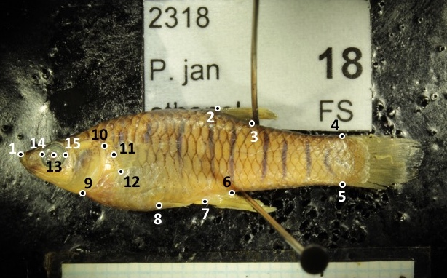
Figure S1. Female Phalloptychus januarius with the 15 landmarks.
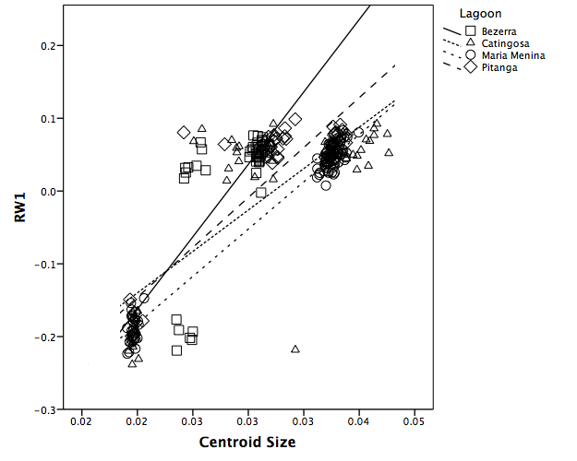
Figure S2. Variation of RW1 as a function of centroid size in the 4 lagoons

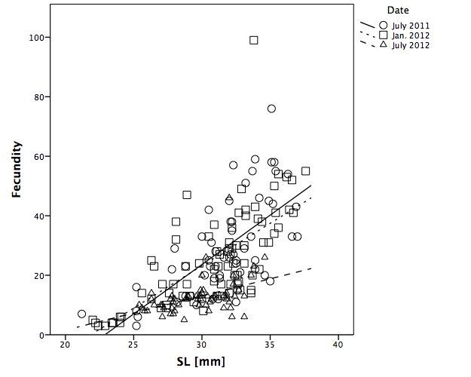
Figure S3. Variation in fecundity as a function of SL between wet (July) and dry (January) seasons.

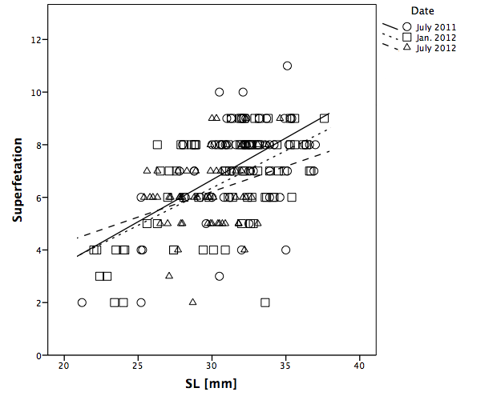
Figure S4. Variation in superfetation as a function of SL between wet (July) and dry (January) seasons.

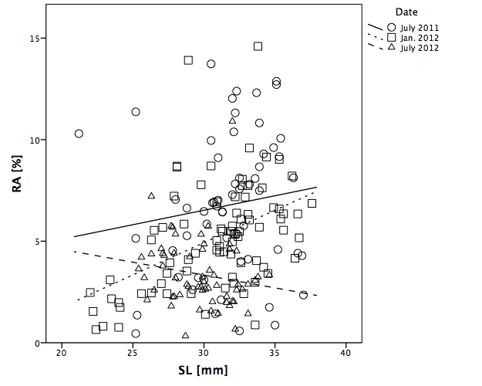
Figure S5. Variation in RA as a function of SL between wet (July) and dry (January) seasons.

