Phenotypic differentiation in a heterogeneous environment: morphological and life-history responses to ecological gradients in a livebearing fish

Francesco Santi^{1*}, Ana Cristina Petry², Martin Plath³ and Rüdiger Riesch¹

¹ School of Biological Sciences, Royal Holloway University of London, Egham, TW20 0EX, UK
² Instituto de Biodiversidade e Sustentatibilidade – NUPEM, Universidade Federal do Rio de Janeiro – UFRJ, Macaé, RJ, Brazil
³ College of Animal Science and Technology, Northwest A&F University, Yangling, Shaanxi 712100, P. R. China
* Corresponding author e-mail address: francesco.santi.2016@live.rhul.ac.uk

Abstract
Predicting how environmental variation drives phenotypic diversification is one of the main aims of evolutionary ecology. Yet, we still only have a limited understanding of how it drives diversity, especially when multiple factors interact. To address this issue, the superfetating livebearing fish Phalloptychus januarius (Poeciliidae) was repeatedly sampled (over a two-year period) in four coastal lagoons in Brazil to investigate the relative contribution of different environmental factors on phenotypic patterns. We further compare our results to those reported for another poeciliid (Poecilia vivipara), which inhabits some of the same lagoons but has a drastically different reproductive strategy (no superfetation). We used a model averaging approach to estimate the relative importance of differences in predation pressure, salinity, dissolved oxygen, pH, temperature and food availability in driving variation in body shape, life histories, and life-history proxies. We found consistent population differences in several traits, but also seasonal variation within each lagoon. Specifically, predation, oxygen availability, and pH affected several different traits, and played important roles in driving phenotypic differences between and among populations. Moreover, our study reveals differential responses in phenotypic traits to the same environmental gradients between P. januarius (this study) and P. vivipara (previous studies), and we suggest that future work should further investigate differential phenotypic responses to single vs. multiple concomitant selective forces, and how this affects different species.

Key-words
Body shape, Environmental gradients, Phalloptychus januarius, Poeciliidae, Predictable evolution.

Introduction
Predicting how organisms respond to changes in their environment is one of the key aims of evolutionary biology (Stearns, 1977; Langerhans, 2018) but faces challenges when multiple (partly interacting) environmental parameters affect trait divergence (MacColl, 2011; Langerhans, 2018; Riesch, Plath & Bierbach, 2018). Nevertheless, we will be able to properly describe the whole extent of phenotypic responses to environmental variation only by simultaneously considering multiple environmental factors and traits (DeWitt & Langerhans, 2003; Heinen et al., 2013; Langerhans, 2018).
Traditionally, the study of predictable phenotypic evolution has concentrated on the effect of a single environmental factor, such as predation (Losos et al., 2006; Heinen et al., 2013), salinity (Palkovacs et al., 2007), or other habitat characteristics (Kaeuffer et al., 2012). A particularly well-researched system is the Trinidadian guppy (Poecilia reticulata), and the effects that differences in predation pressure have on life histories (Reznick & Endler, 1982; Reznick, Bryga & Endler, 1990), morphology (Alexander et al., 2006), body colouration (Endler, 1983) and behaviour (Seghers, 1974). More recently, however, it has become apparent that multiple environmental parameters act in unison to shape phenotypic divergence; e.g., in addition to predation, also food availability (Grether et al., 2001; Hendry et al., 2006) and competition (Bassar et al., 2016) affect guppy life histories. Congruently, more than 50% of the total life-history variation of Bahamas mosquitofish (Gambusia hubbsi) is also not driven by predation regimes (Langerhans, 2018).
Here, we investigated phenotypic differentiation of the livebearing fish Phalloptychus januarius (Hensel 1868) from coastal lagoons in southeastern Brazil with starkly different ecological conditions (Araújo et al., 2014) and diverse fish communities (Di Dario et al., 2013). Previous studies in this system focused on life-history and morphological variation in another poeciliid (Poecilia vivipara), in relation to salinity/predation gradients (Neves & Monteiro, 2003; Gomes-Jr & Monteiro, 2007; Gomes & Monteiro, 2008; Araújo et al., 2014, Rius et al., 2019). The main piscine predator of poeciliids, Hoplias malabaricus, cannot tolerate high-salinity conditions (Gomes-Jr & Monteiro, 2007), while other predators, such as fish-eating bats Noctilio leporinus (Luz et al., 2011), birds (e.g., White-backed stilt, Himantopus melanurus, Great kiskadee, Pitangus sulphuratus, Black-crowned night heron, Nycticorax nycticorax, or various kingfishers) and insects (e.g., Belostomatidae) are present, yet not abundant (A. Petry, M. Plath and R. Riesch, personal observations). Predation pressure for all P. januarius age classes, therefore, is bound to increase from highly saline to freshwater lagoons (Gomes-Jr & Monteiro, 2007). Still, other environmental factors—including oxygen availability, habitat productivity, and pH—also vary between lagoons, and could account for a substantial amount of the observed variation (Langerhans & DeWitt, 2004).
We tested for phenotypic differences between fish from different lagoons as well as temporal differences within lagoons, and evaluated the relative importance of multiple environmental factors in driving these patterns. We focused on a species that has not been studied so far in this system, and compared our results to previous studies on P. vivipara from some of the same lagoons (sampled at the same time as the P. januarius our study focuses on) to identify shared and unique patterns of divergence to the same environmental gradients (Araújo et al., 2014; Rius et al., 2019). This is of particular interest as both species have radically different reproductive strategies: P. vivipara develop a single clutch per reproductive bout and are lecithotrophic (i.e., resources required for embryo development are stored in the eggs prior to fertilization; Arcanjo et al., 2014), while P. januarius are characterised by superfetation (i.e., females simultaneously bear two or more broods at different developmental stages) and matrotrophy (i.e., substantial maternal provisioning after fertilization; Pollux & Reznick, 2011; Olivera-Tlahuel et al., 2015). Superfetation allows females to reduce body cavity space devoted to offspring production without reducing overall fecundity (Qualls & Shine, 1995; Zúñiga-Vega, Reznick & Johnson, 2007). This could result in different evolutionary trajectories when both species are exposed to the same environmental gradient(s).
Correctly predicting how multiple environmental factors interact to drive phenotypic differentiation is difficult due to the inherent complexity. Thus, we formulated the following set of a priori predictions, based on what would be expected if each environmental factor was acting alone. Our statistical analyses test if these effects were still uncovered when multiple environmental factors vary simultaneously.
Prediction 1 (predation-effect): In low-predation lagoons, fish should be larger, have more body fat and larger offspring size at birth, but lower lean weight, fecundity, and reproductive investment compared to high-predation (low-salinity) sites (Stearns, 1989; Reznick et al., 1990; Reznick, Bryant & Bashley, 2002b; Alexander et al., 2006; Riesch et al., 2015). Individuals from high-predation lagoons should have smaller heads but larger caudal peduncles compared to those from low-predation habitats (e.g., Langerhans, 2009; Langerhans & Makowicz, 2009).
Prediction 2 (salinity-effect): High salinity causes osmotic stress and should select for decreased body surface-to-volume ratios, i.e., increased body and offspring size (Alcaraz & García-Berthou, 2007; Gomes-Jr & Monteiro, 2007; Riesch et al., 2015; Moore, Riesch & Martin, 2016). We further predicted higher salinity to be associated with higher fat content, increased fecundity and reproductive investment (e.g., Gambusia holbrooki: Alcaraz & García-Berthou, 2007; Poecilia latipinna, Gambusia affinis and Heterandria formosa: Martin et al., 2009; but see Moore et al., 2016).
Prediction 3 (temperature-effect): Water temperature varies only to a minor extent between lagoons, but greatly between seasons, with warmer temperatures during the wet than during the dry season. We predicted that higher water temperatures will be associated with increased adult body size, fecundity and reproductive investment (Vondracek, Wurtsbaugh & Chech, 1988; Abney & Rakocinski, 2004).
Prediction 4 (oxygen-effect): We predict low-oxygen conditions to be associated with larger head and gill regions to facilitate oxygen acquisition (Chapman, 2015), and potentially also with reduced fecundity (Riesch et al., 2015).
Prediction 5 (food availability-effect): In habitats with greater productivity (estimated as chlorophyll a concentrations), and during the wet season, when habitat productivity and allochthonous carbon input are greatest (e.g., Stepanauskas et al., 2000; Caliman et al., 2010), P. januarius should have greater adult and embryo fat content, lean weight, reproductive investment, fecundity (coupled with smaller offspring), and body size (Reznick & Yang, 1993; Riesch et al., 2016a), as well as deeper bodies (Spoljaric & Reimchen, 2007).
Prediction 6 (pH-effect): Differences in pH cause physiological stress in various aquatic organisms, especially during early life-stages (Crespel et al., 2017). While its effects on poeciliid phenotypes have seldom been studied, higher pH levels appear to be linked to reduced body size and fecundity (Riesch et al., 2015; Jourdan et al., 2016).

Materials and Methods
Study system
Using seines, we collected P. januarius between July 2011 and July 2012 in four lagoons in the Parque Nacional da Restinga do Jurubatiba, Brazil, a protected area that features several coastal lagoons separated from the sea by narrow (50–100 m) strips of sand (Fig. 1). We sampled two lagoons twice and two lagoons three times during this period (Suppl. Table S1, S2), both during the wet (January) and dry season (July). Some smaller lagoons dry up during prolonged drought years, and connections between lagoons during exceptionally wet years are rare (A. Petry, personal observation). However, the four lagoons studied here are temporally stable and thus, can be treated as evolutionarily independent replicates (Araújo et al., 2014).
Sampled fish were immediately euthanized using clove oil, fixed in 10% formalin and preserved in 70% ethanol. During each sampling event, we measured the following environmental parameters (Suppl. Table S3): dissolved oxygen, salinity, temperature (using a YSI-85-hydrometer). We quantified the pH of water samples in the laboratory using a Digimed DM-20 pH-meter, and chlorophyll a by filtering water samples through fiber-glass filters (GF/C Whatman), extracting chlorophyll a with 90% ethanol, and quantifying absorption at 665 nm using a spectrophotometer. Finally, we noted the presence of piscivorous fishes such as Hoplias malabaricus and Hoplerythrinus unitaeniatus (Araújo et al., 2014) as well as potential competitors (mainly P. vivipara and the anablepid Jenynsia darwini).

Body-shape analysis
We employed geometric morphometric analyses on 200 females and 56 males (Rohlf & Marcus, 1993; Adams, Rohlf & Slice, 2004). Using well-established protocols (Riesch et al., 2016a) and 15 landmarks (see Supplement, Fig. S1 for details) we performed a relative warp analysis (Zelditch, Swiderski & Sheets, 2012). The first two relative warps that accounted for more than 90% of the cumulative variance (Suppl. Table S4) were used as shape variables in all subsequent analyses.

Life-history traits and proxies
We dissected 200 pregnant females and 44 mature males following well-established protocols to assess life-history traits and life-history proxies (Reznick & Endler, 1982; Riesch et al., 2016a). We assessed female fecundity (number of developing offspring), offspring lean weight [mg], offspring fat content [%], female reproductive allocation (RA [%], i.e., total offspring dry weight divided by the sum of offspring plus somatic tissue dry weight), and male gonadosomatic index (GSI [%], i.e., testis dry weight divided by the sum of somatic plus reproductive tissue dry weight). Moreover, as proxies for investment into growth and maintenance, we measured male and female standard length (SL [mm]), lean weight [mg] and fat content [%].
Embryonic traits need to be considered relative to the embryo’s developmental stage. We therefore assessed the developmental stage of each embryo following Riesch et al. (2011), with stages ranging from 2 (fertilized oocytes) to 50 (ready-to-be-born embryos). To account for superfetation and high levels of matrotrophy in P. janurarius (Pollux & Reznick, 2011), we estimated offspring size at birth for each individual female by regressing embryo weight against embryonic stage of development. Based on R², cubic regressions were the best-fitting model. Furthermore, we calculated the Matrotrophy Index (MI; Reznick, Mateos & Springer, 2002a) for each individual female as the ratio between two extrapolated values: offspring weight at birth and weight of the unfertilized egg (stage 0). However, cubic regressions cannot provide accurate results for females with fewer than 5 different embryo stages. To avoid missing data values, we calculated mean offspring weight at birth and mean MI for each population and used these values for this particular subset of females (N=15).
To meet statistical assumptions of normality of residuals, we log₁₀-transformed (SL, adult lean weight, offspring weight at birth and MI), square root-transformed (fecundity), or arcsine (square root)-transformed (GSI, RA, adult and embryo fat contents) all variables. We subsequently z-transformed all variables to obtain unit-free variables of similar scale.

Statistical analyses
Population differences and seasonal variation
We compared body size (SL) between lagoons using ANOVA with ‘sex’, ‘lagoon’, and ‘sampling-date-nested-within-lagoon’ [henceforth ‘date(lagoon)’—to account for multiple sampling in each lagoon] as factors. We ran MANCOVA on body shape with ‘centroid size’ as a covariate and including the aforementioned factors. We analysed male and female life-history traits and proxies in two separate MANCOVAs while including ‘SL’ as a covariate, and ‘lagoon’ as well as ‘date(lagoon)’ as factors. We initially included all interaction terms, and subsequently removed terms with P>0.1. We approximated F-values using Wilks’ Lambda and estimated relative effect strengths using partial eta squared (η²). We corrected alpha-levels for multiple comparisons as α’=α/number of comparisons (Suppl. Table S5).

Relative effects of different environmental parameters
To evaluate the relative importance of each environmental variable in driving phenotypic divergence, we employed a model averaging approach (Burnham & Anderson, 2002). We corrected traits for which significant sex- and body size-effects were uncovered (post-hoc ANCOVAs, Suppl. Table S5) by regressing RW1 and RW2 against ‘centroid size’ and ‘sex’, female lean weight, fecundity and superfetation against ‘SL’, and male lean weight against ‘SL’. We used residuals as dependent variables in identical, trait-wise global linear models with ‘presence of predators’ coded as a factor and salinity, temperature, dissolved oxygen, chlorophyll a as well as pH as covariates. We included ‘lagoon’ as a random factor to account for the repeated sampling in each lagoon. Using the dredge function in the MuMIn package in R (Barton, 2011), we performed model selection by fitting all possible model permutations and ranking them using Akaike Information Criteria corrected for small sample size (AICc). As there was no one-best-model in all cases, we selected a subset of most informative models with ∆AICc ≤ 7 from the model pool (Burnham, Anderson & Huyvaert, 2011). Using this subset, we performed model averaging using the model.avg function. Model averaging uses information criteria such as AICc to assess the predictive power of explanatory variables (relative importance values, hereafter RIV; i.e., the cumulative Akaike weights across all subset models that contain the variable), and to obtain averaged parameter estimates (model-averaged coefficients; hereafter b_{MA}) from a set of models (Burnham & Anderson, 2002; Grueber et al., 2011). Statistical analyses were conducted using IBM® SPSS® Statistics v.21 (IBM Corp. 2012; ANOVAs and MANCOVAs) and R (R Development Core Team, 2018; model averaging).

Results

Sexual dimorphism and phenotypic variation within and between lagoons

Body size varied significantly between sexes (ANOVA, F_{1,230}=658.975, P<0.001), lagoons (F_{3,230}=6.868, P<0.001), and sampling events (F_{6,230}=2.705, P=0.015). While males were smaller than females, sexual size dimorphism varied amongst lagoons (‘sex × lagoon’; F_{3,230}=3.938, P=0.009; Suppl. Tables S1, S2).
Similarly, the strongest effect in the MANCOVA analysing body-shape variation reflected differences between the sexes (Table 1), followed by allometric effects (‘centroid size’), differences among lagoons and across repeated samplings. However, also the interactions of ‘sex × lagoon’, ‘sex × date(lagoon)’ and ‘centroid size × lagoon’ were significant (Table 1). Post-hoc univariate models (with corrected alpha-levels: α’=0.025) found significant allometric effects and sex-differences for both RW1 and RW2 (all P≤0.001), while ‘lagoon’ had a significant effect only on RW1 (P<0.001) and ‘date(lagoon)’ on RW2 (P=0.002; Suppl. Table S5a). The sex-effect can be explained by the presence of the gonopodium in males and a generally more anteriorly-positioned anal fin compared to females (Fig. 2), while differences between lagoons and across seasons within lagoons mainly reflect differences in body depth and roundness. Furthermore, body shape scaled differently with body size across lagoons (‘centroid size × lagoon’-effect), and there were differences among lagoons in the direction and extent of sexual dimorphism (‘sex × lagoon’-effect; Suppl. Fig. S2). Seasonal variation affected both sexes differently [‘sex × date(lagoon)’-effect; Table 1].
Both male and female life-history traits and proxies were significantly affected by body size (SL), but we also found significant spatial (‘lagoon’-effect) and temporal [‘date(lagoon)’-effect] differences, as well as a significant effect of ‘SL × lagoon’, indicating that some traits scaled differently between lagoons (Table 3). For female traits, we further uncovered a significant effect of ‘SL × date(lagoon)’, indicating that the extent to which traits scaled with female body size differed in time. Post-hoc univariate models (corrected alpha-levels were α’=0.006, and α’=0.017 for analyses of female and male traits, respectively) revealed that body size had significant positive associations with male and female lean weight, fecundity, and superfetation (Suppl. Table S5b, c). For females, lean weight, fecundity, estimated offspring size at birth, MI, superfetation, embryo fat content and RA all differed between lagoons, while for males only lean weight and GSI did. Temporal variation within lagoons was uncovered for all female traits except embryo fat content, but only for GSI in males (Suppl. Table S5b, c).
The interaction of ‘SL × lagoon’ had a significant effect on male fat content (Suppl. Table S5c): bigger males had higher fat contents in low-salinity (Bezerra and Pitanga) but lower fat contents in high-salinity lagoons (Catingosa and Marina Menina).
Finally, the interaction ‘SL × date(lagoon)’ significantly affected female fecundity, superfetation, and RA (Suppl. Table S5b). These differences appear to be mostly linked to yearly variation, as fecundity and superfetation increased strongly with SL in July 2011 and January 2012, but weakly in July 2012 (Suppl. Fig. S3; S4). Larger females also had greater RA in July 2011 and January 2012, but this relationship was reversed in July 2012 (Suppl. Fig. S5).

Effects of environmental parameters on trait divergence

Model averaging revealed that most environmental parameters were associated with differences in some phenotypic traits, but only effects on life-history traits and proxies were associated with model averaged coefficients that did not bound zero (Table 2). While there were additional trends that conformed (or were sometimes opposite) to our a priori predictions, we will mainly outline significant effects here.

Effects of predation

The effects of predation had a lower importance than other environmental variables, but trends were generally in the predicted direction (Table 2). Among the significant effects, females from high-predation lagoons were smaller (SL) and had higher levels of superfetation than females in low-predation lagoons (Fig. 3). However, both male and female lean weight was lower in high- than low-predation lagoons (Table 2).

Effects of salinity

Most effects of salinity on life-history traits and proxies were significant (Table 2). Higher salinity was associated with larger female body size (SL), increased lean weight in both sexes, and increased offspring size at birth, but also with lower levels of superfetation and female reproductive investment (RA; Fig. 4).

Effects of water temperature

Higher temperatures were associated with lower female fecundity and RA, and less superfetation, while males showed a lower GSI and embryos an increased body fat content (Fig. 4).

Effects of dissolved oxygen, chlorophyll a and pH
Dissolved oxygen (DO) and pH were overall the strongest predictors of phenotypic differentiation. Increases in DO were associated with decreased fecundity, MI, and superfetation, as well as decreased investment into reproduction in both sexes (i.e., RA and GSI). Embryo fat increased with increasing DO (Table 2).
While chlorophyll a had relatively high RIV for several traits, all model-averaged coefficients bounded zero (Table 2). Nonetheless, several responses were in the predicted direction, with female and embryo fat contents, fecundity, superfetation and male GSI all showing positive associations with chlorophyll a.
pH had strong positive associations with female SL, male and female lean weight, female fat content as well as RA and GSI (Table 2).

Discussion
We uncovered strong differentiation in body shape, life histories and life-history proxies between male and female P. januarius, but also amongst lagoons and across repeated samples from the same lagoon, suggesting temporal fluctuations in all traits. Model averaging suggested that all environmental factors assessed herein had effects on at least some traits, but that some parameters (i.e., DO, pH and predation) were more important than others (i.e., chlorophyll a).

Sexual dimorphism and phenotypic variation within and between lagoons
Patterns of sexual dimorphism in phenotypic traits are congruent with those described for other poeciliids (Bisazza, 1993). Seasonal variation of those traits is also well documented in numerous taxa, including poeciliid fishes (Reznick, 1989; Abney & Rakocinski, 2004; Almeida-Silva & Mazzoni, 2014). The direction of seasonal changes in individual life-history traits and proxies, however, was not the same across lagoons. Nonetheless, significant differences among lagoons persisted even when controlling for temporal variation, and the relative importance of the lagoon-effect (estimated using partial η²) was consistently greater than temporal differences. We cannot currently exclude the possibility that most of the observed variation reflects phenotypic plasticity rather than evolved (heritable) differences among populations (however, see Pfennig et al., 2010 for the importance of plasticity in diversification). Nevertheless, the magnitude of lagoon-specific differences reported here are similar to what was previously reported for P. vivipara from the same region (Gomes-Jr & Monteiro, 2007; Araújo et al., 2014; Rius et al., 2019), and further supports the notion that environmental heterogeneity in these lagoons facilitates strong phenotypic differentiation. In the following, we will explore which environmental variables might be underlying these phenotypic differences both among and within lagoons.

Effects of predation
Predation had a significant effect on several life-history traits and proxies, but unexpectedly, was of minor importance in explaining patterns of body-shape divergence. Nonetheless, the trends were largely in the predicted direction, with larger caudal peduncles and smaller heads in high-predation lagoons. In support of our prediction 1, females from high-predation lagoons were smaller. Contrary to prediction 1, however, male body size was larger and male and female lean weight lower in high-predation lagoons. Additionally, we found (weaker) trends of increased fecundity and decreased offspring size at birth coupled with increased RA in high-predation lagoons (congruent with prediction 1), while GSI was lower in high- than low-predation lagoons. Where patterns followed the predicted direction, this matched patterns of divergence reported for P. vivipara from the same and additional lagoons (Neves & Monteiro, 2003; Gomes-Jr & Monteiro, 2007; Araújo et al., 2014; Rius et al., 2019) and for other poeciliids inhabiting environments with different predation intensity (life history, e.g., Brachyrhaphis episcopi: Jennions & Telford, 2002; Gambusia spp.: Riesch et al., 2015; P. reticulata: Reznick & Endler, 1982; body shape, e.g., Gambusia spp.: Langerhans, 2009; Langerhans & Makowicz, 2009).
One pattern we did not specifically predict was that females increased the level of superfetation as predation intensity increased. Nonetheless, this is in line with previous work and matches the hypothesis that environments with high adult mortality should select for increased rates of superfetation (Zúñiga-Vega et al., 2010; see also Travis et al., 1987). Increased superfetation in response to high predation levels has also been reported in another superfetating poeciliid (Phalloceros harpagos; Gorini-Pacheco, Zandonà & Mazzoni, 2017).
Predation did not have strong associations with body shape, contrary to most previous studies (Neves & Monteiro, 2003; Araújo et al., 2014). One potential explanation is that selection from predation could be weaker in P. januarius than in the two other species of livebearing fishes present in these lagoons (P. vivipara, J. darwini), which have larger body sizes (Araújo et al., 2014). Predators of livebearing fishes tend to preferentially target large individuals as prey (e.g., Trexler, Temper & Travis, 1994; Johansson, Turesson & Persson, 2004; Tobler, Schlupp & Plath, 2007) and could selectively prey on P. vivipara and J. darwini rather than on P. januarius. While we currently lack empirical data, this could result in stronger body-shape divergence in the former species (Araújo et al. 2014).

Effects of salinity
Alongside predation, salinity had previously been characterised as the defining selective agents in this system (Gomes-Jr & Monteiro, 2007; Araújo et al., 2014). Salinity indeed showed a number of statistical associations with several traits. However, other environmental variables (i.e., pH and oxygen content) were of similar importance, and it is important to note that P. januarius inhabits lagoons with a narrower salinity gradient than P. vivipara. Nonetheless, in highly-saline lagoons, females were larger (SL), males and females had an increased lean weight, and offspring size at birth was greater (in agreement with our prediction 2). On the other hand, RA decreased at higher salinity (contrary to prediction 2), and superfetation was reduced. This mixed pattern of results supporting and opposing a priori predictions is congruent with a recent meta-analysis that did not find salinity to result in strong, consistent patterns of divergence in offspring size and fecundity across poeciliid species (Moore et al., 2016). Yet, in our present study, the effects of salinity were strong, and similar patterns were reported from other poeciliids (e.g., Alcaraz & García-Berthou, 2007; Martin et al., 2009). We argue that salinity-effects may be more system-specific than those of other environmental variables (Moore et al., 2016).

Effects of temperature
Contrary to prediction 3, under warmer conditions, fish showed a lower (not higher) fecundity, superfetation, GSI and RA when compared to samples obtained at colder conditions, while body size (SL and lean weight) did not show strong associations with temperature, and the trend for female body fat was even negative. Previous laboratory experiments on Gambusia affinis found high temperatures to result in increased growth (and therefore body size), fecundity and reproductive investment (Vondraceck et al., 1988). Moreover, warmer seasonal temperatures were associated with increased fecundity and greater total brood mass in Gambusia puncticulata (Abney & Rakocinski, 2004). Our results suggest a strong decrease in reproduction during the warmer Brazilian summer months (i.e., the wet season). This is congruent with patterns reported for Trinidadian guppies, which decreased fecundity and reproductive allocation during the warm months of the rainy season, and then increased both during the colder dry season (Reznick, 1989). While it is difficult to disentangle the effects of temperature from other, potentially confounding factors we did not quantify, we suspect that seasonal effects in our present study system might partially reflect antagonistic interactions between the three poeciliid species inhabiting these lagoons: under more favourable conditions (i.e., during the wet season) P. januarius, being the smallest of the three species, might be outcompeted by the larger two species, while they might be better competitors under low-resource conditions (during the dry season). Similar dynamics have been reported by Winemiller (1989) for other tropical fish assemblages. We are currently lacking empirical data to properly address this issue, so we call for more research into the effects of seasonal variation in temperature regimes on competitive interactions between the three species, but also on phenotypic divergence in general.

Effects of dissolved oxygen, food availability and pH
DO had one of the strongest effects on phenotypic differentiation, but patterns did not match our prediction 4. For example, in low-oxygen environments, females had higher fecundity, and there was even a weak trend for slightly smaller heads. One possible explanation is that variation in DO in these coastal lagoons was not big enough to elicit the predicted hypoxia-related responses. In our samples, DO levels ranged from 5.01 to 9.27 mg O₂/L, always far above the level below which aquatic environments are considered hypoxic (2 mg O₂/L; Vaquer-Sunyer & Duarte, 2008; Chapman, 2015; although we did not quantify the full diurnal range of DO variation). Nonetheless, even these nuanced changes in DO were associated with several prominent shifts in life-history traits: both males and females drastically reduced their investment into reproduction under elevated oxygen concentrations, with lower GSI in males and lower fecundity, superfetation, MI and RA in females, while embryo fat content was increased. While the evolutionary effects of hypoxic conditions have been studied in several species of fish (Chapman 2015), few studies have directly investigated the effects of smaller, more gradual differences in DO. Similar to our results, DO and fecundity were inversely correlated in G. holbrooki from rice fields in Portugal (Cabral & Marques, 1999), whereas high oxygen levels appear to be linked to an increased fecundity in G. hubbsi (Riesch et al., 2015). We cannot, however, exclude the possibility that some of the strong phenotypic responses we detected in response to relatively subtle differences in DO at the point of sampling reflect responses to greater diurnal fluctuation, which we did not quantify. Clearly, more research on how exactly DO impacts fish life histories, in particular their reproductive traits, is needed. Nonetheless, it is also possible that the effects reported here are indirect effects—mediated by predation—as the two piscivorous fishes in this system are tolerant to low oxygen conditions (Petry et al., 2013). Low DO might increase predation risk (e.g., when prey individuals spend more time in certain oxygen-rich microhabitats), which would align well with the uncovered patterns of divergence in life-history traits (e.g., Reznick et al., 1990, 2002b; Riesch et al., 2015).
The effects of chlorophyll a levels—our proxy for autochthonous habitat productivity—on P. januarius phenotypes were all surprisingly weak but conformed to our prediction 5 with regards to the direction of the trends, with positive associations between productivity and female and embryo fat contents, fecundity, superfetation and GSI. Experimental studies on livebearing fishes showed strong phenotypic responses to varying food availability (e.g., Poecilia mexicana: Riesch et al., 2016b; P. reticulata: Reznick, 1982; Reznick & Yang, 1993), as predicted by life-history theory (e.g., Reznick et al., 2002b). Still, other environmental factors, such as predation (Grether et al., 2001) or seasonal differences (see previous paragraph), can elicit phenotypic responses that might overshadow or partially counteract the direct effects of food availability.
Finally, we found that females increased SL and fat content, and both sexes increased their lean weight and investment into reproduction (RA and GSI) with increasing pH. These results are, if anything, contrary to our prediction 6, but it remains difficult to discuss our findings in a broader conceptual context, as potential effects of variation in pH on variation of life-history traits and proxies in fishes are understudied (Nelson, 2015). Differences in pH are known to cause physiological stress (EIFAC 1969; Crespel et al., 2017) and have been recognised as one of the main factors shaping fish communities in Indian rivers (Sharma et al., 2017). It seems likely that pH-levels play underestimated roles in shaping phenotypic differentiation between populations and warrant increased attention in future experimental studies.

Conclusions
Patterns of phenotypic divergence in P. januarius only partially conformed to our a priori predictions, and several traits even exhibited patterns opposite to the predicted directions. We argue that multifarious selection pressures, experienced by our study species in different lagoons and at different points in time within specific lagoons, explain this pattern. Organisms are usually exposed to a multitude of environmental selective forces that act on the same or different components of the whole phenotype at any given time, and each of these selective forces is likely to have a different relative impact on organismal fitness. This should lead to a mosaic of organismal responses, with some selective forces cancelling each other out, some acting synergistically, while yet other selective forces might be so strong that they overrule potential responses to others (Riesch et al., 2018). This could result in somewhat spurious patterns of phenotypic responses to specific environmental variables (e.g., pH or temperature in our present study), including patterns opposite to those predicted if each environmental variable were to act alone. Thus, more experimental work on responses to several interacting environmental factors is clearly needed. Our study also reveals that our understanding of how exactly some of the environmental variables assessed here might shape organismal responses is still limited, highlighting the need for more experimental work on the effects of as yet understudied environmental factors in driving phenotypic diversification.

Acknowledgements
We thank Dr. Márcio S. Araújo for providing help with sample collection, the Aquatic Ecology Laboratory from NUPEM/UFRJ for help with water sample analyses, and the Brazilian Long Term Ecological Research for partially funding the fieldwork (RLaC; CNPq 558270/2009-3).

Data Accessibility

Upon acceptance, data will be made available via DRYAD.

Conflict of Interest
The authors declare that they have no conflict of interest.

References
Abney, M.A. & Rakocinski, C.F. (2004). Life-history variation in Caribbean Gambusia Gambusia puncticulata puncticulata (Poeciliidae) from the Cayman Islands, British West Indies. Environ. Biol. Fish. 70, 67–79.
Adams, D.C., Rohlf, F.J. & Slice, D.E. (2004). Geometric morphometrics: Ten years of progress following the ‘revolution’. Ital. J. Zool. 71, 5–16.
Alcaraz, C. & García-Berthou, E. (2007). Life history variation of invasive mosquitofish (Gambusia holbrooki) along a salinity gradient. Biol. Cons. 139, 83–92.
Almeida-Silva, P.H. & Mazzoni, R. (2014). Life history aspects of Phalloceros anisophallos Lucinda 2008 (Osteichthyes, Poeciliidae) from Córrego Andorinha, Ilha Grande (RJ, Brazil). Stud. Neotrop. Fauna Environ. 49, 191–198.
Alexander, H.J., Taylor, J.S., Sze-Tsun Wu, S., Breden, F. & Crandall, K. (2006). Parallel evolution and vicariance in the guppy (Poecilia reticulata) over multiple spatial and temporal scales. Evolution 60, 2352–2369.
Alonso-Alvarez, C., Bertrand, S., Faivre, B. & Sorci, G. (2007). Increased susceptibility to oxidative damage as a cost of accelerated somatic growth in zebra finches. Funct. Ecol. 21, 873–879.
Araújo, M.S., Perez, S.I., Magazoni, M.J.C. & Petry, A.C. (2014). Body size and allometric shape variation in the molly Poecilia vivipara along a gradient of salinity and predation. BMC Evol. Biol. 14, 251.
Arcanjo, R.B., de Souza, L.P., Rezende, C.F. & Silva, J.R.F. (2014). Embryonic development and nourishment in the viviparous fish Poecilia vivipara (Cyprinodontiformes: Poeciliidae). Acta Zool. 95, 493–500.
Barton, K. (2011). MuMIn: multi-model inference. R package, version 1.0. 0. R Foundation for Statistical Computing, Vienna, Austria. cran.r-project.org/web/packages/MuMIn/MuMIn.pdf
Bassar, R.D., Childs, D.Z., Rees, M., Tuljapurkar, S., Reznick, D.N. & Coulson, T. (2016). The effects of asymmetric competition on the life history of Trinidadian guppies. Ecol. Lett. 19, 268–278.
Becker, R.A., Wilks, A.R., Brownrigg, R., Mnka, T.P. & Deckmyn, A. (2017). maps: Draw Geographical Maps. R package, version 3.2.0. R Foundation for Statistical Computing, Vienna, Austria. cran.r-project.org/web/packages/maps/maps.pdf
Bisazza, A. (1993). Male competition female mate choice and sexual size dimorphism in poeciliid fishes. Mar. Behav. Physiol. 23, 257–286.
Burnham, K. & Anderson, D.R. (2002). Model Selection and Multi-model Inference, 2nd edn, Springer International Publishing, New York City.
Burnham, K.P., Anderson, D.R. & Huyvaert, K.P. (2011). AIC model selection and multimodel inference in behavioral ecology: some background, observations, and comparisons. Behav. Ecol. Sociobiol. 65, 23–35.
Cabral, J.A. & Marques, J.C. (1999). Life history, population dynamics and production of eastern mosquitofish, Gambusia holbrooki (Pisces, Poeciliidae), in rice fields of the lower Mondego River Valley, western Portugal. Acta. Oecol. 20, 607–620.
Caliman, A., Carneiro, L.S., Santangelo, J.M., Guariento, R.D., Pires, A.P.F., Suhett, A.L., Quesado, L.B., Scofield, V., Fonte, E.S., Lopes, P.M., Sanches, L.F., Azevedo, F.D., Marinho, C.C., Bozelli, R.L., Esteves, F.A. & Fajalla, V.F. (2010). Temporal coherence among tropical coastal lagoons: a search for patterns and mechanisms. Braz. J. Biol. 70, 803–814.
Chapman, L. (2015). Low-oxygen lifestyles. In: Riesch, R., Tobler, M. & Plath, M. (eds) Extremophile Fishes. Springer International Publishing, New York City, pp 9–33.
Crespel, A., Zambonino-Infante, J.-L., Mazurais, D., Koumoundouros, G., Fragkoulis, S., Quazuguel, P., Huelvan, C., Madec, L., Servili, A. & Claireaux, G. (2017). The development of contemporary European sea bass larvae (Dicentrachus labrax) is not affected by projected ocean acidification scenarios. Mar. Biol. 164, 155.
DeWitt, T.J. & Langerhans, R.B. (2003). Multiple prey traits, multiple predators: Keys to understanding complex community dynamics. J. Sea. Res. 49, 143–155.
Di Dario, F., Petry, A.C., de Souza Pereira, M.M., Mincarone, M.M., Soares Agostinho, L., Martins Camara, E., Pellegrini Camaraschi, E. & Ribeiro de Britto, M. (2013). An update on the fish composition (Teleostei) of the coastal lagoons of the Restinga de Jurubatiba National Park and the Imboassica Lagoon, northern Rio de Janeiro State. Acta Limnol. Brasil. 25, 257–278.
Dowling, D.K. & Simmons, L.W. (2009). Reactive oxygen species as universal constraints in life-history evolution. Proc. Royal Soc. B 276, 1737–1745.
Endler, J.A. (1983). Natural and sexual selection on color patterns in poeciliid fishes. Environ. Biol. Fish. 9, 173–190.
EIFAC Working Party on Water Quality Criteria for European Freshwater Fish (1969). Water quality criteria for european freshwater fish – extreme pH values and inland fisheries. Water Res. 3, 593–611.
Gomes-Jr, J.L. & Monteiro, L.R. (2007). Size and fecundity variation in populations of Poecilia vivipara Block & Schneider (Teleostei; Poeciliidae) inhabiting an environmental gradient. J. Fish Biol. 71, 1799–1809.
Gomes, J.L. & Monteiro, L.R. (2008). Morphological divergence patterns among populations of Poecilia vivipara (Teleostei Poeciliidae): test of an ecomorphological paradigm. Biol. J. Linnean Soc. 93, 799–812.
Gorini-Pacheco, B., Zandonà, E. & Mazzoni, R. (2017). Predation effects on matrotrophy, superfetation and other life history traits in Phalloceros harpagos. Ecol. Freshw. Fish. 27, 442–452.
Grether, G.F., Millie, D.F., Bryant, M.J., Reznick, D.N. & Mayea, W. (2001). Rain forest canopy cover, resource availability, and life history evolution in guppies. Ecology 82, 1546–1559.
Grueber, C.E., Nakagawa, S., Laws, R.J. & Jamieson, I.G. (2011). Multimodel inference in ecology and evolution: challenges and solutions. J. Evol. Biol. 24, 699–711.
Heinen, J.L, Coco, M.W., Marcuard, M.S., White, D.N., Peterson, M.N., Martin, R.A. & Langerhans, R.B. (2013). Environmental drivers of demographics, habitat use, and behavior during a post-Pleistocene radiation of Bahamas mosquitofish (Gambusia hubbsi). Evol. Ecol. 27, 971–991.
Hendry, A.P., Kelly, M.L., Kinnison, M.T. & Reznick, D.N. (2006). Parallel evolution of the sexes? Effects of predation and habitat features on the size and shape of wild guppies. J. Evol. Biol. 19, 741–754.
Jennions, M.D. & Telford, S.R. (2002). Life-history phenotypes in populations of Brachyrhaphis episcopi (Poeciliidae) with different predator communities. Oecologia 132, 44–50.
Johansson, J., Turesson, H. & Persson, A. (2004). Active selection for large guppies, Poecilia reticulata, by the pike cichlid, Chrenicichla saxatilis. Oikos 105, 595–605.
Jourdan, J., Krause, S.T., Lazar, V.M., Zimmer, C., Sommer-Trembo, C., Arias-Rodriguez, L., Klaus, S., Riesch, R. & Plath, M. (2016). Shared and unique patterns of phenotypic diversification along a stream gradient in two congeneric species. Sci. Rep. 6, 38971.
Kaeuffer, R., Peichel, C.L., Bolnick, D.I. & Hendry, A.P. (2012). Parallel and nonparallel aspects of ecological, phenotypic, and genetic divergence across replicate population pairs of lake and stream stickleback. Evolution 66, 402–418.
Krause, J., Godin, J.-G.J. (1996). Influence of prey foraging posture on flight behavior and predation risk: predators take advantage of unwary prey. Behav. Ecol. 7, 264–271.
Langerhans, R.B. (2009). Trade-off between steady and unsteady swimming underlies predator-driven divergence in Gambusia affinis. J. Evol. Biol. 22, 1057–1075.
Langerhans, R.B. (2018). Predictability and parallelism of multitrait adaptation. J. Hered. 1–12.
Langerhans, R.B. & DeWitt, T.J. (2004). Shared and unique features of evolutionary diversification. Am. Nat. 164, 335–349.
Langerhans, R.B. & Makowicz, A.M. (2009). Shared and unique features of morphological differentiation between predator regimes in Gambusia caymanensis. J. Evol. Biol. 22, 2231–2242.
Losos, J.B., Schoener, T.W., Langerhans, R.B. & Spiller, D.A. (2006). Rapid temporal reversal in predator-driven natural selection. Science 314, 1111.
Luz, J.L., Mangolin, R., Esberard, C.E.L. & Bergallo, H.G. (2011). Bats (Chiroptera) sampled in lagoons at Parque Nacional da Restinga Jurubatiba, Rio de Janeiro, Brazil. Biota. Neotrop. 11, 161–168.
MacColl, A.D.C. (2011). The ecological causes of evolution. Trends Ecol. Evol. 26, 514–522.
Martin, S., Hitch, A., Purcell, K., Klerks, P. & Leberg, P. (2009). Life history variation along a salinity gradient in coastal marshes. Aquat. Biol. 8, 15–28.
Metcalfe, N.B., Alonso-Alvarez, C. (2010). Oxidative stress as a life-history constraint: the role of reactive oxygen species in shaping phenotypes from conception to death. Funct. Ecol. 24, 984–996.
Moore, M.P., Riesch, R. & Martin R.A. (2016). The predictability and magnitude of life-history divergence to ecological agents of selection: a meta-analysis in livebearing fishes. Eco. Lett. 19, 435–442.
Nelson, J. (2015). Pickled fish anyone? In: Riesch, R., Tobler, M. & Plath, M. (eds) Extremophile Fishes. Springer International Publishing, New York City, pp 193–215.
Neves, F.M. & Monteiro, L.R. (2003). Body shape and size divergence among populations of Poecilia vivipara in coastal lagoons of south-eastern Brazil. J. Fish. Biol. 63, 928–941.
Olivera-Tlahuel, C., Ossip-Klein, A.G., Espinosa-Pérez, H.S. & Zúñiga-Vega, J.J. (2015). Have superfetation and matrotrophy facilitated the evolution of larger offspring in poeciliid fishes? Biol. J. Linn. Soc. 116, 787–804.
Palkovacs, E.P., Dion, K.B., Post, D.M. & Caccone, A. (2008). Independent evolutionary origins of landlocked alewife populations and rapid parallel evolutions of phenotypic traits. Mol. Ecol. 17, 582–297.
Petry, A.C., Abujanra, F., Gomes, L.C., Julio Jr., H.F. & Agostinho, A.A. (2013). Effects of the interannual variations in the flood pulse mediated by hypoxia tolerance: the case of the fish assemblages in the upper Paraná River floodplain. Neotrop. Itchyol. 11, 413–424.
Pfenning, D.W., Wund, M.A., Snell-Rood, E.C., Cruickshank, T., Schlichting, C.D. & Moczek, A.P. (2010). Phenotypic plasticity’s impacts on diversification and speciation. Trends Ecol. Evol. 25, 459–567.
Pollux, B.J.A. & Reznick, D.N. (2011). Matrotrophy limits a female’s ability to adaptively adjust offspring size and fecundity in fluctuating environments. Funct. Ecol. 25, 747–756.
Pollux, B.J.A., Pires, M.N., Banet, A.I. & Reznick, D.N. (2009). Evolution of placentas in the fish family Poeciliidae: an empirical study of macroevolution. Annu. Rev. Ecol. Evol. Syst. 40, 271–289.
Qualls, C.P. & Shine, R. (1995). Maternal body-volume as a constraint on reproductive output in lizards: evidence from the evolution of viviparity. Oecologia 103, 73–78.
R Development Core Team (2018). R: a language and environment for statistical computing. R Foundation for Statistical Computing, Vienna, Austria. www.R-project.org/
Reznick, D.N. (1989). Life-history evolution in guppies: 2. Repeatability of field observations and the effects of season on life history. Evolution 43, 1285–1297.
Reznick, D.N. & Endler, J.A. (1982). The impact of predation on life history evolution in Trinidadian guppies (Poecilia reticulata). Evolution 36, 160–177.
Reznick, D.N. & Yang, A.P. (1993). The influence of fluctuating resources on life history: patterns of allocation and plasticity in female guppies. Ecology 74, 2011–2019.
Reznick, D.N., Bryga, H. & Endler, J.A. (1990). Experimentally induced life-history evolution in a natural population. Nature 346, 357–359.
Reznick, D.N., Mateos, M. & Springer, M.S. (2002a). Independent origins and rapid evolution of the placenta in the fish genus Poeciliopsis. Science 298, 1018–1020.
Reznick, D.N., Bryant, M.J. & Bashey, F. (2002b). r- and K-selection revisited: the role of population regulation in life-history evolution. Ecology 83, 1509.
Riesch, R., Schlupp, I., Langerhans, R.B. & Plath, M. (2011). Shared and unique patterns of embryo development in extremophile Poeciliids. PLOS ONE 6, e27377.
Riesch, R., Easter, T., Layman, C.A. & Langerhans, R.B. (2015). Rapid human-induced divergence of life-history strategies in Bahamian livebearing fishes (family Poeciliidae). J. Anim. Ecol. 86, 1732–1743.
Riesch, R., Tobler, M., Lerp, H., Jourdan, J., Doumas, T., Nosil, P., Langerhans, R.B. & Plath, M. (2016a). Extremophile Poeciliidae: multivariate insights into the complexity of speciation along replicated ecological gradients. BMC Evol. Biol. 16, 136.
Riesch, R., Reznick, D.N., Plath, M. & Schlupp, I. (2016b). Sex-specific local life-history adaptation in surface and cave-dwelling Atlantic mollies (Poecilia mexicana). Sci. Rep. 6, 22968.
Riesch, R., Plath, M. & Bierbach, D. (2018). Guest Editorial: Ecology and evolution along environmental gradients. Curr. Zool. 64, 193–196.
Rius, B.F., Petry, A.C., Langerhans, R.B., Figueiredo-Barros, M.P., Bozelli, R.L., Honda, L.K., Nova, C.C., Araújo, M.S. (2019). Correlates of life-history variation in the livebearing fish Poecilia vivipara (Cyprinodontiformes: Poeciliidae) inhabiting an environmental gradient. Biol. J. Linn. Soc. 126, 436–446.
Rohlf, F.J. & Marcus, L.F. (1993). A revolution morphometrics. Trends Ecol. Evol. 8, 129–132.
Seghers, B.H. (1974) Schooling behavior in the guppy (Poecilia reticulata): an evolutionary response to predation. Evolution 28, 486–489.
Sharma, A.P., Das, M.K., Vass, K.K. & Tyagi, R.K. (2017). Patterns of fish diversity, community structure and ecological integrity of River Yamuna, India. Aquat. Ecosys. Health Manag. 20, 30–42.
Spoljaric, M.A. & Reimchen, T.E. (2007). 10 000 years later: evolution of body shape in Haida Gwaii three-spined stickleback. J. Fish Biol. 70, 1484–1503.
Stearns, S.C. (1977). The evolution of life history traits: a critique of the theory and a review of the data. Ann. Rev. Ecol. Syst. 8, 145–171.
Stearns, S.C. (1989). Trade-offs in life-history evolution. Funct. Ecol. 3, 259.
Stepanauskas, R., Farjalla, V.F., Tranvik, L.J., Svensson, J.M., Esteves, F.A. & Granéli, W. (2000). Bioavailability and sources of DOC and DON in macrophyte stands of a tropical coastal lake. Hydrobiologia 436, 241–248.
Travis, J., Farr, J.A., Henrich, S. & Cheong, R.T. (1987). Testing theories of clutch overlap with the reproductive ecology of Heterandria formosa. Ecology 68, 611–623.
Tobler, M., Schlupp, I. & Plath, M. (2007). Predation of a cave fish (Poecilia mexicana, Poeciliidae) by a giant water-bug (Belostoma, Belostomatidae) in a Mexican sulphur cave. Ecol. Entomol. 32, 492–495.
Trexler, J.C., Tempe, R.C. & Travis, J. (1994). Size-selective predation of sailfin mollies by two species of heron. Oikos 69, 250–258.
Vaquer-Sunyer, R. & Duarte, C.M. (2008). Thresholds of hypoxia for marine biodiversity. Proc. Natl. Acad. Sci. U.S.A. 105, 15452–15457.
Vondracek, B., Wurtsbaughm W.A. & Cech, J.J. (1988). Growth and reproduction of the mosquitofish, Gambusia affinis, in relation to temperature and ration level: consequences for life history. Environ. Biol. Fish. 21, 45–57.
Winemiller, K.O. (1989). Patterns of variation in life history among South American fishes in seasonal environments. Oecologia 81, 225–241.
Zelditch, M.L., Swiderski, D.L. & Sheets, H.D. (2012). Geometric morphometrics for biologists: a primer. Academic Press, Cambridge MA.
Zúñiga-Vega, J.J., Macías-Garcia, C. & Johnson, J.B. (2010). Hypotheses to explain the evolution of superfetation in viviparous fishes. In Uribe, M.C. & Grier, H.J. (eds.), Viviparous fishes II. New Life Publications, Homestead FL, pp 241–253.
Zúñiga-Vega, J.J., Reznick, D.N. & Johnson, J.B. (2007). Habitat predicts reproductive superfetation and body shape in the livebearing fish Poeciliopsis turrubarensis. Oikos 116, 995–1005.
Tables
Table 1. Multivariate analysis of covariance (MANCOVA) on body shape divergence of P. januarius that were repeatedly collected in four coastal lagoons.
Factors | F | Degrees of Freedom | P | Partial η² | Relative η²
Centroid size | 16.622 | 2, 231 | <0.001 | 0.126 | 0.333
Sex | 70.283 | 2, 231 | <0.001 | 0.378 | 1.000
Lagoon | 4.452 | 6, 462 | <0.001 | 0.055 | 0.146
Date(lagoon) | 2.426 | 12, 462 | 0.005 | 0.059 | 0.156
Sex × lagoon | 5.004 | 6, 462 | <0.001 | 0.052 | 0.137
Sex × date(lagoon) | 2.314 | 8, 462 | 0.019 | 0.039 | 0.103
Centroid size × lagoon | 4.261 | 6, 462 | <0.001 | 0.052 | 0.137

Table 2. Summary results from model averaging on phenotypic divergence. Reported are relative importance values (RIV) and model averaged coefficients (b_{MA}) for females; values in parenthesis represent the results of male traits. Predictors with significant effects are highlighted in bold.
 |  | Predators | O₂ | pH | Salinity | Temperature | Chlorophyll a
RW1 | RIV | 0.50 | 0.98 | 0.34 | 0.82 | 0.38 | 0.98
 | b_{MA} | -0.010 | -0.004 | 0.003 | -0.001 | -0.001 | 0.001
RW2 | RIV | 0.37 | 0.52 | 0.75 | 0.35 | 0.80 | 0.27
 | b_{MA} | -0.007 | -0.002 | -0.007 | 0.001 | 0.001 | 0.001
SL | RIV | 0.94  (0.27) | 0.23  (0.25) | 0.94  (0.23) | 0.94  (0.31) | 0.17  (0.19) | 0.63  (0.22)
 | b_{MA} | -3.395  (0.405) | -0.040  (0.180) | 1.762  (0.269) | 0.067  (0.014) | -0.027  (0.016) | -0.007  (-0.002)
Lean weight | RIV | 0.90  (0.65) | 0.76  (0.13) | 0.90  (0.65) | 0.90  (0.79) | 0.23  (0.15) | 0.30  (0.18)
 | b_{MA} | -0.597  (-1.302) | 0.036  (-0.017) | 0.293  (0.674) | 0.027  (0.038) | 0.001  (0.001) | 0.001  (0.001)
Fat content | RIV | 0.53  (0.22) | 0.46  (0.19) | 0.88  (0.24) | 0.64  (0.21) | 0.56  (0.20) | 0.94  (0.25)
 | b_{MA} | -2.123  (0.144) | 0.217  (0.024) | 0.893  (0.183) | 0.060  (-0.005) | -0.135  (0.023) | 0.015  (-0.007)
Fecundity | RIV | 0.50 | 0.98 | 0.46 | 0.52 | 0.97 | 0.96
 | b_{MA} | 0.725 | -0.252 | 0.299 | -0.017 | -0.092 | 0.009
Est. offspring weight at birth | RIV | 0.57 | 0.55 | 0.14 | 0.98 | 0.38 | 0.28
 | b_{MA} | -0.484 | -0.077 | -0.137 | 0.051 | 0.049 | -0.002
MI | RIV | 0.38 | 0.62 | 0.22 | 0.81 | 0.39 | 0.41
 | b_{MA} | -0.259 | -0.125 | -0.084 | 0.030 | 0.010 | 0.005
Superfetation | RIV | 0.96 | 0.96 | 0.23 | 0.96 | 0.96 | 0.91
 | b_{MA} | 1.253 | -0.288 | -0.059 | -0.066 | -0.259 | 0.008
Embryo fat content | RIV | 0.43 | 0.99 | 0.30 | 0.27 | 0.44 | 0.99
 | b_{MA} | 0.466 | 0.197 | -0.056 | 0.002 | 0.043 | 0.018
RA  (GSI) | RIV | 0.09  (0.51) | 0.97  (0.99) | 0.97  (0.99) | 0.97  (0.39) | 0.97  (0.99) | 0.35  (0.99)
 | b_{MA} | 0.119  (-0.842) | -0.527  (-0.607) | 0.581  (1.008) | -0.053  (-0.022) | -0.253  (-0.404) | -0.003  (0.033)

Table 3. Multivariate analysis of covariance (MANCOVA) on (a) female and (b) male life-history traits and proxies of P. januarius from four coastal lagoons.
Factors | F | Degrees of Freedom | P | Partial η² | Relative η²
(a) Female life histories
SL | 114.898 | 8, 173 | <0.001 | 0.842 | 1.000
Lagoon | 10.167 | 24, 502 | <0.001 | 0.318 | 0.427
Date(lagoon) | 5.224 | 48, 855 | <0.001 | 0.190 | 0.243
SL × lagoon | 1.831 | 24, 502 | 0.010 | 0.078 | 0.142
SL × date(lagoon) | 1.88 | 48, 855 | <0.001 | 0.079 | 0.092
(b) Male life histories
SL | 39.67 | 3, 30 | <0.001 | 0.799 | 1.000
Lagoon | 5.43 | 9, 73 | <0.001 | 0.340 | 0.426
Date(lagoon) | 3.20 | 12, 80 | 0.001 | 0.293 | 0.367
SL × lagoon | 2.739 | 9, 73 | 0.008 | 0.210 | 0.263
.
Figures
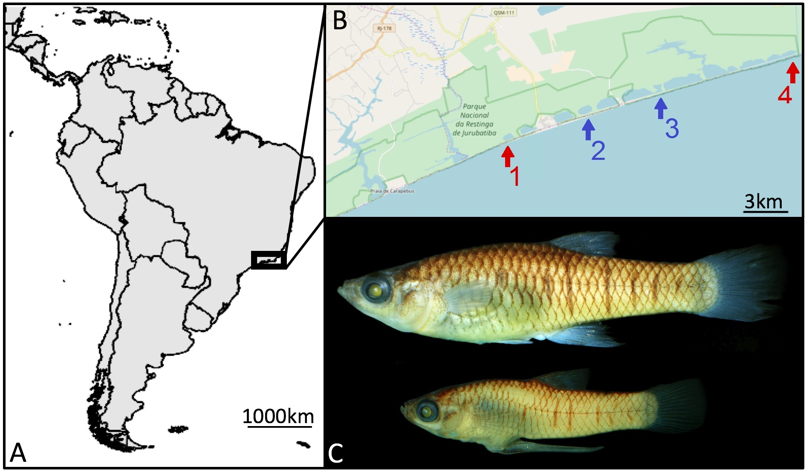Fig.1. (A) Study area in the state of Rio de Janeiro; map created with the R-package maps (Becker, 2017). (B) Locations of the lagoons; map created using OpenStreetMap (https://www.openstreetmap.org, accessed on 14 December 2017): (1) Bezerra, (2) Maria Menina, (3) Catingosa and (4) Pitanga. Lagoons with piscivorous predators are presented in red and those without predators in blue. (C) Female (top) and male (below) adult Phalloptychus januarius.

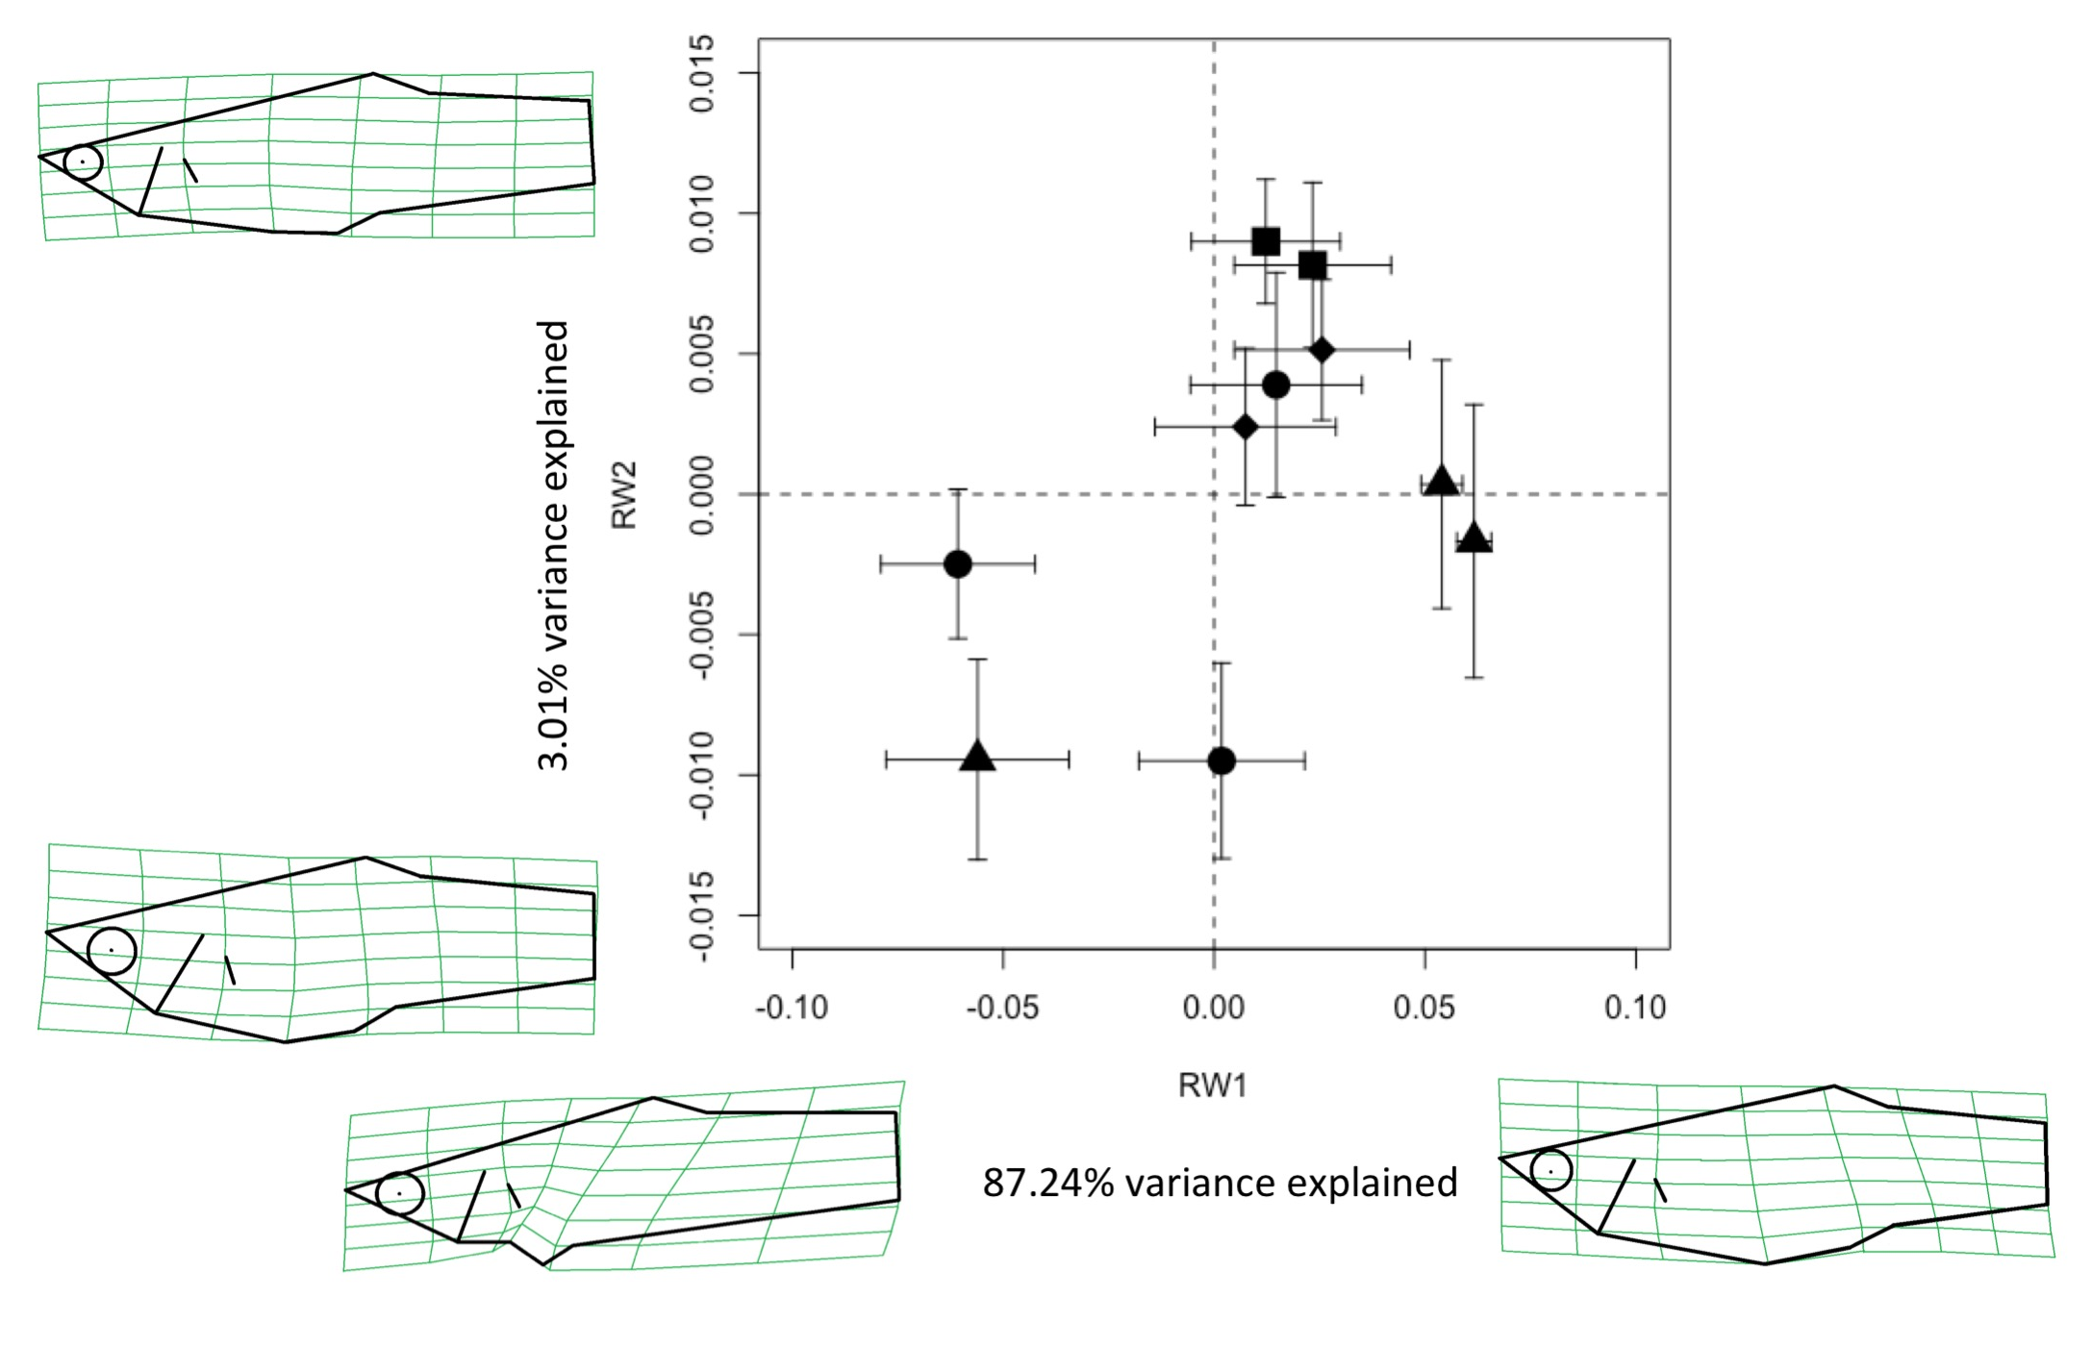
Fig. 2. Body-shape variation (Mean ± SE) in P. januarius. Bezerra: squares, Catingosa: triangles, Maria Menina: circles, Pitanga: diamonds; multiple symbols represent the repeated sampling in each lagoon. Thin-plate spline transformation grids visualize morphological variation across the two relative warps, whereby RW1 mainly separates males (left) from females (right), whereas RW2 describes differences in body roundness and depth.

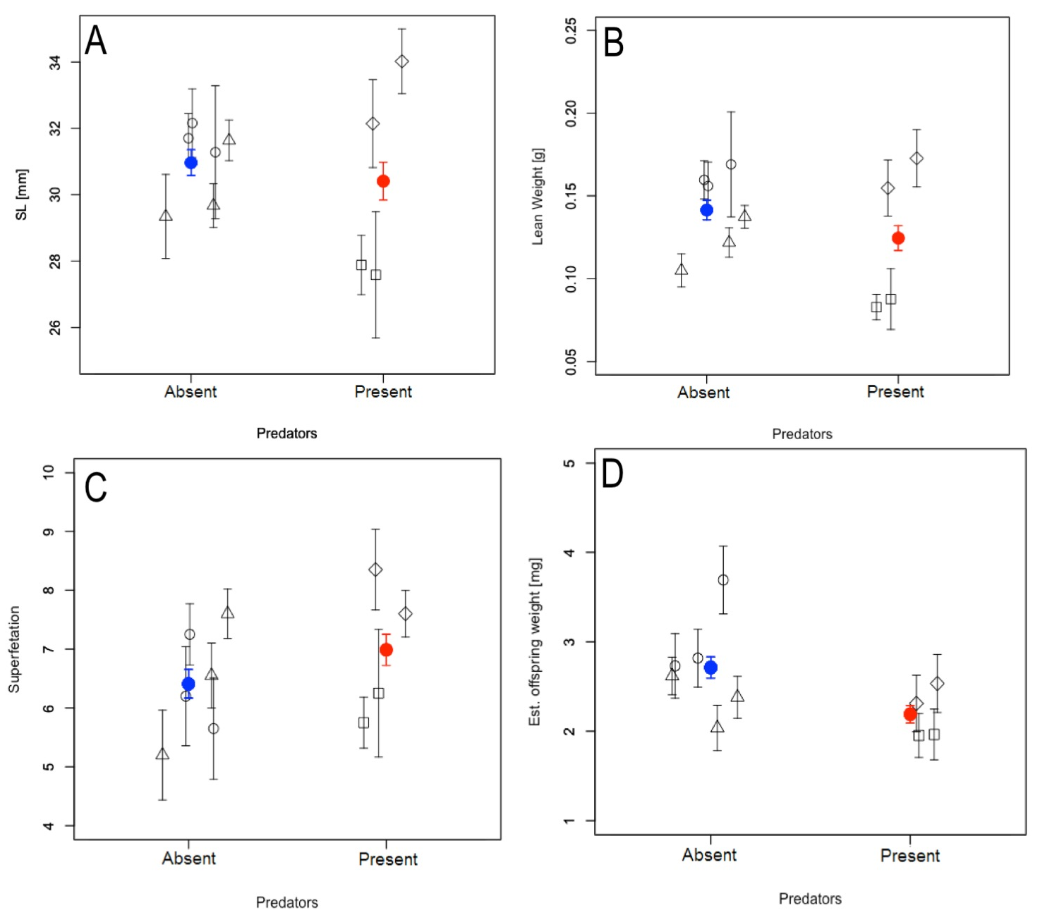
Fig. 3. Mean ± SE of female life-history traits and proxies (A: SL, B: adult lean weight, C: superfetation, D: estimated offspring weight at birth) in populations exposed to different predation regimes. Bezerra: squares, Catingosa: triangles, Maria Menina: circles, Pitanga: diamonds; multiple symbols reflect the repeated sampling in each lagoon. Red symbols represent the overall mean across high-predation lagoons, while blue represents the overall mean across low-predation lagoons.

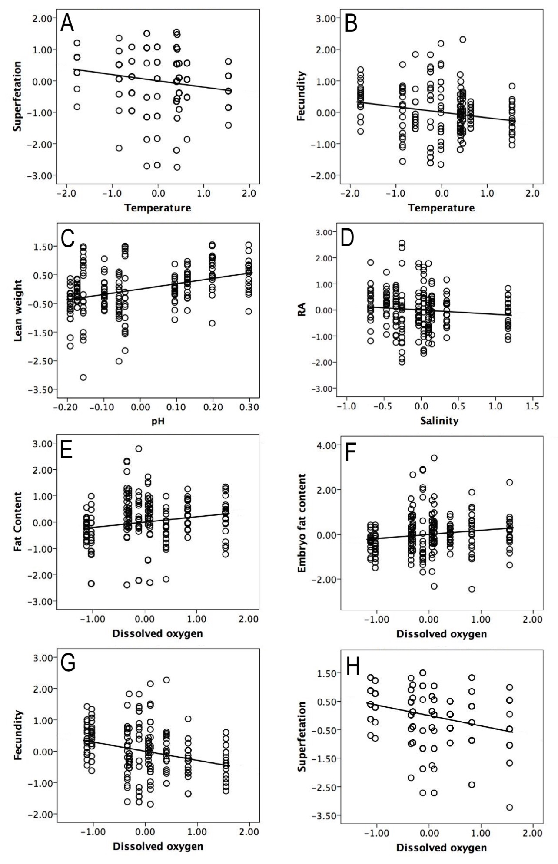
Fig. 4. Partial regression plots (residuals corrected for all other environmental variables) of female phenotypic variation due to different environmental variables. Shown are temperature-effects on A: superfetation and B: fecundity, C: variation in lean weight due to pH, salinity-effects on D: RA and E: adult fat content, as well as effects of dissolved oxygen on F: embryo fat content, G: fecundity, and H: superfetation.

