Cultural Hybridity: A Spatiality of Alternative Possibilities

Andreea Ionescu

Royal Holloway University of London
School of Management

Abstract

This thesis explores how space influences market processes. The research focuses on how space impacts the creation and evolution of an alternative creative ecosystem in a pseudo-public space known as the Leake Street Arches. Highlighting space as either context or object of consumption, researchers highlight the emergence of a platform where producers supply consumers with assets to create and where consumers exert their skills and knowledge to innovate, however studies so far have mainly focused on platforms such as cathedrals of consumption, theme parks, and online communities whereby the consumer sovereignty continues to be scripted and controlled. The study adopts an interpretivist approach for a longitudinal case study of the Leake Street Arches and engaged methods such as participant observation, semi-structured in-depth interviews, and photo-elicitation. Findings illustrate spatial contradictions evoked by the pseudo-public space’ mainstream vs underground, organic vs capitalist, self-curated vs corporate-curated nature that promulgate alternative trajectories. In comparison to the literature on creative public spaces whereby capitalists coopt public initiatives, the study shows how in this case the public space scripted the public space’ consumer experience.

Table of Contents
Abstract 2

CHAPTER 1: INTRODUCTION AND JUSTIFICATION OF STUDY
  - Introduction 3
  - Justification of Study 3
  - Rationale of Study 4
  - Research Aims and Objectives 5
  - Structure and Content of Thesis 6

CHAPTER 2: LITERATURE REVIEW
2.1. Introduction 7
2.2. The Creation of Markets from a Producer and Consumer Perspective 8
2.2.1. The Producer Perspective 10
2.2.2. The Consumer Perspective 12
2.3. Co-optation Theory in Market Development 13
2.4. The Importance of Space in Social Life 15
2.5. Space and Place in Marketing Studies 17
2.5.1. Consumption in space and place 18
2.5.2. Consumption of space and place 18
2.5.3. Consumption in/of space and place 20
2.6. Consumption IN Space and Place 21
2.7. Consumption OF Space and Place 27
2.7.1. An Experiential View of Consumption 29
2.7.2. A Symbolic View of Consumption 30
2.8. Consumption IN/OF Space and Place 35
2.8.1. Agency, Co-production and Consumer-centric Organisations 39
2.8.2. Consumer Contestation and Resistance 45
2.8.3. Consumer Resistance 50
2.8.4. Consumer Renegotiation 51
2.8.5. Theories in Consumer Resistance 51

CHAPTER 3: METHODOLOGY
3.1. Introduction 62
3.2. Research Assumptions 62
3.2.1. Philosophical Worldview 62
3.2.2. Foundation Principles for Interpretivist Research 64
3.2.3. Interpretivist Research 65
3.2.4. Interpretivism vs Positivism 66
3.3. Overall Strategy 75
3.3.1. Case Study Research 76
3.3.2. The Role of Lefebvre’s Theory in Case Study Selection 76
3.3.3. Site for Enquiry: The Leake Street Arches 80
3.3.4. Justifying Sampling Data 84
3.3.5. Triangulation 86
3.3.6. Ethnographies and Participant Observation 87
3.3.7. Semi-structured Interviews 88
3.4. Data Collection Process 91
3.4.1. Researcher Reflexivity 92
3.5. Data Collection Methods 94
3.5.1. The Exploratory Phase 94
3.5.2. Phase 1-The Development of Emergent Themes 95
3.5.3. Phase 2- Development of Core Constructs and Themes 97
3.6. Summary 99

CHAPTER 4: ANALYSIS
4.1. Introduction 100
4.2. Spatial Practice: Understanding Space that is Produced and Experienced 101
4.2.1. Setting the Scene: Flexibility in Electrifying the Alternative Trajectories 102
4.2.1.1. The Adaptive Space: Departicularising Contextual Cues 103
4.2.1.2. Generating the Alternative Trajectories 118
4.2.2. Mobility: The Formation of Fast-moving Environments 143
4.2.2.1. The Creative Practice of Encounters 154
4.2.2.2. The Practice of Creative Recycling 161
4.3. Representations of Space: Defining Managerial Control 167
4.3.1. Introduction 167
4.3.2. The Use of Mystery and Curiosity 168
4.4. Spaces of Representation: A Communal Ecosystem 176
4.4.1. Setting the Foundations for Art of Contestation: Creating Chaos 177

CHAPTER 5: DISCUSSION AND CONCLUSIONS 192

BIBLIOGRAPHY 200

Chapter 1: INTRODUCTION AND JUSTIFICATION OF STUDY

1.1. Introduction

This chapter outlines an overview of the thesis and discusses justification of study, research aims and objectives and its structure.

1.2. Justification of Study

This thesis focuses on the creative pseudo-public space as an alternative creative ecosystem in creating and evolving market alternative trajectories. In the last decades, the marketplace has witnessed a proliferation of creative crucibles- either private companies or non-profit arts organisations that incubate creative empowerment, reuse of materials and translate creativity into business (e.g. Crucible, 2016). In addition tot this, scholarship has extensively analysed creative clusters and the importance such clusters bear for the creative economy (e.g. Lazzeretti & Cinti, 2012; Martins, 2015; Mommaas, 2004), however space and place but also the tight interconnection between space-consumers-producers and practices mediated by the physical and social environment remain limited. To address this oversight, the alternative creative ecosystem, as ‘a biological community of interacting organisms and their physical environment’ (Dictionary, 2011a) is a formulation of three equal terms- space, consumers, producers- that exist in interaction, in conflict and in alliance with each other. However, scholars imply that capitalists recruit and exploit consumers by ‘putting them to work’ and fuel consumers’ needs for freedom and agency by channeling platforms for consumers describing practices, such as customization or personalization, whereby customers experience a sense of freedom (Giesler, 2008; Prahalad & Ramaswamy, 2000; Coimbatore K Prahalad & Venkat Ramaswamy, 2004, p. 18; C. K. Prahalad & Venkatram Ramaswamy, 2004; Ritzer & Jurgenson, 2010; Zwick, Bonsu, & Darmody, 2008). As much as consumers exert this freedom, practices continue to be highly controlled and scripted. Although researchers highlight the emergence of a platform where producers supply consumers with assets to create and where consumers exert their skills and knowledge to innovate, studies so far have mainly focused on platforms such as cathedrals of consumption, theme parks, and online communities whereby the consumer sovereignty continues to be scripted and controlled (Ritzer, 2005; Sorkin, 1992). What makes my study particularly interesting is the focus on a context part organic part capitalist that ushers the dichotomy between managers exploiting consumer labour only and consumers not evolving beyond company-scripted experiences into a creative and democratic model engendered by spatiality. In this sense, the study shows how space influences the creation and evolution of an alternative creative ecosystem. Accordingly, the thesis focuses on how space influences the creation and evolution of creative markets in a pseudo-public space represented by the Leake Street Arches.

1.3. Rationale of the Study

The thesis constitutes an interpretation of how space influences the creation and evolution of an alternative creative ecosystem. Unlike previous interpretivist research in relation to spatial formations that shape consumer experience (Belk & Costa, 1998; Bitner, 1992; Chatzidakis, Larsen, & Bishop, 2014; Chatzidakis, Maclaran, & Bradshaw, 2012; Kozinets et al., 2002; Kozinets et al., 2004; Maclaran & Brown, 2005; Maclaran, Brown, & Stevens, 1999; Sherry et al., 2001), this research sets itself apart by focusing on the interplay between a private-public/organic-commodified space influencing market processes; concept that has received little attention to date (Castilhos, Dolbec, & Veresiu, 2014; Giesler, 2008; Humphreys, 2010a). Moreover, studies in consumer research have analysed how consumer negotiate meanings in the consumption of a public space (Visconti, Sherry Jr, Borghini, & Anderson, 2010), however there has been no attempt in exploring the consumer-producer-space relationship in a creative pseudo-public space. Finally, although by now Lefebvre (1991b) is one of the most cited philosophers in spatial studies, his triadic conceptualisation of spatial practice-representation of space-spaces of representation has voided a dialectical resolution of contradictions whereby the three elements ‘exist in interaction, conflict and alliance with each other’ (Butler, 2012, p. 15).

1.4. Research Aims and Objectives

The overall aim of this study is to explore the ways in which space influences the creation of an alternative creative ecosystem in a pseudo-public space context. The central research question directing the research is: how is the Leake Street Arches pseudo-public space influencing market processes? The key aims and objectives are:

- To explore how space influences the creation and evolution of an alternative creative ecosystem
- To understand how creativity is used in a pseudo-public space
- To investigate the interaction between producers and consumers on a geographically-embedded creative market
- To theorise the production of a pseudo-public space in relation to market processes looking at Lefebvre’s triadic dialectic (conceived, perceived and lived space) that exist in a continuous transformation

1.5. Structure and Content of Thesis

The study is broken down in five chapters. Chapter 2 examines the background literature on space and co-production. Chapter 3 describes the methodology engaged in this study, its overall research strategy, and design. It documents the interpretivist research paradigm evoked in this study and provides a justification for methods and theoretical framework. Chapter 4 presents an overview of key findings and themes emerging from the longitudinal study. It discusses key findings in relation to the study’s aim and objectives, while the final chapter summarizes and draws conclusions while highlighting limitations.

Chapter 2: LITERATURE REVIEW

2.1. Introduction

This chapter discusses the creation of markets and spatial perspectives under examination in this study. It discusses the creation of markets from a consumer and producer perspective, emphasising that space is a missing active category in market formation and processes. It is being advocated that space not only represents a context or object of consumption, but a key actor that explains social processes and actions. To address this oversight, the study explores how the social sciences and humanities have discussed the spatial turn and advocates that presently the importance of space in the creation and evolution has been tangentially analysed. Research in market formation has been monopolised by institutional theory and actor-network theory and although the three approaches and their theories have covered a large myriad of empirical work within the sociology of markets, there is still scope for knowledge (Castilhos et al., 2014). The aim of this chapter is to demonstrate why spatiality is an important context for the study, emphasise main gaps within previous research and illustrate Lefebvre’s theory of the production of space as a viable tool in exploring how space influences the creation and evolution of markets.

2.2. The Creation of Markets from a Producer and Consumer Perspective

In the last decades, research on the emergence and formation of markets has occupied centre stage. As markets impact for example, innovation and diffusion (Martin & Schouten, 2014), understanding of public space (Chatzidakis et al., 2012), consumer subjectivity (Karababa & Ger, 2011) and the commercial experience (Maclaran & Brown, 2005), unfolding how markets are created and how market processes evolve is quintessential. Inquiring how new markets are being created, researchers not only engage in analysing market processes, but also in further expanding knowledge by defining what is a market, hence the significance of this work to current consumer culture literature. Exploring how markets and economic activities are conceptualised, Fligstein and Dauter (2007) argue that the principles of market exchange and competition frame the market model into three categories- markets as networks, institutions, or performances. Scholars in the network tradition have focused on the relational ties between the actors involved and the importance of establishing viable networks capable of bridging trust between buyers and sellers, relationships meant to enable exchange. Institutionalists focus mainly on the formation of concrete markets and how social structures and constructions are contextualised by market rules, power and norms (Fligstein & Dauter, 2007). Finally, the performative school of thought looks at the specific technologies and artifacts employed by actors.

The three approaches have impacted how researchers explore phenomena and view markets as ‘social arenas where firms, their suppliers, customers, workers, and government interact, and all three approaches emphasize how the connectedness of social actors affects their behavior’ (Fligstein & Dauter, 2007, p. 107). Evidencing the importance of connections and interactions and drawing from institutional theory, Weber, Heinze and Desoucey (2008) define markets as exchange structures between producers and consumers. Likewise, Ertimur and Balli (2015) adopt DiMaggio’s (1979, p. 1463) interpretation of markets as ‘organisational fields that comprise the totality of actors and organisations involved in an arena of social or cultural production and the dynamic relationships among them’. In a similar fashion though drawing from actor-network theory, Caliskan and Callon (2010, p. 3) define markets as ‘sociotechnical arrangements or assemblages that organize the conception, production and circulation of goods, deploying rules and conventions, technical devices, metrological systems, logistical infrastructures, texts, discourses and narratives, technical and scientific knowledge, as well as the competencies and skills embodied in living beings’. In this view, firstly scholars who use networks, institutions or performativity as explanatory mechanism mainly invoke institutional theory and network theory; however Fligsteing and Dauter (2007) further summarize the similarities between performative and institutional theory in their exploration of how markets are created and institutionalised. As implied, besides a few studies that employ co-optation theory (Thompson & Coskuner-Balli, 2007), marketplace drama (Giesler, 2008) and stigmatization (Sandikci & Ger, 2010), the field has been monopolised by institutional theory and actor-network theory. However, although the three approaches and their theories have covered a large myriad of empirical work within the sociology of markets, they are by no means complete, as to be discussed throughout this chapter.

Secondly, the definitions imply a nexus of interconnected actors and organisations involved in the creation and dissemination of products or services. Accordingly, the interaction between consumers and producers posits an important research field for scholars. As such, the growing stream of research on market formation and dynamics has so far primarily focused on understanding the role of producers (Humphreys, 2010a; Thompson & Coskuner-Balli, 2007) and consumers (Canniford & Shankar, 2013; Dolbec & Fischer, 2015; Giesler, 2008; Martin & Schouten, 2014; Sandikci & Ger, 2010; Scaraboto & Fischer, 2013) in the creation of market processes. Specifically, consumer researchers are interested in understanding what catalyses the creation of new markets, players who influence the creation of new markets, maintenance and disruption of markets or significant evolution in existing markets (Dolbec & Fischer, 2015). Next, we will look at studies that analysed the role of producers and consumers within market processes.

2.2.1. The Producer Perspective

Drawing from institutional theory, Humphreys (2010a) departs from a very popular approach in marketing that explores product categories and companies in market formation and instead posits the interplay between social and cultural forces. For a market to be created, Humphreys (2010a, p. 2) implies that consumers and producers must share an understanding of what is being exchanged and the reason behind it, thus suggesting that ‘the process of market creation is largely a process of institutionalising certain shared understandings and practices of exchange’. The contention however may be more viable for market evolution research rather than market creation, as multiple contexts such as arts consumption whereby audience members construct personal memorabilia-‘which act as carriers of meaning and memory’ (Larsen, 2013, p. 188) can lead to a different perspective on the shared understanding of what is exchanged and why. Consequently, the power of context can be an important variable that contradicts Humphrey’s contention, echoing here Askegaard and Linnet’s (2011) request for studies that tackle a more thorough understanding of the ‘context of the context’. Focusing on legitimation, although the author argues that it is crucial to understand the place of technological innovations inferring that innovation arises from marginal ideas or practices co-opted by the mainstream, nevertheless he does not offer an overview or explanation of this phenomena or how the process might aid managers. Likewise, Ertimur and Coskuner-Balli (2015) focus on the evolution of markets with plural logics- i.e. brands with multiple belief and cultural systems that impose multiple identities, which are not equally valued by stakeholders, thus creating tensions and incoherence within firms. It is being argued here that institutional logics shape the cognition and behavior of actors by providing organizing principles, practices and vocabularies, and thus constraining action. In questioning how brands address multiple and conflicting demands of plural logics, what strategies should managers adopt to source legitimacy in plural logic markets, the authors examine the co-existence and rivalry of competing logics and document that such incompatibilities can fuel the co-existence of multiple logics thus proving difficult to maintain important institutional referents, posing demands on organisational goals and mission, but also capturing the market’s complexity. Notably however, these logics exclude the consumer involvement and focus mainly on managerial and stakeholder perspectives. However, as the field of marketing evolved from a firm-centric and service-dominant logic to a consumer-centric logic, the consumer engagement and cocreation aspects between firms and consumers have occupied centre stage (Martin & Schouten, 2014).

2.2.2. The Consumer Perspective

Research in the consumer culture tradition has demonstrated that consumers occupy a more participative role in the formation and evolution of markets. For instance, Scaraboto and Fisher (2013) study ‘frustrated fatshionistas’ who foster collective identity formation to mobilize changes in the market according to their desire. In this endeavour, because they lack legitimacy in the mainstream fashion market, the stigmatized group of plus-size consumers appeal to institutional entrepreneurs in taking action to achieve the desired outcomes. In this view however, consumer mobilization was influenced by institutional entrepreneurs who inspired consumers and not vice versa; thus suggesting that ‘consumer sovereignty’ or ‘the consumer is king’ (Chatzidakis et al., 2014) continues to be staged by entrepreneurial and managerial entities. These consumers lack legitimacy, resources, power and the right to be heard and succeed, which ‘serves only to reform the marketplace but not to bring about a radical shift to a more responsible and communitarian-based economic structure’ (Pressey et al., 2013, p. 110). The fatshionistas did not wish to challenge institutional logics in comparison with Kozinets and Handelman’s (2004) study on US-based activists. Focusing on consumer movements, the authors explore how US-based activists object to genetically engineered (GE) foods and how such movements aim to alter the market. Similarly, Giesler (2008) studies music downloaders who challenge institutional logics by resisting paying for music they consumed. Introducing the notion of the marketplace drama in the music market, the author documents the opposing views between consumers and producers in music downloading. Marketplace drama theory describes market evolution as a ‘symbiotic process of cultural performance’ between consumers and producers in the institutionalisation of a market structure (Giesler, 2008, p. 000). To summarise, studies so far on the consumer perspective have tackled consumers wishing to change the market based on ideology (e.g. Giesler, 2008) or an unmet need (e.g. Scaraboto & Fischer, 2013). Business and consumer culture disciplines have devoted efforts to research processes such as innovation and its diffusion, in which consumers benefit from firm-driven innovation (BERLY, 1995; Van de Ven, 1993); but also industry legitimation practices whereby consumers act as more active participants in the market formation (e.g. Ertimur & Coskuner-Balli, 2015; Humphreys, 2010a, 2010b; Scaraboto & Fischer, 2013). Researchers believe that efforts to change market systems and processes are created through co-optation of countercultural meanings by mainstream marketers (Dolbec & Fischer, 2015; Thompson & Coskuner-Balli, 2007). In the next section, the studies reviews leading conceptualisations of corporate co-optation and highlight how practices impacted the market.

2.3. Co-optation Theory in Market Development

Co-optation theory implies a counterculture challenging the dominant symbolic order, defying hegemonic rules and regulations and ‘destabilizing taken-for-granted modes of understanding and fundamentally breaching the fragile consensus through which hegemony of the dominant classes is sustained’ (Thompson & Coskuner-Balli, 2007, p. 137). The dominant culture then adopts and commodifies countercultural expressions, followed by introducing the new product into the commercial mainstream. As consumers however started to play a vital role in market formation, the co-optation theory suffered modifications. The classic co-optation theory (Ewen, 1999) invokes that countercultural expressions are completely redeemed by the mainstream, while the re-politicised consumer variation of co-optation theory (Thompson & Coskuner-Balli, 2007) implies a symbiotic relationship between countercultures and mainstream cultures whereby a counterculture can reclaim its subversiveness by renewing its radical frames and to a certain degree collaborating with the mainstream culture (Shi, 2014). For instance, in his study of Burning Man, Kozinets (2002) shows how participants avoid monetization and branding and co-create an alternative marketplace described by a different set of rules and infrastructure. Similarly, Giesler (2008) shows how the collaboration between consumers and producers creates new market systems whereby music consumers, prosumer hackers and the music recording industry enter a battle and the result is represented by the development and distribution of new products, modes of music consumption and models of pricing (Martin & Schouten, 2014). Finally, Scaraboto and Fisher’s (2013, p. 1235) study on frustrated fatshionistas show how consumers wish to utilise and not reject the hegemonic market as resistance might be ‘less applicable in contexts where consumers would be delighted to make purchases from mainstream marketers if only options were available’. Most of these key studies account for how consumers or producers, or the collaboration between consumers and producers has modified market processes or stemmed new markets. However, space represents the context or a backdrop in which market dynamics unfold. Although research on market formation and processes has looked into how consumers and producers create or modify such practices, how space creates and evolves the market remains a largely undeveloped field.

This study implies that space affects markets. Google uses spaces to motivate employees, hone creativity and performance (J. B. Stewart, 2013), while the Silicon Valley creates a spatial hub of entrepreneurs to boost technological innovation (S. S. Cohen & Fields, 1999). Karababa and Ger (2011) show the importance of spatiality in early modern Ottoman coffeehouses by demonstrating how such sites played a key role in diffusing practices and the formation of the consumer subject. Similarly, studies conducted by Humphreys (2010b) show how mainstream industries legitimate territories, while Martin and Schouten (2014) tackle the minimoto market formation created through a consumption infrastructure. Although these studies account for the importance of spatiality in market processes, further research is needed to explore how geo-contexts impact industries- a field that considers space as an active and not passive category. The next section will look at how space has impacted public and private industries leaving consumers to battle for their right in occupying environments for leisure or self-expression.

2.4. The Importance of Space in Social Life

In recent years, recognising that space matters, institutions have commodified space available to populations. Previous research shows that local state and governance have intervened in the formation and development of public space whereby stakeholders have included space into ‘their own wider economic development strategies’ (Inroy, 2000, p. 23). As such, the last decade has witnessed a proliferation of studies calling into question the end of public space (Mitchell, 1995; Paddison & Sharp, 2007). It has been contended that contemporary cities suffer from the complete eradication of public areas characterised through inclusivity and debate (Paddison & Sharp, 2007). According to Sennett (1992) one of the results of contemporary urban planning has been the emergence of ‘dead public spaces’, such as barren plazas and sanitized sites.

Stemming from the failure of dead public spaces, constant intervention of corporate and state planners in the development and design of urban public spaces based on a capitalistic desire to stimulate further economic rewards, a second result emerged (Mitchell, 2003b). The development of festive spaces for consumption are conceptualised as landscapes in which every interaction is controlled and surveilled, carefully planned up to the smallest detail (Caldeira, 1994; Sorkin, 1992; Zukin, 1993). Accordingly, the public sphere comprises shopping malls, corporatized public spaces and redeveloped parks, termed as ‘interdictory spaces’ (Flusty, 2001). Such interdictory spaces are premised on corporate and state planners’ requirement for control over the public’s behaviour (Fyfe & Bannister, 1998; Mitchell, 2003b) and thus engendering ordered environments conjuring conformity to rules and regulations (Paddison & Sharp, 2007). In particular, these spaces have been conceptualised as promoting social marginalization (Brownill, 1993), increasing social and economic inequalities (Robson, 1994), limiting places for conversation and interrogation (Schneekloth & Shibley, 1995), finally and most importantly limiting involvement in the production of lived environment and in decision-making processes that affect urban development (Butler, 2012). The crux of ordered environments is to limit and control unscripted social interactions, as ‘control-led diversity is more profitable than the promotion of unconstrained social differences’ (Mitchell, 2003b, p. 139). In this view, representations of space that are carefully constructed come to dominate the lived experience (Lefebvre, 1991b; Mitchell, 2003b; Zukin, 1993) and consequently abjure a liberatory celebration of diversity and unscripted involvement in the representation of space by inhabitants. This study aims to explore a pseudo-public space that brings together a free and diverse environment, represented by a public space, and its annex- a private space that is curated and staged. Research so far has not looked into creative pseudo-public spaces and how such sites can alter markets. To further understand however how space has been tackled in marketing and consumer culture studies, the next chapter will address research on spatiality and advocate for a significant gap in how spatiality influences market processes. Also, the next chapter will aim to address the empirical and theoretical shortcoming by developing an understanding of the Leake Street Arches, a creative pseudo-public space based in Central London by engaging a lefebvrian theoretical framework.

2.5. Space and Place in Marketing Studies

Although Arnould and Thompson (2005, p. 875) acknowledge that ‘CCT researchers investigate how consumers consume across a gamut of social spaces [e.g. the home, the office, diverse retail settings, the Web, leisure enclaves, tourist sites]’ the concept of space remains questionable. The concept of space continues to be conceptualised as absolute or physical and as such, forming either the background setting or the object (e.g. entertainment venues) of consumption activity (Chatzidakis & McEachern, 2013). In this view, space as context of consumption activity represents a managerial defined stimulus that directs consumer behaviour; while space as object of consumption activity emphasises consumption as an expressive movement in which consumers experiment with signs produced by managers or marketers and derive their own meaning. Thus consequently, the two streams of literature present a producer-consumer dichotomous relationship in which either the producer impacts consumers’ practices (consumption in space and place), or consumers’ practices have an impact on the producer’s logic (consumption of space and place). The present study intends to explore a more dialectical relationship in which consumers and producers participate in each other’s practices and coevolve.

2.5.1. Consumption in space and place

Bitner (1992) recognised that the physical environment impacts consumer behaviour. It has been shown that the physical environment dictates the success/failure of the organisation by influencing consumers’ satisfaction, motivation, sales, etc. Based on this identification, Bitner (1992, p. 65) coined the term servicescape to denote ‘all the objective physical factors that can be controlled by the firm to enhance (or constrain) employee and customer actions’. The objective, physical factors have been further consolidated into the atmospherics model (Kotler, 1973) that aid consumers in making approach/avoidance decisions (Donovan & Rossiter, 1982; Mehrabian & Russell, 1974). The customer approach/avoidance decisions are impacted by physical and social stimuli- social relationships engendered in space and place can augment or hinder customers’ enjoyment of their service experience (Petruzzellis & Winer, 2016).

2.5.2. Consumption of space and place

Although managers control service stimuli and strive to influence consumer sensations and meanings, settings also incorporate subjective stimuli that require effort to measure and managerially uncontrollable (Rosenbaum & Massiah, 2011). It is asserted that consumers assign personal meanings to a servicescape based on their ‘lifeworlds’ that influences how they categorise the environment (Seamon, 1979). In this view, the servicescape becomes a personal construct in which consumers engage a more active role as meaning creators. When individuals charge space with sentiment and personal symbols as a result of their social relationships, it is being considered that they convert space into place: when individuals instill a place with personal meaning, that place becomes a sign or something beyond itself, thus morphing the space of consumption into a place of significance (e.g. Debenedetti, Oppewal, & Arsel, 2014; Rosenbaum, 2006; Visconti et al., 2010).
As consumers associate place with sentimental meaning, they begin to form attachment and loyalty to the place, developing a ‘sense of place’ or ‘subjective territorial identity’- which gives meaning and belonging to consumers’ lives. Therefore it is being implied that consumers desire opportunities for self-immersion that contribute to their search for an identity.

In meeting this need, Holbrook and Hirschman (1982) discuss experiential aspects of consumption; Pine and Gilmore (1999) analyse the experience economy; while Schmitt (1999) examines the experiential marketing- all informing on the immersive aspect of consuming experience in contrast to the mere purchasing of simple products/services. Following on from this, retail theatres and cathedrals of consumption emerged that focus on an experiential view of consumption, evidencing here the symbolic production and exchange of a significant meaning (Carù & Cova, 2007). Thus, the idea is that consumers come to the market to consume servicescapes as ideological construction and in the process produce their identity. Finally, it is being concurred that although managers create and produce servicescapes that instil a certain mood and shape consumer experience, it is the consumer’s personal identity and their interaction that transforms space into place by attributing sentimental meaning (Massey, 1995).

2.5.3. Consumption in/of space and place

The new market logic implies consumers with more subjectivity and agency (meaning creators), yet they remain subordinated to the treatment of managers and companies’ interests. Based on Firat and Venkatesh’s (1995) declaration of the liberatory potential in consumption, two ‘emancipatory’ strands of consumer research emerge (Maclaran & Brown, 2005):
- Consumer renegotiation (e.g. Maclaran & Brown, 2005; Lisa Peñaloza, 1998; Thompson & Haytko, 1997)- involves active consumers who increasingly engage themselves in a dynamic and explicit dialogue with producers thus describing the consumer as a co-producer of service. In this view, consumers try to dominate the managerial defined environment while interacting; consume the environment directly and use it also as context for further consumption practices.
- Consumer resistance (e.g. Belk & Costa, 1998; Chatzidakis et al., 2012; Kozinets, 2002)- implies consumers who contradict marketing representations and redefine commodities based on their personal worldviews. In this view, consumers appropriate the managerial defined environment while conducting practices of contestation; produce their own environment- a ‘different’ space.

However, it is implied that consumers’ practices of contestation and resistance can only exist due to the marketplace, therefore this chapter implies a dialectical consumer-producer relationship in which both coevolve, contest, and co-produce eachother. To conclude, the following chapters will provide a detailed view of the three streams of literature (consumption in; of; in/of space and place) drawing on the difference between the producer-consumer dichotomous and the producer-consumer dialectical relationship. In this endeavour the Lefebvrian approach will be laid out.

2.6. CONSUMPTION IN SPACE AND PLACE

Since Bitner (1992) recognised that the absolute, physical environment can be altered to influence behaviours and create a schemata, considerable empirical research has been conducted in the marketing literature evaluating how does the physical environment impact consumers within the retail and service environments. It has been suggested that the physical setting dictates the success or failure of the service organisation by influencing customers’ satisfaction with the service (e.g. Bitner, 1990; Harrell, Hutt, & Anderson, 1980); employees’ satisfaction, productivity, and motivation (e.g. Becker, 1981; Davis, 1984); customers’ service experience and the many ways in which consumers perceive such an experience (e.g. Baker, Levy, & Grewal, 1992; Bitner, 1990); customers’ loyalty (e.g. Stuart & Tax, 2004; Zomerdijk & Voss, 2010); how long does it take for consumers to decide and implicitly how long they linger in the store (Grossbart, Hampton, Rammohan, & Lapidus, 1990); value (Babin & Attaway, 2000); and finally, how the physical environment impacts sales (e.g. Donovan & Rossiter, 1982; Milliman, 1986). Based on this identification, Bitner introduced the concept of ‘servicescape’ to denote the objective physical factors (i.e. managerially controllable physical factors) controlled by institutions to improve or confine customer actions. Consequently, the author further notes that ‘through careful and creative management of the servicescape, firms may be able to contribute to the achievement of both external marketing goals and internal organisational goals’ (Bitner, 1992, p. 67). In the same vein, Arnould et al. (1998, p. 90) infer that servicescapes or built environments may represent ‘consciously designed places, calculated to produce commercially significant actions’. In addition, Bitner (1992) conceptualises the objective, physical, and measurable stimuli as constituting the servicescape framework; these stimuli are further consolidated into three dimensions: ambient conditions (e.g. music, lights, temperature etc.); layout and functionality (e.g. furnishings, etc.); and signs, symbols, and artifacts (e.g. signage, personal artifacts, etc.). Such factors, whether tangible or intangible, are apprehended by consumers who respond internally- consciously or cognitively, emotionally, and physiologically to the environment. It is generally believed that the internal responses to the built environment affect the behaviour of individuals, but also impact the nature of their social interactions (Bitner, 1992).
The servicescape framework stems from environmental psychology and ecology studies investigating how organisms react objective stimuli located in a certain space (Stokols, 1977). Environmental psychologists suggest that individuals are in a first instance influenced by perceptions of the environment, then evaluate (favourably or unfavourably) environments, and in return react with two forms of behaviour: approximation or shunning (Donovan & Rossiter, 1982; Mehrabian & Russell, 1974). In making this decision, consumers use ‘atmospherics’ or ‘cues’ present within the service environment. The concept ‘atmospherics’ or ‘cues’ was defined by Kotler (1973). The term parallels Bitner’s ambient conditions and refers to elements such as lighting or noise or scent or taste for example that relate to the five human senses (Tombs & McColl-Kennedy, 2003). Moreover, atmospherics communicate information about the provider’s capabilities, beliefs, values and assumptions, and enable consumers judgements influencing loyalty intentions either favourably or unfavourably (Ezeh & Harris, 2007). In addition, Bitner (1992) implies that signs, symbols, and artifacts are being used, from a corporate perspective, to evoke socio-collective meanings that influence approach behaviours.

Besides producing cognitive responses, the environmental stimuli impact emotions such as pleasure, arousal and dominance (Mehrabian & Russell, 1974) . Donovan and Rossiter (1982) draw on Mehrabian and Russel’s (1974) stimulus-organism-response (S-O-R) framework that proposes stimuli (S) from the environment arousing emotions (O) that will consequently influence behaviour responses (R), and imply that the degree of emotional stimulation received from the environment will determine an approach or avoidance response. Following on from this, engagement with the environment can induce emotional states in terms of pleasure, arousal or dominance, and influence behaviour by affecting the emotional states of individuals (enhance or suppress emotions). Consequently, servicescapes ‘evoke emotions …that help determine value, and this value motivates customers to patronise a given choice repeatedly’ (Babin & Attaway, 2000, p. 93).

Although all service settings describe objective, managerially controllable stimuli that have an impact on consumer behaviour, settings also comprise subjective stimuli- difficult to measure and managerially uncontrollable, that influence consumers and their social interactions (Rosenbaum & Massiah, 2011). According to Bennett and Bennett (1970, p. 191) ‘all social interaction is affected by the physical container in which it occurs’. The context of consumption or the physical container defines the nature of social interaction through a subset of social regulations and conventions. In order to conceptualise social stimuli in servicescapes, researchers have appealed to a wide variety of disciplinary research that includes environmental/natural/human psychology and geography, and sociology (Rosenbaum & Massiah, 2011). Just to give a few examples, Cassidy (1997, p. 3) reviews environmental psychology literature and affirms that ‘the influence of physical settings on behaviour is inextricably bound up with social aspects of the setting’; Proshansky (1978, p. 150) reiterates this idea by suggesting that ‘there is no physical setting that is not also a social, cultural, and psychological setting’. Upholding this position, the geographers Holloway and Hubbard (2001) imply that the relationship between individuals and environments makes geographical understanding meaningful. Other empirical studies reconfirm that physical settings have an impact on behaviours such as group cohesion and friendship formation (Holahan, 1982; Sundstrom & Sundstrom, 1986). From a marketer’s perspective then, servicescapes include atmospherics and social factors whereby ‘the social aspects of the customer’s environment can act to facilitate or hinder the customer’s enjoyment of their service experience’ (Tombs & McColl-Kennedy, 2003, p. 449). The servicescape is a material stimulus, but also a social construct. Drawing on Bagozzi’s (1975) contention that inside the marketplace consumers fulfil their utilitarian needs but also their social and psychological ones, Rosenbaum and Massiah (2011) define customer approach/avoidance decisions as influenced by physical, and social, humanistic stimuli and accordingly postulate that the performance of social factors can either enhance or inhibit the service experience. In the same vein, Schneider (1987) creates the equation: E=f (P, B) that stands for environments as a function of people who behave in them, or better said people in an environment determine the nature and structure of the setting. Consequently, customer approach/avoidance decisions are impacted by the physical stimuli, but also social stimuli, and accordingly the servicescape represents a physical and a social construct where space influences consumers and vice versa.

Positivist, but also phenomenological perspectives have tackled the social dimension of the servicescape. Rosenbaum and Massiah (2011) contend that consumer groups gather in locations that evoke customer togetherness and provide health benefits such as social interaction and combating loneliness. Studies have documented how consumers who experience the loss of social support but also want to engage in pure sociability, may seek solace by forming social relationships with other consumers in servicescapes that facilitate positive customer-to-customer interaction (Nicholls, 2010). Thus, servicescapes also engender the formation of social relationships.

To summarise, from a managerial perspective the servicescape describes a tangible organisational resource, more or less consciously manipulated by managers to produce: desired effects such as favourable dispositions towards the servicescape and implicit, the providing organisation; and commercially significant actions. Many studies have focused on the evaluation and prediction of what the consumer ‘will think or feel, and how he/she will behave in response to the stimuli of the physical environment’ (Aubert-Gamet, 1997, p. 27). Upholding this position, it has been suggested that atmospherics or cues are influential in communicating the organisation’s brand image or purpose to customers and ultimately influence how customers categorize a certain brand. Research suggests that the structures and meanings created and produced by managers and imbued in servicescape may appoint certain expectations about how individuals should act in certain environments, but also shape consumers’ experiences, and accordingly can induce a set pattern of behaviour in customers (Sommer, 1969). Following on from this, the physical environment is considered a managerial defined stimulus that directs consumer behaviour through the atmospherics model and engenders specific states of feeling, portraying the consumer as a ‘relative passive subject who can be encouraged to participate in specified behaviours’ (Ostergaard, Fitchett, & Jantzen, 1999, p. 405). In this regard, other studies have emphasised the importance of manipulating atmospherics in the attempt of creating engaging, compelling and consistent contexts that build customers’ emotional connections to the servicescape and thus determine value which motivates customers to patronise a given servicescape repeatedly (Pullman & Gross, 2004; Zomerdijk & Voss, 2010). However, customer approach/avoidance decisions are not only impacted by the physical stimuli, but also social stimuli, and accordingly the servicescape represents a physical and a social construct where inter-human relationships and the relationship between space and individuals influences behaviour. Yet, although material and human factors are taken into consideration, the literature fails to recognise how consumers develop emotional and symbolic bonds with their physical and social environments (how they vivify consumption settings) - this will be the focus of the following section.

2.7. CONSUMPTION OF SPACE AND PLACE

So far it has been suggested that background environmental stimuli or atmospherics affect human sensations and are being employed by managers to communicate general meaning about the organisation’s establishment and thus guide consumers understanding of the establishment’s identity and set a general mood (Rosenbaum & Massiah, 2011). Furthermore, it has been postulated that the servicescape category also includes social factors- the humanistic dimension that can either enhance or inhibit the service experience and lead to approach/avoidance behaviour (Bitner, 1992; Ezeh & Harris, 2007; Turley & Milliman, 2000). What dovetails these stimuli is that their contribution to a context of consumption remains at all times under managerial control, as the managerial defined servicescape nurtures and directs both the physical and social dimension. As suggested, although managers control service stimuli and strive to influence consumer sensations and meanings strategically, settings also comprise subjective stimuli that are difficult to measure in an objective manner and managerially uncontrollable (Edvardsson, Enquist, & Johnston, 2010). Seamon (1979) asserts that consumers assign personal meanings to a complete servicescape based on their ‘lifeworlds’, which consequently influences approach/avoidance decisions. In this view, the environment is considered a personal construct, a sociospatial construct in which consumers start playing a more active part.

It is generally believed that individuals develop emotional and symbolic relationships with their social and physical environment and imbue the establishment with personal meaning as a result of their social relationships in the given space, i.e. the social production of space (Debenedetti et al., 2014). When individuals charge space with personal symbols as a result of their social relationships, it is being considered that they converse space into place. Visconti et al. (2010, p. 512) suggest that ‘the notion of space traditionally refers to something anonymous [objective], whereas place distinctively accounts for the meaningful experience of a given site [subjective]’. Along the same line of thought, the humanistic geographer Yi-Fu Tuan (1971) opined that when instilling a place with personal meaning, that place becomes a sign or something beyond itself. Accordingly, consumers attribute their spirit and personality to a commercial or non-commercial space as a result of their social relationships and following morph the space of consumption into a place of significance (Rosenbaum, 2006). As consumers associate a place with sentimental meaning, they begin to form attachment and loyalty to the place, thus developing a ‘sense of place’ or a ‘subjective territorial identity’ (Belk, 1992; Gustafson, 2001; Sherry Jr, 2000). Johnstone (2012, p. 1402) describes sense of place as the process in which people ‘acquire a sense of belonging and purpose via personal attachments with a physical location, which in turn may give meaning to their lives…it is one’s sense of place or rootedness that gives one a sense of belonging’. Kleine and Baker (2004) infer that places, similarly to possessions, are imbued in symbolic meanings and represent extensions of self. Following on from this, it is being concurred that although managers create and produce servicescapes that instill a certain mood and shape consumer experiences, it is consumers’ personal identity and their interaction that transforms space into place by attributing sentimental meaning: individuals actively make places (Massey, 1995). Accordingly, consumers use places in ways that have not been intended by managers and their expectations, i.e. commercial or non-commercial exchange (Lewis, 1990). For this reason, when consumers visit retail locations, consumption extends beyond the actual purchase or service experiences and implies consumers assigning meaning to the environment, transforming the environment into a place of significance and emphasising their role as value creators.

Consumers’ desire to exercise their capacity as value creators has been theorised by the experiential marketing literature that focuses on the sensory elements from a hedonistic perspective (e.g. Schmitt, 1999) and consumer culture theoretical ones that emphasise the more symbolic aspects created by our imagination (e.g. Kozinets, 2002).

2.7.1. An Experiential View of Consumption

A notion that first arose in consumption and marketing studies in Holbrook and Hirschman’s (1982): The Experiential Aspects of Consumption: Consumer Fantasy, Feelings and Fun, has been revitalised a couple of decades later as an important element element in understanding hedonistic forms of consumer behaviour (Carù & Cova, 2007). As Carù and Cova further suggest, experience has evolved to become the main foundation for an experience economy (B Joseph Pine & Gilmore, 2011) and subject for the experiential marketing (Schmitt, 1999). This new philosophy describes a fundamental shift in the market logic (Lisa Peñaloza & Venkatesh, 2006), identifying the evolution from a product-dominant to a service-dominant logic- i.e. ‘an area that tends to highlight immersion in consuming experiences as opposed to the mere purchasing of simple products or services’ (Carù & Cova, 2007, p. 3). Thus consequently, consumers do not consume products or services, rather the products’ meanings and images. In an experiential perspective then, consumption incites sensations and emotions that outgrow the individual’s own needs and touch upon consumer’s search for an identity and belonging. Therefore, consumers desire opportunities for self-immersion that contribute to their search for an identity.

In meeting this need, retail theatres and cathedrals of consumption have emerged that range from cultural consumption in a museum to spectacular consumption at Disneyland, Nike Town Chicago or ESPN Zone (e.g. Lisa Peñaloza, 1998; Sherry et al., 2001). Consumption here represents a hedonic experience, but also an opportunity for consumers to produce his/her identity, ‘so that s/he is in fact seeking the experience of being immersed in a thematized framework rather than a mere encounter with some finished product’ (Carù & Cova, 2007, p. 7). Producers provide material opportunities filled with emotional and symbolic meaning that consumers take on and through immersion engage into experiential moments of enchanted, spectacular encounters (Dholakia & Firat, 1998).

2.7.2. A Symbolic View of Consumption

Whereas the experiential marketing literature has focused on the sensory elements from a hedonistic perspective (e.g. Schmitt, 1999), consumer culture theoretical perspectives have emphasised more the symbolic aspects created by our imagination (Kozinets et al., 2002; Kozinets et al., 2004). According to Wolf (1999), the increase in entertainment and spectacle engendered by the experience economy, fulfils a genuine consumer need- that of escaping the market (either through full immersion in the experience or by interacting with the themed servicescape and then constructing personal meanings, thus making use of the consumption environment).

A plethora of spectacular themed environments have been researched by consumer culture theorists: flagship stores (e.g. Kozinets et al., 2002; Lisa Peñaloza, 1998), theme parks (e.g. O'Guinn & Belk, 1989), festival shopping malls (e.g. Maclaran & Brown, 2005), bridal salons (e.g. Otnes, 1998), brandfests (e.g. McAlexander, Schouten, & Koenig, 2002), festival and carnival settings, cyberspace, leisure space, home and body spaces (e.g. Mansvelt, 2005; Sherry, 1998). Further, what dovetails flagship brand stores such as ESPN zone (Kozinets et al., 2002), themed restaurants and malls such as Hard Rock Café and Mall of America (Gottdiener, 1998), Irish pubs (Patterson & Brown, 2002), festival marketplaces (Maclaran & Brown, 2005), alternative placeways such as cyberspace (Venkatesh, 1998) and other leisure venues, is the appealing nature of the spectacular.

Firat and Venkatesh (1995) have defined spectacle through an abundant visual imagery, complex environments which evoke meanings later on integrated into consumers’ understandings of reality. The servicescape, here, is a source that stems cultural constructions, that conveys meanings through the use of designs and displays, and therefore emphasising an ideological space that places consumers in associations with meaningful symbols and artifacts (Lisa Peñaloza, 1998). Peñaloza (1998) further implies that spectacular environments function as both consumption objects and vehicles of cultural consumption meanings. These elaborately designed locations create spectacular environments that appeal to consumers’ imaginations and emphasise the experiential elements of the product or service offered. Moreover, spectacular environments create a memorable and attractive consumer experience, and often make use of open-ended narrative structures that are deliberately ambiguous and allow multiple interpretations, thereby encouraging consumers to actively engage in their own subjective fantasising and meaning creation (Kozinets et al., 2002). Thus, spectacles are conceptualised as a form of market performance that involve consumer participation, and thus emphasise consumers who are more active in the marketplace (Deighton, 1992). In this vein, numerous scholars have compared the notion of retail experience with a theatre, in which services are performances (e.g. Harris, Harris, & Baron, 2001; Lisa Peñaloza, 1998; Pine & Gilmore, 1999; Sherry, 1998; Solomon, 1983).

A first key characteristic of these ‘performances’ is that they are designed to facilitate a personal and addictive connection between customers and the service provided. Zomerdijk and Voss (2010) assert that engagement with the environment can be emotional and depends on customers’ level of engagement. Yet in order to engage, customers must first appropriate the environment, an idea that describes how individuals overpower physical spaces and scenes and transform them into personal constructions, plots and plays (Aubert-Gamet, 1997). In the specific case of the themed environments, there is an established power of the producer. It is the producer who defines the atmospheric cues, freedom of interaction and meanings of the space, but also fixes the extension of customer participation. Following on from this, although it is possible for consumers to attribute a subjective, emotional meaning to built environments and thus own that service place at a mental level by intimately associating the place with life’s events, it is being suggested that producers still manufacture the level of customer participation; therefore consumers continue to play an instrumental and planned role within the servicescape environment.

Part of a themed environment’s ability to transcend everyday reality is how it conveys a sense of ‘elsewhereness’ (Maclaran & Brown, 2005), thus the second key characteristic refers to fantasies of escapism. Ritzer (2010) contends that producers manufacture a sense of place using simulated facades that are incredible shows in their own right. ‘Dream worlds’ such as the Las Vegas casinos, Disneyland, and Planet Hollywood use simulations like medieval castles, Egyptian pyramids, submarine rides, and the rock music worlds to create spectacular fantasy worlds that evoke dreams and invite consumers in a reverie staged especially for them, but also allow consumers to participate. They are participatory in the sense that producers create situations by engaging magical elements- situations that appropriate consumers’ efforts in producing values and meaning; producers create products and services with symbolic properties and consumers attach meanings to products and services, thus enchanting everyday life and facilitating escape from reality (Kozinets et al., 2002; Ritzer & Stillman, 2001). A second possibility of escapism is envisaged by the ‘communal ideal’.

In order to escape the market’s hegemonic practices new attempts have been made towards sharing communal relations. Characterised as sites instilled by a group of people living in close proximity with mutual social relations instilled by caring and sharing; an opportunity for civic engagement; a sense of belonging and social contribution (Kozinets, 2002; Putnam, 2000), places as community encounters create a climate of escapism, pleasure and relaxation and imply playful activities and attitudes (Belk & Costa, 1998). River rafters, mountain men, and burning men just to name a few, socially fabricate a consumption enclave, in which fantastic experiences are fabricated based on their own adventure stories, fairy tales, and local myths (Arnould & Price, 1993; Belk & Costa, 1998; Kozinets, 2002). In this view, consumers construct a reality that all members of the community share, recreating a fantasy spectacle for their own benefit rather than a performance played for a nonparticipating audience (Belk & Costa, 1998).

In conclusion, spaces and places can be consumed for cultural meaning, socialisations of lifestyle preferences, enchantment of everyday life and community building. Studies of consumer enchantment and communities start to address Murray & Ozanne’s (1991) and Ritzer’s (2010) contention that consumers need to be liberated from despotic forms of consumption. Firat and Venkatesh’s (1995) launch the liberatory potential in consumption, and accordingly studies aim to conceptualise and develop conceptions of emancipation that imply consumers escaping the market. In this process, Firat and Dholakia (1998, pp. 157-158) assert that emancipation is honed in communal, self-expressive ‘alternative life mode communities’, which maintain ‘an autonomy from the mainstream market culture’. As represented, previous studies illustrate that the locus of marketplace meanings start shifting from producers to consumers. Consumption is no longer the simple destruction of an object, but the process in which symbolic meanings are also created by consumers, that determine and reproduce the code –i.e. an infrastructure of cultural meanings inscribed by the market into products and services (Firat et al., 1995). Rebelling against ready-made practices and scripts encourages consumers to interpret them differently by actively attaching personal meanings to objects and as such changing the object’s nature and maybe also its physicality (Firat & Venkatesh, 1995; Lisa Peñaloza & Venkatesh, 2006). In doing so, consumers could be liberated ‘in the sense that to escape dominant meanings and practices is to construct his/or her own subjective approach of the environment’ (Aubert-Gamet, 1997, p. 35) or socially fabricate communities where a time and place are created and experienced for fantasy indulgence, civic engagement, social contribution, and belonging (e.g. Belk & Costa, 1998; Celsi, Rose, & Leigh, 1993; Kozinets, 2001, 2002; Schouten & McAlexander, 1995). Consequently, consumers shed their former passive nature and start actively feeding personal desires (Belk, Ger, & Askegaard, 2003), and playfully choose between roles offered within servicescapes (Sherry et al., 2001). In this perspective, the traditional producer/consumer dichotomy- captured by the producers’ hegemonic role- starts shifting its focus towards the contribution of consumers in shaping personal experiences. (Dholakia & Firat, 1998)

2.8. CONSUMPTION IN/OF SPACE AND PLACE

The consumption in space and place literature demonstrates that the context or the physical environment represents a managerial defined stimulus that directs consumer behaviour through the atmospherics model and engenders specific states of feeling, portraying the consumer as a ‘relative passive subject who can be encouraged to participate in specified behaviours’ (Ostergaard et al., 1999, p. 405). In contrast, the consumption of space and place literature shows that consumption is an ‘expressive movement’ (Levy, 1981) in which consumers experiment with signs produced by managers and marketers, and by deriving their own meaning consumers morph spaces into places of significance (Aubert-Gamet, 1997). It was suggested that consumers in the marketplace sacralise consumption objects by drawing these into their fantasies. In this process, the object or experience is being removed from a chain of commodities, ‘so that the object or experience becomes so highly infused with significance that it becomes a transcendental vehicle’ (Belk, Wallendorf, & Sherry Jr, 1989, p. 32; Kozinets, 2002). This act whereby consumers actively attribute meaning to products of industrial civilisation allows emotional, symbolic and spiritual relief, and thus enchants human life and liberates consumers from a repressive rational/technological scheme (Firat & Venkatesh, 1995). In this process, the modernist understanding of consumption as secondary to production is no longer valid. Consumption was regarded as value-destructive and its purpose was to replenish the individual, while production emphasised value-creating attributes and for this reason was considered a sacred activity (Firat & Venkatesh, 1995; Polanyi, 1977). Thus consequently, the understanding that consumers now attach their own meanings derived from cultural frameworks and mould the objects in their world accounts for a more consumer-centric marketplace or what McKendrick, Brewer, and Plumb (1982) call the ‘emergence of consumer society’. The themed retail environments discussed in the previous section demonstrate this new perspective, in the sense that marketers create situations designed not only on aesthetics but also to actively engage the consumer imagination and portray consumer attempts to depart from scripted service delivery texts and account opportunities for authorship (e.g. Arnould et al., 1998; Sherry, 1998). Consumers outflank marketers by freely constructing the ideas that express their desired symbolic statements through their consumption activities. According to Holt (2002, p. 82), ‘people had to be able to experience consumption as a volitional site of personal development, achievement, and self-creation’. Thus it was implied that the actions of consumers on their environment represents a source of experience that may empower individuals in the process (Holbrook, 1999; Holt, 1995; Sherry, 1998), morphing consumers from objects in the marketplace- as recipients of value goods, to consumers as subjects that play an important and active role in the meaning creation. Firat and Venkatesh (1995) have identified this view as the liberatory potential in consumption, whereby consumers strive to escape the market either through fantasy creation or by socially constructing communities (i.e. the first ‘emancipatory’ strand of interpretive consumer research).

However, Peñaloza and Venkatesh (2006) assert that although the new market logic implies consumers with more subjectivity and agency, they yet remain subordinated to the treatment of managers and company interests. Yet, further drawing on Firat and Venkatesh’s (1995) declaration of the liberatory potential in consumption, discuss two ‘emancipatory’ strands of interpretive consumer research emerged in consumer culture: the first focuses on consumers attempting to renegotiate marketplace participation and their roles within such processes (e.g. Maclaran & Brown, 2005; Lisa Peñaloza, 1998; Thompson & Haytko, 1997), while the second tackles consumers’ resistance to the marketplace (e.g. Belk & Costa, 1998; Chatzidakis et al., 2012; Kozinets, 2002).

The process of renegotiation involves active consumers who increasingly engage themselves in a dynamic and explicit dialogue with producers and marketers, thus describing the customer as a ‘co-producer of service…marketing is a process of doing things in interaction with the customer’ (Lisa Peñaloza & Venkatesh, 2006, p. 306; Prahalad & Ramaswamy, 2000). In this view, consumers:
- Try to dominate the managerial defined environment while interacting with the producer
- Consume the environment directly, and use it also as context for further consumption practices

Under these circumstances, managers put effort into engaging consumers’ meaning creation in the market by increasing customisation of services, consumer engagement, consumer assistance in value creation and engendering more consumer-centric organisations, therefore declaring a conditioned consumer free reign process (Vargo & Lusch, 2004a, 2004b).

Conversely, the process of resistance involves consumers resisting marketing representations and exercising a dominant influence over meanings and uses of commodities. In this view, consumers:
- Try to appropriate the managerial defined environment while conducting practices of contestation
- Produce their own environment- i.e. a different space

The following section questions the traditional consumer/producer dichotomy in which sovereignty lies either with the consumer/producer, and implies a more dialectic view that puts forward a more ‘equal’ relation by addressing practices of co-production and resistance.

2.8.1. AGENCY, CO-PRODUCTION AND CONSUMER-CENTRIC ORGANISATIONS

According to Murray (2002), future interpretive research in consumer studies should embrace the dialectical interplay between consumer agency- i.e. the creative capacity of consumers, and consumer domination –i.e. the structural ways consumers are dominated by producers. Upholding this position, Kozinets et al. (2004, p. 659), drawing on Firat and Venkatesh’s (1995) liberatory potential, declare that future research in consumer studies should ‘examine the extent to which consumers, rather than producers, marketers or the market, control their own reality’. Following on from this, Firat and Venkatesh (1995) hybridize two positions on consumer agency that tackle the power relationship between consumers and producers: the first- defined as the ‘critical view’ and engendered by the Marxist and Frankfurt School, assumes that consumers are passive, irrational and unaware entities easy to direct by producers and marketers; while the second- defined as the ‘celebratory view’, assumes that consumers aver their agency over producer and marketer-imposed meanings by negotiating and co-constructing ‘flexible, polysemic, and emergent identities, meanings, and practices’ (Kozinets et al., 2004, p. 660). These views are in line with the first emancipatory strand of interpretive consumer research that focuses on consumers’ attempts to renegotiate marketplace participation.

Marketing oriented studies postulate the importance of the producer-consumer dialectical dyad in a service setting and recognise that customers increasingly are being encouraged to actively participate in the production process (Bendapudi & Leone, 2003; Kristensson, Matthing, & Johansson, 2008; Prahalad & Ramaswamy, 2000; Solomon, Surprenant, Czepiel, & Gutman, 1985). With the emergence of connected, well informed, empowered 21st century individuals, one can envisage that consumers have left the audience arena and entered the stage by actively initiating dialogues with companies and desiring to exercise their influence in every part of the product’s or service production process. Communication between a service provider and a customer is now interactive, and reciprocal rather than linear (Solomon et al., 1985). Such a philosophy includes ‘value co-creation’, a term coined by C.K. Prahalad and Venkat Ramaswamy (Prahalad & Ramaswamy, 2000; Coimbatore K Prahalad & Venkat Ramaswamy, 2004; C. K. Prahalad & Venkatram Ramaswamy, 2004) and upholds as its central idea that ‘control over consumers and markets can best be achieved by providing managed and dynamic platforms for consumer practice, which on the one hand free the creativity and know-how of consumers, and on the other channel these consumer activities in ways desired by the marketers’ (Zwick et al., 2008, p. 165). Practices of co-creation/co-production aim to construct environments that foster contingency, experimentation and playfulness, and from this perspective consumers represent uniquely skilled workers who receive free rein to articulate authentic practices and share their knowledge (C. K. Prahalad & Venkatram Ramaswamy, 2004). Following on from this, consumers and consumer communities as active players take on new responsibilities such as collaborators, codevelopers, competitors, and thus become part of the enhanced network and change the dynamics of the marketplace, from a company-centric towards a more consumer-centric perspective; in addition, the shift redefines the meaning of value and value creation (Prahalad & Ramaswamy, 2000).

Prahalad and Ramaswamy (2004) argue that in the orthodox conception of value creation as company-centric, consumers were ‘outside the firm’, however the emerging interaction between producers and participative consumers represents a source of value creation in which consumers scrutinise the industry’s values and instead present their own views on how experiences should be created. Thus, the marketplace is being re-conceptualised from a ‘mundane site of exchange’ to a ‘vibrant, communicative hive’ in which consumers and producers combine forces to create innovative products and experiences (Tapscott & Williams, 2008). Prahalad and Ramaswamy recognise that consumers possess unique skills that companies are unable to predict, and therefore suggest two challenges for producers and marketers: firstly, they must appropriate consumers and source their loyalty; and secondly, to provide ‘a creative and open communications environment where consumers can effectively apply and enhance their knowledge for the benefit of everyone’ (Zwick et al., 2008, p. 172). Thus, by demanding a role in the production process, consumers usurp the previous status accorded to the producer, and for this reason marketers must ‘open the gates’ to consumers’ active participation in a marketplace where producers and marketers equip consumers with resources to create, and in return consumers offer ‘a contact with the fast-moving world of knowledge in general’ (Terranova, 2000, p. 37). Thus consequently, from a marketing perspective, co-production strategies aim to position the producer and marketer as facilitator and partner of consumer innovation and agency (Zwick et al., 2008).

Therefore it is being implied that the consumption of a service is an experience created and maintained by both the customer and service provider through practices of co-production. Kristensson, Matthing, and Johansson (2008, p. 476) discuss co-production as a ‘rather drastic departure from the traditional approach of customising new products’. The authors further contend that the difference between co-production and customisation depends on how engaged consumers are in the process; being suggested that the customer performs a less active role in customisation than in co-production. In the concept of customisation, consumers play a role during the experience they have with a product or service, whereby they evaluate offerings and then create a customised experience for themselves- i.e. value in exchange (Firat et al., 1995). Conversely, co-production refers to customers as active collaborators right from the beginning of an experience. To recap, customisation is viewed as value built within a product/service during the production process, while co-production infers value determined by consumers during the consumption and production process (Kristensson et al., 2008). Prahalad and Ramaswamy (2004, p. 10) disprove of customisation processes and imply that customisation ‘tends to suit the company’s supply chain, rather than a consumer’s unique desires and preferences’. Instead, the researchers support the concept of co-producing personalised experiences. The concept of personalisation reflects how consumers choose to engage with the experience environment and involves individuals instantiating products with personal symbols or experiences, thus consumers become co-creators of service experiences (Prahalad & Ramaswamy, 2000). Thus, co-production is not about following blindly in producers’ manufactured scripts such as Disneyland or other cathedrals of consumption; but rather scrutinising, analysing and evaluating the industry’s value creation process in order to choose the product/service consumers wish to have a relationship with and get involved as active collaborators right from the beginning of the production and consumption process by co-constructing experiences. Further, doing so will require managers who understand consumers’ need for self-expression and activism, and escape their product-centred thinking in order to collaborate with consumers in co-producing experiences.

In the same vein, consumer culture perspectives infer that while corporate capitalism removes authentic spaces and instead propose more rationalised simulations such as retail theatres (e.g. Powerscourt's rationalised refurbishment in Maclaran & Brown, 2005), companies have started to realise the benefit of equipping consumers with places for producing their own consumption experiences. As such, places provide an experiential context that consumers mobilise into co-producing an experience of authenticity and homeyness (Carù & Cova, 2007; Debenedetti et al., 2014). However, in comparison to the marketing studies on co-production, consumer culture studies infer the same interaction- yet one in which consumers try to dominate producers and marketers. Studies show that consumers are no longer inactive recipients of value goods or services, rather actively participate in the creation of retail theatres as sovereigns (Sherry et al., 2001) by nourishing their own desires (Belk et al., 2003), choosing among roles offered within servicescapes (Sherry, 1998), contributing in shaping imaginary experiences (Chronis, Arnould, & Hampton, 2012), and creating myths for purposes dictated by life projects (Diamond et al., 2009). By anticipating consumers’ value and desires, marketers produce places and allow freedom to consumers who use it to ‘work within the rules of play, to break other rules, and create new rules’ (Kozinets et al., 2004, p. 668). In this perspective, experiences produced by marketers and consumers represent ‘joint cultural productions’ (Lisa Peñaloza, 2000) or ‘interagency’ (Kozinets et al., 2004), and emphasise the co-production concept as going beyond the idea of symbolic and immaterial creation of value by situating the consumer as central to both processes of production and consumption of product and service .

In conclusion, from a marketing and consumer culture perspective the collaboration between producers and consumers has shifted the market’s dynamics from product-dominant to service-dominant, implying that central to service-dominant logic is the proposition that the customer not only consumes products/services but also assigns meanings to objects and therefore creates value; consequently, in this role as value creators, consumers become co-producers of value and thus exercise their ethos of sovereignty. As the co-production experience is central to value creation, ‘the fundamental interaction between the company and the consumer changes in character and importance’, from a company-centric perspective towards a consumer-centric perspective in which the company’s processes are focused on the consumer and foster active participation in all aspects of the co-production experience (Prahalad & Ramaswamy, 2000, p. 12). Bearing in mind that a consumer’s experience with a product/service is impacted by the built environment and therefore consumption is no longer only about the object/service being consumed but rather about the space and place consumed, producers must ‘create situations’ for customers to experiment with products, and select the level of involvement (Coimbatore K Prahalad & Venkat Ramaswamy, 2004; Sherry Jr, 1998). Space and place not only assist the production and consumption of stories (space and place as context for consumption), the creation and negotiation of meaning inherent in built environments (space and place as object for consumption), but also account for the dynamic processes through which consumers’ and managers’ practices co-evolve, thus suggesting that consumers function as objects in the market and as subjects by means of agentic processes.

2.8.2. CONSUMER CONTESTATION AND RESISTANCE

In the last decades studies on consumer contestation and resistance have gained increasing consideration in academic literature. Galvagno (2011) implies that today’s consumers are more equipped to resist corporate marketing actions, therefore it is important to understand the phenomena and practices of consumer contestation and resistance. According to Poster (1992, p. 94), cultural studies on consumer resistance have investigated ‘the ways individuals and groups practice a strategy of appropriation in response to structures of domination’. Thus, the focus of consumer contestation and resistance revolves around the topic of appropriation versus power relations mainly (Michel Foucault, 1982).

In tackling the power relation, Firat and Venkatesh (1995) declared that large corporations subject rationalised marketing procedures to form passive and inert consumers, who stand for objects in the marketplace. However, ‘while most people fall prey to these marketing techniques’, some develop a partnership with marketers by engaging practices of co-production, while ‘some are able to resist and take control of the meanings and uses of commodities’ (2002, p. 71), therefore implying a lower or higher control of consumers in producing their environment. Upholding this position, Ozanne and Murray (1995) contend that practices of contestation and resistance are possible only if consumers develop a reflexively defiant position: a consumer who is empowered to reflect on the marketplace’ practices and who engages this critical reflexivity to defy the system of cultural meanings inscribed by the market in products and services (i.e. the code) in his or her consumption. In the same vein, Holt (2002) implies that consumers can liberate themselves from managerial-imposed codes if they succeed in disentangling the marketer’s artifice. Thus by developing a reflexive distance from the code, by admitting its hegemonic effects rather than live within the code, consumers may achieve emancipation (Ozanne & Murray, 1995). Accordingly, it is being implied that practices of contestation lead to resistance followed by consumer emancipation.

Forms of consumer contestation and emancipation are many, however the multitude of actions evoked as resistance within consumer culture studies represents still a rich area for research. One dimension of resistance proposes that consumers contest marketer-imposed codes and following, alter the meaning of products and services (i.e. using products in unplanned ways and integrating novel production into experiences), signifying opposition to already established values (Holt, 2002). Holt (2002, p. 82) further implies that nowadays consumers pursue cultural experimentation and existential freedom and for this reason they portray hegemonic corporations as the enemy, and declares: ‘people had to be able to experience consumption as a volitional site of personal development, achievement, and self-creation…increasingly, they could not tolerate the idea that they were to live in accord with a company-generated template’. Therefore, in honoring the desire to produce the self, consumers personalize market offerings and avoid the market influence (Holt, 1998).

In this view, consumer culture theorists draw on social theorists such as De Certeau (1984) who defines consumption as the active production, making, re-creation of objects by those who are not its makers; and following this stream of thought Poster (1992, p. 102) writes: ‘like a traveller in a strange land, the consumer… is one who brings a repertoire of practices into a space that was designed for someone else…the consumer inscribes a pattern into space that was not accounted for in its design’. By extrapolating the category of practices, consumer resistance represents ‘the unanticipated agency’ of a consuming subject who alters and reproduces the manager’s designed product/service and ‘contests the place and authority of the marketing position’ (Liza Peñaloza & Price, 1993, p. 124). For example, in Dobscha’s (1998) study of the lived experience of consumer rebellion, respondents avoid the marketplace by actively engaging in the re-creation of products rather than choosing the manufactured alternative. These new products have been created either from ‘scratch’ or from already manufactured parts, therefore avoiding the marketplace and maintaining their resistance stance of not being labeled as consumers. In this view, individuals subvert market signs in favor of meanings that fully express their individual identity projects emphasising the consumer liberatory potential in subverting marketer produced meanings and contesting markets’ representations (Kozinets et al., 2004). However, by using authoritarian marketing techniques to outmaneuver managers, consumers avoid marketing’s cultural hegemony and feel sovereign, but don’t reach emancipation. Holt (2002) infers that products and services, such as servicescapes, are evoked not as cultural blueprints rather as cultural resources, as quintessential tools to incorporate into personalized identity projects and produce the self. Thus, returning to Ozanne and Murray’s (1995) reflexively defiant position, it is being implied that pursuing reflexive resistance creates an individuated identity through consumption and not emancipation.

A second dimension of contestation refers to the communal ideal- i.e. a group of people with reciprocal relations characterised by caring and sharing space. According to Firat and Dholakia (1998, pp. 157-158), emancipation through practices of contestation is being engendered in communal, performative, self-expressive ‘alternative life mode communities’, which maintain ‘an autonomy from the mainstream market culture’ (Kozinets, 2002). Kozinets’s (2002) study on the Burning Man weeklong desert communal gathering represents such an example, characterised as an event outside the market, an antidote to marketing and quiescence of conventional consumers. Participants contest market representations by practices such as vilifying the outsider (i.e. the marketplace), maintaining the negative qualities of the market in thought and neutralize their power through cultural discourses, resisting product exchange / commerce during the event, creating community through changing exchange (i.e. nonmonetary exchange), and self-expression through artistic discourses. Firstly the festival positions production and consumption as vivid and not productive, thus disabling rational effective motives that drive marketplace production; secondly, offers participants with a social arena that empowers individuals enabling them to congregate and aim their critiques on the exploitative nature of producer communities; finally, by contesting and resisting market logics, participants create a new place- i.e. a sense of place different from present society and aimed at self-transformation (Kozinets, 2002). However, although organizers promote the event as outside the market, corporations co-opt the Burning Man for ‘team-building’ and ‘expanding creative thinking’ therefore defeating its purpose; also, as it dissolves after one week, the event succeeds to empower and educate consumers only for a short while. Consequently, this leaves a need for more research on emancipatory driven events that are expressive rather than productive and located inside not outside the market place, exploring how consumers contest representations of space and place designed by producers, in a context not based on a short time frame of existence. Finally, in the case of Burning Man consumer and producer interests have largely intersected, therefore more research is demanded on the power relation between producer and consumer when interests correspond.

A final dimension of contestation implies consumers as constructors of space. Firat and Venkatesh (1995) have noted the creation of new social realities by consumers as a potential route to ‘re-empowerment’. Following Maffesoli (1996), it is argued that consumers resist marketer-imposed symbols by looking for social spaces in which they produce their own symbols. In this vein, Firat and Venkatesh contradict Ozanne and Murray’s (1995) reflexively defiant position and suggest that there is no need for rational analysis to make consumer resistance possible; instead, they argue for a creative resistance in which consumers become cultural producers. As cultural producers, consumers use the market’s symbolically charged arena to form identities, but push the oppositional ideals of self-production and reflexivity to extremes and thus, ‘resisting the market’s cultural authority in order to enact localised meanings and identities produces a new consumer culture in which identity projects are aligned with acts of consumer sovereignty’ (Holt, 2002, p. 79). Following this contention, what dovetails the literature on consumers’ attempts to renegotiate the grounds of their marketplace participation with consumer contestation and resistance is represented by:
- The market’s ability to continue forming the symbolically charged arena with which consumers form their identity projects
- Consumers conduct a quest for sovereignty
- The result of physical space and human activity that coproduce the marketplace (Maclaran et al., 1999)

However, consumer contestation and resistance present ‘unruly bricoleurs who engage in nonconformist producerly consumption practices’ engendering the production of different spaces and producing ‘their own culture rather than ceding this activity [i.e. revolutionary vanguard] to the market’ (Holt, 2002, p. 88), thus demonstrating a main departing point from the consumer renegotiation literature. Following on from this, to evidence the second main distinction between consumer resistance and renegotiation, two sets of examples in consumer culture studies will be provided.

2.8.3. Consumer resistance

Visconti et al. (2010, p. 521/526) show how street art practices transform public place into private place, documenting that ‘deploying art in unexpected or forbidden places to stimulate reflection and social action’ means ‘to be creative in the sense of remaking the world for ourselves as we make and find our place identity’. In a similar way, Chatzidakis et al. (2012) document Exarcheia’s (an Athenian neighbourhood) graffiti-covered walls bearing lurid anarchistic slogans that stand for revolt and anti-capitalist ethos. Both examples portray the physical space itself and human activity deployed within the context as agents for transformation in the urban environment, facilitating the emergence of a particular/different type of social and cultural capital that foster critique, experimentation and generating new ways of thinking. In addition, both examples include contexts with a low level of substantive staging (i.e. the managerial contrived physical creation of environments), which allows consumers to appropriate space.

2.8.4. Consumer renegotiation

In her visual ethnographic study of spectacular consumption behaviour at Nike Town Chicago, Peñaloza (1998) points to the dialectical relationship between consumer behaviour and the marketing practice, implying that meanings are co-produced. Peñaloza (1998, p. 390) demonstrates that consumers not only actively engage themselves in interactions with managerial narratives, but also try to dominate the managerial defined code by infusing their subjective meanings into context and the already defined context’s practices: ‘in experiencing the store design, displays and products, consumers produced meanings and accomplished the spectacle’. Consumers renegotiate meanings about the consumption and production of a particular good by engaging themselves in practices of co-production that aim for their sovereignty and emancipation. Similarly, in their study on consuming the utopian festival marketplace (Powerscourt), Maclaran and Brown (2005) discuss practices of co-production. They show how consumers experience environments and create meanings in tandem with retailers and intermediaries. Both examples include contexts with a high level of substantive staging, which allows consumers to dominate space.

2.8.5. THEORIES IN CONSUMER RESISTANCE

The following section will address the main theoretical approaches that have been implemented so far in marketing and consumer culture studies to understand consumer resistance: the appropriation of space; co-optation theory; and heterotopia.

Appropriation of space

Together with the concept of production of space, Lefebvre (1991b) discusses appropriation of space evoking the interaction between individuals and urban space. Drawing on Lefebvre’s theory of appropriation, Aubert-Gamet (1997, p. 32) defines the idea of appropriation as ‘conquering the physical spaces and scenes and making them into their own personal plots and plays, intentions and intentionalities’. In order to illustrate the unintentional use of service places, Aubert-Gamet notes consumer practices in shopping malls, and contends that visitors use the space in unintentional ways such as meeting places. Such an appropriation of space, in lefebvrian terms, implies the reassertion of use values and creativity in the detriment of exchange and domination (Butler, 2012). In Lefebvre’s (1979, p. 291) words: ‘space remains a model, a perpetual prototype of use value resisting the generalisations of exchange and exchange value in a capitalist economy under the authority of a homogenising state’. Moreover, Lefebvre implies that the idea of appropriation is best defined through its dialectical tension with the idea of domination (Michel Foucault, 1982).

In the Production of Space, Lefebvre (1991b, p. 165) notes that dominated space is constructed according to the plans of experts and is often ‘closed, sterilised and emptied out’; while appropriated space escapes the functional designs of power and resembles a creative work. He further argues that under current conditions, appropriated space is subjugated to the destruction and domination of abstract space (Butler, 2012) (i.e. the rational space of homogenization, and commodification), and in order to transform these destructive and violent spatial relations, a production of space oriented towards appropriation, the imaginary is necessary. Accordingly: ‘in and by means of space, the work may shine through the product, use (and meaning) value may gain the upper hand over exchange value: appropriation, turning the world on its head, may (virtually) achieve dominion over domination, as the imaginary incorporate (or is incorporated into) the real’ (Lefebvre, 1991b, p. 348). Drawing on Foucault’s (1982) idea of power and power system, Aubert-Gamet (1997, p. 32) deems the ‘physical environment of services as an established power- i.e. the power of the provider: it is the provider who defines the material practices, forms and meanings of the space and fixes certain basic rules of consumer behaviour in the physical settings, namely the consumer participation’; facing such a power, the consumer may employ creative resistance in order to appropriate the environment. Following this, Lefebvre suggests the need for construction of space- a differential space by the individual through appropriation.

This new mode of spatialisation, entitled ‘differential space’ by Lefebvre, emphasises appropriation rather than domination, the use of creativity and imagination combined with social activism, and is oriented towards an heterogeneous forms of consumption (Butler, 2012). This view is in line with Firat and Venkatesh’s (1995) liberatory potential, who suggest that the proliferation of consumption styles will accelerate fragmentation and liberate individuals from the market’s domination; if a homogenous market is a totalitarian one, than a diverse heterogeneous market implies that companies and their marketing efforts may lose their control over consumers (Holt, 2002).

Forms of appropriation of space

According to Aubert-Gamet (1997), while the concept consumer participation implies a rather instrumental position in which consumers play a scripted role, the concept of ‘appropriation by the consumer’ implies constructing his/her own place and therefore is based on a constructivist approach (Aubert-Gamet, 1997).

Drawing from environmental psychology, Aubert-Gamet identifies two dimensions of appropriation: practices and representations. At the dimension of practices, three forms of evidences occur: nesting behaviour (i.e. consumers construct a feeling of homeyness and develop practices of rootedness); stamping behaviour (i.e. consumers may use personal things to stamp the location with their own meaning); investigating behaviour (i.e. by exploring the environments, consumers can demonstrate physical control over place). At the dimension of representations, appropriation relates to the process of possession: possessing a site and attributing personal meanings (Aubert-Gamet, 1997).

In conclusion, it is being implied that by contesting representations of space and engaging a creative resistance, consumers appropriate space morphing this into their own, differential space.

Co-optation Theory in Marketing Studies

Holt (2002) implies that today’s market thrives on consumers’ nonconformist producerly consumption practices. In the same vein, Frank (2001) contends that consumer resistive endeavours against despotic market’s ideology have long been yielded to fuel and reproduce the market’s engine. As noted by Mikkonen et al. (2011), whatever forms of rebellion consumer may conjure up, the market will absorb them and transform into commodities. This market co-optation argument is promoted by Holt (2002, p. 89), who argues that ‘consumers are revolutionary insofar as they assist entrepreneurial firms to tear down the old branding paradigm and create opportunities for companies that understand emerging new principles. What has been termed consumer resistance is actually a form of market-sanctioned cultural experimentation through which the market rejuvenates itself’.

Moreover, Giesler presents two alternative theoretical explanations to co-optation. Either nonconformist producerly consumption practices are genuinely subversive and posses a danger to the established capitalist order, but as they become popular corporations move in and destroy the counterculture’s subversive distinctiveness; or as suggested by Holt and Frank, nonconformist producerly consumption practices ‘simply feed the flames [of consumer capitalism], creating a whole new set of positional goods for these new rebel consumers to compete for’ (Health & Potter, 2004, p. 322). However, co-optation theory attributes little or no capability for consumers to re-politicise their co-opted symbols and practices (Hebdige & Potter, 2008). In this spirit, as corporations co-opt the production of difference, Holt (2002) suggests that the most creative, unorthodox sovereignty practices may represent the countervailing possibility to re-politicise principles, meanings, and ideals which have co-opted (Ozanne & Murray, 1995).

Heterotopia- a theory of space

Studies such as ESPN Zone Chicago (Kozinets et al., 2004) or Nike Town (Lisa Peñaloza, 1998) entail the consumption of cultural meanings and products in a hybrid combination of store and museum, and demonstrate the creation of new worlds that consumers interpreted as different realities: ‘a simultaneity of offerings, a heterotopia, a place that is capable of juxtaposing in a single real place several spaces, several sites that are in themselves incompatible’ (Sherry et al., 2001, p. 669).

‘Heterotopia’ represents a Foucauldian concept of space and has been applied, as seen above, to a wide range of geographical, consumer culture and anthropological studies (John, 2001). Latin for ‘place of otherness’, heterotopia is foremost a medical term referring to ‘parts of the body that are either out of place, missing, extra, or, like tumors, alien’ (K. Hetherington, 1997, p. 42). Before progressing to a more elaborative interpretation of the term, it is necessary to emphasise two problems that spring from the concept of heterotopia. The first reference to the term appeared in 1966 within his preface to Les Mots et les choses, and tackled the heterotopic character of language, particularly ‘the way that a textual discourse can be unsettled by writing that does not follow the expected rules and conventions (K. Hetherington, 1997, p. 8). Later however, Foucault introduced the theme into the social sciences through his essay Of Other Spaces (2008 [1967]), in which heterotopia refers to an interrogation of actual locations. Here, Foucault uses the concept to explore a collective or shared spaces of ‘otherness’ ‘whose social meanings are out of place and unsettling within a geographical relationship of sites (K. Hetherington, 1997, p. 8), and consequently defining these spaces as an alternate ordering, ‘different spaces’ (e.g. de ces espaces différent) that greatly differ from their surrounding environment. Following on from this, researchers have concluded that heterotopia represents an unfinished theory.

With importance to the study is Foucault’s (1997) concept of heterotopia meaning- ‘different space’. In defining heterotopias by contrast to ‘utopias’, ‘sites with no real place’- which ‘present society itself in a perfected form, or else society turned upside down’ and expressing ‘the desire for a better life’- there are ‘heterotopias’ as real spaces ‘whose existence sets up unsettling juxtapositions of incommensurate objects which challenge the way we think, especially the way our thinking is ordered’ (K. Hetherington, 1997, p. 42; John, 2001; Levitas, 2010). The ‘different spaces’ are ‘mysterious, full of danger or transgression, have multiple meanings’, and produce new avenues of experimenting with ordering society, from which alternative forms of social organisation take place (Chatzidakis et al., 2012; K. I. Hetherington, 1993; John, 2001, pp. 12-13). In this view, researchers have attempted to understand the concept, by grouping the concept with spaces of resistance and transgression, implying that ‘different spaces’ are sites for resistance to the dominant culture (Johnson, 2006).

Kohn (2003) discusses heterotopias of resistance that aim to bring about some type of social transformation and not generating escapist fantasies; Lees (1997, p. 322) suggests that heterotopia is a ‘heterogeneous field of potentially contestory countersites for political praxis and resistance’; while Genocchio (1995, p. 36) defines heterotopia as ‘socially-constructed countersites embodying…forms of resistance’. It is from this difference, their very ‘otherness’ with respect to the dominant culture, that Foucault emphasises power as the main engine that drives the resistance of ‘different spaces’: heterotopia is a place able to transcend its basic social function and to subvert or mirror the typical kinds of social intercourse of a society’ (Hook & Vrdoljak, 2002, p. 21).

As Hook and Vrdoljak (2002) further suggest there is an unavoidable utopian trait about heterotopia. While utopias represent ideal environments with no real and material place, and remain fundamentally unreal, heterotopia stand for ‘real sites’ of ‘effectively enacted utopias’ (M. Foucault, 1997, p. 24). However, although Foucault characterizes heterotopia as ‘enacted utopia’, ‘ the conception is not tied to a space that promotes any promise or any hope…its is about conceiving space outside, or against, any utopian framework or impulse’ (Johnson, 2006, p. 84). Following it is suggested that heterotopia not only contrasts but also unsettles utopia. In conclusion, the Foucauldian heterotopia provides a useful analytical tool for linking space and power and thus, refers to systems of power that produce the otherness- ‘different spaces’ able to resist the dominant culture; and conceives space outside or against utopian frameworks.

Reasons for implementing a Lefebvrian Approach

In his influential work on ‘space production’, Lefebvre (1991b) characterises spatial relations as a complex of practices, representations and imaginary elements-i.e. the three elements in the production of space (Butler, 2012). Lefebvre tackles the notion of production in order to subsume not only socioeconomic production- the production of things in space, but also the reproduction of social and cultural relations of production- the activities that produce social space, and depicts space as a physical site, a commodity, but also a political instrument and a means of creative and aesthetic expression (Purcell, 2012; L. Stewart, 1995). As suggested, Lefebvre (1991b) creates a three dimensional figure of social reality- three moments in the production of space that find themselves in a dialectical relationship.

According to Schmid (2008), this three –dimensional entity has fundamentally altered the nature of dialectics. Whereas the Hegelian (and Marxian) dialectic rests on the triad ‘thesis-antithesis-synthesis’ with the first two terms in contradiction to eachother, Lefebvre’s triadic dialectic posits ‘three moments that are left distinct from eachother, without reconciling them in a synthesis- three moments that exist in interaction, in conflict, or in alliance with eachother…three moments that assume equal importance, and each takes up a similar position in relation to the others’ (Schmid, 2008, p. 33), thus also suggesting the need to situate social phenomenon within possibilities of constant transformation and renewal. Bearing in mind that the literature on the consumption in/of space and place posits a dialectic view that puts forward a more subject-subject (producer= consumer) relation by addressing practices of co-production and resistance, it is being suggested that Lefebvre’s three-dimensional dialectic represents a match for the exploration of dialectical relationships.

Lefebvre’s (1991b) intention in The Production of Space is to link the physical and the mental with the social character of space in order to understand how space is produced through human agency. In this endeavour, he launches the conceptual triad that emphasises the intricate interaction and dialectical unity:

- Spatial practices refer to the ways individuals generate, use and perceive space; the spatial formations, cues characteristic for each spatial set and used in the production and reproduction of particular environments. Spatial practices are the physical practices, everyday routines, networks and pathways through which the totality of social life is reproduced (Aubert-Gamet, 1997; Butler, 2012; Lefebvre, 1991b; L. Stewart, 1995; Unwin, 2000).
- Representations of space refer to conceived spaces and refer to the sum of signs, codes and managerial implications used to produce a certain social order and atmosphere. Examples provided by Butler (2012) and Lefebvre (1991b, p. 38) include the ‘work of planners, bureaucrats, social engineers, managers’ who control and curate spatial form (Aubert-Gamet, 1997; Butler, 2012; Lefebvre, 1991b; L. Stewart, 1995; Unwin, 2000).

- Representational spaces (spaces of representation) refer to lived spaces produced and modified through use, over time, invested with symbolism and meaning thus emphasising the production of mental conceptions- imaginary landscapes, codes and signs, and material constructs such as symbolic spaces, cathedrals of consumption, etc (Lefebvre, 1991b). These spaces form part of the inhabitant’s social imaginary in which complex symbols dovetail forms of creativity and social resistance (Aubert-Gamet, 1997; Butler, 2012; Lefebvre, 1991b; L. Stewart, 1995; Unwin, 2000). Finally, the resistance creates alternative forms of social organisation, disrupting notions about the ordering of space and thus producing ‘difference’ .

The following chapter will further discuss the theoretical framework and methodologies invoked by the study to empirically define concepts used.

Chapter 3: METHODOLOGY

3.1. Introduction

The previous chapters positioned the thesis within the consumer culture and spatiality streams of literature. This following chapter will serve to position, elaborate and outline the research methodology implemented throughout this study, specifically located within the interpretivist paradigm. Methods and practices used during the research process will be explained- i.e. participant observation, in-depth interviews and photo-elicitation, but also shining some light on the logic and decisions behind the research assumptions.

3.2. Research Assumptions

3.2.1. Philosophical Worldviews

The selection of research methodology depends on a framework that guides beliefs constructed on what is the nature of reality or ontology; what is the connection or relationship between the inquirer and the known or epistemology; and how should the inquirer go about finding out knowledge or methodology (Guba, 1990). The answers or set of answers provided to these questions construct a belief system or better termed a paradigm that steer the researcher in setting boundaries and then establishing a set of practices within those boundaries (Barker, 2003). As edified by Kuhn, a paradigm is a ‘constellation of concepts, values, perceptions and practices shared by a community’; such a constellation constructs an understanding of what is the basis of how a community organises and builds rules and regulations (Kuhn, 1962, p. 168).

Paradigms are informed by philosophical worldviews that remain hidden in research and guide the interconnection between the researcher’s perspectives on the world, strategies of inquiry, and research methods (Slife & Williams, 1995). In designing a strong research design, it is being encouraged that researchers adopt a paradigm that is similar with their beliefs about the nature of reality; as such, it is therefore crucial for the researcher to firstly challenge personal assumptions on philosophical worldviews to establish which paradigm will inform the choice of research practices. According to Nelson et al. (1992, p. 2) the ‘choice of research practices depends upon the questions that are asked, and the questions depend on their context’. By deeply mining into philosophical worldviews, the researcher will be able to demonstrate why they espoused qualitative, quantitative or mixed methods as a framework design (Creswell, 2013). Following on from this, by clearly elaborating and outlining the paradigm from the very beginning ensures that the correct and appropriate data is collected. For example, this research is positioned within the interpretivist paradigm, and thus emphasising rich contextual descriptions of data.

The methodology of this research adopts a range of postpositivistic methods engendered by the interpretivist paradigm. The postpositivist tradition assumes that the world is ambiguous, variable and multiple in its realities and can never be completely apprehended, in comparison to the positivist tradition which contends that ‘there is a reality out there to be studied, captured and understood, as a scientific method’ (Denzin & Lincoln, 2005, p. 9; Guba, 1990).

3.2.2. Foundation Principles for Interpretivist Research

According to Usher (1996), one of the most basic assumptions of interpretivism is that the individual and the society are inseparable and thus, human action must be interpreted and understood within the context of social practices. What follows is that the participants’ thoughts, meanings and interpretations are crucial for the analysis of action. Interpretivism addresses the ways individuals seek understanding of their surrounding world and the process of assigning meaning to objects or social relations. Following on from that individuals construct their own subjective and multiple meanings of their experiences (Creswell, 2013; Dyson & Brown, 2005).

The interpretivist paradigm, associated with research designs such as subjective (Carson, Gilmore, Perry, & Gronhaug, 2001), qualitative and humanistic (Marshall & Rossman, 2014), describes a large variety of research perspectives: ethnography (Van Maanen, 2011), semiotics and structuralism (Holbrook & Grayson, 1986), critical theory (Murray & Ozanne, 1991), existentialism and phenomenology (Goulding, 1999), and hermeneutics (Arnould & Price, 1993). However, although the above share general approaches in studying research topics, which allowed for the strategies to be grouped under the same umbrella, they are distinct and lead to different results.

3.2.3. Interpretivist Research

The goal of interpretivist research is to explore, understand and clarify the meanings in human behaviour and not to generalize and/or predict causes and effects (Hudson & Ozanne, 1988b). Interpretivists believe in a multiple and relative reality which is socially constructed (Hudson & Ozanne, 1988a). By avoiding a strict and rigid framework, usually engaged in positivist research, and instead adopting a more yielding research structure (Carson et al., 2001), interpretivists strive to explore, understand and interpret phenomena in terms of the meanings individuals derive and their understanding of reality. Following on from this, reality is socially constructed (ontology) and involves the numerous ways in which individuals understand reality and assign meaning to it (epistemology). According to Denzin (2000, p. 18), ‘the researcher approaches the world with a set of ideas, a framework (theory, ontology) that specifies a set of questions (epistemology) that he or she then examines in specific ways (methodology, analysis)’. However, the researcher does not enter the field of study with a complete lack of prior insight of the research context. Quite the contrary, interpretivists contend that the researcher and his informants are interdependent, and the researcher’s set of beliefs and worldviews about reality are equally important to the informants’ belief system and the context of study. Therefore, for an interpretivist researcher understanding motives, personal philosophy and subjective experiences that are time and context specific is highly important (Hudson & Ozanne, 1988a). In the same vein, Miles and Huberman (1994) content that as researchers stem from a particular culture and possess well defined set of convictions, beliefs and conceptual orientations; they too have an input into decrypting the phenomenon under study. It is thus being implied that the study’s design and strategy will be moulded by the researcher’s personal worldviews and value system and the context under study.

3.2.4. Interpretivism vs Positivism

As discussed, while positivist research implies that there is a reality out there to be explored, apprehended and understood via a scientific method, postpositivist research contends that reality can never be fully captured, but only approximated (Denzin & Lincoln, 2005). Accordingly, the positivist research applies scientific procedures and methods of exact sciences to the study of individual relationships, context and phenomenon. Positivism can be identified as philosophies characterised by a rigorous positive judgement of sciences and the scientific method (Lincoln & Guba, 1985). This approach stresses the importance of ‘objectivity, systematic and detailed observation, and verification…this would ensure the findings of facts, which were equated with the Truth’(Grant & Giddings, 2002, p. 13). To fully analyse the phenomenon under study, positivists believe that reality is fragmented which makes it removable from its natural habitat and easily be transported in a controlled environment to be studied (Ozanne & Hudson, 1989). In this sense, by isolating the phenomena under study, positivists aim to forecast the existence of a single static reality that is divisible and fragmental. The positivist tradition diagnoses causes and effects by operationalizing theoretical relations and traditional evaluation criteria (e.g. validity and reliability). Moreover, to warrant internal and external validity- i.e. traditional evaluation criteria-positivism relies on computer-assisted methods of analysis, such as tabulations, frequency counts, etc (Denzin & Lincoln, 2005). In this sense, research describes a process in which, through the lens of a theory, claims are made and then refined or abandoned as stronger and more valid claims are assayed (Creswell, 2013). Flick (1998, pp. 2-3) contends that the main difference between the two approaches lies with inquiry; he explains that positivist research has been applied with the purpose of isolating ‘causes and effects…operationalizing theoretical relations…[and] measuring and...quantifying phenomena…allowing the generalisation of findings’. However, due to diversification of life worlds, new social contexts and consumer perspectives, it has been implied that traditional deductive methodologies are failing (Denzin & Lincoln, 2005). As consequence, ‘research is increasingly forced to make use of inductive strategies instead of starting from theories and testing them’ (Flick, 1998, p. 2). To demonstrate such statements, Figure 1 outlines some of the most common differences between the two approaches:
Axioms | Positivist Paradigm | Naturalist paradigm (Interpretivist)
Nature of Reality | Reality is single, tangible and fragmentable | Realities are multiple, constructed and holistic
Relationship of Knower to Known | Knower and known are independent | Knower and known are interactive and can not be separated
Possibility of Generalization | Time and contest-free generalisation are possible | Time and context- bound working hypotheses
Possibility of Causal Linkages | Real causes temporally precedent to/or simultaneous with their effects | Objects and subjects find themselves in a mutual simultaneous shaping- impossible to distinguish causes from effects
Role of Values | Inquiry is value free | Inquiry is value bond

Figure 1: Differences between Positivist and Natural Axioms (Lincoln & Guba, 1985, p. 37)

Accordingly, the positivist paradigm aims to prove or disprove hypothesis thus highlighting the use of statistical analysis, engaging the scientific method, the implementation of an experimental group and a pilot or post method, and generalizable findings (Mack, 2010). In addition to this, the investigator and object of investigation are independent. The table below highlights main thinkers associated with positivism and the philosophy stemmed by such thinkers:

Main Thinkers | Philosophy
Aristotle  Descartes  Galileo  Auguste Comte  Vienna Circle  Francis Bacon  Karl Popper | Deductive reasoning  Realism  Scientific method  Positivism  Logical positivism  Inductive reasoning  Post positivts
Figure 2: Positivist Thinkers and Philosophies (Mack, 2010, p. 6)

Moreover, according to Mack (2010), ontological assumptions tend to overlap epistemological assumptions, as exemplified within the following chart:

Ontological Assumptions | Epistemological Assumptions
- Reality is external to the researcher and represented by objects in space  - Objects have meaning independently of any consciousness of them  - Reality can be captured by our senses and predicted | - The methodology of the natural sciences should be employed to study social reality  - Truth can be attained because knowledge rests on a set of firm, unquestionable, indisputable truths from which our beliefs may be deduced  - Knowledge is generated deductively from a theory or hypothesis  - Knowledge is objective
Figure 3: Positivist Ontology and Epistemology (Mack, 2010, p. 7)

Conversely, the interpretivist paradigm stemmed as a reaction to positivism, and advocates the existence of many realities to be studied holistically (Lincoln & Guba, 1985). Within this approach, the inquirer and object of study are interdependent, and researcher and informant are inseparable (Lincoln & Guba, 1985). For this reason, the interpretivist paradigm has been influenced by hermeneutics and phenomenology- i.e. an approach concerned with interpretation (originally the study of biblical texts) and exploring, describing, and analysing the meaning of individual lived experience (Marshall & Rossman, 2014; Silverman, 2013). The following is a table referencing the main thinkers and the philosophies associated with the interpretivist stream of thought.

Main Thinkers | Philosophy
Edmund Husserl, Arthur Schulz  Wilhelm Dilthey, Hans Georg Gadamer  Herbert Blumer  Harold Garfinkel | Phenomenology  Hermeneutics  Symbolic interaction  Ethnomethodology
Figure 4: Interpretivist Thinkers and Philosophies (Mack, 2010, p. 8)

The engendered philosophies advocate that through observation, researchers can grasp human behaviour and individuals’ perceptions of the world as foundation for interpreting social phenomena. For this reason, as social reality is constructed by multiple individuals who conceptualise and represent events in a different manner and sourcing multiple perspectives of phenomena, interpretivism main philosophical standpoint is that research can never be objectively observed from the outside. To explore and understand phenomena, researcher must gain access to the direct experience of individuals to ‘understand, explain, and demystify social reality through the eyes of different participants’(L. Cohen, Manion, & Morrison, 2013, p. 19). As shown in the following table, researchers seek to understand rather than explain:

Ontological Assumptions | Epistemological Assumptions
- Reality is indirectly constructed based on individual interpretation and is subjective  - People interpret and make their own meaning of events  - Events are distinctive and cannot be generalised  - There are multiple perspectives on one incident  - Causation in social sciences is determined by interpreted meaning and symbols | - Knowledge is gained through a strategy that respects the differences between people and the objects of natural sciences and therefore requires the social scientist to grasp the subjective meaning of social action  - Knowledge is gained inductively to create a theory  - Knowledge arises from particular situations and is not reducible to simplistic interpretation  - Knowledge is gained through personal experience
Figure 5: Interpretivist Ontology and Epistemology (Mack, 2010, p. 8)

Following the above dissection between the two paradigms, it follows that social research is divided between three strategies of inquiry: qualitative, quantitative and mixed methods. Next, the table will introduce an overview of the three approaches to inquiry:

Quantitative | Qualitative | Mixed Methods
- Experimental designs  - Non-experimental designs, such as surveys | - Narrative research  - Phenomenology  - Ethnographies  - Grounded theory studies  - Case study | - Sequential  - Concurrent  - Transformative
Figure 6: Strategies of Inquiry (Creswell, 2013, p. 12)

The interpretivist paradigm is qualitative and inductive in nature, while the positivist paradigm is quantitative and deductive (Denzin & Lincoln, 2005). Quantitative strategies include experiments utilized in quantifying the phenomena under study by testing variables and then producing numerical data that can be generated into statistics. In contrast to quantitative strategies, qualitative strategies are justified by research that:
- Seeks cultural descriptions and ethnography
- Elicits multiple constructed realities, studied holistically
- Seeks to understand experience
- Cannot be done experimentally for practical and ethical reason
(Marshall & Rossman, 2014, p. 100).

Qualitative research aims to document the world according to the people under study and is known for evoking inductive, hypothesis generating rather than hypothesis testing data; furthermore, the approach is categorized as the analysis of words and images and not as an analysis of numbers (Glaser & Strauss, 2009; Silverman, 2013). In short, the strengths of qualitative studies lie with research that is exploratory or descriptive in nature and that highlights the quintessence of context and setting in understanding phenomena (Marshall & Rossman, 2014). Qualitative data articulates the importance of the context or setting in studying phenomena and thus research will take place in the natural setting rather than being divorced and standardized in a laboratory.

As all methods have limitations, researchers felt that only by engaging multiple approaches to data collection could modify or cancel the biases of other methods; thus, triangulating data sources as a method was born- i.e. a process whereby convergence across qualitative and quantitative data is sourced (Creswell, 2013). The following table is presented to summarize the differences between the three strategies:

Tend to or Typically use… | Qualitative Approaches | Quantitative Approaches | Mixed Methods Approaches
Philosophical Assumptions | - Constructivist/advocacy/participatory knowledge claims | - Post-positivist knowledge claims | - Pragmatic knowledge claims
Strategies of Inquiry | - Phenomenology, grounded theory, ethnography, case study and narrative | - Surveys and experiments | - Sequential, concurrent, and transformative
Methods | - Open-ended questions, emerging approaches, text or image data | - Closed-ended questions, predetermined approaches, numeric data | - Both open- and closed-ended questions, both emerging and predetermined approaches, and both quantitative and qualitative data analysis
Use these practices of the research as the researcher | - Positions him or herself  - Collects participant meanings  - Focuses on a single concept or phenomenon  - Brings personal values into the study  - Studies the context or setting of participants  - Validates the accuracy of findings  - Makes interpretations of the data  - Creates an agenda for change or reform  - Collaborates with participants | - Tests or verifies theories or explanations  - Identifies variables to study  - Relates variables in questions or hypotheses  - Uses standards of validity and reliability  - Observes and measures information numerically  - Uses unbiased approaches  - Employs statistical procedures | - Collects both quantitative and qualitative data  - Develops a rationale for mixing  - Integrates the data at different stages of inquiry  - Presents visual pictures of the procedures in the study  - Employs the practices of both qualitative and quantitative research
Figure 7: Qualitative, Quantitative and Mixed Methods Approaches (Creswell, 2013, p. 17)

3.3. Overall Research Strategy

The core research question is how does a pseudo-public space influence the creation and evolution of an alternative creative ecosystem? A case study approach, ethnography and interviews have been selected as suitable methods to collect data within the interpretivist paradigm. Next, the study justifies and discusses the selection of each method.

3.3.1. Case Study Research

According to Yin (2011, p. 3), ‘the case study is the method of choice when the phenomenon under study is not readily distinguishable from its context’. Upholding Yin’s position, the study started as an exploration of ‘unconventional arts spaces’ and how unconventional arts spaces are produced, screened from a public-private perspective of spatiality; however because the phenomenon under study was not evident right from the start, the researcher selected case study as a suitable method to mine and explore the interaction between phenomenon and its context. In selecting the most appropriate case study, theory played a major factor.

3.3.2. The Role of Lefebvre’s Theory in Case Study Selection

Lefebvre’s (1991b) theory of the production of space was crucial to the selection of the case to be studied. In the Production of Space, Lefebvre characterises spatial relations as an intersection between practices, representations and imaginary elements. Spatial practice denotes the ways in which people generate, use and perceive space; representations of space are conceived spaces, born out of the savoir of managers and producers or planners; and spaces of representation are lived spaces produced and reproduced through use and imaginary elements (Lefebvre, 1991b; L. Stewart, 1995). He proposes the theory of the space production as an elaboration of these three moments in time that coexist and coevolve. His main claim is that ‘space cannot accurately be conceptualised as either an inert container of social relations or as a purely discursive or mental field. Instead, he understands it as both a product and a precondition of processes of social production… it is an instrument of state planning and control, and an arena of creativity and political struggle’ (Butler, 2012, p. 5). By production, Lefebvre understands the economic production of things thus explaining space as a product, but also ‘the production of oeuvres’- i.e. a work in which all citizens participate and contribute likewise in the production of knowledge, institutions and power dynamics (Elden, 2001; Mitchell, 2003a). In this sense, Lefebvre points out for example how a non-social space that did not exist beforehand is produced by social forces (e.g. institutions, citizens, etc.).

The oeuvre or open totality reflects a unitary theory concerned with the physical, mental and social or in other words, the space of social practice, the space occupied by managers and producers, and the space of the imagination and agency (Lefebvre, 1991b). Following on from this, Lefebvre exposes the production of space by bringing space as product and precondition of production and the various modalities that dawn space together within a single theory. Moreover, the production of space represents the key from escaping alienation and homogenization induced by society and the market, but also the ways in which the right to the city has been co-opted by mainstream entities (Harvey, 2012). Specifically, the open totality is grounded in the contradictions and differences created by the perceived, conceived and lived space. In this view, he introduces a dialectical thinking that rests on the interaction, conflict and alliance between the conceived, perceived and lived that does not reconcile in a synthesis (Butler, 2012). The rationale behind the triadic dialectic is that only a dialectical resolution of contradictions can disrupt the banality of everyday life and conjures up alternative trajectories. Accordingly, the differences and contrasts between the three entities that rest in a dialectical resolution (i.e. a system that constantly eliminates and accentuates differences in the same time thus producing new alternatives) (Lefebvre, 1991b). Following on from this, as the researcher was initially aiming to explore and understand the production of unconventional arts spaces, the theory implied a context whereby:

- Space is not depicted merely as a geographical, physical location or commodity, but also an instrument in the production of social relationships and a means of creative and aesthetic expression (Butler, 2012; Lefebvre, 1991a, p. 349) (as also informed by the literature review)
- Consumers, producers and the space itself could not be created independently of eachother, classified as in a constant state of interaction- an interaction capable to accentuate and eliminate contradictions with the purpose of instantiating alternative trajectories
- Context capable of conjuring up a public and private space

The development of theory before conducting the study mimics the approach used in experimental science ‘where expert knowledge of prior research and careful hypothesis development precede actual experimentation’ (Yin, 2011, p. 27). In this scenario, the researcher gains valuable knowledge on the topics of inquiry and not only utilises a methodological tool kit, thus minimizes biases that could affect the study’s design and outcome. Moreover, Yin (2011) further infers that case studies are excellent methods when the researcher aims to explore causal relationships and not only a situation or context. As pointed out, case studies are great methods when the study investigates a phenomenon and in addition to this, the context within which the phenomenon is engendered because: ‘the context is hypothesised to contain important explanatory variables about the phenomenon or the boundaries between phenomenon and context are not clearly evident’ (Yin, 2011, p. 31). For instance, the study aims to explore the interconnection between consumers-producers-space.

Wieviorka (1992) explains that for a ‘case’ to exist and for it to be significant, the researcher must identify a characteristic unit containing the subject and the analytical frame or object, as one will not work without the other. The following figure demonstrates the study’s subject and object of discovery. Once defined, the case provides stability to the design and can serve exploratory, descriptive and causal purposes (Yin, 2011).

Figure 8: Justifying the ‘case’ within the present study.

In terms of generalizability, Thomas (2015) contends that in the history of social inquiry there have been two ways in approaching inquiries: the first relates to collecting a large database on the phenomenon and then generalise from it, while the second suggest that learning from a specific example can be more rewarding. In a similar vein, Flyvbjerg (2001, p. 132) infers that the emphasis in exploratory research is ‘getting close to reality’ on ‘little questions’ and thick descriptions’. For this reason but also because the study looks at a specific context that has not been researched before- i.e. the creative pseudo-public space in creating and evolving alternative market trajectories, exploring a particular snapshot of reality in depth and from many angles was necessary.

To select the most appropriate site for enquiry, the researcher explored a few locations, however only one case was selected due to its fame, size and for addressing all the theoretical underpinnings assessed above. The next section will look into the site of enquiry and selecting samples.

3.3.3. Site for Enquiry: The Leake Street Arches

Leake Street is a 300m long road in Lambeth London that crosses off between York Road –Lower Marsh and beneath the Waterloo train station platforms. The road comprises a tunnel, also presently known as the ‘Banksy tunnel’ or ‘Graffiti tunnel’ and a large conundrum of intersected vaults. The site was situated within the railway arches beneath the former Eurostar Terminal located at Waterloo station (between 1994-2007) with a taxi rank running along the railway. However, as Eurostar deserted the tunnel, the environment started attracting criminal activity (drug-taking, murder, public drinking, vandalism and so on) due to its undergroundness and hidden nature, but also became a toilet for homeless people.

At the beginning of 2008, the area passed into the control of Network Rail who desired to perform urban renaissance and revitalize the tunnel. Based on an area development schedule, Lambeth City Council and Network Rail- Leake Street’s owners- set out a plan to upgrade the Leake Street tunnel by ‘encouraging new uses in the arches to make this route safer...including interesting and more affordable spaces for artists, workshops and cultural uses, and other commercial uses so that over time Leake Street becomes more lively’ (Lambeth, 2008; 2011, p. 34). In practice, Network Rail enhanced Leake Street as a ‘safe attractive route’ by creating street level entrances and concourse space in enabling pedestrians to use the tunnel as a shortcut between streets, set up CCTV, cleaned the tunnel, repaired lighting systems and allowed access to street artists to encourage cultural use. Specifically, it is unclear whether Banksy approached the owners and requested to be granted access to Leake Street or the artist was invited (Figure 9), nevertheless in 2008 Banksy was the first to use the area the area for an art display with the aim of ‘transforming a dark forgotten filth pit into an oasis of beautiful art’ (BBC, 2008).

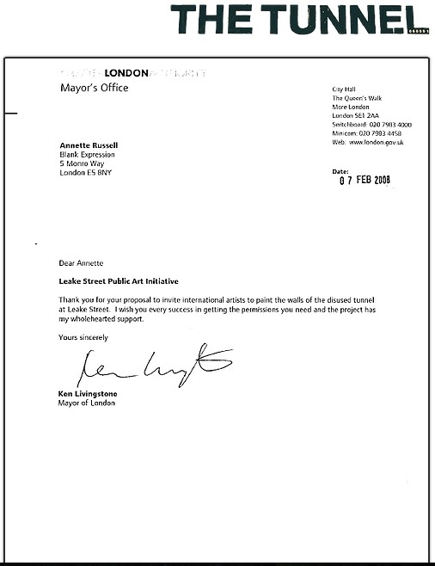
Figure 9: Banksy Authorization (Street, 2016)

According to graffiti artist, David: ‘some people say graffiti makes people feel threatened but here it brightens up a dark, dingy space and is treated like a free art gallery. I also think it means artists are less likely to tag shops and streets. The work in the walkway, off Leake Street, changes daily. Nobody is precious about their pieces. It evolves all the time. Even Banksy's work has been painted over’ (Standard, 2009, p. 1). Following two art festivals and a cinema event hosted by Banksy in the disused tunnel, the local authorities designated the tunnel as a legal wall for graffiti and street art (Ross, 2015). Accordingly, the proposed scheme enhanced the urban environment as a vibrant and safe passageway, but also created spaces in the arches for potential entrepreneurs to occupy. In 2008, Kevin Spacey and Hamish Jenkinson discovered some of the vaulted arches and decided to use the vaults as The Old Vic’s auxiliary event space. The Old Vic Tunnels, comprised 30,000 square feet of unused underground railway tunnels and although it officially opened its doors in 2009, the venue closed in March 2013 (Standard, 2010). Although the Old Vic Tunnels was not successful, it opened the path for other entrepreneurs interested in the space (e.g. the Vaults and House of Vans).

Presently, Leake Street connects York Road on the north side of waterloo Station to Lower Marsh on the south side, is used as a car wash facility, graffiti gallery and events space and is located between a number of tourist and leisure destinations such as the London Eye, the National Theatre and independent retailers on Lower Marsh (Figure 10) (Waterloo, 2015).
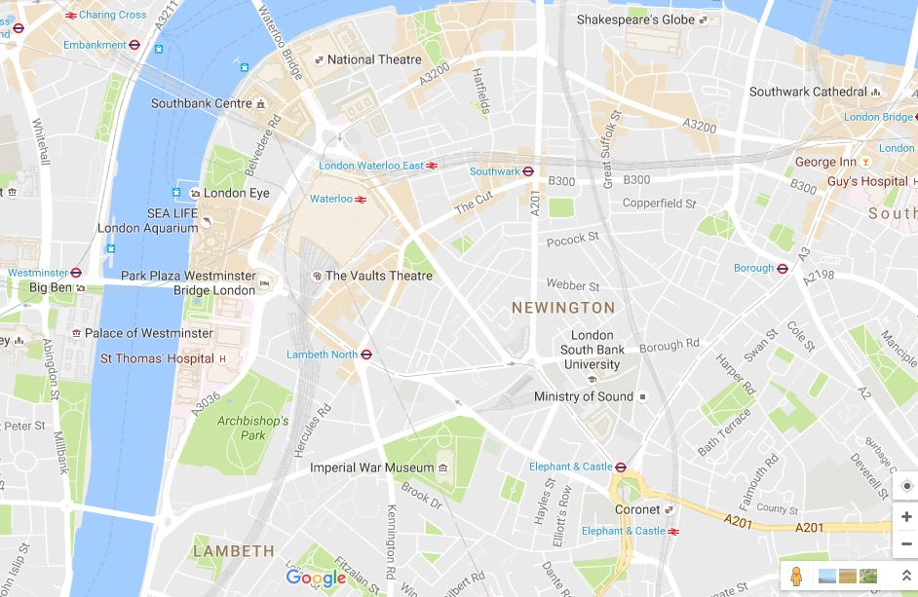
Figure 10: The Vaults Theatre (Google Maps, 2016)

3.3.4. Justifying Sampling Data

According to Thomas (2015), in taking a sample in research equates to taking a sample of a wider population or better said taking a slice drawn from the wider population. In this study, the theoretical framework and the study’s research question and objectives conceptually drove decisions about the selection of the samples. In order to undertake analysis that addresses the creative pseudo-public space in creating and evolving alternative market trajectories and keeping in mind the underlying theory described by Lefebvre (1991b), the following decisions have been made to sample data. It was crucial for the research to gather data on the public space (i.e. the Graffiti tunnel) and the private space (i.e. the Vaults); in this view subsequent to Lefebvre’s (1991b) theory of the production of space on spatial practices, representations of space and spaces of representation- artists, general consumers, and managers/producers represent the target audience. As explained by Jennifer Mason (2002, pp. 93-94), ‘theoretical sampling means selecting groups or categories to study on the basis of their relevance to your research questions and the theoretical position… and most importantly the explanation or account which one is developing. Theoretical sampling is concerned with constructing a sample... which is meaningfully theoretically, because it builds in certain characteristics or criteria which help to develop and test your theory and explanation’. By engaging theoretical sampling, the study wins in demonstrating consumer experiences that are typical of the broad class of phenomena to which the theory relates, but also adds validity and reliability (Silverman, 2013). Indeed, Bryman (2003, p. 91) contends that this process will focus ‘validity of the proposition in other milieu’. To narrow down limitations, data was collected on site between 2014-2016 from 30 respondents: male and female with an age group between 18 and 50 years old.

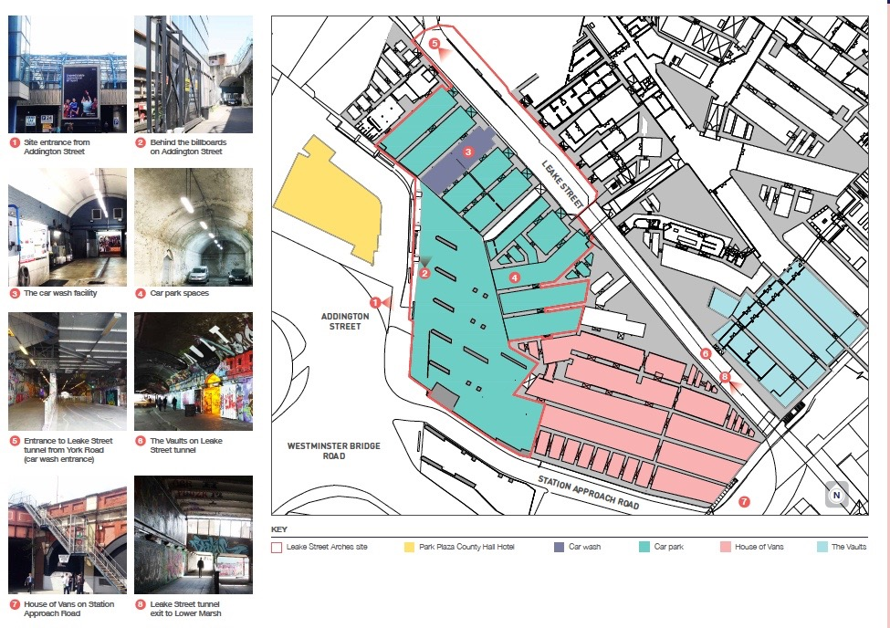
Figure 11: the Leake Street Arches (Waterloo, 2015, p. 2)

3.3.5. Triangulation

Articulating the elements of sound design for validity, reliability and credibility has been critical for the development of qualitative methodologies (Marshall & Rossman, 2014). As such, to achieve a profound understanding in case study research, engaging the use of multiple methods is crucial. By combining multiple methods, researchers aim to overcome biases that may be generated from a single case, a single researcher or a single theory; Cohen et al. (2000, p. 254) define this as the triangulation technique and characterise triangulation is an ‘attempt to map out, or explain more fully, the richness and complexity of human behavior by studying it from more than one standpoint’. The present study triangulates data through ethnographic observation, interviews and visual data, as to be discussed next.

3.3.6. Ethnographies and Participant Observation

According to Silverman (2013), ethnographies, derived from cultural anthropology and qualitative sociology sciences, are based on observational work conducted in social settings. Anthropological fieldwork implies for the researcher to take part of a society for an extended period of time, exploring, understanding and learning the society’s customs (Tedlock, 2005). The intention of the researcher in this view is to construct and represent a society’s reality and its culture as closely as possible. Hitchock and Hughes (1989, pp. 52-53) infer that ethnographies involve:

- The production of descriptive cultural knowledge of a group
- The description of activities in relation to a particular context from the point of view of the members of that group themselves
- The description and analysis of patterns of social interaction
- The provision as far as possible of ‘insider accounts’
- The development of theory

Following this line, participant observation was forged to capture simultaneous emotional involvement and objective detachment (Denzin & Lincoln, 2005). Both an overall approach to inquiry and a method, participant observation is widely used to produce documentary data that reflects the respondents’ own points of view, but also facilitates the researcher’s immersive experience into the respondents’ culture. Participant observation entails talking to people, hanging around in the setting, reading documents, keeping notes that enable the researcher to hear, see and experience the world through the eyes of the inhabitants. In this sense, the researcher is both a participant (to a certain degree) and observer (likewise to a certain degree). The reached immersion allows the researcher to learn directly from his own experience and elaborate on the research design. For instance, the study engaged during the exploratory phase participant observation to familiarise herself with the environment and its elements. In addition to this, participant observation aided the researcher in creating the first set of themes for interview questions aimed at exploring how is the creative pseudo-public space created, but also gain an understanding of interaction patterns between artists, general consumers and managers/producers. The researcher attended most events organised at Vaults and the tunnel and took notes. During the notes taking process or discussing with people, the researcher did not take any information on respondents’ demographics or personal information, thus protecting the respondents’ identity.

3.3.7.Semi-structured Interviews

Denscombe (2014, p. 174) argues that ‘when the researcher needs to gain insights into things like people’s opinions, feelings, emotions and experiences, then interviews will almost certainly provide a more suitable method’. Interviews enable the researcher to source important feedback, are flexible regarding the location where they are being conducted and researchers can increase participation rates by explaining the study’s importance (J. Hair, F.J., Celsi, Money, Samouel, & Page, 2011). In line with an interpretative approach, the study engages semi-structured interviews as a suitable method of collecting and analysing empirical data. Following this line, 30 face-to-face semi-structured interviews were conducted outside and within the venues between 2014 and 2016. The interplay between structured and unstructured interview represents a valuable tool when objectives include exploration and understanding, but also description of phenomena and when standard information by which to characterise each respondent is needed (Richardson, Dohrenwend, & Klein, 1965). As Kvale and Brinkmann (2009, p. 26) argue, the qualitative inquiry aims to ‘understand social phenomena from the actor’s own perspectives and describe the world as experienced by the subjects’. The defining characteristics of semi-structured interviews is being represented by a flexible structure, mining into the culture’s worldviews which gains valuable insights, and the fact that interviews are organised around an interview guide that contains topics, themes and areas to be covered (Jennifer Mason, 2002). Moreover the interview’s informal style facilitates a relaxed and natural exchange of dialogue between interviewer and interviewee, where both entities play an important and active role in constructing knowledge. The interaction establishes empathy and may increase the respondent’s interest in the study (J. F. Hair, 2015). Finally, semi-structured interviews ensure high response rate, if conducted correctly, and due to the active interaction between interviewers and respondents, data can be checked for accuracy and relevance thus ensuring validity (Denscombe, 2014). Now, some of the disadvantages raise issues of reliability, due to the interviewer’s personality that may bias data; difficulty obtaining wide access; high field costs; furthermore, data may be difficult to analyse and is time-consuming; informants’ inhibitions due to tape/video recorder that lead to bias information; sample size would be relatively small and it limits the number of opinions (Denscombe, 2014). Mason (2002) suggests that semi-structured interviewing produces partial interpretive understandings and therefore should be supplemented by other methods (e.g. participant observation, visual methods).

The semi-structured interview seemed to be the right solution at the start of the study due to its benefits in small-scale social research, but also uncovering and describing the participants’ perspectives on the phenomena, i.e. their subjective views. Specifically, after creating a list of themes drafted throughout the participant observation stage, the researcher moved on to interview participants on site. However, it became evident right from the start that the etic perspective (i.e. how the researcher views the phenomena) was performing more than the etic perspective (i.e. the participants’ perspective on the phenomena and exactly how they view and feel about the phenomena). Consequently, the study adopted some of the ethnographic interviewing techniques. Specifically, descriptive questions have been incepted to allow the researcher to learn about participants’ personal views on their experience inside the tunnel and the Vaults (Marshall & Rossman, 2014). In addition to this, structural questions aided the researcher in exploring how participants’ ‘organize their cultural knowledge into categories that are important to them’ (Marshall & Rossman, 2014, p. 152). Moreover to further avoid biasing data, the study engaged in mobile ethnography.

According to Brown and Durrheim (2009) interviewing while on the move provides a less structured and more informative technique that facilitates the production of authentic data. As research questions relate to how a certain place is produced, walking with participants while interviewing provides the capacity to access people’s attitudes and knowledge about their surroundings thus generating more place-specific data, facilitates more intuitive follow up questions, but also helps the researcher in becoming a participant in conversation which relaxes interviewees (Evans & Jones, 2011). In terms of negative aspects of the walking interview, background noise and ambient temperatures may prove to be an inconvenient. For example, part of the fieldwork took place during wintertime when walking in the tunnel is quite cold and noise can disrupt recordings. Nevertheless, the walking interview proved to be a vital data collection process that generated authentic and insightful data and helped the researcher in creating a much better bond with interviewees.

3.4. Data Collection Process

The rationale behind the data collection was to fulfil the research objectives that have not been answered through the literature review and thus contribute to knowledge. The research objectives were as follows:

- To explore how a deserted pseudo-public space has been transformed into a creative crucible ecosystem
- To investigate patterns of interaction between consumers and producers on geographically embedded markets
- To study how the alternative creative ecosystem shapes the creation and evolution of creative markets

The study was carried out longitudinally over a period of two and a half years between 2014 and 2016, when data was consistently gathered. The process of data collection started in 2014 with a pilot study and continued until 2016, consisting of observations, participant observations, interviews and visual data.

3.4.1. Researcher Reflexivity

The act of reflexivity requires that the researcher constantly examine his/her actions in the research process, to critically assess actions so that bias information is not added to the study. As the researcher cannot be objective or disconnected, especially in ethnographic research, from the evidence and knowledge articulated (J Mason, 1996), it is vital for the researcher to be aware of his/her opinions and feelings and how these are being expressed throughout the study. During this process it is quintessential for the researcher to acknowledge the possibility that her actions and opinions might alter the culture and community she is investigating.

The researcher herself graduated from an art school and is a major arts buff. With the same fascination in arts and crafts, it was easy to empathise with respondents and create rapport. Throughout the data collection process, the researcher was honest about her intentions and explained the reason for being in the field and the topic of her study. Honesty in this sense did not motivate respondents to pull away; quite the contrary, respondents were fascinated by the study’s topic and wished to participate. As a result, the researcher was mostly treated as a friend or insider throughout the study with some interviewees pitching business opportunities. For example, one of the artists interviewed offered the researcher the opportunity to take part in the opening of an Arts Foundation based outside London.

To avoid for personal feelings and opinions to interfere with the study, the researcher used ‘how’ and ‘what’ questions that allowed for respondents to express their own opinions, but also where possible interviewed two respondents at the same time so that through discussion more authentic and valid data can be articulated. For this particular study, visual field notes have been collected. Here, photographs and videos were used as data source to channel reflexivity but also generate themes to be discussed with interviewees. It has been suggested that capturing photos is a much faster and discrete process than taking field notes, as it does not incommode the researcher or scare the interviewee, but also the captured scene can be freezed in time and studied later on (Thomas, 2015). Also, by constantly taking photos of the environment throughout the two and a half years, the researcher was able to document changes in the environment and how the case study evolved from a marketing perspective. Moreover, as Thomas (2015) notes, observation per se is channelled from researcher to researched, however image-based methods offer a reciprocal and unbiased relationship whereby interviewees can set the agenda for research and be more inclusive. In this sense, besides the researcher herself taking photos as documentary field notes, she also provided interviewees with a camera during each interview to document their experience within the environment. This procedure explored the interviewees’ voice and generated authentic and unbiased data (Cremin, Mason, & Busher, 2011); not to mention that taking photos helped in breaking the ice and stem conversations.

3.5. Data Collection Methods

3.5.1. The Exploratory Phase

Starting with a pilot study, the researcher was able to build connections with artists and get familiarised with the environment. Over a period of 4 months, the pilot study implied taking pictures of the environment to get familiarised and incept immersion, but also interview a major arts producer- Martin Firrell, who created a sell-out performance at Vaults. During this timeframe, the researcher also started discussing with the public attending Mr. Firrell’s performance and invite to volunteer for the study. It must be mentioned that throughout this process, the researcher was completely honest with regards to her identity and the purpose of the study. The tactic of outright honesty built trustworthiness but also made respondents curious to the nature of the research. Before interviews, the researcher explained the purpose of the discussion and asked interviewees to formally consent to the data being used (using here an ethics form), however some respondents especially artists/managers/producers interviewed did not wish to remain anonymous as they believed this might be another PR opportunity for them.

Specifically, the researcher took photographs of the Graffiti tunnel and waited for the shows to end and for the audience to exit the Vaults in order to recruit interviewees; it must be mentioned here that before engaging individuals, the researcher requested the event’s manager approval first. Located at the entrance, the researcher was holding a small clipboard to send out visual hints of the person’s official status. The symbol was used to protect individuals and allowing them to avoid any conversations if not desired. The researcher however used a friendly and charismatic manner to approach individuals and as such, no respondents refused to enter in conversation. At this stage, the researcher only introduced herself and the study, discussed with respondents to explore if they might be interested in collaborating, followed by taking their contact details to rsvp. Respondents have been approached randomly as no patterns of demographics were needed for this particular study. In addition to this, the researcher also approached artists while painting to explore their experiences. In terms of the Vaults, before taking any photos, the manager was informed of the study and permission was granted. Although no respondents have been recruited inside Vaults, the interview process entailed for the respondents to wonder around through Vaults and take pictures while exploring.

The researcher also participated in graffiti painting and attended events hold in the tunnel by independent parties, but also events created by the Vaults to understand the environment’s symbolic world and the subjective realities of her respondents’, but also explore the world through the eyes of the inhabitants. As Lincoln and Guba (1985) suggest, researchers use themselves and respondents as well for primary data-gathering instruments. Gould (2005) however implies that although the respondents’ experience can never be duplicated and the researcher may have a similar experience but not the exact experience, this does not falsify the consumer’s experience but enrich the interpretation by adding further avenues for generating knowledge and research. From this perspective, introspective accounts were drafted detailing themes used in generating interview questions. Finally, both the researcher’s photos and respondents’ photos have been used to observe the environment and determine its functions and processes.

3.5.2. Phase 1- The Development of Emergent Themes

Subsequent to the exploratory phase, the researcher proceeded in developing a semi-structured interview guide. Face to face, on site interviews have been conducted and each interview lasted for a minimum of one hour. All interviews were taped, with the respondents’ approval, and transcribed. Each interview comprised 10 questions framed on Lefebvre’s (1991b) theoretical framework of the production of space: spatial practices, the representation of space and spaces of representation. Questions have been specifically designed to be open ended in order to allow respondents to exhibit their worldview and provide a rich description about the consumption patterns of a creative pseudo-public space. The interview always started outside in the tunnel where a camera was given to the interviewee with the instructions to explore the tunnel and take photos. This procedure allowed respondents to detach from their daily routine and problems and fully commit to exploring the environment.

Once this stage was completed, the interview started with the first set of questions discussed outside, in the tunnel. Moreover, the researcher also wished to discuss photos taken by the interviewee at this stage. According to Harper (2002, p. 13), this method is entitled photo-elicitation and is ‘based on the simple idea of inserting a photograph into a research interview’. By getting interviewees to describe and explain that information is ‘an opportunity to gain not just more but different insights into social phenomena, which research methods relying on oral, aural or written data cannot provide’ (Bolton, Pole, & Mizen, 2001, p. 503). The researcher simultaneously channelled an emic-etic approach by comparing the nature of the data with the literature review. During this stage the researcher was documenting field notes and taking photos as a visual diary. Photos taken both by the researcher and respondents were subsequently addressed and only photos relevant to the research questions were selected for further analysis. Next, the researcher and interviewee moved inside Vaults. The venue was dissected in two sections- the first section comprised the entrance (i.e. Vaults’ long hallway) and the second section was represented by the venue’s multiple chambers. The dichotomy was important in order to record the blunt difference between the Graffiti gallery and the Vaults. Here, once again the interviewee was provided a camera to record his/her experience throughout the environment, followed by questions and discussing photos taken.

The researcher focused on the consumer experience throughout the interviewees and as such questions have been directed at capturing descriptions, opinions and experiences (e.g. tell me about your experience inside the tunnel; what do you think is the agenda of this space?; how would you describe the space? and so on).

3.5.3. Phase 2- Development of Core Constructs and Themes

Whilst the first phase was focused on conducting interviews with audience members- meaning general consumer who utilise the space as a passageway, hang out space or attend events mainly (besides the pilot interview with Martin Firrell). This second phase aimed to interview artists mainly (i.e. established artists who also produce performances and exhibit in mainstream galleries, but also artists who daily paint in the tunnel for leisure, to practice their craft or as a university project) and Vaults’ manager. The process consisted of comparing and contrasting data from general consumers versus artists (some being consumers while some producers) versus Vaults manager and director. While interviews with artists have been conducted in a similar fashion to phase 1, interviews with Vaults’ manager and producer followed a different schedule. The interview with Vaults manager who is also the venue’s director was conducted inside Vaults’ office area and lasted almost one and a half hour. Similarly, by following a semi-structured interview, the session consisted of exploring themes identified from phase 1 (e.g. the space’ flexibility, an agenda of exploration, access, and so on). As Vaults manager made many references to his partner, one of Network Rail’s Station Manager, the researcher also contacted him to schedule a further interview. However, NR Station Manager replied that due to a large project he was currently part of and due to lack of time he cannot answer any questions.

To manage data, the NVivo software was used to store data in different formats (including here text and images) and create a navigating system by articulating themes. This process was recorded several times evolving from first cycle coding (here implementing mainly in vivo codes and descriptive codes) to axial coding. The first cycle coding implied reading the transcripts and generating codes. Then a process of comparing and contrasting codes was initiated followed by a close observation of repeating codes. As Lefebvre’s (1991b) theory of the production of space was conjured up throughout the study, the three spatial elements- spatial practices, representation of space and spaces of representation- were used to analyse the codes and generate theming coding. Although electronic coding was used at the beginning, the researcher found manual coding to be much more rewarding as the process established a more focused connection with data. Besides coding processes, analytic memo writing was established to document and reflect on code choices and emerging patterns (Saldaña, 2015).
In terms of analysis and interpretation, the researcher followed an emic-etic approach whereby she moved back and forth between the literature, emerging empirical themes and the theory, with each one consistently influencing and informing the other. According to Spiggle (1994), interpretation symbolises a holistic, enlightening grasp of meaning similarly to deciphering a code; as such, familiarisation with the literature, theories and the researcher’s interpretive skills is essential to the empirical process.

3.6. Summary

The study utilised and was focused on approaches stemming from within the interpretivist paradigm, meaning that testing hypothesis or generating statistical data was not the main goal, but rather obtaining a deep and insightful understanding of the environment and community under study. A single case study site was selected, the Leake Street Arches, to explore the production of a creative pseudo-public space. The case study was carried out between 2014-2016 and several methods have been employed to triangulate data: participant observation, in-depth interviews, photo diary and photo-elicitation. Following theoretical sampling, the interview agenda and questions have always been influenced by emergent categories and themes, which influenced a continual update of theoretical themes to be discussed.

Chapter 4: ANALYSIS

4.1. Introduction

The aim of this research has been to explore and build an understanding of how space influences the creation and evolution of an alternative creative ecosystem. It has been documented that prior market research has primarily focused on understanding market systems from a consumer and producer perspective and although social sciences and humanities advocate for space as an active agent in social processes, geographic explanations on market formation and processes remain to this day rather vague (Castilhos et al., 2014).

Specifically, the research looks at how by transforming ‘dead pseudo-public spaces’ into creative ecosystems alternative market possibilities or trajectories emerge, but also looks at the patterns of interaction between consumers and producers on geographically embedded creative markets. Finally, the study shows how the alternative creative ecosystem shapes the creation and evolution of creative markets. While previous chapters outlined an elaborate examination of relevant literature in market formation; the remaining chapters of this study are concerned with outlining the empirical findings of the study. This particular chapter aims to contextualise the findings and present the overarching themes that lead the framework. The chapter is focused on how space influences market-processes and market formation.

4.2. SPATIAL PRACTICE: Understanding Space that is Produced and Experienced

Using Lefebvre’s (1991b) conceptual triad, spatial practice is informed by the physical or material characteristic in the production of space. Lefebvre’s seminal text, the Production of Space identifies space as embodying social relationships articulating that ‘what happens in space lends a miraculous quality to thought, which becomes incarnate by means of a design. The design serves as a mediator itself of great fidelity – between mental activity (invention) and social activity (realisation); and it is deployed in space’ (Lefebvre, 1991b, p. 27/28). This suggests that once individuals perceive space, a mental imagery or activity is formed that serves in conceiving space or realising the mental activity. Lefebvre (1991b, p. 34) contends that space incorporates social action and is ‘a tool for the analysis of society’. Physical space in this sense is both product and process, and fundamental to how we envisage the world but also how we apply products or systems created by individuals following mental activity; space can inspire products, practices and processes. The production of space posits that the perceived (spatial practice), conceived (representation of space) and lived (spaces of representation) are the power relations that occur in space.

Spatial practices embrace the ‘production and reproduction, and the particular locations and spatial sets characteristic of each social formation…[particularly] from the analytic standpoint, the spatial practice of a society is revealed through the deciphering of its space (Lefebvre, 1991b, p. 33/38). In other words, spatial practices refer to the way individuals produce (i.e. use and generate) space, but also how they reproduce (i.e. modify and recreate) space, and each practice creates a certain space but in the same time, space has the power to generate practice. According to Lefebvre (1991b), spatial practices refer to how space is generated, the ways people generate, use, perceive and modify space comprising the everyday routines, networks, pathways and physical practices through which life is produced; particularly spatial practices refer to how individuals are inspired by their everyday routines in creating spatial formations. Spatial practice or the perceived space refers to the physical materiality, the surface and patterns that physically exist and guide behaviour. As social space is a social product and space embodies social relationships, within the following section the study aims to explore firstly what qualities does a pseudo-public space possess, how do individuals generate space and finally, how spatiality and spatial practices inform and influence market processes.

4.2.1. Setting the Scene: Flexibility in Electrifying the Alternative Trajectories

Tasan-Kok (2008, p. 183) defines the concept of flexibility as ‘the property of being flexible, easily bent, or shaped’. In defining spatiality through such terms, the author explains how space changes tendencies in planning, evidencing that a rapid change in the environment loosens rules and channels innovation. Studies so far have extensively researched the concept of flexibility from a planning or organisational behaviour perspective, emphasising how flexible and innovative environments can enable collaboration between consumers and producers, and foster economic capital, such as start-up companies (Healey, 2004; Lake, 2016; Oksanen & Ståhle, 2013; Roth & Mirchandani, 2016); this study however aims to explore and understand market alternative trajectories. In this sense, in comparison to previous studies, the present section will document how space is being generated, but also how space impacts market processes.

The ability to adapt to unforeseen changes and to spark ‘spaces of possibility where something different is not only possible but foundational’ for the defining of alternative trajectories is what this study defines as flexibility (Harvey, 2012, p. xvii). Harvey (2012) evokes here that the ‘alternative trajectories’ emerge in an environment equipped to adapt to various unforeseen changes that spark ‘something different’ or the alternative. Thus, in order for a space to be flexible, two values are quintessential: adaptability and versatility- both values however nurture each other. Specifically, the ability to adapt to unforeseen changes is nurtured by a versatile space capable to engender ‘unforeseen changes’ and vice versa. Arising from this understanding, a first question relates to what makes the space adaptable and how do possibilities emerge. In answering these questions, the next section will address the two concepts of adaptability and versatility in more depth.

4.2.1.1. The Adaptive Space: Departicularising Contextual Cues

As explained above, in creating alternative trajectories, firstly a flexible environment is deemed to be easily adaptable. The following verbatim shows how the Leake Street Arches producers desired to rehabilitate a forgotten space into a more commercial-friendly enterprise:

The Leake Street Arches connects York Road with Lower Marsh and the southern end of Station Approach. The street is mostly an underpass that is beneath Waterloo Station platforms. The pedestrian environment is poor due to inadequate lighting, a lack of activity and perception of crime. … Network Rail plans to upgrade in two key phases:
• By 2014, create new through routes for pedestrians from York Road to Lower Marsh: …would create opportunities to open links through to the arches below the main station, and could eventually create a pedestrian through route linking York Road and the South Bank with Lower Marsh. Reopening would bring pedestrian access down to street level on the western side of the station, improving access for all, relieving congestion at other entrances and providing connections and linkages to the rest of the area together with associated public realm projects around the station.
• Commercial development to part pay for the improvements: … a flexible approach across the station site will be taken, with components of the upgrade being implemented as funding opportunities arise (Lambeth, 2011).

The above statement of planning development demonstrates that the Leake Street Arches’ managers prompted an initiative to generate the once taxi-parking terminal and notoriously criminal environment into a high-quality pedestrian connection, a rapid and user-friendly passage (Figure 12).

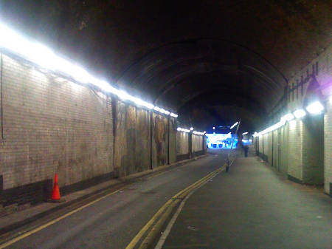
Figure 12. The Leake Street Tunnel before vamped into a public passageway (Hatts, 2007)

As Vaults’ Director narrates:

Because it was underground there were all sorts of problems in the space…homeless people used this as a toilet…a couple of people have been murdered on the street and all sorts of bad stuff happened (Kieron).

In this endeavour, managers created the conditions whereby, they enhanced Leake Street as a ‘safe attractive route’ by creating street level entrances and concourse space in enabling pedestrians to use the tunnel as a shortcut between streets, closed the tunnel to car traffic (only cars that deliver equipment or other necessities to Vaults are allowed to enter), set up CCTV and improved lighting- so that the tunnel can also be used during night time, cleaned the area and grey-painted the tunnel’s walls (Figure 13).

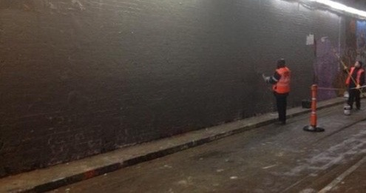
Figure 13. Staff grey-painting the walls before opening the passageway to the public (Keegan, 2013)

Once the tunnel was adapted to a more user-friendly passage, individuals started circulating the area and installing vibrancy. This finding suggests that by redefining the space as a public nomadic passage, painting the walls in a neutral grey colour and assuring safety in the tunnel, the Leake Street Arches’ managers and producers decontextualized a spatial form, initially planned as a taxi parking site that throughout time became a notoriously criminal and unsafe environment. For instance, by repairing the lighting system, installing CCTV and advertising the space as a new public passageway, landlords succeeded in encouraging individuals to utilise the site and through constant circulation, the area was revamped into a safe public passageway. Thus, the Leake Street tunnel, after a process of erasure that deprived the site of a clear and determined plan, was now baptised as a public space, free and open 24h for travel that was leaving scope for new practices and movement.

The new structure was depleted of the former pavement lines guiding taxis where to park or any guidance signage, lights have been fixed, any objects removed from the road and the walls wipe cleaned and grey-painted. This finding confirms research in retail environment suggesting that adaptable space allows landlords to be multi-faceted by responding to market conditions and cater to third parties by accommodating new comfort needs (Davison, Gibb, Austin, Goodier, & Warner, 2006; Kent, 2007; Kozinets et al., 2002). The logical step in future conversations, explains Davison et al. (2006, p. 5) is to design spaces ‘that can accommodate a variety of uses without predetermining their location or extent’. The Leake Street landlords’ intention was to conjure up a polyvalent and versatile space with no special purpose designs describing a neutral surface and ‘non-permanent physical orientation surfaces’; a site that could facilitate multiple use needs and where interchangeable activities may operate at the same time (Aylward, 1966). The newly created spatial form was now characterised by its public nature, security and its perfectly neutral-grey painted large walls endowing versatile activities through the fact that the surface was easy to adopt according to a variety of needs. In this sense, the site is ‘departicularized’ and becoming a fully ‘ageographic’ space that can equally be ‘inserted in an open field or in the heart of the town’ (Sorkin, 1992, p. xviii). Indeed, as evoked by informants and personal observation, Leake Street resembles a ‘nomadic rupture’, ‘womb-like space’, ‘secret’, ‘hidden’, ‘escaping’ space, a dislocation from the present that could be encountered in any other location:

It feels like a gap between whatever happens outside and it’s like you take a journey in another world, so you get detached from whatever happens outside so while you walk through the tunnel you have around two minutes- it’s completely different from what is happening outside, you pass and then you walk out. But when you are here you still hear the traffic above and noises, so you are not completely in another dimension. And I like this because it is not a complete rupture so you still understand; it’s not going to be a shock when you go outside and this could be find anywhere (Bella-artist and producer)

Based on the new development plan, in order for the new avenues to thrive, the tunnel and its annexes have not been structured to a determined plan. This equates Nieuwenhuys (2001) contention of a spatiality that can easily be manipulated by managers in adapting to new avenues and projects, a space characterised as lacking fixed patterns and determined plans. Such a non-fixed and free pattern space evokes a sense of inclusion, democratic practice and versatility. By this token, in comparison to the literature on public spaces that discusses how local state and agents of local governance have by-passed dwellers and undermined public space to include such sites within personal economic development strategies, and throughout this process reproducing forms of social and economic inequalities, hindering the public’s sense of creativity and increasing social marginalisation (Bodnar, 2015; Inroy, 2000; Kirby, 2008; Mattson, 1999; Paddison & Sharp, 2007); the present study emphasises how the Leake Street context evokes a free and open space where public and stakeholders are allowed to express and adapt the environment according to their own choosing- as to be discussed next.

After refurbishing the area, Leake Street demonstrated no functions or patterns that could have given way to artistic practices or social practices. In spite of this however, the managerial process of erasure was prepared to stimulate ‘an encylopedic agglomeration of activities’ (Sorkin, 1992), such as stencilling, skateboarding, filming, singing, teaching bike lessons, exploring and so on (Figure 14). It was not until 2008, when Banksy requested and was granted permission to host the three days ‘Cans Festival’ that the tunnel truly flourished into a public and creative force (Figure 15).

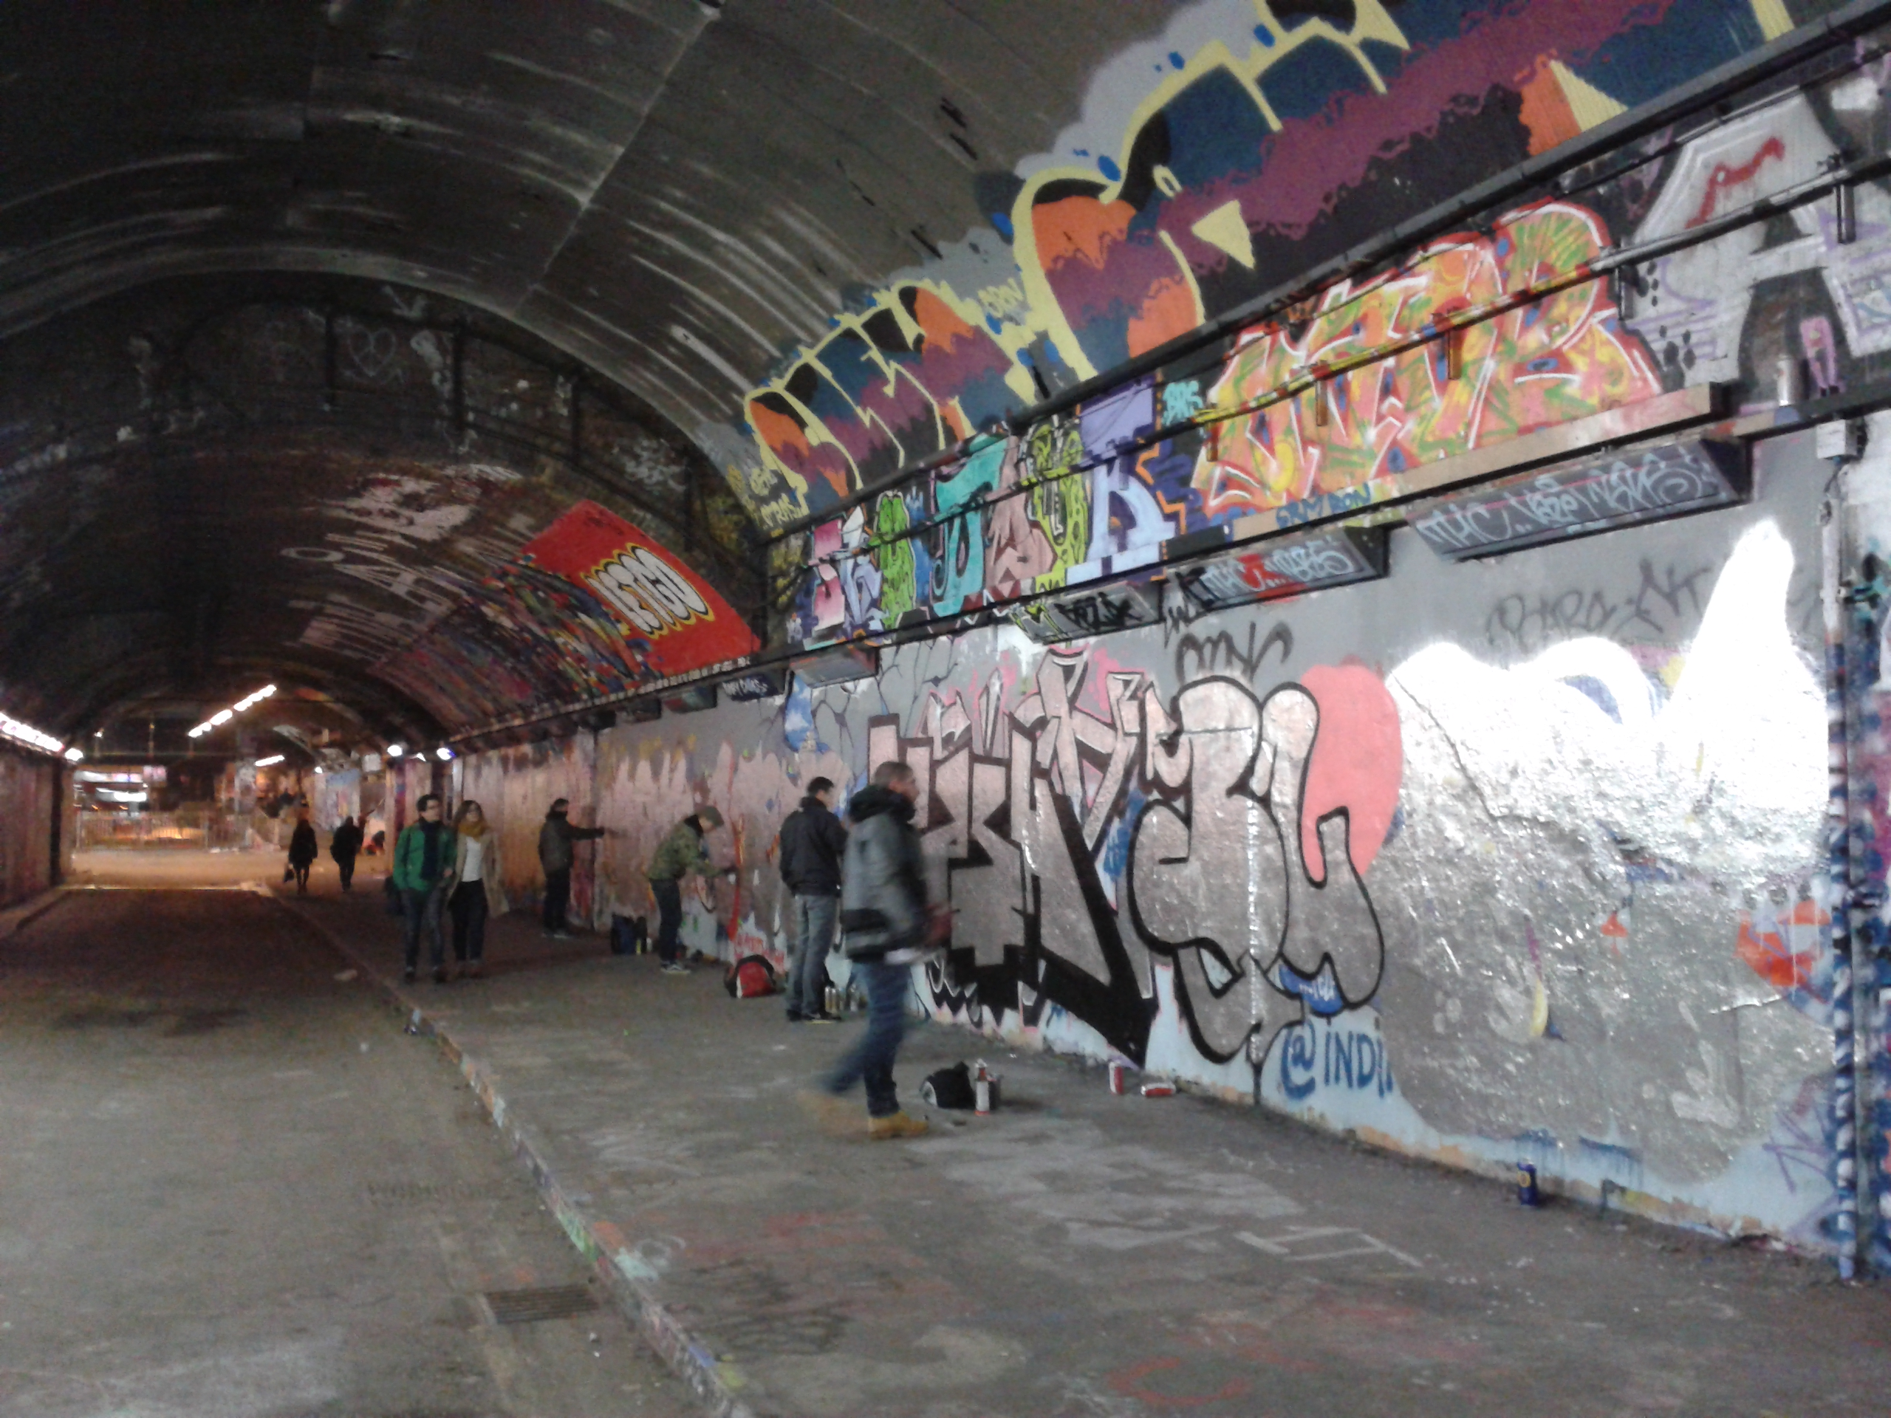
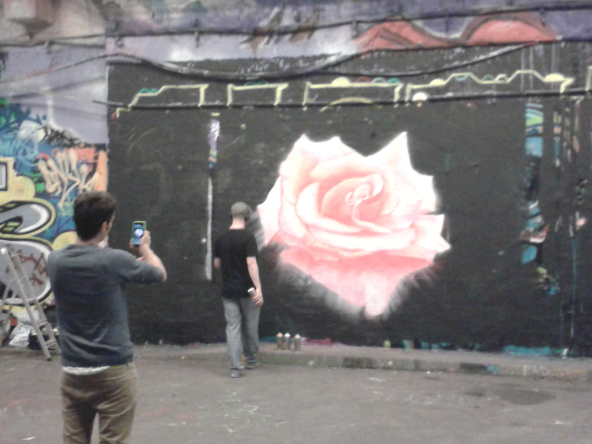

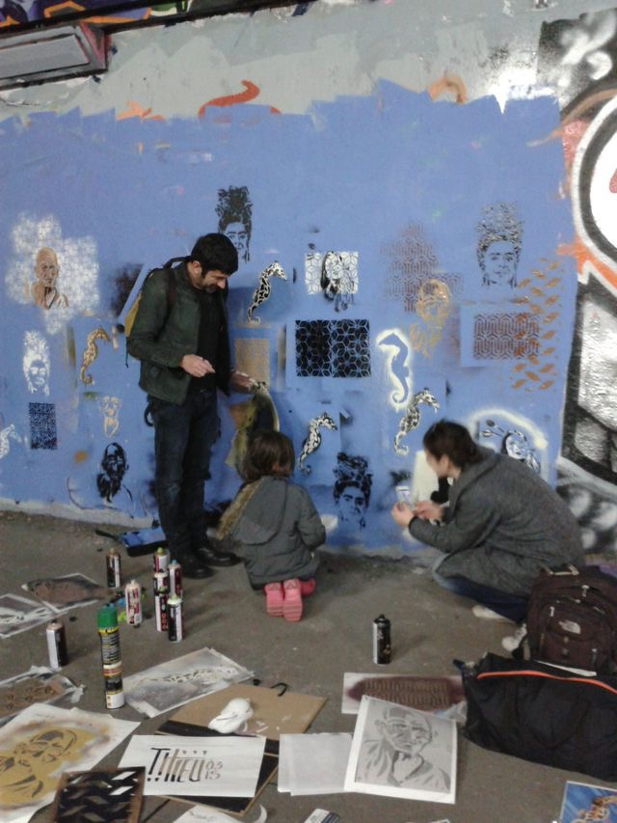

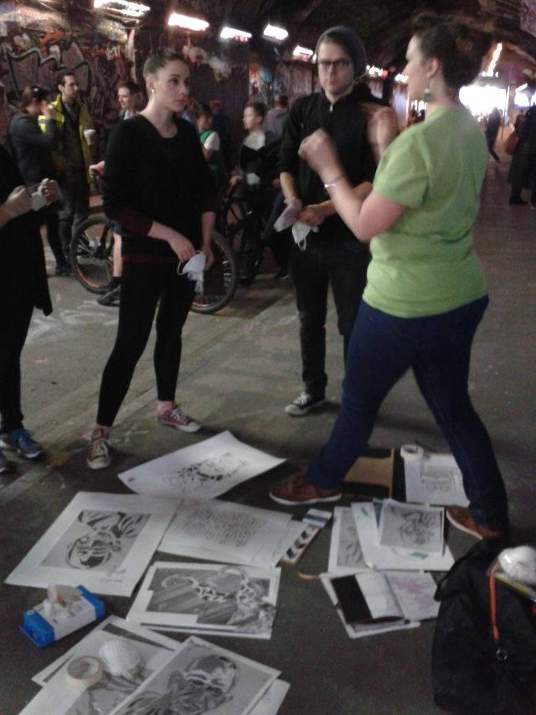

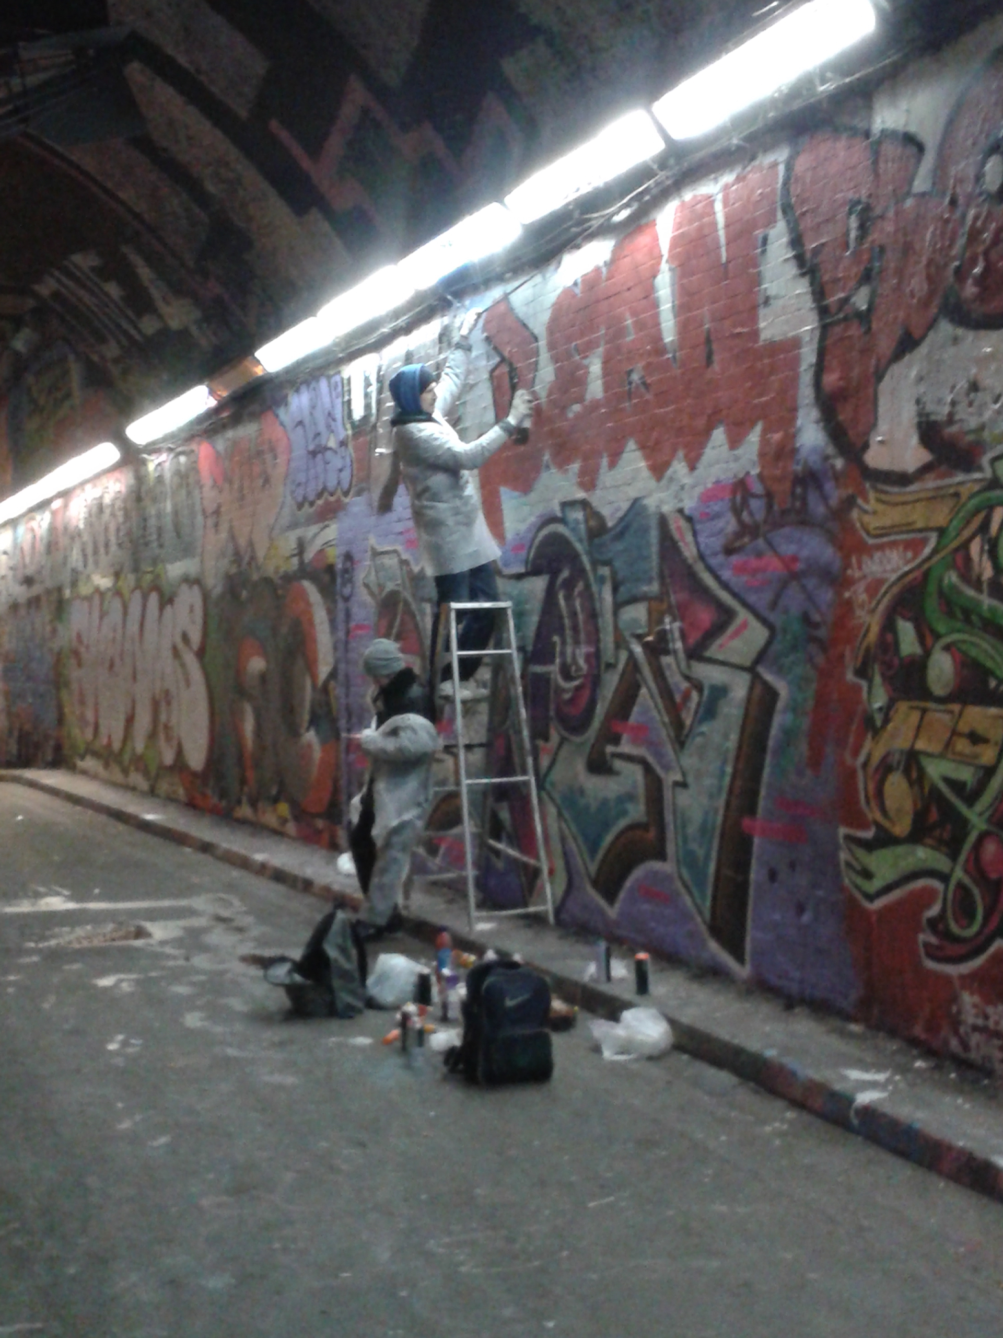

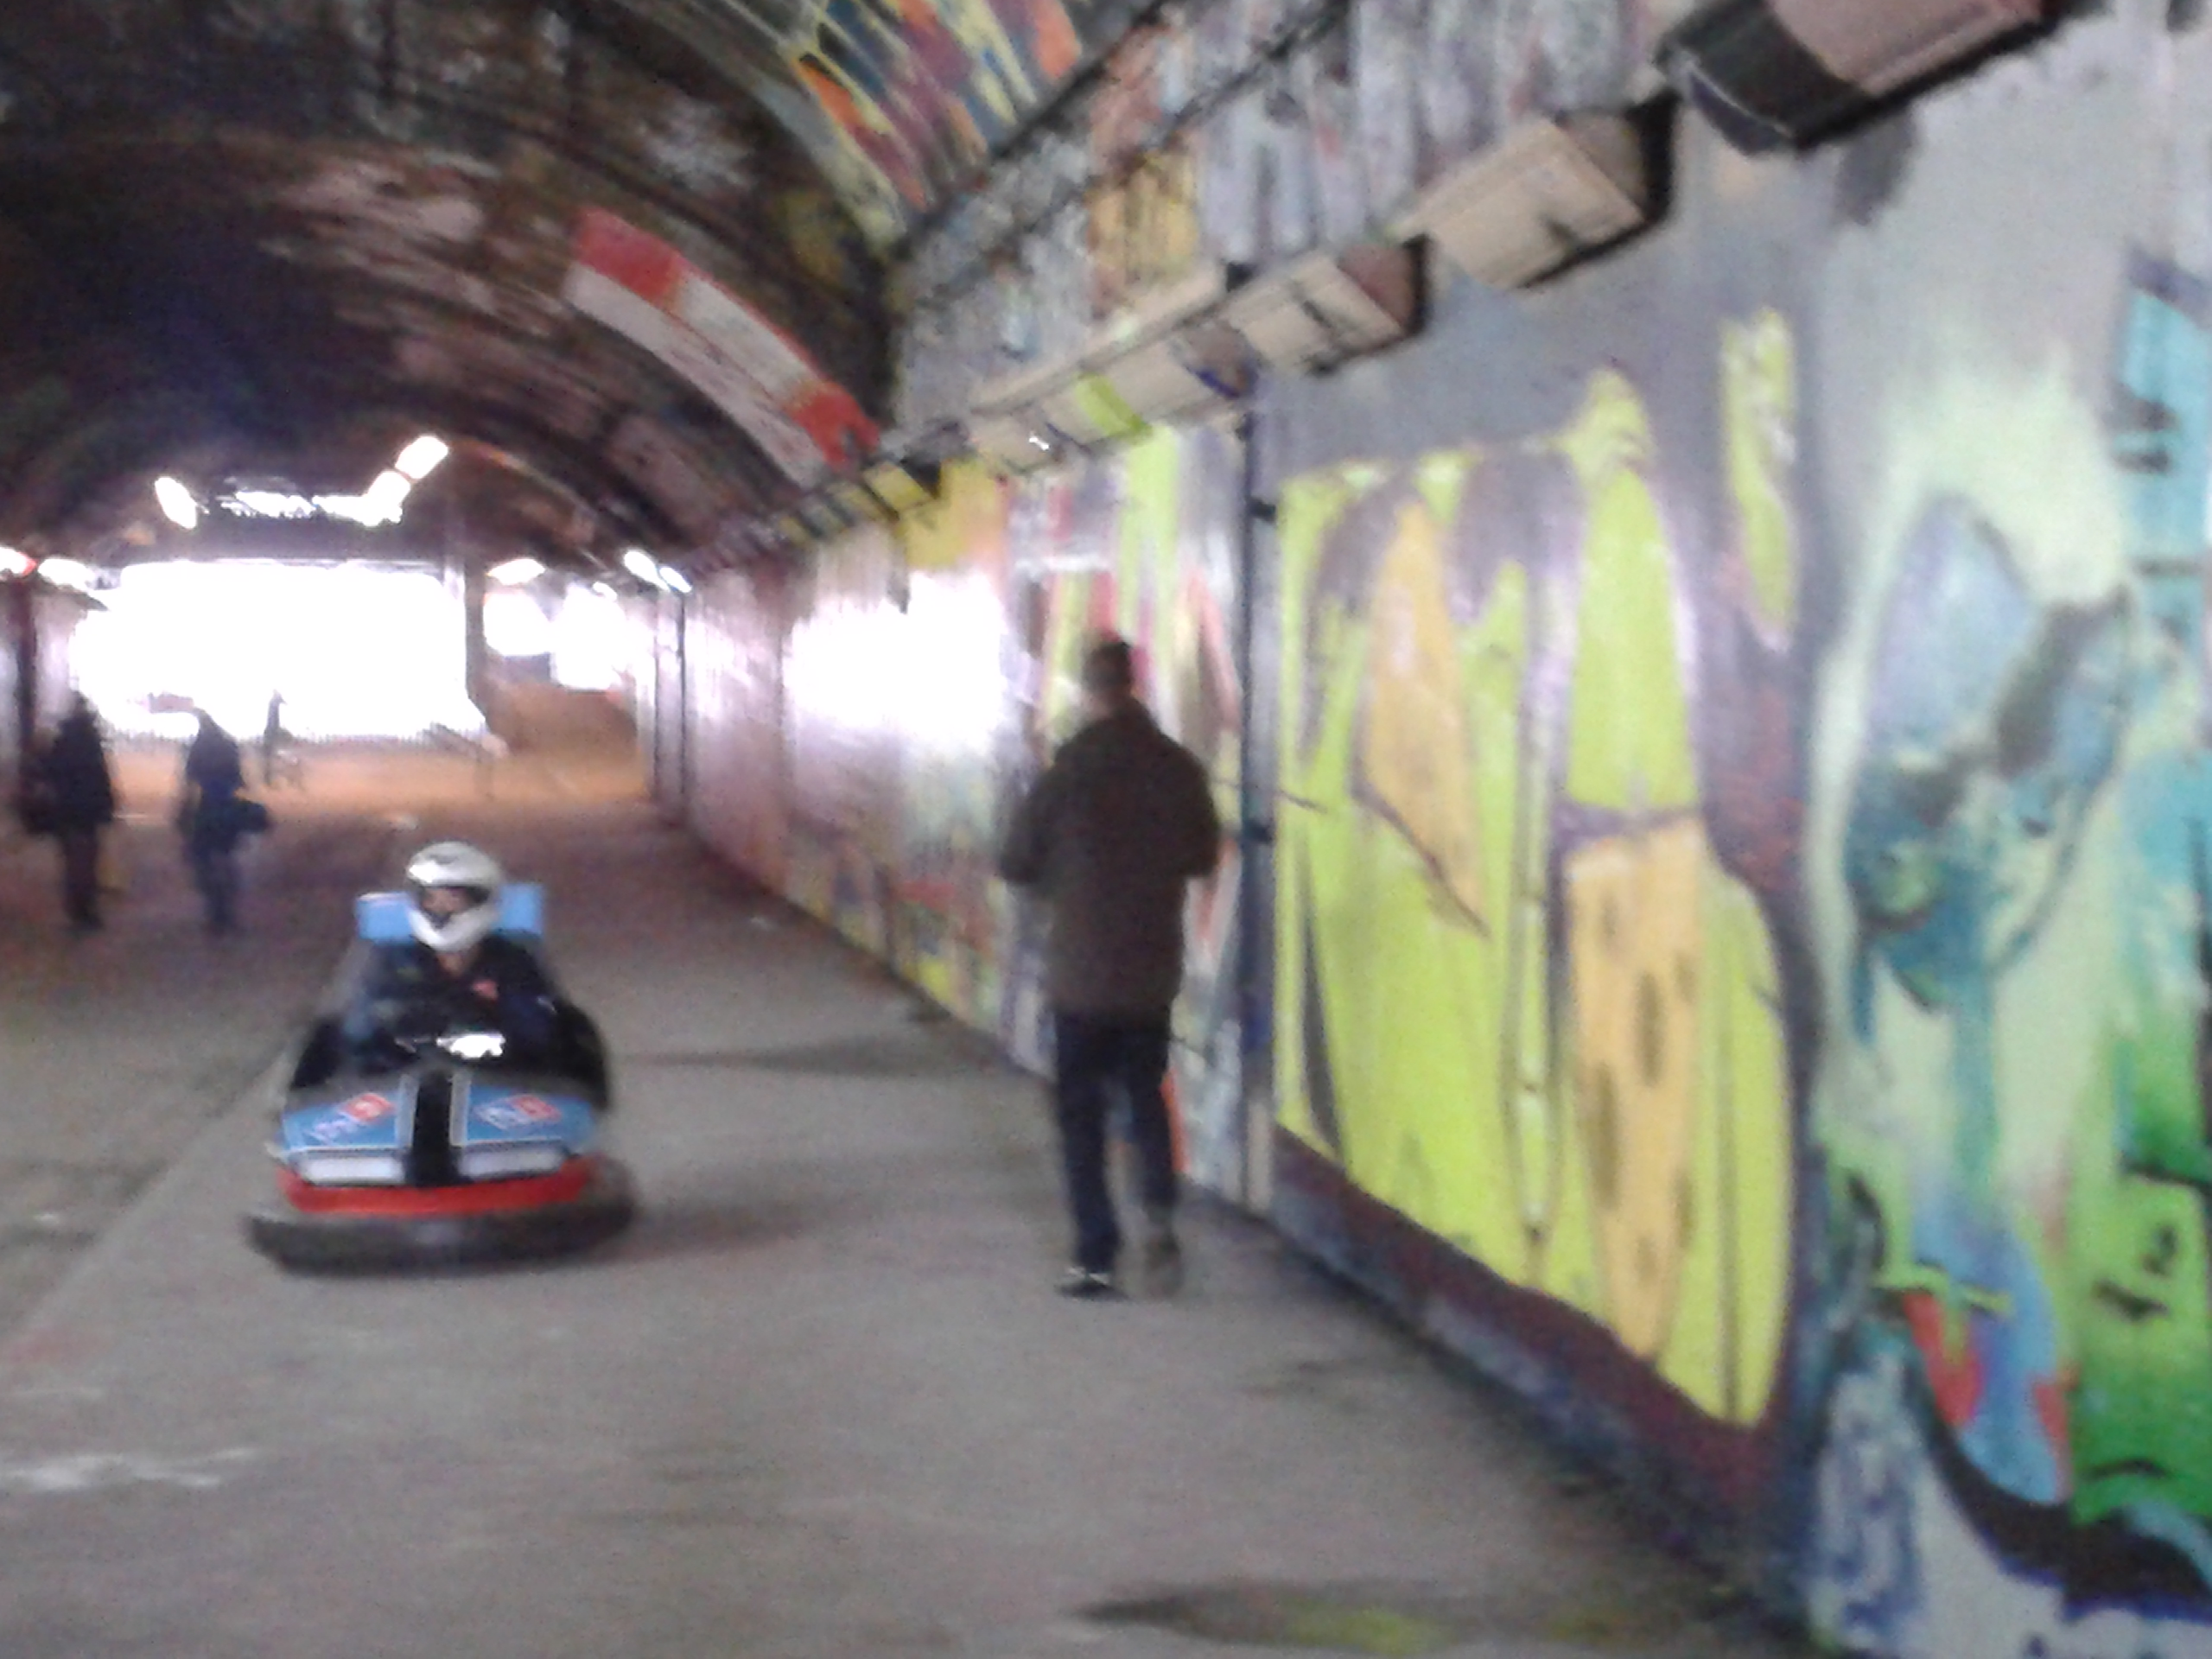
Figure 14. Multiple practices at the Leake Street Arches (photos by author)

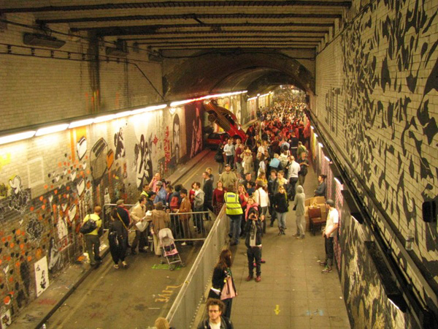

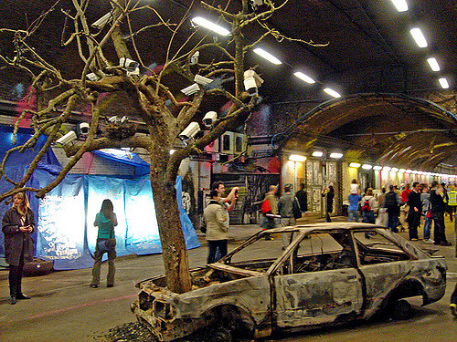

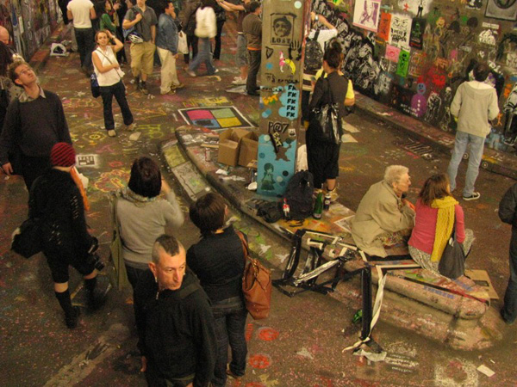
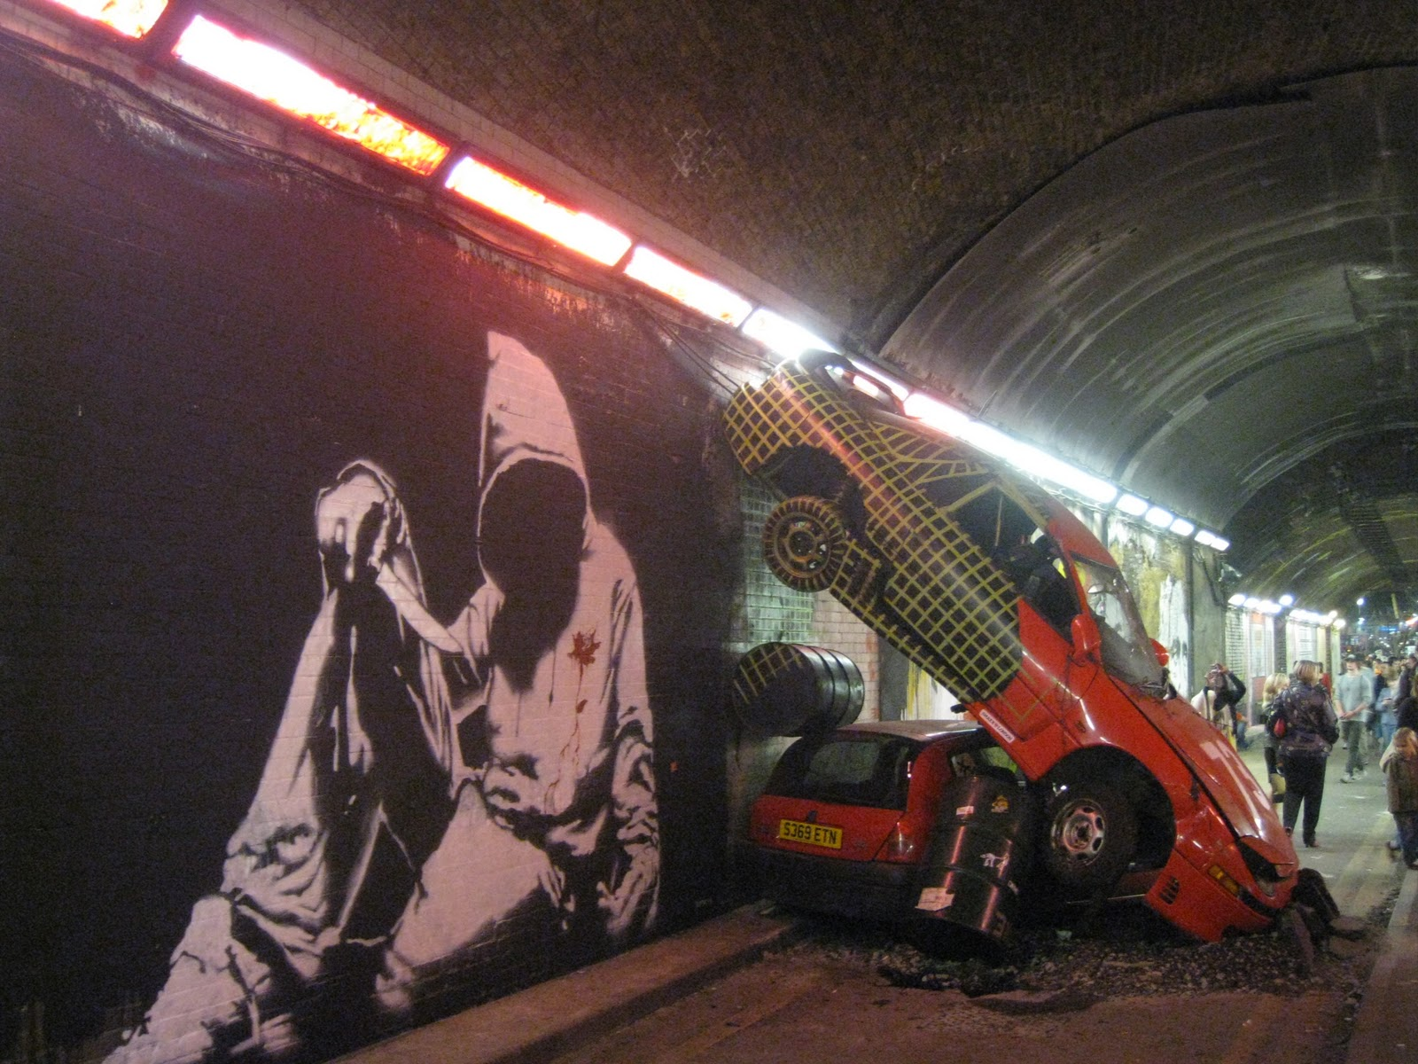
Figure 15. Cans Festival by Banksy (Notcot, 2008)

During this time, the previously disused road tunnel on Leake Street was transformed into an exhibition space showcasing Banksy’s works as well as inviting street artists from all over the world to exhibit their graffiti art. In Banksy’s words, the Cans Festival aimed that ‘in the space of a few hours with a couple of hundred cans of paint I’m hoping we can transform a dark forgotten filth pit into an oasis of beautiful art’ (BBC, 2008). For a few days only, artists and the general public have been granted temporary permission to carry out the activity of creating an artwork inside Leake Street’s tunnel, artwork usually tagged as illegal and illicit if conducted in public spaces. The event therefore created a platform for young artists to practice street art without the fear of prosecution, and complied with the managers’ vision to represent Leake Street as a safe, lively and attractive cultural scene. Following the success of two art festivals and a cinema event hosted by Banksy in the disused tunnel, the local authorities designated the tunnel as a legal wall for graffiti and street art becoming renowned as the Graffiti gallery or Banksy’s gallery (Ross, 2015). In this sense, the study firstly moves beyond Visconti et al. ’s (2010) work in exploring the agentic consumption (i.e. artists and dwellers) of public space where dwellers and its communal collide with artists’ self-interest. My study proposes a democratic environment where consumers, dwellers, stakeholders and managers/producers co-produce an environment based on their needs, however co-production occurs organically and not through a scripted managerial endeavour.

In this respect, through property development and neutral aesthetics, attracting creative power to the site, but also legalising a craft normally deemed to be illegal, managers succeeded in rehabilitating a ‘dead and redundant’ space into a public pedestrian through route considered to be attractive and safe, as it was highly circulated. The erosion of a dead space morphed into a public space which is closely entwined with a democratic management that supports a ‘framework where experimenting, learning and creative and innovative deviance is positively sanctioned’ (Landry, 2012, p. 114). This finding lies in stark contrast to previous studies researching theatres of consumption, whereby a more dominant management controls the scene and consumers’ freedom in adapting the site according to their own choosing. For instance, Sherry et al.’s (2001) study on the ESPN Zone Chicago retail theatre suggests that although consumers play an instrumental role in creating the ESPN experience, managers script consumers’ part, movement trajectories and level of involvement within the retail theatre. Similarly, in exploring spatial play in a festival marketplace, Maclaran et al. (1999) detail how managers decided to adopt a more traditional approach and cancel contradictions or anomalies engendered by consumers’ traditional past and instead source mainstream products and processes. By this token, I argue that a neutral setting together with a relaxed management succeeded in attracting organic creative forces that have not been scripted or invited by managers, producers, stakeholders or landlords. As public space is tightly controlled and modified by capitalism (Luna, 1995), leaving almost no room for the public to freely express, this study evokes an environment where individuals’ creative roles, identities and world-vision is not scripted in any way, guided or restricted. It follows that the emergence of the Leake Street tunnel as a new and open public space naturally attracted a large variety of artists in search of a versatile and easily adaptable space for self-expression. The next section will expand on spatial practices and document how spatial contradictions can inform market alternative trajectories.

4.2.1.2. Generating the Alternative Trajectories

As previously implied, the tunnel was deserted as canvas to future projects, while the arches previously used to serve as Network Rail’s archival storage space have been emptied out and ready to be adapted according to companies’ creative needs (Figure 16).
As managers hoped for the annexes to be transformed into creative hubs, it became important for the environment to not confine entrepreneurs to a set and determined entertainment form, but to empower each entity to easily transform the space according to their own choosing.
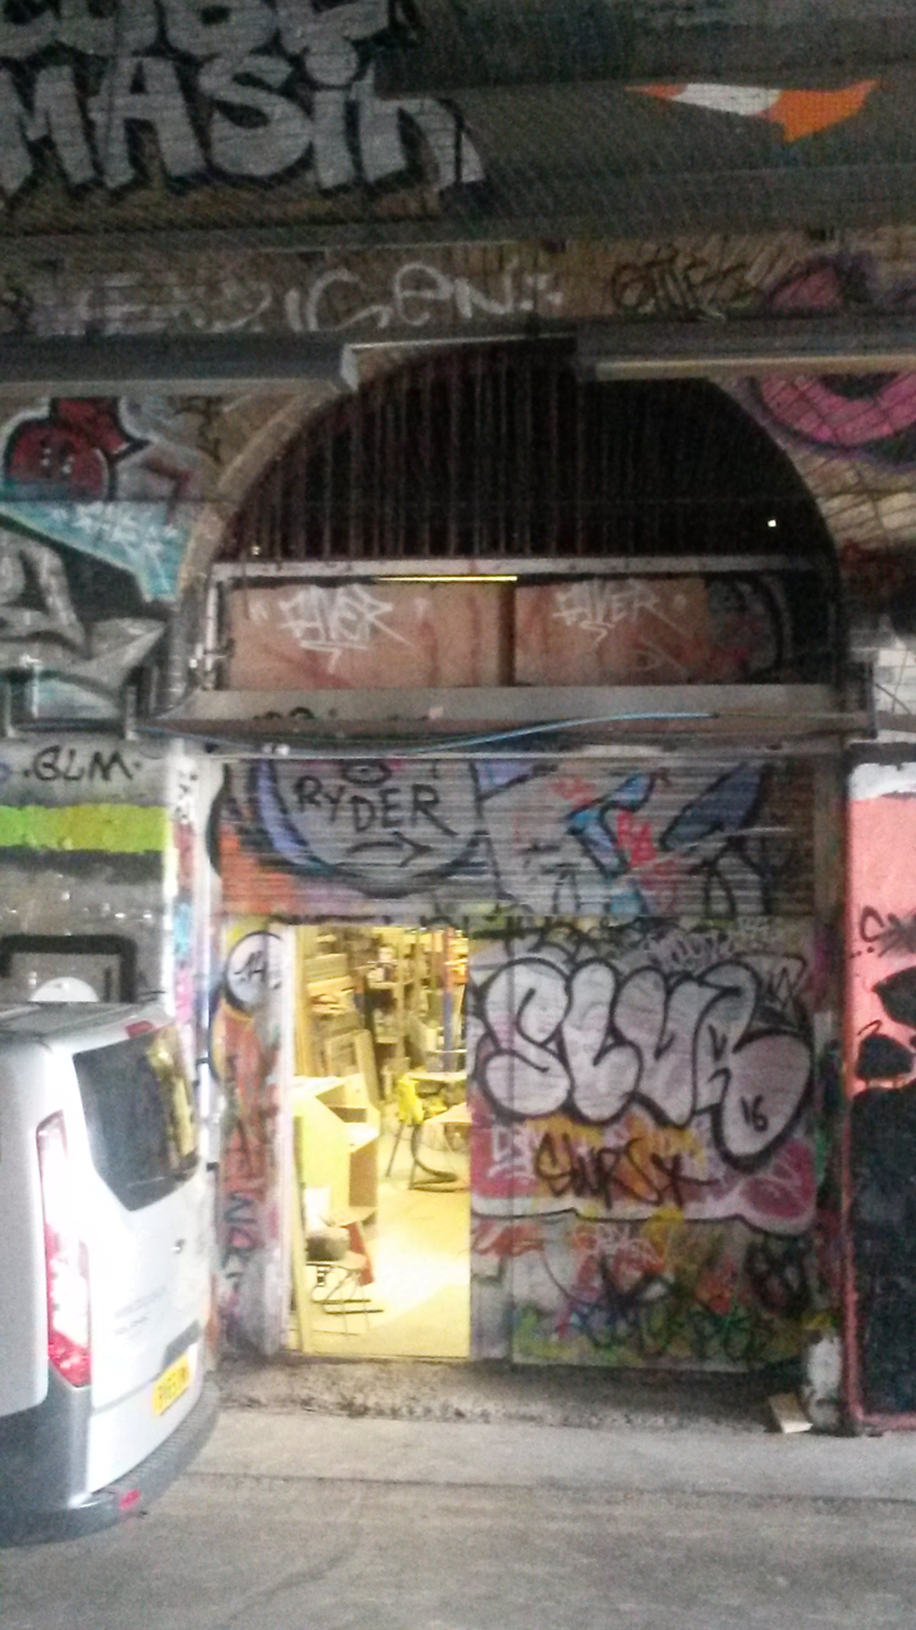
Figure 16. Emptying Network Rail’s archival storage (photo by author)

What gives the Leake Street arches its advantage is:

Every type of person goes through that tunnel and enjoys it in different ways. Whether that’s a tourist, local, person who’s spraying out there, dudes on bikes, people in cars, people wanna shoot music videos… (Kieron, Vaults Director).

Describing such a large and varied audience, it became evident that the Leake Street arches have a unique and versatile potential in ‘matching’ a variety of opportunities together (Florida, 2002), thus suggesting that the Leake Street Arches as an environment can nurture its many forms:

I think it is full of possibilities, it lends itself to all kind of uses and I guess it will get be used for different things at different times. It’s just versatile, it got indoor and outdoor, warm and cold, quiet and noisy, big and small- I think it’s incredibly versatile. I like that because it’s like a sort of a… like a street in a city where there is the potential of different things going on at the same time or smth big to be going on throughout the whole thing. I’m impressed because it is full of potential (Mark- consumer)

Following managers’ desire to restructure the tunnel into a user-friendly and safe passageway, but more importantly opening up lateral arches to invite creative business development, the environment could not be structured to a fixed and determined plan, rather to a more adaptable and liquid space that offers opportunities for movement and creativity. Lacking a fixed-pattern, the environment was opened to any type of movement, change of mood and any mode of behaviour (Nieuwenhuys, 2001). Indeed, as further demonstrated by the Lambeth City Council’s official area development plans:

Development and uses recognise and add value to this important asset through the inclusion of flexible places for people and events, and actively contribute to the enhancement of the collective public realm (Council, 2013, p. 145)

This falls in line with Nieuwenhuys (2001, p. 14) vision of a new urbanism suggesting that ‘the environment must, first of all, be flexible, changeable, open to any movement’ in order to attract entrepreneurial power. Indeed, as Kieron affirms, once the Graffiti tunnel started being recognised as an open, free and legal graffiti wall evoking no artistic boundaries, inclusion and vibrancy, entrepreneurs have also started paying attention:

Once graffiti kicked in, it was much safer because there were much more people on the street and it was Can’s Festival that allowed Kevin Spacey and Hamish Jenkinson, his PA, to create the Old Vic Tunnels [today’s Vaults tunnels]. So Banksy came along, then ‘yes’ to Banksy… on that first day when they were painting all these walls and because it was the first time you had more than 100 artists spray-painting and the fumes were pretty unbearable, so what they did was to open the doors all the way along the street to help the air flow and help ventilation; and in that way of opening that was how Kevin Spacey and Hamish Jenkinson, found what became to be the Old Vic Tunnels or at least this is how the story goes’ (Kieron, Vaults Director).

Landry (2012, p. 120) contends that ‘neutral spaces help creative ideas because they are areas where people feel comfortably relaxed and simultaneously stimulated and challenged by contact with an environment that is more socially heterogeneous than normally experienced’. By upholding this position, I argue that once the tunnel received its neutral looking vibe, opened as a public space and thus used by a large variety of individuals, but also bearing in mind the management’s inclination towards experimentation and innovation, a creative crucible or an incubator unit was articulated for business start-ups. However, while the Leake Street tunnel or Graffiti gallery is deemed an organic creative environment that naturally attracted artists and consumers who used the space in a variety of ways, the Arches have been occupied by capitalistic business start-ups. Accordingly, from 2009 to 2013, the Arches hosted the Old Vic Tunnels (i.e. comprised by the Old Vic Theatre) under the direction of Kevin Spacey. The venue presented a highly awarded programme of experimental art, music, film and community theatre. ‘The disused railway arches were transformed into sets resembling an Algerian market town and 1970s Brooklyn for Secret Cinema nights, a pop-up restaurant run by Michelin-starred chefs and an underground cinema for the premiere of Banksy’s film- Exit Through the Gift Shop’ (Steven, 2014) (Figure 17).

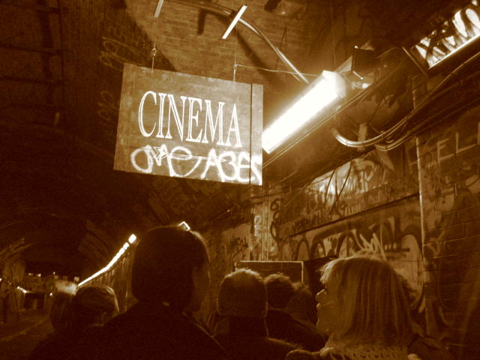
Figure 17: Exit through the Gift Shop (FATLDN, 2010)

The rest of the Arches however were occupied by the House of Vans hosting an indoor skate park, an arts venue with gallery, cinema, café and artist studios (Figure 18).

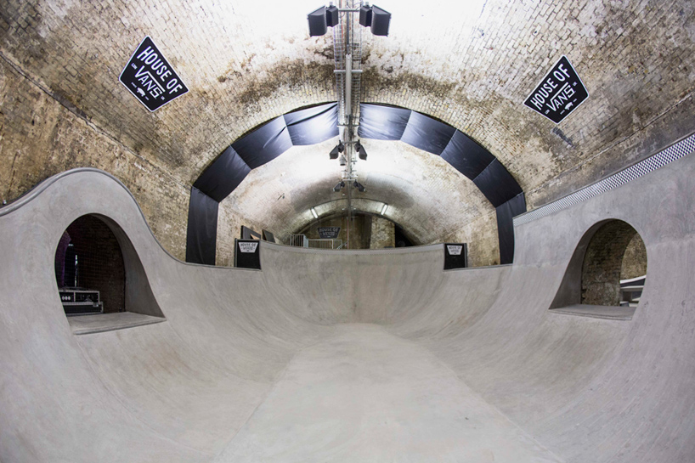

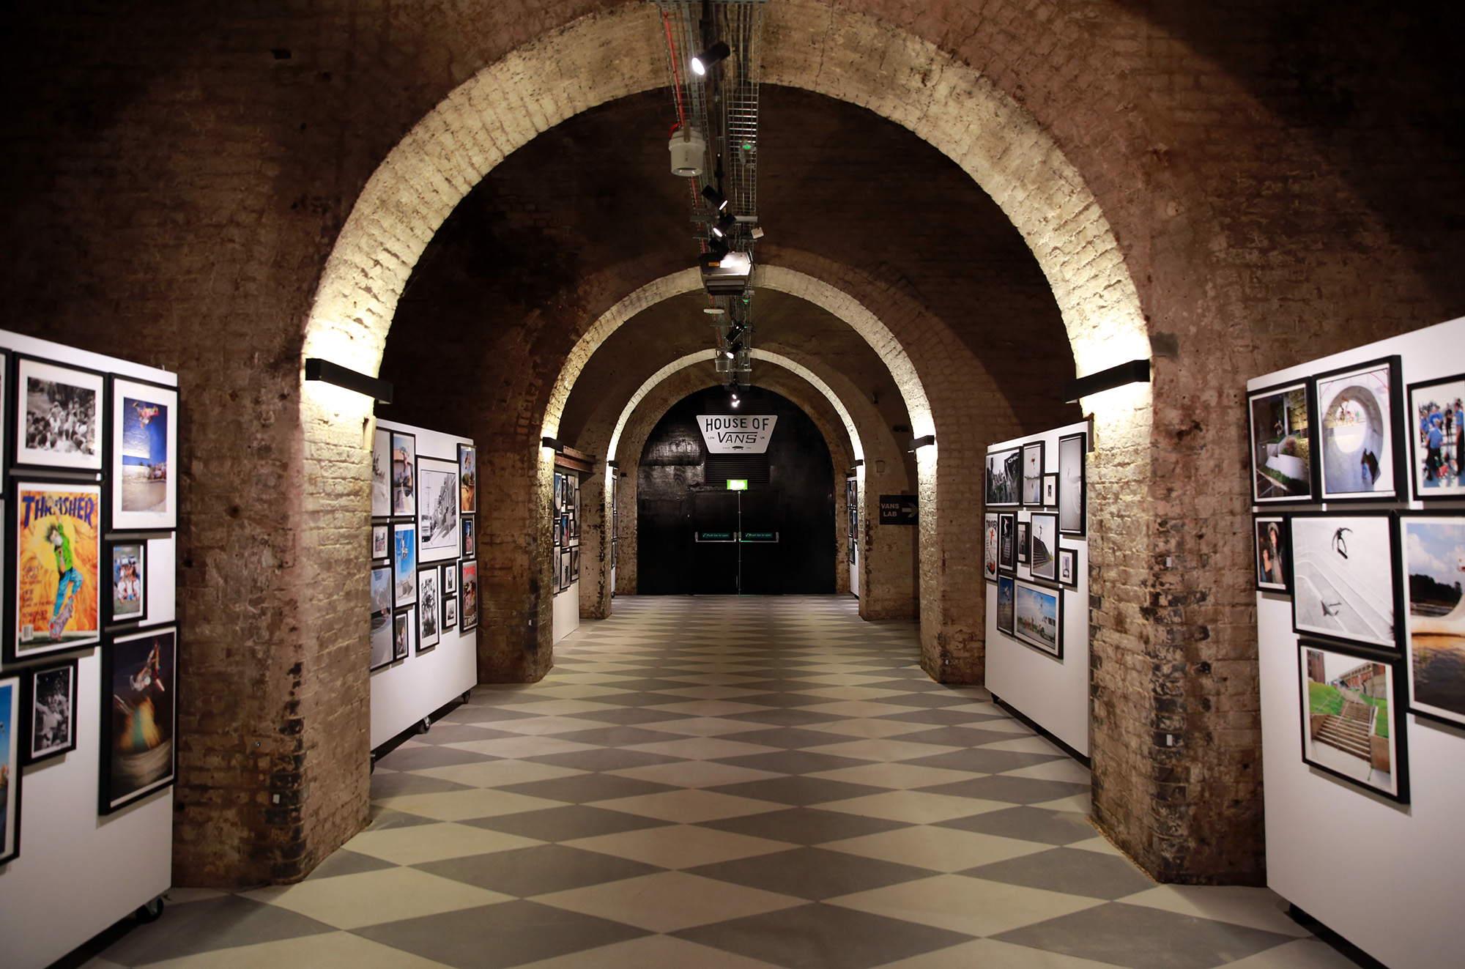

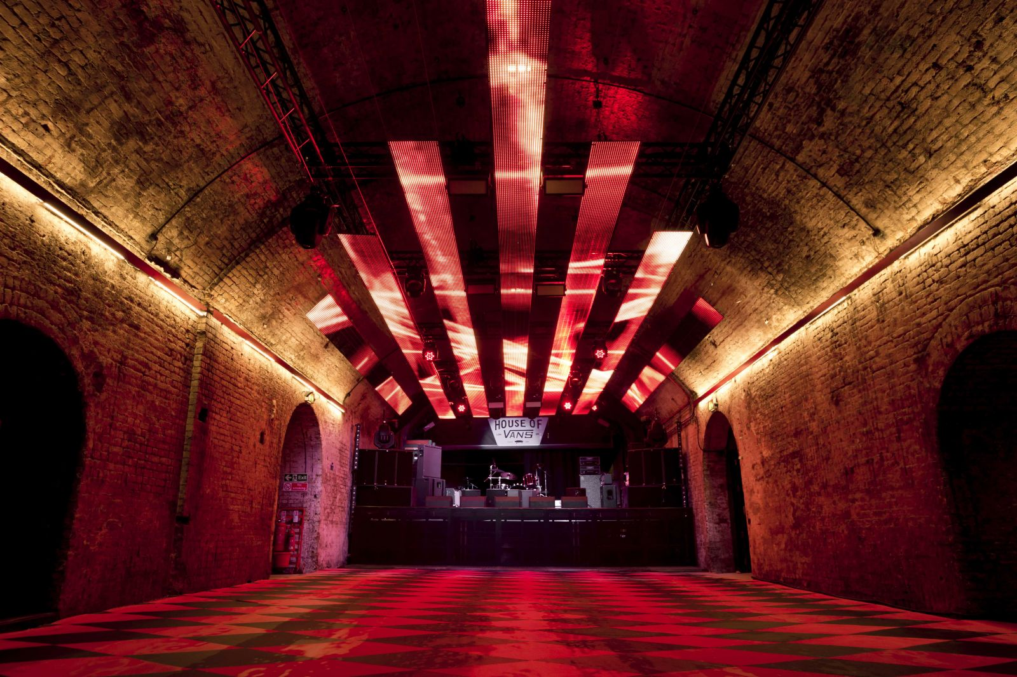
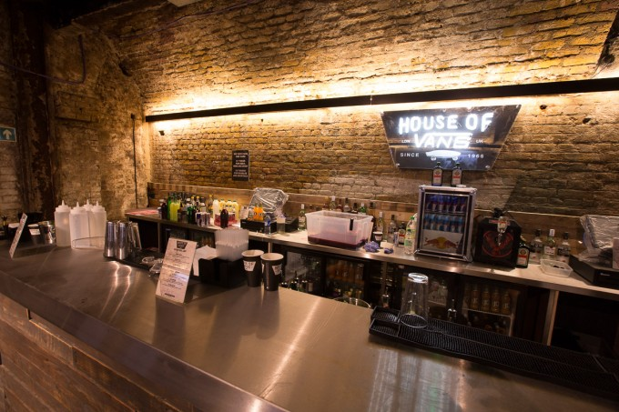
Figure 18. House of Vans (Vans, 2016)

After the Old Vic Tunnels closed, the business was taken over by the Vaults who presently successfully occupy the arches (Figure 19). House of Vans however cannot be entered via Leake Street, only the Vaults can, and as the present study aims to explore a pseudo-public space, channeled here by the relationship between the public space- i.e. the tunnel or Graffiti gallery, and the private space-i.e. the Vaults, only the Vaults and not House of Vans will be analysed.

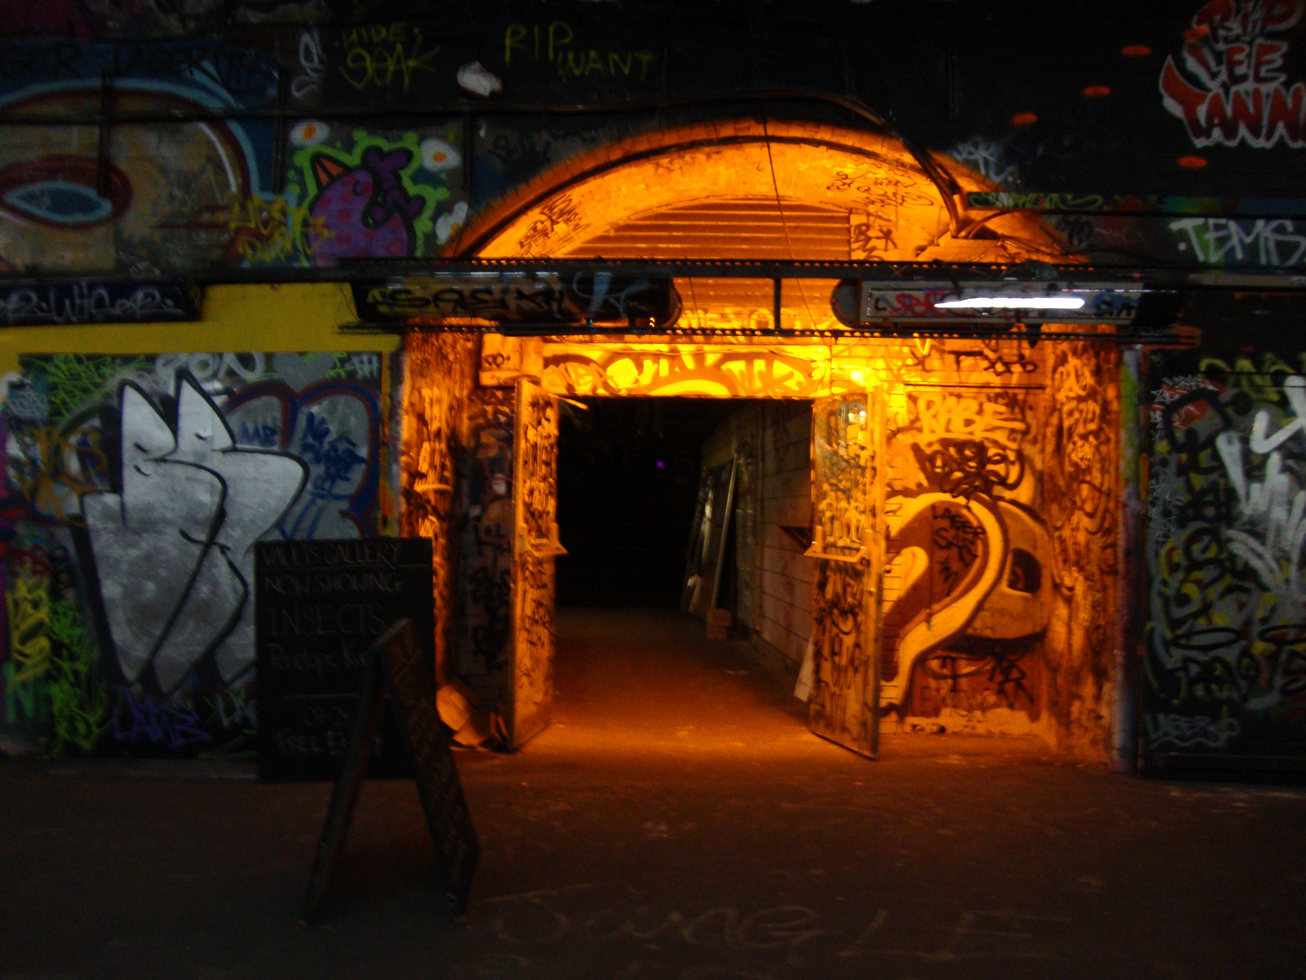
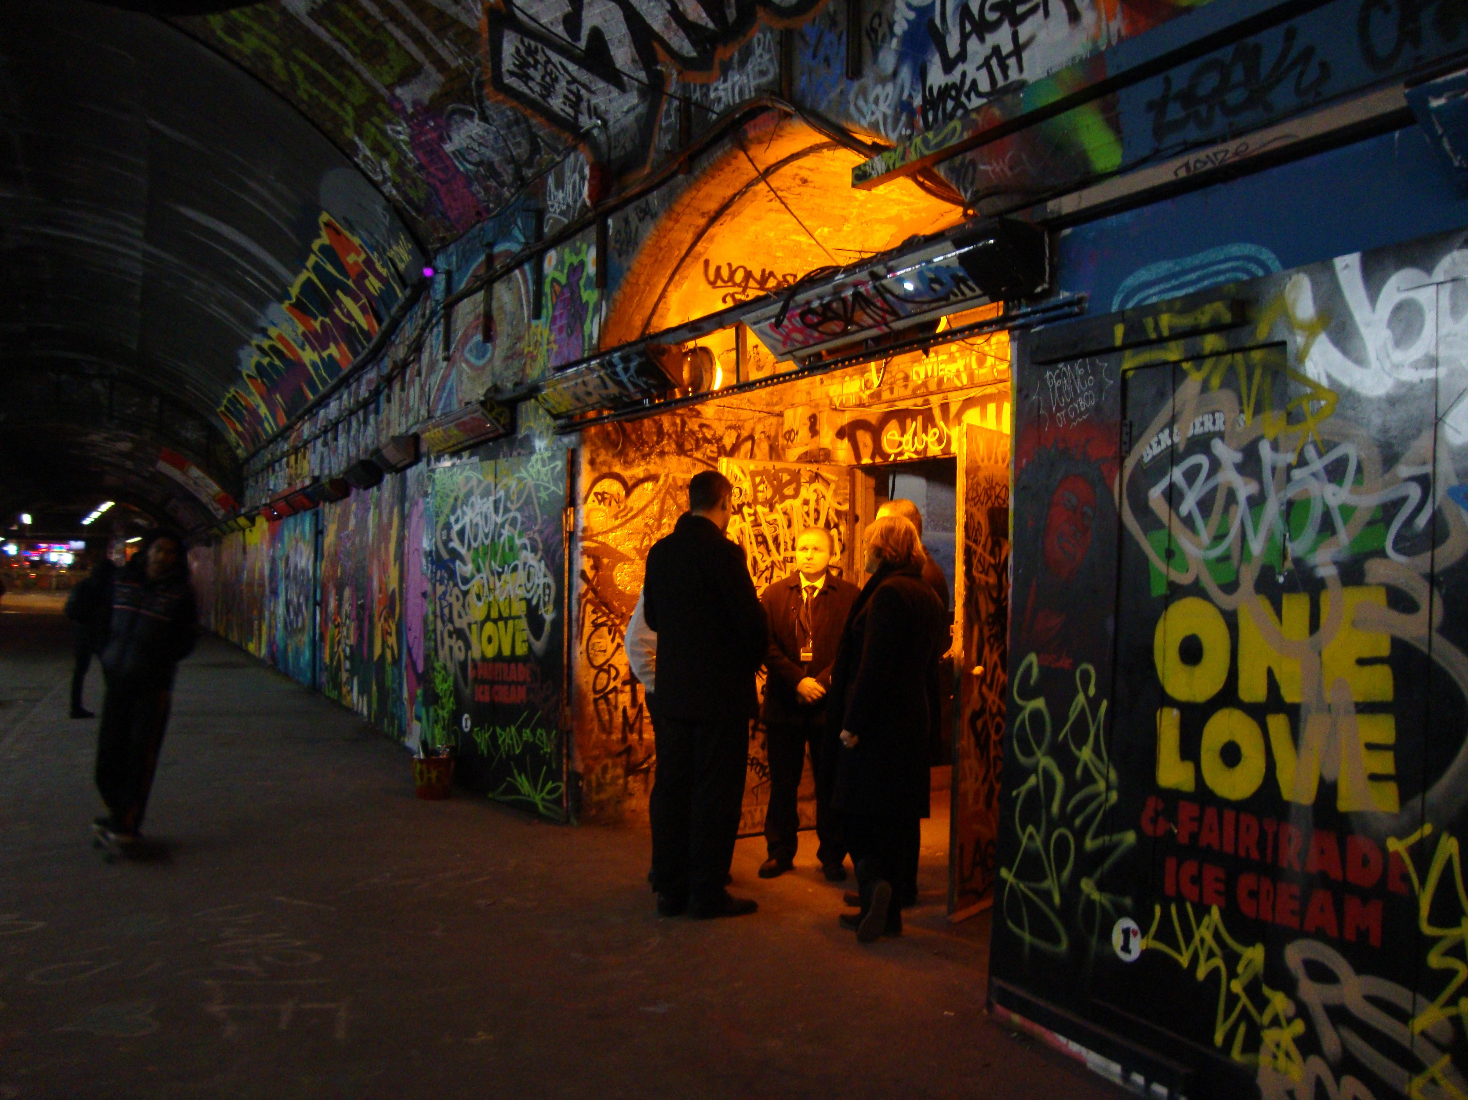

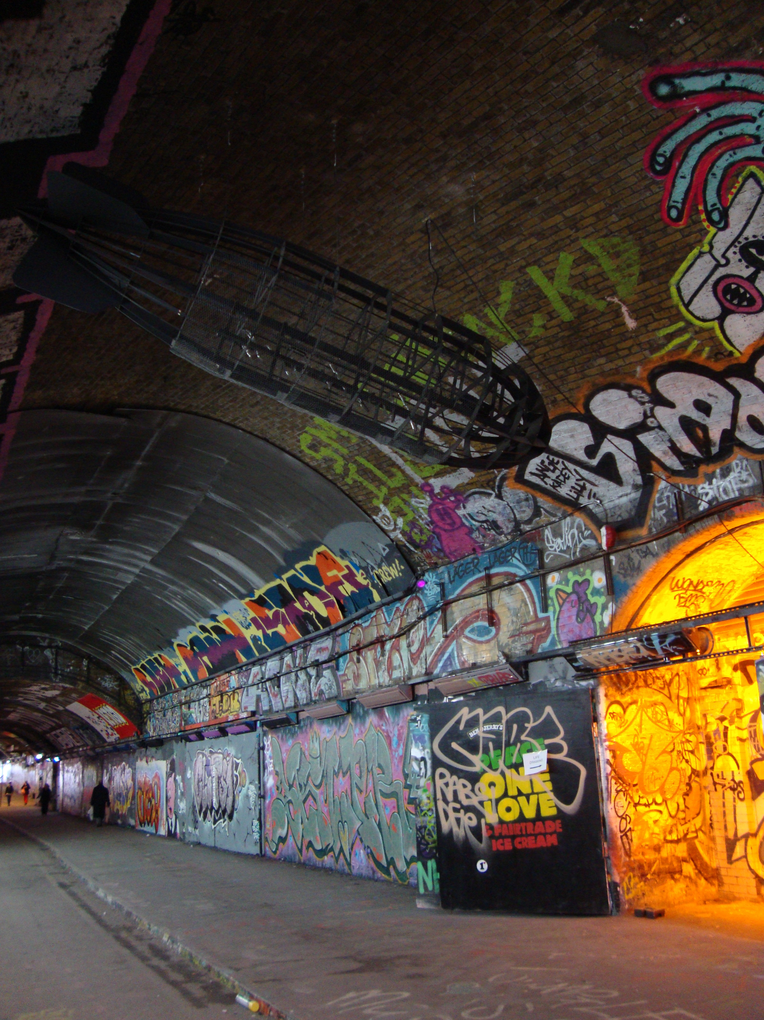

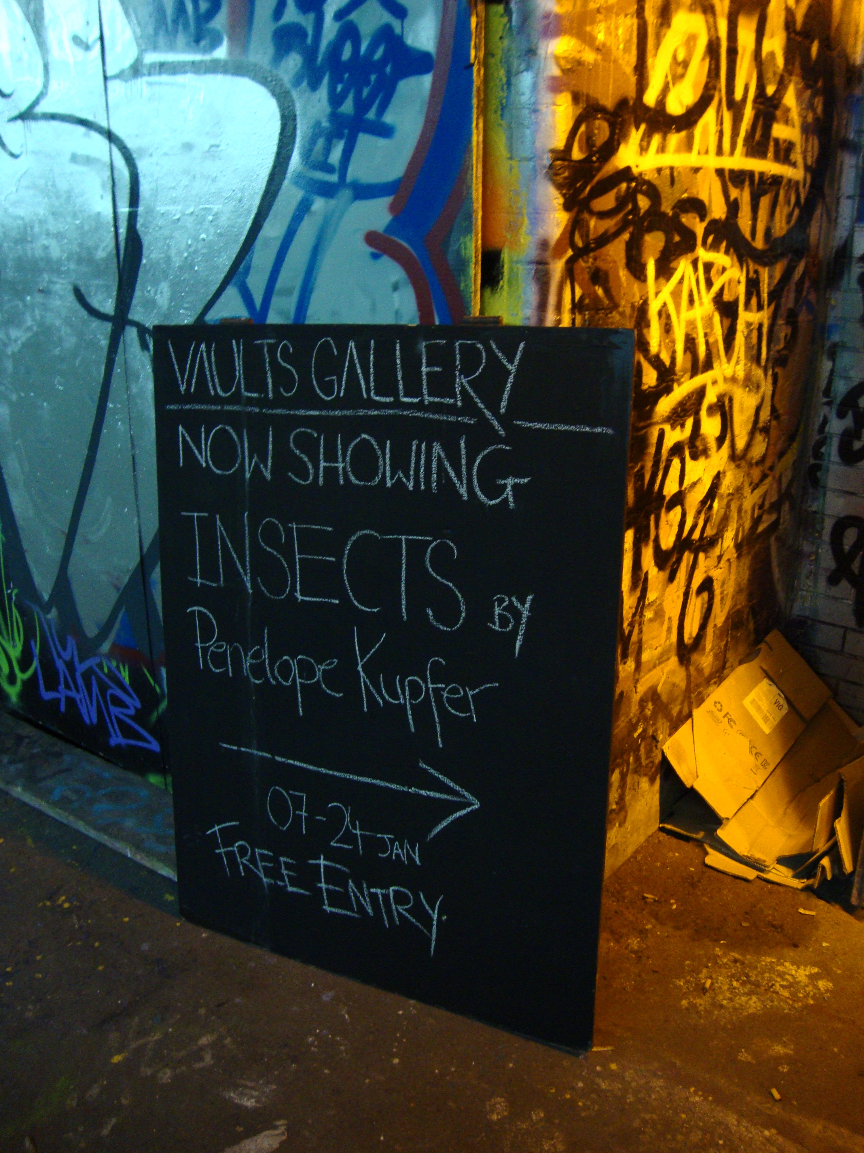

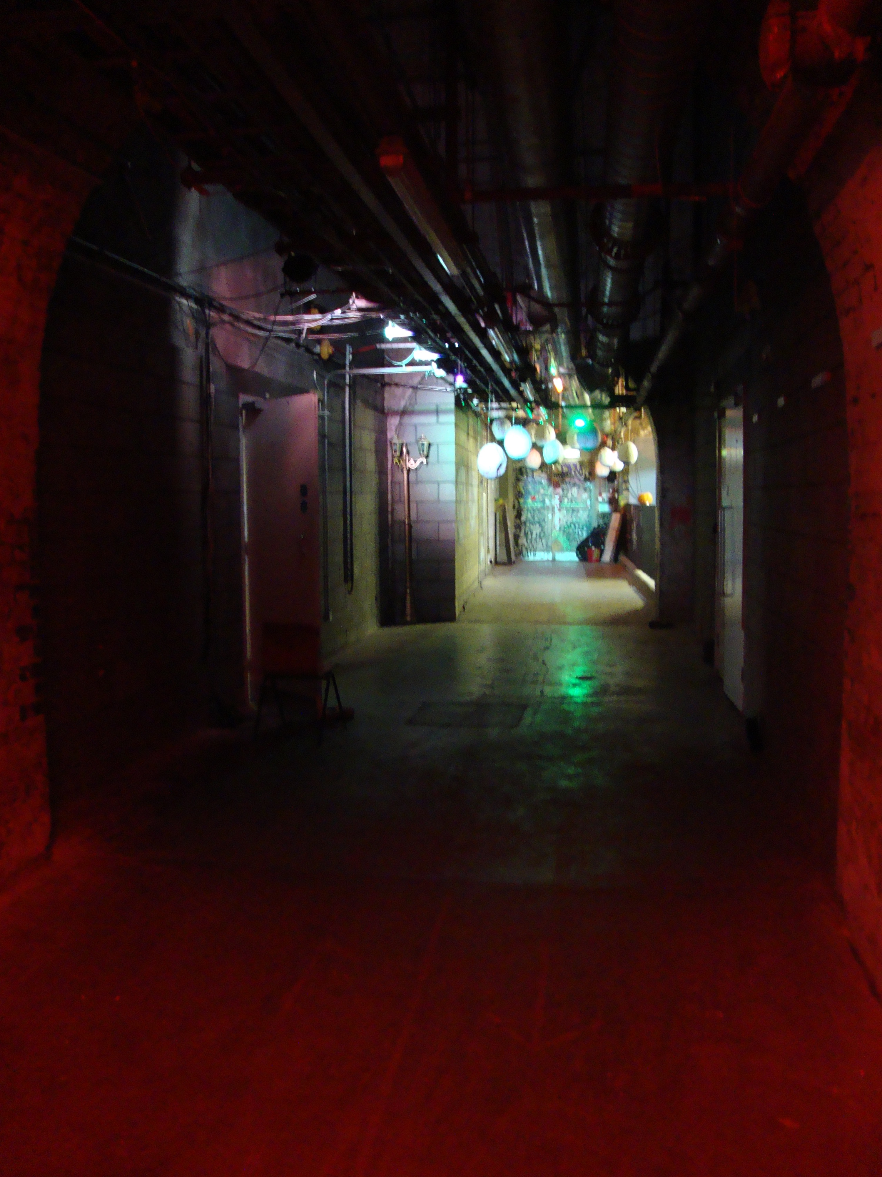
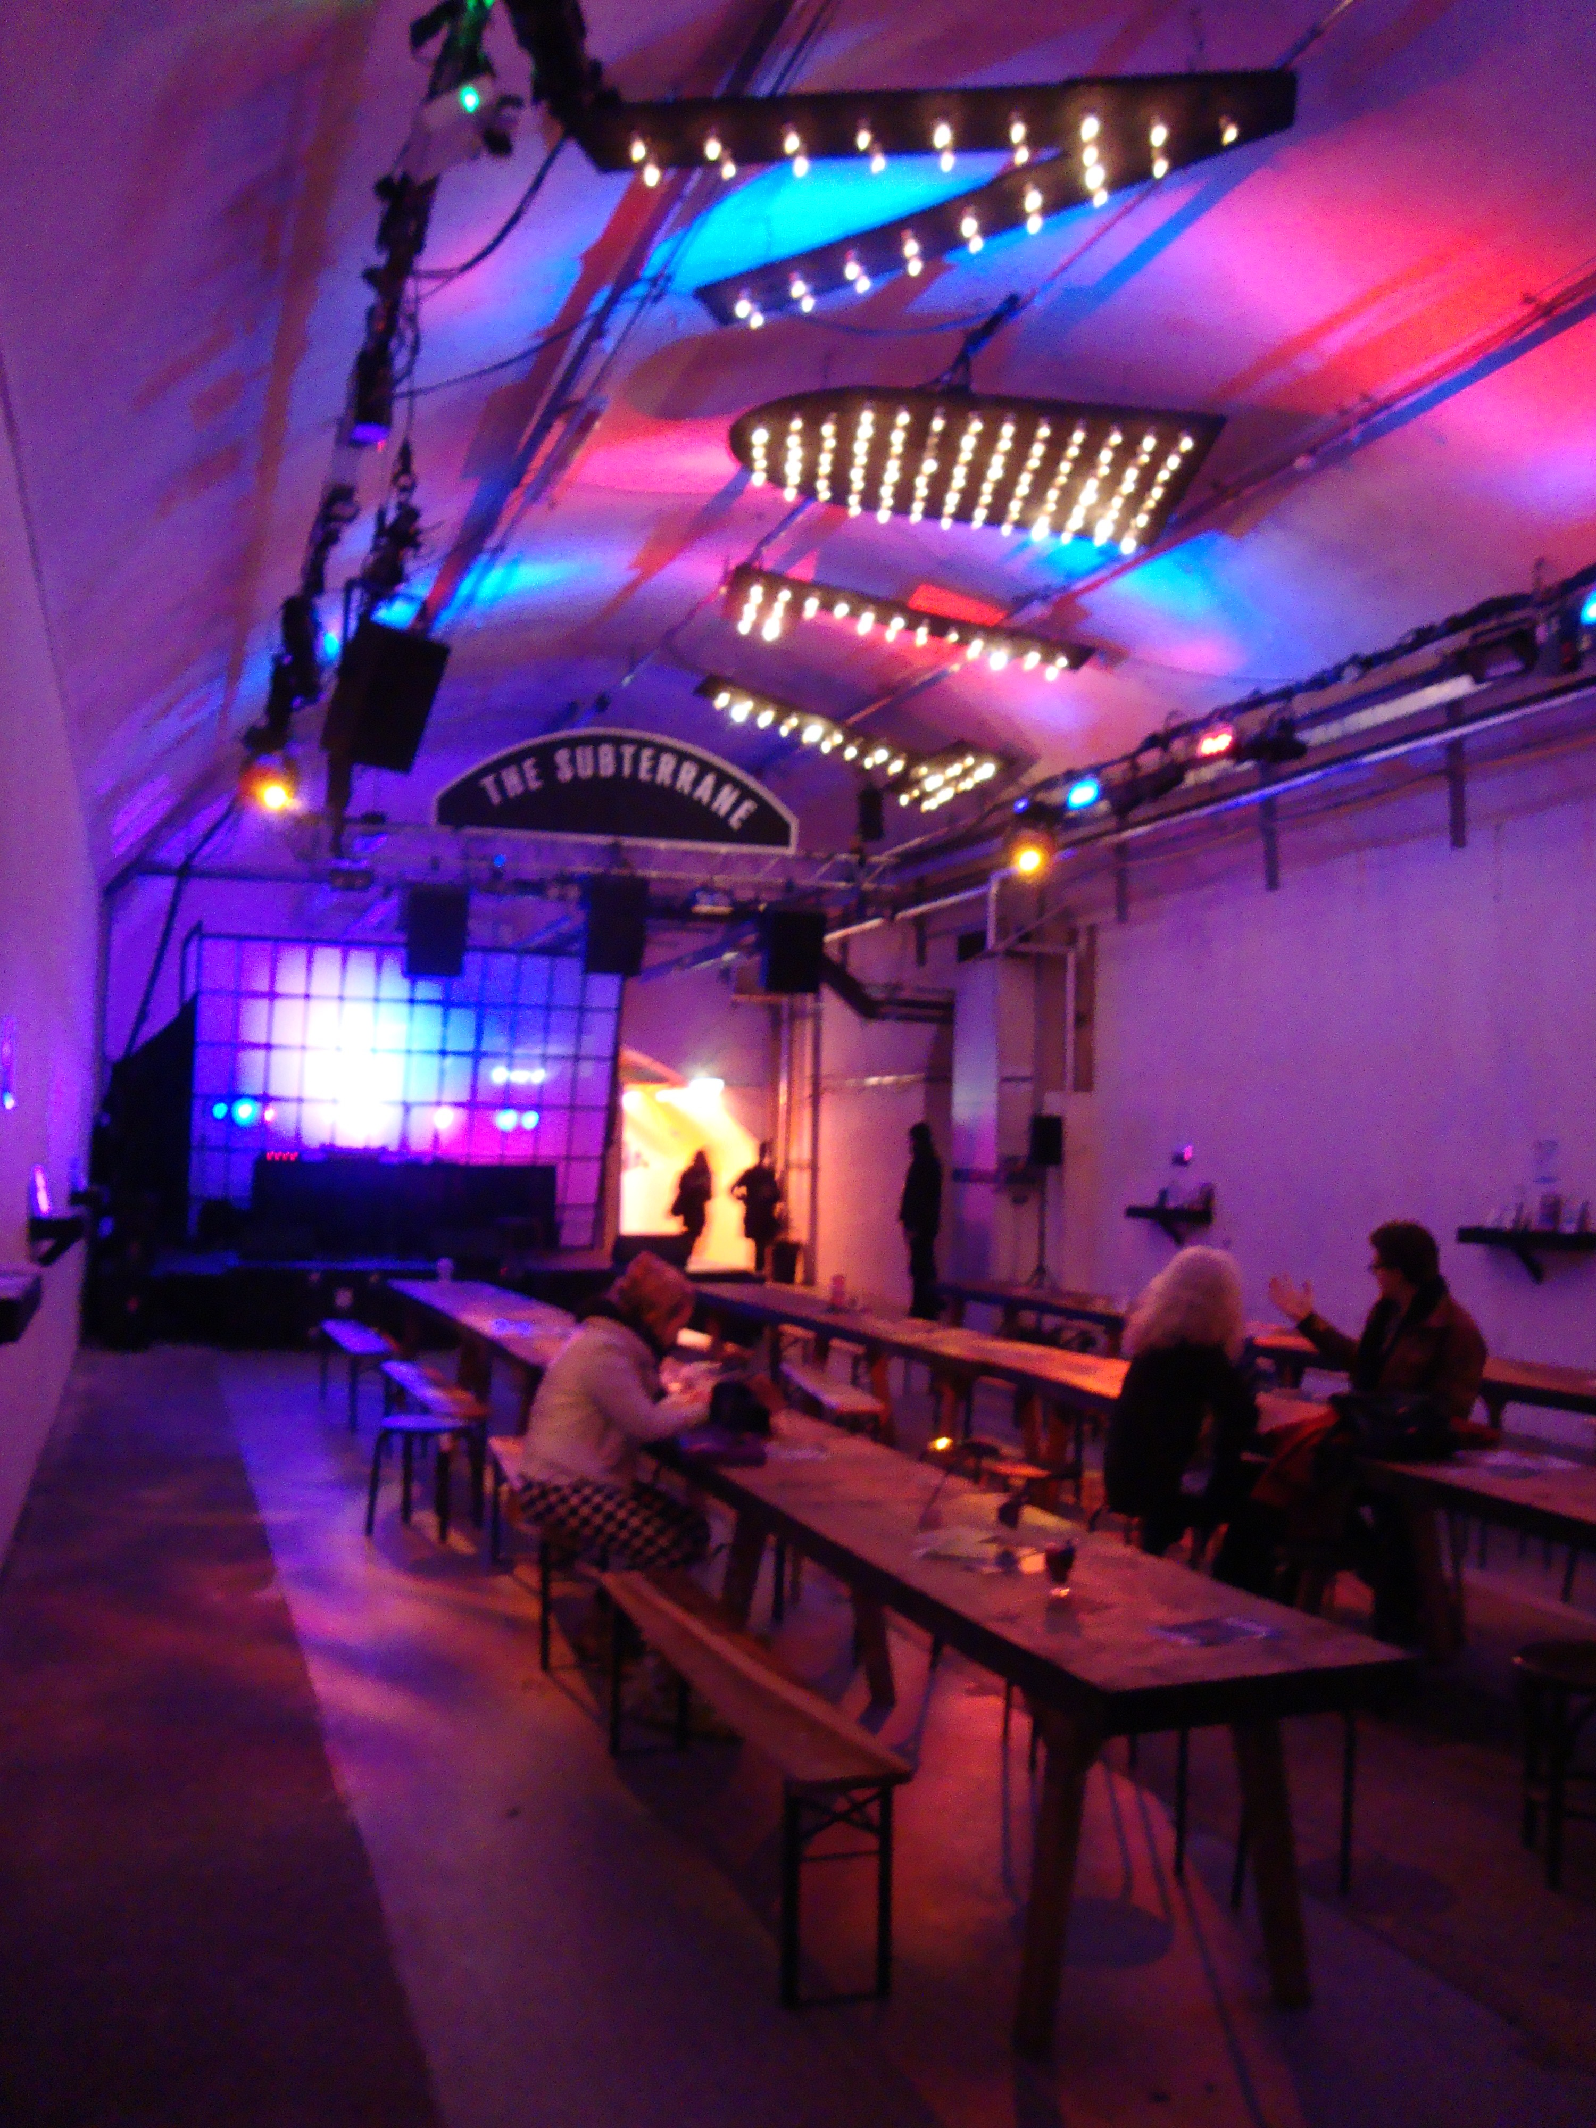
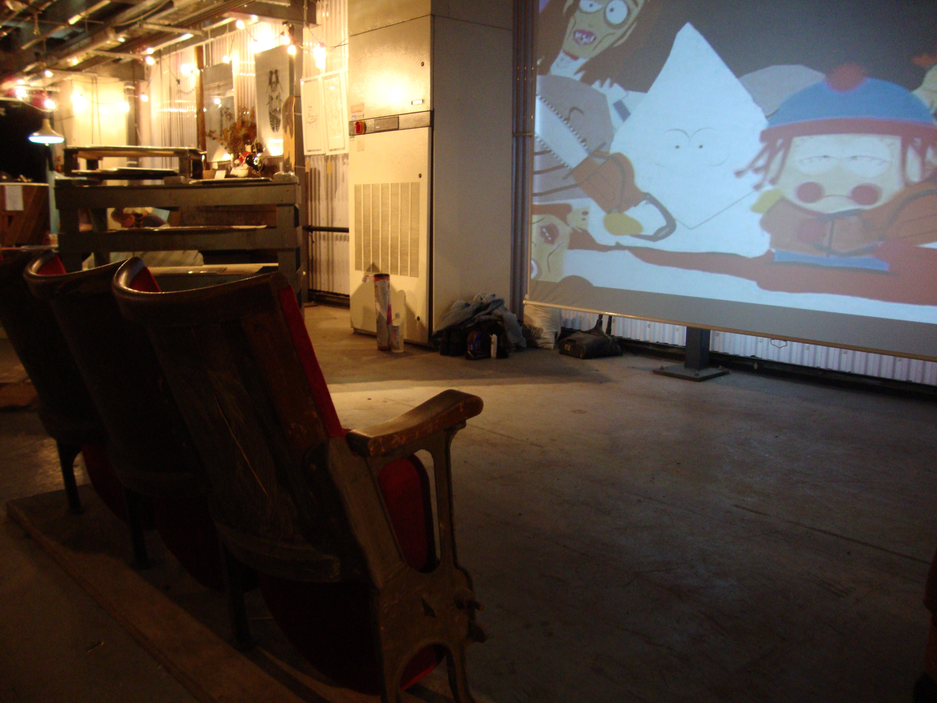
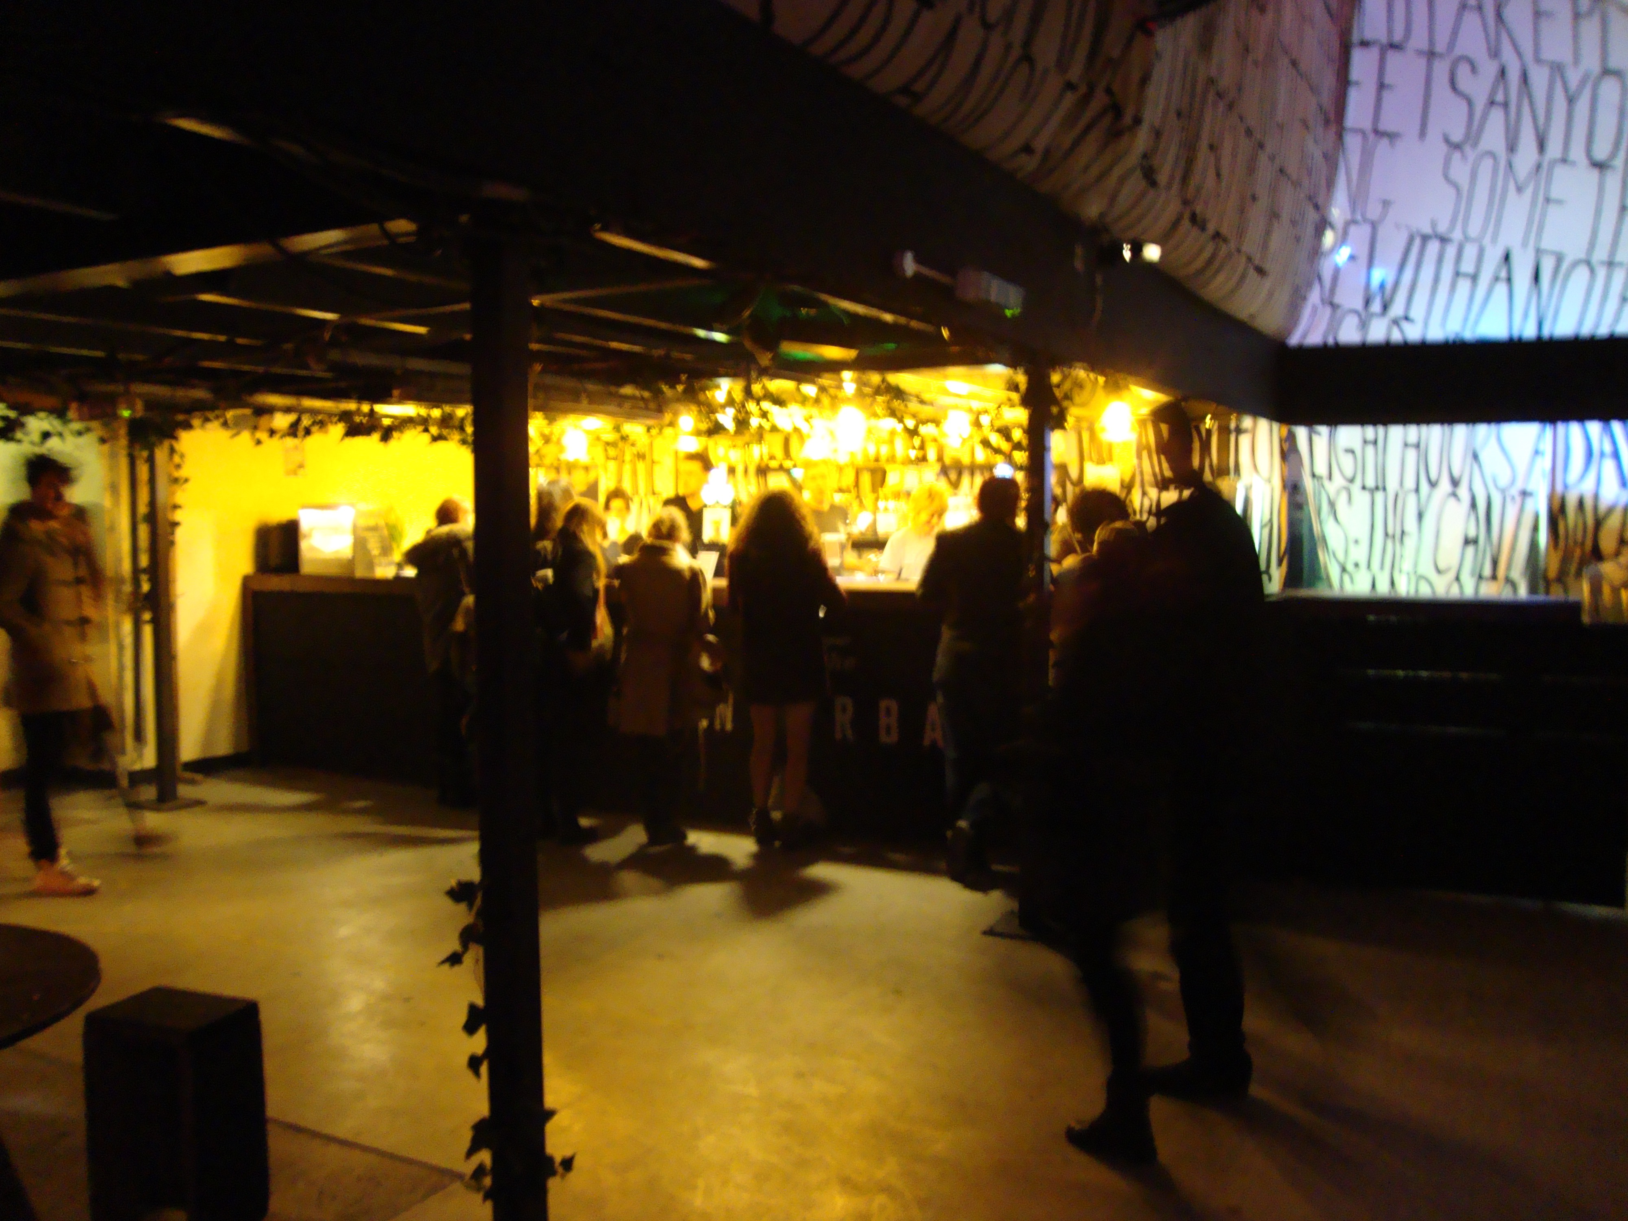
Figure 19. The Vaults comprising main entrance, hallway and several chambers (photo by author)
By granting pedestrian access to the Leake Street tunnel, managers and producers diversify trajectories of movement within the tunnel and so articulate a myriad of possibilities or moments that give the tunnel its ‘ever-changing shape, divide it, vary it, create different atmospheres, [where individuals] play out their lives in a variety of surroundings’ (Nieuwenhuys, 2001, p. 14). Shortly after the tunnel was opened, as to be discussed throughout this section, the environment attracted various artists in search of a ‘studio’, skaters looking for a platform, consumers using the context to produce ‘selfies’ or shoot videos, entrepreneurs teaching consumers how to ride a bike or stencil, or simply consumers using the space as pure shortcut between streets or hang-out that stemmed contradictions. I argue that contradictions between the two environments-i.e. public vs private, the Graffiti tunnel vs the Vaults, but also contradictions between practices channels the emergence of market alternative trajectories.

All the above entities populated the environment by generating different practices, practices that constructed various moments or situations as instructed by Lefebvre. In discussing spatial practices within the production of space, Lefebvre (1991b) studies the formation of ‘moments’ as situations or fragments in time ‘marked by an attempt to achieve the total realisation of a possibility’ aiming to instate discontinuity, and puncturing the monotony and banality of everyday life (Butler, 2012, p. 27). For Lefebvre, play, love, work, rest, struggle, poetry are just a few examples formulated as moments and conveyed as ‘a form and is defined by a form’ (Elden, 2004; Lefebvre, 2003a, p. 170). Furthermore, in rupturing the banality of everyday life, moments challenge strict divisions and are characterised through a constant cycle of rediscovery and reinvention (Elden, 2004). Similarly to Lefebvre’s dimension of moments or situations channelled as a form and defined by a form, the Leake Street tunnel in this sense stems moments or situations that conjure up contradictions.
Such contradictions arise from the interplay and tensions between public location –i.e. the tunnel and the capitalist private location- i.e. the Vaults, but also between practices evoked by various typologies of artists. However, in comparison to Maclaran et al. (1999)’s study on spatial play in a festival marketplace where managers prefer to solve contradictions that arise between the physical space –i.e, the shopping centre and symbolic space- i.e. the consumer imagination play out against each other, my study evidences that contradictions are allowed and encouraged to play out against each other. The following section will document the main contradictions that arise within the Leake Street Arches pseudo-public creative environment:

Consumerist vs Non-consumerist space: Once the tunnel was baptised into a legal and free graffiti zone, artists started using the Graffiti tunnel as a studio to practice their craft, attribute visibility to their work and generate publicity and meet other artists. This falls in line with Lefebvre’s (1991b) vision of spatial practice that embraces production and reproduction of particular spatial locations and sets. In this sense, artists who transformed the location into a public ‘studio’ organically adopted a space produced by landlords as a neutral location. Such a contention contradicts what Mitchell (2003a, p. 18 , italics in original) astutely observed in The Right to the City when conveying that ‘more and more of the public spaces of the city are being produced for us rather than by us’. Accordingly, in contrast to discourses highlighting that dominant interests have appropriated public spaces using techniques of commodification, control and regulation (Mitchell, 1997; Paddison & Sharp, 2007), the Leake Street Arches demonstrate how a site was baptised into a public space only after consumers adopted and transformed the environment into a creative and free location for artists, and generally any type of consumer. The tunnel was thus morphed into a creative place where consumers are welcomed to practice any kind of art. Whether artist or amateur, any skill level was welcomed; and soon after the space’ renaissance, the tunnel was associated with a public gallery. Art created within the tunnel is not rewarded through monetary exchange and consumers cannot purchase or take the art home, as Marky attests:

It is clearly different from a normal gallery. Its architecture, it is not heated, no loos, no shop [talking about the tunnel]. It is cheaper; it doesn’t have price tickets, it is not for sale and I quite like that. I guess it is a lot more accessible; it is the sort of place you might go into by accident. It doesn’t feel as serious, but it doesn’t feel altogether unserious, it doesn’t feel altogether spontaneous…I mean white cube is clearly completely unspontaneous and any gallery like that; this doesn’t feel altogether spontaneous, but more than most galleries (Marky- consumer)

As such, the space escapes commerciality by avoiding monetary exchange between buyer and seller, as usually undertaken within any orthodox gallery. In contrast to the tunnel, Vaults- represented as a contrast and continuation to the tunnel’s Gallery, harbours a café-gallery where art is traded for money and where consumers can purchase food and beverages. Vaults, in comparison to the tunnel, transforms individuals into consumers:

It is interesting that as soon as you walk in, you become- I become a consumer. So instead of ‘outward’ looking [like in the Graffiti tunnel] I’m inward looking: what of these things are ‘me’ or might add to me. It's an interesting concept but how does that work with me? So it becomes much more ‘me’. What would this add to my life, might this look good in my living room, and might this look good on my finger. You walk through and it's all about ‘you’. Outside in the tunnel, I’m not looking through that space thinking ‘how does this fit in my life?’ I’m looking outward: this is interesting, this is a part of the world I don't see, who is in here, what does this mean, what other things have happened here? This [Vaults’ gallery space] is more: this is a nice seat for me, these are interesting things for me to buy- it’s a different mindset, I think. I ‘lost’ the idea of ‘space’ in the sense of it’s interesting, it’s curious, it's pleasing, quirky, but here it's on a superficial level. You're not really thinking of it as an idea that's going to change your mindset or lead to anything. The tunnel’s experience just odd, this [Vaults’ gallery] is immersion in a different way- I feel this is catering to me (Ella- consumer).

Following on from this, as attested by informants, the tunnel describes a commercial-free and non-restrictive environment informed by an ‘outward looking’ behaviour, while the Vaults channels a commercially astute environment where individuals become consumers. The Leake Street Arches, as a pseudo-public space and consumerist/non-consumerist environment also inform how a public space can impact a private space and its financial planning. Specifically, the tunnel is viewed as ‘free’, ‘creative’, ‘lawless’, ‘graffiti’, ‘urban’, ‘skateboard area’, ‘bikers area’ ‘psychedelic’, ‘dark’, ‘underworld’, ‘revolutionary spirit’ and ‘community’; while Vaults is perceived as ‘venue’, ‘event space’, ‘commercial’, ‘business’, ‘exhibition’, ‘private’, ‘capitalist’, and ‘coffee shop’. The distinct views create a stark contrast between commerciality and non-commerciality. As Yasi contends, Vaults capitalise on the tunnel’s organic nature, on its alternative and free vibe:

The Vaults I think they are capitalising on this. Cause you have to go through this to go to the Vaults, there is no other way into it. So I think they are capitalising on this alternative thing, the countercultural and slight resistance of this space, they are using the tunnel’s vibe and feeling, this whole feeling of being alternative, different, not mainstream and using it for their own game. It’s not necessarily a bad thing. And so it puts you in a particular mindset before you go in you know ‘oh so this space is like this’- it’s alternative, it’s different. So when you enter Vaults tour brain is already thinking ‘oh, this is alternative’. The tunnel is being used to their advantage, you have to walk through in order to get to the Vaults, so this is this alternative weird space, and then vaults is obviously going to be on the same line (Yasi- consumer)

The Graffiti tunnel, an environment naturally created by artists who freely exhibit their craft has been associated with the Vaults. Through association, Vaults is also known among artists and consumers as an ‘underground space’ where freedom of expression is exerted. However, the Vaults is a private business that strongly capitalises on the tunnel’s organic and liberal nature, as confessed by Vaults’ Director:

Leake Street tells me what we should be programming in here [at Vaults], what this space should be, who it should be for (Kieron)

Accordingly, Vaults’ managers and producers draft an entertainment programme that is being dictated by the tunnel’s uniqueness and vibrancy. This confirms Jameson’s (1977) idea of a space of neutrality, characterized by multiple and various contradictions that play against each other, but do not neutralize each other as exemplified in Maclaran et al. (1999)’s study of spatial play in a festival marketplace. While Vaults borrows the tunnel’s lack of commerciality, the tunnel also gains through association. Informants attest to a practice of exchange between the two environments, whereby Vaults’ commerciality promotes artists:

Recently Top Gear was filmed in the tunnel and I and other artists were able to showcase our work by association in the space. The space is always changing, it has a symbiotic quality that means artists provide the backdrop and industry provides the coverage. Win win. (Marc- artist)

Marc’s verbatim is just one testimony of how the two environments benefit from the close proximity although such collaboration was not planned or scripted.

Vaults contradiction to the Graffiti tunnel also impacts on the venue’s artistic and financial planning:
Leake Street tells me what we should be programming in here; what this space should be, who it should be for. I make sure that I balance shows for commercial success but also artistic success, so shows that sell out well but also shows less known but very interesting (Kieron, Vaults Director)

In our interview, Kieron explained that in designing Vaults’ artistic programme, the Graffiti tunnel plays a crucial role. To further channel the tunnel’s underground nature, Kieron hosts performances that are not usually characterised as ‘sell out’ or a box-office success’, performances that ‘sell tickets well’ but that rather add to and compliment the tunnel’s underground and corky nature. This demonstrates that the association between the two spaces engenders new avenues and possibilities.

Furthermore, some of the artists that paint in the Graffiti tunnel to showcase their art or use the space as a mere ‘organic studio’ are also invited to exhibit at Vaults’ gallery. Art in the Graffiti gallery has not been created with the purpose of commerce, but as defined at the beginning of the chapter: to revitalize the area, insure safety by channeling vibrancy and hone entrepreneurial power that will implicitly pay for the area’s development plan. Following on from this, although Leake Street’s tunnel has been instantiated as Graffiti or Banksy’s gallery, its purpose is not to sell art. In contrast, Vaults’ gallery pieces hold a price tag and are being sold for currency. The alignment of commercial and non-commercial spaces becomes the impetus of a pseudo-public space that celebrates a mix of creative irruption, develops synergies and collaborations, but also finances the area’s survival and evolution (Figure 20)

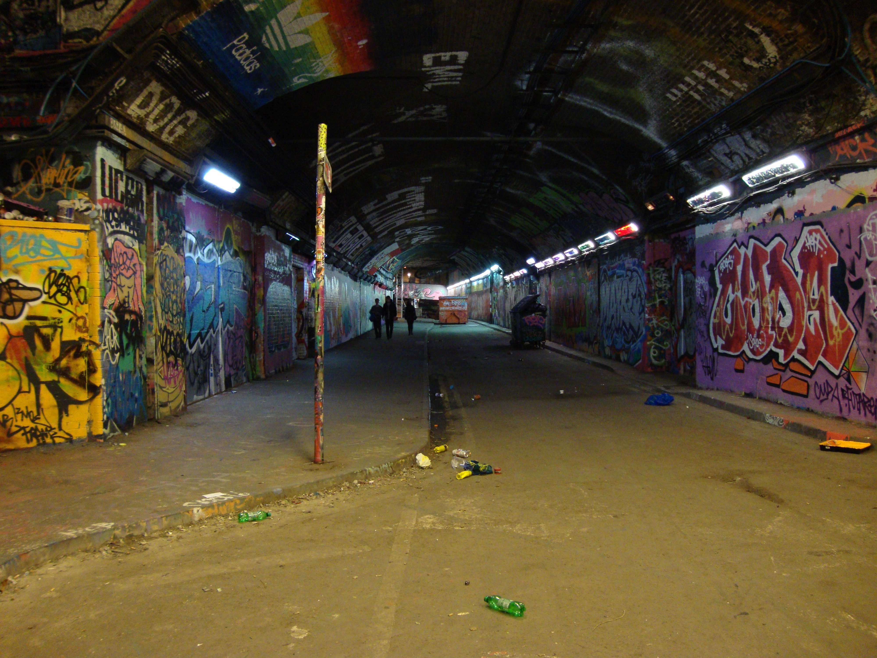
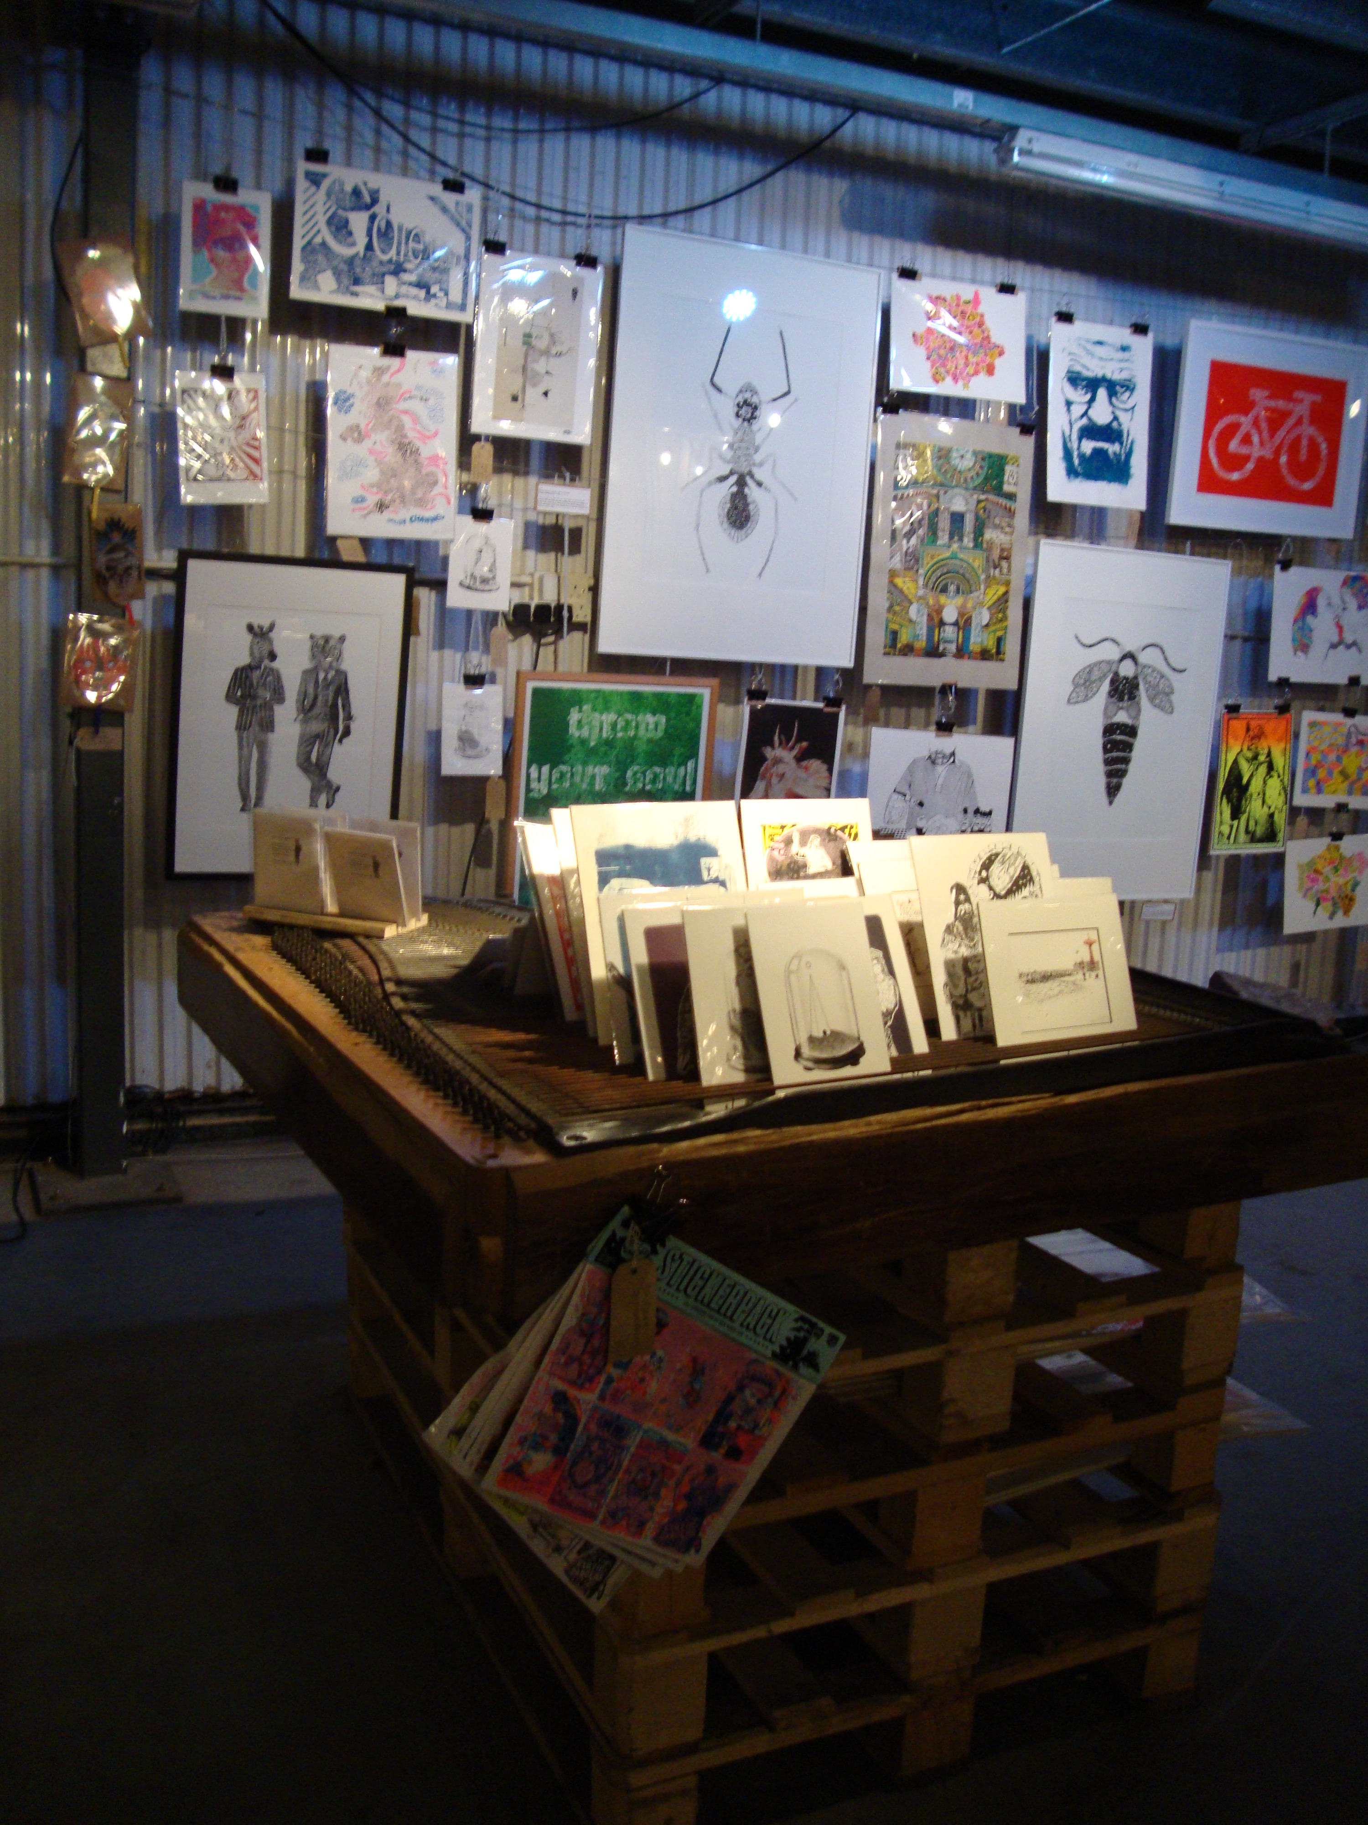
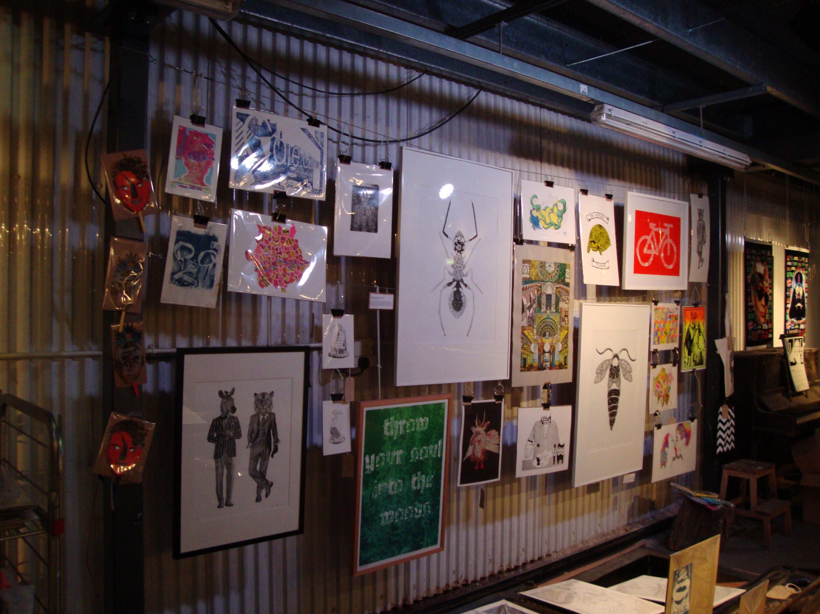

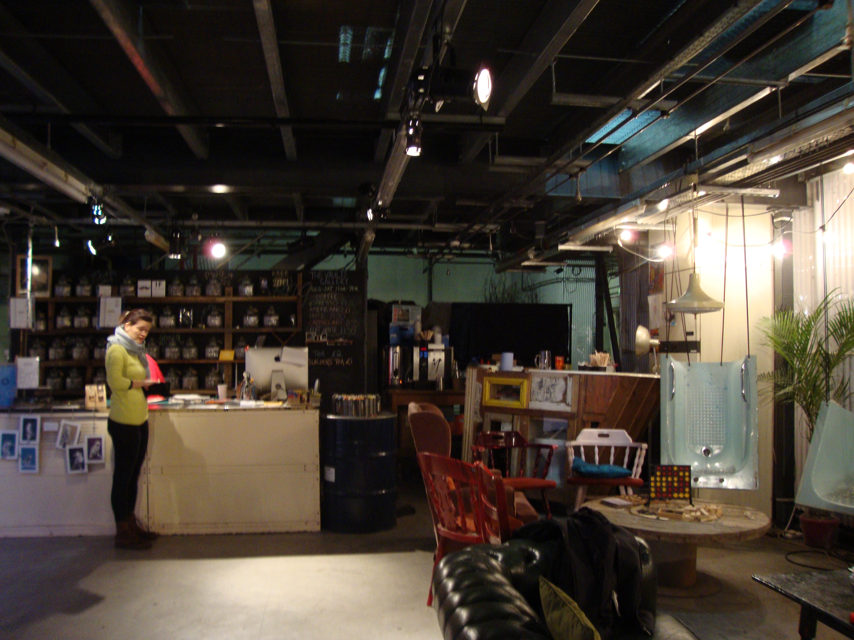

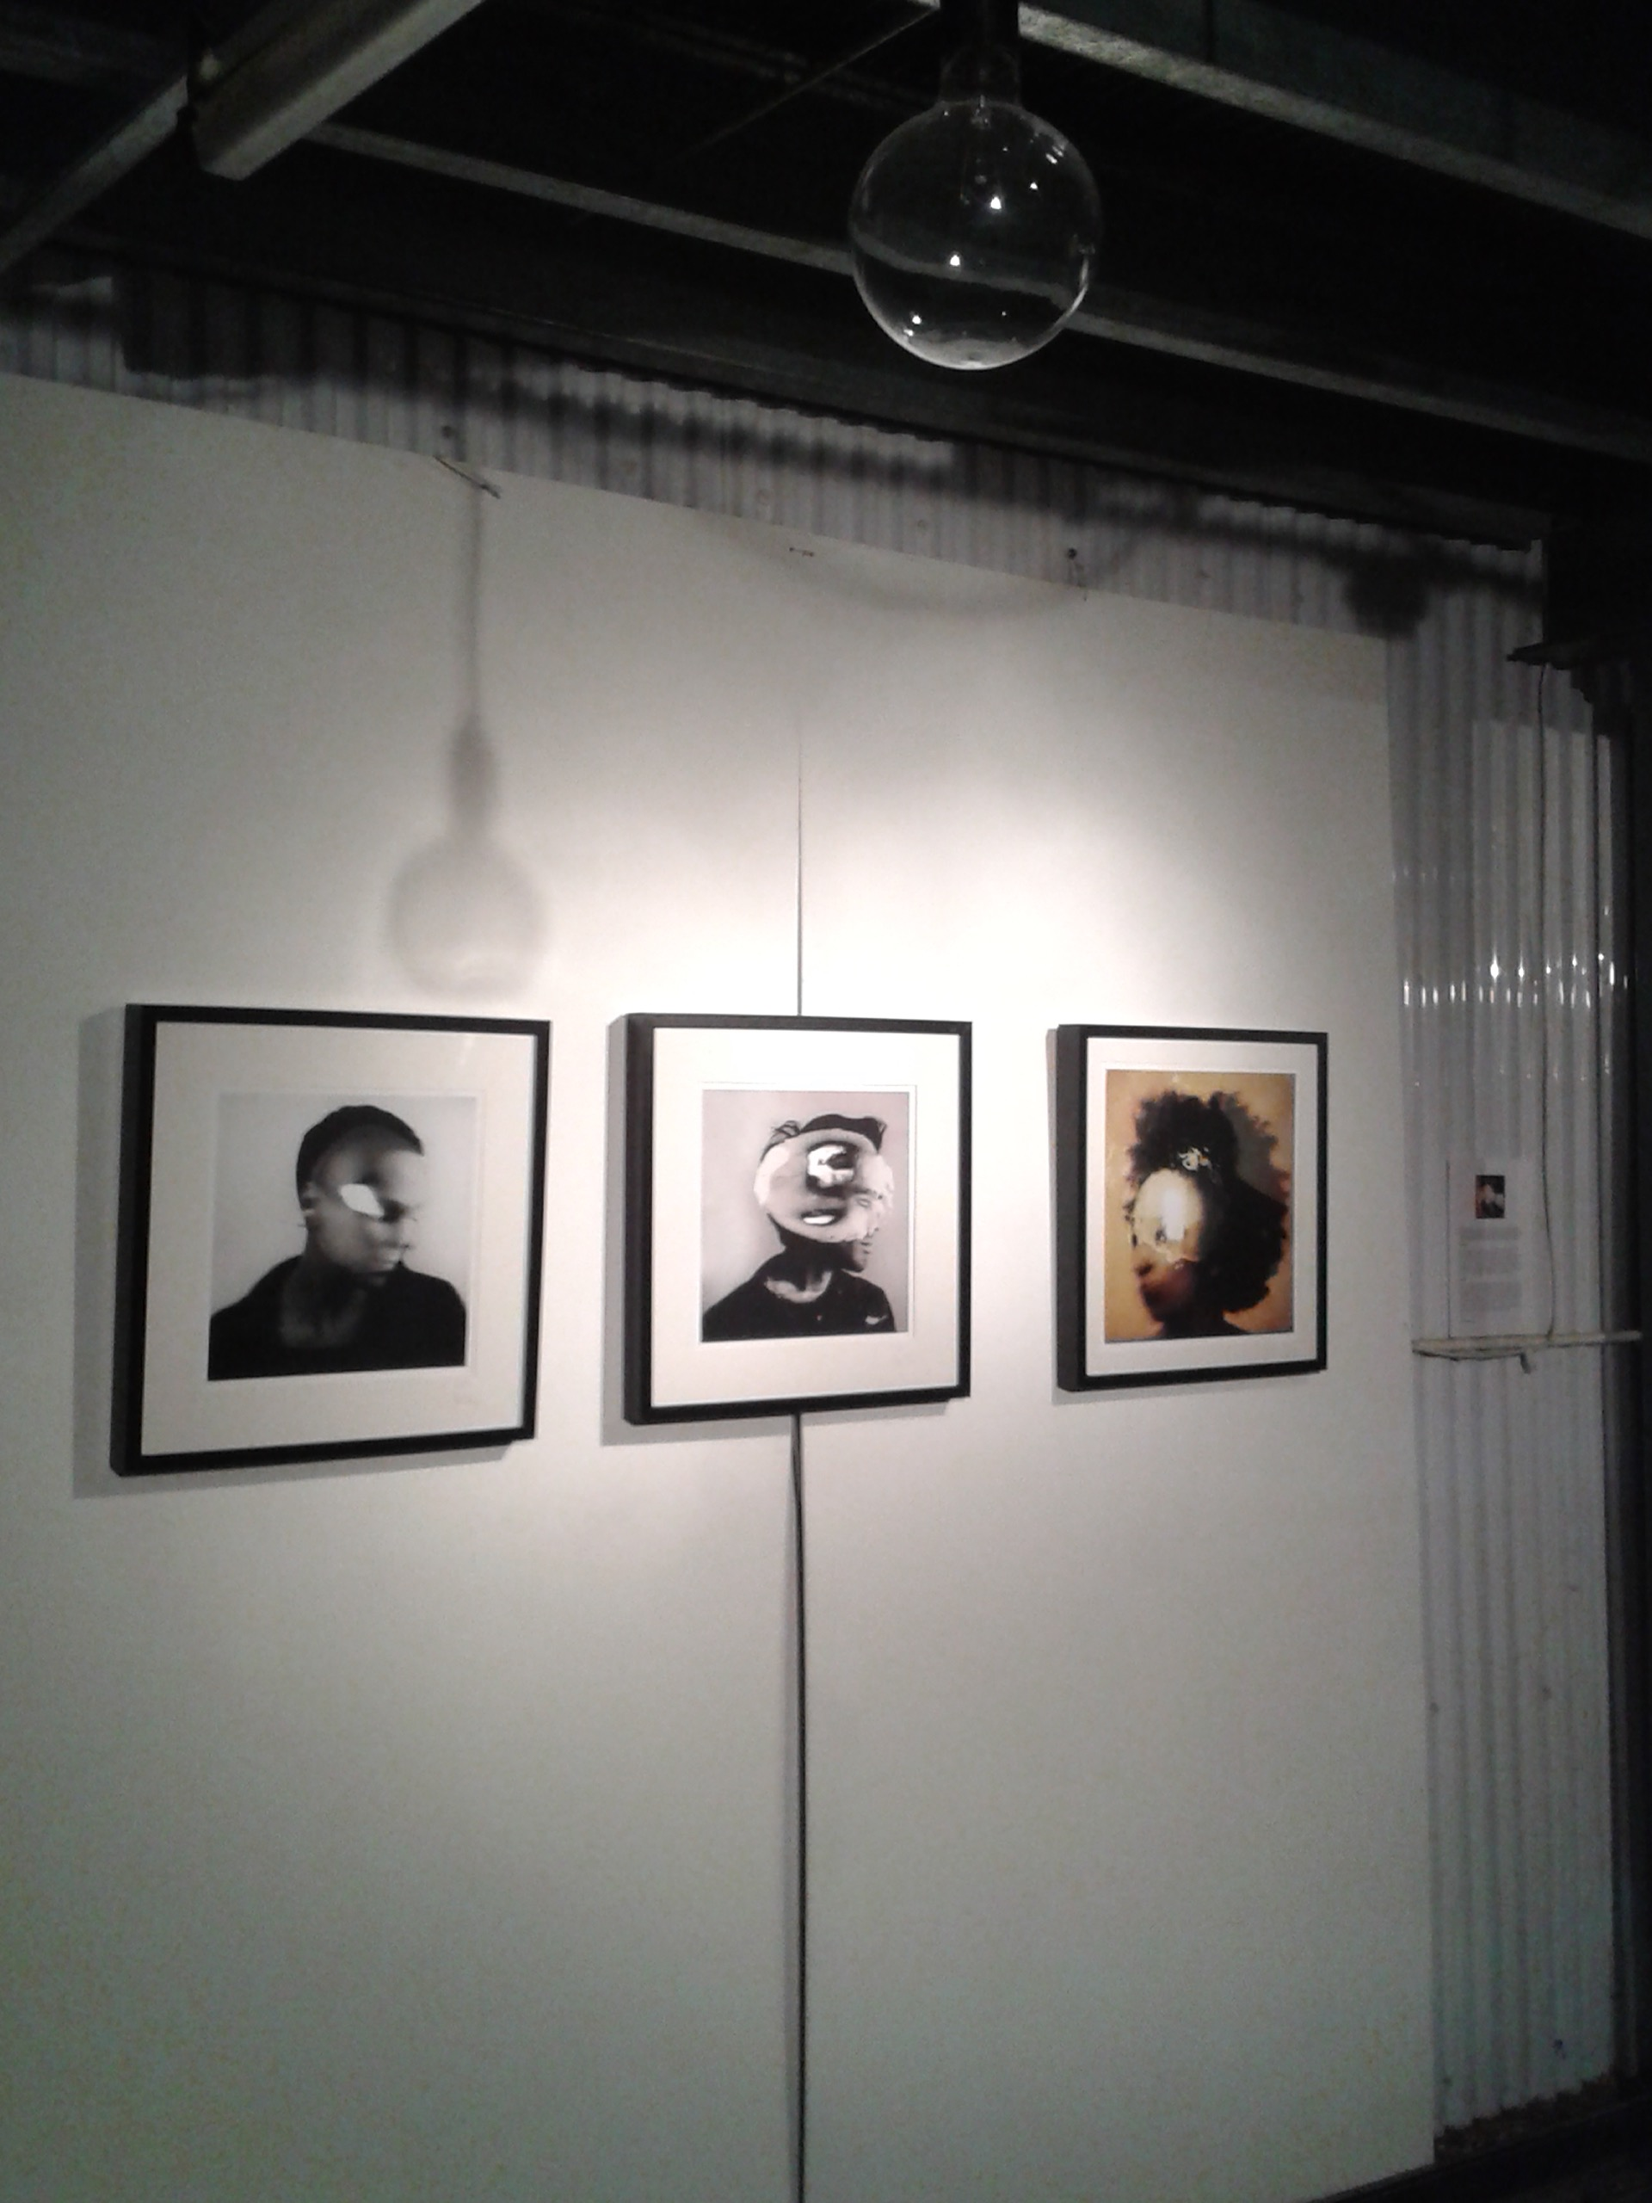
Figure 20. The tunnel vs the Vaults (photo by author)

Self-management vs Corporate Management

The two environments differ greatly in terms of management. While Vaults, as a private entertainment space, is highly curated, scripted and organized; the Graffiti tunnel describes a democratic freedom whereby all individuals no matter the skill level, occupation or passion are welcomed to exhibit their craft- as documented by the following verbatims:

No one curates it, no one comes in and says ‘now we are going to have a season on animals or the environment’; everyone is there to do their own thing. This here is much more curated [the Vaults]. It is displaying art from young artists, people who might not get big places in galleries but it is much more put together and much more controlled. There are things for sale in here, so it’s much more commodified. There is a café in here so you see more suits, so people who maybe are less interested in theatre (Anna- consumer)

It is self-organised; it’s autopoetic [the Tunnel]. It’s like it is artist curated, it doesn’t have some curator with nice glasses and like a good haircut but it’s still a gallery. I interpret it as artists coming here and organising themselves and their own art. It’s got its own programme, like Kieron [Vaults’ Director] is not programming it, people come and do their own art here and that’s kind of thing that is changing every day (Tom- artist)

I love the fact that it’s not curated [the Tunnel] and people just come, and that it is always changing. Any art here is in the moment, so ‘it’s come look’, it’s that moment and then it’s gone- it’s like a performance or installation that is there temporarily (Ella- consumer)

Artists or consumers who wish to exert their craft within the tunnel find complete freedom in selecting where and how to paint within the tunnel. Specifically, artists can choose to paint anywhere in the tunnel, whether on the ceiling, stairs, lights, pipes or even on another artist’s work who finished a piece half an hour ago. For this reason, art in the tunnel is fast-paced. Artists have painted the ceiling, pavement and even the lights. In this view, artists completely shed any rules or clichés generated by the orthodox white cube galleries and mediate complete freedom in practice:

Both walls and most of the ceiling are covered in graffiti as are the lights, most of which aren’t working. The pavement is also graffiti covered and hasn’t been cleaned in a while. People put their mark on the lights even though they are not part of the wall or the ceiling, so people have marked everything. I like that refusal to be put on one canvas and like ‘I’ll just do it anywhere’, it doesn’t matter; and I guess also because they would be part of a culture going over other people’s stuff, it must be quite a culture of ‘it doesn’t really matter, you can do it again’, so that refusal to be confined to one space is nice and I like the fact that people are going over each other’s stuff, I don’t know if…there is not a lot of other art forms that you can do that really to other people and they just accept it (Lara-consumer)

To conclude, the tunnel in comparison to the Vaults is curated and organised by artists only who adopted the neutral site as represented by landlords and revamped the environment into a self-managed and organic gallery. As to be discussed within the following section, an art piece in the tunnel has a life-spam between a few minutes or three days before another artist covers the piece. Following on from this, the study finds that firstly what makes space adaptable for creative purposes is an undetermined and versatile form with no fixed-patterns. The fabric of space here is open-ended and not enclosing, implying that the space can be moulded to every need. Secondly, as to be discussed within the following paragraphs, every element is deemed to be mobile. As envisaged by Nieuwenhuys (2001, p. 14), ‘every element would be left undetermined, mobile and flexible. For the people circulating in this enormous social space are expected to give it its ever-changing shape, to divide it, to vary it, to create its different atmospheres and to play out their lives in a variety of surroundings’.

In conclusion, the study finds that the Leake Street arches channelled creativity to animate a ‘dead’ public environment with activity and rejuvenate structures and streetscapes, to assure safety in a tunnel designed to facilitate decongestion and improve access to stations. Secondly, ‘creativity’ in this scenario also played a part in commercial development and attracting entrepreneurial power to the area. Finally, creativity, besides contributing to the blossom of a public space, also attracted entrepreneurial power, which lead to the development of a creative pseudo- public space. It was due to the area’s flexibility and mobility however that nurtured creativity. Thus, as suggested by Florida (2002), creativity must be motivated and nurtured in a multitude of ways to progress alternative creative possibilities.

4.2.2. Mobility: The Formation of Fast-moving Environments

Since 2008, when Banksy transformed the Leake Street tunnel into an exhibition space, the tunnel has become an oasis of a multitude of practices- from art practices to biking, advertising and pop-up markets. The first stage of the research implied documenting how fast does the Leake Street Graffiti tunnel and the Vaults (both forming the Leake Street arches), as an organism and artifact, evolve. Taking pictures of the tunnel’s walls for a yearlong revealed that art changes every two days. The 300 m long and several m high tunnel is opened at both ends allowing natural light to fill in the tunnel and can be entered via 3 entrances. With no physical barriers, no objects installed within the tunnel and no restrictions via entering the tunnel, complete and non-restrictive movement is warranted. Artists can freely travel along the tunnel and in comparison to standard and orthodox galleries, on Leake Street they can pick a spot of their own choosing and start stencilling, painting, spray-painting, etc. Moreover, as movement is not restricted within the tunnel itself, artists have not only painted the walls, but also the lighting installations, parts of the ceiling and pavement (Figure 21).

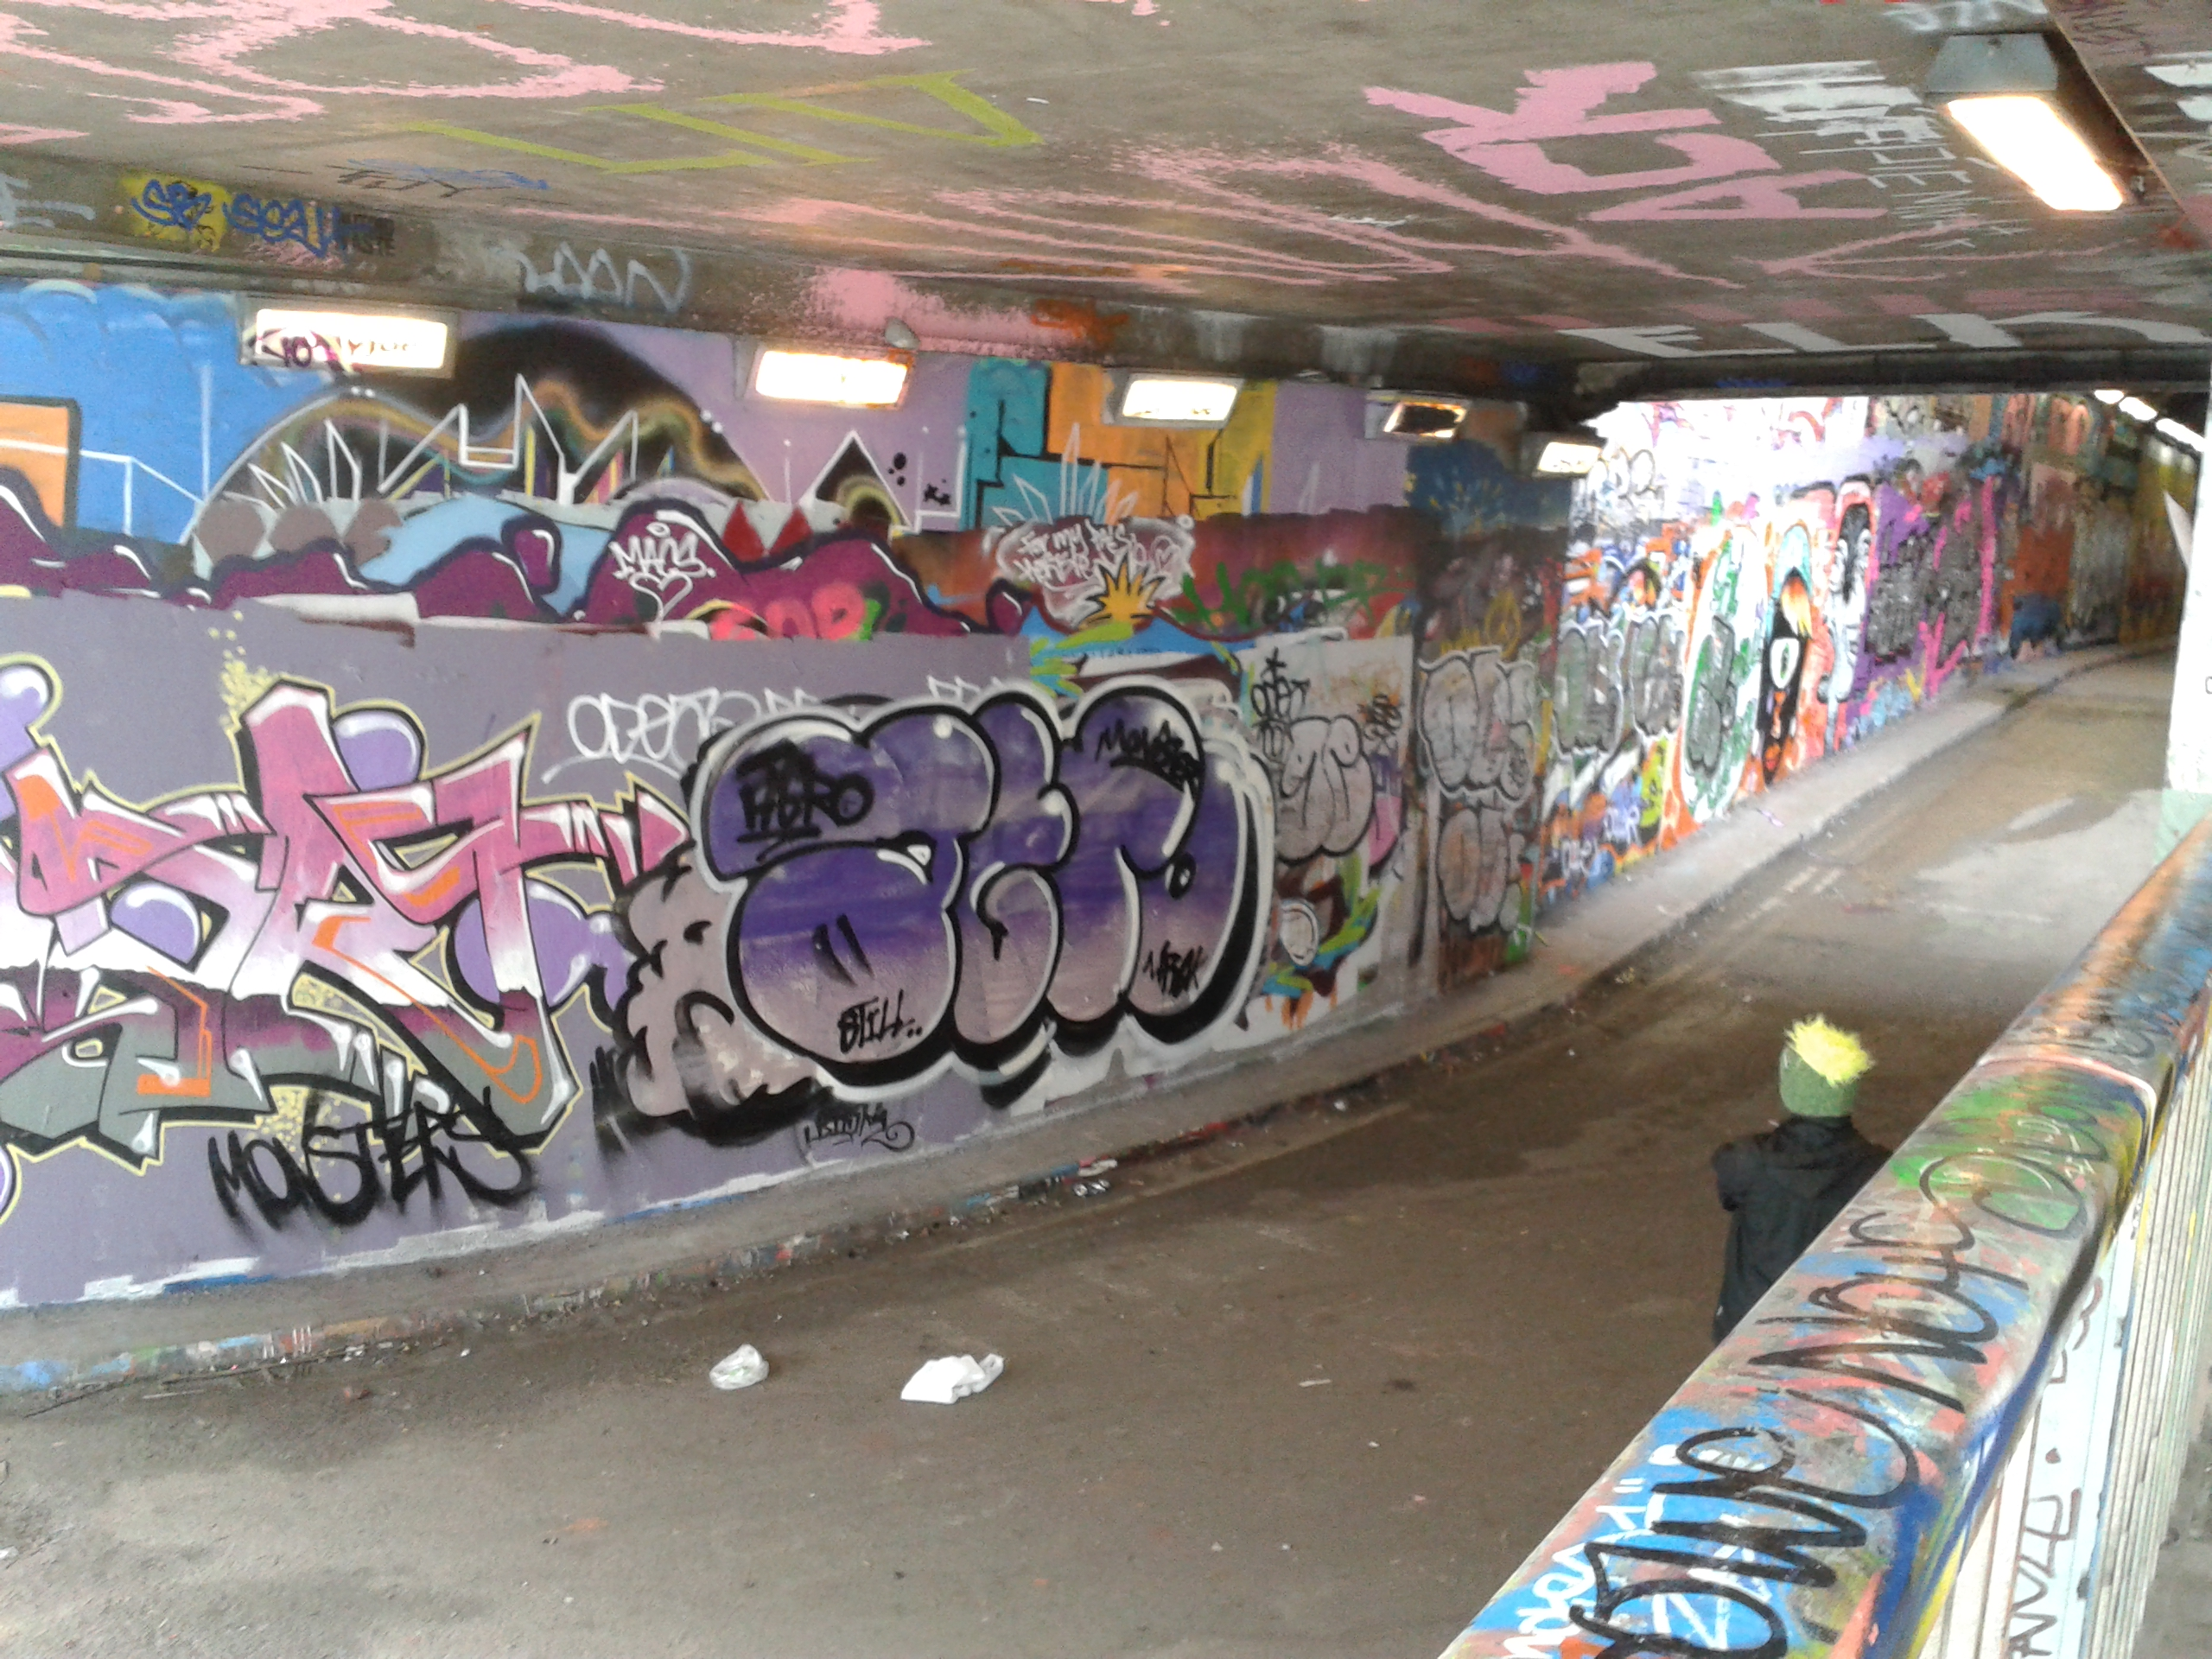

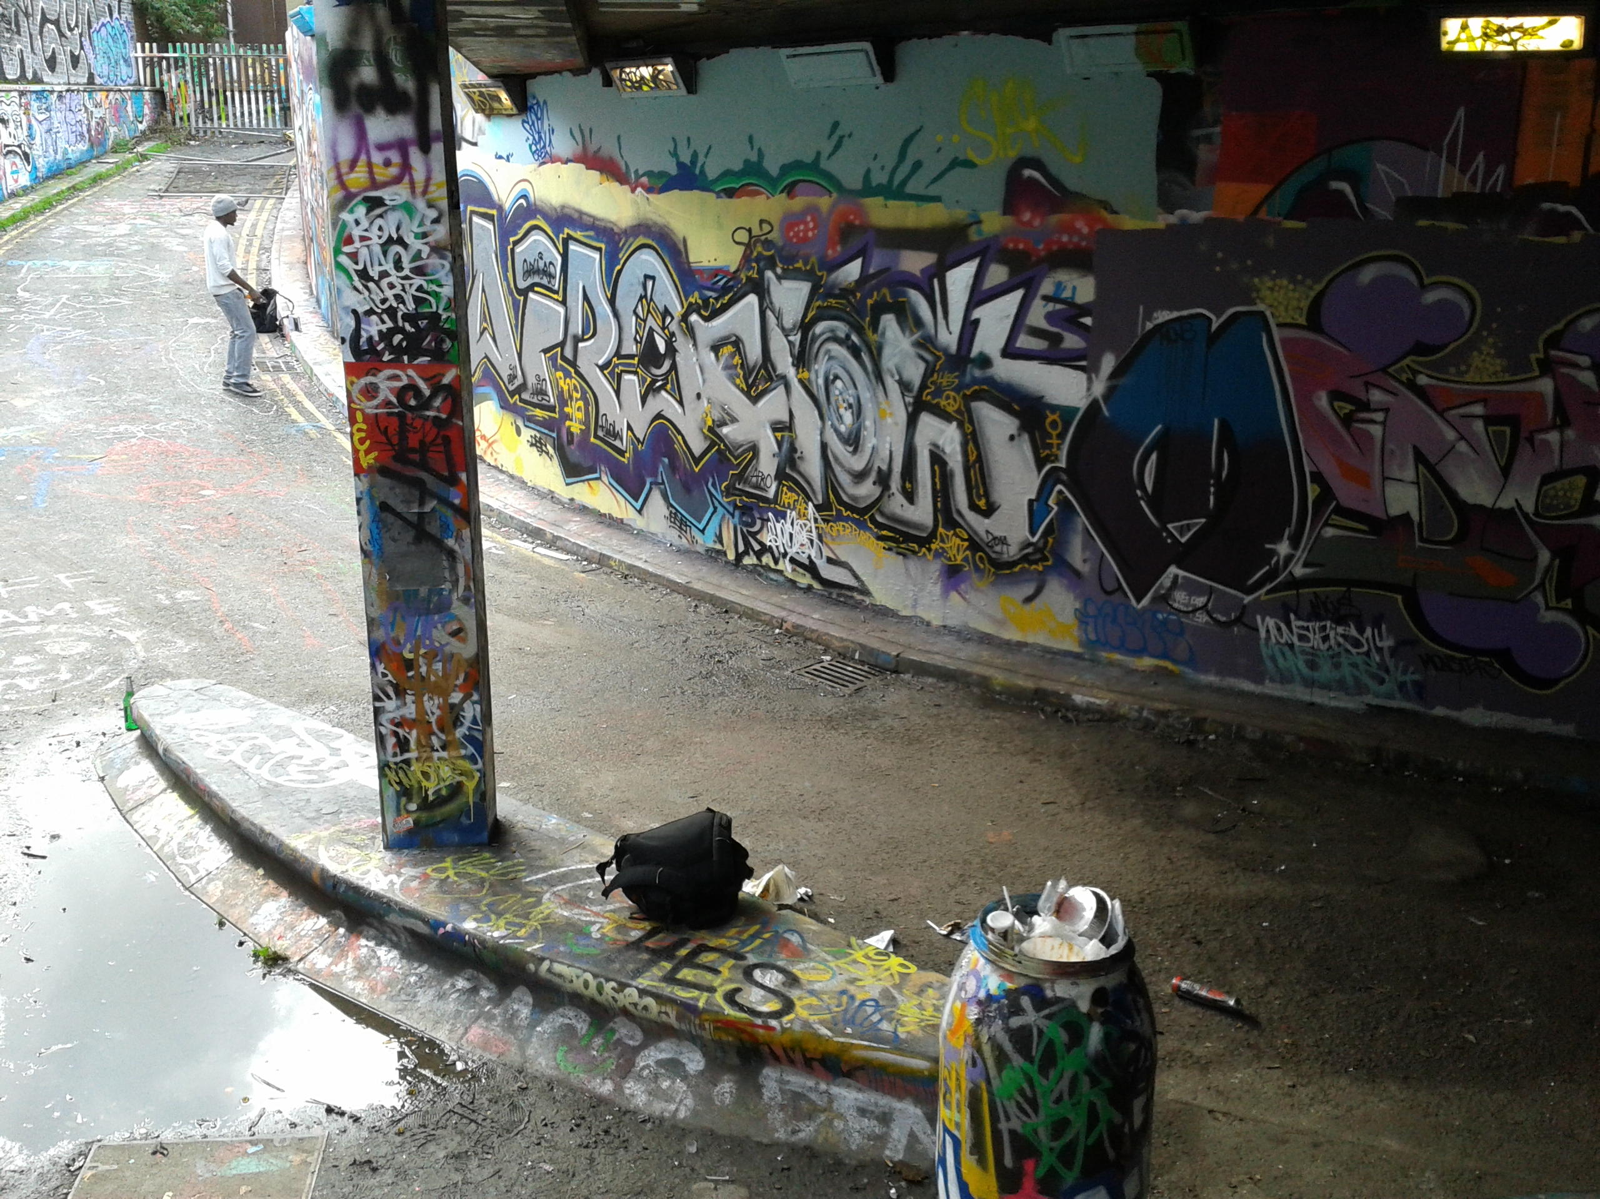

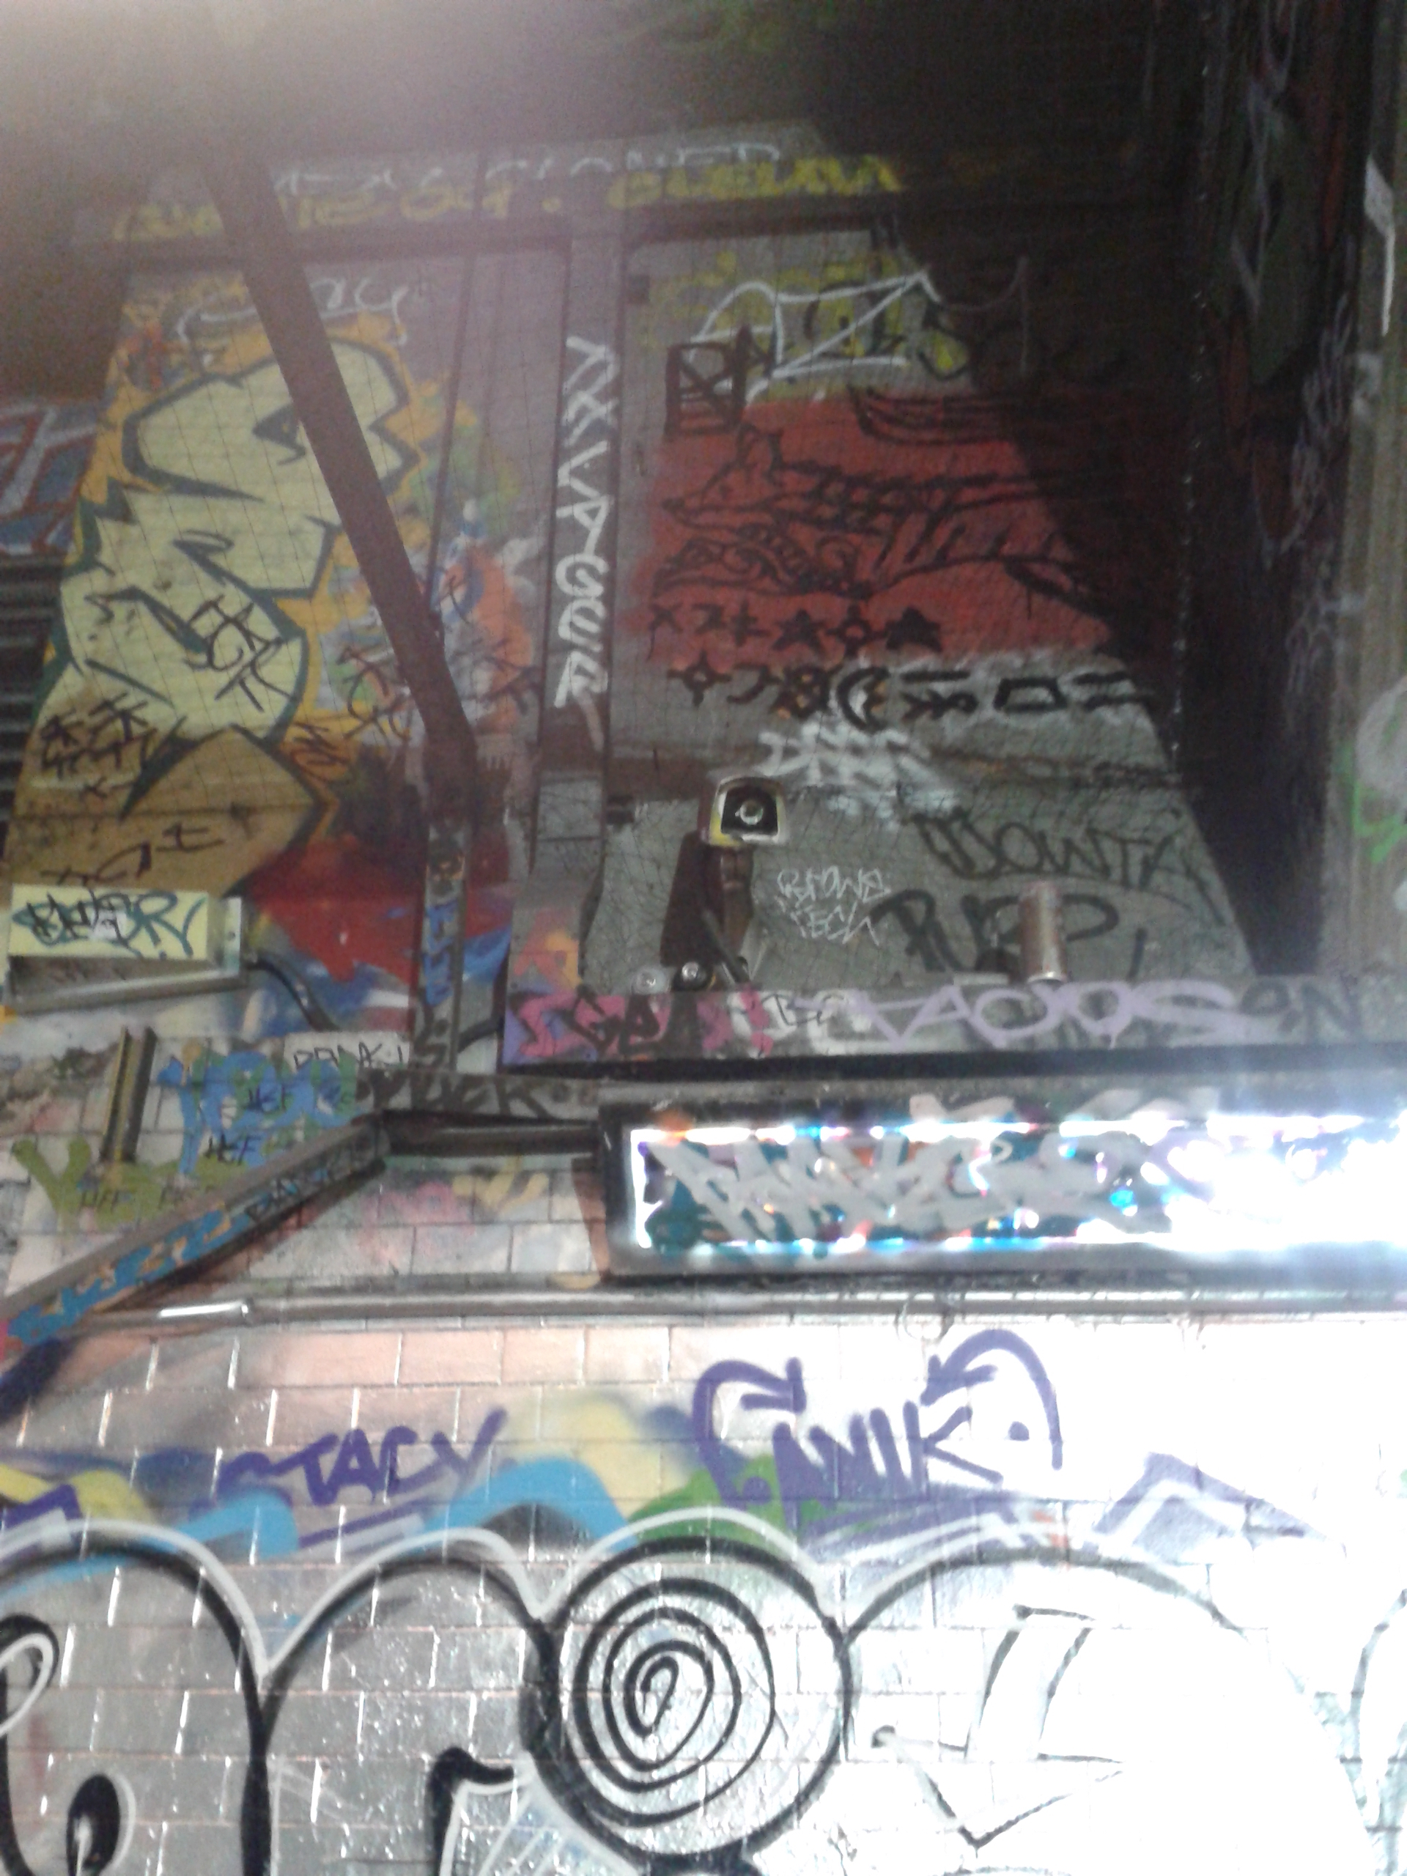
Figure 21. Artists painting surfaces (photo taken by author)

These give some indication of the constant movement-state envisaged and permitted by managers within the Graffiti tunnel. This physical mobility not only provides a democratic way for artists to select the most appropriate ‘canvas’ location for their art pieces, but also liberates the walls from boundaries allowing the space to adapt to changes. To be more specific:

The whole space…kind of you are immersed within the space itself. It’s not like there is a frame on the wall and the white wall there is boxed off, it’s not like each artist has their own thing separate to one another. And it’s also that if you are so inclined you can go and rug yourself against the wall and there is not like a barrier around it. And each person’s artwork is touching everyone else’s artwork. So it’s not like showcasing, also with no explanation everything here is what it is and you make what you will from it, it’s not like there is a prescriptive thing that comes with it where you go in and it’s like oh this is this person who is already as an artist a brand, already well known and then there is their description and everything is contained and explained. Here, everything is completely uncontained and unexplained (Lucy- consumer).

It changes every day, there is different art everyday and it appeals to everyone. I’ve seen an ethnic rainbow here so it’s like everyone and anyone…here they are celebrating all sorts of cultures coming …these are everyone’s cultures here. And I think no one does anything that dominates like the entire tunnel but I guess that the heterogeneity is like the point of the tunnel and the people using the tunnel understand that as well. So I like the fact that there is a huge variety that blurs across eachother… No, it has some messy curation of lots of overlaps and different things colliding (Tom- artists).

The two verbatims clearly illustrate how art pieces flow, collide and overlap building layer upon layer. This physical mobility authors artists to change the space according to their creative needs, ‘to divide it, vary it, to create its different atmospheres and to play out their lives in a variety of surroundings’- as implied by Nieuwenhuys (2001, p. 14). To summarise up to this point, the tunnel describes free trajectories of movement: no physical barriers or boundaries within the space that restrict expression and travel of individuals.

In addition to this, managers have also used the space’ mobility and adaptability to collect inhabitants opinion with regards to the area’s future development plans. In July 2015, Network Rail and Lambeth City Council have organised a public exhibition and market inside the tunnel to view the proposals for the Leake Street arches and test the inhabitants’ reaction to future plans. To accomplish such a task, walls have been used as an open voting poll. During this time, the public was invited to express their thoughts on the development plan by filling in the ‘I want to have/ to keep’ section (Figure 22).
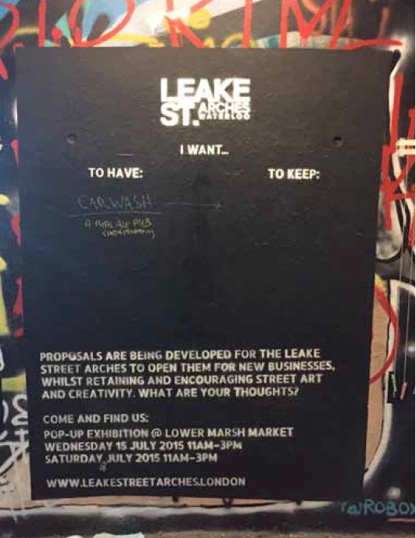
Figure 22. The tunnel as voting pol (photo taken by author)
Similarly, from a consumer perspective, mobility is associated with exploration, activity, adventurousness, and encounters:

I feel that when I am walking through somewhere and taking in something I feel so much more comfortable rather than standing there agitating, so I find that when I am passing through a space ….I felt like the effects, I actually noticed the effects that the space around me has and I was just thinking ‘what is it that I prefer walking to standing there?’ and I was like ‘well it’s because seeing these images and the space around you like going past your eyes as you are walking through somewhere I think it has a sort of like trance sort of… puts me personally in a state of contemplation, really enjoying a sort of like stream of thoughts that I had when walking through. I noticed that the thoughts I am having are more interesting then when I am just standing somewhere and I felt really empowered and sort of like I was exploring and I was taken outside myself. So if I just stand I would be withdrawn and thinking inwardly whereas when I am like walking through somewhere I feel like I am transported out of myself and I feel very empowered and very like I get creative, I guess (Lucy).

Lucy’s comments firstly highlight the importance of movement within the tunnel. The fact that movement is not restricted within the tunnel, such as in orthodox galleries where trajectories are either dictated by architectural objects or signs, here individuals are free to choose their own trajectory in contemplating the surroundings. It must be noted that the tunnel is open day and night with the mention that lights shine during the night and CCTV monitors the tunnel to assure safety. Accordingly, the tunnel can be used around the clock for functional and experiential purposes: i.e. from using the tunnel as a shortcut to stencilling or setting up gigs. As movement is non-restrictive and in perpetual motion, travellers are being transported into their ‘stream of thoughts’ and are enabled to discover the surrounding and murals in their own pace. Also, as the tunnel is quite generous in its shape and size (becoming extremely crowded at street events or graffiti events only) individuals do not feel the pressure of crowdedness- again as in orthodox galleries, and are not interrupted from their reverie as such. Finally, as multiple informants related and the researcher herself experienced, the tunnel’s mobility is empowering through its non-boundaries characteristics but also as a catalyst to a stream of consciousness.

Moreover, physical mobility also stimulates encounters. For example, Ella states,

I like the fact that its still a crossroads for workers, tourists, artists and the shadowy figures round the corner. I make eye contact with people much more down here – who are you – fellow traveller through this space – what are you doing here? – I don’t ask but I think – although I will often smile if I’m looking at the same discovered piece of art that someone else is (Ella).

For Ella and other respondents as well, the tunnel’s physical mobility facilitates encounters between people of different cultures or social backgrounds, but also between the arts of different ‘cultures’ that stimulate debate.

While art in the tunnel changes every two days, Vaults’ inside chambers change monthly according to shows scheduled to inhabit the underground arches. After a careful observation between 2012-2016, I have identified a few objects that have been utilised interchangeably for events taking place at Vaults, events however that are completely different from one another. This demonstrates that Vaults’ requisite leads a nomadic life serving multiple purposes and can be adapted to the shows’ ever-changing needs. This constant movement-state enabled producers to manoeuvre around furniture, lighting and sound installations in creating shows and quite often utilize art pieces, eclectic furniture or clothing items to divide and vary space. For example, Figure 23 shows how the space’ fitness to adaptability allowed for the same room to be vamped for diverse and different shows. Similarly, in 2015 the Vaults Kitchen was opened in a space destined previously for the Vaults Gallery. In this endeavour, producers played around with surroundings and completely altered the atmosphere.

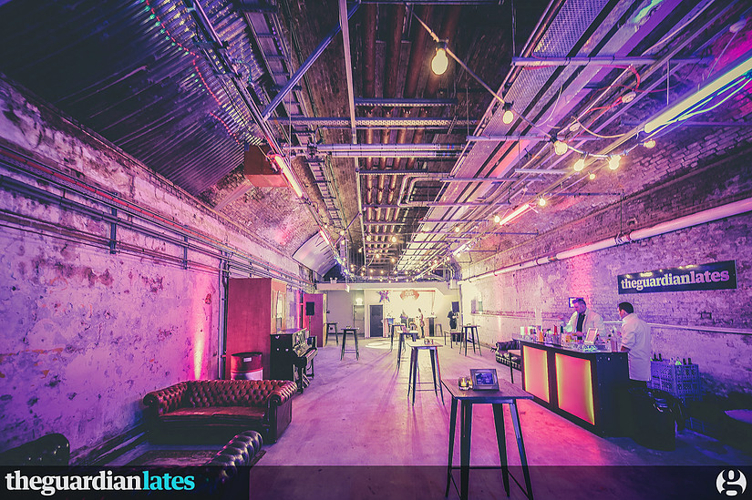

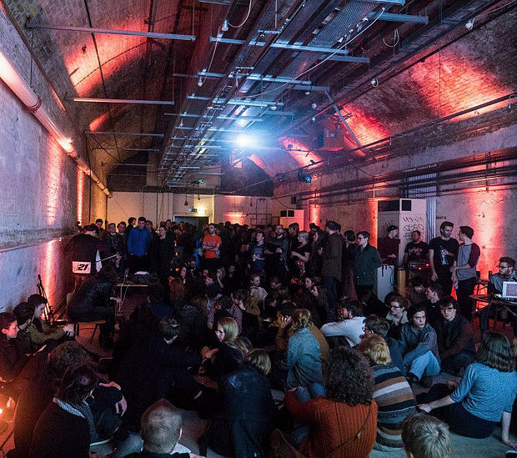
Figure 23. Same chamber- different events (Vaults, 2016)

This argument is excellently exemplified by Anita, who narrates:

I like the way they split up the space, they have taken away the vastness of it by creating subsections. …the gallery bit where the artwork itself is exhibited and the café- a large room actually that is fragmented by pieces of art so that it looks ½ gallery and ½ café. From the point of view of architectural design you can’t have a space that is too big because it won’t be comfortable. So if you have a big living room there is often that kind of strategic positioning of sofas, so kind of the same thing is happening in here (Anita).

As discussed, movable objects are important for adapting the environment according to different needs. However, moveable objects also add to the consumer experience.

All the furniture here…I think they manage it so you feel warm and not like in an arts gallery, you can spend time here not just like go, be silent, see and leave. Here you can touch things and move them around. So the tunnel and inside gallery are a completely new place to me, I have no instructions there, here I am more engaged (Souza).

By using a movable décor, producers facilitate consumer engagement. From moving sofas, board games or the seating swan to feel more intimate, consumers adapt the built environment according to the trajectory of their own choosing and as consequence, feel engaged with the physical environment itself.

Following on from this, in order for interactions between consumers-producers-spatiality to thrive new avenues, it follows that the built environment should envisage an undetermined, non-fixed-pattern form allowing elements to be mobile and flexible. What makes space adaptable is the existence and implementation of an undetermined form with no fixed-patterns. Such a form is prone to naturally creating a habitat of mobile elements that are expected to diversify trajectories of movement and engender a constant movement-state. I argue that flexibility and an undetermined form are preconditions for the emergence of creative alternative possibilities. The emergence of possibilities or alternative trajectories, as envisaged by Harvey (2012), is fruitful only in a relationship of alliance between a space’ undetermined form and its mobile trajectories of movement. By embedding flexibility and undetermined formations an environment becomes open, stimulating, diverse, and accessible to varied talent. Finally, a flexible and undetermined setting is significant in re-using and re-adapting space as incubator units for business start-ups and creative hubs, ‘as headquarters for cutting-edge companies or as artists studios’ (Landry, 2012, p. 123). Since one of the study’s objectives is to explore and analyse the emergence of alternative possibilities on geographically embedded creative markets, it became necessary to highlight a definition of ‘flexibility’. As discussed by Upton (1994), the term has come to be used for many purposes- from manufacturing and operations processes to work flexibility. However, the need to clarify the term as catalyst for alternative possibilities on geographically embedded creative markets is without precedent in the space and place literature. The next section will highlight how the space’ mobility maximizes collaborations and encounters.

4.2.2.1. The Creative Practice of Encounters

Sections even overlap others, creeps on to the side, going up to the centre of the top, of the roof of the tunnel. So at spaces like British Museum or other white cube galleries for example this curator dictates how it’s going to be and look like, whereas here it’s much more free, they organise amongst themselves and the order can change constantly on a daily basis whereas there it’s fixed, here it is fluid and it’s changing (Yasi, visitor)

As Yasi infers and previously discussed, the Graffiti gallery convenes no boundaries, which means no frames to position and present art pieces, as in orthodox galleries. Here by defining limitations or better said the lack of limitations, of imposed rules, the space itself fails in dictating how consumers should behave and channels freedom of movement and expression. The lack of boundaries weaves the tunnel into a large canvas whereby art pieces bleed into each other. This unfettered flexibility unearths collaborations between artists. In some cases, spatiality played a major factor in introducing artists to each other, relationships that incepted future collaboration plans.

I got to meet other artists… usually conversation is based around the piece we're painting or just introduce myself or the other way around. That happens 2/3 times you paint at Leake Street. Many times we'll have a friend who paints in common. Conversations here usually start from paintings mostly or borrowing spray cans… since you're in that environment... it makes sense the easiest thing to discuss is what you have in common. The conversation usually boils down to where are u from, how long have u been painting? What do you paint? Legal / Illegal? Oh do you know _____? Etc. Just starts with a casual conversation about graffiti. Otherwise, yeah I know people who get together to paint every Sunday morning as a social affair and as a way of getting together with friends (instead of football or the pub etc) (Night- artist).

Night’s narrative informs that indeed ‘since you’re in that environment’- i.e. in a manoeuvring space where mobility empowers artists to communicate and collide. Here, the wall as canvas and the accompanying art piece act as facilitators for conversation thus instilling possible further collaborations. In addition, while some artists met for the first time on Leake Street, others meet as a troupe to exhibit their craft during graffiti shows or just as a social gathering. For example, while some artists break down the space into imaginary sections to finalise a piece that spreads across 10m, some use the canvas to practice graffiti for university art projects, while others teach their mates or small children how to stencil. In this sense, flexibility is of a piece with rapid changing and dynamics. To simplify, it becomes clear that flexibility is indeed an ability to change and adapt to different dynamics and equally be responsive to a variety o needs. In this vein, flexibility becomes synonym with adapting, enabling, participation and creativity.

Collaborations however do not occur only within artists’ circle, but can also occur between artists and general consumers. For example, the researcher herself, while talking with a graffiti artist on Leake Street has been offered the opportunity to collaborate on planning the emergence of an art foundation. Similarly, respondents attest to the Graffiti tunnel as an open and flexible space for collaboration.

Furthermore, as painting in the Graffiti gallery is free of cost and the tunnel is highly animated- by tourists, travellers who use the tunnel as a shortcut, regular bike lessons, bikers and skaters, etc- artists utilise the spatiality for advertisement purposes. Informants report how they fell under curators’ radar while working on Leake Street and as a consequence have been offered an opportunity to exhibit in an orthodox gallery or paint a bar’s wall (Figure 24: showing Marc’s work at the tunnel and then inside a Chelsea gallery). Accordingly, I argue that due to the space’ flexibility that maximises encounters, monetary exchanges occur for opportunities that arise from the tunnel.

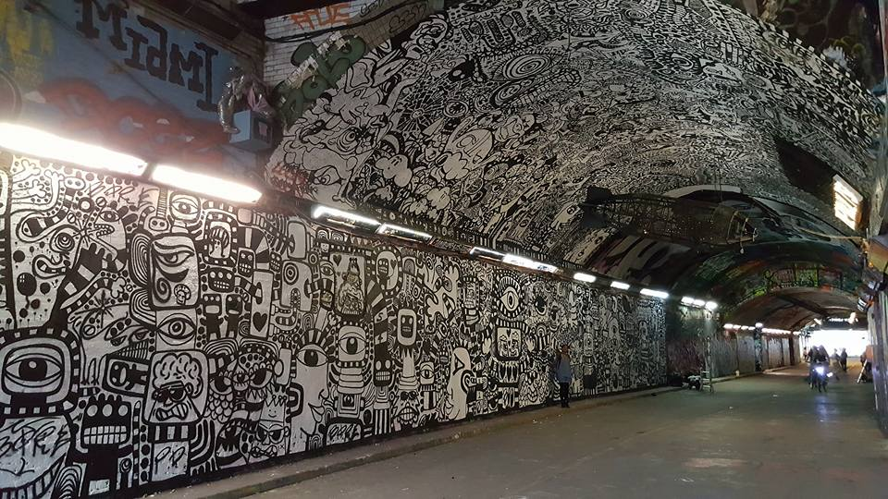

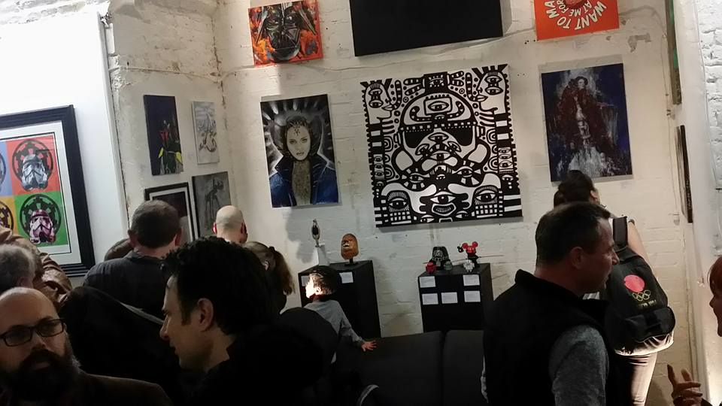
Figure 24. Marc Craig’s piece inside a public space followed by a commercial private space (photos provided by Marc Craig)

Furthermore, the tunnel inspires Vault’s conception and production in every single detail. In programming Vault’s shows, Kieron allows himself to be inspired by the tunnel’s mobility.

Leake Street tunnel tells me what I should be programming and what this space should be and who should it be for. Everything that is going on out there is like fluid, every type of person ever, like seriously every type of person goes through that tunnel and enjoys it in different ways whether as a tourist, local, person who is spraying out there, dudes on bikes, people who want to shoot music videos, every single person goes out there and uses it and that inspires us to what should go on in this building [i.e. the Vaults] (Kieron, Vault’s Director).

In the above excerpt, Kieron describes how the tunnel plays a key role in new market development. To some degree, most performances are replete of seats and are designed on the concept of space exploration. Here, consumers are invited to go on a journey of discovery: discovering the storyline by walking around the venue, but also discovering Waterloo’s underground tunnels. For example, ‘Alice’s Adventure Underground’, one of Vault’s flagship performances, replaces Alice’s character with the audience whereby ‘it is you who falls down the rabbit hole and decides which direction your adventure will take; will you ‘Eat me’ or ‘Drink me’?’. In this sense, the audience travels through a labyrinth created inside Vaults to discover the Underground (Bayes, 2015). While some shows play inside the venue only, others imply a theatrical itinerary whereby the audience is given a certain task and must travel across tunnel or the nearby area. Accordingly, it is being argued that the tunnel’s physical mobility and flexibility inspires equally flexible and nomad performances. Indeed, after discovering the tunnel’s ‘open mindness’ where individuals easily socialize and collaborate, cultural activist and theater director, Martin Firrell incepted one more chamber in the ‘It Ends Here’ 2014 performance; a chamber that was not initially stipulated in the performance’ script, but inspired by the space:

The space started to shape the work, so the entire work in the end was a response purely to the space. The room with the twins was created because I felt it needed one more ingredient…that room did not exist in the original conception (Martin Firrell- producer)

The added ingredient facilitated conversations between actors and the audience while walking through the chamber. Thus similarly to the tunnel’s mobility inspiring collaborations and conversations, the performance’ new chamber echoed the outside space.

Last, but not finally, the tunnel is initially a junction space between two streets; as such, it is being crossed by a large variety of people. To capture this cornucopia of inhabitants’ diversity, Vaults attempted to recreate heterogeneity by producing a wide range of shows: from immersive theatre, promenade shows, gigs, football viewing, cinema, children events, art festivals, gallery shows, workshops, fashion shows and kitchen shows. Thus, as the space holds a variety of individuals in different trajectories of movement, so do performances and exhibitions at Vaults.

So the people out there should be feeling that they are able to go in here and that was why we opened the gallery in the first place [i.e. Vaults’ gallery]. Our doors were shut to Leake Street, we were like a castle with our barrier up and as soon as we opened the doors like other things started happening, like we won the Business of the Year for Lambeth pretty much because we opened the door on Leake Street and if we hadn’t done that then the public and that includes Lambeth Councilors and local visitors would never have come into this space and never seen roughly what it was like. Cause you’d normally come to a ticketing event and if you don’t wanna buy a ticket cause you don’t wanna go to a party or theatre, at least if you would come in not even that far into the building cause you don’t know how big it is, even 50m into the building and explore one bit you’d suddenly feel a little bit more connected with what it is, so that was like a big step and broke the barrier between the venue and Leake Street and connected the two spaces (Kieron, Vaults’ Director).

In this vein, Kieron documents how the tunnel inspired a new product- i.e. Vaults’ inside arts gallery. Reflecting the tunnel’s vibrancy and diversity, Vaults’ gallery represents a market variation by exerting the Graffiti gallery’s symbolic power. The new gallery not only echoes the Graffiti gallery in themes and their variations, but also represents an important tool in inviting and encouraging individuals to enter the establishment. As such, Vaults’ gallery offers an alternative to paying tickets for shows. Specifically, if consumers don’t wish to attend shows at Vaults, they are most welcome to enter Vaults’ gallery and purchase art. In addition to this, the gallery is also a café; therefore individuals can spectate art pieces while enjoying a cup of tea.

Beyond acting as a space conducive to mobility, diversity and collaboration, the Leake Street Arches, by virtue of tensions flamed by the concept of versatility and producers’ desire to source urban renaissance; also support destructive art and innovativeness. According to Marston (2000), tensions arise between structural technologies or forces and practices of human agents. To follow this contention would mean that as the tunnels and Vaults’ space is limited, consumers would find themselves in conflict over the need of context. However, the study finds that in contrary to Marston’s opinions, the lack of available space maximises creativity through artistic destruction. The following section will discuss creative recycling as a practice that facilitates space reconversion.

4.2.2.2. The Practice of Creative Recycling

The Graffiti gallery, although a 300m long tunnel, is a fixed space and thus limited. However, as artists paint pieces on top of pieces, it has been implied that this practice channels physical mobility, versatility and indicates a constant movement- state. Such a space not only broadens social interaction, but also expands usage of urban functions (not constricting them), produces more heterogeneous space (not homogenous) and sparks creative practices.

Indeed, as Tim and Lara (consumers and artists) evoke, art pieces on Leake Street are being replaced almost every single day and if photos would not be taken to document such a rapid movement, art would be lost. As artists look for available space and the tunnel is limited, they are forced towards a practice of layering- i.e. artists in need to express themselves find no other way but to cover previous work. In this endeavour, a disposable society is being created, characterised by ‘art made to be destroyed’. The practice of layering engendered by the space’ mobility is defined by temporality, lack of ownership, participation (as previously implied) and urban regeneration.

It changes every day, there is different art everyday, and I love this state of flux and it will never stop I think. For now it’s so beautiful that so many different artists can come and change this space, every day…it’s a lot of work and it takes so many hours to produce this… it feels like it’s something weird about that kinda like…that flux…that kind like sort of disposable society…like 10 people to see it, that really appreciate it and so on. It’s an inspiring place…cause like I said before, the main thing is going over other people’s work. There is no else where you can do that, I think that’s really cool that you can just be like ‘no, I am improving it or getting rid of it entirely’ and that I think is really creative, and that encourages something that is not encouraged in theatre or writing which is it doesn’t matter if it’s rubbish just do it again and again and again; whereas in a lot of creative practices you have this one of amazing masterpiece and it’s untouchably perfect, whereas this is made to be destroyed and I mean I guess they know that it can get painted over anytime and that they don’t own the space, there is that exception of it can be gone and that’s ok cause it means you can do it again (Tim).

The fact that art in the tunnel changes almost daily catalyses a perennial effect whereby the physical dimension of the space becomes unlimited. This orchestration establishes a democratic space where all consumers (i.e. visitors and artists) exhibit a chance to practice their craft, but also assures that art stays always fresh and exciting. The organic disposal of art through destruction feeds into the larger process of urbanisation as outlined by Lefebvre (2003b). In this sense, artists achieve urban regeneration but also the creation of a specific type of consumer subjectivity. Namely, in using the same territory often conflicts are expected. Contrary to expectations however, the practice of creative layering whereby artists cover previous pieces with graffiti, introduces a more altruistic behaviour:

I think it’s very unselfish and unegotestic to put your work up on the wall, not charge anything and then leave it for someone to paint it over- I think that’s really impressive. I think no one does anything that dominates like the entire tunnel but I guess that the heterogeneity is like the point of the tunnel and the people using the tunnel understand that as well. So I like the fact that there is a huge variety that blurs across eachother (Anna- artist).

In a similar vein, Marc confesses:

The rule is that you accept that it will go. Impermanence is the number 1 rule. The moment I finish the piece I have to let it go. You have to move on to the next one. You can’t take your work home with you. If you don’t share this space then you miss out on the creative energy that builds up in here. That energy, once you share it has no limits… It stays here in the tunnel. Somebody owns the walls, but the energy from the space in the environment, nobody owns that. Here, there is no hierarchy; it’s just the walls. I come down here specifically to enjoy this today. Tomorrow it might not be here. You cannot reclaim this space and call it your own (Marc- artist).

The practice of layering evokes a consumer freed from ownership constraints, a consumer who utilizes the space and does not prevent others from recursively re-using the same ‘canvas’. This finding contrasts literature on ownership that highlights ownership as clearly entailing possession and territoriality, and the prominence of the control criteria and attachment (Rudmin, 1994). Moreover, in contrast to Belk’s (1992) suggestion that possessions become part of the extended self and are used to maintain self-definitions, the Leake Street Arches consumers demonstrate the contrary. In a creative pseudo-public space, consumers test ideas but are not tied to the object or find himself/herself present in it. Instead, consumers attest to an ownership-free ideology defined as a state in which individuals feel as though the physical objects or ideas are not ‘theirs’. The lack of control over space per se and personalization of space as an assertion of identity produce satisfaction whereby individuals are mesmerized by the space’ lack of hierarchy and the created ‘energy’ that lies within the capacity to relinquish power over space. Spatiality here not only informs a process of continuous urban regeneration, but also determines co-ordinates of an ‘unselfish and unegotestic’ consumer drawn by democratic practices.

Collaboration and the right to transfer reflect democratic practices here. This contention is perfectly argued by Marc:

It’s this recycling effect going on, so if I would do an amazing piece here, a day it’s good 2 days it’s a miracle and then eventually someone will scrabble something over it but what it does is it offers the opportunity for other people to work on it as well and then I can come back to replace it. So it’s a very organic process, the taggers do us a favor actually so when I come down here and see that one of my friend’s amazing pieces has been tagged then it is time for me to go over it. It’s a never-ending canvas and it’s one whole art piece, it’s not individual art pieces, the whole thing is an art installation. If you don’t share the space you miss out on a creative energy (Marc- artist).

In the above collaborative work there is no conflict between ‘my’ work and ‘our’ work. Due to the space’ flexible and impermanent nature, a right of transfer between consumers is established. The space organically creates an unwritten rule that attests individuals the right to use each other’s art piece as future canvas without the need of the author’s permission. The author by using the space permits to transfer the right of use and recursively, the right of transfer (Rudmin & Berry, 1987). By transferring such a right, consumers can improve or completely destroy previous work and create a new and fresh piece of art.

Furthermore, managers and producers are aware of the tunnel’s impermanence and in this sense plan activities to assure the continuation of such practices. Upon this quest, managers and producers assure constant cleaning inside the tunnel, when requested artists are offered ladders to paint the tunnel’s ceiling as well, assure the smooth operation of CCTV in the area and implement better lighting systems. Moreover, to establish vibrancy during night-time, managers do not impose any property restrictions and as consequence artists have access around the clock to the tunnel. In this sense, managers and producers address consumers’ needs to further curate practices of layering.

Although Vaults is not open 24h daily, producers aimed to channel the tunnel’s freedom of expression and movement by engaging a relaxed and friendly management:

At Vaults, the management seems very relaxed, friendly. I always felt comfortable when I worked here and they are quite supportive, so it’s a very easy space to work in, just on a social level people are quite friendly. They don’t really tell you ‘you can’t do this and you can’t do that’ and they don’t really interfere with your work. They are quite laid back hosts (Anna).

In the same vein, producers exhibit an effort to recreate the tunnel’s community by hiring personnel that render a friendly and family-like experience:

I try to create some kind of community vibe in every show, we don’t try to make a cool thing here, but an atmosphere that is true to you, we don’t want to make a clean and tidy, but a heartfelt experience. So for example, if you come at the Halloween show, at the bar all my friends would meet you and if you ask a barman ‘come on mate, buy me a drink’ you don’t get a dry attitude but enjoyable and fun, drinks are simple cheap and fast, no queues needed, it’s exactly like what you’d get in a friendly house party….similarly, the security team is mainly all women and that sets a tone like where you are coming into, it’s a bit of a family vibe like you are coming home an your mom is opening the door for you (Kieron, vaults Director).

The verbatims suggest that the tunnel’s spatiality and energy represent a blueprint for producers’ management processes. In this view, it is being suggested that indeed spatiality is an active category in the creation and evolution of market dynamics.

4.3. Representations of Space: Defining managerial control

4.3.1. Introduction

As discussed within the literature review, the rapidly evolving research on market systems has developed our understanding of the role of consumers and producers in the creation and evolution of market processes. One of the study’s objectives however was to consider space as an active category in the market processes and by positioning the framework of ecosystem centre stage, look at the interaction and alliance between consumers-producers-space in shaping such market processes. The current chapter will further analyse this conceptualisation by exploring Lefebvre’s (1991b) ‘representation of space’ dimension.

Representations of space are tied to the relations of production and the ‘order’ imposed by such relations (Unwin, 2000). For Lefebvre, representations of space refer to ‘forms of abstract knowledge that are connected to formal and institutional apparatuses of power involved in the organisation of space’ (Butler, 2012, p. 40). Here, examples include managers and producers in control of spatial form, technocrats, bureaucrats and planners, etc. These practioners subsume knowledge and ideology in their practice (Merrifield, 1993) and as a consequence, convey a dominant ideological approach that channels with it a body of codes and signs (Purcell, 2012; Simonsen, 2005). Hence, managers and producers hold a key role in the production of space. To address this emergence, the following section will look into how managers and producers respect and are inspired by the spatiality’s dominant tendencies as explored in the previous chapter, but ‘feed the beast’ by adding spatial and atmospherical dimensions to renew and regenerate spatial practices. In this view, managers and producers promote ‘a vision of a space marked by free interactions, user determination, and the absence of coercion by powerful institutions’ (Mitchell, 2003b) and capitalize on such a conception.

In this endeavour, the study unpacks three main themes identified while researching the creative pseudo-public space the Leake Street Arches: curiosity and confusion. These themes will be explained fully in the following sections.

4.3.2. How managers and producers use mystery to drive curiosity and confusion in approaching the context

Back in 2014 when the fieldwork for the study started, the tunnel was not stained with Vaults’ advertisements. Quite the contrary, only the wide opened doors, the sometimes accompanied small charcoal board in front of the entrance and a strange looking rocket hanging from the ceiling suggested that there was more to the tunnel than leads the eye (Figure). This mysterious appealing of Vaults’ nature was initially used as a marketing tactic by producers to attract audiences to the venue; mainly because at the beginning, funding was not sufficient to feed into an advertisement campaign, but also because producers wished to respect the Graffiti gallery’s identity and vibration and as consequence, channel the tunnel’s quest for exploration.

When I first started the Vaults, I didn’t have enough money to advertise it, but more importantly for this space to be exciting, underground and secretive, people need to find out not by a big giant ad in the Metro, they need to find out by somebody telling them and that makes it much more appealable and interesting- and this has been done on purpose and that’s what makes the venue the exciting place that it is (Kieron, Vaults’ Director).

The use of mystery as a tactic was derived from a functional need-i.e. the lack of funding, but also from an experiential point of view. Not only did producers wish to further hone the tunnel’s visual identity and vibe, but also add to Vaults’ ‘exciting, underground and secretive’ brand image by getting consumers to ‘labour’ for them. In this sense, managers and producers relied on word of mouth generated from three sources: artists, general consumers and shows created within the tunnel or by Vaults.

As managers and producers actively capitalize on the tunnel’s visual and ideological identity, they also think of collaborative ways to assure the business’ longevity. For example, Kieron requested Lambeth City Council to install better gallery lighting systems within the Graffiti tunnel, so that artists can better paint during dark time, which would ensure that much better pictures can be taken. Capturing visuals within the Graffiti gallery is a very important practice for artists who take pictures of their work to build their online portfolios, but also for general consumers who take pictures to load on social media or use the space as a backdrop for ad/photo shootings. Furthermore, Vaults supports general consumers or third parties who deliver shows within the Graffiti tunnel by allowing entities to use the venue’s facilities free of charge. Accordingly, producers ensure that proper spatial capabilities are installed to further assist the creation of mystery within the tunnel and venue, even if no monetary exchange between Vaults and third parties occurs.

Vaults’ lack of advertisements and guiding signage leads to a state of confusion and curiosity whereby consumers are not sure if to enter the bare entrance in the middle of the tunnel. This state of confusion and curiosity further feed into the concept of mystery:

It intrigues you here, it’s like that rabbit hole that takes you to the next thing. And this is actually how I first found this space the first time, was just by walking in, cause you don’t know exactly what it is, it doesn’t really say or it’s not clear, cause I was walking down the street and I was like ‘this street is cool and the tunnel outside, but what is this?’ and was thinking I might get caught or something if I walk in but then realised that this may be an institution and really celebrates that kind of curiosity (Tim- consumer).

The graffiti kind of disguises the whole tunnel as to what it is really. I think it is definitely hidden… there is no indication that you are welcomed to come down here, it does not advertise itself at all, which is interesting knowing that there is an art space down here. The lack of self-promotion and because you are not being reassured that you are going the right way, you don’t know if you are going the right way. Inside the gallery [Vaults gallery], it has a very large sign telling you that you have arrived at the place that you were intending to go [the Vaults sign], but if you weren’t intending to go here and you saw that sign you’d still wouldn’t know where you were. It just says ‘the Vaults’ it doesn’t tell you anything, it doesn’t say art gallery or performance space, so it’s still confusing and not giving everything away (Lara- artist).

The lack of signage and guidance in this scenario creates a state of curiosity that motivates individuals to question the establishment’s hidden nature. By purposefully evading clear instructions and advertisements, an atmosphere of curiosity is evoked. The complete state of curiosity consumers find themselves in is conceptualised through a series of contrasts that lead to confusion, as described in the table below.

Confusion here is engendered through a palette of contrasts:

Location (Waterloo vs the Leake Street Arches)
I think it’s absolutely fascinating as a contrast to this rest of Waterloo area that’s completely different. You walk towards the end of the tunnel and it’s the London Eye, so it’s this perfect London again. So it’s this chaotic space of self-expression in the middle of this perfection- this clean image of London; I mean you have that and then this hidden in the tunnel (Lucy)

Atmospherics (dirty vs minimal)

So once you step outside the tunnel is very clean and normal Waterloo area, whereas inside here it’s completely different. Inside Vaults, the hallway you don’t see any graffiti- so it’s very clear and minimalistic. And inside it felt like juxtaposition to the outside, it’s very different to the outside feel. The pieces are so chaotic outside and especially at the door, at the entrance but then it starts fading while you go inside Vaults and after you have entered it is blank walls inside (Yasi)

Vibrancy (lack of people inside)

If there is no show on, although the doors to Vaults are wide open there is no music playing until you reach the inside gallery and also there is no staff to guide and reassure that you are following the right direction. This lack of incidental music playing and staff to assure that you have entered an institution add to confusion and perform curiosity (Personal Observation diary)

Table 2.

Table 2 evokes some of the contrasts created by the space outside-i.e. the tunnel vs the space inside- i.e. Vaults. The enchantment derived from the lack of guidance, restrictions and contrasts invite consumers to question the nature of the space, but more importantly how should they behave in such an environment. Firstly, the Leake Street’s colourful tunnel lies in stark contrast to Vaults’ bare entrance. This contrast between a space that consumers immediately associate with public, free, expressive and full of art that challenges the mainstream, finds itself in contradiction with Vaults’ entrance. The stark contrast together with the venue’s lack of signage take consumers on an interrogative process questioning ‘what is this’, ‘am I allowed to go in or not?’ and ‘is this an institution, will I get caught?’ (e.g. Lara, Tim and Ella). In order to comprehend the context, consumers seek ‘the gaps, disruptions, and incongruities differentiating the material world and the worldviews of participants, and brigs these into the dialogue’ (Schneekloth & Shibley, 1995, p. 6). By enabling a practice of interrogation, consumers engage in a dialogue with spatiality wherein they can affirm and construct knowledge to situate and develop a relationship with the space. In this endeavour, the frame of interrogation sparked by a palette of contrasts, instils curiosity that motivates consumers to either enter the venue although not sure if this is permitted and/or continue in exploring the environment. Following on from this it is being implied that mystery curates confusion, which in return stems a practice of interrogation.

The stark contrast between the tunnel’s colourful art and Vault’s sharp emptiness is purposefully created to awake an inquisitive mind and accomplish an experience of exploration. Vaults’ business description is: ‘the Vaults is an arts platform for the bold, the fresh and the fearless. We are here to feed your curiosity and open your mind. Let The Vaults’ maze of underground tunnels swallow you whole’ (Vaults, 2016). Indeed, the events space aims to innovate through fresh collaborative endeavors and to flame an explorative and inquisitive mind.

The space here has always been very forward-thinking, pretty relaxed in terms of their attitude- who they have in and the type of work…here it’s more interesting and more daring, more interrogative, more aggressive as well. But always looking towards investigation and discovery rather than intimidation. The tunnel is a place to spectate and there are some funny pop culture appropriation like the ‘Letgo’ sign on the wall and I quite enjoy seeing that kind of stuff. People questioning mainstream culture and like going through an interrogative process through it. At Vaults, the management seems very relaxed, friendly. I always felt comfortable when I worked here and they are quite supportive, so it’s a very easy space to work in, just on a social level people are quite friendly. They don’t really get protective and tell you ‘you can’t do this and you can’t do that’ and they don’t really interfere with your work. They are quite laid back hosts (Anna).

Anna’s comments attest to how managers and producers have been inspired by the tunnel’s inquisitive nature translated back into Vaults’ programme and mission. To frame such an inquisitive process, producers relax their management style by avoiding managerial restrictions and instead allowing artists to engage in conversations with the venue’s spatiality. For example, during one of Vaults’ Halloween party some of the venue’s chambers remained unlocked for exploration, although the rooms were not part of the show. It is rooted in understanding that although inspired by the tunnel’s identity, managers and producers script the experience:

If they’re [consumers entering the venue] brave they get rewarded by finding the inside gallery, if they’re too brave they get toed off by going too far; different people go different depths. Exploration definitely fits into a lot of stuff, most of the shows will have some kind of exploratory nature to them. If I have an empty room, I’ll keep that open during shows and trying to open up more and more tunnels. People can’t explore what their forefathers built for them and it’s our heritage and totally our right to explore the spaces that we paid for (Kieron, Vaults Director).

The above verbatim demonstrates that firstly, Vaults allows the curious-minded to explore and discover, however although the act of exploration here is not guided through signage it is still scripted- i.e. ‘, if they’re too brave they get toed off by going too far’. Secondly, similarly to how mangers opened a space for public usage, Vaults’ producers acknowledge the act of urban exploration as an experiential purpose but also a civic right. In this sense, exploring and discovery become the performance of urban exploration.

Besides not interfering with artists’ and encouraging individuals’ citizenship right to explore spaces labelled as ‘off-limits’ by capitalists, Vaults managers also pitch for projects designed to aid the public community. Specifically, Kieron requested Lambeth City Council and Network Rail (the landlords) to install gallery lights within the tunnel that will further assist artists in their craft, further attract tourism and assure safety. In this view, I argue that in comparison to other contexts were managers are pure capitalist, the pseudo-public space ushers a new management type: managers and marketers caring for consumers.

4.4. Spaces of representation: A Communal Ecosystem

In Lefebvre’s work ‘space should be seen as the site of ongoing interactions of social relations rather than the mere result of such interactions- a process of production, rather than a product’ (Zhang, 2006, p. 219). While space is a product of interrelations, it is also a process- i.e. space is continuously produced and reproduced (Anderson, 2008). The underlying contention here is that ‘social processes shape and explain geographies but even more so…geographies shape and explain social processes and social action (Soja, 2008, p. 22). In further discussing how space contributes to the constitution of markets, this third section engages Lefebvre’s third element of the triadic production of space, namely spaces of representation.

Representational spaces are associated with the social imaginary of ‘inhabitants and users’ of space in which a multiplicity of meanings and actions are linked to non-hegemonic forms of creative practice (Butler, 2012). In this view, representational spaces provide the means for alternative practices to emerge and develop; ‘they are the sites of counter-discourses that have either escaped the purview of bureaucratic power or manifest a refusal to acknowledge its authority’(Butler, 2012, p. 41). But for the encounter of alternative practices to succeed, as we shall see next, the act of contestation is pivotal. Spaces of representation look at how to challenge representation of space and since space, as Lefebvre writes, may not change but ‘our perceptions of [it] does’ (Hernes, 2004, p. 182).

So far we have discussed entities in interaction and alliance, the next section will look at the importance of conflict and contestation and how such notions produce the alternative trajectories.

4.4.1. Setting the Foundations for Art of Contestation: Creating Chaos

As authorities designated the Leake Street tunnel as a legal wall for graffiti and street art (Ross, 2015), to celebrate this permanent legal right, the governing body created a set of norms, rules and principles of conformity represented by signage marked high up very clearly upon the two entrances (Figure 25): ‘The Tunnel, Authorised Graffiti Area’ compose a code of conduct surging: ‘No Sexism. No Racism. No Adverts. Please take empty cans and litter home. All painting on grey walls will be removed. You don’t have to be a gangster to paint here, so please don’t behave like one’ and ‘Graffiti artists will not be prosecuted beyond this point’. The ‘code of conduct’ communicates the tunnel’s purpose, guides inhabitant behaviour, limits the space to certain practices only, and filters on how the space should be approached. By this token, the governing body limits and controls social inclusivity and aesthetically diverse practices. This feeds into the wider process of space recapitalization where inhabitants are targeted selectively to ensure the city’s economic competitiveness, thus hindering inclusiveness and difference (Paddison & Sharp, 2007).

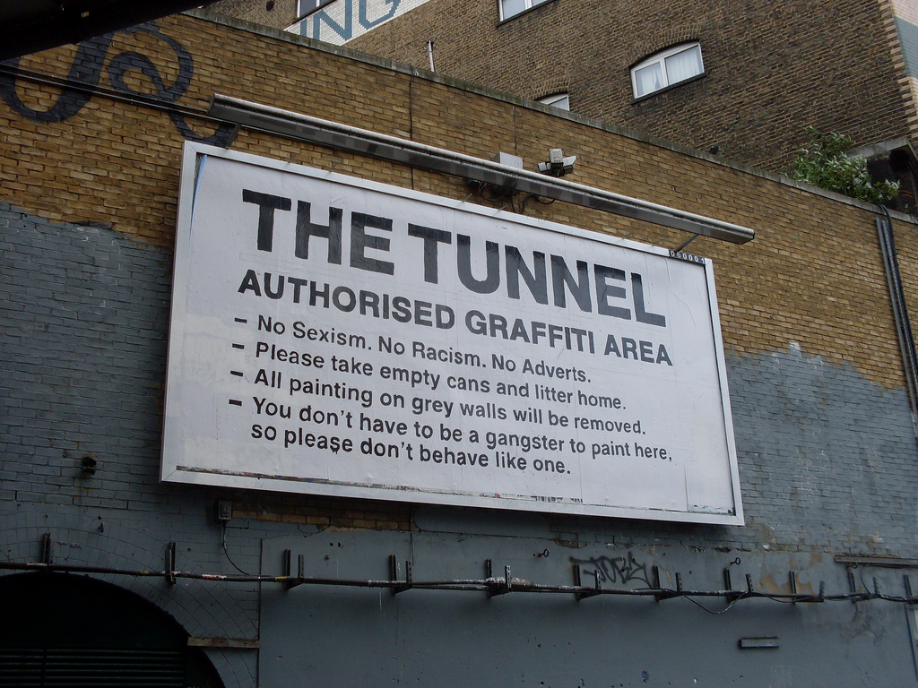
Figure 25: The Tunnel (Google Images, 2008)

Despite the owner’s efforts however to set out clear norms, rules and principles, artists infringed the structure. As Anita narrates, artists take control over rules and regulations by creatively tempering the letters to diffuse the board’s meaning and purposefully twist or divert commitment to the ‘code of practice’ (Figure 26):

I’ve seen this big notice board on the other side and I was wondering…it’s not legally binding when the letters in the word are exchanged...the notice board says “this is an authorised graffiti space, no sexism, no racism, no adverts” but the letters in the word are exchanged and we were wondering because that way it’s not legally binding (Anita).

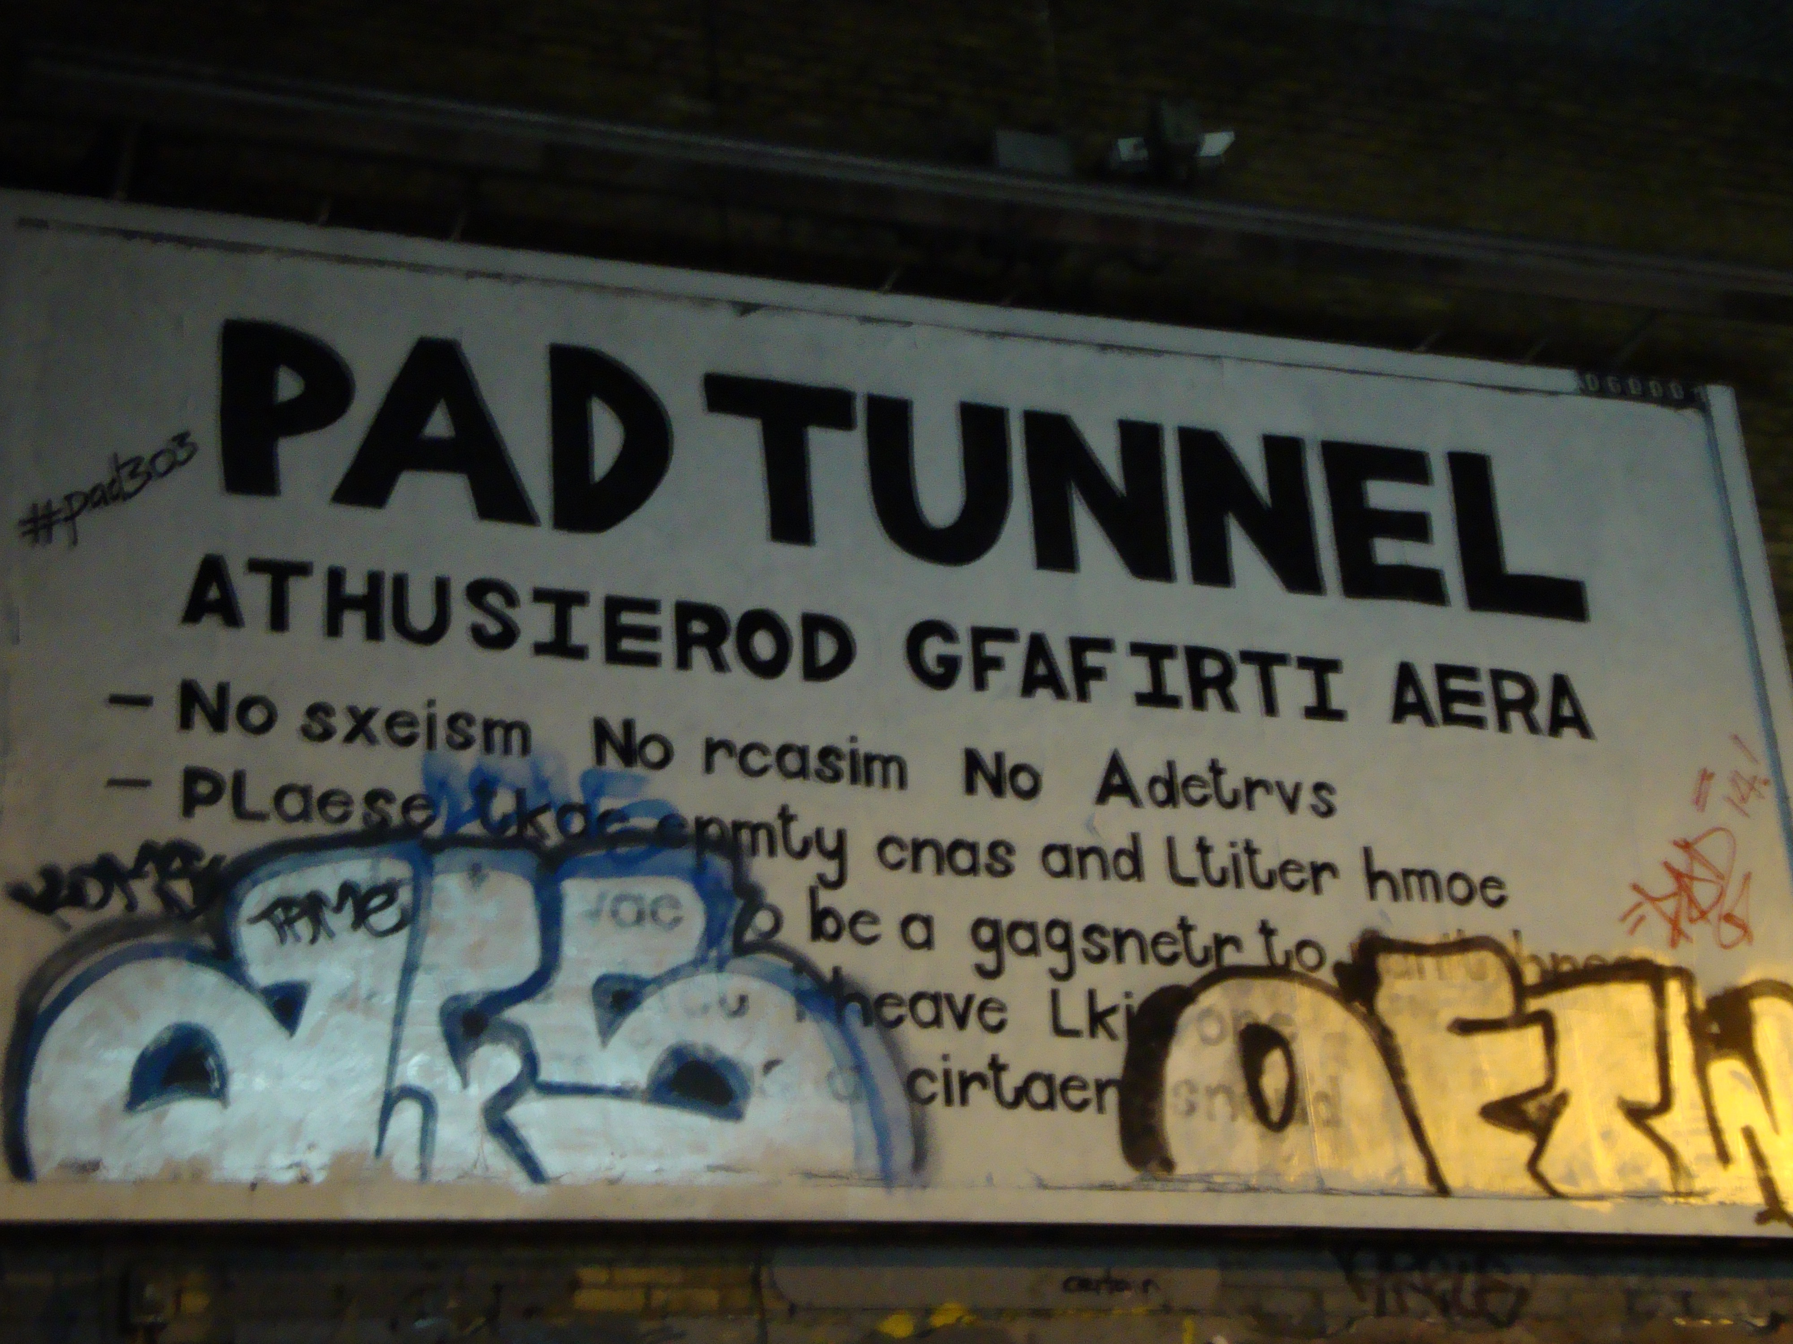
Figure 26. Modifying Rules (picture taken by author)

By modifying the board’s wording and phrasing, artists firstly point towards an explicit exclusion towards other art practices and demographics, and secondly in an upheaval challenge the limitations imposed by owners on how the space is represented and produced (i.e. authorised graffiti area only) and creative practices deployed within the tunnel (i.e. graffiti only). This points towards the fact that although the environment was geared towards a specific set of outcomes, the performance of contestation undermined the given direction and instead engendered an open spatiality. By contesting managers’ rules and regulations, artists liberated the environment from any constraints. The art of contestation here is the central conception of urban space that disrupts the managerial defined normativity premise and opens up the space for new groups of demographics and new kinds of practices to be engaged within the tunnel- ranging from graffiti, culture jamming, painting, filming videos and commercials, mural workshops, learning how to ride- a -bike workshops and live events. What ensues seems to be a heterogeneous urban space that promotes a multidisciplinary chorus of creative practices by overthrowing and replacing the managerial defined ordering.

Although the Leake Street Arches governing body imagined a controlled and ordered environment, after the board has been tempered with however, Network Rail and Lambeth City Council did not exhibit any disapproval of artists’ behaviour, quite the contrary they decided to continue in channeling the ‘energy created…and further organise cool shows…[that are] interactive, fun, and exploratory’ (Kieron). Managers and producers not only did not return to clean or reinstate the tunnel’s signage to its initial exclusionary status, but also continued to service creative access to the tunnel and the arches. In this regard, the practice of contestation is performed explicitly (through contention, objection, questioning or deliberation) and implicitly (through neglect or disregard) (Wiener, 2014). Whereas artists explicitly contested the code of conduct by exerting power through contention and creative practice, authorities not only implicitly neglected and disregarded the behavior and performance, but also persisted in further creating conditions of entry into the tunnel and use of space (e.g. improving the tunnel’s lights and granting no access time restrictions, expanding the creative use of the unused arches). Seeing an implicit contestation in these terms allows us to understand that the normative structure is enacted and performed, thus capturing a power- relation conversation in the internal territorial space of the Leake Street tunnel. As suggested by Wiener (2014, p. viii), any contestation of the normative structure ‘remains bracketed’ or open to continuous contestation and forfeits ‘the central interactive potential of contestation as a social practice that is not limited to notions of opposition, questioning or protest only’. As such the ‘code of conduct’ continued to function as access to regular contestation for all involved space consumers. For instance, Figure 27 shows how the board continued to be painted or tagged over by other artists, space consumers explicitly contested the ‘Tunnel-Authorised Graffiti Area’ signage by replacing its initial content with critical and humorous statements (D, 2016).

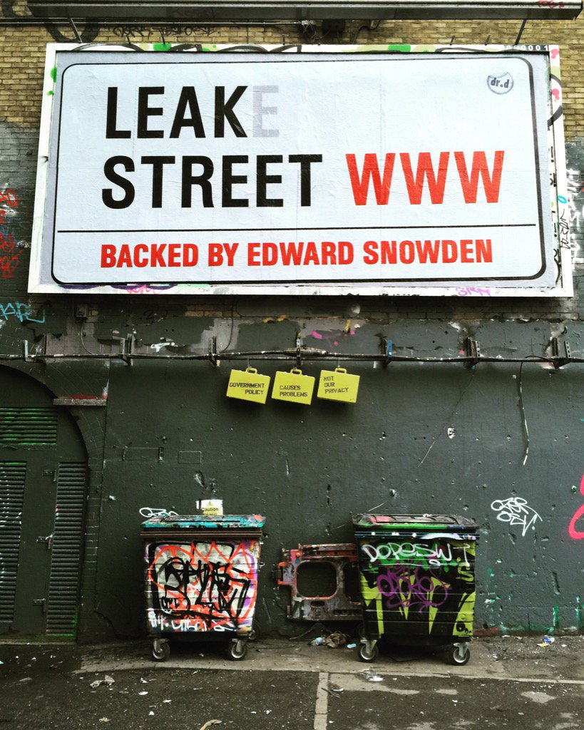
Figure 27: Tempering with rules and regulations (Dr. D, 2016)

Dr. D installed a ‘Leak Street Backed by Edward Snowden’ board and tweeted ‘a home for freedom of expression. #Snowden’ (D, 2015) and Pad shared some of his lifelong experiences (Figure 26). In the same vein, artists also contest each other’s work:

If I see a piece that I think it’s rubbish or a black/white part of the wall and where I have good light, then that’s the spot I am gonna select for my art (Duffy)

It’s this recycling effect going on, so if I would do an amazing piece here, a day it’s good 2 days it’s a miracle and then eventually someone will scrabble something over it but what it does is it offers the opportunity for other people to work on it as well and then I can come back to replace it. So it’s a very organic process, the taggers do us a favor actually so when I come down here and see that one of my friend’s amazing pieces has been tagged then it is time for me to go over it. It’s a never-ending canvas and it’s one whole art piece, it’s not individual art pieces, the whole thing is an art installation (Marc)

This demonstrates that artists not only disrupted the managerial means of expression and order, but also contest each other’s work and as a consequence generate and intensify internal contradictions between ‘capitalist utilizers’ and ‘community users’ (Butler, 2012). What follows is a triumphalism of a creative chaos overthrowing the established order- whether that is defined by managers/producers or consumers themselves- a system to be continuously renewed. The creation of chaos is important for the creative ecosystem in the sense that only through a non-hierarchical system of differences that produces differences can alternative trajectories emerge.

As a result, it is being argued that contestation as a practice stems a vocabulary of chaos: a seed-bed of differences, such as between inclusion and exclusion, that are quintessential to the emergence of an overflow of alternative possibilities (Harvey, 2012). The production of difference, so the argument runs, is engendered by contestation and contradictions between ‘different people with different projects [who] must necessarily struggle with one another over the shape of urban space…out of this struggle the city as a work-as an oeuvre, as a collective if not singular project- emerge, and new modes of living, new modes of inhabiting, are invented’ (Mitchell, 2003b, p. 18 italics in original). This formulation of contradictions rests on three equal stages, which ‘exist in in conflict, interaction and in alliance with each other and do not become reconciled in a synthesis’ (Butler, 2012, p. 15; Lefebvre, 1991b). It is only through a dialectical resolution of contradictions that facilitates an opening for alternative possibilities (Lefebvre, 1991a). For such a space to be nurtured, regular access to contestation and the production of difference needs to be facilitated.

Besides contesting manager and fellow artists, the art of contestation is also shaped by the artwork itself. Both the Graffiti and Vaults gallery shelter art that also discusses political struggle and resisting the mainstream:
Other graffiti were like ‘Paddidas’ and ‘Letgo’ and I like that, I see what they are doing like taking a dig at this big corporations, big companies by twisting the wording. And probably it’s supposed to mock or contest the big companies, so basically, it’s almost like a space of resistance, in a way it’s a resistance, it’s carving out a particular culture of resistance, of self-expression, of trying not to be mainstream, so yeah resisting in a way. But I like the fact that they want to contest the brand. It’s an active resistance really to corporations and corporate power – like the Padiddas and Letgo pieces. And the Vaults I think they are capitalising on this. Cause you have to go through this to go to the Vaults, there is no other way into it. So I think they are capitalising on this alternative thing, the countercultural and slight resistance of this space, they are using the tunnel’s vibe and feeling, this whole feeling of being alternative, different, not mainstream and using it for their own game. It’s not necessarily a bad thing. And so it puts you in a particular mindset before you go in you know ‘oh so this space is like this’- it’s alternative, it’s different. So when you enter Vaults tour brain is already thinking ‘oh, this is alternative’. The tunnel is being used to their advantage, you have to walk through in order to get to the Vaults, so this is this alternative weird space, and then vaults is obviously going to be on the same line.
Inside Vaults, the hallway you don’t see any graffiti- so it’s very clear and minimalistic. And inside it felt like juxtaposition to the outside, it’s very different to the outside feel. The pieces are so chaotic outside and especially at the door, at the entrance but then it starts fading while you go inside Vaults and after you have entered it is blank walls inside (Yasi).

Here, Yasi shows how the tunnel expresses a revolutionary culture whereby artists contest major corporations and inform of political views (figure). This nature is capitalized on by Vaults who ‘bottle’ the experience and recreate the atmosphere at a different scale. Here, the creative ecosystem is a pseudo-market system framed on a organic environment opened for consumers and created by consumers eventually, but also by a commercial annex. The two side of the coins however satisfy a consumers such as artists who actively express themselves and general consumer who voyeur:

It is interesting that as soon as you walk in [Vaults gallery] you come in you become- I become a consumer. So instead of ‘outward’ looking I’m inward looking: what of these things are ‘me’ or might add to me. It's an interesting concept but how does that work with me? So it becomes much more ‘me’. What would this add to my life, might this look good in my living room, and might this look good on my finger. You walk through and it's all about ‘you’. Outside I’m not looking through that space thinking ‘how does this fit in my life?’, I m looking outward: this is interesting, this is a part of the world I don't see, who is in here, what does this mean, what other things have happened here?. This is more: this is a nice seat for me, these are interesting things for me to buy- it’s a different mindset, I think. I ‘lost’ the idea of ‘space’ in the sense of ‘t's a groovy space’, it's interesting, it’s curious, it's pleasing, quirky, but it's on a superficial level. You're not really thinking of it as an idea that's going to change your mindset or lead to anything. I view it in a very different way and it's very comfortable, it's nice and I think I am now used to going to places where interiors are played with. This experience is just odd, this is immersion in a different way- I feel this is catering to me (Ella).

Here [Vaults gallery], it’s more for me to do. So, I can come here for a purpose and here there is guidance. So, outside I could definitely come if I was a sprayer myself, but in here I think there would be more for me to do (like the Life Drawing class) (Anita).

The above verbatim demonstrate that while some acknowledge the consumption experience added by Vaults this does not harm the overall experience, while for some the consumption experience adds agency ‘this is more for me to do’.

Furthermore, as discussed Leake Street Arches is a site owned by the Department for Transport (DfT) and Network Rail (NR) and comprises a public space- presently known as the Graffiti or Banksy’s tunnel- and a private space- the Vaults. Based on an area development schedule, Lambeth City Council, DfT and NR- the governing body- set out an initiative to upgrade the Leake Street Arches by ‘encouraging new uses in the arches to make this route safer...including interesting and more affordable spaces for artists, workshops and cultural uses, and other commercial uses so that over time Leake Street becomes more lively’ (Lambeth, 2008; 2011, p. 34). The schedule was prompted by a need to generate Leake Street Arches as a high-quality safe pedestrian connection, but also as a site aspiring to attract and nurture entrepreneurs, skilled workers, and tourists. In practice, the governing body deliberately enacted a number of policies aimed at surging creativity in the area and implicitly fostering a creative enterprise. To this end, the owners created the conditions whereby, they enhanced Leake Street (LS) as a ‘safe attractive route’ by creating street level entrances and concourse space in enabling pedestrians to use the tunnel as a shortcut between streets, set up CCTV and opened arches to invite creative business development (Lambeth, 2008).

Following this new planning initiative, in 2008, Banksy hosted the three days ‘Cans Festival’ after being granted permission. During this time, the disused road tunnel on Leake Street was transformed into an exhibition space showcasing Banksy’s works as well as inviting street artists from all over the world to exhibit their graffiti art. In Banksy’s words, the Cans Festival aimed that ‘in the space of a few hours with a couple of hundred cans of paint I’m hoping we can transform a dark forgotten filth pit into an oasis of beautiful art’ (BBC, 2008). For a few days only, artists and the general public have been granted temporary permission to carry out the activity of creating an artwork inside Leake Street’s tunnel. It must be mentioned that street artists can operate indoors in private, but conducting street art in public places without permit is considered to be illegal. The event therefore created a platform for young artists to practice street art without the fear of prosecution, and complied with the governing body’s vision to represent Leake Street as a safe, lively and attractive cultural scene. Following the success of two art festivals and a cinema event hosted by Banksy in the disused tunnel, the local authorities designated the tunnel as a legal wall for graffiti and street art (Ross, 2015). Leake Street therefore is one of the first legal graffiti sights in London (maybe the world) that allows individuals to practice street art without the fear of prosecution. In this view, the governing body has ‘appropriated the very activities that were once outside it’ (Mould, 2015, p. 157) and invoked a space where confrontation and collaboration represent a desired outcome. To further enlarge the vision of representing Leake Street as a safe, lively and attractive cultural scene, the governing body spouse the Vaults to further open the tunnels deep under Waterloo station and produce underground cultural events aiming to stimulate:

‘…the value of the cultural hub we’re creating in Waterloo for locals and tourists alike. Popular support is particularly important to independent multi-disciplinary arts spaces like ours, because we are a gateway for emerging and alternative arts of all kinds. We aim to retain the underground, alternative feel of the renowned Leake Street tunnel and expand on it to bring unusual art forms to a wider audience – all of you! We hope it will lead to greater collaboration and success in the community as we continue to build our unusual, yet accessible events spaces.’(Vanstone, 2014).

Accordingly, the tunnel reached its vibrant and creative status in two stages. Firstly, once Leake Street has been baptised as a safe public space, individuals starting using the passageway creating vibrancy. However, it was not until Banksy and his team of artists used the space as an exhibition that the tunnel was morphed into a creative public space that the Graffiti gallery emerged. By allowing infamous artists such as Banksy to use the tunnel as an exhibition space, managers opened the doors to a large variety of artists who channelled a multi-disciplinary chorus of practices. In keeping up with the tunnel’s diversity and freedom of expression, the Vaults- i.e. a private space was opened that matches and capitalises on the Graffiti tunnel. While the tunnel similar to a crucible encapsulates an encyclopaedic agglomeration of creative activities or spatial practices that embraces the production and reproduction of space, the Vaults compliments and capitalises on the tunnel’s production. However, in comparison to scholar inquiry that seeks to understand how and if consumers can escape the market, this study conveys the importance of spaces for consumption in addressing the emergence of alternative trajectories, facilitating the legitimation of space in shaping and creating market processes and finally, in growing a nation of rebels.

In this view, the notion of ‘ecosystem’ has been introduced to define ‘a system evolving the interaction between a community [of entities] in a particular area and its environment’ (Dictionary, 2011b). For instance, Marc argues that:

To me anyone who is walking through Leake Street is partaking in an exchange with the environment. For example...
The artist is using the wall space bringing creativity to the environment (I would include the musicians, fire jugglers and fashion shoots... anything basically that is engaging creativity in the environment of Leake street).
The tourist (on foot or by bike tour) is exchanging currency to experience the environment (people come from around the world to see Leake Street).
The tour guides bring knowledge to the environment in educating others about the space, why it is there and what happens.
The industry bring opportunity to the environment by actively talent scouting (we have had National Geographic and BBC visit along with many other well known industry media brands I am sure).
The local brings a sense of pride to the environment (everyone from someone who lives in a flat across the road to the homeless person who sleeps there at night... Leake Street has pride as it is all inclusive)
The worker that travels through it each and everyday brings responsibility to record to the environment. People record the work that is done so that it is not forgotten. (this would include creatives and tourists taking photos).

All bring an exchange that can change Leake Street for better by exploring all these energies and increasing the personal value that Leake Street has on the many individuals that make it their playground/home/workspace/studio/event space/etc etc etc (Marc- artist).

This interaction and alliance between different entities and the space create the ecosystem whereby all elements in coexistence stimulate eachother and evolve.
Since 2008, the tunnel has been turned into a cultural crucible (i.e. a concentration of commercial and non-commercial cultural entities, artists, and cultural participation) (Nicodemus, 2013). Following on from this, it has been argued that the creative crucible represents a shared endeavor- i.e. partners across private and public sectors and artists alike, implying mutual benefits and reciprocity by shaping a derelict area around arts and cultural activities, but also stimulating experiment and innovation. By forming a set of policies aimed at encouraging cultural stewardship and creative practice, the council’s governing body has set out a plan to animate a private and public space, rejuvenate ‘a dark forgotten filth pit’ into a creative scene, thus fostering a creative enterprise. Through the premise of ‘creativity’, the owners and producers have animated a public and private space, rejuvenated structures and streetscapes, reduced crime and insured safety, and improved entrepreneurial opportunities in the area. This falls in line with Mould’s (2015) urbanity whereby creativity nurtures a more innovative and productive urban scene, thereby stimulating economic rewards, and creating a more rich place for business and attractive tourist destination. Here, the creative crucible improves safety and local business viability, beautifies the neighborhood, and creates an alternative creative urbanity whereby individuals are inspired and inspire.

5. Discussion and Conclusion

Literature on co-creation, co-optation and prosumption has suggested that capitalists recruit and exploit consumers by ‘putting them to work’ and fuel consumers’ needs for freedom and agency by channeling platforms for consumers describing practices, such as customization or personalization, whereby customers experience a sense of freedom (Giesler, 2008; Prahalad & Ramaswamy, 2000; Coimbatore K Prahalad & Venkat Ramaswamy, 2004, p. 18; C. K. Prahalad & Venkatram Ramaswamy, 2004; Ritzer & Jurgenson, 2010; Zwick et al., 2008). As much as consumers exert this freedom, practices continue to be highly controlled and scripted. The ‘managed platforms for consumer practice’ as discussed by Zwick et al., (2008, p. 165) ‘on the one hand free the creativity and know-how of consumers, and on the other channel these consumer activities in ways desired by the marketers’. As such, free reign is given to consumers only with the purpose of exerting their skills and sharing knowledge that shall be later on used as input into production or manufacturing processes (Ritzer & Jurgenson, 2010). In this view, the free consumer subject evoked as partner or collaborator in production and manufacturing activities is being exploited by capitalists for free labour and reducing ‘the risk of consumer behaviour evolving in ways other than prescribed by the company’ (Zwick et al., 2008, p. 168). Although researchers highlight the emergence of a platform where producers supply consumers with assets to create and where consumers exert their skills and knowledge to innovate, studies so far have mainly focused on platforms such as cathedrals of consumption, theme parks, and online communities whereby the consumer sovereignty continues to be scripted and controlled (Ritzer, 2005; Sorkin, 1992). However, in contrast to the literature on value co-creation, co-production and prosumption, the present study firstly documents how spatiality throws off the balance between managers exploiting consumer labor only and consumers not evolving beyond company-scripted experiences. The Leake Street Arches managers exhibit a consumer-caring behaviour characterised through:
- The production of a neutral and flexible environment legitimized as a public space where consumers exhibit a large variety of practices and are allowed to freely curate and manage the site according to their own choosing. This suggests that in contrast to previous studies where managers provide the props for consumption or set a stage where consumers act out various roles, the Leake Street Arches consumers activate as directors and curators. In this view, managers and marketers move beyond sovereign roles informed by the exploitation of consumer labor only and instead channel a more relaxed and caring behaviour by providing an open and democratic space where consumers ‘can effectively apply and enhance their knowledge for the benefit of everyone’ (Zwick et al., 2008, p. 172). In this view, although managers provide the space as resource to create, I argue that the space’ unscripted nature stimulates consumers in various ways and that managers consciously allow consumers to take over and be inspired by the site’s flexibility and openness.
- Vaults’ head-team exhibits a consciously relaxed management by allowing artists who perform at Vaults to organise their shows and exhibitions as they wish and rarely interfere in the process. Secondly, managers believe that consumers have a citizenship right to explore spaces that have been defined as ‘off boundaries’, such as Leake Street’s underground arches, and for this reason open the doors free of charge to individuals, but also submit proposals to Lambeth City Council and Network Rail (the Leake Street Arches landlords) to open further arches with the goal of consumer exploration. Thirdly, managers move beyond their mere roles and actively try to improve the public tunnel for everyone by pitching various projects to the landlords, such as installing gallery lights in the tunnel. This would assist the artists in taking better pictures of their art and thus create better visual portfolios, attract more tourists, but also further improve safety within the tunnel. In addition to this, managers allow entrepreneurs who plan events in the tunnel to use the venue’s facilities, free of charge.

Moreover, in comparison to literature emphasising the commodification of public space and how private spaces have co-opted the public space (Mould, 2015; Paddison & Sharp, 2007), this study demonstrates the contrary. Vaults is informed by the tunnel’s underground ideology, its heterogeneity and democratic nature, but most importantly Vaults opens a private gallery within the venue to mirror the tunnel’s gallery. By this token, firstly the tunnel’s spatiality influences the mergence of a new business opportunity and secondly, its ideology aids managers in attracting and retaining consumers. Accordingly, although managers did provide the tunnel as resource to create, consumers surpassed the tentative company-scripted experience and recreated the tunnel according to their own endeavors, so much that the public space became script for the private space. This finding suggests that pseudo-public spatiality can influence market processes and dynamics and stem alternative possibilities. Such alternatives emerge from contradictions that arise between the two spaces and stimulate heterogeneity. Specifically, the production of the public tunnel vs the production of the private arches adds to a culture of exchange, whereby monetary exchange is eradicated from the public tunnel- although one of the environment’s main function is to exhibit art and is known as a public gallery- and is instead occupied by symbolic exchange. In this sense, although artists exhibit art for free, the association with the private venue Vaults creates media coverage and sources free publicity, but also acts as an artistic networking platform and live studio. Through the space’ public nature, consumers don’t pay entrance and have the chance to see an artist live at his work.

Furthermore, the collaboration between the public and private space is based on a key principle: creativity. In the last decades, creative hubs or clusters and the ‘creative age’ have taken marketing research by storm in the sense that ‘creative work creates more markets and opportunities to tap the creative capabilities of far greater numbers of people’ (Florida, 2002, p. xvii). My research shows how the neutrality and flexibility of a forgotten and ruin space inspires art practices and channels an organic environment where consumers lead their craft. As the tunnel is free from managerial-defined scripts or control, multiple practices emerge that bleed into each other. Such a heterogeneous, open, and tolerant space further draws creative individuals looking to unleash their craft in an appropriate environment. Accordingly the tunnel is a creative center due to its multidimensional, diverse, and democratic nature, but most importantly because art in the tunnel changes daily. As a 300 m tunnel, space is finite and for this reason consumers not only practice art recycling, but also recycle the space through art- a constant cycle of creative reproduction. Such a practice is for the benefit of everyone, as the tunnel further attracts tourists and entrepreneurs, while artists profit from a perennial canvas. Creativity at the Leake Street Arches was initially engaged by managers to ensure safety in the tunnel and vibrancy, so that individuals feel secure in using the tunnel as a passageway. However, once artists found a ‘live studio’ within the tunnel, art served in space reconversion, sustainability, and art recycling. An already famous place among artists, consumers and tourists, the tunnel’s underground and open nature inspired the Vaults as a business. The tunnel’s creative vibe dictates the venue’s set of programme, financial planning (i.e. dividing the venue’s efforts between shows that sell out and more underground shows that further build the venue’s brand), but also inspired the Vaults to host a gallery that mirrors the ‘outside’ gallery and where consumers can purchase art, engage in art workshops or ‘unwind’ at the venue’s café. Although studies do document how managers and marketers have set in motion projects to reconceptualise older industrial buildings as incubator units for start-up companies, how such sites assist sustainability and the role of artists as regenerators (Landry, 2012), this study breaks down the inflexible divides between private space that capitalizes public space, between managers and producers that exploit consumer labor and conversely consumers trying to escape the market, and instead highlights a more hybrid environment represented by the Leake Street Arches. The context is represented by a creative organic public space where artists freely exhibit their craft and a private space that takes inspiration from the first and moves away from traditional capitalistic endeavors. The Vaults capitalizes on the tunnel’s nature, but also portrays a more caring management model whereby managers seek to stimulate the environment by mirroring the tunnel and further feeding into consumers’ appetite for the underground themes- such as resistance and citizenship, but also taking initiatives beyond their job description to improve the tunnel and build relationships with artists. In this vein, I argue that the new hybrid environment, an alternative creative ecosystem is being defined as ‘a biological community of interacting organisms and their physical environment’ (Dictionary, 2011a), a formulation of equal terms between public and private space where consumers and producers exhibit a collaboration beyond monetary exchange and where space plays a crucial role in maintaining such a democratic relationship. To summarize, I argue that one of the study’s contribution is exemplified by the emergence of a new empirical context: the alternative creative ecosystem that balances dynamics between consumer-producer-space. Through a shared endeavor between such entities, multidimensional forms of creativity take root, flourish, and then are destroyed to allow better and alternative forms to take place (i.e. creative recycling). Accordingly, the alternative creative ecosystem is understood in this study as a public-private partnership that works as an incubator unit for developing synergies and providing mutual support and where creative exchange can occur through a partially organic-partially capitalist form.

A second contribution of this study has been to introduce Lefebvre’s theory of the production of space to the creative class and introduce an understanding of how the interplay between spatial practice-representation of space-spaces of representation consolidate the creative industry by breaking away from dichotomies such as commercial vs non-commercial, public vs private, self-managed vs corporate managed and instead propose a more democratic collaboration between consumers-producers-space. For spatial practices to embrace ‘production and reproduction, and the particular locations and spatial sets characteristic of each social formation’ (Lefebvre, 1991b, p. 33), spatial form has to be first and foremost flexible and versatile. The study shows that the Leake Street Arches’ neutral, flexible and versatile form is conducive to a creative organic hub that stimulates multifarious practices such as creative recycling that produces space reconversion, but also a large variety of mobile practices such as skate- and bike-riding workshops. Here, space stimulates creativity, which is an element of production and reproduction of spatial formation, a safety measure, and an economic resource, but also a great resource of alternative trajectories. It is the environment’s proneness to contrasts such as outside vs inside, large vs small, dark vs light, mainstream vs underground, controlling vs democratic that conjures up creative resources. Here, creativity is quintessence in delineating spaces of difference and possibility where ‘something different is not only possible, but foundational for the defining of alternative and revolutionary trajectories’ (Harvey, 2012, p. xvii). Representations of space or conceived space highlight the ways in which managers, producers, landlords and stakeholders mould and control an environment. As discussed however, the Leake Street Arches’ managerial team is characterised by a more relaxed and consumer-caring style, equipped with a mission of creating revenue and customer retention, but also enlarging consumers’ horizon by opening up spatial locations that are usually ‘off limits’ and allowing consumers to freely express creatively. In this sense, managers usher a shift from despotic to democratic producers who encourage creative citizenship and urban exploration. Finally, spaces of representation are lived spaces ‘directly lived through its associated images and symbols, and hence the space of inhabitants and users’ (Lefebvre, 1991b, p. 39). While the tunnel portrays an underground, illicit, free and open, democratic and versatile atmosphere, the venue contrasts the first through a more capitalist and commodified atmosphere although trying throughout to mirror the tunnel. In this view, consumers use creativity as an act of resistance to formulate their thoughts and feelings against mainstream and capitalist formulations. However, central to Lefebvre’s triadic representation of space rests on the three equal terms spatial practice-representation of space-spaces of representation that exist in a continuous interaction with each other; it is only through such a continuous and cyclic reproduction of space that transformations and alternative trajectories can be evoked.
In conclusion, by using an interpretivist approach and case study strategy the study’s intention was to explore the creative pseudo-pubic space in creating and evolving market alternative trajectories.

Bibliography

Anderson, B. (2008). For Space (2005): Doreen Massey. Key texts in human geography, 227-235.
Arnould, E. J., & Price, L. L. (1993). River magic: extraordinary experience and the extended service encounter. Journal of Consumer Research, 24-45.
Arnould, E. J., Price, L. L., & Tierney, P. (1998). Communicative staging of the wilderness servicescape. The Service Industries Journal, 18(3), 90-114.
Arnould, E. J., & Thompson, C. J. (2005). Consumer culture theory (CCT): Twenty years of research. Journal of Consumer Research, 31(4), 868-882.
Askegaard, S., & Linnet, J. T. (2011). Towards an epistemology of consumer culture theory Phenomenology and the context of context. Marketing theory, 11(4), 381-404.
Aubert-Gamet. (1997). Twisting servicescapes: diversion of the physical environment in a re-appropriation process. International Journal of Service Industry Management, 8(1), 26-41.
Aylward, G. M. (1966). Environmental adaptability. Massachusetts Institute of Technology.
B Joseph Pine, I., & Gilmore, J. H. (2011). The experience economy: Harvard Business Press.
Babin, B. J., & Attaway, J. S. (2000). Atmospheric affect as a tool for creating value and gaining share of customer. Journal of Business Research, 49(2), 91-99.
Bagozzi, R. P. (1975). Marketing as exchange. The Journal of Marketing, 32-39.
Baker, J., Levy, M., & Grewal, D. (1992). An experimental approach to making retail store environmental decisions. Journal of Retailing.
Barker, C. (2003). Cultural studies: Theory and practice: Sage.
Bayes, H. (2015). Alice's Adventures Underground. Retrieved from http://www.timeout.com/london/theatre/alices-adventures-underground
BBC. (2008). Tunnel becomes Bansky art exhibit. Retrieved 2 April 2016, from BBC http://news.bbc.co.uk/1/hi/england/london/7377622.stm
Becker, F. D. (1981). Workspace: Creating environments in organizations: Praeger New York.
Belk, R. W. (1992). Attachment to possessions Place attachment (pp. 37-62): Springer.
Belk, R. W., & Costa, J. A. (1998). The mountain man myth: A contemporary consuming fantasy. Journal of Consumer Research, 25(3), 218-240.
Belk, R. W., Ger, G. l., & Askegaard, S. r. (2003). The fire of desire: a multisited inquiry into consumer passion. Journal of Consumer Research, 30(3), 326-351.
Belk, R. W., Wallendorf, M., & Sherry Jr, J. F. (1989). The sacred and the profane in consumer behavior: Theodicy on the odyssey. Journal of Consumer Research, 1-38.
Bendapudi, N., & Leone, R. P. (2003). Psychological implications of customer participation in co-production. Journal of Marketing, 67(1), 14-28.
Bennett, D. J., & Bennett, J. D. (1970). Making the scene. In G. Stone & H. Faberman (Eds.), Social psychology through symbolic interactionism (pp. 190-196). Waltham: MA: Ginn Blaisdell.
BERLY, J. R. K. (1995). How Firms Adapt to Evolving Markets. Redesigning the Firm, 218.
Bitner, M. J. (1990). Evaluating service encounters: the effects of physical surroundings and employee responses. The Journal of Marketing, 69-82.
Bitner, M. J. (1992). Servicescapes: the impact of physical surroundings on customers and employees. The Journal of Marketing, 57-71.
Bodnar, J. (2015). Reclaiming public space. Urban studies, 0042098015583626.
Bolton, A., Pole, C., & Mizen, P. (2001). Picture this: Researching child workers. Sociology, 35(02), 501-518.
Brown, L., & Durrheim, K. (2009). Different kinds of knowing: Generating qualitative data through mobile interviewing. Qualitative Inquiry.
Brownill, S. (1993). The Docklands experience: locality and community in London. British Urban Policy and the Urban Development Corporations. London: Paul Chapman, 41-57.
Bryman, A. (2003). Quantity and quality in social research: Routledge.
Butler, C. (2012). Henri Lefebvre: Spatial politics, everyday life and the right to the city: Routledge.
Caldeira, T. (1994). Variations on a Theme Park: The New American City and the End of Public Space. Journal of Architectural Education, 48(1), 65-67.
Çalışkan, K., & Callon, M. (2010). Economization, part 2: a research programme for the study of markets. Economy and Society, 39(1), 1-32.
Canniford, R., & Shankar, A. (2013). Purifying practices: How consumers assemble romantic experiences of nature. Journal of Consumer Research, 39(5), 1051-1069.
Carson, D., Gilmore, A., Perry, C., & Gronhaug, K. (2001). Qualitative marketing research: Sage.
Carù, A., & Cova, B. (2007). Consuming experience: Routledge.
Cassidy, T. (1997). Environmental psychology: Behaviour and experience in context. East Sussex: Psychology Press Ltd.
Castilhos, R., Dolbec, P.-Y., & Veresiu, E. (2014). Conceptualizing the Space of Markets: How Spatiality Influences Market Dynamics. NA-Advances in Consumer Research Volume 42.
Celsi, R. L., Rose, R. L., & Leigh, T. W. (1993). An exploration of high-risk leisure consumption through skydiving. Journal of Consumer Research, 20(1), 1.
Chatzidakis, A., Larsen, G., & Bishop, S. (2014). Farewell to consumerism: Countervailing logics of growth in consumption. ephemera, 14(4), 753.
Chatzidakis, A., Maclaran, P., & Bradshaw, A. (2012). Heterotopian space and the utopics of ethical and green consumption. Journal of Marketing Management, 28(3-4), 494-515.
Chatzidakis, A., & McEachern, M. (2013). Roundtable- Consumption in and of Space and Place.
Chronis, A., Arnould, E. J., & Hampton, R. D. (2012). Gettysburg re-imagined: The role of narrative imagination in consumption experience. Consumption Markets & Culture, 15(3), 261-286.
Cohen, L., Manion, L., & Morrison, K. (2000). Action research. Research methods in education, 5, 226-244.
Cohen, L., Manion, L., & Morrison, K. (2013). Research methods in education: Routledge.
Cohen, S. S., & Fields, G. (1999). Social capital and capital gains in Silicon Valley. California management review, 41(2), 108-130.
Council, L. C. (2013). Local Plan Pre-Submission Publication.
Cremin, H., Mason, C., & Busher, H. (2011). Problematising pupil voice using visual methods: Findings from a study of engaged and disaffected pupils in an urban secondary school. British Educational Research Journal, 37(4), 585-603.
Creswell, J. W. (2013). Research design: Qualitative, quantitative, and mixed methods approaches: Sage publications.
Crucible, T. (2016). The Crucible. Retrieved from http://thecrucible.org/about/
D, D. (2015). #Snowden. Retrieved from https://twitter.com/subvertiser/status/675297736145698816
D, D. (2016). Dr D Artist Biography. Retrieved from http://www.artrepublic.com/biographies/22-dr-d.html
Davis, T. R. (1984). The influence of the physical environment in offices. Academy of Management Review, 9(2), 271-283.
Davison, N., Gibb, A. G., Austin, S. A., Goodier, C. I., & Warner, P. (2006). The Multispace adaptable building concept and its extension into mass customisation.
De Certeau, M. (1984). The practice of everyday life. Berkeley: University of California Press.
Debenedetti, A., Oppewal, H., & Arsel, Z. (2014). Place Attachment in Commercial Settings: A Gift Economy Perspective. Journal of Consumer Research, 40(5), 904-923.
Deighton, J. (1992). The consumption of performance. Journal of Consumer Research.
Denscombe, M. (2014). The good research guide: for small-scale social research projects: McGraw-Hill Education (UK).
Denzin, N. K., & Lincoln, Y. S. (2005). Introduction: the discipline and practice of qualitative research. In N. K. Denzin & Y. S. Lincoln (Eds.), The Sahe Handbook of Qualitative Research (Vol. 3rd Edition, pp. 1-32). CA: Sage.
Dholakia, N., & Firat, A. F. (1998). Consuming people: From political economy to theatres of consumption: Routledge.
Diamond, N., Sherry Jr, J. F., Mu√±iz Jr, A. M., McGrath, M. A., Kozinets, R. V., & Borghini, S. (2009). American Girl and the brand gestalt: Closing the loop on sociocultural branding research. Journal of Marketing, 73(3), 118-134.
Dictionary, A. H. (2011a). American Heritage® Dictionary of the English Language. Retrieved from http://www.thefreedictionary.com/ecosystem
Dictionary, A. H. (2011b). Ecosystem. American Heritage® Dictionary of the English Language. Retrieved from <a href="http://www.thefreedictionary.com/ecosystem>
DiMaggio, P., Bourdieu, P., Passeron, J.-C., Nice, R., Bourdieu, P., & Nice, R. (1979). On Pierre Bourdieu: JSTOR.
Dobscha, S. (1998). The Lived Experience of Consumer Rebellion Against Marketing. Advances in Consumer research, 25(1).
Dolbec, P.-Y., & Fischer, E. (2015). Refashioning a field? Connected consumers and institutional dynamics in markets. Journal of Consumer Research, 41(6), 1447-1468.
Donovan, R. J., & Rossiter, J. R. (1982). Store atmosphere: an environmental psychology approach. Journal of Retailing, 58(1), 34-57.
Dyson, S., & Brown, B. (2005). Social theory and applied health research: McGraw-Hill Education (UK).
Edvardsson, B., Enquist, B., & Johnston, R. (2010). Design dimensions of experience rooms for service test drives: case studies in several service contexts. Managing Service Quality, 20(4), 312-327.
Elden, S. (2001). Politics, Philosophy, Geography: Henri Lefebvre in Recent Anglo‐American Scholarship. Antipode, 33(5), 809-825.
Elden, S. (2004). Understanding Henri Lefebvre: A&C Black.
Ertimur, B., & Coskuner-Balli, G. (2015). Navigating the institutional logics of markets: Implications for strategic brand management. Journal of Marketing, 79(2), 40-61.
Evans, J., & Jones, P. (2011). The walking interview: Methodology, mobility and place. Applied Geography, 31(2), 849-858.
Ewen, S. (1999). All consuming images: The politics of style in contemporary culture: Basic Books.
Ezeh, C., & Harris, L. C. (2007). Servicescape research: a review and a research agenda. The Marketing Review, 7(1), 59-78.
FATLDN. (2010). A taste of Banksy’s ‘Exit through the gift shop’ at Lambeth Palace. Retrieved from https://fatldn.wordpress.com/2010/02/26/a-taste-of-banskys-exit-through-the-gift-shop/
Firat, A. F., Dholakia, N., & Venkatesh, A. (1995). Marketing in a postmodern world. European Journal of Marketing, 29(1), 40-56.
Firat, A. F., & Venkatesh, A. (1995). Liberatory postmodernism and the reenchantment of consumption. Journal of Consumer Research, 239-267.
Flick, U. (1998). An introduction to qualitative research: Theory, method and applications. London: Sage.
Fligstein, N., & Dauter, L. (2007). The sociology of markets. Annu. Rev. Sociol., 33, 105-128.
Florida, R. (2002). The rise of the creative class. The Washington Monthly, 34(5), 15-25.
Flusty, S. (2001). The banality of interdiction: surveillance, control and the displacement of diversity. International Journal of Urban and Regional Research, 25(3), 658-664.
Flyvbjerg, B. (2001). Making social science matter: Why social inquiry fails and how it can succeed again: Cambridge university press.
Fontana, A., & Frey, J. H. (2000). The Interview. From Structured Questions to Negotiated Text. In N. K. Denzin & Y. S. Lincoln (Eds.), Handbook of Qualitative Research (2nd ed.). USA: Sage.
Foucault, M. (1982). The subject and power. Critical inquiry, 777-795.
Foucault, M. (1997). Utopias and heterotopias. In N. Leach (Ed.), Rethinking architecture: a reader in cultural theory. London: Routledge.
Foucault, M. (2008 [1967]). Of other spaces: Routledge.
Frank, T. (2001). One market under God: Extreme capitalism, market populism, and the end of economic democracy: Random House LLC.
Fyfe, N. R., & Bannister, J. (1998). THE EYES UPON THE STREET'. Images of the Street: Planning, Identity, and Control in Public Space, 254.
Galvagno, M. (2011). The intellectual structure of the anti-consumption and consumer resistance field: An author co-citation analysis. European Journal of Marketing, 45(11/12), 1688-1701.
Genocchio, B. (1995). Discourse, discontinuity, difference: the question of ‚Äòother‚Äôspaces. Postmodern cities and spaces, 35-46.
Giesler, M. (2008). Conflict and compromise: drama in marketplace evolution. Journal of Consumer Research, 34(6), 739-753.
Glaser, B. G., & Strauss, A. L. (2009). The discovery of grounded theory: Strategies for qualitative research: Transaction publishers.
Gottdiener, M. (1998). The Semiotics of Consumer Spaces. In J. F. Sherry Jr (Ed.), Servicescapes. Chicago: NTC Buiness Books.
Goulding, C. (1999). Consumer research, interpretive paradigms and methodological ambiguities. European Journal of Marketing, 33(9/10), 859-873.
Goulding, C. (2005). Grounded theory, ethnography and phenomenology: A comparative analysis of three qualitative strategies for marketing research. European Journal of Marketing, 39(3/4), 294-308.
Grant, B. M., & Giddings, L. S. (2002). Making sense of methodologies: A paradigm framework for the novice researcher. Contemporary nurse, 13(1), 10-28.
Grossbart, S., Hampton, R., Rammohan, B., & Lapidus, R. S. (1990). Environmental dispositions and customer response to store atmospherics. Journal of Business Research, 21(3), 225-241.
Guba, E. G. (1990). The paradigm dialog: Sage Publications.
Gustafson, P. (2001). Meanings of place: Everyday experience and theoretical conceptualizations. Journal of Environmental Psychology, 21(1), 5-16.
Hair, J., F.J., Celsi, M. W., Money, A. H., Samouel, P., & Page, M. J. (2011). Essentials of business research methods: ME Sharpe.
Hair, J. F. (2015). Essentials of business research methods: ME Sharpe.
Harper, D. (2002). Talking about pictures: A case for photo elicitation. Visual studies, 17(1), 13-26.
Harrell, G. D., Hutt, M. D., & Anderson, J. C. (1980). Path analysis of buyer behavior under conditions of crowding. Journal of Marketing Research, 45-51.
Harris, K., Harris, R., & Baron, S. (2001). Customer participation in retail service: lessons from Brecht. International Journal of Retail & Distribution Management, 29(8), 359-369.
Harvey, D. (2012). Rebel cities: from the right to the city to the urban revolution: Verso Books.
Hatts, J. (2007). Leake Street. London-SE1 Website: london-se1.co.uk.
Healey, P. (2004). The treatment of space and place in the new strategic spatial planning in Europe. International Journal of Urban and Regional Research, 28(1), 45-67.
Health, J., & Potter, A. (2004). Nation of Rebels: Why Counterculture Became Consumer Culture. New York: HarperBusiness.
Hebdige, D., & Potter, A. (2008). A critical reframing of subcultural cool and consumption. European Advances in Consumer Research, 8, 527-528.
Hernes, T. (2004). The spatial construction of organization (Vol. 12): John Benjamins Publishing.
Hetherington, K. (1997). The Badlands of Modernity: Heterotopia and Social Ordering. London: Routledge
Hetherington, K. I. (1993). The geography of the other: lifestyle, performance and identity. University of Lancaster.
Hirschman, E. C., & Holbrook, M. B. (1982). Hedonic consumption: emerging concepts, methods and propositions. The Journal of Marketing, 92-101.
Hitchcock, G., & Hughes, D. (1989). Interviewing, asking questions, and conversations. G. Hitchcock, & D. Hughes (Éds), Research and the teacher: a qualitative introduction to school-based research, 153-183.
Holahan, C. J. (1982). Environmental psychology: Random House New York.
Holbrook, M. B. (1999). Introduction to consumer value. In M. B. Holbrook (Ed.), Consumer value: A framework for analysis and research (Vol. Interpretive Merketing Research Series, pp. 1-28). London: Routledge.
Holbrook, M. B., & Grayson, M. W. (1986). The semiology of cinematic consumption: symbolic consumer behavior in Out of Africa. Journal of Consumer Research, 13(3), 374-381.
Holbrook, M. B., & Hirschman, E. C. (1982). The experiential aspects of consumption: consumer fantasies, feelings, and fun. Journal of Consumer Research, 132-140.
Holloway, L., & Hubbard, P. (2001). People and place: the extraordinary geographies of everyday life. London: Prentice-Hall.
Holt, D. B. (1995). How consumers consume: a typology of consumption practices. Journal of Consumer Research, 1-16.
Holt, D. B. (1998). Does cultural capital structure American consumption? Journal of Consumer Research, 25(1), 1-25.
Holt, D. B. (2002). Why do brands cause trouble? A dialectical theory of consumer culture and branding. Journal of Consumer Research, 29(1), 70-90.
Hook, D., & Vrdoljak, M. (2002). Gated communities, heterotopia and a ‚Äúrights‚Äù of privilege: aheterotopology'of the South African security-park. Geoforum, 33(2), 195-219.
Hudson, L. A., & Ozanne, J. L. (1988a). Alternative ways of seeking knowledge in consumer research. Journal of Consumer Research, 508-521.
Hudson, L. A., & Ozanne, J. L. (1988b). Alternative ways of seeking knowledge in consumer research. Journal of Consumer Research, 14(4), 508-521.
Humphreys, A. (2010a). Megamarketing: The creation of markets as a social process. Journal of Marketing, 74(2), 1-19.
Humphreys, A. (2010b). Semiotic structure and the legitimation of consumption practices: The case of casino gambling. Journal of Consumer Research, 37(3), 490-510.
Inroy, N. M. (2000). Urban regeneration and public space: The story of an urban park. Space and Polity, 4(1), 23-40.
Jameson, F., & Marin, L. (1977). Of islands and trenches: naturalization and the production of utopian discourse: JSTOR.
John, G. (2001). Alternative cultural heterotopia and the liminoid body: Beyond Turner at ConFest. The Australian Journal of Anthropology, 12(1), 47-66.
Johnson, P. (2006). Unravelling Foucault's 'different spaces'. History of the Human Sciences, 19(4), 75-90.
Johnstone, M.-L. (2012). The servicescape: The social dimensions of place. Journal of Marketing Management, 28(11-12), 1399-1418.
Karababa, E., & Ger, G. (2011). Early modern Ottoman coffeehouse culture and the formation of the consumer subject. Journal of Consumer Research, 37(5), 737-760.
Keegan. (2013). Burn in Hell. Blog-The London Vandal: The London Vandal.
Kent, T. (2007). Creative space: design and the retail environment. International Journal of Retail & Distribution Management, 35(9), 734-745.
Kirby, A. (2008). The production of private space and its implications for urban social relations. Political Geography, 27(1), 74-95.
Kleine, S. S., & Baker, S. M. (2004). An integrative review of material possession attachment. Academy of Marketing Science Review, 2004(1), 1-35.
Kohn, M. (2003). Radical Space: Building the house of the people: Cornell University Press.
Kotler, P. (1973). Atmospherics as a marketing tool. Journal of Retailing, 49(4), 48-64.
Kozinets, R. V. (2001). Utopian enterprise: Articulating the meanings of Star Trek‚Äôs culture of consumption. Journal of Consumer Research, 28(1), 67-88.
Kozinets, R. V. (2002). Can consumers escape the market? Emancipatory illuminations from burning man. Journal of Consumer Research, 29(1), 20-38.
Kozinets, R. V., & Handelman, J. M. (2004). Adversaries of consumption: Consumer movements, activism, and ideology. Journal of Consumer Research, 31(3), 691-704.
Kozinets, R. V., Sherry, J. F., DeBerry-Spence, B., Duhachek, A., Nuttavuthisit, K., & Storm, D. (2002). Themed flagship brand stores in the new millennium: theory, practice, prospects. Journal of Retailing, 78(1), 17-29.
Kozinets, R. V., Sherry Jr, J. F., Storm, D., Duhachek, A., Nuttavuthisit, K., & DeBerry‚ÄêSpence, B. t. (2004). Ludic agency and retail spectacle. Journal of Consumer Research, 31(3), 658-672.
Kristensson, P., Matthing, J., & Johansson, N. (2008). Key strategies for the successful involvement of customers in the co-creation of new technology-based services. International Journal of Service Industry Management, 19(4), 474-491.
Kuhn, T. S. (1962). SoSR]: The structure of scientific revolutions.(= International Encyclopedia of Unified Science Vol. II, No. 2): Chicago: University of Chicago Press.
Kvale, S., & Brinkmann, S. (2009). Interviews: Learning the craft of qualitative research interviewing: Sage.
Lake, A. (2016). Smart flexibility: Moving smart and flexible working from theory to practice: CRC Press.
Lambeth. (2008). Waterloo Supplementary Planning Document. Retrieved from https://www.lambeth.gov.uk/sites/default/files/pl-waterloo-spd-sustainability-appraisal.pdf
Lambeth. (2011). Waterloo Station and Interchange. Draft Development Brief. Retrieved from GOV.UK: http://moderngov.lambeth.gov.uk/documents/s28630/
Landry, C. (2012). The creative city: A toolkit for urban innovators: Earthscan.
Larsen, G. (2013). Consuming the Arts. In D. O'Reilly, Rentschler, R., & Kirchner, T. A. (Ed.), The Routledge Companion to Arts Marketing: Routledge.
Lazzeretti, L., & Cinti, T. (2012). 9 From cultural cluster to creative cluster. Creative Industries and Innovation in Europe: Concepts, Measures and Comparative Case Studies, 57, 175.
Lees, L. (1997). Ageographia, heterotopia, and Vancouver's new public library. Environment and Planning D, 15, 321-348.
Lefebvre, H. (1979). Space: social product and use value. In J. W. Freiberg (Ed.), Critical Sociology: European Perspectives (pp. 285-295). New York: Irvington.
Lefebvre, H. (1991a). Critique of everyday life (Vol. 2): Verso.
Lefebvre, H. (1991b). The production of space (Vol. 30): Blackwell Oxford.
Lefebvre, H. (2003a). Henri Lefebvre: key writings: Bloomsbury Publishing.
Lefebvre, H. (2003b). The urban revolution: U of Minnesota Press.
Levitas, R. (2010). The concept of utopia (Vol. 3): Peter Lang.
Levy, S. J. (1981). Interpreting Consumer Mythology: A Structural Approach to Consumer Behavior. Journal of Marketing, 45(3).
Lewis, G. H. (1990). Community through exclusion and illusion: the creation of social worlds in an American shopping mall. The Journal of Popular Culture, 24(2), 121-136.
Lincoln, Y. S., & Guba, E. G. (1985). Naturalistic inquiry (Vol. 75): Sage.
Luna, J. (1995). Eradicating the Stain: Graffitti and Advertising In Our Public Spaces. Bad Subjects.
Mack, L. (2010). The philosophical underpinnings of educational research. Polyglossia, 19, 1-11.
Maclaran, P., & Brown, S. (2005). The center cannot hold: consuming the utopian marketplace. Journal of Consumer Research, 32(2), 311-323.
Maclaran, P., Brown, S., & Stevens, L. (1999). The utopian imagination: spatial play in a festival marketplace. European Advances in Consumer Research, 4, 304-309.
Maffesoli, M. (1996). The time of the tribes: The decline of individualism in mass society (Vol. 41): Sage.
Mansvelt, J. (2005). Geographies of consumption: Sage.
Marshall, C., & Rossman, G. B. (2014). Designing qualitative research: Sage publications.
Marston, S. A. (2000). The social construction of scale. Progress in Human Geography, 24(2), 219-242.
Martin, D. M., & Schouten, J. W. (2014). Consumption-driven market emergence. Journal of Consumer Research, 40(5), 855-870.
Martins, J. (2015). The extended workplace in a creative cluster: Exploring space (s) of digital work in silicon roundabout. Journal of Urban Design, 20(1), 125-145.
Mason, J. (1996). Qualitative reasoning: London: Sage.
Mason, J. (2002). Qualitative researching: Sage.
Massey, D. (1995). The conceptualization of place. A Place in the World, 4, 45-77.
Mattson, K. (1999). Reclaiming and remaking public space: Toward an architecture for American democracy. National civic review, 88(2), 133-144.
McAlexander, J. H., Schouten, J. W., & Koenig, H. F. (2002). Building brand community. The Journal of Marketing, 38-54.
McKendrick, N., Brewer, J., & Plumb, J. H. (1982). The birth of a consumer society: The commercialization of eighteenth-century England: Indiana University Press Bloomington.
Mehrabian, A., & Russell, J. A. (1974). An approach to environmental psychology: Cambridge, MA, MIT Press.
Merrifield, A. (1993). Place and space: a Lefebvrian reconciliation. Transactions of the Institute of British Geographers, 516-531.
Mikkonen, I., Dholakia, N., Moisander, J., & Valtonen, A. (2011). Consumer Resistance as Struggle over Subjectivity. Working Paper Series- encouraging creative research, (6).
Miles, M. B. H., Miles, A. M. M. B., & Huberman, A. M. (1994). An expanded sourcebook qualitative data analysis.
Milliman, R. E. (1986). The influence of background music on the behavior of restaurant patrons. Journal of Consumer Research, 286-289.
Mitchell, D. (1995). The end of public space? People's Park, definitions of the public, and democracy. Annals of the association of american geographers, 85(1), 108-133.
Mitchell, D. (1997). The annihilation of space by law: the roots and implications of anti‐homeless laws in the United States. Antipode, 29(3), 303-335.
Mitchell, D. (2003a). The right to the city. Social justice and the fight for public space, 32.
Mitchell, D. (2003b). The right to the city: Social justice and the fight for public space: Guilford Press.
Mommaas, H. (2004). Cultural clusters and the post-industrial city: towards the remapping of urban cultural policy. Urban studies, 41(3), 507-532.
Mould, O. (2015). Urban Subversion and the Creative City: Routledge.
Murray, J. B. (2002). The Politics of Consumption: A Re-Inquiry on Thompson and Haytko's (1997)‚ 'Speaking of Fashion''. Journal of Consumer Research, 29(3), 427-440.
Murray, J. B., & Ozanne, J. L. (1991). The critical imagination: emancipatory interests in consumer research. Journal of Consumer Research, 18(2), 129.
Nelson, C., Treichler, P. A., & Grossberg, L. (1992). Cultural studies: An introduction. Cultural Studies, 1, 22.
Nicholls, R. (2010). New directions for customer-to-customer interaction research. Journal of Services Marketing, 24(1), 87-97.
Nicodemus, A. G. (2013). Fuzzy vibrancy: Creative placemaking as ascendant US cultural policy. Cultural Trends, 22(3-4), 213-222.
Nieuwenhuys, C. (2001). New Babylon: an urbanism of the future. Architectural Design, 71(3), 12-14.
Notcot. (2008). Banksy's Cans Festival. Retrieved from http://www.notcot.com/archives/2008/05/rugenius-at-ban.php
O'Guinn, T. C., & Belk, R. W. (1989). Heaven on earth: consumption at Heritage Village, USA. Journal of Consumer Research, 227-238.
Oksanen, K., & Ståhle, P. (2013). Physical environment as a source for innovation: investigating the attributes of innovative space. Journal of knowledge management, 17(6), 815-827.
Ostergaard, P., Fitchett, J. A., & Jantzen, C. (1999). On appropriation and singularisation: two consumption processes. Advances in Consumer research, 26, 405-409.
Otnes, C. (1998). Friend of the Bride and Then Some: Roles of the Bridal Salon During Wedding Planning. Servicescapes: the concept of place in contemporary markets. Chicago: NTC Business Books.
Ozanne, J. L., & Hudson, L. A. (1989). Exploring diversity in consumer research. SV-Interpretive Consumer Research.
Ozanne, J. L., & Murray, J. B. (1995). Uniting critical theory and public policy to create the reflexively defiant consumer. American Behavioural Scientist, 38, 516-516.
Paddison, R., & Sharp, J. (2007). Questioning the end of public space: Reclaiming control of local banal spaces. Scottish Geographical Journal, 123(2), 87-106.
Patterson, A., & Brown, S. (2002). Reading Writers, Quaffing Quiddity and Rejoicing Joyceans: Unpicking the Packaging of an Irish Icon. Advances in Consumer research, 29(1), 504-509.
Peñaloza, L. (1998). Just doing it: A visual ethnographic study of spectacular consumption behavior at Nike Town. Consumption, Markets and Culture, 2(4), 337-400.
Peñaloza, L. (2000). The commodification of the American West: Marketers‚Äô production of cultural meanings at the trade show. Journal of Marketing, 64(4), 82-109.
Peñaloza, L., & Price, L. L. (1993). Consumer resistance: a conceptual overview. Advances in Consumer research, 20(1), 123-128.
Peñaloza, L., & Venkatesh, A. (2006). Further evolving the new dominant logic of marketing: from services to the social construction of markets. Marketing theory, 6(3), 299-316.
Petruzzellis, L., & Winer, R. S. (2016). Rediscovering the Essentiality of Marketing: Proceedings of the 2015 Academy of Marketing Science (AMS) World Marketing Congress: Springer.
Pine, B. J., & Gilmore, J. H. (1999). The experience economy: work is theatre & every business a stage: Harvard Business Press.
Polanyi, K. (1977). The Livelihood of Man. New York: Academic Press.
Poster, M. (1992). The question of agency: Michel de Certeau and the history of consumerism. diacritics, 94-107.
Prahalad, C. K., & Ramaswamy, V. (2000). Co-opting customer competence. Harvard business review, 78(1), 79-90.
Prahalad, C. K., & Ramaswamy, V. (2004). Co-creation experiences: The next practice in value creation. Journal of interactive marketing, 18(3), 5-14.
Prahalad, C. K., & Ramaswamy, V. (2004). The future of competition: Co-creating unique value with customers: Harvard Business Press.
Pressey, A., Tadajewski, M., Kerrigan, F., Piacentini, M., Larsen, G., & Lawson, R. (2013). Consumer rights: a co-optation of the contemporary consumer movement. Journal of Historical Research in Marketing, 5(1), 97-114.
Proshansky, H. M. (1978). The city and self-identity. Environment and behavior, 10(2), 147-169.
Pullman, M. E., & Gross, M. A. (2004). Ability of experience design elements to elicit emotions and loyalty behaviors. Decision Sciences, 35(3), 551-578.
Purcell, M. (2012). Butler, Chris. Henri Lefebvre: Spatial Politics, Everyday Life, and the Right to the City (reviewed bu Purcell). Retrieved from NY and London:
Putnam, R. D. (2000). Bowling alone: The collapse and revival of American community: Simon and Schuster.
Richardson, S. A., Dohrenwend, B. S., & Klein, D. (1965). Interviewing: Its forms and functions: Basic Books.
Ritzer, G. (2005). Enchanting a disenchanted world: Revolutionizing the means of consumption: Pine Forge Press.
Ritzer, G. (2010). Enchanting a disenchanted world: Continuity and change in the cathedrals of consumption: Pine Forge Press.
Ritzer, G., & Jurgenson, N. (2010). Production, Consumption, Prosumption The nature of capitalism in the age of the digital 'prosumer'. Journal of Consumer Culture, 10(1), 13-36.
Ritzer, G., & Stillman, T. (2001). The modern Las Vegas casino-hotel: the paradigmatic new means of consumption. M@ n@ gement, 4(3), 83-99.
Robson, B. (1994). No city, no civilization. Transactions of the Institute of British Geographers, 131-141.
Rosenbaum, M. S. (2006). Exploring the social supportive role of third places in consumers' lives. Journal of Service Research, 9(1), 59-72.
Rosenbaum, M. S., & Massiah, C. (2011). An expanded servicescape perspective. Journal of Service Management, 22(4), 471-490.
Ross, J. I. (2015). Routledge Handbook of Graffiti and Street Art: Routledge.
Roth, K., & Mirchandani, N. (2016). The rise of co-working: A growing workplace movement. Corporate Real Estate Journal, 5(4), 314-328.
Rudmin, F. W. (1994). Gender differences in the semantics of ownership: A quantitative phenomenological survey study. Journal of Economic Psychology, 15(3), 487-510.
Rudmin, F. W., & Berry, J. W. (1987). Semantics of ownership: A free-recall study of property. The Psychological Record, 37(2), 257.
Saldaña, J. (2015). The coding manual for qualitative researchers: Sage.
Sandikci, Ö., & Ger, G. (2010). Veiling in style: how does a stigmatized practice become fashionable? Journal of Consumer Research, 37(1), 15-36.
Scaraboto, D., & Fischer, E. (2013). Frustrated fatshionistas: An institutional theory perspective on consumer quests for greater choice in mainstream markets. Journal of Consumer Research, 39(6), 1234-1257.
Schmid, C. (2008). Henri Lefebvre's theory of the production of space: Towards a three-dimensional dialectic. Space, Difference, Everyday Life: Reading Henri Lefebvre, 27-45.
Schmitt, B. (1999). Experiential marketing. Journal of Marketing Management, 15(1-3), 53-67.
Schneekloth, L. H., & Shibley, R. G. (1995). Placemaking: The art and practice of building communities: Wiley.
Schneider, B. (1987). The people make the place. Personnel psychology, 40(3), 437-453.
Schouten, J. W., & McAlexander, J. H. (1995). Subcultures of consumption: An ethnography of the new bikers. Journal of Consumer Research, 43-61.
Scott, D., & Usher, R. (1996). Understanding educational research: Psychology Press.
Seamon, D. (1979). A geography of the lifeworld: Movement, rest, and encounter: Croom Helm London.
Sennett, R. (1992). The fall of public man: WW Norton & Company.
Sherry, J. F. (1998). Servicescapes: the concept of place in contemporary markets: NTC Business Books Lincolnwood, IL.
Sherry, J. F., Kozinets, R. V., Storm, D., Duhachek, A., Nuttavuthisit, K., & DeBerry-Spence, B. (2001). Being in the Zone Staging Retail Theater at ESPN Zone Chicago. Journal of Contemporary Ethnography, 30(4), 465-510.
Sherry Jr, J. F. (1998). Understanding Markets as Places. In J. F. Sherry Jr (Ed.), Servicescapes: The concept of place in contemporary markets (pp. 1-25). Chicago: NTC Business Books.
Sherry Jr, J. F. (2000). Place, technology, and representation. Journal of Consumer Research, 27(2), 273-278.
Shi, T. (2014). Mainstreaming, Counter-Co-Optation, and Depoliticization by a Counterculture. Journal of Marketing Development and Competitiveness, 8(3), 107.
Silverman, D. (2013). Doing qualitative research: A practical handbook: SAGE Publications Limited.
Simonsen, K. (2005). Bodies, sensations, space and time: The contribution from Henri Lefebvre. Geografiska Annaler: Series B, Human Geography, 87(1), 1-14.
Slife, B. D., & Williams, R. N. (1995). What's behind the research?: Discovering hidden assumptions in the behavioral sciences: Sage publications.
Soja, E. W. (2008). 2 Taking space personally. The spatial turn: Interdisciplinary perspectives, 11.
Solomon, M. R. (1983). The role of products as social stimuli: A symbolic interactionism perspective. Journal of Consumer Research, 319-329.
Solomon, M. R., Surprenant, C., Czepiel, J. A., & Gutman, E. G. (1985). A role theory perspective on dyadic interactions: The service encounter. Journal of Marketing, 49(1).
Sommer, R. (1969). Personal Space. The Behavioral Basis of Design.
Sorkin, M. (1992). Variations on a theme park: The new American city and the end of public space: Macmillan.
Spiggle, S. (1994). Analysis and interpretation of qualitative data in consumer research. Journal of Consumer Research, 21(3), 491-503.
Standard, E. (2009). Tunnel gives artists freedom to paint graffiti legally. Retrieved from http://www.standard.co.uk/news/tunnel-gives-artists-freedom-to-paint-graffiti-legally-6771378.html
Standard, E. (2010). Kevin Spacey's tunnel vision for underground theatre. Retrieved from http://www.standard.co.uk/goingout/theatre/kevin-spaceys-tunnel-vision-for-underground-theatre-6470799.html
Steven, R. (2014). The House of Vans opens in London’s Old Vic Tunnels. Retrieved from https://www.creativereview.co.uk/the-house-of-vans-opens-in-londons-old-vic-tunnels/
Stewart, J. B. (2013). Looking for a Lesson in Google's Perks. NY Times. Retrieved from http://www.nytimes.com/2013/03/16/business/at-google-a-place-to-work-and-play.html?_r=0
Stewart, L. (1995). Bodies, visions, and spatial politics: a review essay on Henri Lefebvre's The Production of Space. Environment and Planning D, 13, 609-609.
Stokols, D. (1977). Origins and directions of environment-behavioral research Perspectives on environment and behavior (pp. 5-36): Springer.
Street, L. (2016). The Story of Leake Street. Retrieved from http://www.leakestreet.co.uk/ - !about/cjg9
Stuart, F. I., & Tax, S. (2004). Toward an integrative approach to designing service experiences: lessons learned from the theatre. Journal of Operations Management, 22(6), 609-627.
Sundstrom, E., & Sundstrom, M. G. (1986). Work places: The psychology of the physical environment in offices and factories: CUP Archive.
Tapscott, D., & Williams, A. D. (2008). Wikinomics: How mass collaboration changes everything: Penguin.
Tasan-Kok, T. (2008). Changing interpretations of ‘flexibility’in the planning literature: From opportunism to creativity? International Planning Studies, 13(3), 183-195.
Tedlock, B. (2005). The observation of participation and the emergence of public ethnography. The Sage handbook of qualitative research, 467-481.
Terranova, T. (2000). Free labor: Producing culture for the digital economy. Social text, 18(2), 33-58.
Thomas, G. (2015). How to do your case study: Sage.
Thompson, C. J., & Coskuner-Balli, G. (2007). Countervailing market responses to corporate co-optation and the ideological recruitment of consumption communities. Journal of Consumer Research, 34(2), 135-152.
Thompson, C. J., & Haytko, D. L. (1997). Speaking of fashion: consumers' uses of fashion discourses and the appropriation of countervailing cultural meanings. Journal of Consumer Research, 24(1), 15-42.
Tombs, A. G., & McColl-Kennedy, J. R. (2003). Social- Servicescape Conceptual Model. Marketing theory, 3(4), 447-475.
Tuan, Y.-F. (1971). Geography, phenomenology, and the study of human nature. The Canadian Geographer, 15(3), 181-192.
Turley, L. W., & Milliman, R. E. (2000). Atmospheric effects on shopping behavior: a review of the experimental evidence. Journal of Business Research, 49(2), 193-211.
Unwin, T. (2000). A waste of space? Towards a critique of the social production of space‚Ä¶. Transactions of the Institute of British Geographers, 25(1), 11-29.
Upton, D. M. (1994). The management of manufacturing flexibility. California management review, 36(2), 72-89.
Van de Ven, A. H. (1993). Managing the process of organizational innovation. Organizational change and redesign: Ideas and insights for improving performance, 269-294.
Van Maanen, J. (2011). Tales of the field: On writing ethnography: University of Chicago Press.
Vans, H. o. (2016). Gallery House of Vans. Retrieved from http://houseofvanslondon.com
Vanstone, K. (2014). Love Lambeth- Our cultural gen unearthed at business awards. Retrieved from http://love.lambeth.gov.uk/gem-unearthed-at-business-awards/
Vargo, S. L., & Lusch, R. F. (2004a). Evolving to a new dominant logic for marketing. Journal of Marketing, 68(1), 1-17.
Vargo, S. L., & Lusch, R. F. (2004b). The four service marketing myths remnants of a goods-based, manufacturing model. Journal of Service Research, 6(4), 324-335.
Vaults. (2016). About. Retrieved from http://www.thevaults.london/ - !about/c10fk
Venkatesh, A. (1998). Cyberculture: consumers and cybermarketscapes (pp. 343-376): Chicago: NTC Business Books.
Visconti, L. M., Sherry Jr, J. F., Borghini, S., & Anderson, L. (2010). Street art, Sweet art? Reclaiming the 'Public' in Public Place. Journal of Consumer Research, 37(3), 511-529.
Waterloo, T. L. S. A. (2015). Public Exhibition [Press release]. Retrieved from http://leakestreetarches.london/wp-content/uploads/2015/07/01-2179-Exhibition-Boards.pdf
Weber, K., Heinze, K. L., & DeSoucey, M. (2008). Forage for thought: Mobilizing codes in the movement for grass-fed meat and dairy products. Administrative Science Quarterly, 53(3), 529-567.
Wiener, A. (2014). A theory of contestation: Springer.
Wieviorka, M. (1992). Case studies: History or sociology. What is a Case, 159-172.
Wolf, M. J. (1999). The entertainment economy: How mega-media forces are transforming our lives: Times Books New York.
Yin, R. K. (2011). Applications of case study research: Sage.
Zhang, Z. (2006). What is lived space. ephemera, 219.
Zomerdijk, L. G., & Voss, C. A. (2010). Service design for experience-centric services. Journal of Service Research, 13(1), 67-82.
Zukin, S. (1993). Landscapes of power: from Detroit to Disney World: Univ of California Press.
Zwick, D., Bonsu, S. K., & Darmody, A. (2008). Putting Consumers to Work 'Co-creation' and new marketing govern-mentality. Journal of Consumer Culture, 8(2), 163-196.

