Accepted manuscript for “Humans take control of fire-driven diversity changes in Mediterranean Iberia’s vegetation during the mid–late Holocene”

Connor, Simon E.; Vannière, Boris; Colombaroli, Daniele; Anderson, R. Scott; Carrión, José S.; Ejarque, Ana; Gil Romera, Graciela; González-Sampériz, Penélope; Hoefer, Dana; Morales-Molino, César; Revelles, Jordi; Schneider, Heike; van der Knaap, Willem O.; van Leeuwen, Jacqueline F.N.; Woodbridge, Jessie

Connor, S.E. - MSHE USR 3124, Université Bourgogne Franche-Comté, F-25000 Besançon, France; School of Geography, University of Melbourne, Victoria-3010, Australia (Current Address: School of Culture, History & Language, 9 Fellows Road, Australian National University, ACT-2600, Australia); https://orcid.org/0000-0001-5685-2390
Vannière, B. – CNRS, Chrono-environnement UMR 6249, MSHE USR 3124, Université Bourgogne Franche-Comté, F-25000 Besançon, France
Colombaroli, D. – Centre for Quaternary Research, Department of Geography, Royal Holloway University of London (RHUL), Egham, Surrey TW20 0EX, United Kingdom; Institute of Plant Sciences and Oeschger Centre for Climate Change Research, University of Bern, CH-3013 Bern, Switzerland
Anderson, R.Scott – School of Earth & Sustainability, 527 S. Beaver St., Northern Arizona University, Flagstaff, AZ 86011, United States of America
Carrión, J.S. – Department of Plant Biology, University of Murcia, Campus of Espinardo, 30100, Murcia, Spain
Ejarque, A. – Université Clermont Auvergne, CNRS, GEOLAB, F-63000 Clermont-Ferrand, France
Gil-Romera, G. – Dept. of Environmental Sciences and Geography, Aberystwyth University, SY23 3DB, Abersytwyth UK; Dept. of Geoenvironmental Processes and Global Change, Pyrenean Institute of Ecology (IPE-CSIC), Av. Montañana 1005, 50059 Zaragoza, Spain
González-Sampériz, P. – Dept. of Geoenvironmental Processes and Global Change, Pyrenean Institute of Ecology (IPE-CSIC), Av. Montañana 1005, 50059 Zaragoza, Spain
Hoefer, D. – Senckenberg - Research Station of Quaternary Palaeontology, Weimar, Germany
Morales-Molino, C. – Institute of Plant Sciences and Oeschger Centre for Climate Change Research, University of Bern, CH-3013 Bern, Switzerland; Swiss Federal Institute for Forest, Snow and Landscape Research WSL, CH-6953 Cadenazzo, Switzerland
Revelles, J. – Departament de Prehistòria, Universitat Autònoma de Barcelona, Edifici B Facultat Filosofia i Lletres, 08193, Bellaterra, Barcelona, Spain.
Schneider, H. – Institute of Geography, Friedrich-Schiller University Jena; Department of Islamic Art and Archeology, Otto-Friedrich-University Bamberg, Germany
van der Knaap, W.O. – Institute of Plant Sciences and Oeschger Centre for Climate Change Research, University of Bern, CH-3013 Bern, Switzerland
van Leeuwen, J.F.N. – Institute of Plant Sciences and Oeschger Centre for Climate Change Research, University of Bern, CH-3013 Bern, Switzerland
Woodbridge, J. – School of Geography, Earth and Environmental Sciences, University of Plymouth, Drake Circus, Plymouth PL48AA, United Kingdom; Geography, College of Life and Environmental Sciences, University of Exeter, Rennes Drive, Exeter, EX4 4RJ, United Kingdom

Abstract

Fire regime changes are considered a major threat to future biodiversity in the Mediterranean Basin. Such predictions remain untested, however, given that fire regime changes and their ecological impacts occur over timescales that are too long for direct observation. Here we analyse centennial- and millennial-scale shifts in fire regimes and compositional turnover to track the consequences of fire regime shifts on Mediterranean vegetation diversity. We estimated rate-of-change, richness and compositional turnover (beta diversity) in 13 selected high-resolution palaeoecological records from Mediterranean Iberia and compared these to charcoal-inferred fire regime changes. Event sequence analysis showed fire regime shifts to be significantly temporally associated with compositional turnover, particularly during the last three millennia. We find that the timing and direction of fire and diversity change in Mediterranean Iberia are best explained by long-term human–environment interactions dating back perhaps 7500 years. Evidence suggests that Neolithic burning propagated a first wave of increasing vegetation openness and promoted woodland diversity around early farming settlements. Landscape transformation intensified around 5500–5000 cal. yr BP and accelerated during the last two millennia, as fire led to permanent transitions in ecosystem state. These fire episodes increased open vegetation diversity, decreased woodland diversity and significantly altered richness on a regional scale. Our study suggests that anthropogenic fires played a primary role in diversity changes in Mediterranean Iberia. Their millennia-long legacy in today’s vegetation should be considered for biodiversity conservation and landscape management.

Keywords: Iberian Peninsula, Spain, Portugal, paleofire, charcoal, pollen

Introduction
The Mediterranean Basin has extraordinarily high levels of plant species diversity (Blondel and Aronson, 1995; Médail and Diadema, 2009). Changes in the frequency, intensity and size of fires are altering landscapes and vegetation around the Mediterranean Basin (Chergui et al., 2018; Fernandes et al., 2016; Karavani et al., 2018; San-Miguel-Ayanz et al., 2013; Viedma et al., 2017). The recent increase in large fires is connected to the interaction of climatic changes with rising fuel loads and fuel connectivity, which in turn stem from the combined effects of rural land abandonment, loss of traditional agro-pastoral burning practices and the spread of homogenous Pinus and Eucalyptus plantations (Fernandes et al., 2016; Fréjaville and Curt, 2015; Moreira et al., 2011, Pausas and Fernández-Muñoz, 2012). While some Mediterranean plants exhibit traits that enable post-fire recovery (Allen, 2008; Keeley et al., 2011; Paula et al., 2009; Tavşanoğlu and Pausas, 2018), recent high-severity fire episodes have exceeded vegetation resilience and reduced recovery rates (Díaz-Delgado et al., 2002; Malak and Pausas, 2006; Puerta-Piñero et al., 2012). The Mediterranean Basin has extraordinarily high levels of plant species diversity (Blondel and Aronson, 1995; Médail and Diadema, 2009) and fire regime shifts are potentially critical for Mediterranean biodiversity (Paula et al., 2009; Pausas et al., 2008; Keeley et al., 2011). Given the rarity of long historical records of fire (Pausas and Fernández-Muñoz, 2012), it remains unclear whether recent changes in fire characteristics represent natural variability or regime shifts with major biodiversity implications.
Fire regime shifts occur over decades to millennia (Swetnam et al., 1999; Vannière et al. 2008; Whitlock et al., 2010), beyond the temporal scope of monitoring-based ecological studies (e.g. Capitanio and Carcaillet, 2008; Clemente et al., 1996). Longer-term perspectives are therefore needed to understand when a fire regime shift is occurring, to identify its causes and to predict its potential ecological impacts. Long-term ecological insights can be gained from the analysis of fossil pollen and sedimentary charcoal. Both proxies are abundant in Holocene sediments and allow for replication through time and space. Pollen data, if sufficiently taxonomically resolved and compared to the vegetation at appropriate scales, can be linked to the floristic richness of the surrounding vegetation (Birks et al., 2016; Felde et al., 2016). Pollen data may also be used to estimate turnover, compositional change, species loss and resilience (Blarquez et al., 2014a; Colombaroli et al., 2009; Davies et al., 2018; Giesecke et al., 2014; Seddon et al., 2015). Charcoal data are a critical proxy for several dimensions of past fire regimes (e.g. frequency and intensity) and, when compared to past vegetation, palaeoclimatic or archaeological data, provide insights into the climatic, fuel–vegetation and human drivers of long-term fire regime change (Marlon et al. 2016; Power et al., 2008; Roberts et al., this volume; Vannière et al., 2011, 2016).
Fire has played a key role in the landscape construction and the biodiversity heritage of the Mediterranean Basin (Bisculm et al., 2012; Colombaroli & Tinner 2013; Colombaroli et al., 2008; Jouffroy-Bapicot et al., 2016). Charcoal and pollen data, along with climatic inferences from isotopic and lake-level proxies, have contributed to reconstruct a Mediterranean environmental history that is complex, enigmatic and much debated in climatic and anthropogenic terms (Berger et al., 2016; Colombaroli et al., 2008; Kaltenrieder et al.; 2010, Magny et al. 2007, 2013; Mensing et al., 2018; Morellón et al., 2018; Roberts et al., 2011; Tinner et al., 2009; Vannière et al., 2008, 2016; Walsh, 2014). Charcoal records have revealed Holocene fire trends characteristic of latitudinal and altitudinal belts (Vannière et al., 2011), but these trends are less coherent on a regional scale and their drivers are contested (e.g. Burjachs and Expósito, 2015; Carracedo et al., 2018; Gil-Romera et al., 2010; López-Sáez et al., 2017). Climatic interpretations are weakened by a lack of regional coherence in inferred aridity phases (the entire Holocene is ‘arid’ according to different authors: see Fig. 8 in Schneider et al., 2016) and idiosyncratic ecological responses (Carrión et al., 2010; Morellón et al., 2018) due to complex bioclimatic heterogeneity inherent to Mediterranean landscapes. Anthropogenic interpretations suffer from our inability to define what ‘human impact’ constitutes and how to recognise human–environment interactions in palaeoenvironmental records representing different spatial scales (Head, 2008; Chapman, 2017). The scarcity of integrated high-resolution palaeoenvironmental and archaeological studies also hampers our ability to identify human-driven changes in the palaeoenvironmental record. The challenge is to expand the capacity of new and existing methods to provide greater insight into Mediterranean ecosystem trajectories and tipping points.
Here we examine Mediterranean fire and vegetation diversity histories by developing alternative approaches based on regime shift detection. Our analysis focuses on the Mediterranean sector of the Iberian Peninsula, given its numerous high-resolution pollen and charcoal series. We aim to determine: 1) the timing of major environmental shifts during the last 10,000 years and 2) whether a temporal relationship exists between fire regimes and pollen diversity change in Mediterranean Iberia’s Holocene ecosystems. To achieve these aims, we will identify abrupt vegetation changes and common fire histories using objective criteria. We then test the null hypotheses that pollen compositional turnover and fire regime change are unrelated temporally, except by chance. Finally, we discuss the likely drivers of fire regime and diversity change on millennial and centennial timescales.

Methods

Site selection
We selected the Iberian Peninsula for the present study after meta-analysis of Mediterranean pollen and charcoal records, particularly those published in and since the last Mediterranean charcoal synthesis (Vannière et al., 2011). Records were selected for inclusion based on the following criteria: location in the Mediterranean region (boundaries according to Médail and Quézel, 1997; Médail and Diadema, 2009), at least 5000 years of Holocene record, pollen and charcoal data sampled from the same cores with an average sampling resolution of <100 calendar years, an average of <1500 years between dated levels, and no major sedimentation hiatuses. Records with strong fluvial signals were also excluded, but we retained lowland sites with minor fluvial influence to avoid skewing the dataset towards high-elevation lake records.
These criteria produced 13 high-resolution records for the Iberian Peninsula (Table 1; Fig. 1), representing an altitudinal gradient from sea level to >3000 m a.s.l. (Table 1). The records also lend themselves to comparison in terms of vegetation, climate, land-use history and basin size (source-area).

Numerical methods
Sedimentary charcoal data were used as a fire proxy. Microscopic (pollen-slide) charcoal records are traditionally thought to represent regional fire histories and macroscopic (sieved) charcoal to represent local fire histories (Carcaillet et al., 2001). Extensive calibration of recent fires and charcoal in Europe has cast doubt on this division, demonstrating a strong regional component in macroscopic charcoal signals (Adolf et al., 2018), in agreement with charcoal dispersal models (Peters and Higuera, 2007). We included both types of charcoal in our analysis.
Charcoal accumulation rates (CHAR) were calculated for each record using published age models. New age models using Bayesian modelling (Bacon: Blaauw and Christen, 2011) were produced for the BAZ, GAD, NAV and VIL records (Table 1; Supplemental Material Table S1), since revised age-depth models were either unavailable or were overly linear (thus creating artificial inflections in modelled CHAR estimates). While certain aspects of the fire regime can be estimated using contiguous charcoal series, these are presently too scarce in Iberia to permit a synthesis on long temporal and spatial scales (Vannière et al., 2016). Our analysis therefore uses CHAR z-scores (Power et al., 2008) and CHAR variance, these being the most accessible parameters with the available data.
Charcoal z-scores differentiate periods with greater or lesser biomass burned (Ali et al. 2012; Vannière et al. 2016). Changes in charcoal variance indicate periods where charcoal peak magnitudes changed in relation to the background, potentially reflecting shifts in fire episodes’ frequency or intensity (Gavin et al., 2006; Higuera et al., 2009). Charcoal z-scores from all of the sites were combined into a composite curve using a local regression procedure (Power et al., 2008; Daniau et al., 2012). Common trends were compared to potential bioclimatic, palaeoclimatic and anthropogenic drivers (e.g. Fick and Hijmans, 2017; Isern et al., 2014; Roberts et al., 2011).
Rate-of-change analysis is commonly used to estimate compositional change-over-time in pollen sequences (Birks, 2012). It is also used to estimate compositional turnover, but here we use ‘turnover’ to refer to temporal replacement, estimated via beta diversity indices (Legendre, 2014). To pinpoint periods of rapid vegetation change in the records from Mediterranean Iberia, we used the squared chord distance (SCD) metric (Overpeck et al., 1985; Williams et al., 2001; Seddon et al., 2015). SCD is favoured for its high signal-to-noise ratio and its robustness to differences in the number of pollen types included (Overpeck et al. 1985). Interpretation of the significance of SCD change-over-time is achieved by empirical thresholds (Overpeck et al., 1985; Davis et al., 2015) and statistical thresholds (Seddon et al., 2015). The former require high-quality modern pollen data from representative vegetation types to validate the thresholds, while the latter depend on confidence intervals estimated from randomisation (bootstrapping) of samples within the pollen sequences. Both approaches were applied here, with the empirical approach validated using 352 modern pollen samples and associated vegetation descriptions from J.A. López-Sáez’s contributions to the European Modern Pollen Database (Davis et al., 2013; López-Sáez et al., 2010).
As rates-of-change may be unreliable when sampling intervals are uneven (Birks, 2012), data are typically interpolated, smoothed or binned to even intervals prior to SCD calculation (Jacobson and Grimm, 1986; Seddon et al. 2015). These manipulations may introduce statistical artefacts that could be mistaken for palaeoecological changes (Birks, 2012). With this in mind, we modified the approach of Seddon et al. (2015): while they used mean pollen percentages from evenly spaced time bins to calculate SCD, we randomly selected one pollen sample from each time bin, then calculated the SCD between it and a randomly selected sample from the next (younger) sample bin. This was repeated 50 times for each pair of bins before calculating the mean SCD score. The method preserves the age structure of the data (comparing older to younger samples) and better accounts for within-time bin variability. SCD was calculated in this way for bin lengths of 200, 250, 300 and 400 years. Only terrestrial pollen types were included.
In estimating diversity, the taxonomic precision of pollen identifications may influence palynological richness (i.e. number of identified taxa: Odgaard, 1999). This effect is minor in ecosystems where pollen diversity is low and taxonomy is consistent between researchers (Reitalu et al., 2015). In contrast, Mediterranean Iberian pollen records are characterised by diverse, taxonomically rich assemblages. To avoid subjectivity and information loss from taxonomic harmonisation, diversity estimates were calculated independently for each pollen record. Major changes in diversity within each record are thus comparable between records, even if the numerical values assigned to the estimates remain influenced by taxonomic precision.
It is more difficult to correct biases conferred by similarities in pollen morphology within certain botanical families (e.g. Poaceae), by differential pollen production, dispersal and taphonomy, or by the structure of the vegetation (Odgaard, 1999; Giesecke et al., 2014; Birks et al., 2016). Pollen production and dispersal biases may be reduced by the application of empirical correction factors or modelled pollen productivity estimates (Matthias et al., 2015; Felde et al., 2016). Such corrections are unavailable for key Mediterranean taxa, have large uncertainties (Giesecke et al., 2014) and have rarely been tested outside Northern Hemisphere temperate and boreal forest zones (but see Duffin and Bunting, 2008; Mariani et al., 2016). Hence we opted to analyse palynological diversity as an indicator of vegetation change in its own right (Giesecke et al., 2014).
We estimated palynological richness for each pollen record following the randomised procedure of Felde et al. (2016). This method randomly resamples (without replacement) each pollen sample to the minimum sample size (the lowest upland pollen sum in each record). We performed this procedure 100 times for each sample of each pollen record. Results are equivalent to those produced by classical rarefaction (Birks and Line, 1992; Felde et al., 2016). Richness estimates were also calculated to a standard pollen sum (100 grains) to enable multi-record comparisons (Giesecke et al., 2012), keeping in mind that these estimates are influenced by taxonomic precision.
Random resampling was also performed 100 times in the estimation of beta diversity with Ružička’s dissimilarity index:
$$D_{R}=\frac{\left(B+C\right)}{\left(A+B+C\right)}$$
Where A is the sum of the minimum abundances of each taxon; B is one sample’s summed abundances minus A; and C is another sample’s summed abundances minus A (Legendre, 2014). This quantitative form of the Jaccard index may be decomposed into temporal replacement (i.e. turnover) and abundance difference components (Barwell et al., 2015; Legendre, 2014). Decomposition of beta diversity is of interest palaeoecologically because it helps to understand the long-term processes driving turnover and species loss (Blarquez et al. 2014a; Felde et al., 2016; Birks et al., 2016; Jackson and Sax, 2010).
In this study, resampling to the minimum sum in each record means that the abundance difference component of beta diversity is zero (i.e. B and C are equal). All inter-sample dissimilarities are then estimates of replacement (i.e. turnover). These were square-root transformed and two major turnover trends were identified using Principal Coordinates Analysis (PCoA: Legendre, 2014). These trends derive from all inter-sample dissimilarities (unlike the SCD approach, which compares only adjacent samples). Here we use beta diversity decomposition to identify major turnover events and trends in individual pollen records, not to compare turnover values between records (cf. Birks, 2007).
Turnover trends were compared to arboreal pollen ratios and anthropogenic indicators to identify synchronous changes. Anthropogenic indicators on the Iberian Peninsula are problematic because many of ‘classic’ taxa (e.g. Plantago, Rumex, Urtica and Juglans: Behre, 1981) belong to the original flora (Carrión and Sánchez-Gómez, 1992; Pantaléon-Cano et al., 2003; Ejarque et al., 2011). We used Brassicaceae, Cannabis/Humulus-type, Cerealia-type, Castanea, Juglans, Olea, Plantago spp., Polygonum aviculare-type, Rumex spp., Trifolium pratense-type, Urtica dioica-type, Vitis, and fungal spores of Sordariaceae, Sporormiella, Podospora, Cercophora and Coniochaeta (Carrión and van Geel, 1999; Ejarque et al., 2011; Revelles et al., 2017). Any of these taxa that occurred in the early Holocene samples from a record (e.g. prior to Neolithic agriculture) were excluded as anthropogenic indicators from that record.
As our objective was to determine whether a relationship exists between pollen diversity change and fire, we used regime shift detection (Rodionov, 2004) to pinpoint significant change events in plant-diversity and fire proxies. Regime shift detection applies a sequential t-test to the identification of significant temporal changes in univariate series (e.g. Morris et al., 2013; Carter et al., 2018). This type of analysis delineates ‘regime zones’ (Morris et al., 2013) or ‘change points’ (Finsinger et al., 2018), analogous to the results of independent splitting (Walker and Wilson, 1978; Connor et al., 2017).
We implemented regime shift detection with elapsed time as the observation timescale, a significance level of 0.05, a cut-off length of 10 samples and outliers removed with Huber’s weight parameter of 5 (Rodionov, 2004, 2006; Morris et al., 2013). A standard cut-off length was considered appropriate since all our records have high temporal resolution. Cut-off lengths were increased proportionally for higher-resolution contiguous charcoal series to match those of the pollen data. Turnover events for the first and second PCoA axes, as well as variance shifts for charcoal data, were detected using the same parameters. Regime shift outliers in the charcoal records were taken to represent anomalous charcoal peaks.
Finally, significant shifts in fire proxies (CHAR z-scores and variance) and pollen diversity proxies (richness and turnover) were analysed as event sequences. Event sequence analysis is applied in the social sciences to predict how life events (e.g. marriage, childbirth) impact upon subsequent life trajectories (Gabadino et al., 2009). In this study, we define ‘events’ as significant shifts in diversity and fire. Each event was assigned a value of 1 (versus 0 for non-events). We inferred a potential cause–effect relationship if fire/diversity events occurred simultaneously or within the subsequent 200 years in two or more sediment records. The 200-year interval was based on previous estimates of recovery times in Iberian ecosystems (Burjachs and Expósito, 2015; Carrión et al., 2003; Gil-Romera et al., 2014; Morales-Molino et al., 2017b).
The significance of the real event sequences was assessed by randomly reshuffling the samples from each record 1000 times to generate bootstrapped sequences for comparison with real data using the Poisson distribution and 95% confidence intervals. The same approach was used to determine whether the frequency of fire, turnover and richness shifts was significant during each 500-year interval of the Holocene.
The R packages paleofire (Blarquez et al., 2014b), vegan (Oksanen et al., 2018), adespatial (Dray et al., 2018) and TraMineR (Gabadinho et al., 2009; Ritschard et al., 2013) were used for charcoal series composition, rarefaction, beta diversity partitioning and event sequence analyses, respectively (R Core Team, 2018).

Results
Holocene fire records from the 13 Mediterranean Iberian sites are grouped into: i) records with a mid-Holocene fire maximum (MH group: with highest charcoal values between 8000-4000 cal. yr BP) and ii) those with a late Holocene fire maximum (LH group: with highest charcoal values between 3000-1000 cal. yr BP; Fig. 1a). Records in the MH group exhibit turnover on both PCoA axes (Fig. 1b, c) at the onset of the fire increase, the timing of which varies from site to site (e.g. approx. 8000 cal. yr BP at BSM to approx. 5500 cal. yr BP at BAN: see Table 1 for site codes). Despite showing a mid-Holocene fire increase, TUL’s turnover trends group with those of the records in the LH group. These show turnover on axis 2 between 7000–5000 cal. yr BP, several millennia before the late Holocene fire maximum; both axes then exhibit turnover from 3000 cal. yr BP to the present, coinciding with the late Holocene fire maximum. For each group of sites, one of the PCoA axes is strongly correlated with arboreal pollen proportions (Fig. 1d).
Palynological richness estimates (Fig. 1e) reveal minor increases in some records around 7000–6000 (BSM, CHC, RFT) and 3000–2000 cal. yr BP (LRS, BSM, BAN, CHC, ELM, TUL). Pronounced mid-Holocene richness maxima appear at NAV (approx. 5500 cal. yr BP) and VIL (4500 cal. yr BP). Richness trends for the most recent millennium are highly divergent, with major increases at some sites (TUL and ESC) and steep declines at others (CHC and CAS).
Validation of the SCD empirical threshold (i.e. SCD = 15: Overpeck et al., 1985; Williams et al., 2001) using modern pollen data found that most SCD scores (60%) within each vegetation/regional combination were below the empirical limit. These included pine forests (average SCD 10.8), fir forests (8.5), evergreen oak woods (7.9), maquis (3.0), broom heaths (6.2), ericaceous heaths (8.2), olive groves (6.6), cultivated fields (12.4), high-altitude meadows (12.4), saltmarshes (9.9) and vegetation dominated by tamarisk (3.4), Ephedra spp. (7.7) and rushes (3.6). A minority of vegetation types had higher average SCD scores, including dehesas (29.8), pastures (29.3), marcescent oak forests (38.2), xerophytic maquis (21.9), abandoned fields (32.3), riparian forests (32.7) and beech forest (17.7).
Figure 2 shows average SCD scores alongside anthropogenic indicators, a charcoal composite curve and aggregated fire, richness and turnover events in the 13 palaeorecords. The SCD graph distinguishes 200-year periods of pollen assemblage turbulence from periods of relative stability. Abrupt changes are concentrated around 5500–5000 cal. yr BP and since 1800 cal. yr BP. Mean SCD scores for the 13 records exceed the threshold during these periods, and more than 50% of the individual records exceed the threshold at the same time. Sustained increases in charcoal and anthropogenic indicators occur just prior to and during these periods of abrupt vegetation change.
Event sequence analysis showed that turnover events (PCoA axis 1) followed an increase in charcoal variability more often than expected by chance (Table 2; Supplemental Material Figs S1 and S2). This was the only significant result of the 80 different fire–diversity sequences tested. The timing of charcoal, richness and turnover shifts was significant in the mid–late Holocene (Fig. 3). Richness increases were significantly more frequent in the period 2000–1500 cal. yr BP and turnover events were significant in the periods 6750–6000, 3250–2750, 1250–250 cal. yr BP. Charcoal shifts were significant in the periods 5750–4500 and 2250–1750 (increases) and 4500–3750 cal. yr BP (decrease; Fig. 3). The first occurrence of a pre-turnover charcoal peak (regime shift outlier) in each record occurred in two main phases: 7100–5500 and 3300–1600 cal. yr BP (Fig. 3).

Discussion

Our results show several meaningful shifts in vegetation, fire and landscape dynamics during the mid- and late Holocene, and demonstrate a strong link between fire and pollen diversity in the environmental history of Mediterranean Iberia. These links were established quantitatively and replicated in multiple palaeorecords. Some of the observed shifts constitute tipping points (sensu van Nes et al., 2016) in the millennial ecosystem trajectories of the region – quasi-permanent transitions in ecosystem state from wooded to open vegetation and from fire-adapted to fire-prone systems. Before discussing the significance and implications of these results, we outline some methodological considerations.

Methodological considerations
For SCD calculation, randomly resampling within each time bin reduces the bias associated with comparing bin means, while preserving the temporal structure of the data. The empirical threshold of 15 (Overpeck et al., 1985) appears appropriate when compared to modern pollen samples from Iberian vegetation groups. Higher thresholds were found for some groups, e.g. dehesa. This may relate to the structural rather than floristic vegetation classification or the high diversity or low pollen productivity of Mediterranean shrubland plants (Blondel and Aronson, 1995). Additional modern pollen sampling and detailed vegetation surveys would be required to confirm this. Bootstrapped confidence intervals indicated few significant SCD changes and may be unrealistic for Holocene compositional changes.
Beta diversity can be estimated and decomposed with various diversity indices (Barwell et al., 2015; Legendre, 2014). Ružička’s index is a simple quantitative index and other indices produced similar results. To estimate beta diversity, pollen samples were reduced to the minimum sum. While this can cause information loss (Giesecke et al., 2014), repeated random resampling ensures that there is little impact on resulting trends (Supplemental Material Fig. S3). Diversity indices applied to pollen data are influenced by equitability (evenness), a product of pollen productivity and dispersal biases (Odgaard, 1999; Birks et al., 2016). Calibration studies (e.g. Matthias et al., 2015) would be required to correct these biases in estimates presented here. It is unlikely that our estimates reflect floristic richness and turnover directly, but we assume that the long-term trends and short-term shifts provide qualitative indications of diversity change in the surrounding landscape (Birks et al., 2016).
Regime shift detection is useful for identifying abrupt events in palaeoecological records (Carter et al., 2018; Finsinger et al., 2018). One drawback is the method’s reduced performance at the extreme ends of time series (Andersen et al., 2009), hence we removed any such shifts. The timing of some fire shifts could be influenced by sediment accumulation rates (Finsinger et al., 2018), but these are unlikely to be significantly associated with pollen turnover events as the latter are independent of sedimentation rates. Another constraint of regime shift detection is its sensitivity to predetermined parameters (e.g. significance levels and treatment of outliers), especially when the variable of interest changes gradually. We opted for p<0.05 to allow detection of significant moderate shifts. A more stringent significance level of p<0.001 resulted in too few event combinations to permit significance testing.
An important consideration for event sequence analysis is defining appropriate time lags in which responses can occur. Ideally, the lag should be less than the sampling interval and not more than what is ecologically relevant. Of the 1431 pollen samples in our dataset, 19% were >100 years apart, 3% were >200 years apart and 1% were >300 years apart. For a fire shift to be ecologically relevant, a response should occur within the recovery time of the vegetation, otherwise inference is weak. Information on recovery times following fire regime change is lacking for most Iberian vegetation types. Palaeoecological studies (Burjachs and Expósito, 2015; Carrión et al., 2003; Gil-Romera et al., 2014; Morales-Molino et al., 2017b) indicate that a period of 100–200 years is a useful approximation. The maximum lag of 200 years is therefore a compromise between sampling intervals and ecological relevance.
Finally, site selection, dating and data quality have an unavoidable influence on the results. We included pollen/charcoal records that met strict data requirements and represent a broad spectrum of vegetation types, climatic zones and elevations. The records cannot hope to capture the full range of variability in Iberian environments and provide only snapshots of fire–diversity interactions in the past. Non-pollen palynomorph indicators of human activity have been identified in eight of the records, but others lack this proxy. Square-root transformation (Fig. 2) was applied to dampen these differences. Most Iberian sites are small lakes or mires that have a limited pollen/charcoal source-area. The prevalence of pollen-slide charcoal records (microscopic: Table 1) may skew fire history toward regional-scale changes compared to macroscopic charcoal (Carcaillet et al., 2001, cf. Adolf et al., 2018). Charcoal z-scores from sites where both fractions were counted show remarkable similarity (NAV, TUB: Fig. 1). Most Iberian sites are small lakes or mires that have a limited pollen/charcoal source-area. Our capacity to reconstruct key aspects of fire regimes, such as fire return intervals, is limited by the paucity of long charcoal records with contiguous sampling. We hope that future research will fill these gaps in present knowledge with high-resolution multi-proxy datasets.

Drivers of Holocene fire trends in Mediterranean Iberia
Fire has played an undeniably important role in shaping the Holocene vegetation of Mediterranean Iberia (Carrión et al., 2010; López-Sáez et al., 2017). Critical aspects for Holocene vegetation development include fire frequency and the combined impacts of fire and human activity or climatic change (Carrión et al., 2003; Morales-Molino et al., 2017b, 2018). While fire’s effects on palaeovegetation are well understood, the drivers of Holocene fire trends are less so.
Two distinct fire trends emerged from our analysis of high-resolution charcoal series: i) a mid-Holocene fire increase and ii) a late Holocene fire increase (MH and LH groups; Figs 1a, 3). These trends do not lend themselves to clear interpretation in terms of elevation (Vannière et al., 2016), current fire regime (Moreno and Chuvieco, 2013; Vázquez et al., 2007) or soil type (Supplemental Material Fig. S4). Latitude and longitude emerged as weakly related variables (Fig. S5; Morellón et al., 2018; Vannière et al., 2011). MH group sites tend to be situated further east and north compared to LH sites (Fig. 1, top). Today these sites tend to have a milder bioclimate compared to the LH group, which is weakly associated with greater rainfall seasonality and more extreme winter temperatures (Fig. S5).
At a local scale, aspect influences fire frequency through interactions between topography, prevailing winds and fuel accumulation (Moreno et al., 2011). Several of the MH group sites are situated in N–S-oriented valleys, while LH group sites are often in E–W valleys. Without an understanding of charcoal source-area and Holocene wind directions, these local-scale factors remain difficult to reconcile with fire history at appropriate scales. Fire–landscape simulations are needed to shed light on microclimatic and topographic controls (e.g. Snitker, 2018).
At a regional scale, fuel quantity and connectivity interact with climate to promote flammability (Pausas and Paula, 2012; Gil-Romera et al., 2014). Arboreal pollen ratios approximate the level of woody biomass in the site surroundings and may be used to assess Holocene fire–fuel linkages (Burjachs and Expósito, 2015; Marlon et al., 2006). Prior to the mid-Holocene fire increase, neither arboreal pollen ratios (Fig. S5) nor forest type (Fig. S2) anticipate where burning subsequently occurred. Lake-level data (Aranbarri et al., 2014; Fletcher and Zielhofer, 2013) provide little suggestion that aridity, which can increase flammability in moist productive zones (Pausas and Paula, 2012), was a feature of the palaeoclimate around 7500 cal. yr BP, when fire trends from MH and LH groups began to rapidly diverge (Fig. 3).
Population density is a key factor influencing recent ignitions in Mediterranean landscapes (Chergui et al., 2018; Ganteaume et al., 2013; Vázquez et al., 2007). Some sites in the MH group, especially in the lowlands, are located where historical (19th C) population density (Silveira et al., 2013) and agricultural potential (Aubán et al. 2015) were high. The timing of the mid-Holocene fire increase corresponds to the establishment of Neolithic populations across the Iberian Peninsula. This originated at various points along the Mediterranean coast before spreading into northern inland zones and along the Atlantic coast (Aubán et al. 2015; Isern et al., 2014, 2017). Apart from the Pyrenees site (BSM), where early-Holocene fires are linked to climatic instability between 9800 and 8100 cal. yr BP (Pérez-Sanz et al., 2013), an anthropogenic driver is probably consistent with the timing and geographic spread of the mid-Holocene fire increase (Vannière et al., 2016; Dietze et al., 2018).

Abrupt vegetation changes in Mediterranean Iberia
The mid-Holocene spike in SCD scores around 5500–5000 cal. yr BP (Fig. 2) corresponds to major transition in the environmental history of the Iberian Peninsula and Mediterranean more broadly (Burjachs et al., 2017; Roberts et al., 2011; Vannière et al., 2011). During this environmental transition, lake levels changed abruptly at several Mediterranean sites (Aranbarri et al., 2014; Magny et al., 2011, 2013, cf. Reed et al., 2001), vegetation shifted from mesic to more xeric in numerous Iberian pollen records (e.g. Anderson et al., 2011; Carrión , 2002; Carrión et al., 2010; Fletcher et al., 2007; Gil-Romera et al., 2010; Jalut et al., 2000; Morellón et al., 2018; González-Sampériz et al., 2017) and a fire trend ‘reversal’ occurred across the Mediterranean, with fire generally increasing south of 40°N and decreasing north of this latitude (Vannière et al., 2011). The north–south divide in fire and lake-level proxies is indicative of a regional-scale climatic driver, potentially involving shifts in the Intertropical Convergence Zone and North Atlantic Oscillation (NAO; Magny et al., 2013; Vannière et al., 2011).
If climate were the main driver of vegetation change in Mediterranean Iberia, it did not affect the vegetation at all sites equally. SCD scores generally remain below threshold at sites where pine was dominant (Supplemental Material Fig. S2), perhaps due to pine forests’ resilience to environmental change (Morales-Molino et al., 2017a; Rubiales et al., 2010). BSM is an important exception, with its borderline Mediterranean–temperate climate and prevalence of Pinus uncinata instead of typical Mediterranean pines (Pérez-Sanz et al., 2013). Here pine expanded rapidly around 5700 cal. yr BP. Sites with a particularly pronounced spike in SCD scores between 5500–5000 cal. yr BP are mostly situated in Eastern Iberia (BAN, BSM, NAV and VIL), where the influence of the Western Mediterranean Oscillation on rainfall patterns and seasonality may have modulated the effects of Holocene climatic changes relative to NAO-dominated parts of Iberia (Martin-Vide and Lopez-Bustins, 2006; Morellón et al., 2018). Apart from BSM, these sites experienced a rapid decline in Pinus nigra to the benefit of oak and scrub vegetation.
Mid-Holocene expansion of xerophilous scrub and fire-adapted pines (Aranbarri et al., 2014; Carrión et al., 2010; Fletcher et al., 2007) fits well with a change in fire regime, as most Mediterranean shrubland plants have more fire-adaptive traits than Pinus nigra and mesophytes (Tavşanoğlu and Pausas, 2018). Charcoal evidence shows a regional-scale increase in burning and fire regime change between 6000–4500 cal. yr BP (Figs 2, 3). Whether this fire increase was triggered by aridity is uncertain. Mediterranean vegetation switches from low- to high-flammability states according to aridity thresholds that vary geographically (Pausas and Paula, 2012; Fréjaville and Curt, 2015). Aridity causes fire probability to increase in productive mesic zones and to decrease in fuel-limited xeric zones (Batllori et al., 2013). Observed fire trends give no indication of geographic divergence between 5500 and 5000 cal. yr BP. If anything, there is a temporary convergence of sub-regional trends that began diverging much earlier, around 7500 cal. yr BP (Fig. 3).
The peak in anthropogenic indicators around 5500 cal. yr BP, while moderate compared to more recent values, suggests increased human activity may be involved in abrupt vegetation change (Fig. 2). The anthropogenic indicator signal is dominated by changes at the NE sites (BAN, BSM), but archaeological records attest the spread of human occupation across Iberia around 5500 cal. yr BP (Blanco-Gonzalez et al., 2018; Fyfe et al., this volume). Recent modelling at NAV indicates that fires during this period were largely anthropogenic (Snitker, 2018). Human use of fire, especially during a phase of rapid demographic change, might explain the significant co-occurrence of fire shifts.
The final phase of abrupt vegetation change corresponds to the most recent 1800 years. Unlike the mid-Holocene transition, this change is not constrained to a defined period and its onset occurs earlier at some sites. Steadily rising and above-threshold SCD scores appear in the west (CHC) at approximately 3200 cal. yr BP and the SE at approx. 2700 cal. yr BP (VIL). These changes are linked with fire shifts (Figs 1, 2, 3). Abrupt change began at GAD around 1850 cal. yr BP, at ESC, TUL and CAS at approx. 1300 cal. yr BP, and finally BSM, RFT, LRS and ELM in the last millennium. These abrupt changes have no clear geographic pattern and the original research papers (Table 1) link them unanimously to human impacts, including deforestation, grazing and fire. The increase in anthropogenic indicators supports this interpretation (Fig. 2). The amplitude of these late Holocene vegetation shifts was, in most cases, greater than the mid-Holocene transition.

Fire-led changes in vegetation richness
Overall richness in Mediterranean pollen records has generally increased through the Holocene. Researchers have related this increase to human impact (Franco-Mugica et al., 2001; Morales-Molino et al., 2017b; Severa-Vives et al., 2018), reductions in local fire frequency/magnitude and the expansion of grazing (Jouffroy-Bapicot et al., 2016), increases in regional fire activity (Colombaroli et al., 2009; Colombaroli and Tinner 2013), increased landscape openness (e.g. Anderson et al., 2011; Gil-Romera et al., 2014; Morales-Molino and García-Antón, 2014; Muller et al., 2015; Noti et al., 2009; Vescovi et al., 2010), catchment erosion events (Robles-López et al., 2017) and changes in the evenness of plant communities (Beffa et al., 2016).
The variety of interpretations stems in part from the variety of ecosystems considered and potential threshold responses to fire (Colombaroli et al., 2008; Morales-Molino et al., 2017b). Fire changes would be expected to produce different outcomes depending on vegetation type (e.g. coniferous vs sclerophyllous fuels), prevailing climate and the timing, magnitude and nature of human interactions with the vegetation (Carrión et al., 2010; Gil-Romera et al., 2010). Richness sometimes responds positively to fire (Colombaroli and Tinner, 2013), sometimes negatively (Bisculm et al., 2012), and at many sites the relationship is inconsistent (Gil-Romera et al., 2014). It is often unclear whether richness is responding to fire or whether fire is responding to changes in the plant community.
The 13 Mediterranean Iberian pollen sequences exhibit highly divergent Holocene richness trends (Fig. 1e), reflecting the complexity of current and past vegetation patterns. Richness is relatively high in oak-, shrub- and herb-dominated palaeovegetation (e.g. CAS) and relatively low in pine-dominated palaeovegetation (e.g. ESC), a pattern that reflects differences in plant diversity between pine forests and other vegetation types (Blondel and Aronson, 1995) and the equitability of the pollen assemblages. Shifts between these palaeocommunities account for most of the richness changes observed. Early-mid Holocene richness increases are associated with forest or woodland vegetation, while mid-late Holocene richness changes are associated with open vegetation (e.g. scrub, heath, grassland).
Fire and richness are clearly interlinked on a regional scale (Fig. 3) and a site level (Fig. S2). The frequency of richness shifts was significant over the entire period from 5500 cal. yr BP to the present. Richness increases were significant between 2000–1500 cal. yr BP. Both periods were preceded by a significant rise in positive fire regime shifts (Fig. 3), implicating fire as a probable driver of increasing richness (Colombaroli et al., 2007). Richness trends from the different sites tend to converge during the last 2000 years and especially since the Middle Ages (Fig. 1e). This may be due to vegetation homogenisation on a regional scale (Colombaroli and Tinner, 2013; Gónzalez-Sampériz et al., 2017) through the pervasive ecological impacts of the Roman and Medieval periods (Aranbarri et al., 2014; Schneider et al., 2016).

Fire-led vegetation turnover
Turnover provides further insights into fire’s impact on diversity, being a key community-level response to external forcing events (Jackson and Sax, 2010). We interpret the turnover trends as representing oak woodland diversity change (Fig. 1b) and open vegetation (non-forest) diversity change (Fig. 1c). This is based on correlated taxa (Supplemental Material Table S2), richness trends (Fig. 1e) and ecological knowledge (e.g. Blondel and Aronson, 1995). In the early Holocene, the only fire-led turnover events occurred at BSM (Pyrenees) around 9390 and 8390 cal. yr BP (Table 2). Fire regime shifts here caused the temporary expansion of pines to the detriment of oak woodlands, linked to rapid climatic changes (Pérez-Sanz et al., 2013). Mid- and late Holocene fire–turnover relationships are discussed in the sections below.
Mid-Holocene turnover in oak woodlands. On a millennial scale, regardless of whether fire increased in the mid- or late Holocene, fires precede or coincide with periods of greater turnover (Figs 1, 2). Woodland turnover trends for the MH group show an early-Holocene drift toward pine forest. This drift rapidly reversed after the onset of increased fire, the turnover trajectory moving toward higher diversity oak-dominated vegetation (Fig. 1b), with significant positive turnover in woodlands between 6750–6000 cal. yr BP (Fig. 3). No event sequences with fire regime shifts leading to turnover events were observed during this period. However, pre-turnover fire peaks might indicate that individual fire episodes rather than fire shifts were driving turnover (Fig. 3).
With positive turnover in oak woodlands, turnover in the non-forest component (Fig. 1c) also increased and arboreal pollen declined (Fig. 1d). Hence, increasing fire at these sites is accompanied by increasing woodland diversity while woodland cover (biomass) was decreasing. This pattern is more consistent with an anthropogenic fire regime (i.e. land-use controlled) than one governed by climate–fuel linkages (i.e. biomass controlled: Marlon et al., 2006; Pausas and Fernández-Muñoz, 2012). A regional-scale climatic explanation is difficult to justify given the staggered timing of the woodland diversity maximum, its occurrence in diverse bioclimatic zones (Fig. 1, Fig. S5) and its occurrence during a climatic phase of high lake levels and mesophyte expansion (Aranbarri et al., 2014; Fletcher and Zielhofer, 2013).
These fire–turnover patterns are perhaps best explained by manipulation of woodlands to create semi-open agro-silvo-pastoral landscapes. These landscapes harbour the most biodiverse Mediterranean ecosystems and have a cultural heritage stretching back millennia (Blondel and Aronson, 1995; Colombaroli and Tinner, 2013; Stevenson and Harrison, 1992; Zamora et al., 2007). Most of the sites that experienced mid-Holocene fire and turnover increases are located near Neolithic settlements (BAN: Revelles et al., 2015; CAS: Ejarque et al., 2016; GAD: Carrión et al., 2003; NAV: Carrión and van Geel, 1999).
Neolithic settlements in the Western Mediterranean were preferentially located in semi-open vegetation (Carrión and van Geel, 1999; Ejarque et al., 2010; Revelles et al., 2015; Battentier et al., 2018), with settlement cores surrounded by extensive areas used for animal husbandry and exploitation of natural resources (García Puchol et al., 2009). Creation of new semi-open landscapes accompanied Neolithic expansion in lowlands and mountain Iberian areas (Aranbarri et al., 2015, Ejarque et al., 2010; Orengo et al., 2014). Neolithic settlers apparently avoided already populated areas (Aubán et al., 2015; Zilhão, 2001), although in some places pre-existing Mesolithic communities may have assimilated Neolithic cultural elements (Bicho, 2009; García Puchol et al., 2009). The divergent fire histories in the MH and LH groups around 7500 cal. yr BP (Fig. 3) could represent the gradual decline of Mesolithic fires in areas that were avoided by Neolithic settlers (LH) and/or the assimilation of Neolithic practices (MH). Hunter-gatherers use fire differently to farmers, often targeting landscapes already prone to lightning-strike fires (Coughlan et al., 2018).
A growing number of palaeoecological records indicate Neolithic impacts upon Mediterranean vegetation as early as 7500 cal. yr BP, through tree felling (Revelles et al., 2015), arboriculture and cereal agriculture (Tinner et al., 2009), and altering fire regimes (Colombaroli et al. 2008; Kaltenrieder et al. 2010; Snitker, 2018; Vannière et al. 2016). On the Iberian Peninsula, Neolithic populations were distributed from the coastal lowlands and inland plains up to elevations of 2600 m in the Pyrenees, locally exploiting a wide range of wild and domesticated resources (Orengo et al., 2014, Gassiot Ballbè et al., 2015; Montes et al., 2016; Oms et al., 2018; González-Sampériz et al., 2017). These impacts would have varied spatially according to the distribution of resources and the susceptibility of the vegetation to fire–vegetation feedbacks, as well as temporally according to changing socio-economic, climatic and cultural drivers.
The subtlety of Neolithic impacts in pollen diagrams may be illusory, merely reflecting biases in pollen site size and selection (Chapman, 2017) or pollen’s reduced capacity to detect cultivated plants compared to other proxies (e.g. Poher et al., 2017; Schneider et al., 2016; Peña-Chocarro et al., 2018). For example, abundant pollen and macrofossils attest to the cultivation and processing of cereals at La Draga, a major Neolithic site on the shores of Lake Banyoles (BAN; Bosch et al., 2000; Antolín et al., 2015; Revelles et al., 2017), yet cereal pollen scarcely appears in the lake sediments of the same period (Revelles et al., 2015).
Some of the site-specific differences in fire and turnover only make sense in the light of archaeological evidence. Exploitation of oak (Quercus) timber for construction at La Draga caused local deforestation (López-Bultó and Piqué Huerta, 2018; Revelles et al., 2015), explaining why fire was not implicated in Early Neolithic turnover at BAN. Around Navarrés in SE Iberia, fire models coupled with archaeological surveys suggest Early Neolithic communities used fire to create and maintain semi-open maquis vegetation for grazing (Snitker, 2018), corroborating the spike in fire and grazing indicators at NAV (Carrión and van Geel, 1999). The combined use of pollen, non-pollen palynomorphs and charcoal analyses, together with integrated archaeological and multi-site palaeoenvironmental analyses, can significantly overcome traditional pollen limitations to detect strictly mobile and spatially-limited prehistoric cropping and grazing practices in the palaeoenvironmental record (Ejarque et al. 2010; Garcés Pastor et al., 2017).
Late Holocene turnover in open vegetation. Sub-regional fire histories (Fig. 3) suggest there was little change in biomass burning trends through the Neolithic and into the Chalcolithic. This continuity began to break down around 4500 cal. yr BP, a period of changing settlement distribution on the Iberian Peninsula. Populations are thought to have deserted SW Iberia, while expanding in the SE, NE and Meseta zones (Lillios et al., 2016; Blanco-González et al., 2018; Fyfe et al., this volume). This demographic shift may explain negative turnover in oak woodlands and open vegetation in the SW (RFT), while turnover was positive for both at sites in the SE (BAZ, LRS, VIL; Fig. 1b). The significant occurrence of negative fire shifts in this period (Fig. 3) appears to be linked to declining biomass on a regional scale, suggested by rising open vegetation diversity and falling arboreal pollen in most records (Fig. 1c, d).
The Bronze and Iron Ages brought a reorganisation of Iberian landscapes and fire regimes. Sub-regional fire trends (MH and LH groups) began to diverge once again (Fig. 3). Forest cover experienced a regional decline (Fig. 1 c), prompting the first significant episode of open vegetation turnover across the region (Fig. 3) apart from the pinewoods of the northern Meseta (ESC, TUL). Positive turnover in open vegetation is closely aligned with the Late Bronze Age increase in fire (Fig. 3). Indicators of human activity rose steadily (Fig. 3), tracking the spread of human influence across the Iberian Peninsula, particularly at mid–high elevations (see Fig. 11 in Carrión et al., 2010).
A threshold was reached around 2000 cal. yr BP, when fire peaked, turnover in woodland was negative, turnover in open vegetation was positive and richness increased rapidly at many sites (Figs 1, 3). Similar changes are recorded in Sicily (Tinner et al., 2009; Calò et al., 2012) and reflect land-use change as territories fell under Rome’s globalising influence. More recent history has seen the decline of biomass burning in the LH group, following closely the reduction in fuel indicated by arboreal pollen and open vegetation turnover (Fig. 1). Intensification of anthropogenic pressure and landscape homogenisation across Mediterranean Iberia drove significant negative turnover in both oak woodland and open vegetation (Fig. 3), a process that appears to be continuing more recently (Fig. 3).
We do not wish to argue that climatic changes, soil development and other processes had no impact on Mediterranean Iberia’s vegetation diversity patterns (see Allen, 2001; Carrión et al., 2010; Keeley et al., 2012). At the subcontinental scale, the divergent sub-regional patterns identified here would likely blend into a background dominated by climatic drivers (see Dietze et al., 2018). Iberia’s vegetation history is replete with surprises, paradoxes and exceptions (Carrión et al., 2001, 2007, 2010), so we do not expect the same fire–turnover patterns in every record. We merely suggest that turnover in the Mediterranean Iberian records considered here can be parsimoniously explained by the spread of human influence from Early Neolithic centres to more marginal sites over some 7500 years. This spatio-temporal pattern is unrelated to regional-scale climatic reconstructions based on vegetation-independent palaeoclimatic proxies (Aranbarri et al., 2014; Morellón et al., 2018; Roberts et al., 2011). Even so, humans undoubtedly tracked changes in climate and vegetation composition across the landscape, deciding where to farm, where to graze and where to burn to make the best of environmental opportunities (Walsh, 2014).
Our analysis provides a new perspective on Mediterranean environmental history. We see two waves of vegetation modification spreading across the landscape – one wave promoting woodland diversity (e.g. wooded agro-pastoral landscapes) and a second promoting non-forest diversity (e.g. open agro-pastoral landscapes). The first wave was likely accelerated by Neolithic populations and the second propagated by Bronze, Iron Age and Roman populations. These waves arrived earliest in the most fertile coastal lowlands and spread to encompass most of Mediterranean Iberia, propelled by population movements and the progressive exploitation of marginal territories.

Conclusion
This detailed study of Mediterranean Iberian turnover trends and fire history allows conventional proxies to be seen in a new light. The progression of high-diversity semi-open landscapes in Mediterranean Iberia follows a course that can be explained by human activities at many of the studied sites. We suggest that Neolithic impacts have probably been underestimated in the paleoenvironmental record because of biases in pollen site selection, pollen production and preconceptions about prehistoric human agency (Chapman, 2017; Head, 2008; Walsh, 2014).
Our results implicate humans in the creation and maintenance of diverse vegetation mosaics, supporting recent studies that invoke human-driven vegetation change since the Neolithic in parts of the Iberian Peninsula (Carracedo et al., 2018; Ejarque et al., 2010; Fyfe et al., this volume) and across Europe (Colombaroli and Tinner, 2013; Molinari et al., 2013; Vannière et al. 2016; Dietze et al., 2018). In Iberia, human influence on the vegetation spread upwards and outwards from Neolithic centres during subsequent archaeological periods. Landscape transformation intensified around 5500–5000 cal. yr BP and received a final kick during the last two millennia, accelerating the spread of open vegetation and the loss of woodland diversity on a regional scale. Fire regime change was found to play a statistically significant role in initiating turnover events in Mediterranean Iberian pollen records during the mid–late Holocene.
Present-day landscapes in Iberia cannot be understood without considering the deep and cumulative effects of Neolithic, Bronze, Iron Age, Roman and especially more recent activities, both on terrestrial and aquatic systems (Carrión et al., 2010; Delgado et al., 2012). Any attempt to return Mediterranean Iberia’s vegetation to an assumed ‘natural’ state will be swimming against the tide of millennia of dedicated human labour.
Management of Mediterranean biodiversity and fire regimes should consider not only recent fire history (Puerta-Piñero et al., 2012), but also the long-term legacies of prehistoric and historical-era landscape transformations (Colombaroli et al., 2013; Morales-Molino et al., 2017b; Vannière et al., 2016; Whitlock et al., 2018). Biodiversity conservation in ancient cultural landscapes requires active management using traditional practices and local knowledge. Mediterranean landscapes should be treated as living biodiversity heritage, with a human lineage perhaps as long as civilisation itself.
There is enormous scope to improve our understanding of how prehistoric landscape transformations were achieved and how they played out in different environmental zones. Perry et al. (2012) modelled the relative regional contributions of climate, topography, humans and soils to fire-driven forest loss in New Zealand, showing that even small human populations may cause an irreversible shift towards more fire-prone vegetation on a regional scale. This kind of modelling approach could be productively applied in the Mediterranean. In tandem, pollen-based vegetation models (e.g. Mariani et al., 2017), new proxies for human activity (e.g. Poher et al. 2017), contiguously sampled fire histories (e.g. Vannière et al., 2008; Morales-Molino et al., 2017b) and robust palaeoclimatic reconstructions are needed if we are to truly understand the drivers of long-term biodiversity change.

Acknowledgements
This study and SEC were supported by the Project of Excellence: GDRI TSEPE led by BV and funded by the Région Bourgogne Franche-Comté through the MSHE C.-N. Ledoux. This paper is also a contribution to the Global Paleofire Working Group phase 2, which is part of the Past Global Changes (PAGES) project (GPWG2; http://pastglobalchanges.org/ini/wg/gpwg2/intro), and to the Global Charcoal Database project (GCD; www.paleofire.org). Surface pollen samples were extracted from the European Modern Pollen Database (Davis et al., 2013) and the work of the data contributors and community is gratefully acknowledged. Many thanks to Alistair Seddon and Petr Kuneš for kindly providing R code and support and to our helpful reviewers for their expert commentary.

References
Adolf C, Wunderle S, Colombaroli D, Weber H, Gobet E, Heiri O, van Leeuwen JFN, Bigler C, Connor SE, Gałka M, La Mantia T, Makhortykh S, Svitavská-Svobodová H, Vannière B and Tinner W (2018) The sedimentary and remote-sensing reflection of biomass burning in Europe. Global Ecology and Biogeography 27: 199-212.
Ali AA, Blarquez O, Girardin MP, Hely C, Tinquaut F, El Guellab A, Valsecchi V, Terrier A, Bremond L, Genries A, Gauthier S and Bergeron Y (2012) Control of the multimillennial wildfire size in boreal North America by spring climatic conditions. PNAS 109: 20966-20970.
Allen HD (2001) Mediterranean Ecogeography. Harlow: Prentice Hall.
Allen HD (2008) Fire: plant functional types and patch mosaic burning in fire-prone ecosystems. Progress in Physical Geography 32: 421-437.
Andersen T, Carstensen J, Hernández-García E and Duarte CM (2009) Ecological thresholds and regime shifts: approaches to identification. Trends in Ecology and Evolution 24: 49-57.
Anderson RS, Jiménez-Moreno G, Carrión JS, Pérez-Martínez C (2011) Postglacial history of alpine vegetation, fire, and climate from Laguna de Río Seco, Sierra Nevada, Spain. Quaternary Science Reviews 30: 1615-1629.
Antolín F, Buxó R and Jacomet S (2015) Estrategia de recogida de muestras y procesado de sedimento del yacimento de la Draga: primeros resultados del análisis de semillas y frutos de la campaña del 2010. In: Gonçalves VS, Diniz M and Sousa AC (eds) 5º Congresso do Neolítico Peninsular – Actas. Lisbon: UNIARO, pp. 27-35.
Aranbarri J, González-Sampériz P, Valero-Garcés B, Moreno A, Gil-Romera G, Sevilla-Callejo M, García-Prieto E, Di Rita F, Mata MP, Morellón M, Magri D, Rodríguez-Lázaro J and Carrión JS (2014) Rapid climatic changes and resilient vegetation during the Lateglacial and Holocene in a continental region of south-western Europe. Global and Planetary Change 114: 50-65.
Aranbarri J, González-Sampériz P, Iriarte E, Moreno A, Rojo-Guerra M, Peña-Chocarro L, Valero-Garcés B, Leunda M, García-Prieto E, Sevilla-Callejo M, Gil-Romera G, Magri D and Rodríguez-Lázaro J (2015) Human–landscape interactions in the Conquezuela–Ambrona Valley (Soria, continental Iberia): from the early Neolithic land use to the origin of the current oak woodland. Palaeogeography, Palaeoclimatology, Palaeoecology 436: 41–57.
Aubán JB, Barton CM, Gordó SP and Bergin SM (2015) Modeling initial Neolithic dispersal. The first agricultural groups in West Mediterranean. Ecological Modelling 307: 22-31.
Barwell LJ, Isaac NJB and Kunin WE (2015) Measuring β-diversity with species abundance data. Journal of Animal Ecology 84: 1112-1122.
Batllori E, Parisien M-A, Krawchuk MA and Moritz MA (2013) Climate change-induced shifts in fire for Mediterranean ecosystems. Global Ecology and Biogeography 22: 1118-1129.
Battentier J, Binder D, Guillon S, Maggi R, Negrino F, Sénépart I, Tozzi C, Théry-Parisot I and Delhon C (2018) The environment of the last hunters-gatherers and first agro-pastoralist in the Western Mediterranean region, between the Rhone and the Northern Apennines (7th – 6th millennium cal. BCE): attractiveness of the landscape units and settlement patterns. Quaternary Science Reviews 184: 167-182.
Beffa G, Pedrotta T, Colombaroli D, Henne PD, van Leeuwen JFN, Süsstrunk P, Kaltenrieder P, Adolf C, Vogel H, Pasta S, Anselmetti FS, Gobet E and Tinner W (2016) Vegetation and fire history of coastal north-eastern Sardinia (Italy) under changing Holocene climates and land use. Vegetation History and Archaeobotany 25: 271-289.
Behre K-E (1981) The interpretation of anthropogenic indicators in pollen diagrams. Pollen et Spores 23: 225–245.
Berger J-F, Lespez L, Kuzucuoğlu C, Glais A, Hourani F, Barra A and Guilane J (2016) Interactions between climate change and human activities during the early to mid-Holocene in the eastern Mediterranean basins. Climate of the Past 12: 1847-1877.
Bicho NF (2009) On the edge: Early Holocene adaptations in Southwestern Iberia. Journal of Archaeological Research 65: 185-206.
Birks HJB and Line JM (1992) The use of rarefaction analysis for estimating palynological richness from Quaternary pollen-analytical data. The Holocene 2(1): 1-10.
Birks HJB, Felde VA, Bjune AE, Grytnes J-A, Seppä H and Giesecke T (2016) Does pollen-assemblage richness reflect floristic richness? A review of recent developments and future challenges. Review of Palaeobotany and Palynology 228: 1-25.
Birks HJB (2007) Estimating the amount of compositional change in late-Quaternary pollen-stratigraphical data. Vegetation History and Archaeobotany 16: 197–202
Birks HJB (2012) Analysis of stratigraphical data. In: Birks HJB, Lotter AF, Juggins S and Smol JP (eds) Tracking Environmental Change using Lake Sediments: data handling and numerical techniques. Dordrecht: Springer, pp. 355-378.
Bisculm M, Colombaroli D, Vescovi E, van Leeuwen JFN, Henne PD, Rothen J, Procacci G, Pasta S, La Mantia T and Tinner W (2012) Holocene vegetation and fire dynamics in the supra-mediterranean belt of the Nebrodi Mountains (Sicily, Italy). Journal of Quaternary Science 27: 687-698.
Blaauw M and Christen JA (2011) Flexible paleoclimate age-depth models using an autoregressive gamma process. Bayesian Analysis 6: 457-474.
Blanco-González A, Lillios KT, López-Sáez JA and Drake BL (2018) Cultural, demographic and environmental dynamics of the copper and Early Bronze Age in Iberia (3300-1500 BC): towards an interregional multiproxy comparison at the time of the 4.2 ky BP event. Journal of World Prehistory 31: 1-79.
Blarquez O, Carcaillet C, Frejaville T and Bergeron Y (2014a) Disentangling the trajectories of alpha, beta and gamma plant diversity of North American boreal ecoregions since 15,500 years. Frontiers in Ecology and Evolution 2: 6.
Blarquez O, Vannière B, Marlon JR, Daniau AL, Power MJ, Brewer S and Bartlein PJ (2014b) paleofire: an R package to analyse sedimentary charcoal records from the Global Charcoal Database to reconstruct past biomass burning. Computers & Geosciences 72: 255-261.
Blondel J and Aronson J (1995) Biodiversity and ecosystem function in the Mediterranean Basin: human and non-human determinants. In: Davis GW and Richardson DM (eds) Mediterranean-type Ecosystems: the Function of Biodiversity. Berlin: Springer-Verlag, pp. 43-119.
Bosch A, Chinchilla J and Tarrús J (2000) El poblat lacustre neolític de La Draga: Excavacions de 1990 a 1998. Girona: Centre d’Arqueologia Subaquàtica de Catalunya.

Burjachs F and Expósito I (2015) Charcoal and pollen analysis: examples of Holocene fire dynamics in Mediterranean Iberian Peninsula. Catena 135: 340-349.
Burjachs F, Pérez-Obiol R, Picornell-Gelabert L, Revelles J, Servera-Vives G, Expósito I and Yll E-I (2017) Overview of environmental changes and human colonization in the Balearic Islands (Western Mediterranean) and their impacts on vegetation composition during the Holocene. Journal of Archaeological Science: Reports 12: 845-859.
Calò C, Henne PD, Curry B, Magny M, Vescovi E, La Mantia T, Pasta S, Vannière B and Tinner W (2012) Spatio-temporal patterns of Holocene environmental change in southern Sicily. Palaeogeography, Palaeoclimatology, Palaeoecology 323-325: 110-122.

Capitanio R and Carcaillet C (2008) Post-fire Mediterranean vegetation dynamics and diversity: a discussion of succession models. Forest Ecology and Management 255: 431-439.
Carcaillet C, Bouvier M, Fréchette B, Larouche A and Richard PJH (2001) Comparison of pollen-slide and sieving methods in lacustrine charcoal analyses for local and regional fire history. The Holocene 11: 467-476.
Carracedo V, Cunil R, García-Codron JC, Pèlachs A, Pérez-Obiol R and Soriano JM (2018) History of fires and vegetation since the Neolithic in the Cantabrian Mountains. Land Degradation and Development https://doi.org/10.1002/ldr.2891
Carrión JS (2002) Patterns and processes of Late Quaternary environmental change in a montane region of southwestern Europe. Quaternary Science Reviews 21: 2047-2066.
Carrión JS and Sánchez-Gómez P (1992) Palynological data in support of the survival of walnut (Juglans regia L.) in the western Mediterranean area during last glacial times. Journal of Biogeography 19: 623-630.
Carrión JS and van Geel B (1999) Fine-resolution Upper Weichselian and Holocene palynological record from Navarrés (Valencia, Spain) and a discussion about factors of Mediterranean forest succession. Review of Palaeobotany and Palynology 106: 209-236.
Carrión JS, Andrade A, Bennett KD, Navarro C and Munuera M (2001) Crossing forest thresholds : inertia and collapse in a Holocene sequence from south-central Spain. The Holocene 11(6): 635-653.
Carrión JS, Sánchez-Gómez P, Mota JF, Yll R and Chaín C (2003) Holocene vegetation dynamics, fire and grazing from the Sierra de Gádor, southern Spain. The Holocene 13(6): 839-849.
Carrión JS, Fuentes N, González-Sampériz P, Sánchez Quirante L, Finlayson JC, Fernández S and Andrade A (2007) Holocene environmental change in a montane region of southern Europe with a long history of human settlement. Quaternary Science Reviews 26: 1455-1475.
Carrión JS, Fernández S, González-Sampériz P, Gil-Romera G, Badal E, Carrión-Marco Y, López-Merino L, López-Sáez JA, Fierro E and Burjachs F (2010) Expected trends and surprises in the Lateglacial and Holocene vegetation history of the Iberian Peninsula and Balearic Islands. Review of Palaeobotany and Palynology 162: 458-475.
Carter VA, Power MJ, Lundeen ZJ, Morris JL, Petersen KL, Brunelle A, Anderson RS, Shinker JJ, Turney L, Koll R and Bartlein PJ (2018) A 1,500-year synthesis of wildfire activity stratified by elevation from the US Rocky Mountains. Quaternary International 488: 107-119.
Chapman J (in press) Climatic and human impact on the environment?: a question of scale. Quaternary International https://doi.org/10.1016/j.quaint.2017.08.010
Chergui B, Fahd S, Santos X and Pausas JG (2018) Socioeconomic factors drive fire-regime variability in the Mediterranean Basin. Ecosystems 21: 619-628.
Clemente AS, Rego FC and Correia OA (1996) Demographic patterns and productivity of post-fire regeneration in Portuguese Mediterranean maquis. International Journal of Wildland Fire 6: 5-12.
Colombaroli D and Tinner W (2013) Determining the long-term changes in biodiversity and provisioning services along a transect from Central Europe to the Mediterranean. The Holocene 23(11): 1625-1634.
Colombaroli D, Marchetto A, Tinner W et al. (2007) Long-term interactions between Mediterranean climate, vegetation and fire regime at Lago di Massaciuccoli (Tuscay, Italy). Journal of Ecology 95: 755–770.
Colombaroli D, Vannière B, Emmanuel C, Magny M and Tinner W (2008) Fire-vegetation interactions during the Mesolithic-Neolithic transition at Lago dell’Accesa, Tuscany, Italy. The Holocene 18(5): 679–692.
Colombaroli D, Tinner W, van Leeuwen JFN et al. (2009) Response of broadleaved evergreen Mediterranean forest to fire disturbance during the Holocene: insights from the peri- Adriatic region. Journal of Biogeography 36: 314–326.
Colombaroli D, Beckmann M, van der Knaap WO, Curdy P and Tinner W (2013) Changes in biodiversity and vegetation composition in the central Swiss Alps during the transition from pristine forest to first farming. Diversity and Distributions 19: 157-170.
Connor SE, Colombaroli D, Confortini F, Gobet E, Ilyashuk BP, Ilyashuk EA, van Leeuwen JFN, Lamentowicz M, van der Knaap WO, Malysheva E, Marchetto A, Margalitadze N, Mazei Y, Mitchell, EAS, Payned RJ and Ammann B (2017) Long-term population dynamics: theory and reality in a peatland ecosystem. Journal of Ecology 106: 333-346.
Connor SE, Araújo J, van der Knaap WO and van Leeuwen JFN (2012) A long-term perspective on biomass burning in the Serra da Estrela, Portugal. Quaternary Science Reviews 55: 114-124.
Coughlan MR, Magi BI and Derr KM (2018) A global analysis of hunter-gatherers, broadcast fire use, and lightning-fire-prone landscapes. Fire 1: 41.
Daniau, AL, Bartlein PJ, Harrison SP, Prentice IC, Brewer S, Friedlingstein P, Harrison-Prentice TI, Inoue J, Izumi K, Marlon JR, Mooney S, Power MJ, Stevenson J, Tinner W, Andrič M, Atanassova J, Behling H, Black M, Blarquez O, Brown KJ, Carcaillet C, Colhoun EA, Colombaroli D, Davis BAS, D'Costa D, Dodson J, Dupont L, Eshetu Z, Gavin DG, Genries A, Haberle S, Hallett DJ, Hope G, Horn SP, Kassa TG, Katamura F, Kennedy LM, Kershaw P, Krivonogov S, Long C, Magri D, Marinova E, McKenzie GM, Moreno PI, Moss P, Neumann FH, Norstrom E, Paitre C, Rius D, Roberts N, Robinson GS, Sasaki N, Scott L, Takahara H, Terwilliger V, Thevenon F, Turner R, Valsecchi VG, Vanniere B, Walsh M, Williams N and Zhang Y (2012) Predictability of biomass burning in response to climate changes. Global Biogeochemical Cycles 26: GB4007.
Davies AL, Streeter R, Lawson IT, Roucoux KH and Hiles W (2018) The application of resilience concepts in palaeoecology. The Holocene 28: 1523-1534 .
Davis BAS, Zanon M, Collins P, Mauri A, Bakker J, Barboni D, Barthelmes A, Beaudouin C, Birks HJB, Bjune AE, Bozilova E, Bradshaw RHW, Brayshay BA, Brewer S, Brugiapaglia E, Bunting J, Connor SE, de Beaulieu JL, Edwards K, Ejarque A, Fall P, Florenzano A, Fyfe R, Galop D, Giardini M, Giesecke T, Grant MJ, Guiot J, Jahns S, Jankovská V, Juggins S, Kahrmann M, Karpińska-Kołaczek M, Kołaczek P, Kühl N, Kuneš P, Lapteva EG, Leroy SAG, Leydet M, López Sáez JA, Masi A, Matthias I, Mazier F, Meltsov V, Mercuri AM, Miras Y, Mitchell FJG, Morris JL, Naughton F, Nielsen AB, Novenko E, Odgaard B, Ortu E, Overballe-Petersen MV, Pardoe HS, Peglar SM, Pidek IA, Sadori L, Seppä H, Severova E, Shaw H, Święta-Musznicka J, Theuerkauf M, Tonkov S, Veski S, van der Knaap WO, van Leeuwen JFN, Woodbridge J, Zimny M and Kaplan JO (2013) The European Modern Pollen Database (EMPD) project. Vegetation History and Archaeobotany 22: 521-630.
Davis BAS, Collins PM and Kaplan JO (2015) The age and post-glacial development of modern European vegetation: a plant functional approach based on pollen data. Vegetation History and Archaeobotany 24: 303-317.
Delgado J, Boski T, Nieto JM, Pereira L, Moura D, Gomes A, Sousa C and García-Tenorio R (2012) Sea-level rise and anthropogenic activities recorded in the late Pleistocene/Holocene sedimentary infill of the Guadiana Estuary (SW Iberia). Quaternary Science Reviews 33: 121-141.
Díaz-Delgado R, Lloret F, Pons X and Terradas J (2002) Satellite evidence of decreasing resilience in Mediterranean plant communities after recurrent wildfires. Ecology 83: 2293-2303.
Dietze E, Theuerkauf M, Bloom K, Brauer A, Dörfler W, Feeser I, Feurdean A, Gedminen L, Giesecke T, Jahns S, Karpińska-Kołaczek M, Kołaczek P, Lamentowicz M, Latałowa M, Marcisz K, Obremska M, Pędziszewska A, Poska A, Rehfeld K, Staničkaitė M, Stivrins N, Śvięta-Muznicka, Szal M, Vassiljev J, Veski S, Wacnik A, Weisbrodt D, Wiethold J, Vannière B and Słowiński M (2018) Holocene fire activity during low-natural flammability periods reveals scale-dependent cultural human-fire relationships in Europe. Quaternary Science Reviews 201: 44-56.
Dray, S., Blanchet G, Borcard D, Clappe S, Guenard G, Jombart T, Larocque G, Legendre P, Madi N and Wagner HH (2018) adespatial: Multivariate Multiscale Spatial Analysis. R package version 0.1-1. https://CRAN.R-project.org/package=adespatial
Duffin KI and Bunting MJ (2008) Relative pollen productivity and fall speed estimates for southern African savanna taxa. Vegetation History and Archaeobotany 17: 507-525.
Ejarque A, Julià R, Reed JM, Mesquita-Joanes F, Marco-Barba J and Riera S (2016) Coastal evolution in a Mediterranean microtidal zone: mid to late Holocene natural dynamics and human management of the Castelló Lagoon, NE Spain. PLoS ONE 11(5): e0155446.
Ejarque A, Miras Y and Riera Mora S. (2011) Modern pollen and non-pollen palynomorph indicators of vegetation and highland grazing activities obtained from surface and dung datasets from the eastern Pyrenees. Review of Palaeobotany and Palynology 167: 123–139.
Ejarque A, Miras Y, Riera S, Palet JM and Orengo HA (2010) Testing micro-regional variability in the Holocene shaping of high mountain cultural landscapes: a palaeoenvironmental case-study in the eastern Pyrenees. Journal of Archaeological Science 37: 1468–1479
Felde VA, Peglar SM, Bjune AE, Grytnes J-A and Birks HJB (2016) Modern pollen-plant richness and diversity relationships exist along a vegetational gradient in southern Norway. The Holocene 26: 163-175.
Fernandes PM, Barros AMG, Pinto A and Santos J (2016) Characteristics and controls of extremely large wildfires in the western Mediterranean Basin. Journal of Geophysical Research: Biogeosciences 121: 2141–2157.
Fick SE and Hijmans RJ (2017) WorldClim 2: new 1‐km spatial resolution climate surfaces for global land areas. International Journal of Climatology 37: 4302-4315.
Finsinger W, Fevre J, Orbán I, Pál I, Vincze I, Hubay K, Birks HH, Braun M, Tóth M and Magyari E (2018) Holocene fire-regime changes near the treeline in the Retezat Mts (Southern Carpathians, Romania). Quaternary International 477: 94-105.
Fletcher WJ, Boski T and Moura D (2007) Palynological evidence for environmental and climatic change in the lower Guadiana valley, Portugal, during the last 13000 years. The Holocene 17(4): 481-494.
Fletcher WJ and Zielhofer C (2013) Fragility of Western Mediterranean landscapes during Holocene rapid climate changes. Catena 103: 16-29.
Franco Múgica F, García Antón M, Maldonado Ruiz J, Morla Juaristi C and Sainz Ollero H (2001) The Holocene history of Pinus forests in the Spanish Northern Meseta. The Holocene 11(3): 343-358.
Fréjaville T and Curt T (2015) Spatiotemporal patterns of changes in fire regime and climate: defining the pyroclimates of south-eastern France (Mediterranean Basin). Climatic Change 129: 239-251.
Fyfe R, Woodbridge J, Palmisano A, Bevan A, Shennan S, Burjachs F, Legarra Herrero B, García Puchol O, Carrión J, Revelles J and Roberts N (2019) Prehistoric palaeodemographics and regional land cover change in eastern Iberia. The Holocene (special issue in press)
Gabadinho A, Ritschard G, Studer M and Müller NS (2009) Mining sequence data in R with the TraMineR package: A user's guide. Geneva: University of Geneva. (http://mephisto.unige.ch/traminer)
Ganteaume A, Camia A, Jappiot M, San-Miguel-Ayanz J, Long-Fournel M and Lampin C (2013) A review of the main driving factors of forest fire ignition over Europe. Environmental Management 51: 651-662.
Garcés-Pastor S, Cañellas-Boltà N, Pèlachs A, Soriano J-M, Pérez-Obiol R, Pérez-Haase A, Calero M-A, Andreu O, Escolà N and Vegas-Vilarrúbia T (2017) Environmental history and vegetation dynamics in response to climate variations and human pressure during the Holocene in Bassa Nera, Central Pyrenees. Palaeogeography, Palaeoclimatology, Palaeoecology 479: 48-60.
García Puchol O, Molina Balaguer L, Aura Tortosa JE and Bernabeu Aubán J (2009) From the Mesolithic to the Neolithic on the Mediterranean coast of the Iberian Peninsula. Journal of Anthropological Research 65: 237-251.
Gassiot Ballbè E, Mazzucco N, Obea Gómez L, Tarifa Mateo N, Antolín Tutsaus F, Clop García X, Navarette Belda V and Saña Seguí M (2015) La Cova del Sardo de Boí i l’explotació de l’alta muntanya als Pirineus occidentals en època neolítica. Tribuna d’Arqueologia 2012-2013: 199-218.
Gavin DG, Hu FS, Lertzman K and Corbett P (2006) Weak climatic control of stand-sclae fire history during the late Holocene. Ecology 87: 1722-1732.
Giesecke T, Wolters S, Jahns S and Brande A (2012) Exploring Holocene changes in palynological richness in Northern Europe – did postglacial immigration matter? PLoS ONE 7(12): e51624.
Giesecke T, Ammann B and Brande A (2014) Palynological richness and evenness: insights from the taxa accumulation curve. Vegetation History and Archaeobotany 23: 217-228.
Gil-Romera G, Carrión JS, Pausas JG, Sevilla-Callejo M, Lamb HF, Fernández S and Burjachs F (2010) Holocene fire activity and vegetation response in South-Eastern Iberia. Quaternary Science Reviews 29: 1082-1092.
Gil-Romera G, González-Sampériz P, Lasheras-Álvarez L, Sevilla-Callejo M, Moreno A, Valero-Garcés B, López-Merino L, Carrión JS, Pérez Sanz A, Aranbarri J and García-Prieto Fronce E (2014) Biomass-modulated fire dynamics during the Last Glacial-Interglacial transition at the Central Pyrenees (Spain). Palaeogeography, Palaeoclimatology, Palaeoecology 402: 113-124.
González-Sampériz P, Aranbarri J, Pérez-Sanz A, Gil-Romera G, Moreno A, Leunda M, Sevilla-Callejo M, Corella JP, Morellón M, Oliva-Urcia B and Valero-Garcés B (2017) Environmental and climate change in the southern Central Pyrenees since the Last Glacial Maximum: a view from the lake records. Catena 149: 668-688.
Head L (2008) Is the concept of human impacts past its use-by date? The Holocene 18(3): 373-377.
Higuera PE, Brubaker LB, Anderson PM, Hu FS and Brown TA (2009) Vegetation mediated the impacts of postglacial climate change on fire regimes in the south-central Brooks Range, Alaska. Ecological Monographs 79: 201–219.
Isern N, Fort J, Carvalho AF, Gibaja JF and Ibañez JJ (2014) The Neolithic Transition in the Iberian Peninsula: data analysis and modelling. Journal of Archaeological Method and Theory 21: 447–460.
Isern N, Zilhão J, Fort J and Ammermand AJ (2017) Modeling the role of voyaging in the coastal spread of the Early Neolithic in the West Mediterranean. PNAS 114(5): 897-902.

Jackson ST and Sax DF (2010) Balancing biodiversity in a changing environment: extinction debt, immigration credit and species turnover. Trends in Ecology and Evolution 25: 153-160.
Jacobson GJ, Grimm EC (1986) A numerical analysis of Holocene forest and prairie vegetation in central Minnesota. Ecology 67: 958-966.
Jalut G, Amat AE, Bonnet L, Gauquelin T and Fontugne M (2000) Holocene climatic changes in the Western Mediterranean, from south-east France to south-east Spain. Palaeogeography, Palaeoclimatology, Palaeoecology 160: 255-290.
Jouffroy-Bapicot I, Vannière B, Iglesias V, Debret M and Delarras J-F (2016) 2000 years of grazing history and the making of the Cretan mountain landscape, Greece. PLoS ONE 11(6): e0156875.
Kaltenrieder P, Procacci G, Vannière B and Tinner W (2010) Vegetation and fire history of the Euganean Hills (Colli Euganei) as recorded by Lateglacial and Holocene sedimentary series from Lago della Costa (northeastern Italy). The Holocene 20(5): 679-695.
Karavani A, Boer MM, Baudena M, Colinas C, Díaz-Sierra R, Pemán J, de Luis M, Enríquez-de-Salamanca Á. and Resco de Dias V (2018) Fire-induced deforestation in drought-prone Mediterranean forests: drivers and unknowns from leaves to communities. Ecological Monographs 88: 141-169.
Keeley JE, Pausas JG, Rundel PW, Bond WJ and Bradstock RA (2011) Fire as an evolutionary pressure shaping plant traits. Trends in Plant Science 16: 406-411.
Keeley JE, Bond WJ, Bradstock RA, Pausas JG and Rundel PW (2012) Fire in Mediterranean Ecosystems: Ecology, Evolution and Management. Cambridge: Cambridge University Press.
Legendre P (2014) Interpreting the replacement and richness difference components of beta diversity. Global Ecology and Biogeography 23: 1324-1334.
Lillios KT, Blanco-González A, Drake BL and López-Sáez JA (2016) Mid-late Holocene climate, demography, and cultural dynamics in Iberia: a multi-proxy approach. Quaternary Science Reviews 135: 138-153.
López-Bultó O and Piqué Huerta R (2018) Wood procurement at the Early Neolithic site of La Draga (Banyoles, Barcelona). Journal of Wetland Archaeology 18: 56-76.
López-Sáez JA, Alba-Sánchez F, López-Merino L and Pérez-Díaz S (2010) Modern pollen analysis: a reliable tool for discriminating Quercus rotundifolia communities in Central Spain. Phytocoenologia 40: 57-72.
López-Sáez JA, Vargas G, Ruiz-Fernández J, Blarquez O, Alba-Sánchez F, Oliva M, Pérez-Díaz S, Robles-López S and Abel-Schaad D (in press) Paleofire dynamics in Central Spain during the late Holocene: the role of climatic and anthropogenic forcing. Land Degradation and Development
Magny M, de Beaulieu JL, Drescher-Schneider R et al. (2007) Holocene climate changes in the central Mediterranean as recorded by lake-level fluctuations at Lake Accesa (Tuscany, Italy). Quaternary Science Reviews 26: 1736–1758.
Magny M, Vannière B, Calo C, Millet L, Leroux A, Peyron O, Zanchetta G, La Mantia T and Tinner W (2011) Holocene hydrological changes in south-western Mediterranean as recorded by lake-level fluctuations at Lago Preola, a coastal lake in southern Sicily, Italy. Quaternary Science Reviews 30: 2459-2475.
Magny M, Combourieu Nebout N, de Beaulieu JL, Bout-Roumazeilles V, Colombaroli D, Desprat S, Francke A, Joannin S, Peyron O, Revel M, Sadori L, Siani G, Sicre MA, Samartin S, Simonneau A, Tinner W, Vannière B, Wagner B, Zanchetta G, Anselmetti F, Brugiapaglia E, Chapron E, Debret M, Desmet M, Didier J, Essallami L, Galop D, Gilli A, Haas JN, Kallel N, Millet N, Stock A, Turon JL and Wirth S (2013) North–south palaeohydrological contrasts in the central Mediterranean during the Holocene: tentative synthesis and working hypotheses. Climate of the Past Discussions 9: 1901-1967.
Malak DA and Pausas J (2006) Fire regime and post-fire Normalized Difference Vegetation Index changes in the eastern Iberian peninsula (Mediterranean basin). International Journal of Wildland Fire 15: 407-413.
Mariani M, Connor SE, Theuerkauf M et al. (2016) Testing quantitative pollen dispersal models in animal-pollinated vegetation mosaics: An example from temperate Tasmania, Australia. Quaternary Science Reviews 154: 214–225.
Mariani M, Connor SE, Theuerkauf M, Kuneš P and Fletcher M-S (2016) Testing quantitative pollen dispersal models in animal-pollinated vegetation mosaics: An example from temperate Tasmania, Australia. Quaternary Science Reviews 154: 214-225.
Marlon J, Bartlein PJ and Whitlock C (2006) Fire–fuel–climate linkages in the northwestern USA during the Holocene. The Holocene 16: 1059-1071.
Marlon JR, Kelly R, Daniau A-L, Vannière B, Power MJ, Bartlein P, Higuera P, Blarquez O, Brewer S, Brücher T, Feurdean A, Gil Romera G, Iglesias V, Maezumi SY, Magi B, Mustaphi CJC and Zhihai T (2016) Reconstructions of biomass burning from sediment-charcoal records to improve data–model comparisons. Biogeosciences 13: 3225-3244.
Martin-Vide J and Lopez-Bustins J-A (2006). The Western Mediterranean Oscillation and rainfall in the Iberian Peninsula. International Journal of Climatology 26: 1455-1475.
Matthias I, Semmler MSS and Giesecke T (2015) Pollen diversity captures landscape structure and diversity. Journal of Ecology 103: 880-890.
Médail F and Diadema K (2009) Glacial refugia influence plant diversity patterns in the Mediterranean Basin. Journal of Biogeography 36: 1333-1345.
Médail F and Quézel P (1997) Hot-spots analysis for conservation of plant biodiversity in the Mediterranean Basin. Annals of the Missouri Botanical Garden 84: 112-127.
Mensing SA, Schoolman EM, Tunno I, Noble PJ, Sagnotti L, Florindo F and Piovesan G (2018) Historical ecology reveals landscape transformation coincident with cultural development in central Italy since the Roman Period. Nature Scientific Reports 8: 2138
Molinari C, Lehsten V, Bradshaw RHW, Power MJ, Harmand P, Arneth A, Kaplan JO, Vannière B and Sykes MT (2013) Exploring potential drivers of European biomass burning over the Holocene: a data-model analysis. Global Ecology and Biogeography 22: 1248-1260
Montes L, Bea-Martínez M, Domingo R, Sánchez P, Alcolea M and Sebastián M (2016) La gestión prehistórica de un territorio en la montaña Prepirenaica: Tierra Bucho (Huesca, España). MUNIBE Antropologia-Arkeologia 67: 349-382
Morales-Molino C and García-Antón M (2014) Vegetation and fire history since the last glacial maximum in an inland area of the western Mediterranean Basin (Northern Iberian Plateau, NW Spain). Quaternary Research 81: 63-77
Morales-Molino C, García-Antón M, Postigo-Mijarra JM and Morla C (2013) Holocene vegetation, fire and climate interactions on the westernmost fringe of the Mediterranean Basin. Quaternary Science Reviews 59: 5-17.
Morales-Molino C, Colombaroli D, Valbuena-Carabaña M, Tinner W, Salomón RL, Carrión JS and Gil L (2017a) Land-use history as a major driver for long-term forest dynamics in the Sierra de Guadarrama National Park (central Spain) during the last millennia: implications for forest conservation and management. Global and Planetary Change 152: 64-75.
Morales-Molino C, Tinner W, García-Antón M and Colombaroli D (2017b) The historical demise of Pinus nigra forests in the Northern Iberian Plateau (south-western Europe). Journal of Ecology 105: 634-646.
Morales-Molino C, Colombaroli D, Tinner W, Perea R, Valbuena-Carabaña M, Carrión JS and Gil L (2018) Vegetation and fire dynamics during the last 4000 years in the Cabañeros National Park (central Spain). Review of Palaeobotany and Palynology 253: 110-122.
Moreira B, Tormo J, Estrelles E and Pausas JG (2011) Disentangling the role of heat and smoke as germination cues in Mediterranean Basin flora. Annals of Botany 105: 627-635.
Morellón M, Aranbarri J, Moreno A, González-Sampériz P and Valero Garcés B (2018) Early Holocene humidity patterns in the Iberian Peninsula reconstructed from lake, pollen and speleothem records. Quaternary Science Reviews 181: 1-18.
Moreno MV and Chuvieco E (2013) Characterising fire regimes in Spain from fire statistics. International Journal of Wildland Fire 22: 296-305.
Moreno JM, Viedma O, Zavala G and Luna B (2011) Landscape variables influencing forest fires in central Spain. International Journal of Wildland Fire 20: 678-689.
Morris JL, Brunelle A, DeRose RJ, Seppä H, Power MJ, Carter V and Bares R (2013) Using fire regimes to delineate zones in a high-resolution lake sediment record from the western United States. Quaternary Research 79: 24-36.
Muller SD, Rhazi L, Andrieux A, Bottollier-Curtet M, Fauquette S, Saber E-R, Rifai N and Daoud-Bouattour A (2015) Vegetation history of the western Rif mountains (NW Morocco): origin, late-Holocene dynamics and human impact. Vegetation History and Archaeobotany 24: 487-501.
Noti R, van Leeuwen JFN, Colombaroli D, Vescovi E, Pasta S, La Mantia T and Tinner W (2009) Mid- and late-Holocene vegetation and fire history at Biviere di Gela, a coastal lake in southern Sicily, Italy. Vegetation History and Archaeobotany 18: 371-387.
Odgaard BV (1999) Fossil pollen as a record of past biodiversity. Journal of Biogeography 26: 7-17.
Oksanen J, Blanchet FG, Friendly M, Kindt R, Legendre P, McGlinn D, Minchin PR, O'Hara RB, Simpson GL, Solymos P, Stevens MHH, Szoecs E and Wagner H (2018). vegan: Community Ecology Package. R package version 2.4-6. https://CRAN.R-project.org/package=vegan
Oms FX, Terradas X, Morell B and Gibaja JF (2018) Mesolithic-Neolithic transition in the northeast of Iberia: Chronology and socioeconomic dynamics. Quaternary International 470: 383-397.
Orengo HA, Palet JM, Ejarque A, Miras Y and Rieira S (2014) Shifting occupation dynamics in the Madriu-Perafita-Claror valleys (Andorra) from the early Neolithic to the Chalcolithic: the onset of high mountain cultural landscapes. Quaternary International 353: 140-152.
Overpeck JT, Webb T and Prentice IC (1985) Quantitative interpretation of fossil pollen spectra: dissimilarity coefficients and the method of modern analogs. Quaternary Research 23: 87-108.
Pantaléon-Cano J, Yll E-I, Pérez-Obiol R and Roure JM (2003) Palynological evidence for vegetational history in semi-arid areas of the western Mediterranean (Almería, Spain). The Holocene 13(1): 109-119.
Paula S, Arianoutsou M, Kazanis D, Tavsanoglu Ç, Lloret F, Buhk C, Ojeda F, Luna B, Moreno JM, Rodrigo A, Espelta JM, Palacio S, Fernández-Santos B, Fernandes PM and Pausas JG (2009) Fire-related traits for plant species of the Mediterranean Basin. Ecology 90: 1420.
Pausas JG and Fernández-Muñoz S (2012) Fire regime changes in the Western Mediterranean Basin: from fuel-limited to drought-driven fire regime. Climatic Change 110: 215-226.
Pausas JG, Llovet J, Rodrigo A and Vallejo R (2008) Are wildfires a disaster in the Mediterranean basin? – a review. International Journal of Wildland Fire 17: 713-723.
Pausas J and Paula S (2012) Fuel shapes the fire–climate relationship: evidence from Mediterranean ecosystems. Global Ecology and Biogeography 21: 1074-1082.
Peña-Chocarro L, Pérez-Jordà G and Morales J (2018) Crops of the first farming communities in the Iberian Peninsula. Quaternary International 470: 369-382.
Pérez-Sanz A, González-Sampériz P, Moreno A, Valero-Garcés B, Gil-Romera G, Rieradevall M, Tarrats P, Lasheras-Álvarez L, Morellón M, Belmonte A, Sancho C, Sevilla-Callejo M and Navas A (2013) Holocene climate variability, vegetation dynamics and fire regime in the central Pyrenees: the Basa de la Mora sequence (NE Spain). Quaternary Science Reviews 73: 149-169.
Perry GW, Wilmshurst JM, McGlone MS and Napier A (2012) Reconstructing spatial vulnerability to forest loss by fire in pre-historic New Zealand. Global Ecology and Biogeography 21: 1029-1041.
Peters ME and Higuera PE (2007) Quantifying the source area of macroscopic charcoal with a particle dispersal model. Quaternary Research 67: 304-310.
Poher Y, Ponel P, Médail F, Andrieu-Ponel V and Guiter F (2017) Holocene environmental history of a small Mediterranean island in response to sea-level changes, climate and human impact. Palaeogeography, Palaeoclimatology, Palaeoecology 465: 247-263.
Power MJ, Marlon J, Ortiz N, Bartlein PJ, Harrison SP, Mayle FE, Ballouche A, Bradshaw RHW, Carcaillet C, Cordova C, Mooney S, Moreno PI, Prentice IC, Thonicke K, Tinner W, Whitlock C, Zhang Y, Zhao Y, Ali AA, Anderson RS, Beer R, Behling H, Briles C, Brown KJ, Brunelle A, Bush M, Camill P, Chu GQ, Clark J, Colombaroli D, Connor S, Daniau A-L, Daniels M, Dodson J, Doughty E, Edwards ME, Finsinger W, Foster D, Frechette J, Gaillard M-J, Gavin DG, Gobet E, Haberle S, Hallett DJ, Higuera P, Hope G, Horn S, Inoue J, Kaltenrieder P, Kennedy L, Kong ZC, Larsen C, Long CJ, Lynch J, Lynch EA, McGlone M, Meeks S, Mensing S, Meyer G, Minckley T, Mohr J, Nelson DM, New J, Newnham R, Noti R, Oswald W, Pierce J, Richard PJH, Rowe C, Sanchez Goñi MF, Shuman BN, Takahara H, Toney J, Turney C, Urrego-Sanchez DH, Umbanhowar C, Vandergoes M, Vannière B, Vescovi E, Walsh M, Wang X, Williams N, Wilmshurst J and Zhang JH (2008). Changes in fire regimes since the Last Glacial Maximum: an assessment based on a global synthesis and analysis of charcoal data. Climate Dynamics 30: 887-907.
Puerta-Piñero C, Espelta JM, Sánchez-Humanes B, Rodrigo A, Coll L and Brotons L (2012) History matters: Previous land use changes determine post-fire vegetation recovery in forested Mediterranean landscapes. Forest Ecology and Management 279: 121-127.
R Core Team (2018). R: A language and environment for statistical computing. Vienna: R Foundation for Statistical Computing.
Reed JM, Stevenson AC and Juggins S (2001) A multi-proxy record of Holocene climatic change in southwestern Spain: the Laguna de Medina, Cádiz. The Holocene 11(6): 707-719.
Reitalu T, Gerhold P, Poska A, Pärtel M, Väli V and Veski S (2015) Novel insights into post-glacial vegetation change: functional and phylogenetic diversity in pollen records. Journal of Vegetation Science 26: 911-922.
Revelles J, Cho S, Iriarte E, Burjachs F, van Geel B, Palomo A, Piqué R, Peña-Chocarro L and Terradas X (2015) Mid-Holocene vegetation history and Neolithic land-use in the Lake Banyoles area (Girona, Spain). Palaeogeography, Palaeoclimatology, Palaeoecology 435: 70-85.
Revelles J, Burjachs F, Morera N, Barceló JA, Berrocal A, López-Bultó O, Maicher C, Le Bailly M, Piqué R, Palomo A and Terradas X (2017) Use of space and site formation processes in a Neolithic lakeside settlement. Pollen and non-pollen palynomorphs spatial analysis in La Draga (Banyoles, NE Iberia). Journal of Archaeological Science 81: 101-115.
Ritschard G, Bürgin R and Studer M (2013) Exploratory mining of life event histories. In: McArdle JJ and Ritschard G (eds.) Contemporary Issues in Exploratory Data Mining in the Behavioral Sciences. New York: Routledge, pp. 221-253.
Roberts N, Brayshaw D, Kuzucuoğlu C, Perez R and Sadori L (2011). The mid-Holocene climatic transition in the Mediterranean: causes and consequences. The Holocene 21: 3-13.
Robles-López S, Fernández Martín-Consuegra A, Pérez-Díaz S, Alba-Sánchez F, Broothaerts N, Abel-Schaad D and López-Sáez JA (2017) The dialectic between deciduous and coniferous forests in central Iberia: a palaeoenvironmental perspective during the late Holocene in the Gredos range. Quaternary International 470 A: 148-165.
Rodionov SN (2004) A sequential algorithm for testing climate regime shifts. Geophysical Research Letters 31: L09204.
Rodionov SN (2006) The use of prewhitening in climate regime shift detection. Geophysical Research Letters 33: L12707.
Rubiales JM, García-Amorena I, Hernández L, Génova M, Martínez F, Gómez Manzaneque F and Morla C (2010) Late Quaternary dynamics of pinewoods in the Iberian Mountains. Review of Palaeobotany and Palynology 162: 476-491.
San-Miguel-Ayanz J, Moreno JM and Camia A (2013) Analysis of large fires in European Mediterranean landscapes: lessons learned and perspectives. Forest Ecology and Management 294: 11-22.
Schneider H, Höfer D, Trog C and Mäusbacher R (2016) Holocene landscape development along the Portuguese Algarve coast – a high resolution palynological approach. Quaternary International 407: 47-63.
Seddon AWR, Macias-Fauria M and Willis KJ (2015) Climate and abrupt vegetation change in Northern Europe since the last deglaciation. The Holocene 25(1): 25-36.
Servera-Vives G, Riera S, Picornell-Gelabert L, Moffa-Sánchezd P, Llergo Y, Garcia Molsosa A, Mus-Amezquita M, García Álvarez S, Calvo Trías M (2018) The onset of islandscapes in the Balearic Island: a study-case of Addaia (northern Minorca, Spain). Palaeogeography, Palaeoclimatology, Palaeoecology 498: 9-23.
Silveira L, Alves D, Painho M, Costa AC, Alcântara A (2013) The evolution of population distribution on the Iberian Peninsula: a transnational approach (1877–2001). Historical Methods 46: 157-174.
Snitker G (2018) Identifying natural and anthropogenic drivers of prehistoric fire regimes through simulated charcoal records. Journal of Archaeological Science 95: 1-15.
Stevenson AC and Harrison RJ (1992) Ancient forests in Spain: a model for land-use and dry forest management in south-west Spain from 4000 BC to 1900 AD. Proceedings of the Prehistoric Society 58: 227-247.
Swetnam TW, Allen CD and Betancourt JL (1999) Applied historical ecology: using the past to manage for the future. Ecological Applications 9: 1189-1206.
Tavşanoğlu Ç and Pausas J (2018) A functional trait database for Mediterranean Basin plants. Scientific Data 5: 180135.
Tinner W, van Leeuwen JFN, Colombaroli D, Vescovi E, van der Knaap WO, Henne PD, Pasta S, D’Angelo S and La Mantia T (2009) Holocene environmental and climatic changes at Gorgo Basso, a coastal lake in southern Sicily, Italy. Quaternary Science Reviews 28: 1498-1510.
van der Knaap WO and van Leeuwen JFN (1995) Holocene vegetation succession and degradation as responses to climatic change and human activity in the Serra da Estrela, Portugal. Review of Palaeobotany and Palynology 89: 153-211.
van Nes EH, Arani BMS, Staal A, van der Bolt B, Flores BM, Bathiany S and Scheffer M (2016) What do you mean, ‘Tipping Point’? Trends in Ecology and Evolution 31: 902-904.
Vannière B, Blarquez O, Rius D, Doyen E, Brücher T, Colombaroli D, Connor S, Feurdean A, Hickler T, Kaltenrieder P, Lemmen C, Leys B, Massa C and Olofsson J (2016) 7000-year human legacy of elevation-dependent European fire regimes. Quaternary Science Reviews 132: 206-212.
Vannière B, Colombaroli D, Chapron E, Leroux A, Tinner W and Magny M (2008) Climate versus human-driven fire regimes in Mediterranean landscapes: the Holocene record of Lago dell’Accesa (Tuscany, Italy). Quaternary Science Reviews 27: 1181-1196.
Vannière B, Power MJ, Roberts N, Tinner W, Carrión J, Magny M, Bartlein P, Colombaroli D, Daniau AL, Finsinger W, Gil-Romera G, Kaltenrieder P, Pini R, Sadori L, Turner R, Valsecchi V and Vescovi E (2011) Circum-Mediterranean fire activity and climate changes during the mid-Holocene environmental transition (8500–2500 cal. yr BP). The Holocene 21: 53-73.
Vázquez de la Cueva A, García del Barrio JM, Ortega Quero M, Sánchez Palomares O (2007) Recent fire regime in peninsular Spain in relation to forest potential productivity and population density. International Journal of Wildland Fire 15: 397-405.
Vescovi E, Ammann B, Ravazzi C and Tinner W (2010) A new Late-glacial and Holocene record of vegetation and fire history from Lago del Greppo, northern Apennines, Italy. Vegetation History and Archaeobotany 19: 219-233.
Viedma O, Moreno J, Gümgöroglu C, Cogun U and Kavgacı A (2017) Recent land-use and land-cover changes and its driving factors in a fire-prone area of southwestern Turkey. Journal of Environmental Management 197: 719-731.
Walker D and Wilson SR (1978) A statistical alternative to the zoning of pollen diagrams. Journal of Biogeography 5: 1-21.
Walsh K (2014) The Archaeology of Mediterranean Landscapes: Human-Environment Interaction from the Neolithic to the Roman Period. Cambridge: Cambridge University Press.
Whitlock C, Higuera PE, McWethy DB and Briles CE (2010) Paleoecological perspectives on fire ecology: revisiting the fire-regime concept. The Open Ecology Journal 3: 6-23.
Whitlock C, Colombaroli D, Conedera M and Tinner W (2018) Land-use history as a guide for forest conservation and management. Conservation Biology 32: 84-97.

Williams JW, Shuman BN and Webb T (2001) Dissimilarity analyses of late-Quaternary vegetation and climate in eastern North America. Ecology 82: 3346-3362.
Zamora J, Verdú JR and Galante E (2007) Species richness in Mediterranean agroecosystems: spatial and temporal analysis for biodiversity conservation. Biological Conservation 134: 113-121.
Zilhão J (2001) Radiocarbon evidence for maritime pioneer colonization at the origins of farming in west Mediterranean Europe. PNAS 98(24): 14180-14185.

Tables
Table 1. Pollen and charcoal records analysed in this study, ordered according to elevation.
Site code and name | Elevation (m a.s.l.) | Latitude (DD) | Longitude (DD) | Charcoal analysed | Reference
LRS - Laguna de Río Seco | 3020 | 37.05 | -3.35 | Macro | Anderson et al. (2011)
BSM - Basa de la Mora | 1914 | 42.544 | 0.326 | Micro | Pérez-Sanz et al. (2013)
BAZ - Baza | 1900 | 37.23 | -2.7 | Micro | Carrión et al. (2007)
GAD - Gádor | 1530 | 36.931 | -2.905 | Micro | Carrión et al. (2003)
CHC - Charco da Candieira | 1400 | 40.35 | -7.583 | Micro | Van der Knaap and van Leeuwen (1995); Connor et al. (2012)
ELM - El Maíllo | 1100 | 40.55 | -6.217 | Micro | Morales-Molino et al. (2013)
TUL - Tubilla del Lago | 900 | 41.817 | -3.567 | Both | Morales-Molino et al. (2017b)
ESC - Espinosa de Cerrato | 885 | 41.95 | -3.933 | Micro | Franco-Múgica et al. (2001); Morales-Molino et al. (2017b)
VIL - Villaverde | 870 | 38.799 | -2.36 | Micro | Carrión et al. (2001)
NAV - Navarrés | 255 | 39.084 | -0.688 | Both | Carrión and van Geel (1999)
BAN - Banyoles | 174 | 42.133 | 2.75 | Macro | Revelles et al. (2015)
CAS - Castelló | 2.4 | 42.283 | 3.1 | Macro | Ejarque et al. (2016)
RFT - Ribeira do Farelo/ Ribeira da Torre | 2 | 37.15 | -8.6 | Micro | Schneider et al. (2016)

Table 2. Event sequence analysis: interactions between variables that occurred more frequently than expected by chance. Significance levels derived from bootstrapping (1000 iterations) according to the Poisson distribution and 95% confidence intervals (* p<0.05).
Lead variable | Lag variable | p-value | Sites (timing of reaction, cal. yr BP)
Fire variance increase (microCHAR) | Turnover (PCoA axis 1) | 0.011* | BSM (9389, 8389), CHC (3159), VIL (2825), BAZ (2041), ESC (1780), TUL (1262)

Figures
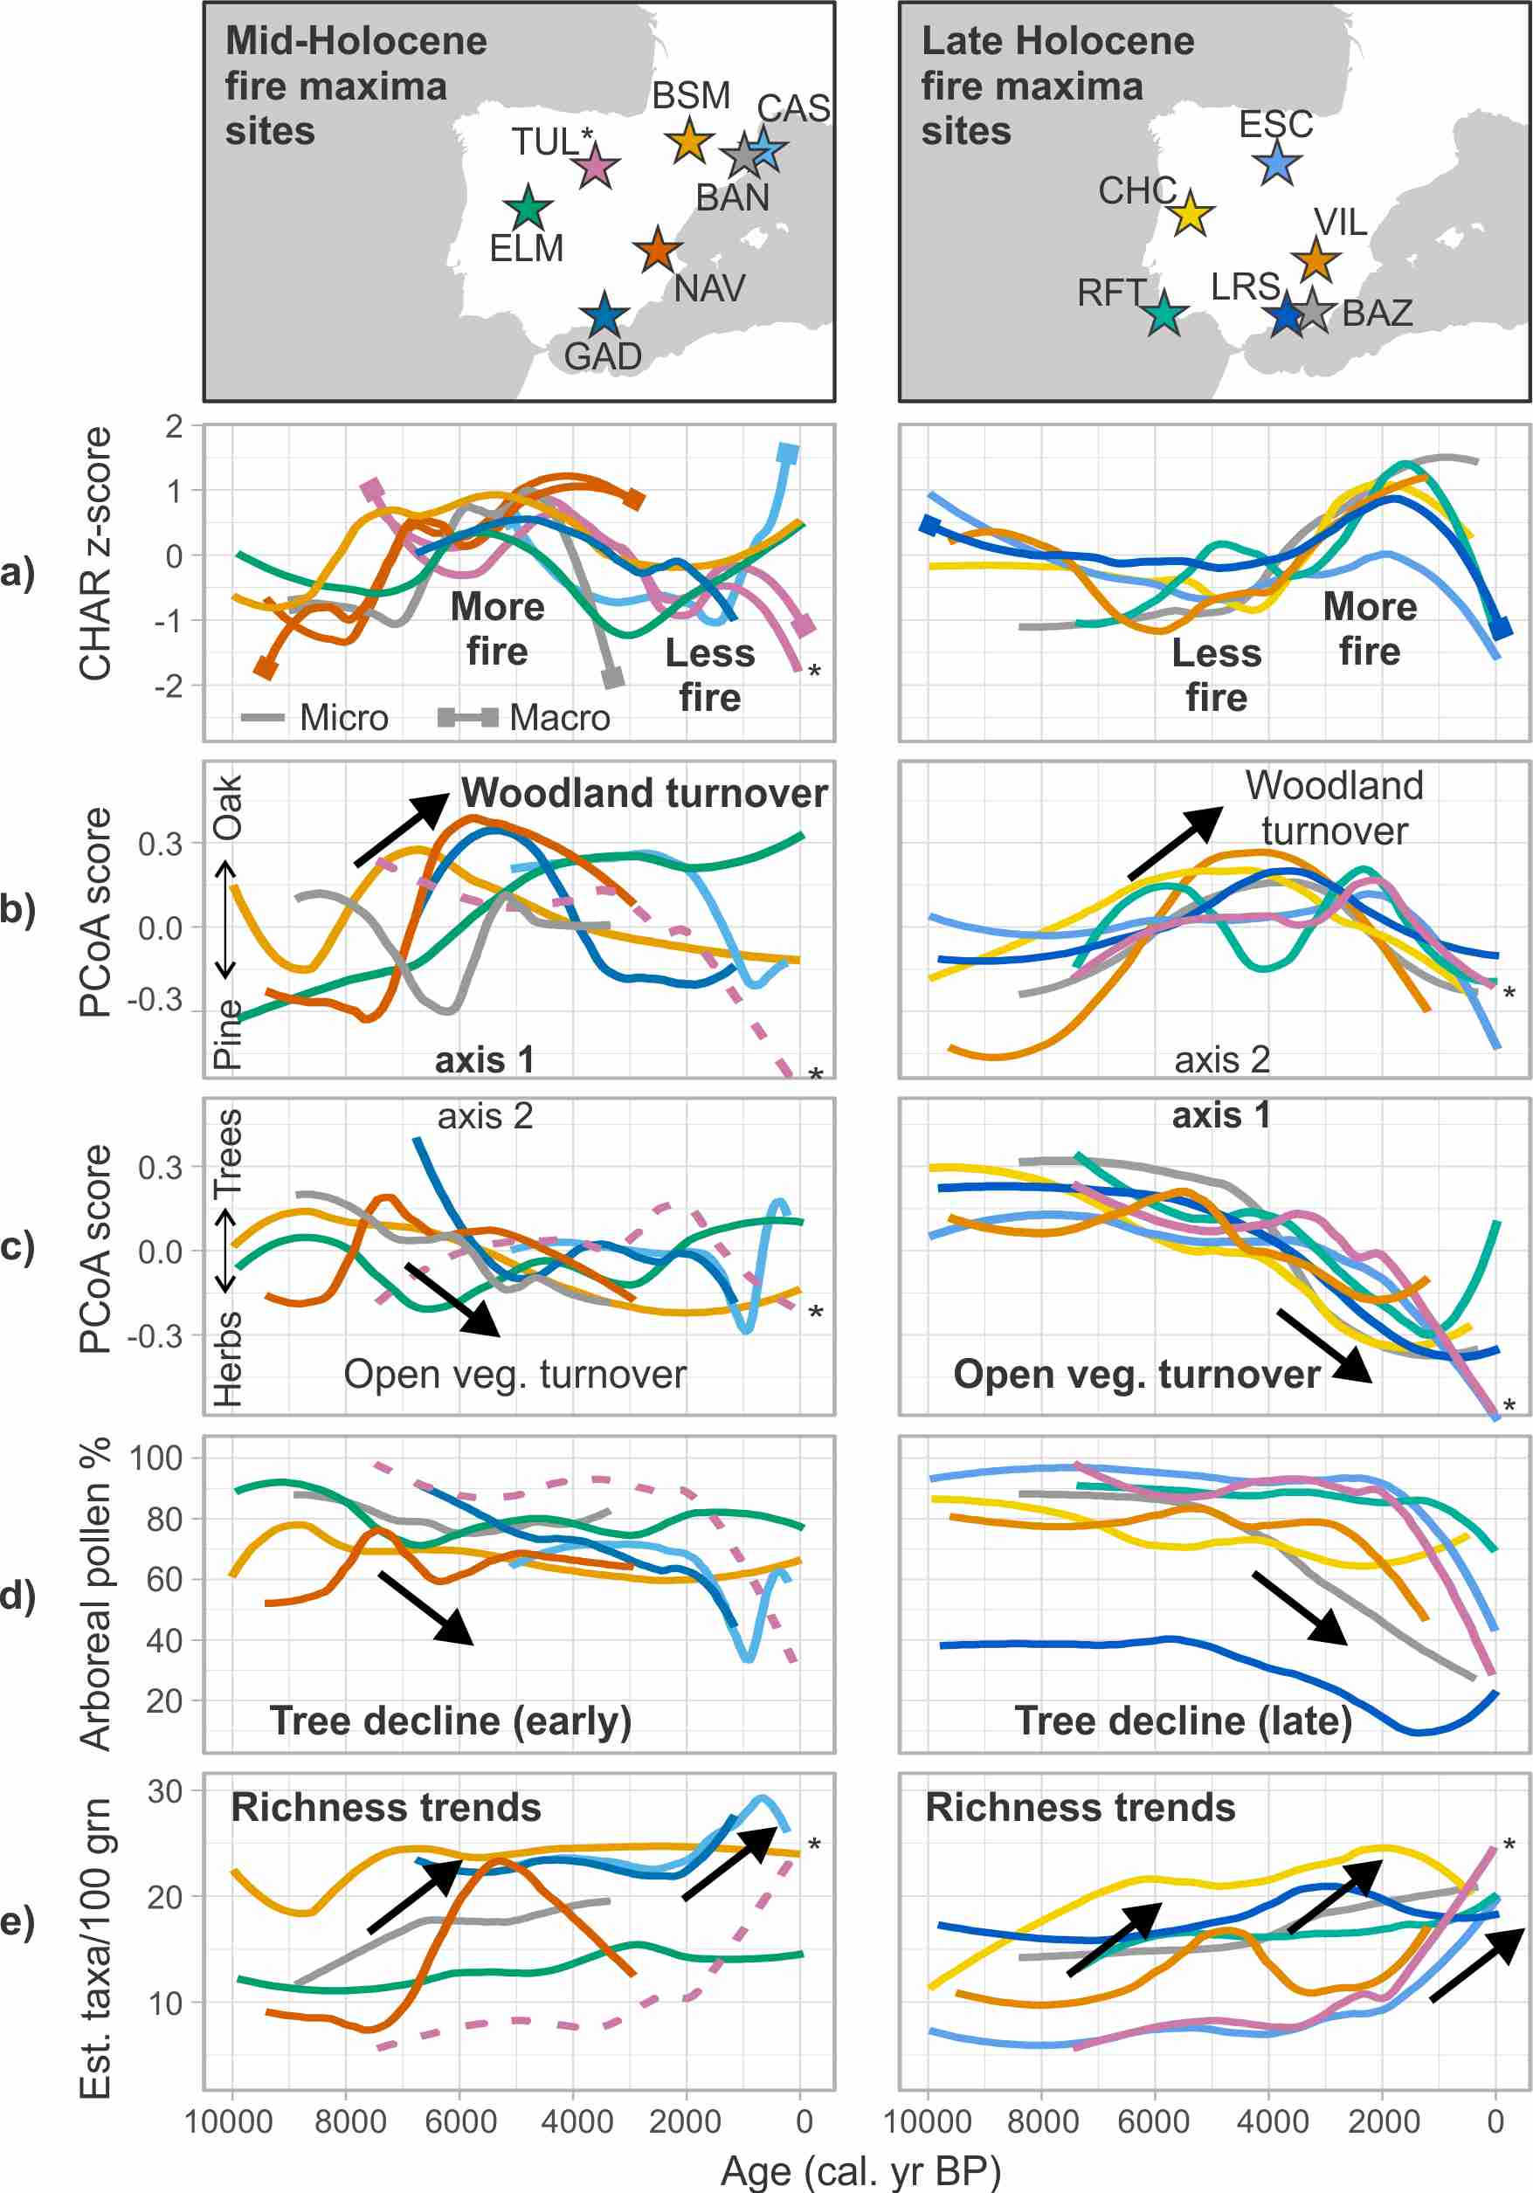
Fig. 1. Site locations (maps, top panel) with site codes according to Table 1. Millennial-scale trends in (a) fire activity (CHAR z-scores; micro: pollen-slide charcoal, macro: sieved charcoal), , (b, c) turnover axes, (d) arboreal pollen percentages and (e) palynological richness (estimated number of taxa in 100 pollen grains) in the 13 selected Mediterranean Iberian records. Records are grouped into those that exhibit a mid-Holocene fire increase (left panel) and those with a late-Holocene fire increase (right). Turnover trends are aligned and labelled according to the correlations in Table S2. For clarity, a 0.5 loess smoother is applied. *TUL trends are shown as dotted lines on the left panel and solid lines on the right panel because this record has a mid-Holocene fire peak but its turnover trends fit with records showing a late-Holocene fire increase (Table S2).

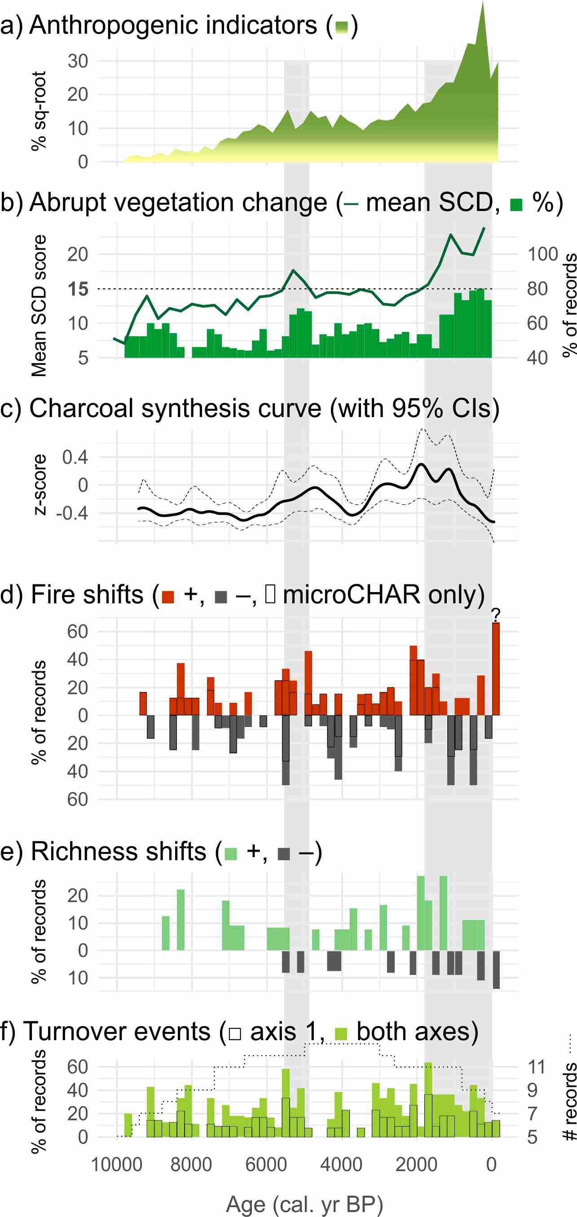
Fig. 2. Centennial-scale summary of a) anthropogenic indicator pollen and fungal spores, b) significant shifts in palaeovegetation (squared-chord distance: SCD), c) synthesised fire history, d) significant fire shifts, e) significant palynological richness shifts and f) significant turnover (beta replacement) events in the 13 Iberian records. Results are binned into 200-year blocks to facilitate comparison with other papers in this volume (e.g. Fyfe et al., 2018). See text for an explanation of the anthropogenic indicator and fire synthesis curves. Squared-chord distance (SCD) results are shown in two ways: mean values for the 13 sites (solid line, with empirical threshold shown dotted) and the percentage of sites with an SCD score >15 (bars). The direction of fire and richness shifts is indicated as +ve (increase) or -ve (decrease). Outlined fire shifts are from microscopic CHAR (pollen-slide method). Mean and variance shifts are combined due to their coherence in terms of timing and direction (see Fig. S2, Supplemental Material). The dotted line on the lowermost graph shows the number of records that contribute to each period. Percentages that may be biased by having few records are marked with a question mark (?).

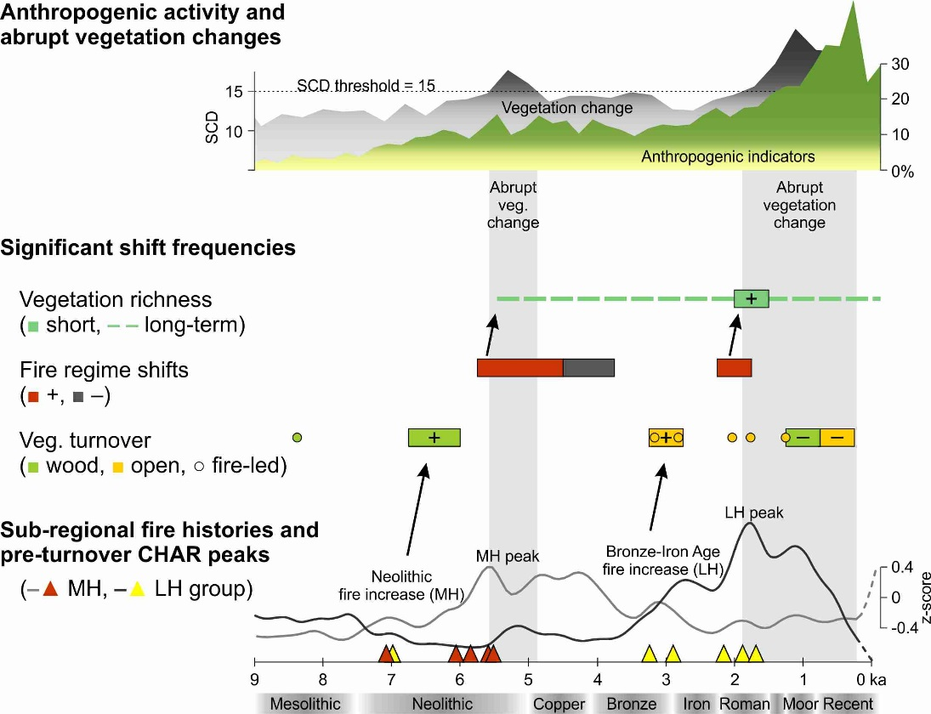
Fig. 3. A synthesis of Holocene fire and vegetation diversity change in Mediterranean Iberia. Human activity and abrupt vegetation change proxies (top) compared to significant richness, turnover and fire shift frequencies (middle) and the timing of anomalous charcoal peaks that precede turnover events, the composite fire history and archaeological periods (bottom). Significant shift frequencies are 500-year periods in which the occurrence of shifts was greater than in the bootstrapped dataset (p<0.05). For richness, ‘+’ indicates an increase in palynological richness. For turnover, ‘+’ indicates an increase in woodland (wood) or open vegetation (open) turnover and ‘–‘ indicates a decrease (see Fig. 1b, c). Dashed lines indicate longer intervals in which the occurrence of richness or turnover shifts was significant. Grey shaded zones indicate abrupt vegetation changes according to above-threshold SCD scores (Fig. 2).

Supplemental material for ‘Humans take control of fire-driven diversity changes in Mediterranean Iberia’s vegetation during the mid–late Holocene’ by SE Connor et al. in The Holocene

Table S1. Bayesian age–depth models adopted for the Baza (BAZ), Gádor (GAD), Navarrés (NAV) and Villaverde (VIL) records, presented in tabular format to enable re-use.
BAZ ages (cal. BP) | 311 391 512 667 788 919 1085 1205 1281 1390 1490 1587 1684 1788 1858 1957 2041 2080 2131 2171 2198 2254 2308 2349 2390 2431 2472 2514 2554 2581 2622 2663 2716 2757 2784 2811 2866 2896 2941 2992 3043 3093 3143 3193 3259 3328 3396 3447 3497 3546 3595 3645 3678 3745 3812 3846 3902 3961 4019 4078 4137 4177 4237 4298 4339 4400 4480 4541 4622 4663 4731 4826 4900 4995 5068 5117 5190 5238 5335 5407 5503 5576 5649 5720 5817 5890 5963 6035 6155 6203 6300 6348 6423 6500 6580 6685 6820 6985 7121 7255 7391 7471 7578 7658 7793 7928 8064 8146 8228 8306 8410
BAZ depths (cm) | 25 27 30 34 37 40 44 47 49 52 55 58 61 64 66 69 72 74 77 80 82 86 90 93 96 99 102 105 108 110 113 116 120 123 125 127 131 133 136 139 142 145 148 151 155 159 163 166 169 172 175 178 180 184 188 190 193 196 199 202 205 207 210 213 215 218 222 225 229 231 234 238 241 245 248 250 253 255 259 262 266 269 272 275 279 282 285 288 293 295 299 301 304 307 310 314 319 325 330 335 340 343 347 350 355 360 365 368 371 374 378
GAD ages (cal. BP) | 1160 1198 1237 1276 1314 1353 1391 1430 1468 1507 1546 1584 1619 1654 1682 1711 1740 1770 1800 1851 1903 1957 2014 2071 2129 2186 2244 2302 2361 2416 2470 2527 2586 2644 2700 2757 2814 2872 2930 2987 3044 3101 3157 3213 3269 3326 3382 3438 3495 3551 3607 3664 3721 3778 3836 3894 3952 4010 4069 4142 4215 4289 4365 4440 4515 4589 4663 4737 4811 4887 4962 5036 5108 5181 5254 5328 5403 5478 5554 5628 5703 5776 5849 5922 5996 6070 6142 6212 6282 6344 6405 6467 6529 6591 6653 6714 6775
GAD depths (cm) | 20 22 24 26 28 30 32 34 36 38 40 42 44 46 48 50 52 54 56 58 60 62 64 66 68 70 72 74 76 78 80 82 84 86 88 90 92 94 96 98 100 102 104 106 108 110 112 114 116 118 120 122 124 126 128 130 132 134 136 138 140 142 144 146 148 150 152 154 156 158 160 162 164 166 168 170 172 174 176 178 180 182 184 186 188 190 192 194 196 198 200 202 204 206 208 210 212
NAV ages (cal. BP) | 2925 3060 3195 3330 3465 3601 3737 3872 4008 4150 4292 4435 4577 4719 4823 4927 5031 5135 5239 5375 5512 5648 5784 5921 6035 6149 6264 6378 6493 6621 6750 6878 7006 7135 7221 7264 7307 7350 7390 7430 7470 7510 7550 7618 7687 7755 7824 7892 8001 8109 8218 8326 8435 8533 8632 8730 8829 8928 9025 9123 9221 9318 9416
NAV depths (cm) | 37 38 39 40 41 42 43 44 45 46 47 48 49 50 51 52 53 54 55 56 57 58 59 60 61 62 63 64 65 66 67 68 69 70 72 73 74 75 76 77 78 79 80 81 82 83 84 85 86 87 88 89 90 91 92 93 94 95 96 97 98 99 100
VIL ages (cal. BP) | 1199 1255 1315 1376 1436 1497 1559 1621 1685 1775 1799 1824 1883 1941 2058 2116 2139 2162 2231 2296 2317 2359 2401 2485 2568 2653 2673 2694 2714 2735 2755 2773 2790 2808 2825 2843 2860 2877 3029 3284 3355 3372 3389 3406 3423 3440 3455 3470 3485 3544 3601 3659 3716 3773 3831 3888 3946 3990 4035 4095 4152 4209 4268 4326 4384 4529 4690 4877 5023 5109 5138 5166 5195 5224 5282 5340 5398 5456 5500 5559 5601 5644 5701 5744 5802 5860 5918 5989 6046 6102  6228 6346 6467 6587 6706 6828 7286 7523 7610 7715 7820 8002 8185 8340 8495 8653 8781 8964 9041 9144 9248 9326 9431 9510 9641
VIL depths (cm) | 108 112 116 120 124 128 132 136 140 144 145 146 147 148 150 151 152 153 156 159 160 162 164 168 172 176 177 178 179 180 181 182 183 184 185 186 187 188 197 212 216 217 218 219 220 221 222 223 224 228 232 236 240 244 248 252 256 259 262 266 270 274 278 282 286 296 307 320 330 336 338 340 342 344 348 352 356 360 363 367 370 373 377 380 384 388 392 397 401 405 410 414 418 422 426 430 445 453 456 460 464 471 478 484 490 496 501 508 511 515 519 522 526 529 534

Table S2. Pollen taxa most strongly correlated with turnover (beta replacement PCoA axes 1 and 2). Abbreviations: Q. = Quercus, Chenopod = Chenopodiaceae/Amaranthaceae. Correlations were r >0.5 except for taxa in parentheses. The last column is the interpreted direction of turnover.
Site & axis | Positively correlated | Negatively correlated | Turnover  (Fig. 2b, c)
BAN 1 | Q. deciduous, Q. evergreen | Pinus, Asteraceae, Pteridium | Woodland
BAN 2 | Q. deciduous | Olea, Poaceae, Plantago, Apiaceae | Open veg.
BSM 1 | Betula, Corylus, Tilia, Q. deciduous | Pinus | Woodland
BSM 2 | Betula | Ericaceae, Poaceae, Artemisia, Chenopod, Plantago | Open veg.
BAZ 1 | Q. deciduous, Pinus, Corylus, Buxus | Ericaceae, Q. evergreen, Cistaceae, Poaceae, Plantago | Open veg.
BAZ 2 | Q. deciduous | (Genista, Plantago, Vitis) | Woodland
CHC 1 | Quercus, Pinus, Taxus, Frangula | Erica, Genista, Anthemis-t. | Open veg.
CHC 2 | Alnus, Dryopteris-t. | Olea, Halimium | Woodland
CAS 1 | Q. deciduous, Q. suber, Corylus, Abies, Pinus | Cistus, Olea, Poaceae, Cerealia, Secale, Cannabis | Woodland
CAS 2 | Ericaceae | Artemisia, Chenopod, Plantago, Achillea-t. | Open veg.
ELM 1 | Olea, Ericaceae, Calluna | Pinus, Betula | Woodland
ELM 2 | Betula | Poaceae | Open veg.
ESC 1 | Pinus | Q. deciduous, Q. evergreen, Erica, Artemisia, Cerealia-t. | Open veg.
ESC 2 | Q. deciduous | (Artemisia, Cerealia-t.) | Woodland
GAD 1 | Q. deciduous, Phillyrea, Myrtus, Maytenus | Pinus, Cistus, Artemisia, Chenopod, Plantago | Woodland
GAD 2 | Pinus, Arbutus, Buxus | Poaceae, Artemisia | Open veg.
NAV 1 | Q. evergreen, Betula, Corylus, Erica, Olea, Pistacia | Pinus | Woodland
NAV 2 | (Pinus, Q. suber) | Asteraceae, Artemisia | Open veg.
RFT 1 | Q. deciduous, Pinus, Pistacia | Ericaceae, Arbutus | Open veg.
RFT 2 | (Cerealia-t., Ziziphus) | Cistus | Woodland
LRS 1 | Pinus, Betula, Poaceae | Artemisia, Castanea, Silene-t. | Open veg.
LRS 2 | Asteraceae, Silene-t. | (Chenopod, Olea) | Woodland?
TUL 1 | Pinus | Q. deciduous, Q. evergreen, Calluna, Erica, Cerealia-t., Rumex, Artemisia, Chenopod | Open veg.
TUL 2 | Q. deciduous, (Q. evergreen) | (Cerealia-t.) | Woodland
VIL 1 | Q. deciduous, Betula, Corylus | (Q. evergreen, Chenopod) | Open veg.
VIL 2 | Q. deciduous, Q. evergreen, Ericaceae | Pinus, Juniperus, Artemisia | Woodland

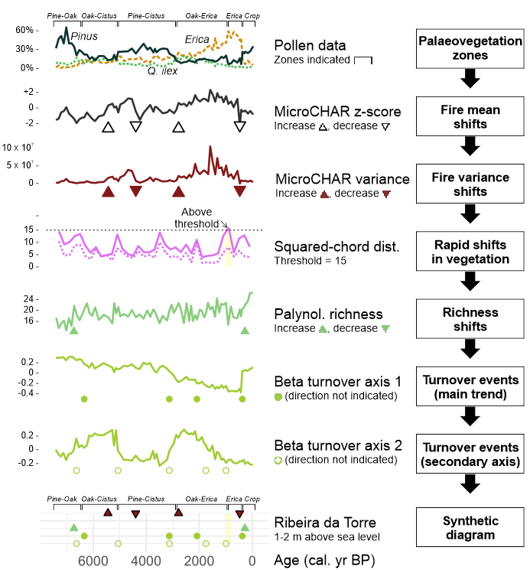
- Fig. S1 – Explanation of methods adopted in this study, with a worked example (Ribeira da Torre, Portugal). Pollen zones were derived from the original publication and labelled according to the dominant or most characteristic pollen type. Significant fire shifts were identified by applying regime shift detection to z-scored charcoal accumulation rates (CHAR). Charcoal variance shifts from untransformed CHAR. Squared-chord distances (SCD) were then estimated using the randomisation technique described in the methods (dotted line: results from applying SCD estimation following Seddon et al., 2015). SCD scores >15 (yellow shading) were taken to represent abrupt palaeovegetation changes (Overpeck et al., 1985). Significant turnover events were identified by applying regime shift detection to Principal Coordinates Analysis axes 1 and 2 of beta replacement. Results are summarised in the synthetic diagram in the lower panel (see Fig. S2). Fire shifts and turnover events were subsequently analysed as event sequences (see methods).

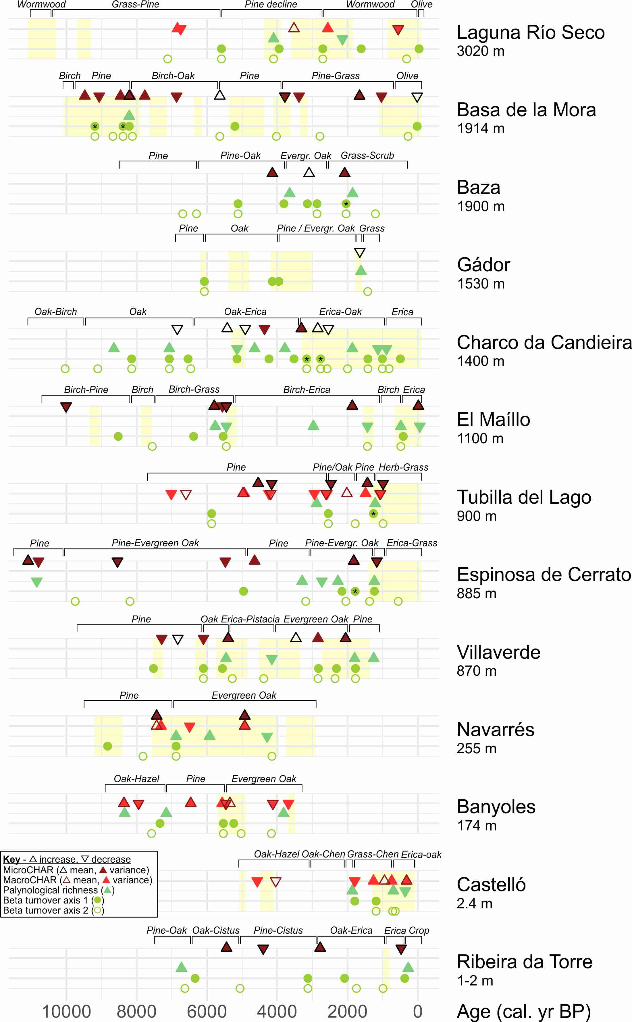
- Fig. S2. Synthetic diagrams summarising pollen zones, abrupt vegetation changes (yellow, squared-chord distance), fire shifts (top two lines, pollen-slide and sieved charcoal), richness changes (middle line) and significant turnover events (bottom two lines) for each of the 13 Mediterranean Iberian pollen records (see Fig. S1 for explanation). Asterisks (*) indicate significant fire-driven turnover events (Table 2).

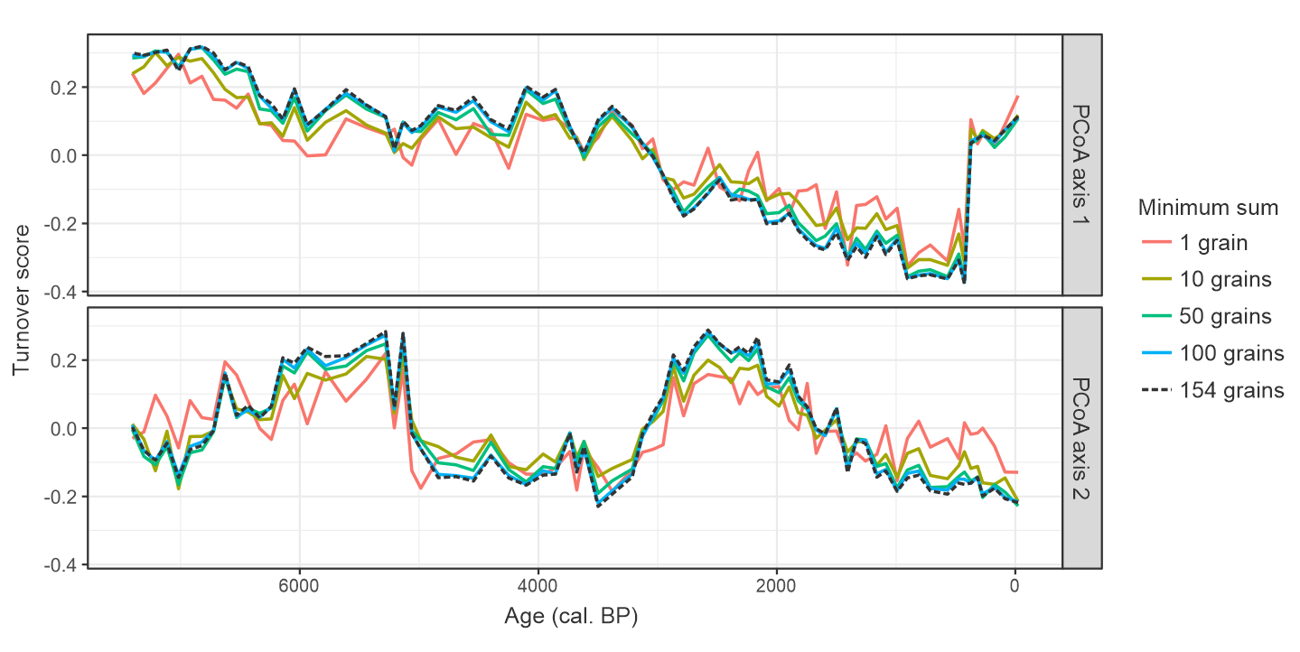
- Fig. S3. Effect of different minimum pollen sums on turnover estimates for the Ribeira da Torre record (Fig. S1) with random resampling. The black dashed line represents the actual minimum sum used for beta diversity estimation (154 grains).

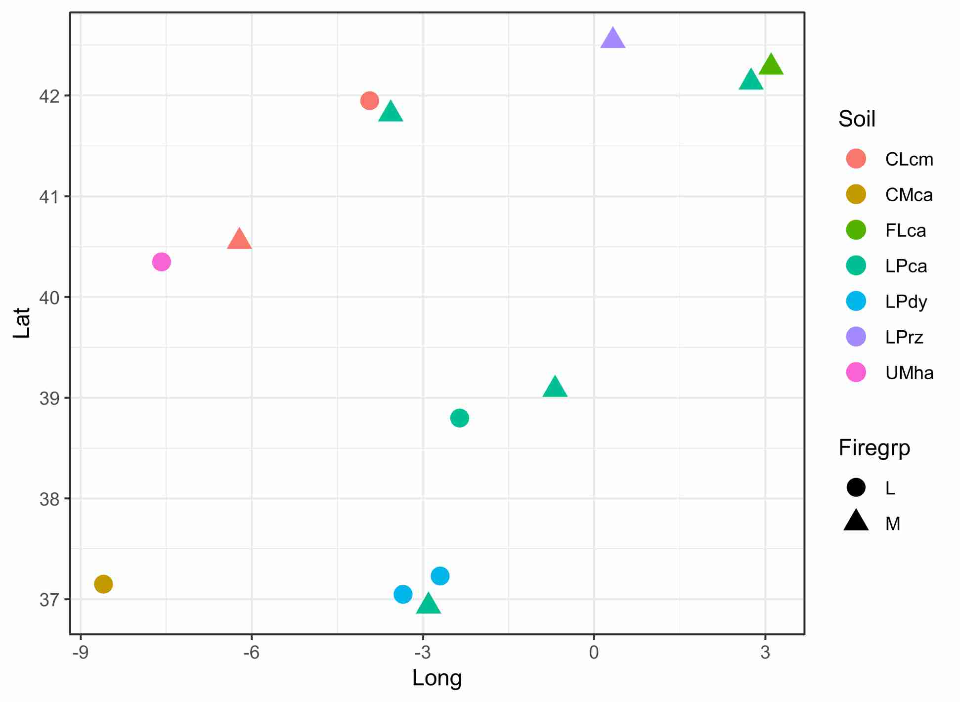
- Fig. S4. Soil type (colours) compared to the fire maxima groups shown in Fig. 1: mid-Holocene (M - triangles) and late Holocene (L - circles). Sites shown by latitude and longitude for comparison with Fig. 1. Soil data from the European Soil Data Centre (ESDAC), European Commission, 2001. Soil codes: CLcm chromic Calcisol, CMca calcaric Cambisol, FLca calcaric Fluvisol, LPca calcaric Leptosol, LPdy dystric Leptosol, LPrz rendizic Leptosol, UMha haplic Umbrisol.
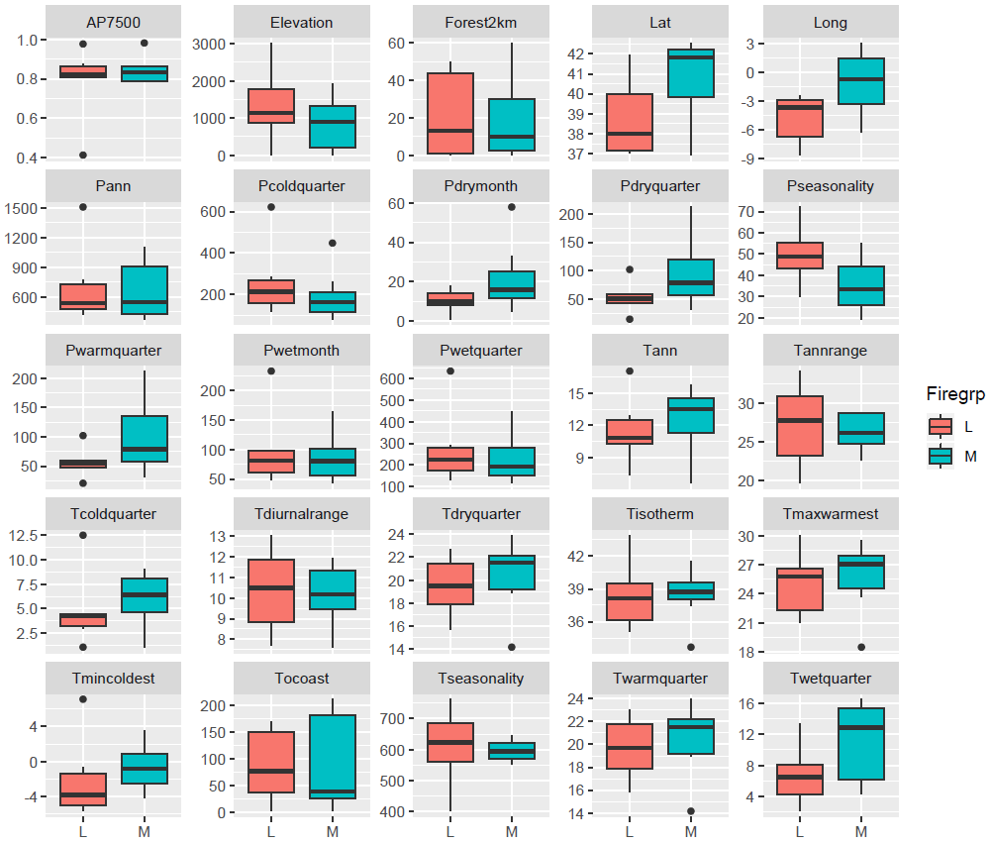

- Fig. S5. Bioclimatic and other potential explanatory variables compared between the group of sites with a mid-Holocene fire maximum (M) and late Holocene fire maximum (L). Names beginning with ‘P’ and ‘T’ are precipitation and temperature variables from WorldClim (Fick and Hijmans, 2017). ‘AP7500’ is the arboreal pollen proportion in the 13 pollen records at 7500 cal. BP (or before significant turnover in sites with earlier turnover, e.g. BSM). ‘Forest2km’ is the approximate percentage of forest cover in a 2 km radius around each site, estimated from recent GoogleEarth satellite imagery. ‘Tocoast’ is the shortest distance (in km) to the nearest coastline, a reflection of continentality.

