In a relationship: sister-species in mixed colonies, with a description of Chikunia bilde (Theridiidae)

AUTHORS
¹Cassandra Smith, ¹Addie Cotter, ²Lena Grinsted, ³Anom Bowolaksono, ⁴Ni Luh Watiniasih, and ¹Ingi Agnarsson

* Corresponding author. E-mail: iagnarsson@gmail.com

¹ Department of Biology, University of Vermont, 120A Marsh Life Science Building, 109 Carrican Drive, Burlington, Vermont 05405-0086, USA
² School of Biological Sciences, Royal Holloway University of London, Egham, Surrey, TW20 0EX, UK (Phone: +44 7500 311156; email: lena.grinsted@rhul.ac.uk)
³ Department of Biology, Faculty of Mathematics and Sciences, University of Indonesia,
Kampus UI Depok, Depok 16424, Indonesia (Phone/fax: +62 21 7270163; email: alaksono@sci.ui.ac.id)
⁴ Department of Biology, Faculty of Mathematics and Natural Sciences, Udayana University, Kampus Bukit Jimbaran, Bali, Indonesia, 80361 (Phone: +62 361 703137; email: luhwatiniasih@unud.ac.id)

ABSTRACT
Group living behavior is rare in spiders, but has evolved repeatedly yielding several species, some showing cooperation among close kin, and others living in colonies where each female builds its own web and is territorial. Most frequent origins of group living are seen in the cobweb spiders (Theridiidae) that commonly build three-dimensional webs and show extensive maternal care, both putatively preadaptive traits to spider sociality. A very unusual behavior was recently discovered in the theridiid genus Chikunia where two distinct but related species occur in mixed-species colonies with potential indiscriminate brood care. These mixed colonies consist of C. nigra and a newly discovered species. Here we describe the new species C. bilde sp. n., redescribe C. nigra, and summarize the unique biology of this species pair. We also place the origin of mixed-species group living in a phylogenetic context, firmly confirming the placement of Chikunia within the clade (lost colulus clade) previously characterized as containing a concentration of independent origins of group living. The two Chikunia studied here are sister-species, representing a rare case of close genetic and behavioral interspecific relationship. We conclude that loss of aggression accompanying group living and social behaviour in cobweb spiders may help explain the origin of mixed-species colonies.

Introduction
Group living spiders are typically categorized as either social or colonial. Social spiders are non-territorial and group members cooperate in all tasks within the colony, while colonial spiders aggressively defend territories within the colony and lack cooperation in colony tasks (Bilde & Lubin, 2011; Lubin & Bilde, 2007). Social spiders have evolved in family groups through extended maternal care that may include maternal feeding of offspring by regurgitation or sharing of prey with offspring, and through the loss of a pre-mating dispersal stage (Avilés, 1997; Lubin & Bilde, 2007; Viera and Agnarsson, 2017). Contrastingly, close kinship and maternal care are thought to be of little importance to the evolution of colonial spiders (Johannesen et al., 2012). Colonial spiders are likened to foraging flocks of birds, benefitting from increased prey capture success in groups, irrespective of genetic relatedness between group members (Rypstra, 1979; Uetz, 1989).

While sociality is phylogenetically very rare in spiders, it has evolved repeatedly with a concentration of origins in derived cobweb spiders (Theridiidae) (Agnarsson et al., 2006; Avilés, 1997; Bilde & Lubin, 2011; Yip & Rayor, 2014; Viera and Agnarsson, 2017). Within Theridiidae, nearly all subsocial (temporarily social, displaying cooperation only amongst juveniles) and social (permanently social and cooperatively breeding) species belong to the sister subfamilies Theridiinae and Anelosiminae (Liu et al., 2016). Together these form the ‘lost colulus clade’, which is ancestrally reconstructed to display extensive maternal care and construct three-dimensional webs (Agnarsson, 2004), both putative pre-adaptations to sociality in spiders (Aéiles, 1997; Bilde & Lubin, 2011; Yip & Rayor, 2014). In both subsocial and social spider species of this clade, cooperative groups are made up of close kin, typically a single matriline (Agnarsson et al., 2013; Agnarsson et al., 2010; Aviles, 1997; Settepani et al., 2017; Avilés and Guevara 2017; Viera and Agnarsson, 2017).

Recently, a new mixed-species spider system was discovered on Bali, Indonesia, where two theridiid species from the genus Chikunia were found to live together in colonies (Grinsted et al., 2012). This system is intriguing not only because mixed-species spider associations are rare, but because both Chikunia species were found to display extended maternal care and possible indiscriminate care of young (pre-adaptations to sociality) while being territorial and lacking cooperation amongst adult group members (i.e. being colonial). Hence, this spider system appears to combine traits from two distinctly different types of group living and warrants further study. The two species involved are the known species C. nigra, and a newly discovered species of Chikunia described herein.

The aims of this paper were to describe Chikunia bilde sp. n., redescribe C. nigra, place the origin of this mixed-species group living in a phylogenetic context, and summarize the biology of this unique mixed-species system. In the field we measured nearest-neighbor distances between females with brood (egg sacs or young) within a large, dense mixed-species colony to ask the following question: Do females show a higher tolerance and closer nearest neighbor distance for females of their own species compared to the other species?

Materials and methods
Study Organisms
Chikunia is a genus of small, often dark or orange spiders (Figure 1), belonging to the cobweb subfamily Theridiinae (Liu et al., 2016). Only two species are currently placed in this genus: C. nigra known from Asia (from China, India and Sri Lanka to Taiwan and Indonesia), and Chikunia albipes also from Asia. The new species we describe here, Chikunia bilde sp. n., distributed in Indonesia, Singapore and Malaysia, and possibly more widely, is thus the third species in this genus. Chikunia and relatives like Chrysso, Helvibis, and Theridula are well known for displaying extensive maternal care (Figure 1), some being classified as subsocial (Coddington & Agnarsson, 2006; Yip & Rayor, 2014). Chikunia and relatives build simple 3D webs with sticky silk distributed throughout the web (Figure 2).

Mixed-species colonies upwards of 100 individuals of C. nigra and C. bilde were found in small trees and on garden plants near the lakes Beretan and Buyan in central northern Bali (Figure 3). Extended maternal care is provided to spiderlings up to about instar IV and includes guarding of the egg sac and feeding hatchlings by catching prey and sharing it with them. Females of both species have been found to readily accept foreign egg sacs and young (Grinsted et al., 2012, see also Samuk and Avilés, 2013), and hence, potentially provide indiscriminate brood care to their own and possibly the other species. Both species can be found living solitarily, in colonies containing only its own species, or in mixed-species colonies (L.G. personal observations). Adult colony members maintain their own territories (including their own capture web) within the group, can behave aggressively towards intruders, and adults do not coo{Aviles, 2017 #172}perate in prey capture, feeding or brood care (Grinsted et al., 2012).

Phylogenetic Methodology
Sequences for two mitochondrial genes, cytochrome c oxidase subunit I (COI) and ribosomal RNA16S (16S), and three nuclear genes, ribosomal RNAs 18S (18S) and 28S (28S), and histone (H3), were obtained from the comprehensive phylogenetic matrix for Theridiidae from (Liu et al., 2016). These included a dense sampling of ‘lost colulus clade’ members, and all sequenced Theridiindae. We also sequenced 12 additional specimens of Chikunia from Malaysia and Bali, adding to the prior Chikunia sequences from Bali, India and Sri Lanka from Grinsted et al. (2012) and Liu et al. (2016). DNA was extracted from two to four legs of each specimen using Qiagen DNeasy Tissue Kit (Qiagen, CA, USA). For the new specimens we sequenced fragments of COI, and ITS2, using primers and protocols as described in (Agnarsson, 2010; Agnarsson et al., 2013). Amplified fragments were sequenced in both directions by Genewiz LCC and then assembled and proofread using the Chromaseq module (D. R. Maddison & W. P. Maddison, 2011) in Mesquite (W. P. Maddison & D. R. Maddison, 2011) employing Phred (P Green & Ewing, 2002) and Phrap (P. Green, 1999). Sequences were submitted to Genbank (accession numbers [not yet available]).

We aligned all sequences using MAFFT (Kazutaka et al., 2005) using the EMBL-EBI online portal. For all analyses, gaps and ambiguous bases were treated as missing data.
For the final matrix (Supplementary material) the appropriate models for the Bayesian analysis were selected with Partitionfinder (Lanfear et al., 2012). The data were analyzed using Bayesian inference with MrBayes 3.2.3 on XSEDE (3.2.3) (Huelsenbeck & Ronquist, 2001). The Markov chain Monte Carlo search for each matrix ran with four chains for 50,000,000 generations sampling the Markov chain every 1,000 generations, and the sample points of the first 12,500,000 generations were discarded as ‘burnin’, after which the chains had reached approximate stationarity as determined by analysis in Tracer.
Note ages were estimated using BEAST 1.8. under a relaxed clock model (Drummond & Rambaut, 2007). We used calibration points as in the most recent Theridiidae phylogeny (Liu et al., 2016) of which the current matrix is a subset. See (Liu et al., 2016) for justification.
The BEAST analysis was done with same partitions and models as implemented in the Mr. Bayes analysis. The analysis was run for 50,000,000 generations with the Yule tree prior. The results were checked in Tracer 1.5 (Rambaut and Drummond, 2007) to determine burn-in and to check for stationarity.

Photo-Documentation
Adult female and male representative specimens of both Chikunia species were photographically documented using the Visionary Digital BK Laboratory System. Spiders and dissected genitalia were positioned using Germ-X hand sanitizer (63% ethanol) and then covered in 95% ethanol to reduce glare. Images were taken using a Canon 5D camera and 65-mm macro zoom lens. Multiple image slices were taken of each specimen using the focus stacking program Helicon Focus 5.3. Each final image was compiled using 15-30 images slices for whole specimens and 4-10 slices for individual genitalia. Epigyna were prepared in potassium hydroxide and deionized water solutions for clearer imaging. Male palps were submerged in potassium hydroxide and then expanded in distilled water. Images were edited in Adobe Photoshop CS6 to adjust lighting and sharpness, eliminate background blemishes, and to place scale bars. Species plates were constructed using Adobe Illustrator CS6.

Field Observations
The largest and densest colony discovered in the field consisted of 100+ individuals of both Chikunia species occupying every single leaf of a couple of small banana trees located next to a pigsty. For each female with brood (egg sac or young) we measured the distance (in cm) to its nearest neighboring female with brood (N = 78), and identified the species of both females. To ask whether females tended to have a same-species neighbor, we performed a X² test on each species. Observed values were numbers of same- versus different-species neighbors, and expected values were numbers of same- versus different-species females present in the colony. To investigate the level of tolerance to other females, we asked whether the two species differed in the distance they kept to their nearest neighbor, and whether the distance to nearest neighbor was affected by the species of the neighbor. To ask these questions, we built a Generalized Linear Model with distance to nearest neighbor as the response variable, and focal female species, same-versus-different species neighbor, and an interaction term between the two factors as predictor variables. The model had a Gaussian error structure and conformed to the assumptions of normally distributed and homogenous residuals. All tests were performed in R (R Core Team, 2016).

RESULTS
Phylogenetics
As expected, the phylogeny in broad strokes recaptures the findings of Liu et al (Liu et al., 2016), on which it is based. It placed Chikunia within the “Chrysso group” of the subfamily Theridiinae, members of the more inclusive ‘lost colulus clade’ where group living and sociality is concentrated (Figure 4). The phylogeny strongly supports the monophyly of Chikunia, each of its three species, and the sister relationship between C. nigra and C. bilde (Figure 4). A dating analysis suggests these species diverged around 8 mya (Figure 5), with old divergence reflected in both COI and the nuclear ITS2. Within both C. nigra and C. bilde we find relatively deep divergences dating back 3-4 mya, and in neither species are samples from Bali monophyletic (Figs. 4-5). However, this intraspecific divergence is only reflected in the mtDNA, whereas an analysis of the rapidly evolving ITS2 marker shows almost no variation within each species (Figure 4, inset).

Taxonomy
Family Theridiidae Sundevall, 1833.
Genus Chikunia Yoshida, 2009.
Chikunia Yoshida, 2009, 378, type species C. alba Yoshida 2009 by original designation.

Chikunia nigra (O. Pickard-Cambridge, 1880)
Originally Argyrodes nigra O. Pickard-Cambridge, 1880, later placed in Theridion by Simon (1905), Theridula by Saito (1933) and Chrysso by Levi (1962), transferred here by Grinsted et al. (2012).

Material examined.
Types from Sri Lanka (Thwaites’s Ceylon collection), not examined. Multiple male and female specimens from northern central Bali, near lake Buyan, approximately -8.243693, 115.104070 to -8.282064, 115.164817 (Figure 3), collected in July 2017. Five specimens from Sri Lanka and India (see Grinsted et al. 2012) were also reexamined.

Diagnosis.
Chikunia nigra differs from other Chikunia species in the long, tapering male abdomen, conformation of male palp (Fig. 8) with very long embolus and large conductor, and in epigynum with oval spermathecae and simple non-spiraling copulatory ducts. Further, C. nigra females are distinct by having both pedipalps and tarsus of Leg I black or very dark brown in color (Fig. 6A & C), in contrast to remaining leg segments which are pale white or yellow in color.

Redescription
Female (from Bali, Indonesia): Total length 3.54. Cephalothorax 1.11 long, 0.91 wide, 0.71 high, medium to dark brown with tan markings laterally. Chelicerae are dark brown in color. Sternum 0.69 long, 0.56 wide, extending half way through coxae IV, medium brown. Abdomen 2.43 long, 2.55 wide, 1.77 subtriangular in shape and tapering towards posterior (Fig. 6A-C). Wide dark brown patch and scattered spots occur dorsally along abdomen (Fig. 6A-C). Eyes approximately equal in size ALE 0.06, AME 0.08 in diameter. All eyes within one eye diameter apart from each other excluding the anterior median which are 0.12 apart. Leg I femur 1.70, patella 0.40, tibia 1.0, metatarsus 1.10, tarsus 0.61. All legs tan in color, tarsus of Leg I dark brown (Fig. 6A & C). Leg formula 1423. Epigynum simple, translucent cuticle, with tiny copulatory openings, leading to oval spermathecae (Fig. 6D-F).
Male (from Bali, Indonesia): Total length 2.32. Cephalothorax 0.83 long, 0.71 wide, 0.53 high, dark brown to black in color with faint medium brown broad patches dorsally, relatively slender and tapering towards end (Fig. 6 G-I). Sternum 0.60 long, 0.47 wide, dark brown. Abdomen 1.49 long, 0.81 wide, 0.72 high, black in color. Eyes approximately equal in size ALE 0.07, AME 0.08 in diameter. All eyes within one eye diameter apart from each other excluding the anterior median which are 0.12 apart. Leg I femur 1.60, patella 0.31, tibia 0.95, metatarsus 0.74, tarsus 0.46. All legs dark brown with white coxae and white coloration where trochanter and femur meet. Leg formula 1423. Male palps with prominent and long embolus, spiral covering outer edge of tegulum, distally supported by a large conductor.

Variation: Female total length 2.01-3.54, femur I 1.11-1.70; male total length 2.32-3.20, femur I 1.37-1.98.
Female abdomen shape and coloration vary greatly (Fig. 9A-I). Colors range from pale orange, to reddish orange, amber, various shades of brown, greenish gray, and black. Some abdomens are uniformly colored, while others have a non-distinct, mottled black pattern in the center of the abdomen of varying size. Abdomen shape vary from having rather large abdominal humps and a short, pointy rear end (abdomen wider than long, similar to C. bilde), to a more slender look with smaller abdominal humps and a longer, tapering rear end (abdomen longer than wide).

Chikunia bilde Smith, Agnarsson & Grinsted, 2018
Chikunia nigra (misidentified)

Material examined. Male holotype from northern central Bali, near lake Beretan, -8.271211, 115.165842, collected in July 2017, leg. L. Grinsted. Multiple additional male and female specimens from and nearby type locality (-8.271211, 115.165842to -8.282525, 115.164386, Fig, 3), collected in July 2017, leg. L. Grinsted. Two females from Malaysia, Pahang Tanah Rata, 4.46N, 101.40E, 1500 m, 21-22.v.2005, leg. I. Agnarsson.

Etymology
The species epithet honors Professor Trine Bilde, Aarhus University, for her significant scientific contributions to the field of behavioral ecology and social evolution in spiders, and for her inspiring role as a PhD supervisor to L. Grinsted. The discovery of C. bilde by L. Grinsted in 2010 was a direct result of Professor Bilde’s approval and encouragement of an exploratory expedition to Bali. Professor Bilde is a strong female role model of high scientific integrity.

Diagnosis
Chikunia bilde differs from Chikunia nigra in the blunt terminus of the male abdomen (Fig. 7H-I), and in the male leg coloration that gives legs a stripy appearance (yellow-brown stripes, Fig. 1G). Further, C. bilde differs in the conformation of male palp with embolus covering the tegulum almost entirely, and short and transparent conductor (Figs, 7J, 8), and in having a conspicuous epigynum with oval round spermathecae and spiraling copulatory ducts (Fig. 7A-L). In habitus, C. bilde females tend to have larger bulbous abdominal humps than C. nigra. Further, C. bilde females differ from C. nigra by lacking the dark brown or black tarsus of Leg 1.

Description
Female: Total length 2.83. Cephalothorax 1.13 long, 1.01 wide, 0.61 high, dark brown with faint tan patches stretching across the midsection. Chelicerae shift from tan in color to a medium brown as they transition outward from the body (Fig. 7B). Sternum 0.71 long, 0.56 wide, dark brown and extending half way through coxae IV. Abdomen 1.88 long, 2.42 wide, 1.59 high, subtriangular with large bulbous humps on both laterals (Fig. 7A-B). Large dark brown colored patches laterally, a dark brown patch present at posterior of abdomen, and a dark brown streak running dorsally in a groove between the two humps (Fig. 7A-C). Abdomen tapers distinctly behind humps. Eyes approximately equal in size ALE 0.09, AME 0.10 in diameter. All eyes within one eye diameter apart from each other excluding the anterior median which are 0.10 apart. Leg I femur 1.93, patella 0.37, tibia 1.32, metatarsus 1.20, tarsus 0.81. All legs tan in color. Leg formula 1423.

Male: Total length 2.34. Cephalothorax 1.06 long, 0.86 wide, 0.61 high, black in color. Sternum 0.63 long, 0.58 wide, dark brown in color extending to past coxae IV. Abdomen 1.29 long, 1.01 wide, 0.88 high, dark brown in color with brown speckled pattern covering entire abdomen, oval in shape, and lacking any humps or ridges, narrows slightly to an abruptly blunt posterior (Fig. 7G-I). Eyes approximately equal in size ALE 0.08, AME 0.09 in diameter. All eyes within one eye diameter apart from each other excluding the anterior median which are 0.10 apart. Leg I femur 2.17, patella 0.35, tibia 1.39, metatarsus 1.37, tarsus 0.75. Legs gradually darken moving from coxae all the way to tarsus. Coxae are white in color. Femuora fade from white to tan to dark brown where they meet the patella. Metatarsus and tarsus both medium brown in color. Leg formula 1423.

Variation: Female total length 2.64-3.18, femur I 0.94-1.48; male total length 2.09-2.78, femur I 1.62-2.19.
Female abdomen coloration vary greatly (Fig. 9J-O). Colors range from bright yellow, to orange, amber, various shades of brown, and black. Black abdomens are uniformly colored, while all other color variants have a clearly defined black or dark brown pattern running dorsally. Additionally, the very tip of the abdomen can be black or dark brown, and often there is a dark brown or black patch, of varying size, on the tip of each of the abdominal humps.

Field Observations

Within a dense mixed-species colony, nearest neighboring females with brood were of the same species significantly more often than would be expected by chance (Fig. 9). This was true for both C. nigra and C. bilde (Pearson's X² test with Yates' continuity correction: C. nigra X² = 4.52, df = 1, p = 0.034; C. bilde X² = 4.45, df = 1, p = 0.035). Within the colony we recorded 48 C. nigra, of which 39 had a same-species nearest neighbor, and 30 C. bilde, of which 19 had a same-species nearest neighbor.
Distances to nearest neighbors ranged from 1cm to 14cm, with both mean and median = 7.0cm. There was no significant difference between species in the distance they kept to their nearest neighbor (Fig. 10, t-value = 0.32, p = 0.75), nor was there a significant difference in distances kept to nearest same-species versus different-species neighbor (Fig. 10, t-value = -0.99, p = 0.33; the interaction term between the two factors was also not significant: t-value = -0.34, p = 0.73).

Discussion

We examined two facultatively group living Chikunia species and provide a description of C. bilde, a rediscription of C. nigra, and a phylogeny showing the placement of the two species as sister-species within their Genus and Family. We further show deep splits in mtDNA genotypes both within and between species, while nuDNA genotypes support a split only between species and find little genetic structuring within species. Finally, we present behavioral data from a dense, mixed-species colony in the field. This data shows that while females with brood keep similar physical distances to females of both species, they tend to keep same-species females as their closest neighbor.

Group living, sociality, and coloniality
We argue that the dense groups of mixed-species Chikunia spiders can be considered spider colonies in accordance with Grinsted et al (2012)—rather than simple aggregations of solitary spiders—for multiple reasons. First, the definition of a colonial spider is very broad (Bilde and Lubin, 2011; Avilés and Guevara, 2017). Most spiders described as colonial are web builders that attach their individual webs together and gain foraging benefits in doing so. However, several spider species that do not build webs for prey capture are considered colonial. For example, several species of salticids live in mixed-species colonial groups in Africa (Jackson et al., 2008). Their nests are attached together with silk, but they forage and breed solitarily. Hence, individual prey capture webs do not need to be attached for spiders to be colonial. Second, what is common for almost all colonial species is that they can occur and breed is high-density aggregations, often around a high concentration of prey, but can also live and breed solitarily. In other words, they tend to be facultatively group living. Colonial spiders have been likened to foraging flocks of birds that hunt and feed alone, but squabble over prey (Rypstra 1979). Third, in colonial spiders there is very little interaction amongst adult group members—as opposed to social spiders that are highly cooperative—and if one crosses the territory of another, there may be aggressive disputes. However, as opposed to typically solitary spiders, tolerance towards neighbors is high and cannibalism low. Fourth, colonial spiders have very clumped distributions: in an area with lots of seemingly appropriate habitat most of it is unoccupied, but when the spiders do occur, they aggregate in high concentration (Lubin and Bilde 2007; Bilde and Lubin 2011). This is exactly what we see with the Chikunia spiders: Chikunia spiders were found on a broad range of trees and smaller plants (especially avocado trees, guava and banana trees and a range of ornamental garden plants and small palms such as hibiscus and dracaenea) and although these habitats were vastly abundant, spiders clustered within a select few of the plants in the area (Fig. 12). They also defend their individual territories while still maintaining extraordinarily high tolerance towards neighbors and avoiding cannibalism just like other colonial spiders do (Grinsted et al. 2012). However, this recently discovered mixed-species system is mostly unexplored, and little is known of the interactions between group members and whether they benefit from grouping. For example, do individuals cooperatively defend against predators and parasites? Do individuals gain foraging benefits by building individual webs next to each other? Until we identify specific cooperative behaviors and fitness benefits associated with group living other classifications might be equally valid, such as both species being solitary with exceptionally high levels of intra- and inter-specific tolerance and a tendency to form dense aggregations.

Phylogenetics and hypothetical origin of mixed species colonies
Group living is phylogenetically rare in spiders (Aviles, 1997), as is the tight sympatry of closely related species (Agnarsson et al., 2016), especially with direct interaction among them (Jackson, 1986). Thus, it was surprising to discover tight relationships between two species both genetically (Fig. 4) and behaviorally (Fig. 10), in the theridiid genus Chikunia. In this sympatric relationship, two sister-species occur in mixed-species colonies, with potential indiscriminate brood care within and between species (Grinsted et al., 2012), and apparently near-identical ecological niches and maternal care behaviors. We have no obvious indication of hybridization between the two species, hence they appear to be genetically isolated (Fig 5). Lack of gene flow in close sympatry provides a strong support for these being separate species. Our morphological examinations suggest that despite great similarities in the overall appearances of the two species (body size, shape and coloration) their reproductive organs differ substantially and, hence, likely maintain reproductive isolation between species.
The phylogenetic placement of the two Chikunia spiders as sister-species, nested within the lost colulus clade (Fig. 4) is interesting for two key reasons. First, origins of group living and social behavior are concentrated within cobweb spiders (Theridiidae) that ancestrally build three-dimensional webs and show extensive maternal care, both putatively preadaptive traits to spider sociality. These traits demark the lost colulus clade. Second, remarkably, this clade also contains the best known example of extensive sympatry among multiple closely related spider species (including sibling species) in the subsocial Malagasy Anelosimus (Agnarsson et al., 2016; Agnarsson et al., 2015). However, unlike Chikunia, sympatric sibling Anelosimus species never share colonies.
It has been hypothesized that loss of aggression in the lost colulus clade, during an ancestral and extensive material care period, predates the origin of sociality. High level of tolerance of conspecifics is seen in many Anelosimus species (Kullmann, 1972) and many others, and among species in both Anelosimus and in Stegodyphus (Grinsted pers. Comm., Bilde & Lubin, 2011). In many such species aggression towards other species living in the web is also dramatically reduced, which has resulted in extensive kleptoparasitic loads in some species’ colonies (Cangialosi, 1990). We hypothesize that this reduced aggression, and the close relationships between the two species discussed here, may have facilitated inter-specific tolerance within colonies. Females do not cooperate with each other within colonies, and keep their own territories which they sometimes defend aggressively (Grinsted et al. 2012). However, they do tolerate other females of both species within just a few cm of themselves and their brood, and we show that there is no difference between the distances they keep to their own versus the other species (Fig. 10). We further show that females tend to have same-species nearest neighbors. In general our findings suggest benefit of having a close neighbor, while the clustering of same-species neighbors within mixed-species colonies may be the results of various mechanisms. A passive mechanism could be natal philopatry whereby female offspring have limited dispersal and settle down close to their maternal nest. An active mechanism would imply that females are capable of recognizing conspecific females and actively seek out these as neighbors. Although we cannot conclude which mechanism brings about same-species clustering within colonies, the discordance between results from mitochondrial and nuclear markers discussed below strongly supports natal philopatry and limited female dispersal.

Discordance between mt- and nu-DNA
It is notable that mitochondrial and nuclear markers are highly concordant in recovering deep and old divergences among the three Chikunia species (Figs 4-5), however, they are discordant in genetic structure within our two focal species (Fig. 4). In particular mtDNA recovers deep and potentially old divergences within both species where the local Bali assemblages of each species are non-monophyletic. This could potentially indicate multiple colonizations of Bali and a lack of panmixia within both C. nigra and C. bilde. This scenario would be highly surprising given the extremely small geographic range of the Bali colonies studied here (Fig.3). In striking contrast, there is almost no intraspecific variation in the nuDNA markers explored here, not even in the rapidly evolving ITS2 (Fig. 4, inset), except for a single nucleotide difference between Indian/Sri Lankan vs Bali specimens of C. nigra. This pattern is consistent with a more intuitive scenario of a single colonization of Bali and intraspecific panmixia within the geographically tiny research area.
What then could explain the contrast between the two sets of markers? The simplest explanation, we speculate, would be extreme site fidelity of females/matrilines, where they stay in their maternal colony or disperse only very short distances, possibly with their close kin. In this scenario we would expect males to disperse among colonies/areas to secure gene flow and thus avoid inbreeding, leading to deep mitochondrial but limited nuDNA genetic structuring. Interestingly, social spiders lack a pre-mating dispersal stage for both males and females and therefore have extraordinarily high levels of inbreeding (Settepani et al 2017), while both sexes in colonial spiders are expected to maintain relatively high levels of dispersal (Johannesen et al., 2012). The results from our molecular study indicate that females may have severely limited dispersal in these two Chikunia species. This is yet another trait showing features from both the colonial spider system and the social spider system, making the mixed-species Chikunia system unique and intriguing. Detailed population genetics studies are currently underway (L. Grinsted, unpublished) to test the currently speculative hypotheses presented here.

Conclusions
In sum, we describe a new spider species, Chikunia bilde, that is found in mixed non-cooperative colonies with its sister species, C. nigra. Mixed species groups are seen in various organisms, but this is the first record of colonial groups made up of two species—that are each others closest relative—in spiders, and we could not find similar examples from other arthropods. These colonies are also unique in combining elements of spider coloniality and spider sociality. As in colonial spiders, each individual builds its own web and direct cooperation seems absent. However, like in social species, these spiders show extensive (and possibly indiscriminate) maternal care. Our genetic analyses indicate that these close relatives do not interbreed in sympatry, hence these societies are clearly made up of two different biological species. Further genetic analyses will reveal the dispersal patterns of both species between colonies and between populations, and help shed light on how these curious mixed-species associations are formed.

Acknowledgements
This work was funded in part by The Leverhulme Trust (Early Career Fellowship): ECF-2016-080, awarded to L.G. Additional support for this study was provided by the University of Vermont Biology Department and the UVM APLE Award, awarded to Addie Cotter and Cassandra Smith. Foreign research permits for Indonesia were granted to L.G. by Ristekdikti (184/SIP/FRP/E5/Dit.KI/VII/2017). We would like to thank Alastair Gibbons and Bethany Turner for help in the field, and Lahuka Ltd. for assistance with research permit procedures. We are grateful to Lisa Chamberland, Patrick Wiencek, Gabe Lemay, and the rest of the Agnarsson Lab for their help and guidance with this research.

Figures legends

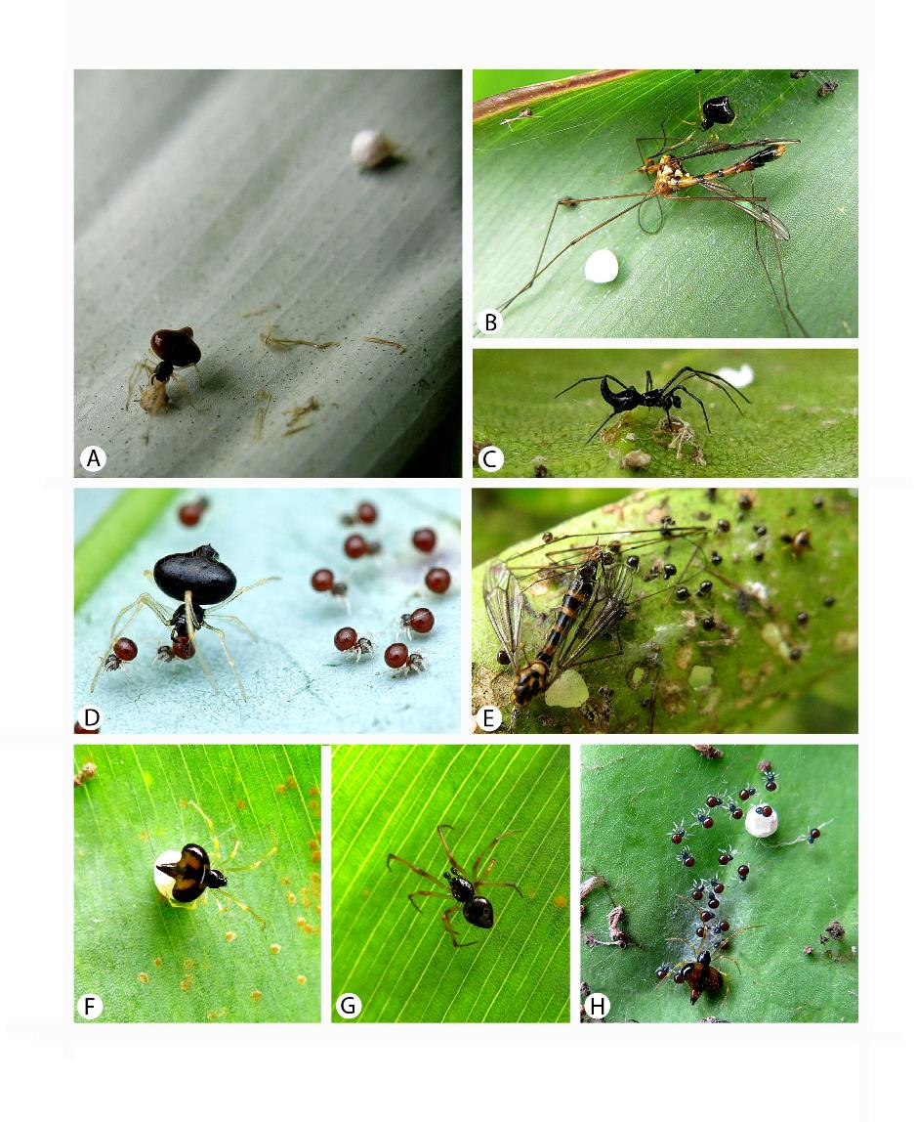
Figure 1 – Field photographs of C. nigra (A-C) and C. bilde (D-H), from Bali (other than D). A, female with egg sac. B, female with large tipulid prey. C, male. D, female from Singapore with spiderlings (photo by Melvyn Yeo, used with authorization). E, female and spiderlings with large tipulid prey. F, female with egg sac, note light brown-orange markings on abdomen. G, male. H, female and spiderlings with egg sac.
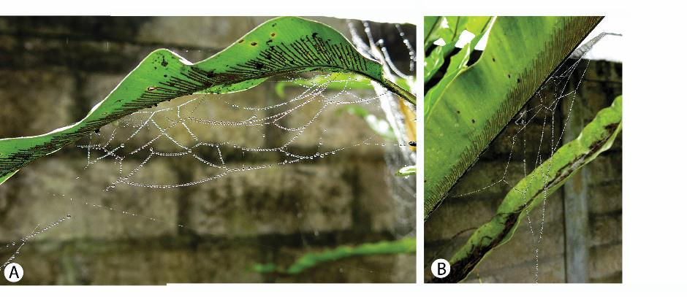
Figure 2 – Web of Chikunia spp.

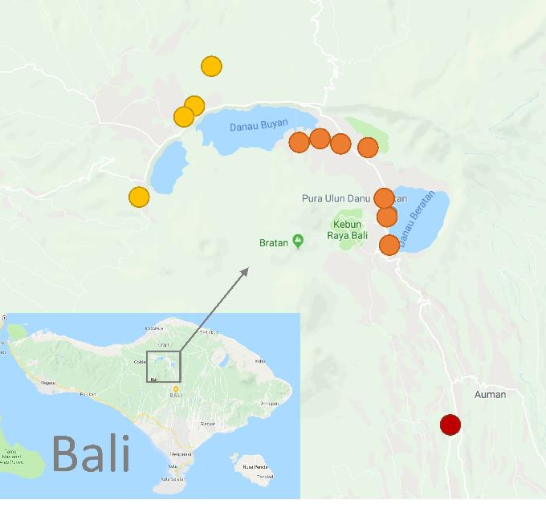
Figure 3 – Map of localities on Bali where Chikunia spp were found. Red circles indicate the occurrence of C. nigra, yellow circles indicate occurrences of C. bilde, and orange circles denote occurrences of both species at the location.
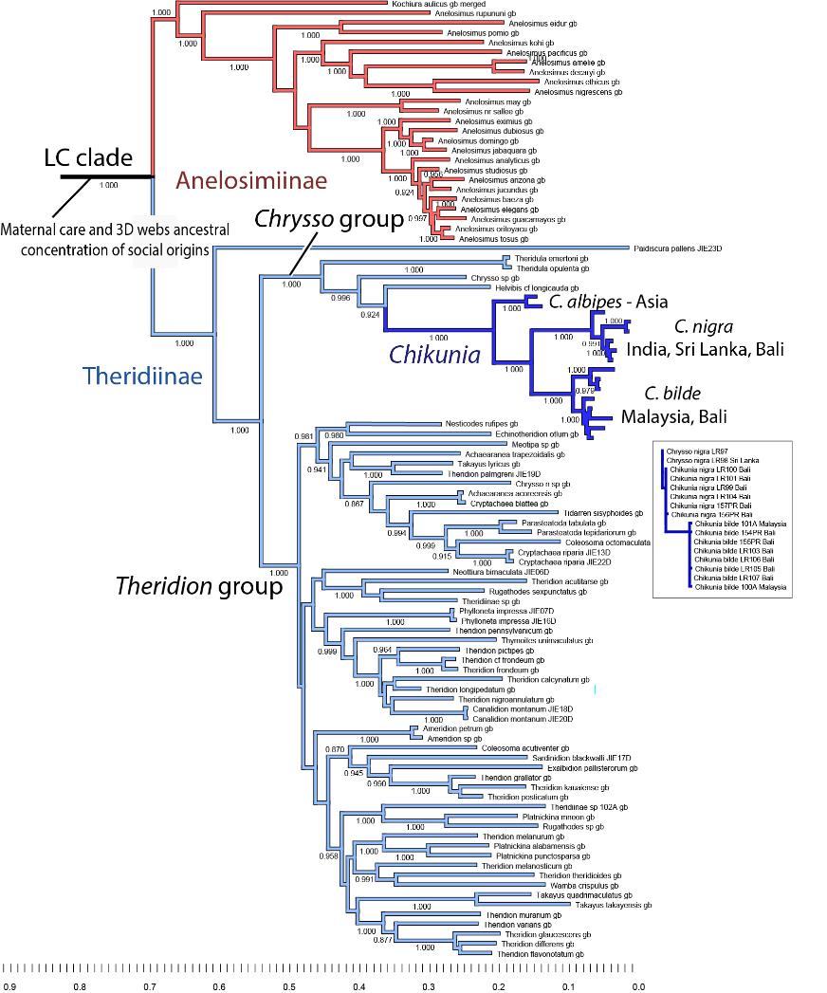

Figure 4 – Phylogenetic placement and structure of Chikunia. Chikunia belongs to the Chrysso group of Theridiinae, within the lost colulus clade marked by social preadaptations and multiple origins of cooperative behavior. The phylogeny supports the sister relationship between C. nigra and C. bilde. Deep genetic structure indicated within each species is reflecting only mtDNA, while the rapidly evolving nuDNA ITS2 marker supports only the deep split between the species but shows almost no variation within either (inset).

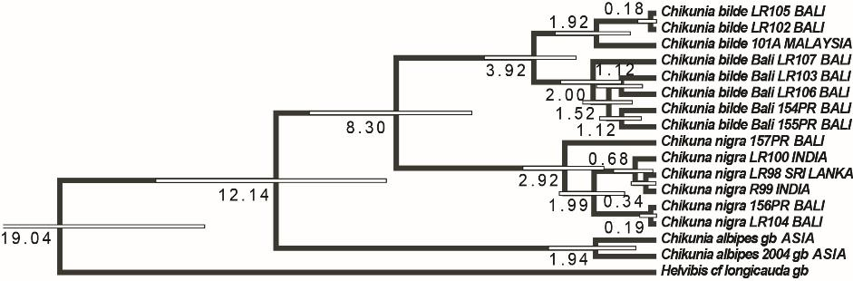

Figure 5 – Dated phylogeny of Chikunia, indicating divergence between the focal species about 8 mya.
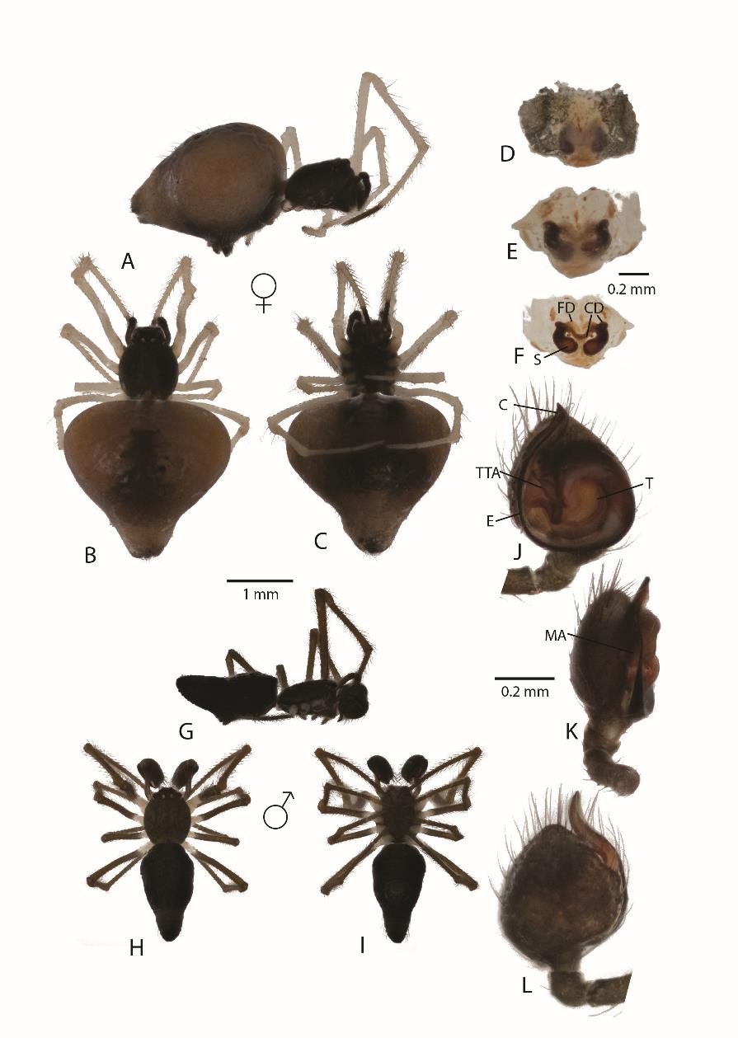
Figure 6 – Chikunia nigra. A-C, female habitus. A, lateral, B, dorsal, C, ventral. D-F epigynum. D, ventral, E, dorsal, F, dorsal after digestion. G-I, male habitus. G, lateral. H, dorsal. I, ventral. J-L male pedipalp. J, ventral, K, lateral, L, dorsal. C-conductor, CD-copulatory ducts, E-embolus, FD-fertilization ducts, MA-median apophysis, S-spermathecae, T, tegulum, TTA-theridiid tegular apophysis.

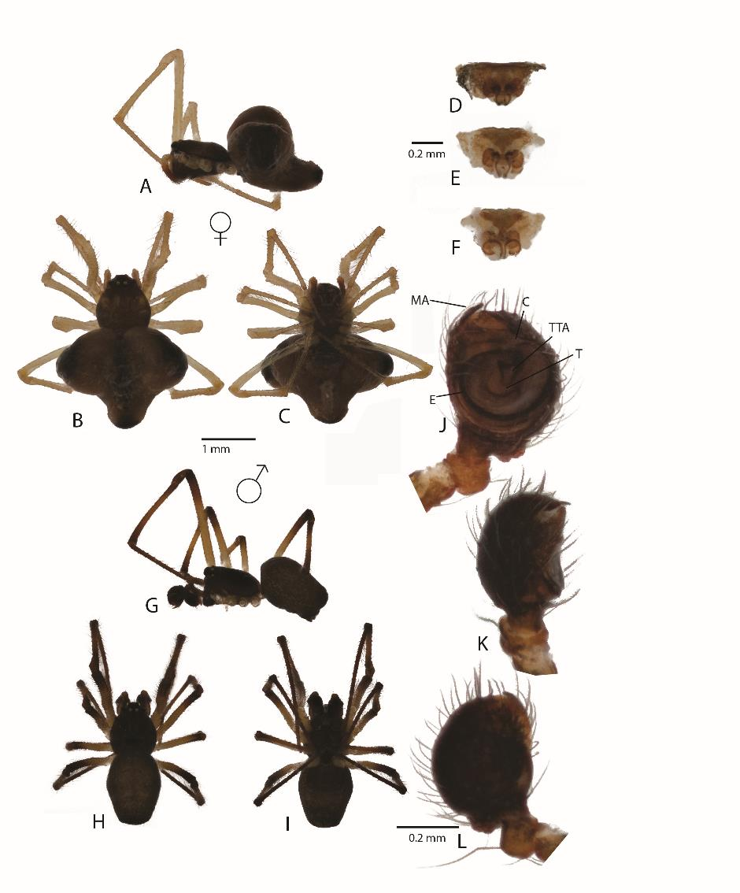Figure 7 – Chikunia bilde. A-C, female habitus. A, lateral, B, dorsal, C, ventral. D-F epigynum. D, ventral, E, dorsal, F, dorsal after digestion. G-I, male habitus. G, lateral. H, dorsal. I, ventral. J-L male pedipalp. J, ventral, K, lateral, L, dorsal. C-conductor, CD-copulatory ducts, E-embolus, FD-fertilization ducts, MA-median apophysis, S-spermathecae, T, tegulum, TTA-theridiid tegular apophysis.
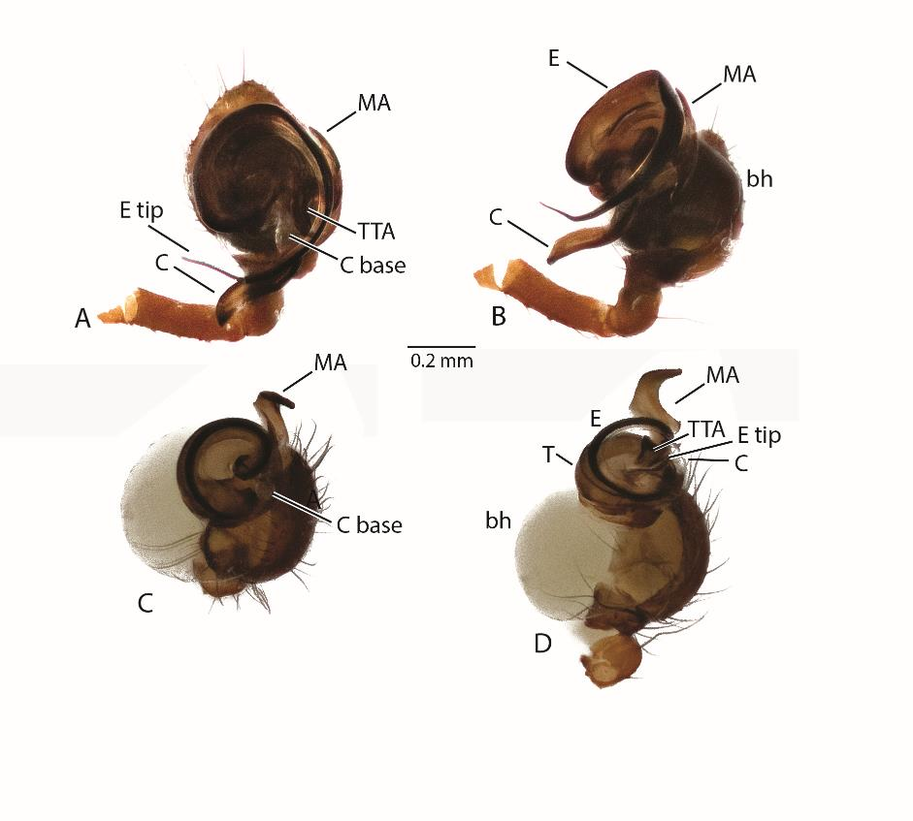
Figure 8 – Expanded male pedipalps. A-B, C. nigra. A, ventral. B, ectal. C-D, C. bilde. C, ventral view of embolus, D, ectal. Note differences in size and length of embolus, the large and extended conductor of C. nigra vs the small and transpared condutor of C. bilde, and the large and finger-like median apophysis of C. bilde. Bh-basal hematodocha, C-conductor, C base-conductor base, E-embolus, E tip-embolus tip, MA-median apophysis, T, tegulum, TTA-theridiid tegular apophysis.

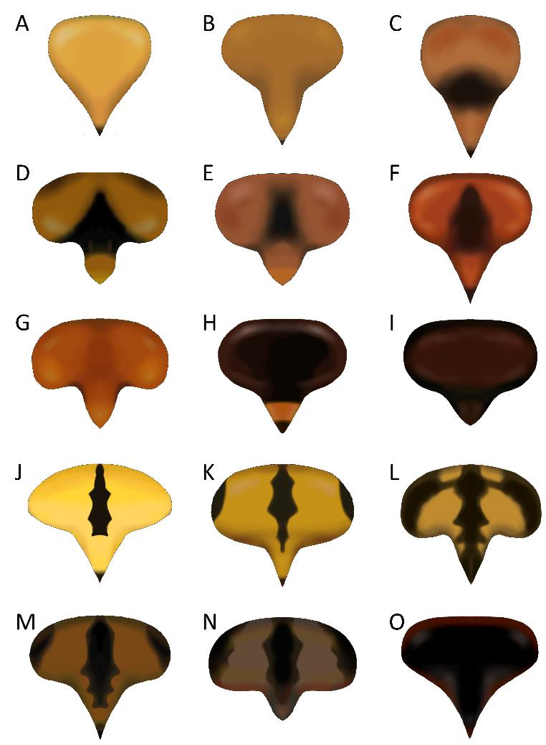

Figure 9. Variation of female abdomen color and shape in sampled specimens. A-I: C nigra. J-O: C. bilde.

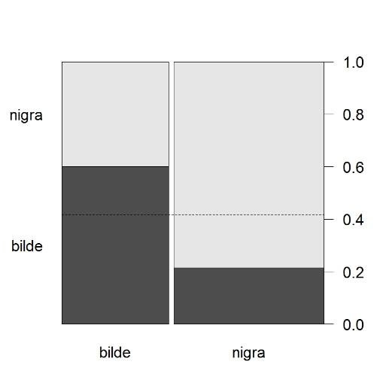
Figure 10 – Proportion of nearest-neighboring females with brood of same- versus different-species (N = 78) in a large, dense colony in the field. The stippled line indicates the proportion of each species observed within the colony and therefore represents the expected values if females were randomly choosing their neighbors.

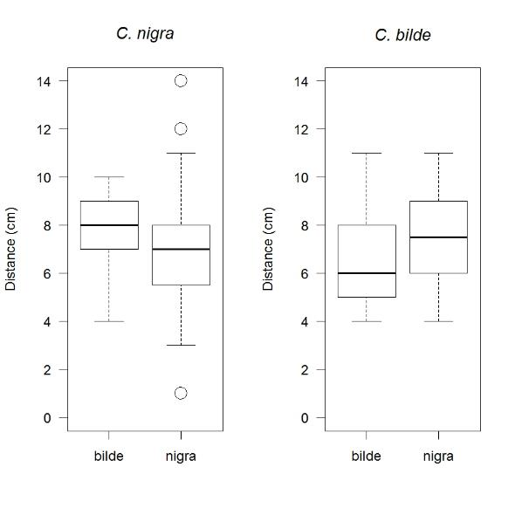

Figure 11 - Boxplot depicting the distances to nearest female with brood of either species for C. nigra and C. bilde within a dense, mixed-species colony in the field.

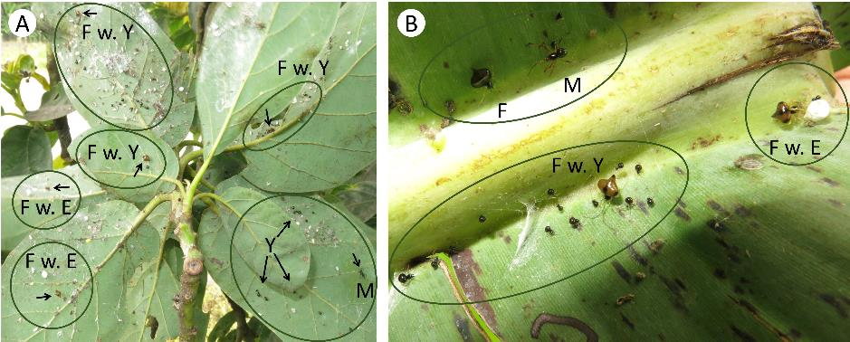

Figure 12 - Mixed-species Chikunia colonies in the field showing females with egg sacs (F w. E), females with young (F w. Y) and males (M). A) The male and most of the females in this photograph are C. nigra. Each female maintains her territory on a single leaf on an avocado tree. B) In this photograph all specimens are C. bilde. Each female occupies a small territory on a banana leaf. Each banana leaf on the tree contained 10+ territories of females and their brood.

References

Agnarsson, I. (2004). Morphological phylogeny of cobweb spiders and their relatives (Araneae, Araneoidea, Theridiidae). Zoological Journal of the Linnean Society, 141, 447-626.
Agnarsson, I. (2010). The utility of ITS2 in spider phylogenetics: notes on prior work and an example from Anelosimus. Journal of Arachnology, 38, 377-382.
Agnarsson, I., Aviles, L., Coddington, J. A., & Maddison, W. P. (2006). Sociality in theridiid spiders: Repeated origins of an evolutionary dead end. Evolution, 60, 2342-2351.
Agnarsson, I., Aviles, L., & Maddison, W. P. (2013). Loss of genetic variability in social spiders: genetic and phylogenetic consequences of population subdivision and inbreeding. Journal of Evolutionary Biology, 26, 27-37.
Agnarsson, I., Gotelli, N. J., Agostini, D., & Kuntner, M. (2016). Limited role of character displacement in the coexistence of congeneric Anelosimus spiders in a Madagascan montane forest. Ecography, 39, 743-753.
Agnarsson, I., Jencik, B., Veve, G., Hanitriniaina, S., Agostini, D., Goh, S., et al. (2015). Systematics of the Madagascar Anelosimus spiders: remarkable local richness and endemism, and dual colonization from the Americas. Zookeys, 13-52.
Agnarsson, I., Maddison, W. P., & Aviles, L. (2010). Complete separation along matrilines in a social spider metapopulation inferred from hypervariable mitochondrial DNA region. Molecular Ecology, 19, 3052-3063.
Aviles, L. 1997. Causes and consequences of cooperation and permanent-sociality in spiders. In J. C. Choe & B. J. Crespi (Eds) The Evolution of Social Insects and Arachnids pp. 476-498. Cambridge: Cambridge University Press.
Aviles, L. and J. Guevara (2017). Sociality in spiders. In D. R. Rubenstein & P. Abbot (Eds) Comparative Social Evolution pp. 188-223. Cambridge: Cambridge University Press.
Bilde, T., & Lubin, Y. 2011. Group living in spiders: cooperative breeding and coloniality. In M. E. Herberstein (Ed) Spider Behavior Flexibility and Versatility pp. 275-306. Cambridge: Cambridge University Press.
Cangialosi, K. R. (1990). Kleptoparasitism in colonies of the social spider Anelosimus eximius (Araneae, Theridiidae). Acta Zoologica Fennica, 190, 51-54.
Coddington, J. A., & Agnarsson, I. (2006). Subsociality in Helvibis thorelli keyserling 1884 (Araneae, Theridiidae, Theridiinae) from French Guiana. Journal of Arachnology, 34, 642-645.
Drummond, A. J., & Rambaut, A. (2007). BEAST: Bayesian evolutionary analysis by sampling trees. Bmc Evolutionary Biology, 7.
Green, P. (1999). PHRAP. Ver. 0.990329: Available at http://phrap.org/.
Green, P., & Ewing, B. (2002). PHRED. Ver. 0.020425c: Available at http://phrap.org/.
Grinsted, L., Agnarsson, I., & Bilde, T. (2012). Subsocial behaviour and brood adoption in mixed-species colonies of two theridiid spiders. Naturwissenschaften, 99, 1021-1030.
Huelsenbeck, J. P., & Ronquist, F. (2001). MRBAYES: Bayesian inference of phylogenetic trees. Bioinformatics, 17, 754-755.
Jackson, R. R. (1986). Communal jumping spiders (Araneae: Salticidae) from Kenya: Interspecific nest complexes, cohabitation with web-building spiders, and intraspecific interactions. New Zealand Journal of Zoology, 13, 13-26.
Jackson, R. R., Ximena J. N. & Salm K. (2008). The natural history of Myrmarachne melanotarsa, a social ant-mimicking jumping spider. New Zealand Journal of Zoology, 35, 225-235.
Johannesen, J., Wennmann, J. T., & Lubin, Y. (2012). Dispersal behaviour and colony structure in a colonial spider. Behavioral Ecology and Sociobiology, 66, 1387-1398.
Kazutaka, K., Kei-ichi, K., Hiroyuki, T., & Takashi, M. (2005). MAFFT version 5: improvement in accuracy of multiple sequence alignment. Nucleic Acids Research, 33, 511–518.
Kullmann, E. (1972). Evolution of social behavior in spiders (Araneae, Eresidae and Theridiidae). Amer. Zool., 12, 419-426.
Lanfear, R., Calcott, B., Ho, S. Y. W., & Guindon, S. (2012). PartitionFinder: Combined Selection of Partitioning Schemes and Substitution Models for Phylogenetic Analyses. Molecular Biology and Evolution, 29, 1695-1701.
Liu, J., May-Collado, L. J., Pekar, S., & Agnarsson, I. (2016). A revised and dated phylogeny of cobweb spiders (Araneae, Araneoidea, Theridiidae): A predatory Cretaceous lineage diversifying in the era of the ants (Hymenoptera, Formicidae). Molecular Phylogenetics and Evolution, 94, 658-675.
Lubin, Y., & Bilde, T. (2007). The evolution of sociality in spiders.Advances in the Study of Behavior, Vol 37 pp. 83-145). San Diego: Elsevier Academic Press Inc.
Maddison, D. R., Maddison, W. P. (2011). Chromaseq: a Mesquite module for analyzing sequence chromatograms, version 1.0. Ver. 1.0.
Maddison, W. P., & Maddison, D. R. (2011). Mesquite: a modular system for evolutionary analysis. Ver. 2.75 (build 566): http://mesquiteproject.org.
R Core Team. (2016). R: A language and environment for statistical computing. Vienna, Austria: R Foundation for Statistical Computing.
Rypstra, A. L. (1979). Foraging Flocks of Spiders - Study of Aggregate Behavior in Cyrtophora citricola Forskal (Araneae, Araneidae) in West- Africa. Behavioral Ecology and Sociobiology, 5, 291-300.
Samuk, K., & Avilés, L. (2013). Indiscriminate care of offspring predates the evolution of sociality in alloparenting social spiders. Behavioral Ecology and Sociobiology, 67:1275–1284.
Settepani, V., Schou, M. F., Greve, M., Grinsted, L., Bechsgaard, J., & Bilde, T. (2017). Evolution of sociality in spiders leads to depleted genomic diversity at both population and species levels. Molecular Ecology, 26, 4197-4210.
Uetz, G. W. (1989). The "ricochet effect" and prey capture in colonial spiders. Oecologia (Berlin), 81, 154-159.
Viera, C., & Agnarsson, I. (2017). Parental care and sociality. In C. Viera & M. O. Gonzaga (Eds), Behavior and Ecology of Neotropical Spiders - Contributions of studies from the Neotropical region, pp. 351-381. Springer, Cambridge.
Yip, E. C., & Rayor, L. S. (2014). Maternal care and subsocial behaviour in spiders. Biological Reviews, 89, 427-449.

