Posterscapes: Encountering Solidarity(ies) in the Streets of Exarcheia

The photo-essay that follows this introduction tells a story of solidarity in the streets of Exarcheia, a small neighborhood in central Athens with disproportionately large historic and political significance. Known, rather sensationally, as the “world’s only anarchist neighbourhood” (Vradis and Dalakoglou, 2011) and as the centre of ‘anarchist renaissance in Europe” (Arampatzi and Nicholls, 2012), Exarcheia has long been the stronghold of Greek urban resistance: including, among others, the 1973 polytechnic uprising against the military junta and the December 2008 riots. Like the rest of Athens, however, Exarcheia has been more recently subjected to, and challenged by, the Greek crisis (e.g. The Economist, 2015), the biggest economic contraction ever recorded in a contemporary Western economy during peacetime.

Previous accounts of the crisis have documented various changes in the everyday logics and practices of Greek residents and in the materiality of their urban environment, within Exarcheia and beyond (e.g. Vradis and Dalakoglou, 2011; Dalakoglou and Agelopoulos, 2017). For instance, Chatzidakis (2017) explores how much of movement activism in Exarcheia was based on the idea of creating “capitalist cracks” (Holloway, 2010) and utopian spaces in the “here and now”. These, however, were undermined by the “here and now” of the crisis: a different kind of socio-temporal logic focusing less on ideology and more on pragmatism, an urgency to satisfy immediate needs amidst the demise of the Greek welfare state. Moving onto the built environment of Exarcheia, and in particular its infamous graffiti-filled walls, Spyropoulos (2013) observes how: “…After December 2008, the graffiti multiplied. The tone of voice changed, humor and irony receded, and more agony and anger emerged. It was only natural… fear is galloping ahead and social cannibalism penetrates everywhere, even inside Exarcheia itself.”

In this photo essay my primary focus is on the area’s political posters, what was often described as “the voices of Exarcheia” or the “walls that speak”, by several of my informants during my ongoing observations of the area (from May 2009 to Oct 2017). Over these years, I have been taking pictures of political posters at regular time intervals (every two-three months) using a mobile phone in my various impromptu walks around the area. Ultimately, the ever-present posters provided me with an opportunity to re-evaluate the relationship between words and images. They did so, I argue, in ways that extended better received forms of urban materiality and street art such as graffiti (e.g. Iveson, 2010).

First, as a preferred and often the main medium of communication in Exarcheia, these posters transferred highly condensed information, both textually and visually, and attempted to mobilise residents and visitors alike. For example, much of the textual content aimed at informing the Exarcheian public of current events – local, national and international - and to propose responses, from protests and demos to solidarity gigs and boycotts. Concurrently, however, these posters were the most ephemeral element of the built environment and as such, they foregrounded time in space as opposed to space in time. Unlike graffiti, for instance, most of these posters have a life span of maximum four months – more often two to three – as they give space to new posters that capture interwoven ideas and political moments: including calls for action, disclaimers, responses to media stories and public events, information about events and collective initiatives. Yet the posters remain spatially embedded. They are (more often than not) put next to other posters; and are in dialogue with other elements of the built environment, offering distinct historic and symbolic articulations. As such, they create visual gestalts that trap a multiplicity of interventions in a single image and which are otherwise lost in time (and space). I attempt to illustrate this through my considered use of eight photos.

Furthermore, each political poster tells its own story(ies) but collectively they also narrate larger-scale ideas and social transformations. In the case of Exarcheia, the indisputable protagonist across the various protests has been a single keyword: solidarity (αλληλεγγύη). No other word had such a long-lasting and consistent presence, appearing explicitly in about half of the posters I encountered and more implicitly, in virtually all of them. In the end, the posters taught me how to “read” solidarity beyond the textual: from solidarity gigs and collective cooking events to guerrilla parks, the Exarcheian cry for political solidarity was everywhere. It became even more prevalent when solidarity became a mainstream native discourse far beyond the confines of the neighborhoud (Rakopoulos, 2016); with social actors such as the church and even extreme right wing parties counter-proposing their own solidarity logics and practices (Chatzidakis, 2017). “We were doing solidarity before it became fashionable”, in the words of one of my key informants.

Ultimately then, the posters depict distinct and sometimes antagonistic “cultures of solidarity” (Fantasia, 1989) in the spatiotemporal landscape of crisis-hit Exarcheia. My essay turns out to be a narrative of place (Coles, 2014) but also of time, in so far as the posters made the otherwise implicit rhythms (Lefebvre, 2004) and paces (Parkes and Thrift, 1975) of solidary logics become visible. Perhaps more aptly, it can be described as chronotopograhic (versus topographic; Coles, 2014), to embrace the Bakthinian chronotope, the idea that space-time are inherently inseparable (Bakhtin, 1981). Posters become a method through which elements of this inseparability can be effectively captured.

Photos:

1.
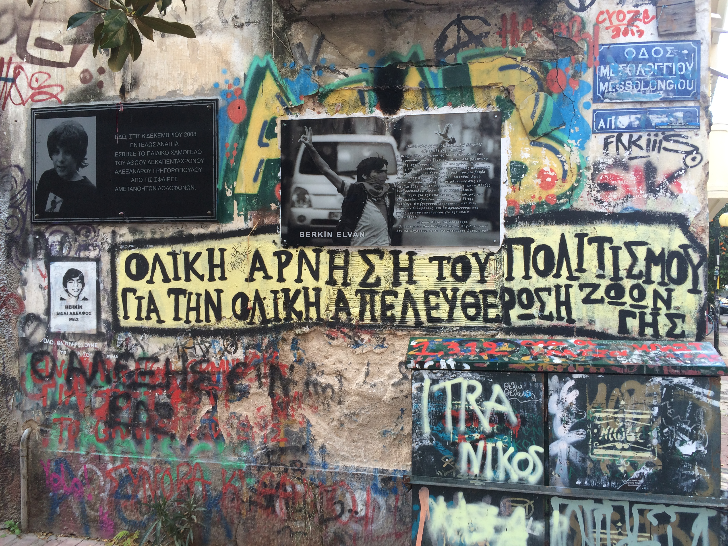
Exarcheian walls “speak”, through their graffiti, their posters and various other objects – here, for instance, a memorial plaque for the assassination of 15yo Alexis Grigoropoulos by a policeman in December 2008, an incident that gave rise to the so-called “December riots”. Next to Grigoropoulos, is another plaque in memory of 15yo Berkin Elvan, fatally injured by police during the Gezi protests. Below, graffiti saying “Total Rejection of Our Civilisation for the Total Emancipation of All Living Species”.

2.
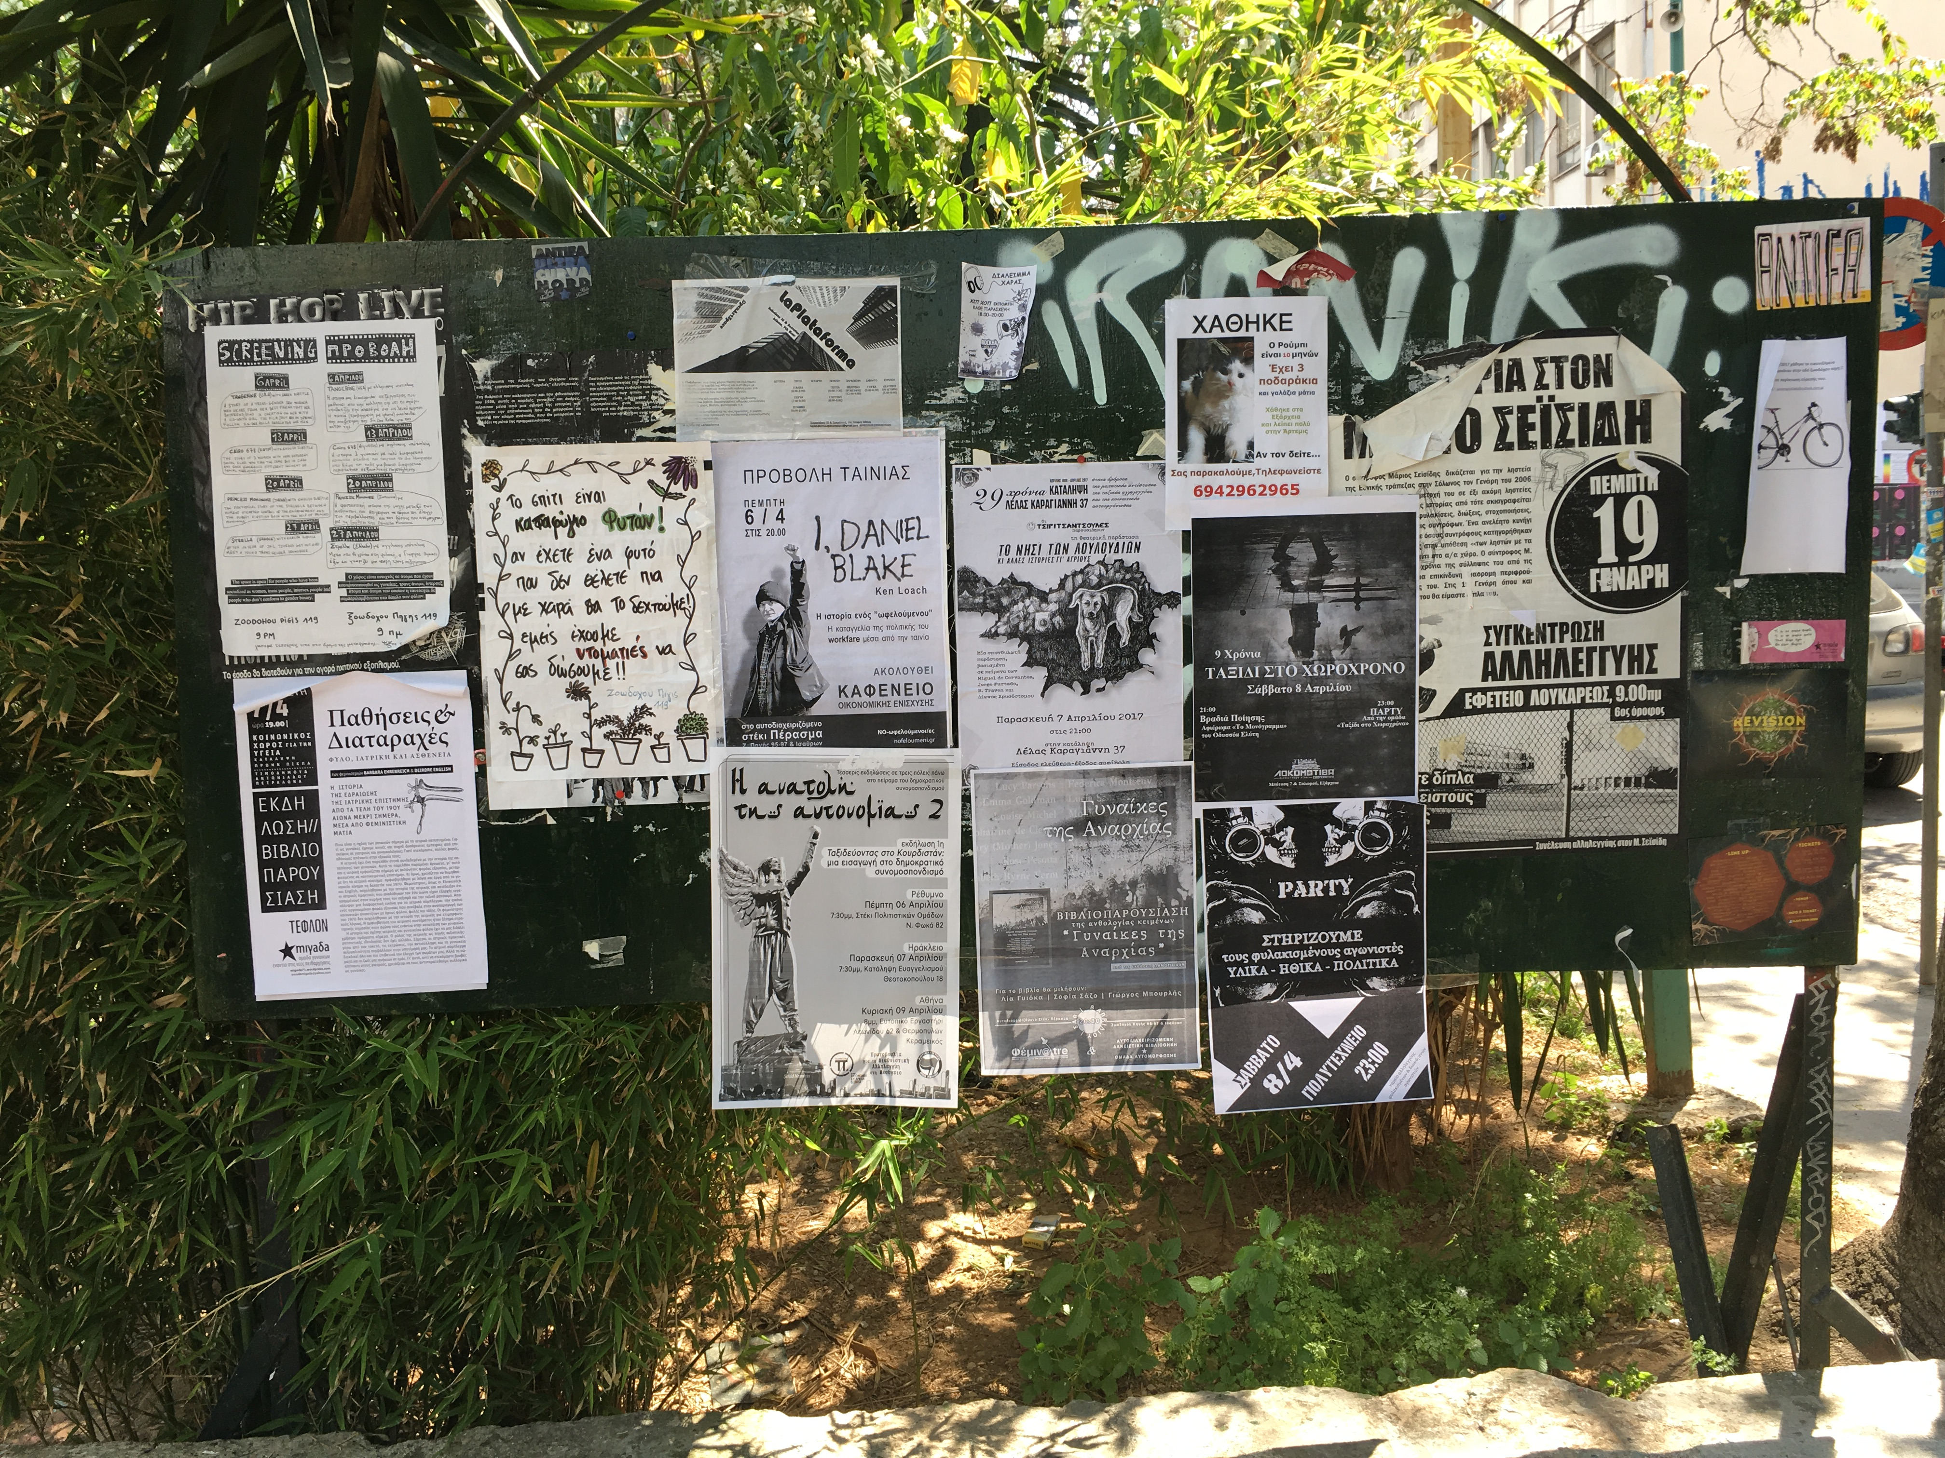
Political posters are ever-present in Exarcheia and often in dialogue with other material manifestations of solidarity. Here a posterscape is foregrounded against the park: a guerrilla park that was created in the aftermath of the December riots. The park is now legitimate and indispensable part of the Exarcheian public sphere, operating on the principles of self-management, horizontal structuring and anti-commercialisation. It has three notice boards that are updated regularly. Current posters are juxtaposed against more special-interest posters (e.g. in relation to hosted events, urban gardening initiatives etc), producing an “heteroglossia” of broader and more specific solidarity discourses and practices.

3.
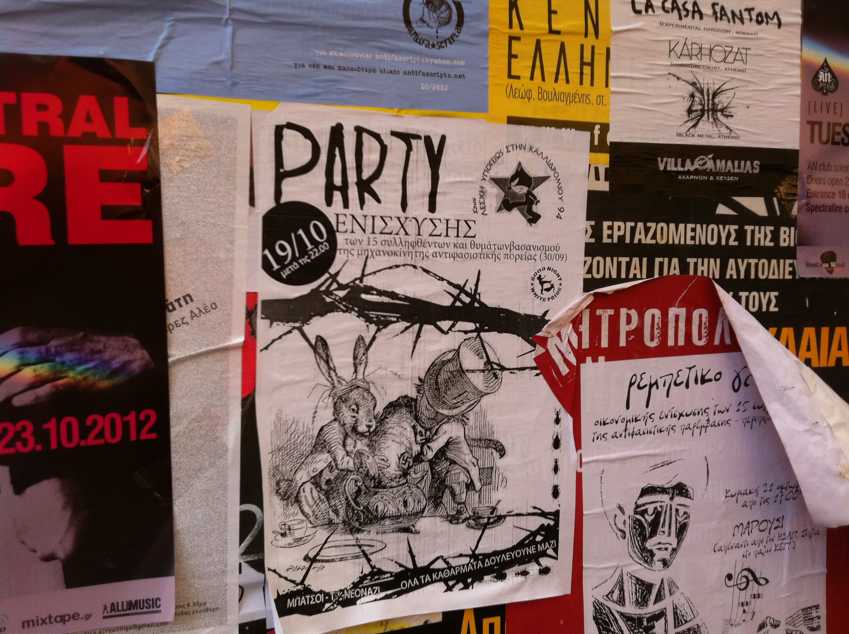
The cry for political solidarity is everywhere in Exarcheia. Here some posters depicting various fundraising parties and gigs in solidarity with arrested comrades.

4.
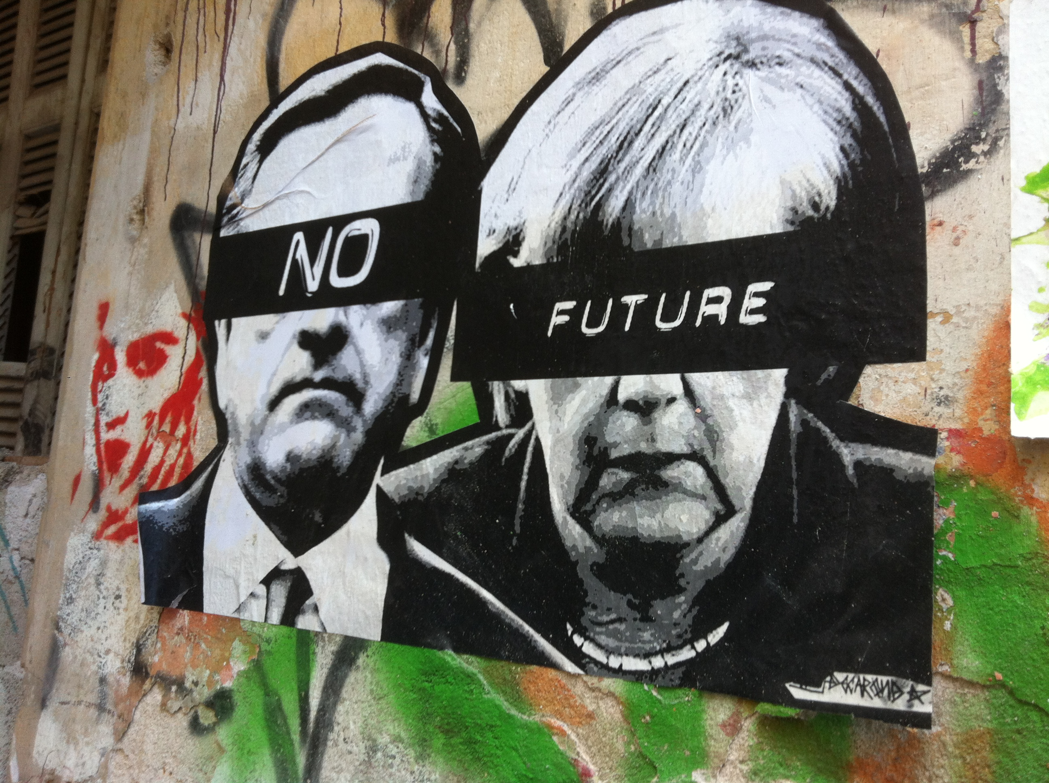
By 2013, the crisis has deeply penetrated the Exarcheian terrain, uncovering its profoundly unsettling and rather permanet nature. The state of a “crisis” has emerged as a prolonged state of being (Agamben, 2005). There is “No future” (through the lips of the then Prime Minister Antonis Samaras and German Prime Minister Angela Merkel), or so it seems for some…

5.
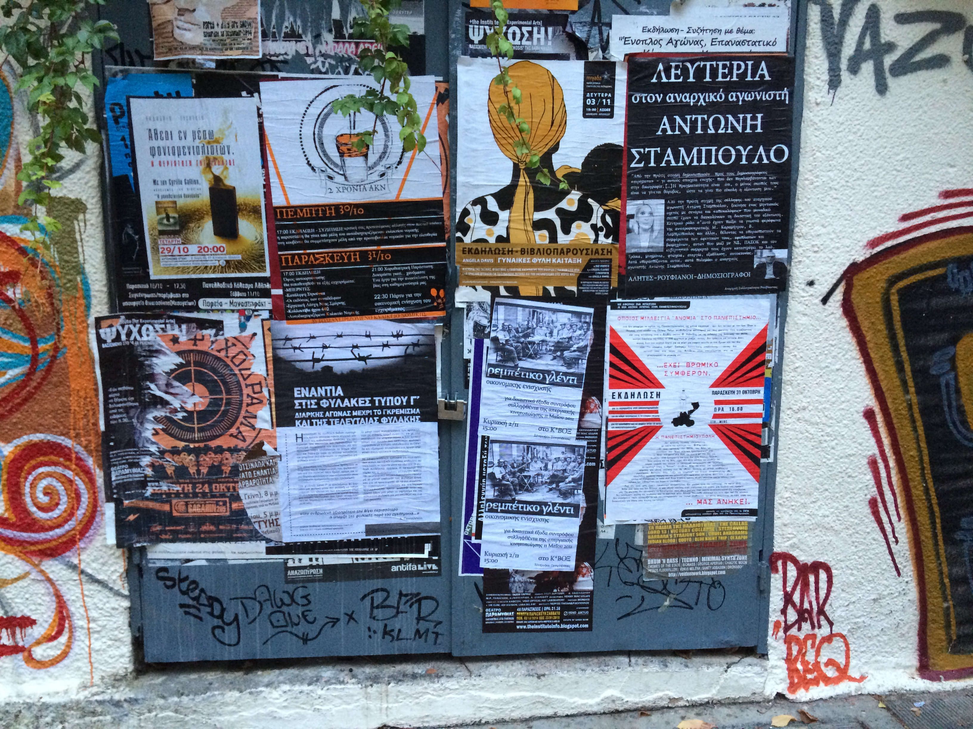
For others, the walls keep speaking: Solidarity gigs, fundraising events, festivals, demonstrations… “Solidarity is our weapon!” becomes a key slogan, a cry against passive acceptance and inaction.

6.
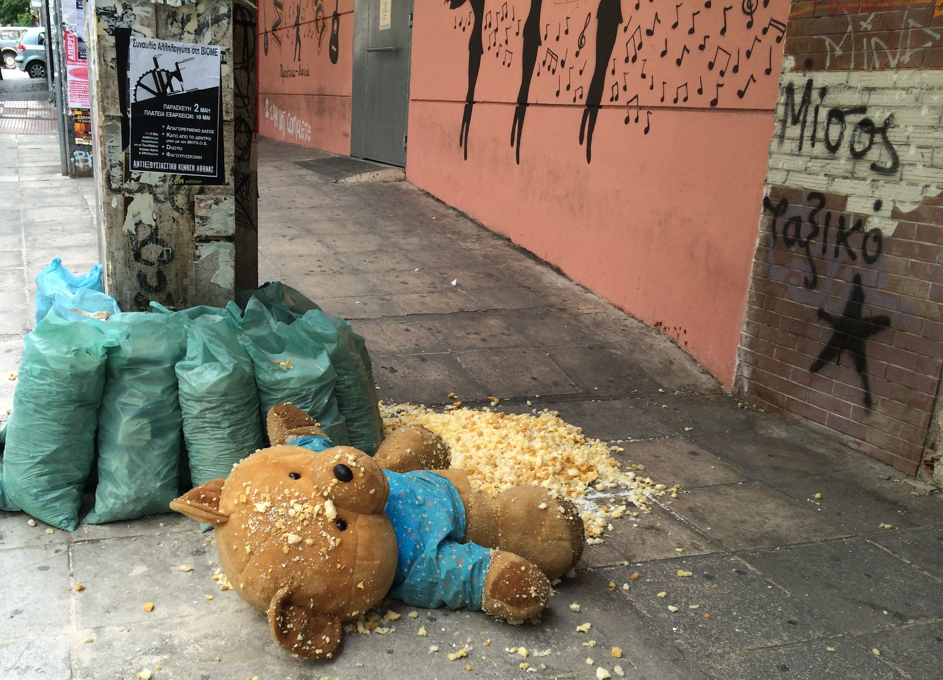
A damaged teddy bear lies next to refuse sacks. Above, a poster publicising a solidarity gig for Viome, an occupied factory that has been hailed in the international media as a successful example of workplace control and solidarity . On the wall to the right, the words ‘Class Hatred’.

7.
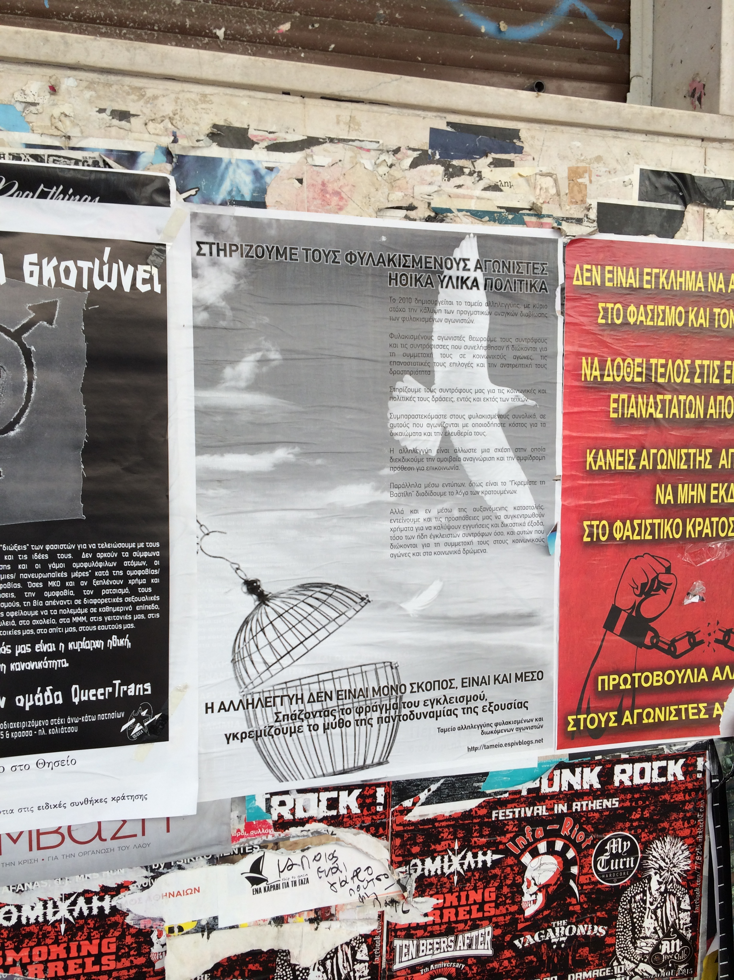
“Solidarity is not only the end, but also the means” says the middle, black-white poster. It refers to a “solidarity fund” recently set up to support the legal expenses of arrested comrades. The poster further explains that “solidarity is a relationship in which we strive for mutual recognition and willingness for two-way communication”.

8.

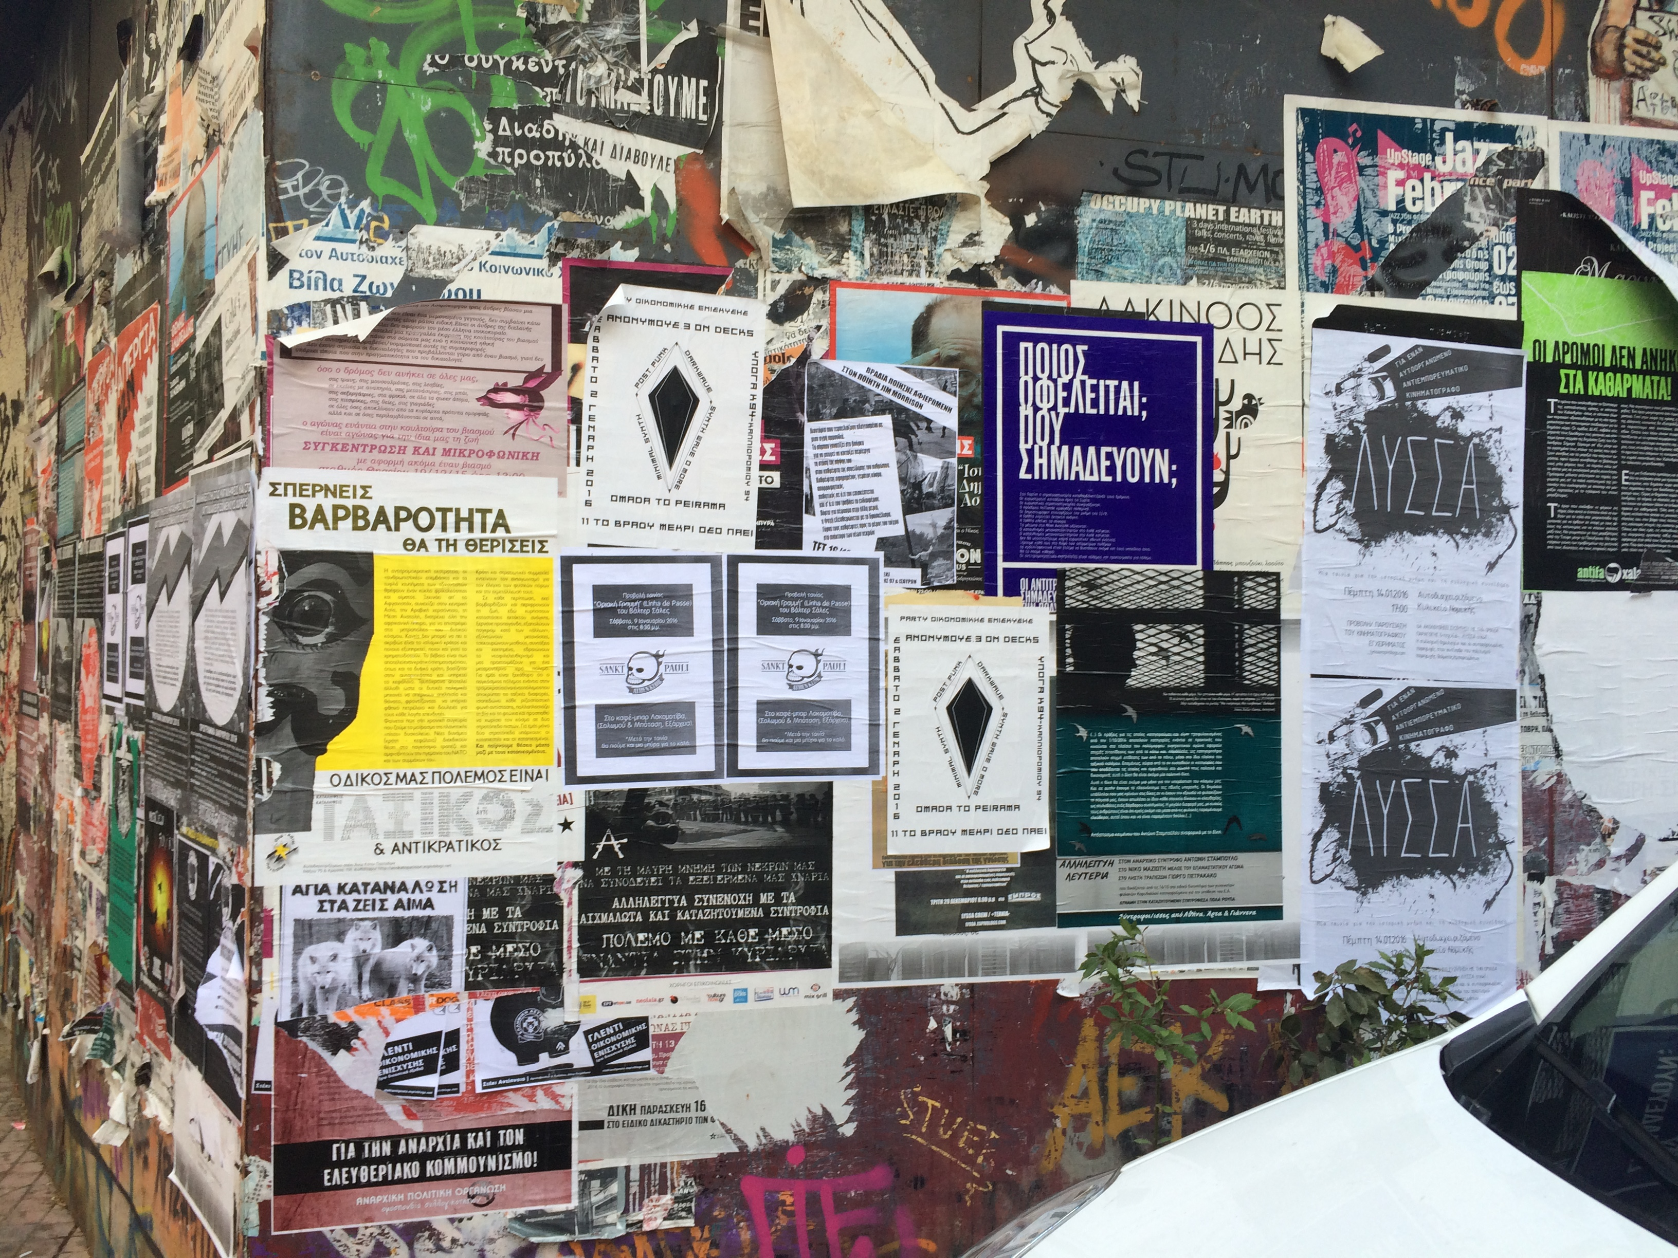

There are common sensibilities in the solidarity logics and practices encountered in Exarcheia: including a commitment to horizontal relationships, mutual recognition, resistance to any form of (capitalist) oppression. They contrast sharply with some of the “new cultures” of solidarity that emerged during the crisis and as a response to it. The posters are testament to the persistence of solidarity during profoundly unsettling times. Posterscapes remain firmly embedded in the local, yet always transcending it, reaching out to difference and distance.

References

Agamben, G. (2005). State of exception (Vol. 2). University of Chicago Press.
Arampatzi, A., & Nicholls, W. J. (2012). The urban roots of anti-neoliberal social movements: the case of Athens, Greece. Environment and Planning A, 44(11), 2591-2610.
Bakhtin, M. (1981). The dialogic imagination – four essays, Austin, TX: University of Texas Press.
Chatzidakis, A. (2017). Consumption in and of Crisis-Hit Athens. In Dalakoglou, D., & Agelopoulos, G. (Ed.) Critical Times in Greece: Anthropological Engagements with the Crisis. London: Routledge (pp. 148-159)
Coles, B. F. (2014). Making the market place: a topography of Borough Market, London. cultural geographies, 21(3), 515-523.
Dalakoglou, D., & Agelopoulos, G. (2017). Critical Times in Greece: Anthropological Engagements with the Crisis. London: Routledge
Fantasia, R. (1989). Cultures of solidarity: Consciousness, action, and contemporary American workers. Univ of California Press.
Holloway, J. (2010). Crack capitalism. Pluto Press (UK).
Iveson, K. (2010). The wars on graffiti and the new military urbanism. City, 14(1-2), 115-134.
Lefebvre, H. (2004). Rhythmanalysis: Space, time and everyday life, London: Continuum.
Parkes D and Thrift N (1975) Timing space and spacing time. Environment and Planning A, 7(6): 651-670.
Rakopoulos, T. (2016). Solidarity: the egalitarian tensions of a bridge‐concept. Social Anthropology, 24(2), 142-151.
Spyropoulos, T. (2013), X-archeia uncensored: The words and graffitis of Exarcheia 2009-2012, Athens, Greece: Rakosilektis. [Σπυρόπουλος Τάκης, (2013), “Χ-άρχεια uncensored: Τα συνθήματα και τα graffiti τών Εξαρχείων 2009-2012,” Αθήνα, Ελλάδα Ρακοσυλλέκτης]
Vradis, A., & Dalakoglou, D. (2011). Revolt and crisis in Greece: Between a present yet to pass and a future still to come. AK press.

https://www.theguardian.com/commentisfree/2017/jul/18/cope-capitalism-failed-factory-workers-greek-workplace-control

