Arctic and Antarctic Regionalism

Klaus Dodds and Alan D. Hemmings

Introduction

In this chapter, we develop two distinct strands of enquiry. At a conceptual level, our discussion is informed by a desire to better understand how ‘territory’ and ‘region’ are put to work discursively and acted out and upon geopolitically (see also Dodds and Hemmings 2015). Informed by the scholarship of authors such as Stuart Elden (2009, 2013) and Philip Steinberg and colleagues (2015), territory is something historically constructed and something that operates on a distinctly material register. In the polar regions, in particular, the intersection of ice, rock and water is particularly distinct in terms of how territorial and regional management is expressed. Working off a volumetric rather than areal focus, recent work alerts us to how region-making projects have worked through height, depth and subterranean domains none more so than in the Arctic and Antarctic.

Second, we address polar regionalism in general which then lead into separate sections on the Arctic and Antarctic respectively. For the sake of brevity, the Arctic Council and the Antarctic Treaty System respectively will be the main areas of reflection. However, we are mindful of the fact that other organizations such as the Nordic Council, West Nordic Council Barents Euro-Arctic Council and Conference of Parliamentarians of the Arctic Region are factors in Arctic regionalism (Exner-Pirot 2013). Multilateral instruments including regional fisheries management organisations operating immediately to its north of the Antarctic Treaty area of application are part of what we might term Antarctic regionalism. The Arctic Council is a circumpolar intergovernmental forum made up of the eight Arctic states (Canada, Denmark, Finland, Iceland, Norway, Russia, Sweden and the United States) while the Nordic Council, as the names implies, has a more regional membership composed of Denmark, Finland, Iceland, Norway, and Sweden. It also axiomatic that the regional boundaries of the Arctic and Antarctic are fluid so that it is imperative that we appreciate that regional and international actors such as the European Union (EU) and UN agencies such as the International Maritime Organization (IMO) play a part in shaping polar regionalism in the water, air, and on the land. For instance, the IMO’s Polar Code (entered into force on 1 January 2017) is an important legal intervention on the maritime environments of the Arctic and Southern Ocean. Alternatively, the EU is an ad hoc observer to the Arctic Council and major funder of Arctic and Antarctic science.

Polar Regionalism

Any account of polar regionalism would have to acknowledge that the materiality of the Arctic and Antarctic plays an important role in the making and remaking of regional projects (Young 2005, 2012, Pincus and Ali 2015, Steinberg et al 2015, Dodds et al 2017). Unlike other continents and islands, the interplay of sea and ice are critical in shaping the human and physical geographies of the Arctic and Antarctic. Both areas change markedly depending on seasonality, and historically have varied in extent depending on the distribution and thickness of land and sea ice. The (then) remoteness of the Antarctic arguably allowed the negotiators of the 1959 Antarctic Treaty (Saul and Stephens 2015, pp. 1-5) to include such path-breaking provisions as the prohibition of military measures, nuclear testing and waste disposal and to entirely ignore the question of potential future resource exploitation which was left to later development of the Antarctic Treaty System. In the case of the Arctic, sea ice and polar weather has played a pivotal role in deepening the work of the Arctic Council and arguably a shared sense of the Arctic region as a demanding space needing regional cohesion when it comes to search and rescue, shipping, and oil response in the event of a shipping or oil/gas disaster affecting the Arctic Ocean. So there are discernible issues that contribute to the imaginative geographies of ‘Arctic challenges’.

The geopolitics of the Cold War is a major factor in determining the how, where, who, why and what of regional co-operation. In the Arctic, the ‘ice curtain’ between the United States and the Soviet Union was clearly pivotal in shaping a lack of regional co-operation and collaboration as both sides feared that the other might engage in long-range bomber attacks and sneak submarine assaults. Where regional co-operation existed it was shaped by a security architecture and including the United States and its regional allies such as the UK, Canada and Norway who were committed to patrolling the ‘Northern Flank’ and ‘Northern Waters’ of the Arctic and northern fringes of the Atlantic and Pacific Oceans (Archer 1988). Where there was a more regional even circumpolar co-operation, it was limited and tied to periods of relative détente. The most notable being the 1973 Polar Bear Agreement signed between Canada, Denmark, Norway, US and Soviet Union, which noted in the preamble that:

“Recognizing the special responsibilities and special interests of the States of the Arctic Region in relation to the protection of the fauna and flora of the Arctic Region…Recognizing that the polar bear is a significant resource of the Arctic Region which requires additional protection…Having decided that such protection should be achieved through co-ordinated national measures taken by the States of the Arctic Region”.

What is significant here is the construction of the parties as ‘States of the Arctic Region’ and thus distinct from other Arctic states such as Iceland, Finland and Sweden because of the geographical scope of the polar bear itself. Thirty-five years later, these same states would be instrumental in re-imagining themselves as Arctic Ocean coastal states, in the sense of the UN Convention on the Law of the Sea (UNCLOS), when addressing the legal and maritime geographies of the Arctic Ocean – a within-region regionalism that privileges the Arctic Five (A5) over the Arctic Eight (A8).

The idea of the ‘Arctic Region’ as being distinct politically, ecologically and legally is embodied in the 1973 Agreement on the Conservation of Polar Bears. Looking south, the 1959 Antarctic Treaty identified and codified an Antarctic Treaty Area (south of 60 degrees South) in order to mobilise a new framework for shaping the present and future governance of the Antarctic. In both cases, these two instruments (an Agreement and a Treaty), one object-specific and another more wide-ranging, contribute to a regionalising process sensitive to prevailing to geopolitical and legal geographies of the regions. In the Arctic, the five states invoked an ‘Arctic region’ for the purpose of polar bear conservation, which places limits on the killing of polar bears, consults with indigenous peoples, and encourages the sharing of polar bear-related research. In the Antarctic, the Antarctic Treaty signatories although, mindful of the contested sovereignty surrounding the polar continent and surrounding oceans, worked to create a regional architecture where states and other parties co-ordinate and integrate their activities above, across and below air, ice, rock and water.

Regional architectures are not just instrumental and legal-based, they are also iterative and declarative. As Judith Butler identified for categories such as ‘gender’, there is an inherent performativity to words such as ‘Antarctic Treaty System’ and ‘Antarctic Treaty Area’. As Butler explains, "Within speech act theory, a performative is that discursive practice that enacts or produces that which it names" (Butler 2011, p. 13). The Protocol on Environmental Protection to the Antarctic Treaty (Madrid Protocol) (Saul and Stephens 2015, pp. 104-137), for example, performs a powerful speech act in its Article 2:

‘The Parties commit themselves to the comprehensive protection of the Antarctic environment and dependent and associated ecosystems and hereby designate Antarctica as a natural reserve, devoted to peace and science’.

By endlessly repeating the Protocol and its provisions, the Antarctic Treaty Consultative Parties help to enact objects such as ‘Antarctic environment’, which then contribute to Antarctic regionalisms appearing both natural and necessary. The enactment of ‘regional norms’, although always artificial, have geopolitical and legal consequences, as well as subjectivities of those involved in the enforcement and monitoring of the Protocol.

Butler’s emphasis on performativity and iteration have relevance for more critical engagements with polar regionalisms, through her interest in what she describes as ‘petty sovereigns’ (often state-sanctioned officials charged with security and border management) responsible for maintaining distinctions between security and insecurity (Butler 2006, p. 56-60). What interests us is the role a medley of state-sanctioned diplomats, scientists, journalists and academics play in policing and monitoring ‘polar regionalisms’ and how distinctions made regarding ‘the Arctic’ and ‘the Antarctic’ have different implications for bodies, ideas, knowledges and activities. As Butler notes in her reading of sovereignty and sovereign power, ‘petty sovereigns’ are implicated in a managerial power that intervenes on how things are evaluated, implemented and judged. This might be most evident in areas such as: who gets to ‘speak’ of and for the ‘Arctic’ and ‘Antarctic’? Which parties, and whose interventions in the Antarctic attract the most critical environmental scrutiny? Are there some actors who are more ‘naturalized’ than others when it comes to speaking and doing things in the Arctic and Antarctic? And, how far does the Arctic and Antarctic extend and stretch in area, height and depth?

The making and remaking of the region and regionalism as both a process and outcome is one riven with both large-scale and public interventions, variously labelled (e.g. treaties, conventions, declarations, and protocols) and perhaps more subtle ‘little things’ that help to determine the shape and scope of regional projects. In the Arctic and Antarctic, state parties have had to negotiate boundaries that are fluid rather than static (e.g. the Southern Ocean), limited political and economic agendas, uncertain sovereignties and/or where there is a complex interplay between the sovereign rights of coastal states and areas beyond national jurisdiction including international waters and the seabed beyond the continental shelf entitlements of coastal states. Depending on the issue and topic, there are different regional architectures and definitions at play, which contribute to multiple Arctic and Antarctic regional governance and geopolitical projects encompassing inter alia fish, whales, minerals, shipping and science. And as we have noted, they also touch upon who, where and what gets evaluated, monitored and judged.

Arctic Regionalism

While there is a wider history and geography to Arctic regionalism to be recorded (e.g. the use of terms of Circumpolar North), the focus is here on the inter-governmental forum, the Arctic Council. Established in 1996, under the Ottawa Declaration, the Council was intended to “provide a means for promoting cooperation, coordination and interaction among the Arctic States, with the involvement of the Arctic indigenous communities and other Arctic inhabitants on common Arctic issues, in particular issues of sustainable development and environmental protection in the Arctic”. The identification of ‘sustainable development’ and ‘environmental protection’ as foci for the Arctic Council was rooted in the legacies and consequences of Cold War militarism and post-Cold War regional collaboration and confidence building as exemplified by the speech in Murmansk by Premier Gorbachev in 1987 calling for the Arctic to be a ‘zone of peace’ followed by the Arctic Environment Protection Strategy (AEPS) negotiated in 1991. And the lesson of that speech, alerts us to the important role that individual political leaders still play in geopolitical shifts – a not entirely comforting, if still necessarily speculative, realization at the dawn of the US Presidency of Donald Trump.

The AEPS addressed common environmental challenges, acknowledged the agency of indigenous peoples and identified trans-national pollution such as lingering nuclear radioactivity and airborne contaminants as regional priorities. It did not specify an Arctic region per se. The Ottawa Declaration did not define the Arctic as region but rather identified eight Arctic states and six indigenous peoples organizations as members and Permanent Participants of the Arctic Council.

As scholars such as Keskitalo recognised (2004), the Ottawa Declaration emerged at a time of Arctic ‘regional-speak’, with multiple Arctic(s) in conversation with one another depending on geographical, ecological, legal and political criteria and registers. The working groups attached to the Arctic Council such as the Arctic Monitoring and Assessment Programme and the Conservation of Arctic Flora and Fauna adopt different Arctic boundaries with countries like Iceland occupying a liminal space between Arctic and near-Arctic and variation in how far the Arctic region should extend over the northern fringes of the Atlantic and Pacific Oceans (which as we will note below, has its analogue in the “Greater Southern Ocean” today). So in terms of advancing the core agenda of the Arctic Council, the working groups and task forces addressing matters such as marine and scientific co-operation have co-opted different working definitions of the Arctic as region. Promoting a circumpolar perspective, and informed by this scientific-technical knowledge producing architecture, the Arctic Council has been integral to producing the Arctic as space of shared governance (Figure 1).

The regional agenda of the Arctic Council grew with a shared recognition that the Arctic coastal states of Canada, Denmark/Greenland, Norway, Russia and the United States were concerned about the ecological changes and challenges confronting the Arctic Ocean environment. Ranging from receding sea ice to ocean acidification, the A5 were drawn into closer co-operation on the basis of environmental change rather than say transnational capital and resource exploitation. The Arctic Ocean, unlike onshore Arctic regions, has largely avoided natural resource exploitation including oil, gas, coal, and fishing. While the coastal areas of the Arctic region have not escaped marine and mineral exploitation, the marine areas closer to the central Arctic Ocean have remained comparatively isolated. But these remoter areas have not been immune to geophysical and chemical changes affecting the Arctic.

In May 2008, the A5 issued the Ilulissat Declaration, which declared that:

The Arctic Ocean stands at the threshold of significant changes. Climate change and the melting of ice have a potential impact on vulnerable ecosystems, the livelihoods of local inhabitants and indigenous communities, and the potential exploitation of natural resources. By virtue of their sovereignty, sovereign rights and jurisdiction in large areas of the Arctic Ocean the five coastal states are in a unique position to address these possibilities and challenges…Notably, the law of the sea provides for important rights and obligations concerning the delineation of the outer limits of the continental shelf, the protection of the marine environment, including ice-covered areas, freedom of navigation, marine scientific research, and other uses of the sea. We remain committed to this legal framework and to the orderly settlement of any possible overlapping claims.

The Declaration highlights both a shared ocean territory but also legal-judicial framework in the form of the ‘Law of the Sea’ in helping to manage and resolve present and future challenges including delimiting the outer limits of the continental shelves of coastal states. While other Arctic states such as Iceland registered their displeasure at this initiative, fearing a geo-politics of exclusion, the Arctic 5 established a regional bloc that while attentive to the regional was also keenly aware of national interests and their individual sovereign rights as coastal states.

State sovereignty and sovereign rights continues to be emphasised by all the Arctic states, and in particular by the A5. Article 76 of UNCLOS and the mechanism for the delimitation of outer limits of continental shelves encouraged substantial investment in oceanographic and geophysical mapping of the Arctic Ocean by the Arctic 5. With the exception of the United States, which has still not ratified UNCLOS, the four other Arctic Ocean coastal states have submitted materials to the UN Commission on the Limits of the Continental Shelf (CLCS). Environmental change coupled with the febrile reactions to the planting of a Russian flag being planted on the seabed of the central Arctic Ocean prompted the Declaration as a device intended to defuse speculation that the Arctic was thinly governed and about to be scrambled over (Dodds and Nuttall 2016). While the UNCLOS-related process has been ‘orderly’, it enables and constrains particular forms of regional co-operation. Denmark, Canada and Russia have, for example, consulted one another over their respective submissions to the CLCS and the A5 have initiated plans to work with other stakeholders about how to manage the central Arctic Ocean (international waters) should fishing become possible in the future. But the fact remained that the other Arctic states were unhappy with what they perceived to be exclusionary tactics and strategies.

Notwithstanding the common purpose of the A5 with regard to Arctic Ocean governance, the A8 were able to conjure up regional alignment by focussing on the prospect of future observers to the Arctic Council. The Ottawa Declaration made reference to:
Observer status in the Arctic Council is open to:
- Non-arctic states;
- inter-governmental and inter-parliamentary organizations, global and regional; and
- non-governmental organizations

The most challenging moment for the Arctic Council came at the Ministerial Meeting in 2013 when the Arctic states and Permanent Participants discussed the applications of six states and other applicants including Greenpeace and the Oil and Gas Producers Association. The six states (China, India, Singapore, Korea, Italy and Japan) were admitted at the meeting while others including the European Union (at the time an ad hoc observer) were not considered. The decision to admit five ‘Asian’ observers marked a shift from the existing pattern of state observers, which were overwhelmingly ‘European’ members including UK, Germany and Poland. At the same time the eight Arctic states agreed to a legally-binding oil spill response agreement, which complemented an earlier agreement on search and rescue in the Arctic region (Steinberg and Dodds 2015).

As part of the expansion of state observers process, the Arctic Council revisited their guidelines (the so-called ‘Nuuk criteria’) for observers. Developed in 2011, they have been revisited in 2013 and revised again in 2016, but in essence it insists that observers respect the sovereignty, sovereign rights and jurisdiction of the eight states, that they contribute positively to the work of the Arctic Council and that they are not permanent observers. In effect, the guidelines stress that the contribution of observers will be assessed and evaluated mindful that the admission of additional observers carries with its transactional costs regardless of how substantial the contribution of an observer might be to the working groups and task forces of the Arctic Council.

The admittance of new observers to the Arctic Council in 2013 brought to the fore different projects – a regionalism shaped by the Arctic states and Permanent Participants and a vision of a global Arctic where states such as China were imagining themselves as ‘near-Arctic’ states. The Arctic as region was imagined as possessing a stretchable quality where a medley of issues such as climate change, shipping, and living and non-living resources enable different Arctic(s) to become the basis for economic, political and legal governance. What makes Arctic regionalism interesting in recent years is how the materiality of the region itself is fundamental – as a transit zone, as a resource frontier, as a military zone, and the pressures that diminishing sea ice, ocean acidification and/or environmental perturbation place on the regulation of the Arctic.

The use, representation and regulation of the Arctic are integral to region building, but the Arctic Council does not enjoy exclusive sovereignty over that project. There are other forums that arguably participate in Arctic regionalism. Notably in October 2013 Iceland hosted an Arctic Assembly, which brought together an array of business, political, and non-governmental bodies and stakeholders together with Arctic and non-Arctic states. While this body and others such as the annual Arctic Frontiers conference do not pose a challenge to the authority and legitimacy of the Arctic Council, it serves as a reminder that the use, representation and regulation of the Arctic is not straightforward. And this became even more apparent in the aftermath of the Russian annexation of Crimea and onset of crisis in Eastern Ukraine from 2014, and the confrontation in relation to Syria. Within months, commentators were expressing concerns that the regional co-operation engendered by the Arctic Council might be jeopardised by worsening relations between the EU, the West and Russia.

Two things have followed from the onset of a crisis in the West’s relationship with Russia. First, the activities of the Arctic Council have endured but specific issues like the application of the EU for observer status has been abandoned for the moment as a consequence of EU sanctions against Russia. In retrospect, there was a period between 2008-2014 when the Arctic states were able to consolidate their collective regional interests, address growing extra-regional interest in the Arctic and cement their dominant role in Arctic governance. While the Arctic Council does not consider military and security matters, the Arctic states found ways of collaborating on matters of mutual interest such as search and rescue, oil spill response, coastguard and constabulary matters and avoided tension between the NATO member states and Russia. The Arctic states arguably also agreed that the admittance of additional state observers such as China and Korea was a useful way of consolidating their sovereign authority (Steinberg and Dodds 2015). Second, as a consequence of sanctions, Russia has looked to other partners such as China and Vietnam to support its oil and gas sector and encouraged different stakeholder involvement as western companies such as Exxon-Mobil and BP have pulled out of Russian partnership deals.

Until the Ukraine crisis and the consequential sanctions/travel restrictions placed on Russia and its officials, we might have concluded by stating that there is evidence of a ‘regional community’ forming around the Arctic region, and centred on the Arctic Council. There are degrees and levels of what might be termed ‘region-ness’ but we could point to a community of states and permanent participants working in a context characterised by working groups/task forces investigating the politics, ecologies and cultures of the Arctic region, supported by a permanent secretariat and working with an architecture characterised by ministerial meetings, permanent participants and Senior Arctic Officials attached to the eight Arctic states, and stakeholder engagement involving states, NGOs and IGOs. While the Ukraine crisis has led to some disruption in that overall process, Arctic regionalism has a resilient quality and [sectorial sectoral? secular?] scope to it that few would have imagined possible in the mid to late 1980s when Premier Gorbachev called for a new vision for the Arctic (Åtland 2008). Importantly, however, when the parties came together to negotiate an Ottawa Convention also it seems likely that very few anticipated that the ‘Arctic region’ would attract the kind of global interest that it does now. The last ten years have witnessed in short an acceleration and intensification of Arctic regionalism, and serves as a reminder that there are temporalities and spatialities at play.

Antarctic Regionalism

What is the region in the Antarctic context? As a geographical area without any indigenous occupation, where permanent presence commenced just over a century ago – and for the first fifty years, discontinuously – the conception is essentially political. The arrival of exploring then sealing and whaling expeditions from the 19th Century, and from the turn of the 20th Century of imperially driven scientific expeditions created a proto-Antarctic-regionalism. This was accelerated by the codification of territorial claims from the early to mid 20th Century. When that project came up against the reality of near universal rejection, including by the post World-War II superpowers of the United States and Soviet Union, a contingent internationalization of Antarctica resulted. Contingent in the sense of only involving a subset of global states, and in representing only a limited abandonment of national autonomy in Antarctica by those states. But, Antarctica was now formally some sort of region; positively in the eyes of its principal actors, in a more passive manner for other states, including those emerging from colonialism. For these states, unless and until they were able to assert rights there too, Antarctic regionalism was at best moot, and at worst an ongoing demonstration of neocolonialism. Later, in the 1980s, as part and parcel of the striving after a New Economic Order, Antarctica was indeed construed as such by the Global South in the annual ‘Question of Antarctica’ in the UN General Assembly (Beck 2017).

But, across this modern period, during which a political Antarctic region has been in place the construct has changed several times. One thing that has not changed has been the global nature of regionalism in the Antarctic context - a seeming paradox. Most regionalisms necessarily coalesce around actors in and of the region, whether in the Mediterranean, the Baltic, West Africa ….. There are of course hot-spots where a region, and often regional dysfunction, also involves extra-regional’ states. The South China Sea presently powerfully demonstrates this, but the Indian and (increasingly) the Arctic Ocean reflect this globalizing reality too (on the latter see Hemmings 2016a). The Antarctic is historically novel in that its regional structure was from inception a globally and not a regionally generated construct. There are states nearer the Antarctic than others, but Antarctica is not meaningfully in anybody’s ‘back yard’. The critical issue here is that inevitably, the Antarctic regional conception has evolved from a different base, and according to a different model, from most other geographical regions on the planet.

Political Antarctic regionalism has seen the dominant Antarctic states, and the Antarctic Treaty System which they created as a regime, exert considerable efforts to preserve their regional hegemony. This was most evident in the 1980s, where the dual challenges of the environmental critique and Group of 77 through the annual UN ‘Question of Antarctica’ debates, galvanized then Consultative Parties to common action in defence of their regional management. Through a combination of the containment of the minerals resources issue (abandonment of the facilitating minerals convention, adoption in its place of the Madrid Protocol with its prohibition of minerals activities), a refocus on environmental protection with the Madrid Protocol, and opening of the ATS to membership by major global south states (notably Brazil, China and India), regional hegemony, only slightly diluted, was preserved, at least in the short term (Hemmings 2014, pp. 59-62, Hemmings 2017).

If we take 1959 as marking the birth of a modern and distinct politico-legal conception of the region, with the adoption of the Antarctic Treaty, we see that across the following almost 60 years, that region has progressively expanded. This expansion is reflected in the architecture of international governance (initially, but no longer exclusively, through the Antarctic Treaty System, important as that remains) but driven by the realities of geopolitical interest attendant upon the expanding menu of resource interests, in turn made possible by technological development. This last made possible the progressive overcoming of both the natural physical barriers of Antarctica (continental and maritime) which had traditionally constrained, if not totally prohibited (see Hemmings 2015), human activity there.

Thus, despite the 1959 Antarctic Treaty applying to the entire area south of 60º South latitude, the absence of marine harvesting activity in the area, apart from the whaling that was the responsibility of the 1946 International Convention for the Regulation of Whaling and its International Whaling Commission (IWC) (Saul and Stephens 2015, pp. 587-593), meant that until 1972, the Antarctic region as most active states understood it in practice applied to little more than the continent and islands.

With first the adoption of the 1972 Convention on the Conservation of Antarctic Seals (CCAS) (Saul and Stephens 2015, pp. 47-53), to manage any resumption of sealing, and then (more substantively, since no sealing has occurred) with the 1980 Convention on the Conservation of Antarctic Marine Living Resources (CCAMLR) (Saul and Stephens 2015, pp. 59-69), the Antarctic region expanded to include the huge oceanic area up to the Antarctic Convergence. This second stage in the conception of the Antarctic region was bolstered, but not materially altered, by the adoption, in 1991, of the Madrid Protocol – the last substantive instrument to be added to the Antarctic Treaty System (ATS).

Post-Madrid Protocol, Antarctic resource exploitation in the conventionally conceived Antarctic region – i.e. the area subject to the instruments of this ATS - was essentially confined to marine harvesting (under CCAMLR) and tourism (not subject to any specific regional regulation beyond generic obligations under the Antarctic Treaty and Madrid Protocol). Minerals resource activity was prohibited under Article 9 of the Madrid Protocol; and sealing (under CCAS) has not eventuated. The problematical issue of ‘scientific’ or ‘special permit’ whaling under the IWC (Fitzmaurice 2015), was now largely conducted close to the continent off East Antarctica and in the Ross Sea. But, as the recent case before the International Court of Justice has shown (Fitzmaurice and Tamada 2016), all parties went to lengths to insulate the Antarctic regime of the ATS from any role – and the corrosive effects of dispute – in relation to whaling there. In the late 20th Century, the only other harvesting activity occurring in high latitudes that was not managed directly under ATS auspices was fishing for southern bluefin tuna. managed by the taxa-specific (and not geographically delimited) 1993 Convention for the Conservation of Southern Bluefin Tuna (CCSBT) (Saul and Stephens 2015, pp. 603609). Southern blue fin tuna occur, and have been harvested, within the CCAMLR area (although their main range appears to be north of it) and therefore it was anticipated that CCSBT and CCAMLR would have to coordinate, although this has proven very difficult in practice, notwithstanding a commonality of active tuna fishing states across the two conventions (Hemmings 2006).

But in the early 21st Century, the huge and hitherto only slightly exploited band of ocean immediately north of the Antarctic Convergence became the focus for a further phase of institutional development, through a series of Regional Fisheries Management Organizations (RFMO) based on a set of new geographically delimited fisheries conventions across the south Atlantic, Indian and Pacific oceans, which each took the northern boundary of CCAMLR as their southern boundary. These RFMOs, comprising the South East Atlantic Fisheries Organisation (SEAFO), South Pacific Regional Fisheries Management Organisation (SPRFMO), and Southern Indian Ocean Fisheries Agreement (SIOFA) (Hemmings 2016b pp.140-142) were adopted over just an eight year period (2001-2009) and all in force by 2012. This is a very fast turnaround in international legal instrument terms, and has created an enormous new area across which marine harvesting is now regulated through international mechanism. Individually and collectively they are positive in terms of fisheries management and the hoped-for wise management of marine ecosystems. Here our interest is in what they also represent in terms of an effective expansion of the Antarctic region.

For a large part of the circumpolar Antarctic, the Antarctic Convergence is a very long way south. From 150º E (to the south east of Tasmania) to 50º W (in the South Atlantic) – i.e. across the entire Pacific sector of the Southern Ocean – the convergence, and the approximation to that codified in CCAMLR, is at 60º S, coincident with the boundary of the Antarctic Treaty, CCAS and Madrid Protocol. The choice of 60º S for the Antarctic Treaty boundary reflects 1950s political rationales, particularly in relation to the placement of the boundary in the South Atlantic. CCAS and the Madrid Protocol were essentially tied to that 1959 decision, and whilst CCAMLR had an ecologically-based rationale for its choice of the Antarctic Convergence as its boundary, the South Pacific sector was not seen as presenting any immediate issues. But, it has been known for some time that a number of Antarctic species cross the 60º S ‘boundary’, and thus any RFMO that has 60º S as its southern boundary will inevitable have assumed control over some clearly high-Antarctic waters and species.

If it is incontrovertible that SPRFMO is substantively an expansion of the Antarctic region, because it exercises control over harvesting across such a huge swathe of the Southern Ocean and South Pacific at high latitudes, one may also argue expansion in the south east Atlantic and southern Indian Ocean areas through SEAFO and SIOFA respectively since here there is a greater northward extension of ‘Antarctic’ lands and waters, though the numerous sub-Antarctic islands that occur here, and the northward extension of CCAMLR to 55º S in the eastern Indian Ocean, 45º S. in the western Indian Ocean and 50º S in the south east Atlantic Ocean. Since this boundary reflects the position of the Antarctic Convergence on this ‘side’ of the Antarctic, SEAFO and SIOFA, just as much as SPRFMO, ‘collects’ a good deal of Antarctic ecosystem. For these reasons, one must see these three new RFMOs in particular as substantially expanding the reality of the Antarctic region, contributing to a new maritime domain (Figure 2), best understood as ‘The Greater Southern Ocean’ (Hemmings 2016b, Hemmings 2016c).

We appear to be seeing the building of a set of fisheries instruments extending from the coastline of Antarctica to the mid latitudes of the south Atlantic, Indian and Pacific oceans. These developments are largely driven by states which have territorial interests in the high Antarctic and sub-Antarctic littoral and/or global fishing interests. This may not seem remarkable, but it is striking in various ways. First in the relatively low representation of developing states – and the fact that amongst the small island states that are represented one is fairly confident that overseas developed-world fishing interests are in fact the prime movers. The United States is conspicuously absent, although it is one of four ‘Cooperating non-Contracting Parties’ to SPRFMO; except that of course the US is particularly well-placed through its global power.

It may be the case that the new RFMO architecture offers a basis for more rational and (one hopes) environmentally sustainable harvesting than an unstructured free-for-all would allow. Whilst much analysis of resource pressures and competition gravitates to discussion of scrambles for hydrocarbons and other minerals (in both polar regions, as elsewhere such as the South China Sea), less commonly remarked is the competition for fisheries resources (Schofield, Sumaila and Cheung 2016). So, there are benefits to system and order but how those ‘benefits’ are articulated, disciplines and understood will remain controversial with plenty of scope for Butler’s conception of ‘petty sovereigns’ to play a crucial role in deliberating on such distinctions.

Polar Regionalism in the Twenty-First Century

The Danish physicist, Niels Bohr, once quipped that “Prediction is very difficult, especially if it is about the future” and followed up with a warning that, “An expert is a person who has found out by his own painful experience all the mistakes that one can make in a very narrow field”. So our forecasting is by necessity cautious but rooted in a certain confidence that polar regionalism is going to be increasingly contentious, complex and creative. The resource potential of the Arctic and Antarctic will continue to attract regional and global attention, the prospect of further fishing in the Southern Ocean and possibly in the central Arctic Ocean remains alluring, and the management architecture erected to facilitate it may be a harbinger of further and broader regional management. We have no reason to think that resource pressures on both regions are going to diminish regardless of the efforts of campaign groups and celebrities to wish it were not so. Indigenous and northern communities in the Arctic region will continue to press their own demands for resource ownership and utilization regardless, and the ‘open’ nature of the ocean areas beyond national jurisdiction around Antarctica poses challenges from a putative ‘free-for-all’ through a consensus international management, to a potential resource appropriation by the ‘usual suspects’.

Physical and political complexity will not diminish (Lenton 2015). The regional and global architectures surrounding and intervening in both the Arctic and Antarctic are extraordinary in the way in which they overlap, intermingle and co-constitute one another. ‘Petty sovereigns’ in the Arctic Council and Antarctic Treaty System play a crucial role in deliberating and determining (where possible) how the boundaries if the regions are policed and monitored. Areas of future tension include the intersection between the UN Declaration on the Rights of Indigenous Peoples and the UN Law of the Sea of the Convention, and their impact on how indigenous peoples, coastal states and other actors negotiate mobility through the entire Arctic Ocean including coastal/historic waters. Diminishing sea ice will pose new challenges to existing bodies of international maritime law (notable Article 234 of UNCLOS). In the Antarctic, as we have noted, fisheries management provides a powerful insight into how multiple regional organizations, overlapping zones of resource management and a medley of actors with their own interests and wishes co-exist uneasily with one another.

Finally, what about the role of creativity in shaping regionalisms? In both cases, the Arctic Council (with regard to the role of indigenous peoples as Permanent Participants) and the Antarctic Treaty System (and its provisions on sovereignty, demilitarization, peace and co-operation, and environmental protection) have been lauded as far-reaching and visionary. What will future iterations embrace and what will it take to secure new forms of consensual ideas and actions, in a world whose global order is changing before our eyes? Is there role for further regional experimentation? Will further regional innovation emerge that is distinct because of the comparative remoteness and ongoing geophysical shifts affecting the polar regions? Our sense is that ideas associated with the 20th century such as science diplomacy and ecosystem-based forms of resource management are becoming a little threadbare, even openly challenged in negotiations over fishing. In the case of the Southern Ocean, notwithstanding the apparent agreement to an amended Ross Sea MPA in October 2016, there was considerable opposition to longer-term resource management/prohibition. We expect polar regionalisms to become ever more contentious as multiple stakeholders engage with overlapping and cross-cutting policy themes, geophysical change, and the contested legacies of exploration, exploitation, colonialism and domination.

References

Archer, Clive (1988), The Soviet Union and Northern Waters, London: Routledge.

Åtland, Kristian (2008), ‘Mikhail Gorbachev, the Murmansk Initiative, and the desecuritization of interstate relations in the Arctic’, Cooperation and Conflict 43, 289-311.

Beck, Peter (2017), ‘Antarctica and the Unite Nations’, in Klaus Dodds, Alan D. Hemmings and Peder Roberts (ed.), Handbook on the Politics of Antarctica, Cheltenham: Edward Elgar, pp. 255-268.

Butler, Judith (2006), Precarious Life: The Power of Mourning and Violence, London: Verso.

Butler, Judith (2011), Bodies that matter, London: Routledge.

Dodds, Klaus and Alan D. Hemmings (2015), ‘Polar Oceans: Sovereignty and the Contestation of Territorial and Resource Rights’, in H.D. Smith, J.L Suárez de Vivero, and Agardy, T.S. (ed.), Routledge Handbook of Ocean Resources and Management, London: Routledge, pp 576-591.

Dodds, Klaus and Mark Nuttall (2016) The Scramble for the Poles, Cambridge: Polity.

Elden, Stuart (2009), Terror and Territory, Minneapolis: University of Minnesota Press.

Elden, Stuart (2013), The Birth of Territory, Chicago: University of Chicago Press.

Exner-Pirot, Heather (2013), ‘What is the Arctic a case of? The Arctic as a regional environmental security complex and the implications for policy’, The Polar Journal 3 (1): 120-135.

Fitzmaurice, Malgosia (2015), Whaling and International Law, Cambridge: Cambridge University Press.

Fitzmaurice, Malgosia and Dai Tamada (ed.) 2016. Whaling in the Antarctic: Significance and Implications of the ICJ Judgement, Leiden: Brill Nijhoff.

Hemmings, Alan D. (2006), ‘Regime overlap in the Southern Ocean: The case of Southern Blue Fin Tuna and CCSBT in the CCAMLR Area’, New Zealand Yearbook of International Law 3: 207-217.

Hemmings, Alan D. (2014), ‘Re-justifying the Antarctic Treaty System for the 21st century: rights, expectations and global equity’, in Richard C. Powell and Klaus Dodds (ed.), Polar Geopolitics? Knowledges, Resources and Legal Regimes, Cheltenham: Edward Elgar, pp. 55-73.

Hemmings, Alan D. (2015), ‘Commercial Harvest in Antarctica’, in Daniela Liggett, Bryan Storey, Yvonne Cook, and Veronika Meduna (ed.), Exploring the Last Continent: An Introduction to Antarctica, New York: Springer, pp. 413-428.

Hemmings, Alan D. (2016a), ‘The 1959 Antarctic Treaty and Subsequent Antarctic Treaty System’ in Heather A. Conley (ed.), History Lessons for the Arctic: What International Maritime Disputes Tell Us about a New Ocean, Washington D.C.: Center for Strategic and International Studies and Brzezinski Institute on Geostrategy, pp. 38-50.

Hemmings, Alan D. (2016b), ‘Southern Horizons: South Asia in the South Indian Ocean’, Panjab University Research Journal Social Sciences 24 (1&2): 129-153.

Hemmings, Alan D. (2016c), ‘Evolution of the Greater Southern Ocean as a Regulatory Sphere’, Presentation at 9th Polar Law Symposium: The Rule of Law in Polar Governance, Akureyri, Iceland, 5-6 October.

Hemmings, Alan D. (2017), ‘Antarctic politics in a transforming global geopolitics, in Klaus Dodds, Alan D. Hemmings and Peder Roberts (ed.), Handbook on the Politics of Antarctica, Cheltenham, Edward Elgar, pp. 507-522.

Keskitalo, E. C. H. (2004), Negotiating the Arctic: The Construction of an International Region, London: Routledge.

Lenton, Tim (2015), Earth System Science: A Very Short Introduction, Oxford: Oxford University Press.

Pincus, Rebecca and Saleem H. Ali. (ed.) (2015), Diplomacy on Ice: Energy and the Environment in the Arctic and Antarctic, New Haven: Yale University Press. .

Saul, B. and Stephens, T. (ed.) (2015), Antarctica in International Law, Oxford: Hart.

Schofield, Clive, Rashid Sumaila and William Cheung (2016), ‘Fishing, not oil, is at the heart of the South China Sea dispute’, The Conversation, 16 August 2016, http://theconversation.com/fishing-not-oil-is-at-the-heart-of-the-south-china-sea-dispute-63580

Steinberg, Philip E. and Klaus Dodds (2015), ‘The Arctic Council after Kiruna’, Polar Record 51: 108-110.

Steinberg, Philip E., Jeremy Tasch and Hannes Gerhardt (2015) Contesting the Arctic: Politics and Imaginaries in the Circumpolar North, London: I.B. Tauris.

Young, Oran R. (2005), ‘Governing the Arctic: From Cold War theatre to mosaic of co-operation’, Global Governance 11: 9-15.

Young, Oran R. (2012), ‘Building an international regime complex for the Arctic: current status and next steps, The Polar Journal 2 (2): 391-407.

Figure 1: Definitions of the Arctic

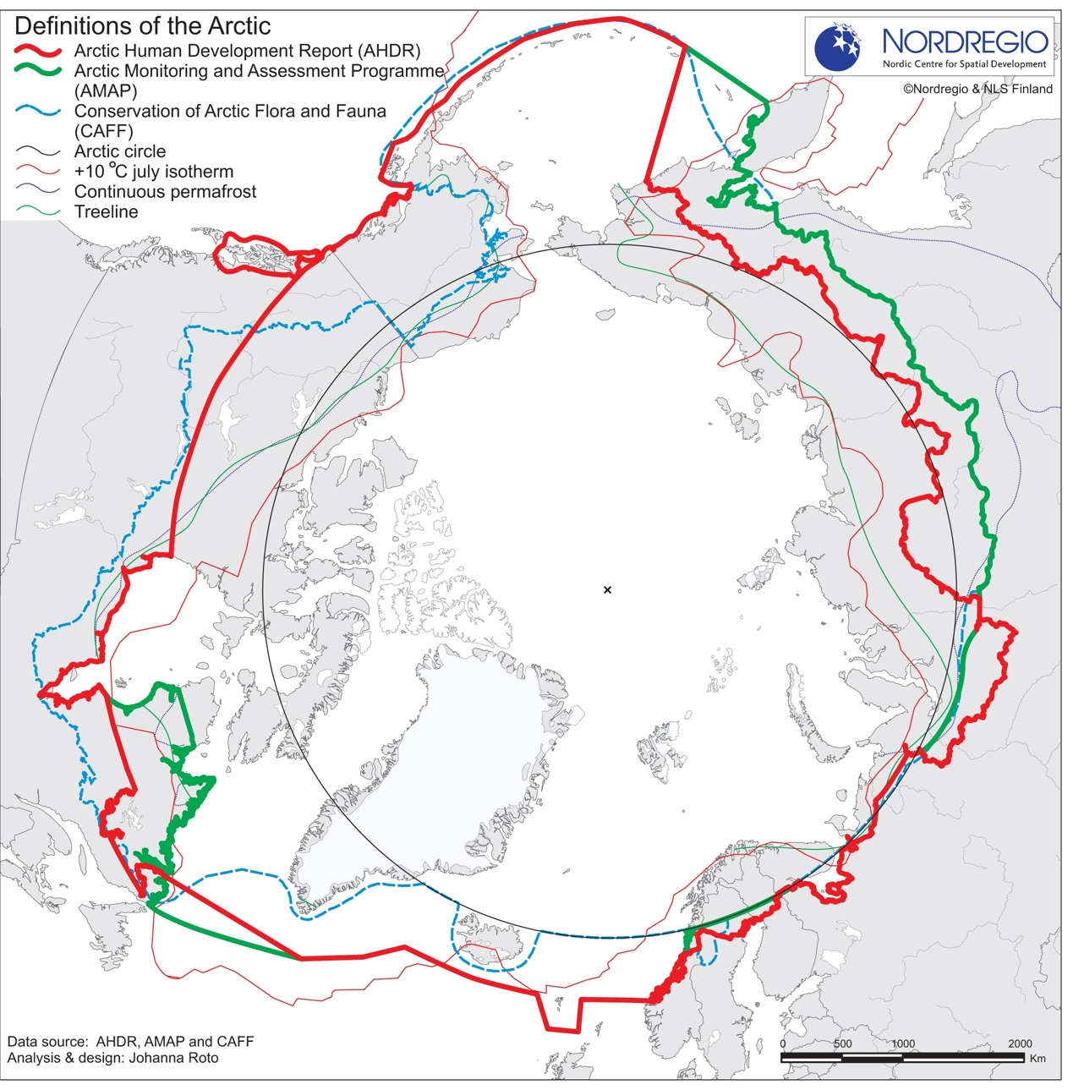

Figure 2: Antarctica showing the major regional instruments regulating the Greater Southern Ocean
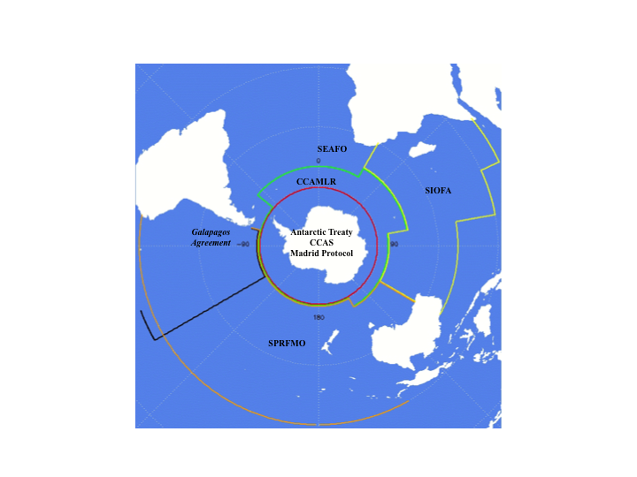

Canada, Denmark, Norway, USSR, USA – Agreement on the Conservation of Polar Bears. Adopted in Oslo 15 November 1973, entered into force 26 May 1976, 13 ILM 13.
The Declaration on the establishment of the Ottawa Convention, 19 September 1996 URL: https://oaarchive.arctic-council.org/bitstream/handle/11374/85/EDOCS-1752-v2ACMMCA00_Ottawa_1996_Founding_Declaration.PDF?sequence=5&isAllowed=y
Arctic Ocean Conference ‘The Ilulissat Declaration’ 29 May 2008 URL available: http://www.oceanlaw.org/downloads/arctic/Ilulissat_Declaration.pdf
For example, Agreement on Cooperation on Aeronautical and Maritime Search and Rescue in the Arctic (2011), Agreement on Cooperation on Marine Oil Pollution, Preparedness and Response in the Arctic (2013), and Agreement on Enhancing Arctic Scientific Cooperation (expected to be signed in May 2017).

