OSL dating of a carbonate island in the Chobe Enclave, NW Botswana.

Diaz, N.^{1*}, Armitage, S.J.^{1,2}, Verrecchia, E. P. ³, Herman, F.³

* Corresponding author: nathalie.diaz@rhul.ac.uk
¹ Department of Geography, Royal Holloway University of London, TW20 0EX Egham, United Kingdom
² SFF Centre for Early Sapiens Behaviour (SapienCE), University of Bergen, Post Box 7805, 5020, Bergen, Norway
³ Institute of Earth Surface Dynamics, University of Lausanne, 1015 Lausanne, Switzerland

Abstract
Carbonate platform islands are important landscape features in the northeastern part of the Okavango Delta region of Botswana, the Chobe Enclave. However, the formation processes and the timing of these “Chobe Islands” remain unclear. They are assumed to be the result of late Quaternary hydrological changes. Records of such changes are poorly preserved, though the occurrence of beach ridges in the Middle Kalahari Basin attests to the existence of large paleo-lakes in the past. Carbonate rocks from the Chobe Island appear to be relics of palustrine environments, but their relationship with the other hydrological archives is still unclear. Here, we report optically stimulated luminescence dating of key sedimentary beds in and around a single Chobe Island. It was necessary to model dose rate evolution for each sample individually, taking into account post-depositional changes in the sediment chemistry and its burial depth. The resulting ages suggest that the dated units were deposited between MIS6 to MIS1. The carbonate platform itself appears to have been deposited in two phases, separated by either an unexpectedly long (~40 ka) depositional hiatus or an episode of erosion. This study demonstrates the potential of using luminescence dating in such settings, and offers the possibility of linking sedimentary processes within the Chobe Enclave to regional paleo-hydrological records.
Key-words: Quaternary; Okavango Region; paleo-hydrology; dose rate assessment

- Introduction
The Quaternary paleo-drainage history of the Middle Kalahari Basin has mostly been reconstructed through geological and geomorphological archive studies (e.g. Thomas and Shaw, 2002; Burrough et al., 2007). The endoreic nature of the basin led to aeolian, fluvial and/or lacustrine sediment accumulation since the Cretaceous (Grove, 1969). However, the present-day semi-arid climate leads to the deflation of sedimentary archives and does not favour the preservation of organic proxies (Burrough and Thomas, 2012). Regional paleo-environmental records are thus fragmentary and difficult to obtain (e.g. Cordova et al., 2017).
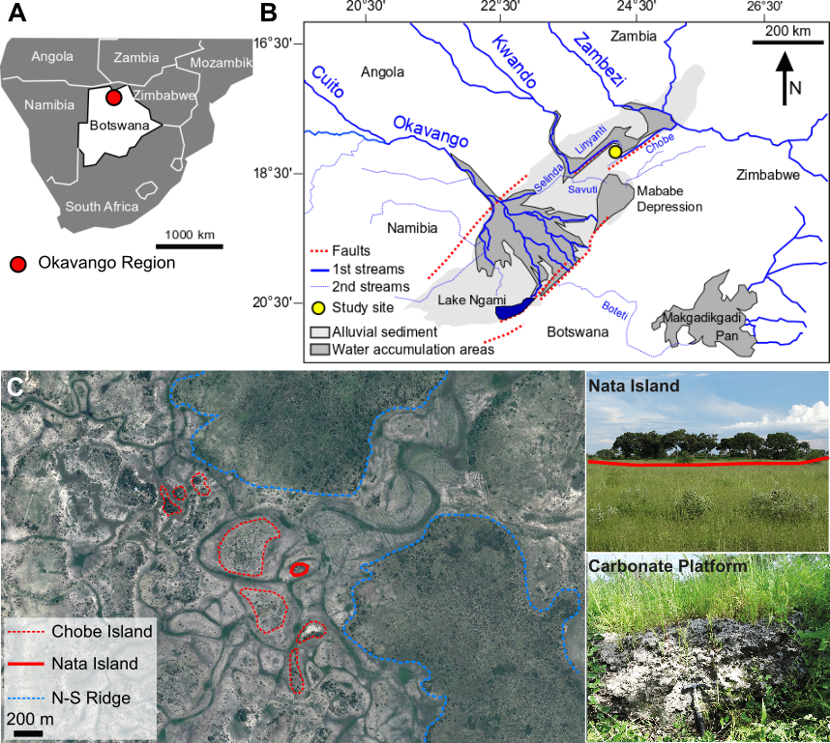
Figure 1: Setting of Nata Island site. A) The Okavango region. B) Hydrological systems within the Okavango region related to the Mababe depression (Mababe Basin), lake Ngami (Ngami Basin) and the Makgadikgadi Pans (Makgadikgadi Basin), and study site location. C) Examples of Chobe Islands, N-S ridges and Nata island with photographs (taken in February 2017) of the study site and the carbonate platform. A schematic diagram depicting the sediments comprising Nata Island can be found in the supplementary material (supp. mat., Fig. S1).
In the Botswanan part of the Middle Kalahari Basin (Fig. 1A), geomorphological features found in the Mababe Basin, the Ngami Basin and the Makgadikgadi Basin are thought to be related to paleo-lake levels (e.g. Grove, 1969; Shaw, 1985, Ringrose et al., 2005; Burrough and Thomas, 2008). In the present-day three main river systems, (i) the Okavango, (ii) the Kwando-Linyanti, and (iii) the Zambezi-Chobe (Fig. 1B), bring waters from the equatorial Angolan highlands to this region. The regional drainage organization is influenced by tectonics, since the local fault system (Fig. 1B) is an extension of the East African Rift Zone (e.g. Moore et al., 2012). The occurrence of landforms indicative of both dry (dunes) and wet (lake shorelines) conditions is due to complex Quaternary palaeohydrological dynamics influenced by both climate and/or tectonic changes. Paleo-shorelines occurring at different altitudes were interpreted as lacustrine transgressions, and seven lake highstands (Fig. 2), dated by luminescence, yeild ages covering the last 100 ka (Burrough and Thomas, 2008; Burrough et al., 2009). These transgressions were proposed to be mainly controlled by climate feedbacks. However, another study (Moore et al., 2012) proposed a paleo-lake history spanning the last 2.5 Ma, in which the paleo-shorelines are suggested to document the long-term contraction of a regional mega-lake. According to Moore et al. (2102) the last desiccation of this lake occurred over the last 100 ka, and produced the present-day Makgadikgadi Pans (Moore et al., 2012, Fig. 2). In this model, tectonic activity would have a major role in the lake contraction through river deviations, for example the capture of the Upper Zambezi during Mid-Pleistocene which removes an important amount of water flowing into the basin (Moore et al., 2012). Nevertheless, in order to maintain a high lake level, climate feedbacks are also needed, such as a positive rainfall-evaporation balance. Consequently, the sparse records, which are difficult to correlate, date and interpret, account for the existence of divergent hypotheses, and emphasize the challenges faced in reconstructing the regional paleo-hydrology.

In the Chobe Enclave (north-west of the Okavango Delta) carbonate platform islands of various sizes, surrounded by ephemeral waterbodies, are a common feature of the landscape (Ringrose, 2015; Diaz et al., 2016; Fig. 1C). Moreover, continental carbonate deposits are generally known to be important archives preserving information of the depositional environment (Alonso-Zarza and Tanner, 2010). However, the precise origin of the Chobe Islands remains unknown. At present, they are hypothesized to have been formed in response to regional paleo-hydrological changes. Indeed, thin section observations suggest that the carbonate precipitation occurred in palustrine environments (supp. mat. Fig. S4). The Chobe Enclave is a key region located between two main fault systems, (i) the Linyanti fault and (ii) the Chobe fault. It receives waters from the Okavango, Kwando-Linyanti, and Zambezi-Chobe river systems in various proportions (Fig. 1B). Consequently, studying the geomorphology and sedimentary composition of the Chobe Islands may yield important information regarding the regional paleo-hydrology and paleo-environment.

The aim of this study is to determine the age of key sedimentary units from a single carbonate island, and to relate these to the paleo-hydrology of the Middle Kalahari Basin. Continental carbonate formations are challenging to date with conventional techniques, such as radiocarbon and U/Th dating. Radiocarbon dating is difficult due to reservoir effects and low age limits (~50 ka cal BP), while U/Th dating of carbonate rocks is hampered by high detrital thorium contents, both leading to poor dating accuracy (Durand et al., 2016). Here we use optically stimulating luminescence (OSL) dating of quartz contained within key sedimentary units to constrain the age of a typical Chobe Island (Nata Island, Fig. 1C). Such secondary continental carbonate can act as paleo-environmental records for regions lacking other sources of data (Dietrich et al., 2017; Diaz et al., 2016a, 2016b). Our aim is to demonstrate the potential of the Chobe Islands to act as paleo-environmental records for the Middle Kalahari Basin.

- Material and Methods
2.1 General settings and sampling
The Chobe Island selected (Nata Island, Fig. 1C) is located within a large ephemeral channel system fed by waters coming from the Linyanti River. The island is 60 m wide, 120 m long, and ~2.5 m above the surrounding landscape. Carbonate layers outcrop at the island margins, and some detached blocks appear to have been undermined and fractured under their own weight, attesting to erosion processes. A 3 m deep borehole on the floodplain, about 3 m from the island, allows access to the underlying sediments. These comprise a 1.6 m thick siliceous nodule-rich sand at the base of the exposure, overlain by a 40 cm thick grey sandy layer, which is itself overlain by 1 m of organic sand. The platform is composed of carbonate rocks (micrite cementing vegetation debris) containing siliceous nodules and detrital minerals, mainly quartz (supp. mat. Fig. S4). In places the carbonate platform is overlaid by an organic sandy layer (supp. mat., Fig. S1).

Three samples were collected from the borehole section. Samples at 2.3 m (IS-1.1) and 1.7 m (IS-1.2) were obtained from the siliceous-nodule rich sand, while a further sample was taken from the overlaying grey sandy layer, at 1.3 m (IS-1.3). Blocks of carbonate rock were taken from the platform at depths of 0.4 m (IS-P1) and 0.2 m (IS-P2) below the present-day surface. Finally, a single sample (IS-4) was taken from the organic layer overlying the platform at a depth of 0.2 m (supp. mat., Fig. S1). In each case, dateable material was extracted from the unexposed central portions of the sample under laboratory red light conditions. The dateable material was immersed in HCl (30%) and H₂O₂ (35%) to remove carbonate and organic fractions respectively. The remaining material was sieved to 212-250 µm, density separated at 2.7 gcm⁻³ and 2.62 gcm⁻³, and etched in HF (35%) for 1 hour to yield purified quartz.

2.2 OSL parameter assessment
All OSL measurements were performed using a Risø TL/OSL-DA-20 automated dating system at either the University of Lausanne and Royal Holloway University of London. Optical stimulation was carried out using a blue (470±30 nm) light emitting diode (LED) array, while infra-red (IR) stimulation was performed using an IR (870 nm) laser diode array. OSL was measured using an Electron Tubes Ltd 9235QB photomultiplier tube with 7.5 mm of Hoya U-340 filter interposed between the sample and photomultiplier. Irradiation was carried out using a 40 mCi ⁹⁰Sr/⁹⁰Y beta source, calibrated relative to the National Physical Laboratory, Teddington Hotspot 800 ⁶⁰Co γ-source (Armitage and Bailey, 2005). Equivalent doses ($D_{e}$) were determined using the single-aliquot regenerative-dose method (SAR, Galbraith et al., 1999; Murray and Wintle, 2000), tested with dose recovery experiments (Roberts et al., 1999; Wallinga et al., 2000; supp. mat., Table S1, Fig. S3, S4). The growth curves were fitted using a saturating-exponential-plus-linear function and standard error associated with each $D_{e}$ determination was estimated by Monte Carlo simulation using Luminescence Analyst Software (Duller, 2015). If the recycling ratio (Murray and Wintle, 2000) or IR depletion ratio (Duller, 2003) differed from unity by more than two standard deviations, or if the sensitivity corrected luminescence intensity in response to a 0 Gy regeneration dose exceeded 5% of the sensitivity corrected natural luminescence intensity, aliquots were rejected (Table 1).

The assessment of the environmental dose rate ($\dot{D}$, Gy ka⁻¹) is not straightforward. $\dot{D}$ is the dose rate produced by natural radiation (Aitken, 1985), and can be divided into two components: (i) the sediment dose rate (${\dot{D}}_{sed}$, Gy ka⁻¹), calculated using the radioisotope concentration of the sample, and (ii) the cosmic dose rate (${\dot{D}}_{cos}$, Gy ka⁻¹), calculated using the latitude, longitude, altitude and mass of overburden. Both ${\dot{D}}_{sed}$ and ${\dot{D}}_{cos}$ are believed to have changed over time at the Nata Island site. The Chobe Enclave sediments belong to the Kalahari Group (Thomas and Shaw, 1991; Thomas, 1988) and sandy layers can be (i) variously “pure” and unconsolidated (IS-1.3), i.e. relatively unchanged since deposition, (ii) enriched in siliceous nodules (IS-1.1 and IS-1.2), (iii) carbonate-rich (IS-P1 and IS-P2) or (iv) enriched in organic matter (IS-4). These different lithologies attest that chemical changes can occur in sediments. Each of these post-depositional modifications to a sample’s chemistry is likely to be accompanied by a change in ${\dot{D}}_{sed}$. In addition, the depth (mass) of overburden above several samples has also changed, causing variations in ${\dot{D}}_{cos}$ over time. The evolution of $\dot{D}$ was assessed according to the stratigraphy, assuming the following succession of sedimentary phases ($T_{i}$) each with a different dose rate (${\dot{D}}_{i}$) (supp. mat., Fig. S5): $T_{1}$) sediment consists of unconsolidated sand, $T_{2}$) sediment consists of unconsolidated sand and siliceous nodules, $T_{3}$) sediment cemented by calcium carbonate, and $T_{4}$) changing overburden as the sand surrounding the carbonate platform is eroded. For the purposes of dose rate modelling, the transition from one time period to another is regarded as instantaneous, though clearly each process, e.g. silica mobilisation and precipitation at the transition from $T_{1}$ to $T_{2}$, will in reality take a finite period of time. Each sample experiences one or more of these sedimentary phases, and the evolution of the $\dot{D}$ needs to be assessed for each sample individually. Details of the dose rate modelling process are provided in the Supplemental Materials (Section S4).

- Results and Discussion
  - Equivalent doses ($D_{e}$)

The $D_{e}$ used to calculate the age of each sample was determined from individual aliquot $D_{e}$ values using the central age model (CAM, Galbraith et al., 1999), and are quoted with ±1σ uncertainties (Table 1). High overdispersion values (OD) can be explained by many factors, such as microscale variation beta dose (Mayya et al., 2006). Sample IS-4, which displays particularly high overdispersion, was taken in the soil profile developing on the carbonate platform. The carbonate redistributed in the soil (supp. mat. Fig. S5) may induce microscale $\dot{D}$ heterogeneity through hot spots or cold spots (e.g. Cunningham et al., 2012). High OD values can also result from bioturbation (Bateman et al., 2007), and termite are very active in the region (e.g. Danderfield and Schuurman, 2000) and may likely affect this surficial soil sample.
Table 1: Central age model (CAM) $D_{e}$, overdispersion (OD) and final ages. n/m are the number of accepted aliquots (n) and measured aliquots (m).
Sample | n/m | CAM $D_{e}$ (Gy) | OD (%) | Age (ka)
IS-1.1 | 18/20 | 64.6±2.0 | 12.2±0.5 | 150.1±30.0
IS-1.2 | 20/20 | 63.2±3.3 | 22.7±0.8 | 149.6±29.9
IS-1.3 | 20/20 | 1.7±0.1 | 14.9±0.5 | 3.6±0.7
IS-P1 | 20/20 | 29.9±1.9 | 28.5±1.0 | 48.2±9.6
IS-P2 | 18/20 | 5.1±0.4 | 32.2±1.3 | 7.2±1.4
IS-4 | 18/20 | 1.5±0.2 | 56.9±2.2 | 0.7±0.1

  - Ages and paleo-environmental significance

The resulting ages (Table 1) are consistent with the stratigraphy and with the proposed succession of sedimentary phases ($T_{i}$). The ages of IS-1.1 and IS-1.2 indicate that they were deposited during the glacial stage MIS 6 (Fig. 2), which is thought to be a relatively dry period in the tropical desert regions (Stewart and Jones, 2016). These ages pre-date the regional high-lake level stands proposed by Burrough et al. (2009) and post-date the paleo-lakes suggested by Moore et al. (2012). Assuming that the carbonate formed between 18 ka and 15 ka (supp. mat., Table S9, Fig. S7), i.e. during one of the more recent lacustrine transgressions (Fig. 2), IS-P1 was deposited during MIS 3, immediately prior to a lacustrine transgression which occurred at ~40 ka (Burrough et al., 2009). The overlying sample, IS-P2, was deposited in MIS 1, assuming that carbonate precipitated between 6 and 4 ka (supp. mat., Table S7). This result is surprising since IS-P2 is only 20 cm above IS-P1, and suggests that large depositional hiatuses (~40 ka) or, less likely very slow sedimentation rates, characterized the formation of the carbonate platform. Assuming that these ages are correct, and hypothesizing that carbonate layers were precipitating when conditions were becoming drier, they suggest that the sediment was deposited in a depression at ~50 ka (IS-P1), after which a swamp developed but very little material was deposited. After ~20 ka, the swamp dried out and carbonate precipitated between 18 ka and 15 ka, i.e. during a lacustrine regression. After this time, there is no evidence for sediment accumulation. During MIS 1, the system was activated again, leading to the deposition of IS-P2 around 7 ka. After this sediment was deposited, the system dried for a second time around ~6-4 ka, i.e. after the last lacustrine transgression (Fig. 2), leading to a second phase of carbonate precipitation. It is possible that the apparent depositional hiatus between samples IS-P1 and IS-P2 results from a period of intense erosion sometime between ~15 ka and ~7 ka, or that very limited sediment deposition did occur between ~45 ka and ~7 ka. Nonetheless, results suggest that the carbonate platform represent multiple phases of deposition and cementation. More detailed sedimentological, petrographic and OSL work is required both to determine the nature of the apparent depositional hiatus between IS-P1 and IS-P2, and to determine whether the timing of deposition is consistent between different Chobe Island platforms. Following precipitation of the Nata Island carbonate platform, a period of erosion occurred, during which the (presumably unconsolidated) sands surrounding the island were removed, and deposition of more recent material (3.6 ka) occurred on the floodplain. This material is represented by sample IS-1.3 deposited contemporaneously with a dry phase recorded in the Mababe Depression (Fig. 2). Finally, sample IS-4 represents a new cycle of soil formation on top of the platform at 0.7 ka.

This initial study demonstrates the feasibility of using OSL dating of Chobe Islands, both to understand the chronology of the sediments themselves, and also to understand the sedimentary processes that led to their deposition and modification. Sediments have been subject to a variety of post-depositional alterations, such as the precipitation of carbonate, the formation of amorphous silica and sedimentation rate variations, and each of these processes appears to be related to changes in the regional hydrology. However, the precise nature of these relationships requires the age and genesis of the Chobe Islands to be fully understood. To achieve this understanding, future research should focus on (i) more detailed sedimentary and chronological work on the Nata Island, to determine the nature of the depositional hiatus, (ii) additional sampling in other Chobe Islands, to determine whether island formation is regionally synchronous, (iii) more detailed $\dot{D}$ modelling, possibly coupled with direct U-Th dating of carbonate/siliceous precipitation, to test the robustness and sensitivity of our proposed calculations. Finally, our existing data already emphasize the importance of coupling OSL dating with an in-depth petrographic and geochemical study of the carbonate rocks composing the islands.
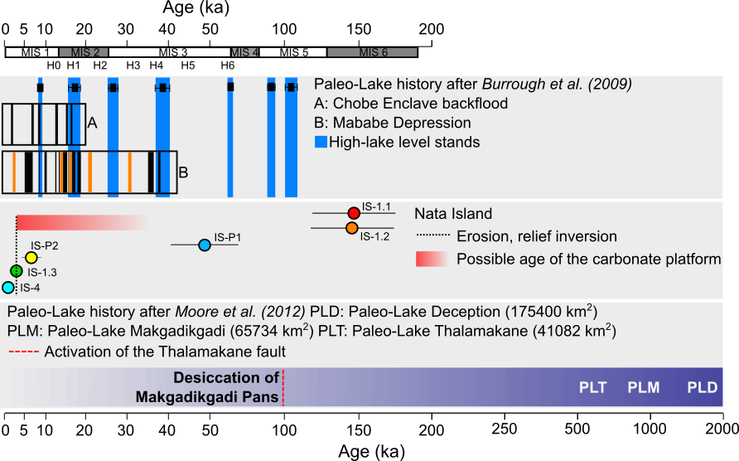
Figure 2: Comparison of ages obtained from Nata Island (middle panel) with the Middle Kalahari paleo-hydrology. Top panel: Proposed lake high-stands (long bars) over the last 100 ka, linking the Mababe Basin, the Ngami Basin and the Makgadikgadi Basin (Burrough et al. 2009, Fig. 1). Boxes show periods of shoreline formation (vertical black bars) in the Chobe Enclave (A) and in the Mababe depression (B). Light bars in Box B represent dry periods. The lower panel illustrates an alternative paleo-hydrological reconstruction (Moore et al., 2012), involving a mega paleo-lake contraction over the last ~2 Ma, with the final desiccation of Makgadikgadi Pans around 100 ka being caused by the activation of the Thamalakane fault (dashed line).

- Conclusion
This study presents the first attempt to OSL date the deposition of sediments comprising a single carbonate island from the Chobe Enclave. The resulting OSL ages span the last 150 ka, and give a stratigraphically coherent chronology, which we discuss within the general framework of the Quaternary hydrology evolution of the Middle Kalahari Basin. In addition to producing ages, OSL dating allowed us to discuss sedimentary processes such as carbonate precipitation or accretion rates. However, our analysis of sediments from the single Chobe Island studied indicates that very careful consideration and modelling of $\dot{D}$ variation through time is necessary. To validate and refine this method, an in-depth study which combines OSL, petrographic and geochemical analysis of the Chobe Island sediments, particularly the carbonate platforms, will be required.

Acknowledgements
This study links to the overall research on the Vegetation and Soil of the Chobe Enclave through the permission of the Ministry for Environment, Natural resources conservation and tourism (n°EWT 8/36/4 XXXVIII (69)). The authors would like to thank all the people working at the Van Thuyne Ridge Research Centre (VTR Centre), particularly Rita Ridge for the logistics, and Ali Mahinga and Mosirizo Kani, for their help and guidance in the field. Special thanks go to Karin Verrecchia and John Van Thuyne for the discussions about the Chobe Islands in the field and elsewhere. Thanks to Rabiul Haque Biswas and Iñaki Valcarcel for their help in the geochronology labs at University of Lausanne or at Royal Holloway University of London. Thank you to the anonymous reviewer for its useful comments that helped to improve the paper. SJA’s contribution to this work was partly supported by the Research Council of Norway, through its Centres of Excellence funding scheme, SFF Centre for Early Sapiens Behaviour (SapienCE), project number 262618. This work is funded by the SNF (ND P2LAP2_174595).

References

Aitken, M.J., 1985. Thermoluminescence Dating. Academin Press, Inc., London, UK.

Alonso-Zarza, A.M., Tanner, L.H., 2010. Carbonates in continental settings - Facies, environments and processes. Developments in sedimentology, 61, Elsevier, Amsterdam.

Armitage, S.J., Bailey, R.M., 2005. The measured dependence of laboratory beta dose rates on sample grain size. Radiation Measurements, 39, 123-127.

Bateman, M.D., Boulter, C.H., Carr, A.S., Frederick, C.D., Peter, D., Wilder, M., 2007. Detecting post-depositional sediment disturbance in sandy deposits using optical luminescence. Quaternary Geochronology, 2, 57-64.

Burrough S.L., Thomas, D.S.G, 2012. Interpreting geoproxies of late Quaternary climate change in African drylands: Implications for understanding environmental change and early human behaviour. Quaternary International, 253, 5-17.

Burrough S.L., Thomas, D.S.G, Singarayer, J.S., 2009. Late Quaternary hydrological dynamics in the Middle Kalahari: Forcing and feedbacks. Earth-Science Reviews, 96, 313-326.

Burrough S.L., Thomas, D.S.G, 2008. Late Quaternary lake-level fluctuations in the Mababe Depression: Middle Kalahari palaeolakes and the role of Zambezi inflows. Quaternary Research, 69, 388-403.

Burrough S.L., Thomas, D.S.G, Shaw, P.A., Bailey, R.M., 2007. Multiphase Quaternray highstands at Lake Ngami, Kalahari, northern Botswana. Palaeogeography, Palaeoclimatology, Palaeoecology, 253, 280-299.

Cordova, C.E., Scott, L., Chase, B.M., Chevalier, M., 2017. Late Pleistocene-Holocene vegetation and climate change in the Middle Kalahari, Lake Ngami, Botswana. Quaternary Science Reviews, 171, 199-215.

Cunningham, A.C., DeVries, D.J., Schaart, D.R., 2012. Experimental and computational simulation of beta-dose heterogeneity in sediment. Radiation Measurements, 47, 1060-1067.

Dangerfield, J. M., Schuurman, G., 2000. Foraging by fungus-growing termites (Isoptera: Termitidae, Macrotermitinae) in the Okavango Delta, Botswana. Journal of Tropical Ecology, 16, 717-731.

Diaz, N., Dietrich, F., Cailleau, G., Sebag, D., Ngounou Ngatcha, B., Verrecchia, E.P., 2016a. Can mima-like mounds be Vertisol relics (Far North Region of Cameroon, Chad Basin)? Geomorphology, 261, 41-56.

Diaz, N., King, G.E., Valla, P.G., Herman, F., Verrecchia, E., 2016b. Pedogenic carbonate nodules as soils time archives: Challenges and investigations related to OSL dating. Quaternary Geochronology, 36, 120-133.

Diaz, N., Mahinga, A., VanThuyne, J., Verrecchia, E., Verrecchia, K., 2016. Primary fieldwork investigation on the carbonate islands from the Chobe Enclave. Unpublished work, Institute of Earth Surface Dynamics, University of Lausanne.

Dietrich, F., Diaz, N., Deschamps, P., Ngounou Ngatcha, B., Sebag, D., Verrecchia, E.P., 2017. Origin of calcium in pedogenic carbonate nodules from silicate watersheds in the Far North Region of Cameroon: Respective contribution of in situ weathering source and dust input. Chemical Geology, 460, 54-69.

Duller, G.A.T., 2015. The Analyst Software Package for Luminescence Data: Overview and Recent Improvements. Ancient TL, 33, 35-42.

Duller, G.A.T., 2003. Distinguishing quartz and feldspar in single grain luminescence measurements. Radiation Measurements, 37, 161-165.

Durand, N., Hamelin, B., Deschamps, P., Gunnel, Y., Curmi, P., 2016. Systematics of U–Th disequilibrium in calcrete profiles: Lessons from southwest India. Chemical Geology, 446, 54-69.

Galbraith, R.F., Roberts, R.G., Laslett, G.M., Yoshida, H., Olley, J.M., 1999. Optical dating of single and multiple grains of quartz from Jinmium rock shelter, northern Australia: Part 1, experimental design and statistical models. Archaeometry, 41, 339-364.

Grove, A.T., 1969. Landforms and Climatic Change in the Kalahari and Ngamiland. The Geographical Journal, 135, 191-212.

Mayya, Y.S., Morthekai, P., Murari, M.K., Singhvi, A.K., 2006. Towards quantifying beta microdosimetric effects in single-grain quartz dose distribution. Radiation Measurements, 41, 1032-1039.

Moore, A.E., Cotterill, F.P.D., Eckardt, F.D., 2012. The evolution and ages of Makgadikgadi palaeo-lakes: consilient evidence from Kalahari drainage evolution south-central Africa. South African Journal of Geology, 115, 385-413.

Ringrose, S., 2015. VTR Calcrete Survey Report. Unpublished work, School of Interdisciplinary Studies, Dumfries Campus, United Kingdom.

Ringrose, S., Huntsman-Mapila, P., Kampunzu, A.B., Downey, W., Coetzee S., Vink, B., Matheson, W., Vanderpost, C., 2005. Sedimentological and geochemical evidence for palaeo-environmental change in the Makgadikgadi subbasin, in relation to the MOZ rift depression, Botswana. Palaeogeography, Palaeoclimatology, Palaeoecology, 217, 265-287.

Roberts, R.G., Galbraith, R.F., Olley, J.M., Yoshida, H., Laslett, G.M., 1999. Optical dating of single and multiple grains of quartz from Jinmium rock shelter northern Australia: Part II, results and implications. Archaeometry, 41, 365-395.

Shaw, P.A., 1985. The Desiccation of Lake Ngami: An Historical Perspective. The Geographical Journal, 151, 318-326.

Stewart, B.A., Jones, S.C., 2016. Africa from MIS 6-2: The florescence of Modern Human. Sacha C. Jones and Brian A. Stewart (eds.), Africa from MIS 2-6: Population Dynamics and Paleoenvironments, Vertebrate Paleobiology and Paleoanthropology. Springer, London, UK.

Thomas, D.S.G., Shaw, P.A., 2002. Late Quaternary environmental change in central southern Africa: new data, synthesis issues and prospects. Quaternary Science Reviews, 21:7, 783-797.

Thomas, D.S.G., Shaw, P.A., 1991. The Kalahari environment. Cambridge University Press, Cambridge, UK.

Thomas, D.S.G., 1988. The nature and depositional setting of arid to semi-arid Kalahari sediments, southern Africa. Journal of Arid environments, 14, 17-26.

Wintle, A.G., Murray, A.S., 2000. Quartz OSL: Effects of thermal treatment and their relevance to laboratory dating procedures. Radiation Measurements, 32, 387-400.

