Target article authors: Pascal Boyer and Michael Bang Petersen

Word count:
Abstract: 60
Main text: 1000
References: 286
Entire text: 1507 (incl. references, addresses, figure caption)

Commentary title: Do the folk actually hold folk-economic beliefs?

Commentary authors: Ben M. Tappin ^{a,1}, Robert Ross ^{a,2}, Ryan T. McKay ^{a,3}

ª ARC Centre of Excellence in Cognition and its Disorders, Department of Psychology, Royal Holloway, University of London, Egham, Surrey TW20 0EX, UK
Institutional telephone number: +44 (0) 1784 434455

Email: ¹ benmtappin@googlemail.com; ² robross45@yahoo.com.au; ³ Ryan.McKay@rhul.ac.uk

In press at Behavioral and Brain Sciences

Abstract
Boyer and Petersen argue that folk-economic beliefs are widespread—shaped by evolved cognitive systems—and they offer exemplar beliefs to illustrate their thesis. We highlight evidence of substantial variation in one domain of these exemplars; beliefs about immigration. Contra B&Ps exemplars, the balance of this evidence suggests the “folk” may actually hold positive beliefs about the economic impact of immigration.

A core feature of folk-economic beliefs (FEBs) according to Boyer and Petersen (B&P) is that they are widespread. There is evidence, however, of substantial variation in several of the exemplar FEBs that they draw upon to illustrate their thesis. For instance, beliefs about the economic impact of immigration vary—sometimes dramatically—as a function of educational attainment and political preference in the US, Europe and elsewhere. Furthermore, this evidence suggests that positive beliefs about the economic impact of immigration may actually be more prevalent than their negative counterparts, contrary to the exemplar beliefs B&P cite as evidence for their thesis; that immigrants “steal jobs” (FEB 2, p.8) and abuse the welfare system (FEB 3, p.9).

Figure 1 displays the results of a recent representative survey of British adults. The data reveal substantial variation; the proportion of Britons who believe immigration is “bad” or “very bad” for the economy is almost equal to those who believe that it is “good” or “very good”. Similarly, the results of the 2014 European Social Survey suggest that 40% of Britons believe immigration is good for the economy, whereas 36% believe it is bad (Ford & Lymperopoulou, 2016). Inferential analyses indicate that educational attainment is a reliable predictor of such variation; more positive beliefs about the economic impact of immigration are consistently observed among individuals with greater education (Hainmueller & Hiscox, 2007; Héricourt & Spielvogel, 2014; Ueffing et al., 2015).

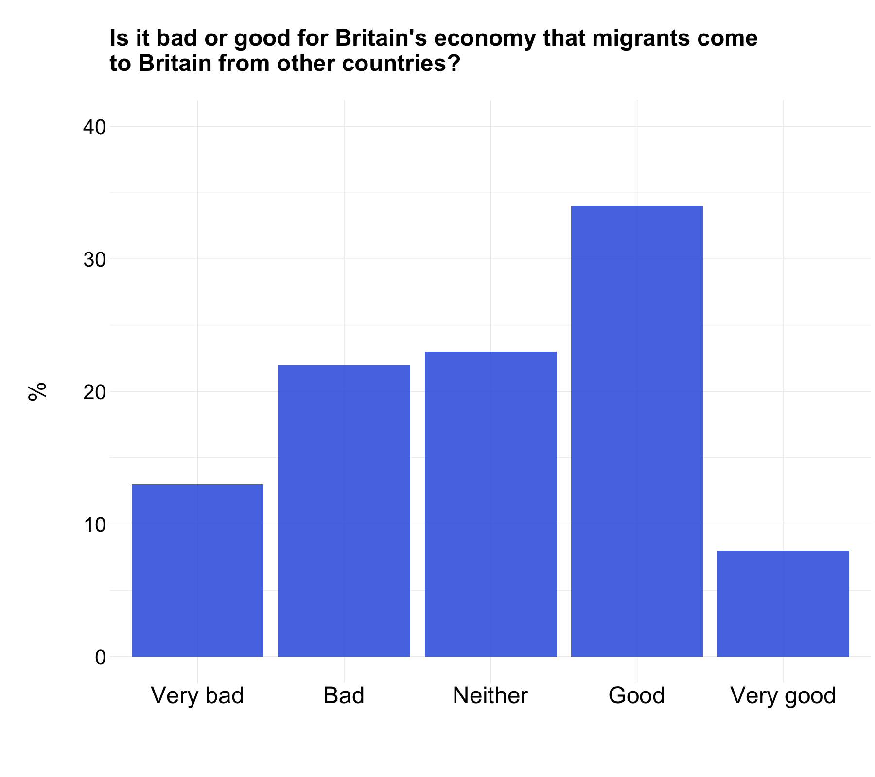
Figure 1 | Distribution of reported beliefs about whether immigration is bad or good for the British economy. Data are from the 2015 British Social Attitudes Survey. In the survey, responses were provided on a 0-10 scale (0 = extremely bad, 10 = extremely good). The categories displayed on the x-axis are collapsed across values: 0-1 (Very bad), 2-4 (Bad), 5 (Neither), 6-8 (Good), and 9-10 (Very good). N = 2167, representative sample of British adults. Source: http://www.bsa.natcen.ac.uk/media/39097/immigration-data-tables-for-web-final.pdf

Survey data from the US reveals comparable variation in beliefs. According to a 2017 Pew survey, for example, 65% of US adults believe that immigrants “strengthen the US with their hard work and talents”, while 26% believe the opposite—that immigrants are a “burden”. This variation is strongly predicted by political identity; 84% of individuals who identify with the Democratic Party report the former belief, compared to only 42% of those who identify with the Republican Party (Pew Research Center, 2017).

B&P do not specify how widespread an economic belief must be to be considered a folk economic belief. Must FEBs be universal, or merely held by a majority? The preceding evidence indicates that, at least in the context of immigration, the content of such beliefs is strongly variable, and, more notably, the average person (i.e., the “folk”) is perhaps more inclined to hold a positive belief about the economic impact of immigration. This stands in contrast to the exemplar (negative) FEBs about immigration proffered by B&P, and is significant because the inference mechanisms they propose to account for negative content—coalitional affiliation and cheater detection—seem less well equipped to explain positive content. One could argue that more educated and more liberal individuals simply possess more accurate beliefs about the (positive) economic impact of immigration, leaving only the negative beliefs to be explained. But according to B&Ps own view (p.7), accurate FEBs are unlikely to be due solely (if at all) to superior economic training, and, therefore, still require explanation.

Below we briefly discuss recent work that offers an explanation for the cited variation in beliefs, and is able to account for both positive and negative content. Broadly speaking, this work suggests variation in beliefs on certain political issues is driven by intergroup processes. Because B&P specify a role for “coalitional” (intergroup) psychology within their model, this work might usefully extend their thesis to account for the variation discussed above.

There is evidence that belief formation is affected by cultural conflict such that, on particularly contested issues, individuals are motivated to form beliefs that signal whose “side” they are on (Kahan, 2016; for a critique, van der Linden, 2016). In other words, that intergroup conflict induces an information processing bias that drives systematic variation in beliefs. In this case, guiding individuals’ beliefs about the economic impact of immigration further toward the belief (positive or negative) that typifies their group identity. B&P allude to such a process in the context of government control over the economy (p.39); here we explicitly draw it out as one explanation for the variation in beliefs about the economic impact of immigration.

Another possibility is that the variation is somewhat illusory—a product of “expressive responding” (Bullock et al., 2015; Prior et al., 2015; for a critique, Berinsky, in press). That is, individuals are prone to express group loyalties, but harbor a more consonant representation of reality in private. Financially incentivizing correct responses, as a case in point, diminishes disagreement between individuals of opposing political parties (Bullock et al., 2015). Additional evidence for this proposition is observed in “list experiments”, where beliefs are elicited under a thicker cloak of anonymity than classic self-report methods afford. The results of several such experiments reveal that more educated individuals report views about immigration closer to those of their lesser educated counterparts when afforded this extra anonymity (e.g., An, 2015; Janus, 2010). One interpretation of these results is that more educated individuals possess greater motivation to signal they are tolerant people; tolerance, after all, is a hallmark of educated society. Interestingly, whether the cited variation in beliefs reflects expressive responding or sincere difference matters little for the role of intergroup psychology considered here. Variation in beliefs about immigration among the political left and right, and among the more and less educated, may indeed be more illusory than real; as suggested by the preceding evidence, however, such an illusion may itself be the product of intergroup processes.

B&P suggest that negative beliefs about the economic impact of immigration are folk beliefs, shaped by a combination of evolved cognitive systems. We have highlighted evidence of substantial variation in beliefs in this domain. We further highlighted evidence indicating that the “folk” may be more inclined to hold positive beliefs about the economic impact of immigration. On these bases, we invite B&P to (i) more clearly specify how widespread an economic belief must be to be considered a folk economic belief (and thus fall within the purview of their model), and (ii) consider how their model might account for widespread positive beliefs about the economic impact of immigration.

References
An, B. P. (2015). The role of social desirability bias and racial/ethnic composition on the relation between education and attitude toward immigration restrictionism. The Social Science Journal, 52, 459-467.
Berinsky, A. J. (in press). Telling the Truth about Believing the Lies? Evidence for the Limited Prevalence of Expressive Survey Responding. The Journal of Politics.
Bullock, J. G., Gerber, A. S., Hill, S. J., & Huber, G. A. (2015). Partisan Bias in Factual Beliefs about Politics. Quarterly Journal of Political Science, 10, 519-578.
Ford, R. & Lymperopoulou, K. (2016). Immigration: How attitudes in the UK compare with Europe. Retrieved from http://www.bsa.natcen.ac.uk/media/39148/bsa34_immigration_final.pdf
Hainmueller, J., & Hiscox, M. J. (2007). Educated preferences: Explaining attitudes toward immigration in Europe. International Organization, 61, 399-442.
Héricourt, J. & Spielvogel, G. (2014). Beliefs, media exposure and policy preferences on immigration: Evidence from Europe. Applied Economics, 46, 225-239.
Janus, A. L. (2010). The influence of social desirability pressures on expressed immigration attitudes. Social Science Quarterly, 91, 928-946.
Kahan, D. M. (2016). The Politically Motivated Reasoning Paradigm, Part I: What politically motivated reasoning is and how to measure it. In R. Scott & S. Kosslyn (Eds.), Emerging Trends in Social and Behavioral Sciences (pp. 1-16).
Pew Research Center. (2017). Most say immigrants strengthen the country. Retrieved from http://www.people-press.org/2017/10/05/4-race-immigration-and-discrimination/
Prior, M., Sood, G., & Khanna, K. (2015). You cannot be serious: The impact of accuracy incentives on partisan bias in reports of economic perceptions. Quarterly Journal of Political Science, 10, 489-518.
Ueffing, P., Rowe, F., & Mulder, C. H. (2015). Differences in attitudes towards immigration between Australia and Germany: The role of immigration policy. Comparative Population Studies, 40, 437-464.
van der Linden, S. (2016). A conceptual critique of the cultural cognition thesis. Science Communication, 38, 128-138.

