Affective Geographies of the Ballot Box

Helen Nicholson, Royal Holloway, University of London
Abstract
This paper interrogates the relationship between affective, place-based identities and the performative act of vote-casting. It tells the story of one solo, rural walk to the Polling Station in May 2014, and uses this narrative to explore how issues of subjectivity, temporality and spatiality are refracted in the experience of voting in a rural setting. Drawing on stories of a suffrage campaigner who lived locally, this paper explores how communities of memory are implicated in acts of voting. It also considers vote-casting as a staged event, and concludes with reflections about the political force of affective relations.
Keywords: Voting, Democratic Sensibilities, Civic Performance, Affective relations

The Path to Voting
22nd May 2014. Elections for the European Parliament. It is the first polling day since I moved to a hamlet on a Buckinghamshire hill, and for the last few days I have been peering apprehensively at my new neighbours’ windows, hoping that no-one displays posters supporting UKIP. But when no evidence of any party allegiance appears, I wonder if this is due to apathy or to local consensus that village harmony is best maintained without overt declarations of affiliation. I reflect that it’s been a while since I voted for anyone who actually got elected, and my vote has been more of a symbolic gesture than political weapon. I am not quite sure where the polling station is, but I have a rough idea that it’s at the bottom of the hill, and I decide to walk.

This article is about voting as an affective geography of place, about the performativity of voting, and about pathways to the ballot box, both actual and metaphorical. It is a self-conscious act of storying; my walk to the ballot box in May 2014 was intended to map a social narrative about the relationship between political participation and rural life. Stephen Coleman’s concept of democratic sensibility informs this journey, a term he uses to bring together the aesthetic, sensory and affective dimensions of everyday life with constitutional proceduralism:
Democratic sensibility opens up a space for fusion between the subjective grammar of affective experience and the objective procedures of the democratic polity.
Democratic sensibility, thus understood, provides an opportunity to reflect on three aspects of political efficacy that relate to my country walk to the ballot box and my experience of voting. First, I am interested in investigating Coleman’s claim that ‘to be a democratic citizen is to belong to a community of memories’ by tracing the footprints of those who have trodden this path before. Second, I hope to explore how the embodied practice of walking to the polling station creates in, itself, a politics of attachment and sense of belonging to my new dwelling place. This raises questions about how an affective experience of the local speaks to wider spatial imaginary of national and international (European) political structures.

Conceptually, my guide for this walk is the work of political and geographical thinkers who, inspired by Gilles Deleuze and Felix Guattari, seek to challenge post-Enlightenment modes of thought that make distinctions between the interiority of the individual and the exteriority of the material world. The political theorist Jane Bennett offers an influential articulation of this debate, suggesting that ‘humans are always in composition with non-humanity, never outside of a sticky web of connections or an ecology [of matter]’. Her emphasis on the complexity of relations reaches beyond the physical connectedness between human bodies and non-human organisms and her study of the ‘enchanted materialism’ of everyday life extends this emphasis on relationality to the affective realm. Describing affective energies as ‘unruly’, Bennett suggests that affective political agency is distributed across and between the flows of human and nonhuman activity, where social meanings are not projected onto the world, but, embodied, imagined and sensed. Affect’s intensity has been politicised, not only as a way of conceptualising the emotions of individuals as politically motivating, but also because it invites a generous re-imagining of the powerful inter-dependence between human agency and non-human actants. As such, this paper represents one response to the challenge to resituate voting in the democratic imagination by attending to the affective qualities of civic participation.

There is also a cultural materialist politics underscoring this paper, through which I hope to chip away at the perception that rural politics are inevitably conservative, or that rural life offers a picturesque retreat from the harsher realities of urban living. There is a history of poverty and resistance etched on the fields I cross, marking the deprivation of generations of rural citizens who owned neither property nor land. Much of this rural radicalism has been erased from cultural memory, suggesting that there is a politics to collective forgetfulness as well as communities of memory. Methodologically, this research is informed by the work of Sarah Pink, whose approach to ethnography is framed by an understanding that sensory engagement with the material environment allows researchers to focus on questions of ‘perception, place, knowing, memory and imagination’. Following Pink’s methodology and Coleman’s concept of democratic sensibility, I am interested in weaving a narrative that finds points of connectivity between the procedures of democratic citizenship and the affective experience of walking to vote. This paper is intended to open questions about how the act of voting – in the staged space of the polling booth- fuses the affective and the procedural in a single performative gesture. In this commingling of biography, place, habit, memory and affect – flows rather than frameworks – I hope to find a gentle radical politics that is crafted on rural footpaths and country lanes as well as the streets and pavements of cities and towns.

Democratic Citizens and Communities of Memories
Describing democratic citizenship in relation to communities of memories prompts an immediate reminder that suffrage has been inequitably distributed over time. Affective communities of memory are not only inferred in the practice of electing politicians to represent a local area, they also weigh on the democratic imagination and serve as a potent marker of insidership or exclusion. In suggesting that citizenship is an ‘an act of memory’, Coleman is alert to the asymmetrical spatial power-relations that this implies:
The democratic imagination inhabits a metaphorical space, marked by the axial boundary between ‘inside’ and ‘outside’. Only those fortunate enough to be ‘within’ rather than ‘beyond’ can hope to be counted.
Communities, like memories, are selective and contested, and it is this exclusionary history that forges an affective bond between my democratic imagination and the act of voting. Remembering that my right to vote is indebted to the many women who participated in the struggle for female suffrage has meant that the habit of voting is deeply engrained, and each time I cast my vote it feels like a small act of commemoration.

On this occasion, in May 2014, my journey to the ballot box is propelled by an interest in the life of a suffragist and campaigner who lived in my village, Berghers Hill. Kate Parry Frye, suffragist, actress and diarist, lived here during World War 1 and stayed almost continually until her death in 1959. I was attracted to this village for its sense of history; I live in the former pub that was built in the 1830, shortly after the Beer House Act was introduced to encourage the working classes to drink beer rather than gin. Kate was a prodigious and prolific diarist, and it is her diaries, rather than her career as an actress, that have ensured that her life is remembered. The damp and mildewed volumes were offered to suffragist historian Elizabeth Crawford, whose intellectual curiosity was alerted when she read Kate’s account of her involvement in the campaign for Votes for Women. Crawford’s edition of the diaries, Campaigning for the Vote: Kate Parry Frye’s Suffrage Diary, charts this aspect of Kate’s life and offers insights into the day-to-day organisation of the New Constitutional Society for Women’s Suffrage (NCSWS). My interest here lies not in the precise history of her role in the suffrage movement, but in how her story has become integrated into the community of local memories through her diaries, and how this small hamlet has been re-imagined through stories of her life. There are many ways to read her diaries and, as I write, Kate is about to become a TV celebrity as her experiences have been televised for a costumed docudrama about life in World War 1, scheduled in the Downton Abbey slot.

However Kate’s diaries are read, it is clear that the relationship (and sometimes tension) between her physical location and material circumstances influenced her political commitment. As a child and young woman Kate lived a privileged existence, dividing her time between London and a large house on the Thames in fashionable Bourne End, Buckinghamshire. Her father Frederick built a prosperous grocery business and although Kate’s early childhood was spent living over the shop in Kensington, the family moved with their servants to the more affluent residential area of London’s Ladbroke Grove when Frederick was elected as Liberal MP in 1895. From about 1880 onwards, the Frye family enjoyed summers in their Thames-side residence, boating, cycling, picnicking and entertaining. Victorian and Edwardian Londoners regarded this stretch of the Thames as a playground, with nearby Maidenhead earning a reputation for frivolity and louche behaviour. The social meanings of this part of the Thames attracted contemporary comment; William Morris describes the reaches around Maidenhead as ‘sorely becockneyed’ in his utopian novel News from Nowhere (1890), and Jerome K. Jerome remarks in his popular account of his Thames river trip, Three Men and a Boat (1889), that it is ‘patronised by dudes and ballet girls’. Bourne End was more respectable, popular with newly rich families and celebrities and, in turn, their glamour attracted crowds particularly at the annual regatta. Crawford observes that Kate’s diary documents both her delight with the fashionable sets she encountered and her occasional disappointment at being ‘snubbed’. Kate may have been star-struck by the stage and by celebrity, but she was also avid reader and critical theatre-goer, and always lamented her lack of formal education. By 1913 the family finances had collapsed, and they were forced to leave their Thames-side home and almost all of their possessions were auctioned on the lawn of the house where, as Crawford notes, the Frye family had previously ‘dispensed largesse… to both the deserving poor and subscribers to the Bourne End Regatta’.

Despite the appalling humiliation incurred by her father’s bankruptcy, Kate returned to
campaigning for the NCSWS immediately, first going to Whitechapel in London and then travelling nomadically across the South of England to rally support for the cause. She also needed the money; apart from relatives’ charity, Kate’s wages were the family’s only means of support. It was after her father’s death that a wealthy cousin offered Kate, her mother and sister a more permanent home, not on the affluent reaches of the Thames, but in nearby Berghers Hill, a hamlet of tumble-down cottages largely populated by labourers. Kate remained in the village until impoverished old age, when she struggled alone to care for her husband who lived with the debilitating effects of dementia. Unable to pay for his care in a nursing home, Kate had no choice but to admit him to St Bernard’s Hospital in Southall, a semi-derelict former asylum, to which she travelled regularly and miserably on the bus until his death. My elderly neighbours remember Kate and her husband as Major and Mrs Collins, and recall with real affection the plays they staged in a tiny Woodman’s Hut Theatre next to their cottage. Major Collins is remembered as warm and friendly, but Mrs Collins was considered pleasant, but always rather aloof. I am affected by this elision of social memory and place, not least because Kate’s life was so nearly forgotten, and also because she has not been part of a prescribed lieux de memoire. Kate Parry Frye has made me see my village as part of a wider social and political imaginary, and voting - my habitual act of civic commemoration - takes on a new dynamic in response. If keeping alive the democratic vision involves the expectation and excitement of a journey, as Coleman suggests, it is to this journey, both metaphorical and material, that I shall now turn.

Walking to Vote
Coleman invokes the metaphor of the journey to describe the passion of disenfranchised people fighting for the right to vote, noting how democratic sensibilities are often diminished once suffrage has been achieved:
Never is the democratic vision as vibrant and vivid as when the right to vote remains a tantalising aspiration. But need the journey to democracy always be so much more exciting than the arrival? Might we conceive of ways of thinking of the arrival as something more like an ongoing journey?
Activism is often associated with acts of walking, usually in urban settings, and democratic sensibilities rely, as Coleman argues, on bringing together civic action and affective memory, a process that requires constant renewal to remain alive. The liveliness of a street protest or the energy of the packed debating chamber, as collective acts of political engagement, in themselves produce affective engagement in shared ideas and delineate areas of dispute. In her book The Transmission of Affect Teresa Brennan suggests that affective atmospheres are contagious, but that agreement is contingent on a range of other factors, including shared values, perception, disposition, and relationships with others in the crowd.

It is here that my solitary walk to the ballot box and political activism appear most at odds. Protesters march on city streets rather than along country lanes and although there were some notable demonstrations of mass rural activism by the Ramblers Association in the first half of the twentieth century, there is often little connection between country walks and political action. Even these protests invoke urban life in their choice of vocabulary; ‘ramblers’ are generally groups of city-dwellers seeking restorative leisure trips to what they call, somewhat poetically, the ‘countryside’. Wandering through pastoral landscapes is still widely associated with inner contemplation, a legacy of Romanticism, or with the Naturalists’ pursuit of good citizenship through healthy outdoor activities. By contrast, aestheticised walks as an act of civic disruption tend to be city-focused. Indebted to the twentieth century avant-garde, and particularly to the Situationists who sought to resist the seduction of capitalism by drifting through urban streets, these aesthetic interventions are produced by – and produce - urban bodies. It is the city and its ‘congregation of strangers’ that, according to Mike Pearson and Michael Shanks, is seen to define ‘contemporary experience’. This way of thinking has shaped spatial identities in political and cultural terms, casting the city as the edgy home of the mobile metropolitan elite, and rural life is associated with stability and conservatism. Even contemporary rural land art, as Nicolas Wybrow points out, ‘remains stubbornly defined by its relationship with urbanity, by being deliberately not-urban’. My walk to vote is inflected by these perceptions of the political, and I am also self-consciously aware of inhabiting a landscape that is both local and unfamiliar to me. This walk is, as Pearson and Shanks suggest, ‘a spatial acting out… a kind of mapping, a kind of narrative understanding’.

Constructing narratives is, of course, an act of political decision-making. Michel de Certeau describes stories in terms of their political geographies, as ‘spatial trajectories’ that ‘traverse and organise places… they select and link them together’. By understanding my walk to vote as a process of mapping an embodied narrative, I am alert to the multiple stories and layers of meaning that can be traced on the landscape’s contours. Such spatial narratives, as Doreen Massey points out, have no ‘stable point’, but are constantly on the move, reconfigured and re-imagined over time:
‘Here’ is where spatial narratives meet up or form configurations, conjunctions of trajectories which have their own temporalities (so ‘now’ is as problematical and ‘here’). But where the succession of meetings, the accumulation of weavings and encounters build up a history...[R]eturns are always to a place that has moved on, the layers of our meeting intersecting and affecting each other; weaving a process of space-time.
Thinking about my walk to vote as part of an ‘accumulation of weavings and encounters’, therefore, not only invites me to locate myself in a setting that is relatively new to me, but also presses me to consider how specific communities of memories are maintained so powerfully over time that they have become accepted. My political interest lies in disrupting narratives that associate rural life with the myth of an ‘original’ English countryside that can so easily tip into prejudicial politics at the ballot box. One of the challenges I am facing in narrating my walk along this country path to the Polling Station is how to connect the affective qualities of place-based identities with affiliation to a wider political sphere.

Walking in the English rural landscape has a complex social history and cultural politics that, as John Wylie points out, is refracted by ‘discursive entanglements of walking, gender, rurality, health, fitness, happiness and patriotism’. In embarking on my walk to the polling station - a distance of only about a mile - I am alert to the practice of walking as part of my own subjective grammar of affective experience, to quote Coleman, but I also hope to find ways to further dissolve the boundaries between subjective experience and objective procedures that constitute his notion of democratic sensibility. Wylie’s reflection on his long-distance walk along the South West Coastal Path in England is instructive here. The performative practice of walking prompted him to re-assess distinctions between affect and percept, arguing in Deleuzian terms that these two domains of experience produce intensities that stretch beyond an individualised response. Wylie uses the phrase ‘more-than-subjective’ to suggest the intense relationality of self and environment in this embodied practice, ‘the ways in which distinctive senses of self and landscape, walker and ground, observer and observed, distil and refract’. This is, perhaps, closest to what Jane Bennett describes as enchantment - a way of attending to the human and nonhuman world and an optimistic way to ‘assent wholeheartedly to life’. It is this intense affective flow that creates feelings of momentary belonging, a form of knowledge that is performative, temporal and sensory rather than ideational and epistemological. Enchantment, perhaps, blurs distinctions between time and history.

On May 22nd 2014, I set out to walk to the Polling Station at 9.45 am. The weather was sunny, but not sufficiently warm to venture out without a jacket. My solitary walk traced the ribbon of the lane with its red-brick cottages built in the eighteenth and nineteenth centuries, taking me to the path beside Kate’s cottage and onto Farm Wood. It was here that Kate and John Collins hosted Scout camps in the 1930s, and where they staged plays in a tiny Woodman’s Hut Theatre in the garden of Hilltop, their cottage. Place-names and topography evoke local histories; Farm Wood has medieval boundaries, Church Path tracks a well-beaten route across a corn field, hardened by the feet of dead worshippers and, less romantically perhaps, flattened by labourers tramping to repetitive and dirty work in the local paper factories. Robert McFarlane describes paths as the ‘habits of the landscape… acts of consensual making’; they map the narratives of history, but they also need to be maintained by the quotidian habits of walkers to survive.

Pausing by the gate, I take a moment to witness the slight damp in the morning air, the sound of Spring-birdsong in the wood, the stickiness of mud underfoot. Spring weeds grow as Gerard Manley Hopkins recalled them, the cow-parsley shoots particularly ‘long and lovely and lush’ at the point where the paths cross. In the darkness of the wood, the repetition of my feet on damp mud plants the footprints that literally mark the ‘spatial acting out’ that will construct my narrative understanding of this place, an understanding that will deepen over the years as the walk becomes part of my repertoire of lived practice. Reaching the edge of the wood, I stand at the top of the stile for a moment to take in the view. Church Path is in the foreground, stretching out towards the Thames valley and its tributary the river Wye, once filthy with the stinking rotting rags used to make paper. Unlike the romance of the river Thames, the Wye was an industrial river, and when my house was built in 1830 the river powered over thirty paper mills that provided regular employment across the valley. When papermaking was mechanised in the early 1830s local men smashed machinery in an act of collective defiance. Known as the Swing Riots, the harsh systems of justice meant that many men of the area were either hanged or deported to Australia, leaving their families destitute. I wonder if the rioters gathered in the pub (now my sitting room) before they set off down the path. As I look downhill, the converted paper factory is in the middle-distance, the church tower to its left. Social change is etched on this path and, with the factories long-gone, its daily use is mainly confined to dog-walkers. Church Path seems depoliticised by its disassociation from religion and patterns of labour, and I am aware that I implicated in this shift in function from labour and worship to leisure space. I rarely have a purpose to follow this route other than for the pleasure of the walk itself.
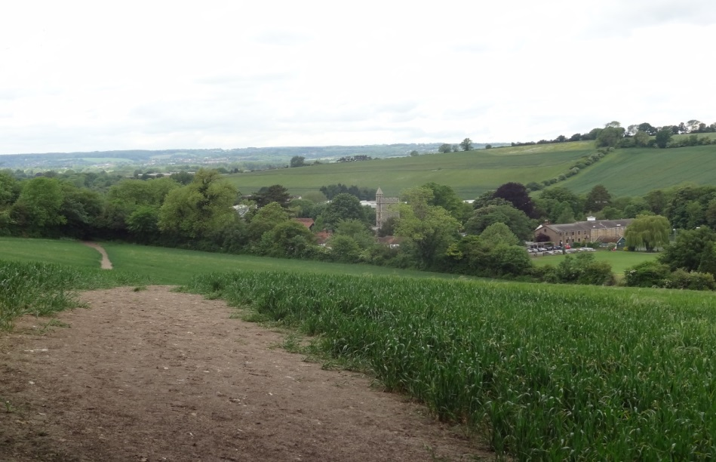
The path is wide and assertive in this landscape, deserted on election morning except for an imagined stream of long-dead people walking to church or to work. It is pretty, but not spectacular enough to attract many escapist ramblers. My pace quickens to an easy stride down the hill, turning left along a hollow lane and onto Wash Hill, the road at the fringes of Wooburn Town where I expect to vote. Documenting my route to vote brings intensity to the walk – the past feels close - an affective affordance attuned to the memories, perceptions and contours of a landscape that has, in Wylie’s words, become ‘inhabited and processed rather than beheld’.
I turn the corner at the bottom of Wash Hill and see the Polling Station.

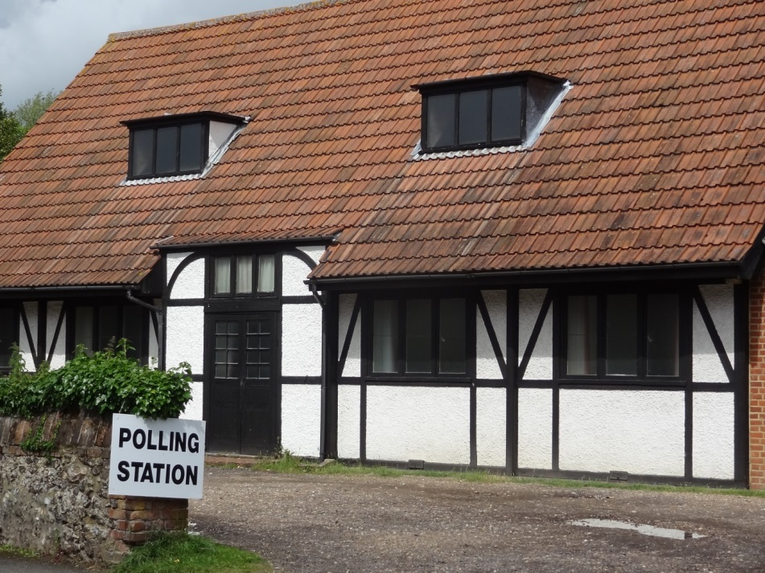

Staging the Vote
The Polling Station is marked by official signs spelling out the letters in heavy black print. I always rather enjoy visiting Polling Stations as it offers a chance to see inside buildings that I have no other cause to visit. Temporarily acquisitioned for civic duty, they adopt a sense of gravitas for the occasion but still carry traces of the various toddler groups, keep-fit classes and youth clubs that habitually occupy these social spaces. It is 10.15 in the morning when I arrive at Wooburn Polling Station, mud clinging to my shoes and feeling self-consciously wind-swept. It is a church hall, a barn-like black-and-white building that looks as if it were constructed in the 1920s. This is the same building that Kate Parry Collins used to cast her vote on 5th July 1945, noting with some pleasure that there was a woman presiding officer, permitted to serve for the first time. As I enter, three women officials are shuffling papers and talking to each other in hushed tones, amplifying the discipline of the space and emphasising its temporary transformation into a platform for civic performance. Coleman describes voting as an ‘affective social performance’, an experience that is both ‘profoundly private and inescapably public’. The tension between the instrumentalism of democratic procedure and private commitment seems to capture my feelings of ambivalence as the affective register of my journey shifts from country hike to the exercise of civic duty.

Coleman argues that vote-casting conforms to three aspects of performativity: it necessitates the voters’ embodied presence at the ballot box; it requires actors to follow foundational rules and prescribed rituals and, lastly, he suggests that voting is intimately connected to questions of representation and misrepresentation. Attentive to Coleman’s analysis of voting as a performative act, I would like to take the inquiry to its logical next step by considering vote-casting as a staged event. This speaks to all three elements of performativity, and also draws attention to the ways in which it is framed theatrically. The act of vote-casting, described by Coleman as ‘moments of mysterious engagement’, shares some attributes with conventional theatre practice; the event is performed and stage-managed, it requires props, scenery and narratives. Material culture is ordered, creating atmosphere and a sense of suspense. Reading the event in this way suggests that this church-hall polling station is a curated space, and by following a predetermined script I am conforming to its dramaturgical structures.

Each voter’s experience is similarly choreographed, and my experience follows the recognised rhythms of this civic dance. The officials sit at a trestle table to one side of the room, and it feels curiously trusting when they hand me a ballot paper without asking for any form of identification. Three polling booths provide the dramatic focus, a neat line of stalls carrying a symbolic status centre-stage in the middle of the room, set apart from all other activity. I am enclosed, briefly, in the booth’s three walls, my back to the audience of officials. My ballot paper marked in the reassuring thickness of a blunt pencil, my final performative gesture is to post it in the black ballot box, and I leave. The whole four-hander, with its cast of one voter, one presiding officer and two non-speaking polling clerks, has taken just over three minutes.

Within these three minutes, however, I am struck by the staged intensity of the event. The church hall, conceived for the day as a fully sanctioned government space, should conform to Henri Lefebvre’s coded representation of space, a term he uses to conceptualise how spatial practices are ordered and reproduced by dominant regimes of power. In some ways it does; the space has been arranged in ways that produces patterns of behaviour that match its official function. But to see the polling station as a theatrical space and voting as a staged event is to pay attention to its affective qualities and the aesthetic dimensions of the performance. Brian Massumi describes the political force of affect in terms of intensity and incipience:
Intensity is asocial but not presocial – it includes social elements but mixes them with elements belonging to other levels of functioning and combines them according to a different logic… Intensity is incipience, incipient action and expression. Intensity is not only incipience. It is the beginning of a selection.
Massumi’s argument opens a way of thinking about affect in relation to political decision-making and, more relevant to this paper, about how this intensity is experienced in the moment of marking the ballot-paper– the dramatic climax of vote-casting. Conceived as incipience, this performative act brings together, memory, relationality, biography, imagination and commitment. I have often wondered why I have found it impossible to vote tactically for a candidate whose views I am unable to fully endorse in order to keep out some-one whose politics seem even less palatable. I have even entered a polling booth with my mind made-up, only to find that in the instant of making that cross I just can’t go through with it. My hesitancy suggests that voting exists primarily in the affective realm, both within and beyond ideation, an improvised gesture of action and expression. Writing about the politics of affect, Lee Spinks points out that ‘political decision is itself produced by a series of inhuman or pre-subjective forces and intensities’.

The silence of the polling station and the secret intimacy of the ballot offer a dramatic contrast to the usual metaphors of political participation - voice, speaking out and so on– and recognise that voting is both an aesthetic and social performance. The act of vote-casting may be a solo performance but, as Coleman points out, the relationship between voting and memory also includes a cast of off-stage actors. My walk to vote was haunted by a cast of actors who had been disenfranchised in their time, who lent my vote additional significance. Inside the polling station, however, my newly-found connection with my rural environment seemed expunged and I found myself in an atmosphere Coleman aptly describes as ‘municipal cheerlessness’. At 10.15 in the morning there were no other voters, no tellers, and none of the sense of social solidarity that might stimulate political action. A rural resident for over 14 years, I have often found that the idea of rural neighbourliness is over-stated; when I was a city-dweller I knew most of the tellers and many elections would lead to impromptu drinks in the pub and watching the results on late-night television at someone’s house. In his quest to understand why many people seem reluctant to vote, Coleman learns that this kind of sociability is central to encouraging civic participation. His interviewees imagine lively and inviting polling stations that offer cups of tea, music and bouncy castles, where the act of voting is ‘an incarnation of civic fellowship’, a collective and social performance that is experienced affectively, as an event. This draws attention to the proposition that affective atmospheres can be infectious, a way of shaking debate and stirring collective feeling.

Paying attention to how voting is staged recognises the official procedures that necessarily circumscribe the experience, but it is improvised and affective attributes of civic conviviality that might inspire the electorate to cast their votes. When I leave the polling station, duty done, my walk takes on a new discursive register as pilgrimage. I cross the path to the church, and pass through the lych-gate to search for Kate Parry Collins’ grave. It is only some time later that I learn that I am looking in the wrong cemetery.

Walking Home: The Affective Politics of Small Stories
I embarked on this journey to the ballot box intending to map a social narrative that explored points of connectivity between democratic citizenship and the affective geographies of voting. At each stage of the journey, I found that the fusion of subjective experience and objective proceduralism that Coleman identified as central to cultivating a democratic sensibility needed to be understood spatially as well as performatively and theatrically. The argument developed in this paper is that a cultural reading of voting, that takes account of the affective intensities of voting as a staged event, might assist in understanding how democratic sensibilities shape political participation within and beyond the conceptual economy of a shared ideological vision. Further, by focusing on one story - my journey to a Polling Station on May 22nd 2014 - I have aimed to rethink how a rural walk might speak to wider spatial and temporal narratives that disrupt or challenge orthodox constructions of rural politics. ‘Small stories, Hayden Lorimer memorably suggests, ‘should also be treated as entry points to the working out of conceptual ideas in local contexts’.

Locality may be central to voting practices, but social fragmentation is also recognised as obstacle to political participation. Coleman argues that one of the problems with encouraging people to vote is that contemporary culture is increasingly mediated, with the effect that the local has become ‘eclipsed’ and social meaning is no longer ‘tuned to the key of the vernacular’. The political sphere to which contemporary voters belong now extends beyond the ‘familiar landmarks of market squares, high streets and town halls’ that were central to Kate Parry Frye’s political consciousness and activism. Attachments are now forged across a wider geographical reach and are constructed in what Coleman describes as ‘the metaphorical space of mediated connection’. In this cultural climate affect has become biopolitical, harnessed to both theatricalised street protests and the highly commodified and mediatised images used to sell political leaders. And yet the twenty-first century has brought a resurgence of interest in localism, partly as a point of resistance to its mediatised culture, but also attracting favour from activists across the political spectrum. From the environmentally-focused Transition Town movement to the Conservative Party’s interest in self-sustaining communities, one new political imaginary is small and local in scale. Writing about transition culture, Sarah Neal points out that there are two ways of thinking about this political paradox. On the one hand, she suggests that this rescaling can re-animate a utopianism in ways that challenge urban-rural binaries:
This rescaling allows the re/connection with ‘rural values’ and a re/building of relationships and ‘local skills’ with…nature and the non-human worlds.
On the other hand, belief in local self-sufficiency ‘can evoke a defensive localism and notions of firmly bounded communities’.

These two conflicting narratives articulate one of the tensions that exists in contemporary political practice and might be identified in the small story of my rural walk to the ballot box. There is, potentially, a new radicalism attached to the ruralisation of urban life that is, as Neal points out, reminiscent of William Morris’ vision of a rural-urban utopia described in News from Nowhere. Morris re-imagined life on the river Thames as a collection of villages, populated by happy, healthy and egalitarian communities. Perhaps the rise of gentrified city farms, farmers’ markets selling ‘local’ food and urban Women’s Institutes are as close as the twenty-first century gets to the Morris’ vision of happy communities of craftspeople. This is, as Neal points out, a commodified performance of rurality that over-simplifies the complexity of rural life. It does, however, speak to an affective politics, not only troubling orthodox narratives that are associated with rural life, but also raising questions about how affective relations across the urban-rural divide might be reshaped and rescaled in practice.

By focusing attention on the relationality of affect, I am interested in re-situating democratic participation as part of a wider network of human and nonhuman sensibilities. This aims to take account of the affective intensities and enchantment of the material world, not as a nostalgic pastoral image, but as a weak ontology that has the potential to extend beyond the ‘affective encounters’ between human and non-human ‘vibrant bodies’. Such affective encounters, can be imaginative as well as material, enabling the past to be newly narrated in the present. This more-than-subjective experience, I suggest, can shape performative relations between communities of memory and forgetfulness, between place-based identities and the wider political sphere. Attuned to spatial trajectories as materiality and imagination, and with attention to relationality, I suggest that there is a strong case for understanding how the instrumentalism of voting and subjective experience might become integral to each other.

On my way home, the weather begins to cloud over. Church Path lies ahead, a walk uphill. Two people are walking towards me, and I recognise them from the village. When we meet, we pause and talk for a moment. It is the ordinary stuff of everyday life, but newly inflected for me with a sense of belonging. They invite me to join the pub quiz team, and walk down the hill to vote.

Stephen Coleman, How Voters Feel (Cambridge, Cambridge University Press, 2013), p.192
Ibid, p. 76
Jane Bennett, ‘The force of things: steps to an ecology of matter’, Political theory 32 (2004), 347–372. (p. 365)
Jane Bennett, The Enchantment of Modern Life: Attachment, Crossings, and Ethics (Princeton: Princeton University Press, 2001), 156-158
Sarah Pink, Doing Sensory Ethnography (London: Sage Publications, 2009), p. 21
Coleman, How Voters Feel, p.87
Elizabeth Crawford, ed. Campaigning for the Vote: Kate Parry Frye’s Suffrage Diary (London: Francis Bootle Publishers, 2013)
The Great War: The People’s Story, ITV, Episode 3, 24.8.2014
Jerome K. Jerome, Three Men in a Boat (London: Penguin, 1974), p. 117
Elizabeth Crawford, The Great War: The People’s Story. Kate Parry Frye: The Long Life of an Edwardian Actress and Suffragette, (ITV ebook, 2014) p. 391
See Pierre Nora, ‘Between Memory and History: Les Lieux de Memoire’, Representations 26 (Spring 1989), 7-25
Coleman, How Voters Feel, p.195
Mike Pearson and Michael Shanks, Theatre/ Archaeology (London: Routledge, 2001), p. 147.
Nicolas Whybrow, Art and the City, (London and New York: I.B Tauris, 2011), p.91
Pearson and Shanks, Theatre/ Archaeology, p. 138
Michel de Certeau, The Practice of Everyday Life, trans S. Rendall, (Berkeley: University of California Press, 1984), p.115
Doreen Massey, For Space, (London: Sage, 2005), p.139
John Wylie, ‘A single day's walking: Narrating self and landscape on the South West Coast Path’, Transactions of the Institute of British Geographers 30: 3 (2005), 234-247 (p.235)
Ibid, p.236
Bennett, The Enchantment of Modern Life: Attachment, Crossings, and Ethics, p. 160
Robert McFarlane, The Old Ways: Journeys on Foot, (London: Penguin, 2012), p. 16
Wylie, ‘A single day's walking: Narrating self and landscape on the South West Coast Path’, p. 240
Coleman, How Voters Feel, p. 15
Ibid, pp.15-19
Ibid, p.176
See Henri Lefebvre, The Production of Space, trans. D. Nicholson-Smith, (Oxford: Basil Blackwell, 1991), pp. 38-42
Brian Massumi, Parables for the Virtual: Movement, Affect, Sensation (London: Duke University Press, 2002), p. 30
Lee Spinks, ‘Thinking the posthuman: literature, affect and the politics of style’, Textual Practice, 15 (2001) 23–46, (p.24).
Coleman, How Voters Feel, p. 79
Ibid p. 179
Ibid, p. 177- 179
Hayden Lorimer, ‘Telling Small Stories: Spaces of Knowledge and the Practice of Geography’, Transactions of the Institute of British Geographers, 28, (2003), 197–217, (p. 214).
Coleman, How Voters Feel, p. 211
Sarah Neal, ‘Transition culture: Politics, localities and ruralities’ Journal of Rural Studies 32 (2013), 60-69, (p.64)
Bennett, The Enchantment of Modern Life, p.118.

