Angular Magnetoresistance of Nanowires with Alternating

Cobalt and Nickel Segments

H. Mohammed¹, H. Corte-León², Y. P. Ivanov ^{1,3}, J. A. Moreno¹, O. Kazakova², and J. Kosel¹

¹King Abdullah University of Science and Technology, Electrical Engineering Department, Thuwal, Saudi Arabia
²National Physical Laboratory, London, United Kingdom
³Austrian Academy of Sciences, Erich Schmid Institute of Materials Science, Leoben , Austria

Magnetization reversal in segmented Co/Ni nanowires with varying number of segments was studied using angular Magnetoresistance (MR) measurements on isolated nanowires. The MR measurements offer an insight into the pinning of domain walls within the nanowires. Angular MR measurements were performed on nanowires with two and multiple segments by varying the angle between the applied magnetic field and nanowire (-90° ≤ θ ≤ 90°). The angular MR measurements reveal that at lower values of θ the switching fields are nearly identical for the multisegmented and two-segmented nanowires, whereas at higher values of θ, a decrease in the switching field is observed in the case of two segmented nanowires. The two segmented nanowire generally exhibits a single domain wall pinning event, whereas an increased number of pinning events at higher .magnetic force microscopydomain wall and propagation

Index Terms— Cylindrical Nanowires, Angular Magnetoresistance, Domain Wall Pinning

Introduction
T
he prospect of utilizing the vertical dimension to enhance data storage capacity has spurred considerable interest in developing 3D memory devices [1]-[3]. In particular, cylindrical magnetic nanowires are emerging as attractive 3D architectures that provide a low cost and simple fabrication technique wherein nanowires are electrochemically grown parallel to each other in a vertical fashion [4]. In addition to the 3D scaling, the non-planarity of the nanowires has been theoretically predicted to be advantageous to the motion of domain walls (DWs) [5]. Even though cylindrical nanowires appear as attractive candidates, their realization has been hindered due to the difficulty in achieving reliable pinning sites as well as the challenges involved in performing single nanowire-based studies. The realization of these 3D devices would depend on the demonstration of moving DWs from one pinning site to another. Approaches such as diameter modulation and egmented nanowireshave been demonstrated, providing pinning sites for DWs [6]-[8]. investigate The segmented nanowires consists of alternating segments of cobalt and nickel, whose interface act as pinning sites. For the realization of a multisegmented nanowire-based device, an understanding of the magnetization reversal mechanism as well as angular switching field dependence is important. In this paper, we perform magnetoresistance (MR) measurements to study the magnetization reversal and angular switching field dependence in nanowires with different numbers of Co/Ni segments.

Methods

Fabrication of Cylindrical Nanowires
Cylindrical nanowires were grown by electrodeposition into anodic aluminum oxide (AAO) templates with pore diameter of approximately 80 nm and inter pore distance of 105 nm. The AAO templates were fabricated using two subsequent anodization processes in oxalic acid solution (see [7] for more details). Segmented Co/Ni nanowires were fabricated by electrodeposition into the AAO templates using two separate solutions. Electrodeposition of Ni was carried out using an electrolyte containing 300 g/L NiSO₄, 46 g/L NiCl₂ and 40 g/L H₃BO₃ at a constant DC voltage of -1 V (vs. Ag/AgCl) at room temperature under constant stirring. The templates were then rinsed with deionized water and Co was electrodeposited at room temperature using a bath containing 250 g/L CoSO₄ and 40 g/L H₃BO₃ at a constant DC voltage of -1 V (vs. Ag/AgCl) under constant stirring. Two types of segmented nanowires of 26 μm length and 80 nm diameter with a varying number of segments were electrodeposited. The first type of nanowire consists of one segment of Co and Ni, each with a length of 13 μm. From here onwards, this type of nanowire is referred to as a two-segmented nanowire (Fig. 1 (a)). The second type of nanowire consists of 750 nm long alternating segments of Co and Ni referred to as a multisegmented nanowire (Fig. 1 (b)).

Fabrication of Electrodes onto the Nanowires
In order to probe the magnetization reversal process of the nanowires, electrical contacts had to be patterned onto individual nanowires to perform MR measurements. For this purpose, nanowires were chemically released from the AAO template and then dispersed onto a Si/SiO₂ substrate. The position of an isolated and defect free nanowire was marked using etch patterns created by a focused ion beam. The etch patterns serve as alignment marks for the subsequent lithography steps [7]. To fabricate the electrodes, a bilayer photoresist approach was utilized consisting of the LOR 5B and AZ 5214 resists, which were spin coated to a thickness of 600 nm and 1.4 μm respectively. The resists were then heated at 180°C and 110°C for 7 and 1 minutes, respectively. The spin coated sample was then exposed with a direct-writing lithography system (Heidelberg Instruments uPG501) which utilizes a 390 nm LED source. This LED-based lithography is
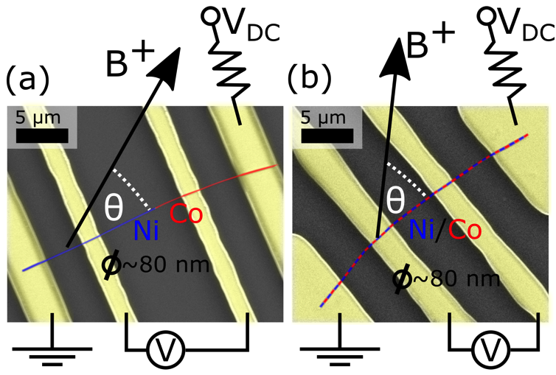

Fig. 1. SEM images with EDX overlapping of Co/Ni nanowires connected to four electrodes: (a) two-segmented nanowire and (b) multisegmented nanowire. Electrical circuits and angular reference for the applied magnetic field are depicted schematically.

a time and cost effective process as it offers a 1000 times faster exposure compared to electron beam lithography. Even though the resolution is limited to 1 μm, the technique is well suited for fabricating electrodes onto single nanowires of at least 10 μm length. The exposed sample was then developed using the developer AZ 726 for 1 minute after which the development process was terminated by dipping the developing sample into deionized water. The developed samples were then sputtered with Cr and Au to a thickness of 10 nm and 180 nm respectively. Prior to sputtering the samples, an etch step was performed to ensure that the Cr/Au layer formed a low resistance electrical contact with the nanowire. Finally lift-off was performed using a resist stripper Remover PG for 10 minutes at 65°C. The sample was then rinsed with Isopropyl Alcohol and deionized water and finally dried with N₂. Fig. 1 depicts Scanning Electron Microscopy (SEM) images with overlapped Energy Dispersive X-ray (EDX) analysis mapping of two-segmented (Fig. 1 (a)) and multisegmented (Fig.1 (b)) Co/Ni nanowires.

C. Magnetoresistance Measurement Setup
The nanowire-based device was wire bonded onto a custom built chip carrier and placed in an aluminum shield box which was connected to a DC stepper motor to enable angular rotation of the sample. The setup was then placed between the poles of an electromagnet, such that at 0° orientation of the nanowire, the magnetic field was applied parallel to the nanowire axis (see Fig. 1 for reference of the angular orientation θ).
Prior to performing the MR measurements, the nanowire was saturated by applying a magnetic field of 250 mT along the nanowire in both directions. The MR measurements were performed at room temperature by injecting a constant current of 100 μA through the outer electrodes and the voltage was measured at the inner electrodes using a nanovoltmeter with 10 power line cycles as integration time (~200 ms per data point) while an in-plane external magnetic field was applied in steps of ~ 0.5 mT. Once an MR measurement was performed, the orientation of the nanowire with respect to the applied field was changed in increments of θ ≈ 1° and the next MR measurement was performed at this angle. Angular MR measurements were carried out at -90° ≤ θ ≤ 90°.

RESULTS
A. Magnetization Reversal in Cylindrical Nanowires
The magnetization reversal in cylindrical nanowires has been previously reported using MR measurements [9]-[12]. The MR effect is a consequence of the orientation of the magnetic moments with respect to the direction of applied electric current. The MR curve is characterized by reversible and irreversible parts and the characteristic features of an MR curve are: (1) a high resistance state, which indicates the parallel alignment of magnetic moments along the direction of current; (2) gradual decrease in resistance, which indicates the rotation of the magnetic moments away from the direction of current; (3) abrupt resistance change, which is a consequence of the reversal of magnetization or DW motion and (4) finally, a high resistance state indicating complete reversal of the magnetic moments in the opposite direction.

B. Magnetization Reversal in Two-Segmented Nanowires
Segmented Co/Ni nanowires have been reported to pin a DW at the interfaces of the segments [7], [8]. The pinning is

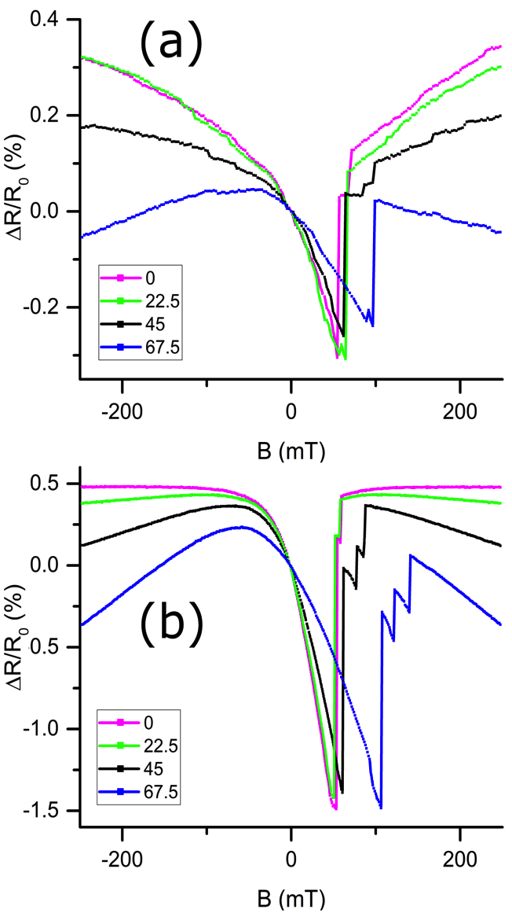
Fig. 2. MR curves of (a) two-segmented and (b) multisegmented nanowires for θ = 0º, 22.5º, 45º, and 67.5º.

manifested as additional n the MR curve, which otherwise . This is an indication of a pinned DW, which subsequently propagates only upon further increase of the applied field [7]. The MR curves consequently demonstrate a switching field B_{sw}, at which a part of the nanowire is reversed and a DW gets pinned, followed by a depinning field, at which the pinned DW propagates.
In this paper, the magnetization reversal in both two- and multisegmented nanowires has been investigated. The two-segmented Co/Ni nanowires offer a simplified version of the multisegmented Co/Ni nanowires as they comprise only one interface, which could act as a reliable pinning site. In addition, since an interface is positioned in between the inner electrodes, interfacial pinning is expected only in the electrically probed area, whereas in a multisegmented nanowire, DWs could be pinned outside the probed area (i.e. outside the inner electrodes), which would be exhibited as a higher switching field value in the MR curve.
MR measurements were performed on two-segmented Co/Ni nanowires with the external magnetic field applied at θ = 0°, 22.5°, 45°, and 67.5° with respect to the nanowire axis as depicted in Fig. 2 (a). The MR measurements reveal that a DW pins randomly at all angles of the applied field. An additional pinning event is observed at θ = 45°, which is an indication of a DW pinning that occurs at a defect within the nanowire. Since the pinning is observed only at a certain angle, i.e. at 45°, it indicates that the defect’s pinning potential is dependent on the magnetic field orientations, whereas the defect is unable to pin the DW at θ = 0°, 22.5°, and 67.5°. In addition to this, the switching field of the nanowire increases with an increased angle of the applied field. At θ = 0°, the applied magnetic field acts along the nanowire axis, whereas at higher angles, the in-plane component of magnetization decreases. At θ = 67.5°, the nanowire experiences a lower component of applied field along the nanowire’s axis, thus requiring a higher magnitude of applied field to switch the nanowire’s magnetization.

C. Magnetization Reversal in Multisegmented Nanowires

Fig. 2 (b) depicts the MR curves of a multisegmented Co/Ni nanowire with external magnetic field applied at θ = 0°, 22.5°, 45°, and 67.5° with respect to the nanowire axis. At θ = 0° and 22.5°, a resistance change is observed in the MR curve indicating a DW pinning event. The pinned DW subsequently depins upon the application of a higher magnitude of applied field. The DW is no longer expected to pin at the subsequent interfaces, as now the in-plane component of magnetization experienced by the DW is larger than the pinning field. A different scenario is observed at higher angles, i.e. at θ = 45° and 67°, wherea -ep resistance observed, indicating two pinning events. This implies that after the first pinning event, the DW propagates and gets pinned at another interface, since the in-plane field experienced by the DW is lower at higher angles of the applied field. D. Field Induced Domain Wall Depinning
Magnetic Force Microscopy (MFM) was performed on multisegmented Co/Ni

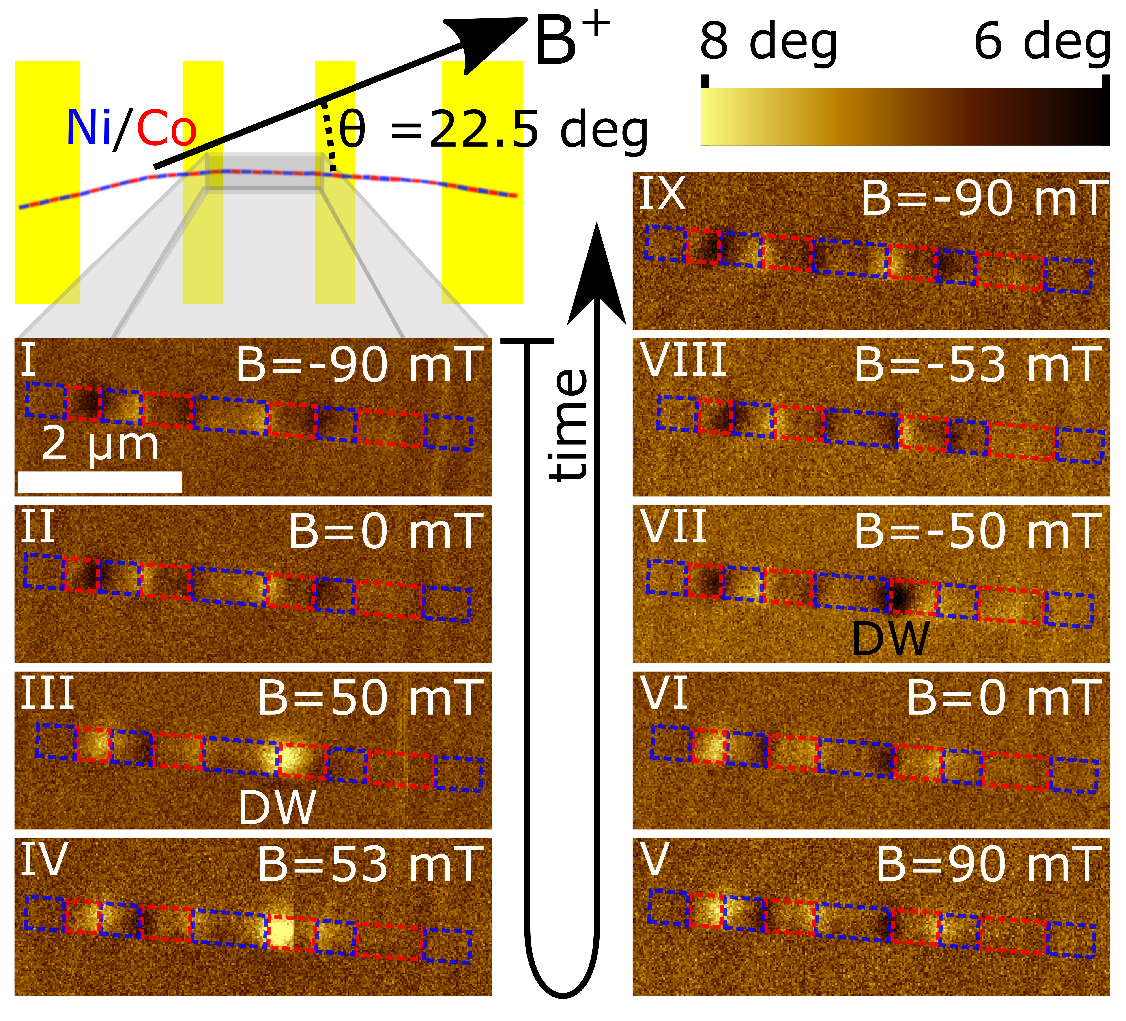
Fig. 3. Me

depicts the MFM images obtained from a multisegmented nanowire with a magnetic field applied at θ = 22.5°. The blue and red dashed boxes in the MFM images indicate the Ni and Co segments, respectively. The nanowire was firstly saturated by an applied field of -90 mT. The saturated nanowire in stage I displays alternating dark and bright contrasts at the interface of the segments, which are a consequence of the stray fields emanating from the Co segments [8]. The applied field is gradually reversed, II. The magnitude of the field is gradually increased and at stage III, at B = 50 mT, the stray field contrasts emanating from the Co segments reverseda DW is pinned at one of the interfaces.Further increase in the field results in the depinning and propagation of the DW in the direction of the applied field leading to the saturation of the nanowire in the reverse direction at B = 90 mT (stages V). The measurement was repeated by sweeping the magnetic field from B = +90 mT to – 90 mT. The direction of magnetization within the nanowire remains unchanged at remanence (stage VI). In stage VII, a DW pinning is again observed at the same interface as in stage III followed by a depinning and reversal of the nanowire’s magnetization (stages VIII and IX). Thus, the second step in resistance at B = 53 mT and θ = 22.5° in figure 2 (b) can be attributed to the presence of a pinned DW. Furthermore, at θ = 22.5° only a single pinning event is observed in the MFM images, as is the case in the MR measurements.

E. Angular Dependence of Switching Field
Angular dependence studies have been previously reported in Co, Ni, and Co_{x}Ni_{x} nanowires [10]-[13]. The value of the switching field B_{SW} as well as its dependence on the angle between the applied field and nanowire axis give an insight into the magnetization reversal mechanism within the nanowire. Reversal mechanism in finite cylindrical nanowires has been proposed to be a localized curling mode, where an open vortex area is nucleated at the ends of the nanowire and a DW propagates and consequently reverses the magnetization within the nanowire.

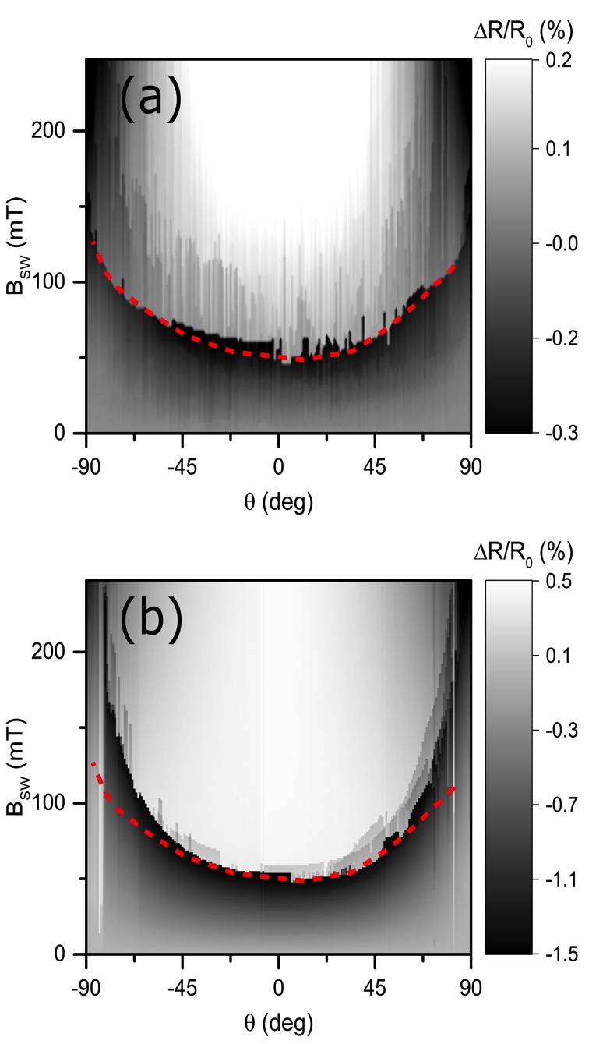
Fig. 4. Angular mapping of MR for (a) two-segmented nanowire and (b) multisegmented nanowire. Dashed line in both graphs indicates switching field of the two-segmented nanowire.

The dependence of the nanowire switching field B_{SW} with respect to the field angle θ was determined for two-segmented and multisegmented Co/Ni nanowires with a diameter of 80 nm using angular MR measurements as shown in Fig. 4 The dotted red line in Fig. 4 indicates the switching field of the two-segmented nanowire. The general trend in the angular dependence curve is that as θ increases, the switching field increases in both nanowires, which is characteristic for the localized curling reversal mode in a finite cylinder. The switching field of the two-segmented and multisegmented nanowires are relatively close to each other at low angles of the applied field, whereas a significant deviation in their switching field is observed at higher angles, where the reversal of the multisegmented nanowire occurs at higher applied fields. This can be due to a DW, which is pinned outside the probed area leading to a higher switching field in the multisegmented nanowire.

CONCLUSION
Segmented Co/Ni nanowires have been demonstrated to pin domain walls between their interfaces. In order to utilize this interfacial pinning phenomenon, it is crucial to gain an understanding of the magnetization reversal within these nanowires. Magnetoresistance measurements as well as the angular dependence of the nanowire switching field gives an insight into the magnetization reversal process. In this paper, two types of Co/Ni nanowires namely multisegmented and two-segmented nanowires have been studied. The two-segmented nanowires offer a simplified structure to investigate interfacial pinning.
Pinning of a DW at the Co/Ni interface was demonstrated by means of MR measurements in both types of nanowires. Angular MR measurements of the multisegmented nanowire reveal an increase in the number of pinning events with an increased angle of the applied field. Even though the angular dependence of the switching field of both nanowires are similar at low angles of the applied field, a characteristic difference is observed at higher angles, where the two-segmented nanowires display a low switching field value. The above observations are a consequence of the low in-plane component of magnetization experienced by a pinned DW at higher values of θ, as well as the possibility of a DW pinned outside the probed area leading to a higher observed switching field in multisegmented nanowires. which is crucial for a segmented race track memory device. We observe that a higher sensitivity to the detection of domain walls can be observed by orienting the external field at an angle to the nanowire.
Easy electrical readout, here we have the detection of the domain walls by electrical measurements for race track memory These

Acknowledgment
This work was funded partly by King Abdullah University of Science and Technology and in part by EMRP and EMRP participating countries under Project EXL04 (SpinCal), and FP7 project NanoMag, and NanoMag (EMPIR).

References
- S. S. P. Parkin, M. Hayashi, and L. Thomas, “Magnetic domain-wall racetrack memory,” Science, vol. 320, no. 5873, pp. 190–194, Apr. 2008.
- S. Song et al., "Three-Dimensional Integration of Organic Resistive Memory Devices," Advanced Materials, vol. 22, pp. 5048, 2010.
- F-P. Amalio et al., “Three dimensional magnetic nanowires grown by focused electron-beam induced deposition,” Scientific Reports, vol. 3, March 2013.
- H. Masuda and K. Fukuda, “Ordered metal nanohole arrays made by a two-step replication of honeycomb structures of anodic alumina,” Science, vol. 268, no. 5216, pp. 1466, Jun. 1995.
- M. Yan, A. Kákay, S. Gliga, and R. Hertel, “Beating the Walker limit with massless domain walls in cylindrical nanowires,” Phys. Rev. Lett., vol. 104, pp. 057201, Feb. 2010.
- L. Rodríguez et al., “Quantitative Nanoscale Magnetic Study of Isolated Diameter-Modulated FeCoCu Nanowires,” ACS Nano, vol. 10, pp. 9669, 2016.
- H. Mohammed, E. V. Vidal, Y. P. Ivanov, and J. Kosel, “Magnetotransport Measurements of Domain Wall Propagation in Individual Multisegmented Cylindrical Nanowires,” IEEE Trans. Magn., vol. 52, no. 7, 2016.
- Y. P. Ivanov, A. Chuvilin, S. Lopatin, and J. Kosel, “Modulated magnetic nanowires for controlling domain wall motion: towards 3D magnetic memories,” ACS Nano, vol. 10, pp. 5326, 2016.
- A. Fert and L. Piraux, “Magnetic nanowires,” J. Magn. Magn. Mater., vol. 200, pp. 338, Oct. 1999.
- J-E. Wegrowe, D. Kelly, A. Franck, S. E. Gilbert, and J.-Ph. Ansermet, “Magnetoresistance of Ferromagnetic Nanowires,” Physical Review Letters, vol. 82, no. 18, pp. 3681, May 1999.
- S. Pignard et al., “Study of the magnetization reversal in individual nickel nanowires,” Journal of Applied Physics, vol. 87, no. 2, pp. 824, 2000.
- Y. Rheem, B-Y. Yoo, W. P. Beyermann and N.V Myung, “Electro- and magneto-transport properties of a single CoNi nanowire,” Nanotechnology, vol. 18, pp. 125204, 2007.
- W. Wernsdorfer et al., “Nucleation of Magnetization Reversal in Individual Nanosized Nickel Wires,” Physical Review Letters, vol. 77, no. 9, Aug. 1996.

