Supplementary Tables and Figures

Table 1: Summary of variables

Variable | Obs | Mean | Std. Dev. | Min | Max
Testosterone levels (pg/ml): Baseline* | 172 | 40.39 | 21.90 | 1.80 | 116.00
Testosterone levels (pg/ml): post Competition | 172 | 50.54 | 30.69 | 3.73 | 267.00
Chooses to compete in stage 3 | 172 | 0.48 | 0.50 | 0 | 1
Chooses the tournament pay out in stage 4 | 172 | 0.38 | 0.49 | 0 | 1
Confidence in forced piece rate (stage 1): low | 172 | 0.09 | 0.28 | 0 | 1
Confidence in forced piece rate (stage 1): medium low | 172 | 0.34 | 0.47 | 0 | 1
Confidence in forced piece rate (stage 1): medium high | 172 | 0.33 | 0.47 | 0 | 1
Confidence in forced piece rate (stage 1): high | 172 | 0.24 | 0.43 | 0 | 1
Confidence in forced tournament (stage 2): low | 172 | 0.07 | 0.26 | 0 | 1
Confidence in forced tournament (stage 2): medium low | 172 | 0.27 | 0.44 | 0 | 1
Confidence in forced tournament (stage 2): medium high | 172 | 0.35 | 0.48 | 0 | 1
Confidence in forced tournament (stage 2): high | 172 | 0.31 | 0.47 | 0 | 1
Confidence in choice tournament (stage 3): low | 172 | 0.05 | 0.22 | 0 | 1
Confidence in choice tournament (stage 3): medium low | 172 | 0.25 | 0.43 | 0 | 1
Confidence in choice tournament (stage 3): medium high | 172 | 0.34 | 0.48 | 0 | 1
Confidence in choice tournament (stage 3): high | 172 | 0.35 | 0.48 | 0 | 1
Performance in forced piece rate (stage 1) | 172 | 8.58 | 3.51 | 2 | 21
Performance in forced tournament (stage 2) | 172 | 10.12 | 3.96 | 2 | 23
Performance in choice tournament (stage 3) | 172 | 10.57 | 4.11 | 2 | 26
Math grade: 0 (lowest) | 172 | 0.03 | 0.18 | 0 | 1
Math grade: 1 | 172 | 0.15 | 0.35 | 0 | 1
Math grade: 2 | 172 | 0.19 | 0.39 | 0 | 1
Math grade: 3 | 172 | 0.34 | 0.47 | 0 | 1
Math grade: 4 (highest) | 172 | 0.30 | 0.46 | 0 | 1
Holt-Laury Risk Measure (risk averse=0, risky=6) | 172 | 3.17 | 1.52 | 0 | 6
CAG 1st tercile: 14 – 19 | 170 | 0.14 | 0.35 | 0 | 1
CAG 2nd tercile: 20 – 23 | 170 | 0.54 | 0.50 | 0 | 1
CAG 3rd tercile: 24 – 30 | 170 | 0.32 | 0.47 | 0 | 1

Table 2: Correlation matrix for variables

 |  | T-levels | CAG | Stage 3 |  |  | Stage 1 |  | Stage 2 |  | Stage 4 | Math grade | Risk
 |  |  |  | Choice | Perf. | Conf | Perf. | Conf. | Perf. | Conf. | Choice
Testosterone levels (pg/ml): Baseline |  | 1.00
CAG repeats |  | -0.01 | 1.00
Stage 3: Choice to compete | Chooses to compete | 0.16* | 0.11 | 1.00
 | Performance | 0.08 | 0.01 | 0.22* | 1.00
 | Confidence | 0.23* | -0.02 | 0.35* | 0.47* | 1.00
Stage 1: Forced piece rate | Performance | -0.02 | 0.02 | 0.17* | 0.65* | 0.06 | 1.00
 | Confidence | -0.06 | 0.04 | 0.31* | 0.30* | 0.12 | 0.59* | 1.00
Stage 2: Forced tournament | Performance | 0.00 | -0.02 | 0.31* | 0.78* | 0.23* | 0.72* | 0.34* | 1.00
 | Confidence | 0.05 | 0.08 | 0.49* | 0.30* | 0.30* | 0.26* | 0.29* | 0.47* | 1.00
Stage 4: Choice for tournament pay out |  | 0.00 | 0.11 | 0.36* | 0.24* | 0.16* | 0.41* | 0.60* | 0.28* | 0.24* | 1.00
Math grade |  | 0.00 | 0.01 | 0.26* | 0.17* | 0.14+ | 0.24* | 0.25* | 0.15+ | 0.26* | 0.13+ | 1.00
Holt-Laury risk measure |  | 0.12 | 0.01 | 0.17* | 0.09 | 0.08 | 0.03 | 0.05 | 0.07 | 0.13+ | 0.11 | 0.02 | 1.00
Spearman rank correlations: * sign. at 5%-level, + sign. at 10%-level

Table 3: Choice to enter competition: marginal effects

Dep. Variable: Dummy | (1) | (2) | (3) | (4) | (5) | (6) | (7)
for choosing to compete | Marg. effects | Marg. effects | Marg. effects | Marg. effects | Marg. effects | Marg. effects | Marg. effects
Testosterone levels (pg/ml) | 0.004 | 0.004 | 0.005 | 0.004 | 0.005 | 0.005 | 0.006
 | (0.002)* | (0.002)* | (0.002)* | (0.002)* | (0.002)** | (0.002)* | (0.002)*
Performance in forced piece-rate |  | 0.036 |  |  |  | -0.009 | -0.006
(stage 1) |  | (0.012)** |  |  |  | (0.015) | (0.015)
Change in Performance: |  | 0.058 |  |  |  | 0.047 | 0.049
stage 2 - stage 1 |  | (0.016)** |  |  |  | (0.024)+ | (0.024)*
Dummy for confidence in stage 2: |  |  | 0.331 |  |  | 0.264 | 0.244
medium (Base: low) |  |  | (0.095)** |  |  | (0.117)* | (0.129)+
confidence in stage 2: high |  |  | 0.590 |  |  | 0.495 | 0.481
 |  |  | (0.071)** |  |  | (0.103)** | (0.109)**
Dummy for high risk aversion (3) |  |  |  | 0.018 |  | -0.024 | -0.055
(Base: medium risk aversion (0-2) |  |  |  | (0.099) |  | (0.133) | (0.137)
low risk aversion (4-6) |  |  |  | 0.195 |  | 0.119 | 0.126
 |  |  |  | (0.094)* |  | (0.127) | (0.129)
Dummy for low math grade (2) |  |  |  |  | 0.328 | 0.307 | 0.304
(Base: very low math grade 0-1) |  |  |  |  | (0.116)** | (0.139)* | (0.145)*
medium math grade (3) |  |  |  |  | 0.341 | 0.305 | 0.300
 |  |  |  |  | (0.102)** | (0.119)* | (0.120)*
high math grade (4) |  |  |  |  | 0.446 | 0.347 | 0.371
 |  |  |  |  | (0.104)** | (0.133)** | (0.132)**
Dummy for choosing to compete |  |  |  |  |  | 0.410 | 0.406
in stage 4 |  |  |  |  |  | (0.092)** | (0.091)**
Dummy for CAG in range 20-23 |  |  |  |  |  |  | 0.235
(Base: 14-19) |  |  |  |  |  |  | (0.171)
CAG in range 24-30 |  |  |  |  |  |  | 0.246
 |  |  |  |  |  |  | (0.169)
Observations | 172 | 172 | 172 | 172 | 172 | 172 | 170
Marginal effects are reported based on logit regressions. + p<0.10, * p<0.05, ** p<0.010

Table 4: Choice to enter competition: Odds ratios

Dep. Variable: Dummy | (1) | (2) | (3) | (4) | (5) | (6) | (7)
for choosing to compete | Odds ratio | Odds ratio | Odds ratio | Odds ratio | Odds ratio | Odds ratio | Odds ratio
Testosterone levels (pg/ml) | 1.018 | 1.018 | 1.019 | 1.016 | 1.021 | 1.022 | 1.023
 | (0.007)* | (0.008)* | (0.008)* | (0.008)* | (0.008)** | (0.009)* | (0.009)*
Performance in forced piece-rate |  | 1.156 |  |  |  | 0.966 | 0.978
(stage 1) |  | (0.057)** |  |  |  | (0.057) | (0.058)
Change in Performance: |  | 1.261 |  |  |  | 1.205 | 1.215
stage 2 - stage 1 |  | (0.082)** |  |  |  | (0.115)+ | (0.116)*
Dummy for confidence in stage 2: |  |  | 3.972 |  |  | 2.958 | 2.710
medium (Base: low) |  |  | (1.709)** |  |  | (1.493)* | (1.499)+
confidence in stage 2: high |  |  | 16.960 |  |  | 9.308 | 8.615
 |  |  | (8.232)** |  |  | (5.509)** | (5.191)**
Dummy for high risk aversion (3) |  |  |  | 1.079 |  | 0.907 | 0.799
(Base: medium risk aversion (0-2) |  |  |  | (0.442) |  | (0.490) | (0.449)
low risk aversion (4-6) |  |  |  | 2.205 |  | 1.614 | 1.663
 |  |  |  | (0.858)* |  | (0.831) | (0.869)
Dummy for low math grade (2) |  |  |  |  | 4.763 | 3.921 | 3.897
(Base: very low math grade 0-1) |  |  |  |  | (3.013)* | (2.594)* | (2.695)*
medium math grade (3) |  |  |  |  | 5.013 | 3.879 | 3.836
 |  |  |  |  | (2.992)** | (2.299)* | (2.300)*
high math grade (4) |  |  |  |  | 7.703 | 4.604 | 5.123
 |  |  |  |  | (4.684)** | (2.959)* | (3.321)*
Dummy for choosing to compete |  |  |  |  |  | 5.746 | 5.629
in stage 4 |  |  |  |  |  | (2.567)** | (2.497)**
Dummy for CAG in range 20-23 |  |  |  |  |  |  | 2.618
(Base: 14-19) |  |  |  |  |  |  | (1.903)
CAG in range 24-30 |  |  |  |  |  |  | 2.742
 |  |  |  |  |  |  | (1.997)
Constant | 0.459 | 0.092 | 0.112 | 0.347 | 0.094 | 0.018 | 0.007
 | (0.154)* | (0.054)** | (0.054)** | (0.137)** | (0.066)** | (0.015)** | (0.008)**
Observations | 172 | 172 | 172 | 172 | 172 | 172 | 170
Pseudo-R2 | 0.03 | 0.10 | 0.21 | 0.05 | 0.10 | 0.33 | 0.34
Wald Test: Chi² | 5.92 | 22.42 | 36.76 | 10.75 | 14.08 | 56.92 | 57.51
Prob > Chi² | 0.01 | 0.00 | 0.00 | 0.01 | 0.01 | 0.00 | 0.00
Odds ratios are reported based on logit regressions. + p<0.10, * p<0.05, ** p<0.010

Table 5: Performance

Dep. Variable: Performance | SS | df (n) | df (d) | F | P | η²
Performance: Stage 1
Model | 111 | 7 | 162 | 1.29 | 0.256 | 0.05
Testosterone levels (pg/ml) | 0 | 1 | 162 | 0.00 | 0.973 | 0.00
CAG terciles | 1 | 2 | 162 | 0.03 | 0.973 | 0.00
Math grade (min=0, max=4) | 108 | 4 | 162 | 2.22 | 0.069 | 0.05
Residual | 1980 | 162
Performance: Stage 2
Model | 101 | 7 | 162 | 0.91 | 0.501 | 0.04
Testosterone levels (pg/ml) | 3 | 1 | 162 | 0.21 | 0.649 | 0.00
CAG terciles | 15 | 2 | 162 | 0.48 | 0.621 | 0.01
Math grade (min=0, max=4) | 84 | 4 | 162 | 1.32 | 0.263 | 0.03
Residual | 2565 | 162
Performance: Stage 3
Model | 392 | 11 | 158 | 2.28 | 0.013 | 0.14
Testosterone levels (pg/ml) | 12 | 1 | 158 | 0.75 | 0.387 | 0.00
Tournament choice in stage 3 | 6 | 1 | 158 | 0.36 | 0.549 | 0.00
Testosterone levels * Tournament choice R3 | 31 | 1 | 158 | 2.00 | 0.159 | 0.01
CAG terciles | 43 | 2 | 158 | 1.37 | 0.257 | 0.02
CAG terciles * Tournament choice R3 | 122 | 2 | 158 | 3.89 | 0.022 | 0.05
Math grade (min=0, max=4) | 39 | 4 | 158 | 0.62 | 0.645 | 0.02
Residual | 2474 | 158
The results of three univariate Anovas are reported. The first anova used the performance in stage 1 as depdendent variable, the second anova used performance in stage 2 as dependent variable and the third anova used performance in stage 3 as dependen variable. R3 stands for stage 3.

Table 6: Confidence in stage 3

Dep. Variable: Confidence (0=min, 3=max) | Full sample |  |  | Only those who chose to compete |  |  |  | Only those who chose not to compete
 | Marg. effects | Odds ratio | Odds ratio | Marg. effects | Odds ratio | Marg. effects | Odds ratio | Marg. effects | Odds  ratio
Testosterone levels (pg/ml) | 0.003 | 1.015 | 1.007 | 0.006 | 1.024 | 0.005 | 1.019 | 0.001 | 1.008
 | (0.002)* | (0.008)+ | (0.011) | (0.003)* | (0.011)* | (0.003)+ | (0.011)+ | (0.002) | (0.013)
Testosterone levels * Tournament |  |  | 1.021
choice in stage 3 |  |  | (0.016)
Dummy for CAG in range 20-23 | -0.039 | 0.842 | 1.467 | -0.485 | 0.113 | -0.344 | 0.228 | 0.062 | 1.569
(Base: 14-19) | (0.089) | (0.329) | (0.716) | (0.190)* | (0.118)* | (0.229) | (0.246) | (0.076) | (0.886)
CAG (20-23) * Tournament |  |  | 0.064
choice in stage 3 |  |  | (0.076)*
Dummy for CAG in range 24-30 | -0.044 | 0.823 | 1.876 | -0.534 | 0.092 | -0.380 | 0.202 | 0.112 | 2.072
 | (0.097) | (0.360) | (1.023) | (0.186)** | (0.097)* | (0.228)+ | (0.214) | (0.107) | (1.312)
CAG (24-30) * Tournament |  |  | 0.040
choice in stage 3 |  |  | (0.049)**
Tournament choice in stage 3 | 0.289 | 3.660 | 21.864
 | (0.071)** | (1.174)** | (28.267)*
Performance in stage 3 |  |  |  |  |  | 0.067 | 1.315
 |  |  |  |  |  | (0.021)** | (0.113)**
Observations | 170 | 170 | 170 | 82 | 82 | 82 | 82 | 88 | 88
Pseudo-R² |  | 0.06 | 0.09 |  | 0.06 |  | 0.17 |  | 0.01
Wald Test: Chi² |  | 24.60 | 29.49 |  | 10.45 |  | 17.96 |  | 1.40
Prob > Chi² |  | 0.00 | 0.00 |  | 0.02 |  | 0.00 |  | 0.71
Marginal effects and Odds ratio are reported based on ordered logit regressions.
The marginal effects are calculated for the highest confidence. + p<0.10, * p<0.05, ** p<0.010

Table 7: Risk and Testosterone

Dep. Var: Holt-Laury Risk Measure (risk averse=0, risky=6) | Marginal effects | Odds Ratio
Testosterone levels (pg/ml) | 0.0014 | 1.011
 | (0.001)* | (0.005)*
Observations | 172 | 172
Pseudo-R2 |  | 0.01
Wald Test: Chi² |  | 4.00
Prob > Chi² |  | 0.05
The marginal effect and the odds ratio are reported based on an ordered logit regression.
The marginal effect is calculated for the highest value on the risk measure.
+ p<0.10, * p<0.05, ** p<0.010

Table 8: Change in testosterone levels

Dep. Variable: Change in T-levels | SS | df (n) | df (d) | F | P | η²
1)
Model | 6035 | 5 | 166 | 2.09 | 0.069 | 0.06
Performance in stage 1 | 104 | 1 | 166 | 0.18 | 0.671 | 0.00
Math grade (min=0, max=4) | 5877 | 4 | 166 | 2.55 | 0.041 | 0.06
Residual | 95821 | 166
2)
Model | 6133 | 5 | 166 | 2.13 | 0.065 | 0.06
Performance in stage 2 | 202 | 1 | 166 | 0.35 | 0.554 | 0.00
Math grade (min=0, max=4) | 5964 | 4 | 166 | 2.59 | 0.039 | 0.06
Residual | 95723 | 166
3)
Model | 5934 | 5 | 166 | 2.05 | 0.074 | 0.06
Performance in stage 3 | 4 | 1 | 166 | 0.01 | 0.934 | 0.00
Math grade (min=0, max=4) | 5932 | 4 | 166 | 2.57 | 0.040 | 0.06
Residual | 95922 | 166
4)
Model | 5963 | 5 | 166 | 2.06 | 0.072 | 0.06
Dummy for choosing the tournament in S3 | 33 | 1 | 166 | 0.06 | 0.812 | 0.00
Math grade (min=0, max=4) | 5918 | 4 | 166 | 2.56 | 0.040 | 0.06
Residual | 95893 | 166
5)
Model | 10 | 1 | 170 | 0.02 | 0.899 | 0.02
Dummy for winning in stage 2 | 10 | 1 | 170 | 0.02 | 0.899 | 0.02
Residual | 101846 | 170
6)
Model | 2 | 1 | 81 | 0.00 | 0.954 | 0.00
Dummy for winning in stage 3 | 2 | 1 | 81 | 0.00 | 0.954 | 0.00
Residual | 59781 | 81
The results of four univariate Anovas are reported. S3 stands for stage 3.

Table 9: Choice to enter competition: Interaction effects of testosterone and CAG repeat polymorphism

Dep. Variable: Dummy for choosing to compete | Odds ratio
Testosterone levels (pg/ml) | 0.963
 | (0.022)
Dummy for CAG in range 20-23 | 0.173
(Base: 14-19) | (0.198)
Dummy for CAG in range 20-23 x Testosterone | 1.064
 | (0.027)*
Dummy for CAG in range 24-30 | 0.272
 | (0.330)
Dummy for CAG in range 24-30 x Testosterone | 1.058
 | (0.028)*
Constant | 2.022
 | (2.114)
Observations | 170
Pseudo-R2 | 0.06
Wald Test: Chi² | 15.19
Prob > Chi² | 0.01
Odds ratios are reported based on logit regressions. + p<0.10, * p<0.05, ** p<0.010
As can be seen from the first row, the testosterone effect for the 1st CAG repeat tercile is negative, though not significant (p=.104; OR=0.96). The testosterone effect for the 2nd and 3rd CAG repeat terciles are positive and significantly different from the testosterone effect for the 1st CAG repeat tercile. In other words, the testosterone effect for the 1st CAG tercile is significantly lower than the testosterone effect for the other two terciles. Given that the negative effect is not significantly different from zero we conclude that the observed testosterone effect is most pronounced for high CAG repeats and absent for low CAG repeat numbers. We did not find any significant interaction effects of CAG repeat numbers and testosterone with regards to performance, confidence or risk.

Figure 4: Screen shot of the math task

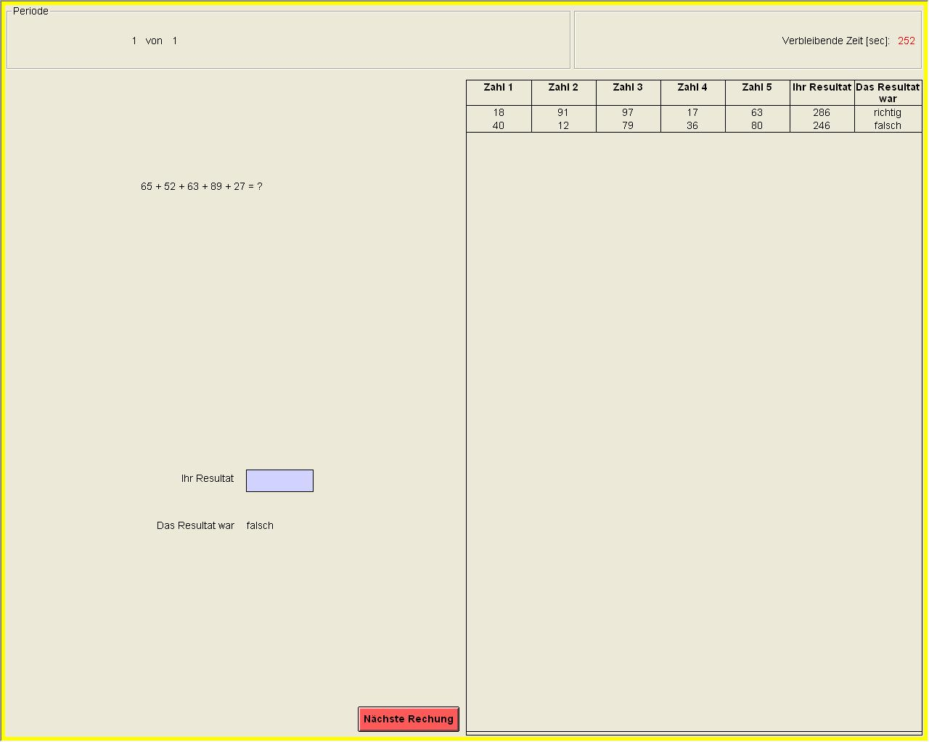
Current math problem
Remaining seconds
Participant enter their solution here
Feedback for previous problem
History of previous math problems and whether participants correctly solved them

