Quærendo 46 (2016) 1-7

A Writing Master’s Sheet from the Low Countries
An Investigation of the Writing Master’s Sheet (Harderwijk,
Streekarchivariaat Noordwest-Veluwe, MS OAH 2002)
Frieda van der Heijden
Royal Holloway, University of London
Frieda.vanderHeijden.2014@live.rhul.ac.uk

Abstract
During a research project in the Streekarchivariaat Noordwest-Veluwe in Harderwijk in 2013, a writing master’s sheet was found in a large group of maculature manuscript sheets. The parchment sheet has been used as a cover since 1595 and became damaged. The scripts on the sheet indicate that it was produced in the second half of the sixteenth century, and the use of both the French and Dutch language implies that it was made in the Low Countries. No other writing master’s sheets from the Low Countries survive. The text fragments on the sheet suggest that it was probably an advertisement poster used to attract students, who might learn the French language and perhaps other skills as well, such as the art of writing.
Keywords
maculature – writing master – Low Countries – sixteenth century

Introduction
In May and June 2013, two students from Utrecht University investigated a group of one hundred and thirty-five parchment maculature manuscript sheets in the Streekarchivariaat Noordwest-Veluwe (Regional Archives of the North West Veluwe) in Harderwijk (Province of Gelderland), the Netherlands. The aim of this project was to describe and analyse the sheets, all of which have been used as covers for administrative documents since the second half of the sixteenth century. Several interesting fragments were found, such as a bifolium from an eleventh-century glossed Bible in Carolingian script (BWH 359); leaves from a twelfth-century liturgical manuscript with neumatic music notation (OAH 208, 251, 354, and 1890); fragments from a pocket dictionary (OAH 237) and a natural encyclopaedia (BWH 346, 348, and 355), both from the fifteenth century; and, perhaps the most remarkable: a writing master’s sheet from the sixteenth century (OAH 2002). The latter will be discussed here.
The writing master’s sheet is the only sheet in the entire collection that was never part of a codex, but is (almost) complete as it is found today. It probably functioned as a writing master’s advertisement poster, before starting its second life as a parchment cover for an administrative document dated 29 January 1595. By this time, it must have already fallen out of use, either because the writing master had died or because the sheet was replaced with a new one. During centuries of use, both in its function as an advertisement poster and as a document cover, it has become damaged. The parchment is worn, the ink has faded, and several stains mark the sheet. Because of this, some text is less legible today than it must have been in the early years. Both the top and the bottom of the sheet have been trimmed to match the size and shape of the administrative document; fortunately, only the decorative borders became damaged in this process.

Writing Master’s Sheets
Towards the end of the Middle Ages, the art of writing became more and more commercial. Writing masters advertised their trade and their penmanship through advertisement posters in the form of sheets with examples of the different scripts and specific skills they had mastered. These were meant either to attract customers who were looking for a scribe to write their administrative or legal documents, or to attract students who were looking for a master to teach them the art of writing.
One of the oldest and best-known surviving writing master’s sheets is the one made by Johann von Haghen from Bodenwerder an der Weser, written in the fourteenth century. The sheet, on which eight different scripts are found, must have been glued to a wooden panel in a public place. It is decorated with coloured and gold-leaf initials, and titles are in gold and silver. This would have caught the attention and admiration of anyone who passed by and saw the poster. Von Haghen’s master’s sheet is an example of an advertisement poster for attracting students rather than customers.
Two severely damaged writing master’s sheets by Herman Strepel from Münster have survived. Both of them are now kept at the Royal Library in The Hague. The fifteenth-century sheets contain various scripts that have been named by Strepel himself: fracta, rotunda, modus copiistarum, brevitura. The naming of scripts is something that can be seen on several other writing master’s sheets, including the one by Von Haghen. The master who produced OAH 2002 neither named his scripts, nor did he give his own name. This may seem remarkable for an advertisement poster, but if the poster was visible on the front side of the master’s abode, people would have known to whom it referred.

Brief Description of MS OAH 2002
Few writing master’s sheets survive. Most of the ones that do date from the fifteenth century or later, and almost all of them were made in Germany or France. To my knowledge, OAH 2002 is the only known example from the Low Countries, which is suggested by the use of the Dutch language on the sheet.

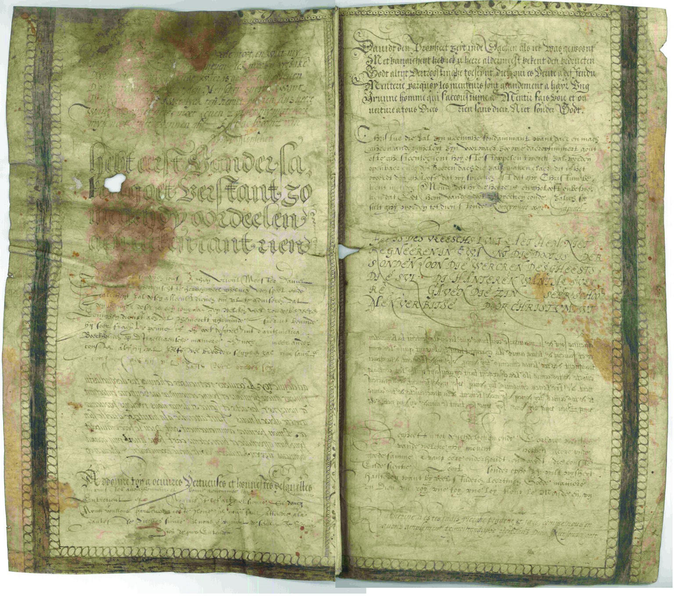
Figure 1 Anonymous, Writing Master’s Sheet, sixteenth century, Low Countries (Streekarchivariaat Noordwest-Veluwe, MS Oud Archief Harderwijk 2002). Thanks to archivist Henk Hovenkamp and archive assistant Tiemen Goossens.

Apart from this, it shares many features with the writing master’s sheets discussed above. It contains several types of script in eleven short text fragments that are given in two columns, five on the left, and six on the right. Three text fragments are in Dutch, three in French, and the other five in a combination of the two languages. Remarkably, none of the texts are in Latin. The columns are about 28.7 cm high and 13.5 cm wide; by way of embellishment both columns are surrounded by decorative borders.

Dating
There is a large variety of scripts on MS OAH 2002, although some of them closely resemble each other. Humanistic minuscules indicate that the sheet must have been made in the sixteenth century. This is confirmed by particular letter shapes, such as a very round ‘r’, and by other palaeographic features that were widely used in the Low Countries between 1570 and 1590.
Apart from the Humanistic minuscule, the sheet also contains several Gothic scripts – at the time mainly used for vernacular texts; and many fanciful and ornamental scripts that show off this master’s penmanship. Two text fragments are in mirrored script – particularly the fourth fragment on the sheet closely resembles a script commonly used in the period in captions for engravings and other printed texts. The master may have wanted to show this commercially useful skill to attract a larger audience, but perhaps he just wanted to show off the variety of his scripts.

French Lessons
Although the contents of the text fragments must have been of subordinate value to the writing master, they can tell us something about the function of the sheet. Some texts are sayings or proverbs, recognizable for the master’s intended clientele; some are Biblical texts in French or Dutch, or liturgical texts of a Protestant nature; others are seem to be more arbitrary in content. A clear example of the first category is the second text fragment, which happens to be the shortest one on the folio and one of the few that is fully legible:
hebt eerst vander sa- | ken goet verstant zo | meuch dy oordeelen | aen eliken cant rien |
The final word is not part of the proverb, but an abbreviation for ‘rien sans Dieu’, a short line that is found in several text fragments on this sheet. The fourth text fragment is written in French and its nature is liturgical. Its final line, however, is in Dutch, and reads: kinderen wilt goede exempelen gheven op (want to give children good examples for [...]). The fact that this is only half a sentence, reinforces the idea that the contents of the texts were of minor importance to the writing master compared to the scripts in which he copied them.
We find the short text U kinderen wilt goede exempelen gheven op dat sy hier wyselyck mogen leven (You want to give good examples to your children, so that they will live well) in the practice book of a young girl from Haarlem, the Netherlands, dated from 12 November 1584 to 28 April 1585. Geertruyt Ruychaver was the mayor’s daughter and she was twelve years old when she copied texts from an exemplar book for practising the art of calligraphy and the French language simultaneously. The twenty-four text fragments in her exemplar book have similar contents to the fragments found on the writing master’s sheet OAH 2002, but because this book was meant to function as teaching material rather than as an advertisement, it contains French and Dutch texts that are direct and complete translations of each other.
As said above, OAH 2002 also includes text fragments in both languages, but only one line is translated directly: rien sans Dieu. Niet sonder godt (Nothing without God). Both the appearance of this short translation and the use of the two languages on the sheet suggest that this writing master’s sheet was meant to attract students rather than customers, like the other sheets discussed above. The master might well have offered to teach his students the French language alongside the art of writing, not unlike the lessons received by the young girl from Haarlem. He would have been a Fransoysche Schoolmeester, or a French schoolmaster, offering lessons in French, writing, arithmetic, and other things. Fransoysche Schoolmeesters were required to have advertisement sheets hanging on their windows to show prospective students de conste ofte scientie die sij sullen leeren (the arts or sciences they will learn). The original function of OAH 2002 could have been similar to that of those pictorial sign boards one sees hanging outside of shops.

The Master
An example of a text fragment that is seemingly more arbitrary in content is the third fragment, which is a letter of recommendation written to vrient Meester Daniel (Friend Master Daniel). The letter writer advises his friend to hire the young man who delivered it, because not only was he skilled in the art of penmanship, but he was also trained in arithmetic, bookkeeping ‘in the Italian way’, and other consten (arts) he would himself explain in more detail. Compared to the other texts on the sheet, this one is of a very personal nature. We might wonder why it is there at all. Arguably, the letter was simply around when the master made his advertisement poster, and he copied it without any specific reason. However, it is more likely that this text was chosen deliberately to underline the importance of the master, and give him more credibility.
Because MS OAH 2002 was not signed by its master, he remains anonymous. This doesn’t mean there is nothing we can say about his identity. Based on his scripts, we can conclude that he must have worked in the second half of the sixteenth century. He may have died before 1595, as his advertisement poster was no longer of use then. The combination of the French and the Dutch language on the sheet implies that the master must have lived and worked in the Low Countries, possibly as a Fransoysche Schoolmeester, and certainly as a very skilled writing master.

Jeanette Ubink and Frieda van der Heijden, for this project supervised by Prof Dr Marco Mostert, Utrecht University, and Dr Bart Jaski, Utrecht University Library.
The document OAH 2002 is part of a group of six anonymous manuscripts that are described as Willekeuren en ordonnantiën, aangevuld tot 1595 januari 29. Hs. (c. 1600) (Various documents and ordinances, compiled up to 29 January 1595. MS. (c.1600)). This date is written on one of the final pages of the document itself, not on the writing master’s sheet. We can assume the sheet was not used as the document’s cover before this date, but possibly somewhat later.
- It has been suggested that Von Haghen was born in Bodenwerder an der Weser based on one of the texts on the writing master’s sheet in which the scribe says he longs for this town. This implies the sheet was not made in the town, but that the master’s roots may well have been there. A. Hessel, ‘Neue Forschungsprobleme der Paläographie’, Archiv für Urkundenforschung, 9 (1926), pp. 161–7: p. 165.
- Ibid., pp. 164–5.
- The final text on the sheet assures that new students will learn quickly and for a decent price. Michael Gullick, Calligraphy. The Treasury of Decorative Art (Wakefield 1996), p. 32; Hessel, art. cit. (n. 3), pp. 164–5, 167.
- A.S. Korteweg, Schatten van de Koninklijke Bibliotheek: acht eeuwen verluchte handschriften (The Hague 1980), p. 17.
- Wybe Jappe Alberts, Moderne Devotie (Haarlem 1969), p. 63.
- A few sheets from the fourteenth century survive as well. Bernhard Bischoff, Latin Palaeography: Antiquity and the Middle Ages, trans. Dáibhí ó Cróinín & David Ganz (Cambridge 1986), pp. 144–5.
- The Gothic quadrata scripts are indeed represented in the text fragments written in Dutch rather than those in French.
- Mirrored scripts are also often considered secret scripts, that many would not have been able to read. The most famous example of mirrored script used for this purpose is that by the hand of Leonardo Da Vinci. In this case however, I consider it more likely that the purpose the master had in mind was printed texts rather than secret scripts – the clear and easy-to-read style would not increase the secrecy of mirrored text, and printed texts would have been much more commercially interesting, both for the master and his prospective students.
- ‘Know about matters first, then you can judge on all sides’ (author’s translation).
- Interestingly, fragments 4 and 5 even represent the same texts, albeit with minor differences.
- J.F.M. Sterck, ‘Het Schrijfboekje van een Haarlemsche Jonge Dame uit 1584’, in: Haerlem. Gedenkschrift. Uitgegeven ter gelegenheid van het vijf-en-twintig-jarig bestaan van de Vereeniging Haerlem (Haarlem 1926), pp. 147–8.
- Text fragments 6 and 11.
Maurits Sabbe, Peeter Heyns en de nimfen uit de lauwerboom. Bijdrage tot de geschiedenis van het schoolwezen in de zestiende eeuw (Antwerp 1929), p. 10; Anthony R.A. Croiset van Uchelen, ‘Abraham van Overbeke, an early-seventeenth-century writing-master from Zeeland’, Quaerendo, 2 (1972), pp. 279–80.

