Relating recovery and living well to involvement groups for people living with a diagnosis of dementia

**Jocelyne Kenny**

**June 2016**

**Research submitted in partial fulfilment of the requirements for the degree of Doctor in Clinical Psychology (DClinPsy), Royal Holloway, University of London**

# Acknowledgements

Special thanks to Dr Kate Theodore and Dr Lorna Farquharson at Royal Holloway for your support. Your combined knowledge of grounded theory and dementia, and expertise in carrying out research provided me with endless support, encouragement and guidance throughout. I am so very grateful for all your time, effort and energy.

Thank you also to Reinhard Guss for your truly exceptional knowledge of all things dementia related and your supervision provided throughout the project. Thank you to Dr Elizabeth Field, Dr Margaret O’Shaughnessy at KMPT and Lisa Bougue at Alzheimer’s Society for facilitating access to participants.

My sincere thanks goes to all the women and men living with dementia who participated in this study. You let a total stranger into your homes, shared deeply personal experiences and provided fascinating material which has kept me going throughout the long hours of transcribing, analysis, typing and editing.

Finally, to my dear friend Keith. It is fair to say that you got me where I am today and without you this project never would have existed. Your fire, energy, dedication and unwavering passion that you channel into showing anyone and everyone what people with dementia can do is astounding.

Keith, this one is for you.

# Abstract

Government policy has led to an increase in the diagnosis of dementia, particularly for those in the milder stages of the disease. There are calls to improve the provision of post-diagnostic psychosocial interventions to provide better cognitive, emotional and behavioural support. Involvement groups are increasingly being offered as one type of psychosocial intervention for people living with dementia. Whilst the number of involvement groups with shared aims and objectives are growing, little is known about the benefits and limitations and the processes that might facilitate these, although some reported benefits appear to relate to recovery and ideas on living well.

This grounded theory study aimed to explore and build a model of how people living with dementia experience involvement groups, and how these experiences might relate to recovery and living well. Thirteen people living with a diagnosis of a dementia were recruited from three involvement groups in London and south east England.

Data analysis resulted in a theoretical model of how involvement groups for people with dementia might relate to recovery and living well. The model was made up of 11 theoretical codes, based on 31 focused codes. The model identified a number of benefits and limitations associated with involvement groups. These were made sense of in the wider context of the losses associated with dementia and the gains associated with involvement groups. Many of the benefits of involvement groups were found to outweigh the social losses of dementia in the present and short term, whilst the progressive nature of dementia made it unlikely that gains would be sustained in the longer term.

The findings highlight important areas for clinical practice, including offering groups more widely in the context of finite resources, benefits and limitations, and managing processes within groups. Suggestions for future research are offered.

# List of tables

*Table 1.* Participant characteristics………………………………………………44

# List of figures

*Figure 1.* Grief model following a diagnosis of dementia (Coventry and Warwickshire NHS Foundation Trust, 2015)…………………26

*Figure 2.* Social inclusion and recovery: components of a model for mental health practice (Repper & Perkins, 2003)……………..32

*Figure 3.* A model of how involvement groups for people living with dementia might relate to recovery and living well…………….…106

*Figure 4.* How specific components of a model of social inclusion and recovery might relate to involvement groups for people living with dementia………………………………………………………..113

Table of Contents

[Chapter one: Introduction 12](#_Toc451108275)

[Introducing the problem 12](#_Toc451108276)

[Dementia 13](#_Toc451108277)

[Definition 13](#_Toc451108278)

[Scale and prevalence 14](#_Toc451108279)

[Diagnosis, impact and adjustment 14](#_Toc451108280)

[Models of dementia 16](#_Toc451108281)

[Medical models 16](#_Toc451108282)

[Biopsychosocial models 17](#_Toc451108283)

[Current treatment approaches 18](#_Toc451108284)

[Person-centred care 18](#_Toc451108285)

[Pharmacological interventions 19](#_Toc451108286)

[Psychosocial interventions 20](#_Toc451108287)

[Defining service-user involvement 21](#_Toc451108288)

[Relevant psychological theories and constructs 24](#_Toc451108289)

[Loss, grief and adjustment 24](#_Toc451108290)

[Social psychology, stigma and inclusion 27](#_Toc451108291)

[A recovery model of mental health for dementia 30](#_Toc451108292)

[Living well with dementia 34](#_Toc451108293)

[Current study 38](#_Toc451108294)

[Summary of the literature 38](#_Toc451108295)

[Research aims and questions 39](#_Toc451108296)

[Chapter two: Method 41](#_Toc451108297)

[Research design 41](#_Toc451108298)

[Participants 41](#_Toc451108299)

[Sampling 41](#_Toc451108300)

[Setting 42](#_Toc451108301)

[Participant characteristics 42](#_Toc451108302)

[Choice of methodology 45](#_Toc451108303)

[Qualitative analysis 45](#_Toc451108304)

[Rationale for Grounded Theory 45](#_Toc451108305)

[Other qualitative approaches 46](#_Toc451108306)

[Grounded Theory 47](#_Toc451108307)

[Procedure 50](#_Toc451108308)

[Ethical approval 50](#_Toc451108309)

[Participant identification and recruitment 52](#_Toc451108310)

[Data collection 53](#_Toc451108311)

[Interview schedule 53](#_Toc451108312)

[Interview process 55](#_Toc451108313)

[Analysis 56](#_Toc451108314)

[Transcription 56](#_Toc451108315)

[Coding 57](#_Toc451108316)

[Memo writing 59](#_Toc451108317)

[Theoretical saturation 60](#_Toc451108318)

[Involving people living with dementia 60](#_Toc451108319)

[Design 60](#_Toc451108320)

[Managing and undertaking research 61](#_Toc451108321)

[Analysing results 61](#_Toc451108322)

[Research quality 62](#_Toc451108323)

[Sensitivity to the data 62](#_Toc451108324)

[Owning your perspective 63](#_Toc451108325)

[Grounding in data 64](#_Toc451108326)

[Credibility checks 65](#_Toc451108327)

[Chapter three: Results 66](#_Toc451108328)

[Summary of results 66](#_Toc451108329)

[1. Living with a *wretched and horrible disease* 67](#_Toc451108330)

[1.1 Losing abilities over time 67](#_Toc451108331)

[1.2 Feeling the *pressure of limited time* 69](#_Toc451108332)

[1.3 Being treated as *less of a person* 69](#_Toc451108333)

[2. Moving from diagnosis to involvement group 71](#_Toc451108334)

[2.1 Processing and attributing meaning to diagnosis 71](#_Toc451108335)

[2.2.Recalling reasons and motivations for joining involvement group 73](#_Toc451108336)

[3. Working together with, not against, the dementia 74](#_Toc451108337)

[3.1 Coming together through dementia 74](#_Toc451108338)

[3.2 Feeling safe showing symptoms of dementia 75](#_Toc451108339)

[3.3 Observing others to learn about dementia 76](#_Toc451108340)

[4. Tolerating the bad traits with the good 77](#_Toc451108341)

[4.1 Liking and disliking other members 77](#_Toc451108342)

[4. 2 Recognising tensions within groups 78](#_Toc451108343)

[4. 3 Using strategies to get along as individuals 79](#_Toc451108344)

[5. Being helped and hindered in getting along 80](#_Toc451108345)

[5.1 Bringing interpersonal skills to help the group operate 80](#_Toc451108346)

[5.2 Highlighting that *we all have dementia but we are all different* 81](#_Toc451108347)

[5.3 Speaking and participating at meetings 82](#_Toc451108348)

[6. Being sure of who ‘we’ are 83](#_Toc451108349)

[6.1 Identifying differential qualities of involvement group 83](#_Toc451108350)

[6.2 Identifying the qualities and characteristics of this ‘type’ of person with dementia 84](#_Toc451108351)

[6.3 Being confident of involvement group’s purpose 85](#_Toc451108352)

[7. Acknowledging ‘our’ shortcomings 86](#_Toc451108353)

[7.1 Meeting some needs but failing others 86](#_Toc451108354)

[7.2 Seeing discussion limited by agendas 87](#_Toc451108355)

[7.3 Having different perspectives on socialising 89](#_Toc451108356)

[7.4 Questioning achievements 90](#_Toc451108357)

[*8. Keeping going* now and in the future 91](#_Toc451108358)

[8.1 Managing an uncertain future 91](#_Toc451108359)

[8.2 Being challenged and motivated by involvement groups 92](#_Toc451108360)

[8.3 Being uncertain of the long term role of involvement groups 93](#_Toc451108361)

[9. Keeping up with the old; learning the new 94](#_Toc451108362)

[9.1 Maintaining old roles and skills 94](#_Toc451108363)

[9.2 Building new roles, relationships and skills 95](#_Toc451108364)

[10. *Feeling respected and useful* with the dementia 96](#_Toc451108365)

[10.1 Creating a flow of expertise and knowledge 96](#_Toc451108366)

[10.2 Creating opportunities to help and be useful 97](#_Toc451108367)

[10.3 Feeling positively evaluated in the eyes of others 98](#_Toc451108368)

[11. Working to *challenge assumptions* 99](#_Toc451108369)

[11.1 Changing opinion through working with professionals, as experts 99](#_Toc451108370)

[11.2 Changing opinion at grass roots level 101](#_Toc451108371)

[Model of how people with dementia experience involvement groups 102](#_Toc451108372)

[Chapter Four: Discussion 107](#_Toc451108373)

[Overview of findings 107](#_Toc451108374)

[How might involvement groups for people living with a diagnosis of dementia relate to recovery values, including a recovery model of mental health? 108](#_Toc451108375)

[How might involvement groups for people living with a diagnosis of dementia relate to ideas on living well? 116](#_Toc451108376)

[Wider psychological theories and constructs 119](#_Toc451108377)

[Loss and grief 119](#_Toc451108378)

[Social psychology 120](#_Toc451108379)

[Study Strengths 123](#_Toc451108380)

[Study Limitations 125](#_Toc451108381)

[Clinical implications 128](#_Toc451108382)

[Providing post-diagnostic support 128](#_Toc451108383)

[Matching individual needs to involvement groups 129](#_Toc451108384)

[Managing processes within groups 130](#_Toc451108385)

[Future research 131](#_Toc451108386)

[Personal reflections 133](#_Toc451108387)

[References 137](#_Toc451108388)

[Appendices 154](#_Toc451108389)

[Appendix 1: Participant demographic sheet 154](#_Toc451108390)

[Appendix 2: NHS Research Ethics Committee approval 156](#_Toc451108391)

[Appendix 3: Royal Holloway ethics approval 160](#_Toc451108392)

[Appendix 4: Research and development approval 161](#_Toc451108393)

[Appendix 5: Participant information sheet 163](#_Toc451108394)

[Appendix 6: Consent for researcher to contact participant 166](#_Toc451108395)

[Appendix 7: Participant consent form 168](#_Toc451108396)

[Appendix 8: Draft interview schedule 170](#_Toc451108397)

[Appendix 9: Purposive sample interview schedule 172](#_Toc451108398)

[Appendix 10: Theoretical sample interview schedule 174](#_Toc451108399)

[Appendix 11: Extract from an initially coded transcript 176](#_Toc451108400)

[Appendix 12: Extract from coding table 179](#_Toc451108401)

[Appendix 13: Example memo following transcription 183](#_Toc451108402)

[Appendix 14: Analytical memo 185](#_Toc451108403)

[Appendix 15: Cluster memo 186](#_Toc451108404)

[Appendix 16: Extract from research journal 187](#_Toc451108405)

[Appendix 17: Extract from an early results table 188](#_Toc451108406)

[Appendix 18: First version of model 189](#_Toc451108407)

[Appendix 19: Dementia friendly research summary 190](#_Toc451108408)

[Appendix 20: Table of theoretical, focused and initial codes 194](#_Toc451108409)

# Chapter one: Introduction

## Introducing the problem

Receiving a diagnosis of dementia can be a life changing event. It is well established that many people with dementia experience excess disability (Larson, Peters & Reifler, 1989), including social disability, over and above that arising from purely neurological impairments (Spector & Orrell, 2010).

Around 50% of people living with dementia receive a diagnosis (Department of Health (DH), 2016) but there are calls for this to increase to 75% by 2017 (Alzheimer’s Society (AS), 2014). A key advantage to early diagnosis is better adjustment, leading to earlier treatment, slowing of progression, planning ahead and ultimately savings to public health services due to prolonged independence (DH, 2016). Successful adjustment is therefore important to the envisaged health and economic benefits of early diagnosis.

Whether successful adjustment takes place, and how it can be maintained, depends in part on the availability of psychosocial interventions and support (Guss et al., 2014b). Whilst a range of psychosocial interventions exist, patchy provision and a lack of resources mean that availability is limited (Watts, Cheston & Moniz-Cook, 2013). This has implications for referrers who might doubt the helpfulness of early diagnosis without follow up support, and for those newly diagnosed in their ability to successfully adjust. The increased pressure on NHS services to diagnose dementia earlier, combined with a lack of post-diagnostic psychosocial support has created a ‘psychosocial intervention gap’ (Guss et al., 2014b; Watts et al., 2013). One way of bridging this gap is to provide more evidence-based psychosocial interventions for people living with a diagnosis of dementia.

The following chapter will outline the current situation in the UK, including the scale and prevalence of dementia and how different models have influenced treatment approaches. The chapter will consider how dementia-related involvement groups are increasingly being offered as a psychosocial intervention. Whilst literature indicates that involvement groups can bring many benefits, there is little understanding as to what facilitates and underpins benefits. More knowledge is also needed on the potential costs and limitations of such groups. The chapter will critically evaluate a number of psychological theories and constructs in considering how they might influence involvement groups, including models of loss and grief and social psychology theories. It will then consider recovery and living well as specific constructs which could relate to, and be used to underpin involvement groups for people living with dementia. The chapter concludes by outlining this study’s rationale, aims and research questions.

## Dementia

### Definition

Dementia is a major neurocognitive disorder where the primary clinical deficit is cognitive function which has not been present since birth or very early life, so represents a decline from a previously attained level of functioning (APA, 2013). Dementia is caused when the brain is damaged by diseases, including most commonly Alzheimer’s disease, followed by vascular dementia, dementia with Lewy body and frontotemporal dementia (including Pick’s disease). The specific symptoms that an individual experiences will depend on the disease that is causing dementia, but may include problems with memory, concentration, planning or organising, language, visuospatial skills and orientation, as well as changes in mood and behaviour. Dementia is progressive. Although there is currently no cure for the vast majority of causes, progress has been made in diagnostic techniques, drug treatments and non-drug therapies (AS, 2013).

Dementia is also seen to carry ‘excess disabilities’ (Larson et al., 1989; Sabat & Harre, 1992) which are disabilities beyond the disease itself (Brody, Kleban, Norton & Silverman, 1971). These include changes in social relationships (Kitwood, 1990; 1993; 1997; Sabat & Harre, 1992) and changes in psychological wellbeing (Ballard & Bannister, 1996; Rodin & Langer, 1980).

### Scale and prevalence

Dementia is age-related, occurs most commonly in people over 65 and is anticipated to grow at a rapid rate due to global ageing. There are currently 850,000 people living with dementia in the UK, predicted to increase to 1.14 million by 2025 (AS, 2014). The disease has a huge economic impact on statutory health and social care services, and families. It currently costs the NHS, local authorities and families £26 billion a year (AS, 2014) predicted to increase to £50 billion by 2038 (DH, 2012).

### Diagnosis, impact and adjustment

The government has reiterated its commitment to diagnosing dementia earlier through its National Dementia Strategy (DH, 2009; 2012; 2016). There are concerns, however, about diagnosing dementia because of potential negative impacts on people, caregivers and service provision. These include stigma, diagnostic uncertainty and misdiagnosis, caregiver stress and overloading of specialist services (Koch & Iliffe, 2010). On the other hand, research shows that people do want to know about a diagnosis (Bamford & Bruce, 2000; Pratt & Wilkinson, 2003) and that the benefits of early diagnosis outweigh the risks (Iliffe & Manthorpe, 2004; Relkin, 2000). Benefits are believed to include access to specialist services for both the person with dementia and caregiver, allowing earlier provision of pharmacological and psychological treatment (Koch & Iliffe, 2010) and bring closure to a period of stress and uncertainty (Combe, 2012). Studies also show the cost-effectiveness of diagnosing dementia earlier (Banerjee & Wittenberg, 2009; Prince, Bryce & Ferri, 2011).

Diagnosis is often accompanied by a difficult emotional journey in part due to the considerable stigma associated with dementia (Gibson & Anderson, 2011; Manthorpe & Moniz-Cooke, 2008). Alzheimer’s Disease International surveyed 2,500 people diagnosed with dementia across 50 countries and found that 75% of respondents reported negative associations, 40% reported being avoided or treated differently and 24% concealed their diagnosis due to stigma (Bautsch & Mittleman, 2012). The Nuffield Council of Bioethics (NCB) collected questionnaire responses from over 200 people with dementia and organisations, held fact finding meetings with professionals and individuals with dementia, and focus groups with members of the public. Respondents described feeling like ‘non-people’, being belittled and treated as inferior, suggesting that negative views about dementia are widely held and can contribute to stigmatisation (NCB, 2009).

Significant psychological and social adjustment is needed to manage the transition from diagnosis to living well, and to challenge the stigma associated with dementia (Bunn et al., 2012; Prince et al., 2011). Whilst the provision of pre-diagnostic counselling has increased to prepare people for different possible outcomes, many continue to describe a ‘journey’ involving frustration, embarrassment, shock, grief, withdrawal, distress, concerns about loss of self and identity and fear for the future (Chrisp, Thomas, Goddard & Owens, 2011; Manthorpe, Samsi & Campbell, 2011).

## Models of dementia

### Medical models

Until recently, the way in which dementia was understood and treated was dominated by a medical model. The medical model sees dementia as pathological, individual and organic, caused by progressive deterioration of those parts of the brain that control cognitive and behavioural functioning (Lyman, 1989). Seeing dementia purely in terms of irreversible neurological impairments served to maintain the belief that pharmacological interventions were the only treatment option. This assumption led to a ‘therapeutic nihilism’ among healthcare professionals through the belief that little could be done except wait for the next breakthrough in medication (Benbow & Reynolds, 2000; Williamson, 2012).

### Biopsychosocial models

The development of non-medical and psychosocial perspectives was led by Kitwood (1990, 1993). Kitwood stressed the importance of psychosocial factors which deprive a neurologically impaired person of their personhood. He suggested that subtle processes enable people to keep those living with dementia at a psychological distance, thereby limiting the ability of people with dementia to be engaged with as full persons. Kitwood argued that the maintenance of self-esteem was crucial to learning, efficacy and social relationships, but self-esteem was damaged in people living with dementia by a ‘malignant social psychology’ that occurred through a number of social processes.

Kitwood understood the development and course of dementia as an interrelationship between neurological damage and psychosocial factors. He presented this in an equation where dementia was made up of personality, biography, physical health, neurological impairment and social psychology (Kitwood, 1993). Kitwood’s work made a significant impact on the way in which dementia has been viewed and worked with. By recognising the interplay between people and their social and psychological environments, dementia became a disease made up of different factors, some of which could be amenable to change (Orrell, 2012).

More recent biopsychosocial models differentiate between biological and psychosocial processes in dementia, and suggest there are fixed and changeable factors in both domains (Spector & Orrell, 2010). Certain aspects of dementia are beyond the control of the individual and their environment, specifically the changes in brain functioning caused by the disease. Some psychosocial and biological factors are also fixed, including personality traits, previous life events, age, health prior to dementia and genetic factors. Other psychosocial and biological factors can be changed including mental stimulation, mood, social psychology, environment, physical health and sensory impairment. Biopsychosocial models therefore encourage people to think about dementia as something which is malleable and where change, adaptation and improvement is possible (Spector & Orrell, 2010).

## Current treatment approaches

### Person-centred care

The term ‘person-centred approach’ to care was first used by Kitwood to describe ways of working with dementia that were not framed within a medical model (Kitwood, 1988). Person-centred care has become synonymous with good quality care (Brooker, 2004) and its principles are reflected in National Institute for Health and Clinical Excellence (NICE) guidelines that recognise:

* The human value of the person with dementia, regardless of age or cognitive impairment, and those who care for them
* The individuality of the person with dementia, with their unique personality and life experiences among the influences on their response to the dementia
* The importance of the perspective of the person with dementia
* The importance of relationships and interactions with others to the person with dementia, and their potential for promoting well-being (NICE, 2006)

Whilst literature is united in recognising the importance of Kitwood’s work, limitations of person-centred care are increasingly recognised. These include being difficult to understand or articulate in a straightforward manner (Brooker, 2004; McCormack, 2004), promoting an individualised focus to dementia care (Adams & Gardiner, 2005) and doing little to empower individuals (Kontos, 2005). Person-centred care can also place too much emphasis on the person and the immediate care environment at the expense of wider social environments (Bartlett & O’Connor, 2007). This is reflected in treatment approaches that centre almost exclusively on individual variables such as symptom change in response to drug or psychotherapeutic treatment (Hill, Roberts, Wildgoose, Perkins & Hahn, 2010).

### Pharmacological interventions

Whilst there are no drug treatments that can cure any dementias, medicines have been developed for Alzheimer’s disease that can temporarily alleviate symptoms or slow the progression in some (AS, 2014). NICE recommends cholinesterase inhibitors and memantine as options for managing cognitive symptoms in mild-moderate Alzheimers (NICE, 2006). The use of antipsychotic medication to treat non-cognitive symptoms and challenging behaviours has declined in recent years due to concerns over increased risk of stroke, falls, cardiac arrhythmias and increased rate of cognitive decline (Overshot & Burns, 2005). NICE recommends using non-pharmacological interventions to treat non-cognitive symptoms and challenging behaviours in the first instance (NICE, 2006). A recent systematic review found evidence for multisensory stimulation, music therapy and structured behaviour management techniques, and limited evidence for therapeutic touch and massage (O’Neil, 2011).

### Psychosocial interventions

There is an evolving literature describing effective psychosocial interventions for the early stages of dementia. Manthorpe & Moniz-Cook (2008) provide a comprehensive overview of evidence-based early interventions for people with dementia and their caregivers, targeting a range of emotional, cognitive and behavioural issues. More recently, a ‘go to’ guide for people newly diagnosed and their families has been compiled. This gives information on a wide range of psychosocial interventions including benefits, limitations, availability and evidence (Guss et al., 2014a). The importance of ensuring that psychosocial interventions are provided more consistently across the country for emotional, cognitive and behavioural aspects of dementia has been recognised in recent Memory Service National Accreditation Programme (MSNAP) guidelines aiming to set quality standards (Hodge, Hailey & Orrell, 2014). Involvement groups are a recognised psychosocial intervention for people in the earlier stages (Guss et al., 2014a), and are described in greater detail below.

**Involvement Groups**

The initial driving force behind involving users of health services in planning, delivery and evaluation was based on the belief that it led to more responsive services and better outcomes of care (DH, 1999). Involvement in public health services is now routine following law and policy drivers (DH, 2001; 2006; 2013).

The therapeutic and inclusive benefits of involvement to individuals are also increasingly recognised. Studies have found that involvement in mental health services may be therapeutic in itself by encouraging greater social inclusion, increasing self-confidence and self-esteem, and helping to develop new skills (Tait & Lester, 2005). It can also bring greater satisfaction with personal circumstances, fewer hospital admissions (Simpson & House, 2003) and can counteract feelings of disempowerment and passivity (Sheldon & Harding, 2010).

### Defining service-user involvement

The language used to describe ‘service-users’ is perhaps more varied in mental health than any other sector of health and social care (Tait & Lester, 2005). Trivedi & Wykes (2002) note controversy over the term ‘service-user’ due to its connotations with ‘drug using’ and some people not seeing themselves as choosing to ‘use’ services. Other critiques of the term ‘service-user’ see it as privileging one aspect of identity, denying a multiplicity of other identities and relationships (McLaughlin, 2009). Whilst ‘service-user involvement’ is the dominant term used to describe service reform and improvement activity carried out by people who are accessing, or have accessed mental health services (McLaughlin, 2009; Trivedi & Wykes, 2002), this study will use the term ‘involvement’ following consultation with research participants over their preferred language.

**Involvement in dementia services**

Research shows that until recently, involvement in dementia services barely existed in comparison to other disability groups (Williamson, 2012; Cantley, Woodhouse & Smith, 2005). It is estimated that 72 involvement groups are now active across the UK. Key activities and shared aims across groups include raising awareness about dementia, providing viewpoints to policy makers, influencing local dementia services and challenging people’s views about what it is like to live with dementia (Litherland, 2015). Examples of work undertaken by different groups across the UK include lobbying government ministers, talking to the media about dementia, being on advisory groups for dementia projects, speaking at conferences and giving talks to those who work with people with dementia (Williamson, 2012). Whilst groups are unique, there are often certain common structural arrangements in how groups are chaired or facilitated to emphasise the importance of leadership coming from people living with dementia. It is recommended, for example, that people with dementia are involved at every level of groups as equals, preferably leading and making decisions, and that paid co-ordinators and/or volunteers provide strong practical support to enable groups to function (DEEP, 2016).

Studies have also found a number of benefits of involvement groups for people living with dementia. Cantley et al., (2005) reviewed existing involvement initiatives across 16 national dementia-related organisations. Whilst the study found that involvement improved self-confidence and self-esteem from having something to contribute, it focused largely on how to involve people as opposed to the potential benefits and costs. Another study similarly focussed on different methods and ethical considerations of involving individuals as opposed to possible outcomes (Cheston, Bender & Byatt, 2000). Whilst such considerations are undoubtedly important, they reflect how dementia-related involvement is a relatively recent phenomenon, and so focus on how to involve as opposed to what involvement might achieve. The recent growth of groups (Litherland, 2015) indicates that research investigating groups themselves might now be more relevant.

The Dementia Engagement and Empowerment Project (DEEP) carried out a mapping survey involving 107 questionnaire responses, 16 individual interviews and a national event with individuals and organisations to investigate involvement that aims to influence dementia-related services and policies. It found that involvement had real value not only for individuals, but also communities and services, including enabling people to come together to share learning and experiences, and increasing empowerment and confidence (Williamson, 2012). These findings were supported more recently by the Alzheimer’s Society who found that people with dementia involved in the Society’s advisory panels reported improved confidence and connectedness to their work (Tooke, 2013). Both studies investigated groups and projects existing at a national level, including structure, aims and relationship to services. This is helpful in establishing common aims and principles, and making groups more replicable but tells us little about what happens at groups and people’s experiences.

The above literature presents an exciting picture on the wide ranging potential benefits of involvement groups for people living with dementia including feeling more empowered, improved self-confidence and self-esteem, and indicates groups are coming to develop shared aims. There is a gap, however, in understanding the link between what groups do and processes that might bring about benefits and limitations to individuals. In other words, how the type of activities carried out by involvement groups might lead to the reported benefits, and what the costs of involvement are. Bringing a theoretical model or construct to underpin involvement groups could provide a better understanding about the processes that facilitate experiences.

## Relevant psychological theories and constructs

### Loss, grief and adjustment

It is widely recognised that people who are faced with sudden changes to life go through a series of powerful emotional reactions as they accept, adjust and adapt to the reality of those changes (Sage, Sowden, Chorlton & Edeleanu, 2008). Earlier models of loss and grief suggest that responses to loss involve moving through different stages of emotions (Bowlby, 1960; Kubler-Ross, 1969) or tasks of grieving (Worden, 1961). Perhaps the most influential stage model was developed by Kubler-Ross (1969) who saw grief following bereavement as involving five emotional stages of denial, anger, bargaining, depression and acceptance. This model was later expanded to include any form of personal loss, including the onset of disease or chronic illness (Kubler-Ross & Kessler, 2007) and is widely used in health settings to facilitate adjustment (Sage et al., 2008).

Recent literature has questioned whether people move through stages of emotions or if different emotions are felt intermittently throughout the adjustment process (Goodall, Drage & Bel, 2003). This is particularly relevant in the context of adjusting to chronic illness due to the continually changing course (Taylor, 2014). The majority of literature which examines loss and grief in the context of dementia does so from the perspective of the caregiver, rather than the person diagnosed (e.g. Meuser & Marwit, 2001; Schulz & Boerner, 2006). This indicates a lack of models that seek to understand loss and grief in individuals following diagnosis.

One qualitative study used a family systems perspective to examine reactions to a diagnosis of dementia in 9 couples (Robinson, Clare & Evans, 2005). The study found that areas needing adjustment included losses in roles and identity, and losses evoked by dementia itself. The process of adjustment was found to oscillate between wanting to both confront and avoid the diagnosis, and was therefore linked to dual-process models of grief (Schut, 1999). Whilst this study goes some way to filling the identified shortcoming in models of loss and grief for people with dementia, the study still incorporates caregivers’ views and does not indicate who contributed to themes and whether themes give more emphasis to caregivers or individuals. Furthermore, dual-process models have been criticised for their lack of clinical utility as they are complex and do not suggest how the process of oscillation might be facilitated (Carr, 2010; Neimeyer & Currier, 2009).

Self-help literature developed for people newly diagnosed with dementia suggests that common emotional reactions to diagnosis include shock, numbness, relief from having an explanation of symptoms, denial, fear of losing relationships, loneliness in feeling that others do not understand, frustration, anger, guilt, embarrassment, changes in self-identity, depression, hopelessness and fear of the future (Coventry and Warwickshire NHS Foundation Trust, 2015). A model of loss and grief shows the progression of emotions that are commonly experienced following diagnosis (figure 1). There is no indication, however, as to how this literature was developed, and whether it is based on research evidence. Whilst the model is easy to understand and might normalise the range of emotions experienced, it is based on a stage theory, making it vulnerable to wider critiques described above.

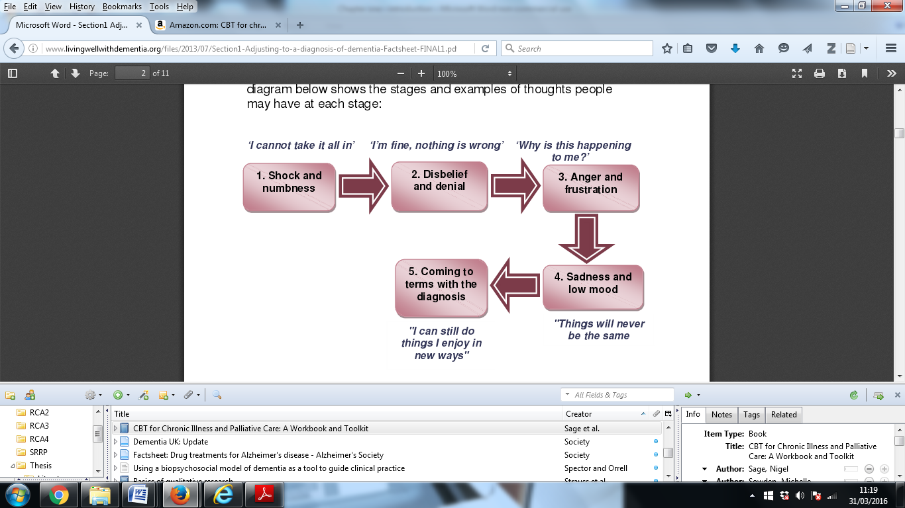

*Figure 1.* Grief model following a diagnosis of dementia (Coventry and Warwickshire NHS Foundation Trust, 2015)

Models of loss and grief in physical health are important to understanding processes of adjustment. Once people have come to terms with an illness they develop a sense of how an illness will alter their lives, which in turn influences various health behaviours (Taylor, 2014). Successfully adjusting to a diagnosis of dementia, in both emotional and practical terms, is seen to be crucial in people transitioning to living well (Watts et al., 2013). It is surprising therefore, that little is understood about the connection between loss, grief and what helps facilitate a ‘successful’ adjustment to dementia.

### Social psychology, stigma and inclusion

The influence of social psychology on people living with dementia was first identified by Kitwood (1990; 1993). He saw that the way in which individuals are treated has a significant impact on their experience of dementia and its progression. Research looking at the impact of social context on the experience of dementia continues to highlight the effect a diagnosis has on how individuals see themselves and are seen by others. A number of case examples demonstrate how individuals struggle to maintain their social selves. Whilst individuals want to be seen and treated as the same person, others see and treat them based on their diagnosis (Sabat & Harre, 1992; Sabat, 2004). It has been suggested that dementia brings a ‘social death’ in the extent to which a diagnosis influences social responses (Sweeting & Gillhooly, 2007).

One study sought to explore how participants’ perception of themselves changed following diagnosis (Langdon, Eagle & Warner, 2007). Twelve people living with dementia were interviewed. IPA revealed five themes, one of which focused on loss of social status and social role where participants reported feeling no longer able to carry out valued roles that had given self-worth, changed social roles in families and communities, and a sense of no longer being useful to the world.

The above literature is important as it provides further evidence to support the significant influence that social contexts have on dementia. There is a gap, however, in suggesting what can be done to help people overcome changes to self-identity, self-worth, social status and roles. Focussing only on what dementia takes away could be seen to support ‘therapeutic nihilism’ as it gives the message that little can be done to reverse these social losses. More research is therefore needed into how people with dementia can be supported in rebuilding feelings of self-worth, self-esteem and confidence.

Social psychology theories are useful for understanding stigma and social exclusion in dementia. Social identity theory (Tajfel & Turner, 1979) suggests that society is stratified hierarchically into different social groups that stand in relation to one another and motivate inter-group behaviour. Social comparison theory (Festinger, 1954) argues that people have a basic need to obtain a relatively positive evaluation of themselves through comparison between themselves and others, and are often attracted to those who share commonalities with themselves. Stigma can be defined as a mark of disgrace or discredit that sets a person aside from others (Byrne, 2001). The process of stigmatisation reflects not only the perceived unfavourable aspects of individuals but also the negative attitudes and adverse behaviour of stigmatisers (Byrne, 2001). Disclosing a diagnosis of dementia has the potential to allocate that person to a new social group associated with devaluation, loss of status and social exclusion (AS, 2008).

Literature identifies different levels of stigma. The Alzheimer’s Society carried out seven focus groups and 8 interviews with 61 people living with dementia and carers, and found a profound stigma associated with a dementia diagnosis. They reported that external stigma exists through society’s exclusion of individuals. Internal stigma exists through the way in which people believe society’s views that they are less of a person due to their diagnosis (AS, 2008). These levels of stigma impact both individuals and society. By stigmatising people with dementia, society limits the economic, social and political contribution of a specific group (Bartlett & O’Connor, 2007) and those with dementia are removed from networks of social and family relationships (NCB, 2009).

The impact of internal stigma, or ‘self-stigmatisation’ in dementia is significant. Internal stigma can bring with it feelings of shame, fear, embarrassment, anger, low self-esteem and low self-confidence (AS, 2008). Internal stigma can also make it difficult for individuals to retain their sense of self and status in society (NCB, 2009). For most people who are part of an older generation, self-stigmatisation also involves internalising society’s ageist views as well as views on dementia in a ‘double jeopardy’ (Milne, 2010).

Issues of stigma and exclusion lead directly to questions about how to be socially inclusive of people living with dementia. Respondents to the NCB consultation suggested participation in lunch clubs and coffee mornings, involvement in dance and art and other forms of social events, more widespread use of voluntary activities and ensuring more supportive and inclusive attitudes in society (NCB, 2009). The Social Care Institute for Excellence (SCIE, 2010) recommends building links with community projects and schools to increase contact between different generations, and using older people’s skills gained in previous employment in voluntary or paid projects.

Whilst these recommendations are useful in helping communities think about being more inclusive, they are largely based on individual opinion rather than evidence as to which approaches are more inclusive. They also lack cohesion and a theoretical framework that could underpin a more structured approach to the social inclusion of people living with a diagnosis of dementia.

### A recovery model of mental health for dementia

Recent literature has looked at similarities between person-centred care and recovery models, and whether recovery can be applied to dementia services as an alternative, or complementary framework (Adams, 2010; Daley, Newton, Slade, Murray & Banerjee, 2013; Hill et al., 2010).

Recovery relates to specific values as well as a model suggesting how values might be supported by mental health services (Repper & Perkins, 2003). The experience of mental illness is generally seen in negative terms, as shortcomings or deficits (Chadwick, 1997). Recovery values recognise that continually focussing on deficits and negatives has a destructive impact as it makes it hard for individuals to maintain confidence and self-esteem. When society views people with mental health difficulties as incompetent it is difficult for these people to continue to believe in themselves. Recovery therefore aims for ‘social’ as opposed to ‘clinical’ recovery where a person can recover their life without necessarily recovering from their illness (Repper & Perkins, 2003). Personal accounts of recovery describe a process where the challenge of living with a disability is accepted or overcome through changing one’s attitudes, values, feelings, goals, skills and/or roles to recover a new sense of self and purpose (Deegan, 1996; Antony, 1993). A recent systematic review and narrative synthesis suggests a conceptual framework for recovery (Leamy, Bird, Le Boutillier, Williams & Slade, 2011) in response to calls for greater clarity (Warner, 2009). The framework is based on 13 characteristics of a recovery journey, which see recovery as active, unique and non-linear, for example, and five recovery processes including connectedness, hope and identity.

The recovery model of mental health brings together recovery values under three dimensions to guide services in how to support people (figure 2). A recovery model places healthcare professionals in a more equal role where they are ‘on tap’ rather than ‘on top’, reflecting the idea that professionals support individuals in their recovery rather than impose recovery on others (Shepherd, Boardman & Burns, 2009). ). Another central component to both recovery values and the model is social inclusion through building inclusive environments and communities (Repper & Perkins, 2003).

**Promoting access and inclusion**

* Helping the person to access the roles, relationships, activities and resources necessary for recovery
* Facilitating access to material resources including enough money, decent clothing, housing and material possessions
* Helping the person to maintain roles, relationships and activities (work, friendships, social activities etc) and develop new ones

**Facilitating personal adaptation**

* Helping the person to mobilise internal resources for recovery: confidence, self-belief and recognition of skills and ambitions
* Helping the person to reach an understanding of what has happened in a way that makes sense and allows the possibility of growth and development
* Helping the person to gain control over mental health problems and his/her life

Research has found that recovery can be applied to dementia (Adams, 2010; Hill et al., 2010; Daley et al., 2013). Hill et al., (2010) examined differences and similarities between person-centred care and recovery by taking a snapshot of current opinion from 33 clinicians attending an old age psychiatry conference in south west England. Participants gave their views on recovery by completing a survey and attending focus groups. The majority of participants thought recovery values were either partly or wholly applicable, and that principles of recovery can be applied from early diagnosis to end of life care. Concern was raised, however, over the term ‘recovery’ in light of the progressive deterioration of dementia.

**Creating hope inspiring relationships**

* Valuing a person for who he/she is
* Believing in the person’s worth
* Seeing and having confidence in the person’s skills, abilities and potentials
* Listening to and heeding what is said
* Believing in the authenticity of the person’s experience
* Accepting and actively exploring the person’s experience
* Tolerating uncertainty about the future
* Seeing problems and set-backs as part of the recovery process: helping the person to learn from and build on these

*Figure 2.*Social inclusion and recovery: components of a model for mental health practice(Repper & Perkins, 2003)

Daley et al., (2013) sought to develop a framework for recovery for older adults both with and without dementia by evaluating whether components of recovery held value for users of older adult services. Interviews were held with 28 service-users (11 of whom had dementia) and 10 carers, and analysed using grounded theory. The study found that components relevant to older adults with dementia included the importance of continuing to be ‘me’, maintaining an enduring sense of self and identity, learning to make sense of, cope and deal with the impact of an illness and the importance of support from others.

In a literature review comparing recovery and person-centred care, Adams (2010) argued that recovery offers a positive theoretical basis for dementia services, and supports the implementation of a range of worthwhile and effective interventions. The relational aspects of recovery were highlighted, including how it locates the person within a matrix of social interactions and relationships, in relation to meeting some of the individualistic critiques of person-centred care.

The above studies indicate that recovery values are applicable to dementia services and offer potential ways of addressing some shortcomings of person-centred care by moving away from individual symptom change, recognising the importance of the social environment and empowering people to take control of their recovery. What the studies fail to do, however, is consider how services might implement recovery approaches. Recovery groups have specific aims and outcomes based on recovery models, including helping individuals see their strengths, consider potential positive changes and learn skills, and are one way of providing recovery-orientated services (BPS, 2008). One way of implementing recovery values in dementia services could therefore be through similar groups that aim to promote specific components of a recovery model.

### Living well with dementia

Ideas about living well with dementia relate to broader concepts of wellbeing. There has been a recent shift in recognising that ‘happiness’, ‘wellbeing’ and ‘contentment’ may be valid outcomes for measuring how healthy an individual or society are (Rahman, 2014). Jahoda (1958) first promoted the idea of wellbeing through her definition of positive functioning including attitudes of an individual towards themselves, self-actualisation, integration, autonomy, perception of reality and environmental mastery.

More recent definitions see wellbeing as a positive and sustainable state that allows individuals, groups or nations to thrive and flourish (Huppert, Baylis & Keverne, 2004). This suggests that wellbeing exists subjectively at an individual level, and objectively at a societal level (Rahman, 2014). This distinction is important given the extent to which governments are increasingly using the concept of wellbeing as policy goals (Huppert & So, 2103; Michealson, 2012).

UK government policy places living well at the heart of its National Dementia Strategy (DH, 2009; 2012; 2016). Living well draws on systemic theories to look at how society’s attitudes towards people with dementia contribute to its ‘social’ deficits. Recent government campaigns have focused on educating the public to increase the inclusion and quality of life for people with dementia (DH, 2009; 2012; 2016). Living Well With Dementia (DH, 2009) aims to ensure that significant improvements are made to dementia services across three key areas: improved awareness, earlier diagnosis and intervention, and a higher quality of care through the implementation of 17 key objectives. These include improving public and professional awareness and understanding of dementia, good-quality early diagnosis and intervention for all, enabling easy access to care, support and advice following diagnosis and development of structured peer support and learning networks. It is argued that successful implementation of the objectives should result in significant improvements in the quality of services provided to people with dementia, and promote a greater understanding of the causes and consequences of dementia, enabling people with dementia to live well throughout the course of the disease (DH, 2009; 2012).

More recent policy has suggested additional objectives centred on wellbeing and independence to enable caregivers and care organisations to support people with dementia to live well. These include supporting individuals in leisure activities and interests, maintaining and developing relationships, supporting physical and mental wellbeing and involvement in planning and evaluating services (NICE, 2013).

One criticism of government policy is how it creates a greater reliance on costly specialist secondary care services in terms of diagnosis, and in providing interventions to bring about predicted clinical improvement (Greaves & Jolley, 2010). The potential impact of policy on statutory and voluntary organisations has also been raised, including the availability of resources and the sustainability of voluntary and statutory organisations in providing services and support (Allen & Whight, 2015). One way of meeting these concerns could be to provide involvement groups to support people with dementia to live well. Not only could groups be offered as an intervention in themselves, they could work alongside statutory and voluntary organisations to provide consultation on areas such as service development.

Research examining wellbeing in dementia is limited due to the lack of randomised controlled trials into different wellbeing interventions (Woods, 1999) and the lack of methods of measuring wellbeing in dementia (Bamford & Bruce, 2000; Trigg, Jones & Skevington, 2007). Some studies examine specific activities that might increase wellbeing, including music therapy (Sixsmith & Gibson, 2007), reminiscence therapy (Woods, Spector, Jones & Orrell, 2005) and goal-directed group activity (Brooker & Duce, 2000).

Research into how people with dementia might be supported to live well is also limited. One study looks at how different environments can promote living well, including care home, hospital ward design, gardens, outside spaces and urban environments (Rachman, 2014). Another study carried out a pilot randomised controlled trial into the effect of living well groups versus wait list control on self-esteem and quality of life for people diagnosed with dementia in the past 18 months (Marshall et al., 2015). The Living Well with Dementia intervention focused on encouraging participants to share feelings associated with dementia such as embarrassment and sadness, and included psychoeducational elements on memory loss, dementia and medical treatments. Groups also used a recovery model to help participants find meaning in life, achieve acceptance and renew hope for the future. Reported improvements in quality of life and self-esteem in the intervention group compared to wait list controls suggest that using recovery values to support living well could be a valid area of research.

There are a number of limitations to the above study. First, groups were offered to people who had received a diagnosis over the past 18 months, suggesting that people who did not feel ready to join within this timeframe were excluded. Groups did not provide ongoing support as they were structured around 10 sessions, each of which had a different focus relating to living well. Given the difficulty that dementia can have on retaining information, providing new information over a relatively short space of time might not be the most appropriate approach for people living with dementia. The study also sees outcomes of living well as consisting of self-esteem and quality of life.

Involvement groups, recovery and living well have many similarities. Literature reviewed above shows how benefits of dementia-related involvement groups include improved self-esteem, self-worth and self-confidence. Involvement groups across the UK are coming to develop shared aims including raising awareness and challenging views about dementia, and influencing local dementia services and policy makers. These benefits and aims relate directly to recovery values of focusing on strengths, social inclusion and working alongside healthcare professionals, and ideas on living well including subjective wellbeing and government policy aims. The importance of sharing experiences with others in groups is also emphasised by each construct: Recovery groups are seen as a good way to promote recovery values, structured peer-support networks are recommended in government policy and literature shows how members of involvement groups value peer-support. One study described above has recognised the shared aims of living well and recovery in Living Well with Dementia groups (Marshall et al., 2015), but has various shortcomings which could be met through providing involvement groups.

## Current study

### Summary of the literature

The literature discussed above provides a framework within which the current study can be understood. The chapter began by introducing key issues associated with current approaches to dementia care, including failure to provide sufficient psychosocial interventions to meet the needs of increasing numbers of people being diagnosed at an earlier stage in the disease. A review of the literature indicated that whilst involvement groups are being more widely offered as a psychosocial intervention, little is known about groups including objectives and outcomes.

Relevant psychological theories were then considered in relation to specific aspects of dementia including how models of loss and grief might enable a successful adjustment to diagnosis, and how social psychology theories can help understand the external and internal stigma associated with dementia. Literature on recovery was then reviewed, including how recovery is increasingly being used as a complementary framework to person-centred care in dementia services. Research that based Living Well with Dementia groups on recovery values was then discussed in light of its relevance to the current study.

### Research aims and questions

This study aimed to bring the above separate but related constructs together to examine whether experiences and processes happening at involvement groups for people with dementia could relate to ideas on recovery and living well. The rationale was to see how a recovery framework might underpin involvement groups, thereby providing specific aims and outcomes. Another rationale was to see how involvement groups might relate to ideas on living well, thereby filling a gap identified in the literature about how living well with dementia might be implemented as an intervention.

As the number of people being diagnosed with dementia at an earlier stage in the disease grows, providing more evidence-based and varied psychosocial interventions is an important public health issue. Current concerns about the ability of services to provide psychosocial interventions are valid given the ‘psychosocial intervention gap’. The findings from this study could help to provide a theoretical underpinning to involvement groups by demonstrating how groups relate to recovery values. This study could also demonstrate how groups might relate to living well, thereby positioning involvement groups as a specific psychosocial intervention to enable living well. The theoretical model may therefore give a stronger rationale to involvement groups, encouraging more research in the area and the potential for groups to be offered more widely. This in turn could help fill the psychosocial intervention gap.

The study aimed to answer the following research questions:

1. How might involvement groups for people living with a diagnosis of dementia relate to recovery values, including a recovery model of mental health?
2. How might involvement groups for people living with a diagnosis of dementia relate to ideas on living well?

In order to answer these questions 13 people living with a diagnosis of dementia were recruited from involvement groups across south east England. Participants took part in research interviews that explored their experiences of living with dementia and being members of involvement groups. Grounded theory was used to develop a model of these experiences, including social and psychological processes, and how these might relate to recovery and living well.

# Chapter two: Method

## Research design

This qualitative study used semi-structured interviews to collect data from 13 people living with a diagnosis of dementia. Data were analysed using constructivist grounded theory following procedures outlined by Charmaz (2006).

## Participants

### Sampling

Participants were people with dementia who were members of a dementia-related involvement group. The following inclusion criteria were used:

* Adult with a diagnosis of a dementia
* Current member of a dementia-related involvement group
* Able to understand and communicate in English
* Capacity to provide consent to participate in the research study

There was no minimum time period for membership, although length of membership was asked about in interviews. There was no upper or lower age limit, or restrictions on type of dementia diagnosed to include as wide a range of people as possible. Unfortunately, it was not possible to include people who could not speak or understand English as interviews could not be offered in other languages.

### Setting

Thirteen participants were recruited from involvement groups for people living with a diagnosis of dementia across south east England and London. Groups were run either by NHS or voluntary services.

There were 10 participants in the purposive sample who were recruited from two involvement groups in south east England. At the time of recruitment, one group had been running for two years and seven months, and the other had been running for one year and two months.

There were three participants in the theoretical sample who were recruited from a group based in London. The group was selected on the basis that the researcher wanted to gain more data from women to provide information on potential differences that were emerging between how men and women experienced groups. The researcher also wanted to capture views from minority ethnic participants, and more broadly, people living in inner city areas. This was to establish whether people from these groups experienced living with dementia and involvement groups differently to participants in the purposive sample. Prior discussion with professionals leading the group identified that the majority of group members were women, two of whom were from minority ethnic backgrounds, and all members lived in London. The London based group had been running for 9 months at the time of recruitment. All groups met once a month for 2 hours.

### Participant characteristics

Table 1 outlines relevant demographic characteristics of participants. This information was gathered by the researcher verbally at the end of the interview using a standard form (appendix 1: Participant demographics sheet). Demographics were collected to situate the sample and provide context for the research. Participants were between the ages of 59 – 82, with a mean age of 69. Four participants (31%) had young-onset dementia as they were under the age of 65. This compares to a national figure of 5% (AS, 2014). Information relating to previous employment histories showed that 11 out of 13 participants had held professional or managerial roles, and 2 participants described themselves as mothers. Specific roles are not included in table 1 to maintain participant anonymity.

There were 8 men and five women in the sample. The average time since diagnosis was 3.1 years and the average length of group membership was 1.6 years. Twelve participants described themselves as white British and one participant described themself as white European. Eight participants (62%) were living with a diagnosis of Alzheimer’s disease, two participants (15%) with a diagnosis of mixed dementia, two participants (15%) with a diagnosis of vascular dementia and one participant (8%) with a diagnosis of fronto-temporal dementia. This is in comparison to national proportions which are estimated as follows: Alzheimer’s disease (62%), vascular dementia (17%), mixed dementia (10%) and fronto-temporal dementia (2%) (AS, 2014).

One participant expressed interest in taking part, but they did not meet inclusion criteria due to having a diagnosis of Mild Cognitive Impairment. Another participant expressed interest in taking part but later withdrew prior to the interview. Both participants were female and from minority ethnic backgrounds.

Table 1 *Participant demographics*

|  |  |  |  |  |  |  |  |
| --- | --- | --- | --- | --- | --- | --- | --- |
| Participant  No. | Age | Gender | Ethnicity | Type of dementia | Approximate time since diagnosis (as at interview) | Relationship status | Approximate length of membership (as at interview) |
| 01 | 72 | Male | White British | Alzheimer’s disease with Lewy bodies | 3 years | Married | 2 years, 5 months |
| 02 | 59 | Male | White British | Alzheimer’s disease | 4 years, 5 months | Married | 2 years, 7 months |
| 03 | 70 | Male | White British | Vascular with Alzheimer’s disease | 1 year, 7 months | Married | 1 year, 6 months |
| 04 | 71 | Female | White European | Vascular | 2 years, 9 months | Married | 2 years |
| 05 | 82 | Female | White British | Alzheimer’s disease | 1 year, six months | Divorced | 2 years, 7 months |
| 06 | 62 | Male | White British | Vascular | 6 years | Married | 1 year, 2 months |
| 07 | 71 | Male | White British | Alzheimer’s disease | 5 years, 2 months | Married | 1 year, 2 months |
| 08 | 72 | Male | White British | Alzheimer’s disease | 4 years | Married | 1 year, 2 months |
| 09 | 63 | Male | White British | Frontal temporal | 2 years,8 months | Married | 2 years, 7 months |
| 10 | 66 | Female | White British | Alzheimer’s disease | 2 years, 10 months | Divorced | 1 year |
| 11 | 66 | Female | White British | Alzheimer’s disease | 3 years | Single | 9 months |
| 12 | 79 | Male | White British | Alzheimer’s disease | 2 years | Married | 9 months |
| 13 | 64 | Female | White British | Alzheimer’s disease | 1 year, 11 months | Married | 9 months |

## Choice of methodology

### Qualitative analysis

This study aimed to explore the experience of involvement groups for people living with a diagnosis of dementia, what processes underpin these experiences and how these might relate to ideas on recovery and living well. One justification for using a qualitative approach comes from the lack of research into involvement for people with dementia, as discussed above. Existing research focuses on how to involve people living with dementia, the structure of groups and how they relate to services, whether recovery is applicable to dementia services and what living well with dementia means, but there is a lack of research into how these constructs might relate to one another.

Furthermore, qualitative research enables one to understand experiences and processes (Harper, 2012), both of which are central to this study. Qualitative research is also believed to give intricate details of phenomena that can be difficult to convey through quantitative methods (Corbin & Strauss, 1990). A qualitative approach was therefore deemed more suited to this study’s research questions and discovery-orientated framework (Barker, Pistrang & Elliott, 2012).

### Rationale for Grounded Theory

Although other qualitative approaches were considered (see below), the approach offered by grounded theory was believed to be particularly suited to this study. First, grounded theory can be used where existing theories are under-defined or patchy (Tweed & Charmaz, 2013). As discussed above, there is some research into involvement groups, recovery and living well but it is under-defined in relation to dementia. Second, grounded theory can examine local interactions and meanings as related to the social context in which they occur (Henwood & Pidgeon, 2003). Grounded theory therefore provides a way of investigating processes within involvement groups, and how these relate to, and are made sense of in the wider social context of living with dementia. This is important given the emphasis in literature on the extent to which social contexts can influence the experience and progression of dementia (e.g. Kitwood, 1993). Third, a key difference between grounded theory and other qualitative approaches is its emphasis on theory development (Strauss & Corbin, 1990) based on social and/or psychological process occurring among research participants. Grounded theory could therefore provide a way of developing a theory of how involvement might relate to recovery and living well.

### Other qualitative approaches

#### Interpretative Phenomenological Analysis (IPA)

IPA is an approach with a particular psychological interest in how people make sense of their experiences (Smith, 2010). In spite of its wide use in psychological research, IPA has been criticised due to the high levels of interpretation by the researcher in comparison to other qualitative approaches (Pringle, Drummond, McLafferty & Hendry, 2011). Whilst IPA can influence and contribute to theory, its primary aim is ‘giving a voice’ to participants and ‘making sense’ of experiences (Larkin & Thompson, 2012) making it unsuitable for the aims of this study.

#### Discourse Analysis (DA)

Discourse Analysis (Potter & Wetherell, 1987) examines the way in which language is used to construct the reality of an individual’s world. DA assumes multiple realities of the world which are shaped by existing knowledge or discourses. It was therefore considered for this study due to the study’s interest in broader societal narratives and how these might shape the worlds of people with dementia. However, it was decided that DA would detract from this study’s aims to develop a model of the processes underpinning the benefits and limitations of involvement groups, and how these might relate to recovery and living well.

Grounded Theory

Grounded theory was developed in the 1960’s by Glaser & Strauss. Through their work *The Discovery of Grounded Theory* (Glaser & Strauss, 1967), Glaser & Strauss defended qualitative research and countered the prevailing opinion that quantitative methods were the only approach (Hallberg, 2006). Glaser & Strauss’s overarching objective was to ground theory in empirical research, where underlying theories were discovered through systematic analysis, rather than the verification of preconceived theories (Kenny & Fourie, 2014). Grounded theory was therefore novel as it attempted to define a systematic method of qualitative analysis that could generate a theory (Charmaz, 2006).

#### Divergent methods of Grounded Theory

The grounded theory developed by Glaser & Strauss is seen as ‘classic grounded theory’, where the researcher ignores all existing literature concerning the research area and enters the field with as few preconceptions as possible. Categories are then ‘discovered’ by the researcher for further conceptualisation. By the 1990s, particular features of classic grounded theory had been refined, including devising a highly analytical and prescriptive framework for coding to deduce theory from data systematically (Strauss & Corbin, 1990).

In spite of these differences, there are specific aspects which define grounded theory as a methodology. It has been suggested that there are two main characteristics: the systematics of the methodology and the constant comparative method (Hallberg, 2006). The constant comparative method means that every part of data i.e. emerging codes, categories, memos and dimensions are constantly compared with all other parts of the data to explore variations and similarities. The systematics of the methodology include simultaneous collection and analysis of data collected through intensive interviewing of purposive and theoretical samples, using theoretical sampling to explore new concepts and ideas that arise from the data and to saturate categories, hierarchical coding processes (from initial, to focused to theoretical) where categories then emerge from these processes, the identification of relationships between categories and detailed memo writing throughout the entire data collection and analysis process (Hallberg, 2006). The themes, concepts and hypotheses that emerge from this process form the basis for a new theory that can be compared to existing theories and literature, to establish how the new theory adds to knowledge and understanding (Glaser & Strauss, 1967).

#### Constructivist Grounded Theory

More recently, Charmaz responded to Glaser & Strauss’s invitation to use grounded theory flexibly in the researcher’s own fashion (Glaser & Strauss, 1967) to develop a third ‘constructivist’ variation. Charmaz’s constructivist interpretation rejects Glaser’s underlying philosophy of ‘discovering’ an implicit theory. She argues that “neither the data nor the theories are discovered” and insists that we “construct our grounded theories through our past and present involvements and interactions with people, perspectives and research practices” (Charmaz, 2006, p. 10). Charmaz also departs from Strauss & Corbin’s highly prescriptive and systematic coding process, preferring more flexible guidelines (Charmaz, 2006).

Constructivist grounded theory therefore proposes that it is not possible for researchers to remain separate from data as they are part of the world they study and the data they collect. Theories are constructed through researchers’ own experiences, perspectives and beliefs which interact with the data. Analytic directions arise from how researchers interact with and interpret their comparisons and analyses, rather than from external positions. Theories are interpretative portrayals as opposed to exact representations (Charmaz, 2006).

Constructivist grounded theory was used in this study as the researcher felt her position on, and beliefs around the areas being studied made her part of the world she was researching. Constructivist grounded theory offered a way of incorporating these into the research method and theory. Second, Charmaz’s approach offers more methodological flexibility than earlier approaches by recognising the practical difficulties of embarking on research without prior knowledge. Glaser & Strauss (1967) advised against carrying out literature reviews ahead of data collection to maintain openness and sensitivity to the data. This was not possible in the current study as the researcher was required to submit research proposals and a literature review early in the research process.

## Procedure

### Ethical approval

The study was granted ethical approval from an NHS Research Ethics Committee in April 2014 (appendix 2: NHS research ethics ethics committee approval). Approval was granted from Royal Holloway University of London Ethics Committee in April 2014 (appendix 3: Royal Holloway ethics approval). Research & Development (R&D) approval was gained from the NHS involvement groups’ sites in June 2014 (appendix 4: Research and development approval). Approval to recruit participants from NHS sites was gained in June 2014.

Careful consideration was given to potential ethical implications of this research, especially due to the impact that dementia can have on capacity to consent. Specific ethical issues were identified and managed in the following ways:

* **Voluntary basis of participation and right to withdraw:** Participants were told that participation in this study was voluntary. Participants were reassured that if they did not wish to take part then this would have no impact on their membership of the involvement group. Participants were also told of their right to withdraw from the study at any time and that withdrawal would have no impact on their membership
* **Confidentiality:** The anonymity of participants’ identities was maintained at all times by anonymising transcripts. Participants were informed on the limits to confidentiality with regards to risk/self harm.
* **Informed consent:** Participation information sheets (appendix 5: Participant information sheet) and consent forms (appendix 7: Participant consent form) were written in collaboration with people living with dementia. In addition to usual consent procedures, the consent form asked participants to agree to a specific point about how interview data would be used if they lost the ability to consent in the future
* **Carrying out research interviews at participants’ homes:** In order to manage risks associated with lone working at home the researcher attended aggression and breakaway training and informed a staff member when she was about to start and had finished each interview.
* **Risk:** All participants were informed of the researcher’s duty of care and the need to pass on information should there be concerns about risk for themselves or others
* **Managing emotional distress:** Participants were told that they could take breaks, skip questions or stop the interview at any time if they became distressed.

### Participant identification and recruitment

**Step 1 – Engagement with staff leading involvement groups for people with dementia:** Prior to ethical approval, the researcher contacted leads of seven involvement groups in London and south east England via telephone or email. This was to gain more information on the groups, including activities that the groups were involved in and what happens in a typical meeting. The researcher was also able to give leads more information on the study to gauge whether groups might be interested in participating.

**Step 2 – Participant identification and recruitment:** Once ethical approval had been obtained the researcher attended two involvement groups for people living with dementia in south east England. Four of the seven groups approached in step 1 either did not reply to the researcher’s initial contact or were not interested in participating. One group was approached later in the recruitment process to provide participants for the theoretical sample. The researcher went through the participant information sheet (appendix 5: Participant information sheet) with all members during a group meeting. Members were then invited to complete a form consenting for the researcher to contact them (appendix 6: Consent for research to contact participant) if they were either interested in taking part or wanted more information. The researcher waited at least 24 hours before following up with these participants. Participants who were interested in taking part were booked in for an interview.

**Step 3 – Informed consent:** Participants were invited to ask questions about the study. Once questions had been answered, and participants indicated that they were satisfied with answers, participants gave written informed consent at the start of the interview using the consent form (appendix 7: Participant consent form).

**Step 4 – Interview and debrief:** Once interviews were completed participants were asked if they would like to be kept informed of the study’s findings. They were also reminded of ways to access further support if needed.

### Data collection

To fully explore the experiences of involvement groups for people living with dementia, semi-structured interviews were used as the method of data collection. All interviews were audio-recorded. The researcher kept a journal of reflections on the interview experience and process in order to enrich the data set and note any questions that participants struggled to answer.

### Interview schedule

A draft interview schedule was developed at the beginning of the research process with a member of a dementia-related involvement group (appendix 8: Initial interview schedule). In line with grounded theory methodology the schedule aimed to include mainly open questions to encourage participant’s experiences to emerge, and to allow for issues that they felt were important to be given space.

#### Adapting the interview schedule

The draft interview schedule (appendix 8: Draft interview schedule) was then discussed with an involvement group for people living with dementia. Feedback centred on wanting more neutral and balanced questions, including asking about what was less good or challenging about groups. This was to help participants feel valid in giving experiences where involvement groups had not been positive, not supported strengths or not improved confidence. Feedback also questioned whether participants would remember details of what happens at group meetings, and that prompts might be needed. This feedback was incorporated into questions 5 and 8 of the purposive sample interview schedule (see appendix 9: Purposive sample interview schedule).

Members also found questions on how the group might influence relationships and public opinion confusing (see questions 10 and 11 of appendix 8: Draft interview schedule). They described how these questions were too cognitively demanding as they required one to hold a number of concepts in mind. This feedback was incorporated into questions 9 and 10 of the purposive sample interview schedule by breaking longer questions down (see appendix 9: Purposive sample interview schedule).

#### Further ongoing adaptations to the interview schedule

A defining feature of grounded theory is simultaneous data collection and analysis, with analysis conducted following the initial stages of data collection (Glaser & Strauss, 1967). In line with this approach each interview was transcribed and initially coded before the next interview was carried out. Emerging gaps, ambiguities and key areas of interest were identified from this initial analysis and added to the interview schedule to be explored further in subsequent interviews. For example, some participants identified that they had not learned new skills but they had been given the opportunity to use existing skills. It also emerged that there was contrasting views on whether the existing social aspect of groups was meeting participants’ needs. Some participants had also identified specific challenges associated with groups. These areas were therefore asked about specifically. The entire interview schedule was reviewed in supervision before carrying out interviews with the theoretical sample (appendix 10: Theoretical sample interview schedule). This was to identify which questions were needed to provide further data to make emergent categories more robust (Charmaz, 2006).

## Interview process

After ensuring that all participants met inclusion criteria, the researcher obtained informed written consent. All interviews were between the researcher and the person living with dementia. Where present, partners, carers or other family members were politely asked to be in a different room. Twelve interviews took place at participants’ homes and one interview took place at a local community centre in a private room. Interviews were audio-recorded and lasted between 42 – 74 minutes, with a mean length of 58 minutes. The interview schedule was used as a guide to ensure that key topics were covered, but questions were asked flexibly and in no specific order to encourage participants to discuss what they felt was important. The researcher followed up on pieces of key information by asking participants to expand on answers and provide more detail. Where the researcher thought that participants had forgotten what was being discussed she gently reminded participants to bring them back to the topic. The researcher gave reflective summaries of participants’ answers throughout the interview to ensure that the responses had been properly understood and interpreted (Forrester, 2010).

At the end of each interview all participants were asked how they had found talking to the researcher. Almost all participants said they had enjoyed the experience and had found it interesting to think deeply about various questions. Although some topics were sensitive, no participants became distressed during interviews. Participants were asked if they would like to be kept informed of the study’s findings and their responses were noted. The researcher then asked about demographic information using a standard form.

## Analysis

In line with the grounded theory approach, analysis happened simultaneously with data collection; data collection shaped analyses and analyses shaped data collection.

### Transcription

Interviews were transcribed by the researcher verbatim as soon as possible after each interview, and before the next interview. The researcher also wrote brief reflections on each interview after transcription. This allowed the researcher to become immersed in each data set and capture important observations before moving on to the next. Data were anonymised and stored on a password-protected computer.

### Coding

Charmaz (2006) sees coding as the process of defining what data are about. This happens by “categorising segments of data with a short name that simultaneously summarises and accounts for each piece of data” (p. 43). Coding in grounded theory takes concrete statements in data and uses these to make an analytic frame from which to build the analysis. It is therefore the “pivotal link between collecting data and developing an emergent theory to explain data” (p. 46). Grounded theory coding consists of at least two main phases including an initial and focused coding phase of both purposive and theoretical samples. Theoretical coding and diagramming then provides the theoretical development of the analysis. This entire process is linked and supported by on-going memo writing. This allows one to record ideas, reflections and initial analyses on the data and the research process itself.

#### Phase 1: Initial coding

Initial coding closely reflects what the data is saying. It is a way of labelling segments of data with words that reflect action. Using gerunds (words ending in ‘ing’) and *in vivo* codes (participants’ own words) to initially code data are recommended as ways to identify processes and stick to the data (Glaser, 1978). Transcripts were initially coded on a line-by-line basis. Initial coding happened as soon as interviews had been transcribed and before the next interview was carried out to ensure that analysis occurred simultaneously with data collection. Gerunds and *in vivo* coding were used to define what was happening in the data, including identifying and defining processes, looking for tacit assumptions, explicating actions and meanings and crystallising the significance of points (Charmaz, 2006). Appendix 11 shows an extract of an initially coded transcript, and appendix 20 shows how initial codes were further refined during the development of focused codes in a two step process of identifying and collating relevant initial codes.

#### Phase 2: Focused coding

Focused coding captures key analytic directions by taking the most significant and/or frequently occurring initial codes, and determining their adequacy in explaining larger segments of data (Charmaz, 2006). Focused codes also help one to revisit earlier data and find new meanings, by capturing and condensing ideas and allowing one to quickly compare these across data sets. This process of constant comparison is a defining feature of grounded theory (Glaser & Strauss, 1967).

Focused coding took place as soon as the researcher felt that some initial codes were directing the data in specific analytic directions. In order to ensure that focused codes were coming from the data as opposed to the researcher’s own ideas about the data, the researcher compiled a table showing which initial codes the researcher believed carried focused codes, and a tally of participants who contributed to each focused code (appendix 12: Extract from coding table). This helped to ensure that focused codes reflected the most frequently occurring and significant initial codes, and had therefore “earned their way into the analysis” (Charmaz, 2006, p. 68).

#### Theoretical coding and diagramming

Theoretical coding is the final stage of coding. It specifies possible relationships between categories developed in focused coding and describes how categories relate to one another, and integrated into a theory (Charmaz, 2006). Theoretical coding was supported by memos that the researcher had written after transcribing interviews and throughout the two phases of analysis. The researcher also made herself aware of common issues that can occur in coding, including coding at too general a level, identifying topics instead of processes/actions and attending to personal rather than participants’ concerns (Charmaz, 2006). After the final coding stage, the emergent theory was compared to the existing literature. A draft model was constructed and discussed with a dementia-related involvement group. The feedback was incorporated into the final model.

### Memo writing

Glaser considered memo writing to be a vital part of generating a theory, as he believed memos provided a repository of ideas which could be revisited to help chart out the emergent theory (Glaser, 1978). In constructivist grounded theory, memos are similarly used to freely explore ideas about emerging categories (Charmaz, 2006). They also form a key part of the constant comparative method by encouraging one to make frequent and ongoing comparisons between participants. Memos were written immediately after transcribing each data set, prior to initial coding. They were also written throughout each coding phase and when developing the model. Memos ranged from reflections on the process of an interview (appendix 13: Example memo following transcription) to more abstract and analytical ideas written as prose (appendix 14: Analytical memo) and cluster diagrams (appendix 15: Cluster memo) which provide a visual and flexible way of organising relationships in material (Charmaz, 2006).

### Theoretical saturation

The concept of ‘theoretical saturation’ in grounded theory is that categories are saturated when gathering new data does not generate new theoretical insights or bring new properties to existing core theoretical categories (Charmaz, 2006). Continuing with data collection until categories are saturated is seen by some to supersede sample size (Glaser, 1998). Others contest the notion of saturation, arguing that coding can never be exhaustive so categories can never be saturated (Dey, 1999).

The term ‘theoretical sufficiency’ can be used to better reflect how researchers conduct grounded theory. Rather than establishing categories that are saturated by data, sufficiency sees categories as suggested by data with ongoing potential for further analysis (Dey, 1999). In light of concerns about the notion of saturation this study aimed to achieve theoretical sufficiency.

## Involving people living with dementia

### Design

The researcher attended a number of involvement group meetings prior to designing this project. This was in order to understand which issues were important to people living with dementia and to also challenge any stereotypical images the researcher held. The researcher then presented some research ideas to the group, and together, thoughts and ideas were discussed.

### Managing and undertaking research

The researcher worked with a dementia-related involvement group to ensure that participant information sheets and consent forms were written in ways that were accessible, and sensitive to the needs of people living with dementia. Feedback from the group centred on the language used, including wanting ‘anonymised’ to be replaced with ‘unnamed’ when referring to how interview data would be used in the project. Feedback also focused on presentation, including having double line spacing and important information underlined, such as length of research interview time.

The researcher worked with a person living with dementia on designing the draft interview schedule. This was to ensure that questions relating to recovery models and living well could be asked in a way that made sense and was relevant to participants. Further input on the interview schedule was provided when the researcher sought opinion from members on wording and length of questions as described above.

### Analysing results

A summary of potential theoretical codes and corresponding quotes from interview transcripts were presented to an involvement group. This was to ensure that theoretical codes were relevant and made sense to the experiences of people in the group and to ascertain which quotes members believed most accurately reflected each theoretical code. This helped the researcher decide which quotes to incorporate in the final theoretical codes.

Later in the analysis process, the model was discussed with members of the same involvement group. Members were asked their thoughts on the relevance of the model to their experiences. They wanted more emphasis on how not all aspects of dementia are outweighed by involvement groups, and that benefits relate to feelings about oneself rather than reversing cognitive decline. Finally, a dementia friendly summary of the research (appendix 19: Dementia friendly research summary) was discussed with another involvement group. This was to obtain feedback on the length of the summary, language and whether it achieved the right balance between being academic and dementia friendly.

## Research quality

A number of recommendations (Elliott, Fischer & Rennie, 1999; Mays & Pope, 2000) were followed to increase the quality of findings in this study. The researcher also continually identified and reflected on her ideas, knowledge and values to recognise the role these might play in her understanding and interpretation of the data.

### Sensitivity to the data

Backgrounds and assumptions can sensitize researchers to certain topics and questions (Charmaz, 2006). Highlighting pre-existing knowledge in areas being researched is important as it draws attention to biases that might prevent one from seeing things that do not fit their beliefs (Strauss & Corbin, 1990). This study was carried out as a part of a doctorate in Clinical Psychology and the author was required to submit a research proposal and literature review prior to any data collection. The researcher had also worked in an adult mental health service based on recovery principles and had been attending an involvement group for people living with dementia prior to carrying out this research. This meant the researcher was aware of existing theories and concepts in the field of dementia and was not able to enter the research field without pre-existing knowledge.

Charmaz (2006) emphasises how one’s grounded theory journey relies on interaction emanating from one’s worldview, standpoints and situations. Interaction comes from making sense of one’s situations, appraisal, interpretation and reflection (Charmaz, 2006). It is therefore important to document and reflect on the research process, to enable researchers to be aware of their own assumptions on the data collection and theory generation process.

Reflexivity and the process of recording one’s personal contribution to research is an important part of ensuring high quality qualitative research (Mays & Pope, 2000) as well contributing to the development of a constructivist grounded theory (Charmaz, 2006). The researcher kept a record of her thoughts, reflections and responses in a journal. Appendix 16 shows a journal extract reflecting on moving from initial to focused coding, and the researcher becoming aware of her own assumptions versus what was emerging from the data. The researcher made use of peer supervision with a group of clinical psychology trainees who were using grounded theory in their research. This allowed space for detailed discussion about methodology and analysis, including looking at others’ codes, categories and models.

### Owning your perspective

In constructivist grounded theory, researchers are part of what they study, not separate from it. It is therefore important for researcher to scrutinise their own research experience, decisions and interpretations in a way that brings them into the process and allows the reader to assess how and to what extent the researcher’s interests, positions and assumptions influenced inquiry (Charmaz, 2006).

In the current study, the researcher was a female trainee clinical psychologist with an interest in working therapeutically with older adults with a diagnosis of dementia, including through involvement groups. This is likely to have significantly contributed towards the researcher’s view of people with dementia being capable, humorous, intelligent and interesting. It is also likely to have contributed towards the researcher’s desire to carry out research that attempted to combat the way in which society stigmatises dementia. Through attending the involvement group the researcher was able to hear and appreciate some of the challenges posed to members, including discrimination experienced in everyday situations. Attending the involvement group also showed the researcher what incredible things people living with dementia can achieve when they are believed in and supported. Opportunities for reflection on the above were provided through keeping a research journal and supervision.

### Grounding in data

Throughout the analysis quotations from raw data were used in memos, initial codes, focused codes and theoretical codes. This was to ensure that both the analysis and the emergent theory was grounded in the data (Elliott et al., 1999), as opposed to the researcher’s preconceptions about the data (Charmaz, 2006). Quotations are presented in the results section to show how focused and theoretical codes were constructed.

### Credibility checks

Credibility checks can be provided in several ways (Elliott et al., 1999). In this study, people with dementia were involved with recruitment, data collection, analysis and dissemination through collaborating on participant information sheets, consent forms, focused and theoretical coding, the model and a dementia friendly research summary.

Each stage of coding was also verified by the researcher’s supervisors. Three initially coded transcripts were read by the researcher’s academic supervisor and feedback discussed. Focused and theoretical codes, and draft models were discussed between the researcher and the academic and field supervisors. Appendix 17 shows an extract from an early version of a results table and appendix 18 shows the first version of the model. These, and later versions, were discussed in supervision and formed the basis for ongoing analytical development. Input from involvement groups on theoretical codes and the model was also discussed with the researcher’s academic supervisor to ensure that it was interpreted accurately and incorporated appropriately.

# Chapter three: Results

## Summary of results

Participants provided rich descriptions of their experiences of involvement groups for people living with dementia. Verbatim extracts from interview transcripts are included to illustrate themes and support the model.[[1]](#footnote-1) Participants are referred to using numbers 1-13 to maintain anonymity. All identifying details from the extracts have been removed to ensure confidentiality.

Analysis of the data resulted in the emergence of 11 theoretical codes made up of 31 focused codes, each of these described and illustrated with quotes in the next section of this chapter. Each focused code contained a number of specific properties that were developed through the initial coding stage (appendix 20: Table of theoretical, focused and initial coding). Appendix 12 is an extract from an analysis table showing how initial codes across transcripts were grouped together to inform focused codes, including a tally of how many participants contributed to that code.

A diagrammatic theoretical model detailing people with dementia’s experience of involvement groups and how this relates to recovery and living well is shown at the end of this chapter.

## 1. Living with a *wretched and horrible disease*

### 1.1 Losing abilities over time

Most participants reported living with symptoms of dementia prior to diagnosis, but not being aware that the symptoms were those of dementia. Symptoms included changes in memory and increased forgetting, difficulties with language and panic attacks. Some participants reflected on how, looking back, they minimised symptoms by attributing them to poor sleep or stress, for example. Three participants had symptoms misdiagnosed as depression by GPs. This was especially frustrating for one participant who had previously experienced depression, and knew that what he was going through was very different. Only two participants were not aware of any symptoms prior to diagnosis. One was persuaded to go to the GP by his daughter and the other was told by work colleagues that they had noticed changes in her speech.

*I started forgetting the odd thing and not remembering where I’d put things and so on. It didn’t occur to me I had dementia, I just thought, well, you’re overtired or not sleeping properly* (P5)

*The first people to notice were work cos I was very high up in [company] and managed lots of people and they noticed I was having problems with sentences* (P11)

Six participants who were still working before diagnosis found that the undiagnosed symptoms made it difficult to carry out work related tasks. Some described the pressure of trying to cover up mistakes, whilst others described the difficult decision to retire.

*I used to do an awful lot of bluffing cos I felt if they knew the difficulties I was having I wouldn't have my job cos in this scenario you're in your office and, erm, you're speaking on the phone to a care coordinator and they say “I want you to look after XYZ, NHS No XYZ, DOB XYZ cos of suicide risk. I'd like you to visit this person three times a day, give them this medication and speak to your doctor”. OK, so you go next door to your team and you forgot every single word you can't recall on the phone* (P10)

Following diagnosis, participants described being more aware of the daily impact of living with dementia. Participants reported feeling less confident, and more restricted in carrying out daily tasks and how this sometimes caused tension with partners. Some participants also reported increased depression and anxiety. A major theme was living with the knowledge that the dementia would get worse. Some participants recognised how the dementia had already progressed, making them less inhibited. Others were concerned at how they would be in the future.

*I said to my wife “can you go?” [to the shop to buy some milk] and she said no…but I wouldn’t go, I kept thinking “I’m going to get lost”…cos I’m questioning whether this shop really was opposite* (P6)

*I still have the ability to think ‘no, come on, that is not so’ I still can do that but I can see that will disappear and of course, the ability to talk* (P4)

### 1.2 Feeling the *pressure of limited time*

Following on from the realities of living with a progressive disease, many participants identified a dichotomy between knowing for sure that the dementia will get worse, whilst not knowing a timeframe for this. This created a kind of ‘known uncertainty’.

*One of the things that I would like to know and I suppose I put it quite bluntly, if you say somebody with dementia is terminally ill what does it mean? Somebody suffering from say, cancer, I would say in most cases are given a time span* (P3)

These participants identified having a different sense of time compared to people who were not living with dementia, as the unknown element created an urgency to get as much done whilst still well. For some participants this meant keeping going with enjoyable hobbies, whilst for others this meant using time in involvement group meetings as effectively as possible.

*The frustration comes in when people aren’t meeting my expectations and I wouldn’t expect anyone who didn’t have dementia to understand that…cos you got to remember that we’re on a time constraint as well, er, each and every one of us is limited in the amount of time, the amount of time we got is limited and we don’t know how much, er, that’s always on my mind* (P6)

### 1.3 Being treated as *less of a person*

Almost every participant described how having a diagnosis of dementia had led others to relate to them differently. Some spoke in general terms about how society views people with dementia, whilst others gave specific examples of being at the receiving end of stigma and prejudice.

*I think when you talk about it to people who’ve not got it they tend to write you off…I’ve always got ‘he’s got Alzheimer’s, they don’t know what’s going on…’* (P7).

*People look at me and say “well you don’t look as if you’ve got dementia”. What does someone look like that has dementia? I hear all sorts, that they have dull eyes and they just sit around all the time and can’t do much* (P9)

Whilst most participants rejected society’s views, one participant had begun to internalise and accept aspects of what society expected of her.

*As a citizen I don’t have the right of a citizen…what I say is not taken. If I say something, somebody else can say ‘no no she didn’t mean that’ and I can’t respond because I have dementia* (P4)

Some participants recalled their decision making process behind when to tell others. One participant delayed it as he did not want others to suddenly think differently of him. Another felt comfortable telling friends, as she saw herself as able to function to the same level as them so perhaps did not fear being treated differently.

*I thought if I started saying I’ve got this then the other people wouldn’t let me do that* (P8)

*I didn’t mind about that [telling others] at all, we all chat together so that’s why I said I’ve got dementia but I’m not that far off with it and I’m fine – I can talk and laugh and I’m OK with it* (P13)

One participant described how she was suddenly no longer allowed to be alone with her grandchildren after telling her daughter-in-law about the diagnosis, indicating a significant change in how her family viewed her.

*My daughter in law said “I wouldn’t want you alone with the children” because a friend of hers has dementia and she’s violent and I said “well I’m not violent” but she obviously has this prejudice against it* (P5)

## 2. Moving from diagnosis to involvement group

### 2.1 Processing and attributing meaning to diagnosis

Participants attributed very different meanings to diagnosis. This was in part related to the extent to which they experienced, and were aware of symptoms previously. Participants who had struggled to get symptoms investigated described feeling relieved once they were told it was dementia, although the diagnosis itself was by no means a positive thing. These participants were also more likely to want to do something about the diagnosis sooner.

*It sounds peculiar but it was a relief…it was confirmed what I thought* (P3)

*You get your diagnosis it’s a strange sensation really cos you don’t want to be given bad news and whatever spin you put on dementia you can’t actually say it’s good news, but there was a tremendous relief when I’d got the diagnosis cos I’d been fighting 2 years to get it acknowledged and put on paper* (P9)

Other participants who had not been aware of symptoms, or who had attributed symptoms to other problems, struggled to accept the news. Two of these participants recognised that they did not fully acknowledge the diagnosis until after joining the involvement group.

*[I felt] devastated, confused, angry, numb…in fact I had a second opinion, I thought it was stress…I spent ages getting all my evidence, saying this is not dementia this is stress* (P10)

*The diagnosis to start off with, if someone had tried to explain it to me from the word go, I don’t think I could have accepted it, so [group] have helped me in understanding the path I’m on* (P1)

Only one participant continued to reject the diagnosis

*I’m still against it, I presume I’ve got it cos they must know I’ve got it but I don’t think I’ve got it* (P13)

Most participants acknowledged that having a diagnosis helped make sense of their symptoms although one saw it as having a power over her.

*I didn’t know much about it [dementia], it just explains why my brain wasn’t working properly* (P7)

*When you’re diagnosed with something by somebody you think that thing has this power over you* (P5)

### 2.2.Recalling reasons and motivations for joining involvement group

Participants were at different stages of coming to terms with the diagnosis when they joined involvement groups and recalled varied reasons for joining. Seven participants were told about the group by healthcare professionals. Three were told at diagnosis and four were told by professionals at other dementia related groups. Although these four participants recalled being told that involvement groups might be more suited to them, only one recalled being told that involvement groups were more structured and finding this appealing. All seven participants saw having a professional recommend groups as an important reason for joining.

*It came to my third round of CST and one of the staff started talking about [SU group] and she recommended it as the direction I should go* (P9)

*[I was told] the group was more my…my focus, more structured and what I was used to doing, so that’s why she suggested I go* (P10)

The majority of participants identified similar reasons for joining groups, including wanting to find out more about dementia, feeling lonely and unsupported following diagnosis and wanting to meet others in similar situations.

*To see lots of other dementia people…and, erm, and how it works* (P11)

*I’d only just been diagnosed and so I was looking for information..we like finding out what we’re letting ourselves in for* (P1)

## 3. Working together with, not against, the dementia

### 3.1 Coming together through dementia

Most participants described dementia as something that united individuals.

*We were so far apart in our backgrounds and attitudes, but we’ve become friends now over the past two years. There wasn’t that feeling of “gee, that person is like me” but what it did do was bring together people living with dementia and show me there are others like me* (P2)

Most participants commented on the benefits of being with people in a similar situation, including reducing isolation and loneliness, improving confidence, being a part of something and learning from each other. Two participants also reflected on how they were treated as ‘normal’ human beings and equal to others at meetings, in comparison to how they felt treated by society.

Three participants saw dementia as creating differences between them and other members. One participant initially decided not to go ahead with diagnosis, and described being told not to disclose this to other members. Another struggled to compare himself with other members as he did not see himself as having dementia. One lady saw her symptoms of dementia as preventing her from keeping up with what went on in meetings, thereby acting as a barrier to feeling together with others.

*[Member] said to me one day “if I was you I wouldn’t mention that you haven’t got a diagnosis because people here think you have” so I accepted that and went to the meetings anyway* (P5)

*I can see what Alzheimer’s is now [in other members], I can…and that’s what I can’t do a comparison with me cos no one there believes I’ve got it and I don’t*  (P12)

*Lots of times lots of people are talking together and I just can’t do that one* (P11)

### 3.2 Feeling safe showing symptoms of dementia

There was a sense of feeling safe and not ashamed of symptoms when in meetings. This sense of safety came from helping one another and making light of times when members struggled. Participants contrasted this to how they sometimes felt outside groups where they described feeling embarrassed, judged, rushed to finish sentences, inadequate and ashamed.

*We help each other out…quite often when you get lost…we’ll sort of poke fun of each other and have a laugh at that and it works well* (P8)

*If it’s a group who knows your problems then it’s different, you’re not placed in that embarrassing situation…very often they’re helpful and will come up with the word or something for you* (P3).

One participant described the process of learning to feel comfortable in the group, and how she observes a similar process in new members.

*Everyone I've met at first, or come after me, you can see they're new cos they apologise but then that soon leaves you...cos they see they don't need to, you don't need to apologise cos when you listen at the others you realise it's that, they have the same difficulties and that's OK* (P10)

One member described the negative aspect of others feeling safe in showing symptoms. For her, seeing dementia so clearly in others was an unwelcome reminder of her diagnosis.

*Sometimes I think I haven’t got it, but if you’re in a group and you’re unsure, and sitting round a table they’ve all got their things going on…then you know you have* (P13)

### 3.3 Observing others to learn about dementia

Over half of participants described observing dementia in other members, particularly the speed with which dementia was progressing. This caused both feelings of sadness when dementia was seen to be winning and encouragement when members were seen to be coping well. There was a general desire to want to know more about the future.

*I was so sad to hear what [member] said this afternoon, how it’s just crept up on him* (P5)

*Although there’s no cure for my type of dementia, looking around at the people in the group there are people who are functioning very well* (P9)

Some participants found it beneficial to see other members whose dementia was more advanced, as it helped them appreciate what they could still do.

*It helps cos there are people there who are worse off than me, so to see people who are worse isn’t depressing cos I can still do so much* (P7)

Others noticed how dementia affected individuals differently, with one participant using this information to guide her in not making generalisations or judgments about others.

*Although I know there are many types of dementia you can see by going to the group…that’s how that part of the brain is affected you can see it in the person when talking to them* (P9)

*I have observed how some of us have gone down more and how some of us don’t talk a lot…so I have learned that you cannot…er, judge them* (P4)

## 4. Tolerating the bad traits with the good

### 4.1 Liking and disliking other members

Every participant disclosed their feelings about others, and both liked and disliked fellow members. Reasons for liking and disliking others varied. Participants generally thought positively of members who they perceived as being skilled, helping group dynamics or coping well with dementia.

*I just love it cos these people are a lot more intelligent than I am and I can learn a lot from them* (P12)

*[member] is very good and very organised, you should see her diary with all her bits written down…and er, most of the things she comes out with have been very good* (P8)

*He’s such a funny man, and every time he says something he, you know, people laugh* (P13)

Reasons for disliking others focused on finding members disruptive or dominant, contributing to wider group tensions described below. One member felt the opposite and disliked members who did not contribute enough to meetings.

*We’ve got one or two people who talk a lot…they need somebody to shut them up really* (P5)

*Three of them in my opinion have been an advantage to the group, but the others…think, well, really, what is the point in you being here?”* (P12)

### 4. 2 Recognising tensions within groups

The majority of participants identified tensions within groups which were largely due to cliques and dominant members.

*Sometimes with certain people it’s a bit cliquey and there are times with meetings, sometimes, it’s perhaps about a selective group and I feel uncomfortable* (P3)

*They take over. The rest of us are nice and we just do as we’re told! (*P5)

Participants commented on how tensions affected group dynamics and functioning by causing members to feel uncomfortable, sidelined or reluctant to participate.

*You can see they’ve gone into a bit of a sulk…or they’ve come to the meeting with every intention of not taking part* (P9)

*He’s been sort of wheedled out really. I didn’t like what went on there.* (P1)

*The strong personalities, erm, they feel snubbed and erm, patronised or demeaned* (P2)

One member described her feelings about a decision that she felt was made unilaterally by another member, and how this made her feel unequal in the group. She described how the impact of this was made worse as it affected the comfort she gained through the group.

*Basically [in making the decision] he just decided that we weren’t equals and I had felt…such a wonderful feeling of comradeship…that’s why when something goes wrong it’s worse cos you need support and comfort you can trust* (P4)

### 4. 3 Using strategies to get along as individuals

There was a sense that participants recognised the importance of getting along. Participants reported using a variety of ways to manage feelings towards, and relationships with others during meetings. Some successfully rationalised thoughts and feelings about others.

*Somebody will say something and I think “I don’t agree with that” but everyone is entitled to their own views* (P3)

*He does get up my nose a bit but on the other hand he’s part of life’s rich pattern* (P5)

Others described specific approaches that they used including pacifying others, using diplomacy, getting to know members and resolving disagreements directly to clear the air.

*I can see when this man is beginning to tick and I try to turn it around so he doesn’t feel like he’s being cut off which would increase his anger level, but try and pacify him and find common things* (P7)

*I’m required to not say what I’m thinking most of the time* (P9)

## 5. Being helped and hindered in getting along

### 5.1 Bringing interpersonal skills to help the group operate

Over half of participants identified how they use interpersonal skills to help the group function and progress. Many identified using positivity and humour to create a good atmosphere.

*I just try and make ‘em laugh…I turn things into jokes!* (P12)

*I bring my positive outlook in life, you know, I haven’t let this thing get me down, it don’t bother me* (P6)

Other participants described being open and sensitive by listening to what others said as well as observing behaviour and potential warning signs.

*I’m patient and a good listener, you know, but, er, I take on board what people are saying and sensitive to their needs and their ideas* (P10)

*I can usually read people quite easily about whether they’re going to be pleasant, unpleasant, aggressive or whatever…[I] pick up and catch warning signs* (P7)

Two participants went further than listening and observing and described the importance of being able to talk openly and how this helps in bringing the group together.

*The ability to talk to people…I have a knack of speaking to people* (P9)

*I tend to be a bit blunt I suppose, most of my skills I think are in, sort of, bringing people together or getting them to, trying to get them to understand things* (P8)

### 5.2 Highlighting that *we all have dementia but we are all different*

One factor that generated both respect and tension between members was recognising how individual personalities might be affected in different ways by dementia. There was a sense of having to deal not only with the usual differences between people as individuals but also the differences posed by dementia.

*With a group of people living with dementia you’ve got to accept even more that people perhaps will not understand things quite so clearly depending on what aspect of their cognitive function has been affected* (P9)

*[member] can see a view of things…and also I have to understand because I have dementia and [member] does too, so he’s focussed on an angle that wasn’t mine* (P4)

Many participants commented on how dementia affected people differently, as well as how members themselves came from different backgrounds. There was a strong sense that members saw themselves and others as individuals.

*So there’s different levels of dementia, isn’t it, and how people can do* (P13)

*We go from mid 50s in age to 80s and we go from people who have never travelled to people who have travelled enormously so there is a tremendous variety* (P4)

### 5.3 Speaking and participating at meetings

Feeling able to speak and participate at meetings influenced the extent to which participants felt united with groups. Participants identified different experiences of speaking and participating. Most participants described wanting to speak more, but being unable to due to dementia and insufficient opportunity, causing feelings of frustration and being let down.

*All these people are talking and I can only talk to one person…I just give up after a while because I like to have one person talking, erm, but they have 4 or 5 people talking and I can’t do it* (P11)

Participants were generally aware of how much other members spoke. Most participants empathised when they saw how individuals struggled to speak due to dementia, and recognised how these people participated through listening. One participant, however, was critical of members who did not speak and was unable to see how their lack of verbal participation might be due to dementia.

*I think they find it hard to speak…I think it’s good cos they may be participating by listening* (P13)

*The others tend to not really say anything, and I don’t mean they’re not bright but I don’t think that they are any advantage* (P12)

## 6. Being sure of who ‘we’ are

### 6.1 Identifying differential qualities of involvement group

Almost all participants had attended, or were still going to other dementia related groups. This allowed for comparisons and reflections on what made groups different. There was a strong sense amongst the majority of participants that groups were active, aimed at making a difference and had a clear structure. Such differences were largely made in comparison to dementia cafes or peer support groups. One participant commented on the importance of involvement groups being professionally led compared to groups led by charities.

*You can sometimes belong to a group, like a dementia café and it doesn’t seem to be going anywhere and not doing anything, but we achieve things and…we…we move things forward* (P9)

*They are professionals, they know…there is a tremendous difference between somebody who has group because it's a charity…you need people who know professionally who have been trained who has studied what is dementia* (P4)

There were specific activities that four participants with more advanced dementia preferred in other groups, including being able to chat, playing games, singing and dancing.

*[Group] is entirely different, cos you’ve got the songs and dances all the time…it’s what I look forward to most and I never ever miss it* (P13)

*We can get up and talk to somebody else or this and that and it really does work, not being around a big table* (P11)

In general, participants saw the benefits of having a variety of groups to meet different needs in themselves and others.

### 6.2 Identifying the qualities and characteristics of this ‘type’ of person with dementia

Participants saw that it was a particular ‘type’ of person with dementia who came to involvement groups. They recognised this in themselves and in qualities and characteristics of other members. On one level, participants recognised that members were generally young, had retired early, and were in the milder stages of dementia. One participant saw these qualities as making him and others inappropriate for usual services offered by the NHS.

*I hadn’t experienced meeting with other people in their 50s who were in the early stages* (P2)

*I’m in a group of people where you go through the memory services, you finish your CST and you drop off the edge of a cliff* (P9)

Participants also saw themselves as having specific personality traits and being at a stage where they had largely come to terms with dementia. This shows how participants saw themselves as needing time to process the diagnosis before feeling the need to ‘do’ something with the dementia.

*I’m quite a proactive person…[I had to] get over the initial onslaught of emotions that you go through, erm, and come back to it then* (P6)

*They are very enthusiastic and like minded and they all want to do something about, er, their journey through dementia… you need to find, everything, 100% yourself into to start with* (P10)

### 6.3 Being confident of involvement group’s purpose

Eight participants saw changing people’s perceptions of dementia as the purpose underpinning involvement groups. Ideas about how groups achieved this ranged from helping the public see that people living with dementia can be useful, to listing specific ways in which groups challenge assumptions.

*People just think that…people with dementia are for no reason. They haven’t got a reason for living and are just wasting their time, where we are for showing you can do a lot that is useful and people see that* (P1)

*I think they challenge stigma and I think they challenge misapprehensions by illustrating what people can do with support and with a desire* (P2)

One member saw the importance of achieving a balance between having a laugh and moving things forward, whilst another participant wanted a clearer target for meetings. This suggests a tension between achieving things on the one hand whilst keeping meetings enjoyable on the other, and ensuring this balance is right for as many members as possible.

*It’s not something we’re doing just for fun, just for us, it’s trying to move things along and do something useful, so whilst we have a laugh while we’re doing it, we are, we hope, achieving that* (P8)

*I see general discussion and I think maybe it ought to be more campaigning to make public awareness of it… I’d like a target, what are we aiming for?* (P7)

## 7. Acknowledging ‘our’ shortcomings

### 7.1 Meeting some needs but failing others

The inevitability of how groups meet some needs but not others is recognised here. There was a sense that participants’ needs and what they wanted from groups changed with the severity of dementia. This suggests that participants looked to groups to meet different or new needs created by the progression of dementia. Participants who struggled more with dementia tended to identify more areas where involvement groups were not meeting needs, and were frustrated with aspects of groups that were dementia ‘unfriendly’. Participants also observed how involvement groups had become too difficult for other members, leading them to retire.

*I felt very sorry because we had a lady there who was more advanced dementia and she was profoundly deaf…but suddenly she didn’t come anymore and she said she felt it was above her head* (P5)

*I'm irritated because all these people are talking and I can only talk to one person… and they speak too fast, and so it doesn't work really* (P11)

One participant identified how the group itself, as well as the dementia, had changed, thereby impacting his enjoyment.

*I find it more difficult now actually, partly because of what we were talking about earlier [dementia] and in the early days…it was an adventure at the beginning, it was very exciting…it’s lost that relaxedness and informal atmosphere* (P1)

Three participants saw involvement groups as meeting all their needs through providing regularity and certainty. This could perhaps be understood in the wider context of living with the uncertainty of dementia.

*I know exactly where I stand after a meeting and I know what I can expect from the next meeting* (P3)

### 7.2 Seeing discussion limited by agendas

Around half of participants interviewed thought that the way in which meetings were based on a set agenda was overly restrictive, and limited participation and discussion. One criticism was how agendas had become too full, meaning that the amount to time allocated to each item was too short. Another criticism, shared by four participants, was the lack of discussion about dementia itself.

*I think that some things get skipped over quite quickly and sometimes I feel I’d like more information* (P7)

*The one criticism that I would have is that you still can’t talk, there is very little of the dementia complaint, the dementia, I would actually like more talk* (P1)

One member believed that having set agendas enabled the group to avoid talking about dementia, and avoid the fact they were all living with it.

*Everybody just glosses over it [dementia] and carries on as if we’re all normal, which we are, but we all have it [dementia]* (P5)

Some participants described how agendas made it difficult for them to speak both during group discussions and to other members. Only one member saw agendas as helpful in that they allowed the group facilitator to go round asking each member what they thought about each point.

*When you’re in a group and you know there’s a purpose it makes a difference and it’s harder to speak because of the purpose… it doesn’t come as easily as just chatting* (P13)

*I have more control at [group name] meeting…I can get up and go over and talk to somebody and then somebody else* (P11)

*The agenda which means that you go through it and [facilitator] sensibly goes around to you and you and you, to every single person* (P12)

### 7.3 Having different perspectives on socialising

Another area where involvement groups did not meet all members’ needs was the extent to which groups facilitated opportunities to socialise. There was agreement in how dementia makes socialising harder, and that groups were a safe place to meet others, but views on whether groups should actively create more opportunities to socialise differed.

*Socialising for people like us is paramount…if you meet with other people with the same thing then it’s very good as you’re in a relaxed atmosphere and you don’t have to explain yourself* (P4)

Approximately half of participants thought that meetings provided enough opportunities to socialise and it was up to members to use these, whilst around half of participants wanted involvement groups to create specific opportunities to socialise.

*People say we’re not social enough, we don’t go out for coffee, but there’s nothing to stop person A ringing up person B saying “do you fancy a coffee?” You form your own friendships* (P9)

*You can’t just chat…more socialising would be good. We get to chat with coffee but maybe more* (P13)

Almost every participant reported going to another dementia related group with a greater social element in order to meet their needs to socialise with other people living with dementia.

### 7.4 Questioning achievements

Whilst participants generally believed that change was happening through the work of groups, there was a sense that progress was slow and there was still a great deal to be done. This frustration was felt by members who identified strongly with the purpose of involvement groups, and suggests that their need to change perceptions was not being completely met. It could also reflect the sense of urgency in living with limited time. Participants questioned what difference involvement groups had made due to the lack of change in some areas, and whether groups, or individuals representing groups were indeed the best people to campaign for change.

*The meeting there tomorrow they all work for different organisations in healthcare, I’m going to be the only one there with dementia. Sometimes the feeling is am I really making a difference?* (P6)

*Are we the best emissaries for dementia? Are we the best people to be talking about it?”* (P5)

Two participants identified situations when the involvement of members from groups might have actually confirmed the public’s assumptions about people living with dementia, thereby hindering the groups’ work.

*[A member] gave the director a very hard time and she’s quite an important position really, and how [a member] was with the MP! I was horrified when [member] went for him. These are important people, erm, people who will go away with the wrong impression* (P5)

*At a recent meeting one of the other [members] went along but feedback from the meeting was they found him disruptive and he upset the whole of the meeting* (P9)

## *8. Keeping going* now and in the future

### 8.1 Managing an uncertain future

Participants identified different ways in which they managed the uncertainty of their future with dementia. Apart from one participant who thought their dementia was getting better, and another participant who completely refused to think about the future, all other participants tended to focus on enjoying things in the short term whilst preferring not to dwell on the long term.

*I try not to think about it [the future] quite frankly. I’ve taken the stance that I live for today because I think “enjoy the day and what happens tomorrow is tomorrow”* (P7)

*I don’t sort of bother with the forward part as far as I’m concerned I’m living now…I’ll continue to do as much as I can as often as I can”* (P8)

Reasons for not thinking about the long term future included seeing it as out of one’s control and finding it too upsetting.

*I don’t know how you can possibly plan because it isn’t down to me is it?* (P5)

*Once I’m unable to do that…it probably won’t bother me cos I’ll be so far gone* (P6)

### 8.2 Being challenged and motivated by involvement groups

Almost every participant had a strong need to keep going, and saw how groups helped do this. For some, going to monthly meetings represented a mental challenge and for others it was a way of proving that they could still achieve things.

*It keeps you alert mentally, intellectually…oh it makes me try and keeps me also trying* (P4)

*You have to keep showing yourself that you can keep going and doing those things, cos if I stop going then I give up* (P9)

Many participants also commented on specific aspects of group meetings that were motivating and represented new challenges.

*[Professionals] help us by pushing us along, erm, to help us write to our local MPs and that sort of thing* (P8)

*You have to report back to the group what you’ve done, so you’ve got that…motivation to do something…cos it’s nice to go back and say ‘guess what I did’? Cos that helps you, you know, in erm, more ways than you can imagine* (P6)

Although being challenged was generally seen as positive, a few participants recognised that groups could, at times, be too challenging and detrimental to their wellbeing.

*The moment I get home [from the group] I'll go....splat and will go floppy and I'll be done for the rest of the day* (P9)

It came down to participants as individuals as to what they felt they could tolerate.

*It does take a lot out of me but it’s worth it…a kind of achievement...a satisfied tiredness* (P10)

*Sometimes we are challenged too much I think some of us, but for me I have always thought it was worth it* (P4)

### 8.3 Being uncertain of the long term role of involvement groups

Whilst participants saw how involvement groups could help them keep going in the short term, opinion was divided over how helpful groups might be in the longer term.

*I don’t think I’m going to go forever actually, just a few more months or so… because it's same old...I know what's going to go on* (P11)

Another participant thought that the group would be helpful, but did not know if she would continue going due to practicalities of getting there.

*I probably will, I don’t know….I find it very difficult relying on others to take me here, and I’m an imposition, they say I’m not but I feel that I am* (P5)

Some participants felt worried about the prospect of no longer being able to go to involvement groups, and another commented on how important they are to her future.

*What’s going to happen when I come to end of my life with the [group] I don’t know…I’m hoping that when I can no longer be a member something else will be there* (P2)

*Without the groups my life would be a much different place and I dread to think, if I’m being honestly speaking, if I’d still be alive* (P10)

## 9. Keeping up with the old; learning the new

### 9.1 Maintaining old roles and skills

Participants saw involvement groups, and associated activities, as helping them feel connected to roles and skills that they held before being diagnosed. Many felt supported in continuing with general and specific skills and interests that had become difficult due to dementia.

*The read aloud takes me to a world that I was always in touch with – literature, now I can’t read a whole book and that gives me that* (P4)

*Social and communication skills is challenging, and I think without [group] I would’ve slipped further back with that* (P2)

An important and recurring theme identified by over half of participants was how groups provided opportunities to use skills developed over professional careers, and how they created similar feelings of achievement and satisfaction. This was a very positive aspect of involvement groups, as participants identified being left with a gap after retiring from work. Groups were therefore seen as comforting and familiar.

*What I have done is basically attending meetings where I bring into play my skills and my professional background… It seemed so very similar to meetings that I’d had in working lives* (P3)

*It fills a gap, I suppose by work, a purpose…I don’t miss my role at the hospital so much* (P10)

### 9.2 Building new roles, relationships and skills

A recurring theme was how participants felt that going to involvement groups had created opportunities to take on new roles, develop relationships and learn new skills. Participants saw themselves take on a variety of new roles, including becoming an expert on dementia, being a mentor to others newly diagnosed and acting as a messenger in spreading dementia-related information

*That is a new skill, this is all new, of course!* (P10)

*They ask me to give a report back of what we did …so I think of myself as a messenger, to tell what the developments are and I’m quite proud of that. I like to be able to inform people and be the messenger figure* (P7)

*He said you’re obviously an expert on it, and I thought “well I suppose I am”, cos I’m the one living with it* (P6)

Other participants described forming friendships with other members, and how these extended beyond monthly meetings to meet socially and help one another.

*She can’t go out alone unless there is somebody…so I do that with me cos I can go all over John Lewis and that sort of thing, but she speaks really well so it’s a good match* (P11)

Learning skills happened through being put in new situations at monthly meetings as well as events outside of meetings. The most frequent skill identified was learning to speak in front of others, either at groups or at conferences, post-diagnostic support groups and other external meetings.

*I’ve learned how I can talk to a whole group of people [at post diagnostic support groups] who have all got a mental health problem, about something I never even knew I had four years ago* (P1)

## 10. *Feeling respected and useful* with the dementia

### 10.1 Creating a flow of expertise and knowledge

Participants saw the importance of their role, both as individuals and as a group, in passing knowledge from involvement groups to others. They identified how people from organisations come to groups to seek advice or input on dementia related projects, and how members visited other groups and conferences to spread knowledge and bring information back to groups.

*I write them down and take them back as an, er, topics of conversation at the [group] and say, OK, this is what the Alzheimer’s Society is doing behind the scenes* (P10)

This process was seen as beneficial to those outside involvement groups as well as members themselves.

*Keeps me connected with the world and what is being discussed about dementia* (P4)

*A greater understanding of dementia that I can take outside…it helps me, well, now championing the cause of better responses to dementia* (P9)

It was also beneficial to processes at play between members in groups, as it created feeling of pride amongst members as well as admiration for what others were achieving.

*They’ve [members] been to meetings, well, about senile dementia, they’ve been up to the offices in London and that sort of thing, I just find them so bright* (P12)

### 10.2 Creating opportunities to help and be useful

Almost every participant spoke of how going to involvement groups in some way made them feel helpful and useful, and the benefits of feeling this way.

*One thing the group does, which is probably the most important thing really, not quite so obvious is that it gives you this feeling of usefulness* (P1)

*It makes me feel that I’m still able to contribute, and that I’m still, generally speaking a positive person with a drive and desire to do something* (P2)

Being helpful and useful happened within groups, where participants identified examples of helping students and other members.

*You feel that you’re helping students with their career progression* (P3)

*We help each other come to terms with dementia* (P1)

Participants spoke more generally about feeling as though they were helping others outside the group.

*It makes me feel good cos I’m doing something…I’m working on behalf of all these people with dementia* (P6)

*I’m in this situation now with my medical condition and I would like to pass any of those experiences on to all with this condition* (P3)

### 10.3 Feeling positively evaluated in the eyes of others

Over half of participants spoke of how they believe involvement groups are highly regarded by those outside the groups, providing a welcome contrast to the experience of feeling stigmatised as described earlier.

*The [group] are a well respected group and well known* (P9)

Participants gave examples of the frequency with which people and organisations visited meetings for advice and input, being well received at conferences as individuals representing groups, as well as examples of achievements through collective group efforts.

*Quite a lot of people seem to come to our meetings and listen to what we have to say* (P8)

*Which is even more fulfilling is when they ask you back [to conferences] and you think “I must have done something right!” They must have got something out of it because why invite somebody back if you’re not really going to get anything from it?* (P10)

Two participants from one group spoke of how the involvement group is gaining recognition among wider dementia related circles, including people living with dementia and organisations seeking to establish similar groups.

*In the last month there have been 2 or 3 people I’ve seen with dementia and who have known about [SU group]…word is getting round and there is this awareness that the [SU group] has a lot to offer* (P3)

*It’s become one of a number of models for other groups and I feel very proud of that and I think most members share that pride…they understand that this group is important because groups like the [group] can be really good role models* (P2)

## 11. Working to *challenge assumptions*

### 11.1 Changing opinion through working with professionals, as experts

Around half of participants described examples where, through involvement groups, they had worked alongside businesses, organisations and professionals including healthcare professionals, politicians, publishers and energy companies. Participants identified differing objectives including changing perspectives, raising awareness, representing the voice of people living with dementia and helping organisations become more dementia friendly.

*[After delivering training at GP surgeries] I think it’s true to say at the end of those two hours the feedback from the group was how useful they found it and what an eye opener it was* (P3)

*It was an MP and he’s on the board with David Cameron…he opened the new venue and I cut the ribbon and made a speech, and then he asked me questions about it [dementia]* (P10)

They also identified some possible processes that facilitated changes in opinion, including showing professionals that people living with dementia are normal and are all different.

*When I’m buzzing and talking and everything I can imagine that I don’t come across like there’s anything wrong with me, so I think that surprises them* (P6)

*[After seeking advice from our group] he must’ve learned that loads of people there are quite bright and not that forgetful, and some aren’t so bright so there are differences between us all* (P12)

Members had their own assumptions about people living with dementia. In spite of two of the three groups being co-chaired by people with dementia and clinical psychologists, there was only one participant who reported feeling equal to professionals in the group. All other participants saw professionals in the group as different to them. Differences were due to seeing professionals having more expert knowledge on dementia and being more qualified to facilitate groups. Members commented on how people with dementia did not have the ability to run groups, in spite of groups being co-chaired by people with dementia. One member commented on how dementia prevented her from seeing professionals as equals. This suggests that whilst, on the one hand, participants were passionate about campaigning to be treated more equally by others, they did not always see themselves as equal to others.

*I’m not involved with the running or anything…you know, people with my problem we can do things we’re told, and we don’t really have the capacity to, er, run things* (P8)

*I think they try, but they don’t have dementia…erm, they treat us as equals but I don’t take them as equals* (P4)

### 11.2 Changing opinion at grass roots level

Another way in which participants saw themselves and other members as challenging assumptions was through their work with media and campaign organisations, raising dementia in everyday conversations and speaking at conferences.

*The fact she came across and spoke to me ticked the box that said, “ah, you can communicate and talk to a person with dementia”, so it ticked that box that we don’t lose everything* (P7)

*I was on the radio and then dementia diaries, er, I did a thing about how you can live well with dementia and that got out into buzzfeed* (P9)

Participants described a desire to simply get dementia talked about more to facilitate a greater acceptance and to ensure the general public have a more accurate understanding of what living with dementia is really like. This included talking about dementia more with families. Four participants commented on how going to involvement groups facilitated conversations with spouses about dementia, thus helping to challenge their misconceptions.

*A more talked about subject and the more people talk the easier it is to accept, that was my goal if you like* (P6)

*It has enabled her to come into contact with other people with dementia and see what they are like…to see what others can do and can achieve* (P2)

## Model of how people with dementia experience involvement groups

The overarching aim of this study was to develop a model of how involvement groups for people living with dementia might relate to a recovery model of mental health and ideas on living well. The model is outlined in figure 3 and theoretical codes are depicted in bold (see below).

The model uses a longitudinal structure to show the parallel processes of **living with a *wretched and horrible disease***, and ***keeping going* with dementia**. A transitional code shows how people living with dementia might move **from diagnosis to becoming members of involvement groups**. At the heart of the model are processes at play within involvement groups. The three central ‘cogs’ relate to core processes between members as individuals and how coming together to function as a group happens. Separate but related to the core processes are wider positive and negative pressures that might influence the core processes. Three theoretical codes link involvement groups to ***keeping going* now and in the future** by depicting the different opportunities provided by groups to motivate and challenge members. These theoretical codes also influence groups as the more positive experiences people gain through going to groups, the more they go to groups to seek experiences.

The whole model is understood within the wider context of losses and gains. A horizontal line through the middle of model delineates codes above the line which represent losses in terms of what dementia takes away, and codes below the line which represent gains in terms of what involvement groups can give.

Codes that relate to losses capture different types of loss, including loss through the progressive symptoms of dementia, loss of self-esteem, social status and a ‘happy’ future, coming to terms with loss, and wanting to work with loss. Codes that relate to gains also capture different types of gains, many of which can be seen to directly balance out some of the losses of dementia. For example, **keeping up with the old; learning the new** shows how involvement groups can provide some members with the chance to use professional skills that they were forced to give up through retiring due to dementia. ***Feeling respected and useful* with dementia** shows how involvement groups can create opportunities where members feel valued, thereby counteracting some of the impact that dementia has on self-esteem. Involvement groups can also create an avenue for members to challenge assumptions held by society towards people with dementia, and in this way can help members feel as though they are doing something positive to balance out some of the stigma and judgement associated with dementia.

The core processes define how people come together to construct an identity of being a member of an involvement group for people living with dementia, and represent both losses and gains. On the one hand learning to feel safe, understanding more about dementia, liking others and doing things to help the group to function could be seen as processes that enhance coming together. On the other hand dealing with tensions, difficult members and the impact of dementia, making a conscious effort to get along, feeling snubbed and unable to speak at meetings could all be seen as processes that cause members to pull away from groups.

The core processes, and how they impact on coming together and pulling apart, are exacerbated by wider positive and negative pressures. Whilst **being sure of who ‘we’ are** brings a shared understanding and identity, sense of cohesion and purpose it also excludes those who do not like tight agendas, want more discussion about dementia and more chances to socialise. Positive pressures can therefore be seen as gains and negative pressures as losses, although they also exert pressure on each other.

The model is based on people’s experiences of gains through involvement groups at present and in the near future. It depicts how gains outweigh some of the indirect losses of dementia, as opposed to the direct losses of the symptoms of dementia. The model brings together participants’ fears and uncertainties about the future by showing how losses of the symptoms of dementia will eventually outweigh the ability to keep going. **Living with a *wretched and horrible disease*** acknowledges the pressure of living with limited time, whilst ***keeping going* now and in the future** acknowledges the uncertainty of whether involvement groups can help in the future. The model therefore recognises a balance between gains and losses, and how there will be a point in the future where the losses associated with the symptoms of dementia will make it impossible for people living with dementia to benefit from the gains offered by involvement groups.

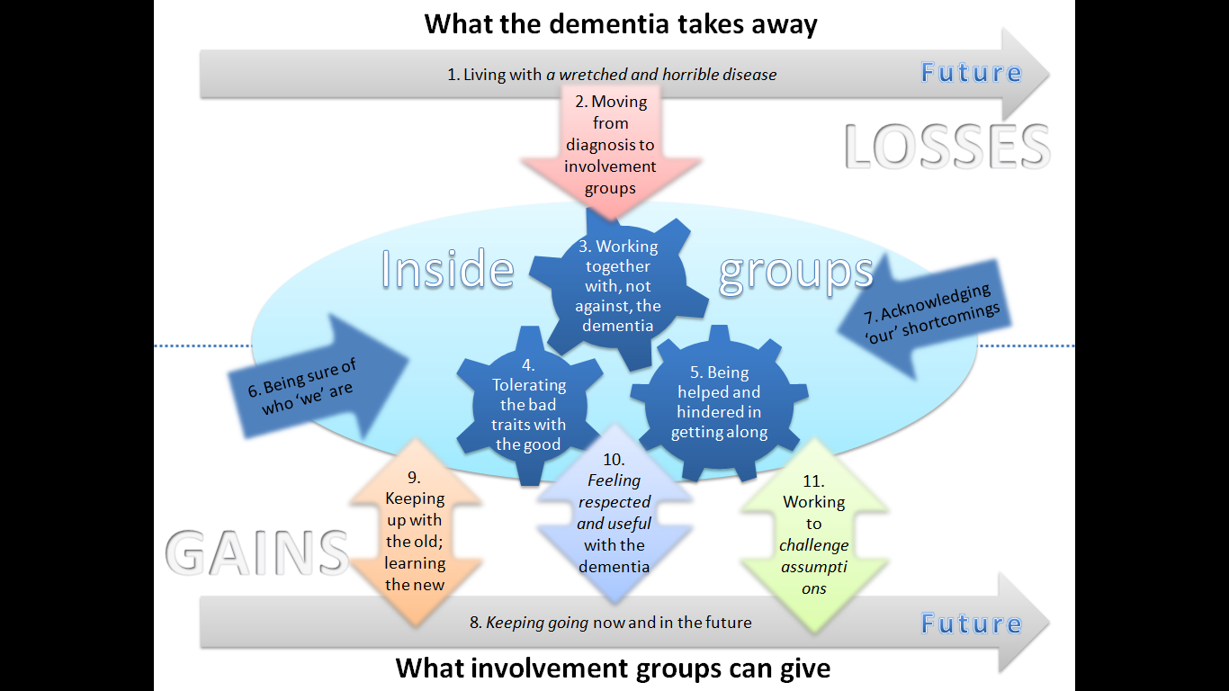

*Figure 3.* A model of how involvement groups for people living with dementia might relate to recovery and living well

# Chapter Four: Discussion

## Overview of findings

This study explored the experience of involvement groups for people living with a diagnosis of dementia, what processes underpin these experiences and how these might relate to ideas on recovery and living well. Thirteen people living with dementia were interviewed. Data were collected and analysed according to the principles of constructivist grounded theory (Charmaz, 2006).

Eleven theoretical codes were constructed from the interview data:

1. Living with a *wretched and horrible disease*
2. Moving from diagnosis to involvement group
3. Working together with, not against, the dementia
4. Tolerating the bad traits with the good
5. Being helped and hindered in coming together
6. Being sure of who ‘we’ are
7. Acknowledging ‘our’ shortcomings
8. *Keeping going* now and in the future
9. Keeping up with the old; learning the new
10. *Feeling respected and useful* with the dementia
11. Working to *challenge assumptions*

These were developed into a model outlining the experiences of involvement groups for people living with dementia. The model suggested that themes could be understood in the wider context of losses and gains. Involvement groups could offer people concrete gains in the short term, but the inevitability of losses due to the progression of dementia made people uncertain of whether they would continue with groups, and therefore gain through the associated benefits, in the longer term.

The model will first be examined in relation to the research questions around recovery and living well, including existing literature and research. The model will then be considered in relation to other psychological theories, including loss and grief, and social psychology. The study’s strengths and limitations will be discussed, followed by clinical implications, suggestions for future research and finally, the researcher’s personal reflections.

## How might involvement groups for people living with a diagnosis of dementia relate to recovery values, including a recovery model of mental health?

This study sought to answer how involvement groups for people living with dementia might relate to recovery. The model will be looked at first in relation to recovery values, and then in relation to a specific recovery model of mental health (Repper & Perkins, 2003). Previous literature examining the applicability of a recovery approach to people with dementia has found that whilst many principles of recovery do apply to dementia care, some principles do not (Adams, 2010; Daley et al, 2012; Hill et al., 2010; Martin, 2009). These findings will be compared and contrasted to the current study.

The following recovery values will be discussed in relation to the model: Focusing on strengths not deficits, supporting social not clinical recovery, facilitating social inclusion and equal relationships between healthcare professionals and clients.

As described earlier, recovery values see the destructive impact of only recognising deficits associated with mental health. Focussing on what people are unable to do can influence society’s views towards those with mental health needs, leading to external and internal stigma. The destructive impact of focussing on deficits is shown in this study’s findings and therefore reflects recovery values and wider literature looking at the stigma associated with dementia (e.g. AS, 2008; Bautsch & Mittleman, 2012). Most participants were aware of stigma and reported various examples of being excluded and treated differently due to the diagnosis. There was also a sense of feeling safe with dementia at involvement groups, compared to feeling judged by others outside groups. Whilst the model largely supported the notion of external stigma, there were very few examples of how participants might have internalised stigma. Indeed, participants saw themselves, and the purpose of involvement groups as challenging stigma and assumptions.

The model therefore supports the notion that seeing dementia in terms of deficits has contributed to society stigmatising people, but these participants had not internalised such views to the extent suggested in recovery literature. The extent to which members of these groups worked to challenge assumptions suggests that this ‘type’ of person with dementia had not succumbed to society’s stigma, or perhaps had learned to overcome stigma through the benefits of involvement groups.

Recovery values aim to support people in reaching social rather than clinical recovery. Recovery does not seek to remove symptoms or restore functioning, but aims for symptoms to interfere less with a person’s life. It therefore addresses the effects of stigma, discrimination and exclusion as well as the effects of symptoms (Repper & Perkins, 2003). Whilst the experience of dementia is no doubt distressing and debilitating, the findings of this study suggest that some aspects of the social deficits associated with dementia through stigma, discrimination and exclusion can be negated via involvement groups. The importance of maintaining a positive sense of self with dementia has been reported elsewhere (Daley et al., 2013; Hill et al., 2010) and this study found that involvement groups helped many participants to develop positive identities, feel valued and respected with dementia. This suggests that involvement groups can go some way to reversing the ‘excess’ disabilities that have been identified in relation to living with a diagnosis of dementia. It also supports findings in previous studies looking at the benefits of dementia-related involvement groups, including improved confidence, empowerment (Williams, 2012) and self-esteem (Cantley et al., 2005).

Building socially inclusive environments and communities is integral to the process of recovery, and the importance of social inclusion for people living with dementia has been recognised in literature (Adams, 2010). The model shows a number of ways in which involvement groups relate to recovery ideas of social inclusion. Participants were involved in making healthcare services more inclusive by delivering training at GP surgeries, for example. Some members described working with business to make them more dementia friendly, whilst others reflected on the importance of getting dementia more talked about through normal conversations with friends and families, and media.

As discussed earlier, recovery is not something which can be ‘done’ to others. Healthcare professionals are ‘on tap’ to support people with their individual recovery journeys, rather than impose recovery on others (Shepherd et al., 2007). Participants in this study did not see themselves as equal to healthcare professionals, and reported finding the professional presence of clinical psychologists at groups appealing and reassuring. Others spoke of how members did not have the skills or abilities to facilitate groups, suggesting that they saw a clear role and need for professionals. A reason for this could be due to the way in which dementia can affect the ability to hold information in short term memory, impair judgement and cause difficulties with abstract thinking (Cantley, 2001), making participants feel unable to run groups. Another reason could be due to a cohort effect identified when working with older people and how this influences ageist beliefs (Laidlaw, Thompson & Gallagher-Thompson, 2004). Members in this study might prefer to be in a ‘patient-expert’ relationship as this fits more closely with their beliefs on the role of professionals.

Figure 4 highlights how specific components of a model of social inclusion and recovery might relate to involvement groups for people living with dementia. The current study demonstrated how involvement groups helped facilitate personal adaptation to a diagnosis of dementia. Findings indicate that most members had started the adaptation process prior to joining involvement groups, but that the process continued throughout membership. The process of coming together and adapting to living with dementia also encouraged participants to see their own resources for recovery, growth and development. This is demonstrated by the way in which members reported recognising professional, interpersonal and practical skills used through groups. Members also recognised new ambitions relating to challenging the stigma associated with dementia, and described a new sense of confidence and self-belief in their abilities and the groups’ achievements.

**Promoting access and inclusion**

* Helping the person to access the roles, relationships, activities and resources necessary for recovery
* Facilitating access to material resources including enough money, decent clothing, housing and material possessions
* Helping the person to maintain roles, relationships and activities (work, friendships, social activities etc) and develop new ones

*Figure 4.* Highlighting how specific components of a model of social inclusion and recovery might relate to involvement groups for people living with dementia

**Creating hope inspiring relationships**

* Valuing a person for who he/she is
* Believing in the person’s worth
* Seeing and having confidence in the person’s skills, abilities and potentials
* Listening to and heeding what is said
* Believing in the authenticity of the person’s experience
* Accepting and actively exploring the person’s experience
* Tolerating uncertainty about the future
* Seeing problems and set-backs as part of the recovery process: helping the person to learn from and build on these

**Facilitating personal adaptation**

* Helping the person to mobilise internal resources for recovery: confidence, self-belief and recognition of skills and ambitions
* Helping the person to reach an understanding of what has happened in a way that makes sense and allows the possibility of growth and development
* Helping the person to gain control over mental health problems and his/her life

The recovery model aims to promote access and inclusion in different ways, and this study related to these aims in a number of ways. Members described taking on a number of new roles through involvement groups, including being a mentor, a role model for other groups and a messenger. In terms of relationships inside groups, members reported new friendships and supporting one another as well as liking and disliking others. Members described being encouraged to try new activities through groups, as well as being supported in continuing with existing hobbies, including reading and writing.

The third recovery dimension relates to ‘creating hope inspiring relationships’. Recovery is seen to depend on relational as well as personal processes (Repper & Perkins, 2009) and relationships between caregivers and people living with dementia are understood to facilitate recovery in a number of ways (Adams, 2010). These include caregivers valuing and believing in individuals with dementia, seeing their potential and ability, and listening to and understanding their experiences (Adams, 2010).

This study found that involvement groups created hope inspiring relationships through relational processes happening within groups, as well as processes between involvement groups and others outside groups. Members reported admiring other members and their skills, the work they did on behalf of groups and the way in which they lived positively with dementia. Members spoke of the benefit in feeling motivated to report back to the group on activities they had been involved in between meetings, indicating how important this admiration was to people’s self-esteem. Activities involving others outside involvement groups also served to build positive relationships between members and businesses, organisations and other groups.

Areas where involvement groups were not found to relate to the recovery model were largely due to the nature of involvement groups and what they seek to do, and to dementia itself. Shortcomings of involvement groups included having little opportunity to speak at meetings, and restrictive agendas. This limited more general discussion, including sharing experiences of living with dementia itself. These shortcomings go against the emphasis in recovery models on listening, sharing and exploring experiences in order to learn from one another, build resilience and provide validation. This difference could be due to the fact that involvement groups see themselves as having a clear purpose. Groups are therefore structured around agendas reflecting this purpose, rather than being forums for sharing and exploring experiences. Another reason for this difference could be related to the symptoms of dementia and how it can literally make it more difficult to speak, including finding words, forming sentences and following conversations.

This study suggested that people with dementia live with a kind of known uncertainty in living with the knowledge that the dementia will get worse, whilst not knowing a timeframe for this. The progressive nature of dementia brings differences between this study’s model and a recovery model. The recovery model encourages people to tolerate uncertainty about the future, through achieving a balance between optimism and realism (Repper & Perkins, 2003). This study found that the reality of thinking about the longer term future was too distressing to tolerate. Participants therefore used involvement groups to help with keeping going in the short term, but preferred not to confront the longer term future. This difference could support findings in wider literature that whilst recovery as a set of values is relevant to dementia, the word ‘recovery’ is seen as less appropriate (Hill et al., 2010).

## How might involvement groups for people living with a diagnosis of dementia relate to ideas on living well?

This study also sought to answer how involvement groups for people living with dementia might relate to ideas on living well. As described above, ideas about living well relate to broader concepts of subjective and objective wellbeing. One study looked at subjective wellbeing by measuring the effect of Living Well with Dementia groups on people newly diagnosed, and reported increased self-esteem and quality of life (Marshall et al., 2015).

Whilst the current study did not use outcome measures, the model suggests qualitative ways in which involvement groups also subjectively support self-esteem and might improve members’ quality of life. There are numerous codes that can be understood to improve self-esteem, including the positive impact of having a group identity, overcoming the shame of diagnosis, pride associated with challenging assumptions and feeling respected and useful with the dementia. Being supported to maintain old, and learn new roles, skills, activities and relationships could be seen as improving members’ quality of life.

The goal to facilitate objective wellbeing can be seen in policy on Living Well With Dementia (DH, 2009; 2012) and wellbeing and independence (NICE, 2013). As detailed above, these policies cover a wide range of areas related to dementia. It would be unlikely, therefore, for this study’s model to relate to all areas. There are, however, specific areas where the model does relate to policy on living well and wellbeing.

Being active is a key part of living well (AS, 2013), and includes keeping physically, socially and mentally active as well as maintaining leisure activities, hobbies and interests. Being active in these ways is believed to support health and wellbeing and provides a sense of purpose (NICE, 2013). The model’s emphasis on keeping going reflects how important this is to people living with dementia, whilst other codes show how involvement groups provide different opportunities to keep going. The model also makes the connection between how the positive associations of feeling challenged and motivated helps with keeping going.

Maintaining relationships and developing new ones are important aspects to living well (NICE, 2013), including the development of peer-support and learning networks (DH, 2009). The model shows how the relationship that members formed with the group through gaining a sense of identity was stronger than other relationships between individuals, perhaps due to limited socialising. The model also shows how members felt supported simply by being with others in similar situations, and how this helped in coming together and feeling safe with symptoms.

Systemic theories emphasise that people, by nature, are not isolated individuals but are embedded in a network of wider systems, including family, social, healthcare and professional relationships (Macejewski, 2001). One way of thinking about a perceived problem, such as dementia, is to think about how dementia affects relationships between people as opposed to locating the problem of dementia in one person (e.g. Fredman & Rapaport, 2010; Martin & Stott, 2010).

Living Well uses systemic ideas by recognising that a shift in societal awareness and understanding about dementia is needed in order to support people and reverse the ‘social deficits’ of dementia. This study found that dementia-related involvement groups can support the drive to create more inclusive and accepting social environments, to the extent that some members saw this as the main purpose to groups. The model shows different ways in which involvement groups might improve awareness in others, including more obvious ways of working with businesses and professionals and campaigning through the media. The model also highlights the more subtle, but hugely important point that involvement groups challenge stigma that people with dementia might have internalised. Feeling useful and respected with dementia suggests that members had experienced feeling useless as a result of diagnosis, but that involvement groups had provided opportunities to reverse some of these beliefs.

The importance of involving people living with dementia in the design, planning, evaluation and delivery of services is a central part of living well (DH, 2009). It is recognised that these people are experts in what it feels like to live with dementia, making their experiences invaluable in developing and improving services. Listening to, and acting on individuals’ views is also believed to give the message that these people have a lot to contribute and play an important role (NICE, 2013). In this study many members saw themselves as ‘experts’ in living with dementia, and had created a flow of expertise through sharing knowledge with others. This included delivering training to healthcare professionals and helping organisations with service design and delivery. Members recognised that working in this capacity helped them to feel valued, useful and respected thereby reflecting the additional benefits of involvement identified in policies.

## Wider psychological theories and constructs

### Loss and grief

This study suggests that emotions related to a diagnosis of dementia were not experienced in a particular order, and that some common emotions experienced were different from those in existing loss and grief models. This supports grief models in the sense that some emotions were commonly felt at similar times, but does not support the idea that grief in response to a diagnosis of dementia occurs in stages, cycles or wheels.

The model highlights a shared fear of losing one’s identity and place in society following diagnosis. Fear is not recognised in existing models including stage models (e.g. Kubler-Ross, 1969) or grief cycles (Goodall et al., 2003). One study recognises how changes to perceived losses of roles and identity require significant adjustment, and suggests this leads people diagnosed to oscillate between confronting and avoiding diagnosis (Robinson et al., 2005). The idea of both confronting and avoiding diagnosis is reflected in how participants confronted the short term realities of living with dementia, but avoided thinking about the longer term realities. Denial was also shared by a number of participants, although some reported minimising or denying symptoms prior to diagnosis, whilst others reported denying the diagnosis itself. This is again different from existing (Kubler-Ross, 1969) and dementia-specific (Coventry & Warwickshire NHS Foundation Trust, 2015) models which suggest that denial is felt after the loss-related event.

Many models suggest that the last aspect of grieving involves acceptance (Kubler-Ross, 1969) or resolution/reorganisation (Bowlby, 1960; Parkes, 1971), characterised by increased energy, decision-making abilities, confidence and focus. This frames the final aspect of grieving as change-orientated, where people become receptive to working with what has happened. These emotional and behavioural changes were reflected in codes describing gains associated with involvement groups, as well as codes describing moving from diagnosis to involvement groups and working together with dementia. Ideas of acceptance, resolution and reorganisation appear to be relevant for understanding the ongoing process of adjusting to a diagnosis of dementia, and are helpful for indicating when a person might feel ready to take positive steps to think about living well. Ongoing efforts to avoid thinking about the long terms future, however, suggests that acceptance also sits alongside denial and that the two cannot be seen as separate stages but more of a fluid and vacillating process.

### Social psychology

Social psychology looks at how thoughts, behaviours and feelings are influenced by the real or imagined presence of others (Allport, 1920) and offers many theories underpinning processes identified in the model. These include social identity (Tajfel & Turner, 1979) and conformity through internalisation (Kelman, 1958).

#### Social identity theory

Social identity is a person’s sense of who they are based on their group memberships (Tajfel & Turner, 1979). Groups provide an important source of pride and self-esteem as well as a social identity. The central hypothesis of social identity theory is that members of a group will seek to enhance their self-image by finding negative aspects of another group. Dividing the world into ‘them’ and ‘us’ leads to the construction of ‘in’ and ‘out’ groups through a mental evaluative process characterised by three stages: social categorisation, social identification and social comparison (Tajfel & Tuner, 1979).

The model shows how people see themselves as different from society following diagnosis. Having a diagnosis of dementia has led them to categorise themselves as different, thereby excluding them from the ‘in’ group of wider society. Through the process of social categorisation, people look for a different group to better fit their new identity of a person who is living with dementia. Through the process of social identification, members adopt the identity of involvement groups which see people with dementia as useful, capable and valued as opposed to useless, incapable and of no value. Members also build self-esteem, shown in themes reflecting core processes within groups, the positive pressures on these processes and coming to feel valued and respected with dementia. Members of involvement groups can then compare themselves more favourably to an array of groups, including other dementia-related groups and groups in society who continue to discriminate against dementia for example.

#### Conformity

Conformity is a type of social influence involving a change in belief or behaviour in order to fit in with a group. Changes are in response to real and/or imagined group pressure (Crutchfield, 1955). Although there are different types of conformity, internalisation is most relevant to this study. Internalisation happens when a person accepts group influence because it is inherently rewarding and indicates that a person has changed both public and private beliefs (Kelman, 1958). Coming together to work with, not against, the dementia reflects this theory. It becomes more rewarding to accept the dementia than it does to reject it, as accepting the dementia allows one to feel safe in showing symptoms as opposed to embarrassed, and provides the opportunity to be open to learning about dementia by observing others. Members could also see it as more rewarding to identify with the group, which views dementia more positively, than to identify with others who see dementia negatively.

People are understood to conform when they lack knowledge, and look to groups for guidance or when a person is in an uncertain situation and sees groups as proving clarity (Deutsch & Gerrard, 1955). This provides a useful way of understanding people’s motivations behind joining involvement groups, and supports reasons given by many participants for joining groups.

## Study Strengths

A strength of this study was the extent to which people with dementia influenced every stage of the research process. Individuals helped the researcher identify initial research questions and gave specific feedback on the wording of information sheets and consent forms. The first interview schedule was co-written by a woman living with dementia and subsequent versions were discussed at involvement groups. Theoretical codes and supporting quotes from interview data, as well as the model itself and a dementia-friendly summary were validated through discussions with people at dementia-related involvement groups. Working in this way provided ongoing credibility checks (Elliott et al., 1999) and respondent validation (Mays & Pope, 2000) at each stage of the analysis.

This level of involvement and influence has helped to ensure that the study resonates with, and is of interest to those living with dementia (Elliott et al., 1999), and suggests that clinical implications will have genuine utility for services, clinicians and individuals. Involving people in this way has made this a study which is for people with dementia, as well as academics and other researchers; the study was designed, carried out, written up and disseminated with the help of people living with dementia, for people living with dementia.

Another strength of this study was the degree to which it adheres to the principles of grounded theory. Analysis happened simultaneously with data collection; data collection shaped analyses and analyses shaped data collection. This allowed the researcher to identify areas requiring further investigation and ensured there was a clear distinction between the purposive and theoretical sample. Although this study aimed to reach theoretical sufficiency as opposed saturation (Dey, 1999) having clear purposive and theoretical samples allowed the researcher to differentiate between gathering data on general experiences and gathering data to refine and explicate categories. The researcher continued to reflect on her own personal interest in the area, thereby enabling her to separate her own assumptions on the data from codes that were grounded in the data itself. The researcher wrote the first memo following the first interview and continued with memo writing until the model was finalised. This enabled the researcher to constantly compare data from the outset and enhanced the analytical process. Each coding process informed the next, supervision, peer support and involvement helped to provide validation for codes, categories and the model.

By choosing to involve and interview people living with dementia, as opposed to carers or family members, this study shows others that people affected by dementia can be involved in different aspects of research. It also sends an important message to individuals that their experiences are important and are being listened to. The model demonstrated how important it is that people are given opportunities to feel useful and respected with dementia. Carrying out research with this population can create such opportunities. Literature discusses the numerous perceived and actual barriers of dementia-related research (McKeown, 2010; Dewing, 2002; Moore & Hollett, 2003). A strength of this study could be the way in which it contributes towards reversing some of the attitudes and assumptions held by healthcare professionals, families, researchers and people with dementia about the ability of this population to be involved in all levels of research.

## Study Limitations

Although every effort was made to recruit participants from ethnically diverse backgrounds, the final sample was unrepresentative of the wider population due to it being comprised of entirely White British/European participants. Figures estimate that people from black, Asian and minority ethnic groups made up 3.5% of the total population of people with dementia in 2011 (AS, 2014) and views from this population were not included in this study. 31% of the study’s participants were people with a diagnosis of young onset dementia compared to the national average of 5% (AS, 2014) and most participants came from managerial or professional backgrounds. This suggests that the sample was also younger, and of higher socioeconomic status than the national average. Whilst this study’s sample was recruited from three different urban and rural involvement groups, all groups were based in south east England and might represent views and experiences that are different from other areas of the UK.

This study only interviewed people who were currently members of involvement groups. Whilst it captured the views of those who were thinking about leaving, it did not interview people who had decided to leave through not enjoying groups. Giving attention to these negative cases (Mays & Pope, 2000) could have highlighted examples that contradicted the emerging explanation of groups as things that largely benefit people with dementia. Capturing these negative experiences and differences could have also led to suggestions about what involvement groups can do differently to meet the wider needs of people with dementia. The study also found that a certain ‘type’ of person was likely to join involvement groups, including those who were younger, in the milder stages of the disease and perhaps looking to fill a gap left by professional or managerial employment. This again suggests limitations to the sample and implications for its representativeness.

The above points have implications for ‘fair dealing’ due to the extent to which this study might not incorporate a sufficiently wide range of perspectives (Mays & Pope, 2000). It could be argued that the findings represent the views of younger people with milder dementia who are white British/European, of higher socioeconomic status, live in the south east of England and view involvement groups positively.

Whilst this study’s qualitative approach facilitated rich narratives of experience, the retrospective design ultimately relied on participants to recall experiences of longer-term events such as diagnosis, and shorter-term events including groups themselves. This could be seen as particularly problematic given the impact of dementia on memory, language and communication. To question the validity and reliability of people with dementia’s personal accounts and experiences, however, imposes positivist assumptions that social phenomena can be seen as objective facts (Bond & Corner, 2001). Whilst some dementia-related qualitative studies use specific approaches in an attempt to enhance the credibility and dependability of data, including a cut off on MMSE scores and comparing answers across repeated interviews, (Beuscher & Grando, 2009) this study felt it was important to see participants’ accounts and experiences as valid in themselves. In doing so, however, the researcher acknowledges that this study’s design imposed its own ‘cut-offs’ in the sense that it focused on the views of a certain ‘type’ of dementia, which is in itself a limitation.

The data may have been subject to other biases, including social desirability, which could have compromised the reliability of results (Nass, Moon, & Carney, 1999). The researcher was obviously interested in involvement groups, so participants may have felt obliged to give more positive than negative answers. The researcher attempted to guard against this by asking about bad and good aspects to groups, as well as asking open questions. When two participants reported liking everything about involvement groups the researcher explored this and encouraged participants to identify aspects of groups they would like to change.

The researcher was required to write a literature review prior to data collection and analysis, which may have forced previously known concepts or theories onto the data (Glaser & Strauss, 1967). The researcher attempted to limit the effect of this prior knowledge by acknowledging and reflecting on assumptions, and using open questions in interviews. The researcher also ensured that the emergent theory was grounded in the data, as opposed to her knowledge, by using the words of participants in all stages of the analysis and making continual comparisons within and between data (Charmaz, 2006).

## Clinical implications

### Providing post-diagnostic support

As discussed earlier, successful adjustment to a diagnosis of dementia is key to the envisaged health and economic benefits of early diagnosis, and can be supported by post-diagnostic psychosocial interventions (Guss et al., 2014b). Whilst there are a range of psychosocial post-diagnostic interventions, availability varies due to limited resources causing a ‘gap’ in their provision (Watts et al., 2013). Extensive consultation work on post-diagnostic support has taken place with people living with early to moderate stages of dementia. Participants commented on how service responses need to be individualised to suit the person and their needs. They also saw post-diagnostic psychosocial support as essential and wanted choice over the type of intervention to reflect the individuality of the person with dementia (Guss et al., 2014a; 2014b).

The findings of this study provide further support in offering involvement groups as part of a wider ‘menu’ of psychosocial interventions to help close the psychosocial intervention gap. Memory services can benefit from having involvement groups as another option to offer, and people diagnosed can also feel that they are being given a greater choice and variety of post-diagnostic support. Involvement groups were recently included in a guide to psychosocial interventions in early stages of dementia (Guss et al., 2014a), but the provision of groups remains patchy. This study indicates that involvement groups do appeal to a specific type of person living with dementia, and can provide a range of psychosocial benefits.

### Matching individual needs to involvement groups

Guidance issued by the British Psychological Society (Guss et al., 2014a) identifies 24 psychosocial interventions currently available. Whilst patchy resources make it unlikely that all interventions will be available in all areas of the UK, findings from this study indicate that people diagnosed access different interventions with varying impact, including Cognitive Stimulation Therapy and involvement groups for example. Using a matched-care model is one way of managing the dilemma of how to best meet individual need within limited resources (Manthorpe & Moniz-Cook, 2008). People could undergo individualised and/or family psychosocial profiling, and recommendations for interventions based on profiles could be made to improve the ‘fit’.

This study has a number of clinical implications that could help a matched-care model. First, this study’s model finds clear characteristics of the ‘type’ of person who identifies with involvement groups, including those who want to make a difference, use professional skills and challenge themselves. The model also shows what involvement groups do not provide, including opportunities for socialising and chances to share experiences of dementia. This type of information could be used in the profiling process to give a more specific understanding as to what involvement groups offer, thereby ensuring a better ‘fit’ between potential members and groups.

On a broader level, the findings of this study could improve clinicians’ and potential members’ knowledge of involvement groups. The findings could help clinicians explain to interested people what being a member might involve, what involvement groups offer that other groups do not, and what in particular might or might not appeal to an individual. This in turn might aid potential members in making an informed decision about attending groups through a shared decision-making process.

### Managing processes within groups

Literature shows how dementia can affect people’s personality, social skills and reasoning, which can impact insight into what behaviour is appropriate in a particular social situation as well as the ability to adapt one’s behaviour (Cantley, 2001). The model found that many processes were at play between members. These were found to be more complex due to the impact of dementia and individual personality differences – in other words, how the dementia was affecting a person on the day. Whilst some processes helped groups to function, others were seen to hinder.

The findings could therefore be used to guide clinicians who are setting up new groups, or facilitating existing groups, in which processes to encourage and which need managing. Processes that helped individuals come together included feeling safe in showing symptoms of dementia and observing symptoms in others. Clinicians could build on this by reiterating at the beginning of meetings that involvement groups are a space where people can feel safe with symptoms. Clinicians could also do more to foster a sense of group identity by promoting the achievements of involvement groups.

Processes that put pressure on group functioning included members being seen as dominant, not being given the opportunity to speak and having too many members speaking at once. The findings also show how members looked to clinicians to manage groups, as they did not see themselves as having the necessary skills. Clinicians could therefore ensure that they take an active role in balancing the input of more dominant members with the group as whole. They could invite individual members to speak and ensure that one person speaks at a time, for example. Other aspects that put pressure on groups included agendas being seen as too restrictive, a lack of discussion about dementia and limited opportunities to socialise. Although groups are unique in their aims and structure, clinicians could be aware of these pressures. They could consider how they might balance the seemingly conflicting needs of the overall ‘purpose’ of the group in terms of agenda and business type discussions with a more social aspect and wider discussions about living with dementia.

## Future research

This study highlights several areas for future research. The study was able to capture some of the ways in which members sought to change family attitudes towards dementia, but it was not possible to see the impact of these efforts. It would be helpful to carry out a qualitative study interviewing partners and families of members to see how their attitudes and assumptions about dementia might have been affected by their husband, wife, father, mother, grandfather or grandmother’s membership of involvement groups. This could capture how involvement groups might affect attitudes in family systems across generations, and is particularly important given the extent to which dementia often affects the whole family, not just the person living with it.

This study identified that the perceived benefits of involvement groups differed between participants. Some participants could not imagine a life without groups whilst others were planning on leaving within a couple of months. This study understood perceived benefits of involvement groups as being related, in part, to the severity of a person’s symptoms of dementia. It would be useful to carry out a longitudinal study capturing members’ evolving experiences of involvement groups, in terms of perceived benefits and costs. This would provide experiences in the moment, rather than relying on members’ recollections. It would also provide data for members who drop out of groups. Tracking people’s experiences of benefits and costs over time could provide data on the point at which involvement groups become more stressful than beneficial. This could enable professionals to have a better understanding of when to bring up conversations about retiring from involvement groups, thereby making decisions to retire more managed and allowing for smoother transitions.

Recent quality standards for dementia services state that services should monitor people’s responses to psychosocial interventions (Hodge et al., 2014). Research into measures of recovery have created INSPIRE, which assess a person’s experience of support they receive from a mental health worker for their recovery (Williams et al., 2015). Questions focus on feeling supported by others, having hopes for the future, feeling good about oneself, feeling in control of one’s life and being engaged in meaningful activities. Future research could look at the applicability of INSPIRE in measuring members’ experiences of support they receive from involvement groups to provide a way of monitoring their responses to groups.

## Personal reflections

Throughout the research process I reflected on how I was at the beginning of a number of life stages, including career, marriage and motherhood and how this might interact with a group of people living with a diagnosis of dementia, many of whom had come to the end of professional careers, and were themselves parents and grandparents and some of whom had lost husbands or wives through death or divorce. I had the sense that many participants wanted to ‘mother’, or ‘father’ me, and I wonder if this might have influenced what they felt I was able to tolerate and therefore what they disclosed.

I was acutely aware that having a diagnosis of dementia was the main factor that separated me from participants. I could not know what it was like to live with dementia, both in terms of the symptoms of the disease and the additional impacts. Some participants alluded to this in interviews. One participant said that although I obviously knew a lot about dementia I could never actually feel what dementia was like in the head, and could never understand it. I feel this lack of knowledge made the extent to which I embedded the involvement of people living with dementia in this study even more important.

Reflecting on this research makes me wonder if I gave sufficient consideration and validation to the realities of living with blankness of mind, sudden forgetting, panic, despair and confusion that comes with dementia. Whilst many mental health difficulties exist on a continuum and I can identify with aspects of depression, anxiety, personality disorders and psychosis, I cannot identify with the kind of changes in memory, behaviour, language and communication that characterises dementia. Indeed, participants frequently spoke of feeling irritated when people without dementia made light of their symptoms. It seems, therefore, that participants look to others to empathise with difficulty of living with the symptoms of dementia as opposed to the experience of the symptoms themselves. Whilst I did not try and pretend that I lived with similar experiences as participants, I wonder if I did enough to validate and empathise with how difficult living with dementia must be both during interviews and in the write up.

There could be a couple of explanations for the above reflection. First, I had my own research agenda which was focused on how involvement groups for people living with dementia can relate to recovery and living well. Both concepts are overtly positive in their outlook. Indeed, recovery explicitly focuses on possibilities rather than deficits; strengths rather than symptoms. This meant that interviews were focused less on people’s experiences of living with dementia and more on their experiences of involvement groups. I did, however, feel that it was important to ask participants about their experiences of diagnosis and dementia to encourage people to tell their story and provide rich contextual information. Some participants commented on how involvement groups do not allow for discussion about what it is like to live with dementia, although I suspect that for other participants this is something that they like. I wonder if some participants experienced the research interview as replicating involvement groups in that there was little talk of ‘the complaint itself’. I also wonder if there is a part of me that wanted to offer participants a ‘positive’ slant to dementia to counteract the undeniable sadness of the reality of the disease, and how that reflects on my own ability to tolerate such sadness.

Another explanation could be due to my own views about ageing. Literature such as *Being Mortal* (Gawande, 2015) and *Tuesdays with Morrie* (Albom, 1997) have reinforced my belief that older adults, including those with dementia, are hugely capable and have a vast amount to offer society. I have been greatly influenced by my own work with dementia-related involvement groups. At a recent meeting one member commented on how people who visit groups get infected by their passion. It is fair to say that I have also been infected by the groups’ energy, humour and passion to educate others, challenge attitudes and speak out about dementia at any opportunity. This enthusiasm for involvement groups meant that it was initially difficult for me to hear criticisms. It made me sad to face up to the reality that involvement groups could not meet all needs, and in some cases were seen to have a negative impact. A personal implication of this research has been my increased interest in the costs of attending involvement groups and how/when members might be supported in thinking about decisions to move on.

One participant stated that the dementia was getting better during our research interview, to which I replied that I was pleased to hear that. I reflected on this in supervision as whilst I felt it was right to validate her experiences, I was also aware that dementia progressively deteriorates. My supervisor agreed that it was not my role as a researcher to question the validity of a participant’s experience. He helped me think about the wider ethical dilemmas of therapeutic approaches that encourage people with dementia to live in our current reality, versus those that encourage them to live in their past realities.

Finally, I came away from every interview feeling hugely privileged that people had wanted to share so many of their experiences with me. Many participants commented on how much they had enjoyed the interview but joked that they would not remember it the next day. I felt happy that I had given participants a positive experience, but sad that the experience would be forgotten. This reflects my feelings about this study in that I am pleased that involvement groups bring benefits for many of the people interviewed, but sad that these benefits cannot be maintained in the long term.

# References

Adams, T. (2010). The applicability of a recovery approach to nursing people with dementia. *International Journal of Nursing Studies*, *47*(5), 626–634.

Adams, T., & Gardiner, P. (2005). Communication and interaction within dementia care triads Developing a theory for relationship-centred care. *Dementia*, *4*(2), 185–205.

Albom, M. (2007). *Tuesdays with Morrie.* New York City: Doubleday.

Allen, S., & Whight, D. (2015). *Dementia today and tomorrow. A new deal for people with dementia and their carers.* London: Deloitte Centre for Health Solutions, retrieved 26 April 2016 from <http://www.hsj.co.uk/Journals/2015/02/19/a/a/w/Dementia-Today-and-Tomorrow.pdf>

Allport, F. H. (1920). The influence of the group upon association and thought. *Journal of Experimental Psychology, 3* (3), 159-182.

Alzheimer’s Society. (2008). *Out of the shadows*. Retrieved 27 May 2014, from <http://alzheimers.org.uk/site/scripts/download_info.php?fileID=454>

Alzheimer’s Society. (2013). *What is dementia?* Retrieved 3 June 2014, from <http://www.alzheimers.org.uk/site/scripts/download_info.php?fileID=175>

Alzheimer’s Society. (2014). *Dementia 2014: Opportunity for change.* Retrieved 12 April 2016, from <https://www.alzheimers.org.uk/dementia2014>

American Psychiatric Association (APA). (2013). *Diagnostic and Statistical Manual of Mental Disorders: DSM-5.* Amer Psychiatric Pub Incorporated

Anthony, W. A. (1993). Recovery from mental illness: The guiding vision of the mental health service system in the 1990s. *Psychiatric Rehabilitation Journal*, *16*(4), 11–23.

Ballard, C. G., & Bannister, C. (1996). Depression in dementia sufferers. *International Journal of Geriatric Psychiatry*, *11*(6), 507–515.

Bamford, C., & Bruce, E. (2000). Defining the outcomes of community care: the perspectives of older people with dementia and their carers. *Ageing & Society*, *20*(05), 543–570. http://doi.org/null

Banerjee, S., & Wittenberg, R. (2009). Clinical and cost effectiveness of services for early diagnosis and intervention in dementia. *International Journal of Geriatric Psychiatry*, *24*(7), 748–754.

Barker, C., Pistrang, N., & Elliot, R. (2012). *Research methods in clinical and counselling psychology.* John Wiley & Sons.

Bartlett, R., & O’Connor, D. (2007). From personhood to citizenship: Broadening the lens for dementia practice and research. *Journal of Aging Studies*, *21*(2), 107–118. <http://doi.org/10.1016/j.jaging.2006.09.002>

Bautsch. D. & Mittleman, A. (2012). *World Alzheimer’s report.* Retrieved 4 June 2014, from http://www.alz.co.uk/research/WorldAlzheimerReport2012.pdf

Benbow, S. M., & Reynolds, D. (2000). Challenging the stigma of Alzheimer’s disease. *Hospital Medicine-Salisbury*, *61*(3), 174–177.

Beuscher, L., & Grando, V. T. (2009). Challenges in conducting qualitative research with individuals with dementia. *Research in Gerontological Nursing*, *2*(1), 6–11.

Bond, J., & Corner, L. (2001). Researching dementia: are there unique methodological challenges for health services research? *Ageing and Society*, *21*(01), 95–116.

Bowlby, J. (1960). Grief and mourning in infancy and early childhood. *Psychoanalytic Study of the Child*, *15*(1), 9–52.

British Psychological Society. (2008). *Discussion paper: socially inclusive practice.* Retrieved 24 May 2014, from <http://www.bps.org.uk/sites/default/files/documents/socially_inclusive_practice_discussion_paper.pdf>

Brody, E. M., Kleban, M. H., Lawton, M. P., & Silverman, H. A. (1971). Excess Disabilities of Mentally Impaired Aged: Impact of Individualized Treatment. *The Gerontologist*, *11*(2 Part 1), 124–133. http://doi.org/10.1093/geront/11.2\_Part\_1.124

Brooker, D. (2004). What is person-centred care in dementia? *Reviews in Clinical Gerontology*, *13*(3), 215–222.

Brooker, D., & Duce, L. (2000). Wellbeing and activity in dementia: a comparison of group reminiscence therapy, structured goal-directed group activity and unstructured time. *Aging & Mental Health*, *4*(4), 354–358.

Bunn, F., Goodman, C., Sworn, K., Rait, G., Brayne, C., Robinson, L., Iliffe, S. (2012). Psychosocial factors that shape patient and carer experiences of dementia diagnosis and treatment: a systematic review of qualitative studies. *PLoS Med*, *9*(10), e1001331.

Byrne, P. (2001). Psychiatric stigma. *The British Journal of Psychiatry*, *178*(3), 281–284. http://doi.org/10.1192/bjp.178.3.281

Cantley, C. (2001). *A handbook of dementia care*. McGraw-Hill Education (UK).

Cantley, C., Woodhouse, J., & Smith, M. (2005). *Listen to us.* *Newcastle: Dementia North*. Retrieved from <http://www.dementiapartnerships.org.uk/archive/wp-content/uploads/listen-to-us.pdf>

Carr, D. (2010). New perspectives on the dual process model (DPM): What have we learned? What questions remain? *Omega: The Journal of Death and Dying*, *61*(4), 371.

Chadwick, P. K. (1997). Recovery from psychosis: Learning more from patients. *Journal of Mental Health*, *6*(6), 577–588.

Charmaz, C. (2006). *Constructing Grounded Theory: A Practical Guide through Qualitative Analysis.* London: Sage.

Cheston, R., Bender, S., & Byatt, W. (2000). Involving people who have dementia in the evaluation of services: A review. *Journal of Mental Health*, *9*(5), 471–479.

Chrisp, T. A., Thomas, B. D., Goddard, W. A., & Owens, A. (2011). Dementia timeline: journeys, delays and decisions on the pathway to an early diagnosis. *Dementia*, 1471301211409375.

Combe, V. (2012). *Unlocking Diagnosis: The key to improving the lives of people with dementia.* Retrieved 2 June 2014, from <http://www.alzheimers.org.uk/site/scripts/download_info.php?downloadID=87>

Coventry & Warwickshire NHS Foundation Trust (2015). *Living well with dementia factsheet.* Retrieved 12 April, 2016 from http://apps.warwickshire.gov.uk/api/documents/WCCC-990-511

Crutchfield, R. S. (1955). Conformity and character. *American Psychologist*, *10*(5), 191.

Daley, S., Newton, D., Slade, M., Murray, J., & Banerjee, S. (2013). Development of a framework for recovery in older people with mental disorder. *International Journal of Geriatric Psychiatry*, *28*(5), 522–529.

Deegan, P. (1996). Recovery as a journey of the heart. *Psychiatric rehabilitation journal,* 11, 11-19.

Deutsch, M., & Gerard, H. B. (1955). A study of normative and informational social influences upon individual judgment. *The Journal of Abnormal and Social Psychology*, *51*(3), 629.

Department of Health. (1999). *Patient and Public Involvement in the New NHS.* London: Department of Health.

Department of Health. (2001). *Involving Patients and the Public in Healthcare: A Discussion Document.* London: Department of Health.

Department of Health. (2006). *National Health Service Act 2006*. Retrieved 2 June 2014, from <http://www.legislation.gov.uk/ukpga/2006/41/contents>

Department of Health. (2009). *Living Well With Dementia: a national dementia strategy*. Retrieved 28 October 2013, from <https://www.gov.uk/government/publications/living-well-with-dementia-a-national-dementia-strategy>

Department of Health. (2012). *Prime Minister’s challenge on dementia*. Retrieved 27 May 2014, from <https://www.gov.uk/government/publications/prime-ministers-challenge-on-dementia>

Department of Health. (2013). *NHS Constitution*. Retrieved 2 June 2014, from <http://www.nhs.uk/choiceintheNHS/Rightsandpledges/NHSConstitution/Pages/Overview.aspx>

Department of Health. (2016). *Prime Minister’s challenge on dementia 2020: Implementation plan.* Retrieved 12 April 2016, from https://www.gov.uk/government/publications/challenge-on-dementia-2020-implementation-plan

Dewing, J. (2002). From Ritual to Relationship A person-centred approach to consent in qualitative research with older people who have a dementia. *Dementia*, *1*(2), 157–171.

Dey, I. (1999). *Grounding grounded theory: Guidelines for qualitative inquiry.* San Diego, CA: Academic Press.

Elliott, R., Fischer, C. T., & Rennie, D. L. (1999). Evolving guidelines for publication of qualitative research studies in psychology and related fields*. British Journal of Clinical Psychology,* **38**, 215-229.

Festinger, L. (1954). A theory of social comparison processes. *Human relations*, 7, 117-140.

Forrester, M. A. (2010). *Doing qualitative research in psychology: A practical guide*. Sage.

Fredman, G. & Rapaport, P. (2010). How do we begin? Working with older people and their significant systems. In G. Fredman, E. Anderson & J. Stott (Eds.), *Being with Older People: A Systemic Approach* (pp. 31 - 60). London: Karnac Books.

Gawande, A. (2015). *Being Mortal.* Profile Books: London.

Gibson, D., & Anderson, P. (2011). The hazards of early recognition of dementia: a risk assessment, *Aging & mental health*, 8, 2, 122-132.

Glaser, B. G. (1978). *Theoretical sensitivity: Advances in the methodology of grounded theory.* Sociology Press.

Glaser, B. G. (1998). *Doing grounded theory – Issues and discussions*. Sociology Press.

Glaser, B., G. & Strauss, A. (1967). *Discovery of grounded theory. Strategies for qualitative research.* Sociology Press.

Goodall, A., Drage, T., & Bell, G. (2003). The Grief Wheel. Making sense of the‘ symptoms’ of grief. *Retrieved from the Web*, *11*(11), 03.

Greaves, I., & Jolley, D. (2010). National Dementia Strategy: well intentioned — but how well founded and how well directed? *The British Journal of General Practice*, *60*(572), 193–198. <http://doi.org/10.3399/bjgp10X483553>

Guss, R., Middleton, J., Beanland, T., Slade, L., Moniz-Cook, E., Watts, S., & Bone, A. (2014a). *A guide to psychosocial interventions in early stages of dementia*. Leicester: British Psychological Society.

Guss, R., Middleton, J., Beanland, T., Slade, L., Moniz-Cook, E., Watts, S., & Bone, A. (2014b). *Clinical psychology in the early stage of dementia care pathway.* Leicester: British Psychological Society.

Hallberg, L. R. (2006). The ‘core category’ of grounded theory: Making constant comparisons. *International Journal of Qualitative Studies on Health and Well-Being*, *1*(3), 141–148.

Harper, D., & Thompson, A. R. (2012). *Qualitative research methods in mental health and psychotherapy: A guide for students and practitioners*. John Wiley & Sons.

Henwood, K., & Pidgeon, N. (2003). Grounded theory in psychological research. Retrieved from http://psycnet.apa.org/books/10595/008

Hill, L., Roberts, G., Wildgoose, J., Perkins, R., & Hahn, S. (2010). Recovery and person-centred care in dementia: common purpose, common practice? *Advances in Psychiatric Treatment*, *16*(4), 288–298.

Hodge, P., Hailey, G. & Orrell, M. (2014). *MSNAP Standards Fourth Edition 2014r.pdf.* Retrieved from http://www.rcpsych.ac.uk/pdf/MSNAP%20Standards%20Fourth%20Edition%202014r.pdf

Huppert, F. A., & Baylis, N. (2004). Well-being: towards an integration of psychology, neurobiology and social science. *Philosophical Transactions of the Royal Society B: Biological Sciences*, *359*(1449), 1447.

Huppert, F. A., & So, T. T. (2013). Flourishing across Europe: Application of a new conceptual framework for defining well-being. *Social Indicators Research*, *110*(3), 837–861.

Iliffe, S., & Manthorpe, J. (2004). The recognition of and response to dementia in the community: lessons for professional development. *Learning in Health and Social Care*, *3*(1), 5–16.

Jahoda, M. (1958). Current concepts of positive mental health. Retrieved from http://doi.apa.org/psycinfo/2006-20880-000

Kelman, H. C. (1958). Compliance, identification, and internalization: Three processes of attitude change. *Journal of Conflict Resolution*, 51–60.

Kenny, M., & Fourie, R. (2014). Tracing the history of grounded theory methodology: From formation to fragmentation. *The Qualitative Report*, *19*(52), 1.

Kitwood, T. (1988). The technical, the personal and the framing of dementia. *Social behaviour, 3,* 161-179.

Kitwood, T. (1990). The dialectics of dementia: with particular reference to Alzheimer’s disease. *Ageing and society,* 10, 177-96.

Kitwood, T. (1993). Towards a theory of dementia care: the interpersonal process. *Ageing and Society*, *13*(01), 51–67.

Kitwood, T. (1997). *Dementia reconsidered: The person comes first.* Berkshire: Open University Press.

Koch, T., & Iliffe, S. (2010). Rapid appraisal of barriers to the diagnosis and management of patients with dementia in primary care: a systematic review. *BMC Family Practice*, *11*(1), 1.

Kontos, P. C. (2005). Embodied selfhood in Alzheimer’s disease Rethinking person-centred care. *Dementia*, *4*(4), 553–570.

Kübler-Ross, E. (1969). *On death and dying: What the dying have to teach doctors, nurses, clergy and their own families*. Taylor & Francis.

Kübler-Ross, E., & Kessler, D. (2007). *On Grief and Grieving: Finding the Meaning of Grief Through the Five Stages of Loss* (Reprint edition). New York, NY: Scribner.

Laidlaw, K., Thompson, L. W., & Gallagher-Thompson, D. (2004). Comprehensive conceptualization of cognitive behaviour therapy for late life depression. *Behavioural and Cognitive Psychotherapy*, *32*(04), 389–399.

Langdon, S. A., Eagle, A., & Warner, J. (2007). Making sense of dementia in the social world: A qualitative study. *Social Science & Medicine*, *64*(4), 989–1000.

Larkin, M., & Thompson, A. R. (2012). Interpretative phenomenological analysis in mental health and psychotherapy research. *Qualitative Research Methods in Mental Health and Psychotherapy: A Guide for Students and Practitioners*, 99–116.

Larson, E., Peters, D. W., & Reifler, B. V. (1989). Excess Disability in Dementia. Retrieved from http://www.karger.com/Article/Abstract/417398

Leamy, M., Bird, V., Le Boutillier, C., Williams, J., & Slade, M. (2011). Conceptual framework for personal recovery in mental health: systematic review and narrative synthesis. *British Journal of Psychiatry, 199,* 445-452.

Litherland, R. (2015). *Developing a national user movement of people with dementia.* Retrieved 12 April, 2016 from https://www.jrf.org.uk/report/developing-national-user-movement-people-dementia

Lyman, K. A. (1989). Bringing the social back in: A critique of the biomedicalization of dementia. *The Gerontologist*, *29*(5), 597–605.

Macejewski, C. (2001). Psychological perspectives. In C. Cantley (Eds.), *A handbook of dementia care* (pp. 26-43). Buckingham: Open University Press.

Manthorpe, J., & Moniz-Cook, E. (2008). *Early Psychosocial Interventions in Dementia: Evidence-Based Practice*. Jessica Kingsley Publishers.

Manthorpe, J., Samsi, K. & Campbell., S. (2011*). The transition from cognitive impairment to dementia: Older people's experiences.* Retrieved 12 April 2016, from http://eprints.kingston.ac.uk/18322/

Marshall, A., Spreadbury, J., Cheston, R., Coleman, P., Ballinger, C., Mullee, M., … Bartlett, E. (2015). A pilot randomised controlled trial to compare changes in quality of life for participants with early diagnosis dementia who attend a ‘Living Well with Dementia’ group compared to waiting-list control. *Aging & Mental Health*, *19*(6), 526–535. http://doi.org/10.1080/13607863.2014.954527

Martin, E. & Stott, J. (2010). Using ourselves in work with older people. In G. Fredman, E. Anderson & J. Stott (Eds.), *Being with Older People: A Systemic Approach* (pp. 61 - 86). London: Karnac Books.

Mays, N., & Pope, C. (2000). Assessing quality in qualitative research. *British Medical Journal*, *320*(7226), 50.

McCormack, B. (2004). Person-centredness in gerontological nursing: an overview of the literature. *Journal of Clinical Nursing*, *13*(s1), 31–38.

McKeown, J., Clarke, A., Ingleton, C., & Repper, J. (2009). Actively involving people with dementia in qualitative research: Actively involving people with dementia in qualitative research. *Journal of Clinical Nursing*, *19*(13-14), 1935–1943. http://doi.org/10.1111/j.1365-2702.2009.03136.x

McLaughlin, H. (2009). What’s in a Name: ‘Client’, ‘Patient’, ‘Customer’, ‘Consumer’, ‘Expert by Experience’, ‘Service User’—What’s Next? *British Journal of Social Work*, *39*(6), 1101–1117. http://doi.org/10.1093/bjsw/bcm155

Meuser, T. M., & Marwit, S. J. (2001). A comprehensive, stage-sensitive model of grief in dementia caregiving. *The Gerontologist*, *41*(5), 658–670.

Michaelson, J. (2012). *Wellbeing evidence for policy: a review.* Retrieved 12 April 2016, from http://www.neweconomics.org/publications/entry/well-being-evidence-for-policy-a-review

Milne, A. (2010). The ‘D’word: Reflections on the relationship between stigma, discrimination and dementia. *Journal of Mental Health*, *19*(3), 227–233.

Moore, T. F., & Hollett, J. (2003). Giving voice to persons living with dementia: The researcher’s opportunities and challenges. *Nursing Science Quarterly*, *16*(2), 163–167.

Nass, C., Moon, Y., & Carney, P. (1999). Are People Polite to Computers? Responses to Computer-Based Interviewing Systems1. *Journal of Applied Social Psychology*, *29*(5), 1093–1109.

Neimeyer, R. A., & Currier, J. M. (2009). Grief therapy evidence of efficacy and emerging directions. *Current Directions in Psychological Science*, *18*(6), 352–356.

NICE. (2006*). CG42 Dementia: NICE guideline.* *Guidance/Clinical Guidelines*. Retrieved 24 May 2014, from <http://publications.nice.org.uk/dementia-cg42/person-centred-care>

NICE. (2013). *QS30 Dementia: Independence and Wellbeing.* Retrieved 12 April, 2016 from <https://www.nice.org.uk/guidance/qs30>

Nuffield Council on Bioethics. (2009). *Dementia: ethical issues*. London: Nuffield Council on Bioethics.

O’Neil, M. E., Freeman, M., & Portland, V. A. (2011). *A systematic evidence review of non-pharmacological interventions for behavioral symptoms of dementia*. Department of Veterans Affairs Washington, DC. Retrieved from http://www.hsrd.research.va.gov/publications/esp/Dementia-Nonpharm.pdf

Orrell, M. (2012). The new generation of psychosocial interventions for dementia care. *British Journal of Psychiatry*, *201*, 342–343. doi:10.1192/bjp.bp.111.107771

Overshott, R., & Burns, A. (2005). Treatment of dementia. *Journal of Neurology, Neurosurgery & Psychiatry*, *76*(suppl 5), v53–v59.

Parkes, C. M. (1971). Psycho-social transitions: A field for study. *Social Science & Medicine (1967)*, *5*(2), 101–115.

Potter, J., & Wetherell, M. (1987). *Discourse and social psychology: Beyond attitudes and behaviour*. Sage.

Pratt, R., & Wilkinson, H. (2003). A psychosocial model of understanding the experience of receiving a diagnosis of dementia. *Dementia*, *2*(2), 181–199.

Prince, M., Bryce, R & Ferri, C. (2011). *World Alzheimer’s report 2011: The benefits of early diagnosis and intervention.* Retrieved 12 April 2016, from https://www.alz.co.uk/research/WorldAlzheimerReport2011.pdf

Pringle, J., Drummond, J., McLafferty, E., & Hendry, C. (2011). Interpretative phenomenological analysis: a discussion and critique. *Nurse Researcher*, *18*(3), 20–24.

Rahman, S. (2014). *Living well with dementia: The importance of the person and the environment for wellbeing.* CRC Press.

Relkin, N. (2000). Screening and early diagnosis of dementia. *The American Journal of Managed Care*, *6*(22 Suppl), S1111–8.

Repper, J., & Perkins, R. (2003). *Social Inclusion and Recovery: A Model for Mental Health Practice*. London: Baillière Tindall

Repper, J., & Perkins, R. (2009). Recovery and social inclusion. *Mental Health Nursing Skills*, 85–95.

Robinson, L., Clare, L., & Evans, K. (2005). Making sense of dementia and adjusting to loss: Psychological reactions to a diagnosis of dementia in couples. *Aging & Mental Health*, *9*(4), 337–347. http://doi.org/10.1080/13607860500114555

Rodin, J., & Langer, E. (1980). Aging labels: The decline of control and the fall of self-esteem. *Journal of Social Issues*, *36*(2), 12–29.

Sabat, S. R. (2004). Barriers to the construction of a valued social identity: A case study of Alzheimer’s disease. *American Journal of Alzheimer’s Disease and Other Dementias*, *19*(3), 177–185. http://doi.org/10.1177/153331750401900311

Sabat, S. R., & Harré, R. (1992). The construction and deconstruction of self in Alzheimer’s disease. *Ageing and Society*, *12*(04), 443–461.

Sage, N., Sowden, M., Chorlton, E., & Edeleanu, A. (2008). *CBT for Chronic Illness and Palliative Care: A Workbook and Toolkit* (1 edition). Chichester, West Sussex, England ; Hoboken, NJ: Wiley-Interscience.

Schulz, R., Boerner, K., Shear, K., Zhang, S., & Gitlin, L. N. (2006). Predictors of complicated grief among dementia caregivers: a prospective study of bereavement. *The American Journal of Geriatric Psychiatry*, *14*(8), 650–658.

Schut, H. (1999). The dual process model of coping with bereavement: Rationale and description. *Death Studies*, *23*(3), 197–224.

Sheldon, K., & Harding, E. (2010). *Good practice guidelines to support the involvement of service users and carers in clinical psychology services.* Leicester: British Psychology Society.

Shepherd, G., Boardman, J. & Burns, M. (2009). *Implementing recovery: A methodology for organisational change.* London: Sainsbury Centre for Mental Health.

Simpson, E. L., & House, A. O. (2002). Involving users in the delivery and evaluation of mental health services: systematic review. *Bmj*, *325*(7375), 1265-1270.

Sixsmith, A., & Gibson, G. (2007). Music and the wellbeing of people with dementia. *Ageing and Society*, *27*(01), 127–145.

Smith, J. A. (2010). Interpretative phenomenological analysis: a reply to Amedeo Giorgi. *Existential Analysis*, *21*(2), 186–193.

Social Care Institute for Excellence. (2010). *Dignity in care.* Retrieved 4 June 2014, from http://www.scie.org.uk/publications/guides/guide15/

Spector, A., & Orrell, M. (2010). Using a biopsychosocial model of dementia as a tool to guide clinical practice. *International Psychogeriatrics*, *22*(Special Issue 06), 957–965. http://doi.org/10.1017/S1041610210000840

Strauss, A. L., Corbin, J. M., & others. (1990). *Basics of qualitative research* (Vol. 15). Sage Newbury Park, CA. Retrieved from http://www.li.suu.edu/library/circulation/Stein/Comm%206020ksStraussCorbinBasicsQualitativeFall07.pdf

Sweeting, H., & Gilhooly, M. (1997). Dementia and the phenomenon of social death. *Sociology of Health & Illness*, *19*(1), 93–117.

Tait, L., & Lester, H. (2005). Encouraging user involvement in mental health services. *Advances in Psychiatric Treatment*, *11*(3), 168–175.

Tajfel, H., & Turner, J. C. (1979). An integrative theory of intergroup conflict. *The Social Psychology of Intergroup Relations*, *33*(47), 74.

Tooke, J. (2013). Involving people with dementia in the work of an organisation: Service User Review Panels. *Quality in Ageing and Older Adults*, *14*, 56–65.

Taylor, S. (2014). *Health Psychology* (9 edition). New York, NY: McGraw-Hill Education.

Tooke, J. (2013). Involving people with dementia in the work of an organisation: Service User Review Panels. *Quality in Ageing and Older Adults*, *14*(1), 56–65. http://doi.org/10.1108/14717791311311111

Trigg, R., Jones, R. W., & Skevington, S. M. (2007). Can people with mild to moderate dementia provide reliable answers about their quality of life? *Age and Ageing*, *36*(6), 663–669.

Trivedi, P., & Wykes, T. (2002). From passive subjects to equal partners. *The British Journal of Psychiatry*, *181*(6), 468–472.

Tweed, A., & Charmaz, K. (2012). Grounded theory methods for mental health practitioners. *Qualitative Research Methods in Mental Health and Psychotherapy: A Guide for Students and Practitioners*, 131–146.

Warner, R. (2009). Recovery from schizophrenia and the recovery model. *Current Opinion in Psychiatry,* 22: 374–80.

Watts, S., Cheston, R., & Moniz-Cook, E. (2013). *Post-diagnostic support for people living with dementia* Retrieved 12 April 2016, from http://www.dementiaaction.org.uk/assets/0000/3825/Faculty\_of\_Psychologists.pdf

Williams, J., Leamy, M., Bird, V., Le Boutillier, C., Norton, S., Pesola, F., & Slade, M. (2015). Development and evaluation of the INSPIRE measure of staff support for personal recovery. *Social Psychiatry and Psychiatric Epidemiology*, *50*(5), 777–786. http://doi.org/10.1007/s00127-014-0983-0

Williamson, T. (2012). A stronger collective voice for people with dementia. *Joseph Rowntree Foundation*. Retrieved from http://socialwelfare.bl.uk/subject-areas/services-client-groups/older-adults/josephrowntreefoundation/1504022012\_stronger\_collective\_voice\_dementia.pdf

Woods, B. (1999). Promoting well-being and independence for people with dementia. *International Journal of Geriatric Psychiatry*, *14*(2), 97–105.

Woods, B., Spector, A., Jones, C., Orrell, M., & Davies, S. (2005). Reminiscence therapy for dementia. *Cochrane Database Syst Rev*, *2*. Retrieved from http://onlinelibrary.wiley.com/doi/10.1002/14651858.CD001120.pub2/pdf/

Worden, J. W. (1961). *Grief counseling and grief therapy: A handbook for the mental health practitioner*. Springer publishing Company.

# Appendices

## Appendix 1: Participant demographic sheet



**SUPPORTING QUALITY OF LIFE THROUGH INVOLVEMENT GROUPS FOR PEOPLE LIVING WITH A DIAGNOSIS OF DEMENTIA**

**Participant demographics**

**Age ­­­­­­­­­­­­­**\_\_\_\_\_\_\_\_\_\_\_\_\_\_\_\_\_\_

**Gender**

Male Female

**Ethnicity**

White British

White Irish

Any other white background \_\_\_\_\_\_\_\_\_\_\_\_\_\_\_\_\_\_

Mixed/multiple ethic group ­­­­­­­­­­­­­\_\_\_\_\_\_\_\_\_\_\_\_\_\_\_\_\_\_\_\_

Asian\_\_\_\_\_\_\_\_\_\_\_\_\_\_\_\_\_\_\_\_\_\_\_\_\_\_\_

Black/African/Caribbean \_\_\_\_\_\_\_\_\_\_\_\_\_\_\_\_\_\_\_\_\_\_\_

Other ethnic group \_\_\_\_\_\_\_\_\_\_\_\_\_\_\_\_\_\_\_\_\_\_\_\_\_\_\_\_

**Type of dementia and date of diagnosis:**

Alzheimer’s disease

Frontal temporal

Vascular

Dementia with Lewy bodies

Other ­­­­­­\_\_\_\_\_\_\_\_\_\_\_\_\_\_\_\_\_\_\_\_\_\_\_\_\_\_\_\_\_\_\_\_\_

**Ask about previous profession/employment:**

**\_\_\_\_\_\_\_\_\_\_\_\_\_\_\_\_\_\_\_\_\_\_\_\_\_\_\_\_\_\_\_\_\_\_\_\_\_\_\_\_\_\_\_\_\_\_\_\_\_\_\_\_\_\_\_\_\_\_\_\_**

**­­­­­­­­­­­\_\_\_\_\_\_\_\_\_\_\_\_\_\_\_\_\_\_\_\_\_\_\_\_\_\_\_\_\_\_\_\_\_\_\_\_\_\_\_\_\_\_\_\_\_\_\_\_\_\_\_\_\_\_\_\_\_\_\_\_**

## Appendix 2: NHS Research Ethics Committee approval

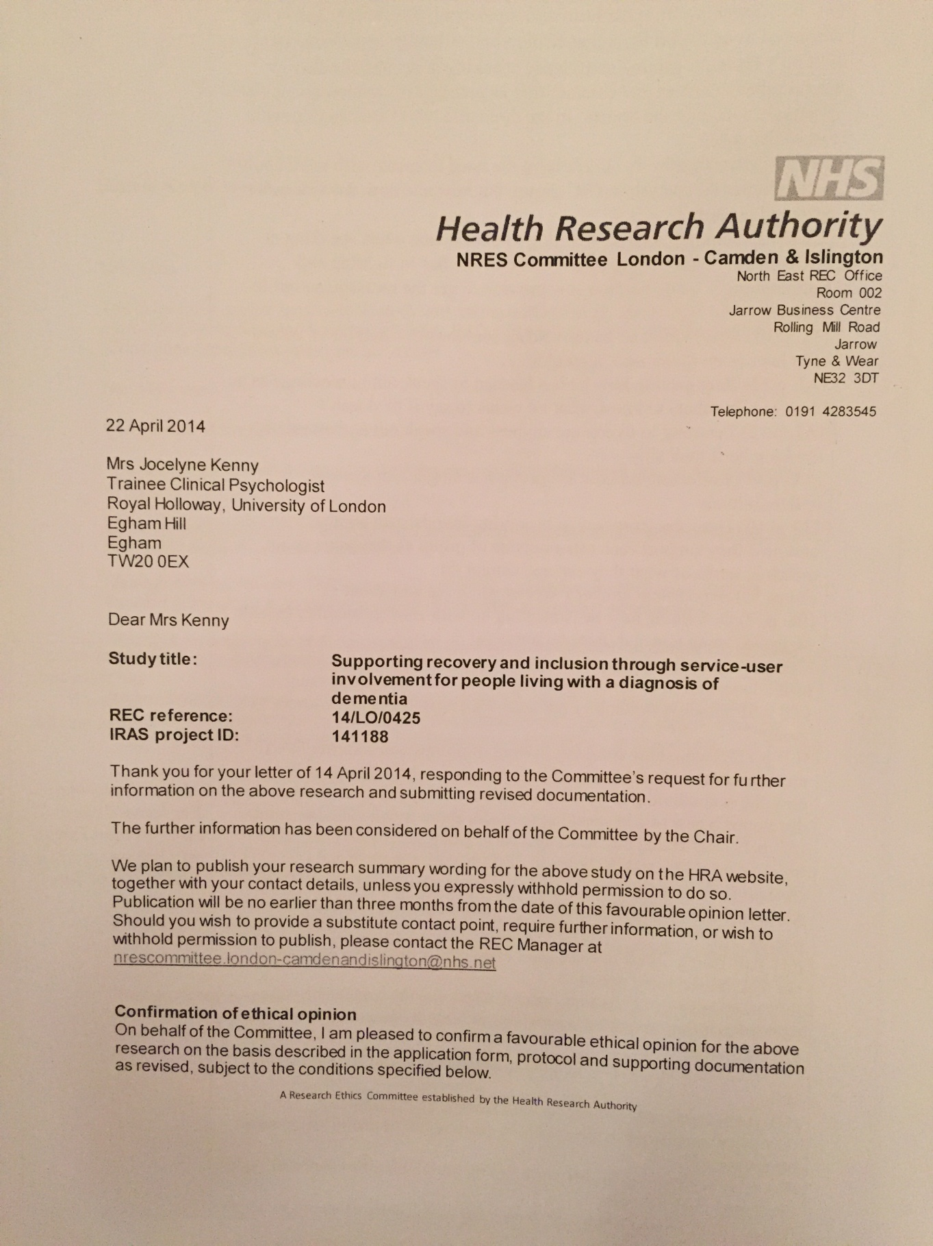

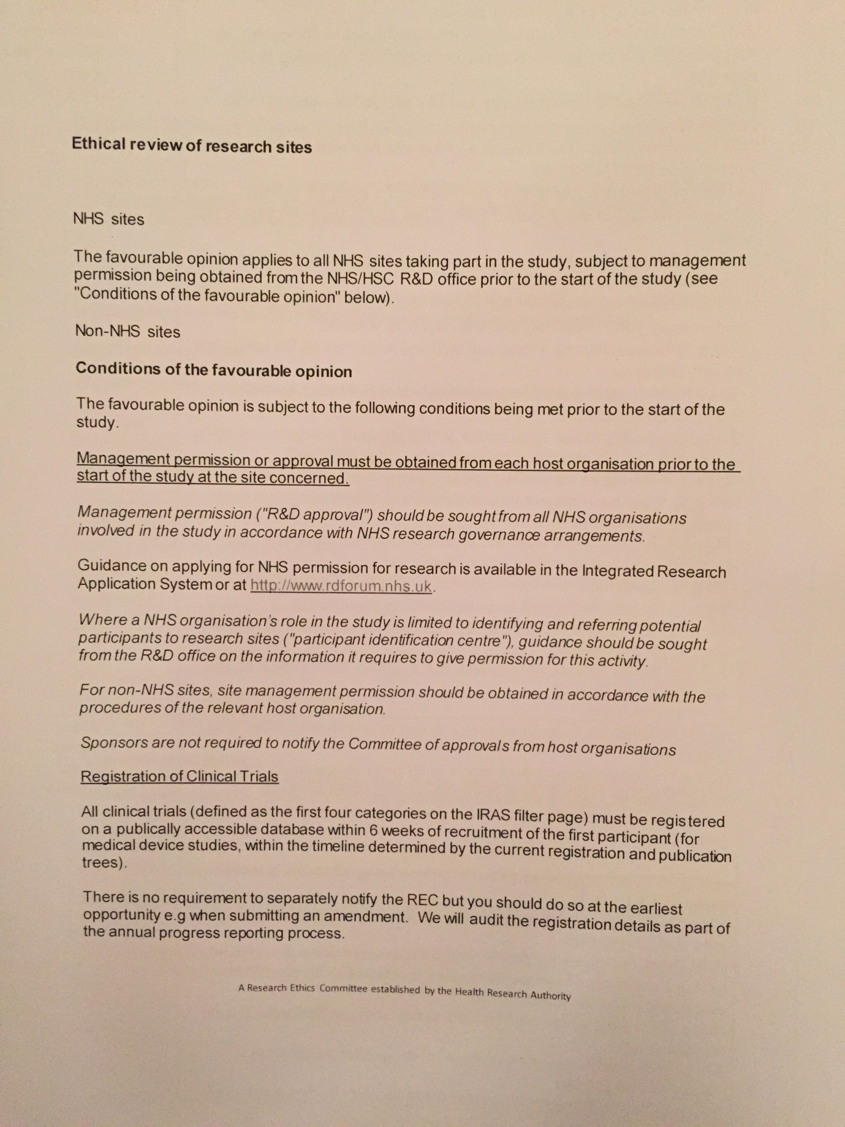

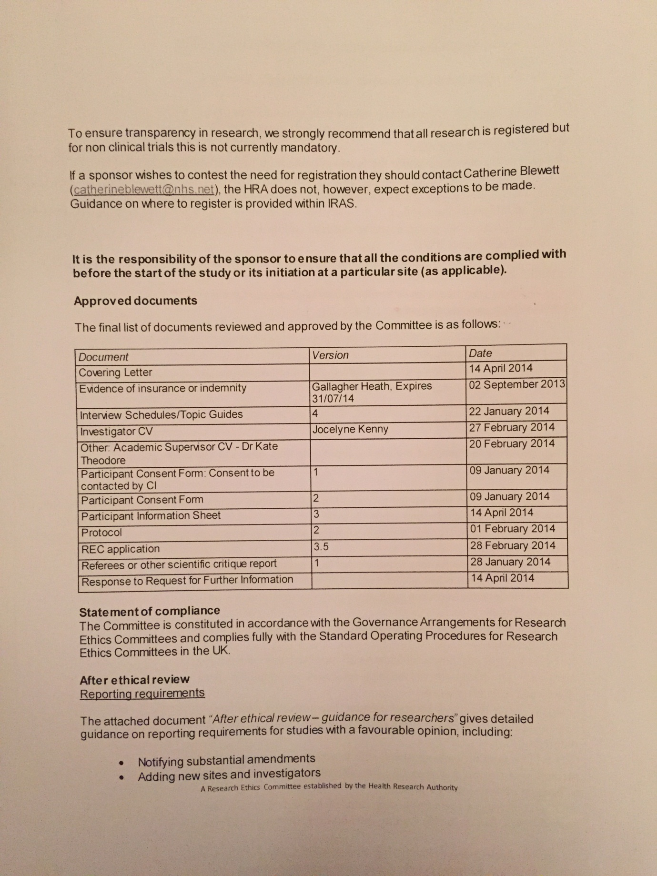

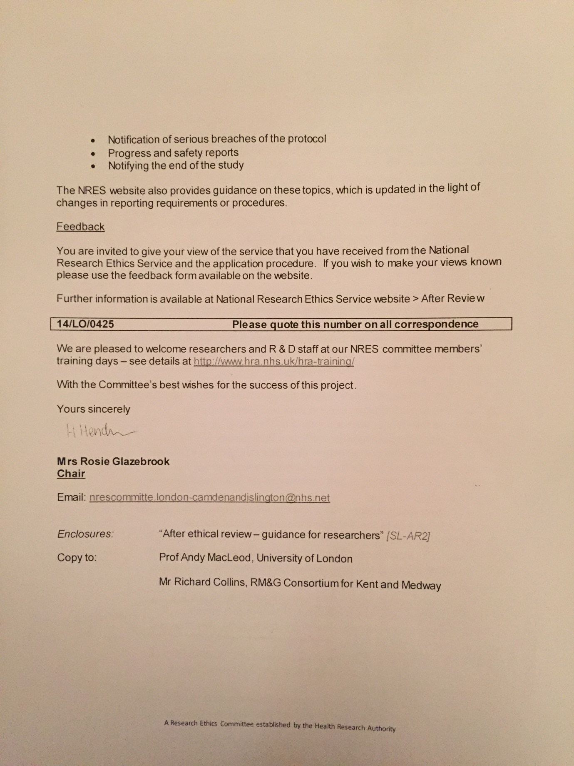

## Appendix 3: Royal Holloway ethics approval

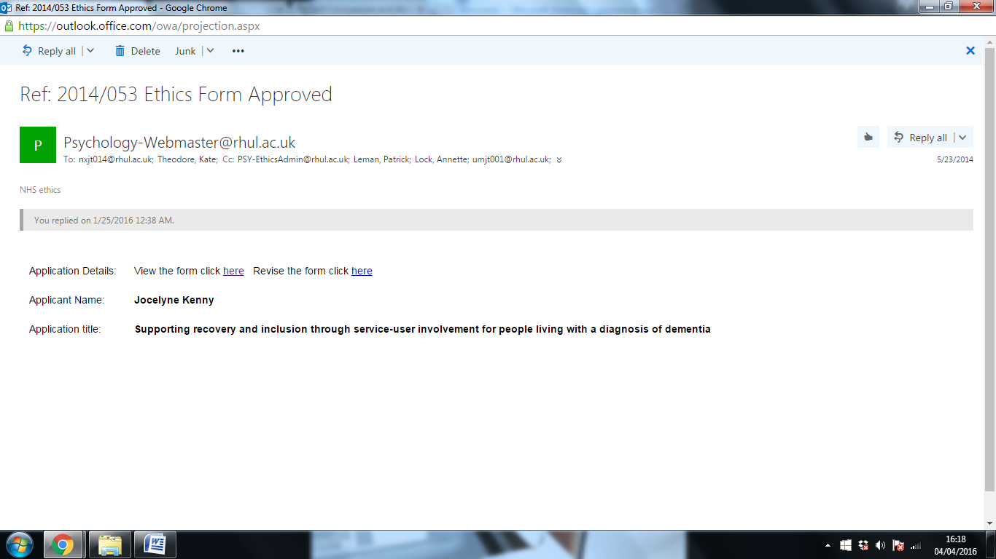

Appendix 3

## Appendix 4: Research and development approval

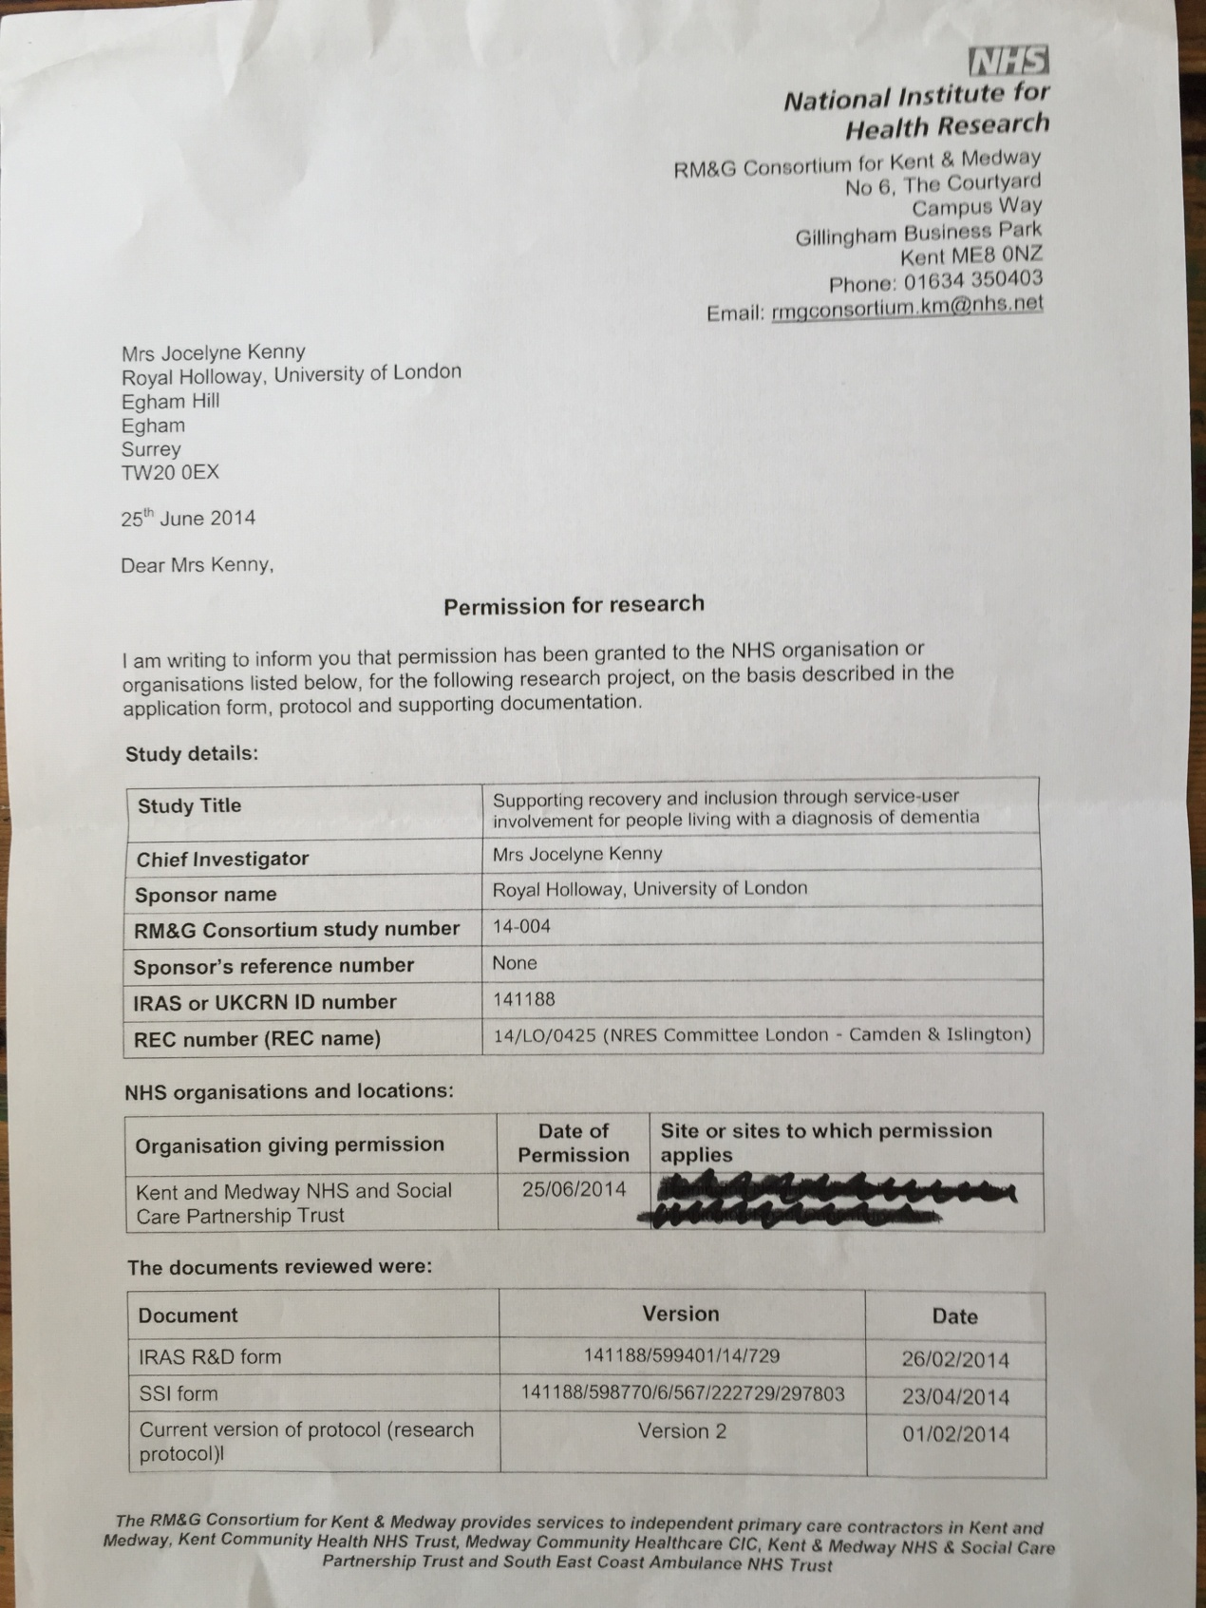

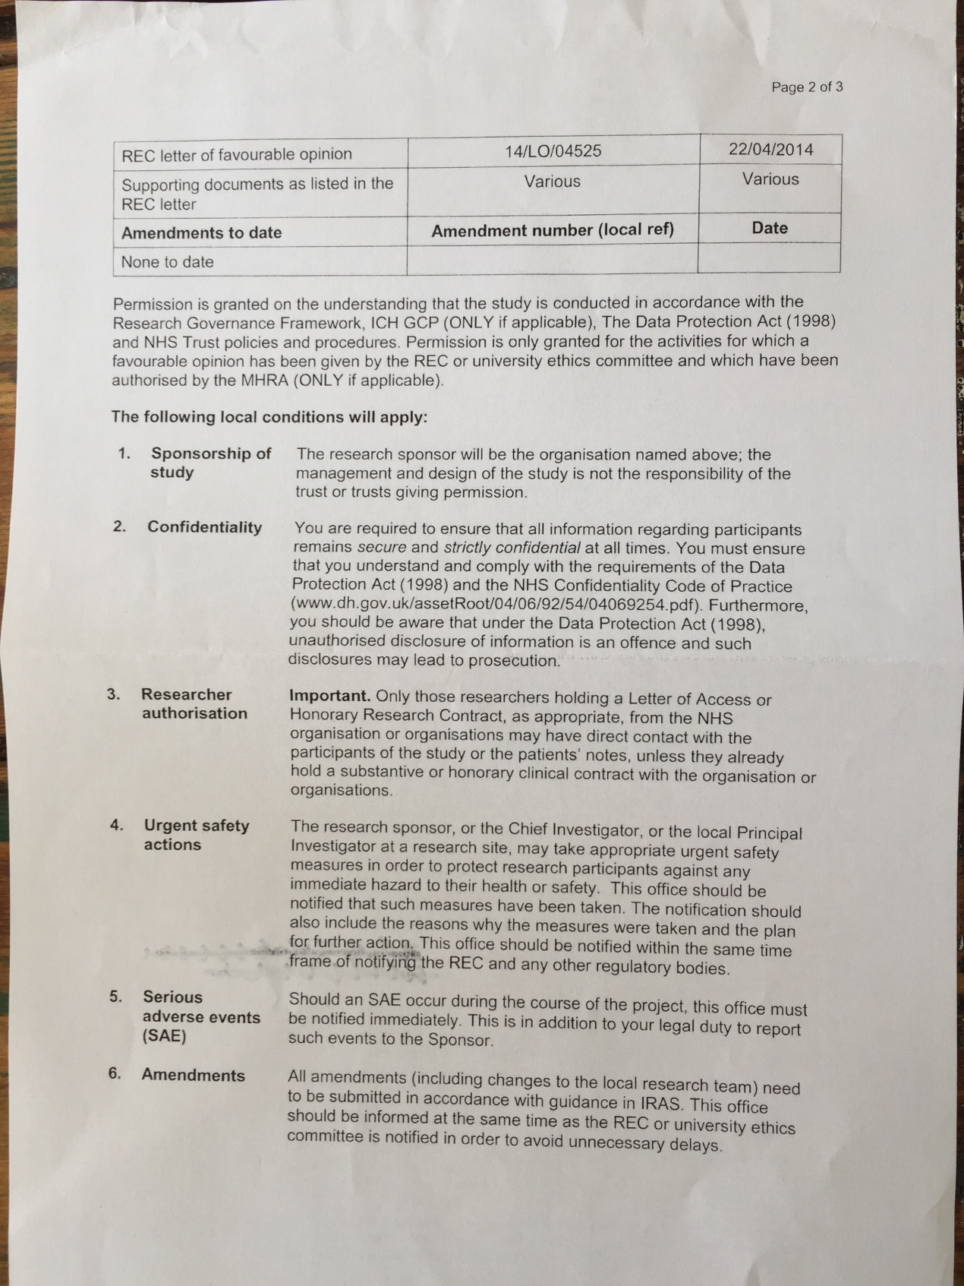

## Appendix 5: Participant information sheet



**SUPPORTING QUALITY OF LIFE THROUGH INVOLVEMENT GROUPS FOR PEOPLE LIVING WITH A DIAGNOSIS OF DEMENTIA**

**Clinical psychology research study**

**Information sheet for participants**

You are being invited to take part in a research study. This study is being carried out as part of a clinical psychology doctorate at Royal Holloway, University of London. Before you decide to take part it is important that you understand why the research is being done and what your participation would involve.

Please take time to read the following information carefully. Discuss it with other group or family members if you wish. Please contact me if anything is unclear or if you would like more information.

If you do decide to take part in this study then you will be given this information sheet to keep. You will also be asked to sign a consent form.

Thank you for reading this.

**What is the purpose of this study?**

This study is looking at how being a member of a group like [INSERT GROUP NAME] can support people with dementia. The study is asking people who live with dementia about the benefits they feel being a member of [INSERT GROUP NAME] has. The study hopes to show that groups like [INSERT GROUP NAME] can have many benefits for people living with dementia, their families and communities, so should be offered more widely.

**Why have I been chosen?**

You are being invited to take part in this study as you are a member of a group for people living with dementia. You are in a good position to give your thoughts and feelings about your experience of receiving a diagnosis of dementia. You are also in a good position to talk about your experience of being a member of [INSERT GROUP NAME].

**What will participation involve?**

You will be asked to participate in one research interview. The interview will last no longer than one hour. It will take place either at the centre where you attend your service user group or at your home. You can decide which location you prefer. The interview will be between you and the researcher, Jocelyne Kenny.

In the interview you will be asked some questions about your experience of receiving a diagnosis of dementia. You will also be asked about your experience of being a member of a service user group. The interview will be recorded and later transcribed. After your interview has been transcribed the recording will be deleted.

**What will happen to the interview data?**

Extracts from your interview will be used to inform the results of a clinical psychology research project. All extracts used in the project will be unnamed. It will not be possible to identify you from extracts used in the project.

A user friendly summary of the research will also be produced and given to groups who participated. Extracts from your interview could be used in this summary. Again, all extracts that appear in the summary will be unnamed.

The results of this study will be made available to everyone who participated in the research.

**Your rights as a participant**

It is completely up to you to decide whether to take part in this study. If you do decide to take part then please be assured of the following:

You can decide to stop the interview at any point and you do not have to answer any questions if you do not want to

You can decide to stop being part of this research study at any time

You do not need to explain your reasons for any of the above

If you decide to stop the interview or stop being part of this research then this will not affect your membership of [INSERT GROUP NAME]

If you decide to stop the interview or stop being part of this research then your interview data will be destroyed and will not be used in the project

If you are no longer able to consent to participate in the research after you have participated in an interview, extracts from your interview will still be used in the study’s results

Your name will be removed from all information and the interview data will be made anonymous

If you have questions or concerns about this research then please contact Jocelyne Kenny. If you remain unhappy then please contact the Patient Experience Team on 0800 783 9972 or [patientexperience@kmpt.nhs.uk](mailto:patientexperience@kmpt.nhs.uk) or FREEPOST RTCS-SBAL-KBUK, KMPT Patient Experience, St Martin’s Hospital, Littlebourne Road, Canterbury CT1 1TD

**Cost, reimbursement and compensation**

Your participation in this study is voluntary. You will not be paid for participating in a research interview.

You will be reimbursed for any travel costs that you have pay when travelling to or from the research interview.

**For further information**

Jocelyne Kenny will be glad to answer your questions about this study at any time.

You can contact Jocelyne by email: [Jocelyne.kenny.2012@live.rhul.ac.uk](mailto:Jocelyne.kenny.2012@live.rhul.ac.uk)

by telephone: 01784 414012 or post: Department of Clinical Psychology, Royal Holloway University of London, Egham Hill, Egham, TW20 0EX

**This project is supervised by**

Dr Kate Theodore, Clinical Psychologist Reinhard Guss, Clinical Psychologist

Royal Holloway University of London KMPT Memory service

01784 414303

## Appendix 6: Consent for researcher to contact participant



**SUPPORTING QUALITY OF LIFE THROUGH INVOLVEMENT GROUPS FOR PEOPLE LIVING WITH A DIAGNOSIS OF DEMENTIA**

**Clinical psychology research study**

**Consent to be contacted**

You have been provided with an information sheet on the above research study.

If you are interested in finding out more about participating in this study then please:

Tick this box which indicates you agree to me contacting you to provide more

information on the above study

Provide your name and contact details so that I can contact you about the above study

NAME and CONTACT DETAILS (email or telephone or address)

…………………………………………………………………………………………

…………………………………………………………………………………………

………………………………………………………………………………………….

If you have provided a telephone number then can I leave a message on the number provided? YES / NO

Thank you,

Jocelyne Kenny, Trainee Clinical Psychologist

Department of clinical psychology, Royal Holloway University of London, Egham Hill, Egham, TW20 0EX

## Appendix 7: Participant consent form



**SUPPORTING QUALITY OF LIFE THROUGH INVOLVEMENT GROUPS FOR PEOPLE LIVING WITH A DIAGNOSIS OF DEMENTIA**

**Clinical psychology research study**

**Participant Consent Form**

Please read the following statements. If you agree with them then please tick the box to confirm your agreement

­­­­­­­­­­­­­­­­­­­­­-------------------------------------------------------------------------------------------------------

I confirm that I have read and understood the information sheet for the above study. I have had enough time to think about the information provided. I have also had the chance to ask questions and am satisfied with the answers.

I understand that my participation is voluntary. I also understand that I can decide to withdraw from the study at any time. I do not need to give reasons for withdrawing. My membership of the [INSERT GROUP NAME] will not in any way be affected if I do decide to withdraw.

I understand that the interview data will be made anonymous. I understand that it will not be possible to identify me in any publication resulting from the study.

I would like my unnamed interview data to be included in the study and write up even if I am no longer able to consent to this in the future

NAME (PLEASE PRINT): ­­­­­­­­­\_\_\_\_\_\_\_\_\_\_\_\_\_\_\_\_\_\_\_\_\_\_\_\_\_\_\_\_\_\_\_\_\_\_\_\_\_\_\_

SIGNATURE: \_\_\_\_\_\_\_\_\_\_\_\_\_\_\_\_\_\_\_\_\_\_\_\_\_\_\_\_\_\_\_\_\_\_\_\_\_\_\_\_\_\_\_\_\_\_\_\_

DATE: \_\_\_\_\_\_\_\_\_\_\_\_\_\_\_\_\_\_\_\_\_\_\_\_\_

## Appendix 8: Draft interview schedule

Interview questions

Introductions – set scene for interview

Thank participant for coming

Recognise that it might be hard for participants to remember exact details of answers to some questions and emphasise that this does not matter

Go through participant info sheet and obtain written informed consent

Ask participant how they feel about interview and what I can do to help with concerns

**Involvement in group**

1. What is the name of your group?

2. Roughly when did you start going to meetings?

3. Can you tell me anything about what usually happens in a [GROUP NAME] meeting?

**Receiving diagnosis of dementia**

4. How did you feel when you received your diagnosis of dementia?

5. Did you tell any friends or people outside your family about your diagnosis? If so then how did they react? If not then could you tell me your reasons?

**Individual’s participation in groups and views about this**

6. Could you share some of your reasons for going to [GROUP NAME] meetings?

7. What do you think is the best thing about your group?

8. How do you feel when you are in a [GROUP NAME] meeting?

9. How does going to the group impact your confidence?

10. How has going to the group influenced relationships with others in the group and others outside the group?

11. How do you think you think the [GROUP NAME] alters the public’s views of dementia? In what ways do you think this happens? Can you give examples?

12. How do these feelings help you in your relationships with others?

**Ending questions**

13. What do you find are the most helpful ways of managing dementia?

14. How did you develop these?

15. What advice would you give to someone who has just received a diagnosis of dementia?

**Debriefing**

Do you have any questions?

Explain what will happen now including how I will disseminate results to participants if interested

Complete demographics

## Appendix 9: Purposive sample interview schedule

**Introductions**

Introduce myself

Go through Participant Information Sheet

Get consent

Ask about any concerns and how I can help with these

Recognise it might be difficult for them to remember exact details of answers to questions

**Interview**

1.Roughly how long have you been going to [GROUP NAME] meetings?

2. What made you decide to start going to meetings?

3. You’re still going to [GROUP NAME] meetings at the moment – what makes you continue to go to the [GROUP NAME]s?

4. What do you like about [GROUP NAME]

5. What don’t you like about [GROUP NAME]?

6. How does being a member of [GROUP NAME]s make you feel?

7. Have you learned any new skills through going to the [GROUP NAME]s?

8. Some groups do things like provide feedback on leaflets for local NHS services, speak at support groups/conferences/events or provide the community with information on dementia. Do you do any similar activities with your group?

9. Do you think [GROUP] changes the way the public views dementia? How?

10. How has [GROUP] changed your relationships with family or friends?

11. How did you feel when you were told that you had dementia?

12. How has going to [GROUP NAME] meetings changed the way you feel about your diagnosis of dementia?

13. Finally, what would you say to someone who has just been diagnosed with dementia?

14. How has being a member of the [GROUP NAME] influenced this advice?

**Ending**

Does participant have any questions?

Explain what will happen to interview data

Offer summary of research findings

Collect demographics

## Appendix 10: Theoretical sample interview schedule

**Introductions**

Introduce myself

Go through PIS

Get consent

Ask about any concerns and how I can help with these

Recognise it might be difficult for them to remember exact details of answers to questions

**Interview**

1.What made you decide to start going to meetings?

2. What makes you continue to go to meetings?

3. What do you like about meetings?

4. Are there any things that you don’t like about meetings?

5. How do you feel during meetings?

6. Has the group led onto other meetings or activities for you?

7. What do you think the people from outside organisations make of the group? Do you think it changes their view of PWD?

8. Why is it important that they come?

9. How do you and the other members support each other?

10. Is there enough of a social element to the groups?

11. What would you change about the group?

12. How do you feel when you think about your future? How does going to the group affect these feelings?

**Ending**

Does participant have any questions?

Explain what will happen to interview data

Offer summary of research findings

Obtain demographics

## Appendix 11: Extract from an initially coded transcript

|  |  |
| --- | --- |
| Initial coding | Interview data |
| Needing to be challenged  Feeling challenge is too much for some  Seeing challenge as worth it for her  Identifying difference in groups that are run by charities v professionals  Seeing professionals as knowing  Coming together to socialise is better at charity run groups  Needing professional presence of those who have formal knowledge and training  Seeing that professionals can never be equal as they do not have dementia  Being treated as an equal but not accepting this  Seeing herself as contributing to a new area  Feeling happy to be involved in new area  Describing initial ways in which she noticed dementia  Seeing changes in her speech and language  Finding words getting harder  Reducing range of vocabulary  Linking her experiences to family history  Being told she is wrong by GP  Being listened to by a locum GP  Not being asked screening questions but being listened to  Being diagnosed with Vascular dementia  Finding out more through reading  Realising that it will get worse  Feeling depressed at the prospect of disease course  Managing depression by thoughts  Drawing comparisons with power of negative thinking and power of alcohol over alcoholics  Deciding to do things to keep going  Identifying link between bad days and private thoughts  Using keeping going to manage  Feeling depressed by diagnosis but not surprised  Identifying how even though diagnosis not a shock it is still depressing  Living with the inevitable loss  Seeing diagnosis as taking away the person she had been  Finding it hard to live with the inevitable intellectual decline  Organising projects to keep going  Using activities that can still do – doing activities  Reflecting on impact of grandmother  Seeing dementia as having changed who she is  Wanting to do things to keep her the same person – i.e. things she did before diagnosis  Enjoying gardening and moving furniture  Focusing on doing activities rather than ones that require high cognitive effort  Seeing inv group as keeping her like her  Describing pleasure she enjoyed from writing book with group  Describing feelings when project was over  Contrasting highs and lows of book project | P5: Yes, it challenges me and I think we need to be, maybe not too much, sometimes we are challenged too much I think some of us, but for me I have always thought it was worth it  JK: So, it was the fact that professionals were running the group that appealed to you initially, with the GROUP  P5: Because they are professionals, they know....they know about....because there is a tremendous difference between somebody who has group because it's a charity and they are paid so people can come and get together which is very good in that point, GROUP is very bad. It has a social thing where people go together, in that point it's good but you need people who know professionally who have been trained who has studied what is dementia and Alzheimer’s  JK: In the meetings do feel there is a difference between CPs and members or do you feel everyone is equal?  P5: I think they try, but they don't have dementia they don't have Alzheimer’s, erm, they treat us as equals but I don't take them as equals  JK: OK, so you don't see yourself as on an equal basis as the CPs  P5: No. I'm a guinea Pig! And I'm very happy to be  JK: Ok, and...How did you feel when you first suspected that you had dementia?  P5: I had for a long time, I would say even years, noticed that my semantic problems were getting worse, I started to notice that I was translating from X into English sometimes, which I never did before and I was trying to find words all the time and I thought that is not normal because I had a very big mouth! I've always had an enormous vocabulary, and, you know, it was changing. And my mother had Alzheimer’s and my grandmother had Alzheimer’s. And I didn’t think I had it but it got worse and worse. And I started telling my GP but he said, oh no  JK: And that was about five years ago, and how did you feel when you suspected it might be dementia?  P5: Erm, I talked to, erm a locum a young woman and she listened to me...she didn't ask me who was they and them. The best, I erm, erm, I can't diagnose you but I can send you to the memory in X. And I went there and they did all the tests and the scans and everything and they said I have Vascular dementia, and erm, reading about it and about how it doesn’t have a very good future, it's going to get worse and worse and it has, I started getting a bit depressed, but then I thought "You can't - you are not allowed to be depressed." It's the worst thing - it's like giving an alcoholic wine. You have to try and do things but it is...I have very bad days where I have to in the privacy of my brain I have to have this conversation, saying you have to keep going  JK: Yup, so you went to your normal GP saying something was wrong and then you came across a locum GP and she sent you to X where you had scans and tests and you were told it was Vascular dementia  P5: Yes  JK: And how did you feel when you were told it was dementia? When you were actually given your diagnosis?    P5: I...told you...I felt depressed...but it wasn't a surprise  JK: It wasn't a surprise, but you suspected you had it and then you began to feel really quite depressed  P5: Mmmhmm  JK: And what was it that made you feel depressed?  P5: The fact that I was going to get less and less, the person I had been, there was going to be a decline of my intellectual ability, that was the difficult thing  JK: And it sounds like you're a very strong person, and as you say you quite quickly realise you couldn't allow yourself to sink into a depression, if you allow yourself to sink in it gets worse and worse so you felt you had to do things to feel less depressed. And what kinds of things do you do that you find helpful?  P5: I have to organise myself to have projects, to do things and I was very lucky that I had a grandmother who taught me to crochet and knit and I find that I can do. And that keeps me in a false, I know, a false feeling that I am the same person. I'm not, I try to things like that, you know, I love going to the garden and doing things in the garden - moving the furniture around  JK: And as you say it's about having projects and doing things that make you feel the same person  P5: Yes  JK: And how does going to the GROUPs fit into this?  P5: Well, it keeps me like me; we have a book that I enjoyed enormously, while we were doing it. The end of it I have to say I felt very bad...I felt left and so alone |

## 

## Appendix 12: Extract from coding table

|  |  |  |
| --- | --- | --- |
| Participant tally | Initial codes | Focus codes |
| P2  P3  P9  P5  P10  P1  P4  P11 | (P2 p.3) Experiencing meeting other PWD in their 50s. Not something he’d done before.  (P2 p.3) Seeing there were others out there like him who were young with dementia  (P2 p.6) Seeing dementia as the aspect that has brought members together  (P2 p.6) Feeling part of something bigger than him  (P2 p.7) Seeing the commonality and shared experiences between those in SU group  (P2 p.3) Feeling far apart from others in terms of backgrounds and attitudes initially, but united in being likeminded about dementia  (P2 p.12) Describing being united in pride felt over achievements of group  (P2 p.7) Being in a group that is socially tuned to one another  (P2 p.7) Being in a group who can talk and listen to one another  (P3 p.2) Meeting others in similar situations  (P3 p.12) Reducing isolation through group meetings  (P3 p. 12) Coming into contact with other PWD  (P3 p.13) Gaining confidence in knowing that he is not alone with dementia  (P4 p. 7) Being treated like a normal human being when she is at the SU group  (P9 p.2) Liking the community feel to groups and being with people who have similar problems  (P5 p. 7) Unwilling to disclose lack of diagnosis because other members assumed she was the same  (P5 p.3) Seeing SU group as a way of meeting other people from a variety of backgrounds  (P10 p.15) Having a network of people to talk with  (P10 p. 5) Seeking advice from through group  (P1 p.6) Seeing best thing about the group is being with people who have the same problem and seeing how they tackle problems  (P13 p. 6) Group gives unwelcome reminder that she has dementia  (P13 p. 8) Feeling resistance towards meeting with other PWD each month  (P12 p. 4) Feeling unable to compare himself to other members as they are very different due to their level of dementia  (P11 p. 3) Seeing that another member is more able than others as she does not have dementia  (P11 p. 3) Feeling left out through her dementia.  (P11 p. 5) Finding it hard to keep up as others speak too quickly | Coming together through dementia |
| P8  P1  P6  P10  P3  P11  P13 | (P8 p.6) Seeing that they all get mixed up  (P8 p. 6) Having a laugh and helping each other when they do  (P1 p.6) Enjoying being able to listen to others without feeling as though he has to say much  (P6 p.8) Understanding when each other uses the wrong words or suddenly forget  (P6 p.8) Not feeling embarrassed suddenly forgetting when in group  (P10 p.7) Feeling safe in group because all members there have lapses of memory  (P10 p. 7) Not feeling hurried to finish sentences  (P10 p. 7) Not feeling judged for speaking slowly and forgetting words  (P10 p.7) Describing how another member has problems with getting words out but how he feels comfortable at group because no one is judging him  (P10 p.7) Learning to feel safe in group  (P10 p. 7) Observing how new members join group and apologise for difficulties, and how they learn not to because no one is judging them  (P10 p.13) Feeling like she is able to be herself in SU group  (P10 p. 13) Not performing, pretending, bluffing or covering symptoms up  (P3 p.10) Having a fear of exposing himself and his dementia when not around PWD, due to people finding out about his dementia and judging him  (P3 p.11) Changing subject when he feels himself ‘drying up’ with others who do not have dementia  (P3 p.11) Not feeling embarrassed when in a group of people with similar problems.  (P3 p.11) Finding others in the group helpful in coming up with words when you are stuck  (P11 p. 5) Describing how group makes her more aware of symptoms of dementia  (P11 p. 5) Highlighting difficulty in keeping up with lots of conversation and forming sentences  (P11 p. 6) Feeling panicky in group when she loses words and irritated that everyone is talking at once  (P13 p. 4) Comparing her mental abilities to other members  (P13 p. 4) Feeling less able to think of what to say as quickly as other | Feeling safe showing symptoms of dementia |
| P5  P3  P9  P7  P4  P6  P10  P12  P13 | (P5 p.11) Feeling sad about how dementia has crept up on other group members  (P5 p.2) Being among other PWD to see what is happening  (P5 p.3) Being very interested in SU members because she knows nothing about dementia  (P5 p.15) Seeing how dementia develops in others  (P5 p.15) Seeing how others are coping with it.  (P3 p.5) Comparing himself with others and when they were diagnosed compared to him  (P3 p.6) Putting his situation into perspective because he can see others who are worse than him  (P3 p.6) Seeing what contributions other group members make compared to his  (P3 p.6) Evaluating contributions in terms of when they were diagnosed  (P3 p. 6) Gauging how fast he sees their dementia to be progressing  (P9 p.14) Looking around at other PWD and finding they are functioning well  (P9 p. 14) Feeling more positive by others function well  (P9 p. 12) Greater understanding of dementias through meeting other PWD  (P9 p. 12) Seeing subtleties of dementias and how they affects each part of brain  (P9 p. 12) Not asking about diagnosis but observing and guessing based on how they are  (P9 p. 15) Observing the differences in some members over time  (P9 p. 15) Seeing that progress of dementia gradual but noticeable  (P9 p. 15) Focusing attention and observations on others with his type of dementia  (P4 p.11) Seeing others at group who can’t talk and seeing other people who are no longer aware of what is happening around them  (P4 p.11) Seeing the positives of this because knowing too much is not always good  (P4 p.11) Observing how others have gone downhill more quickly  (P4 p.11) Challenging her own misconceptions of other members  (P4 p. 11) Talking to those who do not say much and seeing that they have a lot to say  (P4 p.12) Watching other PWD up close helpful in normalising the ‘shades’ of dementia  (P4 p.12) Seeing her ‘odd’ behaviour is being just a shade of dementia  (P6 p.12) Not knowing what dementia was  (P6 p.13) Looking on the internet and finding information really scary  (P6 p.12) Finding out by watching others at group  (P7 p.14) Being around others who are worse off than him at SU group is helpful  (P7 p.14) Staying positive about what he can still do  (P12 p. 2) Going to groups to learn more practical things not related to dementia because does not see himself as having dementia  (P12 p.2) Learning about cheapest energy provider for example  (P12 p. 3) Seeing that other members are doing their best to slow dementia down | Observing others to learn about dementia |

## Appendix 13: Example memo following transcription

**Memo following transcription of P8 - August 2015**

**Groups give people a voice inside and outside group**

Groups help unlock parts of minds of PWD that might not be accessed otherwise. Provide a safe space for people to have a go at saying what is on their mind, where they can make mistakes, get lost or go off on tangents without feeling self-conscious. Group members also help individuals to vocalise things and everyone helps to give each other a voice.

People who come to the groups help to give PWD a voice outside of the group by taking what PWD are saying about what it’s like to live with dementia and telling others outside the group

**Transfer of knowledge but not to ever be able to really know, but to apply knowledge**

Explicit recognition that it is not possible to know what it’s like to live with dementia unless you have it. Saying that other people cannot understand, so their role is to listen to what PWD have to say and try and understand as much as possible and use what PWD are saying to make practical changes to leaflets, hospital services etc. This is a clear transfer of knowledge from those with dementia to those without. Although professionals in the group are very good at getting the knowledge out, that it their role and they can never know what its really.

**The USP of SUI groups is….? How does this interact with society’s stigma?**

SUI are clearly different from other dementia groups out there, but how? What is it about SUI that makes them appealing to some and not others? What do SUI groups offer that other don’t and vice versa? Clearly have a social and support element but support happens in different ways to other more social/peer support type groups. The main aspect seems to be the feeling that members are ‘doing something’ the work is ‘important’ they are ‘changing things’ and ‘campaigning’ and how does this fit in with society’s view of PWD being useless? Is it even more important to feel you are achieving something in the face of such stigma? Being pushed. Being kept going.

**Wealth and variety of skills within group**

And the recognition that each person brings with them a different skill. Some skills are more practical e.g. organisational and others are more interpersonal. But the skills help the group to function together as a group

**Process of carrying out the interview and timings**

PWD have sense that they don’t have much time, so it’s a battle against time so when they get the chance to tell their story and be engaged in something ‘useful’ they have a lot to say. This contrasts with my needs to keep the interviews to one hour. How much more would I get if I let participants tell more of their story versus asking my questions? Would I be able to answer my research questions if my interviews were less structured and more open? As P8 said, the things that he felt were ‘off piste’ were important to him and gave a valuable insight into the kinds of struggles PWD face.

## Appendix 14: Analytical memo

**Memo on Losing and winning –**

**July 2015**

**The dementia loses**

I am increasingly struck by how these groups stand to give members things they feel they are being stripped of through dementia. The process of dementia affects speech, the ability to converse the ability to retrieve language. The groups give people a voice and allow people to speak and be heard, both in the context of speaking at meetings themselves but also a united voice in society, being able to speak out against stigma. Dementia strips people of a place in society; these groups allow people to feel valued again and to feel as though they are useful and have things to contribute. Groups allow people to have a role in society through speaking at PDGs, conferences, meetings. Dementia strips people of the ability to do things they used to enjoy and skills they used in daily life, like reading, being leaders, mentoring others – these groups, or accessing groups through the core groups can go some way to enable people to use these skills

**Losing and winning – the dementia eventually wins**

The inevitable decline associated with the progression of dementia means the dementia inevitably wins. What the group can give to people in terms of what dementia takes away eventually gets overruled by the dementia. How can SUI groups deal with this? What provisions are in place to help people manage this uncertainty? What provisions and put into place for those who are no longer able to attend due to the limitations imposed by dementia?

## Appendix 15: Cluster memo

Cluster memo on examining processes behind falling out and coming together –

January 7 2016

Surprise at level of tension that exists between members, yet at the same time the seeming overall cohesion of groups. Wondering how apparent cohesion exists in spite of animosity, politics and tensions identified in interview data. Seems to be some kind of process of falling apart as individuals, but coming together as a group. Seeing that the group is more important than the individual squabbles and infighting. An interesting dialectic. Falling apart AND coming together

18. Coming together through dementia

11. Sharing feelings about other members

19. Feeling safe showing symptoms of dementia

## Appendix 16: Extract from research journal

29. Speaking within the group

45. Seeing the individuality of the person and the dementia

30. Bringing interpersonal and communication skills to help group operate

12. Managing feelings towards, and relationships with others

13. Recognising tensions and politics within the group

## C:\Users\Edward\Desktop\New folder\Thesis\Write up\Appendices\IMG_4148.JPG

## Appendix 17: Extract from an early results table

|  |  |  |
| --- | --- | --- |
| **Theoretical code** | **Focused code** | **Initial code** |
| 1. Losing abilities over time – *“there will be a stage where I’ll get to a point where I won’t be able to do this”* | Living with undiagnosed symptoms of dementia | * Living with undiagnosed symptoms prior to diagnosis * Living with the symptoms post diagnosis, including living with the knowledge that the symptoms will progressively worsen * Needing to do things as quickly as possible |
| Living with a wretched and horrible disease |
| Feeling the pressure of time |
| 2. How dementia negatively affects relationships – *“I didn’t tell anybody I had Alzheimer’s cos I wanted to make sure I carried on doing as much as what I possibly could”* | Living under society’s perceptions of dementia | * Seeing how dementia changes the nature of how others relate to you. * Describing family and friends’ reactions to diagnosis * Giving examples of lived experience of society’s stigma * Being discriminated against by healthcare professionals |
| Others coming to know about diagnosis |
| Feeling misunderstood by health care professionals |
| 3. Moving from diagnosis to joining SU group - *“if someone had tried to explain it to me to me from the word go, I don’t think I could have accepted it”* | Reacting, responding and attributing meaning to diagnosis  Recalling reasons and motivations for joining SU group | * Process over time of coming to terms with diagnosis * Living with symptoms of dementia prior to diagnosis * Seeing SU groups as different from other groups * Wanting to do something about the dementia |

## Appendix 18: First version of model

14. Living with a wretched and horrible disease

34. Living with undiagnosed symptoms

41. Feeling the pressure of time

Progression of dementia

21. Meeting some needs but failing others

22. Seeing discussion limited by agendas

39. Questioning achievements

44. Wanting change

6. Living under society’s perceptions of dementia

25. Feeling misunderstood by professionals

38. Changing opinion at local and national level

Tolerating the bad Working with not

traits with the good against dementia

What helps and hinders coming together

Service user groups

2. Other coming to know about diagnosis

3. Describing experiences of other dementia related groups

4. Differential aspects of group

17. Qualities and characteristics of this ‘type’ of PWD

40. Being confident of groups’ purpose

16. Maintaining old roles and skills – it keeps me like me

37. Changing opinion through working with professionals

31. Providing a way of continuing with professional life

42. Managing an uncertain future

43. Deciding how or if group can help

5. Being challenged and motivated by group

Keeping going now and in the future

24. Creating a flow of expertise and knowledge

26. Speaking and being listened to as a group

32. Creating opportunities to help and be useful

33. Feeling positively evaluated in the eyes of others

36. Seeing indirect impact of group on family & relationships

## Appendix 19: Dementia friendly research summary

 

Relating living well and social recovery to involvement groups for people living with a diagnosis of dementia

**1.What did this research aim to do and why?**

* Involvement groups are increasingly being offered by NHS services for people who have been diagnosed with dementia
* They are seen as a way of filling a ‘gap’ that has developed following more people being diagnosed with dementia at an earlier stage
* Although there are now believed to be around 50 groups operating across the UK, there is limited research looking at members’ experiences
* This research asked members about their experiences of involvement groups, including the benefits and limitations of going to groups
* The research investigated whether members’ experiences could be linked to government policy on Living Well
* It also investigated whether members’ experiences could be linked to a model of ‘social recovery’ where people are supported in rebuilding self-esteem and a positive identity following a diagnosis of dementia
* By linking people’s experiences to Living Well and ‘social recovery’, this research aimed to give involvement groups a stronger rationale and be offered more widely to people living with dementia

2.**How was this research carried out?**

* 13 participants were recruited from 3 involvement groups for people living with dementia
* Each participant took part in a research interview where we discussed their experience of living with dementia and involvement groups

**3.What did the results show?**

* 11 themes were identified from the interview data:

Theme 1: Living with a *wretched and horrible disease*

Theme 2: Moving from diagnosis to involvement group

Theme 3: Working together with, not against, the dementia

Theme 4: Tolerating the bad traits with the good

Theme 5: Being helped and hindered in coming together

Theme 6: Being sure of who ‘we’ are

Theme 7: Acknowledging ‘our’ shortcomings

Theme 8: Keeping up with the old; learning the new

Theme 9: Feeling respected and useful with the dementia

Theme 10: Working to challenge assumptions

Theme 11: Keeping going now and in the future

* The themes were developed into a model which showed how involvement groups for people living with dementia related to Living Well and ‘social recovery’

**4.A summary of the model**

* Some themes related to the losses associated with a diagnosis of dementia, including ‘losses through symptoms’ such as memory and language, and ‘social losses’ due to stigma
* Other themes were found to balance out some of the ‘social losses’ including:
  + Being given the chance to use professionals skills where the ability to work had been taken away
  + Being given opportunities to feel respected and valued where the diagnosis had brought feelings of uselessness
  + Being given opportunities to educate others and challenge stigma to demonstrate what people with dementia can do
* One theme showed how members saw involvement groups as having a clear purpose, which was to challenge assumptions
* The drawback of having a clear purpose was that members sometimes wanted changes which conflicted with this purpose, for example:
  + More opportunity to socialise
  + More opportunity to talk about experiences of dementia
* One theme showed how involvement groups could help in keeping going with dementia in the short term, but were unlikely to help in the longer term due to the realities of living with a progressive disease

**5.Conclusions**

* The study was able to show specific ways in which involvement groups for people living with dementia can relate to policy on Living Well and ‘social recovery’
* The study recommended that involvement groups should be offered more widely

Please contact Jocelyne Kenny [Jocelyne.kenny@kmpt.nhs.uk](mailto:Jocelyne.kenny@kmpt.nhs.uk) or 01227 812054 for more information

## Appendix 20: Table of theoretical, focused and initial codes

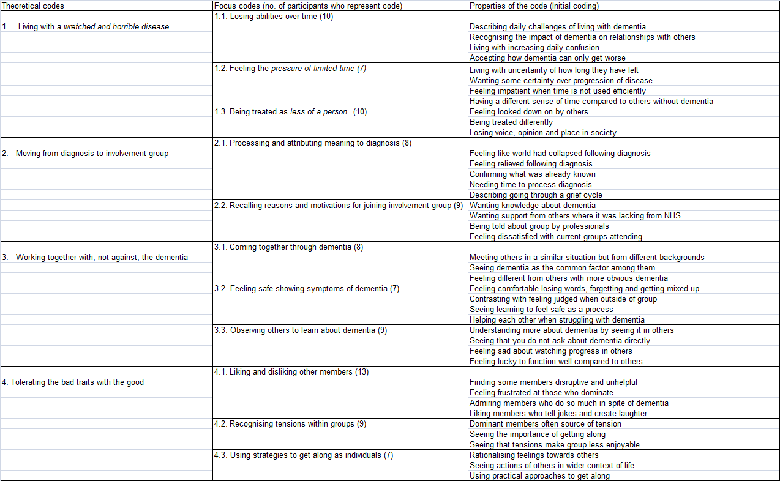

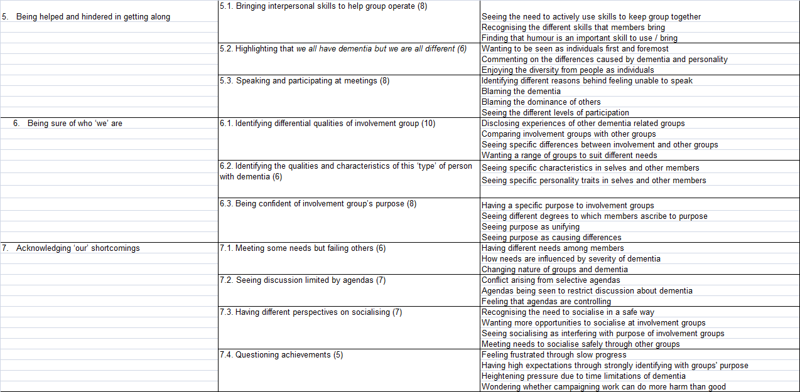

# 

1. Words placed within square brackets (i.e.*[he thought that]* have been added by the researcher so that the extract can be easily understood. A string of dots(…) indicates that a section of the extract has been removed to improve the clarity of the quote. Italicised words in headings represent direct participant quotes [↑](#footnote-ref-1)