Archiving an Urban Exploration - MR NICE GUY, cooking oil drums, sterile blister packs and uncanny bikinis

Cecilie Sachs Olsen, School of Geography, Queen Mary, University of London, UK
Harriet Hawkins, School of Geography, Royal Holloway, University of London, UK

In the auditorium
‘10th June 2015, Queen Mary University, London’ a voice over the loudspeaker announces, we – the participants of the workshop – have 2 hours and 45 minutes for our mission. Three women appear on the stage in front of us, copious pockets adorn their khaki waist-coats. Fieldwork chic, the waist-coats are matched with cream shorts, white high tops, and jewel coloured silky shirts, kingfisher, garnet and sapphire. They seem a little discombobulated, they are time-travellers they tell us, future researchers they say, our mission should we choose to accept it, is one of urban exploration through archiving. One of these archaeologists from the future breaks off and goes over to a metal box on a sort of plinth. ‘Phew,’ she exhales audibly, ‘we came in time’. She turns to us and starts to reprimand us, our first attempt at filling this box (a time capsule we learn) was not good enough. In this first imaginary attempt we had confounded these future archaeologists, we had collected objects and included drawings, but had neglected to detail the social practices that accompanied these things. They had, as a result, been forced to imagine the past uses of these objects, to conceptualise the questions they raised and the lives we lived. Our mission that June afternoon was to re-visit our original collection sites around the local area, to engage with the interpretations the future archaeologists had created of those initial archived objects and either recollect similar objects or choose something new from each site. Specifically our mission was to archive not only objects but also to think through how to record the ways we use them and how we experience urban space. Our time capsule was not just going to contain a material collection but also text and images to bring our objects to life, to explore the social practices that surround them. We are divided into teams, handed brown paper carrier bags containing our ‘field kit’, and we begin.

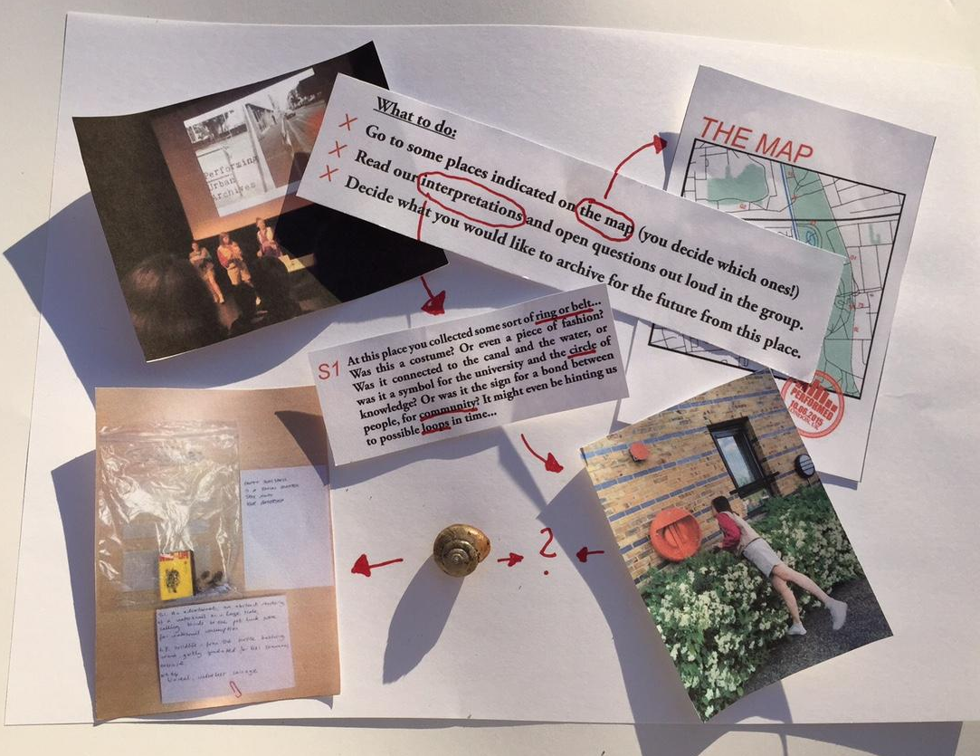

<insert figure one in here>

In the urban environment : before the workshop
In preparation for the workshop we - the zURBS team– walked around the area of Mile End, London, in search of traces of social practices in urban space. These traces, which ended up as the contents of the time capsule, consisted of objects such as the box of salt to spread on the ground in order make it easier and safer to cross the university campus in winter time; the lifebuoys hanging by the canal, the remnants of a colourful balloon found in a park, a coconut found outside a corner shop, a piece of rubber ball found in an area with over-stuffed balconies, a number plate from a mailbox and a used syringe found in a red trash can.

By playing future archaeologists, unaware of the social practices that gave meaning to the objects in the time capsule and rather posing open questions based on various (mis)interpretations of the objects’ materiality and location, we wanted to make explicit the processes by which the meaning of materiality is constantly invented. As the theatre director Anne Bogart points out, ‘when we know what a door is and what it can do, we limit both ourselves and the possibilities of the door. When we are open to its size and texture and shape, a door can become anything and everything’. Accordingly, when thinking about the interpretations of these objects that would inform the clues for the workshop participants, the box of salt became a form of white crystal that ‘might be a salt or a drug’, opening questions such as ‘was it an essential part of university life? Was it supposed to symbolize food or academic pressure, the health care system or the decline of a whole society?’ We reflected on whether a lifebuoy was some sort of ring, belt, costume or even a piece of fashion, and queried: was it a symbol for the university and the circle of knowledge? Or was it the sign for a bond between people, for community? In similar vein, the coconut raised issues of global trade, post-imperial guilt and exoticism; the piece of a rubber ball posed questions of the abundances of things causing apartments to flow over; the number plate had the zURBS team reflecting on identity and exchange of personal information; while the used syringe generated questions around health, life threats and medical services.

The open-ended questions and interpretations aimed to expand the workshop participants’ view of materiality by elucidating the relation between practices and representations in two ways. Firstly, the questions illuminated how social and cultural meanings of things are open for misinterpretation by ‘outsiders’ that are unfamiliar with the social practices of which they are part. The presentational process through which all materiality is (per)formed was here drawn to the fore: to those within a culture, certain meanings are so obvious as to require no explanation; to those on the outside these meanings are ripe for misinterpretation. However, this misinterpretation may open spaces for new understandings and ultimately challenge conventional normative meanings of things that invites or constrains us to use them in certain ways. One example here is an experiment in which the psychologist Stanley Milgram asked his students to violate a commonly accepted social norm in terms of boarding a crowded train and ask someone for a seat, and then examining people’s reactions to it. This seemingly simple task proved to be quite difficult, even almost traumatic, for his students to carry out. The students reported of nausea and fear, and most of them did not go through with the experiment.
Secondly, the interpretations pointed out how traces of social practices may make urban space legible for the users of the city. Traces of use enable people to associate themselves with the collective practice of preceding users, showing confidence in the traces they leave behind. For example, the remnants of the balloons that we found in the park can guide subsequent users of the park to have a party at the same spot. Or, in context where an action can be risky, (non)use or signs of acts can provide a sense of safety. The fact that the lifebuoys by the canal were very old and covered in spider webs may testify that the path by the canal is safe to traverse or that the safety infrastructure is not maintained. By having the participants look for objects and material traces of social practices, we wanted the workshop to explore questions of legibility of the urban environment, we wanted to reflect on the instability of object meaning and use, and how objects and traces of use become read as messengers of content capable of influencing those who interpret them.

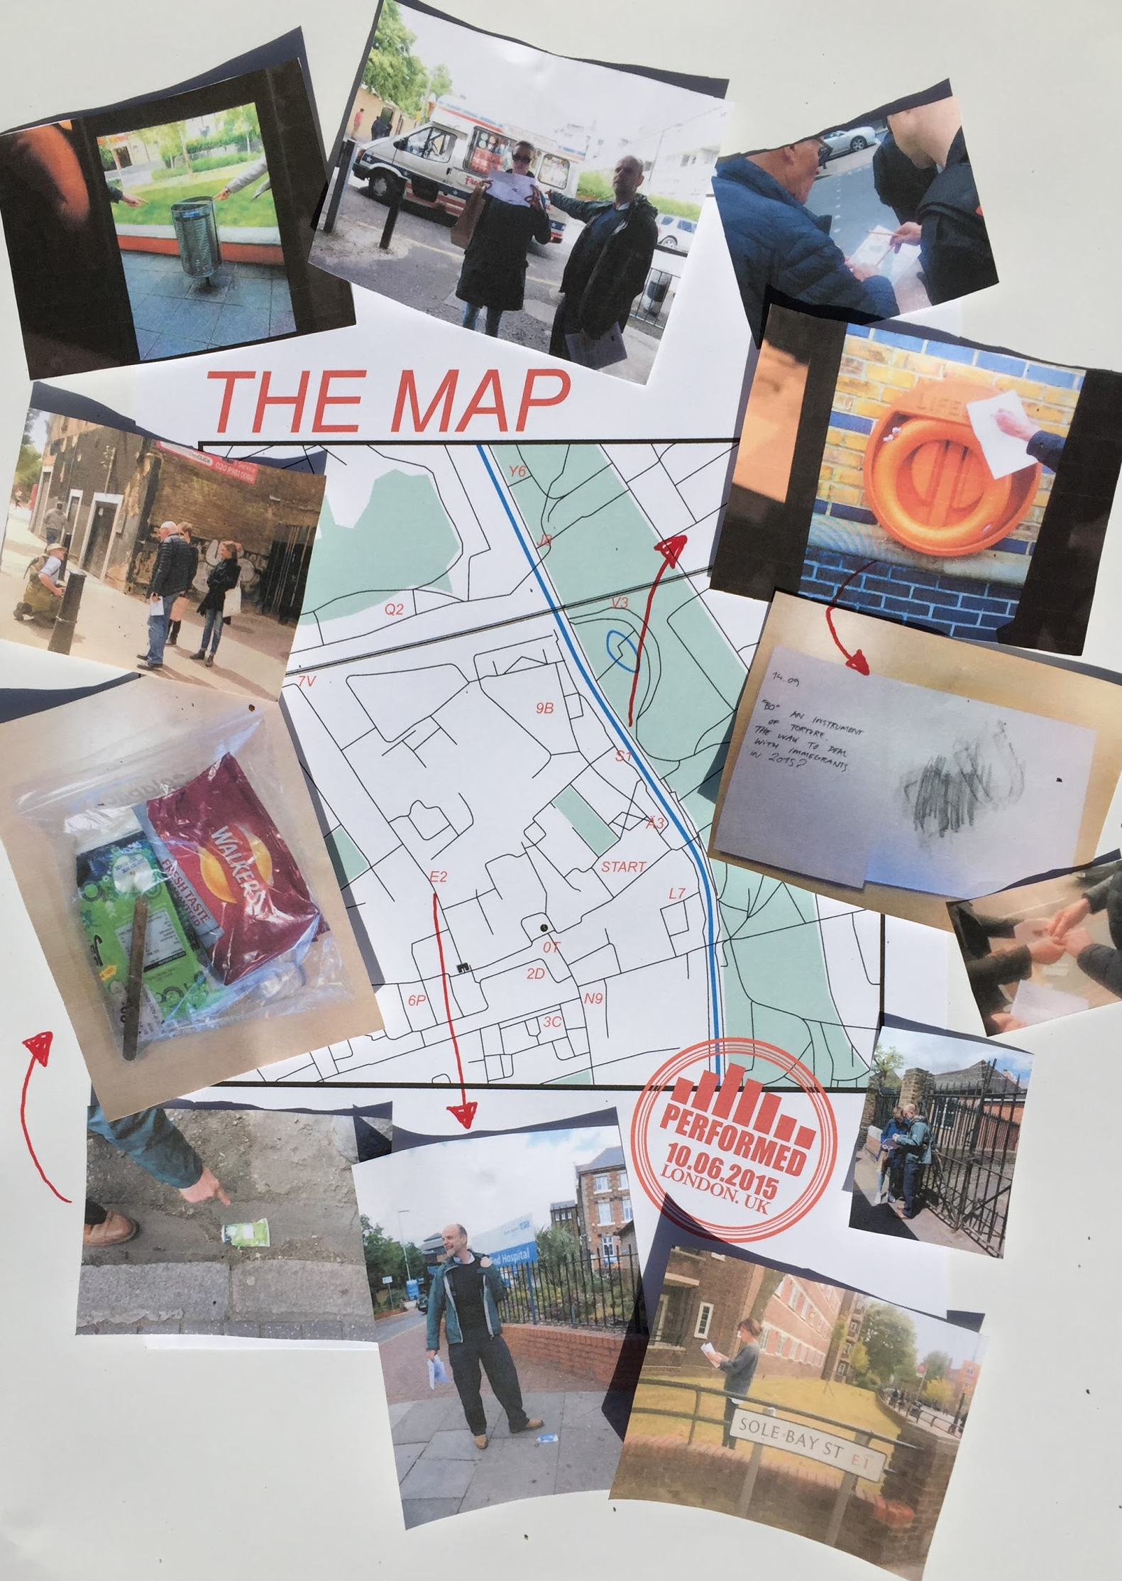
<insert figure two in here>
In the field
We – the workshop participants – are sent into the streets in groups based on those we were sitting near to in the auditorium. One and a half hours are now at our disposal to visit the original collection sites and find objects similar to those initially placed in the time capsule, whether by identifying the ‘correct’ object originally collected, or by finding something new that, in our interpretation ‘fits’ the description given. In our group of three, two geographers and a drama scholar, we curiously open our brown paper carrier. We inspect our ‘field-kit’; a map, a set of clues, some paper, some plastic sample bags. We select a site “T5”, one of us familiar to the area leads on. At first we walk in a sort of gaggle with the other groups, but gradually we string out along the road going in different directions. We navigate underneath the green bridge, across the road - minding the road works- past the corner shops and down a residential street. “Wentworth Mews”, reads the street sign on the designed-to-look-old-fashioned pub on the corner, the Wentworth Arms, complete with purple hued hanging basket. Coincidence, or well-designed route taking in happy circumstance: Only a few hours earlier Richard Wentworth, the artist, had been talking to us about his practice of urban archiving, his own particular poetics of place. Now, seeing the sign we start almost instinctively to look for ‘Wentworth’s’, a homage to the artist’s eye for a quotidian aesthetic constituted through urban practices of making do and getting by. Arriving at the location of ‘T5’ – the intersection of two roads – we stand a little awkwardly on the pavement and read our first clue out loud

<insert figure three in here>
It is like a riddle, we look around the street struggling with what it could be, what could we find that feels worthy of the clue?
We walk along the alley, we look at the security cameras and the mould and peeling paint that adorns the backs of industrial and commercial units. Not yet relaxed into the exercise and each other’s company we are self-consciously searching for something ‘cool’, something edgy, something representative of Wentworth Mews. Taped loosely to a lamp-post, sellotape crinkled together in thin plastic veins is a ripped piece of paper. In a slightly wavering hand, and with blotchy letters where the ink has run a bit the paper reads, ‘MR NICE GUY’, scrawled above is a mobile number. We debate, should we take it? If we do MR NICE GUY, whoever he is, won’t get any calls. The sign feels so ad hoc, so unplanned, we wonder if it is a prank, or whether MR NICE GUY advertised elsewhere? This is an odd alley to play host to such retro dating efforts, the only example, has he posted further signs around Mile End we wonder, did he have any success, has he considered internet dating or Tinder?
We cross the busy road navigating towards the park, there is a fair, the colours pop against the green grass. We read the clue.

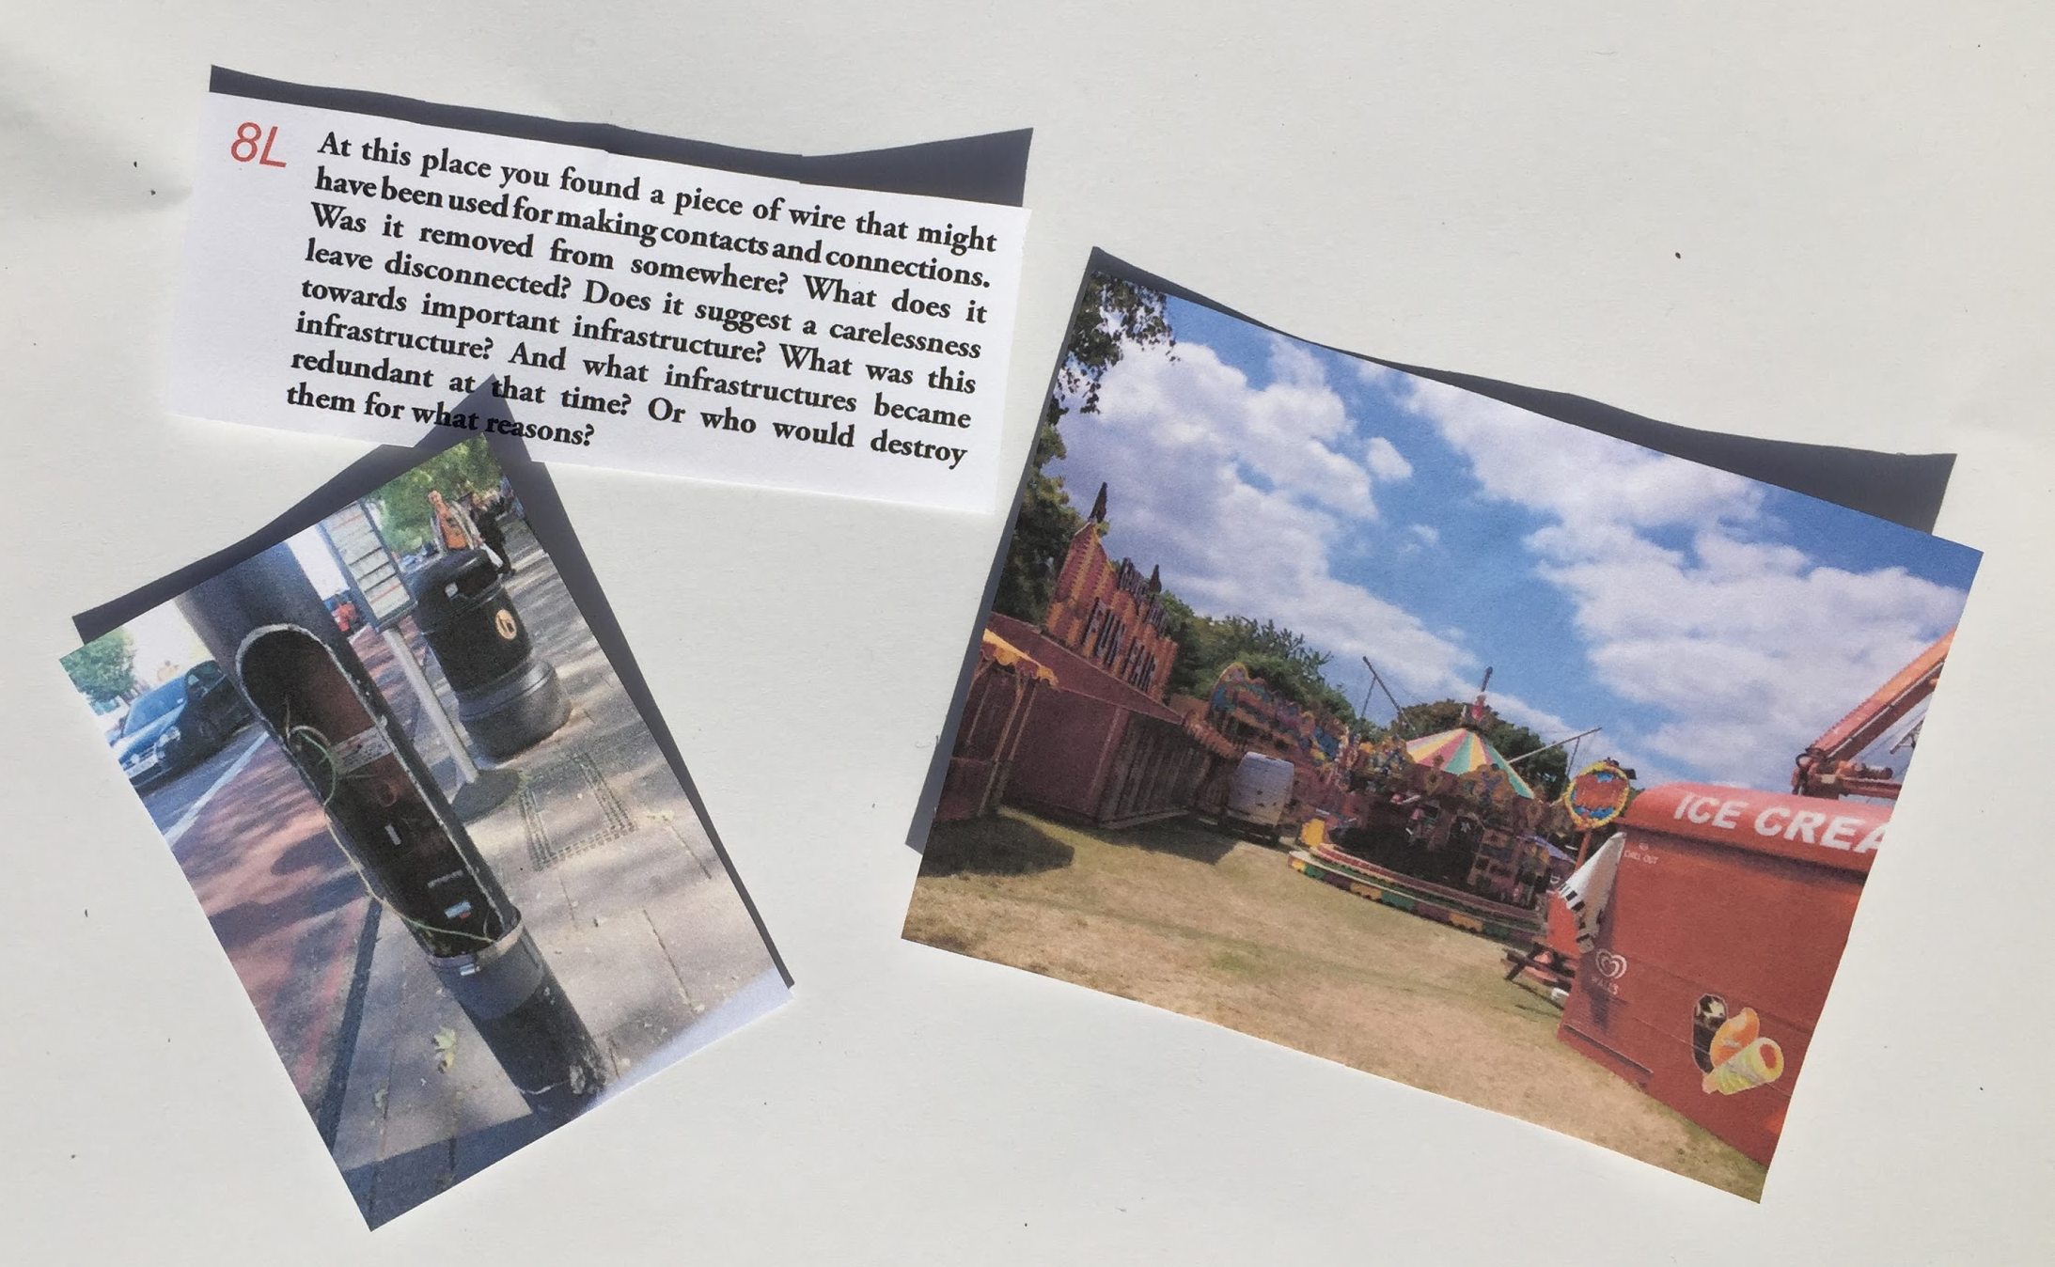
<insert figure four in here>
We look around. What seems interesting, what seems like it says something about this place and its practices? The fair feels like a place of contacts and connections. We choose a piece of strong plastic packing twine. It seems to relate to the clue, sort of, but also to symbolise the nomadic nature of fairground life as well as the precarity of so many contemporary mobile lives. We worry we are overthinking it.
We choose our next location, 5F, and follow the map through the park. As we draw close to the site we realised we are being observed. A group of teenagers and twenty-somethings previously lounging around smoking and laughing, backed by the low buzz of a radio, are now eyeing us suspiciously as we walk towards them bearing our map and brown paper carrier. Wordlessly we change course.

<insert figure five in here>
Seeking G1 we read the clue and are suddenly attuned to our noses as navigation devices. We sniff the air and after attempting to determine the olfactory landscapes of several streets, we start to think about how to archive a smell, how to write a smell in words? We cross the road, and arrived at the mapped location of the clue, the smellscape seems to have changed, how might we describe it differently?
Turning off the busy road we find ourselves in a quiet, gentrified street. The row of Victorian houses has identical white painted wooden shutters on the inside of their matching bay windows. Rows of newly silver bins have been placed on pea gravel, alongside wooden planters of well-disciplined lavender. Neatly groomed bay trees sit like sentries either side of the seemingly obligatory Farrow and Ball painted front doors. These are the material practices of gentrification that mark so many London streets. How do you archive a social process like gentrification?

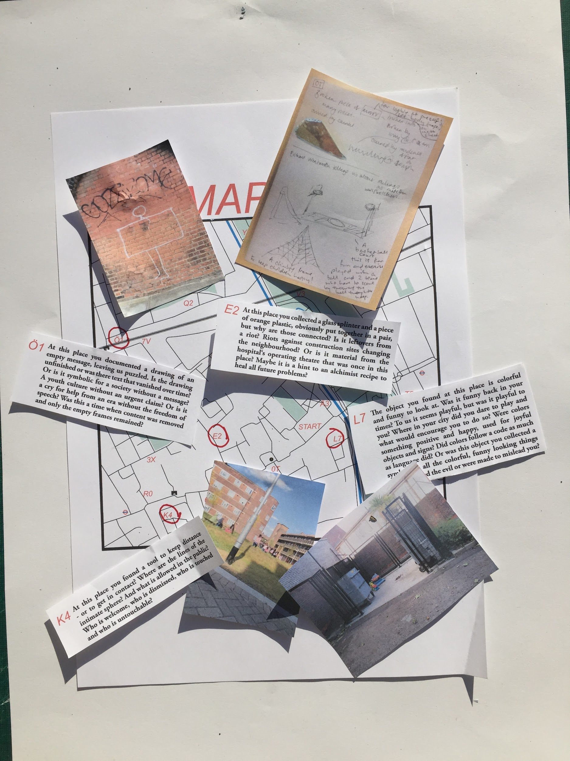
`<insert figure six here>

Back in the auditorium
The auditorium feels dark after being outside in the sun. There is a buzz in the air, people are returning in their groups, sharing what has been found. A table sits on the platform, on it are objects in sample bags accompanied by written descriptions. Some objects, like a cooking oil drum, are far too big for the bags. The team of future archaeologists are instructing us to sort through our objects. We – the participants of the workshop - are asked to evaluate our finds, to pick the one we most want to go in the time capsule and to sort and categorize our collections according to the following criteria; is it clear what the object is and means; is the object site- and time specific; what story does the object tell of how we live in cities? It is important that the future knows these object stories. We sit in our groups and debate which of our objects is worthy of the time capsule, which of these stories should we preserve? While the aesthetic of this archive is that of the everyday and the mundane, mostly too the discarded, sitting on white sheets of paper, accompanied by descriptions, or in the sample bags, our findings gain the importance of specimens. Like seeking objects worthy of the clues, everyday waste picked up from the street or items scavenged from bushes or bins takes on significance when displayed on this table. Transfiguring these objects from their everyday status we come together as a collective to narrate their stories for the time capsule.

In the time capsule
- MR NICE GUY
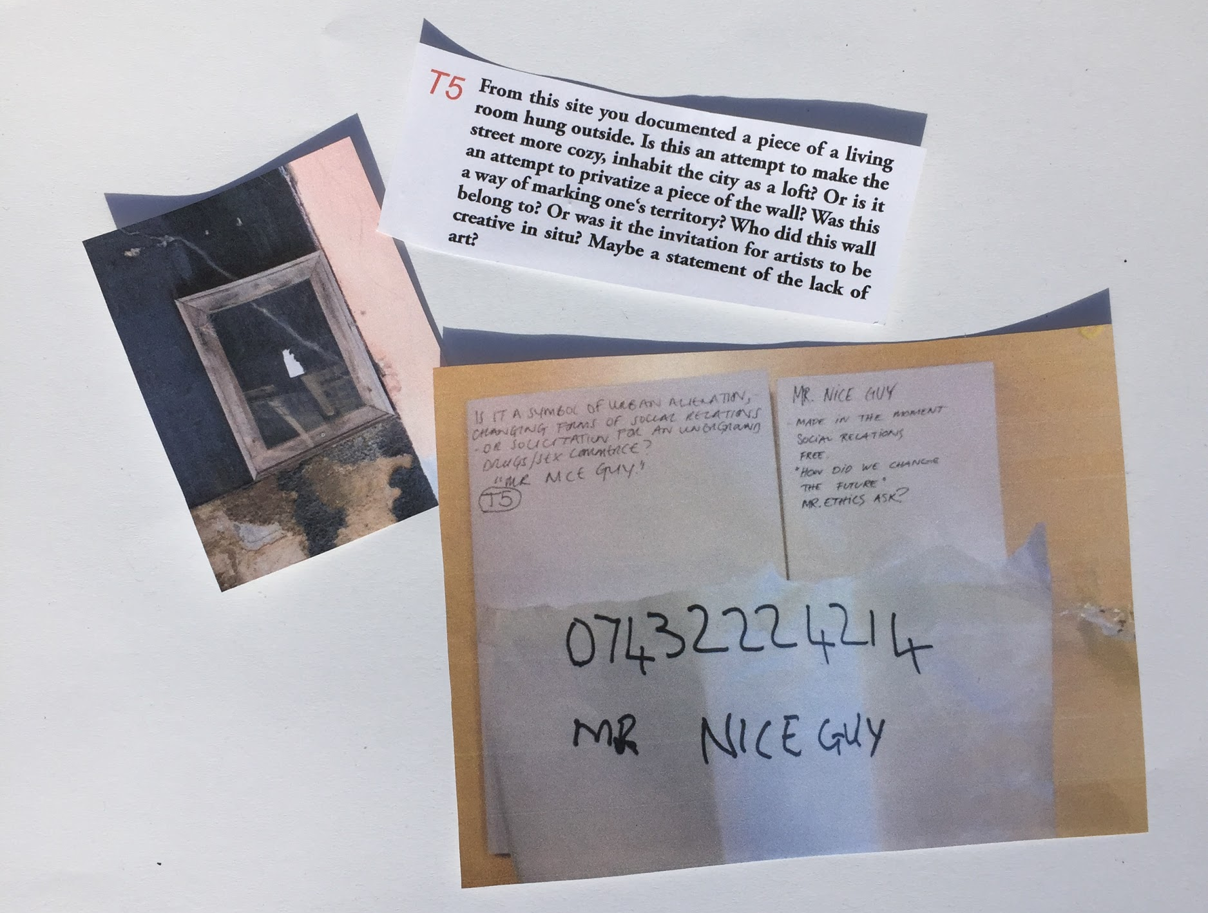
<insert figure seven in here>
Standing at the front of the auditorium we – the zURBS team playing future archeologists – hold up one of the findings, it is a note with a telephone number and the name MR. NICE GUY written on it. The immediate response from the group: ‘Someone is trying his luck the good old way!’ Laughter. In our roles as archaeologists from the future we don’t get the joke and act confused: ‘Is MR. NICE GUY old? Who is he? Is he some kind of ‘protector’ of this area? Or is this a way of marking one’s territory?’ One of the participants answers with a question: ‘I am not so sure whether MR. NICE GUY is, in fact, nice - maybe we’re here talking about a drug dealer trying to get in contact with potential customers?’ Another participant is aware of our, still, confused faces, ‘I don’t know how it is in the future, but you have to understand that ways of communication in 2015 is less often happening face-to-face, and more often occurring through social media and technological mediation’. ‘We call it urban alienation’ another participant shoots in. More laughter. One participant stays serious: ‘I think there are some ethical considerations here: by removing this telephone number from the place it was found, aren’t we in fact changing the future by impeding someone from calling MR NICE GUY? What are our ethical responsibilities as archivists in this regard?’ As the conversation moves on to question the future of the past, we – as future archaeologists – speak up for the future: ‘While MR NICE GUY is now no longer advertised in the present, he is fortunate to gain immortality through the time capsule!’ The response from the participants is immediate: ‘Immortality as what? As a possible retro Don Juan or a vicious drug dealer, both ? Neither?’

B) Cooking Oil Drum

<insert figure eight in here>
The cooking oil drum placed in the middle of the table attracts our attention. Again we – the zURBS team in the roles of the future archaeologists – act confused: ‘What is this?’ ‘This is a token of our abundance society’ is the reply, ‘we buy things in large quantities’ the participants continue. ‘It comes with instructions’ another remarks, directing us the text printed on the metal. ‘This is so that we use it correctly’ he goes on to explain. ‘If we use something wrong, then we might get hurt and the cooking oil company does not want to be responsible for that.’ Another participant gets worked up, ‘yes, that cooking oil is no good! Look at the local area – it is full of chicken shops using a ridiculous amount of oil in their food and there are severe problems with obesity among local youngsters!’ ‘But as an object it is just so beautiful!’ one of the participants takes the conversation in a new direction, ‘we saw it behind the fence, behind the railway tracks, and we simply could not resist it!’ The participant next to her excitedly joins in: ‘yes, let me tell you, it was a performance to get it! We had to traverse the tracks and the fence. It was hard but we did it and there it is!’ She proudly points at the cooking oil drum – the proof of a dangerous journey, the cause of problems, the subject of controversy.

C) Blister Pack

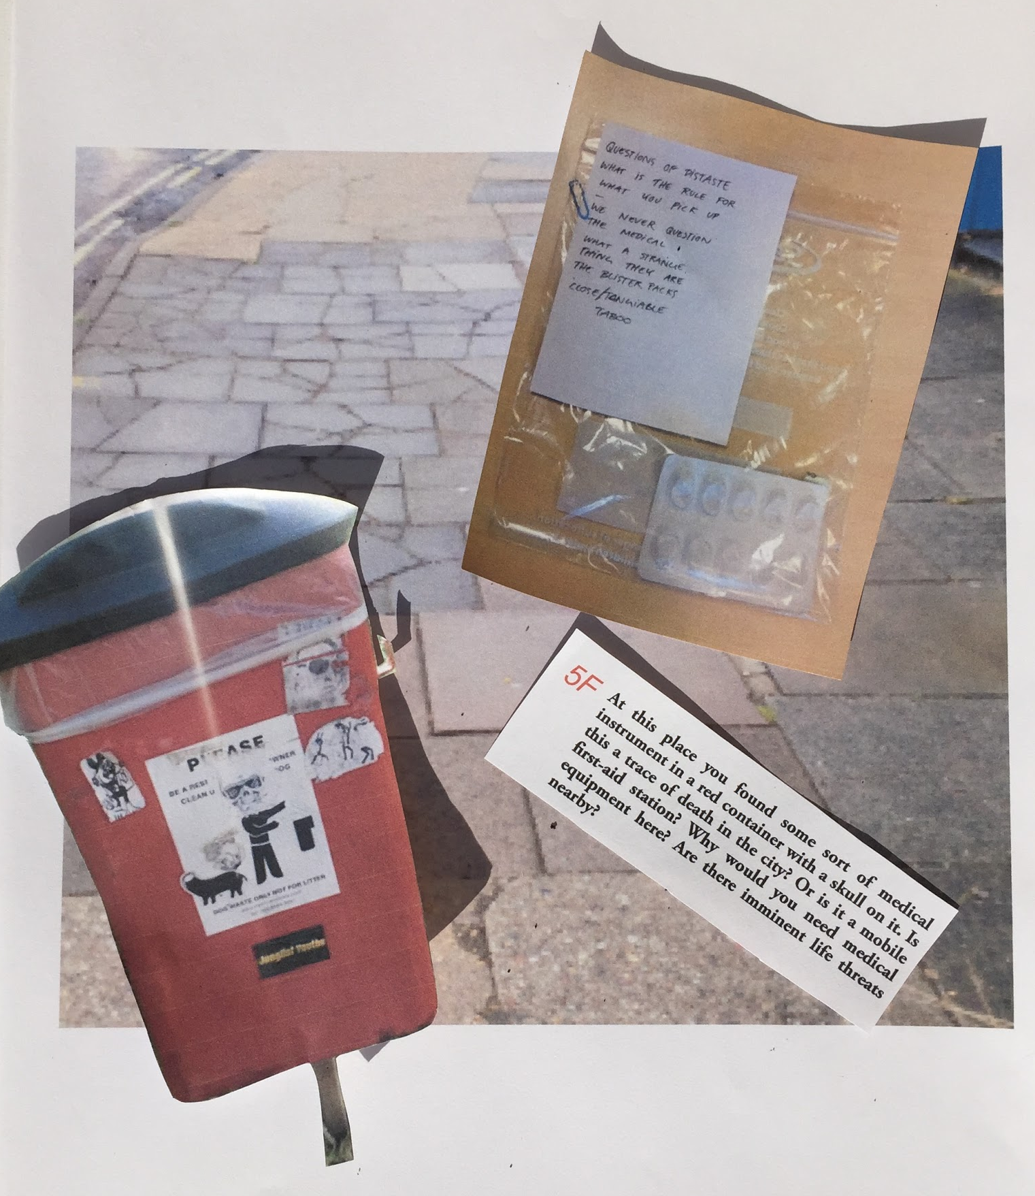
< insert figure nine in here>
We – the future archaeologists learning more and more about 2015 – repeat the question ‘what is this?’ as we reach for a plastic bag containing a white blister pack. ‘It is a container for pills’ explains the group that found it. ‘It points to our strange relation to the medical’ one participant continues,
‘I think, normally, people would not even touch this kind of waste lying around on the sidewalk. It is all about a certain form of sanitation pointing to the prevention of human contact with the hazards of waste and so on. We would not touch these kinds of things. They are supposed to be hidden and packed away in sanitized and sterile containers like this white blister pack.’
Another participant joins in: ‘it is like when you are taking the bus in the morning and every single person around you smells like shampoo. People are no longer dirty, we are clean and sanitized, like urban space itself! Let me ask you all a question: how many of you have ever washed your hands in the toilet?’ Two participants proudly raise their hands. The rest look surprised as if the idea had never occurred to them before. ‘It’s all just a question of perception and classification’ one of the participants who had washed his hands in the toilet explains, ‘there is no such thing as absolute dirt.’

D) Children’s bikini

<insert figure ten in here>
The joyous atmosphere changes slightly as we – the future archaeologists – hold up a plastic bag containing a dirty children’s bikini. We read out loud the note that the participants have attached to it: ‘A folded cloth, remnants of an exotic island? A shelter, blending into nature; flowers, leaves and earth going to ground, a hiding place. Abandonment. A disturbing, frightening past, perhaps.’ For a second there is silence. ‘We found it’ admits one of the participants sitting in the back of the room. ‘It was in the park, next to some used condoms…’ ‘Paradise lost’ someone comments quietly. ‘Maybe some reckless girl had a water fight and forgot her bikini in the park?’ one of the other participants asks, turning the course of the discussion. ‘Children today are becoming adults’ another participant replies, ‘why do children have to wear bikinis anyway?’

In the end
In asking us - the workshop participants - to create our own archive zURBS raised a series of issues regarding the practices of archiving, and archiving the city in particular. As we performed practices of collection, selection, evaluation, narration and display on the city streets and in the auditorium, through clues, maps, sample bags and brown paper carriers we were enrolled in processes that both echoed those of formal institutional archives as well as those artistic, informal and sometimes critical archiving practices that have become increasingly common.
Practices of urban exploration, artistic or otherwise, summon up the spaces and practices of our quotidian urban lives, recreating them as exciting and illuminating territories ripe for (re) discovery and worthy of record. As such our archiving of the everyday, of the discards and detritus of modern life took up a place within a familiar repertoire of archival practices and aesthetics and echoed the critical lens these practices offer onto more formal institutional archival practices.
What did the practices of collecting do to thinking through our relationship with our city? The performance of navigating, reading clues, speculating on what they might mean and finding objects in response oriented us towards our surroundings in particular ways. Many clues begun by attuning us to the materiality of our environments as indistinguishable objects were described in terms of form, material and texture. Some clues stimulated our senses, reminding us of the challenges of archiving the multi-sensuous city and its sonic, tactile and olfactory landscapes. Others attuned us to the remnants of social practice made visible in objects or through the shaping of spaces, imaginations running wild as we explored how things were used, speculated about what they might have meant and were invited to hypothesise about how things came to be in that place in that way. Most clues shuttled us between these in-the-moment embodied experiences of urban space and our speculations on daily practices that constituted it and wider societal concerns, whether it be the privatization and securitziation of the city, ongoing processes of alienation and disaffection, or deeply divided urban lives.
We were not just guided through city streets by clues and maps, but asked to collect objects and then to select from these those that were worthy of the time-capsule. To view the practices and material cultures of city streets through the lens of preservation was to transfigure the city scene. As representations of a sense of place, found objects take on an intensified form as vessels for distilled meanings. Guided by clues we sought everyday discards whose material form bore the trace of social practices and which offered poetic, often speculative, windows onto societal scale problems and processes.
Once back in the auditorium collective imagination, speculation and narration became the focus of our activities, evaluating the objects for inclusion became a practice of the storification of urban spaces and practices. An individual group’s object became a lens for collective imagination, oil drums, discarded bikinis and blister packs became enigmatic objects functioning as lightening rods for the transformation of individual urban engagements into the wider city stories of our time.
We should not however, lose sight of what zURBS asked us to do: for this was not just an archiving process, but critically, a re-archiving process. This, was, afterall, our second attempt at creating this time capsule, our first (imagined) attempt had resulted in the clues as the befuddled future archaeologists speculated on the objects they encountered. The speculation, imagination and sometimes frustration that these clues interjected into our urban explorations that June afternoon ensured we could not overlook the open and contingent nature of the archive and its interpretations. As we collected our objects in response to these urban riddles, recording them in drawing and spinning stories of their use we were forced to confront instability and indeterminacy in the archival record. Rather though than worry about gaps, losses or mis-interpretations or seek a sense of archival completeness, our performances situated these objects and so the archive as a site of speculation, a location for the elaboration of distant pasts, multiple presents and promissory futures.
To perform the archive in this way is also to perform a particular imaginary of the city. The production of the time capsule is at the same time the production of the city, not as a spatial framework external to its users but as produced through them and productive of them. To perform zURBS’ urban archiving is also to perform an urban imagination that might begin from mundane daily practices, discarded matter and overlooked objects, but it opens out onto city speculations, urban becomings and material possibilities.

Acknowledgements
We want to acknowledge the photographic contributions of participants who donated their images of their exploration; thanks to Francesca Brooks, Theresa Franco, Joseph Kohlmaier, Garance Marechal, Claire Qualmann and Richard Wentworth.

Notes
- zURBS is an urban research and art collective, working with a participatory approach in which a wide range of participants are invited to take part in workshops, exhibitions, model-making, treasure hunts, games, seminars, expeditions and walks in order to experiment with different approaches to how we can re-imagine the urban through imaginative and creative processes that question what urban space means and is. zURBS is a collaboration between Sabeth Tödtli, Nina Lund Westerdahl and Cecilie Sachs Olsen
- Bogart, Anne, and Tina Landau. 2005. The Viewpoints Book: A Practical Guide to Viewpoints and Composition. New York: Theatre Communications Group, p.59

Author Biographies
Cecilie Sachs Olsen is co-founder of zURBS and PhD researcher in Geography at Queen Mary, University of London. Her research revolves around how art can be used as a framework to analyse and re-imagine space and politics. Cecilie has been working as a research assistant at the Institute of Critical Theory at Zurich University of the Arts, as well as at the research project Urban Breeding Grounds at/ with? the Chair of Architecture and Urban Design, ETH Zurich.

Harriet Hawkins works at the intersection of geography and creative practices. This includes collaborating with artists, writers, designers and curators to explore how these practices participate in the creation of geographic knowledge. She is a Reader in Geography at Royal Holloway University of London.

