**Liberalization only at the margins? Analyzing the growth of temporary work in German core manufacturing sectors**

**Author:** Chiara Benassi

Position: Lecturer in Human Resource Manager

Affiliation: School of Management, Royal Holloway, University of London.

Address: Royal Holloway, University of London, Egham Hill, Egham, Surrey TW20 0EX.

Phone: +44 1784 276100

Email: [chiara.benassi@rhul.ac.uk](mailto:Chiara.benassi@rhul.ac.uk)

**Acknowledgments:** The author is thankful to the editor and the reviewer for their helpful comments. This article also benefitted of the comments of Lucio Baccaro, Virginia Doellgast, Paul Edwards, Tim Vlandas, the participants in the lunch seminar at Warwick Business School and in the SASE and ILERA panels in 2015.

**Abstract**

Drawing on workers’ surveys and workplace interviews, this article investigates the growth of temporary work in German manufacturing sectors since the eighties. Findings partly confirm a “dualization” scenario as workers without industry-specific vocational training are more likely to be on a temporary contract than skilled workers, and the gap has widened over time. However, also skilled workers have become increasingly vulnerable to casualization due to job routine and the erosion of industrial relations. Evidence confirms the crucial role of institutions in supporting the linkage between specific skills and employment stability, and suggest that the liberalization of the employment relationship has the potential to advance also in the core of the German economy.

# Wordcount: 8,504

# 1 Introduction

This article investigates the relationship between skills, industrial relations institutions and the use of temporary work in German core manufacturing sectors in the last thirty years. This issue is central to academic debates about the changes undergone by the German “coordinated” model of production, which used to rely on strong industrial relations institutions and on a permanent skilled workforce (Hall and Soskice 2001; Streeck 1991).

According to Streeck (1991; 1992), institutional “beneficial constraints” were at the origin of the German model: Collective bargaining agreements, strict employment protection legislation and strong labor representation at workplace limited the ability of management to dismiss their workers or hire on precarious contracts, forcing them to invest in training broad workforce segments in order to increase productivity and to compress labor costs. Skilled workers – called *Facharbeiter[1] -* and their works councils pushed for the implementation of a work organization characterized by teamwork, task rotation and autonomy, which required workers’ “redundant” capacities and employment stability(Kern and Schumann 1984; Streeck 1991).

However, institutional constraints have eroded during the last twenty years (Artus 2001; Hassel 1999), and the German model has moved away from the traditional coordinated model. Some political economy scholars claim that the German political economy is now divided between a service periphery, characterized by low-skill and volatile jobs, and core manufacturing sectors, where coordinating institutions are still in place. The resilient coordination is mainly attributed to employers, supported by works councils, who want to retain their “specific”-skilled workers required by high-quality export production (Hassel 2014; Palier and Thelen 2010; Thelen 2014;).

Other scholars in the field of sociology and industrial relations, however, claim that not even in core manufacturing sectors job security can be ensured without strong industrial relations institutions (Benassi and Dorigatti 2015; Doellgast and Greer 2007). This claim is supported by mounting evidence that employers in core manufacturing sectors have increasingly used subcontractors and contingent work since the nineties (Eichhorst 2015; Jürgens 2004).

These contradicting accounts about the liberalization of the employment relationship in German core manufacturing sectors feed into, first, a broader debate about the role of employers’ interests (Estevez-Abe *et al.* 2001; Hall and Soskice 2001) vs. industrial relations institutions for determining workers’ outcomes (Gallie 2007; Lloyd *et al.* 2013). Second, they reflect the opposing stances within the debate about the changing trajectory of coordinated economies, which expect respectively dualization between core manufacturing and services (Hassel 2014; Thelen 2014) and progressive liberalization (Baccaro and Howell 2011; Streeck 2009) until ‚the fringe will eat the core’ (Streeck 2010: 512).

This paper aims to contribute to both debates. The originality of the analysis consists in combining the quantitative analysis of the workers’ surveys of the Federal Institute of Vocational Training and Education (1986-2012) with interview findings in German automotive and machine tool building plants. The use of mixed methods allows to better illustrate the liberalization of the employment relationship and the mechanisms underlying the diffusion patterns of temporary work in German core manufacturing sectors. The dualization literature focuses only on the national level either through qualitative studies (Hassel 2014; Thelen 2014) or cross-national quantitative studies on the incidence of nonstandard work across sectors, occupations and skill levels (Gebel and Giesecke 2011; Häusermann and Schwander 2012). In contrast, research in industrial relations mainly relies on qualitative case studies at workplace, which do not give a clear overall picture of changes over time in German core manufacturing sectors (Doellgast and Greer 2007; Holst *et al.* 2010).

Findings question the concept of “skill specificity” and suggest that the relationship between skills and employment stability is not as tightly coupled as described in the Varieties of Capitalism and dualization literature. Industrial relations are fundamental for limiting the casualization of work as skills can only partly protect workers, especially because the work organization is routine. By bringing new evidence on the casualization of the employment relationship in the disputed “core” of the German economy, this paper also contributes to the debate about the trajectory of the German model, suggesting that liberalization has the potential to progress also in core manufacturing sectors even though the employment relationship is still predominantly coordinated.

The paper is organized as follows. The next section derives the propositions regarding the influence of skills and work organization on the probability of being on a temporary contract. The third section presents the methodology. The fourth and fifth sections contain respectively the quantitative and the qualitative analysis. The sixth section concludes.

**2 The role of skills, industrial relations and work organization for the expansion of temporary work**

The German system of industrial relations institutions has been eroding in the last twenty years. Collective bargaining coverage has been declining also in the manufacturing sector (Addison *et al.* 2014) and works councils, despite their formal bargaining rights, have decreasing influence on employers’ staffing strategies due to the increasing pressure of reducing labor costs and the incumbent threat of plant closure and outsourcing (Rehder 2003). Union density has been declining after the re-unification membership boom and, while the automotive and steel industries are still well organized, union density greatly varies in the chemical and electronics industries (Bispinck and Dribbusch 2011). The use of temporary work has been progressively deregulated since the nineties, culminating with the Hartz reforms. These lifted any limitation to the maximum duration and any obligation to motivate agency contracts, and allowed derogations by collective agreement to the principle of equal pay (Benassi and Dorigatti 2015).

As mentioned above, the implications of declining legal and negotiated employment protection for stable employment in German core manufacturing sectors are widely debated in the literature, a controversy reflecting the ambiguity of the expression “beneficial constraints”. The different positions are illustrated through the following propositions, which discuss how the effect of workers’ industry-specific skills and work organization on the incidence of temporary work has changed under the erosion of industrial relations. They are formulated at the individual level because the available dataset is a workers’ survey (see the methodology section).

The VoC literature emphasizes the beneficial role of institutions, which contribute to employers’ competitive advantage (Hall and Soskice 2001). Employment protection represents an incentive for workers to invest in skills which are transferable only to a limited extent because they have the guarantee of job security. In turn, employers are interested in retaining those workers who acquired skills specific to the company through vocational training because they want a return on their investment (Estevez-Abe *et al.* 2001; Hall and Soskice 2001). As a stable skilled workforce is necessary to the German high-quality manufacturing production, employers are expected to maintain the “complementarity” between stable employment and workforce skills despite institutional erosion (Hancké *et al.* 2007: 11f.; Soskice 1999). Hassel (2014) and Palier and Thelen (2010) suggest that employers’ commitment contributed to preventing the liberalization of the employment relationship in the core. Employers would hire temporary workers only in low-skill positions, mostly in direct production, for compressing labor costs and for responding to their flexibility needs. Temporary workers would therefore be hired during demand peaks and then dismissed in case of financial difficulties, serving as a flexibility buffer which protects the permanent skilled workforce. These considerations lead to the following proposition:

Proposition 1: *In German core manufacturing sectors* *only workers without industry-specific skills have become more likely to be on a temporary contract over time.*

In contrast with the VoC literature, industrial relations research points out the constraining role of institutions, claiming that employers offer a permanent position to their trainees due to the negotiated and legal employment protection (Scherer 2005). This claim is corroborated by existing research suggesting that “specific” skills are not necessarily coupled with stable employment. The skills provided by the German dual vocational training system are occupational and portable across employers (Marsden 1999; Streeck 2011; Thelen and Busemeyer 2012); furthermore, German companies sometimes train above their needs and therefore employ their young *Facharbeiter* in unskilled positions until a skilled position becomes vacant (Franz and Zimmermann 1999).

Therefore, German manufacturing employers can be expected to make use of cheap and flexible workforce when negotiated and legal employment protection declines (Benassi and Dorigatti 2015; Doellgast and Greer 2007; Streeck 2009). The risk for employers to lose their investment in training is at a minimum as workers might see temporary contracts as a necessary – and possibly short - transition period to a permanent position*.* Looking at occupational labor market in the UK, Marsden (2010) described this phenomenon as “extended entry tournaments”: While hoping to be hired in a permanent position, skilled workers accept lower wages and temporary contracts even for long periods, and some of them might even remain outside companies’ internal labor markets. Employers benefit of this system not only through lower salaries but also because they have a long screening period for the candidates who have acquired experience also in other companies (Marsden 2010). These observations lead to an alternative proposition to Proposition 1:

Proposition 2: *In German core manufacturing sectors workers with industry-specific skills have become more likely to be on a temporary contract over time.*

Stable employment has been argued as necessary to the German manufacturing production not only because employers want a return on their skill investment, but also because task autonomy and complexity require mutual trust and commitment (Marsden 1999). While the comparative political economy literature has often assumed that German core manufacturing sectors are characterized by non-Tayloristic work organization given the high rates of *Facharbeiter[2]* (see Jürgens 2004 for a similar point), industrial sociology research found that the integrated work organization characterized only certain occupational profiles. Work in direct production, especially on the assembly line, has mainly been organized along Fordist lines (Roth 1997; Schumann *at al.* 1994), and work has become overall more standardised and routinized during the nineties (Springer 1999). In his recent analysis of the survey of the European Working Conditions Observatory, Marsden (2015) found that the work organization in around 65% German firms does not include job discretion, autonomy and problem-solving (even though the rate is still low compared to the UK).

These findings suggest that routine work organization might have an independent effect from formal qualifications on the incidence of temporary work. Temporary workers have been found more likely to perform routine, repetitive and low-discretion tasks (Egger and Grossmann 2005; Lepak *et al.* 2003: 688; Letourneux 1998) which can be easily learned and do not require great work experience. As employers can easily hire temporary workers in routine positions, industrial relations institutions are fundamental for preventing the casualization of that type of jobs. Given the weakening of industrial relations institutions in German core manufacturing sectors, the following propositions can be derived:

Proposition 3a: *In German core manufacturing sectors workers* *in highly routine job positions have become more likely to be on a temporary contract over time.*

Existing research found that lean management techniques made the labor process increasingly standardized and routine also in qualified positions, putting an end to the “model of the poised and autonomous *Facharbeiter*” (Lacher 2006: 88; see also Buch 2006). Therefore, under the erosion of institutionalized employment protection it can be expected that work routinization has progressively increased the likelihood of *Facharbeiter* to be on a temporary contract. The following propositions can be derived:

Proposition 3b: *In German core manufacturing sectors the effect of routine on the likelihood to be on a temporary contract has increased over time also among workers with industry-specific skills.*

The next section illustrates the methods used for testing the above propositions against empirical evidence.

# 4 Methodology

The regression analysis is based on the Workers’ Survey from the German Federal Institute for Vocational Training and Education (BiBB). Five waves are taken into consideration: 1985/86, 1991/92, 1998/99, 2005/06 and 2011/12. Even though the surveys do not follow either the same individuals or the same companies over time, the sample is representative for the population in every survey year.

The population is restricted to the blue-collar workforce in core manufacturing sectors: chemicals, steel, forging, machine tool building, automotive, white goods, electronics, fine mechanics, ship and airplane building. These sectors are representative for the core of the German economy because they are export-oriented (DeStatis 2015), and traditionally characterized by a high-skill and high value-added production and by strong industrial relations and social partnership tradition (Kädtler and Hertle 1997; Kern and Schumann 1984). The analysis considers only the active German population (at least 10 working hours a week) aged between 15 and 64, and trainees have been excluded.

A pooled logistic regression analysis was run with robust standard errors using the STATA software. The dependent variable, which is the probability of being on a temporary contract, is dichotomous (1=temporary contract; 0=permanent contract). This variable includes workers on fixed-term contracts and on agency contracts, for which employers need to pay social security contributions (*sozialversicherungspflichtige Besch*ä*ftigte);* however,it excludes workers on freelance contracts and on marginal employment contracts (e.g. minijobs), and therefore might underestimate the diffusion of temporary work. The logistic regression analysis tests a simple model and three interactive logistic models, which aim at testing the conditional effect respectively of skill specificity and job routine on the probability of being on a temporary contract given increasing institutional erosion over time. Model II and III contain only one interaction term each for testing respectively the propositions 1, 2 and 3a. Model IV is the full interacted model, which includes all the interaction terms and the constituent terms, as prescribed by Brambor *et al.* (2006). This model furthers the analysis of the interaction effect between skills, work organization and time on the probability of being on a temporary contract (proposition 3b).

The simple model and the interactive models look as follows:

1. Temporary contract= β0+ Σ β1CONTROLSit + β2 routineit+ β3 skill specificityit+ β4 timeit+ εit
2. Temporary contract= β0+ Σ β1CONTROLSit + β2 routineit+ β3 skill specificityit+ β4 timeit + β5 timeit*skill specificityit+ εit
3. Temporary contract= β0+ Σ β1CONTROLSit + β2 routineit+ β3 skill specificityit+ β4 timeit + β5 timet*routineit+ εit
4. Temporary contract= β0+ Σ β1CONTROLSit + β2 routineit+ β3 skill specificityit+ β4 timeit + β5 timet*routineit+ β6 timeit*skill specificityit + β7 skill specificityit*routineit+ β8 timeit*skill specificityit*routineit + εit

I operationalize my independent variables as follows. The dummy variable *Skill specificity* refers to workers who have their last vocational training degree in an occupation which traditionally belongs to core manufacturing sectors (ISCO 1985/86: from 1210 to 1541 and from 1910 to 3237/ ISCO88: from 10 to 15 and from 19 to 32). This operationalization allows discriminating between specialized manufacturing workers and those workers with a dual vocational training in other occupations, who are also widely employed in the manufacturing industry but do not have skills specific for the manufacturing sector/occupations.[3] By so doing, the variable represents a good proxy for the above mentioned *Facharbeiter,* who traditionally constitute the core “specific-skilled” workforce in the German manufacturing sector.

The variable *Job routine* was operationalized through the survey question “How often do you repeat the same work procedure?”. It takes value 1 if the answer is “always/often” and 0 for “rarely/never” (see appendix). This measurement reflects the findings of Lacher (2006) and Springer (1999) as well as the interview findings in this paper (see section 6), which emphasize the routine of work tasks in German core manufacturing sectors. The choice of this variable can be argued to have some limitations: First, the survey unfortunately does not include the question of whether the work pace is dictated by a machine, which has also often been used as a measure of job routine in manufacturing (e.g. Bailey 1993); however, the measurement in this paper is rightly broader as workers in industrial services (such as logistics) are likely to have a repetitive job even though the pace is not dictated by a machine such as for assembly line workers. Second, the measure of job routine is a perception of workers, which could be argued to be endogenous to the type of contract. This linkage would however be counter-intuitive because temporary workers should find their work less repetitive as they can be reasonably assumed to work in the same job positions for shorter time periods. Following this reasoning, old workers should be more likely to find their job routinized; indeed, across all waves 54% workers between 15 and 25 declared that their work was highly routinized against 60% among workers between 55 and 64.

The erosion of negotiated and legal employment protection was operationalized through the time variablebecause the dataset does not provide information on the presence and strength of industrial relations at workplace. However, the effect of the weakening of industrial relations and of the relaxation of labor market regulation on workers’ outcomes in Germany was widely studied in the literature (Brenke and Eichhorst 2008; Eichhorst and Marx 2011; Promberger 2006). Furthermore, the case study findings illustrate in detail how national labor market reforms and workplace concession bargaining influence the use of temporary work, tracing the causal mechanism linking the weakening legislative and negotiated employment protection to the probability of being on a temporary contract.

*Time* was coded as a continuous variable taking the values from 1 to 5 in order to facilitate the interpretation of the interaction terms and to save degrees of freedom, as the use of dummy waves would have required the inclusion of eight interaction terms between job routine and skill specificity and four wave dummies (excluding the wave dummy used as reference category). In order to make sure that the effect of time follows a positive trend, the logistic regression was first run with the wave dummies instead of the continuous variable *Time*, confirming that the direction of the time effect does not change the direction between the waves, and showing a positive trend since 1992 (see online appendix).

All models include control variables such as age, gender, local unemployment rate, the location of the workplace in Eastern Germany, the firm size and sectoral dummies (see the operationalization in the online appendix). A correlation table is available in the appendix.

# 5 An analysis of skills, job routine and temporary work

*Descriptive statistics.*Table 2 shows that temporary work has been increasing from almost 5% in 1986 to 11% in 2012 within the whole workforce. Temporary work among workers with industry-specific skills has also been growing over time, and particularly among young workers - it increased by 24% between 1986 and 2012.

TABLE 1

Compared to permanent workers, higher rates of temporary workers report to work in routine job positions across all waves – their rates are between 2 and 6% higher. In addition, even though the trend is rising for the whole workforce, the rates of temporary workers in routine job positions increased more rapidly than for permanent workers as they went from 5.4% to 13% while they increased from 3.5% to 7.2% for permanent workers.

However, the employment of temporary workers in routine job positions does not necessarily reflect their skills (see Table A2 in the appendix). Temporary workers are more likely to feel overqualified and overskilled than permanent workers. The overqualification rates of permanent workers increased from 25% to 43% between 1986 and 1998 while 35.2% of temporary workers reported to feel overqualified in 1986 and 62.5% in 1998. Overskilling rates are lower but increasing: they went from 5.9% in 1998 to 11.2% in 2012 for permanent workers while the rates for temporary workers are twice as high (respectively 13.3% and 21.3%). This rising trend might also suggest that the high skill levels reported above might not be necessary and some tasks could be performed by workers with lower qualifications and experience.

*Regression results.* Table 2 shows the results of the logistic regression analysis. The logistic regressions with robust standard errors have been run using the STATA commands *logit* and *robust.* The log odds are reported.

The results of Model I are the following: The variables “firm size” and “Eastern Germany” are positively correlated with the probability of being on a temporary contract. Male and old workers are less likely to be on a temporary contract than female and young workers. The time variable shows that workers have become more likely to be on a temporary contract over time. Having an industry-specific vocational training degree is negatively correlated with the probability of being on a temporary contract while job routine is positively correlated.

Models II and III contain respectively the interaction terms “time*skill specificity” and “time*job routine”. Neither the interaction terms nor the constituent terms – which are non-significant - can be interpreted from the table because the analytical interest lies “in the marginal effect of X on Y for substantively meaningful values of the conditioning variable Z” (Brambor *et al.* 2006: 74; see also Ai and Norton 2003). Following the command routine recommended by Brambor *et al.* (2006) and Williams (2012), the command *margins* is used to estimate the marginal effects of skill specificity and routine given each value of the time variable. The plot graphs are reported, which give a clear representation of the interaction term, but the tables with the values of the marginal effects, the standard errors and the confidence intervals are reported in the online appendix (Tables 1-6). Figure 1 reports the plot for the marginal effect of skill specificity on the probability of being on a temporary contract over time (1=1985…5=2012). The line shows that the marginal effect is significant since 1992 and negative, which means that the negative effect of skill specificity on the probability of being on a temporary contract has been increasing over time. Figure 2 represents the interaction term through predicted probabilities: The probability of being on a temporary contract has become higher for workers without industry-specific skills than for workers with those skills. However, it also shows that both categories of workers have become more likely to be on a temporary contract.

Figure 1 and 2

Figure 3 reports the plot for the marginal effect of job routine on the probability of being on a temporary contract, showing that the positive marginal effect of job routine has been increasing over time. Figure 4 reports that the probability of being on a temporary contract for workers in routine job positions has increased over time and to a greater extent than the probability for workers who are not employed in routine job positions.

Figure 3 and 4

Model IV includes two additional interaction terms: the term job routine*specific skills allows the analysis of the marginal effect of job routine on the probability of being on a temporary contract conditional on workers’ skills. The term job routine*specific skills*time is used for the analysis of how the marginal effect of job routine on the probability of being on a temporary contract changes over time for workers with industry-specific skills. Figure 5 shows that the marginal effect of job routine on the probability of being on a temporary contract is lower for workers with a dual vocational training degree than for workers without those skills. Figure 6 shows that the marginal effect of job routine on the probability of being on a temporary contract has increased over time among workers with industry-specific skills even though it is not significant for the last wave.

Figure 5 and 6

Further logistic regressions have been run as robustness checks (see online appendix). First, the regression has been run with standard errors clustered by sector and by Federal State as the observations might be correlated e.g. through common technology, or labor market regulation at regional level. The significance level and the coefficients of skill specificity and job routine do not change. Second, the regression has been run without Eastern Germany, as the exclusion of Eastern Germany from the sample was recommended by BiBB researchers (Rohrbach-Schmidt and Tiemann 2013) but the model does not show any relevant change.

Third, the logistic regression has been run only on companies with more than 500 employees, which have almost 100% coverage of works councils and a sectoral bargaining coverage going from 93.9% in 1995 to 76.9% in 2010 (Benassi 2014: 69). In this way, the analysis checks whether the results have been biased by missing the control variable “industrial relations”, which has been found significant in studies on temporary work at company level (e.g. Davis-Blake and Uzzi 1993). It could be argued that the probability of being on a temporary contract has not increased in establishments covered by sectoral agreements and with strong workplace representation; or that skills and job routine do not have independent effects in companies with strong internal labor markets rules because works councils ensure a correspondence between workers’ qualifications and complex job positions. However, both the simple model and the interactive model show that both coefficients for “job routine” and “time” are positive and significant. The analysis of the interactions terms “job routine*time” and “job routine*time*specific skills” gives similar results as the analysis conducted on the whole sample. In contrast, the variable “specific skills” is non-significant even when the logistic regression is run without the variable “job routine”. The interaction term “specific skills*time” might be non-significant because big companies have the ability to recruit workers with industry-specific skills even on temporary contracts. These results strengthen rather than undermine the argument of the paper that skill “specificity” does not necessarily lead to stable employment.

This section has shown that, first, workers with a dual vocational training degree are less likely to be on temporary contracts compared to workers without those qualifications – and the gap has widened over time. Furthermore, workers in routine jobs are more likely to be on a temporary contract, and the likelihood has increased over time. These findings confirm a “dualization” scenario. However, also workers with a dual vocational training degree have become more likely to be on a temporary contracts over time, showing that skill “specificity” does not fully protect workers from casualization. In addition, the analysis has shown that the marginal effect of job routine on the probability of being on a temporary contract has been increasing over time even among specific skilled workers. These findings suggest that there is scope to casualize work also among workers with industry-specific skills, also thanks to the routine nature of job.

The qualitative analysis in the following section investigates this pattern of diffusion of temporary contracts also among workers with industry-specific skills and for the continuing association between specific skills and permanent contract, which cannot be fully explained by the complex work organization.

# 

# Case study findings

The case study findings complement the quantitative analysis because they help to map out the effect of labor market reforms and collective bargaining on the relationship between skills, work organization and temporary work. They rely on semi-structured qualitative interviews conducted either by phone or in person between January 2011 and April 2013. The interview partners were human resource managers, union representatives and works councillors in five automotive plants and two machine tool building plants, and included also officials of the German metal union IG Metall who had extensively worked on the issue of temporary work either in the headquarters or in local union offices. The two sectors have been selected because they represent a critical case for studying the liberalization of the employment relationship as past research took them as paramount examples of the German model of production (Kern and Schuman 1984; Streeck 1991). However, it needs to be noted that the dynamics uncovered in the interviews in the automotive and machine tool building industry might not perfectly apply to other core manufacturing sectors (e.g. the chemical sector).

*Is stable employment necessary?*

The interviews both with employers and employees report that there are broad segments in core manufacturing sectors where temporary and permanent workers do not need either firm-specific or sector-specific skills and the training time is very short, especially in direct production. A works councillor in an automotive plant in Bavaria, who worked in the body shop of a big automotive plant for thirty years, suggested that for complex tasks such as welding “even” one day is necessary but two or three hours of training are sufficient for working on the assembly line. Works councillors and union representatives pointed out that standardization and job routine reduce the necessity for complex knowledge, facilitating the employment of temporary workers in certain production areas. The following quote from a works councillor illustrates this:

“Nowadays the work processes are so standardized that anyone with a vocational training degree as electrician could repair the circuits either for Ford or for BMW, it is the same. Today everyone is available and disposable at any time” (Works councillor A 19.04.2012)

An IG Metall official in Lower Saxony even suggested that the expansion of temporary work is an unofficial way to “break out” from the traditional vocational training system as employers cannot do it officially for political reasons, at least at the automotive plant he was closely working with. Instead of training (and then retaining) *Facharbeiter* who do a “very silly job at the assembly line” and “some pro forma teamwork”, they would hire semi-skilled workers on temporary contracts. Employers have, indeed, reduced their commitment to dual vocational training in metal professions, which has become more selective and does not provide anymore “abundant skills” to the workforce (IG Metall 2013; Thelen and Busemeyer 2012).

Both employers and works councillors reported that the temporary workforce is often as skilled as the standard workforce; especially in the case of agency workers, employers can just “order” workers with the required qualifications. Similarly, a works councillor in an automotive plant suggested that *Facharbeiter* qualifications are no longer exclusive to the “core” workforce and that temporary workers with appropriate qualifications can be employed everywhere:

“it *[the phenomenon of temporary work]* has become a real labor market, where workers have all the qualifications you need. It might be that it *[the* *use of temporary workers]* does not work in some job positions. Still, today it is not a problem after a certain training time to employ them *[temporary workers]*, it’s no big deal. Regarding toolmaking, the toolmakers used to say: 'We are not replaceable'. But now you can get it *[the work done]* everywhere in the world. You can do it everywhere” (Works councillor A 19.04.2012)

Furthermore, temporary workers are sometimes employed in the same positions for months and even for years. In those cases, they accept working on temporary contracts in the hope of being hired permanently. A similar mechanism applies to the case of trainees, who have been increasingly offered temporary contracts at the end of their dual vocational training in the last few years. In this way, employers enjoy the benefits of a young and qualified workforce but can decide to dismiss themwhen there is a crisis and when there are no vacancies in skilled positions (DGB Bundesvorstand 2009; IG Metall 23.07.2012; IG Metall Jugend 13.08.2010).

*The role of (weakening) constraints for employers’ strategies*

Works councils and union representatives identified the main cause for the growth of temporary work in labor market deregulation – in particular, the liberalization of the use of fixed-term and agency work which started in the mid-nineties and culminated with the Hartz reforms. A works councillor in an automotive plant in Eastern Germany claimed that “thanks to the legislation employers can take decisions on their own on certain issues *[temporary work]*”, despite the presence of works councils in the workplace. Furthermore, the collective agreements signed by the DGB unions for the agency sector set very low standards but made agency workers politically acceptable, making negotiations for works councils even more difficult.

The casualization of work took place also in companies with strong industrial relations because works councils were under pressure of cost-cutting and the threat of outsourcing, and therefore implicitly accepted the cost reduction through temporary work. However, works councils resisted the employment of temporary workers among *Facharbeiter* and tried to enforce internal labor market rules. For instance, a human resource manager of an automotive company explained that temporary workers could be employed as skilled workers but they are employed in unskilled positions because works councils push permanent skilled employees in unskilled positions up the career ladder as soon as there is a vacancy for a *Facharbeiter*. Indeed, at the BMW plant in Leipzig, where the works council’s power was limited by the high unemployment rate and the threat of locating the plant in Eastern Europe, one third of the employees are on agency contracts at all skill levels (Benassi 2013).

Works councillors and union representatives stressed the role of labor for enforcing internal labor market rules also in regard to the permanent hiring of trainees. An IG Metall union official who worked very closely with a large automotive company, illustrated this mechanism:

“If a company such as X could break out of the vocational training system, they would probably do it and would hire only semi-skilled…But obviously there is an obligation for X to train people, to hire *Facharbeiter* and to pay their qualification in an appropriate way. IG Metall provides that X does not break out” (IG Metall official 24.09.2012)

However, as also mentioned above, this does not happen in all companies, and trainees are more and more frequently hired on a temporary contract first. As a result, IG Metall conducted a campaign between 2009 and 2012 aimed at (re)regulating the hiring of trainees. In May 2012 IG Metall signed a collective agreement which guarantees at least a one-year contract to all trainees (IG Metall 23.05.2012).

The interview findings show that there is a broad scope for employers to casualize work. They show, first, that many job positions, even though they might be occupied by skilled workers, do not require specific qualifications. Second, temporary workers can be easily employed because of the routine nature of work; furthermore, they can even be employed in more complex skilled positions because they are qualified and willing to stay. Third, labor market deregulation and the increasing pressure of works councils for concession bargaining have weakened the institutional constraints supporting the traditional German production model. As a consequence, temporary work spread and young skilled workers are increasingly affected by casualization even though workers with a dual vocational training degree are still given priority to their career ladder.

# Discussion

This article illustrated the extent to which temporary work has spread in German core manufacturing sectors and provided an overview of the mechanisms underlying its patterns of diffusion. Findings confirm a “dualization” scenario as workers without a dual vocational training degree are more likely to be on a temporary contract than *Facharbeiter,* and the divide between the two groups increases over time. However, the evidence also suggests that dualization is not necessarily due to specific skill requirements and a complex work organisation, preventing employers from using temporary work. The interviews have rather shown that works councils have played a fundamental role in this regard, pushing skilled workers up the career ladder within the company’s internal labor market. Furthermore, the works councils in the case studies still managed to ensure the permanent hiring of trainees. This is compatible with existing research evidence showing that works councils have been crucial in bargaining working conditions and internal flexibility arrangements for the “core” workforce in the German manufacturing sector (Eichhorst 2015; Hassel 2014; Seifert and Massa-Wirth 2005). The resilience of internal labor markets and the crucial role of works councils were particularly evident during the recent economic crisis, as employers bargained short-time work arrangements for permanent workers while they just dismissed temporary workers in order to cope with the downward demand (Lehndorff 2012).

On the other hand, workers with industry-specific skills have also become more likely to be on a temporary contract since the eighties. Findings suggest that the “specificity” of skills has been overestimated in the political economy literature, as temporary workers can easily be employed in different positions with a short on-the-job training, also thanks to the routine nature of jobs. Furthermore, the evidence shows that works councils have started losing control over employers’ staffing practices “at the margins” of the internal labor markets, e.g. in regard to workers in routine job positions or to new hires from the dual vocational training. Indeed, the union IG Metall actively intervened to negotiate provisions regarding the hiring of young *Facharbeiter* for at least one year after the end of the vocational training. Labor market deregulation and the lack of effective collective agreements on temporary work in the metal sector were found to constrain works councils’ ability to enforce employment protection for the whole workforce.

By providing a detailed picture of the diffusion of temporary work in German core manufacturing sectors, this article conciliates the different expectations derived from the literature, contributing to the existing debate about the role of employers’ interest in skills (Gebel and Giesecke 2011; Hall and Soskice 2001) vs. industrial relations (Lloyd *et al.* 2013; Streeck 1991) for stable employment. While confirming the “dualization” scenario, findings have suggested that employers’ interests in a stable workforce have been overestimated, corroborating existing criticism of the VoC concept of “specific skills” and its usefulness in the analysis of labor market outcomes (e.g. Streeck 2011). Evidence has shown that the resilience and the erosion of industrial relations are fundamental for understanding how temporary work spread in German core manufacturing sectors, supporting research showing the impact of industrial relations institutions on workplace outcomes (e.g. Doellgast 2010; Lloyd *et al.* 2013).

This new micro-level evidence contributes also to the broad macro-level debate about the trajectory of coordinated economies. It shows that the employment relationship is still predominantly “coordinated” in core manufacturing sectors (Hassel 2014; Thelen 2014), as most skilled workers are on permanent contracts and works councils can still influence employers’ staffing strategies to a great extent. However, the paper has also shown that liberalization has exposed all workers to the casualization of work, suggesting that liberalization might not spare the core in the long run even though it proceeds at a slow pace (Baccaro and Benassi 2014; Baccaro and Howell 2011; Streeck 2009).

The paper hints at different directions for further research. High overqualification and overskilling levels and the interview findings suggest that formal qualifications do not reflect job requirements, raising the question to what extent employers have an interest in providing training. Furthermore, some interview findings suggested that employers could casualize employment to a greater extent than the literature expected without incurring in any costs. Therefore, more research would be needed to assess the extent to which employers need a skilled and stable workforce, and whether they face costs when they depart from the traditional production model, as suggested by arguments on “beneficial constraints”. Finally, job routine is likely to be only one of the factors favoring the expansion of temporary work. The standardization of technologies across the industry and changes in the required knowledge - such as narrowing from broad to more specific competencies - are likely to have taken place and to have contributed to further facilitating the employment of temporary workers.

**References**

Addison, J. T., Teixeira, P., Pahnke, A. and Bellmann, L. (2014). ‘The demise of a model? The state of collective bargaining and worker representation in Germany’ *Economic and Industrial Democracy*. Early view.

Ai, C. and Norton, E.C. (2003). ‘Interaction terms in logit and probit models’. *Economics letters* 80(1): 123-129.

Artus, I. (2001). *Krise des deutschen Tarifsystems: die Erosion des Flächentarifvertrags in Ost und West*. Wiesbaden: Westdeutscher Verlag.

Baccaro, L. and Benassi, C. (2014). ‘Softening Institutions, Hardening Growth Model: The Transformation of the German Political Economy’. *Stato&Mercato* 34(3): 369-396.

Baccaro, L. and Howell, C. (2011). ‘A Common Neoliberal Trajectory: The Transformation of Industrial Relations in Advanced Capitalism’. *Politics & Society* 39(4): 521-563.

Bailey, T. (1993). ‘Organizational Innovation in the Apparel Industry’. *Industrial Relations: A Journal of Economy and Society* 32 (1): 30-48.

Benassi, C. (2013). The political economy of labour market segmentation: agency work in the automotive industry. *ETUI Working Paper 2013.06*. Brussels: European Trade Union Institute.

Benassi, C. (2014). *Growing periphery in core sectors and the challenges for labor representation. A case study of the German manufacturing sector.* PhD thesis atthe London School of Economics and Political Science.

Benassi, C. and Dorigatti, L. (2015). ‘Straight to the Core: The IG Metall Campaign towards Agency Workers’. *British Journal of Industrial Relations* 53(3): 533-555.

Bispinck, R. and Dribbusch. H. (2011) ‘Collective bargaining, decentralisation and crisis management in the German metalworking industries since 1990’*.* *WSI Discussion Paper No. 177.* Düsseldorf: Economic and Social Science Research Center.

Brambor, T., Clark, W.R. and Golder, M. (2006). ‘Understanding interaction models: Improving empirical analyses’. *Political Analysis* 14(1): 63-82.

Brenke, K. and Eichhorst, W. (2008). ‘Leiharbeit breitet sich rasant aus’. *DIW Wochenbericht* 19: 244-252.

Buch, M. (2006). ‘Standardisiertheit von Arbeitsbedingungen: Ein Problemfeld der Arbeitswissenschaft am Beispiel der Automobil(zuliefer) industrie’. In Clement, U.and Lacher, M. (eds.) *Produktionssysteme und Kompetenzerwerb. Zu den Veränderungen moderner Arbeitsorganisation und ihren Auswirkungen auf die berufliche Bildung.* Stuttgart: Franz Steiner Verlag, 73-92.

Davis-Blake, A. and Uzzi, B. (1993). ‘Determinants of Employment Externalization: A Study of Temporary Workers and Independent Contractors’. *Administrative Science Quarterly* 38(2): 195-223.

DeStatis – Statistisches Bundesamt (2015). *Foreign Trade*. Available at: <https://www.destatis.de/EN/FactsFigures/NationalEconomyEnvironment/ForeignTrade/TradingGoods/Tables/ImportsExports.html;jsessionid=10BAE5AB6CC51A891BC7E47F38799BC8.cae4>.

DGB Bundesvorstand (2009). ‘Krise trifft. Junge und Ältere besonders stark’. *Arbeitsmarkt aktuell 07/2009.* Deutscher Gewerkschaftsbund, Berlin.

Doellgast, V. (2010). ‘Collective Voice under Decentralized Bargaining: A Comparative Study of Work Reorganization in US and German Call Centres’. *British Journal of Industrial Relations* 48(2): 375-99.

Doellgast, V. and Greer, I. (2007) ‘Vertical Disintegration and the Disorganization of German Industrial Relations’. *British Journal of Industrial Relations* 45(1): 55-76.

Egger, H. and Grossmann, V. (2005). ‘Non-routine tasks, restructuring of firms, and wage inequality within and between skill-groups’. *Journal of Economics* 86(3): 197-228.

Eichhorst, W. (2015). ‘The Unexpected Appearance of a New German Model’. *British Journal of Industrial Relations* 53(1): 49-69.

Eichhorst, W. and Marx, P. (2011). ‘Reforming German Labor Market Institutions: A Dual Path to Flexibility’. *Journal of European Social Policy* 21(1): 73-87.

Emmenegger, P. (2009). ‘Specificity versus Replaceability: The Relationship between Skills and Preferences for job security regulations’. *Socio-Economic Review* 7(3): 407-430.

Estevez-Abe, M., Iversen, T. and Soskice, D. (2001). ‘Social Protection and the Formation of Skills: A Reinterpretation of the Welfare State’. In: Hall, P.A. and Soskice, D. (eds) *Varieties of Capitalism: The Institutional Foundation of Comparative Advantage.* Oxford: Oxford University Press, 145-183.

Franz, W. and Zimmermann, V. (1999). ‘Mobilität nach der beruflichen Ausbildung: Eine empirische Studie für Westdeutschland’*.* *ZEW Discussion Papers 99-21*. Kiel: Leibniz Information Centre for Economics.

Gallie, D. (2007). ‘Production Regimes, Employment Regimes, and the Quality of Work’. In: Gallie, D. (ed) *Employment Regimes and the Quality of Work.* Oxford/New York: Oxford University Press, 1-35.

Gebel, M. and Giesecke, J. (2011). ‘Labor Market Flexibility and Inequality: The Changing Skill-Based Temporary Employment and Unemployment Risks in Europe’. *Social Forces* 90(1): 17-39.

Hall, P.A. and Soskice, D. (2001). ‘An Introduction to Varieties of Capitalism’. In: Hall P.A. and Soskice, D. (eds). *Varieties of capitalism: The institutional foundations of comparative advantage.* Oxford: Oxford University Press, 1-68.

Hancké, B., Rhodes, M. and Thatcher M. (2007). ‘Introduction: Beyond Varieties of Capitalism’. In: Hancké, B., Rhodes, M. and Thatcher, M. (eds) *Beyond Varieties of Capitalism: Conflict, Contradictions, And Complementarities In The European Economy.* Oxford: Oxford University Press, 3-38.

Hassel, A. (1999). ‘The Erosion of the German System of Industrial Relations’. *British Journal of Industrial Relations* 37(3): 483-505.

Hassel, A. (2014). ‘The Paradox of Liberalization — Understanding Dualism and the Recovery of the German Political Economy’. *British Journal of Industrial Relations* 52(1): 57-81.

Häusermann, S. and Schwander, H. (2012). ‘Varieties of Dualization? Labor Market Segmentation and Insider-Outsider Divides across Regimes’. In Emmenegger, P., Häusermann, S., Palier, B., Seeleib-Kaiser, M. *The Age of Dualization. The Changing Face in Deindustrializaing Societies.* Oxford: Oxford University Press, 27-51.

Holst, H., Nachtwey, O. and Dörre, K. (2010). ‘The Strategic Use of Temporary Agency Work – Functional Change of a Non-Standard Form of Employment’. *International Journal of Action Research* 6(1): 108-138.

IG Metall (23.05.2012). *Tarifergebnis unbefristete Übernahme. Großer Erfolg für Auszubildende*. Available at: http://www.igmetall.de/tarifergebnis-unbefristete-uebernahme-10138.htm

IG Metall (23.07.2012). *Von der Ausbildung in die Perspektivlosigkeit. Gefangen in den Mühlen der Leiharbeit*. Available at: http://www.igmetall.de/von-der-ausbildung-in-die-perspektivlosigkeit-9802.htm.

IG Metall (2013). *Ausbildungssituation 2013 – Eine Analyse der IG Metall. Rückzug der Unternehmen aus der Ausbildungsverantwortung verhindern!* Available at: http://www.igmetall.de/internet/docs_2013_Ausbildungsbilanz_IG_Metall_4f2339f7c84cb11117600db380908ea18bed0603.pdf.

IG Metall Jugend (13.08.2010). *Die IG Metall-Jugend macht für die Zukunft mobil*. Available at: http://www.igmetall.de/jupo-operation-uebernahme-bunt-schraeg-und-erfolgreich-5346.htm.

Jürgens, U. (2004). ‘An Elusive Model–Diversified Quality Production and the Transformation of the German Automobile Industry’. *Competition and Change* 8(4): 411-423.

Kädtler, J. and Hertle, H.H. (1997). *Sozialpartnerschaft und Industriepolitik. Strukturwandel im Organisationsbereich der IG Chemie-Papier-Keramik*. Opladen: Westdeutscher Verlag.

Kern, H. and Schumann, M. (1984). *Das Ende der Arbeitsteilung? Rationalisierung in der industriellen Produktion.* Munich: C.H Beck.

Lacher, M. (2006). ‘Ganzheitliche Produktionssysteme, Kompetenzerwerb und berufliche Bildung’. In: Clement, U. and Lacher, M. (eds) *Produktionssysteme und Kompetenzerwerb. Zu den Veränderungen moderner Arbeitsorganisation und ihre Auswirkungen auf die berufliche Bildung. Stuttgart.* Stuttgart: Franz Steiner Verlag, 73-93.

Lehndorff, S. (2012). ‘German Capitalism and the European Crisis: Part of the Solution or Part of the Problem’. In: Lehndorff, S. (ed.) *A Triumph of Failed Ideas. European Models of Capitalism in the Crisis*, Brussel: European Trade Union Institute, 79-102.

Lepak, D.P., Takeuchi, R. and Snell, S.A. (2003). ‘Employment Flexibility and Firm Performance: Examining the Interaction Effects of Employment Mode, Environmental Dynamism, and Technological Intensity’. *Journal of Management* 29(5): 681-703.

Letourneux, V. (1998). *Precarious employment and working conditions in Europe,* Dublin: Office for Official Publications of the European Communities.

Lloyd, C., Warhurst, C. and Dutton, E. (2013). ‘The weakest link? Product market strategies, skill and pay in the hotel industry’. *Work, Employment & Society* 27(2): 254-271.

Marsden, D. (1999). *A theory of employment systems: micro-foundations of societal diversity*. Oxford: Oxford University Press.

Marsden, D. (2010). ‘The growth of extended'entry tournaments' and the decline of institutionalised occupational labor markets in Britain’. *CEP Discussion Paper No. 989.* London: London School of Economics and Political Science.

Marsden, D. (2015). ‘The future of the German industrial relations model’. *CEP Discussion Paper No 1344*. London: London School of Economics and Political Science.

Palier, B. and Thelen, K. (2010). ‘Institutionalizing Dualism: Complementarities and Change in France and Germany’. *Politics&Society* 38(1): 119-148.

Promberger, M. (2006). *Leiharbeit im Betrieb. Strukturen, Kontexte und Handhabung einer atypischen Beschäftigungsform.* Nürnberg: Hans-Böckler-Stiftung.

Rehder, B. (2003). *Betriebliche Bündnisse für Arbeit in Deutschland: Mitbestimmung und Flächentarif im Wandel*. Frankfurt am Main: Campus Verlag.

Rohrbach-Schmidt, D. and Tiemann, M. (2013). ‘Changes in workplace tasks in Germany - evaluating skill and task measures’. *Journal of Labor Market Research* 46: 215-237.

Roth, S. (1997). ‘Germany: Labor's Perspective on Lean Production’. In: Kochan T.A., Lansbury R.D., and MacDuffie, J.P. (eds) *After Lean Production: Evoliving Employment Practices in the World Autoindustry.* Ithaca: Cornell University Press, 117-136.

Scherer, S. (2005). ‘Patterns of Labor Market Entry – Long Wait or Career Instability? An Empirical Comparison of Italy, Great Britain and West Germany’. *European Sociological Review* 21(5): 427-440.

Schumann, M., **Baethge-Kinsky, V., Kuhlmann, M., Kurz, C., and Neumann, U.** (1994). *Trendreport Rationalisierung: Automobilindustrie, Werkzeugmaschinenbau, Chemische Industrie*. Berlin: Ed. Sigma.

Seifert, H., and Massa‐Wirth, H. (2005). ‘Pacts for employment and competitiveness in Germany’. *Industrial Relations Journal* 36(3): 217-240.

Soskice, D. (1999). ‘Divergent production regimes: coordinated and uncoordinated market economies in the 1980s and 1990s’. In: Kitschelt, H., Lange, P. and Marks, G. (eds) *Continuity and Change in Contemporary Capitalism.* New York: Cambridge University Press, 101-134.

Springer, R. (1999). *Rueckkehr zum Taylorismus?: Arbeitspolitik in der Automobilindustrie am Scheideweg.* Frankfurt Main: Hogrefe & Huber.

Streeck, W. (1991). ‘On Institutional Conditions of Diversified Quality Production’. In: Matzner, E. and Streeck, W. (eds) *Beyond Keynesianism. The Socio-Economic of Production and Full Employment.* Aldershot/Brookfield: Edwar Elgar.

Streeck, W. (1992). *Social Institutions and Economic Performance: Studies of Industrial Relations in Advanced Capitalist Economies.* London: Sage Publications.

Streeck, W. (2009). *Re-Forming Capitalism: Institutional Change in the German Political Economy.* Oxford: Oxford University Press.

Streeck, W. (2010). ‘The fiscal crisis continues: From liberalization to consolidation’. *Comparative European Politics* 8(4): 505-514.

Streeck, W. (2011). ‘Skills and Politics. General and Specific’. *MPIfG Discussion Paper 11/1*. Cologne: Max Planck Institute for the Study of Societies.

Thelen, K. (2014). *Varieties of Liberalization and the New Politics of Social Solidarity.* Cambridge: Cambridge University Press.

Thelen, K and Busemeyer, M. (2012). ‘Institutional change in German vocational training: from collectivism toward segmentalism’. In: Busemeyer, M. and Trampusch, C. (eds) *The Political Economy of Collective Skill Formation.* Oxford: Oxford University Press, 68-100.

Williams, R. (2012). ‘Using the margins command to estimate and interpret adjusted predictions and marginal effects’. *Stata Journal* 12(2): 308-331.

**Tables and figures**

Table 1: : The diffusion of temporary work (1986 – 2012)

|  |  |  |  |  |  |  |
| --- | --- | --- | --- | --- | --- | --- |
|  | **1986** | **1992** | **1998** | **2006** | **2012** | **Rate difference (1986-2012)** |
| **Within the total workforce (%)** | | | | | | |
|  | 4.45 | 6.26 | 8.26 | 8.25 | 10.37 | +5.92 |
| **Among specific skilled workers (%)** | | | | | | |
|  | 4.56 | 4.74 | 6.12 | 8.06 | 7.05 | +2.49 |
| **Among specific-skilled workers by age (%)** | | | | | | |
| **15-25** | 9.32 | 6.83 | 18.29 | 37.7 | 33.33 | +24.01 |
| **45-65** | 6.63 | 5.19 | 9.55 | 15.32 | 14.44 | +7.81 |

n.observations=10,420

Table 2: Logistic regression table

|  |  |  |  |  |
| --- | --- | --- | --- | --- |
|  | (I) | (II) | (III) | (IV) |
| VARIABLES | No interaction | Interaction  specific skills*time | Interaction  routine*time | Fully interacted  model |
|  |  |  |  |  |
| Specific skills | -0.509*** | -0.0985 | -0.509*** | -0.383 |
|  | (0.0990) | (0.228) | (0.0990) | (0.405) |
| Job routine | 0.412*** | 0.411*** | 0.243 | 0.0428 |
|  | (0.0890) | (0.0891) | (0.215) | (0.418) |
| Time trend | 0.268*** | 0.361*** | 0.231*** | 0.235* |
|  | (0.0377) | (0.0585) | (0.0573) | (0.121) |
| Specific skills*time |  | -0.143** |  | -0.00451 |
|  |  | (0.0712) |  | (0.135) |
| Job routine*time |  |  | 0.0612 | 0.166 |
|  |  |  | (0.0703) | (0.136) |
| Job routine*specific skills |  |  |  | 0.379 |
|  |  |  |  | (0.488) |
| Job routine*specific skills*time |  |  |  | -0.187  (0.160) |
|  |  |  |  |  |
| Local unemployment rate | 0.0367** | 0.0371** | 0.0367** | 0.0373** |
|  | (0.0152) | (0.0152) | (0.0152) | (0.0152) |
| Male respondent | -0.215* | -0.206 | -0.213* | -0.198 |
|  | (0.125) | (0.125) | (0.125) | (0.126) |
| Reference category: age 15-25 |  |  |  |  |
| 26-35 | -1.037*** | -1.037*** | -1.037*** | -1.037*** |
|  | (0.119) | (0.119) | (0.119) | (0.119) |
| 36-45 | -1.504*** | -1.504*** | -1.506*** | -1.505*** |
|  | (0.129) | (0.129) | (0.129) | (0.130) |
| 46-55 | -1.566*** | -1.569*** | -1.568*** | -1.571*** |
|  | (0.139) | (0.139) | (0.139) | (0.140) |
| 56-65 | -1.624*** | -1.624*** | -1.630*** | -1.627*** |
|  | (0.186) | (0.186) | (0.186) | (0.187) |
|  |  |  |  |  |
| Reference category for firm size:<10 employees | | | | |
| 10≤ employees ≤500 | 0.406*** | 0.409*** | 0.407*** | 0.409*** |
|  | (0.115) | (0.116) | (0.115) | (0.116) |
| >500 employees | 0.153 | 0.165 | 0.156 | 0.169 |
|  | (0.118) | (0.119) | (0.118) | (0.119) |
| Eastern Germany | 0.823*** | 0.833*** | 0.826*** | 0.836*** |
|  | (0.131) | (0.132) | (0.131) | (0.132) |
| Sectoral dummies | Yes | Yes | Yes | Yes |
|  |  |  |  |  |
| Constant | -2.791*** | -3.083*** | -2.694*** | -2.820*** |
|  | (0.322) | (0.361) | (0.341) | (0.468) |
|  |  |  |  |  |
|  |  |  |  |  |
| Wald chi2  Prob>chi2  Pseudo R2 | 426.42  0.000  0.0838 | 431.93  0.000  0.0846 | 429.06  0.000  0.0839 | 437.93  0.000  0.0851 |
| Observations | 9,922 | 9,922 | 9,922 | 9,922 |

Robust standard errors in parentheses

*** p<0.01, ** p<0.05, * p<0.1

Figure 1: Average Marginal Effects of skill specificity with 95% confidence intervals



Figure 2: Predicted probabilities of skill specificity with 95% confidence interval

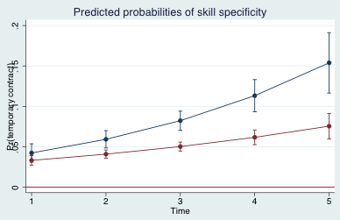upper curve: specific skills =0

lower curve: specific skills =1

Figure 3: Average Marginal Effects of job routine with 95% confidence intervals



Figure 4: Predicted probabilities of job routine with 95% confidence interval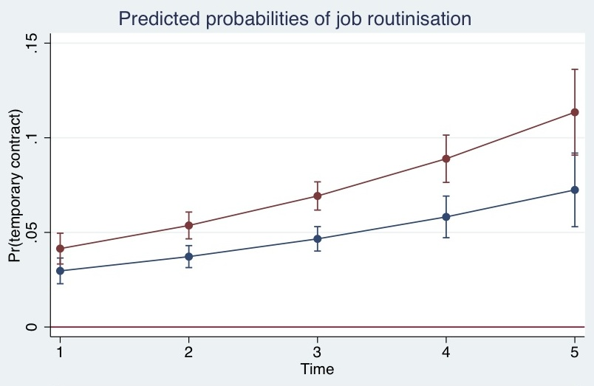

upper curve: job routine=1

lower curve: job routine=0

Figure 5: Average Marginal Effects of job routine at different values of skill specificity with 95% confidence intervals

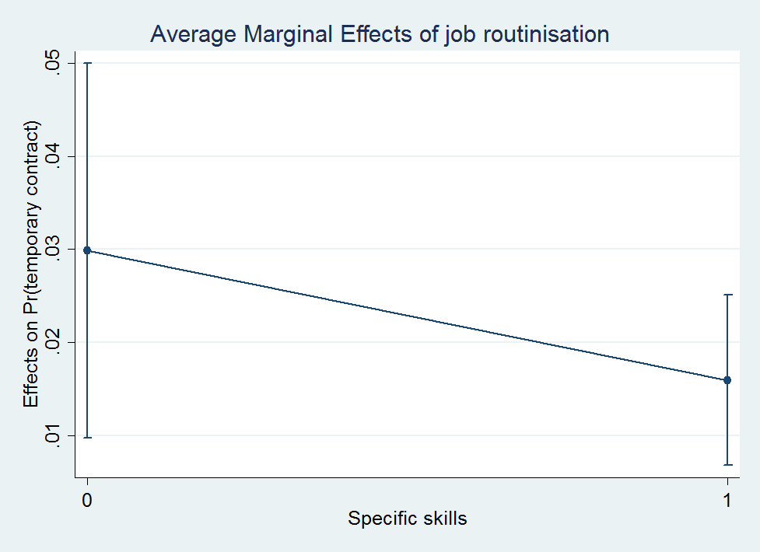

Figure 6: Average Marginal Effects of job routine among specific skilled workers at different time points with 95% confidence intervals

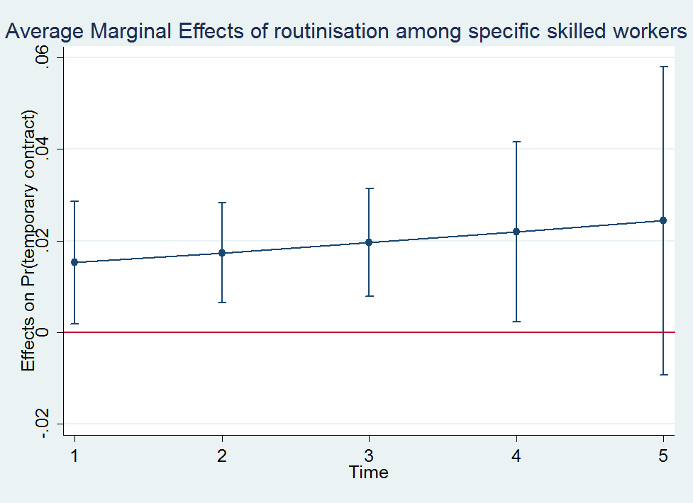

1. The term “*Facharbeiter”* is the German word indicating workers who completed a dual vocational training degree and is typically used for professional figures in the manufacturing sector.
2. See e.g. the work by Emmenegger 2009 and Gebel and Giesecke 2011, who collapse the skill dimension with task complexity.
3. In this regard, a few interview partners even told me the running joke that Opel is the biggest bakery in Germany because they employ workers with a dual vocatonal training in baking professions. See also Lüde, R. v. (1996) *Die Reorganisation der Fabrik und die Wiederentdeckung der Arbeit. Perspektiven für Bildung und Qualifizierung in der Industriegesellschaft*, Wiesbaden, Springer.