Supporting Information
Manuscript: "Nectar chemistry modulates the impact of an invasive plant on native pollinators."
Authors: Erin Jo Tiedeken, Paul A. Egan, Philip C. Stevenson, Geraldine A. Wright, Mark J. F. Brown, Eileen F. Power, Iain Farrell, Sharon M. Matthews, and Jane C. Stout

Appendix S1: Chemical analysis of R. ponticum nectar
Sugar analysis
In 2011 and 2012, 48 ml of floral nectar was removed from approximately 5,400 R. ponticum flowers from four populations in Ireland (table A1), pooled into one sample, and stored at -80 °С. Twenty samples were diluted 200 fold with nanopure water for analysis of sucrose, fructose, and glucose content (figure A1) using high-performance liquid chromatography (HPLC). Analysis was carried out on a Dionex DX500 HPLC system using an ED40 electrochemical detection unit. The mobile phase was 100 mM NaOH. Twenty μl of this sample was injected on to a Carbopack PA-100 column (Dionex, Sunnyvale, California, USA). Sugars were eluted isocratically with 100 mM NaOH with a flow rate of 1 ml/min. Elution profiles were analysed with Chromeleon software (Thermo Fisher Scientific).
Extraction and isolation of grayanotoxins from R. ponticum flowers
Dried R. ponticum flowers (100g) were extracted in 2L of 50% methanol for 24h. Methanol was removed under vacuum in a rotary evaporator and the water extract partitioned once with hexane (500ml) followed by chloroform (500ml) six times and evaporated under vacuum. The combined weight of dried partitioned extract partitioned into chloroform was ~300mg. A C18 isolute column (internal diameter 20mm), adsorbent volume was 70ml and column solvent volume approximately 20ml was conditioned in methanol and then increasing water to a starting condition of 2% methanol. The dried chloroform partition was solubilised in 5ml 2% MeOH and applied to the top of the column and drawn onto the column under low vacuum. The extract was eluted with increasing concentration of methanol and fractions analysed by LC-MS. Grayanotoxin 1 eluted with 40% methanol and verified by comparison with a known standard as previously reported (Tiedeken et al. 2014). The extraction and isolation was repeated 14 times (total 1.4 kg R. ponticum flowers) to yield ~400 mg grayanotoxin. The isolated compound crystallized when drying under nitrogen from methanol.
Appendix S2: Oral Toxicity methodology
Oral toxicity tests were conducted, based on the US Environmental Protection Agency (US EPA) guidelines for the acute toxicity testing of honeybees (1996). Bees from one colony were caught and harnessed, and fed 4 x 5 μL drops of one of six treatments: 0.44 μg/mg GTX, 0.22 μg/mg GTX, 0.11 μg/mg GTX, 0.055 μg/mg GTX, 0.0275 μg/mg GTX and treatment 2 (Table 1) which contained no GTX (n=30 bees per level, divided equally into 5 trials; GTX was a combination of GTX I and GTX III, in the same ratio as found in nectar). Six hours, 24 h, and 32 h after dosing, bees were fed 50% Apiinvert solution ad lib. Survival was recorded at 24 and 48 h.
Appendix S3: Bumblebee harnessed assay methodology
Two hundred and fifty bees were removed from three commercial colonies and placed into plastic vials. Bees were chilled on ice, weighed and harnessed. Harnesses consisted of 2 ml Eppendorf tubes cut at an angle 1 cm below the tip, so that the bee’s head could be pulled through. The bee’s proboscis and neck were unobstructed and cotton wool was put in the bottom of the tube to keep the individual in place. Bees were fed up to 5 x 5 μL 50% Apiinvert solution two hours after harnessing. Because bumblebees are much less likely to feed when restrained, individuals that did not feed on Apiinvert were not discarded. Bees were kept at 28°С, 60% RH, and 0 light in growth chambers. The following day, 50 bees were randomly assigned to the five treatments (see Table 1) and fed their treatment solutions, 5 x 5 μL. Only bees that fed while harnessed (35%) were included in the analyses. Bees were observed for 6 h for survival.
Appendix S4: Bumblebee behaviours
In order to record differences in the response of bumble or solitary bees fed GTX, behaviour was monitored continuously for 90 s per bee per day, on 11 days throughout the unrestrained survival assays. Seven distinct behaviours were observed: (1) Exploring, (2) Still/resting, (3) Consumption of treatment solution, (4) Pollen manipulation, (5) Grooming, (6) Flying, (7) Distress behaviours: bees exhibited two distinct behaviours that appeared to indicate distress or toxicity; a) Paralysis; individuals laid on backs, legs twitching, or b) Intensive grooming: individuals rubbed their hind legs together continuously for 10 s or more, as in Hurst, Stevenson & Wright (2014).
Appendix S5: Parasite assay methodology
In March 2013, we collected 74 B. terrestris queens emerging from hibernation in two locations in Dublin City, Merrion Square and the National Botanic Gardens. Queens were screened for Crithidia bombi infection by collecting and viewing a faecal sample under a phase-contrast microscope (40x magnification). Infected queens were kept at 25-30°С and 24 h darkness and fed ad libitum commercial pollen and Apiinvert bee food. To make an inoculum, faecal samples from 12 infected native queens were mixed and diluted with 50% Apiinvert to a concentration of 2500 Crithidia cells/µL (determined using a Neubaumer Improved Haemocytometer, VWR, Ireland) (Logan et al. 2005; Schmid-Hempel et al. 1993). Thirty stock workers from each of three B. terrestris colonies were removed from the colony, starved for 2 h and fed with 10 µL of standard inoculum. Workers were kept in wooden boxes (10 cm x 7 cm) for 10 days and fed ad libitum pollen and 50% Apiinvert until they reached peak infection (Otterstatter et al. 2006).
Appendix S6: Survival under stress assay
Forty bees from each of three B. terrestris colonies were transferred to individual boxes (as per survival assays) and randomly assigned to either the control treatment (treatment 2) or the treatment containing GTX I and III (treatment 3), n= 60 bees per treatment. Feeders were filled with treatment solutions and the weight was recorded before exposing the feeder to the bee. Ten empty boxes were set up as evaporation controls. Bees were allowed to feed for 24 h and then the feeder was removed and reweighed to measure consumption (g). Individuals were monitored hourly from the time the feeders were removed until they died from starvation so that survival times between the bees fed the two treatments could be compared.
In the survival under stress assay, bees fed the control (treatment 2) consumed slightly less than bees fed the solution containing GTX I and III (treatment 3) (mean= 0.278 g vs. 0.296 g controlled for evaporation, Fig. 3d.); however, this difference was not significant, nor were there any differences in consumption between colonies (F_{(1,71)} = 0.349, P = 0.5566). Survival analysis revealed that colony had a significant impact on survival (P < 0.001). However, the main variable in question, treatment solution, did not significantly impact bumblebee survival time (Fig. 3c., χ_{2.88} ²= 29.8, P = 0.210).

Table S1. Four Rhododendron ponticum populations from which plant materials were collected. “Material collected” refers to the category of plant material collected in a given year: nectar, from which sugar content and grayanotoxin concentration were determined, and flowers, from which grayanotoxin was isolated for use in artificial nectar. Populations were located in the southeast and midlands in Ireland.
Site name | County | Coordinates | Collection year | Material collected
Dunran | Wicklow | 53ᵒ03'47''N 06ᵒ06'05''W | 2011 | Nectar, flowers
 |  |  | 2012 | Nectar
Moate Park | Roscommon | 53°35' 39"N -08°09'46"W | 2011 | Nectar, flowers
 |  |  | 2012 | Nectar, flowers
Shankhill | Wicklow | 53ᵒ11'37''N 06ᵒ25'36''W | 2011 | Nectar, flowers
 |  |  | 2012 | Nectar, flowers
Trooperstown | Wicklow | 53ᵒ01'06''N 06ᵒ16'27''W | 2011 | Flowers
 |  |  | 2012 | Flowers

Table S2. Oral LC₅₀ values (concentration at which 50 percent of individuals die at a given time point) of GTX I for honeybees (Apis mellifera mellifera). Assays were carried out according to the US Environmental Protection Agency guidelines for the acute toxicity testing of honeybees (1996). Individuals were harnessed and dosed with 20 µL of one of six treatments: 0.44 μg/mg GTX, 0.22 μg/mg GTX, 0.11 μg /mg GTX, 0.055 μg/mg GTX, 0.0275 μg/mg GTX and a control sugar solution containing no GTX (n=30 bees per level, divided equally into 5 trials). Data were analyzed using logit regression modelling.
Time | LC₅₀ (µg /mg) | 95 % Confidence limits | n
24 hour | 0.212 | 0.154-0.325 | 153
48 hour | 0.172 | 0.122-0.269 | 153

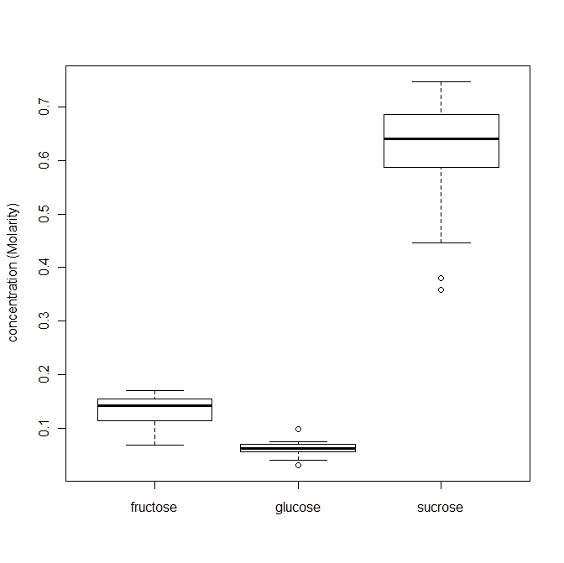
Figure S1. Average sugar concentrations (molarity) of composite Rhododendron ponticum nectar samples collected over two years from three Irish populations. Sugar concentrations were measured using HPLC (conducted using a Carbopac PA-100 column (Dionex, Sunnyvale, California, USA) and an ED40 Electrochemical detector (Dionex, Sunnyvale, California, USA)). Mean concentrations for the three sugars= fructose 0.13 M; glucose 0.06 M; and sucrose 0.61 M.

References
Logan, A., Ruiz-González, M.X. & Brown, M.J. (2005) The impact of host starvation on parasite development and population dynamics in an intestinal trypanosome parasite of bumble bees. Parasitology, 130, 637-642.
Otterstatter, M.C. & Thomson, J.D. (2006) Within-host dynamics of an intestinal pathogen of bumble bees. Parasitology, 133, 749-761.
Schmid-Hempel, P. & Schmid-Hempel, R. (1993) Transmission of a pathogen in Bombus terrestris, with a note on division of labour in social insects. Behavioral Ecology and Sociobiology, 33, 319-327.
Tiedeken, E.J., Stout, J.C., Stevenson, P.C. & Wright, G.A. (2014) Bumblebees are not deterred by ecologically relevant concentrations of nectar toxins. Journal of Experimental Biology, 217, 1620-1635.
Hurst, V., Stevenson, P.C. & Wright, G.A. (2014) Toxins induce malaise behaviour in the honeybee (Apis mellifera). Journal of Comparative Physiology A.
United States Environmental Protection Agency (1996) Ecological Effects Test Guidelines: OPPTS 850.3020- Honeybee Acute Contact Toxicity (ed. U.S.E.P. Agency). United States Environmental Protection Agency, Washington D.C.
Hurst, V., Stevenson, P.C. & Wright, G.A. (2014) Toxins induce malaise behaviour in the honeybee (Apis mellifera). Journal of Comparative Physiology A.
United States Environmental Protection Agency (1996) Ecological Effects Test Guidelines: OPPTS 850.3020- Honeybee Acute Contact Toxicity (ed. U.S.E.P. Agency). United States Environmental Protection Agency, Washington D.C.
United States Environmental Protection Agency (1996) Ecological Effects Test Guidelines: OPPTS 850.3020- Honeybee Acute Contact Toxicity (ed. U.S.E.P. Agency). United States Environmental Protection Agency, Washington D.C.

