Monday, 18-Nov-13. 19:30.
Barbican Centre: Hall. London.
Artist Spotlight: Maxim Vengerov / Polish Chamber Orchestra.
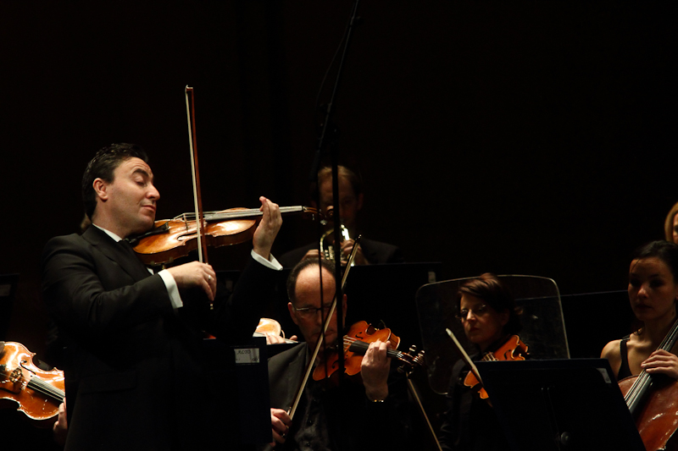
Mozart, Violin Concerto No. 4 in D major (K. 218)
Mozart, Violin Concerto No. 5 in A major, ‘Turkish’ (K. 219)
Tchaikovsky, Sérénade mélancholique in B flat minor for violin and orchestra, Op. 26
Tchaikovsky, Souvenir d’un lieu cher, Op. 42 (orch. D. Walter)
Tchaikovsky, Valse-Scherzo for violin and orchestra in C major, Op. 34

Polish Chamber Orchestra
Maxim Vengerov violin/ director

The Barbican Centre, London was the eighth and penultimate venue in Maxim Vengerov’s nine-city European tour with the Polish Chamber Orchestra, playing and directing Violin Concertos Nos 4 and 5 by Mozart, both written in 1775 in the composer’s late teens; and three pieces for violin by Tchaikovsky: Sérénade mélancholique, Souvenir d’un lieu cher and Valse-Scherzo. The concert was the first of five in Vengerov’s Barbican residency which will last until the end of February, 2014.
Mozart’s Concerto in D with its good-humoured interaction between soloist and orchestra famously opens with a military-style ‘fanfare’ which is then repeated by the soloist, but transposed upwards, as if to poke fun at the orchestral heroics. The jokes continue to unfold as when the violin then moves jauntily to its lowest register to repeat the orchestra’s second, more graceful theme. Such Mozartian wit and cheer seemed slightly restrained in the Allegro, but then in the Andante cantabile Vengerov went on to magnetize the audience with his even, silky tone, before dazzling us with the exuberant virtuosity of the Rondeau (Mozart uses the French spelling). Here the music embraces a potpourri of themes and dance episodes in contrasting tempi, shifting between a light, well-mannered 2/4, a more energetic 6/8, and a gavotte and musette (the latter apparently modelled on a musette entitled ‘Ballo Strasburghese’ in a symphony by Mozart’s friend, Dittersdorf) where the soloist provides a drone bass on the G string to accompany the folk dance.
In keeping with the composer’s unusual marking ‘Allegro Aperto’ (my italics), the orchestral exposition of the A Major Concerto was expansive as well as brisk. When the solo violin appears, its first two notes are exposed against a background of silence before the orchestra joins in, murmuring below. It is a magical moment which Vengerov executed with poise before launching into the pyrotechnical display in the soloist’s own version of the Allegro Aperto. The Andante which followed flowed like a pastoral arioso, its ‘uninterrupted song, an avowal of love’ (Alfred Einstein) gently reiterated with transformations and new embellishments (the latter prompting Antonio Brunetti, Mozart’s successor as concert-master of the Salzburg orchestra, to describe this movement as ‘too studied’). It is the Rondo finale for which the fifth concerto is most famous: in the middle of it, together with a shift to A minor, the tempo switches from 3/4 to 2/4 and we witness an example of what passed for ‘Turkish’ music in Austria in the late 1700s, thereby giving the concerto its nickname, ‘The Turkish’. Everything now suddenly came to life, and the stage was animated with a very vibrant sense of fun in the chromatic crescendos, the wide leaps, the short repeats and the col legno passages in the cellos and double basses.
After the interval we moved to the more soulful palette of Tchaikovsky’s Sérénade mélancholique (1875), the composer’s first work for violin and orchestra. It was originally written for the Hungarian violinist, Leopold Auer who performed it in November 1876. But when in 1878, Auer criticised the composer’s Violin Concerto, claiming he would ‘do himself a mischief’ if he attempted the solo part as it stood, Tchaikovsky withdrew the dedication, although it was impossible to remove Auer’s name from the edition then being published by Jurgenson. What the piece needs more than virtuosity is a soul, preferably a Russian one, and Vengerov, a master of colour and mood, gave voice to the mingled sadness and graciousness of its melody with a rich, sumptuous tone. The climactic double stops in the more restless central section (the piece is in ternary form, A-B-A), and the trilling against the solo cello which takes over the melody near the conclusion (in lieu of the clarinet in a full orchestra) were moments of great beauty.
The titular ‘dear place’ of Tchaikovsky’s triptych Souvenir d’un lieu cher (1878), refers to the Ukrainian country estate, Brailovo, which belonged to the wealthy widow, Nadezhda von Meck, who in 1877 had become Tchaikovsky’s patroness on the understanding that she and the composer would never meet. Tchaikovsky completed the Souvenir on a six-day holiday at Brailovo in May 1878, entrusting the piece on his departure to Mme von Meck’s chief servant to be presented to her as a token of thanks for her hospitality. The orchestral arrangement used for the Souvenir (originally composed for violin and piano) was by David Walter, and Vengerov chose to alter the normal order of the three pieces in the triptych, starting with the second, the Scherzo in C Minor, where the perpetual motion presto together with its pizzicato chords were tossed off with nonchalant ease; moving on to the third, the mellifluous Mélodie in E-flat major which Tchaikovsky himself described as a ‘chant sans paroles’; and ending with the first, the Méditation in D Minor. This rearrangement was obviously made to avoid placing the angst-ridden Sérénade mélancholique and Méditation in succession, and further justified by the fact that, as well as being published together, the three movements were also published separately.
The Méditation, originally intended as the slow movement of Tchaikovsky’s Violin Concerto, but revised as part of the Souvenir, has been frequently decried in musical criticism. Eric Blom, for example, in a symposium of studies edited by G. Abraham calls it ‘dull and mechanical’, lacking in ‘melodic distinction’ and having an ‘uneventful progress’. Listening to Vengerov, I found myself wondering whether Blom would have revised his opinions had he been in the audience: the pace was slightly leaden, but the ‘distinctive’ and memorable theme, whose poignancy Vengerov increased in intensity on each new appearance, is inconsistent with notions of lifelessness, and a rather ‘eventful’ climax is in fact reached at the end of the piece with repeated phrases climbing systematically into the violin’s highest registers and ending on a sustained and feverishly high pitched ‘d’ , right at the top of the fingerboard! Vengerov’s rendering, with his natural feel for these passionate, Russian melodies, was sumptuous, and he had this audience entranced and in the palm of his hand.
The programme ended with the effervescent Valse-Scherzo. In spite of having been written in 1877, the year of Tchaikovsky’s disastrous marriage, this is a buoyant piece whose light-heartedness conceals huge technical demands, particularly in the bravura cadenza. Vengerov nailed it all with sparkle and flair. His two substantial encores – Saint-Saëns’ Havanaise and the Introduction and Rondo Capriccioso - were also exhilaratingly done and demonstrated a generosity of spirit which brought the Barbican audience to its feet.
Professor Vivienne Suvini-Hand.

