Parkour, activism and young people

Oli Mould, Royal Holloway, University of London

Abstract

This chapter details how parkour can be used as a lens to renegotiate the debates about activism in young people. It argues that parkour is child-like, not because it is undertaken by children and young adults, but because it demands a more youthful ‘state of mind’ that inculcates a subversive politics of the urban. Such a view foregrounds emancipatory, ‘child-like’ agency of the subculture of parkour, rather than the spectacular ‘youthful’ corporeality that it has become synonymous with. This chapter argues that parkour offers a ‘way in’ to urban activism; not through a direct engagement with political or anti-hegemonic activities or reactive protest against the forces of neoliberal capitalism, but through a ‘softer politics’ of rediscovering the urban environment around their own beliefs, expressions and desires. By engaging in parkour, people are moving away from cultural provisioning of the modern Global Creative City that is too often prescribed and formulaic, instead participating in a process of urban citizenship that is allowing them to discover the urban and all the experiences it has to offer for themselves. It is this process that this chapter argues characterises the ‘child-like’ characteristics of parkour.

Keywords: Parkour, activism, young people, subcultures

Introduction

The academic literature on parkour has proliferated in the last few years, with a multitude of theoretical inferences (Daskalaki et al., 2008; Mould, 2009; Atkinson, 2009; Ameel and Tani, 2012a, Sharpe, 2013; Kidder, 2013) and empirical observations (Ameel and Tani, 2012b; Kidder, 2012; Lamb, 2013). Much of the literature has focused on the themes of embodiment and its relationship with the city. The contributions have brought parkour to the attention of a wide academic (and non-academic) audience and it has aided significantly in the rich and varied discussions in which parkour can affect positive change in people’s lives, and the way they perceive and/or construct urban space. Given its relative novelty (a crude search on online databases shows that the first mention of parkour comes in 2003, and is restricted to niche conference papers (Gaye et al., 2003) and Rolling Stone Magazine (Smith, 2003)), there is still a great deal of scope for the advancement of parkour as a means of social scientific inquiry. In particular, its relationship to the literature on the geographies of children and young people, given that the vast majority of its participants fall into that category. However, the literature so far has generally represented the practices of traceurs as they go about conducting parkour (often in and on the urban terrain), rather than empirically investigating or theorizing their cultural and socio-economic backgrounds, save recognition that they tend to be generally white, middle-class, young and male (Atkinson, 2009; cf. Kidder, 2013). Given the overtly ‘playful’ aesthetics espoused by parkour and its preponderance to be characterised as having a ‘youthful’ mind set (i.e. extolling child-like behaviour (Angel, 2014; Ameel and Tani, 2012b)) then there is a danger of uncritically adopting the view that to be playful in the city (and all the political and emancipatory affectivities that such behaviour engenders) requires occupying normalising gendered ground (i.e. to be male, physically able and to be of the ‘young-adult’ age bracket).

Moreover, such identity normalisation is pervasive through parkour literature (and often in the communities themselves) and is therefore an important characteristic to highlight as it can skew the gendering of urban spatiality that is constituted by its practice. The spectacular movement (which is often learned methodically, painfully and emotionally (Saville, 2008)) is the fundamental property which has catalysed the appropriation of parkour by capitalistic tendencies (Daskalaki and Mould, 2013). However, given that such movement is most frequently performed by young, mesomorphic and able-bodied men, the practice is associated with (and mediated by) ‘young adults’ who will have the corporeal propensity for the intense performative dimension. Such assumptions however mask more complex identity issues within the subculture of parkour which has seen a rapid increase in participation, particular among the very young, females and the disabled (Edwardes, 2009; Angel, 2011). Such participation is challenging the masculine, mesomorphic and aged bias and brings to light new ways of conceptualising the ‘youthfulness’ of parkour. Indeed, if we think of age relationally (as Hopkins and Pain (2007) argue) then the very nature of parkour as a pastime for ‘young adults’ (and all the corporeal and performative biases therein imbued) can be unpacked.

This chapter will therefore contribute to the ever-burgeoning literature on parkour by arguing that it is child-like, not because it is undertaken by children and young adults (although of course these are the predominant participants), but because it demands a more youthful ‘state of mind’ that is politically subversive, particularly in relation to the city. If parkour is viewed in this light, then its more emancipatory, ‘child-like’ agency comes to the fore, rather than its spectacular ‘youthful’ corporeality. By analysing the parkour oeuvre thus far and relating it to the literatures of the geographies of young people, this chapter will tease out the (sometimes conflicting) relationalites, and posit a more nuanced connection between parkour and its urban political dimensions. Specifically, the chapter will do this by highlighting parkour as a ‘way in’ to urban activism; not through a direct engagement with political or anti-hegemonic activities or reactive protest against the forces of neoliberal capitalism (as is the case with other urban subversive activities (Mould, 2015)), but through a ‘softer politics’ (Amin, 2008) of rediscovering the urban environment around their own beliefs, expressions and desires. By engaging in parkour, people are moving away from the spoon-fed cultural provisioning of the modern Global Creative City, and participating in a process of urban citizenry that is allowing them to discover the urban and all the experiences it has to offer for themselves; and it is this process that characterises parkour as ‘child-like’. The chapter will argue this in four parts. The first will analyse the parkour literature thus far, highlighting how it can (very loosely) be categorized into two (over-lapping) areas of theoretical discussion, namely the body and the city. Second, the chapter will highlight the relevant literature on the geographies of children and young people. Third, it will show how parkour is being institutionalised and to realise its more ‘youthful’ subjectivities, then we need to realise its ludic ‘tacticalness’. The fourth section will postulate that parkour allows everybody a chance to engage in urban politics via their own agency, and to experience child-like play in the city.

Bodies and the City: A review of the parkour literature

Whether it’s on the cinema screen, in computer games, television advertisements, purpose-built parks or people repeatedly jumping on and over walls in urban areas around the city, parkour can be seen in an increasing variety of media, virtual and physical places. As Edwardes (2009: 8) has argued however;

“In one sense, parkour has existed for as long as man [sic] has either moved out of necessity, for enjoyment, or for practice. It exists as the basis for all human movement, from the play of children to the lifestyles of tribal cultures and from the discipline of the traditional martial arts to the methodology of modern athletics”.

However, since 2003, parkour has rapidly entered into the popular consciousness, aided by its spectacular corporeality. Through two of its main protagonists in the early years of the 21st century, David Belle and Sebastian Foucan, parkour became a globally recognized performance sport/art/practice/pastime/philosophy. In the UK, it entered the public gaze through two high-profile television appearances, a BBC ident featuring David Belle called Rush Hour (2003) and a Channel Four documentary, Jump London (2003) featuring Sebastian Foucan. From there, major films (such as Banlieue 13 (2004), Casino Royale (2006) and Die Hard 4.0 (2007)) and computer games (Assassin’s Creed (2007), Grand Theft Auto 4 (2008) and Mirror’s Edge (2009) and many, many more since) have utilized the spectacular movement of tracuers to animate their products; parkour institutions have been set up in order to teach it to anybody who wants to learn; and parkour ‘parks’ have been built in many cities across the world where people can go and practice their parkour skills. So in little over two decades, parkour has gone from being a pastime carried out by a group of French school friends, to an internationally recognized, commercially viable activity.

In this short space of time, the ‘subculture’ of parkour has also engendered a great deal of academic debate (Daskalaki and Mould. 2013). One theme that pervades much of the literature emanating from the more established, recognized and vocal traceurs will talk of the Eastern and quasi-spiritual philosophies that pervade the practice, and many of the earlier iconic short films would have Eastern, martial art, ancient Japanese or Buddhist aesthetic referents (Mould, 2009). However, in contrast to this, others (participants, observers and researchers alike) have articulated the innate reactionary ethos of parkour, with Daskalaki et al., (2008: 61) claiming that parkour is “a form of ‘urban activism’ that poses a challenge to fixed, sterile organisational behaviour, rigid models and ready-made answers”. Such a reactionary ethos of parkour is commensurable with flâneurism. Drawing on the work of Benjamin (1999), Atkinson (2009: 174) for example suggests that traceurs “deliberately call attention to the late modern city’s spatial organization and its environmentally sterile, commercial policing”, thereby embodying similar urban critiques that characterised the flâneur. Fuggle (2008: 205) similarly argued that parkour has subversive qualities that “challenges and subverts our daily experience of the city and city life”. Traceurs, through their spectacular movement across the city are reacting against the confinement of their lived experiences; what social theorists often articulate as the ‘smoothing’ out of otherwise striated, constricted and power-laden space (Ortuzar, 2009).

To say that one of these two different ideas (serene rediscovery and reactionary activism) dominates the ‘philosophy’ of parkour would be to over-simplify matters; parkour can be a simultaneous mix of the two, yet contain even more political characteristics. The complexities of the practice, and the infused ideologies of Eastern, Zen-like philosophies often espoused by traceurs mean the reactionary ethos can be somewhat deadened by a more serene ‘rediscovery’ of the city over time (Mould, 2009). Other research has talked of how parkour is less reactionary and instead, ‘loosens’ public space (Ameel and Tani, 2012a); that traceurs have ‘parkour eyes’. This is when “traceurs notice spaces and details in the environment that are easily missed by other urban dwellers. They see walls, fences, rails, stairs and benches as opportunities that they can use in a creative and playful way” (Ameel and Tani, 2012b: 169). It is perhaps this reappropriation of the urban environment (subversively or otherwise) that is a common theme across much of the parkour literature, and it is a fundamental aspect in its function as a means of urban politics. By realising alternative functions of particular urban objects (see Lamb, 2014) there is very much a consensus within the parkour literature that it has an emancipatory potential from the confinement of existing urban power structures, however covert, tacit and ‘soft’ this emancipation may be.

From a more affective perspective, given the extreme corporeality that parkour mediates, the emotional engagement with it (particularly that of fear) is always highly prominent. Fear, as has been contextualised in related literature on the geographies of children and young people, is often seen as something to be avoided (Nayek, 2003), or as something that is materialised in the child’s environment (Pain, 2006). However, with parkour fear is a fundamental part of the practice (Saville, 2008). The high risk of physical (and emotional) injury associated with the practice means that fear as an emotion is directly associated with the corporeality, and part of the embodiment of parkour. Rejecting a Cartesian dualism of mind/body, parkour inculcates a phenomenological body-mind nexus. Hence, being ‘fearful’ of not making that jump or injuring yourself while rolling therefore has consequences of how it is practiced, moreover, how it looks. It is of little surprise then that one of the earlier offerings from academia came from Saville (2008) that discussed the role of fear in parkour, and its role in embodiment. Saville argued that far from being the ‘fearless’ endeavour that was purported by mainstream media representations of parkour, fear was a fundamental emotion to its practice. The intricate, faithful and meticulous practice of parkour involved the utilization of fear as something that is not “static, singular or dishearteningly negative”, but something which takes “on an array of different textures and colours, many of which were not as unpleasant as has hitherto been theorised” (Saville, 2008: 910). He notes how fear engenders physical attributes (sweaty palms for example), but draws the body toward danger rather than away from it. The exploration of fear as an affective, non-representational aspect of pakour was a catalyst for further research into its embodied (physical and emotional) nature. For example, Sharpe (2013) details how “fear can be incorporated into habituated practices, which it animates rather than paralyses” (Sharpe, 2013: 170). He goes on to theoretically explore how the embodiment of parkour is intricately embroiled with its habitual nature, and that fear plays a fundamental part in that habituation and the eventual complex articulation of parkour’s ‘grace’. In other words, “the vertigo of bodies, the cheating of gravity, the mastery of mobility, and the harnessing of speed all steer a fine line between grace and fear and grace and awkwardness” (Sharpe, 2013: 171).

The intense relationship between emotion (in particular fear, but also triumph, anxiety and so on) and the physical embodiment of parkour also extends to the materiality of where parkour is practiced. While starting off in the woodland areas around Paris, parkour is first and foremost recognised as an urban activity. Unlike other ‘urban subcultures’ that use a nonhuman intermediary between themselves and the architecture of the city (i.e. skateboarders have a board and wheels between them and the concrete; trial riders have a bike), parkour is an intense connection between the body (and maybe a layer of clothing) and the city. The physical connection with the city is one that Chow (2009: 150) argues, reveals hidden realities of the urban experience;

“Participation in these movements, in dialogue with the built environment, moves beyond the imaginary/spectacular – in touching the cold concrete, jumping and holding onto an impossibly high wall, the traceur gains a ‘real’ awareness of the oppressiveness of the space”.

The ‘oppressiveness’ of the city is realised through an unadulterated physical encounter with it. The urban terrain that is most practiced upon is usually hard, rectilinear concrete forms which espouses a physical, emotional and mental oppressiveness. The body therefore can uncover such realities, but can also imbue within them further materialities, and intensify the human-urban nexuses. Drawing upon the work of Elizabeth Grosz (2001), Lamb (2014) argues that the architecture of the city is the articulation of our being in the city. And so through parkour, traceurs are writing (and rewriting) urban experiences, inscribing a palimpsest of meanings into the city by continually acting upon it.

To date then, the parkour literature has articulated its contested urban embodied politics. While some have emphasised its reactionary and subversive nature, others have countered this by suggesting that such transgression is only momentary, with parkour now contributing to urban consumerist tendencies rather than reacting to it. Other facets of the literature contribute by discussing the articulation of the political ideologies of parkour as a wider contextualisation of its more visceral emotionally embodied values. What is clear though throughout the academic literature is that almost exclusively, the majority of the studied subjects (via interviews or auto-ethnographies) are young, able-bodied men, with little exploration of marginalised groups (cf. Angel, 2011). One exception to this is Kidder (2013) who has expressively articulated the way in which parkour masculinizes the urban environment, arguing that it “allows for the accomplishment of masculinity” (Kidder, 2013: 2), and can “marginalize certain people, even while offering transgressive potential to others” (ibid.: 4). He goes on to argue that through parkour, the city becomes “a space for symbolically asserting the male body in action” (ibid.: 16), and that through risk and dangerous acts, traceurs are asserting a masculine ethos upon the subversion and reappropriation of the urban environment. Such assertions risk mirroring the view of hegemonic structures that parkour is eulogised as resisting. Therefore, to mitigate against this, the overt masculinity of parkour then requires further denunciation and critique, if its activist, reactionary and above all, playful and ‘youthful’ ethos is to be further recognised and qualified.

Such playfulness though, while explicitly talked about in reference to parkour, has a more concretised link with the literature of the geographies of children and young people. Therefore, in order to espouse the playfulness of parkour as something that is not confined to normalised identities (i.e. to young, able-bodied men), then we must first excavate the relevant literatures that relates the geographies of young people to the emancipatory politics of parkour.

Geographies of Childhood Politics

Paralleling chronologically the growth of the parkour literature, the scholarly work focusing on the geographies of children and young people has engaged more with politics, and thinking about children politically (Philo and Smith, 2003; Kallio and Häkli, 2013). The main thrust of these debates has been to articulate the “political lives of children beyond adult-constructed ideas of the rational liberal subject” (Mitchell and Elwood, 2012: 801), thereby recognising the agency of children within broader spatial politics. However, there has been some debate as to what constitutes politics in the young, with Kallio and Häkli (2013: 9-10) arguing that, “Youthful political action may thus take all kinds of forms and mobilise gradually anywhere. Yet not all children and young people act politically in all kinds of ways, and there is notable variation to their politics vis-a-vis the situation”. Such a distinction mirrors the broader debates about what constitutes ‘the political’ (see Wilson and Swyngedouw, 2014), and has influenced how scholars have sought to theorise political action in children and young people. Some have suggested that children are ‘citizens in waiting’ and only able to contribute politically once they have “reached the age of reason” (Arneil, 2002: 70). Young people therefore can be empowered to partake in a process of societal, economic, developmental and/or cultural change, but in and of themselves do not espouse any politics. It is only by engaging in a political system outside their own making, do they become political subjects. For example, in researching how children used language as resistance in Palestine, Habashi (2008: 279) found that children “inherited the political discourse not only from the Palestinian community but also from global interaction and the Israeli oppression”. The children being studied here therefore took on the political linguistic characteristics of the wider geopolitical context of the Arab-Israeli conflict to articulate their resistive activities. In order to be political, they had to engage with the prevailing language of conflict. Such a viewpoint reflects a broader line of argument within the literature that sees children as political only when they engage in existing political structures and narratives, perhaps those that can be seen as constituting ‘adult’ politics or adulthood more generally. Such a view is contrasted against a constructed ‘childhood’ (see Kraftl, 2006) which only serves to depoliticise children by labelling them as not adults, and therefore not in the political realm. Such a view, when aligned with the literature on parkour would serve to reduce its politics and see it confined to the notion of ‘childhood’. Indeed, as Horton and Kraftl (2006) have noted with the title of their paper, politics is not always about growing up, but also about going on.

So, other schools of thought within the geographies of children and young people have countered such a view, and see children’s actions as political in their own right precisely because they eschew the centralising and normalising forces that ‘adulthood’ enforces upon them. Wood (2012: 344) argues “that conventional binaries which classify Politics/politics (Formal/informal; Public/private; Macro/micro) obscure the liminal position which young people occupy at the interstitial intersection of these extremes”. Such political actions are often ‘less-seen’ but are no less instrumental in changing the lives of those involved in relation to their social and spatial contexts. Skelton (2007) talks of children occupying a ‘liminal’ space between engrained institutional Politics (with a capital ‘P’) and more everyday politics (with a small ‘p’), and such liminality “enables them to occupy two Political/political spaces at the same time” (ibid.: 148, original emphasis). Such a viewpoint, when taken in the context of thinking about parkour, is more useful as it encourages us to think of children’s activity as overtly political because of its denormalising qualities. Moreover, the ‘unsocialised’ character of children and their reaction to adult-centred spatial and social codes of conduct is often posited as un-normalising or even subversive behaviour (although such actions themselves are however being normalised as ‘childhood’ (Kraftl, 2006)). Therefore, to be ‘child-like’ in behaviour is an act of becoming that is somewhere in between the identifiable and articulable ‘states’ of adulthood and childhood (Skelton, 2007; Wood, 2012). To be child-like then, as one of the characteristics given to parkour, is to break from centralising forces of socialisation and conformity (both from the adult and the child), and to participate in activities that question, critique and go against such behaviour.

Parkour therefore can be viewed as very much aligned with such a child-like epistemology as it involves a break from using the city ‘normally’. Another useful line of inquiry to unpack such normalisation, I argue, is to emphasize its ‘youthful’ tendencies and its recalibration as ‘play’. Such an ideology aligns with the liminality of children’s politics and helps us to better articulate the ‘youthfulness’ of parkour. Indeed, as the numbers of people (and their diversity) who partake in parkour continue to grow, more purpose-built parkour sites have been developed so younger people can train in a safer environment than urban public space. Such ‘institutionalisation’ of parkour has many observable benefits, but by removing it from the urban realm, by creating structures and official programs arguably necessitates a reduction in the politics of parkour. In the following section therefore, I want to argue that by focusing on playfulness in parkour, we can rediscover its emancipatory (perhaps even resistive) qualities, through a questioning of how parkour’s critical edge has been redacted somewhat by these parkour ‘parks’. Moreover, by injecting playfulness into the politics of parkour, its participants are hence given a ‘child-like’ agency to affect change in their environment.

Playing at ‘parkour’, or playing in ‘our-park’?

In order to deconstruct the potentially deleteriousness of parkour parks on its playful politics, we need to briefly understand what we mean by play. The term can take on a number of different meanings depending upon its usage. To play football, to play the drums, playing the game, to get played, seeing a play, playing at politics, child’s play, a play on words, ‘stop playing with my emotions’, ‘I was only playing’ and so on. There is a sense that playing can either be used to indicate activities that are based on particular rules or systems (like playing a game, sport or an instrument) or that playing can somehow go against a system (playing around), being unpredictable, creative and perhaps even subversive within or to an existing set of prescribed guidelines. Additionally, play is often seen to be the purview of children and young people. The antithesis of work-life, play is something that is done by those as yet unsocialised (Denzin, 1977). Once we ‘grow-up’ and start to work for and within a capitalistic (or even adult) system, we compartmentalise playing as being outside that system. Such an approach however belies how instances of ‘play’ can occur constantly within the everyday. It is perhaps pertinent to talk of the work of De Certeau (1984) here, as he has theorised most readily how the practices of the everyday contain instances of playful activity. He distinguishes between what he calls ‘strategies’ and ‘tactics’. Strategies contain, compartmentalize and conduct the rules of the game; they “assume a place that can be circumscribed” (1984: xix), or a “place that can be delimited as its own” (1984: 36). De Certeau offers some examples of such strategies, including a business, an army, a scientific institution, and a city. Tactics, he argues, are those instances of incursion into a strategy. The tactic insinuates itself into the other’s place but never takes it over fully. “Whatever it wins, it does not keep. It must constantly manipulate events in order to turn them into “opportunities”” (De Certeau, 1984: xix). While De Certeau does not use the language of play, we can see epistemological commensurability if we understand play as Schechner (1993: 42) does as “the on-going, underlying process of off-balancing, loosening, bending, twisting, reconfiguring, and transforming the permeating, eruptive/disruptive energy and mood below, behind and to the side of focused attention”.

Tactics are “guileful ruse[s]”(De Certeau, 1984: 37), in that they ‘play’ with the established order of things. Lacking the ossified resistive stance of more subversive anti-hegemonic ontologies such as anarchism, tactics subvert from within, manipulate and change strategic power. One particular example of a tactic De Certeau offers is ‘la perruque’, which “is the worker’s own work disguised as work for his [sic] employer” (ibid.: 25). Different to stealing, pilfering or absenteeism, la perruque is using office supplies for personal use, or “writing a love letter on company time” (ibid). Whatever the instance, la perruque is not claiming a space within the strategy but rather claiming time (and therefore wasting time for the employer). He suggests that la perruque is “becoming more and more general” (ibid) and can be considered part of the everyday nature of things. There are many other instances of ‘being tactical’ that could be offered, and indeed Wood (2012) aligns De Certeau’s conception of tactics with the liminality of childhood politics as discussed in the previous section. She argues that

“Focussing on young people’s politics in liminal spaces provides a chance to conceptualise moments … as tactics which young people employ to enact change, subvert or manipulate a situation, and are intrinsically concerned with shaping the society we want to live in”.
(Wood, 2012: 344)

Performing parkour is highly applicable to such a view given that it is playfully interactive with the city, and not as reactionary as other urban subversive activity (Mould, 2015). So far from being the sole purview of children, or something to do outside of work, playing can be seen to be occurring in the everyday, as it has the effect of disrupting (however small) the established order of strategies. Woodyer (2006: 322) has comprehensively outlined this by arguing; “By liberating playing from the preserve of children, we are better placed to address its relations to the everyday, its inwardly oriented politics and its more-than-rational⁄representational feature”. Moreover, being tactical is infiltrating the ‘strategy’ of the imposed adulthood/childhood dichotomy (Kraftl, 2006). Drawing from Lacanian psychoanalysis, we can say that the (continuing) socialisation of children into adults by societal forces (including the family, the city, religion, capitalism and so on) can also be seen as a strategic operation – the circumscription of a set of acceptable socialised human characteristics and behaviours (usually conformity, wealth-generation and productivity). Therefore, the very act of being playful, of subverting and changing pre-given authoritarian or even dogmatic ‘rules’ (in a tactical way) is essentially enacting child-like subjectivities. Such subjectivities can be affective, in that they inculcate a creative curiosity, a constant search for how the strategy can be altered. But also, it can be corporeal, particularly with parkour as the movement can be seen to be childlike; jumping, rolling, climbing and so on.

Parkour entails having almost a “naïve imagination” that combines “physical maturity with disciplined practice” (Ameel and Tani, 2012: 18). It is unsurprising that much of the literature equates parkour as being a ‘playful’ act (see Saville, 2008; Mould, 2009; Atkinson, 2009). Indeed as has been noted by Ameel and Tani (2012: 21) during their research, parkour looks ‘bewildering’ to onlookers:

“One of the prime causes of bewilderment… was the playful element in parkour and the fact that the playful behaviour was acted out in public by adults and teenagers rather than by children. To the bewilderment of onlookers, traceurs tend to create a “ludic” city”.

Within the context of the city, parkour is playful in that it transforms the built environment, however briefly, from a place of work, consumption, capitalistic accumulation, into an arena for play, experimentation and body-architecture improvisation; fuelling the ludicity of the city. Traceurs deliberately use the urban environment as their playground, both public and private spaces. The playfulness of parkour therefore further engenders it with youthful subjectivities, insofar as it necessarily entails an ‘unsocialised’ (or un-grown-up) state of mind, as well as a child-like ‘ambivalence’ to embodied risk (explored so articulately by Saville (2008) and others). This is why the aesthetics and corporeality of parkour gets more ‘appealing’ the younger the viewer is, as further noted in Ameel and Tani’s (2012: 22) research:

“Children often started to copy parkour moves. Teenagers remained more aloof and tended to comment on the actions they saw. Their reactions, however, were also often positive and perceived as refreshing by the traceurs. The reactions of adults ranged from encouraging comments to indifference, negative reactions and even aggressive behaviour”.

And so we can say that parkour is ‘youthful’ not because it is undertaken predominantly by young people (although this is certainly the case), but it actively encourages a continual process of childlike embodiment (physical and mental) through adhering to a tactical ethos in relation to the strategies of the city and adulthood.

So with this in mind, it is possible to see why purpose-built parkour ‘parks’ are lessening the tacticalness of parkour. The physical architecture and layout of these environments are designed using an intricate knowledge of the technicalities of parkour as well as its philosophy of a freedom of movement. Many of the outdoor parks (such as the LEAP park in London) also replicate the aesthetics of the urban environment (more or less) with hard concrete surfaces, metal railings and sharp edges. Some are indoors (such as Brooklyn Beast in New York) and use crash mats, soft edges and more ‘gymnasium’ style equipment. These places are formulated for people (young and old, although minimum ages are in place for some) who want to get involved in parkour, and can practice it in a safe environment with training from professionals. Some of these parks charge an entrance fee and require a particular level of certification in order to use them unsupervised.

Such parks champion parkour’s inclusivity and actively encourage physical exercise, sociality and forge strong communities of practice (Wenger, 1998). They have encouraged people to get engaged in parkour who would have otherwise remained ‘inactive’ or perhaps even turned to more destructive social communities. They engender a collective ‘spirit’ of togetherness among children and young people, something that they can claim as their own; they are ‘our parks’ (is a phrase often iterated by those frequenting them). For this they are to be celebrated and championed as having a constructive and positive mode of effective change on the behaviour, attitudes and health of young people. These positive effects are not to be downplayed in any way. However, while they espouse healthy bodies and constructive social bonds, they are, to a greater or lesser extent, reducing the tactical nature of parkour’s playfulness. The politics of tactical incursion that parkour engenders when conducted in the urban realm are rendered less distinct in these purpose-built environments. Also, the layering of commercialism, finance, health and safety exacerbates the diminution of not only the corporeal experience of the architecture of the city, but also the ‘playfully’ subversive politics of parkour. However progressive they are in the wider sense, there is always an underlying accusation that they are taking parkour off the streets and into an institutionalised environment, however briefly or irrelevant that may be to the people who use it. In essence then, these parkour parks could be said to be the strategy of the city taking hold of the tactic of parkour, and redacting the subjectivities of social critique.

While parkour can engender a child-like mentality that aims at being tactical and playful, such subjectivities are reduced in the environment of a parkour park. In effect, they reinstate adulthood (via strategic qualities of health and safety, financialisation, commercialisation and the like) and physically relocate parkour off the streets, however temporarily, thereby reducing its playful qualities. Hence these parkour parks could be said to represent those ‘liminal’ sites of conflicting politics of young people’s activist tendencies (as articulated by Skelton (2007)). On the one hand, they further engagement of young people in parkour, but on the other, the child-like subjectivities of playful tacticalness are being redacted by the establishment of strategy. Parkour’s ‘youthfulness’ comes not from the fact that it is aimed at the young, but because it encourages youthful behaviour in everyone; and such youthfulness is highly empowering and emancipatory. Therefore to exemplify this, and to understand more readily the child-like politics of parkour, we need to return to the street.

Parkour as facilitating activism in young people

The Vauxhall Walls is a small area in South London that is regularly frequented by traceurs (see Figure 1), and has become one of the UK’s most recognisable parkour spots for training, sociality and also virtual dissemination.

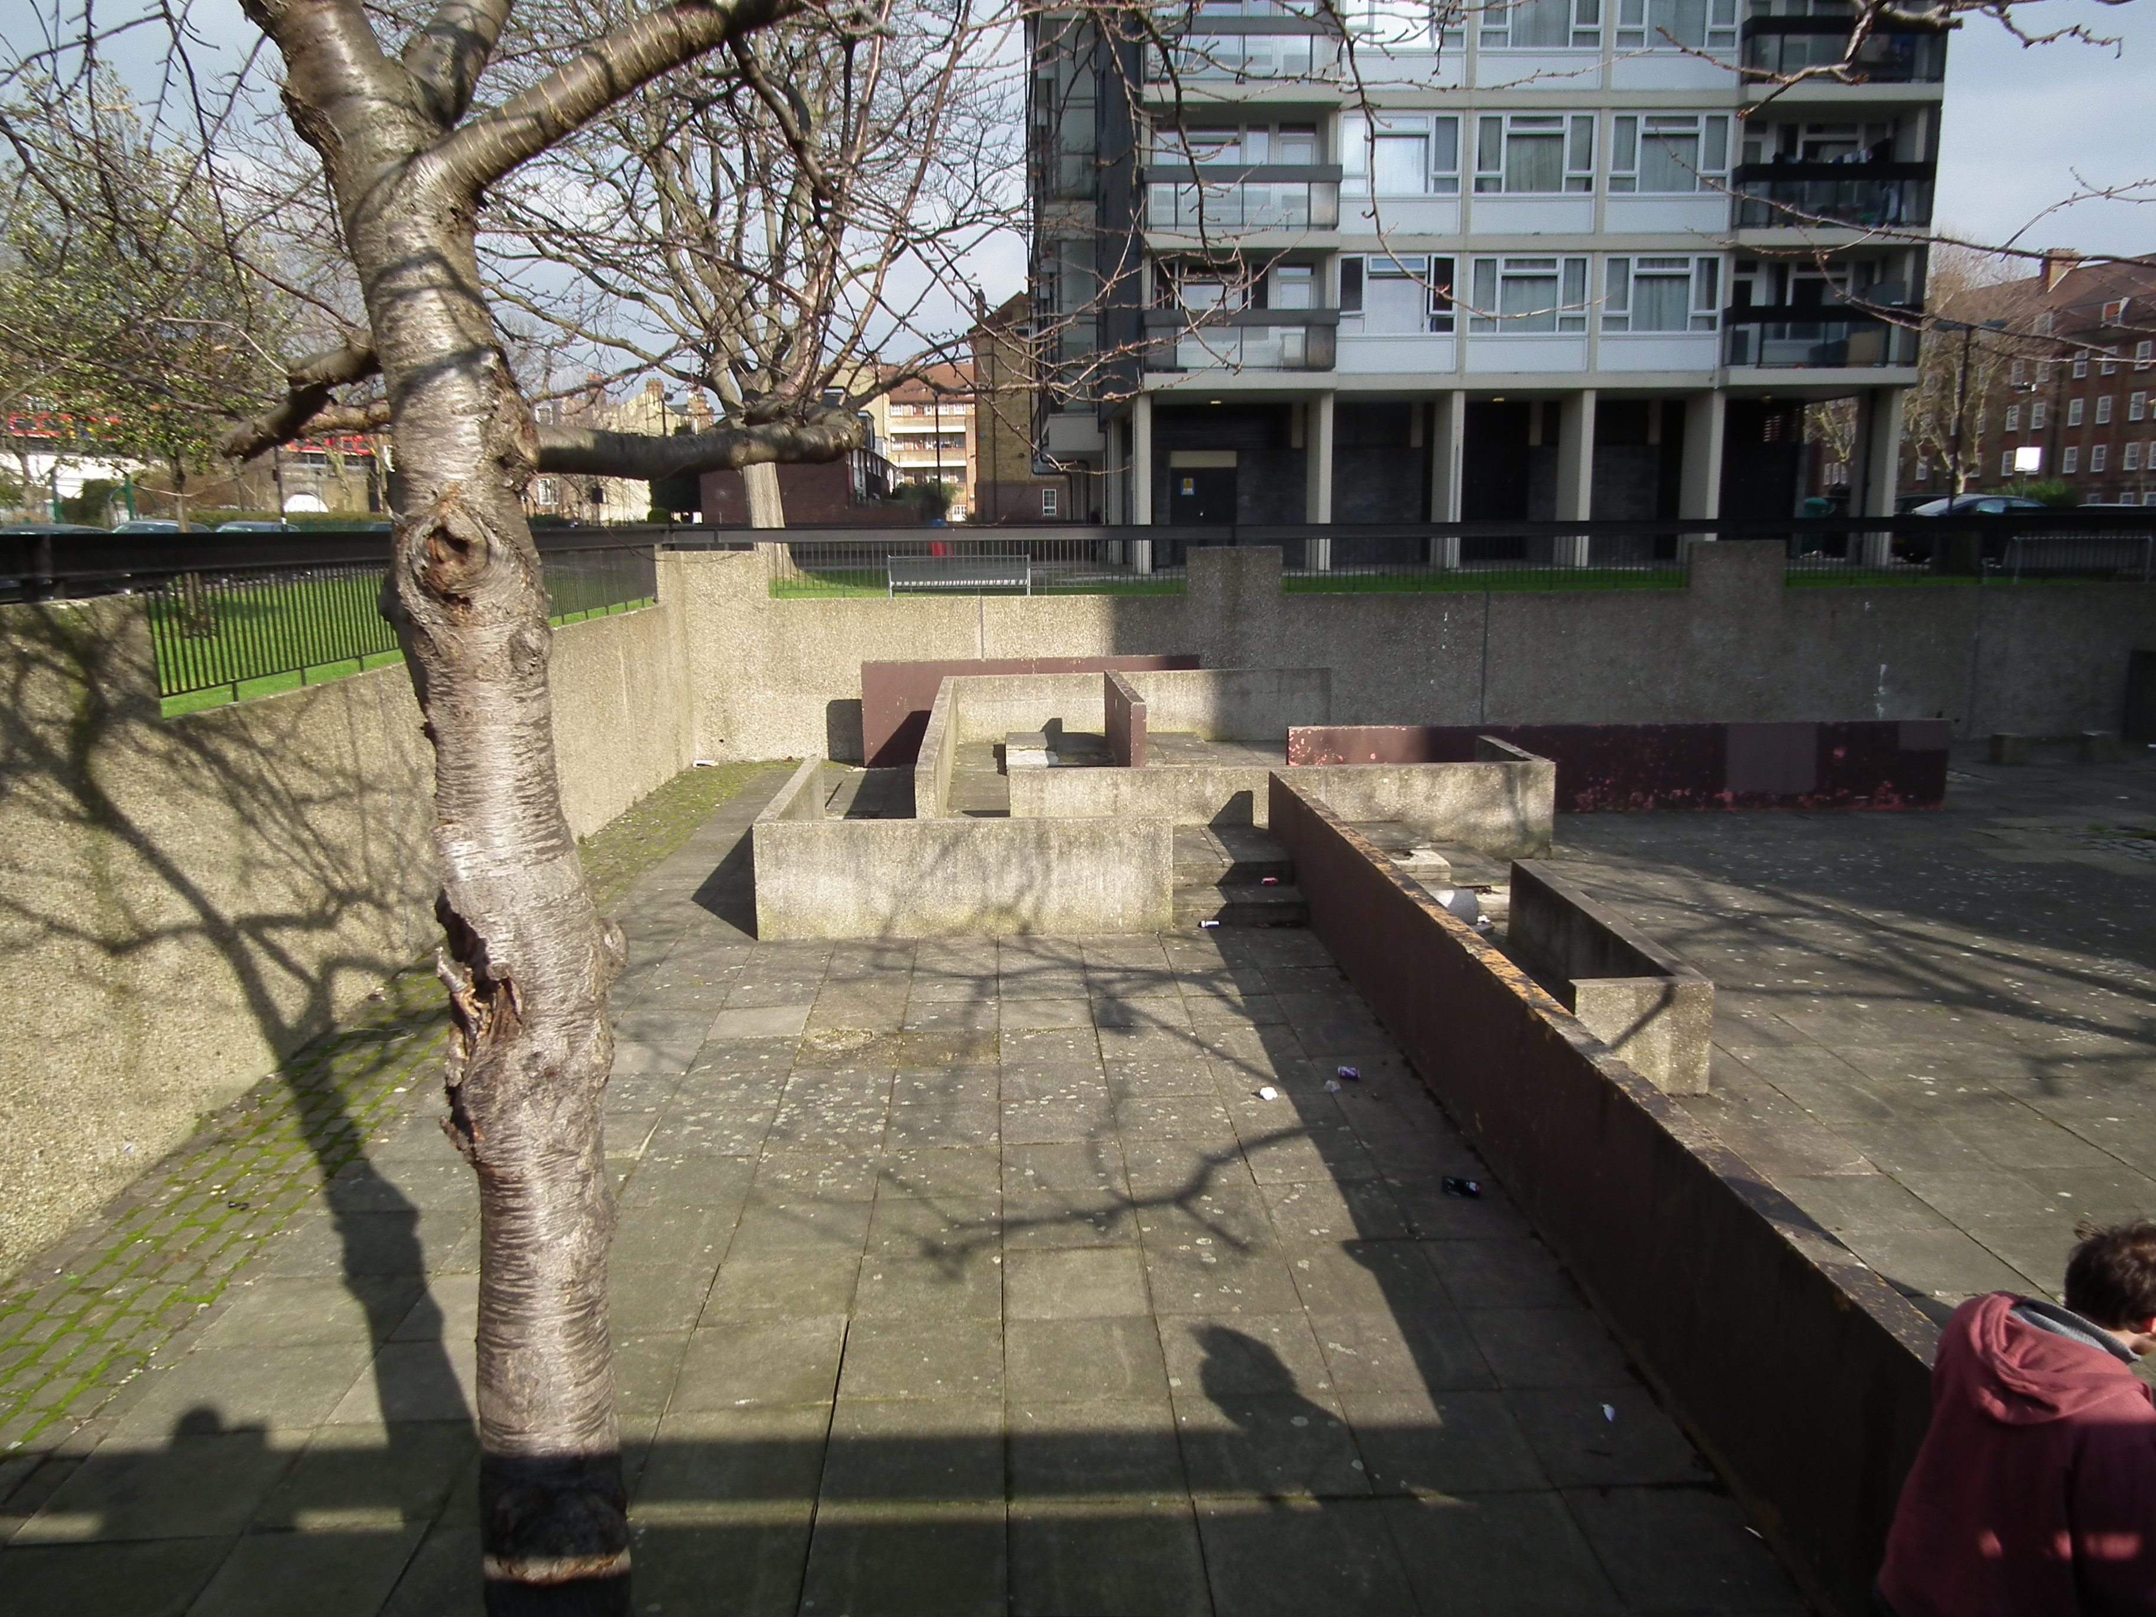
Figure 1. Vauxhall Walls parkour spot, South London (Source: Author’s photo, 19th February, 2013)

This area was originally formulated as the communal part of the adjacent tower blocks. It was built in in 1966, at a time when modernist architectural housing initiatives were being erected across London. The ‘garden’ area that can be seen in Figure 1 is made up of low-level concrete walls and harsh, exposed stone seating. There are also occasional concrete pillar protrusions which were, ironically, once stepping stones for children’s play. Nearly half a century later, the concrete rectilinear design of the 1960s has become tired, out-of-fashion and neglected by the residents, the council and other users for which it was intended. However, the relics of this place have inadvertently made for a highly architecturally appropriate place to practice parkour (or free-running as it is known to the locals). It has, as many traceurs have indicated, become almost a right of passage for anyone who takes parkour seriously in London. The ideal layout is very inviting for many people starting out, it provides a location whereby people are encouraged by other users (known to them or not) and has a sociality that actively encourages ‘beginners’, as well as allowing more ‘advanced’ traceurs to hone their skills. Through word of mouth, online dissemination through community forums, videos and user-generated maps, it has become one of the more ‘famous’ of parkour spots in London and the UK. Figure 2 below shows the Vauxhall Walls in use.

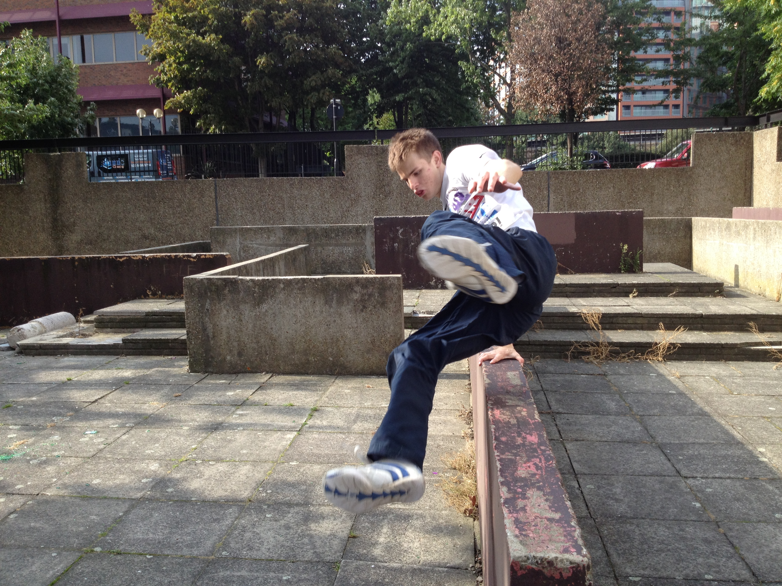
Figure 2: The Vauxhall Walls in use by one young man (Source: James Taylor, July 13th 2013)

The reappropration of the walls (in this case) as a vaulting device shows how practicing parkour has a visceral tacticalness to it. By vaulting over the wall in this way, this young man is turning this neglected space into a space of playful rediscovery of urbanity.

It is however, a contested space. Haymans Point is a residential area maintained by the Vauxhall Gardens Estate Residents and Tenants Association (VGERTA) and Lambeth Council. Over the years since the traceurs/free-runners have been practicing and performing here, they have been largely unwelcome by the local residents and businesses. Signs have been put up insisting they stop (see Figure 3) and online forums often tell of verbal abuse from residents. Insults have been heard from local residents, and despite the traceurs attempting to extol the virtues of parkour, they are threatened with police action (even though their practice is not illegal). Overall, the traceurs are viewed as ‘anti-social’.

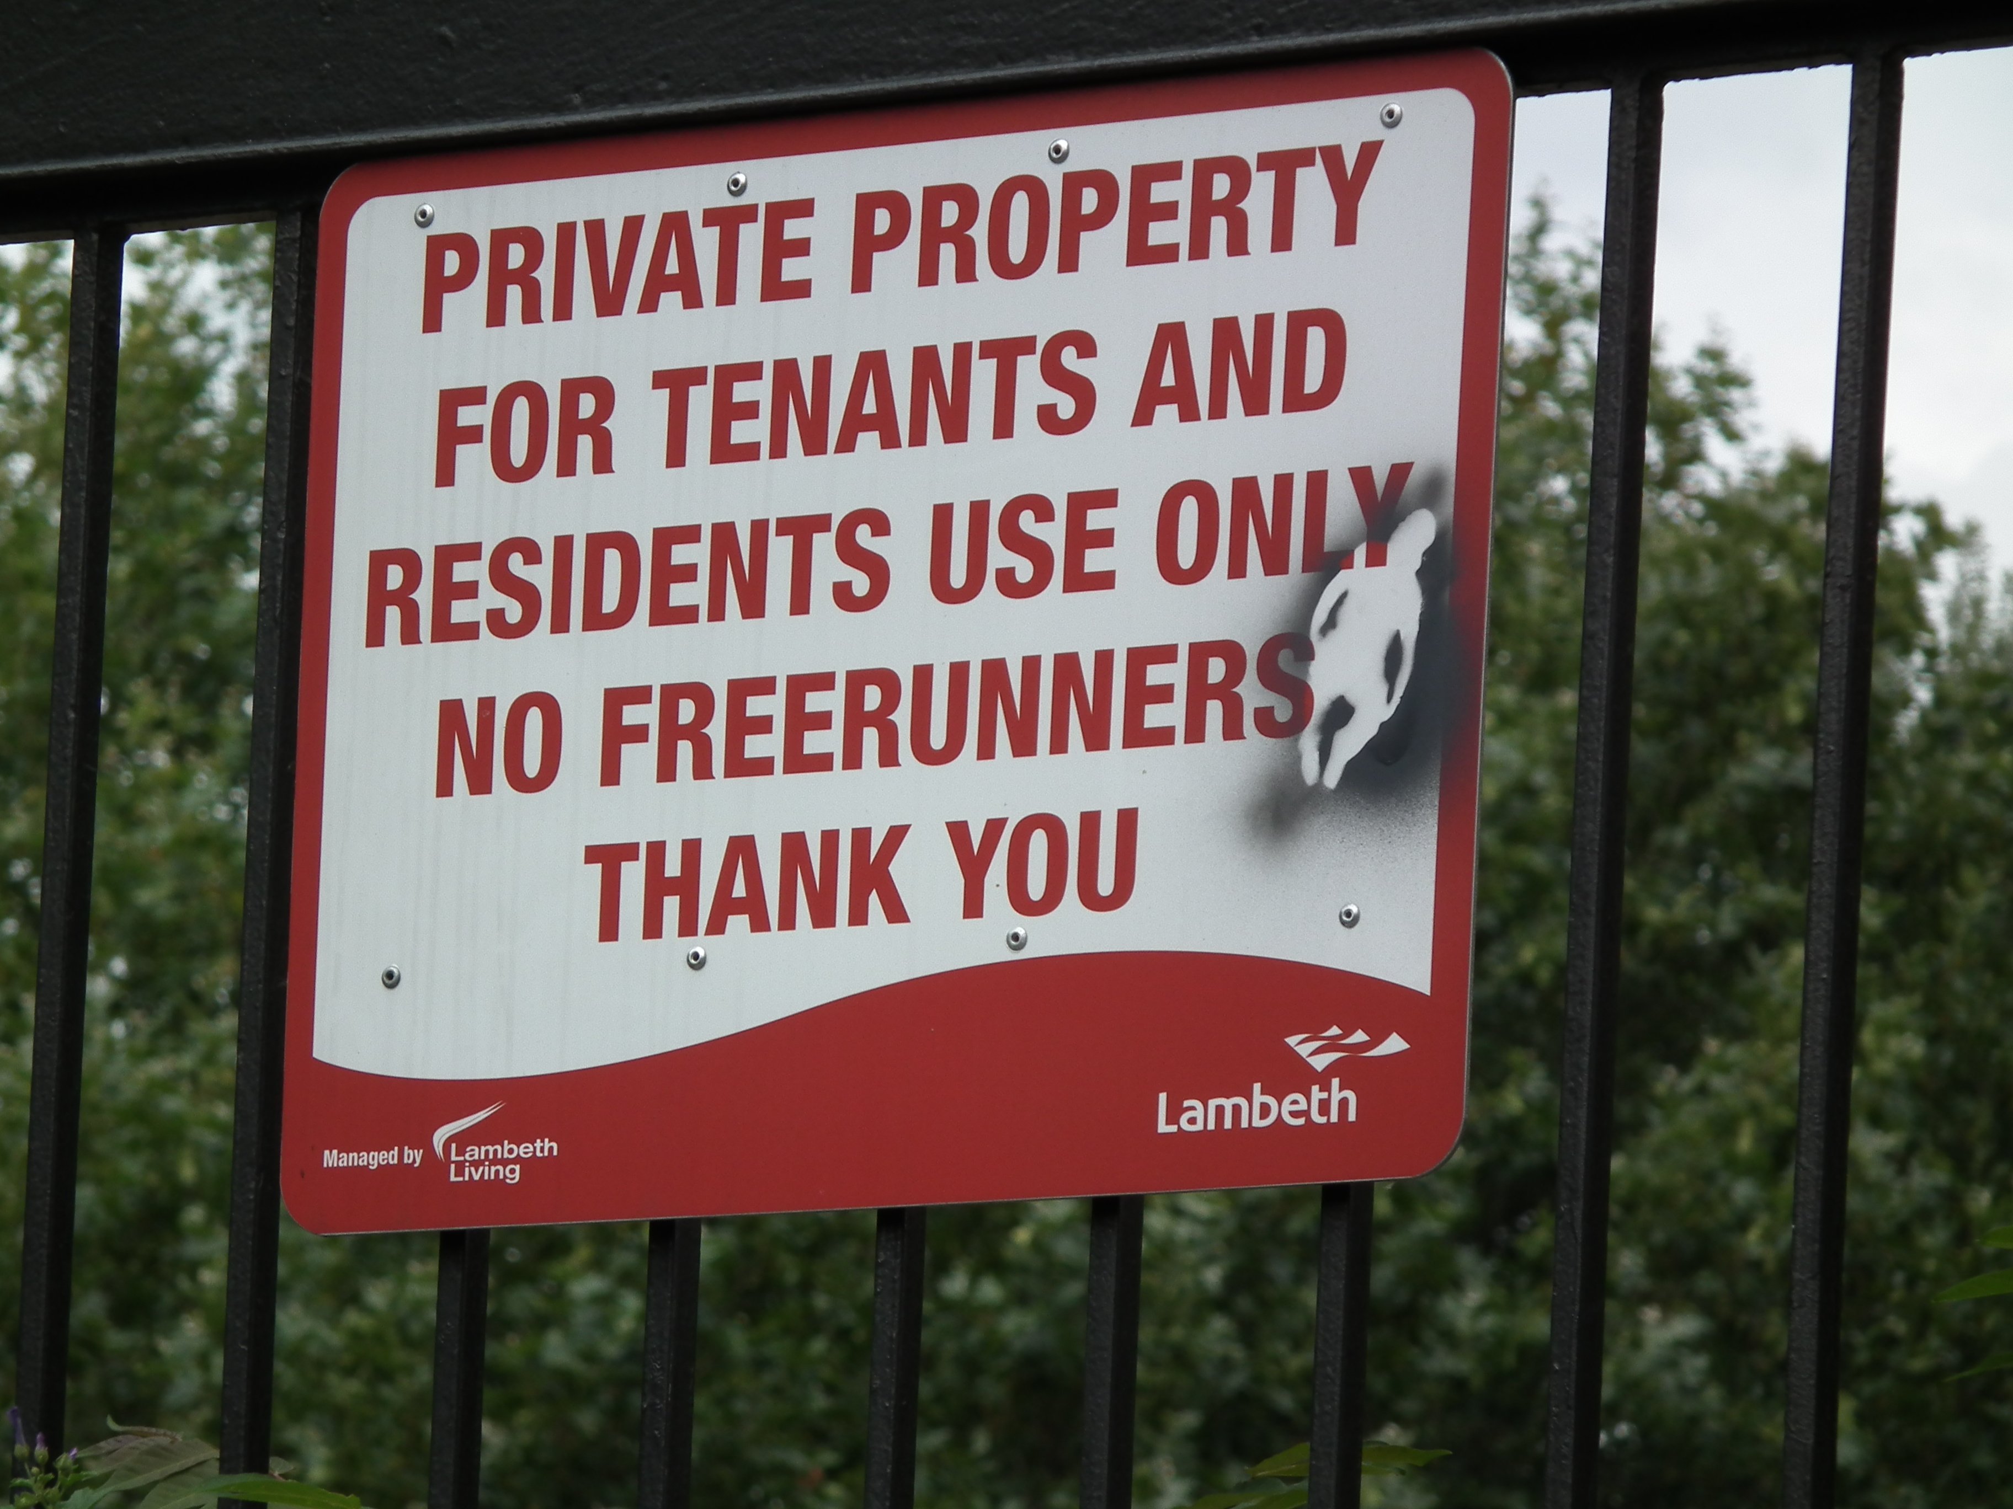
Figure 3: Sign marginalising freerunners at the Vauxhall Walls (Source: Author’s photo, 5th August, 2014)

The continued marginalisation of traceurs from the site by ‘official’ means (such as signage seen in Figure 3 and police action) and more ‘informal’ actions (like verbal insults and physical intimidation) has been matched by the resolve of traceurs to continue using the site. Far from being a neglected ‘garden’ for the local residents, for the traceurs who use and engage with it, it is a place of intricate preparation, of personal and collective triumph and achievement, and a place where individual histories were made. Their desire to continue using the site in the face of strategic marginalisation articulates the political activism that is inherent in traceurs using the site. The child-like nature of parkour is in evidence because of their tactical incursion of the strategy to practice, perform and experience the architecture of this site corporeally and emotionally.

The ability of traceurs to reappropriate this space, to realise a new function as a place to practice parkour is also an innate political act. They are engaging in ‘soft’ activism that is not overtly reactionary, but as Atkinson (2009: 174) notes, “deliberately call[s] attention to the late modern city’s spatial organization and its environmentally sterile, commercial policing” via reappropration of the Vauxhall Walls. They are, as the traceur in Figure 2 demonstrates rediscovering alternative urban subjectivities that would otherwise remain unrealised. They are finding a new function for this place that has not been designated by the official urban narrative, but rather by the subculture of parkour that is maintained through its sociality. Online distribution of videos, institutions using the site as a place for beginners to practice, online forums, stories and anecdotes; these are the narratives that the traceurs who use this site are contributing to. As such, they are being tactical not within the strategy of parkour as a recognised (and highly commercialised) activity, but within the strategy of the officialdom of the city, in this case made up Lambeth Council, VGERTA, the police, local residents and so on. In the summer of 2014, this area has officially been earmarked for redevelopment into a landscaped garden (Mould 2015). After which, given the plans, it is hard to see how traceurs will continue to be able to use the site. Therefore we have seen the further marginalisation of the tacticalness of parkour. It could be said to have taken the place of the Vauxhall Walls fleetingly, but it has now succumbed again to the hegemonic powers of the Global City. To paraphrase De Certeau (1984), parkour won it, but it didn’t keep it.

The agency of the traceurs in this case was, however temporarily, in resisting the official city to practice parkour how they wanted to. Through being playful and tactical, they resisted the city and engaged in emancipatory politics. Their agency brought to light a new city, however fleetingly. And it is this agency that engenders a politics of playfulness to parkour. There are still of course normalising aspects to it; an able body is required, there are overt masculine practices and aesthetics, such biases are intrinsic to the ‘creation’ of a subculture. The child-like nature of parkour is therefore not through a playful tacticalness with the established normativity of masculinist subcultures, rather it is realised in the playfulness with the strategy of the city. Such agency can have even more ‘radical’ emancipatory results. Much like the young people in Palestine that Habashi (2008) wrote about, Thorpe and Ahmad (2013), through research into parkour in Gaza, have highlighted how young people have agency within a region where dominant forces of hegemony seek to suppress it. Young men in Gaza, they contend, are using parkour to engender activism and inculcate fighting for a right to the city. In their research, they highlight a particularly telling correspondence with a traceur;

“We demonstrate that this land is our right and we do what we like in a place that we want, even if you have to kill us or bomb us... we will continue to practice our sport in any place and at any time”.
(Thorpe and Ahmad, 2013: 15)

The risk of being ‘killed or bombed’ is certainly one which inculcates a highly subversive politics to parkour in Gaza; practicing parkour with the risk of imminent death from external forces is certainly a far more extreme set of circumstances than being told to move on by the police or suffering verbal abuse from local residents (as was the case at the Vauxhall Walls). Such continued defiance of hegemony by the traceurs in Gaza does, Thorpe and Ahmad (2013) argue, highlight their emancipatory agency. Moreover they also tie parkour’s important virtual dimension to the traceurs’ ability to stay connected to a ‘global’ parkour community while remaining reflexive to the highly volatile situation locally. So not only is parkour giving the young people of Gaza (and other parts of the Middle East) a way to claim their right to the city, it is also giving them a reason to connect, communicate and collaborate with other like-minded individuals from across the globe. In so doing, the traceurs of Gaza are able to tell the rest of the global parkour community of their local oppression, and showcase their agency in defying it. As such, we see the empowering political activism of parkour within the young people of Gaza. Thorpe and Ahmad (2013: 21) go on to argue that;

“We should not overlook their agency, nor should we assume them to be victims, ideologues or fundamentalists. Some youth are demonstrating remarkable agency in creating sporting opportunities that cater to their own and other local children and youths’ physical, social and psychological needs”

So within the context of geopolitical violence, parkour has tactical agency. The youths of Gaza are eschewing their labelling as ‘victims, ideologues and fundamentalists’ to produce new youthful subjectivities of powerful traceurs who are critiquing the hegemonic strategies that attempt to direct them.

Conclusion

This brief foray into the parkour literature has shown that there are three related, yet conflicting epistemologies. First, parkour has been debated of late as highly corporeal and embodied practice that allows for the ‘rediscovery’ of the city through a quasi-subversive politics that is not overtly resistive, but playful. Second, such playfulness inculcates child-like qualities, as it is tactical to the strategies of the city, the body and an adulthood/childhood dichotomy. As such parkour is not necessarily the purview of the young, but can be considered to encourage child-like behaviour in all that partake in it. This is why parkour parks can have an unintentional effect of reducing the activist politics of parkour because they are reinforcing the strategic control of the city onto the youthful practice of parkour. Third, the child-like nature of parkour increases agency in people that realise different urban subjectivities and situations in which they can eschew attempts to label them as something else.

Therefore, we see that parkour has a rather complicated relation when it comes to thinking about young people and children. On the one hand, the increasing mediation and institutionalisation of parkour can have a detrimental effect on the way in which young people can use it to express their agency. The spectacular corporeality that parkour engenders can render it ‘out of reach’ of people starting out. Additionally, institutions offer training and build parkour parks, but as has been shown, are redacting the more visceral political agency of parkour that is seen ‘on the streets’. On the other hand though, parkour has the ability to engender a child-like activities, one that encourages De Certeuian tacticalness, a playful engagement with the city that questions both existing urban power structures, as well as the masculine, able-bodied, aged biases of the practice.

It is worth highlighting though that the ‘institutionalised’ parkour parks are important because they show young people that practicing parkour is not about trying to achieve the spectacular imagery often seen online, on TV and in films, but realising alternative possibilities of their own body and the environment around them through the intense movement that parkour entails. The original term for parkour is l’art du placement’, the art of displacement. And this is perhaps the most appropriate term given that at its most visceral, it is “a return to a more natural way of moving and a method by which to unlock the enormous potential hidden within your anatomy and physiology” (Edwardes, 2009: 11). Whatever that produces (be it spectacular jumps or simply being more sociable with people), parkour has an innate ability to allow people to ‘break free’ from whatever strategies contain them. However, as this chapter has argued, by institutionalising the practice via the building of parkour parks, by wrapping the practice in layers of bureaucracy, by mediating and marketing it as a commercialised entity chips away at such emancipatory characteristics and reduces its political playfulness. In effect, it reduces its child-like qualities and creates more concretised childhood identities. In so doing, it creates ontologically a different kind of practice from that which was shown with the cases of the Vauxhall Walls and in Gaza. Put crudely, the politics of parkour (as opposed to parkour as political) often marginalises the ‘voices’ of its younger participants.

So the ‘youthfulness’ and child-like nature of parkour comes not from the over-whelming majority of participants, but from realising that it is a political act that is ‘child-like’, however ‘soft’ (Amin, 2008) that politics may be. There are of course issues around its identity normalising tendencies, much of the institutionalised literature seems to unproblematically extol the virtues of pure physicality and celebrates the freedom of movement. If one however does not have this ability, if one uses a wheelchair or has severe arthritis for example, parkour, as it is currently mediated is out of reach. It is also still a highly masculine practice, partly because of the way many urban subcultures manifest themselves, and partly because as parkour has become more commercialised and institutionalised, it begins to mirror the masculinity of more mainstream corporeal and/or sporting practices. However if we realise these biases and continue to pursue the celebration of parkour’s agency in being playful, inculcating a youthfulness that critiques all forms of strategic control (including gender and identity normalisations), then we can continue to fan the flames of its activist potential, and admonish the attempts to control it.

References

Ameel, L., &Tani, S. (2012a). Parkour: Creating loose spaces?.GeografiskaAnnaler: Series B, Human Geography, 94(1), 17-30.
Ameel, L., &Tani, S. (2012b). Everyday aesthetics in action: Parkour eyes and the beauty of concrete walls. Emotion, Space and Society, 5(3), 164-173.
Amin, A. (2008). Collective culture and urban public space.City, 12(1), 5-24.
Angel, J. (2011) Cine Parkour. Julie Angel, London.
Angel, J. (2014) ‘Game Maps: Parkour Vision and Urban Relations’ In Schiller, G and Rubidge, S. (eds.) Choreographic Dwellings: Practicing Place. Palgrave Macmillan, Basingstoke: 178 – 198.
Arneil, B. (2002) Becoming versus being: a critical analysis of the child in liberal theory. In Archard D and McCleod, C. (Eds.) The Moral and Political Status of Children. Oxford University Press, Oxford: 70–96.
Atkinson, M. (2009). Parkour, anarcho-environmentalism, and poiesis.Journal of Sport & Social Issues, 33(2), 169-194.
Benjamin, W. (1999) The Arcades Project. Harvard University Press, Cambridge.
Chow, B. (2010) Parkour and the critique of ideology: Turn-vaulting the fortresses of the city. Journal of Dance & Somatic Practices.2(2): 143 – 154.
Cresswell, T. (2013) Place: A Short Introduction. Blackwell, London.
Daskalaki, M., & Mould, O. (2013). Beyond urban subcultures: urban subversions as rhizomatic social formations. International Journal of Urban and Regional Research, 37(1), 1-18.
Daskalaki, M., Stara, A., &Imas, M. (2008). The ‘Parkour Organisation’: inhabitation of corporate spaces. Culture and Organization, 14(1), 49-64.
De Certeau, M. (1984) The Practice of Everyday Life. University of California Press, London.
Denzin, N. (1977) Childhood Socialisation.Jossey-Bass Inc. Publishers, New York.
Edwardes, D. (2009) The Parkour and Freerunning Handbook. HarperCollins, London.
Fuggle, S. (2008), ‘Discourses of Subversion: The Ethics and Aesthetics of Capoeira and Parkour’, Dance Research, 26(2): 204–22.
Gaye, L., Mazé, R., &Holmquist, L. E. (2003). Sonic city: the urban environment as a musical interface. In Proceedings of the 2003 conference on New interfaces for musical expression, National University of Singapore: 109-115.
Gilchrist, P. & Wheaton, B. (2011) 'Lifestyle sport, public policy and youth engagement: examining the emergence of parkour', International Journal of Sport Policy and Politics, 3(1): 109-131.
Grosz, E. (2001), Architecture from the Outside: Essays on Virtual and Real Space. The MIT Press, Cambridge.
Habashi, J. (2008). Language of political socialization: language of resistance. Children's Geographies, 6(3): 269-280.
Hopkins, P and Pain R. (2007) Geographies of age: thinking relationally. Area, 39(3): 287-294.
Horton, J., &Kraftl, P. (2006). Not just growing up, but going on: materials, spacings, bodies, situations. Children's Geographies, 4(3): 259-276.
Kidder, J. (2012).Parkour, the affective appropriation of urban space, and the real/virtual dialectic.City & Community, 11(3), 229-253.
Kidder, J. L. (2013). Parkour, Masculinity, and the City. Sociology of Sport Journal, 30(1).
Kraftl, P. (2006). Building an idea: the material construction of an ideal childhood. Transactions of the Institute of British Geographers, 31(4): 488-504.
Lamb, M. D. (2014). Misuse of The Monument: The art of parkour and the discursive limits of a disciplinary architecture. Journal of Urban Cultural Studies, 1(1), 107-126.
McDowell, L. (1997) Capital Culture: Gender at Work in the City. Wiley, London.
Mitchell, K, and Elwood S. (2012). Mapping children’s politics: the promise of articulation and the limits of nonrepresentational theory. Environment and Planning D: Society and Space, 30(5): 788 – 804.
Mould, O (2013) ‘The Cultural Dimension’. In Acuto, M and Steele, W. (eds.) Global City Challenges: Debating a Concept, Improving the Practice. Palgrave, Basingstoke: 140 – 154.
Mould, O. (2009). Parkour, the city, the event.Environment and planning.D, Society and space, 27(4), 738-750.
Mould, O. (2015) Urban Subversion and the Creative City.Routledge, London.
Nayak, A. (2003). ‘Through children’s eyes’: childhood, place and the fear of crime. Geoforum, 34(3): 303-315.
Ortuzar, J. (2009): ‘Parkour or l’art du déplacement: a kinetic urban utopia’, TDR: The Drama Review 53(3): 54–66.
Pain, R. (2006). Paranoid parenting? Rematerializing risk and fear for children. Social & Cultural Geography, 7(2): 221-243.
Philo, C. and Smith, F. (2003) Political geographies of children and young people, Space & Polity, 7(2): 99–212.
Rawlinson, C &Guaralda, M (2011) ‘Play in the city : Parkour and architecture’. In The First International Postgraduate Conference on Engineering, Designing and Developing the Built Environment for Sustainable Wellbeing, 27-29 April 2011, Queensland University of Technology, Brisbane.
Saville, S. (2008) ‘Playing with fear: parkour and the mobility of emotion’. Social & Cultural Geography, 9(8): 891 – 914.
Schechner, R. (1993) The Future of Ritual: Writings on Culture and Performance. Routledge, London.
Sharpe, S. (2013). The aesthetics of urban movement: Habits, mobility, and resistance. Geographical Research, 51(2), 166-172.
Skelton, T. (2010). Taking young people as political actors seriously: opening the borders of political geography. Area, 42(2): 145-151.
Smith, L. (2003) Hot Way to Get Around Town: Le Parkour. Rolling Stone Magazine, 95.
Thorpe, H., & Ahmad, N. (2013). Youth, action sports and political agency in the Middle East: Lessons from a grassroots parkour group in Gaza. International review for the sociology of sport, DOI: 10.1177/1012690213490521.
Wenger, E. (1998) Communities of Practice: Learning, Meaning, and Identity. Cambridge University Press, Cambridge.
Wilson, J.&Swyngedouw, E.(2014) ‘Sees of Dystopia: Post-Politics and the Return of the Political. In Wilson, J. &Swyngedouw, E. (Eds.) The Post-Political and Its Discontents: Spaces of Depoliticization, Spectres of Radical Politics. Oxford University Press, Oxford: 1-24.
Wood, B. E. (2012) Crafted within liminal spaces: young people's everyday politics. Political Geography, 31(6): 337-346.
Woodyer, T. (2012). Ludic geographies: not merely child’s play. Geography Compass, 6(6): 313-326.

