# Supporting Information Captions

Figure S1. Map showing sampling sites.

Figure S2. Distribution of SNP *F*ST-values along an exemplary scaffold.

Figure S3. Neighbour-joining tree of populations based on the average *F*ST derived from 10,000 randomly chosen intergenic 1 kb windows.

Figure S4. Distribution of coalescent-simulated *F*ST values of 10,000 loci of 1 kb length per population pair.

Figure S5. Genomic landscape of divergence regions.

Figure S6. Skyline plots visualising changes of migration rates (*Nm*) through time.

Table S1. Pool-sizes and read statistics.

Table S2. Mapping statistics.

Table S3. Genomic landscape of divergence regions.

Table S4. Genomic landscape of divergence regions.

Table S5. Outlier genes.

Table S6. KEGG pathways attributed to outlier genes.

**Figure S1. Map showing sampling sites.** Overview of the study area in Mexico with reference cities in grey. Drainages are underlined, numbers indicate sample sites, black arrows indicate sulphidic sites, and white arrows non-sulphidic sites. 1, Tac-C; 2, Tac-S; 3, Puy-C; 4, Puy-S. Sulphidic waters extend from the point of the black arrows downstream to the nearest confluence with non-sulphidic waters.

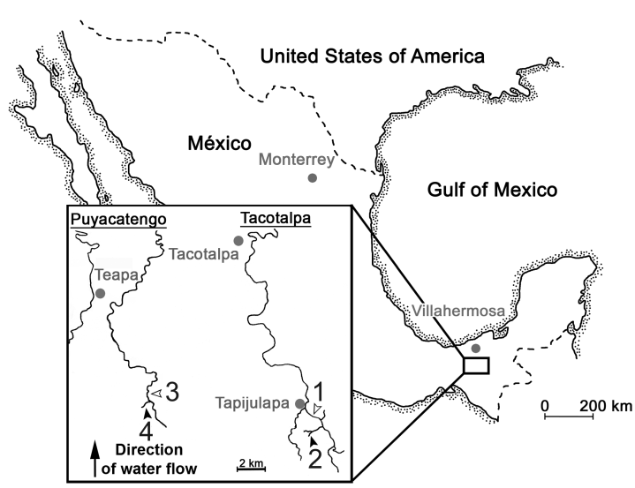

Modified from Plath M, Pfenninger M, Lerp H, Riesch R, Eschenbrenner C, et al. (2013) Genetic differentiation and selection against migrants in evolutionarily replicated extreme environments. Evolution 67: 2647-2661.

**Table S1. Pool-sizes and read statistics.**

|  |  |  |  |  |
| --- | --- | --- | --- | --- |
| Population pool | Pool size | No. raw paired-end reads | No. paired-end reads after TRIMMOMATIC1 | No. paired-end reads after additional quality filtering2 |
| Tac-C | 218 | 229,488,244 | 161,901,233 | 130,585,530 |
| Tac-S | 375 | 232,650,340 | 151,377,240 | 115,479,279 |
| Puy-C | 206 | 221,139,557 | 220,844,592 | 220,682,467 |
| Puy-S | 400 | 162,705,064 | 162,478,825 | 162,368,529 |

1 These reads have been uploaded to the Sequencing Read Archive (SRA) of the European Nucleotide Archive (ENA) hosted by EMBL-EBI under accession PRJEB8912.

2Additional quality filtering included removing any reads with at least one N and/or one base call less than Q20.

**Table S2. Mapping statistics.**

|  |  |  |  |  |
| --- | --- | --- | --- | --- |
| Population Pool | % of reads mapped | % properly paired | Mean coverage before cleaning (×) | Mean coverage after cleaning (×) |
| Tac-C | 94.58 | 90.63 | 34 | 32.76 |
| Tac-S | 95.12 | 95.12 | 29.98 | 28.98 |
| Puy-C | 92.35 | 84.82 | 51.09 | 30.281 |
| Puy-S | 92.36 | 84.72 | 37.74 | 34.03 |

1the Puy-C *bam file was sub-sampled to ~30× coverage

**Figure S2. Distribution of SNP *F*ST-values along an exemplary scaffold** (NW_006799998.1). The dashed line indicates the 1% SNP outlier threshold for the respective drainages. Above: TAC, below: PUY.



**Figure S3. Neighbour-joining tree of populations based on the average *F*ST from 10,000 randomly chosen intergenic 1 kb windows.** Support values were generated from subsampling 100 times 1,000 windows.



**Figure S4. Distribution of coalescent simulated *F*ST-values of 10,000 loci per population pair of 1 kb length.** Simulations were based on empirically estimated gene-flow rates and θ values (Table 1) under the assumption of a mutation rate of 5 × 10-8 per generation and site, constant population sizes, a population split 106 generations ago and a neutral coalescence process. Dashed lines are the empirical 1% outlier thresholds for 1 kb windows for the respective population pairs. Simulated densities above these thresholds were zero for Tac and 0.0006 for Puy.



**Table S3. Genomic landscape of divergence regions.**

|  |  |  |
| --- | --- | --- |
|  | Tac | Puy |
| No. of regions | 3797 | 2357 |
| Median length | 1 kb | 3 kb |
| Max. length | 31 kb | 151 kb |
| Sum | 6,665 kb | 12,698 kb |
| Median distance | 55 kb | 10 kb |
| Max. distance | 1,934 kb | 2,631 kb |

**Figure S5. Genomic landscape of divergence regions.** Frequency distributions of the length of outlier regions (upper panel) and the distance on a scaffold between them (lower panel) for the Tac (left) and Puy (right) population pairs.



**Figure S6. Skyline plots visualising changes of migration rates (*Nm*) through time.** Curves were estimated from 67 (Tac) and 68 (Puy) nuclear loci with Migrate 3.6.5. Above: results for the Tac population pair. Below: Puy drainage. Migration from non-sulphidic-habitats to sulphidic habitats: blue line, vice versa: yellow line.

