the influence of community structure on how communities categorize the world

Shiri Lev-Ari
Royal Holloway, University of London

Address correspondence to:
Shiri Lev-Ari
Dept. of Psychology
Royal Holloway, University of London
Egham Hill, Egham TW20 0EX
shiri.lev-ari@rhul.ac.uk
TEL: +44 1784 276547

Abstract
Categorization is the foundation of many cognitive functions. Importantly, the categories we use to structure the world are informed by the language we speak. For example, whether we perceive dark blue, light blue and green to be shades of one, two, or three different colors depends on whether we speak Berinmo, English, or Russian, respectively. Different languages, then, differ by how granular their categories are, but the source of these differences is still poorly understood. Understanding the source of cross-linguistic differences in linguistic categorization is important because categorization influences communicative efficiency and cognitive performance. Here we use computational simulations to show that community structure, and specifically, community size and community inter-connectivity, influence the categorization systems that communities create. In particular, the simulations show that the obstacles for diffusion that large communities encounter push them to develop categorization systems that are more expressive and better understood, but only if they have sufficiently long memory to do so. The simulations also show that larger communities are better at creating useful references to rarely-communicated meanings, thus further boosting communication in these cases. These findings demonstrate how taking social structure, and especially community size, into account can illuminate why languages evolved to have their current forms. They further show how social constraints, such as those encountered by large communities, can drive the creation of better and more robust systems. As categorization is a building block for many cultural products, these results also have implications for our understanding of cultural evolution more broadly.
Keywords: categorization; social networks; language evolution; communication
Language does not merely reflect the world, it structures it (Whorf, 2012). For example, the color spectrum is continuous but language imposes boundaries between different frequency bands. The number of boundaries that different languages set varies. Russian, for instance, divides the space that English categorizes as blue into two different color categories, whereas Berinmo (a language spoken in Papua New Guinea) collapses all the shades of English blue and green into a single color category. Languages thus show variability with regards to how many distinctions they tend to make for certain categories and meanings. This paper uses computational simulations of categorization of a general semantic domain to explore whether the number of distinctions that languages make depends on the social structure of the communities that use them, and specifically, the size and inter-connectivity of these communities. It further examines how community size and inter-connectivity influence the ability of community members to communicate successfully with each other. As the structure of the categorization system can influence perception, memory, and decision making, these results suggest that social structure plays an important role in shaping behavior.
Languages display an array of optimal solutions for categorizing the world
There are over 7,000 languages in the world and they show great variation in how they categorize the world. Despite their differences, though, all languages are argued to balance expressivity with simplicity in an optimal or near-optimal manner (e.g., Kemp & Regier, 2012; Regier, Kay & Khetarpal, 2007). At the same time, while languages tend to be optimally structured, they exhibit an array of optimal solutions rather than converge on a single structure. Some of this variability is due to differences in communicative needs due to environmental differences. For example, whereas languages spoken in colder regions tend to distinguish between ice and snow, languages spoken in warmer climates might use a single word to refer to both because there is less of a need to distinguish between the two (e.g., Regier, Carstensen & Kemp ,2016; Whorf, 2012). Languages, however, are used for social communication. Therefore, languages are likely to adapt themselves not only to the physical environment, but also to the social one (Lupyan & Dale, 2010). This paper examines how a linguistic categorization system adapts to communicative pressures imposed by the social structure of the community, specifically, the community’s size and inter-connectivity.
Larger communities create more robust communication systems
A growing body of research demonstrates the relationship between community structure and features of the linguistic system. An emerging finding is that communities that are larger create more robust languages to overcome their greater communicative challenges. Robustness here refers to languages being easier to learn, use, and understand. For example, both experimental and cross-linguistic correlational data indicate that languages spoken by larger communities create more systematic languages with simpler morphology (Lupyan & Dale, 2010; Raviv et al., 2019). Community size has also been proposed to account for differences between two sign languages of similar age, Israeli Sign Language and Al-Sayyid Bedouin Sign Language. While the language signed by the larger and sparser community (ISL) exhibits a fully developed phonological system, sublexical divisions are absent in the language signed by the smaller and denser community (ABSL; Meir, Israel, Sandler, Padden & Aronoff, 2012). As systematicity facilitates learning and use, these cases show how languages of large communities can systematize as a way to overcome the greater communicative challenges that a large community imposes.
Another way by which languages of larger communities seem to be more robust is by being more iconic. Thus, when participants were asked to guess the meaning of words in unfamiliar foreign languages, they were better at guessing the meaning of words from languages spoken by tens or hundreds of millions of people, such as Mandarin or Hausa, than guessing the meaning of words from languages spoken by only a few hundreds or thousands of speakers, such as Yele or Zenaga (Lev-Ari et al., 2021). Similar findings indicating that larger groups create more transparent languages were obtained experimentally when participants interacted by creating a new visual communication system: the drawings that were created by participants who interacted in groups of 8 were better understood by naïve participants than the drawing created by participants who played in groups of 2 (Fay et al., 2008; Fay & Ellison, 2013).
Most of the research cited above hypothesizes that the reason that larger communities create more robust communication systems is because they experience greater communicative challenges. These communicative challenges include the longer time it takes information to diffuse in larger communities, the greater variability in use in larger communities, the tendency of members of larger communities to have less shared history with each other, and their tendency to be less similar to each other and have different knowledge and expectations. Languages of larger communities are hypothesized to create more robust languages in order to overcome these barriers and enable successful communication. The aforementioned communicative barriers are not unique to large communities. Other dimensions of social structure, such as the heterogeneity of the community, its sparsity, and its degree of contact with other groups, can all impose similar pressures. It seems likely then that these aspects of community structure would also influence the robustness of the language that communities create. In line with this hypothesis, an experimental study that manipulated intergroup contact rather than group size using a similar paradigm to Fay et al. (2008), found that greater intergroup contact, similarly to larger group size, leads to more transparent (i.e., guessable) symbols (Granito et al., 2019). Studies of facial expressions also show that communities with a more heterogeneous immigration history, namely, communities that experienced immigration from more countries, report displaying greater emotion during interaction and the emotions that they display with their facial expressions are better recognized by individuals from other cultures compared to those of individuals from more homogeneous communities (Rychlowska et al., 2015; Wood et al., 2016). Facial expressions, then, similarly to languages, become more transparent in order to overcome communicative barriers.
Further support for the hypothesis that greater communicative challenges can lead to the emergence of a more robust communication system can be found in the development of communicative skills at the individual level. Individuals with larger social networks experience some of the challenges that large communities experience, such as receiving more variable input (Lev-Ari, 2018; Rost & McMurray, 2009, 2010). This variability is an obstacle for learning and aligning with others. At the same time, the difficulty pressures the learner to simplify and generalize the input, and that way overcome the challenge of dealing with variable input (Gómez, 2002). The simplification and generalization, in turn, lead the learner to develop more robust representations. As a consequence, individuals with larger social networks show better communication skills in terms of understanding speech in noise (Lev-Ari, 2018) or product reviews (Lev-Ari, 2016). Thus, the greater challenges that individuals with large social networks experience pressure them to create the representations and skills that would allow them to overcome the challenge.
Social structure and categorization
The recent surge in research on the relation between community structure and language focused on linguistic features or message clarity. The social dynamics that drive the effects of community structure, however, are likely to apply more generally. Categorization is a tool that allows cognitive economy, that is, it is a manner to perceive and interpret the world while saving cognitive resources (Rosch, 1978). As reviewed earlier, languages differ in how they categorize the world. This paper will focus on whether community structure, and in particular its size and density (i.e., inter-connectivity), influence the granularity of semantic categories, a domain that is at the interface between language and cognition and is fundamental to both linguistic and non-linguistic performance. Additionally, as dividing the semantic space into more categories increases expressivity, and should therefore influence communicative success, this paper will also investigate how community size and inter-connectivity influence communicative success. Throughout the paper, community size refers to the number of individuals in the community whereas community density refers to the degree to which an individual’s neighbors are also connected to each other (i.e., inter-connectivity).
The research reviewed so far suggests that communities that experience greater communicative challenges would create more robust categorization systems. It is less clear though what this would mean in terms of the structure of the categories that they create. On the one hand, prior research has found a positive association between community size or community complexity and the size and informativity of the phonological inventory in human language (Hay & Bauer, 2007 but see Wichman et al., 2011) and call repertoire in the animal kingdom (Blumstein & Armitage, 1997; Freeberg, 2006; McComb & Semple, 2005). These could suggest that larger communities and sparser communities would divide the meaning space into more categories than smaller or denser communities, similarly to the way that larger or more complex communities divide the sound space into more categories. On the other hand, it is also possible that the pressure for simplicity would lead larger and sparser communities to develop less granular categorization systems as it is easier to converge on a system with fewer distinctions.
The studies in this paper use computational simulations as a first step to explore whether community size and community density (i.e., inter-connectivity) can influence how the language of the community categorizes a general meaning space. Study 1 and Study 2 differ in the shape of the distribution of the meanings that individuals communicate about. In Study 1, all meanings in the semantic space are communicated equally frequently. In Study 2, two types of non-uniform distributions are explored. To foreshadow the results, the studies suggest that, given sufficient memory, larger communities divide the semantic space into more categories, and achieve greater communicative success. The results also suggest that the greater communicative bottlenecks that larger communities encounter might facilitate communicative success by allowing only the “fittest” labels to survive in larger communities whereas no such selection pressures operate in smaller communities. The results of Study 2 also suggest that larger communities are better able to create references to rarely-communicated meanings. In contrast to community size, community density (i.e., inter-connectivity), as manipulated in these studies, has minimal influence on the categorization system.
Study 1
To examine whether and how community structure can influence categorization, communities that differed in size and density were simulated. Community members communicated about a two-dimensional domain until their manner of referring to the domain stabilized. The emerging categorization of the domain was then analyzed.
The domain was defined by two orthogonal dimensions. The two dimensions can be conceived as two of the three dimensions of color (e.g., hue and lightness), the height and width of objects that need to be categorized, the temperature and humidity of locations etc. As this was the first attempt to tackle the question of how community structure influences categorization, the domain was maintained general and abstract. Once a baseline is set, future studies can examine how the results might change if perception of the dimension is not linear (e.g., as in color space), if there are more than two dimensions etc.
Method
Simulations in the field of language evolution vary to a great deal including architectures borrowed from epidemiological models, models relying on reinforcement learning and so forth. The properties of the simulations in this study are grounded in cognitive research on categorization and language processing. In particular, the simulations were designed to include the following properties. (1) Individuals store exemplars of the tokens that they hear and rely on them in production and perception (e.g., Goldinger, 1998; Johnson, 1997) (2) Category boundaries are fuzzy (e.g., McCloskey & Glucksberg, 1978) (3) Representations are probabilistic and individuals update their representations according to the input they encounter (e.g., Tenenbaum, Kemp, Griffiths & Goodman, 2011), and (4) Errors are gradient, such that mistaking beige for white is a smaller error than mistaking beige for red.
Network construction
Simulations were run using agent-based models. Communities with scale-free structure (Barabási & Albert, 1999) were generated with the Networkx package in Python (Hagberg, Schult & Swart, 2005). Scale-free networks are networks in which the number of people that each individual is connected to is not uniform but follows a power law, such that there are few individuals that are highly connected and many more who have far fewer contacts. Scale-free networks also exhibit short paths between individuals, that is, each pair of strangers is connected by only a few intermediaries. Real-world networks are argued to exhibit scale-free structure (Barabási & Albert, 1999). Figure 1 provides an example of a scale-free network of 100 individuals.
Figure 1. An illustration of a scale-free network with 100 individuals when m (density parameter) is set to 20. This corresponds to a small sparse community in the reported simulations.
Communities had 100 (Small), 200 (Large), or 1,000 (Giant) agents. Thus, the first increase in community size was a doubling of the population, and the next increase consisted of a change in the order of magnitude. While these communities are relatively small due to limitations of computing power and space, they do represent real community sizes, albeit small ones. According to Ethnologue (Eberhard et al., 2019), the median number of speakers per language is ~7,000 (as cited in Lupyan & Dale, 2010), with hundreds of languages having fewer than 1,000 speakers.
Density was manipulated using the m parameter in the networkx.barabasi_albert_graph function in python. This parameter determines how many new edges are added during network construction whenever a new agent is added. The more edges there are, the denser the network. Note that m is not the total or average number of edges an agent has, as each agent might be connected to agents added to the network after its addition. m was manipulated to be either 20 (Sparse) or 50 (Dense). Individuals’ memory (see below) spanned either 500 (Short) or 1000 (Long) rounds. Memory was not predicted to interact with the effects of community structure but was varied to ensure that the results are not dependent on memory capacity. In total, 300 simulations were conducted, 25 in each combination of network size, network density, and memory. Each simulation ran until stabilization, which was defined as 5,000 rounds without a change in number of categories. Each dimension stretched from 0 to 19.
Interaction rounds
Figure 2 illustrates a trial. It depicts the meaning space as a square for illustrative ease but the dimensions are abstract and do not necessarily correspond to spatial locations. In each round of communication, each agent selected a partner from its network. In each interaction, one meaning (i.e., one cell in the grid) was randomly selected for each interacting partner to communicate (see Figure 2a). Then, each agent searched its past history for interactions about that meaning. If such interactions could be found, the agent produced the label that had the highest success score among the labels that were used to refer to that meaning. If the agent did not have in its history an interaction about that meaning, the agent searched for the closest meaning in its past history in terms of Euclidean distance and used the label with the highest success score for that meaning. In the first round, when the agent did not know any labels yet, the agent created a new label by randomly combining 3 letters out of the 26 letters in the English alphabet (17576 possible combinations). Agents interpreted their partners’ labels according to their past history with that label. The weight given to each past use was proportional to its past success as follows:
Equation 1: $x=\frac{\sum_{i=1}^{k}{x_{i}*s_{i}}}{\sum{s}}$ ; $y=\frac{\sum_{i=1}^{k}{y_{i}*s_{i}}}{\sum{s}}$
x and y represent the position on the x and y axes on the meaning space, $s_{i}$ represents the score the label received in interaction i, and k is the number of interactions in the agents’ past history with the target label. In other words, more successful past interactions contributed more to the agents’ interpretation of the meaning (see Figure 2b). If agents did not have an interaction with the target label in their past history, agents selected the meaning that is farthest from any meaning in their past history. This follows learners’ tendency to rely on the mutual exclusivity principle during word learning (Markman & Wachtel, 1988).
If the partner selected the same meaning as the speaker (same cell), the interaction was coded as successful with a score of 1. Success decreased from 1 the farther the selected meaning was from the intended one according to the following formula:
Equation 2: $S=1-\frac{\sqrt{{{(x}_{c}-x_{i)}}^{2}+{{(y}_{c}-y_{i)}}^{2}}}{26.9}$
where x_{i} and y_{i} represent the intended meaning and x_{c} and y_{c} represent the comprehended meaning. That is, the nominator calculated the Euclidean distance, and divided it by 26.9, the maximal Euclidean distance between two meanings on the meaning space.
If a label or a meaning has not been used within the agent’s memory window, it was forgotten, that is, removed from the agent’s history. In half of the simulations, the memory window was set to the last 500 rounds, and in the other half of the simulations, it was set to the last 1,000 rounds.
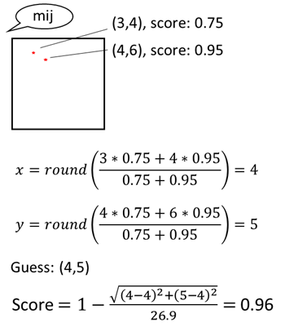
(a)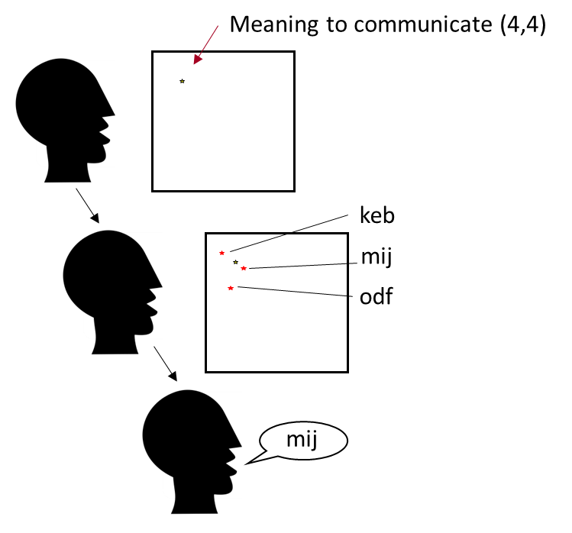(b)
Figure 2. An example of one interaction. (a) The speaker receives a meaning (i.e., a cell) to communicate, represented by the star. The speaker searches its memory for past interactions about that cell. If none is found, the speaker looks for the nearest meaning in its memory. In this case, the closest meaning (i.e., cell) it remembers appearing in past interaction was referred to by mij. The speaker therefore produces the label mij. (b) The listener receives the label mij and searches its memory for prior interactions with that label. Two are found, corresponding to the meanings (3,4) and (4,6). The interactions where these labels were produced received the scores 0.75 and 0.95, respectively. The listener then calculates the most likely meaning based on these prior interactions, and guesses the meaning to be (4,5). As this is quite close to the intended meaning (4,4), the score for this interaction is 0.96. Both partners store in their memory the label, meaning, and communication score. In each interaction, both members receive a meaning to communicate to their partner. This is therefore half of one interaction.
Results
All data and the analyses script for this study are available at: https://osf.io/qvguz/?view_only=c13ad84355ce4218bb4c6a70f40d2164
Unless mentioned otherwise, all statistical analyses were conducted with the lme4 package (Bates, Maechler, Bolker & Walker, 2015) in R (R core Team, 2020). Plots were generated with TidyVerse (Wickham et al., 2019). Small communities needed 11,802 rounds, on average, to stabilize (range: 8,750-17,900), Large communities needed on average 14,040.5 rounds to stabilize (range: 9,250-20,750), and Giant communities needed on average 22,617.5 rounds to stabilize (range: 14,100-38,850). By the end of the simulation, all labels in the Small and Large communities spread throughout the community, reaching, on average, 99.9% and 99.7% of the community, respectively. In the Giant communities, labels, on average, have spread to 94.7% of the community.
Number of categories
The first analysis examined whether community structure influences the number of categories that communities create. A linear regression with Community Size (Small, Large, Giant; reference: Large), Community Density (Sparse, Dense; reference: Sparse), Memory (Short, Long; reference: Short) and their interaction showed that the number of categories that communities created was higher the larger the community was (Small vs Large: β=-24.28, SE=1.30, t=-18.73, p<0.001, Giant vs Large: β=9.88, SE=1.30, t=7.62, p<0.001; See Figure 3).
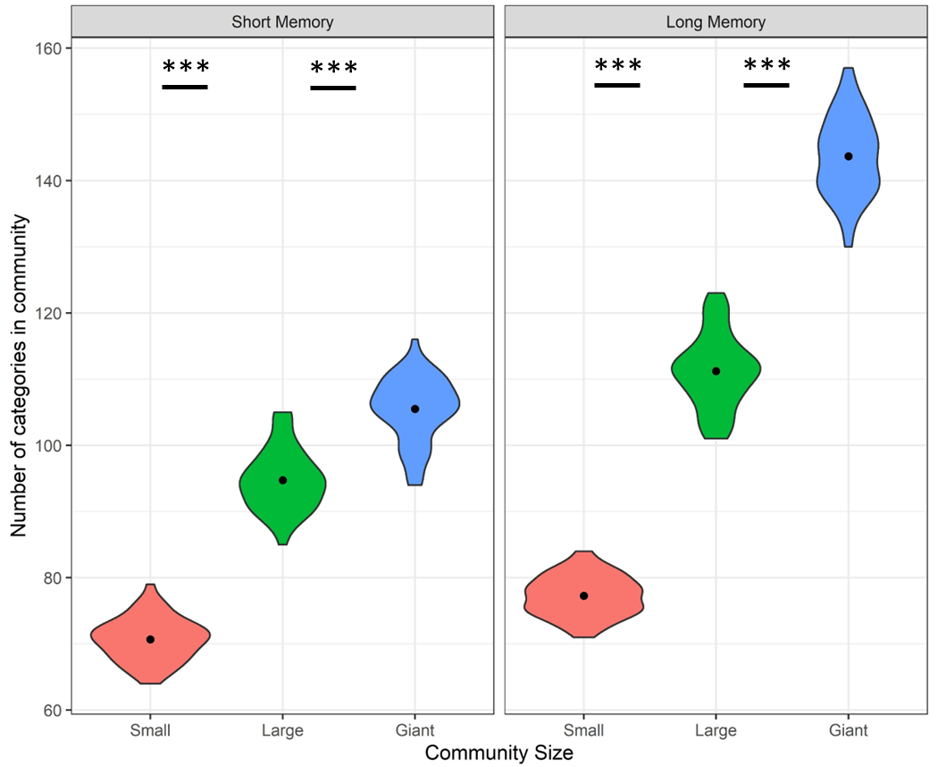
Figure 3. Number of categories as a function of Community Size (Small, Large, Giant) and Memory (Short, Long). Black dots represent means. Asterisks represent significance: *: <0.05, **: <0.01, ***: < 0.001.
Having longer memory also led to having more categories (β=18.24, SE=1.30, t=14.07, p<0.001). Additionally, longer memory enhanced the effect of Community Size, leading to even greater differences between communities of different sizes as indicated by interactions between Memory and Community Size for Small (β=-10.96, SE=1.833, t=-5.98, p<0.001) and Giant (β=19.88, SE=1.83, t=10.84, p<0.001) communities. Community Density did not have an effect nor did it interact with any other predictor.
The positive effect of community size suggests that larger communities created a more expressive categorization system. At the same time, as mentioned earlier, labels were less likely to be shared by all community members in the Giant communities. Therefore, Giant communities might have more category labels at the community level without creating more expressive systems if the abundance of labels is due to different community members using different labels for the same category. To rule out this interpretation, the same analysis was re-run while replacing the dependent measure of number of categories in the community with the average number of categories each community member had instead. The results remained the same. Members of Small communities had fewer categories than members of Large communities (β=-23.89, SE=1.26, t=-18.92, p<0.001) and members of Giant communities had even more categories than members of Large communities (β=5.19, SE=1.27, t=4.11, p<0.001). Additionally, as before, having longer Memory led to the creation of systems with more categories (β=18.51, SE=1.27, t=14.66, p<0.001) and enhanced the effect of Community Size as indicated by interactions between Memory and Community Size (Small: β=-11.21, SE=1.79, t=-6.28, p<0.001; Giant: β=15.94, SE=1.79, t=8.93, p<0.001).
To summarize, the larger the community was, the more expressive its categorization system, and this was true across different memory capacities and density values. The creation of a more expressive categorization system could support more successful communication as it allows more precise reference. Next, it was tested whether that was the case.
Communicative success
Communicative success is the degree to which interacting agents understood each other. It is calculated using the communication score in equation 2. To examine whether community structure influenced communicative success, that is, how well agents understood each other, the average success score that each category label received was analyzed. As scores are bounded (0-1), data were analyzed using a One Inflated Beta Regression with the gamlss package (Rigby & Stasinopoulos, 2005). The model included Community Size (Small, Large, Giant; reference: Large), Community Density (Sparse, Dense; reference: Sparse), Memory (Short, Long; reference: Short) and their interaction as fixed effects and Simulation as a random variable. The results revealed that agents understood each other better the larger the community was (Small vs Large: β=-0.13, SE=0.01, t=-9.09, p<0.001; Giant vs Large: β=0.16, SE=0.01, t=11.69, p<0.001; See Figure 4). Additionally, while having longer Memory slightly decreased success in Large and Small communities (β=-0.06, SE=0.01, t=-4.81, p<0.001), it did not have a negative effect on communicative success in Giant communities, as indicated by an interaction of Memory with Community Size at that level (β=0.06, SE=0.02, t=3.62, p<0.001). As suggested by an anonymous reviewer, the surprising negative effect of memory in Small and Large communities might be because long memory can prevent individuals from updating their representations quickly enough to changes in the lexicon.
Lastly, while Density did not influence communicative success in Small and Large communities, it had a small negative effect on communicative success in Giant communities (β=-0.05, SE=0.02, t=-3.06, p<0.01). Nevertheless, even in Dense communities, communicative success remained higher in Giant communities compared with Large ones (β=0.10, SE=0.01, t=7.42, p<0.001).
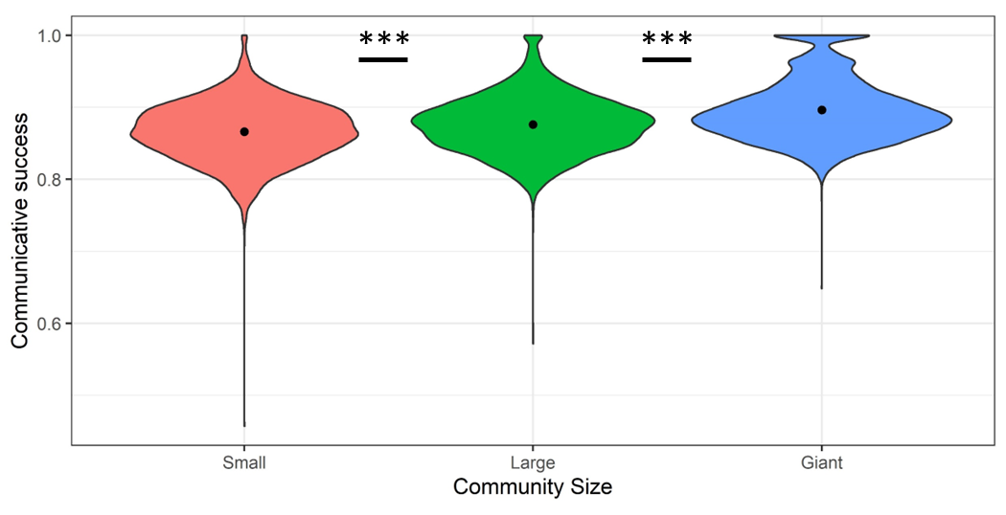
Figure 4. Average communication success score per category label as a function of Community Size (Small, Large, Giant). Black dots indicate condition averages. Asterisks represent significance: *: <0.05, **: <0.01, ***: < 0.001.
Together, the results indicate that larger communities create more expressive categorization systems as well as communicate more successfully across different memory capacities and density levels. Larger communities then, despite the greater communicative challenges they face in terms of diffusion of information, succeed at not only communicating as well as smaller communities, but better than them.
Potential underlying mechanisms
The results above indicate that having a larger community confers benefits by leading to the emergence of a more expressive and better understood categorization system. But why does community size lead to this benefit?
One possibility is that the greater communicative challenges that larger communities encounter lead to the survival of the “fittest” category labels (see Fay et al., 2008 for a similar proposal). In small communities, information can be easily diffused but diffusion becomes slower and harder in larger communities. Furthermore, because there are fewer inventions in smaller communities, it is possible to maintain all the variants that spread. As the community gets larger, however, there are too many variants to maintain them all. This leads them to compete with each other, and eventually only the better labels survive. This greater competition can be demonstrated by examining what proportion of labels that spread to at least half of the community survived until the end of the simulation. As Figure 5 demonstrates, when communities are Small, 78% of the labels that spread survive. This proportion drops to 58% in Large communities, and is only 22% in Giant communities. The fierce competition in larger communities, then, leads category labels with lower communicative success or that do not fit a unique niche to drop out of use in larger communities while they may be maintained in smaller ones. This analysis of the likelihood of labels to survive only included labels that managed to spread to at least half of the community, that is, labels that overcame the diffusion bottleneck. As the diffusion bottleneck is narrower in larger communities and label’s fitness might also influence its likelihood to spread at all, the figure under-estimates the degree of competition that labels in larger communities face.
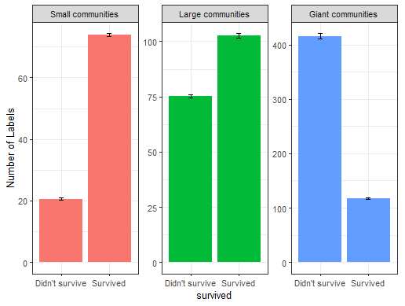
Figure 5. The average number of category labels that were maintained until the end of the simulation (Survived) vs disappeared (Didn’t survive) as dependent on Community Size (Small, Large, Giant). Black bars are error bars. The plot only includes labels that have spread to at least half of the community.
To sum up, while further research is required to understand the mechanisms that can lead larger communities to create more expressive and better understood categorization systems, it seems that it might be at least partially driven by the greater competition between labels that leads only the most successful ones to survive.
Discussion
Study 1 indicates that larger communities create more fine-grained categories that allow them to communicate more successfully. This might seem surprising considering larger communities encounter greater communicative challenges, such as greater variability across individuals and lower likelihood of information to spread. It seems, though, that the same challenges that hinder communication might also be responsible for promoting more successful communication. Those challenges serve as a screening mechanism that only allows the best labels to survive thus promoting communicative success.
In Study 1, all meanings were communicated equally frequently. Many real world domains, however, have some meanings that are communicated more frequently than others. Study 2 investigates the degree to which the results of Study 1 generalize to such cases. It does so by examining how community size and community density influence the number of categories and communicative success in cases where the distribution of communicating about different meanings is not uniform. Specifically, Study 2 examines communication over a semantic space where the likelihood of discussing different meanings follows the normal distribution, or the frequency distribution of number words, focusing on the numbers 1-20.
Study 2
Study 2 examines the effect of community size and community density on categorization when the different meanings in the semantic domain that is discussed are not communicated equally frequently. In particular, it examines two types of meaning distributions: the normal distribution, and the frequency distribution of number words. The frequency of items in many domains follows a normal distribution. To the degree that we discuss more often things that we encounter more frequently, the frequency of communicating about meanings in the semantic space might also follow the normal distribution. In addition to simulating communication over meanings that are distributed along the normal distribution, Study 2 also examines a case of an atypical distribution, that of the frequency of number words in the range 1-20, in order to ensure the robustness of the findings. The frequency of number words in general decreases as the number go up, but with peaks for round numbers (e.g., the word ten is more frequent than either nine or eleven).
By examining the effects of community size and density on categorization in domains with different distributions of meanings, we will have a deeper understanding of how community structure can influence categorization and how well the findings from Study 1 can apply to different types of categories in the real world.
Method
The simulations in Study 2 are identical to those in Study 1 except for the process of meaning selection which is detailed below.
Normal distribution
Meanings for each dimension were selected from a normal distribution with a mean of 9.5 and a standard deviation of 4 with the restriction that values lower than 0 or higher than 19 cannot be selected. When these were generated by error, a new meaning was selected and the value outside the bounds was ignored. These mean and standard deviation were selected because they lead to the generation of values from the entire range between 0 and 19 while values outside this range are rarely produced.
Frequency distribution of number words
The frequency of the number words 1-20 was estimated based on subtlex-US (Brysbaert & New, 2009), and these were mapped onto the values 0-19 (the range of the axis of the semantic space, so 0 corresponds to the word one, 1 corresponds to the word two etc.). Then, values for that axis in the semantic space were sampled according to the relative frequency of the corresponding word. For example, according to subtlex-US, the word two is almost twice as frequent as the word three and four times as frequent as the word four. Therefore, the value corresponding to two had a sampling probability that was almost twice as high as the sampling probability of the value corresponding to three and about four times as high as the sampling probability of the value corresponding to four. Values for the other dimension were sampled from a uniform distribution.
Results
All results and analyses scripts for this study are available at: https://osf.io/s6ne5/?view_only=d9334875fe894f11bb68e2534f7c4511
All statistical analyses followed closely those reported in Study 1. When communication about meanings followed a normal distribution, Small communities needed on average 14,801 rounds to stabilize (range: 10,400-22,400), Large communities needed on average 16,764 rounds to stabilize (range: 11,750-28,800), and Giant communities needed, on average, 19, 696 rounds to stabilize (range: 13,200-35,350). When communication followed the frequency distribution of number words communities needed longer to stabilize: Small communities required 22,373 rounds (range: 12,300-34,850), Large communities required 26,954 rounds (range: 14,300-45,700), and Giant communities required 38,932 rounds (21,700-74,950).
By the end of the simulations, all labels were shared across the community in all community sizes when communication about meanings followed normal distribution. Labels in Small communities spread on average to 99.7% of the community, labels in Large communities spread to 100% of the community, and labels in Giant communities spread of 99.8% of the community. When communication about meanings followed the frequency distribution of number words, labels spread a little less widely: In Small communities they spread on average to 98.2% of the community, in Large communities to 98%, and in Giant communities to 95.4% of the community.
Number of categories
Normal Distribution.
To test whether community structure influences the number of categories that communities create, a linear regression with Community Size (Small, Large, Giant; reference: Large), Community Density (Sparse, Dense; reference: Sparse), Memory (Short, Long; reference: Short) and their interaction was conducted. Results showed that Community Size influenced the number of categories in a non-monotonic manner. At the reference level (Short memory), Large communities created more categories than both Small (β=-13.12, SE=1.15, t=-11.42, p<0.001) and Giant communities (β=-9.20, SE=1.15, t=-8.01, p<0.001; See Figure 6). Results also indicated that the number of categories was higher when Memory was Long (β=16.40, SE=1.15, t=14.28, p<0.001), and, importantly, that when Memory was Long, the advantage of Large communities over Small ones became even larger whereas their advantage over Giant communities disappeared, as indicated by interactions between Memory and Community Size at these levels (Small: β=-5.76, SE=1.62, t=-3.55, p<0.001; Giant: β=9.88, SE=1.62, t=6.08, p<0.001). There was also a triple interaction of Community Size, Density, and Memory for Dense Giant communities with Long memory (β=-5.04, SE=2.30, t=-2.19, p=0.03). It seems to indicate that while Density doesn’t influence the number of categories in most cases, Dense Giant communities have fewer categories than Sparse Giant communities when memory is Long.
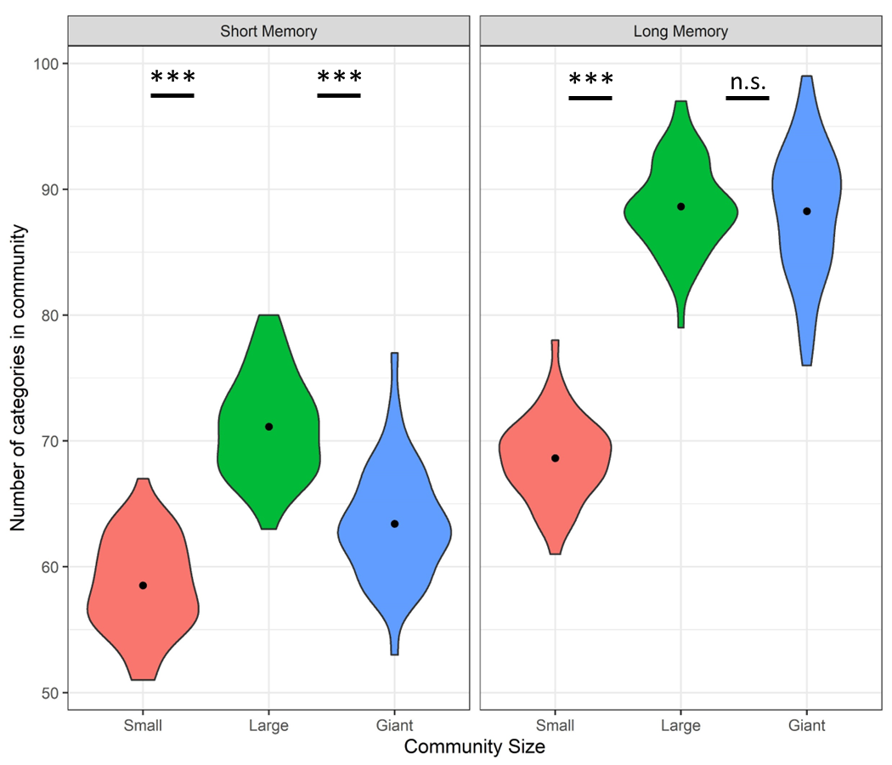
Figure 6. Number of categories as a function of Community Size (Small, Large, Giant) and Memory (Short, Long) when communication over meaning follows the normal distribution. Black dots represent means. Asterisks represent significance: *: <0.05, **: <0.01, ***: < 0.001.
Frequency distribution of number words.
To test whether community structure influences the number of categories that communities create when communication follows the frequency distribution of number words, a linear regression with Community Size (Small, Large, Giant; reference: Large), Community Density (Sparse, Dense; reference: Sparse), Memory (Short, Long; reference: Short) and their interaction was conducted. Results showed that, at the reference level (Short Memory), Giant communities created fewer categories than Large communities (β=-6.76, SE=0.99, t=-6.82, p<0.001; See Figure 7), which did not differ from Small communities (p=0.49).
As before, the number of categories increased when Memory was Long (β=17.56, SE=0.99, t=17.70, p<0.001). When Memory was Long, a difference between Small and Large communities emerged with more categories in Large communities as reflected by an interaction between Memory and Community Size at that level (β=-5.44, SE=1.40, t=-3.88, p<0.001).
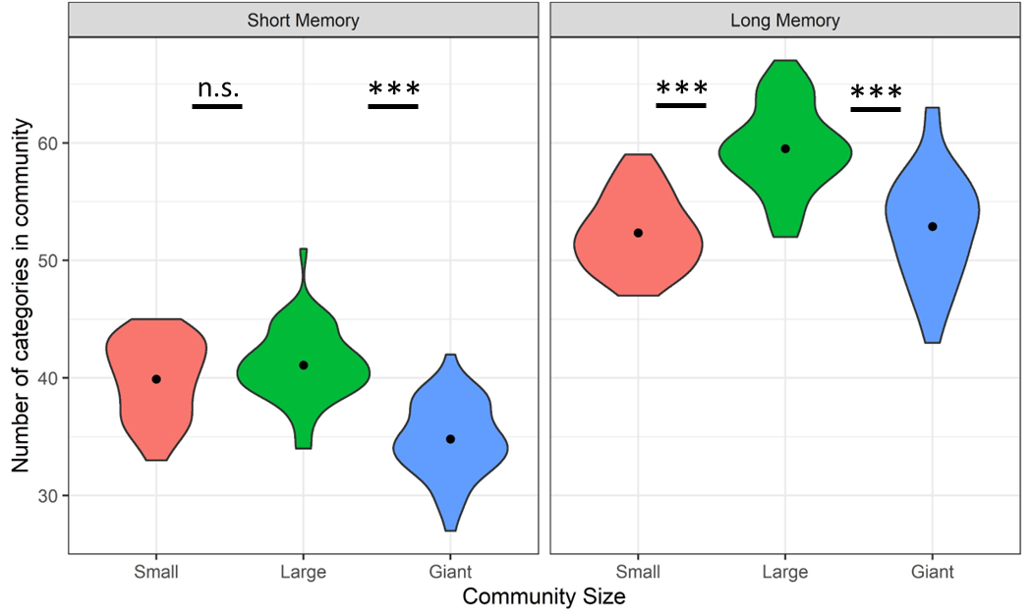
Figure 7. Number of categories as a function of Community Size (Small, Large, Giant) and Memory (Short, Long) when communication over meaning follows the frequency distribution of number words. Black dots represent means. Asterisks represent significance: *: <0.05, **: <0.01, ***: < 0.001.
To summarize, when examining the results of Study 2 it becomes clear that larger communities create more categories, as long as the memory span is long enough to enable label spread. In non-uniform distributions, such as those simulated in Study 2, some meanings are communicated only rarely. In such cases, unless memory is sufficiently long, the labels struggle to spread to all community members when the community is large, leading such communities to have fewer labels. Indeed, across all examined distributions of communicated meanings in the two studies (uniform, normal, number words) the difference between Large and Small communities increased when memory was Long. The increase in memory span often also led to a greater increase in number of categories in Giant communities than smaller ones, but, when the distribution of communicated meaning was not uniform, the increase in memory span was not always sufficient to allow Giant communities to create more categories than Large communities, or to sometimes even equate their performance. To better determine whether Giant communities require an even longer memory span to exhibit a higher number of categories than smaller communities in non-uniform semantic domains or whether they never surpass the number of categories in smaller communities in these distributions, an additional set of analyses was conducted with memory span of 2000 rounds (twice the span of Long memory). In this case, when communication followed the normal distribution, Giant communities created more categories than Large communities (Giant: 113; Large: M=105), which created more categories than Small communities (M=76). When communication followed the frequency distribution of number words, the increase in memory span eliminated the difference between Giant and Large communities, which both created more categories than Small communities (Giant: 76; Large: 79; Small: 65). It seems then that given sufficient memory, larger communities always create more categories than smaller ones, but that they are also more constrained by memory resources, and will thus not exhibit this pattern if available memory resources are not sufficient to overcome diffusion bottlenecks (see also section on underlying mechanism to see differences in diffusion bottlenecks across these meaning distributions).
Communicative success
Normal distribution. To examine how community structure influences communicative success, that is, how well agents understand each other, the average communication score that each category label received was analyzed. A One Inflated Beta Regression with Community Size (Small, Large, Giant; reference: Large), Community Density (Sparse, Dense; reference: Sparse), Memory (Short, Long; reference: Short) and their interaction as fixed effects and Simulation as a random variable revealed that agents understood each other less well when community was Small rather than Large (β=-0.05, SE=0.01, t=-4.99, p<0.001; See Figure 8) while Large and Giant communities did not differ from each other at the reference level (Short memory). At the same time, while Memory did not influence communicative success in Small and Large communities, it led to higher communicative success at Giant communities, leading to better performance in Giant communities than Large communities when Memory is Long, as reflected in an interaction between Memory and Community Size at that level (β=0.06, SE=0.01, t=4.16, p<0.001). Additionally, Density led to worse performance in Large communities (β=-0.04, SE=0.01, t=-3.76, p<0.001) but not in Small communities, as reflected in an interaction between Density and Community Size at that level (β=0.05, SE=0.01, t=3.49, p<0.001). Consequently, the advantage of Large communities over Small ones disappeared when communities are dense.
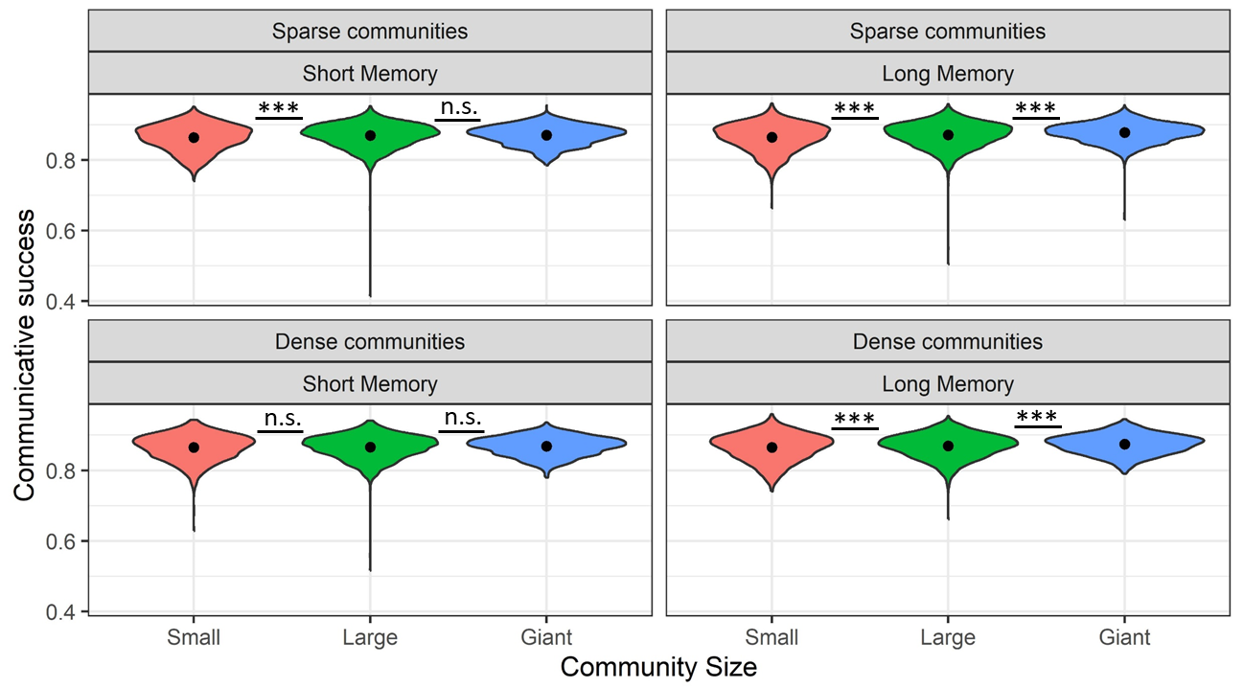
Figure 8. Average communication success score per category label as a function of Community Size (Small, Large, Giant), Memory (Short, Long), and Density (Sparse, Dense) when communication follows the normal distribution. Black dots indicate condition averages. Asterisks represent significance: *: <0.05, **: <0.01, ***: < 0.001.
Frequency distribution of number words. A One Inflated Beta Regression with Community Size (Small, Large, Giant; reference: Large), Community Density (Sparse, Dense; reference: Sparse), Memory (Short, Long; reference: Short) and their interaction as fixed effects and Simulation as a random variable revealed that, at the reference level (Short memory) communicative success was lower in Giant communities than in Large communities (β=-0.08, SE=0.02, t=-4.63, p<0.001; See Figure 8), which did not differ from Small communities. Importantly, longer memory span led to higher communicative success in Giant communities, as reflected in an interaction between Memory and Community Size at that level (β=0.08, SE=0.02, t=3.89, p<0.001). Therefore, when memory was Long, the disadvantage of Giant communities was eliminated. While Memory did not influence performance at the reference level (Large communities) nor did it significantly interact with Small community size, re-running the model with Long memory as the reference level indicates that when memory is Long, a difference between Small and Large communities emerges, with better higher communicative success in Large communities than Small ones (β=-0.03, SE=0.01, t=-2.46, p=0.014). Figure 9 also suggests that, in all communities, there were a few labels with low communicative success.
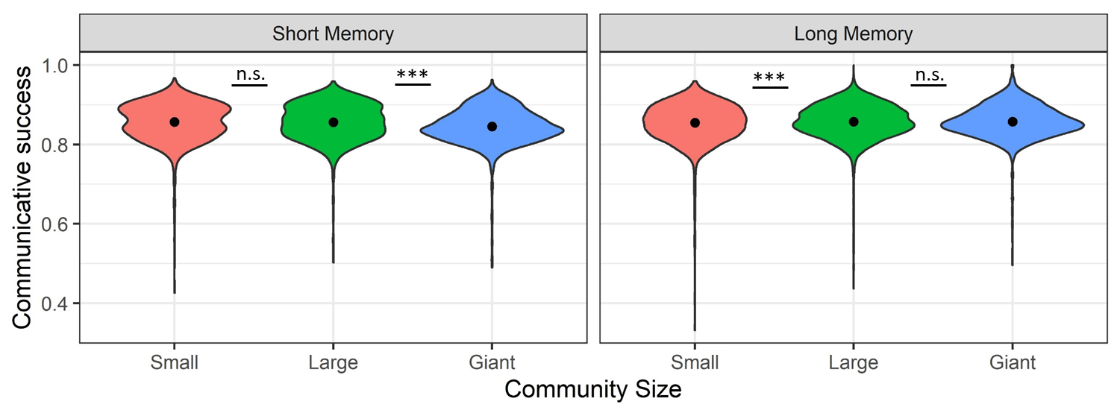
Figure 9. Average communication success score per category label as a function of Community Size (Small, Large, Giant) and Memory (Short, Long) when communication follows the frequency distribution of number words. Black dots indicate condition averages. Asterisks represent significance: *: <0.05, **: <0.01, ***: < 0.001.
One issue with the analysis reported above is that it assumes that the lexicon that a community created covers the entire range of meanings. While this was the case when sampling of meanings was uniform (Study 1), and mostly the case when sampling of meanings followed the normal distribution, a closer examination of the communicative success per meaning indicates that this is not the case when meanings are sampled based on the frequency of number words. Consequently, an analysis that focuses on labels rather than meanings presents a misleading picture. Figure 10 illustrates the average communicative success score per meaning in representative simulations of each community size. As can be clearly seen, in Small and Large communities, certain meanings are less likely to be communicated at all over many rounds (white cells). In these cases, when individuals would attempt to refer to these meanings, there would not be a conventional label they could use. While they could try to extend existing labels also to these meanings, this will not always succeed, as is demonstrated by the blue and green cells dotted in between the white cells. In contrast, because of their size, Giant communities are likely to have members refer to all meanings within a time frame. This promotes the creation and maintenance of conventional labels for all meanings. This discrepancy between communities of different sizes leads the reported analyses, which average across all labels and all their associated meanings, to artificially inflate the communicative scores of Small and Large communities, as these scores do not include how successful communication of meanings without a conventional label would be. In contrast, the communicative success scores for the Giant communities are calculated over all meanings, including those that are communicated less frequently, and therefore have lower communicative success scores, leading to a false impression of lower rather than greater communicative success in Giant communities. Furthermore, Figure 10 suggests that even the frequently-communicated meanings seem to be communicated more successfully in Giant communities (fewer light orange cells and more dark red cells in the top half of the meaning space).
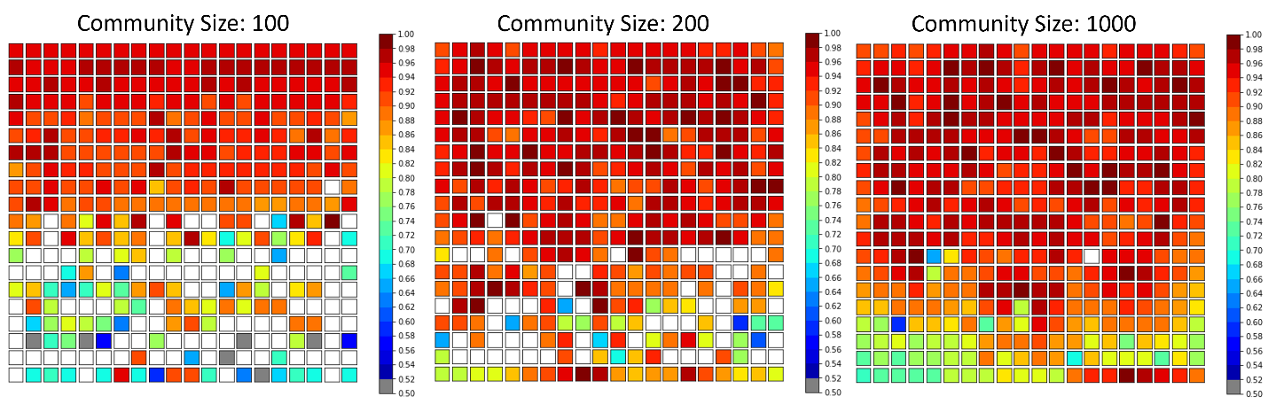
Figure 10. An illustration of communicative success by meaning across communities of different sizes. All communities communicated about meanings along the frequency distribution of the number words in one dimension (plotted as the y-axis here). Smaller numbers (top rows) were communicated more frequently in general than large ones, and rows of round numbers (e.g., 15, 20) were communicated more frequently than meanings in rows around them. Colors indicate communicative success but if a meaning was not communicated at all over the past 5000 rounds, it is colored white.
To summarize, differences in communicative success in Study 2 seem to only partially align with differences in the number of categories. When comparing Small and Large communities, the two measures align: Large communities create more categories and achieve greater communicative success than Small communities in all cases other than when communication follows the frequency distribution of number words and memory is Short. In the latter case, the two types of communities differ in neither the number of categories they create nor in their communicative success. In contrast, difference in communicative success between Large and Giant categories do not fully track differences in number of categories. Giant communities’ communicative success is often equal or superior to that of Large communities even when they create fewer or a similar number of categories. Furthermore, an examination of communicative success by meaning indicates that Giant communities achieve superior communicative success even when they have fewer categories. It seems then that while having more categories can boost communicative success, the size of the community can also boost communicative success in alternative ways, such as by enabling creation of knowledge that might not be invented otherwise, as illustrated in Figure 10. The next section also examines the role of diffusion bottlenecks in achieving communicative success.
Underlying mechanisms
Normal distribution
The results described so far show that larger communities communicate more successfully, as long as memory is not a barrier. It also seems that the superior communication success of larger communities is not due solely to creating more fine-grained categories as Giant communities tend to perform better than they should have considering the number of categories they created. In Study 1 it was suggested that an increase in community size leads to an increase in communicative success because the communicative bottlenecks in larger communities lead only the fittest labels to survive. An examination of the likelihood of labels to survive in Study 2 aligns with this explanation and suggests it is partly responsible for the results. When communication about meanings followed the normal distribution, the pattern of survival was similar to the one found in Study 1 (See Figure 11): When communities are Small, the majority (71%) of the labels survive to the end of the simulation. In Large communities, labels that spread are equally likely (50%) to survive or disappear. In Giant communities, only a minority (21%) of the labels that spread survive. In other words, similarly to Study 1, higher communicative success is achieved in communities that experience greater bottlenecks, at least when memory does not pose a barrier.
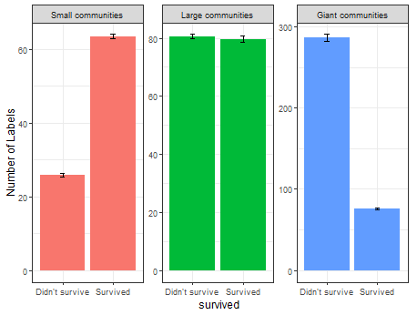
Figure 11. The average number of category labels that were maintained until the end of the simulation (Survived) vs disappeared (Didn’t survive) as dependent on Community Size (Small, Large, Giant) when communication about meanings followed the normal distribution. Black bars are error bars. The plot only includes labels that have spread to at least half of the community.
Frequency distribution of number words
When communication followed the frequency distribution of number words, all communities experienced greater bottlenecks, and the difference between Large and Giant communities became smaller than in other cases. As Figure 12 demonstrates, in this case, a little over half of the labels in the Small communities survived (54%), but only a minority of labels in both the Large (35%) and Giant (19%) communities survived. The greater competition experienced in Large communities might have promoted communicative success in these communities, removing the advantage of Giant communities when communicative success is calculated over labels (though not over meanings).
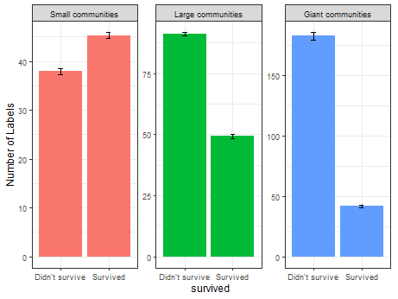
Figure 12. The average number of category labels that were maintained until the end of the simulation (Survived) vs disappeared (Didn’t survive) as dependent on Community Size (Small, Large, Giant) when communication about meanings followed the normal distribution. Black bars are error bars. The plot only includes labels that have spread to at least half of the community.
It seems, then, that differences in label competition contribute to differences in communicative success also in non-uniform meaning distributions. At the same time, the results regarding number of categories and communicative success revealed two additional factors that influence categorization and communicative success: memory span and degree of diversity in the community. In particular, when not all meanings are referred to regularly, as is the case with non-uniform distributions, Giant communities require long memory in order to achieve superior communicative success. At the same time, when memory is sufficiently long, large communities are better at creating and maintaining knowledge of successful labels for less common referents. Their sheer size ensures that a higher proportion of all existing meanings are communicated at any time point, allowing the emergence of successful labels for them.
General Discussion
The question of how and why languages have the form they do is among the most fundamental questions in language research. The form of a language is often taken as clue to understanding human cognition. Thus, language universals and the changes that languages go through across generations have been exploited to understand aspects of and constraints on learning and memory (Greenberg, 1963; Kirby et al., 2015). The results of this study take this approach a step further by placing communication in its social context. They show that linguistic structure, and in this case, the structure of semantic categories, can be influenced by the size of the community and its influence on information flow.
Underlying mechanisms
The study uses computational simulations to examine how structural properties of the community, such as its size and inter-connectivity, can influence categorization. The results indicate that, given sufficient memory, larger communities create more expressive categorization systems that enable the speakers to communicate with each other more successfully. While further research is required into the underlying mechanism, the results suggest that the greater communicative challenges that larger communities encounter lead them to create categorization systems that are more robust in terms of communicative success though this advantage is conditioned on having sufficient memory to enable overcoming the communicative barriers. The results also suggest that larger communities are better able to generate knowledge that is only beneficial in rare cases, thus enabling them to communicate successfully in less common situations.
The study proposes that one of the reasons that the categorization systems of larger communities are more expressive and allow better communication is because of the fiercer competition between labels in larger communities. These results are in line with recent lab studies and cross-linguistic analyses that suggest that communicative challenges lead larger communities to create more systematic (Lupyan & Dale, 2010; Raviv et al., 2019) and transparent (Fay & Ellision, 2013; Fay et al., 2008; Lev-Ari et al, 2021) languages. While smaller communities can maintain all variants that emerge in the community, this is not tenable in larger communities, as there are too many variants, leading to the survival of only the “fittest” labels. Future research can further examine which properties make a linguistic unit more likely to survive. While in the simulations, survival depended on properties such as communicative success and the lexical gap the label fills, in the real world survival is likely to depend on additional cognitive and articulatory factors not considered here, such as production ease, neighborhood density etc.
At the same time, larger communities also enable the creation of labels that are very useful, but only in rare circumstances (i.e., refer to uncommon meanings). The greater diversity that large communities encompass ensures the creation and maintenance of such labels. In contrast, smaller communities do not manage to generate and maintain labels for less common referents. This finding aligns with real world cases of skill loss in small communities around the world. For example, the communities in Torres Islands have lost the knowledge to build the type of boats that brought them there (Rivers, 1912 as cited in Henrich, 2004). Drift-based accounts of cultural evolution predict greater likelihood of loss of variants in small populations. They could apply to loss of labels or loss of knowledge on how to refer to certain referents as found here. They might therefore predict that languages spoken by small communities would be less likely to maintain distinctions that are not useful in common circumstances while larger communities are able to maintain distinctions regardless of how frequently they are useful.
The study examined two aspects of social structure, size and density. Out of the two, only size influenced the categorization system consistently. Effects of density occasionally emerged but they were rare, and even when occurring, were much smaller in size. It is difficult to know whether these reflect a smaller influence of community density on categorization or whether such effects would come about if the manipulation of density was stronger (i.e., larger difference in density between conditions) or implemented in another manner. Future research should examine this further as well as examine the effect of other aspects of social structure, such as homogeneity, proportion of L2 learners in the community etc.
Non-linguistic consequences
Categorization is at the meeting point of language and cognition. Therefore, investigating how community structure shapes the categorization system provides an opportunity to understand the implications of community structure for non-linguistic cognitive performance. A vast literature has demonstrated that the way a language encodes a category has implications for memory, attention, and even low-level perception. Linguistic boundaries shape similarity at both the behavioral and neural level. Thus, speakers judge objects as more similar if they share a label in their language (Degani, Prior & Tokowicz, 2011; Jiang, 2002). Similarly, when the language labels colors differently, speakers are better at identifying them (Roberson, Davidoff, Davies & Shapiro, 2005) and faster to discriminate between them (Winawer, Witthoft, Frank, Wu, Wade & Boroditsky, 2007). Speakers also show a greater neural response to a change in color shade in an oddball task if the change leads to a crossing of a linguistic category boundary (Thierry, Athanasopoulos, Wiggett, Dering & Kuipers, 2009). While not all studies on linguistic relativity find an effect of language on perception and behavior, there is a substantial number of studies that show that language influences cognitive performance (for a review, see Wolff & Holmes, 2011). While the effect of language on thought is not deterministic and individuals are able to perceive distinctions that do not exist in their language, the bulk of the evidence demonstrates that language influences habitual thought. That is, when individuals do not make a specific effort to override their linguistic tendencies, language influences the likelihood and ease at which they will spontaneously attend to stimuli and encode them.
These findings suggest that languages that make more distinctions could facilitate performance, and therefore that community size can influence non-linguistic performance via its influence on linguistic categorization. Differences in categorization can cascade to processes as diverse as prediction, preferences, or problem solving. How we categorize the world might influence how we identify problems or how we design solutions. The influence of community structure on categorization can thus influence cultural evolution more broadly.
Limitations
The communities in the simulations ranged from 100 to 1,000. One may wonder how these size differences compare with differences in community size in the real world. There are ~7,000 languages currently in use in the world, according to Ethnologue (Eberhard et al., 2019). The size of their community of speakers ranges from <100 to >1 billion, but the distribution is highly skewed, such that the median community size is ~7,000 (Lupyan & Dale, 2010). Therefore, a significant proportion of the languages in the world lie within the range covered by the simulations in this paper. Additionally, the simulations included not only a doubling of community size but a change in order of magnitude (100 vs 1,000). The inclusion of the latter was aimed at assessing the generalizability of claims about community size and examining whether they hold when increases are not within a similar range but across orders of magnitude. Most importantly, the goal of the studies was not to predict how many categories a community of a specific size would create or how accurate the communication would be. The goal was to uncover the manners by which community size (and inter-connectivity) could influence the process of categorization and communicative success. The results reveal a few guiding principles, such as the benefit that bottlenecks can provide, the advantage of larger communities in generating and maintaining rarely-used knowledge, but also their greater dependence on memory resources. These insights can be useful in understanding how structural properties such as community size can influence categorization in general, and are not limited to the cases examined here. At the same time, the precise quantification and weight of the involved variables and how their effects scale up should be further investigated when examining communities both within the examined range and outside of it, while keeping in mind that the relative importance of these principles and the magnitude of their effect could vary across different orders of magnitude.
Another limitation of the studies is that they did not consider the cognitive cost of learning more labels or the effort involved in processing them. Languages tend to balance expressivity with simplicity (Carr, Smith, Culbertson & Kirby, 2008; Gibson et al., 2019; Kemp & Regier, 2012; Tamariz, Kirby, Cornish & Smith, 2015). It might be the case, then, that the added distinctions that some communities make come at the cost of greater cognitive effort. On the other hand, it is possible that larger communities can overcome these difficulties, at least partially, via their selection of only the best labels. This can allow them to settle on categories whose relative organization fits better with communicative needs or cognitive biases. Similarly, there might be greater selection pressures with regards to the labels that need to be learned, leading to the survival of labels that are more transparent or have fewer phonological neighbors to assist production and comprehension. Such advantages might balance the greater cost of having more candidates compete for production and comprehension. The results of this study are thus the first step to understanding how community size could shape categorization systems, but additional features of the system need to be investigated to better understand how they balance each other’s costs and advantages.
The current study examined the emergence of a general abstract categorization system in isolation. In the real world, the granularity of categories depends on communicative needs. For example, a community with customs that depend on familial ties might be more likely to lexicalize all the relevant familial distinctions than another community which does not rely on them, even if the latter is larger in size (Racz, Passmore & Jordan, 2019; Regier, Carstensen & Kemp, 2016). Vocabulary structure is also not independent of the structure of the grammar. Languages compensate for simple grammar that does not encode many distinctions by lexicalizing the necessary distinctions (Lupyan & Dale, 2010). Thus, tense could be expressed either grammatically with a rich tense system or lexically with rich vocabularies. This is not to say that the findings here do not bear on language evolution or cross-linguistic differences. Instead, the findings suggest that community size and category structure should be taken into account when investigating topics such as communicative needs or processes of grammaticalization and lexicalization as they play a role in balancing potentially competing pressures and needs.
This discussion raises the question of whether there is evidence for cross-linguistic differences in categorization systems that align with differences in population size. Unfortunately, color and kinship systems are the only semantic domains that have been consistently studied cross-linguistically, and of the two, only color can be seen as comparable to the system simulated here, as variability in kinship systems depends on the efficiency of grouping rules rather than the number of distinctions. To examine whether community size predicts the number of color categories in the real world, data from the colour data survey (http://www1.icsi.berkeley.edu/wcs/) was mapped to data about population size from Ethnologue (Eberhard et al., 2019). The data in the colour survey was collected in an identical and systematic manner from informants from 111 languages, a sample that is a bit small for such an analysis. Nevertheless, a mixed effects model with population size (log-transformed) as a fixed effect, language family as a random variable, and number of color categories as a dependent measure was conducted. Results were inconclusive. Larger communities have numerically more color categories in their language (β=0.52, SE=0.40, t=1.29) but this association is not significant. It is difficult to know whether the null result reflects the small size of the sample, whether it reflects a more complex relationship between community size and number of categories as the distribution of communicated meanings in the color domain differs from the distributions examined in this paper, or whether it reflects a lack of an association between community size and color terms because of conflicting ecological and cultural needs or for another reason. It is also worth noting that an analysis that examines the relationship between community size and number of categories should include more controls such as language contact and geographic region but considering the small sample size, additional covariates were not included.
To conclude, the studies in this paper show that community size can influence the emergence of linguistic categories. It demonstrates that larger communities are under pressure to create more expressive categorization systems that can lead to improved communication as long as memory resources permit that. It thus reveals how better systems can emerge as a response to constraints of information flow. The results also indicate that larger communities are better able to create communicative tools that are only required rarely. This research highlights the importance of network structure in language’s adaptation to its environment, and suggests that community structure might influence cultural evolution by influencing basic cognitive processes such as categorization.

Acknowledgment
I would like to thank Dr. Robert Lachlan for their feedback on an earlier version of the manuscript.

References
Barabási, A. L., & Albert, R. (1999) Emergence of scaling in random networks. Science, 286, 5439, 509-512.
Bates, D., Maechler, M., Bolker, B., & Walker, S. (2015) Fitting Linear Mixed-Effects Models Using lme4. Journal of Statistical Software, 67, 1, 1-48.
Blumstein, D. T. & Armitage, K. B. (1997) Does sociality drive the evolution of communicative complexity? A comparative test with ground-dwelling sciurid alarm calls. American Naturalist 150, 179–200.
Brysbaert, M., & New, B. (2009). Moving beyond Kucera and Francis: A critical evaluation of current word frequency norms and the introduction of a new and improved word frequency measure for American English. Behavior Research Methods, 41, 977-990.
Carr, J. W., Smith, K., Culbertson, J., & Kirby, S. (2018) Simplicity and informativeness in semantic category systems. https://doi.org/10.31234/osf.io/jkfyx
Degani, T., Prior, A., & Tokowicz, N. (2011) Bidirectional transfer: The effect of sharing a translation. Journal of Cognitive Psychology, 23, 1, 18-28.
Eberhard, D. M., Simons, G. F. & Fennig, C., D. (eds.). (2019) Ethnologue: Languages of the World. Twenty-second edition. Dallas, Texas: SIL International. Online version: http://www.ethnologue.com
Fay, N., & Ellison, T. M. (2013) The cultural evolution of human communication systems in different sized populations: usability trumps learnability. PloS One 8, 8, e71781.
Fay, N., Garrod, S., & Roberts, L. (2008) The fitness and functionality of culturally evolved communication systems. Philosophical Transactions of the Royal Society B-Biological Sciences 363, 3553–3561
Freeberg, T. M. (2006) Social complexity can drive vocal complexity: group size influences vocal information in Carolina chickadees. Psychological Science, 17, 7, 557-561.
Gibson, E., Futrell, R., Piantadosi, S. P., Dautriche, I., Mahowald, K., Bergen, L., & Levy, R. (2019). How efficiency shapes human language. Trends in cognitive sciences, 23, 5, 389-407.
Goldinger, S. D. (1998). Echoes of echoes? An episodic theory of lexical access. Psychological review, 105, 2, 251.
Gómez, R. L. (2002) Variability and detection of invariant structure. Psychological Science, 13, 431–436.
Granito, C., Tehrani, J., Kendal, J., & Scott-Phillips, T. (2019). Style of pictorial representation is shaped by intergroup contact. Evolutionary Human Sciences, 1, E8.
Greenberg, J.H. (1963) Universals of language. Cambridge, MA: Massachusetts Institute of Technology Press.
Hay, J. & Bauer, L. (2007) Phoneme inventory size and population size. Language, 83, 388–400.
Hagberg A, Schult D, Swart P. (2005) Networkx: Python software for the analysis of networks. Mathematical Modeling and Analysis, Los Alamos National Laboratory.
Henrich, J. (2004). Demography and cultural evolution: how adaptive cultural processes can produce maladaptive losses—the Tasmanian case. American antiquity, 69, 2, 197-214.
Johnson, K. (1997). Speech perception without speaker normalization. In Talker Variability in Speech Processing, K. Johnson & J. W. Mullennix (eds.), 145–166. San Diego: Academic Press
Kemp, C. & Regier, T. (2012) Kinship categories across languages reflect general communicative principles. Science, 336, 6084, 1049-1054.
Kirby, S., Tamariz, M., Cornish, H., & Smith, K. (2015) Compression and communication in the cultural evolution of linguistic structure. Cognition, 141, 87-102.
Jiang, N. (2002) Form–meaning mapping in vocabulary acquisition in a second language. Studies in Second Language Acquisition, 24, 4, 617-637.
Lev-Ari, S. (2016). How the size of our social network influences our semantic skills. Cognitive Science, 40, 2050-2064.
Lev-Ari, S. (2018) The influence of social network size on speech perception. Quarterly Journal of Experimental Psychology, 71, 10, 2249-2260.
Lev-Ari, S. (2023, December 11). Community size and categorization - Study 1. Retrieved from osf.io/qvguz
Lev-Ari, S. (2023, October 27). Community size and categorization - Study 2. Retrieved from osf.io/s6ne5
Lev-Ari, S., Kancheva, I., Marston, L., Morris, H. & Zaynudinova, M. (2021) ‘Big’ sounds bigger in more widely-spoken languages. Cognitive Science, 45, 11, e13059.
Lupyan, G., and Dale, R. (2010) Language Structure Is Partly Determined by Social Structure. Plos One, 5, e8559.
Markman, E. M. & Wachtel, G.F. (1988) Children's use of mutual exclusivity to constrain the meanings of words. Cognitive Psychology, 20, 2, 121-157.
McComb, K. & Semple, S. (2005) Coevolution of vocal communication and sociality in primates. Biology Letters, 1, 381 –385.
McCloskey, M. E., & Glucksberg, S. (1978). Natural categories: Well defined or fuzzy sets?. Memory & Cognition, 6, 4, 462-472.
Meir, I., Israel, A., Sandler, W., Padden, C.A., and Aronoff, M. (2012) The influence of community on language structure: evidence from two young sign languages. Linguistic Variation, 12, 247–291.
R Core Team (2020) R: A language and environment for statistical computing. R Foundation for Statistical Computing, Vienna, Austria. URL https://www.R-project.org/.
Rácz, P., Passmore, S., & Jordan, F. M. (2019). Social Practice and Shared History, Not Social Scale, Structure Cross‐Cultural Complexity in Kinship Systems. Advance online publication Topics in cognitive science.
Raviv, L., Meyer, A.S., & Lev-Ari, S. (2019) Larger communities create more systematic languages. Proceedings of The Royal Society B, 286, 201912.
Regier, T., Carstensen, A., & Kemp, C. (2016) Languages support efficient communication about the environment: Words for snow revisited. Plos One, 11, 4, e0151138.
Regier, T., Kay, P. & Khetarpal, N. (2007) Color naming reflects optimal partitions of color space. Proceedings of the National Academy of Science, 104, 4, 1436-1441.
Rigby, R. A., & Stasinopoulos, D. M. (2005) Generalized additive models for location, scale and shape,(with discussion). Applied Statistics, 54, 507-554.
Roberson, D., Davidoff, J., Davies, I. R., & Shapiro, L. R. (2005) Color categories: Evidence for the cultural relativity hypothesis. Cognitive Psychology, 50, 4, 378-411.
Rosch, E. (1978) Cognition and Categorization. Erlbaum, Hillsdale, NJ.
Rost, G.C., and McMurray, B. (2009) Speaker variability augments phonological processing in early word learning. Developmental Science, 12, 339–349.
Rost, G. C., & McMurray, B. (2010) Finding the signal by adding noise: The role of noncontrastive phonetic variability in early word learning. Infancy, 15, 6, 608-635.
Rychlowska, M., Miyamoto, Y., Matsumoto, D., Hess, U., Gilboa-Schechtman, E., Kamble, S., … Niedenthal, P. M. (2015). Heterogeneity of long-history migration explains cultural differences in reports of emotional expressivity and the functions of smiles. Proceedings of the National Academy of Sciences, 11219, E2429–E2436.
Tenenbaum, J. B., Kemp, C., Griffiths, T. L., & Goodman, N. D. (2011). How to grow a mind: Statistics, structure, and abstraction. Science, 331, 6022, 1279-1285.
Thierry, G., Athanasopoulos, P., Wiggett, A., Dering, B., & Kuipers, J. R. (2009) Unconscious effects of language-specific terminology on preattentive color perception. Proceedings of the National Academy of Sciences, 106, 11, 4567-4570.
Whorf, B. L. (2012) Language, thought, and reality: Selected writings of Benjamin Lee Whorf. MIT press.
Wichmann, S., Rama, T. & Holman, E. W. (2011) Phonological diversity, word length and population sizes across languages: the ASJP evidence. Linguistic Typology, 15, 177–197.
Wickham, H., Averick, M., Bryan, J., Chang, W., D’Agostino McGowan, L., François, R., Grolemund, G., Hayes, A., Henry, L., Hester, J., Kuhn, M., Pedersen, T. L., Miller, E., Bache, S. M., Müller, K., Ooms, J., Robinson, D., Seidel, D. P., Spinu V... Yutani, H. (2019). Welcome to the Tidyverse. Journal of Open Source Software, 4(43), 1686. https://doi.org/10.21105/joss.01686
Winawer, J., Witthoft, N., Frank, M. C., Wu, L., Wade, A. R., & Boroditsky, L. (2007) Russian blues reveal effects of language on color discrimination. Proceedings of the National Academy of Sciences, 104, 19, 7780-7785.
Wolff, P., & Holmes, K. J. (2011). Linguistic relativity. Wiley Interdisciplinary Reviews: Cognitive Science, 2, 3, 253-265.
Wood, A., Rychlowska, M., & Niedenthal, P. M. (2016). Heterogeneity of long-history migration predicts emotion recognition accuracy. Emotion, 16, 4, 413.

It should be noted that the field of linguistic relativity is highly contentious. Not all studies find an effect of language on thought and existing findings in both directions are interpreted differently by different researchers. That said, the bulk of the evidence seems to suggest that while the effect of language on thought is not deterministic, that is, it is not impossible for individuals to perceive the world differently from the way their language categorizes it, language does influence habitual thought, that is, the way that individuals spontaneously attend to and encode stimuli (for a review, see Wolff & Holmes, 2011).
As agents could have also been selected as interaction partners by other agents in the community, agents could have participated in more than one interaction in each round.
Note that, across the paper, some analyses included Simulation as a random variable and others did not. Whenever a single data point was included per simulation (e.g., the analysis of number of categories), no random variables were included. When each simulation contributed multiple data points (e.g., one per label), a random variable of Simulation was included.

