High-resolution three-dimensional hybrid MRI + low dose CT vocal tract modeling: A cadaveric pilot study

David MEYER^{1*}, Rushdi Zahid RUSHO², Wahidul ALAM², Gary E. CHRISTENSEN³, David M. HOWARD⁴, Jarron ATHA⁵, Eric A. HOFFMAN⁵, Brad STORY⁶, Ingo R. TITZE⁷, Sajan Goud LINGALA⁵

August 18, 2022

¹Janette Ogg Voice Research Center, Shenandoah University, Winchester, VA, USA
²Roy J Carver Department of Biomedical Engineering, University of Iowa, Iowa City, IA, USA
³Department of Electrical and Computer Engineering, University of Iowa, Iowa city, IA, USA
⁴Department of Electronic Engineering, Royal Holloway, University of London, UK
⁵Departments of Radiology, Medicine and Roy J Carver Department of Biomedical Engineering, University of Iowa, Iowa City, IA, USA
⁶College of Science, University of Arizona, Tucson, AZ, USA
⁷Utah Center for Vocology, The University of Utah, Salt Lake City, UT, USA

* dmeyer2@su.edu

Summary
Background:
MRI based vocal tract models have many applications in voice research and education. These models do not adequately capture bony structures (e.g. teeth, mandible), and spatial resolution is often relatively low in order to minimize scanning time. Most MRI sequences achieve 3D vocal tract coverage at gross resolutions of (2mm)³ within a scan time of <20 seconds. Computed tomography (CT) is well suited for vocal tract imaging, but is infrequently used due to the risk of ionizing radiation. In this cadaveric study, a single, extremely low-dose CT scan of the bony structures is blended with accelerated high-resolution (1mm³) MRI scans of the soft tissues, creating a high-resolution hybrid CT-MRI vocal tract model.
Method:
Minimum CT dosages were determined and a custom 16-channel airway receiver coil for accelerated high (1mm³) resolution MRI was evaluated. A rigid body landmark based partial volume registration scheme was then applied to the images, creating a hybrid CT-MRI model. that was segmented in Slicer.
Results:
Ultra-low dose CT produced images with sufficient quality to clearly visualize the bone, and exposed the cadaver to 0.06 mSv. This is comparable to atmospheric exposures during a round trip transatlantic flight. The custom 16-channel vocal tract coil produced acceptable image quality at 1mm³ resolution when reconstructed from ~6 fold undersampled data. The feasibility of hybrid CT-MRI vocal tract modeling was successfully demonstrated using the rigid body landmark based partial volume registration scheme. Segmentations of CT and hybrid CT-MRI images provided more detailed 3D representations of the vocal tract than 2mm³ MRI based segmentations.
Conclusions:
The method described in this study indicates that high-resolution CT and MR image sets can be combined so that structures such as teeth and bone are accurately represented in vocal tract reconstructions. Such scans will aid learning and deepen understanding of anatomical features that relate to voice production as well as furthering knowledge of the static and dynamic functioning of individual structures relating to voice production.

Introduction
Magnetic Resonance Imaging (MRI) and Computed Tomography (CT) based models of the vocal tract have multiple applications in voice research and education. They have been used to explore vocal tract area functions and voice quality,,,,, physiological changes during vowel production,,, and the effects of lowering fundamental frequency. 3D printed models derived from MRI have also been shown to have similar acoustic properties as those found in vivo, and freely downloadable model datasets have been shared online.
In singing voice studies, MRI volumetric imaging and 3D printed models have been used to examine physiological changes when singers vary pitch and loudness,,, vocal registers,,, and to quantify the acoustic contribution of valleculae and piriform fossae. They are a powerful educational tool for teaching the principles of vocal tract resonance and source/filter theory, and have even been used to create a novel musical instrument, the Vocal Tract Organ,,.

Problem
In comparison to many other techniques, MRI is an attractive modality for 3D vocal tract imaging because it poses little to no risk for participants. But because it is based on using the magnetic properties of hydrogen nuclei (which are abundant in tissues containing water and fat) to construct images of anatomical structures, it does not adequately capture the presence of the bony structures (e.g. teeth, mandible), thus compromising the accuracy of MRI modeled oropharyngeal spaces. In addition, the duration of image acquisition is quite slow relative to the duration of most human sound production, and so the spatial resolution is often relatively low in order to minimize scanning time.
Thus, commercially available MRI sequences (e.g. those based on fast gradient echo) can achieve 3D vocal tract coverage at gross resolutions of (2mm)³ within a scan time of <20 seconds, which restricts voice tasks to a single exhalation,,. At this resolution, modeling fine structures such as the epiglottis and vocal folds are compromised. While higher resolutions (e.g. < 1mm³) are desired, they require a scan time of (75-90) seconds, which is too long for sustained vocalization. Furthermore, commercially available receiver coils such as head only coil, head and neck coil, or neurovascular coils do not provide sufficient SNR over the entire vocal tract. They show significant drop in sensitivity in inferior regions of vocal tract space (e.g. base of tongue, glottis, larynx). Accelerated MRI methods such as those based on parallel imaging with custom airway coils or constrained reconstruction can address the above tradeoffs,, and in this work we explore such methods to improve vocal tract reconstruction based on 3Tesla MRI.
In contrast to MRI, computed tomography (CT) is well suited for acquisition of bony structures and air-tissue boundaries,, in images, but is infrequently used for vocal tract studies due to the risk of ionizing radiation. Advances in medical imaging have led to substantially reduced CT dosages,,,. However, even with ultra-low dose CT, when sequential imaging is sought, the risk of ionizing radiation inherent in CT remains and must be mitigated. Determining minimum CT dosages for blended CT-MRI vocal tract model generation is a logical first step.
With the risk of ionizing radiation successfully mitigated, a single, extremely low-dose CT scan of the bony structures (which do not significantly change over time) could be blended with high-resolution MRI scans of the soft tissues, a hybrid CT-MRI vocal tract model may be constructed. Such a model would more accurately represent the structures used in speech and singing.

Methods
This exploratory study used a donor cadaver from the University of Iowa Deeded Body Program to explore the following:
- The minimum CT dosage in milliSieverts (mSv) needed to maintain clear bone contours and air-tissue boundaries
- Evaluating capability of a custom 16-channel airway receiver coil for accelerated high (1mm³) resolution imaging of the vocal tract within a scan time of <10 seconds, and
- The feasibility of blending CT and MR scans to construct a high-resolution hybrid model of the vocal tract.
1) CT dosage determination: The donor cadaver was scanned in the Advanced Pulmonary Physiologic Imaging Laboratory at the University of Iowa with a Siemens SOMATOM Force. Dose modulation was enabled, and various quality reference mAs’s (QRM) were compared. QRM allows the mAs to fluctuate slice-by-slice based on the thickness of the structure being imaged. As QRM decreases, so does effective radiation exposure, measured in milliSieverts (mSv). All images were reconstructed using a Qr40 kernel, an ADMIRE (advanced model based iterative reconstruction) strength of 5, Slice thickness and spacing of 1mm (matching MR resolution), a pitch of 1.0, scan rotation time of 0.25 second, kVp of 120.
2) MR Imaging was performed on a GE 3Tesla Premier scanner equipped with high performance gradients (80 mT/m - maximum gradient strength, 200 mT/m/sec - slew rate). A gradient echo 3D sequence was used to scan the cadaver’s upper-airway with a custom 16-channel upper-airway receiver coil using the following parameters: field of view: 24 cm x 24 cm x12 cm; resolution: 1 mm x 1 mm x 1 mm; TR=5.5 ms/TE=2.5ms; flip angle = 5 degrees, receiver Bandwidth=244.14 Hz/pixel; scantime = 77.4 secs. The scan was repeated with the same parameters but for a lower resolution: 2 mm x 2 mm x 2 mm, and shorter scan time of 19.44 sec. The raw multi coil k-space data was saved and exported for offline processing. Coil sensitivity maps were estimated from the central 5% of k-space measurements using the sum of squares approach. Next, multiple coil volumes were reconstructed by applying two dimensional inverse Fourier Transforms (2D-IFT) on the acquired multi-coil k-space measurements. A single ground truth volume was formed by multiplying the complex conjugate of the coil maps to the multi coil volumes, followed by addition along the coil dimension. To evaluate acceleration capabilities of the airway coil, retrospective under-sampling was performed, in which the multi coil k-space data was sub-sampled by a variable density random order sampling scheme in the sagittal (ky-kz) plane. The acceleration factor ( R) is defined as the total number of k-space samples in the ky-kz plane in the fully sampled data divided by the number of k-space samples in the sub-sampled dataset. The undersampled k-space data was then passed through an image domain based sparse sensitivity encoding (sparse-SENSE) parallel imaging constrained reconstruction algorithm to reconstruct the underlying volume from limited k-space samples. The algorithm exploits the diversity of receiver coil sensitivity profiles across the vocal tract, and sparse spatial finite differences of the images using a total variation constraint. We evaluated image quality using the Peak Signal to Noise ratio (PSNR) metric that captures the pixel-by-pixel error between the reconstructed images and the fully sampled reference image.
3) A rigid body landmark based partial volume registration scheme was used to match the MRI and CT volumes using corresponding manually identified anatomical landmarks in the MRI and CT modalities. These landmarks were: tip of the epiglottis, posterior boundary of inferior nasal concha, hyoid bone body midline, apex (tip) of the tongue, buccal portion of the bony ridge between left first and second premolars, and base of the mandible. The estimated transformation was used to transform the MR image into the coordinate system of the CT image. The bones and the teeth were segmented from the CT image using intensity-based thresholding. These segmentations were then inserted into the registered MR image to create a hybrid image that had soft tissue imaged by MR, and the bones and teeth imaged by CT.
Vocal tract data from 2mm³ MR, 1mm³ CT, and the blended 1mm³ CT-MR images were imported into Slicer 5.1.0 r31082 / 115e32b as Digital Imaging and Communications in Medicine (DICOM) stacks. These were segmented to produce 3D models that were compared and visually evaluated by the authors (Meyer, Lingala, Howard) for anatomical accuracy. Manual slice-by-slice segmentation, “grow from seeds,” and “threshold paint” methods were employed to ensure accurate reconstructions.

Results
1) Image quality was evaluated to determine the minimum dosage needed to maintain clear bone contours and air-tissue boundaries. The lowest dose (QRM 5) produced images with sufficient quality to clearly visualize the bone, and represents a substantially mitigated risk for living participants in future studies (see Figure 1) and allows for multiple scans or higher spatial resolution (thinner slices) should that be needed. Emerging photon counting CT technologies will provide for further reductions in ionized radiation, and higher spatial resolution. The following dosages were reported:

Neck QRM-10: 0.17 mSv
Neck QRM-5: 0.09 mSv
Head/Neck QRM-5: 0.06 mSv

By comparison, a single chest x-ray is on the order of 0.1 mSv, and a New York to London round trip flight exposes travelers to 0.064 mSv.

<<INSERT FIGURE 1 ABOUT HERE>>
2) At full sampling (i.e, Rnet=1), MR scans at 1mm³ and 2mm³ voxel resolution were compared. Scans at 1mm³ voxel resolution displayed clearer air-tissue boundaries, reduced blurring, and were informally assessed by a subset of the authors (Meyer, Lingala, and Howard) to be superior in quality to images scanned at 2mm³ voxel resolution. 1mm³ and 2mm³ voxel resolution images are shown in Figure 2 below.
<<INSERT FIGURE 2 ABOUT HERE>>

Figure 3 shows sparse SENSE reconstructions of the 1mm³ data at reduction. We observe robust reconstructions as a function of reduction factor (R). An example of the sampling mask used at R=6 is also shown. The reconstructions gracefully degrade with increasing R. At R=8 fold, there is still clear depiction of the various air-tissue boundaries, and image texture/features. The 8-fold gain in acceleration means that the scanning time of 1mm³ 3D vocal tract MRI can be reduced by a factor of 8, which equals to ~9.6 seconds. The <10 seconds scan time can allow for high 1mm³ resolution imaging of short sustained sounds. <<INSERT FIGURE 3 ABOUT HERE>>

3) The rigid body landmark based partial volume registration scheme was successfully applied to match the manually identified anatomical landmarks in both the MRI and CT modalities. Figure 4 shows the locations of the landmarks in axial, sagittal, and coronal views for both MRI and CT images. The alignment of landmark registration from the MR and CT images may be seen in Figure 5, and when deemed acceptable, the MR image was transformed into the coordinate system of the CT image to create a hybrid image that had soft tissue imaged by MR, and the bones and teeth imaged by CT (see Figures 6-7).
<<INSERT FIGURE 4-8 ABOUT HERE>>

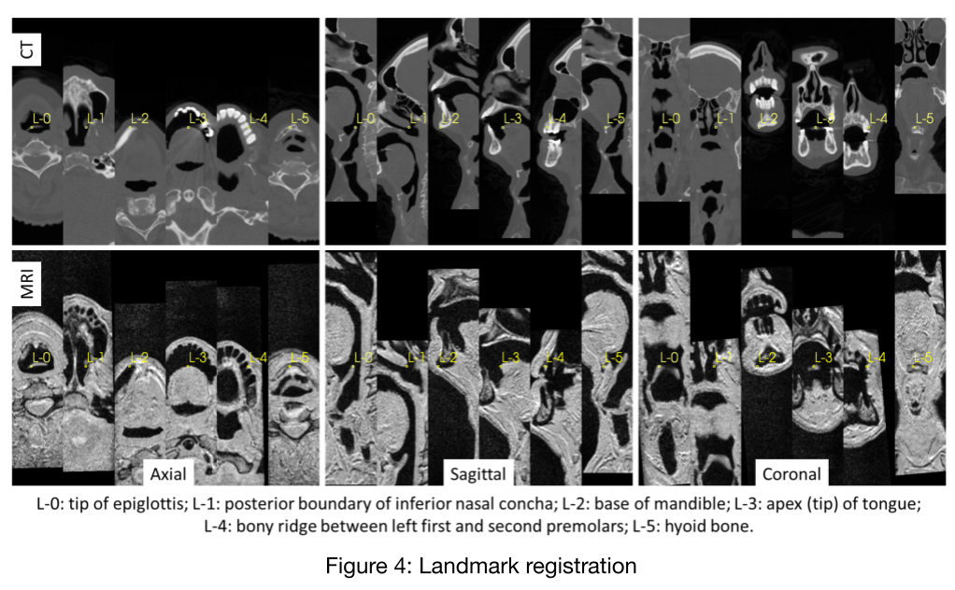

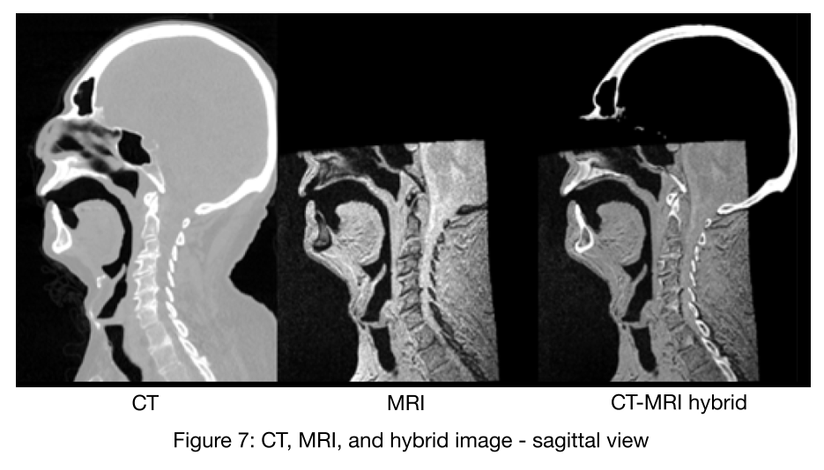

2mm³ MRI, 1mm³CT, and 1mm³ hybrid CT-MRI DICOM stacks were segmented in Slicer 5.1.0 r31082 to produce 3D models of the vocal tract (see Figures 8 + 9). These 3D models were compared and visually evaluated by a subset of the authors (Meyer, Lingala, Howard) for anatomical accuracy. Figure 8 also includes a superimposed segmentation of the oral cavity, combining 2mm³ MRI (in yellow) with 1mm³ CT (in green). As stated earlier, as opposed to CT, MRI poorly images teeth. Therefore the superimposed image demonstrates the MRI segmentation (yellow) ‘leaking’ into dental spaces that are more accurately imaged in CT (green).

<<INSERT FIGURES 8+9 ABOUT HERE>>
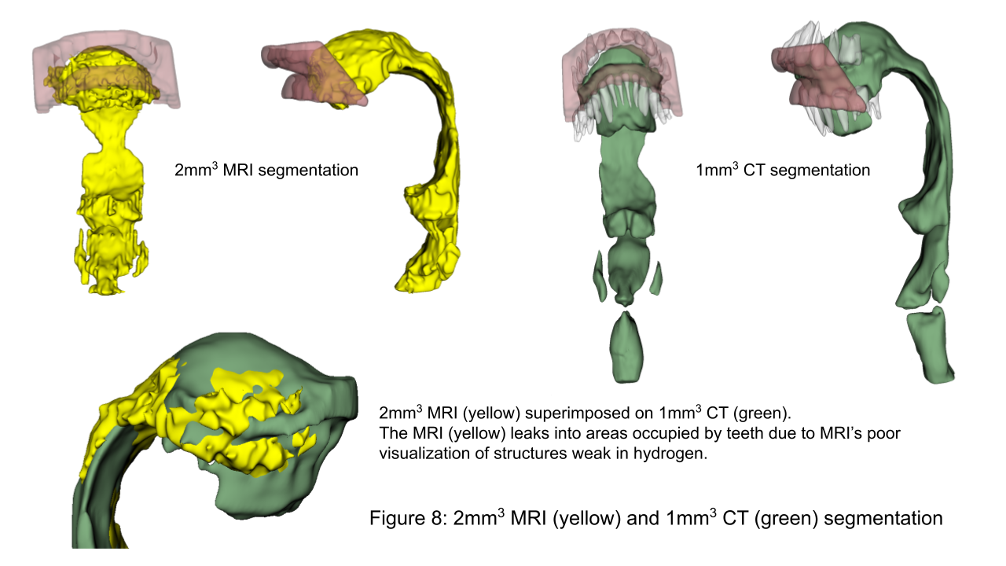

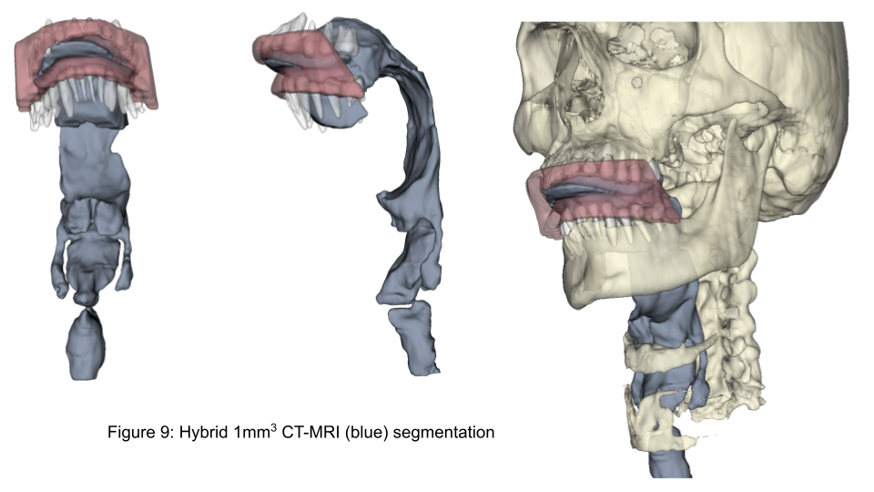

Discussion
The aims of this proof-of-concept investigation were: 1) to use an ultra-low dose CT protocol to establish minimum CT radiation dosage needed to maintain clear bone contours and air-tissue boundaries, 2) to evaluate a custom 16-channel airway receiver coil for accelerated high (1mm³) resolution imaging of the vocal tract, and 3) to determine the feasibility of low-dose hybrid CT-MRI vocal tract models with 1mm³ spatial resolution.
This method exposed the cadaver to very low levels of ionizing radiation, comparable to atmospheric exposures during a round trip transatlantic flight. This low level of exposure represents a substantially mitigated risk for living participants in future studies. Further reductions in ionized radiation and higher spatial resolution may be possible with emerging photon counting CT technologies. The SOMATOM Force represents a current state-of-the-art CT technology with high spatial and contrast resolution along with current generation iterative reconstruction (ADMIRE) and a quantitative reconstruction kernel (Qr40).
As seen in Figure 3, imaging with the custom 16-channel vocal tract coil and finite difference reconstruction constraints produced acceptable image quality of the 1mm³ resolution data, when reconstructed from ~6 fold undersampled data. The image quality had an acceptable PSNR throughout the entire vocal tract.
The feasibility of hybrid CT-MRI vocal tract modeling was successfully demonstrated using the rigid body landmark based partial volume registration scheme. Segmentations produced from various imaging modalities displayed noteworthy characteristics (see Figures 8 and 9). The CT and hybrid images appeared to provide more detailed representations of the vocal structures than the 2mm³ MR images. This was an expected finding due to the poor visualization of teeth in MRI, and the complex geometry of the vocal tract’s small structures. Details of the piriform sinuses and valleculae appeared to be best represented in the hybrid segmentation, and CT generally produced the clearest air-tissue boundaries.

Limitations and Future work
The techniques described in this study indicate that CT and MR image sets can be combined so that structures such as teeth and bone are accurately represented in vocal tract reconstructions. Still unknown, however, is whether the enhanced spatial accuracy of the airspace will translate into acoustic characteristics that are better aligned with those produced by an actual talker or singer than if MRI alone were used as the imaging modality.
Future work will include applying the CT/MRI hybrid technique to image sets collected from live talkers or singers (as opposed to cadavers) from which simultaneous audio recordings can also be obtained. Vocal tract reconstructions can then be processed to allow for various modeling and experimental approaches to be used to assess the acoustic characteristics, particularly the frequency response functions, relative to those measured from the talkers or singers. These can include plane wave modeling, 2D and 3D finite-element modeling, as well as 3D printing to generate a physical structure than can be excited with a sound source to produce an output signal that can be analyzed,,.
This method will also be applied in future work to more accurately image the mean vocal fold surface position and surface contour in the coronal view. Capturing such images is an ongoing challenge addressed in previous ultrasonic imaging studies, with mixed results.

Conclusion
The combined CT-MRI images enable segregation of a number of features based on how these are depicted best depending on their responses to CT or MRI scanning. This provides flexibility in image selection for users where different features can be explored by observing one or the other images (CT or MRI) or the combined rendering. Individual structures can be 3D printed to lifesize to enable the vocal tract to be studied in detail and in the context of learning. It has been shown that students using 3D anatomical models had advantages in test scores, accuracy, and student satisfaction over students in the 2D and cadaver groups. In addition, more students in the 3D printing group were satisfied with their learning compared with the conventional group.
Such scans will aid learning and deepen understanding of anatomical features that relate to voice production as well as furthering knowledge of the static and dynamic functioning of individual structures relating to voice production, extending the cylindrical vocal tract models of Arai, relevant particularly for example to ENT and speech therapists, medical professionals, singers, orators, teachers, broadcasters, actors and their voice teachers. The possibility of handling and manipulating anatomical structures (in 3D printed form or within virtual and/or augmented reality) is a well-proven and rewarding way of gaining enhanced and more in-depth understanding of the function of component parts as well as raising awareness in the public and future generations of researchers.

Acknowledgements

The authors would like to thank Brian Chapman, Program Manager of the Deeded Body Program at the University of Iowa Carver College of Medicine for his assistance in this study. We are also profoundly grateful to those who in death have chosen to serve the living, dedicating their remains for use in science and education. We are honored by your gift. Thank you.

David Meyer, DM, Director, Janette Ogg Voice Research Center; Associate Professor of Voice and Voice Pedagogy, Shenandoah Conservatory, 1460 University Drive, Winchester, VA 22601, (540)-665-4600, dmeyer2@su.edu.

Rushdi Zahid Rusho, Graduate Research Assistant, Roy J Carver Department of Biomedical Engineering, University of Iowa, 5612 Seamans Center, Iowa City, IA 52242; rushdizahid-rusho@uiowa.edu

Wahidul Alam, Graduate Research Assistant, Roy J Carver Department of Biomedical Engineering, University of Iowa, 5612 Seamans Center, Iowa City, IA 52242; mohammadwahidul-alam@uiowa.edu

Jarron Atha, BS, RT(R)(CT)(ARRT), Clinical Research Associate, Advanced Pulmonary Physiomic Imaging Laboratory (APPIL), The University of Iowa, (319) 384-7926, jarron-atha@uiowa.edu.

David M. Howard, FREng, PhD, BSc, Dept. of Electronic Engineering, Royal Holloway
University of London +447766232928 david.howard@rhul.ac.uk

Eric A. Hoffman, PhD, Professor of Radiology-Division of Physiologic Imaging, University of Iowa, C748 General Hospital (GH), 200 Hawkins Drive, Iowa City, IA 52242, (319) 356-1381. eric-hoffman@uiowa.edu.

Brad Story, PhD, Professor & Associate Dean College of Science, University of Arizona, 1131 E. 2nd Street, Tucson, AZ 85721-0071, 520-626-9528. bstory@arizona.edu

Gary E. Christensen, D.SC., Professor of Electrical and Computer Engineering and Radiation Oncology, University of Iowa, Iowa City, IA 52242, gary-christensen@uiowa.edu.

Ingo R. Titze, PhD, Executive Director, National Center for Voice and Speech, The University of Utah,
Salt Lake City, UT 84101, (801) 596-2012. ingo.titze@ncvs2.org.
Sajan Goud Lingala, PhD, Assistant Professor, Roy J Carver Department of Biomedical Engineering, Department of Radiology, University of Iowa, 5609 Seamans Center, Iowa City, IA 52242; (319) 467-0320, sajangoud-lingala@uiowa.edu.

Story BH, Titze IR, Hoffman EA. Vocal tract area functions from magnetic resonance imaging. The Journal of the Acoustical Society of America. 1996;100(1):537-554. doi:10.1121/1.415960
Story BH, Titze IR, Hoffman EA. The relationship of vocal tract shape to three voice qualities. The Journal of the Acoustical Society of America. 2001;109(4):1651-1667. doi:10.1121/1.1352085
Story BH. Comparison of magnetic resonance imaging-based vocal tract area functions obtained from the same speaker in 1994 and 2002. The Journal of the Acoustical Society of America. 2008;123(1):327-335. doi:10.1121/1.2805683
Story BH, Titze IR, Hoffman EA. Vocal tract area functions for an adult female speaker based on volumetric imaging. The Journal of the Acoustical Society of America. 1998;104(1):471-487. doi:10.1121/1.423298
Guzman M, Laukkanen AM, Krupa P, Horáček J, Švec JG, Geneid A. Vocal Tract and Glottal Function During and After Vocal Exercising With Resonance Tube and Straw. Journal of Voice. 2013;27(4):523.e19-523.e34. doi:10.1016/j.jvoice.2013.02.007
Kitamura T, Takemoto H, Honda K. Acoustic characteristics of solid vocal tracts modeled from ATR MRI database of Japanese vowel production. The Journal of the Acoustical Society of America. 2008;123(5):3734-3734. doi:10.1121/1.2935241
Takemoto H, Mokhtari P, Kitamura T. Acoustic analysis of the vocal tract during vowel production by finite‐difference time‐domain method. The Journal of the Acoustical Society of America. 2008;123(5):3323-3323. doi:10.1121/1.2933804
Honda K, Kitamura T, Takemoto H, et al. Visualisation of hypopharyngeal cavities and vocal-tract acoustic modelling. Computer Methods in Biomechanics and Biomedical Engineering. 2010;13(4):443-453. doi:10.1080/10255842.2010.490528
Hirai H, Honda K, Fujimoto I, Shimada Y. An MRI study of the physiological mechanism of F0 lowering. The Journal of the Acoustical Society of America. 1993;93(4):2294-2295. doi:10.1121/1.406495‌
Probst J, Lodermeyer A, Fattoum S, et al. Acoustic and Aerodynamic Coupling during Phonation in MRI-Based Vocal Tract Replicas. Applied Sciences. 2019;9(17):3562. doi:10.3390/app9173562
Birkholz P, Kürbis S, Stone S, Häsner P, Blandin R, Fleischer M. Printable 3D vocal tract shapes from MRI data and their acoustic and aerodynamic properties. Scientific Data. 2020;7(1):255. doi:10.1038/s41597-020-00597-w
Takemoto H, Honda K, Saitou T, Tanabe Y, Kishimoto H, Kitamura T. Changes in the vocal tract shape of sopranos at high pitch. The Journal of the Acoustical Society of America. 2012;131(4):3378-3378. doi:10.1121/1.4708739
Echternach M, Burk F, Burdumy M, Traser L, Richter B. Morphometric Differences of Vocal Tract Articulators in Different Loudness Conditions in Singing. Bolhuis JJ, ed. PLOS ONE. 2016;11(4):e0153792. doi:10.1371/journal.pone.0153792
Echternach M, Traser L, Richter B. Vocal Tract Configurations in Tenors’ Passaggio in Different Vowel Conditions—A Real-Time Magnetic Resonance Imaging Study. Journal of Voice. 2014;28(2):262.e1-262.e8. doi:10.1016/j.jvoice.2013.10.009
Echternach M, Sundberg J, Arndt S, Markl M, Schumacher M, Richter B. Vocal Tract in Female Registers—A Dynamic Real-Time MRI Study. Journal of Voice. 2010;24(2):133-139. doi:10.1016/j.jvoice.2008.06.004
Echternach M, Sundberg J, Baumann T, Markl M, Richter B. Vocal tract area functions and formant frequencies in opera tenors’ modal and falsetto registers. The Journal of the Acoustical Society of America. 2011;129(6):3955-3963. doi:10.1121/1.3589249
Köberlein M, Birkholz P, Burdumy M, et al. Investigation of resonance strategies of high pitch singing sopranos using dynamic three-dimensional magnetic resonance imaging. The Journal of the Acoustical Society of America. 2021;150(6):4191-4202. doi:10.1121/10.0008903
Feng M, Howard DM. The Dynamic Effect of the Valleculae on Singing Voice – An Exploratory Study Using 3D Printed Vocal Tracts. Journal of Voice. Published online January 2021. doi:10.1016/j.jvoice.2020.12.012
Delvaux B, Howard D. A New Method to Explore the Spectral Impact of the Piriform Fossae on the Singing Voice: Benchmarking Using MRI-Based 3D-Printed Vocal Tracts. Robin DA, ed. PLoS ONE. 2014;9(7):e102680. doi:10.1371/journal.pone.0102680
Seeing Voice: Visualization of Vocal Tract Shaping with MRI (Meyer, Howard, Lingala – The Voice Foundation, Care of the Professional Voice Symposium, 2019). www.youtube.com. Accessed June 22, 2022. https://youtu.be/XlSVq7aQj2s
Howard DM. The Vocal Tract Organ and the Vox Humana organ stop. Journal of Music, Technology and Education. 2014;7(3):265-277. doi:10.1386/jmte.7.3.265_1
Howard DM. Singing synthesis and the Vocal Tract Organ. eprints.whiterose.ac.uk. Published 2014. Accessed June 22, 2022. https://eprints.whiterose.ac.uk/87529/
Howard, DM. Developing the Vocal Tract Organ. Journal of Voice. in press, DOI: https://doi.org/10.1016/j.jvoice.2022.06.025 Accessed August 15, 2022
Traser L, Birkholz P, Flügge TV, et al. Relevance of the Implementation of Teeth in Three-Dimensional Vocal Tract Models. Journal of Speech, Language, and Hearing Research. 2017;60(9):2379-2393. doi:10.1044/2017_jslhr-s-16-0395
Bresch E, Yoon-Chul Kim, Nayak K, Byrd D, Narayanan S. Seeing speech: Capturing vocal tract shaping using real-time magnetic resonance imaging [Exploratory DSP]. IEEE Signal Processing Magazine. 2008;25(3):123-132. doi:10.1109/msp.2008.918034
Isaieva K, Laprie Y, Leclère J, Douros IK, Felblinger J, Vuissoz PA. Multimodal dataset of real-time 2D and static 3D MRI of healthy French speakers. Scientific Data. 2021;8(1):258. doi:10.1038/s41597-021-01041-3
Scott AD, Wylezinska M, Birch MJ, Miquel ME. Speech MRI: Morphology and function. Physica Medica. 2014;30(6):604-618. doi:10.1016/j.ejmp.2014.05.001
Lingala SG, Sutton BP, Miquel ME, Nayak KS. Recommendations for real-time speech MRI. Journal of Magnetic Resonance Imaging. 2015;43(1):28-44. doi:10.1002/jmri.24997
Lingala SG, Toutios A, Töger J, et al. State-of-the-Art MRI Protocol for Comprehensive Assessment of Vocal Tract Structure and Function. Interspeech 2016. Published online September 8, 2016. doi:10.21437/interspeech.2016-559
Burdumy M, Traser L, Burk F, et al. One-second MRI of a three-dimensional vocal tract to measure dynamic articulator modifications. Journal of Magnetic Resonance Imaging. 2016;46(1):94-101. doi:10.1002/jmri.25561
Storck C, Gugatschka M, Friedrich G, et al. Developing a 3D model of the laryngeal cartilages using HRCT data and MIMICS’s segmentation software. Logopedics Phoniatrics Vocology. 2010;35(1):19-23. doi:10.3109/14015430903552378
Vorik A, Unteregger F, Zwicky S, Schiwowa J, Potthast S, Storck C. Three-dimensional Imaging of High-resolution Computer Tomography of Singers’ Larynges—A Pilot Study. Journal of Voice. 2017;31(1):115.e17-115.e21. doi:10.1016/j.jvoice.2016.03.011
Unteregger F, Honegger F, Potthast S, Zwicky S, Schiwowa J, Storck C. 3D analysis of the movements of the laryngeal cartilages during singing. The Laryngoscope. 2016;127(7):1639-1643. doi:10.1002/lary.26430
Newell JD, Fuld MK, Allmendinger T, et al. Very Low-Dose (0.15 mGy) Chest CT Protocols Using the COPDGene 2 Test Object and a Third-Generation Dual-Source CT Scanner With Corresponding Third-Generation Iterative Reconstruction Software. Investigative Radiology. 2015;50(1):40-45. doi:10.1097/rli.0000000000000093
Hammond E, Sloan C, Newell JD, et al. Comparison of low- and ultralow-dose computed tomography protocols for quantitative lung and airway assessment. Medical Physics. 2017;44(9):4747-4757. doi:10.1002/mp.12436
Hammond E, Chan KS, Ames JC, et al. Impact of advanced detector technology and iterative reconstruction on low-dose quantitative assessment of lung computed tomography density in a biological lung model. Medical Physics. 2018;45(8):3657-3670. doi:10.1002/mp.13057
Hoffman EA. Origins of and lessons from quantitative functional X-ray computed tomography of the lung. The British Journal of Radiology. 2022;95(1132). doi:10.1259/bjr.20211364
Gordic S, Morsbach F, Schmidt B, et al. Ultralow-Dose Chest Computed Tomography for Pulmonary Nodule Detection: First Performance Evaluation of Single Energy Scanning With Spectral Shaping. Investigative Radiology. 2014;49(7):465-473. doi:10.1097/RLI.0000000000000037
Hoffman EA. Origins of and lessons from quantitative functional X-ray computed tomography of the lung. The British Journal of Radiology. 2022;95(1132). doi:10.1259/bjr.20211364
Radiology (ACR) RS of NA (RSNA) and AC of. Radiation Dose in X-Ray and CT Exams. Radiologyinfo.org. Published 2021. https://www.radiologyinfo.org/en/info/safety-xray
Radioactivity : Radiation in Flight. www.radioactivity.eu.com. https://www.radioactivity.eu.com/site/pages/Radioactivity_in_Flight.htm ‌
Traser L, Birkholz P, Flügge TV, et al. Relevance of the Implementation of Teeth in Three-Dimensional Vocal Tract Models. Journal of Speech, Language, and Hearing Research. 2017;60(9):2379-2393. doi:10.1044/2017_jslhr-s-16-0395
Zhou X, Woo J, Stone M, Prince J, Espy-Wilson C. Improved vocal tract reconstruction and modeling using an image super-resolution technique. Published online 2013. doi:10.1121/1.4802903]
Arnela M, Guasch O, Alías F. Effects of head geometry simplifications on acoustic radiation of vowel sounds based on time-domain finite-element simulations. The Journal of the Acoustical Society of America. 2013;134(4):2946-2954. doi:10.1121/1.4818756
Blandin R, Arnela M, Félix S, Doc JB, Birkholz P. Efficient 3D Acoustic Simulation of the Vocal Tract by Combining the Multimodal Method and Finite Elements. IEEE Access. 2022;10:69922-69938. doi:10.1109/ACCESS.2022.3187424
Fleischer M, Mainka A, Kürbis S, Birkholz P. How to precisely measure the volume velocity transfer function of physical vocal tract models by external excitation. Reby D, ed. PLOS ONE. 2018;13(3):e0193708. doi:10.1371/journal.pone.0193708
Birkholz P, Kürbis S, Stone S, Häsner P, Blandin R, Fleischer M. Printable 3D vocal tract shapes from MRI data and their acoustic and aerodynamic properties. Scientific Data. 2020;7(1):255. doi:10.1038/s41597-020-00597-w Birkholz P, Kürbis S, Stone S, Häsner P, Blandin R, Fleischer M. Printable 3D vocal tract shapes from MRI data and their acoustic and aerodynamic properties. Scientific Data. 2020;7(1):255. doi:10.1038/s41597-020-00597-w
Delvaux B, Howard D. A New Method to Explore the Spectral Impact of the Piriform Fossae on the Singing Voice: Benchmarking Using MRI-Based 3D-Printed Vocal Tracts. Robin DA, ed. PLoS ONE. 2014;9(7):e102680. doi:10.1371/journal.pone.0102680
Jing B, Ge Z, Wu L, Wang S, Wan M. Visualizing the mechanical wave of vocal fold tissue during phonation using electroglottogram-triggered ultrasonography. The Journal of the Acoustical Society of America. 2018;143(5):EL425-EL429. doi:10.1121/1.5039726
Tsai CG, Chen JH, Shau YW, Hsiao TY. Dynamic B-Mode Ultrasound Imaging of Vocal Fold Vibration During Phonation. Ultrasound in Medicine & Biology. 2009;35(11):1812-1818. doi:10.1016/j.ultrasmedbio.2009.06.002
Ye, Z., Dun, A., Jiang, H. et al. The role of 3D printed models in the teaching of human anatomy: a systematic review and meta-analysis. BMC Med Educ 20, 335 (2020).
Arai, T., “Education in acoustics and speech science using vocal-tract models,” J. Acoust. Soc. Am., 131(3), Pt. 2, 2444-2454, 2012.
Arai, T., “Vocal-tract models and their applications in education for intuitive understanding of speech production,” Acoust. Sci. & Tech., 37(4), 148-156, 2016.
Howard, D.M. (2012). Raising public awareness of acoustic principles using voice and speech production, The Journal of the Acoustical Society of America – Invited Paper for Special Issue on Acoustics Education, 131, (3), 2405-2412.

