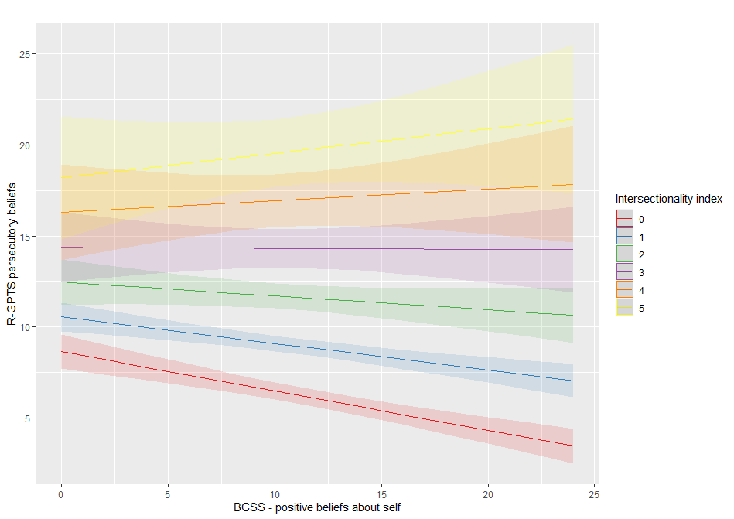
Figure 4.
Predicted associations between positive beliefs and paranoid thinking as a function increasing intersectionality index levels. Linear regression by intersectionality index level with 95% confidence bands.

