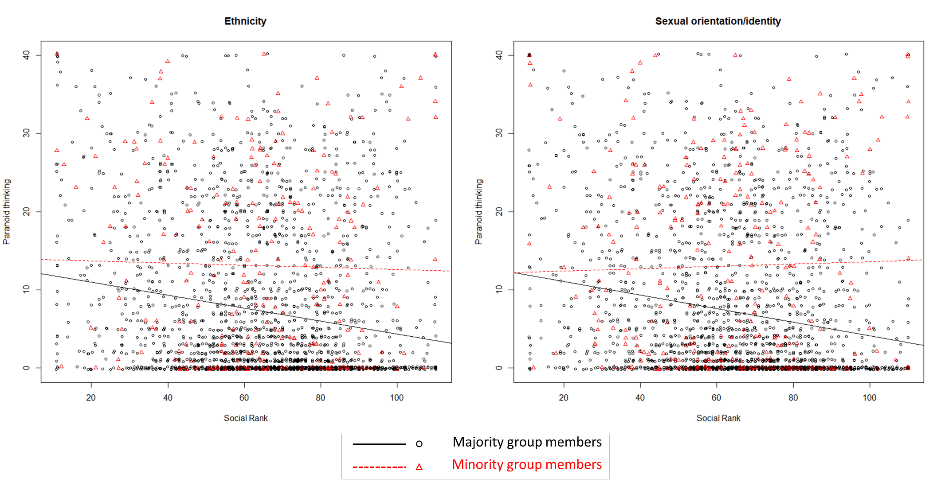
Figure 3.
Exemplary depiction of the association between social rank and paranoid thinking as a function of ethnic (left) and sexual identity/orientation (right) group status.

