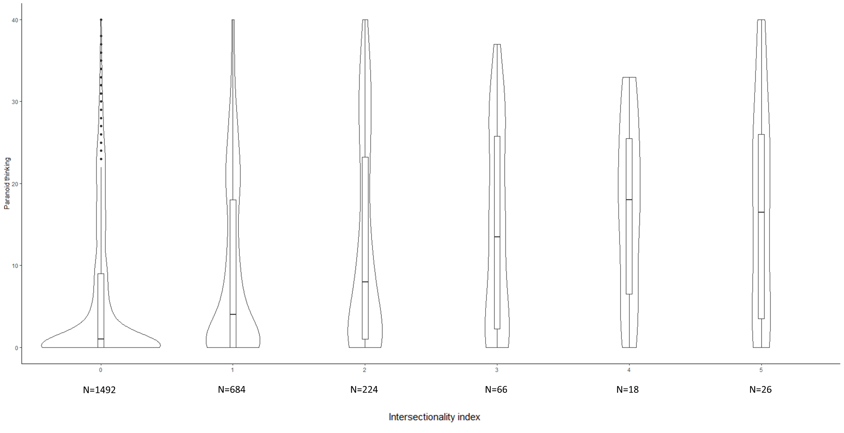
Figure 2. Boxplots and Violinplots of the distribution of paranoid thinking at all levels of the intersectionality index

