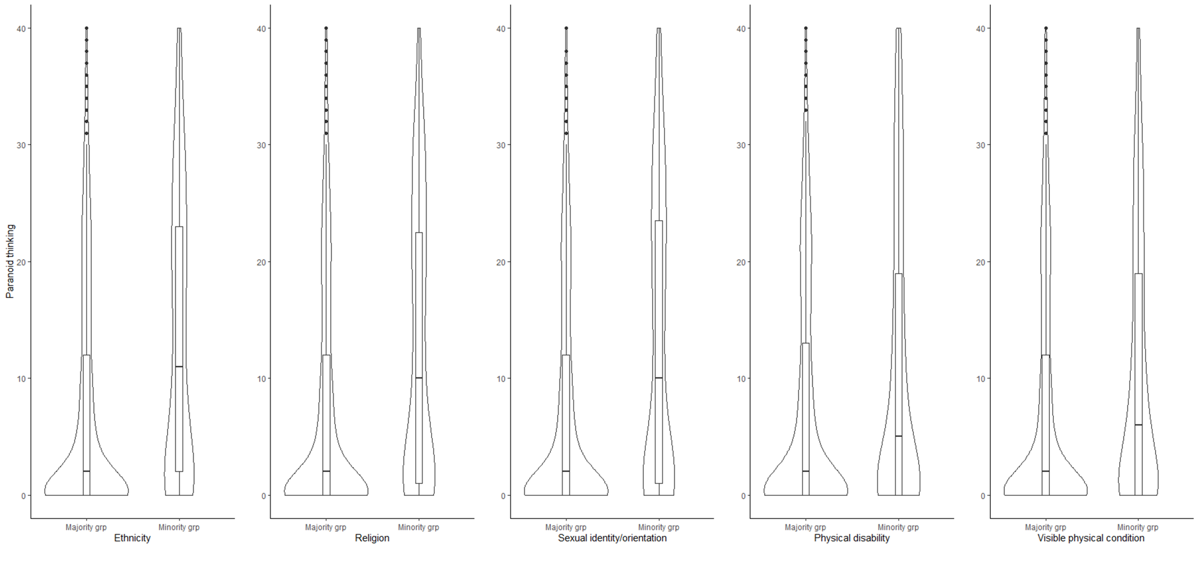
Figure 1.
Boxplots and Violinplots of the distribution of paranoid thinking in minority and corresponding majority groups

