Association of polypharmacy and anticholinergic burden with length of stay in hospital amongst older adults admitted with hip fractures: a retrospective observational study

David Fluck¹; Email: david.fluck@nhs.net
Radcliffe Lisk²; Email: radcliffe.lisk1@nhs.net
Keefai Yeong²; Email: keefai.yeong@nhs.net
Jonathan Robin³; Email: jonathan.robin@nhs.net
Christopher Henry Fry⁴; Email: chris.fry@bristol.ac.uk
Thang Sieu Han^{5,6}; Email: thang.han@rhul.ac.uk

¹Department of Cardiology, Ashford and St Peter’s NHS Foundation Trust, Guildford Road, Chertsey, Surrey KT16 0PZ, UK
²Department of Orthopaedic Trauma, Ashford and St Peter’s NHS Foundation Trust, Guildford Road, Chertsey, Surrey KT16 0PZ, UK
³Department of Acute Medicine, Ashford and St Peter’s NHS Foundation Trust, Guildford Road, Chertsey, Surrey KT16 0PZ, UK
⁴School of Physiology, Pharmacology and Neuroscience, University of Bristol, Bristol BS8 1TD, UK
⁵Department of Endocrinology, Ashford and St Peter’s NHS Foundation Trust, Guildford Road, Chertsey, Surrey KT16 0PZ, UK
⁶Institute of Cardiovascular Research, Royal Holloway, University of London, Egham, Surrey TW20 0EX, UK

Running title: Impact of ACB and polypharmacy on discharge delay
Word count: 2764, 3 Tables, 2 Figures

Keywords: Drugs; hospital discharge; health economics; mobility; pressure ulcers

Corresponding author: Dr Thang S Han, MA, MB BChir, PhD, FRCP
Institute of Cardiovascular Research, Royal Holloway, University of London
Egham, Surrey, TW20 0EX, UK. Tel: 01784443807
Email: thang.han@rhul.ac.uk
ABSTRACT
Background: Age-associated multimorbidity and polypharmacy, predispose individuals to falls and consequent hip fractures. We examined the impact of polypharmacy (≥4 drugs daily), including anticholinergic agents, on hospital length of stay (LOS), mobility within 1-day of hip surgery and pressure ulcers in adults ≥60yr admitted with hip fractures.
Methods: In this retrospective observational study, information on medications at admission was obtained to calculate the total number of drugs taken, including those imposing an anticholinergic burden (ACB). Associations between variables were examined by logistic regression; adjusted for age, sex, co-morbidities, pre-fracture functional limitations and alcohol consumption.
Results: There were 787 women and 318 men of similar mean age (±SD): 83.1yr (±8.6) and 82.5yr (±9.0), respectively. Compared to patients with an ACB score=0 and taking <4 drugs daily, those with an ACB score ≥1 and taking ≥4 drugs daily had greater risk of prolonged LOS (≥2weeks), OR=1.8 (1.2-2.7); failure to mobilise within 1-day of surgery, OR=1.9 (1.1-3.3); and pressure ulcers, OR = 3.0 (95%CI: 1.2-7.9). LOS was further prolonged by failure to mobilise within 1-day of surgery and/or pressure ulcers. Those with either an ACB score ≥1 or the use of ≥4 drugs daily had intermediate risks.
Conclusions: Anticholinergic agents and polypharmacy in patients with hip fractures are associated with longer LOS in hospital, further accentuated by failure to mobilise within 1-day after surgery and pressure ulcers. This study provides further evidence of the impact of polypharmacy, including those with an ACB, on adverse health outcomes and lends support to reduce potentially inappropriate prescribing.
KEY POINTS
- Age-associated multimorbidity and polypharmacy/anticholinergics predispose individuals to falls and consequent hip fractures.
- Patients receiving polypharmacy, including an anticholinergic burden score of ≥1, had a longer stay in hospital.
- Patients also had a reduced ability to mobilise within 1-day of surgery and a greater risk of developing pressure ulcers.
INTRODUCTION
There are currently many more people in the world living to an older age than ever [1] and ageing is associated with multimorbidity and polypharmacy [2, 3]. Age-related frailty and chronic ill-health, as well as too many drugs, particularly anticholinergic agents, predispose individuals to frequent falls that result in injuries, including bone fractures. The majority of hip fractures in older adults occur as a result of a fall and are one of the highest causes of all hospital admissions, incurring a huge cost to patients and healthcare services [3, 4]. The total cost of hip fractures to health and social services is approximately £1 billion each year in the UK [5], which is about 1% of the entire National Health Service budget. The largest share of the cost arises from the length of stay (LOS) in hospital [6]. At any one time, 3,600 hospital beds are occupied by patients admitted with hip fractures, equivalent to 1 in 45 beds in England and Northern Ireland, and 1 in 33 beds in Wales, totalling 1.5 million hospital bed days per year in the UK [7].

It is well recognised that many medications on regular prescription, especially in older adults, are not required – and termed “potentially inappropriate prescribing” [8]. This phenomenon is increasingly more widespread [9] and incurs unnecessary additional use of healthcare resources and poses avoidable harm to the individual [10]. Studies of general populations have shown that individuals who take too many medications, particularly anticholinergic agents, have increased risk of hospital admissions [11, 12], early readmissions [13, 14] and mortality [14, 15]. These adverse effects may be enhanced amongst patients admitted with hip fractures, but this particular sub-group has not been specifically examined. In addition, the impact of polypharmacy that includes anticholinergic agents on health outcomes, such as the LOS in hospital, has not been explored in detail. Hospital LOS is an important health-quality indicator; the longer the LOS, the greater the risk to the patients. For each additional day in hospital, approximately 5% of muscle strength is lost [16] and the risk of nosocomial infections and mortality is augmented [17, 18].

In this study of adults ≥60 years of age admitted with hip fractures, we assessed the impact of polypharmacy, including those with an anticholinergic burden (ACB), on hospital LOS. In addition, we assessed in this same group other factors that may also accentuate LOS including failure to mobile within 1-day of hip surgery and hospital-acquired pressure ulcers.

METHODS
Study design, participants and setting
This cross-sectional study comprised 1,105 patients admitted to a single NHS hospital from their own home with hip fractures between April 2009 and June 2019. This hospital in South-West Surrey, UK serves a population of more than 430,000 people.

Data collection
Data were prospectively collected by a Trauma Coordinator, as part of our participation in the National Hip Fracture Database [7, 19], comprising clinical characteristics and care-quality indicators during hospital admission including LOS, mobility within 1-day of hip surgery and pressure ulcers. Patients’ co-morbidities were identified from electronic record databases by disease codes categorised by the International Classification of Diseases [20], and pre-fracture mobility status was assessed by a standardised tool [7, 21].

Categorisation of variables
Polypharmacy was defined as ≥4 different types of medications taken daily [4,9]. The ACB score was based on the list of medications developed by the Aging Brain Program [22]. Three levels of medication status were created according to different combinations of ACB scale and the number of daily drugs. Level-1: ACB score =0 and <4 drugs a day, Level-2: ACB score ≥1 or ≥4 drugs a day, and Level-3: ACB score ≥1 and ≥4 drugs a day. Pre-fracture mobility status was recorded as: freely mobile without aids; mobile outdoors with one aid; mobile outdoors with two aids or frame; some indoor mobility but never goes outside without help; and no functional mobility of lower limbs [7]. The last two groups were considered as a “limited to indoors” category [21].

Statistical analysis
Kruskal-Wallis tests assessed differences in LOS (as a continuous variable) between more than two categories (i.e. three levels of medication status). Chi-squared tests assessed differences between categorical outcome variables including hospital LOS ≥1 week or ≥2 weeks, failure to mobilise within 1-day of surgery, pressure ulcers and levels of medication status.

Multivariable logistic regression assessed the association of levels of medication status with clinical outcome measures. The results are presented in three models; model 1 – unadjusted; model 2 – adjusted for age and sex; model 3 – adjusted for age, sex and confounding factors including co-morbidities, pre-fracture mobility and alcohol consumption. Individual co-morbidities (dementia, stroke, ischaemic heart disease, and diabetes) were entered into model 3 as binary variables (presence or absence of each condition). Results are presented as odds ratio (OR) and 95% confidence interval (CI). All analyses were performed using IBM SPSS Statistics, v28.0 (IBM Corp., Armonk, NY). The statistical significance threshold was accepted as P <0.05. Multiplicity-adjusted P values were computed using the Bonferroni correction method.

RESULTS
A total of 1,105 patients was admitted with hip fractures, comprising 787 (71.2%) women and 318 (28.8%) men of similar mean (±SD) ages of 83.1yr (±8.6) and 82.5yr (±9.0), respectively. The mean age (83.1 years ±8.8) and sex distribution (70.2% women and 29.8%men) of a sub-sample of 541 patients who failed to mobilise within 1-day of hip surgery were also similar to those of the entire sample. The peak hospital admissions occurred amongst the 80.0-89.9 year group. Polypharmacy (≥4 drugs a day) were identified in 74.8% and ACB score ≥1 in 38.8% of patients. There were 22.0% of patients with level-1, 42.2% with level-2, and 35.7% with level-3 of medication status. Arthroplasty (50.0%) was the most common surgical technique, followed by an intramedullary nail (30.2%) and a sliding hip screw (14.6%); a small proportion received a hybrid total hip replacement (3.9%). Antiresorptive agents were taken by 4.1% of patients prior to admission, and newly prescribed for 81.1% of patients before discharge, with 14.5% whilst waiting for dual x-ray absorptiometry results in the outpatient clinic (Table 1). There were significantly higher proportions of patients with an ACB score ≥1 amongst those taking ≥4 drugs a day than amongst taking <4 drugs a day (47.6% vs 12.6%, P <0.001).

Co-morbidities including dementia, stroke, ischaemic heart disease and diabetes were present in 20.2, 14.2, 10.3, 12.9% respectively. There were 20.0% of patients who had pre-fracture mobility limited to indoors and 5.3% reported consumption of >14 alcohol units a week. There were 72.9% and 31.0% of patients staying hospital ≥1 week and ≥2 weeks respectively, and 35.3% who failed to mobilise within 1-day of hip surgery (Table 1).

Table 2 shows that generally, the proportions of patients within any level of medication status rose with age up to 89.9 years, and then declined in the oldest group (≥90 years). Amongst the younger age groups (60.0-79.9 years), there were proportionally more patients with level-1 or level-2 medication status than with level-3. This trend was reversed in older ages and reached a peak in the 80.0-89.9 year group: rising from 34.6% in patients with level-1 medication status, to 47.6% in those with level-2, and highest (51.1%) amongst those with level-3.

In addition, co-morbidities (dementia, stroke, ischaemic heart disease, and diabetes), pre-fracture mobility limited to indoors and pressure ulcers all increased with increasing level of medication status. The corresponding proportions of patients staying in hospital ≥1 week rose from 55.1%, to 76.6% and 80.9%, and patients staying in hospital ≥2 weeks rose from 19.8%, to 31.5% and 38.1%, those who failed to mobilise within 1-day of surgery rose from 23.2%, to 36.2% and 43.2%, and those who acquired a pressure ulcer rose from 0.4 to 1.3% and 3.6% (Table 2).

Compared to patients who were not taking an antiresorptive agent before hip fractures, the proportions of those who were taking an antiresorptive agent prior to hip fractures did not differ for LOS ≥1 week: 73.2% vs 80% (P = 0.202), and for ≥2 weeks in hospital: 30.8% vs 42.2% (P = 0.076); failure to mobilise within 1-day of hip surgery: 34.9% vs 44.4% (P = 0.374); and significantly higher for hospital-acquired pressure ulcers: 1.7% vs 6.7% (P = 0.017).

Patients with level-1 medication status had the shortest median (IQR) LOS: 7.5 days (5.3-12.1), rising to 10.3 days (7.3-15.6) in those with level-2, and 11.6 days (7.5-18.3) amongst those with level-3 (Figure 1). Within each of these three medication status levels, LOS was significantly longer amongst those who failed to mobilise compared with those who were able to mobilise within 1-day of hip surgery (Figure 2A). Within those with level-2 or level-3 medication status, LOS in hospital was longer amongst those who acquired a pressure ulcer in hospital compared to those who did not (Figure 2B).

Multivariable logistic regression analysis with adjustment for age, sex, dementia, stroke, ischaemic heart disease, diabetes, pre-fracture mobility, and alcohol consumption showed that, compared to those with level-1 medication status, those with level-2 were more likely to stay in hospital ≥1 week: OR = 2.5 (95%CI: 1.7-3.7) and ≥2 weeks: OR = 1.8 (95%CI: 1.21-2.7), and failure to mobilise within 1-day of hip surgery: OR = 1.9 (95%CI: 1.1-3.3). Due to the lower prevalence of pressure ulcers, only two categories of medication status were compared with each other. The risk of pressure ulcers was increased in patients with level-3 compared to all those with level-1 and level-2: OR = 3.1 (95%CI: 1.2-7.9) (Table 2).

DISCUSSION
Summary of findings
The present study observed that the LOS in hospital and failure to mobilise within 1-day of hip surgery increased with polypharmacy and/or ACB in a stepwise manner, being highest amongst patients with a combination of an ACB score ≥1 and polypharmacy (level-3 medication status). Level-3 medication status also associated with pressure ulcers acquired in hospital. In addition, the LOS was further prolonged in those who failed to mobilise within 1-day of surgery or those who acquired a pressure ulcer in hospital. These associations were independent of confounding factors including age, sex, co-morbidities and pre-fracture mobility limitations. As far as we are aware, this analysis had not been previously reported.

The association between drugs used to treat health conditions and adverse effects is complex due to many factors including drug-drug interactions, adherence to treatment and underlying health. The majority of previous studies often considered ACB and polypharmacy as distinct entities; however, these indices are not mutually exclusive. Our study revealed that there were higher proportions of patients with an ACB score ≥1 amongst those taking ≥4 drugs than those taking <4 drugs daily. It is therefore important to compare different combinations of medication status based on ACB scores and the number of drugs. Through this procedure, we demonstrated that LOS was increased by two and a half days from level-1 to level-2 medication status, and a further one and a half days from level-2 to level-3. Level-3 was also related to a greater risk of failure to mobilise within 1-day of surgery and development of pressure ulcers. These findings highlight the importance of reduction, where possible, of both the number of medications as well as ACB. At our hospital, medications are routinely reviewed by doctors and pharmacists for all patients at admission and reduced where necessary. Further research is being planned to prospectively examine the impact of a greater reduction in the number of drugs and anticholinergic agents on outcome measures. Despite a body of existing evidence on the adverse effects from polypharmacy, success in reducing the number of drugs has been mixed. A recent review reported that pharmacists were able to help reduce anticholinergic agents in only two out of four studies [23], whilst another study showed medication review by pharmacists was ineffective in reducing the anticholinergic/sedative load over a period of three months [24]. There is therefore a need to increase awareness on a national scale to improve clinical practice, involving healthcare professionals at all levels, to regularly review patients’ medications and omit surplus drugs or modify them to a less toxic treatment regimen where possible.

The rate of polypharmacy of 74.8% amongst patients with hip fractures in our study is higher than that observed in general populations [4]. This suggests that patients who sustained a hip fracture were at a greater risk of a fall as a consequence of polypharmacy. A greater number of drugs can lead to many detrimental eventualities including: drug-drug interactions, organ damage including renal, hepatic and cerebral impairment, as well as loss of appetite and gastrointestinal disturbances [25, 26]. These adverse effects are likely to be most detrimental in older adults who are most commonly prescribed a high number of drugs including those with anticholinergic effects. The distribution pattern of level-3 medication revealed in this study - increasing with age up to 89.9 years, with a drop in the oldest group (≥90 years), is consistent with previous reports [11]. It is important to note that the impact of medications on outcomes may be underestimated since between 50-80% of patients with multiple medications may not be compliant to treatment, particularly those in older age groups [4]. This issue not only results in poor treatment of the underlying disease, but also increases the cost to avoidable spending for medical care. The observation that only 4.1% of patients were taking an antiresorptive agent prior to admission, whilst 81.1% needed treatment after hip fractures suggest a widespread lack of bone protection amongst high-risk older adults in the community setting. Routine detection such as vitamin D levels and treatment should therefore be offered to older individuals to prevent bone fractures. The observation that hospital-acquired pressure ulcers were greater amongst patients who were treated with an antiresorptive agent prior to hip fractures than those who did not receive was surprising, but consistent with a previous study [27]. It is plausible that those who received an antiresorptive agent had a history of severe osteoporosis or a previous bone fracture. It would be of interest to further examine the impact of vitamin D status and clinical outcomes in this group of patients. However, we did not routinely collect data for vitamin D levels in this project.

The observation that LOS was further prolonged in those who failed to mobilise within 1-day of surgery or pressure ulcers for any given level of medication status (except level-1 for pressure ulcers) provides further insights on the impact of polypharmacy and anticholinergic agents on prolonging the duration of hospitalisation for different reasons. It is plausible that the association of LOS with pressure ulcers and possibly failure to mobilise within 1-day of hip surgery is bidirectional, i.e. longer LOS results in pressure ulcers and failure to mobilise whilst the latter two factors could lead to an increase in LOS.

The strengths of this study lie in its relatively large number of participants whose data were gathered using standardised protocols [7, 19]. To minimise bias from individuals living in residential/nursing care who were likely to have poorer health, only patients admitted from their own homes were selected for this study. The analysis was robustly adjusted for potential confounding factors including major chronic conditions including dementia, stroke, ischaemic heart disease and diabetes as well as functional limitations prior to a hip fracture.

Limitations
This study is limited by its observational design. Polypharmacy and ACB were determined from drugs at the time of hospital arrival. Because some drugs were discontinued on admission, therefore some of the outcome measures may reflect the frailty of the patient rather than any lingering effects of drugs. We recognise that there remained other potential residual unmeasured confounders, including pre-admission frailty, that could have additional bearing on our findings. However, our study included pre-admission mobility limitation as a confounding factor and is likely to reflect pre-admission frailty [21]. Interpretation of the findings should be taken carefully and should not be extrapolated to general populations since these findings were derived from data in a single centre and for a particular group of patients undergoing surgery for a hip fracture. Further large-scale prospective studies are necessary to assess the impact of a reduction in the number of drugs and those with anticholinergic effects on care-quality outcomes, including the prevention of falls and hip fractures, avoidance of hospital admission, reduction of hospital LOS, acquisition of hospital-acquired complications, as well as early readmissions.

In conclusion, a longer LOS is associated with in hospital polypharmacy and ACB, and further accentuated by failure to mobilise within 1-day after surgery and pressure ulcers. This study provided further evidence of the impact of polypharmacy and ACB on adverse health outcomes, and lent support for a reduction of potentially inappropriate prescribing, especially amongst older adults.

ACKNOWLEDGEMENTS

Contributions
TSH and DF reviewed the topic related literature and performed the study concept and analysis design. RL, KY, JR and DF performed the study coordination and data collection and commented on the manuscript. TSH wrote the first draft, analysed, interpreted the data and revised the manuscript. CHF edited the manuscript. All authors checked, interpreted results and approved the final version.

ETHICS DECLARATIONS
Conflict of interest
The authors declare that they have no conflicts of interest.

Ethical approval
This study does not require NHS Research Ethics Committee approval since it involves secondary analysis of anonymised data. This study was conducted in accordance with the 1964 Helsinki declaration and its later amendments or comparable ethical standards.

Statement of human and animal rights
This article does not contain any studies with animals performed by any of the authors.

REFERENCES
- United Nations Department of Economic and Social Affairs Population Division. World population ageing 2013. http://www.un.org/en/development/desa/population/publications/pdf. (Accessed 15 Jan 2023).
- Dharmarajan K, Strait KM, Tinetti ME et al. Treatment for multiple acute cardiopulmonary conditions in older adults hospitalized with pneumonia, chronic obstructive pulmonary disease, or heart failure. J Am Geriatr Soc 2016; 64: 1574-82.
- Fuller GF. Falls in the elderly. Am Fam Physician 2000; 61: 2159-68.
- Mair A, Wilson M, Dreischulte T. Addressing the challenge of polypharmacy. Annu Rev Pharmacol Toxicol 2020; 60: 661-81.
- Judge A, Javaid MK, Leal J et al. Models of care for the delivery of secondary fracture prevention after hip fracture: a health service cost, clinical outcomes and cost-effectiveness study within a region of England. Health Services and Delivery Research. 2016 Sep 5;4(28). Available from: https://www.ncbi.nlm.nih.gov/books/NBK385615/ doi: 10.3310/hsdr04280
- Castelli A, Daidone S, Jacobs R, Kasteridis P, Street AD. The determinants of costs and length of stay for hip fracture patients. PloS One 2015; 10: e0133545.
- Royal College of Physicians. NHFD annual report 2019. https://www.rcplondon.ac.uk/projects/outputs/nhfd-annual-report-2019
- Spinewine A, Schmader KE, Barber N et al. Appropriate prescribing in elderly people: how well can it be measured and optimised?. Lancet 2007; 370: 173-84.
- Wise J. Polypharmacy: a necessary evil. BMJ 2013;347.
- Cahir C, Fahey T, Teeling M, Teljeur C, Feely J, Bennett K. Potentially inappropriate prescribing and cost outcomes for older people: a national population study. Br J Clin Pharmacol 2010; 69: 543-52.
- Lu WH, Wen YW, Chen LK, Hsiao FY. Effect of polypharmacy, potentially inappropriate medications and anticholinergic burden on clinical outcomes: a retrospective cohort study. CMAJ 2015; 187: E130-7.
- Salahudeen MS, Hilmer SN, Nishtala PS. Comparison of anticholinergic risk scales and associations with adverse health outcomes in older people. J Am Geriatr Soc 2015; 63: 85-90.
- Liang CK, Chou MY, Hsu YH et al. The association of potentially inappropriate medications, polypharmacy and anticholinergic burden with readmission and emergency room revisit after discharge: A hospital‐based retrospective cohort study. Br J Clin Pharmacol 2023; 89: 187-200.
- De Vincentis A, Gallo P, Finamore P et al. Potentially inappropriate medications, drug–drug interactions, and anticholinergic burden in elderly hospitalized patients: does an association exist with post-discharge health outcomes?. Drugs Aging 2020; 37: 585-93.
- Hanlon P, Quinn TJ, Gallacher KI et al. Assessing risks of polypharmacy involving medications with anticholinergic properties. Ann Fam Med 2020; 18: 148-55.
- National Audit Office (2016) Discharging older patients from hospital. Report by the Comptroller and Auditor General. NAO, London. http://www.nao.org.uk/wp-content/uploads/2015/12/Discharging-older-patients-from-hospital-Summary.pdf. (Accessed 15 Jan 2023).
- Kaye KS, Marchaim D, Chen TY et al. Effect of nosocomial bloodstream infections on mortality, length of stay, and hospital costs in older adults. J Am Geriatr Soc 2014; 62: 306-11.
- Han TS, Murray P, Robin J, Wilkinson P, Fluck D, Fry CH. Evaluation of the association of length of stay in hospital and outcomes. Int J Qual Health Care 2022; 34:mzab160.
- Lisk R, Uddin M, Parbhoo A et al. Predictive model of length of stay in hospital among older patients. Aging Clin Exp Res 2019; 31: 993-9.
- World Health Organization (2004) ICD-10: international statistical classification of diseases and related health problems: tenth revision. WHO, Geneva.
- Yeong K, Lisk R, Watters H et al. Pre-fracture mobility using standardized scale as an early indicator of high health risk in patients with a hip fracture. Ageing Int 2023; 48: 301-15.
- Aging Brain Care. Anticholinergic cognitive burden scale. Regenstrief Institute, 2012. https://corumpharmacy.com/wp-content/uploads/2020/08/Anticholinergic-cognitive-burden-scale.pdf (Accessed 15 Jan 2023).
- Nakham A, Myint PK, Bond CM et al. Interventions to reduce anticholinergic burden in adults aged 65 and older: a systematic review. J Am Med Dir Assoc 2020; 21: 172-80.
- van der Meer HG, Wouters H, Pont LG, Taxis K. Reducing the anticholinergic and sedative load in older patients on polypharmacy by pharmacist-led medication review: a randomised controlled trial. BMJ Open 2018; 8: e019042.
- Davies EA, O'mahony MS. Adverse drug reactions in special populations–the elderly. Br J Clin Pharmacol 2015; 80: 796-807.
- Lavan AH, Gallagher P. Predicting risk of adverse drug reactions in older adults. Ther Adv Drug Saf 2016; 7: 11-22.
- Fox KM, Cummings SR, Williams E, Stone K, Study of Osteoporotic Fractures. Femoral neck and intertrochanteric fractures have different risk factors: a prospective study. Osteoporos Int 2000; 11: 1018-1023.

LEGENDS
Figure 1. Length of stay in hospital (as a continuous variable) according to levels of medication status.

Figure 2. Comparison of length of stay in hospital (as a continuous variable), according to levels of medication status, between patients who: A; mobilised within 1-day of surgery against those who did not; B, developed pressure ulcers in hospital against those who did not.

Figure 1.
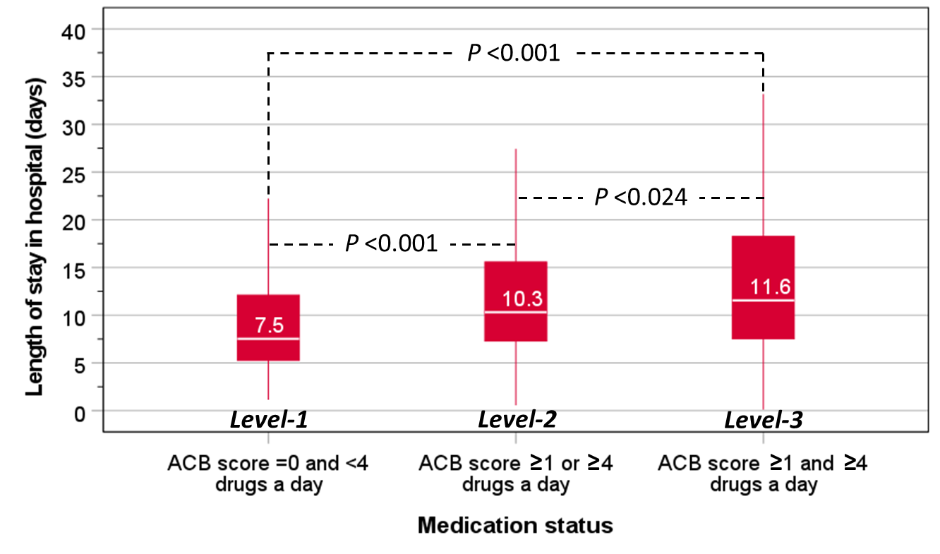

Figure 2.
(A)
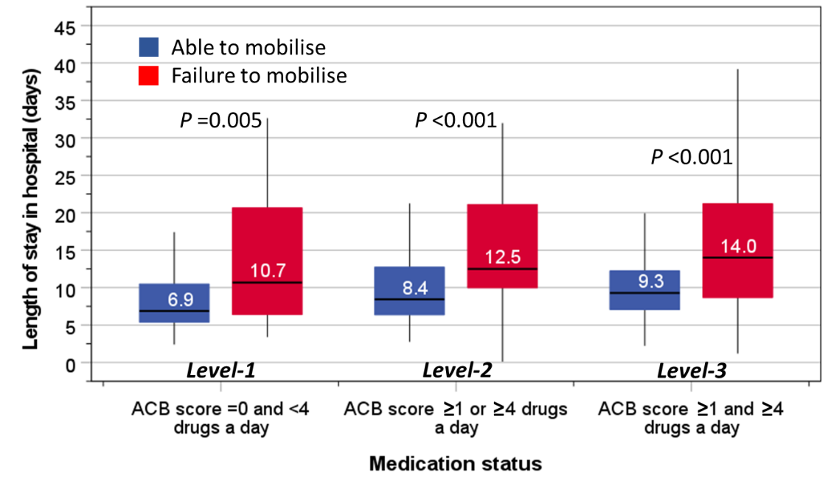

(B)
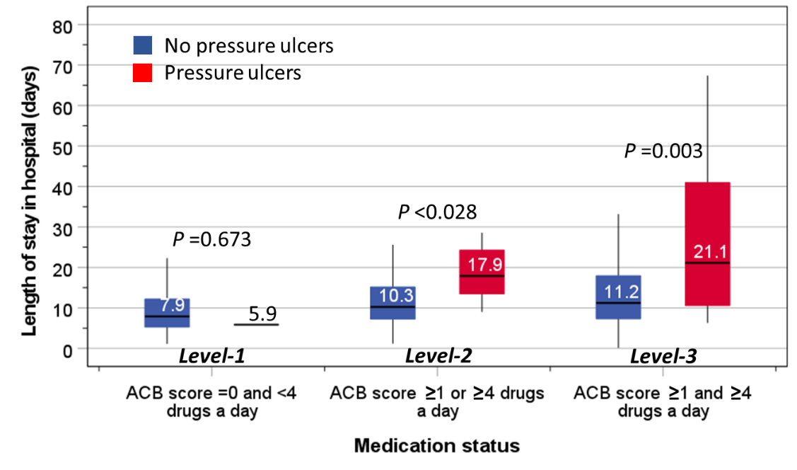

Table 1. Distribution of 1,105 patients of mean age 83.1 years (SD 8.8) admitted to hospital with hip fractures.

 | Distribution (n = 1,105)
 | n | %
Sex
Women | 787 | 71.2
Men | 318 | 28.8
Age
60-69.9 | 108 | 9.8
70-79.9 | 251 | 22.7
80-89.9 | 510 | 46.2
≥90 | 236 | 21.4
Medication status
Polypharmacy (≥4 drugs a day) | 827 | 74.8
ACB score ≥1 | 429 | 38.8
Level-1 | 243 | 22.0
Level-2 | 468 | 42.4
Level-3 | 394 | 35.7
Co-morbidities
Dementia | 223 | 20.2
Stroke | 157 | 14.2
Ischaemic heart disease | 114 | 10.3
Diabetes | 143 | 12.9
Pre-fracture mobility limited to indoors | 221 | 20.0
Alcohol intake >14 units a day | 58 | 5.3
Surgical techniques
Arthroplasty | 552 | 50.0
Intramedullary nail | 334 | 30.2
Sliding hip screw | 161 | 14.6
Hybrid total hip replacement | 43 | 3.9
Antiresorptive agents
Before admission for hip fractures | 45 | 4.1
After discharge for hip fractures | 896 | 81.1
Wating for dual x-ray absorptiometry results | 160 | 14.5
Outcomes
≥1 week | 805 | 72.9
≥2 weeks | 343 | 31.0
Failure to mobilise within 1-day of surgery | 191 | 35.3
Hospital acquired pressure ulcers | 21 | 1.9
ACB, anticholinergic burden; Subsample of 541 patients. Level-1: ACB score =0 and <4 drugs a day; Level-2: ACB score ≥1 or ≥4 drugs a day; Level-3: ACB score ≥1 and ≥4 drugs a day.

Table 2. Distribution of patients of different ages, gender and morbidities according medication status.
 | Level-1 (n = 243) | Level-2 (n = 468) | Level-3 (n = 394) | Group differences
 | % | % | % | χ² | P
Age
60-69.9 | 17.7 | 6.6 | 8.6 | 52.3 | 0.001
70-79.9 | 32.1 | 23.3 | 16.2
80-89.9 | 34.6 | 47.6 | 51.5
≥90 | 15.6 | 22.4 | 23.6
Co-morbidities
Dementia | 12.8 | 22.6 | 21.8 | 10.7 | 0.003
Stroke | 4.1 | 16.0 | 18.3 | 26.8 | <0.001
IHD | 2.9 | 9.2 | 16.2 | 30.1 | <0.001
Diabetes | 3.7 | 14.5 | 16.8 | 24.5 | <0.001
Pre-fracture mobility limited to indoors | 14.8 | 19.7 | 23.6 | 7.3 | 0.007
Alcohol intake >14 units a day | 3.7 | 5.6 | 5.9 | 1.6 | 0.460
Outcomes
LOS ≥1 week | 55.1 | 76.6 | 80.9 | 55.2 | <0.001
LOS ≥2 weeks | 19.8 | 31.5 | 38.1 | 23.5 | <0.001
Failure to mobilise within 1-day of surgery | 23.2 | 36.2 | 43.6 | 14.3 | <0.001
Hospital acquired pressure ulcers | 0.4 | 1.3 | 3.6 | 9.6 | 0.003
Level-1: ACB score =0 and <4 drugs a day; Level-2: ACB score ≥1 or ≥4 drugs a day; Level-3: ACB score ≥1 and ≥4 drugs a day.

Table 3. Logistic regression analysis of the association between ACB and polypharmacy with adverse outcomes.

 | Model-1: Unadjusted |  |  | Model-2: Age- and sex-adjusted |  |  | Model 3: Adjusted for age, sex and co-morbidities*
 | OR | 95 CI | P | OR | 95 CI | P | OR | 95 CI | P
Hospital LOS ≥1 week
Level-1 (reference) | 1 | -- | -- | 1 | -- | -- | 1 | -- | --
Level-2 | 2.7 | 1.9-3.7 | <0.001 | 2.3 | 1.7-3.3 | <0.001 | 2.0 | 1.4-2.9 | <0.001
Level-3 | 3.5 | 2.4-4.9 | <0.001 | 3.0 | 2.1-4.3 | <0.001 | 2.5 | 1.7-3.7 | <0.001
Hospital LOS ≥2 weeks
Level-1 (reference) | 1 | -- | -- | 1 | -- | -- | 1 | -- | --
Level-2 | 1.9 | 1.3-2.7 | <0.001 | 1.6 | 1.1-2.3 | 0.017 | 1.4 | 0.9-2.1 | 0.103
Level-3 | 2.5 | 1.7-3.7 | <0.001 | 2.1 | 1.4-3.1 | <0.001 | 1.8 | 1.2-2.7 | 0.004
Failure to mobilise within 1-day of surgery
Level-1 (reference) | 1 | -- | -- | 1 | -- | -- | 1 | -- | --
Level-2 | 1.9 | 1.2-3.0 | 0.010 | 1.8 | 1.1-2.9 | 0.017 | 1.5 | 0.9-2.4 | 0.136
Level-3 | 2.6 | 1.6-4.2 | <0.001 | 2.4 | 1.5-4.0 | <0.001 | 1.9 | 1.1-3.3 | 0.014
Hospital acquired pressure ulcers
Level-1 and level-2 (reference) | 1 | -- | -- | 1 | -- | -- | 1 | -- | --
Level-3 | 3.7 | 1.5-9.3 | 0.005 | 3.4 | 1.4-8.6 | 0.009 | 3.0 | 1.2-7.9 | 0.019
*Co-morbidities: dementia, stroke, ischaemic heart disease, diabetes, limited pre-fracture mobility and alcohol consumption. Due to a low prevalence of pressure ulcers, the first two categories of medication status were used as reference group. Level-1: ACB score =0 and <4 drugs a day; Level-2: ACB score ≥1 or ≥4 drugs a day; Level-3: ACB score ≥1 and ≥4 drugs a day.

