Effects of Paranoia on Well-being in Adolescents:
A Longitudinal Mediational Analysis

Kingston¹, J. L., Parker¹, A., & Schlier², B.

¹ Royal Holloway, University of London, United Kingdom
² Universität Hamburg, Germany

Correspondence should be addressed to: Dr Jessica Kingston, Royal Holloway, University of London, United Kingdom. Email: Jessica.kingston@rhul.ac.uk

Funding Statement: This research received no specific grant from any funding agency, commercial or not-for-profit sectors.

Key words: paranoia, adolescents, well-being, self-esteem, worry, non-judgemental awareness
Word count: 995
Dear Editors,
Previous research has found that paranoia is common in adolescence (Bird et al., 2020), with some authors proposing this to be a critical phase for the emergence of paranoid cognitions (Raihani & Bell, 2019). Adolescence is a period of increased complexity in social interactions; young people are more attuned to the intentions of others and can feel acutely sensitive to issues of inclusion and exclusion, trust and mistrust. From a developmental perspective, adolescence can be understood as a phase in which competition for occupying a place in a superior rank (or avoiding a low rank) takes centre stage due to the emerging establishment of more significant relationships with peers (Barreto Carvalho et al., 2014). Therefore, Barreto Carvalho and colleagues argue that adolescent paranoia may be an adaptive mindset for recognising threats to a still fragile social rank and defending one’s position within one’s peer group. Following this line of thought, inferring the established link between paranoia and decreased mental health and well-being in adult populations to adolescents may be an undue overgeneralization. We therefore aimed to elucidate whether paranoia in adolescents negatively impacts well-being over time and to what extent mediators established in adult populations (worrying, self-esteem, non-judgmental thinking) account for this pathway (see Supplementary Figure S1).
The study was nested within a randomised control trial (Parker & Kingston, 2021; see supplementary materials for more details on the methods). Ethical approval was obtained from the host university’s Ethics Committee and all participants provided written consent before taking part. Two hundred and ninety-six adolescents (14-16yrs, M_{age}=14.93yrs, 47.4% male, 57% White British) from inner and outer London secondary schools completed questionnaires at baseline (T1) and 2- and 6-week later (T2 and T3 respectively). Cross-sectional analyses used the full dataset and longitudinal analyses are based on the control group (n=133, demographics in Supplementary Table S1). Participants completed measures of paranoia (Bird Checklist of Adolescent Paranoia (B-CAP); Bird et al., 2020), well-being (The Warwick-Edinburgh Mental Well-being Scale (WEMWBS); Tennant et al., 2007), self-esteem (Rosenberg Self-Esteem Scale, Rosenberg, 1965), non-judgemental awareness (Baer et al., 2006), and worry (Penn State Worry Questionnaire for Children (PSWQ-C); Chorpita et al., 1997).
Consistent with previous research (Bird et al., 2020), paranoia was commonly reported. At baseline, the “at least weekly endorsement score” of individual thoughts ranged from 8% (“People are collecting my information or photos to use against me”) to 42% (“I’m sure people are gossiping about me on social media”), with an overall average weekly endorsement of 20.68% across all items, and for the paranoia subscales: 25.78% for social harm, 12.06% conspiracy concerns, and 23.43% physical threat.
At baseline, paranoia was negatively associated with well-being (r=-0.343, p<0.001; social harm, r=-0.384, p<0.001; conspiracy concerns, r=-0.149, p=0.014; and physical threat, r=-0.273, p<0.001). For those with average levels of paranoia, WEMWBS scores were comparable to scores in other adolescent and adult groups (M_{WEMWBS=}48.29, SD=9.86, Med=49). For those with paranoia scores in the “mildly elevated” to “severe” range, well-being was significantly lower (M_{WEMWBS}=40.06, SD=9.04, Med=41; t=5.45, p<0.001; see Supplementary Figure S2).
Next, we calculated cross-lagged panel models of the associations between paranoia and well-being over time using the R-package lavaan (Figure 1, model A). Results showed no significant time-lagged associations from well-being to paranoia (T1-T2: β=-0.07, Z=-1.12, p=.263, T2-T3: β=-0.13, Z=-1.52, p=0.130), suggesting that well-being did not precede and predict paranoia. Conversely, T1 paranoia predicted T2 well-being (β=-0.21, Z=-2.90, p=0.004). No association was found between T2 paranoia and T3 well-being (β=-0.08, Z=-1.20, p=0.229). However, a modified cross-lagged-panel design focussing solely on baseline values as predictors of later paranoia/well-being levels (Figure 1, model B) found an association between T1 paranoia and T3 well-being (β=-0.20, Z=-2.49, p=0.010).
With a time-lagged association from T1 paranoia to T3 well-being established, we tested for mediation. Overall, we tested four mediation models; one for each mediator (T1 B-CAPs -> T2 mediator -> T3 well-being) and one parallel mediator model (all mediators examined simultaneously). All independent models significantly predicted well-being at T3 (self-esteem: F(2, 74)=48.00, R²=.565, p <.001, worry: F(2, 74)=11.52, R²=.248, p <.001, non-judgemental awareness: F(2, 74)=15.66, R²=.298, p <.001). Each model also showed a significant association between T1 paranoia and the mediator at T2, a significant association between the mediator at T2 and well-being at T3, and a significant indirect effect (see Supplementary Table S2). The indirect effect accounted for 43% (worry) to 55% (self-esteem, non-judgemental awareness) of the respective total effect. The parallel mediator model was also significant (F(4, 67)₌23.34, R²⁼.582, p<0.001). Here, baseline paranoia significantly predicted all mediators at T2, but only self-esteem predicted well-being at T3 and yielded a significant indirect effect (see Supplementary Table S3).
To examine the validity of the direction of causality proposed, a reverse mediation model was run (mediators as IV and paranoia as mediator, Supplementary Table S4). The indirect effects (0.09 ≤ β ≤ 0.14) and the amount of the total effect explained in the reverse models (15% to 30%) were lower than the corresponding values of the proposed models.
These findings are in line with a causal pathway from paranoia to low levels of well-being in adolescents, attesting to the generalizability of detrimental effects in adults (e.g., Freeman et al., 2014) to adolescent populations. Furthermore, whilst all mediational paths were significant when considered independently, only self-esteem emerged as a significant mediator in the parallel model, suggesting that paranoia reduces adolescent well-being via its detrimental effect on self-esteem. The study has some limitations: the sample is not nationally representative and the short timeframe precludes conclusions about the long terms effects of paranoia on well-being. This being said, the findings underscore the importance of increased attention to understanding paranoia in adolescents and the potential for its adverse impact on mental health at a young age. Implications include the possible utility of universal interventions designed to promote and protect one’s self-esteem, especially when thinking about social interactions and peer relationships, as well as wider societal level implications, such as school-based initiatives that aim to foster positive peer relations and cultures of safety amongst peers.

References
Baer, R.A., Smith, G.T., Hopkins, J., Krietemeyer, J. and Toney, L., 2006. Using self-report assessment methods to explore facets of mindfulness. Assessment, 13(1), pp.27-45.
Barreto Carvalho, C., Sousa, M., Motta, C., Pinto‐Gouveia, J., Caldeira, S.N., Peixoto, E.B., Cabral, J. and Fenigstein, A., 2017. Paranoia in the general population: A revised version of the General Paranoia Scale for adults. Clinical Psychologist, 21(2), pp.125-134.
Bird, J.C., Loe, B.S., Kirkham, M., Fergusson, E.C., Shearn, C., Stratford, H., Teale, A.L., Waite, F. and Freeman, D., 2020. The assessment of paranoia in young people: Item and test properties of the Bird Checklist of Adolescent Paranoia. Schizophrenia Research, 220, pp.116-122.
Chorpita, B.F., Tracey, S.A., Brown, T.A., Collica, T.J. and Barlow, D.H., 1997. Assessment of worry in children and adolescents: An adaptation of the Penn State Worry Questionnaire. Behaviour research and therapy, 35(6), pp.569-581.
Freeman, D., Startup, H., Dunn, G., Wingham, G., Černis, E., Evans, N., Lister, R., Pugh, K., Cordwell, J. and Kingdon, D., 2014. Persecutory delusions and psychological well-being. Social psychiatry and psychiatric epidemiology, 49(7), pp.1045-1050.
Parker, A. and Kingston, J., 2021. Evaluating a Values-Based Intervention for Adolescence with High Nonclinical Paranoia: A Schools-Based Randomised Control Trial. Cognitive Therapy and Research, pp.1-9.
Raihani, N.J. and Bell, V., 2019. An evolutionary perspective on paranoia. Nature human behaviour, 3(2), pp.114-121.
Rosenberg, M., 1965. Rosenberg self-esteem scale. Journal of Religion and Health.
Tennant, R., Hiller, L., Fishwick, R., Platt, S., Joseph, S., Weich, S., Parkinson, J., Secker, J. and Stewart-Brown, S., 2007. The Warwick-Edinburgh mental well-being scale (WEMWBS): development and UK validation. Health and Quality of life Outcomes, 5(1), pp.1-13.
Tables & Figures

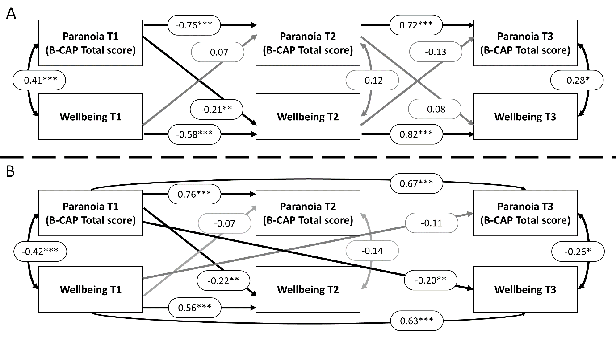
Figure 1.
Results of the cross-lagged panel analyses. Black arrows indicate significant pathways, grey arrows indicate non-significant pathways.

