Event-related transcutaneous vagus nerve stimulation modulates behaviour and pupillary responses during an auditory oddball task
Valerio Villaniª, Gianluca Finottiª, Daniele Di Lernia^{a,b}, Manos Tsakiris^{a,c}, Ruben T. Azevedo^{a,d}*

ªLab of Action and Body, Department of Psychology, Royal Holloway University of London, Egham, Egham Hill, TW20 0EX, United Kingdom
^{b}Humane Technology Lab, Università Cattolica del Sacro Cuore, Milano, 20100, Italy
^{c}Department of Behavioural and Cognitive Sciences, Faculty of Humanities, Education and Social Sciences, University of Luxembourg, Luxembourg
^{d}School of Psychology, University of Kent, Canterbury, Kent, CT2 7NP, United Kingdom

*corresponding author (r.a.teixeira-azevedo@kent.ac.uk)

Abstract
Transcutaneous auricular vagus nerve stimulation (taVNS) is a neuromodulatory technique that is thought to activate the Locus Coeruleus-Noradrenaline (LC-NA) system. Standard taVNS protocols consist of the administration of intermittent or continuous stimulation over long periods. However, there is currently a limited understanding of the temporal dynamics of taVNS modulation of cognitive processes, as well as its mechanisms of action. We argue that novel stimulation approaches, informed by established theories of the LC-NA system, are needed to further our understanding of the neurocognitive underpinnings of taVNS. In this pre-registered study, we tested whether an “event-related” taVNS protocol can modulate the LC-NA system. In a within-subject design (single session) we delivered brief trains of taVNS (3 seconds) during an auditory oddball paradigm. The taVNS was time-locked to the target stimuli and randomly interleaved with sham stimulation. Response times (RT) and stimuli-driven pupillary diameter (PD) were used as indices of LC-NA activity. Results revealed that active taVNS increased RT to targets, as compared to sham trials. Notably, in line with current theories of LC-NA functioning, taVNS modulation of target-related pupil dilation depended on pre-stimulation PD, an index of baseline LC-NA activity. In particular, active (vs. sham) taVNS was associated with smaller pupil dilation in trials where the baseline PD was small. These results demonstrate, for the first time, the effectiveness of brief event-related taVNS in the modulation of cognitive processes and highlight the importance of using pupil size as an index of tonic and phasic LC-NA activity.

Keywords: vagus nerve, taVNS, oddball paradigm, locus coeruleus, pupil size, noradrenaline

Introduction
Over the past 10 years, transcutaneous auricular vagus nerve stimulation (taVNS) has become a popular neuromodulatory technique (Farmer et al., 2021). This non-invasive technique entails the application of electrical current to the auricular branch of the vagus nerve. Researchers have been using taVNS to investigate a wide range of mental processes, including emotion recognition (Colzato et al., 2017; Sellaro et al., 2018), cognitive control (Beste et al., 2016; Steenbergen et al., 2015), memory and learning (Burger et al., 2016; Jacobs et al., 2015; Weber et al., 2021), perception (Keute et al., 2019a; Villani et al., 2019) and as a clinical tool for the treatment of conditions like tinnitus and depression (Stegeman et al., 2021; Wu et al., 2018). While there is still some uncertainty regarding the precise neurocognitive mechanisms of action underlying taVNS, the consensus and initial empirical evidence suggest that taVNS modulates the activity in the Locus Coeruleus–Noradrenaline (LC-NA) system (Colzato and Beste, 2020), which is known to modulate cognition at different levels (Poe et al., 2020).
As a consequence, many studies combined taVNS with experimental methods that are known to activate the LC-NA system. However, results from these studies were not always consistent and several null findings have been reported, casting doubt on the reliability of the stimulation protocols in use (e.g., Borges et al., 2021; Farmer et al., 2021; Keute et al., 2019b; Warren et al., 2019). Indeed, the field counts many taVNS approaches varying in different aspects such as ear site (tragus vs. cymba conchae), device settings (e.g., current intensity and pulse-width) and duration of the stimulation. Moreover, taVNS can be administered before or during the critical task and either in a continuous or in an intermittent (e.g., 30 seconds ON-OFF periods) fashion. We argue that not only the uninformed adoption of disparate approaches hinders advances in the field, but also that, in many cases, the current taVNS protocols are not ideal to address the research questions asked. To design effective taVNS interventions or experimental designs and, importantly, to further our knowledge on its mechanisms of action, we should capitalise on the existing understanding of the proposed neural underpinnings of taVNS.
According to current models, the LC-NA system (Aston-Jones and Cohen, 2005; Poe et al., 2020) exhibits two modes of activity: phasic and tonic. During the phasic mode, LC neurons fire at a high frequency in response to salient or task-relevant stimuli. This type of activity increases the neuronal gain in critical brain regions, optimising information processing and performance. Importantly, the two activity modes are related to each other in an inverted-U shape function: phasic firing is attenuated when tonic activity is low (e.g., sedation) or high (e.g., stress) and is maximal when tonic activity is intermediate. Initial evidence for these modes of LC-NA activity came from direct LC recordings in animal studies showing baseline-dependent (i.e., tonic state) LC phasic activity in response to target stimuli, as compared to distractors (see Aston-Jones and Cohen, 2005). Behavioural response times (RT) and pupil diameter (PD), which is a widely accepted proxy for LC-NA activity (Mridha et al., 2021), in response to the stimuli were highly correlated with LC phasic activity. Subsequent research in humans confirmed the coupling between rapid changes in pupil size, behavioural responses and brain activity to target stimuli in simple two-alternative forced-choice tasks (e.g., Gilzenrat et al., 2010; Murphy et al., 2011). Notably, Murphy and colleagues (2011) provided compelling evidence in humans by using an auditory oddball task. In this task, repetitive sounds (standard stimuli) are played in a sequence and interrupted by infrequent deviant sounds (oddball/target stimuli), to which participants have to respond with a keypress. The authors demonstrated that pre-stimulus pupil size exhibited an inverted U-shape relationship with RT and stimuli induced pupil changes, further suggesting the involvement of the LC-NA activity in the adaptive detection of salient stimuli in humans.
Several studies used taVNS in conjunction with oddball tasks but often these yielded conflicting results. In some experiments, taVNS increased neurophysiological responses to target stimuli (Rufener et al., 2018; Ventura-Bort et al., 2018), while in others it failed to modulate either psychophysiological or behavioural responses (Keute et al., 2019b; Warren et al., 2019). Similarly, whereas pupil size is believed to be a marker for LC-NA activity, the vast majority of studies found no taVNS-related changes in pupil size (e.g., Borges et al., 2021; Keute et al., 2019b; Warren et al., 2019). The variability in the results might be related to the administration of taVNS intermittently. This type of protocol does not distinguish between stimulus-elicited responses when the taVNS is ON from when it is OFF. If we consider the proposed modes of LC-NA activity, tonic LC firing is likely to differ between ON and OFF stimulation periods, which, consequently, may correspond to different psychophysiological states. This difference would, in turn, modulate the phasic LC-NA activity and the underlying psychophysiological states. Similarly, it is not clear how continuous taVNS alters tonic activity (throughout long stimulation periods) and, consequently, how it affects phasic firing. Thus, standard taVNS protocols may have limited power and specificity to address the current research questions about the LC-NA system.
We propose a new stimulation approach, the “event-related” taVNS, where brief trains of taVNS (i.e., a few seconds) are synchronised with the presentation of stimuli. We argue that this approach might provide a more effective and flexible way to tap into the LC-NA system. We anticipate that this approach may help to elucidate (1) if and how taVNS differentially impacts the tonic and phasic modes of the LC-NA system and (2) how this, in turn, modulates cognitive and behavioural processes. In line with this suggestion, animal research has shown that stimulating the LC (Liu et al., 2017) and the vagus nerve (Mridha et al., 2021) increases PD in a graded, intensity-dependent way, providing convincing evidence that vagus nerve stimulation modulates phasic LC firing and PD. Notably, one recent study using short pulses (3.4 s) of taVNS in human participants found transient increases in PD following stimulation further suggesting the effectiveness of brief stimulation procedures (Sharon et al., 2021; see also: Keute et al., 2021; Sclocco et al., 2019). With the present pre-registered study (https://aspredicted.org/blind.php?x=56kp3z), our goal was to provide a proof-of-concept for the effectiveness of brief, event-related taVNS in modulating cognitive processes. We delivered taVNS in bursts of 3 seconds around target stimuli, while participants performed an auditory oddball task. We specifically focused on the effects of this event-related taVNS protocol on RT and PD. Based on the hypothesis that taVNS relies on the LC-NA system and facilitates the detection of salient stimuli, we predicted that active (vs. sham) stimulation would reduce RT and increase PD, especially when the task requires greater engagement (i.e., difficult targets). In addition, we explored how pre-stimulation PD, a proxy of LC-NA baseline activity, modulated the effects of taVNS on RT and PD.

Methods

Participants
A power analysis conducted with G*Power (www.gpower.hhu.de/) based on a previous study (Ventura-Bort et al., 2018) investigating the effects of taVNS on the P300 ERP responses during an auditory oddball task (effect size: η²_{p} = 0.13) revealed a minimum of 29 participants to detect a significant effect (α = 0.05) with 95% power. Assuming a relatively lower sensitivity of PD compared to the P300 to detect the relevant effects (note that no study to date has found taVNS modulation of PD during a cognitive task), we set our target sample size to 40 participants (as pre-registered). Predicting the need to exclude between 15-20% of participants from pupillary analyses due to poor signal and excessive blinking, we recruited 50 participants (17 males; mean age = 22.74 years; SD = 5.21). Seven additional participants took part in the study but their data were excluded before any analyses (i.e., discarded immediately after the testing session or during preliminary data integrity checks) and therefore were not considered for the sample size determination. The reasons for the exclusions were: technical failure (2); excessive sleepiness (1); poor compliance (1); poor eye-tracker signal or excessive blinking (3). All participants were eligible to receive taVNS, gave their written consent to collect their data, and were given £8 at the end of the study. The study was approved by the Ethics Committee of Royal Holloway, University of London.

Auditory oddball task
In a typical auditory oddball paradigm, participants listen to a sequence of standard sounds, which is interleaved with one type of deviant sound. The deviant sound is called “oddball” and participants have to respond to it, as quickly and as accurately as they can. In the present version of the paradigm, we played a sequence of standard sounds at 500 Hz occasionally interrupted by one of two oddball sounds, which varied in pitch. These sounds were designed to be easy (1000 Hz) and difficult (530 Hz) to discriminate against the standard sounds. Across trials, the probability of occurrence of an oddball was ~15% with easy and difficult targets equally represented (~7.5% each). The inter-stimulus interval, i.e. the time interval between two consecutive sounds, varied randomly between 2000-3100 ms. All sounds lasted 100 ms and were played through two computer speakers, placed bilaterally behind the participant. We recorded RT to target stimuli as our behavioural dependent variable.
During the task, we administered either sham or active taVNS around the oddball (cf. section 2.3) or, in a control condition, around a standard sound. Thus, the task included six orthogonal conditions (Active Easy; Active Difficult; Active Standard; Sham Easy; Sham Difficult; Sham Standard) with 30 trials each for a total of 180 trials. All trials were pseudo-randomised: the sound sequence was randomised for each participant but constrained to ensure a minimum of 9 seconds between two consecutive taVNS onsets independently of stimulation type.
We used a Tobii T120 eye-tracker to record the participants’ pupil dilation throughout the task. To maximise data quality, we asked participants to use a chin-rest and performed the eye-tracker calibration twice – i.e., at the beginning of the task and halfway through it. The whole session lasted on average 55 minutes (SD = 3) and was split into 6 blocks. After each block, participants were allowed to take a self-paced break and rest their eyes. Between the third and the fourth block, participants had a mandatory break of at least 1 minute.
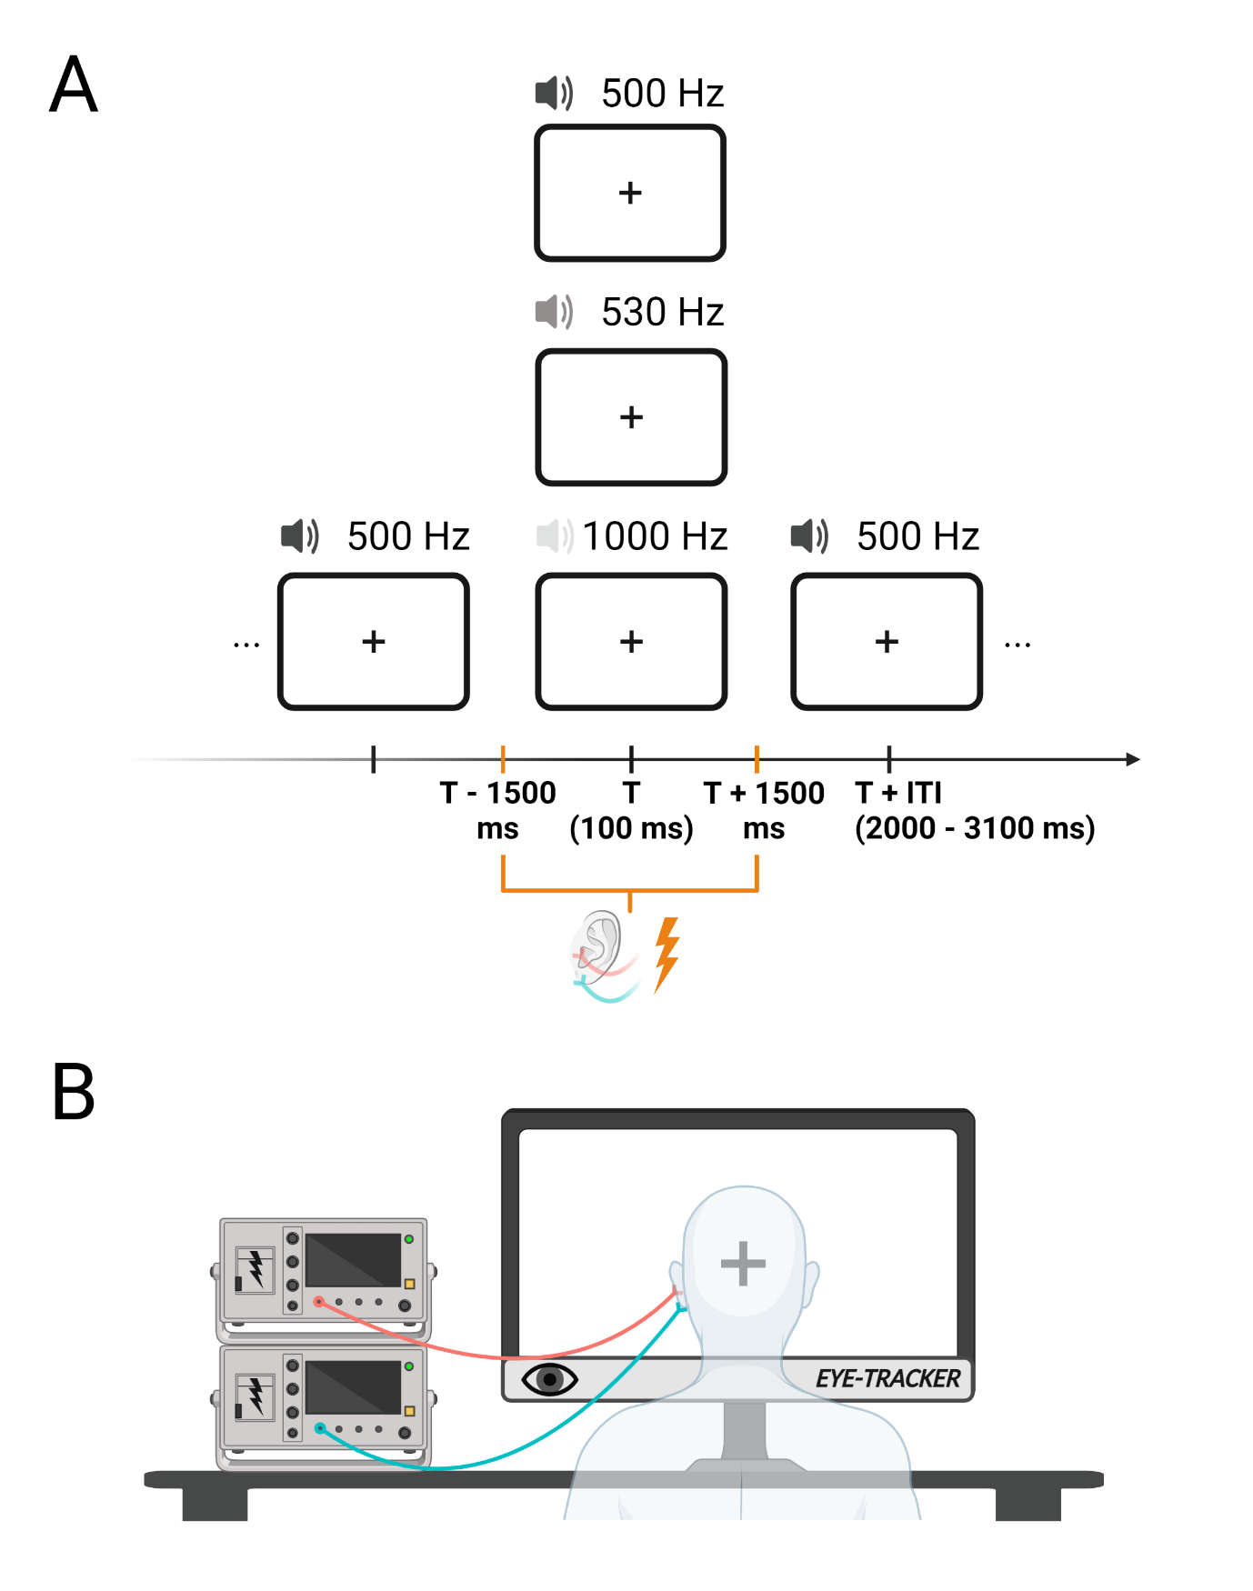
Figure 1. Diagram of the experimental design. (A) The auditory oddball task consisted of a sequence of standard sounds played at 500 Hz interspersed with easy (1000 Hz) and difficult (530 Hz) target sounds. Alongside target presentation, (B) taVNS was delivered to either the left earlobe (sham stimulation) or tragus (active stimulation) in brief trains of 3 seconds. As a control, taVNS was also administered during the presentation of some standard sounds. Throughout the task, pupil size was measured and served as an index of LC-NA activity. Image created with BioRender.com.

Event-related taVNS
To administer the taVNS, we used two Digitimers DS7A with 1 cm diameter surface electrodes attached to two clips. Each Digitimer was connected to a pair of electrodes, one pair placed on the participants’ left tragus (active stimulation) and the other on their left earlobe (sham stimulation). The skin under the electrodes was cleaned with disposable wipes (70% isopropyl alcohol) before electrode placement. We used a staircase procedure to adapt the current intensity at each ear-site and for each participant to a level just below their perceptual threshold (M_{tragus} = 0.38 mA, SD_{tragus} = 0.25; M_{earlobe} = 0.36 mA, SD_{earlobe} = 0.18). The staircase started at 0.10 mA for all participants and involved 2-second trains of taVNS. We adjusted the current in steps of ± 0.03 mA until the participants felt a faint tingling sensation at the ear-site. Next, we reduced the current by 0.03 mA and delivered five trains of taVNS. When the participant felt a tingling sensation in, precisely, three out of five times in this sequence, we reduced the current by a further 0.03 mA and set the intensity to that value. The pulse width and frequency were set to 500 µs and 25 Hz, respectively (Badran et al., 2018). During the task, we administered taVNS in an event-related fashion using a custom-built Arduino trigger box to interface between the stimuli presentation algorithm controlled with MATLAB (www.mathworks.com/) and the Digitimers. Stimulation consisted of monophasic trains of 3 seconds, starting and ending 1.5 s before and after, respectively, the onset of the target or control standard sound (see Figure 1). This protocol allowed us to switch stimulation type from trial to trial and investigate its effects at a finer timescale. It is important to note that LC-NA firing has been shown to decline shortly after stimulation offset, i.e. ~2 s (Hulsey et al., 2017; see also: Keute et al., 2021; Sharon et al., 2021). Moreover, because the trial sequence and stimulation type are randomised by the computer algorithm for each participant, this event-related approach assumes, by default, a double-blind protocol. At the end of the experiment, we asked participants to fill in a questionnaire about the taVNS-related sensations they had experienced (see the supplementary materials). Each sensation was rated on a numerical scale from 1 (not at all) to 5 (extremely); when appropriate, we included separate items for the earlobe and the tragus (see supplementary materials).

Analyses
The pre-registered analyses plan proposed to use repeated-measures ANOVA for analysing pupillary and behaviour data. However, upon further reflection, we concluded that Linear Mixed Models (LMM) would be a more appropriate approach to analyse this particular dataset. Not only LMM are becoming the standard statistical approach in psychological sciences, but they also bring a number of analytical advantages to the present study. In the first place, LMM allowed us to account for the nested structure of our data, by using a random intercept (and a correlated slope) for each participant. LMM are also better suited for analysing Response Times (RT), whose distribution typically violates the assumption of normality (see Lo and Andrews, 2015) and can handle missing values (using maximum likelihood estimation), which are frequent in intrinsically noisy data such as those of pupil dilation. Lastly, LMM allowed us to model the data at the level of individual trials and, by adding “trial number” as a covariate, to control for the effect of time in behaviour and pupillary responses across the session. For completeness, we report all analyses using the original approach in the supplementary materials.
All the analyses were carried out in R (R Core Team, 2021) with the following approach (see the supplementary materials for an explanation on why this is preferred to the pre-registered ANOVA analyses). First, we fitted linear mixed-effects models, as implemented by the {lme4} package (Bates et al., 2015), following a forward approach model selection. Model comparisons were carried out with likelihood-ratio chi-squared tests and using the anova() function. Once the final model was established, the statistical significance of main effects and interactions was determined using the Anova() function of the {car} package (Fox and Weisberg, 2019), which calculates type-II analysis-of-variance tables for mixed-effects models and returns likelihood-ratio Chi-Square statistics. Planned post-hoc comparisons were carried out, where appropriate, using the function emmeans() of the {emmeans} package (Lenth, 2021) to test differences between active and sham taVNS in the relevant conditions. Given the small number of planned post-hoc comparisons testing exclusively for differences between active and sham stimulation in the individual conditions (as pre-registered), no correction for multiple comparisons was used. Bayes Factors were calculated with the {BayesFactor} package (Morey and Rouder, 2018) to support the null findings of the regression analyses.
Data and analyses scripts are available at https://osf.io/x9f2y/?view_only=9a71b5e6ef534718adf4f149d58272f9.

Results

Response times
We trimmed the tails of the RT distribution at 100 and 1200 milliseconds (mean number of trials excluded = 0.53, SD = 1.10, Max = 6). The pre-registered analysis plan proposed the exclusion of participants whose general accuracy (i.e., number of missed or excluded trials across conditions) laid outside ± 2.5 standard deviations around the mean. This approach would have resulted in the exclusion of three participants. However, given the remarkably high accuracy across participants (M = 97.5%, SD = 0.32; Min = 87.5%) we judged that there is no reason to exclude participants based on performance. Analyses following the pre-registered plan provide equivalent results and are reported in supplementary materials for transparency and completeness.
We entered the trial number as a continuous predictor in the regression formula; stimulation (1 = active; 2 = sham) and sound (1 = easy; 2 = difficult) type were entered as categorical predictors instead. Importantly, we let the intercept vary by participant and the correlated slope by trial number. The regression used a Gaussian family function with a log link function.
The best-fitting model was:
RT ~ trial_num + stimulation*sound + (1 + trial_num | ppt)
The results showed a significant effect of trial number (X² = 6.60, p = 0.010), showing that RT increased over time (Beta = 0.02). We also found a significant effect of sound type (X² = 1024.22, p < 0.001) and taVNS (X² = 7.48, p = 0.017). As expected, difficult sounds were associated with longer RT (M = 536 ms [94.4]) than easy ones (M = 415 ms [85.3]). During taVNS, RT were slower during active trials (M = 478 ms [87.5]) as compared to sham trials (M = 471 ms [86.0]), in contrast to our hypothesis – see the raincloud plots (Allen et al., 2019) in Figure 2. The two-way interaction between taVNS and sound type was not significant (X² = 0.31, p = 0.58; BF = 19.06 ± 6.71%).
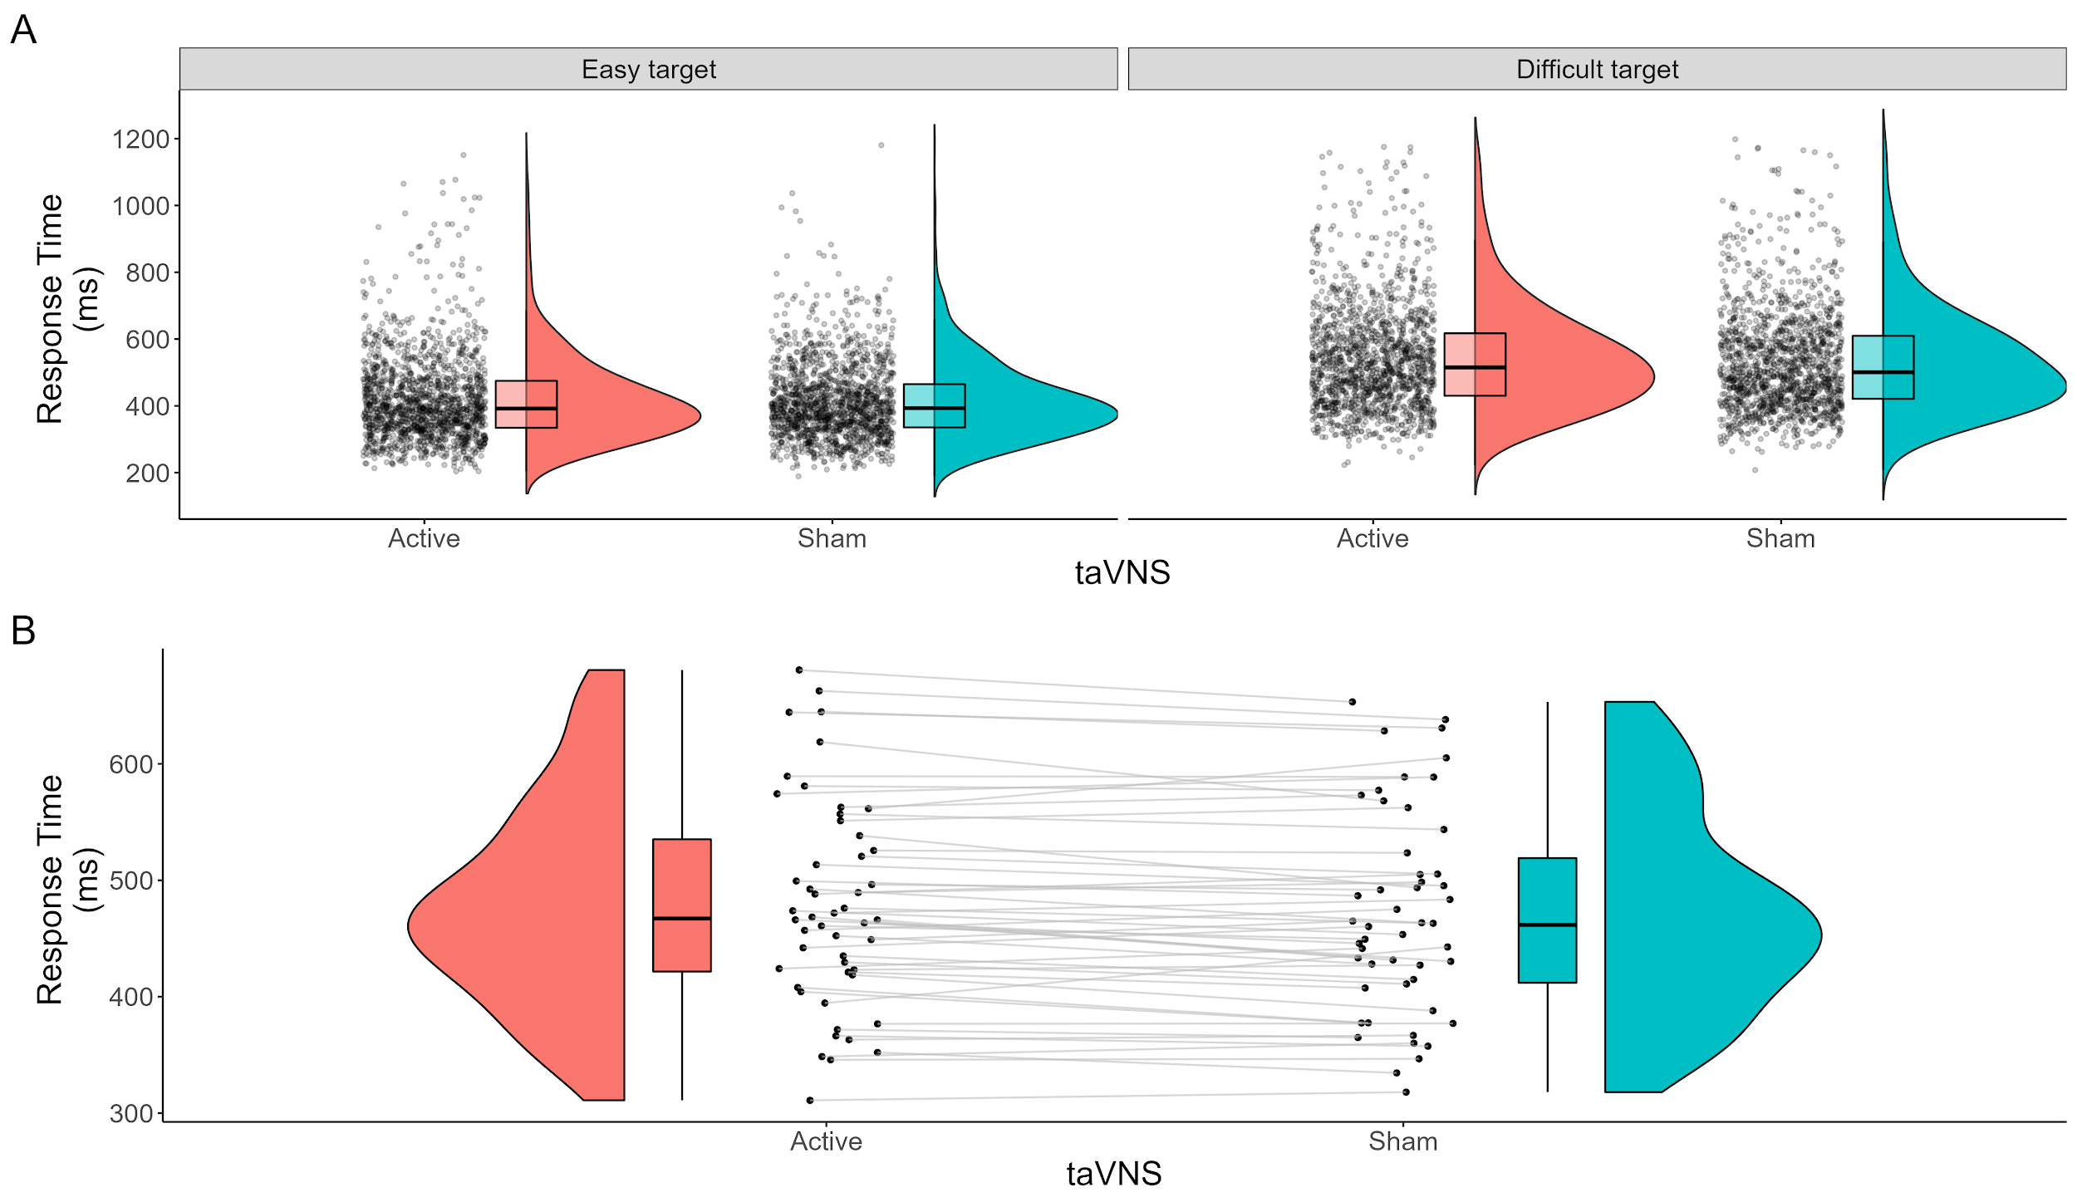
Figure 2. Response Times (RT). (A) Average RT as a function of stimulation (Active vs. Sham) and target sound (Easy vs. Difficult) type. (B) Average RT as a function of stimulation: active taVNS was associated with longer RT to target stimuli than sham taVNS.

Pupil diameter
Pupil data were processed according to the pre-registered analysis plan. Trials where 50% (or more) of pupil data were missing (e.g., due to blinking) were excluded from analyses. Data from participants with over 50% of excluded trials in any condition were not analysed (N = 14). The resulting dataset (N = 36) was pre-processed according to the guidelines and code provided by Kret and Sjak-Shie (2019); please refer to the code made available by the authors – Pupil Size Preprocessing Code v. 1.1 – and to the supplementary materials for the specifications of the parameters adopted in this study. Pre-stimulus baseline was defined as the average pupil size during the second immediately preceding sound onset at each trial.
The maximal pupil diameter within 2 seconds after stimulus onset (divided by pre-stimulus baseline) was entered as the dependent variable in the mixed-model regressions, with participants as random variables. Stimulation (1 = active; 2 = sham), sound (1 = easy; 2 = difficult; 3 = standard), and their interaction were tested as predictors. Only the sound factor (X² = 440.9, p < 0.001) was found to be a significant predictor as neither stimulation nor its interaction with sound improved model fit (ps > 0.05). We then explored whether pre-stimulation baseline (defined as the average pupil size in the second before active or sham taVNS stimulation in each trial), as a proxy for ongoing pre-stimulus LC-NA activity, interacted with stimulation to predict stimulus-driven pupil changes. For this, we classified each trial as “low” or “high” baseline pupil size according to within-participant median splits. Baseline pupil size (1 = low; 2 = high) and its interactions with sound and stimulation were tested as predictors in the regression models. The trial number and its interactions with the remaining predictors were also entered in the models.
The best fitting model was:
max_pupil ~ trial_num + stimulation*sound*baseline_pupil + (1 + trial_num | ppt)
A statistical trend was found for the three-way interaction stimulation × sound × baseline pupil (X² = 5.47, p = 0.065, BF = 4.38 ± 35.2%) (see Figure 3). Notably, the stimulation × baseline pupil was significant (X² = 4.95, p = 0.026), suggesting that taVNS modulation depended on ongoing LC-NA activity. Results also revealed a significant sound × baseline pupil interaction (X² = 21.26, p < 0.001) and significant main effects of sound (X² = 477.39, p < 0.001), baseline pupil (X² = 363.66, p < 0.001) and trial number (X² = 9.99, p = 0.002). The remaining predictors were not significant (ps > 0.05). Post-hoc analyses on the significant stimulation × baseline pupil interaction revealed that active (vs. sham) taVNS was associated with smaller PD during low pupil baseline trials (t-ratio = -2.07, p = 0.038). No difference between active and sham taVNS was found for high pupil baseline trials (t-ratio = 1.03, p = 0.30). As exploratory analyses (given the statistical trend), we also carried out post-hoc analyses to follow up on the stimulation × sound × baseline pupil interaction. Results revealed that sound-driven PD only differed between active and sham taVNS for easy targets in low baseline pupil trials (t-ratio = -3.18, p = 0.0015) (all other ps > 0.05). It should be noted, however, that the planned post-hoc comparisons were not corrected for multiple comparisons and therefore should be interpreted with caution.
To understand if taVNS induced pupil changes in the period before target onset, we carried out a mixed-models regression analysis with the average pupil size in the second before target onset as the dependent variable. Type of taVNS, baseline pupil (1 = low; 2 = high) and their interaction were entered as predictors. Neither stimulation (X² = 0.16, p = 0.68, BF = 31.07 ± 1.9%), nor its interaction with baseline pupil size (X² = 1.94, p = 0.16, BF = 7.63 ± 9.78 %) were significant (see Figure 4).
To investigate whether there was any carry-over effect of taVNS on PD, we carried out a mixed-models regression analysis with pre-stimulation pupil baseline as the dependent variable and stimulation on the previous trial as a predictor. We found no evidence of such carry-over effects on the baseline pupil (X² = 0.22, p = 0.64, BF = 19.06 ± 6.71%).

Figure 3. Stimulus-related changes in pupil dilation. (A) Across all trials; (B) in trials with low pre-stimulation pupil size; (C) in trials with high pre-stimulation pupil size. * p < 0.05.

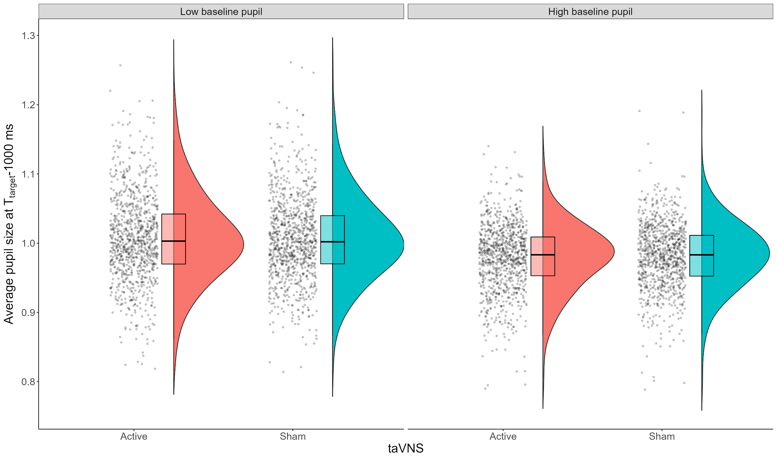
Figure 4. Average pupil size following stimulation onset (in the 1000 ms prior to stimulus presentation), as a function of stimulation (Active vs. Sham) and baseline pupil size (Low vs. High).

Sensations induced by the taVNS
We tested for differences in both objective (i.e., stimulation intensity) and subjective (i.e., elicited sensations) aspects of taVNS. For all the variables, we used a Shapiro-Wilk test to check for normality. None of the variables of interest was normally distributed (p < 0.05), thus we used a paired Wilcoxon test for all the analyses reported below.
We found no difference between the objective intensity of active (M = 0.38 mA [0.25]) and sham (M = 0.34 mA [0.18]) taVNS (V = 417, p = 0.18). Likewise, there were no differences in stinging (V = 54, p = 0.21; M_{tragus} = 1.38 [0.60], M_{earlobe} = 1.5 [0.71]) and burning (V = 13.5, p = 0.15; M_{tragus} = 1.28 [0.57], M_{earlobe} = 1.16 [0.37]) sensations elicited by the taVNS. Overall, the scores were right-skewed and 90% of them fell below the value of 2, indicating that taVNS did not elicit sensations most of the time and, if it did, the sensations were tolerable.

Discussion
Pupil dilation is an established biomarker of the LC-NA system’s activity and invasive vagus nerve stimulation in animals (Mridha et al., 2021) and humans (Jodoin et al., 2015) have shown that stimulating the vagus leads to an increase in pupil size. Nevertheless, taVNS studies on human participants have consistently failed to show increases in PD (e.g., Borges et al., 2021; Keute et al., 2019b; Warren et al., 2019), with one notable exception. Sharon and colleagues (2021) demonstrated that brief trains of taVNS, applied at rest, modulated PD as well as electrophysiological indices of arousal. Here, we adopted a similar approach and showed that brief trains of taVNS also impact performance in an auditory oddball task, which is thought to rely on the LC-NA system. Specifically, we demonstrated that delivering 3 seconds of active, event-related taVNS increased RT and decreased PD in response to target stimuli. Importantly, the effect of taVNS on PD depended on the baseline pupil size (i.e., PD before the stimulation), suggesting that taVNS effects are contingent on pre-stimulus LC firing. Our results provide evidence that event-related taVNS is an effective approach to modulate LC-NA activity and advocate for the use of PD as an important biomarker. Together, these results demonstrate the effectiveness of brief stimulation approaches and highlight the importance of considering how stimulation protocols impact both baseline and phasic LC-NA activity.
In standard protocols, researchers administer taVNS in an intermittent (e.g., 30 seconds ON/OFF) or continuous fashion, for several minutes. Within this time frame, the variables of interest are recorded and then averaged together for statistical analysis. Typically, no distinction is made between events that occur during ON or OFF periods and little is known about the dynamics of taVNS effects over extended periods of stimulation. Moreover, to date, it is not clear how these stimulation approaches may impact tonic and phasic LC-NA activity. This novel stimulation protocol, together with reliable biomarkers of neuromodulation, holds the promise of advancing our understanding of taVNS. From animal models, we know that stimulating the vagus nerve with brief trains of current activates the LC-NA within a few milliseconds (Hulsey et al., 2017) and that PD increases in the following 2-3 seconds (Mridha et al., 2021). Brief stimulation paired with stimulus onset has also been shown to be an effective method to induce neuroplasticity in animals (Engineer et al., 2011). Building upon this line of research, we provide a proof-of-principle that this approach can be used in humans to investigate the dynamics of taVNS effects on cognition. Specifically, we show how taVNS can be used as a neuromodulatory tool to induce transient changes in LC-NA activity and modulate behaviour in an event-related fashion. Importantly, LC-NA firing is thought to decline shortly after stimulation offset (Hulsey et al., 2017) and we found no evidence of an influence of stimulation type on baseline pupil size on the subsequent trial suggesting that no carryover effect, from trial to trial, is likely to occur.
It is normally expected that taVNS increases LC-NA firing which in turn promotes facilitated detection of target stimuli. Interestingly, however, contrary to our hypotheses, active (vs. sham) taVNS increased RT and decreased PD suggesting reduced engagement of the LC-NA system by the target stimuli. While it is difficult to be certain of the reason behind this pattern of results, it is likely to be related to the dynamics of LC-NA activity. One possibility is that the reduced engagement of the LC-NA system reflects the post-activation inhibition characteristic of noradrenergic LC neurons. Specifically, it is well-known that phasic excitation of LC neurons is typically followed by the inhibition in impulse activity (Aghajanian et al., 1977; Ennis and Aston-Jones, 1986) which could explain diminished responses to the target stimuli. However, this self-inhibitory effect is thought to last only a few hundred ms and is, therefore, not clear how it relates to longer stimulation periods such as the one used here or in standard taVNS protocols.
It is also possible, and more likely, that the taVNS, delivered 1.5 s before the oddball, transiently increased the neuronal firing in the LC-NA system during this period, dampening the potential for stimulus-driven phasic activity. Such explanation would be consistent with the proposed inverted U-shape relation between tonic and phasic modes of activity whereby states of high (vs intermediate) activity are associated with reduced neural firing and poorer behavioural responses to incoming salient stimuli (Aston-Jones and Cohen, 2005; Poe et al., 2020). In fact, we found that stimulus-driven modulation of PD was only evident on trials where the baseline pupil was small and, therefore, the LC-NA system was more sensitive to engage in the stimulation-driven phasic activity. In line with this explanation, Yang and colleagues (2021) recently reported diminished startle responses, and augmented indices of cortical arousal, to loud acoustic stimuli presented immediately after brief electrical stimulation to the LC of rats. It is thus likely that instead of increasing the potential for stimulus-driven phasic LC-NA responses, phasic taVNS before stimulus onset may actually dampen the phasic engagement of the noradrenergic system to the detection of salient stimuli. However, our evidence is only tentative as the effects of active taVNS on PD, before the oddball’s presentation, were not statistically different from those on sham trials. In this regard, we should note that Sharon and colleagues (2021) reported that PD peaked 4 seconds after the onset of taVNS. In the present study, this critical moment overlaps with stimulus-driven changes in PD; therefore, our design may not allow us to measure stimulus-independent effects of taVNS on PD. Future studies could deliver taVNS at different moments relative to stimulus onset to elucidate this issue. A promising approach would be to deliver even shorter trains of taVNS synchronised with stimuli’s onset to maximise excitatory responses (Engineer et al., 2011). Despite these limitations, the fact that both behavioural and pupillary responses were found in the opposite direction from our predictions further emphasises the need to test novel stimulation approaches and to consider the differences between baseline and phasic LC-NA activity to further our knowledge of the working mechanisms of taVNS. It is likely, for example, that some of the contradictory or null findings present in the taVNS literature reflect (un)balanced enhancement and inhibition of stimulus-driven LC-NA responses due to the different effects that taVNS can have on the LC-NA system throughout the task, e.g., during ON vs OFF stimulation periods in intermittent protocols.
It is important to note that the requirement to adopt short inter-stimulus intervals (ranging from 2000 ms to 3100 ms), to minimise participants’ fatigue and promote task engagement, had as a consequence the overlap between the pupil dilation to the previous standard stimulus and the pre-stimulation baseline period. This means that, even if standard sounds are likely to elicit only small LC-NA phasic responses, the baseline period might not be completely free from contamination. This limits the interpretation of PD at baseline as a proxy of “pure” tonic LC-NA activity. Nevertheless, the clear main effect of baseline pupil observed here – i.e., a greater increase of PD in low baseline pupil trials – provides convincing support to our interpretation of reduced LC-NA responses during states of higher baseline activity. Future experimental protocols may want to address this issue to further differentiate tonic from phasic LC-NA activity and elucidate on how these two complementary modes of activity shape taVNS modulation of cognitive and physiological responses to external stimuli.
While the effects reported here may be considered to be small-to-medium in magnitude, the congruency between RT and pupil data confirms their reliability. Moreover, these results must be considered in light of the current limitations in the field. Among the limitations are concerns on: age and inter-individual variability in vagus nerve innervation in the external ear; ongoing discussions about which is the optimal stimulation site (tragus vs. cymba conchae); doubts about the adequacy of earlobe as a control site; uncertainty regarding the optimal stimulation parameters and protocol (for discussions, see: Butt et al., 2020; Ludwig et al., 2021). All these factors may influence the ability to effectively measure the impact of taVNS on cognitive function and could be partially responsible for some of the small effects and null findings observed in the literature. It is only by improving methodological practises that we will be able to estimate the true potential of taVNS.
Indeed, for as much as existing literature suggests taVNS as a promising and exciting neuromodulatory tool, there is also, at present, a consensual need to further our knowledge on its mechanisms of action and most appropriate stimulation protocols. To achieve this, researchers need to adopt the most appropriate taVNS protocols to test their hypotheses. This endeavour requires exploring novel stimulation protocols, guided by current theories of brain functioning. We are convinced that the novel approach we propose here – i.e., adapting stimulation parameters (time and duration) and monitoring both pre- and post-stimuli pupil size – is an important step in that direction. Depending on experimental demands, this approach may have several advantages. Firstly, the event-related taVNS allows within-subject manipulations in a single session and is suitable for double-blind experiments. Secondly, it works at a finer temporal scale reducing possible psychophysiological confounds like learning across experimental sessions or shifts in baseline physiological states. Thirdly, using pupil size as a dynamic index of ongoing LC-NA activity will allow investigating in a systematic and controlled way what are the optimal stimulation parameters to meet experimental demands. For example, it should allow inducing targeted changes in tonic or phasic activity to maximise neuromodulatory power and prevent possible stimulation plateau. Lastly, the closer alignment with current models of LC-NA function may be of considerable value to the effort to advance our understanding of the mechanisms underlying taVNS impact in cognition and behaviour.

Credit author statement
Valerio Villani: Conceptualisation, Methodology, Software, Validation, Formal analysis, Investigation, Resources, Data curation, Writing - Original draft, Writing - Review and editing, Visualisation, Supervision, Project administration. Gianluca Finotti: Software, Resources, Writing - Review and editing. Daniele Di Lernia: Software, Resources, Writing - Review and editing. Manos Tsakiris: Conceptualisation, Methodology, Writing - Review and editing, Supervision, Funding acquisition. Ruben T. Azevedo: Conceptualisation, Methodology, Software, Validation, Formal analysis, Investigation, Resources, Data curation, Writing - Original draft, Writing - Review and editing, Visualisation, Supervision, Project administration, Funding acquisition.
See the supplementary materials for a visual overview of the authors’ relative contributions to the study.

Acknowledgements
Funding: MT was supported by the European Research Council Consolidator Grant (ERC-2016-CoG-724537) for the INtheSELF project under the FP7. RTA and VV were supported by a BIAL Foundation Grant for Research Project 088/2016 to RTA. The authors thank Marco Tullio Liuzza for advice given on Bayesian statistics.

References
Aghajanian, G.K., Cedarbaum, J.M., Wang, R.Y., 1977. Evidence for norepinephrine-mediated collateral inhibition of locus coeruleus neurons. Brain Research 136, 570–577. https://doi.org/10/cfqnx5
Allen, M., Poggiali, D., Whitaker, K., Marshall, T.R., Kievit, R.A., 2019. Raincloud plots: a multi-platform tool for robust data visualization. Wellcome Open Res 4, 63. https://doi.org/10/gfxr7w
Aston-Jones, G., Cohen, J.D., 2005. An integrative theory of locus coeruleus-norepinephrine function: adaptive gain and optimal performance. Annual Review of Neuroscience 28, 403–450. https://doi.org/10.1146/annurev.neuro.28.061604.135709
Badran, B.W., Mithoefer, O.J., Summer, C.E., LaBate, N.T., Glusman, C.E., Badran, A.W., DeVries, W.H., Summers, P.M., Austelle, C.W., McTeague, L.M., Borckardt, J.J., George, M.S., 2018. Short trains of transcutaneous auricular vagus nerve stimulation (taVNS) have parameter-specific effects on heart rate. Brain Stimul 11, 699–708. https://doi.org/10/gdtspj
Bates, D., Mächler, M., Bolker, B., Walker, S., 2015. Fitting linear mixed-effects models using lme4. Journal of Statistical Software 67, 1–48. https://doi.org/10/gcrnkw
Beste, C., Steenbergen, L., Sellaro, R., Grigoriadou, S., Zhang, R., Chmielewski, W., Stock, A.-K., Colzato, L., 2016. Effects of concomitant stimulation of the GABAergic and norepinephrine system on inhibitory control – a study using transcutaneous vagus nerve stimulation. Brain Stimulation 9, 811–818. https://doi.org/10/gddn5w
Borges, U., Pfannenstiel, M., Tsukahara, J., Laborde, S., Klatt, S., Raab, M., 2021. Transcutaneous vagus nerve stimulation via tragus or cymba conchae: are its psychophysiological effects dependent on the stimulation area? International Journal of Psychophysiology 161, 64–75. https://doi.org/10/gh2qx2
Burger, A.M., Verkuil, B., Van Diest, I., Van der Does, W., Thayer, J.F., Brosschot, J.F., 2016. The effects of transcutaneous vagus nerve stimulation on conditioned fear extinction in humans. Neurobiology of Learning and Memory 132, 49–56. https://doi.org/10/ghtcxt
Butt, M.F., Albusoda, A., Farmer, A.D., Aziz, Q., 2020. The anatomical basis for transcutaneous auricular vagus nerve stimulation. Journal of Anatomy 236, 588–611. https://doi.org/10/ggnw34
Colzato, L., Beste, C., 2020. A literature review on the neurophysiological underpinnings and cognitive effects of transcutaneous vagus nerve stimulation: challenges and future directions. Journal of Neurophysiology 123, 1739–1755. https://doi.org/10.1152/jn.00057.2020
Colzato, L., Sellaro, R., Beste, C., 2017. Darwin revisited: the vagus nerve is a causal element in controlling recognition of other’s emotions. Cortex 92, 95–102. https://doi.org/10/ggk3db
Engineer, N.D., Riley, J.R., Seale, J.D., Vrana, W.A., Shetake, J.A., Sudanagunta, S.P., Borland, M.S., Kilgard, M.P., 2011. Reversing pathological neural activity using targeted plasticity. Nature 470, 101–104. https://doi.org/10/b63kt9
Ennis, M., Aston-Jones, G., 1986. Evidence for self- and neighbor-mediated postactivation inhibition of locus coeruleus neurons. Brain Research 374, 299–305. https://doi.org/10/fb9p32
Farmer, A.D., Strzelczyk, A., Finisguerra, A., Gourine, A.V., Gharabaghi, A., Hasan, A., Burger, A.M., Jaramillo, A.M., Mertens, A., Majid, A., Verkuil, B., Badran, B.W., Ventura-Bort, C., Gaul, C., Beste, C., Warren, C.M., Quintana, D.S., Hämmerer, D., Freri, E., Frangos, E., Tobaldini, E., Kaniusas, E., Rosenow, F., Capone, F., Panetsos, F., Ackland, G.L., Kaithwas, G., O’Leary, G.H., Genheimer, H., Jacobs, H.I.L., Van Diest, I., Schoenen, J., Redgrave, J., Fang, J., Deuchars, J., Széles, J.C., Thayer, J.F., More, K., Vonck, K., Steenbergen, L., Vianna, L.C., McTeague, L.M., Ludwig, M., Veldhuizen, M.G., De Couck, M., Casazza, M., Keute, M., Bikson, M., Andreatta, M., D’Agostini, M., Weymar, M., Betts, M., Prigge, M., Kaess, M., Roden, M., Thai, M., Schuster, N.M., Montano, N., Hansen, N., Kroemer, N.B., Rong, P., Fischer, R., Howland, R.H., Sclocco, R., Sellaro, R., Garcia, R.G., Bauer, S., Gancheva, S., Stavrakis, S., Kampusch, S., Deuchars, S.A., Wehner, S., Laborde, S., Usichenko, T., Polak, T., Zaehle, T., Borges, U., Teckentrup, V., Jandackova, V.K., Napadow, V., Koenig, J., 2021. International consensus based review and recommendations for minimum reporting standards in research on transcutaneous vagus nerve stimulation (version 2020). Front. Hum. Neurosci. 14. https://doi.org/10/gjh7gz
Fox, J., Weisberg, S., 2019. An R companion to applied regression, 3rd ed. Sage, Thousand Oaks CA.
Gilzenrat, M.S., Nieuwenhuis, S., Jepma, M., Cohen, J.D., 2010. Pupil diameter tracks changes in control state predicted by the adaptive gain theory of locus coeruleus function. Cognitive, Affective, & Behavioral Neuroscience 10, 252–269. https://doi.org/10/frkp6k
Hulsey, D.R., Riley, J.R., Loerwald, K.W., Rennaker, R.L., Kilgard, M.P., Hays, S.A., 2017. Parametric characterization of neural activity in the locus coeruleus in response to vagus nerve stimulation. Experimental Neurology 289, 21–30. https://doi.org/10/gdvht7
Jacobs, H.I.L., Riphagen, J.M., Razat, C.M., Wiese, S., Sack, A.T., 2015. Transcutaneous vagus nerve stimulation boosts associative memory in older individuals. Neurobiology of Aging 36, 1860–1867. https://doi.org/10/ggsnph
Jodoin, V.D., Lespérance, P., Nguyen, D.K., Fournier-Gosselin, M.-P., Richer, F., 2015. Effects of vagus nerve stimulation on pupillary function. International Journal of Psychophysiology 98, 455–459. https://doi.org/10/f747mh
Keute, M., Boehrer, L., Ruhnau, P., Heinze, H.-J., Zaehle, T., 2019a. Transcutaneous Vagus Nerve Stimulation (tvns) and the dynamics of visual bistable perception. Front. Neurosci. 13. https://doi.org/10/ghs26r
Keute, M., Demirezen, M., Graf, A., Mueller, N.G., Zaehle, T., 2019b. No modulation of pupil size and event-related pupil response by transcutaneous auricular vagus nerve stimulation (taVNS). Scientific Reports 9, 11452. https://doi.org/10/ghvqc5
Keute, M., Machetanz, K., Berelidze, L., Guggenberger, R., Gharabaghi, A., 2021. Neuro-cardiac coupling predicts transcutaneous auricular vagus nerve stimulation effects. Brain Stimulation. https://doi.org/10/ghszmn
Kret, M.E., Sjak-Shie, E.E., 2019. Preprocessing pupil size data: guidelines and code. Behav Res 51, 1336–1342. https://doi.org/10/gf5ssx
Lenth, R.V., 2021. emmeans: estimated marginal means, aka least-squares means (manual).
Liu, Y., Rodenkirch, C., Moskowitz, N., Schriver, B., Wang, Q., 2017. Dynamic lateralization of pupil dilation evoked by locus coeruleus activation results from sympathetic, not parasympathetic, contributions. Cell Reports 20, 3099–3112. https://doi.org/10.1016/j.celrep.2017.08.094
Lo, S., Andrews, S., 2015. To transform or not to transform: using generalized linear mixed models to analyse reaction time data. Frontiers in Psychology 6, 1–16. https://doi.org/10/f7nwr4
Ludwig, M., Wienke, C., Betts, M.J., Zaehle, T., Hämmerer, D., 2021. Current challenges in reliably targeting the noradrenergic locus coeruleus using transcutaneous auricular vagus nerve stimulation (taVNS). Autonomic Neuroscience 236, 102900. https://doi.org/10/gnkt93
Morey, R.D., Rouder, J.N., 2018. BayesFactor: Computation of bayes factors for common designs (manual).
Mridha, Z., de Gee, J.W., Shi, Y., Alkashgari, R., Williams, J., Suminski, A., Ward, M.P., Zhang, W., McGinley, M.J., 2021. Graded recruitment of pupil-linked neuromodulation by parametric stimulation of the vagus nerve. Nat Commun 12, 1539. https://doi.org/10/gjv49x
Murphy, P.R., Robertson, I.H., Balsters, J.H., O’connell, R.G., 2011. Pupillometry and P3 index the locus coeruleus–noradrenergic arousal function in humans. Psychophysiology 48, 1532–1543. https://doi.org/10.1111/j.1469-8986.2011.01226.x
Poe, G.R., Foote, S., Eschenko, O., Johansen, J.P., Bouret, S., Aston-Jones, G., Harley, C.W., Manahan-Vaughan, D., Weinshenker, D., Valentino, R., Berridge, C., Chandler, D.J., Waterhouse, B., Sara, S.J., 2020. Locus coeruleus: a new look at the blue spot. Nature Reviews Neuroscience. https://doi.org/10.1038/s41583-020-0360-9
R Core Team, 2021. R: A language and environment for statistical computing (manual). Vienna, Austria.
Rufener, K.S., Geyer, U., Janitzky, K., Heinze, H.-J., Zaehle, T., 2018. Modulating auditory selective attention by non-invasive brain stimulation: differential effects of transcutaneous vagal nerve stimulation and transcranial random noise stimulation. European Journal of Neuroscience 48, 2301–2309. https://doi.org/10.1111/ejn.14128
Sclocco, R., Garcia, R.G., Kettner, N.W., Isenburg, K., Fisher, H.P., Hubbard, C.S., Ay, I., Polimeni, J.R., Goldstein, J., Makris, N., Toschi, N., Barbieri, R., Napadow, V., 2019. The influence of respiration on brainstem and cardiovagal response to auricular vagus nerve stimulation: a multimodal ultrahigh-field (7T) fMRI study. Brain Stimulation 12, 911–921. https://doi.org/10/gm47br
Sellaro, R., de Gelder, B., Finisguerra, A., Colzato, L., 2018. Transcutaneous Vagus Nerve Stimulation (tVNS) enhances recognition of emotions in faces but not bodies. Cortex 99, 213–223. https://doi.org/10/gc4vcc
Sharon, O., Fahoum, F., Nir, Y., 2021. Transcutaneous vagus nerve stimulation in humans induces pupil dilation and attenuates alpha oscillations. J. Neurosci. 41, 320–330. https://doi.org/10/ghszrz
Steenbergen, L., Sellaro, R., Stock, A.-K., Verkuil, B., Beste, C., Colzato, L., 2015. Transcutaneous vagus nerve stimulation (tVNS) enhances response selection during action cascading processes. European Neuropsychopharmacology 25, 773–778. https://doi.org/10/f7gfqs
Stegeman, I., Velde, H.M., Robe, P. a. J.T., Stokroos, R.J., Smit, A.L., 2021. Tinnitus treatment by vagus nerve stimulation: a systematic review. PLOS ONE 16, e0247221. https://doi.org/10/gjnbs4
Ventura-Bort, C., Wirkner, J., Genheimer, H., Wendt, J., Hamm, A.O., Weymar, M., 2018. Effects of transcutaneous vagus nerve stimulation (tVNS) on the P300 and alpha-amylase level: a pilot study. Frontiers in Human Neuroscience 12. https://doi.org/10/gdtq57
Villani, V., Tsakiris, M., Azevedo, R.T., 2019. Transcutaneous vagus nerve stimulation improves interoceptive accuracy. Neuropsychologia 134, 107201. https://doi.org/10.1016/j.neuropsychologia.2019.107201
Warren, C.M., Tona, K.D., Ouwerkerk, L., van Paridon, J., Poletiek, F., van Steenbergen, H., Bosch, J.A., Nieuwenhuis, S., 2019. The neuromodulatory and hormonal effects of transcutaneous vagus nerve stimulation as evidenced by salivary alpha amylase, salivary cortisol, pupil diameter, and the P3 event-related potential. Brain Stimulation 12, 635–642. https://doi.org/10/gf7jcg
Weber, I., Niehaus, H., Krause, K., Molitor, L., Peper, M., Schmidt, L., Hakel, L., Timmermann, L., Menzler, K., Knake, S., Oehrn, C.R., 2021. Trust your gut: vagal nerve stimulation in humans improves reinforcement learning. Brain Communications. https://doi.org/10/gjhjph
Wu, C., Liu, P., Fu, H., Chen, W., Cui, S., Lu, L., Tang, C., 2018. Transcutaneous auricular vagus nerve stimulation in treating major depressive disorder: A systematic review and meta-analysis. Medicine 97, e13845. https://doi.org/10/gk4j4h
Yang, M., Logothetis, N.K., Eschenko, O., 2021. Phasic activation of the locus coeruleus attenuates the acoustic startle response by increasing cortical arousal. Sci Rep 11, 1409. https://doi.org/10/gmxtj9

Originally, we pre-registered 550 Hz difficult sound. However, subjective reports collected during informal piloting suggested the sound to be extremely easy to detect, and therefore we decided to change it to 530 Hz.

