Insecure Attachment to Parents as a contributor to Internalizing and Externalizing Problem Behaviors in Mexican Preadolescents
Fuentes-Balderrama Jaime (ORCID: 0000-0002-8225-0294)¹*
Turnbull-Plaza Bernardo (ORCID: 0000-0001-9663-913X)²
Ojeda-García Angélica (ORCID: 0000-00032540-9665)²
Parra-Cardona José Rubén (ORCID: 0000-0003-0250-1012)¹
Cruz del Castillo Cinthia (ORCID: 0000-000324235456)²
Díaz-Loving Rolando (ORCID: 0000-0002-4865-480X)³
Von Mohr Mariana (ORCID: 0000-0003-0671-0735)⁴
Steve Hicks School of Social Work, University of Texas at Austin, Austin, Texas, United States.¹
Departamento de Psicología, Universidad Iberoamericana, Ciudad de México, México²
Facultad de Psicología, Universidad Nacional Autónoma de México, Ciudad de México, México³
Department of Clinical, Educational and Health Psychology, University College, London, England.⁴

Correspondence:
Jaime Fuentes-Balderrama. Steve Hicks School of Social Work, University of Texas at Austin. 1925 San Jacinto Blvd., Stop D3500, Austin, TX, 78712. j.fuentes@austin.utexas.edu

The authors state that there are no conflicts of interest, and no funding was received to carry out this project. The first author would like to acknowledge the invaluable support of Dr. Tiffany A. Whittaker and Dr. Óscar Ulises Reynoso González. Data is available upon request.
Abstract
Insecure attachment to parents has been related to internalizing and externalizing problem behaviors in children and adolescents; yet, a notorious research gap regarding preadolescent attachment still prevails. Preadolescent development and cultural factors might favor the development of insecure attachment to parents, deprive Mexican youth from a paramount protection factor during this time of transition, and favor the development of internalizing and externalizing problem behaviors. This study aims to compare means of insecure attachment to parents and problem behaviors between sex and school grades, locate linear and non-linear effects from anxious and avoidant insecure attachment to parents on internalizing and externalizing problem behaviors, and to test whether attachment to mothers present a stronger association with problem behaviors than attachment to fathers. The sample was comprised of 188 students from a public elementary school in Mexico City (56% girls, age M = 9.9 SD = 0.86) from 4th (34.6%), 5th (30.3%), and 6th (35.1%) school grades. Consistent with previous research, differences in insecure attachment to parents between grades were found. Avoidant attachment to parents was found to be lower for 5th and 6th grades, whereas anxious attachment was higher for both these grades. Anxious attachment to mothers was found to be a direct predictor of internalizing problem behaviors and an indirect predictor of externalizing problem behaviors. Avoidant attachment to fathers presents a non-linear effect on internalizing problem behaviors.
Keywords: Attachment · Anxious · Avoidant · Mexico · Preadolescents

Resumen
El apego inseguro hacia los padres se ha relacionado con los problemas de conducta internalizados y externalizados en niños y adolescentes; sin embargo, todavía prevalece una brecha de investigación notoria sobre el apego preadolescente. Tanto el desarrollo preadolescente como los factores culturales pueden favorecer el desarrollo de un apego inseguro con los padres, lo que podría privar a los jóvenes mexicanos de un factor de protección primordial durante este tiempo de transición y favorecer el desarrollo de problemas de conducta internalizados y externalizados. Este estudio tiene como objetivo comparar medias de apego inseguro hacia ambos padres y problemas de conducta entre el sexo y grados escolares; localizar efectos lineales y no lineales del apego inseguro ansioso y evitativo hacia ambos padres sobre los problemas de conducta internalizados y externalizados; y probar si el apego a las madres presenta una asociación más fuerte con los problemas de conducta que el apego a los padres. La muestra estuvo compuesta por 188 estudiantes de una escuela primaria pública de la Ciudad de México (56% niñas, edad M = 9.9 DE = 0.86) de 4° (34.6%), 5° (30.3%), y 6° (35.1%) grados escolares. Consistente con investigaciones previas, se encontraron diferencias en el apego inseguro hacia ambos padres entre grados. Se encontró que el apego evitativo hacia ambos padres era menor en 5° y 6° grados, mientras que el apego ansioso era mayor en estos grados. Se encontró que el apego ansioso a las madres es un predictor directo de los problemas de conducta internalizados y un predictor indirecto de los problemas de conducta externalizados. El apego evitativo a los padres presenta un efecto no lineal sobre los problemas de conducta internalizados.
Palabras Clave: Apego · Ansioso · Evitativo · México · Preadolescentes

Introduction
Common youth psychopathology has been categorized in two broad bands, with noteworthy comorbidity: internalizing and externalizing problem behaviors. Externalizing problem behaviors are impulsive, aggressive, oppositional defiant, as well as other disruptive and hurtful conducts aimed at others; whereas, internalizing problem behaviors refer to negative emotions and moods such as depression, anxiety, and guilt (Bohlin et al., 2012; Roelofs et al., 2006; Zahn-Waxler et al., 2000). For the majority of Mexican children and adolescents in low-income families, the relationship with their residential family (especially with their mothers) sometimes functions as the sole protective factor against the development of problem behaviors (Gómez-Dantés & Frenk, 2018). During preadolescence, there is an expected decrease in parental guidance and control (Jones et al., 2018; Laursen & Collins, 2009), and the quality of the emotional bonds preadolescents have previously established with their parents can either become predecessors of protective factors, or influence the development of problem behaviors (Lowell et al., 2014; Madigan et al., 2016; Sesti Becker et al., 2019). Moreover, the onset of puberty usually represents an abrupt change to the parent–child relationship which might favor the development of a negative relationship during this moment of transition (Castillo et al., 2010; Tay-Karapas et al., 2015).
In Mexico, the parent–child relationship endures both a developmental and cultural strain where preadolescent demands for autonomy clash with cultural values that position family unity and commitment over individual desires and needs (Calzada et al., 2015; Fuentes-Balderrama, et al., 2020a, 2020b). This mismatch consequently jeopardizes the scarce protective factors in their family systems and places Mexican youth at greater risk of developing problem behaviors, deriving a need to deepen the understanding of the parent–child relationship during preadolescence to guide preventive clinical interventions in Mexico and Latin America.
Rooted in a collectivistic culture, relationships within Mexican families are governed by hierarchies and traditional gender roles (Diaz-Loving & Andrade-Palos, 1996). Common to Latin-American family dynamics, Mexican mothers express a more frequent exchange and involvement in their children’s everyday life as primary caregivers, while fathers are generally perceived as providers and figures of maximum authority within a household (Cox, 2014; García Linares et al., 2011).
Consistent with most parenting literature, maternal parental practices, and parental relationship quality has demonstrated stronger effects on youth when compared to paternal for both children and adolescents (Alajgerdi et al., 2015; Al-Yagon, 2014, 2018; Cox, 2014; García Linares et al., 2011; Kline et al., 2016). Despite a notorious research gap concerning attachment to fathers (Ahnert & Schoppe-Sullivan, 2020; Al-Yagon, 2018; Sanghag Kim et al., 2015; Sesti Becker et al., 2019; Verhage et al., 2018), attachment to both parental figures also seems to contribute differently to youth development. Secure attachment to fathers has been associated to socially acceptable behaviors as well as adaptation resources that act as protective factors against externalizing problems. Conversely, secure attachment to mothers has been shown to bolster emotional understanding and integration, which act as a protective factor against internalizing problem behaviors (Al-Yagon, 2014; Sanghag Kim et al., 2015; Szepsenwol et al., 2015).
Attachment theory states that the quality of the bond children develop with their parents or caregivers is crucial, as securely attached children use their secure bonds as a safe haven to return to in times of distress and also as a secure base when exploring their social environments (Ainsworth, 1991; Madigan et al., 2013). During childhood development, these bonds and experiences with primary caregivers are stored and organized in mental representations called internal working models of attachment (Bowlby, 1979; Kammermeier et al., 2020). These models have shown to impact cognitive, social, and relational processes as they usually contain emotionally charged beliefs and memories regarding how much the child feels loved and valued, which later translate into self-worth as well as expectations of the relationship and support from others (Pinto et al., 2013; Rosalina et al., 2020; Zimmermann & Iwanski, 2018).
Specifically for preadolescents, interactions with attachment figures provide a critical context for learning about emotions and distress, as caregivers anticipate and contribute to the emotional needs of their children which favors the development of secure internal working models of attachment that children utilize when confronted with stressors later in their development (Cooke et al., 2018). Secure attachment to parents has been linked to positive psychoaffective development, greater emotional understanding and expression, diminished conflict during adolescence, increased parental closeness, better quality friendships as well as fewer problem behaviors during adolescence and adulthood (Bustos & Russo de Sánchez, 2018; Khan et al., 2019; Sanghag Kim et al., 2015; Sesti Becker et al., 2019; Zimmer-Gembeck et al., 2017).
Consequently, children with insecure attachment to parents present higher internalizing and externalizing problem behaviors than their securely attached counterparts, while also displaying emotional inhibition, lack of trust in others, and decreased coping skills (Alajgerdi et al., 2015; Bravo Lechuga, 2014; Duprey et al., 2019; Lowell et al., 2014; Madigan et al., 2013, 2016; Padilla Ramírez, 2015; Pasco Fearon & Belsky, 2011; Suárez Colorado et al., 2019). Insecure attachment is usually divided into avoidant and anxious (Mikulincer & Shaver, 2010), where attachment avoidance reflects working models concerning negative beliefs about others and represents the extent to which people are comfortable with emotional intimacy and dependence. In contrast, attachment anxiety reflects working models concerning negative beliefs about the self and captures the extent to which people worry that others will not be available when needed (Simpson & Belsky, 2008; Suárez Colorado et al., 2019; Zimmer-Gembeck et al., 2017).
Children tend to develop avoidant attachment towards their parents when they consistently experience indifference and emotion invalidation which develops psychological and physical distance from their parents. Consequently, they are prone to minimizing or overregulating their negative affect in order to not disturb their attachment figures (de Vries et al., 2016; Khan et al., 2019; Tahir & Faiz, 2014). When these children develop future interpersonal relationships, they report less interest in their peers and less warm exchanges as they actively avoid relationships by experiencing an anticipatory feeling of indifference (Brumariu, 2015; Cooke et al., 2018). In contrast, anxious attachment to parents develops when children frequently experience parental response inconsistency, resulting in a strong desire for parental comfort while ambivalently resenting the parent for not responding previously. Anxiously attached children exaggerate and intensify their expressions of negative affect to try and not lose their attachment figure’s attention and as a result of relying on caregivers to regulate their emotions, these children are hypothesized to be less resourceful and less effective in regulating their emotions than their avoidantly attached peers (Cooke et al., 2018; Martin et al., 2019; Mashegoane & Ramoloto, 2016; Zimmer-Gembeck et al., 2017).
Although most research on attachment involves young children, a growing body of work has begun to focus in older children and younger adolescents as parental attachment might be associated differently to problem behaviors when children approach adolescence (Jones et al., 2018; Khan et al., 2019; Madigan et al., 2016; Sanghag Kim et al., 2015). Attachment to parents seems to be safer during late childhood when compared to middle-adolescence evidencing attachment evolution; and although the quality of attachment to parents diminishes during the transition towards adolescence, it might still influence preadolescent coping strategies and act as a buffer against both internalizing and externalizing problem behaviors (Allen & Tan, 2016; Al-Yagon, 2018; Cooke et al., 2018; Sim & Yow, 2011).
To our knowledge, no studies on preadolescent attachment to parents have been carried out in Mexico, and thus, the current study intends to address the research gaps pertaining attachment during preadolescence in Mexico and the impact insecure attachment to parents have on preadolescent internalizing and externalizing problem behaviors. Based on previous findings, our hypotheses were (1) a difference in insecure attachments to parents and problem behaviors depending on school grades and sex (Al-Yagon, 2018; Castillo et al., 2010; Cooke et al., 2018; Sim & Yow, 2011; Tay-Karapas et al., 2015); (2) anxious and avoidant attachment to parents will present a significant effect on preadolescent internalizing and externalizing problem behaviors (Abraham & Kerns, 2013; Alajgerdi et al., 2015; Al-Yagon, 2018; Bohlin et al., 2012; Jones et al., 2018; Madigan et al., 2013; Mashegoane & Ramoloto, 2016; Tahir & Faiz, 2014); and (3) there will be a greater effect on problem behaviors from insecure attachment to mothers when compared to insecure attachment to fathers (Alajgerdi et al., 2015; Cox, 2014; García Linares et al., 2011; Kline et al., 2016).

Method
Sample. This cross-sectional ex post facto study had a non-probabilistic sample comprised by 188 Mexican elementary school students (56% girls, age M = 9.9 SD = 0.86) from 4th (34.6%), 5th (30.3%), and 6th (35.1%) grades (see Table 1).
[Table 1]
Data Collection and Ethics. We recruited students from a public elementary school in southern Mexico City during spring 2018 and the project was carried out following the Mexican Psychological Society’s code of ethics (2010). Prior to data collection, participants, parents, and staff were informed about the purpose of the research project, potential risks, benefits as well as our confidentiality and anonymity policy. Informed consent was obtained from all individual participants included in the study and their parents. All students from 4 to 6th grade were eligible but only those whose parents had provided informed consent and were in school at the time of data collection were selected to take part. On data collection day, students were asked to read each the test battery silently, and later the classroom teacher would read the item aloud so that the students could clarify any doubts about the items and respond.
Instruments: Attachment to parents was measured using a Latin-American adaptation of Shaver and Fraley’s Experiences in Close Relationships Scale (ECR) (TayKarapas et al., 2015). The ECR has 9 statements per parent (e.g., it is very helpful for me to go with my father in difficult times) divided into two factors: avoidant attachment (items 1–4. Father Cronbach’s α = 0.82, mother α = 0.83) and anxious attachment (items 5–9. Father α = 0.81, mother α = 0.74). The statements are agreed upon by using a Likert scale (7 points ranging from 1 = “Strongly Agree”, to 7 = “Strongly Disagree”) where higher scores indicate higher insecure attachment. The ECR presents moderate internal reliability and has shown construct validity with Mexican preadolescents (Fuentes-Balderrama, et al., 2020a, 2020b).
Internalizing and externalizing problem behaviors were measured using an adaptation to the Latin-American validation of Goodman’s Strengths and Difficulties Questionnaire (Rivera Gutiérrez, 2013). The 6 resulting statements (e.g., “I am easily distracted, it’s hard for me to concentrate) are agreed upon using a Likerttype scale (3 points ranging from 1 = “Never” to 3 = “Always”), with higher scores indicating higher presence of problem behaviors. This adaptation has demonstrated construct validity with Mexican preadolescents (Fuentes-Balderrama, et al., 2020a, 2020b) and presents sufficient internal reliability for this study: internalizing (α = 0.66) and externalizing problem behaviors (α = 0.64).
Analysis: Data presented less than 5% missing values. In order to test the assumption that missing values did not follow a specific pattern based on observed data, we performed Little’s Missing Completely at Random (MCAR) test (Little, 1988). Once we confirmed data were MCAR (χ2(1877) = 1906.76 p = 0.31), missing values were imputed using the specific variable mean. All variables were tested for univariate normality using the Shapiro–Wilk test.
Our first hypothesis was tested through a 3 × 2 factorial MANOVA, aimed at finding mean differences in attachment to parents and problem behavior using school grades and youth sex as main effects. After confirming equivalence of covariance matrices (MBox = 121.22, F(105, 42,447.26) = 1.05, p = 0.34), Pillai’s trace (v) was chosen as an omnibus test because data did not fulfill the assumptions of normality nor balanced cells. Additionally, we performed 1000 bias corrected accelerated bootstrap replications and Bonferroni-adjusted post hoc comparisons to prevent inflating our type I error rate due to the absence of normally distributed data. Regarding type II error, the MANOVA quantified an observed power above the threshold of 0.8 for all variables (0.81 < 1-β < 0.97).
Our second and third hypotheses were tested through Structural Equation Modeling (SEM) and kernel regression, where attachment to parents served as independent variables and problem behaviors as dependent. To determine whether our data fulfilled the statistical assumptions of SEM, we assessed multivariate normality and presence of leverage points. Mardia’s coefficients demonstrated multivariate kurtosis within acceptable ranges (MKurt Z = 1.93, p = 0.05), but the presence of abnormal multivariate skewness for the set of variables (Mskew χ2(26,000) = 1475.76, p < 0.001). Cook’s distance discarded distant points and outliers as leverage points (Di Cook > 0.02), so both outlier management and data transformation were discarded. Given the absence of multivariate normality, the SEM model was estimated using the maximum likelihood estimator with robust standard errors (“MLR”).
To confirm the associations observed in the structural model and to determine whether non-linear relationships between variables were more suitable, we also performed two product kernel regression models with least squares cross-validation bandwidth estimation as smoothing parameters and bootstrapped error bounds (Hayfield & Racine, 2008; Li & Racine, 2004) (i.e., one with internalizing problem behaviors as a dependent variable and the second one using externalizing problem behaviors). Analyses were performed in R v.4.0.1 using the Lavaan, MVR and np packages.
Results
Although all variables presented a significant Shapiro–Wilk test statistic (0.89 < W < 0.96), skewness was consistently below |1| and kurtosis below |1.25|, indicating all variables followed an approximately normal univariate distribution (Curran et al., 1996). As of the hypothesis regarding mean differences in attachment to parents and problem behaviors by youth sex and school grade, Pillai’s trace omnibus test ruled out an effect by sex (v = 0.03, F(6, 168) = 0.96, p = 0.45) (see Table 2), yet detected a large significant effect in at least one of the variables between school grades (v = 0.28, F(12,338) = 4.61, p = 0.002, η2 = 0.14) (see Table 3).
[Table 2]
Follow-up ANOVAs demonstrated differences between school grades for all four attachments to parents. Bonferroni-adjusted post hoc comparisons located higher means of avoidant attachment to both mothers and fathers in 4th grade, whereas anxious attachments to both parents were found to be lower in 4th grade when compared to both 5th and 6th grades (see Table 3).
[Table 3]
[Figure 1]
To test the hypotheses regarding the effects of insecure attachment to parents on problem behaviors as well as a greater effect from attachment to mothers, we first computed an SEM model. The structural model presented absolute fit: S-Bχ2(233) = 257.97; p = 0.17; CFI 0.97; TLI.97; RMSEA.02 [CI 0.00–0.03]; SRMR 0.05, which implies it is an accurate representation of the existing associations between variables for Mexican preadolescents. Lagrange multipliers suggested adding covariances between error terms of items 5 and 6 (not communicating with parents), as well as items 2 and 3 (sharing personal information with parents) for both parent scales. Structural coefficients indicate anxious attachment to mothers has a moderate significant effect on internalizing problem behaviors (β = 0.36 p = 0.006) and that internalizing problem behaviors are robust contributors of externalizing problem behaviors (β = 0.74 p < 0.000). No significant effects from attachment to fathers were found. A Bonferroni-adjusted Sobel test also demonstrated a significant indirect effect from anxious attachment to mothers on externalizing problem behaviors through internalizing (β = 0.22 p = 0.009). Both direct and indirect effects on both outcome variables account for moderate amounts of explained variance (internalizing R2 = 12%) (externalizing R2 = 53%) (see Fig. 1).
To robustly test the effects from attachment to parents on problem behaviors and to identify possible non-linear effects, we conducted two product kernel regression models. The regression curves corroborate the associations observed in the structural model as anxious attachment to mothers is positively and significantly associated with internalizing problem behaviors (bw = 6.58, p = 0.005) (view Fig. 2); and only internalizing problem behaviors were positively and significantly associated with externalizing problem behaviors (bw = 0.63, p < 0.001) (view Fig. 3). Additionally, avoidant attachment to fathers also presents an association with internalizing problem behaviors (bw = 2.31, p = 0.008), which was not detected by the structural model as the relationship between variables is non-linear. Avoidant attachment to fathers presents a negative association with internalizing problem behaviors for scores below the mean (x̅ = 21.66), and a weaker positive association for scores above the mean (view Fig. 2). These effects account for more than double explained variance in internalizing problem behaviors when compared to the SEM model (R2 = 29.47%), but less for externalizing problem behaviors (R2 = 35.79%).
[Figure 2]
[Figure 3]
Discussion
This research paper aimed to broaden our understanding of attachment to parents during preadolescence as well as identifying the impact insecure attachment to parents have on internalizing and externalizing problem behaviors in Mexican preadolescents. Our first hypothesis was partially supported given that we only found significant mean differences between school grades indicating an overall increase in attachment insecurity as older children transition into adolescence, which is consistent with research in attachment evolution throughout childhood development (Allen & Tan, 2016; Al-Yagon, 2018; Cooke et al., 2018; Sim & Yow, 2011). Albeit, our cross-sectional design prevents us from inferring developmental processes our results hint at growing insecure attachment to parents during preadolescence. Increasing parental anxious attachments could be contiguously associated by preadolescents as a consequence of increasing autonomy and independence clashing with the Mexican value of familismo (Calzada et al., 2015; Fuentes-Balderrama, et al., 2020a, 2020b), whereas declining parental avoidant attachments could be attributed to the incorporation of peers into internal working models, thus enhancing social emotional validation and support from relationships outside the family; yet, longitudinal research should be carried out to support these claims.
Our second hypothesis was partially supported, as anxious attachment presented a significant effect on internalizing problem behaviors on both the SEM and kernel regression models (Cooke et al., 2018; Mashegoane & Ramoloto, 2016; ZimmerGembeck et al., 2017). Anxious attachment to mothers resulted to be the sole contributor in the structural model, which goes in line with previous research findings and partially supports our third hypothesis as no linear effects from attachment to fathers were found (Alajgerdi et al., 2015; Cox, 2014; García Linares et al., 2011; Kline et al., 2016). Despite most attachment research is carried out in individualistic cultures with predominantly European or Caucasian samples, the relationship between attachment to mothers and problem behaviors seems to be cross-culturally robust and this study was not the exception (Madigan et al., 2016). As proposed by previous research, attachment to mothers and emotions are strongly linked where the relationship and resulting internal working model serve as an emotional regulation system throughout childhood and adolescence (Brumariu, 2015; Cooke et al., 2018; Khan et al., 2019; Zimmer-Gembeck et al., 2017). In this study, attachment to mothers presented this link to emotions; yet, insecure attachment posed a maladaptive pathway towards psychopathology.
By frequently experiencing insensitive and inconsistent interactions from their primary caregiver, Mexican preadolescents might develop negative beliefs about themselves and reinforce a perception of interpersonal relationships as unsafe and unpredictable, which contributes to develop in them inner distress in the form of depressive or anxious emotions and negatively affect their internal working models (Simpson & Belsky, 2008; Suárez Colorado et al., 2019). Furthermore, Mexican preadolescents that are more anxiously attached to their mothers may find themselves deprived of emotional scaffolding, thus making them prone to emotional inhibition, social distancing, and other maladaptive regulatory strategies, placing them in a potentially more vulnerable state of mind where negative emotions may resonate deeper and become increasingly harder to comprehend and regulate (Cooke et al., 2018; de Vries et al., 2016; Madigan et al., 2016; Martin et al., 2019; Padilla Ramírez, 2015; Suárez Colorado et al., 2019). In addition, preadolescents might not only experience distress by maternal inconsistency but might also feel guilty about acting more autonomously hence straining an already culturally tense mother–child relationship, thus giving rise to the development of ambivalent feelings towards autonomy and adolescence in a collectivistic culture where family loyalty and commitment are core components to family well-being (Calzada et al., 2015; Diaz-Loving & Andrade-Palos, 1996).
The SEM model reported no linear associations between avoidant or anxious attachment to fathers and problem behaviors, which partially rebuffs previous findings (Al-Yagon, 2014; Cox, 2014) and provides evidence that partially supports our third hypothesis. Yet, the non-parametric regression model demonstrates a significant and complex association between avoidant attachment to fathers and internalizing problem behaviors, where the regression curve follows both positive and negative gradients depending on the kernel. Values within a standard deviation below the mean for avoidant attachment to fathers present a predominantly negative association, whereas values above the mean present a positive association with internalizing problem behaviors. These results contrast with previous findings which localized an effect from attachment to fathers on externalizing problem behaviors (Al-Yagon, 2014; Sanghag Kim et al., 2015; Szepsenwol et al., 2015).
The observed effect might be understood through the role fathers play in LatinAmerican culture who are expected to act as providers and have scarce interactions with preadolescents other than the exercise of authority (Cox, 2014; Diaz-Loving & Andrade-Palos, 1996; García Linares et al., 2011). By encountering average or below average paternal emotional “indifference” (as conveyed by avoidant attachment), preadolescents might experience their family system working as usual, and thus, it might constitute a protective factor during this time of transition. Conversely, higher than average means of avoidant attachment to fathers is associated to higher emotional distress, which confirms previous claims about insecure attachment to both parents influencing problem behaviors (Alajgerdi et al., 2015; Bravo Lechuga, 2014; Duprey et al., 2019; Madigan et al., 2016; Suárez Colorado et al., 2019). More work on attachment to fathers must be conducted to further understand its linear and non-linear associations with youth problem behaviors and close the research gap pertaining attachment to fathers and its influence on childhood development and well-being (Ahnert & Schoppe-Sullivan, 2020; Sanghag Kim et al., 2015; Sesti Becker et al., 2019; Verhage et al., 2018).
Although previous studies (Alajgerdi et al., 2015; Bravo Lechuga, 2014; de Vries et al., 2016; Jones et al., 2018; Mashegoane & Ramoloto, 2016; Suárez Colorado et al., 2019) had established specific pathways from insecure attachment to parents and both internalizing and externalizing problem behaviors, this study supports the presence of an indirect effect through internalizing, which suggests an additive backlash proposed by previous studies (Duprey et al., 2019; Madigan et al., 2016). The mediation could be explained in two ways: emotional discomfort due to maternal practices of anxious attachment and paternal practices of avoidant attachment might influence the behavioral exaggeration of negative affect in preadolescents, hoping that this will gain them the support, attention, and care they desire (Fearon et al., 2010; Jones et al., 2018; Mikulincer & Shaver, 2010). Or, given the lack of emotional scaffolding and internal resources (Cooke et al., 2018), the aforementioned emotional discomfort may derive in a “spillover” effect to externalizing problem behaviors whenever Mexican preadolescents are emotionally distressed.
Concerning the clinical applicability of our findings, Mexican families could benefit from parental behavior training interventions centered around avoiding maternal practices that favor preadolescent development of anxious attachment (e.g., providing mothers with communication tools, modeling consistent, and reliable caregiving) through increasing parental involvement. Similarly, by bolstering paternal presence and emotion management of their children, Mexican preadolescents could find in their fathers another source of emotional support during times of uncertainty. Family therapy interventions may also focus on increasing specific caregiving behaviors such as availability, support in times of distress, and provision of a secure base for exploration and autonomy. Despite an increasing need for autonomy during preadolescence, confidence in the availability or responsiveness of parents when needed is thought as a significant contributor of youth wellbeing (Allen & Tan, 2016; Al-Yagon, 2018; Lowell et al., 2014). On the other hand, youth would benefit from interventions aimed at emotion regulation and management to prevent the possible “spillover” effect into externalizing problem behaviors. By focusing on strengthening parent–child attachment relationships, preadolescents would become more resourceful against problem behaviors and distress which would in turn make them less vulnerable to future threats and negative outcomes during adolescence (Sesti Becker et al., 2019).
This study was not without limitations. Although the original adaptation evidenced validity and reliability in the problem behaviors subscales (Fuentes-Balderrama et al., 2020a, 2020b), the Strengths and Difficulties Questionnaire reported low internal consistencies which might have biased some pathways and limited the effect attachment to fathers might have presented on problem behaviors. Furthermore, given that there is no golden standard for measuring attachment from childhood to adolescence; and due to the fact that problem behavior scales differ as children mature and consequently comprehend their internal states and behaviors better, more research must be conducted to validate representational and questionnaire methods of attachment and problem behavior self-reports throughout childhood and adolescence (Grills & Ollendick, 2003; Madigan et al., 2016). Similarly, phenomenological research might shed some light as to how preadolescents perceive their parental relationships, and aid in identifying adaptive and maladaptive parental behaviors that further contribute to the development of preadolescent problem behaviors.
Although this study only incorporated youth perceptions, SES factors such as parental level of education, total number of family members living in a household and family income might also moderate some of the observed associations. Additionally, sample size might have only adequately powered the model for medium effect sizes, and thus, a bigger sample size might be capable of capturing smaller effects. Likewise, the current model could not be tested for sex invariance; yet, future research might benefit from identifying which relationships are moderated by sex. Finally, the sample was collected from a single public elementary school in Mexico City and our measurements were prone to self-report bias; therefore, our findings should be interpreted with caution.
Conclusions
From the results obtained, we conclude that levels of insecure parental attachment seem to be similar between Mexican preadolescent boys and girls. Despite finding a significant increase in anxious attachment to parents through school grades, as well as a decrease in avoidant attachment through the same time span, this finding is beyond the scope of this study as longitudinal research should be carried out regarding attachment in preadolescents. The results demonstrate three effects between insecure attachment to parents and problem behaviors: anxious attachment to mothers contributes to the development of internalizing as well as externalizing problem behaviors in Mexican preadolescents, while avoidant attachment to fathers presents a non-linear effect where higher than average avoidant attachment presents a positive association with internalizing problem behaviors.

References
Abraham, M. M., & Kerns, K. A. (2013). Positive and negative emotions and coping as mediators of mother-child attachment and peer relationships. Merrill-Palmer Quarterly, 59(4), 399–425. https://doi.org/10.13110/merrpalmquar1982.59.4.0399
Ahnert, L., & Schoppe-Sullivan, S. J. (2020). Fathers from an attachment perspective. Attachment & Human Development, 22(1), 1–3. https://doi.org/10.1080/14616734.2019.1589054
Ainsworth, M. D. S. (1991). Atachments and other affectional bonds across the life cycle. In C. Murray Parkes, J. Stevenson-Hinde, & P. Marris (Eds.), Attachments across the life cycle (pp. 33–51). Tavistock/Routledge.
Alajgerdi, M., Sarabian, S., & Asgharipour, N. (2015). Comparative study of attachment styles in mothers of 8 to 12 year-old children with and without behavioral problems. Journal of Fundamentals of Mental Health, 17(1), 31–37.
Allen, J. P., & Tan, J. S. (2016). The multiple facets of attachment in adolescence. Handbook of Attachment: Theory, Research, and Clinical Applications, (pp. 399–415). Guilford Press.
Al-Yagon, M. (2014). Child-mother and child-father attachment security: Links to internalizing adjustment among children with learning disabilities. Child Psychiatry & Human Development, 45(1), 119–131. https://doi.org/10.1007/s10578-013-0383-9
Al-Yagon, M. (2018). Models of child–parent attachment in attention deficit hyperactivity disorder: Links to executive functions. Personal Relationships, 25(2), 280–298. https://doi.org/10.1111/ pere.12232
Bohlin, G., Eninger, L., Brocki, K. C., & Thorell, L. B. (2012). Disorganized attachment and inhibitory capacity: Predicting externalizing problem behaviors. Journal of Abnormal Child Psychology, 40(3), 449–458. https://doi.org/10.1007/s10802-011-9574-7
Bowlby, J. (1979). The Bowlby-Ainsworth attachment theory. Behavioral and Brain Sciences, 2(4), 637–638.
Bravo Lechuga, I. A. (2014). Estilos de Apego y Actividad Física en Adolescentes con y sin Obesidad [Universidad Autónoma del Estado de México]. http://ri.uaemex.mx/bitstream/handle/20.500. 11799/41200/ESTILOS%20DE%20APEGO%20Y%20ACTIVIDAD%20FISICA%20EN%20ADO LESCENTES%20CON%20Y%20SIN%20OBESIDAD.pdf?sequence=1. Accessed 23 Jan 2020
Brumariu, L. E. (2015). Parent–child attachment and emotion regulation. New Directions for Child and Adolescent Development, 2015(148), 31–45. https://doi.org/10.1002/cad.20098
Bustos, V. Á., & Russode Sánchez, A. R. (2018). Salud mental como efecto del desarrollo psicoafectivo en la infancia (Mental health as an effect on childhood emotional development). Psicogente, 21(39), 183–202. https://doi.org/10.17081/psico.21.39.2830
Calzada, E., Barajas-Gonzalez, R. G., Huang, K.-Y., & Brotman, L. (2015). Early childhood internalizing problems in Mexican-and Dominican-origin children: The role of cultural socialization and parenting practices. Journal of Clinical Child & Adolescent Psychology, 46(4), 1–12. https://doi.org/10. 1080/15374416.2015.1041593
Castillo, L. G., Perez, F. V., Castillo, R., & Ghosheh, M. R. (2010). Construction and initial validation of the Marianismo Beliefs Scale. Counselling Psychology Quarterly, 23(2), 163–175. https://doi.org/ 10.1080/09515071003776036
Cooke, J. E., Kochendorfer, L. B., Stuart-Parrigon, K. L., Koehn, A. J., & Kerns, K. A. (2018). Parent– child attachment and children’s experience and regulation of emotion: A meta-analytic review. Emotion, 19(6). https://doi.org/10.1037/emo0000504
Cox, R. (2014). Differential effects of parents and peers on externalizing behavior and drug use. Acta De Investigación Psicológica, 4(2), 1491–1509. https://doi.org/10.1016/S2007-4719(14)70389-8
Curran, P. J., West, S. G., & Finch, J. F. (1996). The robustness of test statistics to nonnormality and specification error in confirmatory factor analysis. Psychological Methods, 1(1), 16–29. https://doi. org/10.1037/1082-989X.1.1.16
de Vries, S. L., Hoeve, M., Stams, G. J. J., & Asscher, J. J. (2016). Adolescent-parent attachment and externalizing behavior: The mediating role of individual and social factors. Journal of Abnormal Child Psychology, 44(2), 283–294. https://doi.org/10.1007/s10802-015-9999-5
Diaz-Loving, R., & Andrade-Palos, P. (1996). Desarrollo y validación del Inventario de Reacciones ante la Interacción de Pareja (IRIP)[Development and validation of a measure of reactions toward couple interaction]. Psicologia Contemporánea, 31, 90–96.
Duprey, E. B., Oshri, A., & Liu, S. (2019). Developmental pathways from child maltreatment to adolescent suicide-related behaviors: The internalizing and externalizing comorbidity hypothesis. Development and Psychopathology, 32(3), 1–15. https://doi.org/10.1017/S0954579419000919
Fearon, R. P., Bakermans-Kranenburg, M. J., van IJzendoorn, M. H., Lapsley, A.-M., & Roisman, G.
  - (2010). The significance of insecure attachment and disorganization in the development of children’s externalizing behavior: A meta-analytic study. Child Development, 81(2), 435–456. https:// doi.org/10.1111/j.1467-8624.2009.01405.x
Fuentes-Balderrama, J., Cruz, C., Ojeda-García, A., Díaz-Loving, R., Turnbull-Plaza, B., & Parra-Cardona, J. R. (2020a). The Effects of parenting styles on internalizing and externalizing behaviors: A Mexican preadolescents study. International Journal of Psychological Research, 13(1), 9–18. https://doi.org/10.21500/20112084.4478
Fuentes-Balderrama, J., Cruz, C., Parra-Cardona, J. R., Turnbull-Plaza, B., Ojeda-García, A., & DíazLoving, R. (2020b). Parental practices and maternal warmth as protective factors for problem behaviors in Mexican preadolescents. Journal of Sociology & Social Welfare, 47(2), 59–82.
García Linares, M. C., Cerezo Rusillo, M. T., de la Torre Cruz, M. J., de la Carpio Fernández, M., & V., & Casanova Arias, P. F. (2011). Prácticas educativas paternas y problemas internalizantes y externalizantes en adolescentes españoles. Parenting Practices and Internalizing and Externalizing Problems in Spanish Adolescents, 23(4), 654–659.
Gómez-Dantés, O., & Frenk, J. (2018). Ni mito ni estigma: Integrar la salud mental a los servicios de salud convencionales de los países en desarrollo. Salud Pública de México, 60(2), 212–217. https:// doi.org/10.21149/9244
Grills, A. E., & Ollendick, T. H. (2003). Multiple informant agreement and the anxiety disorders interview schedule for parents and children. Journal of the American Academy of Child & Adolescent Psychiatry, 42(1), 30–40. https://doi.org/10.1097/00004583-200301000-00008
Hayfield, T., & Racine, J. S. (2008). Nonparametric econometrics: The np package. Journal of Statistical Software, 27(5), 1–32. https://doi.org/10.18637/jss.v027.i05
Jones, J. D., Fraley, R. C., Ehrlich, K. B., Stern, J. A., Lejuez, C. W., Shaver, P. R., & Cassidy, J. (2018). Stability of attachment style in adolescence: An empirical test of alternative developmental processes. Child Development, 89(3), 871–880. https://doi.org/10.1111/cdev.12775
Kammermeier, M., Duran Perez, L., König, L., & Paulus, M. (2020). Attachment security and attention to facial emotional expressions in preschoolers: An eye-tracking study. British Journal of Developmental Psychology, 38(2), 167–185.
Khan, F., Chong, J. Y., Theisen, J. C., Fraley, R. C., Young, J. F., & Hankin, B. L. (2019). Development and change in attachment: A multiwave assessment of attachment and its correlates across childhood and adolescence. Journal of Personality and Social Psychology, 118(6), 1188–1206. https:// doi.org/10.1037/pspi0000211
Kline, G. C., Killoren, S. E., & Alfaro, E. C. (2016). Perceived parental psychological control, familism values, and Mexican American college students’ adjustment. Cultural Diversity and Ethnic Minority Psychology, 22(4), 524–532. https://doi.org/10.1037/cdp0000096
Laursen, B., & Collins, W. A. (2009). Parent—Child relationships during adolescence. In R. M. Lerner &
L. Steinberg (Eds.), Handbook of adolescent psychology (3rd ed., Vol. 2, pp. 1–42). John Wiley & Sons. https://doi.org/10.1002/9780470479193.adlpsy002002
Li, Q., & Racine, J. (2004). Cross-validated local linear nonparametric regression. Statistica Sinica, 14(2), 485–512.
Little, R. J. (1988). A test of missing completely at random for multivariate data with missing values.
Journal of the American Statistical Association, 83(404), 1198–1202.
Lowell, A., Renk, K., & Adgate, A. H. (2014). The role of attachment in the relationship between child maltreatment and later emotional and behavioral functioning. Child Abuse & Neglect, 38(9), 1436– 1449. https://doi.org/10.1016/j.chiabu.2014.02.006
Madigan, S., Atkinson, L., Laurin, K., & Benoit, D. (2013). Attachment and internalizing behavior in early childhood: A meta-analysis. Developmental Psychology, 49(4), 672–689. https://doi.org/10. 1037/a0028793
Madigan, S., Brumariu, L. E., Villani, V., Atkinson, L., & Lyons-Ruth, K. (2016). Representational and questionnaire measures of attachment: A meta-analysis of relations to child internalizing and externalizing problems. Psychological Bulletin, 142(4), 367–399. https://doi.org/10.1037/bul0000029
Martin, M. J., Sturge-Apple, M. L., Davies, P. T., & Gutierrez, G. (2019). Attachment behavior and hostility as explanatory factors linking parent–adolescent conflict and adolescent adjustment. Journal of Family Psychology, 33(5), 586–596. https://doi.org/10.1037/fam0000529
Mashegoane, S., & Ramoloto, N. P. (2016). Attachment dimensions’ capacity to predict problem behaviors in an African context. South African Journal of Psychology, 46(2), 266–277. https://doi.org/10. 1177/0081246315603334
Mikulincer, M., & Shaver, P. R. (2010). Attachment in adulthood: Structure, dynamics, and change. Guilford Press.
Padilla Ramírez, S. I. (2015). Asociación entre el estilo de apego del adolescente y el estilo de socialización parental percibido por adolescentes [Universidad de Montemorelos]. http://dspace.bibli oteca.um.edu.mx/xmlui/handle/20.500.11972/326. Accessed 15 Dec 2019
Pasco Fearon, R. M., & Belsky, J. (2011). Infant–mother attachment and the growth of externalizing problems across the primary-school years. Journal of Child Psychology and Psychiatry, 52(7), 782–791.
Pinto, A., Gatinho, A., Silva, F., Verissimo, M., & Santos, A. (2013). Attachment and internal working model of the self in preschool children. Psicologia, Saúde & Doenças, 14(3), 515–528. https://doi. org/10.15309/13psd140311
Rivera Gutiérrez, M. (2013). Análisis psicométrico del cuestionario de capacidades y dificultades (SDQ) administrado en profesores de niños y niñas escolares de la Provincia de Santiago de Chile. http:// repositorio.uchile.cl/handle/2250/133869. Accessed 2 Sept 2016
Roelofs, J., Meesters, C., Ter Huurne, M., Bamelis, L., & Muris, P. (2006). On the links between attachment style, parental rearing behaviors, and internalizing and externalizing problems in non-clinical children. Journal of Child and Family Studies, 15(3), 319.
Rosalina, G., Tiatri, S., & Verauli, R. (2020). Correlation between internal working model of attachment and marital satisfaction of young adult. Advances in Social Science Education and Humanities Research, 439, 662–670. https://doi.org/10.2991/assehr.k.200515.109
Sanghag, Kim, Boldt, L. J., & Kochanska, G. (2015). From parent-child mutuality to security to socialization outcomes: Developmental cascade toward positive adaptation in preadolescence. Attachment & Human Development, 17(5), 472–491. https://doi.org/10.1080/14616734.2015.1072832.
Sesti Becker, A. P., Vieira, M. L., & AparecidaCrepaldi, M. (2019). Apego e parentalidade sob o enfoque transcultural: Uma revisão da literatura. Attachment Behavioral and Parenting Definitions, Based on a Cross-Cultural Approach: A Review of the Literature., 22(42), 1–25. https://doi.org/10.17081/ psico.22.42.3507
Sim, T., & Yow, A. (2011). God attachment, mother attachment, and father attachment in early and middle adolescence. Journal of Religion & Health, 50(2), 264–278. https://doi.org/10.1007/ s10943-010-9342-y
Simpson, J. A., & Belsky, J. (2008). Attachment theory within a modern evolutionary framework. In J. Cassidy & P. R. Shaver (Eds.), Handbook of attachment: Theory, research, and clinical applications (pp. 131–157). The Guilford Press.
Sociedad Mexicana de Psicología. (2010). Código ético del psicólogo (4th ed.) Trillas.
Suárez Colorado, Y. P., Ebratt Pedraza, J. D., Samper Santiago, C., & Medina Cotes, J. (2019). Apego parental y riesgo suicida en adolescentes y jóvenes. Parental Attachment and Suicidal Risk in Adolescents and Young People., 19(2), 67–79. https://doi.org/10.18566/infpsic.v19n2a05
Szepsenwol, O., Simpson, J., Griskevicius, V., & Raby, L. (2015). The effect of unpredictable early childhood environments on parenting in adulthood. Journal of Personality and Social Psychology, 109, 1045–1067. https://doi.org/10.1037/pspi0000032
Tahir, M. A., & Faiz, H. (2014). Impact of attachment styles on internalizing and externalizing behavioral problems among children and their academic achievement. Bahria Journal of Professional Psychology, 13(2), 42–56.
Tay-Karapas, K., González, M. G., Silva, J. B., Tirado, D. L., & Córdova, A. O. (2015). Propiedades psicométricas de la escala de experiencias en relaciones cercanas-estructuras de relaciones (ECRRS) para medir apego en adolescentes chilenos//Psychometric properties of the experiences in close relationships revised (ECR-RS) scale. Salud & Sociedad, 6(1). http://www.saludysociedad.cl/index. php/main/article/view/212. Accessed 26 Aug 2016
Verhage, M. L., Fearon, R. M. P., Schuengel, C., van IJzendoorn, M. H., Bakermans-Kranenburg, M. J., Madigan, S., Roisman, G. I., Oosterman, M., Behrens, K. Y., Wong, M. S., Mangelsdorf, S., Priddis, L. E., Brisch, K.-H., Arnott, B., Aviezer, O., Bailey, H., Behringer, J., Bernier, A., Cassibba, R., & Cassidy, J. (2018). Examining ecological constraints on the intergenerational transmission of attachment via individual participant data meta-analysis. Child Development, 89(6), 2023–2037. https:// doi.org/10.1111/cdev.13085
Zahn-Waxler, C., Klimes-Dougan, B., & Slattery, M. J. (2000). Internalizing problems of childhood and adolescence: Prospects, pitfalls, and progress in understanding the development of anxiety and depression. Development and Psychopathology, 12(3), 443–466.
Zimmer-Gembeck, M. J., Webb, H. J., Pepping, C. A., Swan, K., Merlo, O., Skinner, E. A., & Dunbar, M. (2017). Caregiver-child attachment, emotion regulation, and coping with stress. International Journal of Behavioral Development, 4, 74–93. https://doi.org/10.1177/0165025415618276
Zimmermann, P., & Iwanski, A. (2018). Attachment disorder behavior in early and middle childhood: Associations with children’s self-concept and observed signs of negative internal working models. Attachment & Human Development, 21(2), 170–189. https://doi.org/10.1080/14616734.2018.14992 12

Table 1. Student frequencies, age and gender proportion by school grade.
 | School grade
 | 4th | 5th | 6th | Total
n | 65 | 57 | 66 | 188
Males | 28 | 31 | 29 | 84 (44.68)
Females | 37 | 26 | 37 | 104 (55.32%)
Age (S.D.) | 8.93 (.25) | 9.94 (.42) | 10.84 (.47) | 9.9 (.86)

Table 2. Descriptive statistics for attachment to parents and problem behaviors for the entire sample, mean comparisons by sex.
 |  |  | Sex
 | Total sample (n=188) |  | Boys (n=84) |  | Girls (n=104)
Variable | M | SD | M | SD | M | SD | F(1, 173) | *p | η²
Avoidant attachment to mothers | 24.71 | 9.43 | 23.10 | 9.65 | 25.74 | 9.22 | 3.05 | 0.08 | 0.017
Anxious attachment to mothers | 20.31 | 8.71 | 21.51 | 9.39 | 19.71 | 8.11 | 1.33 | 0.25 | 0.008
Avoidant Attachment to fathers | 21.66 | 9.63 | 21.10 | 10.1 | 22.13 | 9.31 | 0.26 | 0.63 | 0.001
Anxious Attachment to fathers | 20.57 | 9.42 | 20.43 | 9.99 | 20.65 | 8.86 | 0.15 | 0.69 | 0.001
Internalizing | 5.26 | 1.75 | 5.28 | 1.67 | 5.24 | 1.86 | 0.08 | 0.78 | 0.000
Externalizing | 5.20 | 1.64 | 5.30 | 1.65 | 5.06 | 1.62 | 1.24 | 0.25 | 0.007
Note: *Bootstrapped p values

Table 3. Descriptive statistics for attachment to parents and problem behaviors by school grade, mean comparisons, effect sizes and post hoc tests.
 | Grade
 | 4th (n=65) |  | 5th (n=57) |  | 6th (n=66)
Variable | M | SD | M | SD | M | SD | F(2, 173) | p | η² | Bonferroni | *p
Avoidant attachment to mothers | 27.78 | 7.9 | 23.55 | 10.85 | 22.7 | 8.86 | 5.27 | 0.006 | 0.06 | 4 > 6 | 0.005
Anxious attachment to mothers | 15.69 | 8.67 | 22.51 | 8.77 | 22.98 | 6.72 | 16.25 | 0.000 | 0.16 | 4 < 5, 4 < 6 | 0.001 | 0.006
Avoidant Attachment to fathers | 25.00 | 8.08 | 20.2 | 10.22 | 19.64 | 9.78 | 6.08 | 0.03 | 0.07 | 4 > 5, 4 > 6 | 0.006 | 0.002
Anxious Attachment to fathers | 16.54 | 8.83 | 22.21 | 10.05 | 23.11 | 8.14 | 9.21 | 0.000 | 0.10 | 4 < 5, 4 < 6 | 0.005 | 0.001
Internalizing | 5.65 | 1.75 | 5.10 | 1.84 | 5.02 | 1.62 | 1.82 | 0.17 | 0.02 | NS | NS
Externalizing | 5.53 | 1.49 | 5.00 | 1.74 | 5.04 | 1.66 | 2.14 | 0.12 | 0.02 | NS | NS
Note: *Bootstrapped p values

Figure 1. SEM model, covariances between attachment factors are omitted for visibility purposes.
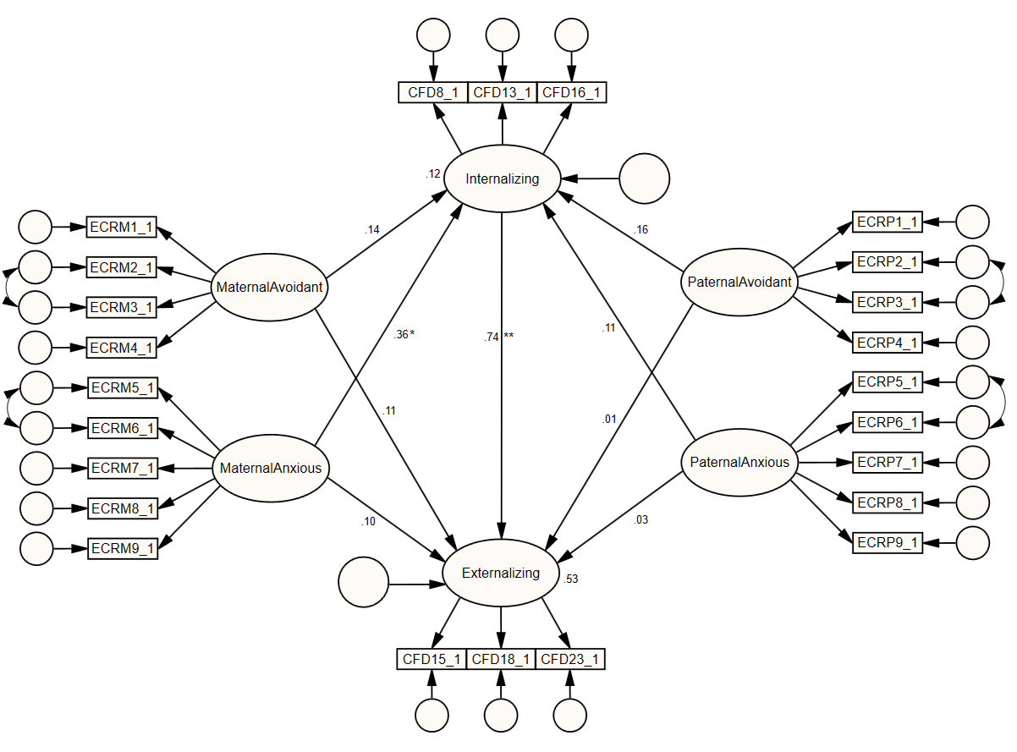

Figure 2. Local non-parametric regression plots with bootstrapped error bounds. Anxious and avoidant attachment to parents and internalizing problem behaviors.
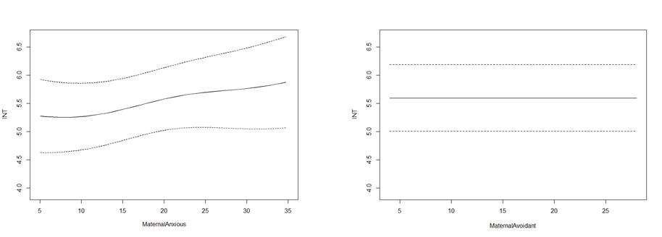
Internalizing problem behaviors
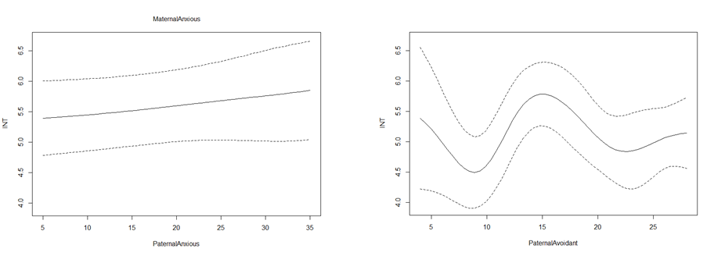

Figure 3. Local non-parametric regression plots with bootstrapped error bounds. Anxious and avoidant attachment to parents and externalizing problem behaviors.
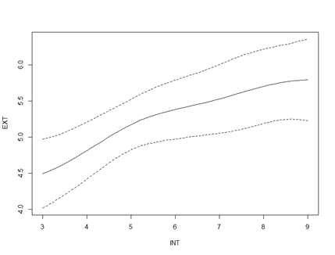
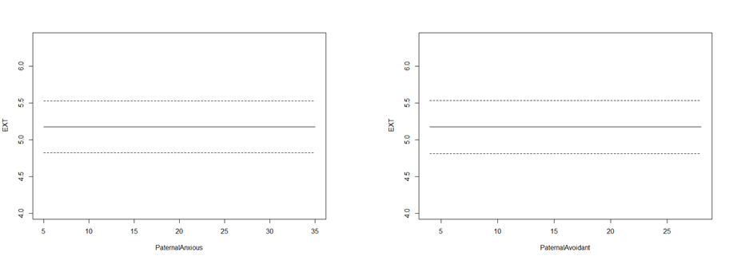
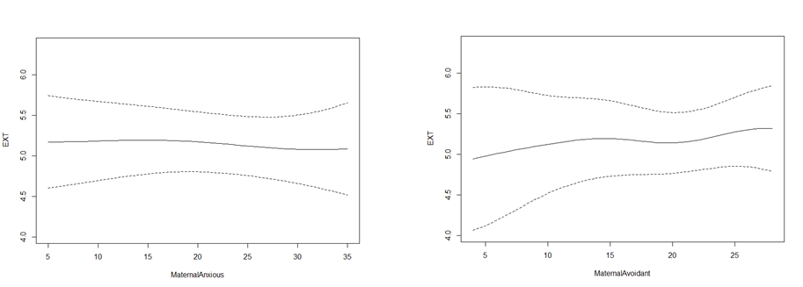
Externalizing problem behaviors

