Nature of the beast? Complex drivers of prey choice, competition and resilience in Pleistocene wolves (Canis lupus L., 1754)
Flower, Lucy O.H.¹, Schreve, Danielle C.¹ and Lamb, Angela²*
¹Department of Geography, Royal Holloway University of London, Egham, Surrey TW20 0EX, UK; ²National Environmental Isotope Facility, British Geological Survey, Nicker Hill, Keyworth, Nottinghamshire NG12 5GG, UK. *Corresponding author alla@bgs.ac.uk.
Abstract
The wolf (Canis lupus L., 1754) has been a major keystone predator in the Palaearctic since the late Middle Pleistocene. Today, wolves display considerable dietary plasticity over their range, characterised by their preferential consumption of large and medium-sized wild ungulates, supplemented by smaller prey, including small mammals, fish and plant foods. However, the origins of this dietary flexibility (arguably the key to the wolf’s long persistence) are poorly understood in terms of responses to different drivers over the course of the Pleistocene, including changing climate, environment and competition from other large carnivores. Here, in the first study using direct palaeodietary measurements on British fossil wolves, carnivore competitors and potential prey species, we compare stable isotope (δ¹³C and δ¹⁵N) evidence from three sites representing a late Middle Pleistocene interglacial (Marine Oxygen Isotope Stage [MIS] 7c-a, c.220-190ka BP), the early Devensian (last cold stage, MIS 5a, c.90-80ka BP) and the middle Devensian (MIS 3, c. 60-25ka BP). The results reveal clear patterns of changing wolf prey choice through time. Notwithstanding issues of collagen preservation obscuring some dietary choices in the oldest samples, both small and large prey (hare, horse) were taken by wolves in the MIS 7c-a interglacial, large prey only (reindeer, bison) during MIS 5a and a broader range of large prey items (horse, woolly rhinoceros, bison) during MIS 3. The results also reveal two further important aspects: (1) that where wolves and spotted hyaenas co-existed, they occupied the same dietary niche and the former was not outcompeted by the latter, and (2) that the stable isotope evidence indicates prey choices during MIS 7c-a and MIS 3 that are not in synchrony with palaeodietary reconstructions from previous studies based on wolf cranio-dental morphology. This establishes for the first time a likely lag between changing predatory behaviour and morphological response but is interestingly not seen in the wolves from MIS 5a, where the prey choices are echoed by the cranio-dental morphology.
Keywords: Wolves; Canis lupus; Pleistocene; stable isotopes; palaeodiet; morphology
1. Introduction
Wolves, Canis lupus L. 1754, are successful keystone predators of modern Palaearctic ecosystems. They are able to modulate their choice in prey, and hence diet, based on resource availability and regional environmental conditions. Extensive studies of wolf diet in North America (Voight et al. 1976; Fritts and Mech, 1981; Paquet, 1992; Boyd et al. 1994) and in Europe (e.g. Kojola et al. 2004; Nowak et al. 2011; Jedrzejewski et al. 2012; Wagner, 2012) have revealed that wolves typically predate large wild ungulates such as elk Alces alces, wapiti Cervus canadensis, reindeer Rangifer tarandus, and red deer Cervus elaphus, alongside medium sized species such as wild boar Sus scrofa, white-tailed deer Odocoileus virginanus and roe deer Capreolus capreolus. Of note is that consumption of livestock is generally low but is directly dependent on the abundance of wild ungulates, which are preferred as a more risk-free resource (Meriggi and Lovari, 1996; Imbert et al. 2016; Janeiro-Otero et al. 2020). Nevertheless, in some regions, seasonal resource availability, the selection of some prey types over others, and the demands of provisioning for young have allowed wolves to add berries (Homkes et al. 2020), smaller mammalian prey such as hare Lepus spp. and beaver Castor fiber (Mysłajek et al. 2019), spawning Pacific salmon Oncorhyncus spp. (Stanek et al. 2017) and even freshwater fish such as northern pike Esox lucius as an exceptional short-term prey item (Gable et al. 2018), into their dietary repertoire. It therefore appears that by having a wide menu of prey and other food types, wolves are afforded an unusually high level of foraging behavioural flexibility and dietary resilience, a factor that has undoubtedly facilitated their widespread geographical dispersal and presence in diverse habitats.
Yet, dietary flexibility and ecological resilience are not recent traits and a deeper understanding of the long-term evolution of these traits is therefore important for wolf conservation biology today. In Pleistocene wolf populations, morphological plasticity in the cranio-dental feeding apparatus provides clues as to how wolves were able to survive rapidly changing climatic and ecological conditions typical of this period (Fox-Dobbs et al. 2008; Leonard et al. 2007). In Britain, for example, palaeodietary-related morphological variation was characterised by temporal changes in jaw strength, molar crushing and carnassial slicing ability that implied differences in the proportion of flesh to non-flesh foods consumed and the ability to manipulate carcasses at different climatic periods (Flower, 2014; Flower and Schreve, 2014). When paired with concomitant changes in body mass (Flower, 2014; 2016), together these provide strong evidence for wolves adapting to variations in prey type. Hence, morphological plasticity and behavioural flexibility apparently enabled Pleistocene wolves to cope better with climatic and environmental change than many other competing large carnivores.
In general, flexible rather than specialist behaviour was an advantage during the early Middle Pleistocene (~500ka BP) when changes in ungulate diversity, driven by climatic and environmental change, led to the collapse of the once highly-diverse Early Pleistocene carnivore community, and the rise of the dominant wolf, lion and spotted hyaena group to become the top predators of the Late Pleistocene (Turner, 1992). Over time, wolves progressively became more adept at surviving Pleistocene climatic and environmental change, whereas in contrast, spotted hyaena (another social and very abundant large carnivore) became extirpated from north western Europe between 35-31ka BP (Stuart and Lister, 2014; Jones, 2019). Hence, morphological plasticity and behavioural flexibility also provided wolves with an advantage in the face of structural changes in the coeval carnivore community and inter-species competition.
Nevertheless, key questions remain over: i) the nature of these prey choices, ii) the impact competitive interactions with coeval carnivores had on wolf prey choice and iii) the extent to which cranio-dental morphology was in step with dietary behaviour, or whether a time lag existed between morphological and behavioural responses.
To address these questions, direct measurement of British Pleistocene wolf palaeodiet through time was undertaken using stable isotopes of carbon (δ¹³C) and nitrogen (δ¹⁵N) from bone collagen, in combination with comparisons to established Pleistocene wolf morphometric data. Whilst dietary-specific cranio-dental morphology can provide indirect evidence of phenotypic variation over relatively longer timescales, analysis of stable isotope geochemistry from bone collagen can reveal dietary signatures in the years immediately prior to death. This is because bone collagen can reflect isotopic trends over shorter timescales as bone continuously remodels over several years of an animal’s life (Koch, 2008), with the timescales of remodelling varying with bone element (Sealy et al. 1995).
The composition of carbon and nitrogen in animal bone collagen is primarily derived from dietary protein, hence the δ¹³C and δ¹⁵N values of a consumer will reflect an average of what has been consumed. The use of stable isotopes of carbon (δ¹³C) and nitrogen (δ¹⁵N) from bone collagen in Late Pleistocene (<60ka) palaeobiological studies is well established (for a review, see Bocherens, 2015), including, but not limited to, reconstructions of ungulate diet and derived inferences on local and more regional-scale palaeoecology (e.g. Richards & Hedges, 2003; Stevens and Hedges, 2004; Drucker et al. 2011; Drucker et al. 2012), whilst others have focused on trophic level reconstructions of biomes such as the Eurasian mammoth steppe and Beringia (e.g. Coltrain et al. 2004; Fox-Dobbs et al. 2008; Yeakel et al. 2013; Drucker et al. 2018). Key to this work, however, are studies with predators as their central focus, since these can spotlight prey choice and predator-prey interactions during the Pleistocene (e.g. Leonard et al. 2007; Bocherens et al. 2011, Bocherens, 2015; Baumann et al. 2020), thereby allowing the reconstruction of complex and changing food webs in the past.
In carnivore collagen, δ¹³C and δ¹⁵N values primarily reflect the δ¹³C and δ¹⁵N values of their herbivore prey and subsequent higher trophic level. However, this simplification is complicated by isotopic fractionation within their soft tissues, as well as a host of ecological, environmental and climatic factors. For instance, ¹³C in herbivore collagen is driven by plant type, which in turn is controlled by C3 or C4 photosynthetic pathways related to environmental and climatic factors (for a review, see Bocherens, 2003), whilst ¹⁵N is controlled by type of plant consumed, which is itself driven by factors such as temperature, aridity and moisture availability, as well as altitude and soil maturity (Drucker et al., 2011, 2012; Bocherens, 2015).
This is the first predator-centric stable isotope study for Pleistocene Britain using wolves as a lens to examine prey choice and competition. Previously, wolf specimens from a range of sites covering interglacial, interstadial and glacial conditions, and correlated respectively with Marine Oxygen Isotope Stage (MIS) 7c-a (c.220-190ka BP), MIS 5a (c. 90-80ka BP) and MIS 3 (c. 60-25ka BP) were found to exhibit high levels of palaeodietary and behavioural flexibility based on their cranio-dental morphology (Flower, 2014; Flower and Schreve, 2014). These different climatic stages thus provided ‘snap shots’ of divergent dietary behaviours that were thought to be driven by a combination of competition and environmental triggers. Crucially, these findings provided a unique opportunity to re-examine morphology in light of the new stable isotope data presented here.
Although most Pleistocene stable isotope studies relying on bone collagen remain firmly within the assumed 100ka BP limit for successful collagen retrieval (Hedges et al. 2005), viable collagen extraction in older skeletal material has occasionally been achieved for assemblages of 120ka BP (Scladina Cave, Bocherens et al., 1999 and Neumark-Nord 2, Britton et al., 2012) and c. 200ka (Stanton Harcourt, Jones et al. 2001). By including a much larger new dataset of wolf, other large carnivore and herbivore material from MIS 7, and supplementing this with additional stable isotope measurements from sites representing different parts of the last cold stage, the present study offers the first opportunity to examine changing wolf interactions with both the wider carnivore guild and prey spectrum over a significantly longer timescale.
1.2. Sites
Three faunal assemblages from cave sites in southwest Britain (Fig. 1) were selected for the dietary isotope study based on: i): prior knowledge of the wolf remains in the assemblage (Flower, 2014), ii) knowledge of the other fauna present (Schreve, 1997; Currant, 2004), iii) taphonomic comparability of the assemblages and iv) close geographical proximity of the sites in southwest Britain, thereby allowing more robust intercomparison.
The Hutton Cave faunal assemblage, interpreted as the vestiges of a wolf den (Currant, 2004), is characterised by an abundance of remains of horse (Equus ferus) and the presence of a late morphotype of steppe mammoth, Mammuthus trogontherii. Although no absolute dates are available from this locality, biostratigraphical comparison of the assemblage indicates that it is typical of the Sandy Lane Mammal Assemblage-Zone (MAZ) of Schreve (2001a), which has been dated elsewhere to the second half of the penultimate (MIS 7) interglacial (Candy and Schreve, 2007). Three temperate substages of comparable magnitude are recognised within MIS 7, most recently divided into two discrete interglacials: MIS 7e and MIS 7c-a (Berger et al. 2015), with the latter episode (with which the Hutton Cave assemblage is correlated) characterised by cool-temperate and predominantly open grassland conditions (Schreve, 2001b; Murton et al. 2016). Additional elements of the potential prey base available to wolves included mountain hare (Lepus timidus), wild boar (Sus scrofa) and red deer (Cervus elaphus) (Currant, 2004). Of the major predators, wolf, lion (Panthera spelaea) and spotted hyaena (Crocuta crocuta) are all present, with the mesocarnivores represented by red fox (Vulpes vulpes) and wild cat (Felis silvestris) (Schreve, 1997).
Banwell Bone Cave is the type site for the Banwell Bone Cave MAZ (Currant and Jacobi, 2001; 2011) and has been attributed to the Early Devensian (Weichselian), the early part of the last cold stage. Assemblages of this age have been correlated with MIS 5a (Gilmour et al. 2007; Currant and Jacobi, 2011; Stevens and Reade, 2021). The classic low diversity fauna of Britain at this time featured bison Bison priscus, reindeer Rangifer tarandus and mountain hare Lepus timidus, in addition to mesocarnivores including red fox, arctic fox Alopex lagopus, and wolverine Gulo gulo. Notably, brown bear Ursus arctos is the only other large carnivore present apart from wolf, with both P. spelaea and C. crocuta absent from Britain (Turner, 2009; Currant and Jacobi, 2001, 2011) at this time.
The final assemblage comes from the site of Sandford Hill and is largely the product of accumulation by spotted hyaenas (Currant, 2004). The presence of horse, woolly mammoth (Mammuthus primigenius) and woolly rhinoceros (Coelodonta antiquitatis) in association with spotted hyaena, bison and reindeer is considered typical of the Pin Hole MAZ of the Middle Devensian (Weichselian), correlated with MIS 3 (Currant and Jacobi, 2011). A radiocarbon date on C. crocuta yielded a corresponding age estimate of 36 ±1.9 ka BP (Burleigh et al. 1982), although given recent advances in collagen ultrafiltration methods, re-dating of this specimen would now be advised (Jacobi et al. 2006). Mountain hare and red deer make up the complement of herbivores known from the site, with wolf, red fox, lion and brown bear also present.

2. Material and Methods
2.1. Material
Permission for destructive sampling was granted from the South-West Heritage Trust, Taunton, UK, where the specimens are housed. The assemblages of Hutton Cave, Banwell Bone Cave and Sandford Hill are important sites for understanding the Pleistocene fauna and palaeoenvironment of the Mendip Hills in Somerset. Initially included in the wolf morphometric analyses of Flower (2014), knowledge of the faunal composition, chronology and palaeoenvironmental context of each assemblage (see Schreve, 1997; Currant, 2004) aided in choosing likely competitors and potential prey species from each assemblage. Understanding carnivore prey choice and competitive interactions relies on the ability to distinguish the δ¹³C and δ¹⁵N of their prey, and hence the inclusion, wherever possible, of all likely prey species present within these reconstructed communities is important (Bocherens, 2015). Based on this reasoning, the aim of this isotope study was to include the best possible range of likely wolf prey species, in addition to their coeval competitors, tempered by state of preservation and availability of specimens for sampling.
2.2. Methods
All sampling and analyses were undertaken at the National Environmental Isotope Facility (NEIF), British Geological Survey, Keyworth, Nottingham, UK. Samples were taken from compact areas of bone avoiding areas of morphological or taphonomic interest. Before sampling for collagen extraction, all samples were pre-screened in order to assess collagen preservation by taking ~1mg of whole bone powder from each specimen (Bocherens et al. 1997). The surface of each sample was lightly abraded using a diamond-tipped burr and dental drill to remove surface contamination. 1 mg of bone powder was then removed and %N measured using a Costech Elemental Analyser (EA) on-line to a VG TripleTrap and Optima duel-inlet mass spectrometer with %N calibrated against an Acetanilide standard. Specimens with %N <1.0 were not subject to further destructive sampling as bone nitrogen content <1.0 suggests poor collagen preservation and would necessitate the destruction of a significantly larger sample. The sampling permit protocol required bone powder to be removed by abrading the surface of each bone, rather than cutting sections of bone in order to minimize damage. A 1.0%N was therefore used as the minimum requirement for sampling.
All specimens deemed viable were re-sampled prior to bone collagen extraction. The sampling area was lightly abraded using a diamond-tipped burr to remove surface contamination, with 20-100mg of whole bone powder removed for collagen extraction, using a modified Longin (1971) method, ahead of isotopic analysis. 7.5 ml of 0.5M HCL was added to bone powders and left for 24H at 5°C to demineralise. Samples were then centrifuged and washed with MilliQ water and the sample transferred to a hot block at 70 °C for 48H in pH3 solution to gelatinise. Following this, samples were then filtered (8μm ezee-filter, Elkay, Basingstoke), frozen and freeze dried. All bone collagen samples are screened for collagen condition, through %N and %C content and atomic C/N ratios. Samples with C/N of ≤ 2.9 or ≥3.6 were excluded (DeNiro, 1985). For δ¹³C/δ¹⁵N isotope analysis, 0.6mg of collagen was weighed in duplicate for each sample. Isotope ratios of carbon and nitrogen were measured by continuous flow-elemental analyser-isotope ratio mass spectrometry (CF-EA-IRMS). The instrumentation comprises a ThermoFinnigan EA IsoLink coupled to a Delta V Plus isotope ratio mass spectrometer via a ConFlo IV interface. Carbon and nitrogen isotope ratios (δ¹³C, δ¹⁵N) are reported in per mil (‰) relative to VPDB and AIR respectively. Carbon isotope ratios were calibrated using a 2-point calibration against an in-house powdered gelatine standard (M1360P from British Drug Houses) calibrated to USGS 40 and 41 (-20.45 ‰) and USGS 40 (-26.39 ‰). Nitrogen isotope ratios were calibrated using a 2-point calibration against M1360P calibrated to IAEA N-1 and IAEA N-2 (8.12 ‰) and a fish gelatin (Elemental microanalysis B2215, certified value +4.26 ‰). An additional check standard comprising a modern cow bone was also included. M1360P was used to calculate %N and %C (15% N and 42.4% C, calibrated against USGS 40 and USGS 41). Repeated measurements of M1360P gave a 1σ reproducibility of <0.2 for both elements. Duplicate sample 1σ reproducibility was <0.2 for both elements.
Trophic enrichment values, occurring between predator bone collagen and their assumed prey, were taken from Bocherens (2015) as 1.0 ±0.3‰ for δ¹³C and 4.2 ±1.4‰ for δ¹⁵N, based on predators and prey being from archaeological rather than modern contexts.
All statistical analyses were conducted in SPSS (v.21). The data set did not reach the minimum sample number required to employ Bayesian mixing models to model the proportion of different prey consumed at each site. A few co-eval sites do exist (e.g. Stanton Harcourt, Oxfordshire, Jones et al. (2001) for Hutton Cave) however, there is not sufficient equivalent isotope data available to make their inclusion viable.

3. Results
After screening all specimens, viable collagen was extracted from 67 samples, with 8 excluded from further interpretation based on ratios of C/N being outside the accepted range of 2.9 to 3.6 (DeNiro, 1985). Results are shown in Table 1. Of particular note are the number of successful samples from Hutton Cave (n=16), correlated with MIS 7c-a, and from the MIS 5a age deposits at Banwell Bone Cave (n=16). The MIS 3 assemblage from Sandford Hill further provided a rich set of dietary isotope data (n=35).
3.1. Hutton Cave
The overall isotopic range from the penultimate interglacial assemblage of Hutton Cave shows relative stability in δ¹³C values, with a range of -2.1‰ between minimum and maximum values (Table 2a). In contrast, δ¹⁵N values are much more variable, with a much larger range of 10.7‰
Out of a suite of herbivores sampled, only horse and hare provided viable collagen and in terms of δ¹³C values, both show minimal variation in their ranges (Table 2b, Figure 2a), which is in contrast to their δ¹⁵N values, which show a high level of variability. This is especially the case for hare, which exhibits a range of 2.1‰ to 6‰.
Although carnivore δ¹³C values appear more variable than those of herbivores, they are consistent with each other; wolf and spotted hyaena share similar mean and maximum-minimum ranges, and the single lion δ¹³C value also fits within these ranges at -19.8‰ (Table 2b). As expected, higher variation is present between herbivore and carnivore δ¹⁵N values, consistent with differences in trophic level (Bocherens and Drucker, 2003). Again, wolves and spotted hyaena share similar δ¹⁵N value ranges (Table 2), whilst the single lion is considerably elevated in comparison at 12.8‰.
When differences in trophic enrichment factors between carnivores and their herbivorous prey are considered (Figure 2b), two of the Hutton Cave wolves plot in close proximity to both hare and horse, whereas the third wolf plots more closely with the group of spotted hyaenas. As many of the prey species targeted did not yield viable collagen, it is likely that key prey resources are missing from this isospace; this is highlighted by the single lion specimen, which has much higher δ¹⁵N values than all the other carnivores sampled.

3.2. Banwell Bone Cave
The overall isotopic range of the Early Devensian assemblage of Banwell Bone Cave shows minimal variation in δ¹³C values, with a range of -1.9‰ (Table 2a) that compares well with that of Hutton Cave. However, mean δ¹⁵N is higher at 10.7‰, with a much larger range of 12.2‰.
The low variability of δ¹³C values in herbivores and slightly more variable results from the carnivores, are similar to the pattern seen earlier at Hutton Cave. However, there is a marked elevation in δ¹⁵N values for all sampled fauna in comparison to the other sites (Table 1, Figure 2b, Figure 3a). These elevated values are also highly variable: reindeer ranges from 7.8‰ to 9.7‰, bison have slightly higher δ¹⁵N values ranging from 10.2‰ to 11.3‰, which overlaps with those of brown bear (11.3‰ to 14.0‰) (Table 2b). As the top predator, wolves have the highest δ¹⁵N values (mean 13.5‰), which are also comparatively the least variable ranging from 13.0‰ to 13.6‰ (Table 2b). Of note is the single hare sample with a low δ¹⁵N value of 1.8‰ (Table 2b). As a single sample only, although the difference between it and the other species sampled is stark and its isotopic similarity to other hares at Hutton Cave and Sandford is interesting, it may not fully be representative of all hares at Banwell.
When trophic enrichment factors are considered (Figure 3b), wolves are likely consuming bison, in addition to reindeer. One of the brown bears appears to follow a similar diet. However, the remaining four bears are either utilising a so-far unquantified resource (although it is difficult to see what this may be, given that no other ungulates are present in Britain at this time) or (perhaps more likely) other factors, such as seasonal torpor, are in effect.

3.3. Sandford Hill
The overall isotopic range of the assemblage at the Middle Devensian site of Sandford Hill, shows higher variation in δ¹³C values than both the Hutton Cave or Banwell Bone Cave assemblages, with a range of 3.6‰ (Table 2a). In contrast, the overall range of δ¹⁵N values is lower at 8.8‰ (Table 2a).
The large herbivores including bison, horse and woolly rhino produced similar δ¹³C values ranging from -21.2‰ to -20.9‰ (Table 2b), clustering as a group (Figure 4a). Reindeer are comparatively more variable, ranging from -18.7‰ to -19.5‰, whilst hare is more variable still, ranging from -22.3‰ to -20.8‰ (Table 2b). Carnivore δ¹³C values are more variable than the coeval herbivores, with brown bear and spotted hyaena being key examples (Table 2b).
It is notable that δ¹⁵N values are relatively low in comparison to Banwell Bone Cave (Figure 4a) and are more comparable to those from Hutton Cave. In general, carnivore δ¹⁵N values are lower (Tables 1, 2), with differences in trophic level between carnivores and herbivores much more pronounced (Figure 4a). Similar to Hutton Cave, wolf and spotted hyaena overlap in their δ¹³C and δ¹⁵N values, whereas lions are much more variable at Sandford Hill. Although brown bears are separated from the large carnivore cluster (Figure 4a) by lower δ¹³C values, the range of their δ¹⁵N values is similar to that of spotted hyaena. Variation in herbivore δ¹⁵N values is relatively high, with woolly rhino, horse and hare being notable examples (Tables 1, 2).
When trophic enrichment factors between carnivores and herbivores are accounted for (Figure 4b), the species cluster in the isospace. Two groups of carnivores appear: the two wolves, spotted hyaenas and one lion appear to consume overlapping resources including horse, woolly rhino, bison, with perhaps some reindeer increasing their δ¹³C values. However, the four remaining lions cluster with comparatively lower δ¹⁵N values, suggesting perhaps increased importance of reindeer in their diet as opposed to bison. Brown bear is separate from both carnivore groups, with lower δ¹³C values. Two of the bears plot closely with bison and horse, however, showing some sharing of resources with the predominantly wolf and spotted hyaena group.
3.4. Wolf populations through time
These results record a chronologically distinct ‘snapshot’ of a wolf population, their competitors and potential prey. Tests of significance between δ¹³C and δ¹⁵N values between these separate wolf populations were conducted. First, Levene’s Test for homogeneity of variance was found to be equal between wolf groups for δ¹³C (F_{2,5}=01.906, p=0242) and δ¹⁵N (F_{2,5}=1.699, p = 0.274). A one way ANOVA was then undertaken, which indicated that differences in δ¹³C between MIS 7, 5a and 3 for each assemblage were significant (F_{2,5}=7.338, p=0.033) with Tukey HSD post hoc tests further indicating significant differences relating to the Hutton Cave with Sandford Hill wolf populations (p=0.033). Although not meeting the significance level of 0.05, Hutton Cave with the Banwell population are close to significance (p=0.096).
With respect to differences in δ¹⁵N between the three wolf populations, these were found to be significant (F_{2,5}=118.222, p=0.000), with Tukey HSD post hoc tests further indicating significant differences occurring between Banwell and Sandford Hill wolves (p=0.000), as well as Hutton Cave (p=0.000). No significant differences were found between Sandford and Hutton Cave wolf δ¹⁵N values (p=0.609).
3.5. Wolves and their competitors
The significance of the relationship between wolves and spotted hyaenas was investigated at Hutton Cave and Sandford Hill. Levene’s Tests for both groups were found to be equal and hence non-significant (p = <0.05). Using independent T tests, differences between wolves and spotted hyaenas at Hutton Cave were found to not be significant: δ¹³C (t₄=-0.210, p=0.844) and δ¹⁵N (t_{5,}=-0.049, p = 0.963), as well as at Sandford Hill: δ¹³C (t₅=-1.811, p=0.130) and δ¹⁵N (t_{4,}=-1.075, p = 0.343).

4. Discussion
4.1. Hutton Cave
The separation between δ¹⁵N values of the herbivorous prey species (horse, hare) and carnivorous predators (wolf, spotted hyaena and lion) at Hutton Cave is consistent with expected differences in trophic level. For the predators, wolves and spotted hyaena plot similarly, whereas lion is positioned in a higher trophic level than the other carnivores present. High δ¹⁵N in carnivores can be related to the amount of meat consumed (Bocherens, 2003), however, ¹⁵N composition of herbivore prey collagen is complicated by type of plants consumed and how they are affected by environmental factors, in addition to ambient temperature, moisture availability, soil maturity and metabolic processes (Britton et al., 2012).
The δ¹³C values in hare and horse at Hutton Cave are consistent with a grassland environment (Bocherens et al. 2015). Not only does this correspond well with the chronological attribution of the assemblage to the Sandy Lane MAZ and the MIS 7c-a interglacial (Schreve, 2001a, b) but these findings also provide the first insight into the past vegetation history around the locality, since no direct palaeobotanical proxies were present at the site. As a highly mobile and open environment indicator species, horses provide a regional environmental picture, whereas hares deliver a local signal based on their small home ranges, shorter lifespans and more generalised diets, making them an effective proxy for palaeoenvironmental reconstructions (Somerville et al. 2018).
The relatively low variation between herbivore and carnivore δ¹³C values at Hutton Cave is consistent with trophic level differences between predators and their prey (Bocherens and Drucker, 2003). When trophic enrichment factors are considered (Figure 2a), two of the three wolves are inferred to be predominantly consuming horse and hare. However, the remaining wolf plots closely with the spotted hyaena group and, based on their comparatively higher δ¹³C and δ¹⁵N values, it seems this group are integrating an additional food source into their diet that is presently not accounted for by the herbivore data. Nevertheless, differences in isotopic values for both wolves and spotted hyaena were found not to be significant, thus reflecting the overall similarity of their diets. The aforementioned higher values are likely driven by consumption of herbivores from open environments (Bocherens et al. 1999). In the context of Hutton Cave, this is most likely to be from a medium-sized mixed-feeder prey species such as red deer (as opposed to the more woodland-adapted wild boar), although unfortunately this cannot be tested further because of the problem of collagen preservation. Although the steppe mammoth sampled from Hutton Cave equally did not produce sufficient collagen for analysis, the frequently-observed elevated δ¹⁵N values in mammoths (eg. Jones et al. 2001) suggests that these megaherbivores did not form part of the diet of either the wolves or the hyaenas from Hutton Cave.
This overlapping of wolf and spotted hyaena raises the question of competitive interaction. Although spotted hyaena were seemingly rarer during MIS 7c-a in comparison to lion (Schreve, 1997) and certainly less abundant than during both the Last Interglacial and Last Cold Stage in Britain, evidence here suggests their interactions with wolves in the vicinity were important and that similar prey selection from the same area was occurring.
In terms of wolf-hyaena interactions, the only known comparison is with last cold stage populations, for example in Belgium ~40ka BP, where wolves were apparently outcompeted by spotted hyaena for access to prey with high δ¹⁵N values, including mammoth, woolly rhino and horse (Bocherens et al. 2011). There, overlap in prey choice was more common between wolves and lone individuals of cave lion Panthera spelaea (Bocherens et al. 2011). It is therefore interesting that the opposite is true for Hutton Cave, during an interglacial, with wolves and spotted hyaenas on ‘equal footing’ and neither excluded from the two prey species sampled. A possible explanation for this may be the character of the MIS 7c-a interglacial, which has been identified as the most species-rich temperate-climate periods in the last c.400,000 years, attributed to its unique combination of high insolation variability, moderate temperatures and dry, open landscapes (Schreve, 2019). High herbivore diversity and concomitant biomass may thus have reduced inter-specific competition between these two major predators at this time.
Notwithstanding the fact that one of the Hutton Cave wolves was clearly consuming something not currently registered in the palaeodietary isospace (perhaps red deer), the new isotopic evidence presented here for a diet (at least partly) consisting of small prey (between 10-50kg) corroborates previous analysis of the cranio-dental morphology of MIS 7 wolves by Flower and Schreve (2014). That study highlighted an increased ability of wolves at this time to crush rather than slice foods, combined with reduced jaw strength characterised by shallower, narrower jaws. These morphological attributes led Flower and Schreve (2014) to conclude that wolves during the penultimate interglacial were focused primarily on small to medium-sized prey, likely constrained by competition with lions, and had increasingly generalised diets. The increased proportion of non-meat foods in the diet would be consistent with an interglacial period where plant and insect resources would be relatively more abundant than in cold-climate episodes. However, the isotopic evidence presented here reveals that MIS 7 wolves were also consuming large-sized prey (c.100-1000kg) such as horse. This was not predicted by the cranio-dental morphological study of Flower and Schreve (2014) and suggests that there is a lack of correspondence or lag between, on the one hand, some aspects of feeding behaviour and, on the other, the rate of morphological response. A possible reason for this might be the relatively rapid climatic and environmental turnover in MIS 7 and the short duration of each interglacial, with an early, forest-dominated temperate episode (MIS 7e) replaced by predominantly open conditions in MIS 7c-a (Schreve, 2019). This may have left wolf morphology lagging the change in hunting behaviour required, as landscape and vegetation changed.
It also raises the question of whether the relationship between wolves and spotted hyaena is an artefact of the latter’s apparently lower density in the landscape; were hyaena scavenging from wolf kills? However, although they were in competition for resources, as stated above, prey biomass in the vicinity was likely rich enough to sustain both predators, while both were equally competitively excluded from megaherbivore (>1000kg) prey by lions. Lions during MIS 7 would have inhabited a savannah context similar to their modern African counterparts, in addition to being comparatively much larger in size (Schreve, 1997), thereby giving them a competitive advantage over other carnivores.
At the co-eval site of Stanton Harcourt, Oxfordshire, Jones et al. (2001) reported high δ¹⁵N values for straight-tusked elephant (δ¹³C -20.8, δ¹⁵N 10.7‰ and δ¹³C -21.6 and δ¹⁵N 13.2‰), steppe mammoth (δ¹³C -21.1, δ¹⁵N 10.9‰) and bison (δ¹³C -20.9, δ¹⁵N 11.0‰). However, there is difficulty in comparing these results to those in the present study from Hutton Cave. Although regional differences between southwest and central Britain at this time may be in play, perhaps underlined by the difference in δ¹⁵N from horse at Hutton versus bison from Stanton Harcourt, which one would normally expect to be closely comparable, it is important to note that Jones et al. obtained collagen from molar dentine, which forms during the period of lactation (Bocherens et al. 1994). The high δ¹⁵N values at Stanton Harcourt could thus potentially represent a suckling rather than a palaeoenvironmental signal. Furthermore, Jones et al. (2001) ruled out aridity as a driver of ¹⁵N elevation based on apparent incompatibility with palaeoenvironmental evidence indicating fully interglacial conditions at the site. However, this contradicts current understanding of the palaeoenvironmental and palaeoclimatic characteristics of MIS 7c-a, which indicate a relatively cool interglacial with mean summer temperatures of +15 to +16°C (de Rouffignac et al., 1995; Murton et al., 2001) and higher magnitude insolation variability than any other interglacial of the Middle and Late Pleistocene (Berger et al., 2015). These factors produced a landscape of dry, predominantly open vegetation conditions with abundant grasses, sedges and dry ground herbs (e.g. Murton et al., 2001), with intensive grazing by large herbivores further increasing evapotranspiration and reducing surface water infiltration (Schreve, 2019). Dry conditions are therefore a strong feature of this interglacial (contra Jones et al., 2001) and may thus be a key influence on high δ¹⁵N values, particularly for assemblages from central England.

4.2. Banwell Bone Cave
Separation between herbivore and carnivore trophic levels is less pronounced at Banwell than at either Hutton Cave or Sandford Hill, with overall elevated δ¹⁵N values for most members, excluding the single hare sample that may not be representative of conditions at the site (see above). The overall higher δ¹⁵N values for the Banwell Bone Cave wolf population were also found to be significantly different from those at either Hutton Cave or Sandford Hill, further highlighting the particularity of the Banwell Bone Cave assemblage.
However, δ¹³C values are much more similar to those in the other two study assemblages, although a low level of significance was found between Hutton Cave and Banwell Bone Cave wolf populations in δ¹³C values. One of the noticeable differences in δ¹³C values is exhibited by reindeer, which at Banwell Bone Cave display lower than expected δ¹³C values (Bocherens, 2003). Reindeer are lichen consumers, commonly resulting in bone collagen δ¹³C values between -16 to -19‰ (Bocherens et al. 2015). However, at Banwell, lower δ¹³C values suggest that, as with modern reindeer, these animals supplemented their lichen-based diet with other herbs or graminoids (Drucker et al., 2010).
When trophic enrichment factors are accounted for, the central position of wolves between reindeer and bison (Figures 3a, b) indicates they were consuming both species. As the only two large herbivores present in Britain at this time (Currant and Jacobi, 2001), this is not surprising. A recent study of Banwell Bone Cave by Stevens and Reade (2021) further underlines this trophic position (Figures 5a, b).
Previous analysis of the cranio-dental morphological of MIS 5a wolves highlighted this wolf population as being better adapted to fast carnassial slicing, paired with deeper and stronger jaws (Flower and Schreve, 2014). It was inferred that these morphological differences, in comparison to wolves of MIS 7 and 3, enabled them to better hunt and subdue large-sized prey and consume carcasses faster, which combined with high incidences of tooth breakage and heavy tooth wear, implied high levels of dietary stress in a competitive environment (Flower and Schreve, 2014).
These inferences on prey size are borne out in the new isotope data here, since wolves appear to be actively hunting both reindeer and bison. However, evidence for intense competition with brown bears is lacking, notwithstanding that one brown bear does plot with the other sampled wolves. As it is commonplace for brown bears to scavenge wolf kills (e.g. Ordiz et al. 2020; Prugh and Sivy, 2020), it is possible that this scenario was occurring at Banwell. Indeed, the aforementioned wolf morphological differences, in combination with tooth breakage and wear data from Flower and Schreve (2014), indicates that Banwell wolves were adept at consuming carcasses as quickly as possible, which may relate to the threat of kleptoparisitism. This finding, where dietary behaviour and morphology are synchronous, is in clear contrast to the situation reported from Hutton (4.1). Although MIS 5a is an interstadial, it is thought that the cold-adapted reindeer and bison arrived in Britain across the continental landbridge to the European mainland during MIS 5b, but were then stranded through MIS 5a by a rise in sea level (Currant, 2004). If so, this would give any wolves present in Britain a longer period of time (around 20ka) for their morphology to come fully in line with predatory choices.
However, the range in both δ¹⁵N and δ¹³C values for brown bear suggests that other factors may be at play. During the Pleistocene, brown bears were more carnivorous than either their modern counterparts or cave bears Ursus spelaeus, especially when inhabiting the same landscape as the latter (Münzel et al., 2008; Bocherens et al. 2011). Although cave bear is missing from the Late Pleistocene record in Britain, the high δ¹⁵N values of some of the Banwell brown bears (similar to those of wolves) is suggestive of carnivory; and the consumption of bison and reindeer. However, the range of both ¹⁵N and ¹³C also suggests a level of dietary flexibility: omnivory, with the inclusion of reindeer or resources not discernible from this study. Dietary flexibility in Late Pleistocene brown bear has been established (Münzel et al. 2008; Bocherens et al. 2011) and could similarly be invoked for the Banwell brown bears.
Another reason for the range in brown bear ¹⁵N values may be in their response to environmental conditions, with colder periods eliciting a longer dormancy period and thus leading to higher δ¹⁵N values (Fernàndez-Mosquera et al., 2001). Although Fernàndez-Mosquera et al. found that δ¹³C values did not follow an environmental trend, Pérez-Rama et al. (2011) found that torpor reduced δ¹³C values due to utilisation of fat stores, which corroborated with higher δ¹⁵N values driven by longer torpor in colder climates, and were both recorded in bone collagen.
Nonetheless, the overall high δ¹⁵N values in more than one species present at Banwell, in addition to the relative elevation in ¹⁵N in most fauna in comparison to Hutton Cave, is intriguing. As noted previously, ¹⁵N composition of herbivore collagen is controlled by a range of different factors, including soil maturity (e.g. Drucker et al., 2011, 2012), with high δ¹⁵N values linked to mature soils with increased microbial activity, warmer conditions and closed habitats, and low δ¹⁵N values attributed to immature soils with low activity, colder conditions and open habitats (Drucker et al. 2011, 2012).
However, herbivore δ¹³C values at Banwell Bone Cave are indicative of open environmental conditions (cf. Bocherens et al. 2015), and in conjunction with palaeoecological evidence from deposits of similar age at Cassington, Oxfordshire (Maddy et al. 1998), linking high δ¹⁵N values with aforementioned factors of closed environments and climatic warmth is complex.
Although MIS 5a is an interstadial, pollen evidence and Coleopteran MCR reconstructions from Cassington suggest relatively cool continental conditions in southern Britain that deteriorated towards the end of the interstadial. Pollen spectra from Cassington are predominantly herbaceous indicating a largely open steppe/tundra environment, with variable coverage of open aspect pine and spruce forests that characterise southern Scandinavia today (Maddy et al. 1998). When combined with evidence from Coleoptera, temperatures gradually cooled over time from a mean of 17 to 18°C for the warmest month and -4 to 4°C for the coldest month, further declining to maximum summer temperatures of 14°C and the notably cold temperatures of 7 to 11°C during the warmest month and -10 to -30°C during the coldest at the end of MIS 5a/transition to MIS 4 (Maddy et al. 1998). It therefore seems unlikely that high δ¹⁵N values here were driven by long established warm conditions and closed habitats that would be more characteristic of a warm interglacial rather than a cool interstadial.
Higher δ¹⁵N values in fauna have also been linked to aridity (Heaton et al. 1986; Bocherens et al. 1994; Gröcke et al, 1997), with arid conditions at the end of the Late Glacial proposed as a driver for elevated horse δ¹⁵N values seen at this time (Stevens and Hedges, 2004). Increasingly open environmental conditions are linked to drier conditions, and it is therefore possible that the predominantly open conditions and dry grassland communities (with xerophile beetles also present) as seen a t Cassington (Maddy et al. 1998) could be linked to drier climatic conditions in southern Britain. These could be largely responsible for the elevated δ¹⁵N values of Banwell Bone Cave. This theory is also supported by Stevens and Reade (2021), who attributed similarly high δ¹⁵N values in bison and reindeer to arid conditions. These authors ruled out nutritional stress as a driving factor due to the lack of evidence of starvation in either species, their abundance in the assemblage and proposed long-term coexistence in the area.
It is also worth noting the comparably low δ¹⁵N values of the hare sampled. Although a single specimen, it is suggestive of a more complex scenario than an overall picture of higher δ¹⁵N at the site. Hare from Hutton and Banwell share lower δ¹⁵N values (Hutton 2.1-6‰, Banwell 1.8‰) than coeval large herbivores. This difference may relate to leporids being caeco-colic hindgut fermenters, a process responsible for lower δ¹⁵N values in bone tissue (Sponheimer et al. 2003), however, the effects of coprophagy on isotopic composition are as yet not well understood (Somerville et al. 2018). Nevertheless, as mentioned previously, leporids provide a localised environmental signal. Even with the effects of caeco-colic hindgut fermentation lowering δ¹⁵N values, it would still be expected to reflect the overall elevated ¹⁵N signal identified in the other fauna present and be higher than at Hutton Cave or Sandford Hill.

4.3. Sandford Hill
As with Hutton Cave, trophic levels between carnivores and herbivores are clear at Sandford Hill (Figure 4a), and in contrast to Banwell Bone Cave, δ¹⁵N values have returned to a lower environmental baseline (Table 2a). Differences in wolf δ¹⁵N values are also not significant between Sandford Hill and Banwell. However, in contrast to Hutton Cave, herbivore niches at Sandford Hill are more compressed, with isotopic values similarly clustered for horse, bison and woolly rhino (Figure 4a), as frequently observed from Late Pleistocene contexts (Bocherens et al., 2011). Of note are the higher reindeer δ¹³C values here, in contrast to those from Banwell Bone Cave, indicating a diet perhaps richer in lichen (Bocherens, 2015). Additionally, δ¹³C values for the wolf population were also found to be significant in comparison to those at Hutton Cave.
Three carnivore groupings are recognised at Sandford Hill: (1) wolves and spotted hyaenas, (2) lions, and (3) brown bears, with the addition of a single lion in the ‘wolf-hyaena’ group, and a spotted hyaena in the ‘bear’ cluster. Focussing on the wolves first, and taking into consideration trophic enrichment factors (Figure 4b), consumption of horse, in addition to woolly rhino and bison is indicated. Comparable studies have been obtained from Late Pleistocene Beringia (>50-23ka BP), where wolf prey values overlap with horse, bison and reindeer and similarly occupy a central position in the isospace amongst most large prey types (Leonard et al. 2007).
As with Hutton Cave, wolves and spotted hyaenas once again overlap in their prey consumption and are in competition for resources, with no significant difference found between their isotopic values. Similarly, this apparently did not result in competitive exclusion from certain prey items, rather both carnivores were able to sustain comparable diets, likely aided by the presence of a rich prey base present in the vicinity of the cave.
The pattern seen at Sandford Hill is compared in Figures 6a and 6b from the aforementioned evidence from the middle part of the last cold stage in Belgium, where wolves were apparently competitively excluded by cave hyaenas from larger prey species with high δ¹⁵N values, such as woolly rhino, horse and woolly mammoth (Bocherens et al. 2011). At Sandford Hill, wolves apparently share the isospace with hyaenas and the dietary influence of horse and woolly rhino is clearly present within the wolves (Figures 6a and 6b). Whether this is the result of wolves engaging in direct hunting of rhinos themselves, or the result of scavenging carcasses accumulated by hyaenas (or even lion) cannot, however, be determined. The presence of visible characteristic hyaena gnawing on the rhino remains from Sandford Hill attests to their exploitation of the bones.
There is also evidence that wolves competed with early hominins, during the late Middle and Late Pleistocene in Britain (Schreve, 1997; Turner, 2009) and thus there is the potential that wolves may have scavenged carcasses at Sandford Hill accumulated by Middle and/or Upper Palaeolithic humans. Past environmental change periodically eliminated some of these competitors and allowed the wolf to expand its niche, resulting in temporary diet-led morphological adaptations that disappeared once these competitors returned (Flower and Schreve, 2014). Thus, it can be hypothesised that wolves were ecologically constrained by larger predators and that this directly impacted wolf prey choice in the past.
Analysis of cranio-dental morphology in MIS 3 wolves by Flower and Schreve (2014) revealed similar results to those from MIS 7, namely an increased ability to crush rather than slice foods, paired with shallower, narrower jaws. This suggested they were hunters of small to medium-sized prey, with more generalist diets, and that they were likely excluded from the largest prey by lion, brown bear and particularly spotted hyaena. As with Hutton Cave, however, the new isotopic evidence from Sandford Hill does not tally entirely with these conclusions, since it indicates that wolves were also taking large prey, such as horse and bison, and potentially scavenging very large prey such as woolly rhino. This may again reveal an intriguing lag between a change in dietary behaviour and a morphological response in the cranio-dental apparatus, possibly the result of very rapid stadial-interstadial oscillations during MIS 3 (Rasmussen et al., 2014).
The wolf-hyaena grouping dominates the large herbivores of bison, horse and woolly rhino (Figure 4b), whereas lions apparently preferentially consumed reindeer, explaining their lower δ¹⁵N values in comparison to the other carnivores present. However, their similar δ¹³C values implies some reliance on prey with comparatively lower δ¹³C values, such as horse. This corroborates the findings of Yeakel et al. (2003) who equally identified lions as consuming a large proportion of reindeer in the Swabian Jura. After the Last Glacial Maximum in mainland Europe, and with the extirpation of hyaena from the region, wolves became the dominant predators with access to a larger suite of herbivorous prey, leading to the suggestion that lions then adopted the role of reindeer specialists (Bocherens et al. 2011, 2015). The situation presented by Sandford Hill, which occurs prior to the Last Glacial Maximum, perhaps foreshadows this niche partitioning.
The lack of overlap between wolves and brown bears in the Sandford Hill isospace suggests that some level of dietary differentiation is taking place. Although the ranges of both δ¹³C and δ¹⁵N values in bears are smaller than seen earlier at Banwell, clustering based on their δ¹³C and δ¹⁵N values is apparent with two bears consuming horse. The remaining two are either supplementing their diets with bison, or their isotopic signatures are affected by torpor, as previously discussed with the Banwell brown bears.
As part of the Pin Hole MAZ, the Sandford Hill assemblage is characteristic of the ‘Mammoth steppe’ conditions of MIS 3. Although the calcareous limestone of Sandford Hill has not favoured preservation of plant or insect proxies, information on the climate and environment can be gleaned from open sites of this age in central England. Plant macrofossil evidence from the site of Lynford in Norfolk, reveals a cool open grassland of herbaceous plants (Schreve, 2006; Boismier et al., 2012), correlating well with the beetle assemblage present with inferred mean July temperatures of 12-14°C and mean winter month temperatures at or below -10°C (Boismier et al. 2003). Palaeotemperature reconstructions at Whitemoor Haye in Staffordshire corroborate these fndings, with cooler mean July temperatures of 8-11°C and mean December temperatures of -22 and -16°C (Schreve et al., 2013). It is therefore likely that similar environmental and climatic conditions were present at Sandford Hill.

5. Conclusions
This is the first predator-centric stable isotope study for Pleistocene Britain using wolves as a lens to examine prey choice and competition. The study was designed to allow comparison of the predator-prey dynamics from an interglacial (MIS 7c-a), the early part of the last cold stage (MIS 5a) and the middle part of the last cold stage (MIS 3), by examining the prey choices of a range of large carnivores under contrasting climatic and environmental scenarios. The results from the stable isotope (δ¹³C and δ¹⁵N) analyses presented here also enabled comparison with a previous study by Flower and Schreve (2014), which used changes in wolf cranio-dental apparatus to reconstruct changing diet over the same period and thus enables a direct comparison of proxy indicators of dietary flexibility.
Although collagen preservation potential declines with age, the results are notable for the successful retrieval of viable collagen back to c.200ka (MIS 7c-a), one of very few studies to have this (cf. Jones et al., 2001). The isotopic measurements provide clear evidence for changing prey consumption and the interaction of wolves with other potential competitors. With respect to prevailing environmental and climatic parameters, the δ¹³C values in herbivores from all three sites are consistent with predominantly open, grassland environments, although occurring under different climatic regimes. High δ¹⁵N values from most of the Banwell Bone Cave specimens, however, are likely to reflect a notable signal of aridity.
In terms of prey choice, MIS 7 c-a interglacial wolves were consuming both small and large prey (hare and horse) respectively, although there is evidence for an additional food source presently not accounted for (likely the result of collagen preservation, since a wide range of taxa were originally sampled). During MIS 5a, wolves were consuming reindeer and bison at Banwell Bone Cave and during MIS 3, when herbivores niches were apparently more compressed, horse, bison and woolly rhino were being predated. The results reveal that wolves were apparently competing on an equal footing with spotted hyaenas, sharing the same dietary isospace. They were therefore not pushed into taking smaller prey or lower choice food items and were able to consume a wide range of large herbivores during both periods when the two species coexisted, MIS 7 and MIS 3, no doubt facilitated by the richness of the environment and accompanying herbivore biomass. This is in contrast, however, to the evidence from other parts of north-west Europe such as Belgium, where wolves were apparently out-competed by hyaenas during the last cold stage (Bocherens et al., 2011). Over the three study sites presented here, competition between wolves and brown bear is variable, with overlaps noted during MIS 5a for consumption of bison, but only partially for MIS 3, where there is more differentiation except for the consumption of horse. With regards to lion, however, there is no evidence of any dietary overlap with wolves or any other large carnivore during MIS 7; lion is positioned on a higher trophic level and although the dietary source could not be identified in the present study, it may well have involved predation of megaherbivores such as rhinos or elephants. During MIS 3, lions appear to have occupied a much narrower niche than the wolves, adopting the role of reindeer specialists. This behaviour has been noted in sites post-dating the Last Glacial Maximum in northern Europe (Bocherens et al. 2011, 2015) but the evidence from Sandford Hill indicates that this behaviour can now be traced back further into the middle part of the last cold stage.
Finally, the results from the present study offer a tantalising insight into the tempo and mode of evolution within the wolf lineage, namely the morphological responses of the cranium, jaws and dentition to changing diet. While the palaeodietary evidence from Banwell (MIS 5a) indicates close correspondence between prey selection, carnassial tooth morphology and deeper and stronger jaws in wolves, suggesting adaptations for subduing large prey and rapid consumption of carcasses (Flower and Schreve, 2014), the same degree of synchrony is not seen at Hutton Cave (MIS 7c-a) nor at Sandford Hill (MIS 3). At both those sites, the cranio-dental morphology of the wolves, notably enhanced crushing capacity of the teeth, combined with shallower, narrower jaws, suggested a more generalist diet (including non-meat foods) and a focus on small to medium-sized prey (Flower and Schreve, 2014). This contrasts with the evidence from the present study, which reveals that wolves were also taking large prey during MIS 7c-a and 3. This demonstrates for the first time that during both these periods, predatory behaviour and morphology were not in step. A possible reason for the offset may be the abrupt nature of the climatic and vegetation oscillations at these times. These may have precipitated rapid changes in hunting behaviour as wolves responded flexibly to their changing circumstances but caused morphological adaptations in the wolves’ cranio-dental apparatus to fall out of step with the shifting prey choices.

6. Acknowledgements
The authors would like to thank the South-West Heritage Trust, Taunton, UK for permission to sample material. Funding via a NERC IGFSC pilot study (IP-1512-114) in 2015 and a follow-up study (IP-1828-0618) granted in 2018. Jen Thornton (Department of Geography, Royal Holloway University of London) is thanked for cartographic assistance. Two anonymous reviewers are thanked for their constructive feedback on the manuscript.

List of Figures
Figure 1: Map of British study sites
Figure 2a: δ¹³C and δ¹⁵N values of carnivores and herbivores from Hutton Cave. Figure 2b: Trophic enrichment factor applied to carnivores following Bocherens (2015). Mean herbivore δ¹³C and δ¹⁵N values shown to 1 standard deviation.
Figure 3a: δ¹³C and δ¹⁵N values of carnivores and herbivores from Banwell Bone Cave. Figure 3b: Trophic enrichment factor applied to carnivores following Bocherens (2015). Mean herbivore δ¹³C and δ¹⁵N values shown to 1 standard deviation.
Figure 4a: δ¹³C and δ¹⁵N values of carnivores and herbivores from Sandford Hill. Figure 4b: Trophic enrichment factor applied to carnivores following Bocherens (2015). Mean herbivore δ¹³C and δ¹⁵N values shown to 1 standard deviation.
Figure 5a: δ¹³C and δ¹⁵N values from Banwell from this study (closed symbols) compared to those from Stevens and Reade (2021) (open symbols). Figure 5b: Trophic enrichment factor applied to carnivores following Bocherens (2015). Mean herbivore δ¹³C and δ¹⁵N values shown to 1 standard deviation.
Figure 6a: Sandford Hill data from this study (symbols in legend followed by SH), compared with data from Goyet, published by Bocherens et al. (2011). Figure 6b: Trophic enrichment factor applied to carnivores following Bocherens (2015). Mean herbivore δ¹³C and δ¹⁵N values shown to 1 standard deviation.

List of Tables
Table 1: Results from isotopic analyses conducted during this study.
Table 2a and b: Mean, maximum and minimum, and ranges of isotopic values for each site (a) and for each species (b). Note that for Hutton lion and Banwell hare samples, n=1 with no maximum, minimum or ranges shown.
References
Baumann, C., Starkovitch, B.M., Drucker, D.G., Münzel, S.C., Conard, N.J., Bocherens, H. 2020. Dietary niche partitioning among Magdalenian canids in southwestern Germany and Switzerland. Quaternary Science Reviews, 227, 106032.
Berger, A., Crucifix, M., Hodell, D.A., Mangili, C., McManus, J.F., Otto-Bliesner, B., Pol, K., Raynaud, D., Skinner, L.C., Tzedakis, P.C., Wolff, E., Yin, Q.Z., Abe-Ouchi, A., Barbante, C., Brovkin, V., Cacho, I., Capron, E. , Ferretti, P., Ganopolski, A., Grimalt, J.O., Honisch, B., Kawamura, K., Landais, A., Margari, V., Martrat, B., Masson-Delmotte, V., Mokeddem, Z., Parrenin, F., Propenko, A.A., Rashid, H., Schulz, M., Vazquez Rivieros, N.. 2016 Interglacials of the last 800,000 years. Reviews of Geophysics, 54 (1). 162-219. https://doi.org/10.1002/2015RG000482
Bocherens,H. 2003. Isotopic biogeochemistry and the paleoecology of the mammoth steppe fauna. In W.F. Reumer, F. Braber, D. Mol, de Vos, J. (Eds.) Advances in mammoth research. Rotterdam, the Netherlands: Deinsea 57-76.
Bocherens, H. 2015. Isotopic tracking of large carnivore palaeoecology in the mammoth steppe. Quaternary Science Reviews, 117, 42–71.
Bocherens, H., Drucker, D. 2003. Trophic level isotopic enrichment of carbon and nitrogen in bone collagen: Case studies from recent and ancient terrestrial ecosystems. International Journal of Osteoarchaeology 13, 46–53.Bocherens, H., Fizet, M., Mariotti, A. 1994. Diet, physiology and ecology of fossil mammals as inferred from stable carbon and nitrogen isotope biogeochemistry: Implications for Pleistocene bears. Palaeogeography, Palaeoclimatology, Palaeoeocology, 107, 213-225.
Bocherens, H., Billiou, D., Patou‐Mathis, M., Bonjean, D., Otte, M., Mariotti, A. 1997. Paleobiological implications of the isotopic signatures (C‐13, N‐15) of fossil mammal collagen in Scladina cave, Sclayn, Belgium). Quaternary Research, 48, 370–380.
Bocherens, H., Billiou, D., Mariotti, A., Patou-Mathis, M., Otte, M., Bonjean, D., Toussaint, M. 1999. Palaeoenvironmental and Palaeodietary Implications of Isotopic Biogeochemistry of Last Interglacial Neanderthal and Mammal Bones in Scladina Cave (Belgium). Journal of Archaeological Science 26, 599-607.
Bocherens, H., Drucker, D. 2003. Trophic level isotopic enrichment of Carbon and Nirtrogen in bone collagen: case studies from recent and ancient terrestrial systems. International Journal of Osteoarchaeology, 13, 46-53
Bocherens, H., Drucker, D., Bonjean, D., Bridault, A., Conard, N.J., Cupillarde, C., Germonpré, M., Höneisen, M., Münzel, S.C., Napierala, H., Patou-Mathis, M., Stephan, E., Uerpmann, H.P., Ziegler, R. 2011. Isotopic evidence for dietary ecology of cave lion (Panthera spelaea) in North-Western Europe: Prey choice, competition and implications for extinction. Quaternary International 245, 249-261.
Bocherens, H. 2015. Isotope tracking of large carnivore palaeoecology in the mammoth steppe. Quaternary Science Reviews, 117, 42-71.
Boismier, W.A., Gamble, C. and Coward, F. (eds) 2012. Neanderthals amongst Mammoths: Excavations at Lynford Quarry, Norfolk. Swindon: English Heritage, 529pp.
Boyd, D.K., Ream, R.R., Pletscher, D.H., Fairchild, M.W. 1994. Prey taken by colonising wolves and hunters in the glacier National Park area. Journal of Wildlife Management, 58, 289-295.

Britton, K., Gaudzinski‐Windheuser, S., Roebroeks, W., Kindler, L., Richards, M.P. 2012. Stable isotope analysis of well‐preserved 120,000‐year‐old herbivore bone collagen from the Middle Palaeolithic site of Neumark‐Nord 2, Germany reveals niche separation between bovids and equids. Palaeogeography, Palaeoclimatology, Palaeoecology, 333, 168–177.
Burleigh, R., Matthews, K., Ambers, J. 1982. British Museum natural radiocarbon measurements XIV. Radiocarbon, 24 (3), 229-261.
Candy, I. and Schreve, D.C. 2007. Land–sea correlation of Middle Pleistocene temperate sub-stages using high-precision uranium-series dating of tufa deposits from southern England. Quaternary Science Reviews, 26, 1223-1235.
Coltrain, B., Harris, J.M., Cerling, T.E., Ehleringer, J.R., Dearing, M-D., Ward, J., Allen, J. 2004. Rancho La Brea stable isotope biogeochemistry and its implications for the palaeoecology of late Pleistocene, coastal southern California. Palaeogeography, Palaeoclimatology, Palaeoecology, 205, 199-219.
Currant, A.P. 2004. The Quaternary mammal collections at the Somerset County Museum, Taunton. In Schreve, D.C. (ed.) The Quaternary Mammals of Southern and Eastern England. Field Guide. London: Quaternary Research Association, 101-109.
Currant, A. and Jacobi, R. 2001. A formal mammalian biostratigraphy for the Late Pleistocene of Britain. Quaternary Science Reviews, 20, 1707-1716.
Currant, A.P. and Jacobi, R. 2011. The Mammal Faunas of the British Late Pleistocene. In Ashton, N., Lewis, S.G. and Stringer, C. (eds). The Ancient Human Occupation of Britain. Developments in Quaternary Sciences, 14, 165–180.DeNiro, M.J. 1985. Postmortem preservation and alteration of in vivo bone collagen isotope ratios in relation to palaeodietary reconstruction. Nature 317, 806-809
de Rouffignac C, Bowen DQ, Coope GR, Keen DH, Lister AL, Maddy D, Robinson JE, Sykes GA, Walker MJC. 1995 Late Middle Pleistocene interglacial deposits at Upper Strensham, Worcestershire. Engl. J. Quat. Sci. 10, 15–31.
Drucker, D.G., Hobson, K.A., Ouellet, J.-P., Courtois, R. 2010. Influence of forage preferences and habitat use on ¹³C and ¹⁵N abundance in wild caribou (Rangifer tarandus caribou) and moose (Alces alces) from Canada. Isotopes in Environmental and Health Studies, 46, 107-121.
Drucker, D.G., Bridault, A., Cupillard, C., Hujic, A., Bocherens, H. 2011. Evolution of habitat and environment of red deer (Cervus elaphus) during the Late-glacial and early Holocene in eastern France (French Jura and the western Alps) using multi-isotope analysis (δ¹³C, δ¹⁵N, δ¹⁸O, δ³⁴S) of archaeological remains. Quaternary International 245, 268–278.
Drucker, D.G., Bridault, A., Cupillard, C. 2012. Environmental context of the Magdalenian settlement in the Jura mountains using stable isotope tracking (¹³C, ¹⁵N, ³⁴S) of bone collagen from reindeer (Rangifer tarandus). Quaternary International, 272–273, 322-332.
Drucker, D.G., Stevens, R.E., Germonpré, M., Sablin, M.V., Péan, S., Bocherens, H. 2018. Collagen stable isotopes provide insights into the end of the mammoth steppe in the central East European plains during the Epigravettian. Quaternary Research, 90, 457-469.
Fernàndez-Mosquera, D., Vila-Taboada, M., Grandal-d’Anglade, A. 2001. Stable isotopes data (δ¹³C, δ¹⁵N) from the cave bear (Ursus spelaeus): a new approach to its palaeoenvironment and dormancy. The Royal Society of London B, 268, 1159-1164.
Flower, L.O.H. 2014. Canid evolution and palaeoecology in the Pleistocene of western Europe, with particular reference to the wolf Canis lupus L. 1758. Unpublished PhD thesis: University of London.
Flower, L.O.H. 2016. New body mass estimates of British Pleistocene wolves: Palaeoenvironmental implications and competitive interactions. Quaternary Science Reviews 149, 230-247.
Flower, L.O H. and Schreve, D. C. 2014. An investigation of palaeodietary variability in European Pleistocene canids. Quaternary Science Reviews 96, 188-203.
Fox-Dobbs, K., Leonard, J., Koch, P. 2008. Pleistocene megafauna from eastern Beringia: Paleoecological and paleoenvironmental interpretations of stable carbon and nitrogen isotope and radiocarbon records. Palaeogeography, Palaeoclimatology, Palaeoecology, 261, 30–46.
Fritts, S.H., Mech, L.D., 1981. Dynamics, movements, and feeding ecology of a newly protected wolf population in northwestern Minnesota. Wildlife Monographs 80, 3-79.
Gable, T.D., Windels, S.K., Homkes, A.T. 2018. Do wolves hunt freshwater fish in spring as a food source? Mammalian Biology 91, 30–33.
Gilmour, M., Currant, A., Jacobi, R., Stringer, C., 2007. Recent TIMS dating results from British Late Pleistocene vertebrate faunal localities: context and interpretation. Journal of Quaternary Science, 22, 793-800.
Gr öcke, D.R., Bocherens, H., Mariotti, A. 1997. Annual rainfall and nitrogen-isotope correlation in macropod collagen: application as a palaeoprecipitation indicator. Earth and Planetary Science Letters, 153, 279-285.
Heaton, T.H.E., Vogel. J.C., von la Chevallerie, G., Collett, G. 1986. Climatic influence on the isotopic composition of bone nitrogen. Nature, 322, 822-823.
Hedges, R.E.M., Stevens, R.E., Koch, P.L. 2005. Isotopes in bones and teeth. In: Leng, M.J. (ed) Isotopes in palaeoenvironmental research. Developments in Palaeoenvironmental Research, 10, 117-145.
Homkes, A.T., Gable, T.D., Windels, S.K., Bump, J.K. 2020. Berry important? Wolf provisions pups with berries in northern Minnesota. Wildlife Society Bulletin, 1-3.
Imbert, C., Caniglia, R., Fabbri, E., Milanesi, P., Randi, E., Serafini, M., Torretta, E., Meriggi, A. 2016. Why do wolves eat livestock? Factors influencing wolf diet in northern Italy. Biological Conservation, 195, 156-168.
Janeiro-Otero, A., Newsome, T.M., Van Eeden, L., Ripple, W.J., Dormann, C.F. 2020. Grey wolf (Canis lupus) predation on livestock in relation to prey availability. Biological Conservation, 243, 108-433.
Jacobi, R.M., Higham, T.F.G., Bronk Ramsey, C., 2006. AMS radiocarbon dating of Middle and Upper Palaeolithic bone in the British Isles: improved reliability using ultrafiltration. Journal of Quaternary Science, 21, 557–573.
Jędrzejewski, W., Jędrzejewska, B., Okarma, H., Schmidt, K., Zub, K., Musiani, M. 2000. Prey selection and predation by wolves in Białowieza Primeval Forest, Poland. Journal of Mammalogy 81, 197-212.
Jones, A.K. 2019. The palaeodietary and morphometric responses of Pleistocene spotted hyaena (Crocuta crocuta Erxleben, 1777) to environmental changes in Europe. Unpublished PhD thesis: University of London.
Jones, A.M., O'Connell, T.C., Young, E.D., Scott, K., Buckingham, C.M., Iacumin, P., Brasier, M.D. 2001. Biogeochemical data from well preserved 200 ka collagen and skeletal remains. Earth and Planetary Science Letters, 193, 143-149.
Koch, P. 2008. Isotopic study of the biology of modern and fossil vertebrates. In: Michener, R., Lajtha, K. (eds.). Stable isotopes in ecology and environmental science. Blackwell, p. 99-154.
Kojola, I., Huitu, O., Toppinen, K., Heikura, K., Heikkinen, S., Ronkainen, S. 2004. Predation on European wild forest reindeer (Rangifer tarandus) by wolves (Canis lupus) in Finland. Journal of Zoology London, 263, 229-235.
Leonard, J.A., Vilà, C., Fox-Dobbs, K., Koch, P.L., Wayne, R.K., Van Valkenburgh, B. 2007. Megafaunal extinctions and the disappearance of a specialised wolf ecomorph. Current Biology 17, 1146-1150.
Longin, R. 1971. New Method of Collagen Extraction for Radiocarbon Dating. Nature 230, 241–242.
Maddy, D., Lewis, S.G., Scaife, R.G., Bowen, D.Q., Coope, G.R., Green, C.P., Hardaker, T., Keen, D.H., Rees-Jones, J., Parfitt, S., Scott, K. 1998. The Upper Pleistocene deposits at Cassington, near Oxford, England. Journal of Quaternary Science, 13, 205-231.
Meriggi, A., Lovari, S. 1996. A review of wolf predation in southern Europe: does the wolf prefer wild prey to livestock? Journal of Applied Ecology 33, 1561-1571.
Münzel, S.C., Hofreiter, M., Stiller, M., Conard, N.J., Bocherens, H., 2008. Neue Ergebnisse zur Paläobiologie der Höhlenbären auf der Schwäbischen Alb (Chronologie, Isotopie und Paläogenetik). Stalactite 58, 27-30.
Murton, J.B., Baker, A., Bowen, D.Q., Caseldine, C.J., Coope, G.R., Currant, A.P., Evans, J.G., Field, M.H., Green, C.P., Hatton, J., Ito, M., Jones, R.L., Keen, D.H., Kerney, M.P., McEwan, R., McGregor, D.F.M., Parish, D., Schreve, D.C., Smart, P.L., York, L.L. 2001 A late Middle Pleistocene temperate-periglacial-temperate sequence (Oxygen Isotope Stages 7-5e) near Marsworth, Buckinghamshire, UK. Quaternary Science Reviews, 20, 1787–1825.
Murton, J.B., Bowen, D.Q., Candy, I., Catt, J.A., Currant, A., Evans, J.G., Frogley, M.R., Green, C.P., Keen, D.H., Kerney, M.P., Parish, D., Penkman, K., Schreve, D.C., Taylor, S., Toms, P.S., Worsley, P., York, L.L. 2015. Middle and Late Pleistocene environmental history of the Marsworth area, south-central England. Proceedings of the Geologists’ Association, 126, 18-49.
Mysłajek, R.W., Tomczak, P., Tołkacz, K., Tracz, M., Tracz, M., Nowak, S. 2019. The best snacks for kids: the importance of beavers Castor fiber in the dier of wolf Canis lupus pups in north-western Poland/ Ethology, Ecology & Evolution, 31(6), 506-513.
Nowak, S., Mysłajek, R.W., Kłosińska, A., Gabrys, G., 2011. Diet and prey selection of wolves (Canis lupus) recolonising Western and Central Poland. Mammalian Biology 76, 709-715.
Ordiz, A., Milleret, C., Uzal, A. Zimmermann, B., wabakken, P., Wikenros, C., Sand, H., Swenson, J.E., Kindberg, J. 2020. Individual Variation in Predatory Behavior, Scavenging and Seasonal Prey Availability as Potential Drivers of Coexistence between Wolves and Bears. Diversity, 12, 356 doi:10.3390/d12090356.
Paquet, P.C. 1992. Prey use strategies of sympatric wolves and coyotes in Riding Mountain National Park, Manitoba. American Society of Mammologists, 73(2), 337-343
Pérez-Rama, M., Fernàndez-Mosquera, D., Grandal d’Anglade, A. 2011. Effects of hibernation on the stable isotope signatures of adult and neonate cave bears. Quaternaire, Hors-série, 4, 79-88.
Prugh, L.R., Sivy, K.J. 2020. Enemies with benefits: integrating positive and negative interactions among terrestrial carnivores. Ecology Letters https://doi.org/10.1111/ele.13489
Rasmussen, S.O., Bigler, M., Blockley, S.P., Blunier, T., Buchardt, S.L., Clausen, H.B., Cvijanovic, I., Dahl-Jensen, D., Johnsen, S.J., Fischer, H. and Gkinis, V. (2014) ‘A Stratigraphic Framework for Abrupt Climatic Changes During the Last Glacial Period based on Three Synchronized Greenland Ice-Core Records: Refining and Extending the INTIMATE Event Stratigraphy’, Quaternary Science Reviews, 106, 14-28.
Richards, M.P., Hedges, R.E.M. 2003. Variations in bone collagen δ¹³C and δ¹⁵N values of fauna from Northwest Europe over the last 40 000 years. Palaeogeography, Palaeoclimatology, Palaeoecology, 193, 261-267.
Sealy, J., Armstrong, R., Schrire, C., 1995. Beyond lifetime averages - tracing life-histories through isotopic analysis of different tissues from archaeological human skeletons. Antiquity, 69, 290-300.
Schreve, D.C. 1997. Mammalian biostratigraphy of the later Middle Pleistocene in Britain. Unpublished PhD thesis: University of London.
Schreve, D.C. 2001a. Differentiation of the British late Middle Pleistocene interglacials: the evidence from mammalian biostratigraphy. Quaternary Science Reviews, 20, 1693-1705.
Schreve, D.C. 2001b. Mammalian evidence from fluvial sequences for complex environmental change at the oxygen isotope substage level. Quaternary International, 79, 65-74.
Schreve, D.C. 2006. The taphonomy of a Middle Devensian (MIS 3) vertebrate assemblage from Lynford, Norfolk, UK, and its implications for Middle Palaeolithic subsistence strategies. Journal of Quaternary Science 21, 543-565.
Schreve D. 2019. All is flux: the predictive power of fluctuating Quaternary mammalian faunal-climate scenarios. Philosophical Transactions of the Royal Society B 374: 20190213. http://dx.doi.org/10.1098/rstb.2019.0213
Schreve, D., Howard, A., Brooks, S., Buteux, S., Coope, R., Crocker, B., Field, M., Greenwood, M., Greig, J., Toms, P. 2013. A Middle Devensian woolly rhinoceros (Coelodonta antiquitatis) from Whitemoor Haye Quarry, Staffordshire (UK): palaeoenvironmental context and significance. Journal of Quaternary Science, 28, 118–130.
Somerville, A.D., Froehle, A.W., Schoeninger, M.J. 2018. Environmental influences on rabbit and hare bone isotope abundances: Implications for paleoenvironmental research. Palaeogeography, Palaeoclimatology, Palaeoecology 497, 91-104.
Sponheimer, M., Robinson, T., Ayliffe, L., Roeder, B., Hammer, J., Passey, B., West, A. Cerling, T., Dearing, D., Ehleringer, J., 2003. Nitrogen isotopes in mammalian herbivores: hair δ¹⁵N values from a controlled feeding study. International Journal of Osteoarchaeology, 13, 80–87.

Stanek, A., Wolf, N., Hilderbrand, G., Causey, D., Welker, J. 2017. Seasonal foraging strategies of Alaskan gray wolves (Canis lupus) in a salmon subsidised ecosystem. Canadian Journal of Zoology, 95(8). DOI: https://doi.org/10.1139/cjz-2016-0203
Stevens, R.E., Hedges, R.E. 2004. Carbon and nitrogen stable isotope analysis of northwest European horse bone and tooth collagen, 40,000 BP–present: Palaeoclimatic interpretations. Quaternary Science Reviews 23, 977–991.
Stevens, R.E., Reade, H., 2021. Stable isotopes confirm the Banwell Bone Cave Mammal Assemblage Zone represents an MIS 5 fauna. Quaternary Research, First View, 1 – 11. DOI: https://doi.org/10.1017/qua.2020.104.
Stuart, A.J., Lister, A.M. 2014. New radiocarbon evidence on the extirpation of the spotted hyaena (Crocuta crocuta (Erxl.)) in northern Eurasia. Quaternary Science Reviews 96, 108-116.
Turner, A. 1992. Large carnivores and earliest European hominids: changing determinants of resource availability during the Lower and Middle Pleistocene. Journal of Human Evolution, 22, 109-126.
Turner, A. 2009. The evolution of the guild of large Carnivora of the British Isles during the Middle and Late Pleistocene. Journal of Quaternary Science 24, 991 – 1005.
Voight, D.R., Kolenosky, G.B., Pimlott, D.H. 1976. Changes in summer foods of wolves in central Ontario. The Journal of Wildlife Management, 40(4), 663-668
Wagner, C., Holzapfel, M., Kluth, G., Reinhardt, I., Ansorge, H. 2012. Wolf (Canis lupus) feeding habits during the first eight years of its occurrence in Germany. Mammalian Biology, 77, 196-203.
Yeakel, J.D., Guimarães, P.R., Bocherens, H., Koch, P.L. 2013. The impact of climate change on the structure of Pleistocene food webs across the mammoth steppe. Proceedings of the Royal Society B, https://doi.org/10.1098/rspb.2013.0239.

Figure 1: Map of British study sites. Half column width.
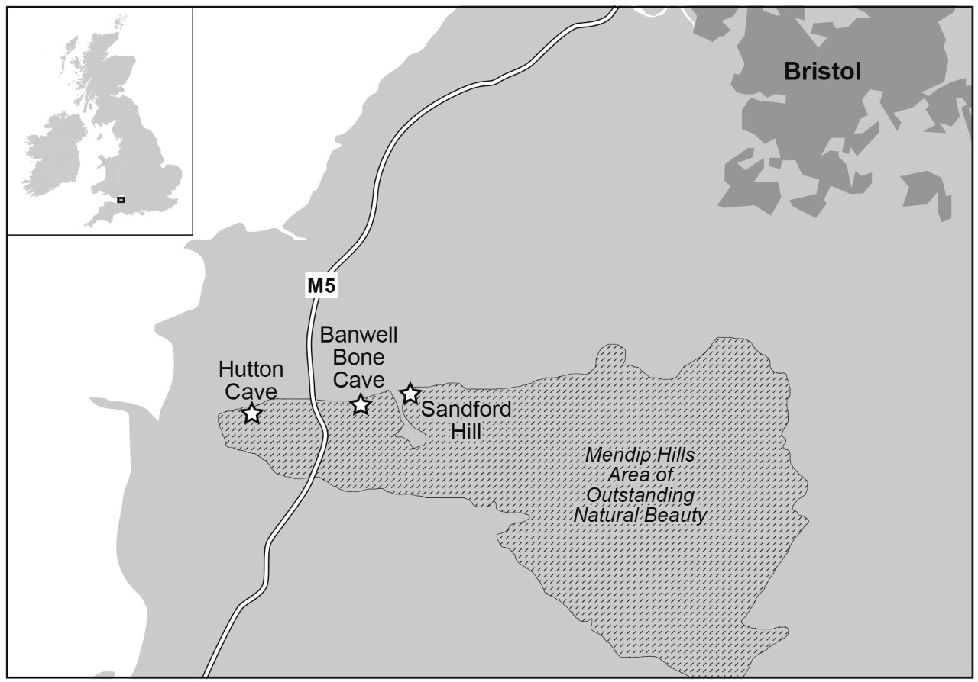

Figure 2a: δ¹³C and δ¹⁵N values of carnivores and herbivores from Hutton Cave. Figure 2b: Trophic enrichment factor applied to carnivores following Bocherens (2015). Mean herbivore δ¹³C and δ¹⁵N values shown to 1 standard deviation.
Double column width.
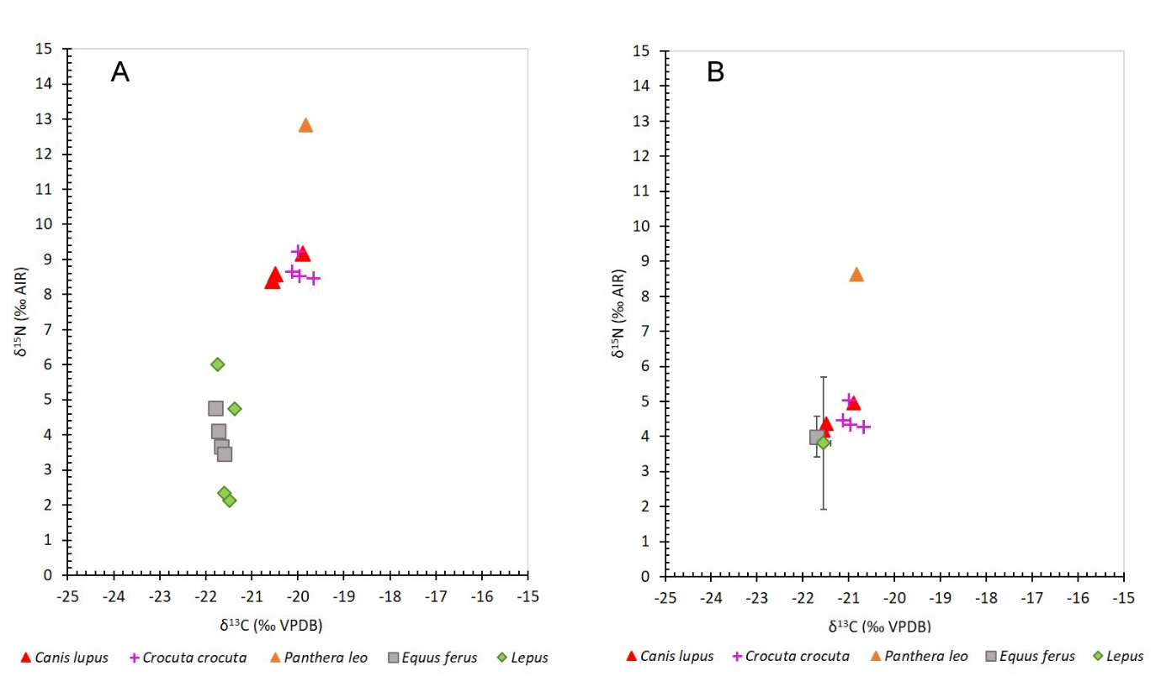

Figure 3a: δ¹³C and δ¹⁵N values of carnivores and herbivores from Banwell Bone Cave. Figure 3b: Trophic enrichment factor applied to carnivores following Bocherens (2015). Mean herbivore δ¹³C and δ¹⁵N values shown to 1 standard deviation. Double column width.
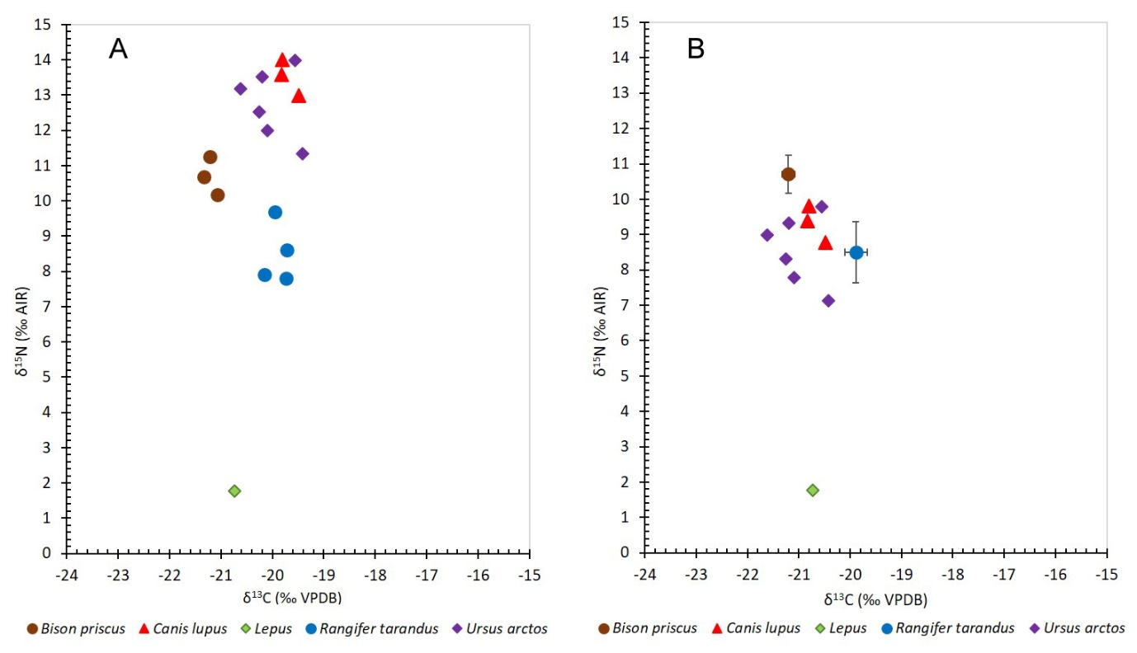

Figure 4a: δ¹³C and δ¹⁵N values of carnivores and herbivores from Sandford Hill. Figure 4b: Trophic enrichment factor applied to carnivores following Bocherens (2015). Mean herbivore δ¹³C and δ¹⁵N values shown to 1 standard deviation. Double column width.
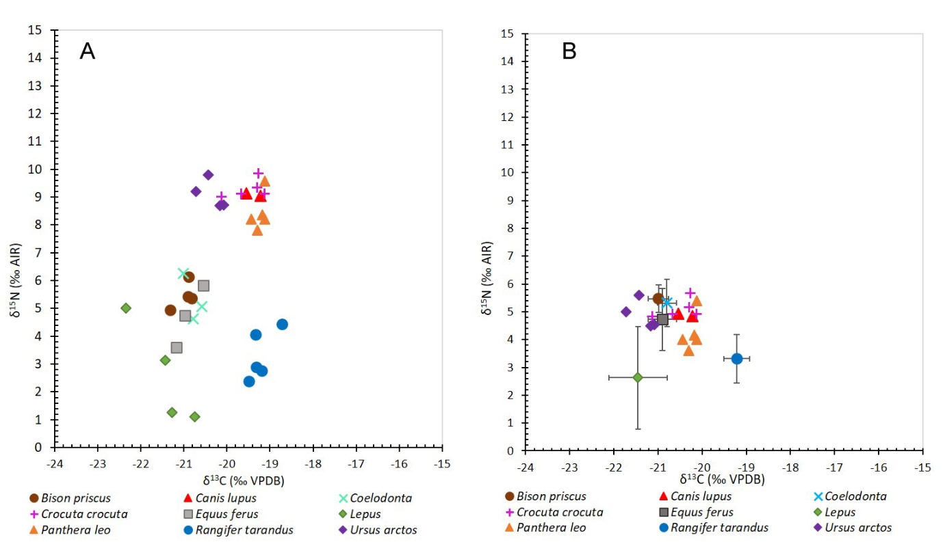

Figure 5a: δ¹³C and δ¹⁵N values from Banwell from this study (closed symbols) compared to those from Stevens and Reade (2021) (open symbols). Figure 5b: Trophic enrichment factor applied to carnivores following Bocherens (2015). Mean herbivore δ¹³C and δ¹⁵N values shown to 1 standard deviation. Double column width.
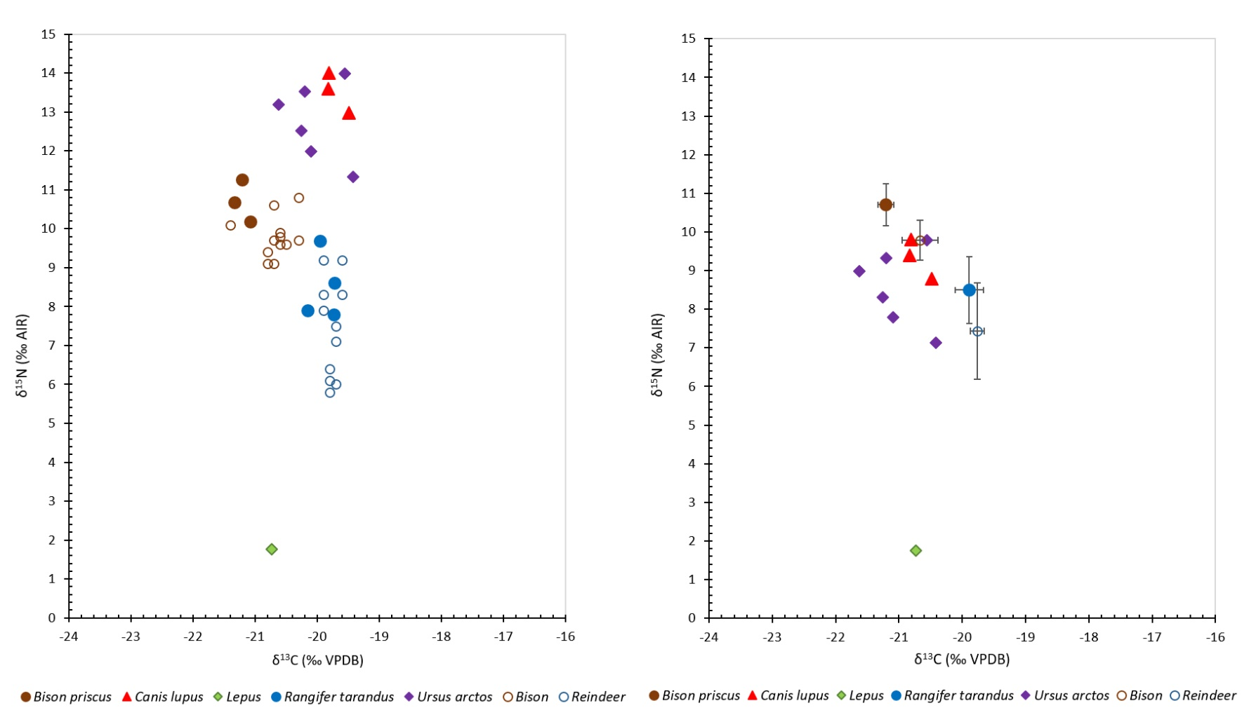
Figure 6a: Sandford Hill data from this study (symbols in legend followed by SH), compared with pre-Late Glacial Maximum age data from Goyet, published by Bocherens et al. (2011). Figure 6b: Trophic enrichment factor applied to carnivores following Bocherens (2015). Mean herbivore δ¹³C and δ¹⁵N values shown to 1 standard deviation.
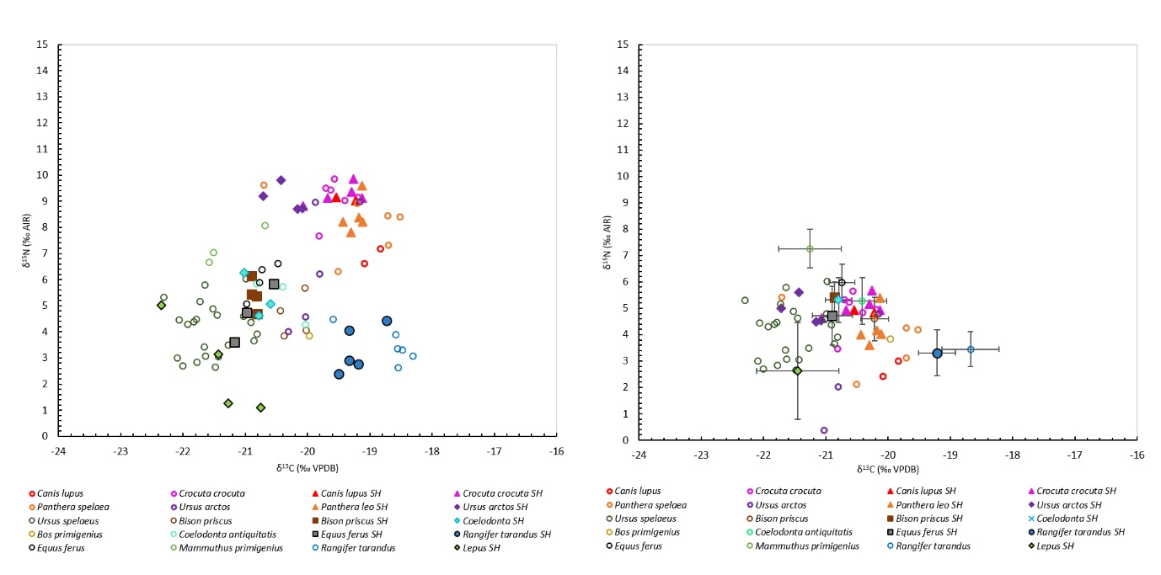
Table 1: Results from isotopic analyses conducted during this study.
Site | Age (MIS) | Species | Specimen Number (all preceded TTNCM except where stated) | NEIF Lab Number | Bone Element | %C | %N | C/N | δ¹³C (VPDB) ‰ | δ¹⁵N (AIR) ‰ | Sample date
Hutton | 7 | Canis lupus | 42/1995/129 | 10 | Left ulna | 41.5 | 14.1 | 3.4 | -20.6 | 8.4 | 2018
Hutton | 7 | Canis lupus | 42/1995/145 | 145 | Right femur, distal | 36.2 | 12.1 | 3.5 | -20.5 | 8.6 | 2015
Hutton | 7 | Canis lupus | 42/1995/738 | 738 | Right dentary | 40.7 | 14.1 | 3.4 | -19.9 | 9.2 | 2015
Hutton | 7 | Crocuta crocuta | 42/1995/212 | 11 | Right humerus | 40.4 | 14.4 | 3.3 | -20.0 | 9.2 | 2018
Hutton | 7 | Crocuta crocuta | 42/1995/223 | 12 | Left ulna | 41.4 | 14.5 | 3.3 | -20.1 | 8.7 | 2018
Hutton | 7 | Crocuta crocuta | 42/1995/218 | 218 | Left ulna | 42.1 | 14.6 | 3.4 | -19.7 | 8.5 | 2015
Hutton | 7 | Crocuta crocuta | 42/1995/255 | 255 | Right humerus | 42.5 | 14.1 | 3.5 | -20.0 | 8.5 | 2015
Hutton | 7 | Equus ferus | 42/1995/536 | 14 | Left astragalus | 40.6 | 14.4 | 3.3 | -21.7 | 3.7 | 2018
Hutton | 7 | Equus ferus | 42/1995/534 | 15 | Left astragalus | 41.0 | 14.7 | 3.3 | -21.7 | 4.1 | 2018
Hutton | 7 | Equus ferus | 42/1995/440 | 440 | Right third metacarpal | 41.8 | 14.6 | 3.3 | -21.8 | 4.8 | 2015
Hutton | 7 | Equus ferus | 42/1995/535 | 535 | Left astragalus | 39.9 | 13.7 | 3.4 | -21.6 | 3.4 | 2015
Hutton | 7 | Lepus | 42/1995/4/ | 2 | Right tibia | 40.4 | 14.3 | 3.3 | -21.4 | 4.7 | 2018
Hutton | 7 | Lepus | 42/1995/4/ | 3 | Right tibia | 40.8 | 14.4 | 3.3 | -21.5 | 2.1 | 2018
Hutton | 7 | Lepus | 42/1995/8/ | 7 | Left humerus | 41.9 | 14.4 | 3.4 | -21.7 | 6.0 | 2018
Hutton | 7 | Lepus | 42/1995/8/ | 8 | Left humerus | 42.9 | 14.3 | 3.5 | -21.6 | 2.3 | 2018
Hutton | 7 | Panthera spelaea | 42/1995/260 | 260 | Right magnum | 39.1 | 13.3 | 3.4 | -19.8 | 12.8 | 2015
Banwell | 5a | Bison priscus | 185/2002/151 | 116 | Left astragalus | 36.5 | 13.1 | 3.3 | -21.3 | 10.7 | 2018
Banwell | 5a | Bison priscus | Unreg. 10-B | 10-B | Right metacarpal | 32.4 | 11.2 | 3.4 | -21.1 | 10.2 | 2015
Banwell | 5a | Bison priscus | Unreg. 10-J | 10-J | Dentary fragment | 33.6 | 11.5 | 3.4 | -21.2 | 11.3 | 2015
Banwell | 5a | Canis lupus | 40/1995/50 | 103 | Right dentary fragment with p1-p4 | 38.2 | 12.4 | 3.6 | -19.8 | 13.6 | 2018
Banwell | 5a | Canis lupus | 40/1995/52 | 104 | Right dentary fragment with p2-p4 | 34.3 | 11.1 | 3.6 | -19.8 | 14.0 | 2018
Banwell | 5a | Canis lupus | Unreg. 10-O |  | Right dentary fragment | 29.6 | 10.2 | 3.4 | -19.5 | 13.0 | 2015
Banwell | 5a | Lepus | 40/1995/1 | 101 | Sacrum | 36.3 | 11.9 | 3.6 | -20.7 | 1.8 | 2018
Banwell | 5a | Rangifer tarandus | 40/1995/382 | 113 | Right calcaneum | 34.9 | 12.0 | 3.4 | -19.7 | 7.8 | 2018
Banwell | 5a | Rangifer tarandus | SCHREVE COLLECTIO | 118 | Right calcaneu | 37.3 | 13.4 | 3.3 | -19.7 | 8.6 | 2018
Banwell | 5a | Rangifer tarandus | 40/1995/321 | 321 | Left mandible | 28.7 | 9.3 | 3.6 | -20.2 | 7.9 | 2015
Banwell | 5a | Rangifer tarandus | 40/1995/372 | 372 | Right metatatarsal, proximal | 39.5 | 13.6 | 3.4 | -19.9 | 9.7 | 2015
Banwell | 5a | Ursus arctos | 40/1995/229 | 107 | Right calcaneum | 31.2 | 10.9 | 3.3 | -19.4 | 11.3 | 2018
Banwell | 5a | Ursus arctos | 40/1995/227 | 109 | Right calcaneum | 34.8 | 11.4 | 3.6 | -20.1 | 13.4 | 2018
Banwell | 5a | Ursus arctos | 40/1995/230 | 110 | Right calcaneum | 35.5 | 12.4 | 3.3 | -20.3 | 12.5 | 2018
Banwell | 5a | Ursus arctos | 40/1995/220 | 220 | Left astragalus | 32.7 | 11.2 | 3.4 | -19.6 | 14.0 | 2015
Banwell | 5a | Ursus arctos | 40/1995/201 | 21-22 | Right humerus, distal | 35.4 | 12.4 | 3.3 | -20.1 | 12.0 | 2015
Sandford | 3 | Bison priscus | 44/1995/637 | 92 | Right cubo-navicular | 41.3 | 14.3 | 3.4 | -20.9 | 5.4 | 2018
Sandford | 3 | Bison priscus | 44/1995/638 | 93 | Right cubo-navicular | 38.6 | 13.3 | 3.4 | -20.9 | 6.1 | 2018
Sandford | 3 | Bison priscus | 44/1995/639 | 94 | Right cubo-navicular | 39.7 | 13.1 | 3.6 | -20.8 | 4.7 | 2018
Sandford | 3 | Bison priscus | 44/1995/641 | 96 | Right cubo-navicular | 40.5 | 14.2 | 3.3 | -20.8 | 5.4 | 2018
Sandford | 3 | Canis lupus | 44/1995/61 | 61-16 | Right ulna | 43.2 | 14.9 | 3.4 | -19.5 | 9.1 | 2015
Sandford | 3 | Canis lupus | 44/1995/61 | 61-3 | Left dentary | 41.1 | 14.2 | 3.4 | -19.2 | 9.0 | 2015
Sandford | 3 | Coelodonta | 44/1995/471 | 88 | Left humerus, midshaft | 42.2 | 14.7 | 3.4 | -21.0 | 6.3 | 2018
Sandford | 3 | Coelodonta | 44/1995/477 | 89 | Left humerus, midshaft | 42.6 | 14.8 | 3.4 | -20.6 | 5.1 | 2018
Sandford | 3 | Coelodonta | 44/1995/478 | 90 | Right ulna, proximal | 41.3 | 14.6 | 3.3 | -20.8 | 4.6 | 2018
Sandford | 3 | Crocuta crocuta | 44/95/286-73 | 73 | Right ulna, proximal | 41.7 | 14.4 | 3.4 | -19.3 | 9.4 | 2018
Sandford | 3 | Crocuta crocuta | 44/95/288-74 | 74 | Right ulna, proximal | 37.8 | 13.4 | 3.3 | -19.7 | 9.1 | 2018
Sandford | 3 | Crocuta crocuta | 44/95/289-75 | 75 | Right ulna, proximal | 37.7 | 13.8 | 3.2 | -19.3 | 9.9 | 2018
Sandford | 3 | Crocuta crocuta | 44/1995/290 | 76 | Right ulna, proximal | 35.6 | 11.2 | 3.6 | -20.1 | 8.8 | 2018
Sandford | 3 | Crocuta crocuta | 44/1995/291 | 77 | Right ulna, proximal | 35.3 | 13.0 | 3.2 | -19.1 | 9.1 | 2018
Sandford | 3 | Equus ferus | 44/1995/429 | 84 | Metapodial, distal | 40.3 | 13.6 | 3.5 | -21.0 | 4.7 | 2018
Sandford | 3 | Equus ferus | 44/1995/430 | 85 | Metapodial, distal | 41.3 | 14.2 | 3.4 | -21.2 | 3.6 | 2018
Sandford | 3 | Equus ferus | 44/1995/428 | 428 | Left third metatarsal, proximal | 32.5 | 11.2 | 3.4 | -20.5 | 5.8 | 2015
Sandford | 3 | Lepus | 41/95/40 | 65 | Right tibia, proximal | 38.0 | 13.0 | 3.4 | -20.8 | 1.1 | 2018
Sandford | 3 | Lepus | 44/95/42-67 | 67 | Right tibia, proximal | 38.3 | 13.0 | 3.5 | -22.3 | 5.0 | 2018
Sandford | 3 | Lepus | 44/95/44-68 | 68 | Right tibia, proximal | 38.6 | 13.1 | 3.5 | -21.4 | 3.1 | 2018
Sandford | 3 | Lepus | 44/95/45-69 | 69 | Right tibia, proximal | 42.5 | 13.7 | 3.6 | -21.3 | 1.3 | 2018
Sandford | 3 | Panthera spelaea | 44/95/385-78 | 78 | Left radius, proximal | 44.9 | 15.5 | 3.4 | -19.2 | 8.4 | 2018
Sandford | 3 | Panthera spelaea | 44/1995/386-79 | 79 | Left radius, distal epiphysis | 43.8 | 15.2 | 3.4 | -19.3 | 7.8 | 2018
Sandford | 3 | Panthera spelaea | 44/95/397-80 | 80 | Metacarpal III, distal side | 43.1 | 14.9 | 3.4 | -19.1 | 9.6 | 2018
Sandford | 3 | Panthera spelaea | 44/1995/404-81 | 81 | Right astragalus | 42.1 | 14.4 | 3.4 | -19.4 | 8.2 | 2018
Sandford | 3 | Panthera spelaea | 44/1995/415-82 | 82 | Metatarsal, distal | 41.1 | 14.4 | 3.3 | -19.1 | 8.2 | 2018
Sandford | 3 | Rangifer tarandus | 44/1995/839-97 | 97 | Mandible with p2-m2 side | 39.3 | 14.0 | 3.3 | -19.3 | 2.9 | 2018
Sandford | 3 | Rangifer tarandus | 44/1995/840-98 | 98 | Mandible with m1-m3 side | 37.5 | 13.0 | 3.4 | -19.5 | 2.4 | 2018
Sandford | 3 | Rangifer tarandus | 44/95/841-99 | 99 | Mandible with p2-m1 side | 39.2 | 13.4 | 3.4 | -19.3 | 4.1 | 2018
Sandford | 3 | Rangifer tarandus | 44/1995/1120 | 20 | Right radius | 40.7 | 13.9 | 3.4 | -18.7 | 4.4 | 2015
Sandford | 3 | Rangifer tarandus | 44/1995/800 | 800 | Left mandible | 38.8 | 13.1 | 3.5 | -19.2 | 2.8 | 2015
Sandford | 3 | Ursus arctos | 44/1995/67-70 | 70 | Left humerus, distal and shaft | 32.9 | 10.8 | 3.6 | -20.7 | 9.2 | 2018
Sandford | 3 | Ursus arctos | 44/95/93-72 | 72 | Left humerus, distal | 35.7 | 11.8 | 3.5 | -20.4 | 9.8 | 2018
Sandford | 3 | Ursus arctos | 44/1995/68 | 68 | Left radius, proximal | 37.1 | 12.8 | 3.4 | -20.2 | 8.7 | 2015
Sandford | 3 | Ursus arctos | 44/1995/76 | 76 | Left calcaneum | 39.4 | 13.5 | 3.4 | -20.1 | 8.7 | 2015

Table 2a and b: Mean, maximum and minimum, and ranges of isotopic values for each site (a) and for each species (b). Note that for Hutton lion and Banwell hare samples, n=1 with no maximum, minimum or ranges shown.
TABLE 2A
Assemblage | Mean | MAX | MIN | RANGE
Hutton δ¹³C | -20.8 | -19.7 | -21.8 | -2.1
Hutton δ¹⁵N | 6.6 | 12.8 | 2.1 | 10.7
Banwell δ¹³C | -20.2 | -19.4 | -21.3 | -1.9
Banwell δ¹⁵N | 10.7 | 14.0 | 1.8 | 12.2
Sandford Hill δ¹³C | -20.1 | -18.7 | -22.3 | -3.6
Sandford Hill δ¹⁵N | 6.3 | 9.9 | 1.1 | 8.8
TABLE 2B
Species | Mean | MAX | MIN | RANGE
Hutton wolf δ¹³C | -20.3 | -19.9 | -20.6 | -0.7
Hutton wolf δ¹⁵N | 8.7 | 9.2 | 8.4 | 0.8
Hutton Hyaena δ¹³C | -19.9 | -19.7 | -20.1 | -0.5
Hutton Hyaena δ¹⁵N | 8.7 | 9.2 | 8.5 | 0.8
Hutton lion δ¹³C | -19.8 |  |  | n=1
Hutton lion δ¹⁵N | 12.8 |  |  | n=1
Hutton Horse δ¹³C | -21.7 | -21.6 | -21.8 | -0.2
Hutton Horse δ¹⁵N | 4.0 | 4.8 | 3.4 | 1.3
Hutton hare δ¹³C | -21.5 | -21.4 | -21.7 | -0.4
Hutton hare δ¹⁵N | 3.8 | 6.0 | 2.1 | 3.9
Banwell wolf δ¹³C | -19.7 | -19.5 | -19.8 | -0.3
Banwell wolf δ¹⁵N | 13.5 | 14.0 | 13.0 | 1.0
Banwell bear δ¹³C | -19.9 | -19.4 | -20.3 | -0.8
Banwell bear δ¹⁵N | 12.6 | 14.0 | 11.3 | 2.7
Banwell bison δ13C | -21.2 | -21.1 | -21.3 | -0.3
Banwell bison δ¹⁵N | 10.7 | 11.3 | 10.2 | 1.1
Banwell reindeer δ¹³C | -19.9 | -19.7 | -20.2 | -0.4
Banwell reindeer δ¹⁵N | 8.5 | 9.7 | 7.8 | 1.9
Banwell hare δ¹³C | -20.7 |  |  | n=1
Banwell hare δ¹⁵N | 1.8 |  |  | n=1
Sandford Hill wolf δ¹³C | -19.4 | -19.2 | -19.5 | -0.3
Sandford Hill wolf δ¹⁵N | 9.1 | 9.1 | 9.0 | 0.1
Sandford Hill hyaena δ¹³C | -19.5 | -19.1 | -20.1 | -0.9
Sandford Hill hyaena δ¹⁵N | 9.3 | 9.9 | 8.8 | 1.0
Sandford Hill lion δ¹³C | -19.2 | -19.1 | -19.4 | -0.3
Sandford Hill lion δ¹⁵N | 8.4 | 9.6 | 7.8 | 1.8
Sandford Hill bear δ¹³C | -20.3 | -20.1 | -20.7 | -0.6
Sandford Hill bear δ¹⁵N | 9.1 | 9.8 | 8.7 | 1.1
Sandford Hill bison δ¹³C | -20.9 | -20.8 | -20.9 | -0.1
Sandford Hill bison δ¹⁵N | 5.4 | 6.1 | 4.7 | 1.4
Sandford Hill woolly rhino δ¹³C | -20.8 | -20.6 | -21.0 | -0.4
Sandford Hill woolly rhino δ¹⁵N | 5.3 | 6.3 | 4.6 | 1.6
Sandford Hill horse δ¹³C | -20.9 | -20.5 | -21.2 | -0.6
Sandford Hill horse δ¹⁵N | 4.7 | 5.8 | 3.6 | 2.2
Sandford Hill reindeer δ¹³C | -19.2 | -18.7 | -19.5 | -0.8
Sandford Hill reindeer δ¹⁵N | 3.3 | 4.4 | 2.4 | 2.0
Sandford Hill hare δ¹³C | -21.5 | -20.8 | -22.3 | -1.6
Sandford Hill hare δ¹⁵N | 2.6 | 5.0 | 1.1 | 3.9

