On ‘Victory images’ and Gaza

Alan Feldman (Feldman, 2014) described Israel’s regime of total control over Gaza as ‘genocidal desistance,’ in which ‘each Israeli attack on Gaza is simultaneously and implicitly recast by state subtext as a desistance from genocide’. The violence inflicted on Gaza in May 2021 can be analysed from different angles, but the regularity in which the terror of the destruction of Gaza recurs, inflicting much of its deadly damage on innocent civilians, makes the besieged territory a unique global emergency. The following comments are my attempt to explain one visual filter through which this violence is normalised in Jewish Israeli society.
In Israel, the repeated campaigns in Gaza are framed as a regular necessity of conflict management, which was euphemistically termed ‘mowing the grass’ (Inbar and Shamir, 2014: 65). The unleashing of disciplining violence in almost regular intervals is seen as a structural necessity. Moreover, the ‘Gaza wars’ as Bregman (2016) calls them, provide a sense of ontological security to the Israeli state to a large degree derives its corporeal identity as a ‘nation in arms’ from its fighting stance and from its largest institution – the Israeli Defence Forces (Galai, 2019).
Scholars like Yagil Levy (2008, 2018) Edna Lomsky Feder (2010), Erella Graciani (2018), Adi Kuntsman (2020), and others have interrogated the tensions between militarism, militarisation and the identity of the Israeli state. At the heart of this tension is a discrepancy between the image of the state of itself as reluctantly having to be vigilant to protect itself from harm, the changing nature of its security practices as the occupation is further entrenched, and the regularity in which violent carnage is inflicted upon Palestinian (and Lebanese) populations.
This tension manifests in the visual realm and it sparked a search for visual artefacts that could resurrect a view of the state’s ‘conflicts’ as something honourable and familiar, as indicators of achievement. These visual artefacts took the form of ‘victory images’ and this term has grown in its prevalence in the media sphere, so much that it became a constant refrain during the violent military operations 2008-9, 2012, 2014, 2018 and 2021 and pundits in TV studios repeated the message that ‘The IDF is looking for a victory image’ as a goal of the operation that would allow it to stop.
The ‘victory image’ as an operational goal was born during the 2006 conflict in Lebanon, at the same time as the IDF’s ‘Dahye doctrine’, which targeted civilian infrastructure. With public perceptions of the war as a failure, due to the continued missile strikes from Hezbollah even after the ground invasion, IDF command came up with a plan to achieve the appearance of success. On 8 August, an Israeli military unit was charged with capturing the same building from which Hezbollah chief Nasrallah gave a historic speech and to fly the Israeli flag. The resultant image, they hoped, would serve as a ‘victory image’ much in line with previous such iconic imagery (Azoulay, 2011).
The picture-taking operation was a complete failure. Two soldiers were killed by friendly fire (Rappoport, 2007: 264-265) and the image that was taken was not at all impressive and was not distributed to the media, as was initially planned. However, the concept of a ‘victory image’ survived, and later a different image was found. Moreover, the concept of a ‘victory image’ that would legitimise the use of the army became entrenched in Israeli public discourse.
In the subsequent military operations in Gaza, talk of the ‘victory image’ was rife in the Israeli media. However, no image was found. Yagil Levy (2017) explained that the IDF in its operations in Gaza engaged in risk-management and approved remote military operations that were predicted to cause a great deal of ‘collateral damage’ in order to avoid placing soldiers at risk. Remote warfare does not yield victory images. The enactment of the Dahiye doctrine, which meant the heavy bombing of civilian areas, offered nothing that could be celebrated and any rudimentary search in censored newswires would reveal the horrific and bloody reality of emaciated bodies that suffer its consequence. Yet, the concept of the ‘victory image’ was not abandoned. In fact, it only grew in prominence.
It simply transformed from a visual depiction of an act of heroism or success that inspired pride in the military achievement to a narrative statement or a collation of data that lays claim to an achievement. Israeli journalist Uzi Benziman (2012) explained that ‘lacking a spontaneous victory image, the Israeli leadership is trying – through verbal media, to instil in the public consciousness a feeling of unequivocal achievement’. In conceptual terms, the victory image, whether visual or verbal is an act of ‘victory staging’ in which ‘a symbol of victory becomes a condition for the cessation of fighting’ (Galai, 2019).
The conversations in Israeli TV studios during these military operations in Gaza, including the most recent one, heavily used the term ‘victory image.’ For example, the IDF’s operation in 13 May, in which it faked an invasion and used reporters to corroborate its ruse, was already being framed in the Israeli media as a ‘victory image’ until it became known that it did not succeed. The intention was not to celebrate the scenes of Israel’s enemies buried alive in tunnels as a visual image of victory, but to render them into data as part of an additional transformation of the ‘victory image’ that occurred in 2012 and had repeated itself in more recent IDF operations in Gaza.
The compiled ‘victory image’ of which two samples are presented below, re-visualises such data as an infographic that serves two purposes. First, it serves as a victory image, designed to look like a scoreboard, indicating the end of a level in some video game. In this respect, it is well aligned with the self-perception of Israeli society as having to progress through constant conflict. Second, it embodies a desire for a new visual interface through which to experience ‘the conflict’. A clean, high-tech aesthetic that would devour the messy reality of genocidal desistance.
A-virtual-victory-reality is established in which Palestinian dead bodies are screened-off (Feldman, 2005: 212) and only ‘terrorists’ remain who in 2014 were ‘killed’ and in 2021 were ‘neutralised’. This newest iteration of the ‘victory image’ visually emplots claims for military achievement into a neat and symmetrical scorecard. In giving up on iconicity and taking on icons these new images turn away from the classic story of sacrifice and victory in the face of defeat and instead, they carry an implicit promise – we will do better next time.

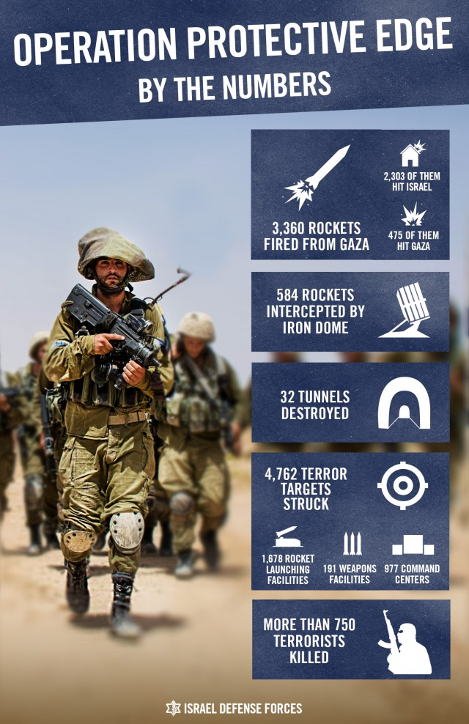 | 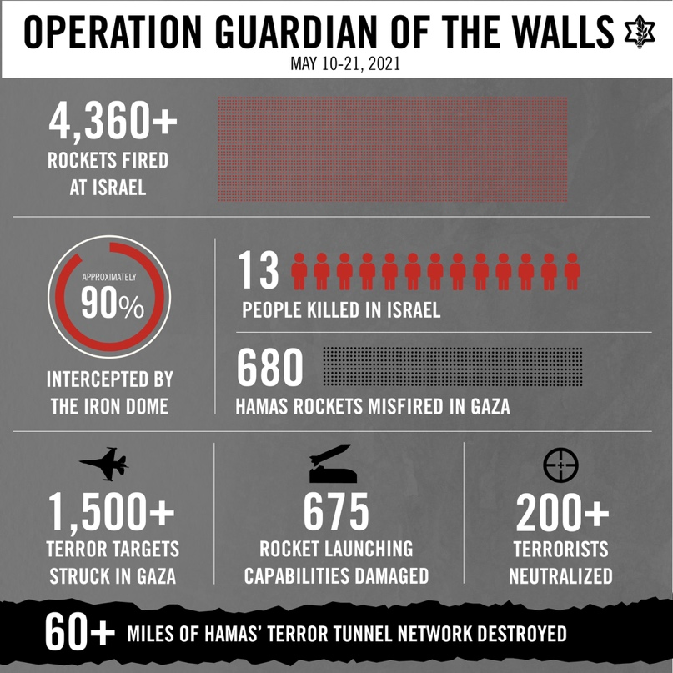
Figure 1: 2014 - Operation 'Defensive Edge’ - Graphics generated by the IDF’s spokesperson unit and disseminated in social media, available on the IDF blog’ available at: http://www.idfblog.com/blog/2014/08/05/operation-protective-edge-numbers/ | Figure 2: 2021 - Operation 'Guardian of the Walls' - Graphics generated by the IDF’s spokesperson unit and disseminated in social media, available on the IDF blog’ available at: https://twitter.com/idf/status/1396170789305659402

References:

Azoulay, Ariella Aïsha (2011) Declaring the State of Israel: Declaring a state of war. Critical Inquiry 37(2): 265–285.

Benziman, Uzi (2012) A thousand words for one picture. Ha’ayin Hashvi’it, 22 November. Available at: www.the7eye.org.il/7599 (accessed 11 December 2017) (Hebrew).

Bregman, Aaron (2016) Israel’s Wars: A History Since 1947. London: Routledge.

Feldman, Alan (2005) On the actuarial gaze: From 9/11 to Abu Ghraib. Cultural Studies 19(2): 203–226.

Feldman, Alan (2014) ‘Genocidal desistance in Gaza’, Social Text, 27 August, http://socialtextjournal.org/genocidal-desistance-in-gaza/ (accessed 9 July 2021)

Galai, Yoav (2019) The victory image: Imaging Israeli warfighting from Lebanon to Gaza. Security Dialogue, 50(4), 295-313.

Grassiani, Erella (2018) Between security and military identities: The case of Israeli security experts. Security dialogue, 49(1-2), 83-95.

Inbar Efraim and Shamir Eitan (2014) ‘Mowing the grass’: Israel’s strategy for protracted intractable conflict. Journal of Strategic Studies 37(1): 65–90.

Kuntsman, Adi and Rebecca L. Stein (2020) Digital militarism. Stanford University Press.

Levy Yagil (2008) Israel’s violated republican equation. Citizenship Studies 12(3): 249–264.

Levy Yagil (2017) The Gaza fighting: Did Israel shift risk from its soldiers to civilians? Middle East Policy 24(3): 117–132.

Lomsky-Feder Edna and Eyal Ben-Ari (2010) The discourses of ‘psychology’ and the ‘normalization’ of war in contemporary Israel. In: Sheffer G and Barak O (eds) Militarism and Israeli Society. Bloomington, IN: Indiana University Press, 280–303.

Rappoport, Amir (2007) Friendly Fire: How We Failed Ourselves in the Second Lebanon War. Tel Aviv: Maariv (Hebrew).

Yoav Galai, Royal Holloway, University of London, England (Yoav.Galai@rhul.ac.uk)

