Psychological responses to the COVID-19 pandemic are heterogeneous but have stabilised over time: One year longitudinal follow-up of the COVID-19 Psychological Research Consortium (C19PRC) Study.
Mark Shevlin¹, Sarah Butter², Orla McBride¹, Jamie Murphy¹, Jilly Gibson-Miller², Todd K. Hartman², Liat Levita², Liam Mason³, Anton P. Martinez², Ryan McKay⁴, Thomas VA Stocks², Kate M Bennett⁵, Philip Hyland⁶, Frédérique Vallieres⁷, Richard P. Bentall^{2,5}

¹ Ulster University, Northern Ireland
² University of Sheffield, England
³University College London, England
⁴ Royal Holloway, University of London, England
⁵ Liverpool University
⁶Maynooth University
⁷Trinity College Dublin

Corresponding author: Professor Mark Shevlin, Ulster University (Psychology), Room H256, Cromore Road, Coleraine, Northern Ireland, BT52 1SA. Email: m.shevlin@ulster.ac.uk
954 words
Financial support. The initial stages of this project were supported by start-up funds from the University of Sheffield (Department of Psychology, the Sheffield Methods Institute and the Higher Education Innovation Fund via an Impact Acceleration grant administered by the university) and by the Faculty of Life and Health Sciences at Ulster University. The research was subsequently supported by the ESRC under grant number ES/V004379/1 and awarded to RPB, TKH, LL, JG-M, MS, JM, OM, KB and LM. The funders had no role in study design, data collection and analysis, decision to publish, or preparation of the manuscript

Shevlin et al. (2021) recently demonstrated heterogeneity in mental health responses to the COVID-19 pandemic over time from a nationally representative sample of UK adults (March–July 2020). Five subpopulations representing either stability, deterioration or improvement in both anxiety-depression and COVID-19 PTSD were identified. The majority of the sample were characterised by low levels of anxiety-depression (56.6%) and COVID-19 traumatic stress (68.3%) during this early phase of the pandemic but some showed deterioration and some showed mental health benefits. Here we extend these findings using two additional survey waves from the C19PRC Study, thereby modelling mental health trajectories for the UK population within the entire first year of the pandemic.
The C19PRC Study is a longitudinal, internet-based UK survey with five completed waves to date. Methodological accounts of the study are available elsewhere (McBride et al., 2020; McBride et al., 2021a; McBride et al., 2021b; McBride et al., 2021c). Ethical approval was granted by the University of Sheffield (Ref. 033759). Anxiety-Depression was measured using the Patient Health Questionnaire Anxiety-Depression Scale (PHQ-ADS), a 16-item scale used as a composite measure of depression and anxiety (Kroenke et al., 2016), with scores ranging from 0 – 48. The International Trauma Questionnaire (ITQ: Cloitre et al., 2018) was used to measure traumatic stress. Participants were asked to complete the ITQ “in relation to [their] experience of the COVID-19 pandemic…[and] how much [they] have been bothered by that problem in the past month”. Possible PTSD scores range from 0–24. The same baseline predictor variables were used as in Shevlin et al. (2021).
Data analysis was undertaken in three linked phases. First, mean scores on the PHQ-ADS and ITQ were estimated for each survey time point, and tests for mean differences were conducted. Second, we used latent variable mixture modelling to identify different trajectories in anxiety-depression and COVID-19 traumatic stress separately using unstructured growth mixture models (GMM). Non-linear trajectories were estimated based on the approach of Meredith and Tisak (1990) with the first and last loadings on the ‘slope’ factor fixed at 0 and 1 respectively (and the other loadings estimated). In the third phase of analysis, the classes from the GMMs were regressed on the predictor variables. These models were specified and estimated using Mplus Version 8.1.
The mean scores on the PHQ-ADS were similar from Waves 1 to 5 (W1 M=10.53, W2 M=10.36, W3 M=10.81, W4 M=10.83, W5 M=10.58), and the equality test indicated that there were no significant differences (χ²(4) = 2.97, p = .562); thus, the level of anxiety-depression appeared to remain stable across this entire time period. Similarly, the mean scores on the ITQ were also consistent across waves (W1 M=4.57, W2 M=4.54, W3 M=4.20, W4 M=4.48, W5 M=4.13), and the equality test indicated that there were no significant differences (χ²(4) = 8.91, p = .063).
The table of fit statistics for the GMMs can be found at https://osf.io/bwfmh/. The 5-class solutions (see Figure 1) were considered to be the optimal solutions for both Anxiety-Depression and COVID-19 traumatic stress models as the difference in the BIC for the 5- and 6-class models were relatively small, entropies were high, and the LMR-As were significant for the 5-class solutions but not for the 6-class solutions. Importantly, the 5-class solutions reproduced the trajectory patterns identified in the analysis of the first three waves (Shevlin et al., 2021). For anxiety-depression there were three classes that were stable over time; a ‘Resilient’ class (68.6%) characterised by stable low scores, a ‘Chronic’ class (5.7%) characterised by stable high scores, and a ‘Moderate-Stable’ class (14.5%) characterised by stable moderate scores. A ‘Deteriorating’ class (4.7%) had low scores at Wave 1 that increased at Waves 2, 3 and 4, while an ‘Adaptive’ class (6.5%) started high but decreased from Waves 2 to 4. For traumatic stress the number, size and shape of the trajectories were very similar to those identified for anxiety-depression and were therefore given the same labels.
Figure 1 here
The full estimates of the regression analyses are available at https://osf.io/bwfmh/. Overall, the significant odds ratios indicated that individuals with a history of mental health treatment, higher levels of loneliness, intolerance of uncertainty, death anxiety, and lower levels of resilience were more likely to be in the non-resilient trajectory classes for both anxiety-depression and traumatic stress. The largest effects of these predictors were generally for the ‘chronic’ trajectory, and in particular, for the mental health treatment variable.
The current study extends the findings of Shevlin et al. (2021) by identifying trajectory patterns that were consistent with those initially reported from the analysis of the first three waves of C19PRC data (March–July 2020): ‘Resilient’, ‘Chronic’, ‘Deteriorating’, ‘Adaptive’ and ‘Moderate-stable’. The size and characterisation of these trajectories were similar for both anxiety-depression and COVID-19 traumatic stress. To the authors’ knowledge, this is the first study to examine change in mental health severity over the course of the first year of the pandemic in the UK. The current findings suggest that the vast majority of the sample experienced a homeostatic mental health response over the course of the first year of the pandemic, with over two-thirds being characterised as ‘Resilient’, while about 15% were characterised as ‘Moderate-Stable’ and roughly 6% fell into the ‘Chronic’ category. Yet, for a minority of individuals (~12%) the months following the initial UK outbreak represented a period of rapid change in mental health, for better or worse. Notably, however, these trajectories plateaued from summer 2020 onwards, with only minor fluctuations in mental health scores during the period July 2020–March/April 2021. It may be that some individuals will experience a more delayed response to the pandemic, which has not fully manifested itself until much later after the traumatic event, as has been documented with the case of delayed-onset PTSD.

References
Cloitre, M., Shevlin, M., Brewin, C. R., Bisson, J. I., Roberts, N. P., Maercker, … Hyland, P. (2018). The International Trauma Questionnaire: development of a self-report measure of ICD-11 PTSD and complex PTSD. Acta Psychiatrica Scandinavica, 138(6), 536–546. https://doi.org/10.1111/acps.12956
Kroenke, K., Wu, J., Yu, Z., Bair, M. J., Kean, J., Stump, T., & Monahan, P. O. (2016). Patient Health Questionnaire Anxiety and Depression Scale: Initial Validation in Three Clinical Trials. Psychosomatic Medicine, 78(6), 716–727. https://doi.org/10.1097/PSY.0000000000000322
McBride, O., Murphy, J., Shevlin, M., Gibson‐Miller, J., Hartman, T. K., Hyland, P., … Bentall, R. P. (2020). Monitoring the psychological, social, and economic impact of the COVID-19 pandemic in the population: Context, design and conduct of the longitudinal COVID-19 psychological research consortium (C19PRC) study. International Journal of Methods in Psychiatric Research, 30(1), e1861. https://doi.org/10.1002/mpr.1861
McBride, O., Butter, S., Murphy, J., Shevlin, M., Hartman, T. K., Hyland, P., … Bentall, R. P. (2021a). Context, design and conduct of the longitudinal COVID-19 Psychological Research Consortium (C19PRC) Study - Wave 3, International Journal of Methods in Psychiatric Research, 30(3), e1880. https://doi.org/10.1002/mpr.1880
McBride, O., Butter, S., Murphy, J., Shevlin, M., Hartman, T. K., Bennett, K., … Bentall, R. P. (2021b). Design, content, and fieldwork procedures of the COVID-19 Psychological Research Consortium (C19PRC) Study - Wave 4. PsyArXiv. https://psyarxiv.com/nytxc/
McBride, O., Butter, S., Murphy, J., Hartman, T. K., Hartman, T. K., Shevlin, M., … Bentall, R. P. (2021c). Tracking the psychological and socio-ecoomic impact of the COVID-19 pandemic in the UK: a methodological report from Wave 5 of the COVID-19 Psychological Research Consortium (C19PRC) Study. PsyArXiv. https://psyarxiv.com/fyqjb/
Meredith, W., & Tisak, J. (1990). Latent curve analysis. Psychometrika, 55, 107–122. https://doi.org/10.1007/BF02294746
Pierce, M., McManus, S., Hope, H., Hotopf, M., Ford, T., Hatch, S. L., ... Abel, K. M. (2021). Mental health responses to the COVID-19 pandemic: A latent class trajectory analysis using longitudinal UK data. The Lancet Psychiatry, 8, 610-619. doi:10.1016/S2215-0366(21)00151-6.
Shevlin, M., Butter, S., McBride, O., Murphy, J., Gibson-Miller, J., Hartman, T. K., … Bentall, R. P. (2021). Refuting the myth of a 'tsunami' of mental ill-health in populations affected by COVID-19: evidence that response to the pandemic is heterogeneous, not homogeneous. Psychological Medicine, 1–9. Advance online publication. https://doi.org/10.1017/S0033291721001665

Figure 1. Trajectory Plots for Anxiety-Depression (A) and Traumatic Stress (B).

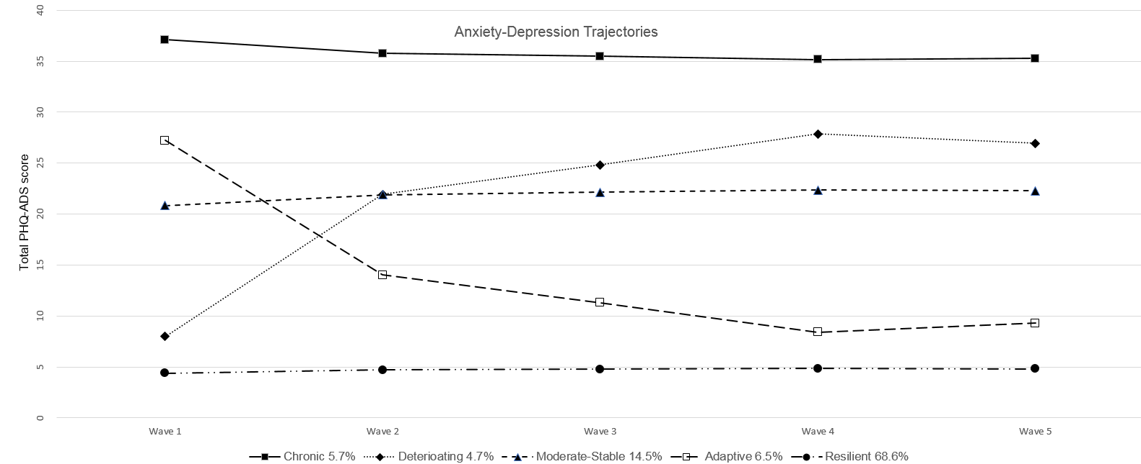
Panel A

Panel B

Panel B

