Political Insight Article
James Sloam and Ben O’Loughlin (both Royal Holloway University)

From Waves of Crisis to Sustainable Public Policy: The Everyday Politics of Young Londoners
Young people’s lives and politics have been transformed by successive waves of crisis: the Great Recession, the Climate Emergency, and the Covid-19 Pandemic. This article shows how young people’s lives in London are marked by ‘cycles of insecurity’ and a sense of powerlessness to effect change. The research nevertheless demonstrates how efforts to amplify youth voice have the potential to break these cycles and contribute to a more sustainable public policy.

Introduction
Young people’s lives and politics have been transformed by successive waves of crisis over the past two decades: the Great Recession and austerity in public spending; a Climate Emergency that will most affect younger generations; and the ongoing economic, social and health impacts of the Covid-19 pandemic. These period effects have shaped the politics of younger generations, who are much more socially liberal and left-leaning than older generations. This is especially true for young women, ethnic minorities, students, and city-dwellers.
The crises also led to a surge in political participation for socially liberal, non-mainstream candidates and parties (from Corbyn’s Labour to the German Green Party), as well mass participation in youth-led protest activity: to express outrage at financial inequalities and corruption after the 2008 Financial Crisis (Occupy Wall Street, the Spanish Indignados and many more), against racial discrimination in all its forms (Black Lives Matter), and to press for urgent action on climate change (#FridaysforFuture).
Yet, in ageing post-industrial democracies, the political weight of younger generations is relatively small, which has led to public policy that is geared towards older generations. This is particularly problematic for young people from less privileged backgrounds, who lack the family resources to insulate them from economic shocks, and suffered from reductions in benefits and services: from the abolition of the Education Maintenance Allowance in 2011, to the reduction of local council expenditure on youth services of a staggering 70% since 2011, to the removal of free travel for 11 to 17-year-olds in London in August 2020.
Whilst the surge in youth political activism is relatively well documented, there is little focus in political science on the micro-politics of young people’s everyday lives. In this article, we investigate the ongoing impact of waves of crisis on young people in an urban environment through participatory research with young Peer Outreach Workers in the Greater London Authority. The POWs led ten deliberative focus groups with 98 participants – a majority of whom came from deprived communities – in City Hall in 2019 and in online groups in 2020.
The research found that young people’s lives are marked by ‘cycles of insecurity’ and a sense of powerlessness to effect change. It nevertheless provides evidence to illustrate how efforts to amplify youth voice have the potential to break these cycles and contribute to a more sustainable public policy.

Voices in the Urban Wilderness
In designing the research with young Londoners, a common frustration was feeling ignored by those in power. And yet our participants were keen to tell their stories and contribute to their communities.
This was encapsulated by the story of one young woman in her early twenties. She had grown up in care and faced daily struggles with poverty and crime. On leaving care, she had received no support and had little knowledge of the benefits she could receive and was pushed into homelessness. Even when life improved, and she was able to find part-time work, this was a precarious existence. The jobs were low-paid, and she had constantly to deal with unscrupulous employers withholding pay or demanding more hours and landlords threatening eviction for late rent on run-down accommodation. This young woman understood how poverty could ‘weigh you down’ make you ‘run out of options’ and prioritised ‘just getting by’ – the everyday politics of her lived experiences.
Yet, through the support of mentors and with the help of opportunities provided through the Peer Outreach team, she managed to overcome many of her personal struggles, move on to higher education and develop a strong commitment to promoting youth voice in London. Like many of the young people we spoke to, she was suspicious and distrustful of politicians. She might vote, but probably not for the mainstream candidates and parties. Coming from an ethnic minority background and having to deal with cuts in public services first-hand, she was deeply opposed to the Conservative Party, yet was wary of the ‘tokenism’ and hollow promises of politicians who appeared to be on her side. She was used to being asked her opinion, but sceptical about the outcomes.
Many other young Londoners we spoke to, shared the feeling that they were living in an urban wilderness where no-one in authority was concerned about the existential problems they faced daily. Nevertheless, support from groups like the Peer Outreach team can scaffold a young person’s transition into adulthood. As a result, this young woman was empowered to empower the voices of other young people at community level – and had begun to see this both as a career and a vocation.
This short vignette illustrates the multiple challenges faced by young people from deprived communities. It also points to the problems political scientists (and, potentially, political parties) face in understanding youth voice as policy preferences. In our 2019 survey of young Londoners, we generated questions from the focus groups to ask about the importance of different everyday issues (Figure 1): mental health came out on top, followed by two housing issues, knife crime, and education about democracy. We also know from a follow-up survey climate change and anti-racism (two issues related to protest movements) have also risen to the top of young Londoners’ agendas over the past two years.

Cycles of Insecurity
For the young Londoners in this study, the plot was dominated by the overarching issues of poverty, precarity and lack of opportunity. Participants emphasized the knock-on effects of poverty on crime. One said, ‘who really robs houses for fun?... how many 14-year-olds would be selling drugs if their family had money?... how many youngsters in areas such as Peckham, Camberwell and Brixton would be doing some of the things that they do if their families had money?’ (female, 21). Regarding crime in the capital, they viewed the police as primary actors, and pointed to an increasing lack of trust: ‘I’m not saying that all of them are bad, because not all of them are bad, but being young and black – I’m not going to lie – there is a growing hatred’ (male, 18).
Another key theme for young Londoners was what was described as a ‘cliff-edge’ for those turning 16 and 18. Again, when poverty is an ongoing problem, the increased cost of living and withdrawal of support during the transition to adulthood was hard to deal with. Regarding public transport, one young woman (aged 18) explained: ‘It’s not reasonable and it feels like it’s suddenly changed… from going to school to suddenly going to college and having to spend so much money to get to college.’
To understand the everyday politics of marginalised groups, it is important to reflect on affect – the emotional dimension of narratives. This is a strength of participatory research – using young people themselves as researchers. Emotion provided a useful entry point for discussions, motivating young people to think about and discuss issues they care about. Young people felt very strongly about housing in London – primarily, affordable housing and homelessness. According to one young Londoner, ‘landlords in my opinion are the scum of the earth’ (male, 20). Another participant (female, 19) added: ‘You can pay a ridiculous amount for a shithole’.
Emotions also provided an entry-point for discussions of issues such as the environment, where participants did not have well-formed views prior to the events. Low environmental standards were associated with poor and ignored communities that people in power did not care about. For example, several participants were angry about the lack of recycling facilities and piles of rubbish on the streets in ‘shit neighbourhoods’.
A third dimension of the research was to understand young Londoners’ sense of agency – or lack thereof. At the extreme end of the spectrum, one participant (male, 18) described his Lego creation as: ‘a representation of a young child being brought up in London, who is not acknowledged, who is invisible, and leading to a narrow path that ends up six feet underground, which is causing knife crime and gun crime because they’re not acknowledged and given opportunities.’
The views of young Londoners on crime, housing, mental health was that they were all inter-related, so that many young people became trapped in cycles of insecurity where there was seemingly no way out: ‘in situations like these it’s very easy to see how, just because of the circumstances of the way you’re born, it is very easy for you to fall into a sort of cycle where you can’t really escape from it, because you are dealing with one problem by making a new problem’ (male, 21).
Another participant (female, 16) explained this sense of powerlessness. She linked issues of poverty and struggles with mental health, the most mentioned concern alongside crime and housing). She explained her Lego representation ‘of someone in a box whilst there’s everyone talking around them… it’s meant to represent the lack of support for mental health’ (Figure 2).

Figure 2: Lego Representation of Powerlessness and Mental Health
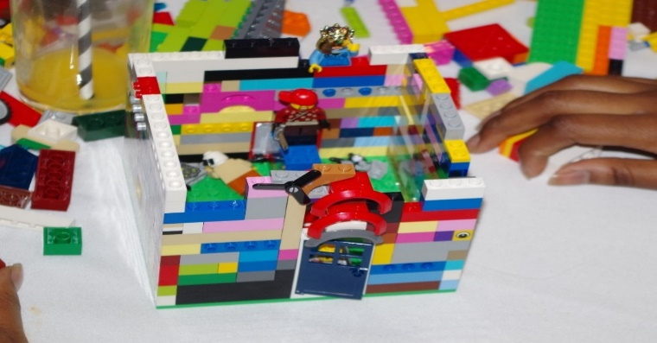

Sustainable Solutions
If a sense of powerlessness was prevalent amongst the young Londoners we spoke to, it was equally evident that many of the participants were eager to have their voices heard. The deliberative focus groups provided opportunities for them to construct narratives with one another about where the problems lay, what the potential solutions might be, and even what they could do to affect change themselves, to provide sustainable solutions for their communities.
The discussion of environmental issues provided a good example of how these discussions could develop organically (Figure 3). For young people from less well-off backgrounds, the environment was a less pressing issue than personal safety or economic stability. Yet, the focus groups allowed the young Londoners we spoke to the opportunity to weave environmental issues into personalised accounts of the challenges they faced. According to one participant: Another young woman (aged 23) was in dispute with her council over their plans to build on a green space the community used for events, to walk dogs, and take children out. Family, friends, and local communities were central to the conversations.
In their seminal study of young people in cities, Skelton and Gough wrote about the need to take young people seriously as ‘social agents’ and ‘competent urban actors’. In this respect, the focus groups encouraged young Londoners to recapture a sense of agency by putting forward local solutions. These included ‘better schemes for local tenants to be able to purchase their properties’, ‘community-led self-build projects’, ‘schemes for growing your own produce within the community’, and building more dedicated cycle routes.
Nevertheless, they recognized some limits to community action. As one young woman (18) explained: ‘me and a friend of mine started a network for young women, because there wasn’t any youth clubs and we literally funded it ourselves until we were both broke and could not keep doing it.’ Even when young people’s sense of internal efficacy was strong, they were tested by the reality of the structural problems discussed above.

Figure 3: Visualization of Themes from Focus Groups
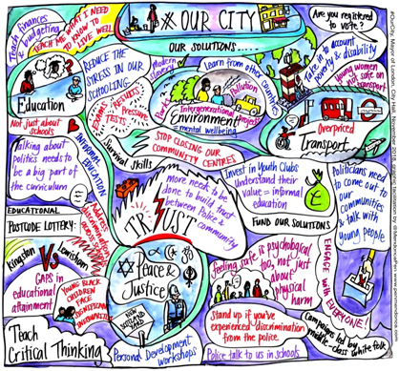

Conclusion
Younger generations have faced successive waves of crisis. Their ability to cope is highly dependent upon the economic resources they have at their disposable. Even before the pandemic hit, the young Londoners we spoke to were marked by poverty and precarity and felt trapped in cycles of insecurity.
Whilst the sense of powerlessness (lack of voice) and hopelessness (lack of opportunity) might be most heavily concentrated amongst disadvantaged groups of young people, it is an outlook that stretches across a whole generation. Younger generations may have become more politically active – generally, outside mainstream electoral politics – but this activism is heavily concentrated among young people with high levels of educational attainment.
On the supply-side, the challenge for government and political parties is to integrate the voices of young people into public policy. In the backdrop of the Covid-19 crisis and commitments made to achieve a carbon neutral economy, vast sums of money have been allocated to recovery and transition. However, there has been a general failure to engage with young people designing a recovery and transition. The argument here is that greater youth engagement can lead to a more effective or sustainable public policy. Bodies as diverse as the Prince’s Trust and the OECD have begun to recognise the economic and social value of youth participation.
Through our work with the Greater London Authority, we found that the Peer Outreach Group had – through their outstanding efforts – already provided significant inputs into policy-making. We produced a Children and Young People Handbook to further support this powerful work. At its best, youth participation in public policy has delivered local solutions to seemingly intractable problems across London, including many community projects supported by the Mayor’s Young Londoners’ Fund. However, tokenism is commonplace amongst policy-makers who fear the radical voices of younger citizens. The defunding of local government is an even greater barrier to effective youth participation.
On the demand-side of the equation, there is further work to do to equip young people with the skills and confidence to be able to engage with policy-makers. The research, demonstrated the high value placed of ‘education about democracy’ – the fifth-ranked issue in the survey – by young people themselves. According to one participant (female, 21): ‘Political education is something that is just ridiculously lacking… you can see how much people from 18-24 are basically left out of the entire policy process’.
In this sense, both supply-side and demand-side solutions are essential to foster youth voice and engagement in public policy, to break up these cycles of insecurity in London and in towns and cities across the UK. Engagement with young people between elections would also begin to address widespread disillusionment with mainstream electoral politics.

See J. Sloam and M. Henn (2019) ‘Youthquake 2017: The Rise of Young Cosmopolitans in Britain’ (Palgrave), available open access at Youthquake 2017 | SpringerLink.
Figures cited in YMCA (2019) report ‘Out of Service’, available at https://www.ymca.org.uk/wp-content/uploads/2020/01/YMCA-Out-of-Service-report.pdf (last accessed 1 July 2021).
For detail on what this concept means, see Gillespie, M., & O’Loughlin, B. (2016). The media–security nexus: researching ritualized cycles of insecurity. In P. Robinson, P. Sieb & R. Frohlich (eds.) Routledge Handbook of Media, Conflict and Security, London: Routledge, pp. 71-87.
Skelton, T., & Gough, K. V. (2013). Introduction: Young people’s im/mobile urban geographies. Urban Studies, 50(3), 455-466.
OECD (2020) report, Governance for Youth, Trust and Intergenerational Justice, available at Governance for Youth, Trust and Intergenerational Justice: Fit for All Generations? | en | OECD (last accessed 1 July 2021).

