Agrochemicals, but not other stressors, interact synergistically to increase bee mortality
Harry Siviter^{1,2*}, Emily J Bailes^{1,3*}, Callum D Martin¹, Thomas R Oliver^{1,4,5}, Julia Koricheva¹, Ellouise Leadbeater¹, Mark J F Brown¹
¹ Department of Biological Sciences, Royal Holloway University of London, Egham, Surrey, TW20 0EX, UK
² Department of Integrative Biology, University of Texas at Austin, 2415 Speedway, Austin, TX 78712, USA
³ Department of Molecular Biology and Biotechnology, University of Sheffield, Sheffield, S10 2TN, UK
⁴ School of Natural Sciences, Bangor University, LL57 2UW, Gwynedd, UK
⁵ Rothamsted Research, Harpenden, Hertfordshire AL5 2JQ, UK
*These authors contributed equally, corresponding author (Harry.Siviter.2016@live.rhul.ac.uk)

Keywords: pesticide; insecticide; interaction; stress; antagonistic; nutrition; parasite; meta-analysis; reversal
Summary
Global concern over widely-documented pollinator declines^{1–3} has led to the identification of anthropogenic stressors that, individually, are detrimental to bee populations^{4–7}. Synergistic interactions between these stressors could significantly amplify their environmental impact, and thus have critical implications for policy decisions that aim to improve pollinator health^{3,8,9}. To quantitatively assess the scale of this threat, we conducted a meta-analysis of 356 interaction effect sizes from 90 studies where bees were exposed to combinations of agrochemicals, nutritional stressors, and/or parasites. We found an overall synergistic effect between multiple stressors on bee mortality. Sub-group analysis of bee mortality revealed strong evidence for synergy when bees were exposed to multiple agrochemicals at field realistic levels, but interactions were not greater than additive expectations when bees were exposed to parasites and/or nutritional stressors. All interactive effects on proxies of fitness, behaviour, parasite load and immune response were either additive or antagonistic, and so the potential mechanisms that drive the observed synergistic interactions on bee mortality remain unclear. Environmental risk assessment schemes that assume additive effects of agrochemical exposure risk underestimating the interactive impact of anthropogenic stressors on bee mortality and will fail to protect pollinators that provide a key ecosystem service underpinning sustainable agriculture.

Main text
Conventional intensive agriculture is associated with landscape simplification and habitat loss, but also relies heavily on agrochemicals (including pesticides, insecticides, herbicides and fungicides) for controlling pest species and enhancing yield^{10,11}. Individually, these factors negatively impact key ecosystem services providers, and particularly the insects that underpin crop pollination⁴. In addition, the use and transport of commercial pollinators, such as domestic honeybees (Apis) and commercially produced bumblebees (Bombus), at high densities and across great distances, increase pathogen pressure on both wild and managed pollinators in these agro-ecosystems¹². Consequently, key pollinators, such as social and solitary bees, will frequently be exposed to a multitude of environmental stressors within agricultural environments^{3,8}.
When organisms are exposed to more than one stressor, the resulting effects can be: (i) antagonistic, where the impact of both stressors combined is less than would be predicted from adding the individual impacts of each stressor together, which may occur when stressors directly compete with one another or interact negatively within the target organism^{13–15}; (ii) additive, where the impact of two stressors is equal to their combined individual impacts, which is likely when stressors affect different aspects of the target organism’s biology¹⁶, (iii) synergistic, where the impact of combined stressors is significantly higher than predicted additive effects, perhaps because one stressor potentiates the other^{17,18}. While numerous narrative reviews have suggested that bee population declines may be driven by the accumulative (additive or synergistic) negative effects of multiple anthropogenic stressors on bees^{3,8,19}, empirical studies have demonstrated a range of interaction effect types^{19–21}, making it unclear how these effects should be modelled when considering management interventions. Understanding the interactions between stressors is vital for pollinator conservation as it enables policy makers to implement effective mitigation measures within the risk assessment process to reduce the negative consequences of anthropogenic stressors on bees. Here, we present the first meta-analysis of interactive effects of environmental stressors on bees. Specifically, we address the following questions: (i) do interactions between environmental stressors have an overall synergistic effect on bee mortality and/or other fitness proxies? (ii) do specific types of environmental stressors interact in a way that is more detrimental than others? and (iii) if this is the case, what are the mechanisms driving any observed differences?
To determine how different environmental stressors interact and affect pollinator health, we conducted a systematic search of published studies on the effects of anthropogenic stressors that are thought to be the greatest drivers of bee declines^{3,8,12}. We searched Web of Science for studies that assessed how exposure to agrochemicals, parasites and poor nutrition interact to influence bee health (see methods for search terms and further detail), obtaining 14,844 papers. To be included in our analysis, bees had to be exposed to at least two environmental stressors in a fully crossed design (i.e. Control group, Treatment 1, Treatment 2, Treatment 1 + 2). We included cases where two stressors from the same class were used (e.g. more than one agrochemical). The response variables were classified into 5 separate categories: (i) mortality, (ii) fitness proxies (e.g. reproductive output, colony growth), (iii) behaviour, (iv) parasite load, (v) immunity (see Table S1 for category definitions). Across the five different categories of response to environmental stressors we obtained data from 100 papers published between 1991 and 2020.
We then calculated the observed interaction effect as the standardised mean difference (Hedges’ d) between the predicted value that would be seen if stressors act additively [(mean stressor 1 – mean control) + (mean stressor 2 – mean control) + mean control)], and that would be observed when both stressors are used in combination (mean stressor 1 + 2 tested in combination)^{22,23}. For effects that are expected to be positive (e.g. effects of stressors on parasite load) a significant positive interaction effect would indicate a synergistic interaction, while a negative effect indicates antagonism, and zero values indicate additive effects (effects were considered significantly different from zero if their 95% confidence intervals did not include zero). Conversely, for effects that are expected to be negative (e.g. effects of stressors on number of worker bees), the reverse is true. Hence, in cases where both main effects were negative, or where the largest main effect was negative (see Methods) we inverted the sign of the estimated interaction effect, such that significant positive and negative interaction effects indicated synergism and antagonism, respectively^{22,23}. We removed from the analysis 10 studies (29 of 385 effect sizes) for which the predicted additive effect of both stressors exceeded the boundaries of experimental observation (for example, >100% mortality), because observed interaction effects from such studies are likely to produce unreliable estimates of interaction effect size (see Methods).
Overall, exposure to multiple stressors had a synergistic effect on bee mortality (Figure 1A, d = 0.19, 95% Confidence intervals (CI) = 0.08 to 0.29, n = 172), and an additive effect on fitness proxies (Figure 2A, d = -0.06, CI = -0.32 to 0.20, n = 39). Between-study heterogeneity for both bee mortality (I² = 96.79), and fitness proxies (I² = 90.03%) was high, with individual effect sizes demonstrating additive, synergistic, and antagonistic interactions between stressors (Figure 1B; Extended data Figure 1). We investigated this heterogeneity by examining the potential differences between stressor group combinations (e.g. parasite*parasite or agrochemical*nutrition) and found that these did not explain heterogeneity for either data set (Mortality, QM = 8.26, df = 5, p = 0.14; Fitness proxies, QM = 3.30, df = 5, p = 0.65). However, subgroup analysis revealed that the strongest evidence for synergistic effects on bee mortality derived from those studies in which bees were exposed to multiple agrochemicals (Figure 1A, agrochemical*agrochemical, d = 0.33, CI = 0.13 to 0.52, n = 69).
In contrast, we found no evidence to suggest that the overall interaction effects differed from additive expectations for the effects of stressor combinations involving parasite infection or nutrition on mortality (Figure 1A, parasite*parasite, d = 0.04, CI = -0.16 to 0.24, n = 21; parasite*nutrition, d = -0.12, CI -0.42 to 0.17, n = 12), including those in which such stressors were combined with agrochemicals (Figure 1A, parasite*agrochemical, d = 0.10, CI = -0.06 to 0.27, n = 50; agrochemical*nutrition, d = 0.25, CI = -0.01 to 0.51, n = 19). For parasite infections, this may reflect qualitative differences in the effects of individual parasite groups, and accordingly, individual combinations demonstrated a range of antagonistic, synergistic, and additive effects (Extended data Figure 2). However, we are cautious in our interpretation of this result, firstly because the sample size for these subgroups was smaller than those involving agrochemical*agrochemical combinations, and secondly because our analysis is inherently conservative in its ability to detect synergism for bounded response variables such as mortality. Where additive predictions approach the boundary of experimental observation (e.g. 100% mortality), synergistic interactions may appear additive simply because there is very limited scope to exceed the additive prediction, while antagonistic interactions are unaffected.
To determine whether experimental doses of agrochemicals at above field-realistic levels (see methods for definition of this term) were driving synergistic effects on bee mortality, we reanalysed our dataset including only field-realistic dosages in the analysis. When only experiments with field realistic agrochemical exposure were analysed, the interaction effects between agrochemicals and nutritional stress, or inoculation with parasites remained additive (Figure 1C, agrochemical*nutrition, d = 0.02, CI = -0.13 to 0.17, n = 12; parasite*agrochemical, d = 0.05, CI = -0.16 to 0.26, n = 31), and those involving multiple agrochemicals remained synergistic (Figure 1C, agrochemical*agrochemical, d = 0.46, CI = 0.15 to 0.76, n = 37). Furthermore, when only field realistic agrochemical data were included in the main analysis, the overall effect of all stressors also remained synergistic (Figure 1C, bee mortality at field realistic levels, d = 0.25, CI = 0.08 to 0.43, n = 80).
Both the mortality and fitness data sets had a strong bias towards honeybees (Apis spp; Extended data Figure 3) and so to explore variation between different genera, we re-ran the analysis, grouping by genus. As before, this identified an overall synergistic interaction between environmental stressors on honeybee mortality and an additive effect on fitness (Extended data Figure 3A & 1B; honeybee mortality, d = 0.22, CI = 0.10 to 0.33, n = 134; honeybee fitness proxies, d = -0.18, CI = -0.48 to 0.12, n = 25). For other taxa, antagonistic (Megachile) and additive (Bombus & Osmia) interactions were observed for mortality, but these results should be treated with caution as sample sizes were much lower for non-Apis taxa (Extended data Figure 3). However, given the differences in sociality and life-histories of the estimated 20,000 bee species²⁴, our analysis suggests that future studies are urgently required to better understand the interaction effects between environmental stressors and non-Apis bees. Despite this, our results confirm that exposure to multiple stressors will generally have an accumulative (additive or synergistic) negative impact on bees.
We also investigated the effects of stressor interactions on traits that impact closely upon bee mortality and fitness, to identify potential drivers of the main effects reported above. For example, effects on mortality may be mediated through effects on behaviour that influence foraging efficiency of workers²⁵, or effects on parasite load or immune responses¹⁹. However, effects of combined stressor exposure were antagonistic for both behaviour and parasite load (Figures 2B & 2C, Behaviour, d = -0.22, CI = -0.42 to -0.03, n = 76; Parasite load, d = -0.82, CI = -1.37 to -0.27, n = 37). In both cases, we found a high degree of heterogeneity in the data (behaviour I² = 89.44%, parasite load 98.14%), and subgroup analysis suggested that this effect may be driven by particular stressor combination types (Behaviour: agrochemical*nutrition, d = -0.42, CI = -0.71 to -0.13, n = 5; Parasite load: parasite*parasite, d = -1.82, CI = -2.93 to -0.71, n = 15), as the effects of all other stressor combinations did not significantly depart from additive predictions. Antagonistic interactions between specific parasite types are a likely outcome if the two parasites compete for resources within the host, interacting either directly or indirectly through aspects of host biology²⁶, while additive effects would be expected for those parasites with qualitatively different mechanisms of action. Although previous research has suggested that exposure to certain agrochemicals, such as neonicotinoids, may suppress the immune response of bees and leave them more vulnerable to other stressors^{18,27,28}, overall effects on immune response were additive (Figure 2D: Immune response, d = -0.21, CI = -0.55 to 0.13, n = 32). Heterogeneity in the data was high (I² = 92.82%) but subgroup analysis provided no evidence of synergistic effects when bees are exposed to multiple agrochemicals (Immune response, agrochemical*agrochemical, d = -0.38, CI = -0.80 to 0.04, n = 13), possibly because the agrochemicals induced a similar immune response²⁸. Given that none of the interactions for behaviour, parasite load, or immune response were synergistic overall, the drivers of the synergism detected for bee mortality remain unclear.
Our results show that while many classes of anthropogenic stressors may have additive effects on bee mortality and fitness proxies, exposure to combined agrochemicals can have synergistic effects that are more detrimental than would be predicted by independent risk assessments. Meta-analysis provides a quantitative picture of broad patterns, but the high heterogeneity within our data is important from a risk assessment perspective and should not be overlooked. Synergistic interactions between non-agrochemical stressors did occur, but less frequently (Figure 1B & Figure 3), and so were clearly more dependent on the context of the interaction (e.g. Extended data Figure 1 & 2). Future empirical research is required to determine whether interactions between specific stressors, such as loss of pollen²⁹ or specific species of parasite (e.g. DWV³⁰), are more detrimental to bee health than other nutritional or pathogenic stressors. The same is true for our mechanistic response variables (e.g. behaviour, parasite load). We also expect that variation may exist in the extent to which particular groups of agrochemicals interact synergistically. A recent systematic review highlighted five pesticide groups in this regard³¹; of these, two (azole fungicides and pyrethroids) featured prominently in our dataset, and when we restricted our mortality analysis to those interactions including at least one of these groups, we found strongly synergistic effects in both cases (Extended Data Figure 4).
Our analysis also identifies broader knowledge gaps, particularly regarding the potential impact of poor nutrition at the landscape scale; of the 356 effect sizes collected for this study only 58 concerned nutritional stressors. Given widespread habitat and flower loss^{32,33}, increasing intensive agriculture¹⁰, and changes in plant phenology as a result of climate change³⁴, it is increasingly likely that bees will forage in environments containing fewer floral resources. Understanding how other anthropogenic stressors interact with poor nutrition is therefore of key importance and requires further research, particularly because agri-environment schemes could be employed to at least partially mitigate the consequences of poor nutrition³⁵. Likewise, looking beyond parasite-nutrition-chemical interactions to other multi-stressor interactions that may impact pollinators, and that occur in real landscapes (e.g. including effects of climate extremes, pollution, or other population-level effects), is a major challenge that is yet to be addressed.
The challenge that non-additive effects of combined exposure poses for the agrochemical regulatory process is significant, but our results suggest that it cannot be ignored^{36–38}. While testing all stressor combinations for all agrochemicals is not practical, it is easy to predict that certain stressors will often be present in bee populations (e.g. Deformed Wing Virus in Apis, Crithidia bombi in Bombus, poor nutrition in both), and thus could reasonably be included at upper tier testing. While patterns of combination in the use of agrochemical products represent a key knowledge gap that should be addressed to move the regulatory process forward, even here, certain combinations are predictable. For example, a requirement to perform regulatory testing that takes into account common tank mix/formulation contexts could address the concern that active ingredients may interact with the highly engineered and often toxic co-formulants and adjuvants that are applied alongside such products³⁹. Ultimately, knowledge about effects of commonly occurring agrochemical combinations could be critical to informing an Integrated Pest Management approach, and potentially to lowering the recommended dose required to treat a crop effectively⁴⁰.
Perhaps the single measure that offers the most promise for identifying commonly interacting agrochemical combinations involves a paradigm switch to include large-scale planned post-licensing observations as a final step in the regulatory process⁴¹. Interrogation of the results of such monitoring would offer a top-down, workable means to capture the biological complexity of such effects at scale, across multiple bee species that are not limited to Apis⁴². Yet post-licensing monitoring, despite being a critical feature of chemical product release in public health, is neither currently reported for agrochemicals, nor systematically carried out⁴¹. Ultimately, our results demonstrate that the regulatory process in its current form does not protect bees from the unwanted consequences of complex agrochemical exposure. A failure to address this, and to continue to expose bees to multiple anthropogenic stressors within agriculture will result in a continued decline of bees and pollination services, to the detriment of human and ecosystem health^{12,41,43}.
Acknowledgments: We would like to thank all authors who made data available to us upon request (C Alaux, K Antunez, B Baer, B Blochtein , C Botias, B Dainat, M Diogon, AG Dolezal, V Doublet, K Fent, DC de Graaf, G de Grandi-Hoffman, P Graystock, E Guzman-Novoa, RM Johnson, EG Klinger, IM de Mattos, NA Moran, M Natsopoulou, F Nazzi, P Neumann, R Odemer, R Raimets, G Retschnig, RM Roe, E Ryabov, BM Sadd, C Sandrock, F Sgolastra, R Siede, HVV Tome, I Toplak, S Tosi, M Tritschler, V Zanni, YC Zhu). We thank Judit Bagi and Arran J Folly for helping with the initial screening of titles and abstracts. HS was supported by a Royal Holloway University of London Reid PhD Scholarship and by contributions from High Wycombe Beekeeper’s Association. This project has received funding from the European Horizon 2020 research and innovation programme under grant agreement no.773921 and ERC Starting Grant BeeDanceGap 638873, and from the Biotechnology and Biological Sciences Research Council, Grant/Award Number: BB/N000668/1.
Author contributions: HS, EB, CM, TO & MB conceived the idea for the study in a discussion group. HS & EB oversaw and managed the data collection. HS, EB, CM & TO carried out the literature search and collected the data. HS & EL conducted the statistical analysis and HS wrote the first version of the manuscript. HS, EB, JK, EL & MB contributed to the writing of subsequent drafts.
Data availability: All data and the R code used in this analysis are available at OSF (https://osf.io/8xnua/).
Competing interests – The authors declare they have no competing interests.

References
1. Holden, C. Ecology: report warns of looming pollination crisis in North America. Science 314, 397–397 (2006).
2. Aizen, M. A. & Harder, L. D. The global stock of domesticated honey bees is growing slower than agricultural demand for pollination. Curr. Biol. 19, 915–918 (2009).
3. Goulson, D., Nicholls, E., Botias, C. & Rotheray, E. L. Bee declines driven by combined stress from parasites, pesticides, and lack of flowers. Science 347, 1255957 (2015).
4. Woodcock, B. A. et al. Impacts of neonicotinoid use on longterm population changes in wild bees in England. Nat. Commun. 7, 12459 (2016).
5. Siviter, H., Brown, M. J. F. & Leadbeater, E. Sulfoxaflor exposure reduces bumblebee reproductive success. Nature 561, 109–112 (2018).
6. Cameron, S. A. et al. Patterns of widespread decline in North American bumble bees. Proc. Natl. Acad. Sci. 108, 662–667 (2011).
7. Powney, G. D. et al. Widespread losses of pollinating insects in Britain. Nat. Commun. 10, 1018 (2019).
8. Vanbergen, A. J. & Insect Pollinators Initiative. Threats to an ecosystem service: pressures on pollinators. Front. Ecol. Environ. 11, 251–259 (2013).
9. EFSA. Bee health. (2019). Available at: https://www.efsa.europa.eu/en/topics/topic/bee-health.
10. Foley, J. A. et al. Global consequences of land use. Science 309, 570–4 (2005).
11. Tilman, D., Cassman, K. G., Matson, P. A., Naylor, R. & Polasky, S. Agricultural sustainability and intensive production practices. Nature 418, 671–677 (2002).
12. Potts, S. G. et al. Safeguarding pollinators and their values to human well-being. Nature 540, 220–229 (2016).
13. Pettis, J. S. et al. Crop pollination exposes honey bees to pesticides which alters their susceptibility to the gut pathogen Nosema ceranae. PLoS One 8, e70182 (2013).
14. Siviter, H., Folly, A. J., Brown, M. J. F. & Leadbeater, E. Individual and combined impacts of sulfoxaflor and Nosema bombi on bumblebee (Bombus terrestris) larval growth. Proc. R. Soc. B Biol. Sci. 287, 20200935 (2020).
15. Retschnig, G. et al. Effects, but no interactions, of ubiquitous pesticide and parasite stressors on honey bee (Apis mellifera ) lifespan and behaviour in a colony environment. Environ. Microbiol. 17, 4322–4331 (2015).
16. Doublet, V., Labarussias, M., de Miranda, J. R., Moritz, R. F. A. & Paxton, R. J. Bees under stress: Sublethal doses of a neonicotinoid pesticide and pathogens interact to elevate honey bee mortality across the life cycle. Environ. Microbiol. 17, 969–983 (2015).
17. Folt, C. L., Chen, C. Y., Moore, M. V. & Burnaford, J. Synergism and antagonism among multiple stressors. Limnol. Oceanogr. 44, 864–877 (1999).
18. Di Prisco, G. et al. Neonicotinoid clothianidin adversely affects insect immunity and promotes replication of a viral pathogen in honey bees. Proc. Natl. Acad. Sci. 110, 18466–18471 (2013).
19. Collison, E., Hird, H., Cresswell, J. & Tyler, C. Interactive effects of pesticide exposure and pathogen infection on bee health - a critical analysis. Biol. Rev. 91, 1006–1019 (2016).
20. Tsvetkov, N. et al. Chronic exposure to neonicotinoids reduces honey bee health near corn crops. Science 356, 1395–1397 (2017).
21. Carnesecchi, E. et al. Investigating combined toxicity of binary mixtures in bees: Meta-analysis of laboratory tests, modelling, mechanistic basis and implications for risk assessment. Environ. Int. 133, 105256 (2019).
22. Jackson, M. C., Loewen, C. J. G., Vinebrooke, R. D. & Chimimba, C. T. Net effects of multiple stressors in freshwater ecosystems: a meta-analysis. Glob. Chang. Biol. 22, 180–189 (2016).
23. Piggott, J. J., Townsend, C. R. & Matthaei, C. D. Reconceptualizing synergism and antagonism among multiple stressors. Ecol. Evol. 5, 1538–1547 (2015).
24. Ascher, J. S. & Pickering, J. Discover life: bee species guide and world checklist (Hymenoptera:Apoidea: Anthophila). (2012). Available at: https://www.discoverlife.org/mp/20q?guide=Apoidea_species&flags=HAS.
25. Gill, R. J., Ramos-Rodriguez, O. & Raine, N. E. Combined pesticide exposure severely affects individual- and colony-level traits in bees. Nature 491, 105–8 (2012).
26. Schmid-Hempel, P. Evolutionary Parasitology. (Oxford University Press, 2011).
27. Sánchez-Bayo, F. et al. Are bee diseases linked to pesticides? - A brief review. Environment International 89–90, 7–11 (2016).
28. Brandt, A., Gorenflo, A., Siede, R., Meixner, M. & Büchler, R. The neonicotinoids thiacloprid, imidacloprid, and clothianidin affect the immunocompetence of honey bees (Apis mellifera L.). J. Insect Physiol. 86, 40–47 (2016).
29. Vaudo, A. D., Patch, H. M., Mortensen, D. A., Tooker, J. F. & Grozinger, C. M. Macronutrient ratios in pollen shape bumble bee (Bombus impatiens) foraging strategies and floral preferences. Proc. Natl. Acad. Sci. 113, E4035–E4042 (2016).
30. Fürst, M. A., McMahon, D. P., Osborne, J. L., Paxton, R. J. & Brown, M. J. F. Disease associations between honeybees and bumblebees as a threat to wild pollinators. Nature 506, 364–366 (2014).
31. Cedergreen, N. Quantifying synergy: a systematic review of mixture toxicity studies within environmental toxicology. PLoS One 9, e96580 (2014).
32. Carvell, C. et al. Declines in forage availability for bumblebees at a national scale. Biol. Conserv. 132, 481–489 (2006).
33. Baude, M. et al. Historical nectar assessment reveals the fall and rise of floral resources in Britain. Nature 530, 85–88 (2016).
34. Ovaskainen, O. et al. Community-level phenological response to climate change. Proc. Natl. Acad. Sci. 110, 13434–13439 (2013).
35. Carvell, C. et al. Bumblebee family lineage survival is enhanced in high-quality landscapes. Nature 543, 547–549 (2017).
36. Siviter, H. & Muth, F. Do novel insecticides pose a threat to beneficial insects? Proc. R. Soc. B Biol. Sci. 287, 20201265 (2020).
37. Topping, C. J., Aldrich, A. & Berny, P. Overhaul environmental risk assessment for pesticides. Science 367, 360–363 (2020).
38. Sgolastra, F. et al. Bees and pesticide regulation: Lessons from the neonicotinoid experience. Biol. Conserv. 241, 108356 (2020).
39. Mullin, C. A. Effects of ‘inactive’ ingredients on bees. Curr. Opin. Insect Sci. 10, 194–200 (2015).
40. Colin, T., Monchanin, C., Lihoreau, M. & Barron, A. B. Pesticide dosing must be guided by ecological principles. Nat. Ecol. Evol. (2020). doi:10.1038/s41559-020-01302-1
41. Milner, A. M. & Boyd, I. L. Toward pesticidovigilance. Science 357, 1232–1234 (2017).
42. Franklin, E. L. & Raine, N. E. Moving beyond honeybee-centric pesticide risk assessments to protect all pollinators. Nat. Ecol. Evol. 3, 1373–1375 (2019).
43. Brühl, C. A. & Zaller, J. G. Biodiversity decline as a consequence of an inappropriate environmental risk assessment of pesticides. Front. Environ. Sci. 7, (2019).
44. OECD. Test No. 245: Honey Bee (Apis Mellifera L.), Chronic Oral Toxicity Test (10-Day Feeding). (OECD, 2017). doi:10.1787/9789264284081-en
45. Viechtbauer, W. Conducting meta-analyses in R with the metafor package. J. Stat. Softw. 36, 1–48 (2010).
46. Duval, S. & Tweedie, R. Trim and fill: a simple funnel- plot–based method of testing and adjusting for publication bias in meta-analysis. Biometrics 56, 455–463 (2000).
47. Woodcock, B. A. et al. Meta-analysis reveals that pollinator functional diversity and abundance enhance crop pollination and yield. Nat. Commun. 10, 1481 (2019).
48. Siviter, H., Koricheva, J., Brown, M. J. F. & Leadbeater, E. Quantifying the impact of pesticides on learning and memory in bees. J. Appl. Ecol. 55, 2812–2821 (2018).

Methods
Scope and search strategy
We used Web of Science as our search engine, using the databases “Web of Science Core Collection” (1990 - present) and “BIOSIS Citation Index” (2006 – present). The search terms used were based on 3 groups: (i) population/ taxa (e.g., bumblebee) (ii) potential stressors (e.g., Varroa) and (iii) potential response variable (e.g., colony fitness). The full search terms used were (“bumblebee*” OR “bumble bee*” OR ”bumblebee” OR “bumble bee” OR “honey bee*” OR “honeybee*” OR “bee” OR “bees” OR “apis” OR “bombus” OR “solitary bee*” OR “osmia”) AND (“black queen cell virus” OR “BQCV” OR “acute bee paralysis virus” OR “ABPV” OR “chronic bee paralysis virus” OR “CBPV”OR “deformed wing virus” OR “DWV” OR “varroa destructor virus” OR “VDV” OR “varroa*” OR “varroa” OR “varoa” OR “varroa mite” OR ”Israeli acute paralysis virus” OR “IAPV” OR “Kashmir bee virus” OR ”KBV” OR “Slow bee paralysis virus” OR “SBPV” OR “sacbrood virus” OR “SBV” OR “trypanosom*” OR “Crithidia” OR “locustacarus” OR “nosema” OR “apicystis” OR “gregarine” OR “nematode” OR “sphaerularia” OR “parasitoid” OR “parasitoid* OR “tracheal mite” OR “tracheal mite*” OR “acarapis” OR “pesticide*” OR “insecticide*” OR “neonicotinoid*” OR “parasit*” OR “nutrition” OR “pathogen*” OR “disease*” OR “virus” OR “virus*” OR “pollen” OR “nectar” OR “protein” OR “fat” OR “lipid” OR “lipids” OR “pyrethroid*” OR “herbicide” OR “herbicide*” OR “fungicide” OR “fungicide*” OR “acetamiprid” OR “clothianidin” OR “coumaphos” OR “ fipronil” OR “imidacloprid” OR “thiamethoxam” OR “nutrient” OR “diet” OR “dietary”) AND (“mortality” OR “survival” OR “sublethal” OR “sub-lethal” OR “sub lethal” OR “health” OR “fitness” OR “colony fitness” OR “growth” OR “reproductive output” OR “output” OR “colony output” OR “reproductive” OR “sperm” OR “reproduction” OR “queens” OR “males” OR “weight” OR “mass” OR “fecundity” OR “offspring” OR “development” OR “ovary” OR “ovary development” OR “food stores” OR “foraging” OR "navigat*" OR “homing” OR “behaviour” OR “behavior” OR “motor” OR “orientation” OR “brood care” OR “labour” OR “labor” OR “success” OR “parasite load” OR “parasite*” OR “parasite prevalence”)
The literature search was initially conducted on 27/02/2018 and updated on 20/04/2020. The search yielded 14,844 papers (Extended data figure 5). We excluded articles that did not include data (e.g. reviews and editorials) and data from clearly irrelevant topics (e.g. ‘engineering aerospace’ & ‘nursing’), after which 12,320 papers remained and were imported from Web of Science into RefWorks ProQuest online (https://refworks.proquest.com/). We screened the titles of all papers (see Extended data Figure 5) and excluded papers that did not mention bees or any potential environmental stressors. Each title was screened by one researcher, after an initial phase of group screening of 40 titles to ensure that screening was consistent across researchers (90% agreement between researchers). In total 10,701 titles were excluded. Abstracts were then screened to determine (i) if the study had measured a response variable relating to bee mortality, fitness proxies, behaviour, parasite load or immune response, and (ii) mentioned multiple environmental stressors (parasites, pesticides or nutritional stressors). Importantly, studies were included even if interaction between stressors was not mentioned/explicitly tested (this was assessed by reading the full text, see below). During abstract screening, each abstract was read by two different researchers, and papers were only rejected when both researchers rejected the abstract - a further 2,496 papers were excluded at this stage, leaving 1,647 papers (Extended data figure 5). Each of these papers were read by one researcher (either CM, EJB, HS, or TO) to determine whether they contained 4 treatment groups (control, treatment A, treatment B & treatment A+B), at which point a further 1,347 papers were excluded. We were unable to obtain the full text for 3 papers (authors were contacted) and were unable to translate the full text of one other paper, meaning the total number of excluded papers was 1,351. We also cross-checked our search with Google Scholar by using a reduced search engine term, and checking the first 200 results (Google Scholar search terms: (“bumblebee” OR “honeybee*” OR “bee” OR “bees”) AND (“parasite” OR “pathogen” OR “agrochemical” OR “pesticide” OR “insecticide” OR “nutrition”) AND (“sublethal” OR “health” OR “fitness” OR “survival” OR “mortality”). This yielded zero new results, confirming our initial search in Web of Science was reliable.
The final 296 full texts were examined for extractable data as described below (see Extended data Figure 5 for PRISMA diagram).
Inclusion criteria and data extraction
For a study to be included in the meta-analysis, it had to satisfy the following inclusion criteria: i) the paper had to consider the impact of a combination of parasites, agrochemicals or nutritional stressors on bee health, ii) the experimental design had to be fully crossed with an n>2 for each treatment group²², and iii) means, standard deviations and sample sizes needed to be reported for each treatment group, calculable from raw data, or provided by the author when contacted (see below). All studies of individual bees, caged groups, or colonies, at any life-stage, were included. Most agrochemical-based studies uncovered by our literature search investigated the impact of neonicotinoids on bees, but we included all insecticides within our analysis, including chemicals used for apiary maintenance (such as acaricides and miticides, n = 9). Nutritional stress was defined as one treatment group having fewer nutritional resources available to them than the other treatment group, and all bee parasites and pathogens were included within the data collected, including viruses (see Table S5 for a full list of all stressors included in the experiment).
Many studies measured multiple response variables, which we classified into one of 5 categories and analysed independently of one another: (i) mortality, (ii) fitness proxies, (iii) behaviour, (iv) parasite load, (v) immune response (see Table S1 for list of all response variables used). In cases where there were multiple response variables within a paper for a certain category, one response variable was randomly chosen (using the RANDBETWEEN function in Excel) except when collecting fitness proxy data for which we would preferentially choose reproductive output (number of sexual offspring produced where gyne data were available, or otherwise number of males produced) over other variables (see Table S1). The approach of randomly selecting a single effect size to extract within a category was taken because we had to contact authors for data in multiple instances, and this was viewed as the approach most likely to get a response. For all categories, if there were multiple time points recorded for a particular variable, the time points were chosen randomly unless otherwise stated (Table S1). For categories other than mortality, the sample size for studies using cages of more than one bee was at the cage level, where relevant data were reported and the n value relating to the SD was clear. The number of studies for which relevant data was clearly reported at the cage level was 3/8 studies using cages (fitness; total studies = 22); 9/18 (behaviour; total studies = 31); 2/11 (parasite; total studies = 22); 0/6 (immune; total studies =11). For mortality studies, 33 out of 64 studies use cages, but we used number of individuals as the sample size as only 3 studies had the raw data to calculate the standard deviation at the cage level or reported a cage level standard deviation. Many studies using A. mellifera follow the OECD guidelines⁴⁴ when designing mortality studies and we suggest that it may be pertinent for the reporting guidelines to be updated to include data on cage level replication in the future. Most data were obtained by extracting information from the text, tables or figures using WebPlotDigitizer (https://automeris.io/WebPlotDigitizer/) (n = 280) and/or raw data published alongside the paper (n = 66). In cases when we could not extract all the required information from the text, we contacted the authors and we were successful in 49 cases. Ultimately, we successfully extracted data from 100 papers (which yielded 385 effect size) between the years 1991 & 2020 (see attached data for all texts included, and for rejected texts with reasons; also see Extended data Figure 5 for PRISMA diagram). 29 effect sizes were removed at the analysis stage (see below) which resulted in a total of 356 effect sizes from 90 papers (Extended data Figure 5).
Statistical analysis
All analyses were conducted in R (version 3.5.2), using the package metafor (version 2.1-0)⁴⁵. Each category of response variables (mortality, fitness, behaviour, parasite load, immunity) was analysed separately.
To estimate each interaction effect size, we first calculated the additive predicted value for the two stressors based on the sum of their single independent effects: [(mean stress 1 – mean control) + (mean stress 2 – mean control) + mean control]. At this stage, following Jackson et al.²², we removed effect sizes when the additive predicted value was impossible (e.g. mortality > 100%), because in such cases the true interaction effect cannot be estimated. For example, if hypothetical Stressors A and B both cause 60% mortality relative to the control group, the predicted mortality of the combined treatment exceeds the boundary of observable values (100%), rendering synergistic and additive interactions impossible to detect, and apparently antagonistic interactions unreliable. This resulted in the removal of 29 effect sizes from 10 studies. For the remaining 356 data points, interaction effect size was then calculated as standardized mean difference (Hedges’ d) by comparing the predicted additive effect with the actual observed effect when bees were exposed to both stressors in combination²² (see supplementary material).
Where independent effects of both stressors were negative, we inverted the sign of the interaction effect such that a positive Hedges’ d indicated synergism, and a negative effect indicated antagonism. Hence, for all categories, a Hedges’ d value close to zero depicts an additive interaction, whereby the sum of the combined interaction effect is not significantly different from that predicted by the individual stressors. In cases when the independent effects of two stressors had opposing directional effects (one positive and one negative), these were recorded as reversal interactions, and, if the sign of the largest of the two effects was negative, we inverted the sign of the final calculated interaction effect²². Therefore, reversal interactions could be antagonistic, additive, or synergistic (see Figure 1B & 3).
For all data sets we used a random effects model (rma), with a restricted maximum-likelihood estimator (REML) to determine the overall grand mean (Hedges’ d) with “Source paper” included within each model as a random factor to control for non-independence of multiple effect sizes from the same studies. To explain between-study heterogeneity in effects and to test whether interaction effects differ depending on the combination of stressors applied, we conducted meta-regression with stressor pairing included as a fixed factor, and paper included as a random factor. Subgroup analysis was used to investigate the effects of specific combinations of stressors (e.g. agrochemicals and parasites, nutrition and parasites, etc.) and significance of interaction effects was determined using 95% confidence intervals calculated around the mean effect. Confidence intervals that do not cross the zero line indicate significant synergistic (positive values) or antagonistic (negative values) interactions (in cases when n = 1 Hedges’ d & CI represent the output from the singly calculated effect size).
To test and adjust for a possible publication bias, a trim and fill technique was used on all variables measured⁴⁶. The results did not change across the mortality, parasite load and immune response data (Mortality, d = 0.19, CI = 0.08 to 0.29: Parasite load, d = -0.81, CI = -1.36 to -0.26: Immune response, d = -0.20, CI = -0.54, to 0.31) and only changed marginally for the fitness proxy and behaviour data (Fitness proxies, d = 0.24, CI = -0.02 to 0.05: Behaviour, d = 0.07, CI -0.13 to 0.28). Importantly, this bias was towards studies with antagonist results, suggesting observed results on behaviour and fitness may underestimate the interaction effects between stressors (Extended Data Figure 6). Observation of funnel plots also identified two outliers in the mortality and immune data, respectively. Cook’s distance was less than one⁴⁷, so we retained them within the analysis but, as a sensitivity analysis, we re-ran the analysis without them and the results did not change for the mortality data and changed marginally, from additive to antagonistic, for the immune data (Mortality, d = 0.17, CI = 0.07 to 0.27; Immune, d = -0.31, CI = -0.56 to -0.07). To examine the robustness of our results to non-independence of data from studies with caged bees (see above) we ran a sensitivity analysis for bee mortality because this dataset relied most heavily on data using individual-level n values and therefore would be most likely to be affected by non-independence of data points. We calculated the effective sample size for caged studies and found no qualitative differences between the results of the analyses conducted using number of individuals or effective sample size (see supplementary material for detailed methods and results), supporting the robustness of our analysis above.
The majority of the data gathered considered the interaction effects of stressors on honeybees rather than on wild bees. To assess whether results differed across taxa, we analysed both the full data set (when Apis and non-Apis bees were included) and subset datasets according to genus (Extended data Figure 3). We conducted the same analysis as described above across both data sets and found qualitatively similar results in both cases.
We were also interested in determining whether the field realism of agrochemical exposure influenced the interaction effects between stressors. The definition of field realism is highly contentious, as application rates vary across countries with different mitigation measures and legislation. We based field realism on reported residue concentrations in treated crops and, as in previous research⁴⁸, re-classified the field realism of agrochemical exposure for each of the effect sizes generated in this meta-analysis. Both acute and chronic exposure regimes were included within the data gathered. Acute exposure occurs when a foraging bee feeds and/or comes into contact with an agrochemical and receives a single dose of the toxin. Chronic exposure occurs when a bee is repeatedly exposed to agrochemicals over a sustained period of time (e.g. during mass flowering of a treated crop, such as oilseed rape). For orally exposed bees, field realism of chronic exposure was based on the average concentration (ppb) of agrochemical residue found in the nectar and pollen of treated crops (Table S2). For acute oral exposure the concentration was combined with the mean amount of nectar collected by foraging bees (Table S3). For contact toxicity tests we considered the mean reported concentration of active substance within the tank of spray solutions (Table S4). Any values above these dosages were considered above field realistic. In cases when multiple agrochemicals were used, the results were coded as above field realistic when at least one agrochemical exposed was above estimated field realistic levels. When residue data were not available, the corresponding effect sizes were not included within the analysis. We used the same approach as described above to estimate effect sizes and confidence intervals.

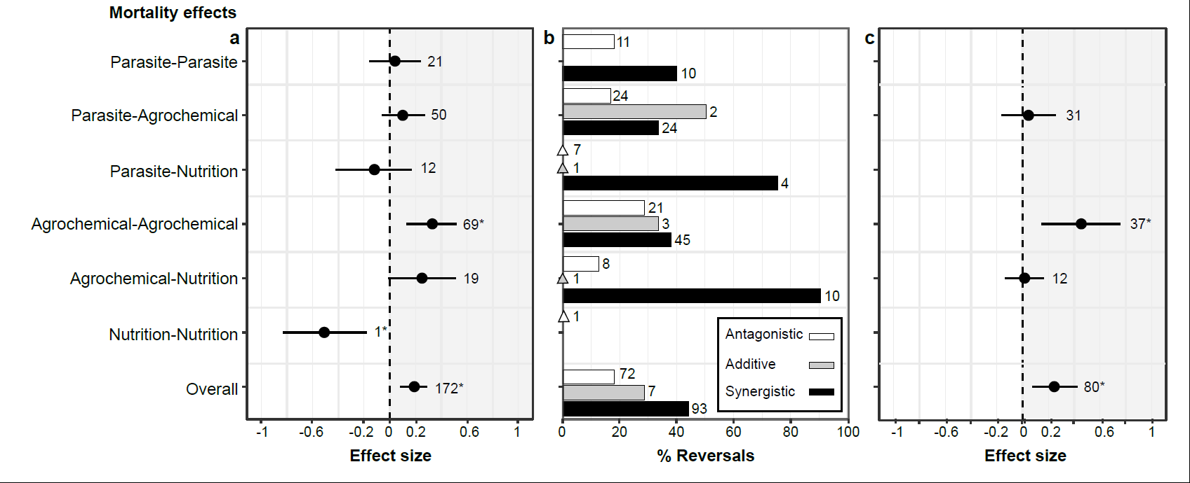
Figure 1: The interaction effects of parasites, agrochemicals, and nutritional stressors on bee mortality (A) Hedges’ d values (± 95% CI). Interactions are synergistic when effect size is positive and 95% CI does not include zero, antagonistic when effect size is negative and 95% CI does not include zero, and additive when 95% CI includes zero. Numbers next to confidence intervals indicate the number of effect sizes in each category. Asterisks indicate CI that do not include zero (B) The percentage of additive, antagonistic, and synergistic interactions between stressors that were reversal interactions (see methods). The fill indicates the type of interaction (see key). Triangles indicate interactions for which there were no reversals. Numbers indicate the total number of effect sizes within that category. (C) Hedges’ d values (± 95% CI) when bees are exposed to field realistic concentrations of agrochemicals.

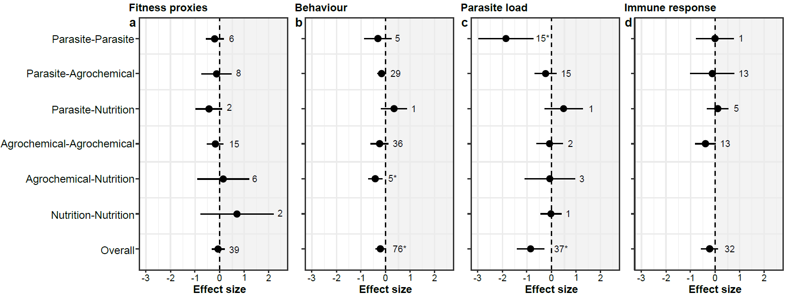
Figure 2: The interaction effects of parasites, agrochemicals, and nutritional stressors on non-mortality response measures. Hedges’ d values (±95 % CI) are shown for (A) bee fitness proxies, (B) behaviour, (C) parasite load, (D) immune response. Interactions are synergistic when effect size is positive and 95% CI does not include zero, antagonistic when effect size is negative and 95% CI does not include zero, and additive when 95% CI includes zero. Numbers next to confidence intervals indicate the number of effect sizes in each category. Asterisks indicate CI that do not include zero. Note that the scale is different to Figure 1.

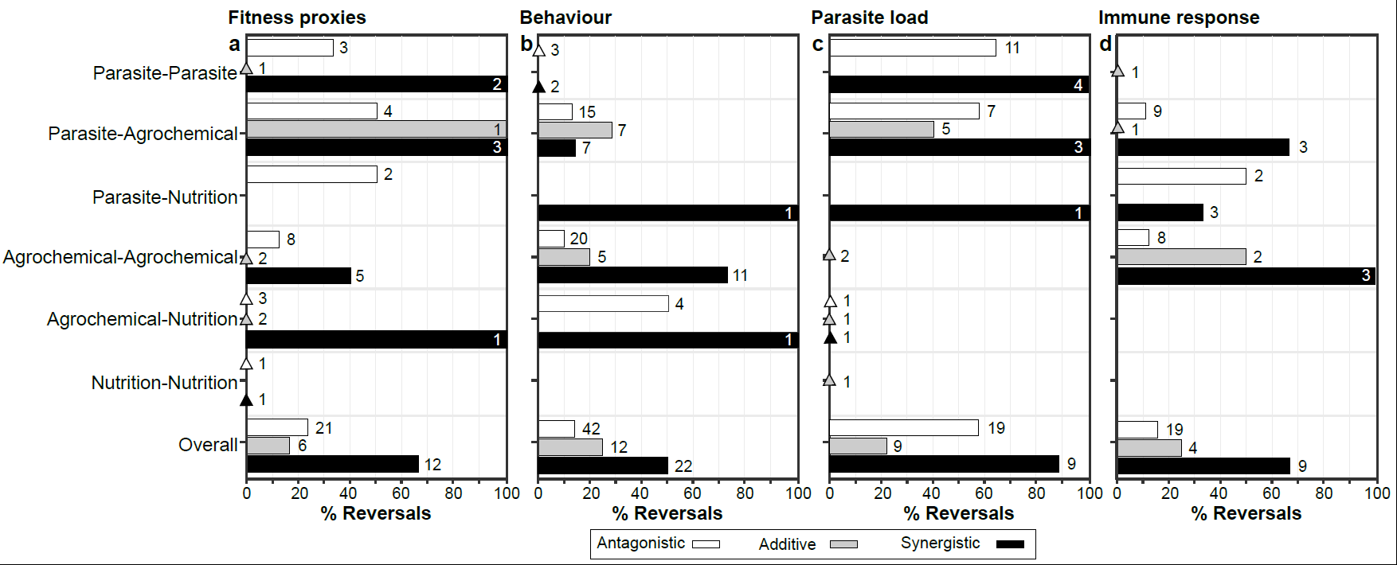
Figure 3: Reversal interactions. The percentage of additive, antagonistic, and synergistic interactions between stressors that were reversal interactions for (A) fitness proxies, (B) behaviour, (C) parasite load, (D) immune response. The fill indicates the type of interaction (see key). Triangles indicate interactions for which there were no reversals. Numbers indicate the total number of effect sizes within that category.

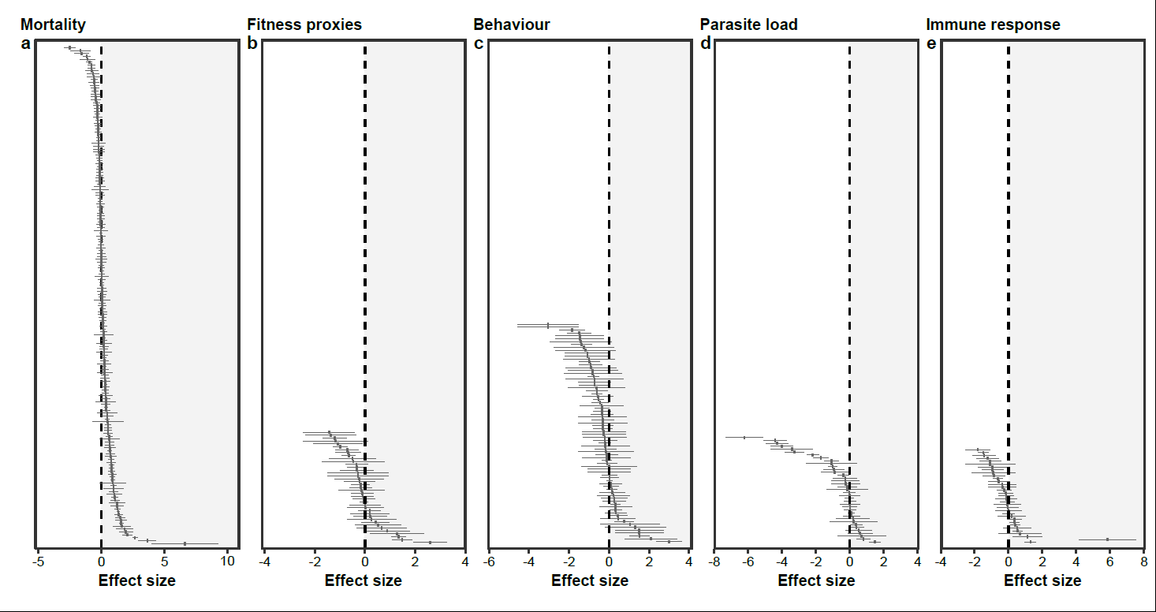
Extended data Figure 1: Distribution of Hedges’ d values (±CI) for the individual effect sizes included for the interaction effects of parasites, agrochemicals, and nutritional stressors for bee response variables: (A) mortality, (B), behaviour, (C) fitness, (D) parasite load, (E) immune response. Effect sizes are sorted for each response variable from most negative to most positive. Interactions are synergistic when effect size is positive and 95% CI does not include zero, antagonistic when effect size is negative and 95% CI does not include zero, and additive when 95% CI includes zero. Note that each subpart is presented on a different scale.

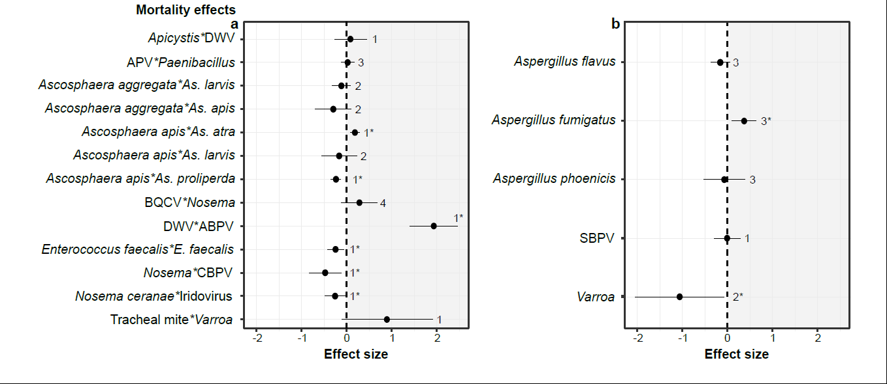
Extended data Figure 2: Hedges’ d values (±CI) for interactions between specific stressors on bee mortality. (A) combinations of parasite stressors, (B) combinations of parasite and nutritional stressors. Interactions are synergistic when effect size is positive and 95% CI does not include zero, antagonistic when effect size is negative and 95% CI does not include zero, and additive when 95% CI includes zero. Numbers next to confidence intervals indicate the number of effect sizes in each category. Asterisks indicate CI that do not include zero.

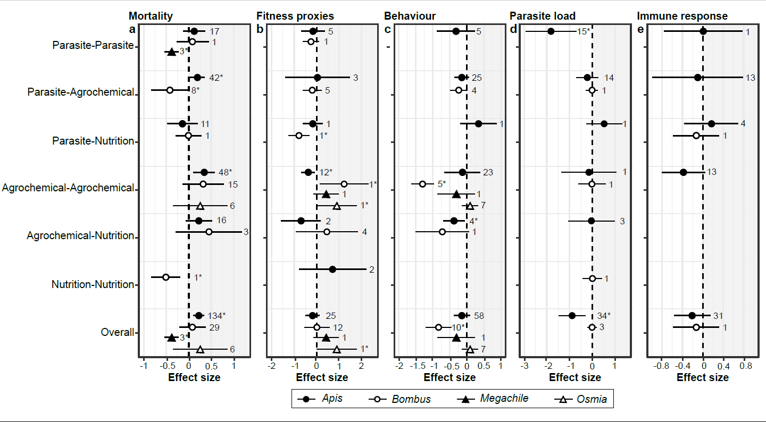
Extended data Figure 3: Hedges’ d values (±CI) for different bee genera. Data are shown for (A) mortality, (B) behaviour, (C) fitness proxies, (D) parasite load, (E) immune responses. Genus is indicated by shading and symbol shape. Interactions are synergistic when effect size is positive and 95% CI does not include zero, antagonistic when effect size is negative and 95% CI does not include zero, and additive when 95% CI includes zero. Numbers next to confidence intervals indicate the number of effect sizes in each category. Asterisks indicate CI that do not include zero. Note that each subpart is presented on a different scale.
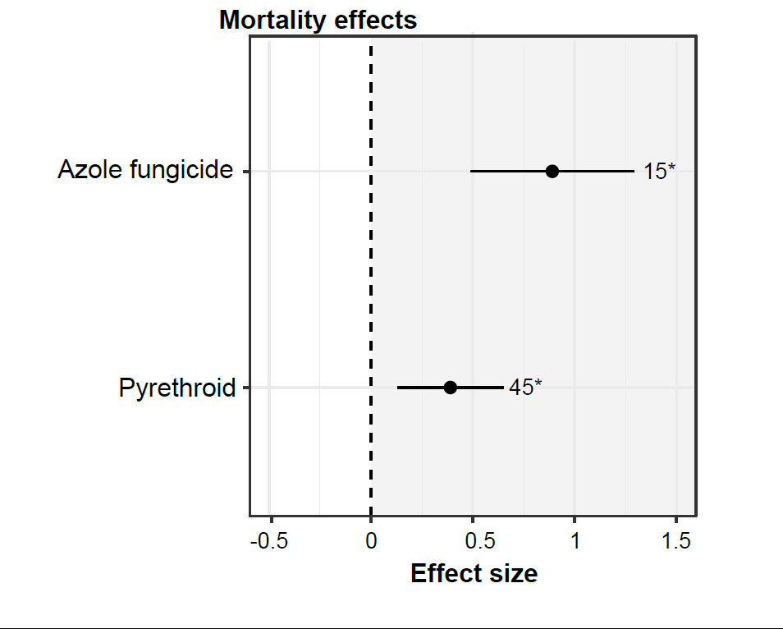
Extended data Figure 4: The interaction effects of different agrochemical classes on bee mortality response measures. Hedges’ d values (± 95% CI) are shown. Asterisks indicate CI that do not include zero. Numbers next to confidence intervals indicate the number of effect sizes in each category. Note that effect sizes for azole fungicide*pyrethroid are included in both groups.
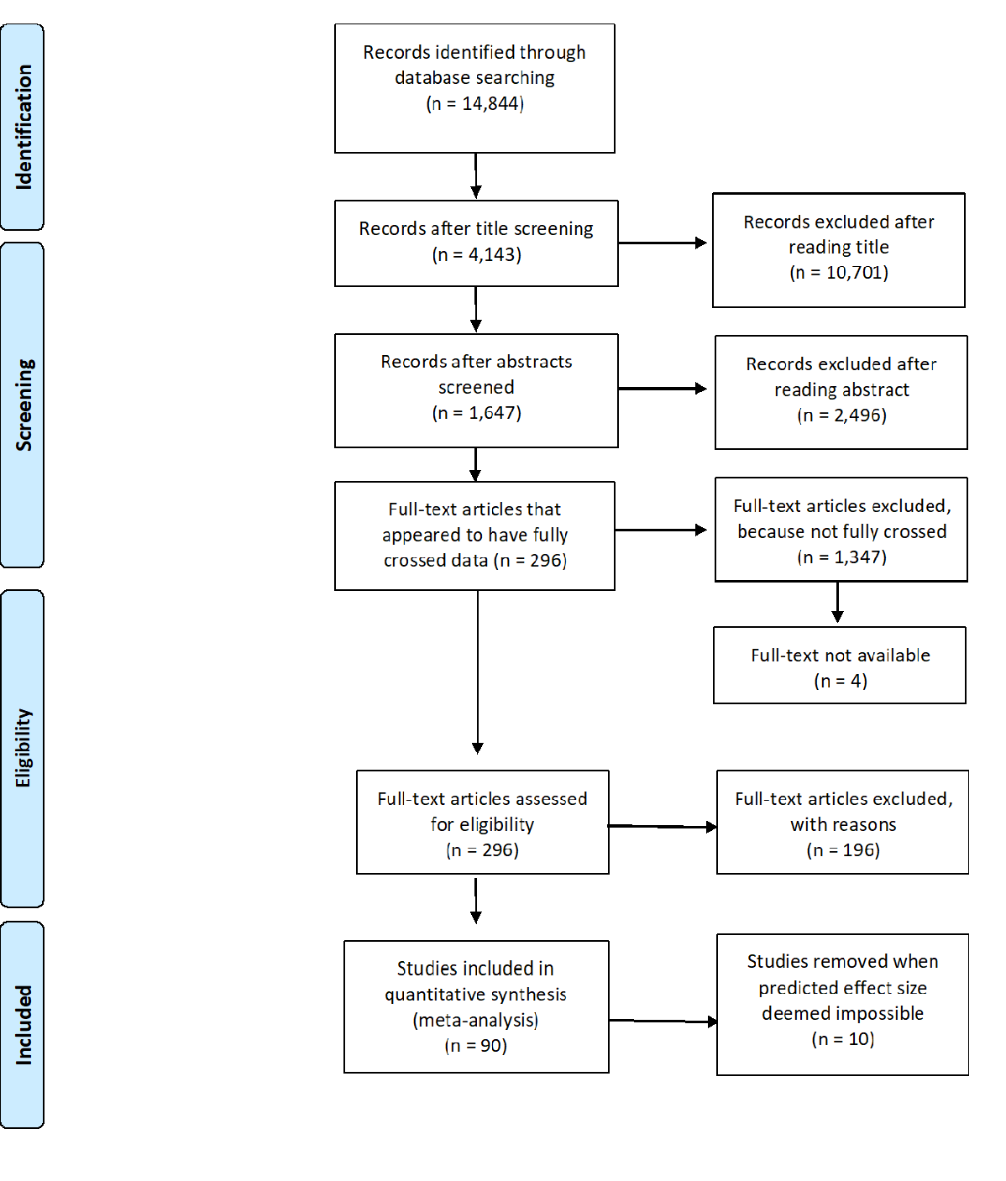
Extended data Figure 5: Modified PRISMA flowchart.

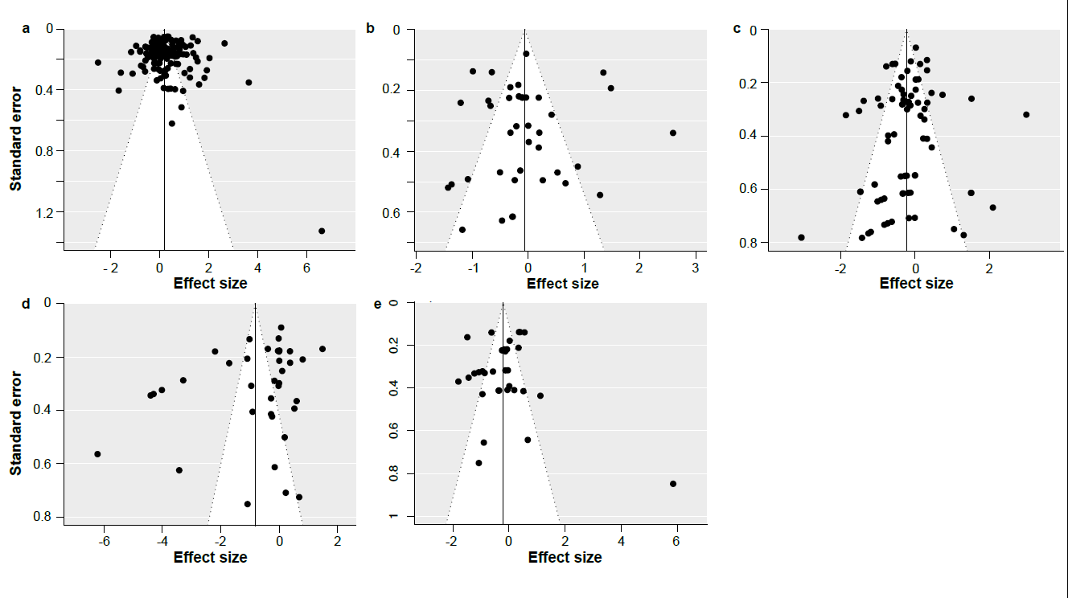
Extended data Figure 6: Funnel plots of the full models of the interactions between specific stressors. Plots represent the models for (A) mortality, (B) behaviour, (C) fitness proxies, (D) parasite load, (E) immune response.

