Are Value-Behavior Relations Stronger than Previously Thought?
It depends on value importance

Lee, J. A., Bardi, A., Gerrans, P., Sneddon, J., van Herk, H., Evers, U., & Schwartz, S. (in press). Are Value-Behavior Relations Stronger than Previously Thought? It depends on value importance. European journal of personality.

Authors’ Note: This research was funded by an Australian Research Council Linkage grant in partnership with Pureprofile (Project LP150100434). All authors contributed to conceptualization and manuscript writing. In addition, Julie Lee was responsible for the methodology and data curation, Paul Gerrans for the software and quantile analyses, and Hester van Herk for the polynomial analyses.

* Corresponding Author: Julie Anne Lee, Centre for Human and Cultural Values, University of Western Australia, Perth, Western Australia, 6009, Australia; phone +61 8 64882912; email Julie.lee@uwa.edu.au

Abstract
Research has found that value-behavior relations are usually weak to moderate. But is this really the case? This paper proposes that the relations of personal values to behavior are stronger at higher levels of value importance and weaker at lower levels. In a large, heterogeneous sample, we tested this proposition by estimating quantile correlations between values and self-reported everyday behavior at different locations along the distribution of value importance. We found the proposed pattern both for self-reports of everyday behaviors chosen intentionally to be value-expressive and everyday behaviors subject to strong situational constraints (e.g., spending allocation to clothing and footwear). Our findings suggest that value-behavior relations may be stronger than previously recognized, depending on value importance. People who attribute high importance to a value will not only engage in value-expressive behaviors more frequently, but as we move up the value importance distribution, the relations strengthen. In contrast, people who attribute low importance to a value not only engage in value-expressive behaviors less frequently, but as we move down the value importance distribution, the relations weaken. These findings provide important insight into the nature of values.

Keywords: Human values; value-expressive behavior; value-behavior relations; quantile correlations
The Role of Value Importance in the Relationship Between Values and Behavior
Many people seem to assume that personal values motivate behavior. This assumption may have stemmed from observations that people’s behaviors often appear to be consistent with the values they verbally express. For example, we may observe that a person who parties a lot also verbally endorses hedonism values. In contrast to this lay assumption, empirical studies have typically found weak value-behavior correlations, even when behaviors are measured by self-reports (Cieciuch, 2017). The gap between this assumption and research findings may signify that people’s assumptions are wrong. Alternatively, it is possible that lay people’s assumption of a value-behavior link is based on observations of people who behave consistently according to a value that is highly important to them. However, to the best of our knowledge, past research has ignored the possibility that value importance may have a role in value-behavior relations.
In this paper, we propose that value-behavior associations are not only non-linear, but that they vary systematically across the value importance distribution. Specifically, we expected to find stronger associations in the upper ranges of value importance and weaker associations in the lower ranges of value importance. To test our proposition, we adopted the recently developed method of quantile correlation (Choi & Shin, 2018; Li et al., 2015). This method enabled us to assess value-behavior relations at different points along a value’s distribution of importance, thereby providing a more complete picture of value-behavior relations than currently exists.
Value-Behavior Relations
Individuals’ values (e.g., benevolence, power) express the important, broad life goals that serve as guiding principles in their lives (e.g., Schwartz, 1992). People’s value priorities have been found to be relatively stable, with research showing little change throughout adulthood (Schuster et al., 2019). Moreover, values are thought to transcend specific situations and contexts (Schwartz, 1992). This suggests that, for example, a person who prioritizes benevolence values tends to prioritize being kind across time and in different relationships.
Values are by nature socially positive (Rokeach, 1973). However, the degree of importance people attribute to different values, and the priority they give to one value over another, has been found to vary across individuals (e.g., Schwartz, 1992). Thus, one person may prioritize stimulation values over security values, whereas another may prioritize security values over stimulation values. These differences in priorities may influence how people perceive and interpret situations and hence behave (Schwartz, 2015).
Studies of value-behavior relations have typically used carefully selected everyday behaviors presumed to express primarily one value. For example, the behavior item ‘Do[ing] risky things for the thrill of it’ was selected to express primarily stimulation values and the behavior item ‘Avoid[ing] walking alone on a dark street at night’ was selected to express primarily security values (Schwartz & Butenko, 2014). Selecting such behaviors makes it easier to specify the expected predictor values, providing the best chance of finding strong value-behavior relations. Nonetheless, the strength of observed relations, even when using self-reported behaviors, has typically been small to medium (see Bardi & Schwartz, 2003; Schwartz & Butenko, 2014; Schwartz et al., 2017).
There are many reasons why value-behavior relations may not have been found to be as strong as people tend to assume. First, values are only one of the many internal and external factors that may drive any behavior. Values are relatively broad and abstract aspects of the self, whereas behaviors are specific and concrete actions (Bardi & Schwartz, 2003). A lack of knowledge or ability or resources to act, together with situational or time constraints, may influence the enactment of a behavior. Second, multiple values can motivate any single behavior and, conversely, people can express any value through different behaviors (Schwartz, 2015). Third, even if a given value does motivate a person, the appropriate behavior may not come to mind (Verplanken & Holland, 2002), or may not be perceived as an expression of the value (Maio et al., 2009; Hanel et al., 2018). Fourth, normative pressures may weaken relations between values and behavior (Bardi & Schwartz, 2003). People may comply behaviorally with normatively expected values even when they do not prioritize those values, and people may comply with normatively expected behaviors even when their own values are not compatible with those behaviors. Value-behavior researchers have designed many studies in ways that attempted to overcome such factors (e.g., Eyal et al., 2009; Verplanken & Holland, 2002). Nonetheless, the usual value-behavior associations they have found, though often significant in the predicted direction, are rather weak.
Past research has overlooked the possibility that the strength of value-behavior relations may vary at different points along the value’s distribution of importance. In this paper, we propose that the links between values and behavior are stronger in the upper ranges of the distribution of value importance and weaker in the lower ranges. This proposition does not simply imply that greater frequency of the behavior accompanies higher levels of value importance, as would be expected with a linear correlation (e.g., Pearson). Rather, this proposition also implies that value-behavior relations should be stronger at higher levels of value importance and weaker at lower levels of value importance. Thus, an increase in value scores at higher levels of value importance should accompany a greater positive increase in value-expressive behavior than an equivalent increase at lower levels of value importance. Testing the proposition that value-behavior relations are stronger at higher levels of value importance and weaker at lower levels requires a different statistical approach from those used previously in the value-behavior literature.
Psychological research has commonly used linear models to estimate average associations or differences among group means (e.g., correlation, ordinary least squares regression (OLS), analysis of variance, and multilevel linear models). These models focus on the conditional mean of an outcome as a linear function of explanatory variables, to estimate a single relationship for each predictor. OLS can include polynomials to capture non-linear relations, but this nonetheless remains a model of the conditional mean of the outcome on these predictors, again estimating the average relations for each predictor. Thus, it cannot test whether value-behavior relations are stronger at higher levels of value importance and weaker at lower levels, as we propose. In contrast, quantile techniques, used in this paper, allow the estimation of relations at different points along the distribution of a variable of interest (see the Appendix for a discussion and comparison of OLS regression and the quantile technique we used in this paper).
The Current Research
Evidence that supports the idea that values motivate behavior far more strongly above a certain threshold of value importance can contribute to our understanding of the nature of values and value-behavior relations. We provide the first evidence of this by testing our proposition in a diverse sample of adults aged 18 and 75 years, across two very different types of self-reported behavior. Part 1 investigated everyday self-reported behaviors presumed to express primarily one value, that is, value-expressive behaviors (Bardi & Schwartz, 2003). We examined the strength of association between 20 refined values and a validated measure of such behaviors (Schwartz & Butenko, 2014; Schwartz et al., 2017). Part 2 investigated the allocation of monthly expenditure to specific value-expressive categories. Purchasing behaviors are vulnerable to strong situational constraints (e.g., resource scarcity, choice restrictions, social coordination, and environmental uncertainty; Hamilton et al., 2019). We asked whether situationally constrained behaviors exhibit the expected pattern of varying correlations along the distribution of value importance. Specifically, Part 2 examined the strength of association of (1) the broad value of self-enhancement with spending allocated to clothing and footwear and (2) the broad value of openness to change with spending allocated to recreation. The hypotheses were not pre-registered.
Method
The current study was part of a larger project that examined value-behavior relations across the adult lifespan (18 to 75 years of age). The surveys used in the current study were administered to respondents over several weeks in mid-2017, as part of a series of 5 to 10 minute online surveys. The first survey in the series measured respondents’ personal values, the fourth survey measured self-reports of their everyday behaviors, and the fifth survey measured self-reports of their monthly expenditure allocation to 11 spending categories. Between the first and fourth surveys, respondents answered questions about a wide range of traits and states and about how they spend their time. The use of a series of short surveys over time was designed to reduce respondent fatigue and common method bias (Hulland et al., 2018). All surveys including those not relevant to this study can be viewed by following this link: https://osf.io/w6uen/. They were all approved by The University of Western Australia Human Ethics Committee.
Analytical Strategy
We tested whether relations between values and self-reported value-expressive behavior differ across the distribution of value importance by estimating quantile correlations following the method of Choi and Shin (2018). Quantile correlation conditions the analysis on different points along the value’s importance distribution to investigate different sensitivities or strength of relations at higher and lower levels of value importance. We examined and compared these relations at nine different quantiles (i.e., .1, .2, …, .9) of value importance. This method extends the idea of estimating relations using subsets of data (e.g., the highest quartile), but importantly includes all the data in the estimation for each quantile (see Appendix for details). Thus, it avoids splitting the data into subsets on the variable of interest which “would yield disastrous results” (Koenker & Hallock, 2001, p.147).
We first estimated the quantile regression coefficients necessary to estimate quantile correlations, using the quantile regression function (qreg) in Stata 16 (StataCorp, 2019). Each quantile (τ) correlation coefficient ($ρ_{τ}$) is the geometric mean of the two quantile regression slopes, $β_{XY}^{τ}$ (i.e, X on Y) and $β_{YX}^{τ}$ (i.e., Y on X) calculated with Equation 1.
${ ρ}_{τ}=sign\left(β_{XY}^{τ}\right)\sqrt{β_{XY}^{τ}.β_{YX}^{τ}}$ 1
The quantile correlation coefficient is τ specific. It ranges between -1 and +1, and can be interpreted like the Pearson correlation coefficient.
Quantile analysis can be done on non-continuous psychological data, but it was designed for random sampling of truly continuous variables (e.g., temperature and prices). To prepare non-continuous psychological data, such as Likert scales and behavior counts, requires small adjustments to the data. This can be done by adding random noise to smooth discrete points in the data. We used the approach of Machado and Silva (2005), adding a small uniformly distributed noise to the raw value scores, in order to avoid the potentially “deleterious effects of degenerate solutions” (Koenker, 2019, p. 20). Specifically, we introduced a random small perturbation to each value importance score. The perturbations had a mean of zero and standard deviation equal to .2 times the smallest distance between the unique scores for each value. The addition of this noise served the purpose well. It increased the continuity of scores while leaving them indistinguishable, on average, from the raw scores.
We used bootstrapping to estimate 95% confidence intervals conditioned around each quantile (i.e., .1, .2, …, .9) to assess differences in value-behavior correlations across quantiles. Specifically, we drew 1000 samples with replacement from the original data set (cf. Kirby & Gerlanc, 2017 on bootstrapping). We compared each quantile correlation with the median (.5 quantile) correlation. We adjusted confidence intervals to be consistent with the method of Zou (2007). All code and data used to produce these results can be accessed for this project at the following link: https://osf.io/vejwp/?view_only=c8aea5dd657f47a3af99f0295c4b7f6a
The required sample size for quantile correlation depends on the chosen quantiles examined, the effect size, and distribution of the data. To estimate the necessary sample size, we used the R function, power.rq.test (Gong, 2016), that assesses adequacy of sample size for quantile regression. We chose a power value of .80 and a p-value of .05, with a normal distribution (see Cohen, 1992), as these are commonly used in psychological research. In our analyses, the samples met the sample size requirement for estimating the quantile correlations (see Supplementary Materials pp.1-3 and Table S1 for details).
Part 1
As the first test of our proposition, we chose behaviors with a clear conceptual link to one value. Specifically, we tested relations between the refined values (Lee et al., 2019; Schwartz, et al., 2012) and the corresponding self-reported value-expressive behaviors at different points along the value importance distribution.
Participants and Procedures
In this part of the study, 6023 Australian adults completed the two surveys. Of these, 5,348 (62% women; M_{age} = 48.5 years, SD = 15.6) provided reliable values data, as indicated in the Measures section. The respondents were citizens (91%) or residents (9%) of Australia, with 76% born in the Oceania region, 14% in Europe and 7% in Asia. The occupational distribution of respondents was 53% in paid employment, 22% retired, 13% homemakers, 7% unemployed, and 5% students. Most respondents had a post high school education; 35% had a trade certificate or diploma, 20% an undergraduate degree, and 13% a graduate diploma or degree. The median household income was between A$55,000 and A$59,999.
We drew upon data from two separate survey modules (i.e., the first and fourth in the series); the first on personal values and the fourth on value-expressive behavior. The two survey modules were administered an average of 13 days apart.
Measures
Values. We measured respondents’ values with the Schwartz Refined Values Best Worst Survey (BWVr: Lee et al., 2019). The BWVr instrument asks participants to choose the most and the least important values from 21 value sets derived from a Youden balanced incomplete block experimental design. This design ensures that all value items appear five times and every pair of items appears together once across all sets. In best-worst scaling, the latent value of a construct is estimated based on the choice frequencies (Louviere et al., 2015).
Prior to scoring the value items, we assessed the reliability of respondents’ value choices by examining the number of times each value was chosen as most important by each individual. In best-worst scaling reliability of the data can be assessed by examining the consistency of choice. Specifically, we considered responses to be reliable when respondents chose at least one value-item as most important four or five of the five times it appeared across all sets. Of the 6,023 people who responded to the values survey, 675 respondents (11%) did not meet this criterion and were excluded from the analysis, leaving 5,348 respondents. The respondents we included also appeared to be more diligent than those we excluded in their responses to the other surveys. For instance, respondents identified as reliable took significantly more time to answer the value-expressive behavior survey (median = 701 seconds) than those who were not (median = 376 seconds; p < .001).
To calculate relative importance scores for the 20 refined values, we used the square root of the ratio of most-to-least counts (see Lee et al., 2008). We chose this method of scoring because it produces more scale points than other scoring procedures (Louviere et al., 2015). We calculated the square root of the best-worst ratio for value j as in equation 2:
$SVBWS score V_{j}=\frac{1}{S}\sum_{s=1}^{S}{\sqrt{\frac{{Best}_{v_{j}}}{{Worst}_{v_{j}}}}}$ 2
where V_{j} is the score for each value, v_{j} is the score for the j^{th} value and Best v_{j} is the weighted sum representing the most important score for the j^{th} value in a set. This scoring method produced a 20 point-scale ranging from 0.25 to 4.00.
Behavioral self-reports. Respondents indicated how often they had performed each behavior in an expanded version of the Schwartz and Butenko’s (2014) 85-item Everyday Behavior Questionnaire (e.g., Comply with deadlines, attendance rules, dress codes and schedules at my work or school; Collect food, clothing, or other things for needy families). We added six items designed to measure behaviors expressive of the universalism-animals value (e.g., Avoid buying items that are tested on animals) from Lee and colleagues (2019). These instruments have been used successfully in five countries (e.g., Lee et al., 2019; Schwartz et al., 2017).
Respondents reported how often they engaged in each behavior during the past 12 months, relative to their opportunities to do so. The 5-point response scale was labelled 0 (never), 1 (rarely--about a quarter of the times), 2 (sometimes--about half of the times), 3 (usually--more than half the times), and 4 (always). Three to six items in the behavior survey were intended to express each value. We centered individuals’ responses to each item around that person’s mean response across their behaviors. We then averaged the responses to the items intended to express each refined value to form indices of the relevant behavioral tendency. Centering reduced possible individual differences in activity levels and in acquiescence bias (see Bardi & Schwartz, 2003). Averaging behaviors from different situations to capture a behavior tendency reduced the effects of situation specific constraints.

Results
Figure 1 graphically presents the results of Pearson correlations (OLS) and of quantile correlations for value-behavior relations, together with their 95% confidence intervals. The solid black horizontal line and corresponding dotted lines show the Pearson correlations and their confidence intervals. The x-axis shows the quantiles of value importance that we report. The solid red line represents the estimated quantile correlations at these conditional quantiles (i.e., .1, .2, …, .8, .9), with the grey shading representing their 95% confidence intervals. Each plot allows us to compare the Pearson correlation with the quantile correlations across the entire distribution of value importance.
Figure 1 about here
The graphs in Figure 1 show that value-behavior relations vary across the distribution of value importance in almost every case. Figure 1 presents the values in the order of the strength of their Pearson correlations, as the expected pattern appeared to be most consistent when value-behavior relations were stronger. As expected, value-behavior relations tend to be stronger at higher levels of value importance, and weaker at lower levels, than at “average” levels. This expected pattern can be seen in 17 of the 20 graphs. To illustrate the pattern of relations, we describe the plot for the universalism-animals value and associated behaviors (see Figure 1, column 1, row 1). In this case, the Pearson correlation (r = .551), shown as a solid black horizontal line, clearly underestimated relations at the higher levels of value importance (e.g., at the .9 quantile the τ correlation coefficient $ρ_{τ}$ = .738) and clearly overestimated relations at lower levels of value importance (e.g., at the .1 quantile $ρ_{τ}$ = .334).
Table 1 provides the estimated Pearson correlation with their confidence intervals and the quantile correlations. In addition, tests of the differences between the median (τ =.5) quantile correlation and all other quantile correlations are reported. For each value, the first row presents the estimated correlations between the value and its value-expressive behavior. The two rows under each quantile correlation list the bootstrapped 95% confidence intervals for the difference between the median and all other quantile correlations. If the confidence intervals do not include zero, the quantile correlation differs significantly from the median correlation. Quantile correlations highlighted in green are significantly stronger, and those in yellow are significantly weaker, than the median correlation.
Table 1 about here
To illustrate the nature of value-behavior relations along the distribution of value importance, we again consider the universalism-animals value at the top of Table 1. Its median correlation (i.e., at the .5 quantile the τ correlation coefficient $ρ_{τ}$ = .475) was significantly weaker than the quantile correlations at the .6 ($ρ_{τ}$ = .545), .7 ($ρ_{τ}$ = .613), .8 ($ρ_{τ}$ = .674) and .9 ($ρ_{τ}$ = .738) quantiles. It was also significantly stronger than the quantile correlations at the .1 ($ρ_{τ}$ = .334), .2 ($ρ_{τ}$ = .332), .3 ($ρ_{τ}$ = .331), and .4 ($ρ_{τ}$ = .397) quantiles. Further, only one quantile correlation (at the .6 quantile) was not significantly different from the Pearson correlation, which showed the same pattern of differences in the strength of relations as with the median.
Overall, Table 1 shows that value-behavior relations were stronger in 75% of the top two quantiles (.8 and .9), and 73% of the top three quantiles (.7, .8, and .9), than at the median. Moreover, value-behavior relations were weaker in 78% of the bottom two quantiles (.1 and .2), and 73% of the bottom three quantiles (.1 to .3), than at the median. Taken together, these results demonstrate the substantial gain in information afforded by examining value-behavior relations along the distribution of value importance.
As a comparison point, we also examined the results of polynomial regression to assess whether non-linear patterns of value-behavior relations can be found with this method (see Section 3 in the Supplementary Materials). In Table S2, it can be seen that OLS polynomial regression detected some form of non-linear relations (p < .05) in 16 of the 20 analyses. In Figure S1, it can be seen that the general overall expected pattern can be found in most cases. Nonetheless, using quantile correlations results in a richer and therefore more informative result regarding how the strength of the relations between values and behaviors changes along the value importance distribution.
Discussion
The results supported our proposition that value-behavior relations are stronger at higher and weaker at lower levels of value importance. We observed this expected pattern in 17 of the 20 value-behavior relations examined in Part 1. We briefly mention two possible reasons for the three exceptions and elaborate upon them in the General Discussion. In the case of the two benevolence values (caring and dependability), strong normative pressures to promote the welfare of family and friends may have induced most people, not just those who prioritize benevolence highly, to behave in ways consistent with these values. Second, where a value correlates relatively weakly with the behaviors expected to express it, as with security-societal, the behavioral items may not have been appropriate to capture the behavioral tendency in the study sample (i.e., Australians).
These findings go beyond what we know about values and their expression. They not only show that higher levels of value importance were accompanied by greater frequency of the behavior, as linear correlations signify, but also show that correlations between values and behavior were stronger at higher levels of value importance and weaker at lower levels. This provides a novel and more complete understanding of how values may relate to their associated expressive behaviors. In the next part of the paper, we examined whether the same pattern of relations was also found in everyday behaviors that have stronger situational constraints.
Part 2
Part 1 assessed the proposed pattern of variation in value-behavior relations across the value importance distribution with a validated measure of value-expressive behaviors, designed to be conceptually linked primarily with one value. In contrast, Part 2 assessed our proposition with behaviors vulnerable to strong situational constraints (e.g., resource scarcity, choice restrictions, social coordination, and environmental uncertainty; Hamilton et al., 2019). We asked whether, even when situational constraints are likely to weaken value-behavior associations, relations of values to behavior are stronger at higher and weaker at lower levels along the value importance continuum.
We examined the self-reported proportion of monthly expenditure people allocate to two value-expressive categories: (1) clothing and footwear and (2) recreation, in a subsample of the original respondents. We chose these categories because we expected them to express different values. Specifically, we expected the proportion of total monthly expenditure allocated to clothing and footwear to relate most strongly to values that emphasize maintaining, demonstrating, and protecting one’s social status and prestige (i.e., self-enhancement values). These values have been positively associated with materialism (e.g., Burroughs & Rindfleisch, 2002; Kilbourne et al., 2005; Kilbourne & LaForge, 2010) and with purchasing luxury brands (e.g., Roux et al., 2017). Thus, we expected people who ascribe higher importance to self-enhancement values to allocate a larger proportion of their total monthly expenditure to clothing and footwear, as a way of signaling their status. Crucially, our proposition postulates that these value-behavior correlations will also be stronger at higher levels and weaker at lower levels of the self-enhancement value importance distribution.
Similarly, we expected the proportion of total monthly expenditure allocated to recreation to relate most strongly to values that emphasize novelty, excitement, fun, and independent thought and action (i.e., openness to change values). These values have been positively associated with the frequency of leisure activities (e.g., visiting art museums: Luckerhoff et al., 2008) and with higher levels of optimum stimulation (Steenkamp & Burgess, 2002). We therefore expected people who ascribe higher importance to openness to change values to allocate a larger proportion of their total monthly expenditure to recreational activities, as a way of attaining their valued goals. Crucially, our proposition postulates that these value-behavior correlations would also be stronger at higher and weaker at lower levels of the openness to change value importance distribution.
Participants and Procedures
Of the 5,545 Australian adults who completed the fifth survey module, designed to elicit the allocation of monthly expenditure to each of 11 categories, 4902 provided reliable values data, as indicated in the Measures section. Their characteristics were almost identical with those reported in Part 1, as would be expected given the overlap in respondents. In this part of the paper, we focus on respondents who answered the first survey on personal values and the fifth survey on the allocation of monthly expenditure, including clothing and footwear and recreation. These surveys were administered an average of 20 days apart.
Measures
Values. Respondents’ values were measured with the Schwartz Refined Values Best Worst Survey (BWVr: Lee et al., 2019) as in Part 1, and scored in the same manner. We used the basic values to calculate the higher order values, following Schwartz and colleagues (2012). Specifically, we computed the broad value of self-enhancement by averaging the basic values of power and achievement and the broad value of openness to change by averaging the self-direction and stimulation values.
As in Part 1, we assessed the reliability of respondents’ value-item choices to identify respondents who were less consistent in their value choices. Of the 5,545 people who responded to the values survey, 643 respondents (12%) did not meet the reliability criterion identified in Part 1 and were excluded from the analysis, leaving 4,902 respondents.
Self-reported spending allocation. Respondents were asked to report their average monthly expenditure allocation to 11 major spending categories, selected from the Australian Bureau of Statistics household expenditure survey (Australian Bureau of Statistics, 2017). Specifically, respondents indicated how much money, to the nearest dollar, they currently allocate on average every month to each of 11 categories. We then calculated the proportion allocated to recreation and to clothing and footwear by dividing the expenditure in these two categories by the total allocated across all 11 categories.
Results and Discussion
Figure 2 graphically presents the results of Pearson correlations (OLS) and of quantile correlations for value-behavior relations, together with their 95% confidence intervals. Despite potentially strong situational constraints, the graphs in Figure 2 show the expected pattern of value-behavior relations along the distribution of value importance. As expected, value-behavior relations were stronger at higher, and weaker at lower levels, of value importance than at “average” levels. For example, for the relations between self-enhancement values and the proportion of monthly expenditure allocated to clothing and footwear, the Pearson correlation (r = .090) underestimated relations at higher levels of value importance (.8 and .9 quantiles) and overestimated relations at lower levels of value importance (.1, .2, .3, .4, .5, and .6 quantiles). Similarly, for relations between openness to change values and proportion of monthly expenditure allocated to recreation, the Pearson correlation (r = .088) underestimated relations at higher levels of value importance (.8 and .9 quantiles) and overestimated relations at lower levels of value importance (.1, .2, and .3 quantiles).
Figure 2 about here
Table 2 provides the point estimate of the Pearson correlations and their confidence intervals, and the quantile correlations. As with Table 1, tests of the difference between the median (.5 quantile) and all other quantile correlations are reported. As in Part 1, the first row presents the estimated correlations between the values and related spending behavior. The two rows under each quantile correlation list the bootstrapped 95% confidence intervals for the difference between the median and all other quantile correlations. If the confidence intervals do not include zero, the quantile correlation differs significantly from the median correlation.
Table 2 about here
The median correlation between self-enhancement values and proportion of spending allocated to clothing and footwear (i.e., at the .5 quantile $ρ_{τ}$ = .052) was significantly weaker than the quantile correlations at the .7 ($ρ_{τ}$ = .091), .8 ($ρ_{τ}$ = .122), and .9 ($ρ_{τ}$ = .187) quantiles. The median correlation was also significantly stronger than the quantile correlations at the .1 ($ρ_{τ}$ = .000), .2 ($ρ_{τ}$ = .000), and .3 ($ρ_{τ}$ = .026) quantiles. Similarly, the median correlation (i.e., at the .5 quantile $ρ_{τ}$ = .081) between openness to change values and proportion of spending allocated to recreation was significantly weaker than the quantile correlations at the .8 ($ρ_{τ}$ = .149) and .9 ($ρ_{τ}$ = .172) quantiles and significantly stronger than the quantile correlations at the .1 ($ρ_{τ}$ = .000), .2 ($ρ_{τ}$= .000) and, .3 ($ρ_{τ}$ = .000) quantiles.
Although these results were more modest than those in Part 1, the patterns of relations still supported the key proposition of the Study that the correlations between values and behavior would be stronger at higher levels of value importance and weaker at lower levels of value importance. This goes beyond what the Pearson correlations convey, that there were positive relations between values and value-expressive behavior. It also goes beyond results from the polynomial regression, which in addition to linear effects finds a quadratic effect for spending allocation to clothing and footwear (see Table S3 and Figure S2). Thus, quantile correlation provided a more complete view of the relations between values and behavior even in contexts with strong situational constraints.
For both types of spending behavior the Pearson correlations found with the mean-centered approaches were so low that practitioners might be tempted to ignore values as factors in purchasing. Knowing, however, that the variance in money spent on these types of purchases increased by approximately 10% at higher levels of value importance might have significant implications for marketing.
General Discussion
We proposed that values may be more strongly related to behavior than was previously recognized. More specifically, we hypothesized that value-behavior correlations are stronger at higher levels, and weaker at lower levels, of the value importance distribution. Using the novel method of quantile correlation, we provided support for this proposition by examining self-reports of everyday behaviors chosen intentionally to be value-expressive and everyday behaviors subject to strong situational constraints (i.e., spending allocations to clothing and footwear and to recreation). Thus, our results provide insight into both value-behavior relations and the nature of values. That is, highly important values may motivate behavior more strongly than previously recognized. This insight suggests that similar patterns of associations may exist for the links of values to other related variables such as goals, attitudes. Studying these links with quantile correlation has the potential to advance substantially our understanding of how values relate to many other variables.
It is important, nonetheless, to note that there were some exceptions to the expected pattern of associations. While the proposed variation in the strength of value-behavior relations emerged in 17 of the 20 assessments in Part 1 and in both assessments in Part 2, these patterns were not evident in every case. We suggest possible theoretical and statistical explanations for the exceptions.
First, the proposed pattern may not occur in the presence of normative pressure. Bardi and Schwartz (2003) reported that value-behavior correlations were weaker for especially normative values and for behaviors that were especially common. Benevolence-dependability and benevolence-caring did not exhibit significantly stronger correlations at the higher quantiles than at the median in Part 1. These values were by far the two most normative values in our sample, as evidenced by the fact that their average ratings of value importance were the highest of all values. Thus, there was probably strong normative pressure to behave consistently with them and people may have felt less free to express their own values. Both those who attributed high importance to these two values and those who did not, are likely to behave consistently with them. The former do so as an expression of their own values, the latter do so because they comply with the normative pressure. Thus, normative pressures can attenuate or even eliminate the proposed variation in the strength of value-behavior relations across the importance distribution of a value.
The normative pressure argument may be especially relevant for benevolence-dependability, where both the value and value-expressive behavior had the highest mean levels in the sample. People who value conformity highly are particularly prone to normative influence (Lo¨nnqvist et al., 2006) and also likely to value benevolence. These people would occupy the moderate-high area in the benevolence values distributions, but perform benevolence behaviors with a higher than expected frequency, not because they value benevolence moderately, but because they value conformity highly and are more likely to succumb to normative pressures. This may explain the higher value-behavior correlations found in the moderate benevolence-dependability region.
Second, variation in the strength of correlation with a behavior across the importance distribution of a value is unlikely to occur for behaviors that are not truly expressive of the value. This may have been the problem with the security-societal value in Part 1. Its correlation was the weakest of all of the value-behavior relations in Table 1 (Pearson r = .136 and median .5 quantile $ρ_{τ}$ = .067). The behavioral indicators we adopted for security-societal were developed for a Russian sample (Schwartz & Butenko, 2014). These indicators may not have been value expressive for Australians at the time of the survey. For example, the item “In a conversation, speak in favor of maintaining a strong national defense” may have been less relevant in Australia than in countries with shared borders and/or ones that are exposed to recent or imminent conflicts. Behaviors that express security-societal values may vary greatly across countries, making it problematic to adopt them. Behaviors that are poor examples of a value in a context are unlikely to show the expected pattern of value-behavior relations. They are simply not value-expressive.
In summary, across two studies, measuring very different types of self-reported value-expressive behaviors, we provided the first evidence that people who ascribe high importance to a value will not only engage in value-expressive behaviors more frequently, but as we move up the value importance distribution, the relations strengthen. Moreover, people who ascribe low importance to a value not only engage in value-expressive behaviors less frequently, but as we move down the value importance distribution, the relations weaken. This provides a more complete picture of relations between values and behavior than previously recognized.
Limitations and Future Directions
Relying on self-reports of behavior is certainly less desirable than actual behaviors. It was necessary in this pioneering research in order to be able to reach large numbers of participants and to study 20 values and sets of expressive behaviors in Part 1. Moreover, most research on value-behavior relations has been done with self-reported behaviors, so the insights we derived are relevant to that vast body of research. Furthermore, past research has produced similar patterns of value-behavior correlations whether the behaviors studied were self-reported, other-reported, or actual. For example, actual selfish behavior in a money allocation experiment (Schwartz, 1996) had the same pattern of correlations with ten basic values as self-reported and other-reported selfish behaviors in a survey (Bardi & Schwartz, 2003). This suggests that the current findings are likely to apply to actual behaviors. Nonetheless, future research should seek to replicate our findings with actual behaviors.
A related limitation is our use of self-reports for both values and behavior. This may have amplified value-behavior correlations as respondents sought to be consistent. We tried to mitigate consistency effects by measuring values and behavior on separate occasions, approximately two weeks apart, and by having respondents complete at least two survey modules with different content during the intervening weeks. Further, the strength of the linear value-behavior correlations we obtained was similar to the correlations prevalent in the literature. This suggests that the postulated pattern we observed may have been present in many of those studies, too.
A growing number of psychological studies employ the quantile regression method to examine variability in the impact of individual difference characteristics along quantiles of a predicted variable (e.g., Dauvier et al., 2019; Dumas, 2018; Pargulski & Reynolds, 2017). The use of quantile correlations opens the door to examine variability in relations along quantiles of predictor variables, which may lead to new insights. For example, using quantile regression, Rogers and Joiner (2018) showed that relations of suicide risk factors to suicidal ideation were strong at higher quantiles of suicidal ideation, but weak or nonsignificant at median levels. By using quantile correlations, it would be possible to uncover whether the strength of these relations also varies along quantiles of suicide risk factors. Quantile correlation could also be used to uncover potential protective factors that reduce suicide risk-ideation relations. Further, many existing, large data sets include psychological constructs that could be re-examined with quantile correlations. This would be especially useful for understanding people who have scores far from the mean on psychological characteristics (e.g., highly neurotic individuals or very high and low achievers). Initial research of this type is likely to be exploratory, but our findings may help guide the formation of formal, pre-registered hypotheses.
Researchers are generally being encouraged to expand their populations of participants, both in terms of size and diversity, to improve the potential for generalizing findings (Kitayama, 2017). Not only does the current paper do this, but it also illustrates the importance of sample diversity. Relatively homogeneous samples, such as university students in a specific field (e.g., psychology students) may mask the effects we find in our sample if the studied values are of low importance in this population (e.g., tradition values). However, for values that tend to be highly important to students (e.g., self-direction values), we may witness an inflated value-behavior correlation compared to general populations. As illustrated by spending behavior in Part 2, at low levels of value importance, values sometimes have no perceptible association with behaviors that are presumed to express them, but at higher levels of value importance, they show stronger associations. This has implications for selecting appropriate samples and for explaining failures to replicate value-behavior relations in particular samples. For instance, universalism values tend to be especially important in West Europe but only moderately important in North America (Schwartz, 2006). Hence, relations of Universalism values to behavior found in West Europe may not replicate in samples from North America. Applying quantile correlation to re-examine past value-behavior studies may clarify why findings did or did not replicate across studies.
A note of caution is that the analyses of the more extreme quantile correlations can require relatively large sample sizes, depending on the relations between focal constructs and the standard deviations in the sample (see Section 2, Table S1 in the Supplementary Material). When large samples are not available, values researchers may draw on the current study to suggest where to focus the power they have. For instance, the current research suggests that a threshold for stronger value-behavior relations may be at or above the 70th percentile of the value importance distribution. Researchers might compare the quantile correlations estimated at .75, .5, and .25 on a focal value. However, where behavior is subject to strong situational pressures, such as the spending behaviour examined in Part 2, the examination of higher quantiles may be necessary. For instance, we expected and found low value-behavior correlations between self-enhancement and spending on clothing and footwear with Pearsons correlation (.090). It is therefore striking that the correlation in the highest quantile of self-enhancement (.187) was the same as the average median correlation (.19) between individual differences found across 708 meta-analytic correlations (Gignac & Szodorai, 2016).
Alternatively, researchers might compare individuals who ascribe their highest priority to a particular value (e.g., self-direction) with those who ascribe their highest priority to the opposing value (e.g., conformity). The value to which an individual ascribes highest priority may be especially important in guiding behavior. Although comparisons of extreme groups within a sample is not generally advised (Preacher et al., 2005), including this as an additional analyses may provide further information about value-behavior relations. As an illustration, in Part 2, those in the top quartile of the importance distribution of self-enhancement values allocated almost twice as much ($86) to clothing and footwear in a month as those in the bottom quartile ($49; t = 3.625, p < .001).
Conclusion
The current research revealed that the strength of value-behavior relations varied in a meaningful non-linear pattern. Knowing that value-behavior relations may be stronger at higher levels of value importance and weaker at lower levels is central to progress in the field of values research. We should no longer conclude that values relate only weakly to behavior as mean centered analyses suggest. Our results indicated that, when specific values are highly important to individuals, they seem to provide a much stronger guide for behavior than previously recognized.

Data Accessibility Statement
Materials can be accessed at https://osf.io/w6uen/
Scripts and Data can be accessed at https://osf.io/vejwp/?view_only=c8aea5dd657f47a3af99f0295c4b7f6a
References
Australian Bureau of Statistics (2017). Household Expenditure Survey and Survey of Income and Housing, User Guide, Australia, 2015-16. http://www.abs.gov.au/ausstats/abs@.nsf/mf/6503.0
Bardi, A., & Schwartz, S. H. (2003). Values and behavior: Strength and structure of relations. Personality and Social Psychology Bulletin, 29(10), 1207-1220. https://doi.org/10.1177/0146167203254602
Burroughs, J.E., & Rindfleisch, A. (2002). Materialism and well-being: a conflicting values perspective. Journal of Consumer Research, 29(3), 348–70. https://doi.org/10.1086/344429
Cameron, A. C., & Trivedi, P. K. (2009). Microeconometrics using stata (Vol. 5, p. 706). Stata press.
Choi, J-E., & Shin, D.W. (2018). Quantile correlation coefficient: a new tail dependence measure. https://arxiv.org/abs/1803.06200
Cieciuch, J. (2017). Exploring the complicated relationship between values and behavior. In Roccas S., Sagiv L. (eds) Values and behavior (pp. 237-247). Springer. https://doi.org/10.1007/978-3-319-56352-7_11
Cohen, J. (1992). A power primer. Psychological Bulletin, 112(1), 155. https://doi.org/10.1037/0033-2909.112.1.155
Dauvier, B., Pavani, J-B., Le Vigouroux, S., Kop, J-L., & Congard, A. (2019). The interactive effect of neuroticism and extraversion on the daily variability of affective states, Journal of Research in Personality, 78, 1-15. https://doi.org/10.1016/j.jrp.2018.10.007
Dumas, D. (2018). Relational reasoning and divergent thinking: An examination of the threshold hypothesis with quantile regression. Contemporary Educational Psychology, 53, 1-14. https://doi.org/10.1016/j.cedpsych.2018.01.003
Eyal, T., Sagristano, M. D., Trope, Y., Liberman, N., & Chaiken, S. (2009). When values matter: Expressing values in behavioral intentions for the near vs. distant future. Journal of Experimental Social Psychology, 45(1), 35–43. https://doi.org/10.1016/j.jesp.2008.07.023
Gong, Z. (2016). Estimation of Sample Size and Power for Quantile Regression (Doctoral dissertation), Queen’s University Kingston.
Hamilton, R. W., Mittal, C., Shah, A., Thompson, D. V., & Griskevicius, V. (2019). How financial constraints influence consumer behavior: An integrative framework. Journal of Consumer Psychology, 29(2), 285-305. https://doi.org/10.1002/jcpy.1074
Hanel P., Maio G. R., Soares A., Vione K. C., de Holanda Coelho, G. L., Gouveia V. V., Patil, A. C., Kamble, S. V., & Manstead, A. S. R. (2018). Cross-cultural differences and similarities in human value instantiation. Frontiers in Psychology, 9, 849. https://doi.org/10.3389/fpsyg.2018.00849
Hulland, J., Baumgartner, H., & Smith, K. M. (2018). Marketing survey research best practices: evidence and recommendations from a review of JAMS articles. Journal of the Academy of Marketing Science, 46(1), 92-108. https://doi.org/10.1007/s11747-017-0532-y
Kilbourne, W., Grünhagen, M., & Foley, J. (2005). A cross-cultural examination of the relationship between materialism and individual values. Journal of Economic Psychology, 26(5), 624-641. https://doi.org/10.1016/j.joep.2004.12.009
Kilbourne, W. E., & LaForge, M. C. (2010). Materialism and its relationship to individual values. Psychology & Marketing, 27(8), 780-798. https://doi.org/10.1002/mar.20357
Kirby, K. N., & Gerlanc, D. (2017). Finding bootstrap confidence intervals for effect sizes with BootES. APS Observer, 30(3).
Kitayama, S. (2017). Journal of Personality and Social Psychology: Attitudes and social cognition [Editorial]. Journal of Personality and Social Psychology, 112(3), 357-360. https://doi.org/10.1037/pspa0000077
Koenker, R. (2019). Package ‘quantreg’. The R Project for Statistical Computing. https://cran.r-project.org/web/packages/quantreg/quantreg.pdf
Koenker, R., & Hallock, K. F. (2001). Quantile regression. Journal of Economic Perspectives, 15(4), 143-156. DOI: 10.1257/jep.15.4.143
Lee, J. A., Soutar, G., & Louviere, J. (2008). The best–worst scaling approach: An alternative to Schwartz's values survey. Journal of Personality Assessment, 90(4), 335-347. https://doi.org/10.1080/00223890802107925
Lee, J. A., Sneddon, J. N., Daly, T. M., Schwartz, S. H., Soutar, G. N., & Louviere, J. J. (2019). Testing and extending Schwartz refined value theory using a best–worst scaling approach. Assessment, 26(2), 166-180. https://doi.org/10.1177/1073191116683799
Li, G., Li, Y. & Tsai, C-L. (2015) Quantile Correlations and Quantile Autoregressive Modeling, Journal of the American Statistical Association, 110(509), 246-261. https://doi.org/10.1080/01621459.2014.892007
Lo¨nnqvist, J., Leikas, S., Paunonen, S., Nissinen, V., & Verkasalo, M. (2006). Conformism moderates the relations between values, anticipated regret, and behavior. Personality and Social Psychology Bulletin, 32(11), 1469–1481. https://doi.org/10.1177/0146167206291672
Louviere, J. J., Flynn, T. N., & Marley, A. A. J. (2015). Best-worst scaling: Theory, methods and applications. Cambridge University Press.
Luckerhoff, J., Perreault, S., Garon, R., Lapointe, M. C., & Nguyên-Duy, V. (2008). Visiting art museums: Adding values and constraints to socio-economic status. Loisir et Société/Society and Leisure, 31(1), 69-85. https://doi.org/10.1080/07053436.2008.10707770
Machado, J. A. F., & Silva, J. S. (2005). Quantiles for counts. Journal of the American Statistical Association, 100(472), 1226-1237. https://doi.org/10.1198/016214505000000330
Maio, G. R., Hahn, U., Frost, J. M., & Cheung, W. Y. (2009). Applying the value of equality unequally: Effects of value instantiations that vary in typicality. Journal of Personality and Social Psychology, 97(4), 598. https://doi.org/10.1037/a0016683
Pargulski, J. R. & Reynolds, M. R. (2017). Sex differences in achievement: Distributions matter. Personality and Individual Differences, 104, 272-278. https://doi.org/10.1016/j.paid.2016.08.016
Preacher, K.J., Rucker, D.D., MacCallum, R.C., & Nicewander, W.A. (2005). Use of the extreme groups approach: A critical reexamination and new recommendations. Psychological Methods, 10(2), 178-192. https://doi.org/10.1037/1082-989X.10.2.178
Rogers, M. L., & Joiner, T. E. (2018). Severity of suicidal ideation matters: Reexamining correlates of suicidal ideation using quantile regression. Journal of Clinical Psychology, 74(3), 442-452. https://doi.org/10.1002/jclp.22499
Rokeach, M. (1973). The nature of human values. Free Press.
Roux, E., Tafani, E., & Vigneron, F. (2017). Values associated with luxury brand consumption and the role of gender. Journal of Business Research, 71, 102-113. https://doi.org/10.1016/j.jbusres.2016.10.012
Schuster, C., Pinkowski, L., & Fischer, D. (2019). Intra-individual value change in adulthood: A systematic literature review of longitudinal studies assessing Schwartz’s value orientations. Zeitschrift für Psychologie, 227(1), 42-52. https://doi.org/10.1027/2151-2604/a000355
Schwartz, S. H. (1992). Universals in the content and structure of values: Theoretical advances and empirical tests in 20 countries. In Advances in experimental social psychology (Vol. 25, pp. 1-65). Academic Press.
Schwartz, S. H. (1996). Value priorities and behavior: Applying a theory of integrated value systems. In C. Seligman, J. M. Olson, & M. P. Zanna (Eds.), The Ontario Symposium: Vol. 8. The psychology of values (pp. 1-24). Erlbaum.
Schwartz, S. H. (2006). A theory of cultural value orientations: Explication and applications. Comparative Sociology, 5, 137-182. https://doi.org/10.1163/156913306778667357
Schwartz, S. H., (2015). Basic individual values: Sources and Consequences. In T. Brosch and D. Sander (Eds.), Handbook of Value (pp.63-84). Oxford University Press.
Schwartz, S. H., & Butenko, T. (2014). Values and behavior: Validating the refined value theory in Russia. European Journal of Social Psychology, 44(7), 799-813. https://doi.org/10.1002/ejsp.2053
Schwartz, S. H., Cieciuch, J., Vecchione, M., Davidov, E., Fischer, R., Beierlein, C., Ramos, A., Verkasalo, M., Lönnqvist, J.-E., Demirutku, K., Dirilen-Gumus, O., & Konty, M. (2012). Refining the theory of basic individual values. Journal of Personality and Social Psychology, 103(4), 663–688. https://doi.org/10.1037/a0029393
Schwartz, S. H., Cieciuch, J., Vecchione, M., Torres, C., Dirilen‐Gumus, O., & Butenko, T. (2017). Value tradeoffs propel and inhibit behavior: Validating the 19 refined values in four countries. European Journal of Social Psychology, 47(3), 241-258. https://doi.org/10.1002/ejsp.2228
Stahel, W. & Maechler, M. (nd). jitter: 'Jitter' (Add Noise) to Numbers. R Documentation. https://rdrr.io/r/base/jitter.html
StataCorp. (2019) Stata Statistical Software: Release 16. College Station, TX: StataCorp LLC.
Steenkamp, J. B. E., & Burgess, S. M. (2002). Optimum stimulation level and exploratory consumer behavior in an emerging consumer market. International Journal of Research in Marketing, 19(2), 131-150. https://doi.org/10.1016/S0167-8116(02)00063-0
Verplanken, B., & Holland, R. W. (2002). Motivated decision making: effects of activation and centrality of values on choices and behavior. Journal of Personality and Social Psychology, 82(3), 434. https://doi.org/10.1037/0022-3514.82.3.434
Wenz, S.E. (2019), What Quantile Regression Does and Doesn't Do: A Commentary on Petscher and Logan (2014). Child Development, 90: 1442-1452. https://doi.org/10.1111/cdev.13141
Zou, G. Y. (2007). Toward using confidence intervals to compare correlations. Psychological Methods, 12(4), 399-413. https://doi.org/10.1037/1082-989X.12.4.399
Appendix: A Comparison of OLS Regression and Quantile Techniques
OLS, including those with polynomial terms, and quantile regression both use all of the data in their estimations. However, some important differences between these techniques led us to adopt quantile correlations in this paper. First, OLS regression estimates one equation producing a single relationship for each independent variable. In contrast, quantile regression produces a relationship at each chosen quantile. To do this, a different loss function is utilized. In quantile regression the loss function is the minimization of the sum of weighted absolute residuals (Wenz, 2019), whereas in OLS regression it is the sum of the squared residuals (Cameron & Trivedi, 2009). Second, quantile regression weights the residuals differently from OLS regression in the loss function. OLS regression treats the positive and negative residuals as equally important (i.e., equally weighted), whereas quantile regression gives positive residuals an importance equal to the chosen quantile (τ), which is between 0 and 1, and negative residuals an importance equal to 1-τ. Only for the median regression (equivalent to τ = 0.5) do the residuals receive equal importance (i.e., equal weighting) as they do in OLS regression. Thus, quantile regression allows researchers to examine whether significant differences exist between quantile coefficients at different points along the predicted variable’s distribution (e.g., at the .25 quantile, at the median, or at the .75 quantile). This paper refers to the quantiles in terms of the proportion or percent of the sample below each quantile (e.g., τ = .25, the 25th percentile).
Quantile regression allows researchers to assess whether relations are stronger at higher levels and weaker at lower levels of a predicted variable. However, this method is not directly applicable to our analyses because it is designed to examine the effect of predictor variables (e.g., values) at different points along the distribution of the predicted (e.g., behavior) variable. In our case, we wished to examine the effect at different points along the distribution of a predictor variable (values) on the predicted variable (behavior). The quantile correlation technique developed by Choi and Shin (2018) solved this problem. This technique extends quantile regression to estimate quantile correlations in which neither variable is explicitly the predicted or predictor variable, as is also the case with Pearson correlation. This technique permits researchers to estimate correlations at different quantiles of either of the two variables and uncover where in a distribution relations may differ. Thus, this method enabled us to test our proposition that value-behavior relations are stronger at higher levels and weaker at lower levels along the distribution of value importance.

Table 1
Pearson and Quantile Correlations of Values with their Expressive Behaviors
 |  | Pearson |  | τ = .1 |  | τ = .2 |  | τ = .3 |  | τ = .4 |  | τ = .5 |  | τ = .6 |  | τ = .7 |  | τ = .8 | τ = .9
Universalism- animals |  | .551 |  | .334 |  | .332 |  | .331 |  | .397 |  | .475 |  | .545 |  | .613 |  | .674 | .738
 |  | .532 |  | -.168 |  | -.163 |  | -.165 |  | -.092 |  |  |  | .054 |  | .123 |  | .178 | .236
 |  | .570 |  | -.117 |  | -.121 |  | -.122 |  | -.064 |  |  |  | .085 |  | .157 |  | .219 | .292
Universalism- nature |  | .487 |  | .301 |  | .289 |  | .302 |  | .385 |  | .436 |  | .476 |  | .517 |  | .566 | .650
 |  | .466 |  | -.163 |  | -.169 |  | -.154 |  | -.064 |  |  |  | .028 |  | .064 |  | .109 | .180
 |  | .507 |  | -.112 |  | -.127 |  | -.114 |  | -.034 |  |  |  | .054 |  | .100 |  | .157 | .242
Tradition |  | .425 |  | .229 |  | .269 |  | .292 |  | .296 |  | .303 |  | .318 |  | .382 |  | .489 | .621
 |  | .403 |  | -.096 |  | -.051 |  | -.028 |  | -.017 |  |  |  | .006 |  | .048 |  | .154 | .298
 |  | .447 |  | -.056 |  | -.014 |  | .002 |  | .004 |  |  |  | .029 |  | .101 |  | .217 | .349
Universalism- concern |  | .382 |  | .219 |  | .282 |  | .356 |  | .373 |  | .398 |  | .397 |  | .401 |  | .416 | .437
 |  | .359 |  | -.201 |  | -.151 |  | -.055 |  | -.037 |  |  |  | -.016 |  | -.013 |  | -.004 | .015
 |  | .405 |  | -.153 |  | -.088 |  | -.027 |  | -.010 |  |  |  | .015 |  | .030 |  | .045 | .073
Stimulation |  | .332 |  | .185 |  | .197 |  | .205 |  | .247 |  | .320 |  | .348 |  | .380 |  | .406 | .448
 |  | .307 |  | -.159 |  | -.146 |  | -.132 |  | -.086 |  |  |  | .016 |  | .041 |  | .062 | .081
 |  | .355 |  | -.108 |  | -.103 |  | -.096 |  | -.054 |  |  |  | .045 |  | .086 |  | .113 | .157
Power- resources |  | .312 |  | .143 |  | .164 |  | .179 |  | .208 |  | .227 |  | .255 |  | .294 |  | .374 | .525
 |  | .288 |  | -.104 |  | -.085 |  | -.061 |  | -.031 |  |  |  | .013 |  | .048 |  | .112 | .254
 |  | .336 |  | -.069 |  | -.049 |  | -.036 |  | -.012 |  |  |  | .041 |  | .084 |  | .176 | .337
Universalism- tolerance |  | .310 |  | .185 |  | .238 |  | .280 |  | .296 |  | .322 |  | .334 |  | .353 |  | .375 | .370
 |  | .286 |  | -.163 |  | -.112 |  | -.059 |  | -.039 |  |  |  | -.002 |  | .006 |  | .025 | .014
 |  | .334 |  | -.110 |  | -.061 |  | -.019 |  | -.009 |  |  |  | .029 |  | .057 |  | .085 | .087
Self-direction thought |  | .297 |  | .197 |  | .234 |  | .282 |  | .261 |  | .244 |  | .278 |  | .328 |  | .368 | .399
 |  | .273 |  | -.076 |  | -.037 |  | .017 |  | .003 |  |  |  | .012 |  | .063 |  | .098 | .123
 |  | .322 |  | -.021 |  | .014 |  | .057 |  | .034 |  |  |  | .051 |  | .102 |  | .148 | .190
Power- dominance |  | .295 |  | .099 |  | .180 |  | .153 |  | .202 |  | .231 |  | .258 |  | .285 |  | .325 | .416
 |  | .270 |  | -.158 |  | -.074 |  | -.099 |  | -.049 |  |  |  | .011 |  | .033 |  | .069 | .128
 |  | .319 |  | -.109 |  | -.037 |  | -.059 |  | -.019 |  |  |  | .039 |  | .076 |  | .128 | .225
Benevolence- dependability |  | .262 |  | .132 |  | .254 |  | .309 |  | .391 |  | .392 |  | .348 |  | .277 |  | .221 | .067
 |  | .237 |  | -.315 |  | -.174 |  | -.105 |  | -.025 |  |  |  | -.064 |  | -.141 |  | -.251 | -.357
 |  | .287 |  | -.188 |  | -.101 |  | -.052 |  | .021 |  |  |  | -.013 |  | -.085 |  | -.137 | -.273
Achievement |  | .256 |  | .142 |  | .138 |  | .171 |  | .199 |  | .211 |  | .223 |  | .254 |  | .312 | .353
 |  | .231 |  | -.097 |  | -.096 |  | -.058 |  | -.025 |  |  |  | -.001 |  | .020 |  | .068 | .081
 |  | .281 |  | -.055 |  | -.058 |  | -.031 |  | -.002 |  |  |  | .020 |  | .062 |  | .119 | .171
Conformity- interpersonal | .245 |  | .162 |  | .162 |  | .166 |  | .172 |  | .174 |  | .183 |  | .194 |  | .326 |  | .430
 | .220 |  | -.034 |  | -.028 |  | -.022 |  | -.016 |  |  |  | -.002 |  | -.001 |  | .118 |  | .210
 | .270 |  | .008 |  | .006 |  | .006 |  | .005 |  |  |  | .022 |  | .039 |  | .185 |  | .288
Self-direction action | .229 |  | .111 |  | .067 |  | .088 |  | .212 |  | .152 |  | .213 |  | .264 |  | .306 |  | .342
 | .201 |  | -.084 |  | -.127 |  | -.104 |  | .028 |  |  |  | .022 |  | .080 |  | .114 |  | .147
 | .252 |  | -.003 |  | -.049 |  | -.026 |  | .089 |  |  |  | .085 |  | .143 |  | .188 |  | .232
Face | .227 |  | .080 |  | .154 |  | .145 |  | .178 |  | .180 |  | .197 |  | .224 |  | .285 |  | .317
 | .201 |  | -.126 |  | -.048 |  | -.055 |  | -.017 |  |  |  | .006 |  | .023 |  | .068 |  | .089
 | .252 |  | -.078 |  | -.008 |  | -.018 |  | .010 |  |  |  | .031 |  | .061 |  | .132 |  | .178
Security- personal | .221 |  | .089 |  | .070 |  | .221 |  | .188 |  | .232 |  | .259 |  | .270 |  | .283 |  | .246
 | .195 |  | -.172 |  | -.186 |  | -.037 |  | -.082 |  |  |  | .005 |  | -.005 |  | .019 |  | -.017
 | .246 |  | -.080 |  | -.104 |  | .036 |  | -.008 |  |  |  | .069 |  | .078 |  | .097 |  | .070
Hedonism | .209 |  | .128 |  | .135 |  | .136 |  | .209 |  | .224 |  | .224 |  | .250 |  | .237 |  | .248
 | .184 |  | -.129 |  | -.116 |  | -.110 |  | -.040 |  |  |  | -.052 |  | .005 |  | -.059 |  | -.031
 | .235 |  | -.068 |  | -.067 |  | -.067 |  | .002 |  |  |  | .014 |  | .044 |  | .045 |  | .069
Benevolence- caring | .209 |  | .208 |  | .227 |  | .226 |  | .225 |  | .238 |  | .187 |  | .237 |  | .072 |  | .205
 | .184 |  | -.060 |  | -.068 |  | -.031 |  | -.028 |  |  |  | -.120 |  | -.020 |  | -.189 |  | -.068
 | .235 |  | -.001 |  | .008 |  | .006 |  | .003 |  |  |  | -.005 |  | .020 |  | -.145 |  | -.007
Humility | .206 |  | .121 |  | .112 |  | .107 |  | .107 |  | .122 |  | .104 |  | .210 |  | .347 |  | .419
 | .180 |  | -.018 |  | -.024 |  | -.030 |  | -.024 |  |  |  | -.032 |  | .039 |  | .174 |  | .249
 | .232 |  | .020 |  | .005 |  | -.000 |  | -.005 |  |  |  | .004 |  | .139 |  | .251 |  | .333
Conformity- rules | .206 |  | .143 |  | .177 |  | .157 |  | .129 |  | .087 |  | .100 |  | .266 |  | .296 |  | .274
 | .180 |  | .031 |  | .068 |  | .058 |  | .032 |  |  |  | .005 |  | .157 |  | .163 |  | .042
 | .232 |  | .086 |  | .103 |  | .083 |  | .051 |  |  |  | .027 |  | .199 |  | .237 |  | .238
Security-  societal | .136 |  | .050 |  | .112 |  | .083 |  | .161 |  | .067 |  | .161 |  | .052 |  | .148 |  | .045
 | .110 |  | -.046 |  | .007 |  | -.003 |  | .021 |  |  |  | .074 |  | -.032 |  | -.010 |  | -.047
 | .163 |  | -.001 |  | .110 |  | .094 |  | .122 |  |  |  | .108 |  | -.000 |  | .125 |  | -.001
Note. N = 5,348. Results are ordered by the strength of Pearson correlation. The first row for each value presents the estimated correlation between the value and its value expressive behavior (in bold). The second and third rows under the quantile correlation list the bootstrapped confidence intervals. For the Pearson estimate, the intervals are of the point estimate, based on the same ‘jittered’ data as with the quantile estimates. For the quantile estimates the intervals are for the difference between the respective quantile correlation and the median (.5 quantile) correlation. Quantile correlations highlighted in green are significantly stronger and those in yellow are significantly weaker than the median correlation.

Table 2
Quantile Correlations of Higher Order Values with Self Reported Spending Allocation to Clothing and Footwear and Recreation
 | Pearson | τ = .1 | τ = .2 | τ = .3 | τ = .4 | τ = .5 | τ = .6 | τ = .7 | τ = .8 | τ = .9
Self-enhancement & clothing & footwear | .090 | .000 | .000 | .026 | .046 | .052 | .058 | .091 | .122 | .187
 | .062 | -.072 | -.072 | -.047 | -.026 |  | -.007 | .018 | .027 | .054
 | .118 | -.029 | -.029 | -.010 | .007 |  | .024 | .070 | .108 | .217
Openness to change & recreation | .088 | .000 | .000 | .000 | .074 | .081 | .082 | .108 | .149 | .172
 | .060 | -.104 | -.104 | -.097 | -.021 |  | -.013 | -.008 | .021 | .016
 | .115 | -.053 | -.053 | -.037 | .008 |  | .026 | .055 | .100 | .165
Note. N = 4,902. The first row for each value presents the estimated correlation between the value and its value expressive behavior (in bold). The second and third rows under the quantile correlation list the bootstrapped confidence intervals. For the Pearson estimate, the intervals are of the point estimate, based on the same ‘jittered’ data as with the quantile estimates. For the quantile estimates the intervals are for the difference between the respective quantile correlation and the median (.5 quantile) correlation. Quantile correlations highlighted in green are significantly stronger and those in yellow are significantly weaker than the median correlation.

Figure 1
Quantile and Pearson Correlations for 20 Refined Values and their Value-Expressive Behaviors
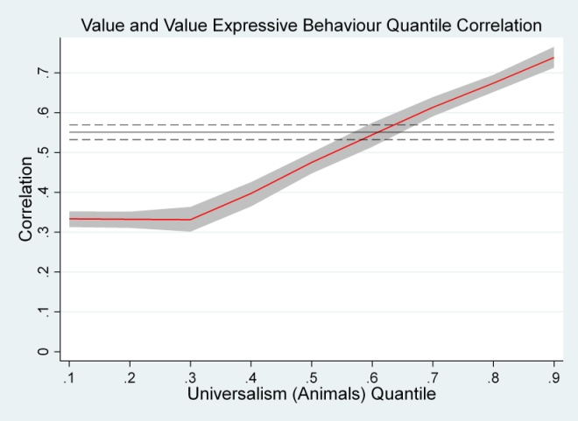 | 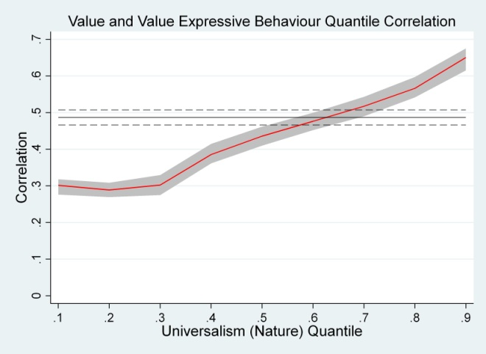
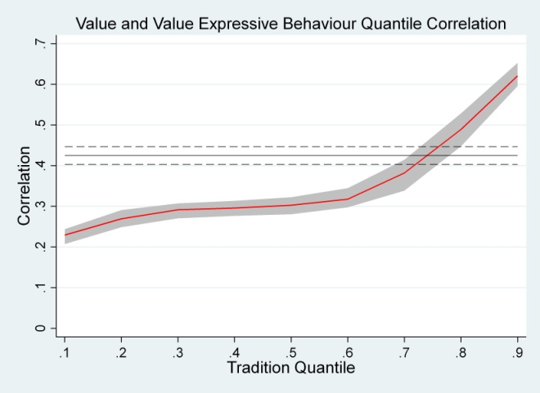 | 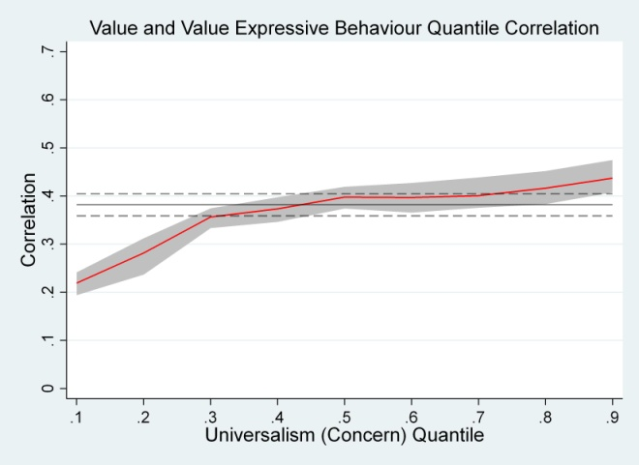
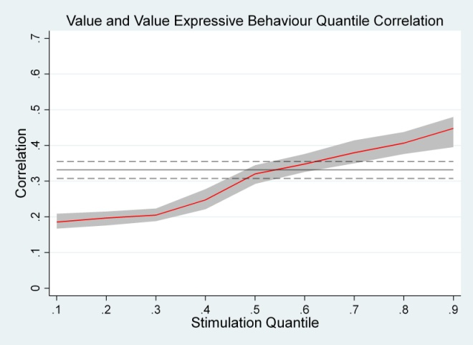 | 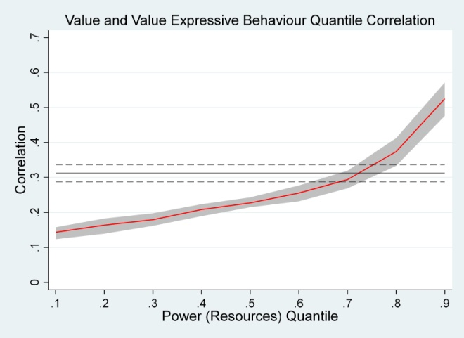
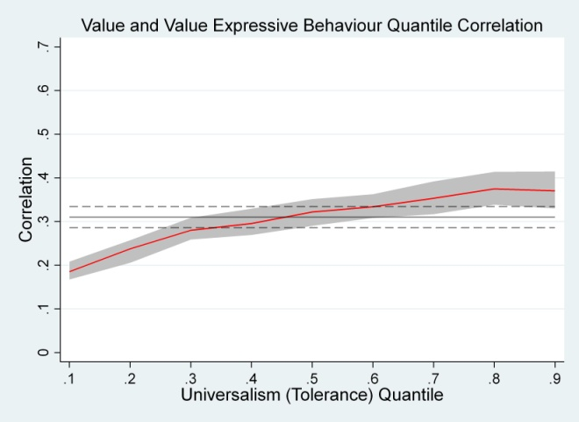 | 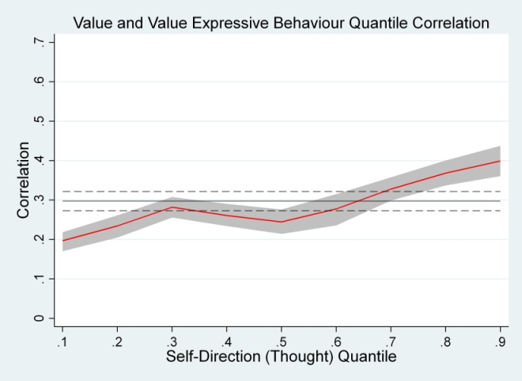
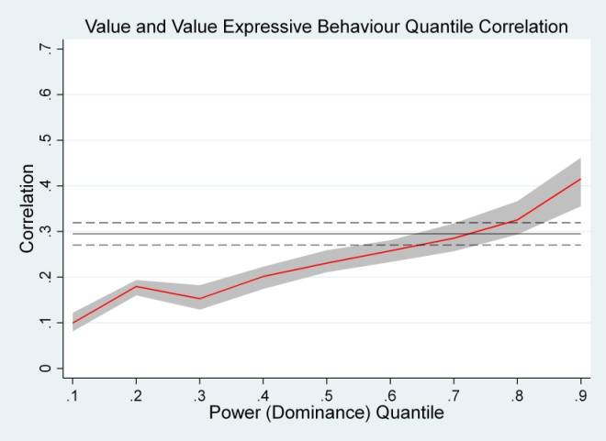 | 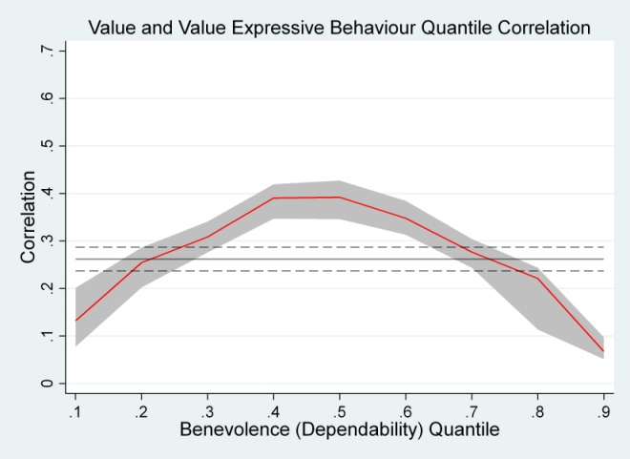
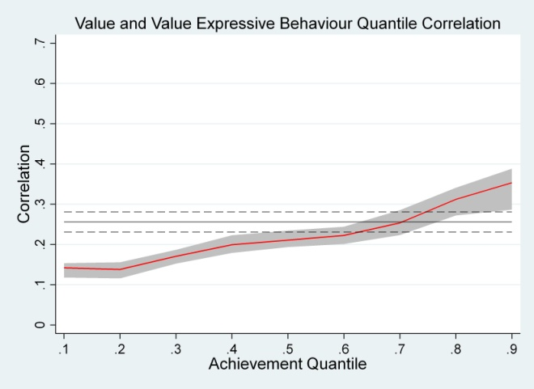 | 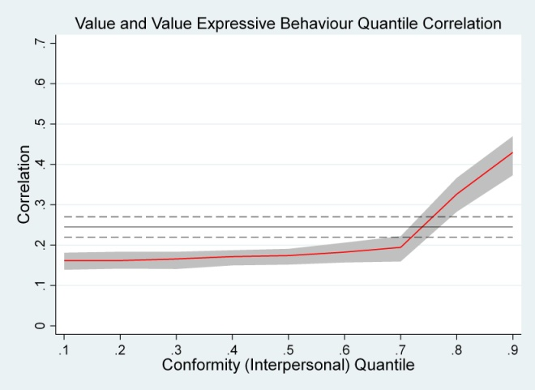
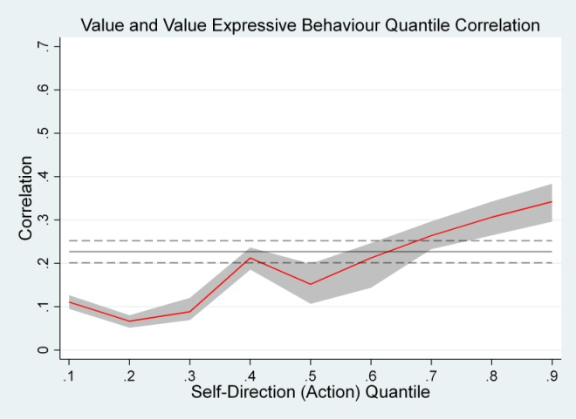 | 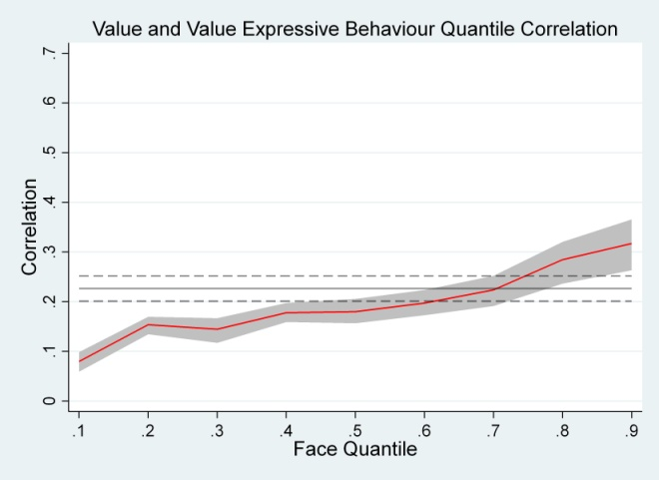
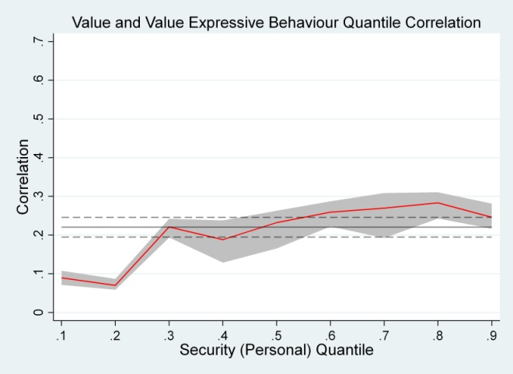 | 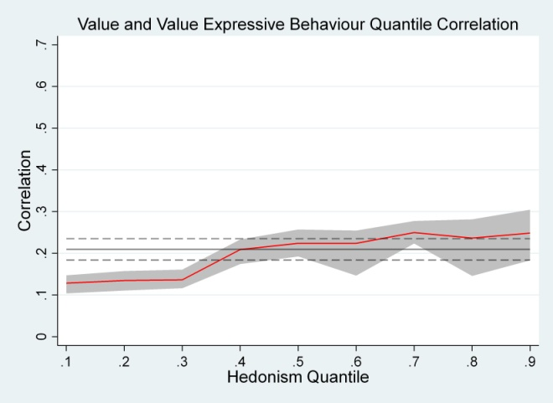
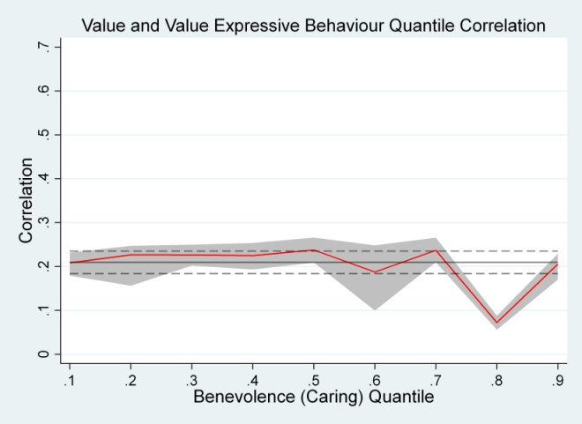 | 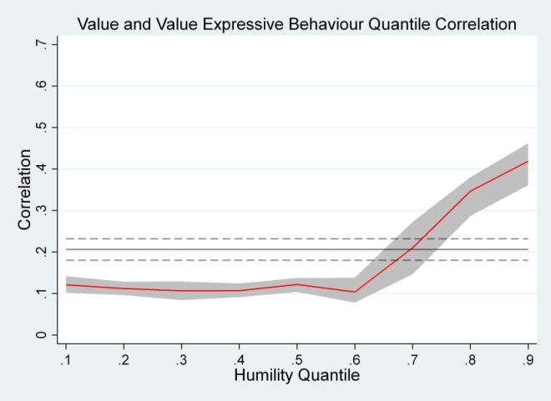
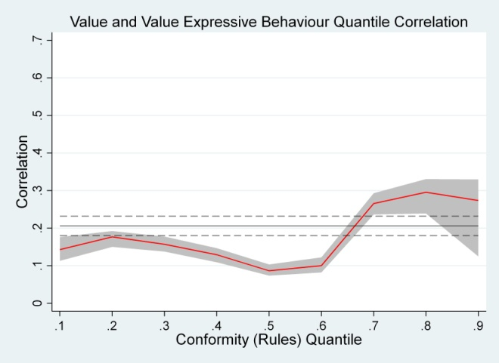 | 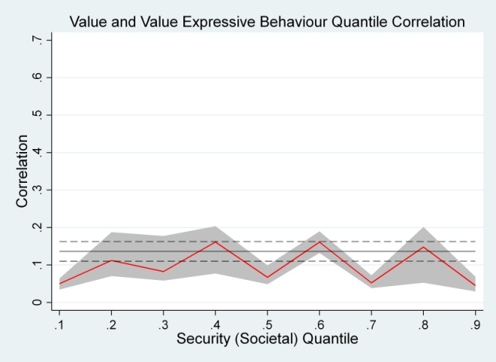

Note. Red lines join the point estimates of quantile correlations at the .1, .2, .3, .4, .5, .6, .7, .8, and .9 quantiles. The shaded areas indicate the 95% confidence intervals around the quantile correlations. The horizontal solid black lines show the Pearson correlations with their 95% confidence intervals indicated by the dotted lines above and below them.

Figure 2
Quantile and Pearson Correlations for Higher Order Values and Spending on Clothing and Recreation.
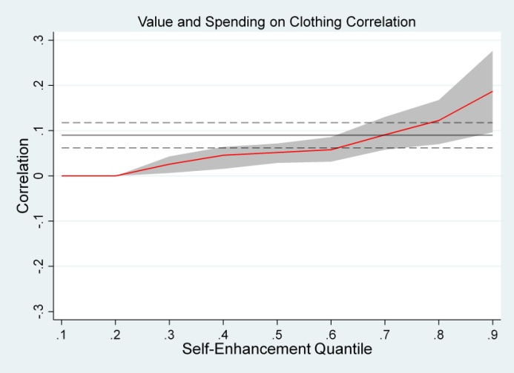 | 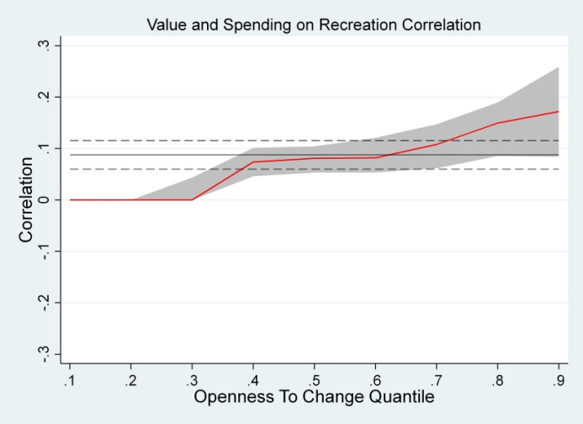

Note. Red lines join the point estimates of quantile correlations at the .1, .2, .3, .4, .5, .6, .7, .8, and .9 quantiles. The shaded areas indicate the 95% confidence intervals around the quantile correlations. The horizontal solid black lines show the Pearson correlations with their 95% confidence intervals indicated by the dotted lines above and below them.

See Supplementary Materials p.1 for results of an empirical study that supports this statement.
Also referred to as “jittering” by Machado and Silva (2005). We used the perturb function in Stata (version 16) for the estimation.
This level of perturbation or jittering is consistent with the jitter function in R (Stahel & Maechler, nd).
Zou (2007) developed this extension to better account for sampling distribution skewness when estimating Pearson correlations.
Results using the full sample are presented in Section 4, Figure S3 and Table S4 in the Supplementary Materials. These results are very similar, but show less differentiation between quantiles closer to the median.
We repeated these analyses including face in self-enhancement and including hedonism in openness to change, as hedonism was more strongly correlated with openness to change than self-enhancement. The expanded three value indices correlated highly with the two value indices (.90 for self-enhancement and .87 for openness to change). Results of the analyses were almost identical.
As in Part 1, the results using the full sample were very similar. These results are in presented in Section 4, Figure S4 and Table S5.
The quantile regression estimates the parameters of the conditional quantile function ${ Q}_{τ}\left(y|x\right)=xβ_{τ}$ by minimizing ${\sum_{i:y_{i}≥x_{i}{\hat{β}}_{τ}}^{N}{τ\left|y_{i}-x_{i}{\hat{β}}_{τ}\right|}+\sum_{i:y_{i}<x_{i}{\hat{β}}_{τ}}^{N}{\left(1-τ\right)\left|y_{i}-x_{i}{\hat{β}}_{τ}\right|}}_{}$(Wenz, 2019). See also Cameron and Trivedi (2009) for further discussion.

