This is a pre-copyedited, author-produced PDF of an article accepted for publication in Past and Present following peer review. The version of record will be available online at: https://academic.oup.com/past

Mothering in the Archives: Care and the Creation of Family Papers and Photographs in Twentieth-Century Southern England

Jane Hamlett, Royal Holloway, University of London
Abstract
In England in the early twentieth century, it became increasingly common for families to document their lives by assembling papers, ephemera, photographs and other objects. These archives were often made by mothers. A wider social range of people recorded their activities visually, as photography became cheaper and easier to use – family collections filled with snapshots and photograph albums. This essay explores the creation of family archives as material practices of mothering and expressions of care, paying close attention to this new visual component. Using three case studies based on family papers and photographs assembled by women in southern England in the twentieth century, the essay examines how the arrival of children in the family shaped the way in which women created family archives, how child development was visually and materially depicted, and how women framed their own roles. Looking at the archives women produced allows us to see the self-representation of mothers during a period when mothering was in flux, changing as a material and practical endeavour, and subject to new ideas and critical scrutiny. Comparing three women from different backgrounds reveals variety within these material practices, but also shared aims and visual strategies. Drawing attention to the generative role of care in creating family archives also demonstrates the lasting impact of mothering on large numbers of archives currently held in the public domain.
224 words

Mothering in the Archives: Care and the Creation of Family Papers and Photographs in Twentieth-Century Southern England

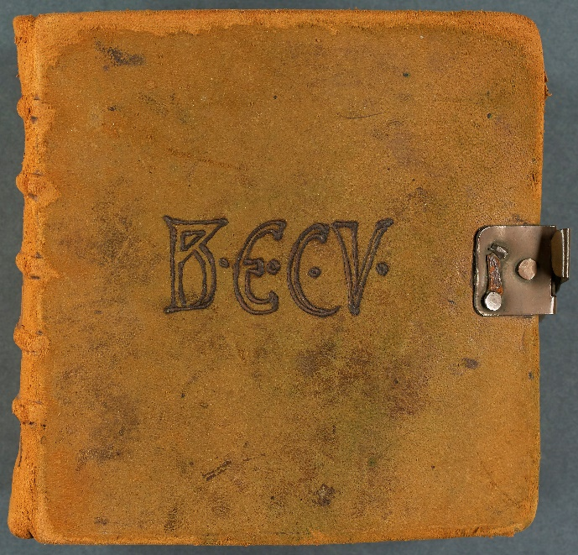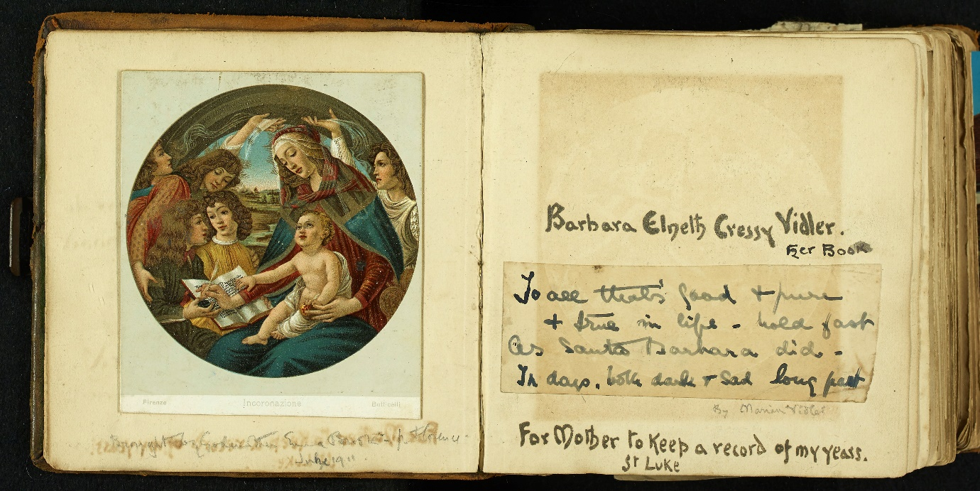

Figure 1 Cover and opening inscription of 'Barbara Elneth Cressy Vidler - Her Book'. East Sussex Record Office, ACC/5253/4.

During the 1910s, Edith Vidler, the wife of a shipping merchant based in Rye, began work on a scrap book devoted to the life of her daughter Barbara, born in 1902. The opening pages were inscribed ‘Barbara Elneth Cressy Vidler – Her Book’ and ‘For mother to keep a record of my years’. Beginning with Barbara’s birth and birthplace, Edith created a visual and material record of Barbara’s life as a child and family history. A series of photographs charted Barbara’s development from baby to young girl, and later showed her schooldays. These are juxtaposed with small material trophies that could be easily fastened and folded within the text, including invitation cards, locks of hair and swathes of fabric. Later, Barbara herself added to the book, and mother and daughter worked on it together. Interspersed with Barbara’s story are quotations, often about the nature of motherhood and children, and images of motherhood, both religious and secular. An artist’s daughter who continued to work as a professional craftswoman after her marriage, Edith was unusual in possessing the skills needed to bind and inscribe the book herself and her High-Anglican perspective clearly informed its tone and imagery. But the book was also part of a wider culture of making that was associated with mothering in early twentieth-century England. At this point, it became increasingly common for families to document their lives by assembling papers, ephemera, photographs and other objects. These archives were often made by mothers. A wider social range of people recorded their activities visually, as photography became cheaper and easier to use – family collections filled with snapshots and photograph albums. In this essay, I will explore the creation of family archives as material practices of mothering and expressions of care, paying close attention to this new visual component.
In the context of this collection of essays, which focus on mothering as a process, this piece offers a new approach through interpreting material objects that mothers produced to commemorate their families and children. Photos, albums and scrapbooks are used to examine mothering as a material practice, looking at how women represented themselves and their children through the creation of visual and material archives. In a previous essay in this collection, Helen McCarthy argues that more attention should be paid to the ‘emotional work’ performed by mothers for their families. The creation of family archives – and the documentation of childhood – was part of that emotional work, in which women used visual and material culture to position both family identities and their role as mothers. The social geographer Gillian Rose has assessed the relationship between mothers and family photography in contemporary society. Rose, and other visual studies scholars, have emphasized that it is the study of what women do with photographs, can be as meaningful as the study of their content. Penelope Pitt, for example, adopts a ‘visual-material’ approach, in studying the photographic archive created by an Iranian migrant mother through a series of interviews to understand how she used them to negotiate her subject position. I will explore the value of applying this approach in a social historical context – looking at what mothers in early twentieth-century England did with photographs and other kinds of family archives. In the absence of oral history, the focus here is on reading the material practice of motherhood direct from the papers themselves – drawing connections between images and objects and reading the archive for material clues. I am also interested in the lasting effects of mothering on collections of family papers that have been placed in the public domain. In their innovative Family Archive project, Anna Woodall and her team have drawn attention to the role of twenty-first families in creating archives – they examine private archives rather than public ones, but their work demonstrates the importance of family relationships in archival creation. Building on their work, this essay considers how mothering and care contributed to making archives in the past, and how those relationships and activities influenced the form of collections found in the public domain today.
The essay is based on three case studies from southern England in the first half of the twentieth century. During the Victorian period the role of mothers was celebrated in British culture – as part of a new cult of Evangelical middle-class domesticity that placed emphasized the home as an engine of social values. In the early twentieth century authority structures came under new stresses, although the central expectation that a woman’s primary role was wife and mother remained intact. While motherhood continued to be promoted, the practical circumstances in which women mothered changed considerably. From the late nineteenth century, middle-class professionals actively limited the size of their families – the average number of children dropped from eight to ten to two to three. This altered the experience of mothering – women were no longer in a long-term cycle of repeat pregnancy, and instead might look back on their children’s early years in midlife. Class position and socio-economic resource remained a powerful differentiating factor. While mothers in working-class communities drew support from nearby female friends and relatives, in middle and upper class families it remained the norm to delegate the physical and material aspects of daily childcare to waged servant labour well into the twentieth century. A middle-class mother delegating basic physical childcare to nanny was very different to the mother struggling to find resources to support her children in a small tenement flat. Arguably, from the nineteenth century, mothers and mothering were also placed under greater scrutiny. With the emergence of the Child Study Movement, scientists sought new ways of studying the growth and development of children – mothers were obviously heavily implicated in this process. After the Boer War triggered fears over the physical and mental state of the next generation, working-class mothers were increasingly criticised. Later in the twentieth century, as McCarthy shows, working mothers were obliged to negotiate new expectations about the performance of motherhood that emphasized attachment between mother and child. Looking at the archives women produced, then, allows us to see the self-representation of mothers during a period when mothering was in flux, changing as a material and practical endeavour, and subject to new ideas and critical scrutiny.
The interpretation of albums, scrap books and photographs pose a methodological challenge – how can we make sense of these objects in the absence of direct evidence of how mothers thought and felt about them? Diaries and letters sometimes give a fleeting glimpse into the processes of making but it is rare to find reflections on why family archives were assembled. Visual studies specialists argue that we should take a more speculative approach. Patrizia di Bello, for example, suggests that we should ‘flirt’ with Victorian albums engaging with the playful spirit in which they were constructed. Mette Sandbye has also argued that the flexibility and mutability of photography may call for a more creative approach from scholars and theorists. While this essay takes an empirical approach to the historical evidence, some of the commentary on how the archives came into being is speculative – and I would argue that this kind of reflection on the processes and circumstances in which archives are created is a valuable interpretative tool. Material culture scholars also suggest that working outwards from an object can be an effective research strategy. Leonie Hannan, Sarah Longhair and Vivienne Richmond have all demonstrated the rewards of working outwards from surviving objects. Rather than treating texts and visual representations as separate entities, here the family archive itself is seen as set of material objects that need to be seen in relation to each other. Some caution must be exercised here – the composition of family archives took place over time, and we cannot know what was discarded, or if retention was accidental of deliberate. While mothers often generated archival material other family members or friends might be responsible for placing that material in the public domain. Nonetheless, by comparing three case studies, the essay will consider how far it is possible to generalise about mothering as a material practice. The examples here demonstrate how class and socio-economic status effected the creation of family archives. But all three women were engaging in a new visual culture and a shared idea of motherhood that was specific to their time and place. Finally, the essay will comment on how far we can identify shared characteristics in the creation of those archives – and, if this model might be useful for considering other societies and cultures.
The three case studies are drawn from a wider survey of family papers in local archives and record offices in the south of England with rich collections of visual evidence. Family papers are a core part of the holdings of British archives. The aristocracy and gentry are strongly represented and the subject of large collections assembled in the course of estate management. Historians of the early modern period and nineteenth century have made extensive use of these records to understand and interpret women’s lives. From the mid-nineteenth century the character of these collections changes – there are more diaries, and letters, but they also become strongly visual and cover a greater social range, with better documentation of middle class and some working-class families. Historians of the twentieth century are beginning to write more about them. But relatively little attention has been paid to who assembled them and why, although the role of women is beginning to be acknowledged. In discussing the relationship between mothering and archival sources held in the public domain, I also hope to make a larger point about the capacity of mothers and those engaged in mothering, to influence the nature and content of family archives, even after they have been reframed in a public context. Reading family papers can reveal the way in which archives were originally structured by their female creators – whose arrangements, logic and ordering have survived even within catalogues that are blind to female activity. As many feminist historians have noted, archives are frequently gendered, focusing on men who have achieved public acclaim and sometimes obscuring female activities. Although mothers are often a significant presence within family archives, women and domesticity have only recently begun to be seen as themes worth highlighting in catalogues which have been written over many decades. However, because public archives also work to preserve information about deposition – as well as the ordering and material structures (folders, envelopes etc) imposed by the depositor – they can reveal a great deal about their original makers. Woodall, King, Gloyn et al. have developed a new approach to viewing archival collections, suggesting that exploring the practices of archival creation in families can usefully blur the boundaries between public and private archives. A further exploration of the processes of family archiving, they suggest, has the potential to unlock new interpretations of holdings in the public domain. Mothering and care were powerful drivers in the creation of family archives – an exploration of the impact of mothering on their production adds to this growing reinterpretation. The final section of this essay examines how mothering relationships often informed the deposition of archives and their transference to the public domain, and how the activities of the mothers who created them continue to inform their structure.
The first case study focuses on Thelma Newton (previously Hammond), whose family papers are held at The Keep in Sussex as part of the East Sussex Record Office collections. Thelma was an American, born in Indianapolis in 1893, who married Henry Newton, an English civil servant, in 1911. The couple lived in Brighton and Farnborough and had three sons Roy (1912), Bob (1917) and Phillip (1920). The Newton papers relate to Thelma, Harry and the lives of their children. The archive contains very little textual evidence of Thelma’s years as a mother of small children – the main sources for her childhood, girlhood and early years of marriage are a collection of loose photographs and three photograph albums. As such, Thelma’s archive is typical of the material that survives for middle-class women from this time – photography had become embedded in everyday day life and was actively being used by middle-class families, who were also often more inclined to preserve and pass down photos and albums than other documents. The second case study is from another middle-class family– the Vidler family of Rye in Kent also held at the Keep. A significant section of the archive relates to Edith Vidler (formerly Roper) who married Leopold Vidler, a shipping merchant, in 1899. The couple had two children, Alec (1899) and Barbara (1902). In contrast to Thelma Hammond’s collection, Edith Vidler’s visual and material record is extensive including diaries, letters and a large body of visual and ephemeral material. The unusual size of Edith’s archive may partly be explained by her background. The daughter of the painter and illustrator Edward Roper, Edith travelled with her father to Canada and Australia, supporting her father’s artistic activities and earning money from her own painting before her marriage. After her marriage Edith continued to earn as a craftswoman and her professional and personal archiving practices overlapped. The archive includes albums Edith made by hand for her children – providing a rich and unusual example of material mothering. The final case study focuses on Sarah Doreen Budd, known as Doreen, (1908-1993) and is held at Hampshire Record Office. Doreen was the daughter of a carter from Longparish near Andover, and left school at fourteen to become a domestic servant. This was her occupation before she married her husband, Howard Budd, a gardener, in 1934. She had no children. I selected the Budd collection for two reasons. Firstly, because it offers a rare glimpse into an archive, assembled by a working-class woman in the first half of the twentieth century, that includes a strong visual component; consisting of two albums and a large collection of small photographs, miscellaneous papers and memorabilia, and a set of diaries, kept between 1937 and 1993. Secondly, as a childless married woman Doreen stood outside the norm in the mid-twentieth century, and we can use her archive to consider how she positioned herself in relation to this status. As Naomi Miller and others have demonstrated, mothering is not exclusively practiced by women who have given birth. While Doreen was not a mother, her archiving practices were also often driven by care and family relationships, which can be seen in her visual and material record, and the retention and prominence of photographs of her nephews and nieces.

MAKING ARCHIVES
It seems particularly important to interrogate the motivations behind the creation of family archives by mothers. While the commemoration of children might appear to be an obvious or ‘natural’ activity, this varied according to personal and individual circumstances, class, marital position and numbers of children. Access to new technologies, socio-economic resource, and time could be crucial to the production of visual records. From the invention of photography in the mid-nineteenth century, increasing numbers of people had access to it – first through studio photography and later through everyday domestic photography that allowed informal snapshots of family life. Domestic and personal photography is often seen as a leisure activity, popularised by an industrialised working class. It was widely marketed to women by Kodak from the 1910s. Viewing these tasks as leisure, however, is problematic in that the production of family archives was, for mothers, often part of the emotional and cultural work that they performed for the family. As feminist historians have pointed out, women’s leisure, especially that of mothers, has always been a highly unstable category, shaped by women’s wider work for the household. Underpinned by new industrial technologies and understandings of the expression of individual selfhood, twentieth-century family archives had a new modern visual component. But they also need to be situated in an older female tradition of the production of goods by hand. As historians of earlier periods show, making things can be a powerful emotional resource for mothers, helping them negotiate new territory and experiences. As McCarthy also points out in this collection, the new domestic leisure opportunities afforded to twentieth-century middle-class women were ambiguous – sometimes restrictive but also allowing creativity. The production of family archives may usefully be viewed alongside other material activities undertaken by mothers in the home such as crafting and needlework. Sometimes these activities promoted a restrictive femininity, but they also brought pleasure and emotional satisfaction.
For all three women, their creation of their personal archives was closely related to their stage in the lifecycle, socio-economic resources and access to technologies. Thelma Hammond was born into a wealthy family in Indianapolis, she travelled to England in the 1900s and was at school in Brussels, before settling down in Brighton in 1911. Her photos suggest that she owned a Brownie Box Camera or similar, that allowed snapshot photography. Such cameras were relatively easy to use but required some skilful handling. In Thelma’s first two albums, the camera documents her social life, in Brighton where she and her mother temporarily settled, and at the school in Brussels. Thelma was an adept photographer, and her travels probably encouraged her to take photographs. Nonetheless her practice is fairly typical of middle-class women in England in the early twentieth century, who were encouraged and even expected to practice photography. While there is no direct evidence of why Thelma created these records, the objects themselves give clues. Her albums are annotated – suggesting that they were intended to be passed between generations. Thelma carefully labels many images with first names and places – including self-portraits marked ‘myself’ or ‘me’ – it seems likely that the labelling was intended for future generations who might not recognise Thelma physically (see figure two). Her collection is also oddly patchy – her third album documents the early years of her first child Roy in depth to 1915, but the fourth jumps to the 1930s. It is not clear why the early years of her second and third child are not included. It’s important, here, to exercise caution with the interpretation – we cannot know if this was a deliberate choice, but we can speculate. With three children on her hands, album assembly may have had to take a back seat. Another explanation is that these albums remained in private hands – the archive was deposited by Thelma’s daughter-in-law Joyce, who married Philip, the third son. Joyce may have wanted to keep images of Phillip’s early years in the family.

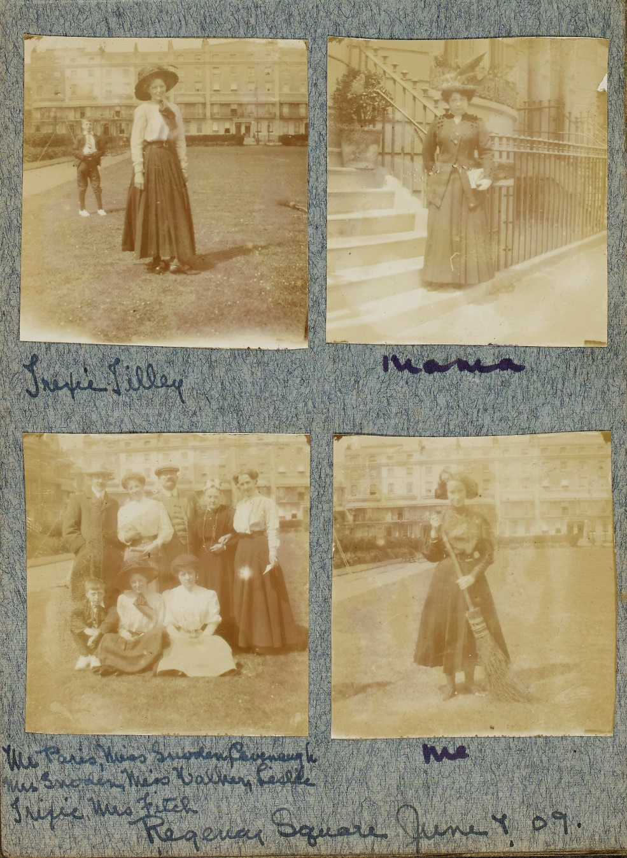
Figure 2 Thelma Hammond's self-labelling in her first photograph album. East Sussex Record Office, AMS 7094/2/3.
Material traces within the Vidler archive give a much stronger sense of the personality and intentionality of its maker, Edith. Edith’s book binding supplemented the family income in the 1910s and 1920s. Her archive is thus informed by her professional artistic practice and her identity as a craftswoman – and the objects she made reflect this – her albums have embossed initials, signatures and monograms (see figures one and three). She does not seem to have taken photographs herself, but compiled those taken by other people, particularly her son Alec. These are brought together with ephemera, programmes, material objects, inscriptions, poetry and epigrams, to create her ‘books’. Individual books were made for Barbara, Alec and husband Leopold and special volumes devoted to family trips and holidays (see figures one and three). Edith also had a strong high Anglican identity, reflecting on religious experiences and views in diaries and commonplace books and incorporating religious language and iconography into her books for the family. In June 1922, in a piece written for a women’s magazine, Edith argued that hand made things ‘wrought with love as in the days of old’ had an emotional value, and that makers would be ‘rewarded for all our efforts by the pleasure hand wrought work and individual thought for each member of the home and our friends always gives’. In this public statement, she depicts craft as a special kind of creative work produced in dialogue with modernity – and an understanding of the emotional value of handmade things. Her diary underscores the powerful personal emotional value of documenting her children’s lives. The diaries express constant pleasure in the children’s health and development and a strong emotional attachment, particularly to Barbara. On her first birthday, in 1903, Edith writes, ‘Thank god so well and bonny is our darling so happy 4 teeth can stand alone’. Edith’s archive was also produced in collaboration with her family and intended to pass into their hands within her lifetime. ‘Barbara Vidler, Her Book’, the special book that she produced for her daughter, was a collective endeavour. Documenting Barbara’s birth, childhood and life as a young woman, it was made by Edith but Barbara added to it from around 1914. Mother and daughter continued to work on it until 1929 when twenty-seven-year-old Barbara left home to get married - one of the last entries is a prayer dated 1929 ‘inscribed by mother’. Barbara appears to have treasured it throughout her life – an inserted postcard suggests that it travelled to her marital home in Worthing before it was returned to the family archives.
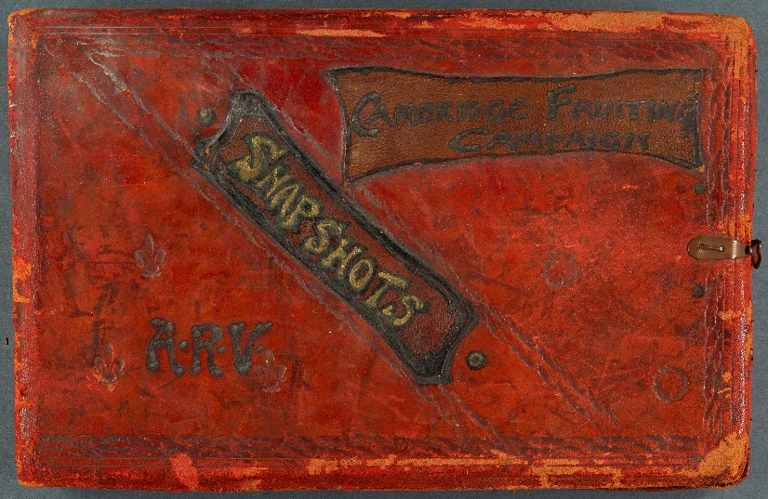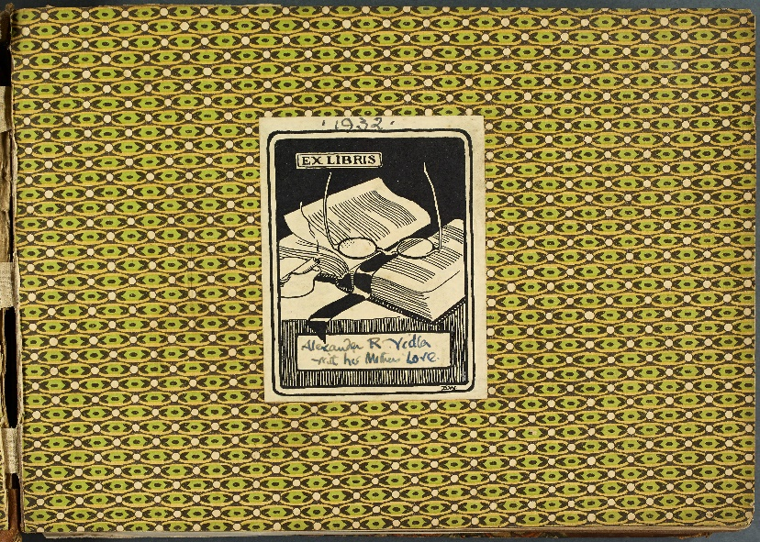

Figure 3 Album that Edith Vidler created for her son Alec and book plate with inscription. East Sussex Record Office, ACC/8784/9/6/3.

In contrast to the middle-class papers, Doreen Budd’s archive consists of a large collection of loose photographs (a small selection of these are shown in figure four), a run of diaries, and a few albums. Doreen collected photographs from an early age. As the daughter of an agricultural labourer Doreen’s access to photographic technologies was limited. There are no photographs of Doreen herself as a child except for a school photograph – such images were often the first time that working-class children came into contact with the camera. The collection expands in the 1920s and early 1930s, photos of Doreen in her domestic service placements and of her early relationship with Howard. In the late 1930s her collection shifts from individual portraits, mainly of herself, to images of her home, family and friends – small children of close family and immediate friends are more prominent. In the early 1950s Doreen acquired her own camera, which transformed her visual record. Doreen’s use of family photography can be seen as an expression of care. Her growing ability as an amateur photographer led to her taking the lead role in capturing family occasions. Being able to take good ‘snaps’ was a source of great satisfaction to Doreen, and she recorded with pride that her images of her nephew Donald's wedding, taken in 1965, had come out particularly well. They were so good that she had copies made for Ella, and waited with impatience for their arrival. Even prior to her acquisition of a camera the exchange of images played an important role in family life. In the 1930s and 1940s the family saw each other infrequently even though they lived in the same county. Sending photographs, letters and other small objects formed part of an important material and epistolary system of exchange – through which Doreen was able to maintain links with her family and to carry out small acts of material care. Her early diaries show that she exchanged letters with her mother every week, and frequent communications with Howard’s Mum and Granny. When possible the family circulated photographs of key events by post.

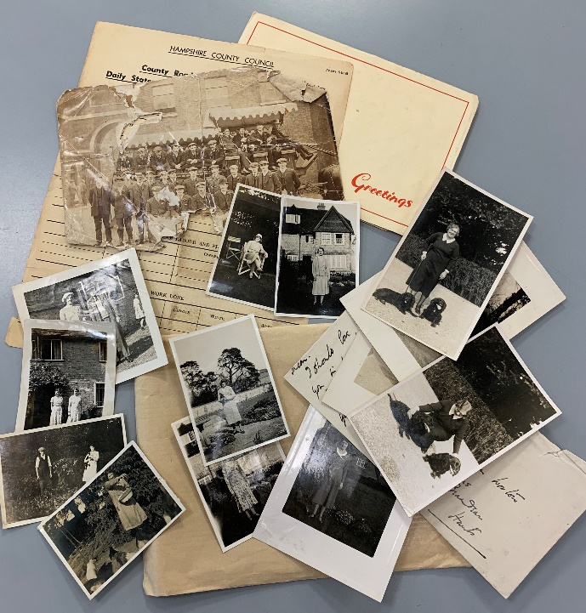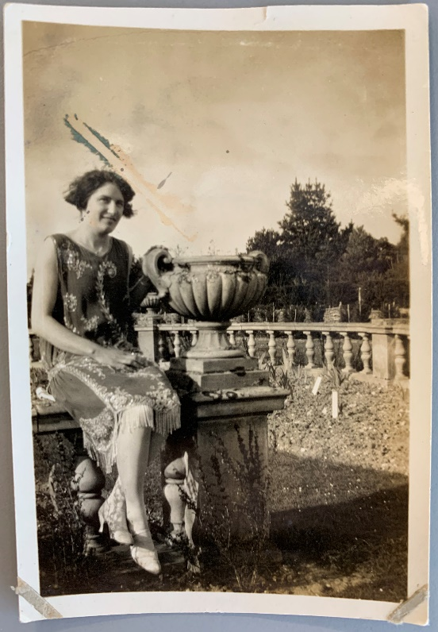

Figure 4 Some of the loose photographs from Doreen Budd's collection and photograph of Doreen at Thorns Beach before her marriage. Hampshire Record Office, 58M98/71.

What is different about Doreen’s archive is that there is little sense, from the objects and images, that they were created to be passed on. Doreen seems to have created these images for immediate use – for her personal satisfaction and for handing onto friends and family – but not with the next generation in mind. For Doreen, the production of photographs and the selection of certain images for preservation, and the arrangement of images and ephemera in albums was part of a bigger practice of small-scale home production that encompassed gardening, stamp collecting, home decoration, but above all needlework and knitting. They were part of her practices as a ‘homemaker’. The importance of the production of hand-worked things to Doreen is made very clear by the way in which they figure prominently in the diary – entries are often rather sparse, with basic details of housework and paid cleaning work, and a few personal comments. But it was important to record progression in making things – she notes the acquisition of materials, when an object is begun and when it is finished (and often when it is posted, usually to a niece or nephew). There are two albums in the collection. One contains birthday cards from family members and postcards (Doreen clearly collected and treasured these – the album is inscribed as a gift from an auntie before her marriage). The second is also designed as postcard album (the inscription suggests it was originally a gift to Doreen’s sister Winnie) but has been filled with photos relating to Doreen’s life. The photos, which go back to Doreen’s family home before she married and include her various postings and life in her marital home in the 1950s, are mainly unlabelled – the album seems to have been designed for her own use (see figure five). Later on, her former lodger, Paul Humber, helped her label her collection for deposition with a public archive – but when she first created these objects and images, they appear to have been for herself alone. It might be assumed that this focus on the present value of the archive was a result of Doreen’s childlessness, but she could have passed on her archive to nieces and nephews. Her diaries suggest that she valued her visual record in a more immediate way –showing snaps to family or friends soon after their arrival. There may be a class difference here. Middle-class women were accustomed to having the means to create family archives, and likely to be in possession of objects from previous generations. Both Edith and Thelma had things that had belonged to their parents, and Edith drew on mid-nineteenth-century photographs and letters when she created her books. With more material wealth and greater access to things, middle-class families were already used to passing objects down to the next generation – indeed, doing so in the right way was an indication of social status.

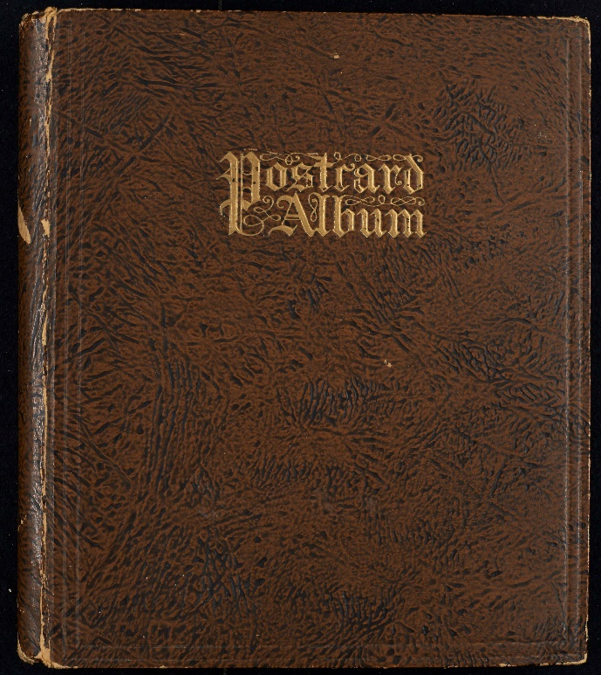
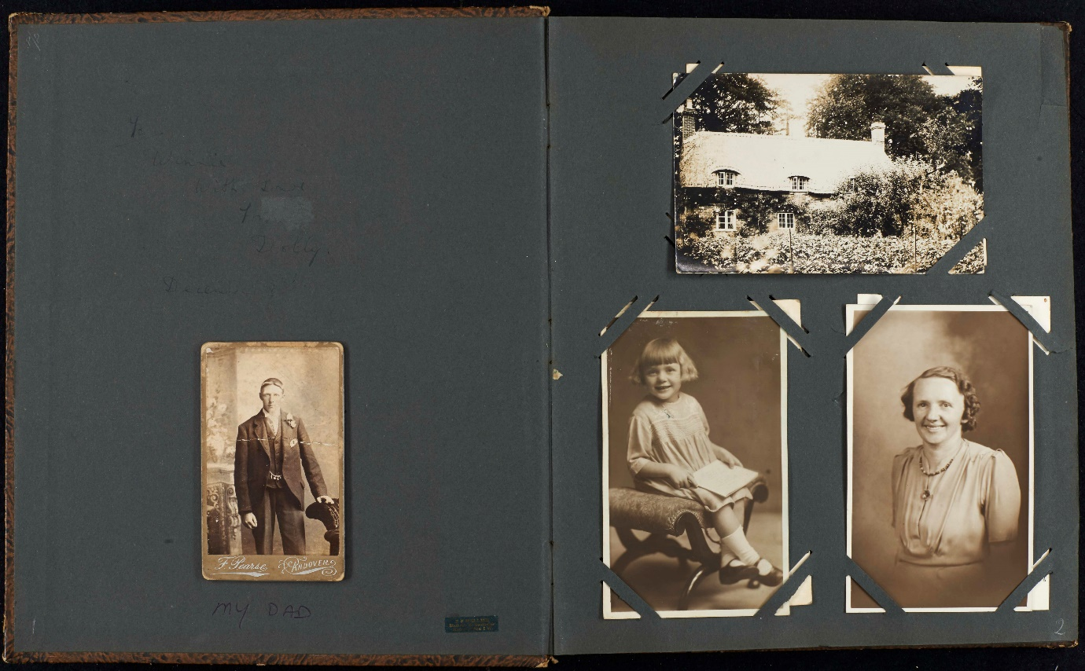
Figure 5 Doreen Budd’s postcard album which was repurposed for photographs – mostly unlabelled but some labels were added later. Hampshire Record Office, 51M98/70.

DOCUMENTING CHILDREN AND MOTHERING
The archiving practices of the three women were all changed by the arrival of children, either their own or in Doreen’s case her sister’s children. When Thelma became a mother and gave birth to her first son Roy in 1912, she had the means and skills to create a photographic record of her new life. This is very clearly seen in the third album in her collection, when the focus shifts to Roy who features in the majority of photographs. Thelma’s albums were also organised in a different way after Roy’s arrival. The bulk of the third album documents a long trip that she made back to the US with her mother in 1913 – and features Roy onboard the ship and at play in St Paul’s Minneapolis with his grandmother and grandfather. Here Thelma’s identity as a migrant – and her need to connect her son with the place and culture from which she had come – shapes her album making practice. After the trip, the album’s main focus is a 1915 holiday to Filey in Yorkshire in which Roy again takes centre stage. The final page of the album features five photographs of Roy in which the child is at the centre of almost every photograph (see figure six). This kind of ‘centring’ of the child is also evident in Edith Vidler’s album making, in the volumes devoted to Barbara and Alec. Labelling the albums in this way allowed her to focus exclusively on the lives of the children. Doreen’s collection also took on a new emphasis when small children arrived in the family. One of the larger groups of photographs relates to her married sister Ella Ware, and her nephew and two nieces. 1944 saw the arrival of Donald – Ella’s first child and Doreen’s first nephew. Donald is prominent in Doreen’s photographs. Her diary records that her Christmas present from Ella was a photograph from Ella, showing the newly-toothy ten-month old. Photographs of Anne and Marion Ware, the nieces that followed Donald, were also kept. Within Doreen’s collection there are also several other groups of images that relate to close friends, such as the Prout family – in these young children are also prominent.
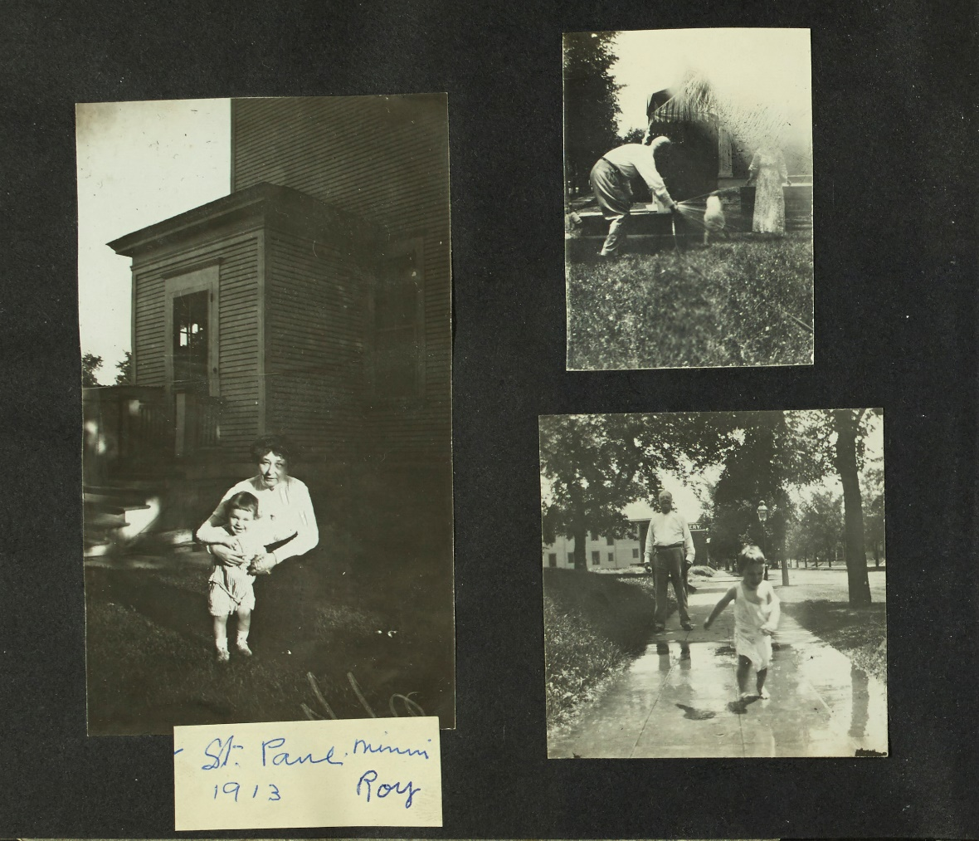
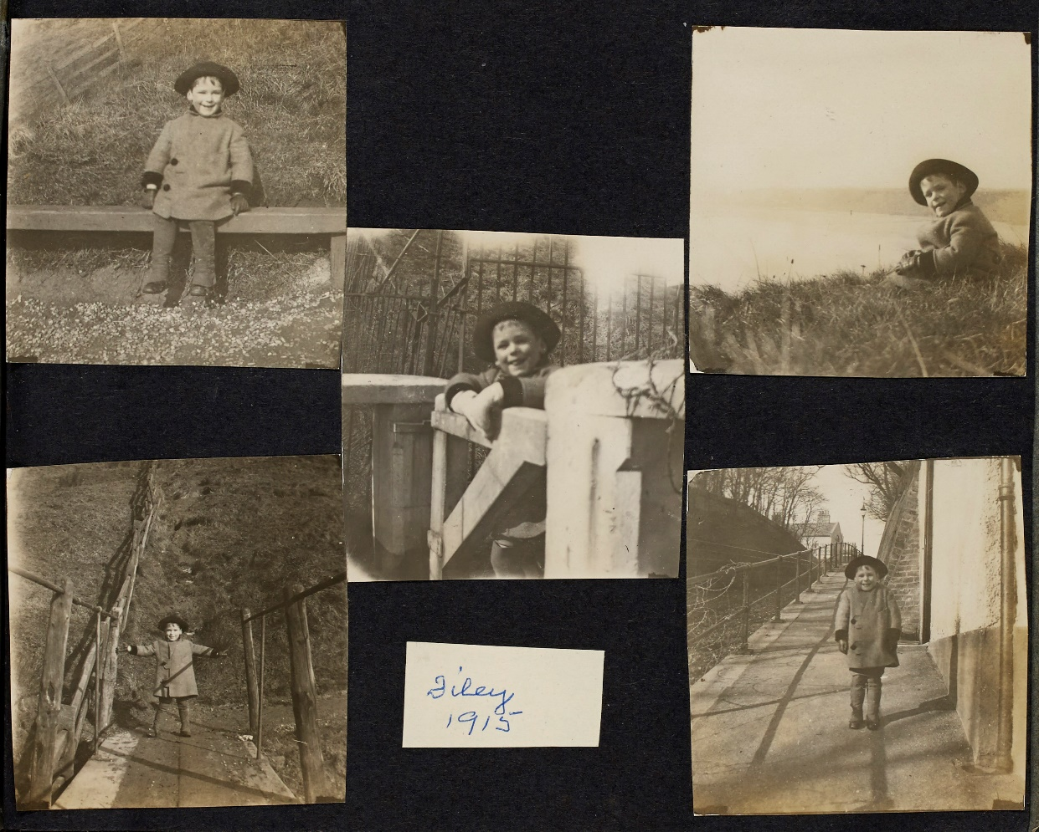
Figure 6 Thelma’s Third Album features Roy’s first visit to her family home in the US and Roy on holiday in Filey. East Sussex Record Office, AMS/7094/2/5.

At the same time as children began to be photographed more frequently and mothers were arranging and conserving these images, a new scientific and popular culture emerged that was concerned with the analysis of child development. Linda Pollock’s study of diaries in the period 1500-1900 demonstrates that parents from across the period took an interest in children’s developmental stages, and noted milestones such as walking and talking. In the eighteenth and nineteenth centuries that interest became more pronounced, and reflections went into greater detail. Social awareness of early childhood as a developmental process grew with the emergence of the Child Study Movement – by the late nineteenth century there was a significant growth in attempts to find new ways of studying children scientifically. New ideas on child development circulated through mass publications aimed at mothers such as the magazine Baby. As Sally Shuttleworth has shown, developmental stages were often the subject of debate between mothers and scientists – the meaning and moment of a child’s first smile was particularly contentious. The magazine itself shows that visual culture was a means of transmitting these ideas – both advertising and features promoted the idea that photographs of babies and small children were a direct visual testament to child health, development and the achievements of mothers. We can’t know if the three women here had read these magazines or absorbed this debate – yet there was in British and North American culture at this point a new and heightened awareness of the developmental progress of the infant. This informed women’s consciousness of the importance of ‘firsts’ and fed into a wider cultural emphasis on the development of young children, contributing to their increasing presence in personal visual culture.
Looking at the three archives together it is noticeable that certain stages in the life of the children are highlighted. In the case of Doreen’s photograph collection it is her first nephew, Donald, who is most prominently documented. Thelma Newton’s third album – recording the Roy’s first doings – performs a similar documentary function and includes a notable image of what was surely the child’s first pony ride (see figure seven). In Edith Vidler’s album for Barbara a more powerful emphasis on firsts and developmental stages emerges, created by the assemblage of commentary, images and ephemera. The book includes many images and items that convey the moments that Edith believed to be significant milestones. Barbara’s birthplace, and date of birth are listed as well as the christening presents she received. There is a list of ‘firsts’ including first tooth, first words, first song, first walk and first visit. Barbara’s growth and development are made physically relatable by the inclusion of a lock of her hair, the continuation of a Victorian tradition of sentimental memorialisation (see figure eight). Barbara’s progress is also tracked in Edith’s diary and she displays a strong concern for the health of both children. Visual studies specialists have argued that late twentieth-century white middle-class mothers created linear narratives in photograph albums that corresponded to the sequence of child development promoted by contemporary advice manuals. This can be applied to Edith – ‘Barbara Vidler Her Book’ is linear in intention as it commemorates Barbara’s childhood and coming of age. Yet it is also episodic, planned but also constructed opportunistically, it moves backwards and forwards through time. There is also a strong emphasis on a material culture shared between mother and daughter. The book celebrates Barbara’s role in this female world – a page commemorates her as bridesmaid at her godmother’s wedding, including a photograph, including a swatch of the ‘pale blue Liberty satin’ and a ‘Bow from the Juliette cap’ of Barbara’s bridesmaid outfit (see figure eight). Historians of earlier periods have pointed to a distinct feminine material culture, often associated with marriage. At points the book seems as much an expression of this older matrilineal material culture as a modern concern with child development.
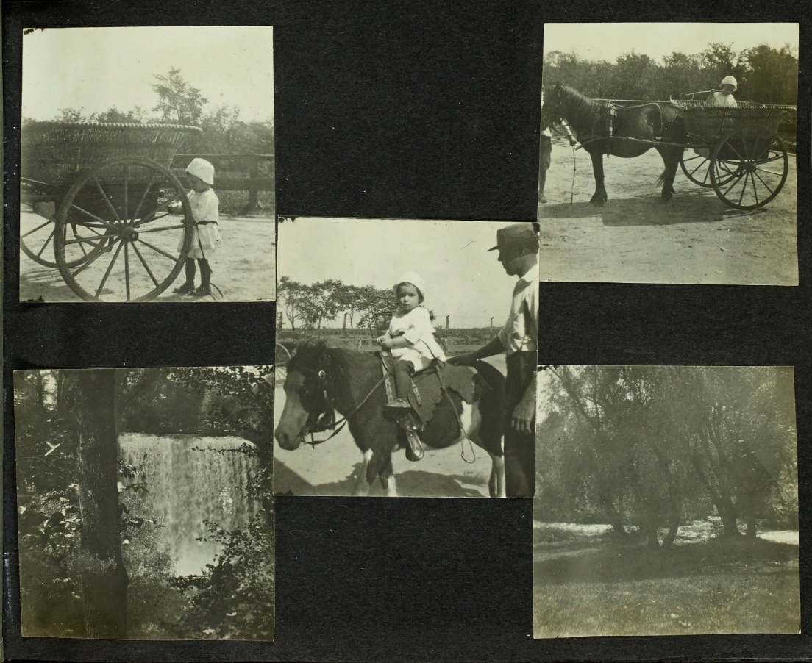
Figure 7 Thelma’s third album shows what was probably the infant Roy’s first pony ride. East Sussex Record Office, AMS/7094/2/5.

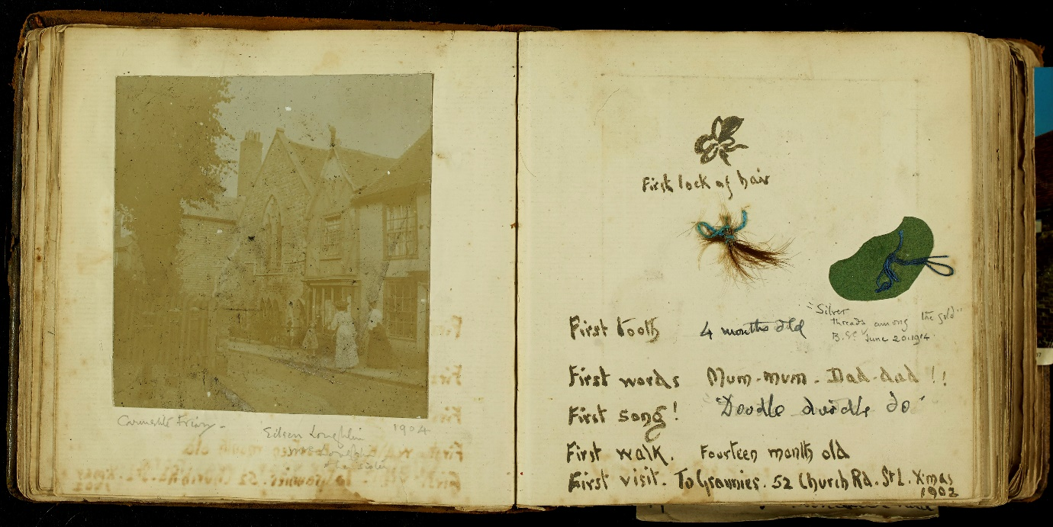
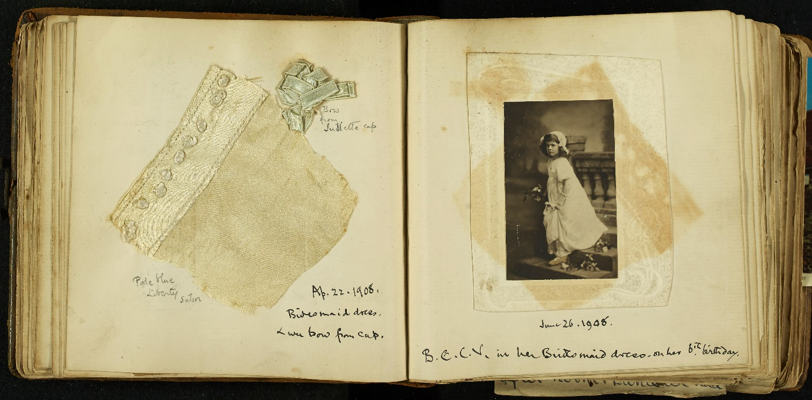

Figure 8 Pages recording first tooth, words, song, walk and visit and commemorating Barbara’s role as bridesmaid. East Sussex Record Office, ACC/5253/4.

All three women were photographed differently after the arrival of children in the family, and photographs were used to frame their new relational positions. As Audrey Linkman has shown during the nineteenth century common formats for family photographs evolved in studio portraiture. The Newton family continued to procure studio portraits alongside using more informal family photography. An image of Thelma Newton, posed with five-year-old Roy and new baby Bob in 1917, taken by a professional photographer in Scarborough, reproduces these conventions – Thelma is seated cradling the baby, Roy is close at her side – it is a scene of formalised intimacy and everyone is wearing their Sunday best (see figure nine). The image would have helped shore up the family’s class status. This contrasts with more informal pictures of early motherhood in Thelma’s album – a snapshot in the garden in which a joyous Thelma clutches baby Roy aloft – and relaxed cuddles on ship to the US (see figure nine). Thelma is pictured but it is likely she handed her camera to someone else on the spur of the moment before posing before the lens. Although it is clear from Doreen’s diary and photograph collection that she was a reasonably prolific photographer from the 1950s, there are relatively few images of Doreen herself in middle age, partly, perhaps, because she was often behind the camera. But a few of the images that were taken (or she chose to keep) feature her alongside nephews and nieces that restate her new role in relation to the children. In one example, Donald stands beside her while she wheels Anne in a pushchair, the image was probably taken by Ella on one of the family’s trips to Doreen’s cottage at Bighton in Hampshire. Another, later portrait of Doreen shows her with Ella and the children at Bighton in 1953 and may have been taken around the time of the Coronation.
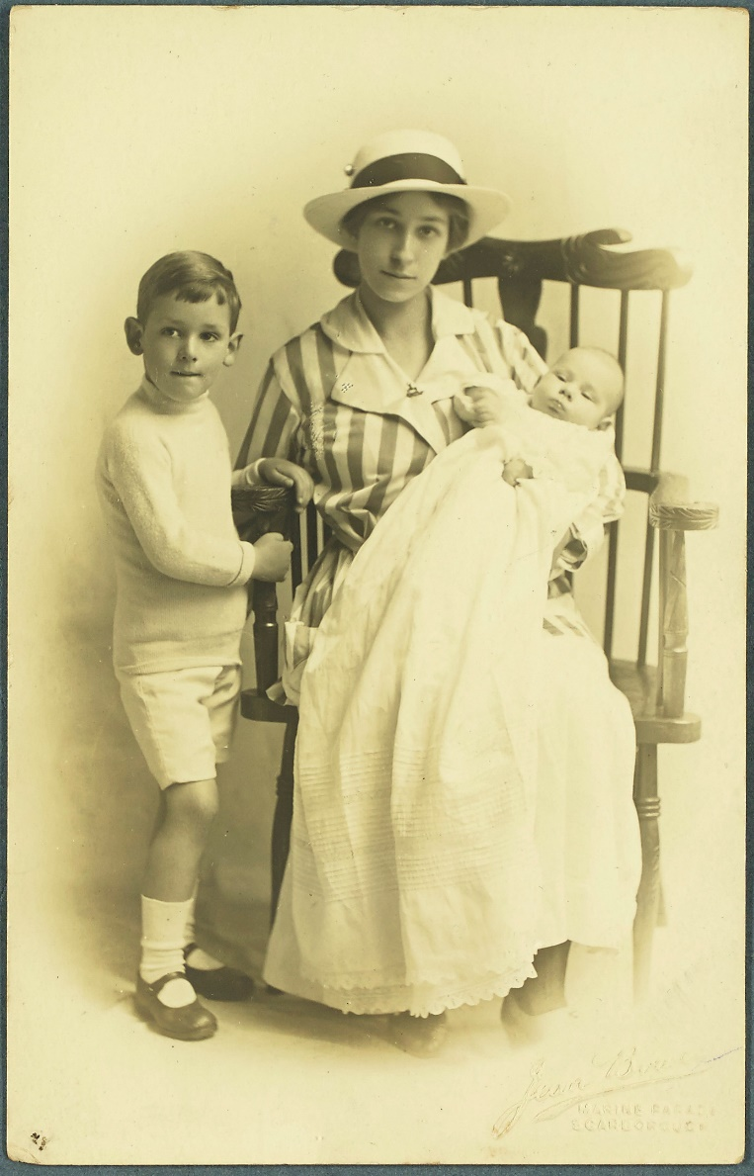
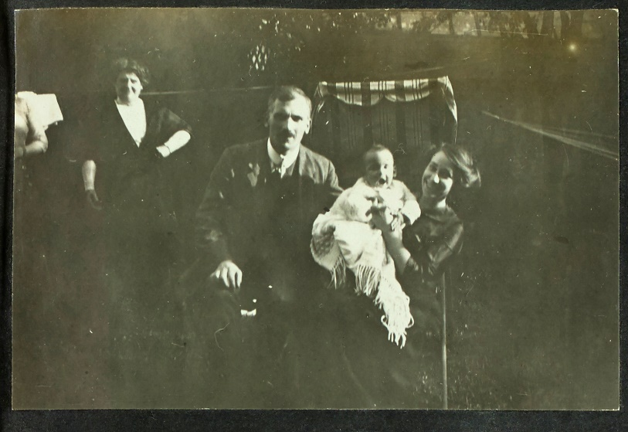
Figure 9 A formal photograph of Thelma, Roy and Bob at Scarborough in 1917 and an informal snapshot of Thelma with baby Roy from her third album. East Sussex Record Office, AMS/7094/2/2 and AMS/7094/2/5.

Edith Vidler did not create many pictures of herself as a mother but her book for Barbara can be read as a visual representation of the mother’s role. Barbara’s book includes reproductions of works of art, poetry and quotations that frame her life within a wider presentation of motherhood. By choosing these items Edith placed herself in a middle-class cultural milieu – she drew on an imagined artistic and literary world to position herself as a mother. The religious connotations of motherhood are underlined by the inclusion of a reproduction of a painting of the Madonna and child in the opening pages of the book, and a quotation attributed to the gospel of Luke (see figure one). Additions included an unattributed poem ‘When Baby is Asleep’, quotations from Rosetti, Longfellow and Masefield and a printed copy of the Tennyson poem ‘Little Birdie’. ‘When Baby is Asleep’ celebrates the emotional centrality of motherhood and its self-sacrifice: ‘when a little child lies in your arms at night what do you care for care?’. Edith also aligned herself with Victorian ideals of motherhood by including a small reproduction of Franz Xavier Winterhalter’s ‘The First of May’ (1851), which depicts the Duke of Wellington offering a gift to Victoria’s first-born child. This was immediately contrasted with a more modern image of motherhood which appeared on the previous page – John Lavery’s ‘The Mother’ (1909) (see figure ten). The Winterhalter reproduction celebrates motherhood as a public role and is typical of the image that Victoria projected of herself as a mother. Its display and celebration of motherhood as public performance and national duty contrasts with the emotional and physical intimacy framed in the Lavery image – which places mother and baby alone at the centre of the canvas. As an artist and craftswoman Vidler appears highly conscious of the visual framing of motherhood – her material practices express an identification with different versions of mothering –religious, publicly sanctified, but also emotionally intense.
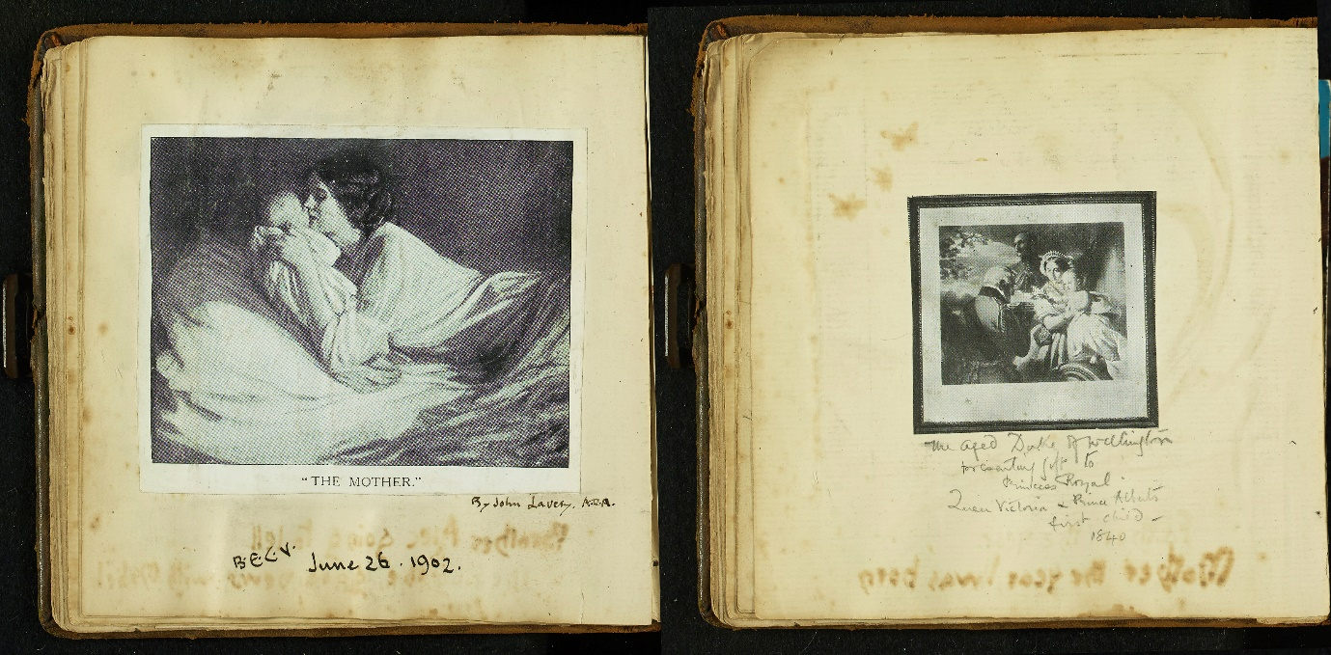

Figure 10 John Lavery's 'The Mother' (1909) juxtaposed with Francis Winterhalter's 'The First of May' (1851). East Sussex Record Office, ACC/5253/4.

MOTHERING IN THE ARCHIVES

All three sets of papers now reside in public archives. The private material practices of mothers and other women - driven in their lifetimes by the need to express care, show pride in their achievements and document their lives for the next generation – have crossed into the public domain. Edith and Thelma’s papers were deposited because of their relationship with their sons – Edith as the mother of the noted theologian Alec Vidler, Thelma because her daughter-in-law Joyce researched the family’s history. It was also Doreen’s quasi-maternal role that led to her unusual collection ending up in a record office. In the 1940s she formed a close relationship with her lodger, a young man called Paul Humber, who eventually became responsible for depositing her archive. His view of Doreen was shaped by his perception of her as a ‘surrogate’ mother and homemaker. The young Paul moved in with Doreen and Howard in 1947, after having had difficulties at home (he did not get on with a new stepmother), and he also joined the army. Paul remained close to Doreen for the rest of his life and felt responsible for her in old age. Sometime before her death, Paul went through Doreen's collection of photographs with her. The backs of many of the images are annotated in two hands. Paul believed that Doreen’s childlessness had a powerful effect on her life: ‘as there were no children born to the union so Doreen took up anything to amuse her’. He also believed that she was lonely. Doreen’s collection had come to Paul on her death and while he thought that it was interesting in its own right, his emotional attachment to Doreen, and his belief that her mothering qualities had gone unrecognised, was fundamental to his desire to see her recognised in the archives: ‘Doreen was a gem of a lady who deserved better in life than she got, a good home maker with very little to spend all her life, a loving kindly lady and she would help anybody all her life if she could, as she did me in early days’.
The material practices of these women continue to influence the structure and shape of sets of family papers within public archives. This is most evident in the case of the Vidler archive. It is preserved in the East Sussex Record Office collections because of its local significance (several male Vidlers were mayors of Rye) and because it relates to the life of leading twentieth-century popular theologian Alec Vidler. While this collection has been kept because of its association with prominent men, its core materials from the early twentieth century were produced by Edith. Significantly Edith’s creative work, and the ten bound albums she made, provide the central means of organisation within an otherwise chaotic visual archive. The Keep catalogue, which is organised around different family members, does not always reveal her role, but her albums provide the family’s diverse visual archive with a powerful backbone and narrative. Their presence – and their lively titles such as ‘Our Motor Tour’ – stand out within the catalogue, allowing Edith’s voice to come through. While Thelma Newton and Doreen Budd were less prolific makers, their material practices have also had a lasting effect. Thelma Newton’s camera produced much of her archive. Doreen’s photography shaped the visual archive too – but her practices were also about collecting and compiling images of family and friends from a range of different sources.

To understand the significance of these papers we need to think about the imperatives that created them in the first place, and the interlinkages between objects, images and texts. This needs to be done with care, considering original makers and keepers but also how family relationships influenced what was kept and what was thrown away. The three case studies demonstrate how mothering and care informed the material practice of these three women, but how far can we generalise on a basis of this evidence? Western women’s engagement with family archiving and photography has often been characterised as a uniform practice, but the three case studies demonstrate how migration and movement, class position and socio-economic resources, religious affiliation, as well as artistic engagement produced very different archives. Thelma’s archive was fashioned in response to her return to her home country; Edith’s extensive material archive the produced by her artistic background and training as well as her High Anglican religious sensibilities. Doreen’s visual world, meanwhile, was shaped by her rural Hampshire location and the limited mobility of working-class families in the first half of the twentieth century. There were, however, commonalities in the women’s material practices too. All three engaged, to a greater or lesser extent, in a new form of modern visual culture brought about by the arrival of photography, and all three altered their practices in response to the arrival of children. The three women were operating at the same time as the emergence of a new cultural focus on child development – which was certainly evident in Edith’s collection. Having said this, the commemorative volume for her daughter, with its emphasis on female objects, can also be read as a continuation of an older celebration of matrilineal heritage. All three collections were produced by time and personal effort. It is worth noting that both Edith and Thelma – with two and three children apiece – had quite a different experience to mothers of the previous generation. Smaller families shortened the period of early mothering, which could leave women with more time and a different kind of space in which to reflect on their development. While the chronology of access to photographic technology varied across class groups – the affective power of certain kinds of images was similar – Doreen’s emphasis on images of young children echoes the practices of the other two women.

The collections discussed in this paper are confined to a time and place – both the creation of family papers and their subsequent archiving are culturally specific products of twentieth-century Britain. Not only was their production shaped by contemporary social values, but the archiving process itself also reflects contemporary power structures – this is clearly evidenced by the kinds of archives that we now have access too – in which middle-class and upper-class white families are heavily represented. As Shawn Michelle Smith has demonstrated, the creation of family photographs was linked, in the late nineteenth century, to the construction of a racial hierarchy – the reproduction of white middle-class images literally reproduced a socially sanctioned image of whiteness. Either consciously or unconsciously, women who created material archives reproduced the dominant image of a colonial group. Any discussion of the value of these archives, then, must acknowledge their cultural relativity. In the context of this collection it is interesting to speculate on how far the characteristics of these material practices were restricted to Western women. What material things did mothers in other societies and cultures produce that expressed their identities and commemorated their children’s lives? What did they want to show and record – and can the things they made be subjected to similar interpretations? Do they remain in private hands – or are they discoverable in public collections? It is impossible to fully answer these questions here. But it is worth noting that family photography can be used in different ways - recent studies of how migrant mothers use and create photograph albums suggest that they are less likely to conform to Westernised narratives of child development. The imperative to create albums focused on the immediate family is also influenced by Western family structures and a particular model of motherhood. Sarah Knott, in her recent cross-cultural study, suggests that white middle-class culture tends to portray motherhood as an individual endeavour and achievement, rather than a collective one – other mothers are often overlooked. It may be that the emphasis on the individual achievement of mothers – in this case expressed through visual documentation of child development – is specifically Western. Paying more attention to mothering as a material process – and examining the material and visual qualities of commemorative objects that mothers produce – may help us answer these questions.

It is widely assumed that women were responsible for making albums and family archives, both now and in the past. Patricia Holland, ‘Introduction,’ in Patricia Holland and Jo Spence (eds.), Family Snaps: The Meanings of Domestic Photography (London, 1991), 9. But there have been few in depth analyses of this process or its emotional meaning. Patrizia di Bello’s work on the nineteenth-century albums of Anna Waterlow is a notable exception. Patrizia di Bello, Women’s Albums and Photography in Victorian England: Ladies, Mothers and Flirts (London, 2016), 77 - 105.
Nicole Hudgins, ‘A Historical Approach to Family Photography: Class and Individuality in Manchester and Lille, 1850-1914’, Journal of Social History, xliii (2010), 562.
Gillian Rose, ‘Family Photographs and Domestic Spacings: A Case Study’, Transactions of the Institute of British Geographers, xxviii (2003).
Ibid.; Di Bello, Women’s Albums; Penelope Pitt, ‘Exploring subject positions and multiple temporalities through and Iranian migrant mother’s family photograph albums,’ Gender, Place and Culture, xxii (2015).
Pitt, ‘Exploring subject positions’, 206.
Anna Woodham, Laura King, Liz Gloyn, Vicky Crewe and Fiona Blair, ‘We Are What We Keep: The “Family Archive”, Identity and Public/Private Heritage’, Heritage & Society, x (2017).
Patricia Branca, Silent Sisterhood: Middle Class Women in the Victorian Home (London, 1975); M. Vicinus, ‘The Perfect Victorian Lady’, in M. Vicinus (ed.), Suffer and be Still: Women in the Victorian Age (Bloomington, Indiana, 1972); Leonore Davidoff and Catherine Hall, Family Fortunes: men and women of the English middle class 1780-1850 Revised Edition (London, 2002). For discussion of competing discourses of motherhood see Claudia Nelson and Ann Sumner Holmes, ‘Introduction’, in Claudia Nelson and Ann Sumner Holmes (eds.), Maternal Instincts: Visions of Motherhood and Sexuality in Britain, 1875-1925 (Basingstoke, 1997), 10; Susan C. Greenfield and Carol Barash (eds.), Inventing Maternity: Politics, Science, and Literature, 1650-1865 (Kentucky, 1999).
For a discussion of the emergence of a new understanding of the emotional role of fatherhood, see Laura King, Family Men: Fatherhood and Masculinity in Britain, 1914-1960 (Oxford, 2015), 198 - 199; on increasing expectations of emotional intimacy in marriage see Claire Langhamer, The English in Love: The Intimate Story of the Emotional Revolution (Oxford, 2013).
Michael Anderson, ‘The Emergence of the Modern Life Cycle in Britain’, Social History, x (1985); Simon Szreter, Fertility, Class and Gender in Britain, 1860-1940 (Cambridge, 1996).
Theresa McBride, ‘“As the Twig is Bent”: the Victorian Nanny’, in Anthony S. Wohl (ed.), The Victorian Family: structure and stresses (London, 1978), 49; Katherine Holden, Nanny Knows Best: A History of the British Nanny (Stroud, 2013), 79 - 93.
Ellen Ross, Love and Toil: Motherhood in Outcast London 1870-1918 (New York, 1993); Elizabeth Roberts, A Woman’s Place: An Oral History of Working-Class Women 1890-1940 (Oxford, 1984).
Sally Shuttleworth, The Mind of the Child: Child Development in Literature, Science and Medicine, 1840-1900 (OUP, 2010), 268 - 279; Jane Lewis, The Politics of Motherhood: Child and Maternal Welfare in England, 1900-1939 (London, 1980). For the post war period see Angela Davis, Modern Motherhood: Women and Family in England, 1945-2000 (Manchester, 2012), esp. chapter five.
Anna Davin, ‘Imperialism and Motherhood’, History Workshop Journal, v (1978).
Patrizia Di Bello, ‘Seductions and Flirtations’, Photographies, i (2008).
Mette Sandbye, ‘Looking at the Family Photo Album: A Resumed Theoretical Discussion of Why and How’, Journal of Aesthetics & Culture, vi (2014), 25419, DOI: 10.3402/ jac.v6.25419.
For a discussion of the evolution of the field, see Hannah Greig, Jane Hamlett and Leonie Hannan, ‘Introduction: Gender and Material Culture,’ in Grieg, Hamlett and Hannan (eds.), Gender and Material Culture in Britain since 1600 (Basingstoke, 2016).
Leonie Hannan and Sarah Longair, History through Material Culture (Manchester, 2017), 59 - 61; Vivienne Richmond, ‘Stitching Women: Unpicking Histories of Victorian Clothes’, in Grieg et al, Gender and Material Culture.
For example: Amanda Vickery, The Gentleman’s Daughter: Women’s Lives in Georgian England (London, 1998); M. Jeanne Peterson, Family, Love and Work in the Lives of Victorian Gentlewomen (Bloomington, 1989); Jane Hamlett, Material Relations: Middle-Class Families and Domestic Interiors in England, 1850- 1910 (Manchester, 2010).
On the challenges of reading twentieth-century diaries see Joe Moran, ‘Private Lives, Public Histories: The Diary in Twentieth-Century Britain’, Journal of British Studies, liv (2015).
For new work in this area see Alison Flint, ‘To the Ladies of Ogston Hall: the Epistolary Cultures of Nineteenth-Century Gentry Women of Derbyshire’, (Derby Univ. Ph.D. thesis, 2017).
Archives are widely acknowledged to be far from neutral spaces, structured by the power relations that create them. Antoinette Burton, ‘Introduction: Archive Fever, Archive Stories’, in Antoinette Burton (ed.), Archive Stories: Facts, Fictions, and the Writing of History (Durham, 2005); Maryanne Dever, Sally Newman and Ann Vickery (eds.), The Intimate Archive: Journeys Through Private Papers (Canberra, 2009).
Dever, Newman and Vickery, The Intimate Archive, 11 - 16. Antoinette Burton, ‘Archive Stories: Gender and the Making of Imperial and Colonial Histories’, in Phillippa Levine (ed.), Gender and Empire (Oxford, 2004), 281.
Helen M. Buss, ‘Introduction’, in Helen M. Buss and Marlene Kadar (eds.), Working in Women’s Archives: Researching Women’s Private Literature and Archival Documents (Ontario, 2001), 1 - 6. Maryanne Dever, Sally Newman and Ann Vickery offer an excellent feminist critique of ‘the archive’ but do not mention motherhood. Dever, Newman and Vickery, The Intimate Archive.
Woodham, King, Gloyn, Crewe and Blair, ‘We Are What We Keep.’
Ibid., 216-217.
The Newton Family of Brighton, East Sussex Record Office (hereafter ESRO), AMS 7094.
Photographs and papers of Thelma Newton, ESRO, AMS 7094/2.
Patricia Holland, ‘“Sweet it is to Scan”: Personal Photographs and Popular Photography’, in Liz Wells (ed.), Photography: A Critical Introduction (Routledge, 1996), 140
The Vidler Family of Rye Diaries, Correspondence and Papers, ESRO, ACC 5242; Papers of the Vidler Family of Rye, including Alexander (Alex) Vidler, theologian (1899-1991), ESRO, ACC 8784.
The Keep – catalogue entry for the Vidler papers. http://www.thekeep.info/collections/getrecord/GB179_ACC8784
Pawsey’s Pocket Diary and Almanack for 1895 (Edith Roper’s diary), 2 Aug. 1895, ESRO, ACC 5242/2/2.
Budd of Ropley collection, Hampshire Record Office (hereafter HRO), 51M98. My original survey focused on searching for sets of family papers that included significant collections of photographs or albums as well as substantial textual documentation such as a run of diaries or large collection of letters. The Budd collection was one of very few that included a large collection of photographs and significant textual sources assembled by a working-class woman in this period. The original search included the holdings of the following repositories: Hampshire Record Office; West Sussex Record Office; East Sussex Record Office (The Keep); Kent History and Local Archive Centre.
Katherine Holden, The Shadow of Marriage: Singleness in England, 1914-60 (Manchester, 2007), 16.
Naomi J. Miller, ‘Mothering Others: Caregiving as Spectrum and Spectacle in the Early Modern Period’, in Naomi J. Miller and Naomi Yavneh (eds.), Maternal Measures: Figuring Caregiving in the Early Modern Period (Aldershot, 2000), 1.
Audrey Linkman, The Victorians: Photographic Portraits (London, 1993), 173 - 174.
Ross McKibbin, ‘Work and Hobbies in Britain, 1880-1950,’ in Jay Winter (ed.), The Working Class in Modern British History: Essays in Honour of Henry Pelling (Cambridge: Cambridge University Press, 1983), 129; Holland, ‘“Sweet it is to Scan”, 133.
Holland, ‘“Sweet it is to Scan”’, 140; John Taylor, ‘Kodak and the “English” Market between the Wars’, Journal of Design History, vii (1994).
Claire Langhamer, Women’s Leisure in England 1920-60 (Manchester, 2000), 134.
Hudgins, ‘A Historical Approach to Family Photography’; Erika Hanna, ‘Reading Irish Women’s Lives in Photograph Albums: Dorothy Stokes and Her Camera, 1926-53’, Social and Cultural History xi (2014).
Vickery, The Gentleman’s Daughter, 151; Hamlett, Material Relations, 81.
Sally Holloway, ‘Materialising Maternal Emotions’, in Stephanie Downes, Sally Holloway and Sarah Randles (eds.), Feeling Things: Objects and Emotions through History (Oxford, 2018).
Rozsika Parker, The Subversive Stich: Embroidery and the Making of the Feminine (New York, 2010, reprint); Langhamer, Women’s Leisure, 176 - 179; Pat Kirkham, ‘Women and the Inter-war Handicrafts Revival’, in Judy Attfield and Pat Kirkham (eds.), A View from the Interior: Women and Design (London, 1989), 175.
Holland, ‘Sweet it is to Scan’, 140.
Edith Vidler to H. Dunelm, Apr. 1912, ESRO, ACC 5253/5; Edith Vidler to Leo Vidler, 26 Mar. 1916, ESRO, ACC 5253/1.
Commonplace books, ESRO, A5242/2/12-14.
Mrs Edith Hamilton Vidler, ‘Leather Work by A Canadian’, You and I, 1 Jun. 1922, 116 - 7. Pasted into Photograph Album, ESRO, ACC 8784/8/5/1.
Hamlett, Material Relations, 86 - 87.
26 Mar. 1903; Earlier that month Edith recorded that Barbara had her first tooth and ‘gets on splendidly crawling’, 20 Mar. 1903; The Englishwoman’s Pocket Book, ESRO, A5242/2/4.
Audrey Linkman, Family Albums (Manchester, 1982), 12.
Loose collection of photographs, HRO, 51M98/71. The diary frequently mentions photographs of family and friends: 14 May, 16 Nov. 1944, HRO, 51M98/8; 3 Apr. 1954, HRO, 51M98/18; 27 Sep., 2 Oct. 1958, HRO, 51M98/22; 10 Jul. 1965, HRO, 51M98/29.
First mentioned 30 Mar. 1950, HRO, 51M98/15.
6 Sep. 1965, HRO, 51M98/29.
11 Nov. 1965, HRO, 51M98/29.
HRO, 51M98/1.
7 Jan. 1939, HRO, 51M98/2.
In 1953 for example, Doreen knitted six cardigans and jumpers for friends and relatives. HRO, 51M98/16.
Hamlett, Material Relations, 188 - 194.
19 Dec. 1944, HRO, 51M98/8.
Linda Pollock, Forgotten Children: Parent-Child Relations from 1500 to 1900 (CUP, 1983), 226.
Ibid., 226 - 228.
Shuttleworth, The Mind of the Child, 268.
Ibid., 271, 279.
In the 1900s adverts in Baby frequently used photographs as a visual indicator of child health, for example the ‘Frame Foods’ campaign which published a different photograph of a real child each month. Baby, Jun. 1909, p.vii; Jul. 1909, p.vii; Sep. 1909, p.vii. Readers’ photos of children were also published, with commentary from mothers. For example, Edwyna Denning’s portrait was accompanied by her mother’s description of her as a ‘healthy specimen’. Baby, Feb. 1909, cover and 98.
ESRO, ACC 5253/4.
M. Pointon, ‘Materialising Mourning: Hair, Jewellery and the Body’, in M. Kwint, C. Breward and J. Aynsley (eds.), Material Memories: Design and Evocation (Oxford, 1999), 39 - 57.
‘4 years and so many mercies - & our precious children given to us – so dear bright darlings so healthy’, 1 Feb. 1903, ESRO, A5242/2/4.
Pitt, ‘Exploring subject positions,’ 209 - 210.
J. Gillis, For Better, For Worse: British Marriages 1600 to the Present (Oxford, 1985), 6; A. Fine, ‘A Consideration of the Trousseau: A Feminine Culture?’, in M. Perrot (ed.), Writing Women’s History (Oxford, 1992), 118 - 145.
Linkman, The Victorians, 108.
Photographs of Thelma Newton 1900-1930, ESRO, 7094/2/2.
Genealogical research, ESRO, AMS 7094/6.
Typescript notes on the life of Doreen Budd, HRO, 51M98/57. Sandra Naish, ‘Editorial’, The Hampshire Family Historian, xxxi (2004), 167.
HRO, 51M98/16.
Typescript notes on the life of Doreen Budd, HRO, 51M98/57.
See Alec Vidler, Scenes from a Clerical Life: An Autobiography (London, 1977); Matthew Grimley, Sam Brewitt-Taylor, ‘Vidler, Alexander Roper [Alec] (1899–1991)’, Oxford Dictionary of National Biography, Oxford University Press, Sept 2012.
Seven Days in Normandy, ESRO, 8784/8/5/6; Our Little Tour – 1934, ESRO, 8784/8/5/7; Scotland – 1935, ESRO, 8784/8/5/8; The Last Days of the Great War 1914-1918, ESRO, ACC 5253/1; Photograph album, ESRO, ACC 5253/3.
Holland, ‘History, Memory and the Family Album’, 1.
Shawn Michelle Smith, ‘Feeling Family Photography: A Cautionary Note’, Photography and Culture, x (2017), 165 - 167.
Pitt, ‘Exploring Subject Positions’, esp. 210 - 213. Adeola Solanke considers how her mother’s use of ten photograph albums played a vital role in building a Nigerian identity within British culture. Adeola Solanke, ‘Complex, not Confused’, in Spence and Holland (eds), Family Snaps, 128 - 138.
Sarah Knott, Mother: An Unconventional History (London, 2019), 213. Also see 193 - 212 on the roles of others in caring for children.

